Academy of Marketing Annual Conference 2013
University of Glamorgan, Cardiff/Wales, July 9th - 11th, 2013

PILED HIGHER AND DEEPER:
“THE PHD COMICS” AS A CO-CREATIVE CONSUMPTION EXPERIENCE?
By
Markus Wohlfeil
Norwich Business School, University of East Anglia, UK
Mar Solé
Copenhagen Business School, Denmark

ABSTRACT
Ever since Jorge Cham launched the “Piled Higher and Deeper – The Life (or the Lack Thereof) in Academia” in 1997, this newspaper- and web-based comic strip series has enjoyed a growing popularity among postgraduate research students and academic staff members all over the world, for whom the main protagonists provide a humorous mirror to their own daily experiences of life in academia. Thus, the Piled Higher and Deeper comic strips appeal to a very distinct brand community that is narrowly defined by common shared experiences as postgraduate researchers. This netnographic study explores whether, to what extent and how members of the Piled Higher and Deeper brand community are getting actively involved in co-creation activities.

Keywords: PhD Comics, brand community, life in academia, co-creation, netnography, experiential consumption

Track: Arts & Heritage Marketing

PILED HIGHER AND DEEPER: “THE PHD COMICS” AS A CO-CREATIVE CONSUMPTION EXPERIENCE?

Introduction
When in the fall of 1997 Jorge Cham first published his “Piled Higher and Deeper – The Life (or the Lack Thereof) in Academia”-series, nobody could have foreseen that these short newspaper- and web-based comic strips would eventually become a worldwide popular phenomenon (Cham, 2002; Choe, 2011). Indeed, reprints of the “PhD Comics”, as the comic strip series is commonly known, appear regularly in student publications on campuses around the world, while books with comic strip collections are sold via the official website to readers across North and South America, Europe, Asia, Australia and New Zealand (Cham, 2002, 2009; Cloe, 2011; Lawson, 2011). The success of these “PhD Comics” is essentially driven by their steadily growing popularity among the global community of postgraduate research students and junior academics (often in tenure track positions or on probational contracts), who have only recently completed their own PhD, for whom the main protagonists provide a humorous mirror image to their own daily experiences (Fine & De Soucey, 2005) of life in academia (Cham, 2002, 2009). Fans of this comic strip series also find on the official “PhD Comics” website, Facebook and Twitter sites a platform, on which they can exchange their own daily experiences. It is therefore only fair to say that the “Piled Higher and Deeper”-comic strips – as well as their recent film adaptation – appeal to a very distinct (virtual) brand community that is both global and, at the same time, also narrowly defined by their common shared lived experiences as postgraduate researchers.
The present working paper presents a contextual overview and the first insights from an on-going netnographic research project that examines what meaning(s) the “PhD Comics” have for postgraduate students (and junior academics) in their everyday lives in academia (see Figure 1). In doing so, we explore in particular whether, to what extent and how readers and participants in the Piled Higher and Deeper-brand community are also getting actively involved in various kinds of co-creation activities, whereby they not so much add to the official canon by poaching and recreating elements of the media text (Cova, Kozinets & Shankar, 2007; Hills, 2002; Jenkins, 1992; Kozinets, 2001), but actually make a genuine constructive contribution to the creation, development and production of the original text.

“What am I doing here? A monkey could do that!”
For those who don’t know them, “The PhD Comics” follow the lives of postgraduate research students and the different day-to-day issues they constantly have to face at their US university (= Stanford) from a humorous and ironic perspective (Fine & De Soucey, 2005; Koziski, 1984). These issues include their complicated student-supervisor relationships, the problematics of scientific research, the demands of teaching and marking assignments (see Figure 2), the lack of a private or social life, the perils of procrastination and ‘the endless search for free food’ (Cham, 2002). While Jorge Cham initially conceived the PhD comics as a form of ‘therapy’, by which he could exercise his own frustrations, anxieties and other demons have grown within him while working towards a PhD in mechanical engineering at Stanford University (Cham, 2002; Choe, 2011), they have enjoyed a growing popularity among postgraduates and junior academics around the world, who experience similar issues as the characters in their daily lives (Lawson, 2011). In fact, as postgraduate research is a lonely pursuit for most of the time, especially in the social sciences and humanities, the PhD comics have become a platform for them to exchange their own experiences with like-minded individuals and to feel part of wider (global) community (Cham, 2009). Due to this global success and to keep up with the demand, Jorge Cham has since his graduation dedicated himself to the professional production and distribution of the PhD comics. While the official Facebook site counts more than 124,000 members (https://www.facebook.com/piledhigher anddeeper?rf=110860725605522), the official website (http://www.phdcomics.com) attracts approximately 7 million visitors every year (Choe 2011) and also serves as a retail outlet for official Piled Higher and Deeper merchandise, such as the five edited comic strip collections (Cham, 2002, 2005, 2007, 2009, 2012), mugs, T-shirts and the DVD of the film adaptation “Piled Higher and Deeper – The PhD Movie” (2011). Written and produced by Jorge Cham himself, the film (http://www.phdmovie.com) features an amateur cast and crew of postgraduate students at California Institute of Technology and has seen ‘sold-out’ screenings on university campuses worldwide (Lawson, 2011; see also http://youtu.be/BepMrE_Uw9Y). In recent years, the PhD Comics have also moved into the production of funny information videos, in which one of the main characters discusses a topic that is relevant to postgraduate researchers and/or captures their particular attention such as ‘open access publishing’ or ‘theory development’.
It would therefore be interesting to see how the audience of the Piled Higher and Deeper comic strips compares to the readers of ‘traditional’ comics and sheds a new light on the consumption of comics and graphic novels, which refines our understanding of fans and brand communities. Sadly, however, the existing literature on the consumption of comics and their readers turns to be rather scarce. While a handful of consumer researchers paid limited attention to comics back in the 1980s (Belk, 1987, 1989; Kassarjian, 1983; Spiggle, 1986), those early studies only looked at what social values, and especially materialist values, Sunday comics and underground comix would be promoting to readers. But as Kozinets (2001) and Cusack et al. (2003) already pointed out, both academic and popular discourse have for most of the time tended to stigmatise fans, including comic readers, as a bunch of gullible, alienated and socially awkward geeks (Browne 1997; Hills, 2002; Jenson, 1992; Thorne and Bruner 2006). Perhaps, postgraduate research students may have to be socially awkward geeks in order to have an interest in certain academic fields and commit themselves to academic research. But can academics really be described as gullible, dull, cognitively inflexible and uneducated, as the traditional picture for fans would paint them? Thus, what makes the PhD Comics a particularly interesting field of study for consumer researchers is that, due to their unique set of narrative set of narratives, characters and settings, they appeal to a very distinct brand community that is not bound by geography, nationality, ethnicity or class, but still narrowly defined by common shared experiences of life as postgraduate researchers that is mirrored in the comic strips as well as their recent film adaptation. In other words, the everyday lived experiences of the characters in the individual comic strips and the film seem to represent comedic and/or tragic reflections of the audience’s own real everyday lived experiences in world of academia (Hirschman, 2000; Wohlfeil and Whelan, 2008).

Quo vadis? Research question and methodology
The question, therefore, is what meaning(s) do the PhD Comics have for their readers in their everyday lives as postgraduate researchers and/or junior academics? Moreover, to what extent, how and why are members of the Piled Higher and Deeper brand community getting actively involved in acts of co-creation? To explore these questions, this on-going study is taking the following methodological approach: First, we conducted a textual analysis of the two official websites and the official social media platforms on Facebook, Twitter and YouTube with a particular emphasis on the PhD comics’ narrative content and character development and the interactive communication between the makers and their audiences. Following the principal ideas of open innovation theory (Chesbrough, 2003), (potential) influences and active contributions made by audience members to character introductions and developments, issues and topics or the sale of merchandising were scrutinised. Secondly, a netnography (Kozinets, 1998) is currently in progress, whereby both researchers engage in participant observation within the Piled Higher and Deeper brand community on their different social media platforms.

Raiders of the preliminary findings
Preliminary findings from the textual analysis already reveal some interesting insights that warrant further investigation. Unlike traditional comics that are driven by the hero’s conflict with the villain as his binary opposite, the PhD comics feature a group of PhD students as anti-heroes who struggle with the faceless ‘way-of-doing-things’ that is at the heart of academia – instead of a concrete villain. Due to the required insider knowledge to understand many of the jokes, the audience of the PhD Comics consists primarily of current and recent PhD students as well as junior academics who often continue to face similar issues. Interestingly, despite being set within the concrete context of the US graduate school system, the PhD Comics offer a universal appeal in terms of their essence and the addressed issues of life in academia that transgresses the different national postgraduate systems. Another interesting finding is that, even though the vast majority of members on the social media platforms do not participate beyond subscribing to the page and leaving the occasional ‘Love it!’ post, there is nonetheless growing evidence of various co-creation activities at different levels of the PhD Comics brand development.
While the nameless (anti-)hero of the comic strips is an alter ego of Jorge Cham himself and his personal experiences, the other main characters Cecilia, Mike and Tajel as well as the faculty members were initially modelled on fellow graduate students and faculty members and their shared experiences (Cham, 2002). In the following years, especially since Cham’s graduation, the PhD comics have not only improved significantly in quality and sophistication, but also saw their main characters evolving just like the real people they are based on. More importantly, however, as a form of user-driven innovation (Jeppesen & Frederiksen, 2006; von Hippel, 2005), new plot lines and a number of new characters were introduced on the active request of readers to represent the experiences of PhD students from other academic disciplines and/or cultural backgrounds as well as the ‘suffering spouses of procrastinating postgraduates’ (Cham, 2009). On several occasions, the request for the introduction of new characters became a plot line for comic strips itself (see Figure 3) as well as a platform for poking fun on the debate about the value of different disciplines. Another very recent development is that Alexandra Lockwood and Crystal Dilworth, the leading actresses in the PhD Movie who are PhD students themselves, as well as Jorge Cham visit with a camera-team interesting research projects or events on the invitation of postgraduate researchers or academics and share the videos on the official PhD Comics and PhD Movie websites. On a higher level of co-creation, international brand community members volunteered to translate the film script into their native language and provide the subtitles for the film adaptation’s international screenings (http://www. facebook.com/pages/The-PHD-Movie/212606438778958). First signs of crowd-sourcing (Brabham, 2008) are also visible, but require further examination.
The next phase of this research will explore in more detail the nature of these co-creation activities, the motivation of those more devoted brand community members to get actively involved and the value that both makers and consumers of the PhD Comics derive from their co-creations (Amit & Zott, 2001).

References
Amit, R. & Zott, C. (2001). Value Creation in eBusiness. Strategic Management Journal, 22, 493-520.
Belk, R.W. (1987). Material Values in the Comics: A Content Analysis of Comic Books Featuring Themes of Wealth. Journal of Consumer Research, 14 (1), 26-42.
Belk, R.W. (1989). Effects of Identification with Comic Book Heroes and Villains of Consumption on Materialism among Former Comic Book Readers. Advances in Consumer Research, 16, 414-419.
Brabham, D. (2008). Crowdsourcing as a Model for Problem-Solving: An Introduction and Cases. Convergence: The International Journal of Research into New Media Technologies, 14 (1), 75-90.
Browne, J.A. (1997). Comic Book Fandom and Cultural Capital. Journal of Popular Culture, 30 (4), 13-31.
Cham, J. (2002). Piled Higher and Deeper: A Graduate Comic Strip Collection. Palo Alto, CA: Piled Higher and Deeper Publishing.
Cham, J. (2005). Piled Higher and Deeper – Chapter 2: Life Is Tough and then You Graduate. Palo Alto, CA: Piled Higher and Deeper Publishing.
Cham, J. (2007). Piled Higher and Deeper – Chapter 3:Scooped. Los Angeles, CA: Piled Higher and Deeper Publishing.
Cham, J. (2009). Piled Higher and Deeper – Chapter 4: Academic Stimulus Package. Los Angeles, CA: Piled Higher and Deeper Publishing.
Cham, J. (2012). Piled Higher and Deeper – Chapter 5: Adventures in Thesisland. Los Angeles, CA: Piled Higher and Deeper Publishing.
Chesbrough, H.W. (2003). The Era of Open Innovation. MIT Sloan Management Review, 44 (3), 35-41.
Choe, J. (2011). The Joke Is on the PhD. The New York Times [online]. Retrieved January 02, 2013, from: http://www.nytimes.com/2011/07/24/education/edlife/edl-24phd-t.html?r=1.
Cova, B., Kozinets, R.V. & Shankar, A. (2007). Tribes, Inc.: The New World of Tribalism. In B. Cova, R.V. Kozinets & A. Shankar (Eds.) Consumer Tribes (pp. 3-26). Oxford: Butterworth-Heinemann.
Cusack, M., Jack, G. & Kavanagh, D. (2003). Dancing with Discrimination: Managing Stigma and Identity. Culture and Organisation, 9 (4), 295-310.
Hills, M. (2002). Fan Cultures. London: Routledge.
Hirschman, E.C. (2000). Consumers’ Use of Intertextuality and Archetypes. Advances in Consumer Research, 27, 57-63.
Jenkins, H. (1992). Textual Poachers: Television Fans and Participatory Culture. Abingdon: Routledge.
Jenson, J. (1992). Fandom as Pathology: The Consequences of Characterization. In L.A. Lewis (Ed.) The Adoring Audience: Fan Culture and Popular Media (pp. 9-29). London: Routledge.
Jeppensen, L.B. & Frederiksen, L. (2006). Why Do Users Contribute to Firm-Hosted User Communities? The Case of Computer-Controlled Music Instruments. Organization Science, 17 (1), 45-63.
Kassarjian, H.H. (1983). Social Values and the Sunday Comics: A Content Analysis. Advances in Consumer Research, 10, 434-438.
Kozinets, R.V. (1998). On Netnography: Initial Reflections on Consumer Research Investigations of Cyberculture. Advances in Consumer Research, 25, 366-371.
Kozinets, R.V. (2001). Utopian Enterprise: Articulating the Meanings of Star Trek’s Culture of Consumption. Journal of Consumer Research, 28 (1), 67-88.
Koziski, S. (1984). The Standup Comedian as Anthropologist: Intentional Culture Critic. Journal of Popular Culture, 18 (2), 57-76.
Lawson, J. (2011). Review: The PHD Movie – ‘Around Here Everyone’s an Imposter’ [online]. BlueSci, January 05, 2013, from: http://www.bluesci.org/?p=5406.
Spiggle, S. (1986). Measuring Social Values: A Content Analysis of Sunday Comics and Underground Comix. Journal of Consumer Research, 13 (1), 100-113.
Thorne, S. & Bruner, G.C. (2006). An Exploratory Investigation of the Characteristics of Consumer Fanaticism. Qualitative Market Research: An International Journal, 9 (1), 51-72.
Von Hippel, E. (2005). Democratizing Innovation. Cambridge, MA: The MIT Press. Free download: http://web.mit.edu/evhippel/www/democ1.htm.
Wohlfeil, M. & Whelan, S. (2008). Confessions of a Movie-Fan: Introspection into a Consumer’s Experiential Consumption of ‘Pride & Prejudice’. European Advances in Consumer Research, 8, 137-143.

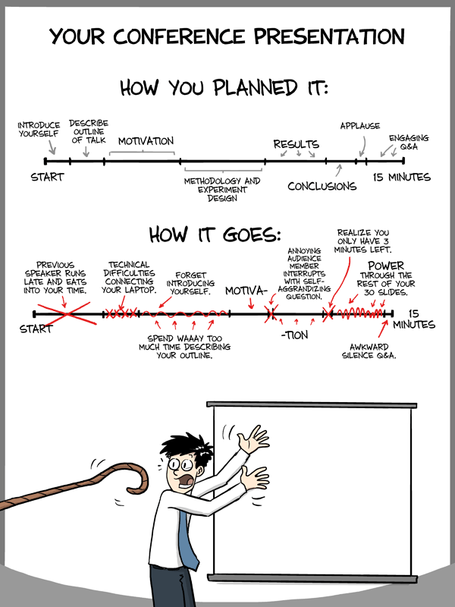

Figure 1: Your conference presentation (courtesy of PhD Comics/Jorge Cham, 2013)

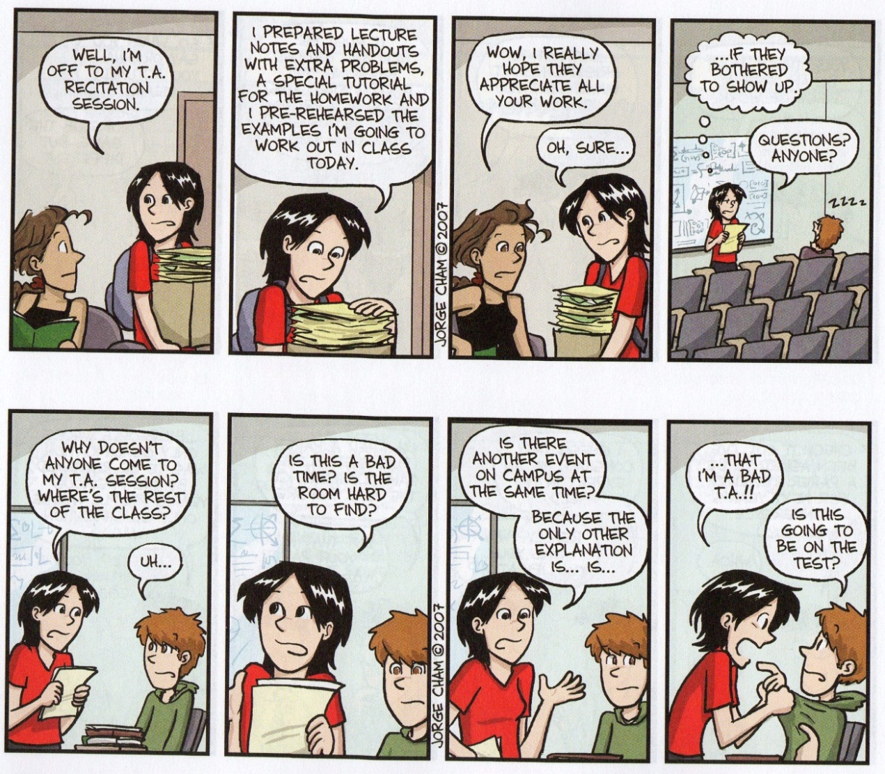

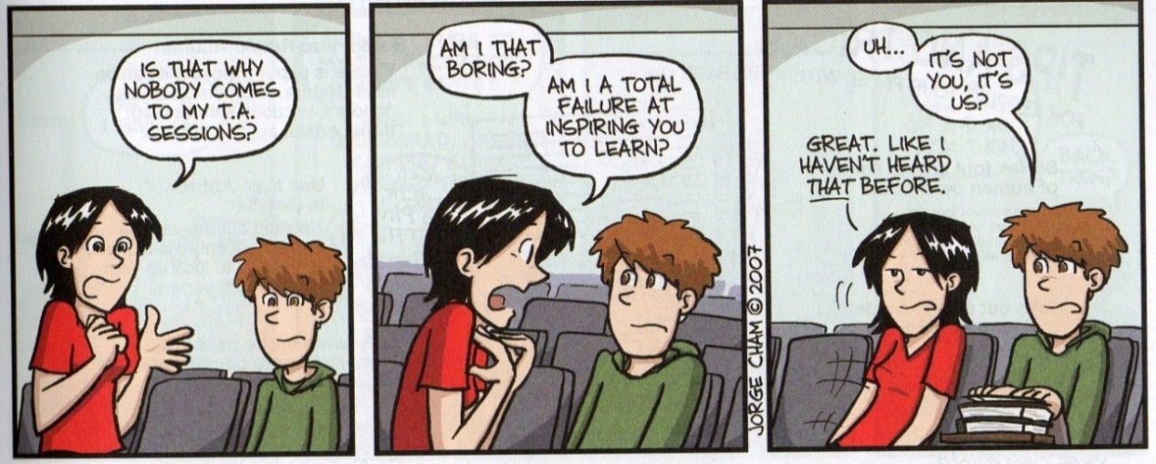

Figure 2a: Understanding the UG Mind (courtesy of PhD Comics/Jorge Cham, 2013)

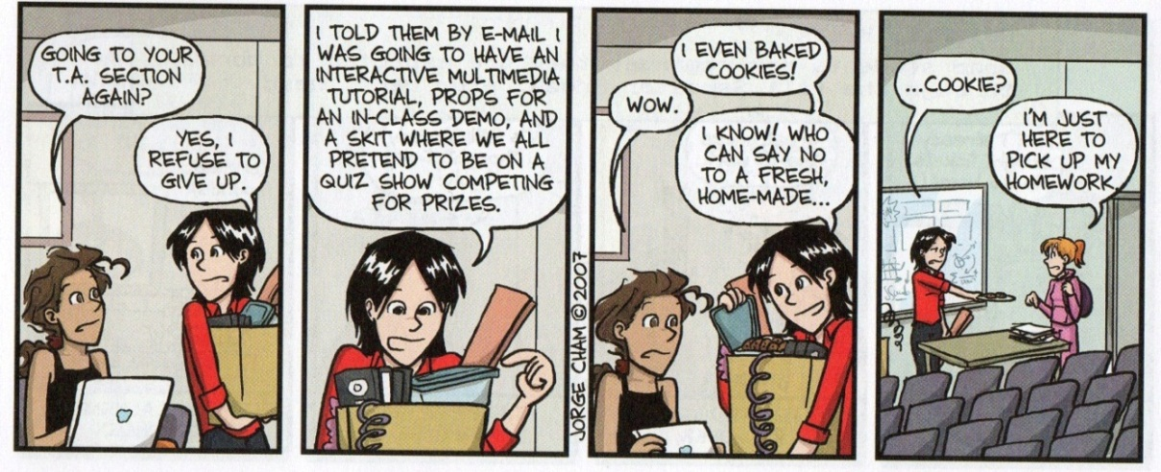

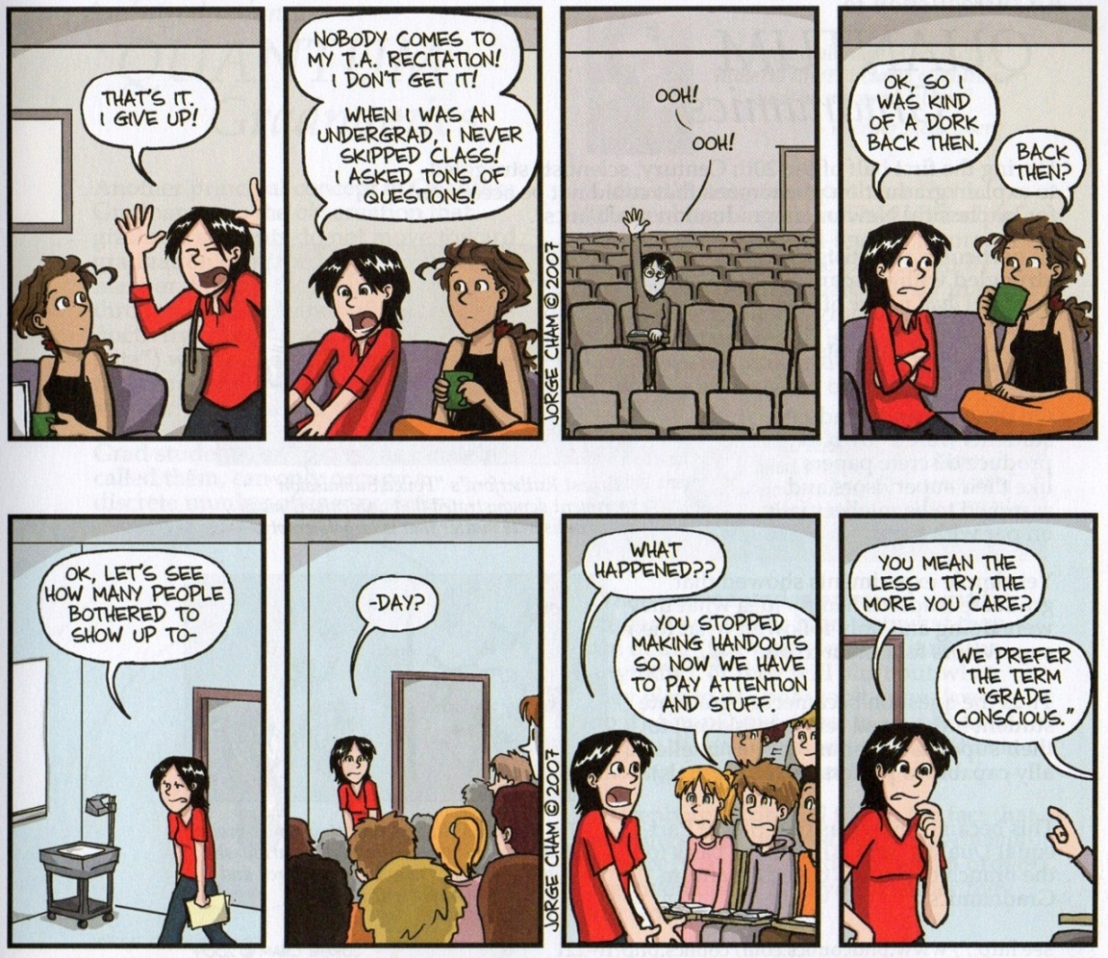

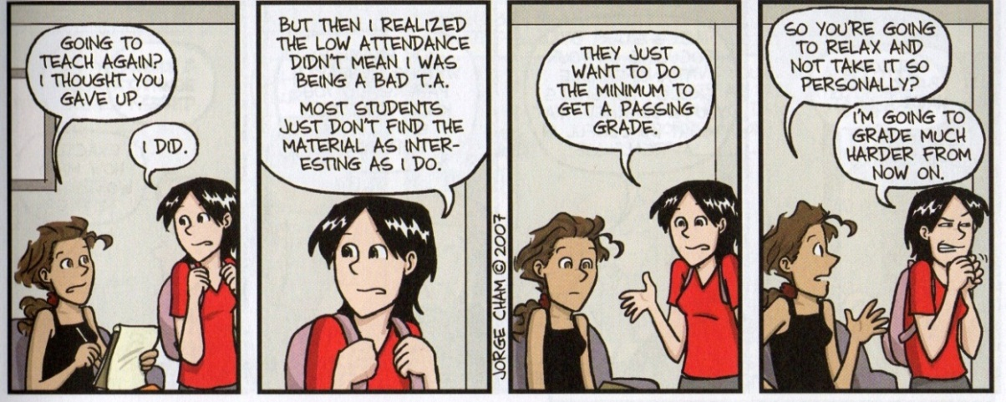

Figure 2b: Understanding the UG Mind (courtesy of PhD Comics/Jorge Cham, 2009)
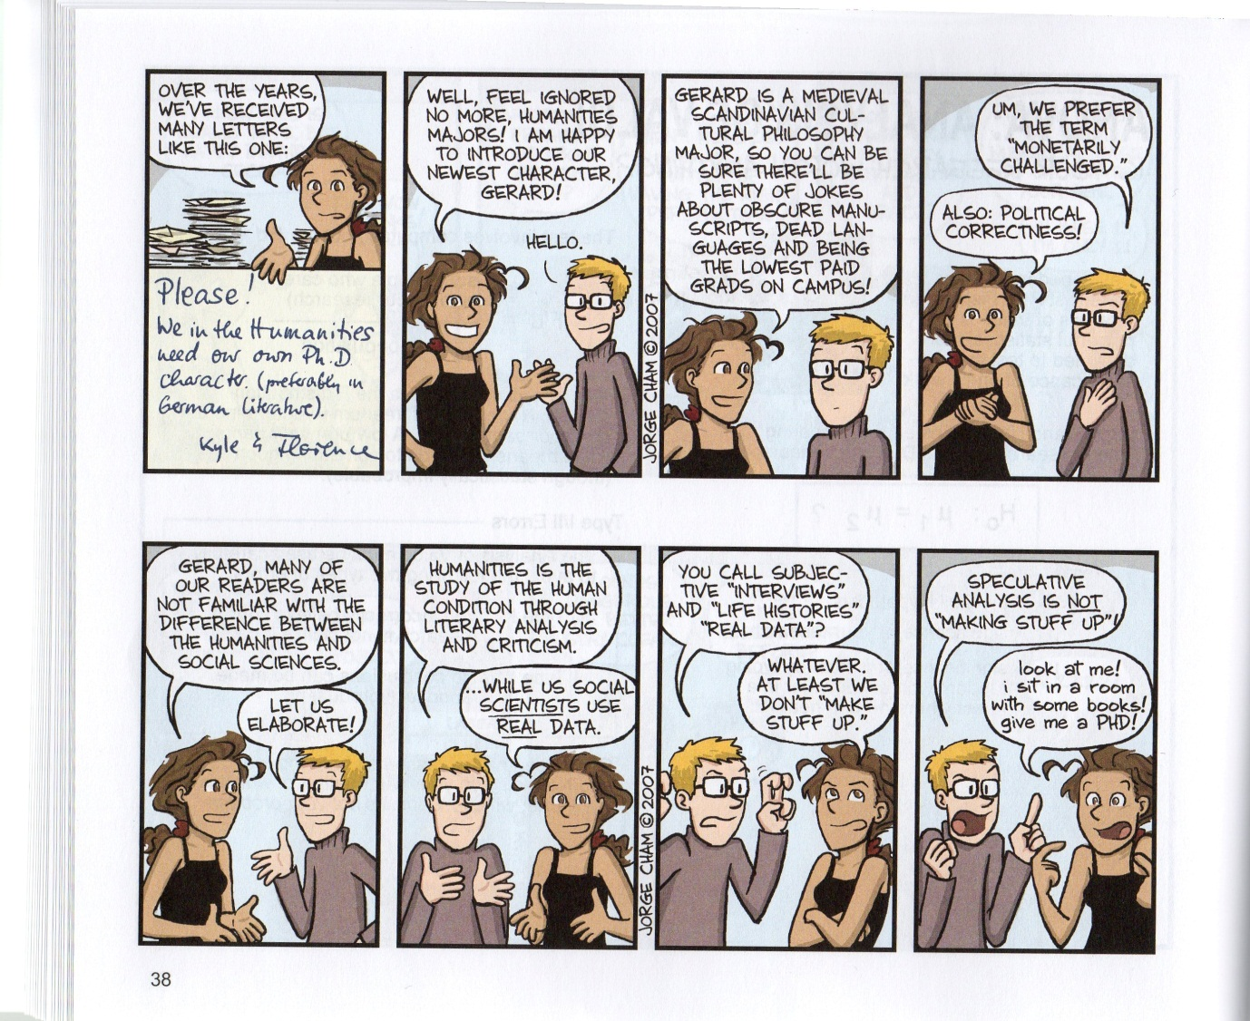
Figure 3: Request for a New Character (courtesy of PhD Comics/Jorge Cham, 2009)

