Analysis of epithelial cell shedding and gaps in the intestinal epithelium
Dr Carrie A. Duckworth, Prof Alastair J. Watson
Gastroenterology Research Unit, School of Clinical Sciences, University of Liverpool, Liverpool, UK

Abstract
The intestinal barrier is formed by a monolayer of columnar epithelial cells. This barrier is effectively maintained despite the high turnover of epithelial cells in the gut. Defects in the mechanism by which barrier function is maintained are believed to play a central role in the pathogenesis of inflammatory bowel disease (IBD). Proinflammatory cytokines such as TNF-α and IFN-γ are often elevated in inflamed tissue of patients with IBD. In fact, anti-TNF-α therapy is routinely administered to patients with Crohn’s disease. We have previously demonstrated that intestinal epithelial cells are shed from the intestine leaving a ‘gap’ in the epithelium that is able to maintain barrier function. The rate of cell shedding and barrier permeability is substantially increased by the administration of TNF-α. Loss of barrier function at the site of a gap may provide a site of entry for disease causing bacteria.
Key words
Small intestine, confocal, cell shedding, epithelium, TNF-α, gap, barrier function

1. Introduction
The single layer of columnar epithelial cells lining the small intestine and colon are replaced every 3-5 days making the intestine one of the most rapidly regenerating tissues of the body. Approximately 1400 epithelial cells are shed from each villus every 24 hours (1). Barrier function is nonetheless normally maintained despite the high rate that epithelial cells turnover. Cells arise from the stem cell region at the base of the crypt and migrate along the crypt-villus axis in the small intestine and along the crypt in the colon. Epithelial cells are then shed mainly from the villus tip in the small intestine and from the crypt table in the colon (1). Defects in this mechanism are believed to play a role in disease pathogenesis of the intestine.
We have observed the cell shedding process using confocal and multiphoton microscopy in vivo and have confirmed the presence of gaps in the epithelium left behind by a shed cell (2-3). The nuclear stain Hoechst 33258 is used to observe shedding nuclei and to assess whether a cell is present or not by confocal microscopy. An image stack is created by taking confocal images at several focal planes through the tissue to ascertain that the apparent gap is not due to a displaced nucleus. Confirmation that epithelial gaps were not being confused with goblet cells containing mucin came from the study of Math1^{-/-} mice that lack goblet cells in approximately 90% of the small intestine and colon, however display the normal complement of epithelial gaps (3). We have previously demonstrated that epithelial cells leave perpendicular to the plane of the epithelium at a rate of 0.83 ± 0.6µm/min (2) which is faster than the 0.3µm/min rate of epithelial cell migration along the villus axis (4-5) suggesting that shedding cells are pushed out of the epithelium rather than passively expelled.
The lack of cellular components within epithelial gaps has been investigated. BCECF-AM did not stain gaps indicating that the cytosolic esterases required to cleave BCECF-AM to fluorescent BCECF were not present. The membrane dye DiI highlighted discontinuities in the brush border membrane at the site of epithelial gaps and YC3.0 calcium chameleon mice demonstrated epithelial gaps despite fluorescent protein expression in the cytosol of all intestinal epithelial cells. Lucifer yellow, a highly polar fluorescent probe that is not able to permeate cell membranes was observed in approximately 3% of gaps however did not extend deeper than the line of adjacent nuclei suggesting that there was some impermeable substance filling the gap. Despite the absence of cellular components in epithelial gaps, confocal reflectance imaging confirmed that gaps contained non-fluorescent material that prevented Lucifer yellow penetrating deeper (2).
The administration of murine recombinant TNF-α causes shrinkage of villi, shedding at the villus tip and enterocyte detachment in the small intestine (3, 6). TNF-α-induced cell shedding leads to a decrease in the integrity of local barrier function and an increase in intestinal permeability. We have shown that Lucifer yellow penetrates approximately 20% of TNF-α-induced shedding events which is substantially increased from that observed during physiological cell shedding (3).
Epithelial cell shedding and subsequent gap formation is a dynamic process and is therefore best assessed in real-time. Time-lapse confocal detection of fluorescent dyes administered in vivo, in combination with standard laboratory techniques provides a valuable tool for assessing this dynamic process.

2. Materials
2.1 Surgical preparation of mice
- Ketamine (20mg/ml; Vetalar, Pfizer, Germany) and medetomidine (0.16 mg/ml; Domitor, Pfizer, Germany) are made up in water for injection.
- 150mM sodium chloride (Sigma, Dorset, UK).
- Surgical instruments (scissors, forceps).
- Heat pad (Vet Tech Solutions, UK).
- Cauteriser.
- 1mm external diameter glass tube or Pasteur pipette bent into a right angle and tip blunted by Bunsen burner (Fig 1).
- Suture.
2.2 Confocal imaging in mice
- Leica DM IRE2 Confocal microscope (Leica Microsystems (UK), Milton Keynes, UK).
- 35mm round glass bottom culture dish with 10mm microwell covered by 0.16-0.19mm coverglass (MatTek corporation, Ashland, MA).
- 3.85mM acriflavine hydrochloride made up in 150mM sodium chloride (Sigma, Dorset, UK).
- Hank’s Balanced Salt Solution (HBSS; Sigma, Dorset, UK).
- Hoechst 33258 is dissolved at 1mg/ml in 150mM sodium chloride and stored in aliquots at -20°C (Sigma, Dorset, UK).
- Lucifer yellow is dissolved at 100µM and stored in aliquots at -20°C (Invitrogen, Paisley, UK).
- Dextran MW 10,000 conjugated to Alexa Fluor 647 is dissolved at 2mg/ml and stored in aliquots at -20°C (Invitrogen, Paisley, UK).
- Insulin syringe (Vet Tech Solutions Ltd, UK).
- Murine TNF-α (PeproTech EC, London, UK) is dissolved in 0.1% bovine serum albumin (BSA, Sigma, Dorset, UK) at a concentration of 40µg/ml.
2.3 Rigid pen confocal probe microscopy in mice
- Pen confocal probe (Optiscan, Melbourne, Australia).
- 3.85mM acriflavine hydrochloride made up in 150mM sodium chloride (Sigma, Dorset, UK).
- Hank’s Balanced Salt Solution (HBSS; Sigma, Dorset, UK).
- Murine TNF-α is dissolved in 0.1% BSA at a concentration of 40µg/ml (PeproTech EC, London, UK).
- 20mm x 30mm x 3mm piece of cork board with a 10mm x 5mm hole made in the middle.
- Fine gauge pins.
- Clamp and stand to hold confocal probe in position.

2.4 Confocal endoscopy in the human

- Conscious sedation of patient with midazolam hydrochloride, fentanyl citrate and propofol.
- N-butyl-scopolamine used as an antispasmolytic (Buscopan, Boehringer, Ingelheim, Germany).
- Miniature confocal microscope inside the distal tip of a conventional video endoscope (EC 3830K, Pentax, Tokyo, Japan).
- Acriflavine made up in 150mM sodium chloride at a concentration of 1.93mM.

2.5 Image analysis of cell shedding and gap identification
- Image analysis is carried out with Leica Confocal software, Leica Applications Software and Image J.
- Image analysis from confocal endoscopy and Optiscan pen confocal probe is undertaken with proprietary Pentax and Optiscan software and Photoshop.

3. Methods
3.1 Surgical preparation of mice
- C57BL/6 male and female mice are used from 8-12 weeks of age and are anaesthatised with 75mg/kg ketamine and 1mg/kg medetomidine intraperitoneally and placed on a heat mat. A body temperature of 37°C is maintained throughout and 0.2ml of subcutaneous saline is administered.
- A midline incision of approximately 1cm is carried out and a small segment of small intestine is exteriorised.
- Being careful to maintain a healthy blood supply at all times, the segment of intestine is flushed out with 150mM sodium chloride.
- The segment is then isolated by tying sutures around each end to prevent intestinal contents coming out of the intestine.
- A cauteriser is used to make a small hole at each end of the isolated segment on the anti-mesenteric axis of the intestine. A blunted glass rod is thread through the intestine through the two holes and cautery is carried out from one hole to the other along the anti-mesenteric axis (see Note 1).
- The intestine is carefully opened out and kept moist by the application of 150mM sodium chloride.

3.2 Confocal imaging in mice
- Drug treatments if needed are administered; for instance 10µg TNF-α is placed within the peritoneal cavity (see Note 2).
- Hoechst 33258 is administered at a dose of 2mg/kg via lateral tail vein or retro-orbital injection.
- A 35mm round glass bottomed culture dish is placed on top of the opened out intestine with the area of intestine to be imaged over the cover-slipped area. The mouse is carefully transferred from the supine position to the prone position and placed on an inverted confocal microscope stage that is surrounded by an incubator (see Note 3). A small volume of HBSS is administered directly into the dish to keep the intestine moist once on the microscope. Luminal dyes such as Lucifer yellow may be introduced into the culture dish at this stage (see Note 4).
- A suitable field of view is found where there isn’t too much peristaltic movement but a continuous blood supply can be observed. A x40 objective is ideal for directly studying gaps whereas a x20 objective is more suitable for the assessment of cell shedding (see Note 5).
- Z-stacks at 1µm intervals are taken every 2.5 minutes for up to 3 hours using excitation and emission wavelengths suitable to the fluorescent dyes being used (see Note 6).
3.3 Rigid pen confocal probe microscopy in mice
- Drug treatments if needed are administered following surgical preparation; for instance 10µg TNF-α is placed within the peritoneal cavity.
- The exteriorised intestine is pulled through a small hole in a cork board and pinned out flat giving a solid surface for the confocal probe. It is essential that the blood supply is not inhibited by this process.
- A few drops of the acriflavine solution is placed directly onto the exposed intestinal mucosa (see Note 7).
- The mouse is left in the supine position and the confocal probe is placed directly in contact with the intestinal mucosa (see Note 8).
- Z-stacks are taken every 2.5 min for up to 3 hours (see Note 9).
- The mucosa must be kept moist at all times throughout the procedure by dropping 20µl volumes of HBSS onto the exposed mucosa as required.
3.4 Confocal endoscopy in human
- Standard endoscopical techniques are used to locate a suitable clean area of intestine for imaging. Two fluorescent probes can be used. Fluorescein (5ml of 10% sodium fluorescein (Alcon, Pharma, Gmbh, Freiburg, Germany) gives good views of mucosal blood vessels. Alternatively acriflavine (3.85mM) gives high resolution images of mucosal nuclei. A spraying catheter is used to administer a small amount of acriflavine in the region chosen for imaging and the endoscope is placed in a gentle fashion on the mucosal surface.
- A z-stack of images 7µm apart is taken from villi in the en face orientation up to a depth of 70µm.
- Images are assessed for gaps if they are part of 3 or more image planes within a stack of images and of sufficient technical quality to discern individual cells.
3.5 Image analysis of cell shedding and gap identification
- Goblet cells and gaps have a different microscopic appearance. When stained with acriflavine, goblet cells display a ‘target’ like appearance. The centre of the target appears as a small dark area which contains mucin and is unstained, this is surrounded by a lighter coloured area which contains mucin and cytoplasm which does stain (Fig 2).
- Gaps do not stain with acriflavine however do reflect laser light showing that they do contain a plug.
- Luminal administration of Lucifer yellow has shown that on rare occasions gaps are infiltrated by Lucifer yellow (Fig 3) however in the majority of cases barrier function is maintained despite gaps in the epithelial layer.
- Cell shedding is a dynamic process and can be quantified by assessing the movement of Hoechst 33258 or acriflavine stained nuclei out of the epithelial layer (Fig 4). These can be counted by close inspection of movies created at each z position. Confirmation that a cell has shed leaving a gap is carried out by the observation of the same cell shedding at various z positions. Apoptotic fragmentation of the Hoechst stained nuclei of a shed cell can also be observed in the lumen.
4. Notes
- The glass rod is used to protect the mucosa of the intestine beneath from being damaged by cautery. A Pasteur pipette bent in a Bunsen burner is easy to make (Fig1).
- TNF-α administration causes an increase in cell shedding and gap formation. In order to study this process, it is beneficial to administer TNF-α in some cases.
- It is important that the mouse is kept warm at all times throughout the procedure. A heated stage or heated incubator where the temperature can be modified to keep the body temperature of the mouse at 37°C is essential.
- Hoechst 33258 and alexa-dextran 647 are administered intra-venously. Acriflavine and Lucifer yellow are topically administered to the mucosal surface.
- Confocal reflectance images may also be taken to confirm that gaps contain an impermeable substance that is not stained by other dyes.
- Sufficient anaesthesia is maintained throughout by intramuscular injections of ketamine and medetomidine. Continual assessment of anaesthesia and body temperature are required throughout the procedure.
- Acriflavine stains both nuclei and cytoplasm and has a very broad emission spectrum. It is currently one of only two dyes that is licensed for use in humans allowing a direct comparison between mouse and man. Both the confocal probe and confocal endoscope are currently only able to detect dyes excited by a 488nm solid state laser (Fig 4).
- The pen confocal probe is used in a very similar fashion to that used by the human endoscope and in fact has the same optics.
- The pen confocal probe images provide an ideal way to observe epithelial gaps which are readily distinguishable from goblet cells (Fig 2).

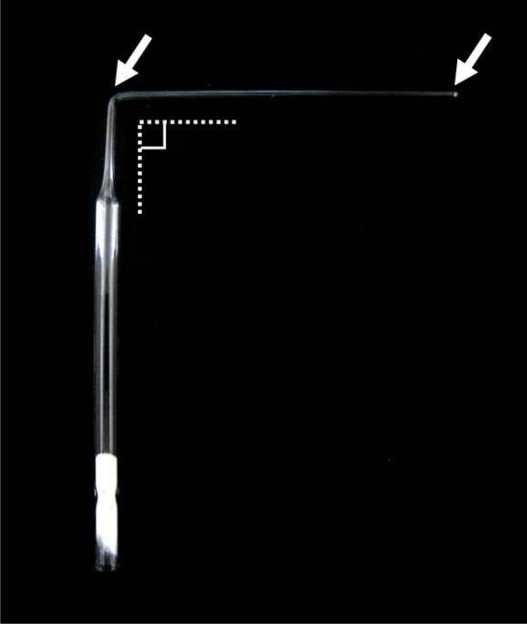
Figure 1. Example of Pasteur pipette bent to form an ‘L’ shape. Arrows indicate where a Bunsen burner has been used to bend pipette and to blunt the end thus helping to reduce damage caused to small intestine upon cauterising.

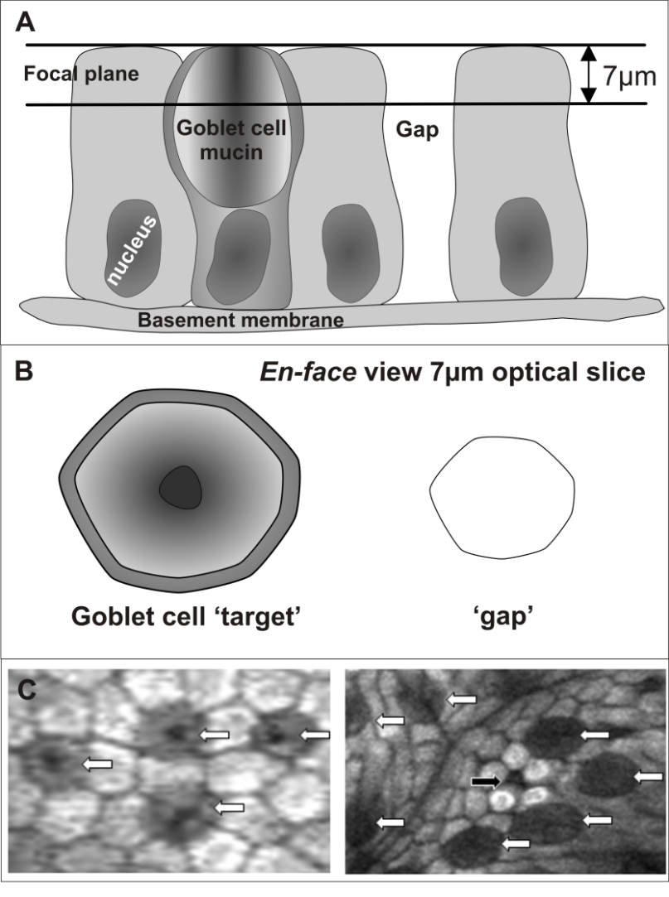
Figure 2. Goblet cells have a distinct appearance from gaps. (A) Diagram illustrating a goblet cell and gap in the epithelial layer. (B) Diagrammatic representation of the “target-like” appearance of a goblet cell and a gap in the en face view. (C) En face view of goblet cells in the human small intestinal epithelium (white arrows) and an example of an epithelial gap (black arrow) stained with acriflavine.
Figure 3. Confocal section across villi showing all epithelial cell nuclei stained by Hoechst 33258 (blue). Time-course showing infiltration of an epithelial gap (white arrow) by Lucifer yellow over a 15 minute period and restitution by 25min.

Figure 4 Acriflavine stained villous epithelial cells. Single cell shedding from the small intestinal epithelium over time (white arrow).

Acknowledgments
The authors would like to thank Dr Ralph Kiesslich from The University of Mainz, Germany for adapting the confocal endoscopy technique in the human.

References
1. Potten, C. S., and Loeffler, M. (1990) Stem cells: attributes, cycles, spirals, pitfalls and uncertainties. Lessons for and from the crypt, Development 110, 1001-1020.
2. Watson, A. J., Chu, S., Sieck, L., Gerasimenko, O., Bullen, T., Campbell, F., McKenna, M., Rose, T., and Montrose, M. H. (2005) Epithelial barrier function in vivo is sustained despite gaps in epithelial layers, Gastroenterology 129, 902-912.
3. Kiesslich, R., Goetz, M., Angus, E. M., Hu, Q., Guan, Y., Potten, C., Allen, T., Neurath, M. F., Shroyer, N. F., Montrose, M. H., and Watson, A. J. (2007) Identification of epithelial gaps in human small and large intestine by confocal endomicroscopy, Gastroenterology 133, 1769-1778.
4. Kaur, P., and Potten, C. S. (1986) Effects of puromycin, cycloheximide and noradrenaline on cell migration within the crypts and on the villi of the small intestine. A model to explain cell movement in both regions, Cell Tissue Kinet 19, 611-625.
5. Potten, C. S. (1998) Stem cells in gastrointestinal epithelium: numbers, characteristics and death, Philos Trans R Soc Lond B Biol Sci 353, 821-830.
6. Piguet, P. F., Vesin, C., Guo, J., Donati, Y., and Barazzone, C. (1998) TNF-induced enterocyte apoptosis in mice is mediated by the TNF receptor 1 and does not require p53, Eur J Immunol 28, 3499-3505.

Suggested image for front cover

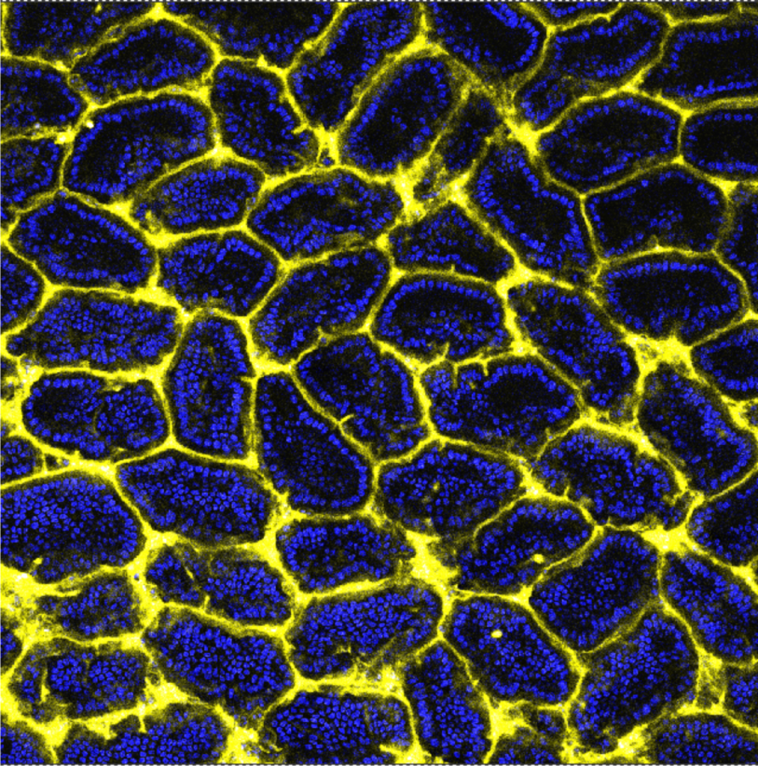
(Image as for Figure 3 however much greater field of view, Lucifer yellow = yellow, Hoechst 33258 = blue. Image by Duckworth 2009, higher resolution available upon request).

