The electrodynamic mechanisms of optical binding

David L. Andrews and Luciana Dávila Romero

School of Chemistry, University of East Anglia,
Norwich NR4 7TJ, United Kingdom

Abstract

The term ‘optical binding’ conveniently encapsulates a variety of phenomena whereby light can exert a modifying influence on inter-particle forces. The mutual attraction that the ‘binding’ description suggests is not universal; both attractive and repulsive forces, as well as torques can be generated, according to the particle morphology and optical geometry. Generally, such forces and torques propel particles towards local sites of potential energy minimum, forming the stable structures that have been observed in numerous experimental studies. The underlying mechanisms by means of which such effects are produced have admitted various theoretical interpretations. The most widely invoked explanations include collective scattering, dynamically induced dipole coupling, optically-dressed Casimir-Polder interactions, and virtual photon coupling. By appeal to the framework that led to the first predictions of the effect, based on quantum electrodynamics, it can be demonstrated that many of these apparently distinct representations reflects a different facet of the same fundamental mechanism, leading in each case to the same equations of motion. Further analysis, based on the same framework, also reveals the potential operation of another mechanism, associated with dipolar response to local dc fields that result from optical rectification. This secondary mechanism can engender shifts in the positions of the potential energy minima for optical binding. The effects of multi-particle interactions can be addressed in a theoretical representation that is especially well suited for modeling applications, including the generation of potential energy landscapes.

Keywords: Optical binding, optical forces, optical trapping, nanomanipulation, photonics, quantum electrodynamics, Casimir-Polder interaction, dispersion interaction

INTRODUCTION

The mechanical responses of atoms, molecules and larger particles to light are generally well understood. In any listing of the phenomena the subject area embraces, it will be apparent that many of the most well-known aspects prominently involve an exchange of momentum associated with the absorption or deflection of light – this part of the catalog accommodates such diverse observations as solar radiation pressure, laser tweezers and optical molasses [1-3]. Nonetheless, in several effects there is no such momentum transfer between matter and light. In the latter cases, as material properties are modified by throughput radiation, mechanical motion ensues by response to local variations in an optically induced potential energy field. Here too, there are contributions to optical tweezer effects, as polarizable particles subjected to what is commonly termed a ‘dipole force’ move to regions of higher or lower beam intensity, according to the sign of their detuning from resonance [4]. Within bulk materials, optical electrostriction effects can be observed [5,6].
When two or more individual particles in sufficiently close proximity experience the effects of throughput optical radiation, the behavior of the system is no longer simply representable as that of independent units. Dynamical forces of considerable intricacy arise as, in addition to the response of each particle, there are collective actions falling under the umbrella term ‘optical binding’ [7-10]. Physically distinct from standing-wave and related forms of holographic optical trap [11], particles are subject to variations in an optically conferred local potential energy whose gradient force depends on their relative rather than absolute displacement. As has been pointed out [12], the form of such a potential is not always one that generates attractive forces – indeed, highly complex undulating potential energy landscapes are a typical feature – but most of the interest centers on systems where there is a short-range energy minimum so that particles can fall into stable, non-contact configurations [13]. Again, the term ‘optical matter’ has previously been coined in this connection [14-16].
With the burgeoning number of theoretical and experimental studies of optical binding, the last decade has seen the identification of several distinctly novel aspects – including a characterization of the force field [17], the prediction and formation of ring structures in beams conferring orbital angular momentum [18], an identification of the possibility for engineering the collapse of optically assembled particles [19], and tailored interactions based on controlling optical bandwidth. Over the same period, the understanding of the fundamental mechanisms responsible for the phenomenon has benefited from analyses based upon a variety of theoretical perspectives [20]. It has not always been clear, however, where there is a common ground between different theories, or where they might differ; such is the context for the present overview of mechanisms and features.
Before entering into a detailed analysis, a brief critique of one common, semiclassical approach may be instructive. In such a theory – where quantum principles are applied to the matter but not the light – optical binding is represented by the scheme shown in Figure 1.
Sinusoidal
electromagnetic field
Motions in the charge distributions of the particles
Oscillatory electric
dipoles in each particle

Interaction between the particles’ induced dipoles, dependent on intensity and relative
phase of the radiation at each point, subject to sharp decline with particle separation

Figure 1. Semiclassical rendering of optical binding

It is not hard to spot one immediate difficulty with this conception; the productions of oscillatory dipoles in each particle are here being represented as individual interactions which then interact. However, as will be seen in the full quantum electrodynamical analysis that follows, inter-particle coupling is in fact engaged with the actual mechanism for the production of induced dipoles. That engagement is directly associated with retardation features that still have to be taken into account if the correct form of potential energy landscape is to be produced. Those same features are, however, intrinsic to a calculation based on the principles of quantum electrodynamics (QED). Moreover, only it is only the latter type of representation that can reveal the very tangible significance of oscillatory dipoles produced by a vacuum field.
The present paper develops a previous, smaller scale study whose primary aim was an identification and discrimination between the multiplicity of reported mechanisms for optical binding [20]. The basis for the more comprehensive analysis that follows lies in the foundation equations of QED, here cast in a general form to address multi-particle interactions with arbitrary radiation states. In deriving specific equations for optical binding effects, the development then follows the style of several earlier works that include the earliest prediction of the effect – but in the present case with a considerably broadened scope. Several key features of the optical binding results are then identified. From this fundamental perspective, a variety of other representations are assessed, before a broader discussion. A subsequent paper [21] follows up one specific aspect of optical binding that appears to have been elicited only within a quantum electrodynamical approach – the potential significance of static interactions.

QED Background

During the twentieth century, the advent first of quantum mechanics and then quantum electrodynamics (QED) led to a parallel development of theory for numerous optical phenomena where, compared to the phenomenon of optical binding, the photonic character of visible radiation is more directly evident. Despite its perceived difficulty, the singular advantages of a QED quantized field formulation are not only its well-known rigor and comprehensive scope, but its capacity for explanation and prediction. In the latter respect, especially, QED has a proven record of identifying and predicting new mechanisms well in advance of the first experimental observations. The prediction of optical binding by Thirunamachandran in 1980 [22] is indeed a classic example, this theory presaging the first observations by Fournier et al. [23] that took place almost a decade later – and leading onwards to the current heightened degree of interest. Comprehensive in its sweep, the quantized field formulation has proved highly successful and remarkably accurate in describing this and numerous other interactions of electromagnetic radiation with matter, unveiling connections between processes which could not become apparent in the classical framework.
In essence, the QED approach differs from classical theory in that the full system is treated as quantized; both matter and radiation are dealt with quantum mechanically, the latter necessitating a photon-based description for optical phenomena. The scattering of light by a single particle serves to illustrate significant features in such a representation. The photon that emerges from any scattering interaction in no meaningful sense continues the existence of the input; both input and output photons enumerate changes in occupancy of distinct radiation mode (the sole exception being forward Rayleigh scattering, where only one optical mode is involved). Moreover, in any scattering process, two distinct time-orderings of the input photon annihilation and emergent photon creation events are necessarily entertained, their quantum amplitudes being summed. Thus there are two virtual states that, whilst each is of immeasurably short duration, in a certain sense represent intermediates within the scattering process: in one case the input photon annihilation precedes the creation event, so that neither is present in the intermediate state; in the other, both photons are simultaneously present. Physically, the addition of amplitudes for these two quantum pathways can be understood as indicating the impossibility of precise photon localization in space or time, a manifestation of the photon’s intrinsically quantum mechanical character, as sketched in Fig. 2. Whilst the virtual states need not conserve energy – hence their severely limited lifetime, indicated by Δt in Fig. 2 – completion of the scattering process restores energy conservation.

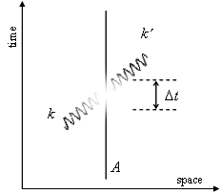

Figure. 2. Rayleigh scattering schematically depicted with respect to a time-space frame. The scatterer A is represented by a vertical straight line (its kinetic energy being considered negligible). The input k and output k′ radiation are represented by sinusoidal lines. The central fade-out region signifies radiation and scatterer states manifesting quantum uncertainty.

The above example is useful not only as an introduction to the issues that arise in a fully fledged QED theory – in fact it serves to introduce the multi-particle scattering representation in which the exact theory of optical binding can be cast. To this end we now begin with a formal equation for the Hamiltonian operator, H, for a system comprising molecular particles labeled ξ, which in multipolar form is exactly expressible as;
.
Here H_{mol} is the molecular Hamiltonian, H_{rad} is the radiation Hamiltonian and H_{int} is the Hamiltonian representing the interaction of the radiation field with each molecule. The prototypical case of optical binding is a scattering process that entails two particles, ξ = (A, B). Compared to the single-center case, this system is clearly electrodynamically much more complex, since interaction between A and B can occur on essentially the same timescale as the pairwise scattering of the incident radiation, as illustrated by Fig. 3.

Figure 3. Four contributory mechanisms for optical binding. In the dynamic cases (a) and (b), the coupling depends on the polarizability of both particles. In (a) the photon absorption occurs in centre A and photon emission at B, while the process in (b) the roles of A and B are reveresed. In the static couplings of (c) and (d), the permanent dipole of one center is coupled to the hyperpolarizability of the other one.

In Dirac notation the eigenstates, of a basis Hamiltonian, given by equation excluding H_{int}, form a composite set expressible in the form , in which comprises a product of state vectors for each molecule ξ, and is the radiation state. Inspection of equation shows that, in contrast to a classical description, pairwise coupling cannot be considered to be mediated by instantaneous coupling interactions – notice the absence of any terms with ξ ≠ ξ' . Instead, all such interactions are mediated by the quantum radiation field, whose photons exhibit retardation associated with their finite speed of propagation [24]. The interactions of and between two functionally identical particles (A, B) are fundamentally based on electric interactions with the radiation field, expressible as follows (using the implied summation convention for repeated tensor and vector indices):
,
being the position vector of particle ξ, with and the corresponding operators for the electric dipole and electric quadrupole (E1 and E2, respectively). The second term in , which for radiation in the uv/visible range is typically smaller than the first by the order of the fine structure constant (i.e. two–three orders of magnitude smaller), takes the lead in a series of higher order multipole corrections; for the present, only this leading correction is retained, with a view to the subsequent analysis. The electric displacement vector field in (1) is itself expressible as a mode expansion exhibiting photon creation and annihilation operators [25];
,
where is the polarization unit vector ( being its complex conjugate), V is an arbitrary quantization volume and , are respectively the photon annihilation and creation operators for a mode (k, λ). The appearance of these operators in H_{int},, through , signifies the interaction Hamiltonian effecting photon annihilation and creation.
For each of the four processes described in Fig. 3 there are four light-matter interactions of relevance. Consider Fig 3(a), for example; this process entails: (i) input light absorption (photon annihilation) at A; (ii) emergent light emission (photon creation) at B; (iii) a pair coupling event at A; (iv) equivalent to (iii) but interchanging the roles of A and B. It is important to notice that, in the QED description, the pair coupling is itself mediated by the creation of a virtual photon at one particle and its annihilation at the other. Accordingly there are four fundamental photon events, not discernibly separated in time, every permutation of which must therefore be considered a contributory mechanism. As a calculational aid, such permutations are conveniently depicted in the state-sequence diagram [26] of Fig. 4, within which each of twenty-four routes (from the initial state on the left to the final state on the right) represent one possible state permutation, each signifying a distinct contribution to the quantum amplitude. Moreover, each state sequence signifies a particular time ordering, whose more familiar Feynman graph rendering is illustrated in Fig. 5. One singular advantage of the state-sequence form of representation is that it accommodates the information of all twenty-four Feynman diagrams.

Figure 4. State-sequence diagram for two-center scattering, progressing left to right. Each box denotes a state of the composite system; for simplicity an input photon is designated by k and its counterpart k′ ; p denotes a virtual photon. In each box, circles represent the states of particles A and B. An empty circle denotes a ground electronic state; virtual states are labeled r and s. There are 24 routes from left to right; one specific path, arbitrarily chosen, is indicated by the dashed line.

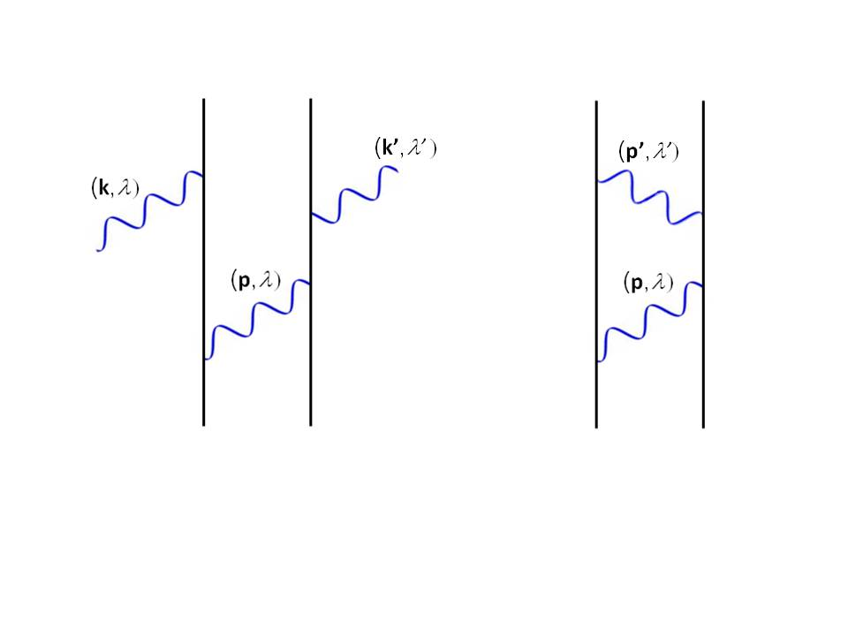
A
B

Figure 5 Time-ordered diagram corresponding to the pathway signified by a dashed lime in the state-sequence representation, Fig. 4. This graph generates one of 24 quantum amplitude contributions whose sum represents the totality of the mechanism illustrated in Fig. 3(a).

Similar state sequence diagrams for each of the remaining processes shown in Fig. 3 must also be considered: Fig. 3(b) represents a case where electromagnetic radiation is absorbed at B and emitted at A, accounting for a further 24 permutations; the two static contributions exhibited in Fig. 3(c), and (d) each generate the same number. All of the resulting quantum amplitude contributions must be included in calculations since they connect the same initial and final states, and are therefore physically indistinguishable

Bimolecular Scattering Process

To continue, we now develop the detailed, generic results for bimolecular scattering processes that include optical binding. Consider the following simple representation of two-center Rayleigh scattering,
,
for which the initial and final states of the system can be written as;
After lengthy calculation detailed elsewhere [9], and taking the leading electric dipole term of the interaction Hamiltonian , it emerges that the dynamical terms in the quantum amplitude for the overall process reduce to the following (static terms being considered later);
where the first term corresponds to the mechanism exhibited in Fig. 3(a), and the second to Fig, 3(b); n denotes the number of photons in an arbitrary quantization volume V (linearly related to the physical irradiance through [9]); denotes the position of centre ξ; α^{A/B} is a polarizability tensor , is the i^{th} component of the laser polarization vector and is the retarded resonance dipole-dipole interaction tensor [27] whose elements are defined by;
.
The calculation that leads to involves a summation over radiative modes for a virtual photon that can travel in either direction between A and B. It is interesting to observe that the QED analysis, since it registers radiation states, can offer a distinction between forward and non-forward optical scattering by the pair – a distinction that is lost in a semiclassical approach. Let us assume that particles A and B are fixed and given by and . A dependence on the spatial distribution is evident in equation . In deriving a potential energy associated with the interaction, quantum theory requires summation over all of the parameters for the unobserved output mode. Therefore, it is necessary to perform a 4π steradian integration over the emission direction for the output radiation mode , duly resulting as follows;
To obtain the first line of (3.6), use has been made of the three-dimensional rotational average identity , where are vectors having a fixed mutual orientation in a particular frame, and are vectors mutually fixed in a different reference frame against which the orientational average is carried out. The result given in equation (1.7) shows that non-forward Rayleigh scattering yields a vanishing inter-particle energy – and hence no associated optical binding forces. A finite result only arises in the case of forward scattering. Since a photon with a wave-vector k carries a linear momentum k, the result serves to demonstrate conservation of linear momentum [28]. Thus, whilst the response of a polarizable particle to an oscillating electromagnetic field (the semiclassical –α ⟨E ²⟩ term) in QED language corresponds to the annihilation and stimulated emission of a photon from and ‘back into’ the throughput light, the same principle applies in a multiple scattering case – again, a photon delivered back into the throughput beam.
In the case of optical binding, or forward two-center Rayleigh scattering, the initial and final states of the system are therefore given by;
Calculational procedures are similar to those follow in . Given that the initial and final states of the system are identical, the quantum amplitude is an optically induced shift in inter-particle potential energy, produced by a beam of irradiance I defined above;
where is the separation between the particles, . Because the result is quadratic in the polarizability, the energy is not dependent on the sign of the optical frequency detuning (in contract to the optical trapping experienced by individual particles). The above expression for dynamic coupling is valid for all particles, and it is complete in application to those particles that are centrosymmetric and non-polar. Otherwise a static contribution must be considered, involving the static dipole moments, μ, for each particle. Specifically this contribution involves a coupling in which both the annihilation and re-creation of the beam photons are co-located at one or the other particle, see Fig 3(c) and (d). These terms are independent of k and simply represent an additional, repulsive correction that drops off with R⁻³. Such terms can only serve to modify the exact positions of the optical binding minima. A further study of the influence of these terms on the optically induced energy shift will be the subject of reference [21].
For simple cases where the inter-particle axis is aligned with the propagation wave-vector direction, k‖R., namely longitudinal binding, or where these vectors are perpendicular to each other, transverse binding, the results yielded by agree with those that can be achieved following a semiclassical approach. In these cases, one can correctly surmise the physical existence of an optically induced force that exhibits a strongly damped oscillatory dependence on the separation of the particle pair. The sinusoidal electric field of monochromatic radiation produces motions in the charge distributions of the particles it encounters. Such motions lead to corresponding oscillatory electric dipoles, whose phase is determined by that of the radiation at each particle. For two particles in sufficiently close proximity, the interactions between their oscillating dipoles is evidently subject to the relative phase of the optical field at the two locations; it is also subject also to the sharp decline of such an interaction with distance, see Fig 6.
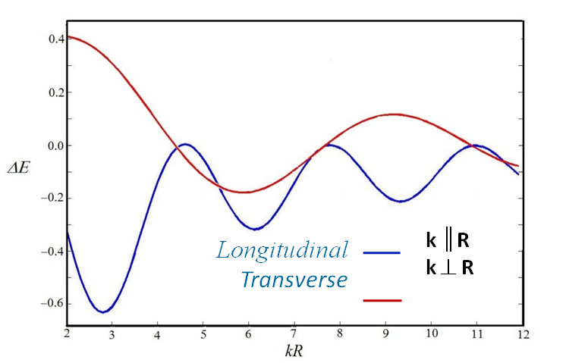
Longitudinal binding
Transverse binding

Figure 6. Dependence of optically-induced potential energy, for a pair of particles separated by distance R, plotted against kR, where k = 2π /λ and λ is the laser wavelength. In the case of longitudinal binding , the inter-particle axis is aligned with the propagation wave-vector direction, k‖R. In transverse binding the inter-particle axis is perpendicular to the propagation wave-vector direction, kR. In both cases the polarization of the electric field, perpendicular to the wave-vector k , is also generally perpendicular to the particle separation vector R .
More generally, expression can be used to produce contour plots representing the variation of potential energy, with the positions and orientations of each particle relative to each other, and to the throughput radiation. The results take the form of energy landscapes exhibiting highly detailed topographic features [12]. The analysis of these features facilitates the determination of possible stability points associated with optical binding, and the identification of other, anisotropic features revealing the operation of local forces and torques. Furthermore, the pair potential provides a prototypical template for the optical assembly of larger numbers of particles, and possibilities to optically fabricate structures.
Before proceeding further we briefly address higher multipole contributions to the induced energy shift [12]. As shown in expression , no other contributions arise at order (E1⁴). The next highest order contributions emerge when the second term in equation , the electric quadrupole interaction Hamiltonian, is considered as the coupling basis for any one of the four photon events described previously. The additional (E1³E2) contributions to the energy which result are given by;
Here, the term involving the dipole-dipole interaction tensor arises from contributions where one of the real, laser photon interactions is accomplished by an electric-quadrupole interaction. In the remainder of the above expression , it is the virtual coupling photon that experiences one quadrupole interaction in its generation or annihilation, as is reflected through the involvement of the fully retarded resonance quadrupole-dipole interaction tensor , given by [29];
For each particle , the results introduce frequency-dependent dipole-quadrupole polarizabilities which are comprehensively expressible as;
.
The general form of these results is an Em²En² shift, for arbitrary integers m and n. In passing we note that, symmetry permitting, expression is the lowest order non-zero correction to the energy because it invokes only one quadrupole interaction. The odd parity rank 3 tensors and vanish if the particles are centrosymmetric. Crucially, any dipolar particle (i.e. one whose static electric dipole moment is non-zero) will also have non-zero tensors. Hence, for such material particles the third and fourth terms in equation will also contribute – and since they have E1⁴ form, they will outweigh any contribution involving an electric quadrupole. Expression (3.10) is the lowest order correction, because it invokes only one quadrupole interaction, i.e. has a E1⁴-E2 form . Further higher order corrections can be found in [12, 30]. In passing we may also note, for completeness, it that the leading corrections produced by the involvement of one magnetic-dipole interaction are also of the same order as the electric quadrupole correction (3.8) [31] – again, if the material symmetry permits. Mixed E1-M1 electric-magnetic polarizabilities, commonly denoted as G tensors [32] are also supportable only by non-centrosymmetric particles.

Optical Binding Mechanisms
A singular advantage of the QED representation developed above is that is provides a rigorous basis on which to compare the variety of other mechanistic interpretations of optical binding. Amongst the most commonly invoked mechanisms one can include: laser-dressed Casimir forces, optically induced dipole resonance, collective scattering, virtual photon coupling, and plasmon resonance coupling.
Laser-dressed Casimir forces: It has been established that the origins of optical binding lie in a form of radiation-induced coupling representing an extension to the usual Casimir-Polder interactions – the latter signifying dispersion interactions of a form that accommodates the effects of retardation. In the absence of populated radiative modes, Casimir interactions entail the pairwise exchange of virtual photons [24], i.e. two virtual photon creation events and two corresponding annihilations. The formal similarity to optical binding is apparent on inspection of the corresponding time-ordered graphs – see for example Fig 7. Salam has recently compared the relative merits of Feynman time-orderings and state-sequence diagrams in performing the ensuing calculations [33]. Both kinds of interaction – both optical binding and Casimir force – arise from fourth order perturbation theory; moreover in both, two photon creation and two photon annihilation events are involved. With increasing inter-particle distance, retardation is physically manifest by a progressive change from a short-range to a long-range asymptote (R⁻³ yielding to R⁻¹ in the case of optical binding, R⁻⁶ becoming R⁻⁷ for the Casimir-Polder interaction). The reader is referred elsewhere [34] for a concise alternative QED representation, also based on QED, but closer in spirit to the classical representation.

Figure 7. One time-ordered diagram for quantum electrodynamical calculation of the Casimir Polder interaction, which incorporates retardation effects into the London formula. Compare Fig. 5, representative of optical binding.

The link to optical binding is not simply one of mathematical congruence, however. It is worth recalling that when quantum mechanisms entail the participation of virtual photons, the formulation requires that a summation be performed over the corresponding mode parameters – specifically the wave-vector and polarization. This is the same principle that as was invoked in Section 3, concerning a summation of properties for the emergent photon – and for the same physical reason; this radiation is not the subject of measurement. Usually, virtual photons are created in modes whose initial occupancy is zero, the associated mechanism generally being referred to as one that involves vacuum fluctuations. However, when laser light is present, one or more radiation modes has a non-zero occupation number; a photon generated in or taken from one of these modes may take the place of a virtual photon – generating intensity-dependent terms exactly as feature in optical binding. Conversely, the Casimir-Polder interaction – even the London interaction which is its short-range asymptote – can be understood as a special case of optical binding where the radiation field comprises only vacuum fluctuations. This much is evident from the form of the state vectors , which reduce to the basis for Casimir forces once the occupation number of ‘throughput’ radiation is equated to zero. The corollary is that the phenomenon of optical binding essentially subsumes the normal dispersion interaction – one important physical consequence being that it can over-ride the latter at routinely attainable levels of light intensity.[12]
Virtual photon coupling: The language of virtual photon coupling adds another tier of understanding to the mechanism of optical coupling. As has been demonstrated above, the optically conferred coupling between particles is not limited to near-field interactions – as is evident from the retardation features apparent in the resonance dipole-dipole interaction (3.4). It is instructive to recall again the quantum electrodynamical origin of this expression, which results from performing a summation over virtual photon properties. Such virtual photons can be understood as ‘borrowing’ energy from the vacuum, consistent with the exploitation of an energy uncertainty h/t – a principle considered earlier in Section 2, in connection with single-center scattering. In the context of optical binding the key parameter associated with the uncertainty-limiting time t is the photon time-of-flight, determined by the distance between the two particles. This signifies a temporary relaxation of exact energy conservation between causally linked but physically separated photon creation and annihilation events. When the system within which the virtual photon propagates enters its final state, i.e. after the virtual photon is extinguished, energy conservation is restored. Another key feature of virtual photon behavior is that only photons whose propagation vector p is essentially collinear to R remain significant as the inter-particle separation increases. In contrast, in the short-range region where kR << 1, photons with p not parallel to R are also involved in the coupling. This again is consistent with the position-momentum uncertainty principle, i.e. the positions of the photon creation and annihilation events are uncertain - see, for example, [35].
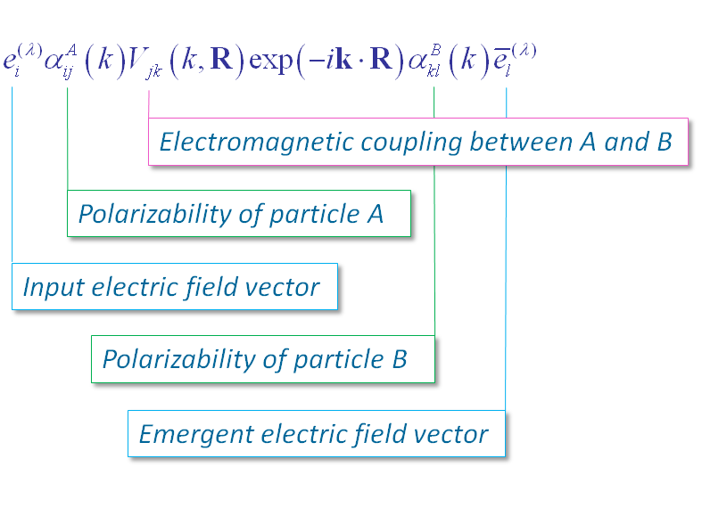
Optically induced dipole resonance: The classical description of light scattering depicts the oscillatory electric field of incoming radiation as inducing a similarly fluctuating electric dipole moment. The dynamic polarizability thereby represents a constant of proportionality between the induced dipole and the strength of the electric field. Moreover, the fluctuating electric dipole is interpreted in the sense of a radiating dipole. Commonly, this model is applied to coherent, forward Rayleigh scattering where the emergent light proceeds onwards in phase with the throughput radiation. When two particles in sufficiently close proximity undergo the same process, it is to be anticipated that a coupling will occur between the induced electric dipole moments that each experiences. At short distances this coupling takes precisely the same form as that which applies to the interaction between static dipoles; at longer distances retardation modifies the coupling. Using the textbook formulation of retarded dipolar fields [36] p.411, it is readily shown that precisely the same result as is given by equations and emerges. However, correlating the results of the two formulations affords a useful basis for a physically interpreting those equations, as shown in Fig. 8.

Figure 9. Compact description of the optical binding induced energy shift, for the process described by figure 2(a). The product of the polarisation and the polarizability signifies particle’s A induced dipole.

Collective scattering: Most of the theoretical studies on optical binding concentrate on the optical interaction between particle pairs. However, experimentally the phenomena has been observed in multi-particles systems, where it has been shown that optical binding facilitates the formation of arrays in particular geometries [8, 37], and there is scope for controlled optical manipulation [14]. It is apparent that the principles of interaction between a pair of spherical particles afford a tractable basis for extension to a system of N such particles. Even with the standard disregard of three-body interactions – by no means necessarily a physically reasonable proposition – a determination of the optically induced potential experienced by the whole assembly would require the evaluation of equation for N!/(N-2)!/2 particle pairs – obviously making an analysis of the system still more complex when considering a large number of particles. The possibility of optically fabricating structures for the next simplest case of just three particles is an interesting and expedient way to approach and explore the problem. Such a system represents a prototype for developing generic models of multi-particle complexity [12]. Additional, higher-order contributions to the optically-induced energy shift can be calculated from first principles; a system involving N particles will accommodate contributory mechanisms, each one involving calculations based on time-ordered diagrams. In the case of a three-particle system this would involve consideration of 6 different mechanisms, each involving 720 time orderings. Fortunately the coupling method introduced in [38] offers a straightforward answer to such a problem. This method, which can deliver a result for a system with an unspecified number of particles, is the subject of ongoing research.
Plasmon resonance coupling: Laser-irradiated metal nano-structures give rise to locally enhanced fields, associated with high field gradients due to their strong spatial confinement [39]. Compared to dielectrics, metallic particles differ in several respects; in particular, they present much larger polarizability values per unit volume. However, a key to the accurate representation of optical trapping and binding forces exerted on metal nanoparticles is a consideration of their unique optical dispersion properties. In the Drude model the frequency-dependence of the polarizability in emerges from the formula , where ω_{p} is the plasmon frequency and γ is the damping. It also becomes important to consider the behavior of the conduction electrons, when they are in close proximity to the metal surface. If the particle dimensions are smaller than the corresponding ‘skin depth’, the incident field interacts with the whole particle volume, resulting in a linear dependence between force and volume – the particle is in this case acting as if it were rather transparent. However, for particle sizes greater than the skin depth, the field interacts only with a thin outer layer and the force varies as the square of the diameter. More detail is given in a forthcoming review [40].
Maxwell stress tensor formulation: There is another semiclassical formulation of optical binding, most often deployed for particles whose size dictates that linear momentum plays a major role in optical trapping. Specifically, for particles whose linear dimensions approach or are equal to the relevant optical wavelength, classical electrodynamics can be used to apply the conservation law for linear momentum in an optical field. Here the net optical force exerted on an arbitrary object is completely determined by Maxwell’s stress tensor ,[36],
,
where the angular brackets denote a time average, and the surface integral over S encapsulates the material system. The optical force expressed in these terms is entirely determined by the electric and magnetic fields at the surface – although if the material deforms, additional electro- and magneto-strictive forces must be included. The fields used for the calculation of force using equation are self-consistent fields, i.e. superpositions of the incident and scattered fields. If the media in which the dielectric particle resides is represented by an isotropic electric permittivity ε and magnetic susceptibility μ, then Maxwell’s stress tensor has components given by:
Detailed calculations based on this approach have been applied to both the optical trapping of individual particles [41, 42] and the optical binding between them [43, 44 ]. In a typical application, the stress tensor may be calculated for spheres on the basis of Mie theory, considering both the fields inside and outside of the sphere to be continuous at the surface.
Microparticle organization in optical traps: To conclude, it is important to acknowledge that there are some systems which exhibit forms of optical binding with a clearly different origin. Microparticles held in a Gaussian laser beam trap are one important example. Taylor and Love [45] have recently described the mechanisms behind the formation of optically bound particle chains in such a system, addressing the case where the particles are significantly larger than the wavelength of the trapping laser. Here an optical binding effect arises from a balancing of mechanical repulsion, due to the light scattered from one particle impinging on the next one in the chain, and compressive effects due to the background harmonic potential of the trap. The results of a Mie scattering model produce a convincing physical description, accurately predicting the behavior of particle chains trapped in Gaussian beam traps. In particular, it properly describes the observed non-uniform particle spacing, showing its anticipated dependence on the number of particles.

Discussion

A critique of the familiar semiclassical description of optical binding, as a coupling of induced dipole moments, demonstrates its simple explicatory power – but it also reveals some physical and interpretive shortcomings. At first sight a fully quantum electrodynamical approach, which certainly provides a more robust basis for performing the necessary calculations, appears to represent a very different mechanistic basis for the phenomenon. However, for the dynamic coupling of dielectric spheres the demonstrable equivalence between the associated results that ensue from each method affords several new and fundamental insights into the photonic basis for the interaction. Moreover, the QED method elicits additional features that have not previously been identified using the semiclassical approach, one aspect of which – contributions associated with optically induced static fields – is to be further detailed in a following paper [21]. The QED basis is particularly well suited to systems of molecular or nanoscale dimension, where the optical properties of the relevant materials are determined by localized electronic structure. Its limitations are to be found in addressing materials in which the electronic structure is extensively delocalized. In particular, alternative methods are better suited to the description of optically induced forces within or between systems whose conductive dimensions approach or exceed the relevant optical wavelength, such as may occur in optical electrostriction and in the forces between parallel waveguides [46-47].

ACKNOWLEDGEMENTS
The authors gratefully acknowledge funding of this research by the Engineering and Physical Sciences Research Council.

References
- Mulser, P., "Radiation pressure on macroscopic bodies,” J. Opt. Soc. Am. B, 2, 1814-1829 (1985) [doi: 10.1364/JOSAB.2.001814]
- Ashkin, A.,. Dziedzic, J. M., Bjorkholm, J. E., and Chu S., “Observation of a Single-Beam Gradient Force Optical Trap for Dielectric Particles,” Opt. Lett., 11, 288-290 (1986) [doi:10.1364/OL.11.000288]
- Carter, A. R, Babiker, Al-Amri, M., and Andrews, D. L., “Generation of microscale current loops, atom rings, and cubic clusters using twisted optical molasses,” Phys. Rev. A, 73, 021401(R) (2006) [doi:10.1103/PhysRevA.73.021401]
- Ashkin, A., “Optical trapping and manipulation of neutral particles using lasers,” PNAS, 94, 4853-4860 (1997).
- Andrews, D. L., and Crisp, R. G., “Optomechanical forces and electrostriction in laser optical materials,” Proc. SPIE, 6326, U106-U112 (2006) [doi:10.1117/12.678039]
- Andrews, D. L., Crisp, R. G., and Bradshaw, D. S., “Optically induced inter-particle forces: from the bonding of dimers to optical electrostriction in molecular solids,” J. Phys. B, 39, S637-S650 (2006) [doi:10.1088/0953-4075/39/15/S11]
- Burns, M. M., Fournier, J. M., and Golovchenko, J. A., “Optical matter-crystallization and binding in intense optical fields,” Science, 249, 749-754 (1990) [doi:10.1126/science.249.4970.749]
- Guillon, M., and Stout B., “Optical trapping and binding in air: Imaging and spectroscopic analysis,” Phys. Rev. A, 77, 023806 (2008) [doi:10.1103/PhysRevA.77.023806]
- Bradshaw, D. S., and Andrews, D. L., “Optically induced forces and torques: Interactions between nanoparticles in a laser beam,” Phys. Rev. A, 72, 033816 (2005) [doi: 10.1103/PhysRevA.72.033816]
- Dávila Romero, L. C., and Andrews, D. L., “Nanoscale Optics: Interparticle Forces,” in [Structured Light and Its Applications: An Introduction to Phase-Structured Beams and Nanoscale Optical Forces] Academic Press, Burlington MA (2008).
- Fournier, J. M., Burns, M. M., and Golovchenko, J. A.., “Writing diffractive structures by optical trapping,” Proc. SPIE, 2406, 101-111(1995) [doi: 10.1117/12.206208]
- Rodríguez, J., Dávila Romero, L. C., and Andrews, D. L., “Optical binding in nanoparticle assembly: Potential energy landscapes,” Phys. Rev. A, 78, 043805 (2008) [doi: 10.1103/PhysRevA.78.043805]
- Andrews, D. L., Rodríguez J., Dávila Romero, L. C., “Optically induced nanoparticle assemblies,” Proc. SPIE, 7038, 70380R (2008). [doi: 10.1117/12.796090]
- Marchington, R. F., Mazilu, M., Kuriakose, S., Garcés-Chávez, V., Reece, P. J., Krauss, T. F.. Gu, M., and Dholakia, K., “Optical deflection and sorting of microparticles in a near-field optical geometry,” Opt. Express, 16, 3712-3726 (2008) [doi:10.1364/OE.16.003712]
- Mohanty, S. K., Andrews, J. T., and Gupta, P. K., “Optical binding between dielectric particles,” Opt. Express, 12, 2746-2753 (2004) [doi 10.1364/OPEX.12.002746]
- Mellor, C. D., Fennerty, T. A., and Bain, C. D., “Polarization effects in optically bound particle arrays,” Opt. Express, 14, 10079-10088 (2006)[doi:10.1364/OE.14.010079]
- Dávila Romero, L. C., Rodríguez, J., and Andrews, D. L., “Electrodynamic mechanism and array stability in optical binding,” Opt. Comm, 281, 865-870 (2007) [doi: 10.1016/j.optcom.2007.10.026]
- Rodríguez J. and Andrews, D. L., “Optical binding and the influence of beam structure,” Opt. Lett., 33, 2464-2466 (2008) [doi: 10.1364/OL.33.002464]
- Andrews, D. L. and Rodríguez, J., “Collapse of optical binding under secondary irradiation,” Opt. Lett., 33, 1830-1832 (2008) [doi: 10.1364/OL.33.001830]
- Andrews, D. L. and Dávila Romero, L. C., “Mechanisms for optical binding,” Proc. SPIE, 7400, 74001H (2009) [doi:10.1117/12.827983]
- Dávila Romero, L. C., and Andrews, D. L., “Geometric configurations and the influence of static interaction mechanisms in optical binding,” Proc. SPIE, 7613 (2010) (in press)
- Thirunamachandran, T., “Intermolecular interaction in the presence of an intense radiation-field,” Mol. Phys.. 40, 393-399 (1980) [doi: 10.1080/00268978000101561]
- Burns, M. M., Fournier J. M., and Golovchenko J. A., “Optical Binding” Phys. Rev. Lett., 63, 1233-1236 (1989)[doi: 10.1103/PhysRevLett.63.1233]
- Power, E. A., [Introductory Quantum Electrodynamics], American Elsevier Pub. Co., New York, (1965).
- Craig, D. P., and Thirunamachandran, T., [Molecular Quantum Electrodynamics], Dover, Mineola, New York, (1998).
- Jenkins, R. D., Andrews, D. L., and Dávila Romero, L. C., “A new diagrammatic methodology for non-relativistic quantum electrodynamics,” J. Phys. B, 35, 445-468 (2002).[doi: 10.1088/0953-4075/35/3/301]
- Daniels, G. J., Jenkins, R. D., Bradshaw D. S., and Andrews, D. L., “Resonance energy transfer: The unified theory revisited,” J. Chem. Phys., 119, 2264-2274 (2003) [doi:10.1063/1.1579677]
- Andrews, D. L., Bradshaw, D.S. and Dávila Romero, L. C., “Multiple light scattering and optomechanical forces,” to be published in J. Nanophoton. (2010).
- Scholes, G. D., and Andrews, D. L., “Damping and higher multipole effects in the quantum electrodynamical model for electronic energy transfer in the condensed phase,” J. Chem. Phys., 107, 5374-5384 (1997) [doi:10.1063/1.475145]
- Salam, A., “Intermolecular interactions in a radiation field via the method of induced moments,” Phys. Rev. A, 73, 013406 (2006) [doi 10.1103/PhysRevA.73.013406]
- Andrews, D. L. and Allcock, P., [Optical Harmonics in Molecular Systems] Wiley-VCH, Weinheim; Great Britain, (2002).
- Barron, L. D., [Molecular Light Scattering] Cambridge University Press, Cambridge; Great Britain, (1982).
- Alligood B. W., and Salam, A., “On the application of state sequence diagrams to the calculation of the Casimir-Polder potential,” Mol. Phys., 105, 395-404 (2007) [doi: 10.1080/00268970601178545]
- Power, E. A., “Casimir-Polder potential from first principles,” Eur. J. Phys., 22, 453-461 (2001).
- Andrews, D. L., and Bradshaw, D. S., “Virtual photons, dipole fields and energy transfer: a quantum electrodynamical approach,” Eur .J. Phys., 25, 845-858 (2004). [doi 10.1088/0143-0807/25/6/017]
- Jackson J D, [Classical Electrodynamics], New York; Chichester: Wiley (1999).
- Metzger, N. K,. Wright, E. M., Sibbett W., and Dholakia, K.., “Visualization of optical binding of microparticles using a femtosecond fiber optical trap,” Opt. Express, 14, 3677-3687 (2006).[doi 10.1364/OE.14.003677]
- Dávila Romero, L. C, .and Andrews, D. L., “A retarded coupling approach to intermolecular interactions,” J. Phys. B, 42, 085403 (2009) [doi 10.1088/0953-4075/42/8/085403]
- Novotny, L., and Henkel, C., “Van der Waals versus optical interaction between metal nanoparticles,” Opt. Lett., 33, 1029-1031 (2008) [doi 10.1364/OL.33.001029]
- T. Čižmár, T., Dávila Romero, L. C., Dholakia, K., and Andrews, D. L., “Multiple optical trapping and binding: new routes to self-assembly,” to be published in J. Phys. B. (2010)
- Barton, J. P., Alexander, D. R., and Schaub, S A., “Internal and near-surface electromagnetic fields for a spherical particle irradiated by a focused laser beam,” J. Appl. Phys., 64, 1632-1639 (1988) [doi:10.1364/AO.34.005542]
- Barton J. P., Alexander, D. R., and Schaub, S A., “Theoretical Determination of Net-Radiation Force and Torque for a Spherical-Particle Illuminated by a Focused Laser-Beam,” J. Appl. Phys., 66, 4594-4602 (1989) [doi:10.1063/1.343813]
- Grzegorczyk, T. M., Kemp, B. A., and Kong, J. A., “Trapping and binding of an arbitrary number of cylindrical particles in an in-plane electromagnetic field,” J. Opt. Soc. Am. A,. 23, 2324-2330 (2006) [doi:10.1364/JOSAA.23.002324]
- Guillon, M., Moine, O., and Stout, B., “Longitudinal Optical Binding of High Optical Contrast Microdroplets in Air,” Phys. Rev. Lett., . 96, 143902, (2006) [doi 10.1103/PhysRevLett.96.143902]
- Taylor, J. M., and Love, G. D., “Optical binding mechanisms: a conceptual model for Gaussian beam traps,” Opt. Express, 17, 15381-15389 (2009) [doi:10.1364/OE.17.015381]
- Povinelli, M. L., Loncar, M., Ibanescu, M., Smythe, E. J., Johnson, S. G., Capasso, F., and Joannopoulos, J. D., “Evanescent-wave bonding between optical waveguides,” Opt. Lett., . 30, 3042-3044 (2005) [doi: 10.1364/OL.30.003042]
- Pernice, W. H. P., Li, M., Fong, K. Y., and Tang, H. X., “Modeling of the optical force between propagating lightwaves in parallel 3D waveguides,” Opt. Express,. 17, 16032-16037 (2009) [doi: 10.1364/OE.17.016032]
- Roels, J., De Vlaminck, I., Lagae, L., Maes, B., Van Thourhout, D., and Baets, R., “Tunable optical forces between nanophotonic waveguides,” Nature Nanotech., 4, 510–513 (2009) [doi:10.1038/nnano.2009.186]

david.andrews@physics.org

