Geometric configurations and perturbative

mechanisms in optical binding

Luciana Dávila Romero and David L. Andrews

School of Chemistry, University of East Anglia,
Norwich NR4 7TJ, United Kingdom

Abstract

Optical binding is a phenomenon that is exhibited by micro-and nano-particle systems, suitably irradiated with off-resonance laser light. Recent quantum electrodynamical studies on optically induced inter-particle potential energy surfaces have revealed unexpected features of considerable intricacy. When several particles are present, multi-particle binding effects can commonly result in the formation of a variety of geometrical assemblies. The exploitation of these features presents a host of opportunities for the optical fabrication of nanoscale structures, based on the fine control of attractive and repulsive forces, and the torques that operate on particle pairs. This paper reports the results of a preliminary analysis of the structures formed by optically driven self-assembly, and the three-dimensional symmetry of energetically favored forms. In systems where permanent dipole moments are present, optical binding may also be influenced by a static interaction mechanism. The possible influence of such effects on assembly formation is also explored, and consideration is given to the possible departures from such symmetry which might then be anticipated.

Keywords: Optical binding, optical forces, self-assembly, hyperpolarizability, optical trapping, nanomanipulation, quantum electrodynamics, nanoparticles

INTRODUCTION

At a fundamental level the familiar process of optical binding can be described as the interaction of individual particles with electromagnetic fields that are generated by light scattering and optical rectification processes in other neighboring particles. A directly corresponding quantum electrodynamical representation casts the pair coupling mechanism as a two-center scattering process comprising no less than four photon events: the annihilation of an input photon within one particle, the mediation of interaction between this and another particle through the propagation of virtual photons (created at one site, annihilated at the other), and the stimulated re-emission of a photon into the throughput mode in either of these particles. Generally it is assumed that the absorption and re-emission of the throughput light occurs in different centers, giving rise to what is commonly termed ‘dynamic’ optical binding. In either theoretical representation, the explicit form of the inter-particle potential can be derived and evaluated using the tools of perturbation theory [1]. Recent research has confirmed that the potential energy oscillates with particle separation, and that it depends on particle disposition with respect to the optical polarization. These features combine to generate complex patterns of maxima and minima that are capable of supporting a variety of 2-dimensional arrays [2-4].
It is possible to regard optical binding as a specifically forward directed, two-center form of Rayleigh scattering, as the initial and final states of the system are identical. Writing the system state in terms of the energy level occupancy of the two particles, and the number of photons q in the optical mode, , the optically induced shift in inter-particle potential energy, produced by a beam of irradiance I, is expressible as;

where k is the optical wave-vector, is the displacement vector between a pair of particles, and is the retarded resonance dipole-dipole interaction tensor;
,
For a detailed derivation of the source of expression the reader is referred to a review paper in the present Proceedings, [5]. In the present context it is particularly noteworthy that equation (1.1) not only represents the result of pair-wise interactions; it can be regarded as an expedient basis for the analysis of systems that comprise a larger number of particles.

Geometrical configurations in Optical Binding

The potential energy of interaction of particle pairs, due to optical binding, has been the study of numerous investigations. The energetics associated with the arrangements of more than two particles can be explored by placing particles at the minima of a suitable template that optimizes the pair interactions [6]. We begin with the contour maps of the energy surfaces of three interacting particles, shown as a function of the Cartesian coordinates of one of the particles, as exhibited in Fig. 1. A number of significant potential energy minima may be observed for any of the three planar surfaces considered – revealing a dramatic increase, with the number of particles available, in the number of stable, physically realizable arrays. When the fixed displacement vector is longitudinally disposed with respect to the direction of propagation of the particles, and its magnitude such that kR = 3 as in Fig. 1 (a), the most significant minima are given by the sequence (0, 3m, 0) for m = 2, 3, 4… with an energy inversely proportional to m. The formation of a longitudinal chain proves the most stable configuration, as may also be observed in Fig. 1 (b) when the magnitude of this separation is kR = 6. When the vector displacement between the two fixed particles is transverse to the propagation direction, as in Fig. 1 (c) for example, there is a sequence of potential energy minima at approximately the positions (0, 2m, 2) for m = 1, 2, 3…, the lowest of them for m = 2; another significant minimum of energy occurs close to the position with coordinates (0, 8, 3). When the fixed displacement vector is given by (0, 8.6, 3), as exhibited in Fig. 1(d), there are two important symmetrically equivalent stability points occurring at approximately (0, 2, 3) and (0, 7, 0).
When four particles are present, as in Fig. 2, a significant reduction of the energy shift may be observed over the entire surface; in this case, the most stable position for the fourth particle is found for the longitudinal arrangement – another important stable configuration is close to . The introduction of an additional particle in the system can, of course, be expected to introduce secondary readjustments in the positioning of the other particles, and some of the energetically optimal structures may be slightly different in detail to those indicated by the contour maps – then requiring optimization of the potential energy as a function of the inter-particle displacement vectors). However such issues do not impinge on the symmetry analysis that follows.

Figure 1. Potential energy landscapes generated by two particles at different positions of stable equilibrium indicated by the dark circles. One particle is located at the origin while the other is: (a) (0, 0, 3); (b) (0, 0, 6); (c) (0, 6, 0); (d) (0, 8.6, 3). Black circular shapes represent local divergences in energy signifying proximity of the fixed particles. The dark wells indicate the potential minima for introduction of a third particle. In each case the field polarization is directed along the x-axis, the wave-vector on the z-axis. [7].
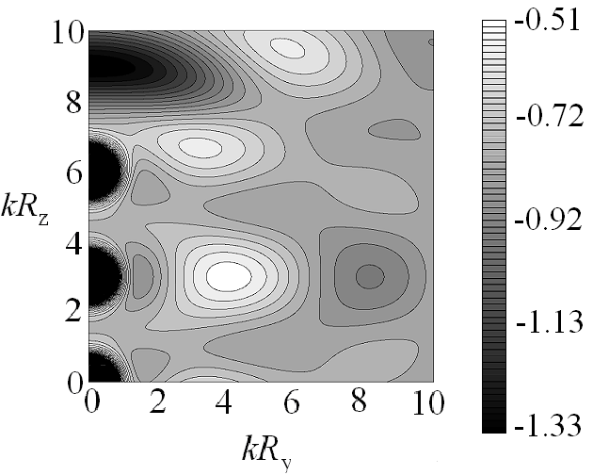

Figure 2. Optically induced potential energy landscapes for four identical interacting particles as a function of the vector positions of one of them, when the other three particles are at the stable position indicated by black circles. Field polarization and wave-vector as in Fig 1. [7].

Additional, higher-order contributions to the optically-induced energy shift can be calculated by considering multi-particle interactions. The coupling method introduced in [8] offers a straightforward answer to such a problem. This method, which can deliver a result for a system with an unspecified number of particles, is the subject of ongoing research aimed at identifying the interplay of assembly geometry and particle morphology.

THE SYMMETRY OF AN OPTICAL ASSEMBLY

On first reflection, it might be conjectured that an optically bound assembly of n identical, spherical micro- or nano-particles would assume a configuration of the highest possible symmetry, three particles for example displaying an equilateral triangular form (D_{3h} symmetry in the Schönflies system) and four, that of a tetrahedron (T_{d}). However such a notion, drawing on any presumed analogy with the principles of chemical bonding, is misconceived for several reasons. It has to be borne in mind that, in contrast to the usually isotropic environment within which bonding occurs in atomic clusters, the electromagnetic field that is responsible for generating an optical binding effect is decidedly anisotropic – excepting the specially engineered multi-beam configurations that have been studied with a view to effecting a collapse of optically bound structures [9,10]. It is apparent from (1.1) that the coupling between each pair of interacting particles depends on their mutual disposition with respect to both the wave-vector and the polarization vector of the local field. In consequence, as depicted in Fig. 3 – and as follows from the results exhibited in Fig. 1 – a system of three non-collinear particles might commonly assume either a linear (D_{∞h}), isosceles (C_{2v}) or scalene (C_{h}) triangular structure. With four particles, the two most prominent energy minima that occur for the example shown in Fig. 2 – corresponding to the addition of a fourth particle to a stable linear configuration of three particles – correspond to linear or isosceles structures. According to the initial three-particle conditions, self-assembly can in fact lead to a variety of other low-symmetry conformations.

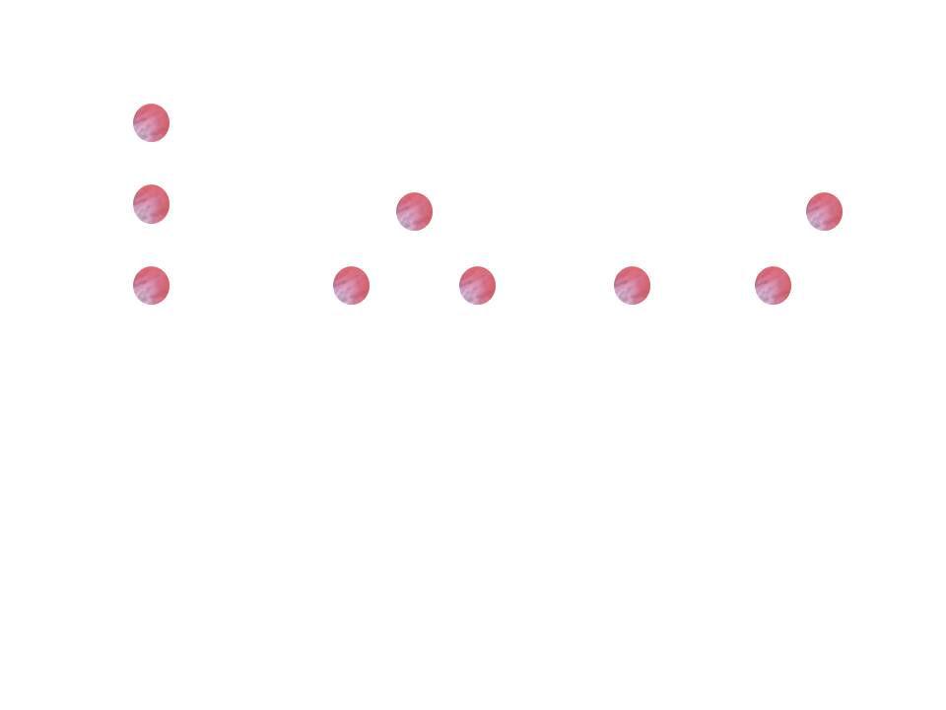

(a) (b) (c)

Figure 3. Three-particle configurations resulting from the potential energy landscapes of Fig. 1: (a) linear arrangement associated with prominent minima in Figs 1(a) and (b); (b) isosceles configuration from Fig. 1(c); (c) scalene configuration from Fig. 1(d).

It is significant that the particles studied in current optical binding experiments are generally secured in an optical trap. Moreover, for particles held under such conditions, Brownian motion is generally ineffective, and the mass scale too large for quantum tunnelling to occur between different local potential energy minima. In consequence it cannot be assumed that an optically formed assembly will adopt a configuration of lowest absolute energy. The shape of any cluster so formed will usually depart from the initial particle positioning – rearrangement into a lower energy configuration is in the nature of the optical binding effect – but the eventual shape will nonetheless be very substantially determined by initial conditions. This is why the formation of chain structures is so prominent in the essentially linear geometry of the longitudinal configuration for optical binding. Nevertheless there is one symmetry principle that can be expected to operate in this apparently simple case. Although the equilibrium structure of a linear chain cannot be expected to deliver exactly identical separations between each pair of neighboring particles, we can anticipate end-to-end inversion symmetry, i.e. the structure will have D_{∞h} rather than simply C_{∞v} axial symmetry. This is because the optical binding potential is independent of the sign of the wave-vector k that determines the axis for chain formation. In fact, the common use of counter-propagating beams, deployed in order to obviate radiation pressure effects that could otherwise cause the whole structure to drift down-beam, only serves to reinforce this symmetry principle.

PARTICLE AND HOST COMPOSITION

In cases where there is optical binding between molecular aggregates, each formed by p molecules or optical centers, we need to entertain for each particle an effective polarizability [6, 11]. The aggregates can be considered as mesoscopically disordered materials, within which local domains may possess particular structures. For small particles, where their separation is much smaller than the radiation wavelength, the weighting factor in the induced energy is proportional to , as in the case of nanoparticles. In the limiting case, using a similar analysis to that given in ref. [5], the sum over optical centers ξ in the susceptibility may be approximated by a continuous integral. With these assumptions, we can express the optically induced potential between two spherical aggregates of radius r as follows;
(4.1)
where , dρ is the number density of molecules, and α the isotropic polarizability. The result demonstrates that optical binding, in aggregates comprising relatively few, high volume, electronically distinct units, will be less effective than in other aggregates of the same size, comprising a larger number of small sub-units.
To complete the representation of a standard trapping environment, account can be also taken of the dielectric influence of any medium in which the particles are individually suspended. It has previously been shown [12] that the relative value of the refractive index between the particles and the surrounding medium can significantly influence optical binding phenomena, producing sizeable shifts in the positions of stability. With the incorporation of appropriate Lorenz field factors, the dependence on changes to a dependence on , where the multiplier is the complex refractive index of the medium supporting the particles. Most experiments are of course conducted using wavelengths at which the system under study is optically transparent, well away from any resonance. Then, the dielectric effect of the medium is equivalent to a simple scaling of the particle separations by the real index n, i.e. the results reported and exhibited here can be regarded as establishing the coordinates of potential energy minima on a scale where all distance values are truly given by R/n.

Static contribution in Optical Binding

In cases where optical binding occurs between non-centrosymmetric, polar particles, static coupling contributions arise. The prototypical case is a scattering process that entails two particles, ξ = (A, B), but where the photon absorption and emission occur at the same centre, as shown in Fig. 4. As described before [5] in a quantum electrodynamical representation, and in contrast to a classical description, pairwise coupling cannot be considered to be mediated by instantaneous coupling interactions. For each of the two processes described in Fig. 4 there are four light-matter interactions of relevance.

Figure 4. The static contributory mechanisms for optical binding, where the coupling depends on the permanent dipole of one center is coupled to the hyperpolarizability of the other one, In (a) the photon absorption and photon emission occurs in centre A, while the process in (b) the roles of A and B are reveresed.

In Fig 4(a), for example; this process entails: (i) input light absorption (photon annihilation) at A; (ii) emergent light emission (photon creation) at A; (iii) a pair coupling event at A; (iv) equivalent to (iii) but interchanging the roles of A and B. Every permutation of these four events must be considered a contributory mechanism. For derivation of the associated energy of interaction, the state sequence diagram shown in Fig 5 is a calculational aid, within which such permutations are conveniently depicted [13]. Each path that can be followed from the initial state (depicted by the box to the far left of Fig 5) to the final state (box on the far right) represents a particular time-ordering. For example, the path shown by a dashed line in Fig 5 correlates with the time-ordered diagram illustrated in Fig 6.

Figure 5. State-sequence diagram for the static contribution of a two-center scattering, progressing left to right. Each box denotes a state of the composite system; for simplicity an input photon is designated by k and its counterpart k′ ; p denotes a virtual photon. In each box, circles represent the states of particles A and B. An empty circle denotes a ground electronic state; virtual states are labeled r and s. There are 24 routes from left to right; one specific path, arbitrarily chosen, is indicated by the dashed line.

The calculational procedures that need to be undertaken are similar to those followed in previous work [5, 14]. The static contribution to the quantum amplitude for optical binding, restricting consideration to the electric dipole approximation, emerges as follows;
(5.1)
where is the corresponding electro-optic hyperpolarizability of particle ξ – a tensor usually associated with optical rectification   [15-17]. Equation (5.1) involves the static dipole moments, μ, for each particle; the two terms relate to Figs 4(a) and (b). These terms are not retarded, but they retain a dependence on k through the optical dispersion properties of the hyperpolarizability. In general, such terms represent an additional, repulsive correction that drops off approximately with R⁻³. Clearly, as might have been anticipated, if both particles are centrosymmetric and non-polar, these terms vanish. When that is not the case, however, such terms can serve to modify the exact positions of the optical binding minima, compromising some of the higher symmetries shown in some low-number assemblies.

Figure 6. Time-ordered diagram corresponding to the pathway signified by a dashed line in the state-sequence representation, Fig. 5. This graph generates one of 24 quantum amplitude contributions whose sum represents the totality of the mechanism illustrated in Fig. 4(a).

Just as, in the case of centrosymmetric particles, it is possible to interpret the induced energy shift, expression (3.6) of [5], to the coupling of two optically induced dipoles; the above expression (5.1) can also relate to a classical description – here an induced dipole moment couples to a permanent one. As before, the light scattering depicts the oscillatory electric field of incoming radiation as inducing a similarly fluctuating electric dipole moment. In this case it is the static hyperpolarizability that represents a constant of proportionality between the induced dipole and the strength of the electric field. In close proximity to a permanent dipole moment, it is to be anticipated that a coupling will occur between the two dipole moments. Fig.7 is a compact representation of one of the terms in the static contribution to optical binding, and its physical interpretation.

Figure 7. Compact description of the optical binding induced energy shift, for the process described by Fig. 4(a). The product of the polarization with the hyperpolarizability physically signifies the induced dipole of particle A.

Discussion

It has been shown that multi-particle binding effects can result in the formation of a variety of geometrical assemblies. The precise three-dimensional symmetry of the energetically favored structures so formed depends on several factors, being significantly influenced by initial conditions – and in particular, the configuration of other trapped particles already held together by optical binding. To fully account for experimental observations, the effects of intra-particle domain size and host medium effects should also be taken into account. Moreover, in systems where permanent dipole moments are present, optical binding may be additionally influenced by a static interaction mechanism that invokes not only electric dipoles, but also the electro-optical nonlinearity more commonly associated with optical rectification. The possible influence of such effects on assembly formation has been also explored; it is clear that further consideration needs to be given to the possible departures from such symmetry which might be anticipated. With the continued advancement of theory to inform the design of suitable experiments, the exploitation of such features presents a host of future opportunities for the controlled, precision optical fabrication of nanoscale structures.

ACKNOWLEDGEMENTS
The authors gratefully acknowledge funding of this research by the Engineering and Physical Sciences Research Council.

References
- Burns, M. M., Fournier, J. M., and Golovchenko, J. A., “Optical matter-crystallization and binding in intense optical fields,” Science, 249, 749-754 (1990).
- Karasek, V., and Zemanek, P., “Analytical description of longitudinal optical binding of two nanoparticles,” J. Opt. A, 9, S215-S220 (2007).
- Rodríguez, J., Dávila Romero, L. C., and Andrews, D. L., “Optical binding: potential energy landscapes and QED,” Proc. SPIE, 6905, 69050H (2008).
- Dávila Romero, L. C., Rodríguez, J., and Andrews, D. L., “Electrodynamic mechanism and array stability in optical binding,” Opt. Commun., 281, 865-870 (2007).
- Dávila Romero, L. C., and Andrews, D. L., “The electrodynamic mechanisms of optical binding,” Proc. SPIE, 7613 (2010). (in press)
- Andrews, D. L., Rodríguez, J., and Dávila Romero, L. C., “Optically induced nanoparticle assemblies” Proc. SPIE, 7038, 70380R (2008).
- Rodríguez, J., Dávila Romero, L. C., and Andrews, D. L., “Optical binding in nanoparticle assembly: Potential energy landscapes,” Phys. Rev. A, 78, 043805 (2008).
- Dávila Romero, L. C, .and Andrews, D. L., “A retarded coupling approach to intermolecular interactions,” J. Phys. B, 42, 085403 (2009).
- Andrews, D. L., and Rodríguez, J., “Collapse of optical binding under secondary irradiation,” Opt. Letts 33, 1830-1832 (2008).
- Andrews, D. L., Rodríguez, J., and Dávila Romero, L. C., “Configuring the cancellation of optical near-fields,” Proc. SPIE 7029, 70290C (2008).
- Andrews, D. L. and Allcock, P., [Optical Harmonics in Molecular Systems] Wiley-VCH, Weinheim; Germany, (2002).
- Chen, F., Klimchitskaya, G. L., Mostepanenko, V. M., and Mohideen, U., “Demonstration of optically modulated dispersion forces,” Opt. Express, 15, 4823-4829 (2007).
- Jenkins, R. D., Andrews, D. L., and Dávila Romero, L. C., “A new diagrammatic methodology for non-relativistic quantum electrodynamics,” J. Phys. B, 35, 445-468 (2002).
- Bradshaw, D. S., and Andrews, D. L., “Optically induced forces and torques: Interactions between nanoparticles in a laser beam,” Phys. Rev. A, 72, 033816 (2005).
- Bass, M., Franken, P. A., Ward J. F., and Weinreichet G., “Optical Rectification,” Phys. Rev. Lett., 9, 446-448 (1962).
- Bass, M., Franken, P. A., and Ward J. F., “Optical Rectification,” Phys. Rev., 138, A534-A542 (1965).
- Dávila Romero, L. C., Naguleswaran, S., Stedman, G. E., and Andrews, D. L., “Electro optic rotation in isotropic media,” Nonlinear Optics, 23, 191-201 (2000).

david.andrews@physics.org

