Well-being in digital-free tourism: A mixed-methods rhythmanalysis

Abstract
Tourism research has largely treated well-being as a motivation or outcome, neglecting how it unfolds in-situ and relying on self-report data. Through a mixed-methods rhythmanalysis, this study examines how well-being emerges and evolves in digital-free tourism. Following 23 participants through three-night digital-free cabin stays, we integrate electrodermal activity, interviews, and diaries to capture embodied experiences of disconnection. Participants experienced rhythmic re-attunement from linear, digital temporalities towards cyclical, embodied rhythms aligned with nature and interpersonal connection. Physiological data showed varied responses to disconnection and fewer detected skin conductance responses post-trip, supporting qualitative accounts of calm and rhythmic re-attunement. Through attunement, plenitude, stillness, and reflexivity, we reconceptualise well-being as a dynamic rhythmic process shaped through embodied experiences, environmental cues, and relational synchrony.
Keywords: digital-free tourism, well-being, rhythmanalysis, processual, mixed methods, electrodermal activity

Introduction
Digital technologies can deeply impact our lives, shaping how we connect, communicate, and construct sense of self in ways both empowering and detrimental to well-being. While research suggests technology use can improve well-being, there is a tendency towards negative impacts (Stangl et al., 2023). Social media use can cause depression (Perlis et al., 2021), social isolation (Primack et al., 2017), and/or social anxiety (Oral & Karakurt, 2025). Therefore, a growing digital detox market has emerged, including retreats (Anderson et al., 2024), smartphone lockboxes (Bozan & Treré, 2024), and digital restriction software (Bozan & Treré, 2024). Digital detoxing may mitigate the adverse effects of technology use on well-being (Coyne & Woodruff, 2023); yet its effectiveness depends on contextual and individual factors, including when, how, why, and for whom it is applied.
Research on digital detox outcomes remains inconclusive. Some studies report enhanced well-being (Ansari et al., 2024). Common strategies include abstaining from specific platforms, e.g., quitting Facebook (Tromholt, 2016), or reducing usage (Hunt et al., 2018). Alternative approaches, such as disabling mobile internet, have also improved attention, mental health, and subjective well-being (Castelo et al., 2025). However, technology-based interventions often show limited efficacy in curbing overuse (Dekker et al., 2024) or only marginally reduce stress (Brockmeier et al., 2025). Some studies report no significant improvements in life satisfaction (Hall et al., 2021) or in anxiety, depression, or self-esteem (Hartanto et al., 2025). These inconsistent findings underscore the limitations of conventional detox methods and prompted increased scholarly interest in more immersive, context-specific approaches, most notably, digital-free tourism, offering physical displacement from the ‘always-on’ environment.
Digital-free tourism offers a setting to study how disconnection unfolds away from habitual digital cues. Yet embodied, in-situ accounts of well-being remain scarce (Cai & McKenna, 2023a). While existing tourism frameworks address well-being’s many facets (Huang et al., 2024; Rossetti et al., 2024), they offer relatively static or compartmentalised views. They risk overlooking process: the day-to-day rhythms, embodied sensations, temporal dynamics, and shifts in awareness through which well-being benefits unfold. We understand daily rhythms as the temporal organisation of everyday life through which well-being is lived (Lefebvre, 2013; Lyon, 2020). In digitally saturated life, these rhythms are increasingly shaped by linear demands of productivity and constant availability, often in tension with bodily and environmental rhythms. Digital-free tourism is analytically important because it interrupts these familiar rhythms and makes their reconfiguration visible.
Rhythmanalysis, developed by Henri Lefebvre (2013), provides a theoretical framework for examining tensions between the ‘linear’ rhythms of digital obligation and the ‘cyclical’ rhythms of the body and nature. Tracing competing temporalities’ interactions reveals well-being’s dynamic unfolding beyond static satisfaction snapshots. We use rhythmanalysis because digital-free tourism is a temporal, embodied, and relational experience that unfolds through shifting rhythms of body, environment, and social interaction.
Our research question is: How does well-being emerge, evolve, and transform through digital-free tourism experiences? We make three contributions. First, interviews, diaries and electrodermal activity during cabin stays combine participants’ accounts with physiological recordings, responding to reliance on self-reports (Hassan & Saleh, 2024) and calls for complementary measures (Stangl & Riedl, 2024). Second, we examine how well-being is lived and negotiated during and shortly after disconnection rather than only as a motivation. Third, we challenge static, outcome-focused notions of well-being in tourism through rhythmanalysis.

Well-being through digital-free tourism
Digital-free tourism refers to tourism spaces where internet and mobile signals are absent or digital technology use is voluntarily controlled (Egger et al., 2020; Li et al., 2020). Millennials are regarded as a key target group for digital-free experiences because of their ‘always on’ lifestyle, alongside awareness about mental health, well-being, and personal growth and a preference for experiential travel (Cai & McKenna, 2023b; Floros et al., 2021; Hassan & Saleh, 2024). This growing awareness led to a growth in digital-free tourism studies. Previous research examines motivations (Egger et al., 2020), emotions (Cai et al., 2020), developing character strengths (Li et al., 2020), and reconsideration of daily life (Zhang & Zhang, 2022).
Most research on digital-free tourism frames well-being as a motivation (e.g., Egger et al., 2020; Liu & Hu, 2021). Other motivations include escaping technostress and seeking social bonding, mindfulness, and experiential satisfaction to alleviate techno-exhaustion, social media fatigue, anxiety, depression, social isolation, and loneliness (Egger et al., 2020; Sthapit et al., 2024).
Research on individual well-being in tourism has drawn on theoretical frameworks such as the PERMA model (Rossetti et al., 2024) and the Positive Psychology perspective (Vada et al., 2020), which integrate happiness, meaning, and engagement. Self-Determination Theory highlights the fulfilment of autonomy, competence, and relatedness as key motivational drivers of tourist well-being (Huang et al., 2024). Scholars distinguish between hedonic and eudaimonic well-being (Huang et al., 2024), and emotional fluctuations through tourism are shown to lead to better well-being outcomes (Yao et al., 2025). ‘Flourishing’ bridges hedonic and eudaimonic lenses by emphasising emotional and existential outcomes of pleasure, personal growth, and social connectedness (Coghlan, 2015). These frameworks, typically focused on motivations, needs and/or types, largely neglect the processes through which individual well-being unfolds.
We do not delimit individual well-being through a single lens (subjective/objective; eudaimonic/hedonic) or focus on one dimension (e.g. emotional, physical, social). Focusing on how well-being unfolds through time in digital-free tourism, we approach it as a multidimensional, embodied, and continually evolving process encompassing affective, reflective, relational, and existential aspects of living well. Existing frameworks usefully show that well-being may involve pleasure, restoration, meaning, autonomy, and connectedness (Coghlan, 2015; Huang et al., 2024; Rossetti et al., 2024; Vada et al., 2020), but they rely heavily on self-report and retrospective evaluation. Our study departs from this tendency by combining qualitative accounts with physiological data, allowing participants’ accounts of well-being to be considered alongside physiological recordings of arousal. This is consistent with rhythmanalysis, which treats the body as a key site of inquiry (Lefebvre, 2013). Physiological data are used not as a standalone measure of well-being, but as a complementary indicator of one embodied dimension through which well-being is lived and negotiated in digital-free tourism.
Few studies explore well-being as an outcome of digital disconnection, though it is rarely the central focus. Li et al. (2020) suggest that digital-free travel may cultivate character strengths conducive to post-trip well-being. Sthapit et al. (2024) report improvements in hedonic and eudaimonic well-being among participants in a digital-free meditation retreat, though it remains unclear whether these outcomes stem from digital disconnection or the retreat context itself. Their study measures well-being only afterwards, overlooking in-situ processes. Hassan et al. (2022) also focus on well-being and link digital-free tourism to an internal locus of control and associated well-being benefits, but offer limited engagement with well-being as a multidimensional construct and established theoretical frameworks. Their focus remains on immediate reflective and relational experiences, without assessing their post-travel durability. These limitations highlight the need for more comprehensive research that treats well-being as both a process and a primary outcome of digital-free tourism.

Rhythmanalysis
Existing digital-free tourism and tourism well-being research can identify motivations, outcomes, and types of well-being, but engages less with how well-being is lived through time during the experience itself. Rhythmanalysis can address this gap. Rhythmanalysis enhances understanding of well-being by revealing how it unfolds through day-to-day rhythms, bodily sensations, and shifts in awareness. Previous tourism research suggests that disrupting regular everyday rhythms can render bodily, sensory, and environmental rhythms more perceptible (Rantala & Valtonen, 2014), while attuning to natural rhythms may afford restorative and healing connections (Huijbens, 2016). Building on this understanding, rhythmanalysis enables us to examine how well-being in digital-free tourism emerges through changing relations between bodily, environmental, and social rhythms during the trip, rather than being understood only through retrospective evaluation.
Henri Lefebvre conceptualises rhythm as a relational and dynamic phenomenon that integrates time, space, and energy, manifesting through the patterned interaction of repetition and variation in natural processes, human activities, and the surrounding environment (Edensor, 2010; Lefebvre, 2013). To capture such patterns, Lefebvre (2013) proposed rhythmanalysis, both a theory and a method, to uncover how rhythms structure daily life and shape individual embodied experiences and collective behaviours (Lyon, 2021). By examining spatial and temporal patterns, rhythmanalysis reveals the intersections of physical movement, social practices, and environmental influences (Walker et al., 2022).
Rhythmanalysis addresses the harmonious, disruptive, and multifaceted nature of rhythms (Lyon, 2020). Polyrhythmia refers to the coexistence of diverse rhythms within a system, highlighting how their interaction shapes individual and collective experiences (Sang, 2024). Eurhythmia signifies the synchronisation of natural, biological, social, and technological rhythms, while arrhythmia indicates discord, often linked to illness or conflict (Rongna & Sun, 2020). Lefebvre (2013) discussed moments of ‘plenitude’ in eurhythmia, when individuals forget time when deeply in harmony with the world.
Lefebvre’s key concepts include cyclical and linear rhythms; they intertwine temporal structures that shape human practices, environments, and experiences of time (Lefebvre, 2013). Cyclical rhythms are inherently ‘cosmic’, emerging from natural processes such as day and night, seasonal changes, or bodily functions such as heartbeat and breathing. These rhythms generate a sense of continuity, renewal, and environmental connection, offering stability and predictability (Huijbens, 2016). In contrast, linear rhythms reflect modernity’s imposition of fragmented and mechanical time, shaped by work schedules, industrial labour, and digital technologies. Lefebvre critiques linear time as ‘homogeneous’ and ‘quantified’, displacing natural rhythms and producing exhaustion and alienation in contemporary life (Lefebvre, 2013; Lyon, 2020). These rhythms coexist: Lefebvre identifies their constant ‘interference’, where moments of compromise, tension, or disturbance arise as natural cycles persist within modern linear impositions (Lyon & Coleman, 2023).
Digital technology further complicates these relationships, reshaping temporality and increasingly blurring the boundaries between cyclical and linear rhythms. Technologies enable greater flexibility, yet they also embed productivity demands into traditionally cyclical spaces, creating an ‘always-on’ culture where natural rhythms are disrupted and linear rhythms are enforced (Lyon, 2020). Digital tools, therefore, create a paradoxical rhythm-scape where flexibility coexists with fragmentation. Understanding this digital colonisation of time is crucial for our inquiry, as it frames digital-free tourism not merely as a pause, but as a rhythmic intervention required to recover the cyclical temporalities essential for well-being.
Writing on media day, Lefebvre (2013) explores a way of life shaped by the constant flow of information. Media day describes the relentless and pervasive influence of media rhythms, creating a sense of present (a mediated, simulated reality, often imposed by media representations) without true presence (an authentic, embodied connection to the moment). Lefebvre critiques how media undermines genuine dialogue, and disrupts natural rhythms and authentic co-presence by substituting ‘real’ interactions with mediated simulations. In today’s digital media landscape, smartphones, through push notifications and constant access to algorithmically curated content, reinforce an always-on culture, amplifying the omnipresence of media rhythms (De Saulles & Horner, 2011).
Rhythms are shaped by power and capitalism, with dressage (Lefebvre, 2013) capturing how individuals internalise dominant temporalities through bodily adaptation. This process enforces conformity to imposed rhythms, such as those of digital technologies, through routinised practices (Edensor, 2014). In technologically mediated environments, dressage helps explain how users are disciplined into neoliberal rhythms of productivity and self-surveillance (Jones & Warren, 2016; Vigren & Bergroth, 2021). Edensor (2010) argues that the artificiality of imposed temporalities disrupts rhythms and opens pathways for counter-rhythms. Individuals may resist hegemonic digital technologies by negotiating technology use for self-reflection, collaboration, and community-building (Jones & Warren, 2016; Vigren & Bergroth, 2021). Alternatively, some address such arrhythmia more radically by moving to the countryside (Meadows, 2016) and/or going off-grid (Cai & McKenna, 2023b), hoping to restore eurhythmia.
Advancing tourism research through rhythmanalysis
Tourism research has embraced rhythmanalysis, yet the ‘state of the art’ remains heavily focused on the macro/meso-scales of destination dynamics and community adaptation. Studies have examined the temporal disruptions caused by event-driven tourism (Antchak, 2018), the embedding process of tourism livelihood (Rongna & Sun, 2020), the livelihood transitions of indigenous tribes (Rongna & Sun, 2020) and the impact of tourism development on islanders’ livelihood rhythms (Sang, 2024). While these contributions highlight how tourism disrupts and reshapes livelihood and community rhythms, few studies have shown how rhythmanalysis can assist process-related inquiries by examining how tourists synchronise with destination rhythms and negotiate changing bodily and environmental temporalities. For example, Rantala and Valtonen (2014) show how sleeping in nature brings bodily rhythms into relation with environmental cycles, making regular everyday rhythms newly perceptible, while Huijbens (2016) highlights the well-being potential of attuning bodily rhythms to natural rhythms. These studies point to the promise of rhythmanalysis for embodied and well-being-related research, but also reveal how limited this literature remains. Particularly, how tourists navigate internal, environmental, and interpersonal rhythms, and how well-being unfolds through these temporal relations, remains under-theorised.
Through rhythmanalysis, this study advances tourism scholarship in three ways. First, it uses rhythmanalysis to examine the processual nature of well-being. Unlike static models that measure well-being as a fixed outcome, polyrhythmia helps to analyse the continuous, dynamic interaction between distinct internal (bodily), social, and environmental rhythms. Second, Lefebvre’s concepts of media day and dressage have yet to be applied to tourist experiences despite their relevance to digital life. Drawing on media day and dressage, we frame digital rhythms as intrusive forces that disrupt natural bodily cycles through habitual, embodied use. Within the polyrhythmic condition of modern life (Lefebvre, 2013), digital rhythms often produce arrhythmia by clashing with social and biological rhythms, undermining well-being. Digital-free tourism offers a unique context to examine how disengaging from these rhythms enables alternative temporal attunement.
For Lefebvre (2013), the body is a metronome of lived experience; rhythmanalysis must attend to bodily pulses and respirations (Edensor, 2010). We extend this principle by pairing physiological recordings with participants’ lived accounts. Wearable sensors capture changes in arousal around disconnection and reconnection that participants may not notice or report. Read alongside diaries and interviews, those recordings help examine how bodily responses accompany shifts from digital stimuli to slower cabin rhythms. This integration extends rhythmanalysis without treating physiological arousal as a measure of well-being.

Methodology
We adopt a critical realist paradigm, viewing reality as stratified into objective physiological reality and subjective lived experiences. Consistent with this methodological pluralism, we employ a mixed-methods approach, guided by Venkatesh et al. (2013; 2016), to capture well-being’s multifaceted, dynamic nature in digital-free tourism. Our mixed methods approach fulfils three key purposes: complementarity, development, and expansion. First, we integrate qualitative interviews and diaries with physiological data to triangulate subjective and objective insights, enriching our understanding of disconnection. Second, qualitative data informed the interpretation of biometric patterns, supporting theoretical refinement. For example, linking reported bodily awareness with physiological markers of arousal. Third, by combining psychological, social, and physiological perspectives, we expand the analytical scope to capture both conscious and embodied dimensions of well-being.
Our fully mixed, concurrent design integrates qualitative and quantitative strands across data collection, analysis, and interpretation to ensure rigorous, holistic inquiry. Inference quality was assessed both within and across methods to generate valid meta-inferences. For the qualitative part, we used an interpretive approach similar to Cai et al. (2020) with interviews and participant diaries. We furthermore collected physiological data with an Empatica E4 device. This screenless wristband records heart rate, heart rate variability, skin temperature, and electrodermal activity. The Empatica E4 is a validated, research-grade device used extensively in psychophysiology, neuroscience, information systems research, among others (Empatica, 2025). Although wrist measurements may generate lower absolute amplitude than palmar sites, they remain scientifically valid for analysing relative arousal changes, especially when paired with artefact filtering and segment standardisation. While finger-based electrodermal activity offers higher accuracy, our study aimed to capture real-life emotional responses in a natural tourism setting. Asking participants to wear finger electrodes for 24 hours would disrupt their daily activities, so we chose the wristband configuration, though it has limitations.
The Empatica E4 device is also widely used by tourism researchers as a valid tool for measuring emotional arousal (e.g., Li et al., 2025; Stadler et al., 2018). We focus on electrodermal activity in the present study as it best reflects emotional arousal (Dawson et al., 2007). Most digital-free tourism studies have used traditional self-report methods (e.g., Cai & McKenna, 2023b; Cai et al., 2020), which are prone to cognitive and social desirability biases. Nevertheless, we emphasise that our study primarily relies on qualitative data. The electrodermal activity data serve as a complementary source for triangulation, rather than our primary analytical focus. We present individual participants’ data in the findings to support this approach.

Data Collection
The study site is a rural cabin near the south coast of the United Kingdom. The cabin (Figure 1), called Unplugged (real name used with permission), offers three-night digital-free holidays for up to two guests and allows guests to lock their phones in a box. Guests also receive a paper map, compass, radio, cassette tapes, a Polaroid camera, board games, lists of nearby walks and activities, a fireplace, and cooking equipment, to help guests disconnect. Data collection spanned four summer months, when Unplugged guests could opt into the project. The researchers were not involved in participant recruitment, and the sample reflects a self-selected group of participants who opted into the study during their stay, and was not stratified by demographic characteristics such as age. The study included 23 millennial participants (Table 1). All guests were domestic tourists within the UK. Many participants travelled in pairs, with a few solo travellers. Relationship types between paired participants (e.g., friends, romantic partners) were not systematically recorded, although some participants disclosed this informally. The study instead focused on participants’ reported interpersonal experiences and their perceived changes in well-being.
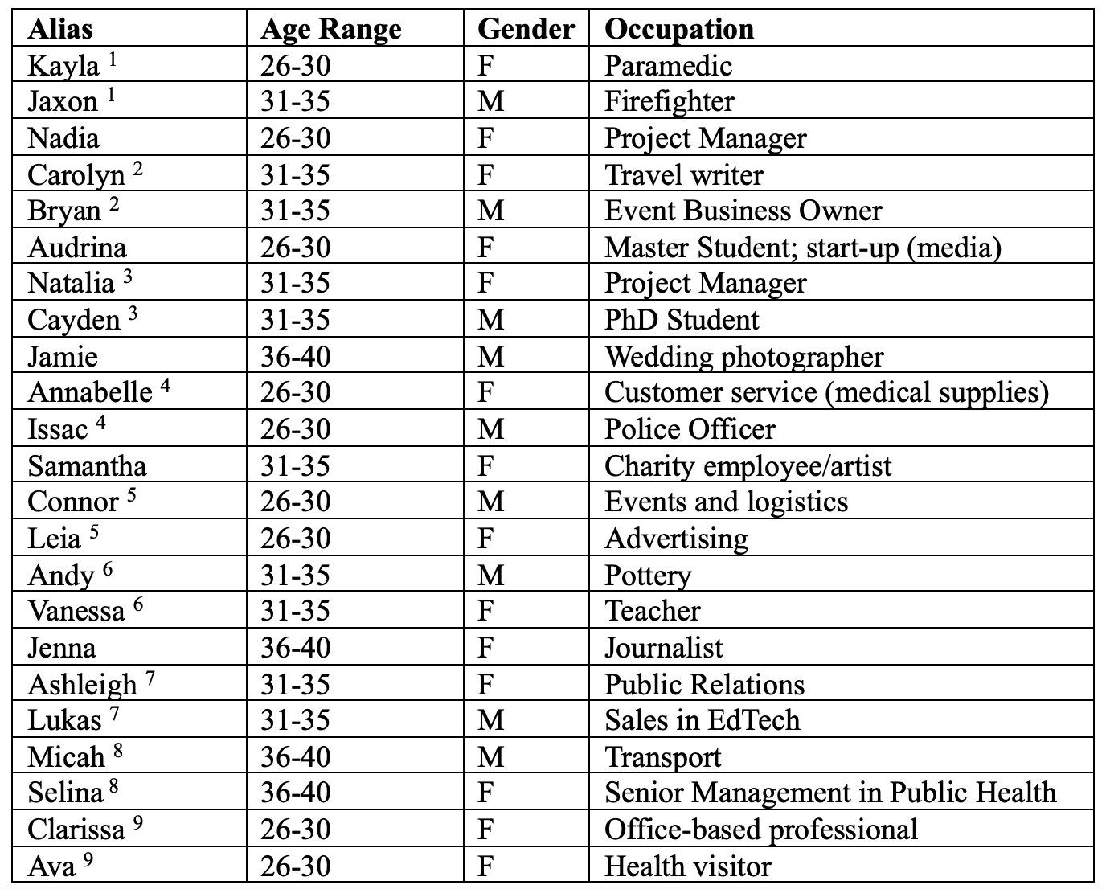
Table 1: Participant Information. Numbers by names indicate which participants travelled together.
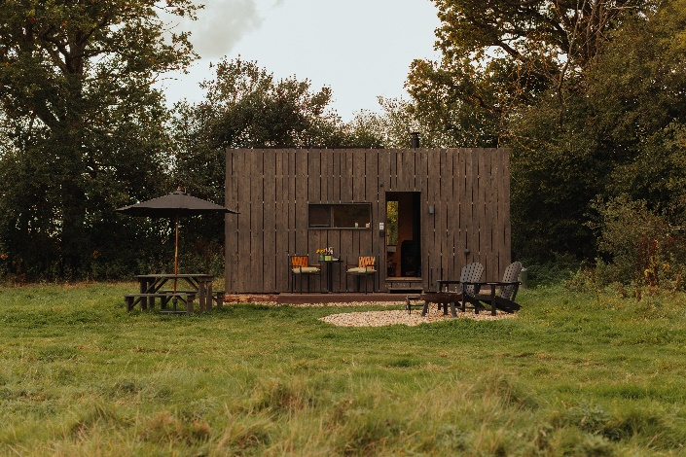
Figure 1: Unplugged Cabin (Image credit: Rebecca Hope Photography / Unplugged)

Data were collected pre-, during, and post-trip. Pre-trip, we interviewed participants using the questions in Appendix A. The participants were given an Empatica E4 and instructed to wear it on a non-working day for a 24-hour period before their trip. This aimed to establish a physiological baseline. They were advised to always wear the wristband as tightly as possible and avoid touching the device, to minimise noise and reduce potential interference.
At check-in, a researcher met participants at the cabin. They were instructed to wear the E4 for the full three-day stay, taking it off only for charging or showering. Participants wore the device for 30 minutes before disconnecting their phone so we could capture their physiological responses at the disconnecting moment. The participants disconnected their phones at the cabin after the researchers departed and reconnected before the researchers returned three days later. During their stay, guests were asked to write a diary of their emotions and activities. We asked participants to record their feelings at the disconnect and reconnect moments, as the researchers were not present at these times. The cabin’s isolated rural setting remained constant, although factors such as the weather could not be controlled. We could not control for other factors such as the weather. At trip’s end, participants were instructed to wear the E4 for another 30 minutes after reconnecting their phones, allowing us to capture their physiological responses following the reconnecting moment.
After the trip, participants were asked to wear the E4 for another 24 hours on a non-working day to compare their pre-trip baseline with their post-trip physiological responses. Afterwards, the researcher met participants for a post-trip interview. Before the post-trip interview, the researchers examined the trip’s physiological data and asked the participants follow-up questions to contextualise physiological responses. Table 2 summarises the data collection phases. The researchers visited the participants multiple times: pre-trip, at cabin check-in and checkout, and post-trip. The researchers did not stay with guests at the cabin.
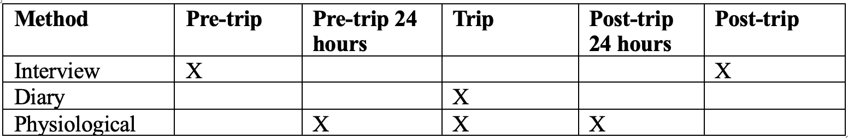
Table 2: Data collection phases

Data analysis
We cleaned electrodermal activity data of artefacts to correct for motion-related interference. We then decomposed the electrodermal activity signal into tonic and phasic components. As the phasic component primarily captures rapid, event-related changes driven by sympathetic activation, which is predominantly a function of emotional arousal, our analyses focused on the phasic data. Appendix B provides further details of qualitative analysis and physiological data processing. Given high contextual noise in continuous real-world physiological data, we adopt an event-based segmentation approach, focusing on theoretically meaningful transition points (i.e., disconnection and reconnection), while using the full dataset for baseline comparison and qualitative triangulation. Appendix C summarises the initial sample, the valid physiological recordings retained, and the number and reasons for exclusions for each analysis.

Findings
Themes are presented in the temporal order they became most visible, but should be understood as interconnected dimensions of both how well-being was lived and negotiated during the experience and the short-term physiological, affective and behavioural outcomes observed or reported afterwards. Not all experiential states described below are treated as well-being in themselves; rather, moments of discomfort, anxiety, or disorientation are analysed as arrhythmic disruptions through which well-being is unsettled, negotiated, and, at times, reconfigured. Electrodermal activity findings predominantly focus on the critical rhythmic transitions of disconnection and reconnection, providing arousal evidence at these key transitional moments.

Disconnecting and tuning into the senses
The disconnecting moment functioned as a rhythmic threshold, where dominant media-day rhythms were suspended and new temporalities could emerge. Illustrative participant profiles are presented below.
Post-disconnection calming pattern
Eight participants (34.8%) showed lower arousal after than before disconnection, as indicated by decreases in SCR frequency and mean amplitude. For instance, Ava described feeling ‘nervous and excited’ while turning off her phone but felt ‘relieved and curious’ immediately afterwards. Her biometric pattern echoed this shift: a sharp drop in skin conductance response following disconnection (Figure 2). These participants, initially anxious, appeared to release anticipatory stress once the device was no longer accessible.
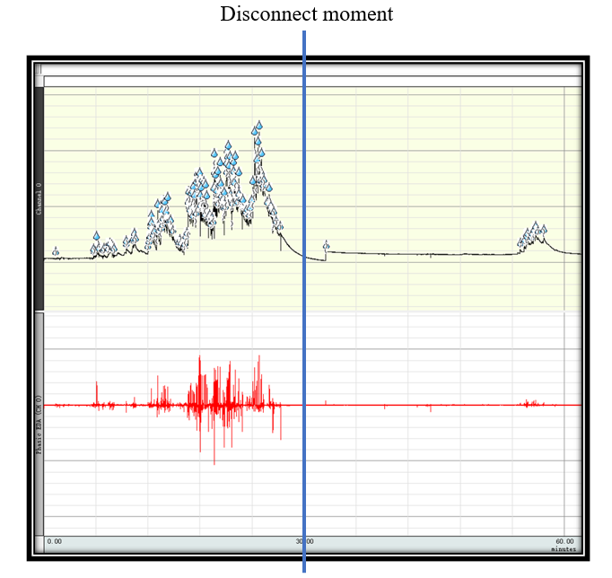
Figure 2: Ava’s physiological response

Pre- to post-disconnection relatively stable pattern
Three participants (13.0%) were assigned to the relatively stable pattern, which included descriptively small or discordant changes in SCR frequency and mean amplitude across the two windows. For example, before switching off his phone, Bryan (Figure 3_Left) reported feeling ‘nervous, deflated, and odd’, expressing anxiety about being disconnected from work. At switching-off, his physiological signals indicated a brief period of calm. However, this was soon followed by a subtle rise in arousal, as he experienced a strong habitual urge to check his phone again. Despite these shifts, there was no substantial difference between his physiological state before and after the switch-off.

Post-disconnection arousal pattern
The largest group comprised 12 participants (52.2%), whose SCR frequency and mean amplitude increased after disconnection. This pattern reflects a within-participant increase and does not imply that pre-disconnection arousal was low. Natalia (Figure 3_Right) illustrated this pattern. She said, ‘I felt calm and prepared, having completed tasks and informed my family’. Yet after switching off, she reported ‘feeling strange, anxious, and alone’. These participants may have underestimated their reliance on digital rhythms, with signs of distress emerging only in the silence that followed.
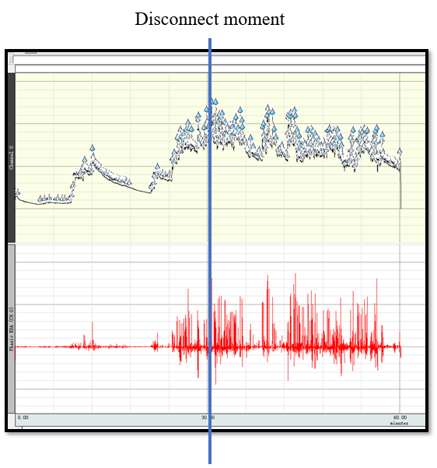
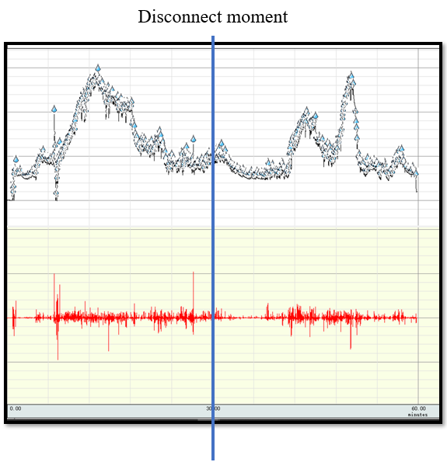
Figure 3: Bryan (Left) and Natalia’s (Right) physiological response

These biometric patterns suggest that disconnection was an active disruption of internalised, technology-mediated rhythms shaping attention and emotion. For some, it enabled immediate re-attunement to the body and environment; for others, it surfaced affective dissonance and latent anxiety. The coexistence of rhythmic disjunction and realignment supports Lefebvre’s view that rhythms are bodily embedded, not merely external. Transitions between dominant and emergent rhythms are negotiated physiologically and sensorily. Twenty participants (87.0%) were assigned to patterns showing concordant increases or decreases in SCR frequency and mean amplitude around disconnection. These physiological changes do not independently identify emotional shifts. Interview and diary accounts provided the basis for interpreting how participants experienced disconnection, including reported feelings of anxiety, relief, calm, and clarity. Together, the data suggest that changes in electrodermal arousal accompanied the experiential adjustments described by participants.

Attuning to Ambient Rhythms
Once disconnected at the cabin, participants described well-being unfolding through attunement: a shift in temporal orientation from linear, device-driven rhythms towards cyclical, natural, and sensory rhythms. This was experienced as greater grounding, sensory presence and connection to place. Lukas found he was more ‘rooted and grounded’: ‘You feel your own existence within that setting. When I was drawing, I was looking at the trees…and thinking, wow, these have got to be like hundreds of years. I just felt way more connected with the location’. Lukas’s reflections on becoming synchronised with nature align with Lefebvre’s notion of eurhythmia. Andy also found himself paying far more attention to the surroundings: ‘I was far more invested in the area that we were in, the places we were seeing’. Andy and Lukas’s attentiveness reflects a shift from device-driven rhythms to place-rhythms, demonstrating how place invites certain rhythms while resisting others (Lyon, 2020).
Withdrawing from media-day rhythms (Lefebvre, 2013; Örnebring & Hellekant Rowe, 2022), participants reflected on the joy of sensing environmental rhythms through natural sounds (acoustic rhythms), and entering into cyclical rhythms, where sound and silence alternate meaningfully. Cayden said, ‘I really enjoyed just being in a meadow, in the quiet, just hearing the birds, going for the walk, and having nothing there’. Similarly, Samantha anticipated peace and quiet due to the cabin’s location: ‘…it was so quiet that you just couldn’t hear anything. You could just hear all the insects in the field.’
Participants shifted their focus from taking unlimited digital photos to cherishing and remembering special moments. ‘I also think not having a phone meant we were more present. We couldn’t take pictures of something to remember it. We actually had to stop, look at it and really absorb it’ (Lukas). The shift towards being in the moment and the absence of the ‘rhythm of the feed’ (Örnebring & Hellekant Rowe, 2022) enable more embodied presence and memory-making rather than just being present (Lefebvre, 2013). Lukas’s accounts mirror Lefebvre’s notion of plenitude, when individuals are immersed in lived moments when natural, social, and bodily rhythms are in sync, leading to eurhythmic states that are emotionally restorative.
Nadia found ‘it’s quite therapeutic to solely focus on one thing’. When cooking in the cabin, although she ‘messed up’ slightly without access to instructions on her phone, she enjoyed focusing on one thing at a time: ‘that’s the therapeutic bit. You just have to, rather than trying to immediately look up what you’re meant to be doing. That’s so good just to put all your attention to one activity without distractions.’ Nadia’s reflection responds to Lefebvre’s (2013) critique of linear time, which is fragmented, and driven by technological and capitalist agendas. Nadia’s account shows this attunement being experienced through the absorbed pace of a single activity. Grounding, presence and flow were not subsequent benefits, but an unfolding process of well-being within the experience itself.

Reclaiming Time: Living Beyond the Clock

From Clock Time to Body Time
Over time, participants described moving from linear, externally imposed rhythms towards cyclical, embodied rhythms aligned with nature and the body. Jenna enjoyed the slowness in the morning with no alarm, no phones, no notifications: ‘it was really nice because of the natural light. That’s what wakes you up…rather than hearing the bin man shouting outside my window’. Jenna’s narrative illustrates attunement to cyclical rhythms emerging from the cosmos and nature, in contrast to the discordant rhythms of urban living.
Participants valued losing track of time and being guided instead by bodily and environmental cues. Kayla noted: ‘I think the big thing that we realised was not being like, oh, it’s this time we need to go and do this or, we’ve got to do this in an hour’. Vanessa similarly reflected on the ease of following natural rhythms: ‘Should we have dinner? Should we go to bed?...being led by how our body feels’. Natalia added that without strict scheduling, the experience felt more relaxed: ‘It didn’t really matter about timing. It was more about just enjoying what was happening’. These accounts reflect a shift away from clock time and linear temporality toward body and nature-led rhythms, a key marker of rhythmic reorientation.
Without the smartphone reminding him of everyday life, Jamie enjoyed the mindful slowness during this trip and hoped to implement it after returning: ‘This is something I want to take back to normal life, just like morning time to start a day slowly.’ Jamie’s reflection suggests a growing rhythmic awareness and re-evaluation of daily rhythms (Lyon, 2021). Instead of seeing slowness as non-productive and guilt-inducing in the linear disciplined temporality (Lefebvre, 2013), Jamie recognised it as experientially rich, consciously eurhythmic time, which is grounding, harmonious, and reflective of presence.

Escaping the Demands of Digital Time
Participants such as Andy, Ashleigh, and Connor described a release from digital obligation, often tied to emotional or existential weight: ‘I felt freer because I wasn’t contactable and I wasn’t tied to my phone, and I wasn’t messaging people’ (Andy). Ashleigh also felt that being physically and virtually away helped her well-being: ‘it was a really good way to distance myself from everything else that was going on and just chill out a bit. I have quite a stressful life, so it’s just nice to just stop’. Connor agreed that being cut-off from the outside world allowed him to focus solely on the experience: ‘I just relish the chance of not living with this [pointing at his phone], and not having to contact anyone and just being able to live’. Escaping the temporal demands of connectivity, such as alerts, responses, and obligations, allowed participants to tap into their internal tempo that aligned with self-paced temporality, living in the moment, and a rhythm of ‘dwelling’ rather than ‘doing’ (Degen, 2008). This responds to Lefebvre’s distinction between presence and present; he critiques the latter as a mediated simulation that overrides embodied connection.

Stillness, Creativity, and Mental Clarity
By focusing on the moment, Ashleigh suggested a suspension of productive, multi-tasking time of modern digital life (linear time), and taking a break from attention-grabbing distractions: ‘my mind constantly races. I’ll have like 100 ideas or thoughts in my head. It was nice to just drop it...it’s like finally you could think clearly’. Withdrawing from the dressage where cognitive rhythms are trained and fragmented by notifications, tasks, and stimuli, Ashleigh enjoyed the bliss of ‘still rhythm’, which is often invisible and overlooked in the hegemony of linear temporality: ‘stayed silent watching the flames, mind didn’t turn to phone. Actually, not sure I thought of anything for the first time in a long time’. Such rhythms of stillness and solitude provide temporal contrast to modern acceleration and stress (Doughty, 2011); they are not an absence between activities, but a lived rhythm of well-being, experienced through mental quiet, embodied presence and the capacity to pause without demand.
Natalia’s account expresses achieving a state of plenitude as a process of unfolding well-being in digital-free travel, with the momentary synchronisation of internal and external rhythms experienced as reflection, relaxation and calm: ‘it just feels like a bit of an opening of your mind where you can go into a very really reflective space…into more of a state of relaxation and calm’. By having more headspace, Andy found more ideas flowing through: ‘because of the much better, much clearer headspace, we just kept coming up with ideas, so we just wrote them down, so we didn’t forget them’. Both Natalia and Andy’s ideas do not come from forced productivity, but through rhythmic rebalancing and attunement to their environment, body, and mind. The suspension of digital time allows mental polyrhythms (e.g., creativity, memory, reflection) to emerge and align, resulting in ‘clearer headspace’ and eurhythmia.

Reengaging through Shared Rhythms

Relational Presence
All participants within this theme travelled with a companion. While relationship types were not systematically recorded, the findings highlight how shared rhythms and mutual engagement emerged within participants' travelling pairs. Beyond individual realignment, the digital-free trip fostered a relational unfolding of well-being (via relational eurhythmia) through deeper communication, intimacy and shared presence. Ashleigh noted in her diary: ‘I miss having more one-on-one time with Lukas and feel like I have fallen a little bit more in love with him. Back to basics, back to just us.’ Jamie reflected: ‘Undoubtedly, we talked more, we had more fun, we giggled more, we had more sex. When [we] were in the cabin, instead of reaching for our phones to kill time, we reached out to each other’. These moments reflect how disconnecting from technology enabled reconnection through simplicity, bodily attunement, and temporal liberation from technological dressage, reshaping not only individual rhythms but also relational ones. Well-being was lived through an uninterrupted exchange in which vulnerability, sustained attention and intimacy could coexist.
Some couples reflected on how intrusive digital rhythms interrupt and fragment shared rhythms. Vanessa considered the smartphone as the ‘third wheel’ in their relationship, and was happy their phones were locked away: ‘I feel like I didn’t have to share Andy with anyone. I feel like we are so distracted and other people are texting us and calling us and emailing us.’ Vanessa’s metaphor demonstrates how digital rhythms served as rhythmic disruptors, desynchronising the rhythms of intimacy, attention, and co-presence, and creating arrhythmia. Without competing rhythms from smartphones, couples could co-create their own rhythm of relational presence. Post-trip, Jamie reflected on how digital technology affects communicative rhythms. Digital dressage has replaced mutual, co-regulated conversational flows with fractured, absent-minded and inattentive exchange: ‘sometimes, we are aware that we’re talking at each other while looking at the screen, so it’s just not very direct communication’.
This reflects a form of domestic arrhythmia, where co-presence is disrupted by competing media rhythms. The digital-free setting offered a rhythmic clearing, removing such distractions and enabling emotional alignment. Natalia captured this renewed temporal intimacy: ‘It was so great to spend quality time…because you could focus on it a little bit more and actually really enjoy being with each other.’ Participants did not just spend time together; they inhabited it, developing deeper connections and shared stillness.

Eurhythmia in Conversation and Silence
The digital-free rhythm facilitated meaningful conversations, which enhanced a sense of togetherness. Ashleigh found it helped them improve their communication skills: ‘without the interruptions of our phones…we weren’t afraid to talk about the stuff that needs talking about, like having an honest, heart-to-heart conversation’. Ashleigh’s account shows how slow, uninterrupted temporalities support vulnerability and depth, which resonates with Lefebvre’s (2013) notion of plenitude, when all energies align into a meaningful moment. Early in their relationship, Connor and Leia found the experience helped deepen their intimacy: ‘We spoke a lot about what we’d done previously…we had really good conversations and got to know each other much better’ (Connor).
A subtle but deep rhythmanalytical insight concerns participants’ appreciation of each other’s company in silence. Jamie distinguished three types of silence with a partner: ‘…there’s the comfortable silence. There’s the awkward silence, you’ve had a fight or you’re being passive-aggressive…then, there’s the technology-induced silence, which is we’re both doing our thing’. Participants reported enjoying several moments of comfortable silence. For instance, Lukas wrote in his diary: ‘Feel content and peaceful and so sat up in bed with a coffee, watching Ashleigh pick flowers and getting lost in her own world. Was lovely to just watch’. Such ambient co-presence extends Seamon’s (2015) account of unspoken synchrony and quiet companionship, showing shared stillness as a non-intrusive, relational form of well-being felt through temporal synchronisation rather than speech.

Reconnecting and Reorienting

Back to the Feed

While disconnection disrupted digital rhythms, reconnection marked their potential return. Yet biometric and narrative data show this threshold was navigated in complex, often unexpected ways. Some participants described reconnection as anticlimactic, suggesting a reassessment of the anticipated demands of connectivity. Electrodermal activity at reconnection revealed two recurring physiological response patterns, which were interpreted alongside the qualitative accounts of rhythmic resynchronisation.

Rhythmic indifference: minimal arousal changes across reconnection
Nine participants (56.25%) were assigned to the minimal arousal changes across reconnection pattern, which included descriptively small or discordant changes across the two SCR indicators. This pattern does not establish physiological or affective stability; its experiential meaning was interpreted alongside participants’ interview and diary accounts, including accounts of detachment and an anticlimactic return to their phones. Ashleigh’s electrodermal recording illustrates this response category (Figure 4, left). Many in this group expressed surprise post-trip at how little they had missed and how unimportant their devices felt after being without them. These qualitative accounts may be interpreted as rhythmic disinvestment (Lefebvre, 2013) – participants had begun to release the anticipatory alertness and micro-temporal loops tied to constant connectivity. These accounts suggest a temporary distancing from habitual digital rhythms that may be understood as a form of rhythmic resistance.

Anticipatory arousal followed by reduced electrodermal responding
The remaining seven participants (43.75%) were assigned to the anticipatory arousal followed by emotional calming pattern, showing an overall reduction in electrodermal responding after reconnection. Qualitative reflections from participants reveal consistent themes: ‘I thought there would be so much to catch up on, but there wasn’t’, one participant noted. Another said, ‘It was mostly junk’. These qualitative accounts suggest that the demands of reconnecting were less substantial than anticipated. The physiological data provide complementary information about arousal across this transition (see Figure 4, right, for Jaxon’s pattern).
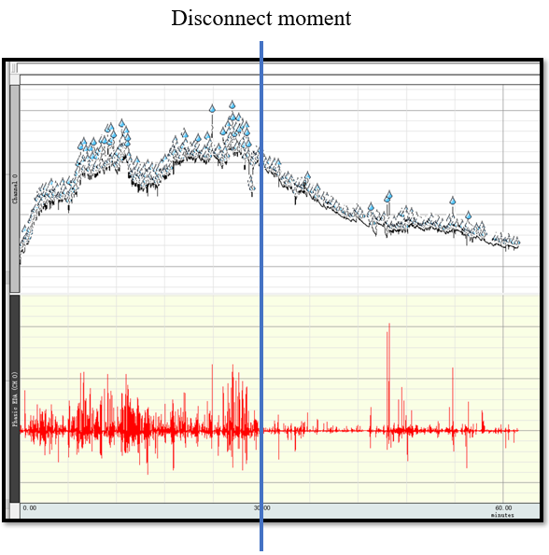
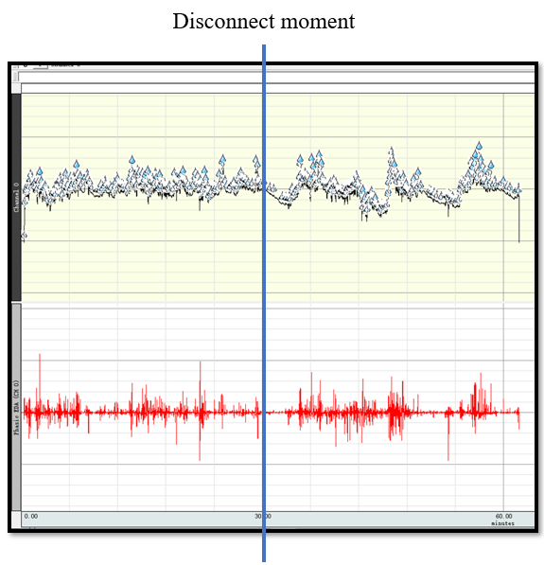
Figure 4: Ashleigh (Left) and Jaxon (right)’s physiological response during the 30-minute periods before and after mobile phone reconnection
After the digital-free stay, nearly half of the participants reported no strong desire to regain their phones. Participants’ narratives also described reconnection as muted or anticlimactic and, in some cases, anticipation as more stressful than the act itself. These accounts suggest a re-evaluation of digital habits. The electrodermal findings provide complementary information about arousal around reconnection, but do not independently establish reduced phone dependence or a reduced psychological need for phones.

Calmer Bodies, Calmer Lives
Rewriting Everyday Rhythms
The digital-free stay also became a space of reflexivity, as participants noticed how everyday rhythms shaped their fatigue, rest and sense of self. Some expressed intentions to carry elements of the experience into daily life. Jenna found the experience restful and wanted to repeat it: ‘It makes me inclined to do this on other trips like putting away your phone’. After the trip, many participants felt rejuvenated through time off from constant connectivity. Clarissa explained how the inability to stay constantly connected enabled reflection on her lifestyle: ‘I realised that I was doing too many things and trying to juggle everything…and that’s why I was burnt out, taking that time off allowed me to come back to myself’. The digital break acts as a counter-temporality and shows well-being unfolding through reflexivity itself: examining bodily fatigue, emotional exhaustion, and the need for rest, which had previously been ignored and overridden.
Ashleigh took this opportunity to reflect on her relationship with work: ‘I shouldn’t let work monopolise so much energy…I just don’t need to be always available’. This temporal reflexivity demonstrates resistance towards the imposed linear rhythm of ‘productive time’. Vanessa emphasised the trip helped her to re-centre her life priorities: ‘It helped me realise my priorities as a human being and what I want my life to look like, and what my priorities are in terms of my well-being’. Reflexivity continued as participants re-centred priorities and questioned the dressage of 24/7 availability and instant responsiveness. Their reported intentions and changes extended, rather than completed, the negotiation of well-being on returning to everyday rhythms.
To assess broader physiological changes beyond event-based responses, we compared 24-hour electrodermal activity recordings from non-working days before and after the trip (Please see details in Appendix B).

Discussion
The findings have been interpreted through a broader rhythmanalytical process in which participants moved from the digitally saturated discipline of media-day rhythms and dressage, through moments of arrhythmia generated by disconnection and re-entry, towards partial forms of eurhythmia. Within this process, well-being became experientially visible through four interrelated forms: attunement, stillness, plenitude, and reflexivity. Attunement captures participants’ re-synchronisation with bodily, environmental, and relational rhythms; stillness marks a counter-rhythm to the restless demands of linear digital time; plenitude describes moments of eurhythmic immersion; and reflexivity captures participants’ growing awareness of, and intervention in, the digital rhythms shaping everyday life. These four forms were identified primarily through participants’ interview and diary accounts. Physiological data provide complementary evidence of arousal interpreted alongside the qualitative accounts; these two approaches support the analysis of bodily calming and re-attunement, while participants’ narratives remain the basis for interpreting the dynamic and unfolding process of well-being. Drawing upon and extending Lefebvre (2013) rhythmanalysis, the findings demonstrate how the relentless influence of contemporary media day rhythms enabled by smartphones ‘dressage’ our lived time. Applying media day and dressage to tourist well-being offers novel insights: digital-free tourism functions not merely as a space of absence but as a site of temporal resistance, enabling participants to disrupt digital dressage and reinhabit rhythms that had been suppressed by the intrusive forces of digital life.
The suspension of digital connectivity initiates a rhythmic disruption that temporarily destabilises the internalised training of dominant digital temporalities. Here, new or forgotten rhythms emerge more clearly. Ambient micro-rhythms of light, sound, smell, and weather surfaced more prominently, while internal rhythms of reflection, emotion, and creativity, typically repressed under the imperatives of digital productivity and constant attention-switching, re-emerged.
Participants’ experiences illustrate a process of rhythmic reattunement, from externally imposed, linear, and digital rhythms to cyclical, body-led, and relational temporalities. This reattunement represents a loosening of the hegemonic grip of digital dressage, allowing participants to realign with temporalities that nourish rather than fragment selves. Attunement contributes uniquely to well-being by enabling participants to feel in sync with their surroundings and relationships. It involves listening to bodily signals, reading environmental cues, and co-regulating with others in time. Rather than emerging as a form of perception, attunement is understood as an embodied, affective, and social rhythmic practice through which well-being is rhythmically lived and negotiated: a process of recalibrating bodily rhythms in relation to cyclical temporalities (Huijbens, 2016; Rantala & Valtonen, 2014). This bodily attunement deepened participants’ sense of place, grounded them emotionally, and cultivated interpersonal harmony. Attunement thereby integrated internal, external, and social rhythms; Lefebvre (2013) refers to this as a bundle of rhythms: different in tune, producing a rhythmically lived sense of well-being.
Drawing primarily on participants’ interview and diary accounts, this study offers a rhythmanalytical perspective on well-being, framing stillness, presence, and plenitude not as static states but as dynamic, rhythmically enacted practices. Far from being an absence of rhythm, stillness emerged as a generative force, enabling recalibration, reflection, and relational attunement in contrast to the accelerated tempo of digital life. Stillness here is not a void or rupture, but a rhythmic form with its own temporal texture, enabling participants to settle attentively into their environments and relationships, free from the pace and demands of digital life. In the digital-free context, stillness became a rhythm of care and clarity, grounding well-being in the embodied capacity to pause, notice, and dwell. It thus functions as a rhythmic reorientation that fosters both personal and interpersonal flourishing. Similarly, plenitude emerges as a state of eurhythmia in which bodily, environmental, and relational rhythms harmoniously coexist. These moments stand in sharp contrast to the linear, segmented, and commodified rhythms of digital life. Digital technologies promote a mode of existence dominated by presentness rather than presence, always on, constantly reacting, yet rarely grounded. In contrast, plenitude marks a shift toward immersive, embodied being, where the experience of time is slowed, saturated, and inhabited (Degen, 2008). Plenitude here can be understood as a quiet, grounded form of resistance against the alienation embedded in digital dressage and linear rhythms.
The joy participants expressed in sustained focus and flow was a mode of dwelling rather than doing, where rhythms of self, the environment, and interpersonal connection aligned in eurhythmia. Here, relational presence also deepened: shared silence, attuned conversation, and mutual bodily awareness became pathways to co-experienced well-being. Well-being, therefore, emerges in and through the rhythmic unfolding of lived time, in the synchronisation of internal, external, and relational temporalities.
This study’s qualitative account emphasises rhythmic reflexivity as a mode of temporal agency through which individuals become aware of, and selectively reconfigure, their relationship to multiple rhythms. Throughout and after the digital-free experience, participants engaged in rhythmic reflexivity: a heightened awareness of how different temporalities feel, what they enable or suppress, and how individuals might actively choose or resist them. This reflexive awareness became a vital tool for well-being. It allowed participants to discern which rhythms were aligned with care, rest, and presence, and which were exhausting, such as those driven by efficiency, urgency, and digital fragmentation. As Lefebvre (2013) suggests, the rhythmanalyst must not only listen to rhythms but use this awareness to intervene and reorganise lived time.
This reflexivity often translated into action, as participants made post-trip adjustments: restructuring routines, reducing screen time, and embracing stillness. Such changes represent not just reflection but resistance: the creation of counter-rhythms that challenge dominant values of speed, productivity, and hyper-connectivity (Edensor, 2010). Rhythmic reflexivity and resistance thus emerge as intertwined expressions of temporal agency, enabling movement toward eurhythmia where internal, environmental, and social rhythms align. Rather than framing well-being as a static outcome, this study conceptualises it as a dynamic, lived process, rhythmically shaped through embodied experiences, environmental cues, and relational synchrony.
Conclusion
This study used rhythmanalysis to examine how well-being emerges and evolves through digital-free tourism. Our mixed-methods analysis suggests that digital-free tourism was associated with changes in physiological arousal, while interviews and diaries revealed well-being as a dynamic, in-situ process. These complementary approaches offer new insights into how digital-free tourism can promote mental and physical restoration. Participants reported short-term benefits and behavioural changes post-trip, such as reducing phone use at home, highlighting the potential of such experiences to foster lasting shifts. Further research should assess long-term impacts and how the phenomenon plays out in other generations. As relationship type (e.g., married partners travelling together) was not systematically captured, potential differences in how digital-free travel is experienced across relationship categories could not be examined. Shared relational rhythms nonetheless emerged as a prominent theme, highlighting the need for research explicitly exploring how varying relationship types shape processes of well-being.
By theorising well-being as a rhythmic phenomenon, we have offered an alternative to prior tourism well-being research that primarily treated well-being as a secondary outcome or motivating factor (Egger et al., 2020; Liu & Hu, 2021), or where well-being outcomes remained unclear (e.g., Hassan et al., 2022; Sthapit et al., 2024). In contrast to earlier studies that place well-being as part of broader frameworks (e.g., Li et al., 2020), this research offers a more comprehensive, processual and multidimensional account to understand well-being. The qualitative accounts show how well-being unfolded through affective change, relational connection, altered experiences of time and reflection on everyday life, while physiological data provide complementary evidence of changes in arousal. Building on Lefebvre’s (2013) conception of rhythm as the entanglement of time, space, and energy, the paper demonstrated how well-being is not only an outcome but a process of reattunement across bodily, environmental, and social temporalities. Particularly, the analytical focus on attunement, plenitude, stillness, and reflexivity reframes well-being as dynamic and situated, highlighting how individuals reorient and attune themselves within unfolding temporalities. The study thereby expands rhythmanalysis into affective and experiential well-being.
The primary academic contribution of this study has been its theoretical expansion of well-being literature in tourism beyond its predominant focus on motivations, needs, secondary outcomes and types. By using rhythmanalysis to examine the processual nature of individual well-being, the study also pushes the digital-free tourism literature beyond partial previous accounts of well-being. Our deployment of rhythmanalysis in a digital-free travel context has extended the few studies that examine relationships between bodily rhythms and nature cycles for well-being benefits (Huijbens, 2016; Rantala & Valtonen, 2014), and contributed to the growing theorisation of how micro-rhythms configure well-being in tourist bodies. Bodies are metronomes of lived experience (Lefebvre, 2013), as evidenced by our novel methodological extension of rhythmanalysis in tourism to include insights from combining physiological measures with qualitative insights. To our knowledge, this is the first study to mobilise Lefebvre’s concepts of media day and dressage for understanding tourist experience, extending rhythmanalysis by showing how digitally mediated temporal discipline is embodied, disrupted, and partially resisted in digital-free travel.
This study contributes to broader tourism well-being research through the lenses of mindfulness, meanings, and immersive experiences, which are strongly linked to digital-free tourism. For example, well-being can be mediated by nature and social connections (Jia et al., 2026). Complementing this, slow tourism research emphasises immersive, reflective engagement as central to enhancing well-being (Beegum A & Aboobaker, 2026). Practically, digital-free tourism should be designed as a whole-journey intervention rather than a simple device-free rule, incorporating pre-arrival preparation, low-tech and temporal supports during the stay, and post-trip reflection. At the destination level, its effectiveness depends on coordinated provision across accommodation, mobility, food, activities, and restorative spaces, enabling slower and less fragmented visitor rhythms. Providers should also move beyond generic satisfaction measures and assess well-being through processual indicators such as attentional slowing, sensory engagement, relational presence, reflective reorientation, and, where feasible, complementary physiological evidence.
Limitations and recommendations for future research
This study has certain limitations. The physiological response categories were exploratory and involved descriptive judgement rather than explicit numerical thresholds. The distinction between relatively small and more pronounced changes was sample-relative, and the relatively stable category included discordant changes that do not establish physiological stability. High inter-rater agreement indicates consistency between coders but does not establish the validity of the category boundaries or eliminate judgement from the procedure. Qualitative triangulation supported interpretation but did not provide a numerical basis for classification. These features limit comparisons across studies. Future research should develop and independently evaluate explicit classification criteria using larger samples. Moreover, the supplementary 24-hour analysis used total SCR counts without normalisation by artefact-free recording duration. Although observation periods were scheduled for equal durations, the amount of valid data may have varied across participants and between pre- and post-trip recordings because of artefact removal and data loss. The observed count difference may therefore reflect differences in data availability as well as physiological responding. It should be interpreted as a difference in detected response counts rather than evidence of a lower duration-standardised SCR rate. Future studies should record and report valid recording durations and compare duration-standardised rates.

References
Anderson, K. C., Wallach, K. A., & Grimes, M. (2024). The anti‐consumption journey: Unplugging for improved well‐being. Journal of Consumer Behaviour, 23(6), 3152–3174.
Ansari, S., Iqbal, N., Azeem, A., & Danyal, K. (2024). Improving Well-Being Through Digital Detoxification Among Social Media Users: A Systematic Review and Meta-Analysis. Cyberpsychology, Behavior, and Social Networking, 27(11), 753–770.
Antchak, V. (2018). City rhythms and events. Annals of Tourism Research, 68, 52–54.
Beegum A, S., & Aboobaker, N. (2026). Advancing slow tourism research: an integrative review. Journal of Hospitality and Tourism Insights, In press, 1–24.
Bozan, V., & Treré, E. (2024). The politics of disconnective media: unraveling the materiality of discourses on disconnectivity. Media and Communication, 12.
Brockmeier, L. C., Mertens, L., Roitzheim, C., Radtke, T., Dingler, T., & Keller, J. (2025). Effects of an intervention targeting social media app use on well‐being outcomes: A randomized controlled trial. Applied Psychology: Health and Well‐Being, 17(1), e12646.
Cai, W., & McKenna, B. (2023a). Digital-free tourism: The state of the art and future research directions. In D. B. Alastair M. Morrison (Ed.), Routledge Handbook of Trends and Issues in Global Tourism Supply and Demand (pp. 199–208).
Cai, W., & McKenna, B. (2023b). Power and resistance: Digital-free tourism in a connected world. Journal of Travel Research, 62(2), 290–304.
Cai, W., McKenna, B., & Waizenegger, L. (2020). Turning it off: Emotions in digital-free travel. Journal of Travel Research, 59(5), 909–927.
Castelo, N., Kushlev, K., Ward, A. F., Esterman, M., & Reiner, P. B. (2025). Blocking mobile internet on smartphones improves sustained attention, mental health, and subjective well-being. PNAS nexus, 4(2), pgaf017.
Coghlan, A. (2015). Tourism and health: using positive psychology principles to maximise participants’ wellbeing outcomes–a design concept for charity challenge tourism. Journal of Sustainable Tourism, 23(3), 382–400.
Coyne, P., & Woodruff, S. J. (2023). Taking a break: the effects of partaking in a two-week social media digital detox on problematic smartphone and social media use, and other health-related outcomes among young adults. Behavioral Sciences, 13(12), 1004.
Dawson, M. E., Schell, A. M., & Filion, D. L. (2007). The electrodermal system. Handbook of psychophysiology, 2, 200–223.
De Saulles, M., & Horner, D. S. (2011). The portable panopticon: Morality and mobile technologies. Journal of Information, Communication and Ethics in Society, 9(3), 206–216.
Degen, M. M. (2008). Sensing cities: Regenerating public life in Barcelona and Manchester. Routledge.
Dekker, C. A., Sumter, S. R., & Baumgartner, S. E. (2024). Unraveling the dynamics of perceived smartphone overuse and disconnection strategies: Longitudinal insights. New Media & Society, 14614448241303113.
Doughty, K. S. E. R. (2011). Walking and Well-being: Landscape, affect, rhythm University of Southampton].
Edensor, T. (2010). Introduction: Thinking about rhythm and space. In T. Edensor (Ed.), Geographies of rhythm (pp. 1–18). Routledge.
Edensor, T. (2014). Rhythm and Arrythmia. In P. Adey, D. Bissell, K. Hannam, R. Merriman, & M. Sheller (Eds.), Routledge Handbook of Mobilities, (pp. 163–171). Routledge.
Egger, I., Lei, S. I., & Wassler, P. (2020). Digital free tourism–An exploratory study of tourist motivations. Tourism management, 79, 104098.
Empatica. (2025). E4 Wristband. Retrieved 20 April 2025 from https://www.empatica.com/research/e4/
Floros, C., Cai, W., McKenna, B., & Ajeeb, D. (2021). Imagine being off-the-grid: millennials’ perceptions of digital-free travel. Journal of Sustainable Tourism, 29(5), 751–766.
Hall, J. A., Xing, C., Ross, E. M., & Johnson, R. M. (2021). Experimentally manipulating social media abstinence: results of a four-week diary study. Media Psychology, 24(2), 259–275.
Hartanto, A., Kasturiratna, K., Kothari, M., Goh, A. Y., Quek, F. Y., & Majeed, N. M. (2025). Investigating the effect of full and partial social media abstinence on fear of missing out and well-being outcomes: A daily diary experimental approach. Psychology of Popular Media, In press.
Hassan, T., & Saleh, M. I. (2024). Tourism digital detox and digital-free tourism: What do we know? What do we not know? Where should we be heading? Journal of tourism futures, In press.
Hassan, T. H., Salem, A. E., & Saleh, M. I. (2022). Digital-Free tourism holiday as a new approach for tourism well-being: Tourists’ attributional approach. International Journal of Environmental Research and Public Health, 19(10), 5974.
Huang, X., Wang, P., & Wu, L. (2024). Well-being through transformation: An integrative framework of transformative tourism experiences and hedonic versus eudaimonic well-being. Journal of Travel Research, 63(4), 974–994.
Huijbens, E. H. (2016). Rhythmic revitalisations: attuning to nature for health and wellbeing. In The routledge handbook of health tourism (pp. 393–402). Routledge.
Hunt, M. G., Marx, R., Lipson, C., & Young, J. (2018). No more FOMO: Limiting social media decreases loneliness and depression. Journal of Social and Clinical Psychology, 37(10), 751–768.
Jia, R., Xu, H., Huang, C., Ma, Y., & Wei, Z. (2026). How nature adventure tourism heals employees’ unhappiness: A logotherapy approach. Tourism management, 113, 105345.
Jones, P., & Warren, S. (2016). Time, rhythm and the creative economy. Transactions of the Institute of British Geographers, 41(3), 286–296.
Lefebvre, H. (2013). Rhythmanalysis: Space, time and everyday life. Bloomsbury Publishing.
Li, J., Pearce, P. L., & Oktadiana, H. (2020). Can digital-free tourism build character strengths? Annals of Tourism Research, 85, 103037.
Li, S., Li, S., Fong, L. H. N., & Li, Y. (2025). When intangible cultural heritage meets modernization–Can Chinese opera with modernized elements attract young festival-goers? Tourism management, 107, 105036.
Liu, Y., & Hu, H.-f. (2021). Digital-free tourism intention: a technostress perspective. Current Issues in Tourism, 24(23), 3271–3274.
Lyon, D. (2020). Rhythmanalysis: Research Methods. Bloomsbury Publishing.
Lyon, D. (2021). Introduction: Rhythm, Rhythmanalysis and Urban Life. In D. Lyon (Ed.), Rhythmanalysis (Vol. 17, pp. 1–23).
Lyon, D., & Coleman, R. (2023). Rupture, repetition, and new rhythms for pandemic times: Mass observation, everyday life, and COVID-19. History of the Human Sciences, 36(2), 26–48.
Meadows, C. (2016). ‘I'm in a park and I'm practically dead’: insomnia, arrhythmia and Withnail and I. In Geographies of Rhythm (pp. 83–96). Routledge.
Oral, M., & Karakurt, N. (2025). Mediating Role of Social Anxiety in the Relationship Between Phubbing and Social Media Addiction Among Higher Education Students. International Journal of Human–Computer Interaction, 1–10.
Örnebring, H., & Hellekant Rowe, E. (2022). The media day, revisited: rhythm, place and hyperlocal information environments. Digital Journalism, 10(1), 23–42.
Perlis, R. H., Green, J., Simonson, M., Ognyanova, K., Santillana, M., Lin, J., Quintana, A., Chwe, H., Druckman, J., & Lazer, D. (2021). Association between social media use and self-reported symptoms of depression in US adults. JAMA network open, 4(11), e2136113–e2136113.
Primack, B. A., Shensa, A., Sidani, J. E., Whaite, E. O., yi Lin, L., Rosen, D., Colditz, J. B., Radovic, A., & Miller, E. (2017). Social media use and perceived social isolation among young adults in the US. American journal of preventive medicine, 53(1), 1–8.
Rantala, O., & Valtonen, A. (2014). A rhythmanalysis of touristic sleep in nature. Annals of Tourism Research, 47, 18–30.
Rongna, A., & Sun, J. (2020). Integration and sustainability of tourism and traditional livelihood: A rhythmanalysis. Journal of Sustainable Tourism, 28(3), 455–474.
Rossetti, G., Jepson, A., & Albanese, V. E. (2024). Food festivals and well-being: Extending the PERMA model. Annals of Tourism Research, 107, 103772.
Sang, S. (2024). The rhythm-making of an island destination community. Annals of Tourism Research, 107, 103775.
Seamon, D. (2015). Body-subject, time-space routines, and place-ballets. In The human experience of space and place (pp. 148–165). Routledge.
Stadler, R., Jepson, A. S., & Wood, E. H. (2018). Electrodermal activity measurement within a qualitative methodology: Exploring emotion in leisure experiences. International Journal of Contemporary Hospitality Management, 30(11), 3363–3385.
Stangl, F. J., & Riedl, R. (2024). Neurophysiological measurements in the research field of digital detoxing: Review and implications for future research. NeuroIS Retreat, 105–121.
Stangl, F. J., Riedl, R., Kiemeswenger, R., & Montag, C. (2023). Negative psychological and physiological effects of social networking site use: The example of Facebook. Frontiers in psychology, 14, 1141663.
Sthapit, E., Ji, C., Yang, P., & Woosnam, K. (2024). Memorable digital-free tourism experiences: Antecedents and outcomes. Journal of Vacation Marketing, 13567667241282022.
Tromholt, M. (2016). The Facebook experiment: Quitting Facebook leads to higher levels of well-being. Cyberpsychology, Behavior, and Social Networking, 19(11), 661–666.
Vada, S., Prentice, C., Scott, N., & Hsiao, A. (2020). Positive psychology and tourist well-being: A systematic literature review. Tourism management perspectives, 33, 100631.
Venkatesh, V., Brown, S. A., & Bala, H. (2013). Bridging the qualitative-quantitative divide: Guidelines for conducting mixed methods research in information systems. MIS Quarterly, 21–54.
Venkatesh, V., Brown, S. A., & Sullivan, Y. W. (2016). Guidelines for conducting mixed-methods research: An extension and illustration. Journal of the Association for Information Systems, 17(7), 2.
Vigren, M., & Bergroth, H. (2021). Move, eat, sleep, repeat: Living by rhythm with proactive self-tracking technologies. Nordicom Review, 42(s4), 137–151.
Walker, G., Booker, D., & J Young, P. (2022). Breathing in the polyrhythmic city: A spatiotemporal, rhythmanalytic account of urban air pollution and its inequalities. Environment and Planning C: Politics and Space, 40(3), 572–591.
Yao, Y., Lv, X., Ren, L., & Wu, A. (2025). Rhythmic tour: Emotional fluctuation and tourist well-being. Annals of Tourism Research, 114, 104002.
Zhang, M., & Zhang, X. (2022). Between escape and return: Rethinking daily life and travel in selective unplugging. Tourism management, 91, 104521.

