Relating object memory to word learning:
Data from a new test of toddlers’ object recognition

Short Title: Object Memory and Word Learning

Milena Bakopoulou*, Jade Archer, & Larissa K. Samuelson*@
* School of Psychology, University of East Anglia

In Press, British Journal of Developmental Psychology

@corresponding author
School of Psychology
University of East Anglia
Norwich NR4 4TJ
l.samuelson@uea.ac.uk

Keywords: cognitive development, language development, memory
The authors declare no conflicts of interest
The data, coding manual, and full analysis scripts for this work are available on GitHub (https://github.com/developmentaldynamicslab/VPAR) and OSF (https://osf.io/ag43v/overview?view_only=b3cb3696fd494714a0efdd24ef42d365)

Acknowledgments
The authors wish to thank the parents and children who participated in this study. We also
thank Jo Walther and Nicky Bridgham for help with participant recruitment,
John Spencer for discussions of design, Samuel Forbes for statistical support, and
members of the Developmental Dynamics lab for discussions of the study. For the purpose of open access, the authors have applied a Creative Commons Attribution (CC BY) licence to any Author Accepted Manuscript version arising from this submission.

Abstract
Learning names for concrete objects, which dominate early vocabularies, relies on visual processes such as object recognition and memory for previously named objects. We examined the relation between memory for pairs of familiar and novel objects and early vocabulary development. We tested 52 14- to 24-month-olds (26 girls) in a preferential-looking object recognition task. Analysis on data from 44 toddlers suggested memory performance was based on whether the stimuli were from categories known to children in this age range, and a vocabulary percentile score based on age and gender, rather than just age or total productive vocabulary. We found some evidence that toddlers with higher vocabulary percentile scores remembered familiar, but not novel, object pairs. We discuss possible reasons for differences in memory for familiar and novel objects, limitations of our task, and how our findings fit with proposals on the relations between memory, visual processing, and variability in vocabulary development.

Relating object memory to word learning:
Data from a new test of toddlers’ object recognition
Cognitive development and vocabulary growth are intricately interconnected. Marchman and Fernald (2008) demonstrated a significant link between vocabulary at 25 months and later language and cognition. At the same time, advances in children’s thinking, problem-solving and memory capabilities are known to underpin advances in vocabulary (Cowan, 2014). As children’s cognitive abilities mature, particularly attention and categorisation skills, they become more adept at learning and retaining new words (Rose et al., 2004). Additionally, developments in memory allow children to retain and process more complex and abstract information, including new vocabulary (Wojcik, 2013). We seek to add to the literature examining relations between early cognitive processing and vocabulary development by exploring how one underpinning process, object memory, is related to vocabulary development. Our focus on this process is based on its importance for learning object names as well as recent research demonstrating links between object processing and vocabulary development.

Object names, object memory and visual processing in early word learning
Many of the words that comprise the early toddler vocabulary are names for things. This component of the early vocabulary provides a foundation for learning other kinds of words like adjectives and verbs (Bates et al., 1994; Kersten & Smith, 2002; Mintz & Gleitman, 2002). While object names may be learned first because the things they refer to are more stable and concrete than the transient or abstract referents of verbs and adjectives (Gentner, 1982; McDonough et al., 2011; Snedeker & Gleitman, 2004), learning object names is nevertheless a complex process. Like other words, learning names for objects requires children to form associations between words and referents that can vary on multiple dimensions and may be underspecified in the dynamic flow of language input (see Samuelson & McMurray, 2017, for review). Recent research suggests that visual memory processes support finding referents and creating initial associations (Vlach, 2019; see also Wojcik, 2013). In their 2023 systematic review and meta-analysis, Pickering et al. (2023) found a positive correlation suggesting that 2- to 12-year-old children with stronger visual memory skills in tasks that required memory for perceptual details of stimuli had higher vocabularies. Relatedly, Vales and Smith (2015, 2018) found labels helped 3-year-old children find targets in a visual search task. They suggested that the labels cued active visual representations in working memory supporting the kind of visual attention processes necessary to find word referents in visual scenes. Other recent work has shown a relation between toddlers’ active visual exploration of objects in free play and later vocabulary growth (Slone et al., 2019). Vlach and Johnson (2013) suggest developmental changes in memory during toddlerhood may influence word learning. They showed that while 20-month-old children were able to learn new word-object mappings across presentations that were spaced out, 16-month-old children needed presentations to be massed. They suggested this difference was because the older toddlers could remember presentations long enough for them to be re-activated even when time elapsed between them; a proposal supported by computational modelling of the learning process (Bhat et al., 2022).
Two other recent studies suggest a link between children’s memory for pairs of objects and their vocabulary. Collisson et al. (2015) asked 3- and 4-year-old children to remember a novel object paired with a novel symbol. Half of the children tested had Specific Language Impairment (SLI) and the other half were typical language learners. While the performance of typical learners steadily improved across days of testing, the SLI group’s performance stayed at chance even on the last day of testing. The authors concluded that the ability to remember novel pairings of visual stimuli may be one difficulty facing children with slow vocabulary development.
Similarly, Vlach and DeBrock (2017) demonstrated a link between visual paired associate (VPA) learning and vocabulary. They had children between 22- and 66-months-of-age complete both a word learning task and a VPA task and also asked the children’s parents about their vocabulary development. They found children who remembered more object pairs learned more words and had larger vocabularies.

The current study
The current study builds directly on the prior work by Collisson et al. (2015) and Vlach and DeBrock (2017) to examine the relation between object memory and vocabulary development during the period of rapid early productive vocabulary growth from 14- to 24-months-of-age. Because the procedures used by Collisson et al. (2015) and Vlach and DeBrock (2017) required extended verbal instruction and explicit responses not suitable for younger children, we developed a new preferential-looking VPA task that used eye tracking to measure object memory. Eye tracking is commonly used to gain insight into the mental abilities of infants and toddlers because it does not require explicit responding (see papers in Oakes, 2012 for review and discussion). Thus, rather than asking toddlers to point to an object that had previously been seen with another, we first presented toddlers with a pair of visual objects and then asked if re-presentation of one of those objects (the probe) primed toddlers’ gaze during a subsequent presentation of a pair of images, including one that had previously been presented with a probe item and a second that had not (see Figure 1).
We examined the relation between toddlers’ performance on this task and their vocabulary development considering two exploratory hypotheses. Based on the findings reviewed above suggesting a relation between vocabulary development and memory, we expected that children with more words in their vocabulary would create more robust memories for pairs of objects. Our first hypothesis, then, was that toddlers who had larger vocabularies would show more evidence of remembering object pairs. Based on the idea that children would have some prior representation of the familiar items, but not the novel ones, we also expected it would be easier for toddlers to remember pairs of familiar objects. Our second hypothesis, then, was that toddlers would show more evidence of remembering object pairs on trials with familiar, compared to novel, objects.
We evaluated both hypotheses by examining how trajectories of toddlers’ gaze towards a target object evolved over the course of test array presentation. We defined performance on the random trials as a baseline under the idea that cuing memory with a probe item that had not previously been paired with another item should not evoke a specific memory and thus no overall bias in looking during the test array. In contrast, if toddlers successfully encoded the pair seen on the memory array, probing memory with one of these items, an ‘associated’ probe, should cue that memory of the pair and result in a bias to look towards the other item that had been present on the memory array. To look at the relation to vocabulary, we collected parent report of total productive vocabulary. However, because our participants are too young to have been evaluated for the SLI diagnosis that Collisson et al.’s (2015) participants had, we derived vocabulary percentile scores as another vocabulary metric. Toddlers who are in the lower percentiles of vocabulary development for their age and gender are often referred to as ‘late talkers’. Some late talking toddlers will later receive a diagnosis of DLD† (see, e.g., Perry et al., 2021; Rescorla, 2009). Thus, in line with Collisson et al (2015), we felt this metric might be revealing with our young participants.

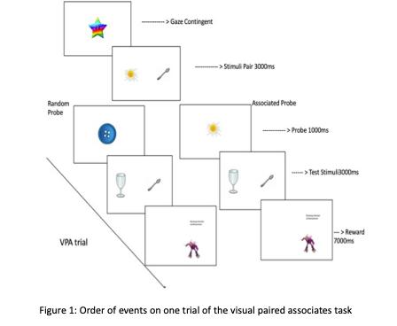
Method

Participants
A total of 52, 14- to 24-month-old toddlers (Mean = 20.17, SD = 2.63, 26 girls) with a mean total productive vocabulary of 150.93 words, (SD = 122.37 Median = 123.5) participated. This initial sample size was based on that of Vlach and DeBrock (2017) who tested 47 children. Children were from a medium-sized city in the East of England and had normal or corrected-to-normal vision. Data from 1 additional participant was excluded due to technical problems (n=1). After cleaning (see Results), data from 44 participants were submitted to analysis. Informed consent was obtained from parents prior to the experiment. All children received a small prize for participation. This project received ethical approval from the ethics board the University of East Anglia.
Apparatus
The task was presented via A 24-inch BenQ Zowie XL2430, 144 Hz monitor screen connected to a Gigabyte computer. An Eye-Link Duo portable eye tracker (SR Research, Ontario, Canada) in the monocular remote setting, placed at the midline of the presentation screen, tracked gaze position of a single eye via the pupil and corneal reflections of an infrared light source. The sampling rate was 500 Hz. The child’s head position was tracked via a small target sticker placed on the forehead as they sat 80 cm from the screen on their caregivers’ lap or on a highchair. The camera to eye distance was set to approximately 50cm from the top of the screen. The eye tracking software was hosted on a Lenovo laptop. The experiment was monitored from another room via wall-mounted cameras located just above the display monitor and at the back of the room.
Stimuli
Stimuli consisted of 120 images of objects. Half were of familiar objects that corresponded to names known by 50% of 18-month-old children according to OCDI norms from Wordbank (http://wordbank.stanford.edu, Frank et al., 2017, see supplementary materials table S1 for a list). The other half were of novel objects that toddlers would not have prior experience with, selected from the NOUN database (Horst & Hout, 2016) and from an open source page (https://osf.io/49avs/overview, Bergmann et al., 2022). The pictures were processed and scaled using GIMP software (GNU Image Manipulation Program, n.d.). The task was programmed and data collected using Experiment Builder (SR-Research, Ontario, Canada).
Procedure and design
Prior to the experiment, the procedure was described to parents and informed consent obtained in a waiting room. Parents also completed a demographic form. The parent and child were then shown into the experimental room. A child-friendly video was played while the parent placed the target sticker on the child’s forehead. The eye tracker was adjusted and the calibration sequence, presenting a looming black and white geometric shape in the middle, top, bottom, left, right and middle of the screen, was begun.
The procedure consisted of 48 trials in 4 blocks of 12 trials. The block structure was used so that the experiment could be stopped following the completion of any block, enabling as many participants as possible to contribute data. The task started with an exposure phase that presented each image used in the subsequent block of trials so all images would have been seen by the children at least once before the trials.
Trials started with a memory array of two images presented for 3000ms (Figure 1) followed by a probe image presented for 1000ms. On associated probe trials, the probe was one of the two just-presented images. On random probe trials, the probe was not from the memory array and thus only previously seen during the exposure phase. Following the probe, the test array presented the other item from the memory array (target) and another item from the familiarization phase (distractor), for a 3000ms response period. Task timings were based on visual working memory studies with infants (e.g., Ross-Sheehy & Eschman, 2019). Trials ended with a dancing cartoon character presented on the target image side of the display, regardless of where the toddler had looked. Between trials, a rainbow-coloured star ensured participants were looking in the middle of the screen.
In each block, half of the trials included associated probes and half random probes. These factors were fully crossed with stimuli familiarity/novelty to create four trial types: familiar associated (FA), familiar random (FR), novel associated (NA), novel random (NR). Two trial orders were pseudo-randomly determined within blocks with no more than two trials of a type in a row, and a maximum of 2 targets on the same side in a row. Orders were counterbalanced across toddlers.
After the task toddlers were given a small prize. Parents were emailed a link to the Oxford Communicative Development Inventory (OCDI, Hamilton et al., 2000) and asked to complete it within 15 days of their visit.
Analysis
Data Viewer software (SR-Research, Ontario, Canada) was used to extract the data from the 3000ms response period of the test array. Areas of interest (AOIs) divided the screen in two halves with the objects centred in the middle of each. Raw gaze data were processed in R (R Core Team, 2020) using the eyetrackingR package (Forbes et al., 2021) which calculated the proportion of fixations in the target AOI aggregated into 100ms time bins, ignoring offscreen looks. Data were analysed with growth curve models (Mirman, 2014).
In addition to using children’s total productive vocabulary score as a developmental variable to examine performance, we created vocabulary percentile scores for each child. We first created a dataset of total vocabulary scores on the OCDI that included data from 677 children who had previously visited our lab combined with data from 780 entries on Wordbank (Frank et al., 2017). This dataset was used to calculate percentiles for each age between 14 and 24 months separately for each gender. Individual children’s vocabulary was then compared to these scores to assign a vocabulary percentile score.
Prior research suggests children in our age range tend to look more at images of animate objects (Fernald et al., 2008; Spriet et al., 2022), and our stimuli had a mix of both animate things (alligator) and inanimate objects (spoon). For this reason, we classified each of our familiar stimuli as animate or inanimate according to whether the image depicted a whole animate being with eyes (bee, bird, cow) versus an inanimate object or part of an object (car, bowl, jumper, all of the novel stimuli which were depictions of pet toys, artifacts or tools). Table S1 in the supplementary materials includes a list of all the familiar stimuli and their classifications, the novel stimuli can be found on the NOUNS database. We then created a ‘stimulus characteristic’ variable to include in our analysis. This variable classified individual trials as both target and distractor animate, both target and distractor inanimate, target animate, or distractor animate, so we could account for differential preferences towards animate stimuli. A trial count after initial data processing revealed, however, we only had data for 8 both animate trials, thus these were dropped from analysis.

Results
This was a challenging task for our young participants. It took 20-25 minutes and did not include any auditory stimuli. Nevertheless, 22 toddlers completed all 48 trials in the task and 33 (64%) completed 36 or more trials. Neither age nor vocabulary were correlated with the number of trials completed, R = 0.13, p = .36 for age, and R = 0.058, p =0.69 for vocabulary. Of the completed trials, we removed those on which participants did not look to the screen for at least 25% of the response window. This resulted in removal of data from one participant who did not provide sufficient looking data and six participants who did not contribute at least one trial of each type. In addition, one participant who did not have vocabulary data was excluded, resulting in 44 participants submitted to analysis. Included participants ranged from 14 to 24 months of age (mean 21 months) with a mean productive vocabulary of 151 (range 2 - 365). Table 1 presents the mean number and range across individual participants of each trial type included in analyses. Children completed fewer of the novel associated trials, t(172) = -2.198, p = .004, and marginally fewer novel random trials, t(172) = -1.960, p < .052, compared to the familiar associated trials which was not different to the familiar random trials. In the data submitted to looking analysis, correlations between the total number of trials completed and age (R = .12, p = 0.44), vocabulary (R = 0.019 p = .90), and vocabulary percentile (R = -0.066 p = .67) were not significant.
Table 1: Mean number and range across participants of the four trial types included in analyses.
Type of trial | Mean number of trials | Range number of trials
Familiar associated (FA) | 6.43 | 1-12
Familiar random (FR) | 6.23 | 1-11
Novel associated (NA) | 4.91 | 1-9
Novel random (NR) | 5.41 | 1-12

Looking Time Course
To look at the relation between visual paired associated memory and early vocabulary development (hypothesis 1), specifically whether toddlers who know more words evidence better memory of object pairs, we examined the time course of gaze dynamics during the test array in relation to both total productive vocabulary and vocabulary percentile. The binary outcome data were examined with a series of logistic regressions (generalized linear mixed-effects models with a betaminomial distribution and a logit link function) using the glmmTMB package (Brooks et al., 2017). We used cbind (SamplesInAOI, (SamplesTotal -SamplesInAOI)) to calculate the proportion looking to the target in each time bin. Models predicted the proportion of target looking by productive vocabulary (or percentile, both entered as a continuous variable), associated/random probe, and familiar/novel stimuli (hypothesis 2) as fixed effects. The associated/random probe condition was effect coded with random as the baseline and the familiar/novel stimuli were contrast coded with familiar being the positive value. The linear, quadratic, cubic and quartic orthogonal time terms were included as fixed effects based on visual inspection of the gaze trajectories. The maximal random effects structure included intercepts for participants nested in stimulus characteristics, and slopes for the four time terms and the random/associated variable within each nesting level.
Comparison of models, via the DHARMa (Hartig, 2020) and Performance (Ludecke et al., 2021) packages, differing in the use of total productive vocabulary, age, and vocabulary percentiles in the fixed effects showed that the models using total productive vocabulary and age were nearly interchangeable, AICs of 62619 and 62623 for the vocabulary and age models respectively, and the model with vocabulary percentiles had a lower AIC of 62584. We then compared multiple models with the same random effects structure but simplified fixed effects. Performance of the models was similar, with AIC comparison favouring the fully interactive model that included percentiles, while BIC favoured the simplest model (see supplementary materials table S2). Because we were particularly interested in how memory for visual objects may be related to vocabulary we decided to use the more complex model. To confirm that looking patterns were related to percentile rather than age, we tested a version of the final model adding age as a covariate. Adding age as a covariate did not significantly improve model fit (χ²(1) = 1.71, p = .191; BF = 0.026), with the Bayes Factor strongly favouring the simpler model without age.
The final model revealed multiple significant interactions between all the factors and the time terms, indicating that the time course of toddler looking towards the target was influenced by the familiarity of the stimuli, the probes and vocabulary. The highest-level effects (see bold items in Table 2) included a four way-interaction between associated/random, familiar/novel percentiles and ot1 (z = -2.91, p = 0.004), three-way interactions between associated/random, familiar/novel and both ot3 (z = -6.86, p < 0.001) and ot4 (z = 2.29, p = 0.022), associated/random, percentiles and ot3 (z = -5.22; p < 0.001), and familiar/novel, percentiles and ot4 (z = -2.65, p = 0.008), and a two-way interaction between percentiles and ot2 (z = -2.59, p = 0.010). These effects subsumed other significant interactions and a significant intercept (z = -2.47, p = 0.014), and main effect of familiar/novel (z = -2.17, p = 0.003 see Table 2).
Table 2: Regression results for model predicting proportion looking at the target during the response period by a full factorial of productive vocabulary percentile (continuous), associated/random probe and familiar/novel stimulus as fixed effects. Associated/random (AR) was effect coded with random as the baseline. Familiar/novel (FN) was contrast coded with familiar as positive. The random effects structure included intercepts for participants nested in stimulus characteristics, slopes for the four time terms and the random/associated variable within each nesting level. Highest level significant effects, discussed I text, are in bold. The full summary table, including non-significant higher-order interactions are provided in the supplementary materials, Table S2.

Variable | Estimate | Std. Error | z value | p-value
(Intercept) | -0.34 | 0.14 | -2.47 | 0.014*
ot1 | -0.56 | 0.44 | -1.29 | 0.199
ot2 | -0.11 | 0.48 | -0.23 | 0.820
ot3 | -0.41 | 0.48 | -0.86 | 0.393
ot4 | -0.18 | 0.39 | -0.47 | 0.639
RA | -0.01 | 0.21 | -0.05 | 0.962
FN | -0.60 | 0.28 | -2.17 | 0.030*
Percentiles | 0.09 | 0.14 | 0.67 | 0.503
AR x ot3 | -1.39 | 0.20 | -6.82 | < 0.001***
AR x ot4 | 1.07 | 0.20 | 5.28 | < 0.001***
FN x ot1 | -2.45 | 0.87 | -2.80 | 0.005**
FN x ot3 | 1.90 | 0.97 | 1.97 | 0.049*
Percentiles x ot2 | -1.23 | 0.48 | -2.59 | 0.010**
AR × FN x ot1 | 1.45 | 0.42 | 3.48 | < 0.001***
AR × FN x ot3 | -2.80 | 0.41 | -6.86 | < 0.001***
AR × FN x ot4 | 0.93 | 0.41 | 2.29 | 0.022*
AR × Percentiles x ot3 | -1.07 | 0.21 | -5.22 | < 0.001***
FN × Percentiles x ot4 | -2.03 | 0.77 | -2.65 | 0.008**
AR × FN × Percentiles x ot1 | -1.22 | 0.42 | -2.91 | 0.004**

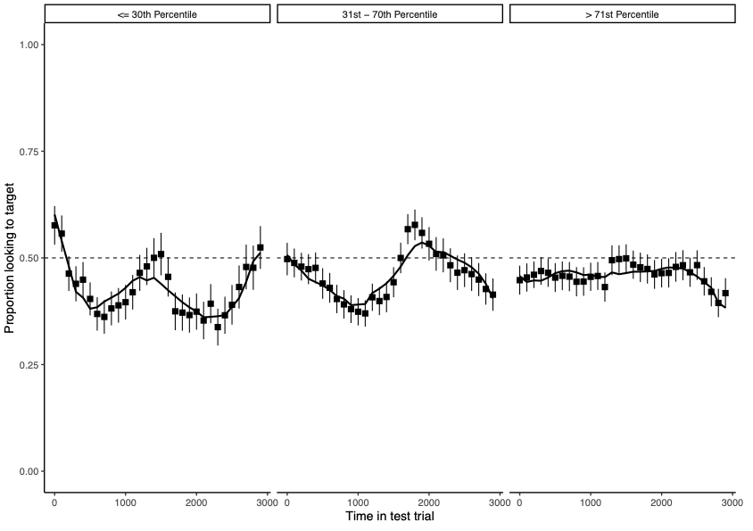
The interaction of percentiles and ot2 is pictured in Figure 2. For visualization purposes, we divided participants into groups along the continuous variable of percentile: at or below the 30th percentile, 31st-70th percentile, and above the 71st percentile. This division was chosen so that lowest group corresponds to a cutoff to define children as ‘late talkers’ in a prior study of object perception (Jones & Smith, 2005), with the participants above this cutoff divided into equal-sized groups (see Table S4 in supplementary materials for descriptive statistics). As can be seen, the negative sign of this interaction suggests that when collapsing across stimuli and probe type, lower percentile toddlers show a significant downward curvilinear trend indicating looking to the distractor, in contrast to higher percentile toddlers.
Figure 2. Proportion looking to the target over the response period for trials for groups of children based on vocabulary percentile score. Note that percentile was entered in statistical models as a continuous variable, and thus grouping is for visualization purposes only.

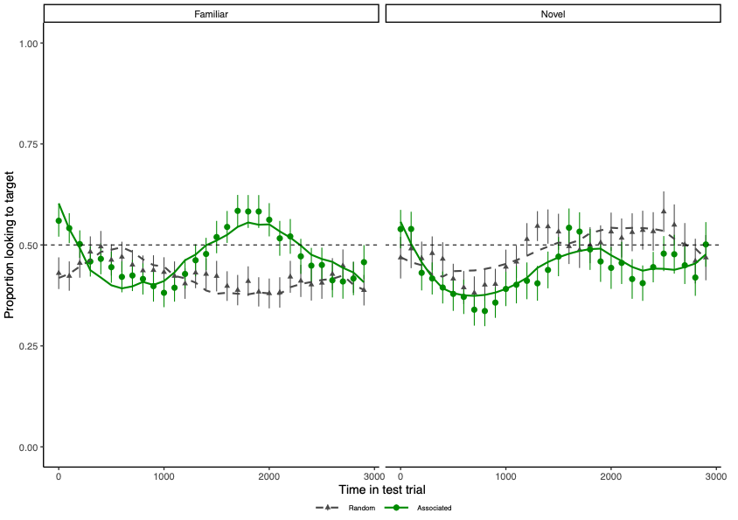
The interaction of associated/random, familiar/novel and ot3 reflects an s-shaped looking trajectory. The left panel of Figure 3 shows that with familiar stimuli following an associated probe (because random was coded as the baseline) toddlers first looked away from the target but then switched to look towards the target (solid green line) and did so at levels that surpassed the 50% equal target/distractor looking rate, before looking back to the distractor. The ot4 effect appears to reflect that with novel stimuli toddlers make one more change in looking back towards the target at the end of the test array period (solid green line, right panel). Overall, however, it is clear that with familiar stimuli toddlers look to the target following associated probes, but not random ones.
Figure 3. Proportion looking to the target over the response period for trials with familiar (left panel) and novel (right panel) objects, following associated (green circles) and random (grey triangles) probes. Lines (solid for associated, dashed for random) represent model fit.

The significant four-way interaction including percentile and ot1 suggests this difference in looking with familiar stimuli following associated probes was also influenced by infant vocabulary level. As can be seen in in the bottom panels of Figure 4, there was little linear change in the overall amount of looking to the target for novel stimuli following associated probes relative to random ones, and no differences across vocabulary percentile. By contrast, with familiar stimuli, the difference in looking to the target
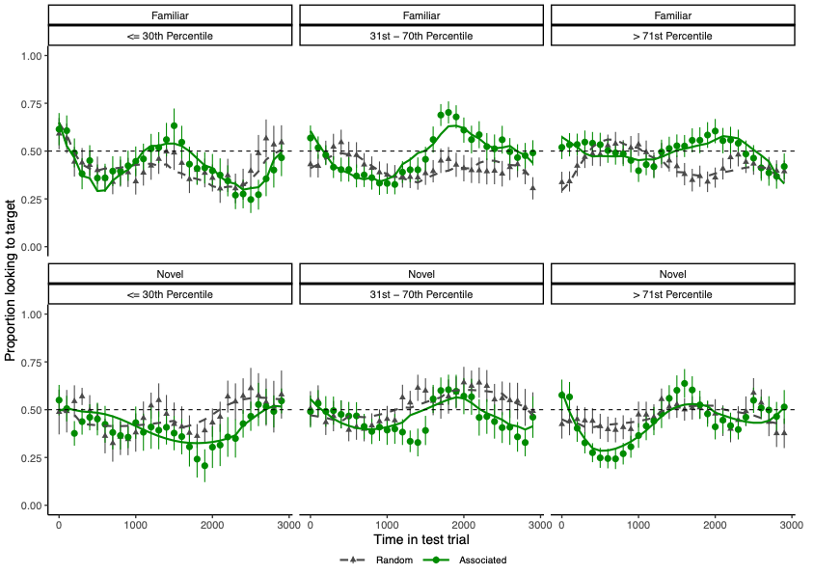
Figure 4. Proportion looking to the target over the response period for trials with familiar (top row) and novel (bottom row) objects, following associated (green circles) and random (grey triangles) probes. Lines, solid for associated, dashed for random, represent model fit. Data are divided into groups of children based on vocabulary percentile score for visualization purposes, but this variable was continuous in statistical models.

following associated but not novel probes is again seen in higher percentile toddlers. The linear component suggests that for toddlers in the middle of the vocabulary percentile range this difference rode on top of an overall tendency for increasing looking to the target over the course of the test array. For the highest percentile toddlers this tendency was pulled down by the sharp look to towards the distractor at the end of the test array. And, while toddlers towards the low end of the percentile range showed an overall increase in looking towards the target over the course of the test stimuli presentation period following associated probes, this only reached a maximum of 50% looking to the target.
Overall, then, the data and analyses provide some support for both of our exploratory hypotheses. Toddlers with more words in their productive vocabulary for their age and gender showed more evidence of remembering object pairs (hypothesis 1). And toddlers showed more evidence of remembering pairs of familiar, compared to novel, objects (hypothesis 2).
Discussion
The goal of this study was to investigate the relation between object memory and the early stages of children’s productive vocabulary development. To that aim, we collected data from toddlers between 14- and 24-months-of-age in an eye tracking visual paired associates memory task. We found that toddlers who scored in the higher percentiles of vocabulary for their age and gender showed more evidence of remembering familiar object pairs. When these toddlers were presented two objects that toddlers their age often produce names for and they had likely seen outside of the experiment (but perhaps not together), the subsequent presentation of one of those objects cued looking to the other. In contrast, for toddlers who scored in lower percentiles in productive vocabulary given their age and gender the presentation of an object did not clearly cue looking to the object it had been just-previously paired with.
When toddlers were shown two objects they are unlikely to have seen outside of the study and would not have names for, the subsequent presentation of one of them did not cue looking to the other. However, following a probe that had been previously paired with another item toddlers who scored lower and higher percentile ranges tended to look not at the target item that had previously presented with the probe, but at the other object (green solid lines, bottom left and right panels of Figure 4). This object was only previously seen during the initial exposure phase before the experimental trials. This looking pattern, then, suggests looking to the most novel object and thus some differentiation between the objects in terms of what had previously been seen.
Our finding that toddlers’ gaze trajectories related to their vocabulary percentile is in line with prior findings from Collisson et al., (2015) and Vlach and DeBrock (2017) who also found relations between children’s memory for objects and aspects of vocabulary development. Vlach and DeBrock (2017) demonstrated that 22- to 66-month-old children who performed better on a VPA task that required an explicit pointing response also learned more novel word-object mappings. Collisson et al. (2015) found that 3- and 4-year-old children with SLI were less able to learn pairs of objects presented in a VPA task that required explicit instruction and responses.
Our results are also consistent with previous research showing that infants in the studied age range find it difficult to form and maintain associations created after brief presentations. For example, previous studies have indicated that children under 30 months struggle to remember new word-object mappings when presented only a handful of times (Bion et al., 2013; Horst & Samuelson, 2008). Interestingly, Kucker and Samuelson (2012) found that 24-month-old children did remember novel word-object mappings if they were allowed to familiarize themselves with the objects first by handling and manipulating them. This fits with our finding that children did better remembering pairs of objects with which they were likely to have had more experience with and thus formed some representation of.
The difference in memory for pairs of familiar objects might be attributed to the children having established concepts and prior representations of these objects, making it easier to encode both objects during the memory array and/or retrieve which of the objects had been seen with the probe during the response period. In the absence of such concepts or prior representations, encoding of the novel stimuli is likely to be more difficult, perhaps resulting in memories that are not as complete or a memory for only one of the objects presented on the memory array. Thus, when confronted with the test array, toddlers cannot retrieve which item was previously associated with the probe, and their looking is attracted to the most novel stimulus. However, the fact that toddlers’ performance on novel trials differed depending on whether the probe had previously been seen with one of the items on the test array (associated trials) suggests some memory for the object pair. Nonetheless, the difference in performance with familiar and novel objects lends further support to the idea our task is sensitive to differing levels of vocabulary knowledge, as we used likelihood of children near our age range knowing the label as our measure of familiarity.
It is important to note, however, that we cannot completely rule out that children’s performance in our object memory task may be related to age rather than vocabulary. As would be expected, there was a strong and significant correlation between age and productive vocabulary size (R = 0.62, p < .0001). The similar AIC values for models using these variables may reflect the correlation between these variables, which likely capture overlapping developmental variance. This raises the possibility that age and productive vocabulary are both indexing a shared underlying developmental process, rather than indexing fully independent contributions to performance. That said, the developmental variable that model comparison supported, vocabulary percentile score, was uncorrelated with age (R = 0.035, p = 0.65). This is as expected given it is a measure of productive vocabulary given children’s age and gender. This suggests that performance is better predicted by a child’s relative vocabulary development compared to peers, rather than chronological age or overall productive vocabulary. Of course, our results are only preliminary and there are likely many factors that contribute to an individual child’s memory performance in our task, including the additional exposure to objects and words that may come with age.
More generally, our research contributes to the body of work investigating how memory and language are related. This growing area of investigation has emphasised the importance of visual memory in the early stages of vocabulary development (Pickering et al., 2023; Vlach, 2019; Wojcik, 2013). Related work also shows how memory processes are influenced by words (Vales & Smith, 2015, 2018) and points to how this connection may further support word learning (Carvalho et al., 2018). Other work has suggested that children’s visual exploration of objects is related to subsequent vocabulary development. Slone et al., (2019) showed that children who showed themselves more variable views of objects during free play at 15-months-of age had larger vocabularies 6 months later. Further exploration of the interaction of visual processing, visual memory and vocabulary may reveal how differences in individual children’s visual processing and visual memory relate to variability in vocabulary development.

Limitations and Future Directions
Our study represents an initial effort to develop an efficient, toddler-friendly task that could be used to examine relations between memory for visual objects and early vocabulary development. We found some evidence that children who are slower in their vocabulary development showed less evidence of memory for pairs of objects. However, caution is warranted as we had only a small number of children in our sample with vocabularies below the 30th percentile. An important future step would be to collect data from a larger sample, perhaps selectively recruiting participants from families with a history of language delay. It is also the case that our percentile data are not based on a large normative sample, and thus it is also possible that our percentile scores do not match those based on a larger, more representative sample. Nonetheless, given we used the same method to assign percentiles to all the children in our study, the relative percentiles within our sample, and this the relation to object memory on our VPA task, should still hold.
Future studies may also want to focus on trials with familiar stimuli. While there is some suggestion that children had some memory of which novel object they had been seen before, fewer novel object trials were completed and submitted to analysis. It would be worthwhile to only use familiar objects and perhaps boost the number of familiar object trials to make those trials even more robust.
Finally, it could be useful in future work to analyse data from the memory array portion of the task. To demonstrate memory for the objects they have seen, children first need to form a robust encoding the memory array. In additional set of exploratory analyses not included here, we did not find that looking on the test array was influenced by total looking to the memory array (Bakopoulou, 2024). However, a more detailed examination of looking patterns may provide more insight. Indeed, in a study with adults, Kamp and Zimmer (2015) found that the average number of transitions produced during encoding correlated with associative memory performance, with more transitions being related to increased probability of later retrieval. Examining transitions in future work could prove fruitful, although the longer encoding window used by Kamp and Zimmer (2015; 5s v the 3s used here) might need to be balanced with constraints on overall task time for infants.
Despite its limitations, this study revealed some evidence suggesting that infants’ memory for pairs of objects was related to their vocabulary rather than their age. Given that object names form a large proportion of children’s early productive vocabularies, it is not surprizing that children’s ability to create and remember representations of objects would be related to their vocabulary size. Much more work is needed to both map out the extent of this relation and its nature. Nevertheless, we believe the work presented here, and specifically the new VPA task we used, is a useful addition to the growing body of literature linking visual processing to vocabulary development and will support future work that seeks a deeper understanding of the extent and nature of the relation between these domains.

References
Bakopoulou, Melina, E. (2024). Exploration of multiple memory processes in children’s mapping and generalising of novel nouns. Doctoral dissertation, University of East Anglia. UEA Digital Repository; https://ueaeprints.uea.ac.uk/id/eprint/98444/
Bates, E., Marchman, V., Thal, D., Fenson, L., Dale, P., Reznick, J. S., Reilly, J., & Hartung, J. (1994). Developmental and stylistic variation in the composition of early vocabulary. Journal of Child Language, 21(1), 85–123. https://doi.org/10.1017/S0305000900008680
Bhat, A. A., Spencer, J. P., & Samuelson, L. K. (2022). Word-Object Learning via Visual Exploration in Space (WOLVES): A neural process model of cross-situational word learning. Psychological Review, 129(4), 640–695. https://doi.org/10.1037/rev0000313
Bion, R. a H., Borovsky, A., & Fernald, A. (2013). Fast mapping, slow learning: Disambiguation of novel word-object mappings in relation to vocabulary learning at 18, 24, and 30months. Cognition, 126(1), 39–53. https://doi.org/10.1016/j.cognition.2012.08.008
Bishop, D. V. M., Snowling, M. J., Thompson, P. A., Greenhalgh, T., Adams, C., Archibald, L., Baird, G., Bauer, A., Bellair, J., Boyle, C., Brownlie, E., Carter, G., Clark, B., Clegg, J., Cohen, N., Conti-Ramsden, G., Dockrell, J., Dunn, J., Ebbels, S., … Whitehouse, A. (2016). CATALISE: A multinational and multidisciplinary Delphi consensus study. Identifying language impairments in children. PLoS ONE, 11(7), 1–26. https://doi.org/10.1371/journal.pone.0158753
Carvalho, P. F., Vales, C., Fausey, C. M., & Smith, L. B. (2018). Novel names extend for how long preschool children sample visual information. Journal of Experimental Child Psychology, 168, 1–18. https://doi.org/10.1016/j.jecp.2017.12.002
Collisson, B. A., Grela, B., Spaulding, T., Rueckl, J. G., & Magnuson, J. S. (2015). Individual differences in the shape bias in preschool children with specific language impairment and typical language development: Theoretical and clinical implications. Developmental Science, 18(3), 373–388. https://doi.org/10.1111/desc.12219
Cowan, N. (2014). Working Memory Underpins Cognitive Development, Learning, and Education. Educational Psychology Review, 26(2), 197–223. https://doi.org/10.1007/s10648-013-9246-y
Dedre Gentner. (1982). Why nouns are learned before verbs: Linguistic relativity versus natrural partitioning. BBN Report, (no 4854).
Fernald, A., Zangl, R., Portillo, A. luz, & Marchman. (2008). Looking while listening: Using eye movements to monitor spoken languae comprehension by infants and young children. In I. A. Sekerina, E. M. Fernandez, & H. Clahsen (Eds), Developmental Psycholinguistics: On-line methods in children’s language processing (pp. 97–135). John Benjamins.
Forbes, S. H., Dink, J. W., & Ferguson, B. (2021). eyetrackingR. http://www.eyetracking-r.com/
Frank, M. C., Braginsky, M., Yurovsky, D., & Marchman, V. A. (2017). Wordbank: An open repository for developmental vocabulary data. Journal of Child Language, 44(3), 677–694. https://doi.org/10.1017/S0305000916000209
GIMP, GNU Image Manipulation Program. (n.d.). [Computer software]. Retrieved https://gimp.org
Hamilton, A., Plunkett, K., & Schafer, G. (2000). Infant vocabulary development assessed with a British communicative development inventory. Journal of Child Language, 27(3), 689–705. https://doi.org/10.1017/S0305000900004414
Hartig, F. (2020). DHARMa: Residual Diagnostics for Hierarchical (Multi-Level / Mixed) Regression Models. Retrieved from https://cran.r-project.org/package=DHARMa.
Horst, J. S., & Hout, M. C. (2016). The Novel Object and Unusual Name (NOUN) Database: A collection of novel images for use in experimental research. Behavior Research Methods, 48(4), 1393–1409. https://doi.org/10.3758/s13428-015-0647-3
Horst, J. S., & Samuelson, L. K. (2008). Fast Mapping but Poor Retention by 24-Month-Old Infants. Infancy, 13(2), 128–157. https://doi.org/10.1080/15250000701795598
Jones, S. S., & Smith, L. B. (2005). Object name learning and object perception: A deficit in late talkers. Journal of Child Language, 32(1), 223–240. https://doi.org/10.1017/S0305000904006646
Kamp, S.-M., & Zimmer, H. D. (2015). Contributions of attention and elaboration to associative encoding in young and older adults. Neuropsychologia, 75, 252–264. https://doi.org/10.1016/j.neuropsychologia.2015.06.026
Kersten, A. W., & Smith, L. B. (2002). Attention to novel objects during verb learning. Child Development, 73(1), 93–109. https://doi.org/10.1111/1467-8624.00394
Kucker, S. C., & Samuelson, L. K. (2012). The First Slow Step: Differential Effects of Object and Word-Form Familiarization on Retention of Fast-Mapped Words. Infancy, 17(3). https://doi.org/10.1111/j.1532-7078.2011.00081.x
Lisa M Oakes. (2012). Special Issue: Advances in eye tracking in infancy research. In Infancy (pp. 1–140).
Ludecke, D., Ben-Shachar, M., Waggoner, P., & Makowski, D. (n.d.). performance: An R Package for Assessment, Comparison and Testing of Statistical Models. Journal of Open Source Software, 6(60), 3139. Retrieved https://doi.org/10.21105/joss.03139
Marchman, V. A., & Fernald, A. (2008). Speed of word recognition and vocabulary knowledge in infancy predict cognitive and language outcomes in later childhood. Developmental Science, 11(3). https://doi.org/10.1111/j.1467-7687.2008.00671.x
McDonough, C., Song, L., Hirsh‐Pasek, K., Golinkoff, R. M., & Lannon, R. (2011). An image is worth a thousand words: Why nouns tend to dominate verbs in early word learning. Developmental Science, 14(2), 181–189. https://doi.org/10.1111/j.1467-7687.2010.00968.x
Mintz, T. H., & Gleitman, L. R. (2002). Adjectives really do modify nouns: The incremental and restricted nature of early adjective acquisition. Cognition, 84(3), 267–293. https://doi.org/10.1016/S0010-0277(02)00047-1
Mirman, D. (2014). Growth Curve Analysis and Visualization using R. Chapman and Hall/CRC.
Perry, L. K., Kucker, S. C., Horst, J. S., & Samuelson, L. K. (2021). Late Bloomer or Language Disorder? Differences in Toddler Vocabulary Structure Associated with Long-term Language Outcomes. Under Review.
Pickering, H. E., Peters, J. L., & Crewther, S. G. (2023). A Role for Visual Memory in Vocabulary Development: A Systematic Review and Meta-Analysis. Neuropsychology Review, 33(4), 803–833. https://doi.org/10.1007/s11065-022-09561-4
R Core Team. (2020). R: A Language and Environment for Statistical Computing.
Rescorla, L. (2009). Age 17 language and reading outcomes in late-talking toddlers: Support for a dimensional perspective on language delay. Journal of Speech, Language, and Hearing Research, 52(1), 16–30. https://doi.org/10.1044/1092-4388(2008/07-0171)
Rose, S. A., Feldman, J. F., & Jankowski, J. J. (2004). Infant visual recognition memory. Developmental Review, 24(1), 74–100. https://doi.org/10.1016/j.dr.2003.09.004
Ross-Sheehy, S., & Eschman, B. (2019). Assessing visual STM in infants and adults: Eye movements and pupil dynamics reflect memory maintenance. Visual Cognition, 27(1), 78–92. https://doi.org/10.1080/13506285.2019.1600089
Samuelson, L. K., & McMurray, B. (2017). What does it take to learn a word? Wiley Interdisciplinary Reviews: Cognitive Science, 8(1–2), 2012–2013. https://doi.org/10.1002/wcs.1421
Slone, L. K., Smith, L. B., & Yu, C. (2019). Self‐generated variability in object images predicts vocabulary growth. Developmental Science, 22(6), e12816. https://doi.org/10.1111/desc.12816
Snedeker, J & Gleitman, L. (2004). Why it is hard to label our concepts. In Weaving a lexicon (Vol. 257294).
Spriet, C., Abassi, E., Hochmann, J.-R., & Papeo, L. (2022). Visual object categorization in infancy. Proceedings of the National Academy of Sciences, 119(8), e2105866119. https://doi.org/10.1073/pnas.2105866119
Vales, C., & Smith, L. B. (2015). Words, shape, visual search and visual working memory in 3‐year‐old children. Developmental Science, 18(1), 65–79. https://doi.org/10.1111/desc.12179
Vales, C., & Smith, L. B. (2018). When a word is worth more than a picture: Words lower the threshold for object identification in 3-year-old children. Journal of Experimental Child Psychology, 175, 37–47. https://doi.org/10.1016/j.jecp.2018.04.015
Vlach, H. A. (2019a). Learning to Remember Words: Memory Constraints as Double‐Edged Sword Mechanisms of Language Development. Child Development Perspectives, 13(3), 159–165. https://doi.org/10.1111/cdep.12337
Vlach, H. A. (2019b). Learning to Remember Words: Memory Constraints as Double-Edged Sword Mechanisms of Language Development. Child Development Perspectives, 13(3), 159–165. https://doi.org/10.1111/cdep.12337
Vlach, H. A., & DeBrock, C. A. (2017). Remember dax? Relations between children’s cross-situational word learning, memory, and language abilities. Journal of Memory and Language, 93, 217–230. https://doi.org/10.1016/j.jml.2016.10.001
Vlach, H. A., & Johnson, S. P. (2013). Memory constraints on infants’ cross-situational statistical learning. Cognition, 127(3), 375–382. https://doi.org/10.1016/j.cognition.2013.02.015
Wojcik, E. H. (2013). Remembering New Words: Integrating Early Memory Development into Word Learning. Frontiers in Psychology, 4. https://doi.org/10.3389/fpsyg.2013.00151

† Note that while the literature prior to 2016 uses Specific Language Impairment (SLI) to refer to children with difficulties apparently constrained to language learning, we use the Developmental Language Disorder (DLD) to refer to this group, in line with the recent consensus in the field (Bishop et al., 2016).

