Breeders are less active foragers than non-breeders in wild Damaraland mole-rats
Yannick Francioli¹, Jack Thorley², Kyle Finn³, Tim Clutton-Brock² & Markus Zöttl¹
¹ Ecology and Evolution in Microbial Model Systems, EEMiS, Department of Biology and Environmental Science, Linnaeus University, Kalmar, Sweden
² Department of Zoology, University of Cambridge, Cambridge, UK
³ Mammal Research Institute, Department of Zoology and Entomology, University of Pretoria, South Africa
Correspondence: Markus.zottl@lnu.se
ABSTRACT
Eusocial societies are characterised by a clear division of labour between non-breeding workers and breeding queens and queens often do not contribute to foraging, defence and other maintenance tasks. It has been suggested that the structure and organisation of social mole-rat groups resembles that of eusocial insect societies. However, the division of labour has rarely been investigated in wild mole-rats and it is unknown whether breeders show decreased foraging activity compared to non-breeding helpers in natural groups. Here we show that, in wild Damaraland mole-rats (Fukomys damarensis), breeders show lower activity in foraging areas than non-breeding group members. Both breeders and non-breeders displayed variation in activity across the different seasons. Our results suggest that group living allows social mole-rat breeders to reduce their investment in energetically costly behaviour, or alternatively, that the high cost of reproduction in this species forces a behavioural trade-off against foraging investment.
INTRODUCTION
Eusocial insects show pronounced division of labour, where breeders are limited to the nest and reproduce, whereas workers are sterile and engage in foraging, brood care and defence of the colony [1]. It has been argued that two species of social mole-rats in the family Bathyergidae share some of the characteristics of termites and other eusocial insects [2-5]. In particular, previous studies have suggested that mole-rat groups consist of distinct castes of infrequent workers, frequent workers and breeders that differ in their behaviour, body size, growth and longevity [2-7]. In captive groups of both naked and Damaraland mole-rats, breeders move substrate and food through their tunnels less frequently than non-breeders and spend less time digging than nonbreeding helpers [8, 9], and recent studies of both species show that behavioural variation among non-breeders is continuously distributed and that non-breeders do not specialise in certain activities [10-12].
While captive studies provide detailed records of individual activity, food is usually provided ad libitum and animals are maintained in artificial tunnel systems that are far shorter than those in the natural habitat, where mole-rats dig vast tunnel systems through sandy soils in order to access the tubers of desert plants that they feed on [3, 13]. Once accessed, most tubers are too large to be eaten by a single individual and are therefore left in situ and eaten when needed [3], though smaller bulbs and items are often moved to a common food store in close proximity to the nest (Supplementary Figure 1). As a result, the reduced need for group members to dig and maintain tunnel systems in captive groups could decrease the difference in activity patterns between breeders and non-breeders, which may be substantially larger in natural groups. It is now important to compare the activity patterns of breeders and non-breeders in the wild to determine whether or not there are contrasts in the involvement of breeders and non-breeders in different cooperative activities, as there are in termites, primitively eusocial insects, and other cooperatively breeding vertebrates.
In this study, we developed and used a bio-logging approach to record activity of foraging Damaraland mole-rats in their natural habitat. While others have used telemetry-based methods to investigate general activity patterns of mole-rats in the wild [14-16], we deployed a radio-frequency identification (RFID) reader array to record the activity of transpondered individuals in foraging areas of the burrow system (Supplementary Figures 2 & 3). Activity in foraging areas is likely closely linked to digging behaviour, i- because the reader array was always placed above tunnels showing recent digging activity in the form of fresh mounds (Supplementary Figure 1, Supplementary Table 1), and ii- because total activity and digging are closely correlated in captivity [12]. Subsequently, we investigated whether breeders and non-breeders of wild Damaraland mole-rats differed in their investment in foraging activity, after having controlled for other individual characteristics and environmental drivers of activity.
MATERIALS AND METHODS
Study animals
The Damaraland mole-rat is a cooperatively breeding species occurring in southern Africa in groups of up to 41 individuals, with a single reproductive female and usually a small number of reproductive males, while non-reproductive individuals engage in foraging behaviour, pup care and group defence [3]. The study was carried out at the Kalahari Research Centre in the Northern Cape of South Africa (26°58’S, 21° 49’E), between January 2014 and September 2015. Mole-rats at our study site have been monitored from October 2013 to the present and all groups were recaptured approximately every 6 months. All individuals were implanted with a subcutaneous passive integrated transponder microchip at first capture (Trovan, DorsetID, Netherlands; hereafter ‘transponder’) and sexed by their genitals. Breeding females were identified from their perforated vagina and prominent teats [17]. Breeding males were identified through longitudinal capture records because these are usually the only large males remaining in breeding groups for a period of more than 1-2 years [18, Supplementary Figure 4]. On every capture, individuals were weighed to the nearest gram on an electronic balance.
Activity recording
To measure mole-rat activity we used a RFID reader array consisting of a stationary decoder (LID650/608, DorsetID, Netherlands) connected to a panel by-pass antenna (Trovan ANT 612, 47.5 x 40 x 4 cm, Supplementary Figures 2 & 3) which detected transponders passing within 30 cm of the panel. Mole-rat burrow tunnels run directly underneath a line of mounds. To place the array we i) identified an area of the burrow system with fresh mounds (indicating active foraging, see Supplementary Methods & Supplementary Table 1), ii) dug a shallow hole between two mounds, iii) placed the panel antenna over the top of the tunnel, and iv) covered the panel with sand. The antenna was powered by a solar panel and a car battery to allow continuous activity recordings of up to 7 days. The decoder scanned continuously and recorded every transponder passing within range in 3 second intervals. If individuals remained in the read range for longer periods they would therefore be recorded multiple times at 3 second intervals.
We placed the reader array repeatedly at 19 different groups (mean group size ± SE = 6.6 ± 0.53) in 39 different reading sessions (Supplementary Figure 5). In most cases the complete group was captured as indicated by the absence of any trapping activity for 48 hours at the end of the trapping session. Across the study 128 unique individuals were trapped and recorded. The number of reading sessions on each group ranged from 1 to 8, (mean ± SE = 2.21 ± 0.402), and the number of reading sessions per month ranged from 1 to 7 (mean ± SE = 3.545 ± 0.562). The mean duration of reader placement was 41.84 hours (SE = 4.202).
Statistical analysis
To analyse individual variation in total daily activity we calculated a daily activity score for each individual in a group that was detected at least once during a recording session and included individuals with zero values if they were recaptured after the recording session with the group but were not recorded by the RFID reader array. For each recording session we removed data from the first 4 hours after reader placement because visual inspection of the activity plots suggested that the mole-rat activity in this period may be affected by the disturbance of the group brought about by placement of the reader array and associated tunnel repair behaviour. Each time an individual was detected it gained a point of activity. Because previous radio tracking of Damaraland mole-rats suggested a mean duration of activity bouts of approximately one hour [13], an individual was assumed active for the hour following each reading of its transponder. It would then not gain a further activity point until it was detected beyond the time of this one-hour window.
We analysed the variation in daily activity by fitting a generalized linear mixed model (GLMM) with Poisson error using the glmmTMB package [19] in R 3.6.2 [20]. As predictors of daily activity we included individual characteristics (sex, body mass, breeding status), group characteristics (group size), the day of the reading (first day, second day, etc…), the time of year (cosine and sine wave expressed in radians, where 0 is the 1st January, 2$π$ is 31st December) and rainfall. Rainfall was measured by an on-site weather station, and because data from a soil moisture probe indicated that rainfall increased soil moisture for a leading period of 20 days, rainfall represented the log-transformed total rainfall 20 days prior to an activity recording (Supplementary Figure 6). We also added two-way interactions between the sex and reproductive status factors, as well as between sex and body mass. Individual identity and the unique reading session ID were specified as random intercepts to control for non-independence among observations. All continuous predictors were scaled to the mean and unit variance prior to model fitting, and because males are generally larger than females, the weight term was scaled within each sex. Inspection of the scaled model residuals indicated that assumptions of independence and normality of errors were met, and the dispersion parameter did not suggest any over or under-dispersion. The proportion of explained variance was estimated using marginal and conditional R² [21].
RESULTS
Our results show that breeders were less active than non-breeding group members in foraging areas of their group’s tunnel system (Table 1, Figure 1 & Supplementary Figure 7). Though male and females breeders did not differ significantly from each other, breeder males show intermediate levels of foraging activity between non-breeders and breeding females (Interaction term Sex*Breeder status, Table 1, Figure 1 & Supplementary Figure 7). Foraging activity was independent of body mass (Table 1). Across the seasons, rainfall increased mole-rat activity and highest activity occurred between April and October (Table 1, Figure 2).
DISCUSSION
Our analysis of activity frequencies of wild Damaraland mole-rats suggests that female breeders spend about half as much time in foraging areas as do non-breeding helpers, with male breeders somewhere intermediate between these two classes of individuals. Because activity in foraging areas is likely to be closely associated with foraging [12], our results indicate that the contrasts in cooperative foraging may be more pronounced in the wild than in captive groups, where breeder females show about a 25% percent reduction, and breeder males show similar investment as non-breeding helpers [2, 8, 9]. Given that the energetic costs of foraging are high in mole-rats [22], our results suggest that group living might allow social mole-rat breeders to reduce their investment in an energetically costly behaviour. However, whether this reduction is enough to offset the costs of breeding is uncertain, particularly for females, who often produce multiple litters per year [3] and for whom a single litter weighs on average 27.9% of a female’s post-parturition mass (n = 47 captive litters; see Supplementary Material).
Our data aligns well with recent studies on captive groups [10-12] and suggests that division of labour in mole-rat groups may be less pronounced than in primitively eusocial insects and resembles that of other cooperatively breeding vertebrates where breeder contributions can vary widely. In the primitively eusocial paper wasp (Polistes sp), queens rarely contribute to foraging [23], whereas in cooperatively vertebrates the breeders often show more substantial contributions to cooperative activities [24-26]. However, cooperation can take many forms and the degree to which the contributions of breeders and helpers diverge in their cooperative effort varies widely across different taxa and is likely to depend on the nature of the behaviour and the relative costs and benefits of carrying it out. For example, in cichlid fishes, breeders do less brood care compared to subordinate helpers [24], whereas in callitrichid primates, breeders and helpers both engage in energetically demanding infant-carrying behaviour, but the contribution of helpers is typically lower than that of breeders [25]. Some of the most detailed information on contrasts in cooperative behaviour in mammals comes from Kalahari meerkats, where reproduction is monopolised by a breeding pair and individuals engage in an unusually diverse array of cooperative behaviours including pup-feeding, babysitting, digging and guarding [26]. Across these behaviours, dominant individuals of both sexes rarely babysit [27]; but feed pups and dig at similar rates to subordinates [27], and dominant males are the most frequent sentinels in the group [28].
Our results indicate that there are pronounced contrasts in contribution to a potential public good between breeders and non-breeders in wild social mole-rats. However, we did not find differences in foraging activity across non-breeders of different sizes as suggested by some studies in captivity [5, 8, 11, 12]. As breeders are generally the oldest individuals, we could not strictly separate the effect of reproductive status from age, and to overcome this confound experimental manipulations of breeding status in the wild would be needed. Our data also does not allow us to directly identify behaviours and we suggest that future studies of division of labour in wild mole-rats should make use of biologging techniques that facilitate the identification of behavioural modes [29] to study division of labour across non-breeding mole-rats, and thereby answer the question of whether non-breeders specialise permanently or temporarily on specific tasks, and whether variation in collective foraging affects development and future fitness prospects.
Acknowledgements
We thank Dave Gaynor, Philippe Vullioud and all managers, students and volunteers for their contribution to the data collection and to organising the field site. We thank the Kalahari Research Trust for access to the research facilities and Marta Manser for her contribution to maintaining the Kalahari Research Centre and Nigel Bennett for generous support and invaluable advice during this project. We are grateful to the Northern Cape Department of Environment and Nature Conservation for permission to conduct research in the Northern Cape.

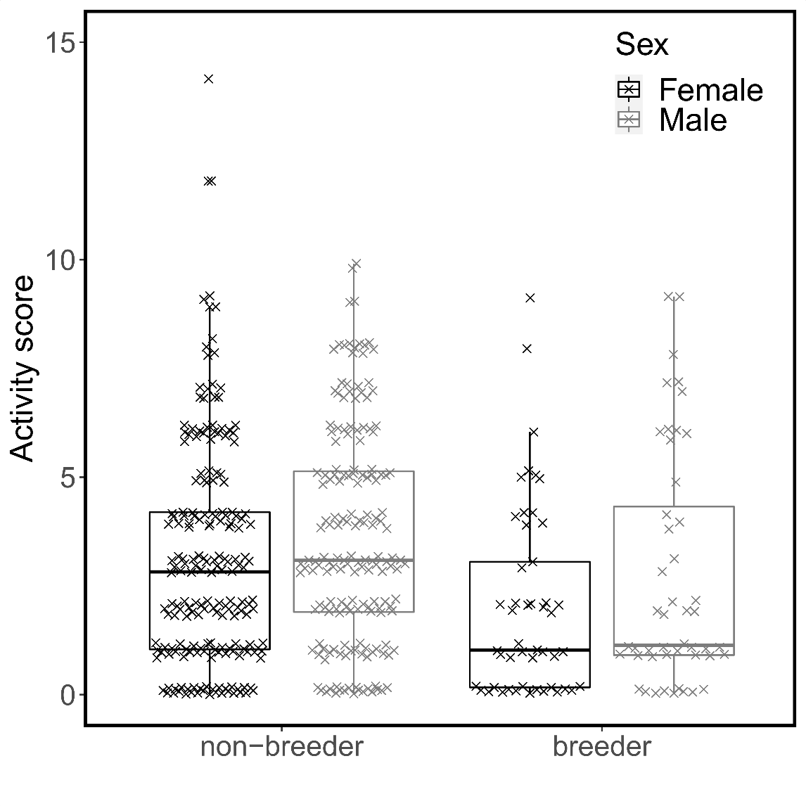
Figure 1: Foraging activity of male (grey) and female (black) breeders and non-breeders in Damaraland mole-rats. Daily activity score represents the total number of unique one-hour windows in which an individual was detected in the foraging tunnel. The box and whiskers represent the median, 25/75% quantiles (hinges) and the smallest/largest observation less/more than lower/upper hinge -/+ 1.5 * inter-quantile range. The raw data points are jittered behind the boxes (Table 1).

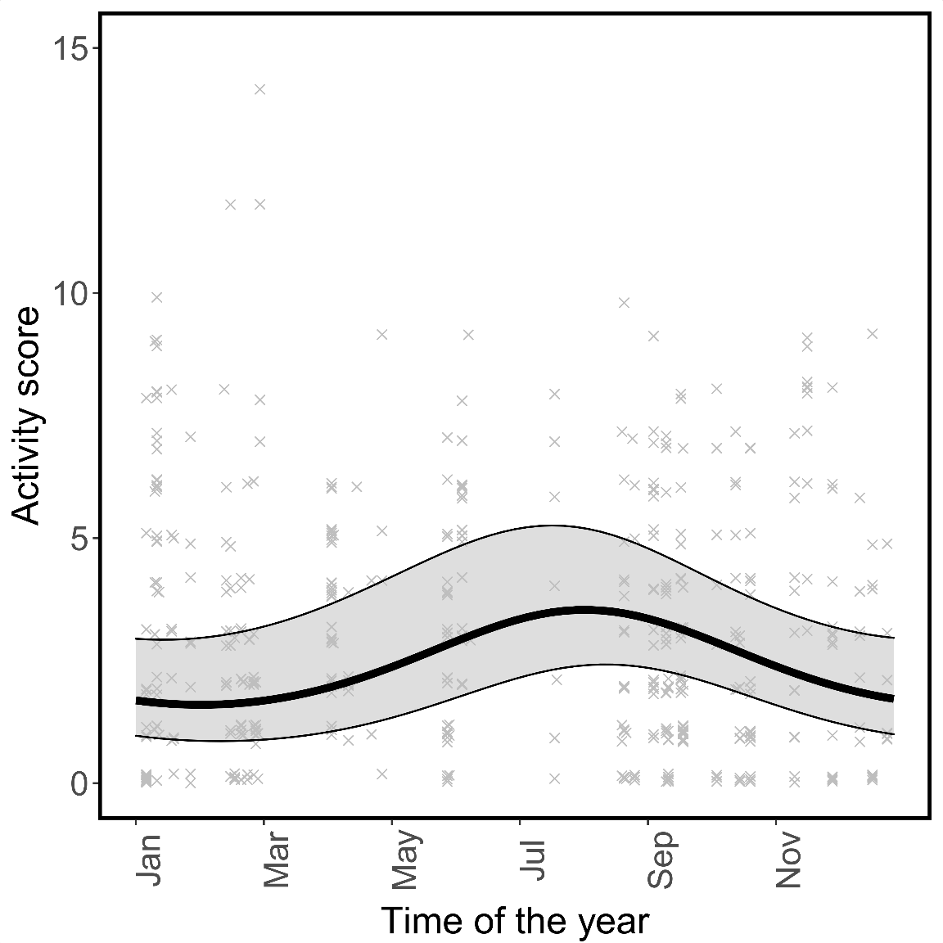
Figure 2: Foraging activity of Damaraland mole-rats across different seasons. Daily activity score represents the total number of unique one-hour windows in which an individual was detected in the foraging tunnel. Predictions were estimated from the GLMMs for a non-breeding female at the mean group size, with error bars indicating the 95% confidence intervals conditional on the fixed effects (Table 1). The raw data points are plotted in the background.
REFERENCES
[1] Bourke, A. 2011 Principles of Social Evolution. Oxford, Oxford University Press.
[2] Sherman, P.W., Jarvis, J.U.M. & Alexander, R.D. 1991 The biology of the naked mole-rat. Princeton, N. J., Princ. Univ. Press.
[3] Bennett, N.C. & Faulkes, C.G. 2000 African mole-rats: ecology and eusociality, Cambridge University Press.
[4] O'Riain, M., Jarvis, J., Alexander, R., Buffenstein, R. & Peeters, C. 2000 Morphological castes in a vertebrate. Proceedings of the National Academy of Sciences 97, 13194-13197.
[5] Jarvis, J.U., O'Riain, M.J., Bennett, N.C. & Sherman, P.W. 1994 Mammalian eusociality: a family affair. Trends in Ecology & Evolution 9, 47-51.
[6] Scantlebury, M., Speakman, J., Oosthuizen, M., Roper, T. & Bennett, N. 2006 Energetics reveals physiologically distinct castes in a eusocial mammal. Nature 440, 795-797.
[7] Dammann, P. & Burda, H. 2006 Sexual activity and reproduction delay ageing in a mammal. Current Biology 16, R117-R118.
[8] Lacey, E.A. & Sherman, P.W. 1991 Social organization of Naked Mole-Rat colonies: evidence for divisions of labor. In The Biology of the Naked Mole-Rat (eds. P.W. Sherman, J.U.M. Jarvis & R.D. Alexander), pp. 275-336. Princeton N. J., Princeton Univ. Press.
[9] Houslay, T.M., Vullioud, P., Zöttl, M. & Clutton-Brock, T.H. 2020 Benefits of cooperation in captive Damaraland mole-rats. Behavioral Ecology. 31, 711-718.
[10] Mooney, S.J., Filice, D.C., Douglas, N.R. & Holmes, M.M. 2015 Task specialization and task switching in eusocial mammals. Animal Behaviour 109, 227-233.
[11] Zöttl, M., Vullioud, P., Mendonça, R., Ticó, M.T., Gaynor, D., Mitchell, A. & Clutton-Brock, T. 2016 Differences in cooperative behavior among Damaraland mole rats are consequences of an age-related polyethism. Proceedings of the National Academy of Sciences 113, 10382-10387.
[12] Thorley, J., Mendonça, R., Vullioud, P., Torrents-Ticó, M., Zöttl, M., Gaynor, D. & Clutton-Brock, T. 2018 No task specialization among helpers in Damaraland mole-rats. Animal Behaviour 143, 9-24. (doi:https://doi.org/10.1016/j.anbehav.2018.07.004).
[13] Lovegrove, B. 1988 Colony size and structure, activity patterns and foraging behaviour of a colony of the social mole‐rat Cryptomys damarensis (Bathyergidae). Journal of Zoology 216, 391-402.
[14] Lövy, M., Šklíba, J. & Šumbera, R. 2013 Spatial and Temporal Activity Patterns of the Free-Living Giant Mole-Rat (Fukomys mechowii), the Largest Social Bathyergid. Plos One 8, e55357.
[15] Šklíba, J., Lövy, M., Hrouzková, E., Kott, O., Okrouhlík, J. & Šumbera, R. 2014 Social and environmental influences on daily activity pattern in free-living subterranean rodents: the case of a eusocial bathyergid. Journal of Biological Rhythms 29, 203-214.
[16] Šklíba, J., Lövy, M., Burda, H. & Šumbera, R. 2016 Variability of space-use patterns in a free living eusocial rodent, Ansell’s mole-rat indicates age-based rather than caste polyethism. Scientific Reports 6, 1-9.
[17] Seney, M.L., Kelly, D.A., Goldman, B.D., Šumbera, R. & Forger, N.G. 2009 Social structure predicts genital morphology in African mole-rats. PLoS One 4, e7477.
[18] Torrents‐Ticó, M., Bennett, N.C., Jarvis, J.U. & Zöttl, M. 2018 Sex differences in timing and context of dispersal in Damaraland mole‐rats (Fukomys damarensis). Journal of Zoology 306, 252-257.
[19] Brooks, M.E., Kristensen, K., van Benthem, K.J., Magnusson, A., Berg, C.W., Nielsen, A., Skaug, H.J., Machler, M. & Bolker, B.M. 2017 glmmTMB balances speed and flexibility among packages for zero-inflated generalized linear mixed modeling. The R journal 9, 378-400.
[20] R Core Team, 2020 R: A language and environment for statistical computing. R Foundation for Statistical Computing. Vienna, Austria, R Development Core Team.
[21] Nakagawa, S. & Schielzeth, H. 2013 A general and simple method for obtaining R2 from generalized linear mixed-effects models. Methods in Ecology and Evolution 4, 133-142.
[22] Lovegrove, B. 1989 The cost of burrowing by the social mole rats (Bathyergidae) Cryptomys damarensis and Heterocephalus glaber: the role of soil moisture. Physiological Zoology 62, 449-469.
[23] Dew, H.E. 1983 Division of labor and queen influence in laboratory colonies of Polistes metricus (Hymenoptera; Vespidae). Zeitschrift für Tierpsychologie 61, 127-140.
[24] Zöttl, M., Fischer, S. & Taborsky, M. 2013 Partial brood care compensation by female breeders in response to experimental manipulation of alloparental care. Animal Behaviour 85, 1471-1478.
[25] Santos, C.V., French, J.A. & Otta, E. 1997 Infant carrying behavior in callitrichid primates: Callithrix and Leontopithecus. International Journal of Primatology 18, 889-907.
[26] Clutton-Brock, T.H. & Manser, M. 2016 Meerkats: cooperative breeding in the Kalahari. In Cooperative breeding in vertebrates (eds W.D. Koenig & J.L. Dickinson), pp. 294-317. Cambridge, UK: Cambridge University Press.
[27] Clutton-Brock, T.H., Russell, A.F. & Sharpe, L.L. 2004 Behavioural tactics of breeders in cooperative meerkats. Animal Behaviour 68, 1029-1040.
[28] Clutton-Brock, T.H., O'Riain, M.J., Brotherton, P.N.M., Gaynor, D., Kansky, R., Griffin, A.S. & Manser, M. 1999 Selfish sentinels in cooperative mammals. Science 284, 1640-1644.
[29] Hammond, T.T., Springthorpe, D., Walsh, R.E. & Berg-Kirkpatrick, T. 2016 Using accelerometers to remotely and automatically characterize behavior in small animals. Journal of Experimental Biology 219, 1618-1624.

SUPPORTING INFORMATION
“Breeders are less active foragers than non-breeders in wild Damaraland mole-rats”

Study site supplementary details:
The summers (October – April) in the region are very hot with a mean maximum daily temperature of 34.0°C (range 17.9 – 44.2°C) and a mean minimum of 15.1°C (range -2.1 – 28.9°C) in summer, while in winter (May – September) mean minimum and maximum daily temperature is 3.1°C (range -11.6 – 18.7°C) and 25.0°C (range 8.7 – 39.2°C; averaged over 2009-2016 see Finn et al. 2018), respectively. Throughout the year the soil surface temperature can be more than 10°C above the ambient air temperature and maintain that temperature for over five hours during summer, but at depths inhabited by mole-rats (0.3m – 2m) the temperatures stay between 15 – 35°C with a 12 – 20°C difference between burrow and surface soil temperatures (Bennett et al. 1988).

Reproduction in captivity
At the median litter size of four in our captive population (see Zöttl et al. 2016 for details of the captive set-up), the average total mass of pups at birth was 39.23g (1SD = 4.64), which represented 27.9% (1SD = 0.04) of the female’s post-parturition mass (mean = 142.66g, 1SD = 19.41; n = 47 unique litters where the mass of pups was recorded on the date of birth).

Activity in foraging areas is probably a good indicator for cooperative foraging effort
It could be argued that the increased activity detected in foraging areas may be a consequence of dispersal and that individuals spend more time active in peripheral tunnels when they are in the process of dispersing. However, information from our long-term study site, in conjunction with the data collected in this paper, suggests that this is improbable.
We have very little evidence from our field site that dispersal takes place below-ground via burrowing, as would be predicted if dispersal is preceded by periods of digging and manifests in increased activity in peripheral tunnels. Of 44 known dispersal events recorded at our field site as of 2017, the mean dispersal distance was 984m (Finn Msc Thesis, University of Pretoria 2017). If such dispersal events routinely take place below-ground, we would therefore expect much longer tracts of mounds radiating from groups than those which we observe- particularly if one considers the high attrition rate of individuals from groups, which suggests dispersal is frequent (see below). Hazell et al. 2000 made a similar observation of Damaraland mole-rat burrow systems in the Waterburg region in Namibia, and, with additional information from mole-rats that had drowned after falling into an open canal, also concluded that dispersal in Damaraland mole-rats often takes place above-ground. If dispersal is often above-ground, it would appear non-adaptive for animals to expend considerable energy digging immediately prior to dispersal.
In addition, we find that individuals that disappeared in the period between their detection by the reader and their recapture within the group were no more or less active than those who did not disappear in this same time frame. With few predators in their close-off burrow systems, adult survival in mole-rats is thought to be high and disappearance is consequently thought to more often be a consequence of dispersal than it is of in-group mortality. To test whether individuals that disappeared were more active, we recovered all reading sessions where a complete capture of the focal group followed the deployment of the reader array. Of the 39 reading sessions in our data set, 33 fulfilled this criterion, with a mean time between reader deployment and group capture of 125.61 ± 20.68 days (range = 9-452 days); in 5 cases, the group was recaptured but the capture was not complete, so this data was removed. Of the 33 sessions with the requisite information, 244 individuals were recorded by the reader array, and could then subsequently be recaptured in the group (not disappear- 0) or not (disappear- 1). 53 of the 244 individuals (23.7%) disappeared. We then modelled the probability that an individual disappeared in a generalised linear mixed effects model with a binomial error structure, including as fixed effects the mean daily activity in the prior reading session, the time between reader deployment and subsequent live capture, sex, weight and breeding status. As random effects we specified the individual ID and the reading session ID. All continuous covariates were scaled (scaling by sex for the weight term).
From this simple model, mean daily activity did not predict subsequent disappearance after having controlled for the time between reader deployment and live capture (Supplementary Table 1). However, the model did detect a strong breeder effect such that breeders were more likely to be recaptured in a group, as well as a significant effect of weight, with heavier individuals being more likely to disappear. This latter effect is consistent with work in other populations of Damaraland mole-rats indicating that heavier (and presumably older) non-breeding individuals often disperse (Hazell et al. 2000, Torrents‐Ticó et al. 2018).

Supplementary Table 1. The probability of disappearance between reader deployment and group recapture. Estimates, standard errors and P-values taken from a generalized linear mixed model assuming a binomial error structure. Estimates provided on the log scale (logit link).
Fixed Effect Estimates | Estimate | Std. Error | P value
(Intercept) | -19.82 | 5.61 | < 0.001 | ***
Mean activity | 0.50 | 1.01 | 0.620
Time between reading and group capture | 4.93 | 2.73 | 0.072 | .
Weight | 6.67 | 2.61 | 0.011 | *
Breeding status - breeder | -21.40 | 10.43 | 0.040 | **
Sex - male | 4.27 | 4.44 | 0.335

Supplementary Table 2. Daily activity of Damaraland mole-rats, minimal model output. Estimates, standard errors and P-values taken from a generalized linear mixed model assuming a poisson error structure. Estimates provided on the log scale (logit link). Marginal R² is 0.04 and conditional R² squared is 0.58.
Fixed Effect Estimates | Estimate | Std. Error | P value
(Intercept) | 1.02132 | 0.11269 | < 0.001 | ***
Sex - male | 0.1688 | 0.09663 | 0.08066 | .
Breeding status - breeder | -0.38134 | 0.12516 | 0.00231 | **
Group size | -0.03137 | 0.09325 | 0.73652

Supplementary Figures
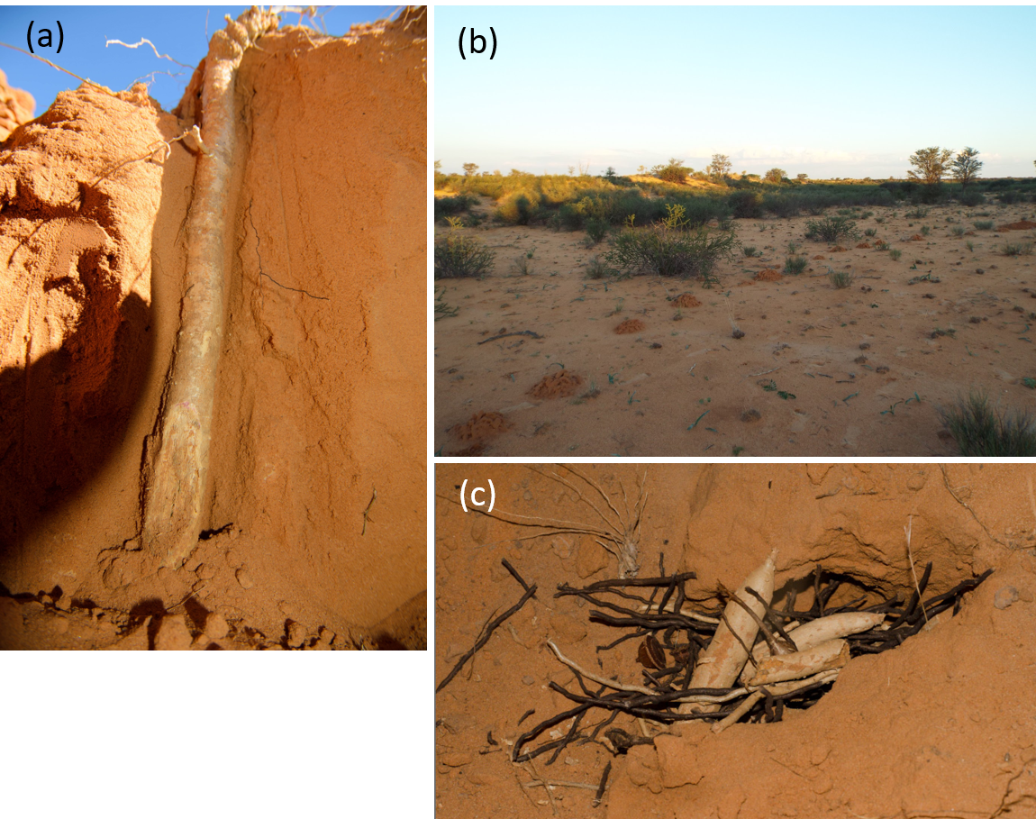
Supplementary Figure 1: a) The below-ground root stock of a Gemsbok cucumber, the principal food resource of the Damaraland mole-rat in the Kalahari Desert. The roots of cucumbers are usually 50cm in length, and often extend to 1m. b) Fresh mounds on the surface, as indicative of recent and ongoing tunnel expansion. c) A communal food store containing pieces of gemsbok cucumber and other roots. These storage areas in the tunnels are typical for all Bathyergidae mole-rats and in social species contain food. Pictures copyright Kyle Finn (a,c) & Jack Thorley (b).

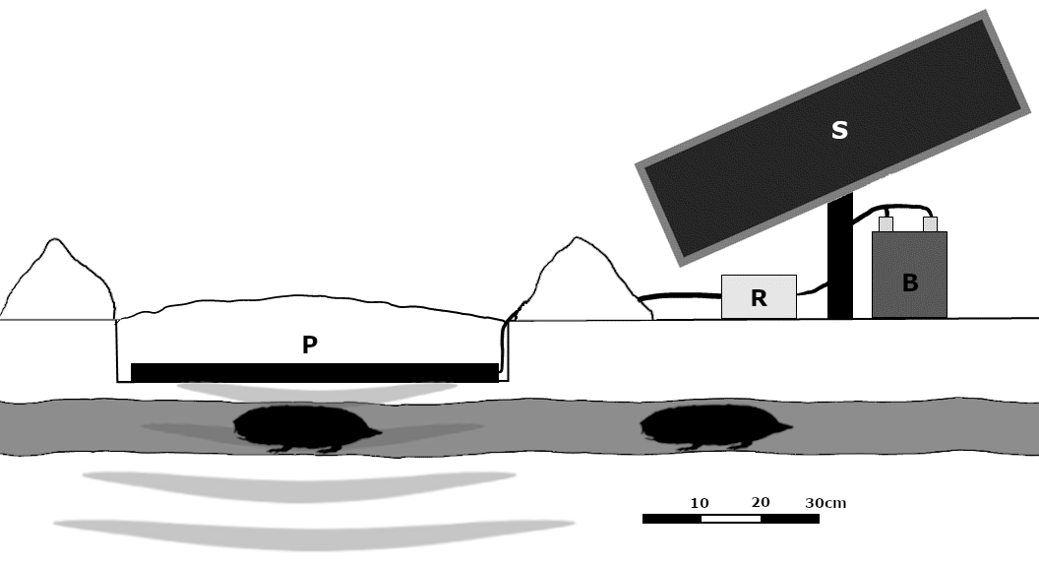
Supplementary Figure 2: Illustration of the placement of the reader array in the field. A shallow hole is carefully dug between two mole-rat mounds and the antenna (P) is placed inside. The panel has a range of ca. 30cm in a widening cone and any transponder tag passing within range is stored in the recorder (R). The recorder is powered by a car battery (B) attached to a solar panel (S).

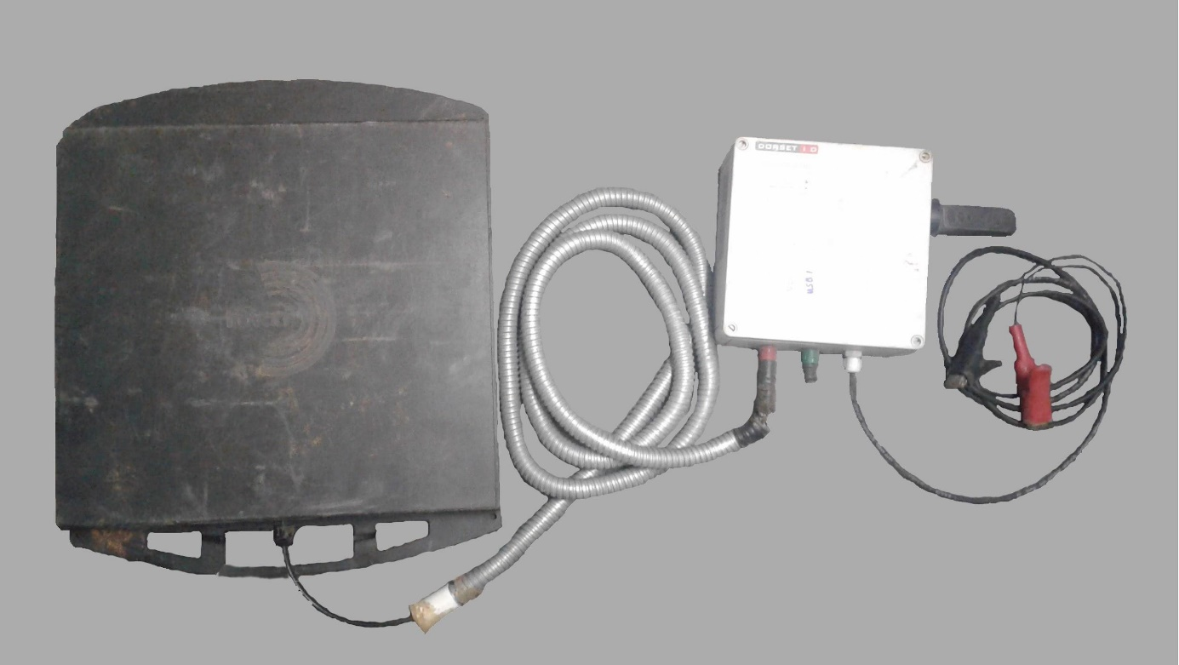
Supplementary Figure 3: RFID reader array with a custom made decoder LID650/608 (DorsetID, Aalten, Netherlands) attached to the panel antenna ANT612. The black panel scans for passive integrated transponder tags at regular intervals which are stored on a USB drive attached to the white recording box. Red and black cables are attached to a power source.
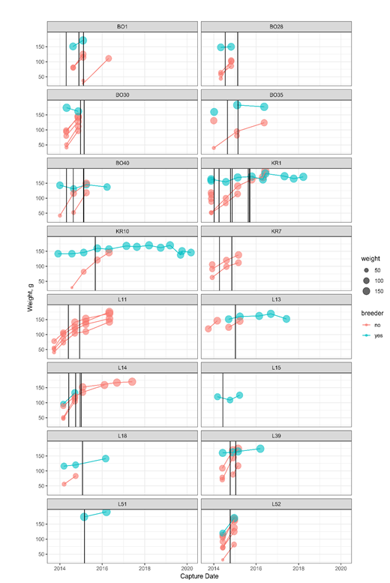
Supplementary Figure 4: The identification of breeding males using capture history and weights information. Each panel indicates the capture history of males present in a group that were detected by the reader array (reader deployments shown by black vertical lines). Note that any males recruited into the group after the last reader deployment are not shown, as we wish to emphasize the contrasts between breeding and non-breeding males in relation to the placement of the reader. From this plot, we show that breeding males (blue) are often heavier than non-breeders and persist in groups for longer.

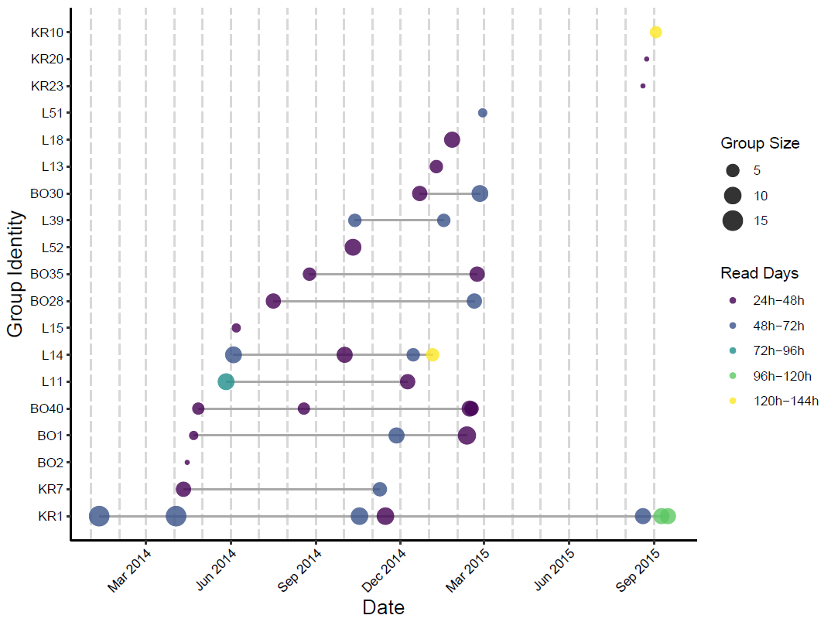
Supplementary Figure 5: Time course of Damaraland mole-rat activity recording via an RFID reader array. The array was set up at 19 groups between January 2014 and October 2015 for 1-5 days (duration of sampling indicated by the colour of the point). Some groups were sampled repeatedly (horizontal lines), generating a total of 38 unique sampling periods. The size of the points reflects the group size just prior to the deployment of the array.
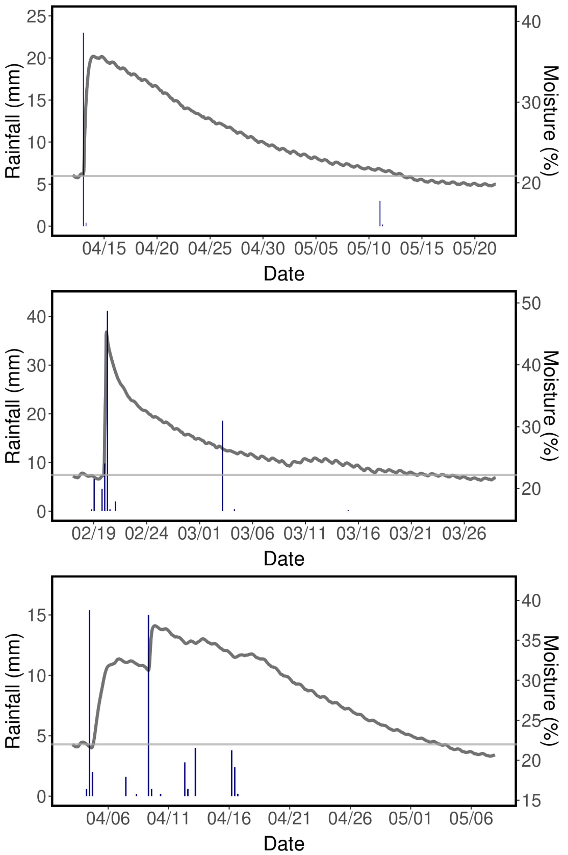
Supplementary Figure 6: Effect of rainfall on the soil moisture in 40 cm depth. Soil moisture is represented by the dark grey line, and rainfall by the blue bars (each bar represents the quantity of rain over 6 hours). The light grey line shows the mean moisture over the 24 hours preceding the first rainfall.

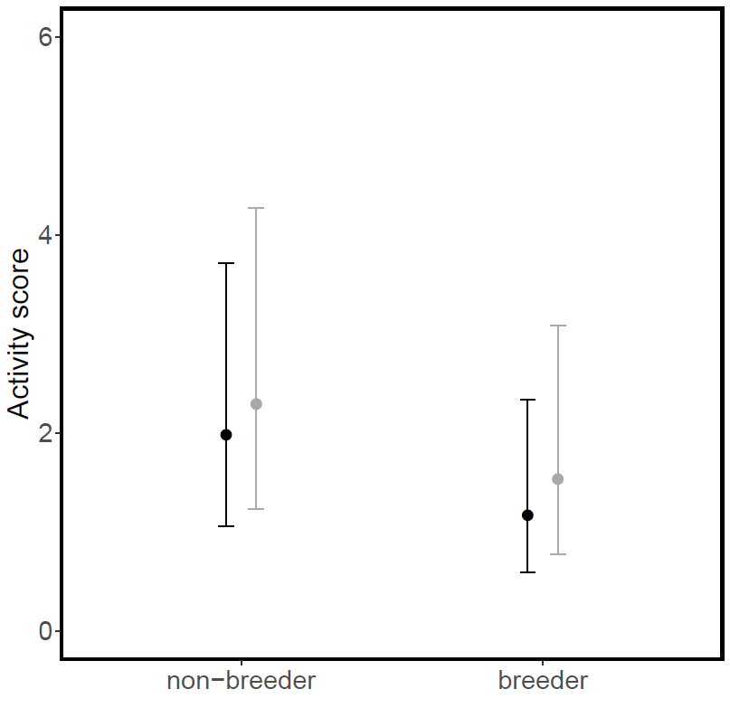
Supplementary Figure 7: Model estimates for foraging activity of breeders and non-breeders in Damaraland mole-rats for the model presented in Table 1. Black dots represent females. Grey dots represent males. Predictions were estimated from the GLMM for a mean group size, with error bars indicating the 95% confidence intervals conditional on the fixed effects (see Table 1).

Supplementary References
Hazell, R.W.A., Bennett, N.C., Jarvis, J.U.M., & Griffin, M. 2000 Adult dispersal in the co-operatively breeding Damaraland mole-rats (Cryptomys damarensis): a case study from the Waterberg region of Namibia. J. Zool. Lond. 252, 19-25.

Torrents‐Ticó, M., Bennett, N.C., Jarvis, J.U. & Zöttl, M. 2018 Sex differences in timing and context of dispersal in Damaraland mole‐rats (Fukomys damarensis). Journal of Zoology 306, 252-257.

Zöttl, M., Vullioud, P., Mendonça, E., Torrents‐Ticó, M., Gaynor, D., Mitchell, A., & Clutton-Brock, T. 2016. PNAS 113, 10382- 10387.

