Merger simulations in EU merger control: what have we learned?
Abstract
It has been over 25 years since merger simulation was first used in a European Commission merger decision. Since then, simulations – submitted by both the Commission and merging parties – have featured in numerous cases. Although their use has declined since the late 2010s, no comprehensive review has yet examined the evidence these simulations provide. We attempt to fill that gap, to hopefully rekindle the debate around their role in EU merger control. We begin with a qualitative assessment of where the Commission and the merging parties most frequently diverged in their simulation approaches, such as model selection, assumptions, and input data. We then conduct a quantitative analysis, using a data set of several hundred post-merger price predictions derived from simulations cited in Commission decisions. We find that simulations using econometrically estimated demand parameters generally predict lower post-merger price increases, though not universally. Contrary to common belief, we also show that the merging parties’ simulations do not consistently predict smaller price increases than those of the Commission. When econometric demand models are used, estimates from both sides tend to converge. We argue that this consistency offers a promising foundation for restoring confidence in the value of simulations in EU merger control.
Keywords: European Commission, merger simulations, price change, systematic review

Introduction
It has been 25 years since the first time the European Commission (Commission) used a simulation in a merger investigation: Volvo/Scania in 2000. Since then, simulations have been employed and presented by both the Commission and the merging parties in a number of cases. Simulations in EU merger control had their heyday in the middle of the 2010s, when, in 2014-2016, nearly half of the 16 total merger reviews including a simulation analysis took place. Since then, the enthusiasm of the 2010s waned and the last merger decision that reports the results of a merger simulation was in 2018. This does not necessarily mean simulations are no longer used internally—they may still serve as screening tools for identifying high-risk mergers or as aids for structuring the economic analysis of a case. Nevertheless, the high cost of producing such simulations likely limits their broader use, and they are now not included in published decisions.
There have been numerous papers discussing various aspects of merger simulations in EU merger control. We add to this literature by qualitatively and quantitatively reviewing merger simulations in Commission mergers. Although merger simulations have been applied much more sparingly by the Commission than by their US counterparts, details of the simulations are more consistently available in the Commission’s published decisions. This transparency in how simulations are presented in Europe enables us to undertake this systematic review and test several hypotheses put forward in prior academic and policy discussions.
This paper has two main contributions. First, it provides a qualitative review of how the Commission and merging parties have approached simulations, focusing on their modelling choices and core assumptions, and how the other side reacted to these. We show that certain modelling issues were discussed frequently, such as how to model countervailing factors and the choice of purchasing the outside good, whereas some appeared less frequently, such as the approach to contestable customers. We find significant disagreement around key modelling decisions – such as model choice or realism of the model’s assumptions – while other areas, like the use of instrumental variables and modelling of information asymmetries, appear less contentious.
Our second contribution is to examine three hypotheses that we identified from previous literature discussing (at a conceptual level) merger simulations in the EU. First, we test whether speculations on whether some simulations models are more or less likely to predict a large price increase. Second, we test whether simulation outcomes depend on whether the model was prepared by the Commission or the merging parties. Third, noting that a disproportionately large share of merger simulations were done in merger cases in the telecoms industry (six out of the last nine simulations), we look at whether the companies in this industry received ‘unfair’ treatment from the Commission.
One of the main objectives of our paper is to re-direct attention to merger simulations as an important part of the merger control toolkit. This is particularly timely as the European Commission’s new draft Merger Guidelines repeatedly refer to merger simulations as one of the tools to quantify the loss of head-to-head competition , especially in the context of balancing the benefits and harms of proposed mergers. Moreover, simulations deserve more attention given the emergence of new and evolving markets where traditional tools may be less well suited, and where simulations can help capture richer demand and competitive dynamics. Recent merger cases also show a shift towards more dynamic theories of harm and more complex modelling challenges, suggesting a renewed and potentially expanded role for simulation-based evidence. At the same time, we recognise that simulations are not a standalone tool and should be complemented by pricing pressure methods within the broader toolkit of predictive approaches used in merger assessment.
The remainder of the paper is structured as follows. Section 2 contains a brief overview of the merger simulation methodology. Section 3 describes our data set of merger simulations. Section 4 then contains our qualitative review of simulation practices in Commission decisions. Section 5 introduces the hypotheses we explore with the data, and Section 6 present our quantitative findings. The paper concludes in Section 7 with a discussion of their implications.

Merger simulations
Merger simulations are quantitative analyses used to predict the potential effects of a proposed merger on market outcomes, such as prices, quantities, and consumer welfare. Based on estimated or available data on key features of the market, they compare the market as it is, with a simulation of how the market would be in various counterfactual scenarios. For example, by comparing outcomes in a market with and without the merger, one can evaluate whether said merger is likely to be anticompetitive or not.
Merger simulations provide a number of advantages over other so-called ‘price-pressure’ techniques – such as ‘upward pricing pressure’ (UPP) and the gross upward pricing pressure index (GUPPI). First, in a simulation setting, one can calibrate the likely change in price and quantities for all firms in the market, not just for the merging parties. Second, they account for various competitive responses and feedback effects between the merging parties and their competitors. Together, therefore, the simulation provides a more complete assessment of the impact that the merger may have on consumers.
Furthermore, the formal framework of simulations means that the assumptions behind the price change predictions have to be made explicit, and relying on calculations compared to intuition adds accuracy and better related predictions of economic theory. Moreover, merger simulations can more accurately capture substitution patterns between products. Finally, merger simulations can be very useful for both the competition authority and the merging parties when determining which divestment remedies would be the most appropriate (if required), as they can be used to test the price and volume impacts of the merger for any redistribution of assets (brands, products or even geographic areas) between competitors.
The main disadvantage of merger simulations is that they can be difficult to apply well – their sophistication often comes at the cost of additional data requirements, more complex decisions (assumptions) about how to represent competition in the real world, and more time needed for the analysis. Moreover, as is always the case, all estimations have to be judged in light of the assumptions made. Because the estimated price effects are sensitive to the functional forms of demand (and costs), this sensitivity limits the power of the analysis. Finally, a ‘standard’ merger simulation only predicts the short-term price effects of a merger without considering the impact of future entry, product repositioning (i.e., a company shifting its product or service’s features or position within the market) and other structural changes.
There is an increasing literature that looks at how well merger simulations can predict post-merger price changes. Some of these provide evidence of simulations that accurately predict price changes, for example, Nevo (2000) looking at two mergers in the ready-to-eat cereal industry in the US, Pinske and Slade (2004) looking at two mergers in the UK brewing industry, Friberg and Romahn (2015) on a merger in the Swedish beer market, and Björnerstedt and Verboven (2016) for a merger in the market for painkillers in 2016. Garmon (2017) compares how accurate various screening methods for anticompetitive hospital mergers (traditional methods such as HHI, price pressure methods such as UPP, and calibrated merger simulation) are, finding that UPP performed better than the traditional method and even better than merger simulations, but acknowledging that data limitations could be the reason for the latter result. Balan and Brand (2023) find that merger simulations used in hospital mergers in the US performed well on simulated data.
Other papers have been less positive about the accuracy of simulations. Looking at the US airline industry, Peters (2006) finds that a simulation based on a variant of a nested logit demand model, was only modestly able to accurately predict post-merger prices. In addition, Weinberg and Hosken (2013) analyse two mergers in the motor oil and breakfast syrup industries, and find that their simulations based on a range of demand models predicted small price effects in the former industry and large price effects in the latter, though in reality prices rose considerably more in the former compared to the latter. Weinberg (2011) is similarly scathing of the accuracy of simulation predictions. Finally, in ongoing work, Illanes et al. (2024) look at 37 US mergers and find that simulations have very limited predictive power, although the authors emphasise that these results are preliminary.
Looking at the technique in more detail, merger simulations combine a model of demand with a model of supply. Parameters of the two sides of the market are calibrated using existing information and data on the market, or estimated using various econometric methods. The former approach (we use the shorthand ‘calibrated merger simulation’) is less data- and time-intensive. Instead of estimating parameters, these parameters are calibrated using the predicted structural relationships between observed variables.
Where data and resources allow, the supply and demand parameters can be estimated (‘econometric merger simulation’). For example, such econometric estimation of the demand parameters, based on rich, granular data can – if implemented correctly – capture consumers’ preferences between the products sold within a given industry that could be much more informative than documentary evidence – particularly in complex mergers involving many products where it may be difficult to otherwise disentangle the effects they have on each other – or case precedents (which could either be outdated or incorrect in the first place). This can even help at the earlier market definition stage, even if one does not proceed to actually running a fully-fledged merger simulation. Moreover, merger simulations do not require the market to be defined in the first place – provided the demand side of the model can sufficiently capture the switching patterns between all products, the merger simulation can directly predict price changes for all products.
Using calibrated or estimated parameters, a market equilibrium is then defined, and the merger is accounted for by transferring and combining assets. Finally, the model predicts how the pricing incentives of both the merging parties and the other competitors in the market are affected by the change in assets, holding all other features of the market unchanged. It does this by calculating predicted post-merger prices and quantities either at the level of the merging parties, or at the level of the whole market. If one expects the merger to generate efficiencies, these can be incorporated into the simulation as well.
Merger simulation is not a one-size-fits-all technique. A critical issue is that one must design the model so that it provides a useful approximation of how demand and supply work in the real market. This requires making assumptions. For instance, on the supply side, one needs to understand and approximate the way firms compete and supply products, which is likely to differ by industry. Is the relevant product homogeneous (i.e., largely the same across players within the market) or heterogeneous, do firms compete on prices, or quantity, or innovation? Similarly, on the demand side, one has to decide on the best approximation of consumer choices and preferences, for example, whether these are best described by linear demand models, discrete choice models (i.e., where a consumer typically purchases a single item – for example, a car – from a choice of alternatives), demand system estimation models (typically estimated with econometric methods), survey-based models, or multi-sided demand models (relevant for e.g. tech platforms, that bring together consumers and advertisers). The calibrated simulations we analysed in this paper typically impose linear demand, which permits heterogeneous substitution patterns, and has the advantage that it requires data only on margins and diversion ratios (i.e. how much the demand for one product increases when another product’s price increases). The applicability of the chosen model and the credibility of the assumptions have often been contested between the Commission and the merging parties. We turn to a detailed discussion of these assumptions in Section 4.

Our data set of merger simulations
Since the first occurrence in 2000 (Volvo/Scania), merger simulations have been used in 16 mergers assessed by the Commission, which are listed in Table 1. Their use increased from 2010, peaking in 2014-2016, a period in which seven cases presented price change predictions based on some form of merger simulation method. Since then, there have only been two cases using simulations, both in 2018.
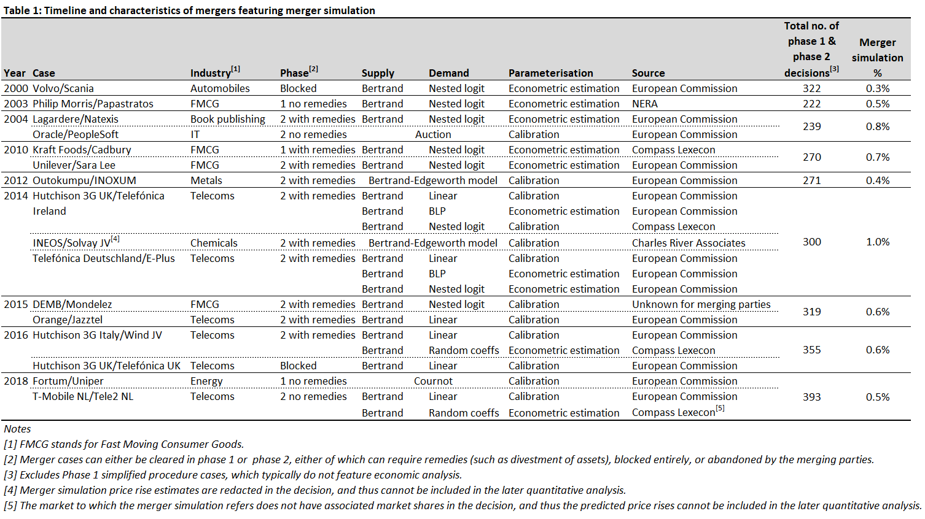
Across these 16 cases, 22 different merger simulations were produced by either the Commission or a small group of economic consultancies representing the merging parties. This concentration of simulations among the Commission and the largest consultancies speaks to the complexity of the task to deliver simulations in a robust and reliable way. These assessments typically include a set of baseline estimates presented in the relevant decision, and most include further estimates from various sensitivity/robustness checks. Finally, as we will elaborate on later in the paper, most simulations were deployed in mergers in the telecoms industry.
The number of Phase 1 (non-simplified) and Phase 2 cases that the Commission reviewed was around 250-300 per year until 2016, after which it increased. Less than 1% of these featured a merger simulation. Whilst the purpose of our review is not to assess whether simulations should have been used in other merger cases, or to speculate about the outcome of hypothetical simulations in other merger decisions, it is useful to look at how simulation cases in our sample differ from other merger cases. To do this, we use the data set compiled by Affeldt et al. (2018), which contains information on all mergers assessed by the Commission from 1990 to 2014. Of the 16 simulation cases listed in Table 1 above, the first seven featured in the Affeldt et al. (2018) data set. Table 2 below compares the average of key variables in the data set across three samples: the cases featuring merger simulation, all Phase 2 cases (as the majority of cases featuring merger simulation went to Phase 2), and all non-simplified Phase 1 and Phase 2 cases.
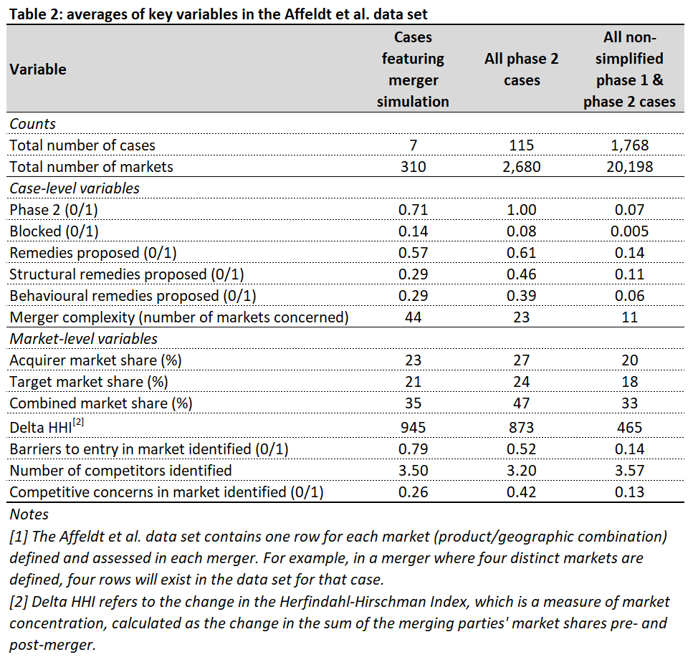
Although only a few cases featured simulations, based on this, we see that these cases were more complex, were more likely to be blocked than the wider set of Phase 2 cases, and more likely to identify barriers to entry. However, remedies were proposed at the same rate as in all Phase 2 cases. Moreover, market shares were on average lower than the set of Phase 2 cases (though the delta HHI was similar), and overall competitive concerns were less likely to be found in simulation cases than the wider set of Phase 2 cases.
These results suggest that merger simulation may have been used as a tool to consistently assess mergers across multiple markets, but in terms of the ‘fundamentals’ typically assessed at the start of a review (e.g. market shares), they are similar to the wider set of Phase 2 cases. Finally, the use of merger simulation may be a contributing factor to the rate of competitive concerns being found actually being lower than the set of Phase 2 cases.

A qualitative review of the Commission’s use of merger simulations
In this section, we review the Commission’s detailed written decisions for each merger case, to explore the modelling decisions taken by the ‘side’ using the merger simulation (the Commission or the merging parties) and how they were received by the other side.
The Commission’s merger decisions discuss economic evidence in detail, including the assessment of merger simulation models. This includes not only the results of the models, but also the modelling assumptions used as inputs, and how related issues were debated by the two sides.
Using this information, we assessed whether a given merger simulation approach can be considered ‘successful’ or not based on how much the modelling assumptions and predictions were criticised (or accepted) by the other side. We defined modelling choices and assumptions to be ‘uncontested’ if the other side did not criticise it or agreed with the way it was implemented, ‘debated’ if the other side criticised it but in response the model’s author tried to address it or showed evidence as to why it would not have a material impact, and ‘criticised’ if the other side contested the modelling issue and it was not subsequently addressed. We note that our analysis is contingent on the information available in the case report. We had no access to other information that was privy to the parties and the Commission. Of course, such an assessment is inherently subjective. Moreover, due to the adversarial nature of the debate between the Commission and the merging parties in the decisions, the fact that model features were criticised by the other side may not necessarily mean that the simulation was controversial per se. It is also worth noting that case decisions are written exclusively by the Commission with essentially no input from the merger parties.
Whilst we saw no change in the level of information available in case reports regarding the economic modelling done over the years, we find that the level of agreement (share of issues that were uncontested) dropped over time, and the number of issues that were debated or criticised increased.
To understand why some of the simulations were less contested between the parties, in Figure 1 we identified the main grounds of agreement or disagreement, focusing on specific questions such as modelling choices, technical inputs such as data, and the outcome of the simulations.
Figure 1 - Modelling issues and the outcomes of simulations used in Commission merger review, and how they were debated by each side
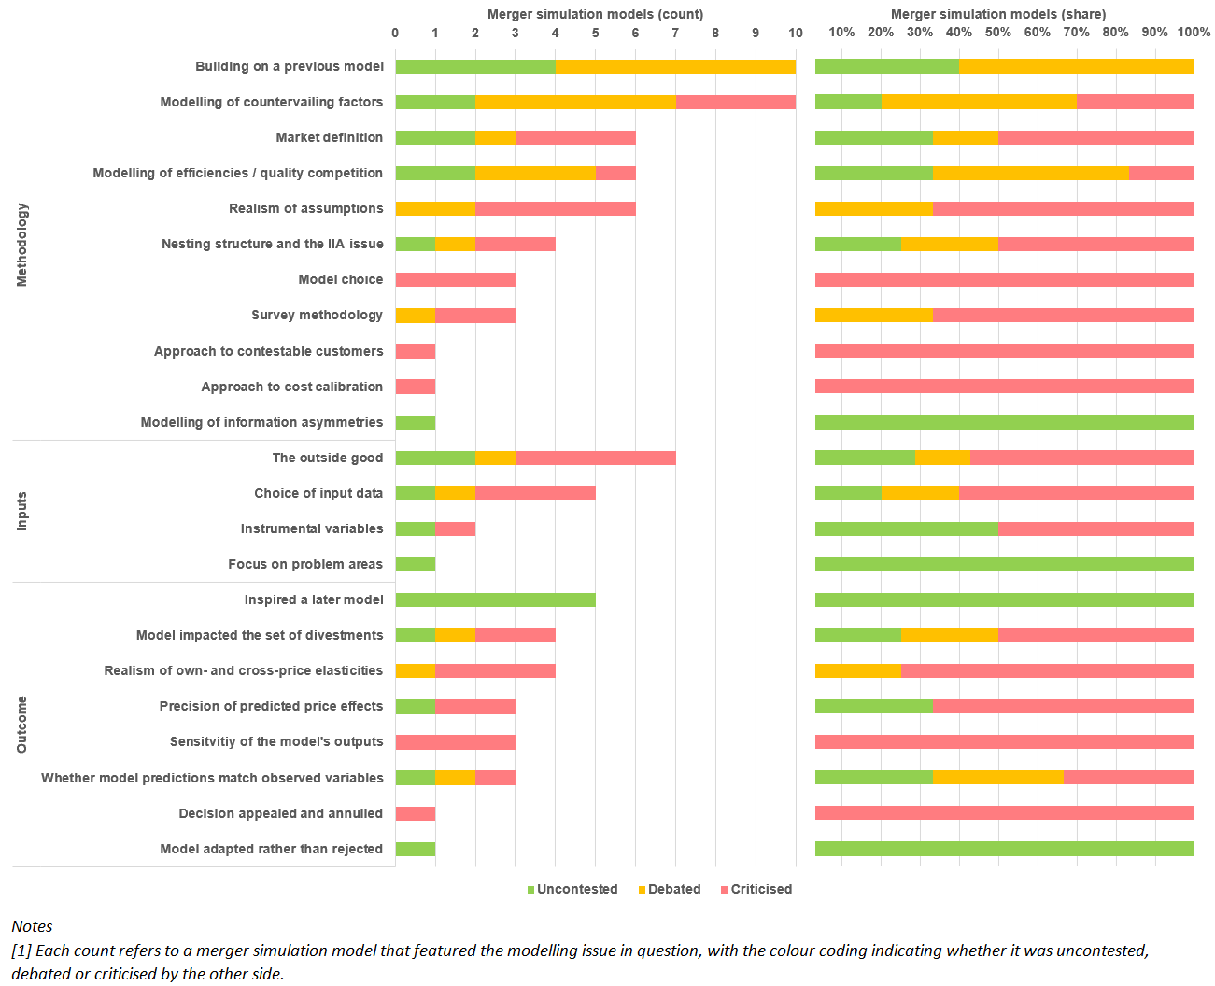
In general, certain modelling issues have arisen more than others, and have been more strongly debated. For example, the modelling of countervailing factors was discussed more than the approach to modelling contestable customers. Moreover, model choice and the realism of the model’s assumptions often appeared controversial. This, perhaps, is not surprising, as the choice of the simulation method and the assumptions can lead to widely differing price change predictions. Understanding these areas of agreement and disagreement between the Commission and the merging parties can be useful when deploying a merger simulation. In the following sub-sections we discuss these in more detail.

Methodology
The simulations in our sample are frequently building on a previous model (from a previous merger), suggesting that the effort required to develop and evaluate a successful simulation in one case can benefit subsequent cases. This perhaps provides one explanation as to why over half of the 22 simulations in our sample (12) were in the telecoms industry. This tendency to rely on earlier models was seen as a positive in some of the cases. For example, the Commission’s simulation in Unilever/Sara Lee in 2010 closely followed the merging parties’ simulation in Kraft Foods/Cadbury from earlier in the same year. Moreover, in Unilever/Sara Lee, the Commission was willing to use a model put forward in a previous case by the merging parties’ economists. In other cases, particularly the later telecoms cases, the fact that the Commission continued to use some of the same methodological choices, without necessarily considering how they could be improved, was raised as a concern by the merging parties.
Even where simulations were built on previous models, the model choice tended to be contested. Even the most fundamental steps could be controversial, for example because of disagreements on the type of auctioning structure used in an auctioning model, or whether the modelling assumptions implied a realistic pre-merger world, or because the chosen model produced “implausible interim metrics” (such as demand elasticities) and therefore implausible final predicted price effects.
Other contested modelling assumptions include discussions on whether the simulation captured how competition worked in the book publishing industry, whether the degree to which simplifying assumptions made a model was unrealistic, whether some of the assumptions used were too “extreme”, or because the merger occurred at the manufacturing level, but the input data used for the simulation recorded sales at the retail level, with the model simply assuming away any impact on the results from the margin earned between these two levels of the supply chain.
Part of designing a simulation study is to choose between dynamic and static models, and to decide whether a simulation should include the modelling of countervailing factors such as buyer power, entry and product repositioning. In some cases, there was no disagreement in this regard between the Commission and the merging parties, but in most of them the use or omission of countervailing factors was contested, for example, because the Commission argued for circumventing these effects in the analysis because they manifest over the long-run and would be too complex to account for them within the short-run focus of a merger review, or because the Commission disagreed with the merging parties’ analysis showing how the merger could increase product quality (a form of product repositioning).
Half of the simulations used discrete choice models to model demand. The main drawback of these models is the so-called ‘nesting structure and the independence of irrelevant alternatives (IIA) issue’, which restricts substitution patterns between products. Of the discrete choice models used, the most popular form was ‘nested logit’, whereby products are organised into different nests (one-level) or even sub-nests (two-, three-level etc.). The choice of the nesting structure inevitably assumes some level of discretion. Consequently, these modelling choices were often debated between the parties.
More specific modelling assumptions relate to the modelling of efficiencies and quality competition are accommodated by the simulations. In some cases the Commission accepted some efficiency claims made by the merging parties and factored them into its simulations, or at least in the sensitivity analysis. On the other hand, the Commission debated the technical aspects of the merging parties’ models in other cases, for example, where the merging parties quantified the efficiencies (increasing network coverage in telecoms markets). The parties have also criticised the Commission’s reluctance to account for efficiencies in some of the cases.
Theoretically, simulations based on econometrically estimated demand and supply parameters can circumvent the need for market definition, therefore the assumptions used in the simulations can have an impact on what the market is considered to be. This is not always without dispute between the Commission and the merging parties. For example, there has been disagreement on whether the Commission’s model had a nesting structure for its demand function that followed the actual market definition, or whether the merging parties were right to infer the relevant market from their estimation of the demand system.

Inputs
We identified two main issues under the inputs used for simulation. The first one relates to the treatment of the outside good (i.e., the choice to not purchase the products in the relevant market). Although there is some common ground in this respect between the Commission and the merging parties, there has been disagreement on either how the outside good was calculated and its resulting size, or the choice to exclude some products from the analysis (implying that they would instead sit within the outside good), or excluding them completely, or whether the Commission was right to assume away the outside good in its baseline simulation, and only include them in a robustness analysis.
In some cases the Commission acknowledged the merging parties’ criticisms regarding the choice of input data into its simulations, and adjusted the input data accordingly. In other cases criticisms related to the choice of data for calculating diversion ratios between the firms in the market, the choice of lower quality data when allegedly better data was available, or combining input data sources in an inconsistent way.

Outcomes
Often, the simulation model impacted the set of divestments, but we observed some inconsistency in the decisions. For example, in some cases the merging parties’ simulation was deployed in some countries but not others, despite the merging parties’ combined shares being similarly high across them all. As a result, divestment remedies were not required in some of the countries where the simulation was deployed. In another case the merging parties initially proposed divestment remedies on a certain expected ‘broad’ market definition – its simulation, once accounting for this divestment remedy, showed that the price increase would be reduced to 2%. Nevertheless, the Commission decided upon narrower product markets, for which the initial proposed divestment remedy would not alleviate all of its competition concerns. As a result, the final divestment remedy package was larger, consisting of more brands.
Some of the simulations produced results that were overly sensitive to small changes in the inputs. These issues arose solely in the simulations based on particularly sophisticated econometrically-estimated demand (i.e., BLP or random coefficients (RCs) models), as compared to simpler models such as nested logit. As a result, other methods were summoned to estimate them, such as numerical methods, which could allegedly produce ‘unstable’ results that were harder to replicate.
The realism of elasticities predicted by the simulation is a key factor in the price changes it predicts, and is one of the key assumptions behind a simulation model. For example, in DEMB/Mondelez, because the simulation was judged to have been applied to the wrong market definition (see above) the substitution patterns it predicted were also judged to be unrealistic.
Finally, some other cases produced results, where the parties contested the precision of the predictions. The Commission used various methods to address these criticisms, for example using Monte Carlo simulations to estimate confidence intervals.
As the above overview suggests, methodological issues such as model choices or modelling assumptions in merger simulations are most likely to be contested between the Commission and the merging parties. This is not surprising, as the choice of the simulation method and the assumptions can lead to widely differing price change predictions. In section 5 and 6 we aim to further understand what drives these price change estimates.

The role of the Chief Economist
Although the Chief Economist and the Chief Economist Team (CET) operate within the structured institutional framework of the European Commission, they do have independence regarding the assessment of economic evidence used in merger assessments, for example influencing what economic evidence is put forward by the CET, as well as influencing how the CET should interpret economic evidence put forward by the merging parties in merger review, and whether to rely on merger simulations at all in a merger case.
Table 3 below lists each Chief Economist and their respective tenures. As can be seen, Massimo Motta oversaw the busiest period in terms of merger simulations deployed, which coincided with the wave of telecoms mergers.
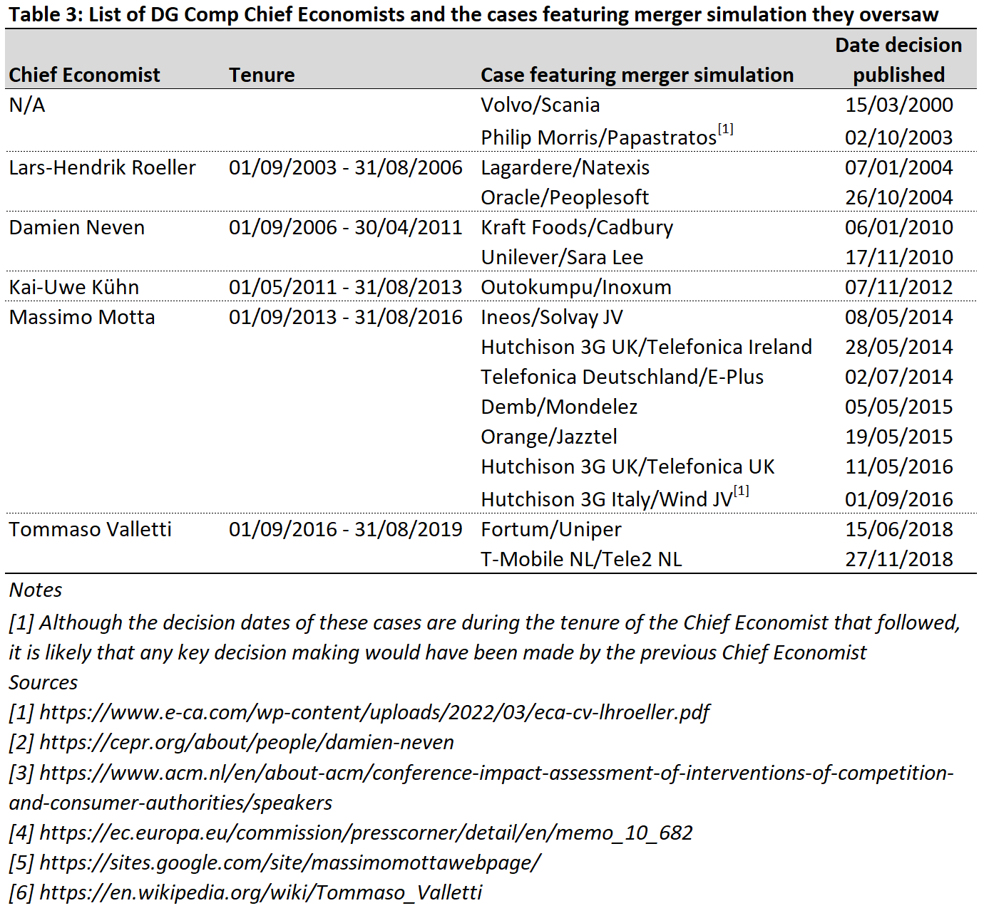
We also looked at how contested some of the modelling issues were when using simulations under the different Chief Economists. Figure 2 below shows the share of modelling issues that were uncontested/debated/criticised for each. As can be seen, the share of modelling issues that did not face any debate or criticism at all decreased over the period, whilst the share of issues that were debated or criticised rose.
Figure 2 – Share of uncontested/debated/criticised modelling issues, by Chief Economist
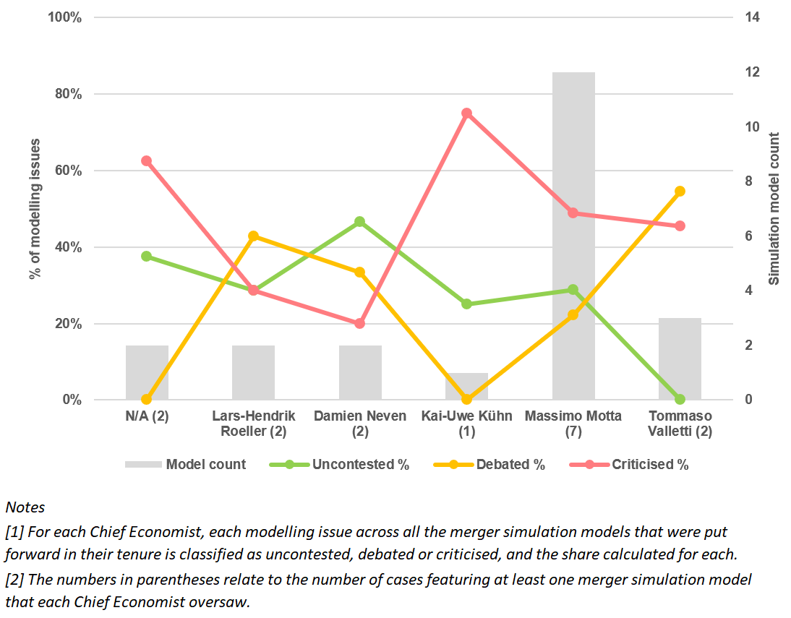

The price effects predicted by simulations
In this section, we introduce three hypotheses regarding how the implementation of merger simulations can vary from model to model and case to case. We then assess these hypotheses qualitatively. Next, we introduce our data set of price change estimates used for our quantitative analysis in Section 6.

Hypotheses
In reviewing the price effects predicted by merger simulations, we focus on three main hypotheses, which both relate to issues that formally or informally have been expressed by previous commentators or by the Commission itself, and that we identified to be the most contentious when reviewing the decisions.
More specifically, we test whether simulation outcomes depend materially on the methods and models used, whether it matters for the price change estimates whether the simulation was conducted by the Commission or the merging parties’ economists, and on the industry that the merger took place in.
First, do simulation outcomes depend on the method? Whilst formal explanations are not given, there has been some speculation among practitioners that econometrically estimated simulations are possibly more likely to produce lower predicted price increases. For example, in Hutchison 3G UK/Telefónica UK, the merging parties argued that: “When in previous mergers where the Commission has complemented pricing pressure analysis with demand estimation based merger simulation techniques, those alternatives produced much lower predicted price increases.”
In the literature, when looking at different types of merger simulations, Froeb et al. (2003) find that different assumptions regarding the shape of the demand curve (linear, log-linear etc.) can have a large effect on the resulting elasticity estimates and thus price increase predictions. There is also a consensus that simulations (under certain assumptions) produce larger price-increase predictions than price-pressure methods. For example, Valletti and Zenger (2021) rank price-pressure methods and calibrated simulations (with isoelastic demand), and show that isoelastic simulations produce larger price increases than illustrative price rise (IPR), GUPPI, or compensating marginal cost reduction (CMCR).
As explained in Section 2, we distinguish between two branches of simulations methods: calibrated and econometrically estimated. 12 of our simulation models had their parameters calibrated (eight with the standard Bertrand-Nash framework of differentiated products, two with the Bertrand-Edgeworth model, one with an auction model and one with a Cournot model), and 10 models had their parameters econometrically estimated (six with the nested logit demand model, two with the BLP demand model and two with the random coefficients demand model). We are not aware of any work analysing whether these two types of model are likely to produce systematically different post-merger price predictions.
A priori, if the assumptions behind the calibrated simulations are aligned with the core parameter estimates of the econometric simulations, there is no economic reason why predictions using one method should be different from the predictions of the other. On the other hand, differences in the assumptions behind calibrated versus estimated demand parameters, or differences in how efficiencies are taken into account can lead to differences in estimates.
Second, do simulation outcomes depend on whether they were prepared by the Commission or the merging parties? This hypothesis arises from the conception that economic advisors could be held captive to the merging parties that they represent, but also that the competition authority (in our case, the Commission) could hold pre-conceived notions of whether a merger should be cleared or not.
In principle, there should be no reason to believe that predictions coming from models developed by the Commission or the merging parties’ economic advisors would be different. In an ideal world there would exist a single method which would produce reliable estimates that do not hinge on who is conducting the study, i.e. the estimates presented by the Commission should not systematically differ from the estimates of the merging parties. But if different methods produce consistently different estimates, and if the Commission or the merging parties are more/less likely to rely on certain methods, this could lead to differences in the price change estimates. Some commentators have indeed argued that the outcomes of merger simulations can be ‘gamed’, particularly given the different incentives that the Commission and merging parties might have in a merger review.
Different assumptions can also lead to different estimates, and if the assumptions used by the Commission are systematically different from those used by merging parties, it can lead to systematically different estimates. One might expect that this would be more likely to be so in the case of calibrated models, where more hinges on the assumed information used for characterising demand and supply.
Third, have companies in the telecoms industry received ‘unfair’ treatment from the Commission? There have been numerous telecoms mergers in the EU since 2010, many of which were characterised as a reduction of four firms in the market to three (often referred to as a ‘4-to-3’ merger). In most of these cases a merger simulation, as well as other economic models such as UPP, have been used to determine the possible consumer harm caused by the merger.
It has been noted that, due to the nature of the telecoms industry, oligopolistic markets where a large share of players’ costs are fixed, a merger simulation would be more likely to predict higher price changes than an equivalent model applied to mergers in other industries would. Therefore, if the Commission had an incentive to prohibit the merger, a merger simulation might be a fruitful avenue for showing competitive harm – and commentators have argued that this may explain why merger simulations were so popular in this industry and not others.
In addition, it has been argued that data availability may have also played a role: in Hutchison 3G UK/Telefónica UK (a merger which was blocked by the Commission in 2016), the merging parties argued: “The use of [UPP] as key evidence would also give rise to an arbitrary discrimination against mergers in markets where [UPP] data is available”.

A qualitative assessment of the above hypotheses
As shown in Table 1, in four cases (all in the telecoms industry), more than one merger simulation was put forward, from which in principle a direct qualitative assessment of the first and second hypotheses above might be possible.
- In Hutchison 3G UK/Telefónica Ireland, the Commission put forward a linear calibrated model (based primarily on mobile number porting/switching data) and an econometric BLP model (based on based on tariff-level data), and Compass Lexecon submitted a nested logit calibrated model (where the underlying data is not described). The linear calibrated model predicted substantial price increases in the baseline for the merging parties and the market. The BLP model predicted a market-wide price increase of “not less than 4%”, consistent with the low end of the range of the calibrated model. On the other hand, the nested logit calibrated model predicted “negligible price increases”. In the decision the Commission appears to suggest that the difference was due to the nested logit model “not [being] quantified on the basis of observed factual data of the Irish mobile telecommunications market”.
- In Telefónica Deutschland/E-Plus, the Commission complemented its linear calibrated model (also based on mobile number porting data) with nested logit and BLP econometric demand-based simulations (also based on tariff-level data). It noted that the results of the econometrically-estimated simulations are consistent with the linear calibrated model’s sensitivity scenario based on incremental rather than contribution margin data, though it did not expand on why this could be, but rather used it as further evidence that the overall conclusions from the economic analysis as a whole were robust.
- In Hutchison 3G Italy/Wind JV, the Commission again put forward a linear calibrated model based on mobile number porting data. In response, Compass Lexecon submitted a model which attempted to estimate demand parameters based on online survey responses and which predicted the overall effect of the merger on consumer surplus taking into account anticipated quality improvements (i.e. calculating ‘quality-adjusted prices’). Although the merging parties argued that the overall impact was positive, the Commission compared the ‘raw’ price changes to its own model, stating that they were largely comparable (with the exception of the predicted price change for H3G, which was higher in Compass Lexecon’s model), without attempting to explain why.
- In T-Mobile NL/Tele2 NL, the Commission, in its standard linear calibrated model, found price changes that it described as “moderate”. In comparison, Compass Lexecon, in its model that was similar to the one used in Hutchison 3G Italy/Wind JV, found price changes that it described as “modest and more than offset by the merged entity offering higher quality FMC products post-transaction” – the Commission agreed that the findings of this model coincided with its ultimate assessment of the merger not giving rise to a significant impediment to competition.
These four cases alone illustrate that different modelling approaches and/or economists can still result in consistent estimates, other than in instances where the data inputted into the model are potentially incorrect. Nevertheless, in our quantitative analysis in the following section, we are able to compare the results of all merger simulation models, and not just those from cases where more than one model was put forward.

Our sample of price change estimates
Because simulations were run and reported differently in each case, there is considerable variation in the data available from these simulations. Models can calculate and report predicted price changes for the merging parties, the merged entity, for competitors or the market as a whole (in any combination).
The unit-of-observation in our price change data set therefore represents a given ‘player’ in the market (the merged entity, a competitor, or the market as a whole), for a given product-geographic market combination, for a given merger simulation model, for either the baseline analysis or a sensitivity, deployed in a given merger case. For example, in Volvo/Scania, the Commission deployed merger simulations in 16 countries (where the geographic market was deemed to be national), for two types of truck (‘rigid’ or ‘tractor’, following the product market definition), showing predicted price changes for two ‘players’ (the merged entity and for all other competitors together). Because all of these would produce a separate price change estimate, in this case, we have $16×2×2=64$ observations in our sample.
This gives us a sample of 272 baseline estimates, of which 114 price change estimates were for the merged entity, a further 123 for competitors, and 35 for the market as a whole. The merger simulations also include a further 508 sensitivity estimates for the impact of the merger on prices (of which, 156 are for the merging parties, 326 for competitors and 26 for the market as a whole).
Most price change estimates (162 baseline and 662 including sensitivities) are from simulations where demand parameters were not estimated from data (‘calibrated models’), particularly so when including sensitivity checks, which is unsurprising, as these models rest on a wider range of assumptions regarding demand parameters (i.e. more sensitivities are presented around these assumptions). Around 40% of the baseline estimates (110 estimates), and 15% of all estimates including sensitivities (118 estimates) were based on an econometric estimation of demand parameters (‘econometric models’).
Most simulations (246 baseline predicted price changes and 753 including sensitivities) come from the Commission. Moreover, the Commission was more likely to report a larger number of sensitivity estimates in its assessments. Roughly 10% of all baseline price change predictions, and only 3% of all estimates (including sensitivities) were delivered by the merging parties.
Most (57% baseline estimates, and 77% including sensitivities) price change estimates are for telecoms, followed by the automobiles and fast moving consumer goods industries, then followed by a tail of other industries with smaller contributions to the sample. In telecoms, merger simulations seemed to have become self-reinforcing precedent, which may explain why it was used more in this industry compared to the others.
Finally, there is variation in how much each merger simulation model (and thus the associated case as a whole) contributes to the overall sample count, and thus its contribution in the regression. This is explained by the fact that some of the mergers in the sample have their merger simulation applied to multiple product/geographic markets, and because there is variation in how much detail the Commission provides in its decisions regarding the merger simulation models, e.g. whether price change predictions are provided for all market participants and the market as a whole, or just a subset of these.

Variables
Our data set comprises the following variables.
- Price change: the price increase estimated by the merger simulation, expressed as a percentage of pre-merger prices. In some decisions the price change prediction is redacted into 5 or 10% ranges; in these instances, the midpoint is used.
- Econometric demand: whether the parameters in the demand model in the merger simulation were estimated econometrically.
- Source: whether the merger simulation was prepared by the Commission.
- Telecoms: whether the merger simulation was deployed in a merger assessment in the telecoms industry.
- Combined share: the combined market share of the merging parties. We use this as a measure of market concentration.
- Increment: the change in market concentration caused by the merger, equal to the smaller market share of the two merging parties.
- Synergies: a binary variable to indicate whether merger-related efficiencies were considered in the simulation.
- Phase 2: a binary variable to indicate whether the case went to Phase 2 or not.
- Blocked: a binary variable to indicate whether the merger was eventually blocked.
- Sensitivity: a binary variable to indicate whether the predicted price change was a sensitivity to the baseline simulation put forward.
- Competitor / market: binary variables to indicate whether a price estimate is for a competitor or the market as a whole (where both are zero, the price estimate refers to the merged entity).
Summary statistics for the main characteristics of the analysed merger simulations are given in Table 4, broken down into pairwise comparisons by: the simulation method (econometric demand vs. calibrated demand), the source (Commission vs. merging parties), and the industry (telecoms vs. others). In each column, and for each pairwise comparison, we report the t-statistics and p-values for the difference between the means. In the Appendix, we present the same table, showing (a) only estimates for the merged entity, and (b) including the various sensitivity checks that are made available.
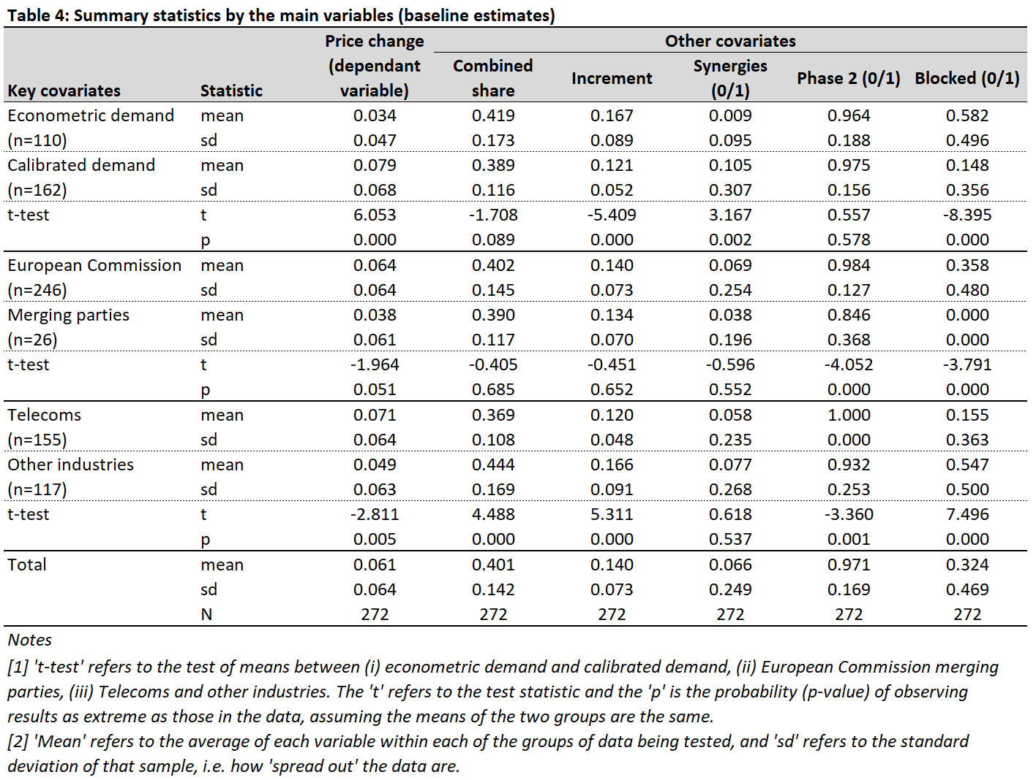
The price change column in the table above provides some descriptive evidence to the hypotheses introduced above. Price increase predictions are lower when using econometric estimation of demand parameters in comparison to calibrating them, even though econometric simulations were applied in markets that were becoming slightly more concentrated. Price increases are predicted to be higher when the simulation was done by the Commission in comparison to the merging parties, though the difference is (marginally) statistically insignificant. Finally, the predicted price increase is higher in the telecoms industry, even though the markets in the telecoms mergers were not becoming as highly concentrated on average.
The Commission has always stated that models estimating price effects are just one piece of evidence considered in a merger review, and thus that there is no ‘safe harbour’ predicted price increase under which a merger would be considered unproblematic. However, commentators in the past have argued that such a threshold may be present, for example in Unilever/Sara Lee, where a predicted price rise higher than 2% identified markets affected by the merger where divestments were required.
In addition, simulations relying on econometrically estimated demand parameters were more likely in cases that ended up being blocked by the Commission. This is more likely to do with the Commission using econometrically estimated demand parameters, because none of the cases where the merging parties’ consultancies delivered simulations were blocked.
As is always the case, these variables are correlated with each other, which is why we use standard regression techniques to illicit which are the most important.

The main drivers of price change estimates
In this section, we perform our quantitative analysis of the data set introduced above. Specifically, we test if there is evidence in the data supporting the three main hypotheses regarding how price change estimates can vary from model to model and case to case.

Descriptive findings
We now examine how the interaction of the factors presented in Table 4 impact the average estimated price effect. Table 5 summarises the mean predicted price change for samples of the data that were selected around the three testable hypotheses described above.
For example, the first two rows show the mean price change estimate when using econometric demand models in simulations done by the Commission, first for simulations in the telecoms industry (a 3.8pp price increase when considering the baseline models) and then for simulations in other industries (a 3.1pp price increase).
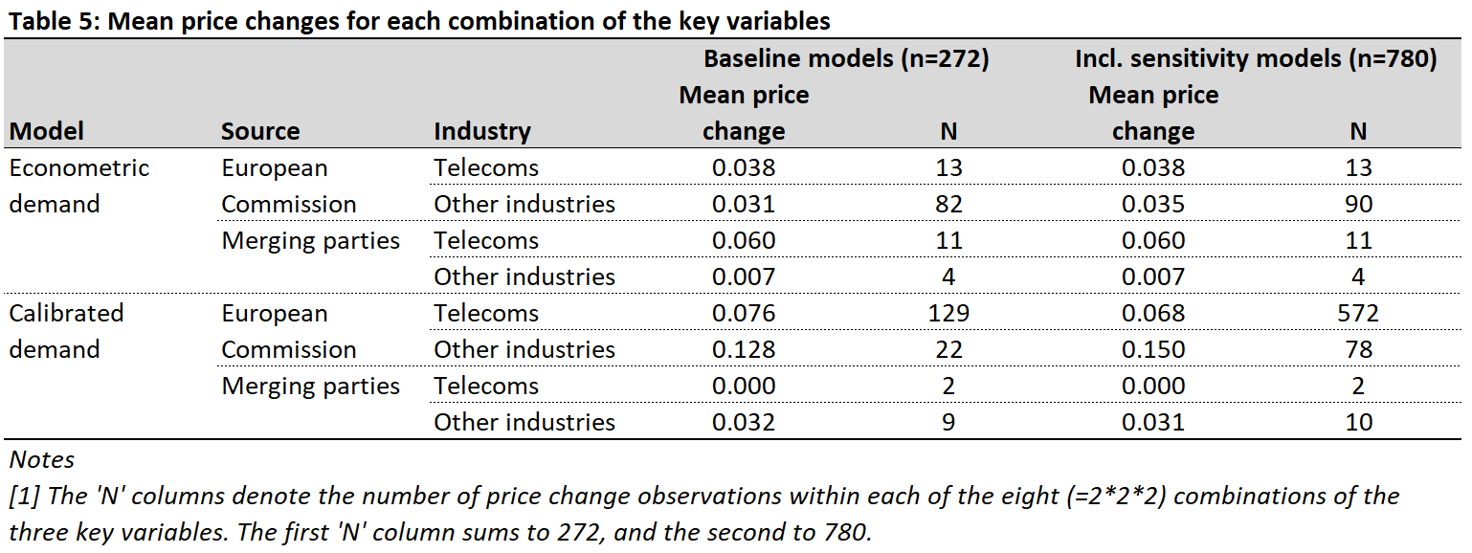
Although, on average, simulations done by the Commission seem to produce higher price change estimates on average (as was shown in Table 4), Table 5 suggests that this is not true for econometrically estimated simulations (top half of table) in telecoms, where the mean price change is 6pp (0.06) in simulations produced by the merging parties, as opposed to 3.8pp (0.038) in Commission simulations.
Simulations in the telecoms industry predict higher post-merger price increases than those in other industries, and econometrically estimated merger simulations predict lower post-merger price increases than calibrated models (see Table 4 in the previous section). However, Table 5 above shows that this relationship depends on some of the other characteristics of the simulation. Firstly, price increases are larger in telecoms, but only for econometric models (for calibrated models, the opposite is true). On the other hand, price changes are lower for econometric models, but not for models put forward by the merging parties in telecoms.
To test whether these differences in the estimated price change of the merger remain when controlling for other merger characteristics, such as the combined market share of the merging parties, we turn to a regression analysis in the following sub-section.

Regression analysis
We estimate two regression models:
$${PriceChange}_{i}=β_{0}+β_{1}{Econometric}_{i}+β_{2}{Commission}_{i}+β_{3}{Telecoms}_{i}+β_{4}{CombinedShare}_{i}+β_{5}{Increment}_{i}+β_{6}{Synergies}_{i}+β_{7}{Phase2}_{i}+β_{8}{Blocked}_{i}+β_{9}{Sensitivity}_{i}+β_{10}{Competitor}_{i}+β_{11}{Market}_{i}+u_{i}$$
and
$${PriceChange}_{i}=β_{0}+β_{1}{Econometric}_{i}+β_{2}{Commission}_{i}+β_{3}{Telecoms}_{i}+α_{1}\left({Econometric}_{i}*{Commission}_{i}\right)+α_{2}\left({Econometric}_{i}*Telecoms\right)+α_{3}\left({Commission}_{i}*{Telecoms}_{i}\right)+α_{4}\left({Econometric}_{i}*{Commission}_{i}*{Telecoms}_{i}\right)+β_{4}{CombinedShare}_{i}+β_{5}{Increment}_{i}+β_{6}{Synergies}_{i}+β_{7}{Phase2}_{i}+β_{8}{Blocked}_{i}+β_{9}{Sensitivity}_{i}+β_{10}{Competitor}_{i}+β_{11}{Market}_{i}+u_{i}$$
where i denotes a single price change estimate, as described in Section 5.3. Each regression is applied to two samples: just the models’ baseline estimates (n=272), and including the models’ sensitivity estimates (n=780).
In Table 6 we focus on our three main hypotheses introduced in Section 5.1. The full results of our regression analysis are presented in Table 14 in the Appendix. Because the different price estimates within a given merger simulation model are likely not independent, in our headline models we cluster standard errors within each simulation model.
The table shows the predicted marginal effects, using the estimated regression parameters together with different combinations of values of the three main variables of interest (econometric vs. calibrated demand model, Commission vs. merging parties, telecoms vs. other industries).
For example, the first row shows the difference in the predicted price increase between econometrically estimated simulations and calibrated models done by the Commission in the telecoms industry. This suggests that econometrically-estimated simulations predict, on average, 2.5pp lower price increases when considering baseline models, and the difference is significant with a p-value of 0.011.
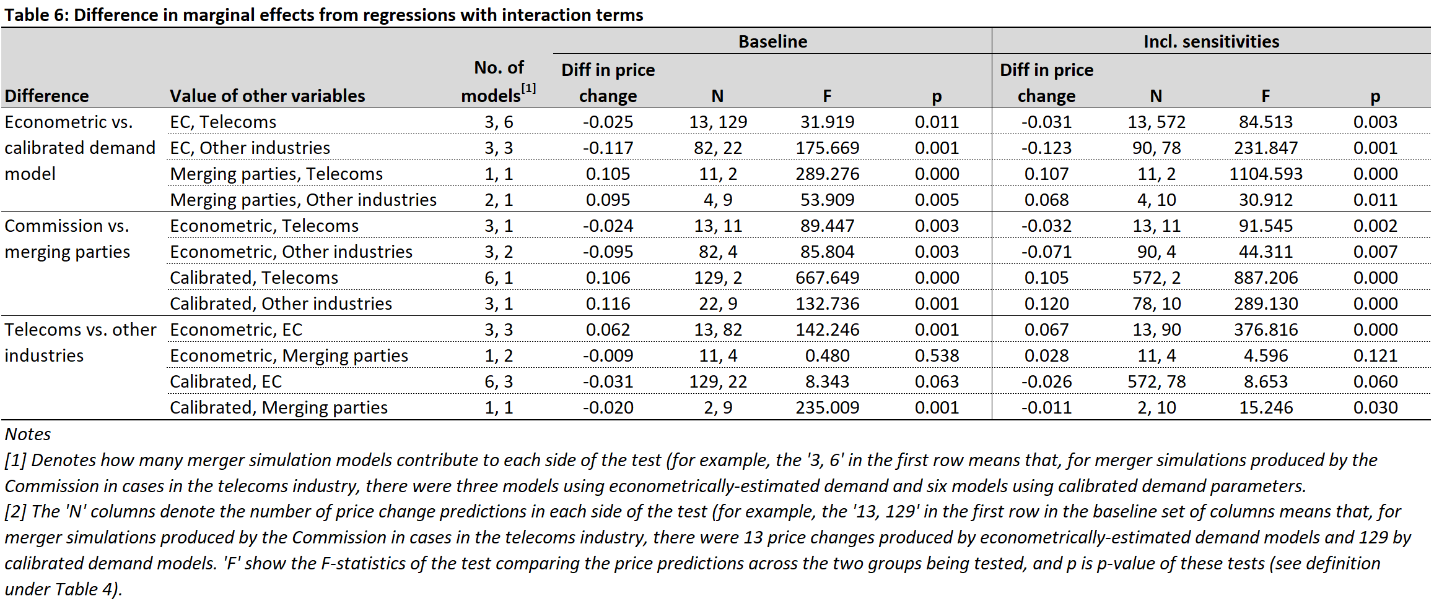

Does it matter which method is used?
Table 6 shows that simulations using econometrically estimated demand parameters produce lower price change estimates even after controlling for differences in market concentration and other factors, but only for simulations done by the Commission, either in telecoms, or in other industries. On the other hand, econometric models result in higher price change estimates if the simulation was performed by the merging parties. One intuitive explanation could be that in calibrated models there are more assumptions about the underlying demand/supply parameters, and thus more leeway than where demand/supply parameters are estimated from data. This is discussed in more detail below.

Do the Commission’s simulations always produce higher price increase predictions?
Even when controlling for other factors, we find evidence to reject the hypothesis that the Commission always produces higher price-increase estimates (or, that the merging parties always produce lower price-increase estimates). When using simulations based on econometrically estimated demand parameters, the merging parties’ price increase estimates actually seem to be higher than those of the Commission, after controlling for differences in market concentration and the industry (-2.4pp in telecoms and -9.5pp in other industries). Moreover, these differences between the Commission’s and the merging parties’ predictions is also lower in absolute terms than when demand parameters are calibrated (10.6pp in telecoms and 11.6pp in other industries).
We draw the following conclusions from this. First, simulations relying on econometrically estimated demand parameters give more consistent post-merger price predictions (first two rows of the Commission vs merging parties block in Table 6). This could be because non-econometrically estimated simulations (typically calibrated models) rely on more arbitrary assumptions. This is something that CMA has also noted in Vodafone/Three JV: “Compared to the detailed [econometric] estimation exercise … a calibration approach is more approximate and has a number of limitations. As such we place limited evidentiary weight on specific harm estimates and instead consider how the scale and direction of the harm estimates change under different assumptions.”
To offer some qualitative support to this point, in Oracle/PeopleSoft the merging parties debated the degree to which both the Commission (and the DOJ, in its own simulation submitted in the merger review in the US) relied on simplifying assumptions in their respective models, such as using market shares as a proxy for success rate in bids, not accounting for costs in the model because they were “mostly sunk”, and assumption of participants having ‘complete information’ made their respective models unrealistic. This lead to a predicted price increase of 24.9% in the Commission’s model (averaged across all baseline and sensitivity estimates).
In Outokumpu/INOXUM (and also INEOS/Solvay JV, which used a similar simulation model) the Commission predicted a 10.6% post-merger price increase for the merged entity (averaged across all baseline and sensitivity estimates), but acknowledged that its model could not account for various features such as customer switching costs – in response, the merging parties suggested adjustments to the model that would result in little to no predicted price effect, but the Commission rejected these, arguing the assumptions needed to achieve this result were “extreme”.
Other assumptions in calibrated models can also lead to discrepancies in the price-increase estimates between the Commission and the merging parties. For example, it is well known from economic theory that the convexity of the demand curve impacts the level of pass-on, and thus the size of the price effect of the merger. The Commission typically assumes linear demand in their calibrated simulations, which is associated with lower pass-on on than convex demand curves, and argues that this is a lower bound. However, it appears that when the Commission econometrically estimates demand parameters, it leads to a lower predicted post-merger price increase. Similarly, predicted post-merger price changes can vary greatly depending on elasticity assumptions in a calibrated model. Finally, in the cases where the Commission predicted lower price increases it is possible that the Commission relied on more conservative assumptions to show that even under those assumptions, there is still a meaningful price increase.
Based on the above, and if one accepts the argument that consistency across the two sides is an indicator of robustness of the analysis, econometric simulations, and in particular those done in the telecoms industry, would be a good starting point for designing future simulations.

The role of the Chief Economist in the predicted price change
Although we did not include this in our regression (given our sample size), on an aggregate level we looked at whether the average predicted price changes of the merged entity changed depending on the Chief Economist in charge – see Figure 3 below. There was a gradual increase in the average predicted price change for each Chief Economist, followed a sharp decline towards the end of our sample period, which might reflect that the two last simulation mergers – Fortum/Uniper and T-Mobile NL/Tele2 NL – which were relatively less complex mergers, both being cleared without remedies (the former in Phase 1 and the latter in Phase 2).
Figure 3 – Average merged entity predicted price change (baseline estimates), by Chief Economist
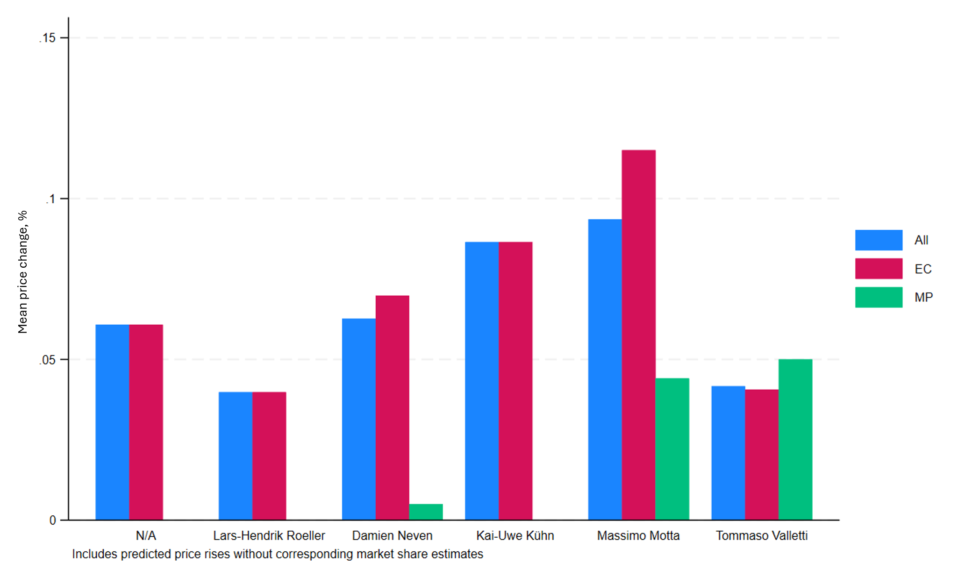
Notes
[1] EC stands for European Commission, and MP for merging parties.
[2] Includes predicted price changes without corresponding market share estimates.
When focusing on the limited sub-sample of simulations put forward by the merging parties (‘MP’ in the figure), we see an increase from Damien Neven tenure to the Massimo Motta and Tommaso Valletti tenures, which is driven by the models put forward in Hutchison 3G Italy/Wind JV and T-Mobile NL/Tele2 NL, which predicted relatively large price increases (reflected in the data set) but which were offset by even larger quality increases (not reflected in the data set).

Does it matter if the merger is in the telecoms industry?
In Table 6, we present evidence that simulations in the telecoms industry produce higher price change estimates even after controlling for differences in market concentration and other factors, although this is only true for simulations using econometrically estimated demand parameters, done by the Commission. For econometric simulations put forward by the merging parties, or calibrated models put forward by the Commission (where the majority of observations are), the price change predictions in telecoms and other industries are not statistically significantly different from each other. Finally, for calibrated models put forward by the merging parties, predicted price changes are actually higher in other industries than in telecoms.

Conclusions
In this paper we present a detailed review of the merger simulations used in EU merger control. We analyse key areas of contention between the Commission and merging parties, including differences in the purpose of simulations, data selection, modelling approaches, and underlying assumptions, and then look at the main drivers of the price change estimates produced by these simulations.
We do not find support for the argument that the Commission’s simulations always present higher price change estimates than those of the merging parties. The choice of the simulation method plays an important role in this respect.
Both the Commission and merging parties may question whether the benefits of a fully-fledged merger simulation – with the increased data requirements and complexities that come with that – are worthwhile compared to simpler (and thus cheaper) price pressure indices which are easier to implement and require less data. This is particularly true from the perspective of the Commission which may be more resource constrained, if simulations are viewed to increase the Commission’s exposure to a successful appeal by the merging parties, and if merger simulations are considered to be only a marginal improvement on the predictions of simpler price-pressure methods. We hope that our article helped, at least, to lessen the concerns about these points.
We show that there is more consistency in the estimates of the Commission and the merging parties when they use econometrically estimated simulations. If the consistency of price predictions between the Commission and the merging parties can be considered a useful measure of simulation quality, in future work it would be useful to compare these simulation estimates with the predictions provided by price-pressure methods (such as GUPPI), which use more assumptions about structural parameters, and hence potentially giving way to more discrepancy between the Commission’s and the merging parties’ estimates.
This would be particularly important because it has been argued that the merging parties use simulations to deliver results favourable to them. Whilst we do not find general evidence to support this claim, we also see no reason to think that this argument should not also apply for price-pressure methods. Given that these methods are more likely to rely on a wider range of assumptions, the same argument should actually favour fully-fledged merger simulations as a more consistent prediction method.
At the same time, there have also been significant changes over time in the types of mergers being attempted and the theories of harm being applied to these cases. This should provide an even stronger case for using simulations. For example, dynamic considerations have become more important in some of the recent large mergers. In Activision/Blizzard, the main concern was regarding the merger’s impact on cloud gaming, a nascent segment of the gaming industry, and it is possibly difficult to see where a ‘traditional’ simulation could have represented useful economic evidence in this regard. Nevertheless, as was shown in Hutchison 3G Italy/Wind JV and T-Mobile NL/Tele2 NL in front of the Commission, and most recently Vodafone/Three JV in front of the CMA, the merging parties tend to submit more novel simulation methods which aim to quantify efficiencies or quality improvements directly into the model. These types of merger simulation model should be encouraged.
Another example is platform mergers, or mergers involving two-sided markets, which have become increasingly relevant in recent years, particularly in the tech industry. A simulation in these settings could be especially useful, given the indirect network effects on each side of the market, the impact of a merger on which may be obscured when using simpler models. Despite there being relevant academic literature on how to incorporate this into a simulation, there have not been any cases of this type where such a simulation was deployed.
Merger reviews are carried out against relatively strict statutory deadlines, which might limit the possibility of the Commission or merging parties to produce complex economic evidence, as their reliable implementation may take time. The Commission (and also the CMA) has indeed stated that time constraints have reduced its ability to produce reliable models. This issue of timing could be mitigated if the merging parties were able to invest time early in a merger proceeding, for example in pre-notification, for developing a robust, reliable simulation model, which may also help the Commission with its own investigation. This would also have the added benefit that the underlying demand model could be used to help with the market definition stage, like in Unilever/Sara Lee. In addition, as discussed, a merger simulation model can also help determine the optimal set of divestments required to mitigate any adverse price or consumer surplus effect, where that decision often occurs at a particularly ‘tight’ part of the merger review process. In any case, given that the length of Phase 1 and 2 reviews has not shortened over time, it is unlikely that this factor has caused the reduction in the use of simulations. Moreover, methods are being proposed to shorten the time needed for the estimation of structural parameters, which could also help merger simulations to fit into the tight timeframe of merger procedures.
We must also note that most of the simulations in our sample were in the telecoms industry. This could be simply due to path-dependence, as simulations were done in early big telecom mergers, and subsequent merger analysis built on these previous simulations. It is also possible because, in telecoms, standard tools like market shares and simple price comparisons are often not reliable predictors of post-merger outcomes. Pricing in telecoms is highly complex due to bundling, nonlinear tariffs, price discrimination and frequent promotions. Moreover, telecom markets are typically oligopolistic with strong strategic interaction between a small number of firms, meaning that a merger can materially change equilibrium behaviour rather than just add market share. Simulation models allow analysts to explicitly incorporate demand elasticities, substitution between operators and post-merger pricing strategies in these conditions.
We hope that this review is a useful piece of evidence that highlights best practice, issues of simulations design and delivery that are least contentious between the Commission and the merging parties. At the same time, we acknowledge that simulations are not a standalone merger investigation tool, and we would like to build on this analysis to also include pricing pressure methods – something more commonly used by competition authorities – to better understand best practice in the toolkit of predictive methods that competition authorities rely on for assessing mergers.

References
Affeldt, P., Duso, T., & Szücs, F. (2018). EU merger control database: 1990-2014. Deutsches Institut für Wirtschaftsforschung (DIW), Berlin (95).
Balan, D. J., & Brand, K. (2023). Simulating hospital merger simulations. The Journal of Industrial Economics, 71(1), 47-123.
Berry, S., Levinsohn, J., & Pakes, A. (1995). Automobile Prices in Market Equilibrium. Econometrica, 63(4), 841-890.
Björnerstedt, J., & Verboven, F. (2016). Does merger simulation work? Evidence from the Swedish analgesics market. American Economic Journal: Applied Economics, 8(3), 125-164.
Budzinski, O., & Arndt, C. (2007). The Oracle/PeopleSoft case: unilateral effects, simulation models and econometrics in contemporary merger control. Legal Issues of Economic Integration, 34(2).
Budzinski, O., & Noskova, V. (2022). Prospects and Limits of Merger Simulations as a Computational Antitrust Tool. Stan. Computational Antitrust, 2, 56.
Buettner, T., Federico, G., & Lorincz, S. (2016). The use of quantitative economic techniques in EU merger control. Antitrust, 31, 68.
Cayseele, P., & Vanormelingen, S. (2019). Merger analysis in two-sided markets: the Belgian newspaper industry. Review of Industrial Organization, 54, 509-541.
Döpper, H., MacKay, A., Miller, N. H., & Stiebale, J. (2024). Rising Markups and the Role of Consumer Preferences. Journal of Political Economy, 133(8).
Froeb, L., Tschantz, S., & Crooke, P. (2003). Bertrand competition with capacity constraints: mergers among parking lots. Journal of Econometrics, 113(1), 49-67.
Döpper, H., MacKay, A., Miller, N., & Stiebale, J. (2024). Rising markups and the role of consumer preferences (No. w32739). National Bureau of Economic Research.
Filistrucchi, L., Klein, T., & Michielsen, T. (2012). Assessing unilateral merger effects in a two-sided market: an application to the Dutch daily newspaper market. Journal of Competition Law & Economics, 8(2), 297-329.
Friberg, R., & Romahn, A. (2015). Divestiture requirements as a tool for competition policy: A case from the Swedish beer market. International Journal of Industrial Organization, 42, 1-18.
Garmon, C. (2017). The accuracy of hospital merger screening methods. The RAND Journal of Economics, 48(4), 1068-1102.
Illanes, G., Bhattacharya, V., Stillerman, D., Kreps, A., & Salas, J. (2024). A Large-Scale Evaluation of Merger Simulations. Available at SSRN 5177604.
Ivaldi, M., & Verboven, F. (2005). Quantifying the effects from horizontal mergers in European competition policy. International Journal of Industrial Organization, 23(9-10), 669-691.
Mariuzzo, F., Ormosi, P.L, & Havell, R. (2019). A review of merger decisions in the EU, Book chapter in Ex-post economic evaluation of competition policy: the EU experience, Wolters Klumer.
Nevo, A. (2000). Mergers with differentiated products: The case of the ready-to-eat cereal industry. The Rand Journal of Economics, 395-421.
Panhans, M. T., & Taragin, C. (2023). Consequences of model choice in predicting horizontal merger effects. International Journal of Industrial Organization, 89, 102986.
Peters, C. (2006). Evaluating the performance of merger simulation: Evidence from the US airline industry. The Journal of Law and Economics, 49(2), 627-649.
Pinkse, J., & Slade, M. E. (2004). Mergers, brand competition, and the price of a pint. European Economic Review, 48(3), 617-643.
Valletti, T., & Zenger, H. (2021). Mergers with differentiated products: Where do we stand?. Review of Industrial Organization, 58, 179-212.
Walker, M. (2005). The potential for significant inaccuracies in merger simulation models. Journal of Competition Law and Economics, 1(3), 473-496.
Weinberg, M. C. (2011). More evidence on the performance of merger simulations. American Economic Review, 101(3), 51-55.
Weinberg, M. C., & Hosken, D. (2013). Evidence on the accuracy of merger simulations. Review of Economics and Statistics, 95(5), 1584-1600.

Appendix

Qualitative review
Figure 4 shows the number of uncontested/debated/criticised issues for each merger simulation model in our sample. For example, the merger between coffee manufacturers DEMB and Mondelez, which was approved subject to a set of remedies after a Phase 2 investigation, included simulations presented by the merging parties that were seemingly strongly criticised by the Commission. On the other hand, in the telecom merger between Orange and Jazztel, there was more agreement between the Commission and the merging parties on how the Commission’s simulation was run.
Figure 4 - Modelling issues and the outcomes of simulations used in Commission merger review, and how they were debated by each side (sorted chronologically)
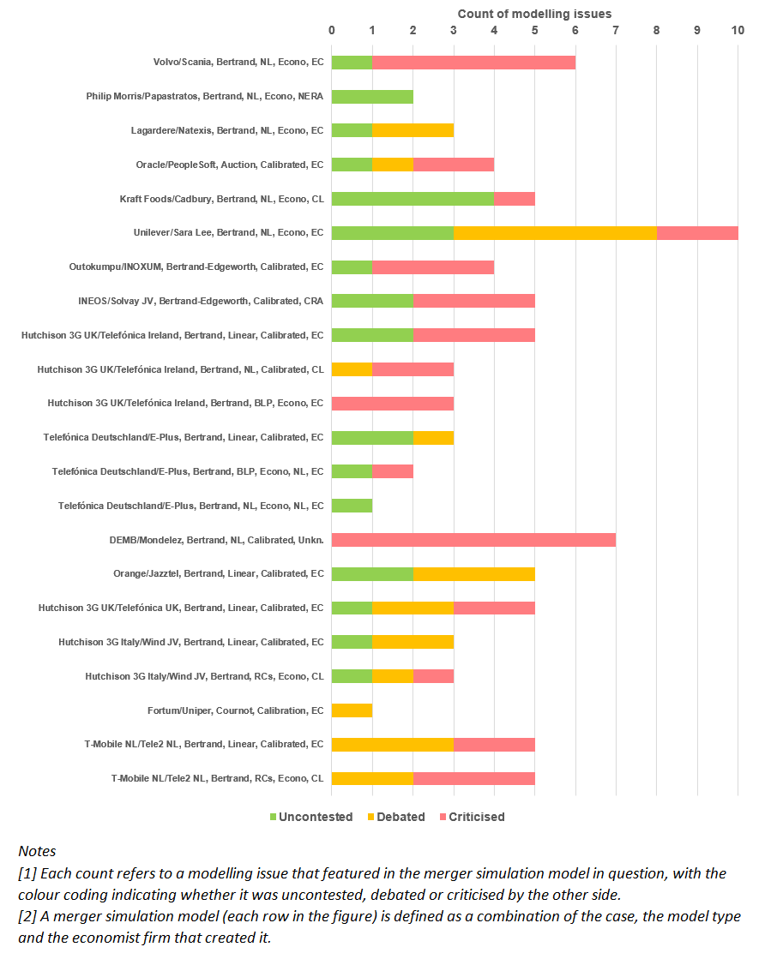

Quantitative analysis: summary statistics
The following tables show the breakdown of the regression samples by the following variables: model type, source (Commission or economic consultancy), industry and finally by model.
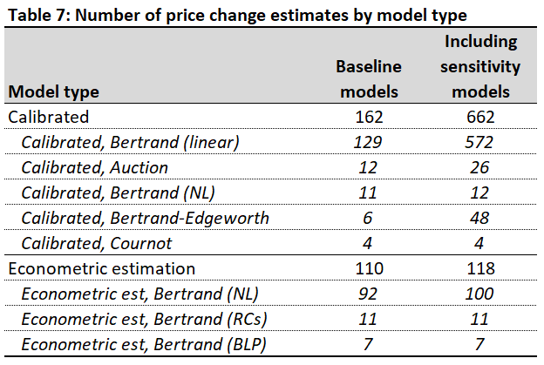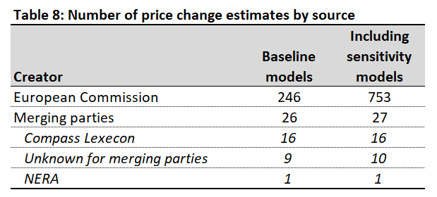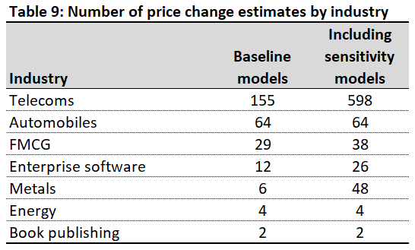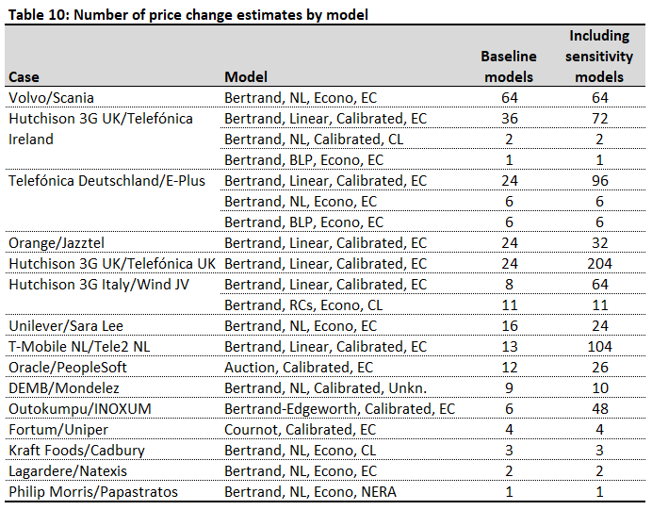
Table 11 below shows the summary statistics of the main variables from Table 4, but instead restricting the sample to the price change estimates of the merged entity only.
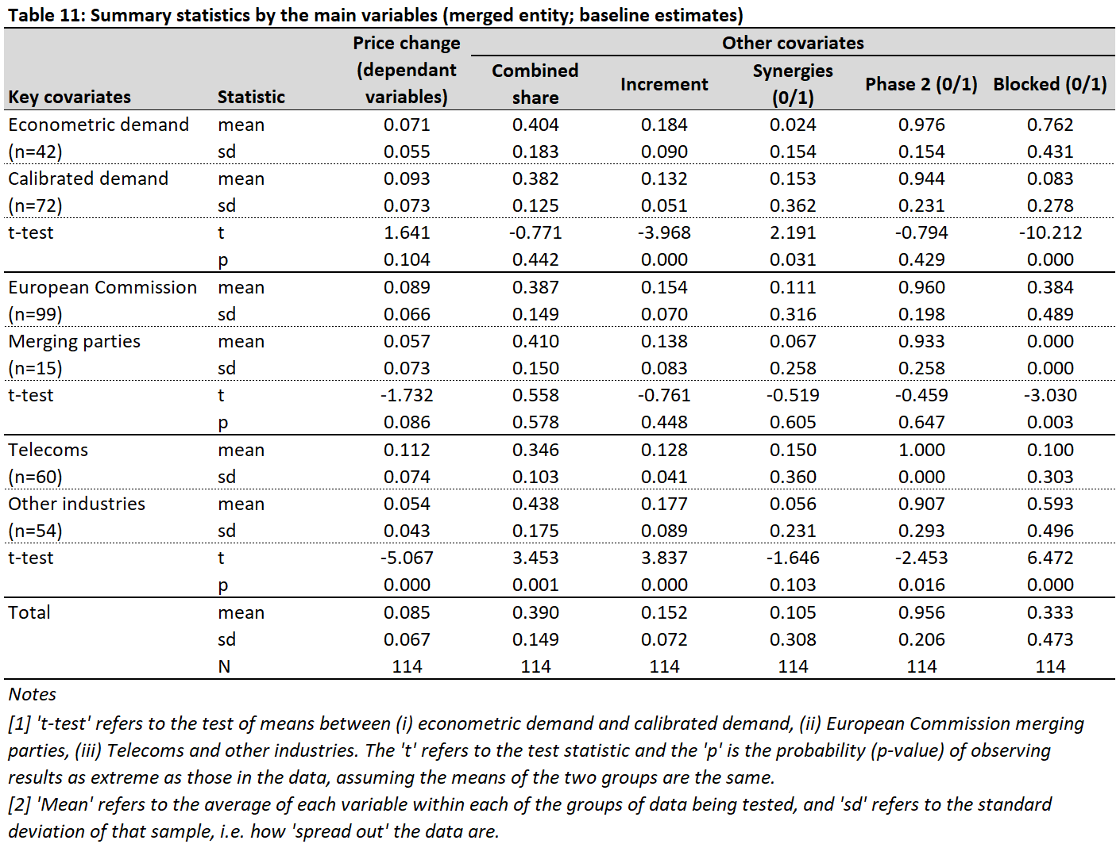
Table 12 below shows the summary statistics of the main variables from Table 4, but instead including sensitivity estimates in addition to baseline estimates. Here, the (positive) difference between average price changes produced by the Commission vs. the merging parties is statistically significant, and the average price change in telecoms is lower than in other industries.
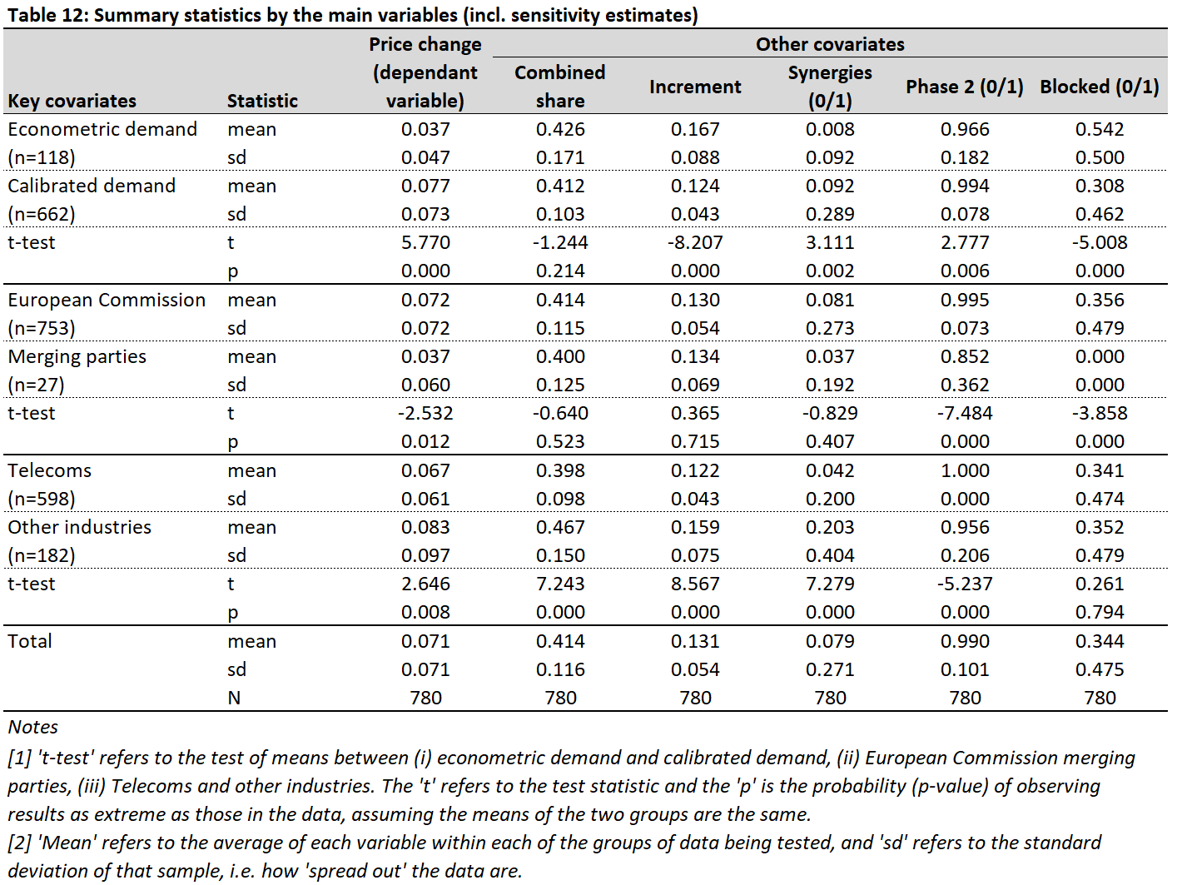
Table 13 below shows the differences in mean price changes across different dimensions of the data from Table 5, but instead restricting the sample to the price change estimates of the merged entity only. The results are largely qualitatively similar, except for predicted price changes being higher in telecoms for calibrated models put forward by the Commission.
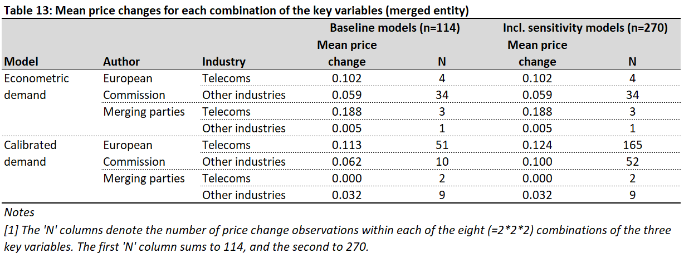

Full regression results
The full regression results underlying the marginal effects presented in Table 6 are presented in Table 14 below.
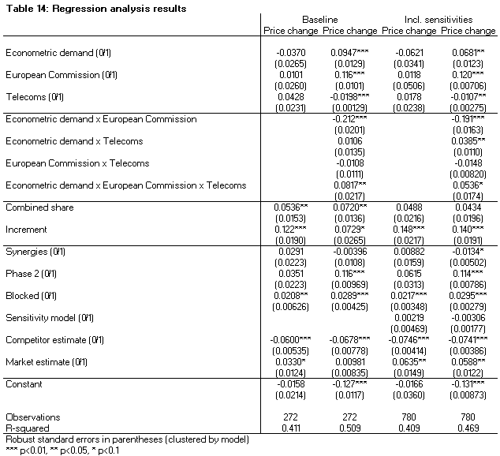

Regression sensitivities
Table 15 shows the estimated marginal effects of the main regression model, but instead calculates the average price change across the merging parties weighted by each merging party’s pre-merger market share (rather than taking a simple average). Table 16 shows the equivalent regression results. The results are qualitatively similar, with the exception that the negative difference between the predicted price changes of telecoms vs. other industries for calibrated models put forward by the Commission becomes statistically significant.
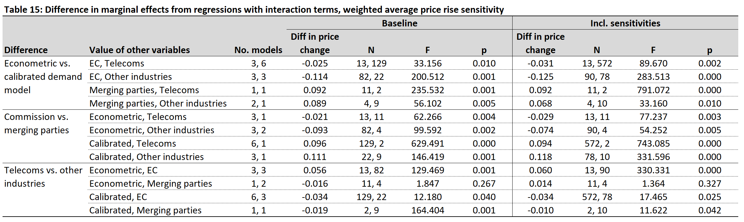
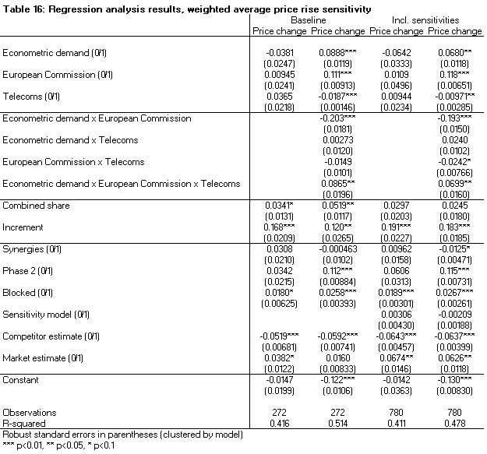
Table 17 shows the estimated marginal effects of the main regression model, but instead removes combined share and increment as regressors, in order to include the observations from the merging parties’ model in T-Mobile NL/Tele2 NL in the sample (as well as other observations without combined share and increment). Table 18 shows the equivalent regression results. The results are qualitatively similar, with the exception that the negative difference between the predicted price changes of telecoms vs. other industries for econometric models put forward by the merging parties and calibrated models put forward by the Commission become statistically significant.
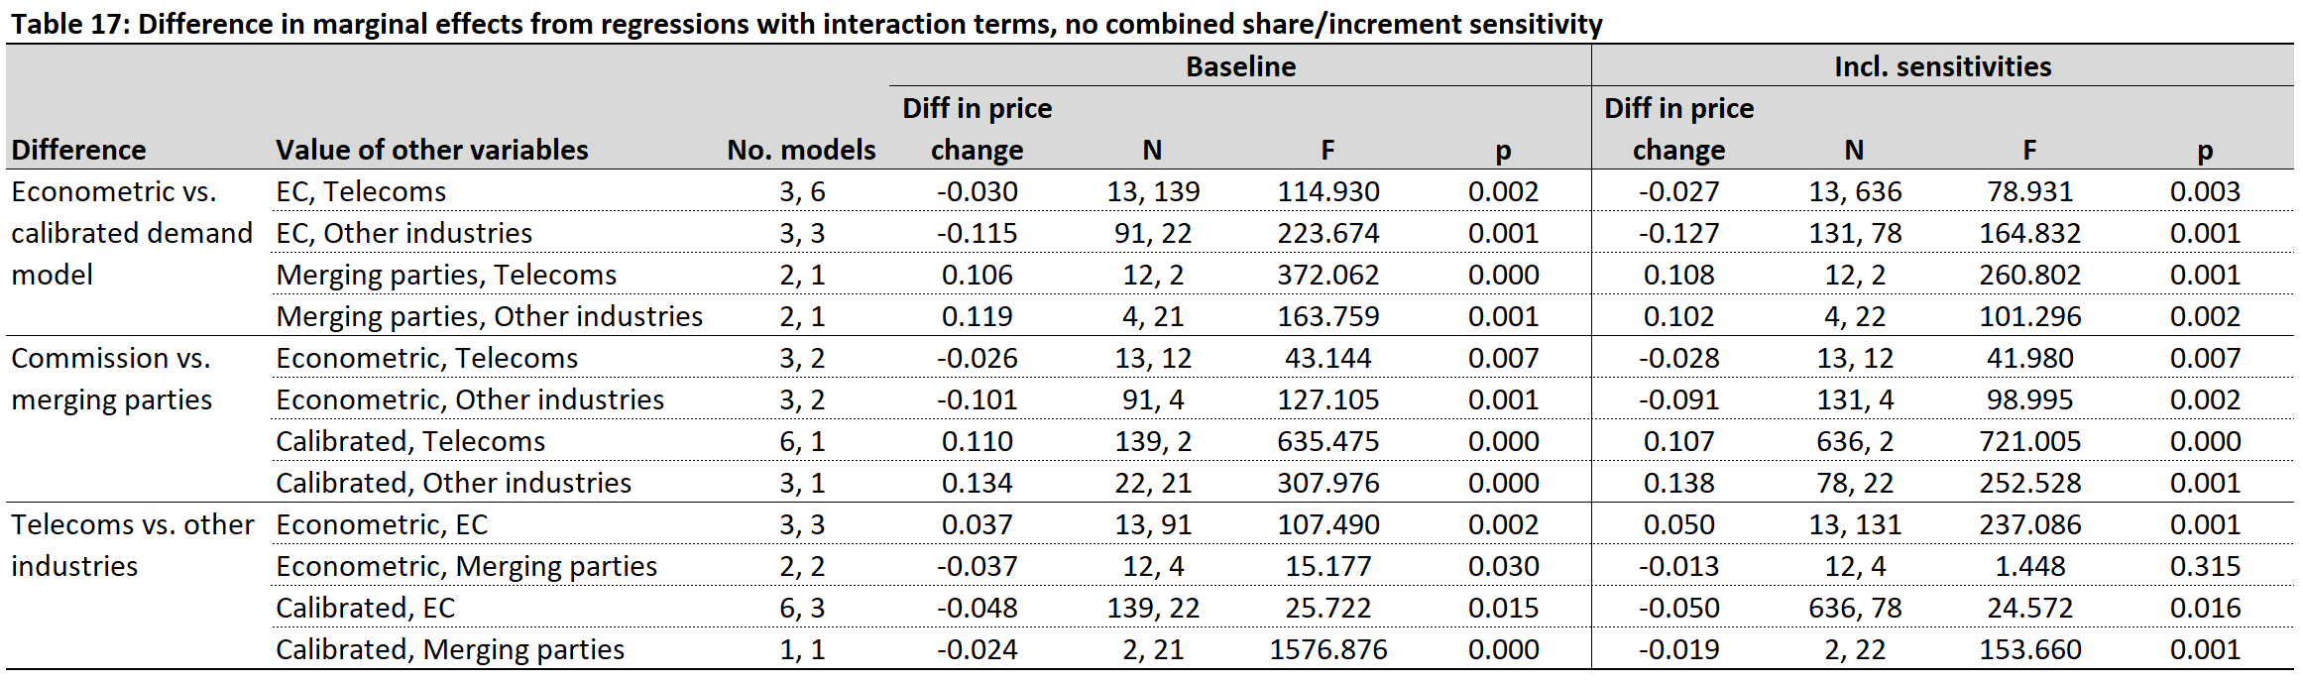
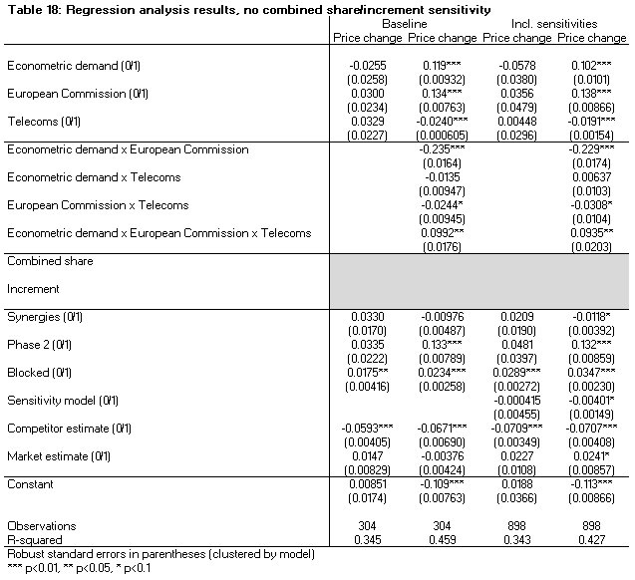
Table 19 shows the estimated marginal effects of the main regression model, but clusters the standard errors by case (rather than model). Table 20 shows the equivalent regression results. Now, the negative difference between econometric and calibrated models for models done by the Commission in telecoms is no longer statistically significant, and the difference between econometric and calibrated models for models done by the merging parties in other industries is no longer statistically significant.
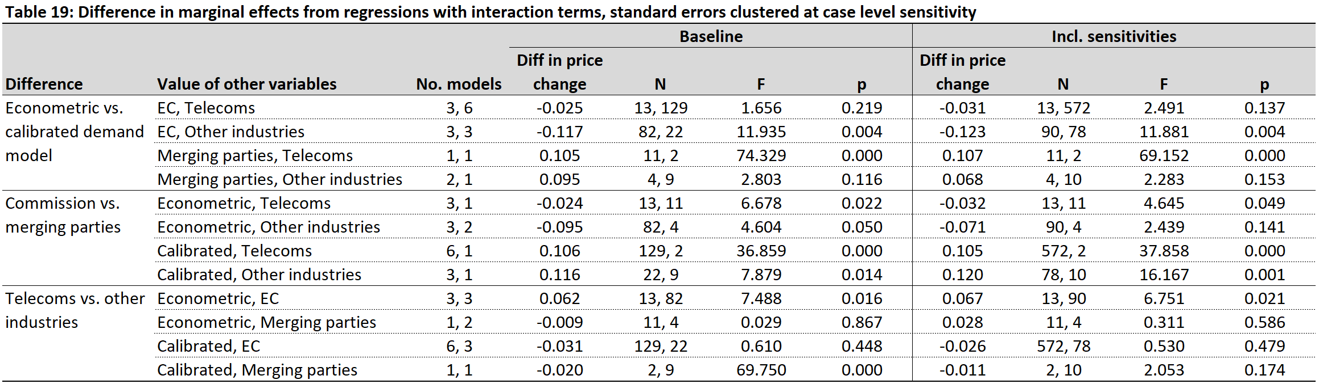
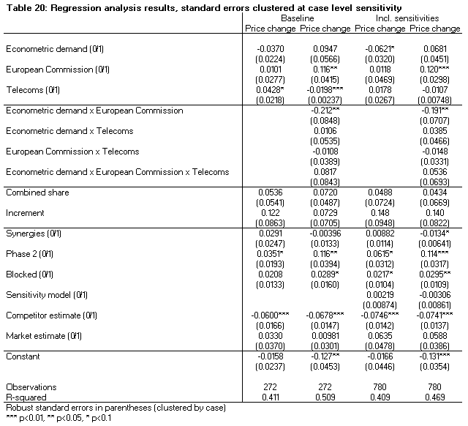
Table 21 shows the estimated marginal effects of the main regression model, but adjusts some price increase predictions to be ‘quality adjusted prices increases’. In three models, the merger simulation predicted increases in price due to the merger, but also predicted that consumer surplus would also increase due to an increase in quality. Table 22 shows the equivalent regression results. The results are qualitatively the same, other than the difference between the Commission and the merging parties for econometric models in telecoms is no longer statistically significant in the baseline scenario, and the difference between telecoms and other industries for calibrated models done by the Commission is now statistically significant.
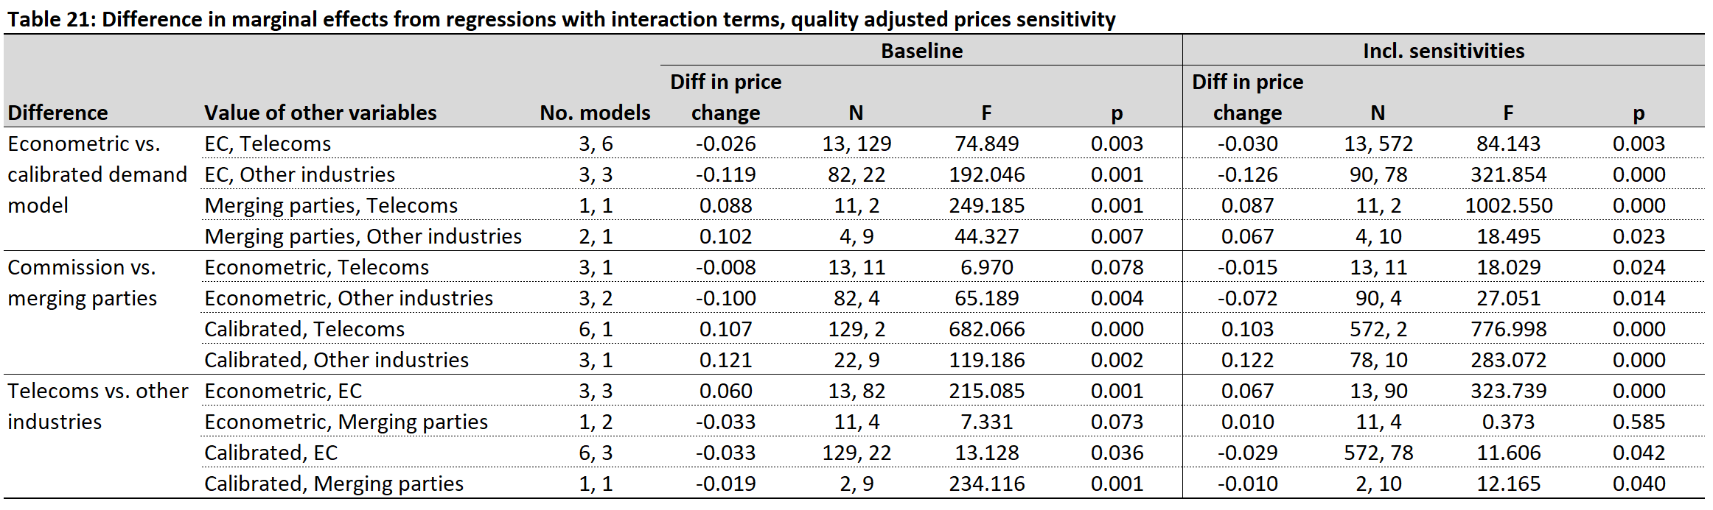
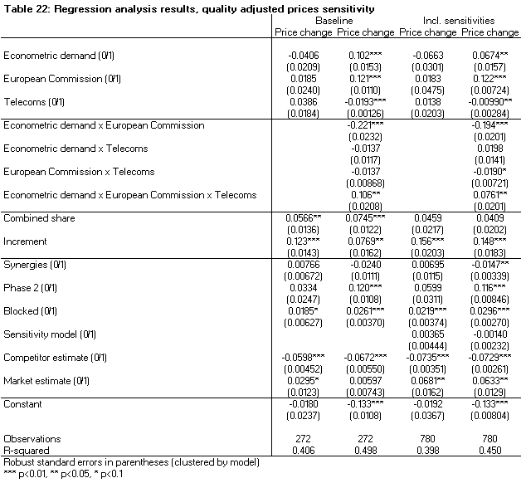
Table 23 shows the estimated marginal effects of the main regression model, but does not combine price increase predictions for the individual merging parties (for those models where the information is presented as such in the decisions) into a single price increase prediction for the merged entity. Table 24 shows the equivalent regression results. The results are qualitatively the same, other than the negative difference between the econometric and calibrated models done by the Commission in telecoms is no longer significant in the baseline scenario, and the negative difference between the telecoms and other industries for calibrated models done by the Commission is now statistically significant.
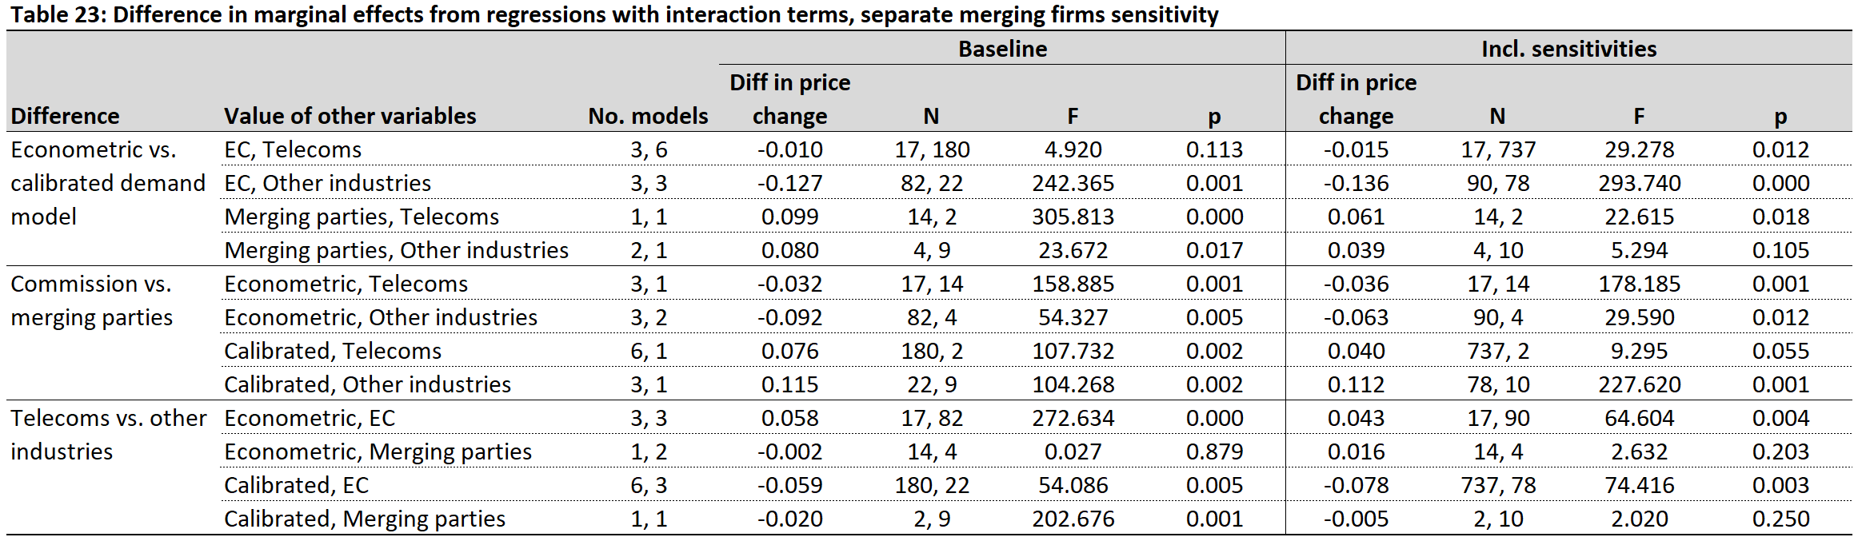
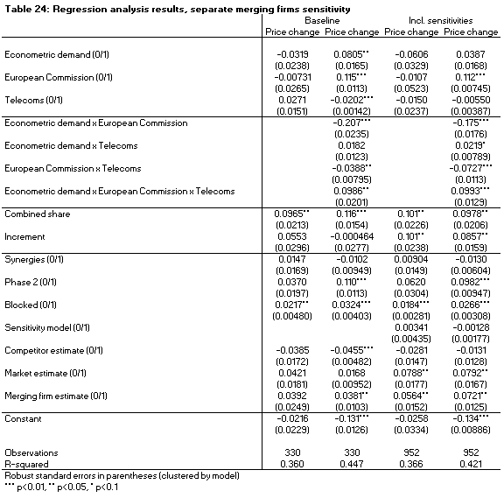

Predicted price changes, by Chief Economist – including sensitivity estimates
Figure 5 – Average merged entity predicted price change (including sensitivity estimates), by Chief Economist
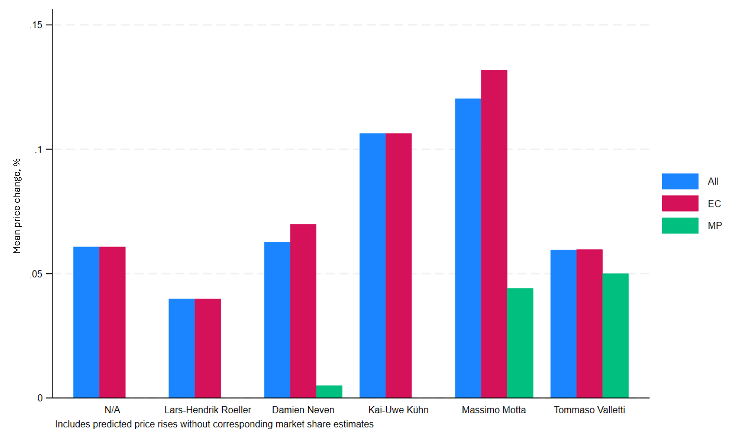
See figure notes under Figure 3.

See, for example, Budzinski et al. (2022), Valletti et al. (2021), Buettner et al. (2016) and Mariuzzo et al. (2019).
Draft Communication from the Commission, Guidelines on the assessment of mergers under Council Regulation (EC) No 139/2004 on the control of concentrations between undertakings.
Although one might be able to infer the direction of those effects and consequently whether the result is an upper/lower bound effect, etc.
See, for example, Unilever/Sara Lee, where the demand model ultimately used for the merger simulation was first used to determine whether ‘male’ and ‘non-male’ deodorants belonged to the same product market or not. See paras. 92-94 of the Decision.
The Commission noted that the specific assumption of linear demand “is conservative as other forms of demand, such as log-linear demand, would imply a higher predicted price increase.” See, for example, Commission Decision in Hutchison 3G Italy/Wind JV, supra note 23, Annex A at para. 10.
The term ‘merger simulation’ features in the Commission decision in Thales/Finmeccanica/Alcatel Alenia Space/Telespazio, in regards to an economic model submitted by a complainant to the concentration. However, having reviewed this decision, we believe the analysis is more akin to a vertical arithmetic / bidding analysis, and thus is not comparable to the other merger simulations we analyse in this paper. As a result, we do not include this analysis in our data set.
From Volvo/Scania (2000) to Outokumpu/INOXUM (2012). Although the data sets runs to 2014, the three cases featuring merger simulation in 2014 do not appear. We restrict the data set to those where the decision was published between 2000 and 2012 inclusive.
For some (earlier) cases, we found more information (both for this qualitative analysis and the later quantitative analysis) than was presented in the decisions, in academic articles commenting on the cases. These were: Ivaldi and Verboven (2002), Table 5 (for Volvo/Scania); and Budzinski and Arndt (2007), Tables 3-4 (for Oracle/PeopleSoft).
The number of modelling issues that were uncontested fell from 12 in the first six cases/simulation models (spanning 2000 to 2010 inclusive), nine in the next four cases/eight models (spanning 2012 to 2014), to only five in the final six cases/eight models (spanning 2015 to 2018). See Figure 4 in the Appendix.
The previous models are from: Volvo/Scania, Kraft Foods/Cadbury, Outokumpu/INOXUM, Hutchison 3G UK/Telefónica Ireland and Hutchison 3G Italy/Wind JV.
Philip Morris/Papastratos, Lagardère/Natexis, Unilever/Sara Lee and INEOS/Solvay JV.
Kraft Foods/Cadbury.
Telefónica Deutschland/E-Plus, Orange/Jazztel, Hutchison 3G UK/Telefónica UK, Hutchison 3G Italy/Wind JV and T-Mobile NL/Tele2 NL (two simulations).
In Oracle/PeopleSoft, a merger assessed in the US as well as Europe, the Commission and DOJ both submitted simulations in their respective merger reviews, based on an auction structure to the market. However, the auction structures they used were different: the DOJ’s model was an ‘English’ auction where competitors bid in turn in an ascending manner, whereas the Commission’s model was ‘first price sealed bid’.
In Outokumpu/INOXUM, the Commission acknowledged that its chosen Bertrand-Edgeworth model could not account for customer switching costs, customer multi-sourcing, and the costs to customers from changing their product mix, and hence that the simulation predicted more competition pre-merger than in reality, meaning that the simulation would predict relatively more of a fall in competition post-merger and larger rise in prices. As the simulation applied in INEOS/Solvay JV was largely the same, the same issues applied there as well.
Hutchison 3G UK/Telefónica Ireland.
Lagardère/Natexis.
Oracle/PeopleSoft.
Outokumpu/INOXUM and INEOS/Solvay JV.
Volvo/Scania and Unilever/Sara Lee.
In Unilever/Sara Lee, which concerned the market for deodorants, there was a debate as to how realistic the Commission’s simulation was given that it was ‘static’, whereas it was pointed out that deodorants were storable and thus would be purchased more and stockpiled in periods of price promotions (implying the model should be ‘dynamic’). The problem was not dealt with explicitly in the model, but instead the Commission pointed towards academic literature that showed that static models with storable products would underestimate merger price effects.
In Telefónica Deutschland/E-Plus, the Commission presented arguments as to why product repositioning due to the merger was unlikely, citing an academic study where the conditions for it to occur were not present in the telecoms industry in Germany. Similar arguments were also made as regards the Commission’s simulation in Hutchison 3G UK/Telefónica UK.
Unilever/Sara Lee, Hutchison 3G UK/Telefónica Ireland, Orange/Jazztel, Hutchison 3G Italy/Wind JV and Fortum/Uniper. Not accounting for countervailing factors was criticised in Volvo/Scania, Lagardère/Natexis, Oracle/PeopleSoft, Unilever/Sara Lee, Outokumpu/INOXUM and INEOS/Solvay JV.
Unilever/Sara Lee.
Hutchison 3G UK/Telefónica Ireland.
Known as the ‘red bus/blue bus’ problem. Imagine a commuter chooses between a car (50%) and a blue bus (50%). If a red bus is introduced, IIA suggests the new shares will be: car (33%), blue bus (33%), red bus (33%). However, intuitively, the new bus should only steal share from the existing bus, resulting in 50% car and (for example) 25% blue bus, and 25% red bus.
In Volvo/Scania, the Commission’s one-level nested logit model was criticised by the merging parties for not overcoming the IIA problem, whereas in Kraft Foods/Cadbury the Commission was receptive to the merging parties’ one-level model, arguing that it attenuated the IIA problem and furthermore relied on fewer parameters needing to be estimated compared to alternative demand models such as the AIDS model. In Unilever/Sara Lee, the Commission argued that its two-level nested model provided a good trade-off between the ‘simple’ logit model on one hand, that is computationally simple but suffers from the IIA issue, and the full BLP model (Berry, et al., 1995) on the other, which overcomes the IIA property but comes at the price of increased computational complexity and in the Commission’s view less stable results. Moreover, it showed that the results were robust to different alternatives. Finally, in DEMB/Mondelez the Commission argued that the merging parties’ use of nested logit was inappropriate – specifically having two coffee types as different ‘nests’. The Commission judged the market to be narrower (implying that it instead should have run separate simulations for each coffee type).
Orange/Jazztel and Hutchison 3G Italy/Wind JV.
The Commission’s model in T-Mobile NL/Tele2 NL.
Hutchison 3G Italy/Wind JV and T-Mobile NL/Tele2 NL, where merging parties relied on novel models, and used online surveys to estimate consumers’ willingness to pay for certain mobile tariff characteristics (e.g., data allowance, network speed), and then used these valuations to predict the consumer surplus effects of the mergers (on top of any increase in price pressure brought about by the concentration).
For example, the Commission’s simulation in Hutchison 3G UK/Telefónica Ireland for focusing on price rather than quality competition and not accounting for possible quality increases.
Lagardère/Natexis and Volvo/Scania.
In DEMB/Mondelez the merging parties submitted a separate demand estimation study, arguing that two coffee types that the parties’ sold belonged in the same product market. The Commission dismissed this model, finding instead that the products were in separate markets, and that the merging parties’ simulation should not have included both segments as separate nests in a single model, but instead had two separate models.
The Commission and the merging parties agreed on how the outside good should be factored into the simulation (how to model the choice of not buying the product in question at all) in Hutchison 3G UK/Telefónica Ireland and Telefónica Deutschland/E-Plus.
Volvo/Scania and Hutchison 3G UK/Telefónica UK.
DEMB/Mondelez.
T-Mobile NL/Tele2 NL.
Orange/Jazztel.
Orange/Jazztel.
Hutchison 3G UK/Telefónica UK.
The merging parties’ simulation in Hutchison 3G UK/Telefónica Ireland.
The Commission’s econometric BLP-based simulation in Hutchison 3G UK/Telefónica Ireland and the merging parties’ simulation in DEMB/Mondelez.
See, for example, Kraft Foods/Cadbury and Unilever/Sara Lee.
DEMB/Mondelez.
In Hutchison 3G UK/Telefónica Ireland, the merging parties argued that the Commission’s BLP model was “overly sensitive to the underlying method” – the Commission ultimately placed no evidentiary weight on its own model. In Telefónica Deutschland/E-Plus, the merging parties argued that the Commission’s BLP model – due to its increased complexity relative to simpler logit models – was “highly unreliable” and that its other nested logit model deployed in the case “better fits the data”. In T-Mobile NL/Tele2 NL, the Commission argued that the merging parties’ RCs model was computationally intensive and produced “unstable” results.
Unilever/Sara Lee.
Although in this section we analyse the same set of cases as in Section 4, it is not possible to link the two analyses, as the sample size is not large enough to incorporate in an econometric analysis each of the modelling issues discussed.
See Annex A, para. 244 of the Decision.
See also Buettner et al. (2016).
See, for example, Tommaso Valletti (2024) What Have The Consultants Ever Done For Us?, https://www.promarket.org/2024/02/28/what-have-the-consultants-ever-done-for-us.
See, for example, Thilo Klein, The General Court's CK Telecoms Ruling: Towards a Re-assessment of Unilateral-Effects in Merger Review: “The Commission’s model is driven largely by two variables: the diversion ratios between the parties, which will tend to be high in a concentrated industry like mobile telecoms, and the parties’ gross margins, which will be high because most of the costs of network operators are fixed. In combination, these two factors drive high price forecasts.”
See, for example, Katarzyna Czapracka, “No Magic Number” Means “No Magic Number”: Will the EU Court Turn the Tide on 4-to-3 Mobile Mergers in Europe?
See Annex A, para. 244 of the Decision. Although they explicitly refer to the UPP model in the quote, it applies equally to the merger simulation used.
Coded as 4% in the quantitative assessment.
Coded as 0% for the merging parties/merged entity in the quantitative assessment.
To make the price change predictions comparable across simulations, where an assessment presents price change estimates separately for each merging party, these are combined together and a simple merger-level average price change computed. This is also more consistent with how we record market share data for the quantitative analysis, which is at the level of the merged entity – this is because the combined share is a proxy for the magnitude of the concentration and hence should be a predictor of the predicted price change in the associated merger simulation. In the Appendix we show that our regression analysis is robust to instead calculating an average weighted by each merging party’s individual market share.
We made some other restrictions to the data to prepare it for our analysis. First, for the models where predicted price changes for the market are calculated and presented in addition to those of the merging parties/merged entity/competitors, these are removed to remove double counting. However, for the models where only predicted price changes for the market as a whole are presented, these are retained, including a dummy to control for these observations in the regressions. Second, for a small number of price change estimates, corresponding information on the combined share and increment is not available, usually because the market definition used for the model is not the same as the market definition established elsewhere in the decision and hence market shares are not calculated and presented – these are dropped from the sample.
See Table 7 in the Appendix for further detail.
See Table 8 in the Appendix for further detail.
See Table 9 in the Appendix for further detail.
See Table 10 in the Appendix for further detail.
For example, in Volvo/Scania, the merger simulation was applied to 16 national markets, whereas in the telecoms cases there was only one geographic market in each.
See, for example, Jan Peter van der Veer, Unilever/Sara Lee – The return of merger simulation?
The same conclusions arise when considering only the merged entity observations (n=114) which would not suffer from mix effects from the inclusion of price change estimates for competitors and/or the market as a whole, which we can control for in a regression but not when considering simple averages as in this table. See Table 11 in the Appendix.
Though this is based on a relatively small sample size, and driven by the random-coefficients econometric models put forward by the merging parties in Hutchison 3G Italy/Wind JV, where the models predicted large nominal price increases but which they argued would be offset by even larger increases in quality.
These conclusions are largely the same when only considering the predicted price changes of the merged entity, a sub-sample which does not suffer from mix effects (see Table 13 in the Appendix).
These results confirm some of the conventional wisdom of merger analysis: the price increase prediction is larger if the change in market concentration (post-merger combined share) is larger, and/or where the increment in market concentration is larger. Similarly intuitively, the price increase estimates are larger in simulations produced in phase 2 or in blocked mergers in most of the specifications, and they are lower when synergies are factored into the model.
This implies that, for the cases that featured more than one simulation model, the standard errors are still clustered at the model level, not the case level. However, in the Appendix, we show the results clustering standard errors by case.
Supporting the specific point made by the merging parties in Hutchison 3G UK/Telefónica UK, that when the Commission presented both calibrated and econometric models side-by-side, the latter produced lower price increase estimates – see Section 4.1. Outside of our data set of merger simulations used in EU merger control, there is further anecdotal evidence to support this point, in that the CMA, in its review of the Vodafone/Three JV in the UK in 2024, used a merger simulation model based on econometrically estimated demand as its baseline, “conservative”, model that predicted that consumers would be £216 million worse off every year post-merger. It then performed a number of sensitivity analyses where the main change to the baseline was that the demand parameters were calibrated instead – each of these sensitivities produced higher price changes, the largest of which predicted that consumers would be up to £900 million worse off each year. See CMA final report in Vodafone/Three JV, paras. 42-43 and Table D.10.
Though these results are based on limited samples, i.e., equivalent to comparing five models. In telecoms, this is a comparison of the random coefficients econometric model used in Hutchison 3G Italy/Wind JV (where the merging parties acknowledged its model’s high predicted price changes, but argued that overall consumer surplus would be higher due to quality improvements brought about by the merger) and the nested logit calibrated model used in Hutchison 3G UK/Telefónica Ireland, which produced “negligible” price increases. In other industries, our results are equivalent to a comparison of the econometric nested logit models in Philip Morris/Papastratos and Kraft Foods/Cadbury with the calibrated nested logit model in DEMB/Mondelez.
CMA final report in Vodafone/Three JV, Appendix D, para. 108.
We reviewed this model in detail, but did not include its predictions in the quantitative analysis as the focus is on European merger review.
As noted above, the DOJ’s model is excluded from the regression data set.
Panhans et al. (2023) look at the impact of a potentially mis-specified demand model can have on the merger simulation predictions.
Froeb et al. (2003) and Walker (2005).
We did not include the predicted price changes of competitors and the market as a whole in this graphical analysis, to avoid mix effects. Includes baseline price change estimates only.
The pattern is largely the same when including sensitivity price change estimates, the only change being that the average price change for Commission simulations under the last three Chief Economists is slightly higher (see Figure 5 in the Appendix).
See, for example, Filistrucchi et al. (2012) and Cayseele & Vanormelingen (2019).
Noted explicitly in its review of Vodafone/Three JV.
For example, in Unilever/Sara Lee, the Commission argued that time was the main factor constraining it from introducing entry, repositioning or retailer buyer power into its model. Similarly, in the telecoms cases, the Commission seemingly moved away from relatively more sophisticated models based on econometrically estimated demand due to its increased complexity compared to calibrated demand models.
Döpper et al. (2024).
A result which is driven by the Commission’s simulation model in Oracle/PeopleSoft, where in the sensitivities it iterates over a ‘quality’ parameter, which has a large impact on the predicted price changes (as large as 49%).
For this table and the following equivalent tables, please refer to the table notes under Table 6.
In Oracle/PeopleSoft, the Commission’s model had two ‘scenarios’: pessimistic; and optimistic, where quality improvements and synergies due to the merger are assumed to take place. In practical terms for this sensitivity, we replace the (higher) predicted price changes in the optimistic scenario with the (lower) predicted price changes from the pessimistic scenario. In the merging parties’ model in Hutchison 3G Italy/Wind JV, predicted price changes in the scenario where quality is assumed to increase due to the merger are set to zero, to reflect the model’s predictions that consumer welfare would overall increase. The same is done for the merging parties’ model in T-Mobile NL/Tele2 NL.

