The Politician, the Press and the Public: How Politicians’ Perceptions of the Media Shape UK Aid Allocations

April 14, 2026

Abstract
This paper examines politicians’ attitudes and beliefs about the press, their potential role in shaping aid policy and how these views differ from the public’s. We address these questions using survey data from 107 UK MPs and 2,047 members of the UK public. We find a positive association between MPs’ beliefs that the news media influence public opinion, reflect public opinion, and are central to a political career - and a belief that the news media should influence aid policy. This suggests that politicians’ attitudes and beliefs about the media can play a role in shaping aid policy. We also find that MPs are significantly more likely to think that the media influences public attitudes towards aid spending than the public. This suggests that politicians could potentially be overweighting news coverage when making decisions about aid spending. Overall, these findings help fill an important gap in our understanding of what happens ‘upstream’ of aid allocations and adds further nuance to our understanding of the media’s political effects.
Key words: Aid policy, media influence, politicians’ attitudes, public opinion, political communication
Data Availability: Raw data and code is available (Authors, 2026).

Introduction
In liberal democracies, politicians are incentivised to consider, if not always follow, the opinions of their electorate. Since voters tend to favour candidates who act in ways that align with their views and concerns, listening to public sentiment can help politicians to remain in office (Schumacher and O¨ hberg, 2020).
But politicians operate in a complex, fragmented and often incomplete information environ-ment, receiving many noisy signals about public opinion. They can seek to ascertain the will of an electorate through conversations with constituents, or their letters and emails. But these in-dicators of public opinion are often drawn from a highly motivated and unrepresentative section of the electorate. Politicians are also typically quite sceptical about the ability of social media to accurately represent public sentiment, given its tendency to amplify minority or partisan views (Walgrave and Soontjens, 2023). Even national polling has limitations including question framing, response bias, relevance and low response rates amongst certain demographics.
Our interest is in politicians’ use of news coverage as an indicator of public opinion and whether this influences their decision-making. National news outlets remain central to politi-cians’ media habits, despite the rise of online alternatives. In the UK, more than three-quarters of MPs access digital news publications multiple times a day (Rice and Cooper, 2025). The website of The Times, for example, is visited frequently by 73% of Conservative MPs, 70% of Labour MPs and 62% of Liberal Democrats (Rice and Cooper, 2025).
The idea that the news media relay citizens’ concerns to politicians is known as the represen-tation function (Curran, 2002). It is based on the premise that, in a highly competitive media landscape, where people tend to consume news that aligns with their perspectives, news outlets are responsive to different aspects of public opinion. Whether the press do in fact provide a reliable proxy for public opinion, or not, if politicians believe this to be true, they may respond to news coverage because they regard it as a useful reflection of public opinion.
But this is not the only way that politicians’ attitudes and beliefs about the press might play a role in shaping policy. There are three further possibilities. First, politicians might also believe that news coverage can influence public opinion and not only reflect it. If so, they might adjust their policy making decisions according to how they anticipate the press will cover them. They may do this either to avoid the blame associated with critical coverage or seek the credit associated with favourable coverage (Flinders et al., 2024). This is akin to anticipating possible future public opinion and adjusting decision-making accordingly. It is based on the idea of Presumed Media Influence (PMI), or that individuals react not necessarily to media content but to their perceptions of how the media affects others (Gunther and Storey, 2003).
However, the press are important to politicians not only because they might help them to get re-elected, either by reflecting or influencing public opinion. They can also help politicians achieve other objectives like making and managing policy or pursuing higher office. For instance, there is a widespread and well-documented belief among politicians in liberal democracies that engaging with the media has become an intrinsic part of how politics gets done. This is referred to as the mediatization of politics (Hjarvard, 2013). A belief that politics has become mediatized can lead politicians to tailor their behaviours to gain media attention because this is how they influence internal party debates, for example, or communicate with other legislators (Davis,

2009).
Finally, politicians may favour specific policies that they anticipate will generate positive media coverage for themselves in order to seek favourable attention from their party leaders and gain promotion. However, in the UK the Government Communication Service’s (2023) Propriety Guidelines describe such ‘image making’ or building of ministers’ personal brands via Govern-ment Communication as ‘improper’. This is because government communications are supposed to provide an impartial public information service for citizens, rather than partisan communi-cation (Garland, 2025). Therefore, the use of policy for image making will depend on whether politicians believe it is acceptable to gain personal reputational benefits from government policy announcements.
In this article, we explore these four different possible relationships between politicians, the press and the public (the representation function, Presumed Media Influence, mediatisation and image making) in the context of UK development aid. Over the last two decades, levels of UK aid spending and the volume of news coverage about it have varied significantly - as Figure 1 illustrates - making this a useful context for the study of media influence. Since 2006, UK aid spending grew steadily from around 0.3% of GNI to the UN target of 0.7%. This target was first met in 2013 and maintained for seven years, being a legal obligation from 2015. This period of increased aid spending coincided with austerity under consecutive Conservative-led governments (starting in 2010) when almost all other Government departments experienced cuts in spending budgets. In 2020, the 0.7% target was lowered to 0.5% with spending being at or slightly above this figure in subsequent years. During this time, the definition of ODA has been stretched, with many more costs now included such as hosting refugees within the UK (Hughes and Mitchell, 2024).

Figure 1: UK Public Support for Aid, and its Public Spending on ODA

UK's ODA/GNI, %
.7
.5
.3

UK Public Support for Maintaining or Increasing Aid
60
AAT data
DEL data
50
40
30

UK's Annual Volume of Press Coverage of Aid, by Political Leaning
300
centre
left
right
200
100
0
2008 2010 2012 2014 2016 2018 2020 2022 2024

Note: Data on UK public Support comes from https://developmentengagementlab.org/publication/ great-britain-dashboard-january-2025/. They changed methodology in 2019, hence the AAT and DEL labels referring to different wording. Data on ODA/GNI comes from https://www.gov.uk/ government/statistics/statistics-on-international-development-provisional-uk-aid-spend-2023/ statistics-on-international-development-provisional-uk-aid-spend-2023#the-odagni-ratio Data on UK press coverage comes from the results of our own keyword search of the Factiva databases for all news articles mentioning ‘aid’ and ‘Department for International Development’.

Figure 1 shows that public support for at least the current level of aid spending has remained more stable, at between 40% and 55% (2020-2024). The DEL data has fewer data points but are high quality. Respondents are first given the absolute values of UK government spending and ODA, and then the % figure. Only then are they asked if they support increasing, decreasing or maintaining that figure. Responses to other similar questions asked by the Aid Attitudes Tracker (AAT data) tell a similar story of relatively stable levels of support between 2014 and 2019.
Finally, Figure 1 shows that the volume of UK press coverage of aid in two centrist newspapers (the FT and Independent) was flat between 2009 and 2020, with a slight increase in coverage by left-leaning publications (The Guardian and The Mirror). By contrast, coverage of UK aid in right-leaning publications - including the Daily Mail, Daily Telegraph, Express, The Sun and The Times - increased significantly between 2015 and 2018. The Daily Mail newspaper alone published 174 stories about UK aid in 2016 and 2017 – the vast majority of which were critical of aid spending. High-profile examples include stories entitled: ‘Britain Gives £5m to African Girl Band’ (19.12.16) and ‘India Boasts of Satellite Launch (as we hand them £54m of aid)’ (5.10.17).

While existing research on aid allocation has examined donor allocation patterns (Alesina and Dollar, 2000; Clist, 2011) and the effect of public opinion on setting aid budgets (Kaufmann et al., 2019), it has not systematically investigated how politicians’ beliefs about the media may influence allocation decisions. Therefore, we aim to investigate (1) whether MPs hold certain views about the relationship between the press, the public and politicians (2) whether politicians and the public disagree on such matters and (3) what views, if any, correlate with thinking the media should influence aid policy. Addressing these questions can help us to establish whether politicians’ attitudes and beliefs about the press may lead to aid allocations being less responsive to public opinion than previously thought.
We explore these issues by conducting two surveys. First, we ask 107 MPs nine questions. As there are 650 members of Parliament in the UK, we have responses from a little under a sixth of the main legislative body (16%). Second, we ask 2,047 members of the UK public a subset of six questions. Both sets of respondents are weighted to be representative of the appropriate population. Using this data, we can test the average views of MPs, whether they differ from the public, and what correlates with thinking the media should influence aid spending. We preregistered most of our analysis (Clist and Scott, 2024, note we did not preregister tests of the average views of MPs, but use a similar approach to other questions), which uses a series of regressions and robust standard errors.
We find that, on average, MPs do hold views consistent with Presumed Media Influence and the mediatisation of politics but do not perceive the media as performing a representation function and disagree that image making is acceptable. While MPs and the public have similar views on the media’s representation function (and the public’s views on mediatisation were not tested), we find that MPs are more likely than the public to believe in the acceptability of image making (especially Conservative MPs) and in Presumed Media Influence. Finally, we find that MPs who think it acceptable for the media to influence aid policy are also more likely to believe in all four theories of political communication under investigation. This is significant for mediatisation and the representation function, but the largest, most robust and most significant effect is for Presumed Media Influence.

Literature Review
Our research aims to fill an important gap in our understanding of aid allocation. Early investi-gations of aid allocation essentially took the size of the aid budget as exogenous, and sought to understand how government donors divided this amount between different bilateral recipients, finding fairly large donor heterogeneity (Alesina and Dollar, 2000; Clist, 2011). Downstream of this, it seems the type of aid delivered responds to governance within the recipient country (Clist et al., 2012; Molenaers et al., 2015) and that the within-country geographical distribution of aid only weakly responds to need (Briggs, 2017).
Upstream of the aid budget, there is a literature on what affects public support for aid. Public policy preferences do seem to influence the size of the aid budget (Milner and Tingley, 2010), with Kaufmann et al. (2019) showing discrepancies relate to the power of special interests. Several papers have studied the determinants of public support for aid, with mixed results on relative and absolute income. Looking across a range of countries, support is typically positively

correlated with religiosity, beliefs about the causes of poverty, awareness of international affairs, and trust in people and institutions (Paxton and Knack, 2012; Chong and Gradstein, 2008; Kaufmann et al., 2019). In a UK context, Henson and Lindstrom (2013) find limited effect of any demographic variables, with variation explained mainly through different ideas of moral obligation.
How easily influenced are the public? Hurst et al. (2017) run an experiment to examine the question. They provide people with short arguments for and against aid, and find quite large effects in the expected directions on the support for aid amongst US public. Kobayashi et al. (2021) study aid attitudes in the context of COVID-19, and find US residents were more supportive of aid only if they felt it could reduce their own exposure to the virus. In a similar design, Wood and Hoy (2022) provide experimental evidence, showing newspaper style articles to a little over 4,000 Australians. They provided vignettes resembling news articles with different emphases (e.g. national interest or altruistic motives), all of which were positive about an aid project. The articles decreased the number of people that thought Australia gives too much aid from about 45% to about 35% regardless of the emphasis, with slight increases in the numbers saying Australia gives too little aid. In all these cases, it is unclear whether these effects would persist outside of the study as subjects may exhibit a social desirability bias where they feel they should report in line with the suggested effect, without changing their true opinion. Further, the long-term effects are not known. However, these provide a useful upper bound on how changeable the public may be.
This existing literature examines many elements of aid allocation’s casual chain including understanding individual citizen’s preferences and how the aid budget is allocated. However, there is a gap between these steps: with current research implying politicians learn of public opinion and respond to it without much friction or role for the media. We aim to address this gap by investigating whether politicians place weight on the media’s coverage of aid and why they might do so – in relation to the four political communication theories discussed above. Existing research has provided some anecdotal and indirect evidence to indicate that politicians’ attitudes and beliefs about the press are likely to shape aid policy but this potential influence has not been systematically tested. For instance, Fisher (2015b, p.13) has shown that since the mid-2000s political conditionality was increasing used within UK aid spending, not to increase the efficacy of aid spending, but “for ‘expressive’ reasons - to signal [donor officials’] putative commitment to delivering ‘value for money”’. This leads him to argue that “DFID officials interpret public support for or opposition to key decisions through media headlines” (Fisher, 2015a, p.5) - an assumption consistent with a belief in the media’s representation function.
Similarly, policymakers’ beliefs about Presumed Media Influence may shape aid policy. De-vanny and Berry (2022, p.98) describe how “aid-scepticism amongst... right-leaning [UK] media [has]... reportedly influenced policymakers” via the so called ’Daily Mail test’. This refers to the apparent tendency of DFID officials to view policy decisions “through the prism of the infamous test: ‘how will the Daily Mail present this’” (Devanny and Berry, 2022, p.98). Underpinning this strategy of blame avoidance, according to Devanny and Berry (2022, p.98), is a belief that “media criticism resonated with core Conservative voters”, or a presumption of media influence. Regarding the potential influence of politicians’ beliefs in the acceptability of image-making,

a recent study of humanitarian aid allocations identifies a widespread perception among senior civil servants across multiple countries. Specifically, Scott et al. (2022, p.178) report the belief that some ministers proactively use aid allocations “as an opportunity to engage in a ‘frontstage’ publicity-gaining politics” to “advance the personal career/s of the minister/s concerned”. One senior official is quoted as saying, ‘[Ministers’] priorities are not purely humanitarian. It is also about their career... To guarantee their next steps. [Some] ministers like to [have] publicity” (Scott et al., 2022, p.178).
Finally, Valters and Whitty (2017) analysis of policymaking within the UK Department for International Development (DFID) suggests that politicians’ perceptions of the mediatisation of politics might also influence policymaking. In an interview, the former Secretary of State for International Development, Andrew Mitchell (2010-12), told them that, ‘it’s the job of politicians to explain complex things to the public in a way that they understand’ (ibid., p.9). Valters and Whitty (2017, p.39) argue that this desire to “to ensure the public understand how aid and development work” helped drive DFID’s ‘results agenda’ from 2010 onwards, because a focus on results, evidence, value for money and transparency could provide more useful material for public communication.
Such claims about the policy implications of politicians’ beliefs about the press currently rest either on indirect evidence drawn from civil servants’ beliefs – or on anecdotal evidence from a small number of politician’s testimonies. We seek to complement this work by directly and systematically testing politicians’ beliefs about news coverage of aid and assess their implications for policymaking.
We also examine how MPs’ beliefs compare with those held by the public because studies of politicians’ beliefs about other issues often identify systematic misperceptions of public opinion (Broockman and Skovron, 2018). For example, Tsfati (2014, p.571) argues that previous re-search has shown that politicians’ perceptions of the media’s influence over public opinion “are significantly and substantially larger than those of average citizens”. In a comparative analysis of perceptions of media influence among politicians and the public in Sweden, Johansson (2004, p.270) finds that, ‘in the politicians’ worldview, they themselves are most influenced by their own experience, while other people are more influenced by. . . forms of communication... [espe-cially] television and newspapers’. This matters because misperceptions of public opinion and media influence could be driving politicians’ actions.

Methods
We have three goals. First, we wish to establish whether the average MP holds certain views about the relationship between the press, the public and politicians. These views (the represen-tation function, Presumed Media Influence, mediatization and image-making) were introduced above, and are illustrated in Figure 2. In Figure 2, the direction of the arrows represents the proposed direction of influence between politicians, the press, and the public, according to each theory. Second, we wish to see whether politicians and the public disagree on such matters, also noting any major differences within these groups. Third, we wish to investigate which MP’s views, if any, correlate with thinking the media should influence aid policy. This helps to un-derstand which politicians’ beliefs about the press are associated with an acceptance of media

Figure 2: Four Theories of Political Communication, with relevant Survey Questions

Politicians

Presumed Media Influence Q1, 4 & 5

Press

Public Opinion
Mediatisation Q8

Representation Function Q2
Image Making Q6

Note: The three boxes show three agents. The four theories are then shown using arrows to express the hypoth-esised direction of influence. Below each arrow we show the relevant survey question(s).

influence on aid policy.
To achieve these aims, we commissioned the UK polling organisation, YouGov, to ask 100 members of Parliament nine questions about their attitudes and beliefs about the relationship between the press, the public and politicians. This included six questions designed to test the four theories of political communication under investigation, as well as three additional contextual questions. Figure 2 illustrates which survey questions correspond with the four theories.
To examine politicians’ belief in the representation function, or that public opinion influences press coverage, we asked MPs to what extent they agreed with the statement: ‘News coverage about overseas aid reflects public support for overseas aid’ (Q2). To investigate politicians’ belief in Presumed Media Influence, or that news coverage influences public opinion, we asked MPs the extent to which they agreed with the statement: ‘News coverage about overseas aid influences public support for overseas aid’ (Q1). We explored this further by asking MPs to what extent they agreed that news coverage about overseas aid influences ‘public opinion about how the UK’s overseas aid budget is spent’ (Q4) and ‘public support for the size of the UK’s overseas aid budget’ (Q5).
To examine politicians’ belief in the mediatisation of politics we asked MPs to rate their agreement with the idea that ‘to advance a political career is it important to be successful in the media’ (Q8). To investigate politicians’ belief in the legitimacy of using policy for image-making, or political self-promotion, we asked MPs to rate their agreement with the statement that ‘it is acceptable for government ministers to use announcements about overseas aid spending to advance their own political careers’ (Q6).
In addition to asking MPs six questions regarding their beliefs about the four theories of political communication, we asked them three further questions which are crucial for our other goals, and which provide useful context. To gauge a politician’s openness to policy decisions being influenced by the media we asked MPs to what extent they agreed that ‘it is acceptable that news coverage influences UK government aid spending’ (Q3). We also asked MPs to rate their agreement with two further statements: ‘the government should increase the amount of money it spends on overseas aid’ (Q7) and ‘news coverage about overseas aid influences govern-ment spending on aid’ (Q9). For all questions, we test whether the MPs’ average response is significantly different from zero, i.e. neutrality. We use bivariate regressions and weight data to be representative of all MPs, excluding Northern Ireland.
Our second goal is to investigate how MPs’ beliefs and attitudes about the press compare with

those of the public, within the context of UK aid policy. To achieve this, we also commissioned YouGov to ask 2000 members of the UK public the first six questions asked of MPs (Q1 – Q6), in the same month. For each of these six questions, we test whether there is a difference between the average response of both samples. In each case, we preregistered a directional hypothesis, and so report one sided p values from a t test. We did not ask the UK public about their beliefs regarding the mediatisation of politics (Q8), as we considered them unlikely to be able to judge the importance of media success for advancing a political career. We also did not ask the public about their support for aid spending (Q7) or whether news coverage actually influences aid spending (Q9) because these questions relate specifically to our interest in the policymaking role of MPs.
Our third goal is to probe why politicians may find media influence of policy acceptable. Question 3 is key here, asking whether ‘it is acceptable that news coverage influences UK gov-ernment aid spending’. MP’s answers to this question allowed us to explore why politicians may think media influence on policy is acceptable, or not, by seeing which other answers are associated with this answer. This does not allow us to establish a causal relationship between politicians’ attitudes and beliefs about the press and aid policy decisions, nor does it allow for a more discursive argument from respondents. However, by examining the correlations between different views, we can assess the extent to which different theoretical accounts of the influence of politicians’ attitudes and beliefs about the press are consistent with politicians’ expressed attitudes. We achieve this using a series of bivariate regressions, and one omnibus specification. Table 1 summarises the nine survey questions, the rationale for their inclusion and who was asked each question.

Table 1: Full wording of all questions, Grouped by View

Presumed Media Influence
Q1. News coverage about overseas aid influences public support for overseas aid.
Q4. News coverage about overseas aid influences public opinion about how the UK’s overseas aid budget is spent.
Q5. News coverage about overseas aid influences public support for the size of the UK’s overseas aid budget.
Representation Function
Q2. News coverage about overseas aid reflects public support for overseas aid.
Mediatisation of Politics
Q8. To advance a political career is it important to be successful in the media.
Image Making
Q6. It is acceptable for government ministers to use announcements about over-seas aid spending to advance their own political careers.
Normative/Descriptive Views on Media Influence on Policy
Q3. It is acceptable that news coverage influences UK government spending on overseas aid.
Q9. News coverage about overseas aid influences government spending on overseas aid.
Contextual
Q7. The government should increase the amount of money it spends on overseas aid.
Note: MPs are asked all questions, the Public are asked questions 1-6.

In both surveys, YouGov slightly oversampled, leading to samples of 107 MPs and 2,047 members of the public. YouGov provided a series of weights, so that each sample can be representative of its population (excluding Northern Ireland in both cases). In addition, several standard variables were provided. For the public these comprised age, gender, social grade on a six-point scale, region and voting behaviour in the 2019 general election and 2016 EU referendum. For MPs, since there could be concerns about unmasking individual respondents, as we have 107/650 MPs, only gender and party were included. A constraint with the sample is that all answers are provided on a five-point scale; strongly/somewhat agree/disagree, with a middle option of ‘neither agree nor disagree’. As preregistered, we treat responses as continuous and convert these ratings to a five-point scale running -2 to +2.
Although this survey approach allows us to gain a direct window into MPs’ attitudes and beliefs about the press and explore how these might be associated with their views on policy, it also carries some limitations. As with responses to all surveys, respondents may not be telling the truth about their genuine opinions. In our case, MPs may doubt assurances of anonymity given the relatively small size of the population (650) and since they know their responses are attached to their party affiliation. However, this survey was conducted in March 2024, just four months before a much-anticipated general election, where (as expected) the majority of MPs

lost their seats. As such, MPs may have felt somewhat freer to answer honestly.
Another important limitation of this survey is that it is not limited to the relatively small number of Government Ministers in aid-spending departments (of which, the UK’s Foreign, Commonwealth & Development Office is most important) and the Treasury (which sets depart-mental budgets). Instead, the survey is weighted to be representative of the House of Commons as a whole but relies on voluntary and anonymised participation. Despite this, we believe this survey of MPs still provides a valuable means of understanding how politicians’ perceptions of the media relate to aid policy, for three reasons. First, having surveyed 107 of the 650 serv-ing MPs, our sample likely includes some politicians who previously, currently, or would in the future have direct responsibility for UK aid policy. In the calendar year of 2024 alone, there were nine different MPs with Ministerial posts in the FCDO, including five Conservative and four Labour MPs. Second, regardless of whether surveyed MPs have direct responsibility for UK aid policy, the large proportion of MPs included in the sample (16%) suggests it serves as a reasonable representation of the perspectives of those who do. Finally, MPs who are not part of the executive still have several ways of influencing aid policy. These include several relevant All Party Parliamentary Groups (APPGs), such as those on Human Rights, Extreme Poverty and Global Health as well as the influential Foreign Affairs and International Development Select Committees. Both committees have 11 MPs as members and are responsible for examining the expenditure, administration and policy of the FCDO. All MPs can also ask Government Minis-ters questions related to aid policy in the House of Commons. According to Hansard, 396 such questions were asked about “foreign aid” or “development aid” in first six months of 2024.
In the following sections, we report in turn on whether MPs, on average, believe in the four theories of political communication under investigation, how these beliefs vary between MPs and with the public, and whether they correlate with a belief that the media should influence aid spending.

Results
We start by asking whether, on average, MPs hold views associated with the four theories of political communication under investigation: the representation function, presumed media influence, mediatisation and image making. We do this using simple tests of their agreement or disagreement with relevant statements. We did not preregister these particular tests (i.e. the tests in section 3.0), but they follow the same logic as the other tests. We run a regression using the provided weights and robust standard errors. We then test if the constant (i.e. MP’s average) is equal to zero. We use two-sided p values as we did not preregister directional hypotheses in this subsection. All data an code is available (Authors, 2026).
To assess MPs’ views on the media’s representation function, we analyse their responses to the statement in survey question 2: ‘News coverage about overseas aid reflects public support for overseas aid’. We find that, in general, MPs have a neutral view on this, with an average response of 0.06 (p=0.603, t=0.52). This indicates that MPs do not perceive the media as performing a representation function in relation to development aid.
To assess MPs’ views on Presumed Media Influence, we use three tests, which all point in the same direction. On average, MPs agree that ‘news coverage about overseas aid influences

public support for overseas aid’ (Q1). The mean response is 0.876, which is significantly different from 0 (p=0.000, t=9.13). MPs’ average response of 0.88 to question 4 shows they also agree that news coverage influences public opinion about how the UK’s overseas aid budget is spent (p=0.000, t=10.75). Similarly, the average response of 0.77 to question 5 is significant (p=0.000, t=8.54) suggesting they also agree that news coverage influences public support for the size of the UK’s overseas aid budget. Thus, the three tests show that MPs hold views consistent with Presumed Media Influence; they think the public’s support for aid is influenced by the media. This is the case whether considering the overall support, the budget’s size or its use.
To assess MPs’ views on the mediatisation of politics, we analyse responses to Question 8. The average response of 0.54 is significant (p=0.001, t = 4.43), indicating that MPs, in general, agree that ‘to advance a political career is it important to be successful in the media’.
Finally, to assess MP’s views about image making, we analyse responses to Question 6. Here, MPs disagreed that it is acceptable for government ministers to use announcements about overseas aid spending to advance their own political careers. The average response is -0.51, with p=0.001 and t=3.32.
Regarding other views expressed by MPs in the survey, we found that, on average, MPs weakly supported increased spending on aid (the average for Q7 is 0.32, p=0.052, t=1.96) and agreed that the media does influence policy (the average for Q9 is 0.42, p=0.001, t=3.43). We also find that, in general, MPs hold neither positive nor negative views on whether news coverage should influence aid spending (the average for Q3 is 0.05, p=0.73, t=0.35).
We now turn to explore differences within and between MPs and the public.

Results: Comparing the Beliefs of MPs and The Public

Table 2: Comparison of Public and MPs Responses

 |  | Mean Response |  |  |  | Test
Question Wording | Public | MPs Difference | SE |  | T | p
Q1. News coverage about overseas aid influences public support for overseas aid
0.559 0.876 0.318 0.098 3.234 0.001***

Q2. News coverage about overseas aid reflects public support for overseas aid
-0.002 0.060 0.062 0.118 0.528 0.299

Q3. It is acceptable that news coverage influences UK government spending... on overseas aid
-0.193 0.046 0.239 0.135 1.776 0.038**

Q4. News coverage about overseas aid influences public opinion about how... the UK’s overseas aid budget is spent.
0.557 0.881 0.324 0.084 3.839 0.000***

Q5. News coverage about overseas aid influences public support for the size... of the UK’s overseas aid budget.
0.276 0.768 0.492 0.092 5.336 0.000***

Q6. It is acceptable for government ministers to use announcements about... overseas aid spending to advance their own political careers
-0.825 -0.510 0.315 0.155 2.035 0.021**

Note: We report t values and (one way) p values using bivariate regressions, robust standard errors, and sampling weights. The scale of answers runs from +2 to -2, with positive numbers denoting agreement.

In table 2 we present the mean responses for MPs and the public, weighted to be representative of the respective populations. We show the full question wording, and test for differences. In figure 3 we plot these differences, alongside averages by the MP’s party and the public’s last vote. Our preregistered hypotheses in each case was that MPs would have higher responses (be more in agreement) than the public, and so use one way p values. This is true in all six cases, though insignificantly so in one case. The other five differences are significant at the 5% level in 2 cases, and at the 0.1% level in the other 3.
Regarding views about Presumed Media Influence, both the UK public and MPs agree that the media influences all three of the following: public attitudes towards aid spending in general (Q1), public opinion about how the UK’s aid budget is spent (Q4) and public support for the size of the UK’s aid budget (Q5). However, politicians answer about a third to a half of a question step higher than the public. We cannot say from this data which population is closer to the

truth - the public may be naive, or politicians may be overestimating the media’s influence. But we can say that MPs think the media has a greater effect on public opinion than the public themselves. This is significant at the 0.1% level for each of the three questions (Q1, Q4, Q5). Figure 3 shows differences amongst populations by political party or voting history are relatively small.
Regarding views about the media’s representation function amongst the UK public and MPs, there is no significant difference, nor agreement with the statement made in question 2. Neither population believes the media is performing a representative function on the issue of aid in the UK. Figure 3 again shows that differences between populations, by political party or voting history, are relatively minor.
On the issue of image-making, or the idea that, ‘it is acceptable for government ministers to use announcements about overseas aid spending to advance their own political careers’, the answers to Q6 show a significant difference at the (one way) 5% level. Whilst both populations disagree with the statement on average, politicians are less strongly opposed. Furthermore, on this question (Q6), there are significant differences between parties. Figure 3 shows that the average Conservative MP (then the ruling party) actually has a slightly positive response to the question, with politicians from all other parties having a more negative response than the public. Of the 55 Conservative MPs to respond to the survey, 23 somewhat agreed with the statement in survey question 6, with 21 neutral, and 11 disagreeing (5 strongly). Only 1 non-Conservative MP agreed, from the Labour Party. Those 42% of Conservative MPs that agree appear to be endorsing a position which is at odds with the ministerial code, which states that Ministers should ‘avoid any criticism that a Minister is using his or her official position to influence or take the credit for donations to charity’ (Government Communication Service, 2023). This is by far the largest difference between politicians from the two largest parties.
We cannot compare each population’s beliefs about the topic of mediatisation, since the public were not asked to respond to question 8. However, we did ask the public whether they believed it was acceptable that news coverage influences UK government aid spending (Q3). There is again a significant difference with MPs. The public (weakly) thinks that the media should not influence UK aid spending, but politicians, on average, do not take a view. The difference is small at about a quarter of a question step, but it is significant at the (one way) 5% level.
To complete our investigation into the differences within and between populations, Figure 4 shows the variation in MPs’ responses to the three questions asked only to them. It indicates broad agreement between politicians for Question 8, which relates to MP’s beliefs about medi-atisation, and Question 9, which assessed MP’s beliefs about whether news coverage actually influences government aid spending on aid.
Figure 4 also indicates there is a large difference by party for politicians in their response to Question 7. Labour, SNP and Others agree that the UK government should increase its aid budget, but Conservatives tend to disagree. This difference in averages is 1.4 (we did not preregister a test for this difference). For context, after the 2024 general election, the aid budget was cut by the Labour government, with funds diverted to the defence budget, related to the war in Ukraine and unpredictable defence support from the USA.

Figure 3: Average Responses for MPs and the Public, Questions 1-6




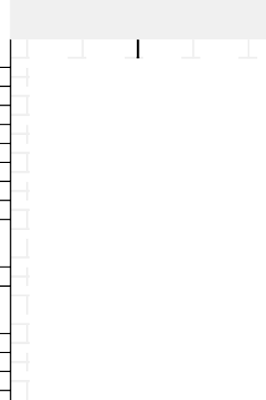
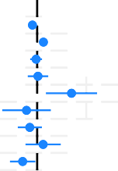
Public by '19 Vote
Q1.
Q2.
Conservative
Labour Liberal Democrat
SNP
Plaid Cymru Brexit Party
Green Other Don't know


Overall
Public
MP


MP by Party
Conservative
Labour
SNP
Other



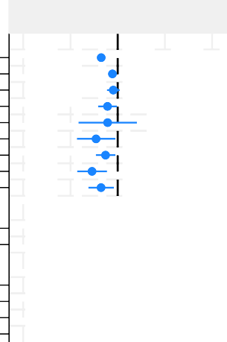


Public by '19 Vote
Q3.
Q4.
Conservative
Labour Liberal Democrat
SNP
Plaid Cymru Brexit Party
Green Other Don't know


Overall
Public
MP


MP by Party
Conservative
Labour
SNP
Other


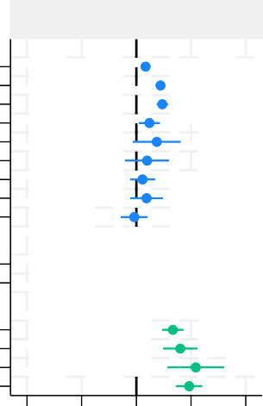
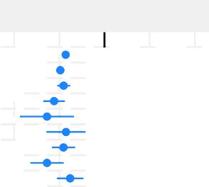
Public by '19 Vote
Q5.
Q6.
Conservative
Labour Liberal Democrat
SNP
Plaid Cymru Brexit Party
Green Other Don't know


Overall
Public
MP

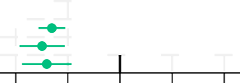
MP by Party
Conservative
Labour
SNP
Other
-2 -1 0 1 2 -2 -1 0 1 2

Note: In line with one tailed p values, 90% confidence intervals are shown, alongside the mean response.

Figure 4: Three Questions, asked only to MPs

MP
MP by Party
Conservative
Labour SNP
Other

MP
MP by Party
Conservative
Labour SNP
Other

MP
MP by Party
Conservative
Labour SNP
Other
Q7. The government should increase the amount of money it spends on overseas aid

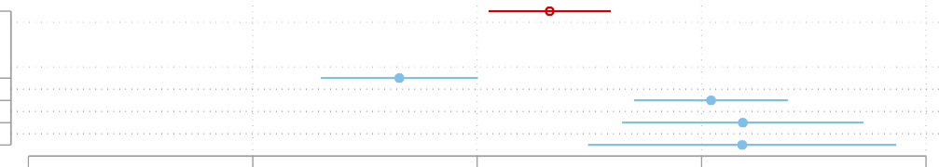
-2 -1 0 1 2
Q8. To advance a political career is it important to be successful in the media

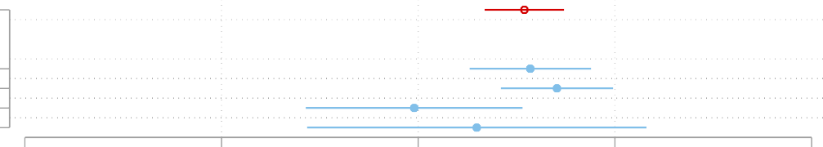
-2 -1 0 1 2
Q9. News coverage about overseas aid influences government spending on o. aid

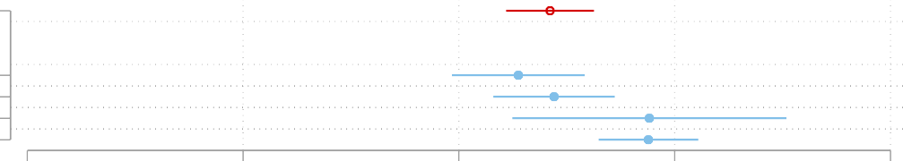
-2 -1 0 1 2

Results: What Correlates with Thinking the Media Should Influence Aid Policy?
Whilst the average MP does not think it acceptable for the media to influence aid policy (Q3), there is a range of opinion, with 39% of MPs agreeing it is acceptable. Probing this helps us understand why politicians may accept media-influence. Although we cannot ask MPs why they hold this view, we can examine correlations with other views which helps us to distinguish between different explanations. For example, MPs may find media influence acceptable because they believe the press is performing its representation function by reflecting public opinion, which politicians in a liberal democracy are normatively expected to consider when making policy deci-sions. Alternatively, MPs may regard media influence as justifiable on more pragmatic grounds, for example, because it facilitates personal career advancement (‘image-making’). These views suggest very different rationales for welcoming media influence. For this reason, we preregistered tests on which views correlate with answers to survey question 3.
In Table 3, we explore why politicians may think a role for the media in influencing aid policy is acceptable by showing how responses to Question 3 relate to other answers. We present a range of bivariate regressions, and one multivariate regression. In line with our expectation, all bivariate regressions have a positive coefficient. Our sample is small in absolute terms (107), even if a reasonable share of the population of MPs (16%), and so it is unsurprising that these associations are not always significant. Two results are significant at the 5% level: politicians who agree that the media should influence aid policy are also significantly more likely to agree

that the media influences public support for aid (Q1) and reflects public support for aid (Q2). These results are consistent with an explanation that media influence on aid policy is seen as acceptable by politicians who believe in the media’s representation function, and in Presumed Media Influence. The association with Question 1 is both a little stronger and retains significance in column 7 (the omnibus specification) where we include all independent variables together. The best and most robust predictor of thinking media influence on aid policy is acceptable is a belief in Presumed Media Influence, followed by thinking the media performs a representation function.
Other correlates, all insignificant at the 5% level, are that politicians are likely to believe media influence on aid policy is acceptable if they think that it being successful in the media is important for one’s political career (Q8) and if they believe it is acceptable to use govern-ment announcements to advance a political career (Q6). These results are consistent with an explanation that media influence is seen as acceptable because of a belief in the mediatisation of politics, and/or the acceptability of image making.
Finally, additional correlates, all positive and insignificant, include a belief that UK gov-ernment aid spending should increase (Q7) and that news coverage does influence aid policy (Q9).

Table 3: Correlates of Thinking the Media Should Influence Aid Policy

 | (1) | (2) | (3) | (4) | (5) | (6) | (7)
Q1 | 0.294** |  |  |  |  |  | 0.277**
 | (0.134) |  |  |  |  |  | (0.161)
Q2 |  | 0.239** |  |  |  |  | 0.148
 |  | (0.135) |  |  |  |  | (0.157)
Q6 |  |  | 0.120 |  |  |  | 0.0976
 |  |  | (0.124) |  |  |  | (0.112)
Q7 |  |  |  | 0.0883 |  |  | 0.0525
 |  |  |  | (0.103) |  |  | (0.0925)
Q8 |  |  |  |  | 0.135* |  | 0.0828
 |  |  |  |  | (0.104) |  | (0.104)
Q9 |  |  |  |  |  | 0.00717 | -0.131
 |  |  |  |  |  | (0.152) | (0.142)
Constant | -0.211* | 0.0318 | 0.107 | 0.0177 | -0.0267 | 0.0432 | -0.162
 | (0.150) | (0.133) | (0.133) | (0.137) | (0.145) | (0.160) | (0.160)
Note: The sample consists of 107 MPs, with no questions skipped. We report robust standard errors, and weight by sample weight. The dependent variable is Question 3. We report 1 tailed p values, with 1-3 stars signifying significance at the 10, 5 and 1% levels.

Discussion & Conclusion
Our findings support the idea that politicians’ perceptions of the press can play a role in shaping aid policy. Most notably, we found that on average MPs believe that the news media influences

various aspects of public opinion about aid, and that these beliefs about Presumed Media Influ-ence are positively associated with a belief that the media should influence aid policy. These are important findings because, while previous studies have repeatedly demonstrated that Presumed Media Influence can shape citizen’s political behaviours (Cohen et al., 2008), this is only the second study we are aware of that implies PMI may shape politician’s decision-making (Dohle and Bernhard, 2014). In doing so, it lends weight to the suggestion – implicit in claims about ‘the Daily Mail test’ – that politicians may avoid supporting aid projects which they anticipate may receive critical headlines because they wish to avoid blame associated with such coverage. We also found that, on average, MPs believed that politics was becoming mediatized - or that engaging with the media is central to a political career - and that this belief was positively associated with a view that the media should influence aid policy. While a widespread belief in the mediatisation of politics amongst politicians has been well documented (Maurer, 2023), this is the first survey-based study to provide evidence of an association between this belief and poli-cymaking. This supports the growing claims that, in the UK at least, politicians are increasingly creating policies that align with the conventions and dynamics of the media (Garland, 2025). It also indicates that the media’s influence over aid policy is not exclusively tied to its association
with public opinion.
Regarding the media’s representation function, there was a strong positive association be-tween MP’s belief that the news media reflect public opinion, and a belief that the media should influence aid policy. However, it is important to note that MPs, on average, did not tend to believe that the news media reflect public opinion on the issue of aid. Put another way, the national press do not appear to be one of the noisy signals most politicians rely on to gauge existing public support for aid.
Collectively, these findings help to fill an important gap in our understanding of how we arrive at aid allocations. They show that the news media can help to link public support for aid with aid allocations – but not simply by reflecting the former. Instead, the press provides what politicians generally regard as means of influencing future public opinion about aid. At the same time, our findings indicate that the media are also considered important in and of themselves, irrespective of their association with public opinion.
These findings also contribute to the study of political communication by further nuancing our understanding of the media’s political effects. They suggest that the media’s capacity to influence policy is shaped - not just by the volume, timing and framing of media content itself
- but also by the significance and meaning given to the media by politicians. In so doing, they support Wolfsfeld et al. (2022) ‘politics-media-politics’ model of political communication, which proposes that the impact of the media on political processes is itself pre-conditioned by the political context. In this case, critical news coverage of aid spending is only likely to influence aid policy if politicians believe it influences public opinion.
Furthermore, our findings indicate that multiple influential beliefs about the media can be operating simultaneously. This challenges the idea that media influence operates via any singular effect and instead suggests that aid bureaucracies are a site where multiple forms of media influence converge.
Our results also suggest that some attitudes and beliefs MPs have about the press are out of

step with the public’s. We found that MPs are significantly more likely to think that the press influence public attitudes towards aid spending, including the overall size of the aid budget and how it is spent, compared to the public themselves. This raises the possibility at least that MPs may be over-estimating the media’s influence on the public, especially given previous research consistently shows that such influence is likely to be marginal, contingent and context-specific (Schieferdecker, 2021; Orgad and Seu, 2014). If so, politician’s potential misperceptions about media influence may be giving the press an outsized or undue influence over aid policy. Put another way, potentially, politicians could be overweighting the media when making decisions about aid spending. As Garland et al. (2018, p.506) have noted in a study of UK civil servants, “there was agreement that ministers overestimate the influence of the media, especially the national press, and spend a lot of time trying to manage it, possibly out of insecurity”. The main implication of this finding is that misperceptions about media influence may be leading aid allocations to be less responsive to public opinion.
This finding also raises the possibility that other areas of foreign policy might be distorted by inaccurate beliefs about media influence. Such beliefs could include the widely accepted but heavily criticised concepts of ‘compassion fatigue’ (Moeller, 2002; Cohen, 2013) and the ‘CNN Effect’ (Gilboa, 2005). The former refers to the idea that repeated exposure to sensationalized and formulaic media coverage of atrocities and disasters creates a form of public apathy towards distant suffering, while the later refers to the idea that 24-hour television news coverage of dis-tant suffering stimulates public opinion to ‘do something’, which places pressure on democratic governments to intervene on humanitarian grounds. A recent study of media influence on hu-manitarian aid allocations has lent further support to this idea. It found that many governments allocate additional humanitarian aid to ‘forgotten crises’ based partly on a mistaken belief that other governments’ annual aid allocations are influenced by news coverage (Scott et al., 2022). Therefore, these further potential implications of Presumed Media Influence on foreign policy require further investigation.
However, we also find that not all MP’s perceptions about the press are positively associated with an openness to media influence on policy. For instance, most MPs did not believe that using aid announcements to advance their own political careers was acceptable (image making), and the relationship between this belief and a belief in the acceptability of media influencing aid policy was not significant.
Our analysis also revealed some important variations between the beliefs of different respon-dents. In particular, Conservative MPs (42%) were considerably more likely to agree it was somewhat acceptable to use aid announcements to advance their own political careers compared to the public (11%) and MPs from other parties (2%). This suggests that future research should investigate further whether politicians’ attitudes and beliefs about the press are commonly asso-ciated with different political ideologies. This finding also supports the results of recent research which identified a widespread perception amongst senior civil servants in aid bureaucracies that some ‘publicity-seeking’ ministers proactively use aid allocations as an opportunity to gain favourable media coverage for themselves (Scott et al., 2022).

References
Alesina, A. and Dollar, D. (2000). Who gives foreign aid to whom and why? Journal of Economic Growth, 5:33–63.
Authors (2026). Replication data for the politician, the press and the public. ResearchBox.org,
https://researchbox.org/5874&PEER_REVIEW_passcode=SATNUL(5874).
Briggs, R. C. (2017). Does foreign aid target the poorest? International Organization, 71(1):187–206.
Broockman, D. E. and Skovron, C. (2018). Bias in perceptions of public opinion among political elites. American Political Science Review, 112(3):542–563.
Chong, A. and Gradstein, M. (2008). What determines foreign aid? the donors’ perspective.
Journal of Development Economics, 87(1):1–13.
Clist, P. (2011). 25 years of aid allocation practice: Whither selectivity? World Development, 39(10):1724–1734.
Clist, P., Isopi, A., and Morrissey, O. (2012). Selectivity on aid modality: Determinants of budget support from multilateral donors. The Review of International Organizations, 7:267–284.
Clist, P. and Scott, M. (2024). Media influence on UK aid spending. AsPredicted, 166064.
Cohen, J., Tsfati, Y., and Sheafer, T. (2008). The influence of presumed media influence in politics: Do politicians’ perceptions of media power matter? Public opinion quarterly, 72(2):331–344.
Cohen, S. (2013). States of denial: Knowing about atrocities and suffering. John Wiley & Sons. Curran, J. (2002). Media and Power. Routledge: London.
Davis, A. (2009). Journalist–source relations, mediated reflexivity and the politics of politics.
Journalism studies, 10(2):204–219.
Devanny, J. and Berry, P. A. (2022). The conservative party and dfid: party statecraft and development policy since 1997. Contemporary British History, 36(1):86–123.
Dohle, M. and Bernhard, U. (2014). Presumed online media influence and support for censor-ship: Results from a survey among german parliamentarians. International Journal of Public Opinion Research, 26(2):256–268.
Fisher, J. (2015a). Written evidence from Dr Jonathan Fisher, Senior Lecturer in African Politics, International Development Department (IDD), University of Birmingham. Written evidence submitted to the International Development Committee, UK Parliament, Available at: https://committees.parliament.uk/writtenevidence/63638/pdf/.
Fisher, J. (2015b). ‘Does it work?’–work for whom? Britain and political conditionality since the Cold War. World Development, 75:13–25.
Flinders, M., Dimova, G., Hinterleitner, M., Rhodes, R. A., and Weaver, R. K. (2024). The politics and governance of blame. Oxford University Press.
Garland, R. (2025). Politics, government and the media: A site of struggle between opposing conceptions of public communication. In Histories of Political Public Relations, pages 95–106. Routledge.
Garland, R., Tambini, D., and Couldry, N. (2018). Has government been mediatized? a uk perspective. Media, Culture & Society, 40(4):496–513.

Gilboa, E. (2005). The cnn effect: The search for a communication theory of international relations. Political communication, 22(1):27–44.
Government Communication Service (2023). Propriety & ethics guidance for government com-municators. UK Cabinet Office.
Gunther, A. C. and Storey, J. D. (2003). The influence of presumed influence. Journal of Communication, 53(2):199–215.
Henson, S. and Lindstrom, J. (2013). “A mile wide and an inch deep”? Understanding public support for aid: The case of the United Kingdom. World Development, 42:67–75.
Hjarvard, S. (2013). The mediatization of culture and society. Routledge: London.
Hughes, S. and Mitchell, I. (2024). How much uk aid will labour divert to refugee hosting in 2024? CGD Blog Post, available at: https://www.cgdev.org/blog/ how-much-uk-aid-will-labour-divert-refugee-hosting-2024.
Hurst, R., Tidwell, T., and Hawkins, D. (2017). Down the rathole? Public support for US foreign aid. International Studies Quarterly, 61(2):442–454.
Johansson, B. (2004). Mass media, interpersonal communication or personal experience? Nordi-com Review, 25(1-2):259–276.
Kaufmann, D., McGuirk, E. F., and Vicente, P. C. (2019). Foreign aid preferences and percep-tions in donor countries. Journal of Comparative Economics, 47(3):601–617.
Kobayashi, Y., Heinrich, T., and Bryant, K. A. (2021). Public support for development aid during the COVID-19 pandemic. World Development, 138:105248.
Maurer, P. (2023). Perceptions of media influence and performance among politicians in euro-pean democracies. International Communication Gazette, 85(5):347–364.
Milner, H. V. and Tingley, D. H. (2010). The political economy of us foreign aid: American legislators and the domestic politics of aid. Economics & Politics, 22(2):200–232.
Moeller, S. D. (2002). Compassion fatigue: How the media sell disease, famine, war and death.
Routledge.
Molenaers, N., Gagiano, A., Smets, L., and Dellepiane, S. (2015). What determines the suspen-sion of budget support? World Development, 75:62–73.
Orgad, S. and Seu, I. B. (2014). The mediation of humanitarianism: Toward a research frame-work. Communication, culture & critique, 7(1):6–36.
Paxton, P. and Knack, S. (2012). Individual and country-level factors affecting support for foreign aid. International Political Science Review, 33(2):171–192.
Rice, D. and Cooper, S. (2025). Influence and information: Media Habits of Westminster. About 5654 and MessageSpace, avilable at https://www.5654.co.uk/our-perspective/influence-and-information-media-habits-of-westminster.
Schieferdecker, D. (2021). Passivity in the face of distant others’ suffering: An integrated model to explain behavioral (non-) response. Annals of the International Communication Association, 45(1):20–38.

Schumacher, G. and
O¨ hberg, P. (2020). How do politicians respond to opinion polls? An

experiment with Swedish politicians. Research & Politics, 7(3):2053168020955106.
Scott, M., Bunce, M., and Wright, K. (2022). The influence of news coverage on humanitarian aid: The bureaucrats’ perspective. Journalism Studies, 23(2):167–186.

Tsfati, Y. (2014). Public and elite perceptions of news media in politics. In Kenski, K. and Jamieson, K. H., editors, The Oxford Handbook of Political Communication, pages 565–580. Oxford University Press.
Valters, C. and Whitty, B. (2017). The politics of the results agenda in dfid: 1997–2017. Walgrave, S. and Soontjens, K. (2023). How politicians learn about public opinion. Research &
Politics, 10(3):20531680231200692.
Wolfsfeld, G., Sheafer, T., and Althaus, S. L. (2022). Building theory in political communication: The Politics-Media-Politics approach. Oxford University Press.
Wood, T. and Hoy, C. (2022). Helping us or helping them? What makes foreign aid popular with donor publics? Economic Development and Cultural Change, 70(2):567–586.

Appendix: Exploratory analysis of heterogeneity
Figure 5 plots the regression coefficients and 90% confidence intervals from a range of regressions. We use all information provided by YouGov for our MP sample, and regress Party and Gender on each of the nine questions. This is exploratory, but is included as it may be interesting for some readers. In all cases, a constant is included and reference categories are noted in the table. Hence a male conservative MP is represented by the constant. Female MPs appear slightly more likely to agree in most cases.

Figure 5: Heterogeneity of MP responses

Constant
Gender versus Male
Female
Party versus Conservative
Labour SNP
Other

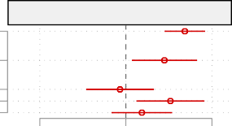
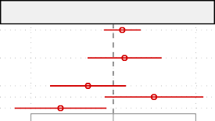
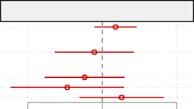
-1 0 1 -1 0 1 -1 0 1
Q1
Q2
Q3

Constant
Gender versus Male
Female
Party versus Conservative
Labour SNP
Other

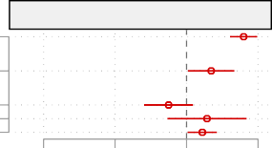
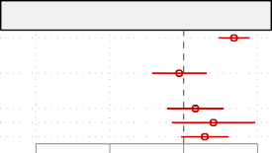
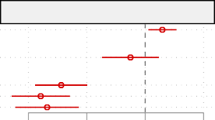
-2 -1 0 1 -2 -1 0 1 -2 -1 0 1
Q4
Q5
Q6

Constant
Gender versus Male
Female
Party versus Conservative
Labour SNP
Other

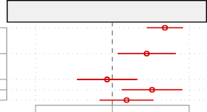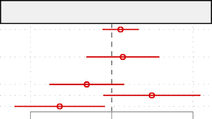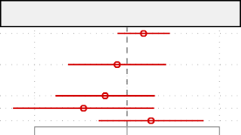
Q7
Q8
Q9
-1 0 1 -1 0 1 -1 0 1

Figure 6 explores heterogeneity for the public. This has fewer questions, but much more information on respondents. Gender and age have small coefficients, and regional differences are similarly mixed. There are some correlates that appear worthy of further exploration. The EU vote seems to capture a small but persistent difference across questions, with Leave voters less likely to agree across questions. The previous general election appears to have small and less consistent differences. Social grade has a common pattern, with a reasonable ordering of effects across social categories.

Figure 6: Heterogeneity of Public responses

Constant Female
Age
Social Grade versus. A
B C1 C2 D E
Region versus North East
North West Yorkshire and the Humber
East Midlands West Midlands East of England
London South East South West
Wales Scotland
2019 Vote versus Conservative
Labour Liberal Democrat
Scottish National Party (SNP)
Plaid Cymru Brexit Party
Green Other Don't know
'16 EU Vote versus remain
I voted to Leave I did not vote Can’t remember

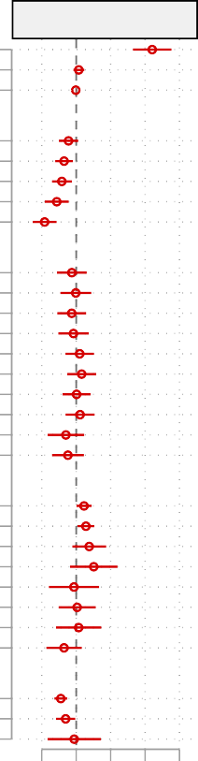
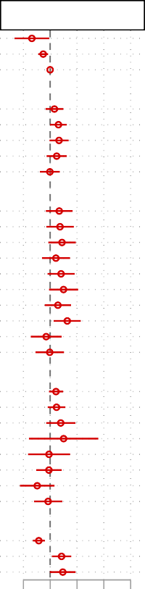
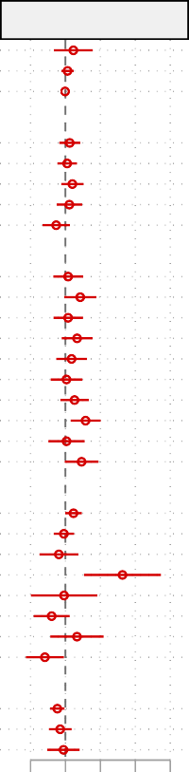
-.5 0 .5 1 1.5 -.5 0 .5 1 1.5 -.5 0 .5 1 1.5
Q1
Q3
Q2

Constant Female
Age
Social Grade versus. A
B C1 C2 D E
Region versus North East
North West Yorkshire and the Humber
East Midlands West Midlands East of England
London South East South West
Wales Scotland
2019 Vote versus Conservative
Labour Liberal Democrat
Scottish National Party (SNP)
Plaid Cymru Brexit Party
Green Other Don't know
2016 EU Vote versus remain
I voted to Leave I did not vote Can’t remember

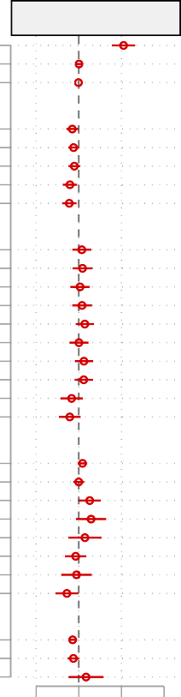
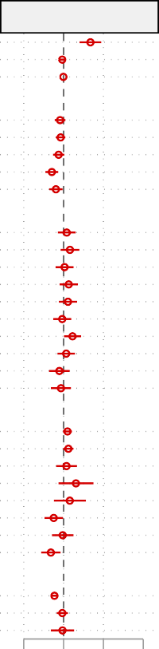
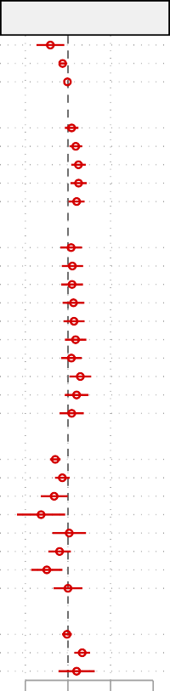
-1 0 1 2 -1 0 1 2 -1 0 1 2
Q4
Q5
Q6

