Running head: SEEING ANIMALS, CHOOSING PLANTS

Seeing Animals, Choosing Plants: Evidence from a Cafeteria Field Study
on Food Choices

Siobhan Murray¹

Rose Meleady¹

Gordon Hodson²

1 = School of Psychology, University of East Anglia, Norwich

2 = Department of Psychology, Brock University, St. Catharines, Ontario, Canada,

Word Count: 2852

Abstract

Reducing meat consumption is a priority for reducing greenhouse gas emissions and mitigating the climate crisis. Past research reveals that reminders of meat’s animal origins can reduce self-reported willingness to consume meat. Less clear is whether such reminders affect natural, real-world behavior. In the present field study, images of living animals were placed alongside the corresponding meat-based dishes on a cafeteria menu at a British university (e.g., a cow next to beef bolognese, a pig next to pork gyros, and a chicken next to sweet and sour chicken). Unobtrusive sales data were collected across two periods: a baseline period and an intervention period with a matched menu (without photos). Analysis of 3,674 meal sales revealed a significant increase in vegetarian choices, with the odds of selecting a vegetarian meal 22% higher during the intervention (vs. baseline) period. Effects were consistent across meat types. The present findings provide behavioral evidence that visual cues linking meat to its animal origins can influence real-world food choices, helping bridge the gap between laboratory research and applied behavioral evidence.

KEYWORDS: Meat consumption, behavioral intervention, field study, animals, dissociation

Seeing Animals, Choosing Plants: Evidence from a Cafeteria Field Study
on Food Choices
Reducing meat consumption is widely recognized as one of the most effective actions for mitigating environmental impact (Poore & Nemecek, 2018). The IPCC estimates that a global shift to plant-based diets could achieve greenhouse gas emission reductions comparable to replacing fossil fuels with nuclear energy (Schiermeier, 2019). Despite these potential benefits, global meat consumption has risen steadily, driven not only by population growth but also by increased per capita consumption, and this upward trajectory is expected to continue (Food and Agricultural Organization of the United Nations, 2018). It is therefore critical to develop behavioral interventions aimed at reducing meat consumption.
Many people who eat meat experience unease about the idea of causing suffering to animals. This tension - known as the “meat paradox,” (Loughnan & Davies, 2020; Piazza et al., 2015) – reflects a form of cognitive dissonance arising from the conflict between valuing animal welfare and consuming meat (Festinger, 1957; Rothgerber & Rosenfeld, 2021). To lessen this tension, it is argued that humans have developed strategies to increase the psychological and physical separation between meat production and meat consumption. Traditional family farming has been vastly replaced by large-scale corporate farming meaning that most consumers never directly observe the rearing or slaughtering of animals. Before meat is seen by consumers, animal bodies are usually processed, removing obvious traces of the animal (Leroy & Degreef, 2015), and while animals are often displayed in dairy advertising, they are typically omitted from meat products rendering the animals invisible in the visual representation of meat products (Grauerholz, 2007; Heinz & Lee, 1998). Even at a linguistic level, living animals are referred to as cows, pigs or calves in English, yet once slaughtered and prepared for consumption, they become known as beef, pork, or veal (Adams, 2004; Dunayer, 2001; Singer, 1995). In these ways, meat becomes dissociated from its animal origins.
Research suggests that reminding people of meat’s animal origins lessens their willingness to consume it. In a series of experiments, Kunst and Hohle (2016) presented participants with images that either explicitly linked meat to the animal it came from, or showed the meat alone. For example, participants saw a whole roasted pig versus a decapitated version, or a live sheep alongside lamb chops versus lamb chops alone. Exposure to the animal-meat pairings, compared to images of the meat by itself, increased empathy for the animals and disgust towards the meat. These emotional responses, in turn, were associated with lower willingness to eat the meat. Subsequent studies have replicated these findings. Earle and colleagues (2019) for instance, showed participants images of a lamb paired with prepared lamb chops, images of a cow with prepared beefsteak, and an image of a pig with prepared ham. Compared to participants who saw images of the meat dishes alone, participants in the animal-meat reminder condition reported lower meat consumption willingness and higher distress about meat consumption (see also Piazza et al., 2018; Tian et al., 2016, Zickfeld et al., 2018).
Building on this work, Schiller et al. (2025) recently examined whether animal imagery on food packaging could influence meat selection in a simulated grocery store. Participants navigated a digital store where products were either labeled with images of animals—such as chickens, pigs, and cattle—or with standard packaging without any animal images. Overall, the presence of animal images reduced meat selection, particularly when images were neutral, depicting the animal alone, or negative, showing the animal in poor husbandry conditions. Results showed that participants selected fewer meat products when animal images were displayed alongside the items compared to when no imagery was present. While the simulated grocery store setup provides preliminary evidence that visual reminders of animals can influence meat selection, it remains a hypothetical scenario that lacked the real-life consequences of their choice, that is, paying for and receiving the food as behaviors.
The present research sought to provide a direct behavioral test of whether reminders of meat’s animal origins can reduce meat consumption in a naturalistic field setting. Such research is critical given that intention-behavior gaps exist across a range of sustainable behaviors (Carrington et al., 2010; Grimmer & Miles, 2017). Put simply, intentions do not always translate into action. Of relevance to the current study, research has also identified an intention-behavior gap specifically in the context of meat consumption. Arnaudova et al. (2022) and Laffan et al. (2023) reported that between one-third and one-half of participants failed to align their intention to reduce their meat intake with actual dietary choices, with taste and habitual cooking practices ultimately being stronger predictors of eating choices. Reviews of interventions designed to reduce meat consumption consistently highlight the scarcity of studies with behavioral outcomes (e.g. Harguess et al., 2020; Kwasny et al., 2022; Mathur et al., 2021). Strikingly, Benningstad and Kunst (2020) found no study examining the dissociation of meat from its animal origins that included a behavioral measure. This gap underscores the urgent need to move beyond self-report to test animal reminder interventions in naturalistic settings, where actual decision-making and consumption occur.
The Current Study

To address this gap in behavioral evidence, we examined whether visual reminders of meat’s animal origins could influence customers’ food choices in a real-world dining setting. During the intervention, images of living animals were displayed alongside meat-based dishes on cafeteria menus at a British university. The effect of the intervention was assessed by comparing sales data during periods when menus included animal images with sales during baseline periods when standard menus—without images—were used. We hypothesized that the presence of these animal images would reduce meat dish selection relative to baseline. If successful, this approach could offer a low-cost, easily implementable strategy for encouraging more sustainable and ethical eating by increasing diners’ awareness of the connection between their food choices and the animals involved.
Methods

This study was pre-registered on AsPredicted.org: https://aspredicted.org/9rjc-xj2x.pdf. All materials as well as analysis code are available in the online supplementary materials (OSM).
Intervention, materials and procedure
The intervention took place in a cafeteria unit at the University of [blinded for peer review] in the UK. Ethical approval was provided by the same institution on the 4th April 2025 (REF: ETH2425-1038). The university hosts approximately 18,000 students who are the primary users of the cafeteria, alongside staff and members of the public. Sales data were collected over two six-day periods: one baseline period, and one intervention period, between April and May 2025. Data were not collected on weekends or on other days when the cafeteria was closed, including a national holiday (5 May) and two closures for special events (30th April, 1st May). All data collection took place during university term time. The sample size was determined by natural cafeteria traffic during the periods the cafeteria was able to collaborate with us. No personally identifying information was gathered, hence informed consent was not obtained for assessing behavioral data.
The cafeteria operates a rotating menu featuring three counters per day (e.g. Burgers, Pasta, Asian), and a variety of meat and vegetarian options within. The control and intervention menus were matched across periods, with the same dishes offered in both to ensure that any observed differences in sales could be attributed to the intervention itself, rather than to variations in menu or customer preferences for specific dishes. The matched menus were implemented on different days of the week as part of the cafeteria’s standard rotation. Full menus are provided in OSM 1.
Upon entering the cafeteria, customers view a large display showing the day’s menu options, with duplicate copies positioned beside each food counter. During the intervention period, images of animals were added beside the corresponding meat-based meal options on these menus (see Figure 1). For instance, an image of a chicken accompanied the sweet and sour chicken, an image of a pig accompanied the pork gyros, and an image of a cow accompanied the beef bolognese. No images were added next to the vegetarian dishes. The pig and cow intervention images were taken from Earle et al. (2019), while comparable images of chicken, duck, and fish were sourced separately. The images showed the neutral depictions of the animals alone without any other contextual background. All animal images are included in OSM 2. Following the intervention period, posters were displayed in the cafeteria providing a link to study information and the debriefing.

Figure 1

A portion of the cafeteria’s menu during the control period (left) compared the intervention period (right).
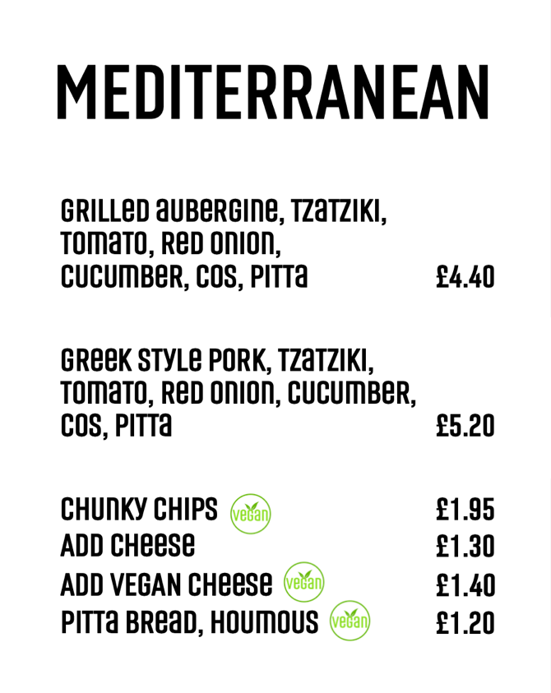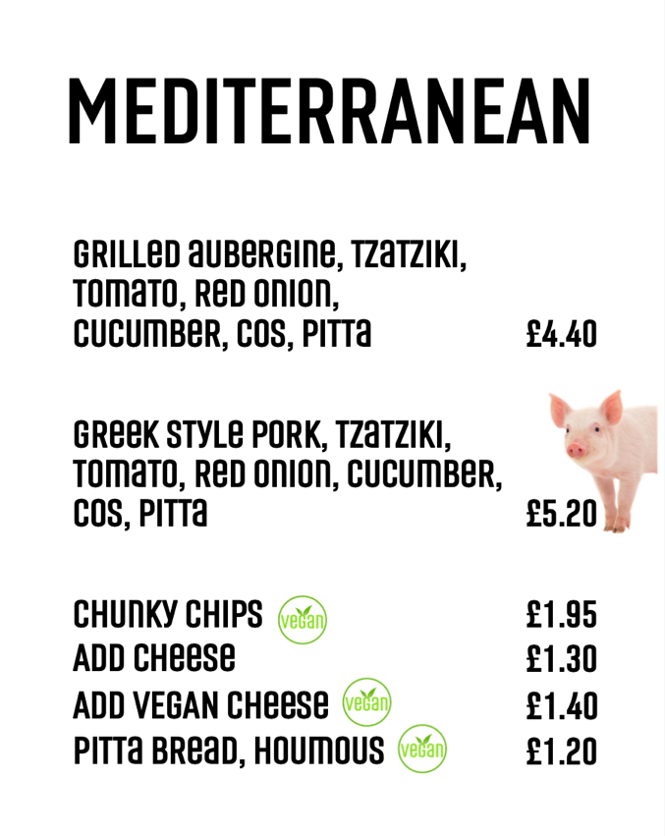

Measures

For the behavioral data, the cafeteria provided count data of the items sold during the study period. The data included a total of 1,721 main meals sales during the baseline period and 1,953 during the intervention period. Sales data were coded by the researchers according to whether it was a main or a side, whether it was vegetarian or meat-based, and, if it was meat-based, which type of meat it was. Meat was taken to include red meat, white meat, and fish.
As per our registration, sales from the self-serve salad bar were excluded as the till data did not allow classification of these items by meat content. A small number of unexpected items recorded by the tills (i.e. items which were not on the menu for a given day) were also excluded from the analysis as it is likely they were recorded in error. Additionally, deviations from the planned intervention procedure resulted in the exclusion of two intervention days (and their matched controls): one where a cow image was omitted from the beef option, and another where the fish and chip counter (which included a vegetarian alternative) was unexpectedly replaced by a chicken counter with no vegetarian alternative. Because the number and variety of vegetarian dishes can independently influence their sales (Sethuraman et al., 2022), these days were excluded to maintain consistent menu composition across conditions and isolate the intervention’s effect. Analyses that include these days as a robustness check are provided in OSM 4.
Results
Table 1 shows the breakdown of the sales of meals sold during the baseline and intervention periods. We compared the proportion of vegetarian main meals sold between the baseline and intervention periods using a binomial logistic regression. The model estimated the proportion of vegetarian meals sold per day, weighted by the total number of meals sold, as a function of condition (baseline vs. intervention), with baseline period coded as the reference category (see Guedes et al., 2023). Analyses were conducted in R (v4.3.1, R Core Team, 2023), and the full R Markdown code is provided in OSM 3. The regression revealed a significant effect of the intervention. Specifically, the log-odds of a sold meal being vegetarian were significantly higher during the intervention period compared to the baseline (b = 0.20, SE = 0.09, z = 2.19, p = .029). The odds ratio was 1.22 (95% CI [1.02, 1.45]), indicating that the odds of ordering a vegetarian meal were 22% higher during the intervention (vs. baseline) period. Additional exploratory analyses revealed no significant interaction between intervention condition and meat type (χ²(4) = 6.95, p = 0.14), indicating that the effect of the intervention did not significantly vary by meat type.

Table 1
Number and percentage of meal sales during the baseline and intervention periods
Period | Vegetarian | Meat (total) | Pork | Beef | Chicken | Fish | Total
Baseline:  Sales  Percentage | 262  15.2% | 1459  84.8% | 273  15.9% | 121  7.0% | 982  57.1% | 83  4.8% | 1721
Intervention:  Sales  Percentage | 350  17.9% | 1603  82.1% | 280  14.3% | 138  7.1% | 1093  56.0% | 92  4.7% | 1953

Discussion
The present study demonstrates that visual reminders of meat’s animal origins can influence actual food choices in a natural setting. By displaying images of live animals alongside meat-based dishes on university cafeteria menus, we observed a significant increase in the proportion of vegetarian meals sold. These findings demonstrate that linking meat to its animal source can produce measurable behavioral changes, and highlight the practical potential of simple, low-cost animal-meat reminders in everyday dining contexts.
Previous research on animal-meat reminders has so far relied on self-reported intentions or artificial choice scenarios (Earle et al., 2019; Kunst & Hohle, 2016; Tian et al., 2016; Zickfeld et al., 2018). By capturing objective sales data, this study provides a more accurate and reliable assessment of intervention impact. Collecting such behavioral data is often more challenging than self-reports, requiring additional logistical coordination, resources, and access to operational settings. Nevertheless, objective behavioral measures are essential for rigorously evaluating intervention effectiveness, as self-reported intentions or willingness to consume meat provide only indirect evidence and can overestimate or misrepresent actual meat consumption (Arnaudova et al., 2022; Laffan et al., 2023). By overcoming these challenges, this study strengthens the evidence base for interventions targeting the meat paradox (Loughnan & Davies, 2020) and confirms that associating meat with its animal source can shift real consumption behavior.
The intervention effect appeared to be generally consistent across different types of meat suggesting that the psychological mechanisms underlying the meat paradox—such as empathy for animals and heightened moral or disgust responses—are presumably activated by the recognition of any animal source, rather than being restricted to certain meats that are culturally or emotionally more salient. Nevertheless, although the interaction did not reach statistical significance, the trends observed indicate somewhat larger effects for pigs – and to a lesser extent chickens – relative to beef or fish. This pattern mirrors findings from Earle et al. (2019) who reported stronger effects for pigs than for other animals, and may reflect heightened moral concern stemming from the perception of pigs as more intelligence, social, and cure compared to other livestock (e.g., Davis & Cheeke, 1998; Wang & Basso, 2019; Zickfeld et al., 2018). Notably, the images used in the present intervention were neutral depictions of animals rather than highly emotive representations. While some previous work suggests that more affectively-charged images exert a stronger impact (e.g. Piazza et al., 2018; Schiller et al., 2025; Zickfeld et al., 2018), our findings demonstrate that even simple, neutral imagery can nonetheless effectively shift consumers’ preferences toward vegetarian options.
Unlike interventions that seek to change behavior through information, monetary incentives, or restrictive policies, animal-image interventions are low-cost, scalable, and easy to implement. Our findings align with broader evidence that labeling and visual cues can reduce meat consumption (e.g. Campbell-Arvai et al., 2014; Hughes et al., 2024, Kunst & Hohle, 2016). For instance, Lohmann et al. (2022) found that carbon footprint traffic light labels in university cafeterias led to a significant decrease in meat meal sales. Although the specific cues differ, both studies demonstrate the potential of visual cues or primes to influence consumer choices around meat. Moreover, by operating at the point of decision, such interventions leverage a moment when consumers may be particularly responsive to contextual cues, potentially making it more effective than information and awareness campaigns or distant messaging that may fail to engage individuals at the moment of choice (Yi et al., 2022).
Several limitations of the present study warrant consideration. First, although the intervention influenced overall meal choices, the observed effect size – an increase in 2.7 percentage points in vegetarian meal selection – is fairly modest. Nevertheless, even small shifts can accumulate meaningfully at scale, for example, across multiple sites or with repeated exposure over time. Future research should examine the intervention’s longer-term impact to determine whether effects persist once customers become habituated to images (Nisa et al., 2019). Additionally, the current data captures only a single, immediate choice, and do not reveal whether the intervention affects participants’ subsequent food choices beyond the intervention setting. Future research should explore whether exposure to animal-meat reminders produces spillover effects, which could be positive, with participants continuing to reduce meat consumption in subsequent meals or other eating contexts, or negative, with participants compensating by increasing meat consumption later (Truelove et al., 2014). Complementary self-report data could also help clarify how, and for whom, the intervention is most effective, with prior research suggesting that people scoring higher on trait-level dissociation of meat from its animal origins may be particularly sensitive to cues priming the animal-meat connection (Kunst & Hohle, 2016).
Another consideration concerns generalizability. The intervention took place in a university cafeteria with a predominantly young adult population, a group that may show stronger effects than older age groups given that younger adults tend to be more emotionally engaged with environmental issues (Poortinga et al., 2023). Effects may also differ across cultural or national groups, with prior work suggesting that animal-meat association effects may be less pronounced in cultures more accustomed to seeing unprocessed meat (Kunst & Haugestad, 2018). Responses may likewise vary between individuals from rural versus urban backgrounds, with smaller effects expected among those with greater familiarity with farming and animal husbandry. Beyond these group-level differences, replication across diverse settings is also needed to assess the broader applicability of the intervention. Introducing animal-meat reminders in commercial food settings, as opposed to universities or other educational settings, may pose additional challenges, including vendors’ concerns about potential reductions in meat sales, customer complaints, or conflicts with brand image. However, such imagery may be more acceptable than explicit animal-welfare messaging, given that similar visuals are already common on non-meat animal products (Capilé et al., 2021). While future research is needed to assess broader applicability, our findings demonstrate that visual cues reminding consumers of meat’s animal origins can meaningfully influence real-world food choices and add to a toolkit of interventions aimed at encouraging more ethical and environmentally-sustainable food choices.

References
Adams, C. J. (2004). The sexual politics of meat: A feminist-vegetarian critical theory. Continuum.
Benningstad, N. C. G., & Kunst, J. R. (2020). Dissociating meat from its animal origins: A systematic literature review. Appetite, 147, 104554. https://doi.org/10.1016/J.APPET.2019.104554
Campbell-Arvai, V., Arvai, J., & Kalof, L. (2014). Motivating sustainable food choices: The role of nudges, value orientation, and information provision. Environment and Behavior, 46(4), 453–475. https://doi.org/10.1177/0013916512469099
Capilé, K., Parkinson, C., Twine, R., Kovalski, E. L., & Paixão, R. L. (2021). Exploring the representation of cows on dairy product packaging in Brazil and the United Kingdom. Sustainability, 13(15), 1-24. https://doi.org/10.3390/su13158418
Carrington, M. J., Neville, B. A., & Whitwell, G. J. (2010). Why ethical consumers don’t walk their talk: Towards a framework for understanding the gap between the ethical purchase intentions and actual buying behaviour of ethically minded consumers. Journal of Business Ethics, 97(1), 139–158. https://doi.org/10.1007/S10551-010-0501-6
Davis, S. L., & Cheeke, P. R. (1998). Do domestic animals have minds and the ability to think? A provisional sample of opinions on the question. Journal of Animal Science, 76(8), 2072–2079. https://doi.org/10.2527/1998.7682072x
Dunayer, D. (2001). Animal equality: Language and liberation. Ryce Publishing.
Earle, M., Hodson, G., Dhont, K., & MacInnis, C. (2019). Eating with our eyes (closed): Effects of visually associating animals with meat on antivegan/vegetarian attitudes and meat consumption willingness. Group Processes and Intergroup Relations, 22(6), 818–835. https://doi.org/10.1177/1368430219861848
Festinger, L. (1957). A theory of cognitive dissonance. Stanford University Press.
Food and Agriculture Organization of the United Nations. (2018). The future of food and agriculture – Alternative pathways to 2050. https://www.fao.org/global-perspectives-studies/food-agriculture-projections-to-2050/en/
Grauerholz, L. (2007). Cute enough to eat: The transformation of animals into meat for human consumption in commercialized images. Humanity & Society, 31(4), 334-354. https://doi.org/10.1177/016059760703100404
Grimmer, M., & Miles, M. P. (2017). With the best of intentions: a large sample test of the intention-behaviour gap in pro-environmental consumer behaviour. International Journal of Consumer Studies, 41(1), 2–10. https://doi.org/10.1111/ijcs.12290
Guedes, D., Brazão, V., Roque, L., Campos, L., Godinho, C., Truninger, M., Vinnari, M., & Graça, J. (2023). Promoting plant-based eating in meat-centric meal contexts: A field study. Public Health Nutrition, 26(11), 2619-2627. https://doi.org/10.1017/S1368980023001763
Harguess, J. M., Crespo, N. C., & Hong, M. Y. (2020). Strategies to reduce meat consumption: A systematic literature review of experimental studies. Appetite, 144, 104478. https://doi.org/10.1016/J.APPET.2019.104478
Heinz, B., & Lee, R. (1998). Getting down to the meat: The symbolic construction of meat consumption. Communication Studies, 49(1), 86-99. https://doi.org/10.1080/10510979809368520
Hughes, L. (2024). The second domestication of dairy and beef: Food 2.0 proteins without the animals. In M. Lester & M. dela Rama (Eds.), Innovation pathways to sustainability: Conversations towards complex systems of governance (pp. 185–194). Routledge. https://doi.org/10.4324/9781003280316-20
Kunst, J. R., & Haugestad, C. A. (2018). The effects of dissociation on willingness to eat meat are moderated by exposure to unprocessed meat: A cross-cultural demonstration. Appetite, 120, 356–366. https://doi.org/10.1016/J.APPET.2017.09.016
Kunst, J. R., & Hohle, S. M. (2016). Meat eaters by dissociation: How we present, prepare and talk about meat increases willingness to eat meat by reducing empathy and disgust. Appetite, 105, 758–774. https://doi.org/10.1016/J.APPET.2016.07.009
Kwasny, T., Dobernig, K., & Riefler, P. (2022). Towards reduced meat consumption: A systematic literature review of intervention effectiveness, 2001–2019. Appetite, 168, 105739. https://doi.org/10.1016/J.APPET.2021.105739
Laffan, K., Lades, L. K., & Delaney, L. (2023). Paths that lead astray: Examining the situational predictors of intention-behaviour gaps in meat consumption. Journal of Environmental Psychology, 89, 102045. https://doi.org/10.1016/J.JENVP.2023.102045
Leroy, F., & Degreef, F. (2015). Convenient meat and meat products. Societal and technological issues. Appetite, 94, 40-46. https://doi.org/10.1016/j.appet.2015.01.022
Lohmann, P. M., Gsottbauer, E., Doherty, A., & Kontoleon, A. (2022). Do carbon footprint labels promote climatarian diets? Evidence from a large-scale field experiment. Journal of Environmental Economics and Management, 114, 102693. https://doi.org/10.1016/J.JEEM.2022.102693
Loughnan, S., & Davies, T. (2020). The meat paradox. In K. Dhont & G. Hodson (Eds.), Why we love and exploit animals: Bridging insights from academia and advocacy (pp. 171–187). Routledge.
Mathur, M. B., Peacock, J., Reichling, D. B., Nadler, J., Bain, P. A., Gardner, C. D., & Robinson, T. N. (2021). Interventions to reduce meat consumption by appealing to animal welfare: Meta-analysis and evidence-based recommendations. Appetite, 164, 105277. https://doi.org/10.1016/J.APPET.2021.105277
Nisa, C. F., Bélanger, J. J., Schumpe, B. M., & Faller, D. G. (2019). Meta-analysis of randomised controlled trials testing behavioural interventions to promote household action on climate change. Nature Communications, 10(1), 4545. https://doi.org/10.1038/s41467-019-12457-2
Piazza, J., McLatchie, N., & Olesen, C. (2018). Are baby animals less appetizing? Tenderness toward baby animals and appetite for meat. Anthrozoos, 31(3), 319-335. https://doi.org/10.1080/08927936.2018.1455456
Piazza, J., Ruby, M. B., Loughnan, S., Luong, M., Kulik, J., Watkins, H. M., & Seigerman, M. (2015). Rationalizing meat consumption. The 4Ns. Appetite, 91, 114–128. https://doi.org/10.1016/J.APPET.2015.04.011
Poore, J., & Nemecek, T. (2018). Reducing food’s environmental impacts through producers and consumers. Science, 360(6392), 987–992. https://doi.org/10.1126/science.aaq0216
Poortinga, W., Demski, C., & Steentjes, K. (2023). Generational differences in climate-related beliefs, risk perceptions and emotions in the UK. Communications Earth & Environment, 4(1), 229. https://doi.org/10.1038/s43247-023-00870-x
R Core Team (2023). R: A language and environment for statistical computing. R Foundation for Statistical Computing. https://www.R-project.org/
Rothgerber, H., & Rosenfeld, D. L. (2021). Meat-related cognitive dissonance: The social psychology of eating animals. Social and Personality Psychology Compass, 15(5), e12592. https://doi.org/10.1111/spc3.12592
Schiermeier, Q. (2019). Eat less meat: UN climate-change report calls for change to human diet. Nature, 572(7769), 291–292. https://doi.org/10.1038/d41586-019-02409-7
Schiller, J., Ruby, M. B., & Sproesser, G. (2025). A license to eat meat? Exploring processes underlying the effect of animal labels on meat consumption. Appetite, 215, 108242. https://doi.org/10.1016/J.APPET.2025.108242
Sethuraman, R., Gázquez-Abad, J. C., & Martínez-López, F. J. (2022). The effect of retail assortment size on perceptions, choice, and sales: Review and research directions. Journal of Retailing, 98(1), 24–45. https://doi.org/10.1016/J.JRETAI.2022.01.001
Singer, P. (1995). Animal liberation (2nd ed.). Pimlico
Tian, Q., Hilton, D., & Becker, M. (2016). Confronting the meat paradox in different cultural contexts: Reactions among Chinese and French participants. Appetite, 96, 187–194. https://doi.org/10.1016/J.APPET.2015.09.009
Truelove, H. B., Carrico, A. R., Weber, E. U., Raimi, K. T., & Vandenbergh, M. P. (2014). Positive and negative spillover of pro-environmental behavior: An integrative review and theoretical framework. Global Environmental Change, 29, 127–138. https://doi.org/10.1016/j.gloenvcha.2014.09.004
Wang, F., & Basso, F. (2019). “Animals are friends, not food”: Anthropomorphism leads to less favorable attitudes toward meat consumption by inducing feelings of anticipatory guilt. Appetite, 138, 153–173. https://doi.org/10.1016/j.appet.2019.03.019
Yi, S., Kanetkar, V., & Brauer, P. (2022). Customer support for nudge strategies to promote fruit and vegetable intake in a university food service. BMC Public Health, 22(1), 1–20. https://doi.org/10.1186/S12889-022-13054-7
Zickfeld, J. H., Kunst, J. R., & Hohle, S. M. (2018). Too sweet to eat: Exploring the effects of cuteness on meat consumption. Appetite, 120, 181–195. https://doi.org/10.1016/J.APPET.2017.08.038

