The Can Challenge: Understanding the best ways to incentivise recycling through a diffusion approach
Michael Brock, Lucia M. Murgia, Stefania Sitzia, Jiwei Zheng

  - Abstract
Understanding the best ways to incentivise recycling and improve the efficiency of waste practices is a key environmental, social, and economic management problem that needs addressing.
We search for solutions to this issue by testing the effectiveness of two incentive mechanisms (a piece-rate and a lottery-based system). We run a similar field experiment in three different locations, namely a student, residential, and workplace environment, to verify the robustness of our findings and thus increase confidence in the external validity of our intervention. By interpreting recycling activity as a marketable service, we employ a diffusion model to analyse the potential adoption of the service.
We find that monetary rewards increase recycling levels in almost all locations, independently of the type of incentive. More specifically, incentivising recycling stimulates action by those on lower incomes through opportunities for income generation. By contrast, those in workplace environments engage with or without incentives, but the latter provides a boost. Diffusion seems to exist in each environment, but with differing levels of success. Our study contributes to the literature by providing evidence on how to best increase public involvement through recycling and offering important insights for policy making to address this worldwide relevant issue.

Keywords: Recycling Behaviour; Field Experiment; Monetary Incentives; Bass Diffusion Model.

JEL: C32; C93; D90; Q5

1. Introduction
The increased waste witnessed in modern societies poses a significant management challenge for a successful transition towards a circular economy. This requires rethinking waste disposal and minimising by-products sent to landfill. Globally, these themes are crucial to preventing environmental degradation and indeed span many of the UN Sustainable Development Goals. This challenge not only requires organisational restructuring, but also the need to address non-sustainable human behaviour regarding consumption and disposal within social and environmental systems.
As Gilli et al. (2018) point out, to support a successful transition to a circular economy, many European countries have reorganised their waste management systems. However, they note that less effort has been placed on understanding the role that human behaviour plays in achieving the ambitious targets of reaching 65% of municipal solid waste and 75% of packaging waste recycling by 2030. As individuals are responsible for waste sorting, their involvement, as Bongers and Casas (2022) point out, is crucial to achieving this transition.
Confirming the direction of travel set by the European Union, the UK has retained the 65% target set by the post-Brexit Resource and Waste Strategy (Oluwadipe et al., 2022) and has set more ambitious targets for specific materials, such as a 90% recycling rate for aluminium. These policy targets reflect not only efficiency goals of waste management systems, but also broader concerns regarding ecological sustainability.
In the UK, recycling is a normalised and well-established behaviour. For example, 90% of citizens report recycling regularly (Recycling Tracker Survey in the UK: Spring 2024, WRAP). Furthermore, there exists the presence of an extensive waste infrastructure, including well-established collection systems (kerbside and off-site), disposal facilities, and dedicated authorities. Despite both aspects above, UK household recycling rates have consistently remained around 45% over the past 10 years (DEFRA, 2022-23). Looking at recycling rates by material reveals wide variation, with the recycling rate of aluminium sitting at a modest 58.6% (Department for Environment, Food & Rural Affairs) compared to the 90% target to be achieved by 2035.
To stimulate participation in UK recycling activities, we experimentally compare the effectiveness of two different types of monetary incentives (sure and probabilistic rewards) on drinks can recycling across three different locations. The sure reward consists of a piece-rate payment for every can recycled. The probabilistic reward gives the chance to win a monetary prize funded by cans recycled across preset groups of participants, with the chance of winning the prize being proportional to the number of cans recycled. The prize is set so that the expected earnings in both treatments are the same.
As recycling behaviour has been shown to be highly contextual, to establish whether the ability of monetary incentives to influence behaviour carries similarities across different settings/demographic groups, we ran field experiments in three different locations: students’ accommodation at the University of East Anglia (Student Environment – SE), in social housing (Residential Environment – RE) with Norwich City Council as landlord, and Norfolk County Council’s offices (Working Environment – WE).
A common concern regarding monetary rewards is that they may crowd out intrinsic motivation for ‘virtuous’ behaviour (Gneezy and Rustichini, 2000). Hence, it is an empirical question whether monetary rewards, such as those that we implemented in our field experiments, will lead to an overall increase in recycling rates. Although we do not measure intrinsic motivation directly, our field experiments can inform ongoing debates about the design of behavioural interventions that promote sustainable behaviour across diverse social environments and thus guide a behavioural transition toward a circular economy.
As a methodology, we decided to employ a field experiment as this allowed us to observe behaviour in its natural environment with minimal disruption, thus increasing our confidence in the external validity of our results. We take the chance to clarify that the design of these field experiments is not intended as a ‘ready-to-use’ recycling programme. Our main aim is to establish whether monetary incentives influence recycling levels. Nevertheless, our findings may help governments design feasible and economically viable recycling policies.
We focus on drinks can recycling, as aluminium is one of the most common metals used worldwide. The transport industry uses 33% of total production. This decreases to 18% in the construction industry and amounts to 12% in packaging (Vikhrova, 2019). Furthermore, increasing aluminium recycling is beneficial for the environment, as secondary production (i.e., production using recycled aluminium) uses only 6% of the energy needed for its primary production (Risonarta et al., 2019). In addition, focusing on can recycling has the advantage of being easily implementable in a field experiment and is simple to explain to participants.
To analyse the data, we employ the Bass (1969) diffusion model, which allows us to empirically estimate the function that describes the population of recycling adopters at any point in time in the experiment, thus enabling us to produce forecasts of recycling activity.
In the field experiments, we implement a 10-week Monitoring Phase where the recycling activity is not monetarily incentivised. Afterwards, we undertake a 10-week Incentive Phase in which monetary rewards are introduced. The introduction of a new recycling system and subsequently of monetary incentives can be thought of as the introduction of a new product in the market and a subsequent innovation.
Our results show that incentives work in almost all locations. They boost an already present recycling activity in WE and are an essential stimulus in RE. We do not find systematic differences between sure and probabilistic rewards. Our results on the diffusion process (Section 5) show that in the Monitoring Phase, the number of potential adopters in SE and RE are not significantly different from zero, implying the absence of a growing diffusion process. In WE, we find a growing diffusion process. In the Incentive Phase, in SE we find no or very mild diffusion, while we observe a persistently growing diffusion process in WE and RE. The main difference between WE and RE is that a diffusion process in WE is also present in the Monitoring Phase. The diffusion results complement our econometric analysis of overall recycling by incentive type (Section 4). Observed recycling in WE suggests that incentives provide a boost but are not the main determinant of recycling.
Our findings illustrate a strong need for future research to further investigate the determinants of recycling in the workplace, as this environment could be key in helping mitigate the low engagement commonly observed in such settings. The Bass model suggests that the differences in the adoption of a product/service might relate to informational exchange intensity within a social system. This is likely to be higher in a working environment where individuals spend a considerable amount of time together, and interactions are a built-in feature of the workplace, as compared to households living in self-contained flats (as in our residential location), or even compared to students that are sharing accommodation for the first time. We can only offer some limited insight in this respect, and our study should be seen as a first step towards developing a more thorough understanding of recycling diffusion processes and their determinants.
The remainder of this paper is as follows: Section 2 presents a review of the relevant literature. Section 3 presents the experimental design; Section 4 provides the results relative to the effectiveness of the monetary incentives on recycling; Section 5 explores the diffusion process as estimated by the Bass model; Section 6 discusses the role of incentives in recycling, and Section 7 provides a discussion of our findings and their relevance for policymaking.

2. Literature Review
The academic literature on recycling behaviour classifies economic factors among the most important determinants of recycling behaviour (see Knickmeyer, 2020; Miafodzyeva and Brandt, 2013; Varotto and Spagnolli, 2017). Economic incentives can be broadly categorised into penalties, such as fees, fines, taxes, and pay-as-you-throw (PAYT) systems, and rewards, such as cash payments, vouchers, coupons, discounts, and save-as-you-go systems. Deposit Return Schemes (DRS), which involve an upfront payment refunded upon recycling the packaging, are something of a hybrid that provides both a penalty and a reward concept (albeit that, technically, a DRS does not deliver a true payment reward for recycling). In all cases above, negative and positive incentives aim to promote pro-environmental behaviour by changing its perceived costs and benefits to waste management. Economic incentives can also be classified by the group they target. Advanced Disposal Fees, which involve an upfront payment to cover the cost of recycling, and Extended Producer Responsibility, which consists of recycling cost internalisation, are both examples of incentives directed at producers. In this review, we focus on economic incentives directed at consumers, as our intervention targets households, students, and employees.
When considering penalties, instruments that impose financial costs on waste production have been proven to be effective. For example, Seacat and Boileau (2018) find that PAYT, which charges households based on the weight of non-recyclable waste they produce, encourages higher recycling rates. On the reward side, Allen et al. (1993) found that offering coupons to increase aluminium recycling has a positive impact only on those who already recycle. Green scores (exchangeable for some rewards) were found to be a main motivator of recycling for only 13% of respondents. DRS have become increasingly popular policy tools, yet their effectiveness remains doubtful. Zhou et al. (2023) show that their overall environmental impact is contingent on specific national contexts. Limited to glass recycling, Agnusdei et al. (2022) also report mixed outcomes on DRS, suggesting again context-dependent variability.
Relevant to this study is the comparison between sure and probabilistic monetary rewards. A stylised fact from experimental economics literature is that in Tullock contests (Tullock, 1980), subjects systematically overinvest resources compared with the Nash equilibrium prediction (Sheremeta, 2013). This motivated our comparison between sure and probabilistic rewards. In such contests, the probability of winning is proportional to the individual investment. Our lottery scheme implements this mechanism, as participants receive a raffle ticket for each can they recycle.
Several factors might influence preferences over the schemes we employ and therefore their effectiveness in influencing recycling levels. We discuss here preferences towards risk, elements related to relational goods, and competitiveness.
Preferences towards risk can influence recycling uptake. From a theoretical standpoint, a risk-neutral individual would be indifferent between the two schemes, but a risk-averse individual would prefer a sure reward over a risky one that holds the same expected value. The literature in experimental economics finds consistent evidence that most individuals are risk averse in small-sized gambles (Barsky et al., 1997; Holt and Laury, 2002; Dohmen et al., 2011; Harrison and Rutström, 2008). If the distribution of preferences towards risk in our population of participants is in line with these findings, we should expect most participants in our trials to prefer the sure reward over the risky one.
Risk preferences may not be the only factor influencing recycling behaviour. Raffle competitions, such as the one we implement, can have some characteristics associated with relational goods (Uhlaner, 1989; Gui, 2002) to the extent that they might lead to shared experiences among participants (e.g., shared anticipated excitement before the draw, conversations about who won etc.). Such feelings are particularly feasible in environments where social proximity and information exchanges are more likely, such as our working environment.
Our incentive schemes, albeit purely monetary, can also invite an element of competition when recycling, removing some of the current ‘invisibility’ that is seen with domestic kerbside disposal. This can have two contrasting impacts. The first is a form of intra-group competition, which can manifest itself in our lottery setting. This could enhance recycling, either through the desire to outcompete others or to establish a reputation for appearing better than others. But it could also do the opposite, either through the dissuasive effect from being a poor performer, or via a ‘Jevons Paradox’ - a channel whereby people lower recycling because they see themselves as carrying a larger share of pro-environmental action compared to others (Alcott, 2005; Brock and Borzino, 2020). Although we have no concrete evidence to suggest which effect would dominate, it is important to highlight that introducing new methods for recycling (or their remuneration) might introduce a set of competing effects that are not attached to standard economic commodities.
We note that these features of the sure and probabilistic schemes might partly offset each other. It is therefore an empirical question which will be more effective, if any, in promoting recycling behaviour.
Probabilistic versus sure monetary rewards have also been studied within the recycling literature. Luyben and Bailey (1979) show that monetary rewards increased the amount of paper recycled more than just providing easy access to recycling facilities. By contrast, Meneses and Palacio (2003) use a lottery-based system to promote recycling behaviour. In two related studies, Geller et al. (1975) and Witmer and Geller (1976) find that individual raffles were more effective than group ones in increasing recycling volumes, and that both were more effective than no reward at all. In a field experiment, Jacobs and Bailey (1982) found that, compared to piece-rate rewards, probabilistic rewards led to higher household participation rates in a residential newspaper recycling programme. In a meta-analysis, Maki et al. (2016) concluded that, based on data from the recycling literature, probabilistic rewards have a slightly stronger effect than piece-rate rewards on recycling.
Closer to our investigation is the study by Diamond and Loewy (1991) who provide evidence that lotteries were more effective than sure rewards in changing paper recycling. In a subsequent quasi-experimental field study, they show that lotteries were also more effective than individualistic or group rewards in increasing recycling of glass and paper. Our study still differs from theirs in several respects. The sure reward we implement is proportional to the recycling volume rather than being a fixed amount. Similarly, the prizes in our probabilistic reward treatment are determined by the amount contestants recycle rather than being exogenously determined. This allows us to cleanly compare the two types of incentives in three different environments.
Overall, the literature suggests that economic incentives tend to have a positive impact on pro-environmental behaviour, but this does not mean that they are necessarily more effective than non-financial incentives. Ultimately, their impact crucially depends on factors such as incentive design and how these are communicated, individual characteristics, pre-intervention behaviour, contextual factors, and social norms (Maki et al., 2016; Delmas et al., 2013; Hornik et al., 1995; Osbaldiston & Schott, 2012).
A handful of other studies have explored whether economic incentives are effective when the benefit is to someone else, or to the community. For example, about a quarter of the projects commissioned by Defra’s Household Waste Incentives Pilot Scheme involved community rewards, to local schools or charities. Almost all these incentives led to an increase in recycling, but for Timlett and Williams (2008) it is not clear whether other factors, uncontrolled for, influenced these results. More recently, Donnelly et al. (2017) find that social recycling, whereby items are given to others rather than being thrown away, is associated with positive emotions. Donnelly (2024) finds that people tend to recycle more when charitable donations are made contingent on recycling. Hartmann and Cavagnaro (2025) obtain similar results where the deposit is not returned to consumers but given to charity. These findings highlight the importance of “warm glow” altruism (Andreoni, 1989; 1990) and moral attitudes to pro-environmental behaviour.
This perspective is in line with the theory of planned behaviour (Ajzen, 1991), which emphasises the role of attitudes, subjective norms, and perceived behavioural control as determinants of pro-environmental behaviour. Relatedly, a common concern is that monetary rewards may crowd out intrinsic motivation for ‘virtuous’ behaviour, potentially leading to unintended or even the opposite outcomes (Gneezy and Rustichini, 2000). According to self-determination theory (Deci and Ryan, 1985), monetary incentives can undermine intrinsic motivation because they can “commodify” a morally driven activity. When this occurs, personal responsibility might no longer be the main driver of that action, and this might weaken individuals’ moral commitment.
Evidence shows that monetary incentives can crowd out intrinsic motivation for pro-environmental behaviours in some contexts, while crowding it in for others (see Rode et al., 2015 for a review). Steinhorst and Klöckner (2018) argue that emphasising the monetary aspect of the payoff does not undermine intrinsic motivation for sustainable actions such as energy conservation. In the domain of recycling, Xu et al. (2023) indicate that the negative impacts of monetary rewards on intrinsic motivation for household recycling are significantly less than their positive counterparts. Abbott et al. (2013) explore the notion of warm glow for kerbside recycling and find this phenomenon to exist, albeit at an insignificant level within their study.
A strand of literature has shown that crowding in of intrinsic motivations can be influenced by how monetary incentives are framed and whether they are accompanied by messages relating to the environmental impact. Framing can shift the focus of monetary incentives to social norms, attitudes and personal values. The literature in support of this claim is, however, mixed.
In the context of energy conservation behaviour, some studies (e.g., Schwartz et al., 2015) find that environmentally framed information has a greater effect on the willingness to enrol in an energy saving programme, as compared to providing only monetary information. By contrast, Steinhorst and Klöckner (2018) show that neither monetary nor environmental framing changed actual short- and long-term electricity consumption. Monetary information did not change intrinsic motivation, while the environmental framing increased them.
Evidence from other contexts shows similar patterns. Maca-Millán et al. (2021) combine payments for ecosystem services with non-monetary incentives and find no significant crowding-out effects in their experimental setting. In the recycling context, Yang and Thøgersen (2022) find the effect of framing rewards as green or monetary to be dependent on the level of internalisation regarding pro-environmental behaviour across three countries.
Monetary incentives can also be framed as losses (surcharges) or gains (discounts). Examples of these are fees for using plastic bags or non-reusable coffee mugs. Lieberman et al. (2019) demonstrate that unlike discounts, surcharges convey information about social norms by signalling common or socially desirable behaviour. Because of this, they can lead to behavioural changes that spill over in settings where incentives are not in place.
In our field experiments, incentives are presented as a gain, as is standard in experimental economics, with no environmental frame manipulation. This frame highlights monetary earnings from recycling and could, in principle, shift the focus of recycling from internally motivated actions to externally motivated ones, crowding out intrinsic motivations. However, given the mixed findings in the literature above, the crowd-out effect cannot be taken for granted.
For its repetitive nature, recycling is often seen as a habitual activity, carried out automatically without conscious deliberation (Aarts et al., 1998). Habits play an important role in the decision to recycle. For example, Knussen and Yule (2008) find that past recycling was a strong predictor of current recycling. Interestingly, Li et al. (2021) show that financial incentives are useful in the creation of new recycling habits, but once those habits are established, the importance of monetary incentives is drastically reduced. This finding has clear policy implications for interventions like ours. More specifically, monetary incentives can be used for as long as is necessary (between 3 and 12 months according to Lally et al., 2010) to establish recycling habits and then they can be gradually removed. This approach is particularly promising in neighbourhoods with traditionally low engagement, such as social-housing estates (RE environment) and in the workplace.
It is well known that recycling behaviour in one setting has been shown not to carry over into other settings. For example, people recycle less while on holiday (Barr et al., 2010), at university (Scott, 2009), or in the workplace (Marans and Lee, 1993; Lee et al., 1995, Oke, 2015), compared to at-home recycling. Overall, household recycling has received much more attention than recycling in other settings. What is more, studies carried out in university dormitories are sometimes classified as being run in the workplace (e.g., Oke, 2015). In fact, only a handful of studies have occurred in real workplaces, and most of these employ surveys as an investigative method (Marans and Lee, 1993; Lee et al., 1995). Thus, to establish whether the ability of monetary incentives to influence behaviour can carry similarities across different settings/demographic groups, we ran field experiments in three distinctly different locations.
Alongside traditional econometric models, we contribute to the literature by focusing on the diffusion process of recycling. We assume that our participants who decide (or not) to recycle are (non-) consumers of a “recycling service”. This allows the interpretation of the recycling activity as a service offered to consumers.
The Bass (1969) model fits our analysis because it classifies the potential consumers of a new product or service based solely on the timing of their initial adoption. Within a social system, innovators are the first adopters and are only influenced by direct information about the product (e.g., advertising channels). Imitators adopt the product at a later point in time, following the behaviour of innovators, and are influenced by indirect communication channels within the social system (e.g., word of mouth). Informational exchanges play a critical role in influencing the diffusion process. The greater the intensity of informal informational exchanges, the larger the proportion of imitators.
Viewing recycling behaviour through the marketing lens offers new tools to tackle long-standing issues of under-engagement with recycling. For example, Shrum et al. (1994) propose a new framework in which recycling behaviour is the product that consumers wish to adopt, the price of the product is the cost of recycling to the individual, and the distribution channels are the ways in which consumers can recycle (in their house for example or taking waste to disposal centres). Meneses and Palacio (2005) define members of the household as consumers with different recycling tasks. Marketing strategies can then be tailored to increase engagement with the task. We contribute to this strand of literature by making use of the Bass model to analyse and interpret our data.

3. Experimental Design
The field experiment was run in three different locations. In this section, we describe the key features of the experimental design and, where necessary, will highlight how and why any slight yet necessary design variations occurred across locations.
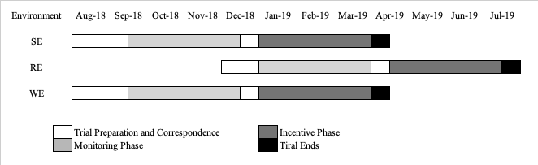
Figure 3.1: Experimental Timeline (month and year) by Environment
The study involved a Monitoring Phase, during which the number of cans recycled was merely observed and recorded without providing any monetary reward, and an Incentive Phase, where monetary rewards were given for recycling (see Figure 3.1 for when phases were implemented across environments).
In the Monitoring Phase, we recorded the number of cans recycled for 10 weeks. Participants were instructed to place cans in designated bins provided by the experimenters. The data collected in this phase provide a within-subject benchmark for evaluating the effectiveness of monetary incentives implemented in the Incentive Phase. The Incentive Phase consisted of three treatments: the No-Reward treatment (NR), the sure reward treatment implemented as a Pay-Per-Can payment (PPC), and the probabilistic reward treatment involving lottery prizes (Lottery).
NR treatment - In the NR treatment, which served as a between-subject control group, we only recorded the number of cans recycled without providing any monetary incentive, as in the Monitoring Phase.
PPC treatment - In the PPC treatment, participants were paid £0.10 for each can recycled.
This amount was chosen so that it was not too small as to fail to incentivise recycling behaviour, but not too large as to be too expensive for local authorities to implement. We start by noting that this amount aligns with what is paid per container in deposit return schemes implemented in several European countries, which range between €0.10 to €0.25 (e.g., Ireland, Slovakia, Germany). The amount is easy to remember, and rewards are easy to calculate. More importantly, informal chats with Norwich City Council indicated that this amount was reasonable as it would still allow them to make a profit from can recycling. According to Induced Value Theory (Smith, 1976) incentives should satisfy three principles: non-satiation, salience, and dominance. This means that incentives should be large enough to compensate for effort costs. Too small amounts might not adequately incentivise participants. We could have chosen a larger amount, but we decided that 10-15% of the average price of a can was large enough for our purposes.
Lottery Treatment - In the Lottery treatment, participants were assigned to lottery-groups and had a chance to win a prize. The size of the prize in each lottery group equalled £0.10 times the total number of cans recycled in that group. Each lottery group contained $N =\{1,…,n\}$members, with $n≥2$. Lottery-group members received a raffle ticket for each can they recycled. If the size of the prize was positive, the probability that a lottery group member $i∈N$ wins the prize was:
$$p_{i}=\frac{t_{i}}{\sum_{j=1}^{n}{t_{j}}}$$

in which $t_{i}$ represents the number of raffle tickets member $i$received, and $\sum_{j=1}^{n}{t_{j}}$ represents the total number of tickets gained by the group. In this setting, the greater the number of cans recycled, the greater the probability of winning. Draws took place every two weeks. The design of the lottery prize was purposely chosen so that the expected earnings would match those in PPC. Therefore, for a risk-neutral individual, the monetary incentives from recycling in PPC or the Lottery treatments are theoretically equivalent. We acknowledge that other possible lottery scheme designs could have been implemented. One would have been to have set a fixed (action-exogenous) prize, and another would not have made the chances of winning proportional to the number of cans recycled. The existing literature implies that, generally, people invest excessively in Tullock contests. Such ‘over dissipation’ (Konrad, 2009) is accentuated in applied settings and evidence shows the extent to which respondents engage in real contests consistently exceed the thresholds predicted by theory (Davis & Reilly, 1998). Furthermore, we know that risk preferences are often highly varied and susceptible to excess effort or disengagement if an exogenous prize was deemed too large or too small for a given subject pool (Kahneman & Tversky, 1984). Therefore, we implemented a Tullock-style lottery that is payoff-equivalent to a piece-rate reward to a risk-neutral participant, striking a balance between these various competing effects, whilst still enabling comparability between the two types of incentive systems.
The experiment was conducted in three different environments: a student environment (SE), a residential environment (RE), and a workplace environment (WE). Participants in SE were students living on the University of East Anglia campus. About 36 flats took part in the experiment, comprising a total of over 360 students (10-12 students per flat). Participants in RE were 176 households (44 flats distributed in 4 different buildings) living in two different social housing areas in Norwich. Participants in WE were employees from Norfolk County Hall, involving around 600 employees distributed more or less evenly across six floors within the building.

Phase | Treatments | Conditions | SE | RE | WE
Monitoring | None | Individual | 18 Flats | 88 Households | 6 Floors
Monitoring | None | Group | 18 Flats | 88 Households | 6 Floors
Incentive | NR | Individual | 6 Flats | None | 2 Floors
Incentive | NR | Group | 6 Flats | None | 2 Floors
Incentive | PPC | Individual | 6 Flats | 88 Households | 2 Floors
Incentive | PPC | Group | 6 Flats | 88 Households | 2 Floors
Incentive | Lottery | Individual | 6 Flats | 88 Households | 2 Floors
Incentive | Lottery | Group | 6 Flats | 88 Households | 2 Floors
Notes: Lottery-groups consisted of 2 flats in SE, 44 households in RE, and 2 floors in WE.
Table 3.1: Distribution of the units of observation across phases and conditions.
The experimental settings varied slightly across each environment. In WE, employees could not be identified and individually paid, so the money raised through the recycling activity was given to floor managers who decided (with input from the employees in that floor) how to best spend those amounts. PPC and Lottery conditions are still directly comparable within WE.
Only in SE were participants assigned to two different conditions for the duration of the study, namely the Individual and Group conditions. Our reason for doing this is that it gave us a chance to compare our results with those in Diamond and Loewy (1991) as this is the study closest to ours. In the Individual condition, each student was given bags in which they were asked to place the cans they intended to recycle. To identify students (while maintaining anonymity), everyone in this condition was given a set of cable ties with different colours and lengths unique to them. Students were then asked to tie their recycling bags with the cable ties provided. Failure to do this in the Incentive Phase would result in no payment for those students taking part in the PPC or Lottery treatments. They were then asked to place those bags in a cardboard bin located in the communal kitchen. In the Group condition, students simply put the cans they intended to recycle in the cardboard bin located in their communal kitchen.
In RE, only two buildings (with 44 households each) took part in the Monitoring Phase. In the Incentive Phase, to avoid running multiple incentive treatments in either building, we decided to run only the PPC treatment in one building and the Lottery treatment in the other, leaving out the NR treatment. When the opportunity presented itself, we incorporated two more buildings (another 88 households) in the Incentive Phase, one for the PPC treatment and one for the Lottery treatment. This enabled us to increase the number of observations in these two treatments. We decided not to designate one of these two additional buildings for the NR treatment due to the notably low level of engagement observed during the Monitoring Phase.
Table 3.1 reports how the units of observation were distributed across phases and treatments. Flats or Individuals in SE, households in RE, and floors in WE are the units of observation.

3.1 Implementation
Before data collection began, participants were handed a set of paper instructions (see Appendix A) in which they were informed that a recycling trial would be implemented and that new bins would be placed in addition to those already there. They were informed about the starting date of the recycling trial (Monitoring Phase), but the instruction contained no information about the Incentive Phase. This was done to avoid any strategic postponement of recycling. In all environments, experimenters installed a new recycling bin and gave participants recycling bags. In RE, with the help of Norwich City Council, new bins were placed near the existing waste disposal areas. These new bins were clearly identified with stickers. In SE and WE, cardboard bins donated by recycling charity “Every Can Counts” were provided to each flat and floor respectively. In the RE households and the SE Individual condition, we provided instructions on how to apply the colour and length-coded cable ties (see Appendix A for the RE version of the instructions). Participants were told that this would ensure anonymity, whilst enabling researchers to identify who was recycling what, in order to later pay them the correct rewards.
For any trial to work, participants must be aware of its introduction. We believe that in each intervention location, the new recycling schemes were highly visible. Furthermore, the placement of new recycling bins in communal kitchens and courtyards was hard to miss. Of course, as with any intervention of this nature, we cannot be completely certain that all people in the trial understood and were aware of the adjustments made. This possibility implies that our results might underestimate the magnitude of behavioural change that would occur if such a policy were adopted at a larger scale.
At the end of the Monitoring Phase, participants were handed a second set of instructions that informed them that a new phase of the trial would start. The instructions contained detailed information (see Appendix B) on how the new system worked. In both Monitoring Phase and Incentive Phase, cans were collected, counted and data recorded weekly. For logistic reasons, lottery draws were carried out fortnightly, and payments were carried out at the end of the Incentive Phase. All participants were aware that this would be the case.
Logistical reasons also explain why the individual and group conditions were implemented only in SE. In WE, this was not feasible, as we could not possibly ask each employee to recycle separately from others, and monetary rewards could not be given directly to them. In RE, a first obstacle was that of identifying individual and collective units. In principle, one can think of a household both as a group and as an individual unit. If we think of it as a group, the implementation of the individual condition would simply ask each individual member of the same household to recycle separately from the others. Not only did this not seem a viable option, but we did not believe data from such a trial would be representative of any household’s actual recycling habits. Equally, thinking of a household as an individual unit would give rise to the same problems if one were to implement a group condition comprising of several households.
Considering these key differences, as well as the demographic ones across environments, in the result section, we primarily focus on comparisons within each environment. A general prediction we can make is that participants, whether as individuals or groups, are more likely to recycle cans when provided monetary incentives. As for which incentive type (piece-rate or lottery) is more effective, given that the evidence from the literature is mixed, we suspect that the relative effectiveness of these two incentive types is context-dependent. Our research in this regard is exploratory, so we refrain from drawing speculative hypotheses on this matter.

4. Results

4.1 Overview
Figures 4.1, 4.2, and 4.3 show aggregate recycling levels (number of cans) by location and phase. For comparability, the figures only report data for the participants that were subsequently exposed to either PPC or Lottery in the Incentive Phase.
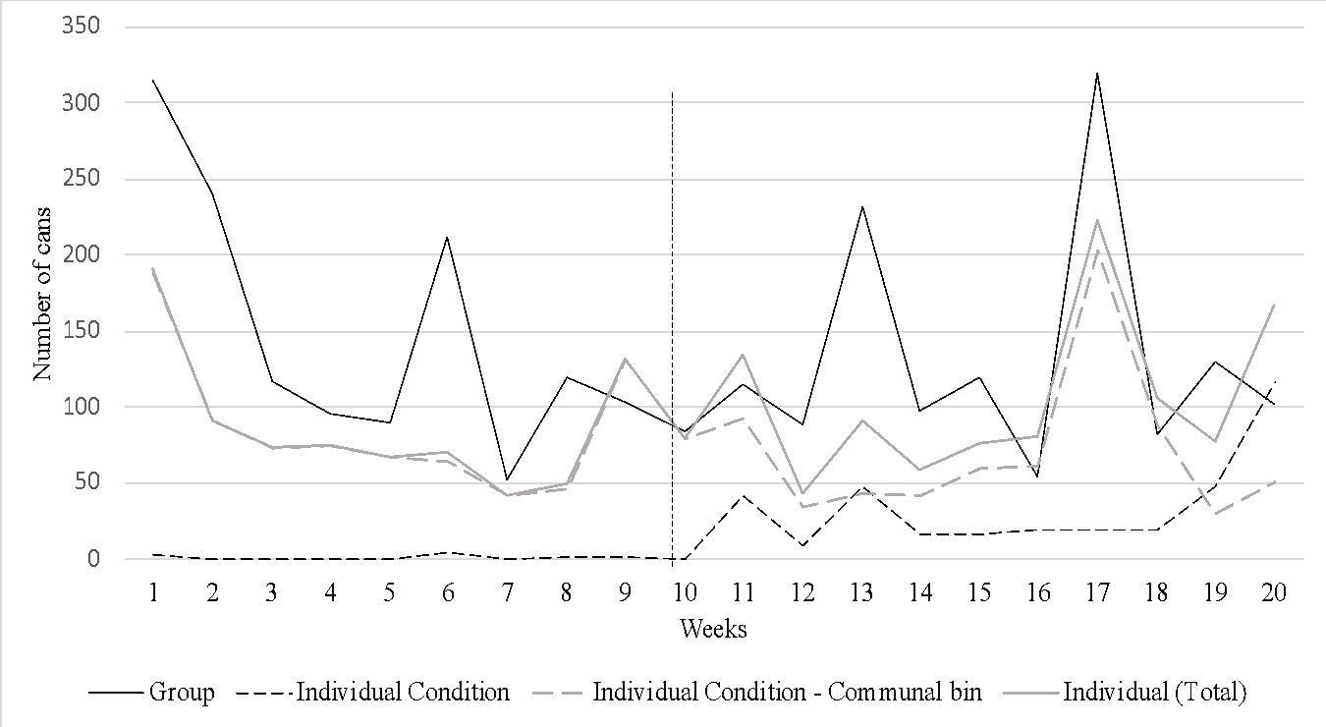
Figure 4.1: Number of cans recycled over time in SE.
Notes. Only participants exposed to monetary incentives in IP are included.
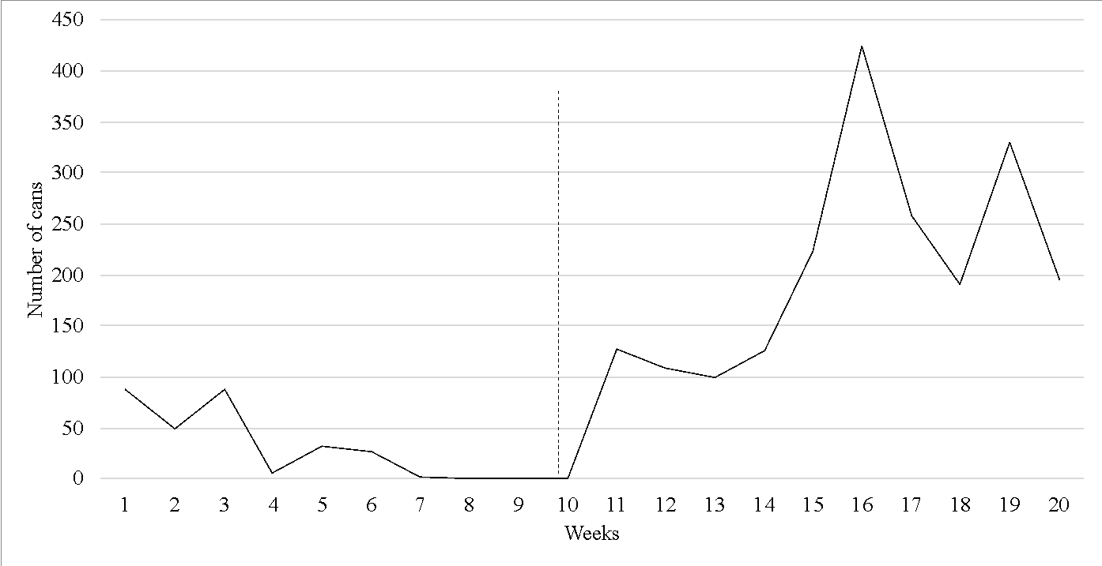
Figure 4.2: Number of cans recycled over time in RE.
Notes. The data include only flats that took part in both the Monitoring and Incentive Phases.

In SE (Figure 4.1), we report the number of cans recycled for both the Group and Individual conditions. The Individual condition data refer only to cans correctly recycled in individual bags. As a reminder, students in this condition were asked to recycle by placing their personal cans in individually identifiable bags. These bags should then be placed in a “communal” bin located in the kitchen. In the Incentive Phase, failure to follow this system resulted in no reward being paid. In this condition, however, students often placed loose cans (i.e., not correctly recycled) directly in the communal bin. We still recorded this data, which we refer to as ‘Communal Bin’ cans.
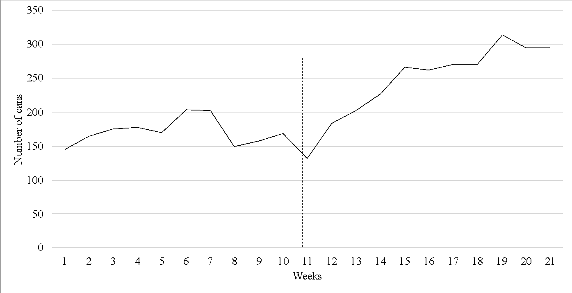
Figure 4.3: Number of cans recycled over time in WE.
Notes. Only floors exposed to monetary incentives in IP are included.
In all locations, we witness a negative trend over time in the Monitoring Phase. In SE we still observe some recycling in the Group and Communal bin conditions at the end of the period. In RE (Figure 4.2), by contrast, the number of cans recycled goes down to zero several weeks before the end of the phase, while in WE (Figure 4.3), the decline is only mild, as by week 10 of the phase, recycling levels are just below those recorded in the first week.
In the Incentive Phase, we observe an increase in recycling levels in all locations (an exception being possibly the Group Condition in SE). By contrast, students in the Individual condition recycle more than in the Monitoring Phase and we observe fewer cans in the communal bin. In RE, incentives lead to a sharp increase in recycling and in WE they seem to provide a boost.

4.2 The Student Environment (SE)
Table 4.1 reports the results of three sets of random effects regressions.
Set 1: SE - Group Condition
 | (1) | (2) | (3) | (4) | (5) | (6)
VARIABLES | MP | MP | MP&IP | IP | IP | IP
PPC |  | 0.867 |  |  | 3.967 | 3.3
 |  | (4.001) |  |  | (3.905) | (4.160)
Lottery |  | 2.8 |  |  | 0.667
 |  | (4.001) |  |  | (3.905)
Week | -1.508*** |  |  | 0.015
 | (0.300) |  |  | (0.485)
IP |  |  | -0.767
 |  |  | (1.844)
Constant | 19.619*** | 10.100*** | 11.933*** | 11.083*** | 8.850*** | 9.517***
 | (2.272) | (2.829) | (1.977) | (3.362) | (2.761) | (2.941)
Observations | 180 | 180 | 240 | 120 | 180 | 120
Set 2: SE - Individual Condition
PPC |  | -0.047* |  |  | 0 | -0.278
 |  | (0.026) |  |  | (0.236) | (0.272)
Lottery |  | -0.058** |  |  | 0.278
 |  | (0.026) |  |  | (0.236)
Week | -0.000 |  |  | 0.039
 | (0.003) |  |  | (0.026)
IP |  |  | 0.270***
 |  |  | (0.079)
Constant | 0.027 | 0.061*** | 0.009 | 0.065 | 0.139 | 0.417**
 | (0.018) | (0.019) | (0.079) | (0.197) | (0.167) | (0.192)
Observations | 1,920 | 1,920 | 2,560 | 1,280 | 1,920 | 1,280
Set 3: SE - Individual Condition (Communal Bin)
PPC |  | -2.317 |  |  | -0.400 | -1.767
 |  | (3.667) |  |  | (3.267) | (3.879)
Lottery |  | -1.883 |  |  | 1.367
 |  | (3.667) |  |  | (3.267)
Week | -0.319 |  |  | 0.151
 | (0.286) |  |  | (0.402)
IP |  |  | -1.283
 |  |  | (1.361)
Constant | 9.619*** | 9.267*** | 7.167*** | 3.551 | 5.400** | 6.767***
 | (2.123) | (2.593) | (1.774) | (6.502) | (2.310) | (2.743)
Observations | 180 | 180 | 240 | 120 | 180 | 120
Notes: Standard errors in parentheses*** p<0.01, ** p<0.05, * p<0.1
Table 4.1: Recycling in SE
Models 1 and 2 only use data from the Monitoring Phase (labelled as MP in Table 4.1). Models 4, 5 and 6 use data only from the Incentive Phase (IP). Model 3 uses all data. The dependent variable in Sets 1 and 2 is the number of cans recycled. Because in Set 3 we only have information on recycling at the flat level, we cluster standard errors at this level, as we do for the Group condition. For the regressions in Set 2 we cluster at the individual level. We employ indicator variables for the PPC, Lottery, and NR treatments, with the latter acting as our baseline. In model (6), Lottery is a dummy variable taking value 1 in the Lottery treatment and zero in the PPC one. Week is a time trend taking values from 1 to 10. IP is a dummy variable that takes a value of one in the Incentive Phase and zero otherwise. The row immediately below the model number reports the set of data used in the analysis.
In Set 2, we do not observe a significant time trend in either phase (models 1 and 4). This result should not be given too much weight, as recycling did not take place regularly (see Appendix C for details). Although incentives significantly increase the number of cans recycled, the effect size is rather small. On average, an individual recycled 0.27 more cans per week in the Incentive Phase compared to the Monitoring Phase (model 3).
Set 3 provides evidence that recycling of loose cans in the communal bin decreases over time in the Monitoring Phase, but no such trend occurs in the Incentive Phase (models 1 and 4, respectively).

4.3 The Residential Environment (RE)
As previously explained, the Incentive Phase involved four buildings (176 flats) while the Monitoring Phase only involved two (thus 88 flats).
Table 4.2 reports results of six regression models, each clustering observations at the flat level. Unlike in SE, we only estimate five models as we do not implement the NR treatment in the Incentive Phase. Models 1 - 3 include only the buildings that took part in both phases, whereas Models 4 and 5 include all buildings. Model 6 includes only engagement data in the Incentive Phase.
To reinforce the informal analysis provided in Section 4.1, we confirm that recycling decreases significantly over time in the Monitoring Phase (model 1), with each additional week resulting in 0.109 fewer cans recycled per flat, and increases significantly in the Incentive Phase, with a weekly rise of 0.967 cans per flat (model 4). This provides evidence to support the strong effect of incentives on recycling in this setting.
Not surprisingly, incentives lead to a significant increase in the number of cans recycled across phases. Compared to the Monitoring Phase, a flat recycles an average of 2.041 more cans per week in the Incentive Phase (model 3). However, our regression results indicate that the type of incentive does not matter (model 5). This is surprising given that the total number of cans recycled by the flats assigned to the PPC treatment was 9470 compared to just 2187 of those assigned to the Lottery one. This lack of significance can be the result of the large heterogeneity of recycling levels, not only across flats (many flats did not recycle at all) but also across weeks (as flats that recycled often did so every few weeks). In the Monitoring Phase, 10 out of 88 flats (11%) actively recycle. On average, they recycle once or twice over the 10 weeks. In the Incentive Phase, engagement increases to about 15% (27 flats out of 176). Of these 27 flats, 15 only took part in the Incentive Phase. On average these flats would recycle 4 weeks out of 10. The non-parametric Mann-Whitney test carried out on the same data does show, however, a significant difference between the Lottery and PPC treatments in the direction indicated by the data (p<0.03).
Model 6 reports the results of a logit regression with standard errors clustered at the flat level. The dependent variable takes value 1 if a flat engaged in recycling in any given week, and zero otherwise. These results provide evidence to suggest that the PPC treatment is more effective in increasing engagement than the Lottery one. Other things being equal, flats in the lottery treatment are 4.3 percentage points less likely to recycle in any given week compared to those in the PPC treatment.
We acknowledge the possibility that the timing of the Incentive Phase in this environment, which ran from April to July, might have influenced recycling uptake, as canned drink consumption usually increases during the summer. However, we observe that recycling increased immediately at the start of the Incentive Phase, which was just a few weeks after the end of the Monitoring Phase, at which point no one in this environment was recycling. In addition, recycling reached a peak in the Incentive Phase well before the end of the trial in July. This pattern suggests that incentives were the main driver of the increase, rather than a change in the weather.
 | (1) | (2) | (3) | (4) | (5) | (6)
VARIABLES | MP | MP | MP&IP | IP | IP | IP (Engagement)
Lottery |  | 0.230 |  |  | -8.276 | -0.043**
 |  | (0.305) |  |  | (5.410) | (0.021)
Week | -0.109*** |  |  | 0.967**
 | (0.0412) |  |  | (0.466)
IP |  |  | 2.041***
 |  |  | (0.366)
Constant | 0.928*** | 0.214 | 0.328 | 1.307 | 10.761***
 | (0.273) | (0.216) | (0.508) | (3.732) | (3.825)
Observations | 880 | 880 | 1,760 | 1,760 | 1,760 | 1,760
Notes: Standard errors in parentheses*** p<0.01, ** p<0.05, * p<0.10.
Table 4.2: Recycling in RE.

4.4 Workplace Environment (WE)
Table 4.3 reports estimates for seven regression models. Model 7 includes only the NR floors from both phases.
Recycling does not decrease in a statistically significant way over the Monitoring Phase (model 1). In this phase, there is no significant difference in recycling between floors (model 2). The introduction of incentives does give a significant boost to the recycling undertaken by those floors assigned to either the PPC or Lottery treatment. On average, each floor recycles just over 22 (22.573) more cans per week in the Incentive Phase compared to the Monitoring Phase (model 3). Additionally, the number of cans recycled by each floor increases by 3.158 cans per week during the Incentive Phase (model 4).
 | (1) | (2) | (3) | (4) | (5) | (6) | (7)
VARIABLES | MP | MP | MP & IP | IP | IP | IP | NR only  MP&IP
PPC |  | 17.272 |  |  | 16.350 | -15.600
 |  | (17.544) |  |  | (20.890) | (24.201)
Lottery |  | 22.682 |  |  | 31.950
 |  | (17.544) |  |  | (20.890)
Week | -0.408 |  |  | 3.158***
 | (0.330) |  |  | (0.466)
IP |  |  | 22.573*** |  |  |  | 18.400***
 |  |  | (2.472) |  |  |  | (3.583)
Constant | 37.764*** | 22.000* | 41.977*** | 47.183 | 40.400*** | 72.350*** | 22.000***
 | (7.309) | (12.406) | (9.668) | (11.156) | (14.771) | (17.112) | (6.974)
Observations | 66 | 66 | 84 | 40 | 60 | 40 | 40
Notes: Standard errors in parentheses*** p<0.01, ** p<0.05, * p<0.1
Table 4.3: Analysis of recycling in WE.
There is no significant difference in the effectiveness of both incentives (model 6). Notably, recycling on the PPC and Lottery floors is no greater than on the NR floors (model 5) and the NR floors do increase their recycling as much as incentivised floors (model 7).

4.5 Summary
Despite the literature in recycling finding that behaviour does not carry over across different settings, we do find interesting similarities across our locations. Firstly, without incentives, recycling levels tend to decrease over time. Secondly, incentives, with one exception, increase the amount recycled. Thirdly, the type of incentive, contrary to our expectations, does not seem to matter. It is worth mentioning that in WE, we find that even those floors that did not receive a monetary reward increased recycling in the Incentive Phase. This could be due to some sort of behavioural spillovers. We will talk about this later, when we employ the Bass Model for a diffusion analysis of recycling.

5. The Diffusion of Recycling: A Bass Model Approach
As with every service, recycling has associated costs and benefits for the individual. Whilst for many goods and services these are monetarily based, the cost of recycling is represented by the individual effort of engaging with the recycling activity itself, and the benefits are those arising from environmental preferences and psychological attitudes. We study the incentivised recycling behaviour with the help of the Bass (1969) model, widely used in the marketing literature to estimate the diffusion potential of new or innovated products and to provide a sector benchmark to be employed by companies to forecast sales. Applied to recycling, diffusion analysis can help provide a benchmark based on location/demographic groups and therefore aid forecasting the potential reach of new recycling programmes.
The Bass model has been employed to study the diffusion process across different settings and within different research fields. For example, Lee et al. (2023) applied the model to study the adoption and diffusion in the Asian movie industry. Krishnan et al. (2023) study whether product managers can rely on the model’s prediction of the time at which sales should peak. Their paper also offers an extensive review of the literature on how to forecast adoption within the diffusion literature, most of which relies on the Bass (1969) model. Both Scaglione et al. (2015) and Bemmaor and Zheng (2018) study the diffusion of mobile Social Networking and broadband availability in different countries. Guseo and Mortarino (2015) extend the Bass model to study competition in the pharmaceutical industry and its effect on innovation. Van den Bulte and Joshi (2007) and Fruchter and Van den Bulte (2011) offer a theoretical and critical perspective on marketing strategy under the generalised Bass model.
In the Bass (1969) model, the key actors are ‘adopters’, who are classified either as innovators or imitators. Innovators’ purchasing decisions (or engagement with the service) are based on direct information about the product. Imitators, by contrast, base their decisions on indirect information that they might receive from innovators, such as word-of-mouth. The estimation of such a model provides information on the proportions of adopters ($p$ and $q$ for innovators and imitators respectively) and the potential market ($m$).
The diffusion process of a new product is characterised by four key elements: innovation, communication channels, time, and the social system (Mahajan, Muller & Bass, 1990). In our study, the ‘new product’ is represented by the recycling trial implemented in the Monitoring Phase and its ‘innovation’ by the introduction of monetary rewards in the Incentive Phase. ‘Time’ is represented by the duration of the experiment measured in weeks (10 weeks in each phase). The communication channels consist of the direct information (instructions) given to the participants about the experimental trials and the indirect information (not observable by the experimenter) given by information participants exchange with each other during the trial. The latter could plausibly differ among locations.

5.1 Overview
Table 5.1 presents the estimated Bass parameters, with the corresponding p-values, by location and phase. According to the Bass model, innovators ($p$) and imitators ($q$) can potentially start engaging with the service simultaneously, however, the number of innovators will monotonically decrease over time. This means that any diffusion, if present, will be driven by imitators. For the adoption of the service to positively grow over time, parameter $q$ must be greater than $p$. The potential market ($m$) is derived from the maximum number of adoptions within the timeframe employed. The variable $T$ represents the point in time (weeks in our experiment) where the maximum level of adoption is reached. The Bass parameters are estimated using the OLS method, as is standard in the literature.
Panel A reports the estimated parameters for SE, by Group (Panel A.1) and Individual (Panel A.2) conditions. The units used for the estimation are the number of cans recycled. In the Group Condition we cannot report amounts recycled at the individual level. For consistency and comparability within this environment, we employ the same unit of estimation (total cans recycled per flat) in the Individual Condition. Panel B reports the parameters for RE, estimated using the number of flats that engaged with recycling in any given week, rather than the number of cans recycled by a flat in that week. This decision is based on considerations found in the literature that view recycling in residential contexts as a household activity rather than an individual one (e.g. Meneses & Palacio, 2005). In addition, diffusion across households is a more important measure than the increasing recycling levels within a given household. This is because, from a marketing perspective, what matters is the number of customers reached, as opposed to the number of products bought by the same customer. This is not to diminish the benefits of also looking at the total number of cans recycled, which also does measure costs and benefits useful when considering the introduction of new recycling policies.

Panel A.1: SE – Group Treatment |  |  |  |  | Panel A.2: SE – Individual Treatment
 | p | q | M | T |  | p | q | M | T
MP | 0.482 | 0.000 | 1631 | NA | MP | 80.438 | 76.543 | 197 | NA
IP | 0.037* | 0.125* | 3848** | 7.7 | IP | 0.084 | 0.412* | 41 | 4.6
Panel B: RE |  |  |  |  | Panel C: WE
 | p | q | M | T |  | p | q | M | T
MP | 0.22** | 0.118 | 20*** | NA | MP | 0.050*** | 0.145*** | 765*** | 5.5
IP | 0.029*** | 0.209* | 190** | 8.0 | IP | 0.038*** | 0.151*** | 1116*** | 8.7
Notes: The present table reports the Bass parameters ($p=$innovators, $q=$ imitators and $M=$ potential market) for the three locations (SE, RE and WE). Panel A.1 and A.2 report the parameters in SE for the group and individual condition, respectively. Panel B and Panel C report the parameters for the RE and WE, respectively. The parameters, reported with their p-values, with *** $p<0.01$, $** p<0.05, * p<0.1$, are estimated using an OLS calibration methodology (more details can be found in Appendix D). The parameter T represents the period in which the maximum level of adoption is reached. For the diffusion process to reach its peak, the density function (adoption curve) needs to be a monotonically increasing function. For the adoption curve to be monotonically increasing the condition $q > p$ needs to be satisfied. When this condition is not satisfied “T” cannot be estimated. This is indicated with “NA” in the present table. Standard errors in parentheses
Table 5.1: The Diffusion of Recycling – Bass Analysis.
Panel C presents the results for WE. The unit of observation is the number of cans recycled, again dictated by the lack of data at the individual (employee) level. Note that in WE, and in SE Groups, the notion of household ‘engagement’ loses any relevance for diffusion processes. This is because in these environments we find that all groups ‘engage’ every week. Recycling from a group could however be the result from the activity of just one person within that group. Although studying diffusion within a group over time would be relevant in our setting, this is not something we can achieve with our data. Nevertheless, the number of cans recycled is a useful approximation for the overall group uptake. In this environment we have assumed that each employee recycles 5 cans per week. Our results are robust to changes in this value.
In the Group condition in SE, incentives provide a boost in the uptake of recycling (Table 5.1, Panel A.1, IP row). In the Individual condition in SE, by contrast, incentives do not seem to encourage the diffusion of recycling (Table 5.1, Panel A.2, IP row). The imitators’ parameter is positive and only mildly statistically significant whereas the innovator parameter is not statistically significant. We believe that this is because students in this condition recycle almost all cans in the final week, therefore the estimation of the model is not able to detect a diffusion process. Altogether, the results don’t allow for a full interpretation of the diffusion path.
In RE (Table 5.1, Panel B), incentives lead to an uptake of recycling over time. In the Monitoring Phase the adoption process monotonically decreases as $p>q$. In the Incentive Phase, by contrast, the diffusion process shows a sustained growth, as $q>p$, demonstrating a positive effect of incentives on the diffusion of recycling. Findings in this location are thus consistent with those of Section 4.
In WE, we find that $q>p$in both the Monitoring and Incentive Phases. Unlike in RE, in this location the size of the estimated parameters only mildly differs between phases. We observe a small increase in imitators and a more sizable increase in the potential market ($m$). Incentives do not ‘change’ the diffusion process but somewhat intensify it. Broadly speaking, our initial analysis suggests that incentives positively and significantly impact the diffusion of recycling in RE and SE Group Condition, provide a mild boost within WE, and an even smaller impact on SE Individual Condition.
To give more context to the presented coefficients, it is worth noting that the values of the parameter $p$ usually span between very small values just above zero and 0.10. By contrast, the values of the q parameters are usually above 0.10 and within 1, with an average value ranging around 0.25 (for a comprehensive review of the parameters ranges and literature, see Meade and Islam, 2006). Our parameters, along with being strongly statistically significant, range within the expected values in most of the IP settings. Particularly in the WE and RE, the values of early adopters versus followers are in line with expectations and corroborate our previous findings.

5.2 The Impact of the Type of Incentive on Diffusion
Figure 5.1 reports six curves for each location and type of incentive within SE. The ‘real adoption curve’ (black dotted line) plots the actual number of cans recycled or flats engaging with the service by week. The remaining curves are estimated using the Bass parameters: the ‘adoption’ curve (black solid line); the ‘innovators’ curve (dark solid grey) and the “imitators” curve (light grey solid). Note that, except for Panel A.2, the innovators, imitators, and adoption curves almost entirely overlap, so portions of some lines are covered by other lines.
Figure 5.1: SE - Lottery vs PPC
Notes. The figure presents the plots of the density functions for the parameters p (Innovators) and q (Imitators) and the total adoption (Adoption) over the 10 weeks of the Incentive Phase.

Compatible with the results in Section 4.1, in SE Individual condition, there is no statistically significant diffusion process for either the PPC or Lottery treatment. At a group level (Panel B.2) we instead observe an increasing diffusion process in the PPC treatment. This is evidenced by the concavity of the imitators’ curve, that presents a maximum in week 7. The NR treatment shows no growing diffusion process either in the Individual or Group Conditions.
Figure 5.2: RE - Lottery vs PPC
Notes. The figure presents the plots of the density functions for the parameters $p$ (Innovators) and $q$ (Imitators) and the total adoption (Adoption), over the 10 weeks of the Incentive Phase.

In line with the results in Table 5.1, in RE (Figure 5.2), for both the PPC (Panel a) and the Lottery treatments (Panel b) we observe an increasing diffusion of recycling. Nevertheless, we do note one key difference - in the PPC treatment the diffusion process peaks before week 10 whereas in the Lottery treatment the maximum is not reached within the experimental time frame. It is for this reason that the estimated parameter $m$is greater in the Lottery treatment.
For WE, Figure 5.3 shows a marked diffusion process in both PPC and Lottery treatments. This process peaks in week 8 for the PPC treatment (Panel a: PPC) and is outside the experimental timeframe for the Lottery treatment (Panel b: Lottery). Although both incentives prove successful in this setting, the Lottery seems marginally more successful than PPC. An unexpected and puzzling result is found in the NR treatment. Namely, a continuous growing adoption curve comparable to those in the other two treatments (Lottery and PPC). This can be seen as a spin-off effect from the incentives introduced in the other floors. This effect only applies to WE and it is not observed in the other two locations.
In the Monitoring Phase, our results broadly replicate those in Section 4. In SE, both conditions demonstrate a mild diffusion trend in this phase. In RE we see little diffusion, which was to be expected given the disengagement in this environment. The adoption patterns in WE confirm not only positive recycling, but a diffusion process across this first ten weeks.
We are unable to comment on the nature of the diffusion process in the Individual condition in SE, as only the imitators’ parameter is found statistically significant. We only find a mild effect of incentives in the Group condition. In RE, incentives are essential to foster the uptake in the recycling service. In WE, incentives intensify the diffusion process, but this boost does not seem to be driven solely by the actual income that can be generated by monetary reward given that NR floors also exhibit adoption behaviour in this phase.
Figure 5.3: WE - Lottery vs PPC
Notes. The figure presents the plots of the density functions for the parameters $p$ (Innovators) and $q$ (Imitators) and the total adoption (Adoption) over the 10 weeks of the Incentive Phase.

6. The role of Incentives in Recycling
Our results show that monetary rewards increase recycling levels in almost all locations. This is reassuring, as the literature has highlighted the non-portability of recycling behaviour across settings, in particular in the workplace. By contrast, we find that recycling levels were sustained without monetary incentives and boosted after they were introduced. Contrary to our expectations, we do not find consistent differences between the sure and probabilistic rewards. It is possible, as mentioned in the literature review, that the riskiness of the lottery, compared to the sure reward, is offset by some of the features of relational goods that participants might have associated with the raffle competition. This might have made the lottery as appealing as the sure reward and therefore explain why we do not find significant differences between these two incentive schemes. However, joint activities (e.g. watching TV together) are necessary for consumption of relational goods. While this is certainly very likely in WE, in RE, and to some extent SE, we believe informational exchanges among different lottery groups are less likely due to the environmental features where the trials were implemented. In the SE setting, lottery groups were student flats spread across campus, thus with limited opportunities for shared anticipation or conversations about the draw. In the RE setting, participants lived in flats in different council housing buildings, making social exchanges about the raffle even less likely. By contrast, in WE, physical proximity and frequent interactions among colleagues could have created, at least in principle, the conditions necessary for such relational good effects. In this environment, as the money generated from recycling was given to floor managers rather than directly to employees, even the sure reward might have generated some effects typically associated with relational goods.
Our study’s results, although only being comparable in some ways, do exhibit interesting differences from those of Diamond and Loewy (1991). They find that both probabilistic and sure rewards increase recycling compared to when no monetary incentives are provided. In addition, individual probabilistic rewards are more effective than individual sure rewards, both of which are more effective than group sure rewards. In our group settings (SE Group Condition and WE), rewards, whether sure or probabilistic, do not seem to be the major driver of recycling. In fact, recycling levels tend to be large even without payments. We also find that sure rewards (PPC) can, in most settings, be as effective as probabilistic ones (Lottery) contrary to Diamond and Loewy. Yet, in keeping with this study, we find that offering incentives to individuals is more effective than doing so to groups.
Of our three settings, monetary incentives worked most effectively in RE. Here, we believe low-income levels could drive engagement in the Incentive Phase. RE participants found cash payments particularly appealing, informing researchers that they collected cans from the streets to increase their “earnings”. The potential for income generation in this phase might be the main reason for success in this location. This could also explain why the Lottery scheme was not as popular among RE participants, as residents may prefer their behaviour to be rewarded with certainty (i.e., they display risk aversion). The analysis of the diffusion process also supports this conjecture.
At first glance, it appears surprising that offering monetary incentives to students did not yield a large response in recycling behaviour. One might argue that, since university students in SE typically do not have full-time jobs or high earnings, they should find cash payments just as appealing as individuals in RE. However, our findings suggest otherwise. One possible reason is that UK university students from higher-income households are over-represented compared to the general population (e.g., Anders, 2012; Department for Education, 2023, 2024; Borrett, 2024). It is therefore plausible that students in SE have been raised in relatively affluent environments, or that they receive financial support from their families, which may make them less sensitive to the small monetary incentives for can recycling compared to individuals in RE. That said, we also acknowledge a range of other possible reasons for this unresponsiveness. These include (but not exhaustively) that the mechanism for earning the monetary reward was particularly laborious in the Individual condition; that students, more generally, face additional strain on their time and attention as they adjust to a completely new environment with new cohabitants; and that, irrespective of parental affluence, many students may experience substantial disposable income for the first time, albeit financed through student loans. All these factors could have reduced the salience and importance of monetary incentives overall and, therefore, help explain why they had little impact on students at the margin who recycle little or not at all, as well as why we did not observe an increase in recycling among those students who recycled even without incentives. More broadly, this interpretation is consistent with the literature which argues that students are considered less representative of the general population’s behaviour in certain contexts (Henrich et al., 2010).
In WE, both incentive schemes prove successful but, unlike in RE, we do not believe money to be the key driver. First, adoption during the Monitoring Phase highlights a strong engagement irrespective of incentives. Second, our results in the Incentive Phase show that even unrewarded floors increased their adoption of the service. Third, any money raised by incentivised treatments was given to floor managers (as opposed to being paid to an employee), diluting the private (pecuniary) benefits of recycling. Beyond monetary incentives, the recycling literature has identified various social factors that may also affect recycling behaviour, such as norms, relational goods, peer pressure, and the observability of recycling activities. Although the purpose of our study is not to identify these factors, the theoretical underpinning of the Bass model can provide novel insights into the non-monetary determinants of recycling in WE. Based on the findings above, we propose that the “proximity” of potential adopters within a social system, such as WE, is a factor that positively influences informational exchanges and, ultimately, promotes recycling.
It is possible that in workplace environments, the likelihood for informational exchanges is far greater than in residential settings, increasing the salience of the intervention and/or fostering a social pressure to recycle (Kashyap and Iyer, 2001; McCarty and Shrum, 2001). In this study, the novelty of a recycling trial introduced in the Monitoring Period could have led to conversations among employees that presumably intensified when incentives were introduced, contributing to the salience and the associated engagement with the service. Additionally, these conversations may have led employees to associate certain characteristics of ‘relational goods’ with monetary incentives, meaning that observed recycling and earning rewards for colleagues on the same floor might have generated non-material benefits such as team spirit and collegiality. Physical proximity among individuals can have the additional effect of making behaviour highly observable, which makes it easier for a group to learn new behaviours or to converge to a social norm (Bandura, 1971; Barr et al., 2001). Social norms in turn influence behaviour as they create social pressure to adhere to the norm. Gamba and Oskamp (1994) find that one of the most important reasons for recycling was the social pressure from the neighbours. This explanation seems compatible with the spill-over effects observed in workplaces, where even the floors that did not receive any monetary compensation increased their recycling activities in the Incentive Period. This echoes the value placed within the recycling literature on observable behaviour and peer effects (Czajkowski et al., 2017).

7. Discussion and Conclusions
Our paper experimentally investigated the effectiveness of different types of monetary incentives, namely sure and probabilistic rewards, on can recycling across three different environments: students’ accommodation at the University of East Anglia, social housing managed by Norwich City Council, and Norfolk County Council’s offices.
One takeaway from our study is that, although the effectiveness of sure and probabilistic rewards is not statistically different, it is crucial to consider the heterogeneity of the environments in which these incentives are implemented.
Our results suggest that introducing a monetary reward could stimulate action in low-income populations where recycling efforts are traditionally low or non-existent, such as residents in social housing. The reason is that monetary rewards may yield relatively high marginal utilities for low-income individuals, especially those who lack financial support from their families. Also, when a population demonstrates low recycling activity in the absence of monetary incentives, it indicates low intrinsic motivation, leaving little room for such motivation to be crowded out when monetary rewards are introduced. Additionally, although our study does not focus on habit formation, evidence from the literature suggests that recycling behaviour encouraged by monetary rewards could foster the development of a long-term recycling habit (Lally et al., 2010; Li et al., 2021). Once such a habit is established, as evidenced by Li et al., the importance of monetary incentives is greatly reduced. Therefore, they could be gradually phased out. This is of particular importance among low-income individuals whose engagement with recycling remains low.
In environments where individuals experience higher levels of informational exchanges and physical proximity, such as employees in Norfolk County Council, the effectiveness of monetary rewards should be assessed carefully, paying particular attention to their interaction with other social factors. In these environments, the motivation to recycle may not solely stem from the material benefits of receiving a monetary reward but also from additional benefits that derive from some characteristics associated with a relational good that employees might have experienced during the trial. These additional effects may foster pro-recycling norms or even crowd in intrinsic motivation of recycling. We therefore propose that informational exchanges, boosted by proximity, are important for the diffusion of recycling in an environment.
We believe our results, along with their interpretation, offer a promising avenue of work for improving sustainable waste management practice. Our findings can help businesses and policy makers address the long-standing issue of poor engagement with recycling practices in different contexts. In low-income populations where both communications and recycling effort are limited, monetary incentives may be the most effective tool to promote recycling behaviour. However, in environments characterised by high level of informational exchanges and physical proximity, such as workplaces, monetary rewards could potentially be replaced with moral or symbolic rewards (Ji et al., 2023; Li et al., 2021), thus reducing the cost of promoting recycling.
Our study contributes to several strands of the recycling literature. First, it introduces Tullock contests (Tullock, 1980) into the comparison of sure versus probabilistic reward for promoting recycling behaviour (Geller et al., 1975; Witmer and Geller, 1976; Jacobs and Bailey, 1982; Diamond and Loewy, 1991; Wang et al., 2021), and provides empirical evidence on their effectiveness in a controlled setting where the size of the two rewards are strictly comparable. Second, it bridges research that investigates recycling behaviour in isolated locations (e.g., Jacobs and Bailey, 1982; Owusu et al., 2013; Abila and Kantola, 2019) and highlights the importance of accounting for contextual heterogeneity when evaluating the effect of monetary incentives. Third, although our study is not specifically designed to explore non-monetary incentives such as intrinsic motivation or social norms (Hornik et al., 1995; Schultz, 1999; Owusu et al., 2013; Rode et al., 2015; Xu et al., 2023), it provides insights into the literature regarding how their effectiveness may vary across environments that differ in physical proximity, levels of information exchange, and income. We also contribute to the field of ecological economics by observing people’s revealed choices and the interplay between financial, social and environmental factors that shape those choices. Finally, our study makes a novel contribution by introducing the Bass Model into the recycling literature, which enabled the analysis of the diffusion of recycling behaviour over time.
Despite our clear contributions to the literature and real-world practice, this research should be considered as a starting point for future investigations. It would be interesting, for example, to compare the effectiveness of non-material incentives or explore the formation of recycling habits across various locations and environments, or to understand how different levels of proximity influence the effectiveness of monetary and non-monetary incentives. From a policy perspective, the purpose of our study was not that of putting forward a ‘ready-made’ recycling system that can be immediately implemented by waste management authorities, rather, it was that of taking a pioneering first step to experimentally investigate where recycling system changes create similar responses across locations and environments, as well as identifying when key differences appear. To this extent, we open a new and potentially exciting avenue of discussion (and research) for policy makers.

Aknowledgments
For the purpose of open access, the author has applied a Creative Commons Attribution (CC BY) licence to any Author Accepted Manuscript version arising from this submission.

References
Aarts, H., Verplanken, B. and van Knippenberg, A. (1998). Predicting behavior from actions in the past: Repeated decision making or a matter of habit? Journal of Applied Social Psychology, 28, pp.1355–1374.
Abbott, J., Kalamas, M. and Kristson, S. (2013). Warm glow giving in kerbside recycling: Evidence from a UK survey. Resources, Conservation and Recycling, 84, pp.62–69. https://doi.org/10.1016/j.resconrec.2013.02.008
Abila, B., & Kantola, J. (2019). The Perceived Role of Financial Incentives in Promoting Waste Recycling—Empirical Evidence from Finland. Recycling, 4, pp.1-11.
Agnusdei, G.P., Gnoni, M.G. and Sgarbossa, F. (2022). Are deposit-refund systems effective in managing glass packaging? State of the art and future directions in Europe. Science of the Total Environment, 851(Pt 2), 158256. https://doi.org/10.1016/j.scitotenv.2022.158256
Ajzen, I. (1991). The theory of planned behavior. Organizational Behavior and Human Decision Processes, 50(2), pp.179–211.
Alcott, B. (2005). Jevons’ paradox. Ecological Economics, 54(1), pp.9–21.
Allen, J., Davis, D. and Soskin, M. (1993). Using coupon incentives in recycling aluminum: A market approach to energy conservation policy. Journal of Consumer Affairs, 27(2), pp.300–318.
Anders, J. (2012). The link between household income, university applications and university attendance. Fiscal Studies, 33(2), pp.185-210.
Andreoni, J. (1989). Giving with impure altruism: Applications to charity and Ricardian equivalence. Journal of Political Economy, 97(6), pp.1447–1458.
Andreoni, J. (1990). Impure altruism and donations to public goods: A theory of warm-glow giving. Economic Journal, 100(401), pp.464–477.
Bandura, A. (1971). Vicarious and self-reinforcement processes. In: A. Bandura (ed.) The nature of reinforcement. pp.228–278.
Barr, S., Gilg, A.W. and Ford, N.J. (2001). A conceptual framework for understanding and analysing attitudes towards household waste management. Environment and Planning A, 33(11), pp.2025–2048.
Barr, S., Shaw, G., Coles, T. and Prillwitz, J. (2010). ‘A holiday is a holiday’: Practicing sustainability, home and away. Journal of Transport Geography, 18(3), pp.474–481.
Barsky, R.B., Juster, F.T., Kimball, M.S. and Shapiro, M.D. (1997). Preference parameters and behavioral heterogeneity: An experimental approach in the Health and Retirement Study. Quarterly Journal of Economics, 112(2), pp.537–579. https://doi.org/10.1162/003355397555280
Bass, F.M. (1969). A new product growth model for consumer durables. Management Science, 15(5), pp.215–227.
Berger, I.E. (1997). The demographics of recycling and the structure of environmental behavior. Environment and Behavior, 29(4), pp.515–531.
Bemmaor, A. C., & Zheng, L. (2018). The diffusion of mobile social networking: Further study. International Journal of Forecasting, 34(4), pp.612–621.
Bongers, A. and Casas, P. (2022). The circular economy and the optimal recycling rate: A macroeconomic approach. Ecological Economics, 199, 107504.
Borrett, A. (2024). Disadvantaged pupils miss out as university entry gap hits record level in England. Financial Times. https://www.ft.com/content/384f6576-3655-433c-b0eb-067983076a17
Brock, M. and Borzino, N. (2020). Using incentives and social information to promote energy conservation behavior. In: Quah, E. and Schubert, R. (eds.) Sustainability and Environmental Decision Making. Sustainable Development. Springer, Singapore. https://doi.org/10.1007/978-981-15-6093-4_8-1
Czajkowski, M., Hanley, N. and Nyborg, K. (2017). Social norms, morals and self-interest as determinants of pro-environment behaviours: The case of household recycling. Environmental and Resource Economics, 66(4), pp.647–671.
Davis, D. D., & Reilly, R. J. (1998). Do too many cooks always spoil the stew? An experimental analysis of rent-seeking and the role of a strategic buyer. Public Choice, 95(1), pp.89-115.
Deci, E.L. and Ryan, R.M. (1985). Intrinsic motivation and self-determination in human behavior. New York: Plenum.
DEFRA (2022-23) UK statistics on waste. [online] Department for Environment, Food & Rural Affairs. Available at: https://www.gov.uk/government/statistical-data-sets/env18-local-authority-collected-waste-annual-results-tables
Delmas, M.A., Fischlein, M. and Asensio, O.I. (2013). Information strategies and energy conservation behavior: A meta-analysis of empirical studies. Energy Policy, 61, pp.729–739.
Department for Education. (2023). The influence of area of residence and other characteristics on higher education participation (LEO) (Data Insight). Department for Education. https://www.adruk.org/news-publications/publications-reports/investigating-the-relationship-between-higher-education-participation-personal-characteristics-and-area-of-residence-among-school-or-college-leavers
Department for Education. (2024). Widening participation in higher education, academic year 2022/23. Explore education statistics (EES). https://explore-education-statistics.service.gov.uk/find-statistics/widening-participation-in-higher-education/2022-23
Derksen, L. and Gartrell, J. (1993). The social context of recycling. American Sociological Review, 58(3), pp.434–442.
Diamond, W.D. and Loewy, B.Z. (1991). Effects of probabilistic rewards on recycling attitudes and behavior. Journal of Applied Social Psychology, 21(19), pp.1590–1607.
Dohmen, T., Falk, A., Huffman, D., Sunde, U., Schupp, J. and Wagner, G.G. (2011). Individual risk attitudes: Measurement, determinants, and behavioral consequences. Journal of the European Economic Association, 9(3), pp.522–550. https://doi.org/10.1111/j.1542-4774.2011.01015.x
Donnelly, G.E., Lamberton, C., Reczek, R.W. and Norton, M.I. (2017). Social recycling transforms unwanted goods into happiness. Journal of the Association for Consumer Research, 2(1), pp.48–63.
Donnelly, G.E., Mertens, S.N. and Sintov, N. (2024). Increasing recycling with charitable incentives. Journal of Environmental Psychology, 99, 102444.
Folz, D.H. (1991). Recycling program design, management, and participation: A national survey of municipal experience. Public Administration Review, 51(3), pp.222–231.
Fruchter, G. E., & Van den Bulte, C. (2011). Why the Generalized Bass Model Leads to Odd Optimal Advertising Policies. International Journal of Research in Marketing, 28(3), pp.218–230.
Fuller, D.A. (1978). Recycling consumer solid waste: A commentary on selected channel alternatives. Journal of Business Research, 6(1), pp.17–31.
Gamba, R.J. and Oskamp, S. (1994). Factors influencing community residents’ participation in commingled curbside recycling programs. Environment and Behavior, 26(5), pp.587–612.
Geller, E.S., Chaffee, J.L. and Ingram, R.E. (1975). Promoting paper recycling on a university campus. Journal of Environmental Systems, 5(1), pp.39–57.
Gilli, M., Nicolli, F. and Farinelli, P. (2018). Behavioural attitudes towards waste prevention and recycling. Ecological Economics, 154, pp.294–305.
Gneezy, U. and Rustichini, A. (2000). Pay enough or don’t pay at all. Quarterly Journal of Economics, 115(3), pp.791–810.
Gui, B. (2002) Più che scambi incontri, in La Teoria Economica Alle Prese Con i Fenomeni Relazionali (Eds) P. L. Sacco and S. Zamagni. Il mulino, Bologna, pp. 15–66.
Guseo, R., & Mortarino, C. (2015). Modeling competition between two pharmaceutical drugs using innovation diffusion models. Annals of Applied Statistics, 9(4), pp.2073–2089.
Harrison, G.W. and Rutström, E.E. (2008). Risk aversion in the laboratory. In: Cox, J.C. and Harrison, G.W. (eds.) Risk aversion in experiments. Research in Experimental Economics, Vol. 12. Bingley: Emerald, pp.41–196. https://doi.org/10.1016/S0193-2306(08)00003-3
Hartmann, M. and Cavagnaro, E. (2025). Motivating recycling behaviour: The role of Deposit Return Systems and collection point design. Cleaner Waste Systems, 18, 1-17. 100334.
Henrich, J., Heine, S. J., & Norenzayan, A. (2010). The weirdest people in the world?. Behavioral and Brain Sciences, 33(2-3), pp.61-83.
Holt, C.A. and Laury, S.K. (2002). Risk aversion and incentive effects. American Economic Review, 92(5), pp.1644–1655. https://doi.org/10.1257/000282802762024700
Hornik, J., Cherian, J. and Madansky, M. (1995). Determinants of recycling behavior: A synthesis of research results. Journal of Socio-Economics, 24(1), pp.105–127.
Jacobs, H.E. and Bailey, J.S. (1982). Evaluating participation in a residential recycling program. Journal of Environmental Systems, 12(2), pp.141–152.
Ji, Z., Gong, Y., Li, Y., & Sun, Y. (2023). Effects of monetary and nonmonetary incentives in Individual Low-carbon Behavior Rewarding System on recycling behaviors: The role of perceived environmental responsibility. Sustainable Production and Consumption, 38, pp.90-103.
Kahneman, D., & Tversky, A. (1984). Choices, values, and frames. American Psychologist, 39(4), pp.341-350.
Kashyap, R.K. and Iyer, E.S. (2001). Attitudes and behaviors of college students in regards to the environment and recycling. In: Moore, M. and Moore, R. (eds.) Developments in Marketing Science, Vol. 24. Academy of Marketing Science, pp.71–79.
Knickmeyer, D. (2020). Social factors influencing household waste separation: A literature review on good practices to improve the recycling performance of urban areas. Journal of Cleaner Production, 245, 118605.
Knussen, C. and Yule, F. (2008). “I’m not in the habit of recycling”: The role of habitual behavior in the disposal of household waste. Environment and Behavior, 40(5), pp.683–702.
Konrad, K. A. (2009) Strategy and Dynamics in Contests. Oxford University Press
Krishnan, T. V., Feng, S., & Jain, D. C. (2023). Peak sales time prediction in new product sales: Can a product manager rely on it? Journal of Business Research, 165, Article 114054.
Lally, P., van Jaarsveld, C.H.M., Potts, H.W.W. and Wardle, J. (2010). How are habits formed: Modelling habit formation in the real world. European Journal of Social Psychology, 40(6), pp.998–1009.
Lee, Y.J., De Young, R. and Marans, R.W. (1995). Factors influencing individual recycling behavior in office settings: A study of office workers in Taiwan. Environment and Behavior, 27(3), pp.380–403.
Lee, Y., Kim, S.H., & Cha, K. C. (2023). The diffusion pattern of new products: Evidence from the Korean movie industry. Asian Business & Management, 22, pp.1830–1847.
Li, C., Wang, Y., Li, Y., Huang, Y. and Harder, M.K. (2021). The incentives may not be the incentive: A field experiment in recycling of residential food waste. Resources, Conservation and Recycling, 168, 105316. https://doi.org/10.1016/j.resconrec.2020.105316
Lieberman, A., Duke, K.E. and Amir, O. (2019). How incentive framing can harness the power of social norms. Organizational Behavior and Human Decision Processes, 151, pp.118–131. https://doi.org/10.1016/j.obhdp.2018.12.001
Luyben, P.D. and Bailey, J.S. (1979). Newspaper recycling: The effects of rewards and proximity of containers. Environment and Behavior, 11(4), pp.539–557.
Maca-Millán, S., Arias-Arévalo, P. and Restrepo-Plaza, L. (2021). Payment for ecosystem services and motivational crowding: Experimental insights regarding the integration of plural values via non-monetary incentives. Ecosystem Services, 52, 101375. https://doi.org/10.1016/j.ecoser.2021.101375
Maki, A., Burns, R.J., Ha, L. and Rothman, A.J. (2016). Paying people to protect the environment: A meta-analysis of financial incentive interventions to promote pro-environmental behaviors. Journal of Environmental Psychology, 47, pp.242–255.
Mahajan, V., Muller, E. and Bass, F.M. (1990). New product diffusion models in marketing: A review and directions for research. Journal of Marketing, 54(1), pp.1–26.
Marans, R.W. and Lee, Y.J. (1993). Linking recycling behavior to waste management planning: A case study of office workers in Taiwan. Landscape and Urban Planning, 26(1–4), pp.203–214.
McCarty, J.A. and Shrum, L.J. (2001). The influence of individualism, collectivism, and locus of control on environmental beliefs and behavior. Journal of Public Policy & Marketing, 20(1), pp.93–104.
Meade, Nigel & Islam, Towhidul, 2006. Modelling and forecasting the diffusion of innovation - A 25-year review. International Journal of Forecasting, Elsevier, 22(3), pp. 519-545
Meneses, D.G. and Palacio, M.A.B. (2003). Comparison of two techniques to promote recycling: Block leader versus reward. Journal of Environmental Systems, 29(1), pp.67–82.
Meneses, G.D. and Palacio, A.B. (2005). Recycling behavior: A multidimensional approach. Environment and Behavior, 37(6), pp.837–860.
Miafodzyeva, S. and Brandt, N. (2013). Recycling behaviour among householders: Synthesizing determinants via a meta-analysis. Waste and Biomass Valorization, 4(2), pp.221–235.
Oke, A. (2015). Workplace waste recycling behaviour: A meta-analytical review. Sustainability, 7(6), pp.7175–7194.
Oluwadipe, S., Garelick, H., McCarthy, S. and Purchase, D. (2022). A critical review of household recycling barriers in the United Kingdom. Waste Management & Research, 40(7), pp.905–918. https://doi.org/10.1177/0734242X211060619
Osbaldiston, R. and Schott, J.P. (2012). Environmental sustainability and behavioral science: Meta-analysis of proenvironmental behavior experiments. Environment and Behavior, 44(2), pp.257–299.
Owusu, V., Adjei-Addo, E., & Sundberg, C. (2013). Do economic incentives affect attitudes to solid waste source separation? Evidence from Ghana. Resources, Conservation and Recycling, 78, pp.115-123.
Risonarta, V.Y., Yu, C. and Ongpeng, J.M.C. (2019). Strategy to improve recycling yield of aluminium cans. E3S Web of Conferences, 130. EDP Sciences.
Rode, J., Gómez-Baggethun, E., & Krause, T. (2015). Motivation crowding by economic incentives in conservation policy: A review of the empirical evidence. Ecological Economics, 117, pp.270-282.
Scaglione, M., Giovannetti, E., & Hamoudia, M. (2015). The diffusion of mobile social networking: Exploring adoption externalities in four G7 countries. International Journal of Forecasting, 31(4), pp.1159–1170.
Schwartz, D., Bruine de Bruin, W., Fischhoff, B. and Lave, L. (2015). Advertising energy saving programs: The potential environmental cost of emphasizing monetary savings. Journal of Experimental Psychology: Applied, 21(2), pp.158–166.
Schultz, P. W. (1999). Changing behavior with normative feedback interventions: A field experiment on curbside recycling. Basic and Applied Social Psychology, 21(1), pp.25-36.
Scott, R.H. (2009). Sustainable curriculum, sustainable university. eCULTURE, 2(1), 15.
Seacat, J.D. and Boileau, N. (2018). Demographic and community-level predictors of recycling behavior: A statewide assessment. Journal of Environmental Psychology, 56, pp.12–19.
Sheremeta, R.M. (2013). Overbidding and heterogeneous behavior in contest experiments. In: Market Experiments. Journal of Economic Surveys, 27(3), pp.491–514.
Shrum, L.J., Lowrey, T.M. and McCarty, J.A. (1994). Recycling as a marketing problem: A framework for strategy development. Psychology & Marketing, 11(4), pp.393–416.
Smith, V. L. (1976). Experimental economics: Induced value theory. American Economic Review, 66(2), pp.274-279.
Steinhorst, J. and Klöckner, C.A. (2018). When framing matters: Monetary versus environmental messages in energy-saving appeals. Journal of Environmental Psychology, 56, pp.109–117.
Timlett, R.E. and Williams, I.D. (2008). Public participation and recycling performance in England: A comparison of tools for behaviour change. Resources, Conservation and Recycling, 52(4), pp.622–634.
Tullock, G. (1980). Efficient rent seeking. In: Buchanan, J.M., Tollison, R.D. and Tullock, G. (eds.) Toward a theory of the rent-seeking society. Texas A&M University Press, pp.97–112.
Uhlaner, C.J. (1989). “Relational goods” and participation: Incorporating sociability into a theory of rational action. Public Choice, 62, pp.253–285.
Van den Bulte, C. (2002). Want to know how diffusion speed varies across countries and products? Try using a Bass model. PDMA Visions, 26(4), pp.12–15.
Van den Bulte, C., & Joshi, Y. V. (2007). New product diffusion with influentials and imitators. Marketing science, 26(3), pp.400-421.
Varotto, A. and Spagnolli, A. (2017). Psychological strategies to promote household recycling: A systematic review with meta-analysis of validated field interventions. Journal of Environmental Psychology, 51, pp.168–188.
Vikhrova, N. (2019). Recycling aluminium waste within the ‘circular’ economy paradigm. International Multidisciplinary Scientific GeoConference: SGEM, 19(5.3), pp.605–612.
Wang, C., Zhang, X., & Sun, Q. (2021). The influence of economic incentives on residents’ intention to participate in online recycling: An experimental study from China. Resources, Conservation and Recycling, 169, 105497.
Witmer, J.F. and Geller, E.S. (1976). Facilitating paper recycling: Effects of prompts, raffles, and contests. Journal of Applied Behavior Analysis, 9(3), pp.315–322.
WRAP. (2024). Recycling Tracker UK: Spring 2024. Available at: https://www.wrap.ngo/resources/report/recycling-tracker-survey-uk-spring-2024
Xu, L., Peng, X. and Zhao, L. (2023). Monetary rewards and intrinsic motivation in household recycling: Evidence from a field study. Journal of Environmental Management, 330, 117207.
Yang, X. and Thøgersen, J. (2022). When people are green and greedy: A new perspective of recycling rewards and crowding out in Germany, the USA and China. Journal of Business Research, 144, pp.217–235. https://doi.org/10.1016/j.jbusres.2022.01.086
Zhou, K., Liu, Q., Feng, J., Chang, T., & Liu, J. (2023). Comprehensive environmental performance of bottle-to-bottle recycling of PET bottles based on deposit-refund system in China. Waste Management, 172, 90–100. https://doi.org/10.1016/j.wasman.2023.10.018

Appendices

Appendix A: RE Instructions Monitoring Phase



CAN RECYCLING TRIAL

Dear Resident,
The University of East Anglia (UEA) and Norwich City Council are working together to trial a new ’can recycling’ scheme from 21st January 2019 until early April 2019.
We will be collecting cans separately from other recycling and measuring the total number of cans recycled each week per household. We would really appreciate your help with this trial, we are asking you to put all of your drinks cans in a separate bag and put the bag in the special bin provided.
We will not need any of your personal details - each property has been assigned a code, linked to coloured cable tie, so the information we collect is anonymous.
Every household will be given transparent plastic bags. Each week:
- Please place all of your empty drinks cans in just one of the plastic bags provided.

- Seal the bag using a cable tie. Cable ties’ colour and length are unique to your property, so please make sure you use the ones provided so that we can count how many cans each household recycles accurately.

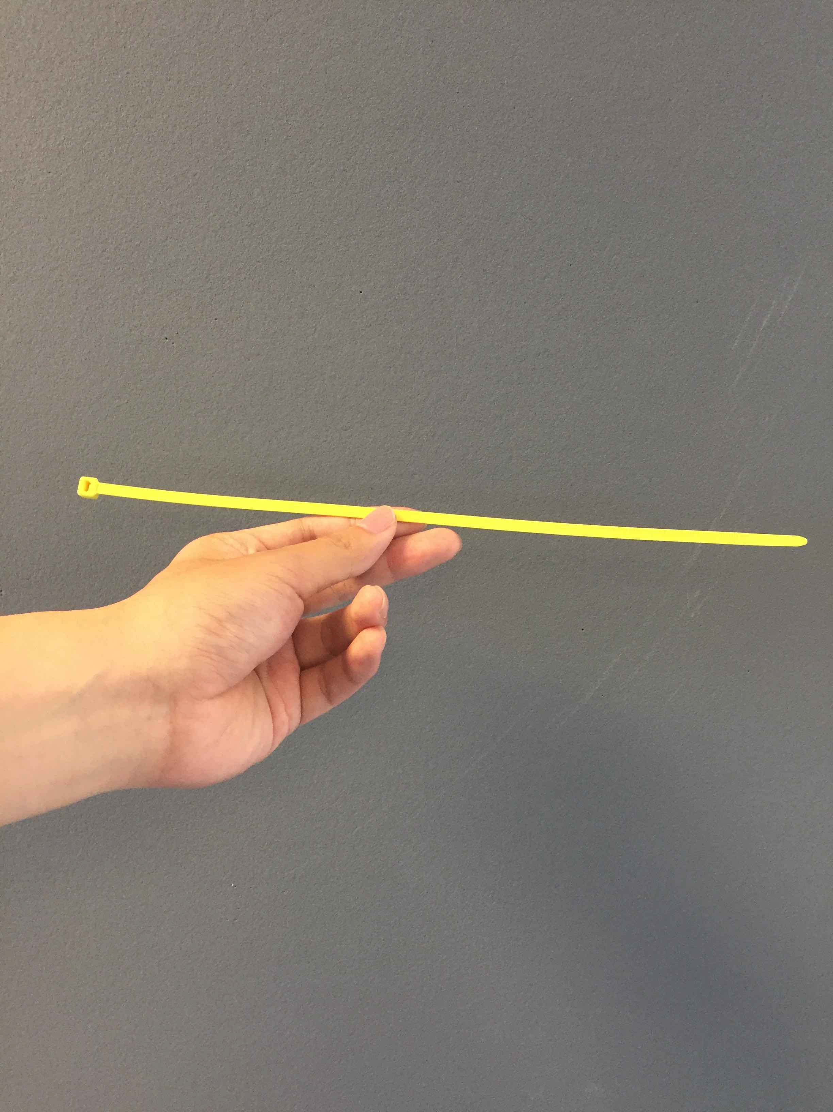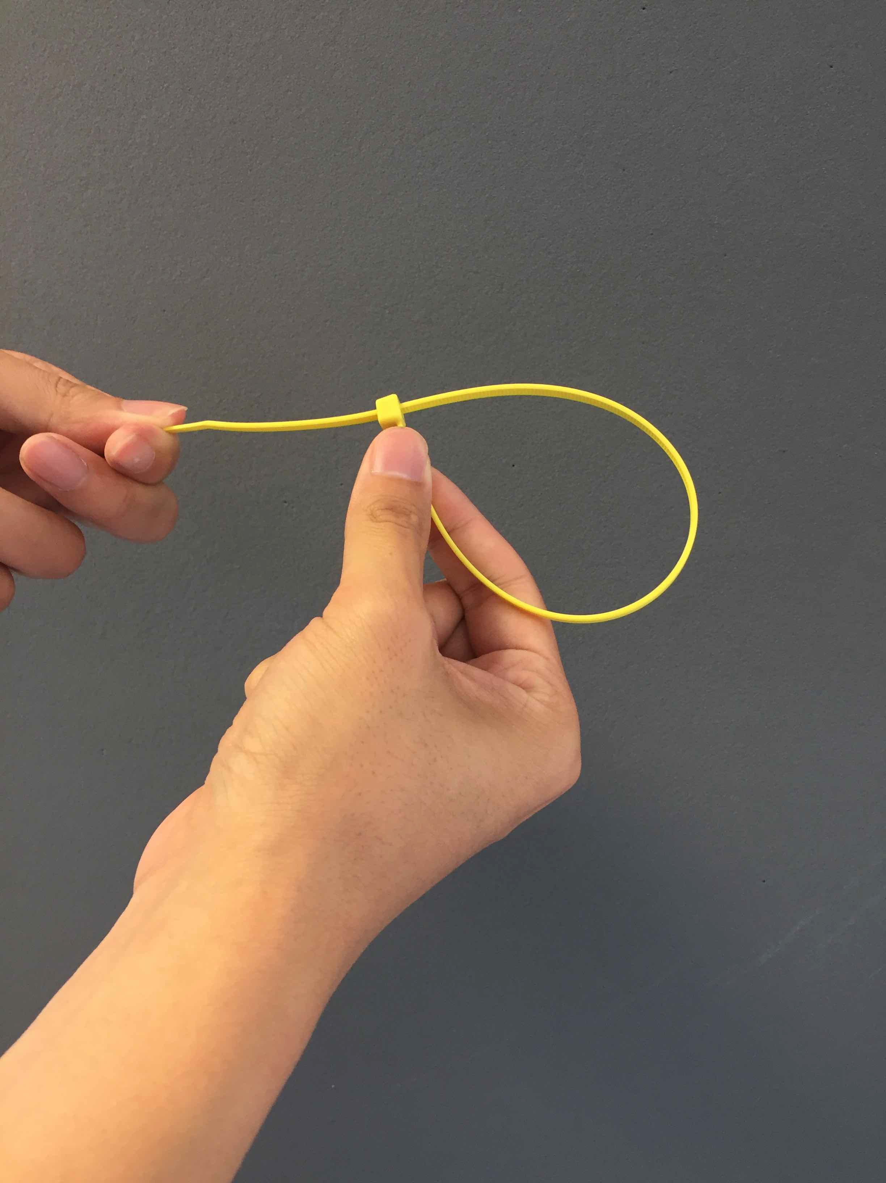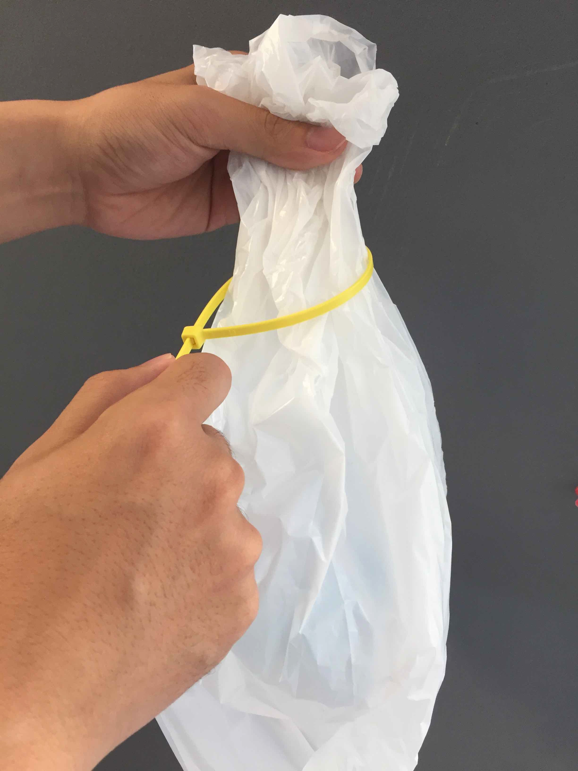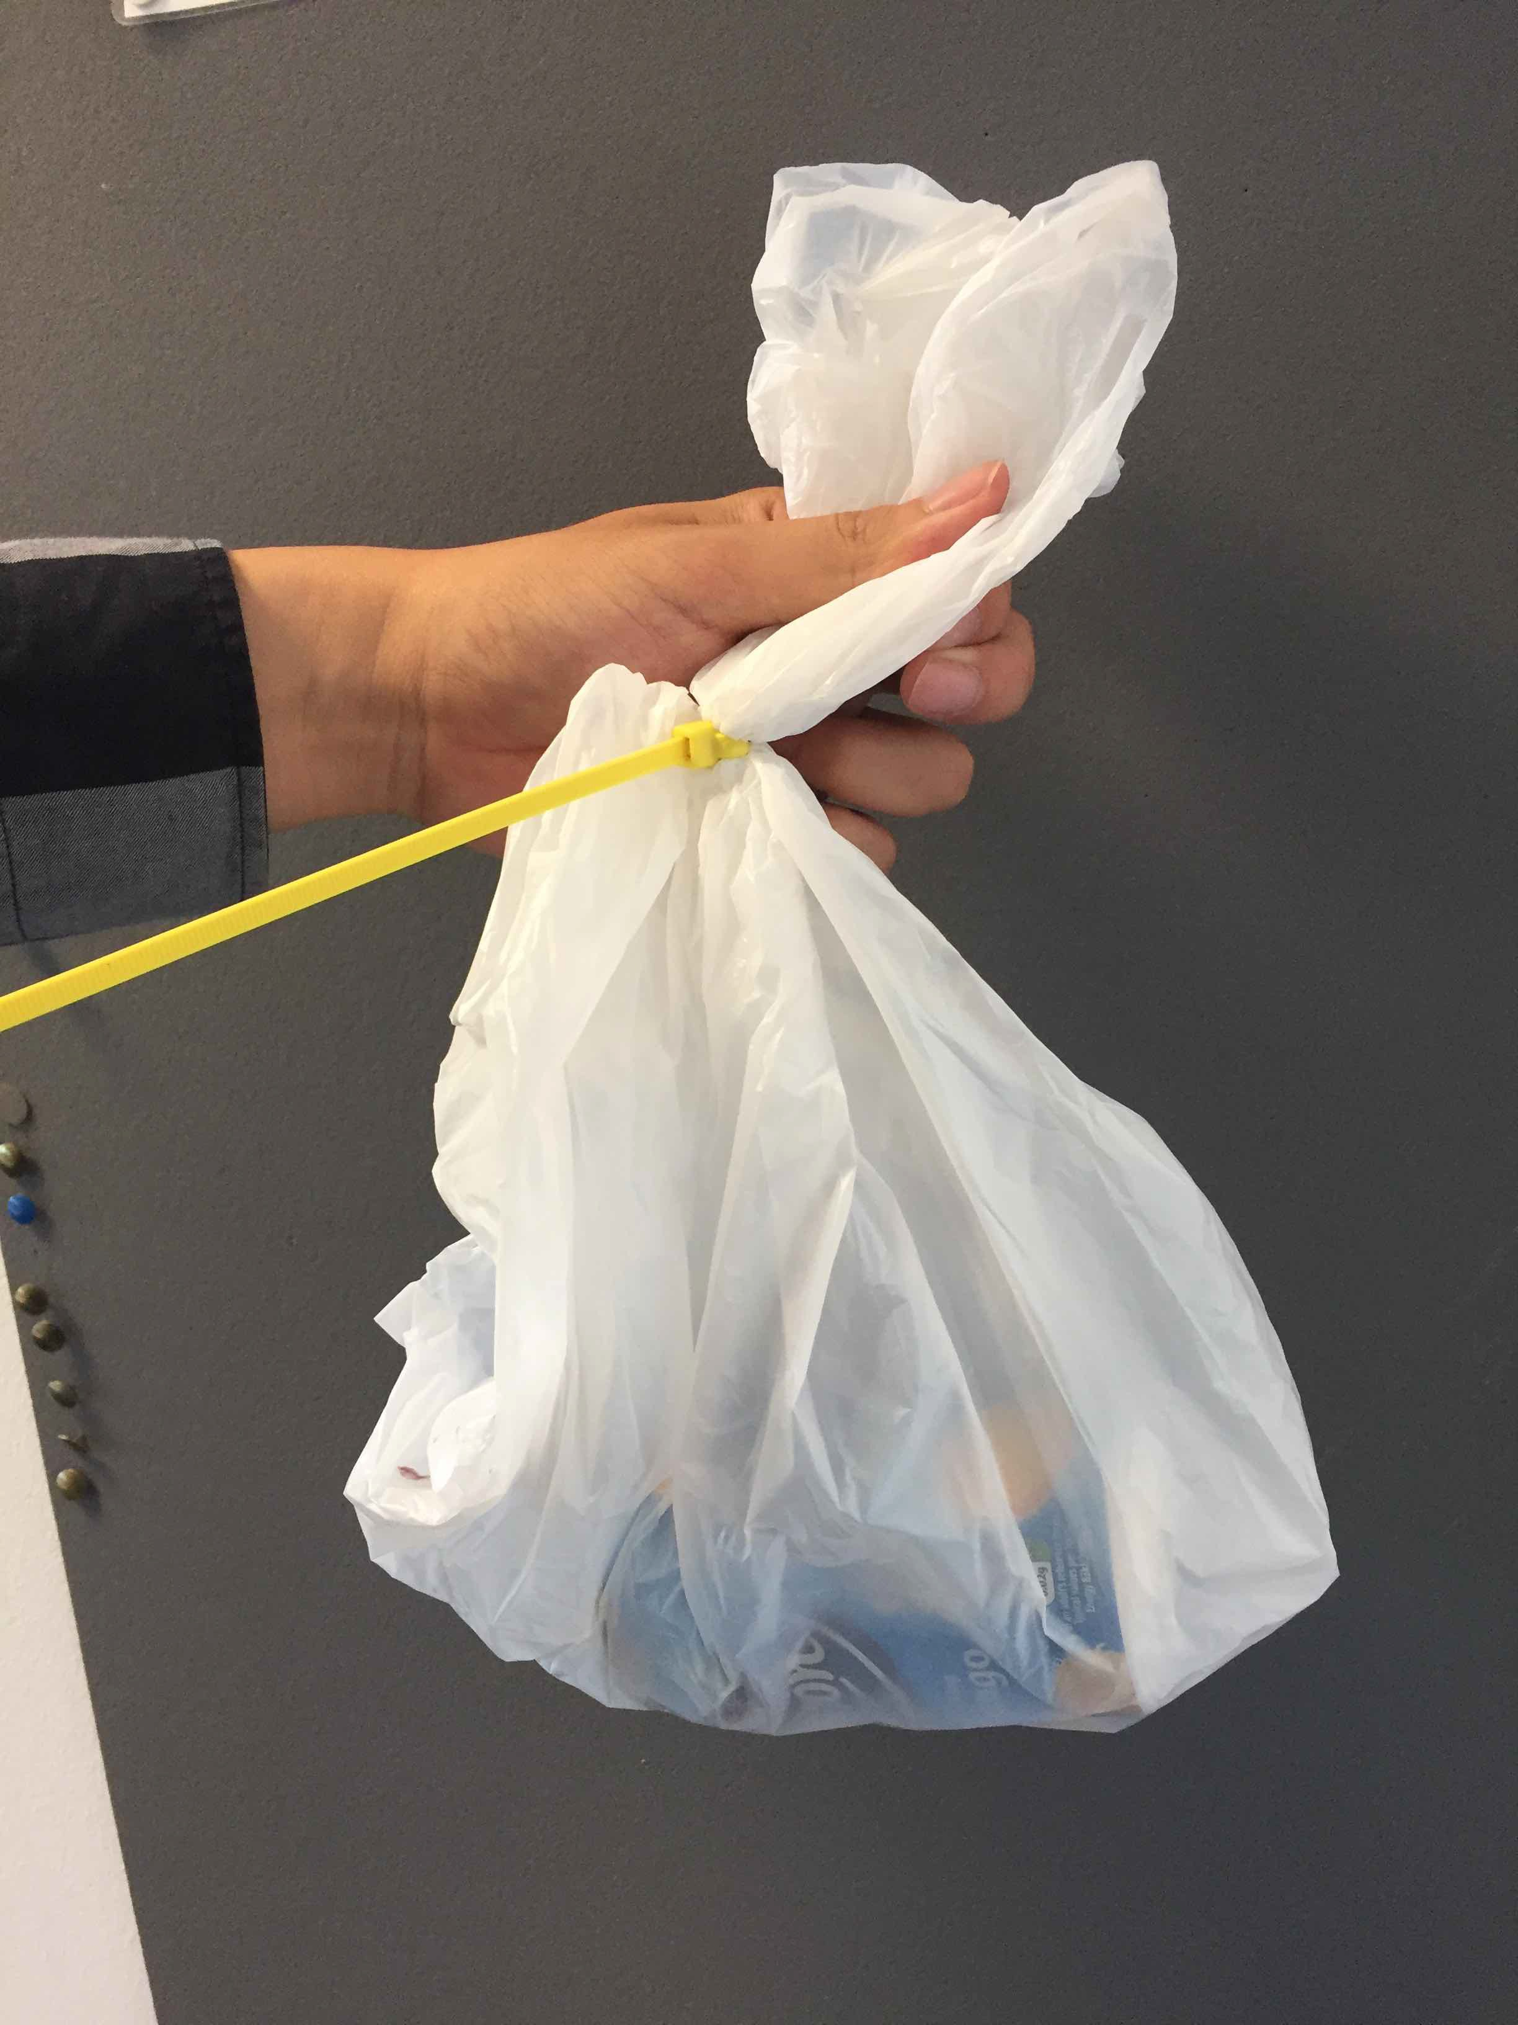

- Place your single plastic bag of cans in the ‘cans bin’ in the area outside the building, identified in the map below with a red ’X’.

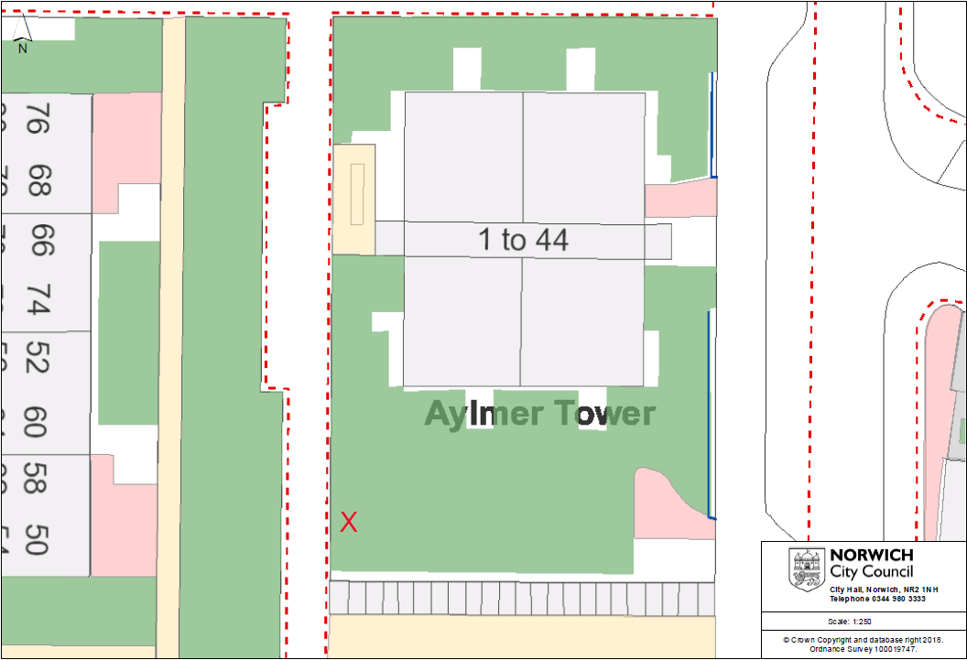

Cans will be collected by authorised personnel every Monday at some point between 8am-10pm.

If you have any questions concerning this project, please do not hesitate to contact us using the details provided at the end of the letter.
We thank you in advance for your cooperation and participation in this project.

Appendix B: SE instructions Individual PPC

CAN RECYCLING TRIAL

Dear Student,
This is to inform you of one important change in the ’can recycling’ introduced in Septem ber 2018.
From January 14th 2019 until March 18th 2019 you will be paid £0.10 for each can recycled. Only cans sealed in the transparent plastic bags with the coloured ties you are given will be considered for payment. So please, do not put any loose cans in the communal cardboard bin if you want to be paid for what you recycle.
To keep track of how many cans you have recycled, you will be given one coloured ticket for each can you recycle. You will only be given tickets if your recycled cans are sealed in plastic transparent bags with the coloured tie you are given. Tickets will be sealed in envelopes and left in your flat every Monday after the can collection.
Remember that the ties’ colour is unique to you, so to identify the envelope that contains your tickets, we will write on the envelope the colour of the tie assigned to you and the colour of your raffle tickets.
You will be able to check how many cans you have recycled by counting the number of tickets you have been given. Each student will be assigned tickets of the same colour with sequential numbering (starting from one). The largest number in the sequence represents the total number of cans you have recycled until then. The colour of the tickets, when possible, will be unique to you. However, when this is not possible, your tickets will still be uniquely identified by a code printed on them.
Payments will be made in cash and can be collected in the Accommodation Office on Wednesday 27th March 2019. Bring the tickets with you and you will be paid accordingly.
If you have any questions concerning this project, please do not hesitate to contact us using the details provided at the end of the letter.
We thank you in advance for your cooperation and participation in this project.

Appendix C: Further analysis

C1. Recycling in the Student Environment
Figures C1.1, C1.2 and C1.3 provide a detailed picture of recycling over time, and also include participants who were not exposed to incentive treatments in either phase. The grey lines correspond to recycling levels in the Monitoring Phase and the black ones correspond to those in the Incentive Phase.
Figure C1.1: Recycling in SE, Group Condition, by phase
Notes: NR: No Reward treatment, PPC: Pay per Can; L: Lottery treatment; MP: Monitoring Phase; IP: Incentive Phase.

:
Figure C1.2: Recycling in SE, Individual Condition, by phase.
Notes: NR: No Reward treatment, PPC: Pay per Can; L: Lottery treatment; MP: Monitoring Phase; IP: Incentive Phase

Figure C1.3: Recycling in SE, Individual Condition (Communal Bin), by phase
Notes: NR: No Reward treatment, PPC: Pay per Can; L: Lottery treatment; MP: Monitoring Phase; IP: Incentive Phase)
The type of incentive does not seem to matter in the Group condition, while the lottery seems more effective than PPC in the Individual condition (see Figure C1.1). Overall, in both phases, Groups outperform individuals no matter whether the Individual condition uses just those who recycle correctly (Mann-Whitney test - $p<0.01$ and $p<0.01$ in the Monitoring Phase and Incentive Phase respectively) or those who recycle using the communal bin (Mann-Whitney test - $p<0.05$and $p<0.02$ in the Monitoring Phase and Incentive Phase respectively).
The clearly visible spikes in recycling observed in both conditions are likely to be attributable to external factors or events happening at the university during those weeks (e.g. reading week in week 7 in which most students do not have lectures to attend).
In the Individual condition (Figure C1.2) we observe an increase in cans recycled in both incentive treatments once the Incentive Phase begins. In the PPC treatment, we observe no recycling except for week 10, and we conjecture that these students only deposited the cans in the last week to reduce the burden involved with this new recycling system. Overall, we only find partial evidence to suggest that monetary incentives can facilitate an adherence to following a new recycling system (here of putting cans in bags).
A note of caution must be applied when evaluating the results in the Individual condition given the limited number of observations. Out of 192 students, only about 11 (5.73%) recycled in the Monitoring Phase and about 12 (6.25%) in the Incentive Phase. These students actively recycled on average for 1.5 weeks in the former phase and for about 3.58 weeks in the latter one. Despite these low magnitudes, this does mean incentives had a positive effect on both the number of students that recycled and the frequency with which they recycled.
C2. Recycling in the Residential Environment
Figure C2.1 reports the number of cans recycled per building given that the allocation of participants to the treatments was done in this way. The black lines represent buildings that
Figure C2.1: Recycling in the residential environment.
Notes: PPC-IP-noMP and L-IP-noMP refer to those buildings that did not take part in the Monitoring Phase.
were assigned to the PPC treatment, and the grey lines represent those assigned to the Lottery treatment. The dotted lines of the type $(⋯$) report recycling in the Monitoring Phase while the dotted lines of the type ($⋅⋅-)$ report recycling in the Incentive Phase for those buildings that did not take part in the first Phase.
C3. Recycling in the Working Environment
Figure C3.1 reports the number of cans recycled each week in WE. The grey lines refer to the Monitoring Phase and the black ones refer to the Incentive Phase. Although no floor received incentives in the Monitoring Phase, for ease of comparison (as was done in SE), we report recycling by the treatment floors would later be assigned to in the Incentive Phase. Although recycling is heterogeneous during the Monitoring Phase, we do observe a clear ‘boost’ to recycling in all treatments once incentives are offered. This effect also extends to the NR floors, although they are not rewarded for recycling.
Figure C3.1: Recycling in the working environment (MP: Monitoring Phase – IP: Incentive Phase)

Appendix D: The Bass Model and Its Parameters’ Estimation

D.1 The math of the Bass Model
The Bass Model, first presented by Bass (1969) is a model that relies on the idea that there are two types of customers: innovators and imitators. These customers, or “potential adopters” are influenced by two different means of communication – mass media, or information specifically related to the product (service) and word of mouth.

The Bass Model derives from the hazard function:

$\frac{f\left(t\right)}{1-F\left(t\right)}=p+q F\left(t\right)$ (1)

Where:

F(t) is ratio of people (out of the total market volume M) that bought the product by the time and f(t) = ratio of people (out of the total market volume M) that bought the product at any time t. p is the parameter that represents the innovators and q the imitators.

Hence, we have:

f (t) = F’(t) (2)

The hazard function expresses the idea that an adoption will occur at time t, given that the individual has not yet adopted it. Moreover, the basic premise states that the conditional probability of adoption at time t is increasing in the fraction of the population that has already adopted.

We have an ordinary differential equation for F(t):

$\frac{F^{'}(t)}{1-F\left(t\right)}= p+q F\left(t\right), F\left(0\right)=0,$ (3)

Which can be solved by the separation of variables:

$\frac{dF}{\left(1-F\right)\left(p+qF\right)}=dt → F\left(t\right)= \frac{1- e^{-\left(p+q\right)t}}{1+ \frac{q}{p} e^{-\left(p+q\right)t}}$ (4)

Corresponding function f(t) = F’(t):

f(t) = $\frac{\frac{{\left(p+q \right)}^{2}}{p} e^{-\left(p+q\right)t}}{{\left[1 + \frac{q}{p} e^{-\left(p+q\right)t}\right]}^{2}}$ (5)

D.2 Estimating the Bass Parameters – Calibration

To estimate the Bass parameters p and q, we can use the historical adoption data (quantity of product sold, sales, individual adopters’ numbers) to fit the adoption curve and estimate the parameters. In this specific case to fit the adoption curves we have employed either the number of cans recycled (in the SE and WE) or the number of flats that have engaged with the service (in SE and RE).

There are two main assumptions and the basis of the estimation:

- The number of adopters (or quantities of product adopted, or sales) in any period is equal to:

s(t) = m* f(t) (6)

Therefore: equal to the market potential parameter (m) multiplied by the value of the diffusion function (defined in the previous subsection D.1) at a specific time t.

- The cumulative number of adopters (or quantities of product adopted, or sales) up to time a specific time t, can be defined as:
S(t)= mF(t) (7)

If we substitute (6) and (7) in the Bass equation (1) we find:

$\frac{\frac{s(t)}{m}}{\frac{1-S(t)}{m}}$ = p + q $\frac{S(t)}{m}$ (8)

We may rewrite this as:

s(t)=[ p+q $\frac{S(t)}{m}$ ] [ m - S(t) ] (9)

Therefore,

s(t)=β₀ + β₁ S(t) + β₂ S(t)² (10)

where:

β₀ = pm (11)
β₁ = q-p (12)
β₂ = -q/m (13)

Equation 10 may be estimated with an Ordinary Least Squares (OLS) regression of the number of adopters (or number of products adopted) against the cumulative number of adopters (or number of products adopted).

Since:

β₁ = q-p = -m β₂ – (β₀/m) (14)

we obtain a quadratic equation in m:

β₂m² + β₁m + β₀ = 0 (15)

we solve equation (15) for m, and then we may use the value to solve for:

p= β₀/m (16)

q= -mβ₂ (17)
Appendix E: Can Challenge Timeline and Partners
Please note that, to comply with both our (UEA) and our partners' research ethics boards, and to adhere to GDPR regulations for our partners, our 'access' to participants was restricted purely based on: location entry; bin installation; counting and recording of can recycling. We were provided with estimates of participants per location, and in RE/SE we were given occupancy v non-occupancy data. However, no other demographic or individual identifiers were issued as part of this study. In the case of RE, this was a strict requirement for our partner, as a landlord, in order to permit this study.
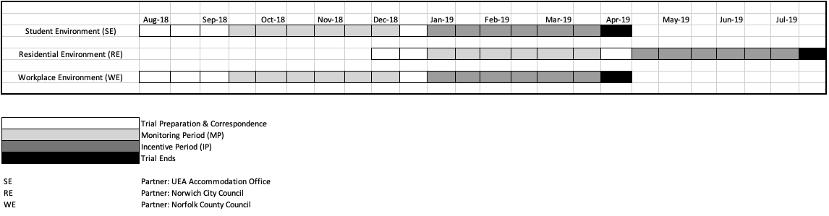
Figure 1: Field experiment timeline

The authors declare no known interests to the submitted manuscript.
We would like to thank our research partners at Norwich City Council, Norfolk County Council and UEA Accommodation Office. We would also like to thank participants at the conferences [BIOECON 2019, ESA 2020, MEA 2021] where we have presented this paper for their insightful views and comments. This experiment has been funding by the School of Economics at the University of East Anglia.
For the purpose of open access, the author has applied a Creative Commons Attribution (CC BY) licence to any Author Accepted Manuscript version arising from this submission.
College for Interdisciplinary Studies, Zayed University, Dubai (UAE). E-mail: Michael.Brock@zu.ac.ae.
School of Management, University College London.One Canada Square L38, L50. Canary Wharf, London, E14 5AA, UK). E-mail: l.murgia@ucl.ac.uk.
School of Economics and Centre for Behavioural and Experimental Social Science, University of East Anglia, Norwich, NR4 7TJ, UK). Email: s.sitzia@uea.ac.uk
Lancaster University Management School, Lancaster University, Lancaster, LA1 4YX, UK. E-mail: j.zheng18@lancaster.ac.uk.
For a detailed review of the Bass (1969) model and its key elements see the work of Mahajan et al. (1990).
In student accommodations the experimental instructions were placed on top the new bin, which was placed in visible area in the kitchen difficult to miss. In the working environment, with the help of partner working for Norfolk County Council, the bins and instructions were placed in the small kitchens in each floor. Given the size of the kitchens, and assurance from our partner, we believe that employees were aware of the trial and how it worked. In the residential settings, instructions were delivered in the letter box in each apartment.
Meneses & Palacio (2005), among many, found that recycling behaviour is multidimensional and strongly associated with sociodemographic and psychographic causal characteristics. The psychology and environmental literature has provided compelling evidence sustaining their thesis (Berger, 1997; Derksen & Gartrell ,1993; Folz, 1991; Fuller, 1978).
Innovation is to be intended as a technological update, a change in the delivery of the service or simply a price variation (Mahajan, Muller & Bass, 1990).
For a comprehensive description of the Bass (1969) model and its mathematical derivation please see Appendix D.
Van den Bulte (2002) offers a comprehensive analysis of US industry sectors and the Bass parameters associated with them, “normally” range from [0-0.1] for parameter p (innovators) and [0.2-0.4] for parameter q (imitators).
The Bass parameters are estimated with OLS estimation, however, NLS analysis was also performed and yielded analogous results.
For further details see “Model Assumptions”, Bass (1969).
More details are also given in Appendix D.
We have also assumed 2 cans per day per employee, and results do not change.
To estimate the adoption curve, we employ the standard equation developed by Bass (1969).
Note that this includes the NR treatment, in which students did not receive any monetary reward
This section is based on the material of: https://srdas.github.io/MLBook/productForecastingBassModel.html, where additional computational and programming details can be found.

