Human Hepatic Cell line 5: In-Vitro Model for Hepatic Immunobiology

Smeeta Shrestha¹ · Ming Yue Yeong¹ · Chen Xin Yi¹ · Wei Wang² · Nidhi Bhayana¹ · Navin Kumar Verma^{1,}* · Yongping Bao^{2,}* · Yulan Wang^{1,3,4,}*

¹Lee Kong Chian School of Medicine, Nanyang Technological University, Singapore 636921, Singapore.
²Norwich Medical School, University of East Anglia, Norwich, NR4 7TJ, United Kingdom.
³Singapore Phenome Centre (SPC), Nanyang Technological University, Singapore 636921, Singapore.
⁴Human Phenome Institute, Fudan University, Shanghai 200438, China.

*Corresponding authors:
Associate Professor Navin Kumar Verma, Lee Kong Chian School of Medicine, Nanyang Technological University, Singapore; nkverma@ntu.edu.sg. ORCID: 0000-0002-5940-6633.
Professor Yongping Bao, Norwich Medical School, University of East Anglia, Norwich, United Kingdom; y.bao@uea.ac.uk. ORCID: 0000-0002-6425-0370.
Professor Yulan Wang, Lee Kong Chian School of Medicine, Nanyang Technological University, Singapore; yulan.wang@ntu.edu.sg. ORCID: 0000-0002-2831-8737.
Abstract
Background: Hepatocellular carcinoma (HCC) remains a major global health burden, partly due to the lack of physiologically relevant in vitro models that accurately recapitulate early host-virus interactions and immune responses. Human Hepatocyte Line 5 (HHL-5) is an immortalized hepatocyte cell line that retains key liver-specific functions. This study aimed to characterize the phenotypic, genetic, and metabolic features of HHL-5 cells and evaluate their suitability as a non-cancerous hepatic model, in comparison with the HCC cell line HepG2.
Methods and results: Morphological and phenotypic assessment of cells showed smaller cell and nuclear areas and slower proliferation with markedly longer doubling time of HHL-5 cells than HepG2 cells. Genomic analyses using whole-exome sequencing revealed enrichment of immune-related pathways in HHL-5 cells, including antigen processing and presentation, whereas HepG2 cells showed predominance of DNA replication pathways. Metabolomic profiling of cells by nuclear magnetic resonance spectroscopy showed hepatocyte-like oxidative profiles of HHL-5 cells, in contrast to the glycolytic phenotypes of HepG2 cells. Moreover, Western blotting for selected proteins showed reduced expression of oncogenic and stress-response markers, including c-Myc, pSTAT3, pNrf2, and select cytochrome P450 enzymes.
Conclusion: Our findings support HHL-5 cells as a robust non-cancerous in vitro model for investigating liver diseases, viral infection, and early events in hepatocarcinogenesis.

Keywords: Hepatocyte-like cells · HHL-5 · HepG2 · Virus · Genetic variants · Metabolomics
Introduction
Hepatocellular carcinoma (HCC) is an aggressive primary liver malignancy with poor clinical prognosis and remains the third leading cause of cancer-related death worldwide [1]. Hepatocarcinogenesis is a complex process driven by both genetic and epigenetic alterations, chronic inflammation, and metabolic reprogramming that collectively contribute to the initiation, promotion, and progression of liver cancer [2].
Extensive information is available on the altered genomic and metabolomic profiles of HCC tumours [3,4], but early changes leading to initiation of cellular transformation and which liver cells are most susceptible to this process remain poorly investigated. HCC exhibits pleiotropic molecular profiles with diverse clinical outcomes necessitating an urgent need to innovate in vitro experimental models to understand HCC pathophysiology and perform high throughput screening for therapeutic agents. Existing in-vitro models rely on hepatocytes derived from hepatic tumours, which inherently exhibit altered germline variants [5], as well as distinct metabolic [6] and gene expression [7] signatures that support strong cell adhesion and proliferation.
There are only a few established liver cell lines that are capable of expressing viral proteins upon integration of Hepatitis B virus (HBV) or Hepatitis C virus (HCV) DNA into their genomes [8]. Such in-vitro models can be used examine changes in gene expression and cell signalling that are important in tumorigenesis [9]. However, hepatic tumour-derived cell lines have poor predictive ability about carcinogenic transformation and early stages of metabolic and biochemical changes leading to tumour progression [10].
Primary human hepatocytes (PHH) are highly permissive to infection and efficiently support HBV replication. However, PHHs de-differentiate during in-vitro culture, lose hepatic function and HBV infection ability [11]. Researchers have created liver cell lines resembling primary hepatocytes by immortalizing them using viral oncogenes that target the human telomerase reverse transcriptase (hTERT) subunit, enabling studies of viral infection and hepatocyte function [12].
The human hepatocyte line 5 (HHL-5) is an immortalized primary hepatocyte-derived cell line generated through transduction with hTERT and human papillomavirus E6E7 [13,14]. Importantly, HHL-5 cells retain phenotypic features of primary hepatocytes and biliary epithelial cells, while exhibiting minimal expression of tumour-associated proteins such as p53 and alpha-fetoprotein (AFP), consistent with a non-tumorigenic profile. They form adherent monolayers, display enhanced binding to HCV-like particles, and respond to interferon-alpha (IFN-α) stimulation with upregulation of major histocompatibility complex (MHC) molecules [15], indicating preserved immune signalling capabilities. Their sensitivity to anticancer agents [16] and lack of cytotoxicity following silicon nanoparticle exposure [17] further support the suitability of HHL-5 cells for immunological and drug-delivery studies.
In the present study, we performed further characterization of HHL-5 cells focussing on morphology, growth characteristics, germline variants, metabolite profiles, and cell marker expression to evaluate their suitability as a hepatocyte model for viral infection and HCC research. Comparative analyses between HHL-5 and HepG2 cell lines were conducted via whole-exome sequencing, metabolomics, immunofluorescence, high-content analysis, and functional assays. Results highlight non-tumorigenic, immune-competent nature of HHL-5 and support its utility as a physiologically relevant in-vitro model for studying hepatic immunity, virus-host interactions, and inflammation-driven mechanisms underlying HCC.
Material and Methods
Cell line and reagents
The human hepatocyte line HHL-5 was kindly supplied by Professor Arvind Patel, Centre for Virus Research, School of Infection and Immunity, University of Glasgow, UK. Cells were maintained in low glucose Dulbecco’s Modified Eagle Medium (DMEM) and 10% fetal bovine serum (FBS) (Gibco, US). Human hepatocyte carcinoma line (HepG2) was purchased from the American Type Culture Collection (ATCC) and maintained in high glucose DMEM with 10% FBS (Gibco, US). Cells were cultured at 37°C and 5% carbon dioxide in a humified cell culture incubator (Nuaire, US).
High content analysis
HHL-5 and HepG2 cells were seeded at 0.2 × 10⁴ cells/well in 96-well plates, cultured for 24 h, and fixed with 4% paraformaldehyde (in pre-warmed PBS) for 15 min followed by 0.03% Triton-X permeabilization for 15 min. Cells were stained for filamentous actin (F-actin), microtubules, and nuclei using Phalloidin-TRITC, AlexaFluor® 488 conjugated anti-α-tubulin (Sigma Aldrich, US), and Hoechst (Sigma Aldrich, US), respectively. Plates were scanned (4 randomly selected fields per well at 20× magnification) using an automated IN Cell Analyzer 2200 Imaging System (GE Healthcare, US). Images were automatically analyzed by IN Cell Investigator software (Version 1.6) using the multitarget analysis bio-application module (GE Healthcare, US).
MTS-based cell proliferation assay
Cell proliferation was determined using the CellTiter 96® Aq_{ueous} Non-radioactive Cell Proliferation Assay (Promega, US) according to the manufacturer’s protocols. A total of 0.2 × 10⁴ cells/well were seeded in 96-well culture plates (Nunc, US) for 0, 8, 24 or 48 h followed by 2 h incubation with MTS solution. Absorbance was measured at 490 nm with the Gen5™ Microplate Reader (BioTek, US).
Real time monitoring of cell proliferation
HHL-5 and HepG2 were seeded at 0.2 × 10⁴ cells per well into an E-plate 16 (ACEA Biosciences, San Diego, CA) containing 100 µL medium per well and monitored in real time using the xCELLigence instrument (Agilent). Cells were pre-treated with nocodazole as toxicity control and were incubated at 37°C in a 5% CO₂ incubator. Cell growth was quantified as baseline “Cell Index”. RTCA software v. 1.2.1 was used to automatically calculate doubling times of both cell lines. Experiments were performed in triplicates and repeated at least 3 times.
GSH/GSSG-Glo assay
HHL-5 and HepG2 cells were seeded into collagen-coated white opaque 96-well plates at density of 1x10⁴ cells/well. The total amounts of combined Glutathione (GSH) and oxidized GSH (GSSG) were measured following the manufacturer's instruction. Luminescence was measured using Cytation 3 image reader instrument with Gen5 microplate reader imager software. GSH/GSSG ratio was calculated as [(net total glutathione RLU – net GSSG RLU)/(net GSSG RLU)] × 2, where RLU is relative light units (RLU). Experiments were performed in triplicates and repeated at least 3 times.
Whole-exome capture and sequencing
Exome capture was performed using Agilent’s SureSelect Human All Exon V6 (58) Kit according to the manufacturer’s instructions (Agilent, Santa Clara, CA). Products were purified with AMPure XP system (Beckman Coulter, Beverly, US) and quantified using the Agilent high sensitivity DNA assay on the Agilent Bioanalyzer 2100 system. Sequencing was performed on HiSeq 2500 (Illumina, San Diego, CA), in 150 bp paired-end sequencing (PE150). NovaSeq 6000 software were used for raw data processing and fastq file generation.
Whole-exome sequencing (WES) data analysis
WES paired-end reads(.fastq) were passed through quality control using FastQC [18]. Reads with TruSeq adaptor sequences, uncertain nucleotides (> 10%) and paired reads when single reads have more than 50 % low-quality (<5) nucleotides were removed using Trimmomatic [19]. Paired end reads were mapped to NCBI human reference genome GRCh38 using Burrows–Wheeler Aligner (BWA) software [20]. Picard tool in Genome Analysis Toolkit (GATK) suite [21] marked duplicates and GATK best practice variants called using HaplotypeCaller. The output variant call files (vcf) were Hard filtered using the VariantFilteration tool. The bcftools was used to filter vcf files based on FILTER="PASS" && %QUAL>50 && GQ>20. Where QUAL is probability that the site has no variant and GQ, probability that the call is incorrect. Finally, variants were annotated using annovar [22] and analysed using vcfshiny tool [23]. Variants were prioritised by filtering based on pathogenicity scores, SIFT and POLYPHEN [24,25]. Variants located in exons were extracted and genes were used for enrichment analysis using EnrichR [26]. Normal human liver exome data was downloaded from the European nucleotide archive project PRJNA207681 [27]. A total of 3 normal human liver exome fastq files (SRR893106, SRR894448, SRR894453) were processed and variants detected as mentioned above.
Metabolic profiling using NMR
Cells were harvested and then subjected to methanol and water extraction (2:1) using tissue lyser. The supernatant collected was dried using Spin-Vac and dried extracts were reconstituted in 600 μL 0.1 M phosphate buffer (pH=7.4, K₂HPO₄/NaH₂PO₄=4:1, 0.005% TSP-d_{4,} 100% D₂O) and then centrifuged 10 min at 16000×g and 4°C; a total of 550 μL of supernatant was transferred into a 5 mm NMR tube for further NMR analysis. Proton (¹H) NMR spectra of cell extracts were recorded by III HD 600 MHz Ascend NMR spectrometer (Bruker), equipped with 5mm BBI 600 MHz Z-Gradient high-resolution probe. The one-dimensional (1D) NMR spectra were acquired at 298 K with the first increment of NOESY pulse sequence. A pre-saturation method was used to suppress the water signal during recycle delay (2 s) and mixing time (100 ms). For each sample, the spectral width was 20 ppm and 32 transients were collected into 32 k data points. NMR spectral peak assignment was performed based on previously reported protocols [28].
NMR spectral processing and multivariate data analysis
The free induction decay (FID) of NMR spectra were Fourier transformation (FT) and the derived NMR spectra were phased, and baseline corrected manually on Topspin 3.6.2 (Bruker Biospin, Karlsruhe, Germany). The calibration of spectra was referenced to the TSP peak with chemical shift of δ 0.00 by Topspin 3.0. NMR spectral region of δ 0.5-9.5 was integrated into 0.002 ppm wide buckets by AMIX package (Bruker Biospin, Karlsruhe, Germany). The region δ 4.55-4.75 was excluded to avoid the disturbance of the remaining water signal. Total intensity normalization was applied prior to multivariate data analysis. Multivariate data analysis was performed by SIMCA 16.0 software (Umetrics, Sweden). Normalized data sets were analyzed by Orthogonal Projection to Latent Structure Discriminant analysis (O-PLS-DA) with unit variance (UV) scaling. The model was cross-validated by CV-ANOVA method (p=0.0015<0.05) and permutation test. The back-transformed and plotted with color-coded correlation coefficients (|r|) using an in-house developed script written in MATLAB 7.1 (the MathWorks, USA) with the red color indicating statistical significance, while the blue color no significance. The cutoff value derived from a 95% confidence limit for each model changes according to the number of samples (n) in the groups, here the cutoff value |r| is 0.523.
Protein isolation and detection
Whole cell lysates were prepared in cell lysis buffer and quantitated using Bio-Rad Protein Assay Dye Reagent Concentrate (Bio-Rad, US). A total of 30 ug protein was separated on sodium dodecyl sulphate polyacrylamide gel electrophoresis (SDS-PAGE) and transferred to nitrocellulose membranes (Bio-Rad, US). The membranes were blocked with 5% BSA and then incubated overnight at 4°C with primary antibodies (Supplementary Table 1). Post-incubation, membranes were washed in 1x TBS-T washing buffer, then incubated in an appropriate secondary antibody for 1 h at room temperature. Blots were developed using the WesternBright™ ECL detection kit (Advansta, US) and imaged by ChemiDoc™ MP Imaging System using Image Lab™ Software (Bio-Rad, US). Densitometry analysis of the Western blots was performed using ImageJ software. For Nrf2 and antioxidant enzymes, Odyssey system was applied according to the manufacturer's instructions.
Statistical analysis
Statistical analysis was performed with GraphPad Prism 9 software. Data was evaluated for normality and Grubbs outlier analysis. The results are presented as means ± standard deviations (SD), and the student’s t-test was used to compare the means of independent samples. For cell morphometry analysis nonparametric Mann Whitney U test was performed. p values of <0.05 were considered statistically significant.
Results
HHL-5 cells exhibit slower cell growth than HepG2 cells
Cell morphology and function are closely related characteristics. Monitoring of cell morphology helps to distinguish between normal and transformed (e.g., cancer-like) cells. Phase-contrast images of confluent monolayers of HHL-5 and HepG2 cells show the presence of typical bile canaliculi-like structures and cell polarization (Fig. 1A). To quantitatively evaluate cellular morphologies, we performed immunofluorescence staining of cytoskeletal proteins (F-actin and α-tubulin) and nuclei (DAPI), and cells were imaged using an automated microscope (Fig. 1B). Quantitative cell-based high content analysis revealed that HHL-5 cells have a significantly smaller overall cell area and nuclear area compared to HepG2 cells (Fig. 1C, D). Cell proliferation analysis using MTS-based assays over 24 h showed slower growth kinetics of HHL-5 cells than HepG2 (Fig. 1E). The observed reduced growth kinetics of HHL-5 cells, compared to HepG2 cells, was further verified using impedance-based monitoring of cell growth in real-time over 96 h (Fig. 1F). Notably, both cell lines showed sensitivity to the microtubule-depolymerizing agent nocodazole (Fig. 1F). HHL-5 cells exhibited significantly longer doubling time of 53.68 ± 14.43 hours than HepG2 cells that was 18.75 ± 2.07 hours (Fig. 1G). Together, these findings demonstrate that HHL-5 cells differ markedly from HepG2 in both morphologies and growth characteristics.
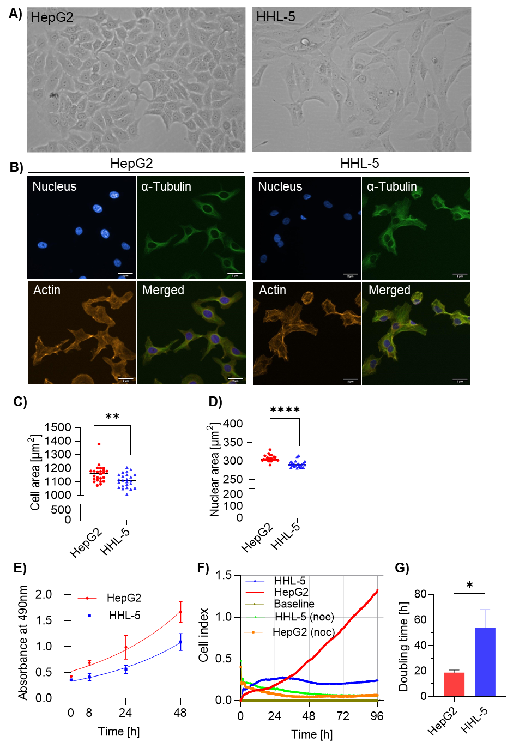
Fig. 1 HHL-5 cells exhibit slower cell growth than HepG2. (A) Phase-contrast images (20X magnification) of HHL-5 and HepG2 cells. (B) Immunofluorescence 20X image of HHL-5 and HepG2 cells stained for nucleus (blue), F-actin (orange), α-tubulin (green) and merged. Randomly selected fields/well were imaged using an INCell Analyzer™ 2200 automated microscope. (C) Cell area and (D) nuclear area were automatically quantified using IN Cell Investigator software v1.6. (E) Trendline plot showing MTS-based proliferation of HHL-5 and HepG2 cells at 0, 8, 24, and 48 h time points. (F) Cell growth profiles generated for HHL-5 and HepG2 cells for up to 96 h using the xCELLigence Real-Time Cell Analyzer based on electrical impedance measurements and plotted as baseline “Cell index”. (G) Bar plot illustrating doubling time in h for HHL-5 and HepG2 cells. Data (mean ± SD) represent at least three biological replicates. *p<0.05; **p<0.01; ****p<0.0001.

Exonic Single Nucleotide Variant (SNV) profiling of HHL-5 cells
We analysed exonic SNV counts obtained from HepG2 and HHL5 cell lines in comparison to that of human primary liver tissues (Fig. 2A). While 813 pathogenic SNVs were found to be common among the three groups, Both HepG2 and HHL5 cells exhibited unique pathogenic SNVs (Fig. 2B). Gene Ontology (GO) analysis identified specific biological processes associated with the three cell types. In HepG2 cells, terms like “protein homo-oligomerization” and “DNA-template replication fidelity” were enriched, while HHL-5 cells showed enrichment in immune-related processes such as “antigen processing via MHC class Ib” and “leukocyte adhesion” (Fig. 2C). SNVs from normal liver tissues displayed enrichment in developmental processes, including “cilium organization” and “intercellular transport” (Fig. 2C), highlighting functional specificity of variants. KEGG pathway analysis revealed that SNVs in HepG2 cells were associated with genes involved in olfactory transduction, HIV-1 infection, butanoate metabolism, the Fanconi anemia pathway, and cell cycle regulation. In HHL-5 cells, enriched pathways included viral myocarditis, antigen processing and presentation, allograft rejection, and ABC transporters. Normal liver tissue variants were linked to folate and retinol metabolism, N-glycan biosynthesis, African trypanosomiasis, and antifolate resistance (Fig. 2D).
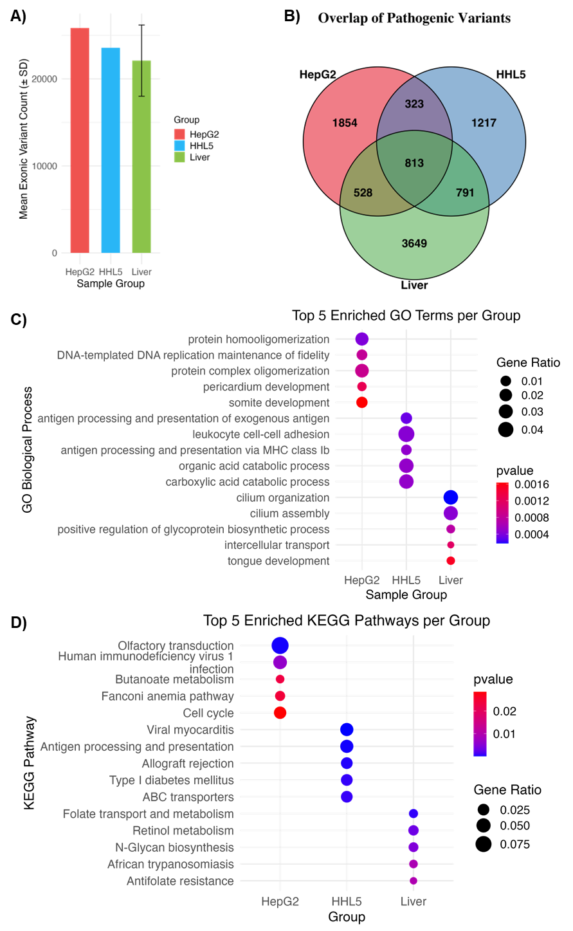
Fig. 2 Characterization of exonic and pathogenic SNVs across HepG2, HHL-5, and normal liver tissues. (A) Bar plot showing mean exonic variant counts (± SD) for HepG2 cells, HHL-5 cells, and normal liver tissues. (B) Venn diagram showing the overlap of pathogenic SNVs across HepG2, HHL-5, and normal liver tissue groups. (C) Top 5 significantly enriched GO biological processes (p < 0.05) in each of the three groups based on pathogenic variants. (D) Top 5 significantly enriched KEGG pathways (p < 0.05). Dot sizes indicate gene ratio, and the colour gradient reflects p-values.
Insertion Deletion (INDEL) Variant profile
Analysis of insertion and deletion variants showed that HepG2 (mean ≈ 520) and HHL5 cells (mean ≈ 500) contain a greater number of INDELs compared to the liver tissue (mean ≈ 300) (Fig. 3A). Functional categorisation of indels showed high non-frameshift deletions across all the three cell types among the three indel categories while cultured cells, HepG2 and HHL-5 lines, showed higher overall variants compared to that in normal liver tissues (Fig. 3B). Each cell types showed several unique variants, out of which 63 variants were shared among all the three groups (Fig. 3C). GO analysis revealed distinct functional signatures across the three cell types: ‘heterotypic cell-cell adhesion’ in HepG2, ‘antigen processing and presentation’ in HHL-5, while ‘negative regulation of phagocytosis’ and ‘mismatch repair’ in the liver tissues (Fig. 3D). KEGG terms enriched in HepG2 and HHL-5 showed immune related pathways, including “graft versus host disease”, “autoimmune thyroid disease”, “allograft rejection”, and “type-1 diabetes mellitus”. Liver and HepG2 showed enriched KEGG term, “olfactory transduction” (Fig. 3E). Collectively, these results show distinct mutational and functional landscape of INDELs across liver-derived cell lines and primary liver tissues, reflecting both shared and divergent genetic landscape.
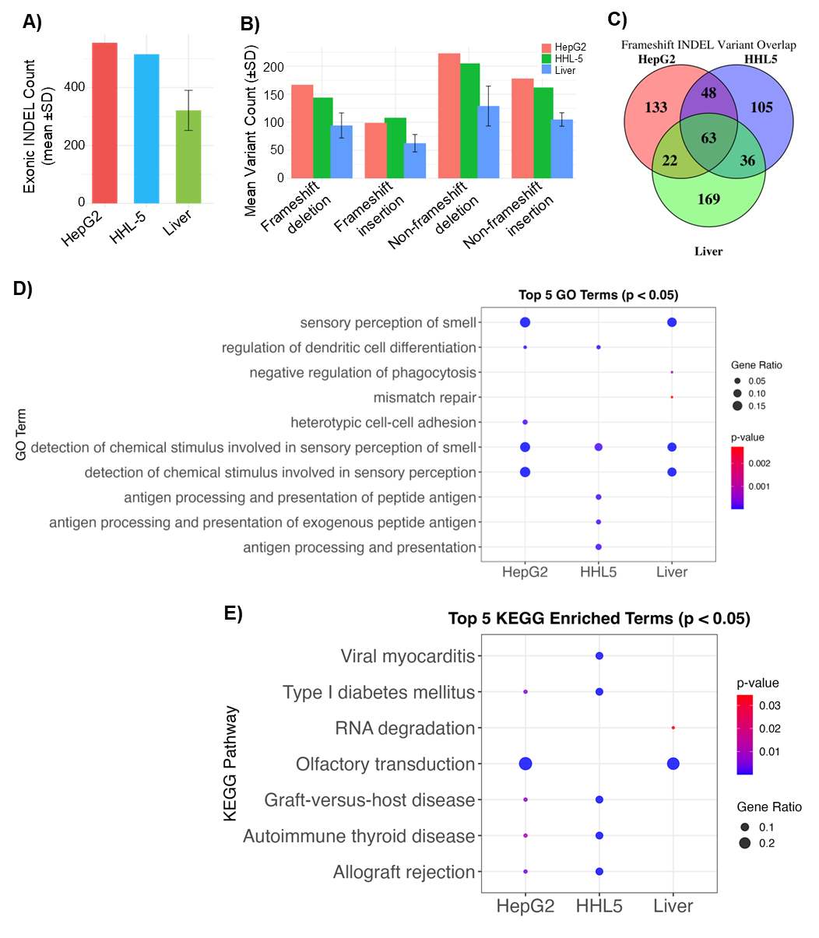

Fig. 3 Comparative analysis of exonic INDEL variants across HepG2, HHL-5, and normal liver tissues. (A) Bar graph showing the mean exonic INDEL count (± SD) detected in HepG2, HHL-5, and the normal liver tissue samples. (B) Functional categorization of INDELs into frameshift and non-frameshift insertions and deletions across the three sample groups. (C) Venn diagram depicting the overlap of frameshift INDEL variants among HepG2, HHL-5, and liver samples. (D) Bubble plot showing the top 5 enriched GO biological processes (p < 0.05) for each of the three sample groups. (E) Bubble plot showing the top 5 significantly enriched KEGG pathways (p < 0.05) for each of the three samples. Dot sizes indicate gene ratio, and the colour gradient reflects p-values.
Hepatocyte function markers in HepG2 and HHL-5 cell line.
It has previously been shown that HHL-5 cells express albumin and Cytochrome P450 (CYP450) proteins at levels comparable to Huh-7 and HepG2 cells [13]. Here, we specifically measured the expression of cancer proliferative marker proteins c-Myc, signal transducer and activator of transcription 3 (STAT3) and its phosphorylated active form (pSTAT3) in HHL-5 cells compared to HepG2. Western blot analysis revealed significantly lower expression levels of c-Myc (Fig. 4A) and pSTAT3 (Fig. 4B) in HHL-5 compared to HepG2 cells. Moreover, HHL-5 cells showed significantly reduced expression of the CYPP450 family protein CYP2A7 compared to HepG2, while we could not detect CYP1A2 in HHL-5 cells (Fig. 4C).
Nuclear factor E2-related factor 2 (Nrf2) is abundantly expressed in cancer and is considered an important prognostic marker that promotes proliferation and metastasis in HCC [29]. HHL-5 cells were found to express significantly reduced amounts of an active phosphorylated form on Nrf2 (pNrf2) compared to HepG2 (Fig. 4D). This result was consistent with significantly low levels of pNrf2-regulated proteins, including Catalase (CAT), Uridine Diphosphate Glucuronosyltransferase 1A1 (UGT1A1), NAD(P)H Quinone Oxidoreductase 1 (NQO1), Glutamyl Cysteine Synthetase (GCS), Glutathione S-Transferase Alpha 1 (GSTA1), and Heme Oxygenase-1 (HO-1) in HHL-5 cells (Supplementary Fig. 1). Additionally, significantly lower amounts of both reduced Glutathione (GSH), and oxidised Glutathione (GSSG) as well as GSH/GSSG ratio were recorded in HHL-5 compared to HepG2 cells (Fig. 4E-G).
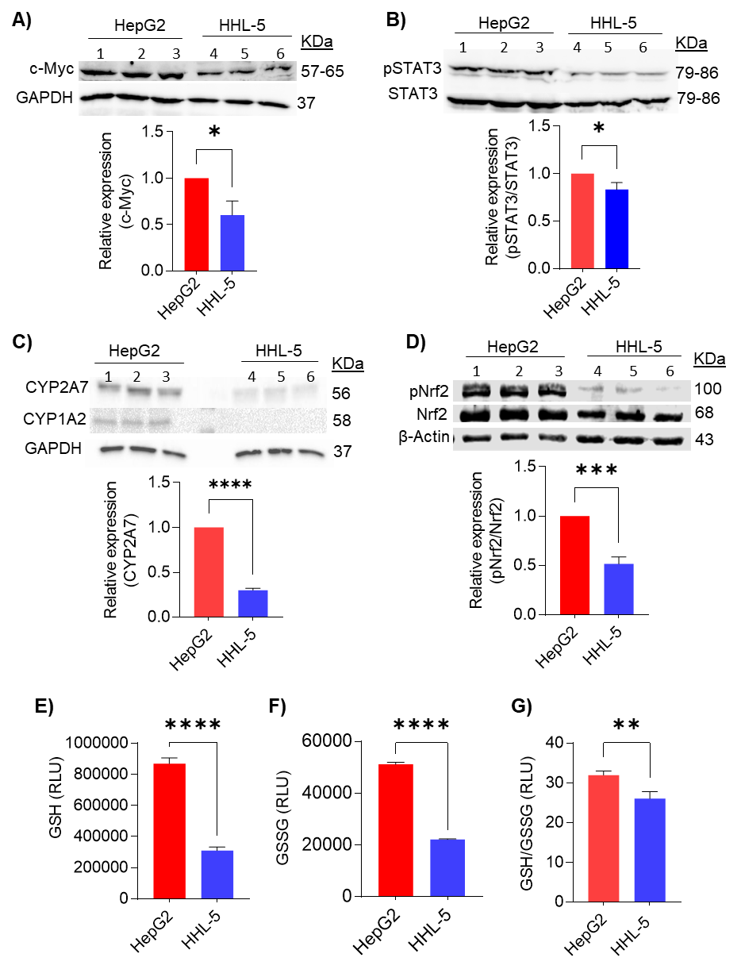
Fig. 4 Expression of hepatocyte protein markers in HHL-5 cells compared to HepG2. Western blot images showing expression levels of (A) c-Myc (B) pSTAT3/STAT3 (C) CYP2A7, CYP1A2, and (D) pNrf2/Nrf2 proteins in HHL-5 cells compared to HepG2 cells. Proteins from 3 independent samples are shown (samples 1, 2, and 3 are from HepG2 and 4, 5, and 6 are from HHL-5 cell lysates). Blots were re-probed for either GAPDH or β-actin for loading control. Relative densitometry values of protein bands are presented as bar graphs below the blots. The amounts (relative light units, RLU) of (E) GSH, (F) oxidized GSSG, and (G) GSH/GSSG ratio were determined using luminescence-based assays. *p<0.05; **p<0.01; ***p<0.001; ****p<0.0001.
HHL-5 cells exhibit distinct metabolic signatures
Multivariate statistical analysis of the 1H-NMR spectra revealed distinct metabolic profiles of HHL5 cells compared to HepG2. In the Partial least squares discriminant analysis (PLS-DA) score plot (Fig. 5A), clear separation of the two cell types was observed, indicating marked differences in their metabolite compositions. The robustness and reliability of the model were confirmed by permutation testing (Fig. 5B), yielding a high predictive value (Q² = 0.895) and excellent model fit (R² = 0.988) (Fig. 5B). Spectral decomposition of the aromatic and ribose region (Fig. 5C) in HHL-5 samples illustrate elevated levels of key metabolites involved in redox regulation, energy metabolism, and biosynthesis. Increased NAD and its derivative 1-methylnicotinamide (1-meNAM) indicate enhanced mitochondrial respiration and NAD⁺ turnover. Higher levels of ADP reflect elevated ATP utilization and energy demand. Additionally, enrichment of UDP-GalNAc and uridine suggests active glycosylation and RNA metabolic processes, supporting a biosynthetically active phenotype. In contrast, HepG2 cells showed increased levels of uracil, indicating enhanced nucleotide degradation and RNA turnover. Elevated aromatic amino acids such as tyrosine and phenylalanine suggest higher protein turnover or altered amino acid metabolism, reflecting a more catabolic or stress-associated metabolic state. (Fig. 5C).
The aliphatic region of the 1H-NMR difference spectrum (Fig. 5D) further revealed distinct metabolic profiles of HHL-5 cells compared to HepG2 cells. Only glutamate exhibited a positive peak (+0.02), indicating it is elevated in HHL-5 and suggests greater engagement in TCA cycle activity and amino acid metabolism. In contrast, a series of metabolites showed negative peaks, indicating they are elevated in HepG2. These included lactate, creatine, GSSG, Glycerophosphocholine (GPC), aspartate, citrate, and the branched-chain amino acids (valine, leucine, isoleucine). This pattern reflects a metabolic state in HepG2, characterized by increased aerobic glycolysis, ATP buffering via creatine, membrane turnover, and amino acid catabolism. Together, these results indicate that HepG2 cells rely more heavily on glycolytic energy production, redox stress adaptation, and amino acid turnover, whereas HHL-5 cells exhibit relatively higher glutamate-linked mitochondrial activity.
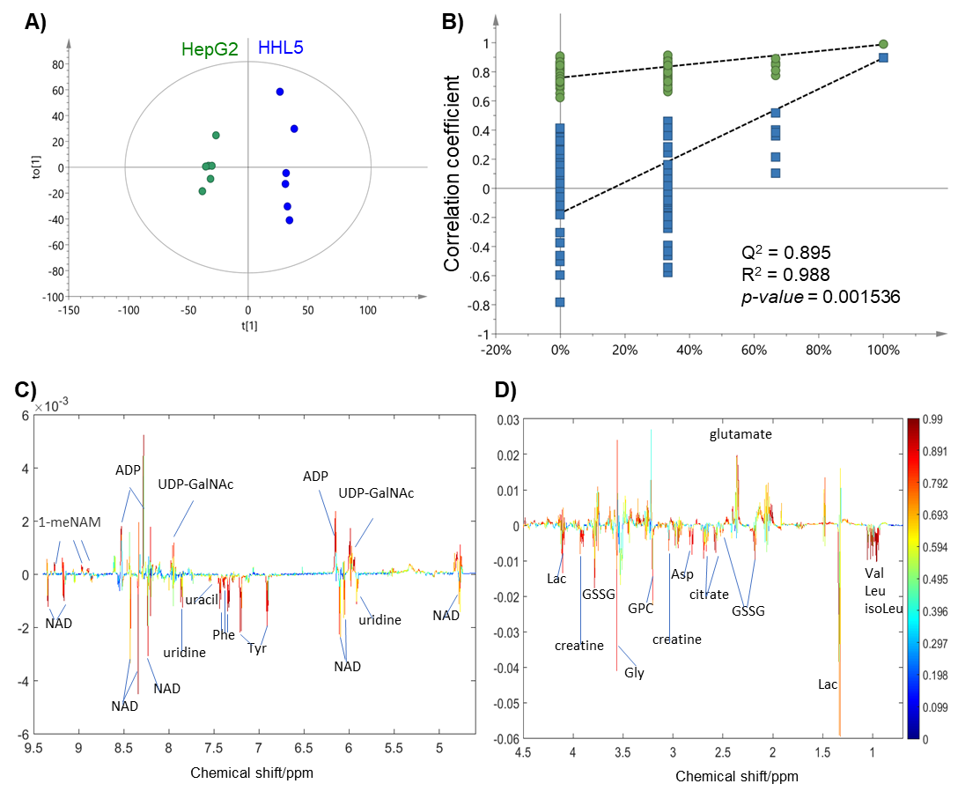
Fig. 5 Partial least squares discriminant analysis (PLS-DA) and 1H-NMR spectral comparisons between HepG2 and HHL5 cells. (A) Score plot showing clear separation of HepG2 (green) and HHL-5 (blue) metabolite profiles, indicating distinct metabolic states. (B) Validation plot from permutation testing (n=200), demonstrating model robustness. R² is the explained variance and Q² is the predictive ability of the model. Loading plots showing differential metabolite contributions in (C) aromatic/ribose (D) and aliphatic regions. Peaks in the positive and negative directions indicate increased and decreased metabolites, respectively, in the HHL-5 samples. Colour gradient represents variable importance projection (VIP) scores. ADP, adenosine diphosphate; Asp, aspartate; Gly, glycine; GPC, glycerophosphocholine; GSSG, glutathione oxidized; isoLeu, iso-leucine; Lac, lactate; Leu, leucine; meNAM, N-methyl nicotinamide; NAD, nicotinamide adenine dinucleotide; Phe, phenylalanine; Tyr, tyrosine; UDP-GalNAc, uridine diphosphate-N-acetylgalactosamine; Val, valine.

Discussion
In this study, we characterized the HHL-5 cell line to support its utility as primary immortalized hepatic cells to study liver pathology. We examined HHL-5 morphologies, growth characteristics, variant and metabolite profiles, along with the expression of markers related to proliferation, xenobiotic biotransformation, and oxidative stress.
Genetic variants serve as critical indicators of a cell’s molecular function, offering valuable insights about its signalling and immune pathways. Germ line variants identified in HHL-5 and HepG2 cells compared to primary human liver tissues revealed distinct landscapes, reflecting their biological contexts. Both hepatic cell lines exhibited a higher overall variant burden than primary liver tissues, consistent with genomic instability in immortalized models [30]. HHL-5 cells uniquely demonstrated enrichment in immune-related pathways, including antigen processing and presentation as well as interferon signalling. These immune-relevant variant signatures are absent in HepG2 cells, which exhibited instead enriched pathways associated with DNA replication and the Fanconi anemia pathway, aligning with their tumorigenic and highly proliferative nature. Of note, the SNV and INDEL profiles of primary liver tissue were included as a reference in the current study to illustrate differences rather than to directly overlay HHL-5 variants. The analyses were designed primarily to characterize each cell type individually, emphasizing their unique features, that emphasised “hepatocyte-like” characteristics of HHL-5 cells while also exhibiting a distinct immune-related landscape with antigen processing and presentation potential. Primary liver tissues showed a comparatively lower burden of variants but was enriched in developmental and xenobiotic metabolism pathways [31], highlighting their intact physiological complexity. Notably, the immune-enriched variant profiles in HHL-5 cells correspond with their expression of antiviral components, such as MHC molecules and toll-like receptors [13,14]. In contrast HepG2 cells lack robust intrinsic immune functionality due to downregulation of innate immune sensors and impaired interferon signalling making HepG2 less capable of mounting effective intrinsic antiviral responses compared to primary hepatocytes [32]. While healthy hepatocytes are not professional antigen presenting cells (APCs), they can present antigens, especially during liver inflammation (e.g., hepatitis) by upregulating MHC-II to activate CD4⁺ helper T-cells.
Metabolites reflect the dynamic biochemical state of a cell, providing key insights into cellular metabolic and immune functions, and are essential for evaluating the suitability of a model system to study liver-specific viral infections. HHL-5 cells display metabolite profiles more closure to primary hepatocytes than HepG2, marked by elevated 1-methylnicotinamide, ADP and UDP-GalNAc, metabolites linked to mitochondrial respiration, redox balance and glycosylation, which are hallmarks of functional oxidative metabolism in hepatocytes [33-35]. Elevated glutamate in HHL-5 indicates enhanced TCA cycle activity and oxidative phosphorylation, further highlighting its bioenergetic profile as more reflective of primary liver tissue [36]. In contrast, HepG2 cells display cancer-associated metabolic reprogramming, with increased levels of lactate, GSSG, creatine, GPC, and branched-chain amino acids (BCAAs). Elevated lactate reflects a shift toward glycolysis, typical of the Warburg effect in cancer cells and is linked to immune suppression and tumour progression [37,38]. High GSSG levels indicate oxidative stress and a heightened antioxidant response, while increased creatine supports elevated energy demands [39,40]. Elevated GPC is associated with membrane turnover and phospholipid remodelling, a hallmark of malignancy, and increased BCAAs have been implicated in cancer metabolism and are consistently observed in HCC [41-43], including HepG2 [44]. Together, these findings reinforce that HHL-5 retains oxidative, mitochondrial-based energy metabolism with minimal signs of metabolic transformation, thereby preserving key aspects of normal hepatocyte function. Importantly, given HHL-5 cells’ immunocompetent genomic profiles and bioenergetic similarity to primary hepatocytes, they provide a robust in vitro platform for studying immunometabolism of liver diseases, viral infection and inflammation-associated hepatocarcinogenesis under physiologically relevant conditions.
Protein markers for proliferation, cytochrome enzymes, and oxidation are essential for evaluating hepatocyte cell line suitability as models for liver function and disease research [45,46]. Comparisons of HHL-5 cells with other cell lines, including Huh-7 and primary hepatocyte lines HHL-7 and HHL-16 in terms of phenotypes and expression of key hepatocyte markers have been reported earlier [13,14]. Studies have shown that HHL-5 cells retain key hepatocyte-like properties, including non-tumorigenicity, matrix-dependent morphology, contact inhibition, albumin secretion, CYP450 expression and CK7 retention, distinguishing it from HCC lines, such as HepG2 and Huh-7 [13]. Notably, HHL-5 cells express both the parenchymal markers CK8 and CK18, as well as the non-parenchymal biliary epithelium markers CK7 and CK19 [13]. CK7 is expressed in the bile duct epithelium in the healthy liver while CK19 expression ceases in liver cells at an early embryonic stage and is retained in bile duct cells only [47]. HHL-5 cells also express the hepatocyte marker albumin [13,14]. These suggest that HHL-5 cells can function as both hepatocyte-like and biliary epithelial-like under normal culture conditions. In contrast, HepG2 cells do not express the non-parenchymal biliary epithelium marker CK7 [13,14]. Moreover, HHL-5 has been shown to express the mature hepatocyte protein marker albumin but lack the hepatocytic malignancy marker AFP, which is in contrast with the well-differentiated HCC line HepG2 [13]. The expression profiles of these protein markers further indicate that HHL-5 cells do not exhibit transformed malignant phenotypes but retain at least some of the phenotypes relevant for primary hepatocytes. It has also been shown that HHL-5 cells maintain monolayer in collagen sandwich-based 3D culture as well as in air-liquid interface. Furthermore, HHL-5 cells contain active gap junctions and respond to IFN-α stimulation. It would be interesting to see whether HHL-5 cells express bile salt export pumps (BSEPs) and multidrug resistance (MDR) proteins, relevant for studies requiring testing of bile salt transport. Future studies should also check whether HHL-5 cells express hepatocyte nuclear factor 4 alpha (HNF4-α), the liver metabolism enzyme aldolase B, and β-catenin/Wnt signaling pathway proteins, which are important in studies related to liver health and development, hepatocarcinogenesis, and HBV-related liver diseases.
In general, pluripotent stem cell-derived hepatocyte-like cells and hepatoma cells exhibit poor drug biotransformation capacity. In this context, HHL-5 cells have been found to exhibit key xenobiotic-metabolizing features and previous studies have demonstrated the utility of this cell line in many toxicological assessments. For example, this HHL-5 cells have been used to test sulforaphane toxicity [16], resistance to H₂O₂, and preserved viability upon ammonium chloride [48] as well as poly-acrylic acid functionalized silicon nanoparticles [17]. These findings support the broader applicability of HHL-5 in pharmaco-toxicology studies of compounds including paracetamol or acetaminophen.
The human liver progenitor stem cell line HepaRG is bipotent and can be differentiated towards either hepatocyte-like or biliary-like depending on various culture conditions such as treatment with dimethyl sulfoxide, or culturing in Matrigel or collagen-I under flow. In the present study, our focus was on metabolic and genomic characterization, and we showed expression profiles of several proteins, including c-Myc, STAT3, CYP2A7, CYP1A2 and cytoplasmic Nrf2 as well as phosphorylated active pNrf2, compared to HepG2. Additionally, HHL-5 cells showed low or absent expression of xenobiotic metabolism enzymes like CYP2A7 and CYP1A2, indicating a preserved inducibility of these pathways and tighter regulatory control [49], which contrasts with the dysregulated enzyme expression often seen in HCC. Importantly, HHL-5 also demonstrates diminished oxidative stress response signalling regulated by Nrf2, including reduced expression of CAT, NQO1, HO-1, and GSTA1, along with a lower GSH/GSSG ratio, hallmarks of primary hepatocytes that are more susceptible to oxidative insults than cancer cells [50]. These collective features highlight the functional alignment of HHL-5 with non-malignant liver tissues.
Conclusion
In conclusion, the protein expression profiles of HHL-5 cells support their utility as a physiologically relevant, non-tumorigenic hepatocyte model suitable for studying HCC development. Moreover, HHL-5 cells exhibit distinct variant and metabolic profiles showing hepatocyte-like functions and immune responsiveness. Unlike the transformed hepatoma line HepG2, HHL-5 cells can serve as a physiologically relevant model, making HHL-5 a valuable resource for studying HBV-host immune interactions and advancing therapeutic strategies against viral-mediated HCC development. Future studies to perform more detailed characterization of protein expression profiles of HHL-5 compared to other available cell lines such Huh7, BC2, HepaRG and THLE-2 as well as primary hepatocytes are needed to further establish the utility of HHL-5 cells for various applications in relevant experimental models.

Author contributions
Smeeta Shrestha: Investigation, formal analysis, Data curation, writing-original draft preparation. Min Yue Yeong: Investigation. Chen Xin Yi: Investigation. Wei Wang: Validation, Investigation. Nidhi Bhayana: Investigation. Navin Kumar Verma: Conceptualisation, resources, Funding acquisition. Yongping Bao: Visualization, resources, writing-reviewing and editing. Yulan Wang: Funding acquisition, Project administration.
Data availability
The data is deposited at NCBI – Bio Project ID PRJNA1069993.

Funding
The study was supported, in part, by grants from Lee Kong Chian School of Medicine, Nanyang Technological University Singapore (start-up grant), Cancer Prevention Research Trust UK, and the National Research Foundation Singapore (NRF) under its Open Fund - Individual Research Grant (OG-IRG) administered by the Singapore Ministry of Health’s National Medical Research Council (NMRC #MOH-001892).
Conflict of interest disclosure
There is no conflict of interest.
Ethics approval statement
Not applicable.
Patient consent statement
Not applicable.
Permission to reproduce material from other sources
Not applicable.
Clinical trial registration
Not applicable.
Acknowledgements
The authors thank Dr Jingtao Zhang and Ms Abigail Thomson for their help in NMR profiling, Ms Bai Hangyu for her assistance in phase-contrast microscopy, and the Lee Kong Chian School of Medicine for providing the facilities to conduct the research. We would like to sincerely acknowledge Professor Arvind Patel for providing the HHL-5 cell line for our study.
References
- Moris D, Martinino A, Schiltz S, Allen PJ, Barbas A, Sudan D, King L, Berg C, Kim C, Bashir M, Palta M, Morse MA, Lidsky ME (2025) Advances in the treatment of hepatocellular carcinoma: An overview of the current and evolving therapeutic landscape for clinicians. CA Cancer J Clin 75(6):498-527. https://doi.org/10.3322/caac.70018
- Liu M, Jiang L, Guan X Y (2014) The genetic and epigenetic alterations in human hepatocellular carcinoma: a recent update. Protein Cell 5:673-691. https://doi.org/10.1007/s13238-014-0065-9
- Ramesh V, Ganesan K (2016) Integrative functional genomic analysis unveils the differing dysregulated metabolic processes across hepatocellular carcinoma stages. Gene 588:19-29. https://doi.org/10.1016/j.gene.2016.04.039
- Neuveut C, Wei Y, Buendia MA (2010) Mechanisms of HBV-related hepatocarcinogenesis. J Hepatol 52:594-604. https://doi.org/10.1016/j.jhep.2009.10.033
- Campani C, Zucman-Rossi J, Nault JC (2023) Genetics of hepatocellular carcinoma: from tumor to circulating DNA. Cancers (Basel) 15(3):817. https://doi.org/10.3390/cancers15030817
- Tenen DG, Chai L, Tan JL (2021) Metabolic alterations and vulnerabilities in hepatocellular carcinoma. Gastroenterol Rep (Oxf) 9:1-13. https://doi.org/10.1093/gastro/goaa066
- Xu XR, Huang J, Xu ZG, Qian BZ, Zhu ZD, Yan Q, Cai T, Zhang X, Xiao HS, Qu J, Liu F, Huang QH, Cheng ZH, Li NG, Du JJ, Hu W, Shen KT, Lu G, Fu G, Zhong M, Xu SH, Gu WY, Huang W, Zhao XT, Hu GX, Gu JR, Chen Z, Han ZG (2021) Insight into hepatocellular carcinogenesis at transcriptome level by comparing gene expression profiles of hepatocellular carcinoma with those of corresponding noncancerous liver. Proc Natl Acad Sci U S A 98:15089-15094. https://doi.org/10.1073/pnas.241522398
- Qiu Z, Zou K, Zhuang L, Qin J, Li H, Li C, Zhang Z, Chen X, Cen J, Meng Z, Zhang H, Li Y, Hui L (2016) Hepatocellular carcinoma cell lines retain the genomic and transcriptomic landscapes of primary human cancers. Sci Rep 6:27411. https://doi.org/10.1038/srep27411
- Cheung PF, Yip CW, Ng LW, Lo KW, Chow C, Chan KF, Cheung TT, Cheung ST (2016) Comprehensive characterization of the patient-derived xenograft and the paralleled primary hepatocellular carcinoma cell line. Cancer Cell Int 16:41. https://doi.org/10.1186/s12935-016-0322-5
- Johnson JI, Decker S, Zaharevitz D, Rubinstein LV, Venditti JM, Schepartz S, Kalyandrug S, Christian M, Arbuck S, Hollingshead M, Sausville EA (2001) Relationships between drug activity in NCI preclinical in vitro and in vivo models and early clinical trials. Br J Cancer 84:1424-1431. https://doi.org/10.1054/bjoc.2001.1796
- Allweiss L, Dandri M (2016) Experimental in vitro and in vivo models for the study of human hepatitis B virus infection. J Hepatol 64:S17-S31. https://doi.org/10.1016/j.jhep.2016.02.012
- Tsuruga Y, Kiyono T, Matsushita M, Takahashi T, Kasai H, Todo S (2008) Establishment of immortalized human hepatocytes by introduction of HPV16 E6/E7 and hTERT as cell sources for liver cell-based therapy. Cell Transplant 17:1083-1094. https://doi.org/10.3727/096368908786991542
- Clayton RF, Rinaldi A, Kandyba EE, Edward M, Willberg C, Klenerman P, Patel AH (2005) Liver cell lines for the study of hepatocyte functions and immunological response. Liver Int 25:389-402. https://doi.org/10.1111/j.1478-3231.2005.01017.x
- Ramboer E, Vanhaecke T, Rogiers V, Vinken M (2015) Immortalized human hepatic cell lines for in vitro testing and research purposes. Methods Mol Biol 1250:53-76. https://doi.org/10.1007/978-1-4939-2074-7_4
- Willberg CB, Ward SM, Clayton RF, Naoumov NV, McCormick C, Proto S, Harris M, Patel AH, Klenerman P (2007) Protection of hepatocytes from cytotoxic T cell mediated killing by interferon-alpha. PLoS One 2:e791. https://doi.org/10.1371/journal.pone.0000791
- Liu P, Wang W, Tang J, Bowater RP, Bao Y (2019) Antioxidant effects of sulforaphane in human HepG2 cells and immortalised hepatocytes. Food Chem Toxicol 128, 129-136. https://doi.org/10.1016/j.fct.2019.03.050
- Wang Q, Bao Y, Zhang X, Coxon PR, Jayasooriya UA, Chao Y (2012) Uptake and toxicity studies of poly-acrylic acid functionalized silicon nanoparticles in cultured mammalian cells. Adv Healthc Mater 1:189-198. https://doi.org/10.1002/adhm.201100010
- de Sena Brandine G, Smith AD (2019) Falco: high-speed FastQC emulation for quality control of sequencing data. F1000Res 8:1874. https://doi.org/10.12688/f1000research.21142.2
- Bolger AM, Lohse M Usadel B (2014) Trimmomatic: a flexible trimmer for Illumina sequence data. Bioinformatics 30:2114-2120. https://doi.org/10.1093/bioinformatics/btu170
- Li H, Durbin R (2009) Fast and accurate short read alignment with Burrows-Wheeler transform. Bioinformatics 25:1754-1760. https://doi.org/10.1093/bioinformatics/btp324
- DePristo MA, Banks E, Poplin R, Garimella KV, Maguire JR, Hartl C, Philippakis AA, del Angel G, Rivas MA, Hanna M, McKenna A, Fennell TJ, Kernytsky AM, Sivachenko AY, Cibulskis K, Gabriel SB, Altshuler D, Daly MJ (2011) A framework for variation discovery and genotyping using next-generation DNA sequencing data. Nat Genet 43:491-498. https://doi.org/10.1038/ng.806
- Chang X, Wang K (2012) wANNOVAR: annotating genetic variants for personal genomes via the web. J Med Genet 49:433-436. https://doi.org/10.1136/jmedgenet-2012-100918
- Chen T, Tang C, Zheng W, Qian Y, Chen M, Zou Q, Jin Y, Wang K, Zhou X, Gou S, Lai L (2023) VCFshiny: an R/Shiny application for interactively analyzing and visualizing genetic variants. Bioinform Adv 3:vbad107. https://doi.org/10.1093/bioadv/vbad107
- Ng PC, Henikoff S (2003) SIFT: Predicting amino acid changes that affect protein function. Nucleic Acids Res 31:3812-3814. https://doi.org/10.1093/nar/gkg509
- Adzhubei, I., Jordan, D. M. & Sunyaev, S. R. (2013) Predicting functional effect of human missense mutations using PolyPhen-2. Curr Protoc Hum Genet Chapter 7, Unit7.20. https://doi.org/10.1002/0471142905.hg0720s76
- Kuleshov MV, Jones MR, Rouillard AD, Fernandez NF, Duan Q, Wang Z, Koplev S, Jenkins SL, Jagodnik KM, Lachmann A, McDermott MG, Monteiro CD, Gundersen GW, Ma'ayan A (2016) Enrichr: a comprehensive gene set enrichment analysis web server 2016 update. Nucleic Acids Res 44:W90-97. https://doi.org/10.1093/nar/gkw377
- Zou S, Li J, Zhou H, Frech C, Jiang X, Chu JS, Zhao X, Li Y, Li Q, Wang H, Hu J, Kong G, Wu M, Ding C, Chen N, Hu H (2014) Mutational landscape of intrahepatic cholangiocarcinoma. Nat Commun 5:5696. https://doi.org/10.1038/ncomms6696
- Li H, Zhu W, Zhang L, Lei H, Wu X, Guo L, Chen X, Wang Y, Tang H (2015) The metabolic responses to hepatitis B virus infection shed new light on pathogenesis and targets for treatment. Sci Rep 5:8421. https://doi.org/10.1038/srep08421
- Zhang M, Zhang C, Zhang L, Yang Q, Zhou S, Wen Q, Wang J (2015) Nrf2 is a potential prognostic marker and promotes proliferation and invasion in human hepatocellular carcinoma. BMC Cancer 15:531. https://doi.org/10.1186/s12885-015-1541-1
- Barretina J, Caponigro G, Stransky N, Venkatesan K, Margolin AA, Kim S, Wilson CJ, Lehár J, Kryukov GV, Sonkin D, Reddy A, Liu M, Murray L, Berger MF, Monahan JE, Morais P, Meltzer J, Korejwa A, Jané-Valbuena J, Mapa FA, Thibault J, Bric-Furlong E, Raman P, Shipway A, Engels IH, Cheng J, Yu GK, Yu J, Aspesi P Jr, de Silva M, Jagtap K, Jones MD, Wang L, Hatton C, Palescandolo E, Gupta S, Mahan S, Sougnez C, Onofrio RC, Liefeld T, MacConaill L, Winckler W, Reich M, Li N, Mesirov JP, Gabriel SB, Getz G, Ardlie K, Chan V, Myer VE, Weber BL, Porter J, Warmuth M, Finan P, Harris JL, Meyerson M, Golub TR, Morrissey MP, Sellers WR, Schlegel R, Garraway LA (2012) The Cancer Cell Line Encyclopedia enables predictive modelling of anticancer drug sensitivity. Nature 483:603-607. https://doi.org/10.1038/nature11003
- Wilkening S, Stahl F, Bader A (2003) Comparison of primary human hepatocytes and hepatoma cell line Hepg2 with regard to their biotransformation properties. Drug Metab Dispos 31(8):1035-1042. https://doi.org/10.1124/dmd.31.8.1035
- Arzumanian VA, Kiseleva OI, Poverennaya EV (2021) The curious case of the HepG2 cell line: 40 years of expertise. Int J Mol Sci 22(23):13135. https://doi.org/10.3390/ijms222313135
- Deng X, Li Y, Jiang L, Xie X, Wang X (2025) 1-methylnicotinamide modulates IL-10 secretion and voriconazole metabolism. Front Immunol 16:1529660. https://doi.org/10.3389/fimmu.2025.1529660
- Yusri K, Jose S, Vermeulen KS, Tan TCM, Sorrentino V (2025) The role of NAD+ metabolism and its modulation of mitochondria in aging and disease. NPJ Metab Health Dis. 3:26. https://doi.org/10.1038/s44324-025-00067-0
- Hopp AK, Grüter P, Hottiger MO (2019) Regulation of glucose metabolism by NAD(+) and ADP-ribosylation. Cells 8(11):E1371. https://doi.org/10.3390/cells8080890
- Brosnan ME, Brosnan JT (2009) Hepatic glutamate metabolism: a tale of 2 hepatocytes. Am J Clin Nutr 90(3):857S-861S. https://doi.org/10.3945/ajcn.2009.27462Z
- Liberti MV, Locasale JW (2016) The Warburg effect: How does it benefit cancer cells? Trends Biochem Sci 41:211-218. https://doi.org/10.1016/j.tibs.2015.12.001
- Daverio Z, Kolkman M, Perrier J, Brunet L, Bendridi N, Sanglar C, Berger MA, Panthu B, Rautureau GJP (2023) Warburg-associated acidification represses lactic fermentation independently of lactate, contribution from real-time NMR on cell-free systems. Sci Rep 13:17733. https://doi.org/10.1038/s41598-023-44783-3
- Espinosa-Diez C, Miguel V, Mennerich D, Kietzmann T, Sánchez-Pérez P, Cadenas S, Lamas S (2015) Antioxidant responses and cellular adjustments to oxidative stress. Redox Biol 6:183-197. https://doi.org/10.1016/j.redox.2015.07.008
- Greenhill C (2017) Role for creatine metabolism in energy expenditure. Nat Rev Endocrinol 13:624-624. https://doi.org/10.1038/nrendo.2017.120
- Glunde K, Bhujwalla ZM, Ronen SM (2011) Choline metabolism in malignant transformation. Nat Rev Cancer 11:835-848. https://doi.org/10.1038/nrc3162
- Ericksen RE, Lim SL, McDonnell E, Shuen WH, Vadiveloo M, White PJ, Ding Z, Kwok R, Lee P, Radda GK, Toh HC, Hirschey MD, Han W (2019) Loss of BCAA catabolism during carcinogenesis enhances mTORC1 activity and promotes tumor development and progression. Cell Metab 29:1151-1165.e1156. https://doi.org/10.1016/j.cmet.2018.12.020
- Mansoori S, Ho MY, Ng KK, Cheng KK (2025) Branched-chain amino acid metabolism: Pathophysiological mechanism and therapeutic intervention in metabolic diseases. Obes Rev 26(2):e13856. https://doi.org/10.1111/obr.13856
- Ananieva EA, Wilkinson AC (2018) Branched-chain amino acid metabolism in cancer. Curr Opin Clin Nutr Metab Care 21:64-70. https://doi.org/10.1097/mco.0000000000000430
- Zheng K, Cubero FJ, Nevzorova YA (2017) c-MYC-making liver sick: Role of c-MYC in hepatic cell function, homeostasis and disease. Genes (Basel) 8(4):123. https://doi.org/10.3390/genes8040123
- Li W, Liang X, Kellendonk C, Poli V, Taub R (2002) STAT3 contributes to the mitogenic response of hepatocytes during liver regeneration. J Biol Chem 277:28411-28417. https://doi.org/10.1074/jbc.M202807200
- Bateman AC, Hübscher SG (2010) Cytokeratin expression as an aid to diagnosis in medical liver biopsies. Histopathology 56(4):415-25. https://doi.org/10.1111/j.1365-2559.2009.03391.x.
- Kerbert AJC, Engelmann C, Habtesion A, Kumar P, Hassan M, Qi T, Volkert I, Otto T, Hall A, Khetan VU, Olde Damink S, Aguilar F, Chollet C, Brunet L, Clària J, Moreau R, Arroyo V, Coenraad MJ, Mehta G, Castelli F, Trautwein C, Fenaille F, Andreola F, Jalan R (2025) Hyperammonemia induces programmed liver cell death. Sci Adv 11(10):eado1648. https://doi.org/10.1126/sciadv.ado1648
- George J, Goodwin B, Liddle C, Tapner M, Farrell GC (1997) Time-dependent expression of cytochrome p450 genes in primary cultures of well-differentiated human hepatocytes. J Lab Clin Med 129(6):638-648. https://doi.org/10.1016/S0022-2143(97)90199-2
- Cassim S, Raymond VA, Lapierre P, Bilodeau M (2017) From in vivo to in vitro: Major metabolic alterations take place in hepatocytes during and following isolation. PLOS ONE 12, e0190366. https://doi.org:10.1371/journal.pone.0190366

