Background:

Rheumatoid arthritis (RA) is the most common autoimmune inflammatory arthritis, with a UK prevalence of 0.8% in 2022/23 estimates. RA causes chronic systemic inflammation of synovial joints, and can result in joint destruction and significant disability. Metabolomics facilitates the profiling and understanding of metabolites (an intermediate or end-product of metabolism) and provides insights into disease mechanisms and potential therapeutic targets.

Objectives:

This study aimed to investigate the association of serum free fatty acid (FFA) metabolites with inflammation, measured by the disease activity score (DAS28) in a cohort of newly diagnosed patients followed over 7 years after their disease onset.

Methods:

A total of 94 RA patients from the NOAR and Norfolk EPIC cohorts were included in the Dietary Signatures in Arthritis (DESIGNA) study. All patients had stored blood samples analysed for fatty acid metabolites in serum from their baseline (newly diagnosed) sample and one follow-up time (2, 3, 5 or 7 years post diagnosis). Eleven long-chain free fatty acids (FFAs) and eight short-chain fatty acids (SCFAs) were isolated from serum samples using well established liquid chromatography-tandem mass spectrometry (LC-MS/MS) techniques which resulted in absolute concentrations (uM) of metabolite being measured. Multilevel modelling was employed to assess the relationship between fatty acid concentrations and DAS28, adjusting for age at RA onset, gender, BMI, and time since diagnosis. A multiple testing correction was applied, with significance defined as p < 0.05.

Results:

Eighty-four patients were analysed after excluding 10 with missing DAS28 scores. A summary of the output from the multilevel models is shown in Figure 1.
Figure 1:
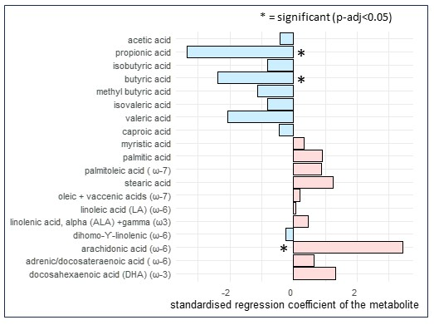

Higher levels of the SCFAs propionic acid and butyric acid were significantly associated with lower DAS28 scores (p < 0.005) indicating a possible anti-inflammatory role. Conversely, higher levels of the long-chain FFA arachidonic acid (ARA) were associated with higher DAS28 scores (p < 0.01), consistent with the known pro-inflammatory role of ARA. Age at onset, gender and BMI were not significantly associated with DAS28 scores. DAS28 decreased significantly over time (P<0.05).

Conclusion:

The study demonstrates that specific free fatty acids are significantly associated with disease activity in RA over the course of seven years following disease onset. SCFAs (Butyric and Proprionic acid) are derived from the by-product of gut bacteria metabolism in the colon. Of these, butyric acid is known to be produced during the metabolism of dietary fibre, which suggests a possible protective role of higher fibre consumption in helping to reduce inflammation. ARA, which has been associated with progressive destruction of cartilage and bone, was positively associated with inflammation. The findings highlight the potential for dietary and metabolic intervention in RA management.

References:

