Joint attention modulates intergroup altruism via incidental learning of trust

Clara D. C. Claveau¹⁺, Laeticia Fatima Gibbs¹⁺, Andrew Bayliss², Frederick L. Philippe¹, and Francesca Capozzi^{1*}

¹ Department of Psychology, UQAM | Université du Québec à Montréal, Montreal, QC, Canada
² School of Psychology, University of East Anglia, Norwich, United Kingdom

⁺ Equal contribution

* Correspondence to Francesca Capozzi
Email: capozzi.francesca@uqam.ca

Abstract
Joint attention (i.e., looking where others look) can implicitly elicit positive social behavior: people trust more and are more altruistic toward individuals who are helpful in cueing relevant objects than toward unhelpful individuals. Does this effect extend to intergroup contexts? White and Black participants (Studies 1 and 3) and Male and Female participants (Study 2) completed a joint attention task in which outgroup faces would provide helpful cues to the response target, and ingroup faces would be unhelpful. Then, participants completed an economic ultimatum game in which they could make altruistic offers to the same faces and finally rated the faces’ trustworthiness. Studies 1 and 2 showed a reliable intergroup joint attention effect and a relationship between trustworthiness perception and altruism. Study 3 showed the independent contribution of gaze-induced trust learning and intergroup trustworthiness perception, and that the link between social learning and altruism is the most evident when intergroup salience is limited. Overall, these data indicate that gaze-mediated social learning increases intergroup altruism by affecting perception of trustworthiness.

Keywords: gaze following; implicit attitudes; intergroup bias; prejudice reduction; social attention.

- Introduction
Social discrimination constitutes a major challenge for human societies, and the improvement of social behaviors across social groups remains a key research topic in social and cognitive psychology (Paluck et al., 2021). Here, we capitalize on recent approaches in cognitive research that focus on the potential of socio-cognitive processes to influence everyday human behavior (Capozzi & Kingstone, 2024) and test the potential of joint attention (i.e., following others’ gaze to attend to the same objects) to serve as an implicit method to improve intergroup social behavior.
Recent research in prejudice reduction has given increased attention to implicit and indirect ways to promote behavioral change (Paluck et al., 2021). For example, intergroup contact theory refers to the notion that (positive) interactions between members of different groups can contribute to social cohesion by reducing prejudice, increasing trust, and generally improving behavioral intentions (McKeown & Dixon, 2017; Pettigrew, 2008; Turner et al., 2020). Yet, supporting evidence for this prediction has been mixed. For example, some studies have found positive effects in White participants who were exposed to other ethnic groups, such as increased positive affect, reduced symbolic racism, and increased ethnic heterogeneity in one’s friendship circle (Lemmer & Wagner, 2015; Shook et al., 2016; Van Laar et al., 2005). However, other studies reported less convincing evidence as they pointed to negative effects (such as increased, rather than reduced prejudice) and other potentially negative consequences (such as unnecessary exposure to prejudice), particularly for underrepresented minorities (Dixon et al., 2010; McKeown & Dixon, 2017; Pettigrew, 2008). Thus, one way to handle this issue is to explore more subtle and indirect ways to engage intergroup experience that do not require face-to-face interactions focusing on intergroup issues (White et al., 2021).
Interestingly, social cognition remains surprisingly under-investigated in these processes. As humans, we have unique skills to learn from subtle behavioral cues, like gaze behavior (Frith & Frith, 2012). Even brief instances of joint attention (i.e., following others’ gaze to attend to the same objects) can have significant and long-term effects on social behavior (Capozzi & Kingstone, 2024). For example, following the gaze of someone who often looks at relevant objects in the environment (e.g., an emergency exit in case of fire) increases positive impressions (Bayliss & Tipper, 2006) and altruism (Rogers et al., 2014) toward that person. These effects have been ascribed to a process called incidental learning of trust: observing someone who is often helpful by constantly cueing relevant locations leads to an implicit appraisal of their trustworthiness and elicits, in turn, positive social behavior toward them (Bayliss et al., 2017; Bayliss & Tipper, 2006; Strachan et al., 2016, 2017; Strachan & Tipper, 2017; Sun et al., 2020). Additionally, joint attention is a potentially ubiquitous socio-cognitive process that requires little effort or explicit knowledge (Frischen et al., 2007), which makes it easy to reproduce and export into society through media, advertisements, and movies (e.g., Palcu et al., 2017). Thus, it represents an ideal candidate to favor intergroup social learning (Paluck et al., 2021). However, the current knowledge of intergroup joint attention remains limited.
  - Intergroup joint attention and altruism
Research on intergroup joint attention has been relatively scarce and somewhat disheartening. In general, it has been observed that people who can be categorized as belonging to socially dominant groups show a decreased propensity to follow the gaze direction of individuals who can be categorized in underrepresented or minority social groups based on visual markers of race or gender (Dalmaso et al., 2020; Kawakami et al., 2018). For example, in White-dominant countries, White participants show decreased gaze following in response to Black faces’ gaze direction (Pavan et al., 2011; see also Kawakami et al., 2014; Zhang, Dalmaso, Castelli, Fiorese, et al., 2021; Zhang, Dalmaso, Castelli, Fu, et al., 2021). As Black participants do not seem to show the opposite pattern (e.g., reduced joint attention in response to White faces’ gaze cues), these data have been taken to suggest that stereotypical perception of group dominance (and not race per se) may modulate joint attention, possibly reflecting the perceived relevance of information from high-status groups (Weisbuch et al., 2017). Similarly, research has reported increased joint attention from female (vs. male) participants (independent of stimuli’s gender presentation) and more negligible joint attention responses for feminine (vs. masculine) face stimuli (independent of participants’ gender; Dalmaso et al., 2020; Frischen et al., 2007; Jones et al., 2010; Ohlsen et al., 2013; Tufft & Gobel, 2022).
The available socio-cognitive models explain these intergroup differences in joint attention through the notion that attentional selection guides and is simultaneously guided by social perception (Capozzi & Ristic, 2018), with prior (stereotypical) knowledge dampening the perceived social relevance of the social information (e.g., gaze cues) coming from social groups perceived as holding lower social status (Capozzi and Kingstone, 2024). However, no study investigating intergroup joint attention manipulated stimulus faces’ gaze reliability, thus leaving open the question of whether intergroup joint attention can be achieved when the gaze cues of outgroup identities are always relevant or informative (Bayliss & Tipper, 2006). Gaze-following behavior and the resulting joint attention are hypothesized to reflect evolutionary mechanisms evolved in social animals to ensure the safe and effective localization of resources via social information (Zuberbühler, 2008). Under this view, gaze reliability may act as a reinforcing mechanism that facilitates positive social learning despite pre-existing social knowledge or expectations (Capozzi & Kingstone, 2024).
Furthermore, the effects of intergroup joint attention on trust learning and altruism remain poorly understood. As mentioned above, positive joint attention can elicit altruistic behavior: participants in past research made higher money offers to stimulus faces who had been consistently helpful in a previous joint attention task by always shifting their gaze toward the location where the response target would appear, compared to faces who had never been helpful (Rogers et al., 2014). This altruistic giving toward helpful gazers is hypothesized to result from a trustworthiness-driven reciprocity process, whereby the helpful gazer is acknowledged as trustworthy as opposed to someone who always “deceitfully” cues irrelevant locations in the environment (Bayliss et al., 2017; Bayliss & Tipper, 2006; Rogers et al., 2014).
However, it is unclear how trust learning applies to intergroup contexts. One study found that White participants exhibited increased perceptions of trustworthiness, induced by joint attention, only for White-looking, ingroup faces but not for Asian-looking, outgroup faces (Strachan et al., 2017). This study confirms the notion that, especially in contexts where both ingroup and outgroup individuals are present, positive social learning occurs more easily for ingroup than outgroup members. Ingroup social learning may indeed be facilitated by pre-existing positive biases, as it is in line with the intrinsic motivation of rewarding the ingroup, whereas outgroup social learning may additionally require optimal conditions (Balliet et al., 2014). Thus, it is possible that previous research dampened intergroup social learning by manipulating race and gaze reliability orthogonally instead of unambiguously associating outgroup identities with reliable gaze behavior cuing relevant information (e.g., Pavan et al., 2011). Additionally, no previous research on intergroup joint attention investigated whether increased gaze reliability would lead to increased intergroup altruism, which is a crucial question to test the applicability of joint attention as an implicit intervention tool to improve social behavior in intergroup contexts (Capozzi & Kingstone, 2024). Finally, as most of this research focused on socially dominant groups (e.g., White participants), how these effects would present themselves in underrepresented social groups (e.g., Black participants) remains unknown (Oswald & Adams, 2022).
  - The current studies
The current preregistered studies have been designed to investigate the impact of joint attention on intergroup altruism. To this aim, participants were first administered a joint attention task. In this type of task, a stimulus face is presented on the screen, showing a straight gaze at first and then shifting their gaze to the left or the right; after the gaze shift, a target response (e.g., an everyday use object) appears in the direction of the gaze shift or the opposite direction. Participants are instructed to ignore the gaze shift and quickly respond to the target (e.g., by pressing a key in correspondence to the target object). Despite these instructions, participants respond faster to gazed-at (vs. gazed-away) targets as they spontaneously follow the stimulus face’s gaze direction, showing the occurrence of a joint attention episode.
Critically, in the present studies, we manipulated the association between gaze validity and group categorization either jointly (i.e., outgroup faces always validly cued the target; Studies 1 and 2) or orthogonally (i.e., ingroup and outgroup faces validly cued the target 50% of the time each; Study 3). In Study 1, face stimuli were White and Black stimulus faces, and participants were individuals self-identifying as White (50%) or Black (50%); for each participant, the outgroup-looking stimulus faces would always validly cue the targets (outgroup_valid), whereas ingroup-looking faces would never cue the targets (ingroup_invalid). Thus, for example, for a White participant, Black stimulus faces would always cue the target, and White stimulus faces would never cue the target, and vice versa for Black participants. Our rationale for this primary manipulation was both methodological and ethical. Methodologically, this manipulation was chosen to maximize the likelihood of (trustworthiness) social learning by unambiguously associating outgroup social cues with relevant information; ethically, we wanted to limit the association of minority groups to unhelpful (gaze) behavior, and the subsequent potential exposure to reduced altruistic giving. Additionally, research shows that out-group altruism is rare (Everett et al., 2015) and costly (De Dreu et al., 2022), hence the importance of this type of study; thus, we reasoned that any increase in intergroup altruism would be attributable to joint attention. However, we also pre-registered Study 3 as a follow-up study to replicate past research and identify relevant differences in these processes that are specifically due to the separation between gaze reliability and social group.
Replicating past research (Rogers et al., 2014), after the joint attention task, participants were administered a one-shot economic ultimatum game in which they could make money offers to the stimulus faces of the joint attention task. In this type of game, participants are given an amount of money (e.g., $10) and are asked to offer some proportion of this money to another individual (called the responder). If the responder accepts the offer, the money is paid according to the participant’s intentions; however, if the responder rejects the offer, neither party receives anything. Response distributions from past research suggest that offers between 30 and 40% of the money can be considered “strategic” to have the offer accepted, whereas offers above 40% can be considered “altruistic” as they are unnecessary (Camerer, 2003); typical offers are below 60% on average (Bayliss et al., 2017; Henrich et al., 2005; Rogers et al., 2014). After the ultimatum game, participants were asked to evaluate each stimulus face’s trustworthiness, to test the role of trust perception in these processes (Strachan et al., 2017), and to respond to questionnaires evaluating individual differences in prejudice to explore additional modulations (Hutchings et al., 2024).
Study 2 applied the same logic to gender-based (rather than race-based) group categorization, aiming to replicate and extend the effects of joint attention to another intergroup categorization. Similar to racism, sexism creates distinct social categories based on biological and social markers to then establish and reiterate the social dominance of one group (e.g., men) over the other (e.g., women; Fiske et al., 2016). However, different from racism, sexist discriminatory behaviors uniquely coexist and are even justified by positive attitudes toward the discriminated group (e.g., women; Diekman & Glick, 2018; Ellemers, 2018; Morgenroth & Ryan, 2021). Thus, it is important to account for similarities and differences regarding the links between joint attention and altruism, depending on whether social categorization is based on racialized or gendered categories. To the extent that intergroup joint attention behavior and/or altruism reflect othering processes of outgroup individuals, we should expect overall similar results across the two studies. Alternatively, it is possible that social categorization per se influences subsequent social behavior (independent of joint attention) and that such influence may be different depending on the basis of the categorization (e.g., positive attitudes toward Women but not Black individuals; for discussion see Hugenberg & Sacco, 2008). Additionally, Studies 1 and 2 also provide experimental control to each other as they use the same stimuli but different associations between group categorization and stimuli’s gaze validity.
Finally, in Study 3, we orthogonally manipulated the association between gaze validity (valid vs. invalid) and group categorization (ingroup vs. outgroup) such that valid cues could be provided by both ingroup (50% of the trials) and outgroup (50% of the trials). Thus, for example, for a given participant, some ingroup faces would always validly cue the target, whereas other ingroup faces would never, and some outgroup faces would always validly cue the target, whereas other outgroup faces would never. This manipulation allowed us to assess the independent effects of gaze validity and group categorization (Strachan et al., 2017).
Concerning joint attention, one experimental question is whether jointly manipulating the association between gaze validity and group categorization (i.e., making outgroup identities always relevant or informative) would elicit intergroup joint attention, and whether it would do so independently of the social group considered (e.g., Black or White participants), as previous research has shown limited intergroup joint attention and differences based on group dominance (Weisbuch et al., 2017). Such an effect would confirm that joint attention, rather than being an innate and immutable behavior, is shaped by experience (Capozzi & Ristic, 2018; Dalmaso et al., 2020; Kingstone, 2020), importantly extending this notion to intergroup social cognition (Kawakami et al., 2018). Additionally, increasing intergroup joint attention would be critical to explore attention-based social interventions, for example, to improve intergroup attitudes and behaviors, as previous research has linked joint attention to improved social communication and behavior (Capozzi & Kingstone, 2024; Mundy & Newell, 2007; Shteynberg, 2015; Shteynberg et al., 2023; Stephenson et al., 2021)
Concerning altruistic behavior, a straightforward hypothesis is that increased gaze reliability globally increases intergroup altruism on average, with overall higher trust ratings and money offers to (outgroup) valid faces than to (ingroup) invalid faces (Rogers et al., 2014). Such an effect would be in line with a categorical understanding of social perception, whereby perceptual cues, behavioral information, and pre-existing knowledge are integrated into threshold-based social categorical judgments (Freeman & Ambady, 2011; Freeman & Johnson, 2016), and would certainly represent a striking achievement regarding implicit methods to improve intergroup social behavior (Capozzi & Kingstone, 2024; Forscher et al., 2019). This comparison was preregistered as the main analysis.
However, one could expect (and previous studies have shown) that individual differences are key in joint attention and social learning (Frischen et al., 2007; Frith & Frith, 2012). For example, individuals may significantly differ in social learning abilities (including the ability to learn implicitly from social gaze) based on a variety of factors, including attentional capacities, empathic abilities, and previous social beliefs (Alwall et al., 2010; Bayliss et al., 2017; Cassidy et al., 2019; McCrackin & Itier, 2019; Mitsuda et al., 2019; Mundy et al., 2014; Okumura et al., 2017; Peterson et al., 2016; Turner et al., 2020). Additionally, individuals vary significantly in their dispositional attitudes (e.g., the tendency to evaluate people and objects positively or negatively; Hepler & Albarracín, 2013) and particularly in trustworthiness judgments (Sutherland et al., 2020). Thus, another (non-mutually exclusive) possibility is that individual differences in trust perception and learning modulate these effects in a correlational fashion (i.e., acting as a moderating factor or covariate). Such a possibility would be in line with predictive processing approaches to social perception, whereby new information and previous biases are continuously integrated into social judgments (McGovern & Otten, 2024; Otten et al., 2017).
Finally, we also included measures of prejudice in all studies; although the relatively limited previous research did not allow us to formulate specific hypotheses, it was reasonable to expect that increased prejudice would correspond to decreased intergroup altruism and trust learning (Giménez-Fernández et al., 2020; Hugenberg & Bodenhausen, 2003; Hutchings et al., 2024; Turner et al., 2020; Xie et al., 2019). All covariate analyses were pre-registered as exploratory or secondary.
  - Open science statement
We preregistered the studies on AsPredicted.org (# 151292; https://aspredicted.org/R9F_S2H); the pre-registered information includes sample size estimation, exclusion criteria, and overall analyses. All studies, measures, manipulations, and data or participant exclusions are reported in the manuscript or its Supplementary Materials available at this link (https://osf.io/ywvnx/?view_only=d39129317f2b4d0a81b6446a447cf7b5). A programming sheet example and the anonymized group data are provided in the Supplementary Material; the experimental stimuli will be made available upon request to the corresponding author. Finally, we introduce a new method to maximize transparent sampling (McGorray et al., 2023); this method addresses a wide range of demographic information (spanning from biological sex to skin tone and immigration history), allowing participants to phrase the responses in their own wording (see Supplementary Materials for the full list of questions). The UQAM University Ethics Committee approved the study (# 2023-5634).
- Study 1, race-based group categories
  - Methods
    - Participants
Participant recruitment was carried out via the online platform Prolific (www.prolific.com) with no geographic restriction. We aimed to collect data from 60 participants self-identifying on Prolific as White and 60 as Black (N_{tot} = 120). To choose this sample size, we used the software G*Power (Faul et al., 2007) to perform an a-priori sample size estimation with alpha = 0.5, beta = 0.2, and dz = 0.4, which is a typical effect size for within-subject modulations of joint attention (Capozzi et al., 2016; Dalmaso et al., 2012; Rogers et al., 2014). This sample size provided >.90% power to detect an effect size of dz = .3 or greater in a paired-sample t-test and r = .3 or greater in a correlational analysis (5% false-positive rate). Participants had to be fluent in English. Following previous literature and our preregistration plan, we excluded the participants who had less than 80% accuracy in and/or more than 20% anticipatory and timed-out responses (i.e., responses faster than 200 ms and slower than 1200 ms) in the joint attention task. Data from 138 participants were collected to arrive at the desired sample size of 120 (60 self-identifying as White, 60 self-identifying as Black), with 18 participants excluded applying the exclusion criteria. Table 1 summarizes the main demographic information of the final sample participants.

Table 1 – Demographic information of Study 1 final sample N = 120
1. How old are you? |  |  |  |  |  |  |  |  |  |  |  |  |  |  | M = 27 (20-39)
2. In which country did you grow up for the most part of your childhood?
Africa  Central and South America  Europe  North America  NA |  |  |  |  |  |  |  |  |  |  |  |  |  |  | 36 (30%)  1 (1%)  60 (50%)  10 (8%)  13 (11%)
4. What is the sex you were assigned at birth?
Female  Male  NA |  |  |  |  |  |  |  |  |  |  |  |  |  |  | 60 (50%)  54 (45%)  6 (5%)
5. What is your gender identity?
Man  Non-binary (including Gender fluid and Trans*)  Woman  NA |  |  |  |  |  |  |  |  |  |  |  |  |  |  | 47 (41%)  7 (6%)  49 (44%)  11 (9%)
6. Which tone best matches your skin color?
13(11%) |  | 26(22%) |  | 10(8%) |  | 9(8%) |  | 8(7%) |  | 21(18%) |  | 19(16%) |  | 7(6%) |  |  | 5(4%) |  | 0(0%)

    - Stimuli
We created 16 3D faces using the software FaceGen Modeller, which is often used in social perception research to create realistic social stimuli (e.g., Todorov et al., 2008). Half of the faces were identifiable as White, the other half as Black; half had a male presentation, and the other half had a female presentation. The faces varied in size from 3.3° to 4.3° in width and 4.5° to 6.5° in height (visual angle at an approximate distance of 60 cm). As in previous research, the target stimuli comprised pictures of 32 household objects, 16 typically belonging to the kitchen (e.g., a fork) and 16 to the garage (e.g., a hammer); the objects varied from 1° to 5° in width and 1° to 3° in height and were randomly presented in four different colors (blue, yellow, red, and green). Figure 1 shows an example of the stimuli.

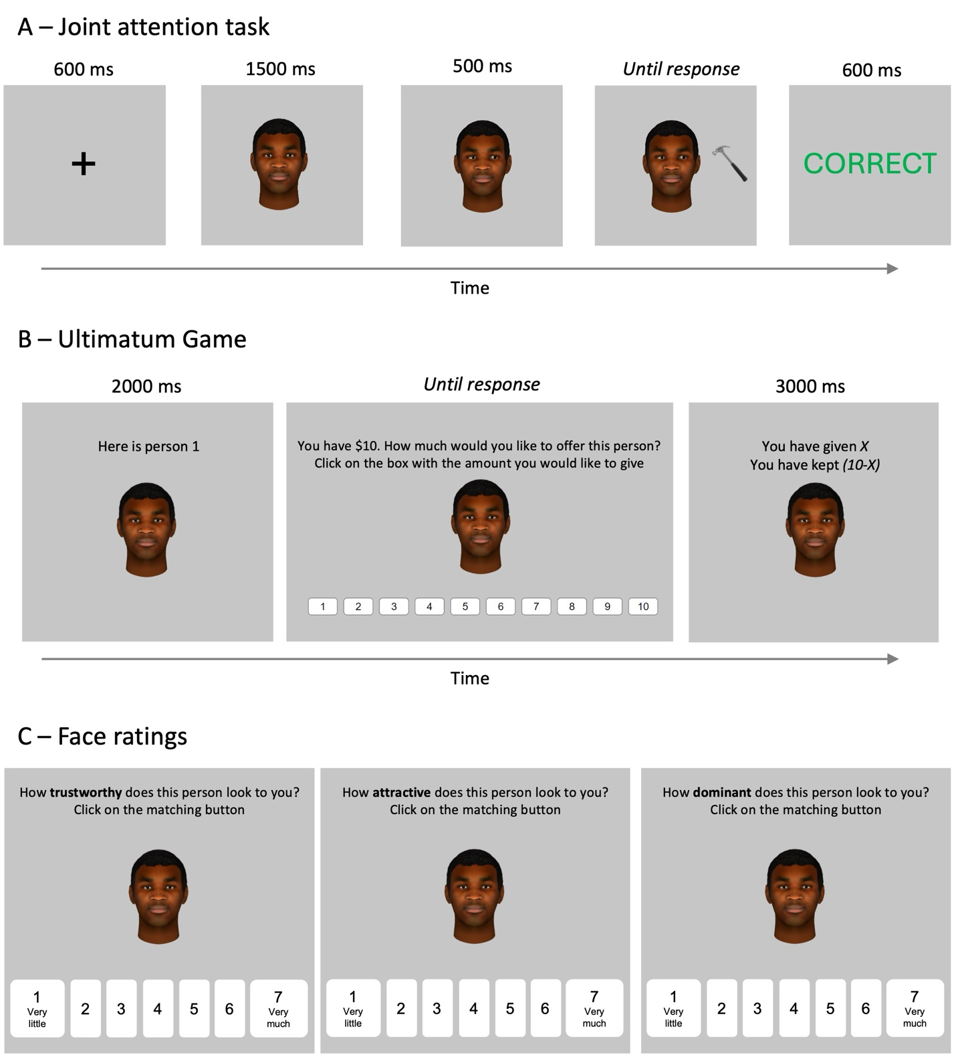
Figure 1. Stimulus presentation sequence for the joint attention task (A; the example shows a valid trial with a correct response), the ultimatum game (B; in the actual study, X corresponded to the amount selected by the participant), and the face ratings (C; the order of the adjectives varied randomly across participants and across faces).

    - Stimuli Apparatus and procedure
All participants were administered a joint attention task, an economic one-shot ultimatum game, face ratings, questionnaires, and debriefing in this order. Experiment programming and data collection were carried out through the online software Testable (www.testable.org). The experiment was performed online, and the devices the participants could use were restricted to their desktop or portable computer (i.e., the experiment would not run upon detection of other portable devices like mobile phones or tablets). Before starting the experiment, participants were instructed to sit approximately 60 cm from their screen to ensure similar stimulus presentation (visual angle). The study lasted about 50 minutes, and participants were compensated £7.50 for their participation.
The joint attention task. We used a standard gaze-cueing procedure replicating as closely as possible previous research on joint attention and altruism (e.g., Rogers et al., 2014; see also Bayliss & Tipper, 2006). The procedure is shown in Figure 1A. After a fixation cross (600 ms), a face with a straight-ahead gaze was presented for 500 ms before shifting its gaze toward the left or the right. After 500 ms, a response target (a kitchen or garage object) appeared. Participants were instructed to ignore the gaze shifts and categorize the target as a kitchen or garage item as quickly and accurately as possible by pressing the corresponding key (“L” or space) on their keyboard. The association between the keys (“L” or space) and the target category (kitchen or garage) was counterbalanced across participants. After the response was given or 2500 ms had elapsed, response feedback CORRECT (in green) or INCORRECT (in red) appeared for 600 msec; a blank screen of 400 ms preceded the next trial. After 16 practice trials, in which only examples of target objects (no faces) were shown, participants completed 192 experimental trials divided into 2 blocks; participants were allowed to take a short break (max 2 minutes) between the two blocks.
Critically, in this study, the outgroup faces (relative to the participant) always shifted their gaze toward the location of the target, thus providing valid cues to the response target 100% of the times (outgroup_valid faces); the ingroup faces always shifted their gaze in the opposite direction, thus providing invalid cues to the response target 100% of the times (ingroup_invalid faces). In Study 1, group categorization was based on racialized skin tone (for the stimuli) and self-identification (for the participants).
The ultimatum game. Participants were invited to play one one-shot ultimatum game with each of the 16 faces of the joint attention task. Before starting the game, participants were told (the cover story) that the face images belonged to individuals who had attended the laboratory for a different experiment but agreed to participate as respondents in the economic game and that their faces had been rendered in 3D models to protect their privacy (Rogers et al., 2014). Participants were also told that the experimenters would subsequently contact the responder in one randomly chosen game and ask him or her to decide whether to accept or reject the participant’s offer. Furthermore, the participants were informed that the money they elected to keep would be added to their attendance fees if the responders accepted their offer, but that no one would receive any money if the offer were rejected.
Figure 1B shows the game procedure. In each trial, an outgroup_valid or ingroup_invalid face was presented in the center of the display above the caption “Here is person n”, where n equaled 1–16 faces. Two seconds later, the text “You have $10. How much would you like to offer this person? Click on the box with the amount you would like to give” appeared on top of the face, and buttons from 1 to 10 appeared beneath. As the study was international, we decided to use the USD currency as it is most likely familiar to most countries. Once participants clicked the button corresponding to their offer, a 3-second screen appeared showing the text “You have given $X, you have kept $Y” – where X indicated the amount offered and Y the amount kept (Y=10-X). After a 3-second screen, the next trial started showing a different face. The 16 faces were presented in randomized order.
Face ratings. The 16 faces were again presented one at a time in random order at the center of the screen, with the text “How adjective does this person look to you? Click on the matching button” on top and buttons from 1 to 7 beneath, as shown in Figure 1C. The adjectives were trustworthy, attractive, and dominant (presented in random order), with trustworthiness being the main rating of interest (the others were used to limit socially desirable answers; (Capozzi et al., 2016). After rating one adjective, the next adjective would appear; once a face was rated on the three adjectives, the next face appeared.
Questionnaires and debriefing. At the end of the experiment, participants were asked to complete the BARS (Beliefs About Race Scale; Tawa, 2017) as a measure of racial prejudice. The BARS is a multidimensional 16-item measure of racial essentialism, which refers to one’s tendency to consider races and differences across racialized groups as biological (vs. cultural) and immutable (vs. changeable). This questionnaire correlates with other prejudice and social dominance measures while being conceived to be administered to both overrepresented and underrepresented social groups (Tawa, 2017; Tawa & Montoya, 2019). In the present study, it reached a Cronbach alpha of .981 (White participants .798; Black participants .980).
After the demographic questionnaire (see Table 1), participants were debriefed and asked whether they noticed that some faces always looked at the target, as previous literature indicated that knowledge of faces’ gaze reliability might play a role in the implicit social learning of trustworthiness (e.g., Rogers et al., 2014).
    - Analyses
Joint attention. Joint attention is typically measured with a comparison between RT (and accuracy) in valid vs. invalid trials, with joint attention being reflected in faster (and more accurate) responses in valid vs. invalid (McKay et al., 2021). A joint attention magnitude (calculated as the difference between RT in valid minus invalid trials) is often used to facilitate direct comparisons (Capozzi & Ristic, 2018). To account for between-group differences, we analyzed accuracy and RT using two separate repeated measures ANOVAs with the within-subject factor validity (2 levels: outgroup_valid, ingroup_invalid) and the between-subject factor social group (2 levels: White participants, Black participants). Significant interactions were followed up with paired or two-sample t-tests as appropriate, and the two-sided p is reported.
Altruism. In this study, altruism is defined in terms of money offers in the ultimatum game, and intergroup altruism is defined as higher offers to outgroup_valid faces than ingroup_invalid faces. Thus, after checking the overall altruistic behavior to identify possible anomalies (e.g., markedly low or excessive offers), we applied the same ANOVA we used for the joint attention task to the money offers in the ultimatum game. To test the role of trust perception, we calculated a trust index as the difference in trustworthiness ratings between (outgroup) valid minus (ingroup) invalid faces (with higher scores indicating higher trust perception for outgroup, valid identities; see also Strachan et al., 2017). We added this index as a covariate in the previous ANOVA on money offers. Similarly, we added the BARS global score as a covariate to the same ANOVA to test the role of individual differences in prejudice. Significant covariate interactions were followed up with Pearson r correlations. Finally, we checked whether noticing that some faces always looked at the target affected offers by coding this variable (noticed vs. not noticed) as a between-group factor.
  - Results
Joint attention. The participants performed the task well, with 95% average accuracy and no differential effects based on validity or social group (Fs < 2.658, ps > .106). RT analyses additionally excluded any anticipatory and timed-out responses (i.e., responses faster than 200 ms and slower than 1200 ms, 5.66% of trials). The analysis revealed a main effect of validity, whereby RT in outgroup_valid trials (M = 720 ms, CI = 706-733) were faster than RT in ingroup_invalid trials (M = 734 ms, CI = 720-747), F(1, 118) = 47.516, p < .001, η_{p}² = .287. A social group main effect indicated that White participants (M = 708 ms, CI = 689-727) responded to the task overall faster than Black participants (M = 746 ms, CI = 727-764), F(1, 118) = 8.195, p = .005, η_{p}² = .065. Finally, there was a validity x social group interaction, F(1, 118) = 10.396, p = .002, η_{p}² = .081, shown in Figure 2A. This interaction was driven by the fact that White participants showed faster RT for both outgroup_valid and ingroup_invalid trials, resulting in overall smaller joint attention magnitudes than Black participants (White participants: M = 8 ms, CI = 2-13; Black participants: M = 21 ms, CI = 14-26; t(118) = 3.224, p = .002, d = .600).
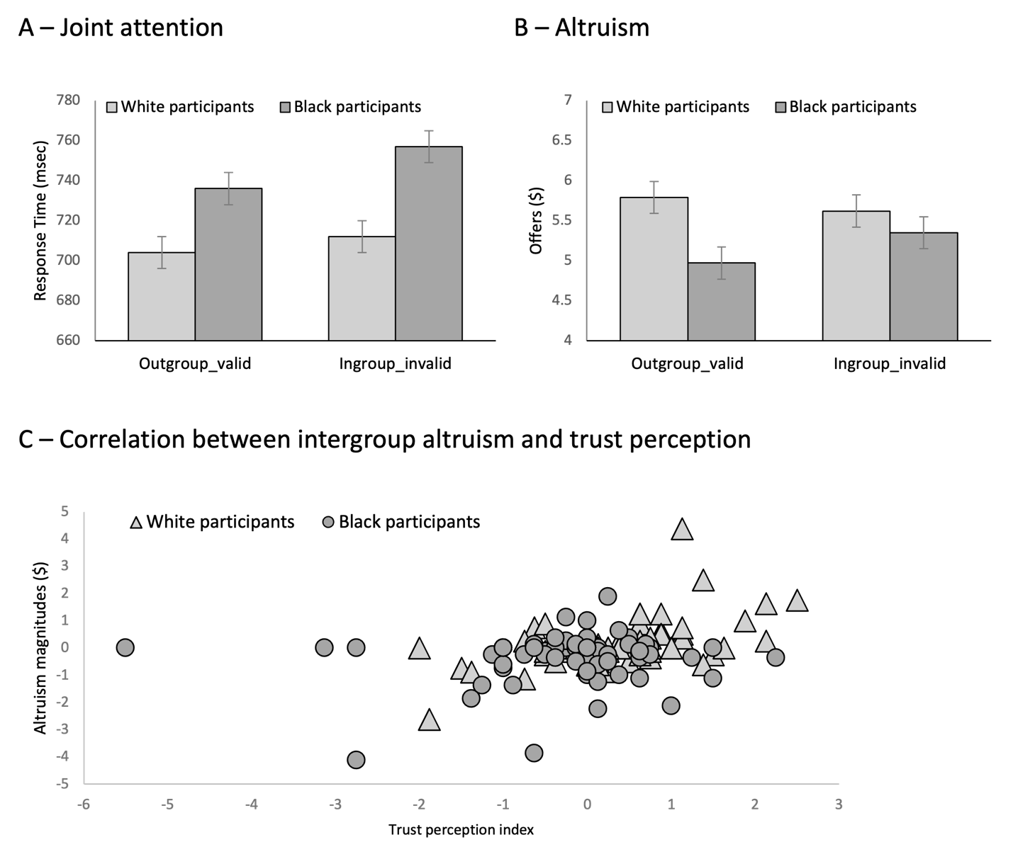
Figure 2. Response times for the joint attention task (A), altruistic behavior from the ultimatum game (B), and correlations between intergroup altruism and trust perception (C) in Study 1.

Overall, these data indicate that manipulating outgroup gaze reliability led to an observable intergroup joint attention effect with no differential effects across groups. Although both social groups showed such an effect, it was overall smaller for White participants than for Black participants.
Altruism. In line with previous literature, participants showed a standard altruistic behavior, with average offers during the ultimatum game (M = $5.43, CI = 5.08-5.78) significantly higher than 40% (i.e., $4), t(119) = 8.268 p < .001, d = .750, and significantly lower than 60% (i.e., $6), t(119) = 3.273, p = .001, d = .297, and no significant differential effects across social groups, t(118) = 3.273, p = .120, d = .286. The ANOVA revealed a validity x social group interaction, F(1, 118) = 9.865, p = .002, η_{p}² = .077, shown in Figure 2B, and no other significant effects (validity: F(1, 118) = 1.481, p = .226, η_{p}² = .012; social group: F(1, 118) = 2.455, p = .120, η_{p}² = .020). This interaction was driven by the fact that Black participants made lower money offers to outgroup_valid identities (M = $4.97, CI = 4.43-5.50) than to ingroup_invalid (M = $5.35, CI = 4.82-5.88), t(59) = 3.022, p = .004, d = .390. The same comparison was not significant for White participants (outgroup_valid: M = $5.79, CI = 5.33-6.25; ingroup_invalid: M = $5.62, CI = 5.13-6.10; t(59) = 1.388, p = .170, d = .179). Additionally, these differences were specifically due to lower offers to outgroup_valid identities (and not to higher offers to ingroup_invalid identities) as Black participants (M = $4.97, CI = 4.48-5.46) offered to outgroup_valid significantly less money than White participants (M = $5.79, CI = 5.29-6.28), t(118) = 2.318, p = .022, d = .423. No significant differences between social groups were observed for the offers to ingroup_invalid identities, t(118) = .735, p = .464, d = .134.
When the trust index (i.e., difference in trustworthiness ratings between outgroup_valid minus ingroup_invalid faces) and the prejudice measure (i.e., BARS global scores) were added as covariates, the analysis yielded an additional validity x trust index interaction, F(1, 116) = 10.986, p = .001, η_{p}² = .087, indicating and money offers to valid (outgroup) and invalid (ingroup) faces were modulated by trust perception. The follow-up correlation between intergroup altruism (i.e., the difference between offers to outgroup_valid minus ingroup_valid faces) and trust learning index revealed a positive effect, r(118) = .352, p < .001, shown in Figure 2C, whereby intergroup altruism increased as trust perception increased.
Overall, these data indicate that White participants offered similar amounts to ingroup and outgroup identities and that Black participants offered less money to outgroup identities. These effects were modulated by trust perception, such that increased trust perception for outgroup, valid identities corresponded to increased intergroup altruism. None of these effects were significantly modulated by whether the participant had noticed (58% of participants) or not noticed (42% of participants) that some faces consistently cued the target (Fs < 1.090; ps > .595). Furthermore, we ruled out possible stimulus-driven differences by analyzing the data from Study 2 (in which the same stimuli were used) as a function of stimuli racialized presentation (White vs. Black faces); no significant differences were observed for RT, t(119) = .289, p = .773, d = .026, or money offers, t(119) = .733, p = .465, d = .067, even if Black faces were judged as more trustworthy than White faces, t(119) = 4.021, p < .001, d = .367.
  - Discussion
Study 1 showed reliable intergroup joint attention, indicating that outgroup identities’ gaze cues are followed and elicit a joint attention episode to the extent that they provide relevant cues to the environment (Capozzi & Kingstone, 2024). Interestingly, in our study, Black participants showed an overall slower performance and bigger joint attention magnitudes. These results were unexpected, but we can retrospectively connect them to research indicating that social threat is one of the factors affecting increased joint attention (Chen et al., 2017; Chen & Zhao, 2015) and overall attentional alert (Trawalter et al., 2008). Unfortunately, none of these previous studies focused on Black participants, making it unclear to what extent Black people may perceive White people as a threat. However, it’s interesting to speculate that this may be the case considering the widespread social discrimination affecting Black people (Kunstman & Fitzpatrick, 2018; Kutlaca & Radke, 2023; Shelton et al., 2023), and future research should explore this notion by investigating the effects of social threat on joint attention in underrepresented groups (Capozzi & Kingstone, 2024).
Study 1 did not show reliable evidence that increased joint attention directly increases intergroup altruism. On the contrary, White participants did not offer significantly different amounts of money to ingroup and outgroup identities, and Black participants offered less money to outgroup identities despite their helpful gaze behavior during the joint attention task. This outgroup penalization in Black participants is particularly interesting as it may indicate a form of psychological resistance to what is perceived as a dominant group (i.e., White identities; (Leach & Allen, 2017), and further research could investigate the factors that modulate such behavior (Olson et al., 2009). Finally, increased altruistic giving was overall proportionally connected to trustworthiness perception, which is consistent with previous research highlighting the key role of perceived trustworthiness in modulating social behavior (Hutchings et al., 2024; Tracy et al., 2020; Turner et al., 2013).
Together, these results indicate that 1) unambiguous gaze validity led to intergroup joint attention, 2) such joint attention was not reliably connected to global increases in intergroup altruism on average (e.g., overall higher money offers to outgroup valid faces than to ingroup invalid), and 3) that intergroup altruism increased proportionally as trust perception of outgroup, valid faces increased. Study 2 assessed whether these results would replicate with gender-based group categorization.

- Study 2, gender-based group categories
  - Methods
    - Participants. We collected data from 131 participants to obtain the desired sample size of 120 (60 Male, 60 Female) according to the same exclusion criteria as Study 1. Table 2 summarizes the main demographic information of the final sample participants.

Table 2 – Demographic information of Study 2 final sample N = 120
1. How old are you? |  |  |  |  |  |  |  |  |  |  |  |  |  |  | M = 26 (18-40)
2. In which country did you grow up for the most part of your childhood?
Africa  Central and South America  Europe  North America  NA |  |  |  |  |  |  |  |  |  |  |  |  |  |  | 22 (18%)  15 (13%)  67 (56%)  4 (3%)  12 (10%)
4. What is the sex you were assigned at birth?
Female  Male  NA |  |  |  |  |  |  |  |  |  |  |  |  |  |  | 54 (45%)  58 (47%)  8 (7%)
5. What is your gender identity?
Man  Non-binary (including Gender fluid and Trans*)  Woman  NA |  |  |  |  |  |  |  |  |  |  |  |  |  |  | 54 (45%)  0 (0%)  51 (43%)  15 (13%)
6. Which tone best matches your skin color?
11(9%) |  | 29(24%) |  | 23(19%) |  | 13(11%) |  | 21(18%) |  | 8(7%) |  | 9(8%) |  | 2(2%) |  |  | 1(1%) |  | 1(1%)

    - Stimuli and procedure. The same stimuli and procedure as Study 1 were used in Study 2, with the exception that group categorization was based on gender presentation (for the stimuli) and self-identification (for the participants). Consequently, the gaze validity x social group categorization changed such that for Male participants, female faces would always provide valid cues to the target, and male faces would always provide invalid cues, vice versa for Female participants. Additionally, prejudice was assessed with the short versions of the Ambivalent Sexism Inventory (ASI) for Male participants and Ambivalence Toward Men Inventory (AMI) for Female participants (Rollero et al., 2014). These scales are designed to assess and differentiate hostile and benevolent sexism, referring, respectively, to negative (e.g., “women are weaker than men”) or positive (e.g., “women need protection”) discriminatory evaluations and stereotypes about a gender (Glide & Fiske, 1996; Rollero et al., 2014). A similar number of items and response scales across the two inventories allowed us to calculate hostile and benevolent sexism scores for both Male and Female participants. In the present study, the ASI reached a Cronbach alpha of .894, and the AMI reached a Cronbach alpha of .791.
  - Results
Joint attention. The participants performed the task well, with 94% average accuracy and no differential effects based on social group (Fs < .175, ps > .676; see Supplementary Analyses 2.1 for detailed statistics), although responses were slightly more accurate in outgroup_valid (M = 95%, CI = 94-95) than ingroup_invalid (M = 94%, CI = 93-95) trials, F(1, 118) = 6.799, p = .010, η_{p}² = .054. RT analyses additionally excluded any anticipatory and timed-out responses (5.33% of trials). The analysis revealed a main effect of validity, whereby RT in outgroup_valid trials (M = 706 ms, CI = 691-721) were faster than RT in ingroup_invalid trials (M = 728 ms, CI = 712-743), F(1, 118) = 99.300, p < .001, η_{p}² = .457. No other effects were significant (social group: F(1, 118) = .409, p = .524, η_{p}² = .003; validity x social group interaction, F(1, 118) = 1.380, p = .242, η_{p}² = .012). Thus, like Study 1, these data indicate that manipulating outgroup gaze reliability led to an observable intergroup joint attention effect, reflected in both accuracy and RT data, with no significant differential effects across social groups (see Figure 3A).
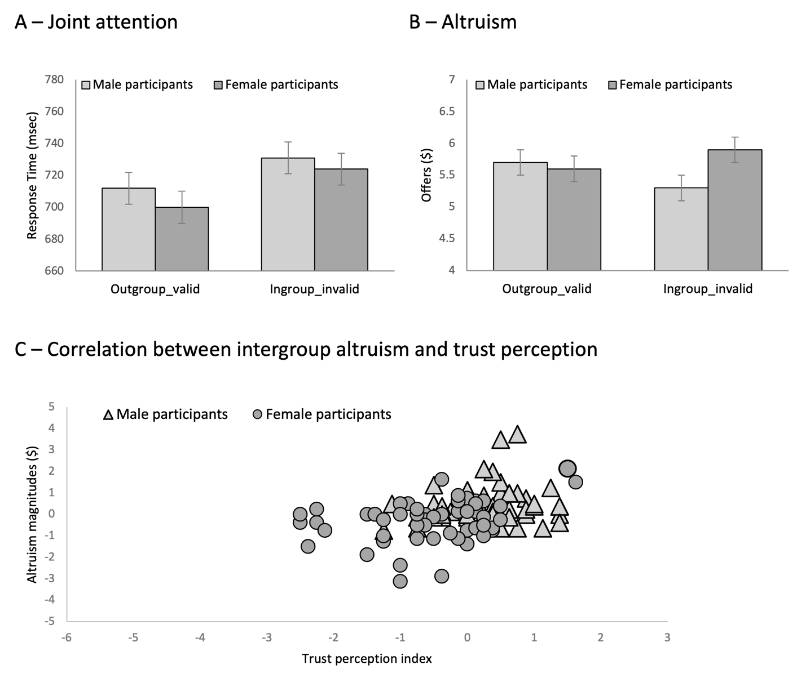
Figure 3. Response times for the joint attention task (A), altruistic behavior from the ultimatum game (B), and correlations between intergroup altruism and trust perception (C) in Study 2.

Altruism. As before, participants showed a standard altruistic behavior, with average offers (M = $5.62, CI = 5.28-5.95) significantly higher than 40% (i.e., $4), t(119) = 9.557, p < .001, d = .867, and significantly lower than 60% (i.e., $6), t(119) = 2.266, p = .025, d = .207, and no significant differential effects across social groups, t(118) = .713, p = .477, d = .130. The ANOVA on the money offers during the ultimatum game revealed a validity x social group interaction, F(1, 118) = 21.475, p < .001, η_{p}² = .154, shown in Figure 3B, and no other significant effects (validity: F(1, 118) = .030, p = .863, η_{p}² < .001; social group: F(1, 118) = .508, p = .477, η_{p}² = .004). This interaction was driven by the fact that Male participants offered more money to valid_outgroup identities (M = $5.70, CI = 5.22-6.17) than ingroup_invalid identities (M = $5.29, CI = 4.70-5.80), t(59) = 3.437, p < .001, d = .444. The reverse was true for Female participants, who offered more money to ingroup_invalid identities (M = $5.92, CI = 5.42-6.43) than outgroup_valid identities (M = $5.55, CI = 5.08-6.03), t(59) = 3.120, p = .003, d = .403. In other words, both groups offered more money to female identities.
When the trust index and the prejudice measure were added as covariates, the analysis yielded a validity x trust index interaction, F(1, 115) = 6.508, p = .012, η_{p}² = .054 and a validity x hostile sexism interaction, F(1, 115) = 5.006, p = .027, η_{p}² = .042, with the main effect of validity now becoming significant, F(1, 115) = 4.979, p = .028, η_{p}² = .041. The correlation between intergroup altruism and trust index revealed a positive effect, r(118) = .381, p < .001, shown in Figure 3C, whereby altruism increased as trust perception increased. The correlation between intergroup altruism and hostile sexism revealed a negative relationship, r (118) = -.310. p < .001, whereby altruism decreased as hostile sexism increased.
Overall, these data indicate that both Male and Female participants offered more money to female faces, independent of group categorization and gaze validity. Corroborating this notion, in Study 1, in which the same stimuli were used, participants also offered more money to female (M = $5.61, CI = 5.25-5.97) than male (M = $5.26, CI = 5.91-5.60) faces, t(119) = 4.194, p < .001, d = .383. However, and again similar to Study 1, these effects were modulated by trust perception, such that increased trust perception corresponded to increased altruistic giving. Again, none of these effects were significantly modulated by whether the participant had noticed (65% of participants) or not noticed (35% of participants) that some faces consistently cued the target (Fs < 1.550; ps > .088).
  - Discussion
As in Study 1, participants in Study 2 showed reliable intergroup joint attention, with no significant differences across gender groups. Interestingly, previous research indicated sex differences in joint attention behavior, with Female participants displaying larger joint attention magnitudes relative to Male participants (Alwall et al., 2010; Cooney et al., 2017; Feng et al., 2011; Ohlsen et al., 2013). Our results do not indicate that these differences extend to the appraisal of social gaze reliability, as both gender groups showed joint attention in response to consistently valid vs. invalid gaze cues (Dalmaso et al., 2020; Frischen et al., 2007).
Additionally, the present results also show that both Female and Male participants offered more money to female faces, which is at odds with the real-life observation that women are systematically penalized in financial attributions in professional (Quadlin et al., 2023) and scientific (Witteman et al., 2019) domains. However, it is important to emphasize that the present study portrayed a helping context in which positive expectations toward women would be in line with stereotypical gender representations that may have, in turn, elicited a more “rewarding” behavior toward female identities (Glick & Fiske, 2011). Further research examining face-based economic decisions may explore this interesting possibility by experimentally manipulating helping vs. professional contexts (for discussion see Rudman & Phelan, 2008).
However, and most critically for our investigation, the results of Study 2 once again showed no reliable evidence that intergroup joint attention directly increased intergroup altruism; similar to Study 1, increased altruism was connected to increased trust perception for outgroup, valid identities and individual differences in prejudice, confirming the role of pre-existing biases in modulating social perceptions and learning (Hehman et al., 2019; McGovern & Otten, 2024).
Overall, Studies 1 and 2 indicate that outgroup gaze validity led to intergroup joint attention, but such social attentional behavior had no significant effects on intergroup altruism, which does not replicate previous research as expected (Rogers et al., 2014). Could this be due to the confound between social category and gaze reliability? In studies 1 and 2, we reasoned that unambiguously associating outgroup identities with reliable gaze behavior cuing relevant information would maximize the likelihood of both intergroup joint attention and altruism. The data showed that this was not the case for intergroup altruism. Thus, one critical question to address is whether separating gaze reliability from social group information would facilitate altruism (e.g., Rogers et al., 2014). Research on learning and memory consolidation indicates that adaptive learning benefits from prediction errors and their distribution; in this sense, the “null variance” in the error distribution of Studies 1 and 2 may have interfered with social learning (Diederen et al., 2016). For example, it is possible that studies 1 and 2 increased the saliency of group information by maximizing the consistency of group-associated social behaviors, making intergroup stereotypes prevail over (gaze-induced) social learning (e.g., Pavan et al. 2011). We tested this hypothesis in Study 3 by orthogonally manipulating gaze validity and group categorization; we reasoned that, if group saliency interfered with social learning in Studies 1 and 2, then associating social group information with both reliable and unreliable (gaze) behavior would restore social learning.
Additionally, Studies 1 and 2 indicate that altruism increased proportionally to trust perception, but their design could not indicate whether trust perception was related to individual differences in the ability to apprehend trust from gaze behavior or a pre-existing, independent appreciation of trust in outgroup identities (Hugenberg & Bodenhausen, 2003; Hutchings et al., 2024; Strachan et al., 2017; Tracy et al., 2020). Note that this would be a minor issue if the results had shown an average increase of outgroup-directed altruistic giving. As argued above, outgroup altruism is generally rare, and any average increase would have made a strong argument for our experimental manipulation. However, the fact that individual differences in trust perception emerged as the main factor modulating altruistic giving in Studies 1 and 2 made it critical to assess the independent effects of gaze validity and group categorization on altruism and trust perception.
To address these issues, in Study 3, we used race-based group categorization to test the independent effects of social group and gaze reliability on joint attention and altruism. Race-based categorization has a well-established role in social cognition as a benchmark to study intergroup behavior (Pavan et al., 2011; Weisbuch et al., 2017) due to its relevance in intergroup interactions and social discrimination (Balliet et al., 2014; Hutchings et al., 2024). Our Studies 1 and 2 yielded largely similar results, which made it less relevant to follow up on both studies. Additionally, both Female and Male participants offered more money to female faces in Study 2, which is in line with the notion of benevolent sexism discussed above (e.g., women; Diekman & Glick, 2018; Ellemers, 2018; Morgenroth & Ryan, 2021), but could also represent a confounding factor to test the independent effects of social group and gaze reliability on joint attention and altruism. Thus, we decided to limit Study 3 to race-based social categorization.
- Study 3, orthogonal manipulation of gaze validity and group categorization
  - Methods
    - Participants. We collected data from 133 participants to obtain the desired sample size of 120 (57 Black, 63 White) according to the same exclusion criteria as Study 1. Table 3 summarizes the main demographic information of the final sample participants.

Table 3 – Demographic information of Study 3 final sample N = 120
1. How old are you? |  |  |  |  |  |  |  |  |  |  |  |  |  |  | M = 27 (18-40)
2. In which country did you grow up for the most part of your childhood?
Africa  Central and South America  Europe  North America  NA |  |  |  |  |  |  |  |  |  |  |  |  |  |  | 55 (46%)  4 (3%)  47 (39%)  3 (3%)  13 (11%)
4. What is the sex you were assigned at birth?
Female  Male  NA |  |  |  |  |  |  |  |  |  |  |  |  |  |  | 57 (44%)  63 (53%)  4 (3%)
5. What is your gender identity?
Man  Non-binary (including Gender fluid and Trans*)  Woman  NA |  |  |  |  |  |  |  |  |  |  |  |  |  |  | 61 (51%)  2 (1%)  51 (43%)  6 (5%)
6. Which tone best matches your skin color?
10(8%) |  | 21(17%) |  | 19(16%) |  | 8(7%) |  | 9(7%) |  | 10(8%) |  | 13(11%) |  | 18(15%) |  |  | 9(8%) |  | 3(3%)

    - Stimuli and procedure. Study 3 used the same stimuli and procedure as Study 1, with the exception that validity (valid, invalid) and group categorization (ingroup, outgroup) were manipulated orthogonally. The face stimuli that were assigned to each combination (e.g., valid, ingroup) were randomized across participants.
  - Results
Joint attention. We analyzed accuracy and RT using two separate repeated measures ANOVAs with the within-subject factors validity (2 levels: valid, invalid) and group categorization (2 levels: ingroup, outgroup), and the between-subject factor social group (2 levels: White participants, Black participants). The participants performed the task well, with 95% average accuracy and no differential effects based on validity, group categorization, or social group (Fs < .1473, ps > .227). RT analyses, shown in Figure 4A, additionally excluded any anticipatory and timed-out responses (5.92% of trials).

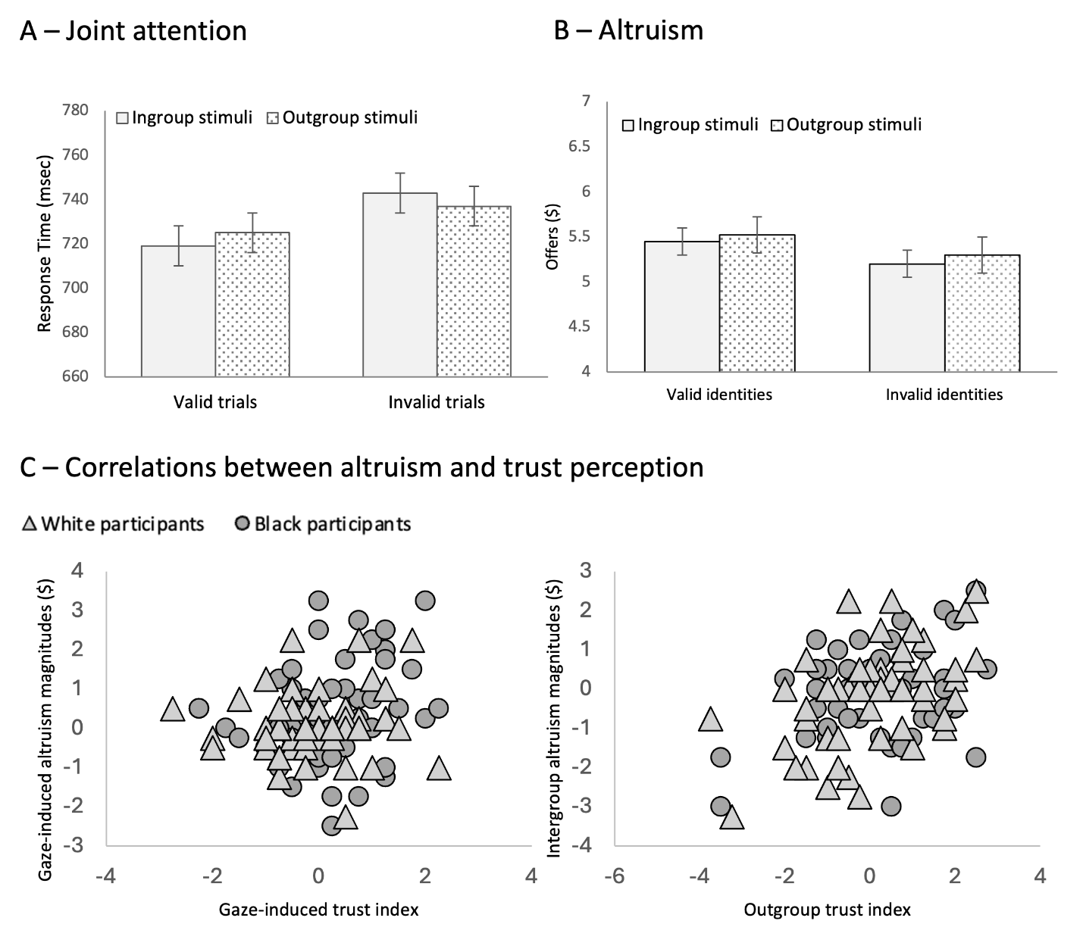
Figure 4. Response times for the joint attention task (A), altruistic behavior from the ultimatum game (B), and correlations between intergroup altruism and trust perception (C) in Study 3.

The RT analysis revealed a main effect of validity, whereby RT in valid trials (M = 723 ms, CI = 708-735) were faster than RT in invalid trials (M = 740 ms, CI = 727-753), F(1, 118) = 73.189, p < .001, η_{p}² = 383. The analysis also yielded a validity x group categorization interaction, F(1, 118) = 9.436, p = .003, η_{p}² = .074, driven by the fact that the joint attention magnitudes were greater for ingroup (M = 24 ms, CI = 18-30) than outgroup identities (M = 13 ms, CI = 7-18), t(119) = 2.916, p = .004, d = .266. A validity x group categorization x social group interaction further qualified the differences in joint attention magnitudes, F(1, 118) = 4.963, p = .028, η_{p}² = .040. Whereas both groups showed significant joint attention effects with significant differences between valid and invalid trials, summarized in Table 4, Black participants’ responses in invalid, ingroup trials (M = 757 ms, CI = 738-776) were slower than their responses in invalid, outgroup trials (M = 744 ms, CI = 724-764), t(56) = 3.007, p = .004, d = .398, and slower than White participants’ responses in in invalid, ingroup trials (M = 731 ms, CI = 712-750), t(118) = 2.010, p = .047, d = .367. No other effects were significant (Fs < 2.137, ps > .146).

Table 4 – Validity effects for each social group and group categorization in Study 3
Social group | Group categorization | t (abs) | df | p | Cohen’s d
Black participants | Ingroup | 6.637 | 56 | <.001 | .879
Black participants | Outgroup | 2.115 | 56 | .019 | .280
White participants | Ingroup | 5.058 | 62 | <.001 | .637
White participants | Outgroup | 4.359 | 62 | <.001 | .549

Altruism. As before, participants showed a standard altruistic behavior, with average offers (M = $5.34, CI = 5.02-5.69) significantly higher than 40% (i.e., $4), t(119) = 7.959, p < .001, d = .727, and significantly lower than 60% (i.e., $6), t(119) = 3.760, p < .001, d = .343. The ANOVA on the money offers during the ultimatum game revealed a main effect of validity, F(1, 118) = 6.381, p = .013, η_{p}² = .051, shown in Figure 4B, whereby offers to valid faces (M = 5.47 ms, CI = 5.12-5.82) were higher than offers to invalid faces (M = 5.24 ms, CI = 4.89-5.39), and no other significant effects (Fs < 1.897, ps > .171).
To account for the role of trust perception, we calculated separately a gaze-induced trust index as the difference between trustworthiness ratings for valid minus invalid identities, and a group-category trust index as the difference between trustworthiness ratings for outgroup minus ingroup identities. When these indexes and the prejudice measure were added as covariates in the ANOVA on the money offers, the analysis yielded a gaze-induced trust index x validity interaction, F(1, 115) = 4.141, p = .044, η_{p}² = .035, a group-category trust index x group categorization interaction, F(1, 115) = 21.950, p < .001, η_{p}² = .160, and a group categorization x prejudice interaction, F(1, 115) = 5.401, p = .022, η_{p}² = .045. The follow-up correlations revealed that altruism toward valid (vs. invalid) identities increased as gaze-induced trust increased, r(118) = .182, p = .047. In contrast, altruism toward outgroup (vs. ingroup) identities increased as group-category trust increased, r(118) = .398, p < .001, and racial prejudice decreased, r(118) = -.198, p = .030.
Overall, these data indicate that gaze validity increased (both ingroup and intergroup) altruistic behavior when it was manipulated independently of group categorization. These effects were further modulated by individual differences in trust perception and learning, such that increased trust perception for outgroup identities was specifically related to increased intergroup altruism, whereas gaze-induced trust learning was specifically related to increased altruism for valid identities. None of these effects were significantly modulated by whether the participants had noticed (66% of participants) or not noticed (34% of participants) that some faces consistently cued the target (Fs < 3.056, ps > .083).

  - Discussion
Consistent with previous literature, participants in Study 3 showed greater joint attention in response to social cues coming from ingroup (vs. outgroup) identities (Capozzi & Kingstone, 2024; Capozzi & Ristic, 2018; Dalmaso et al., 2020). However, contrary to previous studies, this was the case for both White and Black participants, whereas previous literature has rarely shown such ingroup preferences for underrepresented groups (Weisbuch et al., 2017; Zhang, Dalmaso, Castelli, Fiorese, et al., 2021; Zhang et al., 2023).
One reason for this novelty may be that previous research has mostly focused on dominant social groups, limiting the accumulation of equal amounts of evidence across social groups (Oswald & Adams, 2022). Additionally, previous studies have often collected data locally (e.g., in the United States), whereas our participants came from all over the world (e.g., 46% from Africa), which allowed us to minimize country-specific effects of social power (see for example Leach & Allen, 2017). These differences reiterate the importance of increased attention to sampling strategies in social sciences and deserve further investigation in future studies (Lamarche et al., 2023; McGorray et al., 2023; Oswald & Adams, 2022; Wang, 2016).
Critically, Study 3 replicated previous literature on gaze-induced altruistic giving (Rogers et al., 2014) and showed that the face identities that consistently cued the target received more altruistic money offers than those that never did. This result confirms the notion that humans implicitly use others’ gaze behavior to learn about their personality (Bayliss et al., 2017; Bayliss & Tipper, 2006; Rogers et al., 2014), and extends it, for the first time, to intergroup contexts (Strachan et al., 2017; but see Sun et al., 2020). Interestingly, these data are inconsistent with another study showing effects of group categorization on (gaze-mediated) incidental learning of trust, whereby White participants presented with White and Asian face stimuli showed ingroup but not outgroup trust learning (Strachan et al., 2017). However, that study did not include a direct social group comparison (e.g., a group of Asian participants) or economic decisions and money offers, making a direct comparison with the current studies hard, and pointing to the importance of further replication studies across different groups (e.g., Asian, Black, White participants; Lamarche et al., 2023; Oswald & Adams, 2022; Wang, 2016).
Finally, as in Studies 1 and 2, altruistic giving was modulated by trust perception, thus confirming the effects of trust perception on social behavior. However, Study 3 critically allowed us to show the independent effects of gaze-induced trust learning and trustworthiness perception of outgroup identities. Specifically, average intergroup altruism was related to individual differences in racial prejudice and in the perception of trustworthiness for outgroup identities, consistent with the notion that perceived outgroup trustworthiness plays a key role in intergroup social behavior (Sutherland et al., 2020; Tracy et al., 2020). Furthermore, average gaze-induced altruistic giving was specifically related to individual differences in the appraisal of trustworthiness for valid (vs. invalid) identities, consistent with the notion that individual differences in implicit social learning play a key role in social behavior (Frischen et al., 2007; Frith & Frith, 2012; O’Neil et al., 2025; Turner et al., 2020).
Together, these results indicate that the orthogonal manipulation of gaze validity and group categorization led to gaze-induced altruism and that altruistic behavior was modulated by individual differences in implicit social learning, intergroup trustworthiness perception, and racial prejudice. We now turn to the general discussion of the three studies considered together.
- General Discussion
In three studies, we investigated the links between intergroup joint attention and intergroup altruism, and the role of individual differences in these processes. Studies 1 and 2 showed a reliable intergroup joint attention effect and a significant relationship between trustworthiness perception and intergroup altruism. Study 3 showed a direct effect of joint attention on altruism and the independent contribution of gaze-induced trust learning and intergroup trustworthiness perception. Overall, these data show, for the first time, that implicit, gaze-mediated social learning increases intergroup altruism to the extent that it affects social perception of trustworthiness, that the most effective way to expose this link is an orthogonal manipulation crossing gaze reliability and group categorization, and that individual differences play a key role in this link.
Joint attention and intergroup altruism. All studies showed evidence of intergroup joint attention, although this effect was the most reliable when group categorization (i.e., outgroup, ingroup) was unambiguously associated with gaze validity (i.e., valid, invalid, respectively) in Studies 1 and 2, and was modulated by group categorization in Study 3. These results indicate that outgroup identities’ gaze cues elicit joint attention to the extent that they provide relevant cues to the environment (Capozzi & Ristic, 2018), but intergroup comparisons can interfere with these processes (Zhang et al., 2023).
Most critically to our research question, the unambiguous association between group categorization and gaze validity did not lead to an overall increase in intergroup altruism. In other words, and contrary to our initial assumptions, increasing intergroup joint attention did not increase intergroup altruism. Instead, participants in Studies 1 and 2 often preferred to offer more money to ingroup (vs outgroup) identities. This result is in line with the well-documented tendency for increased cooperation and prosocial behavior toward ingroup members, a form of so-called “parochial altruism” that is often complementary to the propensity to penalize outgroup members (e.g., Balliet et al., 2014; Everett et al., 2015; Reynolds et al., 2015). In Studies 1 and 2, the unambiguous association of outgroup identities with reliable gaze behavior was not sufficient to overcome this tendency. On the contrary, gaze-induced intergroup altruism was evident only in Study 3, where group categorization and gaze validity were orthogonal to each other, and intergroup joint attention was even reduced. What could explain this pattern of results?
One possibility is that Studies 1 and 2 made the experimental manipulation of gaze validity too obvious, thus eliciting a form of psychological reactance (i.e., the refusal to act in accordance with external demands when they are perceived as imposed; Rosenberg & Siegel, 2018), which has been shown to interfere with social learning over and above individual differences (Reynolds-Tylus, 2019). However, this possibility is at odds with the observation that the percentage of participants who reported noticing the gaze-validity manipulation was relatively similar across the three studies (58% in Study 1, 65% in Study 2, and 66% in Study 3), thus making this explanation less plausible.
Another intriguing explanation is that joint attention is useful to induce intergroup altruism, but it is not specific to this effect. In other words, incidental learning of trust and the consequent altruistic giving may be the result of the appreciation of gaze validity and the social comparison between valid (reliable) and invalid (deceitful) identities. By associating social group information with both reliable and unreliable (gaze) behavior, Study 3 made group categorization less prominent and allowed this validity-based comparison to come to the fore (Kuhn et al., 2016; Pavan et al., 2011; Zhang et al., 2023). In these regards, previous research has shown that the effects of gaze-induced social learning can indeed be subtle and easy to disrupt when exposed to the tracking and integration of multiple sources of information (e.g., Rogers et al., 2014).
Consistent with this interpretation, altruistic behavior was modulated by group categorization in Studies 1 and 2, but not in Study 3, which supports the notion that group categorization was a more salient category driving social behavior (Zhang et al., 2023; see also Spears, 2021). In Study 3, instead, gaze reliability came to the fore and benefited overall altruistic giving with no group-based differences, indicating that, appropriately presented, joint attention can have indirect effects on intergroup altruism that are worth considering in further interventions (Capozzi & Kingstone, 2024). More generally, our studies indicate that intergroup social learning is impacted negatively by the prominence of group categorization and positively by the integration of social categorization with new information (e.g., gaze reliability). We believe that this finding will significantly benefit future research on prejudice using implicit methods to promote behavioral change (Paluck et al., 2021).
Individual differences. In all studies, intergroup altruism was modulated by individual differences in trustworthiness perception and, to a lesser extent, prejudice. The notion of treating trustworthiness judgments as individual differences is relatively recent (Hehman et al., 2017; Sutherland et al., 2020). Specifically, although social perception theories have long recognized that the perceiver’s and the target’s characteristics contribute to impression formation, most research has focused on the target’s characteristics until recently (Hehman et al., 2019; Todorov et al., 2015). Our research is in line with the notion that perceivers differ in their tendency to evaluate others positively and that these differences largely contribute to personality judgements and social behavior (Rau et al., 2021; Todorov & Porter, 2014; Tracy et al., 2020). Additionally, trustworthiness judgments are known to be modulated by group categorization (Xie et al., 2019), especially in conjunction with prejudice and pre-existing social biases (Hutchings et al., 2024; Wilson et al., 2017). Thus, it is perhaps not surprising that intergroup altruism increased as the perception of trustworthiness for outgroup individuals increased, and the endorsement of sexist (Study 2) and racial (Study 3) beliefs decreased (see also Turner et al., 2020).
However, Study 3 demonstrated that the altruism induced by joint attention behaviors was more specifically modulated by individual differences in implicit social learning, over and above intergroup trustworthiness perceptions. These results support the notion that individual differences play a key role in social attention behaviors and implicit learning (Frischen et al., 2007; Frith & Frith, 2012). For example, previous research has shown that the general population varies in their ability to read and utilize emotional information and social cues based on relatively stable personal characteristics, such as attention to detail and autistic traits (McCrackin & Itier, 2019), as well as relatively transient person states, such as mood and vulnerability to depression (Bayliss et al., 2017). The present results are thus in line with the notion that individual differences in relevant aspects relate directly to gaze-induced trust learning and its effect on altruism and critically extend it for the first time to intergroup contexts. More generally, these data show, for the first time, that joint attention can improve intergroup social behavior to the extent that it affects social perception of trustworthiness, and that individual differences play an important role in this link.
Limitations. One limitation is that the present studies implemented intergroup categorization with relatively categorical visual markers of racialized or gendered presentation (Freeman and Johnson, 2016), which do not necessarily correspond to how the perceived person identifies (e.g., Schudson & Morgenroth, 2022). Thus, future research may benefit from exploring how these effects extend to more ambiguous racialized and/or gendered presentations or orthogonally manipulating appearance and declared self-identification.
Another important limitation of our study is that we used computer-generated stimuli in an online experiment, which may have dampened the relevance of the social interactions independently of the credibility of the cover story (Rogers et al., 2014). Although previous research on joint attention has reported similar effects in face-to-face situations (Lachat et al., 2012) and direct links with ecologically valid social interactions (Capozzi & Ristic, 2022), it is possible that more complex factors in real-life interactions additionally modulate these effects, which remains an important question for future research.
Another potential limitation of our study is that we did not control for cultural differences, which was partially related to our decision not to limit our sampling strategies geographically or ethnically. We aimed to study attentional processes in individuals from diverse ethnic and racial backgrounds so that our findings would be representative of a broad and heterogeneous population. By including participants from multiple regions (e.g., 46% from Africa), we sought to minimize country-specific effects of social power that can arise when data are collected within a single nation. Previous studies have often relied on local samples (e.g., primarily from the United States; see Leach & Allen, 2017), which potentially limits generalizability. In contrast, our approach allows for reliable external validity and supports the possibility of applying our findings across different social groups. However, it is possible that cultural differences add to the effects of intergroup categorization based on visual markers (e.g., Qi et al., 2018), and further research is needed to shed further light on this possibility (McGovern & Otten, 2024; Wang, 2016).
Finally, we acknowledge that our definition of altruistic giving as relatively unnecessary donations to the face stimuli is broad and relatively simple. Extensive literature addresses defining elements of different definitions of altruism based on intentions, consequences, and reciprocity that are not considered in the current perspective (Pfattheicher et al., 2022). Similarly, our paradigm took into account only one economic game to replicate previous literature on the behavioral effects of joint attention and related social aspects as closely as possible (Rogers et al., 2014). However, other games may reflect other and more specific aspects of altruism that would be of great intere(Camerer & Thaler, 1995; Everett et al., 2015; Pfattheicher et al., 2022)2015; Pfattheicher et al., 2022).
- Conclusion
In this paper, we investigated the effects of intergroup joint attention on intergroup altruistic giving. Our data show, for the first time, that joint attention can increase intergroup altruism via incidental learning of trust, and that this link is the most evident when intergroup salience is limited. Future research will be important to deepen our understanding of the individual differences and contextual factors that modulate these effects, especially in reference to underrepresented groups. This type of research is important to fully exploit the potential of non-verbal communication and implicit social cognition to decrease social discrimination and improve social well-being.

Funding details. This work was supported by the Fonds de recherche du Québec under Grant #345127.

Disclosure statement. The authors report there are no competing interests to declare.

References
Alwall, N., Johansson, D., & Hansen, S. (2010). The gender difference in gaze-cueing: Associations with empathizing and systemizing. Personality and Individual Differences, 49(7), 729–732. https://doi.org/10.1016/j.paid.2010.06.016
Balliet, D., Wu, J., & De Dreu, C. K. W. (2014). Ingroup favoritism in cooperation: A meta-analysis. Psychological Bulletin, 140(6), 1556–1581. https://doi.org/10.1037/a0037737
Bayliss, A. P., & Tipper, S. P. (2006). Predictive gaze cues and personality judgments: Should eye trust you? Psychological Science, 17(6), 514–520. https://doi.org/10.1111/j.1467-9280.2006.01737.x
Bayliss, A. P., Tipper, S. P., Wakeley, J., Cowen, P. J., & Rogers, R. D. (2017). Vulnerability to depression is associated with a failure to acquire implicit social appraisals. Cognition and Emotion, 31(4), 825–833. https://doi.org/10.1080/02699931.2016.1160869
Camerer, C. (2003). Behavioral game theory: Plausible formal models that predict accurately. Princeton University Press.
Camerer, C., & Thaler, R. H. (1995). Anomalies: Ultimatums, Dictators and Manners. Journal of Economic Perspectives, 9(2), 209–219. https://doi.org/10.1257/jep.9.2.209
Capozzi, F., Becchio, C., Willemse, C., & Bayliss, A. P. (2016). Followers are not followed: Observed group interactions modulate subsequent social attention. Journal of Experimental Psychology: General, 145(5), 531–535. https://doi.org/10.1037/xge0000167
Capozzi, F., & Kingstone, A. (2024). The effects of visual attention on social behavior. Social and Personality Psychology Compass, e12910. https://doi.org/10.1111/spc3.12910
Capozzi, F., & Ristic, J. (2018). How attention gates social interactions. Annals of the New York Academy of Sciences, 1426(1), 179–198. https://doi.org/10.1111/nyas.13854
Capozzi, F., & Ristic, J. (2022). Attentional gaze dynamics in group interactions. Visual Cognition, 30, 135–150. https://doi.org/10.1080/13506285.2021.1925799
Cassidy, B. S., Harding, S. M., Hsu, K. Y., & Krendl, A. C. (2019). Individual differences correspond with attention to the eyes of white versus black faces. Journal of Nonverbal Behavior, 43, 435–449. https://doi.org/10.1007/s10919-019-00308-z
Chen, Y., & Zhao, Y. (2015). Intergroup threat gates social attention in humans. Biology Letters, 11(2), 2–5. https://doi.org/10.1098/rsbl.2014.1055
Chen, Y., Zhao, Y., Song, H., Guan, L., & Wu, X. (2017). The neural basis of intergroup threat effect on social attention. Scientific Reports, 7, 41062. https://doi.org/10.1038/srep41062
Cooney, S. M., Brady, N., & Ryan, K. (2017). Spatial orienting of attention to social cues is modulated by cue type and gender of viewer. Experimental Brain Research, 235(5), 1481–1490. https://doi.org/10.1007/s00221-017-4909-4
Dalmaso, M., Castelli, L., & Galfano, G. (2020). Social modulators of gaze-mediated orienting of attention: A review. Psychonomic Bulletin & Review, 27, 833–855. https://doi.org/10.3758/s13423-020-01730-x
Dalmaso, M., Pavan, G., Castelli, L., & Galfano, G. (2012). Social status gates social attention in humans. Biology Letters, 8(3), 450–452. https://doi.org/10.1098/rsbl.2011.0881
De Dreu, C. K. W., Fariña, A., Gross, J., & Romano, A. (2022). Prosociality as a foundation for intergroup conflict. In Current Opinion in Psychology (Vol. 44, pp. 112–116). Elsevier B.V. https://doi.org/10.1016/j.copsyc.2021.09.002
Diekman, A. B., & Glick, P. (2018). The role of attitudes in gender. In D. Albarracin & B. T. Johnson (Eds.), Handbook of Attitudes, Volume 2: Applications (pp. 398–418).
Dixon, J., Tropp, L. R., Durrheim, K., & Tredoux, C. (2010). “Let them eat harmony”: Prejudice-reduction strategies and attitudes of historically disadvantaged groups. Current Directions in Psychological Science, 19(2), 76–80. https://doi.org/10.1177/0963721410363366
Ellemers, N. (2018). Gender stereotypes. Annual Review of Psychology, 275–298. https://doi.org/10.1146/annurev-psych-122216
Everett, J. A. C., Faber, N. S., Crockett, M. J., & De Dreu, C. K. W. (2015). Economic games and social neuroscience methods can help elucidate the psychology of parochial altruism. Frontiers in Psychology, 6, 861. https://doi.org/10.3389/fpsyg.2015.00861
Faul, F., Erdfelder, E., Lang, A.-G., & Buchner, A. (2007). G*Power 3: A flexible statistical power analysis program for the social, behavioral, and biomedical sciences. Behavior Research Methods, 39(2), 175–191. https://doi.org/10.3758/BF03193146
Feng, Q., Zheng, Y., Zhang, X., Song, Y., Luo, Y. J., Li, Y., & Talhelm, T. (2011). Gender differences in visual reflexive attention shifting: Evidence from an ERP study. Brain Research, 1401, 59–65. https://doi.org/10.1016/j.brainres.2011.05.041
Fiske, S. T., Dupree, C. H., Nicolas, G., & Swencionis, J. K. (2016). Status, power, and intergroup relations: The personal is the societal. Current Opinion in Psychology. https://doi.org/10.1016/j.copsyc.2016.05.012
Forscher, P. S., Lai, C. K., Axt, J., Ebersole, C. R., Herman, M., Devine, P. G., & Nosek, B. A. (2019). A meta-analysis of procedures to change implicit measures. Journal of Personality and Social Psychology, 117(3), 522–559. https://doi.org/10.1037/pspa0000160
Freeman, J. B., & Ambady, N. (2011). A dynamic interactive theory of person construal. Psychological Review, 118(2), 247–279. https://doi.org/10.1037/a0022327
Freeman, J. B., & Johnson, K. L. (2016). More than meets the eye: Split-second social perception. Trends in Cognitive Sciences, 20(5), 362–374. https://doi.org/10.1016/j.tics.2016.03.003
Frischen, A., Bayliss, A. P., & Tipper, S. P. (2007). Gaze cueing of attention: Visual attention, social cognition, and individual differences. Psychological Bulletin, 133(4), 694–724. https://doi.org/10.1037/0033-2909.133.4.694
Frith, C. D., & Frith, U. (2012). Mechanisms of social cognition. Annual Review of Psychology, 63, 287–313. https://doi.org/10.1146/annurev-psych-120710-100449
Giménez-Fernández, T., Kessel, D., Fernández-Folgueiras, U., Fondevila, S., Méndez-Bértolo, C., Aceves, N., García-Rubio, M. J., & Carretié, L. (2020). Prejudice drives exogenous attention to outgroups. Social Cognitive and Affective Neuroscience, 15(6), 615–624. https://doi.org/10.1093/scan/nsaa087
Glick, P., & Fiske, S. T. (2011). Ambivalent sexism revisited. Psychology of Women Quarterly, 35(3), 530–535. https://doi.org/10.1177/0361684311414832
Glide, P., & Fiske, S. T. (1996). The Ambivalent Sexism Inventory: Differentiating hostile and benevolent sexism. Journal of Personality and Social Psychology, 70(3), 491–512. https://doi.org/10.1037/0022-3514.70.3.491
Hehman, E., Stolier, R. M., Freeman, J. B., Flake, J. K., & Xie, S. Y. (2019). Toward a comprehensive model of face impressions: What we know, what we do not, and paths forward. Social and Personality Psychology Compass, 13(2), e12431. https://doi.org/10.1111/spc3.12431
Hehman, E., Sutherland, C. A. M., Flake, J. K., & Slepian, M. L. (2017). The unique contributions of perceiver and target characteristics in person perception. Journal of Personality and Social Psychology, 113(4), 513–529. https://doi.org/10.1037/pspa0000090
Henrich, J., Boyd, R., Bowles, S., Camerer, C., Fehr, E., Gintis, H., McElreath, R., Alvard, M., Barr, A., Ensminger, J., Henrich, N. S., Hill, K., Gil-White, F., Gurven, M., Marlowe, F. W., Patton, J. Q., & Tracer, D. (2005). “Economic man” in cross-cultural perspective: behavioral experiments in 15 small-scale societies. The Behavioral and Brain Sciences, 28(6), 795–815; discussion 815-855. https://doi.org/10.1017/S0140525X05000142
Hepler, J., & Albarracín, D. (2013). Attitudes without objects: Evidence for a dispositional attitude, its measurement, and its consequences. Journal of Personality and Social Psychology, 104(6), 1060–1076. https://doi.org/10.1037/a0032282
Hugenberg, K., & Bodenhausen, G. V. (2003). Facing prejudice: Implicit prejudice and the perception of facial threat. Psychological Science, 16, 640–643. https://doi.org/10.1046/j.0956-7976.2003.psci_1478.x
Hugenberg, K., & Sacco, D. F. (2008). Social categorization and stereotyping: How social categorization biases person perception and face memory. Social and Personality Psychology Compass, 2(2), 1052–1072. https://doi.org/10.1111/j.1751-9004.2008.00090.x
Hutchings, R. J., Freiburger, E., Sim, M., & Hugenberg, K. (2024). Racial prejudice affects representations of facial trustworthiness. Psychological Science, 35(3), 263–276. https://doi.org/10.1177/09567976231225094
Jones, B. C., DeBruine, L. M., Main, J. C., Little, A. C., Welling, L. L. M., Feinberg, D. R., & Tiddeman, B. P. (2010). Facial cues of dominance modulate the short-term gaze-cuing effect in human observers. Proceedings of the Royal Society B: Biological Sciences, 277(1681), 617–624. https://doi.org/10.1098/rspb.2009.1575
Kawakami, K., Friesen, J., & Vingilis-Jaremko, L. (2018). Visual attention to members of own and other groups: Preferences, determinants, and consequences. Social and Personality Psychology Compass, 12(4), 1–16. https://doi.org/10.1111/spc3.12380
Kawakami, K., Williams, A., Sidhu, D., Choma, B. L., Rodriguez-Bailón, R., Cañadas, E., Chung, D., & Hugenberg, K. (2014). An eye for the I: Preferential attention to the eyes of ingroup members. Journal of Personality and Social Psychology, 107(1), 1–20. https://doi.org/10.1037/a0036838
Kingstone, A. (2020). Everyday human cognition and behaviour. Canadian Journal of Experimental Psychology, 74(4), 267–274. https://doi.org/10.1037/cep0000244
Kuhn, G., Pickering, A., & Cole, G. G. (2016). “Rare” emotive faces and attentional orienting. Emotion, 16(1), 1–5. https://doi.org/10.1037/emo0000050
Kunstman, J. W., & Fitzpatrick, C. B. (2018). Why are they being so nice to us? Social identity threat and the suspicion of Whites’ motives. Self and Identity, 17(4), 432–442. https://doi.org/10.1080/15298868.2017.1413007
Kutlaca, M., & Radke, H. R. M. (2023). Towards an understanding of performative allyship: Definition, antecedents and consequences. In Social and Personality Psychology Compass (Vol. 17, Issue 2). John Wiley and Sons Inc. https://doi.org/10.1111/spc3.12724
Lachat, F., Conty, L., Hugueville, L., & George, N. (2012). Gaze cueing effect in a face-to-face situation. Journal of Nonverbal Behavior, 36(3), 177–190. https://doi.org/10.1007/s10919-012-0133-x
Lamarche, V. M., Tan, K., Stanton, S. C. E., & Carswell, K. L. (2023). Should research samples reflect the diversity of the population? Frontiers in Psychology, 14, 1162324. https://doi.org/10.1136/jme.2003.004374
Leach, C. W., & Allen, A. M. (2017). The social psychology of the Black Lives Matter meme and movement. Current Directions in Psychological Science, 20(3), 543–547. https://doi.org/10.1177/0963721417719319
Lemmer, G., & Wagner, U. (2015). Can we really reduce ethnic prejudice outside the lab? A meta-analysis of direct and indirect contact interventions. European Journal of Social Psychology, 45(2), 152–168. https://doi.org/10.1002/ejsp.2079
McCrackin, S. D., & Itier, R. J. (2019). Individual differences in the emotional modulation of gaze-cuing. Cognition and Emotion, 33(4), 768–800. https://doi.org/10.1080/02699931.2018.1495618
McGorray, E. L., Emery, L. F., Garr-Schultz, A., & Finkel, E. J. (2023). “Mostly white, heterosexual couples”: Examining demographic diversity and reporting practices in relationship science research samples. Journal of Personality and Social Psychology, 125, 316–344. https://doi.org/10.1037/pspi0000417
McGovern, H. T., & Otten, M. (2024). Priors and prejudice: Hierarchical predictive processing in intergroup perception. Frontiers in Psychology, 15, 1386370. https://doi.org/10.3389/fpsyg.2024.1386370
McKay, K. T., Grainger, S. A., Coundouris, S. P., Skorich, D. P., Phillips, L. H., & Henry, J. D. (2021). Visual attentional orienting by eye gaze: A meta-analytic review of the gaze-cueing effect. Psychological Bulletin, 147(12), 1269–1289. https://doi.org/10.1037/bul0000353
McKeown, S., & Dixon, J. (2017). The “contact hypothesis”: Critical reflections and future directions. Social and Personality Psychology Compass, 11(1). https://doi.org/10.1111/spc3.12295
Mitsuda, T., Otani, M., & Sugimoto, S. (2019). Gender and individual differences in cueing effects: Visuospatial attention and object likability. Attention, Perception, and Psychophysics, 81, 1890–1900. https://doi.org/10.3758/s13414-019-01743-2
Morgenroth, T., & Ryan, M. K. (2021). The effects of gender trouble: An integrative theoretical framework of the perpetuation and disruption of the gender/sex binary. Perspectives on Psychological Science, 16(6), 1113–1142. https://doi.org/10.1177/1745691620902442
Mundy, P., Block, J., Delgado, C., Pomares, Y., Van, A. V., Hecke, A. V. Van, & Parlade, M. V. (2014). Individual Differences and the Development of Joint Attention in Infancy. 78(3), 938–954.
Mundy, P., & Newell, L. (2007). Attention, joint attention, and social cognition. Current Directions in Psychological Science, 16(5), 269–274. https://doi.org/10.1111/j.1467-8721.2007.00518.x
Ohlsen, G., van Zoest, W., & van Vugt, M. (2013). Gender and facial dominance in gaze cuing: Emotional context matters in the eyes that we follow. PLoS ONE, 8(4), e59471. https://doi.org/10.1371/journal.pone.0059471
Okumura, Y., Kanakogi, Y., Kobayashi, T., & Itakura, S. (2017). Individual differences in object-processing explain the relationship between early gaze-following and later language development. Cognition, 166, 418–424. https://doi.org/10.1016/j.cognition.2017.06.005
Olson, M. A., Crawford, M. T., & Devlin, W. (2009). Evidence for the underestimation of implicit in-group favoritism among low-status groups. Journal of Experimental Social Psychology, 45(5), 1111–1116. https://doi.org/10.1016/j.jesp.2009.06.021
O’Neil, M. J., Hampton, R. S., & Shiota, M. N. (2025). Be the change you want to see: Intergroup helping reduces ingroup bias and facilitates outgroup bias in trading behaviors. Personality and Social Psychology Bulletin, 51, 2135–2149. https://doi.org/10.1177/01461672241242182
Oswald, F., & Adams, R. B. (2022). Feminist social vision: Seeing through the lens of marginalized perceivers. Personality and Social Psychology Review. https://doi.org/10.1177/10888683221126582
Otten, M., Seth, A. K., & Pinto, Y. (2017). A social Bayesian brain: How social knowledge can shape visual perception. Brain and Cognition, 112, 69–77. https://doi.org/10.1016/j.bandc.2016.05.002
Palcu, J., Sudkamp, J., & Florack, A. (2017). Judgments at gaze value: Gaze cuing in banner advertisements, its effect on attention allocation and product judgments. Frontiers in Psychology, 8(JUN). https://doi.org/10.3389/fpsyg.2017.00881
Paluck, E. L., Porat, R., Clark, C. S., & Green, D. P. (2021). Prejudice reduction: Progress and challenges prejudice. Annual Review of Psychology Downloaded from Www.Annualreviews.Org. Guest, 72, 533–560. https://doi.org/10.1146/annurev-psych-071620
Pavan, G., Dalmaso, M., Galfano, G., & Castelli, L. (2011). Racial group membership is associated to gaze-mediated orienting in Italy. PLoS ONE, 6(10), e25608. https://doi.org/10.1371/journal.pone.0025608
Peterson, M. F., Lin, J., Zaun, I., & Kanwisher, N. (2016). Individual differences in face looking behavior generalize from the lab to the world. Journal of Vision, 16(7), 1–18. https://doi.org/10.1167/16.7.12.doi
Pettigrew, T. F. (2008). Future directions for intergroup contact theory and research. In International Journal of Intercultural Relations (Vol. 32, Issue 3, pp. 187–199). https://doi.org/10.1016/j.ijintrel.2007.12.002
Pfattheicher, S., Nielsen, Y. A., & Thielmann, I. (2022). Prosocial behavior and altruism: A review of concepts and definitions. In Current Opinion in Psychology (Vol. 44, pp. 124–129). Elsevier B.V. https://doi.org/10.1016/j.copsyc.2021.08.021
Qi, Y., Li, Q., & Du, F. (2018). Are rich people perceived as more trustworthy? Perceived socioeconomic status modulates judgments of trustworthiness and trust behavior based on facial appearance. Frontiers in Psychology, 9(APR). https://doi.org/10.3389/fpsyg.2018.00512
Quadlin, N., VanHeuvelen, T., & Ahearn, C. E. (2023). Higher education and high-wage gender inequality. Social Science Research, 112. https://doi.org/10.1016/j.ssresearch.2023.102873
Rau, R., Carlson, E. N., Back, M. D., Barranti, M., Gebauer, J. E., Human, L. J., Leising, D., & Nestler, S. (2021). What is the structure of perceiver effects? On the importance of global positivity and trait-specificity across personality domains and judgment contexts. Journal of Personality and Social Psychology, 120(3), 745–764. https://doi.org/10.1037/pspp0000278
Reynolds, K. J., Subašić, E., & Tindall, K. (2015). The problem of behaviour change: From social norms to an ingroup focus. Social and Personality Psychology Compass, 9(1), 45–56. https://doi.org/10.1111/spc3.12155
Reynolds-Tylus, T. (2019). Psychological reactance and persuasive health communication: A review of the literature. Frontiers in Communication, 4, 56. https://doi.org/10.3389/fcomm.2019.00056
Rogers, R. D., Bayliss, A. P., Szepietowska, A., Dale, L., Reeder, L., Pizzamiglio, G., Czarna, K., Wakeley, J., Cowen, P. J., & Tipper, S. P. (2014). I want to help you, but I am not sure why: Gaze-cuing induces altruistic giving. Journal of Experimental Psychology: General, 143(2), 763–777. https://doi.org/10.1037/a0033677
Rollero, C., Glick, P., & Tartaglia, S. (2014). Psychometric properties of short versions of the ambivalent sexism inventory and ambivalence toward men inventory. TPM.Testing, Psychometrics, Methodology In Applied Psychology , 21(2). https://doi.org/10.4473/TPM21.2.3
Rosenberg, B. D., & Siegel, J. T. (2018). A 50-year review of psychological reactance theory: Do not read this article. Motivation Science, 4(4), 281–300. https://doi.org/10.1037/mot0000091
Rudman, L. A., & Phelan, J. E. (2008). Backlash effects for disconfirming gender stereotypes in organizations. Research in Organizational Behavior, 28, 61–79. https://doi.org/10.1016/j.riob.2008.04.003
Schudson, Z. C., & Morgenroth, T. (2022). Non-binary gender/sex identities. Current Opinion in Psychology, 48, 101499. https://doi.org/10.1016/j.copsyc.2022.101499
Shelton, J. N., Turetsky, K. M., & Park, Y. (2023). Responsiveness in interracial interactions. Current Opinion in Psychology, 53. https://doi.org/10.1016/j.copsyc.2023.101653
Shook, N. J., Hopkins, P. D., & Koech, J. M. (2016). The effect of intergroup contact on secondary group attitudes and social dominance orientation. Group Processes and Intergroup Relations, 19(3), 328–342. https://doi.org/10.1177/1368430215572266
Shteynberg, G. (2015). Shared attention. Perspectives on Psychological Science, 10(5), 579–590. https://doi.org/10.1177/1745691615589104
Shteynberg, G., Hirsh, J. B., Wolf, W., Bargh, J. A., Boothby, E. J., Colman, A. M., Echterhoff, G., & Rossignac-Milon, M. (2023). Theory of collective mind. Trends in Cognitive Sciences, 27(11), 1019–1031. https://doi.org/10.1016/j.tics.2023.06.009
Spears, R. (2021). Social influence and group identity. Annual Review of Psychology, 72, 367–390. https://doi.org/10.1146/annurev-psych-070620
Stephenson, L. J., Edwards, S. G., & Bayliss, A. P. (2021). From gaze perception to social cognition: The shared attention system. Perspectives on Psychological Science, 16(3), 553–576. https://doi.org/10.1177/1745691620953773
Strachan, J. W. A., Kirkham, A. J., Manssuer, L. R., Over, H., & Tipper, S. P. (2017). Incidental learning of trust from eye-gaze: Effects of race and facial trustworthiness. Visual Cognition, 25(7–8), 802–814. https://doi.org/10.1080/13506285.2017.1338321
Strachan, J. W. A., Kirkham, A., Manssuer, L., & Tipper, S. P. (2016). Incidental learning of trust: Examining the role of emotion and visuomotor fluency. Journal of Experimental Psychology: Learning, Memory, and Cognition, 42(11), 1759–1773. https://doi.org/10.1037/xlm0000270
Strachan, J. W. A., & Tipper, S. P. (2017). Examining the durability of incidentally learned trust from gaze cues. Quarterly Journal of Experimental Psychology, 70(10), 2060–2075. https://doi.org/10.1080/17470218.2016.1220609
Sun, Z., He, Z., Zhang, G., Li, X., & Yu, W. (2020). Incidental learning of group trust: Predictive gaze cue matters. Scientific Reports, 10(1), 7789. https://doi.org/10.1038/s41598-020-64719-5
Sutherland, C. A. M., Burton, N. S., Wilmer, J. B., Blokland, G. A. M., Germine, L., Palermo, R., Collova, J. R., & Rhodes, G. (2020). Individual differences in trust evaluations are shaped mostly by environments, not genes. Proceedings of the National Academy of Sciences, 117(19), 10218–10224. https://doi.org/10.1073/pnas.1920131117
Tawa, J. (2017). The beliefs about race scale (BARS): Dimensions of racial essentialism and their psychometric properties. Cultural Diversity and Ethnic Minority Psychology, 23(4), 516–526. https://doi.org/10.1037/cdp0000151
Tawa, J., & Montoya, A. K. (2019). Construals of self and group: How racial nominalism can promote adaptive intergroup outcomes for interdependent selves. Group Processes and Intergroup Relations, 22(7), 1002–1020. https://doi.org/10.1177/1368430218784652
Todorov, A., Olivola, C. Y., Dotsch, R., & Mende-Siedlecki, P. (2015). Social attributions from faces: Determinants, consequences, accuracy, and functional significance. Annual Review of Psychology, 66(1), 519–545. https://doi.org/10.1146/annurev-psych-113011-143831
Todorov, A., & Porter, J. M. (2014). Misleading first impressions: Different for different facial images of the same person. Psychological Science, 25(7), 1404–1417. https://doi.org/10.1177/0956797614532474
Todorov, A., Said, C. P., Engell, A. D., & Oosterhof, N. N. (2008). Understanding evaluation of faces on social dimensions. Trends in Cognitive Sciences, 12(12), 455–460. https://doi.org/10.1016/j.tics.2008.10.001
Tracy, R. E., Wilson, J. P., Slepian, M. L., & Young, S. G. (2020). Facial trustworthiness predicts ingroup inclusion decisions. Journal of Experimental Social Psychology, 91, 104047. https://doi.org/10.1016/j.jesp.2020.104047
Trawalter, S., Todd, A. R., Baird, A. A., & Richeson, J. A. (2008). Attending to threat: Race-based patterns of selective attention. Journal of Experimental Social Psychology, 44(5), 1322–1327. https://doi.org/10.1016/j.jesp.2008.03.006
Tufft, M. R. A., & Gobel, M. S. (2022). Gender and perceived cooperation modulate visual attention in a joint spatial cueing task. Visual Cognition, 30(1–2), 6–27. https://doi.org/10.1080/13506285.2021.1976892
Turner, R. N., Hodson, G., & Dhont, K. (2020). The role of individual differences in understanding and enhancing intergroup contact. Social and Personality Psychology Compass, 14(6). https://doi.org/10.1111/spc3.12533
Turner, R. N., West, K., & Christie, Z. (2013). Out-group trust, intergroup anxiety, and out-group attitude as mediators of the effect of imagined intergroup contact on intergroup behavioral tendencies. Journal of Applied Social Psychology, 43. https://doi.org/10.1111/jasp.12019
Van Laar, C., Levin, S., Sinclair, S., & Sidanius, J. (2005). The effect of university roommate contact on ethnic attitudes and behavior. Journal of Experimental Social Psychology, 41(4), 329–345. https://doi.org/10.1016/j.jesp.2004.08.002
Wang, Q. (2016). Why should we all be cultural psychologists? Lessons from the study of social cognition. Perspectives on Psychological Science, 11(5), 583–596. https://doi.org/10.1177/1745691616645552
Weisbuch, M., Pauker, K., Adams, R. B., Lamer, S. A., & Ambady, N. (2017). Race, power, and reflexive gaze following. Social Cognition, 35(6), 619–638. https://doi.org/10.1521/soco.2017.35.6.619
White, F. A., Borinca, I., Vezzali, L., Reynolds, K. J., Blomster Lyshol, J. K., Verrelli, S., & Falomir-Pichastor, J. M. (2021). Beyond direct contact: The theoretical and societal relevance of indirect contact for improving intergroup relations. Journal of Social Issues, 77(1), 132–153. https://doi.org/10.1111/josi.12400
Wilson, J. P., Hugenberg, K., & Rule, N. O. (2017). Racial bias in judgments of physical size and formidability: From size to threat. Journal of Personality and Social Psychology, 113, 59–80. https://doi.org/10.1037/pspi0000092
Witteman, H. O., Hendricks, M., Straus, S., & Tannenbaum, C. (2019). Are gender gaps due to evaluations of the applicant or the science? A natural experiment at a national funding agency. The Lancet, 393(10171), 531–540. https://doi.org/10.1016/S0140-6736(18)32611-4
Xie, S. Y., Flake, J. K., & Hehman, E. (2019). Perceiver and target characteristics contribute to impression formation differently across race and gender. Journal of Personality and Social Psychology, 117, 364–385. https://doi.org/10.1037/pspi0000160
Zhang, X., Dalmaso, M., Castelli, L., Fiorese, A., Lan, Y., Sun, B., Fu, S., & Galfano, G. (2021). Social attention across borders: A cross-cultural investigation of gaze cueing elicited by same- and other-ethnicity faces. British Journal of Psychology, 112(3), 741–762. https://doi.org/10.1111/bjop.12476
Zhang, X., Dalmaso, M., Castelli, L., Fu, S., & Galfano, G. (2021). Cross-cultural asymmetries in oculomotor interference elicited by gaze distractors belonging to Asian and White faces. Scientific Reports, 11, 20410. https://doi.org/10.1038/s41598-021-99954-x
Zhang, X., Dalmaso, M., Galfano, G., & Castelli, L. (2023). Tuning social modulations of gaze cueing via contextual factors. Psychonomic Bulletin & Review, 30, 1004–1010. https://doi.org/10.3758/s13423-022-02211-z
Zuberbühler, K. (2008). Gaze following. Current Biology, 18(11), R453–R455. https://doi.org/10.1016/j.cub.2008.03.015

