

pubs.acs.org/est
Article

DSMG-Chip: A High-Throughput Degenerate qPCR Chip for Profiling Microbial DMSP and Related Organic Sulfur Metabolic Genes in Diverse Environments

Dong Liu, Yunhui Zhang, Hai Shi, Zihua Guo, Gary Rowley, Jonathan D. Todd, and Xiao-Hua Zhang*
Cite This: https://doi.org/10.1021/acs.est.5c10820
Read Online
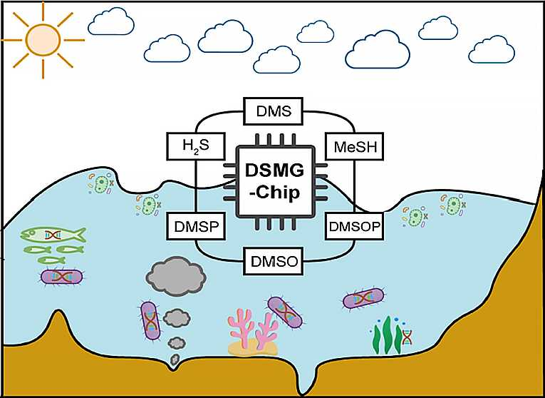
Downloaded via UNIV OF EAST ANGLIA on November 4, 2025 at 15:10:55 (UTC).
See https://pubs.acs.org/sharingguidelines for options on how to legitimately share published articles.

ACCESS
Metrics & More
Article Recommendations
sı Supporting Information
ABSTRACT: The organosulfur cycle involves active microbial transformations of dimethylsulfoniopropionate (DMSP) to yield the climate active gas dimethyl sulfide (DMS) and other compounds. The lack of rapid and accurate methods to quantify the DMSP metabolic potential hinders a deeper understanding of this cycling. We developed a high-throughput qPCR (HT-qPCR) chip, DSMG-chip, to quantify the absolute abundance of DMSP and related organic sulfur metabolic genes. DSMG-chip contains 42 degenerate primer sets targeting 27 organosulfur metabolic genes, with the 16S rRNA gene as a reference, allowing for the detection of 41 environmental samples simultaneously. In silico analysis indicated that the DSMG-chip possesses broad taxonomic coverage (1.4-91.3%, spanning 12 phyla and 275 genera) and high specificity (44.4-100%, mean: 85.34%). Validation experiments using conventional PCR, qPCR, and HT-qPCR confirmed the primers’ strict specificity, robust amplification efficiency (0.677 to 0.997,
mean: 0.771), and excellent accuracy, correlating well with conventional qPCR (Pearson’s r = 0.914). Finally, application of the DSMG-chip accurately reflected variations in DMSP metabolism across diverse seawater and sediment samples, highlighting the active microbial DMSP cycling in Pacific Ocean (section P) seawater and the contribution of the methanethiol (MeSH) methylation pathway (via mddA) in sediments. Our findings provide a powerful, novel tool for studying the organosulfur cycle.
KEYWORDS: DSMG-Chip, DMSP/DMS, organic sulfur cycling, high-throughput qPCR, microbial cycling

1. INTRODUCTION
Dimethylsulfoniopropionate (DMSP) is one of Earth’s most abundant organic sulfur compounds, found throughout marine as well as terrestrial environments.^{1,2} Marine algae (e.g., Emiliania huxleyi), bacteria (e.g., Roseobacter), corals (e.g., Symbiodinum, a coral symbiotic alga), and plants (e.g., Spartina alterniflora) can produce DMSP from methionine (Met) via three distinct pathways: methylation, transamination, and decarboxylation.^{3,4} Diverse S-methyltransferase enzymes involved in DMSP synthesis have been identified in bacteria (DsyB, DsyG, DsyGD, and MmtN) and algae and corals (DSYB, TpMMT, and DsyE).⁵ Within organisms, DMSP has reported functions as an osmoprotectant,^{6,7} antioxidant,^{8,9} cryoprotectant,¹⁰ predator deterrent,¹¹ and hydrostatic pres- 12
sure protectant.
Importantly, DMSP is estimated to constitute 3.8 Pg C a⁻¹ or 2.0 Pg S a⁻¹, and its catabolism provides a significant source of reduced carbon and sulfur for heterotrophic bacteria.¹³ DMSP can be cleaved to dimethylsulfide (DMS) plus C₃ coproducts via diverse DMSP lyase enzymes in bacteria and fungi (ddd gene products) or algae and corals (Alma gene products).¹⁴⁻²² DMSP cleavage can be utilized for carbon assimilation and/or in signaling to attract or ward off 23
organisms Currently, 9 distinct Ddd and diverse Alma-family
lyases have been identified, and these span 5 different protein families.^{14,15,17-22,24,25} The major DMSP catabolic pathway in marine environments is demethylation, driven by the bacterial DMSP demethylase enzyme DmdA,^{26,27} which is predicted to account for ∼80% of marine DMSP catabolism.^{26,28} DMSP demethylation can yield methanethiol (MeSH) and is utilized for the assimilation of carbon and sulfur from DMSP. Notably, DMSP catabolism is a major source of DMS and MeSH, which are climate-cooling gases and contribute to aerosol formation and climate regulation.²³
The ubiquitous amino acid Met can be converted into MeSH via the Met gamma lyase enzyme MegL.^{24,29} Furthermore, DMS can be produced from H₂S, often abundant in sediment environments due to sulfate reducing respiration, and MeSH, via diverse S-methylating Mdd enzymes, which are widespread in marine (predominantly mddH) and terrestrial
Received: August 6, 2025
Revised: October 24, 2025
Accepted: October 27, 2025
© XXXX The Authors. Published by
American Chemical Society
A
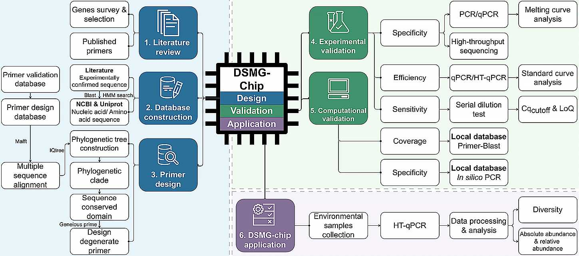
Figure 2. Flowchart of major steps in the development of the DSMG-chip including design validation and application modules.
(predominantly mddA) bacteria and environments.^{24,30} Dimethyl sulfoxide (DMSO) also undergoes enzymatic interconversion with DMS through redox processes³¹ driven by the DdhA, DsoB, Tmm, DorA, and DsmA enzymes.³²⁻³⁶ DMSO has also been shown to be generated via cleavage of a recently reported organic sulfur compound, dimethylsulfoxonium propionate (DMSOP), by DMSP lyase enzymes.³⁷ Together, this complex network of microbially driven transformations constitutes organosulfur cycling related to DMSP (Figure 1) and profoundly influences the global sulfur cycle and climate.
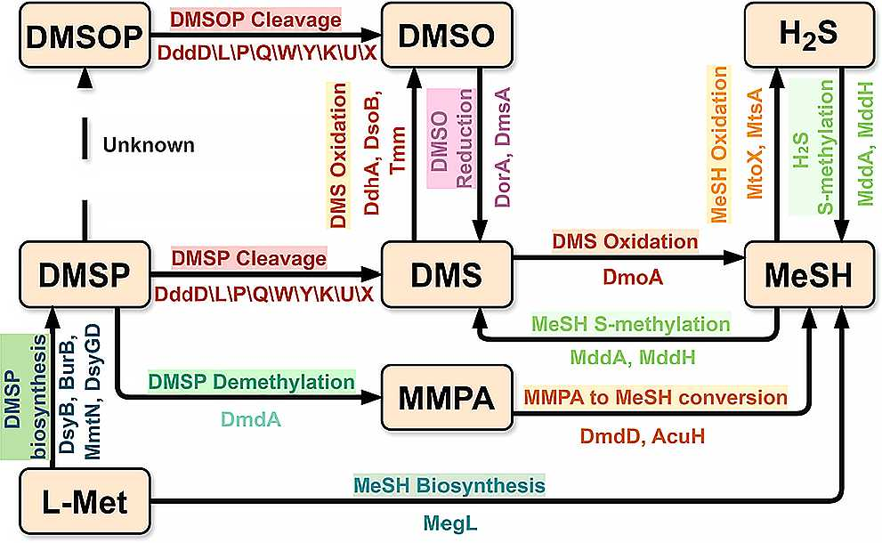
Figure 1. Key metabolic pathways and their catalytic enzymes in organosulfur compound metabolism. All genes were included in the DSMG-chip design.

Given the importance of DMSP and related cycling in marine environments, the microbial metabolic potential to conduct these processes has been extensively investigated. A suite of molecular tools, including traditional gene probing and modern multiomics approaches like metagenomics and metatranscriptomics, has been applied to samples from diverse environments such as nearshore waters and deep-sea trenches, revealing considerable spatial variations in gene diversity and relative abundance. While powerful, these methods often present a trade-off between throughput and the ability to provide absolute quantification, highlighting the need for a more integrated approach.³⁸⁻⁴¹ Most gene probing studies use quantitative PCR (qPCR), which can achieve absolute gene quantification, but its utility is constrained by low sample throughput and batch-to-batch variation. Furthermore, published gene probing work to date rarely uses primer sets for more than one step of DMSP cycling, mainly DMSP synthesis via dsyB or mmtN or DMSP catabolism via dmdA or dddP.⁴²⁻⁴⁴ More importantly, for many newly discovered and highly diverse organic sulfur metabolic genes, traditional specific primers fail to provide comprehensive coverage. The use of degenerate primers with broad coverage and high specificity, therefore, offers a pivotal approach for their quantitative detection. However, such degenerate primer sets for many key genes are still lacking, which prevents the accurate quantification of these important functional genes via traditional qPCR methods. By comparison, metagenomics and metatranscriptomics do consider all DMSP-related genes but are costly, time-consuming, involve complex bioinformatic pipelines, and heavily rely on sequencing depth and the abundance of the genes in question. These factors can make such multiomics unsuitable for the rapid screening of multiple samples and absolute quantification. Thus, there is a pressing need for a method to quickly and robustly profile microbial DMSP and related organic sulfur metabolic potentials across diverse marine environments. High-throughput qPCR (HT- qPCR) coupled with high-coverage degenerate primers targeting key genes may offer an effective solution.
HT-qPCR simultaneously performs thousands of independent qPCR reactions in a nanoliter-scale system, enabling the synchronous, rapid, and precise absolute quantification of hundreds of functional genes.⁴⁵ Owing to its high throughput, low cost, and high sensitivity, HT-qPCR has been used in the fields of biogeochemical cycling,^{46,47} antimicrobial resistance,⁴⁸ and environmental contamination.^{49,50} To advance the application of high-throughput quantitative PCR (HT-qPCR) in marine organic sulfur cycle research, we developed a novel HT-qPCR chip, designated the DSMG-chip. This chip integrates 42 degenerate primer pairs40 newly designed and 2 previously reported setsto target 27 key functional genes. This suite of genes was selected to represent key functional markers and provide comprehensive coverage across all major known pathways of the marine DMSP cycle. Based on the Takara SmartChip Real-Time PCR system’s capacity for 5,184 simultaneous reactions,⁵¹ the DSMG-chip enables the quantitative profiling of these genes across 41 environmental samples in triplicate within a single run. The environmental relevance of this chip was validated by using diverse marine samples from various sources. The DSMG-chip will serve as a powerful tool for the rapid and accurate assessment of microbial DMSP and related organic sulfur metabolic potential in diverse environments. Its applicability extends beyond marine systems to include soil, freshwater, and wastewater, providing critical data to better understand and predict biogeochemical cycling and climate-active gas production.
- MATERIAL AND METHODS
  - Design of the DSMG-Chip. 2.1.1. Selection of Target Genes and Sequence Retrieval. An overview of the major steps for the development of DSMG-chip, including design, validation, and application modules, is depicted in Figure 2. A total of 27 candidate genes were selected for the chip, including those involved in the interconversion pathways of DMSP, DMS, MeSH, and DMSO (Figure 1 and Table 1).A Primer Validation Database was constructed as follows: published experimentally validated gene and protein sequences served as “seed sequences”. By performing BLAST searches against the NCBI nonredundant (nr) and UniProtKB protein databases with these seed sequences, homologous protein sequences exhibiting >40% identity were retrieved. Furthermore, a Hidden Markov Model (HMM) profile was constructed for each gene and used in an HMM search (HMMER v3.4).⁵⁸ Only sequences meeting an E-value cutoff of <1 × 10⁻²⁰ in the HMM search were retained for this Primer Validation Database. To optimize the database for degenerate primer design, a Primer Design Database was constructed based on the dereplicated protein sequences at a 99% identity threshold using CD-HIT (v4.8.1) from the Primer Validation Database. Only 1-3 representative sequences per species were retained, with a maximum of 400 sequences per gene. The resulting Primer Design Database comprised 7,746 amino acid sequences and corresponding 7,270 nucleotide sequences, which is publicly available at [https://github.com/zerooooooooooooooo/DSMG-Chip].
    - Degenerate Primer Design. The degenerate primers were designed based on the Primer Design Database. For each target gene, the nucleotide sequences were aligned using MAFFT (v7.526).⁵⁹ A phylogenetic tree was constructed from the alignment using iqtree (v2.0.7)⁶⁰ with 1000 bootstrap replicates. Based on the tree, sequences were grouped into different clades, and primers for each clade were designed separately. For highly conserved gene sequences, we used larger clades or the entire set of sequences as candidates for primer design. Degenerate primers were designed for the conserved domains of the aligned sequences using Geneious Prime 2023.⁶¹ Following established HT-qPCR protocols,^{43,50} we adopted the following parameters for primer design: (1) primer length of 18-35 mer; (2) melting temperature (T_{m}) of 58-62 °C (preferably 60 °C to ensure uniform annealing); (3) GC content of 40-60%; (4) maximum degeneracy of 256; and (5) amplicon length of 80-400 bp. From this process, 610 candidate degenerate primer pairs were obtained. These, together with 7 previously published primer sets, were advanced to the validation stage (Figure S1).
  - Experimental Validation of the DSMG-Chip.
    - Validation of Primer Specificity. A multitiered approach was employed to experimentally validate the specificity of all candidate primer sets. First, each primer pair was screened by a conventional polymerase chain reaction (PCR). To ensure broad template diversity and minimize sample-specific amplification biases, we used a pooled environmental DNA template. This template was prepared by combining DNA extracted from nearshore seawater and sediment samples using a phenol-chloroform protocol,⁶² with three replicate extractions quantified, pooled in equimolar amounts, and standardized as the final template. For two low-abundance target genes (burB and dsyGD), we substituted the environmental template with DNA from bacterial strains confirmed to harbor homologous genes. The quality and concentration of all extracted DNA were assessed using a NanoDrop 2000 spectrophotometer (Thermo Fisher Scientific, Waltham, MA, USA) and a Qubit 3.0 Fluorometer (Thermo Fisher Scientific, Waltham, MA, USA), respectively.
Conventional PCR was performed in 25 μL reactions containing 12.5 μL of Premix Taq (Takara Biomedical Technology, Beijing, China), 0.4 μM of each primer, and 50 ng of template DNA. The thermal cycling program consisted of an initial denaturation at 95 °C for 5 min and 30 cycles of denaturation at 94 °C for 30 s, annealing at 60 °C for 30 s, and extension at 72 °C for 60 s, followed by a final extension at 72 °C for 5 min. Amplification products were visualized by agarose gel electrophoresis, and only primer pairs yielding a single band of the expected size were subjected to further validation.
The specificity of the prescreened primer pairs was further assessed by quantitative PCR (qPCR) on an Applied Biosystems QuantStudio 5 system (Thermo Fisher Scientific, USA). The 25 μL qPCR reactions contained 12.5 μL of TB Green Fast qPCR Master Mix (2×) (Takara Biomedical Technology, Beijing, China), 0.5 μM primer, and 50 ng of template DNA. The thermal profile included an initial hold at 95 °C for 2 min, followed by 40 cycles of 95 °C for 5 s, 60 °C for 30 s, and 72 °C for 10 s. Following amplification, a melting curve analysis was performed from 60 to 95 °C with fluorescence data collected at 0.5 °C increments to confirm primer specificity.
Finally, amplicons generated from the pooled environmental DNA were purified using an EZ-10 Spin Column PCR Product Purification Kit (Sangon Biotech, Shanghai, China) and subjected to high-throughput sequencing on an Illumina HiSeq 2500 platform (Guangdong Magigene Biotechnology, Guangzhou, China). After quality filtering of the raw reads, nucleotide sequences were translated into protein sequences across all six open reading frames (ORFs). These resulting protein sequences were aligned against the curated primer design database for each respective gene, with a match confirmed if the sequence similarity was ≥80%. The specificity rate here refers to the ratio of matched amplicon sequences to the total amplicon sequences.
    - Determination of Amplification Efficiency, Sensitivity, and Accuracy. The amplification efficiency, sensitivity, and accuracy of each primer set were evaluated using standard curves generated from 10-fold serial dilutions of synthesized plasmid standards. Gene fragments corresponding to the target amplicons for each primer pair were synthesized and cloned into the pUC57 plasmid vector (Tsingke Biotechnology, Beijing, China). For conventional qPCR, each plasmid was individually diluted to 10⁹ copies/μL and then serially diluted 10-fold to 10² copies/μL to generate standard curves. For performance assessment on the high-throughput qPCR (HT- qPCR) platform, all individual plasmid standards were quantified and mixed at an equal copy number to create a composite stock solution with an initial concentration of 1 × 10⁸ copies/μL (21 ng/μL). This mixture was subsequently serially diluted 10-fold down to 10² copies/μL to generate standard curves. HT-qPCR was performed on a SmartChip
Table 1. Summary of Genes on the DSMG-Chip and Related Functions (Ν = 27)
Gene | Pathway | Function | Protein family/Superfamily | Ref
dsyB | DMSP biosynthesis | Catalyzes the methylation of 4-methylthio-2-hydroxybutyrate (MTHB) to produce 4-dimethylsulfonio-2-hydroxybutyrate (DMSHB) | DsyB/DSYB protein family | 28
burB | DMSP biosynthesis | Catalyzes the methylation of Met to produce S-methylmethionine (SMM) | S-adenosyl-L-methionine-dependent methyltransferase superfamily | 52
mmtN | DMSP biosynthesis | Catalyzes the methylation of methionine (Met) to produce S-methylmethionine (SMM) | S-adenosyl-L-methionine-dependent methyltransferase superfamily | 42
dsyGD | DMSP biosynthesis | A bifunctional enzyme; the N-terminal domain (DsyG) has MTHB S-methyltransferase activity, and the C-terminal domain (DsyD) has DMSHB decarboxylase activity | DsyG: DsyG family; DsyD: ureidoglycolate lyase family | 4
megL | MeSH biosynthesis | Catalyzes the S-methylation of MeSH and H₂S to produce DMS | Trans-sulfuration enzymes family | 29
dddD | DMSP/DMSOP cleavage | Catalyzes the cleavage of DMSP or DMSOP to produce DMS or DMSO and 3-hydroxypropionate | CoA-transferase III family | 14
dddL | DMSP/DMSOP cleavage | Catalyzes the cleavage of DMSP or DMSOP to produce DMS or DMSO and acrylate | Cupin superfamily | 15
dddP | DMSP/DMSOP cleavage | Catalyzes the cleavage of DMSP or DMSOP to produce DMS or DMSO and acrylate | M24B peptidase superfamily | 16
dddQ | DMSP/DMSOP cleavage | Catalyzes the cleavage of DMSP or DMSOP to produce DMS or DMSO and acrylate | Cupin superfamily | 18
dddW | DMSP/DMSOP cleavage | Catalyzes the cleavage of DMSP or DMSOP to produce DMS or DMSO and acrylate | Cupin superfamily | 19
dddY | DMSP/DMSOP cleavage | Catalyzes the cleavage of DMSP or DMSOP to produce DMS or DMSO and acrylate | Cupin superfamily | 17
dddK | DMSP/DMSOP cleavage | Catalyzes the cleavage of DMSP or DMSOP to produce DMS or DMSO and acrylate | Cupin superfamily | 20
dddU | DMSP/DMSOP cleavage | Catalyzes the cleavage of DMSP or DMSOP to produce DMS or DMSO and acrylate | Cupin superfamily | 21
dddX | DMSP/DMSOP cleavage | Catalyzes the ATP-dependent cleavage of DMSP or DMSOP to produce DMS or DMSO and acryloyl-CoA | Acyl-CoA synthetase superfamily | 22
dmdA | DMSP demethylation | Demethylates DMSP to produce methylmercaptopropionate (MMPA) | Glycine cleavage system Τ family | 27
dmdD | MMPA to MeSH conversion | Catalyzes the hydration and hydrolysis of MTA-CoA to ultimately produce MeSH | Enoyl-CoA hydratase/isomerase family | 53
acuH | MMPA to MeSH conversion | Catalyzes the hydration and hydrolysis of MTA-CoA to ultimately produce MeSH | Enoyl-CoA hydratase/isomerase family | 54
mtoX | MeSH oxidation | Catalyzes the oxidation of MeSH to formaldehyde | Selenium-binding protein family | 55
mtsA | MeSH oxidation | Mediates the transfer of a methyl group from the substrate to the cobalt cofactor of a methylated-thiol-specific corrinoid protein (MtsB) and the subsequent transfer of the methyl group from the corrinoid protein to coenzyme M | Uroporphyrinogen decarboxylase family | 56
mddA | MeSH/H₂S S- methylation | Catalyzes the S-methylation of MeSH and H2S to produce DMS | SAM-dependent methyltransferase | 24
mddH | MeSH/H₂S S- methylation | Catalyzes the S-methylation of MeSH and H2S to produce DMS | UbiE family methyltransferase | 30
dmoA | DMS oxidation | Catalyzes the oxidation of DMS to MeSH | NtaA/SnaA/DszA monooxygenase family | 57
ddhA | DMS oxidation | Catalyzes the oxidation of DMS to DMSO | Prokaryotic molybdopterin-containing oxidoreductase family | 32
dsoB | DMS oxidation | Catalyzes the oxidation of DMS to DMSO | Methane/phenol monooxygenase, hydroxylase component | 33
tmm | DMS oxidation | Catalyzes the oxidation of DMS to DMSO | FMO family | 34

Real-time PCR System (Takara Biomedical Technology, Beijing, China). Each 100 nL reaction mixture contained 1× LightCycler 480 SYBR Green I Master Mix (Roche Applied Sciences, Indianapolis, IN), 0.4 μM primer, and the serially diluted plasmid mixture (10²-10⁸ copies/μL). The amplification program was as follows: an initial denaturation at 95 °C for 5 min, followed by 40 cycles of 95 °C for 30 s, annealing at 60 °C for 30 s, and extension at 72 °C for 30 s. All reactions were performed in triplicate, with a no-template control (NTC) included in each run. A sample was recorded as positive if amplification was detected in at least two of the three technical replicates.
Linear regression analysis of the standard curves was performed using GraphPad Prism 9. The amplification efficiency (Eff) was calculated from the slope of the standard curve using the equation: Eff = 10^{(-1/slope)}-1.⁶³ The limit of quantification (LoQ) was operationally defined as the lowest plasmid concentration in the standard curve for which the technical replicates could be quantified with high reproducibility, specifically, a coefficient of variation (CV) of less than 25%. The quantification cycle cutoff (Cqcutoff) was then determined as the average Cq value corresponding to this LoQ concentration.^{46,50} The overall sensitivity of the HT-qPCR assay was assessed based on the calculated LoQ values. The accuracy of the HT-qPCR chip was evaluated by comparing its quantification results to those from a conventional qPCR platform via linear regression analysis.
    - In Silico Evaluation. The coverage of the primer sets was evaluated against the Primer Design Database for each gene. Each primer pair was aligned against its target gene database, allowing a maximum of two mismatches. Coverage was defined as the percentage of sequences in the target database that matched both the forward and reverse primers. To more accurately assess specificity, we used the larger Primer Validation Database to check the specificity, false-positive rate, and amplification overlap. The sequences matched by the primer pairs were aligned against the sequences of the target gene. A sequence with ≥80% similarity was defined as a truepositive sequence, while one with <80% similarity was considered a false-positive. The specificity and false-positive rate were calculated as follows: Specificity = true-positives/ (true-positives + false-positives); false-positive rate = false- positives/(total sequences in database - target gene sequences). For genes with multiple primer pairs, we assessed the potential for amplification overlap. If two different primer pairs amplified the same target sequence, it was counted as an overlap. The overlap rate was calculated as overlap rate = number of overlapping sequences/total number of matched sequence results.
  - Application of the DSMG-Chip to Diverse Marine Environments. To demonstrate the performance and broad applicability of DSMG-Chip, a diverse suite of environmental samples was analyzed. Detailed information on sample collection sites is provided in Table S1. The sample set was selected to ensure comprehensive coverage of marine ecosystems and included seawater samples collected from various depths in the Pacific, Atlantic, and Indian Oceans, as well as the Southern Ocean. To further challenge the chip’s performance in unique biogeochemical settings, sediment samples from extreme environments, including hydrothermal vents, cold seeps, and deep-sea trenches, were also incorporated into the analysis (Figure S2). DNA was extracted from all samples and subjected to quality control using the
Table 1. continued
methods previously described in Section 2.2 Validation of the Primer Specificity (Table S2). The HT-qPCR reaction setup, amplification program, and instrumentation were identical to those described for the standard curve analysis in Section 2.2 for the Determination of Amplification Efficiency, Sensitivity, and Accuracy.
Raw amplification data from the SmartChip Real-Time PCR System were processed to determine the quantification cycle (Cq) for each reaction. The abundance of target genes was expressed using both absolute and normalized metrics (relative abundance).
The absolute abundance (copies per gram of sediment or milliliter of seawater) of each target gene was calculated based on its respective plasmid standard curve. For normalization across samples with varying microbial biomass, a primer set targeting the 16S rRNA gene was included in the assay.⁴⁷
A comparative absolute abundance for each DSMG was also calculated to provide a normalized estimate of gene copies per 16S rRNA gene copy. This calculation followed established protocols.^{64,65} First, a relative gene copy number was calculated for each target and for the 16S rRNA gene using the following formula:
Relative Gene Copy Number = 10^{(Cqcutoff Cq)/(10/3)}
In this equation, Cq represents the quantification cycle for a specific sample, and Cqcutoff is the empirically determined optimal cutoff value for that primer pair, as established during the validation phase. The relative abundance of each DSMG was then determined by normalizing its relative copy number to that of the 16S rRNA gene. Finally, the comparative absolute abundance was calculated as
Comparative Absolute Abundance
= Relative DSMG Abundance × Absolute 16
SrRNA Gene Abundance
  - Statistical Analysis. All data calculations and integrations were performed using Microsoft Excel 2022. The frequency distribution histogram for amplification efficiency, heatmaps for relative, absolute, and comparative absolute abundances, and the bar chart for the number of detected genes were generated using GraphPad Prism 9. Nonmetric multidimensional scaling (NMDS) analysis, based on the absolute abundance of DSMGs, was conducted using the vegan package in R, and the results were visualized with the ggplot2 package. Permutational multivariate analysis of variance (PERMANOVA) was used to test for significant differences among the sample groups. The standard curve box plot, sampling site depth plot, and accuracy scatter plot were generated by using Origin 2022. The workflow diagram was created by using IODraw.
- RESULT AND DISCUSSION
  - Degenerate Primer Design and Overview of the DSMG-Chip. To enable high-throughput and accurate quantification of key functional microorganisms in the marine DMSP and related organic sulfur cycle, degenerate primers of 27 key metabolic genes (Table 1) were designed for the DSMG-chip. We first comprehensively evaluated published degenerate primer sets targeting key organic sulfur metabolic genes such as mmtN, dddP, dmdA, and mtoX.^{42-44,55} However, the majority of existing primers were suboptimal, with issues
F
including primer-dimer formation and nonspecific amplification. Additionally, the annealing temperatures of several primer pairs were incompatible with the uniform cycling conditions required for the DSMG-Chip. Consequently, with the exception of the dsyB gene,²⁸ primers for all other targets were designed de novo and rigorously validated in this study.
Recognizing that the high sequence diversity of functional genes in environmental samples poses a significant challenge, we utilized a degenerate primer strategy to enhance detection breadth, addressing a common bottleneck in previous HT- qPCR studies.⁶⁶ The constructed Primer Design Database contained 7,746 amino acid sequences and 7,270 corresponding nucleotide sequences, covering representative sequences of organic sulfur metabolic genes. We initially obtained 610 candidate degenerate primer pairs in total, and after rigorous multistage validation, 41 primer pairs meeting all established criteria were ultimately selected (Figure S1) with a previously reported primer set for the 16S rRNA gene⁴⁷ used as a reference gene. For genes with relatively conserved sequences, 16 universal primer sets were designed. For highly variable genes, such as dmdA and mddH, specific primers were designed to delineate distinct evolutionary clades, resulting in 26 groupspecific primer sets that enhanced detection coverage for these more diverse gene families. Ultimately, among the 41 primer sets for DSMGs on the DSMG-chip, 39 are newly designed degenerate primers, and one is a new specific primer set for dsyGD. The amplicon sizes generated by all primer sets range from 85 to 398 bp, a length well-suited for efficient qPCR amplification (Table S3).
  - In Silico Evaluation of Coverage and Specificity. The performance of these 42 primers was first assessed through an in silico evaluation of their coverage. Based on the Primer Design Database containing over 7,000 sequences, the 41 functional gene primer sets on the DSMG-chip achieved a theoretical total coverage of approximately 30.18%, with each individual primer set coverage ranging from 1.4% to 91.3% (Table S4). These primers targeted bacteria and archaea from 12 phyla, 18 classes, 43 orders, 88 families, and 275 genera; 96.6% of the targeted sequences belonged to Bacteria, primarily comprising Alphaproteobacteria (64.6%), Gammaproteobacteria (21.0%), Actinomycetes (7.5%), and Betaproteobacteria (1.3%). Those archaea were mainly Methanobac- teriota (1.1%).
The low coverage for certain genes, such as burB (6.9%), dsyGD (1.41%), dddW (5.95%), and dddX (9.86%), is mainly due to the fact that only diverse and representative sequences were retained in our Primer Design Database. Additionally, our primers were primarily designed to target the functionally validated phylogenetic clade rather than all sequences in the database, particularly those that are highly divergent and lack extensive conserved regions. Notably, the coverage estimated from our primer design database may not reflect the actual natural abundance of these genes in the environment. Despite the low calculated coverage for these specific, highly variable genes, the DSMG-chip primer sets collectively offer sufficient and robust taxonomic coverage to support a comprehensive assessment of DMSP cycling genes. To validate primer specificity, a more rigorous in silico analysis was conducted against an expanded Primer Validation Database of 30,137 sequences. The results demonstrated that the specificity of these primers ranged from 38.9% to 100%, with an average of 85.34% (Table S4). Although the primer sets demonstrate high specificity overall, it should be noted that the primers for dddD, https://doi.org/10.1021/acs.est.5c10820 Environ. Sci. Technol. XXXX, XXX, XXX-XXX
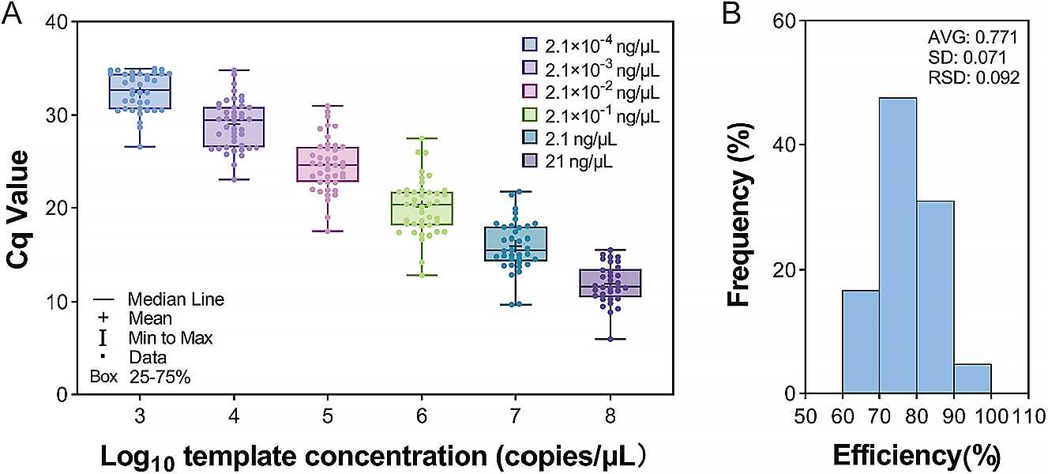
Figure 3. Performance validation of DSMG-chip. (A) DSMG-chip sensitivity (serial dilution test) with 42 primers as evaluated by 10-fold serial dilution of mixed positive plasmid controls. Plasmid DNA concentrations are indicated on upper right. (B) Distribution of amplification efficiency of mixed plasmid target genes on the DSMG-chip (n = 42). AVG: average value; SD: standard deviation; RSD: relative standard deviation.
dddW, and dddY exhibited relatively low specificity, ranging from 38.9% to 48.7%. The ddd gene belongs to the vast cupin superfamily, which makes it difficult to precisely identify the specific ddd type and increases the false positive rate. In addition to these aforementioned genes, over 80% of the primer sets exhibited a false-positive rate of ≤0.03%, confirming the robust specificity of the DSMG-chip primers. We also examined the overlap rates of 26 group-specific primers for 12 genes; for five of these, overlap rates ranged from 9.72% to 26.03% (Table S4). Among them, the overlap rate for two highly abundant genes, acuH and dmdD, exceeded 25%, due to their high sequence similarity between different clades. These primers with overlap may induce quantification biases, and the results for these genes should be interpreted with caution.
  - Experimental Verification of Primer Specificity. The specificity of all primers in the DSMG-chip was examined through PCR, qPCR, and amplicon sequencing. In the PCR with the pooled environmental DNA, all 41 functional gene primer pairs amplified a single band of the correct size on agarose gel electrophoresis. In qPCR, melting curve analyses revealed that all DSMG-chip primer sets produced a single peak (Figure S3). Finally, amplicon sequencing with the degenerate primers (n = 39) indicated an average specificity rate of 82.09% ± 12.6%, and those from 22 primer sets exhibited 100% specificity rate. Collectively, these results demonstrate that the DSMG-chip maintains high specificity with these degenerate primers, which is crucial for precisely quantifying the absolute abundance of organic sulfur metabolic genes in environmental samples.
  - Amplification Efficiency, Sensitivity, and Accuracy of the DSMG-Chip. The amplification efficiency and sensitivity of the DSMG-chip were evaluated using standard curves generated from serially diluted plasmid standards. First, qPCR was performed using single plasmids (n = 41). The results showed that for plasmid concentrations ranging from 10² to 10⁹ copies/μL, the corresponding Cq values were between 38 and 2 (Table S5). This indicates that all qPCR assays produced true-positive signals with specific amplification within this template concentration range, confirming their suitability for subsequent HT-qPCR validation. The amplification efficiencies for these primers ranged from 0.689 to 1.072 (0.878 ± 0.103) (Figure S4), representing a reasonable amplification efficiency range for degenerate primers.^{67,68} To validate the amplification efficiency of the DSMG-chip, mixed
G
plasmid standards (n = 42) were tested using HT-qPCR (Table S6), and the results demonstrated a strong linear correlation between template concentrations (from 10³ to 10⁸ copies/μL) and their corresponding Cq values (Figure 3A). Based on these standard curves, the calculated PCR efficiency of the DSMG-chip ranged from 0.677 to 0.997 (0.771 ± 0.071). The average R² coefficient for the standard curves was 0.997 (Figures 3B and S5). Compared to reported efficiencies of standard HT-qPCR degenerate primers (hgcAB: 60-90%;⁶⁹ nif H: ∼70%⁷⁰) in other biogeochemical studies, the DSMG- chip primers demonstrated comparable PCR efficiency, indicating its robust amplification performance.
Notably, single plasmids showed higher amplification efficiency (on average, 10% higher) than mixed plasmid pools, likely due to competitive binding in complex templates, where nontarget DNA reduces primer-template interactions⁷¹ and mismatched amplifications outcompete perfect matches.⁷² Despite the lower efficiency, mixed plasmids better simulate the performance of DSMG-chip on complex environmental samples.
The optimal cutoff and the limit of quantification (LoQ) were determined from the standard curves (Table S8). The optimal Cq cutoff values for the DSMG-chip primer sets were between 30 and 35. The LoQ ranged from 472 to 1236 copies (average: 859), indicating that the DSMG-chip possesses sufficiently high sensitivity for reliable quantification. To assess its accuracy, we compared the Cq values obtained from conventional qPCR and HT-qPCR. The Cq values from the two methods showed a significant positive correlation (Pearson’s r = 0.914, p < 0.001), with a linear regression slope of 0.93, demonstrating the high reliability and accuracy of the DSMG-chip (Figure 4). Furthermore, this robustness was confirmed at the individual assay level. As detailed in Supplementary Table S7, all 41 primer sets showed a strong and statistically significant positive correlation between the two platforms (Pearson’s r ranging from 0.987 to 0.999, all p < 0.001).
  - Application of the DSMG-Chip on Marine Samples. To evaluate the performance of DSMG-Chip on environmental samples, we tested it with 29 seawater and 26 sediment samples from diverse marine conditions (Figure S2 and Table S1).
All 27 DMSP and related organic sulfur metabolic genes in the DSMG-chip were detected in at least one sample. In seawater samples, the number of genes detected ranged from 1
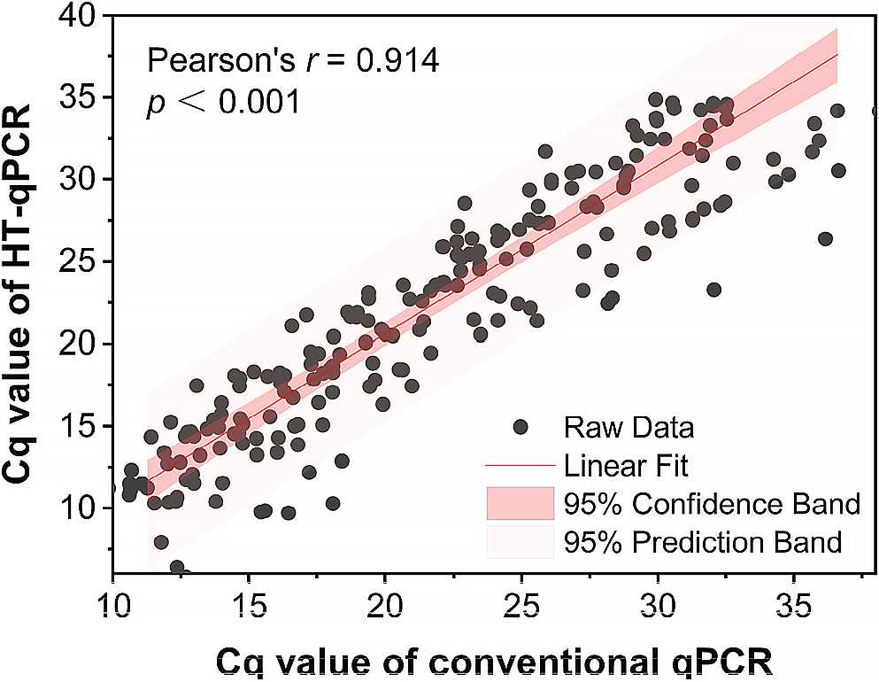
Figure 4. Correlation of cycle quantification (Cq) values between the DSMG-chip and conventional qPCR. The analysis, based on 41 primers, was performed using a Pearson correlation (r = 0.914, p < 0.001).

(at 2000 m depth, station D2, Pacific Ocean) to 23 (in nearshore surface water, Qingdao, Yellow Sea), with ≥15 genes detected in 80% of the samples (Figure S6A). In sediment samples, the number of genes detected varied from 6 (in both surface and 99 cm deep sediments of the Mariana Trench) to 24 (in surface sediment at the Haima cold seep, Tub station), with ≥11 genes detected in 80% of the samples (Figure S6B).
The gene-centric NMDS analysis (Figure 5A) revealed clear associations among functional modules of the organic sulfur cycle. dsyGD and burB clustered distantly from all other targeted genes, possibly due to their extremely low abundance in marine samples.^{4,52} The sample-centric NMDS analysis (Figure 5B) highlighted differences in organic sulfur cycling patterns across various marine environments. Sediment samples from extreme environments, such as the MT trench, hydrothermal vent, and cold seep, formed a distinct cluster, clearly separated from seawater samples. These results confirm that the DSMG-chip effectively discriminates variations in the organic sulfur metabolic gene profile of complex microbial communities.
    - DMSP Cycling in Seawater Revealed by DSMG- Chip. In the water column (Figure 6 A-E), genes associated with DMSP cleavage, DMSP demethylation, Mdd pathways, and DMS oxidation exhibited relatively high abundance, with generally higher relative abundance in seawater than in sediments (except for mddA). Among DMSP cleavage genes in seawater, dddP and dddQ showed the highest relative abundance, a finding that aligns with previous studies identifying dddP as the predominant DMSP cleavage gene in marine environments.^{9,73} Interestingly, our results challenge the widely held view that DMSP demethylation mediated by dmdA is the dominant degradation pathway across all marine 74 75
surface waters. , This pattern was observed only in samples from section P of the Pacific Ocean. In other samples, the relative abundance of dmdA was not higher than that of ddd genes. The section P samples were a clear metabolic hotspot. They not only had high dmdA but also exhibited unusually high relative abundance levels of dsyB (5.74% ± 0.03), a value far exceeding the 0.5%-1.18% range reported previ- ously.^{12,40,73,76} Notably, the relative abundances of mddH (DMS production) and dsoB (DMS oxidation) were also enhanced in these section P samples. This concurrent elevation across synthesis, demethylation, and oxidation pathways implies that the entire bacterial DMSP and organosulfur cycle was particularly active, possibly driven by local phenomena such as deep-nutrient upwelling and ensuing phytoplankton blooms.^{77,78}
The absolute abundances of these genes further underscored these trends. For example, the average abundance of dsyB in the surface waters (5 m) of the Pacific sections D and P was determined to be (1.98 ± 2.20) × 10⁴ copies/mL, which is higher than that reported in the surface waters of the East China Sea [(1.03-2.46) × 10³ copies/mL]^{73,79} and in the Mariana Trench (2.61 × 10² copies/mL).⁴¹ However, the key DMSP cleavage gene dddP showed lower absolute abundance

Figure 5. NMDS ordination of DSMG community structures is based on Bray-Curtis dissimilarity. The ordinations were performed on log- transformed absolute gene abundances. (A) Ordination of 27 DSMGs, showing their co-occurrence patterns across all samples (stress = 0.1458). (B) Ordination of 55 environmental samples, demonstrating distinct clustering by sample type (stress = 0.1551). The sample grouping was confirmed to be statistically significant by ANOSIM (R = 0.3798, p < 0.001).
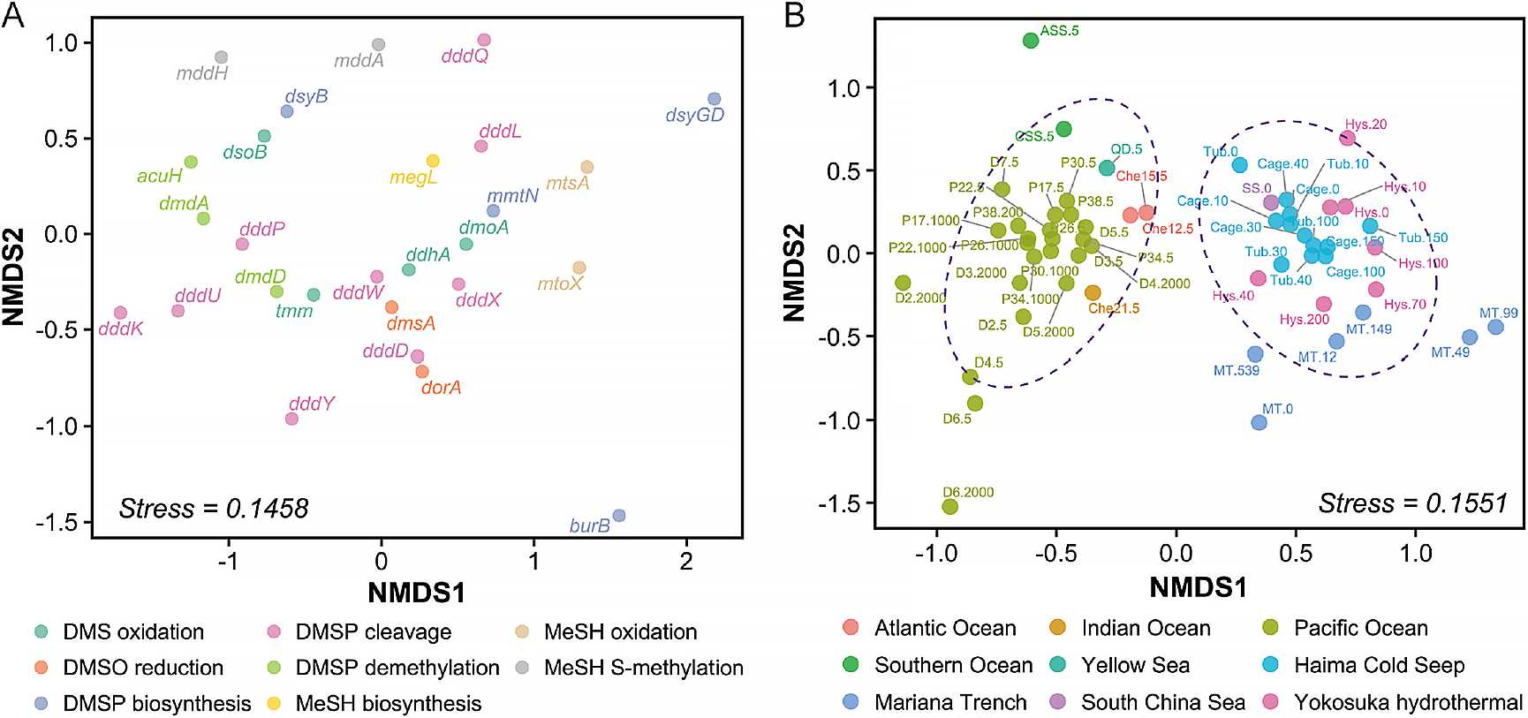

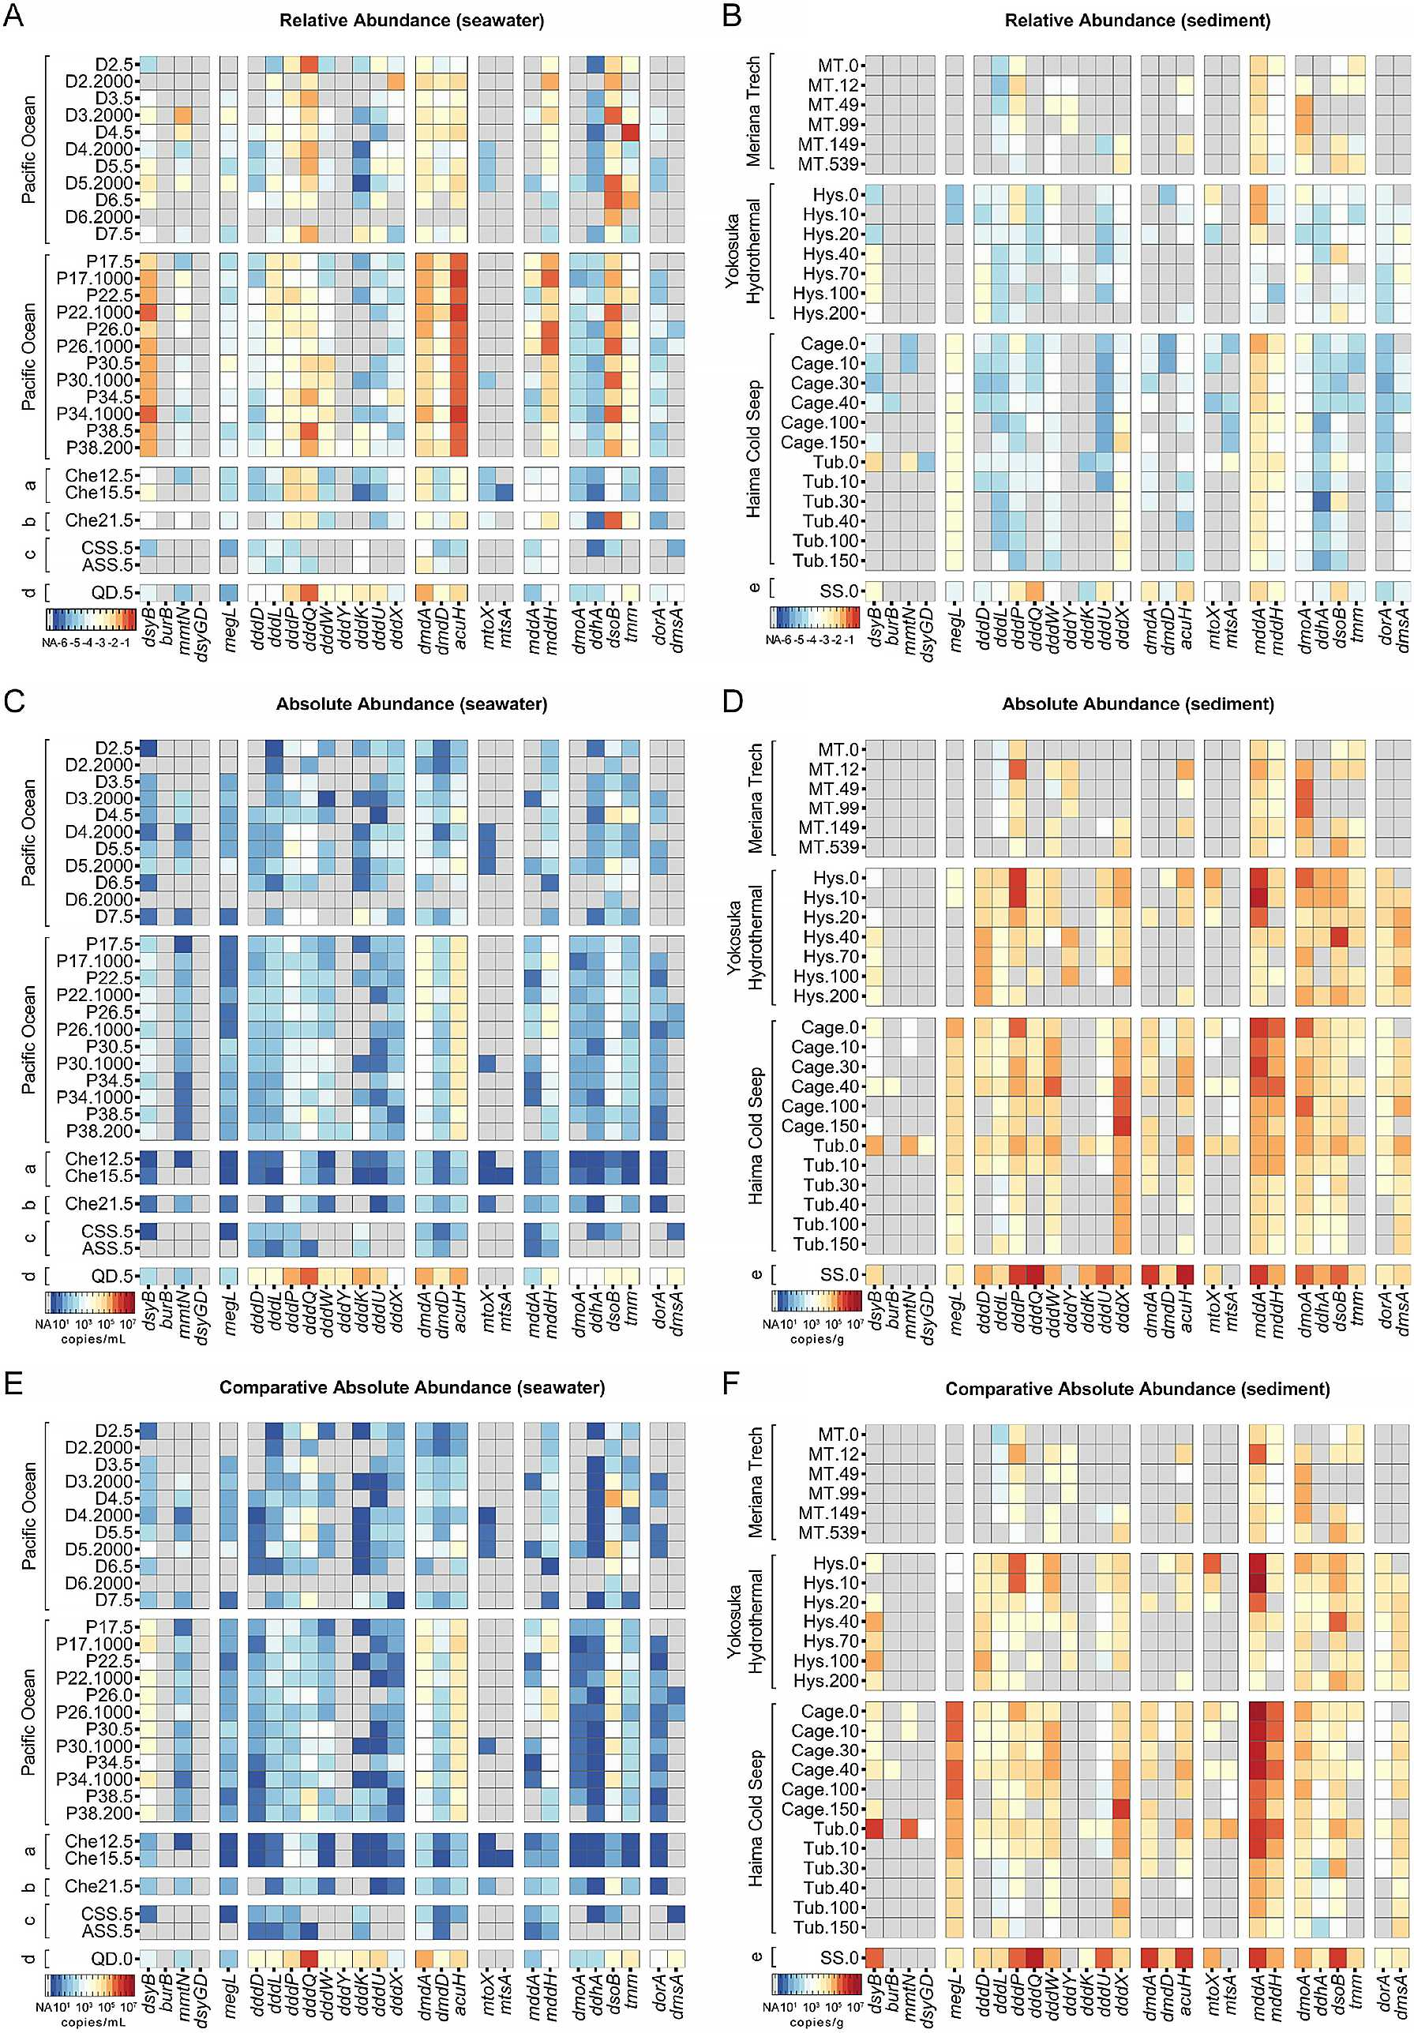
Figure 6. Abundances of DSMGs in diverse marine environmental samples. The heatmaps display the relative abundance (A,B), absolute abundance (C,D), and comparative absolute abundance (E,F) of DSMGs. Panels (A, C, and E) show results from seawater samples (in copies/ mL), while panels (B, D, and F) represent results from sediment samples (in copies/g). All abundance data were log10-transformed for visualization. Gray cells indicate that the corresponding gene was not detected (NA). Geographic regions are abbreviated as follows: (a) Atlantic Ocean, (b) Indian Ocean, (c) Southern Ocean, (d) Yellow Sea, and (e) South China Sea.
in the Pacific surface waters [(1.73 ± 0.14) × 10² copies/mL] compared to the East China Sea (10³-10⁴ copies/mL)⁷⁹ and was comparable to that found in the Mariana Trench (3.51 × 10² copies/mL).¹² Additionally, an extremely high absolute abundance of nearly all genes was observed in one nearshore sample (QD.5), which may be due to the enriched microbial biomass in the coastal environment.^{80,81} In contrast, surface waters from the pelagic ocean (Che12, Che15, Che21) and the Southern Ocean (CSS, ASS) had significantly fewer detected genes and lower absolute abundances (Wilcoxon test, p < 0.05). Except for a few DMSP biosynthesis and degradation genes, no absolute abundance data have been previously reported for most other organic sulfur metabolic genes, and our study provides the first comprehensive data set for these genes.
    - DMSP Cycling in Sediment Samples Revealed by DSMG-Chip. Overall, the absolute abundance of DMSP and related organic sulfur metabolic genes was considerably higher in sediment (copies/g) than in seawater (copies/mL) (Figure 6C,D). This finding strongly suggests that marine sediments serve as hotspots and concentrated reservoirs for microbial communities driving organic sulfur cycling, which is consistent with previous studies.^{40,73}
In contrast to seawater, sediment samples generally exhibited a distinct DMSP cycling pattern with a high abundance of the mdd genes. In sediments from extreme environments such as the Mariana Trench (MT), hydrothermal vents, and cold seeps, mddA abundance was dramatically higher (up to 3.33% ± 2.61%) than in seawater (0.07% ± 0.06%), consistent with prior research^{30,40,41} (Figure 6B and D).
This high abundance of Mdd pathway potential in such sediments is likely influenced by the high concentrations of reduced sulfur compounds in the surrounding environment, where microorganisms possessing the MeSH S-methylation pathway gain a strong survival and competitive advantage through their detoxification, yielding DMS.^{30,38} Vertical profiling in these sediments further revealed that both mddA and dddP abundances decreased with depth, with the exception of a distinct peak at 12 cm in the MT, a pattern that aligns with previous metagenomic data.⁴¹ The decreasing trend along the sediment depth for mdds and dddP was also reflected in the variations of absolute abundance. Generally, fewer organic metabolic genes were detected in the MT sediments, with lower abundance (both relative and absolute) when compared to the hydrothermal vent and cold seep. Additionally, no distinct depth-related patterns were observed for organic sulfur metabolic genes other than dddP in the MT sediments, which may be due to the slow and homogeneous sedimentation of organic detritus from the upper ocean and slow microbial metabolism under extreme pressure, resulting in a uniform distribution of these organic sulfur metabolic genes with depth.^{12,82} The South China Sea surface sediments (SS) provided a valuable contrast, representing more typical marine environments. Here, a broader diversity of 22 organosulfur metabolic genes was detected at notably high relative abundances. This suggests that while extreme environments may select for specific, highly abundant detoxification pathways, other marine sediments can support a more diverse and active organosulfur metabolome. The distinct genetic signatures between these environments imply that extreme environments may harbor unique metabolic genes and microbial taxa not yet captured by our primer sets, presenting a compelling direction for future investigation.
    - Absolute Abundance vs Comparative Absolute Abundance. To simplify the absolute quantification workflow and increase the detection throughput of the DSMG-chip, we calculated a comparative absolute abundance using the 16S rRNA gene copy number as a reference and the optimal cutoff Cq values (Figure 6E,F). The results demonstrated a strong and significant linear correlation between the comparative and standard absolute abundance data (Pearson’s r = 0.982, p < 0.001) (Figure 7), confirming that the comparative approach
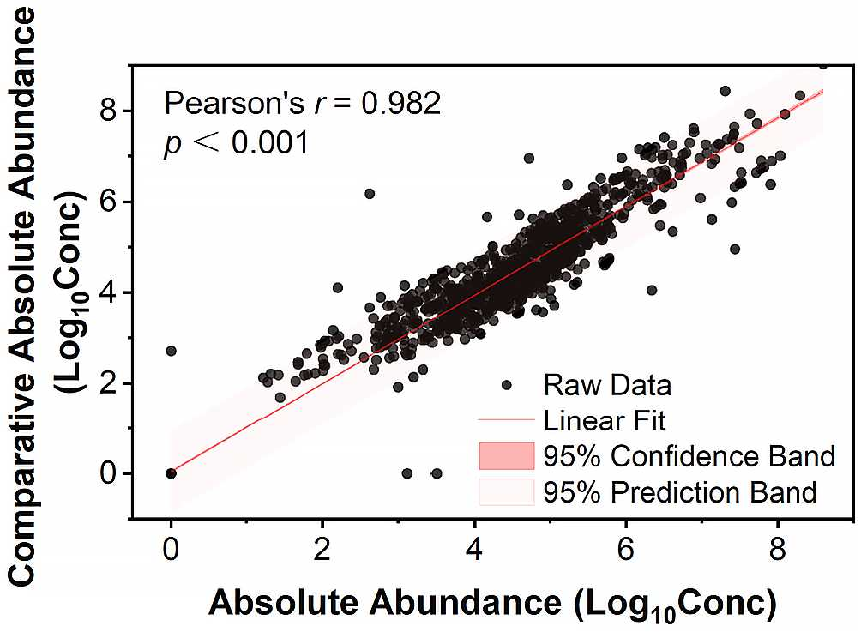
Figure 7. Correlation between absolute and comparative absolute abundances of DSMGs. A significant positive Pearson correlation was observed between the two quantification methods across all 55 environmental samples (r = 0.982, p < 0.001).

offers excellent reliability. Some discrepancies were noted; for example, the megL and mddA genes exhibited higher abundance by the comparative methods. Such inevitable discrepancies have also been reported in the development of other chips,⁴⁸ but our results demonstrate that these potential discrepancies do not substantially affect the overall interpretation of the abundance patterns and variation trends. Additionally, we calculated the comparative absolute abundance after correcting for the amplification efficiency of each primer set (Figure S7). A direct comparison between the efficiency-corrected and uncorrected results revealed that the discrepancies were minimal. This variance has a negligible impact on the final interpretation of the gene abundance profiles. Therefore, this finding validates our use of the comparative absolute abundance method, allowing us to leverage its primary advantage of high throughput for large- scale sample analysis.
    - Summary of DSMG-Chip Application and Performance. In summary, the DSMG-chip demonstrated its potential for rapid and accurate assessment of the microbial organic sulfur metabolism potential in marine samples. It provides a high-throughput solution capable of analyzing 27 DSMGs for 41 environmental samples in a single run, which takes hours instead of days, as is the case with conventional qPCR. Throughout this study, the validated novel degenerate primers can also be applied for in-depth investigations targeting specific organic sulfur metabolic pathways. A vital prerequisite for this approach is the rigorous curation of target sequences for primer design based on a core set of functionally verified genes
as “seed sequences” and a comprehensive collection of homologous sequences from public databases. This two-tiered approach ensures that our primers are anchored to experimentally confirmed functions while also providing the broad coverage necessary to accurately target active metabolic pathways rather than nonfunctional homologues. This systematic pipelinefrom comprehensive database construction and phylogenetic analysis to clade-specific degenerate primer design and high-throughput validationrepresents a robust methodological framework. Indeed, this framework is not limited to sulfur cycling and can be readily adapted as a blueprint for developing similar high-throughput quantitative tools for other key functional gene families in microbial ecology.
The DSMG-chip and its associated protocols are fully compatible with reverse transcription-qPCR (RT-qPCR), allowing for the quantification of gene expression at the RNA level. This is a critical extension, because the mere presence of a gene (genetic potential) does not guarantee its activity. By analyzing transcripts, we can gain more direct insight into the active metabolic processes occurring in situ. To achieve a truly holistic understanding, we advocate that future research should couple transcript-level analysis using this chip with direct measurements of key metabolites (e.g., DMSP and DMS) and biogeochemical rate assessments. Such a synergistic approach will bridge the gap between genetic potential, gene expression, and realized ecosystem function. However, we acknowledge that a limitation of the current validation is the reliance on plasmid standards and sequenced environmental amplicons rather than synthetic communities. Future iterations of this technology would be significantly strengthened by validation against such defined positive controls to provide ultimate proof of primer accuracy and specificity.
This method holds important implications for accurately assessing the production potential of climate-active gases in specific environments under global change scenarios. Combining DSMG-chip with other HT-qPCR chips, functional gene amplicon sequencing, and various “omics” technologies will be essential for comprehensively profiling the community structure and functional potential of marine organic sulfurmetabolizing microbes.
- ASSOCIATED CONTENT

Data Availability Statement
The Primer Design Database is deposited on GitHub at [https://github.com/zerooooooooooooooo/DSMG-Chip]. The amplicon sequencing data from the validation of primer specificity experiments are available on NCBI under the BioProject ID [PRJNA1300291].

sı Supporting Information
The Supporting Information is available free of charge at https://pubs.acs.org/doi/10.1021/acs.est.5c10820.
Supplementary tables with detailed sample data, primer information, amplification efficiency results, and the MIQE checklist (XLSX)
Supplementary figures showing the primer design flowchart, sampling sites, and chip validation results; supplementary tables for in silico assessment and LoQ; and additional gene detection data (PDF)
- AUTHOR INFORMATION

Corresponding Author
Xiao-Hua Zhang - Frontiers Science Center for Deep Ocean Multispheres and Earth System, and College 8 of Marine Life Sciences, Ocean University of China, Qingdao 266003,
China; Laboratory for Marine Ecology and Environmental Science, Qingdao Marine Science and Technology Center, Qingdao 266003, China; Key Laboratory of Evolution & Marine Biodiversity (ministry of Education), and Institute of Evolution & Marine Biodiversity, Ocean University of China, Qingdao 266003, China; orcid.org/0000-0002-7428- 7775; Email: xhzhang@ouc.edu.cn

Authors
Dong Liu - Frontiers Science Center for Deep Ocean Multispheres and Earth System, and College 8 of Marine Life Sciences, Ocean University of China, Qingdao 266003, China; Laboratory for Marine Ecology and Environmental Science, Qingdao Marine Science and Technology Center, Qingdao 266003, China; Key Laboratory of Evolution & Marine Biodiversity (ministry of Education), and Institute of Evolution & Marine Biodiversity, Ocean University of China, Qingdao 266003, China
Yunhui Zhang - Key Laboratory of Evolution & Marine Biodiversity (ministry of Education), and Institute of Evolution & Marine Biodiversity, Ocean University of China, Qingdao 266003, China
Hai Shi - Frontiers Science Center for Deep Ocean Multispheres and Earth System, and College 8 of Marine Life Sciences, Ocean University of China, Qingdao 266003, China Zihua Guo - Frontiers Science Center for Deep Ocean Multispheres and Earth System, and College 8 of Marine Life Sciences, Ocean University of China, Qingdao 266003, China Gary Rowley - School of Biological Sciences, University of East Anglia, Norwich NR4 7TJ, U.K.; Centre for Microbial Interactions, Norwich NR4 7TJ, U.K.
Jonathan D. Todd - Frontiers Science Center for Deep Ocean Multispheres and Earth System, and College 8 of Marine Life Sciences, Ocean University of China, Qingdao 266003, China; School of Biological Sciences, University of East Anglia, Norwich NR4 7TJ, U.K.; Centre for Microbial Interactions, Norwich NR4 7TJ, U.K.
Complete contact information is available at: https://pubs.acs.org/10.1021/acs.est.5c10820

Author Contributions
- D.L. and Y.Z. contributed equally to this work. X.-H.Z. conceived the study and designed experiments; D.L. performed experiments, analyzed data, drew figures, and wrote the manuscript; Y.Z. analyzed data and revised the manuscript; H.S. and Z.G. analyzed data; G.R. and J.D.T. revised the manuscript. All authors edited and approved the manuscript.

Notes
The authors declare no competing financial interest.

■ ACKNOWLEDGMENTS
This study was funded by the National Natural Science Foundation of China (32370118 and 42376101), the S & T Innovation Project of Qingdao Marine Science and Technology Center (2022QNLM030004-3), and the Fundamental Research Funds for the Central Universities (202172002 and 202541011). JDT was funded by Natural Environmental Research Council, UK, (NE/P012671) and Leverhulme trust (RPG-2020-413) grants.

■ REFERENCES
- Yoch, D. C. Dimethylsulfoniopropionate: Its sources, role in the marine food web, and biological degradation to dimethylsulfide. Appl. Environ. Microbiol. 2002, 68 (12), 5804-5815.
- Bullock, H. A.; Luo, H.; Whitman, W. B. Evolution of Dimethylsulfoniopropionate Metabolism in Marine Phytoplankton and Bacteria. Front. Microbiol. 2017, 8, 637.
- Peng, M.; Li, C.-Y.; Chen, X.-L.; Williams, B. T.; Li, K.; Gao, Y.- N.; Wang, P.; Wang, N.; Gao, C.; Zhang, S.; et al. Insights into methionine S-methylation in diverse organisms. Nat. Commun. 2022, 13 (1), 2947.
- Wang, J.; Curson, A. R. J.; Zhou, S.; Carrión, O.; Liu, J.; Vieira, A. R.; Walsham, K. S.; Monaco, S.; Li, C. -Y.; Dong, Q. -Y.; et al. Alternative dimethylsulfoniopropionate biosynthesis enzymes in diverse and abundant microorganisms. Nat. Microbiol. 2024, 9 (8), 1979-1992.
- Carrión, O.; Zhu, X.-Y.; Williams, B. T.; Wang, J.; Zhang, X.-H.; Todd, J. D. Chapter Two - Molecular discoveries in microbial DMSP synthesis. In Advances in Microbial Physiology; Poole, R. K.; Kelly, D. J., Eds.; Elsevier, 2023, Vol. 83, pp. 59-116.
- Kirst, G. O. Salinity Tolerance of Eukaryotic Marine Algae. Annu. Rev. Plant Biol. 1990, 41 (41), 21-53.
- Gregory, G. J.; Boas, K. E.; Boyd, E. F. The Organosulfur Compound Dimethylsulfoniopropionate (DMSP) Is Utilized as an Osmoprotectant by Vibrio Species. Appl. Environ. Microbiol. 2021, 87 (5), No. e02235-20.
- Sunda, W.; Kieber, D. J.; Kiene, R. P.; Huntsman, S. An antioxidant function for DMSP and DMS in marine algae. Nature 2002, 418 (6895), 317-320.
- Curson, A. R. J.; Williams, B. T.; Pinchbeck, B. J.; Sims, L. P.; Martinez, A. B.; Rivera, P. P. L.; Kumaresan, D.; Mercade, E.; Spurgin, L. G.; Carrion, O.; et al. DSYB catalyses the key step of dimethylsulfoniopropionate biosynthesis in many phytoplankton. Nat. Microbiol. 2018, 3 (4), 430-439.
- Toda, K.; Obolkin, V.; Ohira, S.-I.; Saeki, K. Abundant production of dimethylsulfoniopropionate as a cryoprotectant by freshwater phytoplanktonic dinoflagellates in ice-covered Lake Baikal. Commun. Biol. 2023, 6 (1), 1194.
- Kiene, R. P.; Linn, L. J.; Bruton, J. A. New and important roles for DMSP in marine microbial communities. J. Sea Res. 2000, 43 (34), 209-224.
- Zheng, Y.; Wang, J.; Zhou, S.; Zhang, Y.; Liu, J.; Xue, C.-X.; Williams, B. T.; Zhao, X.; Zhao, L.; Zhu, X.-Y.; et al. Bacteria are important dimethylsulfoniopropionate producers in marine aphotic and high-pressure environments. Nat. Commun. 2020, 11 (1), 4658.
- Zhang, X.-H.; Liu, J.; Liu, J.; Yang, G.; Xue, C.-X.; Curson, A. R. J.; Todd, J. D. Biogenic production of DMSP and its degradation to DMS-their roles in the global sulfur cycle. Sci. China Life Sci. 2019, 62 (10), 1296-1319.
- Todd, J. D.; Rogers, R.; Li, Y. G.; Wexler, M.; Bond, P. L.; Sun, L.; Curson, A. R. J.; Malin, G.; Steinke, M.; Johnston, A. W. B. Structural and regulatory genes required to make the gas dimethyl sulfide in bacteria. Science 2007, 315 (5812), 666-669.
- Curson, A. R.; Rogers, R.; Todd, J. D.; Brearley, C. A.; Johnston, A. W. Molecular genetic analysis of a dimethylsulfoniopropionate lyase that liberates the climate-changing gas dimethylsulfide in several marine alpha-proteobacteria and Rhodobacter sphaeroides. Environ. Microbiol. 2008, 10 (3), 757-767.
- Todd, J. D.; Curson, A. R. J.; Dupont, C. L.; Nicholson, P.; Johnston, A. W. B. The dddP gene, encoding a novel enzyme that converts dimethylsulfoniopropionate into dimethyl sulfide, is widespread in ocean metagenomes and marine bacteria and also occurs in some Ascomycete fungi. Environ. Microbiol. 2009, 11 (6), 1376-1385.
- Curson, A. R. J.; Sullivan, M. J.; Todd, J. D.; Johnston, A. W. B. DddY, a periplasmic dimethylsulfoniopropionate lyase found in taxonomically diverse species of Proteobacteria. ISME J. 2011, 5 (7), 1191-1200.
- Todd, J. D.; Curson, A. R. J.; Kirkwood, M.; Sullivan, M. J.; Green, R. T.; Johnston, A. W. B. DddQ, a novel, cupin-containing, dimethylsulfoniopropionate lyase in marine roseobacters and in uncultured marine bacteria. Environ. Microbiol. 2011, 13 (2), 427438.
- Todd, J. D.; Kirkwood, M.; Newton-Payne, S.; Johnston, A. W. B. DddW, a third DMSP lyase in a model Roseobacter marine bacterium, Ruegeria pomeroyi DSS-3. ISME J. 2012, 6 (1), 223-226. (20) Sun, J.; Todd, J. D.; Thrash, J. C.; Qian, Y.; Qian, M. C.; Temperton, B.; Guo, J.; Fowler, E. K.; Aldrich, J. T.; Nicora, C. D.; et al. The abundant marine bacterium Pelagibacter simultaneously catabolizes dimethylsulfoniopropionate to the gases dimethyl sulfide and methanethiol. Nat. Microbiol. 2016, 1 (8), 16065.
- Wang, S. Y.; Zhang, N.; Teng, Z. J.; Wang, X. D.; Todd, J. D.; Zhang, Y. Z.; Cao, H. Y.; Li, C. Y. A new dimethylsulfoniopropionate lyase of the cupin superfamily in marine bacteria. Environ. Microbiol. 2023, 25, 1238.
- Li, C.-Y.; Wang, X.-J.; Chen, X.-L.; Sheng, Q.; Zhang, S.; Wang, P.; Quareshy, M.; Rihtman, B.; Shao, X.; Gao, C.; et al. A novel ATP dependent dimethylsulfoniopropionate lyase in bacteria that releases dimethyl sulfide and acryloyl-CoA. Elife 2021, 10, 10.
- Zhang, X. H.; Liu, J.; Liu, J.; Yang, G.; Xue, C. X.; Curson, A. R. J.; Todd, J. D. Biogenic production of DMSP and its degradation to DMS-their roles in the global sulfur cycle. Sci. China Life Sci. 2019, 62 (10), 1296-1319.
- Carrion, O.; Curson, A. R. J.; Kumaresan, D.; Fu, Y.; Lang, A. S.; Mercade, E.; Todd, J. D. A novel pathway producing dimethylsulphide in bacteria is widespread in soil environments. Nat. Commun. 2015, 6, 6579.
- Alcolombri, U.; Ben-Dor, S.; Feldmesser, E.; Levin, Y.; Tawfik, D. S.; Vardi, A. Identification of the algal dimethyl sulfide-releasing enzyme: A missing link in the marine sulfur cycle. Science 2015, 348 (6242), 1466-1469.
- Howard, E. C.; Henriksen, J. R.; Buchan, A.; Reisch, C. R.; Buergmann, H.; Welsh, R.; Ye, W.; Gonzalez, J. M.; Mace, K.; Joye, S. B.; et al. Bacterial taxa that limit sulfur flux from the ocean. Science 2006, 314 (5799), 649-652.
- Reisch, C. R.; Moran, M. A.; Whitman, W. B. Dimethylsulfo- niopropionate-Dependent Demethylase (DmdA) from Pelagibacter ubique and Silicibacter pomeroyi. J. Bacteriol. 2008, 190 (24), 80188024.
- Curson, A. R. J.; Liu, J.; Martinez, A. B.; Green, R. T.; Chan, Y.; Carrion, O.; Williams, B. T.; Zhang, S.-H.; Yang, G.-P.; Page, P. C. B.; et al. Dimethylsulfoniopropionate biosynthesis in marine bacteria and identification of the key gene in this process. Nat. Microbiol. 2017, 2 (5), 17009.
- Fukamachi, H.; Nakano, Y.; Okano, S.; Shibata, Y.; Abiko, Y.; Yamashita, Y. High production of methyl mercaptan by L-methionine- alpha-deamino-gamma-mercaptomethane lyase from Treponema denticola. Biochem. Biophys. Res. Commun. 2005, 331 (1), 127-131.
- Zhang, Y.; Sun, C.; Guo, Z.; Liu, L.; Zhang, X.; Sun, K.; Zheng, Y.; Gates, A. J.; Todd, J. D.; Zhang, X. H. An S-methyltransferase that produces the climate-active gas dimethylsulfide is widespread across diverse marine bacteria. Nat. Microbiol. 2024, 9 (10), 2614-2625.
- Tebbe, D. A.; Gruender, C.; Dlugosch, L.; Lohmus, K.; Rolfes, S.; Konneke, M.; Chen, Y.; Engelen, B.; Schafer, H. Microbial drivers of DMSO reduction and DMS-dependent methanogenesis in saltmarsh sediments. ISME J. 2023, 17 (12), 2340-2351.
- McDevitt, C. A.; Hugenholtz, P.; Hanson, G. R.; McEwan, A. G. Molecular analysis of dimethyl sulphide dehydrogenase from Rhodovulum sulfidophilum: Its place in the dimethyl sulfoxide reductase family of microbial molybdopterin-containing enzymes. Mol. Microbiol. 2002, 44 (6), 1575-1587.
- Horinouchi, M.; Kasuga, K.; Nojiri, H.; Yamane, H.; Omori, T. Cloning and characterization of genes encoding an enzyme which oxidizes dimethyl sulfide in Acinetobacter sp. strain 20B. FEMS Microbiol. Lett. 1997, 155 (1), 99-105.
- Chen, Y.; Patel, N. A.; Crombie, A.; Scrivens, J. H.; Murrell, J. C. Bacterial flavin-containing monooxygenase is trimethylamine monooxygenase. Proc. Natl. Acad. Sci. U. S. A. 2011, 108 (43), 17791-17796.
- Satoh, T.; Kurihara, F. N. Purification and Properties of Dimethylsulfoxide Reductase Containing a Molybdenum Cofactor from a Photodenitrifier, Rhodopseudomonas sphaeroides f.s. deni- trificans. J. Biochem. 1987, 102 (1), 191-197.
- Müller, J. A.; DasSarma, S. Genomic analysis of anaerobic respiration in the archaeon Halobacterium sp. strain NRC-1: Dimethyl sulfoxide and trimethylamine N-oxide as terminal electron acceptors. J. Bacteriol. 2005, 187 (5), 1659-1667.
- Carrión, O.; Li, C. Y.; Peng, M.; Wang, J.; Pohnert, G.; Azizah, M.; Zhu, X. Y.; Curson, A. R. J.; Wang, Q.; Walsham, K. S.; et al. DMSOP-cleaving enzymes are diverse and widely distributed in marine microorganisms. Nat. Microbiol. 2023, 8 (12), 2326-2337.
- Li, C. Y.; Cao, H. Y.; Wang, Q.; Carrión, O.; Zhu, X.; Miao, J.; Wang, P.; Chen, X. L.; Todd, J. D.; Zhang, Y. Z. Aerobic methylation of hydrogen sulfide to dimethylsulfide in diverse microorganisms and environments. ISME J. 2023, 17 (8), 1184-1193.
- Su, Y.; Yang, Y.; Zhu, X. Y.; Zhang, X. H.; Yu, M. Metagenomic Insights Into the Microbial Assemblage Capable of Quorum Sensing and Quorum Quenching in Particulate Organic Matter in the Yellow Sea. Front. Microbiol. 2021, 11, 602010.
- Song, D.; Zhang, Y.; Liu, J.; Zhong, H.; Zheng, Y.; Zhou, S.; Yu, M.; Todd, J. D.; Zhang, X.-H. Metagenomic Insights Into the Cycling of Dimethylsulfoniopropionate and Related Molecules in the Eastern China Marginal Seas. Front. Microbiol. 2020, 11, 11.
- Cheng, H.; Zhang, Y.; Guo, Z.; He, X.; Liu, R.; Zhu, X. Y.; Li, J.; Liu, J.; Zhang, X. H. Microbial Dimethylsulfoniopropionate Cycling in Deep Sediment of the Mariana Trench. Appl. Environ. Microbiol. 2023, 89 (7), No. e0025123.
- Williams, B. T.; Cowles, K.; Martinez, A. B.; Curson, A. R. J.; Zheng, Y.; Liu, J.; Newton-Payne, S.; Hind, A. J.; Li, C.-Y.; Rivera, P. P. L.; et al. Bacteria are important dimethylsulfoniopropionate producers in coastal sediments. Nat. Microbiol. 2019, 4 (11), 18151825.
- Varaljay, V. A.; Howard, E. C.; Sun, S.; Moran, M. A. Deep Sequencing of a Dimethylsulfoniopropionate-Degrading Gene (dmdA) by Using PCR Primer Pairs Designed on the Basis of Marine Metagenomic Data. Appl. Environ. Microbiol. 2010, 76 (2), 609-617.
- Liu, J.; Liu, J.; Zhang, S.-H.; Liang, J.; Lin, H.; Song, D.; Yang, G.-P.; Todd, J. D.; Zhang, X.-H. Novel Insights Into Bacterial Dimethylsulfoniopropionate Catabolism in the East China Sea. Front. Microbiol. 2018, 9, 3206.
- Wang, F.-H.; Qiao, M.; Su, J.-Q.; Chen, Z.; Zhou, X.; Zhu, Y.- G. High Throughput Profiling of Antibiotic Resistance Genes in Urban Park Soils with Reclaimed Water Irrigation. Environ. Sci. Technol. 2014, 48 (16), 9079-9085.
- Zhao, Y.; Su, J. Q.; Ye, J.; Rensing, C.; Tardif, S.; Zhu, Y. G.; Brandt, K. K. AsChip: A High-Throughput qPCR Chip for Comprehensive Profiling of Genes Linked to Microbial Cycling of Arsenic. Environ. Sci. Technol. 2019, 53 (2), 798-807.
- Zheng, B.; Zhu, Y.; Sardans, J.; Peñuelas, J.; Su, J. QMEC: A tool for high-throughput quantitative assessment of microbial functional potential in C, N, P, and S biogeochemical cycling. Sci. China Life Sci. 2018, 61 (12), 1451-1462.
- Xie, S. -T.; Ding, L. J.; Huang, F. -Y.; Zhao, Y.; An, X. L.; Su, J. -Q.; Sun, G. -X.; Song, Y. -Q.; Zhu, Y. -G. VFG-Chip: A high- throughput qPCR microarray for profiling virulence factor genes from the environment. Environ. Int. 2023, 172, 107761.
- Tuo, J.; Shen, Y.; Jia, S.; Liu, S.; Zhang, Q.; Wang, D.; He, X.; Liu, P.; Zhang, X.-X. HPB-Chip: An accurate high-throughput qPCR- based tool for rapidly profiling waterborne human pathogenic bacteria in the environment. Water Res. 2024, 260, 121927.
- Zhu, J.; Huang, Q.; Peng, X.; Zhou, X.; Gao, S.; Li, Y.; Luo, X.; Zhao, Y.; Rensing, C.; Su, J.; et al. MRG Chip: A High-Throughput qPCR-Based Tool for Assessment of the Heavy Metal(loid) Resistome. Environ. Sci. Technol. 2022, 56 (15), 10656-10667.
- Li, H.-Q.; Xu, M.-R.; An, X.-L.; Liao, H.; Li, L.-J.; Li, W.; Su, J.-
Q. High-risk ARGs (HRA) Chip: A high-throughput qPCR-based array for assessment of high-risk ARGs from the environment. Water Res. 2024, 262, 122106.
- Trottmann, F.; Ishida, K.; Franke, J.; Stanisǐ c,́ A.; Ishida-Ito, M.; Kries, H.; Pohnert, G.; Hertweck, C. Sulfonium Acids Loaded onto an Unusual Thiotemplate Assembly Line Construct the Cyclopropanol Warhead of a Burkholderia Virulence Factor. Angew. Chem., Int. Ed. 2020, 59 (32), 13511-13515.
- Reisch, C. R.; Stoudemayer, M. J.; Varaljay, V. A.; Amster, I. J.; Moran, M. A.; Whitman, W. B. Novel pathway for assimilation of dimethylsulphoniopropionate widespread in marine bacteria. Nature 2011, 473 (7346), 208-211.
- Todd, J. D.; Curson, A. R. J.; Nikolaidou-Katsaraidou, N.; Brearley, C. A.; Watmough, N. J.; Chan, Y.; Page, P. C. B.; Sun, L.; Johnston, A. W. B. Molecular dissection of bacterial acrylate catabolism - unexpected links with dimethylsulfoniopropionate catabolism and dimethyl sulfide production. Environ. Microbiol. 2010, 12 (2), 327-343.
- Eyice, O.; Myronova, N.; Pol, A.; Carrion, O.; Todd, J. D.; Smith, T. J.; Gurman, S. J.; Cuthbertson, A.; Mazard, S.; Mennink- Kersten, M. A. S. H.; et al. Bacterial SBP56 identified as a Cu- dependent methanethiol oxidase widely distributed in the biosphere. ISME J. 2018, 12 (1), 145-160.
- Paul, L.; Krzycki, J. A. Sequence and transcript analysis of a novel Methanosarcina barkeri methyltransferase II homolog and its associated corrinoid protein homologous to methionine synthase. J. Bacteriol. 1996, 178 (22), 6599-6607.
- Boden, R.; Borodina, E.; Wood, A. P.; Kelly, D. P.; Murrell, J. C.; Schäfer, H. Purification and characterization of dimethylsulfide monooxygenase from Hyphomicrobium sulfonivorans. J. Bacteriol. 2011, 193 (5), 1250-1258.
- Finn, R. D.; Clements, J.; Eddy, S. R. HMMER web server: Interactive sequence similarity searching. Nucleic Acids Res. 2011, 39 (Web Server issue), W29-W37.
- Katoh, K.; Misawa, K.; Kuma, K.; Miyata, T. MAFFT: A novel method for rapid multiple sequence alignment based on fast Fourier transform. Nucleic Acids Res. 2002, 30 (14), 3059-3066.
- Minh, B. Q.; Schmidt, H. A.; Chernomor, O.; Schrempf, D.; Woodhams, M. D.; von Haeseler, A.; Lanfear, R. IQ-TREE 2: New Models and Efficient Methods for Phylogenetic Inference in the Genomic Era. Mol. Biol. Evol. 2020, 37 (5), 1530-1534.
- Kearse, M.; Moir, R.; Wilson, A.; Stones-Havas, S.; Cheung, M.; Sturrock, S.; Buxton, S.; Cooper, A.; Markowitz, S.; Duran, C.; et al. Geneious Basic: An integrated and extendable desktop software platform for the organization and analysis of sequence data. Bioinformatics 2012, 28 (12), 1647-1649.
- Zhou, J.; Bruns, M. A.; Tiedje, J. M. DNA recovery from soils of diverse composition. Appl. Environ. Microbiol. 1996, 62 (2), 316-322. (63) Bustin, S. A.; Benes, V.; Garson, J. A.; Hellemans, J.; Huggett, J.; Kubista, M.; Mueller, R.; Nolan, T.; Pfaffl, M. W.; Shipley, G. L.; et al. The MIQE guidelines: Minimum information for publication of quantitative real-time PCR experiments. Clin. Chem. 2009, 55 (4), 611-622.
- Looft, T.; Johnson, T. A.; Allen, H. K.; Bayles, D. O.; Alt, D. P.; Stedtfeld, R. D.; Sul, W. J.; Stedtfeld, T. M.; Chai, B.; Cole, J. R.; et al. In-feed antibiotic effects on the swine intestinal microbiome. Proc. Natl. Acad. Sci. U. S. A. 2012, 109 (5), 1691-1696.
- Ouyang, W. Y.; Huang, F. Y.; Zhao, Y.; Li, H.; Su, J. Q. Increased levels of antibiotic resistance in urban stream of Jiulongjiang River, China. Appl. Microbiol. Biotechnol. 2015, 99 (13), 5697-5707.
- Collier, J. M.; Chai, B.; Cole, J. R.; Michalsen, M. M.; Cupples, A. M. High throughput quantification of the functional genes associated with RDX biodegradation using the SmartChip real-time PCR system. Appl. Microbiol. Biotechnol. 2019, 103 (17), 7161-7175.



- Nam, Y. R.; Lee, U.; Choi, H. S.; Lee, K. J.; Kim, N.; Jang, Y. J.; Joo, C. H. Degenerate PCR primer design for the specific identification of rhinovirus C. J. Virol. Methods 2015, 214, 15-24.
- Zheng, L.; Gibbs, M. J.; Rodoni, B. C. Quantitative PCR measurements of the effects of introducing inosines into primers provides guidelines for improved degenerate primer design. J. Virol. Methods 2008, 153 (2), 97-103.
- Christensen, G. A.; Wymore, A. M.; King, A. J.; Podar, M.; Hurt, R. A.; Santillan, E. U.; Soren, A.; Brandt, C. C.; Brown, S. D.; Palumbo, A. V.; et al. Development and Validation of Broad-Range Qualitative and Clade-Specific Quantitative Molecular Probes for Assessing Mercury Methylation in the Environment. Appl. Environ. Microbiol. 2016, 82 (19), 6068-6078.
- Wang, Z.; Feng, K.; Wei, Z.; Wu, Y.; Isobe, K.; Senoo, K.; Peng, X.; Wang, D.; He, Q.; Du, X.; et al. Evaluation and redesign of the primers for detecting nitrogen cycling genes in environments. Methods Ecol. Evol. 2022, 13 (9), 1976-1989.
- Pelt-Verkuil, E.; Belkum, A.; Hays, J. P. Principles and Technical Aspects of PCR Amplification; Springer, 2008. .
- Kahsen, J.; Sherwani, S. K.; Naqib, A.; Jeon, T.; Wu, L. Y. A.; Green, S. J. Quantitating primer-template interactions using deconstructed PCR. PeerJ. 2024, 12, No. e17787.
- Liu, J.; Zhang, Y.; Liu, J.; Zhong, H.; Williams, B. T.; Zheng, Y.; Curson, A. R. J.; Sun, C.; Sun, H.; Song, D.; et al. Bacterial Dimethylsulfoniopropionate Biosynthesis in the East China Sea. Microorganisms 2021, 9 (3), 657.
- Teng, Z.-J.; Qin, Q.-L.; Zhang, W.; Li, J.; Fu, H.-H.; Wang, P.; Lan, M.; Lu, G.; He, J.; McMinn, A.; et al. Biogeographic traits of dimethyl sulfide and dimethylsulfoniopropionate cycling in polar oceans. Microbiome 2021, 9 (1), 207.
- O’Brien, J.; McParland, E. L.; Bramucci, A. R.; Ostrowski, M.; Siboni, N.; Ingleton, T.; Brown, M. V.; Levine, N. M.; Laverock, B.; Petrou, K.; et al. The Microbiological Drivers of Temporally Dynamic Dimethylsulfoniopropionate Cycling Processes in Australian Coastal Shelf Waters. Front. Microbiol. 2022, 13, 13.
- Shaw, D. K.; Sekar, J.; Ramalingam, P. V. Recent insights into oceanic dimethylsulfoniopropionate biosynthesis and catabolism. Environ. Microbiol. 2022, 24 (6), 2669-2700.
- Yabe, I.; Ito, S.-I.; Kakehi, S.; Nagai, T.; Nishioka, J. Steady nutrient upwelling around a biological hotspot of the confluence between the quasi-stationary jet and the Oyashio in the western North Pacific. Sci. Rep. 2024, 14 (1), 17578.
- Li, Y.; Li, Y.; Wang, H.; Zhang, C.; Lian, K.; Liu, F.; Liang, Y.; Chen, Z.; Zhang, Y.; Shao, H.; et al. Community organization and network stability of co-occurring microbiota under the influence of Kuroshio Current. Mar. Pollut. Bull 2025, 213, 117637.
- Liu, X.; Zhang, Y.; Sun, H.; Tan, S.; Zhang, X. H. Highly active bacterial DMSP metabolism in the surface microlayer of the eastern China marginal seas. Front. Microbiol. 2023, 14, 1135083.
- Sörenson, E.; Farnelid, H.; Lindehoff, E.; Legrand, C. Resource Partitioning Between Phytoplankton and Bacteria in the Coastal Baltic Sea. Front Mar Sci. 2020, 7, 608244.
- Adyasari, D.; Hassenrück, C.; Montiel, D.; Dimova, N. Microbial community composition across a coastal hydrological system affected by submarine groundwater discharge (SGD). PLoS One 2020, 15 (6), No. e0235235.
- Jamieson, A. J.; Fujii, T.; Mayor, D. J.; Solan, M.; Priede, I. G. Hadal trenches: The ecology of the deepest places on Earth. Trends Ecol. Evol. 2010, 25 (3), 190-197.

