**Sex-specific Differences in Self-reported Speech, Spatial, and Qualities of Hearing Abilities**

Andrew J. Kolarik *1, 2, 3, Shahina Pardhan3, Brian C. J. Moore2, 3

1 School of Psychology, University of East Anglia, Norwich, United Kingdom

2 Cambridge Hearing Group, Department of Psychology, University of Cambridge, Cambridge, United Kingdom https://www.psychol.cam.ac.uk/hearing

3 Vision and Eye Research Institute (VERI), School of Medicine, Anglia Ruskin University, Cambridge, United Kingdom

*Corresponding author information: Andrew J. Kolarik, School of Psychology, University of East Anglia, Norwich Research Park, Norwich, NR4 7TJ, United Kingdom, (e-mail: A.Kolarik@uea.ac.uk) ORCID: 0000-0002-5121-7512

**Abstract:**

*Objective:* To investigate sex-specific effects in self-reported auditory abilities using an adapted version of the Speech, Spatial and Qualities (SSQ) questionnaire. *Design*: Three mixed-model analyses of variance were performed, one for each questionnaire section, using rationalized arcsine unit-transformed scores. *Study Sample*: 51 females and 39 males with normal or near-normal hearing. *Results*: Females gave significantly higher (better) scores for: (i) four speech questions, indicating less difficulty following two targets or a conversation when many people are talking, and conversing while ignoring an interfering voice with the same pitch as the talker, (ii) seven qualities questions, indicating less difficulty hearing sounds clearly, or stimuli sounding natural, judging mood, and finding it less effortful to concentrate when listening to or ignoring sounds. For both groups, scores were lowest for situations involving following two targets, judging distances, ignoring competing sounds and concentrating. *Conclusions*: While the observed female advantage for several speech and qualities questions is consistent with performance-based findings in the literature, the lack of male advantage for spatial questions is not. Results show a previously unreported advantage for females in situations involving concentration and listening effort, with implications for educational settings, where male students might benefit from lip-reading in noisy environments.

**Keywords:** Spatial Hearing · Sex · Speech · Sound Localization · Self-report measure

**Introduction**

Sex-specific differences have been demonstrated in brain anatomy, chemistry and function (Cahill, 2006). Females generate stronger and more numerous otoacoustic emissions (sounds generated by the cochlear amplifier in the inner ear) than males (McFadden, 2000). Males show an advantage for interaural level discrimination (Wright and Dai, 2022), and detecting attended auditory oddballs originating from two possible loudspeaker locations (Simon-Dack et al., 2009). Boucher and Bryden (1997) tested non-musicians in melody and timbre tasks, where participants either listened for a target melody, or a target instrument. Females showed greater accuracy for the left ear when listening for a target melody, but no other significant ear differences were observed. Females show an advantage for verbal fluency (Scheuringer et al., 2017), and are generally more accurate than males at decoding nonverbal auditory cues, such as recognizing emotions (Hall, 1978). Füllgrabe et al. (2023) showed that females on average performed worse for envelope regularity discrimination than males. Sex differences in the auditory system were reviewed by McFadden (2014). However, the overall range of auditory abilities tested for possible sex differences to date is limited.

Lewald (2004) investigated the ability to point to the elevation of sound sources presented to one ear only (the other ear being plugged). Males showed significantly greater precision than females for sounds presented to the right ear, but not for sounds presented to the left ear, an effect that was attributed to sex differences in the functional organization of the left hemisphere in the processing of monaural information. Schiff and Oldak (1990) reported that for a time of arrival estimation task, females under-estimated the time compared to males. Neuhoff et al. (2009) showed that females perceived looming sounds as closer than did males. Sex-specific differences were limited to spatial estimates for approaching sounds only, suggesting that females were more influenced by the possible threat of approaching sounds. A bias to perceive sounds as arriving early allows for preparatory actions, and Neuhoff et al. (2009) proposed that sex-specific differences in looming perception might have an evolutionary basis as a consequence of the different psychological and physiological mechanisms evolved by the sexes to aid survival. Zündorf et al. (2011) showed that males performed better than females in localizing a specific sound in the presence of multiple sound sources, a finding also reported by Lewald and Hausmann (2013), who suggested that there might be a general advantage for males for tasks involving auditory spatial attention.

As laboratory-based studies generally involve controlled and often rather artificial environments, it has been suggested that sex-specific effects may be more prominent in more realistic environments such as educational settings, where differences in listening abilities may affect learning (Sax, 2010). However, it is difficult to simulate realistic environments in the laboratory. One way of investigating sex differences in listening abilities in realistic environments is by self-report using structured questionnaires. Moulin and Richard (2016) investigated factors influencing scores for the Speech, Spatial, and Qualities of Hearing Scale, or SSQ (Gatehouse and Noble, 2004) using multiple-regression analysis with sex as a factor. The SSQ is divided into three sections: (i) the speech section assesses the ease of following speech in various listening situations, (ii) the spatial section assesses the ability to localize sound in azimuth, elevation and distance in a range of situations, (iii) the qualities section assesses the experiences of sound quality, such as being able to distinguish between multiple sound sources or how much effort is needed to hear sounds. The SSQ has been widely used to assess effects of age on auditory abilities in normally hearing people (Banh et al., 2012), and auditory abilities for people with hearing impairment (Gatehouse and Noble, 2004; Noble and Gatehouse, 2004). Moulin and Richard (2016) reported that spatial SSQ scores tended to be lower for females than for males, and speech scores tended to be higher for females than for males. The authors suggested that females might have more difficulty with spatial questions due to sex-specific differences in visuospatial ability (Voyer et al., 1995), since some of the questions in the SSQ have visual components. To reduce the influence of visual abilities, the present study assessed sex-specific effects in self-reported auditory abilities using a modified version of the SSQ, the SSQvi (Kolarik et al., 2017), where vi refers to visual impairment; the changes were intended to allow the questionnaire to be administered to individuals with vision loss. The questions are listed in Supplementary Materials S1.

A potential problem with self-report measures, including the SSQvi, is that results are influenced both by the actual difficulty experienced in a given listening situation and by the subjective self-reported assessment of the difficulty. It is possible that males and females differ in the latter. For example, for a fixed level of difficulty (as might be measured in a performance-related task), the overall difficulty might be judged as being greater by males than by females. If so, this would lead to systematically lower scores on the SSQvi for males than for females, even if the auditory abilities of males and females were identical. Hence, in the present study, we focused on whether the pattern of any sex differences differed across listening situations, i.e. across sections and questions in the SSQvi. Some of the SSQvi questions involve hearing situations that have not previously been investigated in laboratory studies of effects of sex, such as situations involving perceived effort and concentration, or having a conversation in a reverberant environment. Confidence that sex differences in SSQvi scores do not simply reflect overall differences in the appraisal of listening difficulty would be strengthened if the pattern of the results were consistent with predictions based on laboratory studies. Based on previous work, it was hypothesized that where significant sex effects were observed, females would give higher scores (better performance) for speech questions (Scheuringer et al., 2017) and qualities questions (Hall, 1978), while males would give higher scores for spatial questions (Lewald, 2004; Neuhoff et al., 2009; Schiff and Oldak, 1990).

**Materials and Methods**

*Participants*

Ninety participants, 51 females and 39 males, recruited in Cambridge by Anglia Ruskin University and Cambridge University through advertisement, completed the SSQvi (females, mean age = 34.6 years, 20-81 years, mean years of education completed = 16.8 years; males, mean age = 32.5 years, 19-75 years, mean years of education completed = 16.0 years), and all reported normal or corrected-to-normal vision. Audiograms were acquired using the procedures recommended by the British Society of Audiology (2011) and used to calculate the pure-tone-average (PTA) hearing thresholds over the range 0.5-8 kHz. All participants had normal hearing (PTA ≤25 dB HL) or mild hearing loss (PTA 25–40 dB) for both ears, and better-ear PTA ≤25 dB HL, similar to Kolarik et al. (2017). Every participant reported learning English before five years of age. Informed written consent was obtained for every participant, in line with the Declaration of Helsinki.Ethics approval was given by the Anglia Ruskin Ethics Panel (approval number: FST/FREP/13/403).

*Data collection*

The SSQvi was adapted from the original SSQ with minor modifications to a subset of questions so as to remove visual aspects, making the SSQvi applicable to participants with vision loss as well as normally sighted participants (Kolarik et al., 2017). The SSQvi consists of 47 questions, 13 related to speech, 17 to spatial hearing, and 17 to the qualities of sound. For nine questions mentioning the visibility of sound sources, text was removed relating to this aspect. Examples are: SSQ speech Q3: “You are in a group of about five people, sitting round a table. It is an otherwise quiet place. You can see everyone else in the group. Can you follow the conversation?” was changed to SSQvi Q3 “You are in a group of about five people, sitting round a table. It is an otherwise quiet place. Can you follow the conversation?” SSQ Speech Q6 was removed since it matched Q4 except for specifying that visual information was available. SSQ Qualities Q6 referred to driving and was thus removed, and SSQ qualities Q7 was removed since it specified that the participant was in a car. SSQ qualities Q15 was removed since it referred to turning off a hearing aid/cochlear implant. To avoid overlap of question numbers between categories, the Spatial and Qualities questions were renumbered, so question numbers ranged from 1 to 47. To avoid a visual response scale being used, participants were instructed to provide a verbal or written rating between 0 and 10 for each question, where a score of ten represented a perfect ability to do or experience what was described in a certain situation, and a score of zero indicated that the participant was not at all able to do or experience what was described. All participants provided a score for all questions.

Data were collected either by self-administration or by interview. For both groups, 34% of the participants were tested using self-administration. Scores were not significantly affected by the method of administration (*p*>0.05).

*Statistical analyses*

Between-subjects *t*-tests were performed to compare male and female groups for age and years of education completed. Three mixed-model analyses of variance (ANOVAs) were performed, one for each SSQvi section (speech, spatial and qualities), using rationalized arcsine unit (RAU)-transformed scores (Studebaker, 1985). SSQvi scores were converted to proportions before RAU transformation. For each ANOVA, item number was a within-subjects factor (thirteen levels for the speech section, and seventeen for each of the spatial and qualities sections), and sex was a between-subjects factor. Where sphericity was violated, the Greenhouse-Geisser procedure was utilized to correct the degrees of freedom. The level of significance was chosen as *p* < 0.05. Post-hoc *t*-tests on the RAU-transformed scores were used to compare the significance of differences between the female and male groups for each SSQvi item. For the speech and spatial sections, Holm-Bonferroni-corrected significance levels were used to allow for multiple comparisons. For the qualities section, following Keppel (1991), we used an uncorrected significance level of 0.05, because the ANOVA for qualities showed a significant interaction between sex and item number.

**Results**

Figure 1

The male and female groups did not differ significantly in age (*t*(88) = 0.65, *p* = 0.52) or years of education completed (*t*(88) = 1.58, *p* = 0.12). Figure 1 shows reverse-ordered mean scores for females (left panel) and males (right panel) for the SSQvi speech items, grouped in terms of the situation (single target talker in different types of backgrounds, and two talkers, Agus et al., 2009), to identify which situations resulted in the greatest perceived difficulty. The grouped situations, in order of increasing difficulty, were: single target in quiet, single target in noise, single target with single competing talker, single target with babble, and two targets. Questions 6 and 11 are not included in these categories, and scores for these are not shown in the panels. Figure 1 (left panel) shows that for females, the situations rated as the most difficult involved following two targets (questions 9 and 13). Following speech in babble was considered as markedly less difficult (questions 4 and 10) and following speech with a single competing talker (questions 7, 1 and 8) or in noise (question 5) was perceived as easier still. Questions involving following speech in quiet were rated as least difficult (questions 3, 12 and 2). For males (Figure 1, right panel), the pattern of difficulty was broadly similar to that observed for females, in that difficulty ranged from greatest to least for speech with: two targets, babble/single talker, noise, and quiet. However, scores tended to be lower for males than for females, particularly for situations involving two targets, and for question 7, which involved following speech with a single competingtalker.

Figures 2, 3, and 4 compare mean SSQvi scores for female and male participants for the speech, spatial and qualities sections, respectively. For all three sections, scores for males were either similar to those for females or were higher for females. The mean scores ranged from 6.9 to 9.9 for females and 5.1 to 9.7 for males. Speech questions were generally scored lower than spatial and qualities questions. In the speech section, situations involving following more than one talker and conversing in the presence of other talkers or background noise were rated as most difficult by both groups. Males also scored ignoring an interfering voice of the same pitch as the target as one of the most difficult situations. For the spatial section, judging elevation and distance were rated hardest by females and judging distance was rated as hardest by males. For the qualities section, questions about ignoring sounds, concentration and effort were rated as most difficult by both groups, while females also scored identifying instruments as more difficult.

For the speech section, the ANOVA indicated main effects of item number (*F*(8.68, 763.67) = 70.98, *p* = 0.001, *η2 p* = 0.47) and sex (*F*(1, 88) = 15.00, *p* = 0.001, *η2 p* = 0.15). For the spatial section the ANOVA showed main effects of item number (*F*(8.15, 717.45) = 30.48, *p* = 0.001, *η2 p*= 0.26) and sex (*F*(1, 88) = 4.16, *p* = 0.044, *η2 p*= 0.05). For the Qualities section the ANOVA showed main effects of item number (*F*(11.1, 979.4) = 24.69, *p* = 0.001, *η2 p*= 0.219) and sex (*F*(1, 88) = 7.80, *p* = 0.006, *η2 p*= 0.081), and a significant interaction between item number and sex (*F*(11.1, 979.4) = 2.19, *p* = 0.013, *η2 p*= 0.024).

Figure 2

Scores were significantly higher for the female group, showing less difficulty, for four speech questions (Figure 2): question 7 (*t* (88) = 3.20, *p* = 0.002, *d* = 0.68); question 9 (*t* (88) = 2.94, *p* = 0.004, *d* = 0.62); question 10 (*t* (88) = 3.04, *p* = 0.003, *d* = 0.65); and question 13 (*t* (88) = 3.87, *p* = 0.001, *d* = 0.82).

Figure 3

For the spatial items (Figure 3), there were no significant difference in scores across groups for individual questions.

Figure 4

For qualities (Figure 4), scores were significantly higher for the female group for seven questions:question 39 (*t* (88) = 3.21, *p* = 0.002, *d* = 0.68); question 40 (*t* (88) = 2.31, *p* = 0.023, *d* = 0.49); question 42 (*t* (88) = 2.16, *p* = 0.034, *d* = 0.46); question 43 (*t* (88) = 2.82, *p* = 0.006, *d* = 0.60); question 44 (*t* (88) = 3.24, *p* = 0.002, *d* = 0.69); question 45 (*t* (88) = 2.81, *p* = 0.006, *d* = 0.60); and question 47 (*t* (88) = 2.31, *p* = 0.023, *d* = 0.49).

**Discussion**

Sex-specific differences occurred for scores on the SSQvi for a range of hearing situations, with females giving significantly higher scores than males. The observation that there were sex-specific effects for some questions but not for others indicates that the effect did not simply reflect a general tendency for females to give higher scores than males. The results show that, compared to males, females gave significantly higher scores for:

1) Four speech situations, where females reported significantly less difficulty for questions involving having a conversation with a single talker in a background talker having a similar pitch to the target (question 7), following what is said by two targets simultaneously (questions 9 and 13), and listening to a target speaking in the presence of babble (question 10).

2) Seven qualities situations, where females gave higher ratings than males when judging sound clarity for their own voice (question 42), and the voices of other people (question 40). Relative to males, females also judged the clarity of everyday sounds as higher (question 39), indicated less difficulty using vocal cues to determine the mood of the speaker (question 43), rated themselves as having to concentrate less (question 44), put in less effort in conversation (question 45), and reported more easily ignoring other sounds (question 47).

The pattern of difficulty for the questions in the speech section for both males and females, and the range of mean responses, was broadly similar to that shown by Agus et al. (2009, see their Table 1) for SSQ questions answered by both male and female participants aged over 50 years without self-reported hearing difficulties, in that difficulty ranged from greatest to easiest for speech questions with two targets, babble/single talker, noise, or quiet. The pattern of difficulty in the current study for speech questions was also similar to that reported by Kolarik et al. (2017) for SSQvi items answered by normally sighted and normally hearing male and female participants. An SSQ study by Moulin and Richard (2016) that included both normally hearing and hearing-impaired participants showed that females tended to give higher scores than males for speech questions, consistent with the current findings. The self-reported advantage for females for a subset of the speech questions is consistent with objective findings in the literature showing a female advantage for verbal fluency (Scheuringer et al., 2017). The hypothesis that females would show an advantage for some of the speech questions was supported by the findings. However, the results extend previous findings by showing a female advantage for a range of speech processing abilities, including having a conversation with a single talker in a background with a similar pitch as the target; following what is said by two targets at the same time; listening to a target speaker in the presence of background babble; higher perceived clarity on the naturalness for voices, and using voice cues to determine speaker mood.

The extent to which objective and subjective measures of hearing ability are correlated is uncertain. A full evaluation of this for the wide range of auditory abilities assessed using the SSQvi is beyond the scope of the current study. However, a subsidiary experiment was conducted to assess the accuracy of absolute distance judgements, so as to compare objective and subjective data (methodological details are provided in Supplementary Materials S2). Participant responses for SSQvi Q21, which referred to vocal distance estimates, were compared with corresponding participant consistency data and systematic error data, for estimates of absolute distance for anechoic speech sounds presented at a range of virtual distances (Figure 5). The Spearman correlation between SSQvi score and consistency was not significant for males: *r*s(8) = -0.57, *p* = 0.083, or females: *r*s(8) = -0.21, *p* = 0.56. The Spearman correlation between SSQvi score and systematic error was significant for males: *r*s(8) = 0.64, *p* = 0.048, but not for females: *r*s(8) = -0.01, *p* = 0.99. These findings suggest that sex affects the relationship between objective and subjective measures of auditory distance judgments. However, the difference between the correlations for males and females was not significant for consistency (*p* = 0.42), or systematic error (*p* = 0.15). Further work is needed to investigate how self-report ratings are related to objective measures for all of the auditory abilities assessed by the SSQvi questionnaire, including speech perception.

Figure 5

In the Introduction, we hypothesized that males would give higher SSQvi scores for auditory spatial situations. This was not supported by the results, which showed that scores for such situations were similar for males and females. Lewald (2004) reported a large sex difference in monaural vertical localization, showing greater precision for males, but only for the right ear. No sex difference was observed for question 18 of the SSQvi, which addressed vertical localization abilities under binaural listening conditions. Although the differences across studies (loudspeaker presentation with one ear plugged by Lewald (2004) versus binaural listening to sounds in a stairwell in question 18) mean that the situations are not directly comparable, it is noteworthy that while females rated the SSQvi vertical localization question as the second hardest in the spatial section, the males rated this question as only sixth hardest, consistent with the idea that, relative to other spatial situations, vertical localization is more difficult for females. The SSQ study of Moulin and Richard (2016) showed that females tended to give lower scores for spatial questions than males, unlike the current findings. It may be that the presence of visual aspects in the original SSQ questions, which were removed in the current study, contributed to this discrepancy, since previous work has shown a robust male advantage for visuospatial tasks (Voyer et al., 1995).

The current results are also not consistent with expectations based on studies of looming (Schiff and Oldak, 1990; Neuhoff et al., 2009), which showed that females tended to underestimate the time of arrival of approaching sounds. Questions 20 and 23-26 of the SSQvi addressed moving sounds, questions 25 and 26 asking about the ability to discriminate approaching (looming) and receding sounds. It is possible that females tend to underestimate the time of arrival of looming sounds, but that they are not aware of this bias, and subjectively the task appears as easy to females as to males. In any case, the task of deciding whether a sound is approaching or receding, as addressed in the SSQvi, is quite different from that of estimating the time of arrival of a looming sound. The results of Schiff and Oldak (1990) and Neuhoff et al. (2009) do not imply that females are worse than males in discriminating approaching from receding sounds or in discriminating different rates of approach.

The hypothesis that females would show an advantage for some of the qualities questions was supported. A review of previous work showed an advantage for females in decoding auditory nonverbal cues (Hall, 1978), and the current study extended that finding by showing that females gave significantly higher scores than males for questions involving perceived clarity or naturalness of sounds, and judging another’s mood from their voice. Also, significantly less concentration and effort was reported by females than by males for some listening tasks, which has not previously been reported in the literature.

These results may have implications in educational settings, such as classrooms and lecture theatres. Previous work has shown that substantial effort is needed when listening at typical signal-to-noise ratios occurring in school classrooms (Howard et al., 2010; Nelson and Soli, 2000). Sex-specific findings within the literature have previously formed the basis for suggestions for teaching in classrooms (Sax, 2010), such as speaking at a level about 6-8 dB higher for male than for female students, and reducing background noise for male students. The current findings show that males perceive ignoring an interfering voice with the same pitch as the target to be among the most difficult speech situations (together with following more than one talker and conversing in the presence of other talkers or background noise, which were rated as most difficult by both groups). Males reported significantly more difficulty than females in following two targets or following a conversation when many people are talking, and having a conversation while ignoring an interfering voice with the same pitch as the talker. These findings suggest that in busy classrooms, or lecture theatres for adult populations as tested in the current study, males might benefit from steps such as avoiding more than one person talking at the same time. In addition, for normally sighted listeners, vision might play a role in the experience of certain situations. Speech perception in situations rated as hardest for males and females, or those that males perceive to be significantly more difficult, might benefit from visual cues. For example, in busy lecture theatres males may benefit from ensuring visibility of the speakers to enable lip-reading. Further research on the role of vision, including questionnaires that specify whether or not the target in a given situation is visible, would help to clarify situations where visual cues are of the greatest benefit.

Greater age is associated with cognitive and auditory perceptual changes for participants with audiometrically normal hearing (Füllgrabe et al., 2015), and although the age at which these changes become measurable is somewhat uncertain, it may be similar to when age-associated hearing loss starts to have noticeable effects for both sexes, at approximately 40 years of age (Pearson et al., 1995). Consistent with this idea, the ability to detect changes in interaural phase, which is important for auditory spatial perception, starts to decline at about 40 years of age (Füllgrabe et al., 2018). To examine how age affected SSQvi responses, S3 Table 1 in the Supplementary Materials shows mean scores for male and female groups across all questions of the three SSQvi sections, with participants divided into groups above and below 40 years of age, following Kolarik et al. (2017). Apart from scores for the speech section for males, on average both male and female participants older than 40 years gave higher scores than those younger than 40 years for all sections of the SSQvi, despite the fact that hearing abilities tend to decline with increasing age. This suggests that the subjective appraisal of listening difficulty changes with age, such that a given level of difficulty is appraised as less difficult by older people.

While sex differences have been established for perceptual modalities other than hearing, including vision (Voyer et al., 1995) and touch (Goldreich and Kanics, 2003), we are not aware of any studies that have investigated effects of sex on spatial processing via self-reports of visual or tactile abilities. Such reports would indicate whether sex-based task advantages or disadvantages are perceived to occur for other modalities in everyday life, and whether they match the findings of laboratory-based studies.

It would be of interest in future research to determine the age at which sex-specific differences in self-reported hearing abilities arise, and the effects of advanced age. Hearing abilities tend to improve from infancy to young adulthood, reflecting the combined effects of listening experience and maturation of the auditory system, and then gradually to decline. Some auditory abilities decrease with increasing age for both males and females even when the audiogram remains within the normal range. Such abilities include speech understanding (Füllgrabe et al., 2015) and sound localization (Füllgrabe et al., 2018). Sex differences have been demonstrated in age-associated hearing loss, with a greater rate of loss among males than among females (ISO, 2017; Pearson et al., 1995).

Banh et al. (2012) compared SSQ scores for younger and older participants with males and females grouped together and showed that the pattern of difficulty across questions was similar for younger and older groups. However, the younger group gave significantly higher scores than the older group for most questions. In the current study, the data indicated that apart from male speech scores, on average both male and female participants older than 40 years gave higher scores than those younger than 40 years, for all three SSQvi sections (see S3 Table 1). The difference between our results and those of Banh et al. (2012) may have been due to differences in overall age, as Banh et al. (2012) tested groups of younger (mean age 19 years; SD 1.0) and older (mean age 70 years, SD 4.1) participants. The differences may also be related to the fact that visual aspects were removed in the SSQvi used here.

Many factors may contribute to sex differences in auditory processing. One proposed factor is differences in intrahemispheric functional organization (Lewald, 2004). Evidence that different neural networks are utilized by males and females during both visual and auditory spatial processing has been interpreted as suggesting that different strategies are used by the two sexes (Jordan et al., 2002). It has been argued that males favor a bottom-up strategy and females favor a top-down strategy (Simon-Dack et al., 2009), although it is unclear whether this would apply for relatively simple tasks such as sound localization that do not necessarily require top-down processing. From an evolutionary perspective, spatial abilities might differ due to different psychological and physiological mechanisms evolved by the sexes, as mentioned in the Introduction (Neuhoff et al., 2009; Zündorf et al., 2011). Females might be better at decoding nonverbal cues, as this might better allow detection of distress in offspring or threatening signals from other individuals, increasing the chances of the survival of their young (Hall, 1978). Some of the effects observed in the current study, such as a female advantage for identifying the mood of others using sound, are consistent with this view.

A limitation of this study is that it did not take into account the potential effects of occupational noise and participant interactions with the environment. As the majority of the participants in the current study were students, it is unlikely that they regularly encountered excessive occupational noise, but they might have encountered high levels of recreational noise. Future studies could investigate the possible effects of the participants’ sex and everyday working and leisure conditions on their self-reported listening abilities; as an example, veterans of urban warfare have difficulties locating and recognizing sounds (Scharine et al., 2009).

In summary, the current study investigated self-reported auditory abilities across a range of situations and identified a female advantage for a number of speech and qualities of hearing questions. Some of these abilities, such as listening effort and concentration, have not previously been tested for effects of sex. Further research is needed to establish whether similar sex effects will be found using auditory performance measures.

**Acknowledgements:** We thank the participants and two anonymous reviewers and the Editor De Wet Swanepoel, whose comments strengthened a previous version of the manuscript.

**Declaration of interest statement:** The authors have no competing interests to declare.

**Funding details:** This work was supported by the Vision and Eye Research Institute (VERI), School of Medicine, Anglia Ruskin University, Cambridge, United Kingdom.

**Data availability statement:** Data are available at <https://osf.io/6dcxg/?view_only=19cba844a7f942d0a1fafdc7681e1a42>.

**References**

Agus, T.R., Akeroyd, M.A., Noble, W. & Bhullar, N. 2009. "An Analysis of the Masking of Speech by Competing Speech Using Self-Report Data." *The Journal of the Acoustical Society of America*, 125: 23-26.

Banh, J., Singh, G. & Pichora-Fuller, M.K. 2012. "Age Affects Responses on the Speech, Spatial, and Qualities of Hearing Scale (SSQ) by Adults with Minimal Audiometric Loss." *Journal of the American Academy of Audiology*, 23: 81-91.

Boucher, R. & Bryden, M. 1997. "Laterality Effects in the Processing of Melody and Timbre." *Neuropsychologia*, 35: 1467-1473.

British Society of Audiology 2011. *Pure-Tone Air-Conduction and Bone-Conduction Threshold Audiometry with and without Masking*. Reading, UK: British Society of Audiology.

Cahill, L. 2006. "Why Sex Matters for Neuroscience." *Nature Reviews Neuroscience*, 7: 477-484.

Füllgrabe, C., Fontan, L., Vidal, É., Massari, H. & Moore, B.C. 2023. "Effects of Hearing Loss, Age, Noise Exposure, and Listening Skills on Envelope Regularity Discrimination." *The Journal of the Acoustical Society of America*, 154: 2453-2461.

Füllgrabe, C., Moore, B.C.J. & Stone, M.A. 2015. "Age-Group Differences in Speech Identification Despite Matched Audiometrically Normal Hearing: Contributions from Auditory Temporal Processing and Cognition." *Frontiers in Aging Neuroscience*, 6: 347.

Füllgrabe, C., Sęk, A.P. & Moore, B.C. 2018. "Senescent Changes in Sensitivity to Binaural Temporal Fine Structure." *Trends in Hearing*, 22: 1–16.

Gatehouse, S. & Noble, W. 2004. "The Speech, Spatial and Qualities of Hearing Scale (SSQ)." *International Journal of Audiology*, 43: 85-99.

Goldreich, D. & Kanics, I.M. 2003. "Tactile Acuity Is Enhanced in Blindness." *Journal of Neuroscience*, 23: 3439-3445.

Hall, J.A. 1978. "Gender Effects in Decoding Nonverbal Cues." *Psychological Bulletin*, 85: 845-857.

Howard, C.S., Munro, K.J. & Plack, C.J. 2010. "Listening Effort at Signal-to-Noise Ratios That Are Typical of the School Classroom." *International Journal of Audiology*, 49: 928-932.

ISO 2017. "7029: Acoustics—Statistical Distribution of Hearing Thresholds Related to Age and Gender." *International Organization for Standardization: Geneva, Switzerland*, 22.

Jordan, K., Wüstenberg, T., Heinze, H.-J., Peters, M. & Jäncke, L. 2002. "Women and Men Exhibit Different Cortical Activation Patterns During Mental Rotation Tasks." *Neuropsychologia*, 40: 2397-2408.

Keppel, G. 1991. *Design and Analysis: A Researcher's Handbook*. New Jersey: Prentice Hall: Upper Saddle River.

Kolarik, A.J., Raman, R., Moore, B.C.J., Cirstea, S., Gopalakrishnan, S. et al 2017. "Partial Visual Loss Affects Self-Reports of Hearing Abilities Measured Using a Modified Version of the Speech, Spatial, and Qualities of Hearing Questionnaire." *Frontiers in Psychology*, 8: 561.

Lewald, J. 2004. "Gender-Specific Hemispheric Asymmetry in Auditory Space Perception." *Cognitive Brain Research*, 19: 92-99.

Lewald, J. & Hausmann, M. 2013. "Effects of Sex and Age on Auditory Spatial Scene Analysis." *Hearing Research*, 299: 46-52.

McFadden, D. 2000. "Masculinizing Effects on Otoacoustic Emissions and Auditory Evoked Potentials in Women Using Oral Contraceptives." *Hearing Research*, 142: 23-33.

McFadden, D. 2014. Sex Differences in the Auditory System. *In*: *Gonadal Hormones and Sex Differences in Behavior*, Psychology Press, pp. 261-298.

Moulin, A. & Richard, C. 2016. "Sources of Variability of Speech, Spatial, and Qualities of Hearing Scale (SSQ) Scores in Normal-Hearing and Hearing-Impaired Populations." *International Journal of Audiology*, 55: 101-109.

Nelson, P.B. & Soli, S. 2000. "Acoustical Barriers to Learning: Children at Risk in Every Classroom." *Language, Speech, and Hearing Services in Schools*, 31: 356-361.

Neuhoff, J.G., Planisek, R. & Seifritz, E. 2009. "Adaptive Sex Differences in Auditory Motion Perception: Looming Sounds Are Special." *Journal of Experimental Psychology: Human Perception and Performance*, 35: 225-233.

Noble, W. & Gatehouse, S. 2004. "Interaural Asymmetry of Hearing Loss, Speech, Spatial and Qualities of Hearing Scale (SSQ) Disabilities, and Handicap." *International Journal of Audiology*, 43: 100-114.

Pearson, J.D., Morrell, C.H., Gordon‐Salant, S., Brant, L.J., Metter, E.J. et al 1995. "Gender Differences in a Longitudinal Study of Age‐Associated Hearing Loss." *The Journal of the Acoustical Society of America*, 97: 1196-1205.

Sax, L. 2010. "Sex Differences in Hearing: Implications for Best Practice in the Classroom." *Advances in gender and education*, 2: 13-21.

Scharine, A.A., Letowski, T.R. & Sampson, J.B. 2009. "Auditory Situation Awareness in Urban Operations." *Journal of Military and Strategic Studies*, 11: 1-24.

Scheuringer, A., Wittig, R. & Pletzer, B. 2017. "Sex Differences in Verbal Fluency: The Role of Strategies and Instructions." *Cognitive Processing*, 18: 407-417.

Schiff, W. & Oldak, R. 1990. "Accuracy of Judging Time to Arrival: Effects of Modality, Trajectory, and Gender." *Journal of Experimental Psychology: Human Perception and Performance*, 16: 303-316.

Simon-Dack, S.L., Friesen, C.K. & Teder-Sälejärvi, W.A. 2009. "Sex Differences in Auditory Processing in Peripersonal Space: An Event-Related Potential Study." *Neuroreport*, 20: 105.

Studebaker, G.A. 1985. "A" Rationalized" Arcsine Transform." *Journal of Speech, Language and Hearing Research*, 28: 455-462.

Voyer, D., Voyer, S. & Bryden, M.P. 1995. "Magnitude of Sex Differences in Spatial Abilities: A Meta-Analysis and Consideration of Critical Variables." *Psychological Bulletin*, 117: 250-270.

Wright, B.A. & Dai, H. 2022. "Discrimination Thresholds for Interaural-Time Differences and Interaural-Level Differences in Naïve Listeners: Sex Differences and Learning." *Hearing Research*, 424: 108599.

Zündorf, I.C., Karnath, H.-O. & Lewald, J. 2011. "Male Advantage in Sound Localization at Cocktail Parties." *Cortex*, 47: 741-749.

**Figures**

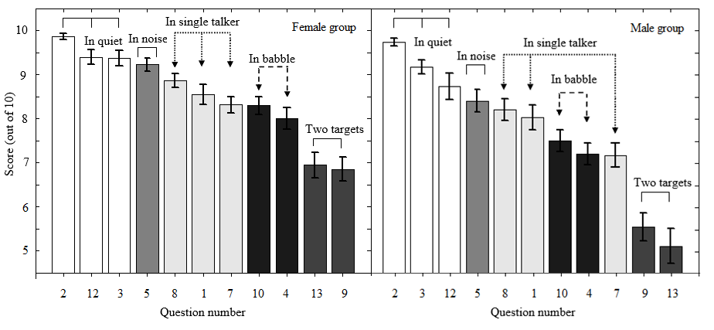

Figure 1. Mean speech scores for the female (left panel) and male (right panel) groups. Question number is reverse-ordered according to the mean scores. Following Agus et al. (2009), the questions are grouped by the type of listening required. Error bars show ±1 standard error of the mean.

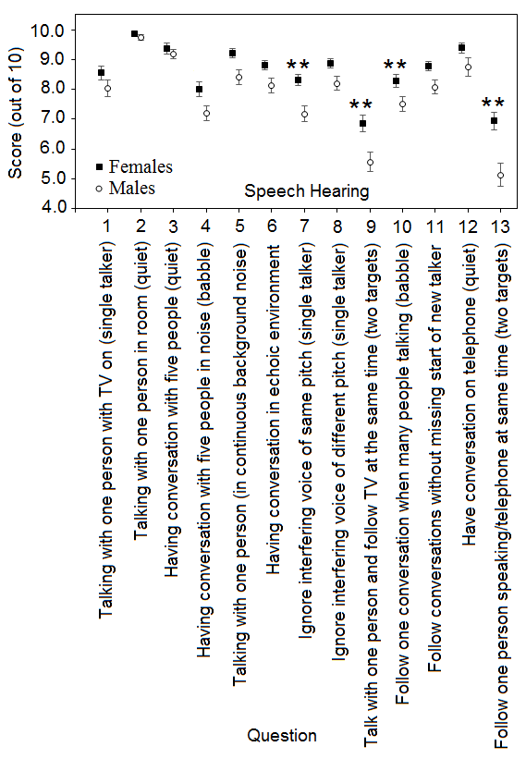

Figure 2. Mean scores for speech questions of the SSQvi, for the female group (closed squares) and male group (open circles). Error bars show ±1 standard error of the mean (not shown if smaller than the size of the symbol). Significant differences are indicated by asterisks: \*\**p* < 0.01.

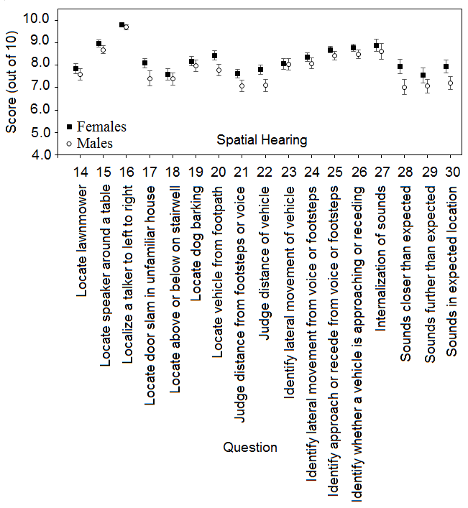

Figure 3. As Figure 2, but for the spatial questions of the SSQvi.

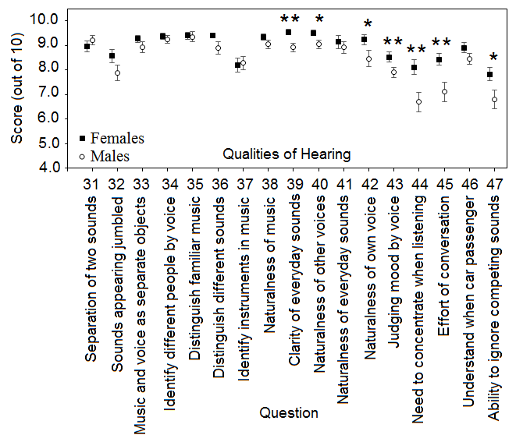

Figure 4. As Figure 2 but for the qualities questions of the SSQvi. Significant differences are indicated by asterisks: \**p* < 0.05, \*\**p* < 0.01.



Figure 5: Consistency and systematic errors for absolute distance judgements plotted against SSQvi responses for question 21, which referred to vocal distance estimates, for the male (panels A and C) and female (panels B and D) groups. D is the simulated distance, SD is the standard deviation of judged distance, and J is the mean judged distance. Spearman correlation between mean error and SSQvi responses are shown in the upper left corner of each panel (\**p* < 0.05, ns: non-significant). A significant fit to the data is shown by a solid black line.

**Figure captions**

Figure 1. Mean speech scores for the female (left panel) and male (right panel) groups. Question number is reverse-ordered according to the mean scores. Following Agus et al. (2009), the questions are grouped by the type of listening required. Error bars show ±1 standard error of the mean.

Figure 2. Mean scores for speech questions of the SSQvi, for the female group (closed squares) and male group (open circles). Error bars show ±1 standard error of the mean (not shown if smaller than the size of the symbol). Significant differences are indicated by asterisks: \*\**p* < 0.01.

Figure 3. As Figure 2, but for the spatial questions of the SSQvi.

Figure 4. As Figure 2 but for the qualities questions of the SSQvi. Significant differences are indicated by asterisks: \**p* < 0.05, \*\**p* < 0.01.

Figure 5: Consistency and systematic errors for absolute distance judgements plotted against SSQvi responses for question 21, which referred to vocal distance estimates, for the male (panels A and C) and female (panels B and D) groups. D is the simulated distance, SD is the standard deviation of judged distance, and J is the mean judged distance. Spearman correlation between mean error and SSQvi responses are shown in the upper left corner of each panel (\**p* < 0.05, ns: non-significant). A significant fit to the data is shown by a solid black line.