Complex Multistate Photophysics of a Rhodanine Photoswitch
Anam Fatima¹, Pratip Chakraborty¹, Xinyue Xu², Garth A. Jones¹, Isabelle Chambrier¹, Giorgia Logan¹, Andrew N. Cammidge¹, Trevor Smith² Christopher R. Hall², and Stephen R. Meech*¹

¹School of Chemistry University of East Anglia
²Department of Chemistry University of Melbourne
Abstract
Development of new and improved photoswitches for molecular photonics and photo-pharmaceutics is an increasingly important research objective. Recently a promising family of photoswitches based on the rhodanine motif was described. Here the photophysics of a typical example are investigated by ultrafast UV and IR spectroscopy and quantum chemical calculation. Remarkably the photophysics are very different to, and more complex than, those of closely related monomethine photoswitches, which relax by ultrafast internal conversion to the electronic ground state. In the rhodanine photoswitch the allowed Franck-Condon excited state also relaxes on a sub-picosecond timescale but the ground state is repopulated only after several hundred picoseconds. Instead, the Franck-Condon state relaxes through (at least) two intermediate states. These states are characterised by transient spectroscopy and the reaction pathway is modelled by quantum chemical calculations. Comparison of calculated and measured IR data suggest that a triplet mediated isomerization pathway is responsible for the slow excited state dynamics. The triplet state is rapidly populated via coupling of nearly degenerate nπ* populated by ultrafast internal conversion from the bright ππ* state. This unexpected isomerization pathway has important implications for the synthesis, analysis and application of rhodanine photoswitches.
*Author for correspondence (s.meech@uea.ac.uk)

Introduction Photoswitches are key components in the development of molecular photonics. They have diverse applications in light-controlled phenomena, ranging over catalysis,^{[1]} chirality,^{[2]} photopharmacology,^{[3]} photoactive gels,^{[4]} superesolution bioimaging^{[5]} and nanomanipulation.^{[6]} There is significant synthetic effort being devoted to enhancing the performance of photoswitches, typically targeting improved yields, higher photostability and the development of switching ability in the visible region of the spectrum.^{[7]} The latter is especially important in photopharmacology and bioimaging applications, given the deleterious effects of UV radiation on living systems and its poor penetration depth.
Recently Köttner et al described a new family of photoswitches based around the rhodanine motif; an example is shown in Figure 1.^{[8]} These new photoswitches have good photostability and operate efficiently under blue light irradiation, having absorption spectra with maxima in the 380 – 400 nm region and large transition dipole moments. Further, it was shown that these rhodanine photoswitches are characterised by high yields of ZE and EZ photoisomerization with long (at least hours) thermal recovery times. In a specific application the photoswitch was shown to support light activated apoptosis.^{[8]} Here we resolve the excited state dynamics underlying the operation of a representative rhodanine photoswitch through ultrafast electronic and vibrational spectroscopy and electronic structure calculations. The objective is to provide mechanistic information for the future synthesis and exploitation of enhanced examples. The sample chosen for study (Figure 1) was synthesised following the method of Köttner et al and is labelled I (it was called Z-8 in the original publication).^{[8]} This example was selected for detailed study because of its red-shifted absorption, high yield of isomerization and the well separated absorption spectra of its two isomers.
Fig. 1 The rhodanine-based photoswitch (I) studied in this work, shown with two well studied monomethine based photoswitches: HBDI (the Green Fluorescent Protein chromophore) and DPN (a bilin chromophore).
The rhodanine photoswitches are a part of the much larger family of monomethine dyes.^{[9]} In Figure 1 two other well studied examples are shown, the chromophore of the green fluorescent protein (HBDI) and dipyrrinone (DPN).^{[10]} Both dyes have been the subject of detailed experimental and theoretical characterization and were shown to undergo Z-E photoisomerization. Indeed, HBDI was the inspiration for the development of other novel monomethine photoswitches,^{[11]} while DPN is a key element of the bilin chromophore,^{[12]} which is an important switch in photobiology. Both HBDI and DPN exhibit extremely weak fluorescence which was shown to arise from rapid radiationless decay of the excited states by internal conversion back to the electronic ground state potential energy surface, on which the product isomer may be stabilized.^{[10]} Further neither HBDI nor DPN exhibit viscosity dependent emission or significant solvatochromism. On the basis of its structural similarity and observed weak fluorescence and medium independence we expected that I would show similar excited state dynamics to these other monomethine dyes. The results described below in fact reveal a richer, more complex photoisomerization pathway for I.
Of course, the monomethine family of dyes is very broad and its members exhibit different photophysical properties dependent on the nature of the substituent.^{[13]} An obvious structural analogue of I are the monomethine thioindigoid dyes, which may indeed have been one of the inspirations for the synthesis of the rhodanine photoswitches.^{[8, 14]} Thioindigiod dye photophysics have been rather thoroughly studied and they were shown to exhibit moderate fluorescence yields and to have lifetimes of tens of picoseconds which are sensitive to solvent viscosity and a strong function of polarity.^{[15]} Thus, despite the structural analogy, the thioindigoids are a less suitable model for I than HBDI and DPN. However, we show below that I also has very different photophysics to the thioindigoids, highlighting its unique behaviour.
Results and Discussion Figure 2 shows the steady state and time resolved electronic spectroscopy of I. The absorption and emission spectra (Figure 2a) are rather featureless. The absorption is strong (extinction coefficient at 401 nm reported as 37,800 M⁻¹cm⁻¹ in THF^{[8]} and slightly solvent dependent) while the emission is extremely weak, with an estimated quantum yield of <10⁻⁴, but somewhat enhanced in viscous media. (The ‘structure’ in emission above 400 nm arises from an imperfect subtraction of solvent Raman.) The fluorescence decay was measured with sub 50 fs resolution by fluorescence up-conversion to resolve the earliest part of the excited state decay, i.e. the relaxation of the bright (i.e. strongly allowed) Franck-Condon state (Figure 2b). The fluorescence decay is ultrafast and non-single exponential in all solvents studied. Qualitatively the excited state decay is only weakly solvent dependent, although somewhat lengthened in viscous ethylene glycol (EG) consistent with the steady state emission (Figure 2a). Fitting the data to a minimum number of exponential terms reveals a dominant (weight >60%) sub 200 fs component along with a weaker second component of ca. 1 ps (the data for the other solvents are Tabulated in Table S1). In EG a third longer component is detected but even in that case the mean lifetime is only five-fold longer than in ethanol even though the viscosity has increased by a factor of 15. These data suggest a moderate to weak viscosity dependence for the excited state decay with no obvious large polarity dependence. Such an ultrafast fluorescence decay with a weak solvent polarity and viscosity dependence is typical of some other monomethine photoswitches, including HBDI and DPN.^{[10d, 10h]}
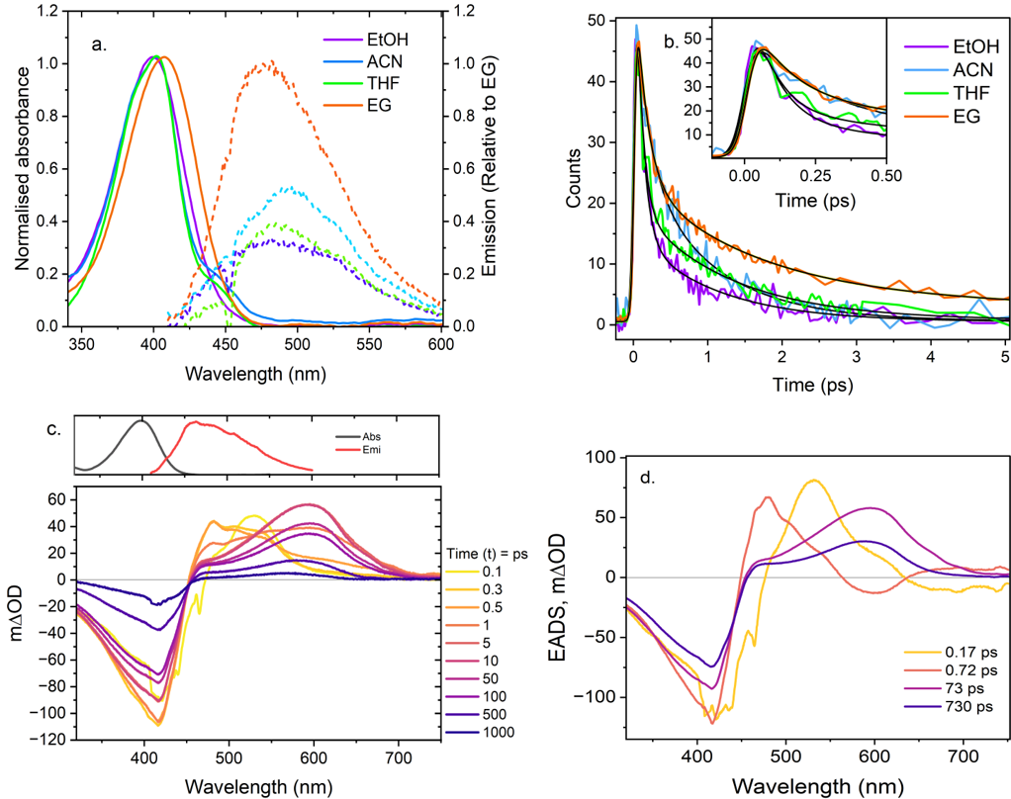
Fig 2. (a) Steady-state absorption and emission spectra (λ_{exc} = 400 nm) of I in different solvents at room temperature. Emission spectra are normalized to ethylene glycol (EG). (b) Ultrafast fluorescence upconversion of I excited at 400 nm in different solvents, with time-resolved emission recorded at the peak wavelength of each emission spectrum. Inset shows magnified view of the sub-ps decay. (c) Transient absorption spectra of I in methanol at different time delays after the pump pulse, with steady-state absorption and emission spectra included for comparison with ground-state bleaching (GSB) and stimulated emission (SE). The slight structure in the 0.1 ps spectrum is a result of the coherent artifact. (d) Evolution-associated difference spectra (EADS) derived from global fitting of the transient absorption data.

In contrast, transient absorption (TA) data reveal a significant divergence between the photophysics of I and those of other monomethine dyes (Figure 2c). In these TA difference spectra a positive signal indicates formation of a new intermediate or product state while a negative (or bleach) signal indicates a species removed from the ground state or a stimulated emission (SE). The TA spectra for I in methanol show that ground state recovery (GSR) is incomplete even after 1 ns (Figure 2c). This contrasts sharply with TA of other monomethine dyes, where the dominant decay pathway is ultrafast internal conversion to the ground state in ca 0.1 - 5 ps, followed by vibrational cooling on the time scale of a few ps. The TA of I show that evolution occurs on the excited state surface for several hundred ps after the sub-ps bright state decay before the eventual ground state repopulation in >1 ns. The initial TA shows a bleach of the ground state at 410 nm accompanied by an excited state absorption (ESA) at 530 nm. The ESA appears within the 100 fs time resolution of the experiment so can be assigned to the Franck-Condon excited state. This initial state relaxes in <1 ps to a new intermediate with a broad ESA peaking near 480 nm. That intermediate relaxes in a few picoseconds to populate a state with a broad ESA centred at 600 nm, which finally relaxes back to the electronic ground state in hundreds of ps, undergoing a small blue shift (ca 30 nm) with accompanying refilling of the GSB (Figure 2c). The data for solvents acetonitrile, THF and EG are qualitatively very similar with only the first intermediate being less well resolved in EG (Supporting Information (SI) Figure S1, Table S2).
The TA data were globally analysed in terms of a sequence of first order steps and the resulting evolution associated difference spectra (EADS) for I in methanol are shown in Figure 2d with the quality of the global fit shown in SI (Figure S2). Analyses for the other solvents are also shown in the SI (Figure S3). In methanol, there is an initial ultrafast (170 fs) relaxation associated with a blue shift in the TA, which is assigned to ultrafast decay from the bright Franck-Condon state. This blue-shifted EADS relaxes in 720 fs to a red-shifted EADS. We associate these two time constants with the very similar values in the time resolved fluorescence (Figure 2b, Table 1). Since the ground state is not recovering in parallel with these processes, the evolution must occur in the excited state. Thus the 170 fs decay reflects a decay in the S₁-S₀ transition dipole moment to form a weakly emissive ‘dark’ state. The 1 ps decay of this ‘dark’ state leads to a new red-shifted intermediate which itself relaxes in 73 ps to a final intermediate, from which the ground state recovers with a 730 ps time constant. The 73 ps relaxation to the final state is associated with only small changes in EADS, specifically a blue shift, and it is possible this indicates a non-single exponential decay of a distribution of intermediate structures formed in ca 1 ps from the ‘dark’ state.
The data and EADS in acetonitrile, THF and ethylene glycol are very similar to those in methanol (Figure S3) although there is a less clear distinction of the earliest EADS. Quantitatively (Table S2) the first two time constants recovered are in very good agreement with the time resolved fluorescence data (Table S1) and independent of solvent viscosity and polarity. The two longer decay times are somewhat viscosity dependent which may indicate that those processes involved large scale structure change, consistent with an isomerization reaction, as discussed below.
To better characterize these long-lived intermediates in the relaxation pathway of I we measured transient infra-red (TRIR) difference spectra in deuterated methanol (CD₃OD) with 250 fs resolution. The steady state IR spectra are shown in Figure 3a and the time resolved data in Figure 3b.
The initial (300 fs) TRIR of I is dominated by the ground state bleach (GSB), specifically a pair of IR active modes around 1700 cm⁻¹ and another broad bleach at 1600 cm⁻¹, which align well with the steady state IR spectrum (Figure 3a). Within 10 ps a pair of transient absorption signals have developed at 1620 and 1645 cm⁻¹. With increasing delay time, the 1620 cm⁻¹ transient decays and the 1645 cm⁻¹ one grows, before finally relaxing to refill the GSB. As the ground state refills a new much longer-lived final TA develops at 1615 cm⁻¹. The data were fit to the sequential global analysis model used for the TA but including a final spectrum to account for the long-lived product observed at 1615 cm⁻¹. The EADS recovered (Figure 3c, Table 1) show an initial state dominated by the three GSB modes, relaxing in 0.9 ps to yield a transient signal at 1620 cm⁻¹ which forms a second intermediate in 24 ps in which the transient absorption has shifted to 1645 cm⁻¹, bisecting the two ground state bleach features at 1600 and 1700 cm⁻¹. These relaxation steps occur without any filling of the grounds state bleach modes. This state goes on to form the final product in 645 ps accompanied by almost complete refilling of the ground state. We compare the steady state light minus dark IR difference spectrum with the final (product plus residual bleach) EADS in the SI (Figure S4). The overall shapes are similar, but the profiles are slightly different and the EADS bands are blue shifted by ca 10 cm⁻¹, which suggests that there are even slower components in the relaxation, occurring on time scales longer than those measured here.
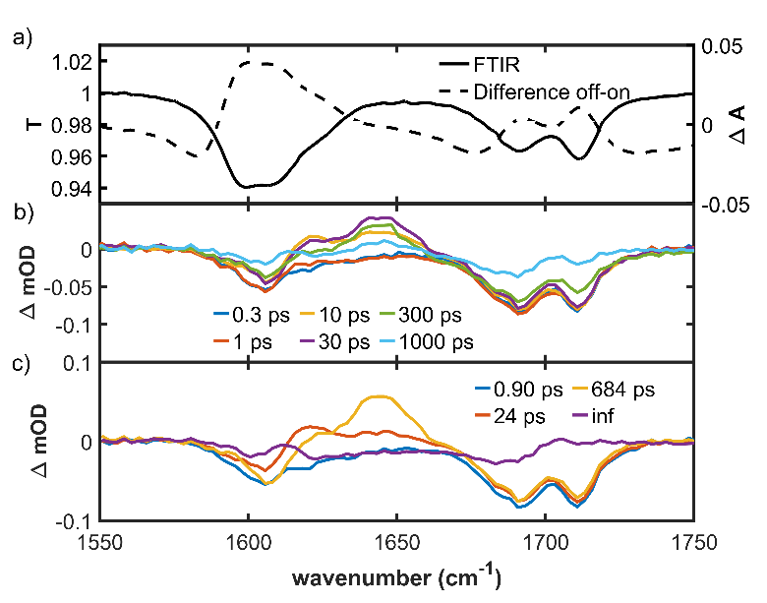
Fig 3. (a) Steady-state IR transmission of I in CD₃OD compared to the light minus dark difference spectrum. (b) TRIR at selected times after excitation at 400 nm. (c) EADS recovered from a sequential analysis of the data in (b). The time constants associated with each step are shown, where inf implies product with a lifetime much greater than the measurement range product.
The TRIR data confirm that photoswitch I indeed operates by relaxing through a series of long lived (compared to typical monomethine dyes) excited state intermediates. The 0.9 ps relaxation and the 645 ps long lived intermediate are in good agreement with the TA data (Table 1) although the fastest (ca 0.2 ps) component seen in fluorescence and TA is not resolved because of the lower time resolution, so the 0.9 ps step in TRIR reflects the decay of the rapidly formed ‘dark’ excited state. The agreement for the formation time of the long lived intermediate is less good (24 ps against 73 ps in TA) but this may reflect either the accuracy attainable with the current TRIR data (the fit quality at representative wavenumbers is shown in SI Figure S5) or that the true kinetics are more complicated, involving a non-single exponential distribution of intermediate states which are only approximately represented by this single step. The tens of ps evolution seen (Figure 3b,c) in the TRIR shows that the intermediate state(s) have distinct vibrational spectra even though the TA (the third and fourth EADS) are similar (Figure 2c).
To summarize, the excited state isomerization of I involves relaxation from the bright state to a ‘dark’ excited state intermediate in ca 200 fs ps, resolved as τ₁ in fluorescence and TA. The ‘dark’ state so formed undergoes further relaxation ca 1 ps (τ₂ ) to form a second intermediate that undergoes relaxation in the excited state in tens of picoseconds (τ₃ ) to form a long lived intermediate which ultimately decays to the ground state (either the original Z isomer or the E product) in several hundred picoseconds (τ₄ ); the time constants associated with each measurement are collected in Table 1. There are two plausible explanations for these unexpectedly slow and complex kinetics. One is the presence of a lower lying optically forbidden singlet state below the bright state which is populated by S₂ – S₁ IC in ca 1 ps and decays in tens to hundreds of picoseconds to the ground/product state. Such behaviour has been seen in for example diphenyl polyenes, where the allowed S₂ excited state decays in <1 ps to a dark (symmetry forbidden) ππ* state with a nanosecond lifetime.^{[16]} In the case of I, which is of low symmetry but is heteroaromatic, a more likely assignment for the initial low-lying dark state would be a ¹nπ* state. The second possibility is that the isomerization is triplet state mediated, and the bright state decay is an intersystem crossing (ISC) to the triplet manifold, on which the structural evolution occurs, ultimately repopulating the ground and product states by reverse ISC. This requires a ca 1 ps ISC, which is certainly exceptionally fast for ISC in the absence of a heavy atom, but by no means unprecedented, for example in the case of nearly degenerate singlet and triplet nπ*/ππ* states.^{[17]} Indeed in the monomethine thioindigoids a minor population of the triplet states has been observed even in the absence of nπ* states, although these molecules have much longer excited state lifetimes than I and the triplet state is very long-lived (unreactive).^{[18]}
Table 1. Lifetimes of I obtained from different techniques in methanol.
 | τ₁ (ps) | τ₂ (ps) | τ₃ (ps) | τ ₄ (ps) | τ ₅ (ps)
Fluo Upconv | 0.09 | 1.10 | -- | -- | --
TA | 0.17 | 0.72 | 73 | 730 | --
TRIR | -- | 0.90 | 24 | 684 | inf

To resolve these relaxation pathways, we turn to quantum chemical calculations and those data are summarized in Figure 4. All the critical points of the photo-switch on the ground, excited singlet and triplet states were optimised at the density functional theory (DFT) level using ωB97x-D functional and 6-31G(d,p) basis set,^{[19]} whereas the local minimum on the S₁ state was optimised at the time-dependent (TD) DFT level using the same functional^{[20]} and basis set. Frequency calculations were performed at the same levels of theory to ensure the stationary points obtained are the minima. S₁/S₀ conical intersection optimization was attempted at the complete active space self-consisted field (CASSCF)^{[21]} level using cc-pVDZ^{[22]} basis set and an active space of 12 electrons in 10 orbitals. Vertical excitation energies (VEE) and oscillator strengths were calculated at all the critical points at the high-level extended multistate complete active space second-order perturbation (XMS-CASPT2)^{[23]} theory using an active space of 14 electrons in 12 orbitals and cc-pVDZ basis set for a comparison of the excited state energies. For a more detailed description, refer to SI. The (TD)-DFT calculations were carried out in Gaussian16,^{[24]} whilst the high-level multi-reference calculations were carried out using BAGEL^{[25]} and OpenMolcas.^{[26]} The frequency calculations yield the IR spectra for comparison with Figure 3.
For the S₀ ground state two prominent high wavenumber modes are calculated in the IR spectrum at 1711 and 1866 cm⁻¹, which correlates well with the IR spectrum in acetonitrile-d₃ (Figure S7) although the calculated wavenumbers are uniformly higher than experimentally observed by ~100 cm⁻¹. These two vibrations arise from the C=O (1866 cm⁻¹) and C=C (1711 cm⁻¹) stretch modes (Figure S6). The highest wavenumber C=O stretch in methanol is observed to split into two bands in the steady state IR spectrum, which is also reflected in the GSB TRIR data (Figure 3a,b). This result suggests a specific solvent interaction but modelling it would require calculations with explicit solvent molecules at several H-bonding sites, making the calculations excessively difficult.
Consistent with the mechanism described above, the calculation shows a ¹nπ* S₁ state lying energetically 2900 cm⁻¹ below a bright ¹ππ* S₂ state. Thus, the fastest, sub 200 fs, decay observed in fluorescence and TA (Figure 2b, τ₁ in Table 1) can be assigned to fast S₂ (bright) to S₁ (‘dark’) state IC. The S₁ state itself is calculated to be degenerate with a ³nπ* state and close to a ³ππ* (Figure 4a). However, the S₁ state populated by IC is itself unstable and can relax along two possible barrierless energetically downhill pathways. One leads to an S₁/S₀ conical intersection (CoIn) as found in typical monomethine dyes. This pathway would thus lead to ultrafast IC which is observed experimentally in HBDI and DPN but not in I (Figure 2,3). This is most likely because in I this pathway is associated with a large structural reorganisation. The alternative low volume structure change pathway involves out of plane motion of C=S and reaches a stable point on the excited state surface which remains close to ³nπ* and ³ππ* states (Figure 4a,b). The IR spectrum at this state, local S₁-min, was calculated and has the same two high frequency stretch modes at wavenumbers very similar to the ground state, only slightly red shifted by 5 – 15 cm⁻¹ (Figure 4c). This small shift is consistent with the experimental observation (Figure 3b,c) that the earliest EADS of the inhomogeneoulsy broadened TRIR spectrum resembles the ground state bleach. We can further conclude that this Local S₁-min state is not the long-lived state, which has a very different IR spectrum (Figure 3b). However, from this stable point calculations show that the relaxed excited state can evolve further through ISC to populate a ³ππ* state, which provides the lowest energy pathway from Local S₁ minimum (Figure 4a,b). This fast ISC must occur on the 0.7 – 1 ps time scale (τ₂) resolved in the slower fluorescence decay component and in the TA and TRIR (Figure 2 and 3 and Table 1). We ascribe this fast ISC to the nearly degenerate nπ* and ππ* states of different character (Figure 4a).^{[27]} Thus, the first pathway, to the S₁/S₀ CoIn, which would lead to rapid internal conversion, is inconsistent with TA and TRIR of I. Instead, the observed slow excited state dynamics of I favours the second low volume structure change pathway, remaining on the excited state surface to rapidly populate a triplet state from S₁-min in ca 1 ps (τ₂). That the low volume structure change pathway supports fast ISC is also shown by the spin-orbit coupling matrix elements (SOCME) calculations illustrated in Fig S8 and tables S3 and S4, which show the increasing strength of SOCME between S1 and T1 along the low volume structure change making this pathway more probable for ISC (unlike the decreasing SOCME along the high volume structure change pathway).
However, the pathway is complicated with multiple changes in the character of the states (see Figure 4b), so quantum dynamical calculations are required to more rigorously resolve the initial dynamics and branching ratios; such calculations are planned.

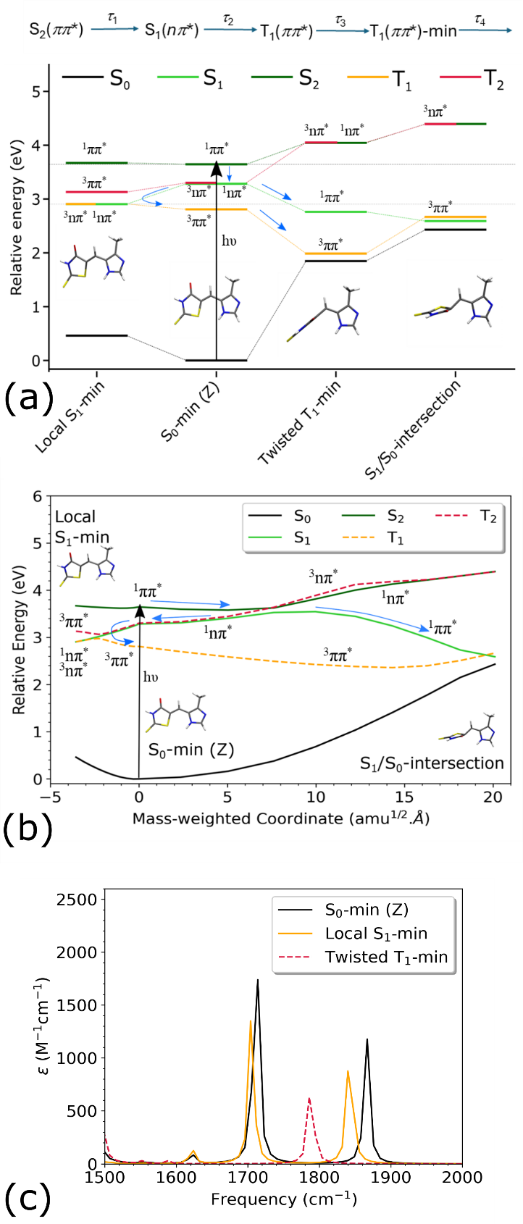
Fig4.a) Relative-energies (with respect to S₀-min (Z)) of critical points calculated at XMS-CASPT2/SA(5/3)-CAS(14,12)/cc-pVDZ level of theory along with the character of the states (nπ* or ππ*). The scheme hypothesised for the relaxation dynamics is also shown (top) with the experimental time-constants indicated. (b) Relative energies (with respect to S₀-min (Z)) of the linearly interpolated pathways from S₀-min (Z) to local S₁-min and S₁/S₀-intersection region, calculated at the XMS-CASPT2/SA(5/3)-CAS(14,12)/cc-pVDZ level of theory along with the character of the states (nπ* or ππ*), SA(5/3) refers to averaging over five-singlet and three-triplet states. Singlet states and triplet states are illustrated using solid and dashed lines respectively. This diagram illustrates that after photoexcitation to S₂ and internal conversion to S₁, there are two main pathways for the population on S₁ to end up on T₁ state and c) IR spectra between 1500-2000 cm⁻¹ for the critical points calculated at ωB97x-D functional and 6-31G(d,p) basis set.
The ³ππ* state populated from the Local S₁-min (Figure 4a and S7) is calculated to be unstable with respect to twisting about the methine C=C bond. Thus, the triplet state will relax along the isomerization coordinate (among others) in several tens of picoseconds (τ₃) on the relatively flat T₁ surface. This relaxation may reflect solvent friction experienced by the large-scale structure change consistent with the dependence on solvent H-bondng and solvent viscosity (Table S2) although the calculation suggests a barrierless pathway. An almost half twisted (97°) minimum (Twisted T₁-min) is detected and its IR spectrum was calculated (Figure 4c). The spectra again show the C=O and C=C stretch modes, but now both are markedly red-shifted such that the wavenumber for the carbonyl stretch lies between those for the two S₀-min modes (Figure 4b). This is in good agreement with the experimental TRIR difference spectrum and the EADS for the long lived transient (Figures 3b,c). The C=C stretch is calculated to have shifted below 1500 cm⁻¹ taking it out of the experimental TRIR window (Figure 3b). Thus, the energetics, the relatively slow excited state dynamics and the agreement between calculated and observed TRIR all point to a triplet mediated pathway for the isomerization of I, with the attainment of Twisted T1-min by large scale structural reorganization (τ₃) Of course, the triplet twisted state must still undergo reverse ISC to form the E product isomer (or refill the Z ground state). This pathway is not calculated, but the TA suggests the ground state is largely repopulated within a few ns, requiring moderately fast reverse ISC; this relaxation (τ₄) was measured as ca 700 ps. To probe this further requires calculations that explicitly model ISC, but we note that Twisted T₁-min on the triplet surface lies close to the twisted singlet ground state (Figure 4a) energy, which may serve to enhance ISC. Finally, we note that analysis of the molecular orbitals indicates that the lone pair on the S atom is involved in the ¹nπ* state (Figure S8). Thus, it will be interesting to see whether the oxorhodanines (which lack the C=S bond) exhibit different excited state dynamics.^{[8]} The required synthesis and measurements are in progress. Indeed, all of the other monmethine dyes described lack this C=S source of non-bonding electrons.
Finally, we turn to consideration of the E isomer, the other half of the photoswitch. A photostationary state of E-Z isomers populated by 365 nm irradiation was studied by excitation on the red-edge to favour excitation of the E isomer. The less than perfect separation of the electronic spectra of E and Z forms in alcohols (compared to THF^{[8]}) and the broad bandwidth inevitably associated with sub 100 fs pulses makes confirmation of selective excitation challenging. However, the TRIR spectra, the EADS and their associated time constants recovered from global analysis are very similar to those for the Z-isomer (see Figure S12) and confirm that a similar mechanism operates in the E form, including population of the unexpected long lived intermediate. The corresponding energetics were calculated as for Figure 4b. and are shown in Figure S13. Consistent with the TRIR spectra, they show a similar level structure to the Z form, notably with regards to singlet – triplet degeneracy and barrier along the singlet pathway. Dynamics calculations will provide a more quantitative picture. On the basis of these data we suggest that the E and Z forms have a common triplet mediated isomerization mechanism.
Conclusion The excited state dynamics of a recently developed rhodanine photoswitch have been analysed by ultrafast electronic and vibrational spectroscopy and quantum chemical calculations. The dynamics are unusually slow compared to photoisomerization in previously studied monomethine dyes. Both experiments and calculation point to an intersystem crossing mediated isomerization pathway, in contrast to the fast internal conversion which typically dominates in similar monomethine dyes. This has implications for the design of similar systems and the possible side reactions that may play a role in applications of these photoswitches. For example, this relatively long-lived triplet state may undergo reactions that would not occur in other monomethine dyes. Secondly, the role of ¹nπ* state may lead to an unexpected substituent dependence, for example revealing heavy atom effects or dependence of photophysics on singlet-triplet energy gap. The calculations point to an important role for nonbonding electrons of the C=S group in modifying the photophysics of I, so it may be possible to introduce other sources of nonbonded electrons.
Acknowledgements
We are grateful to EPSRC for financial support (Grants EP/Y021525/1 and EP/X011410/1). SRM thanks UEA for a study leave and The Department of Chemistry at the University of Melbourne for a Wilsmore Fellowship 2024 which facilitated the TRIR measurements. SRM is grateful to Profs Ken Ghiggino and Tahei Tahara (RIKEN, Japan) and their colleagues for their hospitality during the preparation of this paper and helpful discussions. CRH acknowledges the Australian Research Council for funding (FT210100113) and the Selby Scientific Foundation. The calculations presented in this paper were carried out on the High Performance Computing Cluster supported by the Research and Specialist Computing Support service at the University of East Anglia

References
[1] aR. Dorel, B. L. Feringa, Chemical Communications 2019, 55, 6477-6486; bR. S. Stoll, M. V. Peters, A. Kuhn, S. Heiles, R. Goddard, M. Bühl, C. M. Thiele, S. Hecht, Journal of the American Chemical Society 2009, 131, 357-367.
[2] Z. G. Zheng, H. L. Hu, Z. P. Zhang, B. H. Liu, M. Q. Li, D. H. Qu, H. Tian, W. H. Zhu, B. Feringa, Nature Photonics 2022, 16, 226-+.
[3] aM. J. Fuchter, Journal of Medicinal Chemistry 2020, 63, 11436-11447; bP. Kobauri, F. J. Dekker, W. Szymanski, B. L. Feringa, Angewandte Chemie-International Edition 2023, 62; cK. Hüll, J. Morstein, D. Trauner, Chemical Reviews 2018, 118, 10710-10747.
[4] aJ. V. Accardo, J. A. Kalow, Chemical Science 2018, 9, 5987-5993; bF. Xu, L. Pfeifer, S. Crespi, F. K. C. Leung, M. C. A. Stuart, S. J. Wezenberg, B. Feringa, Journal of the American Chemical Society 2021, 143, 5990-5997.
[5] aT. D. Krueger, L. T. Tang, C. Chen, L. D. Zhu, I. L. Breen, R. M. Wachter, C. Fang, Protein Science 2023, 32; bM. El Khatib, A. Martins, D. Bourgeois, J. P. Colletier, V. Adam, Scientific Reports 2016, 6.
[6] H. Koshima, N. Ojima, H. Uchimoto, Journal of the American Chemical Society 2009, 131, 6890-6891.
[7] aS. Wiedbrauk, H. Dube, Tetrahedron Letters 2015, 56, 4266-4274; bA. Gernet, L. Toursel, L. M. Balivet, L. Pages, L. Jean, Chemphotochem 2024; cD. J. van Dijken, P. Kovarícek, S. P. Ihrig, S. Hecht, Journal of the American Chemical Society 2015, 137, 14982-14991; dC. N. Stindt, S. Crespi, B. Feringa, Chemistry-a European Journal 2024, 30; eM. M. Lerch, W. Szymanski, B. Feringa, Chemical Society Reviews 2018, 47, 1910-1937; fJ. Volaric, J. Buter, A. M. Schulte, K. O. Van den Berg, E. Santamaría-Aranda, W. Szymanski, B. Feringa, Journal of Organic Chemistry 2022, 87, 14319-14333; gD. Doellerer, D. R. S. Pooler, A. Guinart, S. Crespi, B. Feringa, Chemistry-a European Journal 2023, 29.
[8] L. Köttner, F. Wolff, P. Mayer, E. Zanin, H. Dube, Journal of the American Chemical Society 2024, 146, 1894-1903.
[9] aS. Olsen, The Journal of Physical Chemistry A 2016, 120, 10245-10251; bS. Olsen, R. H. McKenzie, Journal of Chemical Physics 2012, 137.
[10] aN. H. List, C. M. Jones, T. J. Martínez, Chemical Science 2022, 13, 373-385; bC. M. Jones, N. H. List, T. J. Martinez, Chemical Science 2021, 12, 11347-11363; cA. Sinicropi, T. Andruniow, N. Ferre, R. Basosi, M. Olivucci, J. Am. Chem. Soc. 2005, 127, 11534-11535; dD. Mandal, T. Tahara, S. R. Meech, J. Phys. Chem. B 2004, 108, 1102-1108; eK. Addison, J. Conyard, T. Dixon, P. C. B. Page, K. M. Solntsev, S. R. Meech, Journal of Physical Chemistry Letters 2012, 3, 2298-2302; fS. R. Meech, Chem. Soc. Rev. 2009, 38, 2922-2934; gJ. Janoš, D. Madea, S. Mahvidi, T. Mujawar, J. Švenda, J. Suchan, P. Slavíček, P. Klán, The Journal of Physical Chemistry A 2020, 124, 10457-10471; hC. F. Staheli, J. Barney, T. R. Clark, M. Bowles, B. Jeppesen, D. G. Oblinsky, M. B. Steffensen, J. C. Dean, Frontiers in Chemistry 2021, 9.
[11] M. Paolino, M. Gueye, E. Pieri, M. Manathunga, S. Fusi, A. Cappelli, L. Latterini, D. Pannacci, M. Filatov, J. Léonard, M. Olivucci, J. Am. Chem. Soc. 2016, 138, 9807-9825.
[12] B. Zietz, T. Gillbro, The Journal of Physical Chemistry B 2007, 111, 11997-12003.
[13] S. McConnell, R. H. McKenzie, S. Olsen, The Journal of Chemical Physics 2015, 142, 084502.
[14] V. Josef, F. Hampel, H. Dube, Angewandte Chemie International Edition 2022, 61, e202210855.
[15] aF. F. Graupner, T. T. Herzog, F. Rott, S. Oesterling, R. de Vivie-Riedle, T. Cordes, W. Zinth, Chemical Physics 2018, 515, 614-621; bK. Stallhofer, M. Nuber, F. Schüppel, S. Thumser, H. Iglev, R. de Vivie-Riedle, W. Zinth, H. Dube, The Journal of Physical Chemistry A 2021, 125, 4390-4400; cS. Wiedbrauk, B. Maerz, E. Samoylova, A. Reiner, F. Trommer, P. Mayer, W. Zinth, H. Dube, Journal of the American Chemical Society 2016, 138, 12219-12227.
[16] aS. M. Bachilo, T. Gillbro, Chemical Physics Letters 1994, 218, 557-562; bD. W. Polak, A. D. P. Hannon, G. A. Marczak Giorio, O. A. Hawkins, T. A. A. Oliver, The Journal of Physical Chemistry B 2023, 127, 8199-8207.
[17] aR. A. Vogt, C. Reichardt, C. E. Crespo-Hernández, The Journal of Physical Chemistry A 2013, 117, 6580-6588; bJ. P. Zobel, J. J. Nogueira, L. González, Chemistry – A European Journal 2018, 24, 5379-5387.
[18] R. Wilcken, M. Schildhauer, F. Rott, L. A. Huber, M. Guentner, S. Thumser, K. Hoffmann, S. Oesterling, R. de Vivie-Riedle, E. Riedle, H. Dube, Journal of the American Chemical Society 2018, 140, 5311-5318.
[19] aW. Kohn, A. D. Becke, R. G. Parr, The Journal of Physical Chemistry 1996, 100, 12974-12980; bT. Ziegler, Chemical Reviews 1991, 91, 651-667; cJ.-D. Chai, M. Head-Gordon, PCCP 2008, 10, 6615-6620; dR. Ditchfield, W. J. Hehre, J. A. Pople, The Journal of Chemical Physics 1971, 54, 724-728.
[20] aE. Runge, E. K. U. Gross, Physical Review Letters 1984, 52, 997-1000; bR. Bauernschmitt, R. Ahlrichs, Chemical Physics Letters 1996, 256, 454-464; cF. Furche, R. Ahlrichs, The Journal of Chemical Physics 2002, 117, 7433-7447.
[21] B. O. Roos, P. R. Taylor, P. E. M. Sigbahn, Chemical Physics 1980, 48, 157-173.
[22] T. H. Dunning, Jr., The Journal of Chemical Physics 1989, 90, 1007-1023.
[23] aJ. Finley, P.-Å. Malmqvist, B. O. Roos, L. Serrano-Andrés, Chemical Physics Letters 1998, 288, 299-306; bA. A. Granovsky, The Journal of Chemical Physics 2011, 134; cT. Shiozaki, W. Győrffy, P. Celani, H.-J. Werner, The Journal of Chemical Physics 2011, 135.
[24] M. J. Frisch, G. W. Trucks, H. B. Schlegel, G. E. Scuseria, M. A. Robb, J. R. Cheeseman, G. Scalmani, V. Barone, G. A. Petersson, H. Nakatsuji, X. Li, M. Caricato, A. V. Marenich, J. Bloino, B. G. Janesko, R. Gomperts, B. Mennucci, H. P. Hratchian, J. V. Ortiz, A. F. Izmaylov, J. L. Sonnenberg, Williams, F. Ding, F. Lipparini, F. Egidi, J. Goings, B. Peng, A. Petrone, T. Henderson, D. Ranasinghe, V. G. Zakrzewski, J. Gao, N. Rega, G. Zheng, W. Liang, M. Hada, M. Ehara, K. Toyota, R. Fukuda, J. Hasegawa, M. Ishida, T. Nakajima, Y. Honda, O. Kitao, H. Nakai, T. Vreven, K. Throssell, J. A. Montgomery Jr., J. E. Peralta, F. Ogliaro, M. J. Bearpark, J. J. Heyd, E. N. Brothers, K. N. Kudin, V. N. Staroverov, T. A. Keith, R. Kobayashi, J. Normand, K. Raghavachari, A. P. Rendell, J. C. Burant, S. S. Iyengar, J. Tomasi, M. Cossi, J. M. Millam, M. Klene, C. Adamo, R. Cammi, J. W. Ochterski, R. L. Martin, K. Morokuma, O. Farkas, J. B. Foresman, D. J. Fox, Wallingford, CT, 2016.
[25] T. Shiozaki, WIREs Computational Molecular Science 2018, 8, e1331.
[26] aI. Fdez. Galván, M. Vacher, A. Alavi, C. Angeli, F. Aquilante, J. Autschbach, J. J. Bao, S. I. Bokarev, N. A. Bogdanov, R. K. Carlson, L. F. Chibotaru, J. Creutzberg, N. Dattani, M. G. Delcey, S. S. Dong, A. Dreuw, L. Freitag, L. M. Frutos, L. Gagliardi, F. Gendron, A. Giussani, L. González, G. Grell, M. Guo, C. E. Hoyer, M. Johansson, S. Keller, S. Knecht, G. Kovačević, E. Källman, G. Li Manni, M. Lundberg, Y. Ma, S. Mai, J. P. Malhado, P. Å. Malmqvist, P. Marquetand, S. A. Mewes, J. Norell, M. Olivucci, M. Oppel, Q. M. Phung, K. Pierloot, F. Plasser, M. Reiher, A. M. Sand, I. Schapiro, P. Sharma, C. J. Stein, L. K. Sørensen, D. G. Truhlar, M. Ugandi, L. Ungur, A. Valentini, S. Vancoillie, V. Veryazov, O. Weser, T. A. Wesołowski, P.-O. Widmark, S. Wouters, A. Zech, J. P. Zobel, R. Lindh, Journal of Chemical Theory and Computation 2019, 15, 5925-5964; bF. Aquilante, J. Autschbach, A. Baiardi, S. Battaglia, V. A. Borin, L. F. Chibotaru, I. Conti, L. De Vico, M. Delcey, I. Fdez. Galván, N. Ferré, L. Freitag, M. Garavelli, X. Gong, S. Knecht, E. D. Larsson, R. Lindh, M. Lundberg, P. Å. Malmqvist, A. Nenov, J. Norell, M. Odelius, M. Olivucci, T. B. Pedersen, L. Pedraza-González, Q. M. Phung, K. Pierloot, M. Reiher, I. Schapiro, J. Segarra-Martí, F. Segatta, L. Seijo, S. Sen, D.-C. Sergentu, C. J. Stein, L. Ungur, M. Vacher, A. Valentini, V. Veryazov, The Journal of Chemical Physics 2020, 152.
[27] M. A. El‐Sayed, The Journal of Chemical Physics 1963, 38, 2834-2838.

ToC Figure
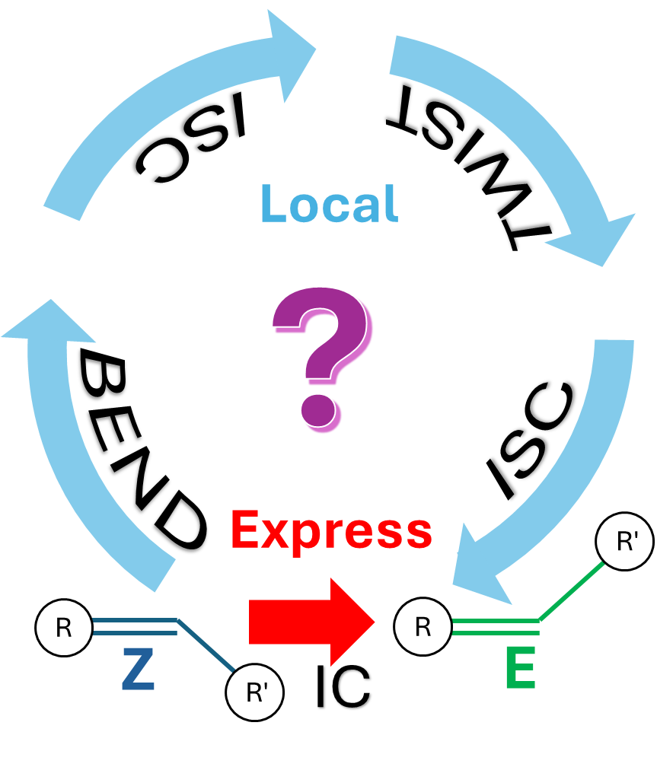
Slow switching. A novel photoswitch is observed by ultrafast experiment to have unusually slow excited state dynamics. The pathway is resolved by quantum chemical calculation.

