Figure 1: Sample DCE and CSPC tasks

DCE task
 | Program A | Program B
Average age of the patients  Quality-of-life without/before treatment  Quality-of-life with/after treatment  Life expectancy without/before treatment  Gain in life expectancy with treatment  Number of patients that could be treated  Total quality-adjusted life years gained | 70 years old  9 out of 10  9 out of 10 [no change]  10 years  10 additional years  5,000  45,000 | 40 years old  5 out of 10  9 out of 10 [4 levels higher]  5 years  1 additional year  2,500  7,250

 I would prefer to fund Program A |  I would prefer to fund Program B

CSPC task
 | Program A | Program B
Average age of the patients  Quality-of-life without/before treatment  Quality-of-life with/after treatment  Life expectancy without/before treatment  Gain in life expectancy with treatment  Number of patients that could be treated  Total quality-adjusted life years gained | 70 years old  9 out of 10  9 out of 10 [no change]  10 years  10 additional years  3,600  32,400 | 40 years old  5 out of 10  9 out of 10 [4 levels higher]  5 years  1 additional year  700  2,030

Share of budget  to Program A | 72% |--------------------------<>------------------------------------------------------ | 28% | Share of budget  to Program B

Figure 2: Distribution of QALY maximising choices per respondent, by group
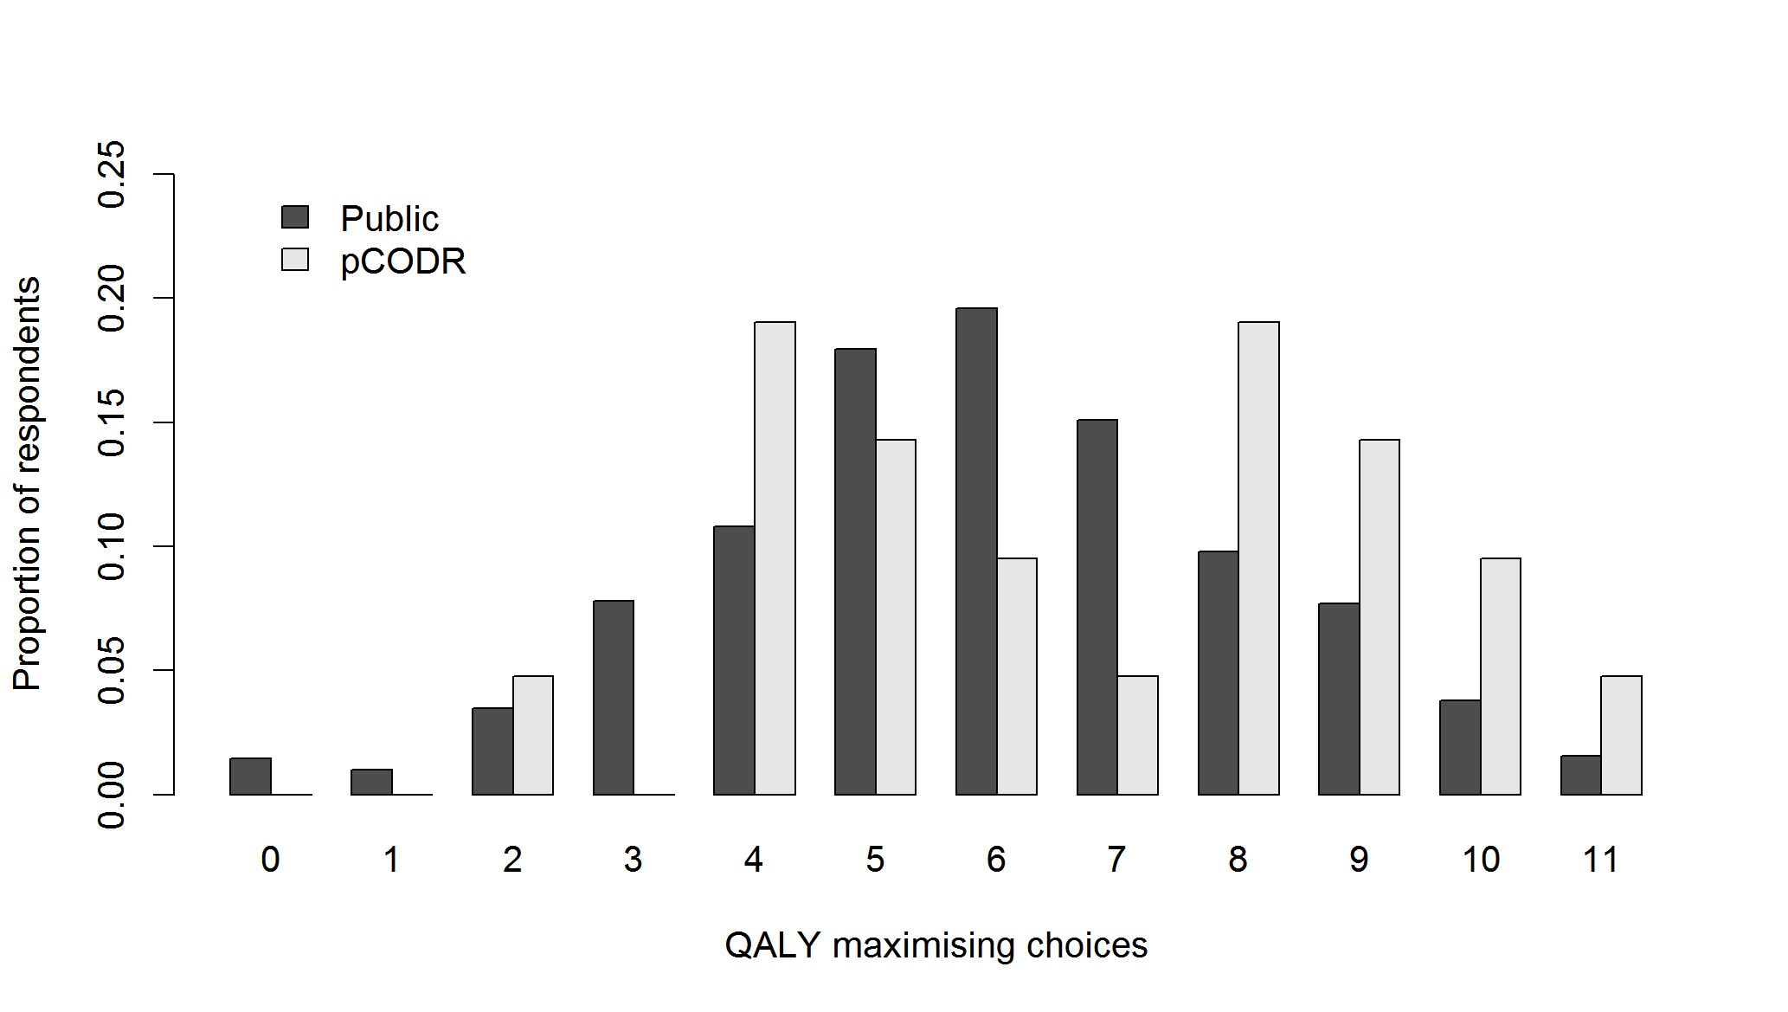
The proportion of respondents in each group by the number of QALY maximising choices they made over the 11 tasks in each questionnaire.
Figure 3: Public and pCODR preferences by attribute level
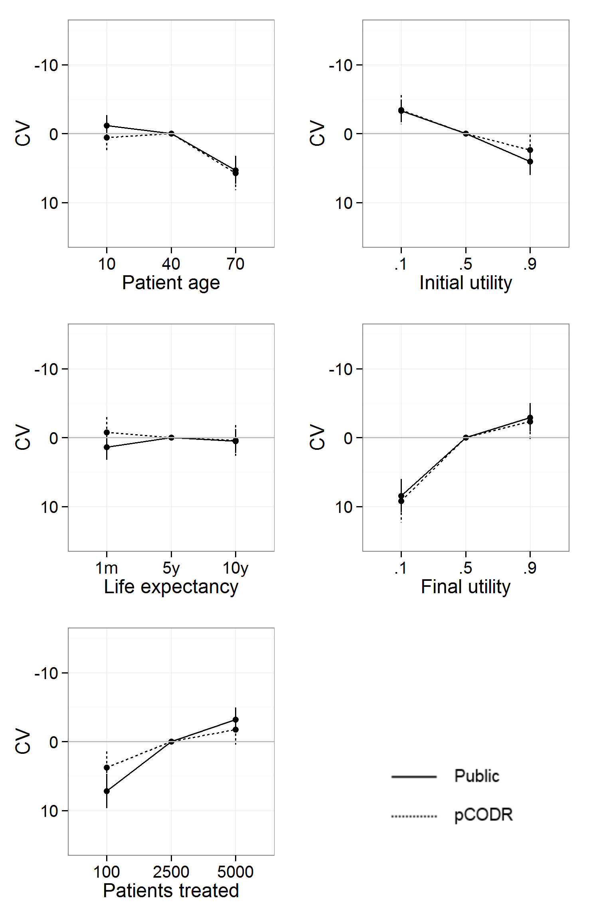
Compensating variations (CV) associated with an upward and downward change in the level of each attribute, relative to a baseline state with all attributes at their middle level, by respondent group. The y-axis is reversed to show more preferred differences above zero and less preferred differences below zero.
Appendix: Canadian and public demographic and socioeconomic comparisons

 | 2011 Cdn. Census (1) |  | Survey
Age group | Males | Females | Males | Females | No answer
18-24 | 6% | 6% | 62 (5%) | 79 (6%) | 0 (0%)
25-34 | 9% | 9% | 109 (8%) | 125 (9%) | 0 (0%)
35-44 | 9% | 8% | 97 (7%) | 213 (16%) | 5 (0%)
45-54 | 10% | 10% | 113 (9%) | 117 (9%) | 3 (0%)
55-64 | 8% | 8% | 89 (7%) | 100 (8%) | 2 (0%)
65-74 | 5% | 5% | 68 (5%) | 31 (2%) | 0 (0%)
75+ | 3% | 5% | 32 (2%) | 71 (5%) | 0 (0%)
No answer | - | - | 0 (0%) | 0 (0%) | 2 (0%)
Subtotal | 49% | 51% | 570 (43%) | 736 (56%) | 12 (1%)
Total |  |  | 1,318

The public sample was broadly reflective of the Canadian population in terms of their distribution by age and gender, although women in the 35-44 year old age group were substantially over-represented, while women in the 65-74 year old age group were under-represented. A small number of respondents chose not to answer the demographics questions, but these missing values were not large enough to skew the overall age and gender distribution of the sample.
The proportion of public respondents that graduated college or university was 35 percent, identical to the 2006 Canadian census population (p=0.98) (2), but the median family income category in the sample ($60,000-64,999) was lower than the 2010 Canadian median family income ($76,950) (3). Income and education were not collected from respondents to the agent invitations, but it seems likely that both would be somewhat higher than in the general population.

1. Government of Canada SC. Population by sex and age group [Internet]. 2012 [cited 2012 Aug 2]. Available from: http://www.statcan.gc.ca/tables-tableaux/sum-som/l01/cst01/demo10a-eng.htm
2. Statistics Canada. Population 15 years and over by highest degree, certificate or diploma (1986 to 2006 Census) [Internet]. 2009 [cited 2012 Aug 2]. Available from: http://www.statcan.gc.ca/tables-tableaux/sum-som/l01/cst01/educ42-eng.htm
3. Statistics Canada. Median total income, by family type, by province and territory [Internet]. 2010 [cited 2011 Feb 4]. Available from: http://www.statcan.gc.ca/tables-tableaux/sum-som/l01/cst01/famil108a-eng.htm

