The association between 25-hydroxyvitamin D and parathyroid hormone in adolescents living with HIV in southern Africa: a cross sectional study

Authors
Tafadzwa Madanhire^{1,3}, Kate A Ward², Amy MacDougall³, Nuredin I Mohammed^{4,5}, Lackson Kasonka⁶, Hildah B Mabuda⁶, Molly Chisenga⁶, Jonathan C. Y. Tang^{7,8}, William D Fraser^{7,8}, Tsitsi Bandason¹, Nyasha V Dzavakwa^{1,4}, Victoria Simms^{1,4}, Rashida A Ferrand^{1,9}, Celia L Gregson^{1,10}

Affiliations
- The Health Research Unit Zimbabwe, Biomedical Research and Training Institute, Harare, Zimbabwe
- MRC Lifecourse Epidemiology Centre, Human Development and Health, University of Southampton, Southampton, UK
- Department of Infectious Disease Epidemiology, Faculty of Epidemiology and Population Health, London School of Hygiene and Tropical Medicine, London, UK
- MRC International Statistics and Epidemiology Group, Faculty of Epidemiology and Population Health, London School of Hygiene & Tropical Medicine, London, UK.
- Medical Research Council Unit The Gambia at the London School of Hygiene & Tropical Medicine, Banjul, The Gambia
- University Teaching Hospital, Lusaka, Zambia
- Bioanalytical Facility, Norwich Medical School, University of East Anglia, Norwich Research Park, Norwich, UK
- Clinical Biochemistry, Diabetes and Endocrinology, Norfolk and Norwich University Hospital, Norwich, UK
- Clinical Research Department, Faculty of Infectious and Tropical Diseases, London School of Hygiene and Tropical Medicine, London, UK
- Global Musculoskeletal Research Group, Musculoskeletal Research Unit, Bristol Medical School, University of Bristol

Corresponding author: Tafadzwa Madanhire: ORCID ID: 0000-0003-2449-0027
Address: Biomedical Research and Training Institute, 10 Seagrave Road, Harare, Zimbabwe
Email: Tafadzwa.Madanhire@lshtm.ac.uk
Telephone: +263 242336691
Short manuscript title: 25-hydroxyvitamin D and parathyroid hormone.
Keywords: Vitamin D, parathyroid hormone, adolescent, Africa, HIV
Funding: NIH Fogarty D43TW011326
Abbreviations
1,25(OH)₂D: 1,25-dihydroxyvitamin-D
25(OH)D: 25-hydroxyvitamin-D
AIC: Akaike Information Criterion
ART: antiretroviral therapy
CDC: Centre for Disease Control and Prevention
CV: Coefficient of variation
DEQAS: Vitamin D external quality assessment
EDTA: Ethylenediaminetetraacetic acid
HAZ: Height for age z-score
HIV: Human immunodeficiency virus
IM: Institute of Medicine
IQR: Interquartile range
LC-MS/MS: Liquid chromatography Tandem Mass Spectrometry
NIST: National Institute of Science and Technology
PTH: Parathyroid hormone
RMP: Reference measurement procedure
SD: Standard deviation
TDF: Tenofovir disoproxil fumarate
VITALITY: Vitamin D for adolescents with HIV to reduce musculoskeletal morbidity and immunopathology
WAZ: Weight for age z-score
Abstract
Low vitamin D associated with high parathyroid hormone (PTH) is commonly reported in the context of HIV infection. We determined the association between total 25-hydroxyvitamin-D [25(OH)D] and PTH in adolescents living with HIV, in Zambia and Zimbabwe. Adolescents (11-19 years) perinatally-infected with HIV and established on antiretroviral therapy (ART) for ≥6 months were recruited into a cross-sectional study. Socio-demographic and clinical characteristics were recorded, anthropometry measured, and fasted serum concentrations of 1,25-dihydroxyvitamin-D (1,25(OH)₂D), total 25(OH)D and intact PTH measured. The association between total 25(OH)D and PTH was examined using natural cubic spline regression modelling. 842 participants (female: 53.2%) with median age 15.5 (IQR:13.2-17.9) years were enrolled. Median ART duration was 9.8 [IQR:6.3-12.3] years and 165/841 (19.6%) had an HIV viral load >60copies/ml. Stunting (HAZ score<-2) and underweight (WAZ score<-2) were observed in 29.9% and 30.0% respectively. Three quarters (n=639) reported daily calcium intakes <150mg/day. The mean (SD) concentrations of total 25(OH)D and 1,25(OH)₂D were 66.1(16.5) nmol/L and 210.6(70.4) pmol/L respectively, and median PTH level was 4.3 (IQR:3.3-5.5) pmol/L. There was an inverse non-linear relationship between total 25(OH)D and PTH, 25(OH)D levelling-off at 74.6nmol/L (95%CI: 74.5-75.2). Results were consistent in those taking tenofovir disoproxil fumarate (81.7%) and in those who were virally unsuppressed. In this population with extremely low habitual calcium intakes, the lack of association between 25(OH)D and PTH when 25(OH)D exceeded 75nmol/L, potentially suggests levels of 25(OH)D >75nmol/l may need to be achieved to improve bone health; investigation is needed in future research studies.

Introduction
What constitutes ‘adequate’ vitamin D is debated around the world ^{1–3}. There is no global consensus on the definition of 25-hydroxyvitamin D [25(OH)D] deficiency, with suggested values ranging between 30 and 100 nmol/L ^{4–6}. 25(OH)D regulates skeletal mineralisation during growth and also thought to play an important role in facilitating macrophage and T-cell function and maintaining a healthy gut microbiome ^{7–9}. In children and adolescents, vitamin D deficiency is associated with secondary hyperparathyroidism, rickets, osteomalacia and poor bone growth ¹⁰.

Fifty three percent of individuals with HIV live in Eastern and Southern Africa ¹¹, a region characterized by a predominantly temperate climate, providing ample sunshine throughout the year ^{12,13}. Low vitamin D is commonly reported among people living with HIV ^{14,15} in part, it is thought, due to certain anti-retroviral drugs ¹⁶. Tenofovir disoproxil fumarate (TDF) is associated with lower 25(OH)D, thought to result from the upregulation of 24-hydroxylase, leading to lower circulating 25(OH)D and 1,25-dihydroxyvitamin D (1,25(OH)₂D) concentrations ^{16,17}. To date, studies on the prevalence of vitamin D deficiency in children and adolescents with HIV have generated variable estimates, mainly due to varying thresholds for insufficiency ^{18–20}.

In 2018, a global systematic review of vitamin D deficiency in children and adolescents living with HIV concluded that the literature comprised multiple small, underpowered and heterogenous vitamin D studies from which it was not possible to draw a firm conclusion on what constitutes an adequate concentration of 25(OH)D for optimising bone health, lowering the risk of secondary hyperparathyroidism and prevention of rickets and osteomalacia ²¹.

Methods of modelling the relationship between 25(OH)D and PTH have so far been limited to linear spline models ^{22–24} and non-linear locally weighted regression smoothing (loess) ^{25–27}. However, the use of linear spline models is questionable since the relationship between 25(OH)D and PTH is non-linear, regardless of the method of segmentation. Similarly, besides its flexibility and ability to show a pattern of association between two variables, a loess function requires dense data to give a smoothed estimate such that they lack tail precision when data are sparse ^{28,29}.
This study aimed to determine the concentration of 25(OH)D at which the association with PTH changes, in children and adolescents living with HIV in Zimbabwe and Zambia. Understanding of such relationships may provide insights into what might constitute ‘adequate’ vitamin D in the context of HIV infection, chronically low habitual calcium intakes, and in turn an understanding of musculoskeletal development in peripubertal adolescents growing up with HIV

Methods

Study design, setting and population
We conducted a cross-sectional study nested within a phase III individually randomised, double-blinded, placebo-controlled trial of vitamin D₃/calcium carbonate or placebo [Vitamin D for adolescents with HIV to reduce musculoskeletal morbidity and immunopathology (VITALITY): Pan African Clinical Trials Registry PACTR20200989766029] ³⁰.

The trial enrolled 842 [$n=\frac{p(1-p)×α^{2}}{d^{2}}$, where p: prevalence vitamin D deficiency (<30nmol/L) ³¹, α: 95% confidential level; 1.96, d: error; 3% ] adolescents aged 11-19 years living with HIV recruited from public sector HIV outpatient clinics in Harare, Zimbabwe and Lusaka, Zambia between January and December 2021. Lusaka and Harare have relatively similar latitude of -15.4º and -17.8º respectively suggesting comparable sunlight exposure ³². The inclusion criteria were perinatally-acquired HIV, taking antiretroviral therapy (ART) for at least six months, and willing to give blood samples. Exclusion criteria included: being acutely unwell, taking tuberculosis treatment, currently pregnant or breastfeeding and a history of either thyrotoxicosis, chronic renal disease, hypercalcemia, phosphate metabolism disorder or osteomalacia. Baseline data were used for this analysis.

Data collection
An interview-administered questionnaire pre-programmed using Open Data Kit on to electronic tablets, was used to collect socio-demographic and clinical data including HIV history. Socioeconomic status (SES) quintiles were derived from a principal component analysis of the participant’s household assets. Dietary calcium intake was assessed using a dietary diversity questionnaire adopted on that of the Food and Agriculture Organization of the United Nations (FAO) questionnaire adapted to Zimbabwe and Zambia, and focussing on multi-micronutrients rich foods (e.g., dairy, eggs, fish, legumes) ³³. Using the FAO food composition tables, estimated dietary calcium intake was then calculated based on the International Osteoporosis Foundation (IOF) frequency of consumption, serving size and calcium quantity per portion size (Supplementary table 1) ^{34–36}.
Participants underwent height and weight measurements and Tanner pubertal staging measurement; Z-scores were calculated using UK reference data ^{37–39}. Stunting and underweight were classified as height- and weight-for-age Z-scores <-2 respectively ³⁸. Venous blood was collected into EDTA tubes (BD Vacutainer) for 1,25(OH)₂D, total 25(OH)D and intact PTH measurements. Blood tubes were promptly centrifuged, and aliquots stored at -20°C, with all analyses performed on the first thaw. HIV viral load testing was performed using the Qiagen rotor gene Q, Hologic Panther, or GeneXpert machines in Zambia and the Roche COBAS Ampliprep/COBAS Taqman48 in Zimbabwe. The classification of HIV viral load suppression (<60 vs ≥ 60 copies/ml) was based on the assay limit of detection.

Total 25(OH)D, 1,25(OH)₂D, 24,25(OH)₂D and intact PTH measurements
25(OH)D, 1,25(OH)₂D and intact PTH concentrations were analysed at the Bioanalytical Facility, University of East Anglia (Norwich, UK). Liquid chromatography Tandem Mass Spectrometry (LC-MS/MS) methods were used for 25(OH)D and 1,25(OH)₂D as previously described ^{40,41}. The 25(OH)D3 and 25(OH)D2 assays were calibrated using the National Institute of Science and Technology (NIST) standard reference material SRM972a. Inter-assay coefficient of variation (CV) were <8.4% across the assay working range of 0.1 to 200.0 nmol/L. 1,25(OH)₂D3, 1,25(OH)₂D2, 24,25(OH)₂D3 and 24,25(OH)₂D2 were analysed by LC-MS/MS following immunoaffinity sample pre-treatment and derivatisation. The assays were calibrated using certified pure internal standards (Cerilliant, LGC). Inter-assay CV were <9.8% across the assay working range of 20.0 to 800.0 pmol/L. All vitamin D metabolite assays met the requirements specified by vitamin D external quality assessment (DEQAS) scheme (http://www.deqas.org/; accessed on 30th Oct 2023). The 25(OH)D3 and 25(OH)D2 assays showed <6% accuracy bias against the Centre for Disease Control and Prevention (CDC) reference measurement (RMP) target values on the DEQAS scheme. Intact PTH was analysed by electrochemiluminescence immunoassay (ECLIA) on the COBAS (Roche Diagnostics, Mannheim, Germany) platform. The inter-assay CV was ≤ 3.8% across the analytical range of 0.1-530.0 pmoL.

Ethical approval
This study was conducted according to the guidelines laid down in the Declaration of Helsinki and all procedures were approved by the Biomedical Research and Training Institute Institutional Review Board (reference AP158/2020); Harare Central Hospital Ethics committee on 18 May 2020 (reference HCHEC030320/12); London School of Hygiene and Tropical Medicine Ethics Committee (reference 22030); Medical Research Council of Zimbabwe (reference A/2626) and University of Zambia Biomedical Research Ethics Committee (reference 1116-2020). Written informed consent in the local vernacular was obtained from all subjects/patients.

Statistical analysis
Data were cleaned, checked and analysed using RStudio (2023: v.421; Integrated Development for R. Boston, MA) ⁴². All quantitative variables were summarised using mean ± standard deviation (SD) if normally distributed, or otherwise as median with an interquartile range (IQR). Categorical variables were summarised as frequencies with percentages. Participant age, dietary calcium intake, PTH and 1,25(OH)₂D distributions were summarised by Tanner stage and sex. Monthly variation in 25(OH)D concentrations over the data collection period was investigated using box (median and IQR) plots. Correlations between 1,25(OH)₂D and PTH, 25(OH)D, and dietary calcium intakes were determined using scatter plots.

The analysis was conducted sequentially: (i) explored the relationship between total 25(OH)D and PTH using a scatter plot with a non-parametric, loess line fitted. As the association exhibited different slopes in different ranges of the data, piecewise regression was used to model the relationship between total 25(OH)D and PTH; (ii) considered different univariable piecewise regression models ranging from linear to order-six polynomial functions for total 25(OH)D and PTH to best fit the data and determine the slope pattern; (iii) used the likelihood ratio test to identify the best fitting univariable piecewise regression model; (iv) identified a natural cubic spline regression as the best model fitting the relationship between total 25(OH)D and natural log transformed PTH (see supplementary methods) ⁴³; (v) further used the Akaike Information Criterion (AIC) to determine the optimal degrees of freedom for the natural cubic spline regression curve [range of degrees of freedom (2-6)]; (vi) assessed the slope pattern by plotting the piece-wise natural cubic spline regression coefficient against total 25(OH)D to determine an inflection point (a point where the relationship between 25(OH)D and PTH differed before and after that point ⁴⁴); (vii) identified an inflection point in the cubic spline regression curve where the association between 25(OH)D and PTH levelled-off, as informed by the 95% confidence interval of the regression coefficient.

In sensitivity analyses, the study first assessed the natural cubic spline model stratified by (i) ART regimen: those taking TDF vs. those not, and (ii) HIV viral load: (those < and > 60 copies/mL) to determine the consistency of inflection points. Secondly, a natural cubic spline model was fitted for the relationship between the vitamin D metabolic ratio (VMR) [25(OH)D/24,25(OH)₂D] and 25(OH)D to confirm the consistency of the inflection point where the association between 25(OH)D and the VMR levelled-off ²⁷.

Results

Participant characteristics
We enrolled 842 participants, with median age of 15.5 (IQR: 13.2-17.9) years, and 53.2% female (n=448) (Table 1). Most participants were in Tanner stages IV (n=207; 24.6%) and V (n=261; 31.1%) with a higher proportion of girls in the latter category (Tanner stage V: 38% vs 23.2%) (Supplementary table 2). Stunting was common, occurring in 29.9% of participants (n=251/840), as was being underweight (n=253/842; 30%). Three quarters (n=639; 75.9%) reported consuming no more than 150 mg of dietary calcium per day. The median duration of ART was 9.8 (IQR: 6.3-12.3) years: 81.7% (n=688) were taking a TDF containing ART regimen. Overall, 164/841 (19.5%) were virally unsuppressed with an HIV viral load ≥ 60 copies/ml.

Serum 1,25(OH)₂D 24,25(OH)₂D total 25(OH)D and PTH
The mean 25(OH)D was 66.1 (SD:16.5) nmol/L; 25(OH)D was comparable between Zimbabwean [mean: 61.3 (SD: 14.2) nmol/L] and Zambian [mean: 70.8 (SD: 17.3) nmol/L] participants. The mean 1,25(OH)₂D was 210.6 (SD: 70.4) pmol/L and likewise the distribution was similar in the two countries [Zimbabwe: 213.1 (SD: 74.9) pmol/L vs Zambia: 208.1 (65.5) pmol/L]. In contrast, serum 24,25(OH)₂D was higher in Zimbabwe [4.5 (SD:1.8) nmol/L] than Zambia [3.7 (SD:1.3) nmol/L] with the overall mean of 4.1 (SD:1.6) nmol/L. The distribution of PTH was right skewed, with median 4.3 (IQR: 3.3-5.6) pmol/L, with no differences by country (Table 1 and Supplementary figure 1a). No evidence of seasonal variation in 25(OH)D concentrations was seen as medians (IQR) were similar (Supplementary figure 2a). The study determined moderate positive (r= 0.274), very weak positive (r= 0.013), and very weak negative (r= -0.065) correlations between 1,25(OH)₂D and PTH, 25(OH)D and dietary calcium intake respectively (Supplementary figure 3a). Dietary calcium intakes and PTH concentrations were similar by Tanner stage in males and females. Marginally higher 1,25(OH)₂D concentrations were seen in participants in Tanner stage III (Supplementary table 2).

The association between total 25(OH)D and PTH
Figure 1 illustrates the relationship between total 25(OH)D and PTH in all participants. The scatterplot (with loess smoother) indicated an inverse non-linear relationship. Notably, the loess line also indicated no discernible change in the concentration of PTH for higher values of 25(OH)D.

PTH-associated total 25(OH)D inflection points
The relationship between total 25(OH)D and log transformed PTH, modelled using a natural cubic spline (Figure 2a), showed a visually similar association pattern to the scatter plot in Figure 1. Figure 2b shows the regression coefficient for the natural cubic spline model [total 25(OH)D vs PTH] at different values of 25(OH)D. The model showed a rapid change in the regression coefficient for the natural cubic spline model for values of 25(OH)D from 59.6 nmol/L (95% CI: 59.4-59.6) to 74.6 nmol/L (95% CI: 74.5-75.2). Figure 2b also shows that the association of total 25(OH)D and log-transformed PTH levels off (inflection point) at 74.6 nmol/L (95% CI: 74.5-75.2), which is also the point at which the 95% confidence interval of the regression coefficient crosses the null (Figure 2b). In sensitivity analyses, stratifying by (i) TDF containing ART regimen (ii) HIV viral load (≥60 copies/ml), we identified consistent evidence of an inflection point (at approximately 75nmol/L) from the natural cubic spline models (Supplementary figures 4a and 5a). Furthermore, a similar association between 25(OH)D and the VMR was observed with an inflection point at 72.4 nmol/L (95% CI: 67.1-78.7) (Supplementary 8a).

Discussion
There is no global consensus for the clinical threshold value for defining vitamin D [25(OH)D] insufficiency or deficiency ^{45,46}. This study confirms the established non-linear association between total 25(OH)D and PTH, and determines for the first time, using natural cubic spline modelling, a clear inflection point in the relationship between serum total 25(OH)D and PTH among children and adolescents living with HIV in southern Africa. This inflection point suggests that, in this population, a plasma total 25(OH)D of at least 75 nmol/L is required to see the 25(OH)D – PTH association levelling off. The inverse relationship between total 25(OH)D and PTH is strongest, at serum concentrations of 25(OH)D levels <60 nmol/L. These thresholds appeared robust to ART regimen and HIV viral load.

A non-linear relationship between total 25(OH)D and PTH has been widely observed ^{23,47}, indicative of the role of low 25(OH)D contributing to increasing PTH concentrations in this population ⁴⁸. Unlike linear spline models ^{22,49,50}, which assume linearity leading to underfitting, the use of a natural cubic spline is more valid as (i) it allows for a non-linear association between 25(OH)D and PTH which better fits the true relationship, (ii) can handle outliers for the association between 25(OH)D and PTH, by modelling the points with an additional constraint of linearity ⁵¹, and (iii) can provide smoother flexible patterns showing different variations in the relationship between total 25(OH)D and PTH.

The current study suggests that vitamin D [25(OH)D] concentrations of at least 75nmol/L may be required for PTH to be at its lowest among adolescents with HIV in southern Africa, in a setting with habitually low dietary calcium intakes. This aligns with the findings from other studies ^{1,31} although many studies among HIV-negative populations have used lower 25(OH)D concentration to define vitamin D insufficiency (e.g., 50nmol/L) ^{31,52–55}. Similar findings showing levels of 25(OH)D > 75nmol/L are required to lower PTH levels have also been reported in a healthy adult Kenyan population (n=253) ⁵⁶, a country with a comparable climate to Zambia and Zimbabwe, although levels were determined using a quadratic model.

Using the second polynomial function showed a less realistic symmetrical inverse relationship between 25(OH)D and PTH with the minimum point of the quadratic model as the inflection point. Despite the well-established non-linear relationship between total 25(OH)D and PTH ^{56,57}, some studies conducted in young people continue to use, arguably the less accurate, linear models to define 25(OH)D adequacy, and hence results vary considerably ^{22,56–60}. As such, the Institute of Medicine’s (IOM) recommendation to use 25(OH)D ≥50 nmol/L (20 ng/mL) is widely supported as an acceptable approach to prevent musculoskeletal disease among children and adolescents ^{1,53}. Studies of African populations, regardless of health status, have generally shown higher mean total 25(OH)D concentrations than in other regions globally ^{20,61,62}, as well as low dietary calcium intakes, as demonstrated in this analysis. Our findings that vitamin D [25(OH)D] concentrations of at least 75nmol/L may be required for PTH to be at its lowest among adolescents with HIV in southern Africa raises the possibility that the IM’s recommended 50 nmol/L threshold to promote bone health might be too low in this setting.

The normal reference range for the LC-MS/MS assay used to measure 1,25(OH)₂D has been reported to be 108 – 246 pmol/L based on a population of Caucasian adolescents ⁶³. However, local 1,25(OH)₂D reference values for African adolescents are limited, and not available in literature. In this study, 73% of participants had a value that fell within this reference range, though the generalisability of this estimate is limited due to differences in sunlight exposure, dietary intake, genetic factors and skin pigmentation between the reference and study population.

This is the first study in East or Southern Africa to determine the association between 25(OH)D and PTH in adolescents living with HIV. Strengths include a large sample size, the use of a robust non-linear model and use of a common PTH assay with low levels of laboratory variation. However, the cross-sectional nature of the study prevents inference on causality between total 25(OH)D and PTH concentrations. Participants with secondary hyperparathyroidism were excluded as it would have been unethical to randomise them to the placebo-controlled trial. Heterogeneity in the data arises as a result of inclusion of participants: (i) with different calcium intakes, (ii) at different pubertal stages, (iii) attending during different seasons, and (iv) by combining boys and girls (as do all vitamin D clinical guideline recommendations), such that interpretation should be made bearing the population in mind. Dietary calcium intake was only semi-quantitatively assessed using a diet diversity questionnaire without direct validation against quantified portions, which may have underestimated intake. The relationship between total 25(OH)D and PTH is affected by multiple factors like ethnicity, pubertal status, renal function, dietary calcium intake which was beyond the scope of this study to explore. Larger sample sizes, generating narrower confidence intervals, may identify an upper infection point > 75nmol/L. The lack of an HIV-negative control group limited the generalizability of findings although it should be noted that in the IMVASK study in the Harare adolescent population⁶⁴, calcium intakes were similarly low in HIV negative control children.

In conclusion, this study reports an inverse relationship between total 25(OH)D and PTH in adolescents living with HIV, and identifies inflection points at which the association changes; the association weakened when 25(OH)D exceeded 75nmol/L. These results may be used to inform the epidemiology of vitamin D insufficiency in Southern Africa among individuals living with HIV. To what extent our findings are explained by the very low dietary calcium intake reported in this population, during a critical period of growth, merits further investigation. Ultimately, understanding the 25(OH)D-PTH relationship in greater detail is intended to help healthcare providers tailor appropriate supplementation strategies to improve bone health during a period of rapid growth and mineral accumulation in a nutritionally vulnerable population.

Acknowledgments

Financial support
The trial is funded by the European & Developing Countries Clinical Trials Partnership (RIA2018CO-2512). The research reported in this publication was supported by the Fogarty International Center of the National Institutes of Health under Award Number D43TW011326 and Eunice Kennedy Shriver National Institute Of Child Health & Human Development (NICHD) to TM. The content is solely the responsibility of the authors and does not necessarily represent the official views of the National Institutes of Health. RAF is funded by the Wellcome Trust (Grant 206316_Z_17_Z).

Declaration of interests
None to declare

Authorship
The study was conceived by TM, KAW, CLG. Design: TM, NVD, VS, LK, RAF, CLG. Data acquisition: TM, TB, VS, NVD, HBM, MC . Analysis: TM, AM, NIM, VS, KAW, CLG. Interpretation: TM, AM, KAW, NIM, RAF, CLG. Manuscript drafting: TM, AM, NIM, KAW, RAF, CLG. Manuscript revision: TM, JCYT, WDF, NVD,RAF, CLG. All authors take responsibility for their contributions outlined above and have read and approved the final manuscript.

Data availability
The datasets used and/or analysed during the current study are available from the corresponding author on reasonable request through the London School of Hygiene and Tropical Medicine (LSHTM) DataCompass.

References
1. Amrein K, Scherkl M, Hoffmann M, Neuwersch-Sommeregger S, Köstenberger M, Tmava Berisha A, et al. Vitamin D deficiency 2.0: an update on the current status worldwide. Eur J Clin Nutr. 2020;74(11):1498–513.
2. Bouillon R. Comparative analysis of nutritional guidelines for vitamin D. Nat Rev Endocrinol. 2017 Aug;13(8):466–79.
3. Giustina A, Bouillon R, Binkley N, Sempos C, Adler RA, Bollerslev J, et al. Controversies in Vitamin D: A Statement From the Third International Conference. JBMR Plus. 2020 Nov 10;4(12):e10417.
4. Gómez-Alonso C, Naves-Díaz ML, Fernández-Martín JL, Díaz-López JB, Fernández-Coto MT, Cannata-Andía JB. Vitamin D status and secondary hyperparathyroidism: The importance of 25-hydroxyvitamin D cut-off levels. Kidney International. 2003 Jun 1;63:S44–8.
5. Holick MF, Siris ES, Binkley N, Beard MK, Khan A, Katzer JT, et al. Prevalence of vitamin d inadequacy among postmenopausal north American women receiving osteoporosis therapy. The Journal of Clinical Endocrinology & Metabolism. 2005 Jun 1;90(6):3215–24.
6. Malabanan A, Veronikis IE, Holick MF. Redefining vitamin D insufficiency. The Lancet. 1998 Mar 14;351(9105):805–6.
7. Jiménez-Sousa MÁ, Martínez I, Medrano LM, Fernández-Rodríguez A, Resino S. Vitamin D in Human Immunodeficiency Virus infection: Influence on immunity and disease. Front Immunol. 2018 Mar 12;9:458.
8. Eckard AR, O’riordan MA, Rosebush JC, Lee St, Habib JG, Ruff Jh, et al. Vitamin D supplementation decreases immune activation and exhaustion in HIV-1-infected Youth. Antivir Ther. 2018;23(4):315–24.
9. Kanhere M, He J, Chassaing B, Ziegler TR, Alvarez JA, Ivie EA, et al. Bolus Weekly Vitamin D3 supplementation impacts gut and airway microbiota in adults with cystic fibrosis: A double-blind, randomized, placebo-controlled clinical trial. J Clin Endocrinol Metab. 2017 Nov 16;103(2):564–74.
10. Cashman KD. Vitamin D in childhood and adolescence. Postgrad Med J. 2007 Apr;83(978):230–5.
11. UNAIDS. Global AIDS update 2019—communities at the centre.
12. Kamarck AM. The Resources of tropical Africa. Daedalus. 1982;111(2):149–63.
13. Skarpe C. Plant functional types and climate in a southern African savanna. Journal of Vegetation Science. 1996;7(3):397–404.
14. Mansueto P, Seidita A, Vitale G, Gangemi S, Iaria C, Cascio A. Vitamin D deficiency in HIV infection: Not only a bone disorder. Biomed Res Int. 2015;2015:735615.
15. Wang Y, Huang X, Wu Y, Li A, Tian Y, Ren M, et al. Increased risk of vitamin D deficiency among HIV-infected individuals: A systematic review and meta-analysis. Front Nutr. 2021;8:722032.
16. Havens PL, Long D, Schuster GU, Gordon CM, Price G, Wilson CM, et al. Tenofovir disoproxil fumarate appears to disrupt the relationship of vitamin D and parathyroid hormone. Antiviral Therapy. 2018 Oct 1;23(7):623–8.
17. Brown TT, McComsey GA. Association between initiation of antiretroviral therapy with efavirenz and decreases in 25-hydroxyvitamin D. Antiviral Therapy. 2010 Apr;15(3):425–9.
18. Rutstein R, Downes A, Zemel B, Schall J, Stallings V. Vitamin D status in children and young adults with perinatally acquired HIV infection. Clinical Nutrition. 2011 Oct 1;30(5):624–8.
19. Piloya TW, Bakeera–Kitaka S, Kisitu GP, Idro R, Cusick SE. Vitamin D status and associated factors among HIV-infected children and adolescents on antiretroviral therapy in Kampala, Uganda. PLoS One. 2021 Jun 24;16(6):e0253689.
20. Mogire RM, Morovat A, Muriuki JM, Mentzer AJ, Webb EL, Kimita W, et al. Prevalence and predictors of vitamin D deficiency in young African children. BMC Med. 2021 May 20;19:115.
21. Penner J, Ferrand RA, Richards C, Ward KA, Burns JE, Gregson CL. The impact of vitamin D supplementation on musculoskeletal health outcomes in children, adolescents, and young adults living with HIV: A systematic review. PLoS One. 2018 Nov 15;13(11):e0207022.
22. Hill KM, McCabe GP, McCabe LD, Gordon CM, Abrams SA, Weaver CM. An Inflection Point of Serum 25-Hydroxyvitamin D for maximal suppression of parathyroid hormone is not evident from multi-site pooled data in children and adolescents1,2. The Journal of Nutrition. 2010 Nov 1;140(11):1983–8.
23. Ikeda K, Hara-Isono K, Takahashi K, Arimitsu T, Sato Y. The cut-off values of vitamin D deficiency in early infancy. Pediatrics & Neonatology. 2022 Jul 1;63(4):361–7.
24. Schoenmakers I, Ginty F, Jarjou LMA, Nigdikar S, Bennett J, Laidlaw A, et al. Interrelation of parathyroid hormone and vitamin D metabolites in adolescents from the UK and The Gambia. The Journal of Steroid Biochemistry and Molecular Biology. 2010 Jul;121(1–2):217–20.
25. Gong M, Wang K, Sun H, Wang K, Zhou Y, Cong Y, et al. Threshold of 25(OH)D and consequently adjusted parathyroid hormone reference intervals: data mining for relationship between vitamin D and parathyroid hormone. J Endocrinol Invest. 2023 Oct 1;46(10):2067–77.
26. Mukhopadhyay P, Ghosh S, Bhattacharjee K, Chowdhury S. Inverse relationship between 25 hydroxy vitamin D and parathyroid hormone: Are there two inflection points? Indian J Endocrinol Metab. 2019;23(4):422–7.
27. Tang JCY, Jackson S, Walsh NP, Greeves J, Fraser WD. The dynamic relationships between the active and catabolic vitamin D metabolites, their ratios, and associations with PTH. Sci Rep. 2019 May 6;9:6974.
28. Cleveland WS. Robust locally weighted regression and smoothing scatterplots. Journal of the American Statistical Association. 1979 Dec 1;74(368):829–36.
29. Gijbels I, Prosdocimi I. Loess. WIREs Computational Statistics. 2010;2(5):590–9.
30. Dzavakwa NV, Chisenga M, McHugh G, Filteau S, Gregson CL, Kasonka L, et al. Vitamin D3 and calcium carbonate supplementation for adolescents with HIV to reduce musculoskeletal morbidity and immunopathology (VITALITY trial): study protocol for a randomised placebo-controlled trial. Trials. 2022 Jan 26;23:78.
31. Mogire RM, Mutua A, Kimita W, Kamau A, Bejon P, Pettifor JM, et al. Prevalence of vitamin D deficiency in Africa: A systematic review and meta-analysis. The Lancet Global Health. 2020 Jan 1;8(1):e134–42.
32. Christopher AJ. Southern Africa. Folkestone: Dawson [u.a.]; 1976. 292 p. (Studies in historical geography).
33. Kennedy G, Ballard T, Dop MC. Guidelines for measuring household and individual dietary diversity. Rome: Food and Agriculture Organization of the United Nations; 2011.
34. Food and Agriculture Organization of the United Nations/World Health Organization: Human vitamin and mineral requirements. Report of a joint FAO/WHO expert consultation - Bangkok, Thailand. 2001.
35. CALCIUM - Calcium Calculator | International Osteoporosis Foundation [Internet]. [cited 2024 Aug 13]. Available from: https://www.osteoporosis.foundation/educational-hub/topic/calcium-calculator
36. Working group on infant and young child feeding indicators. developing and validating simple indicators of dietary quality and energy intake of infants and young children in developing countries: Summary of findings from analysis of 10 data sets. Food and Nutrition Technical Assistance Project (FANTA), )+, Washington, D.C., August 2006.
37. Freeman JV, Cole TJ, Chinn S, Jones PR, White EM, Preece MA. Cross sectional stature and weight reference curves for the UK, 1990. Arch Dis Child. 1995 Jul;73(1):17–24.
38. Cole TJ, Freeman JV, Preece MA. British 1990 growth reference centiles for weight, height, body mass index and head circumference fitted by maximum penalized likelihood. Stat Med. 1998 Feb 28;17(4):407–29.
39. Cole TJ, Freeman JV, Preece MA. Body mass index reference curves for the UK, 1990. Arch Dis Child. 1995 Jul;73(1):25–9.
40. Tang, J.C.Y. (2019) Chapter 10 - Immunoaffinity extraction and DAPTAD derivatisation for LC-MS/MS quantification of serum 1,25-dihydroxyvitamin D. Methods for the measurement of vitamin d metabolites and studies on their relationships in health and disease. Doctoral thesis, University of East Anglia. Pg 145-162.
41. Tang JCY, Nicholls H, Piec I, Washbourne CJ, Dutton JJ, Jackson S, et al. Reference intervals for serum 24,25-dihydroxyvitamin D and the ratio with 25-hydroxyvitamin D established using a newly developed LC–MS/MS method. The Journal of Nutritional Biochemistry. 2017 Aug 1;46:21–9.
42. Posit team (2023). RStudio: Integrated development environment for R. Posit Software, PBC,Boston, MA. URL http://www.posit.co/.
43. Schuster NA, Rijnhart JJM, Twisk JWR, Heymans MW. Modelling non-linear relationships in epidemiological data: The application and interpretation of spline models. Front Epidemiol. 2022 Aug 18;2:975380.
44. Jackie Nicholas. The second derivative and points of inflection. University of Sydney; 2004.
45. Haarburger D, Hoffman M, Erasmus RT, Pillay TS. Relationship between vitamin D, calcium and parathyroid hormone in Cape Town. Journal of Clinical Pathology. 2009 Jun 1;62(6):567–9.
46. Bouillon R, Carmeliet G. Vitamin D insufficiency: Definition, diagnosis and management. Best Practice & Research Clinical Endocrinology & Metabolism. 2018 Oct 1;32(5):669–84.
47. Wong C, Jayaram L, Karalus N, Eaton T, Tong C, Hockey H, et al. Azithromycin for prevention of exacerbations in non-cystic fibrosis bronchiectasis (EMBRACE): a randomised, double-blind, placebo-controlled trial. The Lancet. 2012 Aug 18;380(9842):660–7.
48. Chandler PD, Agboola F, Ng K, Scott JB, Drake BF, Bennett GG, et al. Reduction of parathyroid hormone with vitamin D supplementation in blacks: a randomized controlled trial. BMC Nutrition. 2015 Dec 17;1(1):26.
49. Aloia JF, Talwar SA, Pollack S, Feuerman M, Yeh JK. Optimal vitamin D status and serum parathyroid hormone concentrations in African American women2. The American Journal of Clinical Nutrition. 2006 Dec 1;84(3):602–9.
50. Metzger M, Houillier P, Gauci C, Haymann JP, Flamant M, Thervet E, et al. Relation Between Circulating Levels of 25(OH) Vitamin D and Parathyroid Hormone in Chronic Kidney Disease: Quest for a Threshold. The Journal of Clinical Endocrinology & Metabolism. 2013 Jul 1;98(7):2922–8.
51. Ho FK, Cole TJ. Non-linear predictor outcome associations. BMJ Med. 2023 Jan 20;2(1):e000396.
52. Thacher TD, Clarke BL. Vitamin D Insufficiency. Mayo Clin Proc. 2011 Jan;86(1):50–60.
53. Institute of Medicine. Dietary reference intakes for calcium and vitamin D. Washington, DC: The National Academies Press; 2011.
54. Holick MF, Binkley NC, Bischoff-Ferrari HA, Gordon CM, Hanley DA, Heaney RP, et al. Evaluation, treatment, and prevention of vitamin D deficiency: an Endocrine Society Clinical Practice Guideline. The Journal of Clinical Endocrinology & Metabolism. 2011 Jul 1;96(7):1911–30.
55. Srivastava T, Garg U, Ruiz M, Dai H, Alon US. Serum 25(OH)-vitamin D level in children: Is there a need to change the reference range based on 2011 Institute of Medicine Report? Clin Pediatr (Phila). 2013 Feb 1;52(2):178–82.
56. Kagotho E, Omuse G, Okinda N, Ojwang P. Vitamin D status in healthy black African adults at a tertiary hospital in Nairobi, Kenya: a cross sectional study. BMC Endocrine Disorders. 2018 Oct 11;18(1):70.
57. Hill TR, Cotter AA, Mitchell S, Boreham CA, Dubitzky W, Murray L, et al. Vitamin D status and parathyroid hormone relationship in adolescents and its association with bone health parameters: analysis of the Northern Ireland Young Heart’s Project. Osteoporos Int. 2010 Apr 1;21(4):695–700.
58. Gordon CM, DePeter KC, Feldman HA, Grace E, Emans SJ. Prevalence of vitamin D deficiency among healthy adolescents. Archives of Pediatrics & Adolescent Medicine. 2004 Jun 1;158(6):531–7.
59. Outila TA, Kärkkäinen MU, Lamberg-Allardt CJ. Vitamin D status affects serum parathyroid hormone concentrations during winter in female adolescents: associations with forearm bone mineral density. Am J Clin Nutr. 2001 Aug;74(2):206–10.
60. Guillemant J, Cabrol S, Allemandou A, Peres G, Guillemant S. Vitamin D-dependent seasonal variation of PTH in growing male adolescents. Bone. 1995 Dec 1;17(6):513–6.
61. Luxwolda MF, Kuipers RS, Kema IP, Dijck-Brouwer DAJ, Muskiet FAJ. Traditionally living populations in East Africa have a mean serum 25-hydroxyvitamin D concentration of 115 nmol/l. Br J Nutr. 2012 Nov 14;108(9):1557–61.
62. Musarurwa C, Zijenah LS, Duri DZ, Mateveke-Dangaiso K, Mhandire K, Chipiti MM, et al. Association of high serum vitamin D concentrations with active pulmonary TB in an HIV co-endemic setting, Harare, Zimbabwe. BMC Infectious Diseases. 2017 Feb 13;17(1):142.
63. Higgins V, Truong D, Habeeb NMAWA, Fung AWS, Hoffman B, Adeli K. Pediatric reference intervals for 1,25-dihydroxyvitamin D using the DiaSorin LIAISON XL assay in the healthy CALIPER cohort. Clinical Chemistry and Laboratory Medicine (CCLM). 2018 Jun 1;56(6):964–72.
64. Rukuni R, Rehman AM, Mukwasi-Kahari C, Madanhire T, Kowo-Nyakoko F, McHugh G, et al. Effect of HIV infection on growth and bone density in peripubertal children in the era of antiretroviral therapy: a cross-sectional study in Zimbabwe. The Lancet Child & Adolescent Health. 2021 Aug 1;5(8):569–81.

Titles and legends for Figures and Tables
Figure 1a: Scatter plot and a non-parametric locally weighted smoothing (loess) fitted line, illustrating the relationship between total 25(OH)D and PTH.

Figure 2a: The relationship between total 25(OH)D and PTH (log transformed), modelled using a non-parametric natural cubic spline curve. The regression curve is fitted with a 95% confidence interval showing the variation of the natural cubic spline coefficient.

Figure 2b: Identification of inflection points for the relationship between total 25(OH)D and (log transformed) PTH at 59.6 and 74.6 nmol/l. The natural cubic spline regression coefficient with a 95% confidence interval is plotted against total 25(OH)D. Since, natural cubic splines involves appropriate partitioning of the curve such that the regression coefficient changes at different values of 25(OH)D, this helps in identification of inflection points. Commonly used definitions of 25(OH)D deficiency (<30 nmol/l) and insufficiency (<50 nmol/l) are shown for illustrative purposes.

Supplementary figure 1a: Normal density functions showing the distributions for 25(OH)D, 1,25(OH)₂D, 24,25(OH)₂D and PTH with median values.
Normal density plots for total 25(OH)D, 1,25(OH)₂D, 24,25(OH)₂D and PTH showing their respective median values.

Supplementary figure 2a: Monthly variations in serum 25(OH)D concentrations. Box and whisker plots showing monthly median (horizontal line) and interquartile range (IQR) for 25(OH)D levels over the data collection period.

Supplementary 3a: Correlations between 1,25(OH)₂D and 25(OH)D, PTH and dietary calcium.
Scatter plots (black dots) showing linear associations between 1,25(OH)₂D with 25(OH)D, PTH and dietary calcium. The blue dashed line indicates the line of best fit for the linear correlation. The correlation between dietary calcium and 1,25(OH)₂D is stratified by 25(OH)D < 75 nmol/L (black dashed line) vs 25(OH)D ≥ 75 nmol/L (grey solid line). Correlation coefficients (r) are presented in each scatter plot.

Supplementary figure 4a: Identification of inflection points for the relationship between total 25(OH)D and (log transformed) PTH by ART regimen. Natural cubic spline curves for the relationship between total 25(OH)D and log-transformed PTH and their respective regression coefficients plotted against total 25(OH)D with a 95% confidence interval. The plots are among participants on TDF-containing ART regimen vs those on other HIV treatment regimens showing dotted vertical lines at values 25(OH)D values of 50 and 75nmol/L.

Supplementary figure 5a: Identification of inflection points for the relationship between total 25(OH)D and (log transformed) PTH by viral load. Natural cubic spline curves for the relationship between total 25(OH)D and log-transformed PTH and their respective regression coefficients plotted against total 25(OH)D with a 95% confidence interval. The plots are among participants who are virally suppressed (<60copies/ml) vs virally unsuppressed participants (≥60 copies/ml) showing dotted vertical lines at values 25(OH)D values of 50 and 75nmol/L.

Supplementary figure 6a: The different models evaluated in determining the best fitting model between total 25(OH)D and PTH. Comparison of different models for the relationship between total 25(OH)D and PTH showing the regression coefficient pattern (with a 95% CI) of association in relation to total 25(OH)D. We also show the Akaike Information Criterion (AIC) to estimate the prediction error of the models. AIC values for spline models: Linear (top row: 804.15); Quadratic (second row: 803.7); Cubic spline (third row: 801.4); Natural cubic spline (fourth row: 756.1).

Supplementary figure 7a: Identification of inflection points for the relationship between total 25(OH)D and (log transformed) PTH using simulated data [10 times more data points]. A plot for the natural cubic spline regression coefficient with a 95% confidence interval for the relationship between total 25(OH)D and log-transformed PTH using ten times more (simulated) data points plotted against total 25(OH)D. The non-linear curve also shows total 25(OH)D threshold values of 30 and 50 nmol/L.

Supplementary figure 8a: Identification of inflection points for the relationship between 25(OH)D and the vitamin D metabolic ratio [25(OH)D/24,25(OH)₂D]
A scatter plot (top) showing the relationship between 25(OH)D and VMR. The middle and bottom plots show the natural cubic spline coefficient and its 95% confidence interval for the relationship between 25(OH)D and VMR with vertical dotted lines at 50 and 75 nmol/L.

Supplementary methods
Cubic Spline Models
A natural cubic spline (S) which interpolates $x$ values is defined by:
$S_{i}\left(x\right)=a_{i}+b_{i}\left(x-x_{i}\right)+c_{i}(x-x_{i})^{2 }+ d_{i}(x-x_{i})^{3}$, where:
(i) $a_{i}=y_{i}$ (y-coordinate of the ith data point), (ii) $b_{i}$ is the slope of the spline at the ith point and (iii) $c_{i}$ and $d_{i}$ are coefficients that depend on the curvature of the spline in the interval [$x_{i} , x_{i+1}$]. Additionally, the natural cubic spline imposes the condition that the second derivatives at the endpoints $x_{0}$and $x_{n}$are both zero: $S^{"}\left(x_{0}\right)=0$ and $S^{"}\left(x_{n}\right)=0$ enabling calculations of the coefficients by solving the set equations
Table 1: Baseline descriptive characteristics
 | Total subjects  (n=842) | Zambia  (n=420) | Zimbabwe  (n=422)
Socio-demographic characteristics
Sex (female), n (%) | 448 (53.2) | 230 (54.8) | 218 (51.7)
Age, median (IQR) | 15.5 (13.2-17.9) | 15.0 (13.0-17.4) | 16.2 (13.6-18.1)
Socio-economic status quintiles, n (%)  Q₁  Q₂  Q₃  Q₄  Q₅ | 170 (20.2)  167 (19.8)  175 (20.8)  162 (19.2)  168 (19.9) | 80 (19.0)  86 (20.5)  101 (24.0)  77 (18.3)  76 (18.1) | 90 (21.3)  81 (19.2)  74 (17.5)  85 (20.1)  92 (21.8)
Daily dietary calcium intake/day (mg), n (%)  <150  150-299  300+ | 639 (75.9)  129 (15.3)  74 (8.8) | 321 (76.4)  66 (15.7)  33 (7.9) | 318 (75.4)  63 (14.9)  41 (9.7)
Growth characteristics
Tanner stage, n (%)  I  II  III  IV  V | 77 (9.2)  129 (15.4)  166 (19.8)  207 (24.6)  261 (31.1) | 31 (7.4)  72 (17.1)  90 (21.4)  102 (24.3)  125 (29.8) | 46 (11.0)  57 (13.6)  76 (18.1)  105 (25.0)  136 (32.4)
Height for age z-score <-2, n (%) | 251/840 (29.9) | 126/420 (30.0) | 126/420 (30.0)
Weight for age z-score <-2, n (%) | 253 (30.0) | 135 (32.1) | 118 (28.0)
BMI for age z-score <-2, n (%) | 104/838 (12.4) | 60/420 (14.3) | 44/418 (10.5)
HIV characteristics
Viral load (≥ 60copies/ml), n (%) | 164/841 (19.5) | 64/419 (15.3) | 100/422 (23.7)
ART duration, median (IQR) | 9.8 (6.3-12.3) | 8.3 (4.6-12.2) | 10.3 (7.7-12.3)
TDF containing ART regimen, n (%) | 688 (81.7) | 360 (85.7) | 328 (77.7)
Efavirenz containing ART regimen, n (%) | 54 (6.4) | 18 (4.3) | 36 (8.5)
Vitamin D metabolites
Total 25(OH)D (nmol/L), mean (SD) | 66.1 (16.5) | 61.3 (14.2) | 70.8 (17.3)
1,25(OH)₂D (pmol/L), mean (SD) | 210.6 (70.4) | 208.1 (65.5) | 213.1 (75.0)
24,25(OH)₂D (nmol/L), mean (SD) | 4.1 (1.6) | 3.7 (1.3) | 4.5 (1.8)
PTH (pmol/L), median (IQR) | 4.3 (3.3-5.6) | 4.2 (3.3-5.4) | 4.4 (3.3-5.8)
TDF: Tenofovir disoproxil fumarate; ART: Antiretroviral therapy; PTH: intact Parathyroid hormone`

Figure 1a: Scatter plot and a non-parametric locally weighted scatterplot smoothing (loess) fitted line, illustrating the relationship between total 25(OH)D and PTH

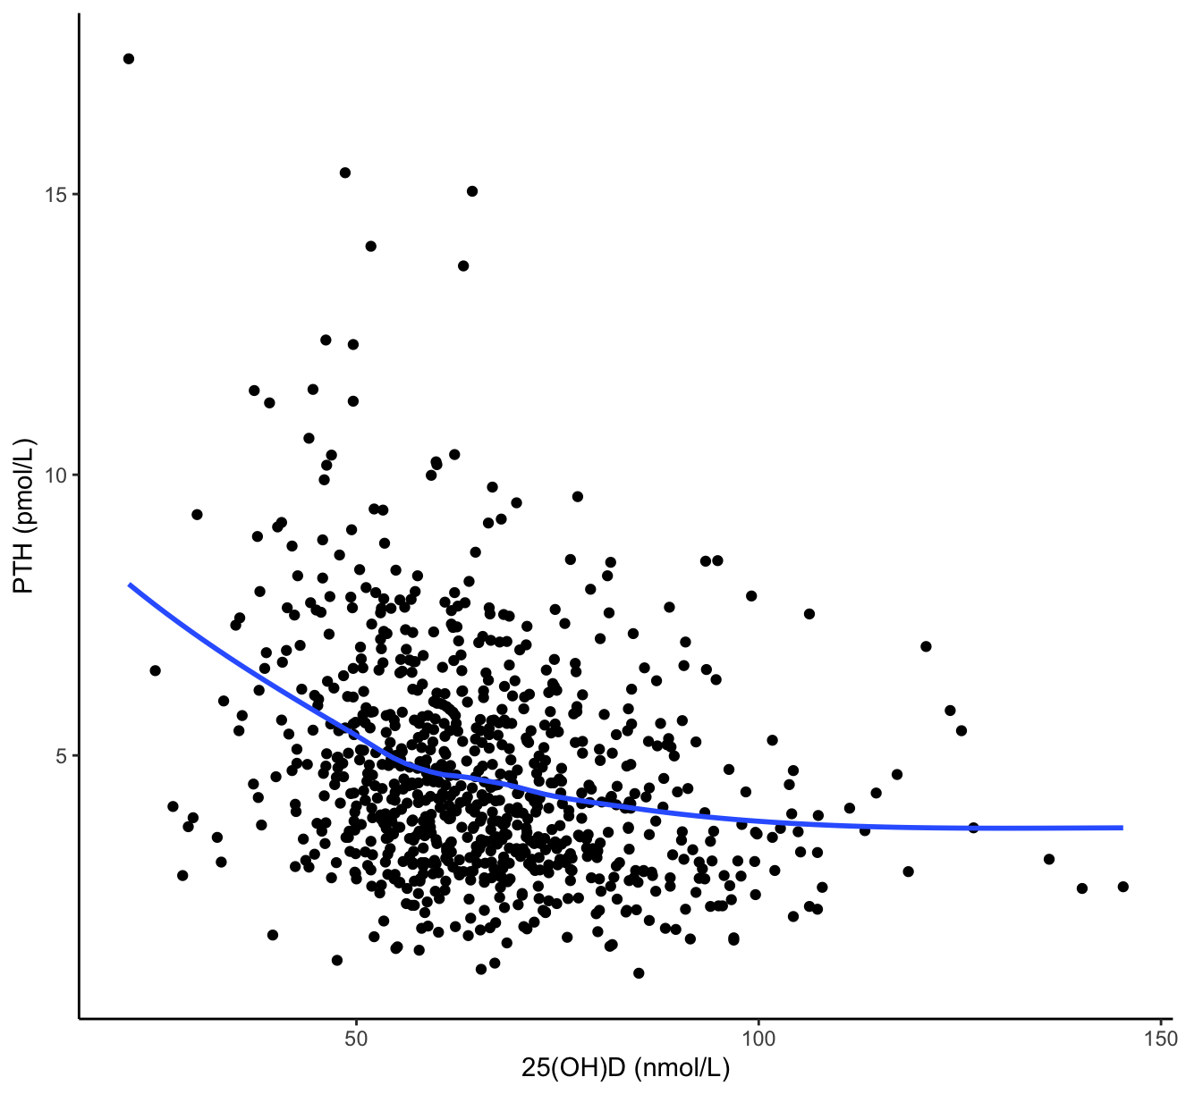

Figure 2a: The relationship between total 25(OH)D and PTH (log transformed), modelled using a non-parametric natural cubic spline curve.
The regression curve is fitted with a 95% confidence interval showing the variation of the natural cubic spline coefficient.

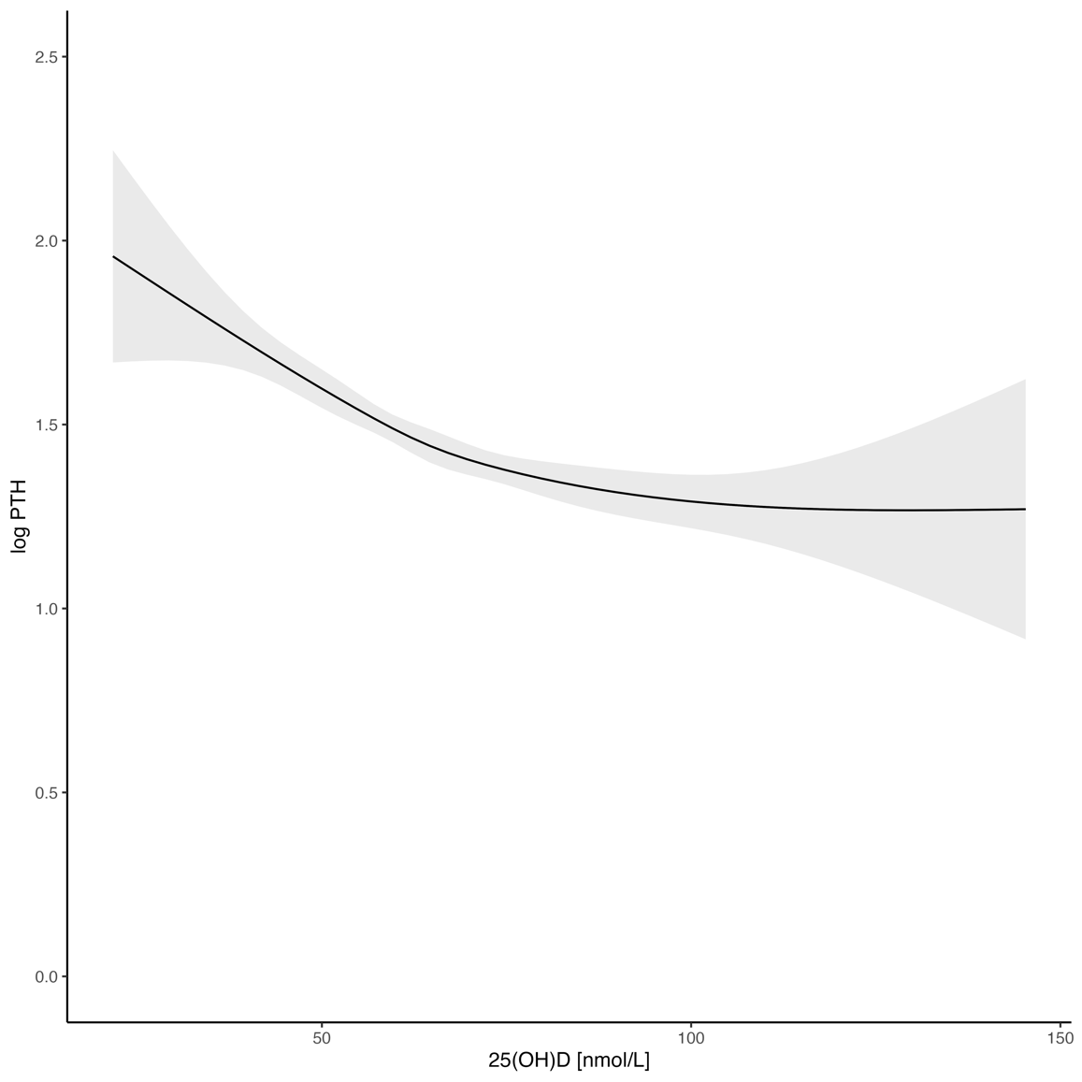

Figure 2b: Identification of inflection points for the relationship between total 25(OH)D and (log transformed) PTH at 59.6 and 74.6 nmol/l.
The natural cubic spline regression coefficient with a 95% confidence interval is plotted against total 25(OH)D. Since, natural cubic splines involves appropriate partitioning of the curve such that the regression coefficient changes at different values of 25(OH)D, this helps in identification of inflection points. Commonly used definitions of 25(OH)D deficiency (<30 nmol/l) and insufficiency (<50 nmol/l) are shown for illustrative purposes.

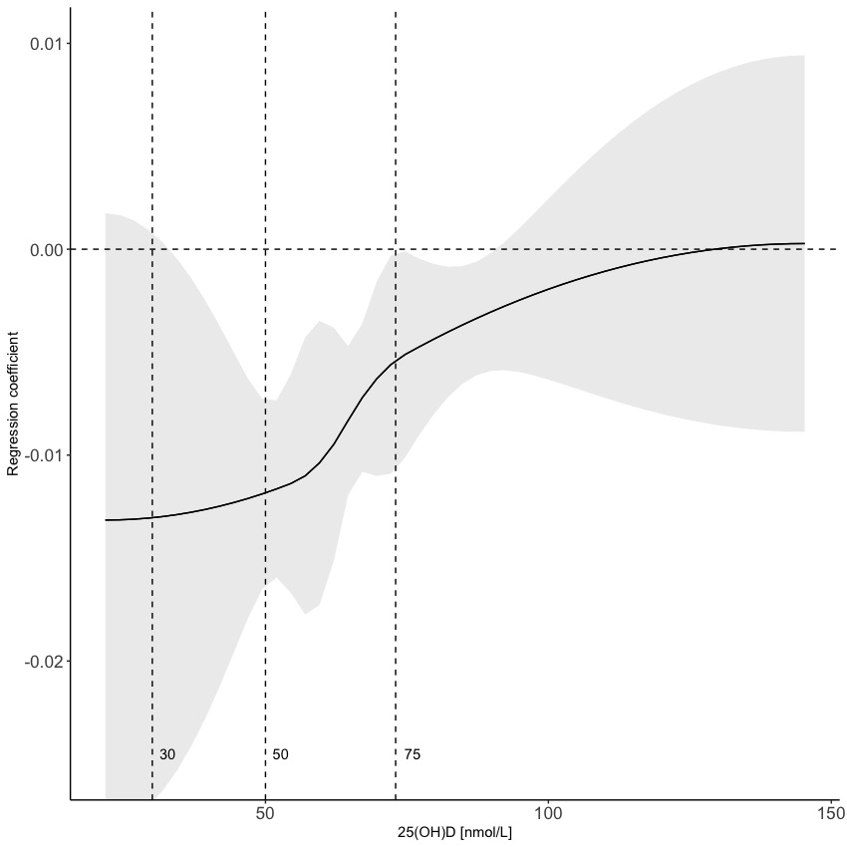
inflection point

The association between 25-hydroxyvitamin D and parathyroid hormone in adolescents living with HIV in southern Africa: a cross sectional study

Supplementary table 1: Lower and upper limits for weekly dietary calcium intake (mg/week) for different food sources and frequencies
 | Calcium Intake-Lower Limit (mg/week) | Calcium Intake-Upper Limit (mg/week)
Dairy
Never | 0 | 0
Less than 4 times in past month | 10 | 249
1-2 times a week | 250 | 749
3-5 times a week | 750 | 1749
Almost every day | 1750 | 2000
Legumes
Never | 0 | 0
Less than 4 times in past month | 10 | 39
1-2 times a week | 40 | 119
3-5 times a week | 120 | 279
Almost every day | 280 | 320
Fish
Never | 0 | 0
Less than 4 times in past month | 10 | 49
1-2 times a week | 50 | 149
3-5 times a week | 150 | 349
Almost every day | 350 | 400
Eggs
Never | 0 | 0
Less than 4 times in past month | 10 | 37
1-2 times a week | 38 | 110
3-5 times a week | 111 | 258
Almost every day | 259 | 304
References:
Calcium calculations:
https://www.iofbonehealth.org/calcium-calculator
https://www.nof.org/patients/treatment/calciumvitamin-d/a-guide-to-calcium-rich-foods/
Calcium estimates are based on the International Osteoporotic Foundation (IOF) calculator after considering dairy, legumes, fish and eggs (micronutrient rich foods as per Food and Agriculture Organization of the United Nations questionnaire). Lower and upper limits for calcium intake per food item (mg/week) are calculated based on serving size, calcium quantity/serving and weekly intake frequency.

Supplementary table 2: Median age, dietary calcium intake, serum PTH and 1,25(OH)₂D concentrations by Tanner stage and sex
n (%) | Tanner  stage | Age (years), median (IQR) | Dietary calcium (mg), median (IQR) | PTH (pmol/L), median (IQR) | 1,25(OH)₂D (pmol/L), median (IQR)
Females
43 (9.6) | I | 11.6 [11.3, 12.1] | 90.3 [47.4, 139.1] | 4.1 [3.1, 5.6] | 221.4 [176.4, 269.2]
45 (10.1) | II | 12.2 [11.4, 13.1] | 100.3 [60.4, 161.8] | 4.3 [3.6, 6.1] | 213.2 [186.2, 255.6]
76 (17.0) | III | 12.9 [12.0, 14.2] | 107.5 [54.6, 205.7] | 4.6 [3.5, 6.8] | 223.7 [179.9, 264.3]
113 (25.3) | IV | 14.9 [13.7, 16.3] | 92.8 [47.4, 140.4] | 4.4 [3.2, 5.7] | 209.9 [172.8, 258.9]
170 (38.0) | V | 17.6 [16.2, 18.6] | 107.5 [62.6, 220.4] | 4.3 [3.3, 5.4] | 175.8 [148.3, 210.5]
Males
34 (8.7) | I | 11.7 [11.3, 12.6] | 86.0 [54.6, 126.2] | 3.9 [2.9, 5.4] | 195.9 [151.4, 227.1]
84 (21.4) | II | 12.6 [12.1, 13.6] | 88.7 [48.9, 152.3] | 3.8 [3.1, 4.7] | 190.8 [162.1, 236.1]
90 (22.9) | III | 14.7 [13.7, 16.0] | 105.7 [65.8, 131.8] | 4.3 [3.3, 5.7] | 226.8 [180.6, 277.7]
94 (23.9) | IV | 16.4 [15.1, 17.6] | 84.8 [52.6, 140.4] | 4.4 [3.4, 6.3] | 211.0 [174.2, 255.8]
91 (23.2) | V | 18.4 [17.6, 19.1] | 103.3 [53.8, 139.7] | 4.5 [3.4, 6.3] | 182.8 [144.3, 235.1]

Supplementary figure 1a: Normal density functions showing the distributions for 25(OH)D, 1,25(OH)₂D, 24,25(OH)₂D and PTH with median values.

Supplementary figure 2a: Monthly variation in serum 25(OH)D concentrations.
Box and whisker plots showing monthly median (horizontal line) and interquartile range (IQR) for 25(OH)D concentrations over the data collection period.

Supplementary 3a: Correlations between 1,25(OH)₂D and 25(OH)D, PTH and dietary calcium.
Scatter plots (black dots) showing linear associations between 1,25(OH)₂D with 25(OH)D, PTH and dietary calcium. The blue dashed line indicates the line of best fit for the linear correlation. The correlation between dietary calcium and 1,25(OH)₂D is stratified by 25(OH)D < 75 nmol/L (black dashed line) vs 25(OH)D ≥ 75 nmol/L (grey dashed line). Correlation coefficients (r) are presented in each scatter plot.

Supplementary figure 4a: Identification of inflection points for the relationship between total 25(OH)D and (log transformed) PTH by ART regimen.
Natural cubic spline curves for the relationship between total 25(OH)D and log-transformed PTH and their respective regression coefficients plotted against total 25(OH)D with a 95% confidence interval. The plots are among participants on TDF-containing ART regimen vs those on other HIV treatment regimens showing dotted vertical lines at values 25(OH)D values of 60 and 75nmol/L.

Supplementary figure 5a: Identification of inflection points for the relationship between total 25(OH)D and (log transformed) PTH by viral load.
Natural cubic spline curves for the relationship between total 25(OH)D and log-transformed PTH and their respective regression coefficients plotted against total 25(OH)D with a 95% confidence interval. The plots are among participants who are virally suppressed (<60copies/ml) vs virally unsuppressed participants (≥60 copies/ml) showing dotted vertical lines at values 25(OH)D values of 60 and 75nmol/L.

Supplementary figure 6a: The different models evaluated in determining the best fitting model between total 25(OH)D and PTH.
Comparison of different models for the relationship between total 25(OH)D and PTH showing the regression coefficient pattern (with a 95% CI) of association in relation to total 25(OH)D. We also show the Akaike Information Criterion (AIC) to estimate the prediction error of the models. AIC values for spline models: linear (top row: 804.15); quadratic (second row: 803.7); cubic spline (third row: 801.4); natural cubic spline (fourth row: 756.1).

Supplementary figure 7a: Identification of inflection points for the relationship between total 25(OH)D and (log transformed) PTH using simulated data [10 times more data points].
A plot for the natural cubic spline regression coefficient with a 95% confidence interval for the relationship between total 25(OH)D and log-transformed PTH using ten times more (simulated) data points plotted against total 25(OH)D. The non-linear curve also shows total 25(OH)D threshold values of 30 and 50 nmol/L.

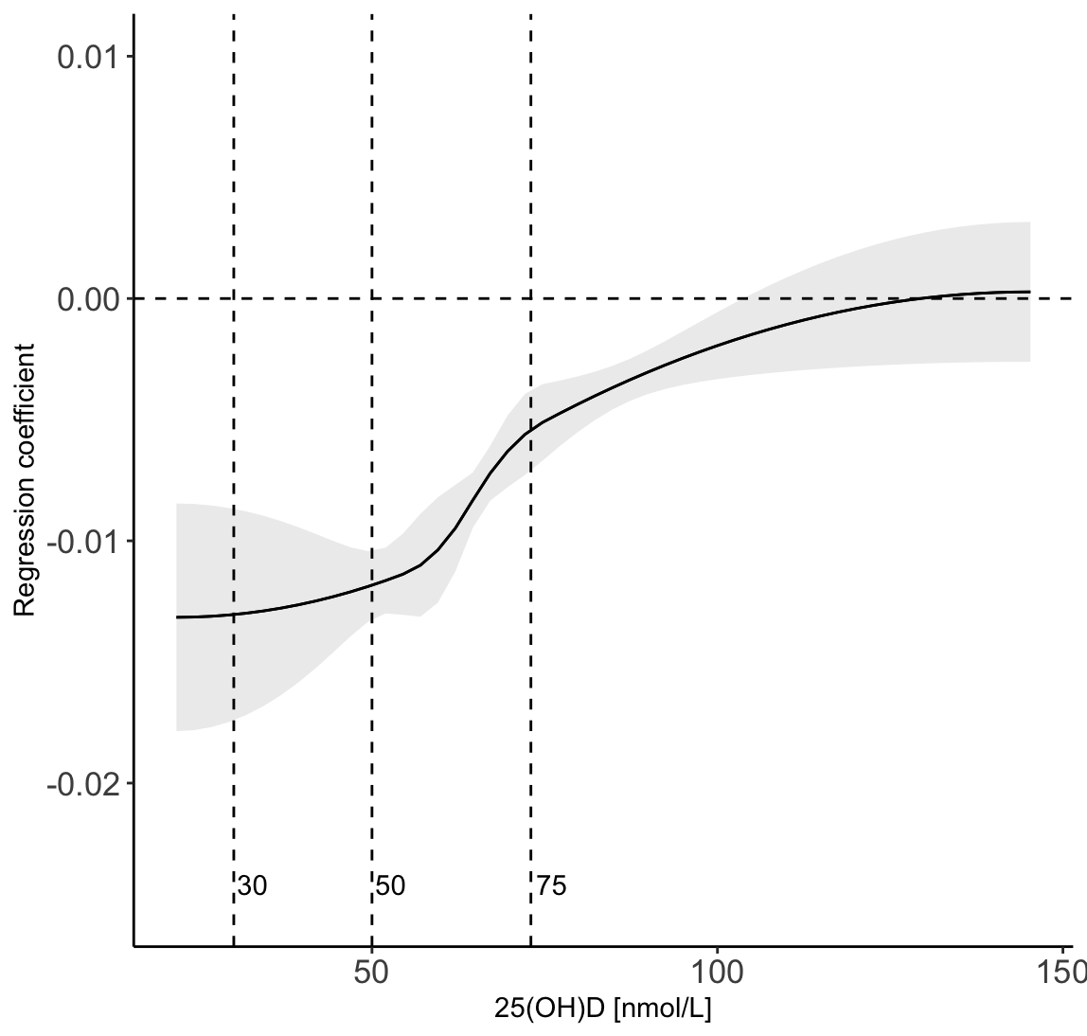

Supplementary figure 8a: Identification of inflection points for the relationship between 25(OH)D and the vitamin D metabolic ratio [25(OH)D/24,25(OH)₂D]
A scatter plot (top) showing the relationship between 25(OH)D and VMR. The middle and bottom plots show the natural cubic spline coefficient and its 95% confidence interval for the relationship between 25(OH)D and VMR with vertical dotted lines at 50 and 75 nmol/L.

