Ultrafast and Coherent Dynamics in a Solvent Switchable “Pink Box” Perylene Diimide Dimer

Giovanni Bressan[a], Samuel E. Penty[b], Dale Green[c], Ismael A. Heisler[d], Garth A. Jones[a], Timothy A. Barendt[b]* and Stephen R. Meech[a]*

[a] Dr. G. Bressan, Dr. G. A. Jones, Prof. S. R. Meech  
School of Chemistry  
University of East Anglia  
Norwich NR4 7TJ (UK)  
E-mail: s.meech@uea.ac.uk

[b] Mr. S. E. Penty, Dr. T. A. Barendt  
School of Chemistry  
University of Birmingham  
Birmingham B15 2TT (UK)

E-mail: t.a.barendt@bham.ac.uk

[c] Dr. D. Green  
Physics, Faculty of Science  
University of East Anglia  
Norwich NR4 7TJ (UK)

[d] Dr. I. A. Heisler  
Instituto de Fisica  
Universidade Federal do Rio Grande do Sul  
91509-900 Porto Alegre, RS (Brazil)  
  
Supporting information for this article is given via a link at the end of the document.

**Abstract:** Perylene diimide (PDI) dimers and higher aggregates are key components in organic molecular photonics and photovoltaic devices, supporting singlet fission and symmetry breaking charge separation. Detailed understanding of their excited states is thus important. This has proven challenging because interchromophoric coupling is a strong function of dimer architecture. Recently, a macrocyclic PDI dimer was reported in which excitonic coupling could be turned on and off simply by changing the solvent. This presents a useful case where coupling is modified without synthetic changes to tune supramolecular structure. Here we present a detailed study of solvent dependent excited state dynamics in this dimer by means of coherent multidimensional spectroscopy. Spectral analysis resolves the different coupling strengths, which are consistent with solvent dependent changes in dimer conformation. The strongly coupled conformer forms an excimer within 300 fs. The low-frequency Raman active modes recovered from two-dimensional electronic spectra reveal frequencies characteristic of exciton coupling. These are assigned to modes modulating the coupling from the corresponding DFT calculations. Further analysis reveals a time dependent frequency during excimer formation. Analysis of two-dimensional “beatmaps” reveals features in the coupled dimer which are not predicted by the displaced harmonic oscillator model and are assigned to vibronic coupling.

Introduction

Molecular architectures based on the perylene diimide (PDI) moiety have been the subject of extensive synthetic and spectroscopic investigations due to its exceptional photophysical properties such as large transition dipole moment (TDM), high fluorescence quantum yield, outstanding photostability and ease of functionalisation, including at the imide nitrogen and perylene bay-positions.[1–5] Such properties make PDI a promising molecular building block for optical sensors, solar light harvesters and non-fullerene acceptors, among others.[6–9] This unique combination of desirable features drove the development of a library of PDI-based supramolecular structures ranging from covalently bound head-to-tail and cofacial dimers to self-assembled oligomers and columnar stacks, each of which displays distinctive electronic and optical properties.[10–13]

The photophysics of PDI-based supramolecular structures are remarkably sensitive to geometry and topology, as their excited states present an array of distinct characteristics, such as excitonic coupling, excimer formation, symmetry-breaking charge separation and singlet fission. Importantly the magnitude of these excited-state properties and the interplay between them can be controlled by synthetic structural modifications which modify interchromophoric interactions.[14–22] It is this tunability of photophysical properties that makes PDI assemblies so important in photonics applications.

However, the fact that these intertwined excited state processes are sensitive to supramolecular structure, makes it difficult for structural modifications to selectively target just one process. Very recently some of us reported on the structure and characterisation of a novel bay-connected PDI dimer, macrocycle **1**, the “pink box” (Figure 1a).[4] Among a number of properties it was found that **1** could be switched from monomer-like electronic absorption and emission spectra to photophysics indicative of strong excitonic coupling and excimer formation. This transformation was achieved without synthetic structural modification, but simply by tuning the solvent, for example between moderately polar 1,1,2,2-tetrachloroethane (TCE) and nonpolar toluene. Uniquely, this (apparently) simple solvent tuning permits investigation of interchromophoric coupling within a single supramolecular architecture. Here we fully assign the solvent-switched optical properties of **1** and probe its

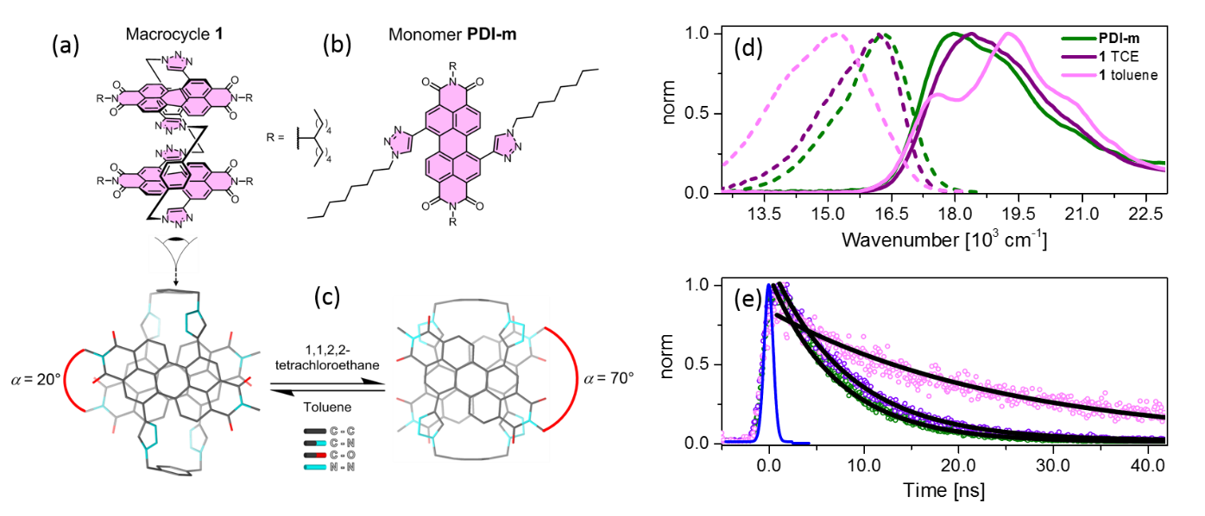

**Figure 1**. Molecular structures of the “pink box” PDI dimer, macrocycle **1** (a), and the PDI monomer PDI-m (b), with the proposed macrocycle conformations in toluene (from SCXRD) and TCE (from DFT) solutions (c).[4] For clarity, hydrogen atoms and, where present, solubilising side chains have been removed from the conformers of **1**. (d) Normalised steady-state absorption (solid) and emission (dashed) spectra of PDI-m in TCE and **1** in TCE and toluene in green, violet and pink, respectively. Fluorescence spectra were excited at ${\tilde{ν}}_{Exc}$ = 17500 cm-1. (e) Nanosecond time resolved fluorescence emission traces measured at 16200 cm-1, after photoexcitation at 18900 cm-1 of PDI-m and **1** in TCE and toluene (open circles, following the colour code of (d)); single exponential fits are shown as black solid lines. The instrument response function (IRF) is shown as a blue solid line

photophysics as a function of interchromophore coupling by means of ultrafast spectroscopy. Specifically we apply femtosecond transient absorption (fsTA) to recover population dynamics and half-broadband two-dimensional electronic spectroscopy (HB2DES)[23–25] to probe vibrational coherence and sub-ps evolution in electronic and nuclear structure; 2DES has only rarely been applied to probe PDI dimers.[17]

Results and Discussion

Spectroscopy

The steady-state absorption and emission spectra of **1** in TCE and toluene are shown in Figure 1d. In moderately polar TCE (*ε*r = 7.42) the absorption spectrum has a maximum at 18200 cm-1 and a weakly resolved vibronic progression, strongly resembling the absorption spectrum of the monomer in toluene (here defined as **PDI-m**,Figure 1b) but with its maximum blue-shifted by ~400 cm-1. The steady-state fluorescence spectrum of **1** in TCE bears an approximate mirror-image relation to the absorption, with an 820 cm-1 Stokes shift, which again closely matches the emission of **PDI-m** (755 cm-1 Stokes shift). Further, in TCE, **1** has a similar fluorescence quantum yield $φ_{Fl}$ and lifetime $τ_{Fl}$ to the monomer (0.9 compared to 0.99 and 8 ns compared to 7 ns (Figure 1c)). In contrast, the absorption spectrum of **1** in nonpolar toluene (*ε*r = 2.38) shows markedly different electronic spectra. There is a reversal of the 0-0 and 0-1 vibronic band amplitudes in absorption and the emission is red shifted from its spectrum in TCE and that of **PDI-m** (1580 cm-1 Stokes shift) and becomes broader (2100 cm-1) and unstructured. Further, the emission in toluene is attenuated ( $φ_{Fl}$ = 0.42) and longer-lived ( $τ_{Fl}$ = 25 ns) corresponding to a six-fold decrease in TDM for emission compared to TCE. These spectral features and smaller TDM are characteristic of strong excitonic coupling leading to emission from an excimer state in toluene.[26]

A widely used parameter to gauge the extent of excitonic coupling in supramolecular PDI-based systems was developed by Spano.[27,28] This builds on the observed ratio between the 0-1 and 0-0 vibronic absorption peak areas (${R_{0-1}}/{R_{0-0})}$ with respect to the same ratio in a PDI reference monomer. For **1** in TCE ( ${R_{0-1}}/{R_{0-0})}$ = 0.89, similar to the value **PDI-m** value of 0.78, yet much smaller than the 1.63 calculated for toluene. These ratios were determined by fitting to the measured steady-state absorption spectra a sum of three Gaussians, whose central frequencies, areas and full-width half-maxima (FWHM) are listed in Table S1 and shown in Figure S1a. These results suggest weak H-type (positive) excitonic coupling for **1** in TCE, with +117 cm-1 and strong H-type excitonic coupling in toluene, with (${R_{0-1}}/{R_{0-0}) }$ = 1.63, and +642 cm-1. [22,29–31] Thus, **1** exhibits strong H-type coupling when dissolved in toluene but essentially monomer-like character in TCE.[27] is the sum of two contributions, the coulombic and a charge transfer coupling terms:

$J_{Tot}{=J}_{Coul}+ J_{CT}$. (1)

The two terms can independently assume positive or negative values so can interfere constructively or destructively.[32,33] is the long-range Coulombic dipole coupling used by Kasha to rationalise the spectra of molecular dimers as a function of distance and orientation between their TDMs:[13,34]

(2)

In (2) the superscript *PD* indicates that the excitonic coupling is calculated using the point-dipole model, $μ$ is the TDM, $α$ and $θ$ are the tilt and slip angles between the TDMs of the PDIs, respectively (see Figures 1c and S1c), $ε_{0}$ the vacuum permittivity, $ε_{r}$ the (dimensionless) solvent relative permittivity, and $R$ the PDI-PDI interplanar centre-centre distance (see Figure S1c).

For an ideal cofacial dimer such as **1** (Figure 1a), $\cos^{2}θ$ vanishes. $α$ is the angle between the projections of the two TDMs on a plane parallel to the PDIs, the tilt angle (Figure 1c). Alongside the solvent dependent electronic spectra, NMR spectroscopy, single crystal X-ray diffraction (SCXRD) and density functional theory (DFT) calculations (described in Penty et al.[4]) indicate a change in the predominant conformation of **1** between toluene and TCE which increases the tilt angle from $α$ = 20° in toluene to $α$ = 70° in TCE (Figure 1c). Experimental and predicted 1H NMR spectra[4] point towards this change arising from the disruption of intramolecular hydrogen bonding and π–π interactions between the two PDI units in TCE. This solvent effect can be rationalised by two factors; firstly, compared to toluene, TCE is more polar, which weakens intramolecular hydrogen bonding,[35] while secondly, as a chlorinated solvent, TCE is more polarisable, an effect known to disrupt the π–π stacking of PDIs due to favourable intermolecular interactions between solute and solvent[36]. Indeed, there is a good correlation between solvent polarity/polarizability and the free energy of intramolecular PDI–PDI aggregation in **1**,[4] i.e., the conformational change shown in Figure 1c. Assuming these two conformations, the long range couplings, $J_{Coul}^{PD}$, calculated from (2) for **1** in toluene and TCE, with a TDM of 10 Debye[13,37,38] and a PDI–PDI distance ($R$) of 0.37 nm (as determined by SCXRD),[4] were found to be significantly overestimated with respect to the $J_{Tot}$ obtained from Spano’s model, by factors of ~4 and ~6 respectively.

As the point-dipole model of (2) is known to overestimate Coulomb coupling in dimers whose interchromophore separation is smaller than their molecular dimensions,[39] we adopted the transition charge method as this approach has been shown to more reliably estimate long-range couplings in PDI (and other acene) dimers.[32,33,39,40] Further details on the method are given in supplemental material. The $α$ = 20° and $α$ = 70° (see Figure 1c) conformers yielded values of +377 and +198 cm-1, respectively. These results are consistent with the conclusion that an increase in tilt angle α weakens the excitonic interaction.

The total excitonic coupling in closely packed chromophore dimers is given by the interference between ${ J}_{Coul}$ and $J_{CT}$, as shown in (1). The latter is a short-range coupling arising from a superexchange interaction mediated by a charge-transfer state, which depends on the frontier molecular orbitals (MO) overlap between the PDI pair.[27,33] This term is calculated to become significant for 0.35 $≤R≤$ 0.45 nm.[39,40] is defined as:

$J_{CT}=\frac{-2t_{e}t_{h}}{E_{CT}-E_{S_{1}}}$ (3)

where $t_{e}$ and $t_{h}$ are the electron and hole transfer integrals, whose magnitude and sign are sensitive to sub-Å changes in the relative orientations of the two PDIs,[33,39,40] and to $E_{CT}-E_{S_{1}}$, the energy gap between the CT and S1 states.[27,33] and $t_{e}$ were determined for both conformers using Gaussian 16[41] and CATNIP, a package to calculate charge transfer integrals.[42] Details of the method are given in supplemental material. For the $α$ = 20°, excimer forming, conformer populated in toluene, $t_{h}$ and $t_{e}$ are respectively −480.1 and +432.0 cm-1, in line with theoretical predictions on other PDI-based systems.[27,40,43] These yield a short-range coupling $J_{CT}$ of +276 cm-1, if is assumed to be +1500 cm-1.[39,43] Following the nomenclature introduced by Hestand *et al*.,[27] this $α$ = 20° conformer of **1** is an HH aggregate, in which long- and short-range coupling terms are comparable and both positive (H-type) thus adding up to yield a total excitonic coupling = +653 cm-1, in very good agreement with the value determined from the fit to the experimental steady-state absorption spectrum (+642 cm-1).

Conversely, for the $α$ = 70° conformer populated in TCE, $t_{h}$ and $t_{e}$ are respectively +351 and +365 cm-1 (again consistent with literature[33,40]) yielding = -158 cm-1 where is again taken as +1500 cm-1. This = 70° conformer of **1** is then an HJ dimer in which the negative (J-type) short-range coupling is weaker than in toluene and partially cancels the positive (but smaller than toluene) Coulomb term, to yield a net = +40 cm-1. The calculations largely underestimate the value determined from the fit to its absorption spectrum ( = +117 cm-1). We speculate that the discrepancy between experimental and calculated $J_{Tot}$ values is due to the ambiguity in fitting a sum of Gaussians to the broad absorption spectrum of **1** in TCE (see Figure S1a). Whilst (1) is strictly valid only when >>,[28,43] the high $φ_{Fl}$ of **1** in TCE suggests we are within its range of applicability. We note that the excitonic couplings were calculated assuming vacuum. Including solvent dielectric constant would modify the results through both (2) and $E_{CT}-E_{S_{1}}$, the latter in ways which are difficult to quantify. Nevertheless, the calculated couplings are consistent with a solvent-induced conformational change of **1** that increases α in TCE, populating a null-aggregate[44] conformer with reduced Coulomb coupling and inverted (negative) sign of $J_{CT}$, as reflected in its electronic spectra.

Here we probe the consequences of this switch in coupling for the excited state dynamics, utilising half-broadband two-dimensional electronic spectroscopy (HB2DES) and ultrafast transient absorption (fsTA).

**Ultrafast spectroscopy: Population dynamics**

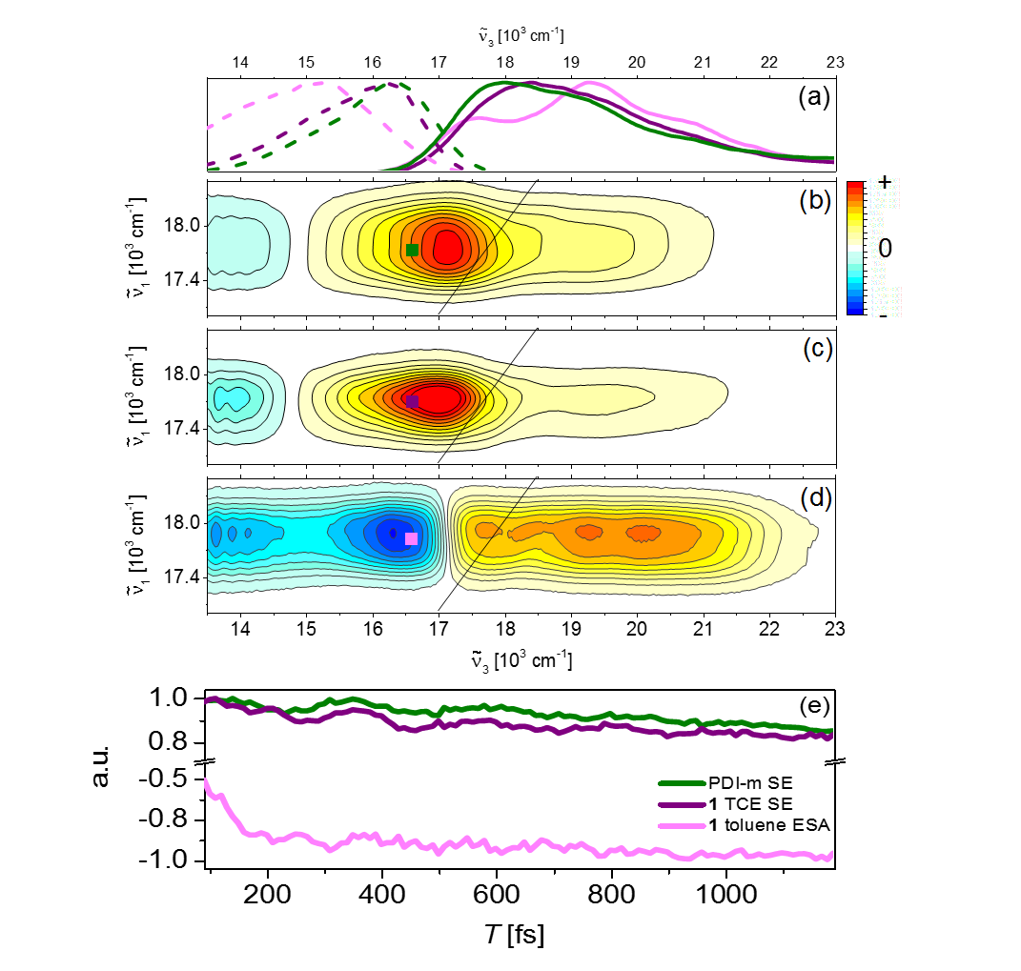

**Figure 2.** (a) Normalised steady-state absorption (solid) and emission (dashed) spectra of the PDI-m and **1** in TCE and toluene in green, violet and pink, respectively. (b-d) Absorptive 2DES spectra of PDI-m and of **1** in TCE and toluene for T = 250 fs. The intensity is given by 21 contour lines, positive signals (GSB+SE) are shown in yellow-orange-red and negative signals (ESA) are shown in blue. All spectra are amplitude normalised to the maximum positive amplitude. (e) Normalised absorptive 2DES traces of PDI-m and of **1** in toluene and TCE, taken at the excitation-detection coordinates marked by solid squares in (b-d); squares and traces follow the colour code of (a).

HB2DES is a four-wave mixing spectroscopy measured in a three pulse sequence (SI) in a pump-probe geometry.[45] The output of a noncollinear optical parametric amplifier (NOPA) is shaped by a programmable acousto optic filter to yield a pair of pump pulses with controllable interpulse coherence time (*τ*) and relative phase $φ_{12}$. A compressed broadband white light continuum (WLC) acts as the probe pulse

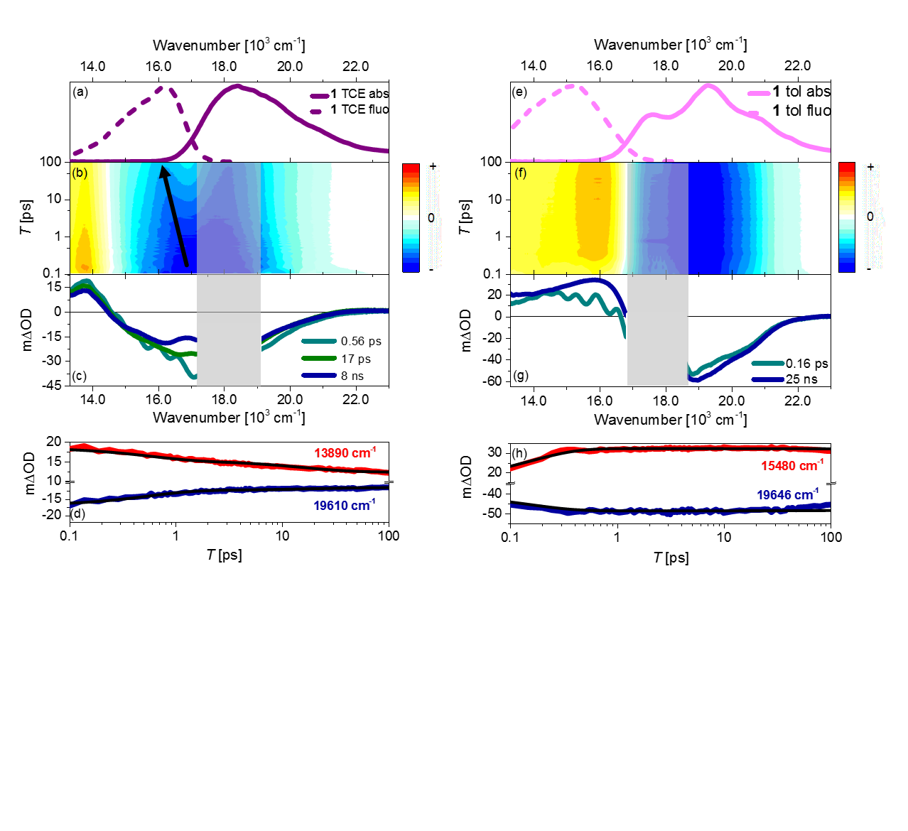

**Figure 3**. (a) Normalised steady-state absorption (solid) and emission (dashed) spectra of 1 in TCE. (b) Broadband fs transient absorption (fsTA) over 0.1-100 ps pump-probe delay range of 1 in TCE; pump-probe wavenumbers were as for Figure 2. The intensity is given by 21 contour lines, negative signals (GSB+SE) are shown in blue and positive signals (ESA) are shown in yellow-orange-red. (c) Evolution associated difference spectra obtained by a global fit to the data in (b). (d) fsTA log time traces and global fit of 1 in TCE at specific probe wavenumbers. (e-h) are the same of (a-d) for 1 in toluene. Grey shaded areas indicate spectral regions excluded from the global analysis as affected by pump scattering artefacts

and interacts with the sample after a waiting time delay *T*. The probe is spectrally resolved to recover the detection frequency axis (${\tilde{ν}}_{3}$) while the excitation frequency dimension (${\tilde{ν}}_{1}$) is retrieved by a Fourier transform (FT) over *τ,* yielding a 2D spectrum at a particular *T.* Maintenance of specific phase relationships between the two pump pulses yields the complex-valued rephasing (photon-echo, shown in the SI, Figures S2, S3) and nonrephasing parts of the response, which are summed to generate the absorptive HB2DES spectra, which can be thought of as excitation-frequency resolved transient absorption at *T*.

Absorptive HB2DES data at *T* = 250 fs for **1** in TCE, toluene and for **PDI-m** were collected using a previously described spectrometer.[24] All samples were excited by ~30 fs NOPA pulses centred at ${\tilde{ν}}_{1}$ = 17800 cm-1, and probed by a WLC spanning ${\tilde{ν}}_{3}$ = 13500-23000 cm-1. The waiting time *T* was sampled in 10 fs steps from 0 to 1200 fs. The absorptive HB2DES at *T* = 250 fs are reported in Figure 2b-d. Normalised steady-state absorption and emission spectra are reproduced in Figure 2a to aid interpretation. The absorptive spectrum of **1** in TCE (Figure 2c) presents a convoluted positive signal assigned to ground state bleach (GSB) and stimulated emission (SE), on the basis of the matching steady-state absorption and emission spectra. There is a weaker negative contribution assigned to excited state absorption (ESA) extending toward the near IR. These results are in good agreement with HB2DES of **PDI-m** (Figure 2b) and with literature 2DES of weakly-coupled PDIs.[13,17]

The corresponding HB2DES of **1** in toluene (Figure 2d) is remarkably different. The most striking features are the quenching of the SE band and the appearance of a negative signal extending from ${\tilde{ν}}_{3}$ = 17200 cm-1 to the near-infrared, with a distinctive broad profile peaking on the red edge of the GSB feature. The difference in the 2DES extends to the temporal evolution. The dynamics observed in HB2DES over the first 1.2 ps after photoexcitation at the excitation-detection wavenumbers indicated in Figure 2b-d are reported in Figure 2e. Over this time window the SE signals of **PDI-m** and **1** in TCE show prompt appearance (within the IRF) and ~15% decay, whilst an ultrafast risetime is detected in the ESA region for **1** in toluene. This time dependence of the absorptive 2DES is consistent with excimer formation occurring within 300 fs, after which the signal remains constant over the measured *T* window. Complete absorptive HB2DES spectra of **1** in toluene at selected *T* values between 80 and 750 fs showing the risetime of the excimer ESA feature are reported in the SI (Figure S4). Such fast ESA evolution in this spectral region has previously been observed in 2DES and broadband fs transient absorption (fsTA) of cofacial PDI dimers and assigned to excimer ESA.[15,17,46] The absence of any further evolution after 1 ps suggests the excimer of **1** has a rigid structure,[20,46,47] consistent with a macrocyclic architecture. Thus, these observations corroborate the assignment of excimer formation of **1** in toluene inferred from the steady state and ns data (Figure 1d,e). Further, the GSB region is more structured in toluene than in TCE, as expected from the better resolved vibronic features in the steady-state absorption spectrum (Figure 2d). Finally, all traces show amplitude modulations during *T* due to coherent nuclear wavepacket dynamics, discussed in detail in the following section.

The solvent-dependent population dynamics of **1** were investigated over a longer time window by fsTA spectroscopy (Figure 3). The fsTA of **1** for pump-probe delays (corresponding to waiting time *T* in HB2DES) between 0.1 and 100 ps are shown on a log-*T* scale (Figure 3b, f for TCE and toluene respectively) whilst data for **PDI-m** are reported in the SI (Figure S5). Since fsTA data are reported in mΔOD, the sign convention is the opposite of 2DES, with negative GSB and SE and positive ESA and photoproduct signals. To aid assignment, normalised steady-state absorption (solid) and emission (dashed) spectra of **1** in TCE and toluene are reported in Figure 3a, e.

For **1** in TCE the GSB+SE and ESA bands are again promptly formed upon photoexcitation, with the SE signal decaying by ~50%, redshifting and narrowing over a hundred ps, as indicated by the arrow superimposed to the contour plot in Figure 3b. In toluene, the GSB feature is promptly formed while the broad ESA, peaked at 16150 cm-1, only reaches its maximum after ~400 fs followed by negligible evolution within the measured window, consistent with macrocycle rigidity. fsTA spectra at selected pump-probe delay times are reported in Figures S6 and S7 for TCE and toluene, respectively. The early time fsTA data are in very good agreement with the HB2DES results shown in Figure 2.

fsTA data were globally fit (using GloTarAn[48]) to a sequential model; the evolution associated difference spectra (EADS) are reported in Figure 3 c and g for **1** in TCE and toluene, respectively. The agreement between data and global fit is shown, at selected probe wavelengths, in Figure 3d, h for **1** in TCE and toluene, respectively and in Figure S5 for **PDI-m**. The dynamics of **1** in TCE were well fit with a single intermediate formed in 0.56 ps from the Franck-Condon (FC) state and decaying in 17 ps to the final spectrum (assigned to a fixed 8 ns population decay to match $τ_{Fl}$, Figure 1e). The small oscillations in the initial spectrum are due to convolution with the coherent artefact due to pulse overlap at *T* = 0 fs. The 0.56 ps and the 17 ps components describe amplitude decay and redshift of the SE between 15000 and 17000 cm-1 yielding a “relaxed” transient spectrum with minima at 16200 and 18000 cm-1, matching the steady-state absorption and emission maxima, respectively. Such an evolution of the TA on a few ps timescale was previously reported for twisted bay-substituted PDI structures[18,19] and assigned to excited-state planarisation of the PDI core i.e. minimisation of the dihedral angle between the two naphthalene units within a PDI, whose ground state minima are distorted by bay-substituents (dihedral = 21° in the ground state of **1**, from SCXRD).[4] The non-single exponential planarisation kinetics reported here suggest that more than one coordinate might be involved in this structural evolution, with an initial fast (0.56 ps) relaxation preceding the slower ps structural dynamics.[49] Consistent with this intra-PDI planarization model, the fsTA of **PDI-m** also required an intermediate, in this case forming in 0.46 ps and decaying to the final state in 11 ps (Figure S5). We speculate that this occurs slightly slower in **1** as its structure is more rigid than **PDI-m** because of the covalent macrocyclic framework.

In contrast, the fsTA of **1** in toluene required only two components of 0.16 ps and 25 ns (fixed to $τ_{Fl}$) to obtain a good fit, yielding the EADS shown in Figure 3g. The earliest EADS, again convoluted with the coherent artifact, evolves in 160 fs to the long-lived spectrum, displaying a broad ESA feature and pronounced feature at 16150 cm-1. The shape and timescale of this EADS indicate ultrafast evolution from the Franck-Condon excited state to populate the excimer state. This observation is in agreement with studies of excimer formation in other PDI cofacial dimers.[15,17,19,20,46,50] Such ultrafast evolution suggests that the ground-state geometry of **1** in toluene, in which two rigid covalent linkers constrain the PDIs to a small tilt angle ($α=$ 20°), is pre-organised for ultrafast barrierless formation of the excimer without substantial reorganisation or solvent displacement. In the case of **1**, and differently to some PDI dimers with a single linker[17,51] the initially formed excimer state is stable for tens of ns (Figure 1c). Next we probe the role of excitation of coherent superpositions of vibrational states in the ultrafast relaxation to excimer.

**Ultrafast spectroscopy: coherent dynamics**

Wavepacket dynamics is evident in the time resolved HB2DES and fsTA data (e.g. Figures 2e and 3d, h). Here we recover the solvent dependent vibrational frequencies and “beatmaps” (maps of coherences across the 2D spectra)[52,53] of **1**. Compared to fs coherence spectroscopy (FCS) 2DES beatmaps offer several advantages in analysis of wavepacket dynamics, including clearer assignments and avoidance of destructive interferences.[17] Beatmaps are obtained by globally fitting real and imaginary parts of the rephasing HB2DES data (Figure S2-3) to a sum of decaying exponential functions, with the wavepacket dynamics isolated as residuals. Beatmaps at specific wavenumbers are obtained from a complex FT of these residual matrices (Figure 4, with details of the analysis procedure shown in SI Figure S8).[24,52,54]

Selection of the relevant wavenumbers can be made from summary Raman spectra created by integration of the entire 3D spectrum over ${\tilde{ν}}_{1}$ and ${\tilde{ν}}_{3}$ after population subtraction. This contains contributions from both ground and excited state coherences.[55] The rephasing positive summary Raman spectra for **PDI-m** and **1** in TCE and toluene are reported as grey shaded areas in Figure 4 a-c. For **PDI-m** and **1** in TCE these spectra show single dominant vibrational modes at +140 cm-1 and +150 cm-1, respectively. The result for **1** in toluene is quite different, with frequencies at +50, +95 and +200 cm-1. As the FT of noisy data can lead to spurious frequency-domain signals, the robustness of these coherence data was assessed by fitting the real part of the rephasing residuals, integrated over a 300 x 300 cm-1 square centred at 17600 cm-1; 16800 cm-1 (see markers in Figures S2-3 and traces in Figure 4d-f) to a sum of damped cosines. These results show that oscillations persist for over 1 ps, including for **1** in toluene where the excimer was formed within 300 fs. Frequencies and dephasing times obtained from the time-domain fits (Figures 4d-f) are summarised in the SI (Table S2) and are in good agreement with the recovered Raman spectra. As a further check, FTs of the integrated residuals data are shown as solid lines in Figure 4a-c. The good agreement amongst these three analyses points to the robustness of the impulsive vibrational spectra and suggests the most significant frequencies for beatmap analysis.[24]

The appearance of modes in the summary Raman spectra suggest they are displaced on excitation from S0. The dominant modes for **1** in TCE (+150 cm-1) and **PDI-m** (+140 cm-1) are similar. A mode at 139 cm-1 was previously reported in a coherence spectroscopy study of a bay-substituted PDI monomer[56] and assigned to an excited state in-plane stretch of the C–C (C═C) bonds. The distinct Raman spectrum of **1** in toluene shows that the low-frequency vibrational as well as electronic spectra of **1** are a strong function of solvent. A different set of enhanced Raman modes for **1** in toluene compared to TCE may arise for two reasons. First, different modes are displaced, and thus enhanced, in the excimer forming geometry. Specifically, modes which modulate the inter-PDI distance and tilt angle ($α$), which are the key coordinates in exciton coupling (see above),[43] are expected to exhibit significant enhancements. To identify these the Raman spectrum of **1** with the ground state geometry that supports excimer formation ( $α$ = 20°) was calculated by DFT (see SI). The ground-state geometry was optimised using the hybrid functional B3LYP employing the 6-31G* basis set. A harmonic frequency analysis of the minimised energy structure yielded no imaginary frequencies, hence is a genuine minimum. Cartesian coordinates of the optimised geometry are reported in the SI. At 210 cm-1 (gas phase, uncorrected) a mode which obviously modulates the inter-ring separation is calculated, while at 179 cm-1 there is a mode which modulates $α$ (see SI Figures S12-S13). Other low frequency modes in that spectral region are mainly localised on the periphery of **1**. The modes observed below 100 cm-1 were reproducible, but we have not attempted an assignment. An alternative origin for the difference between vibrational spectra of **1** in TCE and toluene is the different resonant electronic states. While the frequencies observed will reflect the singlet excited state populated by the pump pulse and the impulsively excited ground state, the enhancements depend on the displacement between the two resonant states.[53] In TCE the enhancing transition is S1-S0 (SE), while in toluene a higher excited state (S1-Sn) is involved (absorptive HB2DES, Figure 2 and fsTA, Figure 3). This may also lead to significantly different intensity distributions

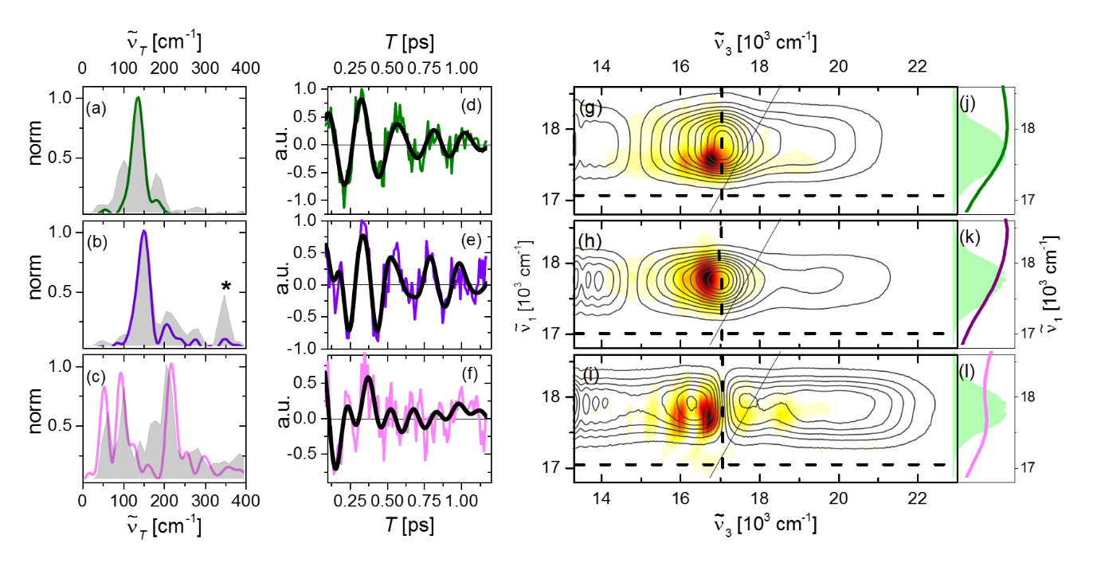

**Figure 4.** (a-c) Rephasing positive summary Raman spectra of PDI-m (a), **1** in TCE (b) and in toluene (c) shown as grey shaded areas. The asterisk marks a solvent (TCE) mode at 338 cm-1. Fourier transforms of the integrated T-domain residuals are shown as green, violet and pink for PDI-m, **1** in TCE and toluene, respectively. (d-f) integrated residuals of a global fitting to the real part of the rephasing HB2DES, using the usual colour code. The residuals were integrated over 300 x 300 cm-1 squares centred at = 17600 cm-1; = 16800 cm-1. Overlaid black solid lines are fits to a sum of damped cosines, whose frequencies and dephasing times are reported in the SI, Table S2. (g-i) Rephasing positive beatmaps of the (g) 140 cm-1 (h) 150 cm-1 and (i) 200 cm-1 Raman active modes of PDI-m, **1** in TCE and in toluene, respectively. Beatmaps are shown as white-yellow-red heatmaps and are all normalised to unity. Contour lines showing the real part of the corresponding experimental absorptive 2D spectra (T = 250 fs, reproduced from Figure 2) are overlaid. (j-l) are the pump and steady-state absorption spectra shown as shaded areas and solid lines, respectively.

for the same state, as discussed for other transient Raman methods.[57,58] Rephasing beatmaps are shown for the most significant modes at 140, 150 and 200 cm-1 for **PDI-m** and for **1** in TCE and toluene in Figures 4g-i. Along the excitation (${\tilde{ν}}_{1}$) axis the distributions are quite similar and rather featureless. In general, specific points on the beatmap can be assigned to distinct Liouville space pathways based on the displaced harmonic oscillator (DHO) model.[52,59] In the present case the modes observed are of low frequency on the order of the thermal energy $kT$, meaning that several vibrational levels in the ground state PES may be thermally populated. This leads to multiple degenerate transitions such that no specific vibrational coherence pathways are resolved. The dominant feature determining the observed intensity distributions is the convolution between the steady-state absorption and the excitation pulse spectra.

There are more significant spectral features along the detection (${\tilde{ν}}_{3}$) axis. The **PDI-m** rephasing +140 cm-1 beatmap shows strong contributions in a region where both SE and GSB pathways contribute, and its pattern can be rationalised in the framework of the displaced harmonic oscillator (DHO) model,[59,60] as the strongest feature of the beatmap amplitude is localised on the low-energy side (below) the diagonal. This broad feature centred at ${\tilde{ν}}_{3}$ = 16800 cm-1 agrees with the expected beatmap pattern for a monomeric (uncoupled) chromophore. A very similar beatmap is observed for the +150 cm-1 mode for **1** in TCE, consistent with these arising from the same mode. The ~10 cm-1 blue-shift may arise from increased rigidity experienced by the PDI cores in **1**, induced by the covalent linkers at the bay positions. The rephasing negative beatmaps of **PDI-m** (−140 cm-1) and **1** in TCE (−150 cm-1) (shown in the SI, Figure S9) are red-shifted along the excitation axis, in line with DHO model predictions.[59,61] As rephasing negative beatmaps report selectively on S1 coherences, they provide further evidence that these low frequency vibrations are active in the excited state. The similarities of their dephasing time, Raman frequency and beatmap pattern is consistent with the FC state of **1** in TCE strongly resembling the S1 state of the uncoupled **PDI-m** chromophore, as suggested based on their electronic and impulsive Raman spectra and population dynamics.

As observed for the Raman spectra (Figure 4b,c), the +200 cm-1 beatmap for **1** in toluene is very different to that in TCE. The beatmap (Figure 4i) shows amplitude on both sides of the ESA maximum, in the region where the excimer ESA growth dominates the sub-ps population dynamics (${\tilde{ν}}_{3}=$ 15200-17000 cm-1). The strongest coherent features, appearing on the low energy side of the diagonal at ${\tilde{ν}}_{3}$ = 16800 cm-1 and = 16000 cm-1 are consistent with the GSB and ESA pathways predicted by a three-electronic level DHO model, respectively. The amplitude of the -200 cm-1 rephasing beatmap amplitude (Figure S9) in this region supports the assignment of this vibrational mode being active in the S1 state.

The weaker above diagonal signals at ${\tilde{ν}}_{3}$ = 17600 and 18850 cm-1 are not predicted by the DHO model and are unique to the strongly coupled dimer. These cannot arise from vibronic mixing between the excitonic levels and excited-state vibrations,[60] as such mixed coherences oscillate at *2 $J_{Tot}$ ± ${\tilde{ ν}}_{T}$*, where $J_{Tot}$ and ${\tilde{ν}}_{T}$ are the excitonic coupling and the Raman mode wavenumbers respectively. Thus, such signals will not appear in the “pure” vibrational beatmap (“sliced” at ± ${\tilde{ν}}_{T}$). Hence, we speculate that these signals instead arise from GSB pathways involving coupled high and low frequency vibrations,[62] as indicated by the example wave mixing diagram in Figure S11. Following this diagram, such signals appear at detection frequencies ${\tilde{ν}}_{3}$ = ${\tilde{ν}}_{eg}+ n{\tilde{ν}}_{Hi}- {\tilde{ν}}_{Lo}$ where the *eg, Hi* and *Lo* subscripts indicate wavenumbers of the 0-0 electronic transition and of the high and low frequency modes, respectively and $n$ is the number of quanta of the high frequency mode involved in the probe transition. Given the ~1100/2200 cm-1 blue-shift of these features from the GSB/SE signal at ${\tilde{ν}}_{3}$ = 16600 cm-1 we conclude that the high frequency mode coupled to the +200 cm-1 mode is the strongly displaced ~1350 cm-1 mode giving rise to the vibronic progression in the steady-state absorption spectrum (see Figure 1d). A beatmap containing signatures of coupling between low and high frequency Raman active vibrations (on the excitation axis) was first reported for a ~180 cm-1 Raman active mode in an (excimer forming) strongly coupled PDI H-dimer by Young *et al.*[17]

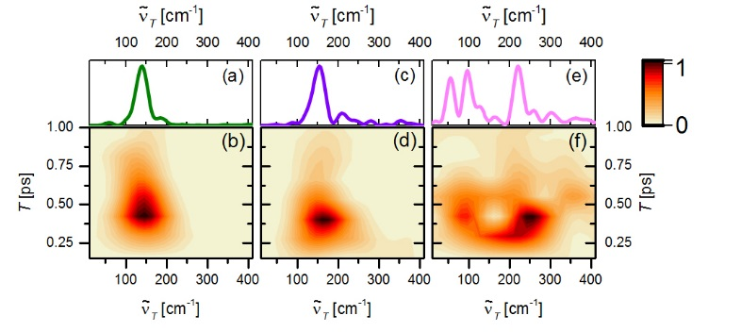

**Figure 5**. Normalised sliding-window Fourier transform (SWFT) spectrograms of **PDI-m** (b) and **1** in TCE (d) and toluene (f), using a 518 fs FWHM Hann window, on residuals in Figure 4d-f. The intensity is given by 21 contour lines where 0 is white and 1 is dark red. The normalised FT spectra reported in Figure 4a-c are reproduced in panels a-c to facilitate assignment.

It was noted above that coherence in **1** persist for >1 ps even in the case of excimer formation in 300 fs in toluene (Figure 4e-f). Information about temporal evolution of frequencies can be recovered from sliding window FT (SWFT) analyses.[54,63,64] For rapidly dephasing low frequency vibrations this presents some challenges, as the window width must contain at least two periods of oscillation to avoid recurrence artifacts. In Figure 5 we show the application of a 518.5 fs wide sliding window FT to the oscillatory residuals in Figure 4d-f, whose FTs are reproduced in Figure 5 a, c, e to aid data interpretation. While the single dominant mode for **PDI-m** and **1** in TCE damps monotonically (Figure 5 b, d) without appreciable frequency shifts, the SWFT for **1** in toluene shows a significant upshift on the time scale of excimer formation for the signal initially centred at ~205 cm-1. When the same analysis was applied to the sum of damped cosines (with time independent frequencies) recovered from fitting the data in Figure 4f (SI, Figure S14) no such upshift was observed, suggesting the observation in Figure 5c is a real feature of the temporal evolution of the spectra. We assign this dynamic blue shift to the formation of a more rigid structure during the evolution from FC to excimer states, manifesting as an increase of the force constant of the vibration modulating the interchromophoric distance (Figure S12).

Conclusions

The photophysics of the “pink box” macrocycle, 1, a solvatochromic H-coupled PDI dimer, were studied in TCE and toluene solvents by steady-state and ultrafast coherent spectroscopies. Steady-state data indicate a five-fold increase in excitonic coupling between TCE and toluene. This arises from a solvent dependent conformational change affecting both the coulombic ($J_{Coul}$) and the charge-transfer ($J_{CT}$) coupling terms. This solvent driven switch translates to radically different excited state and vibrational coherent dynamics. Photoexcitation of 1 in TCE leads to population and nuclear wavepackets dynamics indicating a FC state with pronounced monomer-like character. Conversely, for 1 in toluene, a long-lived and weakly emissive excimer state is populated within ~ 300 fs of photoexcitation. Such ultrafast excimer formation is likely driven by a low frequency excited state vibration bridging the Franck-Condon and excimer states by contracting the PDI-PDI distance and modulating relative orientation. Thus, this detailed picture of solvent controlled excitonic coupling provides new insight into the factors dictating the photophysics of PDI dimers.

Supporting Information

Supporting information available: synthesis and characterisation of **1** and **PDI-m**, coupling strength fit, details of the electronic structure calculations to determine Coulomb and charge transfer coupling strengths, full experimental details concerning the synthesis and the ultrafast measurements, rephasing real and imaginary 2DES spectra, additional absorptive 2DES data showing the excimer formation, fsTA data on **PDI-m** and **1** in TCE and toluene, scheme of the beatmap calculation method, results of the damped cosine fit to the time-domain residuals, rephasing negative beatmaps, additional rephasing positive beatmaps of **1** in toluene, DFT results and additional sliding window Fourier transform data. The authors have cited additional references within the supporting information.[65,66]

Acknowledgements

The quantum chemical calculations presented in this work were carried out on the High Performance Computing Cluster supported by the Research and Specialist Computing Support service at the University of East Anglia. We acknowledge support from the Engineering and Physical Sciences Research Council under Award No. EP/V00817X/1 and EP/W037661/1 and the Royal Society (RGS\R2\222164). G.B. is grateful to the Leverhulme Trust for funding him through an Early Career Fellowship (Grant No. ECF-2023-195). We would like to thank Dr James Bull and Ms Eleanor Ashworth for helpful discussions.

**Keywords:** perylene diimide • ultrafast spectroscopy • excitonic coupling • vibrational coherence • structural dynamics

**References**

[1] F. Wurthner, *Chem. Commun.* **2004**, 1564–1579.

[2] P. D. Frischmann, K. Mahata, F. Würthner, *Chem. Soc. Rev.* **2013**, *42*, 1847–1870.

[3] F. Würthner, *Pure Appl. Chem.* **2006**, *78*, 2341–2349.

[4] S. E. Penty, M. A. Zwijnenburg, G. R. F. Orton, P. Stachelek, R. Pal, Y. Xie, S. L. Griffin, T. A. Barendt, *J. Am. Chem. Soc.* **2022**, *144*, 12290–12298.

[5] T. A. Barendt, W. K. Myers, S. P. Cornes, M. A. Lebedeva, K. Porfyrakis, I. Marques, V. Félix, P. D. Beer, *J. Am. Chem. Soc.* **2020**, *142*, 349–364.

[6] X. Feng, Y. An, Z. Yao, C. Li, G. Shi, *ACS Appl. Mater. Interfaces* **2012**, *4*, 614–618.

[7] B. Wang, C. Yu, *Angew. Chemie - Int. Ed.* **2010**, *49*, 1485–1488.

[8] G. Hu, H. S. Kang, A. K. Mandal, A. Roy, C. Kirmaier, D. F. Bocian, D. Holten, J. S. Lindsey, *RSC Adv.* **2018**, *8*, 23854–23874.

[9] M. E. Farahat, G. C. Welch, *Colorants* **2023**, *2*, 151–178.

[10] F. Würthner, C. R. Saha-Möller, B. Fimmel, S. Ogi, P. Leowanawat, D. Schmidt, *Chem. Rev.* **2016**, *116*, 962–1052.

[11] K. Balakrishnan, A. Datar, T. Naddo, J. Huang, R. Oitker, M. Yen, J. Zhao, L. Zang, *J. Am. Chem. Soc.* **2006**, *128*, 7390–7398.

[12] S. Herbst, B. Soberats, P. Leowanawat, M. Lehmann, F. Würthner, *Angew. Chemie Int. Ed.* **2017**, 2162–2165.

[13] G. Bressan, D. Green, Y. Chan, P. C. Bulman Page, G. A. Jones, S. R. Meech, I. A. Heisler, *J. Phys. Chem. A* **2019**, *123*, 1594–1601.

[14] R. M. Young, M. R. Wasielewski, *Acc. Chem. Res.* **2020**, *53*, 1957–1968.

[15] S. Kang, T. Kim, Y. Hong, F. Würthner, D. Kim, *J. Am. Chem. Soc.* **2021**, *143*, 9825–9833.

[16] Y. Hong, W. Kim, T. Kim, C. Kaufmann, H. Kim, F. Würthner, D. Kim, *Angew. Chemie Int. Ed.* **2022**, *61*, 2021144.

[17] T. Kim, C. Lin, J. D. Schultz, R. M. Young, M. R. Wasielewski, *J. Am. Chem. Soc.* **2022**, *144*, 11386–11396.

[18] C. Kaufmann, W. Kim, A. Nowak-Król, Y. Hong, D. Kim, F. Würthner, *J. Am. Chem. Soc.* **2018**, *140*, 4253–4258.

[19] Y. Hong, F. Schlosser, W. Kim, F. Würthner, D. Kim, *J. Am. Chem. Soc.* **2022**, *144*, 15539–15548.

[20] W. Kim, A. Nowak-Król, Y. Hong, F. Schlosser, F. Würthner, D. Kim, *J. Phys. Chem. Lett.* **2019**, *10*, 1919–1927.

[21] Y. Hong, J. Kim, W. Kim, C. Kaufmann, H. Kim, F. Würthner, D. Kim, *J. Am. Chem. Soc.* **2020**, *142*, 7845–7857.

[22] J. Sung, P. Kim, B. Fimmel, F. Würthner, D. Kim, *Nat. Commun.* **2015**, *6*, 8646.

[23] P. F. Tekavec, J. a Myers, K. L. M. Lewis, J. P. Ogilvie, *Opt. Lett.* **2009**, *34*, 1390.

[24] G. Bressan, I. A. Heisler, G. M. Greetham, A. Edmeades, S. R. Meech, *Opt. Express* **2023**, *31*, 42687.

[25] H. Seiler, S. Palato, B. E. Schmidt, P. Kambhampati, *Opt. Lett.* **2017**, *42*, 643.

[26] H. Yoo, J. Yang, A. Yousef, M. R. Wasielewski, D. Kim, *J. Am. Chem. Soc.* **2010**, *132*, 3939–3944.

[27] N. J. Hestand, F. C. Spano, *Chem. Rev.* **2018**, *118*, 7069–7163.

[28] N. J. Hestand, F. C. Spano, *Acc. Chem. Res.* **2017**, *50*, 341–350.

[29] F. J. M. Hoeben, P. Jonkheijm, E. W. Meijer, A. P. H. J. Schenning, *Chem. Rev.* **2005**, *105*, 1491–1546.

[30] R. E. Cook, B. T. Phelan, R. J. Kamire, M. B. Majewski, R. M. Young, M. R. Wasielewski, *J. Phys. Chem. A* **2017**, *121*, 1607–1615.

[31] P. Roy, G. Bressan, J. Gretton, A. N. Cammidge, S. R. Meech, *Angew. Chemie Int. Ed.* **2021**, *60*, 10568–10572.

[32] M. P. Lijina, A. Benny, E. Sebastian, M. Hariharan, *Chem. Soc. Rev.* **2023**, *52*, 6664–6679.

[33] N. J. Hestand, F. C. Spano, *J. Chem. Phys.* **2015**, *143*, 244707.

[34] M. Kasha, *Radiat. Res.* **1963**, *20*, 55–70.

[35] J. L. Cook, C. A. Hunter, C. M. R. Low, A. Perez-Velasco, J. G. Vinter, *Angew. Chemie - Int. Ed.* **2007**, *46*, 3706–3709.

[36] Z. Chen, B. Fimmel, F. Würthner, *Org. Biomol. Chem.* **2012**, *10*, 5845–5855.

[37] D. Ambrosek, A. Köhn, J. Schulze, O. Kühn, *J. Phys. Chem. A* **2012**, *116*, 11451–11458.

[38] D. Ambrosek, H. Marciniak, S. Lochbrunner, J. Tatchen, X.-Q. Li, F. Wurthner, O. Kuhn, *Phys. Chem. Chem. Phys.* **2011**, *13*, 17649–17657.

[39] C. Kaufmann, D. Bialas, M. Stolte, F. Würthner, *J. Am. Chem. Soc.* **2018**, *140*, 9986–9995.

[40] A. Benny, R. Ramakrishnan, M. Hariharan, *Chem. Sci.* **2021**, *12*, 5064–5072.

[41] M. J. Frisch, G. W. Trucks, H. B. Schlegel, G. E. Scuseria, M. a. Robb, J. R. Cheeseman, G. Scalmani, V. Barone, G. a. Petersson, H. Nakatsuji, X. Li, M. Caricato, a. V. Marenich, J. Bloino, B. G. Janesko, R. Gomperts, B. Mennucci, H. P. Hratchian, J. V. Ortiz, a. F. Izmaylov, J. L. Sonnenberg, Williams, F. Ding, F. Lipparini, F. Egidi, J. Goings, B. Peng, A. Petrone, T. Henderson, D. Ranasinghe, V. G. Zakrzewski, J. Gao, N. Rega, G. Zheng, W. Liang, M. Hada, M. Ehara, K. Toyota, R. Fukuda, J. Hasegawa, M. Ishida, T. Nakajima, Y. Honda, O. Kitao, H. Nakai, T. Vreven, K. Throssell, J. a. Montgomery Jr., J. E. Peralta, F. Ogliaro, M. J. Bearpark, J. J. Heyd, E. N. Brothers, K. N. Kudin, V. N. Staroverov, T. a. Keith, R. Kobayashi, J. Normand, K. Raghavachari, a. P. Rendell, J. C. Burant, S. S. Iyengar, J. Tomasi, M. Cossi, J. M. Millam, M. Klene, C. Adamo, R. Cammi, J. W. Ochterski, R. L. Martin, K. Morokuma, O. Farkas, J. B. Foresman, D. J. Fox, **2016**, Gaussian 16, Revision C.01, Gaussian, Inc., Wallin.

[42] Joshua Brown, “GitHub - JoshuaSBrown/QC_Tools: This Small Repository Provides Functionality for Calculating the Charge Transfer Integrals between Two Molecules.,” can be found under https://github.com/JoshuaSBrown/QC_Tools, **2020**.

[43] A. L. Bialas, F. C. Spano, *J. Phys. Chem. C* **2022**, *126*, 4067–4081.

[44] F. C. Spano, *J. Phys. Chem. C* **2024**, *128*, 248–260.

[45] F. D. Fuller, J. P. Ogilvie, *Annu. Rev. Phys. Chem.* **2015**, *66*, 667–90.

[46] J. Sung, A. Nowak-Król, F. Schlosser, B. Fimmel, W. Kim, D. Kim, F. Würthner, *J. Am. Chem. Soc.* **2016**, *138*, 9029–9032.

[47] S. E. Penty, G. R. F. Orton, D. J. Black, R. Pal, M. A. Zwijnenburg, T. A. Barendt, *J. Am. Chem. Soc.* **2024**, *146*, 5470–5479.

[48] J. J. Snellenburg, S. P. Laptenok, R. Seger, K. M. Mullen, I. H. M. van Stokkum, *J. Stat. Softw.* **2012**, *49*, 1–22.

[49] G. Bressan, M. Jirasek, P. Roy, H. L. Anderson, S. R. Meech, I. A. Heisler, *Chem. Sci.* **2022**, *13*, 9624–9636.

[50] S. Kang, C. Kaufmann, Y. Hong, W. Kim, A. Nowak-Król, F. Würthner, D. Kim, *Struct. Dyn.* **2019**, *6*, 064501.

[51] E. Sebastian, J. Sunny, M. Hariharan, *Chem. Sci.* **2022**, *13*, 10824–10835.

[52] F. V. A. Camargo, H. L. Anderson, S. R. Meech, I. A. Heisler, *J. Phys. Chem. A* **2014**, *119*, 95–101.

[53] G. Bressan, D. Green, G. A. Jones, I. A. Heisler, S. R. Meech, *J. Phys. Chem. Lett.* **2024**, *15*, 2876–2884.

[54] J. D. Schultz, T. Kim, J. P. O’Connor, R. M. Young, M. R. Wasielewski, *J. Phys. Chem. C* **2022**, *126*, 120–131.

[55] D. V. Le, J. M. de la Perrelle, T. N. Do, X. Leng, P. C. Tapping, G. D. Scholes, T. W. Kee, H.-S. Tan, *J. Chem. Phys.* **2021**, *155*, 014302.

[56] M. Son, K. H. Park, M.-C. Yoon, P. Kim, D. Kim, *J. Phys. Chem. A* **2015**, *119*, 6275–6282.

[57] T. J. Quincy, M. S. Barclay, M. Caricato, C. G. Elles, *J. Phys. Chem. A* **2018**, *122*, 8308–8319.

[58] D. Green, P. Roy, C. R. Hall, J. N. Iuliano, G. A. Jones, A. Lukacs, P. J. Tonge, S. R. Meech, *J. Phys. Chem. A* **2021**, *125*, 6171–6179.

[59] D. Green, F. V. A. Camargo, I. A. Heisler, A. G. Dijkstra, G. A. Jones, *J. Phys. Chem. A* **2018**, *122*, 6206–6213.

[60] F. D. Fuller, J. Pan, A. Gelzinis, V. Butkus, S. S. Senlik, D. E. Wilcox, C. F. Yocum, L. Valkunas, D. Abramavicius, J. P. Ogilvie, *Nat. Chem.* **2014**, *6*, 706–711.

[61] A. Gelzinis, R. Augulis, V. Butkus, B. Robert, L. Valkunas, *Biochim. Biophys. Acta - Bioenerg.* **2019**, *1860*, 271–285.

[62] R. Zhu, J. Zou, Z. Wang, H. Chen, Y. Weng, *J. Phys. Chem. A* **2020**, *124*, 9333–9342.

[63] A. Volpato, E. Collini, *Opt. Express* **2015**, *23*, 20040.

[64] T. Kim, S. Kang, E. Kirchner, D. Bialas, W. Kim, F. Würthner, D. Kim, *Chem* **2021**, *7*, 715–725.

[65] C. R. Hall, J. Conyard, I. A. Heisler, G. Jones, J. Frost, W. R. Browne, B. L. Feringa, S. R. Meech, *J. Am. Chem. Soc.* **2017**, *139*, 7408–7414.

[66] T. Lu, F. Chen, *J. Comput. Chem.* **2012**, *33*, 580–592.

**Entry for the Table of Contents**

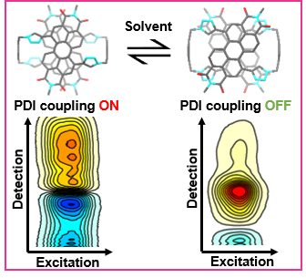

Ultrafast coherent multidimensional spectroscopy probes photoinduced dynamics in a covalent perylene diimide (PDI) dimer exhibiting solvent-controlled on/off excitonic coupling. Excitonic coupling leads to ultrafast excimer formation. The coupling dependent population and vibrationally coherent dynamics in the two cases are measured and discussed in the context of controlling PDI dimer photophysics.

Institute and/or researcher Twitter usernames:

@UEA_Chemistry

@giovannibress

@TabLabChem