A columnar regular-porous stainless steel reaction support with high superficial area for hydrogen production

Tianqing Zheng ª, Wei Zhou ª, Xuyang Chu ^{a,*}, Yunsong Lian ª,
Xiang Huang ^{b}, Kwan San Hui ^{c}, Kwun Nam Hui ^{d}
ª Department of Mechanical & Electrical Engineering, Xiamen University, Xiamen, 361005, China
^{b} School of Electromechanical and Automation, Huaqiao University, Xiamen, 361021, China
^{c} School of Mathematics, University of East Anglia, Norwich, NR4 7TJ, United Kingdom
^{d} Institute of Applied Physics and Materials Engineering, University of Macau, Avenida da Universidade, Macau, 999078, China

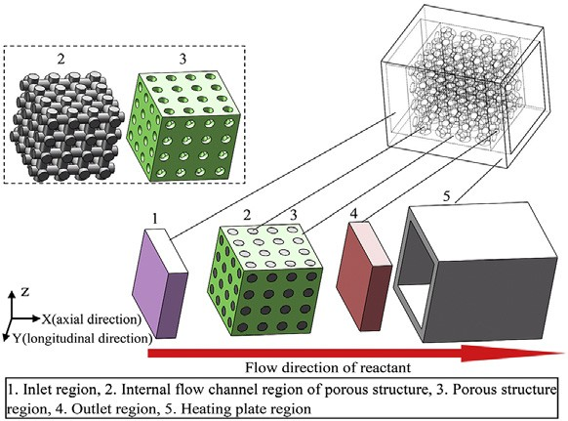
h i g h l i g h t s g r a p h i c a l a b s t r a c t

- A columnar regular-porous hydrogen production reaction support is proposed.
- A numerical simulation model of regular-porous stainless steel
structure is built.
- Heat transfer ability and pressure loss of regular-porous structure are studied.
- Temperature and reactant con- centration of regular-porous
structure are explored.
- Hydrogen production performance of regular-porous structure is investigated.

a r t i c l e i n f o

Keywords:
Superficial area

a b s t r a c t

To improve hydrogen production (HP) performance of regular-porous structure (RPS), a columnar RPS with small specific surface area and high superficial area is developed. A numerical simulation model of regular-porous stainless steel structure (RPSSS) is estab- lished. Subsequently, heat transfer performance, pressure loss, temperature, methanol concentration, H₂ concentration distributions and HP performance of the columnar RPSSS with small specific surface area and high superficial area and the body-centered cubic RPSSS with high specific surface area and small superficial area are compared. Then, temperature, methanol concentration, H₂ concentration distributions and HP performance of axial and longitudinal size-enlarged columnar RPSSSs are studied. The results show that

* Corresponding author.
E-mail address: chuxy@xmu.edu.cn (X. Chu). https://doi.org/10.1016/j.ijhydene.2022.01.117

Specific surface area Regular-porous structure Hydrogen production

compared to the body-centered cubic RPSSS, the columnar RPSSS has higher methanol conversion, larger H₂ flow rate and higher CO selectivity. Especially in the condition of 300 ◦C wall temperature and 12 mL/h methanol-water mixture injection rate (MWMIR), the methanol conversion, H₂ flow rate and CO selectivity of the columnar RPSSS are increased by 12.3%, 9.24% and 30%, respectively, indicating that the superficial area of RPSSS is more important for its HP performance compared to its specific surface area. Compared to the longitudinal size-enlarged columnar RPSSS, the axial size-enlarged columnar RPSSS has higher methanol conversion, larger H₂ flow rate and higher CO selectivity. This research
work provides a new method for the optimization of hydrogen production reaction support (HPRS).
© 2022 Hydrogen Energy Publications LLC. Published by Elsevier Ltd. All rights reserved.

Introduction

Hydrogen production reaction support (HPRS), which is used as a key component of methanol steam reforming micro- reactor for hydrogen production (HP) [1e5], is not only the structure support for supporting HP catalyst, but also the main medium of mass and heat transfer between the methanol steam reforming micro-reactor and reactants [6e10]. Its structure performance determines the HP performance of methanol steam reforming micro-reactor for HP. Porous structure has high mass and heat transfer abilities due to its large specific surface area (specific surface area is the ratio of the superficial area of the porous structure to its substance volume), and it has large catalytic area due to its large su- perficial area, which is regarded as an ideal HPRS widely used in methanol steam reforming micro-reactor for HP [11e15].

Nomenclature

Variables
a volume fraction of CO in reaction product, % b volume fraction of CO₂ in reaction product, % C concentration of the reactant, %
E activation energy of chemical reaction, J/mol g gravitational body force per unit mass, N/kg h enthalpy, kJ/kg
- the i-th fluid
- one direction in x, y and z directions
J diffusion flux of fluid, kg/m²$s
k Arrhenius reaction rate constant of chemical reaction
K equilibrium constant of chemical reaction
Ke Kelvin environmental temperature of methanol steam reforming, K
k_{eff} effective thermal conductivity, W/m$K
p pressure of fluid, bar
r reaction rate, kg/m³$s
R universal gas constant, (m³$bar)/(mol$◦C)
S₁ momentum source term, N
S₂ energy source term of chemical reaction, kW/ m3
S_{co} carbon monoxide selectivity of reaction product,%
T temperature, ◦C
u flow rate of fluid, m/s
V_{injection} flow rate of methanol-water mixture, mL/h V_{reaction} _{product} flow rate of reaction product, mL/min V_{H2} flow rate of H₂, mol/h
X_{CH3OH} methanol conversion rate, %
Y mass fraction, %
z volume fraction of H₂ in reaction product, %
r density of fluid, kg/m³
t stress tensor of fluid, bar

Abbreviations
HP hydrogen production
HPRS hydrogen production reaction support MWMIR methanol-water mixture injection rate RPS regular-porous structure
RPSSS regular-porous stainless steel structure
In the research of HPRS with porous structure, the porous structures with high specific surface area are mainly devel- oped as HPRS. Tang [8] (2008) used solid-phased sintering technology to manufacture a porous copper fiber sintered plate with high specific surface area which is used as HPRS. It was found that the porous copper fiber sintered plate can
obtain >90% methanol conversion under 300 ◦C reaction
temperature and 16252.4 mL/(g$h) GHSV. Zhou [16] (2017) used copper foam with high specific surface area as HPRS. It was found that the copper foam can gain 100% methanol conver- sion in the condition of 300 ◦C reaction temperature and
16252.4 mL/(g$h) GHSV. Lei [17] (2019) prepared a 3D-printed
porous stainless steel structure with high specific surface area as reaction support. It was shown that the 3D-printed porous stainless steel structure can obtain >90% methanol conver- sion under the 360 ◦C reaction temperature and 16252.4 mL/
(g$h) GHSV. Zheng [18] (2020) 3D-printed a regular-porous
stainless steel reaction support with high specific surface area for HP. It was demonstrated that the 3D-printed regular- porous stainless steel reaction support had >95% methanol conversion when methanol-water mixture injection rate (MWMIR) and reaction temperature were 4 mL/h and 360 ◦C, respectively. Wang [3] (2021) used the porous copper foam with high specific surface area as catalyst support of the thermally autonomous methanol steam reforming micro- reactor. It was indicated that the overall efficiency of the microreactor can reach approximately 35%e45%. The above

research works use high specific surface area of the porous structure as its design target, and they have successfully ob- tained porous structures with high HP performance. The su- perficial area of the porous structure affects its catalytic area, and therefore it determines the HP performance of the porous structure. However, the influence of superficial area of the porous structure on its HP performance has not been studied. To further enhance the HP performance of reaction support, it is necessary to investigate the HP performance of the porous structure with high superficial area, which needs a large number of numerical simulation and experiment research works. In this research work, the systematic numerical simulation research work of the HP performance of the porous structure with high superficial area is performed.
In this research work, in order to improve HP performance
of porous structure, a novel columnar regular-porous stainless steel structure (RPSSS) with small specific surface area and high superficial area is proposed. A numerical simulation model of RPSSS is established for investigating its related re- action performance. Then the heat transfer performance and pressureloss of the columnar RPSSS with small specific surface area and high superficial area and the body-centered cubic RPSSS with high specific surface area and small superficial area are compared via the numerical simulation model, and their HP performance is investigated. HP performance of axial and longitudinal size-enlarged columnar RPSSSs is also explored.
occurs in the help of both temperature and catalyst [19e23], which can be shown in Fig. 1(a). As shown in Fig. 1(b), the larger catalytic area of RPS can obtain more opportunities of contact between the RPS and the reactants, resulting in its higher HP performance [24e28]. As can be seen in Fig. 1(c), the slower flow rate of the reactants has more opportunities of contact between the RPS and the reactants, which is beneficial for obtaining higher HP performance of the RPS [29e33]. As shown from Fig. 1(d), the higher wall temperature of RPS is good for higher activity of the reactants, realizing more op- portunities of contact between the RPS and reactants [34e38]. In this way, the higher HP performance of the RPS can be achieved. The specific surface area of the RPS affects its heat transfer ability which determines its temperature obtained from heating source. The higher specific surface area of the RPS can obtain its higher heat transfer ability of the RPS, so as to obtain its higher temperature from the heating source and its higher HP performance. In addition, the specific surface area of RPS affects the residence time of the reactants in the RPS, which determines the contact time between the RPS and the reactants. The higher specific surface area of the RPS can obtain the longer residence time of the reactants in it, so as to obtain longer contact time between it and the reactants and its higher HP performance. The superficial area of RPS affects its catalytic area. The higher superficial area of RPS can obtain its higher catalytic area and its higher HP performance. Therefore, the specific surface area and the superficial area of

RPS have important influence on its HP performance.

Experimental

Influence of specific surface area and superficial area of regular-porous structure (RPS) on its HP performance

Fig. 1 shows the influence of reaction conditions of RPS on its HP performance. The methanol steam reforming reaction

Structure design of RPS

Fig. 2 shows the structure design diagram of RPS. Fig. 2(a) shows the columnar RPS with small specific surface area and high superficial area. Fig. 2(b) shows the body-centered cubic RPS with high specific surface area and small superficial area.


Fig. 1 e Influence of reaction conditions of RPS on its HP performance: (a) Reaction conditions of HP; the influence of (b) catalytic area, (c) contact time and (d) reaction temperature on the HP performance of RPS.

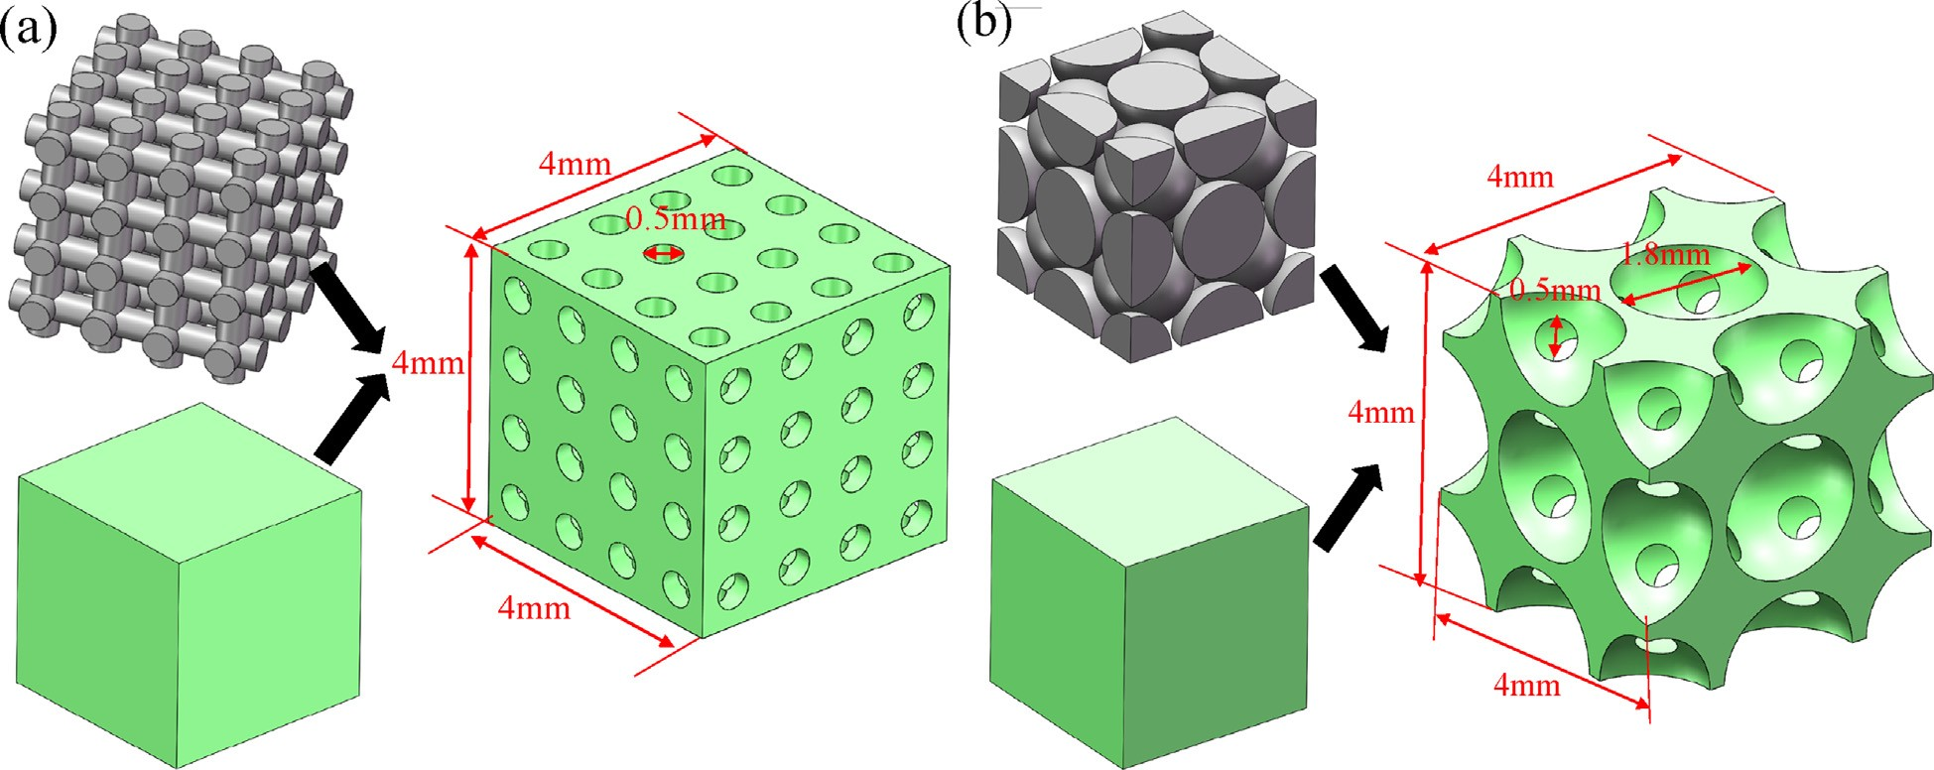

Fig. 2 e Structure design diagram of RPS: (a) Columnar RPS with small specific surface area and high superficial area, (b) body-centered cubic RPS with high specific surface area and small superficial area.

The columnar RPS is obtained through Boolean operation of the intersection between the three-dimensional intersecting columnar and the cube. The body-centered cubic RPS is ob- tained using Boolean operation of the intersection between the body-centered cubic crystal structure and the cube. Table 1 shows the structure performance of various RPSs. As shown in Table 1, the superficial area, substance volume and specific surface area of the columnar RPS are 243.015 mm², 37.891 mm³ and 6.414 mm²/mm³, respectively, and those of the body-centered cubic RPS are 173.211 mm², 15.554 mm³ and
11.136 mm²/mm³, respectively. Compared to the body- centered cubic RPS, the columnar RPS has a smaller specific surface area and a higher superficial area.

Numerical simulation model of RPSSS

Physic model
Fig. 3 shows the numerical simulation physic model of
through the cross-section of the RPSSS, the Reynolds coeffi- cient of water is less than 2000, and therefore the water in the numerical simulation model is set as laminar fluid. In the research of HP performance of RPSSS, due to the less than
1 m/s flow rate of methanol steam reforming gas flowing through the cross-section of the RPSSS, the Reynolds coeffi- cient of methanol steam reforming gas is less than 2000, and therefore methanol steam reforming gas in the numerical simulation model is set as laminar fluid. The flow perfor- mance of fluid in the RPSSS can be expressed using the equations including continuity equation, momentum con- servation equation and energy conservation equation, as well as component mass conservation equation, which are shown in Eqs. (1)e(4) [39e41].
¼
v ruj 0 (1)
vt_{j}

RPSSS. The numerical simulation physic model of RPSSS is
ru vu_{i} vp vt_{ij}

^{j} vt ¼ — vt þ vt
þ rg_{i} þ S₁ (2)

composed of inlet region, internal flow channel region of
RPSSS, RPSSS region, outlet region and heating plate region. The internal flow channel region is used for the flow of fluid.
The RPSSS region is used for transferring heat and setting
j i

vh v
ruj vt ¼ vt
keff vt —
j

vT Xn ! vp
hi Jij
þ u_{j}vt þ S₂ (3)

catalytic surface, whose material is set to stainless steel. The heating plate region is used for setting heating source. In the
research of heat transfer performance and pressure loss of
j j j i¼1 j

ru vYi vJij þ R (4)
^{j} vt ¼ — vt ^{i}

j j
RPSSS, due to the less than 1 m/s flow rate of water flowing
The methanol steam reforming reaction for HP can be seen
in Eqs. (5)e(7) [42e46]. The reaction kinetics equations of
methanol steam reforming reaction for HP can be shown in Eqs. (8)e(10) [47e49].
Table 1 e Structure performance of various RPSs.
Structure type | Superficial area (mm²) | Substance Specific surface volume area (mm³) (mm²/mm³)
Columnar RPS Body-centered  cubic RPS | 243.015  173.211 | 37.891  15.554 | 6.414  11.136

CH₃OH þ H₂O/CO₂ þ 3H₂ (5)
CH₃OH / CO þ 2H₂ (6)
CO þ H₂O4CO₂ þ H₂ (7)

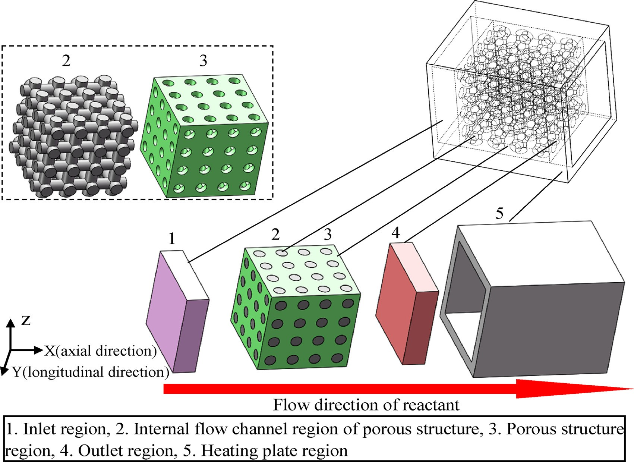
Fig. 3 e Numerical simulation physic model of RPSSS.

r ¼ k
exp — EMSR C C

(8)

the methanol conversion, H₂ flow rate and CO selectivity of

MSR
MSR
RT CH3 OH
H2 O
the numerical simulation models of the RPSSSs with various numbers of discretized mesh are compared, respectively, for

rMD
¼ k_{MD}
exp — EMD (9)
determining the optimal number of mesh for the discretiza- tion of the numerical simulation model of the RPSSS.

r ¼ k
RT
exp — EWGS P P
— PCO2 PH2 ; K

Numerical solution

WGS
WGS
RT CO H2 O
KWGS
WGS
Coupled algorithm is used to solve the numerical simulation

¼ exp Er—WGS — k

(10)

model of the RPSSS. During the solving process, the conver-

RT

Boundary conditions
r—WGS
gence criterion of pressure based solver is set as 1e-5, and the under-relaxation factors of pressure, density and momentum

The inlet is set as velocity inlet and the outlet is set as pressure outlet. The boundary conditions for all the walls and in- terfaces of the numerical simulation model are set as no slip boundary and the temperatures of the walls are set according to the specific reaction conditions. When the heat transfer performance and pressure loss of RPSSS are investigated, the walls of RPSSS region are all set as non-reaction wall. When the HP performance of RPSSS is studied, the walls of RPSSS region are all set as reaction wall and their catalytic layer coefficient is set as 0.01.

Mesh independence analysis
The numerical simulation model of columnar RPSSS is dis- cretized by unstructured mesh via ICEM CFD 17.0 software. In the condition of 300 ◦C wall temperature and 4 mL/h MWMIR,
are set as 0.6.

Heat transfer performance and pressure loss

The heat transfer performance of the numerical simulation model of RPSSS is the water temperature increase of its outlet relative to its inlet. The higher temperature increase indicates the better heat transfer performance of the RPSSS. The pres- sure loss of the numerical simulation model of the RPSSS is the pressure loss of its outlet relative to its inlet. The smaller pressure loss of the RPSSS indicates the lower energy con- sumption of the reactants flowing through the RPSSS.
To determine the difference of heat transfer performance and pressure loss between the columnar RPSSS with small specific surface area and high superficial area and the body-

centered cubic RPSSS with high specific surface area and small superficial area, the temperature increase and pressure loss of water with 25 ◦C initial temperature respectively flowing
through columnar RPSSS and body-centered cubic RPSSS are
V_{H}2
Vreaction product*z
¼ 22400*60
(12)

investigated under 300 ◦C wall temperature and various water injection rates, and their temperature increase and pressure loss under 40 mL/h water injection rate and various wall
Sco
a
¼ a þ b × 100% (13)

temperatures are also studied.

HP performance

To determine the importance of superficial area relative to specific surface area in the HP performance of RPSSS, the temperature, methanol concentration and H₂ concentration distributions of the columnar RPSSS with small specific sur- face area and high superficial area and the body-centered cubic RPSSS with high specific surface area and small super- ficial area under 300 ◦C wall temperature and 4 mL/h MWMIR are investigated, and their HP performance under 300 ◦C wall temperature and various MWMIRs is studied, and their HP performance under 4 mL/h MWMIR and various wall tem-
peratures is also explored.
To realize the large-scale application of RPSSS in meth- anol steam reforming reaction for HP, the temperature, methanol concentration and H₂ concentration distributions of axial and longitudinal size-enlarged columnar RPSSSs under 300 ◦C wall temperature and 8 mL/h MWMIR are investigated, and their HP performance under 300 ◦C wall temperature and various MWMIRs is studied, and their HP performance under 8 mL/h MWMIR and various wall tem- peratures is also explored.
The evaluation indexes of HP performance of the RPSSS are methanol conversion, H₂ flow rate and CO selectivity. The methanol conversion, H₂ flow rate and CO selectivity can be calculated by Eqs. (11)e(13) [44,50].

Results and discussion

Mesh independence analysis of numerical simulation model of RPSSS

Fig. 4 shows the mesh independence of numerical simulation model of columnar RPSSS. As shown in Fig. 4, the methanol conversions of the numerical simulation models with 211507, 296790, 433810, 616304 and 973731 meshes are 79.16%, 79.07%,
79.02%, 78.87% and 78.69%, respectively, and their H₂ flow rates are 0.1472 mol/h, 0.1472 mol/h, 0.1470 mol/h, 0.1468 mol/ h and 0.1467 mol/h, respectively, and their CO selectivities are 7.93%, 7.91%, 7.90%, 7.86% and 7.84%, respectively. The dif- ferences of methanol conversion, H₂ flow rate and CO selec- tivity among the numerical simulation models with 433810, 616304 and 973731 meshes are all less than 1%, and their mesh quality is greater than 0.3. Considering the accuracy of nu- merical simulation result and the calculation time of the nu- merical simulation, 433810 meshes are selected to discretize the numerical simulation model.

Heat transfer performance and pressure loss of various RPSSSs

Fig. 5 shows the heat transfer performance and pressure loss of various RPSSSs. As can be seen from Fig. 5(a) and (b), when the waterflowsfrom theinlet of the RPSSS to theoutlet of the RPSSS, the temperature of water increases, but its pressure decreases.

X ¼ Vreaction product*ðm þ nÞ
(11)
Compared to the body-centered cubic RPSSS with large specific

CH3 OH V
* ¹ * ¹ *²⁷³*22400
surface area and small superficial area, the columnar RPSSS

injection 60 64 K

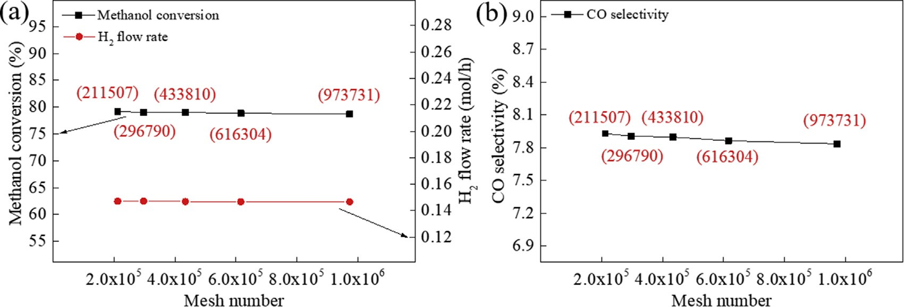
Fig. 4 e Mesh independence of numerical simulation model of columnar RPSSS: (a) Methanol conversion, H₂ flow rate and (b) CO selectivity.

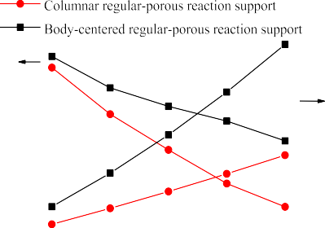
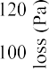

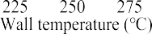
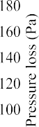

Fig. 5 e Heat transfer performance and pressure loss of various RPSSSs: (a) Heat transfer performance and pressure loss under various water injection rates and 300 ◦C wall temperature, (b) heat transfer performance and pressure loss under various wall temperatures and 40 mL/h water injection rate.

with small specific surface area and large superficial area has a smaller temperature increase and lower pressure loss, indi- cating that the columnar RPSSS has lower heat transfer perfor- mance and smaller energy consume. In the condition of 300 ◦C wall temperature and 50 mL/h water injection rate, the tem- perature increase and pressure loss of the body-centered cubic RPSSS are 140.47 ◦C and 132.73 Pa, respectively, and those of the columnar RPSSS are 118.65 ◦C and 75.75 Pa, respectively. Compared to the body-centered cubic RPSSS, the temperature increase and pressure loss of the columnar RPSSS are decreased by 15.5% and 42.9%, respectively.
Due to its smaller specific surface area compared to the body-centered cubic RPSSS, the columnar RPSSS has lower heat transfer performance compared to the body-centered cubic RPSSS [51,52]. Due to its simpler and straighter fluid channel structure compared to the body-centered cubic RPSSS, the columnar RPSSS has lower pressure loss compared to the body-centered cubic RPSSS. Therefore, compared to the body-centered cubic RPSSS, the columnar RPSSS has a smaller temperature increase and lower pressure loss.

HP performance of various RPSSSs

The steady HP performances of columnar RPSSS and body- centered cubic RPSSS are obtained after 360 min and 200 min numerical simulation calculations, respectively. Fig. 6 shows the temperature, methanol concentration and H₂ concentration distributions of various RPSSSs under 300 ◦C wall temperature and 4 mL/h MWMIR. From Fig. 6 (a) and (b), it can be seen that the low temperature of the reactants exists in the inlet of the RPSSS and the high and similar temperature
exists away from the inlet of the RPSSS. The reaction principle of the reactants is that when the reactants firstly contact the reaction support, the reactants firstly perform the reaction.
Since a large amount of reactants perform the HP reaction in the inlet of the RPSSS and the reaction needs absorb heat, the low temperature of the reactants exists in the inlet of the RPSSS. Due to the low reactant concentration of the reaction
area away from the inlet of the RPSSS, the amount of the re- actants which perform the HP reaction is not much and the RPSSS has the good heat transfer ability, and therefore, the high and similar temperature exists away from the inlet of the RPSSS. As can be seen from Fig. 6 (c)e(f), the methanol con- centration gradually decreases and the H₂ concentration gradually increases from the inlet to the outlet of the RPSSS. Although a large amount of reactants perform the HP reaction in the inlet of the RPSSS, the reactants gradually perform the HP reaction from the inlet to the outlet of the RPSSS. There- fore, the methanol (reactant) concentration gradually de- creases and the H₂ concentration (reaction product) gradually increases from the inlet to the outlet of the RPSSS.
Fig. 7 shows the HP performance of various RPSSSs. As can be seen from Fig. 7 (a)e(d), compared to the body-centered cubic RPSSS with large specific surface area and small super- ficial area, the columnar RPSSS with small specific surface area and large superficial area has larger methanol conver- sion, higher H₂ flow rate and larger CO selectivity. Especially
under 300 ◦C wall temperature and 12 mL/h MWMIR, the
methanol conversion, H₂ flow rate and CO selectivity of the body-centered cubic RPSSS are 52.2%, 0.303 mol/h and 3.03%, respectively, and those of the columnar RPSSS are 58.6%,
0.331 mol/h and 3.94%, respectively. Compared to the body- centered cubic RPSSS, the methanol conversion, H₂ flow rate and CO selectivity of the columnar RPSSS are increased by 12.3%, 9.24% and 30%, respectively. Due to its larger catalytic area obtained by larger superficial area compared to the body- centered cubic RPSSS, the columnar RPSSS has larger meth- anol conversion, higher H₂ flow rate and larger CO selectivity compared to the body-centered cubic RPSSS.

HP performance of axial and longitudinal size-enlarged columnar RPSSSs

Fig. 8 shows the temperature, methanol concentration and H₂ concentration distributions of axial and longitudinal size- enlarged columnar RPSSSs under 300 ◦C wall temperature

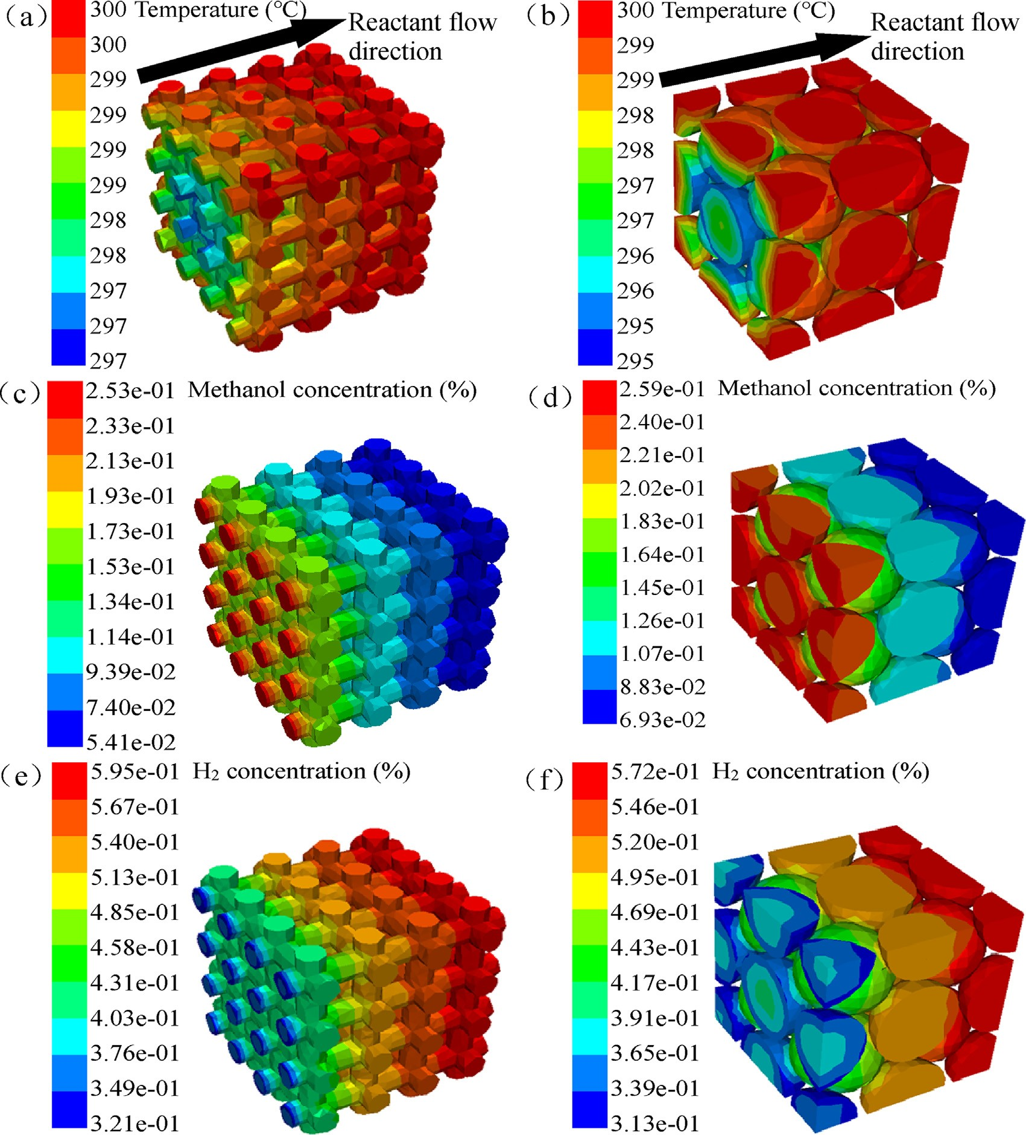

Fig. 6 e Temperature, methanol concentration and H₂ concentration distributions of various RPSSSs under 300 ◦C wall temperature and 4 mL/h MWMIR: (a) Temperature, (c) methanol concentration and (e) H₂ concentration distributions of columnar RPSSS; (b) temperature, (d) methanol concentration and (f) H₂ concentration distributions of body-centered cubic RPSSS.

and 8 mL/h MWMIR. As can be seen in Fig. 8 (a)e(f), compared to the longitudinal size-enlarged columnar RPSSS, the axial size-enlarged columnar RPSSS has lower minimum tempera- ture, same maximum temperature, higher minimum meth- anol concentration, smaller maximum methanol concentration, lower minimum H₂ concentration and larger maximum H₂ concentration. Due to the heat absorption re- action of the reactants reaction and the faster axial velocity of the reactants flowing through the axial size-enlarged columnar RPSSS compared to the longitudinal size-enlarged columnar RPSSS, the inlet has a higher heat consume per area in the inlet of under the same wall temperature, and
therefore the axial size-enlarged columnar RPSSS has the lower minimum temperature in the inlet compared to the longitudinal size-enlarged columnar RPSSS, indicating its higher minimum methanol concentration and lower mini- mum H₂ concentration. Due to the same wall temperature, the axial size-enlarged columnar RPSSS has the same maximum temperature compared to the longitudinal size-enlarged columnar RPSSS. Since the axial and longitudinal size- enlarged columnar RPSSSs have the same injection volume of reactants and the same flow space, the residence times of reactants in the fluid channels of the two RPSSSs are the same and the heat absorbing times of the reactants under the same

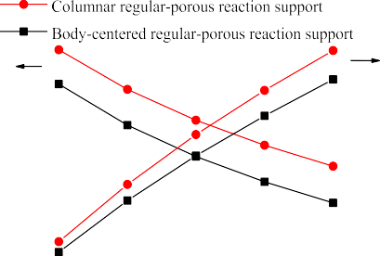
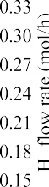

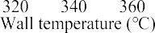
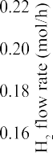
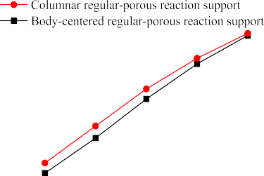

Fig. 7 e HP performance of various RPSSSs: (a) Methanol conversion, H₂ flow rate and (b) CO selectivity under various MWMIRs and 300 ◦C wall temperature; (c) methanol conversion, H₂ flow rate and (d) CO selectivity under various wall temperatures and 4 mL/h MWMIR.

wall temperature are the same. In addition, in the condition of the same specific surface area and superficial area of the axial and longitudinal size-enlarged columnar RPSSSs, due to its smaller longitudinal size compared to the longitudinal size- enlarged columnar RPSSS, the axial size-enlarged columnar RPSSS has higher heat transfer efficiency in the longitudinal direction compared to the longitudinal size-enlarged columnar RPSSS, and therefore it has higher reaction tem- perature. In this way, the higher methanol conversion of the axial size-enlarged columnar RPSSS can be obtained compared to the longitudinal size-enlarged columnar RPSSS, indicating its smaller maximum methanol concentration, and higher maximum H₂ concentration compared to the longitu- dinal size-enlarged columnar RPSSS.
Fig. 9 shows the HP performance of axial and longitudinal
size-enlarged columnar RPSSSs. As can be seen from Fig. 9 (a)e(f), compared to the longitudinal size-enlarged columnar RPSSS, the axial size-enlarged columnar RPSSS has larger methanol conversion, higher H₂ flow rate and larger CO

selectivity under low wall temperature. Especially under 300 ◦C wall temperature and 8 mL/h MWMIR, the methanol conversion, H₂ flow rate and CO selectivity of the longitudinal size-enlarged columnar RPSSS are 78.74%, 0.293 mol/h and 7.81%, respectively, and those of the axial size-enlarged columnar RPSSS are 80.08%, 0.296 mol/h and 8.11%, respec-
tively. Compared to the longitudinal size-enlarged columnar RPSSS, methanol conversion, H₂ flow rate and CO selectivity of the axial size-enlarged columnar RPSSS are increased by 1.7%, 1% and 3.8%, respectively. As analyzed in Fig. 8, due to its smaller longitudinal size compared to the longitudinal size- enlarged columnar RPSSS, the axial size-enlarged columnar RPSSS has higher heat transfer efficiency in the longitudinal direction compared to the longitudinal size-enlarged columnar RPSSS, and therefore it has higher reaction tem- perature. In this way, the axial size-enlarged columnar RPSSS has higher methanol conversion, larger H₂ flow rate and higher CO selectivity compared to the longitudinal size- enlarged columnar RPSSS [6,30].

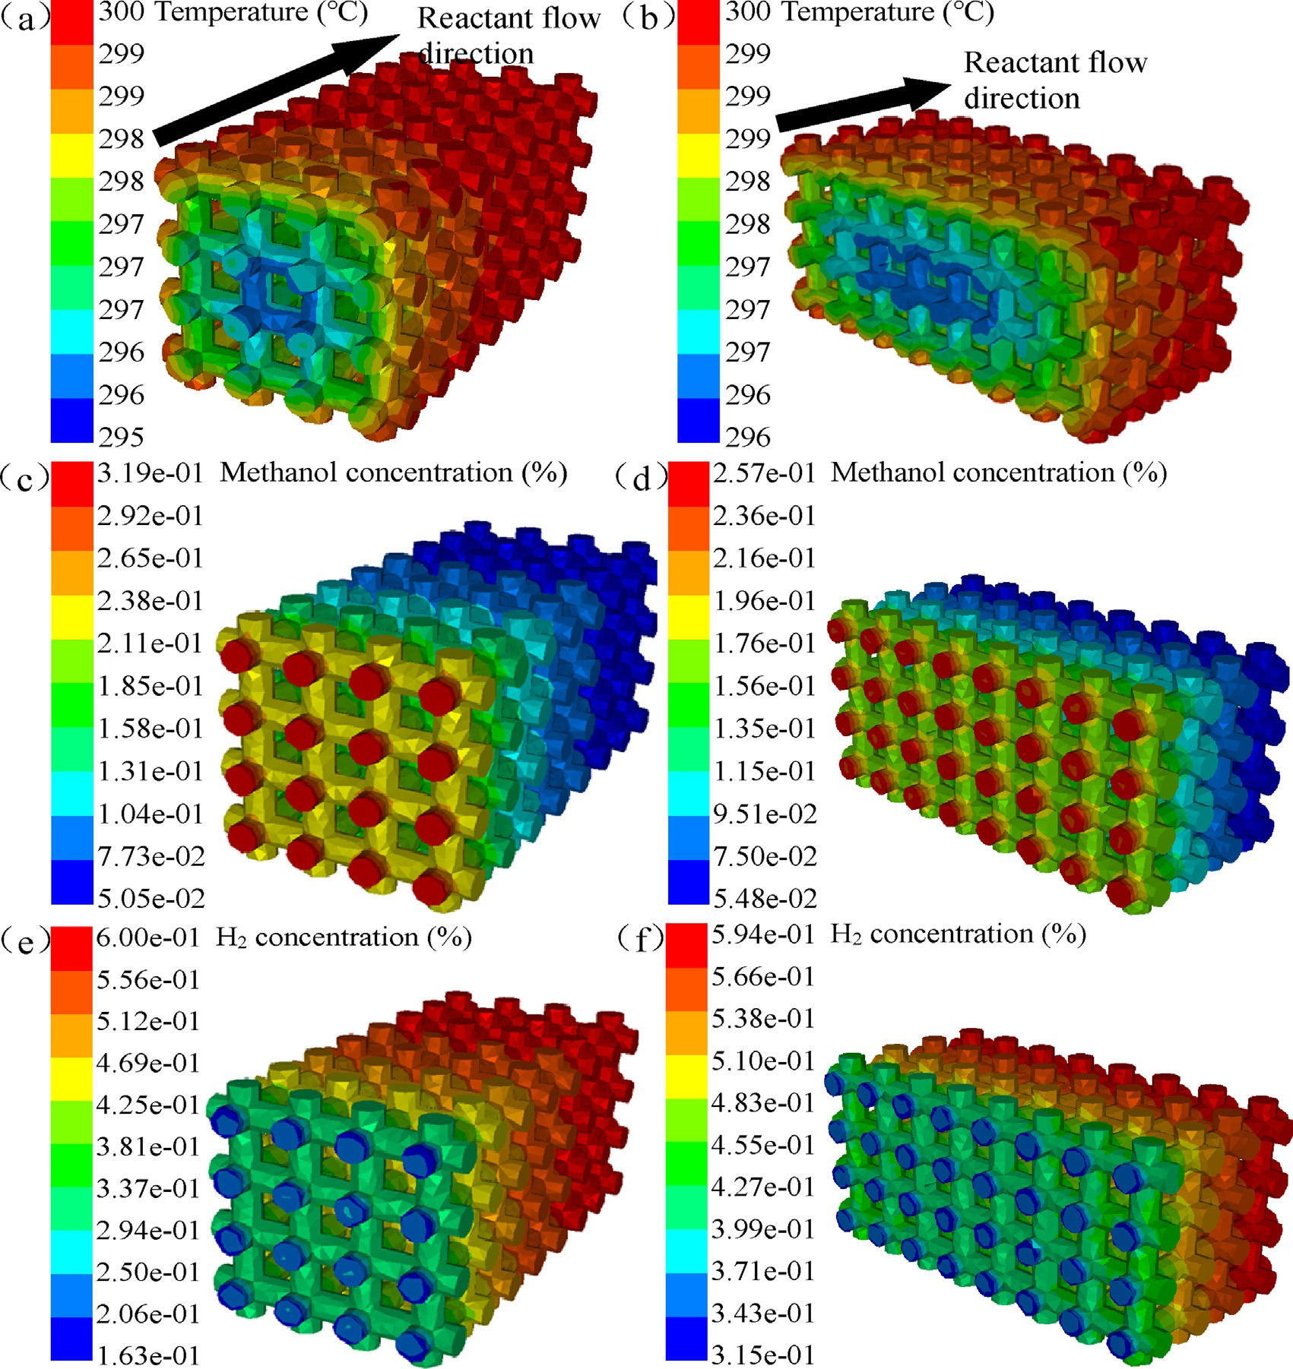

Fig. 8 e Temperature, methanol concentration and H₂ concentration distributions of axial and longitudinal size-enlarged columnar RPSSSs under 300 ◦C wall temperature and 8 mL/h MWMIR: (a) Temperature, (c) methanol concentration and (e) H₂ concentration distributions of axial size-enlarged columnar RPSSS; (b) temperature, (d) methanol concentration and (f) H₂ concentration distributions of longitudinal size-enlarged columnar RPSSS.

Conclusions

To improve HP performance of RPS, a columnar RPS with small specific surface area and high superficial area is designed. Heat transfer performance, pressure loss, temper- ature, methanol concentration, H₂ concentration distributions and HP performance of the columnar RPSSS are investigated. The main research results are listed as follow.

- The superficial area of RPSSS is more important for HP performance of RPSSS compared to its specific surface area. Compared to the body-centered cubic RPSSS with
high specific surface area and small superficial area, the columnar RPSSS with small specific surface area and high superficial area has higher methanol conversion,
larger H₂ flow rate and higher CO selectivity. Under 300 ◦C wall temperature and 12 mL/h MWMIR, methanol conversion, H₂ flow rate and CO selectivity of the
columnar RPSSS are 58.6%, 0.331 mol/h and 3.94%, respectively, which are increased by 12.3%, 9.24% and 30%, respectively, compared to the body-centered cubic RPSSS.
- The smaller longitudinal size between the centerline of the RPSSS and the wall of heating source of HP micro- reactor is beneficial for obtaining higher reaction

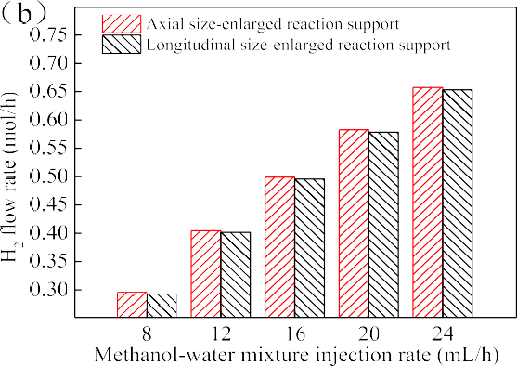
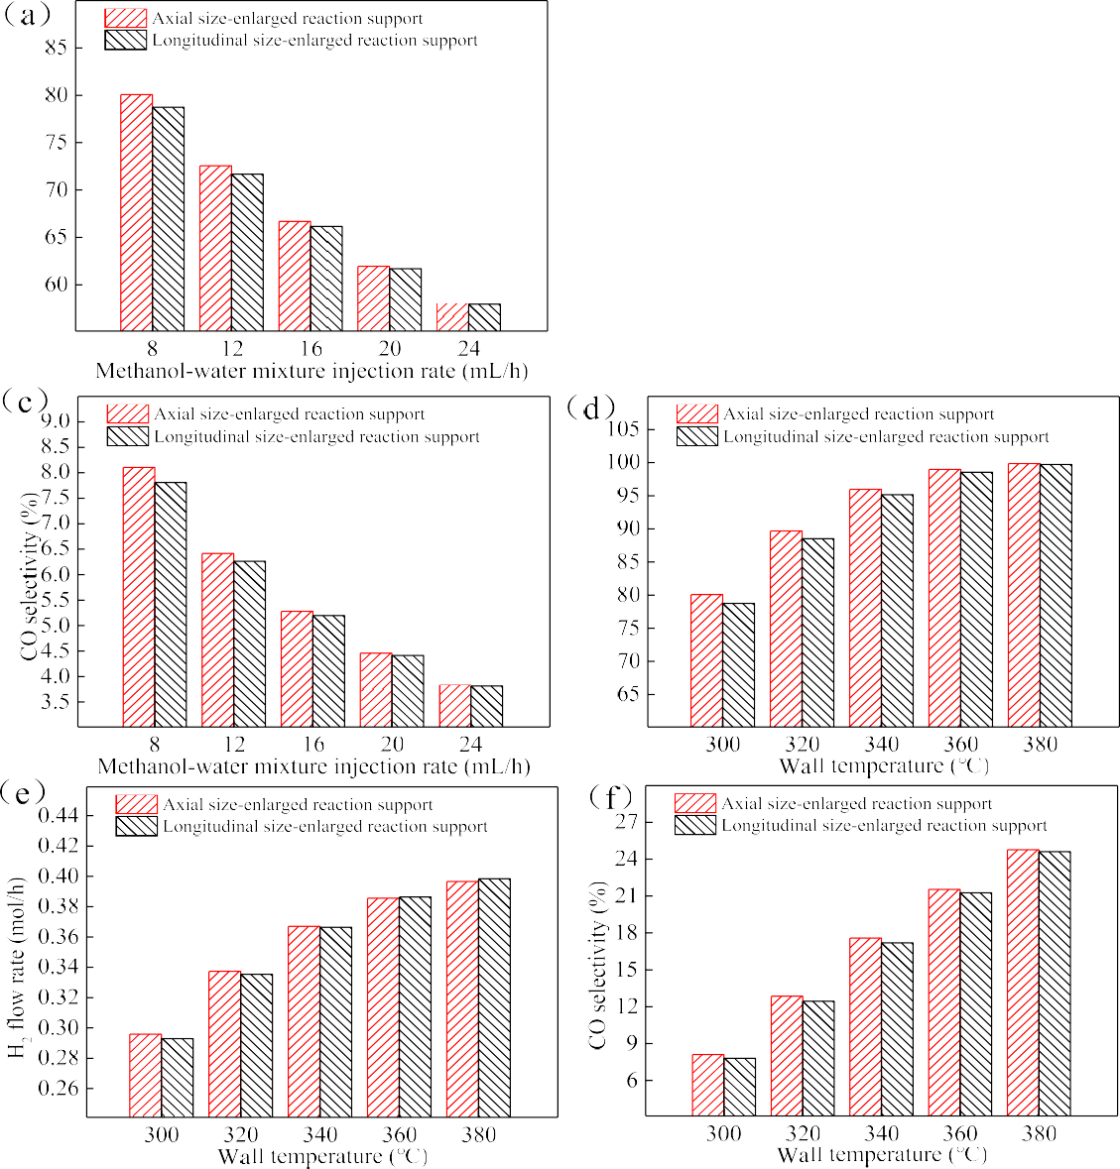

Fig. 9 e HP performance of axial and longitudinal size-enlarged columnar RPSSSs: (a) Methanol conversion, (b) H₂ flow rate and (c) CO selectivity under various MWMIRs and 300 ◦C wall temperature; (d) methanol conversion, (e) H₂ flow rate and (f) CO selectivity under various wall temperatures and 8 mL/h MWMIR.

temperatureof RPSSS, resulting inhigher HPperformance of the RPSSS. In the condition of 300 ◦C wall temperature and 8 mL/h MWMIR, methanol conversion, H₂ flow rate and CO selectivity of the axial size-enlarged columnar RPSSS are 80.08%, 0.296 mol/h and 8.11%, respectively,
which are increased by 1.7%, 1% and 3.8%, respectively, compared to longitudinal size-enlarged columnar RPSSS.

The design of RPSSS with high superficial area not only improves the HP performance of RPSSS, but also reduces its pressure loss, which has a broad application prospect in methanol steam reforming reaction for HP.

Declaration of competing interest

The authors declare that they have no known competing financial interests or personal relationships that could have appeared to influence the work reported in this paper.

Acknowledgments

Thanks to China Scholarship Council (CSC) for financial sup- port (No.202006310047), Fundamental Research Funds for the

Central Universities (No.20720200068) and China's National Science Fund for Outstanding Youth (No.51922092).

referen c es

- Zeng DH, Pan MQ, Wang LM, Tang Y. Fabrication and characteristics of cube-post microreactors for methanol steam reforming. Appl Energy 2012;91:208e13.
- Pan MQ, Tang Y, Wei XL, Jiang X. Oriented linear cutting fiber sintered felt as an innovative catalyst support for methanol steam reforming. Int J Hydrogen Energy 2011;36:7066e73.
- Wang YC, Hong ZY, Mei DQ. A thermally autonomous methanol steam reforming microreactor with porous copper foam as catalyst support for hydrogen production. Int J Hydrogen Energy 2021;46:6734e44.
- Mei DQ, Feng YB, Qian M, Chen ZC. An innovative micro- channel catalyst support with a micro-porous surface for hydrogen production via methanol steam reforming. Int J Hydrogen Energy 2016;41:2268e77.
- Pan LW, Wang SD. Methanol steam reforming in a compact plate-fin reformer for fuel-cell systems. Int J Hydrogen Energy 2005;30:973e9.
- Liu X, Men Y, Wang JG, He R, Wang YQ. Remarkable support effect on the reactivity of Pt/In₂O₃/MO_{x} catalysts for methanol steam reforming. J Power Sources 2017;364:341e50.
- Liu J, Gao Y, Fan YB, Zhou W. Fabrication of porous metal by selective laser melting as catalyst support for hydrogen production microreactor. Int J Hydrogen Energy 2020;45:10e22.
- Tang Y, Zhou W, Pan MQ, Chen HQ, Liu WY, Yu H. Porous copper fiber sintered felts: an innovative catalyst support of methanol steam reformer for hydrogen production. Int J Hydrogen Energy 2008;33:2950e6.
- Wang F, Cao YD, Wang GQ. Thermoelectric generation coupling methanol steam reforming characteristic in microreactor. Energy 2015;80:642e53.
- Park GG, Seo DJ, Park SH, Yoon YG, Kim CS, Yoon WL. Development of microchannel methanol steam reformer. Chem Eng J 2004;101:87e92.
- Wang QH, Yang S, Zhou W, Li JR, Xu ZJ, Ke YZ, et al. Optimizing the porosity configuration of porous copper fiber sintered felt for methanol steam reforming micro-reactor based on flow distribution. Appl Energy 2018;216:243e61.
- Li JR, Yu CL, Xu ZJ, Wang QH, Zhou W, Zheng TQ. Preparing a novel gradient porous metal fiber sintered felt with better manufacturability for hydrogen production via methanol steam reforming. Int J Hydrogen Energy 2019;44:23983e95.
- Zheng TQ, Zhou W, Yu W, Ke YZ, Liu YX, Liu RL, et al. Methanol steam reforming performance optimisation of cylindrical microreactor for hydrogen production utilising error backpropagation and genetic algorithm. Chem Eng J 2019;357:641e54.
- Tian JS, Ke YZ, Kong GG, Tan MW, Wang Y, Lin JD, et al. A novel structured PdZnAl/Cu fiber catalyst for methanol steam reforming in microreactor. Rnew Energ 2017;113:30e42.
- Zheng TQ, Zhou W, Gao Y, Yu W, Liu YX, Zhang CY, et al. Active impregnation method for copper foam as catalyst support for methanol steam reforming for hydrogen production. Ind Eng Chem Res 2019;58:4387e95.
- Zhou W, Ke YZ, Wang QH, Wan SL, Lin JD, Zhang JP, et al. Development of cylindrical laminated methanol steam reforming microreactor with cascading metal foams as catalyst support. Fuel 2017;191:46e53.

- Lei HY, Li JR, Wang QH, Xu ZJ, Zhou W, Yu CL, et al. Feasibility of preparing additive manufactured porous stainless steel felts with mathematical micro pore structure as novel catalyst support for hydrogen production via methanol steam reforming. Int J Hydrogen Energy 2019;44:24782e91.
- Zheng TQ, Zhou W, Geng D, Li YY, Liu YX, Zhang CY. Methanol steam reforming microreactor with novel 3D- Printed porous stainless steel support as catalyst support. Int J Hydrogen Energy 2020;45:14006e16.
- Wang YC, Wu Q, Mei DQ, Wang YD. Development of highly efficient methanol steam reforming system for hydrogen production and supply for a low temperature proton exchange membrane fuel cell. Int J Hydrogen Energy 2020;45:25317e27.
- Chu XY, Zeng XH, Zheng TQ, Zhuang WH, Yang YF, Zhou W, et al. Structural design and performance research of methanol steam reforming microchannel for hydrogen production based on mixing effect. Int J Hydrogen Energy 2020;45:20859e74.
- Wang GQ, Wang F, Chen BH. Performance study on methanol steam reforming rib micro-reactor with waste heat recovery. Energies 2020;13:1564e76.
- Yun J, Trinh NV, Yu S. Performance improvement of methanol steam reforming system with auxiliary heat recovery units. Int J Hydrogen Energy 2021;46:25284e93.
- Liao MY, Guo CX, Guo WM, Hu TC, Xie JW, Gao PZ, et al. One- step growth of CuO/ZnO/CeO₂/ZrO₂ nanoflowers catalyst by hydrothermal method on A_{l2}O₃ support for methanol steam reforming in a microreactor. Int J Hydrogen Energy 2021;46:9280e91.
- Bagherzadeh SB, Haghighi M. Plasma-enhanced comparative hydrothermal and coprecipitation preparation of CuO/ZnO/ Al₂O₃ nanocatalyst used in hydrogen production via methanol steam reforming. Energy Convers Manag 2017;142:452e65.
- Zhu J, Araya SS, Cui X, Sahlin SL, Kær SK. Modeling and design of a multi-tubular packed-bed reactor for methanol steam reforming over a Cu/ZnO/Al₂O₃ Catalyst. Energies 2020;13:610e34.
- Herdem MS, Mundhwa M, Farhad S, Hamdullahpur F. Catalyst layer design and arrangement to improve the performance of a microchannel methanol steam reformer. Energy Convers Manag 2019;180:149e61.
- Ke YZ, Zhou W, Chu XY, Yuan D, Wan SL, Yu W, et al. Porous copper fiber sintered felts with surface microchannels for methanol steam reforming microreactor for hydrogen production. Int J Hydrogen Energy 2019;44:5755e65.
- Tang CW, Chen YJ, Yeh CT, Wu RC, Wang CC, Wang CB. Reforming of methanol to produce hydrogen over the Au/ ZnO catalyst. Int J Hydrogen Energy 2021;46:80e8.
- Fattahi M, Sadeghi A. Influences of viscoelasticity and streaming potential on surface reaction kinetics in micro reactors. Amirkabir J Mech Eng 2020;52:227e30.
- Liu D, Men Y, Wang JG, Kolb G, Liu X, Wang YQ, et al. Highly active and durable Pt/In₂O₃/Al₂O₃ catalysts in methanol steam reforming. Int J Hydrogen Energy 2016;41:21990e9.
- Zhuang XR, Xia X, Xu XH, Li L. Experimental investigation on hydrogen production by methanol steam reforming in a novel multichannel micro packed bed reformer. Int J Hydrogen Energy 2020;45:11024e34.
- Xing S, Zhao C, Ban S, Su HM, Chen M, Wang HJ. A hybrid fuel cell system integrated with methanol steam reformer and methanation reactor. Int J Hydrogen Energy 2021;46:2565e76.
- Zhou W, Ke YZ, Pei PC, Yu W, Chu XY, Li SL, et al. Hydrogen production from cylindrical methanol steam reforming microreactor with porous Cu-Al fiber sintered felt. Int J Hydrogen Energy 2018;43:3643e54.

- Chen JJ, Li LK. Thermal management of methanol reforming reactors for the portable production of hydrogen. Int J Hydrogen Energy 2020;45:2527e45.
- Song QL, Men Y, Wang JG, Liu S, Chai SS, An W, et al. Methanol steam reforming for hydrogen production over ternary composite Zn_{y}Ce₁Zr₉O_{x} catalysts. Int J Hydrogen Energy 2020;45:9592e602.
- Pu YC, Li SR, Yan S, Huang X, Wang D, Ye YY, et al. An improved Cu/ZnO catalyst promoted by Sc₂O₃ for hydrogen production from methanol reforming. Fuel 2019;241:607e15.
- Chen WH, Su YQ, Lin BJ, Kuo JK, Kuo PC. Hydrogen production from partial oxidation and autothermal reforming of methanol from a cold start in sprays. Fuel 2021;287:119638.
- Wang F, Li LJ, Liu YY. Effects of flow and operation parameters on methanol steam reforming in tube reactor heated by simulated waste heat. Int J Hydrogen Energy 2017;42:26270e6.
- Rowshanzamir S, Safdarnejad SM, Eikani MH. A CFD model for methane autothermal reforming on Ru/g-Al₂O₃ catalyst. Procedia Eng 2012;42:2e24.
- Shi LM, Bayless DJ, Prudich ME. A CFD model of autothermal reforming. Int J Hydrogen Energy 2009;34:7666e75.
- Sadeghi A, Saidi MH, Veisi H, Fattahi M. Thermally developing electroosmotic flow of power-law fluids in a parallel plate microchannel. Int J Therm Sci 2012;61:106e17.
- Zhou W, Yu W, Ke YZ, Liu YX, Wan SL, Lin JD. Size effect and series-parallel integration design of laminated methanol steam reforming microreactor for hydrogen production. Int J Hydrogen Energy 2018;43:19396e404.
- Zhou W, Wang QH, Li JR, Tang Y, Huang ZM, Zhang JP, et al. Hydrogen production from methanol steam reforming using porous copper fiber sintered felt with gradient porosity. Int J Hydrogen Energy 2015;40:244e55.
- Zheng TQ, Zhou W, Li XY, You HH, Yang YF, Yu W, et al. Structural design of self-thermal methanol steam reforming microreactor with porous combustion reaction support for hydrogen production. Int J Hydrogen Energy 2020;45:22437e47.
- Wang YC, Wu Q, Mei DQ, Wang YD. A methanol fuel processing system with methanol steam reforming and CO selective methanation modules for PEMFC application. Int J Energy Res 2020;45:6163e73.
- Mei DQ, Liang LW, Qian M, Feng YB. A performance study of methanol steam reforming in an A-type microchannel reactor. Int J Hydrogen Energy 2014;39:17690e701.
- Ipsakis D, Ouzounidou M, Papadopoulou S, Seferlis P, Voutetakis S. Dynamic modeling and control analysis of a methanol autothermal reforming and PEM fuel cell power system. Appl Energy 2017;208:703e18.
- Ouzounidou M, Ipsakis D, Voutetakis S, Papadopoulou S, Seferlis P. A combined methanol autothermal steam reforming and PEM fuel cell pilot plant unit: experimental and simulation studies. Energy 2009;34:1733e43.
- Khoja AH, Tahir M, Amin NAS, Javed A, Mehran MT. Kinetic study of dry reforming of methane using hybrid DBD plasma reactor over La₂O₃ co-supported Ni/MgAl₂O₄ catalyst. Int J Hydrogen Energy 2020;45:12256e71.
- Zheng TQ, Zhou W, Yang YF, Zhong YC, You HH, Li XY, et al. Novel nickel foam with multiple microchannels as combustion reaction support for the self-heating methanol steam reforming microreactor. Energy Fuel 2020;35:2815e25.
- Harirchian T, Garimella SV. Microchannel size effects on local flow boiling heat transfer to a dielectric fluid. Int J Heat Mass Tran 2008;51:3724e35.
- Tang Y, Chen C, Zhang SW, Sun YL, Zeng JA, Yuan W, et al. Effects of structural parameter on flow boiling performance of interconnected microchannel net. Appl Therm Eng 2017;112:164e73.

