www.advmattechnol.de

Rechargeable Batteries: Regulating Electronic and Ionic Transports for High Electrochemical Performance
Xiaolong Xu,* Xiuxiu Zhao, Kwan San Hui,* Duc Anh Dinh, and Kwun Nam Hui*

Introduction
invented the lead–acid battery more than
160 years ago, such typical rechargeable battery is still in use today.[3] With the emergence of electric vehicles (EVs),[4] plug-in hybrid electric vehicles (PHEVs),[5] and 3C (computer, communication, con- sumer) electronics,[6] rechargeable bat- teries are required to have higher energy density and power density.[7] In this con- text, high-electrochemical-performance lithium-ion batteries matched with dif- ferent cathode active materials are rap- idly developed and widely used.[8] The advantages of lithium–sulfur battery and lithium–air battery are gradually high- lighted in the face of challenges from increasing demands for energy density. Thus, attempts to apply these batteries are being made.[9] Simultaneously, some metal elements of sodium, magnesium, aluminum, potassium, calcium, and zinc are being used to replace lithium to improve performance and reduce costs.[10] Thus, rechargeable batteries can be clas- sified into lead–acid batteries, metal-ion batteries, metal–sulfur batteries, and metal–air batteries.
Rechargeable batteries are serving society and are continuing to develop according to application requirements. Recently, rechargeable batteries with high energy density, power density, stability, and rate performance, as well as low cost have attracted the attention of researchers globally. However, achieving all these merits in a single rechargeable battery system is difficult. Accordingly, many approaches are reported to improve the performance of different energy storage devices. Nevertheless, reports on a general research method to improve the performance of battery systems are still limited.
Herein, the current progress of rechargeable batteries and the corresponding opportunities and challenges are summarized. The principles of electro- chemical reactions for lead–acid batteries, metal–ion batteries, metal–sulfur batteries, and metal–air batteries are introduced and compared. The tech- nological challenges in the development of rechargeable batteries on the basis of transports of electrons and ions are comprehensively analyzed. In particular, approaches for regulating electronic and ionic transports are com- prehensively discussed for the enhancement of electrochemical performance. Some advanced energy storage materials with good electronic and ionic conductivities are also highlighted. Furthermore, several perspectives on potential research directions for the choice and design of high-performance rechargeable batteries for practical application are proposed.
Various rechargeable batteries exhibit distinct advan- tages, such as the low cost and ease of recycling of lead–acid

To satisfy the increasing energy usage demands worldwide,[1]
series energy storage devices have been studied, developed, and applied, especially rechargeable batteries.[2] Since Planté
batteries,[11] high energy density, and long life of metal-ion
batteries.[12] However, a series of issues due to unsatisfac- tory electronic and ionic transports needs to be addressed.[13]

X. Xu, X. Zhao
School of Materials Science and Engineering
Qilu University of Technology (Shandong Academy of Sciences) No. 3501, Daxue Road, Changqing District, Jinan
Shandong Province 250353, P. R. China E-mail: xlxu@qlu.edu.cn
X. Zhao
Jinan Environmental Research Academy No. 17199, Tourism Road, Licheng District, Jinan Shandong Province 250000, P. R. China
K. S. Hui
Engineering, Faculty of Science University of East Anglia Norwich NR4 7TJ, UK
E-mail: k.hui@uea.ac.uk
The ORCID identification number(s) for the author(s) of this article can be found under https://doi.org/10.1002/admt.202101107.
D. A. Dinh
NTT hi-tech insitute
Nguyen Tat Thanh University
Ho Chi Minh City, 700000, Vietnam
K. N. Hui
Joint Key Laboratory of the Ministry of Education Institute of Applied Physics and Materials Engineering University of Macau
Avenida da Universidade
Taipa, Macau SAR 999078, P. R. China E-mail: bizhui@um.edu.mo

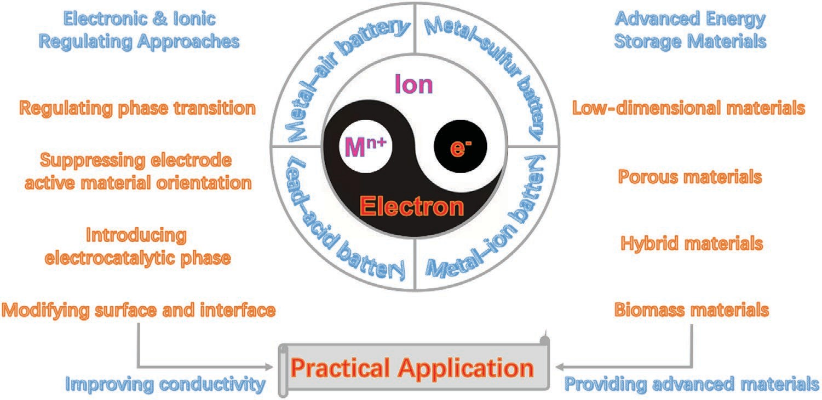
Figure 1. Review scheme of opportunities, challenges, and potential research directions for rechargeable batteries.

Such unexpected electron and ion transports may lead to poor charge/discharge performance, short cycle life, battery failure, and security issues.[14] To resolve the above issues, some strat- egies have been chosen to obtain high-performance recharge- able batteries, such as nanoscale, doping, coating, composite, porosity, mixing, and electrolyte modification.[15–17] Moreover, various reviews summarized these problems and presented solutions.[18–20] For instance, Hao et al.[3b] summarized the roles of carbon materials in lead–acid batteries. Our group reported the recent progresses in the lithium dendrite suppression method based on its growth mechanism for lithium anode pro- tection.[21,22] Sun and co-workers[23] reviewed the chemical and electrochemical fundamentals for sodium–air batteries. Zhang’s group[24] highlighted the progress in high-sulfur-loading lithium–sulfur batteries enabled by hierarchical design princi- ples at multiscale. Cui and co-workers[25] first summarized the key progress in material design and advanced characterization techniques for lithium anodes. However, these reviews focus on single electrode, electrolyte, interface, or batteries. Research viewpoints that have comprehensive universality have not been given. Redox reactions during charge/discharge processes are the consistent principles for all rechargeable batteries, while the essential mechanism is the transports of electrons and ions in the electrochemical processes.[3b,26] Consequently, systemati- cally summarizing the existing problems of rechargeable bat- teries and providing universal guidance to improve their prop- erties and performances are necessary.
Herein, we summarize the current progress of various rechargeable batteries and the corresponding opportunities and challenges (Figure 1). The principles of electrochemical reac- tions for lead–acid batteries, metal-ion batteries, metal–sulfur batteries, and metal–air batteries are introduced and com- pared. The critical issues and challenges of various recharge- able batteries are analyzed and discussed to pave the way for the development of next-generation rechargeable batteries. Approaches for regulating the kinetics of electronic and ionic transport, including controlling phase transition, suppressing electrode active material orientation, introducing the electro-
4
kinetics and electrical conductivity properties, and thus the per- formances of various rechargeable batteries. We also highlight some advanced energy storage materials with ideal electronic and ionic conductivities for high-performance rechargeable batteries, such as low-dimensional materials, porous materials, hybrid materials, and biomass materials. Furthermore, several perspectives on potential research directions for the choice and design of high-performance rechargeable batteries for the prac- tical application of 3C electronics, flexible and wearable devices, smart grid systems, and transportation are proposed.

Principles and Bottlenecks of Rechargeable Batteries
Various rechargeable batteries possess a consistent underlying principle, namely, ion is transported between electrodes and electrolytes, and redox reactions take place in electrodes in internal circuits, corresponding to the electronic transport in electrodes and external circuit.[9,27] Redox reactions and ionic transports depend on battery types.[28] At present, mainly four types of batteries–lead–acid battery,[3a] metal-ion battery,[29] metal–sulfur battery,[30] and metal–air battery[31]—are active in the field of electrochemical energy storage because of their advantages. We describe these rechargeable batteries focusing on their principle of electrochemical reactions and point out key development bottlenecks.

Lead–Acid Battery

Since the lead–acid battery was invented by Plante, it has been used for more than 160 years due to its low cost and long cycle life.[32] A schematic of the lead–acid battery is shown in Figure 2a, constituting of PbO₂ cathode, Pb anode, and H₂SO₄ electrolyte. The electrochemical reactions during the charge/ discharge processes are as follows (Equations (1)–(3))

catalytic phase, and modifying the surface and interface, are comprehensively discussed for enhancing the ion diffusion
Cathode: PbO₂ + 2e⁻ + SO²⁻ + 4H⁺ ↔ PbSO
₄ + 2H₂O
(1)

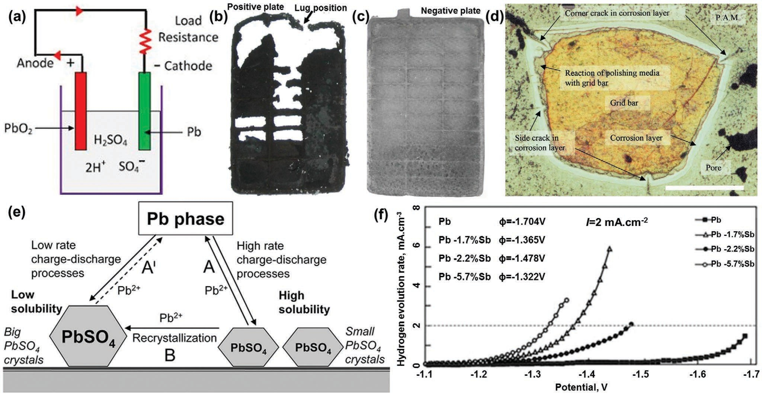
Figure 2. a) Schematic of lead–acid battery. Reproduced with permission.[33] Copyright 2019, Web page. The photographs b) anode and c) cathode of a failed lead–acid battery. Reproduced with permission.[34] Copyright 2009, Elsevier. d) Cathode grid cross-section showing corrosion layer and cracks (scale bar: 500 μm). Reproduced with permission.[35] Copyright 2002, Elsevier. e) Schematic representation of the basic processes that take place at the anode of lead–acid batteries cycled under hybrid electric vehicle operating conditions. Reproduced with permission.[36] Copyright 2012, The Electro- chemical Society. f) Hydrogen gassing rate on pure lead and lead alloy electrodes. Reproduced with permission.[37] Copyright 1994, Elsevier.

Anode: Pb − 2e⁻ + SO²⁻ ↔ PbSO₄
4

Total: PbO₂ + 2H₂SO₄ + Pb ↔ 2PbSO₄ + 2H₂O
(2)

(3)
solubility (process B), resulting in a slight involvement in the charge process (process A). During cycling, the larger PbSO₄ crystals grow further, leading eventually to anode progressive sulfation. Unreduced PbSO₄ crystals precipitate onto the Pb

For practical utilization, the cathode breakage, irrevers- ible sulfation, and hydrogen evolution are the key issues that affect the electrochemical performance of lead–acid bat- teries.[38] Guo et al.[34] proved that some ribs of the cathode grid were severely corroded in a failed battery even though the frame was still in good condition and the cathode had rela- tively good mechanical property. However, severe softening appears in cathode active materials, especially at the top of the cathode (Figure 2b), while the anode remains in good condition (Figure 2c). Cathode grid corrosion is concluded to be a per- manent failure and cannot be reversed.[39] Ball et al.[35] reported a typical grid cross-section with cracks and pores (Figure 2d). The corrosion layer extends around the whole perimeter of the grid, and pores and cracks are visible at a number of locations within the cathode active materials. Although no obvious anode damage can be observed in the photo (Figure 2c), the poten- tial irreversible sulfation phase transition also leads to battery failure.[40] Pavlov and Nokolov[36] described schematically the elementary processes during charge/discharge of the negative plates and the processes of PbSO₄ recrystallization, as shown in Figure 2e. During discharge, smaller PbSO₄ crystals with high solubility are formed on the surface of Pb anodes. Sub- sequently, the formed Pb2+ ions will participate in the charge process (process A). Unfortunately, parts of the Pb2+ ions con- tribute to the growth of the larger PbSO₄ crystals with low
anode surface, limiting the contribution to the charge process and reducing the anode charge acceptance, resulting in bat- tery failure. In addition to the irreversible transformations of cathode and anode,[40b] the hydrogen evolution phenomenon is another key factor that affects battery performance.[41] Normally, gases vented from lead–acid batteries are mainly oxygen and hydrogen.[42] During charging, the fundamental anode reac- tion may be accompanied by hydrogen evolution because of the residual elements contained in the anode grid alloy. Lam et al.[37] reported the polarization curve for different percent- ages of Sb in Pb–Sb alloys in Figure 2f, proving that Sb additive lowers the overpotential of hydrogen evolution and aggravates hydrogen evolution. Hydrogen gas gathers and releases con- tinuously at the top of a battery,[43] causing electrolyte dry-out, thermal runaway, and serious safety problems of the battery.[44]
To solve the above problems, our group systematically sum- marized the strategies and methods for improving the perfor- mance of lead–acid batteries.[38] The addition of Ca, Sn, As, Ag, In, Sm, Te, Ce, and Li can reduce the electrochemical cor- rosion rate of electrode grids because these elements provide a barrier that hinders contact between the electrolyte and the electrode.[45] The addition of suitable carbon materials to the negative electrode could suppress the sulfation phenomenon efficiently. Thus, the batteries produced in this way were called lead–carbon battery.[46] Furthermore, our research proved that

the conductive carbon material derived from the zeolite imi- dazolate framework-8[3a] and chitosan[40a] can suppress sulfa- tion through the formation of a conductive network, leading to improved electrochemical performances. For another case, the additives of In₂O₃, Bi₂O₃, Ga₂O₃, and N-doped carbon are able to decrease the hydrogen evolution rate by enhancing the overpotential of hydrogen evolution.[47,48] The reasonable use of additives to optimize the electrochemical performance of lead– acid batteries is still a major challenge for large-scale energy
example, the principle of the classic LiCoO₂ battery is as follows (Equations (4)–(6))[53]

Cathode: CoO₂ + e⁻ ↔ LiCoO₂ − Li⁺ (4)

Anode: LiC₆ − e⁻ ↔ 6C+ Li⁺ (5)

storage applications.
Total: CoO₂ + LiC₆ ↔ LiCoO₂ + 6C
(6)

Metal-Ion Battery

At the beginning of the 1990s, the lithium-ion battery with LiCoO₂ cathode and graphite anode was successfully pro- duced and applied,[49] leading to the development of various cathode active materials, such as Li_{x}NiO₂,[50] Li_{x}MnO₃,[51] and LiFePO₄.[52]
As a kind of rocking-chair batteries, lithium-ion batteries possess similar reaction principles (Figure 3a[15]). As an
All lithium-ion batteries with graphite anodes deliver a con- sistent anode principle, even if the electrolytes are different.[54] Of course, various cathode active materials display different electrochemical redox reactions and different voltages of charge and discharge. The reduction/oxidation of transition metal cor- responds to the insertion/extraction of lithium ion.[55]
The graphite anode possesses high specific capacity, suitable potential, simple preparation process, and low cost.[56] There- fore, research focused on the cathode materials.[8] During the development of the lithium-ion battery cathode, issues such

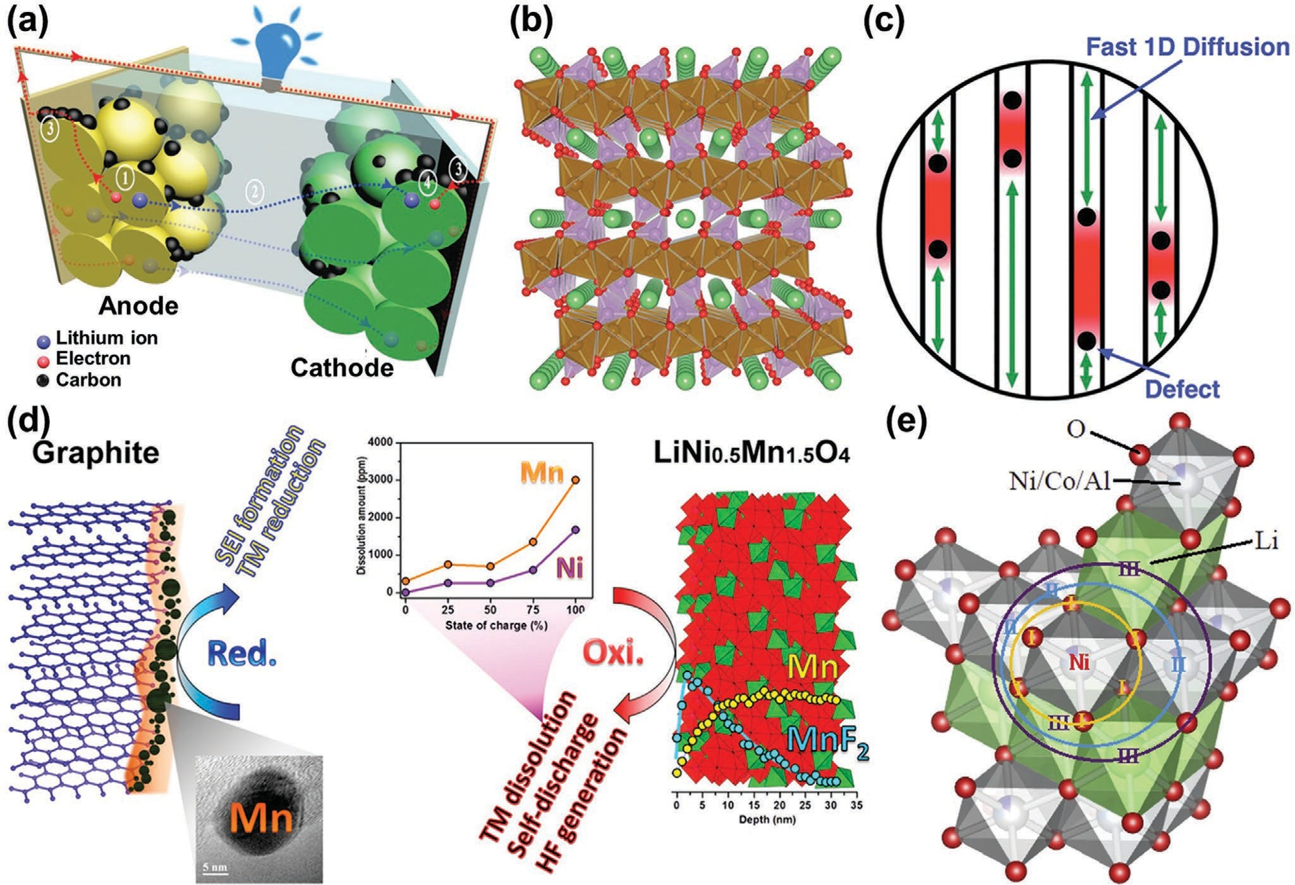
Figure 3. a) Transport pathways of the lithium-ion and the electron in a lithium-ion battery under discharging process. Reproduced with permission.[15] Copyright 2015, Royal Society of Chemistry. b) Crystal structure of LiFePO₄ illustrating 1D lithium-ion diffusion channels oriented along the [010] direc- tion. c) Schematic illustration of lithium ion diffusion impeded by immobile point defects in 1D channels. Reproduced with permission.[60] Copyright 2020, American Chemical Society. d) Cycling degradation mechanisms of high-voltage LiNi_{0.5}Mn_{1.5}O₄ cathode. Reproduced with permission.[65] Copyright 2013, American Chemical Society. e) A section of the crystal structure of LiNi_{0.8}Co_{0.15}Al_{0.05}O₂. The first shell consists of oxygen atoms labeled as I. The second shell is nickel atoms labeled as II, and the third shell is lithium atoms labeled as III. Reproduced with permission.[74] Copyright 2015, Elsevier.

as low conductivities, poor structural stability, and high cost resulted in poor high-C rate performance, low energy density, low power density, and poor cycling.[57]
In general, the conductivities include electronic and ionic conductivities, constrained by the composition and structure of the active materials. The olivine structure of LiFePO₄ delivers a lower intrinsic electronic conductivity (<10−9 s cm−1),[58] while the 1D ionic transport channel exhibits poor ion conductivity (10−14 to 10−16 cm2 s−1).[59] Malik et al.[60] described that lithium- ion migration occurs preferentially via 1D channels oriented along the [010] direction of the orthorhombic crystal structure, as shown in Figure 3b. This condition is significantly different from diffusion in 2D or 3D, being impeded by the presence of immobile and low mobility defects (Figure 3c) in the diffusion path. As a result, the pure-phase LiFePO₄ cannot be used as the cathode. For this reason, many studies aiming to improve the electrochemical performance of the LiFePO₄ materials have been conducted, with the common strategies focusing on doping, nanosize, coating, composite, and porosity.[61,62] Our group has devoted much effort to prepare a carbon-coated porous LiFePO₄ composite cathode material by using adenosine disodium triphosphate biological template and carbon thermal reduction method[26a] to modify the commercial LiFePO₄ mate- rial using metal–organic framework (MOF)-based porous carbon materials.[63,64] The resultant carbon-coated LiFePO₄ composite achieved excellent electrochemical performance because of the synergistic improvements of electronic and ionic conductivities. The poor structural stability of the cathode active material comes from two aspects. On the one hand, long-term rapid lith- ium-ion intercalation/extraction causes severe volume changes, leading to structural damage (such as LiCoO₂, LiFePO₄, and Li₃V₂(PO₄)₃).[61] Thus, a nanoscale coating layer on the active material is well recognized as an effective method to buffer the volume changes of active materials. For example, we coated commercial LiFePO₄ particles by using carbonized zeo- lite imidazolate framework-8, resulting in an excellent cycle life (increased to more than twice).[64] On the other hand, the side reaction between the cathode material and the electrolyte caused structural damages (such asLi_{x}MnO₃, LiNi_{0.5}Mn_{1.5}O₄, and LiNi_{x}Co_{y}Mn_{z}O₂).[8] Pieczonka et al. described the dissolu- tion behaviors of Mn and Ni in LiNi_{0.5}Mn_{1.5}O₄/graphite full cells, as shown in Figure 3d.[65] The amounts of dissolved Mn and Ni, diethyl ether, and the decomposition product of diethyl carbonate in electrolyte increased with the state of charge, temperature, and storage time. The decomposition of elec- trolyte could be explained by the self-discharge behavior of LiNi_{0.5}Mn_{1.5}O₄, which promotes electrolyte oxidation. In addi- tion, HF is believed to be generated during the formation of diethyl ether (via dehydration reaction from EtOH and another decomposition product of diethyl carbonate), which can accel- erate Mn and Ni dissolution from LiNi_{0.5}Mn_{1.5}O₄. In addition, various reaction products formed as a result of Mn and Ni dis- solution, such as LiF, MnF₂, NiF₂, and polymerized organic species, were found on the surface of LiNi_{0.5}Mn_{1.5}O₄ elec- trodes, which would increase battery impedance. For this case, methods for enhancing the structural stability of LiNi_{0.5}Mn_{1.5}O₄ cathodes were developed, including doping,[66] cathode surface
coating,[67] and electrolyte modification;[68] please see our pre-
Insufficient reserves of transition metal elements, especially element cobalt and element nickel, are the main reason for the high price of lithium-ion battery cathode materials.[69,70] Using cheap transition metal elements such as manganese and alu- minum to replace high-priced transition metal elements has become a key way to solve this problem.[71,72] Recently, commer- cial LiNi_{0.8}Co_{0.15}Al_{0.05}O₂ with high specific capacity has provided a way to reduce costs.[73] Kleiner et al.[74] reported the use of LiNi_{0.8}Co_{0.15}Al_{0.05}O₂ as cathode in commercial lithium-ion bat- teries. Figure 3e shows a fraction of the crystal structure where the inner (orange), middle (blue), and outer (purple) rings out- line the first, second, and third coordination spheres around an absorbing nickel atom, respectively. The Roman numerals indicate that the first shell is oxygen atoms, the second shell is nickel/cobalt/aluminum atoms, and the third shell is lithium ions. Zhu et al.[75] reported that the LiNi_{0.8}Co_{0.15}Al_{0.05}O₂ cathode exhibited a reversible capacity of 220.5 mAh g−1 at 0.1 C and an excellent long-term cycling stability with 93.6% capacity reten- tion after 80 cycles at 0.1 C.
The low reserves and high price of lithium sources are fun-
damental reasons for the high cost of lithium-ion batteries.[76] During the development of metal-ion batteries, cheap metal ele- ments that can replace lithium to form sodium-,[77] calcium-,[78] magnesium-,[79] aluminum-,[80] potassium-,[81] and zinc-[82] ion batteries are emerging and widely studied. Similar to research on lithium-ion batteries, the research and development of high-per- formance cathode materials, including carbon materials,[83] metal compounds,[84] and composite materials,[78] is an indispensable research direction for these metal-ion batteries.[85] The improved utilization and protection of metal anodes also play an impor- tant role in battery performance, with porous metal electrodes possibly being the best choice.[21,22] Yang et al.[10] systematically compared the above batteries recently (Figure 4). They pointed out that multivalent cation battery systems, especially Al3+, are considered more promising because of their high capacity (8035 mAh cm−3 and 2976 mAh g−1), acceptable energy density, high safety, and lower cost. In addition, hybrid ion batteries with different metal ions are another development direction for metal-ion batteries because ion exchange improves battery performance.[26a,85]

Metal–Sulfur Battery

In the process of exploring high-performance cathode mate- rials for lithium-ion batteries, sulfur was selected as the cathode active material due to its high theoretical capacity of 1672 mAh g−1.[22] When matching with a lithium metal anode to form a lithium–sulfur battery, its theoretical energy density can reach ≈2600 Wh kg−1.[86] Sodium–, potassium–, and mag- nesium–sulfur batteries have emerged to reduce the cost and improve energy/power densities of batteries.[87] The most rep- resentative among these metal–sulfur batteries is the lithium– sulfur battery (Figure 5a),[88] which is mainly composed of lithium metal anode, organic electrolyte, and sulfur composite cathode. Its principle is as follows[89]

vious review.[8]
Cathode :S₈ + 16Li⁺ + 16e⁻ ↔ 8Li₂S
(7)

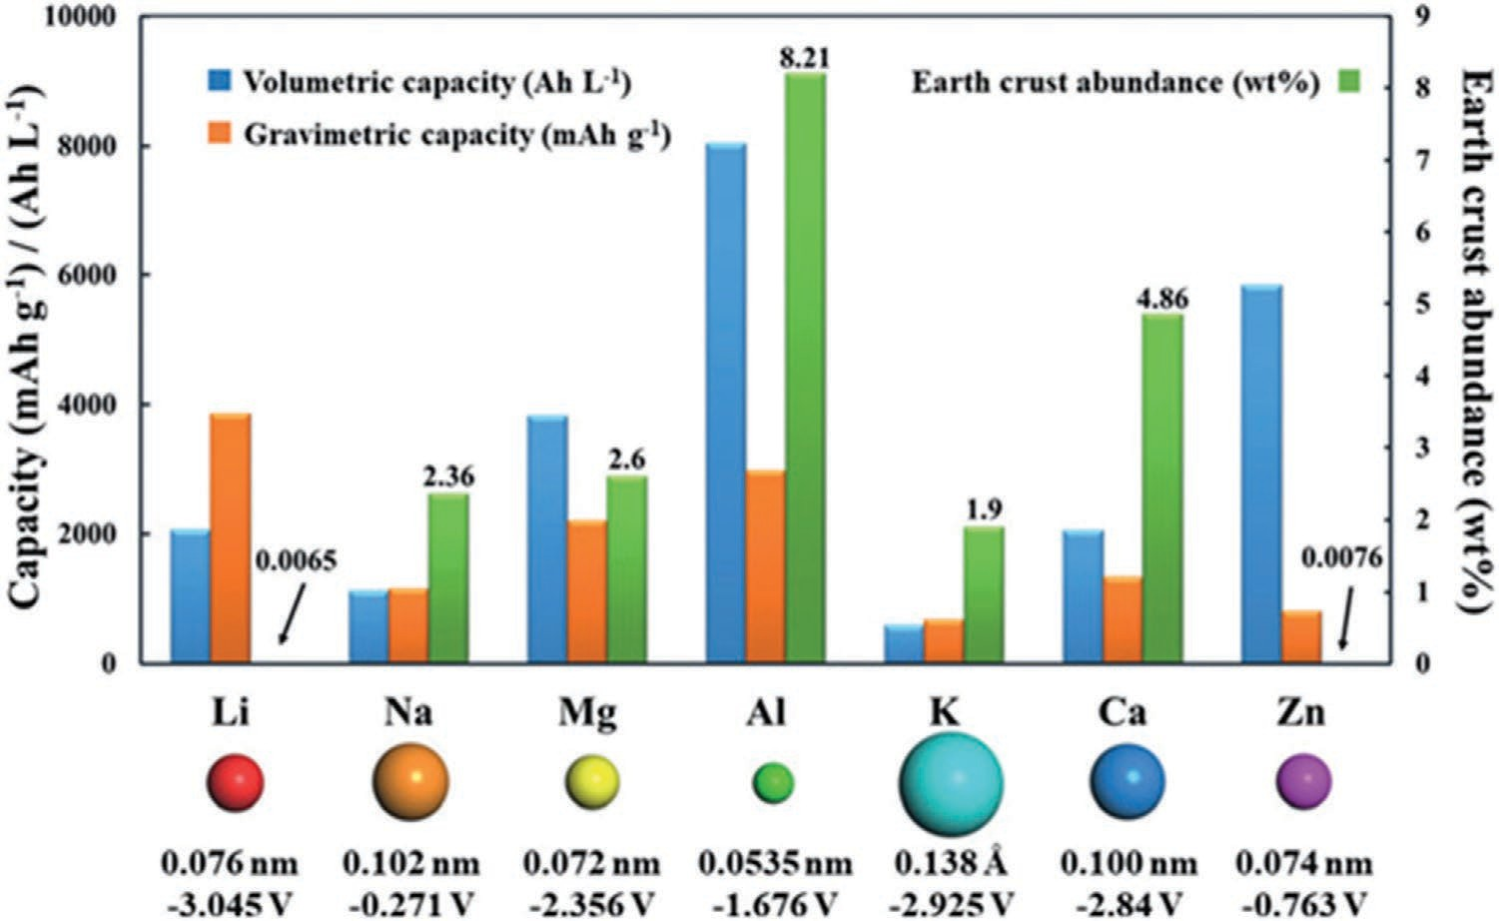
Figure 4. Elemental abundance, ionic radii, standard electrode potential (vs NHE), and gravimetric and volumetric capacities of different metal anodes. Reproduced with permission.[10] Copyright 2019, Wiley.

Anode: Li ↔ Li⁺ + e⁻ (8)
the sulfur cathode to be reoxidized. Such shuttle effect leads to self-discharging and low Coulombic efficiency, even forming an

Total :S₈ + 16Li ↔ 8Li₂S
(9)
internal short circuit.[96] II) Lithium anode reacts with the elec- trolyte to form a nonuniform solid electrolyte interphase (SEI)

Such reaction principle looks simple. However, the charge and discharge processes deliver a voltage profile with two pla- teaus in ether-based electrolytes, as shown in Figure 5b.[90] For discharge process, sulfur is lithiated to form a series of long- chain lithium polysulfide species (S₈ → Li₂S₈ → Li₂S₆ → Li₂S₄) and dissolved in ether-based electrolytes, which delivers a higher voltage plateau of ≈2.35 V and 25% theoretical capacity of 418 mAh g−1. Upon further lithiation, the above long- chain polysulfides transform short-chain sulfide species (Li₂S₄ → Li₂S₂ → Li₂S) and reprecipitate onto the cathode, which correspond a lower voltage plateau of ≈2.1 V and 75% theoretical capacity of 1255 mAh g−1. The charging process is the opposite. Unlike lead–acid batteries and metal-ion batteries, metal–sulfur batteries undergo the reaction process of solid–liquid–solid tran- sition, resulting in the challenges of capacity fading and poor cycling stability.[91] Therefore, metal–sulfur batteries have not been commercialized yet. On the one hand, several challenges exist on the sulfur cathode side:[92] I) low conductivity of sulfur and lithium sulfide leads to low utilization of sulfur cathode active material;[93] II) the continuous loss of sulfur cathode active material caused by the dissolution of long-chain lithium poly- sulfides into the electrolyte and nonprecipitation back onto the cathode as lithium sulfide at the end of discharge results in low discharge capacities and rapid capacity decay;[94] III) large volu- metric expansion of sulfur upon lithiation (a large volumetric expansion of 80%) causes pulverization and structural damage at the electrode level.[95] On the other hand, the following chal- lenges are faced for the lithium anode side. I) Long-chain lithium polysulfides (Li₂S₄ to Li₂S₈) from the cathode in the electrolyte can diffuse to the lithium anode to be reduced to form lower-order polysulfides, subsequently diffusing back to
on the surface with ionic conduction and electronic insulation. Thus, the lithium metal surface is not passivated sufficiently, leading to continuous, undesirable side reactions with the elec- trolyte and resulting in poor reversibility and low Coulombic efficiency.[97] III) The growth of lithium dendrites breaks and reforms SEI, further consuming lithium anode and electrolyte. Dendrites that break off will become dead lithium, resulting in low Coulombic efficiency. More seriously, dendrites potentially penetrate the separator and lead to internal short circuits.[98]
Among these challenges, polysulfide shuttle effect (Figure 5c)[99] and dendritic growth (Figure 5d)[100] are the critical problems that restrict the scale expansion of the metal–sulfur battery. The former issue can be addressed via material develop- ment and structural designs of the sulfur hosts. To tackle the shuttle effect and prolong battery life, the ideal cathodes for metal–sulfur batteries can be designed[99] i) as highly conductive materials for improved electrochemical kinetics, ii) with a large surface area for loading a large amount of insulating sulfur or sulfide species to hinder the agglomeration of elemental sulfur nanoparticles, iii) with nanoporous structures for encapsulating sulfur and its reaction product—lithium polysulfides—within the sulfur hosts, iv) with hierarchical porous structures for enhancing mass transport of the interface between the cathode and the electrolyte, v) with chemical interactions for promoting the adsorption of polysulfides to suppress the shuttle effect, and
vi) with a covered interlayer on the sulfur hosts for spatially con- fining the polysulfides within the cathode side. Kang et al.[101] demonstrated that cathode porosity is an important parameter to optimize lithium–sulfur battery energy density. It proved that electrodes with the porosity of 50–60% are suggested for a prac- tical lithium–sulfur battery design. Chabu et al.[102] designed a

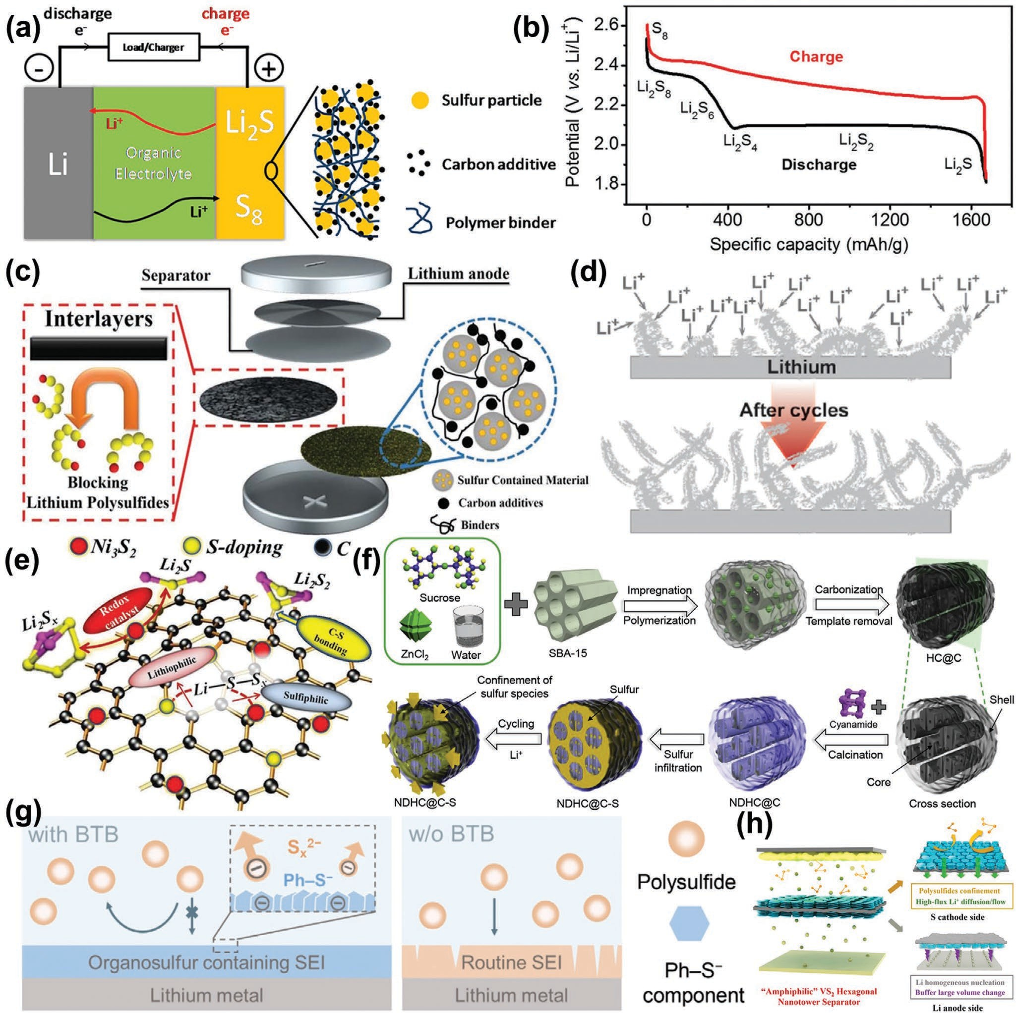
Figure 5. a) Illustration of the charge (red)/discharge (black) process involved in a rechargeable lithium–sulfur battery consisting of lithium metal anode, organic electrolyte, and sulfur composite cathode. Reproduced with permission.[88] Copyright 2013, American Chemical Society. b) A typical two-plateau charge/discharge voltage profile of lithium–sulfur batteries in ether-based electrolytes. Reproduced with permission.[90] Copyright 2016, Royal Society of Chemistry. c) Schematic of the design and structure of sulfur hosts in a lithium–sulfur battery. Reproduced with permission.[99] Copyright 2018, Wiley.
d) Lithium dendrite growth on the lithium metal anode in lithium–sulfur battery. Reproduced with permission.[100] Copyright 2014, Wiley. e) Mechanism
of cooperative lithiophilic and sulfiphilic interfaces of S-doped carbon and Ni₃S₂ for enhanced adsorption and electrocatalytic conversion of lithium polysulfides. Reproduced with permission.[108] Copyright 2019, Wiley. f) NDHC@C preparation and the proposed confinement effects for polysulfides (a color version of this figure can be viewed online). Reproduced with permission.[109] Copyright 2020, Elsevier. g) Schematics of the formation of SEI with and without BTB additive and the corresponding effect of the formed SEI in shielding LiPSs from Li anode. Reproduced with permission.[110] Copyright 2020, Wiley. h) Schematic illustrations of the working principle of the lithium–sulfur battery with D-HVS@PP separator. Reproduced with permission.[116] Copyright 2020, American Chemical Society.

bipyramidal sulfur/graphene oxide cathode with a sulfur con- tent of 92%. Sulfur particles were uniformly coated by a thin wall of graphene oxide and residual polyvinylpyrrolidone molecules,
facilitating electron/ion transportation and restraining the diffu- sion of polysulfides through interfacial chemical interaction. To drive the conversion of sulfur, Wang et al.[103] reported niobium

tungsten oxide microspheres as an electroactive host in the electrochemical window to sulfur, showing good electrochem- ical activity for lithium storage and strong adsorption toward polysulfides. The sulfur-based composite with a tap density of
1.56 g cm−3 showed a volumetric capacity of 1605.3 mAh cm−3, almost 1.9 times of that for the conventional sulfur/carbon composite. Yeon et al.[104] synthesized nitrogen-incorporated honeycomb-like nanoporous carbons (n-hC) with a surface area of 2071 m2 g−1, pore volume of 1.11 cm3 g−1 and N content of 3.47% derived from lignin, in which sulfur is confined in the micropores to inhibit polysulfide dissolution, thereby showing the facile, reversible redox kinetics of sulfur and the improved performance of sulfur cathode. Similarly, Sun et al.[105] reported a hybrid sulfur host composed of Al₂O₃ homogenously deco- rated in nitrogen-rich mesoporous carbon framework. Such host features a polydispersed spherical morphology and a mesoporous configuration with a high surface area and large pore volume that can accommodate a high sulfur content up to 73.5 wt%. Wang et al.[106] introduced spherical metal oxides with high tap density as carbon-free hosts of sulfur, showing the superior synergistic effect of adsorption and electrocatalytic conversion of soluble intermediate polysulfides. They also built stable conductive frameworks and open channels in porous electrodes for fast transport of electrons and active diffusion of electrolytes, achieving good utilization and stable cycle perfor- mance of the sulfur cathode. The S/LiNi_{0.8}Co_{0.1}Mn_{0.1}O₂ com- posite exhibited a capacity decay rate of 0.057% per cycle after 500 cycles at 0.1 C and a volumetric capacity of 1601.9 mAh cm−3. Zhou et al.[107] reported the preparation of sulfur electrode sup- ported by porous vapor silica, which displayed excellent elec- trochemical performances. For a typical case, Zeng et al.[108] proposed a hierarchical electrode design to address the issues corresponding to cathodes. Nickel foam acts as a conductive scaffold. The heteroatom-doped host carbon with desired lithi- ophilicity and electronic conductivity serving as a reservoir for loading sulfur can trap lithium polysulfides and promote elec- tron transfer to interfacial adsorbed lithium polysulfides and Ni₃S₂ sites. The sulfurized carbon nanofiber forest can facilitate Li-ion and electron transport and retard lithium polysulfide dif- fusion as a barrier layer (Figure 5e). Sulfiphilic Ni₃S₂ has been demonstrated as both a chemical anchor with strong adsorption affinity to lithium polysulfides and an efficient electrocatalyst for accelerating kinetics for redox conversion reactions. Syner- gistically, all functional units promote the lithium ion-coupled electron transfer for binding and redox conversion of lithium polysulfides, resulting in high reversible capacities, remarkable cycle stability, and excellent rate capability. Yan et al.[109] reported the synthesis of nitrogen-doped carbon materials with hierar- chical pore architecture and a core–shell-type particle design that includes an ordered mesoporous carbon core and a polar microporous carbon shell (Figure 5f ). The ordered mesoporous carbon not only provides sufficient space for high sulfur loading induced by the high-pore-volume particle core, but also ena- bles the dual effect of physical and chemical confinement of the polysulfides to stabilize the cycle life by adsorbing the sol- uble intermediates in the polar microporous shell. The initial discharge capacity with a sulfur loading up to 72 wt% reaches more than 900 mAh g−1 at 0.5 C. Cycling performance indicates
≈90% capacity retention over 250 cycles at 0.5 C.
To address the issue of dendritic growth, Wei et al.[110] tai- lored an organosulfur-containing SEI for the stabilization of the Li anode by employing 3,5-bis(trifluoromethyl) thiophenol as an electrolyte additive. The organosulfur-containing SEI protected the Li anode from detrimental reactions with lithium polysulfides and decreased its corrosion (Figure 5g). A lithium– sulfur battery delivered 82 cycles with an organosulfur-con- taining SEI in comparison to 42 cycles with a reference SEI. This work provokes vital insights into the role of the organic components of SEI in the protection of the Li anode in practical lithium–sulfur batteries.
Dendritic growth on the lithium metal anode is the most serious problem among various metal–sulfur batteries. Yao et al.[111] reported that the formation of a compact inorganic layer (CIL) between Li anode and ionic liquid is an effective strategy to block Li polysulfides and suppress the shuttle effect. A CE of 96.7% was achieved with CIL-protected Li anode in contrast to 82.4% for bare Li anode while no lithium nitrate was employed. Furthermore, the corrosion of Li during cycling was effectively inhibited. A total of 80.6% of the initial capacity after 100 cycles was retained with CIL-protected ultrathin (33 μm) Li anode compared with 58.5% for bare Li anode. This study pre- sents a feasible interfacial regulation strategy to protect Li anode with the presence of Li polysulfides and opens avenues for Li anode protection in lithium–sulfur batteries under practical conditions. Kong et al.[112] investigated a Li-rich lithium–mag- nesium (Li–Mg) alloy as an anode based on the consideration of improving the stability in the bulk and at the surface of the lithium anode. The robust passivation layer is formed on the surface of the Li–Mg alloy anode, reducing side reactions and enabling the smooth surface morphology of the anode during cycling. The mixed electron and Li-ion conducting matrix of the Li-poor Li–Mg alloy as a porous skeleton structure can also be formed after delithiation, guaranteeing the structural integrity of the anode in the bulk during Li stripping/plating process. Han et al.[113] employed MOF-modified gel polymer electrolyte (GPE) to stabilize the lithium anode. In view of the abundant pores in the MOF skeleton, GPE not only immobilized the large-size polysulfide anions but also caged electrolyte anions into the pores, facilitating a uniform flux of Li ions and homo- geneous Li deposition. Lin et al.[114] reported a class of double- layer photonic crystal (DLPC)@S/DLPC@Li full cell based on a distinctly constructed DLPC with a 3D-ordered interconnected structure. This full cell not only ensures the uniformity of microscopic electrochemical reaction but also solves common problems such as low conductivity of sulfur, poor cycle life, and lithium dendrite growth. Impressively, the full cell exhibits superior electrochemical performance with a high reversible capacity of 703.3 mAh g−1 even at an extremely high rate of 10 C and excellent cycle performance with 1200 cycles with about 0.0317% capacity loss per cycle at 0.5 C. Ren et al.[115] designed spontaneous reactions for protecting porous lithium electrodes. A reaction between molten lithium and sulfur-impregnated carbon nanofiber formed a fibrous network with a lithium shell and a carbon core. Then, they coated the surface of this porous lithium electrode with a composite of lithium bismuth alloys and lithium fluoride through another spontaneous reaction between lithium and bismuth trifluoride solvated with phos- phorous pentasulfide, which also polymerizes with the lithium

sulfide residual in the electrode to form a solid electrolyte layer. This protected porous lithium electrode enables stable operation at 6.0 mA cm−2 for 200 cycles. Wang et al.[116] used 2D hexagonal VS₂ flakes as the building blocks to assemble nanotowers on the separators, forming a symmetrical double- side-modified polypropylene separator without blocking the membrane pores (Figure 5h). Benefiting from the sulfiphilic and lithiophilic properties, high interfacial electronic conduc- tivity, and the unique hexagonal tower-form nanostructure, the recyclable VS₂ hexagonal nanotower (HVS) double-side-modi- fied commercial polypropylene (PP) separator (D-HVS@PP separator) guaranteed rapid ion/electron transfer and realized uniform lithium nucleation growth during cycling.
During the discharge process, Li is oxidized to Li ions, which diffuses from the anode to the cathode through a membrane. At the same time, electrons move via the external circuit from the anode to the cathode, where the ORR occurs. During the charging process, Li ions from the cathode diffuse into the anode through a membrane. The OER occurs at the cathode, and Li ions deposit as neutral Li on the Li anode. The simplest net reaction envisioned for the hybrid battery is a four-electron process

Cathode: O₂ + 2H₂O+ 4e⁻ ↔ 4OH⁻ (15)

Anode: Li ↔ Li⁺ + e⁻ (16)

Metal–Air Battery
Overall: 4Li + O₂ + 2H₂O ↔ 4LiOH
(17)

Another effective strategy to achieve high energy density is the exclusion of the cathode active material from the battery, making the battery smaller and lighter. Therefore, metal–air batteries have been developed.[117] Metal–air batteries employ a dissolu- tion/precipitation reaction on the anodes during the electro- chemical process rather than the intercalation mechanism.[118] Unlike the intercalation reaction, a dissolution/precipitation reac- tion involves an evolution in the crystal structure of the electrode material. According to the differences of electrolytes, metal–air batteries are divided into three categories: 1) nonaqueous, which are alkali metals that react violently with water as anodes, such as lithium and sodium, 2) hybrid, which are alkali metals that react violently with water as anodes, such as lithium and sodium,
3) aqueous, which uses a transition metal as anodes, such as aluminum, zinc, and magnesium. Three typical cases of non-
A zinc–air battery is composed of three main components: a zinc anode, an alkaline (KOH) electrolyte, and an air cathode, as schematically illustrated in Figure 6c.[120] For discharge, oxygen diffuses through the air cathode with the catalyst layer, allowing the reduction of oxygen to hydroxide ions (ORR) in the alkaline electrolyte with the electrons obtained from the electrochemical oxidation of the zinc anode. On charge, oxygen will evolve and diffuse out of the air cathode (OER), whereas zinc is deposited at the anode. The simplest net reaction envisioned for the non- aqueous battery is a four-electron process

Cathode: O₂ + 2H₂O + 4e⁻ ↔ 4OH⁻ (18)

Anode: Zn + 2OH⁻ ↔ ZnO + H₂O + 2e⁻ (19)

aqueous lithium–air battery, hybrid lithium–air battery, and aqueous zinc–air battery are selected to describe the principles.
The chemistry proposed for a nonaqueous lithium–air bat-
Overall: 2Zn + O₂ ↔ 2ZnO
(20)

tery is as follows,[119] corresponding to Figure 6a. During the dis- charge process, metal lithium is oxidized at the anode to form lithium ion. The electrons flow through an external circuit and the lithium ions generated from this reaction reduce oxygen (oxygen reduction reaction, ORR) to form Li₂O₂ (and possibly Li₂O) in the cathode. For the charge process, lithium metal is plated out on the anode, and O₂ is evolved at the cathode (oxygen evolution reaction, OER). The simplest net reaction envisioned for the nonaqueous battery is a two-electron process

Cathode: O₂ + e⁻ ↔ O⁻ (10)
2

O⁻ + e⁻ ↔ O²⁻ (11)
2 2

Anode: Li ↔ Li⁺ + e⁻ (12)
The above electrochemical principles show that the disso- lution/deposition of metal anode and reduction/evolution of oxygen in cathode are two keys of typical metal–air batteries. The reaction principle of metal–air batteries lies in OER and ORR.[26c,121] OER is molecular oxygen generated via the proton/ electron coupled processes.[122] It is also an electron-coupled uphill reaction in the charge of metal–air batteries, corre- sponding to the oxidation of hydroxyl groups (OH−) and/ or oxygen anion (O₂2− and/or O₂−) transforming into O₂.[123] Contrary to OER, ORR is a dissociative adsorption process, beginning with O₂ adsorption on a catalyst surface;[124] please refer to our previous review for a specific description.[26c] Gen- erally, a nonaqueous electrolyte requires a two-electron reac- tion, while an aqueous electrolyte requires a four-electron reaction.[125] Therefore, the key issue of metal–air batteries is the ideal electrocatalysts, which should possess the following advantages:[126] 1) a highly conductive and porous catalyst sub-

Total: Li + O₂ ↔ LiO₂

LiO₂ + Li ↔ Li₂O₂
(13)

(14)
strate, 2) nanostructured catalyst particles, 3) abundant and well-dispersed catalyst sites, and 4) environmentally benign properties of the chemical composition of the catalyst. Our pre- vious report discussed the recent progress of electrocatalysts

A classic example for the hybrid lithium–air battery by con- structing Li/aprotic electrolyte/Li ion-conducting membrane/ aqueous electrolyte/air electrode is shown in Figure 6b.[119]
in detail.[26c] Carbon-based catalysts are a typical kind of ORR electrocatalysts.[92,127] Heteroatoms are used to alter the surface structure, electronic properties, and adsorption/desorption

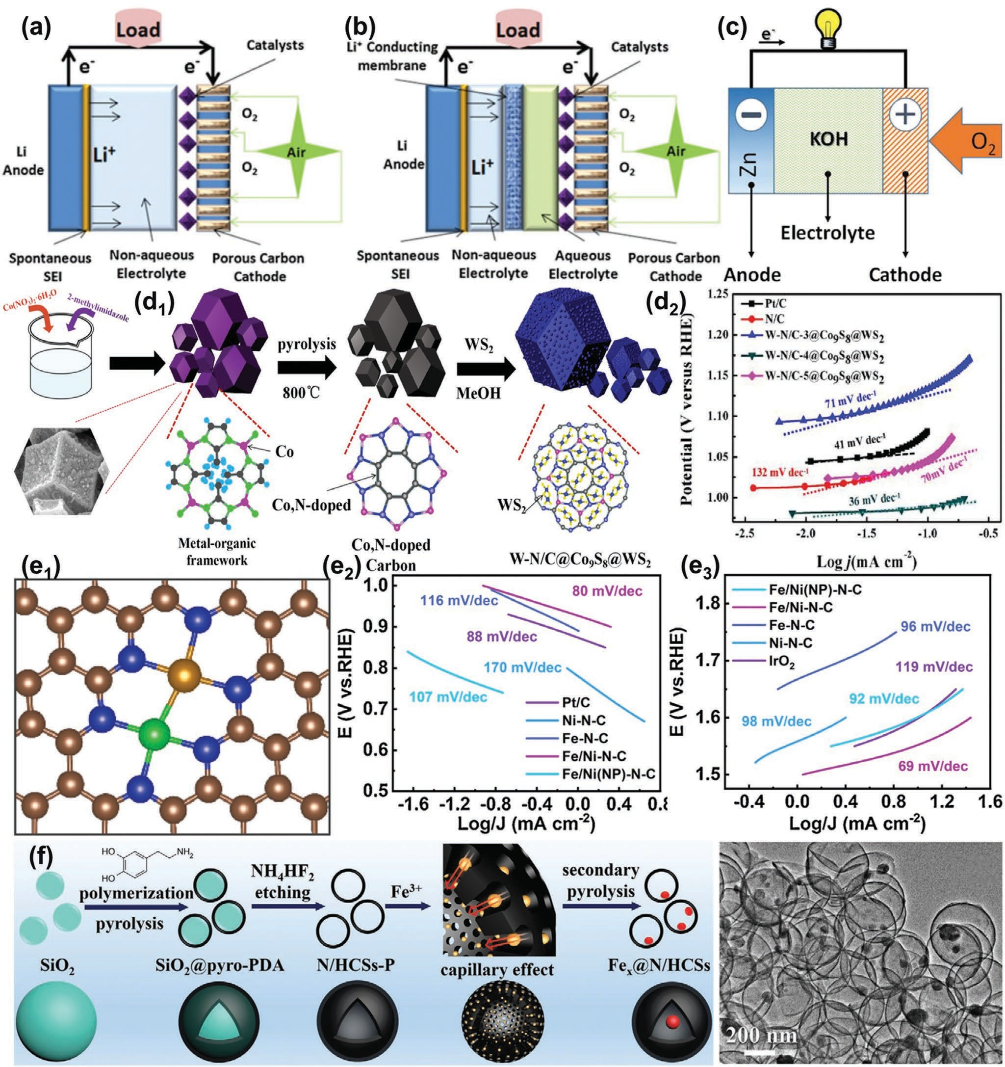
Figure 6. Types of metal–air batteries: a) nonaqueous lithium–air battery. b) hybrid lithium–air battery. Reproduced with permission.[119] Copyright 2010, American Chemical Society. c) aqueous zinc–air battery. Reproduced with permission.[120] Copyright 2014, Springer Nature. d₁) Synthesis route for the structural transformation of WeN/C@Co₉S₈@WS₂-hollow carbon nanocage, and d₂) comparative OER Tafel plots. Reproduced with permission.[147] Copyright 2020, Elsevier. e₁) Fe/Ni–N–C (3-N coordinated), e₂) ORR, and e₃) OER Tafel plots obtained from the RDE polarization curves, respec- tively. Reproduced with permission.[148] Copyright 2021, Elsevier. f) Schematic of the synthesis procedure for Fex@N/HCSs catalysts. TEM image of Fe₂₀@N/HCSs material. Reproduced with permission.[150] Copyright 2020, Wiley.

behaviors toward oxygen intermediates,[128] providing additional ORR active sites and promoting the electrocatalytic kinetic processes of oxygen.[129] Heteroatom-doped carbon mate- rials are expected to replace the traditional Pt-based catalyst
electrode.[130,131] Metal-based catalysts are used for metal–air batteries due to their superior OER performance and good cycle stability.[132] Metal alloys and transition metals have been used as OER catalysts for metal–air batteries.[133] As a class of

bifunctional ORR and OER catalysts, metal oxides are widely studied owing to their high activity, stability, and low cost for metal–air batteries.[134,135] The electrocatalytic activity of metal oxides can be enhanced by altering their compositions, crystal structures, and morphologies.[136] MOF-derived nanostructured materials are promising ORR/OER bifunctional electrocata- lysts because of their large specific surface area, robust mor- phology, and porosity.[137] Perovskite oxides have high ionic/ electronic conductivity, and their specific structure can provide rich oxygen vacancies.[138] Oxygen vacancies can enhance the transfer of oxygen ions, and the optimized chemical composi- tion can improve ORR and OER performance.[139] Single-atom catalysts (SACs) are a breakthrough point in the electrocatalysis community due to their outstanding advantage of maximum atom utilization efficiency for OER and ORR performance.[140]
Among various ORR/OER bifunctional electrocatalysts, the composites of metal/metal compounds and carbon mate- rials have become the latest research hotspot.[141] Li et al.[142] prepared a bifunctional catalyst (Co₃O₄/N-rGO) through a one-pot synthesis method. This catalyst exhibited good ORR and OER activity, high current stability, and methanol toler- ance. Li et al.[143] reported 2D CoFe/SN-doping and tailor-made open porous carbon nanosheets with a specific surface area of 1004 m2 g−1 and a pore volume of 1.25 cm3 g−1, exhibiting superior catalytic activity for ORR (E_{1/2} = 0.843 V) and OER (E_{i=10} = 1.504 V) in alkaline medium, as well as a power den- sity of 169 mW cm−2 and outstanding stability for 5100 min in zinc–air battery. Transition metal (i.e., Co, Fe, W, etc.) and nonmetal (i.e., N, S, P, etc.) heteroatom-doped porous carbon is apparently a promising electrocatalyst due to its low cost and preeminent electrical conductivity.[144] In general, the ORR/OER catalytic activity is observably enhanced via nonmetallic dopants that effectively modulate the electronic structure of carbon[145] and metallic dopants that form transition metal–nitrogen active sites.[146] Liu et al.[147] prepared N-doped C hollow metal–organic frame structure materials as a template. WS₂ nanocrystals were grown and encapsulated in ZIF-67 with interfacial W-N cou- pling centers. After pyrolysis, ZIF-67 becomes Co, N-doped C materials, and the growth of WS₂ was suppressed, forming mul- tifunctional group W-N/C@Co₉S₈@WS₂ materials (Figure 6d₁). With the unique frame pore structure and the synergistic effect of WS₂, Co₉S₈, and W-N multifunctional groups, W-N/C@ Co₉S₈@WS₂ exhibited E_{1/2} = 0.84 V and a slight Tafel slope of 41 mV dec−1 (Figure 6d₂) when employed as electrocatalysts for OER and a potential of 1.79 V to achieve the current density of 10 mA cm−2 in 0.1 m KOH. Li et al.[148] demonstrated that the FeNi dual-site architecture can serve as a superior bifunc- tional catalyst for both ORR and OER by coupling with Ni, Fe 3D electron delocalization (Figure 6e₁). The as-constructed catalyst exhibits outstanding ORR efficiency with a comparable onset potential of 1.005 V and half-wave potential of 0.861 V. The best ORR kinetic activity was reflected in an 80 mV dec−1 Tafel slope (Figure 6e₂) of Fe/Ni–N–C. The low Tafel slope of 69 mV dec−1 (Figure 6e₃) is indicative of higher OER catalytic activity. The outstanding catalytic performance is due to mod- erate spin polarization in the reaction center of Fe and the con- ductive nature via ferromagnetic coupling with Ni. This work opens up a new direction for the study of double atomic cata- lysts. Tomon et al.[149] reported bifunctional electrocatalysts of
hollow Co₃O₄ nanorods with oxygen vacancies toward ORR and OER for high-performance lithium–air batteries. Wang et al.[150] constructed Fe₃O₄ nanoparticles inside N-doped hollow mesoporous carbon spheres (N/HCSs) yolk–shell structure (Fe_{x}@N/HCSs) as a bifunctional electrocatalyst for ORR and OER (Figure 6f ). In situ growth of Fe₃O₄ nanoparticles was effectively controlled and confined by utilizing the N/HCSs and melting–diffusion strategy, and its conductivity and struc- tural stability were significantly improved. Yolk–shell structured Fe₂₀@N/HCSs ecosystem with Fe–N_{x} active sites exhibited high ORR/OER activity and stability. Zinc–air battery assembled with Fe₂₀@N/HCSs achieved an open-circuit voltage of 1.57 V, a power density of 140.8 mW cm−2, and a long-term cycling per- formance of more than 300 h. This work provides a new avenue for the design and optimization of other high-performance yolk–shell materials with nanoscale confinement structures.

Challenges
Various rechargeable batteries with different operation mecha- nisms can be roughly divided into four categories: lead–acid batteries,[151] metal-ion batteries,[152] metal–sulfur batteries,[153] and metal–air batteries.[154] However, the performance of these batteries is hindered by the core issues, namely, electronic and ionic transports,[155] which are influenced by four key parameters such as, the electrode, electrolyte, electrode/electrolyte interface, and surface reactivity (Figure 7). The irreversible sulfation of the anode in the lead–acid battery is caused by the delay of electron transports in the anode discharge product (PbSO₄).[39] The poor high-C rate performance of lithium-ion battery cathode mate- rials is caused by insufficient ion and electron transport kinetics in electrode and interface. Unsatisfactory polysulfide ion trans- port in the electrolyte leads to the degradation of metal–sulfur battery performance and anode dendritic growth. Similarly, the low efficiency of metal–air battery cathode catalysts is caused by poor electrode electronic conductivity and low electrode surface
Figure 7. Challenges of electronic and ionic transports involving in the electrode, electrolyte, electrode/electrolyte interface (referred to as inter- face), and surface reactivity (referred to as surface) of the rechargeable batteries.

adsorption/desorption of OH− ions. Generally, many efforts mainly focus on the modification of electrodes (doping, coating, adding, nano, composite, etc.), electrolytes (additive, ionic liquid, etc.), and separator (solid-state, surface treatment, etc.). Next, we will review the regulation of electronic and ion kinetics according to different strategies.

Approaches for Regulating Electronic and Ionic Kinetics
A high energy barrier that originates from unexpected elec- tronic and ionic kinetics is considered a major obstacle to satisfactory performance in advanced rechargeable battery sys- tems.[156] Electronic and ionic kinetics need to be regulated by applying approaches such as accelerating phase transition, sup- pressing electrode active material orientation, introducing the catalytic phase, and modifying the surface and interface.

Regulating Phase Transition

During the charge and discharge processes of rechargeable batteries, phase transition happens all the time due to the transports of electrons and ions.[157] Structural phase transi- tions can be used to alter the properties of a material without adding any additional elements and are therefore of significant technological value.[158] To understand the phase transition in rechargeable batteries, the schematic illustrations in Figure 8a show a O3–P3 phase transition based on the gliding of TMO₂ layers.[159] Sodium ions in the O3-type phase are originally sta- bilized at edge-shared octahedral sites with ABCABC oxygen packing. Sodium ions at prismatic sites become energeti- cally stable when sodium ions are partly extracted from the O3-type phase, associated with formation of vacancies. Part of the TMO₂ slabs glides by (1/3, 2/3, 0) without breaking MeO bonds, resulting in the formation of the P3 phase. In gen- eral, such phase transition does not need the chemical bond to break during ionic insertion and extraction.[160] The adjust- ment of the phase transition is mainly used for electrode mate- rials that apply ion insertion and extraction as the mechanism of action,[157b,161] such as LiFePO4,[158b] TiO2,[162] Mn3O4,[163]
Na2/3Ni1/3Mn7/12Fe1/12O2,[164] and K5/9Mn7/9Ti2/9O2.[165]
Regulating such phase transition is beneficial to improve the electrochemical performance of rechargeable batteries. In 2015, our group introduced the electrochemically active porous glass of Na₂O–FeO–V₂O₃–P₂O₅–biocarbon (NFVPB) to modify LiFePO₄/NaFe₃V₉O₁₉ cathode active materials.[26a] The amor- phous nature of the NFVPB glass retards the anisotropic Li-ion diffusion in the LiFePO₄ electrode, increases the Li+/Na+ mixed- ion and electronic transport, extends the electroactive zone, and facilitates the transfer kinetics. The NFVPB glass phase may also create a low-energy nonequilibrium path of phase trans- formations in LFP/NFV composite nanoparticles via a contin- uous change in the structure (Figure 8b₁). This is a fast phase transformation process that avoids a classical nucleation pro- cess, that is, major structural rearrangement across a moving interface. These low-energy nonequilibrium paths of phase transformations may help improve the high-rate performance
of LFP/NFV composite nanoparticles despite the large misci- bility gap of Li and Na at room temperature (Figure 8b₂). Wang et al.[159] found that the O3-type phase transforms reversibly into a P3-type phase of NaNi_{0.5}Mn_{0.2}Ti_{0.3}O₂ upon Na+ dein- tercalation/intercalation by using in situ X-ray diffraction, ex situ X-ray absorption spectroscopy, and scanning transmission electron microscopy. The substitution of Ti for Mn enlarges the interslab distance and could restrain the unfavorable and irreversible multiphase transformation in high-voltage regions that is usually observed in O3-type NaNi_{0.5}Mn_{0.5}O₂, resulting in improved Na cell performance. Li et al.[166] demonstrated a zinc hybrid ion battery (ZHIB) with an unusual capacity enhance- ment even within 18 000 cycles by employing V₂CT_{x} (T_{x} rep- resents surface functional groups such as F, OH, O) MXene as the cathode (Figure 8c) because of MXene delamina- tion and an unexpected phase transition during cycling. Both the original cathode and secondary derivative contribute to capacity simultaneously, resulting in unusual capacity enhance- ment. Consequently, the specific capacity of 508 mAh g−1 and high energy density of 386.2 Wh kg−1 are realized. In studies of phase transitions for rechargeable batteries, in situ tests are very important, especially in situ XRD[167] and in situ TEM.[168] Huang et al.[169] disclosed the multistep phase transitions of lay- ered bismuth from Bi→NaBi→c-Na₃Bi (cubic)→h-Na₃Bi (hex- agonal) during Na+ intercalation and alloying processes by in situ transmission electron microscopy (Figure 8d). The struc- ture transition is from the ABCABC stacking type of c-Na₃Bi to ABABAB stacking type of h-Na₃Bi. Lateral ductility can effi- ciently alleviate the in-plane mechanical strain caused by the Na+ migration. Thus, the few-layer bismuth nanosheet exhibits potential cyclability for Na-ion batteries.
The undesired phase transition results in poor electrochem- ical performance. For example, a P2-type layered framework suffers from undesired P2–O2 phase transition, which leads to rapid capacity decay and limited reversible capacities.[171] Thus, this type of phase transition needs to be suppressed. Metal atomic substitution is a common and effective route. Jiang et al.[170] developed Ru-substituted P2-Na_{0.6}MnO₂ as a prom- ising sodium host with a high reversible capacity and cycle life, revealing that Ru substitution could improve electronic and ionic conductions and particularly suppress the phase transi- tion of P2−OP4, resulting in the extension of the single-phase reaction region (Figure 8e). Ru substitution not only enhances the specific capacity (209.3 mAh g−1) but also improves the rate capability (≈100 mAh g−1 at 50 C) and cycling stability. Wang et al.[171] proved that the unexpected phase transition of sodium- based layered oxides was mitigated by substituting nickel ions with magnesium to obtain Na_{0.67}Mn_{0.67}Ni_{0.33−x}Mg_{x}O₂ (0 < x < 0.33). The capacity retention of the P2-type cathode material was remarkably improved as the P2–O2 phase transi- tion was suppressed during cycling (Figure 8f).

Suppressing Electrode Active Material Orientation

In rechargeable batteries, some metal elements, such as lead, lithium, sodium, zinc, and aluminum, can be used as anode electrodes directly due to their high theoretical specific capacity.[172] During the charge and discharge processes, the

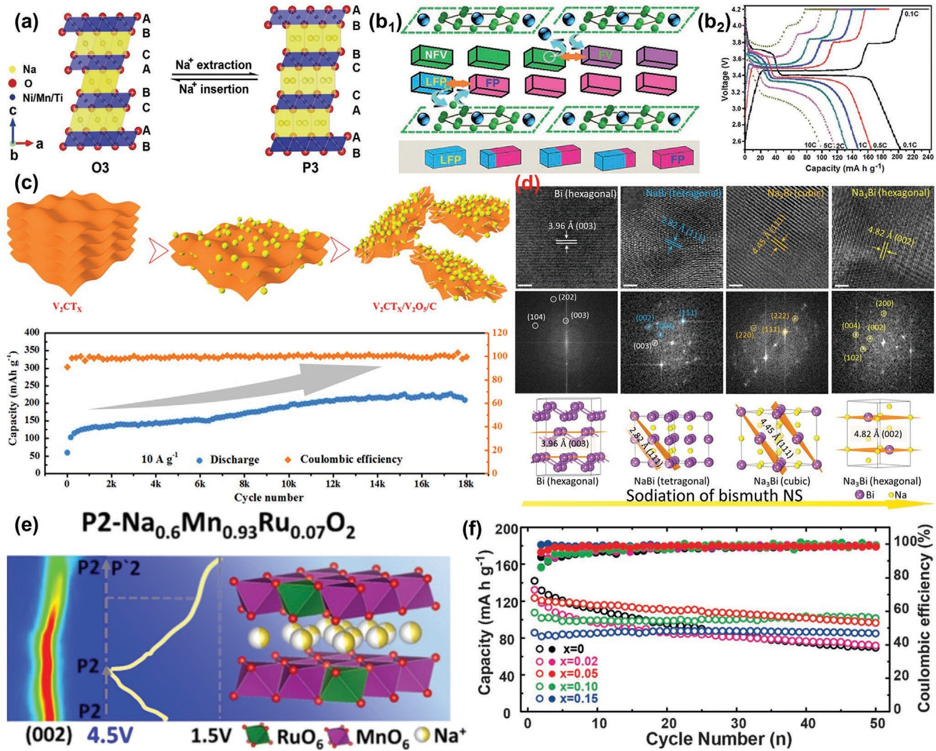
Figure 8. a) Schematic illustration of the O3–P3 phase evolutions during the Na insertion/extraction process. Reproduced with permission.[159] Copy- right 2017, Wiley. b1) Low-energy nonequilibrium paths of the phase transformation process in LFP/NFV composite nanoparticles, the classical phase transformation process in LFP. b2) First charge/discharge curves of the LFP/NFV/NFVPB-2 cathode at different rates. Reproduced with permission.[26a] Copyright 2015, Royal Society of Chemistry. c) Schematic illustration of the possible mechanism of the structural and phase transition of the V₂CT_{x} cathode. Long-term cycling performance of V₂CT_{x}-based ZHIB at 10 A g−1. Reproduced with permission.[166] Copyright 2020, American Chemical Society.
d) Structural evolution of bismuth NS at different sodiation stages. HRTEM images and the corresponding FFT patterns of bismuth NS, NaBi, cubic Na₃Bi, hexagonal Na₃Bi; scale bar: 2 nm. Atomic structure models for different stages of phase evolutions and their plane distances corresponding to HRTEM (vacuum of bismuth NS > 15 Å). Reproduced with permission.[169] Copyright 2019, American Chemical Society. e) Suppressed high-voltage phase transition of P2-type oxide cathode for high-performance sodium-ion batteries. Reproduced with permission.[170] Copyright 2019, American Chemical Society. f) Cycling performance of various P2-type Na_{0.67}Mn_{0.67}Ni_{0.33−x}Mg_{x}O₂ electrodes (x = 0, 0.02, 0.05, 0.10, and 0.15) during 50 cycles. Reproduced with permission.[171] Copyright 2016, Wiley.

change in the composition of the metal electrode can easily cause the orientation growth of metal crystals because of the nonuniform charge distribution and larger state of charge.[173] The oriented growths of electrode active materials may accel- erate the disappearance of active sites in the electrode then reduce the electronic and/or ionic conductivities of the elec- trode, thereby causing the electrode to fail.[174] Typically, lithium anode suffers from battery degradation caused by metal lithium electrode orientation during the charge/discharge process through dissolution and deposition.[175] In general, the crystal growth includes two processes of nucleation and growth, which are the key processes to control the crystal orientation.[176] We
proved that the metal lithium growth in lithium-ion batteries was controlled obviously because graphitized mesoporous carbons (GMCs) regulate the lithium growth along the mesoporous structure and the particle voids, resulting in the significant extension of the operation time of the lithium-ion battery without dendrite formation.[21]
Various studies indicate that the 3D porous frameworks are effective designs for the control of metal crystal growth.[177] Liu et al.[178] synthesized a freestanding and highly flexible 3D cur- rent collector made of carbon nanofibers (CNFs) conformally coated by continuous Sn layer by electrospinning method. The Sn layer enables a lithiophilic and alloyable carbon skeleton

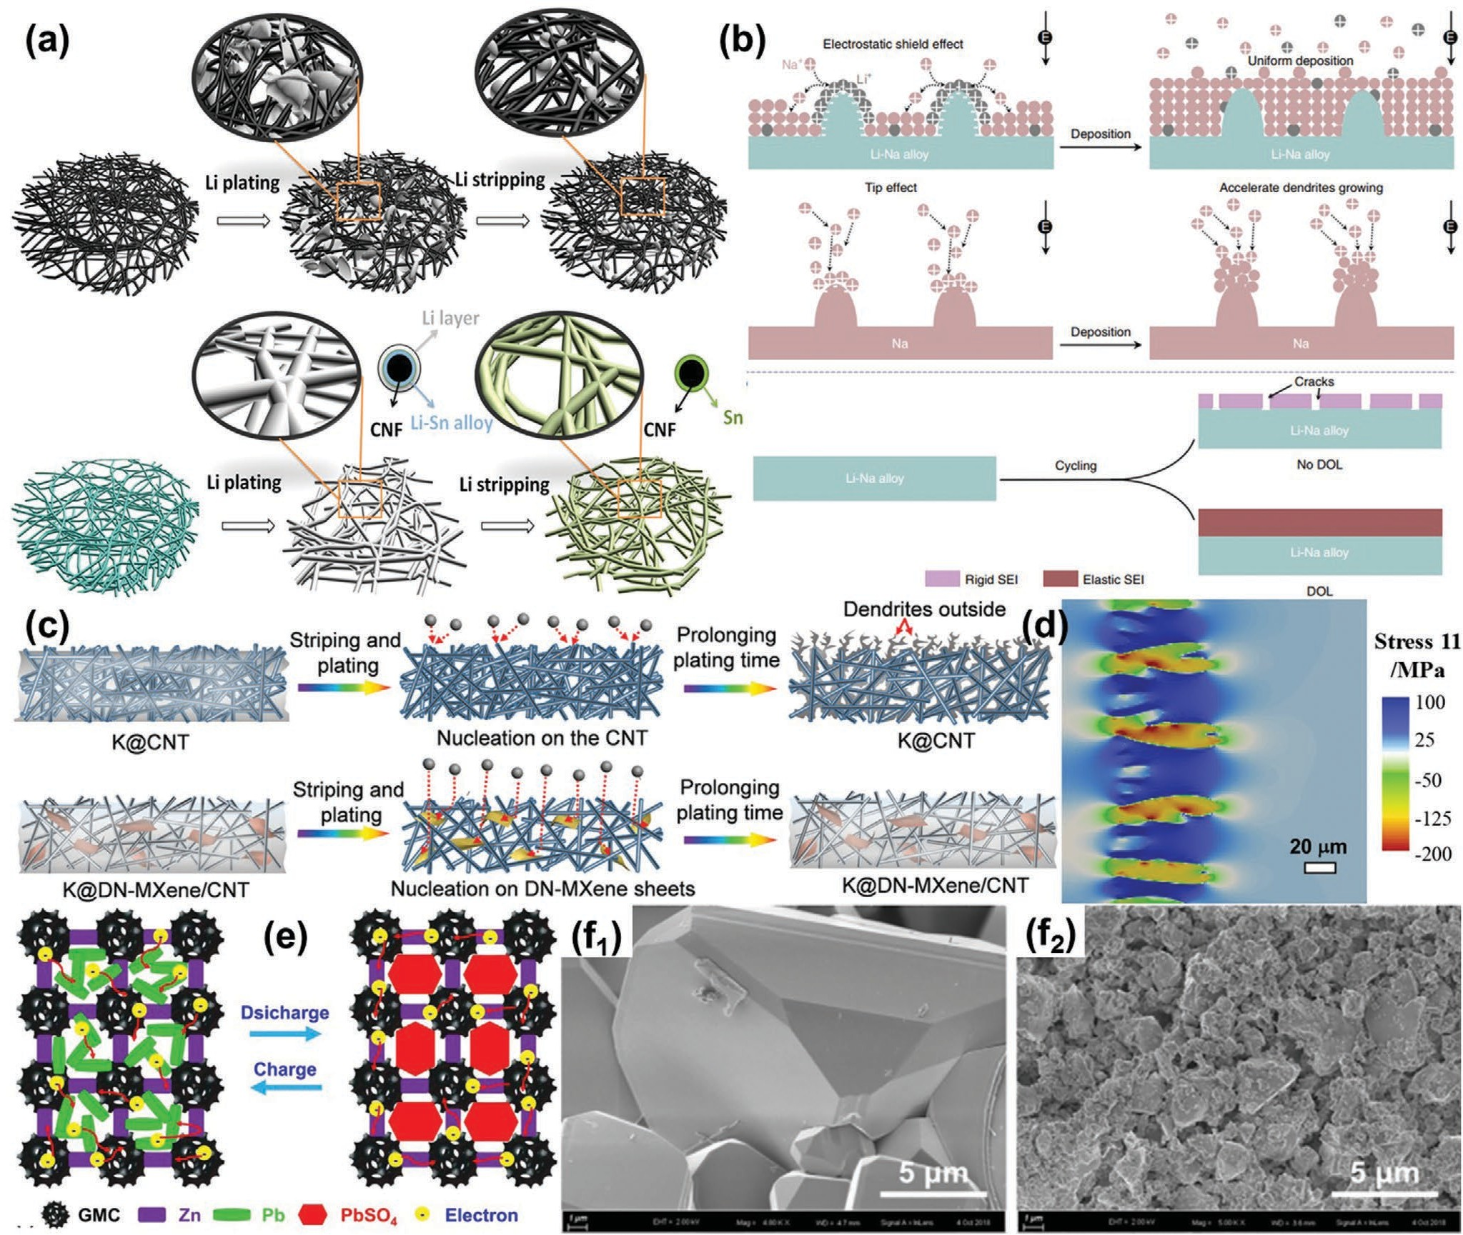
Figure 9. a) Scheme of Li-plating and -stripping behavior for CNF and CNF-Sn-5% composite electrode. The CNF-Sn-5% electrode enables a smooth and conformal coating of Li during plating because of the lithiophilicity and alloyability of the nanofiber surface and complete Li removal during strip- ping because of reinforced electric contact. The CNF electrode enables loose Li injection in the voids of CNF network during plating. Substantial residual Li grains remained after stripping. Reproduced with permission.[178] Copyright 2019, American Chemical Society. b) Illustration of dendrite and crack suppression. In a Li–Na alloy electrode, Li+ adsorbs on the tips to repel incoming Na+ and forces Na+ deposition on adjacent regions away from the tips. At the Na electrode, no Li+ is adsorbed on the tips to repel incoming Na+; thus, Na+ is deposited on the tips. Without DOL, the electrolyte reacts with the alloy to form a rigid SEI that will crack during cycling. After DOL is added, it reacts with the alloy to form an elastic SEI, thus preventing SEI cracking. Reproduced with permission.[181] Copyright 2019, Springer Nature. c) Schematic illustration of plating/stripping of K metal on CNT scaffold (upper panels) and DN-MXene/CNT scaffold (lower panels). Reproduced with permission.[182] Copyright 2020, Wiley. d) Design principles for den- drite suppression with porous polymer/aqueous solution hybrid electrolyte for Zn–metal anodes. Reproduced with permission.[183] Copyright 2020, American Chemical Society. e) Schematic for GMC additive controlling the electrode structure in LABs during charge/discharge process. Reproduced with permission.[3a] Copyright 2018, The Electrochemical Society. SEM images of f1) Pb and f2) Pb/NC-800 samples after cycle tests. Reproduced with permission.[40a] Copyright 2019, Elsevier.

surface and provides uniform and continuous Li nuclea- tion sites (Figure 9a), leading to unusual conformal Li plating behavior and effective inhibition of Li dendrites. Surface treat- ment of electrode can also be used to suppress the oriented growth of metal electrodes,[21] You et al.[179] employed the tam- arind seed polysaccharide (TSP) with an ultrahigh degree of backbone substitution, high viscosity and hardness, excellent elasticity, and remarkable stability in organic electrolytes for
Li metal anode protection. A TSP protective film with optimal thickness was easily coated on the Cu foil (TSP-Cu), which favors the homogeneous electrodeposition of Li metal on the Cu foil and successfully inhibits the formation of dendrite during prolonged cycles. Adding an additive in electrolyte is an effec- tive in situ surface treatment. For example, Wang et al.[180] pro- posed the use of an optimal amount of lithium iodide (LiI) as a functional additive in ether-based electrolyte for dendrite-free

Li deposition. The additive could induce electrolyte polymeriza- tion to in situ form a robust SEI layer enriched with elastic oli- gomer on the Li surface. Furthermore, the LiI in the electrolyte heightens the ionic conductivity of the formed SEI and facili- tates the migration of Li ion, remarkably promoting the uniform deposition of Li at the Li/electrolyte interface and suppressing the growth of Li dendrite. For another case, Ma et al.[181] reported how the use of a Li–Na alloy anode and an electrolyte additive realizes an aprotic bimetal Li–Na alloy–O₂ battery with improved cycling stability (Figure 9b). Electrochemical investigations show that the stripping and plating of Li and Na and the robust and flexible passivation film formed in situ (by 1,3-dioxolane additive reacting with the Li–Na alloy) suppress dendrite and buffer alloy anode volume expansion and thus prevent cracking, avoiding electrolyte consumption and ensuring high electron transport efficiency and continued electrochemical reactions.
In addition to metallic lithium, the oriented growth of other metals also needs to be suppressed during electrochemical pro- cesses. Tang et al.[182] reported a potassium anode prepared by confining potassium metal into a titanium-deficient nitrogen- containing MXene/carbon nanotube freestanding scaffold. The high electronic transport and fast potassium diffusion in this scaffold enable reduced local current density and homogeneous ionic flux during the plating/stripping processes. Such “potas- sium-philic” MXene sheets can induce the nucleation of potas- sium and guide potassium to uniformly distribute in the scaf- fold upon cycling (Figure 9c). Consequently, the potassium metal anodes exhibit a dendrite-free morphology with high Coulombic efficiency and long cycle life during the plating/stripping pro- cesses. Hong et al.[183] used phase-field simulations to analyze the design space for a porous polymer/aqueous ZnSO₄ hybrid elec- trolyte. The dendritic growth could be suppressed, utilizing both the mechanical suppression effect from the polymer framework and the high diffusivity from the aqueous electrolyte (Figure 9d). Similarly, the lead anode suffers from issues caused by anode-oriented growth during charge/discharge processes on the basis of crystal phase transition,[3b,173b] as discussed in Section 2.1. For this case, designing and constructing a con- ductive network are an effective method to suppress this ori- entation. Our group[3a] reported GMCs derived from zeolitic imidazolate frameworks-8 (ZIF-8) by controlling the annealing parameters as porous media in the Pb anode for suppressing the sulfation orientation. The cycle performance of lead–acid batteries with GMC additive (38013 cycle numbers) is about
8.5 times that without additive (4408 cycle numbers) because of the GMCs good physical and chemical properties in forming the conductive network (Figure 9e). In the search for a cheap and effective carbon material, N-doped carbon (NC) derived from chitosan was synthesized to suppress the oriented growths of PbSO₄ crystals.[40a] We found that the size of anode discharge products was reduced from 18 μm (Figure 9f₁) to 3 μm (Figure 9f₂) after the conductive network was utilized, and its cycle life increased to 3.6 times in large-scale batteries.

Introducing the Electrocatalytic Phase

In rechargeable batteries, the electrocatalytic phase exists in the metal–air battery, as discussed in Section 2.4 for the ORR
and OER reactions. With the great kinetic challenges of insu- lating end-redox products (S/Li₂S) and massive lithium poly- sulfide migration in lithium–sulfur batteries, the introduction of the electrocatalytic phase in sulfur cathode to regulate ionic transport has become a new hot spot in the electrocatalytic field.[184,185] Complex S/Li₂S deposition and accumulation on conductive scaffolds pose a high barrier for both charge and mass transport, especially under high sulfur loading and low electrolyte/sulfur ratio conditions.[186] Various catalysts with high activity for stabilizing the lithium–polysulfide shuttle process were reported recently, thus improving the electro- chemical performance of lithium–sulfur batteries.[187]
Recently, catalysts for lithium–sulfur batteries mainly include three categories: 1) heteroatom-doped metal-free cata- lysts (strong chemical affinity toward LiPSs and high catalytic activity for LiPS redox);[188] 2) metal-based catalysts (intriguing structural and electronic properties);[189] and 3) heterostruc- tural catalysts (high chemical interaction with LiPSs and good interfacial LiPS redox kinetics).[190] The heterostructural cata- lysts are the most popular of the three categories because of the synergistic effect of metal-free materials and metal/metal compounds.[140b] Ma et al.[191] designed a host that consists of a crisscrossed network of CNT-reinforced CoS nanostraws (CoS-NSs; Figure 10a). Its capillarity effect and chemisorp- tion of CNTs/CoS-NSs efficiently suppressed the shuttle effect and promoted the redox kinetics of polysulfides. The sulfur- encapsulated CNTs/CoS-NSs exhibited a rate capability of 1045 mAh g−1 at 0.5 C and 573 mAh g−1 at 5.0 C because the electrocatalytic effect of CoS facilitates the redox conversion of sulfur species. Similar to metal–air batteries, SACs are also a breakthrough point in the electrocatalysis community due to their outstanding advantage of maximum atom utilization effi- ciency in lithium–sulfur batteries.[140a] Du et al.[192] reported that monodisperse cobalt atoms embedded in nitrogen-doped gra- phene (Co–N/G, Figure 10b₁) can trigger the surface-mediated reaction of Li polysulfides. The Co–N–C coordination center serves as a bifunctional electrocatalyst to facilitate both the for- mation and the decomposition of Li₂S in discharge and charge processes, respectively, because of the reduction of the energy barrier (Figure 10b₂). The S@Co–N/G composite, with a high S mass ratio of 90 wt%, can deliver a gravimetric capacity of 1210 mAh g−1, and it exhibits an areal capacity of 5.1 mAh cm−2 with a capacity fading rate of 0.029% per cycle over 100 cycles at 0.2 C at 6.0 mg cm−2 S loading on the electrode disk. Zhang et al.[193] prepared single nickel (Ni) atoms on nitrogen-doped graphene (Ni@NG) with Ni–N₄ structure and introduced Ni@ NG to modify the separators of lithium–sulfur batteries. The oxidized Ni sites of the Ni–N₄ structure act as polysulfide traps, efficiently accommodating polysulfide ion electrons by forming strong S_{2x−}⋅Ni–N bonding. In addition, charge transfer between the LiPS and oxidized Ni sites endows the LiPS on Ni@NG with low free energy and decomposition energy barrier in an electrochemical process, accelerating the kinetic conversion of LiPS during the charge/discharge process. The large binding energy of LiPS on Ni@NG also shows its ability to immobilize the LiPS and further suppress the undesirable shuttle effect.
Li et al.[186] expanded atomic electrocatalysts to lithium–
sulfur chemistry, thus deepening the kinetic understanding of sulfur species evolution. The as-designed atomic electrocatalyst

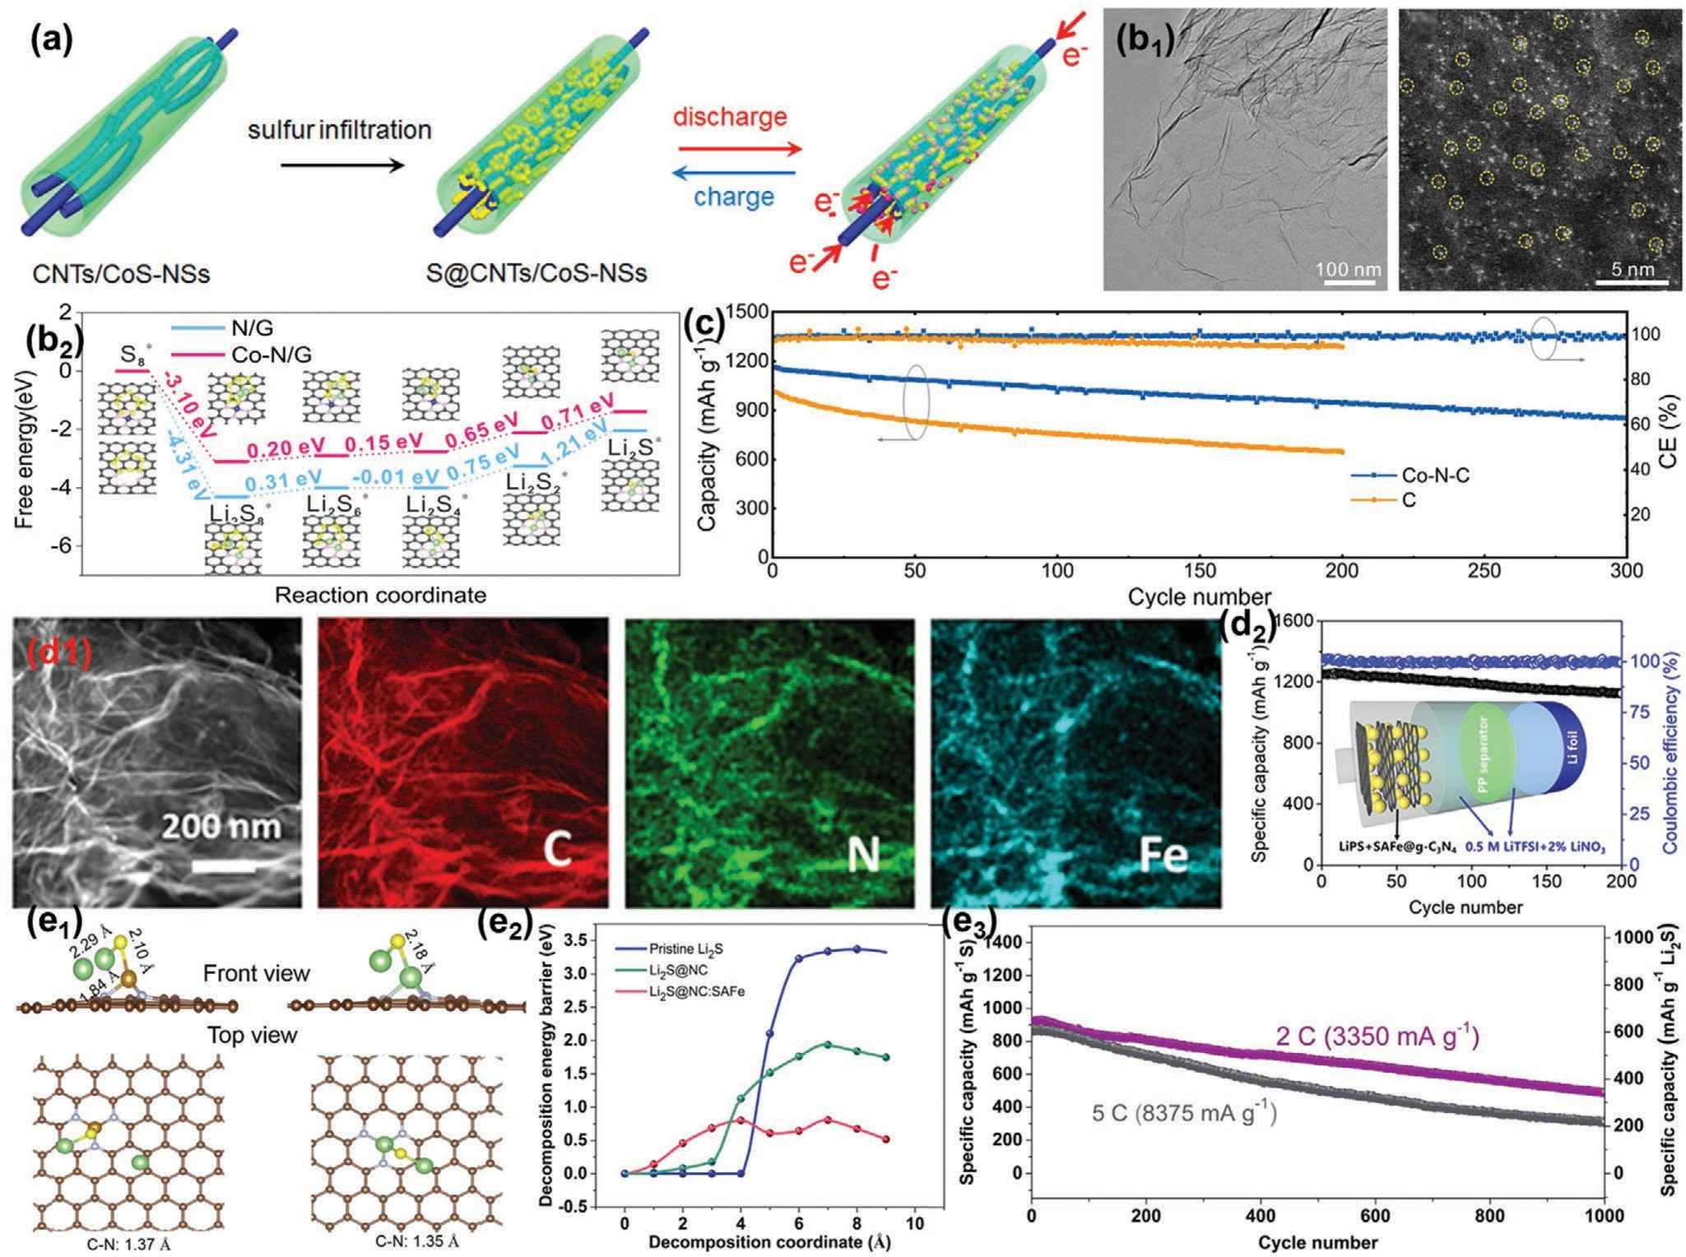
Figure 10. a) Formation and reversible discharge/charge mechanisms of S@CNTs/CoS-NSs. Reproduced with permission.[191] Copyright 2018, American Chemical Society. b₁) TEM and HAADF-STEM images showing the structure of Co–N/G. b₂) Energy profiles for the reduction of LiPSs on N/G and Co–N/G substrates. (Insets) The optimized adsorption conformations of intermediate species on N/G and Co–N/G substrate. Reproduced with permission.[192] Copyright 2019, American Chemical Society. c) Stable operation of Li–S cells, cycling stability. Reproduced with permission.[186] Copyright 2019, Wiley. d₁) EDX mappings of carbon, nitrogen, and iron in SAFe@g-C₃N₄ material, respectively. d₂) Schematic of the structure of battery cell and cycling performance of the SAFe@gC₃N₄-based device at the rate of 0.2 C for 200 cycles. Reproduced with permission.[194] Copyright 2020, American Chemical Society. e₁) The calculated delithiation models of Li₂S with and without SAFe catalyst on the NC surface. e₂) Comparison of delithi- ation energy barriers of pristine Li₂S and Li₂S@NC with/without the SAFe catalyst. e₃) The long cycle performance of the Li₂S@NC:SAFe cathode at 2 C and 5 C. Reproduced with permission.[156] Copyright 2019, Elsevier.

endowed the lithium–sulfur battery with a cyclic decay rate of 0.10% in 300 cycles (Figure 10c), a capability of 1035 mAh g−1 at 2 C, and an impressive areal capacity of 10.9 mAh cm−2 at a sulfur loading of 11.3 mg cm−2 because of the atomically dis- persed lithiophilic and sulfiphilic sites on conductive substrates, thereby encouraging the application of emerging electroca- talysis in other multielectron/multiphase reaction energy sys- tems. Lu et al.[194] designed single-atom materials to accelerate polysulfide conversion for Li–S batteries (Figure 10d₁). Nitrogen sites in the structure not only anchor polysulfides to alleviate the shuttle effect but also enable the high loading of single-atom irons. Density functional theory (DFT) calculations indicate that single-atom sites reduce the energy barrier of electrochemical reactions and thus improve the rate and cycling performances of batteries. The coin battery shows impressive energy storage properties, including a high reversible capacity of 1379 mAh g−1
at 0.1 C and a high rate capacity of 704 mAh g−1 at 5 C. The ratio of electrolyte dosage/energy density is as low as 5.5 g Ah−1. It exhibits excellent cycling performance with a capacity retention of 90% even after 200 cycles at 0.2 C (Figure 10d₂).
The SAC not only helps the initial cycle by lowering the activa- tion energy barrier but also boosts the lithium–sulfur battery rate performance over an ultralong cycle life. Wang et al.[156] proved that atomically dispersed single iron atoms promote the delithia- tion of a relatively inert Li₂S cathode and accelerate reversible elec- trochemical conversion reactions during its long-term cycling. The delithiation energy barriers of pristine Li₂S, Li₂S on NC, and Li₂S on NC with SAC are compared by DFT calculation. The main Li evolution process consists of Li–S bond breaking in Li₂S and the exit of lithium ion, both of which require high energy (Figure 10e₁). The energy barrier of pristine Li₂S is as high as 3.4 eV per chem- ical formula, while the energy barrier of Li₂S@NC:SAFe is merely

0.81 eV (Figure 10e₂). This finding indicates that the highly active SAC could dramatically decrease the energy barriers for delithia- tion of Li₂S and facilitate the transport of Li ion in the electrode. Figure 10e₃ shows the ultralong cycling performance of Li₂S@ NC:SAFe-based cells at higher rates. After 1000 cycles at 2 and 5 C, the cells can still maintain high capacities of 490 and 315 mAh g−1 (based on S), corresponding to extremely low average capacity decay rates of 0.04% and 0.06% per cycle, respectively.

Modifying Surface and Interface

The modification of the surface and interface in recharge- able batteries is a complex and practical process that involves electrode material coating, separator treatment, and electro- lyte optimization.[8,195] Generally, the surface modification of electrode active materials is an efficient route to improve the structural stability and electrolyte wettability, thereby enhancing the high-C rate performance and cycle stability of rechargeable batteries. For example, we[64] provided a 10 nm coating layer, with metal zinc, graphite-like carbon, and uniform and simple connecting mesopores on the surface of commercial LiFePO₄ cathode particles (LFP/C_{ZIF-8}, Figure 11a₁). The improved struc- tural stability and electrolyte wettability after coating resulted in a discharge specific capacity of 159.3 mAh g−1 at 0.1 C and a discharge specific energy of 141.7 mWh g−1 after 200 cycles at 5.0 C (the retention rate is ≈99%, Figure 11a₂). The surface treatment of electrode materials by using special technology is more controllable and efficient. Deng et al.[196] modified the surface of LiNi_{0.5}Mn_{1.5}O₄ cathode materials by applying atomic layer deposition (ALD) technology. Deng et al.[197] designed a dual-functional Li₃PO₄ (LPO) modification by using ALD tech- nology for Ni-rich layered oxide cathodes to achieve high per- formance (Figure 11b₁). The modified cathode demonstrates a significantly improved initial capacity of 170.6 mAh g−1 at 0.1 C, better rate capability, and reduced polarization compared with the bare cathode. More importantly, stable long-term cycling is achieved with a low capacity degradation rate of 0.22 mAh g−1 per cycle for 300 cycles at 0.2 C (Figure 11b₂).
A separator is used to prevent electronic transports between the anode and the cathode in a rechargeable battery and to ensure reasonable ionic transports between the anode and the cathode at the same time.[198] Therefore, the separator is usu- ally an insulator with a large number of suitable pore struc- tures. The effect of separator treatment for regulating electrons and ions mainly focuses on the transports of ions and selec- tion of ions between the anode and cathode in the battery.[199] Wu et al.[200] constructed a temperature-gated 2D cationic nano- channels, stemming from the stacking of functionalized mont- morillonite (MMT) lamellae, for controllable osmotic energy harvesting (Figure 11c). Excellent cation selectivity was obtained after electronegative modification, with an output power of
≈150 mW m−2 as a separator for osmotic power harvesting. To
suppress the shuttle effect and slow conversion rate of soluble polysulfide compromise, Hu et al.[201] reported a separator con- figuration (CoS₂/HPGC/interlayer) as an efficient polysulfide trapping barrier for lithium–sulfur batteries (Figure 11d). As a functional interlayer, this configuration enhanced conductivity, promoted polysulfide trapping capability, and accelerated sulfur
electrochemistry. It delivered a capacity of 846 mAh g−1 after 250 cycles, corresponding to a high capacity retention of 80.2% at
0.2 C and 519 mAh g−1 after 500 cycles at 1 C. Moreover, with the CoS₂/HPGC/interlayer, the lithium–sulfur battery enabled a low self-discharge rate with a very high capacity retention of 97.1%.
Electrolyte is as important to batteries as blood is to humans and is the key channel for ionic transports between the anode and the cathode in nonsolid rechargeable batteries, including nonaqueous electrolyte and aqueous electrolyte.[202] Generally, various rechargeable batteries correspond to suitable metal salts, such as LiPF₆ to lithium battery,[203] NaPF₆/NaClO₄ to sodium battery,[204] and AlCl₃ to aluminum battery.[205] Therefore, electro- lyte modification focuses on the electrolyte solvent. The transport speed of metal salt ions in aqueous electrolytes is much higher than that in nonaqueous electrolytes, which is why this section discusses only electrolyte modification in nonaqueous systems. For nonaqueous electrolyte modification, the selection of organic solvents and the utilization of additives are two effective routes to regulate ionic transport.[8,206] Li et al.[207] reported hybrid N-propyl-N-methylpyrrolidinium bis(trifluoromethanesulfonyl) amide (Py13TFSI) and ether electrolyte for regulating lithium ionic transport. The reversibility of Li plating/stripping can be remarkably increased by the synergy between Py13TFSI ionic liquid and Li salt concentration. The hybrid electrolyte can enhance the stability of SEI layer by the in situ passivation pro- cess. Xie et al.[208] reported two imidazolium redox ionic liquids (RILs), each with one ion modified with ferrocene (Figure 11e). The redox ionic liquid 1-(methylferrocenyl)-3-ethylimidazolium bis(trifluoromethanesulfonyl)imide, [FcEIm][NTf₂] presented a ferrocene on the cation, which forms a dication upon oxidation and remains in the liquid phase. The second RIL was obtained by modifying ferrocene with an anionic function, the structure of which is inspired by the NTf₂ anion. In 1-ethyl-3-methylim- idazolium ferrocenylsulfonyl-(trifluoromethylsulfonyl)-imide, [EMIm][FcNTf ], the anion is the electroactive species and has been shown to deposit on electrodes when oxidized to the zwit- terion [Fc+NTf−]0. When the ionic liquid’s anion is modified with ferrocene, self-discharge is fully suppressed due to the deposition of a film on the electrode. Stokes et al.[209] reported the positive effects of the addition of SEI forming additives (EC and VC) on the performance of Si NWs anodes in a 0.1LiTFSI– 0.6PYR₁₃FSI–0.3PYR₁₃TFSI IL electrolyte (Figure 11f1). The base IL electrolyte used combines FSI− and TFSI− ions to access a combination of properties such as wide electrochemical window, good chemical and thermal stability, flame retardancy, and negli- gible vapor pressures. The incorporation of electrolyte additives leads to not only significant morphological changes in the Si NW arrays during cycling (formation of a connected active mate- rial network vs textured NW formation) but also to crucial SEI composition differences (specifically a suppression of parasitic Li silicate formation). After 250 cycles (Figure 11f2), the anodes retained capacities of 1148 mAh g−1 (no additive), 1443 mAh g−1 (+EC), and 1605 mAh g−1 (+VC).

Advanced Energy Storage Materials
The technological challenges were clarified in the development of various rechargeable batteries, and approaches for regulating

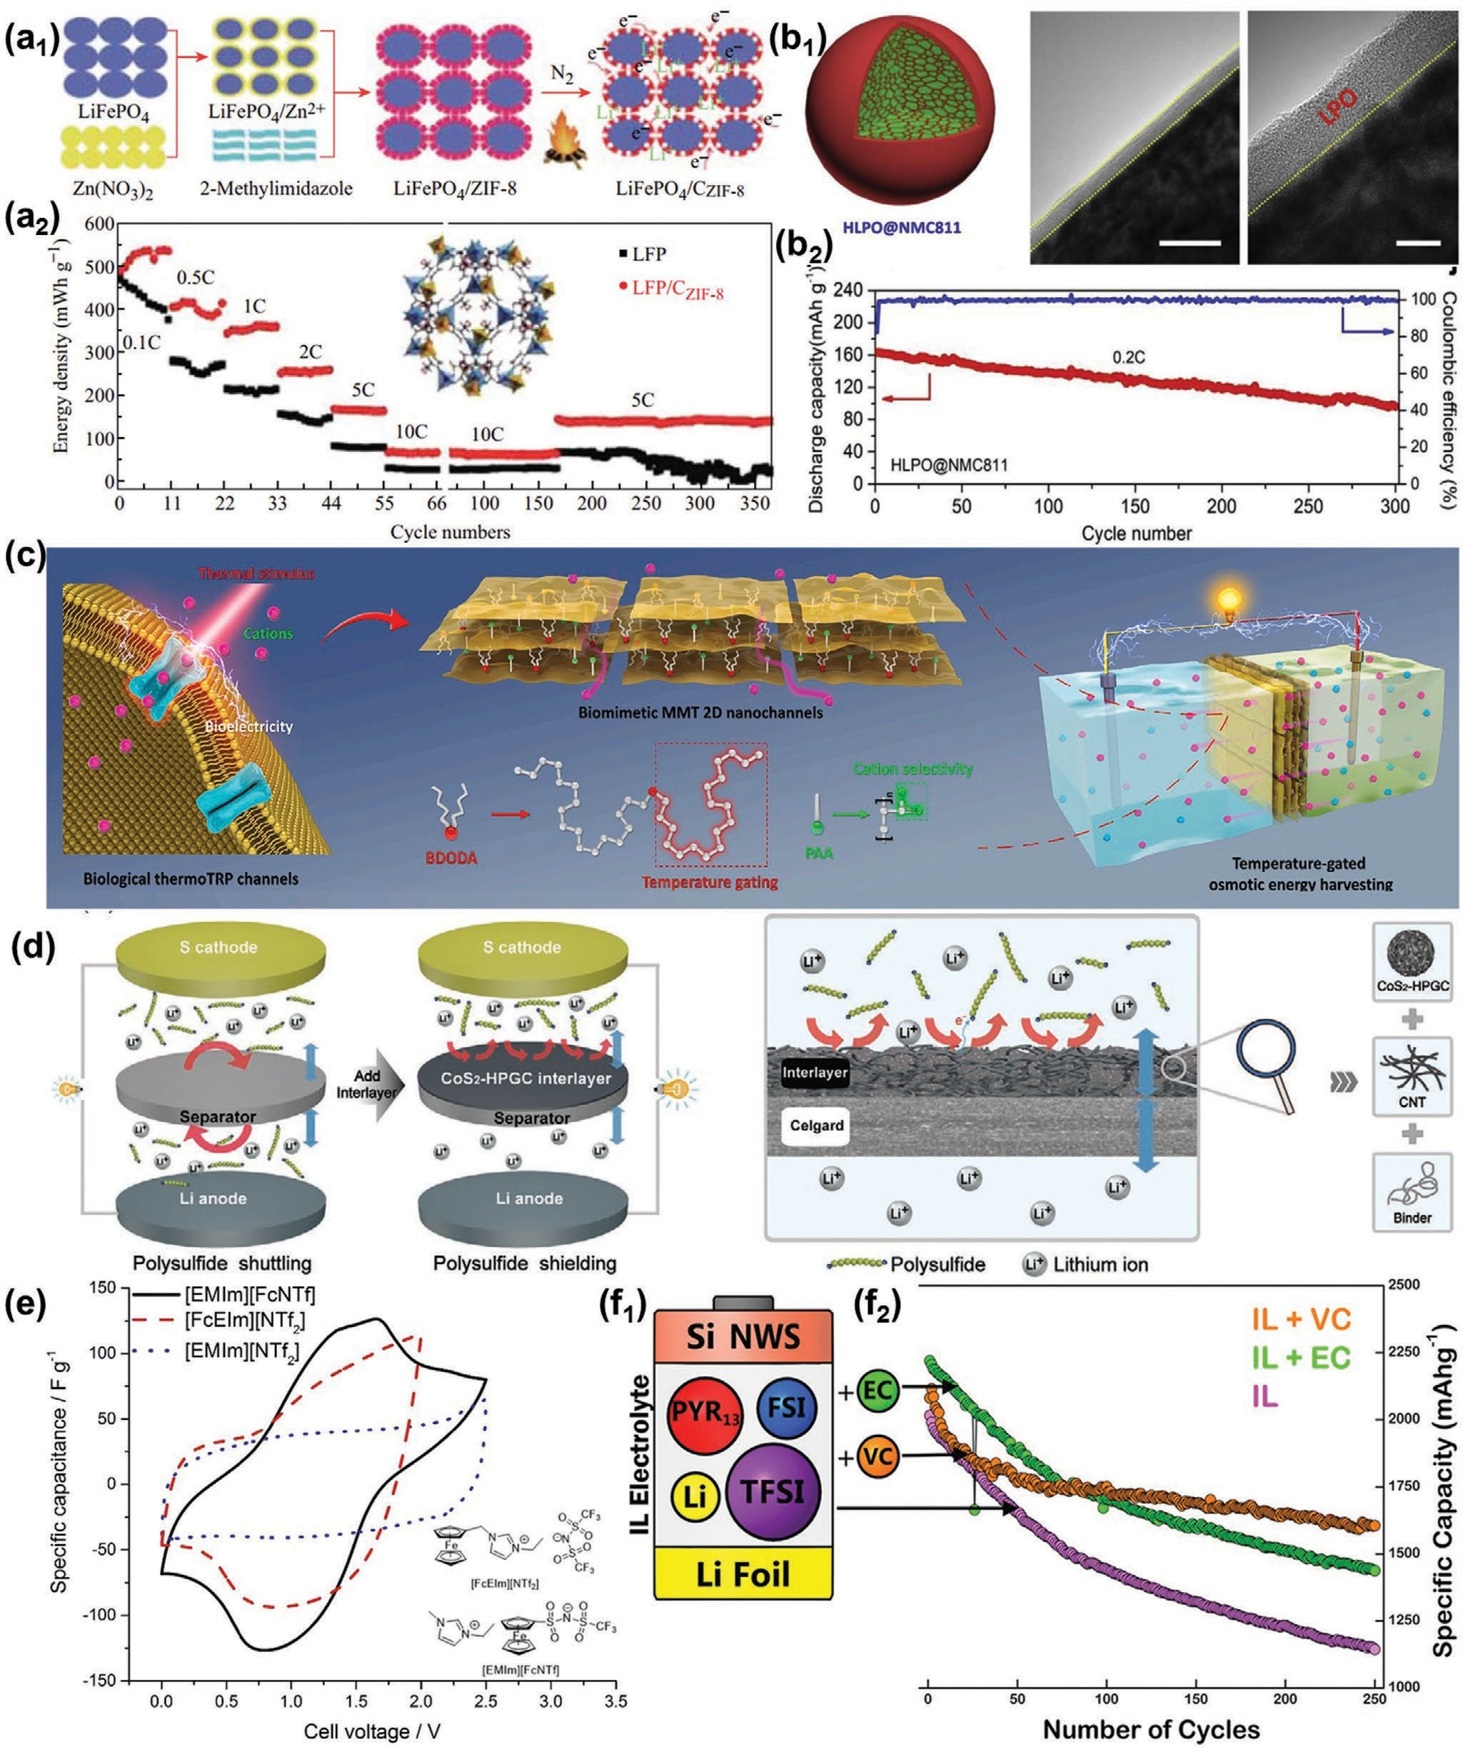
Figure 11. a₁) Schematic illustration of the synthesis process. a₂) The discharge specific energy of different cathode samples for 10 cycles at 0.1–10.0 C rates, respectively, then for 100 and 200 cycles at 10.0 and 5.0 C rates, respectively. Reproduced with permission.[64] Copyright 2018, Springer Nature. b₁) Schematic illustration of the detailed structure of HLPO@NMC811. b,c) HR-TEM images of the secondary LPO coating layer on the HLPO@ NMC811 surface at different magnifications. (b₂) Long-term cycling stability of the HLPO@NMC811 cathode at 0.2 C. Reproduced with permission.[197] Copyright 2020, Elsevier. (c) Schematic illustration of biological temperature-sensitive transient receptor potential channels producing a bioelectrical signal in response to the thermal stimulus and biomimetic temperature-gated 2D cationic nanochannels based on MMT for constructing an osmotic

electronic and ionic transports were discussed. It provides key technical guidance for the manufacture and assembly of high- performance rechargeable batteries. Moreover, some advanced energy storage materials with good electronic and ionic con- ductivities maybe further promoted the advancement of high- performance rechargeable batteries. Here we give a discussion, including low-dimensional materials, porous materials, hybrid materials, and biomass materials.

Low-Dimensional Materials

Materials with a dimensionality smaller than three are called low-dimensional (LD) materials, including 2D, 1D, and 0D materials.[210] 1) 0D materials do not have one dimension out- side of the nanometric size range, are made up of a small number of atoms or molecules, and the size of the particles is in the order of nanometers.[211] 2) 1D materials, such as carbon nanotube,[212] have only one dimension outside of the nano- metric size range. 3) 2D materials have two dimensions out- side of the nanometric size range, with the typical examples being graphene[213] and nanosheets.[214] Many LD materials exhibit very peculiar physical phenomena due to the specificity of the crystal structure.[213] For example, the electrons in these materials are confined to a 1D linear chain or a 2D plane for transports, so their conductivity will be particularly good in one (or two) lattice direction.[210]
LD materials are of particular interest due to their aniso- tropic-tunable properties, which greatly influence their perfor- mances.[215] As a typical kind of 0D nanodomain, quantum dots (QDs) contain only a small number of atoms. Much more atoms are situated on the surface compared with bulk materials owing to the extremely high surface-to-mass ratio of QDs.[216] The sur- face atoms possess a higher energy of delocalized electrons and hence are kinetically more active than the interior atoms.[217] Our group[218] synthesized mesoporous carbon that contained graphite–zinc QDs (MC-GZQDs) via the carbonization of ZIF-8. The QDs with a heterogeneous core (metal Zn)–shell (graphite) structure improved both the electronic conductivity and ion dif- fusion coefficient of LiFePO₄ due to its high conductivity and porous structure. LiFePO₄ mixed with MC-GZQDs delivered a capacity of 154.6 mAh g−1 at 0.5 C and a capacity retention ratio of ≈99.9% after 60 cycles at 10.0 C. Zhang et al.[219] reported high-energy quantum dots (HEQDs) with a feature size of less than 10 nm in ultrathin LiFePO₄ nanosheets. The quantum tunneling of HEQDs in LiFePO₄ nanoparticles (Figure 12a1) and better percolation of mesoporous biocarbon nanowire coating network structures result in more storage sites of Li+ ions and easier transfer kinetics of electrons and lithium ions, showing a specific discharge capacity of 197 mAh g−1 at 0.1 C (a theoretical capacity of 170 mAh g−1, Figure 12a2). Since the dis- covery of CNTs in the early 1990s,[220] 1D nanostructures, such
as nanowires,[221] nanotubes,[222] and nanorods,[223] have been extensively investigated because of their unique geometrical and electronic characteristics. Cao et al.[224] prepared hollow carbon nanowires (HCNWs) as anode material for Na-ion bat- teries, delivering a capacity of 251 mAh g−1 and 82.2% capacity retention over 400 charge/discharge cycles at 50 mA g−1 (0.2 C). A capacity of 149 mAh g−1 was obtained at 500 mA g−1 (2 C, Figure 12b). The good Na-ion insertion property is attributed to the short diffusion distance in the HCNWs and the large interlayer distance (0.37 nm) between the graphitic sheets. Wang et al.[225] reported a multiwalled hierarchical carbon nanotube (HCNT) that consists of an inner CNT with densely stacked graphitic walls and a loosely stacked outer CNT with more disordered walls. Individual HCNTs are further intercon- nected into a hyperporous bulk sponge with a large macropore volume, high conductivity, and tunable modulus (Figure 12c). The inner dense-CNT serves as a robust skeleton, and collec- tively, the outer loose-CNT is beneficial for K-ion accommo- dation. The hyperporous sponge facilitates reaction kinetics, delivering a specific capacity of 232 mAh g−1 and cycling sta- bility for 500 cycles. Cao et al.[226] fabricated a hierarchical het- erogeneous structure of bimetal sulfide Sb₂S₃@FeS₂ hollow nanorods embedded into a nitrogen-doped carbon matrix. The synergistic coupling interaction among the interior Sb₂S₃, inter- layer FeS₂, and external nitrogen-doped carbon matrix acceler- ates the electronic/ion transport and effectively alleviates the volume expansion over a long cyclic performance (Figure 12d1). As an anode material for sodium-ion batteries, such LD material exhibited a capability of 537.9 mAh g−1 at 10 A g−1 and a cyclic stability with 85.7% capacity retention after 1000 cycles at 5 A g−1 (Figure 12d₂).
As another typical LD material, 2D nanomaterials, such as 2D nanosheets of layered double hydroxides (LDHs),[227] transi- tion metal dichalcogenides,[228] and hexagonal boron nitride,[229] have attracted widespread attention since the discovery of graphene.[56] Yin et al.[230] demonstrated the use of LDHs consisting of a trimetallic NiVAl hydroxide host matrix and interlayer Cl− as cathode materials for chloride-ion batteries (Figure 12e₁). The Ni₂V_{0.9}Al_{0.1}-Cl LDH (Figure 12e₂) delivered a capacity of 312.2 mAh g−1 at 200 mA g−1 and a long life over 1000 cycles (with a capacity higher than 113.8 mAh g−1) because of the synergetic contributions from Vm+ (high redox activity), Ni2+ (favorable electronic structure), and inactive Al3+ (enhances the structural stability). Mahankali et al.[231] reported the doping of the MoS₂ atomic structure with nickel (Ni@1TMoS₂) to mod- ulate its absorption capability toward all LiPS and function as an electrocatalyst for Li–S redox (Figure 12f). Both Ni and Mo sites chemically anchor all the intermediates of LiPS. The con- version of liquid LiPS to solid end products is facilitated on the Ni@1TMoS₂ electrocatalytic surface. Ni@1TMoS₂ enhances the Li+ diffusion coefficient, thus contributing to the realization of a high capacity of 1107 mAh g−1 at 0.2 C with a very limited

power harvesting system with a controllable energy output. Reproduced with permission.[200] Copyright 2020, Elsevier. d) Schematic of the cell with the CoS₂/HPGC interlayer, pristine separator. Reproduced with permission.[201] Copyright 2020, Wiley. e) Cyclic voltammograms recorded with two-electrode cells with 80 wt% of the ionic liquid in acetonitrile. Each carbon electrode weighed 3.5 mg and contained 80 wt% of activated carbon. The curves were obtained at a scan rate of 10 mV s−1 at a temperature of 25 °C. Reproduced with permission.[208] Copyright 2016, Elsevier. f₁) Schematic of Si NW half- cell testing and influence of electrolyte composition on structural evolution. f₂) Discharge capacity retention, plotted as a percentage, for each Si NW anode cycled in the IL electrolytes. Reproduced with permission.[209] Copyright 2020, American Chemical Society.

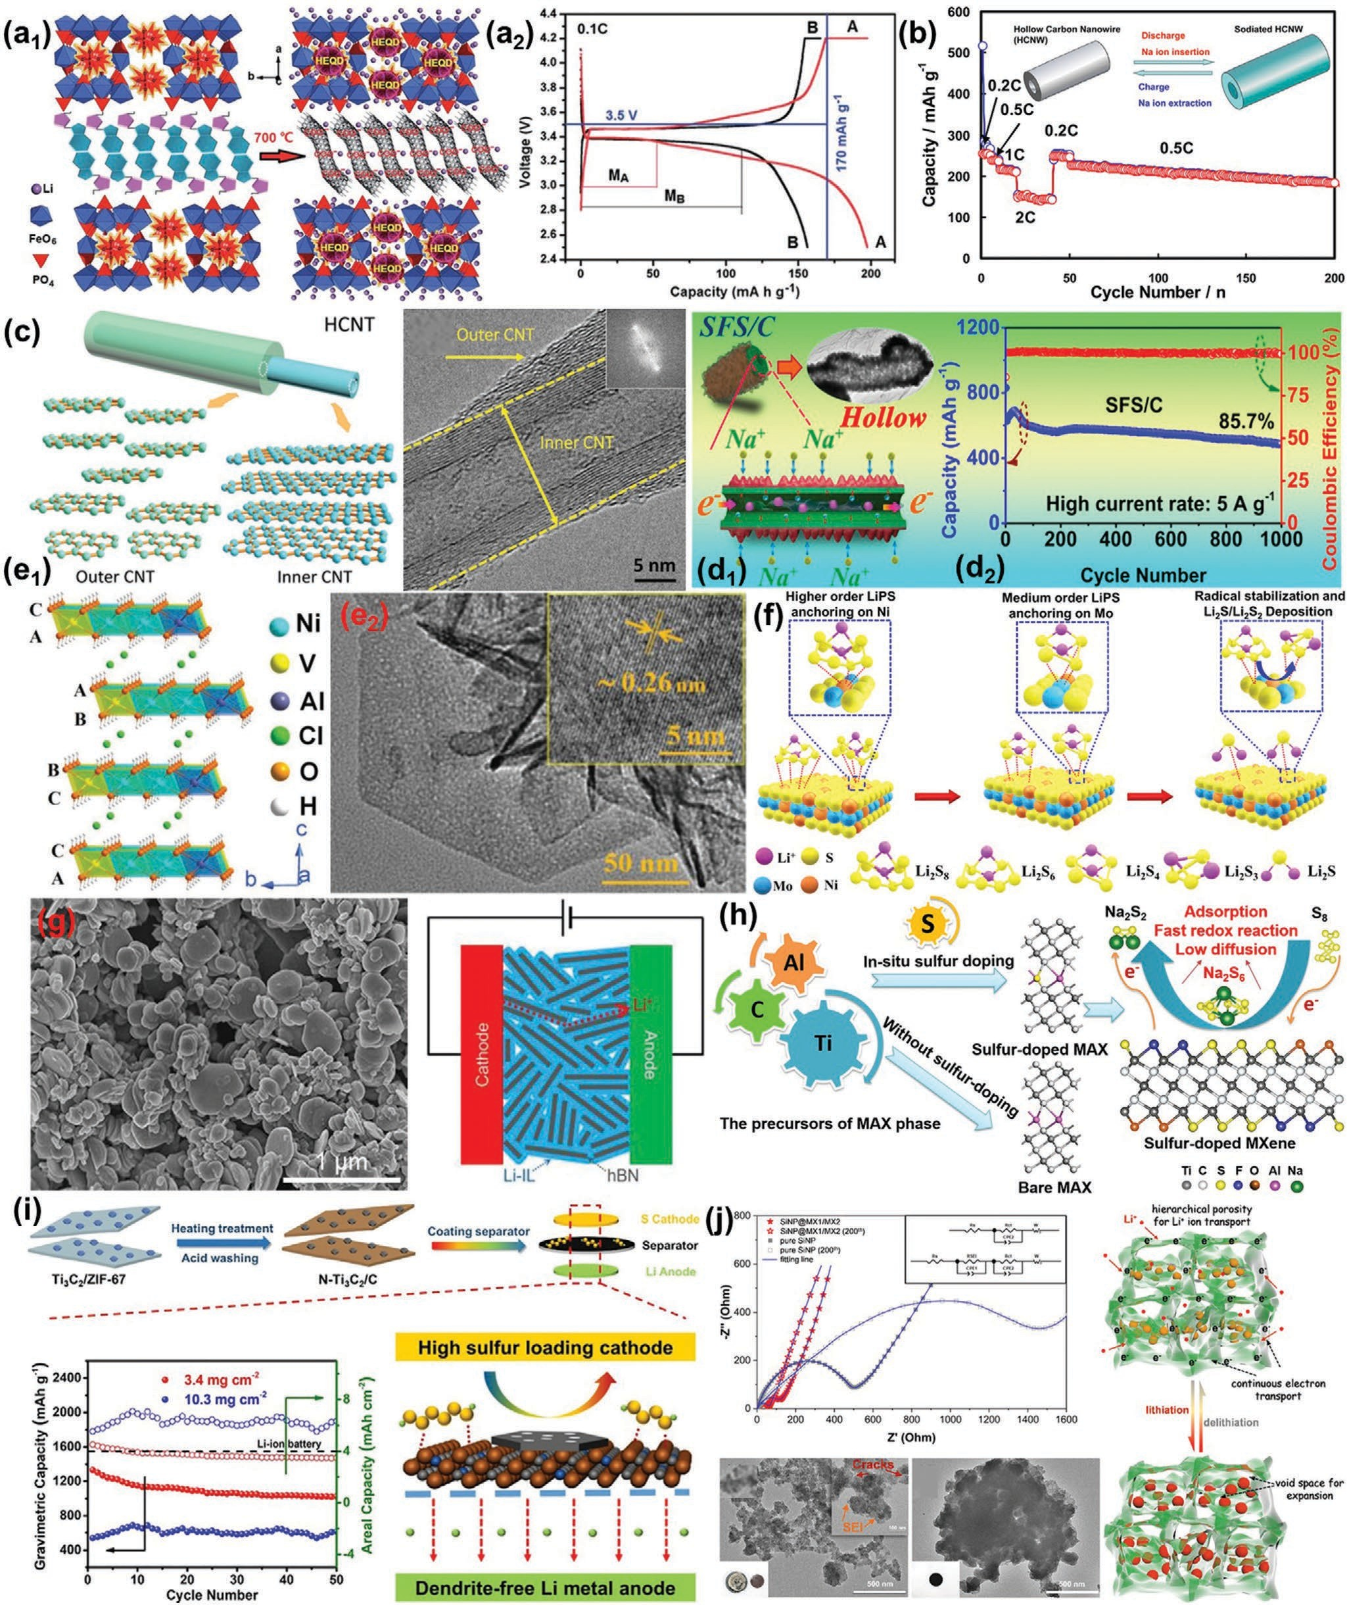
Figure 12. a₁) Schematic of the self-assembly of multifunctional ATP biomolecules with iron phosphate and structure model of MBCNW-LFP-HEQDs. a₂) The first discharge and charge profiles of the MBCNW-LFP-HEQD-2 cathode (A) and the ULFPNP cathode (B) at 0.1 C rate using CR 2032 coin cells. Reproduced with permission.[219] Copyright 2014, Royal Society of Chemistry. b) Discharge capacity of the HCNW electrode as a function of charge/discharge cycles at different charge and discharge current densities of 50 (0.2 C), 125 (0.5 C), 250 (1 C), and 500 (2 C) mAh g−1, respectively. Reproduced with permission.[224] Copyright 2012, American Chemical Society. c₁) Schematic representation of hierarchical CNT, consisting of densely packed graphitic walls in inner CNT and a loosely packed outer CNT. c₂) HRTEM and corresponding FFT (insets) images of the HCNTs. Reproduced

capacity fade of 0.19% per cycle for over 100 cycles. Hyun et al.[232] realized high-modulus, ion-conductive gel electrolytes based on imidazolium ionic liquids and exfoliated hexagonal boron nitride (hBN) nanoplatelets (Figure 12g). Compared with conventional bulk hBN microparticles, exfoliated hBN nano- platelets improve the mechanical properties of gel electrolytes by two orders of magnitude (shear storage modulus ≈5 MPa) while retaining high ionic conductivity at room temperature (>1 mS cm−1). Moreover, exfoliated hBN nanoplatelets are com- patible with high-voltage cathodes (>5 V vs Li/Li+) and impart exceptional thermal stability that allows high-rate operation of solid-state rechargeable lithium-ion batteries at temperatures up to 175 °C.
Recently, a new class of 2D materials, namely, MXenes, which include transition metal carbides and nitrides, has been identified.[233] In general, MXenes originate from their layered precursors, i.e., ternary carbides and nitrides (MAX phases), by selectively etching the A (group IIIA or IVA ele- ment) layers.[234] MXenes have been extensively explored for energy storage application due to their unique 2D planar struc- ture, good mechanical properties, high electrical conductivity, and abundant surface groups (F, OH, O, etc.).[235] Bao et al.[236] reported an in situ sulfur-doping strategy to func- tionalize MXene nanosheets by introducing heteroatomic sulfur into the MXene structure from the MAX phase pre- cursor (Figure 12h). Tailor-made wrinkled sulfur-doped MXene (S–Ti₃C₂Tx) nanosheets were applied as an electrode host material in room-temperature sodium–sulfur batteries. The S–Ti₃C₂Tx matrix showed high polarity with sodium poly- sulfides, restricting the diffusion of sodium polysulfides. The MXene/sulfur electrode can achieve high areal sulfur loading up to 4.5 mg cm−2 and good electrochemical performance (reversible capacity of 577 mAh g−1 at 2 C after 500 cycles). Sun et al.[237] used in situ grown perovskites La_{0.5}Sr_{0.5}CoO_{3−δ} (LaS- rCoO) on Ti₃C₂Tx nanosheets and achieved increased in situ high oxygen ion transport of LaSrCoO by introducing Ti₃C₂Tx in the system of LOBs. The La_{0.5}Sr_{0.5}CoO_{3−δ}/Ti₃C₂Tx improved the electrocatalytic activity and reduced the overpotential, dis- playing a high rate stability at more than 80 cycles at 500 mA g−1 with restriction of 1000 mAh g−1, (nine times that of Ti₃C₂Tx and five times that of LaSrCoO). Jiang et al.[238] fabricated an MXene/MOF derivative 2D hybrid (N-Ti₃C₂/C) by decorating nitrogen-doped MXene nanosheets with porous carbon that
resulted from in situ nucleation and conversion of ZIF-67 on exfoliated MXenes to modify the commercial separator for lithium–sulfur batteries (Figure 12i). The N-Ti₃C₂/C-coated PP separator (N-Ti₃C₂/C@PP) not only prevented the shuttling of polysulfides, but also suppressed the dendritic growth of lithium anodes. Li–S batteries with N-Ti₃C₂/C@PP separator exhibited a high specific capacity of 1332 mAh g−1 at 0.1 C and an extended cycling stability of 0.07% per cycle capacity decay for 500 cycles at 0.5 C at 3.4 mg cm−2 sulfur loading. Li et al.[239] designed and prepared nanosheets with assembled layered Ti₃C₂Tx MXene/MoS₂ composites as anodes for potassium-ion batteries. The hierarchical 2D structure of the MoS₂ nanosheets and MXene facilitated fast ion and electron transport, accom- modated the volume expansion of MoS₂ nanosheets, and pre- vented the restacking of MXene sheets. It exhibited a revers- ible capacity of 290.7 mAh g−1 at 50 mA g−1, high rate capacity, and long cycling stability. Li et al.[240] fabricated a hierarchical porous-structured Si-based anode with dual MXene protection (SiNP@MX1/MX2) for lithium-ion batteries (Figure 12j). The internal MX1 coating accommodated the volume expansion and avoided particle aggregation, and the external MX2 allowed for rapid electron transport/ion transfer while further buffering volume changes. Moreover, double MXene-wrapped protection design benefits from the formation of a stable SEI film by pre- venting Si from contacting the electrolyte. As an anode, SiNP@ MX1/MX2 delivered a high capacity of 1422 mAh g−1 at a cur- rent density of 0.5 A g−1 after 200 cycles, excellent cycle stability, and good rate performance.

Porous Materials

Porous materials are common topics in energy storage research. Pore structure greatly affects the kinetics, ther- modynamics, and stability of the electrochemical process of rechargeable batteries.[241] Common porous materials include metal porous materials and nonmetal porous materials.[242,243] Metal porous material is also called metal foam. Foams have cellular structures with many voids (connected and randomly distributed within the material) and high porosity (e.g., porosity of higher than 0.9).[244] Metal foams, such as nickel foam,[245] copper foam,[246] and aluminum foam,[247] have been used in rechargeable batteries as mass transferable current collector.

with permission.[225] Copyright 2018, Wiley. d₁) Schematic illustration of the morphology characterization of the SFS/C composite. d₂) Cycle perfor- mance for SFS/C composites at a high rate of 5 A g−1. Reproduced with permission.[226] Copyright 2020, American Chemical Society. e₁) Model of the three-layered Ni₂V_{0.9}Al_{0.1}-Cl LDH structure. e₂) TEM images (inset: SAED pattern) of the Ni₂V_{0.9}Al_{0.1}-Cl LDH. Reproduced with permission.[230] Copyright 2019, Wiley. f) Schematic representation of the effective anchoring of LiPS (Li₂S_{x}, x ≤ 8) on various active sites of the Ni@1TMoS₂ surface. Reproduced with permission.[231] Copyright 2020, American Chemical Society. g) Scanning electron microscopy (SEM) image of the exfoliated, carbon-coated hBN nanoplatelets; Schematic of a lithium-ion battery operating with an hBN gel electrolyte. The hBN gel electrolyte separates the anode and cathode elec- trodes without a separator, and lithium ions travel (indicated by the red dotted line) through Li-IL adsorbed on the surface of the hBN nanoplatelets. Reproduced with permission.[232] Copyright 2019, American Chemical Society. h) Schematic of the preparation of sulfur-doped MXene, along with the discharge process in sulfur-doped MXene/S cathode, where sodium redox reduction is accelerated and sodium polysulfide shuttling is minimized. The typical synthesis of these materials leads to O, OH, and F terminations, while in situ doping adds S terminations to the surface. Reproduced with permission.[236] Copyright 2019, American Chemical Society. i) Schematic illustration of the synthesis of N-Ti₃C₂/C nanosheets and the modified PP separator for Li–S batteries. Cycling performances of Li–S cell with N-Ti₃C₂/C@PP separator under different sulfur-loading cathodes. Reproduced with permission.[238] Copyright 2019, Elsevier. j) Electrochemical impedance spectra of SiNP and SiNP@MX1/MX2 before and after cycling. Schematic of the equivalent circuit. TEM image and a digital picture of cycled SiNP and SiNP@MX1/MX2 anodes, respectively. Schematics of reversible volume change, lithium ions, and electronic diffusion paths of the SiNP@MX1/MX2 anode during the lithiation/delithiation process. Reproduced with permission.[240] Copyright 2020, American Chemical Society

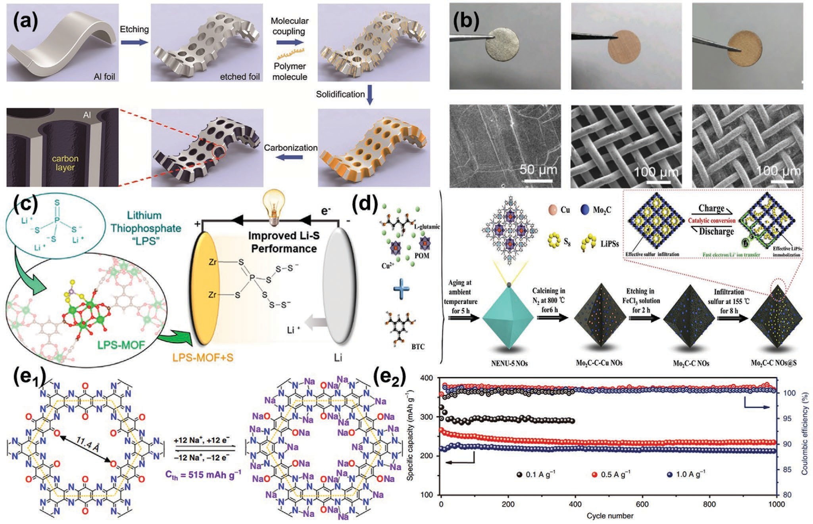
Figure 13. a) Schematic illustration of the fabrication process of the pAl/C anode materials. Reproduced with permission.[249] Copyright 2016, Wiley.
b) Surface pictures of lithium metal, copper mesh, and the Li–metal/3D copper mesh composite. SEM images of lithium metal, copper mesh, and the Li–metal/3D copper mesh composite. Reproduced with permission.[250] Copyright 2017, Wiley. c) Demonstration of the versatile functionality of Zr-MOF nodes in a variety of fields, from chemical transformation to ion sequestration. Reproduced with permission.[256] Copyright 2019, American Chemical Society. d) Schematic illustration of the sequential preparation strategy for the MoC2–C Nos@S composite. Reproduced with permission.[257] Copyright 2020, Elsevier. e₁) The chemical structure and possible electrochemical redox mechanism of TQBQ-COF with a theoretical capacity of 515 mAh g−1. e₂) Long cycling stability of TQBQ-COF electrodes at different current densities (0.1, 0.5, and 1.0 A g−1).[266] Copyright 2020, Springer Nature.

The high specific surface area and abundant porosity of metal foams can provide more electrochemical reaction sites and improve electrolyte permeability, resulting in enhanced elec- trochemical performance of rechargeable batteries with metal anodes.[248] Tong et al.[249] designed a porous Al foil anode for the high-rate AIBs. Porous Al foil coated with a uniform carbon layer (pAl/C) was fabricated by the etching, deposition, and solidification of polyacrylonitrile, and subsequent carbonization (Figure 13a). The 3D porous Al structure provides fast ion/elec- tron transport channels and sufficient space to accommodate volume expansion during electrochemical processes. The AIB cell with the pAl/C anode and natural graphite cathode exhibits a reversible capacity of 104 mAh g−1 at 2 C and 85 mAh g−1 at 20 C. Moreover, the cell demonstrates a retaining capacity of 93 mAh g−1 at 2 C after 1000 cycles with 89.4% retention and a power density of 3084 W kg−1. Li et al.[250] reported a 3D porous Cu current collector/Li–metal composite anode for sta- bilizing lithium–metal batteries. The porous structure of the composite electrode provides a “cage” for the redeposition of “hostless” lithium and accommodates anode volume expansion (Figure 13b). Compared with planar Cu foil, its high specific
surface area favors electrochemical reaction kinetics and lowers the local current density along the anode, leading to low interfa- cial resistance and stabilizing the Li electrodeposition.
Nonmetal porous materials are diverse (including carbon porous materials, compound porous materials, and composite porous materials[251]). Such porous structures are derived from material characteristics and/or structure design.[252] MOFs and covalent organic framework (COFs) have been used in rechargeable batteries recently.[253]
MOFs are a class of porous materials formed by metal ions and organic ligands, and they have attracted considerable interest due to their applications in energy storage.[254] In gen- eral, MOFs need to have a functional design for application in rechargeable batteries because of insufficient electronic con- ductivities.[255] Baumann et al.[256] stabilized reactive lithium thiophosphate (Li₃PS₄) within a porous framework for targeted application in lithium–sulfur batteries on the basis of the func- tionalization of the Zr-MOF (Figure 13c). Lithium thiophosphate in Zr-MOFs improves sulfur utilization and polysulfide encapsu- lation to deliver a high capacity over prolonged cycling. The func- tionalized MOF additives also prevent battery damage, which is

important for energy storage devices. Compound porous mate- rials modified by carbon materials can be designed because of MOF-containing metal elements. Wang et al.[255] fabricated Li₂FeSiO₄/C cathode composites by applying a simple solid-state approach using precursor Fe-MOFs. The Li₂FeSiO₄/C composites with a 19.3 wt% carbon layer presented a prominent electro- chemical capability, the lowest charge transfer resistance, and the highest Li+ diffusion coefficient because of uniform carbon coating and porous structure for Li₂FeSiO₄/C composites. Chen et al.[257] prepared Mo₂C–C nano-octahedrons (Mo₂C–C NOs) with Mo₂C nanoparticles embedded in a 3D porous carbon matrix by applying an MOF-assisted strategy (Figure 13d). The Mo₂C–C NOs@S cathode demonstrated a high initial specific capacity of 1396 and 1050 mAh g−1 at 0.1 C and 1 C, respectively, with an average capacity decay rate of 0.0457% per cycle within 600 cycles at 1 C. The interconnected porous carbon matrices contribute to effective sulfur/electrolyte infiltration, fast elec- tron/Li+ ion transportation, and sufficient buffer for volume change. Carbon porous materials can be designed using organic ligands in MOF. Walle et al.[258] introduced nitrogen-doped cubic carbon (NC) interwoven with a CNT host derived from MOFs to achieve high sulfur content for lithium–sulfur batteries. It can physically confine sulfur, thus providing efficient sulfur loading of 89 wt% (cathode membrane is 3.6 mg cm−2). The NC/CNT composite can obstruct the dissolution and outward diffusion of polysulfides, the S@NC/CNT cell exhibits an initial specific capacity of 1141 mAh g−1 at 0.5 C (837.5 mA g−1), and the capacity is maintained at 674.4 mAh g−1 after 120 cycles.
Similar to MOFs, COFs are an interesting class of crystal- line microporous polymers composed of various nonmetal het- eroatoms with strong covalent bonds.[259] Since Yaghi’s group demonstrated the advantages of COFs in 2005,[260] COFs have become an attractive research topic owing to their potential application in energy storage.[261] Chen et al.[262] in situ pre- pared 10 nm thin film of COF uniformly covered on the Li anode (COF-Li) as an artificial SEI layer for Li plating/striping stabilization and Li dendrite inhibition. Abundant microcellular structures in the COF redistributed the Li-ion flux and led to the homogeneous plating/stripping process. As a result, stable cycling for 400 h was achieved in the COF-Li symmetrical cell at 1 mA cm−2 without the internal short circuit. COFs with dif- ferent compositions and structures can be precisely prepared by careful designations, but their low conductivity limits their application in batteries.[263] Functional design is also neces- sary. Park et al.[264] presented single-ion conducting electrolytes based on a zinc sulfonated COF (TpPa-SO₃Zn_{0.5}) for Zn-ion batteries. It exhibited single Zn2+ conduction behavior via its delocalized sulfonates that are covalently tethered to directional pores and achieved structural robustness through its b-ketoe- namine linkages. TpPa-SO₃Zn_{0.5} improved the redox reliability of the Zn metal anode and acts as an ionomeric buffer layer for stabilizing the MnO₂ cathode, enabling aqueous Zn–MnO₂ bat- teries to exhibit long-term cyclability. Zhang et al.[265] fabricated COF-derived nitrogen-doped porous carbon by using nitrogen- rich COF-JLU2 as precursors through simple carbonization for potassium-ion batteries (PIBs) and aluminum batteries. It displays excellent stability even after 2500 cycles as the anode for PIBs and 30 000 cycles as the cathode for Al batteries with a high Coulombic efficiency of ≈100%. Shi et al.[266] reported
a honeycomb-like nitrogen-rich COF with multiple carbonyls, demonstrating the sodium storage ability of pyrazines and car- bonyls and up to 12 sodium-ion redox chemistry mechanisms for each repetitive unit (Figure 13e₁). The insoluble electrode exhibited a remarkably high specific capacity of 452.0 mAh g−1, excellent cycling stability (≈96% capacity retention after 1000 cycles, Figure 13e₂), and high rate performance (134.3 mAhg−1 at 10.0 A g−1).

Hybrid Materials

Some hybrid materials are emerging and being widely applied in rechargeable batteries to obtain high electrochemical perfor- mance.[267] Hybrid materials are a combination of natural mate- rials and/or synthetic materials and are able to retain some of their original characteristics.[268] In this section, the hybrid materials used to adjust the electronic and ionic transports of rechargeable batteries mainly focus on hybrid ion batteries[269] and hybrid performance devices.[270]
For the hybrid ion batteries, the rechargeable batteries exhibit excellent electrochemical performance because of ionic exchange in electrochemical processes.[271] For example, our group prepared a LiFePO₄/NaFe₃V₉O₁₉/porous glass (see the HRTEM image in Figure 14a) hybrid ion battery cathode material.[26a] It not only involved the migration of Li+ and Na+, but also the ionic exchange between Na+ and Li+ in the heterostructure of the particle, resulting in a high specific capacity of 100.4 mAh g−1 at 10.0 C due to the enhancement of ionic conductivity. During the electrochemical process, some single-phase cathode materials can be used in hybrid ion batteries with different electrolytes. Song et al.[272] prepared Na₃V₂(PO₄)₃ for a hybrid ion battery with Li-involved electrolyte and anode, showing ion exchange between the two Na(2) sites. NaLi₂V₂(PO₄)₃ was produced by ion transportation because the Na+ in the Na(1) site was stationary and the three Na(2) sites were used to accommodate the incoming alkali ions. Further- more, Song et al.[273] reported a rapid ion exchange of Na+ ions on the Na(2) site of the Na₂FePO₄F with Li+ ions to produce NaLiFePO₄F. Li+ ion conduction in NaLiFePO₄F was prone to being 2D in the interlayer plane with an essentially restricted migration along the [010] direction for interlayer transport due to the much higher energy (4.53 eV for sodium ion and 1.63 eV for lithium ion).
Wang et al.[274] developed a Ni–Fe battery that is different
from the hybrid of Li+ and Na+ by using inorganic nanopar- ticle/graphitic nanocarbon (Ni[OH]₂/multiwalled CNTs mixed with FeO_{x}/graphene) hybrid materials as electrode materials, increasing the charging and discharging rates (charged in
≈2 min and discharged within 30 s) by nearly 1000-fold over traditional Ni–Fe batteries while attaining a high energy den- sity (a specific energy of 120 Wh kg−1 and a specific power of 15 kW kg−1). Analogously, Hu et al.[275] developed a Zn/V₂O₅ rechargeable aqueous hybrid ion battery system by using porous V₂O₅ as the cathode and metallic zinc as the anode (Figure 14b). The V₂O₅ cathode delivers a high discharge capacity of 238 mAh g−1 at 50 mA g−1 (Figure 14c). Eighty percent of the initial discharge capacity can be retained after 2000 cycles at a high current density of 2000 mA g−1. Meanwhile,

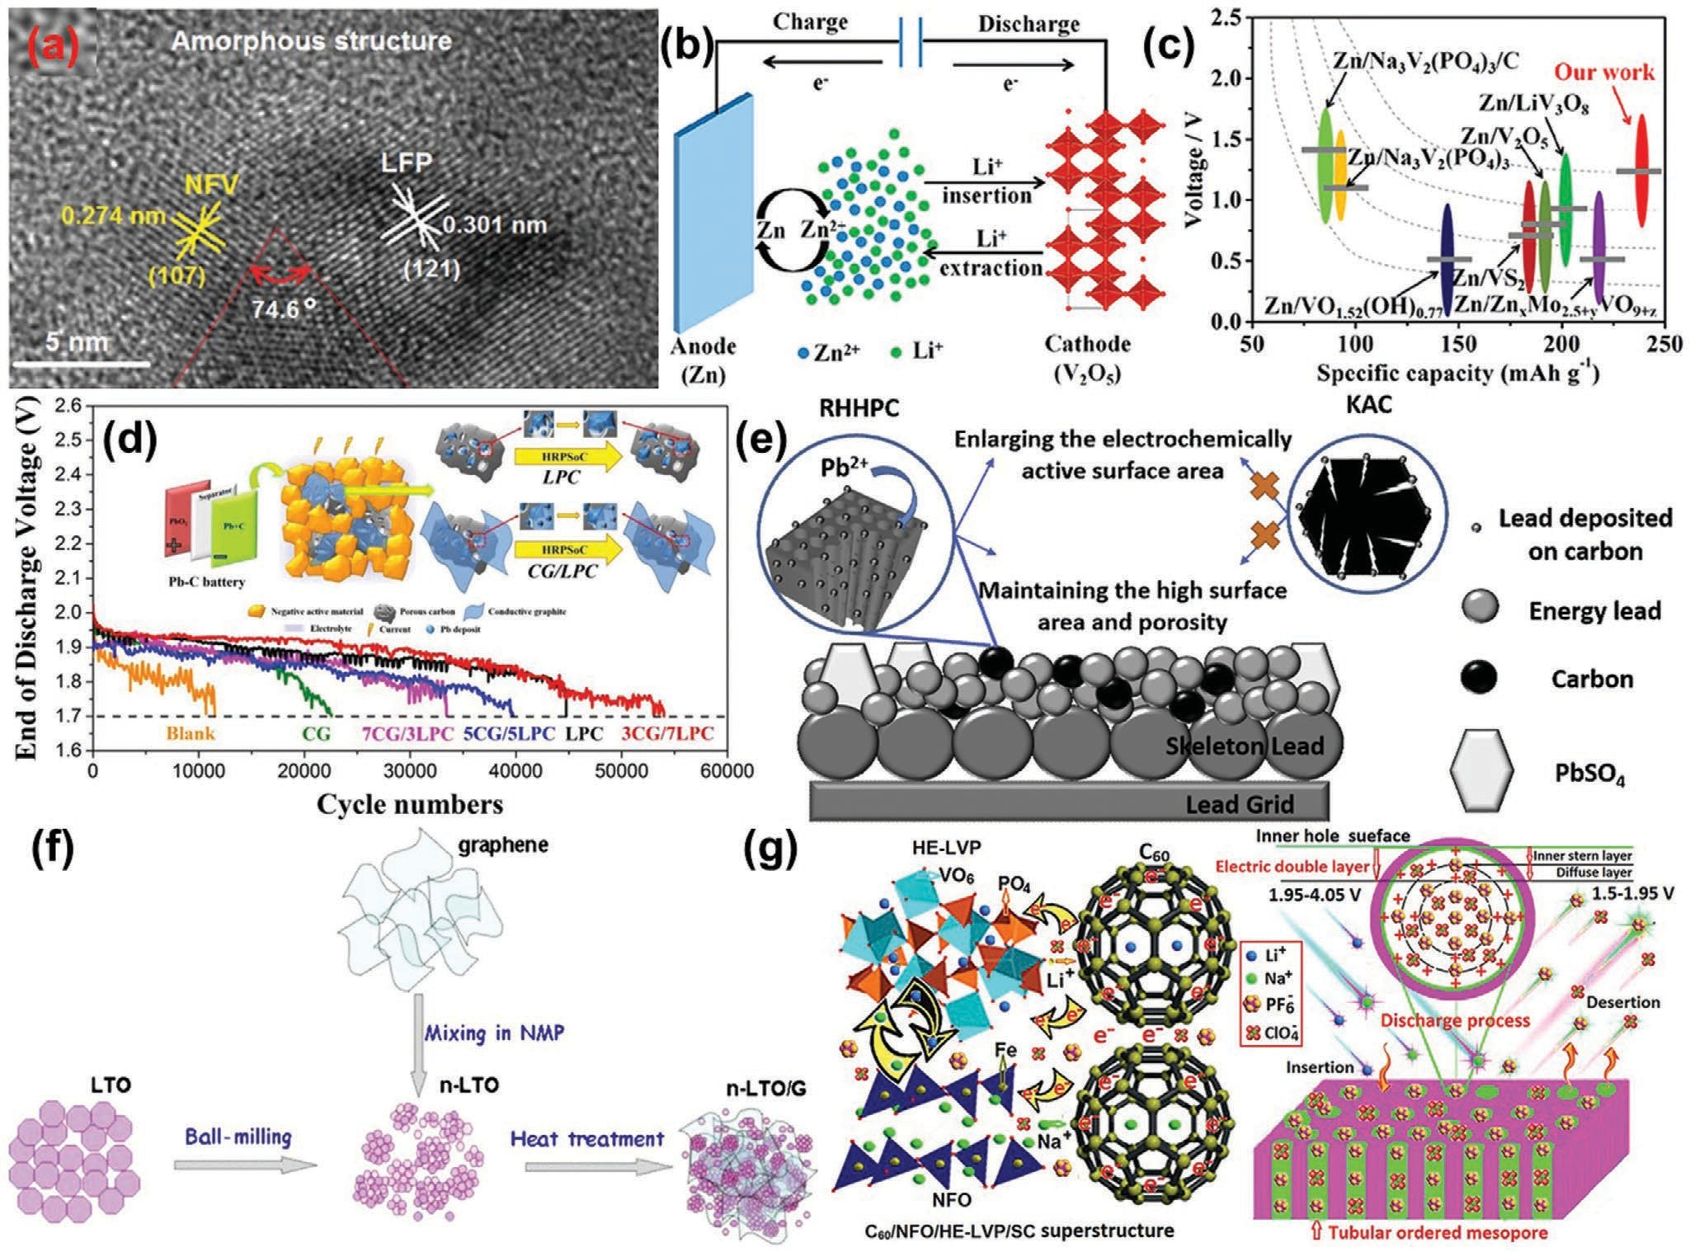
Figure 14. a) HRTEM image of the heterostructure of LFP/NFV composite nanoparticles in NFVPB glass. Reproduced with permission.[26a] Copyright 2015, Royal Society of Chemistry. b) Schematic illustration of a Zn/V₂O₅ aqueous hybrid ion battery. c) Comparison of porous V₂O₅ with recently reported vanadium-based cathode for zinc-ion batteries in terms of specific capacity and voltage platform. Reproduced with permission.[275] Copyright 2017, American Chemical Society. d) HRPSoC cycling performance of 2 V simulated lead–carbon batteries and the diagrammatic sketch of the syner- gistic action mechanism by adding the hybrid carbon additive. Reproduced with permission.[276] Copyright 2017, Elsevier. e) Roles of RHHPC with hierar- chical pores in the negative electrode of lead–carbon battery. Reproduced with permission.[279] Copyright 2019, Elsevier. f) Schematic of the preparation of the hybrid of n-LTO and graphene. Reproduced with permission.[281] Copyright 2011, Elsevier. g) Crystal structure and schematic electronic and ionic
transports of Li+/Na+/PF −/ClO − mixed ions in C /NFO/HE-LVP/SC. Intercalation and deintercalation mechanism of the mixed ions in C /NFO/
6 4 60 60
HE-LVP/SC. Reproduced with permission.[282] Copyright 2020, Springer Nature.

the application of a “water-in-salt” electrolyte results in the increase in the discharge platform from 0.6 to 1.0 V.
For hybrid performance devices, the most typical case is a mixture of battery and capacitive.[144a] For instance, a hybrid material is formed by combining an anode active material of lead powder and a capacitive porous carbon material for lead– carbon battery.[3a] The capacitive porous carbon material forms a porous conductive network in the anode of the lead–carbon battery, thereby improving the anode electronic conductivity in the discharged state and significantly enhancing the battery cycle life.[40a] Wang et al.[276] designed a hybrid carbon addi- tive to inhibit irreversible sulfation by using both lead-doped porous carbon composite and graphite in lead–carbon battery depending on the hybrid battery characteristics and capaci- tance characteristics (Figure 14d). The hybrid carbon additive presented a unique structure of sheets attached to porous bulk,
confining the lead particles between the graphite sheet and porous carbon to independently facilitate higher-rate charge and discharge cycles. The separated lead nanoparticles inhibited the hydrogen evolution induced by carbon and enhanced the revers- ible reaction of Pb/PbSO₄, thereby prolonging the cycle life of lead–carbon batteries. Hu et al.[277] prepared lead oxide and carbon (PbO@C) hybrid materials by pyrolyzing the lead citrate precursor derived from the spent lead paste of lead–acid bat- teries. When the PbO@C is used as an additive to the anode of lead–carbon batteries, the anode utilization efficiency improved from 56.9% to 72.5%, and the cycle life was extended by four times compared with the control. This result is attributed to hydrophilic carbon, which acts as a 3D electroosmotic pump that facilitates electrolyte diffusion and hinders the tendency to excess sulfation. Yin et al.[278] prepared C/Pb hybrid mate- rials by using electroless plating to reduce hydrogen evolution

and achieve high reversibility of the anode of lead–carbon bat- teries. Lead was stuck on the surface of the C/Pb composite, suppressing the hydrogen evolution of the lead–carbon anode and strengthening the connection between carbon additive and sponge lead. The lead–carbon anode with C/Pb displayed good charge and discharge reversibility due to the good con- nection between carbon additives and lead. Yin et al.[279] used rice husk-derived hierarchical porous carbon (RHHPC) to improve the electrochemical kinetics of the lead–carbon elec- trode (Figure 14e). The charge acceptance of the lead–carbon electrode was increased mainly due to the extra electrochemi- cally active surface provided by RHHPC. The lead–carbon bat- tery containing RHHPC shows good rate performance and excellent charge acceptance in deep charge/discharge partial state of charge operation. RHHPC improved the active sites of lead–carbon electrode and the hierarchical pores provided active sites for the growth of Pb branches, thereby enhancing the electrochemical kinetics of Pb/PbSO₄ redox couple of the lead–carbon electrode. Sadhasivam et al.[280] reported the inter- facial effect between the carbon layer and the negative electrode surface in a hybrid electrode with higher charge acceptance for lead–carbon battery. The P-60 (activated carbon) material, with a high specific surface area (1787 m2 g−1) and higher electrical conductivity (98.85 S cm−1), was considered an efficient acti- vated carbon in the present investigations and deposited on the negative electrode. The cycle life of lead–acid battery and lead–carbon battery was 2230 and 6780 cycles, respectively. This condition was attributed to the synergistic mechanism in the hybrid electrode, which resulted from the interfacial effect. The likely synergetic reactions caused by the carbon layer are
i) higher charge acceptance, ii) controlled formation of PbSO₄ crystallite in the electrode surfaces, and iii) improved electro- chemical performances and Pb redox reaction due to higher electrical conductivity properties.
To improve the electrochemical performance of metal-ion batteries in renewable energy storage, a challenging task is to maximize the positive effects of capacitive materials for battery materials. Shi et al.[281] reported a hybrid of lithium titanate (Li₄Ti₅O₁₂, LTO) nanoparticles that are well dispersed on electrical conductive graphene nanosheets as an anode material for high-rate lithium-ion batteries (Figure 14f). Elec- tron transport is improved by forming a conductive graphene network throughout the insulating Li₄Ti₅O₁₂ nanoparticles. The charge transfer resistance at the particle/electrolyte inter- face is reduced from 53.9 to 36.2 Λ. With 5 wt% graphene, the hybrid materials delivered a specific capacity of 122 mAh g−1 at 30 C, an initial discharge capacity of 132.2 mAh g−1, and less than 6% discharge capacity loss over 300 cycles at 20 C. Our group[282] proposed a quaternary hybrid superstructure of stable fullerene C₆₀ nanocages, electroactive Na₄FeO₃, high- energy Li₃V₂(PO₄)₃ and soft carbon, as well as tubular ordered mesoporous channels (Figure 14g). Taking advantage of the unique properties of each component resulted in nanocom- posites with synergistic effects to improve the charge transfer and energy storage. Such a quaternary hybrid electrode of capacitor and battery has high energy and power densities, as well as a long cycling life in a Li/Na mixed ion electrolyte, out- performing a multitude of other battery supercapacitor hybrid devices.

Biomass Materials

Storage and conversion of renewable and sustainable energy from the biomass have been a promising option to relieve the ecological crisis in today’s fossil fuel-based society.[283] Our group synthesized mesoporous LiFePO₄,[284] Li₃V₂(PO₄)₃/C microspheres,[285] LiFePO₄/C nanocomposite microspheres,[286] and LFP/NFV/NFVPB,[26a] by utilizing biomass materials, which displayed good electrochemical performances. Gao et al.[287] reported a reactive pyrolysis of cellulose undergoing oxidation–aminolysis. It converts cellulose paper into carbon paper (CP), which is a 3D network composed of graphenic sheets while avoiding solid or dense carbon fibers/particles. CP is further fabricated as a 3D network support into hybrid CP@Fe₃O₄@RGO (Figure 15a), where reduced graphene oxide (RGO) is added for sandwiching Fe₃O₄ particles. As a binder- free freestanding anode, CP@Fe₃O₄@RGO effectively fastens Fe₃O₄ and buffers the volume changes on cycling, thereby sta- bilizing the passivating layer and increasing the Coulombic efficiency. The anode thus presents an ultralong cycle life of
- 2000 runs at a high capacity of 1160 mAh g−1. It additionally
facilitates electron and ion transport, boosting the rate capa- bility. CP and CP@Fe₃O₄@RGO represent a technological leap that underpins the next-generation long-life, high-capacity, and high-power batteries.
In general, biomass materials play two roles: as a carbon precursor and/or as a template in the preparation of electrodes in rechargeable batteries. Sustainable biomass carbon elec- trodes using various biomass residues have recently become popular for application in rechargeable batteries.[288] Animal biomass[289] and plant[290] biomass were first used to obtain carbon-based electrode materials. The biomass carbon needs to be activated. For example, the carbon precursor obtained from a cherry pit was activated by using either KOH or H₃PO₄ to increase the specific surface area and enable porosity.[291] Sankar et al.[292] synthesized spherical mesoporous activated carbon (SM-AC) nanoparticles from green tea wastes via KOH activa- tion combined with the hydrochloric acid treatment for lith- ium-ion batteries. The SM-AC sample showed a high surface area of 1241 m2 g−1, an initial discharge capacity of 781 mAh g−1, and a reversible capacity of 498 mAh g−1 after 100 cycles. Chen et al.[293] investigated the oxygen-enriched gasification of bio- mass to prepared activated carbon with a specific surface area of 1715.32 m2 g−1 for lithium-ion batteries. The biomass-derived carbon material had less graphitic crystalline structure, less functional groups, and graphene-like porous structure after activation. At 100 mA g−1, a reversible lithium storage capacity is of 327 mAh g−1. Um et al.[294] reported the preparation of carbon from hemp stem as a biomass precursor through a simple, low-cost, and environment-friendly method that uses steam as the activating agent. The hemp-derived carbon with a hierarchically porous structure (Figure 15b₁,b₂) and partial gra- phitization in amorphous domains was developed for lithium- ion battery with a specific capacity of 210 mAh g−1 at 1.5 A g−1. Zhao et al.[295] synthesized hierarchically porous carbon (HPC) with a high specific surface area (≈1714.83 m2 g−1) from biomass reed flowers. The high specific surface area pro- vided rich and fast paths for electron and ion transfer, deliv- ering a capacity of 581.2 mAh g−1 after 100 cycles at 100 mA g−1

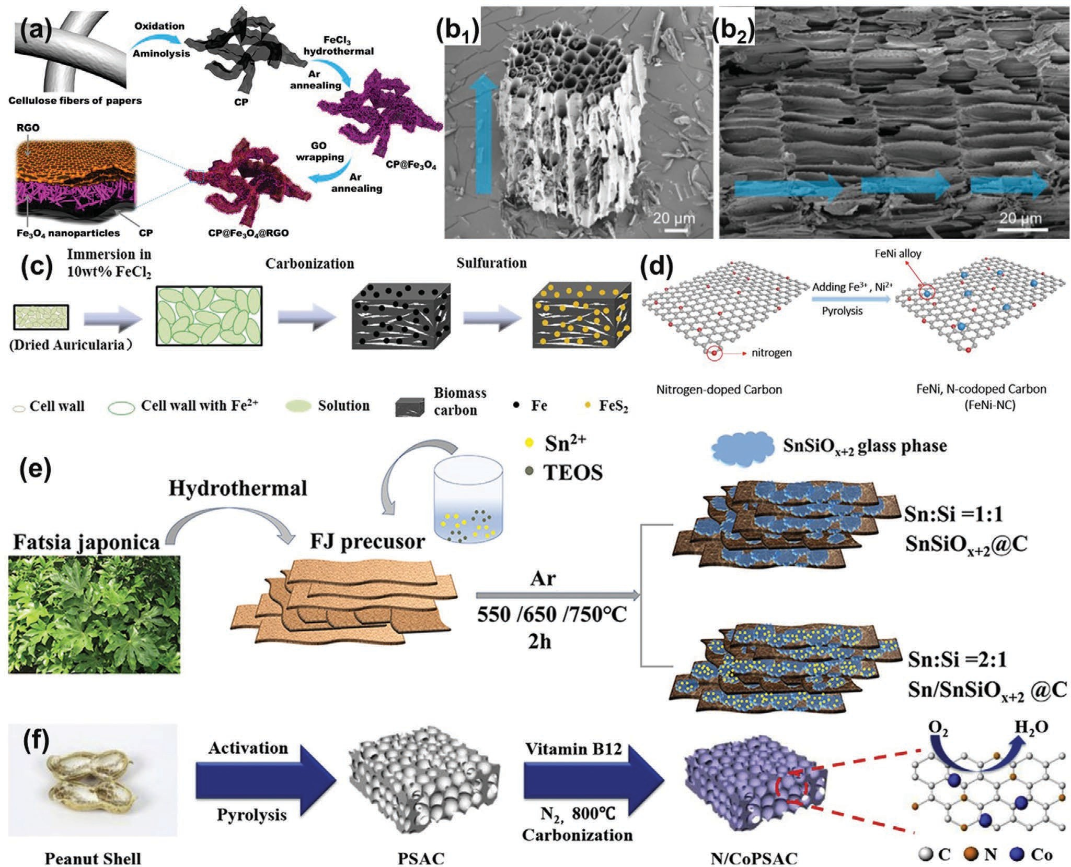
Figure 15. a) Schematic of the synthesis of CP and fabrication of CP@Fe₃O₄@RGO. Reproduced with permission.[287] Copyright 2019, American Chemical Society. b1) SEM image of hemp-derived carbon with a chip-like form. b2) SEM images of xylem-like structure and hierarchically porous structure after the activation process, respectively. Blue arrows in (b2) indicate the primary flow of steam in the reactor. Reproduced with permis- sion.[294] Copyright 2018, Royal Society of Chemistry. c) Formation process of biomass-carbon@FeS₂. Reproduced with permission.[299] Copyright 2018, Elsevier. d) Schematic of the synthesis of FeNi and nitrogen-codoped porous carbons from peanut shells waste. Reproduced with permis- sion.[301] Copyright 2018, Elsevier. e) Fabrication procedures for SnSiO_{x+2}@C and off-stoichiometric Sn/SnSiO_{x+2}@C composites. Reproduced with permission.[302] Copyright 2019, American Chemical Society. f) Schematic illustration of the synthesis of N/CoPSAC. Reproduced with permission.[303] Copyright 2019, Elsevier.

and a capacity of 298.5 mAh g−1 after 1000 cycles at 1000 mA g−1. Li et al.[296] reported a facile activation-annealing route for upcy- cling biomass tar into graphene nanohybrids with developed porosity and enriched pyridinic nitrogen. With the reinforced electric conductivity, hierarchical porosity, and enlarged inter- face achieved via ammonia annealing, the heterogeneously structured carbon catalyst endowed an assembled zinc–air bat- tery with a maximum energy density of 121 mW cm−2. Wang et al.[297] proposed a gas foaming strategy to fabricate sustain- able and 3D hierarchically porous N-doped carbon with a high specific surface area, abundant defect sites, higher half-wave potential (0.861 V), and slightly lower kinetic current density (32.44 mA cm−2) derived from biomass. The Al–air battery

delivered a power density of 401 mW cm−2, an energy density of 2453.4 Wh kg−1, and a high open-circuit voltage of 1.85 V.
For the templates and/or supporters, Xia et al.[298] prepared high-porosity biochar (HPBC) with a specific surface area of 2500 m2 g−1 and a pore volume of 1.18 cm3 g−1 through a car- bonization-activation method by using a high-efficiency pore- forming agent KOH. Then, HPBC/Ni was formed through nickel nanoparticles uniformly growing on the surface of HPBC. Lastly, sublimed sulfur was introduced to prepare HPBC/Ni/S composites. HPBC is a sulfur storage material, and nickel can catalyze the reaction to enhance the reaction kinetics, while the two materials can also synergistically per- form physicochemical adsorption of lithium polysulfide. The

HPBC/Ni/S composite electrode has an initial discharge capacity of 907.3 mAh g−1 at 0.5 C. After 200 cycles, it was main- tained at 610.6 mAh g−1, and the single-turn attenuation rate was only 0.16%. Xu et al.[299] prepared biomass-carbon@FeS₂ com- posites using green and renewable auricularia auricula as the carbon source through the process of carbonization and sulfu- ration (Figure 15c). The auricularia auricula has strong swelling characteristics that enable it to absorb Fe ions into its body. FeS₂ homogeneously distributed in biomass carbon matrix performs high electronic and ionic conductivity. The biomass-carbon@ FeS₂ composites displayed a specific capacity of 850 mAh g−1 after 80 cycles at 0.5 C and a specific capacity of 700 mAh g−1 after 150 cycles at 2 C. Nwanya et al.[298] synthesized rod-like NaNi_{x}Co_{1−x}O₂ with hexagonal-like and cube-like NPs and
-Fe₂O₃ with spherical and quasi-spherical shapes by using an aqueous extract of Zea mays L. dry silk extract. A full device that uses NaNi_{x}Co_{1−x}O₂ and the -FeO₂O₃ displayed a specific capacity of ≈62 and 25 C g−1 at 50 mA g−1. Xiao et al.[300] pro- posed and fabricated NiCo₂O₄ nanowhiskers embedded into biomass-derived porous carbon (NCO@HHPC) by applying a facile one-step hydrothermal strategy, providing rich ORR and OER catalytic active sites. The conductive carbon frame- work with a hierarchically porous microstructure for anchoring NiCo₂O₄ nanowhiskers improved the electronic conductivity and supplied fast transport channels for O₂ diffusion and elec- trolyte infiltration. The assembled zinc–air battery displayed an increase in the narrow voltage gap of 0.08 V over 1460 cycles (487 h) at 10 mA cm−2. Yang et al.[301] used abundantly available peanut shells as precursors and a small amount of iron and nickel salts as nonprecious metal sources to synthesize FeNi alloy and nitrogen-codoped porous carbon (FeNi-NC) electrocat- alyst (Figure 15d). The FeNi-NC catalyst exhibits not only excel- lent ORR electrocatalytic activities with almost the same onset (0.98 V, vs RHE) and half-wave potentials (0.83 V, vs RHE) and limiting current as commercial 20% Pt/C, but also satisfac- tory OER performance with similar activity as IrO₂ in alkaline electrolyte. A zinc–air battery with FeNi-NC displayed excellent charging and discharging polarization curves and robust cycle stability, which are superior to those of the 20% Pt/C + IrO₂- based one. Bai et al.[302] proposed a rational design of a ternary composite by integrating Sn nanoparticles, a glass-phase SnSiO_{x+2} matrix, and a biomass-derived N-doped carbon frame- work via a one-pot, scalable annealing process (Figure 15e). The synergistic effect of abundant functional groups grafted on the processed biomass anchors the metallic precursors for intimate coupling of the electroactive components, and the biomass- derived carbon framework serves as a conductive substrate for ultrasmall Sn particles calcinated from the off-stoichiometric precursor ratio, while glass-phase SnSiO_{x+2} accommodates the volume expansion of the Sn–Li alloy. The Sn/SnSiO_{x+2}@C-650 composite anode displays an overall satisfactory cycle perfor- mance. The high areal capacity of 1.68 mAh cm−2 with average Columbic efficiency higher than 99% at 0.2 mA cm−2 and rate behavior up to 4 mA cm−2 are simultaneously realized in the half cell. Liu et al.[303] prepared a hierarchical porous carbon material doped with nitrogen and cobalt (Co)-based nanoparti- cles (N/CoPSAC) from biomass (i.e., peanut shells and vitamin B12, Figure 15f ). The resultant catalyst of N/CoPSAC demon- strates excellent electrocatalytic activities in alkaline media,
such as more positive on-set potential and half-wave potential, 4-electron oxygen reduction (n ¼ 3.81), and outstanding sta- bility. The observed ORR activities of N/CoPSAC can be attrib- uted to the synergistic effect of the interconnected 3D porous structure and heteroatom doping. Furthermore, the performance evaluation of N/CoPSAC conducted in a more practical setup of zinc–air batteries shows superior durability to that of the bench- mark Pt-based electrocatalysts. Hence, the N/CoPSAC electrocat- alyst derived from peanut biomass has good potential as an alter- native for commercial Pt/C in zinc–air batteries. Lin et al.[304] synthesized a porous microsized composite of nano-Co_{1−x}S/ biomass-derived activated carbon by applying a facile solvo- thermal method using rice husks as the carbon source. As an anode material for lithium-ion batteries, it exhibited a capacity of 630 mAh g−1 at 0.1 A g−1, or a 1% capacity loss after 120 cycles, which is attributed to the buffered large volume change of Co_{1−x}S and good electronic conductivity. Moreover, nature is the greatest factory in the world, producing various biomaterials with com- plicated, elaborate, and efficient hierarchical morphologies and even multiple nanoscale assemblies to satisfy specific require- ments, it leads to the instability and inconsistency of the biomass materials.[283] Although biomass materials play a delightful role in the preparation and structure regulation of electrode materials by acting as carbon precursors and/or templates, the instability and inconsistency are challenges for the development of biomass materials due to the ever-changing biological world.[283,286] There- fore, the purification and universal pretreatment methods of bio- mass raw materials will become a new direction in the develop- ment of biomass-based electrode materials.

Choice of Rechargeable Batteries for Practical Application
The applications and development of rechargeable batteries indicate that each battery has its own advantages. Generally, factors such as cost, powder density, energy density, stability, safety, cycle life, usable capacity, and recyclability of recharge- able batteries are considered for practical application. Figure 16 shows a comparison of the properties and performances of the rechargeable batteries. On the basis of the above compar- ison, we systematically discussed the development potential of these rechargeable batteries and the choices in practical applications.

Electronic Devices

Rechargeable batteries in electronic devices, such as cell phones, tablets, laptops, and cameras, require a fast charging rate, high safety, and suitable volume/mass energy density of batteries.[305,306] A lithium-ion battery with a graphite anode and a modified LiFePO₄/LiCoO₂ cathode may be the best choice for this application so far. The development of solid- state lithium-ion batteries will further improve the safety of these batteries.[307] The development of sodium, magnesium, aluminum-ion batteries, and metal–sulfur batteries may fur- ther improve the configuration of electronic devices through enhancement of rechargeable batteries.

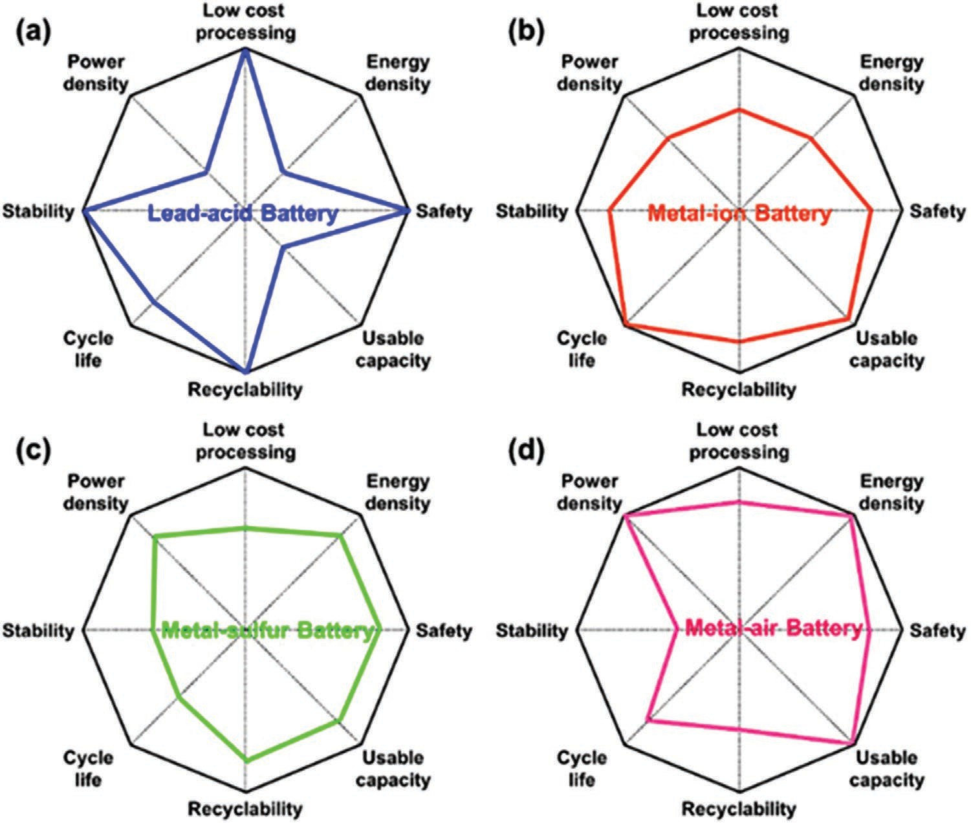
Figure 16. Feature comparison of a) lead–acid battery, b) metal-ion battery, c) metal–sulfur battery, and d) metal–air battery.

Flexible and Wearable Devices

Flexible and wearable electronic devices are often in intimate contact with the human body, thereby requiring electrolytes to have sufficient security.[308] Bracelets and watches do not require a large current discharge (0.5 A).[195] Thus, both metal-ion bat- teries and metal–sulfur batteries that can meet the demand of electronic devices can satisfy the requirement of flexible and wearable devices. However, electrolyte leakage must be pre- vented even under extremely damaged conditions, requiring a gel-solid electrolyte with superior performance as technical sup- port. Refer to our previous review paper for detailed insights.[195]

Smart Grid Systems

Rechargeable batteries for smart grid systems are mainly used for backup power, energy storage of renewable energy sources, and grid frequency modulation.[52] Backup power sources should have excellent self-discharge performance, low cost, and high safety.[309] Typical operating conditions are a small charge/ discharge current rate (0.5 C) and a large depth of discharge (100%) in the application of energy storage from renewable energy sources.[310] Grid frequency modulation requires an energy storage device to be under a large charge/discharge cur- rent rate (1.0 C) and a small discharge depth (45–55%).[311] On the basis of relevant requirements, lead–acid batteries with low cost, high safety, good self-discharge performance, temperate
power density, suitable depth of discharge (≈75%[40a]), accept- able usable capacity, and high cyclability are the best choice for backup power and grid frequency modulation. Although lead–acid batteries have low energy density caused by their heavy weight, this condition does not affect their applications in backup power and grid frequency modulation under long-term stable standing conditions. Presently, rechargeable batteries with a discharge depth of 100% involve only metal-ion batteries and metal–sulfur batteries, and these two types of batteries have higher energy density, power density, and usable capacity.[312] However, the short cycle life of current metal–sulfur batteries caused by polysulfide shuttles[105] makes it difficult to meet the requirements of energy storage applications. Compared with the higher-cost metal-ion batteries, metal–sulfur batteries have higher practical advantages. Thus, solving the problem of poly- sulfide as soon as possible by regulating electronic and ionic transports is an important task. The cost of metal-ion batteries for grid frequency modulation needs to be reduced further to increase their application scale. Thus, the echelon utilization of retired metal-ion power batteries has become an another important research direction.[52]

Transportation

Transportation is an indispensable part of people’s daily life, involving airplanes, ships, PHEVs, EVs, and electric bicycles. Rechargeable batteries penetrate all aspects of

transportation.[52,64] With the increasing number of PHEVs, EVs, and electric bicycles, the application market of recharge- able batteries is expanding. Sales of new energy vehicles reached 110.90 million from January to November 2020, indi- cating a 3.9% year-on-year increase. High growth is expected to resume in 2021. In addition to the requirements of high energy density and safety in charging and discharging, rechargeable batteries in transportation can achieve a high power density.[313] Metal–air batteries, which have the highest energy density, are theoretically the most promising recharge- able batteries for transportation, although their power density and usable capacity need to be improved further through the regulation of electrons and ions. At present, metal-ion bat- teries can meet the basic needs of transportation, and their power density needs to be increased further to ensure a high power output. Importantly, safety issues such as explosion and fire caused by the growth of anode dendrites seriously affect the use of these batteries,[177a] and their growth needs to be inhibited through electronic and ion control. If the current problems can be solved, then metal–sulfur batteries are also an ideal choice for rechargeable batteries in transportation.

Conclusion and Outlook
Series rechargeable batteries, including lead–acid batteries, metal-ion batteries, metal–sulfur batteries, and metal–air bat- teries, have been studied, developed, and applied to satisfy economic, technological, societal, and production demands. A balance of high electrochemical performance and low cost is the target for the application of rechargeable batteries in various fields and conditions. However, some difficulties in achieving this balance are encountered because of the issues from the components in rechargeable batteries. In this respect, a large number of technologies and strategies have been adopted to improve the properties and performances of various rechargeable batteries. However, no report has provided a gen- eral research method for improving various rechargeable bat- teries’ performance. In this review, we summarized the current progress and challenges of various rechargeable batteries on the basis of their electrochemical principles, involving lead–acid batteries, metal-ion batteries, metal–sulfur batteries, and metal– air batteries. The ideal transports of electrons and ions are the main issues and bottlenecks of the above batteries. Approaches for regulating electronic and ionic transports, such as regu- lating phase transition, suppressing electrode active material orientation, introducing the electrocatalytic phase, modifying the surface and interface, and using advanced energy storage materials with good electronic and ionic conductivities, such as low-dimensional materials, porous materials, hybrid materials, and biomass materials, are comprehensively discussed, paving the way for the development of rechargeable batteries with a high electrochemical performance. The choice of rechargeable batteries for practical application is proposed, providing a rich selection for electronic devices, flexible and wearable devices, smart grid systems, and transportation.
Rechargeable batteries have been applied in all aspects of life and production. However, many research opportunities and challenges are still present. First, the use of electronic
and ion control to improve the properties and performance of rechargeable batteries through electron and ion regulation is theoretically feasible and universal, but the enhancements of specific actual batteries still require much effort. Second, the development of rechargeable batteries should focus on maxi- mizing the advantages of traditional batteries while developing new batteries with high performance, low cost, and high safety. Third, the development purpose of new energy is to achieve sustainability. Thus, the retirement, echelon utilization, recovery, and recycling of various rechargeable batteries will become a new hot spot in research on rechargeable batteries. The content and conclusions of this review are obtained based on recent progresses of rechargeable batteries. These findings need to be combined with big data research to obtain more comprehensive and accurate reports. Rechargeable batteries should be developed as competitive technologies for energy storage and solutions for various energy-related challenges.

Acknowledgements
This work was supported by the funding from Qilu University of Technology, the Science and Technology Development Fund, Macau SAR (File Nos. 0191/2017/A3, 0041/2019/A1, 0046/2019/AFJ, and 0021/2019/
AIR), University of Macau (File Nos. MYRG2017-00216-FST and MYRG2018-00192-IAPME), and the UEA funding.

Conflict of Interest
The authors declare no conflict of interest.

Keywords
electronic and ionic conductivities, energy storage materials, rechargeable battery, research direction, technological challenges

- H. Nazir, M. Batool, F. J. Bolivar Osorio, M. Isaza-Ruiz, X. Xu,
K. Vignarooban, P. Phelan, Inamuddin, A. M. Kannan, Int. J. Heat Mass Tranfer 2019, 129, 491.
- a) J. B. Goodenough, K. S. Park, J. Am. Chem. Soc. 2013, 135, 1167;
b) A. Ponrouch, C. Frontera, F. Barde, M. R. Palacin, Nat. Mater.
2016, 15, 169; c) X. Yuan, X. Wu, X. X. Zeng, F. Wang, J. Wang,
Y. Zhu, L. Fu, Y. Wu, X. Duan, Adv. Energy Mater. 2020, 10, 2001583.
- a) X. Xu, H. Wang, Y. Xie, J. Liu, H. Yan, W. Liu, J. Electrochem. Soc. 2018, 165, A2978; b) Z. Hao, X. Xu, H. Wang, J. Liu, H. Yan, Ionics 2018, 24, 951.
- D. B. Richardson, Renewable Sustainable Energy Rev. 2013, 19, 247.
- R. C. Green, L. Wang, M. Alam, Renewable Sustainable Energy Rev.
2011, 15, 544.
- H. S. Yoon, L. G. Occeña, Int. J. Inf. Manage. 2015, 35, 352.
- J. Li, Z. Du, R. E. Ruther, S. J. An, L. A. David, K. Hays, M. Wood,
N. D. Phillip, Y. Sheng, C. Mao, S. Kalnaus, C. Daniel, D. L. Wood,
JOM 2017, 69, 1484.
- X. Xu, S. Deng, H. Wang, J. Liu, H. Yan, Nano-Micro Lett. 2017, 9, 22.

www.advancedsciencenews.com www.advmattechnol.de

- D. Aurbach, B. D. McCloskey, L. F. Nazar, P. G. Bruce, Nat. Energy
2016, 1, 16128.
- H. Yang, H. Li, J. Li, Z. Sun, K. He, H. M. Cheng, F. Li, Angew. Chem. 2019, 58, 11978.
- Q. Gong, Y. Wang, J. Electr. Eng. Technol. 2021, 16, 191.
[12] M. Li, J. Lu, Z. Chen, K. Amine, Adv. Mater. 2018, 30, 1800561.
- H. Wu, Q. Ai, C. Yang, R. Huang, G. Jiang, J. Xiong, S. Yuan, J. Solid State Electrochem. 2020, 25, 869.
- a) S. Wang, D. Zhang, Z. Shao, S. Liu, Carbohydr. Polym. 2019, 214, 328; b) P. T. Moseley, D. A. J. Rand, K. Peters, J. Power Sources 2015, 295, 268; c) J. W. Choi, D. Aurbach, Nat. Rev. Mater. 2016, 1, 16013.
- Y. Tang, Y. Zhang, W. Li, B. Ma, X. Chen, Chem. Soc. Rev. 2015, 44, 5926.
- K. X. Wang, X. H. Li, J. S. Chen, Adv. Mater. 2015, 27, 527.
- J. M. Lujano-Rojas, R. Dufo-López, J. L. Atencio-Guerra,
E. M. G. Rodrigues, J. L. Bernal-Agustín, J. P. S. Catalão, Appl. Energy 2016, 179, 590.
- X. B. Cheng, R. Zhang, C. Z. Zhao, Q. Zhang, Chem. Rev. 2017, 117, 10403.
- M. H. Han, E. Gonzalo, G. Singh, T. Rojo, Energy Environ. Sci.
2015, 8, 81.
- M. Wild, L. O’Neill, T. Zhang, R. Purkayastha, G. Minton,
M. Marinescu, G. J. Offer, Energy Environ. Sci. 2015, 8, 3477.
- X. Xu, S. Wang, H. Wang, C. Hu, Y. Jin, J. Liu, H. Yan, J. Energy Chem. 2018, 27, 513.
- X. Xu, S. Wang, H. Wang, B. Xu, C. Hu, Y. Jin, J. Liu, H. Yan, J. Energy Storage 2017, 13, 387.
- H. Yadegari, Q. Sun, X. Sun, Adv. Mater. 2016, 28, 7065.
- H.-J. Peng, J.-Q. Huang, X.-B. Cheng, Q. Zhang, Adv. Energy Mater.
2017, 7, 1700260.
- D. Lin, Y. Liu, Y. Cui, Nat. Nanotechnol. 2017, 12, 194.
- a) X. Zhang, X. Xu, W. He, G. Yang, J. Shen, J. Liu, Q. Liu, J. Mater. Chem. A 2015, 3, 22247; b) G. Ma, Z. Wen, J. Jin, M. Wu, G. zhang,
X. Wu, J. Zhang, Solid State Ionics 2014, 262, 174; c) X. Xu,
K. S. Hui, D. A. Dinh, K. N. Hui, H. Wang, Mater. Horiz. 2019, 6, 1306.
[27] a) K. Y. Zou, Z. X. Li, Chem 2018, 24, 6506; b) Y. Chen, S. Ji,
S. Zhao, W. Chen, J. Dong, W. C. Cheong, R. Shen, X. Wen,
L. Zheng, A. I. Rykov, S. Cai, H. Tang, Z. Zhuang, C. Chen,
Q. Peng, D. Wang, Y. Li, Nat. Commun. 2018, 9, 5422.
[28] X. Xu, H. Wang, J. Liu, H. Yan, J. Mater. Sci.: Mater. Electron. 2017,
28, 7532.
[29] C. Shu, J. Long, S. X. Dou, J. Wang, Small 2019, 15, 1804701.
- B.-C. Yu, K. Park, J.-H. Jang, J. B. Goodenough, ACS Energy Lett.
2016, 1, 633.
- X. Shen, Y. Li, T. Qian, J. Liu, J. Zhou, C. Yan, J. B. Goodenough,
Nat. Commun. 2019, 10, 900.
- J. Yin, Z. Lin, D. Liu, C. Wang, H. Lin, W. Zhang, J. Electroanal. Chem. 2019, 832, 152.
- https://five.designenvy.co/lead_acid_battery_diagram.php (accessed: December 2019).
- Y. Guo, S. Tang, G. Meng, S. Yang, J. Power Sources 2009, 191, 127.
- R. J. Ball, R. Evans, M. Deven, R. Stevens, J. Power Sources 2002,
103, 207.
- D. Pavlov, P. Nikolov, J. Electrochem. Soc. 2012, 159, A1215.
- L. T. Lam, J. D. Douglas, R. Pillig, D. A. J. Rand, J. Power Sources
1994, 48, 219.
- J. Yang, C. Hu, H. Wang, K. Yang, J. B. Liu, H. Yan, Int. J. Energy Res. 2017, 41, 336.
- H. A. Catherino, F. F. Feres, F. Trinidad, J. Power Sources 2004, 129, 113.
- a) X. Xu, J. Liu, Q. Zhang, H. Wang, Mater. Lett. 2019, 247, 29;
b) D. Pavlov, T. Rogachev, P. Nikolov, G. Petkova, J. Power Sources
2009, 191, 58.
- Y. Wu, M. Gong, M. C. Lin, C. Yuan, M. Angell, L. Huang,
D. Y. Wang, X. Zhang, J. Yang, B. J. Hwang, H. Dai, Adv. Mater.
2016, 28, 9218.
- F. Wang, C. Hu, M. Zhou, K. Wang, J. Lian, J. Yan, S. Cheng, K. Jiang, Sci. Bull. 2016, 61, 451.
- D. Pavlov, J. Power Sources 1997, 64, 131.
- B. Culpin, J. Power Sources 2004, 131, 79.
- A.-R. El-Sayed, E. M. M. Ibrahim, H. S. Mohran, M. Ismael,
H. A.-S. Shilkamy, Metall. Mater. Trans. A 2015, 46, 1995.
- M. Calábek, K. Micka, P. Křivák, P. Bača, J. Power Sources 2006, 158, 864.
- L. Zhao, B. Chen, D. Wang, J. Power Sources 2013, 231, 34.
- L. Zhao, B. Chen, J. Wu, D. Wang, J. Power Sources 2014, 248, 1.
- R. Ruffo, C. Wessells, R. A. Huggins, Y. Cui, Electrochem. Commun.
2019, 11, 247.
- C. Delmas, J. P. Peres, A. Rougier, A. Demourgues, F. Weill,
A. Chadwick, M. Broussely, F. Perton, Ph. Biensan, P. Willmann,
J. Power Sources 1997, 68, 120.
- E. Lee, K. A. Persson, Adv. Energy Mater. 2014, 4, 1400498.
- X. Xu, J. Mi, M. Fan, K. Yang, H. Wang, J. Liu, H. Yan, J. Cleaner Prod. 2019, 213, 1080.
- H. Y. Liu, W. D. Zeng, A. L. Cao, C. Q. Zhang, J. Zhejiang Univ., Sci., B 2010, 11, 952.
- a) B. Li, M. Xu, B. Li, Y. Liu, L. Yang, W. Li, S. Hu, Electrochim. Acta 2013, 105, 1; b) S. R. Sivakkumar, A. G. Pandolfo, Electrochim. Acta 2012, 65, 280.
- a) A. Kraytsberg, Y. Ein-Eli, Adv. Energy Mater. 2012, 2, 922;
b) T.-F. Yi, X.-Y. Li, H. Liu, J. Shu, Y.-R. Zhu, R.-S. Zhu, Ionics 2012,
18, 529.
- G. Kucinskis, G. Bajars, J. Kleperis, J. Power Sources 2013, 240, 66.
- A. Barré, B. Deguilhem, S. Grolleau, M. Gérard, F. Suard, D. Riu,
J. Power Sources 2013, 241, 680.
- R. Amin, P. Balaya, J. Maier, Electrochem. Solid-State Lett. 2007, 10, A13.
- P. P. Prosini, M. Lisi, D. Zan, M. Pasquali, Solid State Ionics 2002,
148, 45.
- R. Malik, D. Burch, M. Bazant, G. Ceder, Nano Lett. 2010, 10, 4123.
- S. Deng, H. Wang, H. Liu, J. Liu, H. Yan, Nano-Micro Lett. 2014, 6, 209.
- J. Wang, X. Sun, Energy Environ. Sci. 2012, 5, 5163.
- X. Xu, Z. Hao, H. Wang, J. Liu, H. Yan, Mater. Lett. 2017, 197, 209.
- X. Xu, C. Qi, Z. Hao, H. Wang, J. Jiu, J. Liu, H. Yan, K. Suganuma,
Nano-Micro Lett. 2018, 10, 1.
- N. P. W. Pieczonka, Z. Liu, P. Lu, K. L. Olson, J. Moote,
B. R. Powell, J.-H. Kim, J. Phys. Chem. C 2013, 117, 15947.
- M. Schroeder, S. Glatthaar, H. Geßwein, V. Winkler, M. Bruns,
T. Scherer, V. S. K. Chakravadhanula, J. R. Binder, J. Mater. Sci.
2013, 48, 3404.
- K.-S. Lee, S.-T. Myung, D.-W. Kim, Y.-K. Sun, J. Power Sources 2011,
196, 6974.
- X. Wang, L. Xing, X. Liao, X. Chen, W. Huang, Q. Yu, M. Xu,
Q. Huang, W. Li, Electrochim. Acta 2015, 173, 804.
- Q. Cao, H. P. Zhang, G. J. Wang, Q. Xia, Y. P. Wu, H. Q. Wu, Elec- trochem. Commun. 2007, 9, 1228.
- T. Ohzuku, A. Ueda, M. Nagayama, Y. Iwakcihi, H. Komori, Electro- chim. Acta 1993, 38, 1159.
- H. Cao, B. Xia, N. Xu, C. Zhang, J. Alloys Compd. 2004, 376, 282.
- C. C. Pan, C. E. Banks, W. X. Song, C. W. Wang, Q. Y. Chen, X. B. Ji,
Trans. Nonferrous Met. Soc. China 2013, 23, 108.
- Z. Hao, X. Xu, S. Deng, H. Wang, J. Liu, H. Yan, Ionics 2018, 25, 2469.
- K. Kleiner, D. Dixon, P. Jakes, J. Melke, M. Yavuz, C. Roth,
K. Nikolowski, V. Liebau, H. Ehrenberg, J. Power Sources 2015, 273, 70.
- L. Zhu, Y. Liu, W. Y. Wu, X. W. Wu, W. P. Tang, Y. P. Wu, J. Mater. Chem. A 2015, 3, 15156.

www.advancedsciencenews.com www.advmattechnol.de

- Z. D. Hao, Q. Zhao, J. D. Tang, Q. Q. Zhang, J. B. Liu, Y. H. Jin,
H. Wang, Mater. Horiz. 2021, 8, 12.
- L. Wang, G. Yang, S. Peng, J. Wang, W. Yan, S. Ramakrishna,
Energy Storage Mater. 2020, 25, 443.
- A. Ponrouch, M. R. Palacin, Curr. Opin. Electrochem. 2018, 9, 1.
- Y. Zhang, H. Geng, W. Wei, J. Ma, L. Chen, C. C. Li, Energy Storage Mater. 2019, 20, 118.
- D. Li, L. Chen, T. Wang, L. Z. Fan, ACS Appl. Mater. Interfaces 2018,
10, 7069.
- X. Zhang, D. Yang, X. Rui, Y. Yu, S. Huang, Curr. Opin. Electrochem.
2019, 18, 24.
- H. Jia, Z. Wang, B. Tawiah, Y. Wang, C.-Y. Chan, B. Fei, F. Pan,
Nano Energy 2020, 70, 104523.
- D. Munoz-Torrero, J. Palma, R. Marcilla, E. Ventosa, Dalton Trans.
2019, 48, 9906.
- Y. Wu, H. B. Huang, Y. Feng, Z. S. Wu, Y. Yu, Adv. Mater. 2019, 31, 1901414.
- C. Li, X. Zhang, W. He, G. Xu, R. Sun, J. Power Sources 2020, 449, 227596.
- a) Y.-S. Su, A. Manthiram, Electrochim. Acta 2012, 77, 272; b) S. Li,
M. Xie, J. B. Liu, H. Wang, H. Yan, Electrochem. Solid-State Lett.
2011, 14, A105.
- L. Medenbach, P. Adelhelm, Electrochem. Energy Storage 2019, 375, 101.
- A. Manthiram, Y. Z. Fu, Y. S. Su, Acc. Chem. Res. 2013, 46, 1125.
- A. Manthiram, Y. Fu, S. H. Chung, C. Zu, Y. S. Su, Chem. Rev. 2014,
114, 11751.
- Z. W. Seh, Y. Sun, Q. Zhang, Y. Cui, Chem. Soc. Rev. 2016, 45, 5605.
- Z.-L. Xu, S. J. Kim, D. Chang, K.-Y. Park, K. S. Dae, K. P. Dao,
J. M. Yuk, K. Kang, Energy Environ. Sci. 2019, 12, 3144.
- J. Zhang, Z. Zhao, Z. Xia, L. Dai, Nat. Nanotechnol. 2015, 10, 444.
- H. Chu, H. Noh, Y. J. Kim, S. Yuk, J. H. Lee, J. Lee, H. Kwack,
Y. Kim, D. K. Yang, H. T. Kim, Nat. Commun. 2019, 10, 188.
- W. Xue, Q.-B. Yan, G. Xu, L. Suo, Y. Chen, C. Wang, C.-A. Wang,
J. Li, Nano Energy 2017, 38, 12.
- D. Sun, Y. Hwa, L. Zhang, J. Xiang, J. Guo, Y. Huang, E. J. Cairns,
Nano Energy 2019, 64, 103891.
- Q. Zhao, Z. D. Hao, J. D. Tang, X. L. Xu, J. B. Liu, Y. H. Jin,
Q. Q. Zhang, H. Wang, ChemSusChem 2021, 14, 792.
- S. Wang, R. Fang, Y. Li, Y. Liu, C. Xin, F. H. Richter, C.-W. Nan,
J. Materiomics 2020, 7, 209.
- Y. Gao, Z. Yan, J. L. Gray, X. He, D. Wang, T. Chen, Q. Huang,
Y. C. Li, H. Wang, S. H. Kim, T. E. Mallouk, D. Wang, Nat. Mater.
2019, 18, 384.
- Y. Wang, X. Huang, S. Zhang, Y. Hou, Small Methods 2018, 2, 1700345.
- J.-S. Kim, T. H. Hwang, B. G. Kim, J. Min, J. W. Choi, Adv. Funct. Mater. 2014, 24, 5359.
- N. Kang, Y. Lin, L. Yang, D. Lu, J. Xiao, Y. Qi, M. Cai, Nat. Commun. 2019, 10, 4597.
- J. M. Chabu, K. Zeng, W. Chen, A. Mustapha, Y. Li, Y.-N. Liu, Appl. Surf. Sci. 2019, 493, 533.
- L. Wang, Z.-Y. Wang, J.-F. Wu, G.-R. Li, S. Liu, X.-P. Gao, Nano Energy 2020, 77, 105173.
- J. S. Yeon, S. H. Park, J. Suk, H. Lee, H. S. Park, Chem. Eng. J.
2020, 382, 122946.
- F. Sun, Z. Qu, H. Wang, X. Liu, T. Pei, R. Han, J. Gao, G. Zhao, Y. Lu, Nano Res. 2020, 14, 131.
- L. Wang, Y.-H. Song, B.-H. Zhang, Y.-T. Liu, Z.-Y. Wang, G.-R. Li,
S. Liu, X.-P. Gao, ACS Appl. Mater. Interfaces 2020, 12, 5909.
- J. Zhou, S. Li, X. Ji, W. Sun, Y. Yang, Chem. Eng. J. 2020, 382, 122843.
[108] Z. Zeng, W. Li, Q. Wang, X. Liu, Adv. Sci. 2019, 6, 1900711.
- R. Yan, M. Oschatz, F. Wu, Carbon 2020, 161, 162.
- J. Y. Wei, X. Q. Zhang, L. P. Hou, P. Shi, B. Q. Li, Y. Xiao, C. Yan, H. Yuan, J. Q. Huang, Adv. Mater. 2020, 32, 2003012.
- Y. X. Yao, X. Q. Zhang, B. Q. Li, C. Yan, P. Y. Chen, J. Q. Huang,
Q. Zhang, InfoMat 2019, 2, 379.
- L. L. Kong, L. Wang, Z. C. Ni, S. Liu, G. R. Li, X. P. Gao, Adv. Funct. Mater. 2019, 29, 1808756.
- D. D. Han, Z. Y. Wang, G. L. Pan, X. P. Gao, ACS Appl. Mater. Inter- faces 2019, 11, 18427.
- S. Lin, M. K. Shafique, Z. Cai, J. Xiao, Y. Chen, Y. Wang, X. Hu, ACS Nano 2019, 13, 13037.
- Y. X. Ren, L. Zeng, H. R. Jiang, W. Q. Ruan, Q. Chen, T. S. Zhao,
Nat. Commun. 2019, 10, 3249.
- J. Wang, S. Yi, J. Liu, S. Sun, Y. Liu, D. Yang, K. Xi, G. Gao,
A. Abdelkader, W. Yan, S. Ding, R. V. Kumar, ACS Nano 2020, 14, 9819.
- S. Wu, S. Hu, Q. Zhang, D. Sun, P. Wu, Y. Tang, H. Wang, Energy Storage Mater. 2020, 31, 310.
- M. Wang, H. Ji, S. Liu, H. Sun, J. Liu, C. Yan, T. Qian, Chem. Eng. J.
2020, 393, 124702.
- G. Girishkumar, B. McCloskey, A. C. Luntz, S. Swanson, W. Wilcke,
J. Phys. Chem. Lett. 2010, 1, 2193.
- V. Caramia, B. Bozzini, Mater. Renewable Sustainable Energy 2014,
3, 28.
- Q. Wu, Y. Ma, H. Wang, S. Zhang, B. Huang, Y. Dai, ACS Appl. Mater. Interfaces 2020, 12, 24066.
- a) Y. Zheng, Y. Jiao, Y. Zhu, Q. Cai, A. Vasileff, L. H. Li,
Y. Han, Y. Chen, S. Z. Qiao, J. Am. Chem. Soc. 2017, 139, 3336;
b) B. E. Conway, T.-C. Liu, Langmuir 1990, 6, 268.
- V. I. Birs, A. Damjanovic, P. G. Hudson, J. Electrochem. Soc. 1986,
133, 1621.
- O. T. Holton, J. W. Stevenson, Platinum Metals Rev. 2013, 57, 259.
- W. Cheng, X. Zhao, H. Su, F. Tang, W. Che, H. Zhang, Q. Liu, Nat. Energy 2019, 4, 115.
- Q. Sun, J. Liu, X. Li, B. Wang, H. Yadegari, A. Lushington,
M. N. Banis, Y. Zhao, W. Xiao, N. Chen, J. Wang, T.-K. Sham, X. Sun, Adv. Funct. Mater. 2017, 27, 1606662.
- W. Ding, Z. Wei, S. Chen, X. Qi, T. Yang, J. Hu, D. Wang, L. J. Wan, S. F. Alvi, L. Li, Angew. Chem. 2013, 52, 11755.
- T. Y. Ma, J. Ran, S. Dai, M. Jaroniec, S. Z. Qiao, Angew. Chem.
2015, 54, 4646.
- a) L. Xu, H. Fan, L. Huang, J. Xia, S. Li, M. Li, H. Ding, K. Huang,
Electrochim. Acta 2017, 239, 1; b) H. Luo, W.-J. Jiang, Y. Zhang,
S. Niu, T. Tang, L.-B. Huang, Y.-Y. Chen, Z. Wei, J.-S. Hu, Carbon
2018, 128, 97.
- Z.-L. Wang, C. Li, Y. Yamauchi, Nano Today 2016, 11, 373.
[131] X. Liu, L. Dai, Nat. Rev. Mater. 2016, 1, 16064.
- a) M. Yu, S. Zhou, Y. Liu, Z. Wang, T. Zhou, J. Zhao, Z. Zhao,
J. Qiu, Sci. China Mater. 2017, 60, 415; b) T. Reier, M. Oezaslan,
P. Strasser, ACS Catal. 2012, 2, 1765.
- a) Y. C. Lu, H. A. Gasteiger, Y. Shao-Horn, J. Am. Chem. Soc. 2011, 133, 19048; b) W. Bian, Z. Yang, P. Strasser, R. Yang, J. Power Sources 2014, 250, 196; c) S. M. Cho, S. W. Hwang, J. H. Yom,
W. Y. Yoon, J. Electrochem. Soc. 2015, 162, A2236.
- F. Wu, Y. Xing, J. Lai, X. Zhang, Y. Ye, J. Qian, L. Li, R. Chen, Adv. Funct. Mater. 2017, 27, 1700632.
- Z. L. Wang, D. Xu, J. J. Xu, X. B. Zhang, Chem. Soc. Rev. 2014, 43, 7746.
- a) H. Zhao, C. Chen, D. Chen, M. Saccoccio, J. Wang, Y. Gao,
T. H. Wan, F. Ciucci, Carbon 2015, 90, 122; b) Y. Cheng, S. Dou,
J. P. Veder, S. Wang, M. Saunders, S. P. Jiang, ACS Appl. Mater. Interfaces 2017, 9, 8121.
- a) X. Zhang, S. Liu, Y. Zang, R. Liu, G. Liu, G. Wang, Y. Zhang,
H. Zhang, H. Zhao, Nano Energy 2016, 30, 93; b) Q. L. Zhu, W. Xia,
T. Akita, R. Zou, Q. Xu, Adv. Mater. 2016, 28, 6391; c) Y. Qian,
Z. Hu, X. Ge, S. Yang, Y. Peng, Z. Kang, Z. Liu, J. Y. Lee, D. Zhao, Carbon 2017, 111, 641; d) S. Dou, X. Y. Li, L. Tao, J. Huo, S. Y. Wang, Chem. Commun. 2016, 52, 9727.

www.advancedsciencenews.com www.advmattechnol.de

- a) J. Zhang, C. Zhang, W. Li, Q. Guo, H. Gao, Y. You, Y. Li, Z. Cui,
K. C. Jiang, H. Long, D. Zhang, S. Xin, ACS Appl. Mater. Inter- faces 2018, 10, 5543; b) Y. Bu, O. Gwon, G. Nam, H. Jang, S. Kim,
Q. Zhong, J. Cho, G. Kim, ACS Nano 2017, 11, 11594.
- a) M. H. Seo, H. W. Park, D. U. Lee, M. G. Park, Z. Chen, ACS Catal. 2015, 5, 4337; b) F. Lu, J. Sui, J. Su, C. Jin, M. Shen, R. Yang,
J. Power Sources 2014, 271, 55.
- a) H. Fei, J. Dong, M. J. Arellano-Jimenez, G. Ye, N. Dong Kim,
E. L. Samuel, Z. Peng, Z. Zhu, F. Qin, J. Bao, M. J. Yacaman,
P. M. Ajayan, D. Chen, J. M. Tour, Nat. Commun. 2015, 6, 8668;
b) Y. Xiong, J. Dong, Z. Q. Huang, P. Xin, W. Chen, Y. Wang, Z. Li,
Z. Jin, W. Xing, Z. Zhuang, J. Ye, X. Wei, R. Cao, L. Gu, S. Sun,
L. Zhuang, X. Chen, H. Yang, C. Chen, Q. Peng, C. R. Chang,
D. Wang, Y. Li, Nat. Nanotechnol. 2020, 15, 390; c) F. Cao, L. Zhang,
Y. You, L. Zheng, J. Ren, X. Qu, Angew. Chem. 2020, 59, 5108.
- a) Q. Lin, X. Bu, A. Kong, C. Mao, F. Bu, P. Feng, Adv. Mater.
2015, 27, 3431; b) V. Rai, K. P. Lee, D. Safanama, S. Adams,
D. J. Blackwood, ACS Appl. Energy Mater. 2020, 3, 9417; c) T. Zhang,
B. Zhang, Q. Peng, J. Zhou, Z. Sun, J. Mater. Chem. A 2021, 9, 433.
- R. Li, R. Zhang, B. Zhang, W. Fang, Y. Qiao, W. Wang, Z. Cui,
D. Zhang, J. Appl. Electrochem. 2021, 51, 155.
- C. Li, E. Zhou, Z. Yu, H. Liu, M. Xiong, Appl. Catal., B 2020, 269, 118771.
- a) C. Zhao, G. Liu, N. Sun, X. Zhang, G. Wang, Y. Zhang,
H. Zhang, H. Zhao, Chem. Eng. J. 2018, 334, 1270; b) P. Chen,
T. Zhou, L. Xing, K. Xu, Y. Tong, H. Xie, L. Zhang, W. Yan, W. Chu,
C. Wu, Y. Xie, Angew. Chem. 2017, 56, 610; c) Y. Guo, P. Yuan,
J. Zhang, Y. Hu, I. S. Amiinu, X. Wang, J. Zhou, H. Xia, Z. Song, Q. Xu, S. Mu, ACS Nano 2018, 12, 1894.
- Y. Meng, D. Voiry, A. Goswami, X. Zou, X. Huang, M. Chhowalla, Z. Liu, T. Asefa, J. Am. Chem. Soc. 2014, 136, 13554.
- J. Yang, X. Wang, B. Li, L. Ma, L. Shi, Y. Xiong, H. Xu, Adv. Funct. Mater. 2017, 27, 1606497.
- X. Liu, X. Li, M. An, Y. Gao, Z. Cao, J. Liu, Electrochim. Acta 2020,
351, 136249.
- H. Li, J. Wang, R. Qi, Y. Hu, J. Zhang, H. Zhao, J. Zhang, Y. Zhao,
Appl. Catal., B 2021, 285, 119778.
- C. Tomon, A. Krittayavathananon, S. Sarawutanukul,
S. Duangdangchote, N. Phattharasupakun, K. Homlamai,
M. Sawangphruk, Electrochim. Acta 2021, 367, 137490.
- B. Wang, Y. Z. Ye, L. Xu, Y. Quan, W. X. Wei, W. S. Zhu, H. M. Li, J. X. Xia, Adv. Funct. Mater. 2020, 30, 2005834.
- C. Zou, L. Zhang, X. Hu, Z. Wang, T. Wik, M. Pecht, J. Power Sources 2018, 390, 286.
- L. Lu, X. Han, J. Li, J. Hua, M. Ouyang, J. Power Sources 2013, 226, 272.
- S. H. Chung, A. Manthiram, Adv. Mater. 2019, 31, 1901125.
- J.-S. Lee, S. Tai Kim, R. Cao, N.-S. Choi, M. Liu, K. T. Lee, J. Cho,
Adv. Energy Mater. 2011, 1, 34.
- H. T. Sun, L. Mei, J. F. Liang, Z. P. Zhao, C. Lee, H. L. Fei, M. N. Ding,
J. Lau, M. F. Li, C. Wang, X. Xu, G. L. Hao, B. Papandrea, I. Shakir,
B. Dunn, Y. Huang, X. F. Duan, Science 2017, 356, 599.
- J. Wang, L. Jia, J. Zhong, Q. Xiao, C. Wang, K. Zang, H. Liu,
H. Zheng, J. Luo, J. Yang, H. Fan, W. Duan, Y. Wu, H. Lin,
Y. Zhang, Energy Storage Mater. 2019, 18, 246.
- a) C. M. Wang, X. Li, Z. Wang, W. Xu, J. Liu, F. Gao, L. Kovarik,
J. G. Zhang, J. Howe, D. J. Burton, Z. Liu, X. Xiao, S. Thevuthasan,
D. R. Baer, Nano Lett. 2012, 12, 1624; b) P.-F. Wang, Y. You, Y.-X. Yin, Y.-G. Guo, Adv. Energy Mater. 2018, 8, 1701912.
- a) T. F. Zhou, W. K. Pang, C. F. Zhang, J. P. Yang, Z. X. Chen,
H. K. Liu, Z. P. Guo, ACS Nano 2014, 8, 8323; b) D. Li, H. Zhou,
Mater. Today 2014, 17, 451.
- P.-F. Wang, H.-R. Yao, X.-Y. Liu, J.-N. Zhang, L. Gu, X.-Q. Yu, Y.-X. Yin, Y.-G. Guo, Adv. Mater. 2017, 29, 1700210.
- D. H. Wang, Y. W. Zhao, G. J. Liang, F. N. Mo, H. F. Li, Z. D. Huang,
X. L. Li, T. C. Tang, B. B. Dong, C. Y. Zhi, Nano Energy 2020, 71, 104583.
- S. Chen, X. X. Shu, H. S. Wang, J. T. Zhang, J. Mater. Chem. A 2019,
7, 19719.
- H. Xiong, H. Yildirim, E. V. Shevchenko, V. B. Prakapenka, B. Koo,
M. D. Slater, M. Balasubramanian, S. K. R. S. Sankaranarayanan,
J. P. Greeley, S. Tepavcevic, N. M. Dimitrijevic, P. Podsiadlo,
C. S. Johnson, T. Rajh, J. Phys. Chem. C 2012, 116, 3181.
- J. Hao, J. Mou, J. Zhang, L. Dong, W. Liu, C. Xu, F. Kang, Electro- chim. Acta 2018, 259, 170.
- Q. Yang, P.-F. Wang, J.-Z. Guo, Z.-M. Chen, W.-L. Pang, K.-C. Huang, Y.-G. Guo, X.-L. Wu, J.-P. Zhang, ACS Appl. Mater. Interfaces 2018, 10, 34272.
- Y.-S. Xu, Q.-H. Zhang, D. Wang, J.-C. Gao, X.-S. Tao, Y. Liu, Y.-G. Sun, L. Gu, B.-B. Chang, C.-T. Liu, S.-Q. Shi, A.-M. Cao, Energy Storage Mater. 2020, 31, 20.
- X. L. Li, M. Li, Q. Yang, H. F. Li, H. L. Xu, Z. F. Chai, K. Chen,
Z. X. Liu, Z J. Tang, L. T. Ma, Z. D. Huang, B. B. Dong, X. W. Yin,
Q. Huang, C. Y. Zhi, ACS Nano 2020, 14, 541.
- H. H. Ryu, G. T. Park, C. S. Yoon, Y. K. Sun, J. Mater. Chem. A 2019,
7, 18580.
- K. Wang, P. F. Yan, M. L. Sui, Nano Energy 2018, 54, 148.
- Y. Huang, C. Zhu, S. Zhang, X. Hu, K. Zhang, W. Zhou, S. Guo,
F. Xu, H. Zeng, Nano Lett. 2019, 19, 1118.
- K. Jiang, X. Zhang, H. Li, X. Zhang, P. He, S. Guo, H. Zhou, ACS Appl. Mater. Interfaces 2019, 11, 14848.
- P. F. Wang, Y. You, Y. X. Yin, Y. S. Wang, L. J. Wan, L. Gu, Y. G. Guo,
Angew. Chem. 2016, 55, 7445.
- L. Chen, H. Chen, Z. Wang, X. Gong, X. Chen, M. Wang, S. Jiao,
Chem. Eng. J. 2019, 363, 270.
- a) F. Mo, J. Ruan, S. Sun, Z. Lian, S. Yang, X. Yue, Y. Song,
Y. N. Zhou, F. Fang, G. Sun, S. Peng, D. Sun, Adv. Energy Mater. 2019, 9, 1902123; b) P. P. Lopes, V. R. Stamenkovic, Science 2020, 369, 923.
- a) A. Jana, S. I. Woo, K. S. N. Vikrant, R. E. García, Energy Environ. Sci. 2019, 12, 3595; b) Z. Ju, J. Nai, Y. Wang, T. Liu, J. Zheng,
H. Yuan, O. Sheng, C. Jin, W. Zhang, Z. Jin, H. Tian, Y. Liu, X. Tao,
Nat. Commun. 2020, 11, 488.
- X. Zhang, S. Wang, C. Xue, C. Xin, Y. Lin, Y. Shen, L. Li, C. W. Nan,
Adv. Mater. 2019, 31, 1806082.
- a) C. Wang, A. Wang, L. Ren, X. Guan, D. Wang, A. Dong,
C. Zhang, G. Li, J. Luo, Adv. Funct. Mater. 2019, 29, 1905940;
- Y. Hu, W. Chen, T. Lei, Y. Jiao, H. Wang, X. Wang, G. Rao,
X. Wang, B. Chen, J. Xiong, Nano Energy 2020, 68, 104373;
- D. Cao, Q. Zhang, A. M. Hafez, Y. Jiao, Y. Ma, H. Li, Z. Cheng,
C. Niu, H. Zhu, Small Methods 2019, 3, 1800539.
- a) S. Ni, S. Tan, Q. An, L. Mai, J. Energy Chem. 2020, 44, 73;
b) Y. Chen, X. Dou, K. Wang, Y. Han, Adv. Energy Mater. 2019, 9, 1900019; c) N. Li, W. Wei, K. Xie, J. Tan, L. Zhang, X. Luo, K. Yuan,
Q. Song, H. Li, C. Shen, E. M. Ryan, L. Liu, B. Wei, Nano Lett.
2018, 18, 2067.
- T. Liu, J. Hu, C. Li, Y. Wang, ACS Appl. Energy Mater. 2019, 2, 4379.
- J.-H. You, S.-J. Zhang, L. Deng, M.-Z. Li, X.-M. Zheng, J.-T. Li,
Y. Zhou, L. Huang, S.-G. Sun, Electrochim. Acta 2019, 299, 636.
- G. Wang, X. H. Xiong, D. Xie, X. X. Fu, X. D. Ma, Y. P. Li, Y. Z. Liu,
Z. Lin, C. H. Yang, M. L. Liu, Energy Storage Mater. 2019, 23, 701.
- J. L. Ma, F. L. Meng, Y. Yu, D. P. Liu, J. M. Yan, Y. Zhang,
X. B. Zhang, Q. Jiang, Nat. Chem. 2019, 11, 64.
- X. Tang, D. Zhou, P. Li, X. Guo, B. Sun, H. Liu, K. Yan, Y. Gogotsi, G. Wang, Adv. Mater. 2020, 32, 1906739.
- Z. Hong, Z. Ahmad, V. Viswanathan, ACS Energy Lett. 2020, 5, 2466.
- J. Lochala, D. Liu, B. Wu, C. Robinson, J. Xiao, ACS Appl. Mater. Interfaces 2017, 9, 24407.
- D. Eroglu, K. R. Zavadil, K. G. Gallagher, J. Electrochem. Soc. 2015,
162, A982.
- B. Q. Li, L. Kong, C. X. Zhao, Q. Jin, X. Chen, H. J. Peng, J. L. Qin,
J. X. Chen, H. Yuan, Q. Zhang, J. Q. Huang, InfoMat 2019, 1, 533.

www.advancedsciencenews.com www.advmattechnol.de

- J. He, A. Manthiram, Energy Storage Mater. 2019, 20, 55.
- J. He, K. Zhou, Y. Chen, C. Xu, J. Lin, W. Zhang, Mater. Today Energy 2016, 1–2, 11.
- C. Zheng, S. Niu, W. Lv, G. Zhou, J. Li, S. Fan, Y. Deng, Z. Pan,
B. Li, F. Kang, Q.-H. Yang, Nano Energy 2017, 33, 306.
- N. Wang, B. Chen, K. Qin, E. Liu, C. Shi, C. He, N. Zhao, Nano Energy 2019, 60, 332.
- L. Ma, W. Zhang, L. Wang, Y. Hu, G. Zhu, Y. Wang, R. Chen,
T. Chen, Z. Tie, J. Liu, Z. Jin, ACS Nano 2018, 12, 4868.
- Z. Du, X. Chen, W. Hu, C. Chuang, S. Xie, A. Hu, W. Yan, X. Kong, X. Wu, H. Ji, L. J. Wan, J. Am. Chem. Soc. 2019, 141, 3977.
- L. Zhang, D. Liu, Z. Muhammad, F. Wan, W. Xie, Y. Wang, L. Song, Z. Niu, J. Chen, Adv. Mater. 2019, 31, 1903955.
- C. Lu, Y. Chen, Y. Yang, X. Chen, Nano Lett. 2020, 20, 5522.
- X. Xu, K. S. Hui, K. N. Hui, H. Wang, J. Liu, Mater. Horiz. 2020, 7, 1246.
- S. Deng, B. Xiao, B. Wang, X. Li, K. Kaliyappan, Y. Zhao,
A. Lushington, R. Li, T.-K. Sham, H. Wang, X. Sun, Nano Energy
2017, 38, 19.
- S. Deng, X. Li, Z. Ren, W. Li, J. Luo, J. Liang, J. Liang, M. N. Banis,
M. Li, Y. Zhao, X. Li, C. Wang, Y. Sun, Q. Sun, R. Li, Y. Hu,
H. Huang, L. Zhang, S. Lu, J. Luo, X. Sun, Energy Storage Mater.
2020, 27, 117.
- C. Peabody, C. B. Arnold, J. Power Sources 2011, 196, 8147.
- Z. Hao, Q. Zhang, X. Xu, Q. Zhao, C. Wu, J. Liu, H. Wang,
Nanoscale 2020, 12, 15923.
- C. Wu, T. Xiao, J. Tang, Q. Zhang, Z. Liu, J. Liu, H. Wang, Nano Energy 2020, 76, 105113.
- Q. Hu, J. Lu, C. Yang, C. Zhang, J. Hu, S. Chang, H. Dong, C. Wu, Y. Hong, L. Zhang, Small 2020, 16, 2002046.
- a) N. Aspern, G. V. Röschenthaler, M. Winter, I. Cekic-Laskovic,
Angew. Chem., Int. Ed. 2019, 58, 15978; b) Z. Lv, M. Han, J. Sun,
L. Hou, H. Chen, Y. Li, M.-C. Lin, J. Power Sources 2019, 418, 233.
- S. F. Lux, I. T. Lucas, E. Pollak, S. Passerini, M. Winter, R. Kostecki,
Electrochem. Commun. 2012, 14, 47.
- A. Laheäär, A. Jänes, E. Lust, Electrochim. Acta 2012, 82, 309.
- H. Xu, T. Bai, H. Chen, F. Guo, J. Xi, T. Huang, S. Cai, X. Chu,
J. Ling, W. Gao, Z. Xu, C. Gao, Energy Storage Mater. 2019, 17, 38.
- D. Pradhan, D. Mantha, R. G. Reddy, Electrochim. Acta 2009, 54, 6661.
- N. W. Li, Y. X. Yin, J. Y. Li, C. H. Zhang, Y. G. Guo, Adv. Sci. 2017,
4, 1600400.
- H. J. Xie, B. Gélinas, D. Rochefort, Electrochem. Commun. 2016, 66, 42.
- K. Stokes, T. Kennedy, G.-T. Kim, H. Geaney, D. Storan, F. Laffir,
G. B. Appetecchi, S. Passerini, K. M. Ryan, Nano Lett. 2020, 20, 7011.
- J. N. Tiwari, R. N. Tiwari, K. S. Kim, Prog. Mater. Sci. 2012, 57, 724.
- W. Liu, R. Yin, X. Xu, L. Zhang, W. Shi, X. Cao, Adv. Sci. 2019, 6, 1802373.
- J. Ren, L. Li, C. Chen, X. Chen, Z. Cai, L. Qiu, Y. Wang, X. Zhu, H. Peng, Adv. Mater. 2013, 25, 1155.
- H. Xu, H. Chen, H. Lai, Z. Li, X. Dong, S. Cai, X. Chu, C. Gao,
J. Energy Chem. 2020, 45, 40.
- B. Sun, Y. Zhang, R. Zhang, H. Yu, G. Zhou, H. Zhang, J. Wang,
Adv. Opt. Mater. 2017, 5, 1600937.
- a) P. Liu, K. Zhu, Y. Gao, H. Luo, L. Lu, Adv. Energy Mater. 2017, 7, 1700547; b) B. Sun, Y. Zhang, R. Zhang, H. Yu, G. Zhou, H. Zhang,
J. Wang, Opt. Express 2018, 26, 1230.
- a) H. Keyang, L. Ruiyi, L. Zaijun, Y. Yongqiang, Electrochim. Acta
2020, 353, 136524; b) L. Gong, R. Yang, R. Liu, Y. Zou, Y. Liu,
L. Chen, Y. Yan, Y. Xu, J. Alloys Compd. 2021, 855, 157278.
- a) J. Yang, T. Feng, H. Zhou, C. Hu, Y. Guo, C. Chen, Z. Chen,
J. Liu, G. Huang, M. Wu, Cell Rep. Phys. Sci. 2020, 1, 100186;
- Y. R. Kumar, K. Deshmukh, K. K. Sadasivuni, S. K. K. Pasha, RSC Adv. 2020, 10, 23861.
- X. Xu, Z. Hao, H. Wang, C. Hu, J. Liu, Y. Jin, Ionics 2018, 25, 89.
- X. Zhang, Z. Bi, W. He, G. Yang, H. Liu, Y. Yue, Energy Environ. Sci.
2014, 7, 2285.
- H. Gu, H. Zhang, C. Ma, X. Xu, Y. Wang, Z. Wang, R. Wei, H. Liu,
C. Liu, Q. Shao, X. Mai, Z. Guo, Carbon 2019, 142, 131.
- D. Lei, Y. B. He, H. Huang, Y. Yuan, G. Zhong, Q. Zhao, X. Hao,
D. Zhang, C. Lai, S. Zhang, J. Ma, Y. Wei, Q. Yu, W. Lv, Y. Yu, B. Li,
Q. H. Yang, Y. Yang, J. Lu, F. Kang, Nat. Commun. 2019, 10, 4244.
- J. Pu, Z. Shen, J. Zheng, W. Wu, C. Zhu, Q. Zhou, H. Zhang,
F. Pan, Nano Energy 2017, 37, 7.
- Y.-M. Lin, P. R. Abel, A. Heller, C. B. Mullins, J. Phys. Chem. Lett.
2011, 2, 2885.
- Y. Cao, L. Xiao, M. L. Sushko, W. Wang, B. Schwenzer, J. Xiao,
Z. Nie, L. V. Saraf, Z. Yang, J. Liu, Nano Lett. 2012, 12, 3783.
- Y. Wang, Z. Wang, Y. Chen, H. Zhang, M. Yousaf, H. Wu, M. Zou, A. Cao, R. P. S. Han, Adv. Mater. 2018, 30, 1802074.
- L. Cao, X. Gao, B. Zhang, X. Ou, J. Zhang, W. B. Luo, ACS Nano
2020, 14, 3610.
- J. Zhang, H. Hu, Z. Li, X. W. Lou, Angew. Chem. 2016, 55, 3982.
- L. Lin, W. Lei, S. Zhang, Y. Liu, G. G. Wallace, J. Chen, Energy Storage Mater. 2019, 19, 408.
- M.-T. F. Rodrigues, K. Kalaga, H. Gullapalli, G. Babu,
A. L. M. Reddy, P. M. Ajayan, Adv. Energy Mater. 2016, 6, 1600218.
- Q. Yin, J. Luo, J. Zhang, S. Zhang, J. Han, Y. Lin, J. Zhou, L. Zheng, M. Wei, Adv. Funct. Mater. 2019, 30, 1907448.
- K. Mahankali, N. K. Thangavel, D. Gopchenko, L. M. R. Arava, ACS Appl. Mater. Interfaces 2020, 12, 27112.
- W. J. Hyun, A. C. M. de Moraes, J. M. Lim, J. R. Downing,
K. Y. Park, M. T. Z. Tan, M. C. Hersam, ACS Nano 2019, 13, 9664. [233] Y.-T. Liu, X.-D. Zhu, L. Pan, Small 2018, 14, 1803632.
- B. Sun, F. Tao, Z. Huang, W. Yan, Y. Zhang, X. Dong, Y. Wu, G. Zhou, Appl. Surf. Sci. 2020, 535, 147354.
- A. VahidMohammadi, A. Hadjikhani, S. Shahbazmohamadi,
M. Beidaghi, ACS Nano 2017, 11, 11135.
- W. Bao, C. E. Shuck, W. Zhang, X. Guo, Y. Gogotsi, G. Wang, ACS Nano 2019, 13, 11500.
- Z. Sun, M. Yuan, L. Lin, H. Yang, C. Nan, G. Sun, H. Li, X. Yang,
ACS Appl. Energy Mater. 2019, 2, 4144.
- G. Jiang, N. Zheng, X. Chen, G. Ding, Y. Li, F. Sun, Y. Li, Chem. Eng. J. 2019, 373, 1309.
- J. Li, B. Rui, W. Wei, P. Nie, L. Chang, Z. Le, M. Liu, H. Wang,
L. Wang, X. Zhang, J. Power Sources 2020, 449, 227481.
- X. Li, Z. Chen, A. Li, Y. Yu, X. Chen, H. Song, ACS Appl. Mater. Interfaces 2020, 12, 48718.
- X. Huang, X. Chen, A. Li, D. Atinafu, H. Gao, W. Dong, G. Wang,
Chem. Eng. J. 2019, 356, 641.
- R. Tauseef ur, H. M. Ali, M. M. Janjua, U. Sajjad, W.-M. Yan, Int. J. Heat Mass Tranfer 2019, 135, 649.
- L. Mao, X. Zhao, H. Wang, H. Xu, L. Xie, C. Zhao, L. Chen, Chem. Rec. 2020, 20, 922.
- S. Rashidi, M. H. Kashefi, K. C. Kim, O. Samimi-Abianeh, Appl. Energy 2019, 243, 206.
- S.-S. Chi, Y. Liu, W.-L. Song, L.-Z. Fan, Q. Zhang, Adv. Funct. Mater.
2017, 27, 1700348.
- Y. Li, S. Chang, X. Liu, J. Huang, J. Yin, G. Wang, D. Cao, Electro- chim. Acta 2012, 85, 393.
- H. Jiang, S. Yu, W. Li, Y. Yang, L. Yang, Z. Zhang, J. Power Sources
2020, 448, 227460.
- M. N. Masri, M. F. M. Nazeri, C. Y. Ng, A. A. Mohamad, J. King Saud Univ., Eng. Sci. 2015, 27, 217.
- X. Tong, F. Zhang, B. Ji, M. Sheng, Y. Tang, Adv. Mater. 2016, 28, 9979.
[250] Q. Li, S. Zhu, Y. Lu, Adv. Funct. Mater. 2017, 27, 1606422.
- a) S. Ramesh, H. M. Yadav, Y. J. Lee, G. W. Hong, A. Kathalingam,
A. Sivasamy, H. S. Kim, H. S. Kim, J. H. Kim, Sci. Rep. 2019, 9, 12622; b) T. Liu, G. Liu, Nat. Commun. 2020, 11, 4984.
- a) B. R. Thompson, T. S. Horozov, S. D. Stoyanov, V. N. Paunov,
J. Mater. Chem. A 2019, 7, 8030; b) J. Jiao, W. Gong, X. Wu, S. Yang,
Y. Cui, Coordin. Chem. Rev. 2019, 385, 174.

www.advancedsciencenews.com www.advmattechnol.de

- a) R. Zhao, Z. Liang, R. Zou, Q. Xu, Joule 2018, 2, 2235; b) G. Xu,
P. Nie, H. Dou, B. Ding, L. Li, X. Zhang, Mater. Today 2017, 20, 191;
- C. S. Diercks, O. M. Yaghi, Science 2017, 355, 1585.
- P. Tan, Y. Jiang, X.-Q. Liu, L.-B. Sun, ACS Energy Lett. 2019, 4, 2656.
- K. Wang, X. Huang, T. Zhou, H. Wang, H. Xie, Y. Ren, Vacuum
2020, 171, 108997.
- A. E. Baumann, X. Han, M. M. Butala, V. S. Thoi, J. Am. Chem. Soc. 2019, 141, 17891.
- G. Chen, Y. Li, W. Zhong, F. Zheng, J. Hu, X. Ji, W. Liu, C. Yang,
Z. Lin, M. Liu, Energy Storage Mater. 2020, 25, 547.
- M. D. Walle, M. Zhang, K. Zeng, Y. Li, Y.-N. Liu, Appl. Surf. Sci.
2019, 497, 143773.
- J. Wang, W. Qin, X. Zhu, Y. Teng, Energy 2020, 199, 117372.
- A. P. Cote, A. I. Benin, N. W. Ockwig, M. O’Keeffe, A. J. Matzger, O. M. Yaghi, Science 2005, 310, 1166.
- B. C. Patra, S. K. Das, A. Ghosh, A. Raj, P. Moitra, M. Addicoat,
S. Mitra, A. Bhaumik, S. Bhattacharya, A. Pradhan, J. Mater. Chem. A 2018, 6, 16655.
- D. Chen, S. Huang, L. Zhong, S. Wang, M. Xiao, D. Han, Y. Meng,
Adv. Funct. Mater. 2019, 30, 1907717.
- a) A. E. Baumann, D. A. Burns, B. Liu, V. S. Thoi, Commun. Chem.
2019, 2, 86; b) L. Alison, S. Menasce, F. Bouville, E. Tervoort,
I. Mattich, A. Ofner, A. R. Studart, Sci. Rep. 2019, 9, 409.
- S. Park, I. Kristanto, G. Y. Jung, D. B. Ahn, K. Jeong, S. K. Kwak, S.-Y. Lee, Chem. Sci. 2020, 11, 11692.
- Q. Zhang, H. Wei, L. Wang, J. Wang, L. Fan, H. Ding, J. Lei, X. Yu,
B. Lu, ACS Appl. Mater. Interfaces 2019, 11, 44352.
- R. Shi, L. Liu, Y. Lu, C. Wang, Y. Li, L. Li, Z. Yan, J. Chen, Nat. Commun. 2020, 11, 178.
[267] H. Wang, H. Dai, Chem. Soc. Rev. 2013, 42, 3088.
- M. C. Orilall, U. Wiesner, Chem. Soc. Rev. 2011, 40, 520.
- a) J. Barker, R. K. B. Gover, P. Burns, A. J. Bryan, Electrochem. Solid-State Lett. 2006, 9, A190; b) H. Ao, Y. Zhao, J. Zhou,
W. Cai, X. Zhang, Y. Zhu, Y. Qian, J. Mater. Chem. A 2019, 7, 18708.
- a) J. Yin, N. Lin, Z. Lin, Y. Wang, J. Shi, J. Bao, H. Lin, W. Zhang,
J. Electroanal. Chem. 2019, 832, 266; b) J. Wang, H. Hou, J. Hu,
X. Wu, Y. Hu, M. Li, W. Yu, P. Zhang, S. Liang, K. Xiao, R. V. Kumar,
J. Yang, Electrochim. Acta 2019, 299, 682.
[271] Y. Fang, X. Y. Yu, X. W. D. Lou, Adv. Mater. 2018, 30, 1706668.
- W. Song, X. Ji, C. Pan, Y. Zhu, Q. Chen, C. E. Banks, Phys. Chem. Chem. Phys. 2013, 15, 14357.
- W. Song, X. Ji, Z. Wu, Y. Zhu, Y. Yao, K. Huangfu, Q. Chen,
C. E. Banks, J. Mater. Chem. A 2014, 2, 2571.
- H. Wang, Y. Liang, M. Gong, Y. Li, W. Chang, T. Mefford, J. Zhou,
J. Wang, T. Regier, F. Wei, H. Dai, Nat. Commun. 2012, 3, 917.
- P. Hu, M. Yan, T. Zhu, X. Wang, X. Wei, J. Li, L. Zhou, Z. Li,
L. Chen, L. Mai, ACS Appl. Mater. Interfaces 2017, 9, 42717.
- L. Wang, H. Zhang, W. Zhang, G. Cao, H. Zhao, Y. Yang, Mater. Lett. 2017, 206, 113.
- Y. Hu, J. Yang, J. Hu, J. Wang, S. Liang, H. Hou, X. Wu, B. Liu,
W. Yu, X. He, R. V. Kumar, Adv. Funct. Mater. 2018, 28, 1705294.
- J. Yin, N. Lin, W. Zhang, Z. Lin, Z. Zhang, Y. Wang, J. Shi, J. Bao,
H. Lin, J. Energy Chem. 2018, 27, 1674.
- J. Yin, N. Lin, Z.-Q. Lin, Y. Wang, J. Shi, J.-P. Bao, H.-B. Lin, S.-H. Feng, W.-L. Zhang, J. Energy Storage 2019, 24, 100756.
- T. Sadhasivam, M.-J. Park, J.-Y. Shim, J.-E. Jin, S.-C. Kim,
M. D. Kurkuri, S.-H. Roh, H.-Y. Jung, Electrochim. Acta 2019, 295, 367.
- Y. Shi, L. Wen, F. Li, H.-M. Cheng, J. Power Sources 2011, 196, 8610.
- X. Zhang, X. Xu, Y. Hu, G. Xu, W. He, J. Zhu, NPG Asia Mater.
2020, 12, 8.
- X. D. Zhang, Y. K. Hou, W. He, G. H. Yang, J. J. Cui, S. K. Liu,
X. Song, Z. Huang, Nanoscale 2015, 7, 3356.
- X. Zhang, X. Zhang, W. He, C. Sun, J. Ma, J. Yuan, X. Du, Colloids Surf., B 2013, 103, 114.
- X. Du, W. He, X. Zhang, Y. Yue, H. Liu, X. Zhang, D. Min, X. Ge, Y. Du, J. Mater. Chem. 2012, 22, 5960.
- X. Zhang, W. He, Y. Yue, R. Wang, J. Shen, S. Liu, J. Ma, M. Li, F. Xu, J. Mater. Chem. 2012, 22, 19948.
- T. Gao, C. Xu, R. Li, R. Zhang, B. Wang, X. Jiang, M. Hu, Y. Bando,
D. Kong, P. Dai, X. B. Wang, ACS Nano 2019, 13, 11901.
- G. S. Dos Reis, S. H. Larsson, H. P. de Oliveira, M. Thyrel,
E. Claudio Lima, Nanomaterials 2020, 10, 1398.
- Z. He, G. Cheng, Y. Jiang, Y. Li, J. Zhu, W. Meng, H. Zhou, L. Dai,
L. Wang, Int. J. Hydrogen Energy 2020, 45, 3959.
- D. Cheng, M. Tian, B. Wang, J. Zhang, J. Chen, X. Feng, Z. He,
L. Dai, L. Wang, J. Colloid Interface Sci. 2020, 572, 216.
- C. Hernandez-Rentero, V. Marangon, M. Olivares-Marin,
V. Gomez-Serrano, A. Caballero, J. Morales, J. Hassoun, J. Colloid Interface Sci. 2020, 573, 396.
- S. Sankar, S. Saravanan, A. T. A. Ahmed, A. I. Inamdar, H. Im,
S. Lee, D. Y. Kim, Mater. Lett. 2019, 240, 189.
- T. Chen, J. Zhang, Z. Wang, R. Zhao, J. He, J. Wu, J. Qin, Energy
2020, 212, 118771.
- J. H. Um, C.-Y. Ahn, J. Kim, M. Jeong, Y.-E. Sung, Y.-H. Cho, S.-S. Kim, W.-S. Yoon, RSC Adv. 2018, 8, 32231.
- W. Zhao, J. Wen, Y. Zhao, Z. Wang, Y. Shi, Y. Zhao, Nanomaterials
2020, 10, 346.
- D. Li, H. Chen, Y. Zhang, J. Yang, H. Yuan, Y. Chen, Electrochim. Acta 2020, 364, 137319.
- Y. Wang, J. Hao, J. Yu, H. Yu, K. Wang, X. Yang, J. Li, W. Li, J. Energy Chem. 2020, 45, 119.
- A. C. Nwanya, M. M. Ndipingwi, C. O. Ikpo, F. I. Ezema,
E. I. Iwuoha, M. Maaza, J. Electroanal. Chem. 2020, 858, 113809.
- X. Xu, Z. Meng, X. Zhu, S. Zhang, W.-Q. Han, J. Power Sources
2018, 380, 12.
- X. Xiao, X. Hu, Y. Liang, G. Zhang, X. Wang, Y. Yan, X. Li, G. Yan,
J. Wang, J. Power Sources 2020, 476, 228684.
- L. Yang, X. Zeng, D. Wang, D. Cao, Energy Storage Mater. 2018, 12, 277.
- M. Bai, X. Tang, C. Sun, Y. Zhang, W. Wu, S. Li, S. Liu, W. Zhao,
Y. Ma, ACS Sustainable Chem. Eng. 2019, 7, 12563.
- Z. Liu, Z. Li, S. Tian, M. Wang, H. Sun, S. Liang, Z. Chang, G. Lu,
Int. J. Hydrogen Energy 2019, 44, 11788.
- J. Lin, J. Cui, F. Cheng, Y. Cui, H. Sun, J. Sun, J. Alloys Compd. 2017,
695, 2173.
- N. Cui, J. Liu, L. Gu, S. Bai, X. Chen, Y. Qin, ACS Appl. Mater. Inter- faces 2015, 7, 18225.
- a) M. Salauddin, R. M. Toyabur, P. Maharjan, J. Y. Park, Nano Energy 2018, 45, 236; b) G. Nagaraju, S. C. Sekhar, B. Ramulu,
L. K. Bharat, G. S. R. Raju, Y.-K. Han, J. S. Yu, Nano Energy 2018,
50, 448.
- a) J. Schnell, T. Günther, T. Knoche, C. Vieider, L. Köhler, A. Just,
M. Keller, S. Passerini, G. Reinhart, J. Power Sources 2018, 382, 160;
b) D. S. Ashby, C. S. Choi, M. A. Edwards, A. A. Talin, H. S. White,
B. S. Dunn, ACS Appl. Energy Mater. 2020, 3, 8402.
- a) H. Zhao, N. Deng, W. Kang, B. Cheng, Chem. Eng. J. 2020, 390, 124571; b) M. Chen, S. Lin, W. Song, J. Lv, Z. Feng, Int. J. Energy Res. 2020, 44, 6745.
- X. Luo, J. Wang, M. Dooner, J. Clarke, Appl. Energy 2015, 137, 511.
- M. C. Argyrou, P. Christodoulides, S. A. Kalogirou, Renewable Sus- tainable Energy Rev. 2018, 94, 804.
- Z. Zhang, K.-T. Chau, IEEE Tran. Smart Grid 2017, 8, 2803.
- a) A. Manthiram, Nat. Commun. 2020, 11, 1550; b) M. Zhang,
W. Chen, L. Xue, Y. Jiao, T. Lei, J. Chu, J. Huang, C. Gong, C. Yan,
Y. Yan, Y. Hu, X. Wang, J. Xiong, Adv. Energy Mater. 2019, 10, 1903008.
- a) Z. P. Cano, D. Banham, S. Ye, A. Hintennach, J. Lu, M. Fowler,
Z. Chen, Nat. Energy 2018, 3, 279; b) Y. Bai, B. Shen, S. Zhang,
Z. Zhu, S. Sun, J. Gao, B. Li, Y. Wang, R. Zhang, F. Wei, Adv. Mater.
2019, 31, 1800680.

www.advancedsciencenews.com www.advmattechnol.de

Xiaolong Xu obtained his Ph.D. in Materials Science and Engineering of the Beijing University of Technology in 2020. Now, he is an associate professor in the School of Materials Science and Engineering in Qilu University of Technology (Shandong Academy of Sciences). He has experi-
ence working with electrochemical energy storage materials and devices, mainly including metal– organic frameworks, battery materials, carbon materials, metal–air batteries, metal-ion batteries, lead–acid batteries, etc.

Xiuxiu Zhao obtained her Master’s degree in Petroleum and Chemical Engineering at Dalian University of Technology in 2017. Now she is a mid-level engineer at the Lab in Jinan
Environmental Research Academy. Her research interests are energy storage, soil, groundwater, surface water, and atmospheric environment.

Kwan San Hui obtained a Ph.D. in Mechanical Engineering from Hong Kong University of Science and Technology in 2008. He is a Reader in Mechanical Engineering at the School of Engineering of University of East Anglia, United Kingdom. He has extensive research experience in material science, catalysis, air/water pollution control, and energy storage.

Duc Anh Dinh achieved his Ph.D. in the field of Chemistry of Materials at the Italian Institute of Technology and Genova University, Italy in 2018. Currently, he is a researcher, working at
Nguyen Tat Thanh hi-tech Institute, Nguyen Tat Thanh University, Vietnam. His research interest is focusing in two fields: 1) production and processing of graphene and related 2D materials for energy storage, sensors, and electronic devices, and 2) synthesis and characterization of biode- grade polymers.

www.advancedsciencenews.com www.advmattechnol.de
Kwun Nam Hui obtained his Ph.D. in Electrical and Electronic Engineering from the University of Hong Kong in 2009. He is an associate professor at the Institute of Applied Physics and Materials Engineering of the University of Macau. His current research focuses on the design and synthesis of nanostructured materials for electrochemical energy storage and conversion including batteries, supercapacitors, and fuel cells.

