Recent Development and Applications of Advanced Materials via Direct Ink Writing

Alpha Chi Him Tsang*, Jintao Zhang, Kwun Nam Hui*, Kwan San Hui*, Haibao Huang*

Alpha Chi Him Tsang
Faculty of Science and Technology, Technological and Higher Education Institute of Hong Kong, Hong Kong
School of Environmental Science and Engineering, Sun Yat-Sen University, Guangzhou, 510006, China
E-mail: chtsang2006@yahoo.com.hk

Jintao Zhang
Key Laboratory for Colloid and Interface Chemistry, Ministry of Education, School of Chemistry and Chemical Engineering, Shandong University, Jinan 250100, China

Kwun Nam Hui
Joint Key Laboratory of the Ministry of Education, Institute of Applied Physics and Materials Engineering, University of Macau, Avenida da Universidade, Taipa 999078, Macau SAR, China
E-mail: bizhui@um.edu.mo

Kwan San Hui
School of Engineering, University of East Anglia, NR4 7TJ, United Kingdom
E-mail: k.hui@uea.ac.uk

Haibao Huang
School of Environmental Science and Engineering, Sun Yat-Sen University, Guangzhou, 510006, China
E-mail: seabao8@gmail.com

Keywords: 3D printing, nanomaterials gel, biomedical, energy, photocatalysts

Direct ink writing (DIW), a type of extrusion-based three-dimensional (3D) printing method, enables the rapid design and building of size- and shape-scalable 3D structures in a low-cost and green manner without the need for specific size reactors and secondary substrates compared to traditional synthesis methods. Coupling the use of sol-gel inks with optimized rheological properties (elastoviscosity and shear stress) and a wide range of nanomaterials enhances the mechanical and electrical conductivity of printed products. In this review, the recent development in DIW methods, critical requirements for printable DIW inks, and applications of DIW-printed products in medical, energy storage, and environmental treatment were reviewed. A perspective outlook associated with limitations from current DIW research is proposed for the breakthrough development of such technology in the future.

1. Introduction
The use of a free-standing macroscopic three-dimensional (3D) structure is the best way to unleash the ability of nanomaterials for daily life applications, especially in medical,^{[1]} battery electrode,^{[2]} and environmental pollutant reduction.^{[1e, 2e, 3]} However, the main barrier to the development of such macroscopic 3D structured materials is the traditional fabrication techniques, which are deemed to be inadequate because (1) they require the use of specific designed reactors,^{[4]} and (2) the contraction of product size throughout the self-assembly process of the materials owing to the surface tension of liquid.^{[4-5]} To achieve non-contract-sized materials, immediate freezing in an extreme environment (liquid N₂) ^{[6]} or the use of a porous secondary substrate like nickel foam (NF) ^{[7]} is required in the self-assembly process of the hydrogel. Although extensive efforts have been devoted to this endeavor, most studies are still in the fundamental laboratory scale. Only a few real applications in the areas of energy storage (lithium ion batteries [LIBs], supercapacitor) and energy conversion (fuel cell) have been reported.^{[6-8]} As a result, the development of new technology to fabricate advanced materials may provide a breakthrough in the limitations of traditional fabrication techniques for nanomaterial-based device preparation.
Additive manufacturing (AM), including 3D printing, is the best solution to overcome the barrier associated with traditional fabrication methodology, because it is template free and does not require a lithographic mask compared to traditional methods.^{[2a-c]} Besides, 3D printing technology is also popular in real life, included food making ^{[9]} and building house.^{[10]} Seven types of 3D printing technologies were developed in past decades, including (1) powder bed fusion, (2) binder jet, (3) directed energy deposition, (4) material jetting, (5) sheet lamination, (6) vat polymerization (e.g. stereolithography (SLA)), and (7) material extrusion (e.g. fused deposition modelling (FDM), direct ink writing (DIW)).^{[11]} Owing to the involvement of 2D structures,^{[11a]} high cost,^{[11b, 11c]} and limited materials selection ^{[11c]} for powder bed fusion, binder jet, directed energy deposition, material jetting, and sheet lamination technologies, their popularity was not as high as that of SLA, FDM and DIW in both scientific research and commercial products development. Thus, this review focuses on some widely used 3D printed techniques such as vat polymerization (SLA) and material extrusion (FDM and DIW).
The summarized characteristics listed in Table 1 reveal that even though SLA and FDM can achieve the same goal, SLA has a clear weakness of slow printing speed, and its choice of solvent is strictly for the successful mixing of nanomaterials with the SLA resin.^{[12]} Moreover, FDM requires the use of either a market-available or self-developed filament via a complicated process.^{[13]} By contrast, the extrusion-based DIW process is relatively simple and suitable for fabricating macroscopic-sized 3D complex materials under ambient condition via (1) continuous filament writing,^{[14]} and (2) liquid droplet writing.^{[15]} More importantly, a wide range of materials is suitable for the preparation of printable DIW gel-ink, ranging from hard materials (e.g. WC-20Co, aspect of wood (polylactic acid (PLA)+wood fibres), metal (PLA+metal) and sandstone (PLA+milled chalk), porous metallic structure) ^{[10d, 14b, 16]} to soft materials (e.g. carbon-based nanomaterials (graphene, activated carbon, carbon nanotubes), polymer, metal oxide (MO_{x}), ceramic, metal oxide framework (MOF), etc).^{[16b, 17]} Even though a post-treatment of the DIW-printed products may be required for particular applications. Thus, since 2002, DIW fabrication has been a potentially convenient and low-cost technology for achieving the goal mentioned above.^{[18]}
Given the attractive properties of the DIW method, we first provide a short review on the recent development of this technology and its applications as proposed in the outline (Figure 1). The operation principle of DIW, characteristics of DIW products, and properties of printable ink for DIW are reviewed in Section 2. Mainstream research on DIW materials and their corresponding applications in biomedical applications, energy storage, and environmental pollutant removal are highlighted in Section 3. The perspective forecast on the future development of DIW 3D printed materials is presented in Section 4.

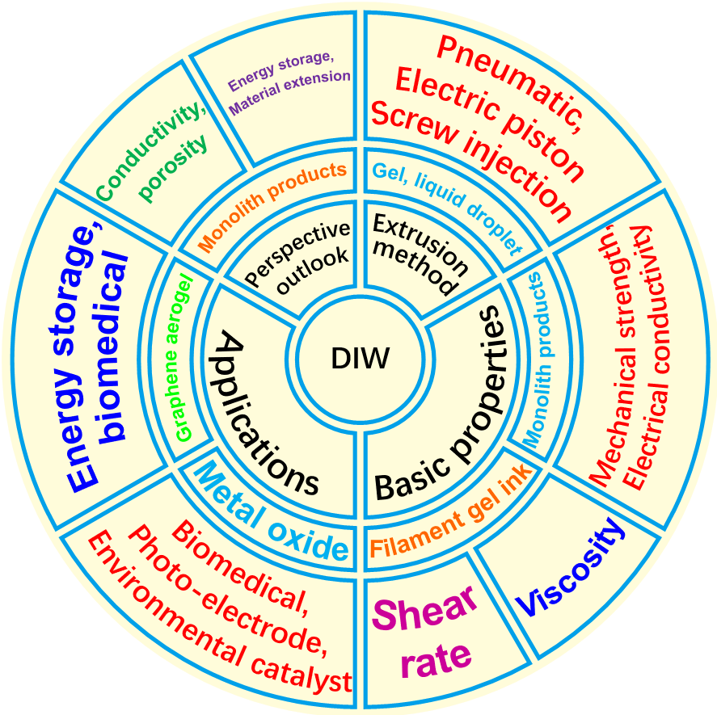

Figure 1. Outline flow of the DIW review: methods, properties, and applications. The three main types of DIW operations include pneumatic, electric piston, and screw injection. Developed materials are mainly metal oxide (MO_{x}) and graphene-based monoliths, and corresponding applications are medical, energy storage, and environmental pollutant removal research.
Table 1. Characteristics of the existing 3D printing methods for materials architecture.
3D printing method | Strength | Weakness
SLA | High printing resolution ^{[12a]}  High resolution ^{[11c]} | Too long printing time ^{[12a]}  Strict reinforce solvent option for mixing nanomaterials and SLA resin ^{[12b]}
FDM | Fast printing time ^{[13c]}  Low cost ^{[13c]}  Market available filament ^{[13a]} | Complicated self-make filament ink preparation process ^{[13d]}  Difficult to achieve nanoparticle catalyst loading ^{[13c]}  Difficult printing temperature control due to varying hardness of printing materials ^{[11c]}
DIW | Simple printing process ^{[2a]}  Low cost ^{[2a]}  Allow binder-free GA monolith printing with proper rheological properties ^{[19]} | Require secondary loading process ^{[2a, 20]}  Require the use of additive ^{[21]} with harsh additive removal process ^{[22]}  Extra curing of every layer may be required ion the printing may result in long printing time ^{[11c]}

2. Basic properties for DIW processing
2.1. Principle of operation and product characteristics
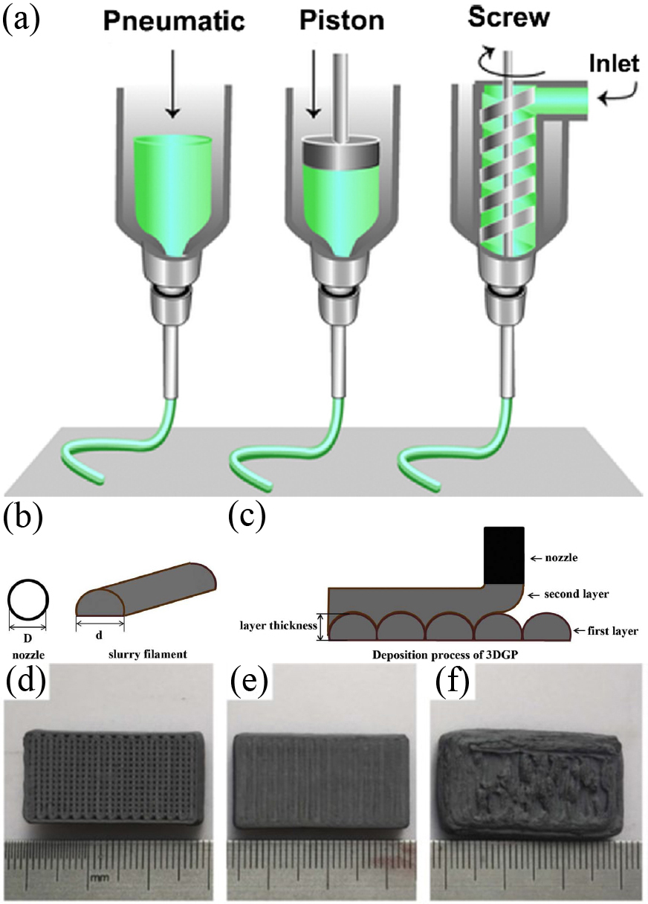
Generally, the first step of DIW is inputting the virtual model of the size- and shape-scalable object via computer aided design (CAD) software,^{[23]} followed by the so-called “stl” file, which is converted from a CAD file to the printing program of the 3D printer.^{[23b]} Printing of the object then proceeds after the operation command of G-code created from the inserted “stl” object file.^{[23b]} Monolith build up on the printer platform by extrusion of the ink from the extrusion nozzle via layer-by-layer assembly is the finishing step of DIW. To date, there are three types of DIW extrusion process to achieve 3D structure construction via continuous filament writing by thick paste or liquid droplet: (1) electric piston,^{[18, 24]} (2) pneumatic,^{[14a, 24b, 24c]} and (3) screw injection.^{[14b, 24b, 24c, 25]} The electric piston method is operated by controlling the speed of the electric piston through the printing program of the monolith created by computer in the extrusion process. The pneumatic method extrudes the ink paste by air pressure from the air pressure system connected to the computer and the printer in the printing process. The screw injection is done by the layer screw extruder installed inside the extrusion syringe, which is controlled by the printer and computerized monolith printing program from the three-axis motion robot or commercial 3D printer, as shown in Figure 2a.^{[24b, 24c]} The monolith is formed by the layer-by-layer stacking of the filament gel via bottom-up synthesis, as illustrated in Figures 2b-c.^{[14b]} The appearance of the printed product is shown in Figures 2d-f, where WC20-Co was chosen as example.^{[14b]} Although these three methods have the common characteristic of achieving continuous filament extrusion, they also have certain distinctions. The main differences include (1) the gel paste ink as the major source of the continuous filament in both electric piston ^{[18, 24b, 24c]} and pneumatic method,^{[14a, 24b, 24c]} whereas the screw injection method uses powder slurry as the continuous filament ink source via direct mixing ^{[14b, 24b, 24c, 25b]} or after heating the materials inside the extruder ^{[25a]} to form slurry filament; and (2) the continuous filament is extruded by air pressure or mechanical pressing via an electric piston in the pneumatic and electric piston techniques, whereas the screw injection produces the filament by mixing the colloidal slurry from a different inlet in the screw extruder layer before extruding from the nozzle. These differences are illustrated in Figure 2a.^{[24b, 24c]} The resolution of the DIW technique is defined by the diameter of the extruded continuous filament gel in the monolith single layer. At present, the printing resolution achieved by continuous filament gel extrusion is in the range of 0.03–0.6 mm ^{[21, 26]} when a suitable-sized nozzle (diameter < 1 mm) is used. The application of a relatively low infill rate (<90%) is also preferred in the printing system to prevent shape distortion in the DIW product, which is reflected by the quality of the DIW-printed WC20-Co monolith with different infill rates as illustrated in Figures 2d-f.^{[14b]}

Figure 2. (a) Schematic of the working principles of extrusion-based 3D printing technique.^{[24b]} (Reproduced with permission.^{[24c]} 2013, WILEY-VCH Verlag GmbH & Co. KGaA, Weinheim) Schematic of the screw injection-driven 3DGP (WC20-Co): (b) slurry filament and (c) deposition process of slurry filaments.^{[14b]} Green samples (WC20-Co) with different filling rate: (d) 84%, (e) 92%, and (f) 100%.^{[14b]} (Reproduced with permission, 2018, Elsevier BV)

Besides the concentrated gel filament-based DIW printing mentioned above, some groups tried the ice-assisted printing involving the freezing of nanomaterials in dilute ink and ice together to form a monolith on the printing platform. The setup used and overall process were similar to the gel filament-based method, but the whole process involved stepwise freezing of the material ink and water in the cold sink, as illustrated in Figure 3.^{[15]} Dilute aqueous nanomaterial solution was used as ink throughout the monolith construction. However, because dilute aqueous ink solution was used, which cannot construct a complete monolith, the concept of freezing printing was applied to compensate for this problem. For example, two-dimensional (2D) macroporous graphene aerogel (GA) block and 3D cage structured GA monoliths developed by Zhang et al. ^{[15]} were achieved by the stepwise dilute aqueous graphene oxide (GO) ink (0.5-10 mg ml⁻¹) and water droplet printing on the chilling surface of the cold sink to form the patterned monolith. Water used acted as support for the formation of the porous area (both 2D porous plan and 3D porous cage) in the aerogel monolith. The porous monolith structure was finally obtained by freeze drying the frozen 3D-printed graphene hydrogel (GH).

Figure 3. 3D printing graphene aerogel (GA). (a-f) 3D GA printing process. (a) 3D printing setup. (b) 3D printing of ice support. (c) 3D printing of GO suspension. (d) Immersion of printed ice structure into liquid nitrogen. (e) Freeze drying. (f) Thermally reduced to 3D ultralight GA on catkin.^{[15]} (Reproduced with permission, 2016, Wiley Interscience)
No matter if a continuous filament gel or liquid ink-based DIW was used, the printed products have several common characteristics. First of all, DIW-printed nanomaterials monoliths are size and shape scalable with the help of CAD software like Solidworks. Such features are illustrated in Figures 2d-f and 4 developed from different research groups. At the same time, DIW nanoporous nanomaterials monoliths with scalable size and pore-shaped macroporous array can be achieved by the designation program ^{[15, 19, 26e, 27]} or by reducing the infill in the printing program,^{[14b]} as illustrated in Figures 2d-f and 4. It is beneficial for high-resolution rigid-shaped honeycomb production of the high-performance solid electrolyte-type battery and air filters because the active surface area can be controlled by a suitable designation of pore shape and size in the design stage. However, high resolution of DIW-printed products for building construction can be achieved by using 3D printers with nozzle size up to cm level via a counter crafting technology (an alternative type of DIW).^{[10a, 10c]} In addition, the shape integrity of DIW-printed products can be maintained with relatively high or very low infill rates, as shown in the monoliths with GO (Figure 4m),^{[19]} N-doped porous carbon (Figures 4n-o),^{[27a]} and Mg(OH)₂ (Figures 4q-r).^{[27b]} These studies suggest that the resolution and the preferred infill rate of DIW printing depend on particular applications.

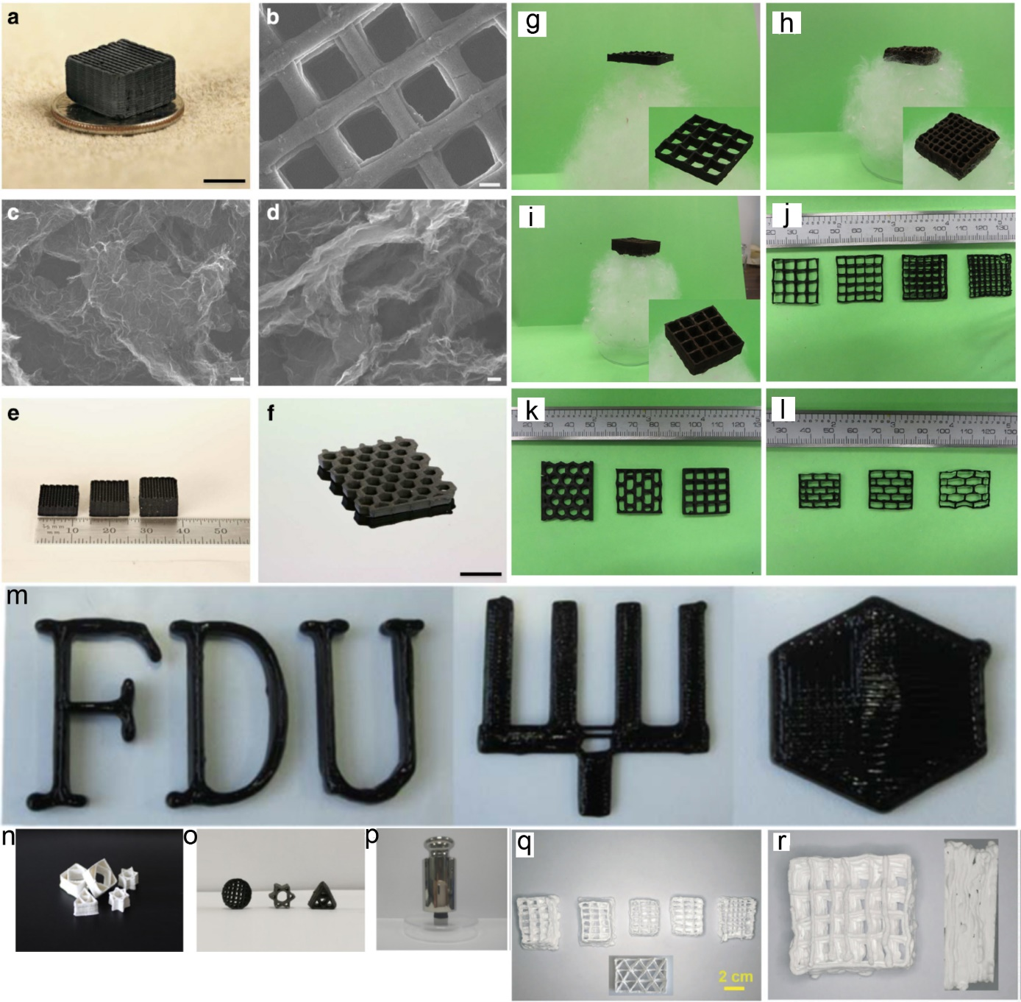

Figure 4. Morphology and structure of graphene aerogels (GAs). (a) Optical image of a 3D-printed GA microlattice. SEM images of (b) a 3D-printed GA microlattice, (c) GA without R–F after etching, and (d) GA with 4 wt% R–F after etching. Optical image of (e) 3D-printed GA microlattices with varying thickness and (f) a 3D printed GA honeycomb. Scale bars: (a) 5 mm, (b) 200 mm, (c, d) 100 nm, and (f) 1 cm.^{[26e]} (Reproduced with permission, 2015, Nature Group) 3D-printed GO aerogels. (g-i) Printed GO aerogels on catkin and (j-l) designs of printed GO aerogels.^{[15]} (Reproduced with permission from Wiley Interscience) (m) Photograph of the printed 3D letter FDU, fork type, and hexagon.^{[19]} (Reproduced with permission, 2019, Elsevier BV) (n) Printed N-doped porous carbon structure before carbonization, (o) Printed N-doped porous carbon structure after carbonization, and (p) Mechanical test.^{[27a]} (Reproduced with permission, 2019, Elsevier BV) Macroscopic, microstructural morphologies, and phase compositions of Mg(OH)₂ honeycombs prepared at 1450 °C: (q) Macroscopic morphology of quadrangular and triangular honeycombs; and (r) Details of a single quadrangular honeycomb.^{[27b]} (Reproduced with permission, 2019, Elsevier BV)

Second, and the most important feature, DIW 3D-printed nanomaterials exhibit strong physical properties, including mechanical and electrical properties. These are summarized in Table 2 with a representative illustration in Figures 4p and 5. For example, DIW-printed N-doped porous carbon can support the mass load (1.6 kg) that is approximately 10,000 times that of the monolith itself (120 mg) without breaking (Figure 4p).^{[27a]} At the same time, compression test results of GA monoliths printed by different DIW techniques ^{[15, 19]} showed strong mechanical compression properties under 50% strain (Figure 5b) to 80% strain (Figure 5e) without breaking the monolith after unloading. Strong electrical conductivity was reflected from the T-LGO monolith printed by Ma’s group as the monolith could light the bulb by completing the simple circuit, as illustrated in Figure 5d.^{[15]} Such attractive features provide the possibility of developing free-standing materials with high mechanical strength and electrical activity for fitting with different applications. Some DIW products like 3D-direct ink written (DIWn) nickel-zinc-ferrite (NZF) synthesized from An et al. ^{[25b]} (Figure 5f) exhibited strong soft magnetic characteristics from the magnetic flux density-magnetic field curve (B–H curve) recorded in Figure 5g. Such properties cause the NZF monolith to further exhibit strong transformer performance by using the monolith as the transformer core (Figure 5h), which is reflected by the strong electromagnetic voltage output (151 mV) step-down from the input voltage (350 mV) and high transformer efficiency (92% at input power range of 1–20 W) via electromagnetic induction process (Figure 5i).^{[25b]} DIW monoliths also exhibited strong chemical properties via fundamental-level traditional reactions. DIW-printed Zr-based MOF structure of Heat treated UiO-66 composite at 280 ℃ (UiO-66comp_{Δ}) developed by Young’s group exhibited strong catalytic activity in the catalytic conversion of methyl-paraoxon into dimethyl phosphate with 90% conversion after 200 min reactions.^{[28]} These results showed the attractive points of DIW monoliths for different applications in the future.

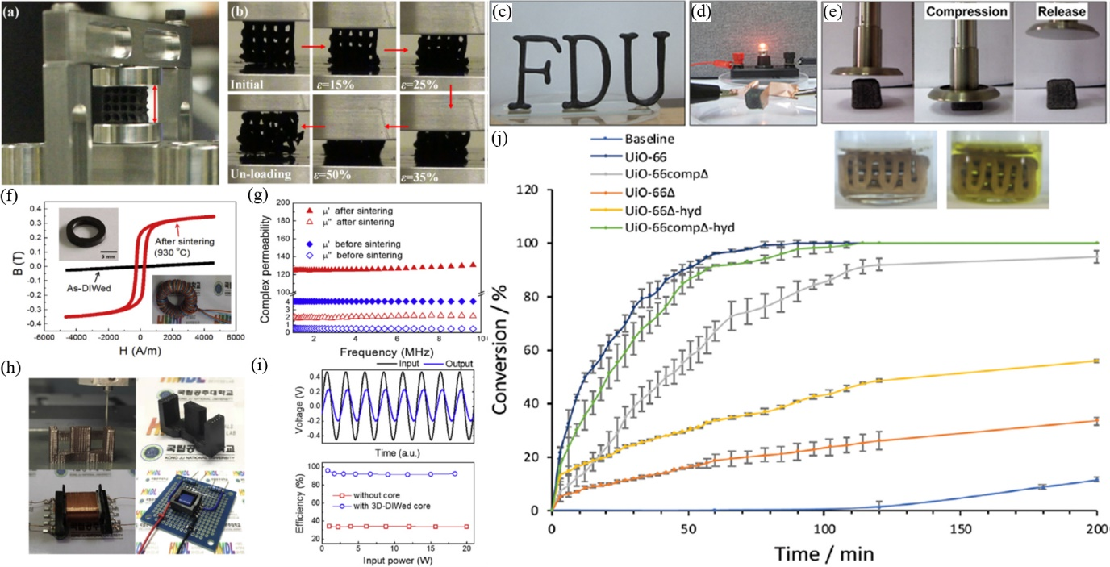

Figure 5. (a) Experimental setup for compression by dynamic thermo-mechanical analyzer (DMA). (b) Loading and unloading process during compression test (50% strain).^{[15]} (Reproduced with permission, 2016, Wiley Interscience) (c) Printed 3D letter FDU, (d) Electrical property of T-LGO monolith, (e) Compressive and resilient property of T-LGO monolith.^{[19]} (Reproduced with permission, 2019, Elsevier BV) (f) Magnetization hysteresis curves and (g) frequency-dependent permeabilities of the 3D-DIWn NZF toroid samples before and after sintering at 930 °C. (h) Transformer with the 3D DIWn EFD-type magnetic core. (i) Performance of the transformer.^{[25b]} (Reproduced with permission, 2020, Elsevier BV) (j) Graph comparing percentage conversion of methyl paraoxon to dimethyl phosphate. Inset: Photographs showing UiO-66comp_{Δ} in a reaction mixture of methyl paraoxon and N-methyl morpholine at the start of the reaction (left) and after 200 minutes (right).^{[28]} (Reproduced with permission, 2019, RSC)

In summary, the main advantage of DIW is that scalable binder-free freestanding monolith construction is achievable, such as the T-LGO monolith ^{[19]} and ZnV₂O₆@Co₃C₂O₈/GO,^{[29]} while most of the sol-gel ink used for DIW printing requires the use of thickening agents. The reason for this will be discussed in detail in the coming section. The shapes of monoliths printed from such inks are more regular due to their high strength (rheological properties).^{[21, 26, 27c]} By contrast, water droplet DIW monolith printing, such as 3D GA open-cell cage printed this way (Figure 3f), has the problem of non-perfect fully 3D porous cage.^{[15]} As a result, the traditional continuous filament method is still the best way to develop rigid size- and shape-scalable porous freestanding nanomaterials monoliths with high resolution in modern 3D printing research.

Table 2. Mechanical and electrical properties of DIW products.
DIW supporting materials | DIW products | Mechanical strength (Percentage of strain) | Conductivity (S/m) | Resistivity | Porosity | Elastic modulus (GPa) | Year | Ref
Polymer | HA-PEGMA/PEDA (35 vol%) | N/A | N/A | N/A | N/A | N/A | 2012 | ^{[30]}
 | Al₂O₃-PEGDA (45 vol%) | N/A | N/A | N/A | N/A | N/A | 2012 | ^{[30]}
 | 3D-TpPa-1 (1,3,5-triformylphloroglucinol (Tp)/ paraphenylenediamine (Pa)) | N/A | N/A | N/A | 5-7 nm pores | N/A | 2019 | ^{[27c]}
 | 3D-TpBD-Me₂ (1,3,5-triformylphloroglucinol (Tp)/ dioxane (BD), mesitylene (Me)) | N/A | N/A | N/A | 5-7 nm pores | N/A | 2019 | ^{[27c]}
Al₂O₃ | Sintered S-Al₂O₃ | 304 MPa | (6.9±3.4)×10⁵ | N/A | 1.3-2.5 % | N/A | 2019 | ^{[31]}
 | α-Al₂O₃ | N/A | N/A | N/A | 80% | N/A | 2021 | ^{[32]}
 | γ-Al₂O₃ | N/A | N/A | N/A | 85% | N/A | 2021 | ^{[32]}
 | Boehmite (γ-AlO(OH)) | N/A | N/A | N/A | 82 | N/A | 2021 | ^{[32]}
Cu | Sintered S-Cu | 521 MPa | (27.9±4.2)×10⁵ | N/A | 1.6-3.2 % | N/A | 2019 | ^{[31]}
 | 3DNHP-Cu | N/A | N/A | N/A | 65% | N/A | 2020 | ^{[16a]}
HST | 75 mol% HST/25 mol% okayamalite (OK) | 5.2 MPa | N/A | N/A | 0.679 | N/A | 2017 | ^{[26h]}
 | Sr/Mg-doped hardystonite (HST) | 2.3 MPa | N/A | N/A | 0.73 | N/A | 2019 | ^{[33]}
Ketjenblack carbon particles (KB) | LFP (30 vol%)-KB (1.25 vol%) | N/A | 13 | N/A | N/A | N/A | 2018 | ^{[34]}
 | LTO (30 vol%)-KB (1.25 vol%) | N/A | 12 | N/A | N/A | N/A | 2018 | ^{[34]}
Carbon | DIW CAs (resorcinol–formaldehyde) | N/A | 995 | N/A | N/A | N/A | 2018 | ^{[35]}
Graphene | rGO (Printed) | 0.018 MPa (20% strain) | 400 | N/A | N/A | N/A | 2015 | ^{[36]}
 | 3DG (60 vol%) | 0.25 MPa (80% strain) | 875 | N/A | N/A | 0.081 | 2015 | ^{[26b]}
 | 3D printed GA | 84.1 Pa (50% strain) | 154 | N/A | N/A | N/A | 2016 | ^{[15]}
 | GO | N/A | 66400 | N/A | N/A | N/A | 2016 | ^{[26c]}
 | 3DGS (25 wt%) | 4.37 MPa | 300 | N/A | N/A | N/A | 2018 | ^{[21]}
 | 3DGS (37 wt%) | 1.51 MPa | N/A | N/A | N/A | N/A | 2018 | ^{[21]}
 | 3DGS (50 wt%) | 0.57 MPa | 479.2 | N/A | N/A | N/A | 2018 | ^{[21]}
 | Epoxy/graphene | 82 MPa | N/A | 1060 (Ω/sq) | N/A | N/A | 2018 | ^{[37]}
 | GAMs | 9000 Pa (80% strain) | 800 | N/A | N/A | N/A | 2018 | ^{[38]}
 | 1:1 mass ratio Graphene/EGB+DBP+PVP | 6 MPa | 71.5 | N/A | N/A | N/A | 2018 | ^{[39]}
 | LGO | 137 Pa (80% strain) | 41.1 | N/A | N/A | N/A | 2019 | ^{[19]}
 | GO/GNP | 0.5 MPa (10% strain) | 4205 | N/A | 0.63 | N/A | 2019 | ^{[40]}
 | 3DGP | N/A | N/A | N/A | N/A | N/A | 2019 | ^{[41]}
 | GO Based ink | 27.5 kPa (30% strain) | 40-120 (Graphene/ MWCNT) | N/A | N/A | N/A | 2018 | ^{[26f]}
 | rGO/CNT (25 wt%) | N/A | N/A | 1.2-1.4 (mΩ/cm) | N/A | N/A | 2019 | ^{[42]}
 | LFP-GO | N/A | 31600 | N/A | N/A | N/A | 2016 | ^{[26c]}
 | LTO-GO | N/A | 6100 | N/A | N/A | N/A | 2016 | ^{[26c]}
 | Mn₃O₄ NS/rGO NS | N/A | N/A | N/A | 24.8 nm pores | N/A | 2018 | ^{[43]}
 | GA (40 mg ml⁻¹ GO/20 wt% silica) | 1.2 MPa (50% strain) | 278 | N/A | N/A | N/A | 2015 | ^{[26e]}
 | GO-GNP-SiO₂-2 (4.2 wt% silica) | N/A | N/A | 0.96 (Ω/sq) | N/A | N/A | 2016 | ^{[26d]}
 | Co₃V₂O₆/GO | N/A | N/A | N/A | N/A | N/A | 2019 | ^{[29]}
 | 10 mL ZnV₂O₆@Co₃V₂O₆/20 mL GO | N/A | N/A | N/A | N/A | N/A | 2019 | ^{[29]}
 | Boehmite (γ-AlO(OH))/MWCNT | N/A | N/A | N/A | 83 | N/A | 2021 | ^{[32]}
 | γ-Al₂O₃/MWCNT | N/A | N/A | N/A | 87 | N/A | 2021 | ^{[32]}
 | α-Al₂O₃/MWCNT | N/A | N/A | N/A | 84 | N/A | 2021 | ^{[32]}
 | Boehmite (γ-AlO(OH))/rGO ribbon | N/A | N/A | N/A | 81 | N/A | 2021 | ^{[32]}
 | γ-Al₂O₃/rGO ribbon | N/A | N/A | N/A | 85 | N/A | 2021 | ^{[32]}
 | α-Al₂O₃/rGO ribbon | N/A | N/A | N/A | 80 | N/A | 2021 | ^{[32]}
NiZn-ferrite | 3D DIWn NZF | N/A | N/A | N/A | N/A | N/A | 2020 | ^{[25b]}
SiC | 3D nanostructured SiC | N/A | N/A | N/A | N/A | N/A | 2018 | ^{[44]}
Silicone | [IPA/MK(40/60)](70%)+crMK(30%) | 2.5±0.97 MPa | 0.0006 | N/A | 64% | N/A | 2016 | ^{[45]}
 | [IPA/MK(40/60)](70%)+crMK(30%)+(0.05 wt% GO) | 2.64±0.67 MPa | 0.005 | N/A | 64% | N/A | 2016 | ^{[45]}
 | [IPA/MK(40/60)](70%)+crMK(30%)+(0.1 wt% GO) | 3.1±0.8 MPa | N/A | N/A | 64% | N/A | 2016 | ^{[45]}
Steel | Sintered S | 359 MPa | (7.4±0.4)×10⁵ | N/A | 1.9-2.5 % | N/A | 2019 | ^{[31]}
Clay | Al₂O₃-MgO-SiO₂ | 2.5 MPa | N/A | N/A | 0.953 | N/A | 2019 | ^{[27b]}
 | 2MgO·2Al₂O₃·5SiO₂ (70 wt% solid) | N/A | N/A | N/A | 34.02-43.08% | N/A | 2019 | ^{[46]}
 | 2SiO₂·Al₂O₃·2H₂O (32 vol%) | 22.08 MPa | N/A | N/A | N/A | N/A | 2019 | ^{[47]}
 | Vf 50-Pol-02A | 235 MPa | N/A | N/A | N/A | N/A | 2019 | ^{[48]}
 | Vf 53-Pol-08A | 264 MPa | N/A | N/A | N/A | N/A | 2019 | ^{[48]}
TiO₂ | L75-S3-O22 MEA | N/A | N/A | N/A | N/A | N/A | 2017 | ^{[49]}
 | TiO₂ (Solid) | N/A | N/A | N/A | 8.1-10.1% | 2.43-5.90 | 2018 | ^{[50]}
 | TiO₂ (Scaffold) | N/A | N/A | N/A | 8.1-10.1% | 2.08-5.81 | 2018 | ^{[50]}
 | DIW porous Ti | 660 MPa (30% strain) | N/A | N/A | 31-45.2 % | N/A | 2019 | ^{[51]}
 | 3D titania ceramic parts (72% Titania) | 125 MPa | N/A | N/A | 8.4-56.5% | 1.22-6.87 | 2019 | ^{[52]}
Ti | 3D printed Ti6Al4V 800×400 | 118 MPa | N/A | N/A | 53% | N/A | 2019 | ^{[53]}
 | Ti₆AlC (80.7 wt%) (PVA+PEG) | 43 MPa | N/A | N/A | 63 % | N/A | 2019 | ^{[54]}
WC-20Co | WC-20Co | 2612.8 MPa | N/A | N/A | N/A | N/A | 2018 | ^{[14b]}
ZnO | AZO (1.6 wt% Al) | N/A | N/A | 1 (Ω cm) | N/A | N/A | 2014 | ^{[55]}
 | ZnO (48 vol %) | 11.09 MPa | N/A | N/A | N/A | N/A | 2016 | ^{[14a]}
ZrO₂ | 3D ZrO₂ nanostructure | N/A | N/A | N/A | N/A | N/A | 2017 | ^{[56]}
 | UiO-66comp_{Δ} | 4.9±0.9 MPa | N/A | N/A | N/A | N/A | 2019 | ^{[28]}

2.2. Ink properties
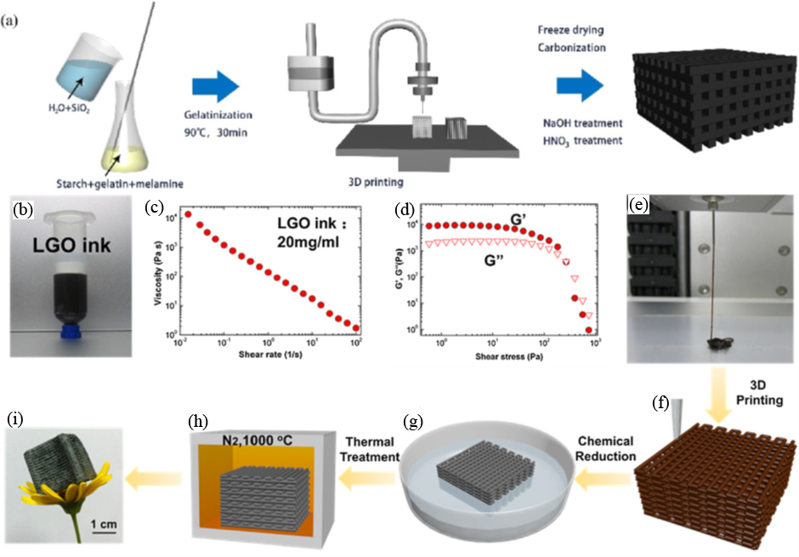
To achieve high-precision DIW monolith printing (Figure 6) without base layer deflection,^{[21, 26]} an appropriate physical property of ink is the key to success. Soft materials like GO, MO_{x}, and polymer are key components of the DIW ink to generate a continuous filament from the extruder nozzle. In addition, the careful control of rheological properties, including viscoelasticity and mechanical shear strength, are very important for the stacking of the material filament gel in bottom-up layer-by-layer assembly.

Figure 6. (a) Procedure for the preparation of the printed N-doped porous carbon structure.^{[27a]} (Reproduced with permission, 2019, Elsevier BV) LGO ink properties and schematic of the fabrication process, (b) digital image of the LGO ink with a concentration of 20 mg mL⁻¹ in a 30 cm³ barrel, (c) viscosity as a function of the shear rate for LGO ink, (d) G0 and G00 as a function of the shear stress for LGO ink, (e) LGO ink extrusion through micro needle (400 μm), (f) the model of printed 3D LGO monolith, (g) chemical reduction of LGO monolith by HI, (h) thermal annealing of monolith at 1000 °C in nitrogen, and (i) optical image of the final low-density 3D graphene monolith.^{[19]} (Reproduced with permission, 2019, Elsevier BV)

First of all, viscoelasticity describes the elastic response of the gel ink and is expressed in Equation (1) below:^{[19, 57]}

$y=k{(\frac{ϕ}{ϕ_{gel}}-1)}^{x}$ (1)

where Φ is the colloid volume fraction, Φ_{gel} is the colloid volume fraction at gelation point, y is the elastic properties of the target ink gel, x is the scaling constant, and k is the arbitrary constant.^{[19, 57]} The elastic response (y) of the gel ink is governed by Φ and Φ_{gel}, where Φ is directly proportional to the interparticle bond density, and Φ_{gel} is inversely proportional to the bond strength of the corresponding gel. From the DIW binder-free GA demonstration performed by Ma’s team (Figures 6a-6b) as an example, the printable GO paste must have enough shear strength in order to be extrudable from the nozzle and forming filament to build up a complicated monolith structure. Next, the ink must be viscous or elastic enough even though the container is inverted as the first requirement (Figures 6a-6b). Generally, this factor is controlled by the value of y through the concentration of the major nanomaterial in the gel ink, which strongly affects the Φ and Φ_{gel} values in Equation (1), and finally, the elastic modulus (G’) of gel ink.^{[19]} Note that Φ is controlled by the concentration of the specific DIW gel ink, whereas Φ_{gel} value is controlled by the material characteristics in the ink. In the printable concentrated gel ink, the ratio of Φ/Φ_{gel} should be large enough to achieve a large y value. The ink will be rigid and elastic enough to form a filament. As a result, this explains why highly concentrated pure nanomaterials ^{[19]} or the synthesis of DIW ink with the help of additives (crosslinkers, binder, etc.) was highly preferred to achieve the freestanding monolith fabrication.
Second, from the shear stress properties expressed in Equation (2) below:

$τ=τ_{y}+K{\dot{γ}}^{n}$ (2)

where τ, τ_{y}, K, $\dot{γ}$, and n represent the shear stress, yield point, viscosity parameter, shear rate, and shear thinning exponent of specific gel, respectively.^{[19, 57]} Generally, determination of the printability of inks is based on evaluating the values of τ_{y} from Equation (2). From Ma team’s demonstration,^{[19]} the elastic/storage modulus (G’) must be slightly larger than the viscosity/loss modulus (G”) in the gelation stage for gel or paste ink and monolith shape integrity preservation after extrusion, but G’ must be lower than G” in the extrusion stage.^{[19]} Otherwise, (1) the gel filament will not be successfully formed from the colloidal ink and extrude out from the nozzle, and (2) the extruded gel cannot preserve the monolith shape properly.^{[19]} This point is the shear stress of ink (τ_{y} in Equation [2]), which can be determined from the intersecting point of G’ and G” curves in the modulus-shear stress graph. The modulus-shear stress curve of the LGO ink is shown as an example (Figure 6c). However, the τ_{y} value and range of viscosity, corresponding shearing rate, and shear rate of the gel ink are totally different and material dependent (graphene, carbon, MO_{x}, silica, etc.). This condition is reflected by the results summarized in Table 3. In the table, graphene-based ink has stronger shear stress than MO_{x}, polymer, carbon, or silica-based DIW inks. At the same time, even though DIW sol-gel inks have non-Newtonian shear thinning behavior between viscosity and shearing rate (i.e., negative slope), pure GO inks exhibited a linear response (Figure 6c), whereas metal oxide or silica-based sol-gel ink exhibited an exponential-like curve response (Figure 7). The possible reason for such finding may be the strong π–π interaction,^{[22, 39]} electrostatic interaction,^{[26g, 29]} polar interaction ^{[37]} exhibited by GO nanosheets or the hydrogen bond between functional groups in GO nanosheets and additives ^{[21, 26f, 36, 38-41]} in the concentrated sol-gel ink formation. By contrast, pure metal oxide, carbon, polymer, and silica-based gel ink was made via the crosslink formation between ink components and crosslinker,^{[14, 47, 55, 58]} dipole–dipole attraction between surfactant and metal oxide nanoparticles,^{[59]} oxygen bridge formation due to hydroxyl group hydrolysis,^{[26j]} or multiviscosity via chemical reaction between water ^{[27b]} or solvent ^{[34, 49]} and the ink components in the gel ink throughout the sol-gel formation. Given that interactions between GO and the additives or among GO nanosheets themselves seem stronger than those between metal oxides and the additives, these may lead to the larger value of τ_{y} and the range of viscosity under the corresponding shear rate range.

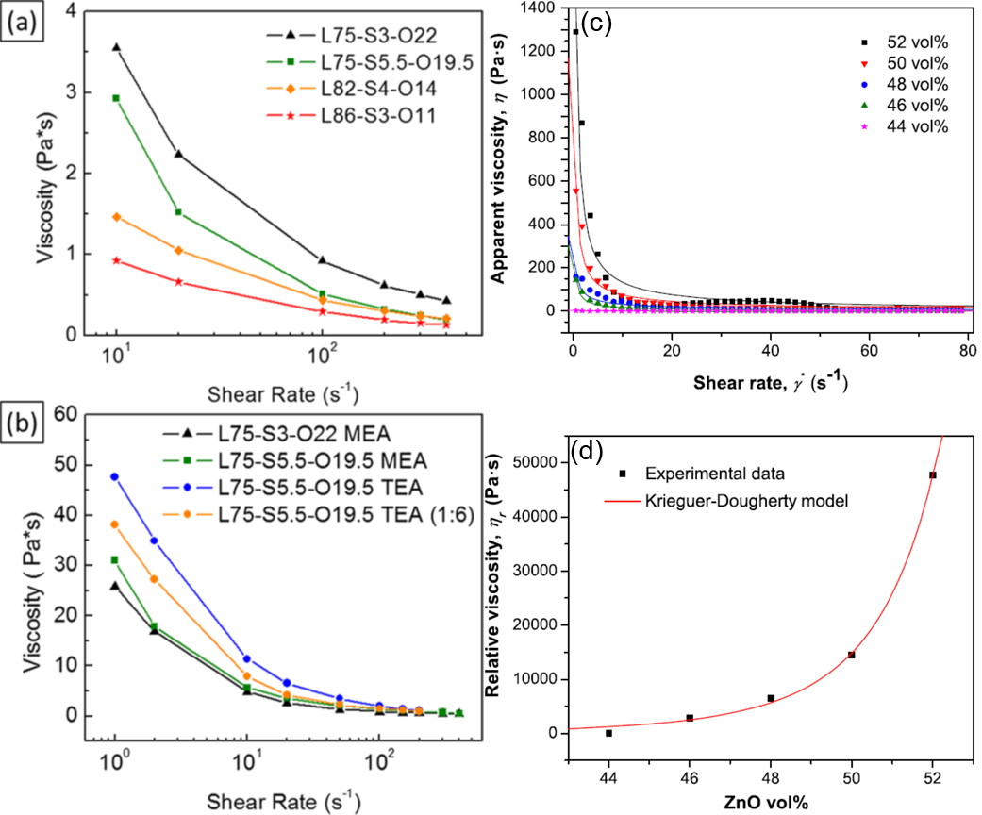

Figure 7. Viscosity of the TALH:TiO₂ 1:12 foams after (a) 4 min and (b) 8 min of frothing time from different liquid−solid−oil content (vol %) formulations.^{[49]} (Reproduced with permission, 2017, ACS) (c) Viscosity curves of ZnO inks at various solid loading and corresponding fitting curves for the power-law model. (d) Relative viscosity dependence on the solid loading at a shear rate of 40 s⁻¹. The solid line represents the Krieger–Dougherty model fitted.^{[14a]} (Reproduced with permission, 2016, Elsevier BV)

A simulation model was also applied to evaluate the rheological properties of the DIW ink and the resulting monolith. Skalla P et al. ^{[60]} focused on the ink’s rheological properties and their effect on the printed products’ simulation on calcium phosphate ink and its monolith (hydroxyapatite [HA] and β-tricalcium phosphate [β−TCP]) system with different shapes (scaffold and cylinder). ANSYS computation results revealed that the contact radius of the gel filament in every layer of the printed monolith determines the effect on elastic properties and local stress because filaments periodically overlap with each other in every regular layer.^{[60]} This finding provided strong reference for the further design of the porous monolith with the best rheological properties of gel filament in the real experiment.
Table 3. List of mechanical properties of DIW gel inks.
DIW supporting materials | Ink material | Viscosity range (Pa s) | Corresponding shear rate range (s⁻¹) | Shear stress (Pa) | Year | Ref
PEGDA | HA-PEGMA/PEDA (35 vol%) | 1.2-400 | 1-700 | 400 | 2012 | ^{[30]}
 | Al₂O₃-PEGDA (45 vol%) | 1-300 | 1-1000 | 45 | 2012 | ^{[30]}
Al₂O₃ | Al₂O₃ | 0-4000 | 0-100 | 105 | 2018 | ^{[26g]}
 | Al₂O₃ separator (with Propylene carbon (PC), Triton X-100 (TX-100)) | 8 | 1 | 0.1 | 2018 | ^{[34]}
 | Al₂O₃-SiO₂ (63 wt% Al₂O₃ powder) | 8000 | 100 | N/A | 2021 | ^{[61]}
Cu | Cu 85 wt% | 500 | 10 | N/A | 2017 | ^{[26i]}
 | Mn₈₀Cu₂₀ for 3DHNP-Cu | 10-1000 | 1-2.5 | 500 | 2020 | ^{[16a]}
KB | LFP (30 vol%)-KB (1.25 vol%) | 6270 | 1 | 3960 | 2018 | ^{[34]}
 | LTO (30 vol%)-KB (1.35 vol%) | 1750 | 1 | 1330 | 2018 | ^{[34]}
Carbon | DIW CAs (resorcinol–formaldehyde) | 10-20000 | 0.01-1000 | 300 | 2018 | ^{[35]}
Graphene | GO/BCS | 50 | 10 | N/A | 2015 | ^{[36]}
 | GO | 100-1000 | 1 | N/A | 2016 | ^{[26c]}
 | 6 wt% CMG | 200 | 10 | N/A | 2017 | ^{[26i]}
 | hGO | 10-1000000 | 0.001-100 | 500 | 2018 | ^{[2a]}
 | 3DGS (25 wt%) | 20-10000 | 0.1-1000 | 64.1 | 2018 | ^{[21]}
 | 3DGS (37 wt%) | 20-10000 | 0.1-1000 | 182.4 | 2018 | ^{[21]}
 | 3DGS (50 wt%) | 20-10000 | 0.1-1000 | 470.6 | 2018 | ^{[21]}
 | Epoxy/graphene | 800-70000 | 0.9-100 | 70-700 | 2018 | ^{[37]}
 | GO-based ink | 10-10000 | 0.01-100 | 450 | 2018 | ^{[26f]}
 | GAMs | 2-10000 | 0.01-100 | 40 | 2018 | ^{[38]}
 | 1:1 mass ratio Graphene/EGB+DBP+PVP | 0.1-1000 | 0.01-1000 | N/A | 2018 | ^{[39]}
 | LGO | N/A | N/A | 216 | 2019 | ^{[19]}
 | GO/GNP | 10-10000 | 0.1-100 | 1000 | 2019 | ^{[40]}
 | Graphene in 10% EC/EtOH | 300-600 | 50-400 | N/A | 2019 | ^{[62]}
 | GO | 10000-5000000 | 0.1-100 | 300 | 2019 | ^{[63]}
 | GO (40 wt%) | 1-1000 | 0.1-1000 | N/A | 2019 | ^{[64]}
 | 0.5 wt% GO-Al₂O₃ | 0-4000 | 0-100 | 25 | 2018 | ^{[26g]}
 | 1 wt% GO-Al₂O₃ | 0-4000 | 0-100 | 80 | 2018 | ^{[26g]}
 | 5 wt% GO-Al₂O₃ | 0-4000 | 0-100 | 110 | 2018 | ^{[26g]}
 | GAMs (0.015 M Ca²⁺) | 20-100000 | 0.01-100 | 160 | 2018 | ^{[38]}
 | HGO-Co₃O₄ | 100000 | 10⁻² | 800 | 2019 | ^{[65]}
 | GO/CNT (25 wt%) | 0.5-106.5 | 0.1-100 | 109.68 | 2019 | ^{[42]}
 | LTO/GO | 100-1000 | 1 | 10000-100000 | 2016 | ^{[26c]}
 | LFP/GO | 100-1000 | 1 | 10000-100000 | 2016 | ^{[26c]}
 | (Polyaniline)_{x}/GO (PANI_{x}/GO) | 50-5000 | 0.1-100 | 500-1000 | 2018 | ^{[22]}
 | GA (40 mg ml⁻¹ GO/20 wt% silica) | 100-2000 | 0.1-100 | ~40 | 2015 | ^{[26e]}
 | GO-GNP-SiO₂-2 (4.2 wt% silica) | 10-1100 | 0.1-100 | 500 | 2016 | ^{[26d]}
 | Co₃V₂O₆/GO | 5-1200 | 0.1-10 | 500 | 2019 | ^{[29]}
 | 10 mL ZnV₂O₆@Co₃V₂O₆/20 mL GO | 5-1200 | 0.1-10 | 200 | 2019 | ^{[29]}
GeO2 | 2.5 mol% (GeO₂/SiO₂) | 9-100 | 10-100 | N/A | 2021 | ^{[66]}
NiZn-ferrite | 3D DIWn NZF (10 wt% SIS) | 3000-10000 | 0.1-10 | 683.02 | 2020 | ^{[25b]}
SiC | 3D nanostructured SiC (80 wt%) | 596.8 | 1 | N/A | 2018 | ^{[44]}
SiO₂ | SiO₂ (4 vol%+UV curing epoxy) | 950 | 1 | 100 | 2018 | ^{[34]}
 | SiO₂ (9.64 wt%/Phosphate ink) | 900-9000 | 1-100 | N/A | 2020 | ^{[67]}
Si₂N₄O₂ | S1 (SiO₂(27.6wt%)/Si₃N₄(64.4wt%)/Y₂O₃(5wt%)/Al₂O₃(3wt%)) | 500-11000 | 0.1-10 | N/A | 2021 | ^{[68]}
Silicone | [IPA/MK(40/60)](70%)+crMK(30%) | 3-4 | 100-400 | N/A | 2016 | ^{[45]}
 | [IPA/MK(40/60)](70%)+crMK(30%)+(0.1 wt% GO) | 7-28 | 100-400 | N/A | 2016 | ^{[45]}
Hollow glass | 61.4 vol% Glass (30% 55k PVP/methanol) | 6000-80000 | 0.1-10 | N/A | 2020 | ^{[58b]}
 | 61.4 vol% Glass (2:1 Bis-GMA:TEGDMA) | 800-80000 | 0.1-10 | N/A | 2020 | ^{[58b]}
Clay | Al₂O₃-MgO-SiO₂ | 0.01-50 | 0.1-1000 | N/A | 2019 | ^{[27b]}
 | 2MgO·2Al₂O₃·5SiO₂ (70 wt% solid) | 50-6000 | 1-100 | 1000 | 2019 | ^{[46]}
 | 2SiO₂·Al₂O₃·2H₂O (32 vol%) | 5.73-1910 | 1-1000 | 1600 | 2019 | ^{[47]}
Ti | Ti6AlV4 | 2000-11200 | 0.01-0.1 | 10 | 2019 | ^{[53]}
 | Ti₂AlC (80.7 wt%) (PVA+PEG) | 9000 | 0.1 | 224.4 | 2019 | ^{[54]}
TiO₂ | Chelated titanium alkoxide (No doped) | 4.16 | 50-300 | N/A | 2012 | ^{[69]}
 | TiO₂ | 10-10000 | 0.1-10 | N/A | 2018 | ^{[50]}
 | TiO₂ sol-gel | 200-300 | 1-20 | 100 | 2018 | ^{[26a]}
 | 3D titania ceramic parts (72% Titania) | 60-4000 | 0.1-21 | 310 | 2019 | ^{[52]}
 | TiO₂ sol-gel ink (75% TIA) | 1000 | 5 | 20000 | 2019 | ^{[70]}
 | Chelated titanium alkoxide (10 wt% Ce doped) | 3.55 | 50-300 | N/A | 2012 | ^{[69]}
 | Chelated titanium alkoxide (10 wt% Zr doped) | 2.77 | 50-300 | N/A | 2012 | ^{[69]}
 | L75-S3-O22 MEA | 0-26 | 1-100 | 41.51 | 2017 | ^{[49]}
 | L75-S3-O22 | 1.25-4.6 | 10-300 | N/A | 2018 | ^{[71]}
WC-20Co | WC-20Co (56 vol% solid loading) | 2.5 | 20 | N/A | 2018 | ^{[14b]}
ZnO | ZnO ink (48 vol%) | 6.53 | 40 | 11 | 2016 | ^{[14a]}
 | AZO/15 wt% PVP | 3.098 | 0.5-104 | N/A | 2017 | ^{[58a]}
 | MZ1 (Mn-doped ZnO, 15 mL EtOH, 40 mL EG, 0.4g PAANa) | 8.7 | 5 | N/A | 2017 | ^{[59]}
ZrO₂ | 3D ZrO₂ nanostructure (47 vol% ZrO₂) | 3 | 50 | 200 | 2017 | ^{[56]}
 | UiO-66 | 10-3000 | 0.1-10 | N/A | 2019 | ^{[28]}

3. DIW 3D-printed products and their applications
To date, reported DIW products are mainly MO_{x} (titania (TiO₂),^{[26a, 26j, 49]}, ZnO^{[14a, 55, 58a]}); ceramic (e.g. Al₂O₃);^{[30, 72]} alloy;^{[53-54]} clay;^{[27b, 46-47]} bioceramic structure from oxide mixture;^{[26h, 33]} carbon-based nanomaterials (graphene,[13a-c, 19-20, 22, 26b, 26f, 29, 73] conductive carbon,^{[34]} porous carbon^{[27a]}); silicon (e.g. Si₃N₄, SiO₂),^{[74]} MOF (zeolite),^{[17d]} and covalent organic frameworks (COFs) from condensed polymers.^{[27c]} Among these products, only a few examples of gel-based DIW synthesis such as T-LGO monolith ^{[19]} and ZnV₂O₆@Co₃C₂O₈/GO ^{[29]} are involved one-step binder-free process. Other DIW process required the use of binders include cross-linking agent to ensure the rheological properties of the printable DIW ink.
On the basis of the strength of size- and shape-scalable properties and convenience of DIW technology as well as the excellent rheological properties of printable DIW inks from the aforementioned material, a variety of research on such products were carried out throughout the past decades to unleash their potentials in different areas of applications. These included medical, energy storage and conversion, and environmental pollutant removal, which will be discussed in detail in the following sections.

3.1. Biomedical application
The strength of DIW includes the (1) capability to achieve high-resolution fabrication of geometrically complex net parts with zero waste of active ingredients ^{[26a, 51, 53]} and (2) controllable size, shape, and structure with desirable physical, mechanical, and biological behavior and osteoconductivity.^{[26a, 53]} These strengths are attractive in biomedical applications, such as defect regeneration ^{[26a]} and tissue and organ design.^{[26b]} To the best of our knowledge, biocompatible 3D biological scaffold has played an important role in tissue engineering, regenerative medicine, and tissue repairment and remodeling (bone cell) in recent years.^{[26a, 26b, 33, 51, 53, 74]} Artificial organs produced from these materials need to be in tight contact with cells like human osteoblast-like cells, including stem and bone cells, which induce osteogenic differentiation.^{[33]} To achieve this goal, 3D-printed artificial organ materials with strong biocompatibility are the first priority. In addition, 3D printing is said to be a revolutionary manufacturing technology for organ and tissue engineering in the past decade, especially the DIW technique. This distinction is attributed to its compatibility with multimaterials for mutilfunctional material assembly layer-by-layer and the rapid solidification of gel ink upon extrusion ^{[26b]} with the help of a computerized designation program for scaffold design. By combining the excellent mechanical and biocompatibility of the 3D-printed nanomaterials and the convenient properties of DIW technology, DIW scaffold becomes the new star for medical materials in artificial organs or tissue for surgery.
To date, bioceramic (e.g. hardystonite (HST)), Ti alloy, and TiO₂, silicon (SiO₂, Si₃N₄), and graphene-based materials have been widely investigated by different groups which exhibited good biocompatibility.^{[26a, 26b, 33, 51, 53, 74]} For example, Jakus et al. ^{[26b]} demonstrated that DIW-printed GA-based materials of 3DG have strong biocompatibility. An in-vivo investigation showed that scaffold structured 3DG demonstrator was actively degraded by the cells after implanting to a mouse for 30 days, as illustrated in Figure 8.

Figure 8. (a) Photograph of female BALB/c mouse several minutes after PLG (blue circle) and 3DG (red circle) scaffolds were subcutaneously implanted. (b) Photograph of the cross-section of 3DG scaffolds and surrounding tissues immediately after explantation 7 days after being implanted. (c) SEM micrograph of cross-section of day 7 explanted 3DG in-vivo sample. Yellow dotted lines outline 3DG strut boundaries. All additional materials are ECM and cells formed by the host mouse. (d) SEM micrograph of representative, circular ECM structure, similar to those observed in histology. These circular structures, both large and (e) small, were ubiquitous through 3DG day 7 samples but were not found in PLG samples. (f–h) SEM micrographs of day 30 in vivo 3DG samples. Tissue (f) interacts closely with 3DG, which is vascularized with both (g) large vessels (red dotted line) and (h) capillaries. (i) H&E histological image of day 30 explanted sample highlighting both vascularization (yellow dotted lines) and graphene degradation through macrophage, possibly multicellular giant cell, deconstruction (green circle and inset). (j) MT histological image highlighting cells concentrated around the 3DG strut breaking it down (yellow arrow points to separated graphene). (k) MT histological images highlighting co-localization of vessels near regions of high cell density surrounding 3DG.^{[26b]} (Reproduced with permission, 2015, ACS)

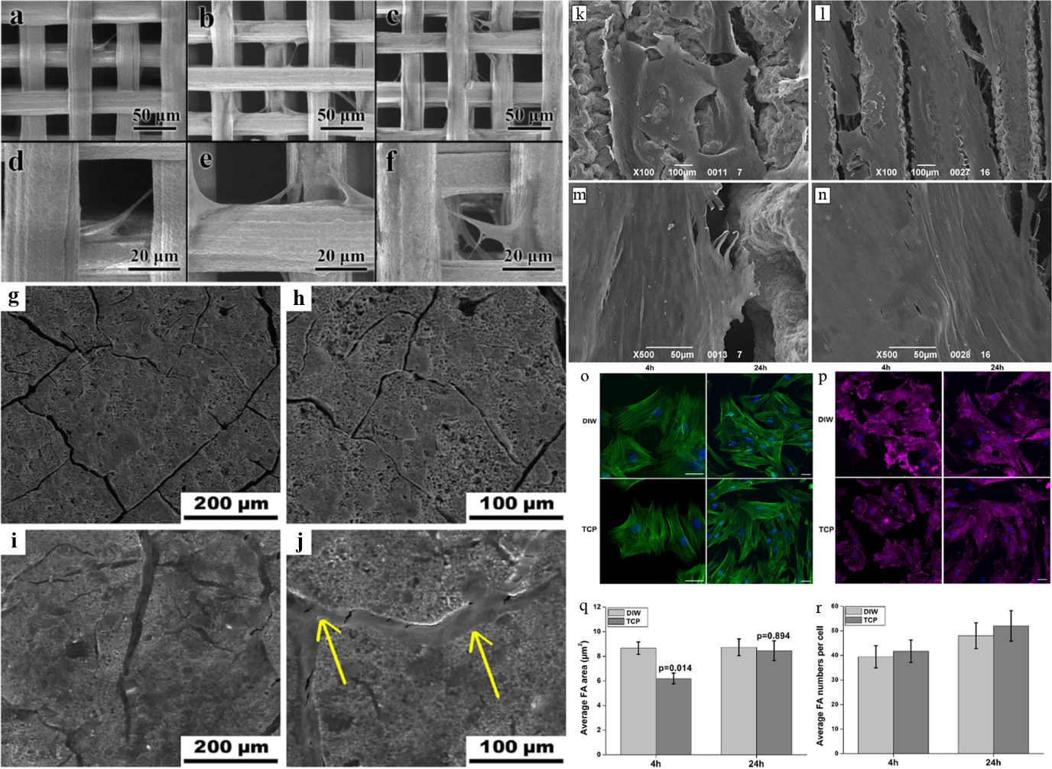
In Ti-alloy and TiO₂ groups DIW products, demonstrations performed by Wang and Elsayed’s team,^{[26a, 33]} when 3D-printed TiO₂ and Sr/Mg-doped hardystonite ceramics were used for cell culturing, respectively. MC3T3-E1 cells almost covered the surface of the 3D-printed periodic TiO₂ bio-ceramic scaffold after five days in-vivo cell culturing, even though the bio-ceramic scaffold was washed at day 1 and day 3 of cell culturing for population analysis. Additionally, adult dermal fibroblasts formed a monomer layer on the monolith surface after 14 days of culturing. Ti-alloy-based DIW scaffold also exhibited strong biocompatibility, such as porous Ti6Al4V scaffold synthesized by Elasyed H’s group and DIW porous Ti by Chen’s group, both of which achieved good cell adhesion for 14 days due to the presence of porous array in the scaffold.^{[51, 53]} The above summarized results are illustrated in Figure 9.^{[26a, 33, 51, 53]}

Figure 9. SEM images of the 3D TiO₂ bio-ceramic scaffold after being incubated with MC3T3-E1 cells for 1 day (a, d), 3 days (b, e), and 5 days (c, f).^{[26a]} (Reproduced with permission, 2018, Elsevier BV) SEM images taken at 500× and 1000× magnification of fibroblasts cultured on Sr/Mg-doped hardystonite ceramics for 7 days (g, h) and 14 (i, j) days. A monolayer of cells covering the surface cracks (yellow arrows) is visible after 14 days from seeding.^{[33]} (Reproduced with permission, 2019, Wiley Interscience) SEM images of fibroblasts seeded on 3D-printed Ti scaffolds after 7 days (k, m) and 14 days (l, n) from seeding.^{[53]} (Reproduced with permission, 2019, Elsevier BV) Evaluation of cell attachment and morphology on DIW porous Ti scaffolds and comparisons to TCP. (o) Cell attachment and morphology using F-actin (green) and nucleus (blue). Scale bar=50 μm. (p) Vinculin expression on hMSCs after 4 and 24 h of culture. Pink (vinculin) and nucleus (blue). Scale bar=50 μm. (q) Quantification of average FA area and (r) numbers per cell (n=30). (For interpretation of the references to color in this figure legend, the reader is referred to the web version of this article.)^{[51]} (Reproduced with permission, 2019, Elsevier BV)

3D printed silicon-based biomaterials such as Si₃N₄ and SiO₂ were popular in biomedical research in recent years. One of the representative examples are bone tissue engineering (e.g. bone substitution and bone regeneration) due to the porous structure of the DIW-printed products and the outstanding properties including hardness, corrosion resistance, fracture toughness, and wear performance.^{[74]} One of the examples is the DIW-printed Si₃N₄ (SN10YAS (in wt%): 90Si₃N₄-4.11Y₂O₃-3.13Al₂O₃-2.76SiO₂) scaffold developed by Saniz et al. ^{[74a]} for bone tissue engineering. High bioactivity of SN10YAS was reflected from the ion release rate in the simulated body fluid (SBF) (release rates of Ca²⁺: 32% (7 days) and P: 56% (7 days)) throughout 28 days study. A stable Bovine Serum Albumin (BSA) layer was deposited onto the SN10YAS scaffold surface for protein adsorption evaluation, which is one of the important parameters for osseous repair and orthopaedic applications.^{[74a]} Justin’s research team demonstrated a DIW application in bone substitution via the hybridization of silica with an organic polymer of methacrylate.^{[74b]} Such DIW-printed inorganic-organic scaffold showed a high bone reconstruction activity via implementing S60 (60% organic content in the SiO₂/organic copolymer (poly(methyl methacrylate-co-3-(trimethoxysilyl)propyl methacrylate)-star) gel ink) scaffold to a mouse with cranial bone defects after 16 weeks of investigation. The S60 scaffold showed new bone tissue formation in the porous structure with a relatively low bone volume/total defect volume (BV/TV) ratio (S60: 12.4% vs control: 19.6%) and higher bone volume/central volume (BV/CV) ratio (S60: ~12.5% vs control: ~9%) as illustrated in Figure 10. The study showed that the porous structure with osteoblast friendly surface in the DIW-printed scaffold likely provided a suitable environment for bone tissue formation.^{[74b]}

Figure 10. A) Representative photograph of critical size calvarial defect (𝜑 8 mm highlighted with yellow dotted line) model in a mouse, and 𝜇CT images of the cranial bone defects: 3D and coronal (2D slice along the red line of 3D image) at 8 and 16 weeks. B) Representative photograph of implantation of S60 scaffold in the calvarial defect, and 𝜇CT images of S60 implanted calvarial defects at 8 and 16 weeks (scale bars: 8 mm): 3D and coronal 𝜇CT images. All the in vivo experiments were conducted on six animals. C) Morphometric analysis of the volume of newly formed bone volume (BV/TV) relative to total skull defect volume (8 mm-sized disk defect). D) Ratio of newly formed bone volume to central volume (5 mm-sized disk defect) (BV/CV) calculated by CTAn program (n = 4, **P < 0.01).^{[74b]} (Reproduced with permission, 2019, Elsevier BV)

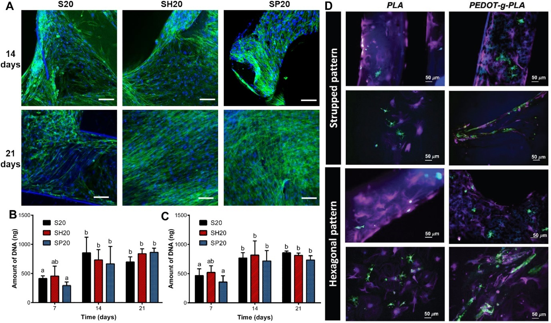
Organic polymers and biomaterial integrated nanocomposites played important roles in biomedical research, including tissue engineering and bioelectronic devices due to their high biocompatibility.^{[17f, 17n]} Some of them even exhibited good electrical conductivity via combining the macromonomer with conductive conjugated polymer throughout the DIW ink preparation.^{[17f]} Low-cost, high resolution, and high reproducibility of the tissue-engineered scaffold with improved mechanical and biological performance via chemical interactions between active ingredients in the DIW ink can be realized.^{[17f, 17n]} A. Dominguez-Alfaro et al.^{[17f]} and D. Mondal et al.^{[17n]} showed high biocompatibility could be achieved throughout the cell culturing with primary ventricular cardiomyocytes (CM) and cardiac fibroblasts (CF) for 7 days ^{[17f]} and 21 days bone marrow mesenchymal stem cell (BM-MSC) culture,^{[17n]} respectively. The representative immunofluorescence images of both materials were illustrated in Figure 11.^{[17f, 17n]} The studies highlighted the possibility of developing novel non-cytotoxic DIW-printed composites for biosensors and bone-tissue repairment.

Figure 11. Cell attachment and proliferation on 3D nanocomposite scaffolds. A) Fluorescence images of cells on the scaffold surfaces. At 14 and 21 days following seeding with osteogenic differentiation media, cells were fixed and labeled for F-actin (green) and DAPI (to label nuclei, blue). Scale bar is 100 μm. Images are representative of multiple fields on each specimen, from 2 independent experiments, each performed using triplicate specimens. DNA contents measured from cell lysates seeded on nanocomposite scaffolds with B) osteogenic differentiation media and C) regular growth media. For panel B–C, data are mean ± SD (n = 12 specimens of each composition from three different experiments). Two-way ANOVA and Tukey's multiple comparison tests were used for statistical analysis. Different lower-case letters indicate statistically significant differences at p < 0.05.^{[17n]} (Reproduced with permission, 2021, Elsevier BV) D) Immunofluorescence images of CM and CFs cocultures grown on printed PLA and PEDOT-g-PLA stripped and hexagonal patterns for 7 d. Antibody staining against 𝛼-actinin (green) and vimentin (pink) label CM and CF, respectively, with nuclei labeled using DAPI (blue).^{[17f]} (Reproduced with permission, 2021, Wiley Interscience)

Owing to the strong biocompatibility of DIW 3D-printed nanomaterials and the convenience of DIW technology than other 3D printing methods (SLA and FDM), some bioengineering materials for medical surgery were further developed via DIW technology. Jakas and Chao’s group made use of 3DG (60 vol% graphene) ^{[26b]} and DIW sintered-metal ^{[31]} to develop the nerve conduit and skull cap and human thigh bones with the help of a computer designation program (Figure 12). The printed 3DG conduit was successfully wrapped around the nerve bundle, and the excessive part of the printed conduit could be removed by surgical shear (Figure 12c).^{[26b]} Skull cap parts can also be produced without collapse (Figure 12d).^{[26b]} Such demonstration showed the advantages of DIW technology for medical surgery applications.

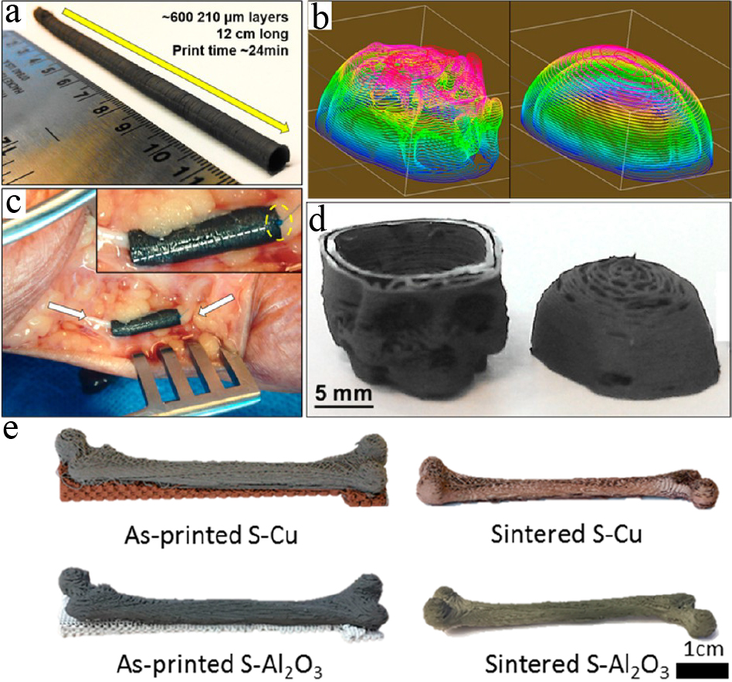

Figure 12. (a) 3DG can be 3D-printed onto structures composed of many hundreds of layers, such as this high aspect ratio (24:1) 5 mm diameter hollow tube, which can be cut to size as needed. (b) Photograph of tubular 3DG nerve conduit cut from (a) what was implanted into a human cadaver via longitudinal transection and wrapped around the ulnar nerve (white arrows). The 3DG nerve conduit was then sutured closed along the previously described longitudinal transection (white dotted line) as well as to the surrounding epinerium and nerve tissue (inset, yellow circle). Excess 3DG nerve conduit length was then cut with surgical shears to expose additional nerve tissue. (c) Digitally sliced STL file of skull and skull cap, and (d) photograph of resulting 3D-printed 3DG skull and skull cap.^{[26b]} (Reproduced with permission, 2015, ACS) (e) Optical images of as-printed and sintered S−Cu and S−Al₂O₃ structures printed as human thigh bones at a scale of 1:7.^{[31]} (Reproduced with permission, 2019, ACS)

3.2. Energy storage and conversion
Energy storage, especially electrochemical energy storage (EES) and energy conversion, is very important for sustainable energy system construction because it can achieve reversible conversion between chemical energy and electrical by allowing electron or ion transfer between electrodes in the devices.^{[2c]} LIBs and supercapacitors, two of the R&D target representatives in the past few decades, can be used with high efficiency from small portable devices ^{[2e]} to large electric vehicle engine ignition systems.^{[2c]} Although US Defense Logistics Agency stated that currently used LIBs and supercapacitors cannot provide high energy and power density simultaneously,^{[2c]} the use of 3D material frameworks for such EES can maximize battery performance (power and energy density) in short ionic paths, especially nanostructures and hierarchical porous materials like graphene-based materials.^{[2e]}
Although they are attractive materials for EES and energy conversion, and shape- and size-scalable bulk monolith can be synthesized by a suitable shape reactor ^{[4]} or NF as template after a simple soaking plus chemical reduction,^{[7a, 7b, 75]} several shortcomings still exist as a barrier to further development using traditional technology. For example, a complicated process is necessary for nanocatalytic electrode fabrication, and the original structure may be destroyed during ultrasonication. Importantly, such a process requires the use of a surfactant to stabilize the electrocatalyst on the support surface, especially 3D structured products. Some supports like NF may also have potential problems for catalytic activity exhibited from the support itself, which makes it difficult to estimate the truth activity of the electrocatalyst. Using traditional hydrothermal or mild chemical reduction method to synthesize large-sized customized GA-derivative electrodes is difficult due to the requirement of a specific reactor with desirable size,^{[4-5]} resulting in high production cost. The contraction in product size also occurs due to the surface tension of the reaction mixture exhibited in the GA products throughout the self-assembly process. All these shortcomings may lead to actual activity not being reflected in the operation and limit the value of binder-free GA-based green energy materials for large-scale production and real device-level application. The application of 3D printing can eliminate the mentioned weakness and achieve the size- and shape-scalable production of bulk freestanding electrode synthesis without specific size and shaped reactors. Given that SLA has the problem of a time-consuming printing process ^{[12a]} and requires the use of photochemical resins,^{[12b]} FDM requires the use of market-available filaments or complicated filament belt synthesis prior to the printing process,^{[13a, 13d]} and the secondary spray process is needed which possibly reduce electrochemical activity. By contrast, DIW only needs the use of sol-gel ink directly, which can achieve simple and production.^{[2a, 23]} The gel ink itself can also be produced by mixing the supporting nanomaterials with the electrocatalyst, and the activity is maximized by increasing the electroactive surface area.
DIW 3D-printed nanomaterials monoliths played an important role in energy storage and energy conversion research, including LIBs,^{[2a, 17a, 17c, 17g, 17j, 34]} supercapacitors,[17m, 20, 22, 26f, 29, 35, 38, 73] and photocurrent production.^{[58a]} Carbon-based products are the majority group among these materials (carbon aerogel (CA);^{[35]} pure GA;^{[2a, 38]} CNT/GA;^{[22]} polymer/GA;^{[26f]} foreign materials loaded 3D printed graphene aerogel/MnO₂ [3D G/MnO₂, MOG]; NiO or MnO₂ loaded integrated graphene network (IGF) [NOG, MOG];^{[20, 73]} polymetallic oxide loaded GA ^{[29]}). Other examples of 3D-printed ZnO-based monolith (Al-doped ZnO (AZO)) ^{[58a]} and organic polymer of PEDOT ^{[17j]} are reviewed in the following sections.

3.2.1. Supercapacitor
DIW carbon-based (GA, carbon aerogel, multi wall carbon nanotubes (MWCNT)) products played an important role in the supercapacitor. They exhibited strong electrical conductivity (71.5-225 S m⁻¹),^{[21-22, 26f, 29]} high specific capacitance (4.79-262 F g⁻¹) and operation stability up to 1,000-50,000 cycles of operation.^{[17m, 20, 22, 26f, 29, 38, 73]} These were reflected in the cyclic voltammetric results in the electrochemical performance study carried out by Tang’s group and Zhao’s group, respectively (Figure 13).^{[26f, 29]} Tang’s team carried out the performance test by assembling the 3D-printed GA electrode into a CR2032 battery.^{[26f]} Zhao’s group demonstrated the ability by using hybrid aerogel microlattice built up from directly combining G/ZnV₂O₆@Co₃V₂O₆ (positive) and G/VN (negative) electrodes (Figures 13e-j).^{[29]} CV and specific capacitance measurements of the mentioned systems exhibited excellent performance with high stability (Figures 13c-d, 13f-j).^{[26f, 29]} A comparison of the systems with those involving the GA-based materials synthesized by the traditional method (Table 4) showed that 3D-printed GA products have comparable activity and are new stars as replacement materials of synthesized GA by traditional method in energy storage application. Besides graphene-based DIW prodcuts, DIW activated CA (ACA) developed by Chandrasekaran et al. ^{[35]} exhibited strong activity, as reflected by the high output capacitance with values of 215 F g⁻¹ compared to those of bulk CA discs (57 F g⁻¹) due to the large surface area with large porosity exhibited from DIW ACA. DIW-printed MWCNTs/AC/BNNTs ternary composite materials exhibited a high specific capacitance of 262 F g⁻¹ with high stability in 1000 cycles operation (specific capacitance retention: 95.4%), which was attributed to the improved electrical double layer capacitor (EDLC) behaviour, as shown in Figure 14.^{[17m]}
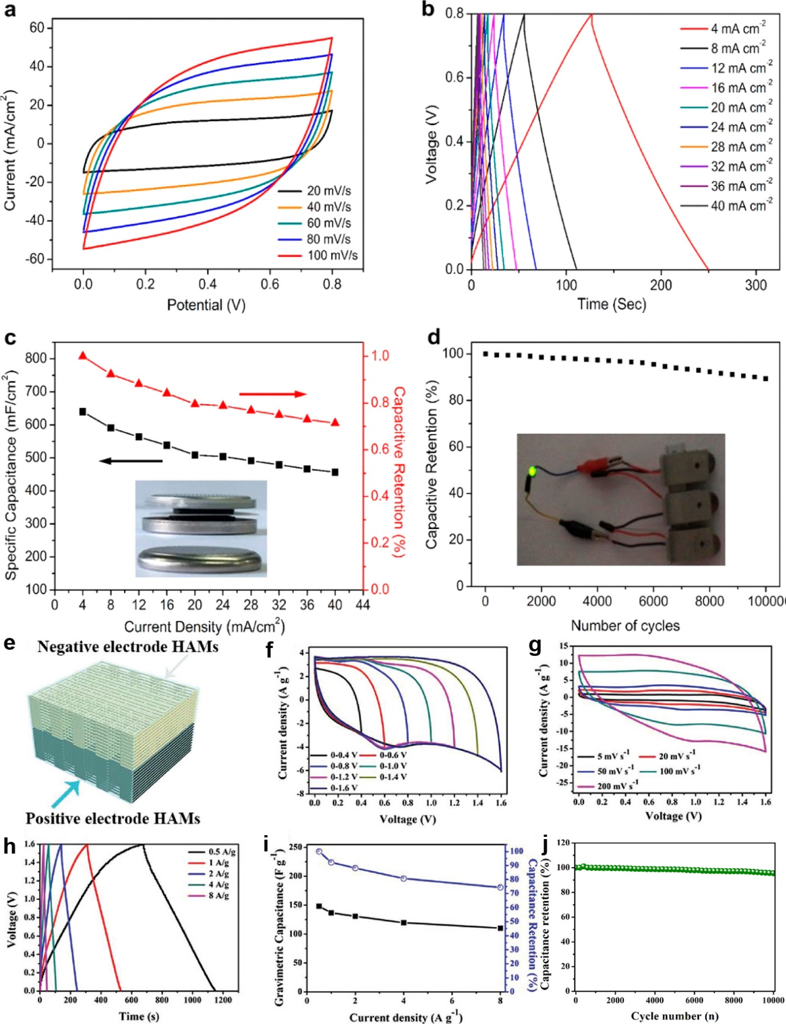
The summarized results in Table 4 indicate that DIW showed comparable activity to materials synthesized via traditional reactions, making them attractive materials for further EES development.

Figure 13. Electrochemical performance of the coin-type symmetric microsupercapacitors. (a) CV curves collected at scan rates of 20−100 mV s⁻¹ in 6 M KOH electrolyte. (b) GCD proﬁles collected at current densities from 4 mA cm⁻² to 40 mA cm⁻². (c) Areal capacitance and capacitive retention versus diﬀerent areal current densities (4-40 mA cm⁻²). The inset shows optical images of the device before and after assembling. (d) Cycling stability measurements. The inset shows an optical image of a green LED lighted by three coins connected in series.^{[26f]} (Reproduced with permission, 2018, ACS) Assembled 3D-printed electrochemical supercapacitor device. (e) Schematic of the assembled structure of the device. (f) CV of the assembled device measured for different voltage windows. (g) CV curves of the assembled device at various scan rates. (h) GCD curves of the assembled FASCs at different current densities. (i) Rate capability. (j) Cycling stability of the assembled device.^{[29]} (Reproduced with permission, 2019, Wiley Interscience)

Figure 14. Schematic diagram showing the improved and rich electrical double layer capacitor (EDLC) behavior of the printed MWCNTs/AC/BNNTs ternary composite material.^{[17m]} (Reproduced with permission, 2021, MDPI)

Table 4. List of energy storage materials involving the use of DIW 3D printed materials against traditional materials.
DIW supporting materials | Materials | Synthesis method | Specific capacitance (F g⁻¹) | Stability (Depreciation) | Year | Ref
Graphene | G-Gel/NF EC | Chemical reduction | 0.0456 (F cm⁻²) | 10000 cycles (10% @100 A m⁻²) | 2012 | ^{[7b]}
 | GAMs (3DGC-1 (300 µm)) | 3D printing (DIW) | 213 | 50000 cycles (10% @10 A g⁻¹) | 2018 | ^{[38]}
 | GCA@NF | Chemical reduction | 207 | 2000 cycles (20% @10 A g⁻¹) | 2013 | ^{[7a]}
 | Graphene/MWCNT MDHA | 3D printing (DIW) | 27 | 10000 cycles (10%) | 2018 | ^{[26f]}
 | PANI@3DGFs | Hydrothermal, electrochemical deposition | 932 | 5000 (29.8%) | 2015 | ^{[76]}
 | PANI_{0.4}/RGO | 3D printing (DIW) | 423 | 1000 cycles (25%) | 2018 | ^{[22]}
 | 3D-NiGOM | Sol-gel reduction | 1186 | 1000 (22%) | 2015 | ^{[75b]}
 | 3D G/MnO₂ | 3D printing (DIW) | 239 | 20000 cycles (7.1% @2 mm) | 2019 | ^{[20]}
 | MOG | 3D printing (DIW) | 121 (F cm⁻²) | 10000 cycles (13.4%) | 2019 | ^{[73]}
 | NOG | 3D printing (DIW) | 400.3 | 10000 cycles (13.9%) | 2019 | ^{[73]}
 | ZnV₂O₆@Co₃V₂O₆/GO | 3D printing (DIW) | 149.71 | 10000 cycles (4.5 %) | 2019 | ^{[29]}
Carbon | CA-D-1 (1 mgmL⁻¹ lingin) | Drop-freezing | 120 | 10000 cycles (2.6%) | 2019 | ^{[77]}
 | Lignin/cellulose carbon aerogel C-10 (10 wt% cellulose) | Stirring | 166 | 1000 cycles (~1.4%) | 2019 | ^{[78]}
 | DIW ACA (resorcinol–formaldehyde) | 3D printing (DIW) | 215 | N/A (17%) | 2018 | ^{[35]}
Carbon nanotubes | MWCNTs/AC/BNNTs | 3D printing (DIW) | 262 | 1000 cycles (~5.4%) | 2021 | ^{[17m]}

3.2.2. Lithium ion battery (LIBs)-based system
Compared to supercapacitors, reports on the application of DIW products in an LIB-based system are relatively few. Among the products, GA,^{[2a]} graphite,^{[17c]} and lithium-based nanostrcutures (LiFePO₄ (LFP),^{[34]} LiFePO₄/MWCNT,^{[17a]} Li_{1.3}Al_{0.3}Ti_{1.7}(PO₄)₃ (LATP),^{[17g]} LFP-PEDOT-CMC^{[17j]}) were the major target of study via battery fabrication (2016-coin cells,^{[17a]} CR2025,^{[17c]} CR2032,^{[2a, 17j]} or self-designed ^{[34]}). Performance exhibited from those materials were strong which reflected from the recorded discharge capacity (133-460 mAh g⁻¹) ^{[17a, 17c, 17j, 34]} and capacity rentenion (70.83-92%) after 60-500 cycles of investiagtion,^{[17a, 17c, 17j]} which summarized in Table 5. The demonstration by Lacey et al. ^{[2a]} showed that the DIW reduced-holey GO (r-hGO) cathode-driven Li-O₂ battery (CR2032 battery) exhibited strong total capacity of 3879 mA h g⁻¹ compared with that fabricated from vacuum-filtered hGO films (Total capacity=92 mA h g⁻¹) (Figure 15a). In addition, Wei et al. ^{[34]} demonstrated the full assembly of LIB devices with multimaterials via stepwise DIW process (Figures 15b-c). The printed LiFePO₄/Li4Ti₅O₁₂ (LFP/LTO) Swagelok cell showed strong activity of 4.45 mAh cm⁻² (packed) to 14.5 mAh cm⁻² (unpacked) output areal capacity (Figures 15d-e) and high stability throughout 25 cycles of operation when 0.1 mm electrode was used in the battery.^{[34]} Above mentioned demonstration ^{[34]} showed the alternative advantage of DIW in terms of unleashing the power of DIW in the energy storage device manufacturing, where the direct manufacture was carried out instead of the traditional pathway of building up the device after printing individual parts via DIW method.
Different shapes of DIW-printed LATP-based solid-state electrolyte for LIBs was demonstrated, exhibiting a high discharge capacity of 150 mAh g⁻¹ with a high capacity retention of 84% throughout 100 cycles in coin cell operation, as illustrated in Figure 16.^{[17g]} The electrical conductivity of the printed electrolytes were similar with different shapes (Rectangle: 4.24×10⁻⁴ S cm⁻¹, T: 4.05×10⁻⁴ S cm⁻¹, L: 4.17×10⁻⁴ S cm⁻¹, +: 3.95×10⁻⁴ S cm⁻¹).^{[17g]} This study shows the potential of developing next-generation customed-made electrochemical energy storage system via DIW technology.
Monitoring of LIBs safety is another important issue. Volatile organic species including C₄H₁₀O₂, C₃H₆O₃, 1,2-dimethoxyethane, dimethyl carbonate, C₄H₈O₃ could be released during the failure of LIBs (in portable computers, mobile phones, hybrid vehicles and electric vehicles (EV)). LIBs gas sensors could be developed via DIW technology because of the potential of fabricating multiple sensors in a single monolith structure.^{[72]} DIW-printed heterostructure of Al₂O₃/CuO and CuO:Fe₂O₃ showed a high response to the volatile organic species commonly found in failed LIBs. The gas response (%) for dynamic sensing of C₃H₆O₃ and LiNO₃ by Al₂O₃/CuO and CuO:Fe₂O₃ heterostructures was up to 28% and 45%, respectively, as shown in Figure 17. The improved response was attributed to the increase in the surface/volume ratio of the interconnection between Al₂O₃ and CuO in the DIW heterostructure.^{[72]} It is expected that DIW-printed LIBs with gases sensors for continuous monitoring of the battery life can be a future research direction in EV markets.
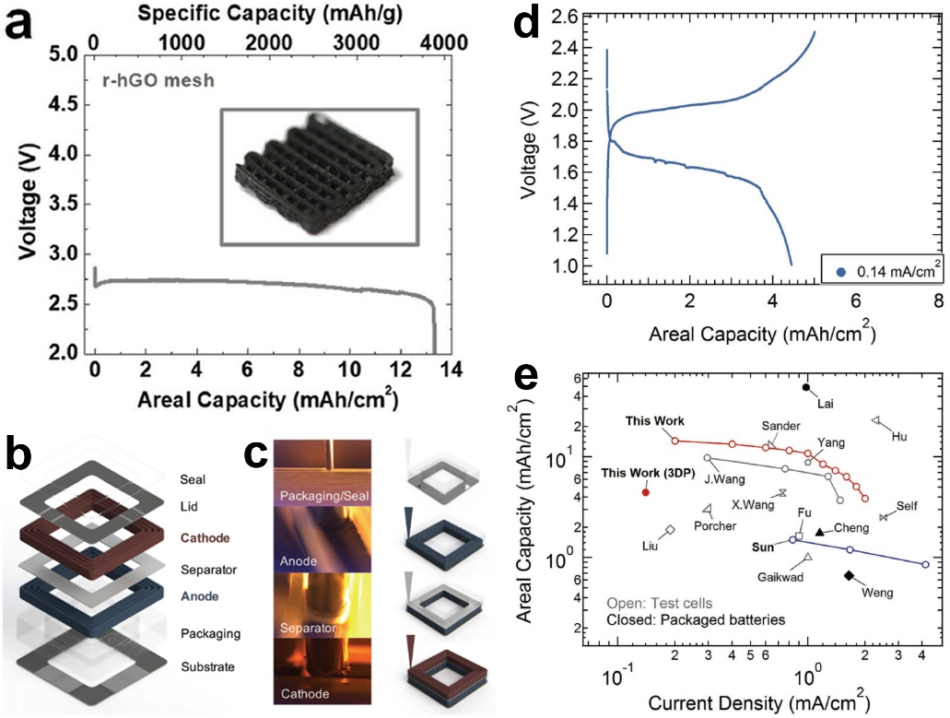

Figure 15. Electrochemical performance and post-characterization of 3D printed Li–O₂ cathodes comprised of hierarchically porous r-hGO mesh architectures. (a) Deep discharge performance of the r-hGO mesh, which demonstrates the hierarchical porosity of the 3D-printed mesh cathode. Note that the specific capacity reported in (a) is the mA h g⁻¹ sample not the mA h g⁻¹ carbon.^{[2a]} (Reproduced with permission, 2018, Wiley Interscience) (b) Schematic representation (expanded view) of fully 3D-printed Li-ion square cell battery with outer dimensions of 1 cm×1 cm×2.5 mm and inner hole dimensions of 6 mm×6 mm. (c) Images (left) and schematics (right) of direct writing of four functional (cathode, separator, anode, and packaging) inks. (d) Voltage as a function of areal capacity (2nd cycle) at 0.14 mA cm⁻² for the fully printed and packaged 3DP LIBs composed of ultrathick biphasic LFP and LTO electrodes, UV-cured composite separator, UV-cured composite packaging, and glassy carbon current collectors. (e) Ragone plot comparing areal capacity versus current density for the LFP/LTO Swagelok cell with 1 mm-thick electrodes and the fully printed and packaged 3DP LIBs to reported literature values [Note: Open symbols denote areal capacity values per electrode obtained on test cells; closed symbols denote areal capacity values per battery for fully packaged batteries.].^{[34]} (Reproduced with permission, 2018, Wiley Interscience)

Figure 16. a) Schematic of DIW of LATP-based HSSE. The inset is the photograph of obtained ink. b) Photograph of LATP-based HSSEs with various geometries. c) SEM image and d) TG curve of LATP-based HSSE. e) Cycling performance at 0.5 C and f) rate performance of LFP/LATP-based HSSE/Li battery.^{[17g]} (Reproduced with permission, 2021, Wiley Interscience)

Figure 17. Dynamic response to 100 ppm vapor for the 3D printed copper and iron oxide sensors to: (a) C₃H₆O₂; and (b) LiNO₃ or E1.^{[72]} (Reproduced with permission, 2021, MDPI)

Table 5. List of selected DIW 3D printed materials-based electrode driven LIBs.
DIW supporting materials | Material | Cell type | Specific capacitance (mAh g⁻¹) | Stability (Retention) | Year | Ref
Lithium | LiFePO4/MWCNT | 2016-coin cell | 107 | 500 cycles (80%) | 2021 | ^{[17a]}
 | LFP-PEDOT-CMC | CR2032 | 141.2 | 100 cycles (92%) | 2021 | ^{[17j]}
 | LiFePO4 (LFP) | Self design | 133 | N/A | 2021 | ^{[34]}
Graphene aerogel | DIW r-hGO | CR2032 | 3879 | N/A | 2021 | ^{[2a]}
Carbon | 1500 mesh flake graphite powder | CR2025 | 460 | 60 cycles (70.83%) | 2021 | ^{[17c]}

3.2.3. Photocurrent production
Relative to the huge effort on energy storage research (Tables 4 and 5), the investigation on energy conversion is relatively in low proportion. One example was the photocurrent generation from DIW-printed AZO carried out by Arango et al.,^{[58a]} who showed that AZO with 15% Poly(vinylpyrrolidone) (PVP) generated 2.36×10⁻⁵ A photocurrent upon 1 mWcm⁻² UV light irradiation in the MSM device, as illustrated in the I–V curve in Figure 18.^{[58a]} Such result showed the potentials of freestanding DIW nanomaterials monoliths as direct electrodes for energy storage research.

Figure 18. Semi-log plot of dark and UV-illuminated I–V characteristics of MSM device based on AZO films. Inset shows the linear plot.^{[58a]} (Reproduced with permission, 2017, IOP publishing)

3.3. Environmental pollutant reduction
3.3.1. Air pollutant control
The removal of air pollutants, such as volatile organic carbons (VOCs) ^{[46]} and nitric oxide (NO_{x}) ^{[17d, 17l]} are hot topics in environmental research because VOCs are major sources of indoor air pollution, while NO_{x} is major pollutant in exhaust gas produced from the conventional internal engine combustion in powerplant and automotive.^{[17d, 17l]} Both of them resulting in adverse effects on human health.^{[79]} The use of a suitable catalyst or absorbent is a solution to these problems, with highly porous honeycomb structure as the best catalytic support due to its large surface area, high strength, and high temperature resistivity.^{[27a]} However, synthesizing the honeycomb via the traditional method involves a complicated and high-cost process.^{[27a]} By contrast, DIW allows the fast synthesis of complicated structures, including the honeycomb.^{[27a]} Some materials like TiO₂ also allow the production of rheological ink for DIW with strong photocatalytic activity.^{[26j]} As a result, the development of high-porosity honeycomb ceramic scaffold via the DIW method has become a popular way to create powerful air filters ^{[46]} or adsorbents for pollutant removal.^{[27a]}
DIW 3D-printed nanomaterials monolith have been attractive candidates as environmental pollutant removal catalysts since the early 2010.^{[26j, 27a, 30, 46, 49, 71]} It is because they are different from the traditional powder-type environmental catalyst that requires post-treatment like ultrasonication to disperse the catalyst on the secondary platform. On the contrary, the 3D printed one can be used directly and shows strong flexibility in the material design, hence the improvement of mass transfer and heat transfer.^{[27a]} These materials also showed comparable activity to the corresponding materials synthesized by the traditional method.^{[30]}
TiO₂-based and clay-based DIW-printed monoliths were highly capable for gaseous phase ^{[26j, 30, 46]} environmental pollutant removal with different technologies. In gaseous pollutant removal, the demonstration carried out by Yoram de Hazan et al. ^{[30]} in 2012 showed that TiO₂-functionalized 3D-printed Al₂O₃ has strong activity in the photocatalytic formaldehyde decomposition, which was comparable to that of traditional TiO₂ powder. However, no concrete experimental results could be observed to prove their activity.^{[30]} In later days, the demonstration from Elkoro’s group showed that DIW pure TiO₂ monolith exhibited strong activity in gaseous pollutant removal because it achieved strong photocatalytic activity in the removal of gas phase acetaldehyde under UV-light source with the percentage conversion of 40%-58% (from 5000 ppmv to CO₂).^{[26j]} Chemically modified clay-based DIW products are also excellent catalysts for VOC removal. The hexagonal-shaped DIW palladium (Pd)-modified cordierite clay (2MgO·2Al₂O₃·5SiO₂) honeycomb array developed by Pan et al. ^{[46]} achieved the lowest T-90 value (temperature for achieving 90% conversion of toluene) of 500K. A possible reason is that a hexagonal array provided a larger active surface area than other shapes (square and round pore array) in the same group of DIW materials under similar pore size.^{[46]} Such properties can make the array load more like a catalyst for activity enhancement.^{[46]}
Zeolite (e.g. ZSM5) ^{[17d]} and attapulgite (ATP) ^{[17l]} based catalysts were widely used in NH₃-SCR for NO_{x} reduction. DIW-printed catalysts with monolith structures could be a cost-effective approach ^{[17d]} and the structures show high mechanical stability and good cyclability of the catalytic process. For example, DIW-printed Mn-Ce-Fe/ATP (as shown in Figure 19^{[17d]} ) exhibited high activity in NO_{x} reduction at low-temperature ranges of 100-400 ℃, achieving high NO conversion (90-100%) and N₂ selectivity (70-100%) under high gas hourly space velocity (GHSV) of 2000 h⁻¹.

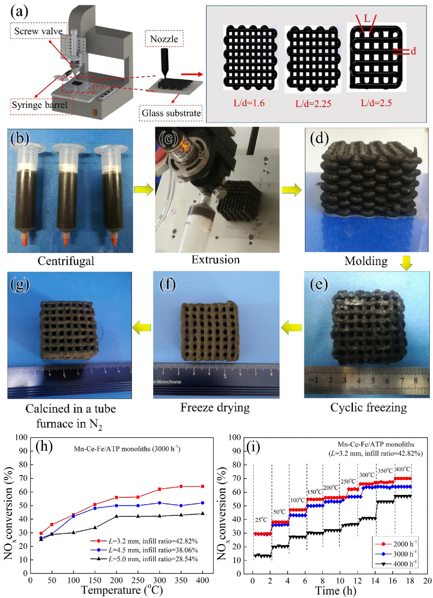

Figure 19. (a) Schematic diagram of the printed the Mn-Ce-Fe/ATP monolithic woodpile structure and (b-g) Mn-Ce-Fe /ATP monolithic catalyst’s formation process. (h) The corresponding NO_{x} conversion for Mn-Ce-Fe/ATP monoliths, (i) the NO_{x} conversion at different GHSV.^{[17l]} (Reproduced with permission, 2021, Wiley Interscience)

3.3.2. Water pollutant removal
3.3.2.1. Photocatalytic water pollutant decomposition
The removal of methylene blue (MB) is hot topics in environmental research because MB has a serious impact on the aquatic environment,^{[27a]} TiO₂-based DIW products showed strong capability in liquid phase reactions.^{[27a, 49, 71]} The demonstration from Liu’s group (Figure 20) and Arango (Figure 21) showed strong activity and advanced points in the dye removal driven by bulk TiO₂-based monolith catalyst,^{[27a, 49]} where the bulk monolith could be used without pre-treatment throughout the research, as shown in Figures 20a and 21f.^{[27a, 49]} L75-S3-O22-based photocatalyst developed by Arango et al. ^{[27a, 71]} showed the strongest activity in the UV-light catalyzed MB photodecomposition as illustrated in Figure 21. Open-cell structured L75-S3-O22 monoliths achieved better performance in terms of kinetics compared to close-cell structured L75-S5.5-O19.5-based monoliths owing to the (1) strongest reaction kinetics recorded throughout the 200 min reaction among all candidates versus the blank (Figures 21a and 21c),^{[27a, 71]} and the (2) color intensity of MB was the lowest among all the treated samples after 200 min photodecomposition when compared to the blank MB solution (Figure 21b).^{[27a]} The most possible reasons for the strong activity were (1) the effective circulation of the dye solution to the photocatalytically active site in the foam and (2) the improved diffusion of light within the larger open-cell foam structure of the catalyst.^{[27a]} Another MB removal demonstration carried out by Liu’s group via adsorption-desorption method according to the illustration in Figure 20 showed that the microporous DIW TiO₂ (NPCR-350 printed) monolith exhibited the best performance (Figure 20b). This outcome is attributed to the best MB removal rate being achieved by the NPCR-350 printed with the value of 86.2% after five times (2 h every time) of recycled MB removal. This value is approximately 40% to 200% higher than other NPCR structures (NPCR-350 pellet and NPCR-0 printed).^{[27a]} Importantly, the monolith remained unchanged after the liquid phase MB adsorption with the complete removal of MB’s color.^{[27a]} Such result benefited from the porous monolith structure with large contact area with dye in the presence of the SiO₂ particles used in the sol-gel ink preparation stage.^{[27a]} The above demonstrations showed strong potential of the freestanding porous DIW monolith for environmental pollutant reduction in the future.

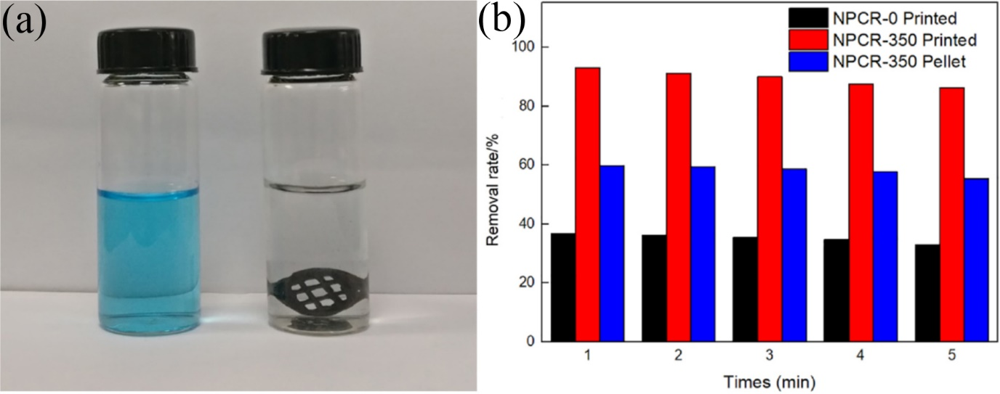

Figure 20. (a) Color change of the MB solution before and after the adsorption by NPCR-350. (b) Removal ratio of MB with increasing absorption-desorption cycles.^{[27a]} (Reproduced with permission, 2019, Elsevier BV)
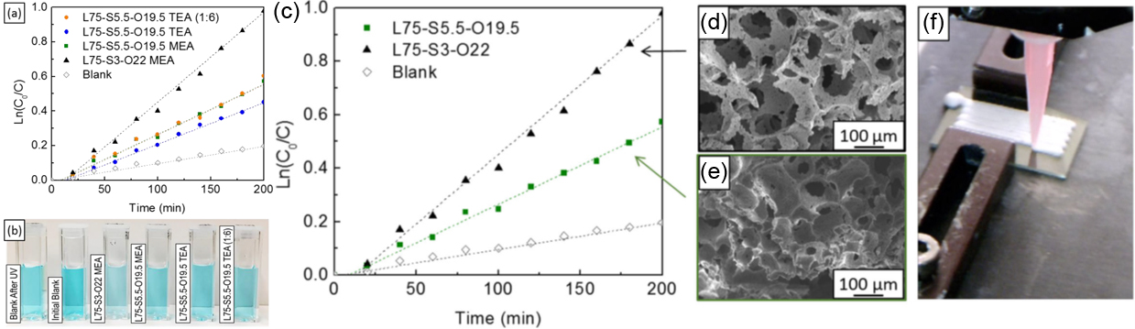

Figure 21. (a) Linearized methylene blue (MB) concentration change in time, undergoing heterogeneous photocatalytic degradation in the presence of different TiO₂ foams under UV light exposure at λ=254 nm. (b) Photograph of cuvettes with degraded MB solutions after 200 min of UV exposure.^{[49]} (Reproduced with permission, 2017, ACS) (c) Linearized MB concentration change in time, undergoing heterogeneous photocatalytic degradation in the presence of the (d) open-cell (L75-S3-O22) and (e) closed-cell (L75-S5.5-O19.5) TiO₂ foams, upon UV light of λ=254 nm. (f) Photograph of TiO₂ foam while being printed (printed area 1 cm×2 cm) (Adapted with permission from.^{[49]} Copyright 2017 American Chemical Society).^{[71]} (Reproduced with permission, 2018, IOP publishing)

3.3.2.2. Radioactive pollutant reduction and oil/water separation
Aquatic pollution caused by radioactive waste (e.g. uranium (U) VI) ^{[17b]} and oil spillage ^{[17k]} from the oil drag were other major problems. In particular, after the large scale nuclear wastewater leakage from Fukushima nuclear plant due to the Pacific Ocean earthquake in 2011, and some oil extraction drag accidents or oil trunk accidents randomly took place in the world. The development of suitable adsorbents or filters with large active surface area and high selectivity for cleaning the pollutants are significant. Traditional materials for such purposes suffer from the problem of dense structure which may result in a reduction in active surface area.^{[17b]} Free-standing monoliths synthesized by conventional methods (e.g. hydrothermal reaction) have the additional problem of size and shape limitation owing to the reactor used in the fabrication.^{[4]} DIW technique offers a wide range of printable materials at a large scale for such applications.^{[17k]}
Carbon-based materials (e.g. organic polymer, graphene, etc) are suitable for adsorbing the pollutants because of abundant, tunable functional groups, large specific surface area,^{[17b]} and superhydrophilicity.^{[17k]} DIW-printed 3D reduced graphene oxide/ethylenediamine (rGOE) hybrid structure was developed for continuous U(VI) removal from simulated radioactive wastewater (Figure 22). This monolith demonstrated a high U(VI) removal activity with a high adsorption capacity of 908 mg g⁻¹ at pH 5.8 in the mixture of metal ions (Cu(II), Co(II), Cd(II), Mg(II), Ca(II), Sr(II), Cs(I), K(I), Na(I)) wastewater. The adsorption rate can be maintained after prolonged adsorption/desorption operation of 11 cycles with a decay rate of <3.8%, and the monolith remained in shape and the interior structure was not damaged (Figures 22c-e).^{[17b]}
Thin DIW-printed PVA/cellulose acetate/silica (PVA/CA/Si) composite membrane (CP (4)-14: 28% CA/PVA (85:15), 14% SiO₂) showed high activity in oil separation (e.g. diesel, n-hexane, vegetable oil, lubricating oil) from wastewater with separation efficiency (rejection %) close to 100% under high flux condition of 2.75×10⁶ L m⁻² h⁻¹ (Figure 23).^{[17k]} The separation efficiency was not declined (maintained ~99%) upon change of pH in oil/water system (pH 1, 7, 13) and even under oil/seawater sample (Figure 23D).^{[17k]} Such good performance was attributed to the superhydrophilic and underwater superoleophobicity of the modified cellulose acetate membrane,^{[17k]} highlighting the potential use of DIW based membrane for industrial sewage treatment.

Figure 22. (a) Schematic setup of cyclic experiments for U(VI) adsorption and recovery. (b) Mechanism illustration of U(VI) adsorption-desorption on rGOE sheet. (c) Cyclic adsorptionedesorption performance over 10 cycles. (d) Optical photographs of 3D rGOE sample before and after cyclic adsorption. (e) SEM morphology of 3D rGOE after 11 adsorption cycles. (f, g) EDS mappings of U and Cl. The inset shows the SEM image of the concentrated uraniferous compounds. (h) Selectivity of 3D rGOE for U(VI) compared to Cu(II), Co(II), Cd(II), Mg(II), Ca(II), Sr(II), Cs(I), K(I), and Na(I) in simulated wastewater. (A colour version of this figure can be viewed online.)^{[17b]} (Reproduced with permission, 2021, Elsevier BV)

Figure 23. Separation process of CP (4)-14 membrane for (A) diesel oil/water mixture, (B) n-hexane/water mixture (n-hexane was marked with Sudan III), (C) Separation efficiency and water flux of CP (4)-14 membrane with different pore size for various oil/water mixtures, (D) Separation efficiency of CP (4)-14 for oil/water mixture with different pH.^{[17k]} (Reproduced with permission, 2020, Elsevier BV)

3.3.3. Water filter for freshwater application
DIW-printed dehydrofluorinated PVDF (dPVDF) microfiltration membrane ^{[17i]} such as dP30 (dPVDF+PVP (30wt% with respect to dPVDF)) showed comparable activity in pure water flux (dP30: ~4300 L m⁻² h⁻¹ vs commercial PVDF: 6300 (FG (0.3 µm pore))-8100 (FH (0.5µm pore)) L m⁻² h⁻¹). Compared to the commercial PVDF membrane, dP30 membrane showed strong tolerance in a caustic environment (1M NaOH) over 4.5 h (270 min), showing almost zero damage to the fibre in the microfiltration membrane (Figures 24a-f); and a low increase in the relatively pure water flux (relative J_{w}) (Figure 24g). Such results are crucial to further developing DIW-printed dPDVF membrane in the industrial freshwater filtration system.

Figure 24. Changes in physical appearance and morphology of (a & d) dP30, (b & e) PVDF commercial (FG), and (c & f) PVDF commercial (FH); and (g) Relative J_{w} of the membranes with respect to exposure time in 1 M NaOH. Scale bars: 20 mm (top, a-c), and 10 μm (bottom, d-f).^{[17i]} (Reproduced with permission, 2021, Elsevier BV)

4. Challenges and Perspective
DIW-printed products showed strong activity and potential in applications, including biomedical,^{[17f, 17n, 26a, 26b, 33, 74]} energy storage and conversion,[2a, 20, 22, 26f, 29, 35, 38, 58a, 73] and environmental pollutant reduction.[17d, 17l, 26j, 27a, 30, 49, 71] Size- and shape-scalable honeycomb monolith array can also be achieved by this method (Figure 4).^{[14b, 15, 26e, 27a, 27b]} Such technology still faces several challenges in its further development. First, some of the reviews proposed that DIW-printed products have the potential problem of weak mechanical strength due to (1) the “bottom-up” layer-by-layer filament stacking assembly for extrusion-based DIW 3D printing process ^{[80]} as well as (2) the physical crosslink interaction (i.e., ionic, π–π interaction, hydrogen bond, Van del Waal forces, etc.) between the gel precursors in nature.^{[24c]} These conditions may lead to difficulty in handling and their overall performance in prolonged operation.^{[24c]} Consequently, further applications of the DIW monoliths may be inhibited, especially the hybrid materials of gel (precursor support plus catalyst) ink printed DIW constructs. Synthesis of the DIW printable ink via the use of crosslinker (lactose, cellulose, silica, polyvinyl alcohol (PVA), polyvinyl butyral (PVB), PVP, starch, etc.) [20, 22, 26f, 27a, 34, 49, 58a, 71, 73] can ensure the printable ink has the proper rheological property and enhanced mechanical properties of the DIW-printed products via the creation of a chemical crosslink (covalent bond) between crosslinker and sol-gel precursors. Although this approach is beneficial to the biomedical applications reviewed by Malda et al.,^{[24c]} it is barrier for catalytic applications. As the active catalytic sites in the DIW energy storage electrodes would be blocked by the additives (crosslinkers), the contact between reactants and loaded catalysts in the DIW monolith array may be inhibited.^{[26f]} The removal of additives is a harsh process, and the intrinsic physiochemical properties of functionality in the monolith will be altered.^{[26f]} Moreover, covalent crosslinked DIW products are printed from macromolecular precursor sol-gel in some of the reviews,^{[24c]} and nanomaterial precursor sol-gel DIW inks have not been explored yet to the best of our knowledge. Second, binder-free electrode materials have the following advantages: (1) ability to increase the specific capacity and conductivity of the electrode compared to those requiring the use of non-conductive and active binders; (2) electron transfer inside the electrode can be strengthened with the help of interconnected or stacked graphene nanosheets throughout self-assembly, which form a strong conductive and robust network; and (3) effective contact between electrolyte and electrode interface owing to the large specific surface area of the electrode resulting in the reduction of the diffusion resistance.^{[81]} Combining the convenience of the binder-free DIW printable gel ink from pure nanomaterials ^{[19]} and the mentioned advantages of binder-free electrochemical materials makes it possible to fully unleash the activity of the free-standing DIW-printed monolith electrode for energy storage by directly mixing the catalyst with supporting materials in the gel ink prior to the printing step. Although there are binder-free DIW monolith examples like 3D-printed catalyst loaded GA monolith (ruthenium-loaded reduced 3D-printed holey graphene oxide mesh [Ru/r-hGO mesh], 3D G/MnO₂, NOG and MOG), they are synthesized by a complicated two-step synthesis via soaking the as-printed r-hGO mesh into the metal solution, which is followed by chemical reduction ^{[2a]} or electrodeposition of MnO₂ or NiO to the DIW GA.^{[20, 73]} Catalysts only concentrate on the monolith surface,^{[2a, 20, 73]} which may waste the interior structure of nanopores. Furthermore, printable gel inks must have reasonable rheological properties as mentioned previously.^{[19]} Compared to the large input in pure nanomaterials DIW monolith, the effect of adding foreign materials to the rheological properties of hybrid ink has not been fully explored yet to the best of our knowledge.^{[29]} As a result, the best quality of DIW printable catalyst/nanomaterial hybrid gel ink remains unknown. Third, relative to extensive study on the printability of DIW inks’ properties, studies on the basic properties of DIW-printed monoliths are few in terms of the summarized data (Tables 2 and 3). Thus far, the mechanical strength of DIW monoliths has been carefully investigated, whereas some important characteristics, including electrical conductivity or resistivity and porosity, have been rarely studied. Such studies were also limited to few groups of materials, including graphene and ZnO-based products (Table 3). Electrical conductivity and porosity of hybrid composite-based DIW monolith have key roles in medical devices, battery electrode, and air filter manufacturing. The lack of the abovementioned characteristics is a major barrier to the modification of DIW products toward heavy-duty applications and the extension towards new species for DIW. DIW demonstrations are also limited to materials such as graphene,^{[13a-c, 20, 22, 26f, 73]} ZnO,^{[58a]} porous carbon,^{[27a]} and mixed oxides ^{[27b]} with varying qualities of printed products (Figure 3). Fourth, even though DIW-printed monolith-based photocatalyst showed strong activity at the fundamental level of research (liquid phase,^{[27a, 49, 71]} gas phase ^{[26j, 30]}), candidates are thus far limited to TiO₂-based materials. Furthermore, pollutant removal activity at the practical level (i.e., device or huge reactor) has not been fully explored yet. Fifthly, even though DIW monoliths showed excellent performance in the pollutant removal via adsorption process (radioactive metal and simulated oil spillage wastewater),^{[17b, 17k]} DIW for filtration was still not fully explored yet (stay at product testing level).^{[17i]} Finally, even though the results listed in Table 3 show that DIW-printed blocks have strong mechanical strength, those are as-printed products. Mechanical strength variation after use has yet to be analyzed in depth to the best of our knowledge. This challenge has an important impact and is critical to the reusability of DIW products for prolonged operation in energy storage devices. Products with too low mechanical strength may be in danger of cracking in liquid electrolytes due to the adsorption of liquid in the reactor, and consequently, result in device failure. This situation then becomes the critical challenge for DIW development.
To fully unleash the potential of the DIW monolith based on the challenges mentioned above, several ways to resolve the mentioned challenges should be considered as proposed in Figure 25. First of all, the development of binder-free printable DIW hybrid nanomaterial gel ink should be further extended. In recent years, DIW hybrid materials monoliths developed by some groups mainly used metal oxide containing hybrid material gel ink ^{[20, 26g, 73]} while metal containing gel ink only occupied a small ratio,^{[26f, 69]} as shown in the summarized results in Tables 2 and 3. Moreover, most of those inks contain additives (e.g., crosslinker, binder, etc.) to achieve reasonable rheological characteristics for successful printing, and some of the crosslinkers are even toxic.^{[24c]} DIW monoliths can be printed out successfully in the absence of additives like pure GA monoliths from concentrated GO gel.^{[19, 38]} Thus, binder-free DIW monoliths printed from corresponding gel ink can also be achieved by the same principle. However, as the mechanical strength of DIW hybrid materials monolith may be weaker than those composed of pure materials owing to the presence of physical crosslinks,^{[24c, 80]} some of the DIW monoliths printed from additives containing gel ink have poor printing quality, like irregular shape or collapsed structure.^{[27b]} These points are indicative for the quality improvement in DIW monoliths. To achieve the best-quality printing of DIW hybrid materials, careful investigation on the rheological properties of the binder-free DIW hybrid material ink should be considered to prevent monolith base-layer deflection. Traditional GA materials, synthesized from the reaction between dopants/additives and GO nanosheets via hydrothermal self-assembly reaction or freezing reaction,^{[82]} show the presence of chemical crosslinking between graphene support and loading materials by XPS ^{[82b, 82c, 82e-h]} and FTIR.^{[82a, 82c, 82e-g]} This observation suggests the feasibility of synthesizing covalent bond crosslinked DIW GAs as most of the them were reduced from the thermal annealing of the corresponding GO aerogel in the post-treatment step,^{[19, 26f, 26i, 36]} which is similar to the traditional GA synthesis. However, the balance between mechanical strength and electrical conductivity becomes an important consideration because this method is a double-side sword, given that it is associated with the reduction of catalytic activity and the removal process of harsh additives for activity maximization when the conductive polymer is used.^{[26f]} Designing suitable nanomaterial support and loading catalysts with non-polymeric crosslinkers like N-organic dopants to achieve strong chemical crosslink in the development of novel DIW ink with systematic study then become important considerations. Second, single atom catalysts (SACs) have drawn strong attention in recent years due to their extraordinary catalytic performance compared with traditional nanocatalysts,^{[82a, 83]} thus offering the potential for industrial applications.^{[82a]} To date, over 30 metal-based SACs on different macroscopic supporting materials can be synthesized via simple electrochemical deposition according to a recent demonstration.^{[83a, 83b]} For instance, materials based on MO_{x}-loaded additive-free DIW-printed products can be synthesized by electrochemical deposition of the metal precursor after the DIW printing step.^{[20, 73]} The physical area of the honeycomb-structured DIW products is large, which makes it the best fit to increase the specific surface area. Consequently, the next generation of strong performance freestanding electrocatalysts is expected to apply the concept of SAC to the DIW product with the help of electrochemical deposition of the metal precursor to the DIW products as support for unleashing the electrochemical activity of energy storage electrodes. Third, basic properties of the printed monolith, including mechanical strength, electrical conductivity, and porosity with optimum catalyst composition, should be fully explored as such properties are important to the applications, especially the energy storage and air filters, which will be exposed to high air or liquid pressure in the operation system. As a result, reasonable mechanical strength and porosity become key issues. Mechanical strength can be adjusted by the gel ink recipe (ratio between loading material content vs. supporting material base gel), while the porosity of the monoliths can be optimized by adjusting the printing configuration (i.e. printing speed, infilling rate) or CAD monolith design based on the requirements in different applications. Fourth, DIW can achieve the porosity, size- and shape-scalable honeycomb manufacture with the help of CAD in a low-cost manner,^{[23, 26e, 27a, 27b]} which demonstrated in the real applications included as small as dessert design,^{[9]} electronic devices,^{[84]} to as large as the house building.^{[10a]} Furthermore, DIW-printed monolith exhibits comparable activity as the same type of traditional materials in their removal ability of gaseous VOCs (aldehyde family) under UV light ^{[26j, 30]} and energy storage devices (Tables 4 and 5),[2a, 17a, 17c, 17j, 22, 26f, 34, 73] and applications of DIW products in existing fields (energy storage) can be further extended. For example, DIW freestanding honeycomb monolith can be developed as a novel air-cleaner filter by using the strength of the traditional method synthesized photocatalyst (e.g., TiO₂), which exhibits strong activity in the IAQ investigation (VOCs, H₂S removal, and disinfection) at the appliance level.^{[79]} In addition, the applications of DIW monoliths in energy storage research are only limited to the supercapacitor,^{[22, 26f, 73]} LIBs,^{[2a, 17a, 17c, 17g, 17j, 34]} and photocurrent production,^{[58a]} and only a limited group of materials (carbon nanomaterials, AZO) have been demonstrated to date. As a result, further investigation in other energy storage applications, like fuel cell, solar cell, and metal-air with a wider range of DIW material candidates (TiO₂, metal-loaded nanomaterials, LDH, Co₃O₄), at both the fundamental and device fabrication levels is an important direction to unleash the activity of DIW products.

DIW challenge and perspective outlook
Challenges and unexplored areas
Solution to challenges and perspective outlook
1. Covalent crosslink DIW product
2. 1-step binder-free DIW hybrid product printing with strong performance
3. Few applications
1. Weak mechanical strength of products
2. Polymeric crosslinker
3. Complicated catalyst loading process
1. Intensive develop 1-step DIW hybrid material gel
2. Non-polymeric crosslinker
3. Rheological properties of DIW hybrid gel ink
4. Full investigation of DIW products (Specific surface area, mechanical strength, electrical conductivity)
1. Honey comb DIW hybrid design
2. Develop SAC/DIW hybrid
3. New applications (LIBs, fuel cells, metal-air battery, air cleaner filters)

Figure 25. Flowchart of challenges and proposed solutions in the perspective outlook for DIW technology.

5. Conclusion
Since the early 2000s, the rapid development of DIW technology has become an attractive method to synthesize bulk freestanding nanomaterial composites with scalable size, shape, and porosity from different materials, including MO_{x}, MOF, polymer, and carbon-based materials. Various DIW techniques like liquid drop printing and continuous gel filament printing, which could achieve high-resolution freestanding 3D monolith manufacturing printing products, were developed by reducing the infill rate of the printing process and controlling the filament diameter via suitable-sized nozzles. Printed products exhibited strong mechanical strength and electrical conductivity. To achieve successful DIW printing via commercial 3D printers, gel ink with optimized rheological properties, including viscosity and shear rate or aqueous ink, were used. However, continuous gel filament type was highly preferred as it could achieve high-resolution regular monolith printing without base layer deflection throughout the printing process. DIW products (GA, polymer, clay, MO_{x}) played an important role in biomedical applications, energy storage such as supercapacitor and photocurrent generation, and environmental pollutant removal investigation, showing strong biocompatibility and comparable activity to those synthesized by traditional methods. Some of DIW products also demonstrated compatibility with real devices, such as artificial skeletons and artificial organs, and battery assembly, thereby exhibiting excellent biocapability and stability in the device operation.
However, the application research of DIW products was limited to the laboratory scale with a narrow range of candidates, and their activity may be limited due to the use of additives for the preservation of rheological properties. In addition, the analysis on the systematic physical properties (i.e., electrical conductivity and mechanical strength) of DIW products only focused on a limited group of materials. These shortcomings limited the further development of DIW products in a green and low-cost manner. In the long term, developing additive-free gel ink for hybridized material-based monolith printing with a wider range of material candidates (i.e. SAC) and non-polymeric chemical crosslinker for stable DIW-printed products will be the main direction. The range of application for DIW products should likewise be extended in the area of energy storage and environmental pollutant removal. Research at the real appliance level should also be considered.

Acknowledgements
This work described in this paper was substantially supported by the Hong Kong-Scotland Partners in Post Doctoral Research Scheme under the Research Grants Council of Hong Kong and the Scotland Government (S-HKU702/15), the National Natural Science Foundation of China (NSFC) and the Research Grants Council (RGC) of Hong Kong Joint Research Scheme (No. 51561165015 and No.N_HKU718/15), NSFC (21677179), the Guangdong Special Fund for Science & Technology Development (Hong Kong Technology Cooperation Funding Scheme) (No. 2016A050503022), the Innovation Platform Construction of Guangdong and Hong Kong (No. 2017B050504001), Guangzhou Science and Technology Project (No. 201504301654288), the Key Fundamental Research Fund for the Central Universities (17lgjc17) and the National Key Research and Development Program of China (No. 2016YFC0204800), the Science and Technology Development Fund, Macau SAR (File no. 0191/2017/A3, 0041/2019/A1, 0046/2019/AFJ, 0021/2019/AIR), University of Macau (File no. MYRG2017-00216-FST and MYRG2018-00192-IAPME), and the UEA funding.

Received: ((will be filled in by the editorial staff))
Revised: ((will be filled in by the editorial staff))
Published online: ((will be filled in by the editorial staff))

References
[1] aS. V. Murphy, A. Atala, Nature Biotechnology 2014, 32, 773-785; bG. M. Vlasceanu, H. Iovu, M. Ionita, Compos. Pt. B-Eng. 2019, 162, 712-723; cC. X. Nie, L. Ma, S. Li, X. Fan, Y. Yang, C. Cheng, W. F. Zhao, C. S. Zhao, Nano Today 2019, 26, 57-97; dS. Sayyar, D. L. Officer, G. G. Wallace, J. Mat. Chem. B 2017, 5, 3462-3482; eA. Jayakumar, V. K. Jose, J. M. Lee, Small Methods 2020, 1900735.
[2] aS. D. Lacey, D. J. Kirsch, Y. J. Li, J. T. Morgenstern, B. C. Zarket, Y. G. Yao, J. Q. Dai, L. Q. Garcia, B. Y. Liu, T. T. Gao, S. M. Xu, S. R. Raghavan, J. W. Connell, Y. Lin, L. B. Hu, Advanced Materials 2018, 30, 1705651; bP. Chang, H. Mei, S. X. Zhou, K. G. Dassios, L. F. Cheng, Journal of Materials Chemistry A 2019, 7, 4230-4258; cM. Wei, F. Zhang, W. Wang, P. Alexandridis, C. Zhou, G. Wu, Journal of Power Sources 2017, 354, 134-147; dX. C. Tian, J. Jin, S. Q. Yuan, C. K. Chua, S. B. Tor, K. Zhou, Advanced Energy Materials 2017, 7, 17; eJ. C. Ruiz-Morales, A. Tarancon, J. Canales-Vazquez, J. Mendez-Ramos, L. Hernandez-Afonso, P. Acosta-Mora, J. R. M. Rueda, R. Fernandez-Gonzalez, Energy & Environmental Science 2017, 10, 846-859; fK. Fu, Y. G. Yao, J. Q. Dai, L. B. Hu, Advanced Materials 2017, 29, 1603468.
[3] W. J. Jiang, Y. F. Zhu, G. X. Zhu, Z. J. Zhang, X. J. Chen, W. Q. Yao, Journal of Materials Chemistry A 2017, 5, 5661-5679.
[4] M. A. Worsley, S. Charnvanichborikarn, E. Montalvo, S. J. Shin, E. D. Tylski, J. P. Lewicki, A. J. Nelson, J. H. Satcher, Jr., J. Biener, T. F. Baumann, S. O. Kucheyev, Adv. Funct. Mater. 2014, 24, 4259-4264.
[5] Z.-S. Wu, A. Winter, L. Chen, Y. Sun, A. Turchanin, X. Feng, K. Muellen, Advanced Materials 2012, 24, 5130-5135.
[6] S. Chen, G. X. Liu, H. Yadegari, H. H. Wang, S. Z. Qiao, Journal of Materials Chemistry A 2015, 3, 2559-2563.
[7] aS. B. Ye, J. C. Feng, P. Y. Wu, ACS Appl. Mater. Interfaces 2013, 5, 7122-7129; bJ. Chen, K. X. Sheng, P. H. Luo, C. Li, G. Q. Shi, Advanced Materials 2012, 24, 4569-4573; cC. H. A. Tsang, K. N. Hui, K. S. Hui, L. Ren, Journal of Materials Chemistry A 2014, 2, 17986-17993; dC. H. A. Tsang, K. N. Hui, K. S. Hui, Journal of Power Sources 2019, 413, 98-106; eC. H. A. Tsang, K. N. Hui, K. S. Hui, Electrochim. Acta 2017, 258, 371-379.
[8] aC. W. Wang, Z. Zhao, X. F. Li, R. Yan, J. Wang, A. N. Li, X. Y. Duan, J. Y. Wang, Y. Liu, J. Z. Wang, ACS Appl. Mater. Interfaces 2017, 9, 41273-41283; bH. T. Sun, L. Mei, J. F. Liang, Z. P. Zhao, C. Lee, H. L. Fei, M. N. Ding, J. Lau, M. F. Li, C. Wang, X. Xu, G. L. Hao, B. Papandrea, I. Shakir, B. Dunn, Y. Huang, X. F. Duan, Science 2017, 356, 599-604; cJ. K. Meng, Y. Suo, J. Li, G. P. Zheng, Y. S. Liu, J. M. Zhang, X. C. Zheng, Mater. Lett. 2015, 160, 392-396; dC. H. A. Tsang, H. Huang, J. Xuan, H. Wang, D. Y. C. Leung, Renewable and Sustainable Energy Reviews 2020, 120, 109656.
[9] C. P. Lee, R. Karyappa, M. Hashimoto, RSC Advances 2020, 10, 29821-29828.
[10] aI. Hager, A. Golonka, R. Putanowicz, in Ecology and New Building Materials and Products 2016, Vol. 151 (Eds.: M. Drdlova, D. Kubatova, M. Bohac), Elsevier Science Bv, Amsterdam, 2016, pp. 292-299; bG. Cesaretti, E. Dini, X. De Kestelier, V. Colla, L. Pambaguian, Acta Astronaut. 2014, 93, 430-450; cB. Khoshnevis, Autom. Constr. 2004, 13, 5-19; dI. Hager, A. Golonka, R. Putanowicz, in International Conference on Ecology and New Building Materials and Products (ICEBMP), Vol. 151, Elsevier Science Bv, Cerna Hora, CZECH REPUBLIC, 2016, pp. 292-299.
[11] aM. Cheng, R. Deivanayagam, R. Shahbazian-Yassar, Batteries Supercaps 2020, 3, 130-146; bM. Cheng, Y. Z. Jiang, J. Mater. Res. 2021, accepted; cY. L. Yap, S. L. Sing, W. Y. Yeong, Rapid Prototyping J. 2020, 26, 1345-1361.
[12] aJ. R. Tumbleston, D. Shirvanyants, N. Ermoshkin, R. Janusziewicz, A. R. Johnson, D. Kelly, K. Chen, R. Pinschmidt, J. P. Rolland, A. Ermoshkin, E. T. Samulski, J. M. DeSimone, Science 2015, 347, 1349-1352; bD. Lin, S. Y. Jin, F. Zhang, C. Wang, Y. Q. Wang, C. Zhou, G. J. Cheng, Nanotechnology 2015, 26, 404003.
[13] aC. W. Foster, M. P. Down, Y. Zhang, X. B. Ji, S. J. Rowley-Neale, G. C. Smith, P. J. Kelly, C. E. Banks, Sci Rep 2017, 7, 42233; bD. Vernardou, K. C. Vasilopoulos, G. Kenanakis, Applied Physics a-Materials Science & Processing 2017, 123, 623; cC. Y. Foo, H. N. Lim, M. A. Mahdi, M. H. Wahid, N. M. Huang, Sci Rep 2018, 8, 7399; dK. Gnanasekaran, T. Heijmans, S. van Bennekom, H. Woldhuis, S. Wijnia, G. de With, H. Friedrich, Applied Materials Today 2017, 9, 21-28.
[14] aC. R. Tubio, F. Guitian, A. Gil, J. Eur. Ceram. Soc. 2016, 36, 3409-3415; bX. Y. Zhang, Z. M. Guo, C. G. Chen, W. W. Yang, Int. J. Refract. Met. Hard Mat. 2018, 70, 215-223.
[15] Q. Q. Zhang, F. Zhang, S. P. Medarametla, H. Li, C. Zhou, D. Lin, Small 2016, 12, 1702-1708.
[16] aS. Mooraj, S. S. Welborn, S. Y. Jiang, S. Y. Peng, J. T. Fu, S. Baker, E. B. Duoss, C. Zhu, E. Detsi, W. Chen, Scr. Mater. 2020, 177, 146-150; bG. Y. Yang, Y. Y. Sun, L. M. Qin, M. R. Li, K. T. Ou, J. Fang, Q. Fu, Compos. Sci. Technol. 2021, 215, 109013.
[17] aL. Li, H. Y. Tan, X. L. Yuan, H. Ma, Z. T. Ma, Y. X. Zhao, J. J. Zhao, X. W. Wang, D. P. Chen, Y. F. Dong, Ceram. Int. 2021, 47, 21161-21166; bF. X. Song, J. X. Zhang, T. Du, N. Wang, Z. Y. Wang, Z. Zhang, B. Liu, Q. Q. Zhang, Carbon 2021, 182, 1-10; cF. Zhang, K. M. Wu, X. Xu, W. Z. Wu, X. Hu, K. F. Yu, C. Liang, Energy Technol. 2021, 9, 2100628; dE. M. Cepollaro, R. Botti, G. Franchin, L. Lisi, P. Colombo, S. Cimino, Catalysts 2021, 11, 1212; eD. Ravichandran, W. H. Xu, M. Kakarla, S. Jambhulkar, Y. X. Zhu, K. N. Song, Addit. Manuf. 2021, 47, 102322; fA. Dominguez-Alfaro, E. Gabirondo, N. Alegret, C. M. De Leon-Almazan, R. Hernandez, A. Vallejo-Illarramendi, M. Prato, D. Mecerreyes, Macromol. Rapid Commun. 2021, 42, 2100100; gZ. X. Liu, X. C. Tian, M. Liu, S. S. Duan, Y. Z. Ren, H. Ma, K. Tang, J. P. Shi, S. Hou, H. Y. Jin, G. Z. Cao, Small 2021, 17, 2002866; hH. Baniasadi, R. Ajdary, J. Trifol, O. J. Rojas, J. Seppala, Carbohydr. Polym. 2021, 266, 118114; iB. Imtiaz, N. A. Shepelin, P. C. Sherrell, S. E. Kentish, A. V. Ellis, J. Membr. Sci. 2021, 632, 119347; jP. Q. Bao, Y. Lu, P. Tao, B. L. Liu, J. L. Li, X. L. Cui, Ionics 2021, 27, 2857-2865; kX. P. Li, H. T. Shan, W. Zhang, B. A. Li, Sep. Purif. Technol. 2020, 237, 116324; lY. Q. Li, P. Jiang, J. Q. Tian, Y. Liu, Y. J. Wan, K. Zhang, D. H. Wang, J. M. Dan, B. Dai, X. L. Wang, F. Yu, J. Environ. Chem. Eng. 2021, 9, 105753; mA. Alam, G. Saeed, S. M. Hong, S. Lim, Appl. Sci.-Basel 2021, 11, 2636; nD. Mondal, A. Srinivasan, P. Comeau, Y. C. Toh, T. L. Willett, Mater. Sci. Eng. C-Mater. Biol. Appl. 2021, 118, 111400.
[18] J. E. Smay, G. M. Gratson, R. F. Shepherd, J. Cesarano, J. A. Lewis, Advanced Materials 2002, 14, 1279-1283.
[19] J. H. Ma, P. Wang, L. Dong, Y. B. Ruan, H. B. Lu, Journal of Colloid and Interface Science 2019, 534, 12-19.
[20] B. Yao, S. Chandrasekaran, J. Zhang, W. Xiao, F. Qian, C. Zhu, E. B. Duoss, C. M. Spadaccini, M. A. Worsley, Y. Li, Joule 2019, 3, 459-470.
[21] K. Huang, J. S. Yang, S. M. Dong, Q. Feng, X. Y. Zhang, Y. S. Ding, J. B. Hu, Carbon 2018, 130, 1-10.
[22] Z. S. Wang, Q. E. Zhang, S. C. Long, Y. X. Luo, P. K. Yu, Z. B. Tan, J. Bai, B. H. Qu, Y. Yang, J. Shi, H. Zhou, Z. Y. Xiao, W. J. Hong, H. Bai, ACS Appl. Mater. Interfaces 2018, 10, 10437-10444.
[23] aC. Zhu, T. Y. Liu, F. Qian, W. Chen, S. Chandrasekaran, B. Yao, Y. Song, E. B. Duoss, J. D. Kuntz, C. M. Spadaccini, M. A. Worsley, Y. Li, Nano Today 2017, 15, 107-120; bA. Ambrosi, M. Pumera, Chemical Society Reviews 2016, 45, 2740-2755.
[24] aR. L. Truby, J. A. Lewis, Nature 2016, 540, 371-378; bJ. Li, C. Wu, P. K. Chu, M. Gelinsky, Materials Science and Engineering: R: Reports 2020, 140, 100543; cJ. Malda, J. Visser, F. P. Melchels, T. Jungst, W. E. Hennink, W. J. A. Dhert, J. Groll, D. W. Hutmacher, Advanced Materials 2013, 25, 5011-5028.
[25] aA. Kotikian, R. L. Truby, J. W. Boley, T. J. White, J. A. Lewis, Advanced Materials 2018, 30, 1706164; bT. An, K.-T. Hwang, J.-H. Kim, J. Kim, Ceram. Int. 2020, 46, 6469-6476.
[26] aR. Wang, P. F. Zhu, W. Y. Yang, S. Gao, B. Li, Q. Li, Mater. Des. 2018, 144, 304-309; bA. E. Jakus, E. B. Secor, A. L. Rutz, S. W. Jordan, M. C. Hersam, R. N. Shah, ACS Nano 2015, 9, 4636-4648; cK. Fu, Y. B. Wang, C. Y. Yan, Y. G. Yao, Y. A. Chen, J. Q. Dai, S. Lacey, Y. B. Wang, J. Y. Wan, T. Li, Z. Y. Wang, Y. Xu, L. B. Hu, Advanced Materials 2016, 28, 2587-2594; dC. Zhu, T. Y. Liu, F. Qian, T. Y. J. Han, E. B. Duoss, J. D. Kuntz, C. M. Spadaccini, M. A. Worsley, Y. Li, Nano Lett. 2016, 16, 3448-3456; eC. Zhu, T. Y. J. Han, E. B. Duoss, A. M. Golobic, J. D. Kuntz, C. M. Spadaccini, M. A. Worsley, Nature Communications 2015, 6, 6962; fX. Tang, H. Zhou, Z. Cai, D. Cheng, P. He, P. Xie, D. Zhang, T. Fan, ACS Nano 2018, 12, 3502-3511; gC. R. Tubio, A. Rama, M. Gomez, F. del Rio, F. Guitian, A. Gil, Ceram. Int. 2018, 44, 5760-5767; hH. Elsayed, M. Sinico, M. Secco, F. Zorzi, P. Colombo, E. Bernardo, J. Eur. Ceram. Soc. 2017, 37, 1757-1767; iV. G. Rocha, E. Garcia-Tunon, C. Botas, F. Markoulidis, E. Feilden, E. D'Elia, N. Ni, M. Shaffer, E. Saiz, ACS Appl. Mater. Interfaces 2017, 9, 37136-37145; jA. Elkoro, I. Casanova, 3D Print. Addit. Manuf. 2018, 5, 220-226.
[27] aZ. X. Liu, X. T. Zhou, C. J. Liu, Diam. Relat. Mat. 2019, 95, 121-126; bB. Ren, J. J. Liu, Y. L. Wang, Y. G. Chen, K. Gan, Y. D. Rong, J. L. Yang, J. Am. Ceram. Soc. 2019, 102, 6498-6506; cM. S. Zhang, L. Y. Li, Q. M. Lin, M. Tang, Y. Y. Wu, C. F. Ke, J. Am. Chem. Soc. 2019, 141, 5154-5158.
[28] A. J. Young, R. Guillet-Nicolas, E. S. Marshall, F. Kleitz, A. J. Goodhand, L. B. L. Glanville, M. R. Reithofer, J. M. Chin, Chem. Commun. 2019, 55, 2190-2193.
[29] J. X. Zhao, Y. Zhang, X. X. Zhao, R. T. Wang, J. X. Xie, C. F. Yang, J. J. Wang, Q. C. Zhang, L. L. Li, C. H. Lu, Y. G. Yao, Advanced Functional Materials 2019, 29, 1900809.
[30] Y. de Hazan, M. Thanert, M. Trunec, J. Misak, J. Eur. Ceram. Soc. 2012, 32, 1187-1198.
[31] C. Xu, B. Quinn, L. L. Lebel, D. Therriault, G. L'Esperance, ACS Appl. Mater. Interfaces 2019, 11, 8499-8506.
[32] C. Ramirez, M. Belmonte, P. Miranzo, M. I. Osendi, Materials 2021, 14, 2111.
[33] H. Elsayed, C. Gardin, L. Ferroni, B. Zavan, P. Colombo, E. Bernardo, Adv. Eng. Mater. 2019, 21, 1800900.
[34] T. S. Wei, B. Y. Ahn, J. Grotto, J. A. Lewis, Advanced Materials 2018, 30, 1703027.
[35] S. Chandrasekaran, B. Yao, T. Y. Liu, W. Xiao, Y. Song, F. Qian, C. Zhu, E. B. Duoss, C. M. Spadaccini, Y. Li, M. A. Worsley, Mater. Horizons 2018, 5, 1166-1175.
[36] E. Garcia-Tunon, S. Barg, J. Franco, R. Bell, S. Eslava, E. D'Elia, R. C. Maher, F. Guitian, E. Saiz, Advanced Materials 2015, 27, 1688-1693.
[37] B. G. Compton, N. S. Hmeidat, R. C. Pack, M. F. Heres, J. R. Sangoro, Jom 2018, 70, 292-297.
[38] Y. Q. Jiang, Z. Xu, T. Q. Huang, Y. J. Liu, F. Guo, J. B. Xi, W. W. Gao, C. Gao, Advanced Functional Materials 2018, 28, 1707024.
[39] X. You, J. Yang, Q. Feng, K. Huang, H. Zhou, J. Hu, S. Dong, International Journal of Lightweight Materials and Manufacture 2018, 1, 96-101.
[40] J. J. Moyano, A. Gomez-Gomez, D. Perez-Coll, M. Belmonte, P. Miranzo, M. I. Osendi, Carbon 2019, 151, 94-102.
[41] K. Huang, S. M. Dong, J. S. Yang, J. Y. Yan, Y. D. Xue, X. You, J. B. Hu, L. Gao, X. Y. Zhang, Y. S. Ding, Carbon 2019, 143, 63-72.
[42] Y. Z. Jiang, M. Cheng, R. Shahbazian-Yassar, Y. Y. Pan, Adv. Mater. Technol., 1900691.
[43] W. J. Wang, Y. Zhang, L. F. Zhang, Y. H. Shi, L. M. Jia, Q. Zhang, X. H. Xu, Mater. Lett. 2018, 213, 100-103.
[44] H. H. Chen, X. F. Wang, F. D. Xue, Y. J. Huang, K. C. Zhou, D. Zhang, J. Eur. Ceram. Soc. 2018, 38, 5294-5300.
[45] G. Pierin, C. Grotta, P. Colombo, C. Mattevi, J. Eur. Ceram. Soc. 2016, 36, 1589-1594.
[46] Y. H. Pan, P. F. Zhu, R. Wang, Z. C. Si, B. Li, Y. W. Yao, Ceram. Int. 2019, 45, 15230-15236.
[47] Q. L. Sun, Y. Peng, H. Cheng, Y. Mou, Z. Z. Yang, D. D. Liang, M. X. Chen, Ceram. Int. 2019, 45, 12535-12543.
[48] E. Ordonez, J. M. Gallego, H. A. Colorado, Appl. Clay Sci. 2019, 182, 105285.
[49] M. A. T. Arango, D. Kwakye-Ackah, S. Agarwal, R. K. Gupta, K. A. Sierros, ACS Sustain. Chem. Eng. 2017, 5, 10421-10429.
[50] A. H. Aleni, I. F. Ituarte, A. Mohite, L. St-Pierre, J. Partanen, Ceram. Int. 2018, 44, 2231-2239.
[51] Y. H. Chen, P. P. Han, L. J. Vandi, A. Dehghan-Manshadi, J. Humphry, D. Kent, I. Stefani, P. Lee, M. Heitzmann, J. Cooper-White, M. Darguscha, Mater. Sci. Eng. C-Mater. Biol. Appl. 2019, 95, 160-165.
[52] T. Chen, A. H. Sun, C. Y. Chu, H. S. Wu, J. Wang, J. Y. Wang, Z. X. Li, J. J. Guo, G. J. Xu, J. Alloy. Compd. 2019, 783, 321-328.
[53] H. Elsayed, P. Rebesan, G. Giacomello, M. Pasetto, C. Gardin, L. Ferroni, B. Zavan, L. Biasetto, Mater. Sci. Eng. C-Mater. Biol. Appl. 2019, 103, 109794.
[54] H. Elsayed, A. Chmielarz, M. Potoczek, T. Fey, P. Colombo, Addit. Manuf. 2019, 28, 365-372.
[55] S. Vunnam, K. Ankireddy, J. Kellar, W. Cross, Nanotechnology 2014, 25, 195301.
[56] J. J. Liao, H. H. Chen, H. Luo, X. F. Wang, K. C. Zhou, D. Zhang, J. Mater. Chem. C 2017, 5, 5867-5871.
[57] J. A. Lewis, Advanced Functional Materials 2006, 16, 2193-2204.
[58] aM. A. T. Arango, O. A. Abidakun, D. Korakakis, K. A. Sierros, Flex. Print. Electron. 2017, 2, 035006; bH. Woods, A. Boddorff, E. Ewaldz, Z. Adams, M. Ketcham, D. J. Jang, E. Sinner, N. Thadhani, B. Brettmann, Propellants Explos. Pyrotech. 2020, 45, 26-35.
[59] S. Sharma, S. S. Pande, P. Swaminathan, RSC Advances 2017, 7, 39411-39419.
[60] P. Skalka, K. Slamecka, E. B. Montufar, L. Celko, J. Eur. Ceram. Soc. 2019, 39, 1586-1594.
[61] K. Zhu, D. Y. Yang, Z. F. Yu, Y. C. Ma, S. Zhang, R. C. Liu, J. Li, J. Y. Cui, H. Y. Yuan, Ceram. Int. 2020, 46, 27254-27261.
[62] H. A. Loh, A. R. Graves, C. D. Stinespring, K. A. Sierros, ACS Appl. Nano Mater. 2019, 2, 4104-4112.
[63] T. Wang, L. Li, X. C. Tian, H. Y. Jin, K. Tang, S. E. Hou, H. Zhou, X. H. Yu, Electrochim. Acta 2019, 319, 245-252.
[64] X. W. Yun, B. C. Lu, Z. Y. Xiong, B. Jia, B. Tang, H. N. Mao, T. Zhang, X. G. Wang, RSC Advances 2019, 9, 29384-29395.
[65] X. C. Tian, K. Tang, H. Y. Jin, T. Wang, X. W. Liu, W. Yang, Z. C. Zou, S. E. Hou, K. Zhou, Carbon 2019, 155, 562-569.
[66] K. Sasan, A. Lange, T. D. Yee, N. Dudukovic, D. T. Nguyen, M. A. Johnson, O. D. Herrera, J. H. Yoo, A. M. Sawvel, M. E. Ellis, C. M. Mah, R. Ryerson, L. L. Wong, T. Suratwala, J. F. Destino, R. Dylla-Spears, ACS Appl. Mater. Interfaces 2020, 12, 6736-6741.
[67] Z. Zhao, G. X. Zhou, Z. H. Yang, X. Q. Cao, D. C. Jia, Y. Zhou, J. Adv. Ceram. 2020, 9, 403-412.
[68] H. Z. Jin, D. C. Jia, Z. H. Yang, Y. Zhou, J. Eur. Ceram. Soc. 2021, 41, 2579-2586.
[69] C. R. Tubio, F. Guitian, A. Gil, J. Sol-Gel Sci. Technol. 2012, 64, 436-441.
[70] R. Wang, W. Y. Yang, P. F. Zhu, S. Gao, B. Li, Q. Li, J. Am. Ceram. Soc. 2018, 101, 1967-1973.
[71] M. A. T. Arango, N. J. Morris, K. A. Sierros, Jom 2018, 70, 1823-1829.
[72] O. Lupan, H. Kruger, L. Siebert, N. Ababii, N. Kohlmann, A. Buzdugan, M. T. Bodduluri, N. Magariu, M. I. Terasa, T. Strunskus, L. Kienle, R. Adelung, S. Hansen, Chemosensors 2021, 9, 252.
[73] T. Wang, L. Li, X. Tian, H. Jin, K. Tang, S. Hou, H. Zhou, X. Yu, Electrochimica Acta 2019, 319, 245-252.
[74] aM. A. Sainz, S. Serena, M. Belmonte, P. Miranzo, M. I. Osendi, Mater. Sci. Eng. C-Mater. Biol. Appl. 2020, 115, 110734; bJ. J. Chung, J. Yoo, B. S. T. Sum, S. W. Li, S. Lee, T. H. Kim, Z. L. Li, M. M. Stevens, T. K. Georgiou, Y. Jung, J. R. Jones, Adv. Healthc. Mater. 2021, 10, 2100117.
[75] aJ. H. Chang, Y. H. Hung, X. F. Luo, C. H. Huang, S. M. Jung, J. K. Chang, J. Kong, C. Y. Su, RSC Advances 2016, 6, 8384-8394; bC. L. Zheng, J. L. Zhang, Q. Zhang, B. You, G. L. Chen, Electrochim. Acta 2015, 152, 216-221; cY. B. Xie, Y. Y. Zhan, Journal of Porous Materials 2015, 22, 403-412; dH. F. Huang, L. Q. Xu, Y. M. Tang, S. L. Tang, Y. W. Du, Nanoscale 2014, 6, 2426-2433; eJ. Yang, E. W. Zhang, X. F. Li, Y. H. Yu, J. Qu, Z. Z. Yu, ACS Appl. Mater. Interfaces 2016, 8, 2297-2305.
[76] M. Yu, Y. Huang, C. Li, Y. Zeng, W. Wang, Y. Li, P. Fang, X. Lu, Y. Tong, Advanced Functional Materials 2015, 25, 324-330.
[77] D. Wang, W. Fan, S. J. Yuan, T. X. Liu, Electrochim. Acta 2019, 323, 134811.
[78] T. L. Cai, L. W. Kuang, C. Wang, C. D. Jin, Z. Wang, Q. F. Sun, ChemElectroChem 2019, 6, 2586-2594.
[79] aL. X. Zhong, F. Haghighat, C. S. Lee, N. Lakdawala, J. Hazard. Mater. 2013, 261, 130-138; bD. Farhanian, F. Haghighat, Building and Environment 2014, 72, 34-43; cX. Li, G. Q. Zhang, H. G. Pan, J. Hazard. Mater. 2012, 199-200, 255-261; dH. B. Huang, D. Y. C. Leung, G. S. Li, M. K. H. Leung, X. L. Fu, Catalysis Today 2011, 175, 310-315; eC. H. A. Tsang, K. Li, Y. Zeng, W. Zhao, T. Zhang, Y. Zhan, R. Xie, D. Y. C. Leung, H. Huang, Environment International 2019, 125, 200-228.
[80] Y. K. Pang, Y. T. Cao, Y. H. Chu, M. H. Liu, K. Snyder, D. MacKenzie, C. Y. Cao, Advanced Functional Materials 2020, 30, 1906244.
[81] J. Ji, Y. Li, W. Peng, G. Zhang, F. Zhang, X. Fan, Advanced Materials 2015, 27, 5264-5279.
[82] aP. M. Sudeep, T. N. Narayanan, A. Ganesan, M. M. Shaijumon, H. Yang, S. Ozden, P. K. Patra, M. Pasquali, R. Vajtai, S. Ganguli, A. K. Roy, M. R. Anantharaman, P. M. Ajayan, ACS Nano 2013, 7, 7034-7040; bY. Qin, J. Yuan, J. Li, D. C. Chen, Y. Kong, F. Q. Chu, Y. X. Tao, M. L. Liu, Advanced Materials 2015, 27, 5171-5175; cC. Chen, X. Y. Zhu, B. L. Chen, Chemical Engineering Journal 2018, 354, 896-904; dH. P. Cong, J. F. Chen, S. H. Yu, Chemical Society Reviews 2014, 43, 7295-7325; eY. Wang, X. Gao, Y. Q. Fu, X. M. Wu, Q. G. Wang, W. Z. Zhang, C. Y. Luo, Compos. Pt. B-Eng. 2019, 169, 221-228; fT. C. Hsieh, Y. H. Tsou, J. S. Chen, Electrochim. Acta 2019, 295, 490-497; gL. M. Xu, G. Y. Xiao, C. B. Chen, R. Li, Y. Y. Mai, G. M. Sun, D. Y. Yan, Journal of Materials Chemistry A 2015, 3, 7498-7504; hY. Liu, J. Li, W. Z. Li, Y. M. Li, Q. Y. Chen, F. Q. Zhan, Journal of Power Sources 2015, 299, 492-500.
[83] aZ. Zhang, C. Feng, C. Liu, M. Zuo, L. Qin, X. Yan, Y. Xing, H. Li, R. Si, S. Zhou, J. Zeng, Nat. Commun. 2020, 11, 1215; bC. H. A. Tsang, A. Zhakeyev, D. Y. C. Leung, J. Xuan, Front. Chem. Sci. Eng. 2019, 13, 736-743; cH. L. Fei, J. C. Dong, Y. X. Feng, C. S. Allen, C. Z. Wan, B. Volosskiy, M. F. Li, Z. P. Zhao, Y. L. Wang, H. T. Sun, P. F. An, W. X. Chen, Z. Y. Guo, C. Lee, D. L. Chen, I. Shakir, M. J. Liu, T. D. Hu, Y. D. Li, A. I. Kirkland, X. F. Duan, Y. Huang, Nat. Catal. 2018, 1, 63-72.
[84] aD. V. Baker, C. Bao, W. S. Kim, ACS Applied Electronic Materials 2021, 3, 2423-2433; bM. Schouten, G. Wolterink, A. Dijkshoorn, D. Kosmas, S. Stramigioli, G. Krijnen, IEEE Sens. J. 2021, 21, 12900-12912; cQ. H. Zhang, J. Q. Zhou, Z. H. Chen, C. Xu, W. Tang, G. Z. Yang, C. Y. Lai, Q. J. Xu, J. H. Yang, C. X. Peng, Adv. Eng. Mater. 2021, 23, 2100068; dX. Aeby, A. Poulin, G. Siqueira, M. K. Hausmann, G. Nystrom, Advanced Materials 2021, 33, 2101328.

Alpha C. H. TSANG obtained his PhD degree at City University of Hong Kong and currently is Senior Research Assistant at Technological and Higher Education Institute of Hong Kong (THEi). His research field covered different areas, included the three-dimensional graphene-based materials development via conventional method and 3D printing technology for the green energy and pollutant reduction research; and non-toxic NCM recycling and reconstruction for renewal lithium-ion batteries (LIBs) production.

Kwan San Hui is a Reader in Mechanical Engineering of School of Engineering, University of East Anglia. He obtained his Ph.D. degree in mechanical engineering at the Hong Kong University of Science and Technology (2008). His research focuses on advanced materials for energy storage, conversion and electrocatalysis.

Kwun Nam Hui is an Associate Professor of the Institute of Applied Physics and Materials Engineering, University of Macau. He obtained his Ph.D. degree from The University of Hong Kong (2009). His research focuses on electrochemical energy storage and conversion.

The table of contents entry should be 50–60 words long and should be written in the present tense. The text should be different from the abstract text.

Alpha Chi Him Tsang*, Jintao Zhang, Kwun Nam Hui*, Kwan San Hui*, Haibao Huang*

Recent Development and Applications of Advanced Materials via Direct Ink Writing

Advanced materials synthesis via 3D printing technology is reviewed, which focus on direct ink writing (DIW). Background information of DIW, properties of the inks for DIW, and their applications in medical, energy storage and conversion, and photocatalytic applications are reviwed. Perspective outlook on the possible improvement and further development direction of DIW for advanced materials synthesis are proposed.

