Article type: Full Paper

Dense Platinum/Nickel Oxide Heterointerfaces with Abundant Oxygen Vacancies Enable Ampere-Level Current Density Ultrastable Hydrogen Evolution in Alkaline

Kaixi Wang, Shuo Wang, Kwan San Hui*, Junfeng Li, Chenyang Zha, Duc Anh Dinh, Zongping Shao*, Bo Yan, Zikang Tang* and Kwun Nam Hui*

K. Wang, S. Wang, J. Li, Prof. C. Zha, Prof. Z. Tang, Prof. K. N. Hui
Joint Key Laboratory of the Ministry of Education, Institute of Applied Physics and Materials Engineering, University of Macau, Avenida da Universidade, Taipa, Macau SAR, China, E-mail: zktang@um.edu.mo; bizhui@um.edu.mo

Prof. K. S. Hui
School of Engineering, Faculty of Science, University of East Anglia, Norwich, NR4 7TJ, United Kingdom, E-mail: k.hui@uea.ac.uk

Prof. D. A. Dinh
VKTech Research Center, NTT Hi-Tech Institute, Nguyen Tat Thanh University, Ho Chi Minh City 700000, Vietnam

Prof. Z. Shao
State Key Laboratory of Materials-Oriented Chemical Engineering, College of Chemical Engineering, Nanjing Tech University, Nanjing, 211816, China, E-mail: shaozp@njtech.edu.cn

Prof. Z. Shao
WA School of Mines: Minerals, Energy and Chemical Engineering (WASM-MECE), Curtin University, Perth, WA, 6102, Australia

B. Yan
School of Materials Science & Engineering, Sun Yat-sen University, Guangzhou, Guangdong 510275, PR China

Keywords: Quasi-parallel nanostructure; Platinum-based heterostructure; Large current density; Hydrogen evolution reaction; Oxygen vacancy-rich nickel oxide

Abstract: Platinum (Pt) remains the benchmark electrocatalyst for alkaline hydrogen evolution reaction (HER), but its industry-scale hydrogen production is severely hampered by the lack of well-designed durable Pt-based materials that can operate at ampere-level current densities. Herein, basing on the original oxide layer and parallel convex structure on the surface of foam nickel (NF), we develop a 3D quasi-parallel architecture consisting of dense Pt nanoparticles (NPs) immobilized oxygen vacancy-rich NiO_{x} heterojunctions (Pt/NiO_{x}-O_{V}) as an alkaline HER catalyst. A combined experimental and theoretical studies manifest that anchoring Pt NPs on NiO_{x}-O_{V} leads to electron-rich Pt species with altered density of states (DOS) distribution, which can efficiently optimize the d-band center and the adsorption of reaction intermediates as well as enhance the water dissociation ability. The as-prepared catalyst exhibits extraordinary HER performance with a low overpotential of 19.4 mV at 10 mA cm⁻², a mass activity 16.3-fold higher than that of 20% Pt/C, and a long durability of more than 100 h at 1000 mA cm⁻². Furthermore, the assembled alkaline electrolyzer combined with NiFe-LDH requires extremely low voltage of 1.776 V to attain 1000 mA cm⁻², and can operate stably for more than 400 h, which was rarely achieved.

1. Introduction
Carbon neutralization accelerates the transformation of the global energy landscape from fossil energy to clean energy. Hydrogen (H₂) has emerged as the most promising renewable energy alternative to fossil fuel due to its high energy density and environment friendliness.^{[1-3]} Currently, industrial H₂ production mainly involves steam methane conversion and coal gasification, resulting in a substantial increase in carbon emissions.^{[4,5]} Alkaline water splitting is an attractive technology for scalable hydrogen supply because of its improved operational safety and cost-effectiveness compared with acid-based electrolysis.^{[6-8]} Pt-based catalysts are well-known benchmark electrocatalysts for hydrogen evolution reaction (HER). However, in alkaline media, Pt exhibits activity approximately two orders lower than that in acidic media due to insufficient hydrogen intermediates (H_{ad}) from water dissociation (H₂O + * + e⁻ → H* + OH⁻, Volmer step) and subsequent slow transfer rate of hydroxy species (OH_{ad}) absorbed on the active sites.^{[9-11]} In addition, high cost and unsatisfactory stability hamper the practical application of Pt.^{[12,13]} Therefore, scholars should develop Pt-based electrocatalysts with high mass activity and good electrochemical durability for efficient HER under alkaline conditions.
In the past few years, various Pt-based catalysts with distinctive structure and composition have been designed, including Pt alloy catalysts,^{[14-17]} heterostructures,^{[18-23]} Pt single-atom catalysts (SACs),^{[7,24-28]} etc.^{[29]} Pt-based alloys show enhanced alkaline HER performance to some extent due to optimized hydrogen adsorption free energy (ΔG_{H*}). However, this strategy suffers from very limited reduction of activation barrier for water dissociation and limited improvement of OH_{ad} transfer rate.^{[11,30]} Pt SACs can maximize the atomic utilization efficiency to realize spectacular mass activity, while Pt single-atoms (SAs) on support usually exhibit a high oxidation state owing to the lower electronegativity of Pt than those of coordinated non-metal atoms (e.g., C, N, O, S). Electron-deficient Pt SAs may lead to the upshift of d-band center for undesirable desorption of H* intermediate, which is unfavorable for efficient HER.^{[16,19]} Constructing Pt-based heterostructures is one of the most effective strategies to improve the alkaline HER performance. Varying the support can modify the metal–support interaction (MSI) and the electron redistribution at the heterogeneous interface as well as the energy pathway to cleave the H-OH bond, thereby affecting the catalytic activity.^{[31,32]} Till now, numerous supports, such as carbon materials,^{[33]} metal oxides^{[19,20,34]}/hydroxides^{[23,31,35]}/sulfides,^{[36,37]} MXenes,^{[9,21]} MOFs,^{[38,39]} and so on, have been reported for high-performance HER application. Among them, oxygen vacancy-rich supports can induce reversed charge transfer from support to metal, resulting in modulated active sites with abundant electrons.^{[19]} These electron-rich active sites can considerably optimize the adsorption/desorption for active H* species, leading to enhanced HER activity.^{[19,40,41]} Despite these achievements, most catalysts are still far from satisfactory for practical applications due to insufficient operating current density (≤100 mA cm⁻²) and durability (≤50 h).
For large-scale hydrogen production in industry, HER electrocatalysts need to have long-term stability and sustainably yield ampere-level current densities at relatively low cell voltages.^{[42,43]} In addition to the scientific issues mentioned above, some technical hurdles should be addressed urgently. For example, the synthesis of catalysts should be simple, scalable, and environment friendly. Besides, the catalysts must withstand large stress caused by bubbles at high current densities without peeling off the electrode. In this case, directly growing Pt-based catalysts on suitable conductive substrates (e.g., nickel foam, NF) to fabricate 3D self-supporting electrodes not only can guarantee the mechanical integrity of the electrode but also facilitate mass diffusion.^{[44]} Moreover, due to the scarcity of Pt, it is meaningful to recover Pt in catalysts for long-term sustainable utilization. Therefore, it is necessary to modify Pt-based catalysts on NF because of its more convenient recovery compared to powder catalysts. It is worth noting that the surface of raw NF has a thin nickel oxide layer and parallel convex tissues; however, these unique structures are often overlooked and never exploited.
In this work, we utilize the original structure of raw NF and develop a facile and green method to construct a 3D quasi-parallel nanostructure consisting of dense Pt NPs grown on oxygen vacancy-rich NiO_{x} nanosheets-supported (Pt/NiO_{x}-O_{V}) on the surface of NF (denoted R-NF-Pt) for efficient alkaline HER. The theoretical calculations manifest that coupling Pt NPs with NiO_{x}-O_{V} can lead to altered DOS distribution of Pt, thus optimizing the d-band center and adsorption of reaction intermediates. Besides, the water dissociation ability is also enhanced. As a result, benefitting from the synergistically optimized electronic configuration, hierarchical quasi-parallel architecture, and abundant active sites, the R-NF-Pt catalyst exhibits extraordinary HER performance with a low overpotential of 19.4 mV at 10 mA cm⁻² and a mass activity of 2.45 A mg_{Pt}⁻¹ at -70 mV vs. RHE, which is 16.3-fold higher than that of 20% Pt/C. Impressively, the catalyst can readily keep long-term durability over 100 h at 1000 mA cm⁻², significantly outperforming previously reported Pt-based electrocatalysts. The assembled R-NF-Pt||NiFe-LDH two-electrode electrolyzer only requires extremely low voltages of 1.418, 1.542, and 1.776 V to attain 10, 100, and 1000 mA cm⁻², respectively, and delivers an ultralong stability over 400 h at 1000 mA cm⁻², which has rarely been achieved before.

2. Results and Discussion
A R-NF-Pt catalyst with rich Pt/NiO_{x}-O_{V} interfaces and quasi-parallel architecture was synthesized by facile reduction treatment of raw NF and subsequent spontaneous reaction between H₂PtCl₆ solution and the reductive NF (denoted as R-NF), as depicted in Figure 1a. The synthesis was carried out at room temperature and did not involve complex, polluting, and high-energy consuming processes. Based on the quantitative atomic force microscopy (AFM) image, the raw NF showed a smooth surface with parallel convex tissues (Figure S1a-c) and a roughness of 1.9 nm (Figure 1b). The thickness of the nickel oxide layer on the surface was determined to be about 8.5 nm by Ar⁺ etching method in X-ray photoelectron spectroscopy (XPS) measurement (Figure S2).^{[45]} The reduction treatment of the oxide layer with NaBH₄ is critical for the whole synthesis process because abundant defects generated in the nickel oxide could accelerate the reaction of nickel oxide in the acidic environment and facilitated the exposure of the underlying nickel. After the chemical treatment, a rough surface was created (Figure S1d-e) and the surface roughness was increased to 3.0 nm (Figure 1c). Besides, the CV profile of R-NF showed an obviously anodic peak at around 0.4 V (Figure S3), indicating the reductive characteristic of R-NF.^{[46]} When immersed in H₂PtCl₆ solution, a spontaneous galvanic deposition-oxide growth occurred,^{[47]} leading to dense Pt NPs deposited on the NiO_{x} nanosheets. The growth mechanism of the prepared Pt/NiO_{x}-O_{V} on NF is proposed as follows:
NiO_{y} + H⁺ → Ni²⁺ + H₂O (1)
PtCl₆^{2–} + Ni → Pt + Ni²⁺ + Cl– (2)
Pt + Ni²⁺ + H₂O → Pt/NiO_{x} + H⁺ (3)
First, the reductive nickel oxide (NiO_{y}) readily reacts with H⁺, leading to the exposure of Ni metal. Notably, acid etching is initiated along the convex tissues^{[48]} to produce quasi-parallel channels and “sandwiched walls” (Figure S4). The simultaneous process of reactions (2) and (3) make Pt/NiO_{x}-O_{V} heterostructure nanosheets self-assemble on the walls. The final R-NF-Pt catalyst shows a 3D quasi-parallel structure with a surface roughness of 7.5 nm (Figure 1d-g, Figure S5 and S6). Such abundant quasi-parallel channels can expedite the mass transportation of reactants and products during the catalysis process.^{[12,49]}
The cross-sectional transmission electron microscopy (TEM) images of R-NF-Pt disclose a thin Pt/NiO_{x}-O_{V} layer with a thickness of about 40−50 nm attached uniformly on the NF substrate (Figure 2a and S7a). Figure 2b reveals that Pt NPs with a size of 4−8 nm (marked by white circles) are distributed in the layer. The high-resolution TEM (HRTEM) (Figure 2c and d) and corresponding inverse fast Fourier transformation (FFT) patterns (Figure 2c₁ and d₁) show that the lattice fringes with an interlayer distance of 0.227 nm correspond to the (111) plane of cubic Pt. The cross-sectional high-angle annular dark-field scanning transmission electron microscopy (HAADF-STEM) images and the corresponding EDX elemental mappings confirm the coexistence of Pt, Ni, and O in the Pt/NiO_{x}-O_{V} layer (Figure 2e and S7b). In addition, the NF substrate exhibits a regular convex–concave surface (marked by the orange curve), corresponding to the quasi-parallel structures, which is attribute to selective etching by H₂PtCl₆ solution. To further observe the Pt/NiO_{x}-O_{V} layer on NF, we investigated the sample exfoliated from the R-NF-Pt surface. As shown in Figure 2f and g, the Pt NPs with an average size around 6.1 nm (Figure S8) were densely anchored on NiO_{x}-O_{V} nanosheets. The high density of Pt on NiO_{x} means more active sites at the metal–support interface, which is beneficial for enhanced catalytic activity. Furthermore, the HRTEM image (Figure 2h) shows two distinct lattice fringes of 0.210 and 0.227 nm, matching well with the (200) crystal planes of NiO and (111) planes of metallic Pt, respectively. The FFT patterns (Figure 2h₁ and h₂) also reveal the same corresponding lattice plane characteristics of NiO and Pt. Moreover, the HAADF-STEM image and the corresponding EDX elemental mappings again disclose a homogeneous distribution of Pt, Ni, and O (Figure 2i). These results further confirm the formation of Pt/NiO_{x} heterostructure nanosheets. The X-ray diffraction (XRD) pattern of R-NF-Pt shows no typical diffraction peaks resulting from Pt and NiO_{x} species except for the peaks from raw NF (Figure S9), indicating the low content of Pt nanocrystals and NiO_{x}.^{[50,51]} The mass loadings of Pt on R-NF-Pt was estimated to be 36.9 μg cm⁻² (~0.104 wt% when taking the whole electrode into account) by inductively coupled plasma-atomic emission spectrometry (ICP-AES). To confirm the important role of NaBH₄ in the synthesis, we prepared NF-Pt for comparison via the same protocol but replacing R-NF with NF that was not treated with NaBH₄. The obtained NF-Pt showed significantly different morphology and structure from R-NF-Pt, in which Pt²⁺-doped NiO nanocrystals were randomly dispersed on the NF surface (Figures S10 and S11).
XPS analysis was employed to obtain insights into the electronic structures and chemical states of the catalyst surface. The survey spectrum of R-NF-Pt reveals the presence of Ni, O, and Pt signals (Figures S12), consistent with the EDX results. As shown in Figure 3a and S13, the deconvoluted Ni 2p_{3/2} peaks at 854.06 and 855.80 eV suggest the existence of nickel oxide layer on the surface of raw NF (Table S1).^{[52]} After NaBH₄ treatment, the Ni 2p spectrum of R-NF showed a negative peak shift of 0.12 eV, indicating a decrease in the oxidation state of Ni,^{[53]} which again characterizes its weak reductive ability. The Ni 2p peak for R-NF-Pt shifted toward higher binding energy compared with that of R-NF, suggesting charge redistribution across the Pt/NiO_{x}-O_{V} interface. In the O 1s XPS spectrum (Figure 3b), three deconvoluted peaks located at around 529.5, 531.2, and 532.6 eV represent the lattice oxygen (M–O, O_{L}), oxygen vacancy (O_{V}), and surface-adsorbed oxygen (O_{abs}), respectively.^{[53-55]} The relative concentration of O_{V} can be estimated by the integrated peak area of O_{V} to (O_{L} + O_{V}), according to the previous reports.^{[55]} The calculated O_{V} concentration in R-NF was 54.7%, which is 24.3% higher than that in raw NF (Figure 3c and Table S2). After the coupling with Pt NPs, the O_{V} concentration decreased by 9.9% but was still higher than that of raw NF, indicating the presence of abundant O_{V} in R-NF-Pt. The introduction of O_{V} can improve the conductivity and alter the electronic structures, thus promoting the electrocatalytic activity.^{[19,25,54]} As mentioned above, the electronic state of Pt is critical for HER activity. To understand the electronic state of Pt in R-NF-Pt, we prepared pure Pt NPs for comparison (Figure S14). The Pt 4f XPS spectrum of R-NF-Pt can be deconvoluted into four peaks (Figure 3d), in which the peaks centered at 70.9 and 74.2 eV belong to the Pt-Pt species in Pt NPs, and the other peaks located at 72.0 and 75.2 eV can be attributed to Pt-O bonds at the Pt/NiO_{x}-O_{V} interface.^{[19,56]} It is noteworthy that the peaks of R-NF-Pt display obvious negative shift of 0.3 eV compared with that of Pt NPs, manifesting the strong electron acquisition of Pt in R-NF-Pt.
The electron transfer between Pt NPs and oxygen vacancy-rich NiO_{x} support was further investigated by Density functional theory (DFT) calculations. According to the experimental observation and analysis, the optimized theoretical model for Pt/NiO_{x}-O_{V} is shown in Figure S15. The charge density difference plots suggest an electronic structure redistribution at the interfaces of Pt/NiO_{x}-O_{V} heterostructure and the transfer of electrons from Ni atoms to Pt atoms, consistent with the XPS results. The Bader charge distribution clearly shows that 0.23 electron is transferred from NiO_{x}-O_{V} to Pt cluster in Pt/NiO_{x}-O_{V} (Figure 3e). These results strongly reveal the strong interaction between Pt NPs and NiO_{x}-O_{V}, resulting in a rich electron density of Pt on the NiO_{x}-O_{V} support, which is beneficial for promoting the adsorbed H conversion and H₂ evolution.^{[26,57]}
Based on the optimized electronic configuration, we further explored its effect on the alkaline HER process and established the Pt (111) plane for comparison (Figure S16). We calculated the adsorption energy of H₂O molecule and subsequently generated *OH, which is important for H₂O splitting in alkaline media. Figure 4a displays that Pt/NiO_{x}-O_{V} possesses similar levels of adsorption energy for H₂O as Pt (111), while the Ni site on Pt/NiO_{x}-O_{V} shows a lower adsorption energy value of -0.58 eV for *OH than the Pt site (0.22 eV) and that of Pt (111) (0.72 eV). This finding suggests that *OH adsorption on the Pt site of Pt/NiO_{x}-O_{V} may transfer to that on the Ni site, and more Pt active sites in Pt/NiO_{x}-O_{V} can be rapidly released for *H adsorption. Moreover, the calculated total density of states (TDOS) reveals the asymmetric DOS distribution of Pt (111), resulting in different positions of the spin-up d-band center (D_{UP}, -2.186 eV) and the spin-down d-band center (D_{DW}, -1.626 eV) (Figure 4b). After coupling with NiO_{x}-O_{V}, the DOS distribution of Pt tends to be symmetric, leading to the coincidence of D_{UP} and D_{DW}. And the d-band center moves to the centered position of -1.852 eV (Figure 4b and c). These results suggest that NiO_{x}-O_{V}-coupled Pt cluster can effectively tune the d-band center and make it a favorable position, which will benefit the optimized adsorption of reaction intermediates. Then the thermodynamic reaction process of H₂O splitting was investigated (Figure 4d and e). The dissociation of adsorbed H₂O into OH-H on Pt (111) is a thermodynamic endothermic process with an energy barrier of 0.63 eV. Impressively, this process is exothermic for Pt/NiO_{x}-O_{V} with an energy barrier of -0.94 eV, indicating much easier dissociation of H₂O when coupling with NiO_{x}-O_{V}. Besides, the hydrogen adsorption Gibbs free energy (ΔG_{H*}) is widely used as an important descriptor for HER to evaluate the intrinsic activity of electrocatalysts.^{[3,51]} The |ΔG_{H*}| value close to zero suggests a moderate adsorption and desorption of H* intermediates, which is crucial for the final H₂ production.^{[19]} As predicted, the ΔG_{H*} value for Pt/NiO_{x}-O_{V} is -0.18 eV, closer to the thermo-neutral state than that of Pt (111) (-0.24 eV), suggesting the faster hydrogen absorption/desorption kinetics. Moreover, we calculated the partial density of states (PDOS) of NiO_{x}-O_{V} before and after Pt cluster coupling (Figure 4f). After coupling the Pt cluster on NiO_{x}-O_{V}, the DOS contribution of the Ni empty orbital appears at the spin-up position (marked by grey circle) above the Fermi level (E_{f}), indicating that the d orbital of Ni loses electrons and the electrons are transferred to Pt to form an empty orbital. This finding further explains the reason why the Pt of Pt/NiO_{x}-O_{V} gains electrons in the previous analysis. The above DFT calculations suggest that the Pt/NiO_{x}-O_{V} hybrid catalyst can significantly accelerate the overall steps of alkaline HER compared with Pt NPs.
Inspired by the theoretical investigations and unique structure of R-NF-Pt, systematic HER performance test was performed in 1.0 M KOH solution by using a typical three-electrode system. Pure Pt NPs, raw NF, NF-Pt, and commercial 20% Pt/C were also measured under the same conditions for comparison. Figure 5a displays the iR-corrected HER linear sweep voltammetry (LSV) curves of different catalysts. Strikingly, the R-NF-Pt exhibits a remarkable HER activity among all catalysts and only requires low overpotentials of 19.4 and 72.8 mV to attain the current density of 10 and 100 mA cm⁻², respectively, which are superior to other counterparts (Figure S17). For alkaline HER, the water dissociation step is a rate-determine step. The Tafel slopes of electrodes were employed to evaluate the reaction kinetics. The Tafel slopes of R-NF-Pt is 49.7 mV dec⁻¹ (Figure 5b), which is lower than those of Pt NPs (78.8 mV dec⁻¹), and Pt/C (58.5 mV dec⁻¹), indicating that the NiO_{x}-O_{V} coupling will facilitate the sluggish water dissociation process of HER on Pt NPs.^{[58,59]} It was reported that the OH_{ad}–M interaction is an important descriptor determining the HER activity.^{[60]} The strong OH_{ad}–M binding could accelerate the adsorption of water molecules and cleaving of HO–H bond.^{[59,60]} Then we measured the cyclic voltammetry (CV) curves to observe the OH adsorption and desorption behavior (OH_{ad} region is usually in the range of 0.6~0.95 V) on the surfaces of R-NF-Pt and Pt/C electrodes. As shown in Figure S18, R-NF-Pt shows an obvious negative shift of OH adsorption peak compared with that of Pt/C, revealing the stronger OH-binding on the surface of R-NF-Pt,^{[59]} which is consistent with the DFT result (Figure 4a). Moreover, the formation and reduction of OH_{ad} is reversible. Altogether, these results demonstrate that coupling NiO_{x}-O_{V} with Pt can significantly promote the Volmer step for alkaline HER. In addition, R-NF-Pt has the highest exchange current density (Figure S19), further demonstrating its intrinsic faster HER kinetics. The mass activity of Pt in R-NF-Pt and Pt/C was evaluated by normalizing the measured current density with respect to the loaded Pt content. As shown in Figure S20, R-NF-Pt shows extraordinarily high mass activity compared with Pt/C. Specifically, at -70 mV vs. RHE, the mass activity of R-NF-Pt is 2.45 A mg_{Pt}⁻¹, which is 16.3 times higher than that of Pt/C (Figure 5c). Therefore, R-NF-Pt could be a suitable HER catalyst in alkaline media due to its ultralow overpotential and ultrahigh Pt mass utilization compared with available best-performing Pt/Ni-based HER electrocatalysts (Figure 5d and Table S3).
To assess the intrinsic activity of R-NF-Pt, we further calculated the electrochemical surface area (ECSA) by measuring double-layer capacitance (C_{dl}), which was obtained from a series of CV curves in the non-Faradic region (Figure S21). As illustrated in Figure 5e, R-NF-Pt has the highest C_{dl} value of 8.93 mF cm⁻² among all the catalysts, which is about 4.6- and 1.6-fold higher than those of NF-Pt (1.96 mF cm⁻²) and Pt NPs (5.70 mF cm⁻²), respectively. As predicted, R-NF-Pt possesses the largest ECSA of 55.8 cm² (Figure S22a), indicating its more accessible active sites. Besides, the specific activity of R-NF-Pt obtained by normalizing the electrode activity to the ESCA is still higher than the reference samples (Figure S22b). For instance, at -100 mV vs. RHE, the enhancement values in the specific activity for R-NF-Pt are up to about 4.6 and 2.7 times as compared with NF-Pt and Pt NPs, suggesting its superior intrinsic activity. The enhanced interfacial reaction kinetics of R-NF-Pt is also demonstrated by the Nyquist plots in Figure 5f. R-NF-Pt shows the smallest charge transfer resistance (R_{ct}) of 1.3 Ω (Figure S23), which is lower than that of NF-Pt (24.4 Ω), Pt NPs (7.3 Ω), and Pt/C (4.9 Ω), implying the improved electron transfer and HER kinetics on the surface of R-NF-Pt. To verify whether O_{V} in R-NF-Pt affect the HER activity, R-NF-Pt with relatively few O vacancies (denoted as R-NF-Pt-300) was also prepared for comparison. The obtained R-NF-Pt-300 catalyst possesses similar morphology and structure to R-NF-Pt (Figure S24), but with a lower O_{V} concentration of 46.9% (Figure S25 and Table S2). The electrochemical test results show that R-NF-Pt-300 displays a declining catalytic activity (Figure S26), revealing the vital role of O_{V} on the HER performance.
Long-term stability is an indispensable evaluation criterion for promising electrocatalysts. As such, CV and chronopotentiometry (CP) methods were adopted to test stability. Figure 5g displays that R-NF-Pt exhibits a negligible negative shift (1.5 mV) at 10 mA cm⁻² after 5000 cycles, while the Pt/C catalyst has 9.8 mV negative shifts under the same conditions. Even after 50000 CV cycles, the performance of R-NF-Pt degrades by only 6.8 mV, which is lower than the 29.1 mV of Pt/C, confirming its excellent cycling stability. Additionally, R-NF-Pt delivers stable performance over 400 h under a constant current density of 10 mA cm⁻² (Figure 5h), validating its outstanding long-term galvanostatic stability. By contrast, the Pt/C reference catalyst shows obvious voltage drop within 100 h. Meanwhile, we investigated the morphology and structure characteristics of R-NF-Pt after HER measurements. The SEM and TEM images suggest no significant aggregation or morphology change in R-NF-Pt after HER (Figure S27 and S28). The inductively coupled plasma-mass spectrometry (ICP-MS) test for the Pt leaching in the electrolyte reveals a nearly constant Pt content on the R-NF-Pt electrode. However. the average size of Pt NPs has increased to 7.4 nm (Figure S28f), 21.3% larger than the initial size, which possibly accounts for the slight decrease in the activity during the stability test. In sharp contrast, the shorter test time of 100 h caused severe dissolution and aggregation of Pt NPs and an average size increase of 58.3% in the Pt/C catalyst (Figure S29), which may originate from the weak physical interaction between Pt NPs and the carbon support. Interestingly, the Pt 4f peaks of R-NF-Pt are downshifted and the peak intensity of high-valent Ni increases after HER, indicating that more electrons transfer from Ni to Pt, which may be attributed to the generation of more O_{V} during the stability test (Figure S30). DFT calculations also confirm the phenomenon that more electrons are transferred from NiO_{x} to Pt due to more vacancies in NiO_{x} (Figure S31). The electron-rich Pt is beneficial to the maintenance of HER activity.^{[19]}
For high-current water electrolysis process, kinetic mass transfer is a bottleneck problem. The surface wettability has a profound influence on the solid-liquid interfacial reactions and is a crucial parameter for evaluating the mass transfer property. Therefore, dynamic contact angle measurements were performed in 1.0 M KOH solution. As shown in Figure S32, the droplet spreads immediately upon contacting the R-NF-Pt surface, indicating its superhydrophilic characteristics. As a comparison, the Pt/C electrode shows a consistently large contact angle, demonstrating its hydrophobic property. The good hydrophilicity of R-NF-Pt can promote charge transfer at the interface and ensure that the electrolyte can be replenished in time under high current catalysis.^{[58,61]} Moreover, the generated large numbers of H₂ bubbles especially at high current densities inevitably block the electrolyte transfer and shield the catalytically active sites, leading to deteriorated HER performance.^{[51,62]} In this case, the bubble detachment ability of electrodes is important to achieve excellent catalytic activity at high current densities. We recorded the HER process at 500 mA cm⁻² using a digital camera to compare H₂ bubble size and release behavior (Figure S33, and Video S1, S2). Clearly, the bubbles attached on the R-NF-Pt surface are much smaller than those accumulated on the Pt/C electrode, implying easier bubble detachment on the R-NF-Pt surface.^{[62]} The well retained potential over 100 h at 1 A cm⁻² signifies excellent galvanostatic stability of R-NF-Pt under high current density (Figure 5h). For comparison, commercial Pt/C needs a rapidly increasing overpotential in a short time, unveiling a sharp activity decline. Impressively, the developed R-NF-Pt catalyst outperforms nearly all state-of-the-art Pt/Ni-based HER electrocatalysts due to its outstanding activity and stability (Table S3) and is thus an industrially promising HER electrocatalyst candidate in alkaline water electrolysis.
To demonstrate the superiority of R-NF-Pt for large-scale H₂ production, we assembled an alkaline two-electrode electrolyzer for practical application to water splitting. The Ni-Fe layered double hydroxide (NiFe-LDH) on NF (Figure S34 and S35) was fabricated as the anode for oxygen evolution reaction (OER), and the R-NF-Pt catalyst was employed directly as the cathode (Figure 6a). For comparison, we also used the benchmark noble metal catalysts Pt/C and RuO₂ as cathode and anode, respectively. Notably, the R-NF-Pt||NiFe-LDH pair exhibits extraordinary activity for overall water splitting, and the cell requires only 1.418, 1.542, and 1.776 V to reach current densities of 10, 100, and 1000 mA cm⁻², respectively (Figure 6b and Figure S36), surpassing the state-of-the-art Pt/C||RuO₂ electrolyzer, which needs larger cell voltages of 1.594, 1.789, and 2.478 V at the same current densities. The activity comparison with other recently reported high-performance electrolyzers at various current densities reveals that R-NF-Pt||NiFe-LDH ranks among the best in alkaline water splitting electrolyzer (Figure 6c and Table S4). The Pt-normalized mass activities of R-NF-Pt||NiFe-LDH reach 1.1, 7.1, and 17.2 A mg_{Pt}⁻¹ at 1.5, 1.6, and 1.7 V, respectively, which are about two orders of magnitude higher than those of Pt/C||RuO₂ (Figure 6d).
The performance of the R-NF-Pt||NiFe-LDH electrolyzer under a constant current density of 1000 mA cm⁻² was also studied. The R-NF-Pt||NiFe-LDH electrolyzer can be stably operated at a cell voltage of 1.99 ± 0.02 V for at least 400 h (Figure 6e), indicating the great potential for practical application. By contrast, the Pt/C||RuO₂ electrolyzer shows obviously inferior stability in a short time at such high current density. To our knowledge, R-NF-Pt||NiFe-LDH exhibits superior stability to the reported noble metal-based electrocatalysts for overall water splitting in alkaline media (Figure 6e and Table S4), which has rarely been achieved before. The Faradic efficiency of the R-NF-Pt||NiFe-LDH electrolyzer was evaluated by collecting the generated H₂ and O₂ via drainage method from an assembled H-type electrolytic cell (Figure S37). By recording the produced gas volume at a series of electrolysis time, the volume ratio of H₂ to O₂ was determined as 2:1 (Figure 6f and Figure S37c), approaching the theoretical value, which manifests the nearly 100% Faradaic efficiency toward full water splitting.^{[63]}

3. Conclusion
In summary, we developed a facile and green method to fabricate a 3D quasi-parallel R-NF-Pt electrocatalyst consisting of oxygen vacancy-rich NiO_{x} nanosheets-supported dense Pt NPs attached on the nickel substrate for robust large-current hydrogen production. A combined experimental and theoretical studies manifest that anchoring Pt NPs on NiO_{x}-O_{V} leads to electron-rich Pt species with altered density of state (DOS) distribution, which can efficiently optimize the d-band center and the adsorption of reaction intermediates as well as enhance the water dissociation ability. As a result, the R-NF-Pt catalyst shows outstanding alkaline HER activity with a low overpotential of 19.4 mV at 10 mA cm⁻², a mass activity of 16.3-fold higher than that of 20 % Pt/C, and a robust long-term durability at 1000 mA cm⁻². Impressively, the assembled R-NF-Pt||NiFe-LDH two-electrode electrolyzer only requires extremely low voltages of 1.418 and 1.776 V to attain 10 and 1000 mA cm⁻², respectively, and delivers an ultralong stability over 400 h at 1000 mA cm⁻², which has rarely been achieved before. This work provides a new approach to design high-performance monolithic electrodes for efficient catalytic application.

4. Experimental Section
Detailed experimental procedures can be found in the Supporting Information.
Supporting Information
Supporting Information is available from the Wiley Online Library or from the author.
Author Contributions
K. Wang and S. Wang contributed equally.
Acknowledgements
This work was financially supported by the Science and Technology Development Fund, Macau SAR (File no. 0191/2017/A3, 0041/2019/A1, 0046/2019/AFJ, 0021/2019/AIR), University of Macau (File no. MYRG2017-00216-FST and MYRG2018-00192-IAPME), the UEA funding.

References
[1] J. A. Turner, Science 2004, 305, 972.
[2] S. Chu, A. Majumdar, Nature 2012, 488, 294.
[3] J. Dai, Y. Zhu, Y. Chen, X. Wen, M. Long, X. Wu, Z. Hu, D. Guan, X. Wang, C. Zhou, Q. Lin, Y. Sun, S.-C. Weng, H. Wang, W. Zhou, Z. Shao, Nat. Commun. 2022, 13, 1189.
[4] J. Zhu, L. Hu, P. Zhao, L. Y. S. Lee, K.-Y. Wong, Chem. Rev. 2020, 120, 851.
[5] F. Yang, Y. Luo, Q. Yu, Z. Zhang, S. Zhang, Z. Liu, W. Ren, H.-M. Cheng, J. Li, B. Liu, Adv. Funct. Mater. 2021, 31, 2010367.
[6] I. Vincent, A. Kruger, D. Bessarabov, Int. J. Hydrogen Energy 2017, 42, 10752.
[7] C. Tsounis, B. Subhash, P. V. Kumar, N. M. Bedford, Y. Zhao, J. Shenoy, Z. Ma, D. Zhang, C. Y. Toe, S. Cheong, R. D. Tilley, X. Lu, L. Dai, Z. Han, R. Amal, Adv. Funct. Mater. 2022, 2203067.
[8] Y. Li, W. Pei, J. He, K. Liu, W. Qi, X. Gao, S. Zhou, H. Xie, K. Yin, Y. Gao, J. He, J. Zhao, J. Hu, T.-S. Chan, Z. Li, G. Zhang, M. Liu, ACS Catal. 2019, 9, 10870.
[9] Y. Yan, R. Zhang, Y. Yu, Z. Sun, R. Che, B. Wei, A. P. LaGrow, Z. Wang, W. Zhou, Appl. Catal., B 2021, 291, 120100.
[10] Y. Xie, J. Cai, Y. Wu, X. Hao, Z. Bian, S. Niu, X. Yin, Z. Pei, D. Sun, Z. Zhu, Z. Lu, D. Niu, G. Wang, ACS Materials Lett. 2021, 3, 1738.
[11] W. Zhang, B. Huang, K. Wang, W. Yang, F. Lv, N. Li, Y. Chao, P. Zhou, Y. Yang, Y. Li, J. Zhou, W. Zhang, Y. Du, D. Su, S. Guo, Adv. Energy Mater. 2021, 11, 2003192.
[12] Z. Lyu, X. Zhang, X. Liao, K. Liu, H. Huang, J. Cai, Q. Kuang, Z. Xie, S. Xie, ACS Catal. 2022, 12, 5305.
[13] K. Wang, Y. Guo, Z. Chen, D. Wu, S. Zhang, B. Yang, J. Zhang, InfoMat 2022, 4, e12251.
[14] Z. Cao, Q. Chen, J. Zhang, H. Li, Y. Jiang, S. Shen, G. Fu, B.-a. Lu, Z. Xie, L. Zheng, Nat. Commun. 2017, 8, 15131.
[15] P. Wang, K. Jiang, G. Wang, J. Yao, X. Huang, Angew. Chem., Int. Ed. 2016, 55, 12859.
[16] D. Kobayashi, H. Kobayashi, D. Wu, S. Okazoe, K. Kusada, T. Yamamoto, T. Toriyama, S. Matsumura, S. Kawaguchi, Y. Kubota, S. M. Aspera, H. Nakanishi, S. Arai, H. Kitagawa, J. Am. Chem. Soc. 2020, 142, 17250.
[17] J. Guo, J. Liu, X. Zhang, X. Guan, M. Zeng, J. Shen, J. Zou, Q. Chen, T. Wang, D. Qian, J. Mater. Chem. A 2022, 10, 13727.
[18] J. Chen, G. Qian, H. Zhang, S. Feng, Y. Mo, L. Luo, S. Yin, Adv. Funct. Mater. 2022, 32, 2107597.
[19] Z.-W. Wei, H.-J. Wang, C. Zhang, K. Xu, X.-L. Lu, T.-B. Lu, Angew. Chem., Int. Ed. 2021, 60, 16622.
[20] L. Zhai, X. She, L. Zhuang, Y. Li, R. Ding, X. Guo, Y. Zhang, Y. Zhu, K. Xu, H. J. Fan, S. P. Lau, Angew. Chem., Int. Ed. 2022, 61, e202116057.
[21] Y. Wu, W. Wei, R. Yu, L. Xia, X. Hong, J. Zhu, J. Li, L. Lv, W. Chen, Y. Zhao, L. Zhou, L. Mai, Adv. Funct. Mater. 2022, 2110910.
[22] Z. Wang, B. Xiao, Z. Lin, Y. Xu, Y. Lin, F. Meng, Q. Zhang, L. Gu, B. Fang, S. Guo, W. Zhong, Angew. Chem., Int. Ed. 2021, 60, 23388.
[23] Y.-R. Hong, S. Dutta, S. W. Jang, O. F. N. Okello, H. Im, S.-Y. Choi, J. W. Han, I. S. Lee, J. Am. Chem. Soc. 2022, 144, 9033.
[24] D. Wang, H. Li, N. Du, W. Hou, Adv. Funct. Mater. 2021, 31, 2009770.
[25] Y. Yan, J. Lin, T. Xu, B. Liu, K. Huang, L. Qiao, S. Liu, J. Cao, S. C. Jun, Y. Yamauchi, J. Qi, Adv. Energy Mater. 2022, 12, 2200434.
[26] K. L. Zhou, Z. Wang, C. B. Han, X. Ke, C. Wang, Y. Jin, Q. Zhang, J. Liu, H. Wang, H. Yan, Nat. Commun. 2021, 12, 3783.
[27] Y. Shi, Z.-R. Ma, Y.-Y. Xiao, Y.-C. Yin, W.-M. Huang, Z.-C. Huang, Y.-Z. Zheng, F.-Y. Mu, R. Huang, G.-Y. Shi, Y.-Y. Sun, X.-H. Xia, W. Chen, Nat. Commun. 2021, 12, 3021.
[28] L. Zeng, Z. Zhao, F. Lv, Z. Xia, S.-Y. Lu, J. Li, K. Sun, K. Wang, Y. Sun, Q. Huang, Y. Chen, Q. Zhang, L. Gu, G. Lu, S. Guo, Nat. Commun. 2022, 13, 3822.
[29] D. Chen, Z. Pu, P. Wang, R. Lu, W. Zeng, D. Wu, Y. Yao, J. Zhu, J. Yu, P. Ji, S. Mu, ACS Catal. 2022, 12, 2623.
[30] Y. Shi, D. Zhang, H. Huang, H. Miao, X. Wu, H. Zhao, T. Zhan, X. Chen, J. Lai, L. Wang, Small 2022, 18, 2106947.
[31] L. Wang, Y. Zhu, Z. Zeng, C. Lin, M. Giroux, L. Jiang, Y. Han, J. Greeley, C. Wang, J. Jin, Nano Energy 2017, 31, 456.
[32] M. Lao, K. Rui, G. Zhao, P. Cui, X. Zheng, S. X. Dou, W. Sun, Angew. Chem., Int. Ed. 2019, 58, 5432.
[33] X.-K. Wan, H. B. Wu, B. Y. Guan, D. Luan, X. W. Lou, Adv. Mater. 2020, 32, 1901349.
[34] L. Liu, Y. Wang, Y. Zhao, Y. Wang, Z. Zhang, T. Wu, W. Qin, S. Liu, B. Jia, H. Wu, D. Zhang, X. Qu, M. Chhowalla, M. Qin, Adv. Funct. Mater. 2022, 32, 2112207.
[35] S. W. Jang, S. Dutta, A. Kumar, Y.-R. Hong, H. Kang, S. Lee, S. Ryu, W. Choi, I. S. Lee, ACS Nano 2020, 14, 10578.
[36] C. Panda, P. W. Menezes, S. Yao, J. Schmidt, C. Walter, J. N. Hausmann, M. Driess, J. Am. Chem. Soc. 2019, 141, 13306.
[37] X. Han, X. Wu, Y. Deng, J. Liu, J. Lu, C. Zhong, W. Hu, Adv. Energy Mater. 2018, 8, 1800935.
[38] M. Wang, Y. Xu, C.-K. Peng, S.-Y. Chen, Y.-G. Lin, Z. Hu, L. Sun, S. Ding, C.-W. Pao, Q. Shao, X. Huang, J. Am. Chem. Soc. 2021, 143, 16512.
[39] C. Guo, Y. Jiao, Y. Zheng, J. Luo, K. Davey, S.-Z. Qiao, Chem 2019, 5, 2429.
[40] Z. Lin, B. Xiao, M. Huang, L. Yan, Z. Wang, Y. Huang, S. Shen, Q. Zhang, L. Gu, W. Zhong, Adv. Energy Mater. 2022, 12, 220085.
[41] S. Shen, Z. Hu, H. Zhang, K. Song, Z. Wang, Z. Lin, Q. Zhang, L. Gu, W. Zhong, Angew. Chem., Int. Ed. 2022, 61, e202206460.
[42] H. Q. Fu, M. Zhou, P. F. Liu, P. Liu, H. Yin, K. Z. Sun, H. G. Yang, M. Al-Mamun, P. Hu, H.-F. Wang, H. Zhao, J. Am. Chem. Soc. 2022, 144, 6028.
[43] Y. Wang, G. Qian, Q. Xu, H. Zhang, F. Shen, L. Luo, S. Yin, Appl. Catal., B 2021, 286, 119881.
[44] H. Song, J. Yu, Z. Tang, B. Yang, S. Lu, Adv. Energy Mater. 2022, 12, 2102573.
[45] Z.-J. Chen, G.-X. Cao, L.-Y. Gan, H. Dai, N. Xu, M.-J. Zang, H.-B. Dai, H. Wu, P. Wang, ACS Catal. 2018, 8, 8866.
[46] M. Grdeń, M. Alsabet, G. Jerkiewicz, ACS Appl. Mater. Interfaces 2012, 4, 3012.
[47] A. Papaderakis, I. Mintsouli, J. Georgieva, S. Sotiropoulos, Catalysts 2017, 7, 80.
[48] W. Li, D. Y. Li, Acta Mater. 2006, 54, 445.
[49] L. Li, W. Zou, Q. Ye, Q. Li, Q. Feng, J. Wei, X. Xu, F. Wang, J. Power Sources 2021, 516, 230657.
[50] L. Li, B. Wang, G. Zhang, G. Yang, T. Yang, S. Yang, S. Yang, Adv. Energy Mater. 2020, 10, 2001600.
[51] K. Wang, S. Wang, K. S. Hui, H. Gao, D. A. Dinh, C. Yuan, C. Zha, Z. Shao, Z. Tang, K. N. Hui, Carbon Energy 2022, 4, 856.
[52] Y. Zeng, Y. Meng, Z. Lai, X. Zhang, M. Yu, P. Fang, M. Wu, Y. Tong, X. Lu, Adv. Mater. 2017, 29, 1702698.
[53] J. Shen, R. Fan, Y. Wang, J. Zhou, C. Chen, Z. Wei, S. Ju, T. Qian, Y. Peng, M. Shen, Energy Environ. Sci. 2022, 15, 3051.
[54] M. Asnavandi, Y. Yin, Y. Li, C. Sun, C. Zhao, ACS Energy Lett. 2018, 3, 1515.
[55] Y. Wang, Z. Liu, R. Wang, ChemCatChem 2020, 12, 4304.
[56] Y.-W. Peng, C. Shan, H.-J. Wang, L.-Y. Hong, S. Yao, R.-J. Wu, Z.-M. Zhang, T.-B. Lu, Adv. Energy Mater. 2019, 9, 1900597.
[57] D. Liu, X. Li, S. Chen, H. Yan, C. Wang, C. Wu, Y. A. Haleem, S. Duan, J. Lu, B. Ge, P. M. Ajayan, Y. Luo, J. Jiang, L. Song, Nat. Energy 2019, 4, 512.
[58] H. Sun, X. Xu, Z. Yan, X. Chen, L. Jiao, F. Cheng, J. Chen, J. Mater. Chem. A 2018, 6, 22062.
[59] H. Sun, Z. Yan, C. Tian, C. Li, X. Feng, R. Huang, Y. Lan, J. Chen, C.-P. Li, Z. Zhang, M. Du, Nat. Commun. 2022, 13, 3857.
[60] R. Subbaraman, D. Tripkovic, K.-C. Chang, D. Strmcnik, A. P. Paulikas, P. Hirunsit, M. Chan, J. Greeley, V. Stamenkovic, N. M. Markovic, Nat. Mater. 2012, 11, 550.
[61] Q. Wen, K. Yang, D. Huang, G. Cheng, X. Ai, Y. Liu, Jiakun Fang, H. Li, L. Yu, T. Zhai, Adv. Energy Mater. 2021, 11, 2102353.
[62] X. Shan, J. Liu, H. Mu, Y. Xiao, B. Mei, W. Liu, G. Lin, Z. Jiang, L. Wen, L. Jiang, Angew. Chem., Int. Ed. 2020, 59, 1659.
[63] X. Luo, P. Ji, P. Wang, R. Cheng, D. Chen, C. Lin, J. Zhang, J. He, Z. Shi, N. Li, S. Xiao, S. Mu, Adv. Energy Mater. 2020, 10, 1903891.

Figures

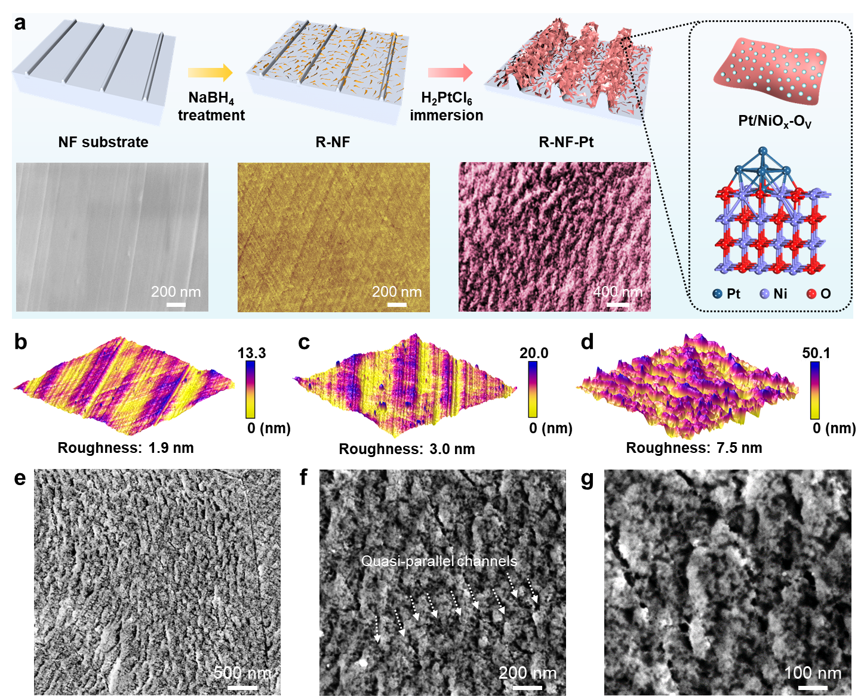

Figure 1. (a) Schematic illustration of the synthetic process of R-NF-Pt and corresponding SEM images at different synthesis stages. (b-d) AFM images for the untreated (b) and NaBH₄ treated NF surface (c), and R-NF-Pt (d), respectively. (e-g) SEM images of R-NF-Pt at different magnifications.

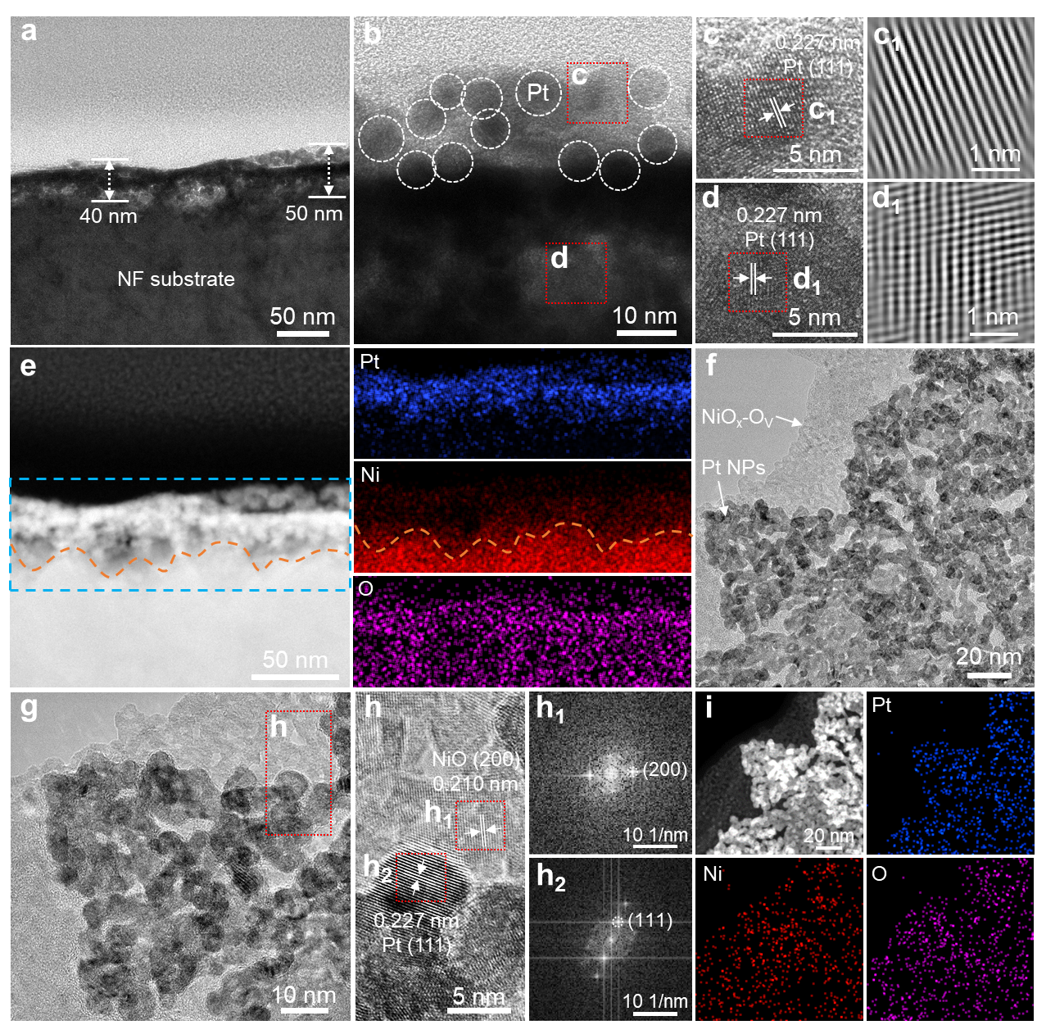

Figure 2. (a) Cross-sectional TEM image, (b-d) cross-sectional HRTEM images, and (e) HAADF-STEM image with the corresponding EDX elemental mapping images of R-NF-Pt. (c₁, d₁) The corresponding inverse FFT patterns taken from the dashed red areas in (c) and (d) via point mask mode, respectively. (f) TEM image, (g, h) HRTEM images, and (i) HAADF-STEM image with the corresponding EDX elemental mapping images of the ultrasonically exfoliated sample from the R-NF-Pt surface. (h₁, h₂) The corresponding FFT patterns from the dashed red areas in (h).

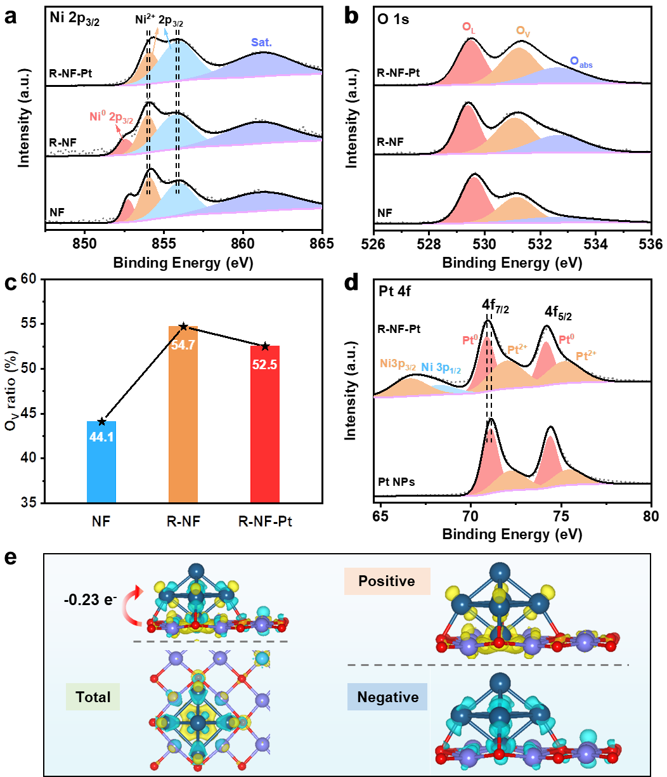

Figure 3. High-resolution XPS (a) Ni 2p_{3/2}, and (b) O 1s spectra of NF, R-NF, and R-NF-Pt. (c) Comparison of the O_{v} ratio. (d) High-resolution XPS Pt 4f spectra of Pt/C, and R-NF-Pt. (e) The difference charge density analysis of R-NF-Pt; yellow and cyan regions represent electron accumulation and depletion, respectively.

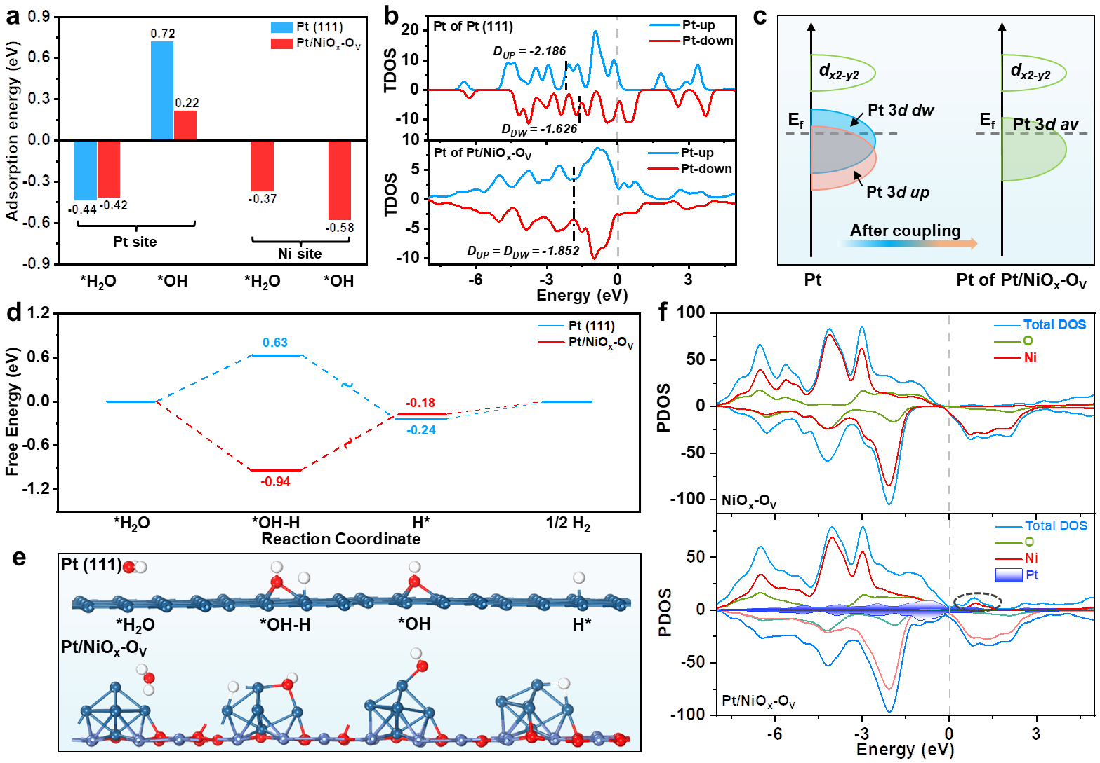

Figure 4. (a) Calculated Adsorption energies of H₂O and OH on Pt (111) and Pt/NiO_{x}-O_{V}. (b) Calculated total density of states (TDOS) for Pt site over the Pt cluster and Pt/NiO_{x}-O_{V} heterojunction. (c) Schematic of the orbital changes in metal and nonmetal elements. (d) Gibbs free energy diagram for HER on Pt and Pt/NiO_{x}-O_{V}. (e) The geometric configurations of the *H₂O, *OH-H, *OH, and H* adsorbed on Pt and Pt/NiO_{x}-O_{V}. (f) Calculated partial density of states (PDOS) of NiO_{x}-O_{V} and Pt/NiO_{x}-O_{V}.

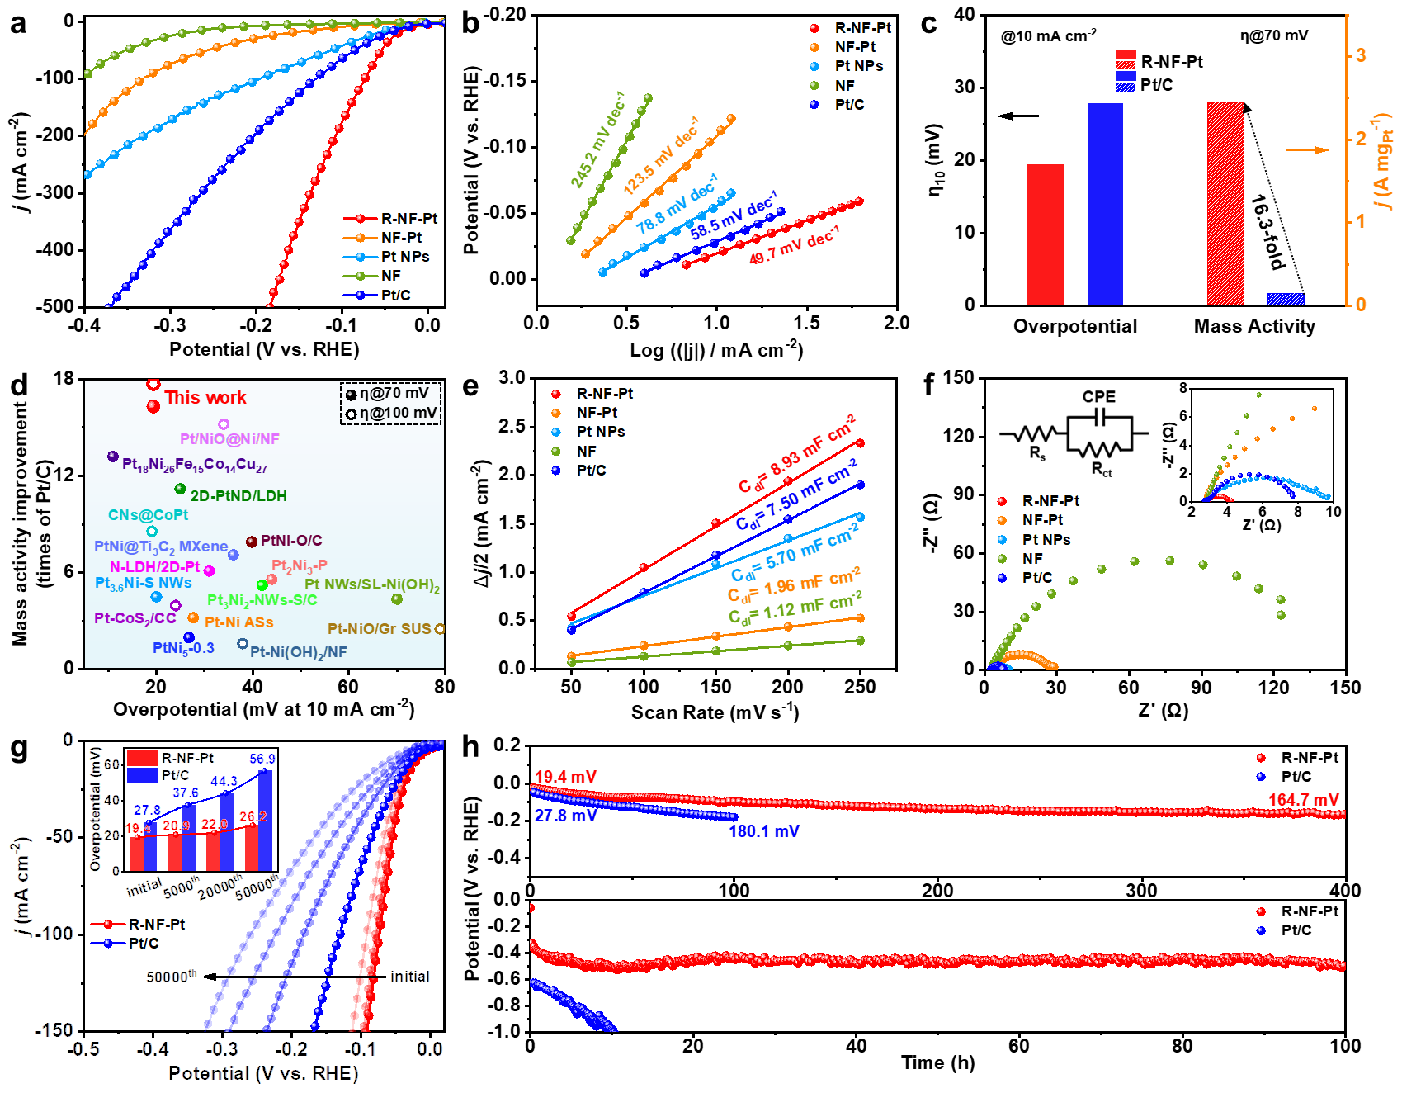

Figure 5. Electrocatalytic HER performance evaluation of various catalysts in 1.0 M KOH. (a) HER polarization curves of R-NF-Pt, NF-Pt, Pt NPs, NF, and Pt/C catalysts. (b) Tafel plots obtained from the polarization curves in (a). (c) Comparison of the overpotentials at 10 mA cm⁻² and the mass activities at -70 mV versus RHE between R-NF-Pt and 20% Pt/C. (d) Comparison of the overpotentials at 10 mA cm⁻² and the mass activities between R-NF-Pt and other reported Pt/Ni-based alkaline HER electrocatalysts. (e) Double-layer capacitance (C_{dl}) plots of R-NF-Pt, NF-Pt, Pt NPs, NF and Pt/C. (f) Electrochemical impedance spectroscopy (EIS) of R-NF-Pt, NF-Pt, Pt NPs, NF, and Pt/C. Inset is the equivalent circuit, in which R_{s}, R_{ct}, and CPE are solution resistance, charge transfer resistance between catalyst and electrolyte, and constant phase element, respectively. (g) The polarization curves and corresponding overpotential changes at 10 mA cm⁻² of R-NF-Pt and Pt/C before and after 5000, 20000 and 50000 CV cycles. (h) Chronopotentiometry tests of R-NF-Pt and Pt/C under constant current densities of 10 and 1000 mA cm⁻².

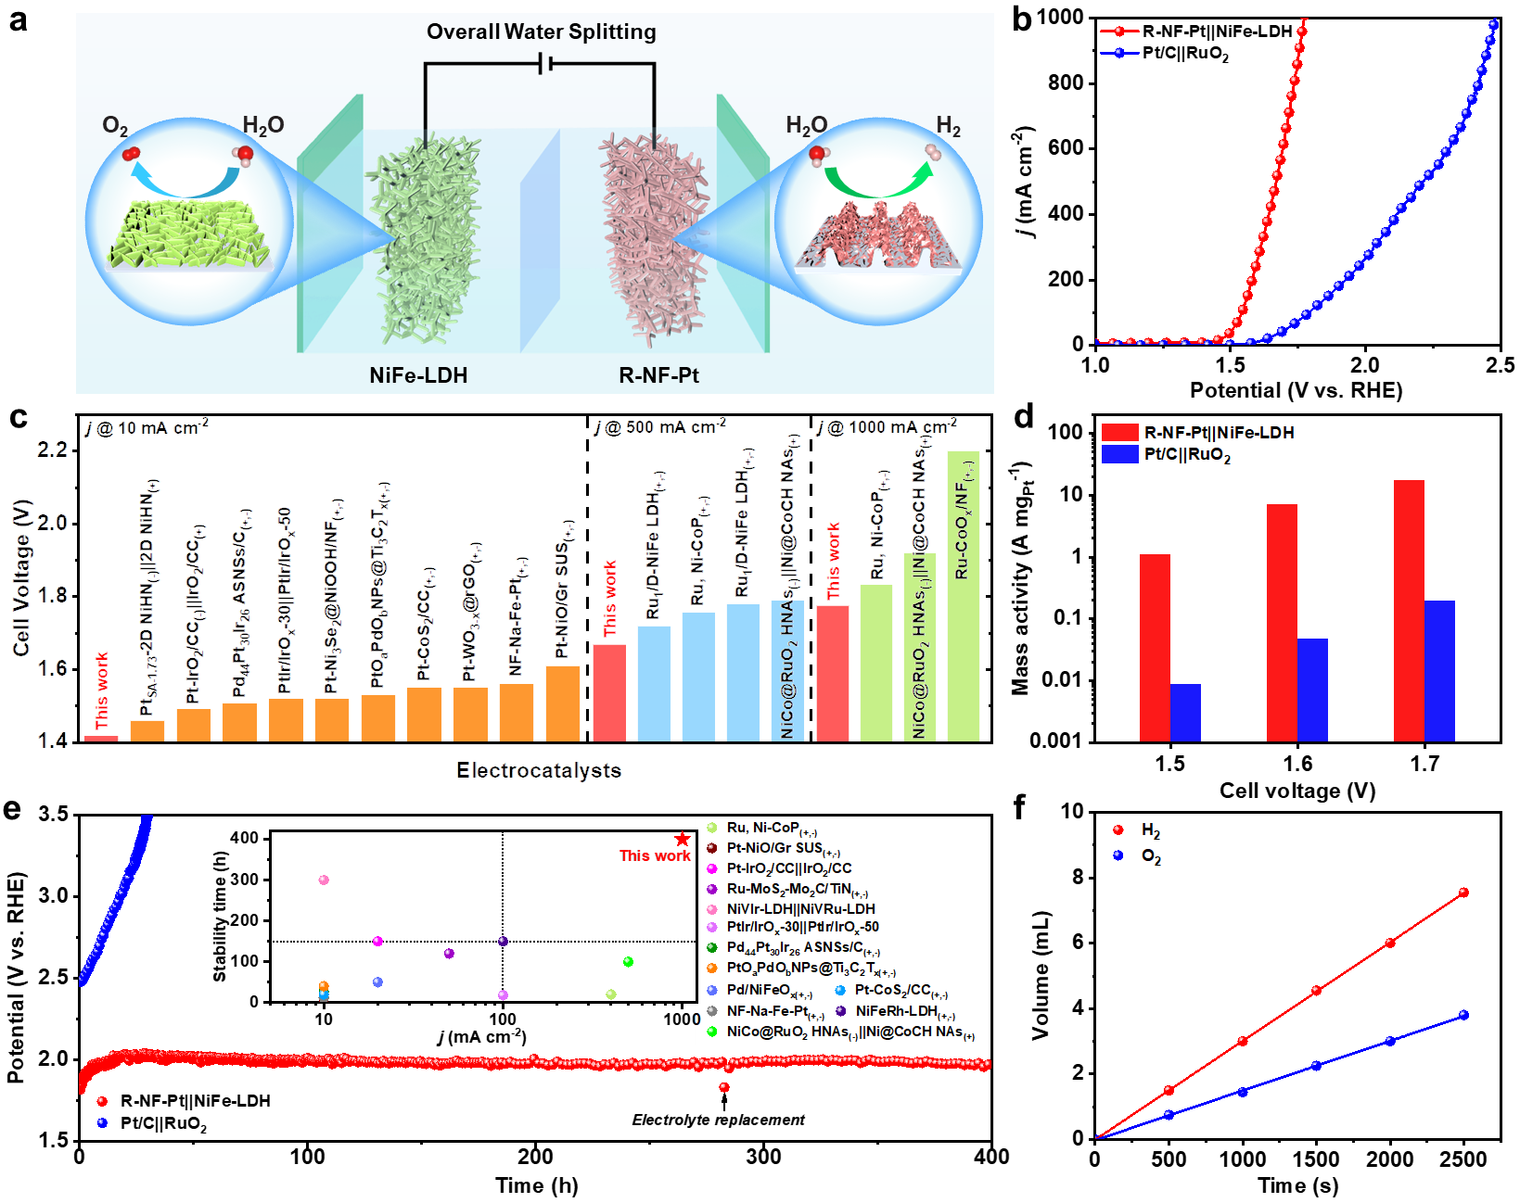

Figure 6. Electrocatalytic performance of overall water splitting. (a) Schematic representation of the overall alkaline water splitting process. (b) Polarization curves of the R-NF-Pt||NiFe-LDH and commercial Pt/C||RuO₂ pairs for water splitting. (c) Overall water splitting activity comparison at 10, 500, and 1000 mA cm⁻² with recently reported high performance noble metal-based catalysts. (d) Mass activities comparisons of the R-NF-Pt||NiFe-LDH and commercial Pt/C||RuO₂ at various cell voltages. (e) Chronopotentiometry tests of R-NF-Pt||NiFe-LDH and commercial Pt/C||RuO₂ at 1000 mA cm⁻². Inset is the comparison of current density and stability between R-NF-Pt||NiFe-LDH and other reported catalysts for water splitting. (f) The amount of H₂ and O₂ collected by the water drainage method as a function of time for R-NF-Pt||NiFe-LDH.

Table of Content

A 3D quasi-parallel architecture consisting of dense Pt nanoparticles immobilized oxygen-vacancy-rich NiO_{x} heterojunctions (Pt/NiO_{x}-O_{V}) is successfully constructed on nickel foam. The self-supporting electrode exhibits extraordinary alkaline HER performance with low overpotential and high mass activity. Besides, the assembled alkaline electrolyzer combined with NiFe-LDH can operate stably for more than 400 h at 1000 mA cm⁻².

Kaixi Wang, Shuo Wang, Kwan San Hui*, Junfeng Li, Chenyang Zha, Duc Anh Dinh, Zongping Shao*, Bo Yan, Zikang Tang and Kwun Nam Hui*

Dense Platinum/Nickel Oxide Heterointerfaces with Abundant Oxygen Vacancies Enable Ampere-Level Current Density Ultrastable Hydrogen Evolution in Alkaline

TOC figure

