Supplementary Materials for
Evoking Episodic and Semantic Details with Instructional Manipulation During Autobiographical Recall

Greta Melega^{1,2}, Fiona Lancelotte^{1,3}, Ann-Kathrin Johnen^{1,4}, Michael Hornberger⁵, Brian Levine ⁶, Louis Renoult¹

¹ School of Psychology, University of East Anglia, Norwich, UK

² Department of Neurology, Charité – Universitätsmedizin Berlin, Berlin, Germany

3 School of Psychology, University of Sussex, UK

4 School of Social Sciences, Birmingham City University, UK

⁵ Norwich Medical School, University of East Anglia, Norwich, UK

⁶ Rotman Research Institute, Baycrest, Toronto, Ontario, Canada and Departments of Psychology and Medicine (Neurology), University of Toronto

Detailed Instructions given to participants in the Personal Semantic Autobiographical Interview (P-SAI) and in the General Semantic Autobiographical Interview (G-SAI)
Below are the detailed instructions given to participants, separately for P-SAI and G-SAI. In italics are the verbatim instructions given to participants, while the normal text are notes for the reader to improve the understanding of the procedure.
Personal Semantic Interview Instructions
In this section, we are not interested in specific events from you past, but in general information about you. For each chapter, I will ask you to give me a brief description of that period of your life and then I am going to ask you more specific questions. I am not looking for detailed events from you past, but only for general information that describe how that chapter was like for you. For example, describing where you would usually go on holidays would be good, however, I don’t need to know about a specific incident that happened on a particular day from these holidays. I do not need to hear about everything that happened during that time period, but I am interested to hear a concise overview of how that period of your life was like in general. Our interest is not so much in which facts or information you choose, but rather how you describe them. Be sure to only choose information that you feel comfortable discussing in detail. Do you have any questions?
Free Recall
Let us start with the first chapter: if you wanted to tell someone how (life chapter title) was like for you, and you only had few minutes to give them a brief overview, what would you say?
General Probe
At the end of the free recall, participants are given a general probe: Is there anything else that is important to complete your brief overview of that time period?
Specific Probe
The specific probing starts from the material that the participants spontaneously recalled in the free recall. Use this information as a base. “You said to me that you … can you tell me about other (activities, traits or facts)?”. Now we are going to ask you more specific questions about the lifetime chapters that you provided. As before, we are not interested in a detailed description of everything that happened in your life, but in a brief description of the activities you were usually doing, the kind of person you were as well as personally relevant facts. In this section of the interview, it is important to work with the information the participant included in the Free Recall (e.g., using the information given as examples for each probe).
Repeated Events. Think of the activities you were doing regularly during (lifetime chapter): Can you briefly tell me about your weekly habits and routines? Chose a few of your frequent hobbies and tell me about those / can you tell more about your frequent hobbies at that time? Can you tell me about other relevant activities you were doing regularly over these years? The researcher should ask each question separately.
Self-Knowledge. Think of the kind of person you were during (lifetime chapter): Which personality traits and character best described you? Did you have particular opinions and beliefs at that time? (e.g., related to the world, your personality or your goals at the time) Were there particular things that you liked and loved? (e.g., preferences and tastes). The researcher should ask each question separately.
Autobiographical Facts. Think of personally relevant facts that characterized your (lifetime period): Which personally relevant facts would you include to create a skeleton of your biography in that period? (here, it is important to work with the facts that the participant included in the free recall) If participants are not sure about the meaning of “facts”, we can rephrase the probe (e.g., which personal information or important events would you include to describe those years). Who are the most relevant people you were interacting with during this period (friends, family, colleagues, and teachers)? Which places were most relevant to you in that period? You can think of places where you lived/studied/worked. The researcher should ask each question separately.
General Semantic Interview Instructions
Now we will do something different. Instead of asking information about yourself and your personal past, I am going to ask you about the public events that defined the last year. You could think of public events in your environment and social context, such as politics or culture (film, music, and fashion), as well as relevant famous people at that time. Do you have any questions?
Free Recall
If you wanted to tell someone what was going on in your community, your country or internationally, during the last year, and you only had few minutes to give a brief overview, what would you say?
General Probe
Is there anything else that is important to complete your brief overview for the last year?
Specific Probe
Now I am going to ask you more specific questions about the world knowledge you have for that time. As before, I am not interested in a detailed description of everything that happened in the world, but by a brief description of the information you think is mostly relevant. Can you tell me about: Public events that happened during that time (things that were in the news) in your community or in the world; Famous public figures during that time in your community or in the world; Trends and things that were popular in your community or in the world at that time (e.g., films, music, fashion)? The researcher should ask each question separately.
Supplemetary Results

Age Differences in the Production of Target Details Across Interviews – Spontaneous Recall
As seen in Figure S1, participants generally oriented their narrative production to produce target details in alignment with instructions. There was a larger number of target details produced across groups for the Autobiographical Interview (AI; Levine et al., 2002) and P-SAI, with the target detail production on the G-SAI being lower than for the other two AI versions. These observations were supported by a main effect of interview (F(2,141) = 78.82, p < 0.001, ηp2 = 0.53, 95% CI [0.44, 1.00]) such that the P-SAI had a higher proportion of target details (M = 0.80, SD = 0.07) than the G-SAI (M = 0.51, SD = 0.17; t(79) = -11.01, p < 0.001, d = 2.23, 95% CI [-0.35, -0.24]) and the standard AI (M = 0.71, SD = 0.12; t(81.38) = -4.61, p < 0.001, d = 0.92, 95% CI [-0.13, -0.05]). Young adults generally produced a higher proportion of target details (M = 0.71, SD = 0.15) than older adults (M = 0.63, SD = 0.20; F(1,141) = 16.50, p < 0.001, ηp2 = 0.10, 95% CI [0.04, 1.00]), and this effect was qualified by an interaction between group and interview (F(2,141) = 4.68, p = 0.01, ηp2 = 0.06, 95% CI [0.01, 1.00]), whereby older adults’ target detail production was lower than young adults for the AI (M = 0.67 vs. 0.76, SD = 0.13 vs. 0.08 for older vs. young adults; t(41.40) = -2.81, p = 0.01, d = 0.83, 95% CI [-0.15, -0.02]) and the G-SAI (M = 0.43 vs. 0.58, SD = 0.15 vs. 0.16 for older vs. young adults; t(46.22) = -3.33, p = 0.005, d = 0.97, 95% CI [-0.24, -0.06]), but not for the P-SAI (M = 0.80 vs. 0.80, SD = 0.08 vs. 0.07 for older vs. young adults; t(48.84) = -1.12, p = 0.91, 95% CI [-0.05, 0.04]; see Figure S1).
We next explored whether young and older adults retained their rank in the proportion of on-target content across interviews. The within-group rank order correlations between the AI and the P-SAI were significant for the young (𝜏 = 0.31, p = 0.04) and older adults (𝜏 = 0.33, p = 0.02), whereas the within-group correlations between the AI and the P-SAI with the G-SAI were not significant (all p values > 0.10).
Age Differences in the Production of Details Across Interviews – Spontaneous Recall
Autobiographical Interview
Considering the proportion of the different sub-type of details in young and older adults episodic narratives, the ANOVA revealed a main effect of detail type (F(6,329) = 1066.73, p < 0.001, ηp2 = 0.95, 95% CI [0.94, 1.00]), and a significant detail type x group interaction (F(6,329) 8.16, p < 0.001, ηp2 = 0.13, 95% CI [0.07, 1.00]), but no main effect of group (p > 0.99). Older adults’ episodic narratives included a lower proportion of episodic details (M = 0.67, SD = 0.13), but a higher proportion of autobiographical facts (AF, M = 0.12, SD = 0.07) and a marginally significant higher proportion of self-knowledge information (SK, M = 0.03, SD = 0.02), compared to young adults (episodic: M = 0.06, SD = 0.04; t(41.40) = -2.81, p = 0.03, d = 0.83, 95% CI [-0.15, -0.02]; AF: M = 0.76, SD = 0.08; t(39.74) = 3.73, p = 0.001, d = 1.05, 95% CI [0.03, 0.09]; SK: M = 0.01, SD = 0.01; t(36.46) = 2.39, p = 0.05, d = 1.26, 95% CI [0.002, 0.02]; see Figure S2 and Table S1 for mean values and plots).
Considering the count of the different sub-type of details in young and older adults episodic narratives, the ANOVA revealed a main effect of detail type (F(6,329) = 195.52, p < 0.001, ηp2 = 0.78, 95% CI [0.75, 1.00]), a significant main effect of age group (F(1,329) = 10.79, p < 0.001, ηp2 = 0.03, 95% CI [0.01, 1.00]), with older adults including overall more details (M = 9.28, SD = 15.40) than young adults in their narratives (M = 6.79, SD = 14.10), but no significant detail type x group interaction (p = 0.11). Participants’ recollections of unique events were richer in episodic details than all the other detail types (all p-values < 0.001), and richer in autobiographical facts than all the other detail types (all p-values < 0.02) except for the “other” category of details (p = 0.12; see Figure S3 and Table S2 for mean values and plots).
Taken together, our findings are consistent with previous research that showed a tendency among older adults to recall past events with a lower proportion of target episodic details (as noted in Levine et al., 2002) and a higher proportion of off-task recall, particularly personal semantics, as compared to young adults (as found in Renoult et al., 2020).
Personal Semantic Autobiographical Interview
We next analyzed the proportion of details in young and older adults' narratives of past life chapters in the P-SAI. The ANOVA on group differences revealed a main effect of detail type (F(6,329) = 303.53, p < 0.001, ηp2 = 0.85, 95% CI [0.83, 1.00]), and a detail x age group interaction (F(6,329) = 9.8, p < 0.001, ηp2 = 0.15, 95% CI [0.09, 1.00]), but no main effect of group (p > 0.98). Older adults’ personal semantic narratives included a higher proportion of autobiographical facts (AF, M = 0.56 vs. 0.47, SD = 0.11 vs. 0.13 for older vs. young adults; t(44.73) = 2.66, p = 0.04, d = 0.75, 95% CI [0.02, 0.16]), but a lower proportion of self-knowledge than young adults (SK, M = 0.17 vs. 0.29, SD = 0.09 vs. 0.12 for older vs. young adults; t(43.91) = -4.02, p = 0.001, d = 1.13, 95% CI [-0.18, -0.06]). No additional group differences were found for the other categories of details (all p-values > 0.08; see Figure S2 and Table S1 for mean values and plots).
Considering details count, the ANOVA revealed a main effect of detail type (F(6,329) = 107.46, p < 0.001, ηp2 = 0.66, 95% CI [0.62, 1.00]), a significant main effect of age group (F(1,329) = 29.69, p < 0.001, ηp2 = 0.08, 95% CI [0.04, 1.00]), and a significant detail type x group interaction (F(6,239) = 15.13, p < .001, ηp2 = 0.22, 95% CI [0.14, 1.00]). Older adults’ memories mainly included more autobiographical facts (M = 22.40 vs. 10.60, SD = 11.20 vs. 4.98 for older vs. young adults; t(33.50) = 4.80, p < 0.001, d = 1.36, 95% CI [6.78, 16.74]), but also more repeated events (M = 2.99 vs. 0.91, SD = 2.76 vs. 1.43 for older vs. young adults; t(36.81) = 3.33, p = 0.004, d = 0.95, 95% CI [0.82, 3.35]), and more off-task content such as episodic details (M = 0.62 vs. 0, SD = 1.13 vs. 0 for older vs. young adults; t(24) = 2.74, p = 0.02, d = 0.95, 95% CI [0.15, 1.08]), and general semantic details (M = 1.97 vs. 0.65, SD = 1.62 vs. 0.87 for older vs. young adults; t(36.98) = 3.59, p = 0.003, d = 1.01, 95% CI [0.58, 2.07]), compared to younger adults (see Figure S3 and Table S2 for mean values and plots), while no difference was found for self-knowledge, repetitions and “other” detail types (all p-values > 0.63).
Taken together, these results suggest that, when probed with instructions targeting personal semantics, older adults’ narratives are richer in autobiographical facts in comparison to young adults. These findings revealed a preserved recall of abstracted forms of autobiographical memories in aging (Acevedo-Molina et al., 2020; Grilli & Sheldon, 2023) and a prevalence of autobiographical facts both when describing past life chapters and unique past events. The presence of more off-target content in older adults’ narratives, despite their low numbers, aligns with previous findings of more story-asides and variety in narrative content (e.g., Acevedo-Molina et al., 2020; Bluck et al., 2016; Sheldon et al., 2023).
General Semantic Autobiographical Interview
The analysis on the proportion of the different details types in the G-SAI revealed a main effect of detail type (F(6,329) = 144.24, p < 0.001, ηp2 = 0.72, 95% CI [0.69, 1.00]), and a significant interaction between age group and detail type (F(6,329) = 13.24, p < 0.001, ηp2 = 0.19, 95% CI [0.12, 1.00]), but no main effect of group (p > 0.98). The narratives of older adults included a lower proportion of general semantic (GS, M = 0.43 vs. 0.58, SD = 0.15 vs. 0.16 for older vs. young adults; t(42.22) = -3.33, p = 0.01, d = 0.97, 95% CI [-0.24, -0.06]), a higher proportion of self-knowledge details (SK, M = 0.30 vs. 0.12, SD = 0.19 vs. 0.13 for older vs. young adults; t(39.40) = 4.12, p = 0.001, d = 1.11, 95% CI [0.09, 0.28]), and a lower proportion of “other” type of details (M = 0.10 vs. 0.21, SD = 0.08 vs. 0.15 for older vs. young adults; t(35.40) = -3.03, p = 0.01, d = 0.91, 95% CI [-0.18, -0.04]), compared to younger adults’ narratives (see Figure S2 and Table S1 for mean values).
Considering details count, the ANOVA revealed a main effect of detail type (F(6,329) = 81.76, p < 0.001, ηp2 = 0.60, 95% CI [0.54, 1.00]), no main effect of age group (p = 0.23) and a significant detail type x group interaction (F(6,239) = 6.22, p < 0.001, ηp2 = 0.10, 95% CI [0.04, 1.00]). Older adults’ general semantic recollections included more self-knowledge information than young adults (M = 6.12 vs. 2.23, SD = 4.37 vs. 2.03 for older vs. young adults; t(34.19) = 4.03, p = 0.002, d = 1.14, 95% CI [1.93, 5.86]; see Figure S3 and Table S2 for median values), while no difference was found in the production of target general semantic and all other types of details (all p-values > 0.14).
Given the commonly observed preservation of semantic memory in aging, the presence of additional content related to non-target information may reflect a tendency of older adults to enrich the recall of semantic knowledge with subjective elements like opinions and beliefs (Bluck et al., 2016; Sheldon et al., 2023), rather than a compensatory strategy. This presence of subjective content in older adults’ narratives may also be attributed to adopting a different communicative goal than young adults (e.g., James et al., 1988).
Age Differences in Details Count Across Interviews – Cumulative Recall
Autobiographical Interview
Considering the count of the different sub-type of details in young and older adults episodic narratives, the ANOVA revealed a main effect of detail type (F(6,329) = 272.31, p < 0.001, ηp2 = 0.83, 95% CI [0.81, 1.00]), a significant main effect of age group (F(1,329) = 18.27, p < 0.001, ηp2 = 0.05, 95% CI [0.02, 1.00]), and a significant detail type x group interaction (F(6,239) = 3.88, p < 0.001, ηp2 = 0.07, 95% CI [0.02, 1.00]). Older adults’ narratives of unique events included more episodic details (M = 72.50 vs. 56.40, SD = 6.53 vs. 2.57 for older vs. young adults; t(46.73) = 2.35, p = 0.04, d = 3.24, 95% CI [2.31, 29.89]), but also more autobiographical facts (M = 10.50 vs. 4.05, SD = 6.53 vs. 2.57 for older vs. young adults; t(46.73) = 4.06, p < 0.001, d = 1.30, 95% CI [3.56, 9.30]), self-knowledge (M = 2.16 vs. 0.76, SD = 1.58 vs. 0.68 for older vs. young adults; t(32.92) = 4.06, p < 0.001, d = 1.15, 95% CI [0.70, 2.10]), and general semantic details (M = 3.54 vs. 1.41, SD = 3.04 vs. 1.56 for older vs. young adults; t(36.06) = 3.11, p = 0.01, d = 0.88, 95% CI [0.74, 3.53]), compared to younger adults, while no difference was found for repeated events, repetitions and “other” detail types (all p-values > 0.06; see Figure S4 and Table S3).
Personal Semantic Interview
Considering details count, the ANOVA revealed a main effect of detail type (F(6,329) = 169.12, p < 0.001, ηp2 = 0.76, 95% CI [0.72, 1.00]), a significant main effect of age group (F(1,329) = 50.02, p < 0.001, ηp2 = 0.13, 95% CI [0.08, 1.00]), and a significant detail type x group interaction (F(6,239) = 18.08, p < .001, ηp2 = 0.25, 95% CI [0.18, 1.00]). Older adults’ memories included more autobiographical facts (M = 79.90 vs. 41.40, SD = 28.80 vs. 12.90 for older vs. young adults; t(33.64) = 6.07, p < 0.001, d = 1.72, 95% CI [25.56, 51.29]), but also more off-task recall such as episodic details (M = 2.59 vs. 0.27, SD = 2.76 vs. 0.66 for older vs. young adults; t(26.84) = 4.08, p < 0.001, d = 1.16, 95% CI [1.15, 3.48]) and general semantic details, compared to young adults (M = 7.10 vs. 2.48, SD = 4.93 vs. 2.39 for older vs. young adults; t(35.03) = 4.20, p < 0.001, d = 0.94, 95% CI [2.39, 6.85]; see Figure S4 and Table S3), while no difference was found for self-knowledge, repeated events, repetitions and “other” detail types (all p-values > 0.05).
General Semantic Interview
Considering details count, the ANOVA revealed a main effect of detail type (F(6,329) = 129.06, p < 0.001, ηp2 = 0.70, 95% CI [0.66, 1.00]), a significant main effect of age group (F(1,329) = 20.49, p < 0.001, ηp2 = 0.06, 95% CI [0.02, 1.00]), and a significant detail type x group interaction (F(6,239) = 3.61, p = 0.002, ηp2 = 0.06, 95% CI [0.01, 1.00]). Older adults’ recollections included more off-task recall and in particular more self-knowledge (M = 16.20 vs. 5.90, SD = 8.18 vs. 4.97 for older vs. young adults; t(39.87) = 5.35, p < 0.001, d = 1.52, 95% CI [6.42, 14.20]), more autobiographical facts (M = 6.71 vs. 3.01, SD = 4.93 vs. 4.24 for older vs. young adults; t(46.46) = 2.82, p = 0.02, d = 0.80, 95% CI [1.06, 6.34]), but also more repetitions (M = 4.11 vs. 2.10, SD = 3.10 vs. 2.36 for older vs. young adults; t(44.73) = 2.55, p = 0.03, d = 0.73, 95% CI [0.42, 3.58]) than young adults (see Figure S4 and Table S3), while no difference was found in the production of general semantic, repeated events, episodic and “other” detail types (all p-values > 0.13).
References
Acevedo-Molina, M. C., Matijevic, S., & Grilli, M. D. (2020). Beyond episodic remembering: Elaborative retrieval of lifetime periods in young and older adults. Memory, 28(1), 83-93. https://doi.org/10.1080/09658211.2019.1686152
Bluck, S., Alea, N., Baron-Lee, J. M., & Davis, D. K. (2016). Story asides as a useful construct in examining adults’ story recall. Psychology and aging, 31(1), 42-57. https://doi.org/10.1037/a0039990
Grilli, M. D., & Verfaellie, M. (2014). Personal semantic memory: insights from neuropsychological research on amnesia. Neuropsychologia, 61, 56-64. https://doi.org/10.1016/j.neuropsychologia.2014.06.012
James, L. E., Burke, D. M., Austin, A., & Hulme, E. (1998). Production and perception of" verbosity" in younger and older adults. Psychology and aging, 13(3), 355-367. https://doi.org/10.1037/0882-7974.13.3.355
Levine, B., Svoboda, E., Hay, J. F., Winocur, G., & Moscovitch, M. (2002). Aging and autobiographical memory: dissociating episodic from semantic retrieval. Psychology and aging, 17(4), 677-689. https://doi.org/10.1037/0882-7974.17.4.677
Palombo, D. J., Sheldon, S., & Levine, B. (2018). Individual differences in autobiographical memory. Trends in Cognitive Sciences, 22(7), 583-597. https://doi.org/10.1016/j.tics.2018.04.007
Renoult, L., Armson, M. J., Diamond, N. B., Fan, C. L., Jeyakumar, N., Levesque, L., ... & Levine, B. (2020). Classification of general and personal semantic details in the Autobiographical Interview. Neuropsychologia, 144, 107501. https://doi.org/10.1016/j.neuropsychologia.2020.107501
Sheldon, S., Sheldon, J., Zhang, S., Setton, R., Turner, G. R., Spreng, R. N., & Grilli, M. D. (2023). Differences in the content and coherence of autobiographical memories between younger and older adults: Insights from text analysis. Psychology and Aging. https://doi.org/10.1037/pag0000769

Figure S1
Proportion of target details during spontaneous recall in young and older adults across interviews.
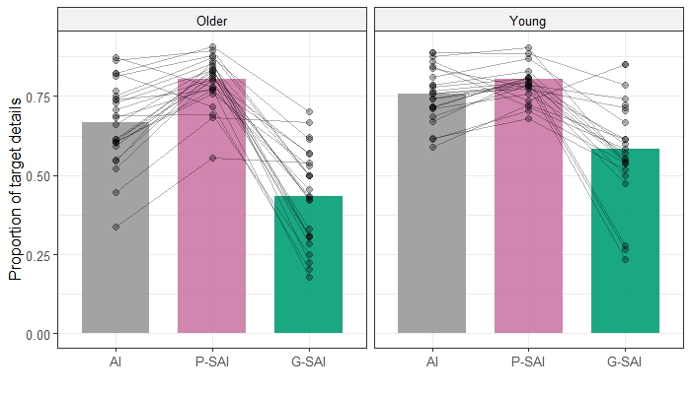
Note. Individual lines and dots represent participants. Target details refer to the information that was directly probed by instructions: episodic details in the AI; personal semantic details (autobiographical facts, self-knowledge and repeated events) in the P-SAI; general semantic details in the G-SAI. Spontaneous recall: free recall and general probe. AI: Autobiographical Interview. P-SAI: Personal Semantic Interview. G-SAI: General Semantic Interview.

Figure S2
Proportion of detail types during spontaneous recall in young and older adults, separately for the Autobiographical Interview, Personal Semantic Interview, and General Semantic Interview.
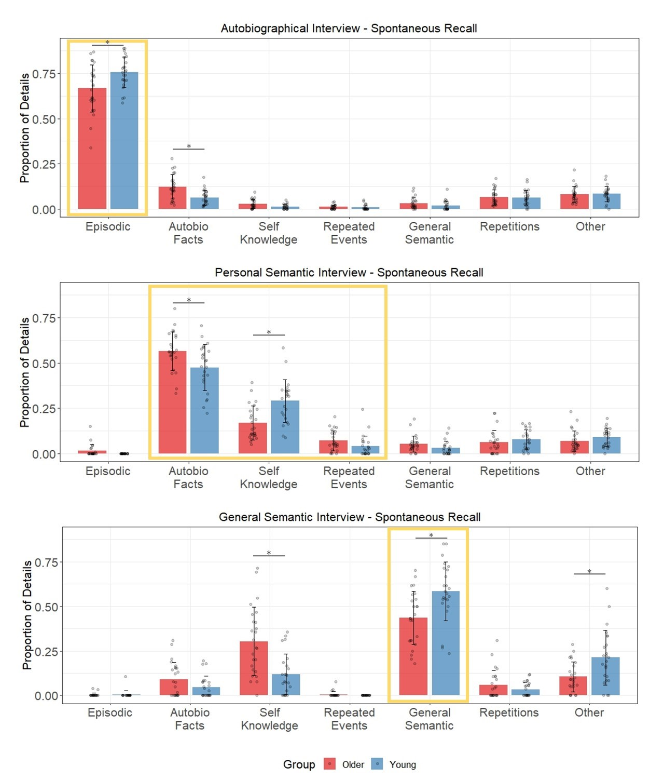
Note: Bar plots display mean proportion values for each category of details produced by young and older adults during the spontaneous recall (free recall and general probe) of the Autobiographical Interview (AI), Personal Semantic Interview (P-SAI), and General Semantic Interview (G-SAI). Individual subjects are represented by dots, and the target details are highlighted within the yellow box. * refers to significant group differences (α = 0.05).
Figure S3
Count of detail types in young and older adults during spontaneous recall, separately for the Autobiographical Interview, Personal Semantic Interview, and General Semantic Interview.
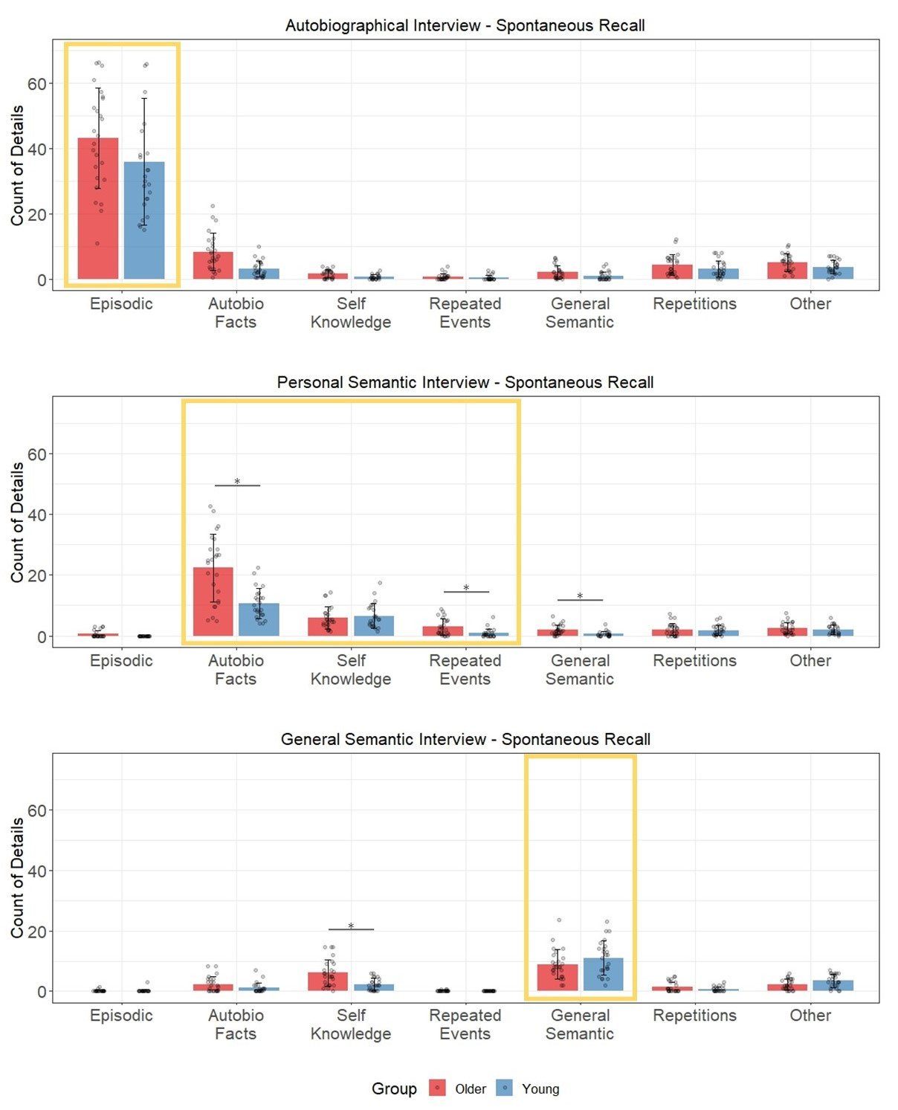
Note: Bar plots display mean count values for each category of details produced by young and older adults during the spontaneous recall (free recall and general probe) of the Autobiographical Interview (AI), Personal Semantic Interview (P-SAI), and General Semantic Interview (G-SAI). Individual subjects are represented by dots, and the target details are highlighted within the yellow box. * refers to significant group differences (α = 0.05).
Figure S4
Count of detail types in young and older adults during cumulative recall, separately for the Autobiographical Interview, Personal Semantic Interview, and General Semantic Interview.
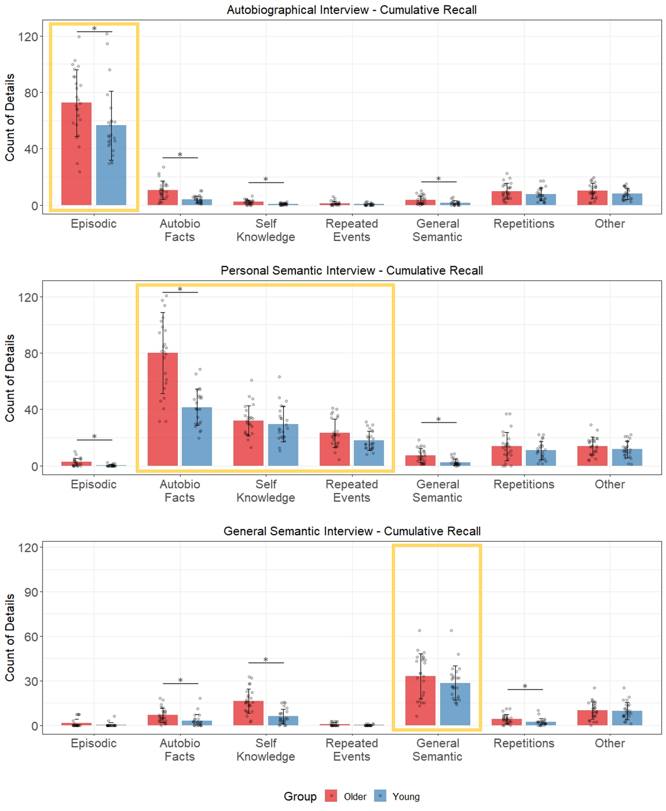
Note: Bar plots display mean count values for each category of details produced by young and older adults during the cumulative recall (free recall, general probe, and specific probe) of the Autobiographical Interview (AI), Personal Semantic Interview (P-SAI), and General Semantic Interview (G-SAI). Individual subjects are represented by dots, and the target details are highlighted within the yellow box. * refers to significant group differences (α = 0.05).
Table S1
Proportion of detail types in young and older adults for spontaneous recall (free recall and general probe) in the AI, P-SAI and G-SAI.
 | AI |  |  | P-SAI |  |  | G-SAI
 | Older | Young | p-value | Older | Young | p-value | Older | Young | p-value
Episodic | 0.67 (0.13) | 0.76 (0.08) | 0.03* | 0.01 (0.03) | 0  (0) | 0.08 | 0.003 (0.01) | 0.004 (0.02) | 0.76
AF | 0.12 (0.07) | 0.06 (0.04) | 0.004* | 0.56 (0.11) | 0.47 (0.13) | 0.04* | 0.09 (0.10) | 0.05 (0.06) | 0.12
SK | 0.03 (0.02) | 0.01 (0.01) | 0.05 | 0.17 (0.09) | 0.29 (0.12) | 0.001* | 0.30 (0.19) | 0.12 (0.11) | 0.001*
RE | 0.01 (0.01) | 0.01 (0.01) | 0.80 | 0.07 (0.06) | 0.04 (0.06) | 0.09 | 0.01 (0.02) | 0  (0) | 0.17
GS | 0.03 (0.03) | 0.02 (0.03) | 0.19 | 0.05 (0.04) | 0.03 (0.04) | 0.09 | 0.43 (0.15) | 0.58 (0.16) | 0.01*
Repetitions | 0.06 (0.04) | 0.06 (0.04) | 0.86 | 0.06 (0.06) | 0.08 (0.05) | 0.38 | 0.06 (0.08) | 0.03 (0.04) | 0.22
Other | 0.08 (0.04) | 0.08 (0.04) | 0.86 | 0.07 (0.06) | 0.09 (0.05) | 0.22 | 0.10 (0.08) | 0.21 (0.15) | 0.01*
Notes. Mean values (and standard deviations) of proportions are reported for young and older adults together with the p-value corrected for multiple comparisons. The values in bold are the targets details in each interview. AI = Autobiographical Interview. P-SAI: Personal Semantic Interview. G-SAI: General Semantic Interview. AF = Autobiographical Facts. SK = Self-Knowledge. RE = Repeated Events. GS = General Semantic. * refers to significant group differences (α = 0.05).

Table S2
Count of details in young and older adults for spontaneous recall (free recall and general probe) in the AI, P-SAI and G-SAI.
 | AI |  | P-SAI |  |  |  | G-SAI
 | Older | Young |  | Older | Young | p-value |  | Older | Young | p-value
Episodic | 43.1 (15.4) | 35.9 (19.5) |  | 0.62 (1.13) | 0  (0) | 0.02* |  | 0.09 (0.32) | 0.12 (0.61) | 0.88
AF | 8.25 (5.75) | 3.0 (2.48) |  | 22.4 (11.2) | 10.6 (4.89) | <0.001* |  | 2.23 (2.62) | 1.08 (1.76) | 0.12
SK | 1.52 (1.25) | 0.59 (0.66) |  | 5.91 (3.56) | 6.58 (3.98) | 0.63 |  | 6.12 (4.37) | 2.23 (2.03) | 0.002*
RE | 0.72 (0.96) | 0.39 (0.72) |  | 2.99 (2.76) | 0.91 (1.43) | 0.004* |  | 0.09 (0.25) | 0  (0) | 0.14
GS | 2.02 (2.0) | 0.94 (1.29) |  | 1.97 (1.62) | 0.65 (0.87) | 0.003* |  | 8.92 (4.83) | 11.0 (5.69) | 0.19
Repetitions | 4.26 (3.18) | 3.08 (2.54) |  | 2.12 (2.05) | 1.86 (1.59) | 0.63 |  | 1.34 (1.77) | 0.67 (0.88) | 0.14
Other | 5.08 (2.62) | 3.59 (2.09) |  | 2.52 (1.93) | 2.05 (1.51) | 0.49 |  | 2.24 (1.80) | 3.46 (2.17) | 0.13
Notes. Mean values (and standard deviations) of details count are reported for young and older adults together with the p-value corrected for multiple comparisons (no multiple comparisons were conducted for the AI). The values in bold are the targets details in each interview. AI = Autobiographical Interview. P-SAI: Personal Semantic Interview. G-SAI: General Semantic Interview. AF = Autobiographical Facts. SK = Self-Knowledge. RE = Repeated Events. GS = General Semantic. * refers to significant group differences (α = 0.05).

Table S3
Count of details in young and older adults for cumulative recall (free recall, general probe and specific probe) in the AI, P-SAI and G-SAI.
 | AI |  |  | P-SAI |  |  | G-SAI
 | Older | Young | p-value | Older | Young | p-value | Older | Young | p-value
Episodic | 72.5 (23.6) | 56.4 (24.4) | 0.04* | 2.59 (2.76) | 0.27 (0.66) | <0.001* | 1.34 (2.76) | 0.37 (1.35) | 0.18
AF | 10.5 (6.53) | 4.05 (2.57) | <0.001* | 79.9 (28.8) | 41.4 (12.9) | <0.001* | 6.71 (4.93) | 3.01 (4.24) | 0.02*
SK | 2.16 (1.58) | 0.76 (0.68) | <0.001* | 32.0 (10.7) | 29.6 (12.5) | 0.47 | 16.2 (8.18) | 5.9 (4.97) | <0.001*
RE | 1.24 (1.54) | 0.5 (0.79) | 0.06 | 23.2 (10.0) | 17.8 (6.67) | 0.05 | 0.63 (1.04) | 0.15 (0.34) | 0.06
GS | 3.54 (3.04) | 1.41 (1.56) | 0.01* | 7.10 (4.93) | 2.48 (2.39) | <0.001 | 33.1 (15.20) | 28.5 (11.60) | 0.28
Repetitions | 9.92 (5.37) | 7.53 (4.5) | 0.11 | 13.8 (10.1) | 10.8 (6.27) | 0.25 | 4.11 (3.10) | 2.1 (2.36) | 0.03*
Other | 10.1 (5.22) | 8.04 (3.9) | 0.12 | 14.0 (6.34) | 11.7 (5.85) | 0.25 | 9.97 (5.9) | 9.72 (5.84) | 0.88
Notes. Mean values (and standard deviations) of details count are reported for young and older adults together with the p-value corrected for multiple comparisons. The values in bold are the targets details in each interview. AI = Autobiographical Interview. P-SAI: Personal Semantic Interview. G-SAI: General Semantic Interview. AF = Autobiographical Facts. SK = Self-Knowledge. RE = Repeated Events. GS = General Semantic. * refers to marginally significant group differences (α = 0.05).

