Zhang, Z. V. & Hyland, K. (2024). Student engagement with peer feedback in L2 writing: Insights from reflective journaling and revising practices. Assessing Writing

Student engagement with peer feedback in L2 writing: Insights from reflective journaling and revising practices

Abstract
The torrent of research into peer feedback in academic writing in recent years has largely overlooked student revision process – how individual students engage with this feedback to revise their texts and why certain changes are made in their texts. In other words, the cognitive dimension of student engagement in revision is little known. Drawing on multiple student drafts, peer feedback on these drafts, reflective journals and interviews with students, this study examines how two L2 students engage with peer feedback to conduct revisions. We identified two patterns of engagement: deep engagement, characterized by self-regulated revising practices, and surface engagement, concerned with other-regulated revision operations. We were not only interested in students’ revision operations in their drafts, but also their reflective practices shown in their reflective journals, finding that the two participants differed considerably in the revision process. The study suggests that effective student engagement with peer feedback largely depends on how they make use of cognitive and metacognitive strategies in the revision process. The study recommends that teachers seek to provide instructional scaffolding to facilitate L2 student cognitive engagement with the peer feedback they receive.
Keywords: student engagement; peer feedback; student revisions; L2 writing

1 Introduction
Peer feedback refers to the activity in which learners evaluate and provide oral or written comments on each other’s drafts. It has been a familiar sight in both first and second language classrooms as a supplement to teacher feedback for many years (e.g., Berggren, 2015; Guerrero & Villamil, 1994). Numerous studies have confirmed its beneficial effects, such as the improvement of evaluative skills and learner autonomy (Berg, 1999; Yu & Lee, 2016), the development of reader awareness (Rollinson, 2005); a reduction in writing apprehension (Authors, xxxx), and increased opportunities for discussion about language (Yu & Hu, 2017). Learners, however, have expressed reservations about peer feedback (Guardado & Shi, 2007), citing that they sometimes distrust their peers’ comments and rarely incorporate them into their revisions (Yoshida, 2008; Yu et al., 2019). While peer feedback has its problems, it is often students’ lack of engagement with peer feedback that is more of an issue – how to engage with it effectively and make revisions accordingly.
Engagement is important in feedback on writing as it encompasses psychological, academic, social, emotional, and cognitive elements that can contribute to student writing development. (Bryson & Hand, 2007; Fredricks, Blumenfeld & Paris, 2004). The literature on peer feedback literature in academic writing, however, has yet to pay sufficient attention to engagement in revision as most studies have focused on student perception and attitude without systematic analysis of revision processes (e.g., Allen & Katayama, 2016; Wu, 2019). Without a clear understanding of student engagement, it is difficult to fully grasp the processes of student writing and revision. Nor is it sufficient, like much peer feedback research, to privilege peer interaction (e.g., Storch, 2002; Yu & Lee, 2015) without focusing on revisions across drafts. In this study, therefore, we locate engagement as a central component of successful peer feedback, exploring how two L2 learners of English responded to such feedback in their revisions and how they conceptualized what they did. Most importantly, we examine multiple essay drafts, peer feedback on these drafts, student reflective journals and interviews to investigate their engagement with peer feedback.
2 Literature review
2.1 Student engagement
The term “student engagement” emerged from the research of educational psychologists in the 1960s, with Tyler’s (1969) work on “time-on-task” seen as a starting point. In the 1990s and early 2000s, student engagement continued to attract attention as a meta construct concerned with students’ academic achievement, positive behaviors, and a sense of belonging in the classroom (Bryson & Hand, 2007; Willms, Friesen, & Milton, 2009). Fredricks et al. (2004), for example, classified types of engagement into behavioral, emotional, and cognitive dimensions. Behavioral engagement refers to time-on-task and student participation. Cognitive engagement occurs when “students make personal investment into learning in a focused, strategic, and self-regulating way” (Fredricks et al., 2004, p. 58), largely involving perseverance and the use of self-regulated strategies. Affective engagement is seen to be present when students display positive attitudes and reactions towards teachers, peers, and school, and it includes a sense of belonging in the classroom, and curiosity or enthusiasm about certain topics or tasks (Fredricks & McColskey, 2012).
A similar model is proposed by Dunleavy (2008, p. 23) who refers to behavioral, academic-cognitive, and social-psychological types. Behavioral engagement includes such things as participation and school attendance; Academic-cognitive engagement refers to time-on-task, homework completion, effort expended and strategic learning; Social-psychological engagement is concerned with the student’s sense of belonging, relationships, motivation and interest. Willms, Friesen, and Milton (2009, p. 7) also divide student engagement in three types: social, academic, and intellectual engagement. In their model, social engagement means “a sense of belonging and participation in school life”. Academic engagement includes “participation in the formal requirements of schooling”. Intellectual engagement refers to “a serious emotional and cognitive investment in learning” and use of analysis, evaluation and problem-solving.
Our focus is narrower than these broad educational aims as we set out to explore more micro-level and empirically-validated forms of engagement, such as how students respond to a feedback comment or correct errors in their drafts. One step towards this is to use the engagement model proposed by Authors (xxxx), whose work was informed by Fredricks et al.'s (2004) tripartite conceptualization of engagement. The model analyzed how L2 students engaged with teacher and automated writing evaluation (AWE) feedback (Figure 1).

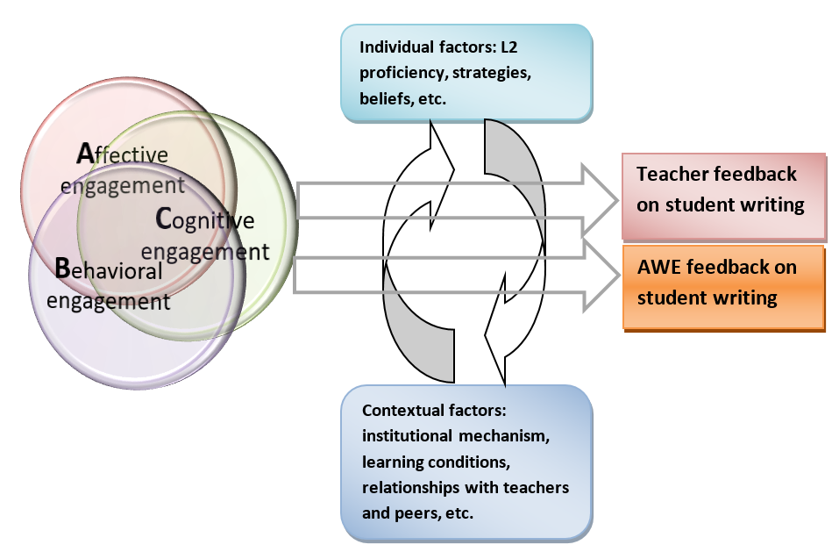
Figure 1. A model of student engagement with teacher and AWE feedback

In this model, engagement is filtered by a number of individual and contextual factors. Behavioral engagement is examined through revision actions and time spent on revision; affective engagement is measured via the student emotional reactions and attitudinal responses; and cognitive engagement is explored in how students use revision operations and cognitive strategies in their revision. This model also connects well with previous writing research which draws heavily on constructs such as affect, motivation, and cognition (Faigley & Witt, 1981; Hayes, 1996). Thus, we see the behavioral-affective-cognitive categorization of engagement as a good fit for peer feedback in L2 writing research.

2.2 Student engagement with peer feedback in L2 writing
Having emerged as an important element of first language writing instruction in process-oriented classrooms, peer feedback has attracted considerable attention in L2 writing (e.g., Connor & Asenavage, 1994; Hu, 2019; Nelson & Carson, 2006; Storch, 2019). Among other benefits, it is said to offer students opportunities to negotiate meanings, improve their self-evaluative skills and develop greater reader awareness (e.g., Lunstrom & Baker, 2009; Yu & Hu, 2017; Berggren, 2015). Despite these potential advantages, students themselves are not always so enthusiastic. One major concern is that L2 students lack sufficient knowledge of linguistic and rhetorical conventions to adequately evaluate other students’ work (e.g., Nelson & Carson, 2006). It is also the case that writers often take little notice of the peer feedback they receive (Allen & Katayama, 2016) and while one reason for this is related to L2 proficiency, students’ learning beliefs, previous feedback experiences and group dynamics may have a greater influence (Yu & Lee, 2016; Yu & Hu, 2017).
Research on student engagement with peer feedback in L2 writing has primarily focused on peer interaction and student response. Storch (2002), for example, identified four patterns of dyadic interaction in peer activities: dominant/dominant, dominant/passive, expert/novice, and collaborative. Zheng’s (2012) study in a Chinese university identified five interactive patterns among peer feedback groups, adding passive-passive to Storch’s categories. Yu and Lee (2015) adopted Activity Theory to investigate peer interaction among L2 groups and found the students made use of five major strategies: using L1 for discussion, applying L2 writing criteria, employing rules of group activity, turning to teachers for help, and assuming different roles. Focusing on text revisions, Yang and Wu (2011) suggested that students involved in effective bi-directional interactions were able to make more global (organization, structure, and development of ideas) and local (grammar, vocabulary, and mechanics) revisions, while those who only engaged in uni-directional interaction only made local revisions.
Students’ perceptions of and attitudes toward peer feedback have also been investigated as one key form of engagement – affective engagement. For instance, Connor and Asenavage (1994) reported that L2 students tended to prioritize teacher feedback over peer feedback as only 5% of their revisions were directly linked to peer feedback compared to 35% linked to teacher feedback. A similar preference for teacher feedback was found in Nelson and Carson’s (1998) interviews with L2 undergraduates. This limited uptake of peer feedback is a result of L2 students’ mistrust of their peers’ knowledge (Diab, 2011). On the other hand, Suzuki (2008) found that university students in Japan took more opportunities to discuss topics, content, and ideas in their writing with the peer reviewers as opposed to self-feedback. Likewise, Zhao’s (2010) interviews with 18 Chinese learners revealed that they often discussed revisions with their peers in detail and thought peer feedback encouraged more interaction than teacher feedback. The ways that L2 students respond to peer review tasks therefore vary considerably and with differing effects on revisions. Such variations may be due to differences in beliefs and values about learning and the local context such as the impact of a strong assessment culture on writing (Yu & Hu, 2017).
Two recent studies have looked at L2 student engagement with peer feedback on writing from behavioral, affective, and cognitive dimensions. In their study of three Chinese students, Yu et al. (2019) found that while individual students were emotionally affected by their peer feedback, they often failed to use effective cognitive strategies to revise their theses. Fan and Xu (2020) also used the tripartite conceptualization to explore 21 L2 student engagement with peer feedback. Their study reveals that students showed active behavioral and cognitive engagement with form-focused peer feedback but low behavioral and cognitive engagement with content-focused engagement. Overall, these two studies were more concerned with peer feedback itself (e.g., focus, scale, types) than revision as neither presented the textual changes across drafts made by the students, so they told us little about the revision processes.

2.3 Reflective journaling
Reflective journals are widely used in the social sciences to allow users to extract meaning from their learning through writing, encouraging them to use cognitive and metacognitive strategies to improve their learning outcomes (Jordi, 2011; Moon, 2006). Individuals engage in sequential and systematic writing to explore their experiences which include personal responses to and reflection on events and ideas (Stevens & Cooper, 2009). Rodgers (2002) identifies four features of reflection:
(1) It is a meaning-making process in which learners move from one experience to the next encouraging the continuity of learning and progress.
(2) It is a systematic and rigorous way of thinking that has its root in scientific inquiry.
(3) It needs to occur in interaction with others and in a community.
(4) It requires attitudes that value both personal and intellectual growth.
Reflection on learning also involves interaction between cognition and affect from experiences whereby learners’ meaning-making decisions are shaped by a mixture of positive and negative emotions. One recent study on peer feedback adopting reflective journaling found that the use of reflective journals contributed to experiential learning by developing student teamwork competencies (Hoo, Tan & Deneen, 2020). Their study did not, however, explore how students engaged with peer feedback and made revisions in their L2 writing.
Although it is yet to be systematically studied in peer feedback in L2 writing, the use of reflective journaling has been well documented in L2 writing teacher education (e.g., Halbach, 1999; Shin, 2003). These studies suggest that through reflection prospective L2 writing teachers can integrate theory and practice to deepen their understanding of teaching philosophy and adjust their teaching practices. Regardless of L2 writing teachers or L2 student writers, reflective journaling is an effective and useful approach because it not only promotes “reflection-in-action”, which examines one’s thought processes during an event and allows for real-time modification of actions, but also encourages “reflection-on-action”, which involves analysis and evaluation following the completion of the event (Schön, 1987).
So, while previous research has improved our understanding of how L2 students interact in peer review sessions and approach revisions, few have explored student engagement with peer feedback in revising across drafts. In this paper we address this gap, by not only exploring changes to drafts but also through the use of reflective journals and interviews to understand why they make certain changes. We believe that a more systematic study of students’ behavioral, affective, and cognitive engagement with peer feedback can help shed light on their use of feedback in the revision process and inform pedagogical practices. We propose the following research questions:
1. What types of peer feedback did the students receive on their writing?
2. How did the students respond to peer feedback in their revisions?
3. Why did the students make the revisions in response to peer feedback?

3 The study
3.1 Participants and context
A case-study design was adopted in this study as it is an established means of gathering rich data to analyze students’ language learning experiences (Duff, 2008) and has been widely used in previous feedback studies (e.g., Yu & Hu, 2017; Yu et al., 2019). Focusing on individual students in this way allows us to present a clear picture of how students engaged with feedback through subsequent drafts. The study was conducted at a comprehensive university in South China. Two participants, Tina and Will (pseudonyms), were selected from a group of 72 students majoring in English Education on the basis of their general typicality of the class and their contrasting profiles.
Tina was a 19-year-old female with an English proficiency of 7.5 in IELTS, and Will was a 20-year-old male with an IELTS score of 5.5. These students were selected partly on the basis of their English proficiency, as this has been identified as a factor in the take up of feedback. Will’s English level was typical of most students in the cohort, while Tina was among the few students with higher proficiency. We also observed that Tina engaged actively with computer-generated feedback in a previous study and seemed to be a motivated student. These participants were also willing to give us access to their texts and to be interviewed for this study after being informed of the purpose of the study. Consent forms were signed before the study.
During the 16-week semester, both participants were enrolled in a compulsory course named Comprehensive English that focused and academic reading and writing. The course instructor, Ms. Wang, was a Chinese female teacher with 20 years of teaching experience. She assigned two 400-word essays: My University and An Ideal Home as course assignments which, accounting for 60% of the overall grade, were fairly high-stakes essays. As an advocate of peer learning and process writing, she integrated peer review in her class. She introduced the principles of peer review in the first lecture and spent two hours demonstrating how to give effective peer feedback, making use of proforma sheets asking reviewers to note positives and negatives of the essay, what to look for in the genres being assessed, modelling language of advice and showing how to highlight problems.
The feedback process involved the two participants having both their essays reviewed outside of class time by peer reviewers (in pairs) and then producing a reflective journal in English before making revisions. Reflective journaling was an interesting innovation in Ms. Wang’s class and was a mandatory aspect of the course. As far as we know, few studies have integrated reflective journaling in the revision process of student engagement with peer feedback, but Ms. Wang believed that the students could benefit from reflecting on their writing and peer feedback as a way of gaining insights into their writing and improving their revisions. She asked the students to evaluate both their writing and peer feedback in their journals and asked them to avoid getting extra help from others outside the peer review system. She instructed them to write the journal after the peer review sessions and during their revising with a minimum of 150 words for each entry. Finally, the students revised their drafts and submitted their essays to the teacher.

3.2 Data collection and analysis
Multiple data sources were included in this study: student texts (an initial draft and a revised one), peer written feedback, student interviews, and, as we have noted, student reflective journals.
Essays with peer feedback were examined and errors and feedback foci were identified. We coded errors and peer feedback according to a revised version of Ferris’ (2006) taxonomy. Error focus was classified into spelling, noun, preposition, verb, adjective, adverb, and sentence, while feedback type included direction correction, indirection correction, praise, criticism, and suggestion. We had minimal disagreement in coding the error and feedback data sets as there is considerable research on this, including our own studies. The two authors worked independently coding the data and inter-rater reliability tests were conducted on the results, with 98% agreement on the coding. To analyze the student essays, we compared revisions made by the students between the first and final draft in terms of lexical, syntactic, paragraph, and discourse changes. We classified these “revision operations” by drawing on Sommers’ (1980) studies of revision strategies and Faigley and Witte’s (1981) taxonomy of revisions. After repeated passes through the student texts and revisions using the coding scheme, we settled on the following six categories: zero correction, effective correction, deletion, substitution, reorganization, and rewriting. These are defined in Table 1.
Table 1. Classifications and definitions of revision operations
Revision operations | Definitions
Zero correction | No actions are taken to address the identified errors.
Effective correction | Errors in grammar (e.g., verbs and nouns) and mechanics (e.g., spelling and punctuation) are correctly addressed.
Deletion | Removal of identified errors or problem areas excluding error correction
Substitution | Replacement of the original words and phrases with new ones excluding error correction (example: big change → enormous change)
Reorganization | Reordering of sentences and paragraphs
Rewriting | Changes of content and structure at syntactic and paragraph levels

The first author then conducted semi-structured interviews soon after the students had finished their revisions, with each participant interviewed twice. The use of the participants’ L1 (Chinese) in the interviews put students at their ease and allowed them to better express their opinions. Each interview lasted approximately one hour. All the interviews were recorded, transcribed and translated verbatim into English by the first author. To increase reliability, all translated texts were double-checked by a certified Chinese-English translator. Then, we looked at the reflective journals that detailed the students’ thoughts on the experience of conducting peer review and the impact they thought these had on revising their drafts. These entries proved to be a valuable source of data, allowing us to discover students’ thoughts on the review process.
The data were coded, and the significant and recurring patterns and themes identified. The analysis of the data moved through three phases: open coding, axial coding, and selective coding (Strauss & Corbin, 1998). Initial codes were assigned to the original data, and these were then refined in the axial coding and the final selective coding. We achieved high levels of inter-coder agreement for behavioral (95.3%), affective (94.8%) and cognitive (92.8%) engagement. Table 2 shows how interviews and reflective journals were coded.

Table 2. Examples of data coding

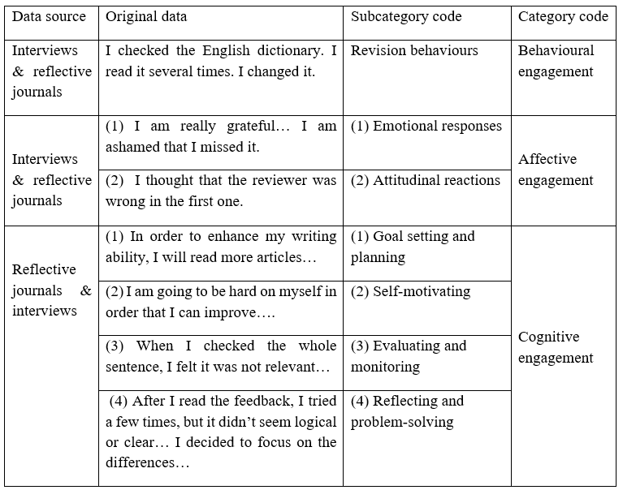
4 Findings
4.1 Peer feedback focus and type
Before discussing student engagement, it is important to identify the kind of feedback the students were responding to (Question 1). We found that this focused on the seven aspects shown in Table 3. Tina’s reviewers did not provide feedback on prepositions and adverbs, but both students received a high percentage of peer feedback on spelling, noun, verb, and sentence errors.
Table 3. Error focus in peer feedback on student writing
Error focus | Tina’s essays | Will’s essays
Spelling | 25.6% | 28.9%
Noun | 24.7% | 23.8%
Preposition | 0 | 7.6%
Verb | 18.8% | 16.7%
Adjective | 19.7% | 4.3%
Adverb | 0 | 6.3%
Sentence | 11.2% | 12.4%
Total | 100% | 100%

Table 4 indicates the type of feedback given by peers to the two students. The majority of feedback was indirect, indicating an error by underlining or circling, etc., but not providing the correction and so encouraging the student to find it. Both students also received subjective peer comments in the forms of praise, criticism, and suggestion, however, these were often brief. Having established the kinds of feedback they received; we now turn to how the participants responded to it.

Table 4. Feedback type in peer feedback on student writing
Feedback type | Tina’s essays | Will’s essays
Direct correction | 0 | 8.7%
Indirect correction | 57.2% | 65.2%
Praise | 21.4% | 4.3%
Criticism | 7.1% | 8.7%
Suggestion | 14.3% | 13.1%
Total | 100% | 100%

4.2 The case of Tina: Deep engagement with peer feedback
We characterize Tina’s engagement with peer feedback as “deep engagement”, indicating a more thorough and comprehensive commitment to working on the text as a result of the feedback provided. Not only was Tina active in responding to peer feedback by revising her essays, but she also displayed characteristics of self-regulated learning. She engaged with writing and revision tasks by adopting a repertoire of strategies: planning, goal setting, monitoring, and evaluating. Her engagement was characterized by a self-directive process guided by her cognitive and metacognitive strategies.

4.2.1 Active engagement in reflective journals
While we examined time on task, attitudes, and emotions in our study as important indicators of student behavioral and affective engagement, the literature suggests that these elements alone may not lead to effective learning outcomes. This is because students often struggle with how to cognitively engage with learning tasks (Bryson & Hand, 2007; Fredricks et al., 2004; Fredricks & McColskey, 2012). Therefore, we were more interested in how Tina cognitively engaged with peer feedback in her revision. We examined the entries in her reflective journals and the revision operations in her essays.
Tina’s two reflective journals were an invaluable data source enabling us to understand how she perceived the peer feedback she received as affective engagement and her efforts to address it in her writing (behavioral and cognitive engagement). We found that in her first reflective journal entry Tina analyzed peer feedback and responded by reflecting on the areas that needed further improvement in a very systematic way. We selected several examples shown in Figure 2.
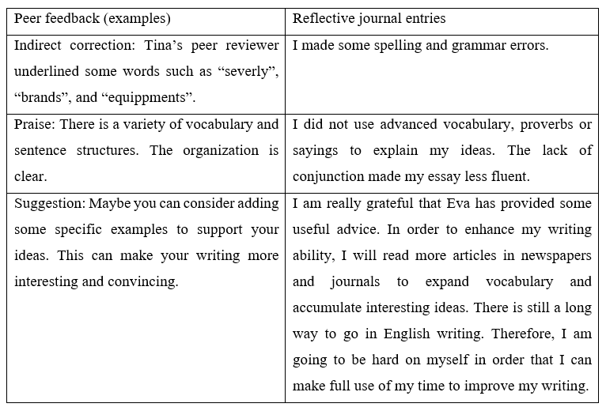
Figure 2 Tina’s first reflective journal entries in response to peer feedback
Tina admits that there are some spelling and grammatical errors in the first draft. Interestingly, she responds to her reviewer’s praise by identifying the lack of advanced vocabulary and connective words. This suggests that she does not get carried away by positive feedback but still conducts critical evaluation. She is also dissatisfied with how she expressed some ideas. To address these weaknesses, Tina develops a plan to read extensively to expand her vocabulary and learn how to convey ideas more effectively. She seems to have been prompted by her peer feedback to broaden her perspectives and produce better written work. She believes that reading might enable her to enrich her knowledge and make better sense of current affairs. This intentional and critical reflection on problems and solutions shows the benefits of reflective journaling as a powerful tool to inform and deepen student learning (Moon, 2006).
Affectively, she shows gratitude to her reviewer and strong determination to improve her writing as she acknowledges that there is still a long way to go in learning to write well in English. The systematic analysis of her weaknesses, the strategic planning of workable solutions, the determination and motivation shown in her journal indicate that Tina exercised a high level of self-regulation in language learning (Oxford, 2016) and indicate that she was behaviorally, affectively, and cognitively engaged in the revision process.
In her second reflective journal, Tina also analyzed the problems in her essay and explored potential solutions to address them (Figure 3).
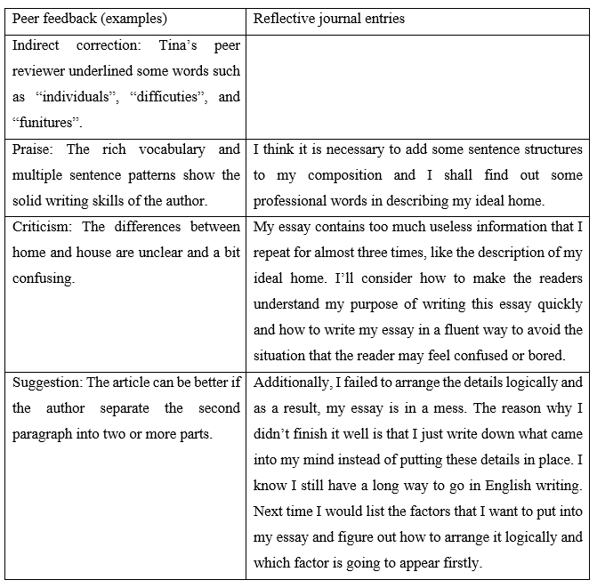
Figure 3. Tina’s second reflective journal entries in response to peer feedback
Here she admits that there were some repetition and illogical expressions in her essay. She attributes this to insufficient planning before writing. In addition, she sees that she failed to elaborate some ideas sufficiently for readers to follow. After this diagnosis of problems, Tina tries to identify solutions. She realizes that to improve the clarity of her writing she should develop an outline to lay out the potential factors to include, explore the connections between these factors, and arrange them in a clear way. The way she actively engages in writing the reflective journal epitomizes an important process-orientation to learning where reflection not only addresses past actions but also what steps to take in the future (Wilson, Howitt & Higgins, 2016). Again, she shows determination to make further improvement in the development of her writing skills in English.

4.2.2 Active engagement in revision operations
In addition to examining her reflective journals, we also looked at Tina’s essay drafts for evidence of cognitive engagement with peer feedback. The fact that she conducted different types of revision operations indicates how she cognitively engaged with the peer feedback in the first essay. Figure 4 shows an example of these revisions in response to peer feedback.

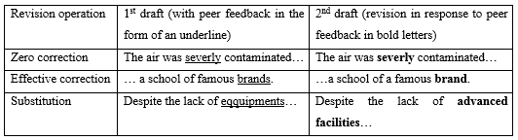
Figure 4. Examples of revision operations in Tina’s 1st essay
In terms of mechanical errors, Tina failed to engage with one feedback point so that the spelling error “severly”, remained in the revised draft. She said “I was too careless. I am ashamed I missed it.” She did, however, respond to the other two feedback points, changing the plural form of “brands” to the singular as suggested by the reviewer and substituting the word “equipments” with “facilities”. While this revision is a behavioral response to peer feedback, the use of substitution can also be seen as a strategic adjustment, thus indicating cognitive engagement with the feedback point. Tina talked about why she made the change in the interview:

After reading the feedback, I immediately found out that I made a spelling error because there should be only one “p” in the word “equipment”. However, when I checked the English dictionary again, I noticed that it is actually an uncountable noun. Then, I realized that the reviewer also made a mistake… So, in the end, I replaced it with a synonym that is a countable noun.

This strategy was thus prompted by an analytical process that included noticing, monitoring, and evaluating (Zhang & Rahimi, 2014), a clear indication of cognitive engagement. Tina also detected another grammatical error that had not been pointed out by the reviewer, correcting a misuse of past tense in the revised draft. In various ways, then, Tina went beyond a search for grammatical errors and tried to revise her original draft as a proofreader.
In the second essay, Tina carried out more extensive revision operations: effective correction, substitution, deletion, rewriting, and reorganization.

When asked in her interview why she replaced “imagine” with “visualize”, Tina said:

My reviewer didn’t ask me to change it. I did it myself. But she mentioned that I used some advanced vocabulary that she really admired. This just made me realize I should replace some simple words with complicated ones. I saw the word “visualize” a few days ago in a book, and I really like it, so I used it in my essay.

This self-initiated substitution shown in Figure 5 is echoed in other feedback studies which shows that student revisions do not necessarily correspond to one specific piece of teacher feedback (Authors, xxxx), and may originate with the student him or herself (Williams, 2004). In addition to substitution, Tina deleted a whole sentence and explained this as follows:

Originally, I was trying to fix word choice problem, but when I checked the whole sentence, I felt it was not very relevant to the point I wanted to say, so I decided to leave it out.

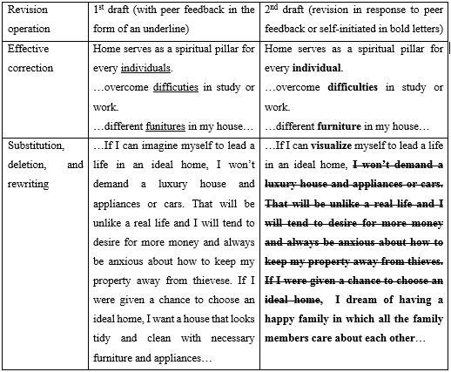
Figure 5. Examples of revision operations in Tina’s 2nd essay

Tina also made use of rewriting in her second essay, altering entirely the meaning of the original. The original sentence talked about a desired house, but the revised one was concerned with a “happy family” that Tina wanted to have. She explained why the change was made:

During the revision, I thought about my reviewer’s comment on the differences between home and house, and I felt that home is more about family rather than house, so an ideal home should have a happy family. That’s why I rewrote that sentence.

Last but not least, Tina made an adjustment in response to peer feedback she received on organization by rearranging two paragraphs. She did not do this haphazardly as she made efforts to evaluate the logical flow in her essay. Figure 6 shows how the reorganization was conducted.
The reorganized paragraphs were more clearly structured compared with the original as Tina first discusses that her understanding of “house” is different from others and then emphasizes that family relationships are more important than a luxurious house. She continued to elaborate on what good family relationships are and what family members need to do. In the end, she acknowledges some difficulty in building such a house but showed determination to work hard for it. With the rearrangement, the logical progression was much better. Overall, Tina did not seem to have treated the revisions as mere correction of errors but also focused on content and organization. She mentioned in the interview how she made the organizational change:

I was not very sure about how to rearrange two paragraphs after I read the peer feedback. I tried a few times, but it didn’t seem very logical or clear. But after several versions, I decided to focus on the differences between house and family first, then the meaning of good family, and last on how to build it.


Figure 6. An example of reorganization in Tina’s 2nd essay

The revision operations and the thought process used in making the changes show how Tina behaviorally and cognitively engaged in the revision process. While cognitive efforts are involved in addressing errors in grammar and mechanics, this type of revision is often seen as merely a surface change (Cho & MacArthur, 2010; Sommers, 1980). We should point out here that Tina not only addressed grammatical errors but also actively engaged in making wider textual changes such as rewriting and reorganization. Changes to content and structure often require more cognitive and metacognitive processing as student writers also need to evaluate their writing and monitor their performance (Authors, xxxx).

4.3 The case of Will: Surface engagement with peer feedback
We consider Will’s engagement with peer feedback as “surface engagement”. This type of learner tends to respond to peer feedback and revision tasks without much enthusiasm, often characterized by other-regulated learning. While he engaged with peer feedback on his written assignments, Will did not demonstrate active behavioral and cognitive engagement in the same way as Tina and his revisions were limited and ineffective.
4.3.1 Surface engagement in reflective journals
To investigate how Will cognitively engaged with peer feedback in the two essays, we once again examined his reflective journals and revision operations. In his first reflective journal, Will briefly assessed his performance in the first essay (Figure 7):
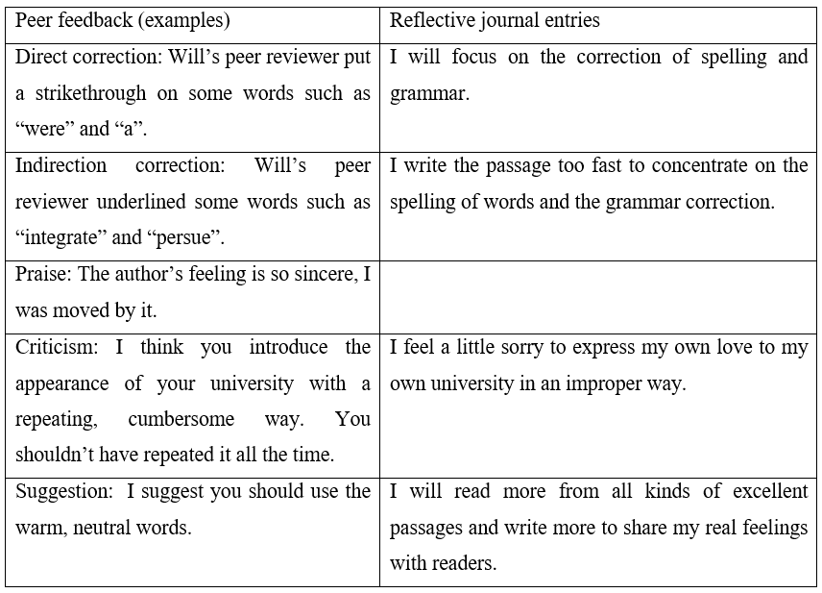
Figure 7. Will’s first reflective journal entries in response to peer feedback
In his reflective journal, Will makes clear that his main focus is on avoiding grammatical and mechanical errors and correcting them when they are pointed out to him. He first considers why he committed these errors, attributing this to carelessness as a result of writing too fast, and, prompted by peer feedback, resolves to use this insight to develop a habit of reviewing his own writing. He then turns to the issue of inconsistency in his tone and expresses his embarrassment at making this type of mistake, deciding to make improvements by learning from reading more well-written articles. However, his overall analysis tends to focus on surface errors in his writing without reflecting on either the content or the structure.
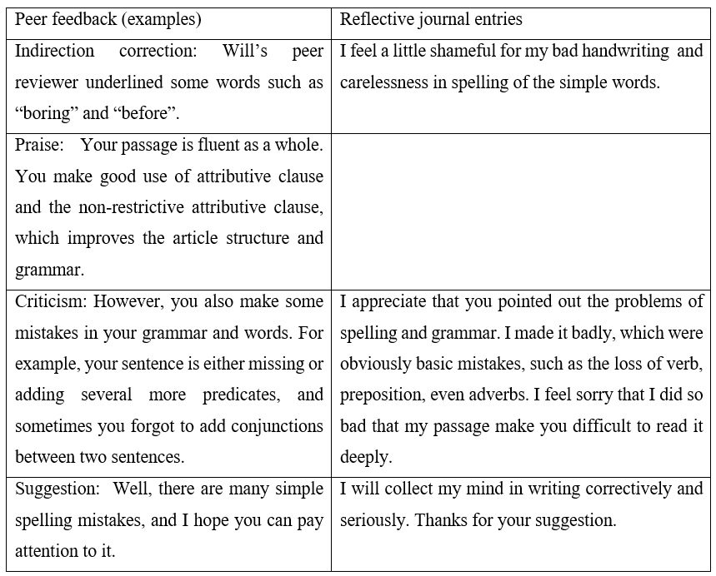
Figure 8. Will’s second reflective journal entries in response to peer feedback

An entry from Will’s second reflective journal (Figure 8) is also largely concerned with grammar and mechanics. For instance, he says how he felt ashamed of his poor handwriting which had made it difficult for his reviewer to read his text. He also regrets his carelessness in making grammatical and spelling errors, suggesting he had learnt from these mistakes and wanted to improve, but did not propose a strategy to do this. While he was able to cognitively engage with peer feedback in revision, his engagement was not sufficiently deep and effective, which is shown in his ineffective revision operations.

4.3.2 Surface engagement in revision operations
Another measure of cognitive engagement is the effort a writer makes to revise an essay in response to peer feedback. A comparison between the drafts of his first essay suggests that Will made use of four types of revision operations: effective correction, zero correction, deletion, and substitution. Examples of these are shown in Figure 9.
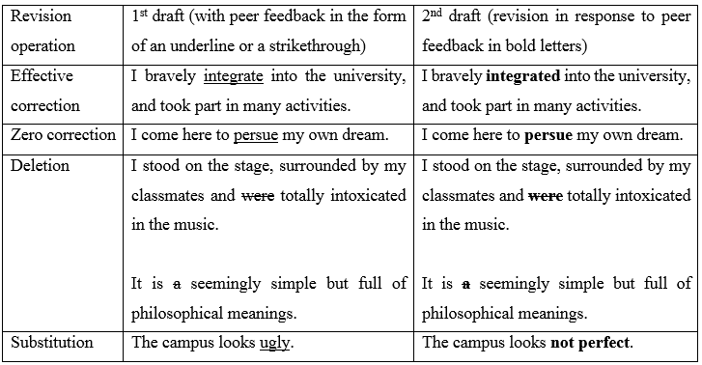
Figure 9. Examples of revision operations in Will’s 1st essay with peer feedback

Most of the errors pointed out by the peer reviewer were corrected by Will. For instance, in one case the peer reviewer underlined the verb “integrate” and in the revised draft Will changed it to the past tense. There was one instance where Will failed to respond to the peer feedback because he initially thought that there was no problem with the word “persue” even though the reviewer had underlined it. However, when he was later asked to check the word, he realized the error:
This is a silly mistake. But I might be able to correct it if the reviewer asked me to check the spelling.
Will used deletion on two occasions where the peer reviewer offered very explicit instructions, so it did not require much cognitive effort to revise. He used substitution by either simply copying the peer reviewer’s suggested correction or following the advice he was given, as he stated in the interview:
The reviewer not only found the wrong use of the word but also told me again at the end of the essay. She asked about my stance in the essay because I wrote something opposite. After I looked again, I decided to reduce my tone by changing a harsh word.
Will made use of four revision operations in his second essay: effective correction, zero correction, deletion, and substitution (Figure 10). He appropriately corrected the majority of the feedback, but he explained why he ignored two feedback points:
I thought that the reviewer was wrong in the first one. I wrote a correct sentence with “such” as a pronoun with a clause. It was deliberate, so maybe the reviewer didn’t get it? So, I didn’t change it. For the second, I thought that “fast” is similar to “quick”, so I just need to add “ly” when changing it from an adjective to an adverb.
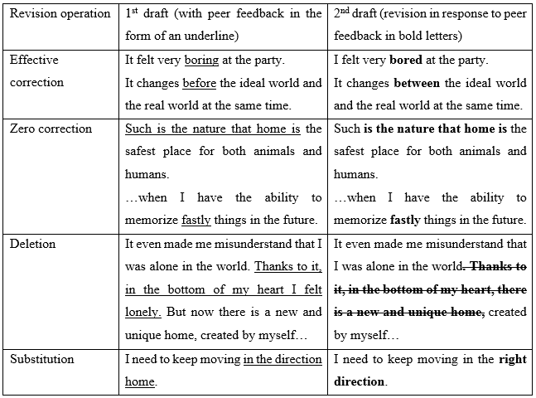
Figure 10. Examples of revision operations in Will’s 2nd essay with peer feedback

As most errors in the first draft were explicitly pointed out by the peer reviewer, who also often provided the correct answers too, Will did not need to invest much effort in revising. However, there was also some implicit feedback on the draft, such as underlining or question marks, without explanation. For example, Will deleted one sentence that was underlined by the reviewer who felt it was redundant and added nothing to the essay development. Will explained in the interview:
At first, I was thinking about how to improve this sentence, but when I read it several times, I found it was unnecessary.
Will substituted “keep moving in the direction of home” with “keep moving in the right direction” when he saw that the peer reviewer underlined “in the direction of home”. He offered explanations in the interview:
When I saw the underline, I thought that maybe “direction of home” was wrong, so I changed it to “right direction” because I remember I saw other people use it.
Overall, Will’s attitude towards peer feedback was positive and he believed that he had benefited from both the corrective feedback and end comments he had received. He demonstrated cognitive engagement with the feedback by making a number of revisions, although most were at the surface level. It is important to note that he did not make use of reorganization and rewriting, which requires more time, effort and skill. With regard to cognitive strategies, he was able to analyze and evaluate the peer feedback, although he did not have the self-awareness or explicit understanding to show how he had monitored the revision process. While he showed some cognitive engagement with the peer feedback, his use of revision operations and cognitive strategies were rather limited.

5 Discussion
5.1 Patterns of engagement in revision
Through reflective journaling and revising practices, we were able to examine both students’ revision processes. Both students engaged behaviorally, affectively, and cognitively with the peer feedback they received on their essays, but the ways they did this were different. We characterize Tina’s participation as deep engagement and Will’s as surface engagement
In the cognitive dimension, Tina’s engagement was characterized by systematic and critical reflection in her reflective journals and her efforts to conduct a wide range of revision operations in her drafts. Apart from multiple revision operations to improve the content and structure in her essays, both the journals and interviews suggest that she was able to articulate how she evaluated and monitored her revision processes, an indication of cognitive and metacognitive strategies (Oxford, 2016). In contrast, Will spent very little time revising and confined these to surface changes and rewording (Sommers, 1980). His focus was almost entirely on grammar and mechanics which limited his revision to error correction and his journals entries showed no .

In terms of affective engagement, the emotional and attitudinal responses to peer feedback of both participants were generally very positive. Tina and Will endorsed peer feedback for its multiple benefits and expressed gratitude for the work of their reviewers. However, a closer look reveals that their affective engagement led to different patterns of behavioral and cognitive engagement. Specifically, the positive attitudes expressed by Tina led to a strong motivation to improve her writing characterized by a determination to set goals and execute plans to achieve them (Barkaoui, 2007). She felt motivated by her peer feedback and prepared detailed solutions to her problems in her reflective journal entries. It is worth noting that reflective journaling offers a valuable insight into her revision process in which affective engagement and cognitive engagement mutually enhanced each other. However, Will did not channel his positive emotions about peer feedback into greater behavioral or cognitive efforts to revise his essays as he neither put in much time on revision nor went beyond surface changes.
In terms of behavioral engagement, we found that the two students were able to make use of different revision operations when responding to peer feedback. Revision for Tina, however, went beyond a focus on error correction to encompass six types of operations: zero correction, effective correction, deletion, substitution, reorganization and rewriting. These operations, made concrete in the textual changes in student texts, are an important way of measuring cognitive engagement with external feedback, which has been reported in previous research on student engagement with teacher feedback and computer-generated feedback (Authors, xxxx; Ranalli, 2021). Tina used all these types of revision operations, especially reorganizing and rewriting beyond the word level. The use of these operations demonstrates considerable commitment and motivation that are often overlooked in studies of L2 writing which focus on word level revisions (e.g., Tuzi, 2004; Pham & Usaha, 2016). More importantly, these operations refer to substantive changes in content and structure that required cognitive and metacognitive efforts, such as planning, evaluating, and monitoring (Authors, xxxx; Flower & Hayes, 1981).
The textual changes in Tina’s drafts therefore suggest considerable cognitive engagement with her peer feedback. Will was also able to conduct revision operations, but these were limited in both number and type, and he did not invest much time and effort in revising his drafts. This surface engagement with peer feedback is consistent with the findings of several previous studies in which most students tended to respond to form-focused peer feedback and mostly revised language errors (Fan & Xu, 2020; Yu et al., 2019). For Will, revision seems to have been a “re-wording activity” (Sommers, 1980, p. 381) rather than a way of making improvements at syntactic and discourse levels.
5.2 Individual and contextual factors
Individual factors, such as L2 proficiency and learner beliefs, may have contributed to the ways these students engaged with feedback. Tina, with a higher L2 proficiency, was able to use her greater knowledge of English to understand and evaluate her peer reviewers’ feedback before revising. When there was uncertainty, she consulted a dictionary and made an informed decision. She also brought this proficiency to bear on assessing the logical flow of her ideas and how the essay was organized. In terms of learner beliefs, Tina stated her conviction that peer feedback could offer her external validation of her language choices. She saw feedback as facilitating her writing rather than directing it with necessary changes, suggesting that while she needed confirmation from her peer reviewers, she made use of the considerable autonomy that her knowledge of English gave her and her own judgement allowed her to follow her own agenda to revise her texts.
Will, on the contrary, did not seem to fully grasp some of his reviewers’ comments, and sometimes simply ignored them. When doubts arose, he was unable to make use of other resources to evaluate this feedback. Less proficient L2 learners tend to favor corrective feedback on surface-level errors as these are relatively easier to address (Ware, 2011; Zhao, 2010). His focus on corrective feedback offered by his peer reviewers and his positive emotions about fewer errors in his second essay indicate that he equated the improvement of writing competence to a decrease in errors. This might help to explain why he made little effort to improve content and organization in his texts. These remarks about proficiency seem plausible, but await further research to clarify the relationship between language ability and engagement.
We also found that specific contextual factors, such as the relative importance of the essays, explicit teacher requirements and students’ previous feedback experiences, also influenced how these two students engaged with peer feedback.
The fact that their teacher set reflective journals as a compulsory task encouraged both students to think about their revisions, the factors that prompted them to revise, and whether they considered the advice useful. While few studies of peer feedback seem to have used reflective journaling in this way, we found it invaluable not just as a learning aid, but as a window into students’ engagement with the revising process. The benefits of using reflective journals have also been documented by Hoo, Tan and Deneen (2020) in a previous study on student engagement with self- and peer-feedback although that study focused on teamwork competencies rather than student revision. Reflective journals not only promote student reflection on writing, encouraging them to engage with feedback, but also gives outsiders insights into these processes. Students’ previous experiences with feedback on their writing also seems to play a role in how far they see peer response as useful and so whether they are likely to engage with it. For instance, Tina mentioned her gratitude to her peer reviewer as she compared her past experience with teacher feedback and her new experience with peer feedback, which further encouraged her active engagement with it.

6 Conclusion
This comparative study points to the importance of reflective journaling and revision operations in opening the black box of revising in student engagement with peer feedback. In contrast to previous research, our study has shed light on student revision processes through journal entries and revisions across different drafts. Effective revisions require the integration of behavioral, affective, and cognitive engagement in the whole process whereby active revision behaviors, positive emotions and attitudes, and conscious use of revision operations and cognitive strategies created a synergistic effect. It is important to emphasize that without reflection, conscious efforts and mindfulness it is unlikely for the students to produce quality revisions. We have shown that the integration of reflective journaling in tandem with revising practices can be the key to encouraging mindful and effective student engagement with peer feedback in L2 writing.
We recognize, however, that our method relies on the in-depth focus of a small sample and fails to provide the possibility of generalizing the findings which a study of a larger cohort might offer. But collecting journal entries, interviewing students and analyzing student revisions provides data not available by more quantitative methods. Future research may offer supporting insights by employing different methods and addressing a wider range of students. Moreover, although we have identified two types of engagement: deep and surface, it is probable that there are intervening degrees of engagement which future studies may reveal. We would, therefore, encourage researchers to explore both the concept of engagement and how students with different levels of L2 proficiency, different backgrounds and varied experiences, engage with peer feedback. As we have shown in this study, cognitive engagement is probably the most difficult to get at analytically as it cannot be directly observed, so the use of think aloud protocols while revising might usefully supplement the analysis of revision operations, reflective journals and interviews.
While we believe student engagement with peer feedback is key to their effective revisions, this is not always easy for students, especially when they may lack adequate proficiency and the strategies to exploit different dimensions of engagement. Teachers play an important role here in providing explicit instruction. In terms of developing behavioral engagement, teachers might encourage students to invest more time in analyzing and evaluating the feedback peers provide. To cultivate the affective dimension students could be offered advice on how to regulate their emotional responses to peer feedback and adopt positive attitudes toward revision. Perhaps the most challenging aspect of instruction lies in helping L2 students improve their cognitive engagement. This requires a clear explanation of what strategies can be used to evaluate the effectiveness of peer feedback and to monitor their revisions in response to it. We have shown that reflective journals can help students become aware of these strategies and their own approaches to revision. They can be an invaluable tool in unlocking the potential of students’ engagement with peer feedback.

References
Allen, D., & Katayama, A. (2016). Relative Second Language Proficiency and the Giving and Receiving of Written Peer Feedback. System, 56, 96–106.
Cho, K., & MacArthur, C. (2010). Student revision with peer and expert reviewing. Learning and Instruction, 20(4), 328-338.
Connor, U., & Asenavage, K. (1994). Peer response groups in ESL writing classes: How much impact on revision? Journal of Second Language Writing, 3, 257-276.
Diab, N. (2011). Assessing the relationship between different types of student feedback and the quality of revised writing. Assessing Writing, 16(4), 274-292.
Duff, P. (2008). Case study research in applied linguistics. New York, NY: Erlbaum.
Dunleavy, J. (2008). Bringing student engagement through the classroom door. Education Canada, 48(4), 10-23.
Faigley, L., & Witte, S. (1981). Analyzing revision. College Composition and Communication, 32(4), 400-414.
Fan, Y & Xu, J. (2020). Exploring student engagement with peer feedback on L2 writing, Journal of Second Language Writing, 50(4): 100775.
Ferris, D.R. (2006). Does error feedback help student writers? New evidence on the short- and long-term effects of written error correction. Feedback in second language writing. New York: Cambridge University Press. (81-104).
Flower, L., & Hayes, J. R. (1981). A cognitive process theory of writing. College Composition and Communication, 32(4), 365-387.
Fredricks, J. A., Blumenfeld, P. C., & Paris, A. H. (2004). School engagement: Potential of the concept, state of the evidence. Review of Educational Research, 74, 59-109.
Fredricks, J. A., & McColskey, W. (2012). The measurement of student engagement: A comparative analysis of various methods and student self-report instruments. In S. L. Christenson, A. L. Reschly, & C. Wylie (Eds.), Handbook of research on student engagement (pp. 763-782). New York, NY: Springer.
Guardado, M. & Shi, L. (2007). ESL students’ experiences of online peer feedback. Computers and Composition, 24(4), 443–461.
Guerrero, M. C. M., & Villamil, O. S. (1994). Social‐cognitive dimensions of interaction in L2 peer revision. Modern Language Journal, 78(4), 484-496.
Halbach, A. (1999). Using trainee diaries to evaluate a teacher training course. ELT Journal, 53(3), 183–90.
Hayes, J. R. (1996). A new framework for understanding cognition and affect in writing. In C. M. Levy & S. Ransdell (Eds.), The science of writing (pp. 1-27). Mahwah, NJ: Lawrence Erlbaum.
Hoo, H., Tan, K., & Deneen, C. (2020). Negotiating self- and peer-feedback with the use of reflective journals: an analysis of undergraduates’ engagement with feedback. Assessment & Evaluation in Higher Education, 45(3), 431-446.
Hu, G. (2019). Culture and peer feedback. Feedback in second language writing. New York: Cambridge University Press (45-63).
Jordi, R. (2011). Reframing the concept of reflection: Consciousness, experiential learning, and reflective learning practices. Adult Education Quarterly, 61(2): 181–197.
Lundstrom, K., & Baker, W. (2009). To give is better than to receive: The benefits of peer review to the reviewer's own writing. Journal of Second Language Writing, 18(1), 30-43.
Moon, J. A. (2006). Learning journals: A handbook for reflective practice and professional development (2nd ed.). London: Routledge.
Nelson, G., & J. Carson. (1998). ESL students’ perceptions of effectiveness in peer response groups. Journal of Second Language Writing, 7(1), 113-131.
Nelson, G., & J. Carson. (2006). Cultural issues in peer response: revising ‘culture’. Feedback in second language writing (2nd ed). New York: Cambridge University Press. (42-59)
Oxford, R. (2016). Teaching and researching language learning strategies: Self-regulation in context (2nd ed.). London: Taylor & Francis Group.
Pham, V. P. H. & Usaha, S. (2016). Blog-based peer response for L2 writing revision. Computer Assisted Language Learning, 29(4), 724-748.
Ranalli, J. (2021). L2 student engagement with automated feedback on writing: Potential for learning and issues of trust. Journal of Second Language Writing, 52, 100816.
Rodgers, C. (2002). Defining reflection: Another look at John Dewey and reflective thinking. Teachers College Record, 104(4), 842–866.
Rollinson, P. (2005). Using peer feedback in the ESL writing class. ELT Journal, 59(1), 23-30.
Schön, D. (1987). Educating the Reflective Practitioner. San Francisco: Jossey-Bass.
Shin, S. J. (2003). The reflective L2 writing teacher. ELT Journal, 57(1), 3-10.
Sommers, N. (1980). Revision strategies of student writers and experienced adult writers. College Composition and Communication, 31(4), 378-388.
Stevens, D., & Cooper, J. (2009). Journal keeping: How to use reflective writing for learning, teaching, professional insight, and positive change. Sterling, VA: Stylus Publishing.
Storch, N. (2002). Patterns of interaction in ESL pair work. Language Learning, 52(1), 119-158.
Storch, N. (2019). Collaborative writing as peer feedback. Feedback in second language writing 2nd ed. New York: Cambridge University Press. (143-161)
Strauss, A. L., & Corbin, J. M. (1998). Basics of qualitative research: Techniques and procedures for developing grounded theory (2nd ed.). Thousand Oaks: Sage Publications.
Suzuki, M. (2008). Japanese learners' self revisions and peer revisions of their written compositions in English. TESOL Quarterly, 42(2), 209-233.
Tuzi, F. (2004). The impact of e-feedback on the revisions of L2 writers in an academic writing course. Computers and Composition, 21(2), 217-235.
Ware, P. (2011). Computer-generated feedback on student writing. TESOL Quarterly, 45(4), 769-774.
Williams, J. (2004). Tutoring and revision: Second language writers in the writing center. Journal of Second Language Writing, 13, 173-201.
Willms, J. D., Friesen, S., & Milton, P. (2009). What did you do in school today? Transforming classrooms through social, academic and intellectual engagement. Retrieved from https://www.edcan.ca/wp-content/uploads/cea-2009-wdydist.pdf on 8 Sep, 2022.
Wilson, A., Howitt, S., & Higgins, D. (2016). Assessing the unassessable: Making learning visible in undergraduates’ experiences of scientific research. Assessment & Evaluation in Higher Education, 41(6): 901–916.
Wu, Z. (2019). Lower English Proficiency Means Poorer Feedback Performance? A Mixed-Methods Study. Assessing Writing, 41, 14–24.
Yang, Y., & Wu, S. (2011). A collective case study of online interaction patterns in text revisions. Educational Technology & Society, 14(2), 1-15.
Yoshida, R. (2008). Learners’ perception of corrective feedback in pair work. Foreign Language Annals, 41, 525–541.
Yu, S., & Hu, G. (2017). Understanding university students’ peer feedback practices in EFL writing: Insights from a case study. Assessing Writing, 33, 25-35.
Yu, S., & Lee, I. (2015). Understanding EFL students' participation in group peer feedback of L2 writing: A case study from an activity theory perspective. Language Teaching Research, 19(5), 572-593.
Yu, S., & Lee, I. (2016). Peer feedback in second language writing (2005–2014). Language Teaching, 49(4), 461-493.
Yu, S., Zhang, Y., Zheng, Y., Yuan, K., & Zhang, L. (2019). Understanding student engagement with peer feedback on master’s theses: A Macau study. Assessment and Evaluation in Higher Education, 44(1), 50-65.
Zhang, L. J., & Rahimi, M. (2014). EFL learners' anxiety level and their beliefs about corrective feedback in oral communication classes. System, 42, 429-439.
Zhao, H. (2010). Investigating learners' use and understanding of peer and teacher feedback on writing: A comparative study in a Chinese English writing classroom. Assessing Writing, 15(1), 3-17.
Zheng, C. (2012). Understanding the learning process of peer feedback activity: An ethnographic study of exploratory practice. Language Teaching Research, 16(1), 109-126.

