Zhang, Z. V. & Hyland, K. (2024). The role of digital literacy in student engagement with automated writing evaluation (AWE) feedback on L2 writing. Computer Assisted Language Learning,

The role of digital literacy in student engagement with automated writing evaluation (AWE) feedback on second language writing

Abstract
Research on second language (L2) writing suggests that student engagement with automated writing evaluation (AWE) feedback is influenced by various individual and contextual factors. Little attention, however, has been given to the role that students’ digital literacy can play in this process. Increasingly, digital literacy is becoming indispensable in language teaching and learning as reading, writing, and communicating are conducted and mediated by digital technologies. This study explores how seven L2 students engaged with AWE feedback on their L2 writing in a Chinese university, analysing data collected from student written texts, AWE feedback, and student interviews. We found that the students engaged with AWE feedback in different ways in terms of their perceptions, attitudes, and revisions. The study shows that students’ digital literacy has considerable impact on how they engaged with AWE feedback regardless of their L2 proficiency. We argue that L2 students’ digital literacy, characterised by an awareness of the affordances and constraints of technologies, an ability to evaluate digital information, and a willingness to use digital technologies for peer collaboration, can be a key factor in effective student engagement with AWE feedback on L2 writing.
Keywords: digital literacy; AWE, automated feedback; student engagement; L2 writing

1. Introduction
The benefits of using automated writing evaluation (AWE) feedback (or computer-generated feedback) in writing instruction and assessment are well documented in second language (L2) writing studies (e.g., Authors, xxxx; Chen & Cheng, 2008; Cotos et al., 2020; Ranalli, 2018; Wang et al., 2013). AWE systems are seen to provide immediate and timely evaluation (Dikli, 2006), offer multiple drafting and revision opportunities (Grimes & Warschauer, 2010), and promote autonomous learning (Authors, xxxx). They are also believed to facilitate students’ metalinguistic development and have an important role to play in genre-based writing instruction (Cotos, 2018; Li et al., 2015).
However, the extent to which students are able to benefit from these advantages depends on how they engage with AWE feedback. Certainly, L2 student engagement with human feedback on writing is a complex process involving multiple individual (e.g., L2 proficiency, learner beliefs, and motivation) and contextual factors (e.g., teacher stance and institutional requirements) (Han & Hyland, 2015; Zheng & Yu, 2018). AWE feedback adds to this complexity as students need to understand the pros and cons of educational technology (Xu et al., 2019) to make effective use of it to improve their writing (Stevenson & Phakiti, 2014). In other words, in addition to linguistic competence (Bai & Hu, 2017), students also need to be technology savvy (Fieldhouse & Nicholas, 2008) with a competence that includes computer skills, abilities in information and communications technology, information evaluation skills, as well as positive attitudes (Bawden, 2001).
Previous studies have identified several factors that might influence student use of automated feedback on their writing, including the specificity of feedback (Ranalli, 2018), student L2 proficiency (Authors, xxxx), learner beliefs and autonomy (Bai & Hu, 2017; Warschauer & Grimes, 2008) and human-automation trust (Ranalli, 2021). But none have recognised the importance of students’ digital literacy – the ability to find, evaluate, and convey information effectively using digital platforms. Digital literacy, in fact, is becoming increasingly important in language teaching and learning as new technologies have a profound impact on communication (Hafner et al., 2015). This means that reading and writing now require both the technical mastery of digital tools and the possession of higher level cognitive skills to evaluate those tools and their suitability for the task at hand (Jones & Hafner, 2012).
Digital literacy, therefore, has tremendous potential to mediate student engagement with AWE feedback and a greater understanding of its role could assist teachers to help students make the most of this feedback to improve their writing. We explore this role by studying how seven L2 students in a Chinese university used AWE feedback and seeking to answer the following questions:
- What AWE feedback did the students receive on their writing?
- How did the students engage with AWE feedback?
- How did digital literacy mediate this engagement?
In doing so we hope to provide insights into how digital literacy and student engagement with AWE are dynamically connected.

2. Conceptual underpinnings
2.1. Digital literacy
Digital literacy, in essence, refers to an individual’s ability to evaluate and compose information appropriately through writing and other media using digitial platforms. The term was coined by Gilster (1997) who referred to it as an ability to understand and use information from a wide variety of digital sources, and knowing when and how to use these technologies effectively. Relevant studies have explored users’ abilities to read and understand information in various digital formats, such as hypertext and multimedia systems (Bawden, 2001), online networks and information technologies (Lankshear & Knobel, 2008). While ‘digital’ and ‘electronic’ are often used interchangeably, the former has a narrower focus and excludes telephones and other telecommunications products. Digital literacy is also distinguished from ‘computer literacy’ that refers to knowledge such as keyboarding skills, coding and familiarity with operating systems (Topping & Mckenna, 1999). It is a concept which sees literacy as a social practice, rather than an abstract skill set; abilities which are related to what individuals can do in particular social and cultural contexts (Street, 2003).
Work in New Literacy Studies has shown that writing, and other modes of communication, are complex human activities always located in specific times and places. Thus the idea of digitial literacy goes beyond having the skills to search and handle information in computerized form; it refers to individuals using technologies to construct meaning in ways appropriate to their needs (Lankshear & Knobel, 2008). Burniske (2007), for example, embraces pragmatic aspects of communication in his understanding of digital literacy, including tact, ethical conduct, logic and critical evaluation of content. The social and communicative practices required to engage in digitally codified meaning making also figure in definitions of digital literacy offered by Lankshear and Knobel (2008) and Meyers et al. (2013).
Jones and Hafner (2012) propose five-dimensions of digital literacy:
- Doing - actions in the physical world including sharing texts, images, or videos as well as using search engines to find information.
- Meaning - forms of representation, such as reading multimodal webpages and hypertext.
- Relating - patterns of interaction that include managing online relationships, interaction between writers and readers, and collaboration among peers.
- Thinking - experiencing and thinking about reality mediated through digital tools.
- Being - social identity that people present and assume in a digital world.
Hafner et al. (2015) suggest two areas that merit further research with regard to language learning: 1) the needs of learners created by new modes of reading, writing, and communication in L2 education, and 2) new contexts of language learning created as a result of the multilingual environments of global online contexts. This five-dimension model is a useful starting point for our study of student engagement with AWE feedback as the five components of digital literacy interact with the three dimensions of student engagement discussed below.

2.2. Student engagement
The concept of student engagement first emerged in the work of educational psychologists, such as Tyler (1969) and Pace (1984), later being taken up by cognitivist psychologists as a meta-construct concerned with students’ academic achievement, positive behaviours, and sense of classroom belonging (Willms et al., 2009). In their synthesis of some 40 studies on engagement, Fredricks, Blumenfeld and Paris (2004) identified three dimensions: behavioural, emotional, and cognitive. Behavioural engagement includes time-on-task and student participation in academic and extracurricular activities. Emotional engagement refers to attitudes towards teachers, peers, and school, a sense of classroom, and interest in school tasks. Cognitive engagement concerns students’ effort, commitment and the use of focused, self-regulated strategies.
This tripartite concept of engagement has proved useful in feedback research. Ellis (2010), for example, uses ‘engagement’ to refer to how L2 learners respond to oral and written corrective feedback, employing a tripartite conceptualization: (1) behavioural, whether and how learners take up feedback or revise their texts, (2) affective, learners’ attitudinal responses to feedback, and (3) cognitive, how learners attend to feedback. In their analysis of student engagement with assessment feedback, Handley, Price, and Millar (2011) emphasise two key notions: readiness-to-engage with feedback and positive active engagement with feedback. The former refers to a willingness to invest time and effort, self-efficacy and a sense of ownership. The latter is concerned with implicit actions such as reflecting on feedback, and actions like asking questions and interacting with feedback providers.
The importance of student engagement has received growing attention in feedback research in L2 writing. For instance, recent work has investigated how L2 students engage with teacher feedback (e.g., Han & Hyland, 2015; Zheng & Yu, 2018). These studies have identified the multifaceted nature of engagement whereby students need to both manage their emotions and utilize cognitive strategies to make corrections. Building on the tripartite framework of Fredricks et al. (2004), Authors (xxxx) proposed a model to analyse dimensions of L2 student engagement with feedback:
- Behavioural engagement is examined through time spent on revisions and revision behaviours;
- Affective engagement is measured via emotional reactions to feedback and attitudinal changes;
- Cognitive engagement is reflected in how cognitive strategies are used in revision and what revision operations are conducted.
This model of engagement is adopted in this study as it is supported by prior work and has been used to study L2 writers’ interaction with AWE feedback.
Drawing on the research discussed above, particularly Jones and Hafner’s (2012) model of digital literacy and Authors’ (xxxx) model of student engagement with feedback, we propose a model of digital literacy and student engagement with feedback on L2 writing summarised in Figure 1 which shows how the two models interact, with behavioural, affective, and cognitive engagement mapping on to doing and meaning, relating and being, and thinking respectively.
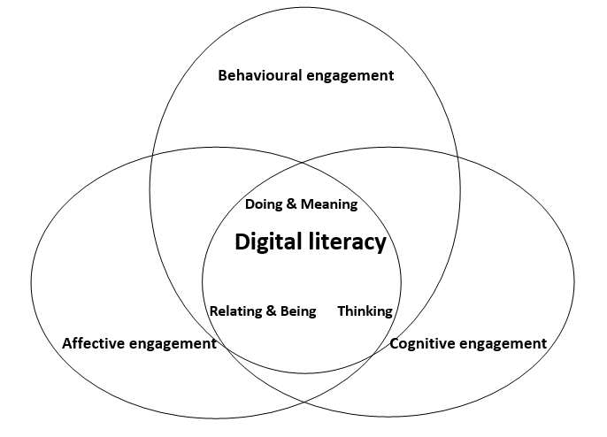
Figure 1. A model of digital literacy and student engagement

We have grouped doing and meaning together as both involve reading, writing, interpreting, and communicating (Hafner et al., 2015). Similarly, relating and being unite in the sense that language learners construct their identities by relating to others and the world (Norton & Toohey, 2011). Specifically, we found the construct of digital literacy interacted with student behavioural, affective, and cognitive engagement in the following ways:
- Thinking by developing an awareness of the affordances and constraints of AWE technology to their writing development
- Doing and meaning by using AWE feedback to conduct revision operations
- Relating and being by interacting with peers in online communities and constructing an identity as a learner and writer in peer groups
This model informs our analysis of how digital literacy mediates students’ engagement with AWE feedback.
3. Previous research on AWE feedback and student revisions
Since emerging in the 1960s, AWE systems have increasingly drawn on developments in artificial intelligence, latent semantic analysis, and improved statistical methods to enhance their performance (Stevenson & Phakiti, 2019). Today they are able to automatically assess student writing by providing feedback on grammar and mechanics (Cotos, 2018), by highlighting problems in content and organization (Weigle, 2013), and by alerting students to rhetorical moves and genre conventions (Cotos et al., 2020). These features have tremendous advantages and AWE systems have been commended for the immediacy of their diagnostic feedback, the opportunities they offer for multiple drafting, and for their role in formative writing assessment (Cotos, 2018; Dikli, 2006). AWE programmes have, however, been criticised for favouring length over brevity, overemphasising the use of transition words and providing generic feedback (Chen & Cheng, 2008). Researchers have also voiced concerns over the accuracy rates in identifying errors of grammar, mechanics, and collocation (Bai & Hu, 2017; Dikli & Bleyle, 2014).
Most AWE research on student revision is concerned with students’ written products, and few studies have examined how students engage with AWE when revising. Researchers tend to focus on the impact of AWE on error reduction in drafts and the improvement of holistic scores (e.g., Li et al., 2014; Li et al., 2015; Wang et al., 2013). Attali (2004), for example, found that students using Criterion reduced their error rates by 25% and increased the number of main points and supporting ideas they gave as well as the length of their conclusions. Warschauer and Grimes (2008), however, showed that students made almost all their revisions at the word or sentence level following advice from Criterion and My Access! without improving their content and organization. Cotos (2011), using an AWE system called Intelligent Academic Discourse Evaluator (IADE), observed that the students revised 87% of their sentences, making 285 changes to their drafts, mainly editing vocabulary, content, and structure with few grammar changes.
Other studies have investigated students’ attitudes toward AWE feedback, with responses varying widely depending on how the system was used (Chen & Cheng, 2008; Grimes & Warschauer, 2010; Dikli & Bleyle, 2014). Obviously, AWE programmes do not work wonders across all contexts, and its efficacy is largely dependent on how students engage with it. Therefore, recent studies have started to look at how students process and respond to AWE feedback in their revisions. Authors (xxxx), for instance, explored how individual L2 learners responded to AWE feedback behaviourally, emotionally, and cognitively. They suggested that engagement requires students to regulate their emotions and employ effective cognitive strategies. Bai and Hu (2017) found that students used the feedback selectively and adjusted their responses to it according to whether they believed it to be accurate. Ranalli (2018) observed that the explicitness of the feedback and levels of L2 proficiency influenced how 82 L2 students made use of AWE feedback. In a recent study, Ranalli (2021) found that student trust in the AWE tool Grammarly played a vital role in their uptake of feedback and their subsequent revisions.
While these studies have enriched our understanding of AWE systems and student revisions, few have explored why students made textual changes in their drafts. Absent from many AWE studies is the triangulation of data sources and research methods needed to ensure the reliability of interpretations of student behaviours. In addition, while researchers have called for more attention to electronic literacies (Warschauer & Ware, 2006) and computer literacy in this area (Bai & Hu, 2017), the construct of digital literacy remains unexplored. By taking a multiple-case study approach to focus in detail on the analysis of drafts, AWE feedback and student interviews, we seek to overcome the limitations of previous research and extend the study of AWE feedback. In the following sections we describe our methods and findings.

4. Methods
4.1. Research context and participants
The study was conducted as part of a larger research project in a public university in China. We adopted a multiple-case study design as an established means of gathering rich data to analyse students’ experiences of language learning (Duff, 2008) and responses to feedback (e.g., Han & Hyland, 2015; Ranalli, 2021). Seven participants were chosen from a cohort of 58 second-year students in a General English Course and with previous experience of using AWE feedback in their first year. Maximum variation sampling was used to select this group, ensuring we included students with different proficiency, gender and disciplinary profiles. The seven participants had already taken IELTS exams as they planned to apply for an exchange programme or master’s degree in English-speaking countries. In addition, they were willing to share their texts and be interviewed after being informed the purpose of the project. The participants’ profiles with pseudonyms are shown in Table 1.

Table 1. Student profiles
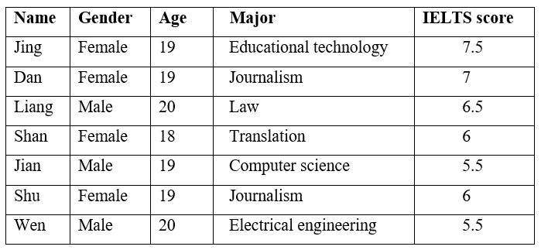
4.2. The AWE programme
The AWE programme is Pigai (www.pigai.org) which was launched by Beijing Cikku Science and Technology Company in 2011 and is now used by millions of students in China. Like other AWE systems such as Criterion and Grammarly, Pigai is supported by language processing technology and statistical algorithms to offer real-time holistic scoring and diagnostic feedback on English writing (Bai & Hu, 2017). For users, Pigai feedback is given immediately on submission and includes an overall score for an essay, the rank the student has achieved compared with others on that assignment, corrective feedback on grammar, vocabulary, mechanics, and sentence structure, and end comments on overall quality. Appendices A and B show illustrative screenshots. Students can submit their work as often as they wish, but are often interested in their overall score, which the program calculates using multiple regression analysis of four measurable text features: vocabulary, sentence, structure, and content relevance. It uses a default formula for this as vocabulary 43%, sentence 28%, structure & organization 22%, and content relevance 7%, but teachers can adjust the weighting of each area according to assessment purposes.

4.3. Data collection and analysis
We collected data from multiple sources: student essays, submission records, AWE feedback, and interviews with the seven students over an eight-week period. The teacher was a Chinese male, Ben (pseudonym), with 10-year’s teaching experience and a strong interest in educational technologies and AWE programmes. He used educational websites in his teaching and encouraged the students to work on laptops. As part of the course he assigned a 500-word review of a BBC documentary entitled Exploring China: A Culinary Adventure which accounted for 40% of the course grade. Reflecting the importance of this assessment task, Ben gave his students eight weeks to write and revise their drafts, asking them to submit their essays to Pigai before submitting to him. The students had been introduced to Pigai in their first year which meant he did not intervene during the eight weeks. Because the programme records and stores each student’s revisions, scores, comments and the number of submissions they make, we were able to retrieve considerable information on their use of it. Guided by prior research (e.g., Han & Hyland, 2015; Zheng & Yu, 2018) we identified and classified the feedback provided by the programme on the students’ drafts (Appendix C).
We also coded the students’ revisions using a modified version of Sommers’ (1980) revision strategies and Faigley and Witte’s taxonomy of revisions (1981). The former categorised revisions into addition, deletion, substitution, and reordering, and the latter viewed revisions as surface changes (e.g., error correction, deletion, and addition) and text-based changes (e.g., substitution, distribution, permutation, and consolidation). Following discussion and reference to the previous literature, we identified six revision operations as shown in Table 2.

Table 2. Classification of revision operations
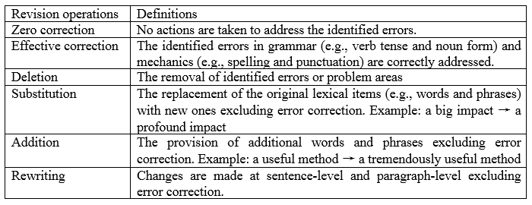
We distinguish revisions of grammar and mechanics in response to AWE feedback from those dealing with substitution, addition, and rewriting as the former explicitly correct existing errors while the latter are made to enhance and polish the text in some way. These different revision operations are important as they have been used in other studies to analyse how L2 students behaviourally and cognitively engage with feedback (Authors, xxxx; Han & Hyland, 2015).
Beyond the text analyses, the first author conducted semi-structured interviews with each student in Chinese for about two hours. The recorded interviews were translated into English and checked by a certified translator. The analysis of the interview data went through open, axial, and selective coding (Strauss & Corbin, 1998). In the first phase, the interview data were read line-by-line repeatedly and were assigned topic codes by the first author. They were then reanalysed by both authors and grouped into categories. As a final check, a colleague with a PhD in applied linguistics coded 20% the same data and his judgements were used to further refine the categories. We then examined the categories and identified a number of core concepts which helped clarify the notion of digital literacy in this context.
Table 3. Examples of Digital Literacy coding
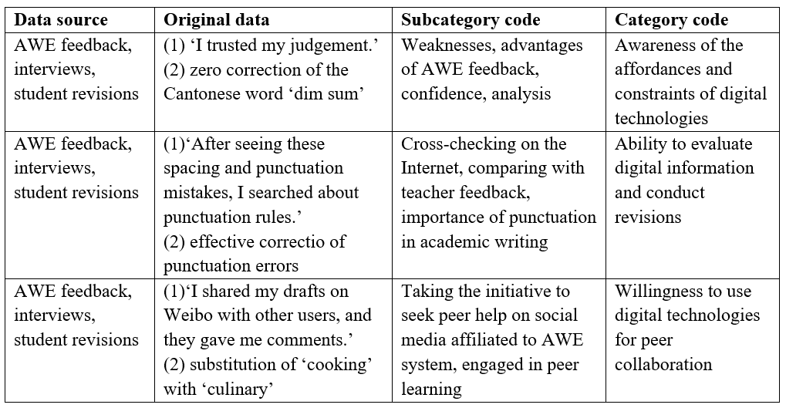

An example of this coding process (Table 3) is that one participant mentioned that she recognised the ‘weakness’ of AWE feedback at one point, so she ‘trusted her judgement’ by adopting ‘zero correction’. Later she accepted the advice the programme offered as helpful and so ‘took it on board’ by conducting ‘effective correction’. These comments were coded by specific topics (weakness, confidence, advantage, etc.) and then refined as ‘awareness of affordances and constraints’ of AWE feedback, which we regard as a component of ‘digital literacy’ This analysis of the interviews was triangulated with our study of the student revisions to improve our understanding and validate the findings.
The relevance of digital literacy thus emerged from our analyses of the interviews and student texts. For us, the construct is a way of understanding the students’ perceptions of and attitudes toward AWE feedback as well as the revisions they made in response to it. Because these revisions are subcategories of affective and cognitive engagement, digital literacy maps directly on to engagement. As the three dimensions of student engagement with feedback (behavioural, affective, and cognitive) have been well-documented in previous studies (e.g., Fredricks et al., 2004; Han & Hyland, 2015), there was considerable agreement (95.2%) in our coding. Initially, we found it harder to clarify the construct ‘digital literacy’ but eventually resolved differences and refined the final categories. Together these categories contribute to an understanding of the term, in the context of AWE research in L2 writing, as an awareness of the affordances and constraints of digital technologies, an ability to evaluate digital information and conduct revisions, and a willingness to use digital technologies for peer collaboration.

5. Findings
5.1. AWE feedback and student responses
To understand how the participants engaged with AWE feedback, we examined the feedback they received from Pigai and tracked their revisions. We also referred to their interviews to explore how they reacted to AWE feedback and why they made certain revisions.
Table 4 shows that the students received Pigai generated feedback on areas ranging from overall score to end comments, totalling 13 different foci. It is worth noting that not only did Pigai flag errors in student essays, but it also offered responses based on the frequency of particular collocations and lexical bundles in a text as well as suggesting more appropriate synonyms where necessary. However, as we have noted, it is not the quantity and range of the feedback provided that contribute to student learning, but how the individual student engages with it. We therefore looked at their revision operations over the eight weeks.

Table 4. AWE feedback on the participants’ first drafts
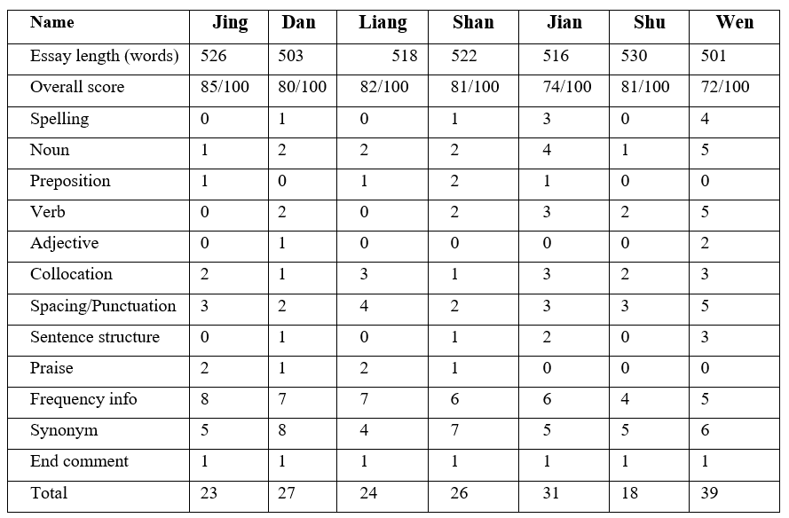
We can see from Table 5 that the seven participants made different types of revisions when redrafting their essays in response to the AWE feedback. While the table shows that they all successfully addressed some errors in their first drafts, as reflected in the revision operation of ‘effective correction’, they differed in their use of all other revision operations. Interestingly, ‘zero correction’, indicating a non-response to a Pigai feedback point, was only taken up by two students: Jing and Wen. Another category employed by only a few participants was ‘rewriting’ – a revision operation going beyond individual words and requiring changes at the sentence and discourse levels. Here only Jing, Liang and Shu adopted this kind of revision in their redrafting.
Table 5. Participants’ revision operations
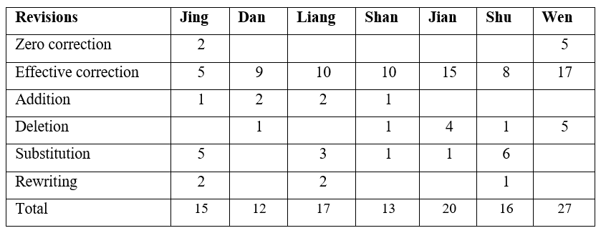
Table 6 shows the number of submissions students made and how much time they spent on revising. Five of the seven students spent over 14 hours on their revisions, indicating more active behavioural engagement characterised by time-on-task (Authors, xxxx; Fredricks et al., 2004).
Table 6. The number of submissions and time spent on revisions
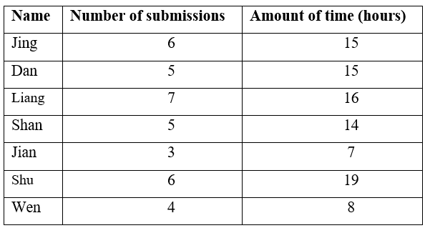
However, behavioural engagement alone, what students do, does not always tell the full story, so we then examined their affective and cognitive engagement. In order to look more closely at engagement, we decided to examine four focal cases more closely. After analysing their revision operations through the textual changes and interviews, we found that three of the four students, Jing, Liang and Shu, showed significant similarities in their perceptions of the AWE system and revision operations (e.g., rewriting and substitution) despite their different levels of L2 proficiency. These commonalities were less evident in the other participants and went beyond the individual and contextual factors identified in previous studies (e.g., Bai & Hu, 2017; Dikli & Bleyle, 2014; Ranalli, 2021). We added a fourth student, Wen, to our focal group as he stood in stark contrast to the other three, suggesting it might be worth delving deeper into their engagement practices. In the next sections, we present four focal participants.

5.2. The case of Jing: Having an awareness of AWE affordances and constraints
Jing, in particular, showed considerable awareness of the affordances and constraints of digital technologies for language learning. An example of this is her engagement with the AWE feedback on the term ‘dim sum’, referring to small portions of steamed Cantonese food. While Pigai identified this as a non-standard English expression (Figure 2), Jing chose not to change her text despite correcting all the other errors identified by the programme.
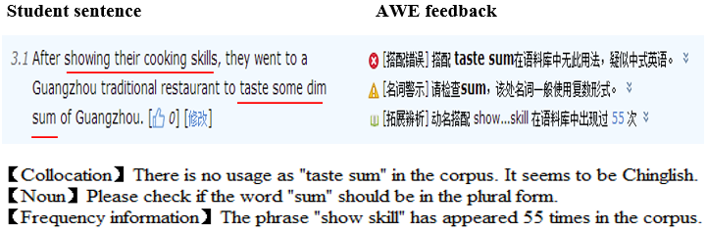
Figure 2. AWE feedback on a term of Cantonese origin in Jing’s essay

Responding to our question why she ignored it, she said:

I didn’t ignore it. In fact, I thought about how I could address this. I am pretty sure that the term “dim sum” has appeared many times on BBC and CNN news, so I think it’s probably an accepted English expression… I remember that Pigai also identified the term ‘kimchi’ as wrong when I wrote an essay on Korean culture last time. I was thinking that this might be a weakness as Pigai may use limited sources. I tried to find out what language database Pigai used. Its website said the company regularly updates its corpora, but I could not see when the last update was. I decided to trust my judgement rather than the program and retained ‘dim sum’.

Jing clearly exercised judgement in making this decision. Her reference to a prior similar experience and active search for information about the programme shows an awareness of the potential constraints of digital technology. Despite this, she did not dismiss the AWE programme as useless but made good use of its affordances and engaged with its feedback effectively. As shown in Figure 3, for example, the feedback alerted her to the spacing and punctuation problems in her essay, which was rarely spotted by her teachers.
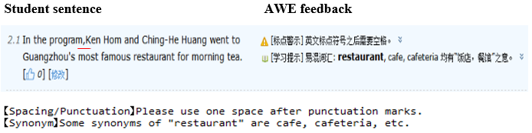
Figure 3. AWE feedback on spacing and punctuation error in Jing’s essay

She talked about this as follows:

This is a new learning experience because teachers have never pointed these errors out to me. After seeing these spacing and punctuation mistakes, I searched about punctuation rules, and I found it is very important in academic writing, so I remembered it. I really like this information from the programme as it helps me improve my writing. I think this is one of the advantages of Pigai compared to the feedback I get from my teachers.

Students typically receive little instruction on punctuation and teachers rarely correct it despite the fact that L2 students are often concerned about its correct use (Hirvela et al., 2012). The AWE feedback on this promoted a new understanding of its importance for Jing. Her search for information on punctuation was prompted by the feedback, epitomizing her digital literacy skills in content evaluation and information-seeking (Lankshear & Knobel, 2008). Her behavioural and cognitive engagement with AWE feedback, her uptake of the feedback and attention to its possible pros and cons, also suggest that she was able to capitalize on the AWE programme to improve her learning.

5.3. The case of Liang: Analysing AWE feedback and revising
In addition to an awareness of the potential strengths and weaknesses of digital technologies, the ability to evaluate and apply digital information effectively is a central competence of digital literacy. In the case of student engagement with AWE feedback, digital literacy is displayed in the ways students analyse the feedback and revise accordingly. Liang differed from most participants in this regard, as reflected in his effective correction of a collocation error and by rewriting simple sentences. When Pigai identified a problematic expression ‘began their personal homecoming’ (Figure 4), for example, he was able to evaluate this information effectively by cross-checking it in the programme’s corpus and changed ‘homecoming’ to ‘journey to the hometown’ (Figure 5).

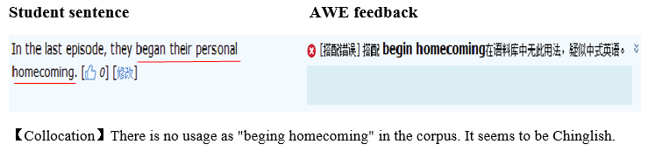
Figure 4. AWE feedback on a collocation error in Liang’s essay

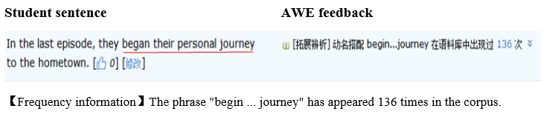
Figure 5. Liang’s response to AWE feedback on a collocation error

Among the various types of revision operations, rewriting at the syntactic level, is perhaps most indicative of serious cognitive engagement (Authors, xxxx; Barkaoui, 2007). It requires the writer to reflect on the feedback, evaluate its value and usefulness, then to improve this by replacing the problem with newly composed text. Figure 6 shows that the end comments in the AWE feedback on Liang’s essay suggested there was still room for improvement in the use of clauses.

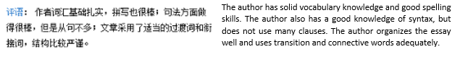
Figure 6. The end comments on Liang’s essay

In response, Liang rewrote several sentences to include different types of clauses (Figure 7). For instance, after evaluating his original simple sentence, he produced a nominal relative clause, a type of subject clause, and a predicative clause, changing ‘The most impressive part of this show was about the profound Chinese food culture’ which he found too simplistic.

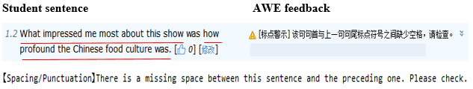
Figure 7. Liang’s response to the end comments

When asked why he made these changes, Liang said:

After reading the comments, I looked at my essay again and saw I did not use many complex sentences, so I believed that the feedback was reasonable. Then, I tried to work on some simple sentences. This sentence was originally ‘The most impressive part of this show was about the profound Chinese food culture’. I felt that this was too simple and wanted to make it more complex. I had already used several attributive clauses, so I tried to write other types of clauses.

So, prompted by the AWE feedback, Liang considered the validity of the comment and searched his essay for simple sentences that could be rewritten. He rewrote a simple sentence into one with a subject clause and a predicative clause. When asked how he did this, he explained:

It was an experiment. At first, I was only thinking about how to change the simple structure ‘be about …’ into a clause because I felt that it was too informal. Then, I searched on the Internet and decided on a predicative clause. While reading online about different types of clauses, I felt that I could also work on the subject and maybe change it into a clause.

The thinking behind this change suggests that Liang was willing to step out of his ‘linguistic comfort zone’ as he experimented with new sentence types. Initially, he focused on how to change something that sounded colloquial into a clause, but he went beyond this, following an internet search, to create another clause. In other words, Liang adopted a learning-oriented attitude, stretching himself to learn new writing skills by drawing on more complex aspects of grammar. Crucially, his ability to evaluate the AWE feedback, search appropriate online resources, and integrate the information in his revisions suggests that in addition to a student’s L2 proficiency digital literacy plays an equally important role in the extent to which a student might engage with AWE feedback to make revisions.

5.3. The case of Shu: Interacting with peers online and building multiple identities
An important aspect of Pigai is an online facility for students to join a learning community around English writing. Not all the participants in the study took advantage of this option, but Shu was an active user and became enthusiastically involved in community collaboration. This opportunity to interact with other Pigai users is a key part of engagement with the programme because writing and revising are now so integral to the processes of information-sharing and peer collaboration. Research on L2 writing has found that peer collaboration has a positive influence on writing and revision where social media platforms provide an inclusive and supportive learning environment (Barrot, 2021). In the context of computer-assisted language learning, a willingness to make use of digital affordances is a hallmark of digital literacy.
During the eight-week revision period, Shu actively sought out and worked with other students in this Pigai platform and an affiliation with that community. She subscribed to several official Pigai-related sites on social media to receive updates and discuss her writing with fellow users. For instance, she followed the official Pigai account on Sina Weibo, one of the biggest social media platforms in China and similar to Twitter, where she posted her initial drafts and sought peer comments. She explained how she had used Weibo to improve her writing:

We are a group of students who love English and always help each other with learning. I shared my drafts on Weibo with other users, and they gave me comments. For example, suggestions such as ‘culinary’ and ‘embark on’ were very helpful. Thanks to their advice, I substituted the original words and phrases with more advanced ones… I think it is great to have a group to support each other and share our knowledge. It makes English writing much more fun.

The mention of ‘culinary’ and ‘embark on’ drew our attention to Shu’s use of substitution in her fourth and fifth drafts (Figure 8). With the help of her peers she was able to use more advanced and more arresting vocabulary. Overall, this quote indicates Shu’s deep affective engagement with the AWE feedback and revision.

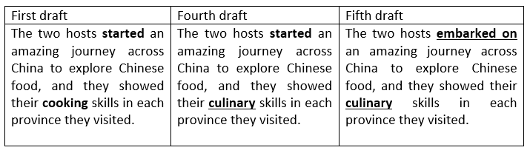
Figure 8. The use of substitution in Shu’s drafts after online peer interaction

Shu also revealed that she browsed the bulletin board system (BBS) of Pigai (Appendix D) to search for posts related to English writing on food:

I also logged in to the Pigai BBS to keep up to date. I found that some of the posts on the forum are very useful. There were relevant topics about food, and they gave me good ideas.

Shu systematically used these platforms to interact with fellow Pigai users and seek feedback on her writing from peers. She made good use of both synchronous and asynchronous technologies to exchange ideas on English usage, becoming highly involved in online peer interaction. These interactions demonstrate all three aspects of engagement: behavioural, by actively seeking and using feedback from peers; affective, by taking a positive stance towards the interactions and the advice she received; cognitive, by absorbing and evaluating the information she was exposed to.
In effect, she approached writing as a social practice rather than as an individual, isolated act, making use of a network of social and peer relations to improve both the text and her command of writing. While Shu showed an awareness of the affordances of the AWE system, we found that her willingness to engage socially also reflects one of the major components of digital literacy. In her engagement with AWE feedback, Shu built multiple identities as an English aficionado, a student writer, a peer reviewer, and a social media user.

5.4 The case of Wen: Lacking an awareness of AWE affordances and constraints
Wen approached his response to AWE feedback very differently. His engagement with the programme showed he was not fully aware of its affordances and constraints. Figure 9, for example, shows that Wen used the term “sous-chef” to refer to someone who assists a chef, but Pigai identified this French word as incorrect. In contrast to Jing, he simply deferred to the feedback unreflectively and revised it to “deputy chef” (Figure 10).

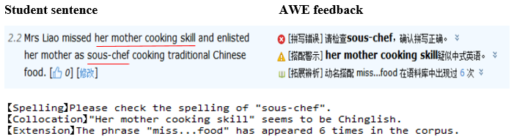
Figure 9. AWE feedback on a term of French origin in Wen’s essay

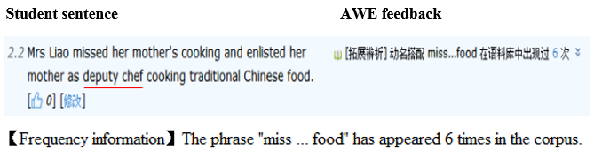
Figure 10. Wen’s response to AWE feedback on a term of French origin

When asked why he made this change, he replied:

I was a bit confused about this because I just borrowed the word from the documentary. Maybe it is a French word and not appropriate for English writing? So, I checked the dictionary and replaced “sous” with “deputy” and found Pigai no longer identified it as an error. Then, I just moved on to the next problem. I think it is important to correct all the errors and improve my grade.

Wen adopted a play-it-safe attitude. He did not question Pigai’s recommendation although the word “sous-chef” is relatively well established in English. He lacked confidence in his own judgment and neither reflected on the feedback nor critically evaluated the programme. He lacked the ‘digital mindset’ (Jones & Hafner, 2012; Lankshear & Knobel, 2008) to recognise the limitations of technology and approach information critically.
While he also had a problem with spacing and punctuation in his writing (Figure 11), Wen did not, unlike Jing, seem to appreciate the AWE feedback on this.

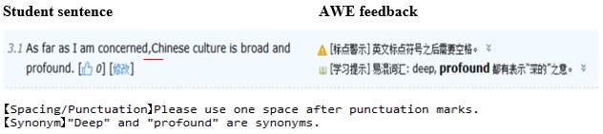
Figure 11. AWE feedback on spacing and punctuation errors in Wen’s essay

When asked about this, he said:

I just corrected all the errors except spacing and punctuation errors. I actually never paid much attention to these in my writing. My English teachers never mentioned it. I’ve never seen it in a grading scheme before.

Wen failed to act on this advice by Pigai and did not take advantage of the programme to discover new information about writing. Compared to Jing, Wen ignored this feedback and did not see it as an affordance of digital technology. Despite being similarly motivated as Jing to improve his work, his lack of digital literacy meant he was unable to critically analyse the new AWE-generated information or make good use of it. In Markless and Streatfield’s (2007) terms, he failed to think critically in evaluating the information and failed to transform the feedback into useful knowledge to apply to his corrections.

6. Discussion
In this study we have proposed a model that synthesises Jones and Hafner’s (2012) five components of digital literacy and Authors’ (xxxx) three dimensions of student engagement to investigate how digital literacy mediates student engagement with AWE feedback. Supported by interview and revision data, we have shown in a concrete way how digital literacy and engagement are dynamically bound together in L2 students’ use of AWE feedback. Developing an awareness of the affordances and constraints of AWE technology and using its feedback to revise texts involves behavioural, affective, and cognitive engagement, which is closely connected to ‘thinking’, ‘meaning’, and ‘doing’ aspects of digital literacy. At the same time, the aspects of ‘relating’ and ‘being’, which we see as characterised by online interaction and identity construction, demonstrate how students are engaged behaviourally, affectively, and cognitively in their learning.
Our study suggests that digital literacy can have a significant impact on how L2 students, of varying levels of proficiency, effectively engage with AWE feedback. Three of the seven participants, Jing, Liang, and Shu possessed considerable familiarity and ease with digital technology. These students were able to recognise the affordances of the programme and make good use of it in exercising choice in their revisions and in seeking out new learning opportunities. Perhaps most importantly, they critically evaluated the accuracy and appropriacy of the feedback they received. The way they filtered and managed information, and eventually transformed it into knowledge, indicates that they possessed information and technology awareness (Fieldhouse & Nicholas, 2008). The other students such as Wen, in contrast, had a weaker sense of digital literacy and were unable to identify the constraints of the programme (e.g., recency of its database) or fully utilise its affordances (e.g., feedback on punctuation), so their engagement was unreflective. In other words, a weaker grasp of digital literacy means that student revisions are likely to be dictated rather than empowered by technology.
This is, of course, not the first study to explore students’ engagement with AWE feedback and previous work has identified various factors which might influence the success students have with this kind of learning. Language proficiency (Authors, xxxx; Ranalli, 2018), teachers’ attitudes and pedagogies (Li et al., 2015) and the teaching context (Bai & Hu, 2017), have all been suggested as important variables. Our study, in fact, corroborates Ranalli’s (2021) argument that students’ trust in the AWE system could influence their engagement. We go further, however, and argue that digital literacy may be the most important factor in the successful implementation of computer-generated feedback. By identifying and conceptualising the construct of digital literacy in this context, we suggest that it is a multi-faceted construct that interacts with different dimensions of engagement. With AWE programmes increasingly part of the teaching landscape, the ability of students to use technologies and to see their possibilities and limitations, is becoming increasingly crucial in L2 writing classrooms.
In addition to highlighting the importance of digital literacy in making best use of an increasingly important language learning tool, this study also lends support to the idea that digital literacy reaches well beyond the mastery of technical skills to encompass student awareness, attitudes, and dispositions (Jones & Hafner, 2012; Meyers et al., 2013). While all the participants were familiar with Pigai and had used the programme before, what differentiates the three participants – Jing, Liang, and Shu - from the rest is their conceptual and cognitive approaches. With a good understanding of the AWE programme, they were able to engage with its feedback more critically and flexibly. Our findings lead us to suggest that digital literacy is a concept that merits more systematic research in language teaching and learning. Equally importantly, this also implies a change in the ways we study digital technologies in language education. We need to supplement the profusion of research which explores the pros and cons of technologies such as AWE programmes and focus on students’ ability to use them in intelligent and informed ways.
Our synthesis of digital literacy and student engagement with AWE feedback has potentially huge significance in an era where Artificial Intelligence is destined to play an increasingly crucial role in language education. To encourage student engagement with language learning in this context we not only need to understand the complex operations of behavioural, affective, and cognitive engagement, but also to keep in mind how digital literacy mediates this engagement. We have demonstrated three key elements of digital literacy in this study: an awareness of the affordances and constraints of digital technologies, an ability to evaluate digital information, and a willingness to use digital technologies for peer collaboration. These are the central attributes we need to foster in our students whose in-school and out-school lives are increasingly intertwined with digital technologies.
7. Conclusions
Overall, we hope to have shown that AWE programmes are more than a means of offering teachers respite from heavy marking loads. Our analysis suggests that strengthening students’ digital literacy skills can help them maximise the benefits of these programmes by effectively engaging with the feedback they provide. We have also offered a characterisation of digital literacy which goes beyond familiarity with digital tools to include an ability to think critically about them and a willingness to engage socially around them. We are, however, aware of the limitations of our study. This is an in-depth exploration of the behaviours and attitudes of a handful of L2 learners engaged in crafting a single 500-word essay in a particular educational context. Clearly, larger samples of student writers possessing a wider range of L2 proficiencies and cultural backgrounds would help fill out this picture and perhaps raise other issues. Certainly, areas remain to be explored and perhaps these might refine our model and its applicability in other genres and in longer texts.
However, the kind of detailed analysis presented here raises important issues which enable us to better understand concepts such as ‘engagement’ and ‘digital literacy’ in relation to the use of AWE feedback. Developing this form of competence can help L2 learners better understand the nature of tools they are increasingly asked to use in their learning and how to engage effectively with their feedback. It is, therefore, paramount to establish realistic expectations and effective training to ensure that students can access these technologies in a way which assists rather than dictates their language learning.

References
Attali, Y. (2004). Exploring the feedback and revision features of Criterion. Paper presented at the National Council on Measurement in Education (NCME), San Diego, CA.
Bai, L., & Hu, G. (2017). In the face of fallible AWE feedback: How do students respond? Educational Psychology, 37(1), 67-81.
Barkaoui, K. (2007). Revision in second language writing: What teachers need to know. TESL Canada Journal, 25(1), 81–92.
Barrot, J. S. (2021). Social media as a language learning environment: a systematic review of the literature (2008-2019). Computer Assisted Language Learning, 1-29.
Bawden, D. (2001). Information and digital literacies: a review of concepts. Journal of Documentation, 57(2), 218–259
Burniske, R.W. (2007). Literacy in the digital age (2nd ed.). Thousand Oaks, CA: Corwin Press.
Chen, C.-F. E., & Cheng, W.-Y. E. (2008). Beyond the design of automated writing evaluation: Pedagogical practices and perceived learning effectiveness in EFL writing classes. Language Learning & Technology, 12(2), 94-112.
Cotos, E. (2011). Potential of automated writing evaluation feedback. CALICO Journal, 28(2), 420-459.
Cotos, E. (2018). Automated writing evaluation. In J.I. Liontas (Ed.), The TESOL encyclopedia of English language teaching. Wiley: New Jersey.
Cotos, E., Huffman, S., & Link, S. (2020). Understanding graduate writers' interaction with and impact of the Research Writing Tutor during revision. Journal of Writing Research, 12(1), 187-232.
Dikli, S. (2006). An overview of automated scoring of essays. Journal of Technology, Learning, and Assessment, 5(1), 1-35.
Dikli, S., & Bleyle, S. (2014). Automated essay scoring feedback for second language writers: How does it compare to instructor feedback? Assessing Writing, 22, 1-17.
Duff, P. (2008). Case study research in applied linguistics. New York: Lawrence Erlbaum.
Ellis, R. (2010). A framework for investigating oral and written corrective feedback. Studies in Second Language Acquisition, 32, 335-349.
Faigley, L., & Witte, S. (1981). Analyzing revision. College Composition and Communication, 32(4), 400-414.
Fieldhouse, M. & Nicholas, D. (2008). Digital literacy as information savvy: The road to information literacy. In Lankshear, C. & Knobel, M. (Eds), Digital literacies: Concepts, policies & practices, (pp. 47-72). New York: Peter Lang Publishing.
Fredricks, J., Blumenfeld, P. C., & Paris, A. (2004). School engagement: Potential of the concept, state of the evidence. Review of Educational Research, 74, 59-109.
Gilster, P. (1997). Digital literacy. New York: Wiley.
Grimes, D., & Warschauer, M. (2010). Utility in a fallible took: a multi-site case study of automated writing evaluation. Journal of Technology, Learning, and Assessment, 8, 4-43.
Hafner, C., A. Chik, & R. Jones. (2015). Digital literacies and language learning. Language Learning & Technology, 19 (3): 1–7.
Han, Y., & Hyland, F. (2015). Exploring learner engagement with written corrective feedback in a Chinese tertiary EFL classroom. Journal of Second Language Writing, 30, 31-44.
Handley, K., Price, M., & Millar, J. (2011). Beyond ‘doing time’: Investigating the concept of student engagement with feedback. Oxford Review of Education, 37(4), 543–560.
Hirvela, A., Nussbaum, A. Pierson, H. (2012). ESL students’ attitudes toward punctuation. System, 40(1): 11–23.
Jones, R. H., & Hafner, C. A. (2012). Understanding digital literacies: A practical introduction. London, UK: Routledge.
Lankshear, C. & Knobel, N. (2008). Digital literacies: Concepts, policies and practices. New York: Peter Lang Publishing.
Li, J., Link, S., & Hegelheimer, V. (2015). Rethinking the role of automated writing evaluation (AWE) feedback in ESL writing instruction. Journal of Second Language Writing, 27, 1-18.
Li, Z., Link, S., Ma. H., Yang, H., & Hegelheimer, V. (2014). The role of automated writinge evaluation holistic scores in the ESL classroom. System, 44, 66-78.
Markless, S., & Streatfield, D. (2007). Three decades of information literacy: Redefining the parameters. In S. Andretta (Ed.), Change and challenge: Information literacy for the 21st century (pp.15-36). Adelaide: Auslib Press.
Meyers, E., Erickson, I., & Small, R. (2013). Digital literacy and informal learning environments: An introduction. Learning, Media and Technology, 38(4), 355-367.
Norton, B., & Toohey, K. (2011). Identity, language learning, and social change. Language Teaching, 44(4), 412-446.
Pace, C. R. (1984). Measuring the quality of college student experiences: An account of the development and use of the college student experiences questionnaire. Los Angeles, CA: University of California, Higher Education Research Institute, Graduate School of Education.
Ranalli, J. (2018). Automated written corrective feedback: How well can students make use of it? Computer Assisted Language Learning, 31(7), 653-674.
Ranalli, J. (2021). L2 student engagement with automated feedback on writing: Potential for learning and issues of trust. Journal of Second Language Writing, 52, 1–16.
Sommers, N. (1980). Revision strategies of student writers and experienced adult writers. College Composition and Communication, 31(4), 378-388.
Stevenson, M., & Phakiti, A. (2019). Automated feedback and second language writing. In Hyland, K & Hyland, F. (ed) Feedback in Second languge writing (2nd ed). (125-142) Cambridge University Press.
Strauss, A. L., & Corbin, J. M. (1998). Basics of qualitative research: Techniques and procedures for developing grounded theory (2nd ed.). Thousand Oaks: Sage Publications.
Street, B. (2003). What's "new" in new literacy studies? Critical approaches to literacy in theory and practice. Current Issues in Comparative Education, 5(2), 77-91.
Tyler, R. (1969). Educational evaluation: New roles, new methods: The sixty-eighth yearbook of the National Society for the Study of Education, Part II. Chicago, IL: University of Chicago Press.
Wang, Y.-J., Shang, H.-F., & Briody, P. (2012). Exploring the impact of using automated writing evaluation in English as a foreign language university students' writing. Computer Assisted Language Learning, 26(3), 234-256.
Warschauer, M., & Grimes, D. (2008). Automated writing assessment in the classroom. Pedagogies: An International Journal, 3, 22-36.
Warschauer, M., & Ware, P. (2006). Automated writing evaluation: Defining the classroom research agenda. Language Teaching Research, 10(2), 157-180.
Weigle, S. (2013). English language learners and automated scoring of essays: Critical considerations. Assessing Writing, 18, 85-99.
Willms, J. D., Friesen, S., & Milton, P. (2009). What did you do in school today? Transforming classrooms through social, academic and intellectual engagement. Retrieved from https://www.edcan.ca/wp-content/uploads/cea-2009-wdydist.pdf on 8 January, 2020.
Xu, Z., Banerjee, M., Ramirez, G., Zhu, G., & Wijekumar, K. (2019). The effectiveness of educational technology applications on adult English language learners’ writing quality: a meta-analysis. Computer Assisted Language Learning, 32(1-2), 132-162.
Zheng, Y., & Yu, S. (2018). Student engagement with teacher written corrective feedback in EFL writing: A case study of Chinese lower-proficiency students. Assessing Writing, 37, 13–24.

Appendix A. A sample of corrective feedback generated by Pigai
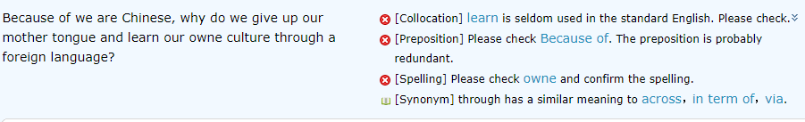

Appendix B. A sample of AWE feedback featuring overall score, ranking, and end comments
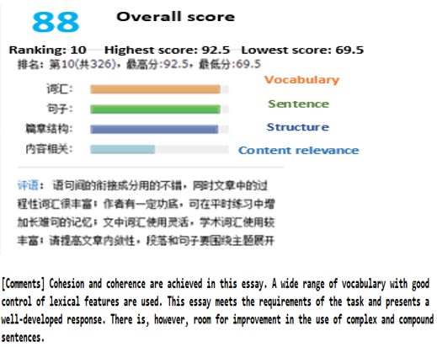

Appendix C. AWE feedback on student essays
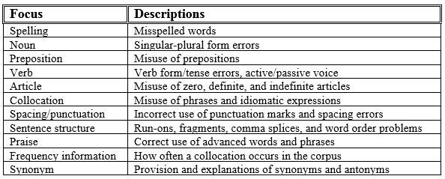

Appendix D. The bulletin board system of Pigai
