A systematic review and meta-analysis of enhanced recovery for open abdominal aortic aneurysm surgery

Authors: Dr Jack Docherty, MBBS, Miss Kersten Morgan-Bates, MBBS, BSc, PGCert (MedEd), FRCS(vasc) Mr Philip Stather, MBChB, MD, FRCS(vasc). Norfolk and Norwich University Hospital.

Corresponding Author: Dr Jack Docherty. Tel 07939684779. Email jack.docherty@doctors.org.uk.
Address: 5D Unthank Road, Norwich, Norfolk, United Kingdom, NR22PA.

Funding: This research received no specific grant from any funding agency in the public, commercial, or not-for-profit sectors.

ABSTRACT

Introduction: Open abdominal aortic aneurysm (AAA) surgery is associated with significant morbidity, mortality and high length of stay (LOS). Enhanced recovery is now commonplace and has been shown to decrease these in other non-vascular surgery settings. This systematic review and meta-analysis aimed to assess the benefits of enhanced recovery in aortic surgery (ERAS).

Method: PRISMA guidelines were used to undertake a systematic review via Ovid MEDLINE and Embase on 10.07.2021. The search terms were “aortic aneurysm” and “fast track” or “enhanced recovery”. Data was obtained on major complications, 30-day mortality and LOS.

Results: 107 papers were identified and 10 papers included for meta-analysis. Complication rates were significantly reduced with ERAS compared to non-ERAS protocols (ERAS n=709, non-ERAS n=930) (odds ratio 0.38, 0.22 to 0.65: p=0.0005). LOS was also significantly reduced with an ERAS protocol (ERAS n=708, non-ERAS n=956) with a mean reduction of 3 .18 days (-5.01 to -1.35 days) (p=0.0007: I² =97%). There was no significant difference however in 30-day mortality (p=0.92).

Conclusion: This meta-analysis demonstrates significant benefits to an enhanced recovery programme in open AAA surgery. There is a need for a multi-centre randomized controlled trial to assess this further.

Key words: Enhanced recovery, abdominal aortic aneursym, open vascular surgery, major complications, length of stay

A systematic review and meta-analysis of enhanced recovery for open abdominal aortic aneurysm surgery

INTRODUCTION

Endovascular aneurysm repair for abdominal aortic aneurysms (AAA) has become increasingly utilised due to shorter length of stay and lower peri-operative mortality. Open surgical AAA repair (OSR) is associated with higher peri-operative morbidity and mortality and an increased length of stay (LOS)^{1,2}, however there have been significant advances in reduction in these outcome measures in open abdominal surgery in recent years³. Enhanced recovery after surgery (ERAS) is now commonly applied in other surgical specialties with similarly large-scale operations including colonic resections, upper gastrointestinal surgery and cardiac surgery^{4,5,6}. It has been shown to reduce complications after abdominal surgery by as much as 40% and LOS by 30%³.

ERAS programmes typically include pre-operative patient education and optimisation, peri-operative management of analgesia and anaesthetic, peri-operative bowel and nutrition plans and post operative mobilisation and discharge plans⁷. Although not standard practice in most vascular units, there is some limited evidence that ERAS can improve outcomes in vascular surgery, particularly for open aortic procedures⁸. However, there is little evidence available for ERAS specifically for aortic procedures. This systematic review and meta-analysis aims to determine the impact of an ERAS protocol in open abdominal aortic aneurysm repair.

METHODS

The 2020 Preferred Reporting Items for Systematic reviews and Meta-Analyses (PRISMA) statement⁹ was used to guide the formulation and conduct of this systematic review. A protocol for this review has not been previously published. The publications selected were those available in an English language format that reported randomised control trial (RCT) and cohort study methodology. The population used was patients undergoing open abdominal aortic aneurysm repair surgery, primarily in an elective setting. Publications that exclusively reported other forms of AAA surgery (such as endovascular aneurysm repair (EVAR) and emergency repairs of ruptured aneurysms) were excluded. Individual publication report statuses such as unpublished manuscripts, protocols and conference abstracts were also excluded. The primary intervention considered was the use of an ERAS approach in the peri-operative pathway (comprising pre-operative, intra-operative and post-operative care). We identified fundamental elements of the ERAS approach, and looked for these within the manuscripts in the situations where a full ERAS protocol was not implemented, utilising the ERAS Society guidelines⁷ for reference. The prevalence of individual ERAS elements implemented by each publication we used for meta-analysis can be seen in Table 1. To meet inclusion criteria, publications had to report on at least one of the following outcomes across patient-centred and healthcare centred domains; perioperative complications (including Clavien-Dindo classification¹⁰ when reported), 30-day mortality rates, and patient length of stay in hospital (LOS). In addition, comparative data for both ERAS and ‘traditional’ (non-ERAS) groups had to be available.

The literature search was performed by two reviewers, with any discrepancies checked by the senior author, on the 12th of July 2021. The databases used were MEDLINE (via PubMed) and Embase. No restrictions on time of publication were used. The search strategy combined search terms used for the intervention (ERAS pathway) “enhanced recovery” and “fast-track” with the term for the population (AAA surgery) “aortic aneurysm”. The primary search used was “aortic aneurysm” AND “fast-track” OR “aortic aneurysm” AND “enhanced recovery”. No automated methods were used in the search, screening or exclusion processes. No contact was made with authors of screened literature. Due to exclusions according to language, no translation of publications was employed.

The Let Evidence Guide Every New Decision (LEGEND) system¹¹ was used to assess the quality of the shortlisted publications prior to data extraction, with the Newcastle-Ottawa Scale (NOS)¹² and Cochrane Risk of Bias 2 (RoB 2) tool¹³ being used to further assess non-randomised cohort and RCT studies respectively. Data was collected by two authors. As per the outcomes previously described, all available data relevant to each outcome domain was collected from the manuscripts. Each primary outcome domain was assigned an equal degree of high importance. Primary data was collected on ERAS pathway implementation, operation performed, number of participants, and the outcome measures; major complications, 30 day mortality rates and LOS. Additional data was collected on manuscript publication date, country of origin, duration of study, and design methodology used. If present, data on patients who underwent EVAR procedures was not used.

We used ReviewManager 5.4 (RevMan)¹⁴ to perform a meta-analysis of 10 publications. Dichotomous data extracted from the manuscripts (pertaining to major complications and 30 day mortality outcomes) was inputted directly into RevMan without any manipulation to synthesise odds ratio values. Continuous data (LOS, measured in days) was manually converted into standardised effect measures (Median to Standard Error to Standard Deviation) as per the methods outlined in the Cochrane Handbook for Systematic Reviews of Interventions (Higgins 2021)¹⁵. Forest plots were made utilising RevMan. A random effects method was used due to the variability in ERAS protocols between trials.

(TABLE 1)

RESULTS

The search strategy yielded 99 publications which were then manually reviewed, screened (initially by title and abstract and then by full text eligibility) and excluded by two reviewers, with discrepancies checked by the senior author. References used by each included publication were screened, identifying a further 8 publications for inclusion. See PRISMA flow-chart for full detailing of this process. (Fig. 1). This resulted in 10 full-text publications, with a combined population of 1569 patients across four countries dating 2003-2021⁽¹⁶⁻²⁵⁾. Two RCTs were found^{(19,20)}, evaluating “fast-track” vs traditional patient care in open AAA surgery. These trials utilised the same population of 101 patients, and despite RCT methodology were low-quality with limitations in reliability and validity when evaluated by LEGEND criteria. When evaluated by the Cochrane RoB 2 tool, there were some concerns over bias in these studies due to an absence of blinding of both the participants and the assessors, with there being some potential for causing bias in collecting/interpreting data as a result. These were both included as they reported on differing outcome measures rather than being true duplicate publications. The remaining eight publications were observational, four of these were longitudinal designs^{(17,18,22,23)} and all eight were deemed good-quality. Details of study characteristics, including design methodology and quality assessment (LEGEND criteria) are portrayed in Table 2. Assessments of non-randomised cohort studies using the NOS can be seen in Table 3. All of the studies scored well on the NOS overall. All the studies scored poorly on assessment of outcomes as information on any use of blinding was not reported. All but one study⁽¹⁸⁾ considered elective AAA surgery exclusively. Six studies^{(16,19,20,22,24,25)} reported including infrarenal AAAs exclusively.

(FIGURE 1)

(TABLE 2)

(TABLE 3)

Length of stay
Meta-analysis was performed for LOS (measured in days), 30-day mortality and major complication prevalence, comparing patients on ERAS pathways or receiving ERAS-like components to patients receiving traditional care. For LOS 9 studies were analysed, totalling 708 ‘ERAS’ patients and 956 ‘non-ERAS’ patients (Fig.2). LOS was significantly reduced with use of ERAS protocols; all studies individually reported a reduction in LOS, with a mean reduction of 3.18 days (-5.01to -1.35 days) (p=0.0007: I² 97%).

(FIGURE 2)

Major complications
There was also a reduction in major complication rates in ERAS compared to non-ERAS protocols (ERAS n=709, non-ERAS n=930) (odds ratio 0.38, 0.22 to 0.65: p=0.0005) (Fig.3), across 7 studies. Rates of individual major complications are shown in Table 4. Where comparisons were available, the majority of studies reported lower rates of pulmonary (5 of 6), renal (6 of 6) and gastrointestinal (GI) (5 of 6) complications in ERAS groups compared to non-ERAS groups. In 3/6 studies the rate of cardiac complications (including acute coronary syndrome/myocardial infarction and arrhythmias) was lower in ERAS groups, however in the other 3/6 the rates were higher. Anaemia requiring blood transfusion was reported in four studies, two of which reported lower rates in ERAS groups and two reported no differences between groups. Returns to theatre were reported in two studies; one showed higher rates in the ERAS group and one found no difference between groups. Where reported, rates of peripheral embolization were found to be higher in ERAS groups (2/2). Rates of early readmission (within 30 days) were equal between groups in 3/4 of applicable studies.

(FIGURE 3)

(TABLE 4)

30-day mortality
For 30-day mortality 7 studies were used, comprising 687 ERAS patients and 885 non-ERAS patients. There were an equal number of events (5) in both groups, and no significant difference found between the groups (p=0.92) (Fig. 4).

(FIGURE 4)

Subgroup Analyses
A subgroup analysis was undertaken to include only studies which had included at least 10/15 possible elements of an ERAS protocol. This confirmed the overall findings that there was a significant reduction in length of stay (ERAS n=413, non-ERAS n=708, MD=-2.52(-4.32 , -0.73), P=0.006), and a significant reduction in major complications (ERAS n=480 non-ERAS n=743, OR=0.62 (0.46-0.84), P=0.002).

DISCUSSION

This meta-analysis aimed to look at the impact of an Enhanced Recovery Programme on outcomes after open Abdominal Aortic Aneurysm surgery. Out results suggest that implementation of an ERAS pathways or receiving ERAS-like components significantly reduces length of stay with a mean reduction of 3 days. There was also a reduction in major complication rates compared to patients receiving traditional care. These overall findings were confirmed with subgroup analysis of patient receiving 10/15 elements of the pathway. There is however no significant difference however in 30-day mortality in this study with the implementation of such a pathway.

Our findings are similar to the results of a previous systematic review and meta-analysis by McGinigle et al showing a reduced length of stay in patients in whom an ERAS programme was followed following open aortic procedures⁹. Our study did however demonstrate an additional benefit of a reduction in post-operative major complications that was not seen in their study⁹.

The exact model of ERAS pathway used did differ between the studies included in this review with only 5 studies using 10 or more of the 15 separate ERAS components. All of the studies included in this meta-analysis used regimens for bowels and diet. Other commonly implemented components were line, catheter and drain management, multimodal analgesia, early mobilisation (9/10 studies) and patient education (8/10 studies). Fasting/carbohydrate loading and discharge co-ordination were also used in 7/10 studies. Other aspects of ERAS such as pre-operative medical optimization (3/10 studies), early anti-emetics (2/10 studies) and analgesia (4/10 studies), patient warming (5/10 studies), goal-directed fluids (3/10 studies), short acting anaesthetic (5/10 studies), opioid diminishment (4/10 studies) and post-operative fluid management programmes (5/10 studies) were less frequently used. Analysis of the effect of any individual ERAS element was limited within the studies. Giacomelli et al suggested that the most important aspect of the ERAS protocol they implemented is a fully-informed multidiscipliniary team that is able to ensure the other ERAS phases are applied successfully. The absence of commentary on the effect of individual ERAS elements and the lack of standardised practice even across the studies that did look at multiple elements of an ERAS pathway makes it highly difficult to form any clear conclusions as to the true effect size of any of the given interventions in open aortic surgery. A systematic review of 1898 elective colorectal patients found that, with the exception of a laparoscopic operative approach, no individual ERAS element was associated with a reduction in the systemic inflammatory response from surgery²⁶. It was concluded that whilst the benefits of an ERAS approach in reducing peri-operative complications and hospital stay are well documented, establishment of a protocol comprising optimised individual components would be a subjective process. There is little evidence directly for many of these interventions at present. There is however, recent evidence that pre-operative medical optimization improves outcomes after open aortic procedures and a recent Cochrane review has shown a reduction in post-operative complications with the use of epidural analgesia in this popluation^{27,28}. Whilst likely challenging to design and implement, a large scale randomised controlled trial in open abdominal aortic repair would be beneficial to assess this further.

There was also a lack of standardisation in the reporting of perioperative complications between studies, with measures such as returns to theatre or early readmission often not reported. ERAS measures were shown to consistently reduce pulmonary, renal and GI complications, with no benefits reported for cardiac complications, anaemia requiring transfusion or early readmission. It is possible that this is reflective of the nature of the ERAS pathway; by facilitating early resumption of diet and mobility post-operatively there may be a reduction in complications such as gastrointestinal ileus or hospital-acquired pneumonia whereas complications such as returns to theatre or need for transfusions may be more likely to be reflective of the nature of open AAA surgery and are harder to avoid with more generic measures. Due to the aforementioned lack of standardised measures and reporting between studies these results need to be interpreted carefully.

The cost implications of implementation of ERAS pathways could not be analysed in this paper due to lack of available data. Overall, we did show however that there was a mean reduction in length of stay of 3 days. The LIFE registry has shown a cost benefit to ERAS implementation in patients undergoing endovascular repair of AAA and Tatsuishi et al did show a reduction of 8% compared to standard treatment with implementation of an ERAS protocol^{18,29} It would stand to reason that with the recently published NICE guidelines stating that open surgery should be the first-line for unruptured AAA repair that interventions that can reduce LOS would show an increasing cost benefit³⁰. Further RCT evidence is required to make a definitive judgement on this.

This meta-analysis was limited by the limited number of high quality RCTs available, with the majority of papers comprising of small longitudinal studies. The studies included were small and limited to selection bias, but did score well when evaluated with the NOS. Despite this, this type of research methodology is not as favourable as more standardised randomised trials and so results from these would need to be interpreted with caution. As discussed previously, interventions and reporting measures were not standardised between the studies, again potentially reducing the validity and applicability of these studies and comparisons between them.

CONCLUSION

This systematic review and meta-analysis provides more evidence that ERAS for open aortic procedures is safe and has significant benefits in reducing LOS and complications. The evidence however is limited and of poor quality, and although outcomes from other specialities can be extrapolated to similar cohorts of patients, a large multi-centre randomised controlled trial is needed to look at the benefits in this particular patient population. The inclusion of a cost-effectiveness analysis in this trial would also be beneficial.

The Authors declare that there is no conflict of interest.

REFERENCES

- Antoniou GA, Antoniou SA, Torella F. Editor's Choice - Endovascular vs. Open Repair for Abdominal Aortic Aneurysm: Systematic Review and Meta-analysis of Updated Peri-operative and Long Term Data of Randomised Controlled Trials. Eur J Vasc Endovasc Surg. 2020 Mar;59(3):385-397. doi: 10.1016/j.ejvs.2019.11.030.

- Greenhalgh RM, Brown LC, Kwong GP, Powell JT, Thompson SG; EVAR trial participants. Comparison of endovascular aneurysm repair with open repair in patients with abdominal aortic aneurysm (EVAR trial 1), 30-day operative mortality results: randomised controlled trial. Lancet. 2004 Sep 4-10;364(9437):843-8. doi: 10.1016/S0140-6736(04)16979-1.

- Greco M, Capretti G, Beretta L, Gemma M, Pecorelli N, Braga M. Enhanced recovery program in colorectal surgery: a meta-analysis of randomized controlled trials. World J Surg. 2014 Jun;38(6):1531-41. doi: 10.1007/s00268-013-2416-8.

- Gustafsson UO, Scott MJ, Schwenk W, et al. Enhanced Recovery After Surgery (ERAS) Society, for Perioperative Care; European Society for Clinical Nutrition and Metabolism (ESPEN); International Association for Surgical Metabolism and Nutrition (IASMEN). Guidelines for perioperative care in elective colonic surgery: Enhanced Recovery After Surgery (ERAS(®)) Society recommendations. World J Surg. 2013 Feb;37(2):259-84. doi: 10.1007/s00268-012-1772-0.

- Low DE, Allum W, De Manzoni G, et al. Guidelines for Perioperative Care in Esophagectomy: Enhanced Recovery After Surgery (ERAS®) Society Recommendations. World J Surg. 2019 Feb;43(2):299-330. doi: 10.1007/s00268-018-4786-4.

- Engelman DT, Ben Ali W, Williams JB, et al. Guidelines for Perioperative Care in Cardiac Surgery: Enhanced Recovery After Surgery Society Recommendations. JAMA Surg. 2019 Aug 1;154(8):755-766. doi: 10.1001/jamasurg.2019.1153.

- The ERAS Society. Guidelines. Accessed 24th August 2021. Available at https://erassociety.org/guidelines/

- McGinigle KL, Eldrup-Jorgensen J, McCall R, et al. A systematic review of enhanced recovery after surgery for vascular operations. J Vasc Surg. 2019 Aug;70(2):629-640.e1. doi: 10.1016/j.jvs.2019.01.050. Epub 2019 Mar 25. PMID: 30922754.

- Page MJ, Moher D, Bossuyt PM, et al. PRISMA 2020 explanation and elaboration: updated guidance and exemplars for reporting systematic reviews. BMJ 2021;372:n160.

- Dindo D, Demartines N, Clavien PA. Classification of surgical complications: a new proposal with evaluation in a cohort of 6336 patients and results of a survey. Ann Surg 2004; 240(2):205-213.

- Clark E, Burkett K, Stanko-Lopp D. Let Evidence Guide Every New Decision (LEGEND): an evidence evaluation system for point-of-care clinicians and guideline development teams. J Eval Clin Pract 2009;15:1054-60.

- Wells GA, Shea B, O'Connell D, et al. The Newcastle-Ottawa Scale (NOS) for assessing the quality of nonrandomised studies in meta-analyses. Ottawa: Ottawa Hospital Research Institute; 2021. http://www.ohri.ca/programs/clinical_epidemiology/oxford.asp . Accessed 10th March 2021.

- Sterne JAC, Savović J, Page MJ, et.al. RoB 2: a revised tool for assessing risk of bias in randomised trials. BMJ 2019; 366: l4898

- Review Manager (RevMan) [Computer program]. Version 5.4, The Cochrane Collaboration, 2020.

- Higgins JPT, Li T, Deeks JJ (editors). Chapter 6: Choosing effect measures and computing estimates of effect. In: Higgins JPT, Thomas J, Chandler J, Cumpston M, Li T, Page MJ, Welch VA (editors). Cochrane Handbook for Systematic Reviews of Interventions version 6.2 (updated February 2021). Cochrane, 2021. Available from www.training.cochrane.org/handbook

- Pasin L, Nardelli P, Landoni G, et al. Enhanced recovery after surgery program in elective infrarenal abdominal aortic aneurysm repair. J Cardiovasc Surg (Torino) 2016 Apr 8

- Feo CV, Portinari M, Tsolaki E, et al. The effect of an Enhanced Recovery Program in elective retroperitoneal abdominal aortic aneurysm repair. J Vasc Surg. 2016 Apr;63(4):888-94. doi: 10.1016/j.jvs.2015.09.060.

- Tatsuishi W, Kohri T, Kodera K, et al. Usefulness of an enhanced recovery after surgery protocol for perioperative management following open repair of an abdominal aortic aneurysm. Surg Today. 2012 Dec;42(12):1195-200. doi: 10.1007/s00595-012-0252-3.

- Muehling B, Schelzig H, Steffen P, Meierhenrich R, Sunder-Plassmann L, Orend KH. A prospective randomized trial comparing traditional and fast-track patient care in elective open infrarenal aneurysm repair. World J Surg. 2009 Mar;33(3):577-85. doi: 10.1007/s00268-008-9892-2.

- Muehling BM, Ortlieb L, Oberhuber A, Orend KH. Fast track management reduces the systemic inflammatory response and organ failure following elective infrarenal aortic aneurysm repair. Interact Cardiovasc Thorac Surg 2011;12:784-8.

- Hayashi K, Hirashiki A, Kodama A, et al. Impact of preoperative regular physical activity on postoperative course after open abdominal aortic aneurysm surgery. Heart Vessels 2016;31:578-83.

- Murphy MA, Richards T, Atkinson C, Perkins J, Hands LJ. Fast track open aortic surgery: reduced post operative stay with a goal directed pathway. Eur J Vasc Endovasc Surg 2007;34: 274-8.

- Brustia P, Renghi A, Gramaglia L, et al. Mininvasive abdominal aortic surgery. Early recovery and reduced hospitalization after a multidisciplinary approach. J Cardiovasc Surg (Torino) 2003;44:629-35.

- Giacomelli E, Dorigo W, Campolmi M, et al. A pilot study of the enhanced recovery after surgery protocol in aortic surgery. J Vasc Surg. 2021 Jul;74(1):90-96.e2. doi: 10.1016/j.jvs.2020.11.042.

- Malik K, Poletto G, Musto L, Giustiniano E, Cecconi M, Civilini, E. Implementation of a perioperative protocol to enhance open aortic repair. J Vasc Surg. 2021 Aug; 74 (2):434-441

- Watt DG, McSorley ST, Horgan PG, et.al. Enhanced Recovery After Surgery: Which Components, If Any, Impact on The Systemic Inflammatory Response Following Colorectal Surgery?: A Systematic Review. Medicine (Baltimore). 2015 Sep;94(36):e1286. doi: 10.1097/MD.0000000000001286. PMID: 26356689; PMCID: PMC4616657.
- Kolh P, De Hert S, De Rango P. The Concept of Risk Assessment and Being Unfit for Surgery. Eur J Vasc Endovasc Surg. 2016 Jun;51(6):857-66. doi: 10.1016/j.ejvs.2016.02.004.

- Guay J, Kopp S. Epidural pain relief versus systemic opioid‐based pain relief for abdominal aortic surgery. Cochrane Database of Systematic Reviews 2016, Issue 1. Art. No.: CD005059. DOI: 10.1002/14651858.CD005059.pub4.

- Krajcer Z, Ramaiah V, Huetter M. Fast-track endovascular aneurysm repair: rationale and design of the multicenter Least Invasive Fast-Track EVAR (LIFE) registry. BMC Cardiovasc Disord. 2015 Dec 19;15:174. doi: 10.1186/s12872-015-0167-1.

- National Institute for Health and Care Excellence. (2020). Abdominal aortic aneurysm: diagnosis and management [NICE Guideline No. 156]. https://www.nice.org.uk/guidance/ng156

Table 1: Enhanced recovery after surgery (ERAS) element prevalence in shortlisted research papers

 | Pre-operative period |  |  |  |  | Intra-operative period |  |  | Post-operative period
 | Screening and medical optimisation | Patient education | Fasting / carbohydrate loading measures | Early antiemetics | Early analgesia | Patient warming | Goal-orientated fluids | Short-acting anaesthetic | Opioid diminishment | Early mobilisation | Multimodal analgesia (epidural) | Fluid management strategies | Long line, catheter and drain management | Regimens for bowels and diet | Discharge co-ordination
Brustia | N/A | Y | N/A | N/A | N/A | N/A | N/A | Y | Y | Y | Y | N/A | Y | Y | Y
Feo | N/A | Y | Y | N/A | N/A | N/A | N/A | Y | Y | Y | Y | N/A | Y | Y | Y
Giacomelli | N/A | Y | Y | N/A | N/A | N/A | N/A | Y | Y | Y | Y | N/A | Y | Y | N/A
Hayashi | N/A | N/A | N/A | N/A | N/A | N/A | N/A | N/A | N/A | Y | Y | N/A | N | Y | N/A
Malik | N/A | Y | Y | Y | Y | Y | N/A | N/A | Y | N/A | N/A | Y | Y | Y | Y
Muehling 2009 | Y | Y | Y | N/A | Y | Y | Y | Y | N/A | Y | Y | Y | Y | Y | Y
Muehling 2011 | Y | Y | Y | N/A | Y | Y | Y | Y | N/A | Y | Y | Y | Y | Y | Y
Murphy | N/A | Y | N/A | N/A | N/A | N/A | N/A | N/A | N/A | Y | Y | N/A | Y | Y | Y
Pasin | N/A | N/A | Y | Y | Y | Y | Y | N/A | N/A | Y | Y | Y | Y | Y | N/A
Tatsuishi | Y | Y | Y | N/A | N/A | Y | N/A | N/A | N/A | Y | Y | Y | Y | Y | Y

N/A, not applicable. This element was not utilised.

Table 2: Study characteristics

Author | Design methodology | Publication date | Study Duration (years) | Location | Grading of paper (LEGEND criteria) | Number of patients in ERAS arm | Number of patients in non-ERAS arm
Brustia | Longitudinal | 2003 | 4 | Italy | 4a | 82 | 64
Feo | Longitudinal | 2016 | 8 | Italy | 4a | 130 | 91
Giacomelli | Prospective non-randomised cohort | 2020 | 0.5 (6 months) | Italy | 3a | 17 | 32
Hayashi | Descriptive | 2016 | 2 | Japan | 4a | 36 | 31
Malik | Retrospective | 2021 | 12 | Italy | 4a | 103 | 66
Muehling | RCT | 2009 | N/A | Germany | 2b | 49 | 50
Muehling | RCT | 2011 | N/A | Germany | 2b | 49 | 50
Murphy | Longitudinal | 2007 | 2 | England | 4a | 30 | 30
Pasin | Retrospective cohort (observational) | 2019 | 5 | Italy | 4a | 276 | 552
Tatsuishi | Longitudinal | 2012 | 8 | Japan | 4a | 52 | 75

ERAS, Enhanced Recovery After Surgery. LEGEND, Let Evidence Guide Every New Decision. RCT, randomised control trial. N/A, data not provided.

Table 3: Newcastle-Ottawa Scale assessments for non-randomised studies

 | Newcastle-Ottawa Scale Criteria
 | Selection |  |  |  | Comparability | Outcome
 | Representativeness of exposed cohort | Representativeness of non-exposed cohort | Ascertainment of exposure to implants | Demonstration that outcome of interest not present at start of study | Comparability of cohorts | Assessment of outcomes | Appropriate follow up length | Adequacy of follow-up of cohorts
Brustia | * | * | * | * | ** | / | * | *
Feo | * | * | * | * | ** | / | * | *
Giacomelli | * | * | * | * | * | / | * | *
Hayashi | * | * | * | * | * | / | * | *
Malik | * | * | * | * | ** | / | * | *
Murphy | * | * | * | * | ** | / | * | *
Pasin | * | * | * | * | ** | / | * | *
Tatsuishi | * | * | * | * | ** | / | * | *

Table 4: Reported complication rates
 | Complication
 | Pulmonary | Cardiac (Arrhythmia, ACS) | Anaemia requiring blood transfusion | Renal | Gastrointestinal | Peripheral Embolisation | Return to theatre | Early readmission (30 days) | Clavien-Dindo Grade I - II (Minor) | Clavien-Dindo Grade III - IV (Major)
Brustia | ERAS 0% (0/82)  Standard 14.0% (9/64) | ERAS 2.4% (2/82)  Standard 9.3% (6/64) | ERAS 7.2% (6/82)  Standard 7.8% (5/64) | ERAS 1.2% (1/82)  Standard 3.1% (2/64) | ERAS 0% (0/82)  Standard 10.9% (7/64) | ERAS 1.2% (1/82)  Standard 0% (0/64) | / | ERAS 1.2% (1/82)  Standard 4.7% (3/64) | / | /
Feo | / | / | / | / | / | / | / | / | ERAS 15.4% (20/130)  Standard 57.1% (52/91) | ERAS 3.1 % (4/130)  Standard 11.0% (10/91)
Giacomelli | ERAS 5.9% (1/17)  Standard 12.5% (4/32) | ERAS 11.8% (2/17)  Standard 0% (0/32) | / | ERAS 0% (0/17)  Standard 15.6% (5/32) | ERAS 5.9% (1/17)  Standard 6.3% (2/32) | / | / | ERAS 0% (0/17)  Standard 0% (0/32) | / | /
Hayashi | / | / | / | / | / | / | / | / | / | /
Malik | Standard 1.5% (1/66)  Partial ERAS 1.8% (4/225)  Full ERAS 1.9% (2/103) | Standard 1.5% (1/66)  Partial ERAS 4% (9/225)  Full ERAS 1.9% (2/103) | Standard 18% (12/66)  Partial ERAS 18% (14/225)  Full ERAS 11% (11/103) | Standard 3.0% (2/66)  Partial ERAS 0.5% (1/225)  Full ERAS 0% (0/103) | Standard 4.5% (3/66)  Partial ERAS 1.3% (3/225)  Full ERAS 1.9% (2/103) | / | / | Standard -/66  Partial ERAS -/225  Full ERAS 0% (0/103) | Standard 3.0% (2/66)  Partial ERAS 4.4% (10/225)  Full ERAS 2.9% (3/103) | Standard 18.0% (12/66)  Partial ERAS 5.8% (13/225)  Full ERAS 4.8% (5/103)
Muehling 2009 | ERAS (0/49)  Standard 2% (1/50) | ERAS 6.1% (3/49)  Standard 8% (4/50) | ERAS 0% (0/49)  Standard 0% (0/50) | ERAS 6.1% (3/49)  Standard 8% (4/50) | ERAS 8.2% (4/49)  Standard 20% (10/50) | ERAS 8.2% (4/49)  Standard 2% (1/50) | ERAS 10% (5/49)  Standard 8% (4/50) | ERAS 0% (0/49)  Standard 0% (0/50) | / | /
Muehling 2011 | ERAS 6.1% (3/49)  Standard 34% (17/50) | ERAS 6.1% (3/49)  Standard 8% (4/50) | ERAS 0% (0/49)  Standard 0% (0/50) | ERAS 6.1% (3/49)  Standard 8% (4/50) | ERAS 6.1% (3/49)  Standard 18% (9/50) | / | / | ERAS 0% (0/49)  Standard 0% (0/50) | / | /
Murphy | / | ERAS 13.3 % (4/30) | / | / | ERAS 3.3% (1/30) | / | / | ERAS 3.3% (1/30) | Complications reported in 18/30 in ERAS group but not specified.
Pasin | ERAS 4.7% (13/276)  Standard 9.6% (53/552) | ERAS 5.1% (14/276)  Standard 4.9% (27/552) | / | ERAS 6.9% (19/276)  Standard 8.2% (45/552) | ERAS 2.2% (6/276)  Standard 1.1% (6/552) | / | "No differences reported between groups"- not specified further | / | / | /
Tatsuishi | / | / | / | / | / | / | / | / | / | /
ERAS, Enhanced Recovery After Surgery. ACS, Acute Coronary Syndrome.

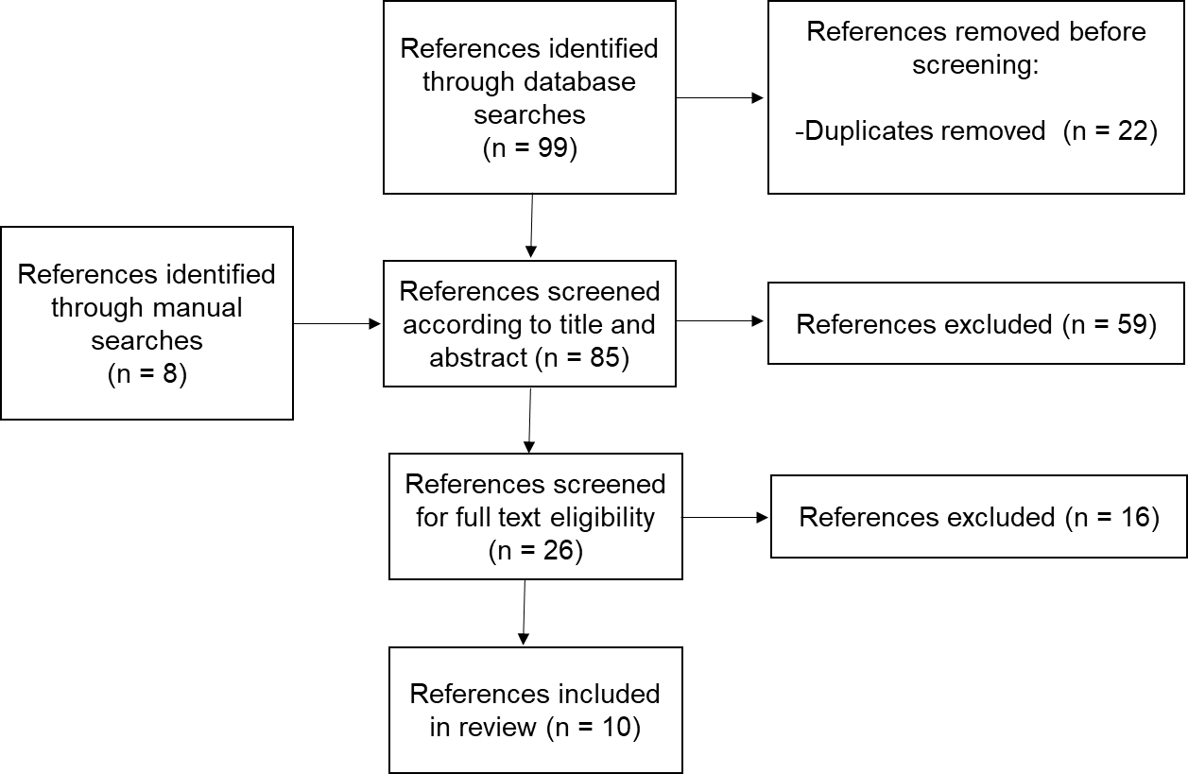
FIGURE 1: Preferred Reporting Items for Systematic reviews and Meta-Analyses diagram

FIG. 2: Meta-analysis of Length of stay data

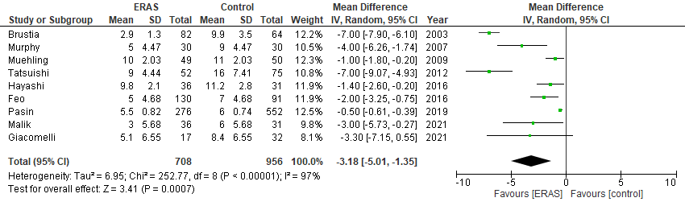
ERAS, enhanced recovery after surgery.

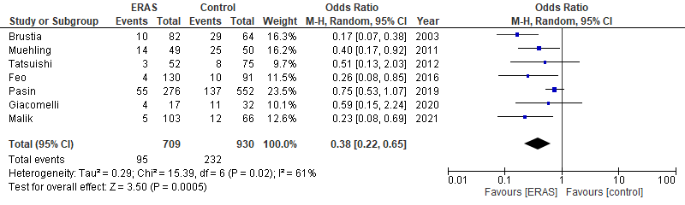
FIG. 3: Meta-analysis of Major complications data
ERAS, enhanced recovery after surgery.

FIG. 4: Meta-analysis of 30-day mortality data

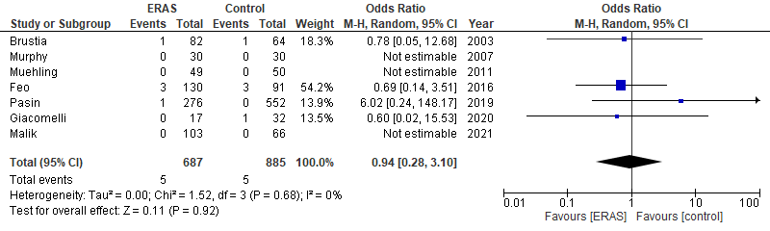
ERAS, enhanced recovery after surgery.

