 | YAS | WRN | AHO | SPFH | CMN | LAF | LASS | PWBCW | PFSPH | PCT
Coefficients | Parameters for estimation of total volume
α₀ | 9.807***  (0.954) | 9.770***  (1.048) | 10.796***  (1.015) | 11.236***  (0.948) | 11.080***  (0.918) | 11.430***  (0.922) | 10.714***  (0.907) | 11.680***  (0.895) | 11.606***  (0.870) | 11.734***  (0.872)
β | -0.003***  (0.001) | -0.003***  (0.001) | -0.003***  (0.001) | -0.003***  (0.001) | -0.003***  (0.001) | -0.003***  (0.001) | -0.002***  (0.001) | -0.002***  (0.001) | -0.002***  (0.001) | -0.002**  (0.001)
γ₁ | 0.531***  (0.121) | 0.695***  (0.133) | 0.780***  (0.129) | 0.712***  (0.121) | 0.678***  (0.117) | 0.694***  (0.117) | 0.572***  (0.115) | 0.622***  (0.114) | 0.595***  (0.111) | 0.571***  (0.111)
γ₂ | 0.579***  (0.123) | 0.779***  (0.135) | 0.832***  (0.131) | 0.775***  (0.122) | 0.802***  (0.119) | 0.741***  (0.119) | 0.599***  (0.117) | 0.714***  (0.116) | 0.697***  (0.112) | 0.682***  (0.113)
γ₃ | 0.285**  (0.118) | 0.273**  (0.130) | 0.307**  (0.126) | 0.272**  (0.117) | 0.416***  (0.114) | 0.241**  (0.114) | 0.235**  (0.112) | 0.277**  (0.111) | 0.294***  (0.108) | 0.347***  (0.108)
α₁ | -0.728***  (0.104) | -0.522***  (0.114) | -0.493***  (0.110) | -0.594***  (0.103) | -0.579***  (0.100) | -0.628***  (0.100) | -0.805***  (0.098) | -0.682***  (0.097) | -0.629***  (0.094) | -0.742***  (0.095)
α₂ | 0.122  (0.297) | -0.033  (0.326) | 0.107  (0.316) | 0.052  (0.295) | 0.050  (0.286) | 0.057  (0.287) | 0.069  (0.282) | 0.058  (0.278) | -0.028  (0.271) | -0.021  (0.271)
α₃ | -0.014  (0.066) | -0.031  (0.073) | -0.067  (0.071) | -0.106  (0.066) | -0.112*  (0.064) | -0.122*  (0.064) | -0.093  (0.063) | -0.149*  (0.062) | -0.166***  (0.061) | -0.169***  (0.061)
α₄ | 0.027  (0.569) | -0.126  (0.625) | 0.513  (0.605) | 0.392  (0.565) | 0.534  (0.547) | 0.576  (0.550) | 0.239  (0.541) | 0.584  (0.533) | 0.683  (0.519) | 0.693  (0.520)
α₅ | -0.925***  (0.150) | -0.936***  (0.165) | -0.797***  (0.160) | -0.889***  (0.149) | -0.874***  (0.144) | -0.846***  (0.145) | -0.899***  (0.142) | -0.898***  (0.141) | -0.941***  (0.137) | -0.900***  (0.137)
α₆ | 0.103  (1.210) | 0.647  (1.330) | 0.949  (1.288) | 0.620  (1.203) | 0.239  (1.165) | 0.528  (1.170) | 0.250  (1.150) | 0.142  (1.135) | 0.108  (1.104) | -0.457  (1.107)
α₇ | -0.184  (0.175) | -0.450**  (0.193) | -0.437**  (0.187) | -0.375**  (0.174) | -0.321*  (0.169) | -0.311*  (0.169) | -0.201  (0.167) | -0.250  (0.164) | -0.260  (0.160) | -0.276*  (0.160)
N | 100 | 100 | 100 | 100 | 100 | 100 | 100 | 100 | 100 | 100
R2 | 0.777 | 0.754 | 0.764 | 0.795 | 0.808 | 0.796 | 0.804 | 0.812 | 0.818 | 0.826
In-sample R² (N=50) | 0.796 | 0.757 | 0.779 | 0.818 | 0.818 | 0.814 | 0.830 | 0.826 | 0.846 | 0.846
Out-of-sample R²  (N=50) | 0.703 | 0.700 | 0.705 | 0.720 | 0.731 | 0.723 | 0.731 | 0.735 | 0.725 | 0.739
Table A1: Parameters estimated for equation (6) when predicting the effect of the levy on total volume of the composite good using Period-1 data. α₀ is the constant term, β is the parameter for the time trend, γ₁ to γ₃ correspond to the Christmas dummy variables and α₁ to α₇ are associated with the prices of the 7 products, p₁ to p₇, as coded in Table 2. Standard errors in parentheses. In-model and out-of-model R² refer to regressions using only first 50 datapoints. *** p¡0.01, ** p¡0.05, * p¡0.1.
 | YAS | WRN | AHO | SPFH | CMN | LAF | LASS | PWBCW | PFSPH | PCT
Coefficients | Parameters for estimation of number of customers
α₀ | 8.766***  (0.580) | 8.547***  (0.729) | 9.654***  (0.698) | 9.993***  (0.657) | 9.744***  (0.626) | 10.143***  (0.635) | 9.672***  (0.563) | 10.430***  (0.599) | 10.165***  (0.565) | 10.455***  (0.539)
β | -0.002***  (0.000) | -0.003***  (0.001) | -0.003***  (0.001) | -0.003***  (0.001) | -0.002***  (0.001) | -0.002***  (0.001) | -0.002***  (0.000) | -0.002***  (0.000) | -0.002***  (0.000) | -0.001***  (0.000)
γ₁ | 0.349***  (0.074) | 0.543***  (0.093) | 0.580***  (0.089) | 0.514***  (0.083) | 0.486***  (0.080) | 0.502***  (0.081) | 0.391***  (0.072) | 0.439***  (0.076) | 0.419***  (0.072) | 0.410***  (0.069)
γ₂ | 0.460***  (0.075) | 0.685***  (0.094) | 0.676***  (0.090) | 0.628***  (0.085) | 0.642***  (0.081) | 0.598***  (0.082) | 0.478***  (0.073) | 0.565***  (0.077) | 0.549***  (0.073) | 0.566***  (0.070)
γ₃ | 0.167**  (0.072) | 0.170*  (0.090) | 0.184**  (0.087) | 0.163**  (0.081) | 0.274***  (0.078) | 0.136*  (0.079) | 0.115  (0.070) | 0.148**  (0.074) | 0.175**  (0.070) | 0.244***  (0.067)
α₁ | -0.307***  (0.063) | -0.294***  (0.079) | -0.331***  (0.076) | -0.343***  (0.071) | -0.337***  (0.068) | -0.350***  (0.069) | -0.350***  (0.061) | -0.364***  (0.065) | -0.363***  (0.061) | -0.402***  (0.059)
α₂ | 0.190  (0.180) | 0.154  (0.227) | 0.295  (0.217) | 0.278  (0.204) | 0.223  (0.195) | 0.247  (0.198) | 0.140  (0.175) | 0.217  (0.187) | 0.196  (0.176) | 0.167  (0.167)
α₃ | -0.058  (0.040) | -0.074  (0.051) | -0.092*  (0.049) | -0.124***  (0.046) | -0.126***  (0.044) | -0.141***  (0.044) | -0.115***  (0.039) | -0.155***  (0.042) | -0.177***  (0.039) | -0.190***  (0.038)
α₄ | -0.562  (0.346) | -0.453  (0.434) | -0.258  (0.416) | -0.354  (0.391) | -0.384  (0.373) | -0.323  (0.379) | -0.311  (0.335) | -0.195  (0.357) | -0.207  (0.337) | -0.246  (0.321)
α₅ | -0.246***  (0.091) | -0.318***  (0.114) | -0.252**  (0.110) | -0.276***  (0.103) | -0.261***  (0.098) | -0.258**  (0.100) | -0.242***  (0.088) | -0.250***  (0.094) | -0.251***  (0.089) | -0.202**  (0.090)
α₆ | 0.223  (0.735) | 0.785  (0.924) | 1.020  (0.886) | 0.890  (0.833) | 0.623  (0.794) | 0.839  (0.806) | 0.339  (0.714) | 0.445  (0.761) | 0.544  (0.717) | -0.220  (0.687)
α₇ | -0.172  (0.107) | -0.400***  (0.134) | -0.402***  (0.128) | -0.371***  (0.121) | -0.375***  (0.115) | -0.350***  (0.117) | -0.270**  (0.103) | -0.302***  (0.110) | -0.326***  (0.104) | -0.276***  (0.099)
N | 100 | 100 | 100 | 100 | 100 | 100 | 100 | 100 | 100 | 99
R² | 0.732 | 0.743 | 0.756 | 0.763 | 0.776 | 0.763 | 0.747 | 0.770 | 0.785 | 0.805
In-sample R² (N=50) | 0.760 | 0.774 | 0.778 | 0.802 | 0.804 | 0.787 | 0.769 | 0.794 | 0.815 | 0.836
Out-of-sample R²  (N=50) | 0.647 | 0.675 | 0.714 | 0.705 | 0.717 | 0.708 | 0.692 | 0.693 | 0.734 | 0.707
Table A2: Parameters estimated for equation (6) when predicting the effect of the levy on number of customers purchasing composite good using Period-1 data. α₀ is the constant term, β is the parameter for the time trend, γ₁ to γ₃ correspond to the Christmas dummy variables and α₁ to α₇ are associated with the prices of the 7 products, p₁ to p₇, as coded in Table 2. Standard errors in parentheses. In-model and out-of-model R² refer to regressions using only first 50 datapoints. *** p¡0.01, ** p¡0.05, * p¡0.1.
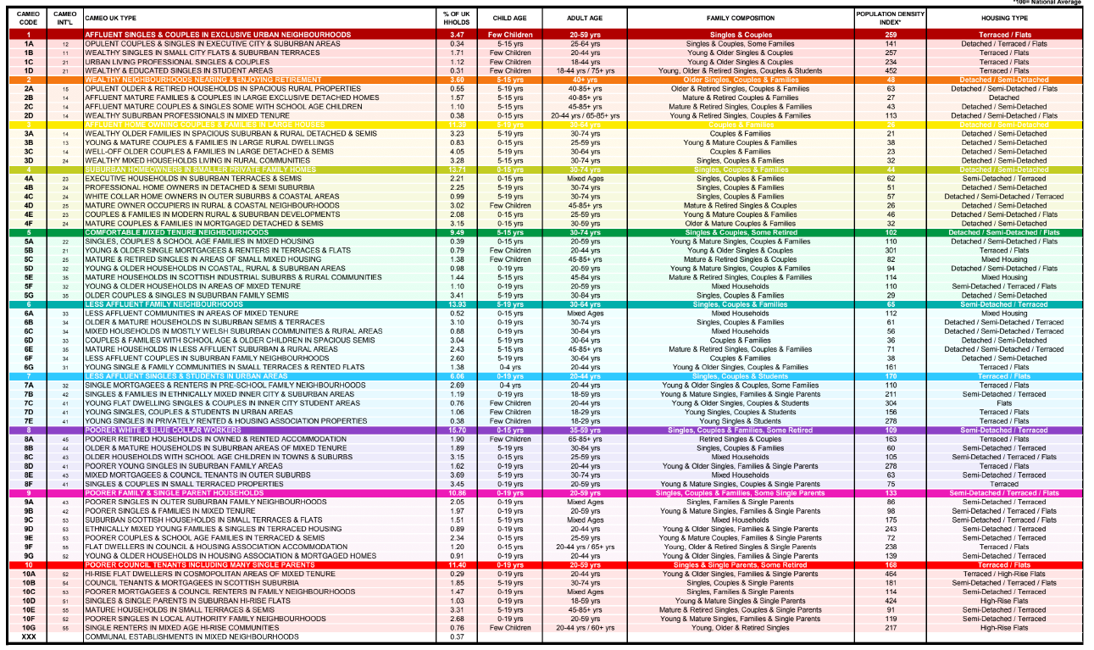
Table A3: Descriptors of Cameo geo-demographic segments

