Matrix-free Hyperfluorescent Organic Light-Emitting Diodes Based on Carbene-Metal-Amides

Hwan-Hee Cho, Alexander S. Romanov, Manfred Bochmann, Neil C. Greenham and Dan Credgington*

Hwan-Hee Cho, Prof. Neil C. Greenham, Dr. Dan Credgington
Cavendish Laboratory, Department of Physics, University of Cambridge, J J Thomson avenue, CB3 0HE, UK
E-mail: dan.credgington@gmail.com

Dr. Alexander S. Romanov, Prof. Manfred Bochmann
School of Chemistry, University of East Anglia, Earlham Road, Norwich, NR4 7TJ, UK

Keywords: hyperfluorescent OLEDs, carbene-metal-amides, exciton energy transfer

A wide-gap host matrix is a major obstacle detrimentally influencing the performance of hyperfluorescent organic light-emitting diodes since it substantially increases driving voltage. Moreover, these hyperfluorescent devices typically require at least three components in their emitting layer, which is unfavorable for mass production. To tackle the issue, we report hyperfluorescent organic light-emitting diodes based on a two-component emissive system of carbene-metal-amide donors and conventional fluorescent acceptors. We demonstrate a significant reduction of the driving voltage versus three-component hyperfluorescent devices at practical brightness (1000 cdm⁻²), leading to a doubling of power conversion efficiency for some composites. From an analysis of thin-film photophysics, it is shown that operational efficiency is limited by Dexter energy transfer between donors and acceptors, which may be reduced by tert-butyl steric substituents, providing new targets for molecular design. While reducing driving voltage, matrix-free hyperfluorescent devices also achieve a maximum external quantum efficiency of 16.5%.

1. Introduction

The demonstration of the first organic electroluminescent device in 1987 marked a new era in light-emitting technology.^{[1]} From the late 2000s, organic light-emitting diodes (OLEDs) became a rival for liquid crystal displays (LCDs) due to superior efficiency, contrast, brightness, and ease of manufacture. OLEDs have now entered mass-production and are widely applied in TVs, tablet PCs, and smartphones whether they increasingly replace LCDs. The use of phosphorescent molecules to turn on emission from normally-dark triplet excited states was a key development, which significantly increased the performance of red and green OLED devices.^{[2-4]} However, the realization of blue phosphorescent OLEDs with high stability remains a key challenge, with operational lifetimes still far from those required for OLED consumer products.^{[5-13]} Moreover, current phosphorescent materials utilize one of the rarest elements on Earth - iridium, which may represent a barrier for cost-effective mass production in the long term. Both of these factors have driven the search for alternative approaches to efficient light emission.
In 2011, Adachi et al. demonstrated highly promising purely organic materials enabling to harvest singlet and triplet excitons via the concept of thermally activated delayed fluorescence (TADF).^{[14]} In most TADF materials, a small energy gap (≤ 0.1 eV) between singlet and triplet states is achieved by separating electron and hole wavefunctions via a charge-transfer (CT) excitation between electron donating and accepting moieties. This is considered to enable up-conversion from nonradiative triplet excited states to radiative singlet excited states by reverse intersystem crossing (RISC). Using this approach, almost 100% electroluminescence internal quantum efficiency (IQE) has been demonstrated, with operating stability and color purity becoming the next target. ^{[15-21]} Improved color purity has recently been attained by developing multi-resonant TADF emitters, which do not rely on the formation of typical CT states, but low stability has not yet been fully solved.^{[22, 23]}
Förster resonance energy transfer (FRET) from triplet-harvesting assistant dopants to singlet emitters has been identified as a concept with the potential to improve operational stability and color purity simultaneously. The particular approach utilizing TADF-type molecules as the assistant dopants in conjunction with conventional fluorescent emitters is termed “hyperfluorescence”.^{[24]} Phosphorescent organometallic complexes can also be employed as assistant dopants, a concept initially suggested in 2000.^{[25]} This has recently attracted renewed interest due to the substantial improvements in efficiency, operational lifetime, and color purity that are possible.^{[26-29]}
Hyperfluorescent emitting layers (EMLs) use composites of multiple functional materials. Transport is typically handled by a host matrix, interconversion of singlet and triplet states is managed by an assistant dopant, while the shape of the emission spectrum is managed by a fluorescent dopant. Dispersal of emissive components in a host matrix also acts to suppress concentration quenching and parasitic Dexter energy transfer (DET) to the fluorescent dopant. The requirement for a host matrix means that a considerable increase in driving voltage is inevitable. Two-component exciplex-forming hosts may be capable of addressing this problem, though the concept requires at least four materials to be used in the EML, which is one reason why hyperfluorescence is not widely implemented in displays.^{[21, 26-28]}
In 2017, we used coinage metal-based organometallic emitting materials (carbene-metal-amides, so-called CMAs) exhibiting TADF-like characteristics with exceptionally rapid mixing of spin states and large oscillator strengths.^{[30]} Interestingly, even in a neat solid film, high photoluminescence quantum efficiency (PLQE) of 83% was achieved for some CMA compounds. This implies an absence of significant concentration quenching, potentially due to weak intermolecular interactions, in part arising due to the tendency of many CMAs to anti-align in a solid phase.^{[31, 32]} This suggests that CMA-type organometallic compounds may be good candidates for realizing hyperfluorescent OLEDs without a host matrix, in the sense that the assistant dopant could fulfill the role normally played by the host. If the host may be removed without a significant drop in quantum efficiency, power conversion efficiency (PCE) will be dramatically increased. Moreover, an emitting system with only two components is advantageous for eventual OLED manufacture.
In this paper, we report matrix-free hyperfluorescent OLEDs with simple structure achieving comparable quantum efficiency and significantly improved PCE versus equivalent devices employing a host matrix. Compounds CMA1 and CMA4 (see [30] for synthetic details, Figure 1(a) for structures) are employed as hosts, and 5,6,11,12-tetraphenylnaphthacene (rubrene) and 2,8-di(t-butyl)-5,11-di[4-(t-butyl)phenyl]-6,12-diphenylnaphthacene (TBRb) are examined as dopants.^{[33-35]} From the absorption and photoluminescence (PL) spectra of the hosts and dopants, Förster radii are calculated to predict the effectiveness of FRET between them. In order to investigate exciton energy transfer more directly, PL quenching measurements are performed. We employ PLQE and transient PL to show the influence of t-butyl substituents and doping concentration on FRET and DET. Finally, the characteristics of the hyperfluorescent OLEDs are explored. In CMA1 based devices, the driving voltage of the matrix-free hyperfluorescent devices is considerably reduced at 1000 cd/m², in line with the approximately two-fold increase in PCE compared to devices employing a host matrix. Maximum external quantum efficiencies (EQEs) of 15.2% and 16.5% for CMA1 and CMA4 matrix-free devices are observed, versus 16.3% and 18.1% when employing a host matrix, respectively.

2. Results and Discussion

2.1. Förster resonance energy transfer

As discussed above, CMAs can achieve high PLQE even in neat films, by contrast with the majority of TADF materials.^{[30, 31, 36]} Table 1 shows the values of absolute PLQE for thermally evaporated films of CMA1 and CMA4 diluted in 1,3-bis(N-carbazolyl)benzene (mCP) and their neat films, which were measured in an integrating sphere under a nitrogen flow with a calibrated spectrometer.^{[37]} The comparable and high PLQE values (81±5 %) imply that CMAs can serve as a single host for hyperfluorescent OLEDs.
We first examine exciton energy transfer between exciton donors and exciton acceptors. Once singlet and triplet excitons are generated on a donor, they may transfer to nearby acceptors via FRET and DET mechanisms. Minimizing DET and maximizing FRET is a way to optimize the performance of hyperfluorescent OLEDs. Even though high PLQE is available in neat films for CMAs, if a host matrix is not utilized, diffusion via DET to the fluorescent sites will be inevitable since the CMAs and fluorescent emitters are in close contact.^{[38]} It was recently demonstrated that the adoption of appropriate substituents attached to fluorescent emitters for the separation of donors and acceptors is a useful method for suppressing DET since the likelihood of transfer varies exponentially with chromophore spacing.^{[39]} In this work, CMA1, CMA4, rubrene, and TBRb (molecular structures shown in Figure 1(a)) are employed to explore the influence of steric bulk, introduced via t-butyl substituents, on DET efficiency between CMAs and fluorescent emitters.
FRET operates on the basis of resonant dipole coupling, with long-range energy transfer between the singlet excited states of two molecules achieved by virtual emission and absorption processes.^{[40-42]} As such, the spectral overlap between the PL of the donor and the absorption of the acceptor is vital for effective FRET. FRET between CMAs and fluorescent emitters is studied via the calculation of the Förster radius (R₀), which is the critical distance that 50% of singlet excited states of donors can be transferred to those of acceptors, expressed as^{[40-42]}
$R_{0}^{6}=\frac{9000\ln{10}{η_{D}κ}^{2}}{128π^{5}N_{A}n^{4}}\int{λ^{4}F_{D}\left(λ\right)ϵ_{A}\left(λ\right)d(λ)}$ (1)
where N_{A} is Avogadro’s number, n is the refractive index, $η_{D}$is the PLQE of the donor, $κ$ is the dipole orientation factor, $λ$ is the wavelength, F_{D} is the donor’s PL spectrum normalized to unity, $ϵ_{A}$ is the acceptor’s molar decadic absorption coefficient. Absorption and PL spectra are shown in Figure 1(b). Figure S1 presents refractive index measurements of neat CMA1, CMA4, and mCP. At 550 nm, the values of n are 1.65, 1.61, and 1.74, respectively. $κ$ in a randomly orientated amorphous film is 0.845$\sqrt{2/3}$, which is used for the calculation of R₀.^{[43]} As shown in Table 1, the calculated values of R₀ for CMA1 and CMA4 with rubrene are 3.48 nm and 3.30 nm, and with TBRb are 3.79 nm and 3.62 nm, respectively, and those for CMA1 and CMA4 diluted in mCP with rubrene are 3.40 nm and 3.34 nm, and with TBRb are 3.70 nm and 3.64 nm, respectively, indicating that FRET is achievable at low doping concentration. The absorption spectra of rubrene and TBRb and the PL spectra of CMAs are well-overlapped with each other, and the absorption coefficient of TBRb is higher than that of rubrene, resulting in a larger R₀.

2.2. Photoluminescence quenching measurements

In order to explore exciton energy transfer in a CMA based host-guest emitting system in detail, PL quenching measurements in a CMA4:mCP:rubrene system were performed to obtain exciton quenching efficiency ($η_{EQ}$).^{[44-46]} As presented in Figure 2(a), mCP was adopted as a host to dilute rubrene and as a spacer to separate CMA4 from rubrene. After 10 nm of an mCP:rubrene 95:5% quencher layer is deposited on glass, a pure mCP spacer layer is deposited on top, followed by a 10 nm CMA4 sensitization layer. The thickness of the mCP spacer layer varies from 0 nm to 10 nm. From the measurements of quenched PL (PL_{Q}) and nonquenched PL (PL_{NQ}), $η_{EQ}$ of CMA4 is constructed by 1- PL_{Q}/PL_{NQ}.^{[46]} In this structure, when CMA4 is excited, excitons formed in CMA4 are transferred to diluted rubrene via FRET or DET. mCP is not expected to directly participate in exciton energy transfer since its singlet and triplet energy levels are much higher than those of either CMA4 or rubrene, so it acts primarily as an inert spacer. Figure 2(b) displays the PL spectral dependence on the thickness of the spacer layer. As mCP layer thickness increases, the proportion of rubrene emission decreases and that of CMA4 emission increases. At a spacer thickness of 10 nm, the PL spectrum almost recovers that of the neat CMA4 control, since the CMA4 layer and mCP:rubrene 5% layer are sufficiently separated to block exciton energy transfer. $η_{EQ}$ of CMA4 and the normalized integrated PL intensity of rubrene are obtained from the deconvoluted CMA4 and rubrene spectra, which are extracted by subtracting a linearly-scaled CMA4-only spectrum from the total PL spectrum. Figure 3(a) and 3(b) show the variation of normalized $η_{EQ}$ and normalized integrated PL intensity with spacer thickness. While $η_{EQ}$ of CMA4 drops significantly for greater than 2 nm of the spacer layer, the normalized integrated PL intensity of rubrene only falls substantially for greater than 3 nm of the spacer layer. We interpret this as originating from the difference of FRET and DET characteristics. Since DET is an electron exchange process, it typically occurs below 1 nm intermolecular distance. Accordingly, between 0 nm and 1 nm spacer layer thickness, both DET and FRET are expected to contribute. However, for spacer layers of 2 nm and greater, excitons primarily migrate via FRET. We interpret the decrease in $η_{EQ}$ of CMA4 observed up to 2 nm spacer thickness as approximating the proportion of quenching due to DET, while we interpret the decrease in $η_{EQ}$ from 3 nm onwards as due to reduced quenching due to FRET, in qualitative agreement with the expected Förster radius between CMA4 and rubrene. Concomitantly, light emission from rubrene drops for spacer layers beyond 3 nm as indirect excitation of rubrene singlets reduces. We thus confirm that DET causes excitons generated in donors to be partly wasted, not contributing to an emission process. We also confirm that FRET is not effective over distances greater than around 4 nm, in agreement with calculations. If a longer Förster radius were achieved, a greater proportion of excitons would be able to be transferred to acceptors via FRET.

2.3. Photoluminescence quantum efficiency

To explore the behavior of different material combinations, we measured PLQE for the CMA based hyperfluorescent films with and without a host matrix and varying doping concentration. The values are summarized in Table 2. The PL spectra of the films are also measured using a fluorimeter, as shown in Figure S2, indicating that in all cases, most of the emission is from rubrene or TBRb. As expected, as doping concentration increases, the PLQE values are substantially reduced, which we interpret as arising from the increased probability of DET between the CMAs and the emitters. There may also be an effect of concentration quenching, but rubrene and TBRb are known to experience negligible concentration quenching at low doping concentration.^{[33-35]} The highest quantum efficiency is observed for conventional hyperfluorescent films where both donor and acceptor are dispersed in a matrix, reducing the probability of DET. In matrix-free films, rubrene shows relatively poor performance, achieving 34-38% PLQE at 2% concentration. By contrast, the performance of bulkier TBRb is better, and when paired with the bulkier derivative CMA4, the relative drop in performance at higher doping concentration is considerably reduced. We ascribe this to suppressed DET resulting from larger inter-chromophore spacing due to t-butyl substituents in both CMA4 and TBRb.

2.4. Exciton decay kinetics and energy transfer pathway

To better understand these implied exciton dynamics, transient PL was measured. Figure 4(a) illustrates a schematic representation of the exciton energy transfer mechanism and decay pathways for CMA-based hyperfluorescence. Once excitons are formed in CMAs, they convert rapidly between singlet and triplet excited states via RISC and ISC and migrate to fluorescent emitters via FRET or DET. Transient PL kinetics were measured at the peak emission wavelengths, which are 510 nm and 535 nm for CMA1 and CMA4, 490 nm and 515 nm for mCP:CMA1 20% and mCP:CMA4 20%, and 560 nm for rubrene and TBRb, respectively, depicted in Figure S3. CMAs and the acene emitters are expected to be dispersed with a broad range of intermolecular distances. Accordingly, decay kinetics are not mono-exponential, since both FRET and DET are strongly dependent on intermolecular distance. From a multi-exponential fit with three components, the average (intensity-weighted) decay time ($τ)$ of rubrene and TBRb diluted in CMA1, CMA4, mCP:CMA1 20%, and mCP:CMA4 20% were calculated as $τ=\frac{\sum_{i=1}^{3}{{A_{i}τ_{i}}^{2}}}{\sum_{j=1}^{3}{A_{j}τ_{j}}}$, where $A_{i}$ and $τ_{i}$ are the amplitude and lifetime of the i^{th} decay component, respectively. The kinetics of CMA1, CMA4, mCP:CMA1 20%, and mCP:CMA4 20% without fluorescent dopants were fitted with double exponential decays to derive $τ$. In general, $k_{r}$ and $τ$ are expressed as:
$k_{r}=\frac{η}{τ}$ (2)
$τ=\frac{1}{k_{r}+k_{nr}}$ (3)
Where $η$ is the value of PLQE, and where $k_{r}$ and $k_{nr}$ are the overall radiative and nonradiative rate of the system, respectively. We parameterize our system in terms of the individual radiative (r) and nonradiative (nr) rates shown in Figure 4(a), with $k_{FRET}$ and $k_{DET}$, the characteristic FRET and DET rates from CMA to fluorescent dopant, respectively. The decay of triplets on the fluorescent dopant ($k_{T}$) is taken to be entirely nonradiative. Note that for brevity, $k_{nr,CMA}$incorporates both nonradiative singlet and triplet decay, and we assume ISC rapidly mixes the singlet and triplet populations on the CMA materials.
Under the assumptions that $k_{r,F}≫k_{nr,F}$ and $k_{r,F}≫k_{FRET}$ where $k_{r,F}$ and $k_{nr,F}$ are the fluorescent radiative and nonradiative decay rate, respectively, we obtain:
$k_{r}≈k_{r,CMA}+k_{FRET}$ (4)
$k_{nr}≈k_{nr,CMA}+k_{DET}$ (5)
$η=\frac{k_{r,CMA}+k_{FRET}}{k_{r,CMA}+k_{nr,CMA}+k_{FRET}+k_{DET}}$ (6)
i.e., the fluorescent emitter acts as a radiative sink for singlets and a nonradiative sink for triplets. These expressions are valid, assuming the fluorescent dyes have close to unity PLQE with radiative decay rates much higher than k_{r,CMA}. PLQE for both rubrene and TBRb is close to unity, negligible concentration quenching is expected, and their radiative rates are of order 10⁹ s⁻¹.^{[33-35]} k_{DET} can, therefore, be approximated from Equation (3)-(6) as:
$k_{DET}≈τ^{-1}-k_{nr,CMA}-k_{r,CMA}-k_{FRET}$ (7)
While k_{FRET} may be obtained from Equation (2) and (4) as:
$k_{FRET}≈\frac{η}{τ}-k_{r,CMA}$ (8)
$η$ and $τ$ are determined for each experiment, and $k_{r,CMA}$ and $k_{nr,CMA}$ obtained from single-component films. The decay time and rate constants are summarized in Table S1. Figure 4(b) shows the ratio of k_{FRET} and k_{DET} depending on the host-dopant combination and doping concentration. Regarding the CMA:rubrene mixed films, the dominance of DET over FRET at all doping concentrations explains their poor PLQE performance and precludes the use of rubrene-based composites in matrix-free hyperfluorescent OLEDs. k_{DET} and k_{FRET} for CMA:TBRb mixed films are much more similar, with CMA4:TBRb the most promising candidate by this metric, explaining its relatively good PLQE performance even at higher doping concentration. Thus, we infer that steric hindrance between the bulkier hosts and dopants is effective in suppressing DET in these composites.
The FRET efficiency (E_{FRET}), which is the proportion of radiative excitons transferred via FRET from CMAs to acceptors, is calculated as^{[29]}
$E_{FRET}=\frac{k_{FRET}}{k_{r,CMA}+k_{FRET}}$ (9)
While the general trend if for k_{r}, k_{FRET}, and E_{FRET} to increase from 2% to 4% doping, as expected, at higher (10%) doping, these metrics drop, and the effect is more pronounced for rubrene-doped films than for TBRb-doped films. The proportion of emission from CMAs and the fluorescent emitters, which is derived from the PL spectra depicted in Figure S2, and E_{FRET} are plotted in Figure S4. It is noticeable that the proportion of emission for TBRb is correlated with E_{FRET}, whereas for rubrene, the correlation is less pronounced, indicating that an additional process begins to dominate. As above, we ascribe this to an increase in the DET rate with increased doping concentration.

2.5. Device characterization

In light of these photophysical results, TBRb was chosen as a dopant for matrix-free hyperfluorescent OLEDs. Figure 5(a) shows the device structure and schematic energy level diagram. 1,1-Bis[(di-4-tolylamino)phenyl]cyclohexane (TAPC) and 2,2',2"-(1,3,5-Benzinetriyl)-tris(1-phenyl-1-H-benzimidazole) (TPBi) were employed as a hole transporting layer (HTL) and an electron transporting layer (ETL), respectively. 1,4-bis(triphenylsilyl)benzene (UGH2) with 10% of TPBi was applied to improve charge balance in the EML.^{[31]} The layers of TBRb 0, 2, 4, and 10% doped in CMA1 or CMA4 served as an EML for matrix-free hyperfluorescence. For comparison, mCP was used as a host matrix for conventional hyperfluorescent devices using the same donor-acceptor mix. CMA1 and CMA4 based hyperfluorescent devices were successfully fabricated; their electroluminescence spectra are displayed in Figure 5(b), 5(c), and 5(d). As anticipated, as doping concentration increases, the proportion of CMA1 and CMA4 emission decreases as per the PL spectra shown in Figure S2.
The device characteristics are summarized in Table 3. Figure 6 shows plots of EQE versus current density and PCE versus luminance as the doping concentration of TBRb varies. Additionally, the characteristics of current density and luminance versus voltage are plotted in Figure S5. It is noticeable that CMA1 based devices show much lower turn-on voltage than CMA4 based ones (3.3 V vs 4.3-4.5 V for the matrix-free devices and 3.5 V vs 4.3 V for the devices with a host matrix), mainly due to the difference of electrical properties between CMA1 and CMA4. In terms of CMA1 based devices, the devices with a host matrix exhibit somewhat higher EQE than the matrix-free counterparts. Matrix-free devices with higher doping concentrations of TBRb show lower EQEs, which is well-correlated with the values of PLQE shown in Table 2. The maximum EQE for CMA1 OLED is 15.2% at 2% doping concentration. As shown in Table 3, at 2% doping concentration, the matrix-free device shows 2.6 V lower driving voltage and nearly two-times higher PCE at a brightness of 1000 cd/m² than those for the device incorporating a host matrix. In addition, 40% higher PCE at 1000 cd/m² is observed in the dopant-free CMA1 based device compared to the mCP:CMA1 based counterpart. This clearly shows that the wide-gap host matrix adversely affects device efficiency. Regarding the CMA4 based hyperfluorescent devices, the maximum EQE for the matrix-free device at 2% doping concentration is 16.5%, while that for the device with mCP is 18.1%. Like the CMA1 based devices, the driving voltage for the CMA4 based matrix-free devices is reduced compared to the mCP:CMA4 based devices, showing about 10% higher PCE at 1000 cd/m² despite the lower EQE at 2% TBRb concentration. From this, we conclude that both CMA4 and the mCP host act to increase driving voltage. In addition, even in 10% doping concentration, the EQE of the CMA4 based device is still high, over 11.9%, which is associated with the high PLQE value and the suppressed DET, as shown in Table 2 and Figure 4(b).

3. Conclusion

In summary, we successfully demonstrated matrix-free hyperfluorescence OLEDs with CMA materials as a donor of excitons. High PLQE in neat films and effective energy transfer to exciton acceptors (fluorescent dopants) indicate the high suitability of CMA materials in this role. This two-component device architecture is particularly sensitive to DET processes, which we have shown can be reduced through the addition of steric t-butyl substituents on both donor and acceptor of excitons. We showed that a matrix-free hyperfluorescent system is able to achieve up to 90% increase in PCE compared with equivalent three-component hyperfluorescent OLEDs, and that this increase in performance arises due to the significantly reduced driving voltage (by up to 2.6 V at 1000 cdm⁻²) in the matrix-free devices. The maximum EQE values for CMA1 and CMA4 matrix-free devices (15.2% and 16.5% respectively) are reduced by only 5-10% versus devices incorporating a host matrix, which was identified as the result of increased DET. We envisage that with further work, two-component hyperfluorescent OLEDs may become the next industry-preferred method to enhance OLED device performance.

4. Experimental Section

Sample preparation: To measure absorption spectra in solution, rubrene and TBRb were dissolved in toluene and methylene chloride (10⁻⁴ M), respectively. Organic films were made by a thermal evaporation process under high vacuum (~10⁻⁷ torr). 100 nm thick neat films were thermally evaporated on a silicon wafer for the measurement of refractive index. 50 nm of mCP:CMA1 or CMA4 20% films and with 2% rubrene or TBRb concentration and 30 nm thick CMAs and TBRb or rubrene mixed films with the variation of doping concentration from 2% to 10% were deposited on glass substrates to measure steady-state PL, PLQE, and transient PL. For the fabrication of OLED devices, ITO coated substrates (~15 Ω/cm²) were cleaned with acetone and isopropyl alcohol, and then O₂ plasma treatment was applied to align the energy level with a hole transporting layer. All layers, including organic layers and a LiF/aluminium cathode, were thermally deposited in high vacuum (~10⁻⁷ torr). Additionally, doping concentration means volume % since the deposition process was calibrated based on the measurement of the film thickness.

Photophysical measurements and device characterization: Steady-state PL spectra were measured from FLS980 spectrofluorimeter with a monochromated xenon arc lamp at λ_{Ex} = 370 nm for CMA1 and λ_{Ex} = 398 nm for CMA4. Shimadzu UV-3600 Plus spectrophotometer was employed for the measurement of absorption spectra. An ellipsometer (J. A. Woollam Co., Inc) was used to gain the real part of the refractive index. The values of PLQE were extracted from the use of an integrating sphere with a nitrogen flow using an Andor Shamrock spectrometer and Andor iDus CCD array and laser excitation at λ_{Ex} = 405 nm. Transient PL was recorded by a time-correlated single photon counting (TCSPC) system at room temperature (~285K) under vacuum (~10⁻⁵ torr), and samples are excited by 375 nm (PDL 800-B, PicoQuant). The performance of the OLED devices was measured by using a Keithley 2635 source-meter and a calibrated Si photodiode.

Supporting Information
Supporting Information is available from the Wiley Online Library or from the author.

Acknowledgements
This work was supported by the Engineering and Physical Sciences Research Council (EPSRC, grant no. EP/M005143/1), the Royal Society (grant no. UF130278), the European Research Council (ERC) and Samsung Display Co. Ltd (SDC). H.-H. Cho acknowledges George and Lilian Schiff Foundation for Ph.D. studentship funding. H.-H. Cho acknowledges Professor Russell Holmes, Dr Emrys Evans, Dr Saul T. E. Jones and Campbell S. B. Matthews for helpful advice and guidance on experiments.

Received: ((will be filled in by the editorial staff))
Revised: ((will be filled in by the editorial staff))
Published online: ((will be filled in by the editorial staff))

References
[1] C. W. Tang and S. A. VanSlyke, Appl. Phys. Lett. 1987, 51, 913
[2] M. A. Baldo, S. Lamansky, P. E. Burrows, M. E. Thompson, S. R. Forrest, Appl. Phys. Lett. 1999, 75, 4
[3] M. A. Baldo, D. F. O’Brien, Y. You, A. Shoustikov, S. Sibley, M. E. Thompson & S. R. Forrest, Nature 1998, 395, 151-154
[4] H. Yersin, Highly Efficient OLEDs with Phosphorescent Materials, WILEY-VCH Verlag GmbH & Co. KGaA, Weinheim, 2008
[5] N. C. Giebink, B. W. D’Andrade, M. S. Weaver, P. B. Mackenzie, J. J. Brown, M. E. Thompson, and S. R.Forrest, J. Appl. Phys. 2008, 103, 044509
[6] R. J. Holmes, B. W. D’Andrade, S. R. Forrest, X. Ren, J. Li, and M. E. Thompson, Appl. Phys. Lett. 2003, 83, 3818
[7] N. Chopra, J. Lee, Y. Zheng, S.-H. Eom, J. Xue, and F. So, Appl. Phys. Lett. 2008, 93, 143307
[8] J. Lee, H.-F. Chen, T. Batagoda, C. Coburn, P. I. Djurovich, M. E. Thompson and S. R. Forrest, Nat. Mater. 2016, 15, 92–98
[9] T.-A. Lin, T. Chatterjee, W.-L. Tsai, W.-K. Lee, M.-J. Wu, M. Jiao, K.-C. Pan, C.-L. Yi , C.-L. Chung, K.-T. Wong, C.-C. Wu, Adv. Mater. 2016, 28, 6976–6983
[10] Y. Zhang, J. Lee, S. R. Forrest, Nat. Commun. 2014, 5, 5008
[11] H. Shin, J.-H. Lee, C.-K. Moon, J.-S. Huh, B. Sim, J-J Kim, Adv. Mater. 2016, 28, 4920–4925
[12] K. Klimes, Z.-Q. Zhu, and J. Li, Adv. Funct. Mater. 2019, 29, 1903068
[13] X. Li, J. Zhang, Z. Zhao, L. Wang, H. Yang, Q. Chang, N Jiang, Z Liu, Z. Bian, W. Liu, Z. Lu, C. Huang, Adv. Mater. 2018, 30, 1705005
[14] A. Endo, K. Sato, K. Yoshimura, T. Kai, A. Kawada, H. Miyazaki, C. Adachi, Appl. Phys. Lett. 2011, 98, 083302
[15] H. Uoyama1, K. Goushi, K. Shizu1, H. Nomura, C. Adachi, Nature 2012, 492, 234-238
[16] H. Kaji, H. Suzuki, T. Fukushima, K. Shizu, K. Suzuki, S. Kubo, T. Komino, H. Oiwa, F. Suzuki, A. Wakamiya, Y. Murata, C. Adachi, Nat. Commun. 2015, 6, 8476
[17] Q. Zhang, B. Li1, S. Huang, H. Nomura, H. Tanaka, C. Adachi, Nat. Photonics 2014, 8, 326-332
[18] R. Furue, K. Matsuo, Y. Ashikari, H. Ooka, N. Amanokura, T. Yasuda, Adv. Optical Mater. 2018, 6, 1701147
[19] T.-L. Wu, M.-J. Huang, C.-C. Lin, P.-Y. Huang, T.-Y. Chou, R.-W. C.-Cheng, H.-W. Lin, R.-S. Liu, C.-H. Cheng, Nat. Photonics 2018, 12, 235-240
[20] D. H. Ahn, S. W. Kim, H. Lee, I. J. Ko, D. Karthik, J. Y. Lee, J. H. Kwon, Nat. Photonics 2019, 13, 540-546
[21] C.-K. Moon, K. Suzuki, K. Shizu, C. Adachi, H. Kaji, J.-J. Kim, Adv. Mater. 2017, 29, 1606448
[22] T. Hatakeyama, K. Shiren , K. Nakajima , S. Nomura , S. Nakatsuka , K. Kinoshita, J. Ni , Y. Ono, T. Ikuta, Adv. Mater. 2016, 28, 2777-2781
[23] Y. Kondo, K. Yoshiura, S. Kitera, H. Nishi, S. Oda, H. Gotoh, Y. Sasada, M. Yanai, T. Hatakeyama, Nat. Photonics 2019, 13, 678-682
[24] H. Nakanotani, T. Higuchi, T. Furukawa, K. Masui, K. Morimoto, M. Numata, H. Tanaka, Y. Sagara, T Yasuda, C. Adachi, Nat. Commun. 2014, 5, 4016
[25] M. A. Baldo, M. E. Thompson, S. R. Forrest, Nature 2000, 403, 750-753
[26] H.-G. Kim, K.-H. Kim, C.-K. Moon, J.-J. Kim, Adv. Optical Mater. 2017, 5, 1600749
[27] H.-G. Kim, K.-H. Kim, J.-J. Kim, Adv. Mater. 2017, 29, 1702159
[28] H.-G. Kim, H. Shin, Y. H. Ha, R. Kim, S.-K. Kwon, Y.-H. Kim, J.-J. Kim, ACS Appl. Mater. Interfaces 2019, 11, 26-30
[29] P. Heimel1, A. Mondal, F. May, W. Kowalsky, C. Lennartz, D. Andrienko, R. Lovrincic, Nat. Commun. 2014, 9, 4990
[30] D. Di, A. S. Romanov, L. Yang, J. M. Richter, J. P. H. Rivett, S. Jones, T. H. Thomas, M. A. Jalebi, R. H. Friend, M. Linnolahti, M. Bochmann, D. Credgington, Science 2017, 356, 159-163
[31] P. J. Conaghan, S. M. Menke, A. S. Romanov, S. T. E. Jones, A. J. Pearson, E. W. Evans, M. Bochmann, N. C. Greenham, D. Credgington, Adv. Mater. 2018, 30, 1802285
[32] J. Feng, E. J. Taffet, A.-P. M. Reponen, A. S. Romanov, Y. Olivier, V. Lemaur, L. Yang, M. Linnolahti, M. Bochmann, D. Beljonne, D. Credgington, Chem. Mater. 2020, 32, 4743-4753
[33] Y.-S. Wu, T.-H. Liu, H.-H. Chen, C. H. Chen, Thin Solid Films 2006, 496, 626-630
[34] Y. Sato, T. Ogata, S. Ichinosawa, Y. Murata, Synthetic Metals 1997, 91, 103-107
[35] H. Mattoussi, H. Murata, C. D. Merritt, Y. Iizumi, J. Kido, Z. H. Kafafi, J. Appl. Phys. 2006 86, 2642-2650
[36] Q. Zhang , D. Tsang , H. Kuwabara , Y. Hatae , B. Li, T. Takahashi , S. Y. Lee , T. Yasuda , C. Adachi, Adv. Mater. 2015, 27, 2096-2100
[37] J. C. d. Mello, H. F. Wittmann, R. H. Friend, Adv. Mater. 1997, 9, 230-232
[38] J. Feng, L. Yang, A. S. Romanov, J. Ratanapreechachai, A.-P. M. Reponen, S. T. E. Jones, M. Linnolahti, T. J. H. Hele, A. Köhler, H. Bässler, M. Bochmann, D. Credgington, Adv. Funct. Mater. 2020, 1908715
[39] D. Zhang, X. Song, M. Cai, L. Duan, Adv. Mater. 2018, 30, 1705250
[40] T. Förster, Discuss. Faraday Soc. 1959, 27, 7
[41] B. E. Hardin, E. T. Hoke1, P. B. Armstrong, J.-H. Yum, P. Comte, T. Torres, J. M. J. Fréchet, M. K. Nazeeruddin, M. Grätzel, M. D. McGehee, Nat. Photonics 2009, 3, 406-411
[42] A. Adronov, J. M. J. Fréchet, Chem. Commun. 2000, 1701-1710
[43] J. Baumanna, M. D. Fayer, J. Chem. Phys. 1986, 85, 4087
[44] S. M. Menke, R. J. Holmes, J. Phys. Chem. C 2016, 120, 8502-8508
[45] W. A. Luhman, R. J. Holmes, Adv. Funct. Mater. 2011, 21, 764-771
[46] P. Peumans, A. Yakimov, S. R. Forrest, J. Appl. Phys. 2003, 93, 3693

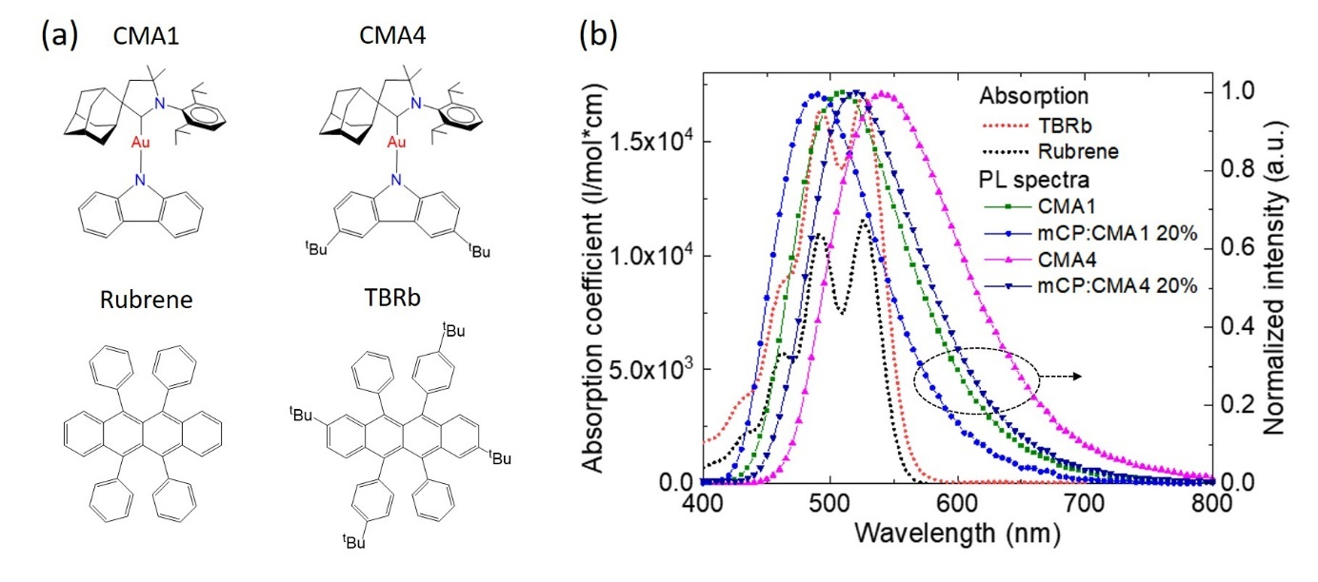
Figure 1. (a) Chemical structures and (b) PL and absorption spectra of CMA1, CMA4, rubrene, and TBRb.

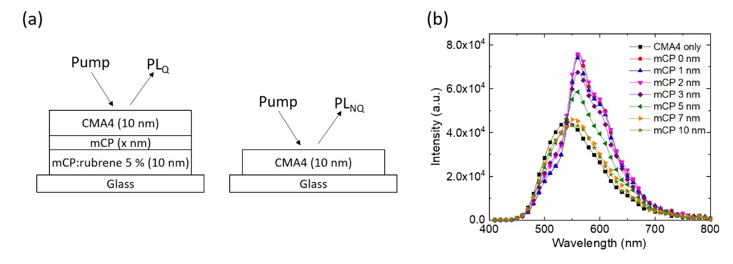
Figure 2. (a) Schematic illustration of the structures for PL quenching measurements. (b) PL spectra variation with the different thickness of an mCP spacer layer.

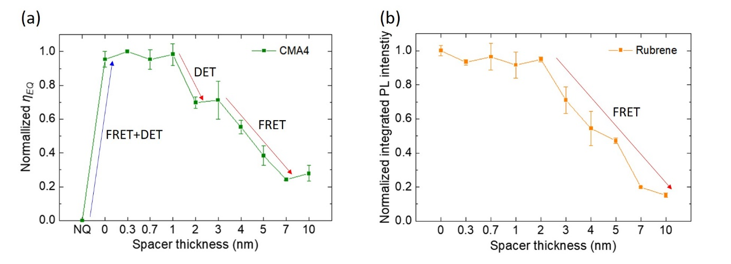
Figure 3. (a) Variation of the exciton quenching efficiency of CMA4 and (b) normalized integrated PL intensity from rubrene as a function of spacer layer thickness. Exciton quenching for CMA4 is attributed to both FRET and DET between 0 nm and 1 nm thick spacer layer. For higher spacer thicknesses, the regimes in which first DET, and then FRET, are turned off are shown. The PL of rubrene is sensitized only via FRET, so no signature from the change in DET efficiency is seen.

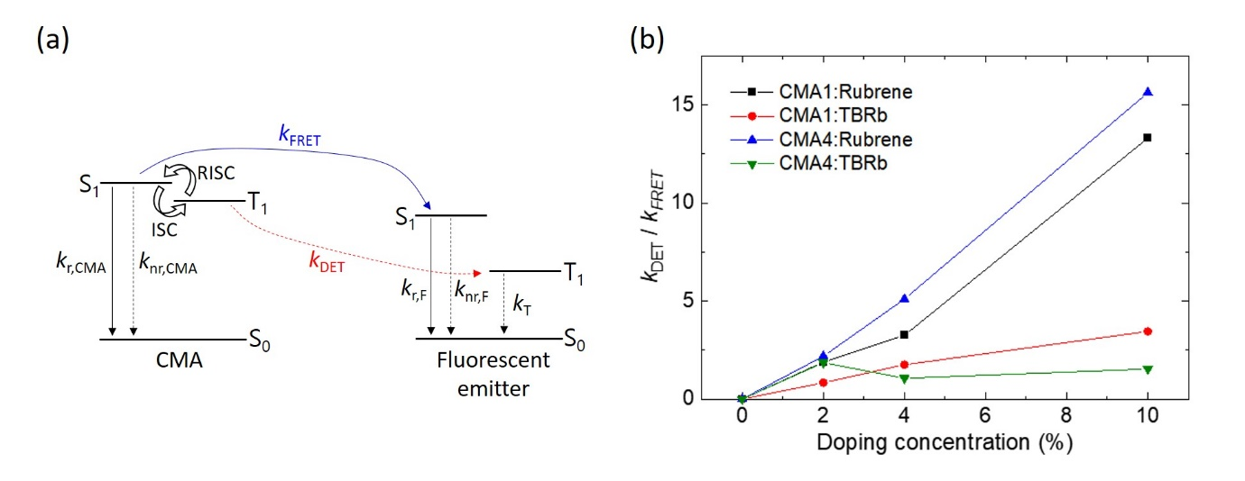
Figure 4. (a) Schematic representation of the energy diagram for exciton decay and energy transfer pathways for CMA based hyperfluorescence. (b) The ratio of DET and FRET rates for the films of rubrene or TBRb doped in CMA1 or CMA4 with the variation of doping concentration. The FRET rate was derived from Equation (8), and the DET rate was calculated from Equation (7).

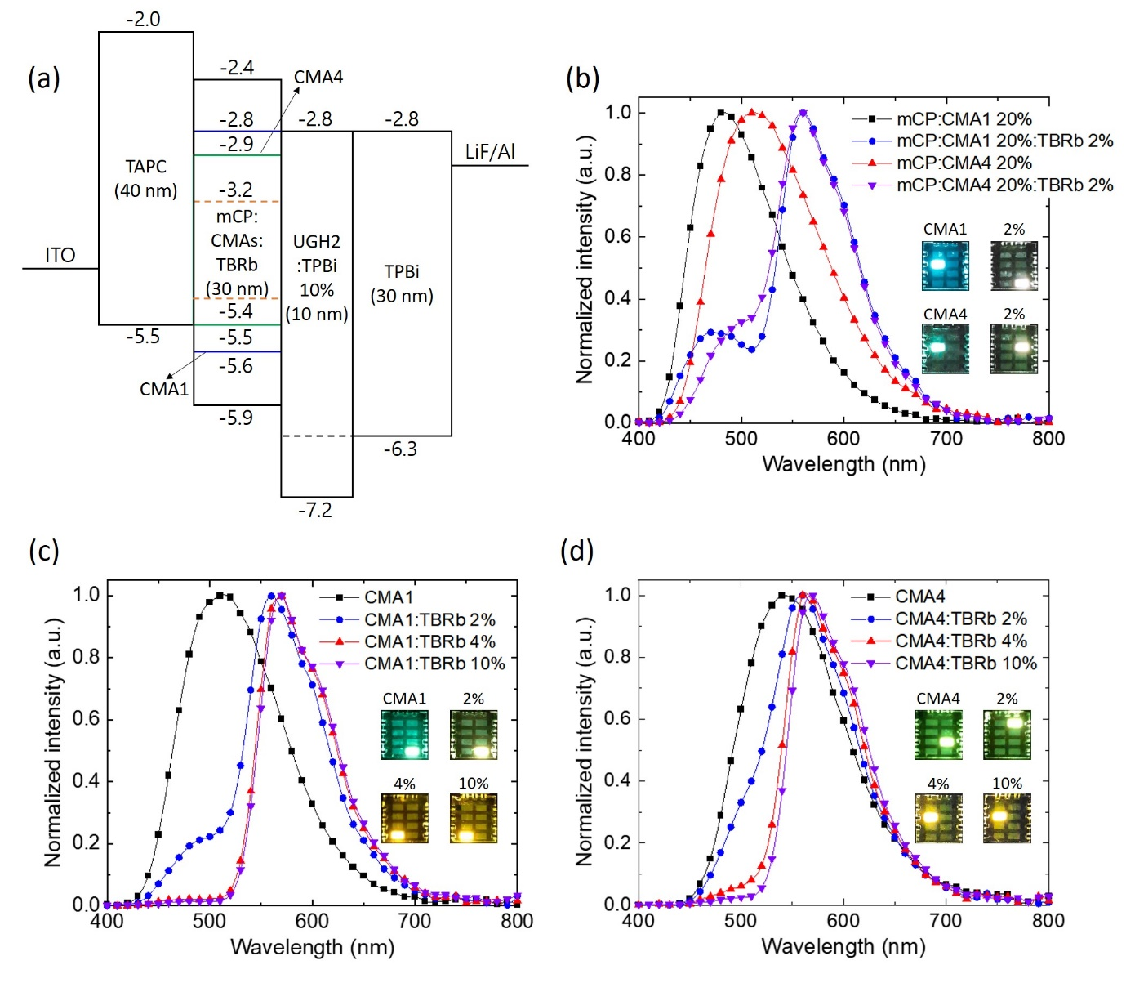
Figure 5. (a) Device structure and energy diagram of CMA based hyperfluorescent OLEDs. (b) Electroluminescent spectra of the mCP:CMA1 and mCP:CMA4 based devices with and without TBRb doping. (c) and (d) show electroluminescent spectra of the devices based on CMA1 and CMA4 with varying TBRb concentration.

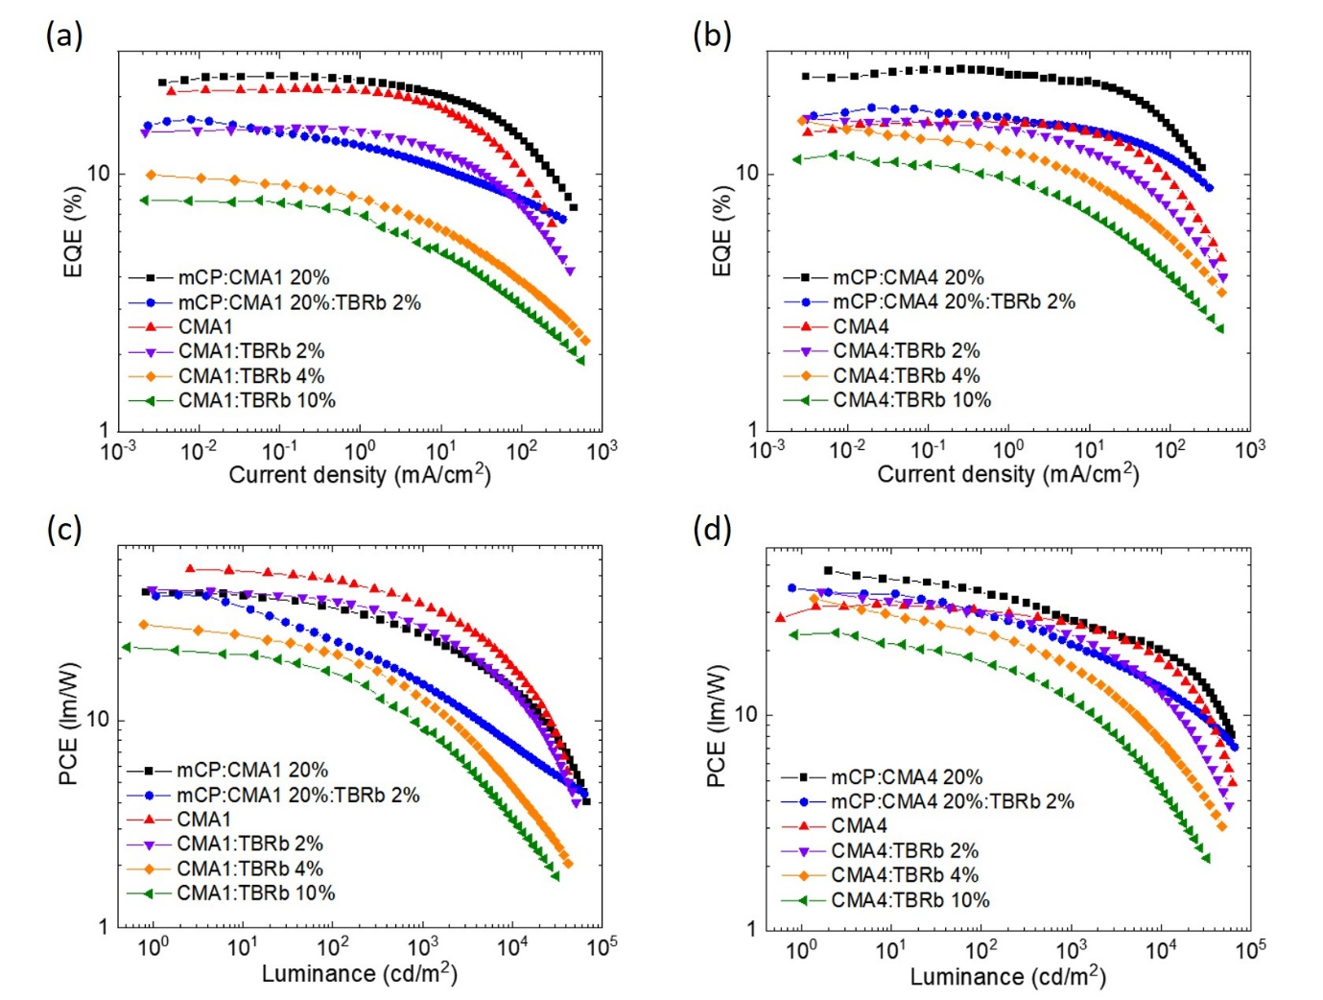
Figure 6. Characteristics of hyperfluorescent OLED devices based on CMA1 and CMA4 with TBRb doping. (a) and (b) present EQE vs current density. (c) and (d) show PCE vs luminance.

Table 1. The PLQE values of CMAs and those diluted in mCP and the Forster radii for each combination of those with rubrene and TBRb.

 |  | CMA1 100% | mCP:CMA1 20% | CMA4 100% | mCP:CMA1 20%
PLQE (%) |  | 83 | 86 | 76 | 82
Rubrene | R₀ (nm) | 3.48 | 3.40 | 3.30 | 3.34
TBRb |  | 3.79 | 3.70 | 3.62 | 3.64

Table 2. The PLQE values of rubrene or TBRb doped in CMA1, CMA4 and those diluted (at 20%) in mCP.

 |  | Rubrene |  |  | TBRb
Doping (%) |  | 2 | 4 | 10 | 2 | 4 | 10
CMA1 | PLQE (%) | 38 | 25 | 8 | 57 | 37 | 24
CMA4 |  | 34 | 19 | 8 | 45 | 50 | 40
mCP:CMA1 |  | 78 | - | - | 74 | - | -
mCP:CMA4 |  | 67 | - | - | 73 | - | -
Table 3. Summary of the performance for the hyperfluorescent OLED devices.

 | Doping  (%) | V_{on}^{a)}  (V) | V_{1000 nit}  (V) | EQE_{Max}  (%) | EQE_{1000 nit}  (%) | PCE_{Max}  (lm/W) | PCE_{1000 nit}  (lm/W) | CIE  (x,y)
mCP:CMA1 | 0 | 3.5 | 5.7 | 24.1 | 22.4 | 41.5 | 25.8 | (0.206, 0.336)
 | 2 | 3.6 | 7.4 | 16.3 | 11.9 | 40.3 | 15.0 | (0.405, 0.453)
CMA1 | 0 | 3.3 | 4.8 | 21.5 | 20.7 | 55.5 | 36.3 | (0.274, 0.466)
 | 2 | 3.3 | 4.8 | 15.2 | 14.0 | 43.5 | 29.0 | (0.431, 0.494)
 | 4 | 3.3 | 5.1 | 9.9 | 6.8 | 29.0 | 12.7 | (0.501, 0.486)
 | 10 | 3.3 | 5.3 | 7.9 | 5.2 | 22.6 | 9.2 | (0.508, 0.481)
mCP:CMA4 | 0 | 4.3 | 7.5 | 25.6 | 24.2 | 47.0 | 27.8 | (0.294, 0.473)
 | 2 | 4.3 | 7.2 | 18.1 | 15.8 | 39.1 | 21.3 | (0.411, 0.497)
CMA4 | 0 | 4.4 | 5.7 | 16.0 | 15.7 | 32.9 | 26.7 | (0.375, 0.541)
 | 2 | 4.4 | 6.1 | 16.5 | 14.3 | 37.6 | 23.7 | (0.423, 0.524)
 | 4 | 4.6 | 6.6 | 16.1 | 11.2 | 34.8 | 16.9 | (0.481, 0.502)
 | 10 | 4.6 | 6.6 | 11.9 | 8.3 | 24.2 | 12.0 | (0.503, 0.487)
^{a)}At 1 cd/m²

Copyright WILEY-VCH Verlag GmbH & Co. KGaA, 69469 Weinheim, Germany, 2018.

Supporting Information

Matrix-free Hyperfluorescent Organic Light-Emitting Diodes Based on Carbene-Metal-Amides

Hwan-Hee Cho, Alexander S. Romanov, Manfred Bochmann, Neil C. Greenham and Dan Credgington*

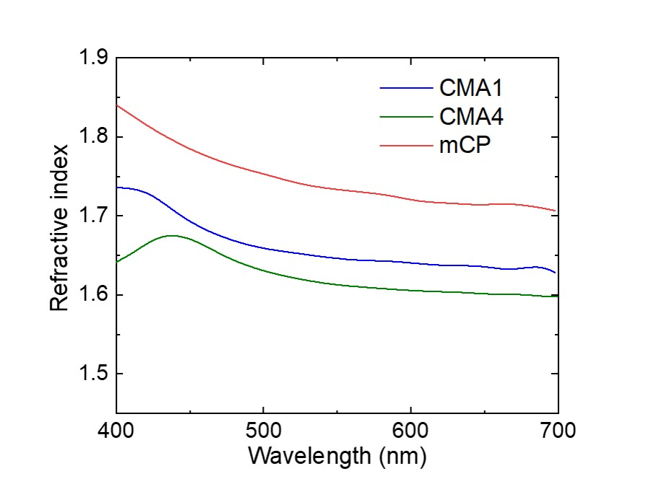
Figure S1. Refractive index of CMA1, CMA4, and mCP.

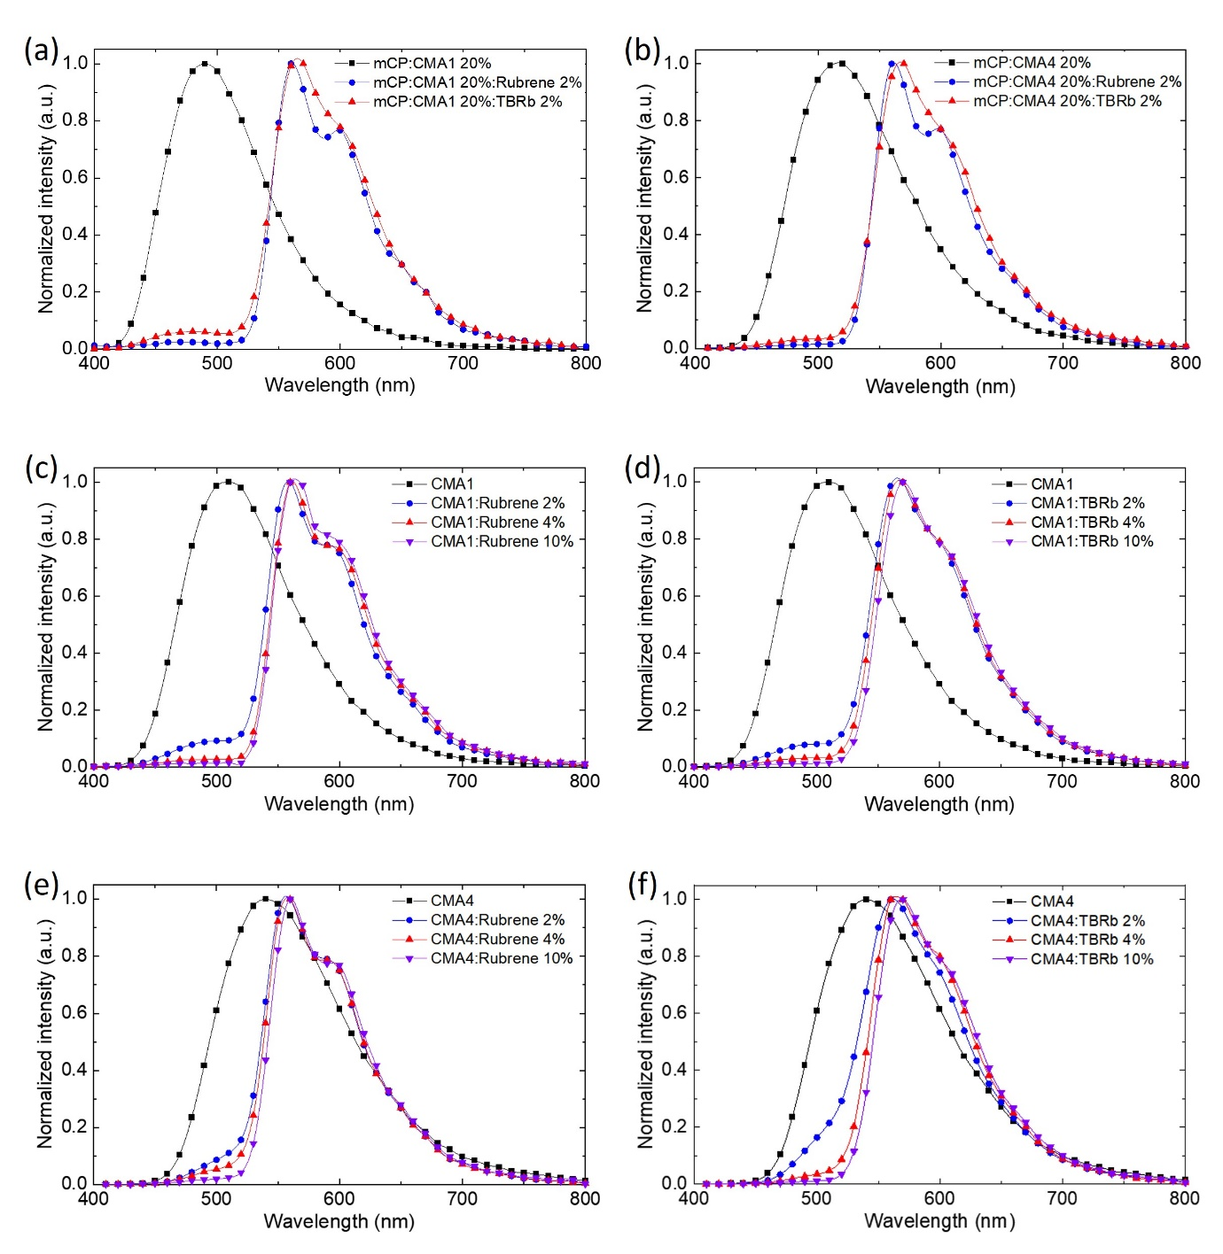
Figure S2. (a) and (b) show PL spectra of 2% rubrene or TBRb doped in mCP:CMA1 20% and mCP:CMA4 20% films. PL spectra of rubrene or TBRb doped in CMA1 or CMA4 films are plotted in (c), (d), (e), and (f), respectively, with the variation of doping concentration.

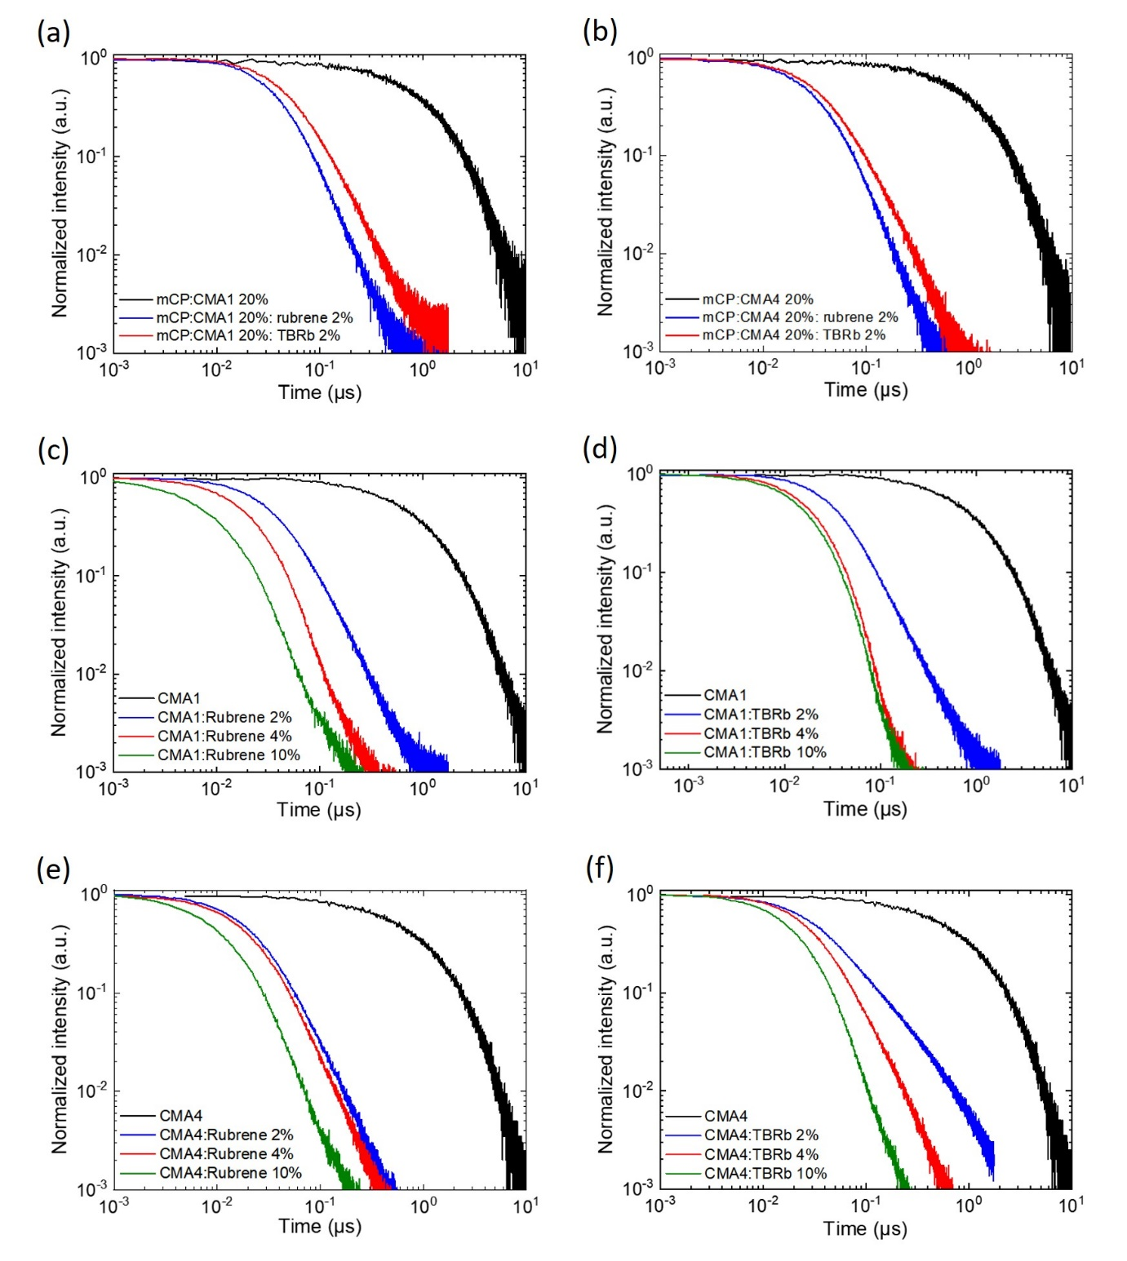
Figure S3. Comparison of transient PL kinetics. (a) and (b) show the transient PL for dopant-free mCP:CMA1 or CMA4 20% and rubrene or TBRb doped in mCP:CMA1 or CMA4 20% films. (c), (d), (e), and (f) display the transient PL for dopant-free CMA1 or CMA4 and rubrene or TBRb doped in CMA1 or CMA4 films.

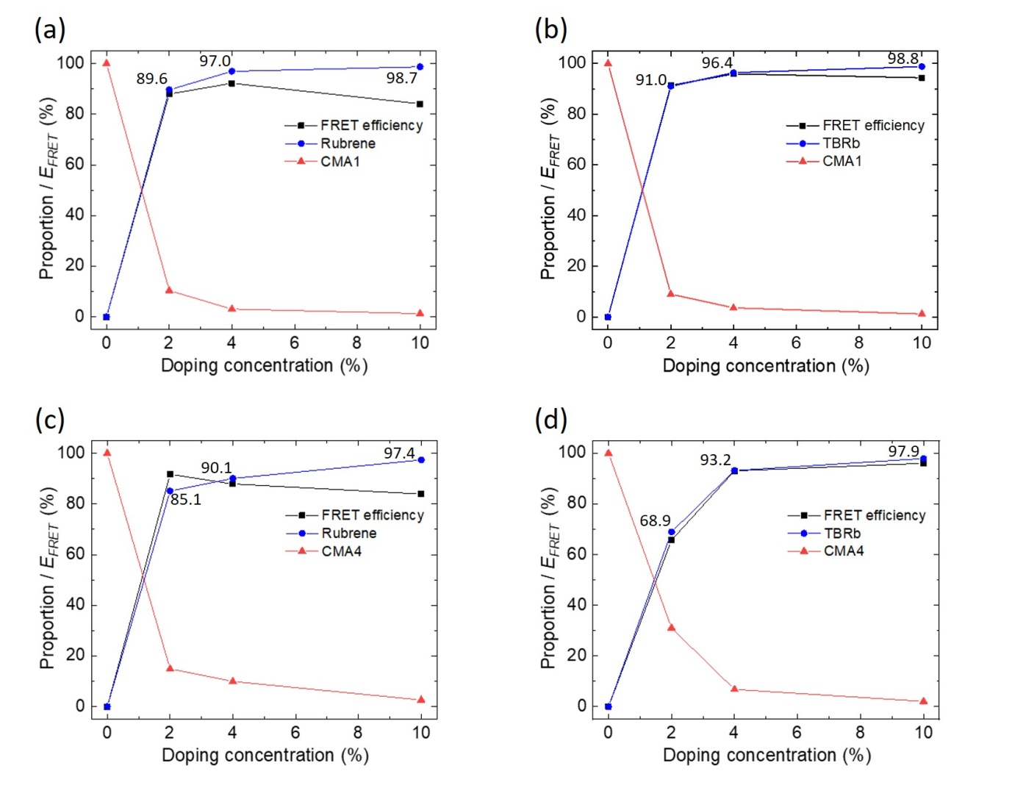
Figure S4. Comparison of FRET efficiency and the proportion of the emission spectra: with varying doping concentration, (a) and (c) are for rubrene doped in CMA1 or CMA4 films, and (b) and (d) are for TBRb doped in CMA1 or CMA4 films.

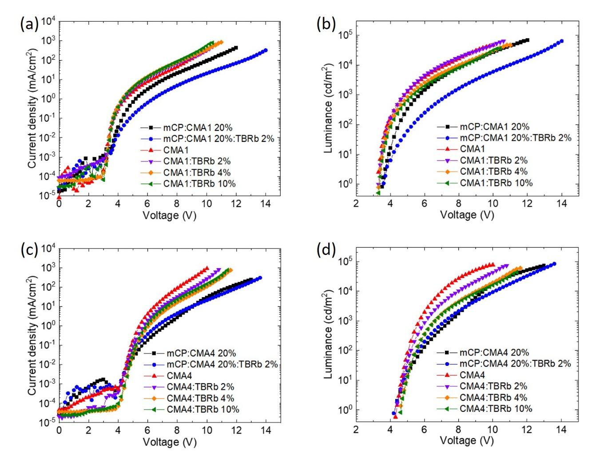
Figure S5. Characteristics of current density vs voltage and luminance vs voltage. (a), (b) CMA1 based devices. (c), (d) CMA4 based devices.

Table S1. Summary of decay lifetime, radiative decay rate, FRET rate, DET rate, and FRET efficiency with respect to the doping concentration in CMA1, CMA4, mCP:CMA1, and mCP:CMA4.

Doping (%) |  | Rubrene |  |  |  | TBRb
 |  | 0 | 2 | 4 | 10 | 2 | 4 | 10
mCP:CMA1 | τ (μs) | 1.19 | 0.046 | - | - | 0.077 | - | -
 | k_{r} (/μs) | 0.70 | 17.02 | - | - | 9.64 | - | -
 | k_{FRET} (/μs) | - | 16.30 | - | - | 8.92 | - | -
 | k_{DET} (/μs) | - | 4.80 | - | - | 3.39 | - | -
 | E_{FRET} (%) | - | 95.7 | - | - | 92.5 | - | -
CMA1 | τ (μs) | 1.15 | 0.063 | 0.027 | 0.018 | 0.068 | 0.021 | 0.018
 | k_{r} (/μs) | 0.72 | 5.98 | 9.21 | 4.52 | 8.31 | 17.48 | 12.72
 | k_{FRET} (/μs) | - | 5.26 | 8.49 | 3.80 | 7.59 | 16.76 | 12.00
 | k_{DET} (/μs) | - | 9.93 | 27.62 | 50.57 | 6.35 | 29.38 | 41.40
 | E_{FRET} (%) | - | 88.0 | 92.2 | 84.1 | 91.4 | 95.9 | 94.3
mCP:CMA4 | τ (μs) | 1.22 | 0.042 | - | - | 0.066 | - | -
 | k_{r} (/μs) | 0.67 | 15.71 | - | - | 11.18 | - | -
 | k_{FRET} (/μs) | - | 15.04 | - | - | 10.51 | - | -
 | k_{DET} (/μs) | - | 7.74 | - | - | 3.93 | - | -
 | E_{FRET} (%) | - | 95.6 | - | - | 93.7 | - | -
CMA4 | τ (μs) | 1.10 | 0.041 | 0.033 | 0.017 | 0.23 | 0.051 | 0.023
 | k_{r} (/μs) | 0.69 | 8.32 | 5.68 | 4.29 | 2.00 | 9.93 | 17.38
 | k_{FRET} (/μs) |  | 7.63 | 4.99 | 3.60 | 1.31 | 9.24 | 16.69
 | k_{DET} (/μs) |  | 16.21 | 24.38 | 52.94 | 2.44 | 9.77 | 25.64
 | E_{FRET} (%) |  | 91.7 | 87.9 | 83.9 | 65.6 | 93.1 | 96.0

