Supporting Information (SI-1) for
Both D- and L-glucose polyphosphates mimic D-myo-inositol 1,4,5-trisphosphate: new synthetic agonists and partial agonists at the Ins(1,4,5)P₃ receptor

Megan L. Shipton,† Andrew M. Riley,† Ana M. Rossi,‡ Charles A. Brearley,§ Colin W. Taylor,‡ Barry V. L. Potter*†
†Drug Discovery & Medicinal Chemistry, Department of Pharmacology, University of Oxford, Mansfield Road, OX1 3QT, United Kingdom
‡Department of Pharmacology, Tennis Court Road, University of Cambridge, CB2 1PD, United Kingdom
1 | Synthesis and characterization of 23 | S2
2 | Synthesis and characterization of 24 | S2
3 | Synthesis and characterization of 8 | S2-S3
4 | Synthesis and characterization of 21 | S3-S4
5 | Synthesis and characterization of 9 | S4-S5
6 | Synthesis and characterization of 10 | S5
7 | Predicted binding modes of compounds 2-7 in Ins(1,4,5)P₃ | S6
8 | Molecular modeling of compounds 2, 3, 6 and 7 | S7-S9
9 | Stability study | S9-S10
10 | HPLC data | S11-S13
11 | Biological data analysis | S13-S14
12 | References | S14-S16
§School of Biological Sciences, University of East Anglia, Norwich Research Park, Norwich NR4 7TJ, United Kingdom

INDEX

Experimental data

Methyl 4,6-O-benzylidene-3-O-benzyl-α-d-glucopyranoside (23) Synthesised as described in Bourdreux et al.¹ using methyl α-d-glucopyranoside (100 mg, 0.515 mmol). The crude product was purified with flash chromatography (petroleum ether/EtOAc, 0-100%) and the pure product was collected as a white solid (143 mg, 0.384 mmol, 74% yield). mp 178.4-181.0 °C (Lit.² mp 184 °C); [α]²²_{D} 87.7 (c= 0.70, CHCl₃) [Lit.² [α]²⁰_{D} 77 (c= 0.91, CHCl₃)]; ¹H NMR (CDCl₃, 400 MHz): δ 7.52-7.27 (m, 10H, Ar), 5.57 (s, 1H, H-7), 4.97 (d, J= 11.6 Hz, 1H, CH₂Ph), 4.82 (d, J= 3.8 Hz, 1H, H-1), 4.79 (d, J= 11.6 Hz, 1H, CH₂Ph), 4.30 (dd, J= 4.3, 9.8 Hz, 1H, H-6), 3.87-3.71 (m, 4H, H-2, H-3, H-5, H-6), 3.65 (t, 1H, J= 9.1 Hz, H-4), 3.45 (s, 3H, OMe), 2.29 (d, 1H, J= 7.4 Hz, OH); ¹³C NMR (CDCl₃, 100 MHz): δ 138.6 (Ar), 137.4 (Ar), 129.1 (Ar), 128.5 (Ar), 128.4 (Ar), 128.1 (Ar), 127.9 (Ar), 126.1 (Ar), 101.4 (H-7), 100.0 (C-1), 82.1 (C-4), 79.0 (C-2 or 3 or 5), 74.9 (CH₂Ph), 72.5 (C-2 or 3 or 5), 69.1 (C-6), 62.7 (C-2 or 3 or 5), 55.5 (OMe).
Methyl 3-O-benzyl-α-d-glucopyranoside (24) As described in Boettcher et al.³ using methyl 4,6-O-benzylidene-3-O-benzyl-α-d-glucopyranoside (23) (120 mg, 0.322 mmol). The product was purified with flash chromatography (petroleum ether/EtOAc, 0-100%) to yield the pure product as a white solid (75.7 mg, 0.266 mmol, 83% yield). mp 92.1- 93.9 °C (Lit.⁴ mp 85-86 °C); [α]²³_{D} 89.9 (c= 1.05, CHCl₃) [Lit.⁴ [α]²³_{D} 95.1 (c=1.16, CHCl₃)]; ¹H NMR (CDCl₃, 400 MHz): δ 7.39-7.27 (m, 5H, Ar), 4.99 (AB, J= 11.6, 1H, CH₂Ph), 4.74 (AB, J= 11.6 Hz, 1H, CH₂Ph), 4.73 (d, J= 3.7 Hz, 1H, H-1), 3.82-3.74 (m, 2H, H-6 x2), 3.67-3.52 (m, 4H, H-2, H-3, H-4, H-5), 3.42 (s, 3H, OMe), 2.74 (d, J= 2.5 Hz, 1H, OH), 2.32 (d, J= 8.7 Hz, 1H, OH), 2.27 (t, J = 6.4 Hz, 1H, OH); ¹³C NMR (CDCl₃, 100 MHz): δ 138.6 (Ar), 128.7 (Ar), 128.10 (Ar), 128.07 (Ar), 99.7 (C-1), 82.8 (C-3), 75.1 (CH₂Ph), 72.9 (C-2), 71.2 (C-5), 70.1 (C-4), 62.3 (C-6), 55.5 (OMe).
Methyl α-l-glucopyranoside (8) In an modified version of the Li et al.⁵ procedure, l-glucose (850 mg, 4.7 mmol) was dissolved in anhydrous MeOH (6.5 mL). A solution of hydrogen chloride was prepared by adding acetyl chloride (0.25 mL) to anhydrous MeOH (1.5 mL) at 0°C and this solution was added dropwise to the glucose reaction solution. The reaction was refluxed for 5 days while under nitrogen before the MeOH was evaporated to yield the crude product. The product was recrystallized from EtOH as a white crystalline solid, which contained approximately 5% of the β anomer. The product was recrystallized from EtOH again to yield the pure α anomer of the product as white crystals (414 mg, 2.13 mmol, 45% yield). mp (EtOH) 167.2-168.1°C (Lit.⁶ mp (EtOH) 161-163 °C); [α]²³_{D} -168.4 (c= 1.00, MeOH) [Lit.⁶ [α]_{D} -161 (c= 1.0, MeOH)]; ¹H NMR (CD₃OD, 400 MHz): δ 4.67 (d, J= 3.8 Hz, 1H, H-1), 3.81 (dd, J= 11.8, 2.4 Hz, 1H, H-6), 3.67 (dd, J= 11.8, 5.8 Hz, 1H, H-6), 3.61 (t, J= 9.2 Hz, 1H, H-3), 3.55-3.50 (m, 1H, H-5), 3.41 (s, 3H, OMe), 3.38 (dd, J= 9.7, 3.8 Hz, 1H, H-2), 3.27 (dd, J= 10.0, 9.0 Hz, 1H, H-4); ¹³C NMR (CD₃OD, 100 MHz): δ 101.2 (C-1), 75.1 (C-3), 73.54 (C-5), 73.53 (C-2), 71.8 (C-4), 62.7 (C-6), 55.5 (OMe).
Methyl 4-O-benzyl-α-d-glucopyranoside (21)
Method A: In a version of the Daragics et al.⁷ method, methyl 4,6-O-benzylidene-α-d-glucopyranoside (100 mg, 0.354 mmol) was dissolved in dry DCM (5.3 mL) and put under argon. The solution was cooled in an ice bath and borane-THF (1 M, 1.8 mL, 1.77 mmol, 5 equiv) was added, followed by a solution of AlCl₃ (94.4 mg, 0.708 mmol, 2 equiv) in dry diethyl ether (0.9 mL). The solution was allowed to gradually warm to room temperature and then stir for 24 h. After this time, the reaction was quenched with the addition of triethylamine (0.2 mL) followed by MeOH (0.9 mL). The reaction solution was concentrated in vacuo to form a solid residue. This residue was dissolved in DCM (50 mL) and washed with 1 M HCl_{(aq)}, sat. NaHCO_{3(aq)} and water. The combined aqueous washes were also extracted three times with EtOAc and the organic layers were combined, dried over MgSO₄ and concentrated to yield the crude product. The crude product was purified through silica column chromatography using petroleum ether and EtOAc. It should be noted that this product was not entirely pure as a very small amount of methyl 6-O-benzyl-α-d-glucopyranoside was generated as well. This regioisomer could not be separated from the desired product (although separation of the regioisomers post-phosphorylation was achievable).
Method B: Using a version of the Shie et al.⁸ procedure, methyl 4,6-O-benzylidene α-d-glucopyranoside (100 mg, 0.355 mmol) was added to borane-THF (1M, 1.8 mL, 1.8 mmol, 5 equiv) and the reaction was put under argon. The solution was allowed to stir for 10 min before lanthanum triflate (31.2 mg, 0.053 mmol, 0.15 equiv) was added and the reaction was allowed to stir at room temperature for a week. The reaction was then cooled to 0°C and the reaction was quenched with triethylamine (0.5 mL, 1 equiv), followed by MeOH (0.7 mL). The reaction was concentrated in vacuo and co-evaporated with MeOH twice before the crude product was isolated as a white solid. The product was purified with flash chromatography (1. petroleum ether/EtOAc, 0-100% and 2. DCM/EtOAc, 0-100%). As impurities were still present, an aqueous work up was carried out. The product was dissolved in EtOAc and washed with 1 M HCl_{(aq)}, sat. NaHCO₃ and water. The aqueous washes were extracted with EtOAc again and the organic phases were combined, dried over MgSO₄ and concentrated to yield the pure product as a white solid (30.8 mg, 0.108 mmol, 31% yield).
mp 123.9-129.0 °C (Lit.⁹ mp 126-127 °C); [α]²¹_{D} 116.2 (c=1.47, CHCl₃) [Lit.⁹ [α]_{D} 154.1 (c= 1, CHCl₃)]; ¹H NMR (CDCl₃, 400MHz): δ 7.36-7.28 (m, 5H, Ar), 4.86 (AB, J= 11.4 Hz, 1H, CH₂Ph), 4.75 (d, J= 3.9 Hz, 1H, H-1), 4.72 (AB, J= 11.4 Hz, 1H, CH₂Ph), 3.86 (t, J= 9.2 Hz, 1H, H-3), 3.83 (ABX, J= 11.6, 2.6 Hz, 1H, H-6), 3.75 (ABX, J= 11.9, 3.6 Hz, H-6), 3.63 (apt dt, J= 9.8, 3.3 Hz, 1H, H-5), 3.51 (brs, 1H, H-2), 3.45 (t, J= 9.4 Hz, 1H, H-4), 3.39 (s, 3H, OMe); ¹³C NMR (CDCl₃, 100 MHz): δ 138.3 (Ar), 128.7 (Ar), 128.2 (Ar), 128.1 (Ar), 99.2 (C-1), 77.2 (C-4), 75.1 (C-3), 74.8 (CH₂Ph), 72.8 (C-2), 70.9 (C-5), 62.0 (C-6), 55.5 (OMe).
Methyl 4,6-O-benzylidene-α-l-glucopyranoside (9) In a version of the Tseberlidis et al.¹⁰ method, methyl α-l-glucopyranoside (8) (100 mg, 0.514 mmol) was suspended in dry MeCN (1.7 mL) and put under a nitrogen atmosphere. To this suspension, benzaldehyde dimethyl acetal (0.24 mL, 1.55 mmol, 3 equiv) and catalytic camphor-10-sulphonic acid (1.6 mg, 0.0068 mmol) were added and the reaction was allowed to stir at room temperature overnight. After 24 h, the reaction was neutralised with a few drops of triethylamine and evaporated to yield the crude product as a white crystalline solid. The crude product was purified through flash chromatography (petroleum ether/EtOAc, 0-100%) and the pure product was collected as a white solid (132.6 mg, 0.470 mmol, 91 % yield). mp 163.1-164.4 °C (Lit.⁶ mp 161-162 °C); [α]²¹_{D} -110.5 (c= 0.69, CDCl₃) [Lit.⁶ [α]_{D} -95 (c= 1.0, MeOH)]; ¹H NMR (CDCl₃, 400 MHz): δ 7.51-7.48 (m, 2H, Ar), 7.40-7.34 (m, 3H, Ar), 5.53 (s, 1H, H-7), 4.79 (d, J= 4.0 Hz, 1H, H-1), 4.29 (dd, J= 9.6, 4.3 Hz, 1H, H-6), 3.93 (apt td, J= 9.3, 2.2 Hz, 1H, H-3), 3.84-3.78 (m, 1H, H-5), 3.75 (apt q, J= 10.3 Hz, 1H, H-6), 3.63 (apt td, J= 9.3, 3.9 Hz, 1H, H-2), 3.49 (apt t, J= 9.3 Hz, 1H, H-4), 3.46 (s, 3H, OMe), 2.76 (d, J= 2.2 Hz, 1H, OH), 2.30 (d, J= 9.5 Hz, 1H, OH); 13C NMR (CDCl3, 100 MHz): δ 137.2 (Ar), 129.4 (Ar), 128.5 (Ar), 126.4 (Ar), 102.1 (C-7), 99.9 (C-1), 81.1 (C-4), 73.0 (C-2), 72.0 (C-3), 69.1 (C-6), 62.5 (C-5), 55.7 (OMe).
Methyl 4-O-benzyl-α-l-glucopyranoside (10) Methyl 4-O-benzyl-α-l-glucopyranoside was made as described for methyl 4-O-benzyl-α-d-glucopyranoside (21) using both method A to generate large amounts of impure product and method B to generate smaller amounts of pure product (26 mg, 37% yield). mp 128.5- 132.0 (Lit.¹¹ mp 125-127 °C); [α]²⁵_{D} -142.5 (c= 0.3, MeOH) [Lit.¹¹ [α]²⁵_{D} -144.2 (c= 1.2, MeOH)]. ¹H NMR (CDCl₃, 400MHz): δ 7.37-7.27 (m, 5H, Ar), 4.87 (AB, J= 11.5 Hz, 1H, CH₂Ph), 4.75 (d, J= 3.9 Hz, 1H, H-1), 4.72 (AB, J= 11.4 Hz, 1H, CH₂Ph), 3.86 (t, J= 9.2 Hz, 1H, H-3), 3.83 (ABX, J= 11.8, 2.6 Hz, 1H, H-6), 3.75 (ABX, J= 11.8, 3.8 Hz, H-6), 3.67-3.62 (m, 1H, H-5), 3.50 (dd, J= 3.9, 9.4 Hz,1H, H-2), 3.45 (t, J= 9.4 Hz, 1H, H-4), 3.40 (s, 3H, OMe); ¹³C NMR (CDCl₃, 100 MHz): δ 138.3 (Ar), 128.7 (Ar), 128.2 (Ar), 127.9 (Ar), 99.2 (C-1), 77.3 (C-4), 75.3 (C-3), 74.8 (CH₂Ph), 72.9 (C-2), 70.9 (C-5), 62.1 (C-6), 55.5 (OMe).

Predicted binding modes of compounds 2-7 in Ins(1,4,5)P₃R
Figure S1. Possible binding modes for the Ins(1,4,5)P₃R ligands. The α- and β-domains of the IBC have been color coded and the regions in which phosphates are required to bind are in bold. The likely binding modes that could plausibly mimic Ins(1,4,5)P₃ binding have been highlighted in yellow, and a possible binding mode for 7 has been highlighted in green.

Molecular modeling of compounds 2, 3, 6 and 7
A
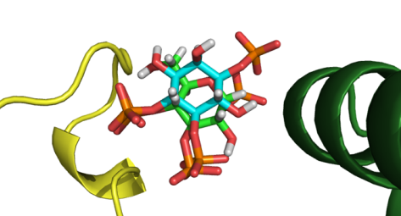
B
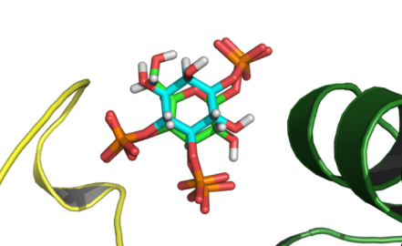
Figure S2. The highest scoring docking conformations of 6 (carbon atoms shown in green, row A) and 7 (green carbons, row B) using GOLD software and the X-ray crystal structure of the type 1 InsP₃R IBC compared to the crystallographic Ins(1,4,5)P₃ (aqua carbons).
Molecular Modeling Methods
The X-ray crystal structure of the IBC of mouse Type 1 Ins(1,4,5)P₃R in complex with Ins(1,4,5)P₃ (PDB ID 1N4K) was used in this work.⁴ Compounds 1-6 were built and minimized using Chem3D version 15.1 and Mercury version 3.10. GOLD version 5.6.1 was used for docking experiments. The compounds were docked 100 times, with two water molecules in the binding site (1139 and 1198) being allowed to toggle and spin while the remaining waters molecules were removed. The lysine residues in the binding site (K412, K508 and K569) were permitted constrained movement. The highest scoring solutions were exported and figures were prepared using PyMOL (DeLano Scientific LLC).

Ligands were docked into the type 1 InsP₃R using structure pdb.1N4K. Docking of Ins(1,4,5)P₃ itself was able to reproduce the binding conformation in the X-ray structure with the inclusion of two of the waters (assigned labels 1139 and 1198 in the crystal structure) and allowing limited movement of the lysine residue side chains.¹² The calculated binding modes from an optimised GOLD docking protocol also predicted that the axial phosphate in α-d-glucopyranosyl 1,3,4-trisphosphate (6) would cause the ligand to shift slightly to accommodate the axial steric bulk, disrupting it from overlapping as closely as 7 with the positioning of the bound Ins(1,4,5)P_{3.} In docking, the axial 1-phosphate of 6 seems to be able to interact more with the side chain of Arg504 and less with the side chain of Arg568 than the auxiliary phosphate in Ins(1,4,5)P₃ (Figure S2).
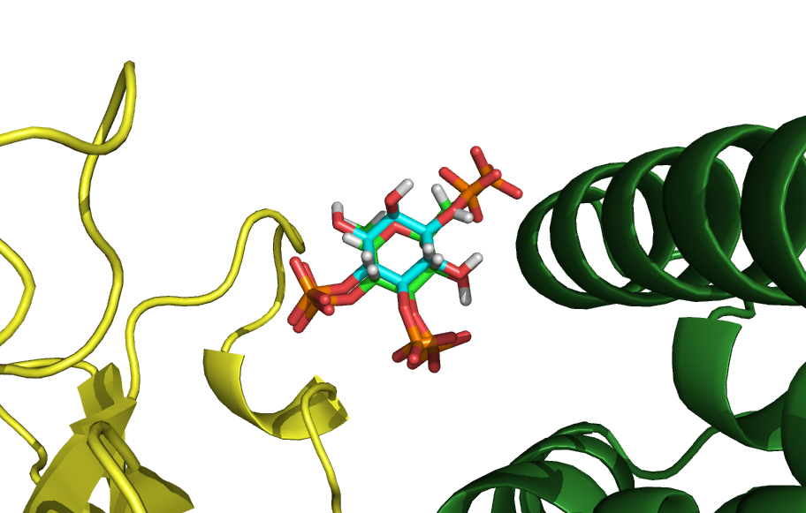
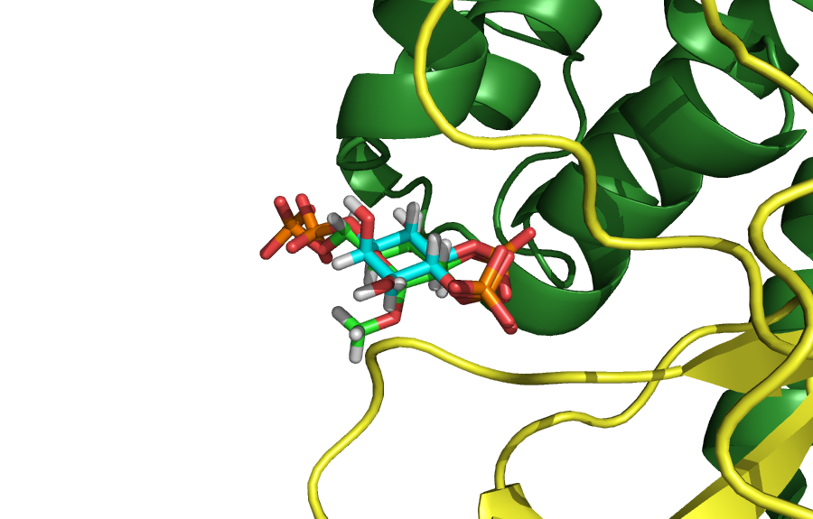
Figure S3. Two angles showing the most favorable docking conformation of methyl α-l-glucopyranosyl 2,3,6-trisphosphate (2, green carbon atoms) to the 1N4K crystal structure of InsP₃R as predicted by the molecular docking experiments. Crystallographic Ins(1,4,5)P₃ (1, aqua carbons) is depicted for comparison, α-domain shown in green; β-domain shown in yellow.

In docking studies, there was found to be significant enough overlap of the vicinal phosphates of 2 with those of Ins(1,4,5)P₃ that the interactions with the residues in the binding site do not appear to deviate from those with Ins(1,4,5)P₃. The auxiliary phosphate (extended in 2) appears still to interact with the side chain of Arg568, although the residue is predicted to bend from its usual position to accommodate the increased steric bulk of the extended phosphate in that region (Figure S3).

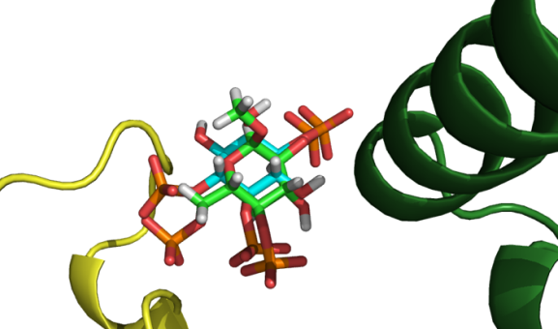
Figure S4. Docking prediction for methyl α-l-glucopyranosyl 2,4,6-trisphosphate (3, green) to the 1N4K crystal structure of InsP₃R as predicted by the molecular docking experiments. Crystallographic Ins(1,4,5)P₃ (1, aqua) is depicted for comparison. Green carbons, α-domain; yellow carbons, β-domain.
The extended phosphate of compound 3 is expected to be accommodated in the region of the binding site normally occupied by the 4-phosphate of Ins(1,4,5)P₃ and to interact with the side chain of Arg265, resulting in the central ring of the ligand being slightly shifted from the position of Ins(1,4,5)P₃ (Figure S4). The axial O-methyl of 3 is then able to point out of the binding site and into solvent.

Stability study
A.1
B.1
7
H-1
6
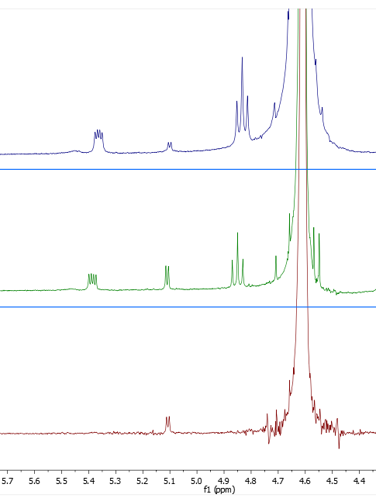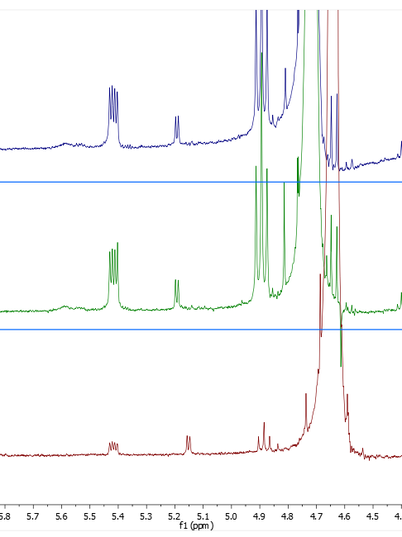
H-1
B.2
B.3
A.2
A.3
H-1
H-1
7
hydrolysed
hydrolysed
H-1
6
H-1

NMR trace | Conditions | Relative integration of 7 compared to normalised 6 peak
A.1 | Neutral pH at RT | 2.3
A.2 | pH 3 for a week at RT | 1.6
A.3 | pH 1 for 1 day at RT | complete hydrolysis
B.1 | Neutral pH at RT | 2.3
B.2 | pH 10 for a week at RT | 2.3
B.3 | pH 14 for 1 day at RT | 1.7
Figure S7. Stability test for α-d-glucopyranosyl 1,4,5-trisphosphate (6) and β-d-glucopyranosyl 1,4,5-trisphosphate (7). The A. column on the left shows the compounds under increasingly acidic conditions and the B. column on the right shows the compounds under increasingly basic conditions.
In Figure S7, a portion of the ¹H NMR spectrum showing the relevant peaks of interest can be seen from experiments performed under acidic and basic conditions. The differences between the integration under the isomer peaks were tracked (data in the accompanying table). By monitoring this ratio, we are able to determine the relative hydrolysis of the two epimers when exposed to different conditions.
It should be noted that the hydrolysis observed under neutral conditions at the beginning of the stability study is the result of degradation of the mixture of the less stable protected precursors of 6 and 7 (17 and 18). Both 6 and 7 required more extreme pH values than initially expected to degrade. As a result, we are confident that both compounds 6 and 7 remained intact throughout the biological assays.

HPLC data
3
5
4
2
6
7
d-glucose 3,4-diphosphate

Compound | Mean integration % | Standard deviation %
methyl α-l-glucopyranosyl 2,3,6-trisphosphate (2) | 99.15 | 0.06
methyl α-l-glucopyranosyl 2,4,6-trisphosphate (3) | 99.83 | 0.08
methyl α-d-glucopyranoside 2,3,6-trisphosphate (4) | 97.21 | 0.71
methyl α-d-glucopyranoside 2,4,6-trisphosphate (5) | 96.87 | 0.23
α-d-glucopyranosyl 1,3,4-trisphosphate (6) | 94.53 | 0.10
β-d-glucopyranosyl 1,3,4-trisphosphate (7) | 95.43 | 0.58
d-glucose 3,4-diphosphate | 97.20 | 1.76
Figure S5. HPLC traces confirming the purity for compounds 2, 3, 4, 5, 6 and 7. The table gives values of the integrated peak area as a % of total peaks in each chromatogram.

6 after H⁺
7 after H⁺
d-glucose 3,4-diphosphate
d-glucose 3,4-diphosphate
Retention time (min)
30
20
10
0
Retention time (min)
Figure S6. HPLC traces of 6 and 7 after they have been exposed to strongly acidic conditions showing the products of hydrolysis.
Inspection of Figure S5 shows elution of d-glucose 3,4-bisphosphate at 10.2 min. Acid treatment of compounds 6 and 7 generated a peak with similar retention time (Figure S6), rendering d-glucose 3,4-bisphosphate the probable hydrolysis product of both compounds as expected. Both peaks have an earlier-eluting shoulder that we take to likely be d-glucose 2,4-bisphosphate arising from acid-catalysed phosphate migration.

Biological Data

Data analysis
Equilibrium binding results and concentration-effect relationships were fitted to Hill equations (GraphPad Prism, version 5) from which -logIC₅₀ (pIC₅₀) and -logEC₅₀ (pEC₅₀) values were obtained. For equilibrium competition binding assays pK_{d} values were calculated using the Cheng and Prussof equation (Cheng et al. 1973). Because pEC₅₀ and pK_{d} values are normally distributed, these results are presented as means ± SEM from n independent experiments. For comparisons of the ratios between mean values (EC₅₀/K_{d}), statistical analyses compared the differences between their log values (pEC₅₀ and pK_{d}),¹³ with the SEM calculated as follows, assuming that the population variances are the same (confirmed using an F test) (Ott et al., 2010):
$$SEM= s_{p}\sqrt{\frac{\text{1}}{{\text{n}}_{\text{1}}}\text{+}\frac{\text{1}}{{\text{n}}_{\text{2}}}}$$
where, s_{p} is the estimate of the population variance:
$$s_{p}\text{ = }\sqrt{\frac{\left({\text{n}}_{\text{1 }}\text{– 1}\right){\text{s}}_{\text{1}}^{\text{2}}\text{+ }\left({\text{n}}_{\text{2 }}\text{– 1}\right){\text{s}}_{\text{2}}^{\text{2}}}{{\text{n}}_{\text{1 }}\text{– }{\text{n}}_{\text{2 }}\text{– 2}}}$$
where, s₁ and s₂ are the sample standard deviations, and n₁ and n₂ are the sample sizes. Although all analyses were performed using log values, for greater clarity we present ratios as the antilogs of the means and the 95% confidence interval.
Statistical analysis used ANOVA followed by Bonferroni's Multiple Comparison Test (GraphPad Prism, version 5). P < 0.05 was considered significant.
Adenophostin was not run in parallel to the other compounds in Ca²⁺ assays. All ligands were run in parallel in ligand-binding assays.
EC_{39.4% release}/K_{d} was calculated because some ligands did not release the stores fully (so EC₅₀/K_{d} ratios were not comparable). The ratio was calculated using the concentration of each ligand that caused release of 39.4% of the total content of the stores (which is the % released by IP₃ at its EC₅₀).

References
(1) Bourdreux, Y.; Lemétais, A.; Urban, D.; Beau, J.-M. Iron(III) Chloride-Tandem Catalysis for a One-Pot Regioselective Protection of Glycopyranosides. Chem. Commun. 2011, 47, 2146–2148. https://doi.org/10.1039/c0cc04398b.
(2) Bauder, C. A Convenient Synthesis of Orthogonally Protected 2-Deoxystreptamine (2-DOS) as an Aminocyclitol Scaffold for the Development of Novel Aminoglycoside Antibiotic Derivatives against Bacterial Resistance. Org. Biomol. Chem. 2008, 6, 2952–2960. https://doi.org/10.1039/b804784g.
(3) Boettcher, S.; Matwiejuk, M.; Thiem, J. Acceptor-Influenced and Donor-Tuned Base-Promoted Glycosylation. Beilstein J. Org. Chem. 2012, 8, 413–420. https://doi.org/10.3762/bjoc.8.46.
(4) Liau, B. B.; Milgram, B. C.; Shair, M. D. Total Syntheses of HMP-Y1, Hibarimicinone, and HMP-P1. J. Am. Chem. Soc. 2012, 134 (40), 16765–16772. https://doi.org/10.1007/s10955-011-0269-9.Quantifying.
(5) Li, C.-W.; Dong, H.-J.; Cui, C.-B. The Synthesis and Antitumor Activity of Twelve Galloyl Glucosides. Molecules 2015, 20, 2034–2060. https://doi.org/10.3390/molecules20022034.
(6) Medgyes, A.; Farkas, E.; Lipták, A.; Pozsgay, V. Synthesis of the Monosaccharide Units of the O-Specific Polysaccharide of Shigella Sonnei. Tetrahedron 1997, 53 (12), 4159–4178. https://doi.org/10.1016/S0040-4020(97)00145-2.
(7) Daragics, K.; Szabó, P.; Fügedi, P. Some Observations on the Reductive Ring Opening of 4,6-O-Benzylidene Acetals of Hexopyranosides with the Borane Trimethylamine-Aluminium Chloride Reagent. Carbohydr. Res. 2011, 346, 1633–1637. https://doi.org/10.1016/j.carres.2011.04.046.
(8) Shie, C.-R.; Tzeng, Z.-H.; Wang, C.-C.; Hung, S.-C. Metal Trifluoromethanesulfonate Catalyzed Regioselective Reductive Ring Opening of Benzylidene Acetals. J. Chin. Chem. Soc. 2009, 56, 510–523. https://doi.org/10.1002/jccs.200900076.
(9) Satomura, S.; Iwata, T.; Sakata, Y.; Omichi, K.; Ikenaka, T. Synthesis of P-Nitrophenyl 6-O-Benzyl-Alpha-Maltopentaoside, a Substrate for Alpha Amylases. Carbohydr. Res. 1988, 176, 107–115. https://doi.org/10.1016/0008-6215(88)84062-X.
(10) Tseberlidis, G.; Zardi, P.; Caselli, A.; Cancogni, D.; Fusari, M.; Lay, L.; Gallo, E. Glycoporphyrin Catalysts for Efficient C-H Bond Aminations by Organic Azides. Organometallics 2015, 34, 3774–3781. https://doi.org/10.1021/acs.organomet.5b00436.
(11) D’Alonzo, D.; Guaragna, A.; Napolitano, C.; Palumbo, G. Rapid Access to 1 , 6-Anhydro- - L -Hexopyranose Derivatives via Domino Reaction : Synthesis of L -Allose and L -Glucose. J. Org. Chem. 2008, 73, 5636–5639. https://doi.org/10.1002/047084289X.rn00831.5636.
(12) Bosanac, I.; Alattia, J.-R.; Mal, T. K.; Chan, J.; Talarico, S.; Tong, F. K.; Tong, K. I.; Yoshikawa, F.; Furuichi, T.; Iwai, M.; et al. Structure of the Inositol 1, 4, 5-Trisphosphate Receptor Binding Core in Complex with Its Ligand. Nature 2002, 420 (December), 3–7. https://doi.org/10.1038/nature01268.
(13) Colquhoun, D. Lectures on Biostatistics: An Introduction to Statistics with Applications in Biology and Medicine; 1971.

