<CH>‘Dear Cinema Girls’: Girlhood, Picturegoing and the Interwar Film Magazine
<author>Lisa Stead, University of Exeter

Film and cinemagoing became an increasingly significant part of everyday life for a great number of British women between the wars. An estimated 40% of the population attended the cinema by weekly the 1930s (Kuhn Everyday 1), and the rise in more luxurious cinema venues, the dominance of the feature film, and the industry’s attempts to attract a middle class audience by promoting cinemas as an arena of affordable luxury were all factors that opened cinema culture up to female audiences. Less documented, however, is the role of gendered print networks in building and sustaining this audience; in particular, the contribution of British fan magazines to building a gendered national film culture. Film fan papers evolved from their earliest incarnation as story magazines in the 1910s into multi-feature media by the late teens, increasingly emulating the format of the woman’s magazine as a means for addressing a growing female spectatorship. A range of such British publications emerged across the teens and 1920s, including Picture Stories Magazine, Film Weekly, Pictures and Picturegoer, Girls’ Cinema (see figure 1.1) and The Picture Show. These papers gave their readers a sense of participation in an appreciative community of cinemagoers, sharing their enthusiasm for film and its increasing presence within everyday life. Film periodicals reviewed current releases, recommended films and new stars, provided personal information the initially silent and largely monochrome screen could not offer, and created platforms for interaction through competitions and letter writing. In doing so, they capitalised on the glamour of the film world and of Hollywood in particular, offering British readers imported images of modern femininity in a period during which American cinema dominated UK screens.
Film magazines constitute a distinct genre within the wide variety of film writing emergent during this period. They marketed themselves as pop culture artefacts, self-consciously feminised, offering a strong contrast to the highbrow and experimental film writings of journals such as Close Up, and the critical commentary of newspaper film writing from popular British critics such as C. A. Lejeune or Walter Mycroft. Their historical and critical value resides precisely with this lowbrow and seemingly more ephemeral status, however. Such historical artefacts are worthy of the same level of detailed critical attention already levied at other kinds of interwar film writing. Critics such as Laura Marcus (2007), David Trotter (2007) and Elaine Showalter (1992) have examined women’s writings around cinema culture through modernist literary techniques and experimental modes. Women-centred film periodicals offer immediate reflections on women’s experiences of modernity, where popular culture, public life and debates about women, home, duty and domesticity intersected, and in which the value of film culture for shaping and reflecting upon women’s experience of modernity was taken seriously by both the creators and consumers of these papers. Within their pages, we find detailed explorations of the home lives and domestic identities of female stars, both Hollywood and European, alongside advertising for cosmetics, women’s clothing and domestic products, presenting readers with fashion, etiquette and homemaking advice learned from the movies and from female stars.
A significant portion of such film magazine content was aimed towards younger readers and fans, and the girl reader in particular. Magazines for girls were prominent in Britain between the wars, targeting both working class and middle class schoolgirls as well as working girls ‘employed in factories, mills and commerce’ (Tinkler 1). Film magazines made an important contribution to this network of popular print ephemera, offering one particular, film-inflected discourse on interwar girlhood within a broader market of popular girl-focused periodicals, such as Girls’ Friend, Girls’ Favourite or Girls’ Weekly. Throughout this chapter, I profile prominent British cinema magazines on the interwar market and look in greater detail at their address to this girl cinemagoer. The chapter is attentive to the differences between publications and how their inflections of girlhood were mediated through their varied, intermedial modes of address. Representations of girlhood within these papers were built predominantly around young female star images, but they were also constructed through particular uses of the specific tools and techniques of magazine media. The film paper blended photographs, film stills and illustrations, with prose, storytelling and advertising, and scattered representations of its stars across these varied platforms, breaking apart the sense of a gendered star identity as stable or singular. In doing so, these periodicals invited readers into a complex and unstable network of film-inflected girlhoods. The did so in a period during which youthful femininity was defined more closely in relation to class and marital status than age, in which British class structures were reformulating, and in which representations of the unmarried working girl and young wife had complex roles to play in defining a national culture after the war. As such, reading the interwar film magazine is one way of re-reading the narrative of ‘home and duty’, complicating a domestic ideal by offsetting more glamorous images and alternative possibilities of modern femininity against more conservative discourses on domesticity and female identity. The print cultures of film affected ideas about girlhood, class and mass culture between the wars in this way, allowing their readers to simultaneously ascribe, test out and in some ways re-write girls’ culturally ascribed domestic roles.

<A>Constructing girlhood in the fan magazine
The image of the cinemagoing girl can be found in a range of print media across the teens, 1920s and 1930s. She was fictionalised and serialised in story papers and film library series, such as The Schoolgirls’ Own Library; she also featured in other interwar literatures, from modernist to middlebrow fictions, and notably within stories written by and for women. Writers like Winifred Holtby, Elizabeth Bowen, Stella Gibbons and Jean Rhys depicted cinemagoing young women; film critics and reviewers further spoke of the girl film fan. Dorothy Richardson, for example, wrote in the experimental journal Close Up of the ‘young woman’ to be found facing the screen, ‘by no means silent, in her tens of thousands’ (174). Fan magazines were thus part of a wider set of interwar literary and media discourses constructing images of the girl cinemagoer and the girl on screen. Significantly, however, the fan magazine was a way of talking back to the more negative connotations that this figure carried, by both centralising her importance and creating a space for her own self-representation in the form of letter writing, competitions and poetry. A range of intersecting debates and discussions from the period emphasised the perceived vulnerability and gullibility of the young film fan. The ‘film struck’ girl was at centre of a network of media soliciting her attention, time and money. Popular culture exploited such dreams of stardom, and capitalised on the glamorous appeal of the screen. Simultaneously, however, she found herself subject to cultural concerns about the lowbrow reputation and potentially damaging effects of both film fictions and cinema environments that threatened to disrupt a more conservative, domesticated image of youthful femininity.
The female fiction consumer – the girl who read magazines, watched movies, and purchased cheap paperback romances – was a signifier at this time for the intellectually damaging qualities mass entertainment media. Cinema was one notable target for these concerns, not only because it sold glamorous fantasy to its apparently naive young consumers, but because it enticed young women into the public space that potentially posed a threat to their modesty and safety. Young female viewers/readers threatened to disrupt what Judy Giles has described as the ‘anti-heroic and anti-romantic mood of post First World War England’ (1995: 21), falling under the influence of what author John Sommerfield characterised as ‘synthetic Hollywood dreams’ (30). Fan magazines were often perceived as part of the problem, emblematic of both the intellectual vapidity of film culture and the modernity of a new generation of young female consumers. The film critic C. A. Lejeune described Picturegoer as ‘pathetic reading’, for example, valuing film performers on a ‘purely commercial’ (9) level and degrading an audience’s ability to appreciate quality art and entertainment. For the young women who read them, these papers had genuine value as an escapist source of pleasure and fantasy. By taking film seriously, and, more importantly, by taking female cinema culture seriously, fan magazines did offer some challenges to the dismissal of cinema as intellectually damaging, and the image of girl fans as mindless consumers.
Fan magazines began life as story papers, ficitionalising recent and upcoming releases in short story form. Britain’s first film paper, The Pictures, was subtitled An Illustrated Weekly Magazine of Fiction for Lovers of Moving Pictures, and included in its early issues a range of tie-in narratives, promising to help readers take the ‘maximum amusement in return for their expenditure of time and money’ (21 October 1911: 1). Other papers, such as Picture Stories Magazine, first published in 1913, took a similar approach to interconnecting print media with film, focusing on retelling and serialising film fictions. Into the teens and twenties, however, film magazines increasingly side-lined their storytelling and focussed overwhelming upon stars.
Fan magazines used the term ‘girl’ in varied and sometimes contradictory ways in their editorial and their advertising in this period, which spoke to the loose construction of the category at this time. Fan magazines attached the term ‘girl’ to descriptions of child actresses from as young as aged six, but also used it to describe teenagers and young women in their twenties, alongside older married female stars and stars with young families. I focus here on girlhood in three of the most prominent papers on the UK interwar market, representative of a spectrum of class and age address: Picturegoer, Girls’ Cinema, and the Picture Show. All of these magazines in some way made an appeal to a girl readership. Pictures and Picturegoer included ‘Young Picturegoer’ sections, whilst Girls’ Cinema traded upon its specific address to a youthful female reader: in its first issue in October of 1920, the magazine declared itself the ‘No.1 of the New Paper for Girls!’. The Picture Show, like all the fan magazines, retained a recurrent focus on youthful starlets and characters, offering a point of potential identification for its girl readers.
Pictures and Picturegoer (originally Pictures, later Picturegoer) was Britain’s leading film periodical in the interwar period, marketing itself as ‘the screen's most popular magazine’ (March 1928: 3). Targeting middle class readers, the paper offered a middlebrow image of girlhood alongside its address to young middle class mothers. It included advertising for cosmetics and beauty products that traded on girlhood as a signifier for aspirational beauty ideals – promising to help consumers maintain ‘that schoolgirl complexion’ (19—26 January 1918: 49) – and published letters from young female readers who wrote in praise of stars like Mary Pickford as ‘Goddess of Childhood and little short frocks!’ (October 1925: 48). Girls’ Cinema provided a different kind of address, explicitly targeting a younger and more working class readership. Annette Kuhn describes ‘the comic-style pulp format’ (‘Cinema’ 184) of the paper, with its inclusion of an agony column and romantic serial stories echoing the downmarket women’s magazines of the 1930s. The paper relied heavily on competitions, and served as more of ‘a general interest magazine for adolescent girls rather than a film magazine’ (Glancy 58). As such, Girls’ Cinema offers a useful example of how discourses on girlhood coalesced around cinema as a loose point of identification and interest for a youth readership, as the ‘Girl’s Gossip’ page from an early 1923 issue below illustrates (fig. 1.1), making no direct mention of cinema.

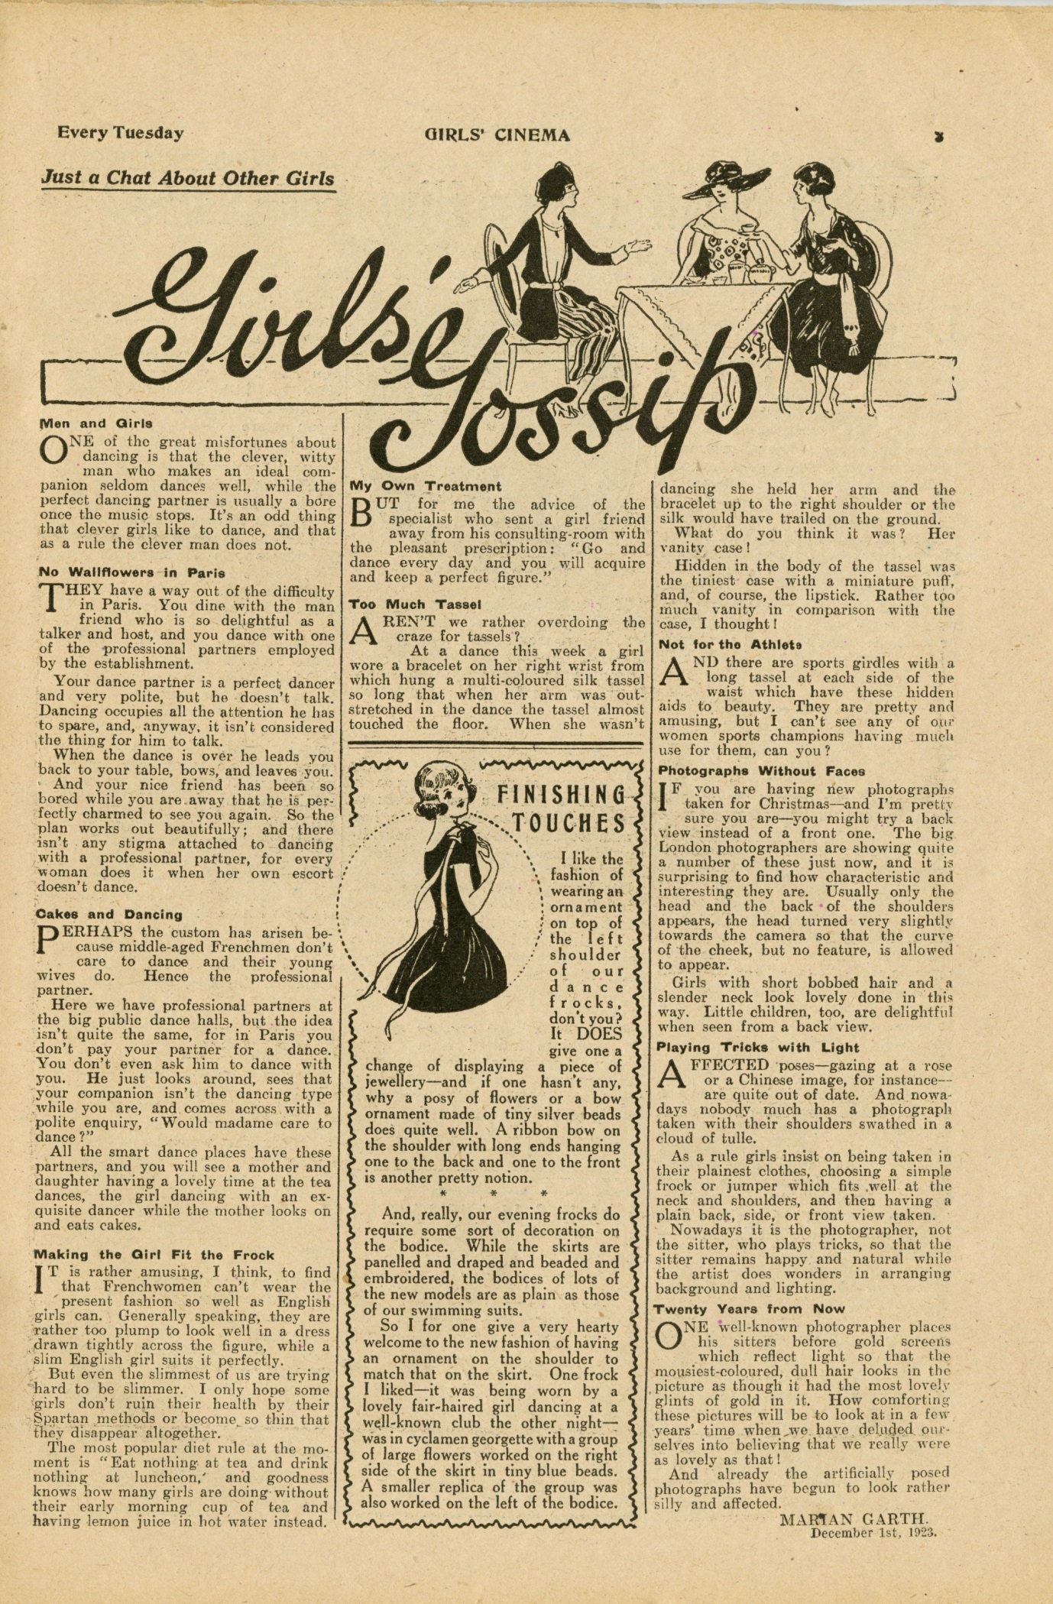
<insert fig 1.1>
<Caption>Fig 1.1: ‘Girls’ Gossip.’ Girls’ Cinema, 1 December 1923, p. 3.
The Picture Show shared a publisher and a cheaper price bracket with Girls’ Cinema in contrast to Picturegoer, and advertising content within the publication suggests a working-class address, with less attention to the ‘consumer luxuries’ (Glancy 56) that papers like Picturegoer promoted. Unlike Girls’ Cinema, the paper generally targeted an older age bracket of women, focusing on ‘married and middle-aged’ (Glancy 56) readers, but its pages contained a range of representations of youthful femininity, particularly in its story serialisations.
Almost all of the early fan magazines emphasised the participatory structure of their media. They encouraged the debate and deconstruction of star images in particular through a sense of a virtual community, where readers could see their letters and criticism published amidst a collective of other critical and creative spectators. Girls’ Cinema incited readers to write to its stars as well as to the paper, supplying studio correspondence details and. Female readers also used participatory platforms to interact with one another and swap their ideas and views through Picturegoer’s ‘What do You Think?’ letters page. In late 1927, for example, ‘Alys’ and ‘Constance Nymph’ debated the merits of English film star Victor McLaglen, with the latter declaring of the former that ‘that nice girl has sense!’ (December 1927: 90). Picturegoer readers also wrote debating the fashions of girl stars, with one reader asserting that ‘young girls’ on the screen ‘are very much over-dressed’, citing Constance Talmadge’s turn as a ‘schoolgirl of eighteen or so’ as ‘far too extravagantly dressed for her part’ (November 1921: 62). As such, the format of these magazine encouraged images of girlhood to remain open for British female consumers who were invited to see themselves as a critical as well as an admiring community, allowing them to learn from and experiment with star images that offered points of connection and points of radical contrast to their own lives. The extravagance of costuming in particular was a topic of constant debate, where American stars were offset, both positively and negatively, against the austere clothing and styles of more reserved British stars.
Early editions of Girls’ Cinema were presented through the editorial voice of ‘Fay Filmer’. As an organising persona for the publication who arranged and presented content for the reader, she spoke of herself as a fellow ‘girl’, offering a focalising personality for this sense of virtual community. The magazine structured a gossipy, friendly, confessional exchange between the editor and its readership. Items featured in the paper that were not short stories or serial fictions were prefaced by a brief introduction from Fay in the early issues, who wrote of her readership as ‘old friends’, attempting to present them with a ‘paper after your own heart’ (16 October 1920: 14-15). As a result, the entire text appears as if assembled by her discerning hand, structured to appeal to a particular model of contemporary girlhood: what Filmer refers to as ‘Up-to-Date Girls’. Filmer asserts that ‘we are one in our liking for photo-plays, and I want us to be one in our outlook on questions that are all-important in the girl of to-day’ (16 October 1920: 30), affirming the link between film fandom and a sense of a modern, youthful gendered community, and focusing on how girls could improve themselves, dress better, be more attractive to men and navigate different social situations.
In the teens and 1920s, editorial content for the Picturegoer tended to refer to female stars generally as ‘girls’, but the word is equally mobilised to address both a child readership and child performers. In the early twentieth century, girlhood was not strictly categorised by age. The term could encompass a figure aged ‘anywhere from ten years old to her mid-twenties’ (Smith 7). Jackson and Tinkler have described the ‘modern girls’ of this decade as ‘white, single, young, urban women aged 1-30 years, usually upper or middle class’ (253). Picturegoer’s ‘Young Picturegoer’ competitions cited fifteen years of age as the cut off point for entrants, whilst a ‘Picture Girl’ competition that ran in 1918 bracketed its entrants as between fifteen and twenty-five years of age (14—21 September 1918: 271), thus suggesting that the magazine designated its image of the ‘child’ girl as below the school leaving age in this period, demarcating ‘schoolgirl’ from ‘girl’ as young woman. An early 1918 issue, for example, heads the paper’s ‘Young Picturegoer’ section with an image of six-year-old star Mary McAllister hugging armfuls of dolls (29 December—5 January 1918: 18). These columns profiled child stars and addressed child readers, inviting them to write to the paper and participate in competitions, including painting or colouring, and awarding a range of prizes that consisted largely of sweets and games. The appeal to very young readers as aspiring stars was not inappropriate to the early star system of this period, in which many leading film actresses began their careers at a remarkably young age. The Picture Show in particular frequently noted the experience stars gained as children. In profiling British film star Alma Taylor, for example, the magazine recounted how ‘at the age of twelve years, she unconsciously played a part in a film play – in a moving picture camera recording the gaiety of party of which she was one of the guests’. The future star was then ‘singled out, and has ever since been a member of the Hepworth Film Company’ (22 November 1919: 12). Another piece on Margery Daw notes that she ‘was just fourteen when she first appeared on the screen’ (28 February 1920: 8).
This kind of ‘making it’ narrative was typically used for many young female actresses. It constructed a connection between the process of becoming a girl and the process of becoming a successful film personality, transitioning from childhood into girlhood as one transitions from bit player to star. A later piece in The Picture Show on actress June Caprice, for example, notes how she discarded seemingly childish interests upon becoming a screen star, swapping dolls for domestic pets: ‘when she went into pictures she thought that she was too grown up for dolls and went in for cats and dogs instead’ (31 January 1920: 8). Young girls ‘grow up’ to be stars, blossoming into stardom as a loose parallel to maturity and self-possession as children move towards modern girlhood. Interviews, features and screen star competitions capitalised on the idea that young readers could learn from and aspire to be like, or be, screen stars. As such, the links between cinema as an important element how both girl stars and girl readers grew up created an exploitable sense of affinity between the two, superficially compressing the distance between Hollywood idols and working and middle class British girls.
Within interwar British culture, the figure of the girl shouldered uncertainties about the boundaries between and polarities of youth and adulthood, increasingly reconfigured as more and more women entered the workforce and the age for compulsory post-elementary education was extended to fourteen years. Girls were also a focal point for concerns about gendered ideas of tradition and modernity and public and private, particularly because they were one of the primary targets for a growing mass culture. Into the 1920s ‘Victorian notions of “girlhood” persisted’ (Delaney 34), particularly in the perpetuation of what Gaylyn Studlar (2001) has seen as a Victorian-inflected, de-eroticised mode of girlhood. Such representations remained visible in culture despite the rise of a new girl-centred iconography marked by distinctly more modern incarnations of femininity, most prominently in the figure of the post war modern girl, characterised as the flapper, the ‘boyette’ or ‘boy-girl’ (Doan 102), with cropped hair and streamlined fashions. Fan magazines played into this pull between tradition and modernity in its representations of both glamorous youthful stars and the construction of certain kinds of star images that fed in some ways into the Victorian aesthetic, most notably the figure of the child impersonator star, embodied by actresses like Mary Pickford and Mary Miles Minter.
This oscillation between innocence and allure, childishness and maturity, was further configured around the representations of clothing, cosmetics, play and labour that proliferated in fan magazine discourses. Film papers depicted girlhood as an arena of liberation as young women’s lives were increasingly fuelled by their ‘financial and social independence’ (Jackson and Tinkler 253), but they also represented girlhood as a period of preparation for adult womanhood. Catherine Driscoll has explored the ways in which girlhood has been conceived of as ‘a stage to be passed through on the way to something else—mostly to “being a woman”’, designating an ‘immature and malleable identity’ (2). The transitory nature of the category is certainly a quality that emerges from the pages of film fan magazines. The meanings that both the magazines and their participating readers assign to the term ‘girl’ are fluid, but there is a particular emphasis upon girlhood as a period of experimentation, using film stars to test out and try on potential articulations of future womanhood. The broader interwar environment focused on the image of the housewife as an emblem of post-war national culture, equating womanhood with heterosexual partnership, domesticity and retirement from paid labour: but within film fan discourses, both girlhood and womanhood were configured in unstable and contradictory ways that unsettled a clear cut affirmation of more traditional gender norms.
Representations of girl-stars emergent from film culture could assist in transitional and transformative processes, enabling readers to further move from girlhood to the status of ‘real woman’, as one article put it, specifically by imitating and copying star personas. An article in a 1920 issue of The Picture Show, for example, written by ‘A Dresser’, sought to profile ‘The Average Girl and Beauty Cultivation’, advising the girl reader on ‘The Art of Finding her Style and Sticking to it.’
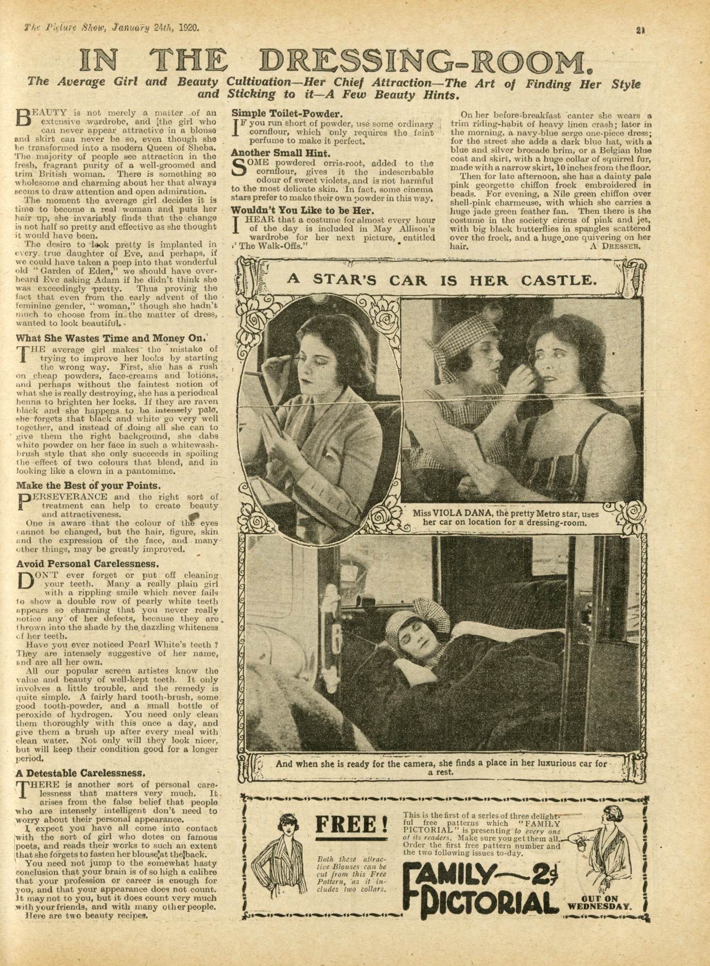
<insert fig 1.2>
<Caption>Fig 1.2: ‘In the Dressing Room’, The Picture Show, 24 Januaray 1920, p. 21.
The editorial suggests that ‘The moment the average girl decides it is time to become a real woman and puts her hair up, she invariably finds that the change is not half so pretty and effective as she thought it would have been.’ Highlighting images of the film star Viola Dana, and reporting on the fashions of star May Allison with the caption ‘Wouldn’t You Like to be Her’ (24 January 1920: 21), the piece suggests that the status of authentic adult womanhood could be achieved via cosmetics and dress if girls learn to cultivate a sense of individual style. Such style could be developed through interaction with the variety that film culture offered in presenting young female stars as identity templates. This was mobilised for working class young women in particular where the magazine profiled the thriftiness, as well as the glamour, of young stars. A piece on ‘How the Young Stars Dress’ from the early 1930s explained that ‘They Balance their Budgets So Ably and Methodically that We might Well Take a Leaf Out of Their Books’, detailing how the younger actresses who ‘haven’t been stars long enough to have accumulated a big banking account’ (11 January 1934: 12) manage their styles.
Magazines thus offered adaptable and imitable templates for girls to imitate and adapt. Such template were constructed through the specific medial tools of magazines. Film magazines, to borrow Robert Stam’s (2000) term, might be viewed as ‘multi-track’ media, combining writing with illustrations, photographs and different fonts and formats. This meant readers accessed representations of girl stars not just through images, but through prose combined with film stills and publicity shots, stories, interviews and advertising. One particular thread of magazine discourse that played upon these multi-track qualities, and their ability to turn young female identity in a multiple and layered image, was the inclusion of tie-in stories focused on girl heroines.

<A>Girlhood, storytelling and intermedia
Fan magazines frequently converted recent and upcoming film releases into short prose narratives. The Picture Show also serialised original girl-centred narratives not directly adapted from films or explicitly about cinema. A typical example is the 1919 serialisation of ‘Her Double Life’, telling the story of ‘Bethia Marvell, a very pretty girl, [who] receives an invitation from some smart friends to pay a visit to them at a large house’ (1 November 1919: 6). Girls’ Cinema, for obvious reasons, more explicitly branded its stories as girl-centred, with early titles including ‘Shown Up by her Family – A Story Telling of a Girl Who Tried to Better Herself’, or ‘The Girl Woman’, adapted from the Vitagaph film starring Gladys Leslie. Stories were a way to extend girls’ interaction with film narratives and generate interest in upcoming releases, but Girls’ Cinema also made reading the story part of a larger sense of female community activity, encouraging readers to pass on the paper and share it with friends once they had finished reading (the paper’s first issue includes ‘a final request from Fay Filmer’ to ‘pass this copy on to a friend’ [16 October 1920: back page]).
One particular strand of these fictions focused on ‘tomboy’ stories, centralising young and wayward female heroines whose exploits constructed an image of girlhood as a period of female experience able to ‘expand the bounds of acceptable feminine behaviour’ (Smith 7). The figure of the tomboy, emergent in the Victorian era, had persisted into the early twentieth century, aided by women’s entry into the workforce, the winning of the vote and their engagement with ‘such formerly masculine activities as smoking and drinking’ (Abate x). Cinema was one notable platform through which the image was perpetuated, with a number of teens and 1920s films whose titles included the word ‘tomboy’. Michelle Abate’s work on Tomboyishness in American literature and culture suggests that tomboy characters ‘and their accompanying behaviours have been linked with such elements as social surprise, gender duplicity and unlimited possibility’ (xiii). Indeed, tomboy film and tie-in narratives particularly capitalised on exploiting the slippages between activities characterised as distinctly gendered, and the independence this afforded their girl heroines.
A tie-in story in The Picture Show, for example, adapting the 1918 film Peg O’the Sea gives the reader a tomboy heroine in the figure of Peg, working the local fishing boats. The male hero and future love interest first presumes Peg to be a boy when he encounters her at sea:

The boy, a slim youth with a delicate face, turned at the shout.
‘That’s all right,’ he said. ‘I’m a McGuire—Peg McGuire!’
With a merry laugh, the supposed poacher pulled off a cap, and down tumbled a cascade of golden curls, framing a face which Frank thought the perfection of girlish loveliness.
[…] ‘I’m only a boy at sea. I’m a girl ashore,’ cried Peg
(22 November 1919: 14).

The narrative plays with the pleasures to be found in masquerade, something girl story papers picked up on more widely in utilising film-centred narratives, particularly where ordinary school girls found themselves ‘swapping in’ for film performer siblings (a common narrative in the School Girls Own library). It also plays upon the freedom of the girl persona to play around with gender roles and engage in a more active, daring premarital identity, in some regards less strictly bound by gender norms. Peg, for example, tackles a man who attacks her grandfather, smacking him with an oar; in other tomboy tie-ins, such as ‘The Adventures of Miss Tomboy’ adapted to Picture Stories Magazine from the Vitagraph film of 1914, the heroine sneaks herself into a male-only boat race, drives speeding cars, and disguises herself as a boy. Such narratives capitalised on the spectacular qualities of new technologies and the ability of cinema to transport their performers and their viewers into physically unbounded spaces of adventure.
Carolyn Jackson and Penny Tinkler have cited widespread anxiety in interwar culture about modern girls ‘becoming like men […] displaying behaviours and attitudes that transgress normative femininity’ (262). They did so in their increasingly public presence as workers and consumers in traditionally male spheres, but also in their adoption of male activities and leisure pursuits, and more androgynous styles. These factors were embodied by a range of new screen star personas, in particular by more glamorous American starlets prominent in UK fan papers such as Gloria Swanson, and stars like Louise Brooks, Colleen Moore or Clara Bow who embodied the image of flapper – the ‘emblem of modern times’ (Melman 1). The female serial star also provided a particular kind of tomboy femininity, more in line with the Peg character. Popular serial actresses like Pearl White and Ruth Roland were made famous by their stunts, escaping from burning buildings, rushing rivers, speeding trains and flying balloons in imported American serials like The Adventures of Ruth (1919). As Shelley Stamp (2000) has shown, womens’ and girls’ preferences for these kinds of narratives pushed against more conservative and traditionally feminised images of femininity, and capitalised instead upon sensation and thrill.
An interview in The Picture Show with the British star Enid Heather, typical of star features that foregrounded the views and opinions of female performers, champions this particular incarnation of modern girlhood:

‘I think every girl should be able to swim, ride a horse, and shoot,’ she says. ‘It isn’t so much a question as to when they may have to make use of such qualifications, but of their value to a girl’s health and appearance […] “Tomboyishness” as a term of reproach should be forgotten. Every girl has the right to become strong and healthy, and football, boxing and wrestling are as good for them as for the sterner sex.’ (6 December 1919: 3-4)

This emphasis upon a (tom)boy/male-inflected girlhood, where strength and physical capability are offset against more traditionally feminine values of beauty and allure, seems to be echoed in readers’ letters from the period to The Picture Show. Published correspondence notes girl readers’ interest in the counterpart magazines Boys’ Cinema, for example, suggesting that this kind of content had just as much relevance and interest for young female readers. An editorial from January 1920, cites a letter from reader Olive Flemming, who declares that, despite purchasing the paper for her ‘small nephews’, she will ‘continue to get it for myself first’ (10 January 1920: 3). ‘Boy’ attitudes, exploits, and themes thus were not inaccessible to a female readership, despite the simplistically gendered division of magazine content (another reader letter from Mollie Dorrington questions ‘Why the “Boys’ Cinema”? Why not Boys and Girls, for I am sure my three sisters, mother, and myself, enjoy it quite as much as the boys.’ [21 February 1920: 3]). Girlhood, as it was embodied on screen and within the off-screen image of the female star through the fan magazine, could therefore be positively inclusively of boyish features, unsettling a more reductive equation of feminine value to aesthetic beauty alone.
Fan magazines worked to hold this seeming contradiction in play. In depicting tomboy characters, they created a fantasy space in which to play around, however superficially, with the ‘girl’ identity. Yet, to return to Peg’s story: like so many of her counterpart serial heroines, the girl protagonist is destined for heterosexual partnership by the conclusion of the narrative, setting aside her earlier hijinks to marry the male lead, at which point the narrative concludes. The boy/girl playfulness such characters exhibit is very frequently made a temporary, transitory freedom. Jackson and Tinkler have suggested that, ‘mindful that their readers may have self-defined as modern girls, young women’s magazines of the 1920s attempted to persuade their readers that they desired marriage’ (258). Indeed, throughout film magazines, particularly Picturegoer, an uneasy negotiation of more conservative and traditional ideals regarding marriage, domesticity and heterosexual partnership can be found sharing space with representations of more radically modern images of youthful femininity. Features often sought to ‘persuade’ readers of the virtues of a more home-centred idea of female identity, whilst capitalising on their appetite for the alternative images of girlhood that film culture could offer.
In profiling young star Marjorie Daw, for example, Pictures and Picturegoer depicted her at home, stressing her youth and her domesticity, and noting that ‘at seventeen’, the reader would expect ‘to find a young girl of the flapper description with an outlook on life hounded by boxes of chocolate and joy-rides in the best boys’ motor. In which case Marjorie ceases to be typical of her period.’ (14 August 1920: 201) The piece profiles her ability to cook ‘better than the average housewife’ (14 August 1920: 201) and provide for her younger brother, alongside knitting and studying. A later interview with Florence Vidor advises ‘every girl to marry when she finds someone she can really love and care for’. It reassures the reader that the ‘“extreme” youth of our leading feminine film stars’ is an ‘illusion’, masking the reality that ‘practically all of them are married’ (July 1921: 9)
Such domesticated images of young stars seemed to affirm the happy ending romantic resolutions of tie-in narratives. The emphasis upon heteronormative conclusions for girl heroines ultimately deconstructed the temporary liberation of girlhood by reinforcing marriage and the unspoken qualifiers of that change in status, including domesticity and retreat from paid public labour. Since the ‘usual pattern’ for women at this time was ‘to work in the period between leaving school and getting married’ (Glucksmann 36), the idea of girlhood as a temporary period of experimentation and play spoke to a female readership who were either experiencing this period as girls, or looking back on it as married women. Yet narrative resolution does not necessarily cancel out the more playful or disruptive aspects of narrative process in these girl-centred texts. The intermedial qualities of the paper, where its pages cross the borders between media in the inclusion of prose, illustrations, photography and film stills went some way to disrupt these resolutions. Multiple female identities for any given characterisation remained in play, sustained beyond the reader’s engagement with the story as a single unit in the larger tapestry of the magazine within these mixed-media modes of representation.
Because magazine stories interspersed their narrative representations with advertising, interviews, images and other mixed media modes and messages, they deconstructed a more straightforwardly linear nature of any interaction with a given story, and, by extension, star image. Whilst Vidor advocates for domesticity, she stresses the negotiation that screen stars uniquely achieve, remaining in high profile careers beyond their wedding vows. Importantly also, any given character in a tie-in story was also simultaneously a star, carrying with it echoes and contradictions inherent in the presence of that star image elsewhere within the magazine in different forms, and within wider cultural discourse. Engaging with tie-in fiction specifically within the film magazine allowed girls to encounter new negotiations of the otherwise seemingly irresolvable conflict between the liberties of girlhood and the restriction of marriage and domesticity. Girlhood could be understood as an arena of independence prior to marriage, in which many women were freer to engage in paid and public labour. The ability of female stars to retain an identity and play characters defined as ‘girl’, whilst also being wives, mothers, and businesswomen (as only film magazines could illuminate, by promoting themselves as the primary access point to such behind the scenes knowledge), thereby made them unique role models. Fan magazines marked young starlets as distinctive bearers of a dual girl/woman, independent/domesticated image, capable of holding many identities in play by simultaneously exploiting the system of ‘typing’ assigned to stars and character roles. As star Louise Glaum asserted in Pictureoger, ‘I want to be all sorts of women—good, bad, and medium, but never indifferent, never colourless. I want to be a human chameleon.’ (17—24 May 1919: 504). Such a ‘chameleon’ identity extended beyond the screen role – often marked by a set of stereotypes as vamp, flapper, innocent, waif – and out into the equally performative discourse of the star image, composed of home life, work life and screen life.
Stars such as Mary Pickford, known for her recurrent portrayal of girls and tomboys on screen and commonly referred to as ‘America’s Sweetheart’, could retain an image of playful girlhood through the roles they inhabited, and simultaneously carry the signifiers of adult domesticated femininity in their off-screen star images. Such stars represented economically successful and independent figures whose cultural value was largely divorced from their families or husbands, and whose financial value was not necessarily tied to inheritance or marriage. American star Viola Dana articulated this modern compromise, suggesting to readers of Picturegoer that ‘My husband has got to be a good pal, or I won’t have him. And we’ll both be independent. I don’t intend to leave the scene when I marry.’ (22 May 1920: 533)
The interwar period was an era in which the image of the housewife and a culture of homemaking dominated British cultural life, with the rise of the suburbs and the swelling ranks of the newly middle class. Such an emphasis upon a domestic identity as central to womanhood sat uneasily with the very public modernity and liberation of the screen star image, particularly as it was imported from Hollywood, whose domestic stars (dominant on British screens at this time) were groomed within a culture that was more materially wealthy and less class-bound. British fan magazine’s handling of girl stars, or stars with notable girl-inflected star images, dealt with these contradictions seemingly by simply multiplying them, offering them to readers for selection and resignification in the process of consuming the mixed representations of the magazine format. Such a proliferation of alternative and contradictory representations of gendered duty and identity thus in some ways troubles the boarder narrative of post-war return to domesticity.
Pickford, for example, featured in the opening instalment of Girls’ Cinema, adopting a wide variety of guises across one single issue. She appears on the magazine’s front cover, which promises to illuminate readers about the details of ‘Her Wedding Day’, reporting on her marriage to Hollywood superstar Douglas Fairbanks. The first item inside the magazine is a tie-in adaptation of her film Heart o’the Hills, illustrated with images of Pickford in character as the tomboy heroine Mavis. The story is intercut with a full page colour insert image of Pickford in her wedding dress marking her marriage to Douglas Fairbanks, and later on the ‘Fay Filmer’s Film Chat’ double page spread, Pickford features in a telegram, supposedly sent by the star herself, welcoming new readers. Readers could thus simultaneously hold these images in play and flux: Pickford as wife, professional actress and adult, and Pickford as child character and tomboyish girl, enjoying the freedoms of travel, glamour, fashions, work and play alongside her domestic identity as Fairbanks’, as well as America’s, and the readers’, ‘sweetheart.’ The particular qualities of the magazine as multi-track media thus meant that readers could interact with stars as composite of girl/woman representations, both potentially subversive and more conservative, traditional and modern.
Unlike the girl reader, the film star could maintain the illusion of seemingly eternal girl, performing as children on screen whilst holding on to the economic, spatial and cultural freedoms of girlhood, despite their status as married women. But readers could still use and engage with the tools that stars employed to achieve this, invited to build composite identities, styles and ways of understanding themselves as girls, inspired by the intermedial qualities of the paper. Fan magazines answered back to the reductive stereotype of the cinemagoing girl by presenting themselves as a toolkit for learning about new fashions and trends, and a platform for girls to debate their own ideas about girlhood and film culture through the participatory structures of these texts. As such, film periodicals offer themselves as rich historical tools for accessing alternative and complex narratives emergent from the interwar years on the place and changing identities of modern girls, and for understanding the important role that women’s print culture played within articulating and constructing these narratives.

<A>Works Cited
Abate, Michelle Ann. Tomboys: A Literary and Cultural History. Philadelphia: Temple UP,
2008. Print.
Bruley, Sue. Women in Britain Since 1900. New York: St Martin’s Press, 1999. Print.
Delaney, Lesley. ‘Little Women, Good Wives: Victorian Constructions of Womanhood in
the Girl’s Own Annual 1927.’ Children’s Literature in Education 4.1 (March 2003):
29-45. EBSCO. Web. 8 September 2015.
Doan, Laura. Fashioning Sapphism: The Origins of a Modern English Lesbian Culture.
Columbia: Columbia UP, 2001. Print.
Driscoll, Catherine. Girls: Feminine Adolescence in Popular Culture & Cultural Theory,
New York: Columbia University Press, 2002. Print.
Giles, Judy. The Parlour and the Suburb: Domestic Identities, Class, Femininity and
Modernity. Oxford: Berg, 2004. Print.
---. Women, Identity and Private Life in Britain. 1900–1950. New York: St. Martin’s Press,
1995. Print.
Girls’ Cinema. 16 October 1920: 14-15; 30; back page. Print.
Glancy, Mark. Hollywood and the Americanization of Britain: From the 1920s to the
Present. London: I. B. Tauris, 2014. Print.
Glucksmann, Miriam. Women Assemble: Women Workers and the New Industries in
Inter-war Britain. London: Routledge, 1990. Print.
Jackson, Carolyn and Penny Tinkler. ‘“Ladettes” and “Modern Girls’”: “troublesome”
young femininities.’ The Sociological Review 55.1 (2007): 251-272. EBSCO. Web. 8
September 2015.
Kuhn, Annette. An Everyday Magic: Cinema and Cultural Memory. London: I. B. Tauris,
2002. Print.
---. ‘Cinema Culture and Femininity in the 1930s.’ Nationalising Femininity: Culture,
Sexuality and British Cinema in the Second World War. Ed. Christine Gledhill and
Gillian Swanson. Manchester: Manchester UP, 1996: 177-192. Print.
Lejeune, C. A. ‘The Price of Idolatory.’ Manchester Guardian. 13 May 1922: 9. Print.
Marcus, L. (2007), The Tenth Muse: Writing About Cinema in the Modernist Period, Oxford:
Oxford University Press.
Melman, Billie. Women and the Popular Imagination in the Twenties: Flappers and Nymphs.
Basingstoke: Macmillan, 1988. Print.
The Pictures. 21 October 1911: 1. Print.
Pictures and Picturegoer. 29 December—5 January 1918: 18. Print.
---. 19—26 January 1918: 49. Print.
---. 14—21 September 1918: 271. Print.
---. 17—24 May 1919: 504. Print.
--. 14 August 1920: 201. Print.
Picturegoer. 22 May 1920: 533. Print.
---. July 1921: 9. Print.
---. November 1921: 62. Print.
---. October 1925: 48. Print.
---. December 1927: 90. Print.
---. March 1928: 3. Print.
The Picture Show. 1 November 1919: 6. Print.
---. 22 November 1919: 8; 12; 14. Print.
---. 6 December 1919: 3-4. Print.
---. 10 January 1920: 3. Print.
---. 24 January 1920: 21. Print.
---. 31 January 1920: 8; 13. Print.
---. 21 February 1920: 3. Print.
---. 28 February 1920: 8. Print.
---. 11 January 1934: 12. Print.
Richardson, Dorothy. ‘Continuous Performance VIII.’ Close Up 1927-1933: Cinema and
Modernism. Ed. James Donald, Anne Friedberg and Laura Marcus. London: Cassell,
1998: 174-76. Print.
Showalter, E. (1992), ‘Introduction’, in V. Woolf, Mrs Dalloway, London: Penguin, pp. xi-
xlviii.
Smith, Michelle J. Empire in British Girls’ Literature and Culture: Imperial Girls, 1880-
1915. London: Palgrave Macmillan, 2011.
Sommerfield, John. May Day. London: Lawrence and Wishart, 1936. Print.
Stam, Robert. ‘Beyond Fidelity: The Dialogics of Adaptation.’ Film Adaptation. Ed. James
Naremore. London: Athlone Press, 2000: 54-76. Print.
Stamp, Shelley. Movie-Struck Girls: Women and Motion Picture Culture after the
Nickelodeon, Princeton, New Jersey: Princeton University Press, 2000. Print.
Studlar, Gaylyn. ‘“Oh, Doll Divine”: Mary Pickford, Masquerade, and the Pedophilic
Gaze.’ Camera Obscura 16:3 (2001): 196-227. Project Muse. Web. 8 September
2015.
Tinkler, Penny. Constructing Girlhood: Popular Magazines for Girls Growing up in
England, 1920-1950. London: Taylor & Francis, 1995. Print.
Trotter, D. (2007), Cinema and Modernism, London: Blackwell.

