Do twisted laser beams evoke nuclear hyperpolarization?
A. B. Schmidtª, D. L. Andrews^{e}, A. Rohrbach^{b,c}, C. Gohn-Kreuz^{b}, V. N. Shatokhin^{d}, V. G. Kiselevª, J. Hennigª, D. von Elverfeldtª, J.-B. Hövener^{a, f,*}

ª Medical Physics, Department of Radiology, University Medical Center Freiburg, Breisacher Straße 60a, 79098, Freiburg, Germany.
^{b} Department of Microsystems Engineering—IMTEK, Albert-Ludwigs-University Freiburg, Georges-Köhler-Allee 103, 79110, Freiburg, Germany.
^{c} BIOSS – Centre for Biological Signaling Studies, Albert-Ludwigs-University Freiburg, Schänzlestr. 18, 79104 Freiburg, Germany.
^{d} Institute of Physics, Albert-Ludwigs-University Freiburg, Hermann-Herder-Straße 3, 79104 Freiburg, Germany.
^{e} School of Chemistry, University of East Anglia, Norwich Research Park, Norwich NR4 7TJ, United Kingdom.
^{f} German Consortium for Cancer Research (DKTK), Im Neuenheimer Feld 280, 69120 Heidelberg, Germany.
*Corresponding author: jan.hoevener@uniklinik-freiburg.de (Received 28 October 2015)

The hyperpolarization of nuclear spins promises great advances in chemical analysis and medical diagnosis by dramatically increasing the sensitivity of nuclear magnetic resonance (NMR). Current methods to produce a hyperpolarized sample, however, are rather cumbersome, time-consuming or costly and require extensive equipment. Recently, a much simpler approach was introduced that holds the potential, if harnessed appropriately, to revolutionize the production of hyperpolarized spins. It was reported that high hyperpolarization of nuclear spins of small molecules in solution can be created by irradiation with a laser beam which carries orbital angular momentum (twisted light). Apart from these initial reports, however, no further experimental verification has been presented. In addition, this effect has so far evaded a critical theoretical examination. In this contribution, we present the first independent attempt to reproduce the effect. We exposed a sample of immersion oil or a fluorocarbon liquid that was placed within a low-field NMR spectrometer to Laguerre-Gaussian and Bessel laser beams at a wavelength of 514.5 nm and various topological charges.
We acquired ¹H- and ¹⁹F-NMR free induction decay data, either during or alternating with the irradiation that was parallel to B₀. We indeed observed an irregular increase in NMR signal in experiments where the sample was exposed to beams with higher values of the topological charge. However, at no time did the effect reach statistical significance of 95 %. Given the measured sensitivity of our setup, we estimate that a possible effect did not exceed a hyperpolarization (at 5 mT) of 0.18 - 6 % in the focal volume of the laser beam, depending on what volume is assumed. It should be noted, though, that there were some differences between our and the previous implementation of the experiment, that may have inhibited the full incidence of this effect here. To approach the theory of this effect, we considered the interaction of an electron with a plane wave, which is known to be able to induce electronic (e.g. in Rubidium) and subsequent nuclear hyperpolarization. Compared to the plane wave, the difference that is induced by a twisted wave is, in the best case, of the order of 10⁻³, suggesting that the twist of the laser is unlikely to be responsible for the hyperpolarization of nuclear spins, unless a new mechanism of momentum transfer is identified.

Keywords: nuclear hyperpolarization, low-field NMR, complex light, light-matter interaction

INTRODUCTION
The hyperpolarization (HP) of nuclear spins is an emerging technique that has had a strong impact in the field of biomedical imaging, promising a whole new range of diagnostic parameters [1–8]. By overcoming the inherent insensitivity of magnetic resonance imaging (MRI) and spectroscopy (MRS or NMR), HP has enabled the ability to monitor metabolism noninvasively and in vivo. The HP process allows for the administration of a non-toxic, non-radioactive, magnetically labeled metabolite such as pyruvate [9]. First human trials were reported that aim to diagnose cancer and monitoring its response to treatment [10]. The methods to generate nuclear hyperpolarization to date are complex, not widely applicable, slow or cost-intensive [11–16].
It was not surprising that the report of an HP method that was described to be much simpler and faster found great interest in the scientific community [17,18]. This method, which aims to exploit the orbital angular momentum (OAM) of light, was reported to produce significant HP ≥ 1.5 % in less than a second [17]. This effect resulted in several patents e.g.,. [19–26] by Albu et al., but has not been verified by other groups. Furthermore, the fundamental mechanism for the creation of HP by OAM-carrying laser light has not been studied theoretically. Hence an independent reproduction and the physical interpretation of this effect is in dire need and highly interesting.
Interactions of electromagnetic waves with molecules have been subject of studies since the early development of quantum mechanics. That angular momentum can be transferred from light to matter has first been demonstrated by Richard Beth about 80 years ago [27]: He observed a light induced torque on a crystal wave plate irradiated with a circularly polarized laser beam.
While the polarization of electromagnetic waves is associated with spin angular momentum (SAM), it was found that paraxial light beams with helical phase fronts can also carry a well-defined OAM that is independent of the polarization of the light [28]. Unlike SAM of photons, which can take only one of two ‘sharp’ values for circular polarizations, photonic OAM can span an infinite number of possible values, with a positive or negative sense determined by the topological charge – essentially the number of wavefront twists over the span of a wavelength. This property of twisted light beams triggered an interest to find the peculiarities of OAM transfer from light to matter and to find possible applications thereof, both experimentally [29–33] and theoretically [34–42].
The unique properties of these helically phase-shaped light beams have already proved useful e.g., for optical micromanipulation and quantum information theory [43], microscopy [44–49] and telecommunication [50,51]. However, apart from the report of Albu et al., though, none considered the hyperpolarization of nuclear spins. Indeed, to the best of our knowledge, no sub-atomic level manifestation of the OAM of light is suggested by any of the existing literature on theory.
In this contribution, we try to shed some light on this matter. We attempt to reproduce the hyperpolarization of nuclear spins by means of orbital angular momentum (OAM-HP), consider the theoretical background and discuss potential mechanisms for this effect. At the low magnetic field used in this study (5 mT), we did not observe an unambiguous experimental evidence for OAM-HP (compared to earlier reports where a much higher field was used). Theoretical considerations using perturbation theory indicate that there is no additional HP effect by the OAM of light by formerly known mechanisms of momentum transfer, as the correction of the transition probabilities that is accounting for the twist of the laser is small.

METHODS

Low-field NMR
Based on a previously described design [52], a multinuclear low-field NMR unit (B₀ ≈ 5 mT, f ≈ 200 kHz for ¹H) was adapted to be operated on an optical table (Fig. 1). The setup was comprised of a solenoidal B₀ – coil to generate a static magnetic field, transmit-receive coils (B₁, Fig. 2) and two sample holders that were designed to allow for laser irradiation of the sample during or intermittent with the NMR experiment (Supplementary Fig. 1).
To operate this unit on a ferromagnetic optical table, an attachment was constructed that comprised of a bar from which the optical elements were held, the sample and detection coil, as well as a slider to move the B₀-coil aside. The symmetry axis of the B₀ solenoid was parallel to the laser beam and was at a distance of 33.5 cm from the optical table (Fig. 1).

Static magnetic field
The static magnetic field was created with a solenoidal coil that was composed of two complete layers of copper wire (Ø = 1.12 mm incl. isolation; Magnesol U-155, Essex, France) on a polymethyl methacrylate (PMMA) tube (l = 360 mm, Ø_{inner} = 110 mm, wall thickness d = 5 mm). 47 windings were added on each end of the coil to improve the B₀-field homogeneity. The coil was driven by a low-noise DC power supply in constant-current mode (E3615A, Agilent Technologies, USA). The current was adjusted between 0-3 A, inducing a magnetic field of strength up to 6.4 mT. The unit was shielded against interfering electromagnetic signals with a copper cylinder made from a 1-mm thick sheath that was placed inside the B₀ - coil (l = 360 mm, Ø_{inner} = 105 mm).

Sample holders
Two cylindrical sample holders with an inner volume of 180 µl and 2.85 ml were made from PMMA (SH_{S} and SH_{L}, respectively, Supplementary Fig. 1). The holders were mounted so that the symmetry axis was perpendicular to the B₀-field and the propagation axis of the laser beam. To enable laser irradiation of the sample, a hole was drilled through the holders to be in line with the laser beam and sealed with microscopy cover slips (thickness 0.13-0.16 mm, refractive index n = 1.523 , Carl Roth, Germany) on front and back. To reduce bubbles and to protect the thin cover slips against bursting from overpressure while being filled, the cap of SH_{L} was equipped with a hole to vent excess liquid and air. SH_{S} was filled by injection with a 30-gauge needle through a centric hole at the top of the holder, and two other holes guided air out. Care was taken to avoid filling these holes.

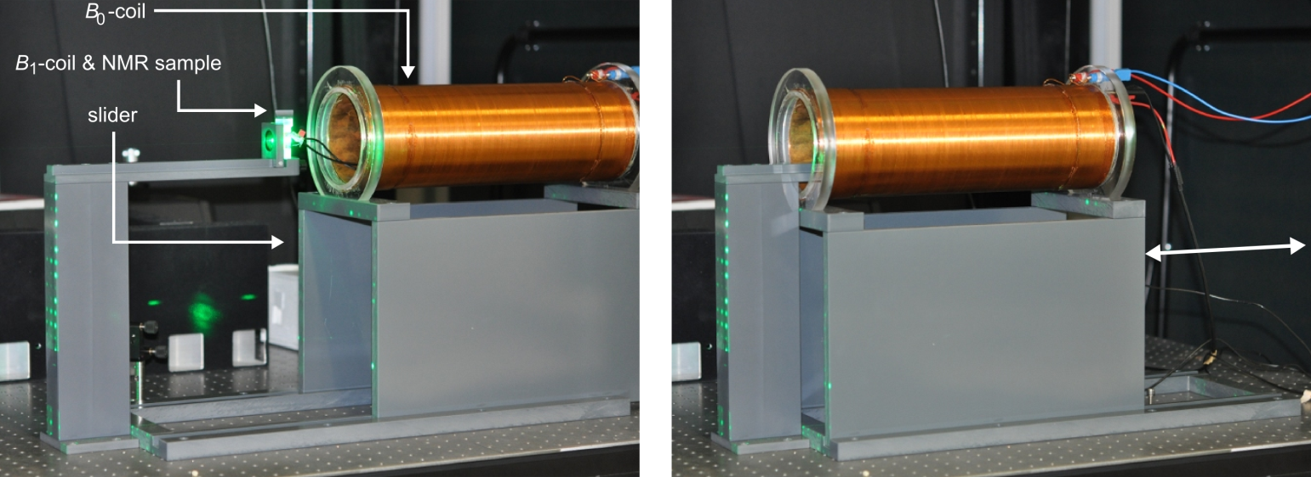
FIG 1. Picture of the low-field NMR setup where (left) the coil that generates the static magnetic field B₀ is slid aside to allow access to sample and beam and where (right) the setup is readily mounted for NMR acquisition.

Excitation, detection and quantification of NMR signal
Two solenoid coils (SC) were constructed to excite and receive NMR signal. The coils consisted of a single layer of insulated, 0.22 mm (SC₂₂), or 0.28 mm (SC₂₈) diameter copper wire (CUL, Block, Germany), that was wound directly on the sample holder on a length of approx. 24.6 mm (inner diameter 15.6 mm). To allow for laser irradiation of the liquid sample during NMR experiments, a gap of approx. 6 mm was left open at the center of the coil (Fig. 2). The capacitors [SC₂₂: C = 1/(10 nF + 10 nF) + 1/(33 nF) ≈ 13 nF; SC₂₈: C = 33 nF, FKP02, WIMA, Germany], crossed diodes (BAP64-04W, 115 NXP semiconductors, USA) and the connecting cables to the data acquisition device were mounted on a circuit board. In the case of SC₂₂, the board was placed at a distance of 5 cm to the inductor to reduce B₀-field distortions induced by the components [Fig. 2 (c)].
Excitation pulses were applied and data was acquired using a digital converter set to a sampling rate of 1 MHz (NI USB-6251, National Instruments, USA) that was controlled by a custom-written software (MATLAB, The MathWorks Inc., USA). Including the excitation pulse of 250 points, 6 ∙ 10⁴ data points were acquired with the same coil. This data was extended to four times the original length by adding zeros to the end (zero-filling). The first 1000 data points that included the excitation pulse and its ring-down were discharged. The remaining data was multiplied by an exponential decay function with a time constant of, where FWHM is the full width at half maximum of the resonance, typically 24 ± 1 Hz and 13 ± 2 Hz for the large or small sample, respectively.
The NMR spectrum was obtained by applying a Fast Fourier Transformation of the time-domain data, and the signal was quantified by fitting a Lorentzian function to the resonance. All post-processing and fitting was performed in MATLAB (The MathWorks Inc, USA).

NMR experiments
The flip angle was calibrated by varying the pulse power (0.7 V – 4.5 V) at constant pulse length (250 µs) for the following liquids: Deionized water; Immersion oil that was matched to the coverslip windows (Immersol 518 N, Carl Zeiss, Germany) with a refraction index of n = 1.518 (23°, 546.1 nm) and Fluorinert (FC-84, 3M, Germany), a fluorocarbon liquid (C₇F₁₆).
To investigate the sensitivity of the coil within the gap in the windings that was left for laser irradiation, the volume of a sample was reduced successively in six steps while NMR signal was recorded (Supplementary Fig. 2).
The reproducibility of the NMR experiment was investigated by comparing consecutive measurements acquired under identical conditions: A total of 16 scan series, each containing 100 free induction decays (FID) of 2.85 ml deionized water, were acquired over 13 days [flip angle α = (90 ± 2)°, T_{R} = 15 s, 4.0 mT]. Similarly, 39 series of 500 FIDs of 180 µl C₇F₁₆ were acquired over four days [α = (90 ± 2)°, T_{R} = 5 s, 4.9 mT].

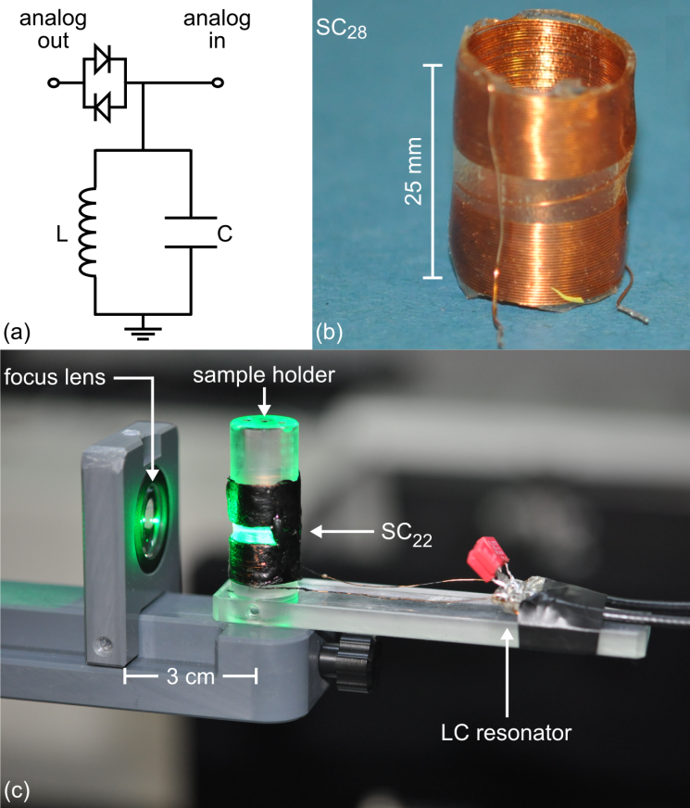
FIG 2. Transmit-receive coils for low-field NMR and OAM-irradiation, circuit diagram (a), photograph of an inductor (b) and complete assembly in the OAM-HP setup (c). Note the gap in the solenoid coil (SC) that allowed laser irradiation of the sample.
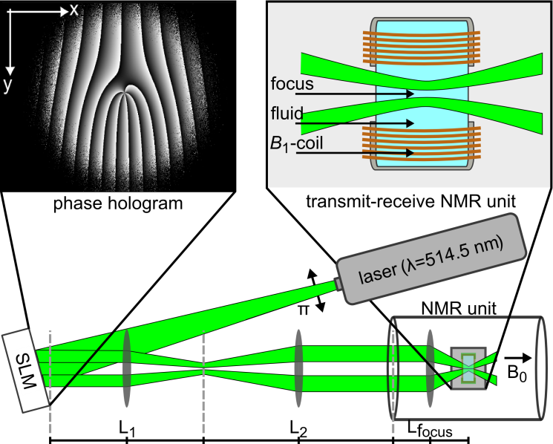

FIG 3. Schematic view of the OAM-HP setup. To create orbital angular momentum (OAM) beams, a spatial phase pattern was imprinted on the beam of an Argon-ion laser by a phase hologram (top left), displayed on a spatial light modulator (SLM). Mirrors and lenses (L) were used to guide this beam into a liquid sample inside the transmit-receive coil of a low-field NMR unit, operating at ≈ 5 mT (top right).

The longitudinal relaxation time T₁ of the liquids was measured by means of saturation recovery. T₁ was calculated by fitting the corresponding exponential saturation function to the data.

Optical setup
An Argon ion laser was operated at a wavelength of 514.5 nm and had an output beam power of approximately 250 mW (BeamLok 2065-5S, Spectra Physics, USA). The vertically polarized Gaussian laser beam was directed to a spatial light modulator (LC-R 2500, Holoeye) to imprint the desired phase property on the beam (Fig. 3). The phase holograms were calculated, corrected and superimposed as described by F. O. Fahrbach et al. [47]. For hyperpolarization experiments, OAM-carrying Laguerre Gaussian (LG) and Bessel beams of higher orders were holographically shaped by adding an azimuthal phase, where 𝓁 denotes the OAM topological charge number and the polar angle, to the holograms. After the SLM, the reflected beam (with or without annular intensity) was guided into the NMR unit parallel to the magnetic field by means of either three (LG beam) or four lenses (Bessel beam). A lens with 0.2 numerical aperture focused the incident beam into the NMR sample, where a power of 75 mW was measured. A photograph of the entire setup can be seen in Fig. 4.
The maximum OAM number (𝓁_{max}) was determined by the finite resolution and dimension of the SLM. The value of 𝓁_{max} was measured by comparing intensity profiles of Bessel beams carrying different topological charge numbers between 0 and 300. These profiles were imaged in the focus of a lens with f = 150 mm, using a CCD camera (BC106N-VIS, Thorlabs, USA).
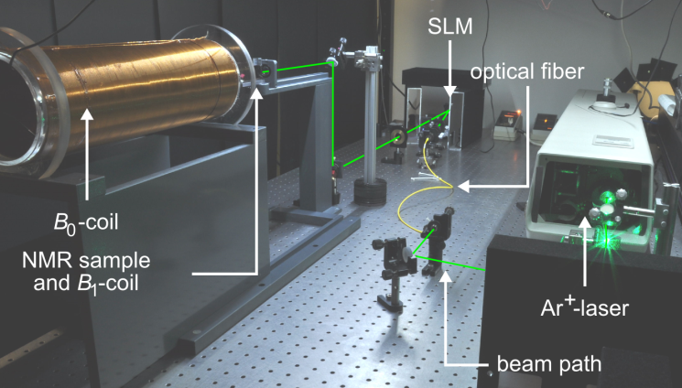
FIG 4. Picture of the entire OAM-HP setup that includes the Ar⁺-laser, the optical path (indicated in green) as well as the low-field NMR unit that is slid aside to allow access to the NMR sample and B₁ coil.

Hyperpolarization experiments
The OAM-HP experiment was realized at 5 mT by focusing a beam with various charge numbers (𝓁 = -5 to 𝓁 = 50) in sample holder SH_{S} that was held inside the NMR unit. The sample was either irradiated continuously, or intermittently with the NMR experiment. For the latter, the beam was applied for 1.3 s up to 9 s and deflected for 0.5 – 1 s during the excitation and acquisition of NMR signal for every T_{R}. There was a short delay between the OAM irradiation and the excitation pulse that was estimated to be less than 200 ms, and that varied slightly because of the finite reaction time of the software. The irradiation of the sample was interrupted by dynamically reprogramming the SLM to deflect the beam. The delay between excitation pulse and data acquisition was constant within one sampling interval of the hardware (1 µs), assuring a stable phase for the summation of multiple acquisitions.
For each setting of 𝓁, the signals of 500 full excitations were summed-up and quantified. To obtain the mean signal area and its standard error, this experiment was repeated 20 times for each 𝓁, yielding one data point in Fig. 8 with a total of 10,000 acquisitions.

Quantification of HP
The absolute polarization P_{HP} was quantified with respect to the signal of the same sample acquired under the same conditions in thermal equilibrium S_{therm}, taking into account the number of acquisitions N_{therm} and N_{HP} and the thermal polarization at the corresponding field P_{therm}:

where S_{HP} is the signal acquired with OAM, V_{HP} is the volume of the hyperpolarized sample and V_{tot} is the volume of the sample.
The relative signal increase is and has a propagated error of . This value is used to discuss a potential effect of the OAM beams on the NMR signal.
It must be taken into account that the volume where OAM-HP potentially takes place, V_{HP}, is possibly of the order of the diffraction-limited focus of the OAM beam (which has zero intensity at its center) and may be therefore much smaller than the thermally polarized sample V_{tot}. However, since the actual mechanism of OAM-HP is unknown, its exact volume is also unknown. We estimate the range of V_{HP} as follows:
The intensity distribution of an annular LG-beam with topological charge 𝓁 can be written as

with the waist size , the total beam power P₀ and λ the wavelength [53]. For a topological charge of 𝓁 = 20 the beam diameter was calculated to be ≈ 10 µm (similar to the value reported by Albu et al.).
Note, though, that the radius of the LG-ring increases with 𝓁 and the effective thickness slightly decreases and is an order of magnitude smaller than the diameter of the ring.

The interaction (and thus HP-) volume V_{HP} of the NMR sample and the vortex beam was estimated by the volume of a hollow cylinder where half of the maximum intensity of the beam accrued (Fig. 5). The volume depends on the charge number and the refraction index of the sample, e.g., for 𝓁 = 20 in immersion oil and for 𝓁 = 50 in Fluorinert, it corresponds to a volume of ≈ 3 pl. This volume may be assumed to be the volume where the conditions of the laser beam are most favorable for any kind of interaction, although an HP effect may occur as well outside that volume. Thus, 3 pl was estimated to be the lower bound of the HP volume. Molecular diffusion is likely to increase V_{HP}, depending on the longitudinal relaxation of the sample. For Fluorinert an upper bound of V_{HP} was estimated to 100 pl by assuming the volume of a sphere with a radius of , with the diffusivity D ≈ 10⁻⁹ m²/s and the longitudinal relaxation time T₁ ≈ 1 s.

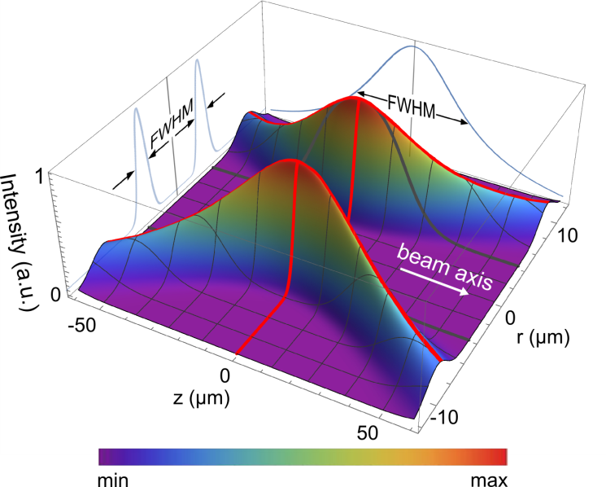

FIG 5. Plot of the calculated signal intensity distribution of a focused LG-beam with 𝓁 = 10. The hyperpolarization volume was estimated by the volume where the intensity of the beam has half of its maximum or more (FWHM: full width at half maximum, r: radius).

RESULTS

Low-field NMR
Thermally polarized ¹H- and ¹⁹F-NMR data were readily acquired at 4.9 mT using the subsequently described setup, although signal averaging was necessary due to the small sample size of 180 µl and 2.85 ml (Fig. 6).

Flip angle calibration: By variation of the pulse power we found that a 250 µs pulse of (1.78 ± 0.02) V or (1.62 ± 0.03) V was required to excite the ¹H spins of 2.85 ml immersion oil by 90° using the coils SC₂₂ or SC₂₈, respectively (Supplementary Fig. 3). Applying the Gaussian error propagation, the calculated uncertainty of the flip angle amounts to (90 ± 2)°.

T₁ measurements: For water, the Longitudinal relaxation time T₁ was previously measured to be (2.40 ± 0.03) s at 1.87 mT [52]. The T₁ of C₇F₁₆ at 4.9 mT was determined to be (1.03 ± 0.03) s by means of a saturation recovery experiment (Supplementary Fig. 4). For immersion oil, the minimum T_{R} = 0.7 s that was feasible with our equipment did not allow to accurately determine T₁, but an upper limit of less than 1 s was found.

Sensitivity within irradiation volume: When the sample size was reduced stepwise towards the volume of the window for laser irradiation (Supplementary Fig. 2), the NMR signal was found to decrease linearly (Supplementary Fig. 5). Thus, we conclude that sufficient sensitivity is provided within the irradiation window to detect a potential effect of the OAM beam.

Reproducibility and sensitivity: The standard deviation σ of the ¹H-NMR signal of 2.85 ml immersion oil that was acquired in 100 scans and summed-up was determined to σ ≈ 5 %. Similarly, for 500 FIDs that were acquired from Similarly, for 500 FIDs that were acquired from 180 µl C₇F₁₆, the standard deviation was measured to σ ≈ 9 %. In both series, no drift of the NMR frequency was observed. The mean frequencies were stable at (169.91 ± 0.05) kHz and (196.64 ± 0.05) kHz, respectively.
The signal of 180 μl solution that is thermally polarized at 4.9 mT (P_{therm} = 17 ∙ 10⁻⁹) corresponds to the signal of 3 pl completely polarized solution (P = 1).
Given the standard deviation of 9 %, this indicates that we are sensitive to detect a polarization of P = 9 % within this volume (3 pl) with a significance of one σ, and P = 18 % with a significance of two σ.
By repeating this experiment 20 times (à 500 FIDs), this limit of sensitivity was lowered further to a polarization of P = 3 % or 6 % with one or two σ, respectively.
Note that if the volume of the hyperpolarized sample is larger, the setup is sensitive to detect smaller changes in polarization and vice versa.
These considerations are important for the estimation of a possible OAM-HP where we assume that a small volume of the sample is hyperpolarized. In this case, the overall signal is composed of the signals from the thermally polarized and the hyperpolarized volume.

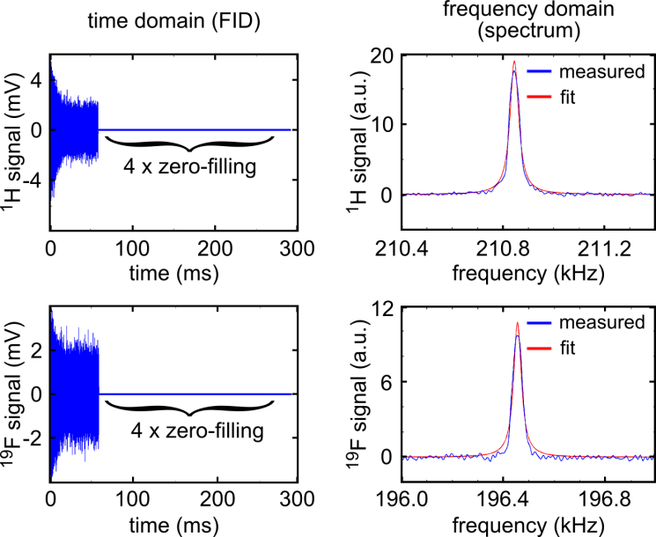

FIG 6. Typical low-field ¹H- (top) and ¹⁹F- (bottom) NMR signal. The data was acquired of 2.85 ml immersion oil or C₇F₁₆, respectively, using the solenoid coil SC₂₂ at 4.9 mT. 2000 individual 90°-acquisitions with a repetition time T_{R} of 1 s (¹H) and 5 s (¹⁹F) were summed-up for each dataset. The spectrum was obtained after four-times zero-filling and subtracting a DC offset by fast Fourier transformation. The signal strength was quantified by fitting a Lorentzian function (red) to the spectrum (blue).

Twisted laser beams
As expected, an annular intensity profile was observed behind the SLM of the higher-order Bessel- and LG-beams. However, we found that distortions of the ring-shaped profile became more and more prominent for higher charge numbers, e.g., 𝓁 = 100. As a consequence, we chose to apply charge numbers no larger than 𝓁_{max} = 50 for the OAM-HP experiment (Fig. 7).

Hyperpolarization experiments
The effect of OAM-carrying beams on the NMR signal was investigated by irradiating a fraction of a 180 μl sample of either C₇F₁₆ or immersion oil during or in between NMR measurements, similar to the description of Albu et al. [18]. Statistically significant evidence for nuclear HP of the order of two was observed in none of our experiments, although a notable increase of NMR signal appeared in some settings (Fig. 8). Moreover, we did not observe a monotonic increase or decrease of the effect with variation in topological charge.
The most prominent signal increase was found when 180 μL of C₇F₁₆ was continuously irradiated with an LG-beam. Here, the area of the ¹⁹F-NMR resonance increased from (1.00 ± 0.02) to (1.06 ± 0.02) [a.u.] for 𝓁 = 0 and 𝓁 = 50, respectively. For comparison of these two experiments an unpaired t-test was used to analyze the significance of the observed variation and a p-value of p = 0.06 was determined. Accordingly, no statistical significance (p < 0.05) was reached and a variation of that order or larger may occur in one out of 20 experiments. However, the level of a possible HP of this signal increase strongly depends on the assumed HP volume and is discussed later.
Furthermore, enlarged standard errors were observed in some 𝓁 ≠ 0 settings, when compared to the measurements with 𝓁 = 0 and compared to the reproducibility of our setup
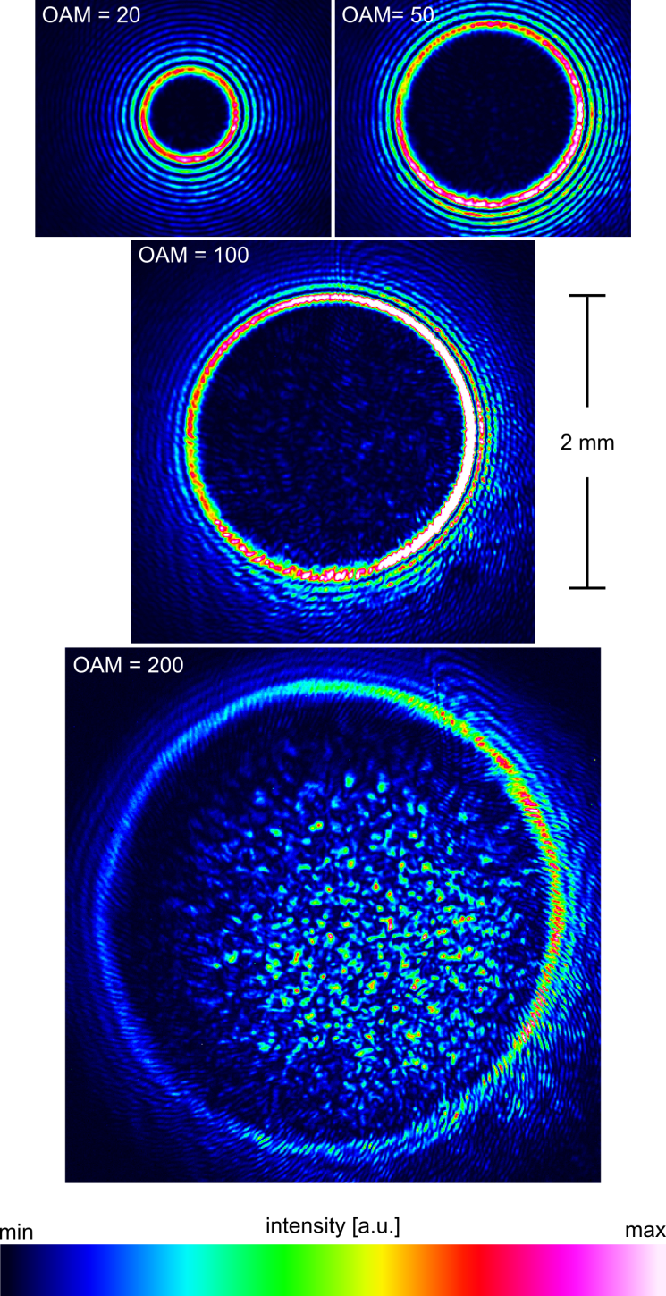
FIG 7. Intensity profile of Bessel beams with different charge numbers 𝓁. The pictures were acquired in the focus of a lens with f = 150 mm. Note the distortions of the ring-shaped profile as well as an increasing intensity inside of the ring that became stronger for large charge numbers of 100 and more.

that was previously determined (Supplementary Table I). This observation may indicate an effect that is not consistently induced in every measurement.

Theoretical considerations
It is already known that light can induce nuclear HP by means of optical pumping [54]. No direct coupling of the optical field to the nuclear spins, whose resonance frequencies lie in the radio-frequency domain, was yet reported.
The primary process of optical pumping is the absorption of a photon by an atom or a molecule. Such absorption processes satisfy the angular momentum conservation law (selection rules), such that the spin of a photon is converted to the angular momentum of the atomic electron in the excited state. Electronic polarization is then mediated to
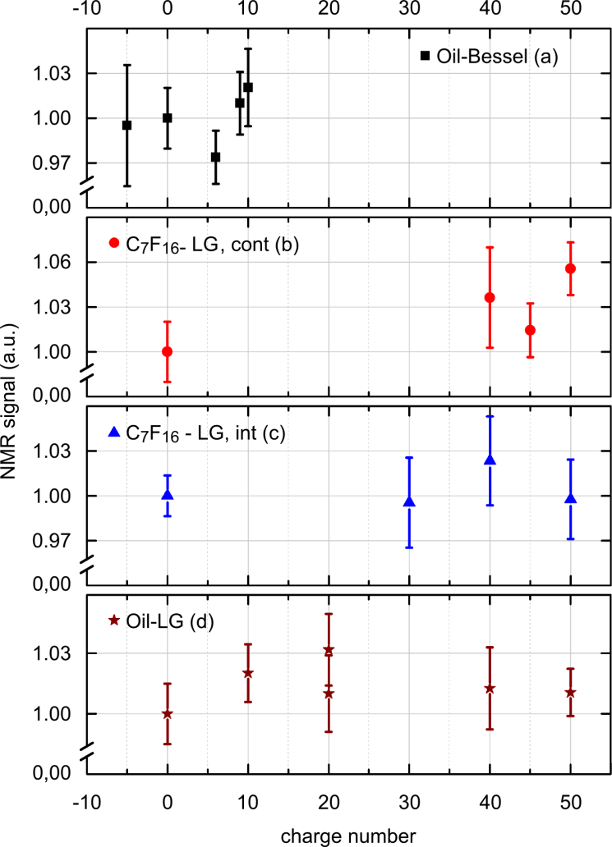
FIG 8. ¹H- and ¹⁹F-NMR signal plotted as function of the charge number 𝓁 of the laser beam that was applied. The data was acquired from 180 µl of solution of either immersion oil or Fluorinert with the following parameters: Oil-Bessel: Bessel irradiation of immersion oil for 9 s subsequent to NMR with T_{R} = 10 s, f = 208.2 kHz; C₇F₁₆-LG, cont: continuous irradiation of Fluorinert with LG beams during NMR with f = 196.5 kHz, T_{R} = 5 s; C₇F₁₆-LG, int: irradiation of Fluorinert for 2.5 s with LG beams subsequently to NMR at f = 196.5 kHz, T_{R} = 3.5 s; Oil-LG: irradiation of immersion oil for 1.3 s with LG beams followed by NMR at f = 211.0 kHz, T_{R} = 1.7 s.
Variations in NMR signal area were not statistically relevant, although some measurements exhibited a notable increase [(b) and (d)]. Each data point represents the mean value of 20 measurements of 500 scans each; error bars indicate the standard error of the mean (s.e.m.).

nuclear polarization due to hyperfine interactions [55]. We stress that the hyperfine interaction occurs between the electronic spins and the nuclei and that it does not involve photons.
Assuming that similar mechanisms may also take place in the case of optically induced OAM-HP, we estimate the variation of the photo-absorption probability due to the twist of a light wave that carries an OAM in the following.
For a qualitative analysis, we used quantum mechanical perturbation theory. The wave function of light-exposed electrons can be written as, where and are the ground and excited electronic states, respectively. In the first order, the photon-absorption probability is proportional to the squared transition amplitude, where and represents the field-molecule interaction Hamiltonian. Here, $z$ was selected in the direction of the light propagation and is the projection of the electric dipole moment on the polarization vector of the incident electric field.
For a plane wave, we have. In the optical domain, the electric dipole approximation can be applied, wherein the spatial variation of the electromagnetic field on the scale of the length of the molecule can be neglected.
For an OAM beam any nonlinear dependence of the transition amplitude on, e.g., due to its complex spatial structure, relies on the x-dependence of the electric field within the electron orbital. Such a deviation is described by the expansion terms of the order of in U.
The twist of the light field amounts to a correction of the interaction Hamiltonian U which is of the order of, where a is the orbital size (≈ 1 nm) and λ_{eff} is the effective wavelength of ≈ 444 nm for the calculated focal diameter of 14 µm for an LG-beam with 𝓁 = 50.
Altogether, we obtain the first-order correction. Thus, the relatively small size of the next-to-leading terms in can be estimated to. For any kind of interaction, ε defines the order of magnitude of - additional - effects generated by the OAM of the light beam.
The above estimate does not assume any symmetry of the electron wave functions. If the ground and excited states of the electrons obey a definite parity, the correction due to the term in U vanishes and the next one arises from the term, yielding a much smaller relative effective magnitude of the order of .

Another aspect is the conservation of angular momentum in the case of OAM-photon absorption. From the same reasoning as above, the major effect of the photonic orbital angular momentum is likely to be on the motion of the molecule as a whole, for which the spread of the wave function is more similar to the local dimensions of the OAM beam. Such a function describes the spatial motion of the molecule after the interaction. In other words, the orbital angular momentum of light is likely to be transferred to the molecular rotation, but not to a nuclear spin or an excited electronic state, which is in agreement with prior theoretical works [37–40]. Note here, that the coupling of the external rotational degree of freedom of a molecule to its internal electronic degrees of freedom can be ignored due to markedly different typical energy scales of these two kinds of motion.
One may think of a mechanism where the OAM of light is directly transferred to OAM of the electron. Thereafter, it could be transferred to electron spin through fine interactions and then the hyperfine interactions may proceed as described above. There are some theoretical works arguing that the transfer of OAM from light to an electron is possible in the electric dipole approximation [41]. However, even if such a transfer would be possible, it would have a scaling factor of

with the spread of the center of mass wave function of the molecule, which is assumed to be smaller than the beam waist, w₀, and the internuclear separation [41]. Thus, this mechanism is negligible in the optical range and would actually decrease with 𝓁, which was not the case in the reports of Elgort and Albu et al.. A tiny effect of 𝓁, however, is consistent with our qualitative considerations presented above.
On the other hand, there is a series of works where it is shown that the OAM of light is only transferred to the center-of-mass motion of an atom/molecule and not to the electrons [37–40]. The latter predictions were actually observed experimentally [32,33].
Summarizing, the transition probability is nearly independent from the OAM of the applied laser and in the case of photon absorption the OAM is most likely to be transformed into molecular rotation. These considerations suggest that no additional effect (including nuclear HP) is expected that wouldn’t occur for a planar laser beam (which doesn’t carry an OAM). In particular, if there is an occurrence of optically induced HP, it shall not be depending on the topological charge 𝓁, unless there is a new mechanism of momentum transfer identified.

DISCUSSION
The goal of this work was to investigate and reproduce the hyperpolarization of nuclear spins by means of twisted laser beams. To this end, the following steps were implemented:

Low-field NMR
- Thermally-polarized ¹H- and ¹⁹F-NMR signal of 180 µl solutions was successfully acquired at 5 mT.
- We ascertained that the detection unit was sensitive in the region of the sample where the laser was focused. Hence, we expect to be sensitive to a change in nuclear polarization that would be induced by the OAM beam.
- The reproducibility of the setup to measure the summed signal of 500 scans of 180 μl thermally polarized solution at 5 mT was quantified to 9 %.
- This reproducibility provides a sensitivity to detect the change in total signal that would be induced by an additional 0.09 pl of 100 % polarized solution (on top of the thermal signal of 180 μl) with one σ. For a significance of 2 σ, a volume of 0.18 pl completely polarized solution is required. This sensitivity was reached by repeating the aforementioned series of 500 acquisitions 20 times. Naturally, if a lower polarization were achieved, a larger HP volume would be required to satisfy the sensitivity of the setup.

Orbital Angular Momentum of Light
- Light angular momenta were created with topological charges up to 𝓁 = 50.
- The OAM-beam was focused in the sample within the sensitive volume of the low-field NMR unit with a power of ≈ 75 mW.
For comparison, Albu et al. applied charge numbers up to 𝓁 = 20 at a power of 40 mW. Note that an increase of the effect with OAM and beam power was reported (Eq. (4)).

OAM-Hyperpolarization
- OAM-beams were applied in NMR experiments.
We estimated the volume that may get hyperpolarized by the laser to V_{HP} = 3 pl – 100 pl.
For comparison, Albu et al. reported V_{HP} = 0.1 pl - 400 pl.
- Some change in signal was observed, namely an increase in NMR signal as well as enlarged variability. These findings may indicate some interaction between helically phase-shaped beams and nuclear spins. However, a significant statistical variation of the order of two standard errors or larger was not observed.

For the interpretation of these results, the sensitivity of our setup to detect changes of the overall NMR signal is key, in particular if this sensitivity is sufficient to detect an HP effect as reported by Albu et al.
To address this question, we consider the parameters of the most promising experiment, where 180 μl of Fluorinert were measured and a signal increase from (1.00 ± 0.02) to (1.06 ± 0.02) [a.u.] was found. Accordingly, the relative change in signal with propagated error was (6 ± 3) % and did not surpass the 2σ - threshold for statistical significance.
The 2-σ sensitivity of our setup to detect changes in total signal is 0.18 pl solution polarized to P = 100 % (or 100 ∙ 0.18 pl of solution polarized to 1 %, etc.).
Depending on the assumed hyperpolarized volume, V_{HP,} (estimated to 3 pl – 100 pl), we can deduce that the HP in this volume did not exceed P = 6 % - 0.18 %.
Thus, the first conclusion we can draw with relative certainty is that we did not observe an HP effect of the order of unity, which was predicted in [26].

The second conclusion is more difficult to make: is the polarization limit sufficient to detect the effect as reported by Albu et al.? Unfortunately, it was not reported how exactly the HP was determined, and which values were used for the calculation. Thus, this question cannot be answered directly.
However, the question can be addressed by using the relative signal increases I₊ shown in the data in [18] and the relation of Eq. (1) ().
It turns out that the quoted numbers appear not to be entirely consistent, or that we are misinterpreting the results [18] (Table I):
Given the values of V_{S} = 1 nl, V_{HP} = 0.1 pl – 400 pl, I₊ = 5 - 21 % (extracted from the plot) and a thermal ¹H-polarization of P_{therm} = 3 ppm at B₀ = 1 T, a polarization (dependent on I₊) of P_{HP} = 3.8*10⁻⁷ – 1.6*10⁻⁶ (assuming V_{HP} = 400 pl) up to P_{HP} = 1.5*10⁻³ – 6.3*10⁻³ (assuming V_{HP} = 0.1 pl) is expected. However, P_{HP} = 1.5*10⁻² – 5*10⁻² was reported.
Accordingly, one or more values must have been misreported or misinterpreted, prohibiting a direct comparison of our results to the previous work.

Still, it is enlightening to discuss whether we may have induced and observed an HP level as it was reported, P_{HP} = 1.5 - 5 %. We conclude that most likely this was not the case: effects of the reported order may have been indistinguishable only if the volume where the HP takes place (V_{HP}) was indeed no larger than 3 pl (which was the lower bound in our estimation, assuming that no molecular motion takes place).
However, we want to stress that according to Eq. (4), which was provided by Albu et al., our implementation of the experiment is expected to induce a stronger HP effect than the one reported before: we were applying beams with higher power (75 mW vs. 40 mW), shorter wavelength (514.5 nm vs. 532 nm) and higher topological charges, up to 𝓁 = 50 (vs. 𝓁 = 20).

where I is the beam intensity, 𝓁 the charge number, R the beam waist, a is the molecule size, λ the wavelength and T_{OAM} the build-up constant of a hyperpolarized state (note that we have replaced the “≈” symbol by “~” in view of misbalanced physical dimensions).

Thus, our second conclusion is that a polarization of the reported range P = 1.5 - 5 % was, most likely, not observed, despite the fact that more powerful OAM-laser beams were applied compared to the earlier setup.

We discuss possible reasons for this finding in the following:
- Hyperpolarized volume: Albu et al. have estimated a lower limit of V_{HP} = 0.1 pl. If the hyperpolarized volume is indeed that small, the sensitivity of our setup is not sufficient to detect the effect, even if the volume were polarized to P_{HP} = 1. Note, though, that the V_{HP} in our and the earlier implementation is likely to be similar because the same focal diameter of ≈ 10 µm was used (𝓁 = 20) and as the Rayleigh range can be expressed by, where n_{m} is the index of refraction of the sample, λ is the wavelength and w₀ is the waist size. Thus, length and diameter of the laser irradiated volume are of a similar order.
- Misreported or misinterpreted values: As some of the values in [18] appear to be inconsistent, it is possible that we did not reproduce an important parameter correctly, e.g., the required irradiation time. The achieved HP of P_{HP} = 1.5 – 5 %, however, was consistently reported in several places, including the oral contribution of the ISMRM 2012, and appears reliable.
- Differences of the setups: We note that there were some differences between the setup reported here and the original one, although according to Eq. (4), none of these differences are expected to have a relevant impact on the HP (Table I). In particular, the B₀ field was much smaller in our setting (5 mT vs. 1 T), however, Elgort and Albu did not state a dependency on B₀ and have reported a similar setup operating at 180 mT earlier [17]. Furthermore, our sample size was larger (180 µl vs. 1 nl). Note, though, that the difference in detected thermal signal (3000 [a.u.] vs. 3.4 [a.u.]) that is due to the difference in sample size is partially compensated by the lower magnetic field (and thus lower polarization) we used (17 ppb vs. 3.4 ppm).
- Weaknesses of our setup: There was a short delay of the order of < 200 ms between deflecting the beam from the sample and starting the NMR measurement (in experiments with interrupted laser irradiation). During this delay, a hyperpolarized state would decay with the longitudinal relaxation time T₁. This effect is more relevant for experiments with immersion oil that has a short T₁ < 1 s, but less for long-T₁ samples like C₇F₁₆ with T₁ ≈ 1 s. Note that the highest signal increase was observed during continuous irradiation of a long-T₁ sample.

These items may explain why HP was experimentally not induced positively.

Another conclusion can be drawn regarding to our theoretical considerations. Starting from the formerly known mechanisms of optically-induced nuclear polarization, there was no evidence found for a relevant additional HP effect that arises from the OAM of the laser:
the magnitude of perturbation-theory correction terms, which are accounting for the twist of the beam, suggests that the OAM of the light does not change the excitation of electrons by more than a few parts per thousand in the most favorable case. The effect of the twist of the phase is negligible due to the small electron-orbital size of ≈ 1 nm relative to the effective wavelength of ≈ 444 nm. Moreover, in the case of photon absorption, the OAM is expected to result in molecular rotation instead of nuclear HP. These observations suggest that the OAM of the light is not accountable for the observed HP effects, if no fundamentally new mechanism of OAM transfer is identified.

However, the earlier reports of OAM-HP still remain promising for the field of nuclear hyperpolarization. If the reported experiments indeed were reproduced, it must be born in mind that the polarized amount of sample is relatively small and may need improvements for in vivo application. Thus, it is likely that the new method may rather get relevant for spectroscopic applications than for the polarization of large amounts of sample.
For the full harvesting of OAM-HP it shall be noted though, that the relevant setup parameters may potentially be further increased compared to our implementation. However, all parameters in Eq. (4) are, to date, technically restricted such as, e.g., the beam intensity and 𝓁 by the specifications of the spatial light modulator, or the wavelength by the application itself. Additionally, when further increasing the beam power, possibly unwanted nonlinear effects may arise.

Conclusion
A widely-applicable and simple method for the hyperpolarization of nuclear spins is of great interest for many fields including medical diagnostics. A promising method that uses the orbital angular momentum of light was reported in 2008 [17] and 2012 [18]. In this work, we reproduced the experiment at a low magnetic field. We observed an increase of NMR signal in conjunction with OAM-irradiation as well as enlarged standard deviations in some measurements. At no time however, did the effects surpass the 95 % threshold for statistical significance. We were able to provide an upper limit for a possible HP of nuclear spins by means of twisted light of P < 0.18 – 6 %, although this limit is highly depending on the hyperpolarized amount of sample that is assumed. Note however, that there may be experimental intricacies that are required for OAM-HP that we are unaware of and that exacerbated the observation of the effect.
Physically argued theory suggests that the effect of the OAM on nuclear spins could deviate from the interaction with a plane wave by a few parts per thousand at most. This result sheds some doubt onto the correlation of the twist of the irradiating laser and the observed hyperpolarization effects, which were reported before. Still, this subject matter remains highly interesting and an experimental verification would require a deeper theoretical reassessment. Certainly, a concrete mechanism would also have to be identified to support any such observations.

Acknowledgements
The authors want to thank Dr. Ingo Breunig and the Chair for Optical Systems, Department of Microsystem Engineering, Freiburg, for providing the optical equipment and their lab for conducting the experiments. Support by the DFG (HO 4604/1-1 and HO 4604/2-1), the German Consortium for Translational Cancer Research, Partner Site Freiburg and the cost network is gratefully acknowledged.

TABLE I. Setup parameter of the original and the reproduction setup side by side (n.s. means not stated). * The values of the report from 2012 were not consistent or were misinterpreted here (see text).
parameter |  | Elgort and Albu  (abstract ISMRM 2008) | Albu and Elgort et al.*  (abstract ISMRM 2012) |  |  | Albu  (talk ISMRM 2012) |  | Schmidt et al.  (this report)
NMR:
static magnetic field |  | 180 mT | 1 T |  |  | 350 mT and 1 T |  | 5 mT
sample volume |  | 30 µl | 1 nl |  |  | 1 µl |  | 180 µl
liquid sample |  | index matching oil | n.s. |  |  | n.s. |  | immersion oil and C₇F₁₆
data acquisition |  | FID | spin-echo |  |  |  |  | FID
optics:
wavelength |  | 532 nm | 532 nm (amongst others) |  |  | 488 nm |  | 514.5 nm
beam power (focus) |  | n.s. | 40 mW |  |  | 5 – 30 mW |  | (75 ± 4) mW
focus diameter |  | ≈ 4.8 µm | ≈ 10 µm |  |  | ≈ 1 – 20 µm |  | ≈ 10 µm (𝓁 = 20)
sample irradiation |  | intermittent | most likely intermittent |  |  | n.s. |  | continuous and intermittent
B₀ ∡ |  | transversal | longitudinal |  |  | trans. and long. |  | longitudinal
charge carrying beam:
beam type |  | n.s. | LG |  |  | n.s. |  | LG and Bessel
range of 𝓁 |  | 0 - + 19 | -20 - +19 |  |  | -20 - +80 |  | -5 - +50
OAM-HP
assumed VHP |  | n.s. | 0.1 – 400 pl |  |  | n.s. |  | 3 – 100 pl
increase in total signal |  | n.s. | 5 – 21 % |  |  | 5 – 21 % |  | < (6 ± 3) %
HP in V_{HP} |  | n.s. | 1.5 – 5 % |  |  | 1.5 – 5 % |  | < 0.18 % or < 6 %

References
[1] S. E. Day, M. I. Kettunen, F. A. Gallagher, D.-E. Hu, M. Lerche, J. Wolber, K. Golman, J. H. Ardenkjaer-Larsen, and K. M. Brindle, Nature Medicine 13, 1382 (2007).
[2] F. A. Gallagher, M. I. Kettunen, S. E. Day, D.-E. Hu, J. H. Ardenkjær-Larsen, R. in ‘t Zandt, P. R. Jensen, M. Karlsson, K. Golman, M. H. Lerche, and K. M. Brindle, Nature 453, 940 (2008).
[3] M. S. Albert, G. D. Cates, B. Driehuys, W. Happer, B. Saam, C. S. Springer, and A. Wishnia, Nature 370, 199 (1994).
[4] M. C. Cassidy, H. R. Chan, B. D. Ross, P. K. Bhattacharya, and C. M. Marcus, Nat Nano 8, 363 (2013).
[5] J.-B. Hövener, N. Schwaderlapp, T. Lickert, S. B. Duckett, R. E. Mewis, L. A. R. Highton, S. M. Kenny, G. G. R. Green, D. Leibfritz, J. G. Korvink, J. Hennig, and D. von Elverfeldt, Nat Commun 4, (2013).
[6] K. Münnemann and H. W. Spiess, Nature Physics 7, 522 (2011).
[7] F. Reineri, T. Boi, and S. Aime, Nat Commun 6, 5858 (2015).
[8] R. W. Adams, J. A. Aguilar, K. D. Atkinson, M. J. Cowley, P. I. P. Elliott, S. B. Duckett, G. G. R. Green, I. G. Khazal, J. López-Serrano, and D. C. Williamson, Science 323, 1708 (2009).
[9] M. Harada, H. Kubo, T. Abe, H. Maezawa, and H. Otsuka, Japan Radiological Society 28, 173 (2010).
[10] S. J. Nelson, J. Kurhanewicz, D. B. Vigneron, P. E. Z. Larson, A. L. Harzstark, M. Ferrone, M. van Criekinge, J. W. Chang, R. Bok, I. Park, G. Reed, L. Carvajal, E. J. Small, P. Munster, V. K. Weinberg, J. H. Ardenkjaer-Larsen, A. P. Chen, R. E. Hurd, L.-I. Odegardstuen, F. J. Robb, J. Tropp, and J. A. Murray, Sci Transl Med 5, 198ra108 (2013).
[11] A. Abragam and M. Goldman, Rep. Prog. Phys. 41, 395 (1978).
[12] J. Wolber, F. Ellner, B. Fridlund, A. Gram, H. Jóhannesson, G. Hansson, L. H. Hansson, M. H. Lerche, S. Månsson, R. Servin, M. Thaning, K. Golman, and J. H. Ardenkjær-Larsen, Nuclear Instruments and Methods in Physics Research Section A: Accelerators, Spectrometers, Detectors and Associated Equipment 526, 173 (2004).
[13] J. H. Ardenkjaer-Larsen, A. M. Leach, N. Clarke, J. Urbahn, D. Anderson, and T. W. Skloss, NMR Biomed. 24, 927 (2011).
[14] C. R. Bowers and D. P. Weitekamp, Phys. Rev. Lett. 57, 2645 (1986).
[15] M. Goldman and H. Johannesson, C. R. Physique 6, 575 (2005).
[16] J.-B. Hövener, E. Chekmenev, K. Harris, W. Perman, L. Robertson, B. Ross, and P. Bhattacharya, Magn Reson Mater Phys 22, 111 (2009).
[17] D. R. Elgort and L. R. Albu, Proc. Intl. Soc. Mag. Reson. Med. 16, 3200 (2008).
[18] L. R. Albu, D. R. Elgort, and J.-L. Robert, Proc. Intl. Soc. Mag. Reson. Med. 20, 265 (2012).
[19] L. R. Albu and D. R. Elgort, WO2010146502A1 (June 2010).
[20] L. R. Albu, D. R. Elgort, and S. Mukherjee, US 20100327866A1 (30 December 2010).
[21] D. R. Elgort and L. R. Albu, WO/2010/146517 (24 December 2010).
[22] D. R. Elgort and L. R. Albu, WO/2010/064155 (11 June 2010).
[23] D. R. Elgort and L. R. Albu, US 20120150019A1 (14 June 2012).
[24] D. R. Elgort, L. R. Albu, and C. Bos, US20140037062 A1 (August 2012).
[25] D. R. Elgort and L. R. Albu, WO/2012/172471 (21 December 2012).
[26] D. R. Elgort and L. R. Albu, US 8,765,099 B2 (1 July 2014).
[27] R. A. Beth, Phys. Rev. 50, 115 (1936).
[28] L. Allen, M. W. Beijersbergen, R. J. C. Spreeuw, and J. P. Woerdman, Physical Review A 45, 8185 (1992).
[29] H. He, M. E. J. Friese, N. R. Heckenberg, and H. Rubinsztein-Dunlop, Physical Review Letters 75, 826 (1995).
[30] M. E. J. Friese, T. A. Nieminen, N. R. Heckenberg, and H. Rubinsztein-Dunlop, Nature 394, 348 (1998).
[31] V. Garcés-Chávez, D. McGloin, M. J. Padgett, W. Dultz, H. Schmitzer, and K. Dholakia, Physical Review Letters 91, 093602 (2003).
[32] F. Araoka, T. Verbiest, K. Clays, and A. Persoons, Physical Review A 71, 055401 (2005).
[33] W. Löffler, D. J. Broer, and J. P. Woerdman, Physical Review A 83, 065801 (2011).
[34] S. J. van Enk, Quantum Opt. 6, 445 (1994).
[35] R. Jáuregui, Physical Review A 70, 033415 (2004).
[36] M. Babiker, W. L. Power, and L. Allen, Physical Review Letters 73, 1239 (1994).
[37] M. Babiker, C. R. Bennett, D. L. Andrews, and L. D. Romero, Physical Review Letters 89, 143601 (2002).
[38] L. D. Romero, D. L. Andrews, and M. Babiker, Journal of Optics B: Quantum and Semiclassical Optics 4, S66 (2002).
[39] D. L. Andrews, L. C. D. Romero, and M. Babiker, arXiv Preprint physics/0305002 (2003).
[40] D. L. Andrews, L. C. D. Romero, and M. Babiker, Optics Communications 237, 133 (2004).
[41] A. Alexandrescu, D. Cojoc, and E. Di Fabrizio, Physical Review Letters 96, 243001 (2006).
[42] P. K. Mondal, B. Deb, and S. Majumder, Physical Review A 89, 063418 (2014).
[43] M. Padgett, J. Courtial, and L. Allen, Physics Today 57, 35 (2004).
[44] P. Török and P. Munro, Optics Express 12, 3605 (2004).
[45] S. Fürhapter, A. Jesacher, S. Bernet, and M. Ritsch-Marte, Optics Express 13, 689 (2005).
[46] K. I. Willig, B. Harke, R. Medda, and S. W. Hell, Nature Methods 4, 915 (2007).
[47] F. O. Fahrbach, P. Simon, and A. Rohrbach, OPTICS EXPRESS 18, 24229 (2010).
[48] F. O. Fahrbach, P. Simon, and A. Rohrbach, Nature Photonics 4, 780 (2010).
[49] M. A. Lauterbach, M. Guillon, A. Soltani, and V. Emiliani, Scientific Reports 3, (2013).
[50] G. Gibson, J. Courtial, M. Padgett, M. Vasnetsov, V. Pas’ ko, S. Barnett, and S. Franke-Arnold, Optics Express 12, 5448 (2004).
[51] M. Krenn, R. Fickler, M. Fink, J. Handsteiner, M. Malik, T. Scheidl, R. Ursin, and A. Zeilinger, New Journal of Physics 16, 113028 (2014).
[52] R. Borowiak, N. Schwaderlapp, F. Huethe, T. Lickert, E. Fischer, S. Baer, J. Hennig, D. v. Elverfeldt, and J. B. Hoevener, Magn Reson Mater Phy 26, 491 (2013).
[53] J. Arlt, R. Kuhn, and K. Dholakia, Journal of Modern Optics 48, 783 (2001).
[54] W. Happer, Reviews of Modern Physics 44, 169 (1972).
[55] S. Appelt, A. B.-A. Baranga, C. J. Erickson, M. V. Romalis, A. R. Young, and W. Happer, Physical Review A 58, 1412 (1998).

