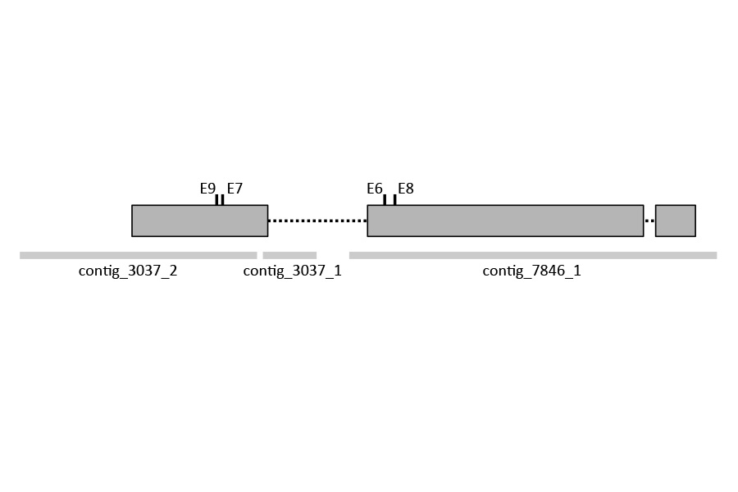
Supplementary Figure 1

The Sr33 locus with contig sequences and SNV mutations identified by RenSeq.
Sr33 exons are depicted as grey boxes while introns are shown as dashed black lines. The positions of point mutations (E6 to E9) are marked by vertical lines. RenSeq contigs aligning to the locus with 100% identity are indicated by grey lines below Sr33..
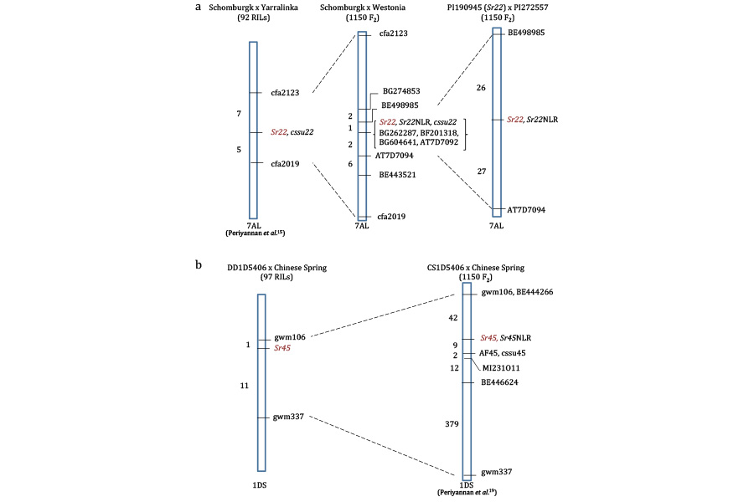
Supplementary Figure 2

Genetic linkage maps of Sr22 and Sr45.
a. Linkage of markers around Sr22 in hexaploid wheat (T. aestivum) and diploid Einkorn (T. monococcum).
Markers are indicated on the right of each chromosome (blue rectangle) and the number of recombinant individuals is indicated between markers on the left. Sr22NLR is the marker derived from the Sr22 candidate gene which co-segregates with Sr22 resistance (shown in red) in both diploid and hexaploid bi-parental mapping populations.
b. Linkage of markers around Sr45 in hexaploid wheat. Sr45NLR is the marker derived from the Sr45 candidate gene which co-segregates with the Sr45 resistance locus (shown in red) in the hexaploid bi-parental mapping population¹⁹.

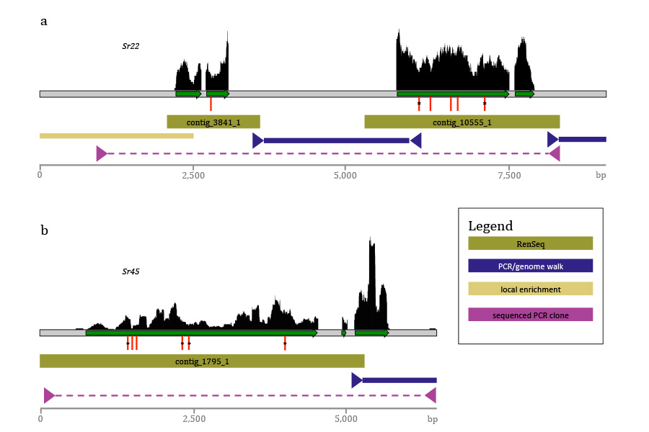
Supplementary Figure 3

Verification of the physical structure of Sr22 and Sr45.
Purple and magenta triangles mark the primer positions for PCRs on or in close proximity of RenSeq contigs (khaki green) within the genome. Purple (Sr22Candidate_F2 x Sr22Candidate_R2) and magenta (S22F14 x S22R4) primers are listed in Supplementary Table 11. Whole leaf transcriptome RNAseq (top, black) was used to confirm exon structure (green arrows). The sequence between RenSeq contigs was determined using Sanger sequencing of PCR products. The Sr22 5’ sequence was obtained using local RenSeq (yellow).
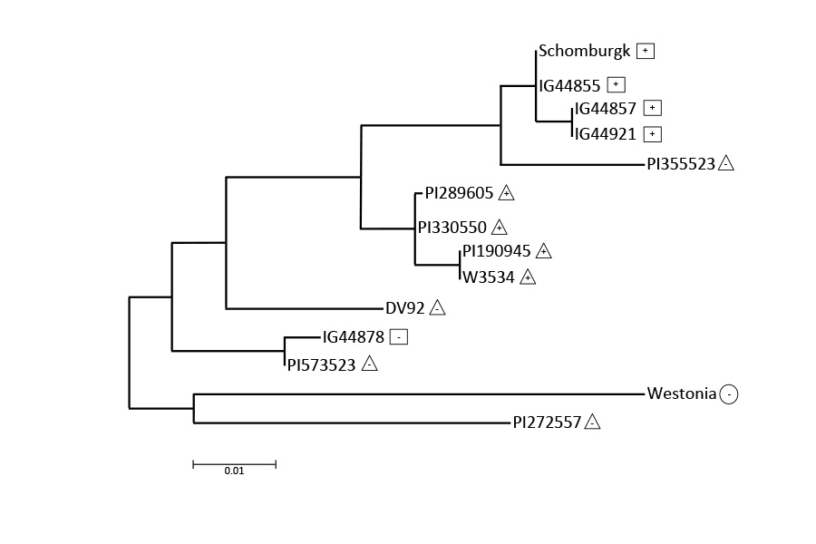
Supplementary Figure 4

Neighbour-joining tree analysis of Sr22 gene variants identified from diploid and hexaploid wheat (Supplementary Table 12).
The postulated presence or absence of Sr22 based on resistance to wheat stem rust is denoted with “+” or “–“ signs located in box, triangle or circle symbols that indicate a T. boeoticum, T. monococcum or T. aestivum origin, respectively.
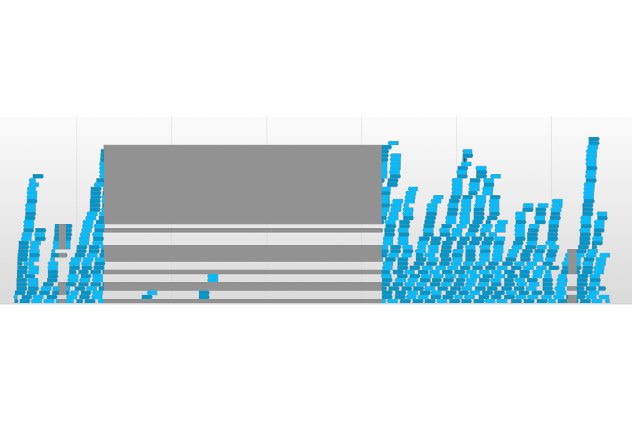
Supplementary Figure 5

Transcript read coverage of the Sr22 locus.
RNAseq reads were aligned to the Sr22 genomic locus using the gapped aligner Tophat2¹⁰. Reads were filtered for mapping in a proper pair using SAMtools⁹. The Savant¹¹ screenshot shows the region of the locus that includes the start and end of transcribed sequence. The blue arrows depict mapped reads (dark blue: forward reads; light blue: reverse reads) and grey stretches represent skipped bases (gaps) within mapped reads. The few reads mapped to the second intron are unspecific mappings resulting from mapping the entire transcriptome to a single locus.
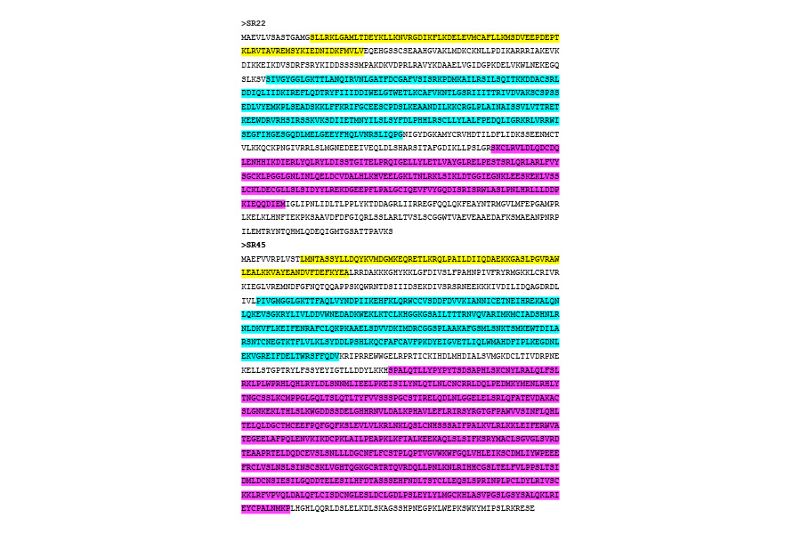
Supplementary Figure 6

Amino acid sequence of SR22 from Schomburgk and SR45 from CS1D5406.
Domains within the sequence are highlighted according to NLR-associated motif analysis from Jupe et al.²³: Coiled-coil, yellow; NB-ARC, cyan; Leucine-rich repeats, magenta.
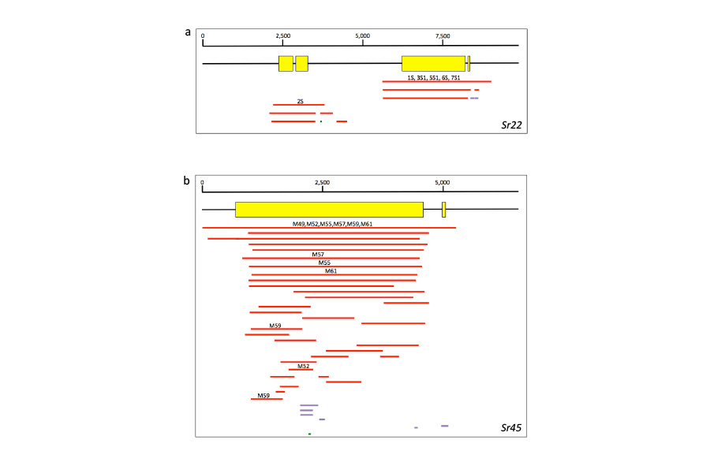
Supplementary Figure 7

Local alignments of RenSeq assemblies to Sr22 and Sr45.
Yellow blocks represent gene coding sequence. Lines below represent local alignments between Sr22 (a) and Sr45 (b) coding sequences and contigs in the RenSeq assemblies. The score of each alignment is colour coded by red (score ≥200), purple (score between 80 and 200) and green (score below 80). Text above alignments indicate the positions of mutations within the coding sequence.

