Is Chinese Competition Causing De-industrialization in Brazil?

Rhys Jenkins
School of International Development
University of East Anglia
Norwich
NR4 7TJ
United Kingdom

E-mail: R.O.Jenkins@uea.ac.uk
Is Chinese Competition Causing De-industrialization in Brazil?

Abstract

There has been a lively debate in Brazil in recent years involving sectors of business, the labour movement and academics, over deindustrialization and the future of the manufacturing sector. This is often linked to the growing relation between Brazil and China which is now the country’s most significant trade partner. The paper shows that Brazil has experienced relative deindustrialization in the sense of a declining share of the manufacturing sector in GDP which is mainly attributable to the changes in the country’s trade balance in manufactures. It then considers both the direct and indirect impacts of China on Brazilian manufacturing and concludes that these have contributed both to the “primarization” of Brazilian exports and the relative deindustrialization both through competition in the domestic market and in exports.

Key words: Brazil; China; de-industrialization; trade; manufacturing; employment
Is Chinese Competition Causing De-industrialization in Brazil?

- Introduction
One of the most significant economic developments of the past three decades has been the re-emergence of China as a global economic power. Since 1980 China’s GDP has grown at more than 9% a year and it has overtaken Japan to become the second largest economy in the world after the United States. It has also become much more integrated into world trade, increasing its share of total global trade from 1% in 1980 to over 10% by 2010. In that year it overtook Germany to become the world’s largest exporter. It is also growing in terms of global financial resources as was highlighted recently by the attempts of the Eurozone economies to enlist Chinese financial support for the Euro. China’s foreign exchange reserves, in excess of US$3 trillion, are the largest in the world. Also having been a major destination for foreign direct investment since the 1980s, it is now emerging as an outward investor.

The growth of China has had a significant impact on the Brazilian economy over the past decade. Trade has grown twenty-fold and China is now Brazil’s most significant trading partner accounting for 17% of total exports and more than 15% of Brazilian imports (SECEX data for 2012). In 2010 China also emerged as an important investor in the Brazilian economy with major acquisitions of companies in oil and gas and in mining (CEBC, 2011). In March 2013 the two countries agreed a currency swap equivalent to US$30 billion so that trade between them could take place in local currencies rather than in dollars.

The growing economic links between the two countries have been reflected in a number of Presidential visits both by Chinese President Hu Jintao to Brazil and by Brazilian President Lula da Silva to China. China was also the first country visited by President Dilma Rousseff after taking over from Lula. In 2012 the two countries upgraded their relationship terming it a “comprehensive strategic partnership”.

The relationship with China has been a source of considerable controversy in Brazil (Barbosa and Mendes, 2006; Maciel and Nadel, 2011). While exporters of commodities, particularly iron ore and soybeans have benefited from the rapid growth of demand for primary products in China and rising world prices, manufacturers have felt threatened by Chinese competition in both the domestic and the export markets. Some commentators have gone so far as to suggest that the re-emergence of China is leading to a “primarization” of Brazilian exports and a “deindustrialization” of the economy, with negative impacts on long term economic development.

- Deindustrialization, primarization and development
- Industrialization and development
Orthodox economics tends to assume that all economic activities are the same in terms of dynamic potential and that countries should specialize according to their comparative advantages, whatevever those may be. From this perspective there is no particular virtue in producing manufactured goods. In contrast heterodox economists and radical political economists have a long tradition of emphasizing the specificity of manufacturing and the key role of industrialization in economic development (Reinert, 2007).

In the nineteenth century, Marx identified important “progressive” features of manufacturing which have been highlighted in more recent heterodox analyses of industrialization. These included increasing returns to scale, learning-by-doing and the potential for cumulative productivity increases which played a key role in his analysis of the production of relative surplus value and the process of capital accumulation. Marx also emphasized the importance of the social changes brought about by industrialization including the development of an industrial proletariat and changes in the structure and interests of the ruling class.

In Latin America, an emphasis on the key role of industrialization in economic development is particularly associated with the structuralist approach developed by the Economic Commission for Latin America (ECLA) after World War II (Kay, 1989).
The dangers of relying heavily on primary product exports were highlighted by the Prebisch-Singer thesis that commodity exporters faced a secular deterioration of the terms of trade vis-à-vis exporters of manufactured goods, which provided a rationale for import substituting industrialization,. The volatility of commodity prices was also seen as a negative aspect of specializing in primary products.

The Latin American structuralists formed part of a broader heterodox tradition in development economics which put forward a number of arguments in favour of developing a strong manufacturing sector (see Weiss, 1988, Ch.3 for a summary).
Backward and forward linkages play a role in generating economic growth and were seen as being particularly prevalent in manufacturing (Hirschman, 1958). Economic growth theories which emphasized “learning by doing” as a form of dynamic economies of scale also regarded manufacturing as the sector which drove economic growth. Moreover industry was also seen as being the key source of technological change which was then diffused through the rest of the economy.

Industry also enjoyed a privileged position in many radical writings on political economy (see Weiss, 1988, Ch.4 for a summary). Dependency theorists analysed the core-periphery relation in which the core concentrated industrial production and the periphery specialized in primary commodities (Frank, 1967; Cardoso and Faletto, 1979). When industrialization occurred in the periphery, this merely led to a “new dependence” in which the disarticulated nature of accumulation meant a continued reliance on traditional exports of primary commodities (Dos Santos, 1978, Ch.XVI). Industrialization in the periphery was compared unfavourably to the autocentric industrial development of the core (Amin, 1974). Even Marxist critics of dependency theory such as Warren (1973) and Harris (1986) shared a belief in the transformative capacity of industrialization. These theories provided a broader view of the key role played by industrialization including the associated class dynamics as well as the more technical arguments in favour of industrialization highlighted by heterodox economists.

- What is deindustrialization?
Concern about deindustrialization began in the advanced industrial economies in the 1960s. More recently however it has also been seen as a problem in a number of developing countries particularly in the context of structural adjustment programs and trade liberalization which were often associated with the contraction of the industrial sector.

Most of the literature on deindustrialization in the North focussed on the declining share of the manufacturing sector in total employment. In the advanced economies this fell from about 28% in 1970 to 18% in 1994 (Rowthorn and Ramaswamy, 1997, p.2). This does not necessarily mean that total employment in manufacturing decreased, although in many cases it did. This decline was particularly spectacular in the UK where the number of workers in manufacturing fell from 6.2 million in 1979 to 2.5 million in 2010 (Chakrabortty, 2011).

Deindustrialization can also be looked at in terms of the share of output that comes from the manufacturing sector. Some of the theoretical arguments concerning the negative effects of deindustrialization in fact relate to a declining share of manufacturing output rather than employment (Tregenna, 2009). This raises the question of whether output should be measured in current or constant prices. As Tregenna (2009, p.440, n.2) points out, some of the concerns over deindustrialization relate to the volume of manufacturing production while others are more linked to the value of manufacturing output. When considering the share of manufacturing in GDP therefore, there are grounds for looking at trends in both current and constant price terms.

Although the term deindustrialization carries negative connotations, this need not be the case. The relative importance of different economic activities changes over time as economies develop. All economies go through a phase of “de-agrarianization” as the share of the labour force and output from the agricultural sector declines and this is not seen as problematic. The notion of a post-industrial society in which the share of the service sector becomes more important has been around for a long time. In the context of the global South, the concern with deindustrialization can be seen as really referring to “premature deindustrialization” (Palma, 2008). This is seen as being different from the “normal” processes of deindustrialization experienced in advanced countries once they reach a certain level of income per capita.

Deindustrialization is sometimes associated with the notion of “primarization” or “re-primarization” which is taken here to refer to an increased reliance on exports of primary products to generate foreign exchange. This has been linked by Palma (2005) to a new concept of the “Dutch Disease” which is associated with a shift in the economy as a result either of a new commodity boom or a change in economic policy away from trying to generate a trade surplus in manufacturing. It is particularly likely to occur in middle income countries which developed significant exports of manufactures on the basis of an earlier process of import substituting industrialization and subsequently went through a process of structural adjustment involving trade liberalization. This leads to a return to a pattern of exports based on the countries’ static comparative advantage in primary products and resource-based manufactures.

- Causes of deindustrialization
The literature on deindustrialization identifies a number of potential causes of deindustrialization (Palma, 2005; Tregenna, 2009). First there is the change in consumer demand away from manufactures and towards services as incomes increase. This is not generally regarded as a cause of concern, but simply part of the evolution of economic activity, reflecting differences in the income elasticity of demand for manufactures and services.

Second there is the differential growth in productivity between manufacturing and other sectors of the economy. This can have an effect both on the share of manufacturing in output and employment. Faster productivity growth in manufacturing leads to relatively fewer workers being required to produce a given share of GDP so that the share of employment falls. It may also lead to a fall in the relative price of manufactured goods, so that the share of GDP accounted for by manufacturing falls when measured in current (but not in constant prices).

Third, changes in the trade balance of a country which results in a declining surplus or increased deficit in trade in manufactures can also contribute to deindustrialization. Where growing imports are of labour-intensive goods, then deindustrialization in terms of employment share is likely to be further intensified.

Finally there is the outsourcing of activities by manufacturing companies which has grown in recent years. This creates a statistical illusion of deindustrialization where activities which were previously carried out in-house and therefore classified as “manufacturing”, are outsourced to specialised suppliers in the service sector and now appear as “service” activities, without any real change in the nature of the activities having taken place. This last effect can also be regarded as a form of “hollowing out” of the manufacturing sector where the outsourced activities are shifted abroad. In this case where the offshoring involves manufacturing operations, then the deindustrialization is not merely a statistical artefact and may be linked to the third effect on the trade balance.

- Why worry about deindustrialization and primarization?
Orthodox economists tend to take a benign view of deindustrialization since they do not regard the sector of activity as having any particular significance. Concerns about deindustrialization and primarization tend to come mainly from heterodox economists, and radical political economists.

From a heterodox point of view deindustrialization is likely to have a negative impact on economic growth. Resources are shifted to sectors which create fewer linkages and have less potential for innovation and cumulative productivity increases. If labour is displaced from the manufacturing sector as a result of deindustrialization, it may also lead to increased unemployment or underemployment. As far as exports are concerned, primarization results in disadvantageous specialization leading to greater volatility of exports and balance of payments problems.

From a Marxist perspective, Tergenna (2013b) distinguishes between two types of deindustrialization depending on whether resources are shifted from manufacturing to non-surplus value producing sectors or to other sectors that do produce surplus value.
In Latin America she argues that deindustrialization has been mainly of the latter type reflected in a shift from manufacturing to primary production. This can have a negative impact on growth because the technological-organizational characteristics of manufacturing are more conducive to cumulative productivity increases and relative surplus value production which affects accumulation (and hence growth) in the long term.

Deindustrialization and primarization are also likely to have important social and political consequences. Deindustrialization may lead to changes in the structure and nature of the working class if there is a shift away from factory employment where it is relatively easy to unionize and mobilize, to more dispersed workplaces. It can also lead to changes in the nature of work and job security with the growth of non-standard employment conditions. Primarization is likely to lead to a strengthening of the position of landlords and mine owners, some of whom may be foreign, while deindustrialization threatens the interests of domestic industrial capital or changes the nature of their activities as they shift from manufacturing into trade and services.

- The Deindustrialization Debate in Brazil
Over the past decade the Brazilian economy has made significant progress. Gross Domestic Product (GDP) has grown by an average of 3.6% per annum since 2000, the best performance since the debt crisis of the early 1980s, although still not matching the rates achieved during the fifties, sixties and seventies (IBGE). Exports have increased four-fold from US$60 billion in 2002 to over US$240 billion in 2012 (SECEX) and Brazil has enjoyed a trade surplus throughout the period. The proportion of the population living on less than US$2 a day has been halved from 22% to 11% between 2001 and 2009 (World Bank). Nevertheless, despite these achievements, there are concerns that this growth is not sustainable in the longer term and these have been reinforced by the economic slowdown since 2010.

Central to these concerns are the structural changes that have taken place in the Brazilian economy over the past decade particularly the declining share of manufacturing in GDP and the increased reliance on exports of primary commodities. There is a lively political debate in Brazil around deindustrialization and the future of the manufacturing sector. The Federaçao das Indústrias do Estado de Sao Paulo (Sao Paulo State Industrial Federation, FIESP) has been particularly vocal in raising concerns about the position of industry in the economy and the threat posed by deindustrialization, as have sectoral associations for the textile industry, machinery and equipment manufacturers, electrical and electronic products and the toy industry.

The labor movement has also raised concerns over deindustrialization and particularly the impact on employment in Brazil. Trade unions have joined forces with industrialists to lobby the government over the issue. In April 2012 a demonstration against deindustrialization and job losses was held in Sao Paulo with support from both employers’ organizations and trade unions.

The concerns over deindustrialization are often linked to the growing competition from Chinese products (Ferias and Pedro, 2012). Manufacturers complain about “dumping” of Chinese products at subsidized prices on the Brazilian market and call for tougher measures against imports (Paraguassu, 2007). In 2010 the Associação Brasileira das Indústrias de Calçados (Brazilian Shoe Manufacturers Association, ABLICALÇADOS) was successful in obtaining anti-dumping duties on footwear imports from China. In 2011 the Associaçao Brasileira da Indústria Textil (Brazilian Textil Industry Association, ABIT) called on the government to investigate imports of denim from China while the Associaçao Brasileira de Máquinas e Equipamentos (Brazilian Machinery and Equipment Association, ABIMAQ) made several requests for safeguard measures to be applied against Chinese imports but these were all rejected (Rossone et. al., 2011). Demonstrators in Brasilia have dressed in caricatured Chinese costumes to protest against imports from China (LA Times, 2012).

On the other hand, powerful economic groups in Brazil favor the growing relationship with China. The Conselho Empresarial Brasil-China (Brazil-China Business Council, CEBC) brings together major exporters to China such as Vale, Usiminas and Suzano Papel e Celulose, investors in China such as Embraer, and Chinese firms with interests in Brazil. They emphasize the benefits which the growth of China brings to Brazil through trade and investment and stress the contribution that Chinese imports and investment make to increasing Brazilian competitiveness

This public debate has been paralleled by an on-going discussion amongst Brazilian economists over whether or not Brazil has been going through a process of deindustrialization (Oreiro and Feijó, 2010). Orthodox economists argue that the extent of deindustrialization has been exaggerated and the evidence is at best ambiguous. On this view Brazil became “over-industrialized” in the period from the 1950s to 1980 as a result of the strategy of import substituting industrialization and the decline in the share of manufacturing in GDP in the 1980s and early 1990s represents a return to a more normal level (Bonelli and Pessoa, 2010). The share of manufacturing tends to decline in times of economic crisis and this explains the fall that occurred in the late 1990s which was cyclical rather than part of a long term trend.

Against this heterodox economists, sometimes referred to as “new developmentalists”, argue that there has been a continuing deindustrialization over the past two decades and that this is not simply a cyclical phenomenon (Bresser-Pereira and Marconi, 2009; Soares et. al., 2011). Nor does it represent a natural readjustment to a more balanced economic structure, but is rather the result of specific economic policies, particularly in terms of financial openness and the overvaluation of the exchange rate.

Much of the academic debate on deindustrialization in Brazil has tended to focus on the longer term decline in the share of the manufacturing sector since the early 1980s (Bonelli and Pessoa, 2010; Nassif, 2008; Oreiro and Feijó, 2010). As such it has not focussed on the impact of Chinese competition on Brazilian industry which only became significant in the mid-2000s. This paper will concentrate on the more recent trends in order to analyse the part played by the growth of China in the deindustrialization process.

- Brazilian Industrial Trends since the mid-1990s
The Brazilian manufacturing sector grew substantially in terms both of value added and employment from the late 1990s until the global financial crisis hit Brazil in 2008. As Table 1 shows, value added in real terms increased by more than a third between 1999 and 2008 and employment by more than 50%. Although manufacturing value added was below its 2008 peak in 2012, employment has continued to grow. This suggests that any discussion of deindustrialization in Brazil in this period relates to relative rather than absolute deindustrialization.

TABLE 1 ABOUT HERE

There are various sources of employment data for Brazil none of which are entirely satisfactory in terms of their coverage. However none of these show a clear downward trend in the share of manufacturing in the total workforce over the past decade (Bonelli and Pessoa, 2010, Tables 1-3 and Graphs 6-8).

In terms of the share of manufacturing in total GDP however there is some evidence to support the relative deindustrialization thesis. Figure 1 shows a decline of 4% in the share of manufacturing in GDP since the mid-1990s in constant prices and more than 5% in current prices. Since 2004 the decline has been particularly marked when measured in terms of current prices, implying that increases in the price of manufactured goods have lagged behind those of other components of GDP.

FIGURE 1 ABOUT HERE

Although not providing direct evidence of deindustrialization, there has also been a shift in the structure of Brazilian exports away from manufactured goods to primary commodities in this period. This was more marked in terms of current prices as a result of the commodity boom from 2002 onwards, but as Figure 2 shows, the share of primary commodities increased and that of manufactures fell from 2005 even in constant prices.

FIGURE 2 ABOUT HERE

- Factors contributing to the declining share of manufacturing in GDP
As was indicated earlier, there are several factors which have been identified as potential causes of deindustrialization. How relevant were each of these in relation to the decline in the share of GDP in Brazil over the past 15 years?

It is unlikely that the decline can be attributed to the evolution of demand in favour of services at higher levels of income. On the basis of cross-country regressions, Palma (2005) estimated that in 1998 the share of manufacturing in total employment began to fall at a per capita income of US$8,691 in 1985 prices. Brazil’s per capita income was well below this level in the late 1990s, so that the decline in the share of manufacturing over the past decade cannot be seen as a “natural” phenomenon associated with increased levels of income.

The second explanation in terms of changes in the relative price of manufactures, as noted above, accounts for the more rapid decline in the share of manufacturing in current prices from 2004 (see Figure 1). However in terms of the overall picture since 1995 the decline in the share of manufacturing was virtually the same whether measured in current or constant prices, implying that there was very little change in the relative price of manufactures. This is consistent with the fact that Brazilian manufacturing has not had rapid growth in productivity in recent years.

There is much stronger evidence that changes in the trade balance in manufactures have contributed to the declining share of manufacturing in GDP.

FIGURE 3 ABOUT HERE

Figure 3 shows that at its peak in 2005 Brazil had a trade surplus in manufactured goods of US$8 billion, equivalent to around 1% of Brazilian GDP. By 2012 this had turned into a deficit of over US$90 billion which represented 4.2% of the country’s GDP. Thus during the period when the share of manufacturing fell most sharply, there was a turn around of more than 5% of GDP in the country’s trade balance in manufactures.

The extent to which outsourcing has contributed to the decline in the share of manufacturing is more difficult to estimate. One rough indicator is the ratio between manufacturing value added and gross output in the manufacturing sector. The greater the degree of outsourcing then the lower the share of value added within the manufacturing sector. This does not indicate whether outsourcing is occurring to non-manufacturing sectors in Brazil or represents offshoring of both manufacturing and non-manufacturing activities.

Table 2 shows some evidence that outsourcing may have increased between 1996 and 2004, however since then the process has been reversed somewhat. This suggests therefore that this “hollowing out” of the manufacturing sector contributed to the fall in the share of manufacturing in the late 1990s and early 2000s, while the negative changes in the trade balance became the most significant factor from 2004 onwards.

TABLE 2 ABOUT HERE

- Chinese competition and Brazilian deindustrialization
As the last section showed the main factor accounting for deindustrialization in Brazil since 2004 has been the growing trade deficit in manufactured products. Given the concerns that have been expressed in recent years over the effects of Chinese imports on Brazilian manufacturing, the obvious question that arises is whether Brazilian deindustrialization is a result of Chinese competition?

It might appear at first sight that this is a relatively simple matter to establish by considering the extent to which the Brazilian trade deficit in manufactures reflects a bilateral deficit with China. Since 2010 trade with China has accounted for around a third of Brazil’s total deficit in manufactures, while between 2004 and 2012 the increase in the deficit with China accounted for 29% of the deterioration of almost US$100 billion in the country’s overall trade balance in manufactures.

However simply measuring the bilateral trade deficit is not an appropriate way of estimating the overall impact of China on Brazil’s manufacturing sector. There are a number of ways in which the growth of economic relations with China could have contributed to deindustrialization in Brazil, not all of which are reflected in bilateral trade flows. The most obvious impact, and the one which has attracted most attention in Brazil, has been the displacement of domestic manufacturing by Chinese imports. However not all of the increase in imports from China comes at the expense of domestic production since some may displace imports from other countries. Thus the deterioration of the trade balance with China may exaggerate the deindustrializing effect of Chinese imports.

A second potential impact of China on Brazilian manufacturing is through competition in third markets. China’s growing competitiveness is posing a major threat to other countries which have developed exports of manufactures. In the Latin American context this has been commented upon most often in relation to Mexico (Gallagher et. al., 2008) but there is growing evidence that other countries in the region, including Brazil, have lost market shares to China in both the US and EU markets in recent years (Jenkins, 2010; Gallagher and Porzecanski, 2010, Ch.3). In this case the displacement of Brazilian manufactures is underestimated by the bilateral trade balance with China since it leads to an increase in Brazil’s deficit with the rest of the world.

A third effect of China on the manufacturing sector operates more indirectly and relates to the growing Chinese demand for primary commodities. This has led to a surge in exports of commodities from Latin America as well as contributing to the boom in commodity prices since 2002. This has contributed to a “primarization” of exports both in real terms and even more markedly in constant prices. As Palma (2005) argues, this can lead to a form of “Dutch Disease” through an appreciation of the real exchange rate. This in turn makes other tradeables, particularly manufacturing, less profitable, thus contributing to deindustrialization. This is reinforced where new foreign direct investment is attracted into the primary sector. The effect of exchange rate appreciation is reflected in Brazil’s overall trade balance in manufactures and again is underestimated if only the bilateral deficit with China is considered. The different channels through which Chinese growth affects Brazilian industry are summarized in Figure 4.

FIGURE 4 ABOUT HERE

- Displacement of domestic production
Although Brazil remains a relatively closed economy, imports of manufactures from China grew by more than US$32 billion from US$1.1 billion in 2000 to $33.4 billion in 2012, despite a temporary decline as a result of the global financial crisis in 2009. China’s share of total Brazilian imports of manufactures increased from 2.4% to 18.1% over the same period (data from MDIC, SECEX).

The share of China in estimated domestic sales of manufactures in Brazil remains low in aggregate increasing from 0.5% in 2003 to 3.4% in 2010 (own elaboration from FIESP data). Since China has been the main target of anti-dumping cases brought by the Brazilian government in recent years, it is likely that in the absence of such protectionist measures, its market share would have increased even more rapidly. Moreover, although the average level of import penetration is relatively low, much higher levels are found in particular industries such as office and IT equipment: medical equipment; leather products; and electronic products and communication equipment, which explains the complaints often voiced against Chinese imports.

As noted above, the overall increase in Chinese import penetration does not necessarily all come at the expense of domestic producers. For example if Japanese or Korean companies start to supply Brazil from their subsidiaries in China rather than from their home countries, it is other imports rather than domestic production that are displaced when Chinese import penetration increases. Similarly if Chinese looms become more competitive than German ones, so that Brazilian textile manufacturers choose to import from China, then again there is no displacement of domestic production.

There is evidence that less than half of the total increase in import penetration by Chinese manufactured products in Brazil in the period between 2001 and 2007 came at the expense of domestic production, and that a larger proportion was the result of displacing imports from other countries (Jenkins and Barbosa, 2011). Thus the growing level of Chinese import penetration would tend to overestimate the overall effect of trade with China on domestic manufacturing.

- Brazilian exports of manufactures to China
China represents not only a source of competition for Brazilian manufacturers, but also a potential market. However the bulk of Brazilian exports to China are of primary products and processed raw materials and the share of manufactures has been limited. Indeed, since 2003, as Figure 5 shows, the share of manufactures has declined significantly. In value terms, exports of manufactures from Brazil to China went up by onlyUS$1.2 billion between 2003 and 2012. This compares with the increase in imports of manufactures from China of more than US$30 billion, over the same period as noted above. Even though only part of the increase in Chinese imports displaced domestic manufacturing, it is clear that the overall bilateral trade relationship had a negative impact on Brazilian industry.

FIGURE 5 ABOUT HERE

- Chinese competition in Brazilian export markets
Another way in which China may have contributed to deindustrialization in Brazil is through its impact on Brazilian exports to countries other than China. Although Brazil is not an export-led economy so that the impact of Chinese competition in third markets is unlikely to have such a significant impact on the manufacturing sector as in Mexico, there is growing evidence that China does compete with Brazilian exports... A recent survey by the Confederação Nacional da Indústria (National Confederation of Industry, CNI) reported that over half of the Brazilian exporters covered faced competition from China in foreign markets and that two-thirds of these had lost customers to Chinese exporters (CNI, 2011). Several reports by FIESP have made estimates of the negative impact of Chinese competition on Brazilian exports to the US, the EU and Argentina suggesting that there have been significant losses (FIESP, 2007; FIESP, n.d.).

There have also been several academic studies which have analysed the impact of China on Brazilian exports to the US, the EU and to other Latin American countries (Machado and Ferraz, 2006; Filgueiras and Kume, 2010; Hiratuka and Cunha, 2011; Lélis et. al., 2012). These too suggest that Brazilian exports have been negatively affected by Chinese competition.

TABLE 3 ABOUT HERE

This is confirmed by the data in Table 3 which shows our estimates of the effect of the loss of market share to China on Brazilian exports to the USA, the European Union and Brazil’s most important markets in Latin America. The cumulative loss to China since 2004, represented more than 10% of Brazilian manufactured exports to the US, Chile, Colombia and Venezuela and between 5% and 10% in the EU, Mercosur and Mexican markets. Not surprisingly in view of the Chinese free trade agreement with Chile, the latter was the country where Brazilian exports were most seriously affected by Chinese competition. This loss of export markets has added to the negative impact of Chinese imports competition on Brazilian manufacturing.

- “Primarization” of Brazilian exports
There is clear evidence of “primarization” of Brazil’s export structure with the share of primary products in the total value of exports rising significantly since the mid-2000s (see de Negri and Alvarenga, 2011 and Figure 2 above). Not surprisingly the increased share of commodities is more marked in terms of current prices, reflecting the impact of the commodity boom, but it is still noticeable even in constant price terms with an increase of almost 10 percentage points.

To what extent then is this “primarization” attributable to the effects of China on the Brazilian economy? In terms of structure, trade between China and Brazil follows the typical centre-periphery pattern in which Chinese manufactures are exchanged for Brazilian primary commodities. Brazil’s exports to China are much more heavily concentrated in primary products and resource-based manufactures with limited processing compared to its exports to the rest of the world (see Figure 6). Whereas primary products accounted for less than 40% of Brazilian exports to countries other than China in 2012, they made up more than 80% of exports to China. Therefore the increasing significance of China as a destination for Brazilian exports has contributed to the “primarization” of exports.

FIGURE 6 ABOUT HERE

Chinese foreign direct investment has in the last couple of years tended to reinforce the bias towards primary commodities. Before 2010 Chinese investment in Brazil was quite limited but since then there has been a surge in inward investment with reported estimates of around US$10 billion in 2010 and 2011 (IPEA, 2011, Table 2;Table III.3; CEBC, 2011, p.13). The main sectors for Chinese investment in Brazil have been oil and gas and mining, with some planned investments in agribusiness. Very little of the investments made so far have been in the manufacturing sector.

Not only have bilateral relations with China contributed directly to the increased share of primary products in Brazil’s exports, but the negative effects of Chinese competition on Brazilian manufactured exports to third markets, discussed in the previous section, have tended to increase the share of primary products in exports to third markets as well. Thus there is little doubt that China has contributed significantly to the “primarization” of Brazilian exports.

- Impact of China on Global Commodity Prices
As was seen above about half the increase in the share of primary products in Brazilian exports since 2004 was due to changes in the relative price of commodities (Figure 2). Since the start of the commodity boom in 2002, the price index for Brazilian exports of primary products increased almost four-fold while that of manufactures only doubled (IPEA DATA).

Many commentators on the commodity boom have attributed the rise in prices to the growth in demand from China which became a net importer of many primary products around the turn of the century (UNCTAD, 2005, Ch.II; IMF, 2006, Ch.5: Streifel, 2005; Farooki and Kaplinsky, 2012, Ch.4). However, although there is general agreement that Chinese demand has contributed to increased prices, there have been very few attempts to estimate the extent of this contribution.

Two of Brazil’s most significant commodity exports over the past decade have been iron ore and soybeans with a large proportion of these exports going to China. China now accounts for more than half of world iron ore consumption and a quarter of soybeans (Coates and Luu, 2012, Chart 14). Since 2002 the world price of iron ore has increased more than tenfold and that of soybeans threefold (IMF, 2012). Although there are a number of factors which have contributed to this increase in prices apart from the growing demand from China, including supply side factors such as new mineral discoveries and weather conditions and financial factors including changes in the value of the dollar in which many commodity prices are set, and speculation, there is a significant “China effect” on many commodity prices (Jenkins, 2011).

Estimates of the impact of China on the prices of 15 primary commodities exported from Brazil showed that overall the total value of primary commodity exports in 2007 was between a fifth and a third higher as a result of the “China effect” on prices since 2002 (Jenkins, 2012, Table 8). This indicates that part of the “primarization” of Brazil’s export structure in current price terms can indeed be attributed to the effect of growing Chinese demand on world commodity prices.

- Exchange Rate Appreciation and “Dutch Disease” Effects
As far as the analysis of deindustrialization in Brazil is concerned, there is widespread agreement that the appreciation of the Real Exchange Rate (RER) has played a key role (Bresser-Pereira and Marconi, 2009; Oreiro and Feijó, 2010; Soares et. al., 2011). An overvalued exchange rate reduces the cost of imported manufactures as well as making it more difficult for Brazilian industry to compete in export markets. Figure 7 shows that there has been a clear inverse relationship between the share of manufacturing in GDP and the RER in recent years. In the late 1990s/early 2000s a more competitive exchange rate saw the share of manufacturing value added increase. However the RER began to appreciate after 2003 and rose continuously until 2011, apart from the crisis of 2009 when it stabilized. This was accompanied by a steady decline in the share of manufacturing, again apart from in 2009 when it stabilized briefly. In 2012 the real exchange rate began to depreciate and this was reflected in the share of manufacturing in GDP stabilizing in 2013.
FIGURE 7 ABOUT HERE

The two main factors that have been identified as contributing to the appreciation of the Real in recent years have been the boom in commodity exports and large inflows of foreign capital (Blanco Mendoza et. al., 2012, p.46). In recent years capital inflows have been encouraged by the high level of Brazilian interest rates and increased international liquidity as a result of the US stimulus package.

As the analysis of the previous two sections showed, the growth of China has contributed to the boom in Brazilian commodity exports and the “primarization” of the structure of exports both directly and indirectly through its impact on prices. This export boom was an important factor in the appreciation of the Real since mid-2004. The implication of this is that China’s contribution to deindustrialization in Brazil goes beyond its direct effect on the trade balance in manufactures. It also has significant indirect effects through the appreciation of the RER.

It would be difficult to quantify the indirect impacts of China on Brazil’s trade balance in manufactures and the size of the industrial sector through the appreciation of the exchange rate, but given the earlier estimates of the effect of Chinese demand on Brazilian commodity exports and on world prices, it is likely to have been significant. However the level of overvaluation that occurred in Brazil between the mid-2000s and 2011 was not an inevitable consequence of the commodity boom and it also reflects government policy decisions and other international conditions. Thus to blame the overvaluation on China would be over simplistic.

- Conclusion
This paper has shown that since the mid-2000s, Brazil has experienced a process of relative deindustrialization, in the sense that the share of the manufacturing sector in GDP has shown a downward trend. This has not meant an absolute decline of the manufacturing sector, nor perhaps more surprisingly of employment which has increased significantly. It has also shown that this process of deindustrialization has not been driven by changes in demand or by relative productivity growth but rather by a significant change in the balance of trade in manufactures from a surplus to a large deficit between 2005 and 2012.

The paper also argued that the growth of China has been an important factor contributing to this deindustrialization. China’s impact on Brazilian manufacturing has been both direct and indirect. The direct effects have involved increased imports of manufactures from China which have, in part, displaced domestic production and which have not been compensated for by a growth of Brazilian exports of manufactures to China. As a result the trade deficit with China has contributed to the overall increase in Brazil’s deficit in manufactures. However focussing on the bilateral trade balance with China does not capture the direct impact on Brazilian industry which is also affected by Chinese competition in third markets. Here there is clear evidence that Chinese products have been displacing Brazilian exports of manufactures.

The indirect effects identified in the paper operate through the impacts of Chinese demand for primary products which have led to a “primarization” of Brazil’s export structure and an increase in the relative price of key commodities which Brazil exports globally. This has contributed to the appreciation of the real exchange rate which reduces the competitiveness of Brazilian industrial production and contributes to the growing trade deficit in manufactures between Brazil and the rest of the world (in addition to China).

As was pointed out above, Brazilian industrialists have called for government to respond to this deindustrialization by providing greater protection against Chinese imports. Brazil already has more restrictive measures against China than against any other country (Blanco Mendoza et. al., 2012, Table 7.16). However this is not a solution. Focussing exclusively on the trade deficit with China does not adequately capture the impact of China on Brazilian manufacturing. Measures to restrict Chinese imports, even if they do not fall foul of WTO rules, will not necessarily reduce the overall trade deficit since they may simply lead to imports being switched to other countries. There is evidence that restrictions on footwear imports from China have led to increased imports from Vietnam and Indonesia.

Nor will a more protectionist stance help Brazilian manufacturers compete with China in third markets. Indeed, in so far as it makes Brazilian production less competitive by international standards, it will in fact exacerbate the problem. Such measures will also do nothing to deal with the indirect impacts of China which affect the level of primary commodity prices and the RER.

Other policies are necessary to deal with these issues. The government introduced measures to discourage short-term capital inflows including taxes and controls on short-term portfolio investments and currency derivatives in late 2009. However despite these measures the Real continued to appreciate in 2010 and 2011. Some commentators argued that more forceful measures needed to be taken to stem the inflow of short-term capital and reduce the overvaluation of the real (Bresser-Pereira quoted in Blanco Mendoza et. al., 2012, pp.52-3). Large cuts in interest rates in 2012 did lead to a depreciation of the exchange rate and it has been suggested that the capital controls may have strengthened the effect of the interest rate cuts (Chamon and García, 2013).

The high level of commodity prices has clearly led to large gains for a relatively small number of producers of iron ore and soybeans particularly. In contrast to Chile where the export sector makes a significant contribution to government revenues particularly through the state copper company CODELCO, in Brazil the key export sectors are in private hands and enjoy a favourable tax regime. As a result they make a much more limited fiscal contribution (Gottschalk and Prates, 2005). Exports of soybeans and iron ore, two of the most significant commodities, are not taxed at present. In the case of soybeans, the differential export tax system was removed in the mid-1990s, in contrast to the situation in Argentina where the system of “retenciones” applied to soybean exports has made a significant contribution to government revenue (López and Ramos, 2009, pp.210-213).

This is an area where changes in policy could be beneficial both in terms of making more resources available for social programmes as well as offsetting the negative impacts of primarization and exchange rate appreciation. However this involves challenging powerful local economic interests and underlines the division between those sectors of capital which are oriented to export production and the interests of local manufacturers and industrial workers. A bill proposed by a member of the Brazilian parliament to impose a 10% tax on iron ore exports has been turned down and there is currently a conflict over the efforts by the government to require iron ore exporters to sell to their subsidiaries overseas at arm’s length prices rather than lower internal transfer prices. It has been estimated that these measures would increase taxes paid by Vale and CSN by 5% (Kinch, 2012). A new mining law which would increase royalties paid by iron ore mines is also being introduced to Congress.

Finally the Brazilian manufacturing sector needs to emulate Chinese industry in becoming more competitive. There is a key role here for industrial and technology policies. The Rousseff government has taken steps in this direction with the Plano Brasil Maior announced in August 2011 to address concerns about deindustrialization. However the plan, although a step in the right direction, has been criticized on the one hand as being unambitious and not doing enough to promote the industrial sector, and on the other for being overly protectionist.

There is clear evidence that China has contributed to deindustrialization in Brazil since the middle of the last decade. However the relationship is more complex than the way it is often portrayed in terms of “unfair competition” from subsidized Chinese manufactures. Rather than focussing exclusively on Chinese import competition and protectionist measures against them, the problem of deindustrialization needs to be seen as highlighting the nature of Brazil’s insertion in the global economy and the need for more comprehensive exchange rate and industrial policies which will make Brazilian industry more competitive internationally.

References:
Amin, S., 1974, Accumulation on a World Scale, New York: Monthly Review Press.
Barbosa, A. and R. Mendes, 2006, Economic Relationships between Brazil and China: A Difficult Partnership, Sao Paulo: Friedrich Ebert Stiftung, Briefing Papers FES Brazil.
Batista, J. C. 2008, “Competition between Brazil and other Exporting Countries in the US import market: a new extension of constant-market-shares analysis”, Applied Economics, 40, pp.2477-2487
Blanco Mendoza, H., J. Kuper, A. Rocha and S. Lora, 2012, “Brazil’s Dutch Disease and the Auto Trade War with Mexico: Stylised Facts” in Débacle: The 11th GTA report on protectionism, …, pp.41-57.
Bonelli, R. and S.A. Pessoa, 2010, Desindustrialização no Brasil: um Resumo da Evidência, Texto para Discussão, n. 7. (Rio de Janeiro: IBRE/FGV
Bresser-Pereira, L. and N. Marconi, 2009, “Dutch Disease and De-industrialization”, Valor Ecônomico, “25 November.
Cardoso, F.H. and E. Faletto, 1979, Dependency and Development in Latin America, Berkley: University of California Press
CEBC, 2011, Investimentos Chineses no Brasil: uma Nova Fase da Relação Brasil-China, Rio de Janeiro: Conselho Empresarial Brasil-China.
Chakrabortty, A., 2011, “Why don’t we make things any more?”, The Guardian, 17 November: 6-10
Chamon, M. and M. García, 2013, Capital Controls in Brazil: effective?, Texto de Discussão 606, Departamento de Economía, PUC, Rio de Janeiro.
CNI, 2011, Sondagem Especial, 9 (1), (fevereiro), Brasilia, Confederação Nacional da Indústria
Coates, B. and N. Luu, 2012, “China’s Emergence in Global Commodity Markets”, Economic Roundup, Issue 1, Canberra: The Australian Treasury.
De Negri, F. and G. Alvarenga, 2011, “A primarizacão de exportacões no Brasil: aind um dilema” Boletim Radar, No.13.
Dos Santos, T., 1978, Imperialismo y dependencia, Mexico City: Ediciones Era/
Farias, L. and S.A.Pedrozo, 2012, “Desindustrialização afeta mais as pequenas”, Diario do Grande ABC, 18 de março.
Farooki, M. and R. Kaplinsky, 2012, The Impact of China on Global Commodity Prices: The Disruption of the World’s Resource Sector, London, Routledge.
Faundez, S., N. Mulder and N. Carpentier, 2011, Productivity Growth in Latin American Manufacturing: What role for international trade intensities?, mimeo, UN Economic Commission for Latin America.
FIESP, 2007, A Ascensão Chinesa e os Prejuízos as Exportações Brasileiras para os Estados Unidos, Sao Paulo: Federaçao das Indústrias do Estado de Sao Paulo .
FIESP (n.d.), Competição Brasil-China nos Mercados Externo e Interno, Sao Paulo: Federaçao das Indústrias do Estado de Sao Paulo .
Filgueiras, M. and H. Kume, 2010, A Competitividade do Brasil e da China no Mercado Norte-Americano: 2000-2008, Brasilia: IPEA Texto para Discussão No.1501.
Frank, A.G., 1967, Capitalism and Underdevelopment in Latin America, New York: Monthly Review Press.
Gallagher, K., J. C. Moreno-Brid and R. Porzecanski, 2008, The Dynamism of Mexican Exports: Lost in (Chinese) Translation”, World Development 36(8): 1365-1380.
Gallagher, K and R. Porzecanski, 2010, The Dragon in the Room: China and the Future of Latin American Industrialization, Stanford University Press
Gottschalk, R. and D.Prates, 2005, The Macro Economic Challenges of East Asia’s Growing Demand fro Primary Commodities in Latin America, Institute of Development Studies at the University of Sussex, paper prepared for G-24
Harris, N., 1986, The End of the Third World: Newly Industrializing Countries and the Decline of an Ideology, Harmondsworth: penguin Books
Hiratuka, C. and S. Cunha, Qualidade e Diferenciacão das Exportacões Brasileiras e Chinesas: Evolucão Recente no Mercado Mundial e na ALADI, (Brasilia: IPEA Texto para Discussão No.1622, 2011)
Hirschman, A., 1958, The Strategy of Economic Development, New Haven, Yale University Press.
IMF, 2006, World Economic Outlook, September, Washington DC: International Monetary Fund
IMF, 2012, World Economic Outlook, Washington DC, International Monetary Fund.
IPEA, 2011, As Relacões Bilaterais Brasil-China : A Ascensão da China no Sistema Mundial e os Desafios para o Brasil, Brasilia, Comunicados do IPEA No.85.
Jenkins, R., 2010, “China’s Global Growth and Latin American Exports” pp.220-240 in A. Santos Paulino and G. Wan (eds), The Rise of China and India, Houndsmill, Palgrave
Jenkins, R., 2011, “El ‘efecto China’ en los precios de los productos básicos y en el valor de las exportaciones de América Latina” Revista CEPAL, No.103, pp.77-93.
Jenkins, R. 2012, China and Brazil: Economic Impacts of a Growing Relationship Journal of Current Chinese Affairs, Vol.41, no.1, pp.21-47
Jenkins, R. 2014, Chinese Competition and Brazilian Exports of Manufactures, Oxford Development Studies published on line 6 February.
Jenkins R. and A. Barbosa, 2011, A Ascensão Chinesa e os Dilemas para a Indústria Brasileira: Pressão Competitiva, Reestruturação Econômica e Emprego, São Paulo: Briefing Paper ESRC/Cebrap Project.
Kay, C., 1989, Latin American Theories of Development and Underdevelopment. London: Routledge.
LA Times, 2012, 4 May
Lelis, M., A. Cunha and M. Gomes de Lima, 2012, “The performance of Chinese and Brazilian exports to Latin America, 1994-2009”, CEPAL Review. 106, (April): 55-73.
López, A. and D.Ramos, 2009, “The Argentine Case” pp.65-157 in R. Jenkins and E. Dussel peters (eds.), China and Latin America: Economic relations in the twenty-first century, Bonn: German Development Institute.
Machado, J. M. and G. T. Ferraz, 2006, Comércio Externo da China: Efeitos sobre as Exportacões Brasileiras, Brasilia: IPEA Texto para Discussão No.1182.
Maciel, R. and D. Nadel, 2011, “China and Brazil: Two trajectories of a “strategic partnership” in A. Hearn and J. L. León-Manriquez, China Engages Latin America: tracing the Trajectory, Boulder, Lynne Rienner.
Nassif, A., 2008, “Há Evidências de Desindustrialização no Brasil?”, Revista de Economia Política 28,1 (109): 72-96.
Oreiro, J.L. and C. Feijó, 2010, “Desindusrtialização: conceituação, causas, efeitos e o caso brasileiro”, Revista de Economia Política, 30 (2): 219-232.
Palma, G., 2005, “Four sources of ‘De-industrialisation’ and a New Concept of the ‘Dutch Disease’” in J.Ocampo (ed.), Beyond Reforms: Structural Dynamics and Macroeconomic Vulnerabilities, New York, Stanford University Press and World Bank.
Palma, G., 2008, “ de-industrialization, ‘premature’ de-industrialization and the Dutch Disease, in S. Durlauf and L. Blume (eds.), The New Palgrave: A Dictionary of Economics (2nd edition), Basingstoke, Palgrave Macmillan.
Paraguassu, F., 2007, “O tamanho de ameaca”, Industria Brasileira, Abril
Reinert, E., 2007, How Rich Countries Got Rich ... and Why Poor Countries Stay Poor, London: Constable.
Rosales, O. and M. Kuwayama, 2012, China y América Latina y el Caribe: hacia una relación económica y comercial estratégica, Santiago, CEPAL
Rossone, F., F. Castro and M. Viana, 2011, Desenvolvimento e Desindustrialização no comercio Brasil-China, um debate, Instituto de Relações Internacionais, BRICS Policy Centre, Policy Brief #7.
Rowthorn R. and R. Ramaswamy, 1997, Deindustrialisation – Its Causes and Implications. Washington DC, IMF, Economic Issues 10.
Soares, C., A. Mutter and J.L. Oreiro, 2011, Uma análise empírica dos determinantes da desindustrialização no caso brasileiro (1996-2008), mimeo, Departamento de Economia, Universidade de Brasilia.
Streifel, S., 2006, Impact of China and India on Global Commodity Markets: Focus on Metals & Minerals and Petroleum, Washington DC: World Bank, Development Prospects Group, draft.
Tregenna, F., 2009, “Characterising deindustrialisation: An analysis of changes in manufacturing employment and output internationally”, Cambridge Journal of Economics, 33: 433-466.
Tregenna, F. 2013a, “The specificity of manufacturing in Marx’s economic thought”, The European Journal of the History of Economic Thought, 20(4): 603-624.
Tregenna, F., 2013b, “A new theoretical analysis of deindustrialisation”, Cambridge Journal of Economics”, Advance Access published July 25.
UNCTAD, 2005, Trade and Development Report, 2005, Geneva: United Nations
Warren, B., 1973, “Imperialism and Capitalist Industrialization”, New Left Revies, 81: 3-44.
Weiss, J., 1988, Industry in Developing Countries, London: Croom Helm.
Table 1: Value Added and Employment in Brazilian Manufacturing, 1996-2012

 | MVA (1995 Prices) | Employment CNAE 1.0 | Employment CNAE 2.0
1996 | 45,911,200 | 5,049,534
1997 | 47,055,954 | 4,914,978
1998 | 44,777,907 | 4,800,839
1999 | 43,943,873 | 4,914,857
2000 | 46,444,097 | 5,222,670
2001 | 46,769,328 | 5,358,896
2002 | 47,908,995 | 5,458,908
2003 | 48,796,563 | 5,867,228
2004 | 52,929,873 | 6,285,933
2005 | 53,591,036 | 6,309,552
2006 | 54,108,301 | 6,639,889
2007 | 57,140,712 | 7,108,656 | 7,310,120
2008 | 58,835,638 |  | 7,683,681
2009 | 53,697,120 |  | 7,714,297
2010 | 59,139,656 |  | 8,211,953
2011 | 59,214,765 |  | 8,430,036
2012 | 57,709,290 |  | n.a.

Source: IBGE

Notes
MVA – manufacturing value added
n.a. – not available
CNAE – Classificação Nacional de Actividades Econômicas
CNAE 1.0 is based on the International Standard Industrial Classification, Revision 3 and CNAE 2.0 on ISIC, Revision 4.

Table 2 : Ratio of Manufacturing Value Added to Gross Output in Manufacturing

 | CNAE 1.0
1996 | 46.9%
1997 | 45.8%
1998 | 45.3%
1999 | 45.7%
2000 | 44.9%
2001 | 44.0%
2002 | 44.0%
2003 | 43.1%
2004 | 42.0%
2005 | 42.3%
2006 | 43.0%
2007 | 42.3%
 | CNAE 2.0
2007 | 42.1%
2008 | 42.7%
2009 | 43.5%
2010 | 44.3%
2011 | 44.1%

Source: IBGE, PIA

Note: CNAE – Classificação Nacional de Actividades Econômicas
CNAE 1.0 is based on the International Standard Industrial Classification, Revision 3 and CNAE 2.0 on ISIC, Revision 4.
Table 3: Reduction in Brazilian Exports as a result of loss of market share to China

 | 2004-2007 | 2007-2010
USA | -6.5% | -8.0%
EU | -3.8% | -2.0%
Argentina | -4.5% | -2.1%
Mexico | -2.3% | -4.0%
Chile | -10.1% | -11.9%
Venezuela | -2.4% | -10.4%
Colombia | -1.0% | -9.2%
Paraguay | -1.0% | -3.8%
Uruguay | -4.3% | -3.3%*

Source: Own elaboration from UNCOMTRADE
Notes: * 2007-9

Figure 1: Share of Manufacturing Value Added in GDP, 1995-2012 (Current and 1995 prices)

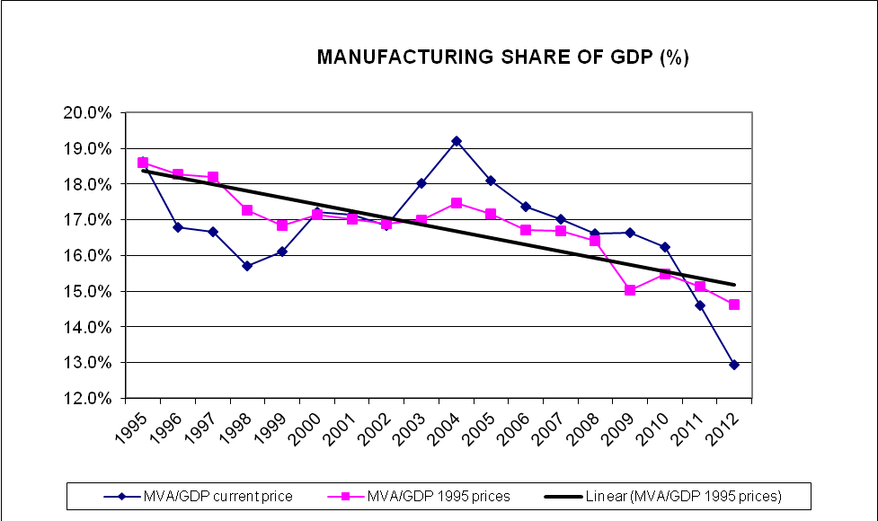

Source: own elaboration from IPEA data.

Figure 2: Share of Primary Products and Manufactures in Brazilian Exports, 1996-2012 (current and constant 2006 prices)

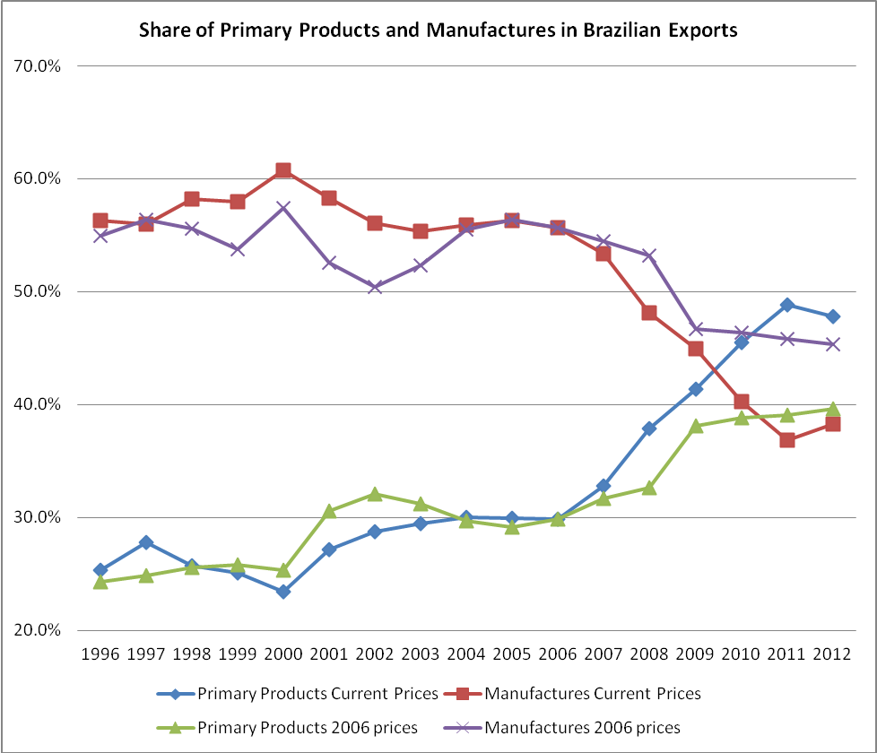

Source: own elaboration from IPEA DATA
Figure 3:

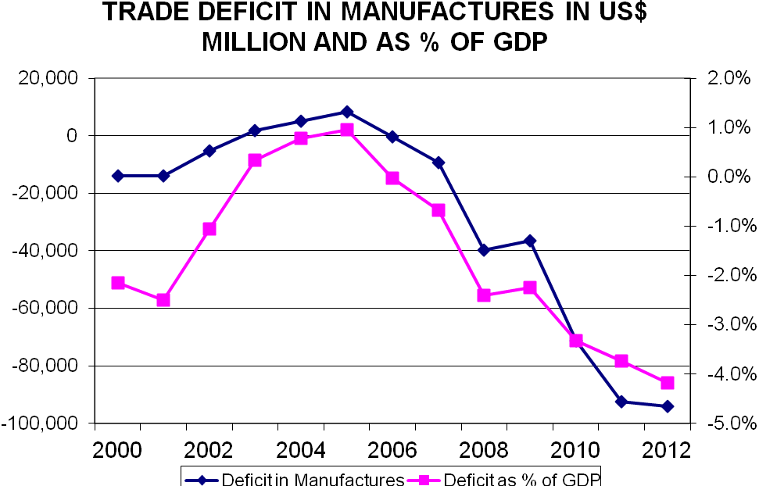

Source: own elaboration from MDIC/SECEX data

Figure 4: Impact of China on Deindustrialization

Growing Chinese demand for primary products
Growth of Chinese competitiveness and exports of manufactures

Chinese FDI in primary products
Increased exports of primary products to China
Increased world prices of primary products
Increased imports of Chinese manufactures
Increased Chinese competition in 3rd markets
Brazilian exports of manufactures to China

“Primarization” of Brazilian exports
Displacement of domestic production in Brazil
Change in manufactured exports from Brazil

RER appreciation and “Dutch Disease”
DEINDUSTRIALIZATION

Figure 5: Distribution of Brazilian Exports to China by Type of Product, 2000-2012

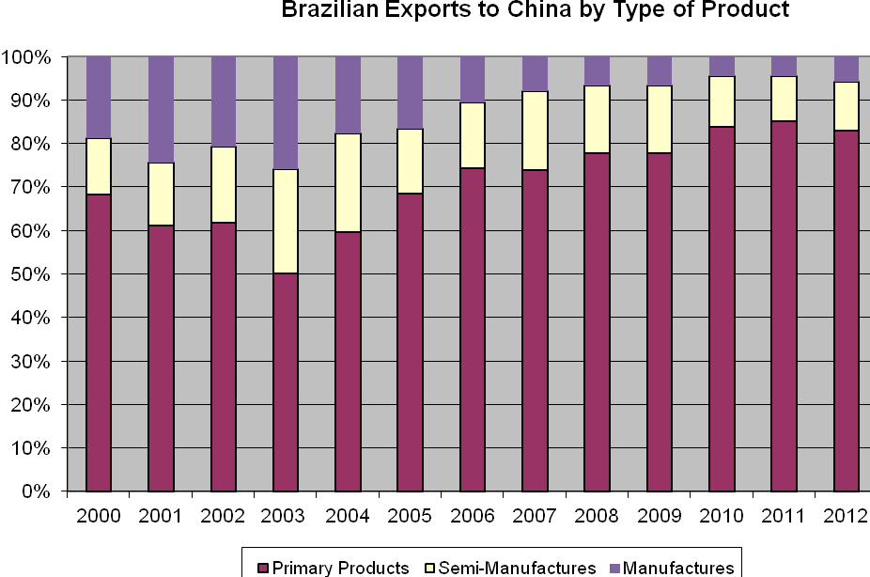

Source: own elaboration from SECEX data
Figure 6: Exports from Brazil to China and the Rest of the World by Type of Product, 2013.

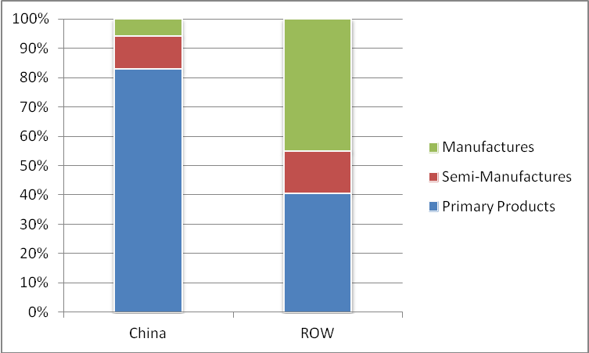

Source: MDIC/SECEX

Figure 7: Brazil Index of Real Exchange Rate (2005=100) and Share of Manufacturing in GDP, 1996-2012

Source: own elaboration from IMF, International Financial Statistics and IPEA DATA.

The paper is based on a research project on Brazilian Manufacturing in the face of Chinese Competition: economic restructuring, competitiveness and employment funded by the ESRC Pathfinder research projects, Grant No. RES-238-25-0006. The research was carried out in collaboration with Alexandre de Freitas Barbosa at the Centro Brasileiro de Análise e Planejamento (CEBRAP), Sao Paulo.
See Tregenna (2013a) for a detailed analysis of Marx’s writings on the role of manufacturing
The linkage effects from manufacturing relate primarily to the volume of production and would not be affected by a change in the relative price of manufactured goods, whereas the importance of manufacturing in alleviating a balance of payments constraint would be more influenced by the value of output and would therefore be sensitive to changes in relative prices
Here outsourcing is used to refer to a shift from inhouse activities to independent suppliers, whereas offshoring refers to the relocation of activities abroad either to independent suppliers or to overseas subsidiaries or parent companies.
This article is not intended to provide a general overview of the impact of China’s growth on the Brazilian economy which I have addressed in another article (Jenkins, 2012)
One study found that labour productivity in Brazilian manufacturing fell between 2001 and 2008 (Faundez et. al., 2011, Table 1)
Own calculation from MDIC SECEX data.
China was affected by 46 out of 82 trade defence measures adopted by Brazil (Global Trade Alert database at:. http://www.globaltradealert.org/site-statistics (accessed 31 October 2013). Although the Brazilian government agreed in 2004 to recognise China as a “market economy” within the WTO, this was never formally approved making it easier for Brazil to impose restrictions on Chinese exporters.
It is also worth noting that the share of imports from countries other than China in total domestic demand for manufactures in Brazil increased from 10.7% to 18.1% between 2003 and 2010 (FIESP)
In real terms after adjusting for inflation in the price of Brazilian manufactured exports, this represented an increase of only 4.4% over the period 2003-2012.
See Gallagher et. al. (2008) for a discussion of the Mexican case.
This was calculated using an extension of constant market share analysis developed by Brazilian economist Chami Batista (2008). For more details see Jenkins (2014).
Pimarization was accentuated by the effects of the US recession which led to a drop of over 40% in Brazilian exports of manufactured goods to the US in 2009 (MDIC, SECEX data).
The share of primary products in total exports to markets other than China increased from less than 30% in 2004 to almost 40% in 2012 (based on MDIC, SECEX data).
Rosales and Kuwayama (2012, p.96) come to a similar conclusion regarding the impact of China on the structure of exports from Latin America as a whole.
More recently they have been joined by oil with new oil field developments.
Own estimation from World Steel Association, Steel Statistical Yearbook 2011, Brussels, 2011Tables 46 & 48
Despite the high level of FDI from China since 2010, this is not likely to have had a major impact on net capital inflows and hence the exchange rate since much of this investment represented acquisitions of existing foreign subsidiaries and was therefore a change of ownership without necessarily involving additional capital flows.

