‘Coordinatively-open’ binuclear α-diiminonickel complexes: polyethylene branch control via co-catalyst
Aoqian Xi,^{a,b} Qiuyue Zhang,^{b} Quanchao Wang,^{b} Yizhou Wang,^{b} Yanning Zeng,^{a,*} Yanping Ma,^{b} Carl Redshaw,^{b,c} Wen-Hua Sun^{b,*}
ª College of Materials Science and Engineering, Guilin University of Technology, Guilin 541004, China.
^{b} Key Laboratory of Engineering Plastics, Institute of Chemistry, Chinese Academy of Sciences, Beijing, 100190, China.
^{c} School of Chemistry and Pharmacy, University of East Anglia, Norwich, NR4 7TJ, U.K
*Email: ynzeng@glut.edu.cn
*Email: whsun@iccas.ac.cn

Abstract
The properties of polyethylenes are profoundly determined by their branching architecture, necessitating precise control over branch formation during polymerization. By employing 2-[bis(4-fluorophenyl)methyl]-4-chloro-6-methylphenyl-modified α-diimines to simultaneously establish a coordinatively-opened structure while preserving the steric and electronic modulation around the nickel core, a series of binuclear nickel complexes (Ni1–Ni6) has been successfully synthesized. The complexes Ni1–Ni6 are found to exhibit a distinct open coordination environment around their nickel centers, as evidenced by their binuclear structural motifs and calculated burial volumes being expected for easier ethylene coordination. Upon activation with either EtAlCl₂ or EASC (Et₃Al₂Cl₃), all nickel complexes demonstrate exceptionally high activities towards ethylene polymerization up to 14.8 × 10⁶ g (PE) mol⁻¹ (Ni) h⁻¹, along with remarkable thermal stability exemplified by the activity of 3.8 × 10⁶ g (PE) mol⁻¹ (Ni) h⁻¹ at 70 ºC. Notably, the resultant polyethylene products display tunable crystallinities ranging from plastic to elastomeric behavior due to their distinct branching properties. Specifically, the choice of co-catalyst (EtAlCl₂ or EASC), with their distinct Lewis acidities, exhibit markedly different structural and property profiles. With EtAlCl₂ as co-catalyst, the resultant polyethylene exhibits higher molecular weight and reduced branching density, resulting in elevated crystallinity. In contrast, use of EASC promoted the formation of polyethylene with increased branching density, lower molecular weight and depressed melting temperatures, which resulted in good elongation to break point and enhanced elastic recovery. These findings reveal a robust strategy for controlling polyethylene branching architecture through judicious co-catalyst selection, providing a versatile approach to tailoring polyethylene microstructure.
Keywords: Unsymmetrical α-diimine nickel complex; ethylene polymerization; co-catalyst effect; plastics and elastomer.

1. INTRODUCTION
Thermoplastic polyolefins (TPOs), as key members of the thermoplastic elastomer (TPE) family, have attracted considerable attention due to their unique combination of high rubber-like elasticity and the processability of conventional plastics.^{[1,2]} Their principal strength resides in the capacity to attain swift molding and effective recycling via thermal processing.^{[3,4]} It is noteworthy to highlight that polyolefin elastomers (POEs) have emerged as a novel addition to the TPO series, showcasing remarkable elasticity owing to their unique blend of amorphous and crystalline regions within the polymer chain.^{[5]} However, the synthesis of branched polyolefin elastomers (POE) with uniform branched chain lengths can only be accomplished through a complex and costly copolymerization process that employs metallocene catalysts.^{[6]} In the 1990s, Brookhart and coworkers pioneered the use of late-transition-metal nickel complexes bearing α-diimine ligands (e.g., A, Scheme 1), which provided an alternative and highly selective route to high-performance polyethylene elastomers (PEEs) via a precisely controllable chain-walking mechanism.^{[7,8]} Such an approach significantly streamlines the preparation of novel thermoplastic polyolefins (TPO) endowed with more uniform chain architectures, adjustable distributions of soft and hard segments, and enhanced resistance to aging.
As research progresses further, both broadening the scope of exploration into ligand frameworks and designing new high-performance catalytic systems that can simultaneously combine remarkable thermal stability and meticulous control over polymer structure, have become of paramount interest in the field of polyolefin catalysis research.^{[9-15]} To provide sufficient space for ethylene coordination and insertion while simultaneously enhancing the electrophilicity of the nickel center, our group has designed a series of unsymmetrical α-diimine nickel complexes. These feature a bulky diphenylmethyl group at both ortho positions of one N-aryl moiety, along with distal fluorine atoms incorporated into the bulky substituent (B, Scheme 1).^{[16]} Theoretical analysis further confirmed that the strongly electron-withdrawing fluorine atoms can effectively stabilize the metal center, rendering it thermodynamically more favorable and catalytically more active in its oxidation state.^{[17]} Nevertheless, the steric crowding imposed by two ortho-bis(para-fluorophenyl)methyl substituents on the N-aryl moiety effectively suppressed chain transfer reactions, thereby enabling the synthesis of high-molecular-weight polyethylene, albeit at the cost of enhanced activity and compromising the chain regularity.^{[18,19]}
To optimize the trade-off between steric protection and catalytic efficiency, one of the ortho-bis(4-fluorophenyl)methyl substituents in B was systematically repositioned to the para-site of the N-aryl moiety (C, Scheme 1)^{[20]} or substituted with a methyl group (D, Scheme 1), ^{[21]} thereby enabling comparative analysis of their impact on polymerization performance. When the ligands are arranged in the order of B, C, and then D, the steric hindrance around the nickel center demonstrates a gradual decreasing trend. This, in turn, leads to a significant enhancement in polymerization activity, particularly at elevated temperatures. Specifically, at 80 ºC, B exhibited an activity of 1.87 × 10⁶ g (PE) mol⁻¹ (Ni) h⁻¹, while C and D also maintained notably high activity, reaching 3.44 × 10⁶ and 3.48 × 10⁶ g (PE) mol⁻¹ (Ni) h⁻¹, respectively, under the same temperature conditions. This observation indicates that by finely tuning the steric environment surrounding the nickel center within the ligand structure, it becomes feasible to attain highly efficient catalysis at higher temperature. According to the theoretical premise that effective chain propagation can be boosted by suppressing chain transfer in structurally congested nickel systems, the molecular weight of the resulting polyethylene also exhibits a similar trend in accordance with the steric ordering of the ligand structure (i.e. M_{w}: B > C > D).
Further investigation reveals that the electronic properties of substituents directly bonded to the benzene ring of the N-aryl group exert a critical influence on the catalytic performance of the resulting nickel complexes, as evidenced by the observed correlations between ligand electron density and polymerization activity.^{[22-26]} An outstanding benefit of ortho-chloro and para-chloro/fluoro substitutions in α-diimine nickel complexes (E, Scheme 1)^{[23,24]} lies in their ability to substantially enhance the thermal stability of the system. Notably, E achieved a remarkable catalytic activity exceeding 10⁷ g (PE) mol⁻¹ (Ni) h⁻¹ for ethylene polymerization at optimal temperatures above 50 ºC. Furthermore, it exhibited minimal activity fluctuations across a wide temperature range of 40-70 ºC, underscoring its robust operational stability. This phenomenon arises from the halogen atoms attached to the benzene ring, which function as potent electron-withdrawing groups to significantly enhance the Lewis acidity of the nickel center, thereby facilitating the coordination and insertion of ethylene monomers during polymerization.^{[23-27]} The modulation of steric hindrance achieved by introducing ortho/para-substituents with small size (E, Scheme 1) also effectively preserves the spatial accessibility of the coordination sphere, thereby creating favorable conditions for ethylene approach and subsequent chain propagation. In contrast to agostic interactions/chain inversion processes during chain walking mechanisms which dominate in bulky catalytic systems, the open coordination sphere in E (Scheme 1) significantly enhanced ethylene coordination and the insertion process, thereby promoting chain propagation to yield low-branched polyethylene.^{[28]} Consequently, replacing the ortho-substituents with appropriately sized groups, such as methyl, offers the potential for generating highly branched polyethylene by altering the steric constraints.

Scheme 1. Structural archetypes of N,N-bidentate nickel(II) pre-catalysts (A-F) for ethylene polymerization.
Studies have shown that α-diimine nickel complexes can produce random hyperbranched linear polyethylenes (RHBLEs) containing both crystalline and amorphous regions by varying the polymerization temperature (40 °C, 60 °C, 80 °C), achieving elastomeric properties.^{[29]} However, such systems often face a trade-off among branching density, molecular weight, and crystallinity, which limits the precise control over the microstructure. Motivated by the enhancement in catalytic performance through the strategic tuning of the steric and electronic properties of N-aryl substituents, a novel N-aryl moiety was designed by combining the following features: (i) a single bulky ortho-bis(4-fluorophenyl)methyl group to provide axial protection and suppress chain transfer; (ii) the introduction of a moderately sized ortho-methyl group to precisely modulate the local steric environment and influence the chain-walking process; (iii) a para-chloro substituent to enhance the electron-deficient character of the nickel center. This modular architecture enabled the systematic preparation of a series of unsymmetrical 1,2-bis(imino)acenaphthene compounds and their corresponding nickel complexes (F, Scheme 1). All titled nickel pre-catalysts exhibited good catalytic performance and thermal stability. Their polymerization behavior, particularly the branching process, showed differentiated responses to different cocatalysts. This allows for the precise regulation of the final properties of polyethylene simply by switching the co-catalyst type.
2. RESULTS AND DISCUSSION
2.1 Synthesis and characterization of pro-ligands and nickel complexes.
Following a modified literature protocol,^{[23]} 2-((2-[bis(4-fluorophenyl)methyl]-4-chloro-6-methylphenyl)imino)acenaphthylen-1(2H)-one was synthesized through a condensation reaction between acenaphthylene-1,2-dione and 2-[bis(4-fluorophenyl)methyl]-4-chloro-6-methylaniline to form the important intermediate. Subsequently, the resulting mono-iminoacenaphthylenone was reacted with individual one of six anilines in the presence of zinc chloride in a 1:1:1 molar ratio, followed by a demetallation procedure that ultimately resulted in the formation of the target pro-ligands in moderate isolated yields (42%-63%, Scheme 2), namely 2,6-dimethylphenyl (L1), 2,6-diethylphenyl (L2), 2,6-diisopropylphenyl (L3), 2,4,6-trimethylphenyl (L4), 2,6-diethyl-4-methylphenyl (L5) and 2-bis[(4-fluorophenyl)methyl]-4-chloro-6-methylphenyl (L6). To verify the structural integrity and compositional purity of the newly synthesized pro-ligands, comprehensive characterization was conducted via FT-IR spectroscopy, ¹H and ¹³C NMR spectroscopy (Figures S1-S16, SI) and elemental analysis, which confirmed the identity of the target structures.
Scheme 2. Synthesis route of the pro-ligands and corresponding nickel complexes.
The six N,N-bidentate nickel(II) complexes (Ni1–Ni6) were synthesized via metal coordination reactions by treating the pro-ligands (L1–L6) with (DME)NiBr₂ in a 1:1 stoichiometric ratio. The structures of Ni1–Ni6 were unequivocally validated by FT-IR spectroscopy, elemental analysis, and SC-XRD. Effective metal-ligand coordination was corroborated by a bathochromic shift of the ν_{C=N} stretching band in the FT-IR spectra [1670–1638 cm⁻¹ for L1-L6 vs. 1657–1620 cm⁻¹ for Ni1-Ni6], in agreement with the spectroscopic behavior of structurally analogous nickel complexes reported previously.^{[24,30]}
Crystals of Ni2, Ni3, and Ni5 suitable for single-crystal X-ray diffraction (SC-XRD) analysis were obtained through the slow vapor diffusion of diethyl ether into dichloromethane solutions of the respective complexes. The crystallographically determined structures are presented in Figure 1, with selected lengths and angles summarized in Table 1. Unlike conventional mononuclear crystal structures,^{[31,32]} all three nickel complexes (Ni2, Ni3, and Ni5) herein possessed a coordinatively-open coordination at nickel by virtue of adopting a binuclear configuration wherein each nickel metal is coordinated to two nitrogen atoms from an α-diimine ligand, one terminal bromine atom and two bridging bromine atoms, ultimately achieving five-coordinate structures.^{[25]} To quantitatively assess the extent of geometric distortion in the complexes with N2 serving as the axial ligand, the τ parameter was computed for each complex utilizing the formula τ = (β - α)/60 (where τ = 0 signifies an ideal square pyramidal geometry, and τ = 1 indicates an ideal trigonal bipyramidal geometry).^{[33]} The calculated τ values—0.98 for Ni2 (β = 161.50(5); α = 102.377(16)), 0.58 for Ni3 (β = 173.71(5); α = 138.834(18)), and 0.52 for Ni5 (β = 174.45(14); α = 143.26(5))—confirm that Ni2 demonstrates a significant deviation, leaning strongly towards a trigonal bipyramidal geometry, while Ni3 and Ni5, although exhibiting distortions between the two ideal geometric forms, predominantly manifest a distorted trigonal bipyramidal configuration. The marked disparity in geometry among these binuclear nickel complexes suggests a wide array of coordination states surrounding the nickel centers, attributable to general steric variations. To achieve the most stable conformation, the benzene rings of two N-aryl groups (namely, N1-aryl and N2-aryl) are oriented nearly perpendicular to the chelating plane [84˚ and 97˚ for Ni2; 80˚ and 98˚ for Ni3；82˚ and 99˚ for Ni5]. The Ni–N bond lengths associated with the bulkier N-aryl moiety, specifically Ni(1)–N(2) [2.0940(18) Å for Ni2, 2.0413(17) Å for Ni3, and 2.053(5) Å for Ni5], exhibit marked differences compared to those involving the smaller N-aryl moiety, namely Ni(1)–N(1) [2.1634(18) Å for Ni2, 2.1967(17) Å for Ni3, and 2.156(5) Å for Ni5] highlighting that the introduction of the bulky N-(2-[bis(4-fluorophenyl)methyl]-4-chloro-6-methylphenyl) group enhances the asymmetry of the nickel complexes.^{[34,35]} For the same reason, the imine bonds [N(1)–C(11)] linked to the bulkier N-aryl moiety are slightly longer than that [N(2)–C(12)] connected with the smaller N-aryl moiety [1.284(3) Å vs. 1.288(3) Å for Ni2; 1.284(3) Å vs. 1.287(3) Å for Ni3; 1.272(8) Å vs. 1.280(8) Å for Ni5]. Furthermore, in the case of the three dimers, specifically Ni2, Ni3, and Ni5, the Ni–Ni distances are measured at 3.626 Å, 3.666 Å, and 3.746 Å, respectively. These variations in bond distances reflect, to some extent, ^{[36,37]} the differing steric environments surrounding the nickel centers, with Ni2 exhibiting the least steric hindrance among them. There are no intermolecular contacts of note.
To quantitatively assess the steric environment surrounding the nickel center, buried volume calculations were performed for three nickel complexes (Ni2, Ni3, and Ni5) using their crystallographically determined structures (Figure 2). The computed buried volume values were 43.6%, 41.6%, and 43.8%, respectively, which are significantly lower than those reported for the Brookhart-type catalyst^{[38]} (45.1%, Figure S23) and structurally analogous ortho/para-methyl substituted D^{[21]} (Ar = 2,6-dimethylphenyl, 46.3%, Figure S24). This reduced steric encumbrance in the current nickel systems, which is attributable to the para-chlorine substitution on the N-aryl ligand, facilitates enhanced catalytic activity and precise control over the chain-walking mechanism. Notably, the exceptionally low buried volume values (≤43.8%) provide compelling evidence for the formation of binuclear structures. Under ethylene polymerization conditions with an excess of organoaluminum cocatalyst, the bromine bridges in these dinuclear precatalysts are expected to cleave, generating mononuclear active species. Nevertheless, the inherently open coordination environment at the nickel centers, evidenced by low buried volume values and asymmetric ligand design, is retained upon activation, which is key to achieving the high activity, high thermal stability, and controlled branching architecture reported in this work. Additionally, the notable disparity in buried volume distribution between Ni2 and the complexes Ni3 and Ni5, as depicted in the topographic steric map, corresponds to the differences observed in the calculated τ values.
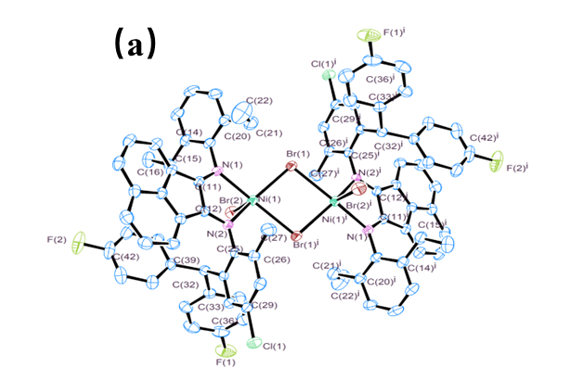
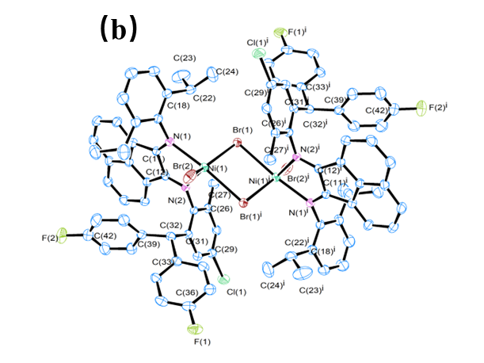
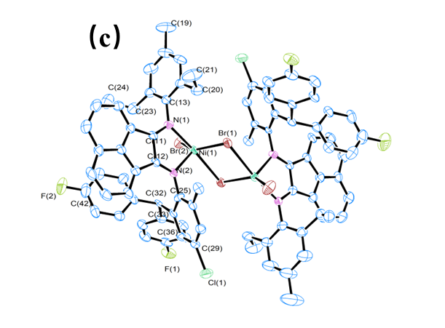
Figure 1. ORTEP representation of Ni2 (a), Ni3 (b) and Ni5 (c): thermal ellipsoids set at 30 % probability level; hydrogen atoms are omitted for clarity.

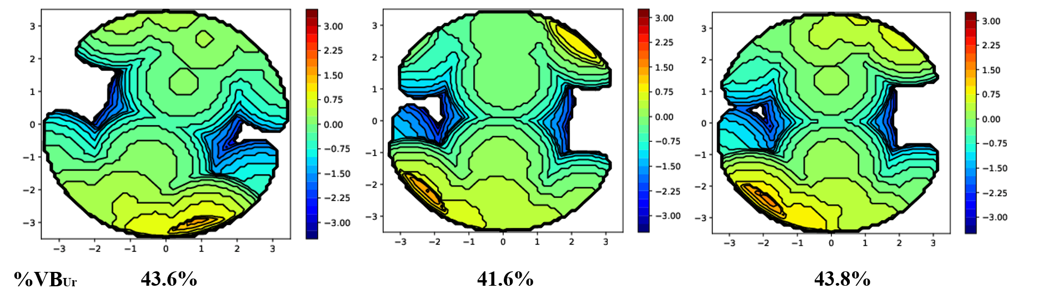
Figure 2. Topographic stereograms of Ni2 (left), Ni3 (middle) and Ni5 (right).
Table 1. Selected bond lengths (Å) and angles (˚) for Ni2, Ni3 and Ni5.
 | Ni2 | Ni3 | Ni5
Bond lengths (Å)
Ni(1)-N(1)  Ni(1)-N(2)  Ni(1)-Br(1)  Ni(1)-Br(2)  N(1)-C(11)  N(2)-C(12)  N(1)-C(13)  N(2)-C(25)  Cl(1)-C(29)  F(1)-C(36)  F(2)-C(42) | 2.1634(18)  2.0940(18)  2.4518(4)  2.4079(5)  1.284(3)  1.288(3)  1.449(3)  1.429(3)  1.740(2)  1.365(3)  1.362(3) | 2.1967(17)  2.0413(17  2.4352(4)  2.3503(4)  1.284(3)  1.287(3)  1.453(3)  1.440(3)  1.745(2)  1.362(3)  1.359(3) | 2.156(5)  2.053(5)  2.4320(12)  2.3770(13)  1.272(8)  1.280(8)  1.456(8)  1.418(8)  1.743(6)  1.368(8)  1.361(9)
Bond Angles (˚)
Br(1)-Ni(1)-Br(2)  N(1)-Ni(1)-N(2)  N(1)-Ni(1)-Br(1)  N(1)-Ni(1)-Br(2)  N(2)-Ni(1)-Br(1)  N(2)-Ni(1)-Br(2) | 102.377(16)  79.21(7)  96.11(5)  99.91(5)  151.10(5)  106.52(5) | 138.834(18)  80.37(7)  99.18(5)  91.21(5)  104.17(5)  116.85(5) | 143.26(5)  80.6(2)  97.79(15)  91.76(15)  99.12(15)  117.46(15)
N(2)-Ni(1)-Br(1)^{i} | 89.00(5) | 93.42(5) | 94.64(14)
N(1)-Ni(1)-Br(1)^{i} | 161.50(5) | 173.71(5) | 174.45(14)
Br(1)-Ni(1)-Br(1)^{i} | 87.32(14) | 83.289(13) | 83.75(4)
Br(2)-Ni(1)-Br(1)^{i} | 97.077(16) | 90.663(14) | 89.69(4)
2.2 Ethylene Polymerization
All newly synthesized nickel complexes (Ni1-Ni6) underwent a systematically investigation for ethylene polymerization. Prior research has demonstrated that both the polymerization conditions and ligand structure exert a substantial influence on the ultimate catalytic performance.^{[39-42]} Drawing on these insights, we initially screened for the optimal co-catalyst type and subsequently carried out a systematic optimization of the polymerization conditions, encompassing co-catalyst dosage, polymerization duration, operational time, and ethylene pressure, with the aim of maximizing the catalytic performance of the catalytic system. To verify our experimental design, we compared and analyzed the results of this study with benchmark data from a series of reported α-diimine nickel complexes (see comparison section 2.4).^{[12,14,24,32]} Additionally, parallel experiments were conducted using different nickel complexes for ethylene polymerization to explore the correlation between the structural variation and catalytic performance.
2.2.1. Co-catalyst screening for ethylene polymerization.
To identify a suitable co-catalyst for ethylene polymerization, a series of aluminum-based activators, including methylaluminoxane (MAO), diethylaluminum chloride (Et₂AlCl), ethylaluminum dichloride (EtAlCl₂), and ethylaluminum sesquichloride (EASC), were evaluated using Ni5 as the model pre-catalyst.^{[24,43-46]} All preliminary polymerization experiments were carried out under uniform conditions, and the pivotal results from this screening process are summarized in Table 2. All four combinations of Ni5 with different co-catalysts displayed remarkable catalytic activity, yielding moderately branched polyethylene characterized by high melting temperature reaching up to 117.3 ºC, high molecular weight ranging from 25.6 × 10⁴ g mol⁻¹ to 30.3 × 10⁴ g mol⁻¹, and narrow polydispersity indices (PDI = 2.1–4.0). Notably, the Ni5/EtAlCl₂ catalytic system (run 4, Table 2) exhibited the highest catalytic activity within this group and was consequently chosen for subsequent optimization investigations (Figure 3). Meanwhile, to offer an alternative approach for exploring the synthesis of highly branched polyethylene, the Ni/EASC system which delivered the lowest crystallinity within this particular set was also chosen to develop a catalytic system suitable for operation at elevated temperatures.
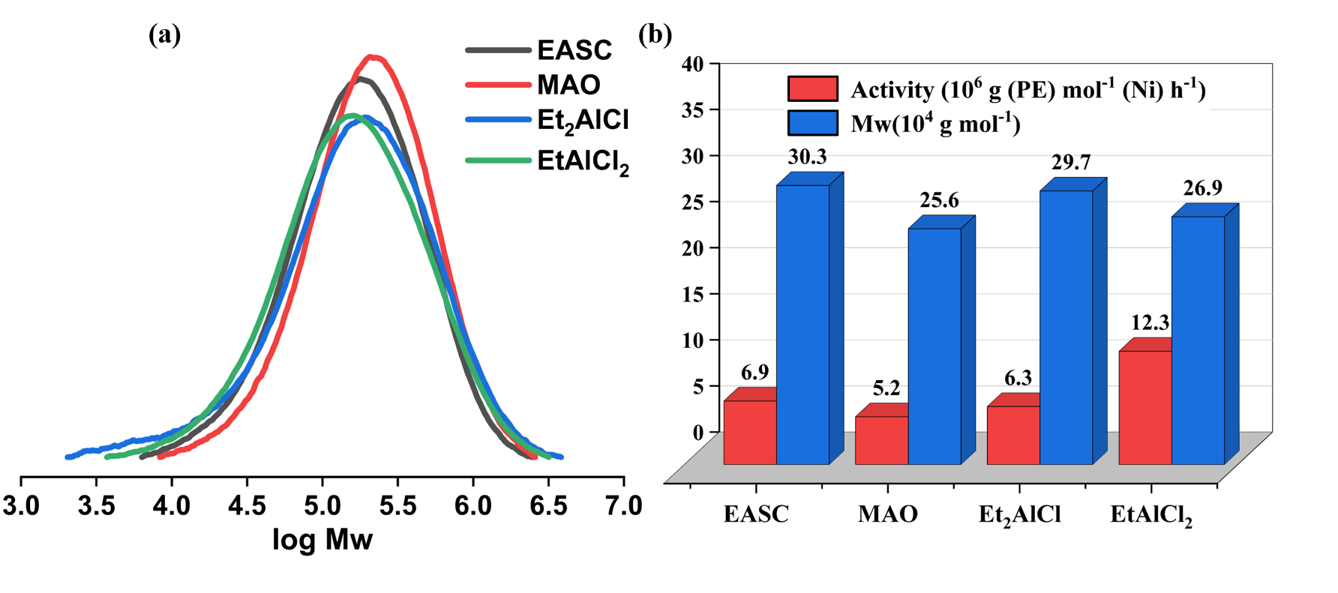
Figure 3. (a) GPC curves of the polyethylene obtained with Ni5 and different co-catalysts; (b) Effects of the co-catalyst type on the catalytic activity and molecular weight (Table 2).
Table 2. Co-catalyst screening for ethylene polymerization.ª
Run | Co-catalysts | Al/Ni | Yield (g) | Activity ^{b} | M_{w} ^{c} | M_{w}/M_{n} ^{c} | T_{m} ^{d} | X_{c}^{e}
1 | MAO | 2000 | 6.9 | 6.9 | 30.3 | 2.1 | 108.3 | 24.5
2 | EASC | 400 | 5.2 | 5.2 | 25.6 | 2.5 | 104.2 | 20.0
3 | Et₂AlCl | 400 | 6.3 | 6.3 | 29.7 | 4.0 | 114.4 | 28.1
4 | EtAlCl₂ | 400 | 12.3 | 12.3 | 26.9 | 3.1 | 117.3 | 33.3
ª General conditions: 2 μmol of Ni5, 30 °C, 30 min, 10 atm ethylene, 100 mL toluene; ^{b} Activity in unit of 10⁶ g (PE) mol⁻¹ (Ni) h⁻¹; ^{c} Values in unit of 10⁴ g mol⁻¹ via GPC;^{d} Values in unit of ºC via DSC. ^{e} Determined by DSC, X_{c} = ΔH_{f} (T_{m}) / ΔH_{f}° (T_{m}°); ΔH_{f}° (T_{m}°) = 248.3 J g⁻¹.
2.2.2 Catalytic evaluation of the Ni5/EtAlCl₂ system
Previous research^{[27,47]} has revealed that an imbalance in the co-catalyst amount, whether excessive or insufficient, can lead to a decline in polymerization activity. This is primarily due to the heightened likelihood of chain transfer reactions and inadequate activation processes. Consequently, the optimal EtAlCl₂ dosage within the current Ni5/EtAlCl₂ system for ethylene polymerization was initially investigated in this study. Under the consistent conditions of a 30-minute polymerization time and a 30 ºC polymerization temperature, as the Al/Ni ratio was incrementally increased from 200 to 400 (runs 1-4, Table 2), the catalytic activity exhibited a rising trend. Specifically, it climbed from 5.3 × 10⁶ g (PE) mol⁻¹ (Ni) h⁻¹ to 12.3 × 10⁶ g (PE) mol⁻¹ (Ni) h⁻¹, achieving a peak value within this range. However, when the Al/Ni ratio was further elevated to 600 (run 7, Table 3), the catalytic activity gradually declined to 5.5 × 10⁶ g (PE) mol⁻¹ (Ni) h⁻¹. This suggests that an excess of co-catalyst adversely affects the stability of the active species.^{[48]} As illustrated in Figure 4, the molecular weight of the polyethylene exhibits a pronounced declining trend as the dosage of the co-catalyst increased. This phenomenon can be attributed to the heightened occurrence of excessive chain transfer reactions at elevated co-catalyst concentrations within the polymerization system.^{[12,49]} In stark contrast, both the molecular weight distribution, which remains within the range of Đ = 1.8-3.1 (Figure 4a), and the melting point of the polyethylene, with Tₘ consistently exceeding 110 °C, display no significant alterations, indicating that within the scope of the present study, the concentration of the co-catalyst has a relatively limited impact on the nature of the active species and the fundamental structure of the main chain.^{[24]}
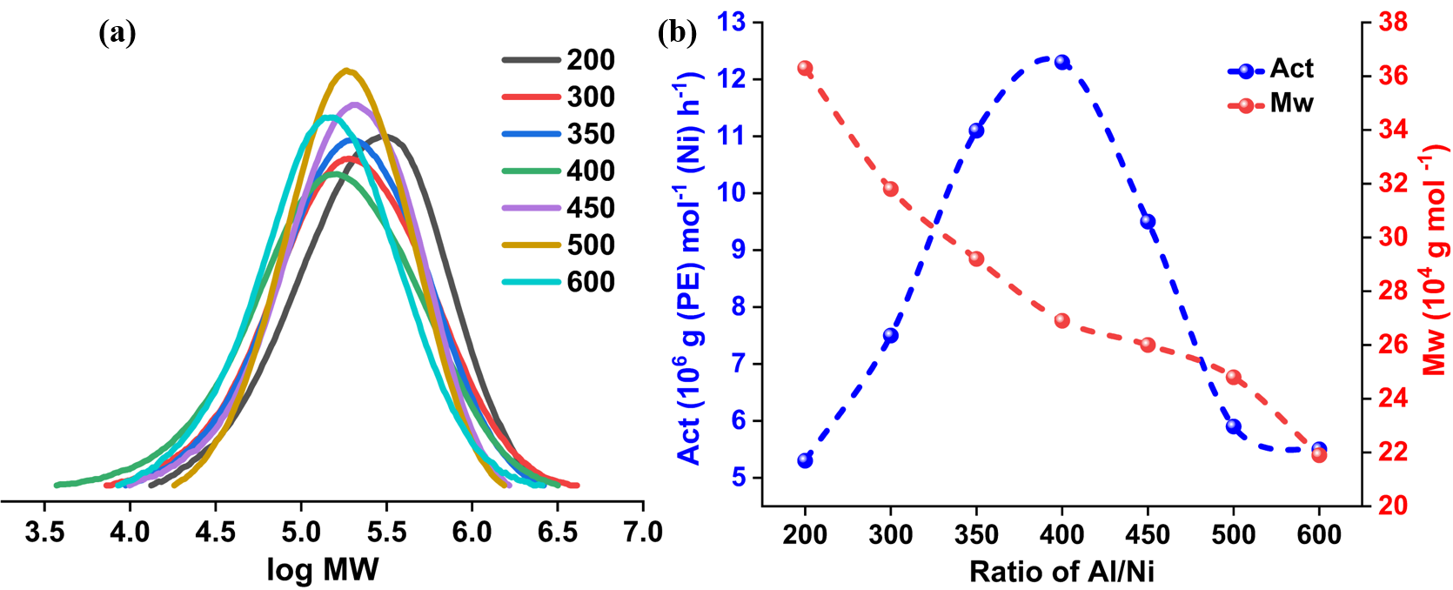
Figure 4. (a) GPC curves of the polyethylene obtained using different Al/Ni ratio; (b) Effects of the Al/Ni ratio on the catalytic activity and molecular weight (runs 1-7, Table 3).
Further investigation revealed that polymerization temperature exerts a more pronounced influence on the catalytic behavior of the Ni5/EtAlCl₂ system than does the co-catalyst dosage (Figure 5). Within the temperature range spanning from 20 ºC to 80 ºC (runs 4, 8–13, Table 13), the catalytic activity initially demonstrated an upward trajectory, rising from 9.0 × 10⁶ g (PE) mol⁻¹ (Ni) h⁻¹ to 12.3 × 10⁶ g (PE) mol⁻¹ (Ni) h⁻¹. Subsequently, it gradually declined, yet still maintained a level of 2.3 × 10⁶ g (PE) mol⁻¹ (Ni) h⁻¹, reflecting the fact that the energy required for chain propagation is an essential factor,^{[14,50]} while the thermal decomposition of the active species and the decreased solubility of ethylene at elevated temperatures are likely to impede the polymerization process, thereby reducing its overall efficacy.^{[33,51,52]} Furthermore, as the polymerization temperature ascended, the molecular weight of the resulting polyethylene (PE) displayed a pronounced linear decline, plummeting from 29.1 × 10⁴ g mol⁻¹ to 9.2 × 10⁴ g mol⁻¹ (Figure 5b). This trend is primarily attributed to the significantly enhanced chain transfer reactions at elevated temperatures.^{[53,54]} Moreover, all polyethylene samples demonstrated narrow and unimodal molecular weight distributions. This characteristic serves as a strong indication of the single-site nature of the current catalytic system, highlighting its unique and consistent catalytic behavior.
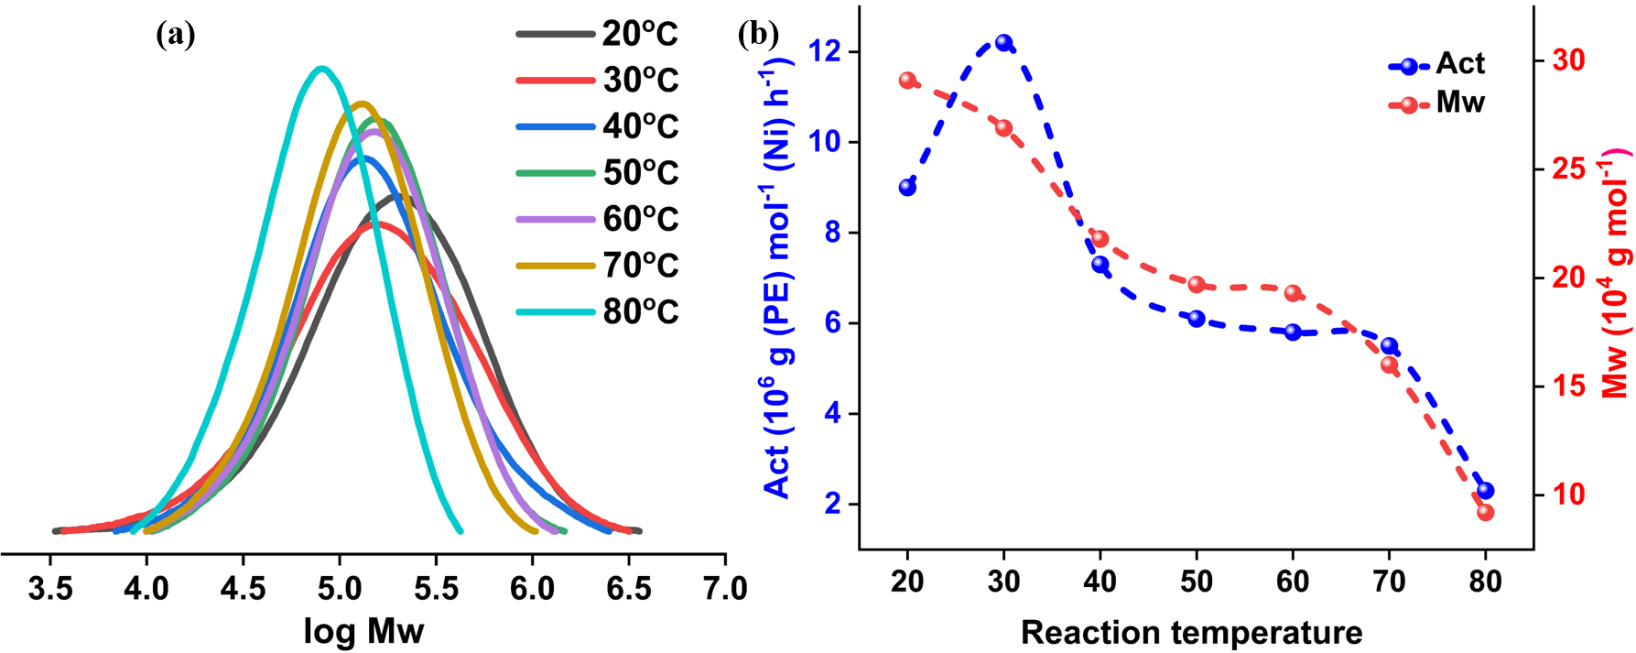
Figure 5. (a) GPC curves of the polyethylene obtained under different temperatures; (b) Effects of the temperature on the catalytic activity and molecular weight (runs 4 and 8-13, Table 3).
A more in-depth analysis of the reaction stability of the Ni5/EtAlCl₂ system over polymerization time (Figure 6) uncovered some key insights. Within the initial 5 minutes, the system achieved its peak activity, reaching an impressive 28.8 × 10⁶ g (PE) mol⁻¹ (Ni) h⁻¹. However, this high activity rapidly declined as the polymerization time was extended. This phenomenon indicates that the addition of EtAlCl₂ swiftly triggered the activation of the nickel centers. However, over the course of polymerization, the active species gradually lost their reactivity and underwent deactivation. Despite this decline, the catalytic activity still maintained a relatively high level of 6.9 × 10⁶ g (PE) mol⁻¹ (Ni) h⁻¹ after 60 minutes, highlighting the excellent usage stability of the current nickel system.^{[55]} Meanwhile, the molecular weight of the polyethylene exhibited a steady increase (Figure 6b), rising from 24.2 × 10⁴ g mol⁻¹ to 36.2 × 10⁴ g mol⁻¹, suggesting that while some active sites were deactivated during the process, a portion of them remained active and continued to facilitate chain growth. When the polymerization pressure decreased from 10 atm to 5 atm and then further to 1 atm (runs 4, 17, and 18, Table 3), both catalytic activity and the molecular weight of the polymer demonstrated a downward trend. This is attributed to the slower rate of ethylene coordination and insertion under reduced pressure conditions (Figure S25).^{[37,56]}
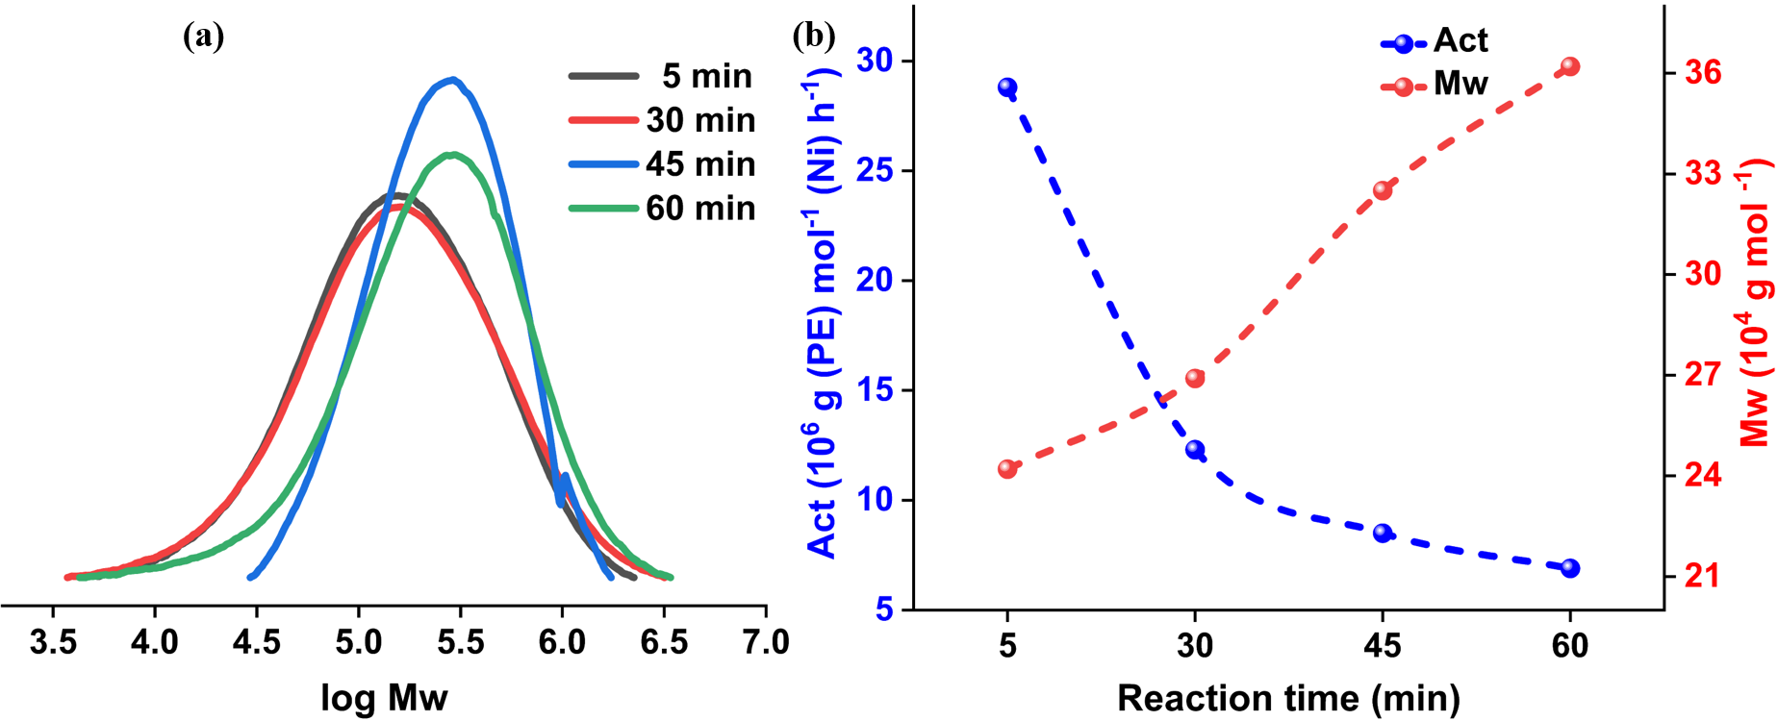
Figure 6. (a) GPC curves of the polyethylene obtained using different time; (b) Effects of the time on the catalytic activity and molecular weight (runs 4 and 14-16, Table 3).
Table 3. Evaluation results of ethylene polymerization using the Ni5/EtAlCl₂ system.ª
Run | Al/Ni | T (℃) | t(min) | Yield (g)^{b} | Activity^{b} | M_{w}^{c} | M_{w}/M_{n}^{c} | T_{m}^{d}
1 | 200 | 30 | 30 | 5.3 | 5.3 | 36.3 | 2.3 | 114.4
2 | 300 | 30 | 30 | 7.5 | 7.5 | 31.8 | 2.8 | 112.5
3 | 350 | 30 | 30 | 11.1 | 11.1 | 29.2 | 2.4 | 120.0
4 | 400 | 30 | 30 | 12.3 | 12.3 | 26.9 | 3.1 | 116.1
5 | 450 | 30 | 30 | 9.5 | 9.5 | 26.0 | 2.1 | 113.6
6 | 500 | 30 | 30 | 5.9 | 5.9 | 24.8 | 1.8 | 111.5
7 | 600 | 30 | 30 | 5.5 | 5.5 | 21.9 | 2.3 | 110.6
8 | 400 | 20 | 30 | 9.0 | 9.0 | 29.1 | 2.8 | 122.2
9 | 400 | 40 | 30 | 7.3 | 7.3 | 21.8 | 2.4 | 87.3
10 | 400 | 50 | 30 | 6.1 | 6.1 | 19.7 | 1.9 | 86.1
11 | 400 | 60 | 30 | 5.8 | 5.8 | 19.3 | 2.0 | 81.2
12 | 400 | 70 | 30 | 5.5 | 5.5 | 16.0 | 1.8 | 78.1
13 | 400 | 80 | 30 | 2.3 | 2.3 | 9.2 | 1.6 | 65.1
14 | 400 | 30 | 5 | 4.8 | 28.8 | 24.2 | 2.8 | 113.1
15 | 400 | 30 | 45 | 12.8 | 8.5 | 32.5 | 1.7 | 101.5
16 | 400 | 30 | 60 | 13.7 | 6.9 | 36.2 | 2.7 | 108.9
17 e | 400 | 30 | 30 | 4.4 | 4.4 | 22.5 | 2.5 | 109.9
18 ^{f} | 400 | 30 | 30 | 1.4 | 1.4 | 16.4 | 2.0 | 106.6
ª General conditions: 2 μmol of Ni5, 10 atm ethylene, 100 mL toluene; ^{b} Activity in unit of 10⁶ g (PE) mol⁻¹ (Ni) h⁻¹; ^{c} values in unit of 10⁴ g mol⁻¹ via GPC; ^{d} values in unit of ºC via DSC; ^{e} 5 atm of ethylene; ^{f} 1 atm of ethylene.
2.2.3 Structural effects of the ligands on ethylene polymerization
Under the optimized polymerization conditions (Al/Ni = 400, 30 ºC, 30 min, 10 atm), which were determined through the aforementioned screening process, a series of nickel complexes, namely Ni1–Ni6, each featuring distinct ligand structures, were thoroughly investigated regarding their catalytic performance in ethylene polymerization. Remarkably, all these nickel complexes demonstrated high catalytic activities ranging from 3.8 × 10⁶ g (PE) mol⁻¹ (Ni) h⁻¹ to 14.8 × 10⁶ g (PE) mol⁻¹ (Ni) h⁻¹. Moreover, they could produce polyethylene with high molecular weight, with values falling within the range of 6.9 × 10⁴ g mol⁻¹ to 76.5 × 10⁴ g mol⁻¹ (Table 4). Further analysis revealed that the variations observed in both the catalytic activity and the molecular weight of the resulting polyethylene were intricately linked to the steric properties of the N-groups present on the nickel complexes.^{[49,57]} Specifically, the overall activity trends of these nickel pre-catalysts employed in different solvents is listed as follows: in toluene, Ni5 [2,6-di(Et)-4-Me] > Ni1 [2,6-di(Me)] > Ni2 [2,6-di(Et)] > Ni4 [2,4,6-tri(Me)] > Ni3 [2,6-di(i-Pr)] > Ni6 (Figure S26); in n-hexane, it was Ni5 [2,6-di(Et)-4-Me] > Ni1 [2,6-di(Me)] > Ni4 [2,4,6-tri(Me)] > Ni2 [2,6-di(Et)] > Ni3 [2,6-di(i-Pr)] > Ni6 (Figure S27). The slight discrepancy in the activity order when the polymerization solvent was altered implies that while the solvent may have a certain influence, the ligand structure remains the predominant factor in determining the catalytic activity of these nickel complexes.^{[58]} Notably, at 30 ºC, Ni5 exhibited the highest activities in both solvents, indicating that the favorable solubility of Ni5 plays a more pivotal factor in influencing catalytic activity than the steric hindrance imposed by the N-2,6-diethyl-4-methyl group within Ni5.^{[14]} Conversely, in Ni3 and Ni6, the incorporation of two bulky N-aryl groups into their ligand frameworks greatly impeded the approach of ethylene monomers to the nickel center, resulting in reduced catalytic activity. Nevertheless, substantial steric hindrance also provided axial protection to the nickel center, thereby inhibiting chain transfer and subsequently promoting the production of higher-molecular-weight polyethylene in the case of Ni3 and Ni6. Upon switching the polymerization solvent from toluene to n-hexane, there was a general enhancement in catalytic performance, encompassing both the catalytic activities of all nickel complexes and the molecular weights of the resulting polyethylene. This suggests that chain walking was suppressed in the non-polar solvent, while chain propagation was promoted, leading to higher molecular weights and enhanced activity.^{[56,59]}
As the temperature was elevated to 70 ºC, the overall catalytic activities demonstrated a general downward trend, spanning a range from 3.8 × 10⁶ g (PE) mol⁻¹ (Ni) h⁻¹ to 6.6 × 10⁶ g (PE) mol⁻¹ (Ni) h⁻¹ (Figure S28). Among the nickel complexes, Ni6 stood out for its exceptional thermal stability, showing only a marginal decline in activity (6.9 × 10⁶ g (PE) mol⁻¹ (Ni) h⁻¹ at 30 ºC vs. 6.6 × 10⁶ g (PE) mol⁻¹ (Ni) h⁻¹ at 70 ºC). This observation underscores the substantial enhancement in thermal stability achieved through bulky structural modification. As the polymerization temperature increased, the molecular weight of the resulting polyethylene exhibited a downward trend, falling from 6.9 × 10⁴ g mol⁻¹ to 39.7 × 10⁴ g mol⁻¹. Notably, the bulkiest nickel complexes, Ni6, yielded the highest molecular weight indicating that the steric hindrance-induced protection of the nickel center remained effective even at elevated temperature. Furthermore, with the rise in polymerization temperature, the molecular weight distributions became narrower, suggesting the formation of a uniform growing polymer chain during the polymerization process. The melting points of the resulting polyethylene also exhibited a general downward trend, likely attributable to the heightened branching degree or diminished crystallinity resulting from the accelerated chain walking at elevated temperatures.^{[24]}
Table 4. Evaluation results of ethylene polymerization using the Ni/EtAlCl₂ system.ª
Run | Pre-cat. | T (℃) | Activity ^{b} | M_{w} ^{c} | M_{w}/M_{n} ^{c} | T_{m} ^{d}
1 | Ni1 | 30 | 10.1 | 22.8 | 2.4 | 108.4
2 | Ni1e | 30 | 13.6 | 41.2 | 2.5 | 120.5
3 | Ni1 | 70 | 6.4 | 9.7 | 1.7 | 87.6
4 | Ni2 | 30 | 9.7 | 28.2 | 2.2 | 106.3
5 | Ni2 e | 30 | 11.3 | 56.3 | 2.4 | 121.5
6 | Ni2 | 70 | 3.8 | 14.1 | 1.8 | 79.6
7 | Ni3 | 30 | 6.9 | 40.8 | 2.2 | 105.8
8 | Ni3 e | 30 | 10.7 | 76.5 | 2.1 | 113.6
9 | Ni3 | 70 | 5.5 | 17.3 | 1.7 | 58.4
10 | Ni4 | 30 | 9.2 | 24.7 | 2.7 | 119.0
11 | Ni4 e | 30 | 12.8 | 42.0 | 2.4 | 119.4
12 | Ni4 | 70 | 4.2 | 6.9 | 1.8 | 70.5
13 | Ni5 | 30 | 12.3 | 36.3 | 2.3 | 116.1
14 | Ni5 e | 30 | 14.8 | 53.2 | 2.2 | 120.7
15 | Ni5 | 70 | 5.6 | 16.0 | 1.8 | 78.1
16 | Ni6 | 30 | 6.9 | 42.8 | 2.3 | 116.5
17 | Ni6 e | 30 | 11.1 | 76.5 | 2.1 | 116.8
18 | Ni6 | 70 | 6.6 | 39.7 | 2.2 | 93.6
ª General conditions: 2.0 μmol of nickel pre-catalyst, Al:Ni = 400, 30 min, 10 atm C₂H₄, 100 mL of solvent, ^{b} 10⁶ g (PE) mol (Ni)⁻¹ h⁻¹, ^{c} values in unit of 10⁴ g mol⁻¹ via GPC. ^{d} values in unit of ºC via DSC; ^{e} solvent in n-hexane.
2.2.4 Catalytic performance of the Ni/EASC system
The intrinsic coordinatively-opened coordination environment facilitated rapid ethylene coordination/insertion during the chain propagation, while simultaneously restricting chain walking. This synergistic effect resulted in the formation of low-branched polyethylene under low-temperature conditions. To systematically compare the catalytic potential of the Ni/EtAlCl₂ and Ni/EASC systems in producing highly branched polyethylene at elevated temperature, we additionally conducted parallel experiments using the Ni/EASC system for ethylene polymerization at 70 ºC (Figure 7 and S29, Table 5). These two systems exhibited markedly distinct catalytic behavior, encompassing variations in the trends of catalytic activity among the different nickel complexes and the molecular weight the resulting polyethylene. Notably, Ni3 and Ni6, which feature bulkier N-aryl groups, retained a highly crowded coordination environment, enabling them to produce polyethylene with higher molecular weights. This underscores the significance of coordinative congestion in influencing the accessibility for ethylene monomers. The Ni/EASC system was found to demonstrate comparable catalytic activities spanning from 2.8 × 10⁶ g (PE) mol (Ni)⁻¹ h⁻¹ to 5.2 × 10⁶ g (PE) mol (Ni)⁻¹ h⁻¹. Moreover, it produced polyethylene that exhibited lower molecular weight and melting temperature when compared to those generated by the Ni/EtAlCl₂ system. This observation can be ascribed to the synergistic interplay between the differential alkylation capacities and acidities of the two co-catalysts, which collectively modulate the activation pathway to produce the observed catalytic behavior.^{[60]} Additionally, during the polymerization mediated by EASC, the elongating polymer chain is more inclined to experience facile chain transfer and chain walking processes compared to when polymerization is mediated by EtAlCl₂. The subsequent discussion on the microstructure of polyethylene reveals a consistent finding that the Ni/EASC system can produce branched polyethylene with a higher branching degree.^{[61]} The precise mechanism by which the co-catalyst type influences chain walking remains ambiguous; however, evidence suggests that EtAlCl₂-mediated polymerizations exhibit reduced branching density. This implies that chain isomerization is selectively impeded, likely due to enhanced interaction between the para-chloro substituent and the more Lewis-acidic aluminum center in EtAlCl₂, which increases steric constraints around the propagating chain end.^{[62]} The synergistic compatibility between the catalyst's structural features and the co-catalyst's chemical nature enables enhanced control over the branching architecture of the resulting polyethylene.^{[63]}
Table 5. Evaluation results of the ethylene polymerization using the Ni/EASC system.ª
Run | Pre-cat. | T (℃)) | Activity ^{b} | M_{w} ^{c} | M_{w}/M_{n} ^{c} | T_{m} ^{d}
1 | Ni1 | 70 | 2.8 | 5.8 | 1.8 | 76.2
2 | Ni2 | 70 | 5.2 | 7.4 | 1.8 | 63.2
3 | Ni3 | 70 | 4.8 | 8.3 | 1.8 | 43.9
4 | Ni4 | 70 | 5.2 | 4.7 | 1.9 | 68.9
5 | Ni5 | 70 | 4.8 | 6.6 | 1.9 | 60.0
6 | Ni6 | 70 | 4.4 | 19.4 | 2.0 | 58.1
ª General conditions: 2.0 μmol of nickel pre-catalyst, Al:Ni = 400, 30 min, 10 atm C₂H₄, 100 mL of solvent, ^{b} g (PE) mol⁻¹ (Ni) h⁻¹, ^{c} values in unit of 10⁴ g mol⁻¹ via GPC. ^{d} values in unit of ºC via DSC.

Figure 7. Comparison of catalytic activity and molecular weight of the polyethylene obtained by Ni/EASC and Ni/EtAlCl₂ at 70 °C.
2.3 Structural properties of typical polyethylene
Late transition nickel complexes are particularly renowned for their exceptional capacity to synthesize polyethylene with a substantial number of branched chains through the chain-walking mechanism.^{[12,24,56]} To thoroughly understand the microstructure of the polyethylene herein, high-temperature ¹³C NMR spectroscopy was employed to analyze fifteen representative samples. These samples were obtained under various polymerization conditions and using different nickel complexes. The measurements were conducted at 120 °C, with deuterated 1,1,2,2-tetrachloroethane serving as the solvent. The branching degree was calculated according to a well-established method from the literature.^{[64]} The typical high-temperature ¹³C NMR spectra of the polyethylene samples PE₇₀-Ni6/EtAlCl₂ and PE₇₀-Ni6/EASC are shown in Figure 8 and Figure 9, while the spectra of the remaining samples are displayed in Figures S30-S42. A detailed summary of the branching analysis for these fifteen samples is provided in Table 6. Analysis of the high-temperature NMR spectroscopy results reveals that the branching architecture and branching degree of the polyethylene are collectively influenced by polymerization temperature, co-catalyst type, polymerization solvent, and ligand structure.
Notably, the polyethylene samples synthesized at 30 ºC using the Ni/EtAlCl₂ system displayed a notably low branching degree, specifically ranging from 21 to 25 /1000C, with methyl branches predominating as the primary branch type. Their high melting points, exceeding 110 ºC and spanning from 116.1 ºC to 120.7 ºC, along with high crystallinity levels above 13%, varying from 13.3% to 34.7%, substantiate the absence of other types of longer branches within the main chain structure. This indicates that at low temperatures, the nickel-based system favors chain propagation over chain walking, as the energy barrier for agostic interactions and chain inversion processes cannot be easily overcome.^{[50]} In contrast, when the polymerization temperature was elevated to 70 ºC, there was a marked surge in branching density, reaching values between 41/1000C and 104/1000C for the polyethylene obtained by the unsymmetrical nickel complexes (Ni1-Ni6). This was accompanied by a diversification in branch types, including the emergence of ethyl, butyl, and long-chain branches, along with a notable decline in melting points (58.4 ºC-93.6 ºC) and crystallinity (10.9-18.6%). This transformation is clearly attributable to the intensified chain walking process at higher temperature.^{[24,65]} The enhanced mobility of the active center along the polymer chain facilitates the formation of numerous short-chain branches, along with a minor proportion of long-chain branches. The increase in the diversity and complexity of branching structures significantly disrupts the regularity of the molecular chains and, as a result, hinders the crystallization process, ultimately leading to the production of semi-crystalline materials.^{[66]}
A further comparison of the physical properties of the polyethylene synthesized at 70 ºC reveals that, for the same polymerization solvent, polyethylene samples prepared using the Ni/EASC system generally exhibited a significantly higher branching density, characterized by fewer methyl branches yet more long branches, and markedly lower melting points and crystallinity levels, in contrast to those prepared with the Ni/EtAlCl₂ system (Table 6). This observation implies that the disparities arise not only from the activation process but also from the chain growth process when employing different co-catalysts. Specifically, the participation of EASC demonstrated a promoting effect on the chain walking processes by virtue of its optimal equilibrium between alkylation activity and Lewis acidity.^{[61]} This conclusion is further corroborated by the notable variation in branching degree of the resultant polyethylene obtained at 70 ºC by the symmetrical nickel system, which increased from 41/1000C of Ni6/EtAlCl₂ system to 76/1000C of Ni6/EASC system (Figures 8 and 9). This significant difference in branching degree is further corroborated by DSC analysis results (Figure S43), revealing that the Ni6/EASC system yielded polyethylene with a markedly lower crystallinity (X_{c} = 7.4%) compared to the Ni6/EtAlCl₂ system (X_{c} = 14.9%), consistent with its 85% higher branching density as determined by ¹³C NMR spectroscopy. Moreover, in the Ni6/EtAlCl₂, methyl branches constituted 100% of all branches in the resultant polyethylene, whereas in the Ni6/EASC system, other branch types accounted for 20.2% indicating that the cocatalyst type can effectively regulate the chain walking process, thereby enabling the preparation of branched polyethylene with diverse microstructures. ^{[67]}
The ligand structure also exerts a pivotal influence on the formation of branched architectures along the polyethylene chain, primarily by fine-tuning the relative rates of chain propagation and chain walking. The key determinant lies in the steric characteristics of the N-aryl group within the ligand framework, which directly modulates both the coordination and insertion of ethylene molecules, as well as the agostic interactions and chain inversion process.^{[25]} Generally, within reasonable ranges, the steric augmentation of ortho-substituents on the N-aryl group of the unsymmetrical complexes (Ni1-Ni5) tended to constrain the chain propagation while facilitating the chain walking process. However, nickel species encircled by the identical N-aryl group in Ni6 were inclined to facilitate the uptake of ethylene monomers, leading to the production of high-molecular-weight and moderately branched polyethylene. Consequently, irrespective of the type of co-catalyst employed, the sequence of branching degrees adheres to the following order: PE₇₀-Ni3 > PE₇₀-Ni2 > PE₇₀-Ni1; PE₇₀-Ni5 > PE₇₀-Ni4; PE₇₀-Ni3 > PE₇₀-Ni6. Additionally, it was observed that transitioning the polymerization solvent from toluene to n-hexane facilitated the production of polyethylene with higher molecular weight and lower branching degree, a finding consistent with previously published literature.^{[23]}
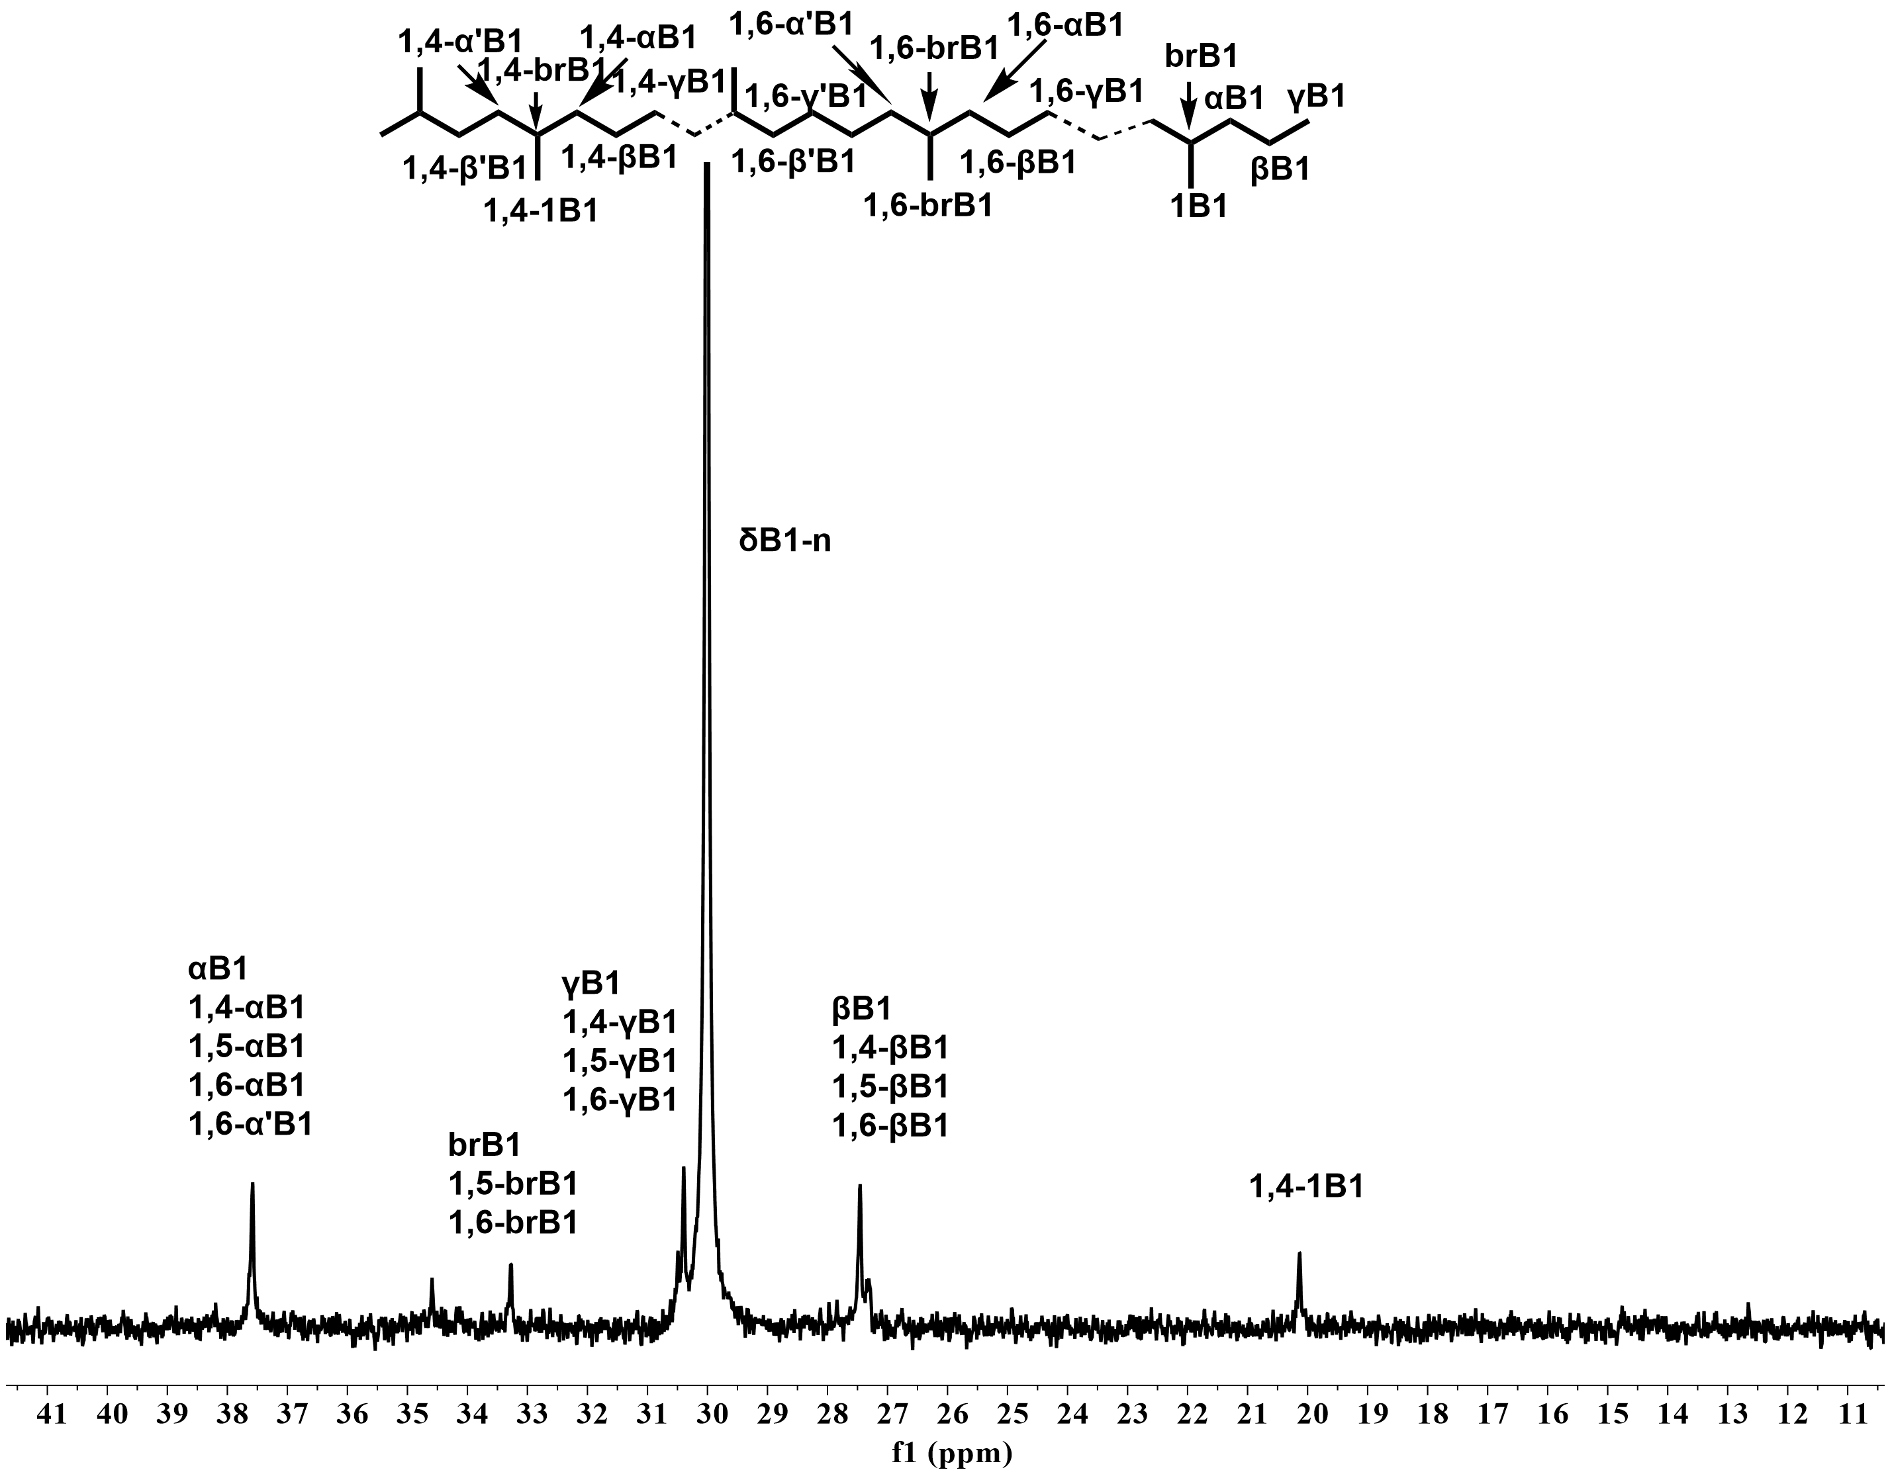
Figure 8. High-temperature ¹³C NMR spectrum of polyethylene produced by Ni6/EtAlCl₂ at 70 ºC with peak assignment and microstructure (run 18, Table 4).

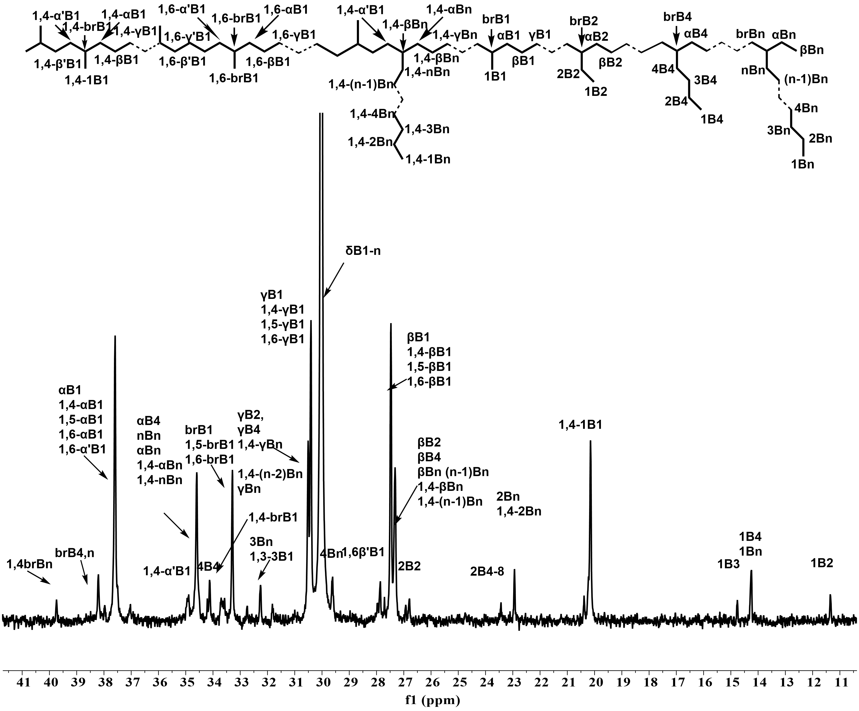
Figure 9. High-temperature ¹³C NMR spectrum of polyethylene produced by Ni6/EASC at 70 ºC with peak assignment and microstructure (run 6, Table 5).
Table 6. Branching information of fifteen typical polyethylene samples produced at different temperatures, different co-catalysts and in different solvents.
PE sample | Branches  /1000Cs | Branching composition (%) |  |  |  |  |  | M_{w} | T_{m} | X_{c}
PE sample | Branches  /1000Cs | Me | Et | Pr | Bu | Amyl | LB | (10⁴)^{d} | (°C)^{e} | (%)^{e}
PE₃₀-Ni4^{b} | 21 | 94.4 | 0.0 | 0.0 | 0.0 | 0.0 | 5.6 | 24.7 | 119.0 | 13.3
PE₃₀-Ni5^{b} | 25 | 100.0 | 0.0 | 0.0 | 0.0 | 0.0 | 0.0 | 26.9 | 116.1 | 30.8
PE₃₀-Ni5ª | 24 | 100.0 | 0.0 | 0.0 | 0.0 | 0.0 | 0.0 | 53.2 | 120.7 | 34.7
PE₇₀-Ni1^{b} | 66 | 82.6 | 2.3 | 0.0 | 6.5 | 0.0 | 8.6 | 9.7 | 87.6 | 18.6
PE₇₀-Ni2^{b} | 72 | 93.3 | 2.9 | 0.0 | 2.1 | 0.0 | 1.8 | 14.7 | 79.6 | 16.4
PE₇₀-Ni3^{b} | 104 | 90.6 | 1.3 | 0.0 | 1.5 | 0.0 | 6.5 | 17.3 | 58.4 | 13.6
PE₇₀-Ni4^{b} | 79 | 80.7 | 1.3 | 0.0 | 6.7 | 0.0 | 13.3 | 6.9 | 70.5 | 10.9
PE₇₀-Ni5^{b} | 88 | 84.2 | 1.7 | 0.0 | 5.8 | 0.0 | 8.3 | 16.0 | 78.1 | 17.3
PE₇₀-Ni6^{b} | 41 | 100.0 | 0.0 | 0.0 | 0.0 | 0.0 | 0.0 | 39.7 | 93.6 | 14.9
PE₇₀-Ni1^{c} | 83 | 83.6 | 3.0 | 0.0 | 5.0 | 0.0 | 8.4 | 5.8 | 76.2 | 7.9
PE₇₀-Ni2^{c} | 86 | 83.8 | 1.9 | 0.0 | 5.3 | 0.0 | 8.9 | 7.4 | 63.2 | 2.5
PE₇₀-Ni3^{c} | 117 | 84.0 | 1.8 | 0.0 | 4.6 | 0.0 | 9.6 | 8.3 | 43.9 | 4.4
PE₇₀-Ni4^{c} | 104 | 78.7 | 1.5 | 0.0 | 6.6 | 0.0 | 13.2 | 4.7 | 68.9 | 3.2
PE₇₀-Ni5^{c} | 116 | 79.7 | 3.0 | 0.0 | 7.0 | 0.0 | 10.3 | 6.6 | 60.0 | 3.3
PE₇₀-Ni6^{c} | 76 | 79.8 | 3.9 | 0.0 | 7.9 | 0.0 | 8.2 | 19.4 | 58.1 | 7.4
ª Solvent in n-hexane, using EtAlCl₂; ^{b} Solvent in toluene, using EtAlCl₂; ^{c} Solvent in toluene, using EASC;^{d} Determined by GPC, unit: g mol⁻¹; ^{e} Determined by DSC, X_{c} = ΔH_{f} (T_{m}) / ΔH_{f}° (T_{m}°); ΔH_{f}° (T_{m}°) = 248.3 J g⁻¹.
2.4 Comparison of catalytic behavior with previously reported 1,2-(arylimino)acenaphthene nickel complexes
To elucidate the superiorities of the present nickel complexes, a systematic comparative analysis has been carried out between the structurally analogous nickel complexes (C, D, G and E, Figure 10)^{[20,21,24,28]} and both the unsymmetric F (Ni4) and symmetric F (Ni6) complexes introduced in the current work. The comparative results reveal that the catalytic performance of the current nickel complexes has been significantly enhanced by effectively modulating the electronic and steric properties of the N-aryl groups in contrast to previously reported nickel complexes.
For example, complex D,^{[21]} which features a 2,4-dimethyl-6-bis(para-fluorobenzhydryl) group on its benzene ring, and only a remotely absorbing electron group, possessed a nickel center with inadequate electrophilicity, thereby demonstrating a significantly lower catalytic activity of 2.2 × 10⁶ g (PE) mol⁻¹ (Ni) h⁻¹, markedly inferior to that of complex F (Ni4). In comparison, complex G^{[27]} containing a chloro-group at the para-position indeed exhibited relatively higher activity than D. Nevertheless, the inclusion of two bulky ortho-bis(para-fluorobenzhydryl) groups introduced excessive steric hindrance around the nickel center, leading to only a modest enhancement in activity, specifically 3.7 × 10⁶ g (PE) mol⁻¹ (Ni) h⁻¹, which remained considerably lower than that of complex F (Ni4) in the current work. Additionally, the bulky characteristics of G facilitated the production of polyethylene with a significantly elevated molecular weight in comparison with F (Ni4) and D, reaching up to 2.9 × 10⁵ g mol⁻¹.
Similar to the description employed in the introduction to elucidate the development trajectory of 1,2-(arylimino)acenaphthene nickel complexes, the significance of substituting the para-bis(4-fluorobenzhydryl) group with a para-chloro group and introducing methyl groups at the ortho-positions, in terms of enhancing the thermal stability of nickel complexes and the branching degree of the resulting polyethylene, was re-emphasized through the comparative analysis of the symmetric complexes (C and E, Figure 10).^{[20,24]} In comparison, C and E showed notably lower activity and inferior thermal-stability relative to F (Ni6). Specifically, F (Ni6) demonstrated the highest activity within the series (6.6 × 10⁶ g (PE) mol⁻¹ (Ni) h⁻¹ for F (Ni6) vs. 3.6 × 10⁶ g (PE) mol⁻¹ (Ni) h⁻¹ for C vs. 5.2 × 10⁶ g (PE) mol⁻¹ (Ni) h⁻¹ for E) at the same or higher temperature (70 °C), while maintaining a comparable molecular weight for the polyethylene (M_{w}: 4.1 × 10⁵ g mol⁻¹). Notably, a significant disparity in crystallinity (X_{c}) was observed between the two types of polyethylene produced by F (Ni1) and the unsymmetrical analogues (E’) derived from E under identical polymerization conditions (25.9% for E’ vs. 4.6% for F (Ni1)) (Figure S44) indicating a markedly enhanced branching degree in the polyethylene synthesized using the F-catalyzed system.
Figure 10. Catalytic comparison between F (this work) and previously documented nickel-based complexes; all polymerizations were conducted under their respective optimal conditions at 10 atm C₂H₄ for 30 min.
2.5. Mechanical properties of the resultant polyethylene
To better understand how the polymerization solvent, polymerization temperature, and ligand structure exert an influence on the mechanical properties of the polyethylene materials, we systematically tested a series of polyethylene samples prepared using different nickel complexes and co-catalysts at varying temperatures (Table 7). The corresponding stress-strain curves are provided in Figure 11, with each tensile test repeated three times to ensure reliability.
The results indicate that the tensile strength and elongation at the break of these branched polyethylene samples are synergistically governed by their molecular weight and branching density, the latter of which dictates the material’s crystallinity. When activated by EtAlCl₂ co-catalyst, the nickel complex structure (maybe the bulky group oriented just at one of the ortho positions in the N-Ar) in this work inherently restricts the chain walking process, leading to polyethylene with a lower branching density than those produced by structurally analogous nickel systems at 30 ºC.^{[68]} As a result, the polyethylene displays moderate to high crystallinity (13.3-35.5%), which accounts for their high tensile strength reaching up to 32.0 MPa. When comparing polyethylene produced at 70 ºC with those obtained at 30 ºC, a pronounced decline is observed in both molecular weight and crystallinity. Specifically, in PE₃₀-Ni1, the molecular weight (M_{w}) dropped from 22.8 × 10⁴ to 9.7 × 10⁴ g mol⁻¹, and the crystallinity (X_{c}) decreased from 18.4% to 4.6%. As a result of these structural changes, the tensile strength decreased from 27.6 MPa to 22.9 MPa, whereas the elongation at break increased significantly from 777.9% to 1058.3%. This trend is attributed to the enhanced chain walking and chain transfer processes that occur at elevated temperature.^{[24]} The ligand steric effect especially from the ortho-substituents further modulate the chain walking process by altering the relative rates of ethylene coordination/insertion and β-H elimination/reinsertion.^{[28]} Among the PE₃₀-Ni1, PE₃₀-Ni2, and PE₃₀-Ni3 series, the sample from the PE₃₀-Ni3 systems has the lowest crystallinity and the highest molecular weight, indicating the greatest branching degree. This microstructure resulted in the highest tensile strength (σb = 32.0 MPa) and considerable elongation at break (εb = 918%). Finally, switching the polymerization solvent from toluene to n-hexane also played a pivotal role in boosting the chain propagation process, resulting in the production of polyethylene with higher molecular weight. Meanwhile, only a minor impact was observed on the chain walking process. Consequently, polyethylene materials synthesized in n-hexane demonstrate superior breaking strength and comparable breaking elongation when compared to those produced in toluene.
To evaluate the impact of microstructural alterations induced by different co-catalyst types, the mechanical properties of the PE₇₀-Ni series of samples, synthesized at 70 °C using toluene solvent, were thoroughly tested and were compared with the Ni/EASC and Ni/EtAlCl₂ systems. Notably, the PE₇₀-Ni samples produced by Ni/EASC possessed a higher branching degree (76-117/1000C vs. 43-104/1000C for Ni/EtAlCl₂), lower molecular weight [M_{w}: (4.7-19.4) × 10⁴ vs. (6.9-39.7) × 10⁴ g mol⁻¹ for Ni/EtAlCl₂], lower melting temperature [T_{m}: 58.7-93.6 ºC vs. 43.9-76.2 ºC for Ni/EtAlCl₂] and reduced crystallinity [X_{c}, 3.7%-14.9% vs. 3.2%-6.9% for Ni/EtAlCl₂]. These contrasts effectively underscore the substantial influence of the co-catalyst selection on the microstructure of the branched polyethylene. Further analysis reveals that utilizing EASC as the co-catalyst significantly enhanced the chain-walking process, thereby facilitating the formation of highly branched chains, likely due to its distinctive role in both activation and chain transfer steps.^{[69-71]} Consequently, the branched polyethylene materials obtained by the Ni/EASC system exhibited relatively lower tensile strength (σb = 12.2-17.5 MPa), but substantially higher elongation at break (εb = 772.1-1628.6%) compared to those obtained by the Ni/EtAlCl₂ system (Figure 12).
To assess the elastic recovery capabilities of these branched polyethylene samples featuring a higher degree of branching, hysteresis tests were carried out on polyethylene samples derived from both the Ni/EtAlCl₂ and Ni/EASC systems at 70 °C, utilizing a DMA Q800 instrument (Figure S45 and Figure 13). Notably, the polyethylene sample with the highest branching density (117/1000C), obtained from the Ni3/EASC system, exhibited superior elastic recovery, achieving a strain recovery (SR) of 65% after 10 cycles. In contrast, the polyethylene sample produced by the Ni3/EtAlCl₂ system, with a relatively lower branching degree of 104/1000C, exhibited a somewhat diminished elastic recovery value (SR = 57%), highlighting the significant correlation between branching microstructure and elastic properties.^{[64]} Similarity, PE₇₀-Ni6, which has the lowest branching degree of 76/1000C among the samples obtained via the Ni/EASC systems, displayed the lowest recovery rate (SR = 43%). Generally speaking, all these polyethylene samples, synthesized under rigorous polymerization conditions that prevented the rampant formation of irregular branches and the generation of amorphous materials lacking strength, exhibited outstanding tensile strength, elongation at break, and elastic recovery capabilities, rendering them promising alternatives to commercial thermoplastic elastomers.
Table 7. Selected properties of PE samples obtained using Ni1-Ni6 under various conditions.
PE sample | T  (°C) | B (/1000C) | M_{w}  (10⁴)ª | T_{m}  (°C)^{b} | X_{c}  (%)^{b} | σ_{b}  (MPa)^{c} | ε_{b}  (%)^{c} | SR  (%)^{d}
PE₃₀-Ni1^{f} | 30 | - | 22.8 | 108.4 | 18.4 | 27.6 | 777.9 | -
PE₃₀-Ni2^{f} | 30 | - | 28.2 | 106.3 | 20.1 | 30.1 | 708.1 | -
PE₃₀-Ni3^{f} | 30 | - | 40.8 | 105.8 | 16.9 | 32.0 | 918.4 | -
PE₃₀-Ni4^{f} | 30 | 21 | 24.7 | 119.0 | 13.3 | 27.8 | 814.8 | -
PE₃₀-Ni5^{f} | 30 | 22 | 26.9 | 116.1 | 30.8 | 15.3 | 508.9 | -
PE₃₀-Ni5e | 30 | 25 | 53.2 | 120.7 | 34.7 | 23.4 | 512.9 | -
PE₃₀-Ni6^{f} | 30 | - | 42.8 | 116.5 | 35.5 | 16.6 | 442.4 | -
PE₇₀-Ni1^{f} | 70 | 66 | 9.7 | 87.6 | 18.6 | 22.9 | 1058.3 | -
PE₇₀-Ni2^{f} | 70 | 72 | 14.7 | 79.6 | 16.4 | 25.2 | 995.8 | -
PE₇₀-Ni3^{f} | 70 | 104 | 17.3 | 58.4 | 13.6 | 16.7 | 878.1 | 57%
PE₇₀-Ni4^{f} | 70 | 79 | 6.9 | 70.5 | 10.9 | 12.1 | 1222.4 | -
PE₇₀-Ni5^{f} | 70 | 88 | 16.0 | 78.1 | 17.3 | 23.5 | 813.2 | -
PE₇₀-Ni6^{f} | 70 | 41 | 39.7 | 93.6 | 14.9 | 23.5 | 718.8 | -
PE₇₀-Ni1^{g} | 70 | 83 | 5.8 | 76.2 | 7.9 | 12.5 | 1202.5 | 58%
PE₇₀-Ni2^{g} | 70 | 86 | 7.4 | 63.2 | 2.5 | 17.5 | 1379.9 | 53%
PE₇₀-Ni3^{g} | 70 | 117 | 8.3 | 43.9 | 4.4 | 12.2 | 1272.9 | 65%
PE₇₀-Ni4^{g} | 70 | 104 | 4.7 | 68.9 | 3.2 | 15.8 | 1558.2 | 60%
PE₇₀-Ni5^{g} | 70 | 116 | 6.6 | 60.0 | 3.3 | 14.5 | 1628.6 | 55%
PE₇₀-Ni6^{g} | 70 | 76 | 19.4 | 58.1 | 7.4 | 15.4 | 772.1 | 43%
ª Determined by GPC, unit: g mol⁻¹; ^{b} Determined by DSC, X_{c} = ΔH_{f} (T_{m}) / ΔH_{f}° (T_{m}°); ΔH_{f}° (T_{m}°) = 248.3 J g⁻¹; ^{c} Determined by using a universal tester; ^{d} Strain recovery values (SR) were calculated by using the standard formula SR = 100(εa-εr)/εa,^{[72]} where εa is the applied strain and εr is the strain in the cycle at 0 loads after 10 cycles; ^{e} Solvent in n-hexane, using EtAlCl₂ as co-catalyst; ^{f} Solvent in toluene, using EtAlCl₂ as co-catalyst; ^{g} Solvent in toluene, using EASC as co-catalyst.

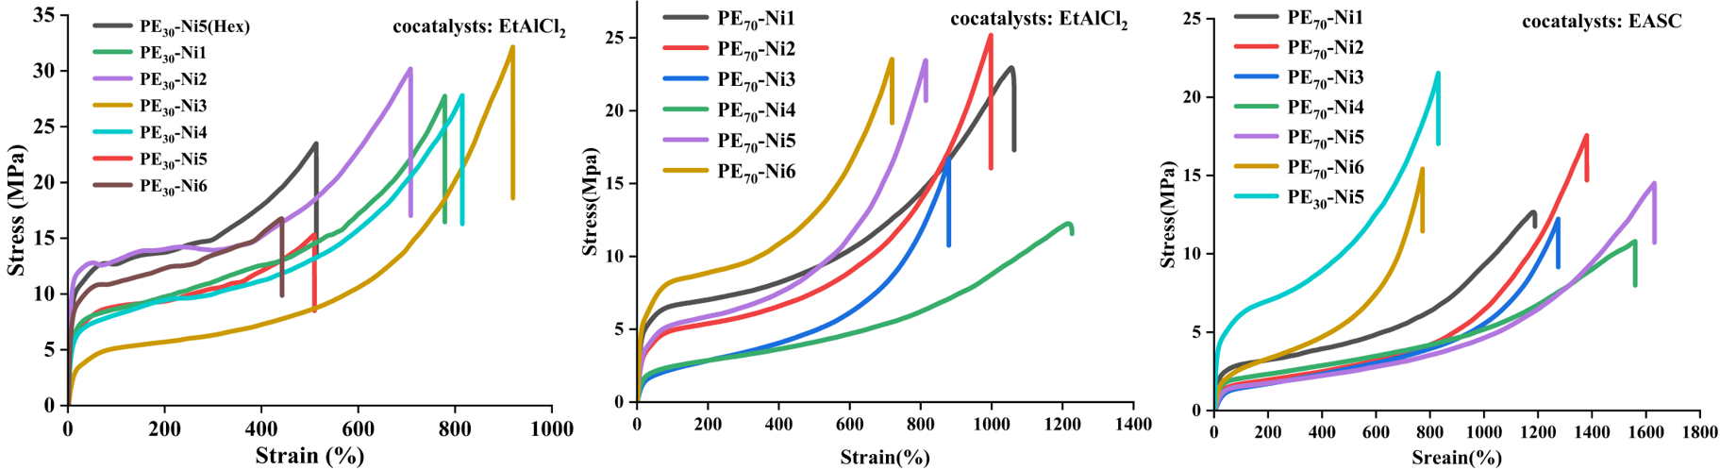
Figure 11. Stress-strain curves for PE₃₀-Ni obtained by Ni/EtAlCl₂ at 30 ºC (runs 12, Table 3; runs 1, 7, 10, 13, 14, 16, Table 4) (left); Stress-strain curves for PE₇₀-Ni obtained by Ni/EtAlCl₂ at 70 ºC (runs 3, 6, 9, 12, 15, 18, Table 4) (middle); Stress-strain curves for PE₇₀-Ni obtained by Ni/EASC at 70 ºC (runs 1-6, Table 5; runs 4, Table 3) (right); the vertical line represents the breakage point.

Figure 12. Comparison of Elongation at Break between the PE₇₀-Ni/EtAlCl₂ and PE₇₀-Ni/EASC systems (runs 3, 6, 9, 12, 15, 18, Table 4; runs 1-6, Table5).

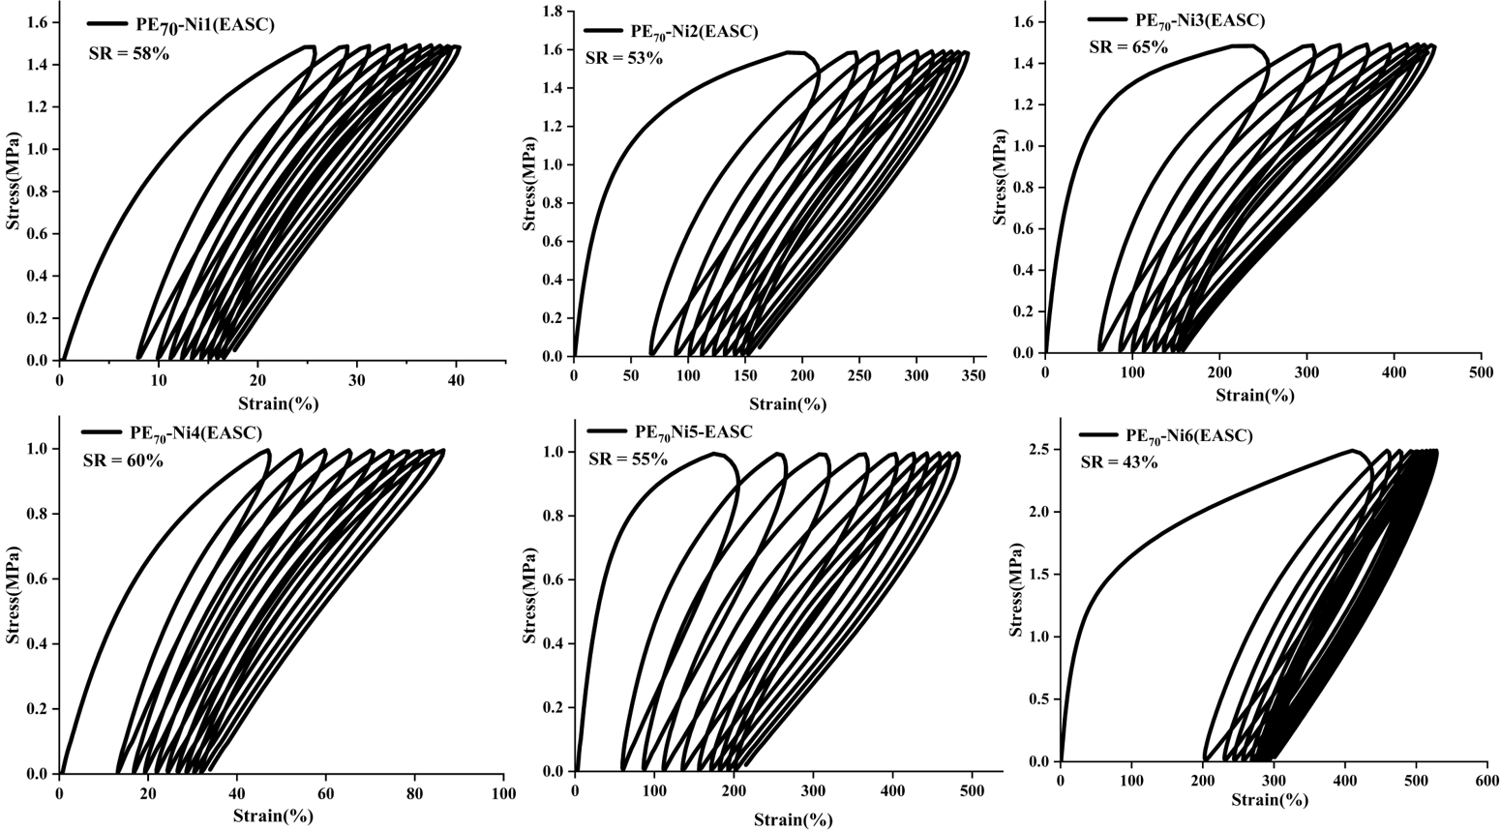
Figure 13. Strain recovery measurements for PE₇₀-Ni obtained by Ni/EASC at 70 ºC (runs 1-6, Table 5).
3. Conclusion
A series of 1,2-(arylimino)acenaphthene-based pro-ligands bearing an N-(2-[bis(4-fluorophenyl)methyl]-4-chloro-6-methylphenyl) group, along with their corresponding nickel(II) bromide complexes, were successfully synthesized and characterized. The low buried volume values and binuclear crystal structures confirm an open coordination geometry around the nickel centers. All these nickel pre-catalysts exhibited remarkably high activity, reaching up to 14.8 × 10⁶ g (PE) mol⁻¹ (Ni) h⁻¹, and exceptional thermal stability in ethylene polymerization. Moreover, the properties of the resulting polymers strongly depend on the co-catalyst selection, owing to the distinct alkylation capacities and Lewis acidities of the employed activation systems. Specifically, the Ni/EtAlCl₂ system yielded polyethylene with higher molecular weights, lower branching densities, and higher crystallinities, resulting in enhanced tensile strength (up to 32.0 MPa) and good ductility (strain recovery, SR = 57%). These materials are well suited for demanding plastomeric applications. In contrast, the Ni/EASC system promoted extensive chain-walking, producing highly branched polyethylene characterized by a notably higher branching density (up to 117 branches/1000C) and a diverse distribution of branch types. These structural features conferred outstanding elastomeric performance, including exceptional elongation at break (up to 1628.6%) and high elastic recovery (up to 65%). Overall, the strategic design of pro-ligands in the current work offers an open yet adjustable coordination environment, enabling the efficient synthesis of highly branched polyethylene with programmable at elevated temperatures.
Supporting Information.
NMR spectra of all newly synthesized organic compounds. The GPC curves of polyethylenes and microstructural characterization of typical polyethylenes.
Accession Codes
CCDC 2525531−2525533 contain the supplementary crystallographic data for this paper. These data can be obtained free of charge via www.ccdc.cam.ac.uk/data_request/cif, or by emailing data_request@ccdc.cam.ac.uk, or by contacting The Cambridge Crystallographic Data Centre, 12 Union Road, Cambridge CB2 1EZ, UK; fax: +44 1223 336033.
AUTHOR INFORMATION
Corresponding Author
Yanning Zeng − College of Materials Science and Engineering, Guilin University of Technology, Guilin 541004, China; orcid.org/0000-0002-6800-6260; Email: ynzeng@glut.edu.cn
Wen-Hua Sun − Key Laboratory of Engineering Plastics and Beijing National Laboratory for Molecular Science, Institute of Chemistry, Chinese Academy of Sciences, Beijing 100190, China; orcid.org/0000-0002-6614-9284; Phone: +86 1062557955; Email: whsun@iccas.ac.cn
Notes
The authors declare no competing financial interest.
ACKNOWLEDGMENT
We acknowledge the support by the Strategic Priority Research Program of the Chinese Academy of Sciences, Grant No. XDC0270102. C. R. is grateful to the Chinese Academy of Sciences President’s International Fellowship Initiative (Grant No.2026PVA0009).

REFERENCES
(1) Zanchin, G.; Leone, G., Polyolefin thermoplastic elastomers from polymerization catalysis: Advantages, pitfalls and future challenges. Prog. Polym. Sci. 2021, 113, 101342.
(2) Mohite, A. S.; Rajpurkar, Y. D.; More, A. P. Bridging the Gap between Rubbers and Plastics: A Review on Thermoplastic Polyolefin Elastomers. Polym. Bull. 2022, 79, 1309–1343.
(3) Braunecker, W. A.; Matyjaszewski, K., Controlled/living radical polymerization: Features, developments, and perspectives. Prog. Polym. Sci. 2007, 32, 93-146.
(4) Sha, Y.; Sun, W.; Ding, S.; Ye, P.; Zhang, Y.; Jia, P. Performance-Guided Design of Chemically Recyclable Polymeric Materials: A Case Study on Thermoplastic Elastomers. ACS Polym. Au 2025, 5, 432–444.
(5) Sun, M.; Xiao, Y.; Liu, K.; Yang, X.; Liu, P.; Jie, S.; Hu, J.; Shi, S.; Wang, Q.; Lim, K. H.; Liu, Z.; Li, B.-G.; Wang, W.-J. Synthesis and characterization of polyolefin thermoplastic elastomers: A review. Can. J. Chem. Eng. 2023, 101, 4886–4908.
(6) Hassanian-Moghaddam, D.; Maddah, Y.; Ahmadjo, S.; Mortazavi, S. M. M.; Sharif, F.; Ahmadi, M., Mechanistic study on the metallocene-based tandem catalytic coordinative chain transfer polymerization for the synthesis of highly branched polyolefins. Eur. Polym. J. 2021, 152, 110454.
(7) Johnson, L. K.; Killian, C. M.; Brookhart, M. New Pd(II)- and Ni(II)-Based Catalysts for Polymerization of Ethylene and α-Olefins. J. Am. Chem. Soc. 1995, 117, 6414−6415.
(8) Killian, C. M.; Tempel, D. J.; Johnson, L. K.; Brookhart, M. Living Polymerization of α-Olefins Using Ni^{ii}-α-diimine Catalysts. Synthesis of New Block Polymers Based on α-Olefins. J. Am. Chem. Soc. 1996, 118, 11664−11665.
(9) Mahmood, Q.; Hu, Z.; Ren, G.; Sun W.-H, Recent advances in nickel Catalysis for thermoplastic polyethylene elastomers: Synthesis strategies, properties, and future perspectives. Coord. Chem. Rev. 2025, 541, 216833
(10) Wang, Z.; Liu, Q.; Solan, G. A.; Sun, W.-H., Recent advances in Ni-mediated ethylene chain growth: Nimine-donor ligand effects on catalytic activity, thermal stability and oligo-/polymer structure. Coord. Chem. Rev. 2017, 350, 68-83.
(11) Wang, Q.; Wang, Y.; Zhang, Q.; Ma, Y.; Liang, T.; Gao, J.; Sun, W.-H. Remote naphthyl enhancing bis(imino)acenaphthene-Nickel precatalysts in ethylene polymerization. Mol. Catal. 2025, 587, 115481.
(12) Zhang, Q.; Lin, W.; Ning, Z.; Wang, Y.; Ma, Y.; Solan, G. A.; Liang, T.; Sun, W.-H., Bimodal and Highly Branched Polyethylenes Using Dual-Site Nickel Catalysts Supported on an Unsymmetrical BIAN-PI Compartmental Ligand Scaffold. Macromolecules 2024, 57, 1087-1105.
(13) Wang, X., Fan, L., Ma, Y., Guo, C.-Y., Solan, G. A., Sun, Y., & Sun, W.-H. Elastomeric polyethylenes accessible via ethylene homo-polymerization using an unsymmetrical α-diimino-nickel catalyst. Polym. Chem. 2017, 8, 2785–2795.
(14) Ren, G.; Mahmood, Q.; Liu, S.; Wang, Y.; Li, Q.; Xi, A.; Liang, T.; Sun, W.-H., Fluoro-enriched α-diimine nickel precatalysts for enhanced thermostability in synthesis of polyethylene elastomer. Eur. Polym. J. 2025, 233, 114004.
(15) Qin, L.-D., Wang, X.-Y., Mahmood, Q., Yu, Z.-X., Wang, Y.-Z., Zou, S., Liang, T.-L., & Sun, W.-H. High-performance α-diamine nickel complexes for facile access of PE elastomers with exceptional material properties. Chin. J. Polym. Sci. 2024, 42, 620–635.
(16) Du, S.; Kong, S.; Shi, Q.; Mao, J.; Guo, C.; Yi, J.; Liang, T.; Sun, W.-H., Enhancing the Activity and Thermal Stability of Nickel Complex Precatalysts Using 1-[2,6-Bis(bis(4-fluorophenyl)methyl)-4-methylphenylimino]-2-aryliminoacenaphthylene Derivatives. Organometallics 2015, 34, 582-590.
(17) Sun, Y.-L.; Hou, Y.-H.; Cui, M.-M.; Meng, H.; Liu, B.-Y.; Yang, M. Homogeneous and Heterogeneous α-Diimine Ni(II) Catalysts with Asymmetric Fluorine-Containing Diphenylmethyl Substituents for the Polymerization of Ethylene. Catal. Lett. 2023, 153, 1944–1955.
(18) Wang, X.; Fan, L.; Yuan, Y.; Du, S.; Sun, Y.; Solan, G. A.; Guo, C. Y.; Sun, W.-H., Raising the N-aryl fluoride content in unsymmetrical diaryliminoacenaphthylenes as a route to highly active nickel(_{II}) catalysts in ethylene polymerization. Dalton Trans. 2016, 45, 18313-18323.
(19) Zhang, Q.; Zhang, R.; Ma, Y.; Solan, G. A.; Liang, T.; Sun, W.-H. Branched polyethylenes attainable using thermally enhanced bis(imino) acenaphthene-nickel Catalysts: Exploring the effects of temperature and pressure. Appl. Catal., A 2019, 573, 73–86.
(20) Chen, Y.; Du, S.; Huang, C.; Solan, G. A.; Hao, X.; Sun, W.- H., Balancing High Thermal Stability with High Activity in Diaryliminoacenaphthene‐Nickel(II) Catalysts for Ethylene Polymerization. J. Polym. Sci., Part A: Polym. Chem. 2017, 55, 1971-1983.
(21) Du, S.; Xing, Q.; Flisak, Z.; Yue, E.; Sun, Y.; Sun, W.-H., Ethylene polymerization by the thermally unique 1-[2-(bis(4-fluorophenyl)methyl)-4,6-dimethylphenylimino]-2-aryliminoacenaphthylnickel precursors. Dalton Trans. 2015, 44, 12282-12291.
(22) Tang, S.; Wang, C.; Xia, S.; Fu, Z.; Xu, T. Regulation of the Components in Broad Molecular Weight Distribution Polyethylene by C₂ -Symmetric α-Diimine Nickel Catalysts With Different N-Aryl Substituents. Appl. Organomet. Chem. 2025, 39, e7989.
(23) Ashfaq, A. M.; Zhang, Q.; Wang, Y.; Ma, Y.; Xing, Q.; Sun, M.; Liang, T.; Sun, W.-H., Thermostable polyhalogen-substituted α-diimine nickel precatalysts towards high performance polyethylene elastomer. J. Mol. Struct. 2025, 1334, 141892.
(24) Xi, A.; Zhang, Q.; Zeng, Y.; Wang, Y.; Wang, Q.; Ma, Y.; Hao, X.; Sun, W.-H., ortho/para-Chlorinated α-Diimine Nickel Precatalysts Resulting Polyethylenes with Improved Mechanical Properties and Controlled Crystallinity. ACS Omega 2025, 10, 33689-33703.
(25) Ren, G.; Yuan, R.; Mahmood, Q.; Zeng, Y.; Wang, Y.; Hu, Z.; Zou, S.; Liang, T.; Sun, W.-H., Congestion of steric and electronic factors in α-diimine nickel precatalysts for high-temperature ethylene polymerization in accessing direct PE elastomer. J. Mol. Struct. 2024, 1316，139037.
(26) Fan, L.; Yue, E.; Du, S.; Guo, C.-Y.; Hao, X.; Sun, W.-H., Enhancing thermo-stability to ethylene polymerization: synthesis, characterization and the catalytic behavior of 1-(2,4-dibenzhydryl-6-chlorophenylimino)-2-aryliminoacenaphthylnickel halides. RSC Adv. 2015, 5, 93274-93282.
(27) Kong, S.; Guo, C.-Y.; Yang, W.; Wang, L.; Sun, W.-H.; Glaser, R., 2,6-Dibenzhydryl-N-(2-phenyliminoacenaphthylenylidene)-4-chloro-aniline nickel dihalides: Synthesis, characterization and ethylene polymerization for polyethylenes with high molecular weights. J. Organomet. Chem. 2013, 725, 37-45.
(28) Guan, Z.; Cotts, P. M.; Mccord, E. F.; and McLain, S. J., Chain Walking: A New Strategy to Control Polymer Topology, Science, 1999, 283, 2059–2062.
(29) He, Z.; Liang, Y.; Yang, W.; Uchino, H.; Yu, J.; Sun, W.-H.; Han, C. C. Random Hyperbranched Linear Polyethylene: One Step Production of Thermoplastic Elastomer. Polymer 2015, 56, 119-122.
(30) Yuan, R.; Wang, Y.; Mahmood, Q.; Zeng, Y.; Qin, L.; Zou, S.; Liang, T.; Sun, W.-H., Synergistic influence of methoxy and benzhydryl groups in α-diimine nickel precatalysts for facile synthesizing UHMW PE elastomers. Polymer 2024, 293, 126690.
(31) Zhang, Q.; Wang, Q.; Wang, Y.; Ashfaq, A. M.; Ma, Y.; Liang, T.; Sun, W.-H., Amino-containing α-Diimine Nickel Complexes with Adjustable Electronic Properties and their Effective Use in Forming Highly Branched Polyethylene. Macromol. Chem. Phys. 2024, 225, 2400169.
(32) Chai, W.; Yu, J.; Wang, L.; Hu, X.; Redshaw, C.; Sun, W.-H., Synthesis, characterization and ethylene oligomerization behavior of N-(2-alkyl-5,6,7-trihydroquinolin-8-ylidene)arylaminonickel(II) dichlorides. Inorg. Chim. Acta 2012, 385, 21-26.
(33) Addison, A. W.; Rao, T. N.; Reedijk, J.; van Rijn, J.; Verschoor, G. C. Synthesis, Structure, and Spectroscopic Properties of Copper(II) Compounds containing Nitrogen-Sulphur Donor Ligands; the Crystal and Molecular Structure of Aqua[1,7-bis(N-methylbenzimidazol-2'-yl)-2,6-dithiaheptane]copper(II) Perchlorate. Journal of the Chemical Society, Dalton Trans. 1984, 1349–1356.
(34) Yuan, S.; Yue, E.; Wen, C.; Sun, W.-H. Synthesis, characterization, and ethylene polymerization of 1-[2,4-bis(bis(4-fluorophenyl)methyl)naphthylimino]-2-aryliminoacenaphthylnickel bromides: influences of polymerization parameters on polyethylenes. RSC Adv. 2016, 6, 7431.
(35) Zhou, A.; Yuan, R.; Mahmood, Q.; Yuan, S.; Wang, Y.; Hu, Z.; Zou, S.; Liang, T.; Sun, W.-H., Benzosuberyl installed “sandwich” type unsymmetrical α-diimine nickel precatalysts for synthesizing plastomeric to elastomeric polyethylene. Polym. Chem. 2024, 15, 4029-4043.
(36) Sun, J.; Wang, F.; Li, W.; Chen, M. Ligand Steric Effects on α-Diimine Nickel Catalyzed Ethylene and 1-Hexene Polymerization. RSC Adv. 2017, 7, 49851–49858.
(37) Liu, F.-S.; Hu, H.-B.; Xu, Y.; Guo, L.-H.; Zai, S.-B.; Song, K.-M.; Gao, H.-Y.; Zhang, L.; Zhu, F.-M.; Wu, Q. Thermostable α-Diimine Nickel(II) Catalyst for Ethylene Polymerization: Effects of the Substituted Backbone Structure on Catalytic Properties and Branching Structure of Polyethylene. Macromolecules 2009, 42, 7789–7796.
(38) Zhong, L.; Zheng, H.; Du, C.; Du, W.; Liao, G.; Cheung, C. S.; Gao, H. Thermally robust α-diimine nickel and palladium catalysts with constrained space for ethylene (co)polymerizations. J. Catal. 2020, 384, 208-217.
(39) Gates, D. P.; Svejda, S. A.; Onate, E.; Killian, C. M.; Johnson, L. K.; White, P. S.; Brookhart, M.; Synthesis of Branched Polyethylene Using (α-diimine)nickel(II)-Catalysts: Influence of Temperature Ethylene Pressure and Ligand Structure on Polmer Properties. Macromolecules 2000, 33, 2320-2334.
(40) Ma, X.; Zhang, Y.; Jian, Z., Tunable branching and living character in ethylene polymerization using “polyethylene glycol sandwich” α-diimine nickel catalysts. Polym. Chem. 2021, 12, 1236-1243.
(41) Liu, J.-K.; Qiu, B.-B.; Feng, Y.; Fan, L.; Huang, L.; Wang, Y.-B.; Song, M.-P.; Gong, J.-F.; Jiang, H. Precise Control of Ethylene Polymerization via Nickel(II) Catalysts with Tunable ortho-Coordinating Groups: From Living Polymerization to Functionalized Polyolefins. Chin. J. Chem. 2026, 44, 15–24.
(42) Li, D.; Qiu, Z.; Xiao, X.; Gao, H.; Feng, C.; Zheng, H.; Gao, H. Effects of ancillary ligands on molecular structure and catalytic properties of tridentate α-sulfonate-β-diimine nickel complexes toward ethylene (co) polymerization Mol. Catal. 2025, 573, 115136.
(43) Yuan, S. F.; Fan, Z.; Zhang, Q.; Flisak, Z.; Ma, Y.; Sun, Y.; Sun, W.-H., Enhancing performance of α-diiminonickel precatalyst for ethylene polymerization by substitution with the 2,4-bis(4,4'‐dimethoxybenzhydryl)-6-methylphenyl group. Appl. Organomet. Chem. 2020, 34, e5638.
(44) Vignesh, A.; Zhang, Q.; Ma, Y.; Liang, T.; Sun, W.-H., Attaining highly branched polyethylene elastomers by employing modified α-diiminonickel(II) catalysts: Probing the effects of enhancing fluorine atom on the ligand framework towards mechanical properties of polyethylene. Polymer 2020, 187, 122089.
(45) Suo, H.; Oleynik, I. V.; Huang, C.; Oleynik, I. I.; Solan, G. A.; Ma, Y.; Liang, T.; Sun, W.-H., ortho-Cycloalkyl substituted N,N’-diaryliminoacenaphthene-Ni(ii) catalysts for polyethylene elastomers; exploring ring size and temperature effects. Dalton Trans. 2017, 46, 15684-15697.
(46) Mahmood, Q.; Zeng, Y.; Yue, E.; Solan, G. A.; Liang, T.; Sun, W.-H., Ultra-high molecular weight elastomeric polyethylene using an electronically and sterically enhanced nickel catalyst. Polym. Chem. 2017, 8, 6416-6430.
(47) Fan, L.; Du, S.; Guo, C. Y.; Hao, X.; Sun, W.-H., 1-(2,6-dibenzhydryl-4-fluorophenylimino)-2-aryliminoacenaphthylylnickel halides highly polymerizing ethylene for the polyethylenes with high branches and molecular weights. J. Polym. Sci., Part A: Polym. Chem. 2015, 53, 1369-1378.
(48) Liu, H.; Zhao, W.; Hao, X.; Redshaw, C.; Huang, W.; Sun, W.-H., 2,6-Dibenzhydryl-N-(2-phenyliminoacenaphthylenylidene)-4-methylbenzenamine Nickel Dibromides: Synthesis, Characterization, and Ethylene Polymerization. Organometallics 2011, 30, 2418-2424.
(49) Liu, H.; Zhao, W.; Yu, J.; Yang, W.; Hao, X.; Redshaw, C.; Chen, L.; Sun, W.-H., Synthesis, characterization and ethylenepolymerization behavior of nickel dihalide complexes bearing bulky unsymmetrical α-diimine ligands. Catal. Sci. Technol. 2012, 2, 415-422.
(50) Musaev, D. G.; Froese, R. D. J.; Svensson, M.; Morokuma, K. A Density Functional Study of the Mechanism of the Diimine-Nickel-Catalyzed Ethylene Polymerization Reaction. J. Am. Chem. Soc. 1997, 119, 367–374.
(51) Zhang, Y.; Zhang, Y.; Hu, X.; Wang, C.; Jian, Z., Advances on Controlled Chain Walking and Suppression of Chain Transfer in Catalytic Olefin Polymerization. ACS Catal. 2022, 12, 14304-14320.
(52) Hai, Z.; Lu, Z.; Li, S.; Cao, Z.-Y.; Dai, S., The synergistic effect of rigid and flexible substituents on insertion polymerization with α-diimine nickel and palladium catalysts. Polym. Chem. 2021, 12, 4643-4653.
(53) Rhinehart, J. L.; Mitchell, N. E.; Long, B. K., Enhancing α-Diimine Catalysts for High-Temperature Ethylene Polymerization. ACS Catal. 2014, 4, 2501-2504.
(54) Rhinehart, J. L.; Brown, L. A.; Long, B. K., A Robust Ni(II) α-Diimine Catalyst for High Temperature Ethylene Polymerization. J. Am. Chem. Soc. 2013, 135, 16316-16319.
(55) Zhang, R.; Wang, Z.; Ma, Y.; Solan, G. A.; Sun, Y.; Sun, W.-H., Plastomeric-like polyethylenes achievable using thermally robust N,N’-nickel catalysts appended with electron withdrawing difluorobenzhydryl and nitro groups. Dalton Trans. 2019, 48, 1878-1891.
(56) Zhang, D.; Nadres, E. T.; Brookhart, M.; Daugulis, O., Synthesis of Highly Branched Polyethylene Using “Sandwich” (8-p-Tolyl naphthyl α-diimine)nickel(II) Catalysts. Organometallics 2013, 32, 5136-5143.
(57) Mahmood, Q.; Zeng, Y.; Wang, X.; Sun, Y.; Sun, W.-H., Advancing polyethylene properties by incorporating NO₂ moiety in 1,2-bis(arylimino)acenaphthylnickel precatalysts: synthesis, characterization and ethylene polymerization. Dalton Trans. 2017, 46, 6934-6947.
(58) Zhong, L.; Du, C.; Liao, G.; Liao, H.; Zheng, H.; Wu, Q.; Gao, H., Effects of backbone substituent and intra-ligand hydrogen bonding interaction on ethylene polymerizations with α-diimine nickel catalysts. J. Catal. 2019, 375, 113-123.
(59) Guo, L.; Lian, K.; Kong, W.; Xu, S.; Jiang, G.; Dai, S., Synthesis of Various Branched Ultra-High-Molecular-Weight Polyethylenes Using Sterically Hindered Acenaphthene-Based α-Diimine Ni(II) Catalysts. Organometallics 2018, 37, 2442-2449.
(60) Wyrvalski, C. N.; De Souza, M. O.; De Souza, R. F., Effect of the alkylaluminum cocatalyst on propene oligomerization catalyzed by dicationic nickel complexes. Quim. Nova 1996, 19, 493–496.
(61) De Souza, C. G.; De Souza, R. F.; Bernardo-Gusmão, K. Effect of alkylaluminum cocatalyst on ethylene polymerization with nickel-α-diimine complex. Appl. Catal., A 2007, 325, 87-90.
(62) Yuan, S.; Duan, T.; Zhang, R.; Solan, G. A.; Ma, Y.; Liang, T.; Sun, W.-H. Alkylaluminum activator effects on polyethylene branching using a N,N’-nickel precatalyst appended with bulky 4,4’-dimethoxybenzhydryl groups. Appl. Organomet. Chem. 2019, 33, e4785.
(63) Xu, M.; Liu, Y.; Pang, W.; Pan, Y.; Chen, M.; Zou, C.; Tan, C. Cocatalyst effects in α-diimine nickel catalyzed ethylene polymerization. Polymer 2022, 255, 1255116.
(64) Galland, G. B.; de Souza, R. F.; Mauler, R. S.; Nunes, F. F. ¹³C NMR Determination of the Composition of Linear Low-Density Polyethylene Obtained with [η³-Methallyl-nickel-diimine]PF₆ Complex. Macromolecules 1999, 32, 1620−1625.
(65) Zhang, Y.; Wang, C.; Mecking, S.; Jian, Z. Ultrahigh Branching of Main-Chain-Functionalized Polyethylenes by Inverted Insertion Selectivity. Angew. Chem., Int. Ed. 2020, 59, 14296–14302.
(66) Falivene, L.; Wiedemann, T.; Göttker-Schnetmann, I.; Caporaso, L.; Cavallo, L.; Mecking, S., Control of Chain Walking by Weak Neighboring Group Interactions in Unsymmetrical Catalysts. J. Am. Chem. Soc. 2018, 140, 1305-1312.
(67) Hamedani, N. G.; Arabi, H. A systematic study of Nickel (II) α-diimine complex performance on ethylene polymerization: influence of cocatalyst nature. Polym. Bull. 2015, 72, 2471–2488.
(68) Liu, M.; Sun, M.; Ma, Y.; Wang, Y.; Li, M.; Sun, W.-H., Trifluoromethoxy- and Fluorobenzhydryl-Tuned Nickel Catalysts for Polyethylene Elastomers. Molecules 2025, 30, 2706.
(69) Ferreira, L. C.; Melo, P. A.; Crossetti, G. L.; Galland, G. B.; Nele, M.; Pinto, J. C. Polymerization of Ethylene by (α‐Diimine) Nickel Catalyst and Statistical Analysis of the Effects of Reaction Conditions. Polym. Eng. Sci. 2010, 50, 1797-1808.
(70) Chen, E. Y.-X. Cocatalysts for Metal-Catalyzed Olefin Polymerization: Activators, Activation Processes, and Structure-Activity Relationships. Chem. Rev. 2000, 100, 1391−1434.
(71) Leatherman, M. D.; Svejda, A. S., Johnson, L. K.; and Brookhart, M., Mechanistic Studies of Nickel(ii) Alkyl Agostic Cations and Alkyl Ethylene Complexes Investigations of Chain Propagation and Isomerization in (α-diimine)Ni(II)-Catalyzed Ethylene Polymerization. J. Am. Chem. Soc. 2003, 125, 3068-3081.
(72) Wang, Y.; Vignesh, A.; Qu, M.; Wang, Z.; Sun, Y.; Sun, W.-H., Access to polyethylene elastomers via ethylene homo-polymerization using N,N′-nickel(II) catalysts appended with electron withdrawing difluorobenzhydryl group. Eur. Polym. J. 2019, 117, 254-271.

