Antagonistic effects during phenanthrene and pyrene co-degradation by Pseudoxanthomonas: Pathway competition and substrate preference

Suhang Wang ^{a,b,†}, Jiaqing Liang ^{a,†}, Yongkai Liao ^{a,b}, Haixuan Zhou ª, Brian J. Reid ^{c}, Chao Cai ^{a,b,*}
ª State Key Laboratory of Regional and Urban Ecology, Institute of Urban Environment, Chinese Academy of Sciences, Xiamen 361021, China
^{b} University of Chinese Academy of Sciences, Beijing 100049, China
^{c} School of Environmental Sciences, University of East Anglia, Norwich Research Park, Norwich NR4 7TJ, UK
† These authors contributed equally to this work

⁎Corresponding author
Address: State Key Laboratory of Regional and Urban Ecology, Institute of Urban Environment, Chinese Academy of Sciences, 1799 Jimei Road, Jimei District, Xiamen, 361021, Fujian, China
E-mail address: ccai@iue.ac.cn (Chao Cai)

*Correspondence
State Key Laboratory of Regional and Urban Ecology, Institute of Urban Environment, Chinese Academy of Sciences, 1799 Jimei Road, Jimei District, Xiamen, 361021, Fujian, China
E-mail: ccai@iue.ac.cn (Dr. Chao Cai)

Abstract
The biodegradation of polycyclic aromatic hydrocarbons (PAHs) involves complex metabolic interactions among multiple degradation pathways. However, how interactions among different pathways influence the overall degradation efficiency remains poorly understood. In this study, Pseudoxanthomonas sp. G3, an efficient degrader of phenanthrene (PHE) and pyrene (PYR), was used to investigate pathway interactions under mixed-PAH conditions. Genomic and metabolomic analyses revealed that strain G3 degrades PHE and PYR through three pathways: the phthalate pathway (with phthalic acid as the dead-end product), a shared catechol degradation pathway, and the benzoate degradation pathway. Notably, PYR induced the benzoate degradation pathway, representing a previously unreported metabolism of PYR by bacteria. Integrated analyses revealed that PHE inhibits PYR degradation via dual mechanisms. Specifically, PHE preferentially utilizes the PYR-induced benzoate degradation pathway, thereby diverting metabolic flux and impeding PYR degradation. Moreover, the benzoate degradation pathway further inhibits the catechol degradation pathway, intensifying suppression of PYR degradation. These findings elucidate mechanistic insights into the interactions among the biodegradation pathways under mixed-PAH stress and provide a theoretical basis for targeted improvement of the efficiency and predictability of mixed-PAH degradation.

Keywords: PAHs; Pseudoxanthomonas; Biodegradation; Benzoate pathway; Competitive inhibition.

Environmental implication
This study reveals that PHE inhibits PYR degradation through dual inhibition-competition mechanisms: PHE preferentially occupies the PYR-induced benzoate degradation pathway and suppresses the catechol degradation pathway during PYR degradation. Such metabolic crosstalk creates bottlenecks that constrain overall PAH degradation in mixed systems. To enhance bioremediation efficiency, the types and concentrations of PAHs and the metabolic traits of degrading microbes should be systematically assessed. Competitive interactions at key metabolic nodes should be evaluated, and tailored microbial consortia or engineered strains can be designed to relieve pathway interference and optimize metabolic flux, enabling efficient, simultaneous removal of mixed PAHs from contaminated environments.

1. Introduction
Polycyclic aromatic hydrocarbons (PAHs) are ubiquitous persistent organic pollutants with carcinogenic, teratogenic, and mutagenic effects [1, 2]. Given the threat to human health [3, 4], it is imperative to develop promising remediation technologies for PAH-contaminated environments [5, 6]. Bacterial remediation offers an effective, eco-friendly, and cost-effective strategy [7]. This strategy relies on specific metabolic pathways to achieve PAH biodegradation. Therefore, to optimize bioremediation, a deeper mechanistic understanding of degradation pathways is essential.
Significant progress has been made in characterizing diverse pathways for the biodegradation of PAHs [8–11]. The upstream degradation of PAHs under aerobic conditions is usually initiated by ring-hydroxylated dioxygenases, which undergo a series of enzymatic reactions to produce key downstream intermediate products such as salicylic acid and phthalic acid. These intermediates are further metabolized through downstream pathways to form acetyl-CoA and succinyl-CoA, which are then incorporated into the TCA cycle to complete mineralization. Different PAHs can produce different intermediate products. Low-molecular-weight PAHs, such as phenanthrene (PHE), are typically degraded via the salicylate or phthalate degradation pathways [12]. In contrast, the degradation of high-molecular-weight PAHs, such as pyrene (PYR), is more complex due to their structural features. For instance, PYR can be metabolized by Mycobacterium through the phthalate degradation pathway, by Pseudomonas through the salicylate degradation pathway, and by Roseobacter through the gentisate degradation pathway [13–16]. Despite much progress, the current understanding of PAH degradation remains incomplete. For example, emerging evidence from limited genomic and metabolic studies suggests that PYR may also be metabolized via the benzoate degradation pathway [15, 17]. This indicates the existence of previously unknown or incompletely elucidated pathways for PAH degradation. Therefore, a comprehensive understanding of the metabolic pathways remains a critical objective in current research.
Bacterial strains can simultaneously activate multiple metabolic pathways when degrading a specific PAH. For example, Pseudomonas putida ND6 degrades naphthalene via both the catechol ortho- and meta-cleavage pathways [18], while Mycobacterium sp. WY10 concurrently initiates the phthalate and salicylate pathways during PHE degradation [19]. Notably, these coexisting pathways often share intermediate metabolites and key enzymes, implying potential interactions between them. Under realistic environmental conditions where multiple PAHs coexist [20, 21], such pathway interactions become increasingly complex. For instance, concurrent degradation of PHE and PYR via the phthalate and salicylate pathways may lead to pathway competition, which in turn limits the overall efficiency of PAH remediation [19]. However, current explanations for the degradation behavior of mixed PAHs are largely limited to the unidirectional regulation of one PAH on the degradation pathway of another [11, 22–25]. While these explanations describe the observed phenomenon, they often fall short of elucidating the underlying mechanism by which PHE influences PYR degradation. Crucially, this perspective overlooks a deeper underlying mechanism: the impact of PHE on PYR likely stems from the complex interplay among their multiple degradation pathways. Therefore, the specific mechanisms of pathway interactions and their regulatory effects on overall PAH degradation remain to be fully elucidated.
To address these knowledge gaps, PHE and PYR were selected as model pollutants due to their shared degradation pathways. Pseudoxanthomonas sp. G3, isolated from coking plant soil, served as the model strain for its ability to degrade both PAHs simultaneously. We systematically investigated the PHE and PYR degradation pathways of strain G3 and elucidated how interactions between distinct pathways influence the overall metabolism of mixed PAHs. The degradation efficiency of individual and mixed PAHs by strain G3 was characterized using HPLC and GC-MS analytical approaches. By integrating analyses of metabolic intermediates, genomic information, and degradation experiments, the models of PHE and PYR degradation pathways were proposed. Subsequently, RT-qPCR, metabolite kinetics, and enzyme activity was measured to assess specific degradation pathways and pathway crosstalk.

2. Materials and methods
2.1. Chemicals and culture media
PHE (98%), PYR (98%), 1-hydroxy-2-naphthoic acid (98%), phthalic acid (99.5%) and salicylic acid (99.5%) were obtained from Aladdin (Shanghai, China), while phenanthrene-d10 (98%) was supplied by Macklin (Shanghai, China). All solvents and reagents applied in this study were of analytical or HPLC grade. Mineral salt medium (MSM) consisted of 1.1 g L⁻¹ NH₄Cl, 1.0 g L⁻¹ K₂HPO₄, 0.5 g L⁻¹ NaCl, 0.2 g L⁻¹ MgSO₄·7H₂O, 0.2 g L⁻¹ KCl, 0.01 g L⁻¹ CaCl₂ and 0.001 g L⁻¹ FeSO₄·7H₂O. The initial pH was adjusted to 7.2 prior to sterilization. For solid cultures, the liquid MSM was supplemented with 2% (w/w) agar. Luria-Bertani (LB) broth consisted of 5 g L⁻¹ yeast extract, 10 g L⁻¹ tryptone, and 10 g L⁻¹ NaCl. All culture media were sterilized by autoclaving at 121 °C for 25 min before use.
2.2. Strain isolation and identification
PAH-degrading bacteria were isolated from contaminated soil obtained from a coking plant in Beijing, China (39°51′0.42″N, 116°31′38.83″E) using an enrichment culture technique. Specifically, a 10 g soil sample was placed in a 250 mL flask with 90 mL of sterile water and glass beads, followed by incubation at 37 °C with shaking at 180 rpm for 3 hours. Subsequently, a 5 mL aliquot of the supernatant was transferred to 45 mL of MSM that had been supplemented with PHE and PYR (25 mg L⁻¹ of each). These enrichment cultures were incubated for 7 days. A subculturing procedure was repeated four times, each time with progressively higher concentrations of PHE and PYR, increasing to 50, 75, 100, and finally 125 mg L⁻¹. For the isolation of individual strains, the final enrichment culture was serially diluted ranging from 10⁻³ to 10⁻⁶. A 100 µL acetone solution of PHE and PYR at 200 mg L⁻¹ was added to MSM solid medium. After acetone evaporation, 100 µL of each bacterial suspension, serially diluted from 10⁻³ to 10⁻⁶, was spread onto MSM solid medium. The plates were incubated for 3 days at 37 °C. The strain was streaked for isolation based on colony morphology to obtain pure cultures. The 16S RNA gene of the isolated bacteria was sequenced by Borui Biotechnology Company (Xiamen, Fujian).
2.3. Determination of PAHs and intermediate metabolites degradation efficiency
The degradation of PHE (50 mg L⁻¹), PYR (50 mg L⁻¹), and their mixture (50 mg L⁻¹ each) was assessed in triplicate. For the preparation of experimental flasks (250 mL), 0.5 mL of a 5 g L⁻¹ PAHs stock solution in acetone was dispensed into each, and the solvent was subsequently allowed to evaporate completely. The degradation process was initiated by adding 45 mL of MSM and 5 mL of a strain G3 suspension (OD₆₀₀ = 0.8) to each flask. At designated time points (0, 1, 3, 5, and 7 days), an equal volume of methanol (1:1 v/v) was added to each flask containing total culture broth for subsequent quantification of PHE and PYR concentrations[26, 27]. The mixture was sonicated for 30 minutes using a KQ-300DE digital ultrasonic cleaner (Kunshan Shumei Ultrasonic Instrument Co., Ltd., China), then filtered through a 0.22 µm membrane prior to HPLC analysis (Shimadzu LC-20A). Quantification was performed using an external standard method, with calibration curves established from certified reference standards of PHE and PYR, showing excellent linearity (R² > 0.999). HPLC analysis was performed on a C18 column (SinoChrom ODS-BP, 4.6 × 250 mm, 5 μm; Elite, Dalian, China) at 30 °C. A mobile phase of 90% methanol in water was used at a flow rate of 1.0 mL min⁻¹. The injection volume was 20 µL, and the analytes were detected at 254 nm.
The degradation of phthalic acid and benzoic acid was determined using a procedure analogous to that described for PAHs, with minor adjustments. Initial concentrations of phthalic acid and benzoic acid were set at 10 mg L⁻¹. Samples were collected at the designated time points and processed under identical extraction and filtration procedures as for PAHs. HPLC analysis was performed using the same C18 column at 30 °C. The solvent flow rate was 1 mL min⁻¹, and the mobile phase consisted of solvent A (0.1% formic acid in acetonitrile) and solvent B (0.1% formic acid in purified water). The gradient program was as follows: solvent A was initially 10%, increased linearly to 34% at 12 min, then to 60% at 30 min, and to 74% at 35 min, before returning to 10% at 40 min; the sum of solvents A and B was maintained at 100% throughout, according to the method described by Sun et al. [19].
2.4. Metabolite extraction and identification
Strain G3 suspensions (10%, v v⁻¹) were inoculated into 250 mL Erlenmeyer flasks containing 50 mL of MSM supplemented with either PHE (50 mg L⁻¹), PYR (50 mg L⁻¹), or a mixture of both (50 mg L⁻¹ each). All cultures, along with abiotic controls prepared using sterile MSM instead of bacterial inoculum, were incubated in the dark at 37 °C with shaking at 180 rpm. All treatments were prepared in triplicate, and samples were collected after 12 hours and 4 days of incubation.
Following incubation, the entire culture was centrifuged (8000 × g, 4 °C, 5 min). The supernatant was first extracted twice with equal volumes of ethyl acetate under neutral conditions. The resulting aqueous phase was then acidified to pH 2.3 with 6 M HCl and subjected to a second round of extraction, again performed twice with equal volumes of ethyl acetate. The combined ethyl acetate extracts from both steps were dehydrated over anhydrous Na₂SO₄. The solvent was concentrated to 1-2 mL using a rotary evaporator and then completely evaporated under a gentle stream of nitrogen gas. The dry residue was reconstituted in 500 µL of n-hexane and filtered through a 0.22-µm membrane for subsequent analysis.
The derivatization and qualitative identification of metabolites, as well as the GC-MS column temperature program, were conducted following the procedures described by Sun et al. [19].
2.5. Genome analysis
Genome sequencing and assembly were carried out at Shanghai Majorbio Bio-Pharm Technology Co., and gene annotation was performed using the NCBI nonredundant database, COG, and KEGG databases. GenBank files of different PAH-degrading mode strains were used as reference genomes, and the predicted PAH degradation genes in G3 were obtained after annotation. Strain G3-containing microbiomes in the NCBI SRA database were identified via MAPseq v1.2.6 (https://microbeatlas.org/) using a 99% sequence similarity cutoff by comparison with the full-length 16S rRNA gene [28]. This Whole Genome Shotgun project has been deposited at DDBJ/ENA/GenBank under the accession JBYFBI000000000. The version described in this paper is version JBYFBI010000000.
2.6. Elucidation of the Antagonistic Mechanism
2.6.1. RT-qPCR analysis of key degradation genes
During PYR and PHE degradation, the cells were collected aseptically at 0, 1, 3, 5 and 7 days. RNA extraction was performed with the SteadyPure Quick RNA Extraction Kit (AG21023-S AG). The concentration and purity of the extracted RNA were subsequently verified using a NanoDrop 1000 spectrophotometer (NanoDrop Tech., Wilmington, DE, USA). cDNA synthesis was carried out with TransScript One-Step gDNA Removal and cDNA Synthesis SuperMix (TRAN). Primers for PYR and PHE degradation genes (0960, 1125, 3468) and the housekeeping gene 16S rRNA were designed using Primer Premier 6.0 (Table S2).
A LightCycler 480II Real-Time PCR System was used for RT-qPCR analysis. The PCR program consisted of an initial denaturation at 95 °C for 30 s, followed by 40 cycles of denaturation at 95 °C for 5 s and annealing/extension at 60 °C for 30 s. A melt-curve analysis was subsequently performed to verify amplification specificity and exclude nonspecific products. For each reaction, C_{t} values were converted to log2-fold changes using the 2^{-ΔΔCT} method.
2.6.2. Quantification of key metabolites
For the quantification of key metabolites (phthalic acid, catechol, and 1-hydroxy-2-naphthoic acid), experiments were conducted in 250 mL flasks containing 50 mL of MSM supplemented with either individual PAH (50 mg L⁻¹ PHE or PYR) or their mixture (50 mg L⁻¹ each). The degradation process was initiated by adding 45 mL of MSM and 5 mL of a strain G3 suspension (OD₆₀₀ = 0.8) to each flask. At designated time points (0, 1, 3, 5, and 7 days), samples were collected and treated with formic acid to adjust the pH to 2.3, an equal volume of methanol (1:1 v/v) was added to each flask containing total culture broth to extract total residual key metabolites. The mixture was sonicated for 30 minutes, then filtered through a 0.22 µm membrane prior to HPLC analysis, following the same procedures described in Section 2.3 for phthalic acid and benzoic acid.
2.6.3. Catechol dioxygenase activity assay
The activities of catechol 1,2-dioxygenase (C12O) and catechol 2,3-dioxygenase (C23O) were determined under the same degradation conditions as described in Section 2.3. Five milliliters of cell culture was harvested by centrifugation (4,000 × g, 5 min). The resulting cell pellet was washed once with MSM and then lysed by sonication (200 W, 80 cycles of 3 s pulses with 2 s intervals) in an ice bath using a SCIENTZ JY92-II ultrasonic cell disruptor (Ningbo Scientz Biotechnology Co., Ltd.). After removing cell debris by centrifugation (13,000 × g, 20 min), the supernatant (cell lysate) was collected. The reaction mixture (3.0 mL total) contained 2.0 mL of 100 mM phosphate buffer, pH 7.0, 0.6 mL 1 mM catechol, 0.2 mL deionized water, and 0.2 mL lysate supernatant, and the reaction was conducted at 22 °C. C12O and C23O activities were quantified according to Li et al. [29] and Kojima et al. [30], respectively, by monitoring the formation of the corresponding ring-cleavage products spectrophotometrically. C12O activity was assayed by measuring the formation of cis,cis-muconic acid at 260 nm, using a molar extinction coefficient difference of 16,000 M⁻¹ cm⁻¹. C23O activity was quantified by monitoring the formation of 2-hydroxymuconic semialdehyde at 375 nm, using a molar extinction coefficient of 12,000 M⁻¹ cm⁻¹. One unit of enzyme activity (U) was defined as the amount of enzyme required to convert 1 µmol of catechol per minute under the specified assay conditions (22 °C, pH 7.0).
2.6.4. Exogenous supplementation experiments
To probe the metabolic crosstalk between the benzoate and catechol degradation pathways, parallel degradation experiments of mixed PAHs were conducted with the exogenous addition of either benzoic acid (1 mg L⁻¹) or 18 µM catechol (1.98 mg L⁻¹). The setup of these flasks was identical to that described in Section 2.4, with the supplements being added simultaneously with the bacterial inoculation. The impact of these additions on degradation efficiency, metabolite profiles, and C23O activity was assessed.
2.6.5. Isotopic Tracing Experiment
To track the metabolic fate of individual PAHs and identify potential pathway crosstalk, degradation experiments were conducted using a combination of deuterated phenanthrene (PHE-d10) and unlabeled PYR as co-substrates. The experimental setup, including culture preparation and inoculation with strain G3 (OD₆₀₀ = 0.8), followed the procedure detailed in Section 2.4.
Samples were collected after specified incubation periods. The residual PAHs were extracted and quantified via HPLC as described in Section 2.4. For the analysis of intermediate metabolites, the extraction protocol from Section 2.5 was employed with a key modification: following the complete removal of solvent, the dry residue was reconstituted in 500 µL of methanol instead of n-hexane, optimized for subsequent LC-MS analysis.
The LC-MS/MS analysis was performed on an AB Sciex 3200 QTRAP triple quadrupole mass spectrometer (ABI, USA) coupled with a Shimadzu LC system (LC-30AD binary pump, SIL-30AC autosampler, and CTO-20AC column oven). Chromatographic separation was achieved on a Kinetex® C18, 2.6 µm, 100 × 2.1 mm, 100 Å column maintained at 40 °C. The mobile phase consisted of water containing 0.1% formic acid (A) and methanol (B) at a flow rate of 0.3 mL/min. The gradient program was: 0–0.1 min, 30% B; 0.1–7.00 min, linear increase from 30% to 100% B; 7.00–11.00 min, hold at 100% B; 11.00–12.00 min, linear decrease from 100% to 30% B; 12.00–15.00 min, hold at 30% B for column re-equilibration. The injection volume was 5 µL.
Mass spectrometry was performed using electrospray ionization (Turbo Spray) in negative ion mode with multiple reaction monitoring (MRM). The optimized ion source parameters were: curtain gas 20 psi, collision gas (CAD) medium, ion spray voltage -4500 V, temperature 500 °C, nebulizer gas (GS1) 50 psi, and heater gas (GS2) 50 psi. The MRM transitions were from m/z 121.0 to m/z 77.0 for benzoate (collision energy -12 V, declustering potential -30 V), and from m/z 125.0 to m/z 81.0 for benzoate-D4 (collision energy -12 V, declustering potential -30 V). Data acquisition and processing were performed using Analyst software.
2.7. Statistical Analysis
All experiments were performed in triplicate (n = 3), and the results are presented as mean ± standard deviation. Statistical analyses were conducted using SPSS 26.0. Differences in degradation efficiency, metabolite concentrations, and enzyme activities among treatments were evaluated using one-way analysis of variance (ANOVA) followed by Tukey’s post hoc test. For pairwise comparisons between single-PAH and mixed-PAHs treatments at the same time points, independent-samples t-tests were applied. A significance threshold of P < 0.05 was used for all analyses.

3. Results and discussion

3.1 Degradation characteristics of mixed PAHs by strain G3
Strain G3, isolated from PAH-contaminated soil, was identified as Pseudoxanthomonas sp. based on 16S rRNA phylogenetic analysis (Fig. S1). It exhibited broad-spectrum degradation capabilities for PAHs, including naphthalene, fluorene, phenanthrene, pyrene, and fluoranthene, and potential adaptation to diverse environmental conditions, highlighting its considerable potential for bioremediation applications (Fig. S2-S4 and Table S1).
Strain G3 exhibited antagonistic interactions during the degradation of mixed PAHs, using PHE and PYR as representative substrates. In single-substrate cultures, the degradation of PHE reached almost 40% within 1 day and was almost completely removed by day 5. Meanwhile, the degradation of PYR reached almost 80 % by day 7 (Fig. 1A and B). In binary mixtures, the addition of PHE significantly inhibited PYR degradation, reducing it to almost 60 % by day 7, whereas PYR had minimal impact on PHE degradation (Fig. 1C). Despite the reduced PYR degradation, strain G3 maintained moderate to high degradation efficiency compared with previously reported strains [31–34]. In parallel, OD₆₀₀ monitoring showed a slight increase during incubation, indicating that strain G3 could sustain growth when PAHs were supplied as the sole carbon sources (Fig. 1D). Therefore, the reduced PYR degradation in the presence of PHE is more likely attributable to metabolic interference.

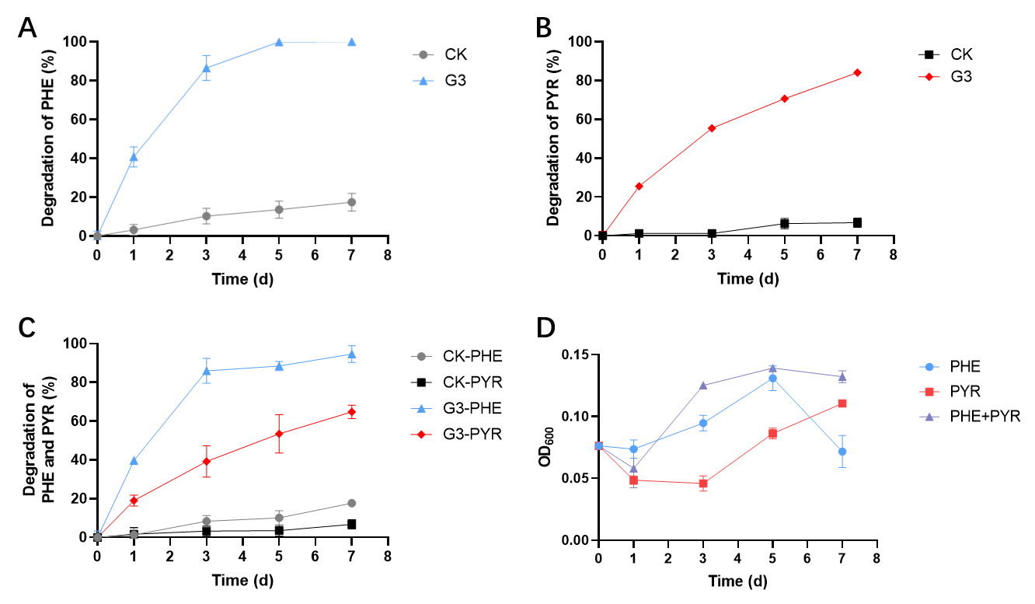
Fig. 1. Degradation of (A) PHE (50 mg L⁻¹), (B) PYR (50 mg L⁻¹), and (C) mixed PAHs (PHE and PYR, each at 50 mg L⁻¹) by Pseudoxanthomonas sp. G3. CK represents the abiotic control (PAHs without inoculation). (D) Growth curves of G3 on Growth curves of G3 on single PHE, single PYR and mixed PAHs.

3.2 Identification of PHE and PYR biodegradation metabolites
To examine whether the observed substrate-dependent inhibition was associated with metabolic interference between PHE and PYR, we analyzed their degradation intermediates and reconstructed the corresponding degradation pathways.

3.2.1 Identification of PHE biodegradation metabolites
The intermediates of PHE degradation identified by GC-MS (Fig. 2A and B and Table 1) were: 1-hydroxy-2-naphthoic acid (1H2N), phthalic acid, salicylic acid, and catechol.
Previous studies have shown that PHE biodegradation typically proceeds via dioxygenation at the C-1,2 and C-3,4 positions [35, 36]. Meta-cleavage of the diols generated from C-1,2 and C-3,4 dioxygenation of PHE produces 2-hydroxy-1-naphthoic acid and 1-hydroxy-2-naphthoic acid, respectively [37–40]. Notably, GC-MS detected 1H2N but not 2-hydroxy-1-naphthoic acid, suggesting that PHE degradation in strain G3 is predominantly initiated via the C-3,4 dioxygenation pathway. Subsequently, 1H2N may be metabolized via two distinct pathways: the phthalate pathway (with phthalic acid and protocatechuic acid as intermediates) and the catechol degradation pathway (with salicylic acid and catechol as intermediates) [41]. Thus, the presence of salicylic acid, catechol, and phthalic acid suggests that strain G3 metabolizes PHE via both pathways, while some Pseudoxanthomonas strains have been reported to degrade PHE via the phthalate pathway [42, 43].

3.2.2 Identification of PYR biodegradation metabolites
Seven metabolites were identified during PYR degradation (Fig. 2C and D, Table 1). Analysis of PYR degradation metabolites indicated that, in addition to catechol and phthalate, strain G3 may also degrade PYR via benzoate. The detection of 1H2N, salicylic acid, and phthalic acid indicated similarity in the downstream metabolic pathways of PHE and PYR. Unlike PHE degradation, PYR degradation produced benzoic acid and 3-hydroxybenzoic acid. Previous studies have shown that certain fungi degrade phenanthrene-4-carboxylic acid to benzoic acid, with 3-hydroxybenzoic acid as a subsequent metabolite [44]. However, this specific degradation pathway has not been reported in bacteria during PYR degradation [45]. To elucidate the formation pathway of benzoic acid, metabolites were further analyzed by solid-phase extraction, identifying phenanthrene-4-carboxylic acid (Fig. S5). Collectively, these findings indicate that strain G3 degrades PYR via phenanthrene-4-carboxylic acid conversion to benzoic acid, confirming the involvement of the benzoate degradation pathway.
Under mixed-PAH conditions, all intermediates detected during the degradation of PHE and PYR as single substrates were also observed, with no novel metabolites identified, indicating that no additional degradation pathways were activated. The analysis via GC-MS did not fully clarify the downstream metabolites of the aforementioned intermediates. This limitation might be due to the rapid turnover of enzymatic reactions, preventing the sufficient accumulation of intermediates to levels detectable by GC-MS. In addition, GC-MS is not optimal for analyzing highly polar or thermally labile compounds [46]. These constraints suggest that the degradation pathway in strain G3 may not be fully characterized. Therefore, integration of genomic information will be necessary to fully elucidate the degradation pathways of PHE and PYR.

Table 1 GC retention times (RTs) and mass spectral data of phenanthrene and pyrene metabolites detected.
 | RT (min) | m/z of fragment ions  (% relative intensity) | Identified metabolite
PHE | 12.00 | 73 (100), 239 (20), 74 (15), 136 (9), 75 (8), 254 (62), 255 (16), 151 (12), 166 (8), 256 (6) | Catechol (diTMS)
 | 12.16 | 195 (100), 92 (44), 138 (27), 75 (19), 224 (16), 120 (72), 177 (28), 121 (23), 209 (17), 135 (16) | Salicylic acid (TMS)
 | 16.07 | 163 (100), 77 (28), 50 (22), 164 (15), 133 (10), 76 (10), 92 (10), 194 (7), 104 (5), 135 (5) | Phthalic acid (diTMS)
 | 22.66 | 57 (100), 171 (86), 71 (65), 186 (54), 85 (52), 115 (43), 55 (36), 69 (24), 99 (21), 83 (20) | 1-Hydroxy-2-naphthoic acid
PYR | 9.91 | 179 (100), 77 (50), 180 (14), 51 (11), 73 (10), 105 (68), 135 (49), 57 (12), 136 (10), 55 (9) | Benzoic acid (TMS)
 | 11.82 | 73 (100), 254 (29), 92 (13), 75 (11), 239 (9), 176 (65), 120 (17), 177 (11), 74 (9), 138 (8) | Catechol (diTMS)
 | 12.15 | 195 (100), 92 (39), 121 (22), 138 (19), 224 (17), 120 (58), 177 (28), 75 (21), 209 (18), 196 (15) | Salicylic acid (diTMS)
 | 15.92 | 169 (100), 73 (71), 191 (38), 55 (34), 69 (28), 75 (81), 141 (40), 265 (36), 77 (29), 280 (26) | 3-Hydroxybenzoic acid (diTMS)
 | 16.08 | 163 (100), 77 (22), 76 (13), 92 (11), 50 (11), 164 (10), 133 (7), 194 (6), 104 (6), 135 (6) | Phthalic acid (diTMS)
 | 22.66 | 57 (100), 171 (80), 71 (60), 186 (51), 85 (44), 115 (41), 55 (28), 69 (24), 83 (22),99 (12) | 1-Hydroxy-2-naphthoic acid
 | 32.25 | 89 (100), 57 (35), 205 (33), 75 (27), 71 (25), 177 (22), 176 (21), 294 (20), 85 (17), 279 (15) | Phenanthrene-4-carboxylic acid (TMS)

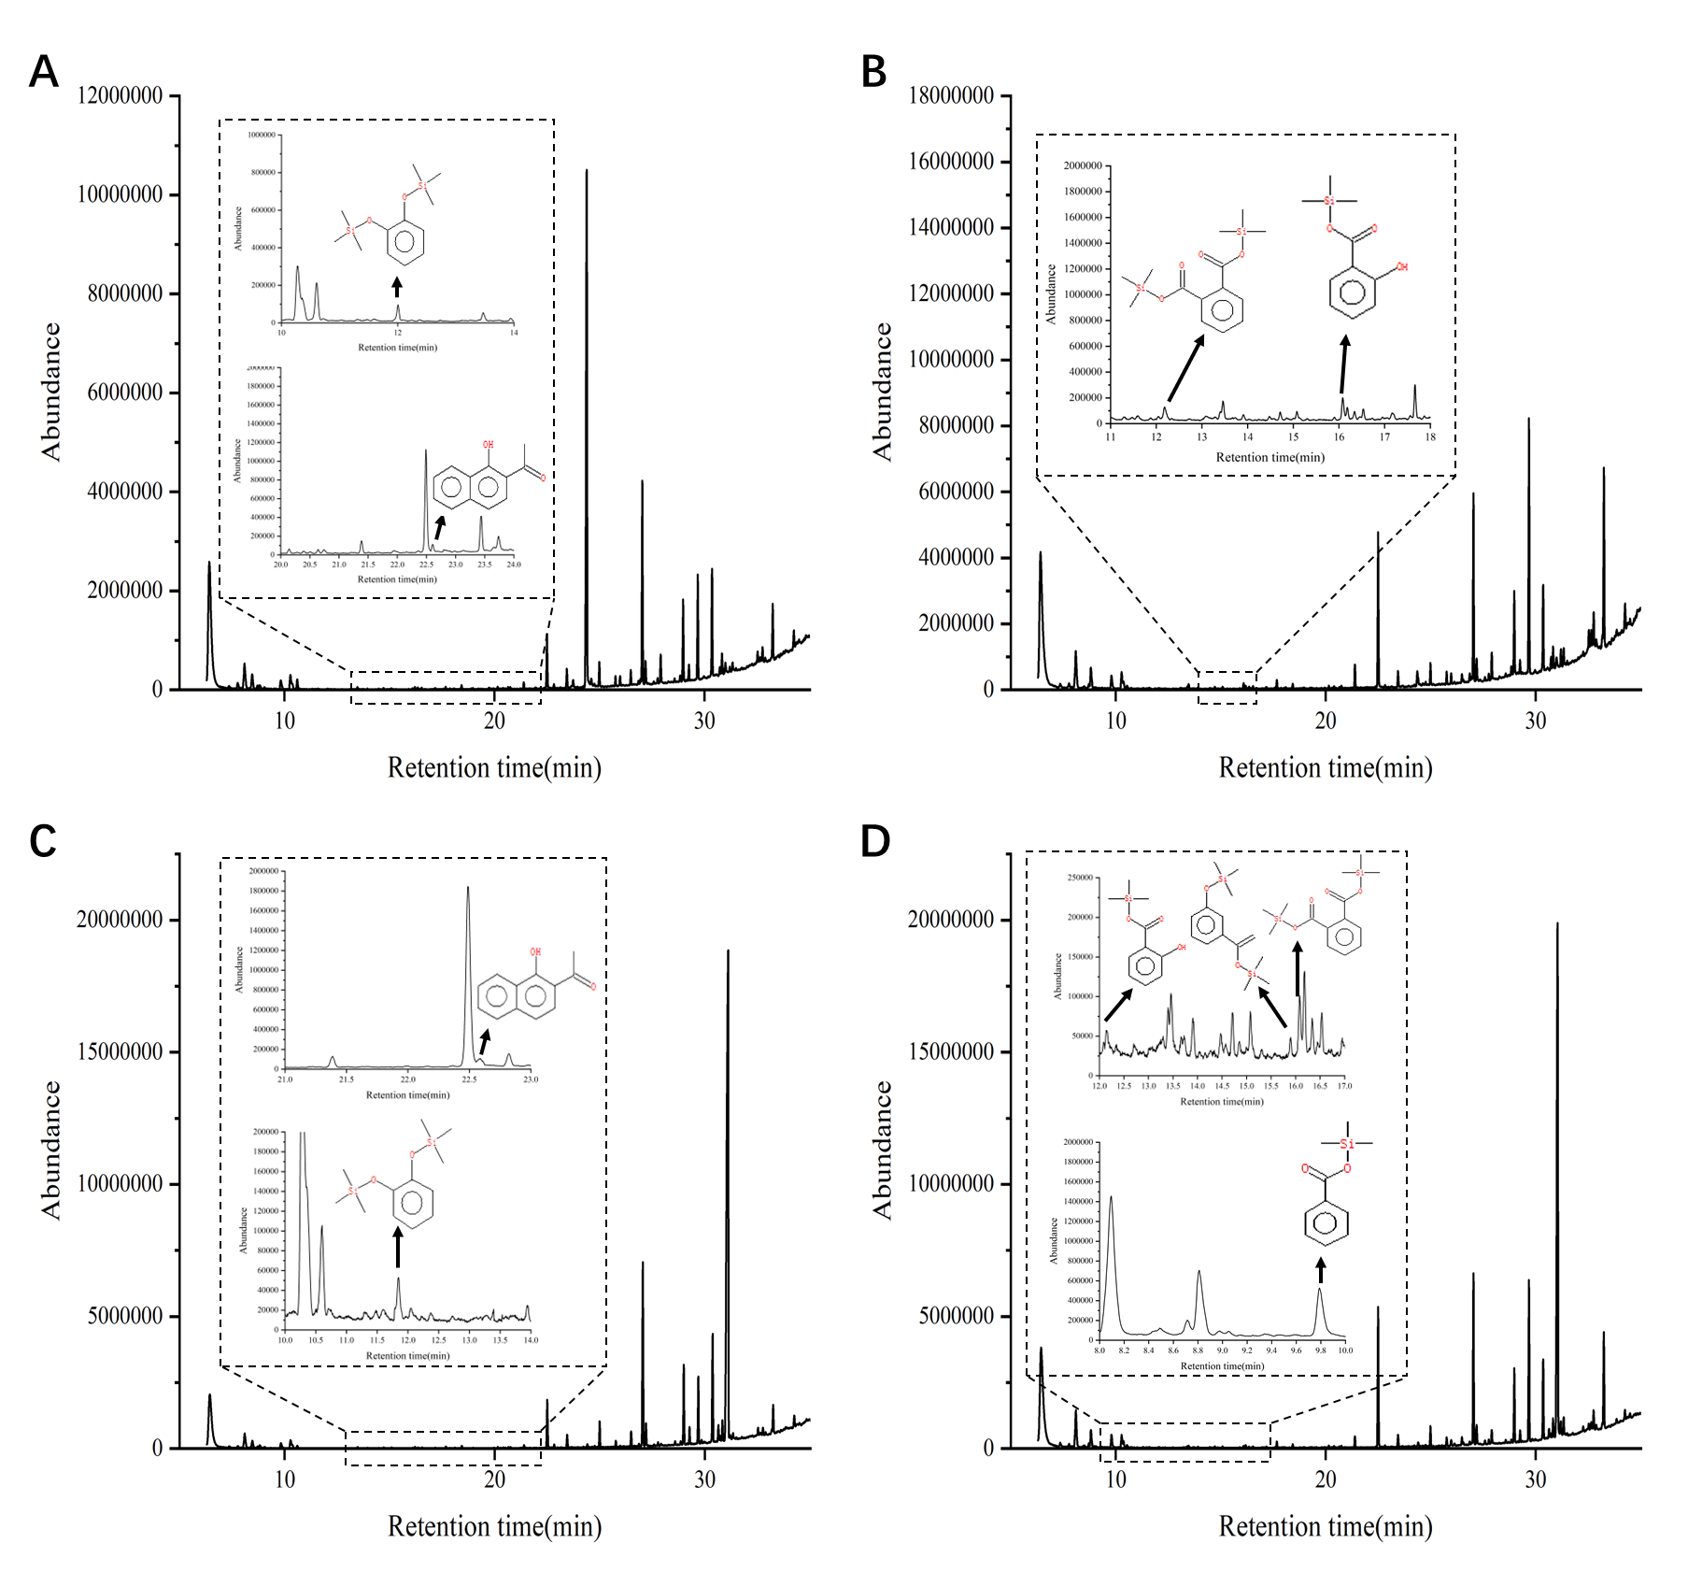
Fig. 2. GC-MS chromatograms of metabolites of strain G3 after degradation of PHE for 12 h and 4 d (A and B) and degradation of PYR for 12 h and 4 d (C and D).

3.3 Genome analysis and construction of PAH degradation pathways
The complete genome of strain G3 comprises a 4.05 Mb circular chromosome with a GC content of 67.02% (Fig. 3A). COG functional classification of the G3 genome was predicted (Fig. S6). Further functional annotation identified 28 putative genes potentially involved in PAH degradation (Table S3). Notably, several degradation genes in G3 exhibited relatively low sequence homology to their counterparts in other known PAH-degrading bacteria [47–49]. Phylogenetic analysis indicated that these genes formed distinct evolutionary clades characterized by traits specific to Pseudoxanthomonas (Table S3, Fig. S7). Furthermore, the putative degradation genes in strain G3 exhibited a complex organization, with related genes distributed across multiple clusters. These findings suggest that Pseudoxanthomonas may employ a flexible genetic architecture for rapid adaptation to environmental pollutants [50].
Three putative dioxygenase genes involved in PHE and PYR degradation were identified in strain G3: a ring-hydroxylating dioxygenase (RHD, encoded by gene 3468), an extradiol ring-cleavage dioxygenase (exRCD, encoded by gene 1125), and a catechol-2,3-dioxygenase (C23O, encoded by gene 0960). RHD catalyzes the initial oxidation of PAHs to form cis-dihydrodiol, a step often considered rate-limiting for aerobic PAH biodegradation [51–53]. exRCD catalyzes dioxygenation of substrates, resulting in the cleavage of aromatic rings [54]. C23O catalyzes the extradiol cleavage of catechol to produce 2-hydroxymuconic semialdehyde (HMS) [55–57]. HMS is further metabolized via the dehydrogenation pathway mediated by 2-hydroxymuconic semialdehyde dehydrogenase. Four genes (0554, 0586, 0960, and 1800) are associated with this pathway, indicating that the catechol degradation pathway likely functions as a downstream pathway for PHE and PYR degradation.
Genome analysis identified genes associated with the catechol degradation pathway, but no typical functional genes involved in the downstream metabolism of phthalic acid or benzoic acid were immediately apparent in the annotation, suggesting that strain G3 might not metabolize phthalate or benzoate. To evaluate the functionality of these degradation pathways, substrate utilization assays were conducted with strain G3 (Fig. 3B). Degradation experiments further confirmed that strain G3 does not metabolize phthalic acid, indicating that it represents a terminal metabolite. In contrast, benzoic acid was effectively metabolized, suggesting that a functional benzoate degradation pathway exists for PYR degradation. However, no functional gene information for the reaction of benzoic acid generating 3-hydroxybenzoic acid was searched from the KEGG database, and the G3 genome also failed to annotate the related genes for subsequent metabolism. This indicated the involvement of novel or atypical enzymes in benzoate degradation by strain G3. Based on the integrated genomic and metabolic evidence, the degradation pathways of PHE and PYR were proposed (Fig. 3C).
To the best of our knowledge, our research provides the first experimental evidence suggesting that PYR can be degraded through the benzoate in bacteria, expanding the known metabolic pathways for PAH degradation. While the conventional phthalate pathway often experiences bottlenecks due to incomplete downstream metabolism leading to intermediate accumulation [19], the benzoate degradation pathway offers an effective alternative route that sustains substrate consumption and energy generation [58, 59].

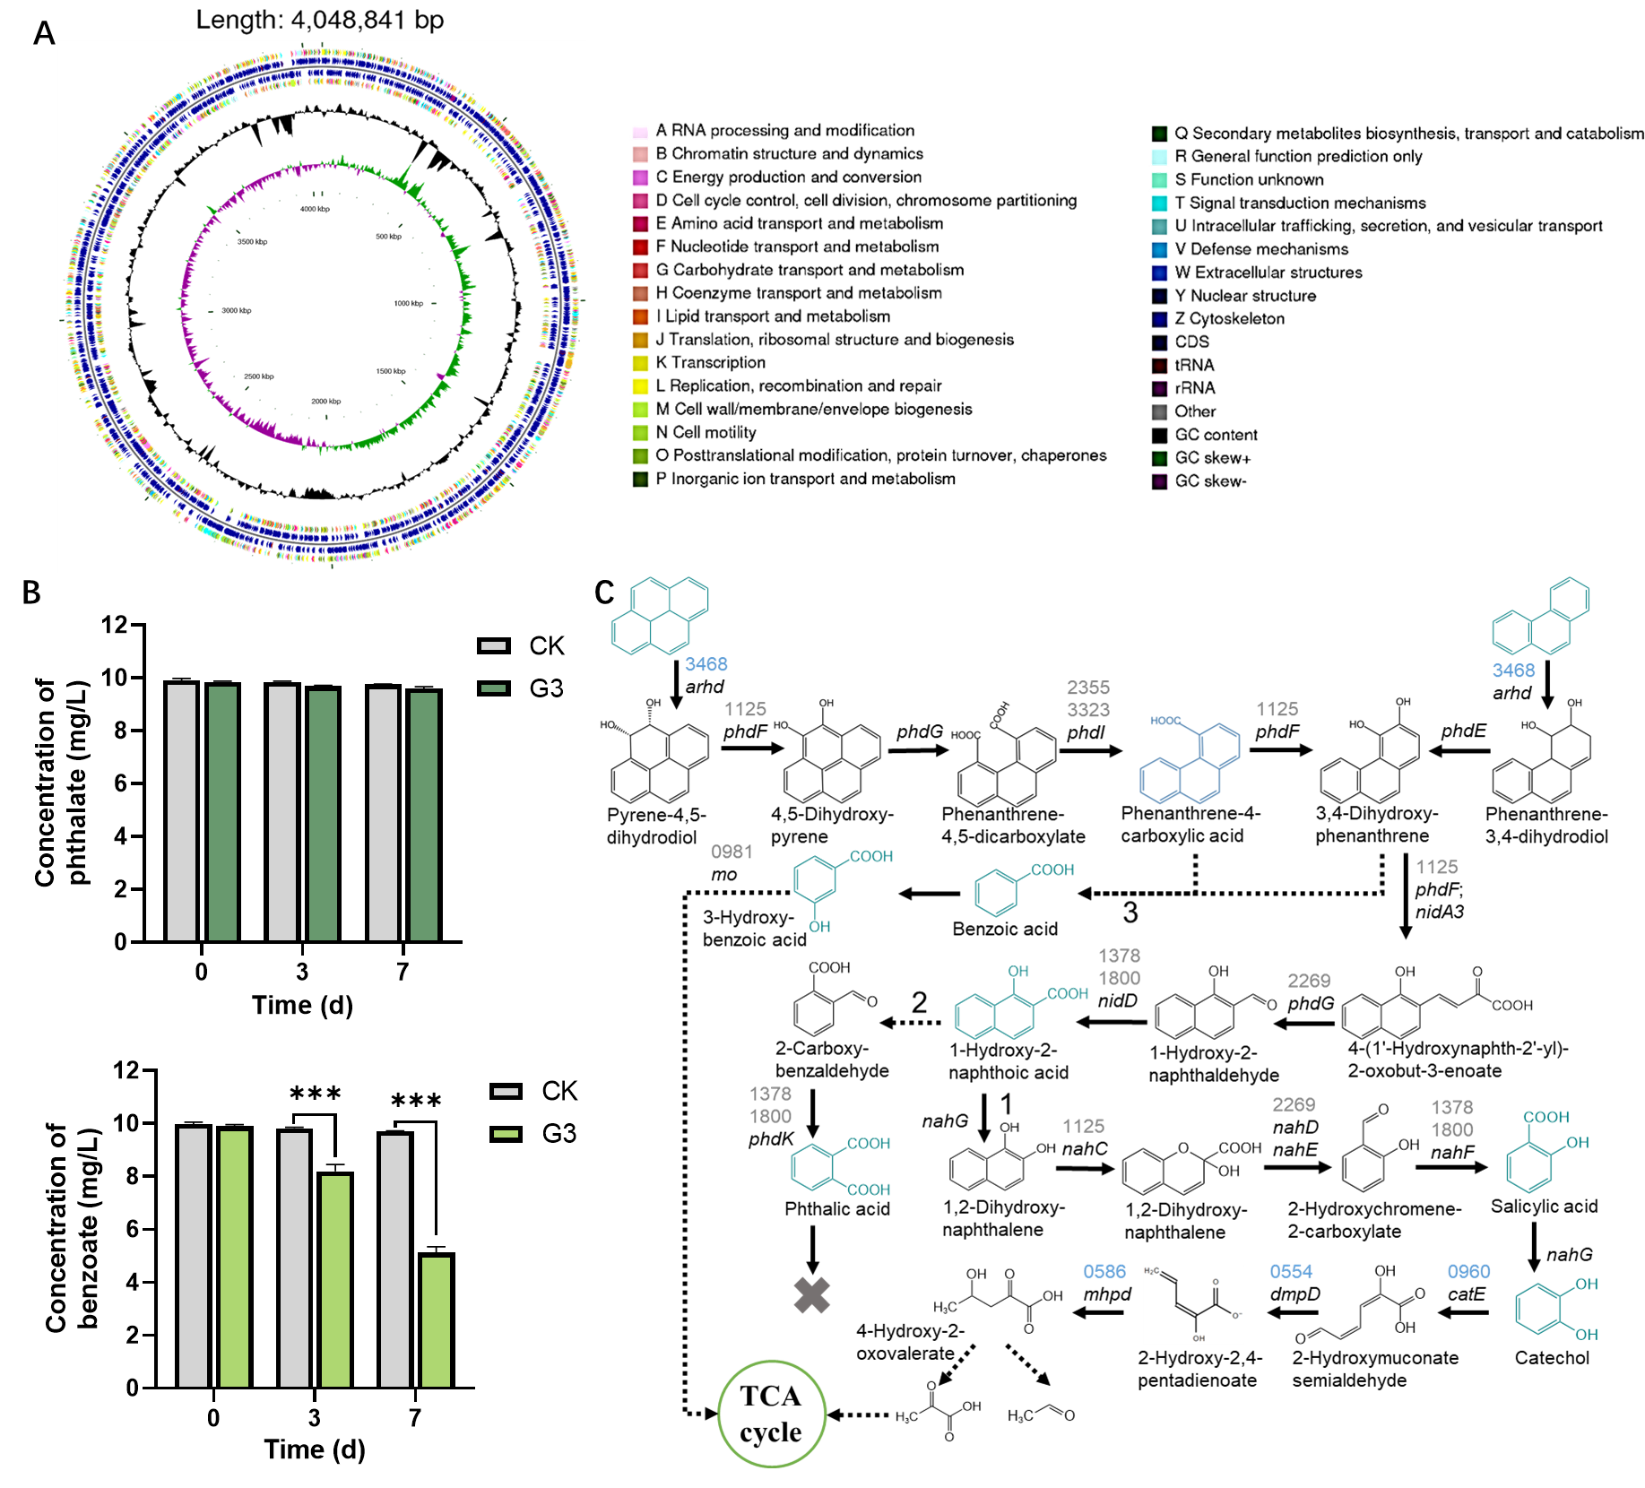
Fig. 3. (A) Circular maps of the chromosomal DNA of Pseudoxanthomonas sp. G3. (B) Substrate utilization of phthalate and benzoate by strain G3. (C) Proposed PHE and PYR degradation pathways in Pseudoxanthomonas sp. G3 based on metabolites and whole-genome analysis. Blue metabolites, detected by GC-MS; black metabolites, speculated metabolites; Blue gene numbers represent the function genes with clear annotations; Grey gene numbers represent the predicted potential function genes; solid arrow, one-step reaction; dotted arrow, multi-step reaction.

3.4 Antagonistic mechanism of PHE on PYR degradation in a mixed-PAH system
3.4.1 Transcriptional repression of downstream genes contributes to limited degradation
Based on the analysis of the PHE and PYR degradation pathways, we further explored the mechanism underlying the limited degradation of PYR under the mixed-PAH stress. Transcriptional analysis of key degradation genes under mixed-PAH stress indicated that the initial oxidation step was not the rate-limiting factor for PYR degradation. Specifically, gene 3468 (RHD) was highly expressed across all conditions: showing 28-fold and 58-fold upregulation under single PHE and PYR conditions, respectively, and maintaining elevated expression levels from day 3 to day 7 in the mixed-substrate system (Fig. 4A). In contrast, transcriptional analysis of genes encoding downstream dioxygenases revealed consistently lower expression under mixed-PAH conditions (Fig. 4B and C). When supplied individually, PHE or PYR markedly induced transcription of gene 0960 (C23O) and gene 1125 (exRCD) within the first day. However, under mixed-PAH exposure, their transcription remained lower than in single-PAH treatments and failed to sustain high expression over time. Specifically, gene 0960 showed relative expression levels of 0.84 and 0.25 on days 1 and 3, while gene 1125 exhibited levels of 0.16 and 0.18, respectively. Notably, the reduced transcription of gene 0960 suggests downregulation of the catechol degradation pathway, likely contributing to diminished PYR degradation.
This inhibition of downstream gene expression under mixed-PAH conditions has also been reported in other strains. For instance, in Mycobacterium sp. JS19b1, the transcription levels of several PAH degradation genes (such as phdF, phdI, and phtAa) decreased in the presence of both PHE and PYR, reducing degradation efficiency [58]. Similarly, Mycobacterium crocinum czh-3 degraded 100% and 75% of PHE and PYR individually, but only 20% and 5% in the mixture, correlating with downregulation of key degradation genes [8].
3.4.2 Catechol degradation constitutes a metabolic bottleneck
Metabolite analysis further confirmed that catechol degradation constitutes a metabolic bottleneck. In the mixed-PAH system, the concentrations of 1H2N on days 1 and 5 were significantly higher than those in the single-substrate system (Fig. 4D–F). In contrast to previous reports suggesting that PYR reduces 1H2N levels by inhibiting the conversion of PHE to 1H2N [25], our study indicates that the conversion of PYR to 1H2N is not the rate-limiting step. Instead, the restriction stems from the interference of 1H2N downstream metabolism by PHE.
Although 1H2N can be metabolized via phthalate and catechol, phthalate was confirmed to be a dead-end degradation product; its intermediate, phthalic acid, remained at consistently low levels (3.36–9.91 µg) with no significant changes between days 1 and 3. Therefore, the accumulation of 1H2N strongly implies a functional limitation in the catechol degradation. Supporting this inference, catechol concentrations in the mixed system (1.28 µg on day 1 and 2.78 µg on day 3) were significantly lower than those in the single PHE treatment (4.32 µg and 3.64 µg, respectively). Combined with the downregulation of key genes in the catechol degradation pathway, these findings indicate that the catechol branch of the PAH degradation pathway is significantly constrained in the early stages of degradation. Furthermore, the accumulation of 1H2N suggests that its conversion to catechol is also subject to a certain limitation. However, the decrease in the concentration of 1H2N and the gradually increasing content of catechol implies that this conversion process is still ongoing.
It is worth noting that the accumulation levels of 1H2N and catechol in this study did not reach the thresholds previously reported to trigger feedback inhibition. For instance, Patel et al. demonstrated that excessive metabolite accumulation (>0.1% w/v) feedback-inhibits key enzymes [60], while Suresh et al. found that increasing salicylic acid concentration from 31 mM to 310 mM significantly enhanced the inhibition of benzo[a]pyrene degradation [61]. Conversely, the consistently low catechol concentration (1.28 µg on day 1 and 2.78 µg on day 3 in mixed-PAH treatment) likely restricted the activity of downstream enzymes, such as C23O. This hypothesis was validated by exogenous catechol addition experiments, where catechol supplementation significantly enhanced C23O activity (Fig. 4G). This observation aligns with prior studies indicating that high concentrations of phenolic compounds can induce C23O activity and promote PAH degradation [62–65]. In the mixed-PAH system, both catechol concentrations and the corresponding C23O activities (0.0286 U L⁻¹ on day 1 and 0.0438 U L⁻¹ on day 3) were consistently lower than those in single PHE treatment (0.1253 U L⁻¹ and 0.1113 U L⁻¹). This further confirms that insufficient catechol accumulation hinders the induction of C23O, thereby restricting PYR degradation.
In addition, catechol 1,2-dioxygenase (C12O) activity was undetectable in all treatments, and genomic analysis revealed no homologs of catA in strain G3, indicating that catechol is exclusively metabolized via the C23O-mediated meta-cleavage pathway. This rules out the possibility that the low C23O activity was compensated by an ortho-cleavage route.

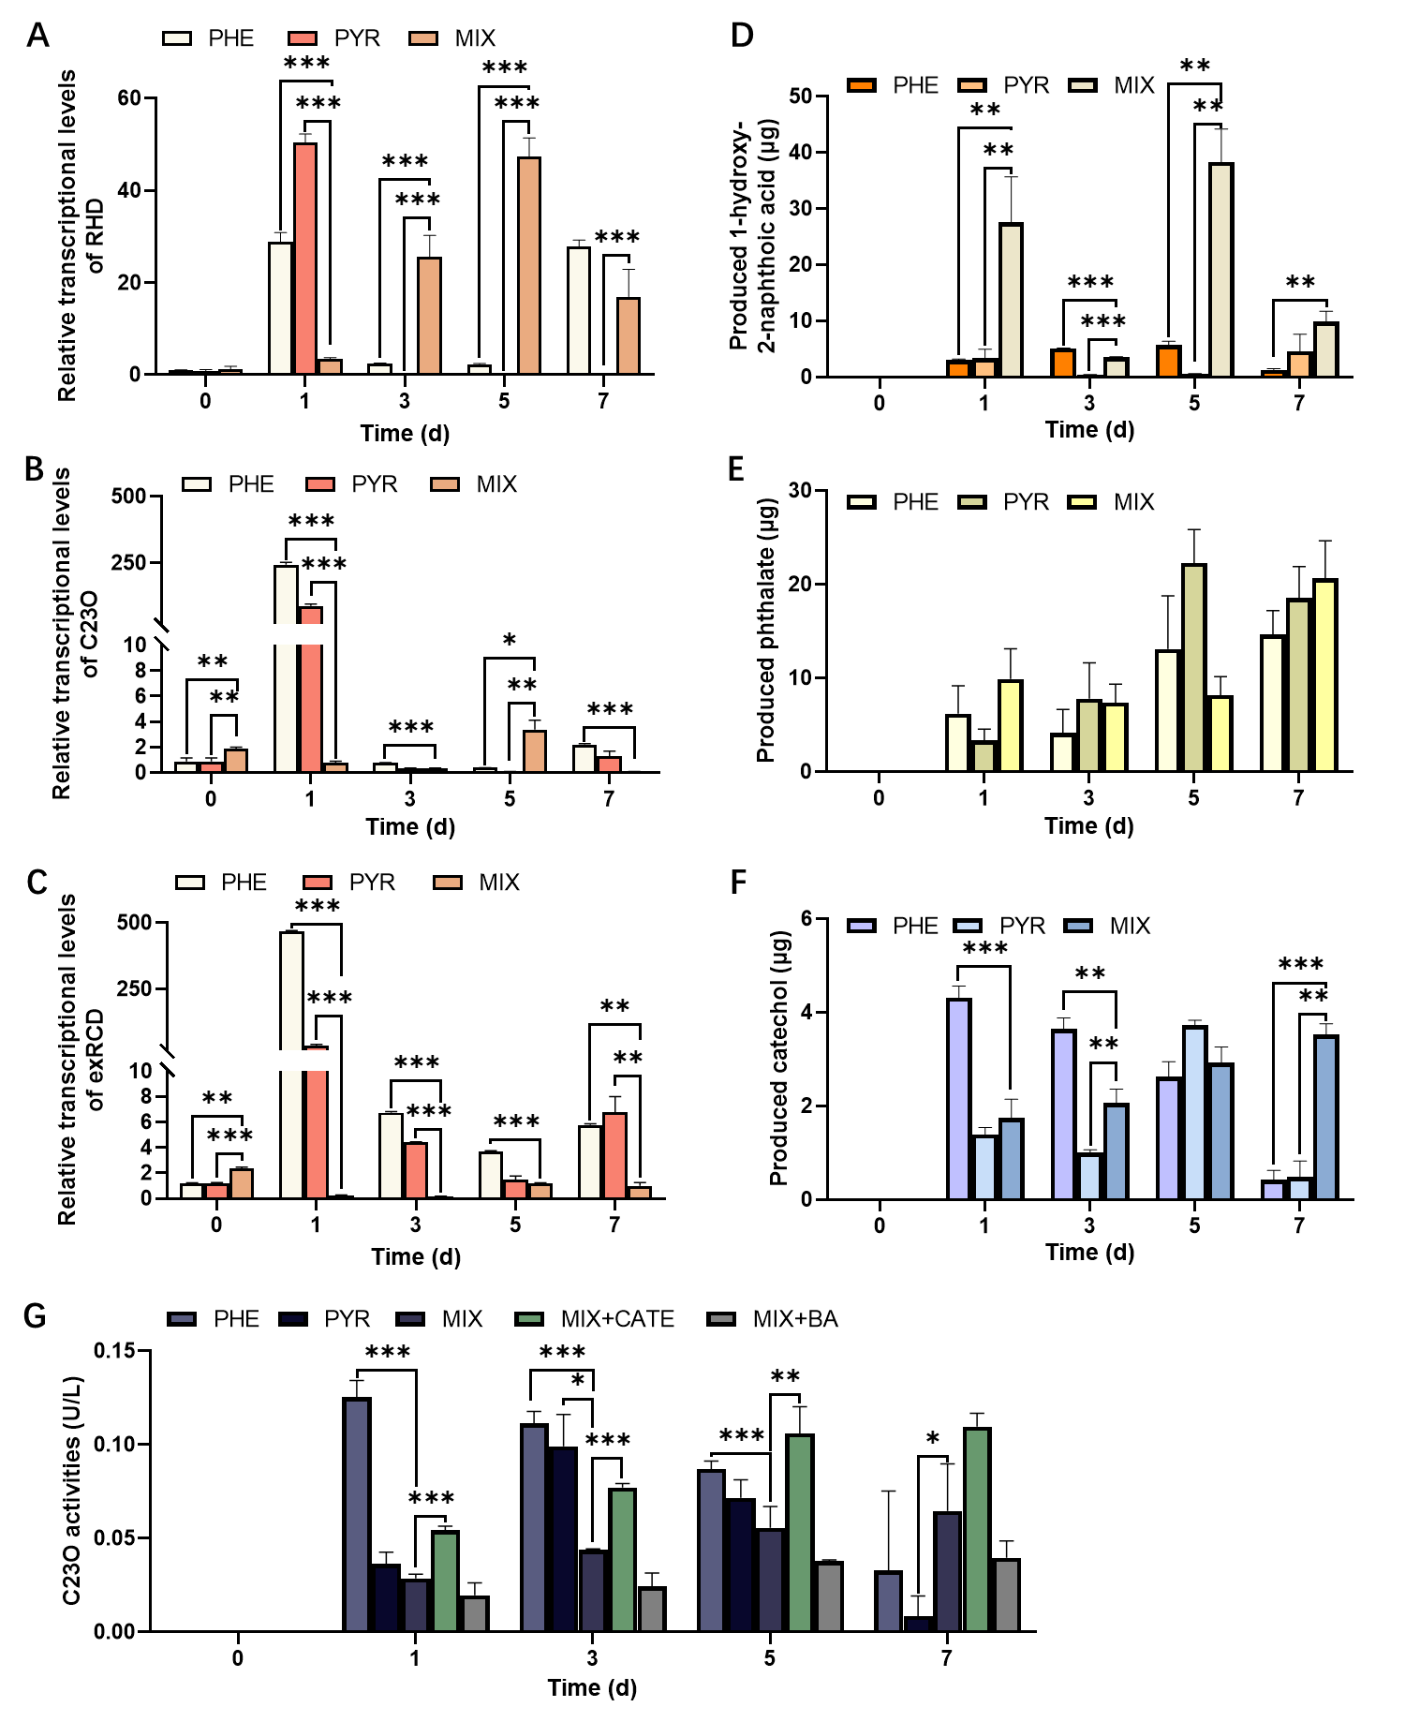
Fig. 4. The transcriptional levels of the putative PAH-degrading genes (A) RHD, (B) C23O and (C) exRCD in strain G3 were detected by RT‒qPCR under PHE, PYR or mixed-PAH stress. The quantified metabolites (D) 1H2N, (E) phthalic acid and (F) catechol in mineral media during the degradation of PHE, PYR and mixed PAHs. (G) C23O activity in PHE, PYR, mixed PAHs, mixed PAHs with 18 µM catechol and mixed PAHs with 1 mg L⁻¹ benzoic acid. *P < 0.05, **P < 0.01, ***P < 0.001. Data are shown as the mean ± SD of three independent experiments (n = 3).

3.4.3 PHE inhibits PYR degradation by occupying the benzoate degradation pathway
Although the catechol degradation pathway was restricted, strain G3 still maintained high degradation activity, suggesting that the benzoate degradation pathway might have served as the primary downstream metabolic route. To further assess the role of the benzoate degradation pathway in PYR degradation, exogenous benzoic acid addition experiments were conducted. Results demonstrated that the addition of benzoic acid significantly increased the concentration of 1H2N in the mixed system, while simultaneously decreasing catechol levels, and inhibiting C23O activity (Fig. 5A and B). This indicates that the benzoate degradation pathway exerted an antagonistic effect on the catechol degradation pathway, thereby impeding the further metabolism of 1H2N. The rapid changes in enzyme activity suggest direct inhibition of C23O and other key enzymes by benzoic acid or its metabolites [66], although the cofactor competition cannot be entirely excluded [67].
Notably, the negligible effect of low benzoic acid concentrations on the PHE degradation rate (Fig. S8), despite the inhibition of the catechol degradation pathway, suggests that PHE degradation may be partially channeled through the benzoate degradation pathway. Combined with the observations that strain G3 degrades PHE faster than PYR, and that PYR exerts negligible inhibitory effect on PHE degradation in the mixed system, it can be inferred that PHE is the preferred substrate of strain G3. Consequently, PHE likely occupies the benzoate degradation pathway, thereby competing with PYR for metabolic flux.
Stable isotope labeling experiments provided direct evidence supporting this hypothesis. When deuterium-labeled PHE (PHE-d10) and PYR were used as carbon sources, deuterated benzoic acid (benzoic acid-d4) was detected (Fig. 5C and Fig. S9). To clarify whether the activation mechanism of benzoate degradation pathway stems from the enzyme-substrate interactions or is induced by metabolic intermediates[68], we investigated potential precursors. When 1H2N was utilized as the sole carbon source, no benzoic acid was detected, indicating that 1H2N is not a direct precursor of the benzoate degradation pathway. Furthermore, GC-MS analysis confirmed that phenanthrene-4-carboxylic acid is a characteristic metabolic product of PYR, rather than originating from PHE [19], and may be converted into benzoic acid as previously reported in fungal systems [44]. These results suggest that the benzoate degradation pathway in mixed-PAH cultures is likely induced by upstream metabolites of PYR, and the evidence supporting direct enzyme-substrate interactions remains limited.
Collectively, these findings lead us to propose a metabolic crosstalk model (Fig. 6): PHE preferentially utilizes the benzoate degradation pathway induced by PYR, occupying its metabolic flux. Simultaneously, benzoate or its downstream transformation interferes with catechol degradation, further suppressing PYR degradation. This model reveals a novel mechanism underlying PHE inhibition of PYR degradation that is distinct from conventional understanding [60, 69–71], advances understanding of inhibitory interactions from the level of substrates, enzymes, or gene expression to metabolic pathway resource competition. Unlike the traditional “substrate competition” where two or more substrates compete for the active site of the same enzyme, this “pathway occupation” is more complex. It involves selective channeling of substrate and its metabolites into pathways, cross-activation or inhibition of pathway induction. Interestingly, some studies have also reported the phenomenon of “PYR inhibits PHE”, which might be caused by metabolic flux redirection or the generation of atypical intermediates resulting from broad enzyme substrate specificity [25, 58]. These contrasts indicate that different strains may employ fundamentally distinct metabolic strategies, underscoring the critical importance of elucidating metabolic strategies at the pathway level.
For the metabolic bottleneck issues identified in this study, targeted bio-strategies can be adopted in the actual environment. For instance, the G3 strain can be co-cultured with a phthalate-degrading bacterium to reduce the accumulation of end products and promote the complete mineralization of intermediates. The G3 strain can also be co-cultured with a benzoate-degrading bacterium to accelerate the metabolism of benzoic acid and alleviate the inhibition of the catechol degradation pathway. And bacteria capable of secreting catechol can be introduced to activate the catechol degradation pathway. Moreover, while this study offers a novel perspective on metabolic interference among PAHs, several limitations should be acknowledged. First, whether the restricted conversion of 1H2N to catechol is directly inhibited at the enzymatic level or regulated via gene expression. Second, as the interactions were investigated in a single-strain system, the applicability of these findings in complex environments containing multiple species or mixtures of pollutants remains uncertain. Future studies integrating stable isotope labeling, metabolic flux analysis, and targeted genetic modifications will help deepen mechanistic insights and assess the broader applicability.

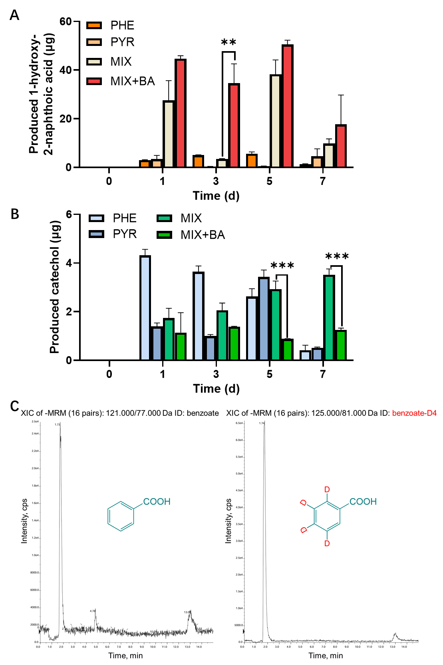
Fig. 5. (A) 1-hydroxy-2-naphthoic acid and (B) catechol in mineral media during the degradation of PHE, PYR and mixed PAHs with 1 mg L⁻¹ benzoic acid (BA). (C) MRM chromatograms of benzoic acid and benzoic acid-d4. **P < 0.01, ***P < 0.001. Data are shown as the mean ± SD of three independent experiments (n = 3).

9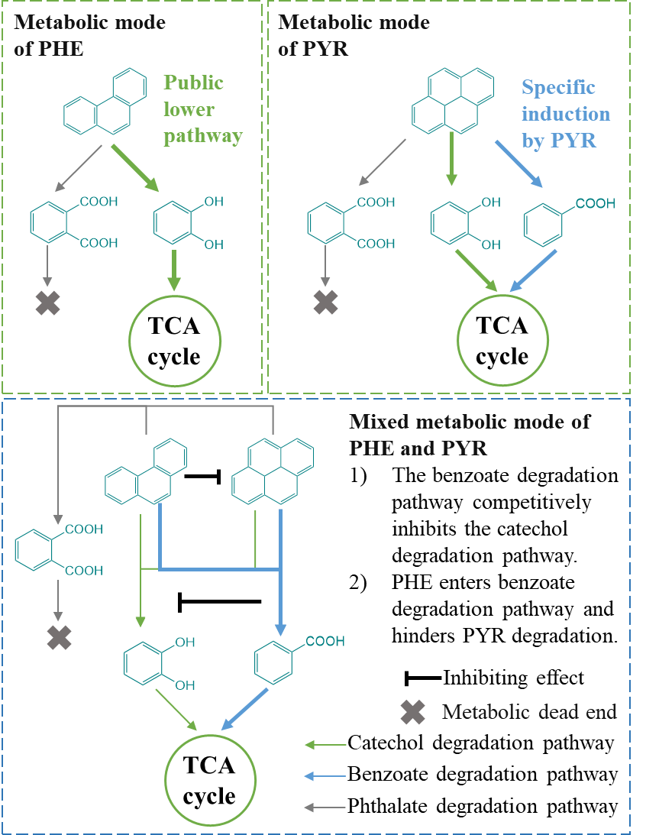
Fig. 6. Metabolic mode of strain G3 in phenanthrene, pyrene and mixed PAHs.

4. Conclusion
In this study, Pseudoxanthomonas sp. G3 was isolated from PAH-contaminated soil. It demonstrated robust biodegradation of PHE and PYR, with PHE nearly completely degraded within 5 days and PYR reaching 84.2% degradation by day 7. An antagonistic interaction was observed during mixed PAH degradation. PYR did not affect PHE degradation, whereas PHE significantly inhibited PYR degradation, reducing its degradation efficiency to 64.8% by day 7. Integration of metabolic intermediates analysis, genomic information, and degradation experiments revealed that PHE degradation involved the catechol degradation pathway and the phthalate (terminal product) pathway, while PYR degradation not only involved the above two pathways but also specifically induced the benzoate degradation pathway. Despite partial pathway overlap, mixed PAH degradation did not produce a synergistic effect; instead, it caused metabolic crosstalk. PHE preferentially occupied the benzoate degradation pathway induced by PYR, while benzoic acid inhibited catechol accumulation, thereby limiting the C23O activity and weakening the catechol degradation pathway. These findings reveal how competition at the pathway level affects the degradation efficiency of the mixed PAH system and highlight the necessity of eliminating metabolic crosstalk. To address metabolic crosstalk, in the future, it can be eliminated by constructing microbial consortia and through targeted gene modification, to achieve the simultaneous and efficient removal of multiple PAHs in complex contaminated environments.

CRediT authorship contribution statement
Suhang Wang: investigation, data curation, writing - original draft. Jiaqing Liang: investigation, data curation, writing - original draft. Yongkai Liao: investigation. Haixuan Zhou: methodology, data curation. Brian J. Reid, writing - review & editing. Chao Cai: conceptualization, funding acquisition, writing - review & editing, supervision.

Conflicts of Competing Interest
The authors declare that they have no known competing financial interests or personal relationships that could have appeared to influence the work reported in this paper.

Acknowledgments
The project was supported by the National Key Research and Development Project of China (Nos. 2024YFC3713802); the Xiamen Natural Science Foundation Project (3502Z202571076).
References
[1] Haritash AK, Kaushik CP, 2009. Biodegradation aspects of Polycyclic Aromatic Hydrocarbons (PAHs): A review. Journal of Hazardous Materials 169, 1–15. https://doi.org/10.1016/j.jhazmat.2009.03.137
[2] Kanaly RA, Harayama S, 2010. Advances in the field of high‐molecular‐weight polycyclic aromatic hydrocarbon biodegradation by bacteria. Microb Biotechnol 3, 136–164. https://doi.org/10.1111/j.1751-7915.2009.00130.x
[3] Gao M, Zhang Q, Chen B, Lei C, Xia Q, Sun L, Li T, Zhou N-Y, Lu T, Qian H, 2025. Global Geographic Patterns of Soil Microbial Degradation Potential for Polycyclic Aromatic Hydrocarbons. Environ Sci Technol 59, 7550–7560. https://doi.org/10.1021/acs.est.5c00306
[4] Jiménez-Volkerink SN, Vila J, Jordán M, Minguillón C, Smidt H, Grifoll M, 2023. Multi-Omic Profiling of a Newly Isolated Oxy-PAH Degrading Specialist from PAH-Contaminated Soil Reveals Bacterial Mechanisms to Mitigate the Risk Posed by Polar Transformation Products. Environ Sci Technol 57, 139–149. https://doi.org/10.1021/acs.est.2c05485
[5] Ball A, Truskewycz A, 2013. Polyaromatic hydrocarbon exposure: an ecological impact ambiguity. Environ Sci Pollut Res 20, 4311–4326. https://doi.org/10.1007/s11356-013-1620-2
[6] Wang J-Z, Zhu C-Z, Chen T-H, 2013. PAHs in the Chinese environment: levels, inventory mass, source and toxic potency assessment. Environ Sci: Processes Impacts 15, 1104. https://doi.org/10.1039/c3em00070b
[7] Li Y, Chen H, Li W, Xi B, Huang C, 2025. A novel immobilized bacteria consortium enhanced remediation efficiency of PAHs in soil: Insights into key removal mechanism and main driving factor. Journal of Hazardous Materials 486, 137144. https://doi.org/10.1016/j.jhazmat.2025.137144
[8] Hennessee CT, 2016. Effects of Polycyclic Aromatic Hydrocarbon Mixtures on Degradation, Gene Expression, and Metabolite Production in Four Mycobacterium Species. Appl Environ Microbiol 82, 3357–3369. https://doi.org/10.1128/AEM.00100-16
[9] Jarvis IWH, Dreij K, Mattsson Å, Jernström B, Stenius U, 2014. Interactions between polycyclic aromatic hydrocarbons in complex mixtures and implications for cancer risk assessment. Toxicology 321, 27–39. https://doi.org/10.1016/j.tox.2014.03.012
[10] Wei W, Ran Z, He H, Zhou K, Huangfu Z, Yu J, 2020. Desorption process and morphological analysis of real polycyclic aromatic hydrocarbons contaminated soil by the heterogemini surfactant and its mixed systems. Chemosphere 254, 126854. https://doi.org/10.1016/j.chemosphere.2020.126854
[11] Zhong Y, Luan T, Zhou H, Lan C, Tam NFY, 2006. Metabolite production in degradation of pyrene alone or in a mixture with another polycyclic aromatic hydrocarbon by Mycobacterium sp. Enviro Toxic and Chemistry 25, 2853–2859. https://doi.org/10.1897/06-042R.1
[12] Liu Y, Zhao N, Dai S, He R, Zhang Y, 2024. Metagenomic insights into phenanthrene biodegradation in electrical field-governed biofilms for groundwater bioremediation. Journal of Hazardous Materials 465, 133477. https://doi.org/10.1016/j.jhazmat.2024.133477
[13] Kim S-J, Kweon O, Jones RC, Freeman JP, Edmondson RD, Cerniglia CE, 2007. Complete and Integrated Pyrene Degradation Pathway in Mycobacterium vanbaalenii PYR-1 Based on Systems Biology. J Bacteriol 189, 464–472. https://doi.org/10.1128/JB.01310-06
[14] Mukherjee AK, Bhagowati P, Biswa BB, Chanda A, Kalita B, 2017. A comparative intracellular proteomic profiling of Pseudomonas aeruginosa strain ASP-53 grown on pyrene or glucose as sole source of carbon and identification of some key enzymes of pyrene biodegradation pathway. Journal of Proteomics 167, 25–35. https://doi.org/10.1016/j.jprot.2017.07.020
[15] Zhou H, Zhang S, Xie J, Wei H, Hu Z, Wang H, 2020. Pyrene biodegradation and its potential pathway involving Roseobacter clade bacteria. International Biodeterioration & Biodegradation 150, 104961. https://doi.org/10.1016/j.ibiod.2020.104961
[16] Fan K, Feng Q, Li K, Lin J, Wang W, Cao Y, Gai H, Song H, Huang T, Zhu Q, Xiao M, 2022. The metabolism of pyrene by a novel Altererythrobacter sp. with in-situ co-substrates: A mechanistic analysis based on pathway, genomics, and enzyme activity. Chemosphere 307, 135784. https://doi.org/10.1016/j.chemosphere.2022.135784
[17] Luo S, Chen B, Lin L, Wang X, Tam NF-Y, Luan T, 2014. Pyrene Degradation Accelerated by Constructed Consortium of Bacterium and Microalga: Effects of Degradation Products on the Microalgal Growth. Environ Sci Technol 48, 13917–13924. https://doi.org/10.1021/es503761j
[18] Li S, Xu J, Hua T, Liu M, Yan W, 2025. Combined transcriptome and metabolome analysis reveal the dual catabolic pathways of naphthalene in Pseudomonas putida ND6. Journal of Environmental Chemical Engineering 13, 115632. https://doi.org/10.1016/j.jece.2025.115632
[19] Sun S, Wang H, Chen Y, Lou J, Wu L, Xu J, 2019. Salicylate and phthalate pathways contributed differently on phenanthrene and pyrene degradations in Mycobacterium sp. WY10. Journal of Hazardous Materials 364, 509–518. https://doi.org/10.1016/j.jhazmat.2018.10.064
[20] Moran IL, Ghetu CC, Scott RP, Tidwell LG, Hoffman PD, Anderson KA, 2025. Divergent Transport Dynamics of Alkylated versus Unsubstituted Polycyclic Aromatic Hydrocarbons at the Air–Water and Sediment-Water Interfaces at a Legacy Creosote Site. ACS EST Water 5, 146–155. https://doi.org/10.1021/acsestwater.4c00737
[21] Wang W, Xu H, Qu X, Yang K, Lin D, 2022. Predicting the total PAHs concentrations in sediments from selected congeners using a multiple linear relationship. Sci Rep 12, 3334. https://doi.org/10.1038/s41598-022-07312-2
[22] Molina M, Araujo R, Hodson RE, 1999. Cross-induction of pyrene and phenanthrene in a Mycobacterium sp. isolated from polycyclic aromatic hydrocarbon contaminated river sediments. Can J Microbiol 45, 520–529. https://doi.org/10.1139/cjm-45-6-520
[23] Chen B, Huang J, Yuan K, Lin L, Wang X, Yang L, Luan T, 2016. Direct evidences on bacterial growth pattern regulating pyrene degradation pathway and genotypic dioxygenase expression. Marine Pollution Bulletin 105, 73–80. https://doi.org/10.1016/j.marpolbul.2016.02.054
[24] Jiang J, Tian W, Lu Z, Chu M, Cao H, Zhang D, 2023. Cometabolic degradation of pyrene with phenanthrene as substrate: assisted by halophilic Pseudomonas stutzeri DJP1. Biodegradation 34, 519–532. https://doi.org/10.1007/s10532-023-10035-4
[25] Zhong Y, Zou S, Lin L, Luan T, Qiu R, Tam NFY, 2010. Effects of pyrene and fluoranthene on the degradation characteristics of phenanthrene in the cometabolism process by Sphingomonas sp. strain PheB4 isolated from mangrove sediments. Marine Pollution Bulletin 60, 2043–2049. https://doi.org/10.1016/j.marpolbul.2010.07.017
[26] Wang H, Lou J, Gu H, Luo X, Yang L, Wu L, Liu Y, Wu J, Xu J, 2016. Efficient biodegradation of phenanthrene by a novel strain Massilia sp. WF1 isolated from a PAH-contaminated soil. Environ Sci Pollut Res 23, 13378–13388. https://doi.org/10.1007/s11356-016-6515-6
[27] Sun S, Wang H, Fu B, Zhang H, Lou J, Wu L, Xu J, 2020. Non-bioavailability of extracellular 1-hydroxy-2-naphthoic acid restricts the mineralization of phenanthrene by Rhodococcus sp. WB9. Science of The Total Environment 704, 135331. https://doi.org/10.1016/j.scitotenv.2019.135331
[28] Matias Rodrigues JF, Schmidt TSB, Tackmann J, Von Mering C, 2017. MAPseq: highly efficient k-mer search with confidence estimates, for rRNA sequence analysis. Bioinformatics 33, 3808–3810. https://doi.org/10.1093/bioinformatics/btx517
[29] Li F, Zhu L, 2012. Effect of surfactant-induced cell surface modifications on electron transport system and catechol 1,2-dioxygenase activities and phenanthrene biodegradation by Citrobacter sp. SA01. Bioresource Technology 123, 42–48. https://doi.org/10.1016/j.biortech.2012.07.059
[30] Kojima Y, Itada N, Hayaishi O, 1961. Metapyrocatechase: a New Catechol-cleaving Enzyme. Journal of Biological Chemistry 236, 2223–2228. https://doi.org/10.1016/S0021-9258(18)64061-X
[31] Ghosh I, 2017. Substrate interaction effects during pyrene biodegradation by Pseudomonas aeruginosa RS1. Journal of Environmental Chemical Engineering 5, 1791–1800. https://doi.org/10.1016/j.jece.2017.03.016
[32] Wu F, Guo C, Liu S, Liang X, Lu G, Dang Z, 2019. Pyrene Degradation by Mycobacterium gilvum: Metabolites and Proteins Involved. Water Air Soil Pollut 230, 67. https://doi.org/10.1007/s11270-019-4115-z
[33] Wang Z, Wang W, Li Y, Yang Q, 2019. Co-metabolic degradation of naphthalene and pyrene by acclimated strain and competitive inhibition kinetics. Journal of Environmental Science and Health, Part B 54, 505–513. https://doi.org/10.1080/03601234.2019.1586033
[34] Ting WTE, Yuan SY, Wu SD, Chang BV, 2011. Biodegradation of phenanthrene and pyrene by Ganoderma lucidum. International Biodeterioration & Biodegradation 65, 238–242. https://doi.org/10.1016/j.ibiod.2010.11.007
[35] Ghosal D, Ghosh S, Dutta TK, Ahn Y, 2016. Current State of Knowledge in Microbial Degradation of Polycyclic Aromatic Hydrocarbons (PAHs): A Review. Front Microbiol 7. https://doi.org/10.3389/fmicb.2016.01369
[36] Mallick S, Chakraborty J, Dutta TK, 2011. Role of oxygenases in guiding diverse metabolic pathways in the bacterial degradation of low-molecular-weight polycyclic aromatic hydrocarbons: A review. Critical Reviews in Microbiology 37, 64–90. https://doi.org/10.3109/1040841X.2010.512268
[37] Seo J-S, Keum Y-S, Li QX, 2012. Mycobacterium aromativorans JS19b1T degrades phenanthrene through C-1,2, C-3,4 and C-9,10 dioxygenation pathways. International Biodeterioration & Biodegradation 70, 96–103. https://doi.org/10.1016/j.ibiod.2012.02.005
[38] Liao X, Luo J, Cassidy DP, Li Y, Tao H, Zhao Y, 2021. Biodegradation of phenanthrene at high concentrations by Acidovorax sp. JG5 and its functional genomic analysis. J of Chemical Tech & Biotech 96, 3142–3151. https://doi.org/10.1002/jctb.6867
[39] Leneva NA, Kolomytseva MP, Baskunov BP, Golovleva LA, 2009. Phenanthrene and anthracene degradation by microorganisms of the genus Rhodococcus. Appl Biochem Microbiol 45, 169–175. https://doi.org/10.1134/S0003683809020094
[40] Li J, Peng W, Yin X, Wang X, Liu Z, Liu Q, Deng Z, Lin S, Liang R, 2024. Identification of an efficient phenanthrene-degrading Pseudarthrobacter sp. L1SW and characterization of its metabolites and catabolic pathway. Journal of Hazardous Materials 465, 133138. https://doi.org/10.1016/j.jhazmat.2023.133138
[41] Mallick Somnath, Chatterjee Subhankar, Dutta TK, 2007. A novel degradation pathway in the assimilation of phenanthrene by Staphylococcus sp. strain PN/Y via meta-cleavage of 2-hydroxy-1-naphthoic acid: formation of trans-2,3-dioxo-5-(2′-hydroxyphenyl)-pent-4-enoic acid. Microbiology 153, 2104–2115. https://doi.org/10.1099/mic.0.2006/004218-0
[42] Nayak AS, Sanjeev Kumar S, Santosh Kumar M, Anjaneya O, Karegoudar TB, 2011. A catabolic pathway for the degradation of chrysene by Pseudoxanthomonas sp. PNK-04: Chrysene catabolic pathway. FEMS Microbiology Letters 320, 128–134. https://doi.org/10.1111/j.1574-6968.2011.02301.x
[43] Patel V, Cheturvedula S, Madamwar D, 2012. Phenanthrene degradation by Pseudoxanthomonas sp. DMVP2 isolated from hydrocarbon contaminated sediment of Amlakhadi canal, Gujarat, India. Journal of Hazardous Materials 201–202, 43–51. https://doi.org/10.1016/j.jhazmat.2011.11.002
[44] Al Farraj DA, Hadibarata T, Elshikh MS, Al Khulaifi MM, Kristanti RA, 2020. Biotransformation and Degradation Pathway of Pyrene by Filamentous Soil Fungus Trichoderma sp. F03. Water Air Soil Pollut 231, 168. https://doi.org/10.1007/s11270-020-04514-0
[45] Zada S, Zhou H, Xie J, Hu Z, Ali S, Sajjad W, Wang H, 2021. Bacterial degradation of pyrene: Biochemical reactions and mechanisms. International Biodeterioration & Biodegradation 162, 105233. https://doi.org/10.1016/j.ibiod.2021.105233
[46] Cao J, Yang Q, Jiang J, Dalu T, Kadushkin A, Singh J, Fakhrullin R, Wang F, Cai X, Li R, 2022. Coronas of micro/nano plastics: a key determinant in their risk assessments. Part Fibre Toxicol 19, 55. https://doi.org/10.1186/s12989-022-00492-9
[47] Cao H, Zhang X, Wang S, Liu J, Han D, Zhao B, Wang H, 2021. Insights Into Mechanism of the Naphthalene-Enhanced Biodegradation of Phenanthrene by Pseudomonas sp. SL-6 Based on Omics Analysis. Front Microbiol 12, 761216. https://doi.org/10.3389/fmicb.2021.761216
[48] Ma J, Zhuang Y, Wang Y, Zhu N, Wang T, Xiao H, Chen J, 2023. Update on new trend and progress of the mechanism of polycyclic aromatic hydrocarbon biodegradation by Rhodococcus, based on the new understanding of relevant theories: a review. Environ Sci Pollut Res 30, 93345–93362. https://doi.org/10.1007/s11356-023-28894-y
[49] Tittabutr P, Cho IK, Li QX, 2011. Phn and Nag-like dioxygenases metabolize polycyclic aromatic hydrocarbons in Burkholderia sp. C3. Biodegradation 22, 1119–1133. https://doi.org/10.1007/s10532-011-9468-y
[50] Waigi MG, Kang F, Goikavi C, Ling W, Gao Y, 2015. Phenanthrene biodegradation by sphingomonads and its application in the contaminated soils and sediments: A review. International Biodeterioration & Biodegradation 104, 333–349. https://doi.org/10.1016/j.ibiod.2015.06.008
[51] Bacosa HP, Inoue C, 2015. Polycyclic aromatic hydrocarbons (PAHs) biodegradation potential and diversity of microbial consortia enriched from tsunami sediments in Miyagi, Japan. Journal of Hazardous Materials 283, 689–697. https://doi.org/10.1016/j.jhazmat.2014.09.068
[52] Qiu X, Wang W, Zhang L, Guo L, Xu P, Tang H, 2022. A thermophile Hydrogenibacillus sp. strain efficiently degrades environmental pollutants polycyclic aromatic hydrocarbons. Environmental Microbiology 24, 436–450. https://doi.org/10.1111/1462-2920.15869
[53] Wang W, Wang L, Shao Z, 2018. Polycyclic Aromatic Hydrocarbon (PAH) Degradation Pathways of the Obligate Marine PAH Degrader Cycloclasticus sp. Strain P1. Appl Environ Microbiol 84, e01261-18. https://doi.org/10.1128/AEM.01261-18
[54] Siegbahn PEM, Haeffner F, 2004. Mechanism for Catechol Ring-Cleavage by Non-Heme Iron Extradiol Dioxygenases. J Am Chem Soc 126, 8919–8932. https://doi.org/10.1021/ja0493805
[55] Mishra S, Singh SN, Pande V, 2014. Bacteria induced degradation of fluoranthene in minimal salt medium mediated by catabolic enzymes in vitro condition. Bioresource Technology 164, 299–308. https://doi.org/10.1016/j.biortech.2014.04.076
[56] Tam LT, Eymann C, Albrecht D, Sietmann R, Schauer F, Hecker M, Antelmann H, 2006. Differential gene expression in response to phenol and catechol reveals different metabolic activities for the degradation of aromatic compounds in Bacillus subtilis. Environmental Microbiology 8, 1408–1427. https://doi.org/10.1111/j.1462-2920.2006.01034.x
[57] Wojcieszyńska D, Hupert-Kocurek K, Jankowska A, Guzik U, 2012. Properties of catechol 2,3-dioxygenase from crude extract of Stenotrophomonas maltophilia strain KB2 immobilized in calcium alginate hydrogels. Biochemical Engineering Journal 66, 1–7. https://doi.org/10.1016/j.bej.2012.04.008
[58] Hennessee CT, Li QX, 2016. Effects of Polycyclic Aromatic Hydrocarbon Mixtures on Degradation, Gene Expression, and Metabolite Production in Four Mycobacterium Species. Applied and Environmental Microbiology 82, 3357–3369. https://doi.org/10.1128/AEM.00100-16
[59] Peralta H, Aguilar A, Cancino-Díaz JC, Cuevas-Rico EA, Carmona-González A, Cruz-Maya JA, Jan-Roblero J, 2022. Determination of the metabolic pathways for degradation of naphthalene and pyrene in Amycolatopsis sp. Poz14. Comparative Biochemistry and Physiology Part C: Toxicology & Pharmacology 254, 109268. https://doi.org/10.1016/j.cbpc.2022.109268
[60] Patel AB, Singh S, Patel A, Jain K, Amin S, Madamwar D, 2019. Synergistic biodegradation of phenanthrene and fluoranthene by mixed bacterial cultures. Bioresource Technology 284, 115–120. https://doi.org/10.1016/j.biortech.2019.03.097
[61] Subashchandrabose SR, Venkateswarlu K, Naidu R, Megharaj M, 2019. Biodegradation of high-molecular weight PAHs by Rhodococcus wratislaviensis strain 9: Overexpression of amidohydrolase induced by pyrene and BaP. Science of The Total Environment 651, 813–821. https://doi.org/10.1016/j.scitotenv.2018.09.192
[62] Jiang Y, Zhang Z, Zhang X, 2018. Co-biodegradation of pyrene and other PAHs by the bacterium Acinetobacter johnsonii. Ecotoxicology and Environmental Safety 163, 465–470. https://doi.org/10.1016/j.ecoenv.2018.07.065
[63] Hupert-Kocurek K, Guzik U, Wojcieszyńska D, 2012. Characterization of catechol 2,3-dioxygenase from Planococcus sp. strain S5 induced by high phenol concentration. Acta Biochim Pol 59. https://doi.org/10.18388/abp.2012_2119
[64] Hupert-Kocurek K, Wojcieszyńska D, Guzik U, 2014. Activity of a Carboxyl-Terminal Truncated Form of Catechol 2,3-Dioxygenase from Planococcus sp. S5. The Scientific World Journal 2014, 1–9. https://doi.org/10.1155/2014/598518
[65] Deng Y, Ren H, Chen Y, Gao Y, Hu G, Wang B, 2025. Insights Into the Enhanced Biodegradation of Pyrene Under Glucose Co-Metabolism. Water Air Soil Pollut 236, 745. https://doi.org/10.1007/s11270-025-08338-8
[66] Hadibarata T, Khudhair AB, Kristanti RA, Kamyab H, 2017. Biodegradation of pyrene by Candida sp. S1 under high salinity conditions. Bioprocess Biosyst Eng 40, 1411–1418. https://doi.org/10.1007/s00449-017-1798-7
[67] Seo J-S, Keum Y-S, Li QX, 2009. Bacterial Degradation of Aromatic Compounds. International Journal of Environmental Research and Public Health 6, 278–309. https://doi.org/10.3390/ijerph6010278
[68] Rentz JA, Alvarez PJJ, Schnoor JL, 2008. Benzo[a]pyrene degradation by Sphingomonas yanoikuyae JAR02. Environmental Pollution 151, 669–677. https://doi.org/10.1016/j.envpol.2007.02.018
[69] Haritash AK, Kaushik CP, 2009. Biodegradation aspects of Polycyclic Aromatic Hydrocarbons (PAHs): A review. Journal of Hazardous Materials 169, 1–15. https://doi.org/10.1016/j.jhazmat.2009.03.137
[70] Sakshi, Singh SK, Haritash AK, 2022. Bacterial degradation of mixed-PAHs and expression of PAH-catabolic genes. World J Microbiol Biotechnol 39, 47. https://doi.org/10.1007/s11274-022-03489-w
[71] Lyu B, Manna B, Zhou X, Leung IKH, Singhal N, 2025. Microbial metabolic enzymes, pathways and microbial hosts for co-metabolic degradation of organic micropollutants in wastewater. Water Research 276, 123229. https://doi.org/10.1016/j.watres.2025.123229

