Title:
Telerehabilitation in Community Stroke Services: A mixed-methods evaluation of current practice and lessons for sustained use

Abstract
Background
The delivery of specialist stroke rehabilitation is undergoing significant transformation, with telerehabilitation increasingly integrated into clinical practice and supported by guidelines and policy. There is growing recognition of the need for pragmatic evaluation of telerehabilitation within existing service frameworks, that includes insights from clinical teams and people with stroke to deepen understanding and inform sustained use. This evaluation sought to address that need, in the context of community stroke services in the East of England.
Objectives
Our evaluation addressed two over-arching aims:
(1) To investigate and map contemporary models and experiences of telerehabilitation delivery in community stroke services, examining how it is currently used and perceived by both healthcare providers and service-users; and,
(2) To identify practical lessons and enabling factors that support the sustained integration of telerehabilitation into routine community stroke services.
Methods
A two-phase exploratory sequential mixed-methods evaluation. Phase One involved discussion groups with stakeholders already using telerehabilitation to explore experiences, attitudes, influences, and behaviours associated with its use. Findings from Phase One directly informed Phase Two by the development of a conceptual framework and in shaping the content of an online survey for clinicians and people with lived experience of stroke. Quantitative and qualitative data were subsequently integrated through triangulation during analysis, interpretation, and reporting stages. Data from the discussion groups were analysed using a recognised framework for reflexive thematic analysis within a contextualist approach. Descriptive statistics were used to summarise quantitative survey responses.
Results
A total of 20 people attended the discussion groups (n=4 groups total). 96 people responded to the survey.
Three themes underpinning successful use of telerehabilitation in this context were derived from triangulation across our data sources: 1) consideration of risks and benefits, with fewer than half of staff viewing telerehabilitation as equivalent in safety (45%) or effectiveness (59%) but most reporting that they could build rapport remotely (69%). 2) the importance of individualised care approaches where most clinicians reported confidence in identifying which service-users would benefit from telerehabilitation (85%), although only 20% offered it routinely and, 3) the need for staff support with up to 34% of staff reporting no training in how to assess suitability for telerehabilitation. Key insights included the potential for telerehabilitation to increase efficiency and address service pressures, the importance of addressing digital exclusion, the value of individualised approaches and the need for timely and tailored staff training.
Conclusions
Our pragmatic, in-service evaluation demonstrates that telerehabilitation works best not as a replacement for in-person care, but as part of a responsive, blended approach grounded in individual need. These findings highlight that, with appropriate clinician training and flexibility in delivery telerehabilitation can meet the needs of individuals through personalised approaches whilst supporting service responsiveness in pressurised clinical environments.
Key words
Stroke; telerehabilitation; stroke rehabilitation; community services; service innovation

Introduction
Telerehabilitation is defined as the delivery of rehabilitation consultations, assessments and therapies remotely using information and communication technologies [1] . It can involve real-time remote consultation, as well as sharing of information such as therapy programs and monitoring performance at other times. The possibilities for telerehabilitation to support provision of stroke rehabilitation were explored in a 2020 systematic review and meta-analysis of 22 studies published between 2004 and 2019: comparisons of a small number of studies found that telerehabilitation might be as effective as in-person care at least for activities of daily living (n=2 studies, moderate-quality evidence) and upper limb function (n=3 studies, low quality evidence) [2]. Telerehabilitation has been proposed as a possible solution to some identified challenges of community rehabilitation such as remote geographical locations [3].
The use of telerehabilitation was rapidly accelerated by the COVID-19 pandemic, with clinical stroke teams adapting to digital solutions for rehabilitation and care delivery, to continue provision of some rehabilitation when face-to-face contact was minimal. Following this rapid adoption, telerehabilitation is now an increasing part of specialist stroke rehabilitation delivery and is supported as such in guidelines and policy [4,5]. Two of the UK government’s 10-year health plan ‘big shifts’- policy drivers initiated after the COVID-19 pandemic- speak directly to increased use of delivery beyond hospital settings: ‘analogue to digital’ and ‘hospital to community care,’. Fundamental to those shifts is digital transformation to enhance patient care through use of technology [6]. As a result, the landscape of stroke rehabilitation is changing.
Despite such policy-driven support for telerehabilitation, it is recommended that further pragmatic evaluation of its use, including understanding patient experiences and those of clinical teams, is carried out to support its implementation as a mode of delivery for stroke rehabilitation [7]. Further evaluation, monitoring and engagement with service users is considered critical to digital service improvement [5]. Following a period of enforced change, there is a need now to strengthen the evidence and understanding in parallel to the service delivery change [7,8]. Whilst safety and feasibility of specific tele-delivered stroke programmes have been explored, e.g. for intense upper limb rehabilitation [9] and for speech and language therapy, [10] understanding of how to operationalise telerehabilitation in community stroke rehabilitation and sustain its use is limited [11]. A deeper exploration of the foundational components of successful use of telerehabilitation is required.
To meet the challenge of evaluation alongside existing service delivery, the service evaluation reported here was commissioned by NHS East of England as part of the UK-Wide Stroke Quality Improvement for Rehabilitation (SQuIRe) initiatives to support the delivery of the UK Integrated Community Stroke Service [5]. The East of England provided a particularly rich setting for the work, due to community health provision across a mix of rural, suburban and city-based populations.
The overarching aims of the mixed-methods evaluation presented here were to:
(1) Investigate and map contemporary models and experiences of telerehabilitation delivery in community stroke services, examining how it is currently used and perceived by both healthcare providers and service-users; and,
(2) identify practical lessons and enabling factors that support the sustained integration of telerehabilitation into routine community stroke services.
Specific evaluation questions were:
- In what ways is telerehabilitation currently delivered in community stroke services, and how do experiences vary between providers and service-users?

- What are the key components of successful use of telerehabilitation in community stroke rehabilitation practice?
Methods
Study Design
An exploratory sequential mixed-methods evaluation, conducted between April 2023 and March 2024. A mixed method evaluation was employed due to the known complexity of pragmatic health services evaluation, enabling deep insights unavailable to the evaluation team from either quantitative or qualitative data alone [12]. The study is reported with attention to the GRAMMS reporting guidelines for mixed methods health service research [13] (Multi-media Appendix 1)
To address study aims, the evaluation comprised two phases:
Phase One: Discussion Groups with clinicians working in community stroke services, the Voluntary Sector, and members of an established stroke-specific Patient and Public Involvement (PPI) group; and,
Phase Two: Conceptual Framework Development and Online Survey for clinicians and people with lived experience of stroke.
Using the sequential exploratory design, findings from Phase One directly informed and were connected to Phase Two by shaping the conceptual framework and survey content. Quantitative and Qualitative data were subsequently integrated through triangulation during analysis, interpretation, and reporting stages.
Inclusion and Exclusion Criteria
Eligibility criteria were necessarily broad to reflect the range of perspectives across community stroke services. Clinicians working in stroke services in the East of England and PPI members with experience of stroke rehabilitation in the region were eligible to take part. Participation in Phase One did not preclude participation in Phase Two. All were invited to take part in both phases of the evaluation, with the option to take part in Phase Two regardless of participation in Phase One.

For Phase One, purposeful sampling was used to recruit clinicians with experience of delivering telerehabilitation, to inform the development of the conceptual framework and survey.
Responses from participants working only in acute services were not included in the analysis.
Recruitment
Recruitment for Phase One was conducted via clinical and stroke-specific PPI meetings. At these meetings the evaluation team presented the study and its aims and invited attendees to participate. Individuals interested in taking part were asked to contact the evaluation team by email to request a Participant Information Sheet with full details of the evaluation and consent procedure (Phase One). All participants had the opportunity to ask questions, and written informed consent was obtained
To maximise accessibility for PPI members, the study was presented at two meetings held at different times of the day.
Fifteen community stroke teams were invited to the clinical meeting, services represented were located within two Eastern Integrated Stroke Delivery Networks (ISDNs) in England.
Phase Two differed from Phase One in that participation involved the completion of an anonymous survey online rather than enrolment in discussion groups. The survey was accessible via an online link or a QR code. Participation was voluntary, and an introductory page outlined the purpose of the study, data handling practices, and participants’ right to withdraw at any time before submission, consent was implied through survey completion and submission. Participation was advertised at clinical and PPI meetings as in Phase One but at a later date. To extend the reach across the region the survey was also promoted at the East of England Stroke Forum and shared via two stroke charities.
Researcher Context/Reflexivity
Data from the discussion groups were analysed using reflexive thematic analysis within a contextualist approach, enabling flexibility of combining multiple sources of data such as peoples’ experiences and practices [14, 15]. This approach highlights the researcher’s active role in knowledge production. Codes are understood to represent the researcher’s interpretations of patterns of meaning across the dataset. Understanding evaluators’ backgrounds in relation to the phenomenon at hand is an important aspect of conducting reflexive qualitative evaluation. Here, the lead author (EC) is a Chartered Physiotherapist and has worked in NHS community and stroke rehabilitation services. EC conducted all the discussion groups. The principal evaluator (NH) is a Chartered Physiotherapist, researcher and innovation lead working in Higher Education, with extensive experience in NHS stroke rehabilitation service delivery, evaluation and research. These professional perspectives informed the interpretation of the data, and ongoing reflexive discussion was used to consider how our assumptions and experiences influenced the theme development. NH was present for 2 of 4 discussion groups. Participants were aware of the evaluators’ background when taking part in the discussion groups.

Data Collection
Phase One: Discussion Groups
Discussion groups were used to explore the use and experiences of telerehabilitation and to identify key attitudes, influences, and behaviours associated with its use. A topic guide was developed a priori (Multimedia Appendix 2. Discussion Group Topic Guide).
At the start of each discussion group, participants were informed that the conversation would be recorded, reminded of their right to withdraw, and assured that their identities would be pseudo-anonymised.
Four groups were held, facilitated by EC. A choice of online or in-person discussion was offered resulting in three via videoconferencing (Microsoft Teams) and one in-person. PPI members and clinical staff attended together, to make use of group dynamics, encourage rich discussion and explore complex issues from both viewpoints. The facilitator used inclusive techniques to support all voices being heard (e.g. inviting responses from all participants and managing dominant speakers). Groups were recorded then transcribed verbatim by an independent third party. Transcriptions were reviewed by EC for accuracy.
Discussion groups were conducted using a pragmatic, time-limited approach consistent with an in-service evaluation. Although formal data saturation was not predefined few new points of discussion arose in the final group, suggesting adequate coverage of the key perspectives.
Phase Two:
Findings from Phase One were combined with insights from published literature and clinical guidelines to inform the development of a conceptual framework (figure 1) and guide the design and content of an online survey. This framework ensured that all relevant topics and variables of interest were addressed, while also facilitating data triangulation by integrating multiple sources and perspectives. The survey aimed to evaluate the current use of telerehabilitation in community stroke services and to explore the beliefs and attitudes influencing its sustained use.
The survey was created using Microsoft Forms and piloted to test ease of use. It was designed to be mobile device-friendly and take no more than 20 minutes to complete. Filtering logic was used to customise questions based on each respondent’s role (clinicians providing stroke services, service users, and unpaid carers) and level of experience with telerehabilitation. Responses were anonymous, and no identifying information or IP addresses were collected.
The survey adopted a recommended range of data-gathering styles, [16] including open- and closed-ended questions, ranking questions, and 4-point Likert scales with the options Strongly Disagree, Disagree, Agree, and Strongly Agree.
It was accessible for an eight-week period.
Data Analysis
The reflexive thematic analysis was conducted by working iteratively through a six-phase process of data familiarisation, generation of initial codes, generating themes and reviewing, refining and naming the themes[15]. According to Braun and Clarke [15], coding was conducted inductively, with codes generated from the data rather than a predefined framework.
Qualitative data were analysed using an inductive coding approach, with codes generated directly from the data. Following coding, relevant published literature and clinical guidelines (including from related areas of physiotherapy practice) were reviewed to check for potential gaps. This process did not lead to the identification of additional codes.
EC was responsible for all coding and generating themes. EC and NH then worked collaboratively to reexamine and redefine themes achieving richer interpretations of the meaning. Differences in interpretation were explored through discussion to deepen understanding and refine themes, consistent with a reflexive approach.
Quote identifiers in the results section include the discussion group number and the participant’s role (e.g. DG1, OT for an occupational therapist in Discussion Group 1). Roles include: OT (Occupational Therapist), Physiotherapist (Physiotherapist), SLT (Speech and Language Therapist), RA (Rehabilitation Assistant), SU (Service-User with lived experience of stroke), and UC (Unpaid Carer).
Survey data were exported from Microsoft Forms into Microsoft Excel for analysis. Responses were screened for eligibility, and ineligible submissions (where rehabilitation/service experience did not take place in the East of England) were excluded. Missing data were reviewed; if a respondent left a non-essential question unanswered, their other responses were retained. No imputation methods were used to estimate missing values.
Where contradictory responses were identified, these were reviewed for internal consistency. In one case, a participant reported discontinuing telerehabilitation entirely but also provided detailed examples of its use. Their response was amended to reflect internally consistent use, in line with the examples given.
Descriptive statistics, including frequencies and percentages, were used to summarise demographic characteristics and closed-ended responses. Likert-scale items were summarised using the proportion of respondents selecting each response option.
For questions that allowed respondents to select multiple answers, percentages of respondents who selected each option as part of their responses were calculated.
The ranking data were analysed by calculating weighted scores for each option based on frequency and rank position. For each response, items ranked in first position were assigned a score of 10, second position a score of 9, and so on down to a score of 1 for the lowest rank. Scores were then summed across responses to produce an overall score for each factor, with higher scores indicating greater perceived importance.
Data Integration
Integration took place at both the design (building) and analysis (merging) stages. Findings from the Phase One discussion groups were used to develop a conceptual framework, alongside relevant published literature, and this informed the design of the Phase Two questionnaire.
After data collection, findings from both phases were considered together. This allowed comparison of perspectives across the two datasets and helped identify areas of agreement and difference.

Ethics and Governance
Ethical approval for this evaluation was granted by the University of East Anglia Faculty of Medicine and Health Sciences Research Ethics Service (Application ID: ETH2223-1521).
All participants in the Phase One discussion groups received a Participant Information Sheet, had the opportunity to ask questions and provided full informed written consent.
For Phase Two, the online survey was anonymous. An introductory section outlined the purpose of the evaluation, ethical approval and data handling. Completion and submission of the survey were taken as implied consent.
Discussion group participants who travelled to the venue were entitled to reimbursement of their travel costs, but participants were not offered financial incentives to take part
All data were securely stored on encrypted servers in compliance with regulatory requirements.

Results
Participants
Phase One: Discussion Groups
A total of 20 people attended across all discussion groups. They were Occupational therapists (n=5) Physiotherapists (n=3), Speech and Language therapists (n=4), Rehabilitation assistants (n=4), members of the Patient and Public volunteer assurance group (n=2; both with lived experience of stroke but not telerehabilitation) and charity representatives from the Stroke Association and Different Strokes (n=2, one a stroke survivor, also without telerehabilitation experience).
Phase Two: Online Survey
A total of 96 people responded to the survey. Four responses were excluded as the participants had not received stroke rehabilitation in the East of England, leaving 92 valid responses from Multidisciplinary Team (MDT) members (n=81), individuals who had experienced a stroke (n=10) and n=1 unpaid carer.
Among the MDT respondents, 14 (17%) worked in acute stroke services, 38 (47%) in Early Supported Discharge (ESD) teams, and 29 (36%) in community stroke or community neurological services, including stroke rehabilitation. To meet the evaluation aims, only responses from clinical staffs working in ESD and community services are reported here (n=67).
Of the stroke survivors, only one had received telerehabilitation services, while the unpaid carer had also experienced telerehabilitation.
To establish MDT participants’ prior experience with telerehabilitation as a baseline for understanding their perspectives and practices a foundational question, 'Have you ever used telerehabilitation?' was asked 49 (73.1%) of participants had used telerehabilitation (Table 1).
Table 1. Survey respondent groups (clinicians, stroke survivors, and carer) and telerehabilitation use by profession among clinicians involved in community stroke rehabilitation services in the East of England, 2023–2024 (total respondents N=92; clinician analytic sample n=67).
Survey respondent groups
Respondent group | n
MDT staff from community stroke services | 29
MDT staff from Early Supported Discharge | 38
MDT staff from acute stroke services | 14
Stroke survivors | 10
Unpaid carers | 1
Total valid respondents | 92
Telerehabilitation use by profession among community stroke services and Early Supported Discharge teams
Profession | Used telerehabilitation (n = 49) | Never used telerehabilitation  (n = 18) | Total respondents  (n = 67)
Non-registered staff | 12 | 4 | 16
Occupational Therapists | 11 | 5 | 16
Speech and Language Therapists | 11 | 0 | 11
Nurses | 3 | 1 | 4
Psychology | 6 | 1 | 7
Physiotherapists | 4 | 5 | 9
Team Leads | 2 | 0 | 2
Dietitian | 0 | 1 | 1
Therapist (unspecified) | 0 | 1 | 1
Total | 49 | 18 | 67

Unless otherwise stated, the findings relating to clinical staff reported are based on respondents who reported prior use of telerehabilitation (n=49) as survey filtering directed subsequent questions to this group. Responses to training-related questions, however, include all clinical participants regardless of telerehabilitation experience (n=67). Service user views are presented alongside clinician findings where available but are based on small numbers (stroke survivors n = 10; carer n = 1). Percentages are presented with underlying counts (n/N) to aid interpretation.
Evaluation findings
A conceptual model was developed based on thematic analysis of Phase One discussion group findings (figure 1) and subsequently informed the design of the Phase Two survey. This analysis led to three derived themes. To enhance coherence, evaluation findings are here presented within these themes, integrating evidence from Phase One (qualitative) and Phase Two (quantitative) data. Within each theme and subtheme, discussion group findings are presented first, followed by survey results, before being integrated through narrative and considered together.
It is important to note that some overlap exists between themes, reflecting the interconnected and nuanced nature of the factors influencing the use of telerehabilitation.
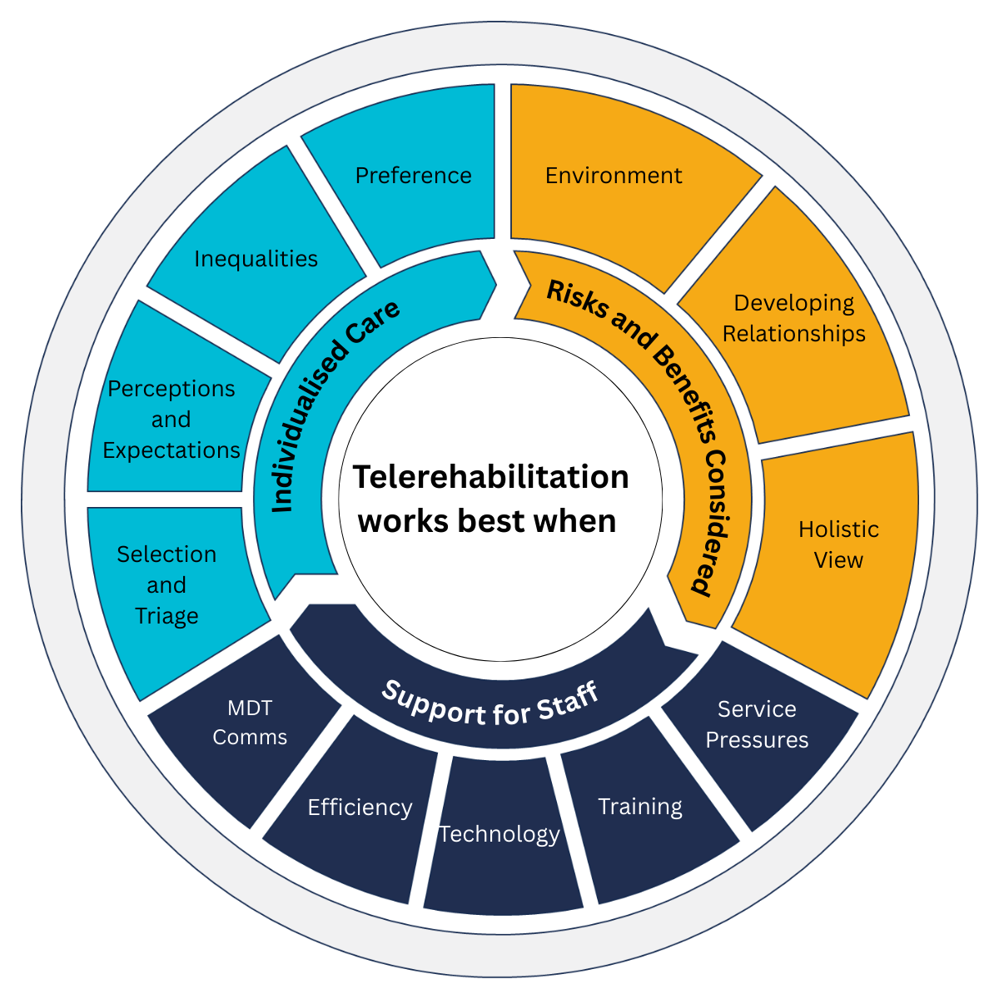
Figure 1: Conceptual diagram illustrating key themes underpinning successful use of telerehabilitation in community stroke services, developed from qualitative interviews with stroke survivors and rehabilitation clinicians in a mixed-methods study conducted in community neurorehabilitation services in the east of England, UK, 2023–2024. Abbreviations: MDT comms: multidisciplinary team communication.

Theme One: Successful use of telerehabilitation: Risks and Benefits
This theme explores the importance of understanding both the potential and the limitations of telerehabilitation in community stroke services. Clinician reflections suggest that when delivered in isolation, telerehabilitation could increase risk particularly in relation to safety, safeguarding and clinical decision-making. However, when integrated within a broader service model, such as blended delivery following face-to-face contact, it is seen as a valuable adjunct to care.

As one participant described:
“On its own, well, I think it can expose risk, but if it's used again as a blended approach after you've met face to face and you've seen the environment and you've established what support and what relationships there are around them, then you can move forward kind of knowing that you're not missing anything.” (DG2, SLT 1)

This balance between risk and benefit was echoed across the focus groups and shaped three interconnected subthemes: The Environment, Relationships, and Working Holistically.

The Environment
Concerns about missing key details in the home environment were consistently raised. Staff spoke of the limitations of video consultations in capturing the full context of a person’s living situation details as compared to face-to-face observations.
An occupational therapist reflected:
“The little things, like just the space around the toilet, you know, and there's just things you don't always pick up on that you can risk assess in the home environment sometimes.” (DG3, OT1)
Survey responses (Phase Two) reflected divided views. Among staff who had used telerehabilitation, 53% (26/49) agreed that initial assessments should always be delivered face-to-face, while a similar proportion disagreed (47%, 23/49). Taken together with discussion group accounts this suggests ongoing uncertainty about when telerehabilitation is appropriate and when in-person assessment is essential for safety and risk management.

Relationships
Participants reflected on how telerehabilitation alters the process of building therapeutic relationships. Many described a more limited sense of the individual and their social environment when interacting remotely.
As one clinician explained:
“The image, the impression that you get through the video or through the phone is very one-dimensional. So you only get the presentation of that person within that square and you don't get those environmental clues. The relationships between the family or carers. So really those things that we pick up on the minute that we're walking up to somebody's house, we don't get. The difference between face to face and sort of virtual options is that you don't pick up on those other clues, those other things around the person” (DG2, SLT1)
Survey responses (Phase Two) reflected this complexity. A strong majority (69%, 34/49) agreed they could build rapport using telerehabilitation, although around one in three (31%, 15/49) still expressed doubt, suggesting that while feasible, clinical staff still experienced challenges rapport-building remotely..

Working Holistically
For many staff, the ability to work holistically, seeing beyond the immediate clinical task, was perceived to be limited by remote delivery. In-person visits often revealed issues not directly related to the stroke-specific goal, enabling a more comprehensive and person-centred response.

One participant explained:
“I work with certain colleagues who …. would really prefer not to do virtual because they don't feel that they have the capacity to do that holistic approach in terms of reaching out beyond the actual stroke specific goal and beyond their professional boundaries in terms of you know what their quality of life is looking like and what kind of what's the bigger picture? Basically, both in the immediate home environment, but also kind of their day-to-day?” (DG1, PT1)
Survey findings (Phase Two) aligned with these concerns. Although 73% (36/49) of staff felt telerehabilitation helped them support the long-term needs of service-users, fewer felt it was as effective (37%, 18/49) or as safe (45%, 22/49) as face-to-face rehabilitation. This aligns with service-user perspectives (Phase Two), fewer than half of the stroke survivors and unpaid carers surveyed (36%, 4/11) agreed that telerehabilitation was of equal quality to face-to-face therapy, while the majority (63%, 7/11) disagreed or strongly disagreed. Although the survey did not explore their reasoning in depth, these responses suggest that some individuals may have experienced limitations or perceived telerehabilitation as less personal or effective. Coupled with findings from clinicians that recognised the benefits of telerehabilitation, but also its limitations when striving for comprehensive care these connected findings emphasise the
importance of aligning telerehabilitation with individual preferences and ensuring it is not positioned as a universal substitute for in-person care. This explored further in Theme Two.

In summary, theme one highlights the complex interplay of risks and benefits when using telerehabilitation in community stroke services. While many staff valued its flexibility and potential to reduce service burden, they also emphasised the need for careful implementation, particularly in relation to understanding the home environment, building relationships, and delivering holistic care. Juxtaposing the perspectives of stroke survivors and carers further underscored that perceived quality, and therapeutic connection may be diminished when services are delivered remotely, even when practical needs are met.
Survey items related to this theme are summarised in (Multimedia Appendix 3. Survey items theme 1).

Theme 2 – Successful use of telerehabilitation: individualised care
This theme explores how telerehabilitation was shaped by individual needs, preferences, and circumstances. Staff and service users alike described a complex mix of practical, emotional, and contextual factors that influenced whether it was perceived as acceptable or beneficial. The legacy of the COVID-19 pandemic remained a notable influence on service delivery and personal choice. One clinician reflected:
“They're still scared of Covid, so they still want their therapy, but they are like, ‘I don't want people in my home.’ Still scared and if they've got like someone in their home that's unwell as well I think video works well. At least having a nice balance between the two so you are going in once a week, face-to-face but then having like the video calls I think sometimes just eases that anxiety.”(DG4, RA2)
Participants emphasised that there was no single “type” of service user for whom telerehabilitation would always be appropriate or inappropriate. Instead, they described the importance of tailoring decisions individually. Interrogation of this theme identified four interrelated subthemes: selection and triage, perceptions and expectations, inequalities, and preferences.
Selection and triage
Across all staff discussion groups, participants described how they triaged service users to determine suitability for telerehabilitation. Clinical factors such as cognitive impairment, visual or hearing loss, and severe communication difficulties were frequently cited as ‘red flags’ for which telerehabilitation was likely to be inappropriate.
“It’s mainly, receptive or cognitive. Or they got visual or hearing [loss]. Those kind of red flags.” (DG3, SLT 1)
Practical issues also influenced decision-making. For example, where service users lived at a considerable distance from the team, video appointments were sometimes used to supplement face-to-face visits. This approach was seen to increase capacity, particularly for disciplines such as speech and language therapy.
“If someone lives an hour’s drive, you’ve got to work that in your day, where on the phone you haven’t got to.” (DG4 RA5)
Telerehabilitation was also used for brief, focused reviews, particularly where the service user’s needs were straightforward.
“Some people prefer to just have a quick review… They can just sort of sign in to the virtual waiting room to discuss their programme.” (DG2, PT1)
In the survey findings (Phase Two), over one-third (37%, 18/49) of staff said they offered telerehabilitation selectively, based on whether they believed the person might like it. Only 20% (10/49) said they routinely offered it to all service users. When asked to rank suitability criteria, staff prioritised access to IT equipment, service user preference, and ability to engage in an online conversation above factors such as age, geography, or presence of a carer.
Perceptions and expectations
Clinicians described a shift in how telerehabilitation was perceived, both by staff and service users, since the early days of the pandemic. While some still expressed concern that service users might see telerehabilitation as inferior, others noted positive changes in how expectations were managed and how individuals had adapted.
“I think a lot of our patients do have certain expectations of what they think therapy is gonna be… I still think they prefer face to face… Maybe they do feel they’re not getting a good deal.” (DG3, SLT1)
However, others gave examples of how telerehabilitation could support self-management and build confidence:
“They are writing down problems before the phone call because they get a little letter before… I think their self-management skills have got better.” “I think it has helped with their expectations and they're actually quite pleased that they are self-managing a bit better...” (DG3, OT1)
Survey responses (Phase Two) indicated that 85% (42/49) of staff felt confident identifying who would benefit most from telerehabilitation, only 41% (20/49) believed that service users enjoyed it, and just 14% (7/49) thought it was considered equal in quality to face-to-face therapy. Among stroke survivors and carers, 81% (9/11) said they would be comfortable using telerehabilitation, 100% (11/11) said they wanted to be involved in the decision to use it, and a slightly lower proportion (73%, 8/11)) felt confident using technology, suggesting that willingness to engage with telerehabilitation may extend beyond self-confidence in the use of digital technology. Juxtaposition of the views of the clinicians and service users illustrates the importance of dialogue and shared understanding.
Inequalities
Concerns about inequality, particularly digital exclusion, were raised in every discussion group. Some participants reflected on assumptions about age and digital literacy, noting that these did not always hold true in practice:
“We have a cohort of our patients that are older. So there's that perception that they wouldn't be able to manage with Telerehab. And I think actually we were quite surprised how well that worked” (DG3, PT1)
“You assume a 35- or 40-year-old is going to be all right with the tech… but some people don’t [have Wi-Fi] and then you’ve got your 98-year-old and they’ve got their iMac.” (DG4, RA5)
Others were more cautious, noting that older adults may prefer face-to-face contact to reduce isolation or maintain connection:
“It’s the contact, the physical contact. Well, especially for the older people…. and that they're not alone. As such, when it comes to the rehab support.” (DG3, OT1)
Access to equipment was another recurring theme. Staff described how many service users lacked suitable devices or only had limited phone access.
“So many didn’t have any devices… a mobile phone, but it wasn’t a smartphone, and they’d only use it very occasionally.” (DG1, SLT1)
These inequalities were also evident in the survey (Phase Two). Among the 10 factors ranked for telerehabilitation suitability, access to IT equipment was rated highest in importance followed by service user preference, whereas age, geographical location and presence of a carer were ranked lowest (Figure 2). Factors relating to safety, purpose and communication occupied the mid-range.
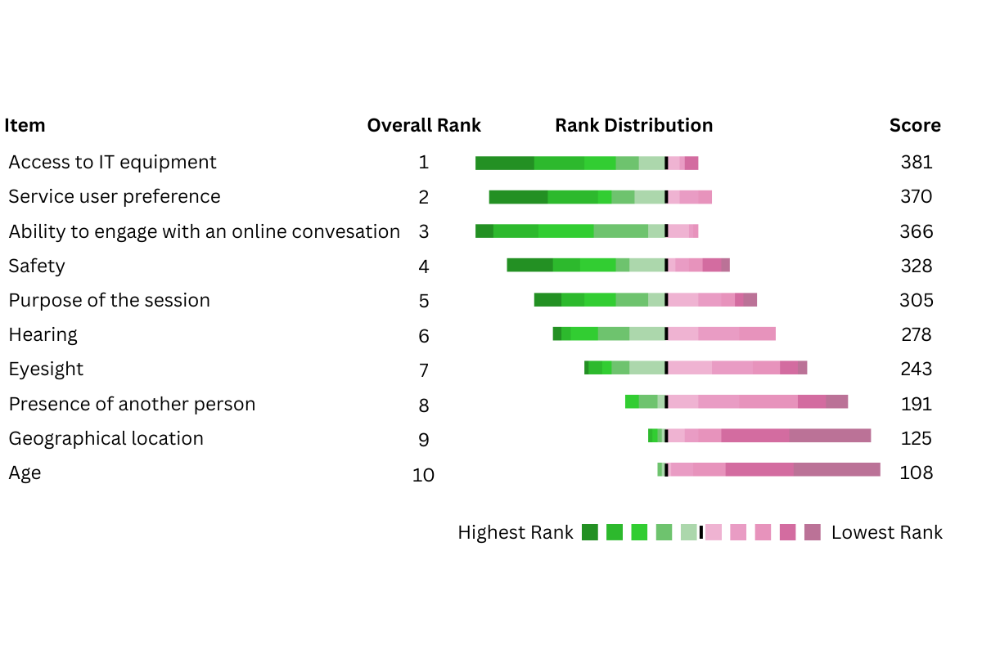
Figure 2: Diverging stacking bar-chart of clinical staffs’ ranking of 10 factors influencing telerehabilitation suitability decisions for stroke survivors in community rehabilitation services, derived from quantitative survey data in the mixed-methods survey of United Kingdom rehabilitation professionals, 2023-2024. Findings are from respondents reporting prior use of telerehabilitation (n=49). Factors are ordered by overall ranking score calculated from the frequency of assignment to each rank position across the 10-item ranking task, with higher ranks contributing greater weight.
Preferences
Personal preference emerged as a key determinant of successful telerehabilitation. Staff spoke of making assumptions about who would or wouldn’t want remote appointments, often based on age or perceived technical ability. However, many recognised the need to move beyond assumptions and to ask service users directly.
“we probably sort of use a bit of bias and maybe in the patients that we think you know would prefer to do video consultations and maybe ask them” (DG3, SLT2)
Several clinicians described how shared decision-making could help match delivery method to the individual’s needs and context, often using a blended approach.
“It’s about the individual and about choice… being able to have those shared decision-making conversations with someone so that you both feel that you have the choice.” (DG2, PT1)
Despite the recognition of preference, in the survey (Phase Two) only one in five clinicians (10/49) said they routinely offered telerehabilitation to all service users, with most choosing to offer it selectively. This contrasts with the voice of service users (Phase Two) who clearly valued being involved: 100% (11/11) of those surveyed said they either wanted or had wanted to be fully involved in the decision to use telerehabilitation.
This theme highlights the importance of flexibility and personalisation in the use of telerehabilitation. While clinical suitability remains critical, particularly for those with cognitive, sensory or communication challenges, decisions are also shaped by geography, workload and perceived confidence with technology. These finding suggest that participants did not consider telerehabilitation to be universally applicable or dismissible, and that a thoughtful approach to shared decision-making is required to meet people’s needs.
Survey items related to this theme are summarised in (Multimedia Appendix 4. Survey items theme 2)).
Theme 3: Successful use of telerehabilitation – Support for staff
This theme explores how staff can be better supported to use telerehabilitation effectively within community stroke services. While telerehabilitation was recognised as a flexible and efficient tool, its success depended on service structures that enabled collaboration, appropriate technology, and sufficient training. For some, telerehabilitation offered a welcome opportunity to work more efficiently and responsively. However, others reflected on the practical and systemic challenges they faced. As one participant put it:
“So it is an incredibly efficient way of working, but I do appreciate and we do have to do it out of necessity because we're so pressed. But actually, I think there's some value in working that way.” (DG2, SLT 1)
Detailed analysis of this theme identified five subthemes: multidisciplinary team (MDT) communication, efficiency, technology, training, and service pressures.
Multidisciplinary team communication
Participants described how telerehabilitation was used not only to engage with service users but also to collaborate with colleagues. Being able to involve other professionals in real time enhanced coordination and decision-making:
“The number of times that people write in their notes, liaise with another colleague, whereas you can do that in the here and now… We can get that piece of equipment ordered. It's not then waiting for another visit the following week. And another lot of travel… it's done.” (DG2, SLT1)
This real-time input also reduced the need for repeated assessments:
“The therapist who has more speciality within that area can ask relevant questions more easily and immediately… So they're not repeating assessments and repeating information.” (DG2, PT1)
Efficiency
Improved communication contributed to greater efficiency, particularly when one staff member could be present with the service user and another could join remotely:
“I found it quite helpful or particularly helpful if a rehab assistant was already seeing somebody and I may be needed to review a situation or review where they were with their exercise programmes that I could join, I could be in the office, but I could join that session remotely “ (DG2, PT1)
Telerehabilitation was also seen to reduce wasted time in care home settings:
“If they're not ready at the time of video, you can just say okay, well, call me back in 10 minutes… Whereas if you're at the care home, you're kind of stuck there.” (DG3, SLT 1)
Survey results (Phase Two) supported these findings. Over three-quarters (76%, 37/49) of staff agreed that telerehabilitation allowed them to be more responsive in assessment. Seventy-three percent agreed that it enabled increased therapy intensity (36/49). Service users also valued this flexibility: 91% (10/11) said they would accept telerehabilitation if it meant being seen more often or more quickly.
Technology
Technology was described as both an enabler and a barrier. While platforms like WhatsApp were familiar and easy to use, some hospital-based systems were harder to navigate:
“We've had to get really good at troubleshooting when patients… navigated the wrong way.” (DG3, PT1)
Device type also mattered. Some participants noted that smartphones worked best for certain tasks, while laptops were preferred for others. Familiarity, accessibility, and ease of use were all seen as essential.
Training
Participants identified a gap in meaningful training both for themselves and for service users. While basic instructions (such as finding a quiet room) were available, more tailored and in-depth training was lacking:
“The obvious bits… were well established, but everything else… not so much.” (DG2, SLT1)
Some staff felt that providing training to service users would improve uptake and quality. However, one person with lived experience shared a different perspective:
“from a patient's point of view, if I've been told at the time that I had to find out quite space, I had to wear certain clothes, I had to do all the things that you’ve just said that …..would have completely put me off full stop. I wouldn't have done it.” (DG2, SU1)
In contrast to analyses restricted to clinical staff with prior telerehabilitation experience, training related survey items included all clinical staff in the analytical sample (n=67). Survey results (Phase Two) revealed varied satisfaction with current training. While 47% (35/49) of staff felt confident in their training on using relevant software, fewer were satisfied with training on adapting service-user goals (33%, 22/49), assessing suitability (32%, 22/49), or communicating effectively via telerehabilitation (36%, 24/49). Notably, staff who had never used telerehabilitation were significantly more likely to report receiving no training at all.

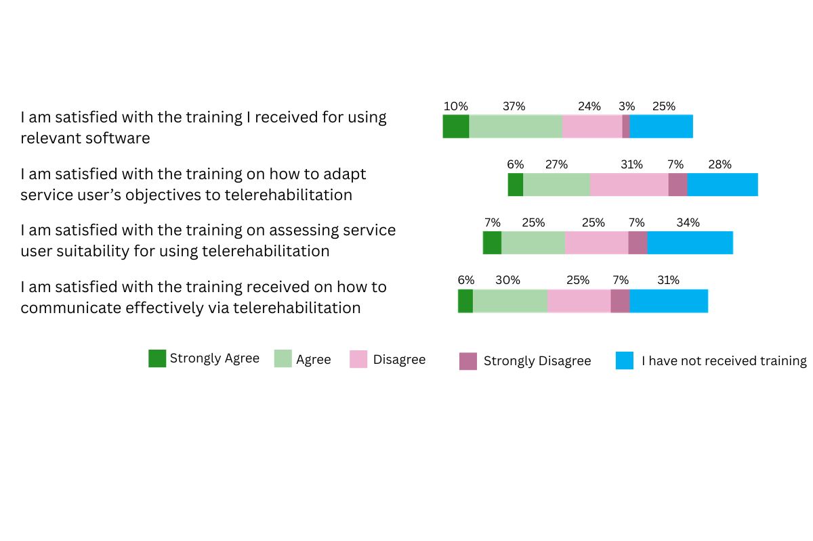
Figure 3. Horizontal stacked bar chart of clinical staffs’ responses to four telerehabilitation training statements (software, adapting objectives, assessing suitability, and effective communication), derived from survey data from all staff delivering community stroke rehabilitation in the East of England who responded to this survey, 2023-2024 (n=67). Response categories were strongly agree, agree, disagree, strongly disagree, and I have not received training.
Service pressures
Participants reflected on how service pressures influenced the use of telerehabilitation. Some acknowledged that it was introduced or used more heavily due to workforce limitations, but still recognised its value:
“They probably get more telerehab than they would face to face. They also might get seen quicker.” (DG3, SLT1)
In this context, telerehabilitation was not simply a compromise, but a means of extending reach and offering timely support. Survey findings (Phase Two) supported this: 75% (37/49) of staff agreed that telerehabilitation helped them to be more responsive in assessment, and 80% (39/49) agreed it was effective for 6-month reviews.
This theme illustrates that successful telerehabilitation is closely tied to how well staff are supported to use it. Staff welcomed the increased efficiency and collaborative opportunities that telerehabilitation enabled, but identified unmet needs around training, technology, and service delivery models. With appropriate tools, shared platforms, and a needs-led approach to staff development, telerehabilitation can enhance both teamwork and service responsiveness, even in pressured environments.
Survey items supporting this theme are summarised in (Multimedia Appendix 5. Survey items theme 3).
Discussion:
This large-scale service evaluation successfully mapped current models and experiences of telerehabilitation delivery in community stroke services by engaging relevant stakeholders, including frontline clinical staff and people with lived experience of stroke, using a sequential mixed-methods approach (evaluation aim 1). It also identified practical lessons and enabling factors to support the sustained integration of telerehabilitation into routine stroke rehabilitation pathways, in line with current policy-drivers (evaluation aim 2). As a result of in-depth interrogation of data from multiple sources using recognised methods, [15] we developed a conceptual model to underpin and guide the successful sustained use of telerehabilitation in community stroke services (figure 1). The model coalesced around three themes: risks and benefits; individualised care, and support for staff.
In considering the possible risks and benefits of using telerehabilitation in community stroke services, a complex interaction between the need to reduce burden on services whilst still building meaningful relationships and understanding personal environments was exposed. Whilst it was clear that immediate practical needs might be met, for clinicians, developing a sense of the person in their social environment and being effective and safe was generally viewed as more challenging using telerehabilitation than face-to-face approaches. Similarly, people with lived experience of stroke generally disagreed that telerehabilitation was comparable to face-to-face delivery. This latter point contrasts with findings of a recent systematic review of randomised-controlled trials investigating factors influencing telerehabilitation delivery in stroke, [11] reporting overwhelmingly positive feedback for access to and interaction with therapists via telerehabilitation. More promisingly in the current evaluation, on deeper interrogation within this theme, many clinicians felt able to adapt and develop rapport, considering themselves able to successfully build relationships with service users using remote communication. And some evidence of forward-planning and improved self-management by people with stroke was apparent as they prepared for telerehabilitation sessions, in line with previous work exploring possibilities for self-management through use of technology [17]. Clinicians also recognised clear efficiency gains when telerehabilitation was used appropriately. Reduced travel time, flexible scheduling and the ability to conduct joint sessions remotely enabled more responsive working, and in some cases increased therapy intensity without additional service burden. For people with lived experience, albeit a small sample size here, this flexibility was viewed positively when it translated into being seen more often or more quickly. These findings suggest that although telerehabilitation can make some aspects of relationship-building more difficult, it may also offer a pragmatic way of increasing rehabilitation dose within constrained workforce capacity. Further, carefully designed research is needed to understand the nuanced characteristics that underpin this paradigm shift in delivery, in concert with the views of people with lived experience.

It is unsurprising that the need for an approach to using telerehabilitation shaped by individual needs, preferences and circumstances was a core finding of the evaluation; that a ‘one-size fits all’ approach was not suitable. The importance of personalised care and shared decision-making throughout patient pathways is well-established in modern health services, with improved outcomes and experiences linked to people’s involvement in shaping their care [e.g.18, 19]. Here, we found that the small group of people with lived experience of stroke included wanted to be fully involved with decisions about use, and that clinicians considered multiple individual factors when deciding whether to use telerehabilitation. These not only included clinical factors such as consideration of cognitive, sensory or severe communication challenges – often seen as ‘red flags’ for telerehabilitation to be avoided- but decisions were also shaped by factors such as people’s personal preferences and their perceived confidence with technology. A deeper exploration of that latter point revealed similarities with previous work on health technologies in stroke and neurorehabilitation- that the challenge is not to dismiss but to support people in taking advantage of the potential benefits of technological approaches without making assumptions about age or digital literacy [20, 21]. In fact, here we demonstrated that age was least important in influencing decision making by clinical teams, but access to appropriate equipment was considered critical to digital participation and reducing inequalities of provision. This theme demonstrated that thoughtful shared decision-making, supported by access to appropriate equipment and clear communication, can help ensure that remote delivery meets the needs of diverse individuals and avoids reinforcing existing inequalities.

A prevailing body of knowledge indicates that, for both technological advancement and other wide-scale service innovation in stroke and neurorehabilitation, supportive organisational cultures are central to sustained change [e.g. 21, 22]; the evaluation findings presented here reflect that understanding. Specifically, clinicians identified the value of a collaborative, multi-disciplinary service approach and a need for meaningful, tailored training for themselves and people with lived experience. Telerehabilitation training needs were exposed on how to work with people to adapt their goals, how to assess suitability for the approach and how to communicate effectively online- in essence, this approach is about much more than the simple mechanics of opening a lap top or smartphone and making a call, if outcomes for both individuals and the service are to be optimal. As recently captured in an extensive scoping review, [23] successful use of telerehabilitation requires a range of competencies from both people with lived experience and clinical teams. Telerehabilitation is a new model of care, implemented at pace in response to urgent need, and as such, workforce transformation through tailored development and a needs-led approach to training is required to embrace its full potential.

Strengths and limitations
The work met an identified need for reporting of the practicalities and challenges of use of telerehabilitation in NHS services [7] using a recognised approach to combining multiple data sources. This was a time-limited pragmatic service evaluation in a large geographical area of the UK (East of England) with community health provision across a mix of rural, suburban and city-based populations. We acknowledge the limitation inherent in evaluating provision only within the UK NHS, but we suggest that key findings on enablers of sustained use of telerehabilitation in community stroke services have potential for application in other systems. The evaluation was supported by the existing Integrated Stroke Delivery Network, ISDN, PPI advisory group, and we acknowledge that our group of participants with lived experience of stroke and their carers was small and therefore, whilst providing considerable insights, cannot represent the views of the wider service-user and carer populations. Despite this, we adopted an inclusive model of shared learning from service users and providers at every opportunity throughout. Where discussion groups included people with stroke, the facilitators endeavoured to ensure their voices were heard. Similarly, we recognise the risk of bias inherent in surveys on a particular rehabilitation approach- that those with strong views and experiences in either direction might be most likely to respond. We made attempt to negate this through a variety of recruitment strategies in collaboration with CD as SQuIRe lead. Finally, it is possible in pragmatic, rapid mixed-methods evaluation that meaningful connections are lost due to limited integration or dominance of one data set; this evaluation used recognised frameworks for study design, integration and interpretation and reflexive approaches to minimise this risk.

Conclusion:
Digital services have clear potential to address pressing unmet rehabilitation needs as demand ever-escalates, though understanding of implementation and sustained use in a variety of service contexts has, up to now, been lacking [23]. This evaluation has made initial steps to enhance that understanding for telerehabilitation in community stroke services and should provide a platform for further, primary research.
Together, the findings presented here suggest that telerehabilitation works best not as a replacement for in-person care, but as part of a responsive, blended approach grounded in individual needs and service-user choice. The evaluation demonstrates that telerehabilitation has the potential to meet people’s, whilst supporting service responsiveness and therapy intensity in pressurised clinical environments. A nuanced approach to implementation that includes appropriate training and carefully integrates the individual needs of service users and staff alongside a supportive organisational culture, is required to support successful, sustained use.

Acknowledgements:
The evaluation team are immensely grateful to NHS East of England for recognising the need for a rigorous service evaluation of telerehabilitation and funding the collaboration with the AbiliTec team at the University of East Anglia to provide it. We are very grateful to all clinical staff and people with lived experience who supported the work herein.
VP is supported by the National Institute for Health and Care Research (NIHR) HealthTech Research Centre in Brain Injury. The views expressed are those of the author(s) and not necessarily those of the NIHR or the Department of Health and Social Care.
Funding:
This work was funded by NHS East of England as part of the Stroke Quality for Rehabilitation SQuIRe, national improvement projects.
Conflicts of Interest:
Dr Hancock has no conflicts of interest to declare.
Charlie Dorer has no conflicts of interest to declare
Prof Valerie Pomeroy has no conflicts of interest to declare
Elizabeth Chandler has no conflicts of interest to declare

Abbreviations
ESD: Early Supported Discharge
ICS: Integrated Care System
ISDN: Stroke Delivery Networks
MDT: Multidisciplinary team
PPI: Patient and Public Involvement
SQuIRe: Stroke Quality Improvement for Rehabilitation
Statement of Author Contributions according to CRediT roles:
EC was day-to-day project lead and was involved in conceptualisation, data curation, analysis, investigation, methodology, project administration, validation, visualisation, and co-led writing the original draft of the manuscript and reviewing and editing.
CD was the NHS lead involved in funding acquisition, conceptualisation, investigation, project administration, writing the original draft of the manuscript and reviewing and editing.
VP was involved in funding acquisition, conceptualisation, project administration, writing the original draft of the manuscript and reviewing and editing.
NH was evaluation lead for the study, and as such led on or was closely involved in conceptualisation, data curation and analysis, investigation, methodology, managing resources and liaising with the funder, supervision of EC, validation, and co-led writing the original draft of the manuscript and reviewing and editing.

Data Availability
Qualitative data (discussion group transcripts) are not publicly available due to the risk of participant identification and the confidential nature of the discussions. De-identified extracts are presented within the manuscript.
Quantitative survey data underlying the reported findings are provided in aggregated form in Multimedia Appendices 2-4. The raw data supporting the conclusions of this manuscript can be made available from the corresponding author upon reasonable request.

Disclosure of Delegation to Generative AI
Generative AI were used for language editing (grammar and sentence structure only). No AI tools were used for data analysis, interpretation, or manuscript content generation.
The GAI tool used was: Chat GPT 4o.
Responsibility for the final manuscript lies entirely with the authors.
GAI tools are not listed as authors and do not bear responsibility for the final outcomes.

References
1. Laver K, Walker M, Ward, N. Telerehabilitation for Stroke is here to stay. But at what cost? Neurorehabil Neural Repair. 2022 Jun;36(6):331-4. DOI: 10.1177/15459683221100492
2. Laver KE, Adey-Wakeling Z, Crotty M, Lannin NA, George S, Sherrington C. Telerehabilitation services for stroke. Cochrane Database of Systematic Reviews. 2020 Jan; DOI: 10.1002/14651858.CD010255.pub3
3. Appleby E, Gill ST, Hayes LK, Walker TL, Walsh M, Kumar S. Effectiveness of telerehabilitation in the management of adults with stroke: A systematic review. PLoS ONE. 2019 14(11): DOI: 10.1371/journal.pone.0225150
4. National Clinical Guideline for Stroke for the UK and Ireland. London: Intercollegiate Stroke Working Party; 2023 May 4. Available at: www.strokeguideline.org
5. National service model for an integrated community stroke service: NHS England; 2022 Feb 28. Available at: https://www.england.nhs.uk/publication/national-service-model-for-an-integrated-community-stroke-service/
6. Fit for the future: 10 Year Health Plan for England: NHS England; 2025 Jul 3. Available at: https://www.gov.uk/government/publications/10-year-health-plan-for-england-fit-for-the-future ISBN 978-1-5286-5807-2
7. English C, Ceravolo MG, Dorsch S, Drummond A, Gandhi DBC, Halliday Green J, Schelfaut B, Verschure P, Urimubenshi G, Savitz S. Telehealth for rehabilitation and recovery after stroke: State of the evidence and future directions. Int J Stroke. 2022 Jun; 17(5):487-493. DOI: 10.1177/17474930211062480
8. Pearce L, Costa N, Sherrington C, Hassett L. Implementation of digital health interventions in rehabilitation: A scoping review. Clin Rehabil. 2023 Nov 1;37(11):1533–51. DOI: 10.1177/02692155231172299
9. Edwards D, Kumar S, Brinkman L, Ferreira IC, Esquenazi A, Nguyen T, et al. Telerehabilitation Initiated Early in Post-Stroke Recovery: A Feasibility Study. Neurorehabil Neural Repair. 2023 Feb 1;37(2–3):131–41.DOI: 10.1177/15459683231159660
10. Mallet KH, Shamloul RM, Lecompte-Collin J, Winkel J, Donnelly B, Dowlatshahi D. Telerehab at Home: Mobile Tablet Technology for Patients With Poststroke Communication Deficits— A Pilot Feasibility Randomized Control Trial. J Speech Lang Hear Res 2023 Feb13;66(2): 648-655. DOI: 10.1044/2022_JSLHR-21-00616
11. Stephenson A, Howes S, Murphy PJ, Deutsch JE, Stokes M, Pedlow K, McDonough S. Factors influencing the delivery of telerehabilitation for stroke: A systematic review. PLoS One. 2022 May 11;17(5). DOI: 10.1371/journal.pone.0265828
12. Cresswell, J. Research Design: Qualitative, Quantitative and Mixed Methods Approaches. Sage publications, London, 2009. pp203-204.
13. O’Cathain A, Murphy E, Nicholl J. The quality of mixed methods studies in health service research; J Health Serv Res Policy 2008 Apr,13(2): 92-98 DOI: 10.1258/jhsrp.2007.007074

14. Braun V, Clarke V. Using thematic analysis in psychology. Qual Res Psychol. 2006, 3(2): 77-101. DOI: 10.1191/1478088706qp063OA
15. Braun V, Clarke V. One size fits all? What counts as quality practice in (reflexive) thematic analysis? Qual Res Psychol. 2021;18(3):328–52. DOI: 10.1080/14780887.2020.1769238
16. Semyonov-Tal K, Lewin-Epstein N. The importance of combining open-ended and closed-ended questions when conducting patient satisfaction surveys in hospitals. Health Policy Open. 2021 Dec: 2. DOI: 10.1016/j.hpopen.2021.100033
17. Demain S, Burridge J, Ellis-Hill C, Hughes AM, Yardley L, Tedesco-Triccas L, et al. Assistive technologies after stroke: Self-management or fending for yourself? A focus group study. BMC Health Serv Res. 2013;13(1). DOI: 10.1186/1472-6963-13-334

18. NHS England. NHS universal personalised care: implementing the comprehensive model; 2019. Available at: https://www.england.nhs.uk/wp-content/uploads/2019/01/universal-personalised-care.pdf
19. Ahmad , Ellins J, Krelle H, Lawrie M. Person-centred care : from ideas to action : bringing together the evidence on shared decision making and self-management support. The Health Foundation, London UK; 2014. Available at: https://www.health.org.uk/reports-and-analysis/reports/person-centred-care-from-ideas-to-action
20. Drake A, Sassoon I, Balatsoukas P, Porat T, Ashworth M, Wright E, et al. The relationship of socio-demographic factors and patient attitudes to connected health technologies: A survey of stroke survivors. Health Informatics J. 2022 Apr 1;28(2). DOI: 10.1177/14604582221102373

21. Alt Murphy M, Pradhan S, Levin MF, Hancock NJ. Uptake of Technology for Neurorehabilitation in Clinical Practice: A Scoping Review. Phys Ther. 2024 Feb; 104(2). DOI: 10.1093/ptj/pzad140

22. Hancock NJ, Houghton J, Jones F. Integrating an approach to personalised self-management support in stroke and neurorehabilitation service contexts: People1st–a quality improvement initiative. Disabil Rehabil. 2023 Sep; 45(19):3034–45. DOI: 10.1080/09638288.2022.2127930

23. Stark AL, Krayter S, Dockweiler C. Competencies required by patients and health professionals regarding telerehabilitation: A scoping review. Digit Health. 2023; 9 DOI: 10.1177/20552076231218841

24.Pearce L, Costa N, Sherrington C, Hassett L. Implementation of digital health interventions in rehabilitation: A scoping review. Clin Rehabil. 2023 Nov 1;37(11):1533-51. DOI: 10.1177/02692155231172299

