Age-Related Differences in Autobiographical Memory Recall: Impact of Retrieval Mode Switching

Greta Melega1,2*, Alice Bush1, Tabitha James3, Riccardo Sacripante3, and Louis Renoult1

1 School of Psychology, University of East Anglia, Norwich, UK
2 Department of Neurology, Charité – Universitätsmedizin Berlin, Berlin, Germany
3 Norwich Medical School, University of East Anglia, Norwich, UK

*Corresponding Author: Greta Melega g.melega@uea.ac.uk, greta.melega@charite.de

Author Note
Greta Melega https://orcid.org/0000-0002-5456-7198
Louis Renoult https://orcid.org/0000-0001-7861-0552
The processed data and codes that support the findings of this study are available on the Open Science Framework project page, at 10.17605/OSF.IO/BGCW3. The raw autobiographical memory narratives are not publicly available due to the highly personal content of autobiographical memories. We would like to thanks Amelia Smith for help with transcriptions and scoring of neuropsychological test. We would like to thank all participants that took part in our study. G.M. and A.B. were supported by PhD studentships from the school of Psychology and T.J., and R.S studentships from the school of Medicine at the University of East Anglia. L.R. was supported by grant MR/S011463/1 from the Medical Research Council (MRC). Portions of these findings were presented as a poster at the Cognitive Neuroscience Society meeting in 2022 in San Francisco and as talk at the New Perspective in Declarative Memory conference in 2022 at the University of East Anglia.

Abstract
Flexibility in the recall of autobiographical memories, from highly detailed unique episodes to more abstract and decontextualised personal knowledge, depends on control processes and contextual factors, including the specific task demands. Here, we investigated the costs of switching between different types of autobiographical retrieval in young and older adults. In an online task, participants were first instructed to recall specific (unique) and categoric (repeated) events sequentially (baseline block). They were then asked to alternate between specific and categoric retrieval (switching block). We analysed autobiographical memory recall as content alignment with instructions (e.g., describing a unique event when instructed to recall a specific memory), and details produced (e.g. describing a unique event with rich episodic details). Our results revealed that participants recalled fewer memories consistent with instructions in the switching block as compared to the baseline block. In particular, older adults showed a lower performance for categoric but not specific memories in the switching compared to the baseline block. However, most age group differences emerged when considering the type of details produced, regardless of task switching demands. When instructed to recall specific events, older adults’ narratives included a lower proportion of episodic details and a higher proportion of semantic details than young adults. Similarly, when instructed to recall categoric events, older adults recalled a lower proportion of repeated events details but a higher proportion of semantic information, as compared to young adults. Together these results reveal that autobiographical memory retrieval in aging varies with task demands, though intertwined with a prevalent episodic-to-semantic shift across instructions.
Keywords: autobiographical memory, aging, personal semantics, episodic memory, retrieval switching

Public Significant Statement
Using an autobiographical memory task where participants were required to switch between the recall of unique and repeated memories, we found a reduced accuracy in older when compared to young adults. Beyond switching costs, older adults consistently shifted from rich episodic details toward more general semantic information, highlighting age-related changes in how personal memories are recalled.
Introduction
In our everyday life, we can flexibly retrieve autobiographical memories that vary in their content, from highly detailed and contextually specific unique events (episodic memories) to more abstract and decontextualised personal knowledge (like autobiographical facts; Barsalou, 1988; Conway & Pleydell-Pearce, 2000; Tulving, 2002). Research on age-related differences in autobiographical memory recall reveals that older adults’ memories are typically more general and semanticised than those of young adults, even when instructed to recall unique events (Addis et al., 2008; Levine et al., 2002; Melega et al., 2024). This shift towards more semanticised memories has been related to changes in narratives style (Bluck et al., 1999; Bluck et al., 2016; see also Schacter et al., 2012), with older adults' memories including more story asides and non-target information (Amer et al., 2022; Bluck et al., 2016), intertwined with changes in cognitive control processes involved in retrieval (Craik & Bialystok, 2006; Holland et al., 2012; Ros et al., 2009; Spreng et al., 2018; Turner & Spreng, 2015; Piolino et al., 2010). The type of autobiographical memory recalled, unique episodes or more semanticised elements, depends critically on these executive control processes, such as maintaining task instructions, inhibiting inappropriate memory responses, or flexibly shifting between retrieval strategies (Diamond, 2013).
A common feature of the tasks used to study autobiographical memory is the block design, where participants are required to follow the same instruction for the entire duration of each block. Across different blocks, the instructions can be goal-directed, typically requiring participants to recall unique events (Levine et al., 2002; Williams & Broadbent, 1986), and sometimes more general events, such as memories of repeated events (Dalgleish et al., 2007; Ford et al., 2014). Alternatively, the instructions can be more open-ended and provide participants with less guidance on the type of memory to be recalled (Strikwerda-Brown et al., 2021). Age-related differences in memory performance particularly emerge in blocks with goal-directed and specific instructions and are less evident or absent with more general and open-ended instructions (Ford et al., 2014; Strikwerda-Brown et al., 2021). Whereas young participants adjust retrieval content with the specific instructions, older adults' memories appear to show less modulation, particularly when the task demands increase (Ford et al., 2014; Strikwerda-Brown et al., 2021). To investigate flexibility in recalling different types of memories along with changes in instructions, Dritschel and colleagues (2014) developed the Alternate Instruction Autobiographical Memory Test (AMT-AI), combining the classic block design of autobiographical studies with a mixed-block design typical of task-switching paradigms. In the initial blocks of the AMT-AI, participants are instructed to recall either specific episodic memories or categoric memories (repeated or extended events) in separate blocks (baseline block). They are then instructed to alternate between the recall of specific and categoric memories within the same block (switching block). Memories are scored as correct or incorrect based on their coherence with instructions (e.g., recalling a repeated event is considered correct if the instruction required the participant to recall a categoric memory). Results from a sample of young adults revealed a reduced proportion of correct memories in the alternating instructions block, compared to the single-instruction block (Dritschel et al., 2014). This suggests that the higher task demands in the alternating block negatively impacted the ability of young adults to recall memories consistent with instructions. It has not yet been investigated whether the adoption of a similar task-switching paradigm might disproportionately affect autobiographical memory retrieval in older, as compared to young adults.
There is, however, a wide range of studies that explored how aging impacts the ability to switch between different tasks. Previous work revealed how age-related differences in switch costs (as indexed by decreased performance and/or increased reaction times) are modulated by the level of cognitive control demanded by the task's structure. Increased switch costs in older adults have been found to vary with task uncertainty, such as cue ambiguity (Mayr, 2001), the unpredictability of the switch (Kray et al., 2002) and the absence of external cue to guide behaviour (Kray & Lindenberger, 2000). Switch costs in aging, particularly increased response time, typically emerge when comparing the overall performance between a baseline block with only one instruction to follow, and a switching block which requires participants to maintain and adapt to varying instructions (e.g., Kray & Lindenberger, 2000). On the contrary, there is little evidence for age-related differences when considering the switch costs at a trial level, thus when comparing the performance in switch trials and no-switch trials (or remain trials) within a block (Kray et al., 2002; Meiran et al., 2001; Mayr & Kliegl, 2000). This pattern suggests that aging impairs the ability to simultaneously maintain and differentiate multiple task instructions more than the ability to actively inhibit irrelevant stimuli and information from the previous trial, or to switch attention to the current stimulus (Mayr, 2001; Monsell, 2003; Verhaeghen & Cerella, 2002). Although cognitive aging research has investigated age-related differences in task switching, little is known about the switching costs associated with autobiographical memory retrieval.
Current study
In this study we used a modified version of the AMT-AI (Dritschel et al., 2014) to compare the flexible retrieval of specific (unique events from one’s past) and categoric memories (memory events that happened in a similar way multiple times) in young versus older adults. Participants were initially instructed to recall specific and categoric memories sequentially (baseline block). In the following switching block, instructions to recall specific or categorical memories changed every second or third trial, instead of alternating on each trial (as in Dritschel et al., 2014), making the switch unpredictable for participants. We defined switch trials as those preceded by a trial with a different instruction, while remain trials followed a trial with the same retrieval instructions. We evaluated autobiographical recall by checking the overall coherence of each memory with the given instructions (e.g., recalling a repeated event under categoric instructions; Dritschel et al., 2014; Piolino et al., 2006) and by breaking down each narrative into different types of details (e.g., Levine et al., 2002; Renoult et al., 2020; Strikwerda‐Brown et al., 2019). This latest approach provides a more detailed consideration of participants' ability to re-experience and elaborate each event (Levine et al., 2002). As these measurements, although similar, are not equally sensitive to aging (Mair et al., 2021), we expected a different impact of task switching on our measures of interest. In particular, given the increased switching costs in aging (for a meta-analysis, see Wasylyshyn et al., 2011), we expected a lower proportion of memories recalled coherently with the instructions in older adults at a block level, when comparing baseline and switching blocks, but less so at a trial level, when comparing switch and remain trials within the switching block. When considering details production, given the general semanticisation of memories in aging (Grilli & Sheldon, 2022; Levine et al., 2002; Spreng et al., 2018) and older adults' reduced ability to modulate their recollection with task instructions (Ford et al., 2014; Strikwerda-Brown et al., 2021; Melega et al., 2024), we hypothesized that older adults would elaborate specific memories with fewer episodic details and more semantic information, both in the baseline and switching blocks. Additionally, we anticipated extending these findings to the elaboration of categoric memories, as in Dritschel et al. (2014). Repeated events typically include contextual and perceptual details as well as more general and semantic information (Conway & Pleydell-Pearce, 2000; Renoult et al., 2012; Rubin & Umanath, 2015). We thus expected older adults to recall fewer contextually specific information about the repeated events and to include more semantic information, when asked to recall categoric memories.
Methods
Transparency and Openness
Scored data and analysis code are available (see Author Note; raw data could not be released as these data could not be fully anonymized). This study’s design and its analysis were not pre-registered. Data were analyzed using the R statistical software version 4.1.2. (R Core Team, 2020) and the models were fitted using the glmmTMB package (Brooks et al., 2017) and significant interactions were further examined using the emmeans package (Lenth, 2023). Access to the task can be available upon request. Analysis on the sample size and exclusion criteria are defined in the Participants section.
Participants
45 older adults and 45 younger participants were recruited for the study. Young adults were undergraduate psychology students from the University of East Anglia recruited through the SONA online system and awarded with course credits. Older adults were recruited through a local cohort and were compensated for their participation (at a rate of £12 per hour). Participants were English native speakers and screened for psychiatric, medical and neurological conditions that might impact normal brain functions. Older adults were also screened for cognitive impairments using the Addenbrooke's Cognitive Examination III (ACE-III, using a cut-off value of 88, following Mioshi et al., 2006). One older adult was excluded as they scored under the cut-off value for the ACE-III, another as they did not complete the experiment, and six additional older adults were excluded due to difficulty in following task instructions (see the Material section for more details). Three young adults were excluded due to difficulty in following task instructions, while five others were excluded due to poor quality of the recorded memories, which could not be transcribed. The analysed sample consisted of 37 older adults (28 Female and 9 Male; M_{age} = 70.02, SD_{age} = 6.80, range = 60-85; M_{ace-III} = 95.79, SD_{ace-III} = 2.58) and 37 younger adults (32 Female and 5 Male; M_{age} = 22.07, SD_{age} = 6.61, range = 18-33). Participants did not differ in their level of education (older adults: M = 15.66, SD = 2.16; younger adults: M = 14.95, SD = 1.16). According to a G*Power analysis (G*Power Version 3.1.9.2; Faul et al., 2007), the sample size was sufficient to detect a between-groups main effect size of f = 0.39, a within-groups effect size of f = 0.13, and a within-between interaction effect size of f = 0.19. This calculation assumes 80% power at an α level of 0.05, with a correlation of 0.50 between repeated measures, as in similar experiments.
All participants completed the Patient Health Questionnaire (PHQ9; Kroenke et al., 2001), and the Generalized Anxiety Disorder Assessment (GAD7; Spitzer et al., 2006) to assess potential differences in depressive and anxiety symptoms that could confound age and task-related comparisons of memory retrieval patterns. This decision was motivated by evidence linking reduced autobiographical memory specificity with depression and anxiety (e.g., Hallford et al., 2019; Sumner et al., 2010; Wessel et al., 2001; Williams et al., 2007). Young and older adults did not differ on the PHQ-9 (older adults: M = 4.68, SD = 2.23; younger adults: M = 5.46, SD = 3.93) nor the GAD-7 (older adults: M = 3.21, SD = 4.42; younger adults: M = 4.45, SD = 3.01). A subset of participants (30 older adults and 30 young adults) additionally completed the digit span digit span backwards and the trail making test A and B. There was no difference between age groups for the digit span backwards (older: M = 14.1, SD = 13.9; young: M = 10.98, SD = 13.8; p = .56) and the trail making test (older: M = 6.29, SD = 1.49; young: M = 5.74, SD = 1.55; p = .79).
The study was approved by the Research Ethics Committee of the School of Psychology of the University of East Anglia and all participants provided informed consent. Data collection was conducted between 2021 and 2025.
Stimuli
Twenty-one cue words were selected from the database of Clark and Paivio (2004). The words selected were neutral in emotional valence (M = 3.37, SD = 1.12) and high in concreteness (M = 6.56, SD = 0.69), imageability (M = 6.38, SD = 0.56) and Thorndike-Lorge frequency (M = 1.91, SD = 0.15) in order to increase the likelihood of event recall. The cue words were counterbalanced across conditions and presentation order was randomized across participants (see Table S1 in the Supplementary Materials for the list of words and corresponding ratings).
Material
Our autobiographical memory switching task was designed for online testing using the Gorilla experiment builder (Anwyl-Irvine et al., 2020). In this task, participants were instructed to verbally recall specific and categoric events in response to cue words that appeared on the screen. Instructions for the recall of specific memories required participants to describe in as much details as possible a personal specific event that happened at a specific time and place (e.g., “I had a good time at Jane’s party last month in London, we went to a karaoke bar and I was laughing a lot”). Instructions for the recall of categoric memories required participants to describe in as much details as possible memories of personal repeated events that happened in a similar way multiple times (e.g., “When I go to Jane’s house, we usually cook together and watch a movie afterwards”).
The task was composed of two blocks: a baseline block and a switching block. In the baseline block, participants were instructed with descriptions and examples for one memory type (specific or categoric) and then were instructed to recall three memories of that type. They then received instructions and examples for the other memory type, followed by the recall of three corresponding memories (order counterbalanced across participants). Participants were excluded from the analysis if they failed to recall all three categoric and all three episodic memories (4 older adults and 3 younger adults were excluded due to poor performance during this training block; see participants section). In the switching block, participants were instructed to recall specific or categoric memories. We defined each trial as switch if they were preceded by a trial with different instructions, or as repeat, if they were preceded by a trial with the same instructions. The switching block was composed of 14 trials (3 switch episodic, 3 switch categoric, 4 repeat categoric and 4 repeat episodic trials), where the retrieval instructions changed every two or three consecutive trials of the same type. The type of memory retrieved in the first trial of this block, specific or categoric, was counterbalanced across participants.
On each trial, participants were given up to one minute to search for a memory. Once they had a memory in mind, they were instructed to press the recording button on the screen and then had up to two minutes to verbally describe the memory. Once the verbal recall was completed, they were asked to press the “stop recording” button on the screen. Participants were then asked how detailed the memory recalled was (vividness rating; from 1 “poorly detailed” to 5 “highly detailed”), how emotional (emotion rating; from 1 “not emotional at all” to 5 “intense emotional experience”), what type of perspective they had during retrieval (perspective rating; from 1 “seeing the event from your own eyes” to 5 “seeing the event from the perspective of an observer”) and finally to locate the memory in time (time rating; “within last year”, “less than 5 years ago”, “between 5 to 10 years ago”, “more than 10 years ago” and “across my life” only for categoric memories). Participants had 5 seconds to complete each subjective rating (see Figure 1 for a graphic description of the trial and task structure). These ratings were included to conduct an exploratory analysis of possible differences in the subjective recall of specific and categoric memories in young and older adults.
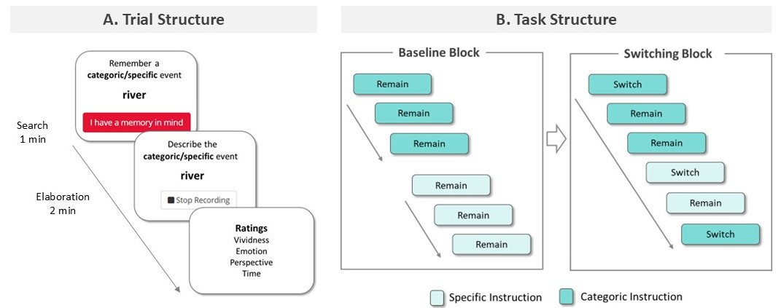
Figure 1. Schematic description of the Retrieval Switching Task. (A) Participants were shown a cue word and instructed to recall either a specific or a categoric event and to press a button when they had a memory in mind. They had up to 1 minute to search for a memory. They were then asked to verbally describe the memory in as much details as they could for up to 2 minutes. Finally, they were asked to subjectively rate the vividness, emotion, perspective and time of the recalled memory. (B) The trials where the instructions changed are labelled as “switch trials” while the trials where the instruction were coherent with the previous trial are considered as “remain trials”. In the switching block, instructions changed every 2 or 3 trials.

Procedure
The autobiographical memory switching task was conducted online (duration was about 30 minutes). Older adults completed the cognitive screening on a separate online session, during a video call on Microsoft Teams (duration was about 30 minutes) to avoid subjecting them to long online testing sessions and to reduce fatigue.
Scoring
Memories were scored for their consistency with instructions and for details production (count of different types of details produced). Consistency with instructions was determined following the AMT scoring procedure (Williams & Broadbent, 1986). Each memory was categorized as one of the following: (1) Specific: episodic memory, unique event that lasted less than a day; (2) Categoric: repeated event, events that happened multiple times in the past in a similar way; (3) Extended event: event that lasted longer than a day; (4) Semantic associate: not an event, but personal or general semantic information (e.g., personal facts or self-knowledge). (5) Omission: no memory has been recalled. After this categorization, overall consistency with instructions was computed as the percentage of memories coherent with the instructions (e.g., the memory recalled was of a unique event when the instructions asked to recall a specific memory, or the memory was of a repeated event when the instruction asked to recall a categoric memory), which is referred below as accuracy (see figure 2).
For details production scoring, each memory was segmented into details, each classified following an adaptation of the scoring scheme for the Autobiographical Interview (AI; Levine et al., 2002; see also Renoult et al., 2020 for the classification of semantic details). Each detail was scored as one of the following: (1) Episodic: detail about the unfolding of a specific event (including perceptual, spatial-temporal and emotional information); (2) Repeated Event: detail about a repeated event, including perceptual, spatial-temporal and emotional information; (3) Semantic: general and personal semantic information (including autobiographical facts and self-knowledge information); (4) Other: repetition and metacognitive statement. Examples of participants’ recollections can be found in the Supplementary Materials section. Details were then automatically counted and summed for each memory. To correct for difference in length of protocols observed when comparing young and older participants (see results section), we used the proportion of details produced by participants for this analysis (see statistical analysis below), however, analyses on details counts are reported as Supplementary Materials.
To assess reliability, two members of our lab (A.B. and T.J.), blind to the age group, scored memories of 12 participants (6 randomly selected from the pool of older adults and 6 from the pool of young adults) for a total of 244 memory trials. The inter-rater reliability, calculated with the Intraclass correlation coefficient (ICC; two-way, random effects model), revealed very good to excellent scores for memory categorization (specific memories = 0.89; categoric memories = 0.93) and for the scoring of each detail type (episodic details = 0.89; repeated event details = 0.85; semantic details = 0.79; other details = 0.83).
Statistical analysis
Before analysing detail counts, we applied a winsorization procedure to all memories to rescale detail counts exceeded +/- 2.5 SD from the mean to be 2.5 SD from the mean to control for a positive skewness of detail counts that is typical of autobiographical narratives (see McKinnon et al., 2008; McKinnon et al., 2015).
Older and young adults took a similar time to select a memory (M = 17.27 vs 14.19 seconds, SD = 14.28 vs 14.26, p = 0.28). However, older adults spent more time elaborating memories compared to young adults (M = 45.33 vs 26.62 seconds, SD = 28.19 vs 20.17, t(27.7) = 2.53, p = 0.02, d = 0.57, 95% CI [3321.37, 31851.88]). This resulted in memories with an overall greater amount of details in older than in young adults (M = 11.00 vs 7.41 details, SD = 4.76 vs 4.73, t(78) = 3.37, p = 0.001, d = 0.79, 95% CI [1.46, 5369]). To account for this difference in elaboration duration between young and older adults (e.g., Badham et al., 2021; Melega et al., 2024; Spreng et al., 2018), the following analyses focused on the proportional scores (computed as the number of details type divided by the total number of target details, separate for each memory) instead of absolute details count. However, analyses on details counts are reported in the Supplementary Materials.
For the analysis on accuracy, data about the consistency of memories with instructions were analysed using a beta regression mixed-effects model with block (baseline vs. switching), age group (young vs. older), and memory instructions (categoric vs. specific) as fixed factors, while participants were included as random intercept. A follow-up beta regression mixed-effects model was conducted to examine trial-levels effects within the switching block, comparing switch and remain trials. The model included trial type (switch vs. remain) instead of block as a fixed factor. A significant interaction between trial type and memory instruction would indicate that performance differed between switch and repeat trials as a function of memory type, thereby suggesting a potential order effect.
For all models, statistical inference was based on Wald tests, with coefficient-level effects reported as z-values and overall effects evaluated using Type II Wald chi-square tests (Fox & Weisberg, 2019). Post hoc comparisons for all models were conducted using estimated marginal means with Bonferroni correction applied for multiple comparisons. We also ran as exploratory analysis a beta regression mixed-effects model on inaccurate memories with age group (young vs. older), memory instructions (categoric vs. specific) and memory type (semantic vs episodic vs extended vs repeated event vs omission) as fixed factors, while participants were included as random intercept.
For the analysis on elaboration, data about details production were analysed using a series of beta regression mixed-effects models, separated by memory type (categoric vs. specific). The choice of separating memory type was to avoid mixing detail types that are consistent with instructions for one memory but off-task for another type (i.e. recalling episodic details under specific instructions is coherent, however, recalling episodic details under categoric instructions is off-task). The models included details type (episodic, repeated events, semantic and other), block (baseline vs. switching), and age group (young vs. older) as fixed factors, while participants were included as random intercept. Additional beta regression mixed-effects models were run at a trial level, with the same factors but including trial (remain vs. switch) instead of block. Importantly, only accurate memories, those that were scored as coherent with instructions, were included in the details production analyses.
Finally, subjective ratings of vividness, perspective, emotion and time location were analysed at a block level. We ran linear mixed models with block (baseline versus switching) as within-subjects factor, and with memory type (categoric vs specific) and age group (young versus older adults) as between-subjects factors, while participants were included as random intercept. Analysis of time ratings followed the same structure while including Time as additional within-subject factor (for categoric memories: last year, within five years, from 5 to 10 years ago, more than 10 years ago, and across the life course; for specific memories: last year, within five years, from 5 to 10 years ago, and more than 10 years ago).
Results
Retrieval accuracy is affected by age and increased task demands
Comparison between baseline and switching block (block-level analysis)
We first examined whether the consistency with instructions of the memories recalled differed between the baseline block (i.e., when participants recalled the same type of memory throughout the block) and the switching block (i.e., when participants alternated between different retrieval modes within the same block), reflecting an overall impact of increased task demands in memory recall. Participants were less likely to recall memories consistent with instructions in the switching block compared to the baseline block, as indicated by a main effect of block in the model (χ²(1) = 14.22, p < .001; M = 0.73 vs. 0.82; see and Figure 2). Additionally, the model revealed main effects of age group (χ²(1) = 5.94, p = .01) and retrieval instructions (χ²(1) = 5.05, p = .02), as well as a significant interaction between these factors (χ²(1) = 7.70, p = .005). Follow-up comparisons revealed that older adults were less likely to produce memories consistent with categoric instructions then young adults (M = 0.68 vs. 0.81; z = -3.69, p < .001), while no age-difference was found for specific instructions (M = 0.81 vs. 0.80; z = 0.09, p = .93; See Figure 2). No other main effects nor interactions were significant (ps > .41).
Comparison between remain and switch trials within the switching block (trial-level analysis)
We then assessed whether, within the switching block, the consistency with instructions varied between switch trials (i.e., when the retrieval mode changed between specific and categoric instructions) and repeat trials (i.e., when the retrieval mode remained the same as on the preceding trial), reflecting a specific impact of changing retrieval mode during memory recall. The model examining the ability of participants to follow instructions in the switching block, comparing the performance for remain and switch trials, revealed a main effect of memory instructions (χ²(1) = 12.89, p < .001), as participants were more likely to produce memory consistent with specific than with categoric instructions (M = 0.81 vs. 0.75; See Table 1 and Figure 2). The model also revealed a main effect of age group (χ²(1) = 5.37, p = .02), as older adults were less likely to produce memories consistent with instructions then young adults (M = 0.68 vs. 0.70; z = -2.33, p = .02). No additional main effects nor interactions between these factors and memory instructions were found (all ps > 0.14), suggesting that participants were as likely to recall memories coherent with instruction in remain and switch trials, and thus an absence of order effect. 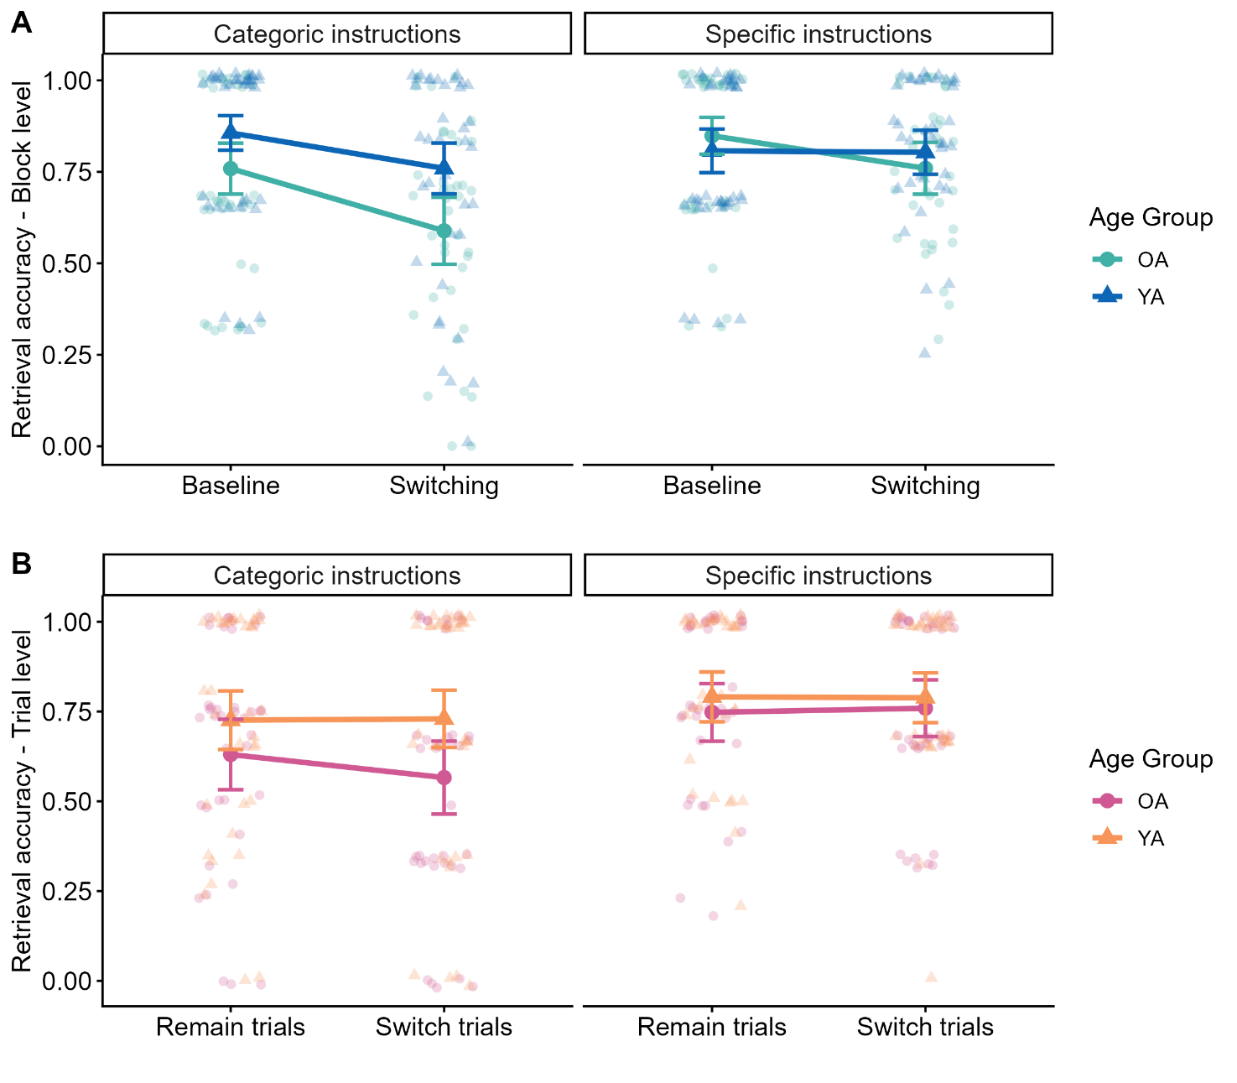
Figure 2. Retrieval accuracy based on the proportion of memory recalled consistent with instructions at a block level (A) and trial (B) level. A) Participants showed lower retrieval accuracy in the switching, compared to the baseline block. Additionally, older adults (OA) showed lower retrieval performance than young adults (YA) only when instructed to retrieve categoric memories. B) The trial-level analysis revealed that participants were more likely to produce memory consistent with specific instruction than with categoric instructions. Additionally, older adults were less likely to produce memories consistent with instructions then young adults. Individual data points are shown. Error bars represent standard errors of the mean.
Inaccurate recall analysis
As an exploratory analysis, we examined the types of memories participants recalled when they failed to follow the given instructions. The model on the proportion of memories recalled with categoric instructions revealed a significant main effect of memory type (χ²(4) = 50.81, p < .001) but no main effect of group and no interaction between these factors (both ps > .26). Participants reported semantic associates more frequently than specific memories (M = 0.35 vs. 0.14; p < .001) and more frequently than extended events (M = 0.35 vs. 0.12; p < .001). The model on the proportion of memories recalled with specific instructions revealed a significant main effect of memory type (χ²(4) = 10.55, p = .01), but no main effect of group and no interaction between these factors (both ps > .12). Participants recalled semantic associates (M = 0.35), repeated events (M = 0.14) and extended events to a similar extent (M = 0.12; all ps > .54).
Details production is affected by age and retrieval task demands, particularly at a block level.
Separately for categoric and specific instructions, we first examined whether the proportion of details produced differed between the baseline block and the switching block (block-level analysis), and then examined whether, within the switching block, the proportion of details varied between switch trials and repeat trials (trial-level analysis).
Categoric instructions
Block-level analysis. The model revealed significant main effects of detail type (χ²(3) = 825.64, p < .001), and a significant interaction with block (χ²(3) = 28.23, p < .001), with age group (χ²(3) = 114.06, p < .001), and with both block and age group (χ²(3) = 12.16, p = .01). To facilitate the interpretation of the three-way interaction, separate models were fitted for each detail type. For target repeated event details, there was a significant effect of age group (χ²(1) = 35.08, p < .001), and block (χ²(1) = 15.59, p < .001), but no significant interaction (p = .08). Follow-up comparisons revealed that young adults produced a higher proportion of target repeated events than older adults (M = 0.72 vs. 0.48; z = -5.96, p < .001; See Figure 3A), and that participants produced a higher proportion of repeated event details in the baseline than in the switching block (M = 0.67 vs. 0.54; z = 4.05, p < .001). For semantic details, there was a significant effect of age group (χ²(1) = 38.97, p < .001) and an interaction with block (χ²(1) = 4.78, p = .03). Follow-up comparisons revealed that older adults produced a higher proportion of semantic details than young adults in the baseline block (M = 0.42 vs. 0.15; z = 6.11, p <.001) and in the switching block (M = 0.40 vs. 0.24; z = 3.51, p < .001; see Figure 3A), and only young adults increased the proportion of details reported in the switching compared to the baseline block (z = -2.60, p = .01). Finally, the model on other types of detail only revealed a main effect of block (χ²(1) = 10.99, p <.001) with participants reporting higher proportion of other typed of details in the switching compared to the baseline block (0.08 vs. 0.05; z = -3.34, p <.001; see Figure 3A). In summary, these findings indicate that older adults produced less on-task repeated event details and more off-task semantic details, while the impact of increased task demands on was only evident for the proportion of repeated details produced by participants.
Trial-level analysis. The model revealed significant main effects of detail type (χ²(3) = 723.12, p < .001), and a significant interaction with age group (χ²(3) = 93.48, p < .001), while no other main effects nor interactions were found (all ps > 0.09). Follow-up comparisons revealed that older adults produced a lower proportion of target repeated event details than young adults (M = 0.46 vs. 0.70; z = -6.83, p < .001), and a higher proportion of semantic details than young adults (M = 0.40 vs. 0.18; z = 7.02, p <.001; see Figure 3B), while no age difference was found for episodic and other types of details (all ps > .31).
Specific instructions
Block-level analysis. The model revealed significant main effects of detail type (χ²(3) = 1205.56, p < .001), and a significant interaction with age group (χ²(3) = 33.07, p < .001), and with block (χ²(3) = 24.59, p < .001), while the other main effects and interactions were not significant (all ps > .12). Follow-up comparisons revealed that young adults reported a higher proportion of target episodic details than older adults (M = 0.79 vs. 0.66; z = -5.11, p < .001), but a lower proportion of semantic details than older adults (M = 0.13 vs. 0.18; z = 2.59, p = .01; see Figure 3A), while no difference was found for episodic and other types of details (all ps > .14). Follow-up comparisons also revealed that participants produced a higher proportion of target episodic details in the baseline than switching block (M = 0.79 vs. 0.66; z = 3.17, p = .001; See Figure 3A), and a lower proportion of semantic details in the baseline than in the switching block (M = 0.12 vs. 0.18; z = -3.41, p < .001), as well as a lower proportion of other types of details in the baseline than in the switching block (M = 0.07 vs. 0.10; z = -2.35, p = .02; see Figure 3A), while no difference was found for repeated event details (p = .40). In summary, these findings indicate that older adults produced less on-task episodic details and more off-task semantic details, while the impact of increased task demands under specific instructions was evident across age groups and with a general increased in the production of semantic details and reduction of target episodic details.
Trial-level analysis. The model revealed significant main effects of detail type (χ²(3) = 1249.08, p < .001), a significant interaction with age group (χ²(3) = 39.03, p < .001), a marginally significant interaction with trial type (χ²(1) = 3.68, p = .05), but no other main effects nor interactions (all ps > 0.09). Follow-up comparisons revealed that older adults produced a lower proportion of target episodic details than young adults (M = 0.46 vs. 0.70; z = -5.46, p < .001), a higher proportion of semantic details than young adults (M = 0.40 vs. 0.18; z = 2.73, p =.01; see Figure 3B), while no age difference was found for repeated event and other types of details (all ps > .09). Follow-up comparisons on the interaction between trial and age group revealed no differences that survived corrections (all ps > .07).
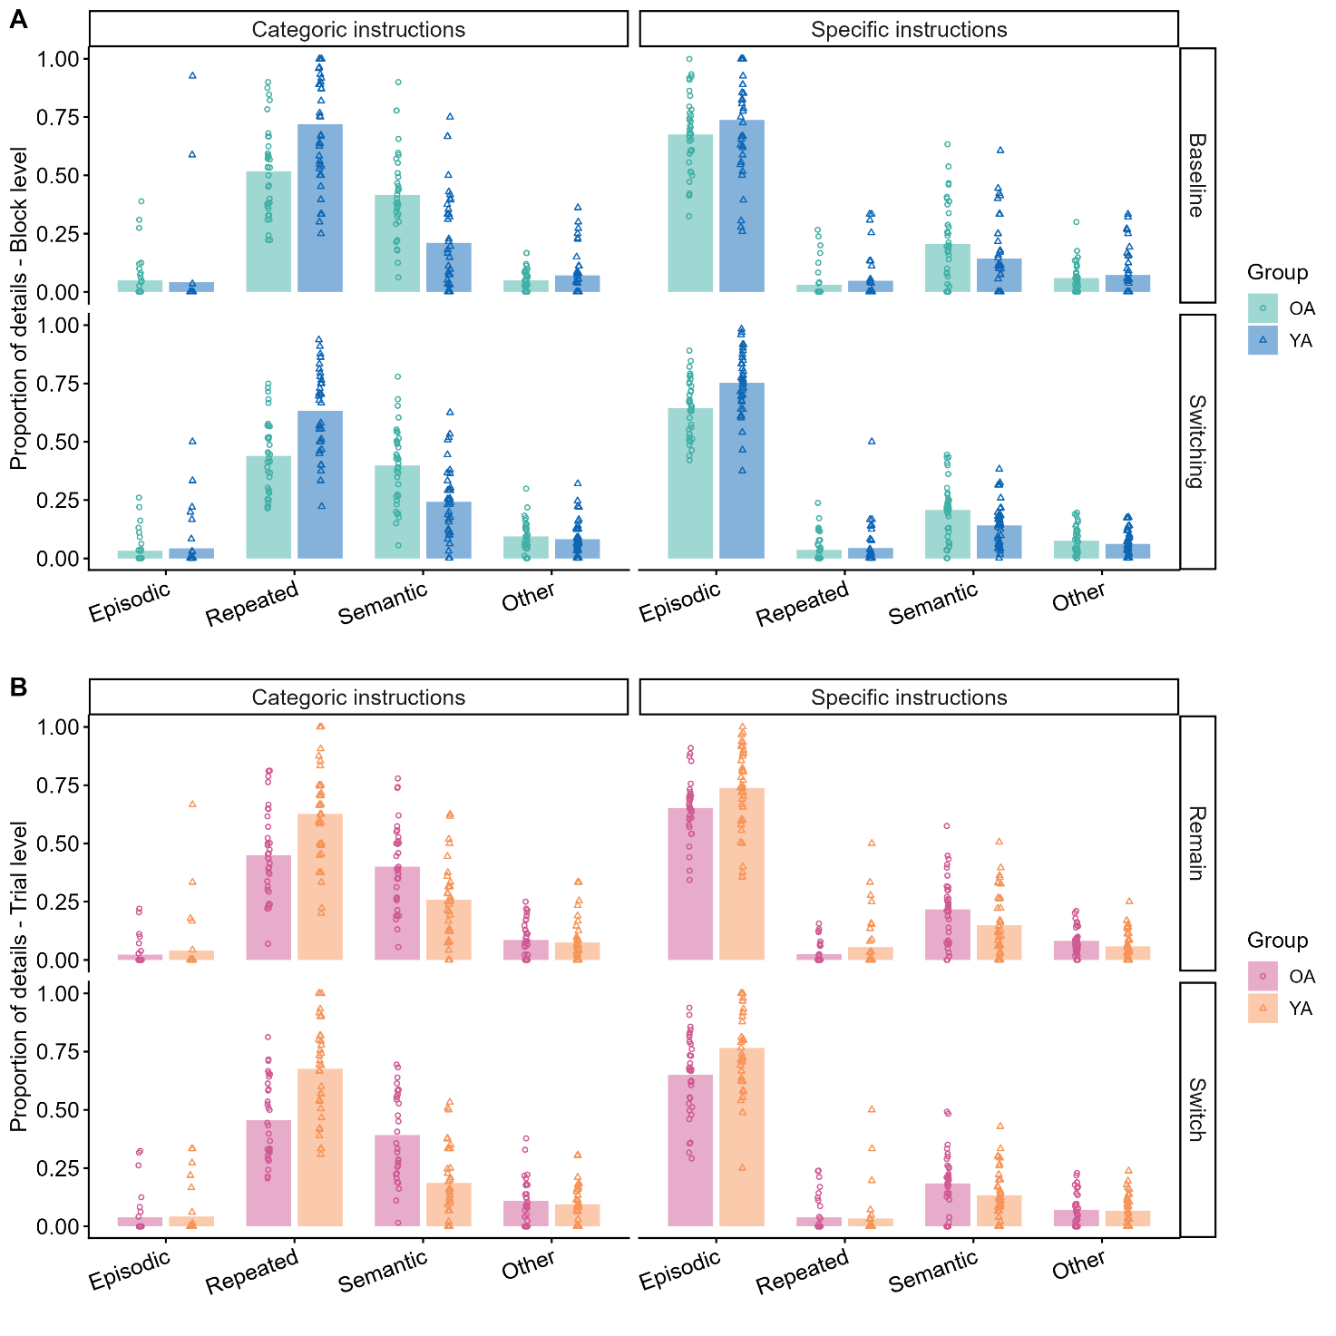Figure 3. Proportion of details produced by participants under specific and categoric instructions A) Proportion of details produced in the baseline and switching block. B) Proportion of details produced in the switch and remain trials of the switching block. Points refer to individual data points. OA = Older adults. YA = Younger adults.

Age affects the subjective ratings of vividness, perspective, emotion and time for specific and categoric memories
We then analysed the effect of task switching and age group in the subjective ratings of vividness, visual perspective, emotion and time of the memories produced following specific and categoric instructions.
Vividness ratings
The model revealed significant main effects of memory type (χ²(1) = 51.16, p < .001), and age group (χ²(1) = 18.78, p < .001), and a significant interaction between these factors (χ²(1) = 13.72, p < .001). Follow-up comparisons showed that older adults rated their specific memories as more vivid than young adults (M = 3.81 vs. 3.53; z = 5.58, p < .001), and marginally their categoric memories as more vivid than young adults (M = 3.58 vs. 2.49; z = 1.99, p = .05; See Figure 5A).
Perspective ratings
The model revealed a significant main effect of block (χ²(1) = 4.89, p = .03), with participants rating their memories as more predominantly from their own perspective in the switching than in the baseline block (M = 2.15 vs. 2.35; See Figure 5A). No additional main effects or interactions were found.
Emotion ratings
The model revealed a significant main effect of memory type (χ²(1) = 19.33, p < .001), with participants rating their memories under specific instructions as more emotional than those under categoric instructions (M = 2.84 vs. 2.54), and a main effect of age group (χ²(1) = 9.83, p = .002), with older adults rating memories as more emotional than young adults (M = 2.92 vs. 2.46). However, there was no main effect of block, nor any interaction with the other factors (ps > .15; See Figure 5A).
Temporal subjective ratings
The model on the temporal subjective ratings under specific instructions revealed significant a main effect of time of the memories (χ²(1) = 100.37, p < .001), and a significant interaction between time and age group ( χ²(1) = 168.75, p < .001). Follow-up comparisons showed that under specific instructions, older adults recalled more memories older than 10 years than young adults (M = 0.39 vs. 0.15; t(146) = 4.85, p < .001), but less memories from last year (M = 0.15 vs. 0.35; t(140) = -3.91, p < .001) and the past 5 years (M = 0.09 vs. 0.17; t(143) = -2.43, p = .03; See Figure 5B). However, there were no additional significant main effects nor interactions (all p-values > 0.07). The model on the temporal subjective ratings under categoric instructions revealed significant a main effect of time of the memories (χ²(4) = 70.01, p < .001), a significant interaction between time and age group ( χ²(4) = 55.63, p < .001), and a significant interaction between time and block ( χ²(1) = 15.94, p = .003). Follow-up comparisons showed that under categoric instructions, older adults recalled significantly more memories older than 10 years compared to young adults (M = 0.48 vs. 0.07; t(98) = 10.9, p < .001). In contrast, older adults recalled less memories from the last year than young adults (M = 0.28 vs. 0.55; t(145) = -5.11, p < .001) and less memories in the past 5 years compared to young adults (M = 0.13 vs. 0.31; t(138) = -4.99, p < .001; See Figure 5B). In summary, while young adults tended to recall recent memories (particularly from the last year and within the last 5 years), older adults showed a preference for recalling more remote memories, both for specific and categoric memories.
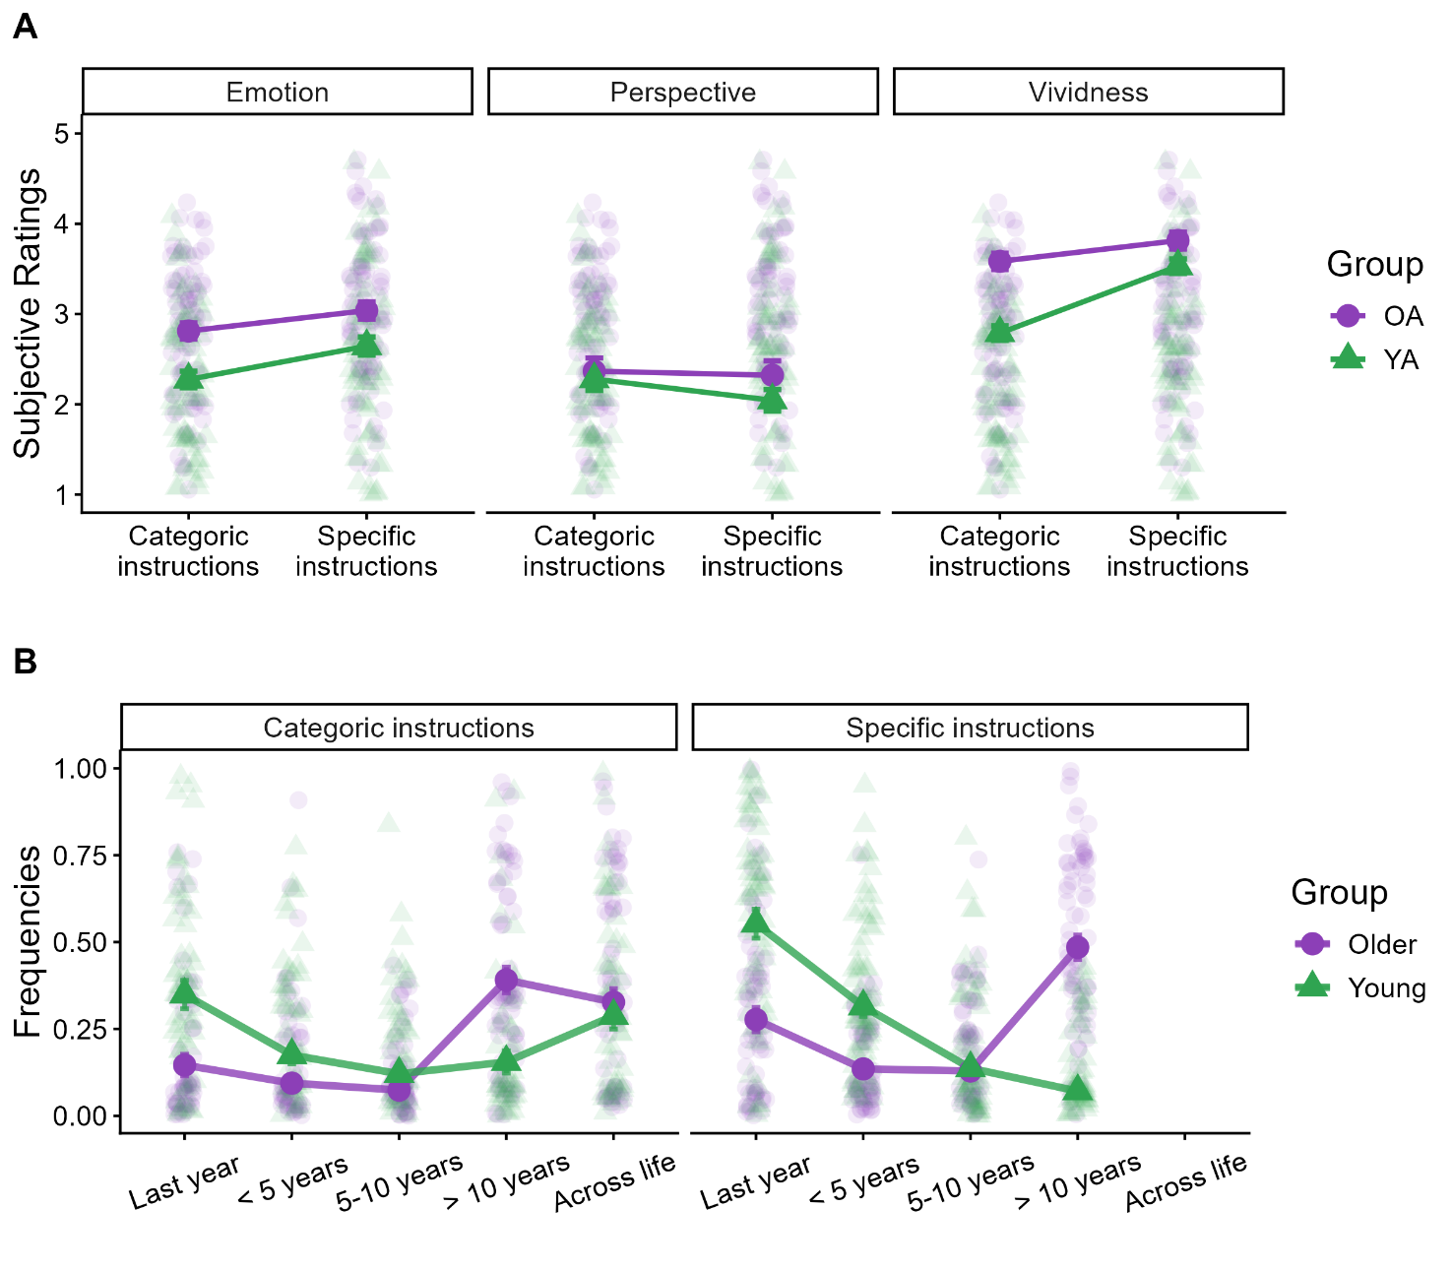Figure 5. Subjective ratings and temporal distribution of specific and categoric memories in young and older adults. A) Episodic memories were considered as more emotional than categoric memories; moreover, older adults considered their memories as more emotional than those of young adults. Perspective: no differences were found between groups and retrieval instructions. Recall for both types of memories was predominantly from participants’ own perspective. Vividness: older adults consider both their specific and categoric memories as more vivid than those of young adults. B) Older adults tended to recall a greater proportion of remote memories from more than 10 years ago, while young adults recalled more recent memories from 1 to 5 years ago. Y values represent mean frequencies of recalled memories. Points refer to individual data points. Error bars represent standard errors of the mean.

Discussion
In the present study, we investigated age-related differences in switch costs during the recall of different types of autobiographical memories: specific events, which are memories of unique past episodes, and categoric events, which are memories of recurring experiences. Specifically, we investigated how switching between these memory types affected participants' ability to recall narratives that are coherent with the given instructions. Switch costs in retrieval accuracy were observed when comparing the overall consistency of narratives with instructions between the baseline and switching blocks. The analysis of the content of memories during elaboration revealed that older adults tended to include a higher proportion of semantic details compared to young adults together with a lower proportion of details consistent with instructions, specifically fewer episodic details under specific instructions and fewer repeated events details under categoric instructions. The detailed findings and implications of these results are discussed further below.
Task-switching reduces coherence with instructions during memory retrieval
Our primary finding shows that task-switching demands significantly affect autobiographical memory retrieval. Participants produced a lower proportion of memories coherent with instructions in switching blocks compared to baseline blocks, while no differences emerged between switch and remain trials within the switching block. This pattern aligns with established findings in cognitive task-switching research, where "global" switch costs (baseline vs. switching blocks) are consistently observed, but "local" switch costs (switch vs. remain trials) are often absent or minimal (Kray et al., 2002; Meiran et al., 2001; Mayr & Kliegl, 2000). Moreover, these results extend limited prior research on task-switching in autobiographical memory contexts (Dritschel et al., 2014; Rathbone & Moulin, 2014) by demonstrating that cognitive control demands associated with maintaining multiple retrieval strategies impair memory recall across the adult lifespan, particularly the overall coherence with task instructions.
Critically, older adults did not show greater impairment than young adults in the switching condition. Age-related differences in producing memories consistent with instructions were limited to the instruction to retrieve categoric memories (general, repeated experiences), while performance under specific memory instructions (prompts for unique, episodic events) remained comparable between age groups, even under switching demands. This result contrasts with previous studies that showed reduced autobiographical memory specificity in aging, manifested as a tendency to recall overgeneral memories under specific instructions (e.g., Barry et al., 2021; Ros et al., 2009;2018). However, these studies also reported a relationship between memory specificity and executive functions, and particularly that low working memory ability was a determining factor for overgeneral memories (Ros et al., 2009; Williams et al., 2007). Although examining executive functions was beyond the purposes of our study (our paradigm did not include a measure of working memory), the subsample of our participants who completed executive tests revealed no significant age-related differences. This may explain why we observed preserved performance to produce specific memories in our sample of older adults, as previous research has linked overgeneral memory to executive decline (Ros et al., 2009; Williams et al., 2007). However, as we will see below, age-related differences emerged when considering details production, where the memories that were categorised as specific were found to include a lower proportion of episodic details and a higher proportion of semantic details in older than in young adults, in line with the well-documented tendency of older adults to retrieve more general autobiographical memories when instructed to recall specific events (Addis et al., 2008; Levine et al., 2002; Piolino et al., 2002).
The reduced consistency with instructions when participants were asked to retrieve categoric memories was associated with increased recall of other types of personal semantics, particularly autobiographical facts (referring to more generalized knowledge of events from one’s personal past). Although repeated events are more general than unique events, they may require greater inhibition of competing memories, resulting in the recall of less context-dependent forms of personal semantics, such as autobiographical facts. This tendency in remembering personal semantic knowledge instead of repeated events might depend on a truncated memory search that ends at more general semantic information, instead of recalling repeated events richer in temporal and contextual information, due to the increased task demands (similarly to what has been found for specific memories; Williams, 1996).
An episodic-to-semantic shift affects memory elaboration in aging regardless of switching demands
Memory elaboration, referring to the proportion of details that participants included to describe their memories, was less influenced than overall consistency with instructions by the increased task demands associated with retrieval switching, and more by an age-dependent shift from episodic to semantic retrieval. In particular, when participants were instructed to retrieve specific memories, the type of details produced during memory elaboration was not affected by task switching. Support for the observation that memory elaboration may be less affected by retrieval switching can also be found in a recent study from Mair and colleagues (Mair et al., 2021). They observed that the ability of older adults to recall unique events consistently with instructions was associated with efficiency in executive abilities, whereas details production, the ability of describing the unfolding of the event, appeared to be less dependent on executive abilities (Mair et al., 2021). Instead, the content of memories produced during elaboration was more influenced by age-dependent shifts from episodic to semantic retrieval. Consistent with these previous findings, older adults in the present study included a higher proportion of semantic details and a lower proportion of episodic details than young adults when describing unique events from their past (e.g., Addis et al., 2008; Levine et al., 2002). Interestingly, older adults also recalled categoric memories with a lower proportion of repeated events details and a higher proportion of semantic associates than young adults. Categoric or repeated events are thought to emerge from the extraction of commonalities across a series of separate but similar events (Barsalou, 1988; Neisser, 1981; Rubin & Umanath, 2015). Although repeated events are more general and schematic than unique episodes, they retain perceptual and contextual information (Renoult et al., 2012; Rubin & Umanath, 2015). Our findings are consistent with the observation that older adults tend to focus on the gist and broader meaning of events when describing their past (reviewed in Grilli and Sheldon, 2022). This tendency also applies to repeated events, as evidenced by the reduced proportion of details specific to those events in older adults' recollections. In addition, we also found that young adults were more affected by the switching block than older adults when recalling categoric memories, as resulted in a reduction in the proportion of details produced. One possible interpretation to this pattern of results is due to the higher ability of young adults in implementing task instructions (e.g. Ford et al., 2013), which could make them more sensitive to increased task demands in the switching block.
When considering the time of memories produced, we observed that older adults tended to recall remote episodic memories, while young adults preferred recalling recent memories. This pattern of results aligns with the reminiscence bump, the tendency of older adults to recall more events from adolescence and early adulthood than from more recent lifetime periods (Janssen et al., 2012; Koppel & Berntsen, 2015; Rubin & Wenzel, 1996). However, it remains unclear whether the remote lifetime period targeted by older adults was equivalent to the recent one from young adults. The structure of the present task, as typical in the Autobiographical Memory Test (AMT; Williams & Broadbent, 1986), let participants select their most relevant memories without any constraints about the lifetime periods to target (see below).
Finally, results on vividness rating are in line with previous findings in the literature, with older adults rating their memories as more vivid than young adults despite a reduction in the amount of specific details included in the narratives (Folville et al., 2021; Folville et al., 2020; St-Laurent et al., 2014). This discrepancy between the details produced and subjective ratings has been related to age differences in how the details produced are used to judge the personal experience of remembering (Folville et al., 2022). A recent study revealed a correspondence between memory for gist information and vividness ratings even among young participants (Cooper and Ritchey, 2022). Given the preference towards more gist and semanticised details production in aging, one possibility is that older adults are focusing more on the broader context, relying more on general details when making these subjective judgments about their memories. Further work is needed to explore this possibility.
Limitations and future directions
There are some limitations of the present study. First, to avoid long online testing sessions and fatigue, especially in older adults, we only included six trials in the baseline block and six trials in the switching block (three episodic and three categoric). This prevented analysing which memory type was the most affected by the switch. Given previous evidence that increased task demands preferentially affect episodic memory retrieval (e.g., Dritschel et al., 2014; Ford et al., 2014) and, more generally, the most complex and effortful task (e.g., Vatansever et al., 2021), we might have seen a decreased performance in episodic recall. However, future studies are needed to better understand whether recalling unique events is actually more effortful than recalling repeated events.
Additionally, in our experimental design, the baseline block always appeared first, followed by the switching block. The baseline block was intentionally administered first to familiarize participants with the task and allow them to practice a single retrieval mode before introducing the additional cognitive demands of switching between the specific and categoric retrieval modes. However, in future work, it would be important to counterbalance the administration of the baseline and switching block to rule out the possibility that the initial memories retrieved in the baseline block were more easily accessed.
Older adults exhibited longer elaboration time than young adults. Future studies could include follow-up questions after free recall (as in Levine et al., 2002) aimed at eliciting details production from all participants to enhance comparability between the narratives of young and older adults.
Although switch costs usually refer to decreased performance and increased reaction times, we only focused on the effect of switching on memory coherence with instructions and elaboration. Given the online nature of the task, there was variability in the devices used by participants (e.g., touchscreen, touchpad or mouse), especially among older adults, which would have affected the reliability of response time measures. Additionally, the intra-subject reliability was also difficult to assess due to inconsistent recording of the onset of memory elaboration. Future studies could attempt to restrict the type of devices used by participants to inform how switching between different types of autobiographical memories affects response times.
In our paradigm, as in typical in the AMT, participants were allowed to choose memories from any time period and were subsequently asked to determine the specific time when the memory occurred. To comprehensively explore the effects of switching during memory retrieval, future studies could specify predefined time periods from which participants are permitted to recall memories (as in Levine et al., 2002). Implementing such a restriction would facilitate a thorough performance comparison between young and older adults.
Finally, we note that the sample was predominantly composed of female-identifying participants, which may limit the generalizability of the findings. For instance, this imbalance could have potentially biased results toward longer narratives, although prior work suggests that gender differences in autobiographical memory are not consistently observed (see Grysman & Hudson, 2013). Future research should examine whether the present findings replicate in more gender-diverse samples.

Conclusion
In the present study, we investigated age differences in switch costs during the recall of different types of autobiographical memories: memories of unique (specific) and repeated events (categoric). Consistent with previous work on task-switching, we found a reduced ability in recalling memories coherent with instructions in a switching block as compared to a baseline block across age groups. However, when considering memory elaboration, the impact of task-switching was more limited, and age-related differences in details production were observed with an increased semanticisation of memories of unique and repeated events. Together these results reveal that autobiographical memory retrieval in aging varies with task demands, though intertwined with a prevalent episodic-to-semantic shift across instructions.
Disclosure Statement
The authors report there are no competing interests to declare.
References
Addis, D. R., Knapp, K., Roberts, R. P., & Schacter, D. L. (2012). Routes to the past: neural substrates of direct and generative autobiographical memory retrieval. Neuroimage, 59(3), 2908-2922. 10.1016/j.neuroimage.2011.09.066
Addis, D. R., Wong, A. T., & Schacter, D. L. (2008). Age-related changes in the episodic simulation of future events. Psychological science, 19(1), 33-41. 10.1111/j.1467-9280.2008.02043.x
Amer, T., Wynn, J. S., & Hasher, L. (2022). Cluttered memory representations shape cognition in old age. Trends in Cognitive Sciences. https://doi.org/10.1016/j.tics.2021.12.002
Anwyl-Irvine, A. L., Massonnié, J., Flitton, A., Kirkham, N., & Evershed, J. K. (2020). Gorilla in our midst: An online behavioral experiment builder. Behavior research methods, 52(1), 388-407. https://doi.org/10.3758/s13428-019-01237-x
Barry, T. J., Gregory, J. D., Latorre, J. M., Ros, L., Nieto, M., & Ricarte, J. J. (2021). A multi-method comparison of autobiographical memory impairments amongst younger and older adults. Aging & Mental Health, 25(5), 856-863. https://doi.org/10.1080/13607863.2020.1729338
Barsalou, L. W. (1988). The content and organization of autobiographical memories. https://doi.org/10.1017/CBO9780511664014.009
Bates, D., Mächler, M., Bolker, B., & Walker, S. (2015). Fitting Linear Mixed-Effects Models Using lme4. Journal of Statistical Software, 67(1), 1 - 48. https://doi.org/10.18637/jss.v067.i01
Bluck, S., Alea, N., Baron-Lee, J. M., & Davis, D. K. (2016). Story asides as a useful construct in examining adults’ story recall. Psychology and aging, 31(1), 42.
Bluck, S., Levine, L. J., & Laulhere, T. M. (1999). Autobiographical remembering and hypermnesia: a comparison of older and younger adults. Psychology and aging, 14(4), 671. https://doi.org/10.1037/a0039990
Brooks ME, Kristensen K, van Benthem KJ, Magnusson A, Berg CW, Nielsen A, Skaug HJ, Maechler M, Bolker BM (2017) glmmTMB balances speed and flexibility among packages for zero-inflated generalized linear mixed modeling. R J 9(2):378–400. https://doi.org/10.32614/RJ-2017-066
Cabeza, R., Albert, M., Belleville, S., Craik, F. I., Duarte, A., Grady, C. L., Lindenberger, U., Nyberg, L., Park, D. C., & Reuter-Lorenz, P. A. (2018). Maintenance, reserve and compensation: the cognitive neuroscience of healthy ageing. Nature Reviews Neuroscience, 19(11), 701-710. 10.1038/s41583-018-0068-2
Clark, J. M., & Paivio, A. (2004). Extensions of the Paivio, Yuille, and Madigan (1968) norms. Behavior Research Methods, Instruments, & Computers, 36(3), 371-383. https://doi.org/10.3758/BF03195584
Conway, M. A., & Pleydell-Pearce, C. W. (2000). The construction of autobiographical memories in the self-memory system. Psychological review, 107(2), 261. 10.1037/0033-295x.107.2.261
Cooper, R.A., Ritchey, M. Patterns of episodic content and specificity predicting subjective memory vividness. Mem Cogn 50, 1629–1643 (2022). https://doi.org/10.3758/s13421-022-01291-5
Craik, F. I., & Bialystok, E. (2006). Cognition through the lifespan: mechanisms of change. Trends in Cognitive Sciences, 10(3), 131-138. 10.1016/j.tics.2006.01.007
Dalgleish, T., Williams, J. M. G., Golden, A.-M. J., Perkins, N., Barrett, L. F., Barnard, P. J., Au Yeung, C., Murphy, V., Elward, R., & Tchanturia, K. (2007). Reduced specificity of autobiographical memory and depression: the role of executive control. Journal of Experimental Psychology: General, 136(1), 23. https://doi.org/10.1037/0096-3445.136.1.23
Diamond A. (2013). Executive functions. Annual review of psychology, 64, 135–168. https://doi.org/10.1146/annurev-psych-113011-143750
Dritschel, B., Beltsos, S., & McClintock, S. M. (2014). An “alternating instructions” version of the Autobiographical Memory Test for assessing autobiographical memory specificity in non-clinical populations. Memory, 22(8), 881-889. 10.1080/09658211.2013.839710
Evans, L. H., Williams, A. N., & Wilding, E. L. (2015). Electrophysiological evidence for retrieval mode immediately after a task switch. Neuroimage, 108, 435-440. 10.1016/j.neuroimage.2014.12.068
Faul, F., Erdfelder, E., Lang, A.-G., & Buchner, A. (2007). G*Power 3: A flexible statistical power analysis program for the social, behavioral, and biomedical sciences. Behavior Research Methods, 39(2), 175–191. https://doi.org/10.3758/BF03193146
Folville, A., Bahri, M. A., Delhaye, E., Salmon, E., & Bastin, C. (2022). Shared vivid remembering: age-related differences in across-participants similarity of neural representations during encoding and retrieval. Aging, Neuropsychology, and Cognition, 29(3), 526-551. https://doi.org/10.1080/13825585.2022.2036683
Folville, A., Bahri, M. A., Delhaye, E., Salmon, E., D’Argembeau, A., & Bastin, C. (2020). Age-related differences in the neural correlates of vivid remembering. Neuroimage, 206, 116336. 10.1016/j.neuroimage.2019.116336
Folville, A., Simons, J. S., D’Argembeau, A., & Bastin, C. (2021). I remember it like it was yesterday: Age-related differences in the subjective experience of remembering. Psychonomic Bulletin & Review, 1-23. https://link.springer.com/article/10.3758/s13423-021-02048-y
Ford, J. H., Rubin, D. C., & Giovanello, K. S. (2014). Effects of task instruction on autobiographical memory specificity in young and older adults. Memory, 22(6), 722-736. 10.1080/09658211.2013.820325
Gelman, A., & Hill, J. (2006). Data analysis using regression and multilevel/hierarchical models. Cambridge university press.
Grilli, M. D., & Sheldon, S. (2022). Autobiographical event memory and aging: older adults get the gist. Trends in Cognitive Sciences. https://doi.org/10.1016/j.tics.2022.09.007
Grysman, A., & Hudson, J. A. (2013). Gender differences in autobiographical memory: Developmental and methodological considerations. Developmental Review, 33(3), 239-272. doi.org/10.1016/j.dr.2013.07.004.
Hallford, D. J., Mellor, D., Bafit, L., Devenish, B., Bogeski, T., Austin, D. W., & Kaplan, R. (2019). The effect of increasing state anxiety on autobiographical memory specificity and future thinking. Journal of Behavior Therapy and Experimental Psychiatry, 65, 101488. 10.1016/j.jbtep.2019.101488
Herron, J. E., & Wilding, E. L. (2004). An electrophysiological dissociation of retrieval mode and retrieval orientation. Neuroimage, 22(4), 1554-1562. 10.1016/j.neuroimage.2004.04.011
Holland, C. A., Ridout, N., Walford, E., & Geraghty, J. (2012). Executive function and emotional focus in autobiographical memory specificity in older adults. Memory, 20(8), 779-793. 10.1080/09658211.2012.703210
Jacques, P. L. S., Rubin, D. C., & Cabeza, R. (2012). Age-related effects on the neural correlates of autobiographical memory retrieval. Neurobiology of aging, 33(7), 1298-1310. 10.1016/j.neurobiolaging.2010.11.007
Janssen, S. M., Rubin, D. C., & Conway, M. A. (2012). The reminiscence bump in the temporal distribution of the best football players of all time: Pelé, Cruijff or Maradona? Quarterly Journal of Experimental Psychology, 65(1), 165-178.
Kline, R. B. (2011). Principles and practice of structural equation modeling (3. Baskı). New York, NY: Guilford, 14, 1497-1513. 10.1080/17470218.2011.606372
Koppel, J., & Berntsen, D. (2015). The peaks of life: The differential temporal locations of the reminiscence bump across disparate cueing methods. Journal of Applied Research in Memory and Cognition, 4(1), 66-80. https://doi.org/10.1016/j.jarmac.2014.11.004
Kray, J., Li, K. Z., & Lindenberger, U. (2002). Age-related changes in task-switching components: The role of task uncertainty. Brain and cognition, 49(3), 363-381. 10.1006/brcg.2001.1505
Kray, J., & Lindenberger, U. (2000). Adult age differences in task switching. Psychology and aging, 15(1), 126. https://doi.org/10.1037/0882-7974.15.1.126
Kroenke, K., Spitzer, R. L., & Williams, J. B. (2001). The PHQ‐9: validity of a brief depression severity measure. Journal of general internal medicine, 16(9), 606-613. 10.1046/j.1525-1497.2001.016009606.x
Lenth, R. (2023). Emmeans: Estimated marginal means, aka least-squares means. (R package version 1.8.6). https://CRAN.R-project.org/package=emmeans
Levine, B., Svoboda, E., Hay, J. F., Winocur, G., & Moscovitch, M. (2002). Aging and autobiographical memory: dissociating episodic from semantic retrieval. Psychology and aging, 17(4), 677. 10.1037//0882-7974.17.4.677
Mair, A., Poirier, M., & Conway, M. A. (2021). Age effects in autobiographical memory depend on the measure. PloS one, 16(10), e0259279. https://doi.org/10.1371/journal.pone.0259279
Mayr, U. (2001). Age differences in the selection of mental sets: the role of inhibition, stimulus ambiguity, and response-set overlap. Psychology and aging, 16(1), 96. 10.1037/0882-7974.16.1.96
Mayr, U., & Kliegl, R. (2000). Complex semantic processing in old age: Does it stay or does it go? Psychology and aging, 15(1), 29. 10.1037//0882-7974.15.1.29
McKinnon, M. C., Nica, E. I., Sengdy, P., Kovacevic, N., Moscovitch, M., Freedman, M., Miller, B. L., Black, S. E., & Levine, B. (2008). Autobiographical memory and patterns of brain atrophy in fronto-temporal lobar degeneration. Journal of cognitive neuroscience, 20(10), 1839-1853. 10.1162/jocn.2008.20126
McKinnon, M. C., Palombo, D. J., Nazarov, A., Kumar, N., Khuu, W., & Levine, B. (2015). Threat of death and autobiographical memory: A study of passengers from Flight AT236. Clinical psychological science, 3(4), 487-502. 10.1177/2167702614542280
Meiran, N., Gotler, A., & Perlman, A. (2001). Old age is associated with a pattern of relatively intact and relatively impaired task-set switching abilities. The Journals of Gerontology Series B: Psychological Sciences and Social Sciences, 56(2), P88-P102. https://doi.org/10.1093/geronb/56.2.P88
Melega, G., Lancelotte, F., Johnen, A.-K., Hornberger, M., Levine, B., & Renoult, L. (2024). Evoking episodic and semantic details with instructional manipulation during autobiographical recall. Psychology and Aging, 39(4), 378–390. https://doi.org/10.1037/pag0000821
Mioshi, E., Dawson, K., Mitchell, J., Arnold, R., & Hodges, J. R. (2006). The Addenbrooke's Cognitive Examination Revised (ACE‐R): a brief cognitive test battery for dementia screening. International Journal of Geriatric Psychiatry: A journal of the psychiatry of late life and allied sciences, 21(11), 1078-1085. 10.1002/gps.1610
Monsell, S. (2003). Task switching. Trends in Cognitive Sciences, 7(3), 134-140. 10.1016/s1364-6613(03)00028-7
Morcom, A. M., & Rugg, M. D. (2002). Getting ready to remember: the neural correlates of task set during recognition memory. NeuroReport, 13(1), 149-152. https://doi.org/10.1097/00001756-200201210-00034
Neisser, U. (1981). John Dean's memory: A case study. Cognition, 9(1), 1-22. https://doi.org/10.1016/0010-0277(81)90011-1
Piolino, P., Desgranges, B., Clarys, D., Guillery-Girard, B., Taconnat, L., Isingrini, M., & Eustache, F. (2006). Autobiographical memory, autonoetic consciousness, and self-perspective in aging. Psychology and aging, 21(3), 510. 10.1037/0882-7974.21.3.510
Piolino, P., Coste, C., Martinelli, P., Macé, A. L., Quinette, P., Guillery-Girard, B., & Belleville, S. (2010). Reduced specificity of autobiographical memory and aging: do the executive and feature binding functions of working memory have a role?. Neuropsychologia, 48(2), 429–440. 10.1016/j.neuropsychologia.2009.09.035

Rathbone, C. J., & Moulin, C. J. (2014). Measuring autobiographical fluency in the self-memory system. SAGE Publications Sage UK: London, England. 10.1080/17470218.2014.913069
Renoult, L., Armson, M. J., Diamond, N. B., Fan, C. L., Jeyakumar, N., Levesque, L., Oliva, L., McKinnon, M., Papadopoulos, A., & Selarka, D. (2020). Classification of general and personal semantic details in the Autobiographical Interview. Neuropsychologia, 144, 107501. https://doi.org/10.1016/j.neuropsychologia.2020.107501
Renoult, L., Davidson, P. S., Palombo, D. J., Moscovitch, M., & Levine, B. (2012). Personal semantics: at the crossroads of semantic and episodic memory. Trends in Cognitive Sciences, 16(11), 550-558. 10.1016/j.tics.2012.09.003
Renoult, L., Irish, M., Moscovitch, M., & Rugg, M. D. (2019). From knowing to remembering: the semantic–episodic distinction. Trends in Cognitive Sciences, 23(12), 1041-1057. 10.1016/j.tics.2019.09.008
Ros, L., Latorre, J. M., & Serrano, J. P. (2009). Working memory capacity and overgeneral autobiographical memory in young and older adults. Aging, Neuropsychology, and Cognition, 17(1), 89-107. 10.1080/13825580903042650
Ros, L., Romero, D., Ricarte, J. J., Serrano, J. P., Nieto, M., & Latorre, J. M. (2018). Measurement of overgeneral autobiographical memory: Psychometric properties of the autobiographical memory test in young and older populations. PloS One, 13(4). https://doi.org/10.1371/journal.pone.0196073
Rubin, D. C., & Umanath, S. (2015). Event memory: A theory of memory for laboratory, autobiographical, and fictional events. Psychological review, 122(1), 1. 10.1037/a0037907
Rubin, D. C., & Wenzel, A. E. (1996). One hundred years of forgetting: A quantitative description of retention. Psychological review, 103(4), 734. https://doi.org/10.1037/0033-295X.103.4.734
Schacter, D. L., Addis, D. R., Hassabis, D., Martin, V. C., Spreng, R. N., & Szpunar, K. K. (2012). The future of memory: remembering, imagining, and the brain. Neuron, 76(4), 677-694. 10.1016/j.neuron.2012.11.001
Spitzer, R. L., Kroenke, K., Williams, J. B., & Löwe, B. (2006). A brief measure for assessing generalized anxiety disorder: the GAD-7. Archives of internal medicine, 166(10), 1092-1097. 10.1001/archinte.166.10.1092
Spreng, R. N., Lockrow, A. W., DuPre, E., Setton, R., Spreng, K. A., & Turner, G. R. (2018). Semanticized autobiographical memory and the default–executive coupling hypothesis of aging. Neuropsychologia, 110, 37-43. 10.1016/j.neuropsychologia.2017.06.009
St-Laurent, M., Abdi, H., Bondad, A., & Buchsbaum, B. R. (2014). Memory reactivation in healthy aging: evidence of stimulus-specific dedifferentiation. Journal of Neuroscience, 34(12), 4175-4186. 10.1523/JNEUROSCI.3054-13.2014
Strikwerda-Brown, C., Williams, K., Lévesque, M., Brambati, S., & Sheldon, S. (2021). What are your thoughts? Exploring age-related changes in episodic and semantic autobiographical content on an open-ended retrieval task. Memory, 29(10), 1375-1383. 10.1080/09658211.2021.1987476
Strikwerda‐Brown, C., Mothakunnel, A., Hodges, J. R., Piguet, O., & Irish, M. (2019). External details revisited–A new taxonomy for coding ‘non‐episodic’content during autobiographical memory retrieval. Journal of neuropsychology, 13(3), 371-397. 10.1111/jnp.12160
Sumner, J. A., Griffith, J. W., & Mineka, S. (2010). Overgeneral autobiographical memory as a predictor of the course of depression: A meta-analysis. Behaviour research and therapy, 48(7), 614-625.
Tulving, E. (2002). Episodic memory: From mind to brain. Annual review of psychology, 53(1), 1-25. https://doi.org/10.1146/annurev.psych.53.100901.135114
Turner, G. R., & Spreng, R. N. (2015). Prefrontal engagement and reduced default network suppression co-occur and are dynamically coupled in older adults: the default–executive coupling hypothesis of aging. Journal of cognitive neuroscience, 27(12), 2462-2476. 10.1162/jocn_a_00869
Vatansever, D., Smallwood, J., & Jefferies, E. (2021). Varying demands for cognitive control reveals shared neural processes supporting semantic and episodic memory retrieval. Nature communications, 12(1), 1-11. https://doi.org/10.1038/s41467-021-22443-2
Veríssimo, J., Verhaeghen, P., Goldman, N., Weinstein, M., & Ullman, M. T. (2022). Evidence that ageing yields improvements as well as declines across attention and executive functions. Nature Human Behaviour, 6(1), 97-110. https://doi.org/10.1038/s41562-021-01169-7
Wasylyshyn, C., Verhaeghen, P., & Sliwinski, M. J. (2011). Aging and task switching: a meta-analysis. Psychology and aging, 26(1), 15. 10.1037/a0020912
Wessel, I., Meeren, M., Peeters, F., Arntz, A., & Merckelbach, H. (2001). Correlates of autobiographical memory specificity: The role of depression, anxiety and childhood trauma. Behaviour research and therapy, 39(4), 409-421.
Williams, J. M. G. (1996). Depression and specificity of autobiographical memory. In D. C. Rubin (Ed.), Remembering our past: Studies in autobiographical memory (pp. 244-267). Cambridge University Press.
Williams, J. M., & Broadbent, K. (1986). Autobiographical memory in suicide attempters. Journal of abnormal psychology, 95(2), 144. https://doi.org/10.1037/0021-843X.95.2.144
Wylie, G., & Allport, A. (2000). Task switching and the measurement of “switch costs”. Psychological research, 63(3), 212-233. https://doi.org/10.1007/s004269900003

