Title: A randomised controlled trial testing a digital intervention to promote weight loss and weight loss maintenance
Authors: Dominika Kwasnicka¹, Iga Palacz-Poborczyk², Peter Verboon³, Aleksandra Luszczynska², Eleanor Quested^{4,5}, Suzanne Robinson⁶, Lan Gao⁶, Anna Januszewicz², Martin S. Hagger^{7,8}, Sherry Pagoto⁹, Paulina Idziak², Felix Naughton¹⁰

Affiliations:
- Melbourne School of Population and Global Health, University of Melbourne, 333 Exhibition Street, 3000, Melbourne, Australia
- Faculty of Psychology, SWPS University, Aleksandra Ostrowskiego 30b, 53-238, Wroclaw, Poland
- Department of Psychology and Educational Sciences, Open Universiteit Nederland, Heerlen, Netherlands
- Physical Activity and Well-being Research Group, enAble Research Institute, Curtin University, Perth, Australia
- Curtin School of Population Health, Curtin University, Kent Street, 6102, Perth, Australia
- Deakin Health Economics, Deakin University, Burwood, Victoria, Australia
- Psychological Sciences, University of California, Merced, Merced, 5200 N. Lake Rd., California 95343, United States of America
- Faculty of Sport and Health Sciences, University of Jyväskylä, Seminaarinkatu 15, 40014 Jyväskylä, Finland
- Department of Allied Health Sciences, The UConn Center for mHealth and Social Media, University of Connecticut, Connecticut, United States
- Addiction research Group, Faculty for Medicine and Health Sciences, School of Health Sciences, University of East Anglia, Norwich, NR4 7UL, United Kingdom

Corresponding author: A/Prof Dominika Kwasnicka, Melbourne School of Population and Global Health, University of Melbourne, 333 Exhibition Street, 3000, Melbourne, Australia. Email: dom.kwasnicka@unimelb.edu.au
Funding: Funding The Choosing Health project is carried out within the HOMING program of the Foundation for Polish Science co-financed by the European Union under the European Regional Development Fund; grant number POIR.04.04.00-00-5CF3/18-00; HOMING 5/2018.

Competing interests: None declared.

Abstract
Objective: This study aimed to determine the effectiveness and cost-effectiveness of the Choosing Health program which tailors support to an individual’s weight loss and weight loss maintenance determinants among adults with overweight and obesity.
Methods: We conducted a randomised controlled trial (RCT) with a nested interrupted time series (ITS) within-person design. Participants (N = 288) were randomised to the Choosing Health digital intervention (n = 145) or a control group (n = 143). Intervention participants completed 90 days of Ecological Momentary Assessments (EMA) which were used to identify behavioural determinants to tailor an intervention. Control participants received non-tailored weight loss advice via generic emails and eBook. Weight measured at 3, 6 and 12 months and secondary outcomes (including blood pressure, % body fat) were restructured into change of baseline scores and analysed using multilevel regression analysis, with the three time points nested within subjects.
Results: Findings revealed no significant difference in mean weight loss between groups at 6 months controlled for baseline (primary outcome), (mean difference = 0.78 kg, F(1, 175) = 1.44, p = 0.232). Intervention participants had higher weight loss at 12 months than control participants (mean difference = 2.05 kg, F(1, 108) = 2.96, p = 0.088); however, the difference was not statistically significant.
Conclusions: The results showed promising trends for the intervention group in weight loss maintenance measured at 12 months. Dropout rate was higher than expected as the intervention was delivered during the COVID-19 pandemic making face-to-face assessments difficult.
Trial registration: This trial was registered with www.clinicaltrials.gov; registration number NCT04291482.
Keywords: behaviour maintenance; behavioural theory; weight loss; digital health; within-person design
Introduction

Overweight and obesity are recognised as key public health problems facing the world today (Dakanalis et al., 2023). According to the World Health Organisation, two billion adults are currently living with overweight, of which 650 million are considered to be affected by obesity (BMI ≥30 kg/m²). That equates to 39% of adults aged 18 or over living with overweight and 16% living with obesity (WHO, 2021) and facing negative health consequences related to excess weight. The World Obesity Federation estimates that by 2030 over one billion adults globally will be affected by obesity unless we act soon (Nutter et al., 2024).
Both overweight and obesity are complex and they are impacted by biological (e.g., age, genes, current body weight), behavioural (e.g., sedentary work patters), environmental (e.g., safety to exercise, healthy food provision) and psychological factors (e.g., motivation, habits, effective self-monitoring and self-regulation) (Nutter et al., 2024). Assessing person’s physical, behavioural, environmental and psychological influences in real time, can provide a comprehensive understanding of what factors are contributing to weight gain (Chopra et al., 2021). By better understanding individual influences, more effective and more personalised weight loss programs can be designed and provided to persons with overweight and obesity.
Digital tailored interventions have demonstrated promise in supporting sustained weight management and health behaviour change. For instance, prior work by Tate and colleagues has shown that individually tailored web-based programs can promote clinically meaningful weight loss and maintenance when engagement is sustained (Tate, 2001; Tate et al., 2006). Building on this evidence, the current trial extends tailored feedback approaches using real-time Ecological Momentary Assessment (EMA) data.
Several weight loss programs support people with overweight and obesity in loosing and maintaining weight loss, including digital health programs that are gaining popularity globally (Patel et al., 2021). The personalisation of these programs provides promising results (Berry et al., 2023). The emerging technologies allow a person’s cognitions and outcomes to be assessed in real time and used to tailor intervention content to the individual (Chopra et al., 2021; Skinner et al., 2020).
In this study we designed a digital theory- and evidence-based digital behaviour change intervention promoting weight loss and weight loss maintenance (trial protocol published here: Kwasnicka et al., 2020). Using a randomised controlled trial (RCT) design we assessed the effectiveness and cost-effectiveness of the proposed tailored intervention. The novel aspect of this intervention was that we used EMA to identify the behavioural, environmental and psychological determinants of weight loss maintenance behaviour for each individual. We then provided a digital intervention that was tailored to the key identified determinants for each individual. We hypothesised that participants in the tailored intervention group will lose significantly more weight than participants in the non-tailored control group at 6 months (primary outcome) and will maintain weight loss at 12 months (secondary outcome) as compared to baseline. We also examined the intervention’s impact on additional health, behavioural and psychological secondary outcomes.
Methods
Study design
We conducted a two-group RCT testing the effectiveness and cost-effectiveness of the Choosing Health intervention (Figure 1). The RCT was designed in line with CONSORT criteria (Hopewell et al., 2025) (Online Supplement 1. Checklist). EMA was used to assess key determinants of weight loss and weight maintenance for everyone in the intervention group over 3 months (within person results to be reported elsewhere). The study was conducted in Wroclaw, Poland, start date was 30st July 2020, study end date was 31st July 2022. The study assessment period was extended due to the COVID-19 pandemic given the challenges associated with in person participant assessments (e.g., meeting cancellations, delays).
The trial was registered with www.clinicaltrials.gov; registration number NCT04291482 and the study protocol was published (Kwasnicka, Luszczynska, et al., 2020). Intervention development applying Intervention Mapping and extensive participant and public involvement is described extensively elsewhere (Palacz-Poborczyk et al., 2022). The study evaluation followed guidance on process evaluation for complex interventions (Moore et al., 2014) assessing intervention uptake, feasibility, usability and effectiveness (Palacz-Poborczyk et al., 2024).
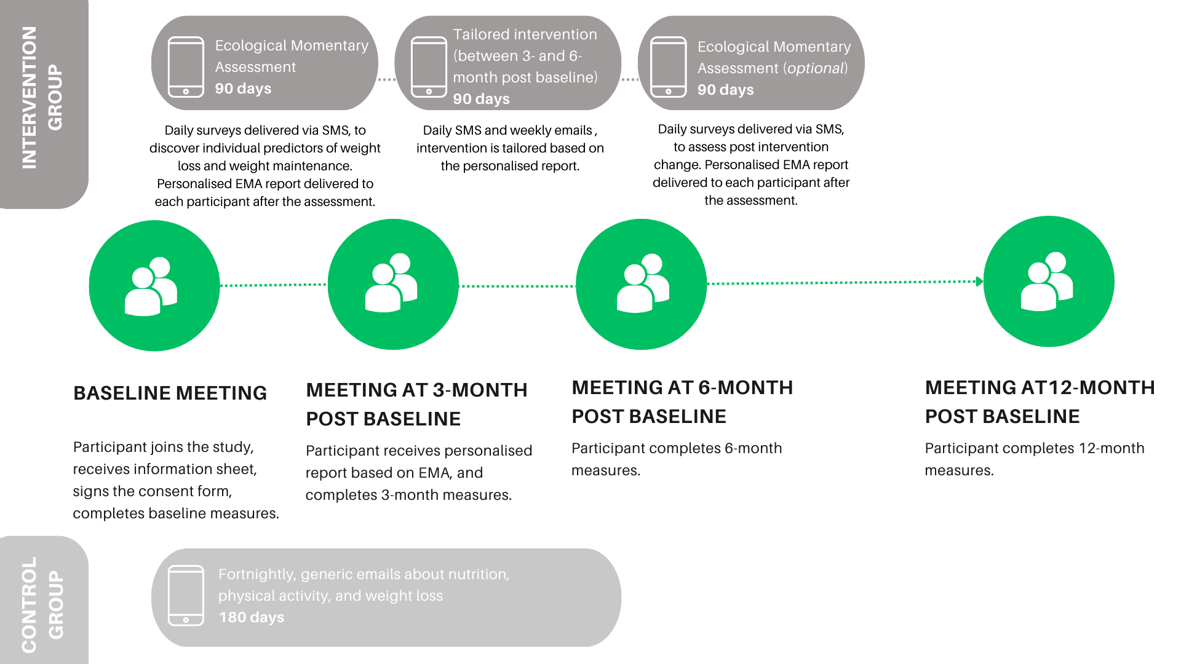
Figure 1. Intervention and control group – main study activities and assessment points

Ethics. Ethical approval was granted by Faculty of Psychology, SWPS University of Social Sciences and Humanities, Ethics Committee, Wroclaw, Poland, approval number 03/P/12/2019.
Participants
Inclusion criteria. We recruited adults aged 18 years or older with a BMI of 25 or higher at the baseline assessment (classified as persons with overweight, 30+ with obesity) who reported no physical condition or impairment preventing them from being physically active or losing excess body weight. Prior to study consent, participants were screened for eligibility using the Physical Activity Readiness Questionnaire (PAR-Q) (Warburton et al., 2018) and had their height and body weight measured to determine their BMI. Individuals who reported any contraindications to exercise (as assessed by the PAR-Q) were asked to consult the doctor and obtain approval to participate in the study. Breastfeeding women were also asked to consult the doctor and obtain study participation approval.
Exclusion criteria. We excluded individuals who have had bariatric surgery or were planning to have one within the next 12 months; did not have a mobile phone with access to the internet (our intervention was delivered online and required primary use of a mobile phone); who were currently participating in another weight loss program (e.g., personal training); who were planning to move outside of the study region (Wroclaw, Poland) and were not willing to travel for study measurement sessions; who were pregnant; who were on medication that causes weight gain, or weight loss, or who were reporting having a pacemaker (as the weighing scale used in the study was not appropriate for use in these individuals).
Procedure
Recruitment. Participants were recruited online from relevant groups via email lists, social media (Instagram, Facebook and Twitter) posts on relevant interest pages, through the local press, radio, and study posters and leaflets placed in community centres and in other popular locations. We also engaged with external advertising agency that designed a Facebook campaign targeting users who fit our inclusion criteria. Study advertising materials directed interested individuals to the project website www.wybieramyzdrowie.pl (Wybieramy Zdrowie means Choosing Health) providing study information, including a link to the study eligibility questionnaire, and the tool allowing to schedule the initial appointment with study facilitator.
Impact of COVID-19. All participants were required to attend four face-to-face visits with the study facilitator (including baseline, 3-, 6- and 12-month follow-up) at the university premises to complete comprehensive body composition measures. The duration of the assessment visits decreased during the COVID-19 pandemic. The study protocol was modified so that questionnaires were completed online prior to the sessions to shorten the face-to-face assessment time; and specific protective measures were adopted (e.g., wearing face-shields and facemasks, room ventilated and disinfected between appointments). Before the meeting, each participant had to fill in a survey screening for COVID-19 symptoms, if any were reported, the meeting had to be postponed by two weeks to comply with the University visitors’ regulations.
Baseline. At the baseline visit, eligibility criteria were confirmed, study information provided, and consent form signed. Participants completed device-captured (described below) and self-reported measures (or confirmed completing them online before the session). Feedback on the device-captured measures was provided including BMI, weight, body fat percentage, and blood pressure.
Randomisation and blinding. After baseline assessment was completed, participants were randomised using an online randomisation tool, randomisation stratified by BMI (25-30 and 30+) using block randomisation, eight people per block. The researchers doing the randomisation were blinded from the allocation sequence. Participants scheduled follow-up visits at 3, 6 and 12 months.
Control group. Control participants received an eBook or printed book (personal preference) with generic weight loss information, received non-tailored health-related educational emails every 2 weeks for 6 months from baseline, and attended body weight measurement sessions. The emails were factual and included generic information about benefits of weight loss. Intervention baseline assessment phase (0-3 months). Intervention participants received the same eBook or printed book (personal preference) as control participants and completed EMA daily for three months assessing their determinants of adherence to weight loss promoting behaviours (before they received any intervention at 3 months). At the initial meeting instructions and questions were provided and there was the opportunity to add personal questions capturing participants’ proposed self-selected determinants (if they wanted to add any to the existing list). Participants indicated a preferred time to receive the EMA survey link, between 8pm to 11pm, sent daily by text message.
At the end of 3 months (we used 90 days for consistency), EMA data were analysed for each intervention participant separately (see analysis section), to identify their strongest determinant(s) (based on standardised effect size) of weight loss behaviour adherence (up to 4 determinants per participant). Each participant received a personalised report including their EMA data summaries (Online Supplement 2. Example report). At this second session, the facilitator discussed, based on the personalised report, which behavioural domains they should work on and improve. Control participants also met with the facilitator at three months to complete study measures but did not receive the personalised report.
Intervention delivery phase (4-6 months). Based on the strongest within-person associations between the determinant domains identified in the baseline assessment phase and their adherence to weight loss promoting behaviours, participants were provided with tailored daily text messages and weekly emails targeting the predictive domain(s) (up to four domains). More information about how messages and emails were developed, piloted and their included content, see our Intervention Mapping article (Palacz-Poborczyk et al., 2022) and resources provided on the Open Science Framework (OSF) study page https://osf.io/sf264/. Participants could choose which day of the week to receive the emails, and time of day to receive daily text messages (between 6-10am). Intervention participants were asked to complete a further 90-days of daily EMA measures following intervention delivery phase (months 7-9) and received a final personalised report.

Study measures

Between group comparisons (RCT). The study measures were taken at baseline (Time 0), and three follow-ups at 3 (Time 1), 6 (Time 2), and 12 (Time 3) months post-enrolment. The primary outcome was weight change (in kg), the secondary outcomes were fat percentage change, and blood pressure change, where change was defined as the difference from baseline in the variables at 3-, 6- and 12 months. Demographic variables were assessed at baseline (Time 0). Changes from baseline were also computed for the other outcomes measured at each time point (baseline, 3-, 6-, and 12 month), which included self-reported measures of physical activity, sitting time, quality of life, and theory-derived correlates of weight loss (listed below). We also monitored adverse events (i.e., participants were invited to report any adverse events at any time during the study, either during follow-up assessments or by contacting the research team directly) and collected feedback on intervention acceptability, advice, delivery, and format. Detailed description of study measures and scales used are described in the study protocol and below (Kwasnicka, Luszczynska, et al., 2020).

Device-based measures at four timepoints included weight (in kgs), height, body fat percentage, total muscle mass, and blood pressure. Weight in kilograms and body fat percentage were assessed with a body composition scale (Tanita, MC-780MA S, Japan) and height with a free-standing stadiometer (Seca 274, Germany). BMI was calculated as weight in kilograms divided by the square of height in metres (kg/m²). Resting systolic and diastolic blood pressure were measured with a validated digital blood pressure monitor (Omron HBP-1100 Professional Blood Pressure Monitor, Japan). For the participants whose systolic blood pressure exceeded 140 mmHg and/or measured diastolic blood pressure exceeded 90 mmHg after taking the first measurement, up to two further measures were taken and, if the blood pressure was elevated after the additional two measures, they were asked to consult their physician about their study participation.

We used the Tanita MC-780MA S body composition scale, which employs multi-frequency bioelectrical impedance analysis (BIA) to estimate body composition. Previous validation studies indicate that this model demonstrates good reliability and acceptable validity in adults, including those with overweight and obesity, when assessing changes in body fat percentage and weight over time (Qadah et al., 2024), but not in people with severe obesity (Coppini et al., 2005). Although BIA may slightly underestimate body fat in adults with obesity (Verney et al., 2016) it is widely used in longitudinal weight-loss studies due to its practicality, safety, and ability to detect relative changes over time. Therefore, it provides a suitable method for tracking weight and fat percentage changes in our cohort.
Self-reported measures included food consumption measured with an adapted version of the Dietary Instrument for Nutrition Education with higher scores indicating higher consumption, with items tailored to the Polish population (Roe et al., 1994) for fatty food, fruit and vegetable, and sugary food scores. Alcohol consumption was recorded using the AUDIT-C (Bush et al., 1998). Physical activity was assessed using the International Physical Activity Questionnaire (IPAQ) short version (Hagströmer et al., 2006), a self-report measure of activity levels. Sleep duration and quality were measured using the Pittsburgh Sleep Quality Index (Buysse et al., 1989). Health related quality of life was assessed with the quality of life scale, EQ-5D-5 L (EuroQol Office, 2017). Theory-derived psychological constructs included self-reported measures of intentions (Courneya & McAuley, 1994), self-efficacy, attitudes (Rhodes et al., 2010), action planning and coping planning (Kwasnicka et al., 2013; Sniehotta et al., 2005), goal facilitation and goal conflict (Presseau et al., 2009). Habit strength for physical activity and healthy eating was measured using the self-report behavioural automaticity index (Gardner et al., 2012).

Psychosocial determinants of weight loss measured within person. We used nested interrupted time series (ITS) within-person design and assessed with EMA using items derived from previous studies (Sainsbury et al., 2018). Determinant variables included: motivation, self-regulation, habits, internal factors (perceived stress, energy levels, and hunger), and external factors (perceived physical environment and social support), listed in Online Supplement 3. The outcome variable for EMA was self-reported adherence to weight loss promoting behaviours, i.e., subjective assessment of progress towards a weight loss/weight loss maintenance goal (0-100) consistent with previous research (Kwasnicka, Dombrowski, et al., 2017). To lower participant burden and to enhance autonomy, participants were free to answer EMA less frequently, if they considered the requested daily assessment to be too burdensome.

Sample size

We aimed to detect a medium-to-large effect size for differences in weight change between the intervention and control groups (4kg of weight loss difference between groups with a SD of 10kg at 6 months and a mean control arm body weight at 6-months follow up of 85kg). A total of 100 participants per group was therefore required to achieve 80% power (alpha .05). Based on an estimated average drop out of 30% from online tailored interventions (Davies et al., 2012), a sample size of 285 participants was required.
Data analysis
Developing the tailored intervention. The EMA data obtained in the baseline assessment phase were analysed using multiple regression for each participant separately with adherence as the dependent variable and all other variables (including competing goals, motivation, sleep, hunger, stress, energy level, social support, happiness, awareness, obstacles, environment) as determinants adjusting for autocorrelation. Determinants with the largest standardised effect size (up to four) were used to tailor the intervention, as described above.
Between group comparisons (RCT). After presenting general descriptives of the participants (Table 1), the descriptive statistics of the primary and secondary outcomes at baseline were presented for control and intervention group (Table 2). Next, an ANOVA was used to test the intervention effect on the primary outcome at 6 months (Table 3). This analysis also included the BMI sub-groups using less than 30 (overweight) vs. higher than 30 (obese). Analyses of the intervention effect were also presented for the secondary outcomes at 6 months (Table 4).
Multilevel modelling (MLM) was conducted, with a 2 (condition: control, intervention) x 3 (time: 3-, 6-, 12-month follow up) mixed-model design, with condition as a between-participants effect and time as a within-participants effect. Models were conducted to compare change between conditions of the primary outcome (weight loss) (Table 5) and secondary outcomes, including loss in fat percentage (Table 5) and change in blood pressure (Table 5), and the other self-reported measures, including change in physical activity, and theory-derived psychological constructs (motivation and planning for physical activity and healthy eating, and habits). Multilevel analysis, also known as mixed-effects modeling, is preferred in RCTs with multiple time points to account for the correlation of observations within individuals or groups. Traditional statistical methods may underestimate standard errors and overestimate the significance of results when data are not independent, as is the case with repeated measurements. Multilevel analysis addresses this by incorporating random effects, which model the variability at different levels of the hierarchy, such as the individual level and the time level. Random intercepts were assumed in these analyses. A fully anonymised data set, statistical code and all study materials are publicly available on the Open Science Framework: https://osf.io/sf264/.
Economic evaluation
This study included an evaluation of the cost-effectiveness of the Choosing Health program at 6- and 12-months post-intervention with respect to the primary outcomes of the trial and quality of life. Data on resource utilisation were collected using self-report questionnaires including utilisation of healthcare services, and medication use. All measures were taken at baseline and at each follow up point. Costing information was applied based on established costing methodologies drawing on primary research and national costing activity (Drummond et al., 2015). Costs included direct costs associated with the program (e.g., set up costs and cost of trained facilitators’ time), hospitalisation, number of outpatient visits, and medication use. In terms of outcome measurement, besides weight loss, we included short-term outcomes that enabled us to look at the weight reduction and cost per quality-adjusted life years (QALYs), measured using the EQ-5D-5L questionnaire (Herdman et al., 2011).
The economic analysis was conducted using two primary methods: the completers analysis, which served as the primary approach and focused on participants with complete data, and a sensitivity analysis that followed the intention-to-treat (ITT) principle and included all randomised participants. For the ITT analysis, health outcomes with missing data, specifically changes in body weight and QALYs at 6 months, were addressed using multiple imputation (MI) under the assumption of random missingness. The between -group difference in both costs and health outcomes (i.e., weight loss and QALYs) were used to calculate the incremental cost-effectiveness ratio (ICER) per kilogram of weight reduction and per QALY gain. Sensitivity analysis was undertaken to test the robustness of the base case results.
Results
Overall results RCT outcomes
Recruitment. The most effective recruitment method was the Facebook campaign (n=665 were eligible to participate), followed by recruitment through local communities (n=122), the study website (n=36), Instagram (n=22), posters (n=7), radio (n=6), TV (n=2), newspapers (n=2), leaflet (n=1), Twitter (n=1), other (unspecified n=27), overall we reached 1284 potential participants through our recruitment efforts. Participants were selected to participate in the program on the first come, first served basis. Out of those assessed for eligibility (891), 288 people consented and were randomised either to the control (n=143) or intervention (n=145) groups (Figure 2). At 3 months follow-up, 48 participants in the intervention group and 59 in the control group did not complete study measures. At 6 months, 18 participants in the intervention group and 19 in the control group did not complete measures and at 12 months 19 participants in the intervention group and 10 in the control group did not complete measures. We had to exclude 5 participants from the control group analysis due to missing baseline data on all subjective measures, due to data collection error.
Participants characteristics. Participants were on average 36.1 years old (SD= 9.9; range: 21-71); 83.7% were female, and mean BMI was 31.76 (SD= 4.6; range= 25.2-50.3). Most participants were either married (n=108, 38%), in a non-marital relationship (n=80, 28%) or single (n=64, 22%). Most participants were Polish (n=279, 97%) with a minority Ukrainian (n=4, 3%). The majority of participants had a Master’s degree (n=150, 52%), followed by Bachelor’s degree (n=65, 22%), secondary education (high school, n=50, 18%), PhD (n=11, 4%) or other (not specified n=12, 4%).
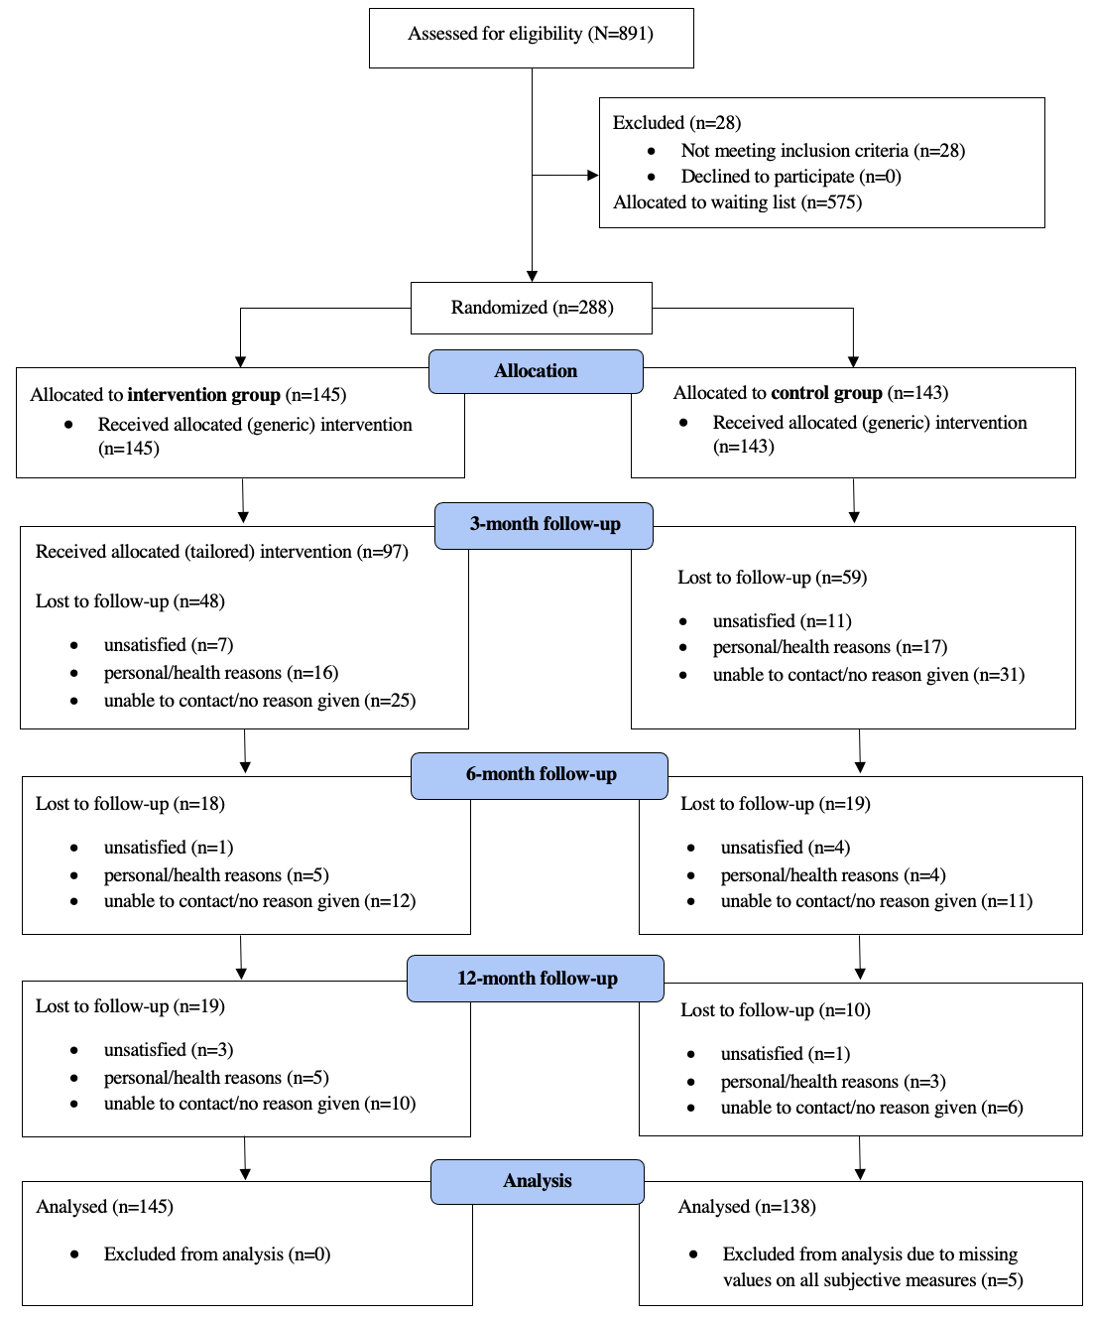
Figure 2. CONSORT diagram.
Table 1. Participant baseline characteristic of the Choosing Health study.
Baseline characteristic |  | Control |  | Intervention
 |  | (n=138) |  | (n=144)
 |  | Mean | SD | Mean | SD
Number of working hours per week, Mean (SD) |  | 46.80 (74.84) |  | 40.55 (9.78)
Number of Sick Day Off, Mean (SD) |  | 11.17 (23.28) |  | 9.88 (23.31)
Sex |  | n | % | n | %
 | Female | 119 | 86.86 | 117 | 81.25
 | Male | 18 | 13.14 | 27 | 18.75
Education Level
 | Secondary Education | 26 | 18.98 | 23 | 15.97
 | Bachelor | 32 | 23.36 | 32 | 22.22
 | Msc/MA | 73 | 53.28 | 77 | 53.47
 | PhD | 3 | 2.19 | 8 | 5.56
 | Other | 3 | 2.19 | 4 | 2.78
Nationality
 | Polish | 136 | 99.27 | 141 | 97.92
 | Ukrainian | 1 | 0.73 | 3 | 2.08
Marital Status
 | Single | 25 | 18.25 | 38 | 26.39
 | Married | 55 | 40.15 | 53 | 36.81
 | Non-marital relationship | 40 | 29.2 | 39 | 27.08
 | Separated | 1 | 0.73 | 1 | 0.69
 | Divorced | 13 | 9.49 | 9 | 6.25
 | Widowed | 1 | 0.73 | 3 | 2.08
 | Other | 2 | 1.46 | 1 | 0.69
Children
 | Yes | 64 | 46.72 | 64 | 44.44
 | No | 73 | 53.28 | 80 | 55.56
Number of Children
 | 1 | 26 | 40.62 | 28 | 43.75
 | 2 | 33 | 51.56 | 28 | 43.75
 | 3 | 3 | 4.69 | 7 | 10.94
 | 4 | 2 | 3.12 | 1 | 1.56
Housing Situation
 | Living in my own house without a mortgage | 29 | 21.17 | 27 | 18.88
 | Living in my own house with a mortgage | 52 | 37.96 | 58 | 40.56
 | Renting a house or apartment | 31 | 22.63 | 33 | 23.08
 | Living with friends or family | 11 | 8.03 | 11 | 7.69
 | Lodgings or dormitory | 10 | 7.3 | 6 | 4.2
 | Other | 4 | 2.92 | 8 | 5.59
Employment Status
 | Full-time | 111 | 81.02 | 112 | 77.78
 | Part-time | 5 | 3.65 | 12 | 8.33
 | Retired | 1 | 0.73 | 1 | 0.69
 | Unemployed | 20 | 14.6 | 19 | 13.19
Abbreviations: SD: standard deviation; MSc: Master of Science; MA: Master of Arts; PhD: Doctor of Philosophy

The predictive determinants of adherence to weight loss promoting behaviours based on individual data collection that were used for intervention tailoring were: motivation (57.2%), competing goals (46.2%), awareness (46.2%), habit (28.3%), obstacles (15.2%), social support (6.9%), happiness (5.5%), environment (4.1%), energy level (3.5%), stress (2.1%), sleep (1.4%), and hunger (0.7%).
Table 2. Descriptive statistics and group differences at baseline.

Measure | Intervention (Mean [CI], SD) | Control (Mean [CI], SD)
Age | 36.40 [34.46, 38.34], 11.80 | 36.45 [34.55, 38.35], 11.28
Weight in kg | 92.27 [89.29, 95.26], 18.18 | 89.41 [86.84, 91.98], 15.57
Fat % | 36.88 [35.92, 37.84], 5.85 | 36.51 [35.55, 37.47], 5.80
Fat in kg | 34.46 [32.76, 36.17], 10.36 | 33.00 [31.48, 34.52], 9.18
BMI | 31.96 [31.19, 32.72], 4.67 | 31.56 [30.80, 32.32], 4.58
Blood pressure diastolic | 82.78 [81.11, 84.45], 10.19 | 81.72 [79.61, 83.84], 12.79

Primary outcome at 6 months
After removing 6 outliers, defined as having an absolute weight loss larger than 40kg (deemed unrealistic after 3 months and so likely to be an error), no statistically significant difference was found between groups on mean weight loss at 6 months follow up (mean difference = –0.78, F = 1.44, df = 1, 175 p = 0.232), means (with SD) are 2.42 kg (4.29) and 1.64 kg (4.26) for intervention and control group, respectively). Findings were similar when groups were split using the threshold of BMI < 30 vs. ≥ 30, although as expected overall weight loss was greater in the BMI ≥ 30 subgroup. There was a small (eta² = 0.02) significant difference for the BMI-split, meaning that there was more weight loss in the > 30 BMI group, but not between the interaction between these two factors (see Table 3), meaning that the weight loss difference between the intervention versus control group was similar in both BMI groups.
Table 3. ANOVA for weight loss at 6 months with intervention versus control and BMI split
 | df | SSQ | F | p
Intervention-control | 1 | 26.34 | 1.458 | 0.229
BMI-split | 1 | 76.20 | 4.218 | 0.042
IC x BMI | 1 | 0.01 | 0.000 | 0.982

Secondary outcomes at 6 months
No statistically significant between-group differences were found for any of the secondary outcomes (fat percentage, blood pressure) at 6 months, or between BMI subgroups for these measures. The means and standard deviations for weight loss at 6 months in the groups are in Table 4. The means and standard deviations for fat % change and (diastolic) blood pressure change are also given in Table 4. Differences in fat reduction and blood pressure reduction with respect to the intervention-control factor or the BMI-split factor were not significant at 6 months (results in the appendix).
Table 4: Changes in outcomes by trial arm at 6 months follow up
 | BMI | Intervention |  | Control
Measure |  | Mean | SD | Mean | SD
Weight loss (Kg) | all | 2.42 | 4.29 | 1.64 | 4.26
Fat% | all | 1.47 | 3.05 | 1.35 | 2.60
Blood pressure (diastolic) | all | 3.33 | 11.46 | 3.62 | 9.15
Weight loss (Kg) | <30 | 1.71 | 3.70 | 0.95 | 3.53
Fat % | <30 | 1.36 | 3.28 | 1.20 | 2.16
Blood pressure (diastolic) | <30 | 2.48 | 8.42 | 2.63 | 9.89
Weight loss (Kg) | ≥30 | 3.04 | 4.71 | 2.25 | 4.76
Fat % | ≥30 | 1.56 | 2.88 | 1.49 | 3.02
Blood pressure (diastolic) | ≥30 | 4.03 | 13.53 | 4.60 | 8.40

Longitudinal results

Weight Loss. The results of the MLA for the time (3, 6 and 12 months) and group (intervention versus control) effects on weight loss are given in Table 5.
Table 5: Longitudinal results

Weight loss
 | Estimate | SE | t | p
A. At 3 months control (intercept) | 1.008 | 1.009 | 1.000 | 0.318
B. At 3 months intervention vs A | 0.533 | 1.380 | 0.386 | 0.699
C. At 6 months control vs A | 0.239 | 1.287 | 0.186 | 0.853
D. At 12 months control vs A | -0.797 | 1.479 | -0.539 | 0.591
E. At 6 months intervention vs ABC | -0.022 | 1.757 | -0.013 | 0.990
F. At 12 months intervention vs ABD | 1.222 | 2.042 | 0.598 | 0.550
Body fat percentage reduction
A. At 3 months control (intercept) | 0.989 | 0.294 | 3.369 | 0.001
B. At 3 months intervention vs A | -0.032 | 0.402 | -0.080 | 0.936
C. At 6 months control vs A | 0.240 | 0.281 | 0.852 | 0.395
D. At 12 months control vs A | -0.210 | 0.301 | -0.698 | 0.485
E. At 6 months intervention vs ABC | 0.259 | 0.388 | 0.668 | 0.504
F. At 12 months intervention vs ABD | 0.509 | 0.418 | 1.218 | 0.224
Blood pressure (diastolic) change
A. At 3 months control (intercept) | 1.976 | 1.092 | 1.809 | 0.072
B. At 3 months intervention vs A | 0.771 | 1.492 | 0.517 | 0.606
C. At 6 months control vs A | 2.061 | 1.143 | 1.803 | 0.073
D. At 12 months control vs A | 2.534 | 1.223 | 2.071 | 0.039
E. At 6 months intervention vs ABC | -0.641 | 1.574 | -0.407 | 0.684
F. At 12 months intervention vs ABD | 0.582 | 1.695 | 0.344 | 0.731
Blood pressure (systolic) change
A. At 3 months control (intercept) | -1.417 | 1.67 | -0.849 | 0.397
B. At 3 months intervention vs A | 0.149 | 2.28 | 0.065 | 0.948
C. At 6 months control vs A | -1.621 | 1.70 | -0.951 | 0.342
D. At 12 months control vs A | 0.299 | 1.82 | 0.164 | 0.870
E. At 6 months intervention vs ABC | 0.113 | 2.35 | 0.048 | 0.961
F. At 12 months intervention vs ABD | -2.910 | 2.53 | -1.151 | 0.251

Months 3, 6 and 12 refer to the differences from baseline in weight in the control group at the three time points respectively. A is the reference point referring to the estimated weight loss in the control group at 3 months. B refers to the difference between intervention and control group at 3 months. C and D refer to the differences in estimated weight between control group at 6 and 12 months, respectively and the control group at 3 months. E and F refer to the differences in weight in the intervention group relative to the baseline estimates of the control and intervention group and the estimate in the control group at respectively 6 and 12 months. Since we analysed weight loss, positive values in the table indicate a decrease in weight over time.
To illustrate these effects the estimated means are shown in Figure 3. Although none of the estimated effects are significant, the Figure shows that the intervention group is performing slightly better than the controls, especially at 12 months.
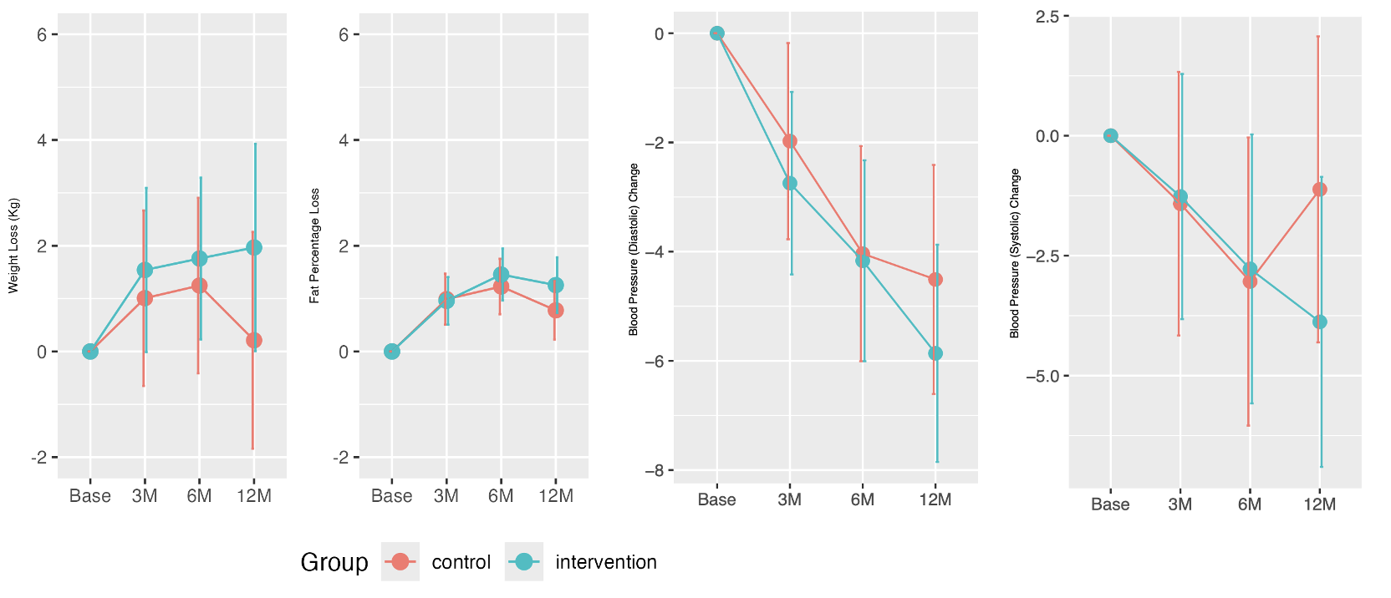
Figure 3: Estimated means with 90% confidence intervals for weight loss, fat reduction and blood pressure change at 3, 6 and 9 months after baseline, comparing the intervention and control group.

Body fat percentage reduction. The results of the MLA for the effects on body fat percentage are given in Table 5. At 3 months fat reduction is about 1% in both groups, which is a significant reduction. The groups do not differ. At 6- and 12-months Figure 3 shows this reduction remains in the intervention group and slightly weakens in the control group. At no point in time control and intervention show a significant difference.
Blood pressure reduction. The results of the MLA for the effects on blood pressure are given in Table 5. At 3 months blood pressure (diastolic and systolic) seems to improve (Figure 3) in both groups during the 4 time points. At 12-months blood pressure reduction compared to the 3-months score is significant. At no point in time control and intervention show a significant difference.
Self-reported measures. The MLA test statistics for the self-reported measures are in the appendix. Figure 4 illustrates the general outcomes. This Figure shows a slight increase in physical activity (MPVA). Except for the control group at 3 months there were no significant effects of time and group.
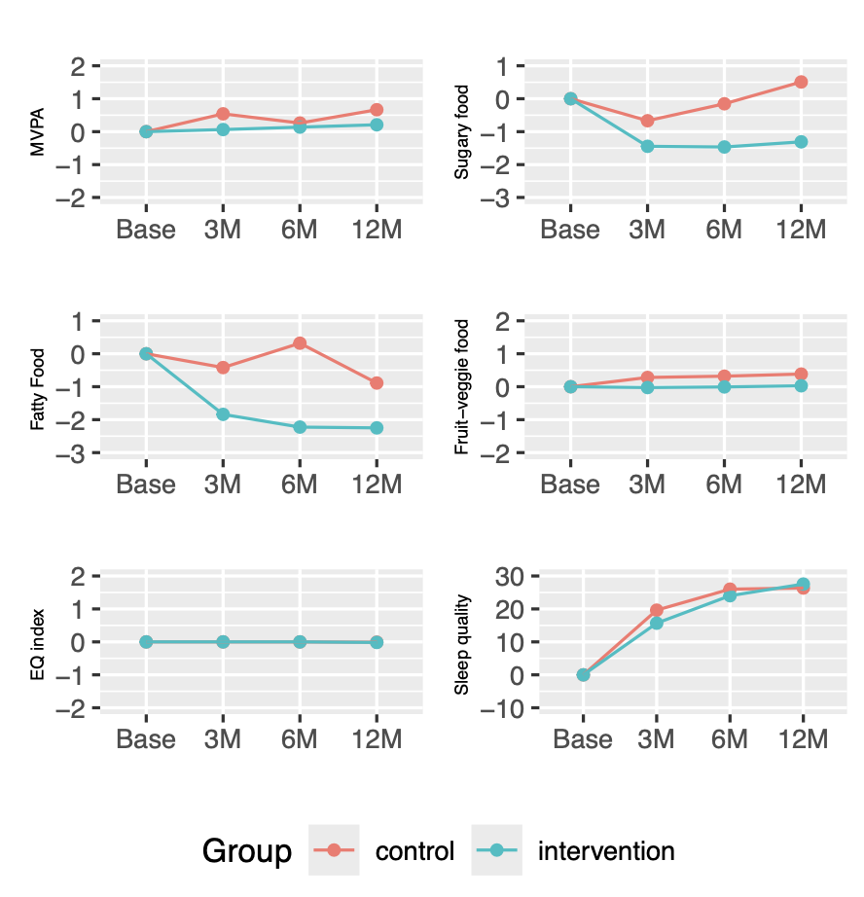
Figure 4. Estimated means at 3, 6 and 9 months after baseline, comparing the intervention and control group for six self-reported measures: physical activity (MVPA), Sugary food, fatty food, fruit-veggie food, health-related quality of life (EQ), and sleep quality.

Figure 4 shows a higher decrease for fatty food and sugary food consumption in the intervention group than controls, which remains after 12 months, although between-group differences were not significant. For fruit and vegetable consumption and for the health-related quality of life index there was no effect at all. Sleep quality shows an improvement over time in both groups, which is significant at 3 and 6 months.
The MLA test statistics for the psychological constructs are in the appendix. Figure 5 illustrates the general outcomes. This Figure shows that the effects are negligible over time for all constructs and that there are no differences between intervention and control group.
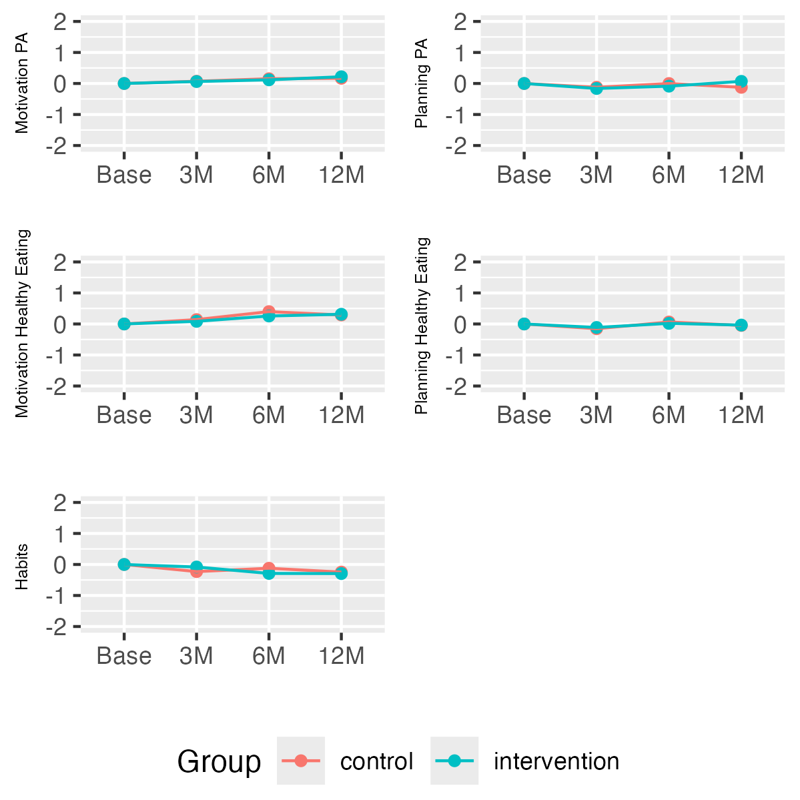
Figure 5. Estimated means at 3, 6 and 9 months after baseline, comparing the intervention and control group for five psychological constructs: motivation for PA, planning PA, motivation healthy eating, planning healthy eating, and habits.

No adverse events were reported during the study. Findings for intervention acceptability and feasibility are reported elsewhere (Palacz-Poborczyk et al., 2024).

Economic evaluation outcomes
Choosing Health program was associated with a cost of zł1681 per participant (AUD 695.40; USD 450.64, and 330 GBP) (Supplement 4).
Table 6. Findings from the Cost-Effectiveness Analysis of the Choosing Health Study
Parameter | Analysis | Difference Mean  (95% CI) | P-value
Health Outcome
Weight loss | Base-case | -3.03 (-7.90;1.84) | 0.224
Weight loss | Multiple Imputation | -4.08 (-4.90; -3.27) | P<0.001
QALY | Base-case | -0.02 (-0.03; -0.001) | 0.042
QALY | Multiple Imputation | -0.02 (-0.02; -0.01) | P<0.001
Cost-effectiveness analysis |  | ICER | Probability of being cost-effective (%)
Cost per kg body weight loss | Base-case | zł 224.61 per kg | -
Cost per kg body weight loss | Multiple Imputation | zł 166.80 per kg | -
Cost per QALY | Base-case | Dominated | 0%
Cost per QALY | Multiple Imputation | Dominated | 0%
Abbreviations: QALY: Quality-adjusted life year; CI: Confidence Interval; ICER: Incremental cost-effectiveness ratio

In the base case results, the Incremental cost-effectiveness ratio (ICER) of the Choosing Health intervention over the trial period was zł 225 per kg reduction in body weight. In the ITT-based analysis, the ICER of the Choosing Health intervention increased to zł 167 per kg reduction in body weight. Because the mean differences of QALY were negative in both base case and ITT-based analyses, the ICER based on QALY was not calculated (Table 6).
Discussion

The RCT results did not show a difference in weight loss between groups after 6 months. However, the intervention group participants had higher levels of weight loss than control group participants at 12 months, although this was not statistically significant. This lack of a significant difference may have been affected by the high attrition rate, but this remains speculation. Several digital weight loss programs support people with overweight and obesity showing various levels of effectiveness (Patel et al., 2021). In our trial, our control group participants had received an active intervention including receiving an eBook and regular informational emails related to weight loss. Both the eBook and the emails were factual and not tailored to behavioural determinants; however, they still produced weight change (Kwasnicka et al., 2024). Control group participants also participated in four meetings with a trained intervention provider for data collection, including a detailed body scan from body composition scales (Tanita, MC-780MA S, Japan) summarising change in weight and fat percentage at 3, 6 and 12 months. Feedback on the device-captured measures was provided including BMI, weight, body fat percentage, and blood pressure and potentially acted as tailored support and intervention (even though that was not intended by the researchers). Although the weight loss observed was modest, even small reductions (3–5%) can produce meaningful improvements in cardiometabolic health and behavioural outcomes, as evidenced by prior research (Fontana, 2018; Sattar et al., 2020).
Our intervention included three months of monitoring individual determinants of weight loss before providing personalised intervention. We showed that on average, the most frequent predicting determinants were motivation, competing goals, awareness, habit, and obstacles. We also showed that participants had unique profiles and different combinations of behavioural determinants were predictive for each participant. These results were in line with previous studies (Kwasnicka, Dombrowski, et al., 2017) also demonstrating the need for individual tailoring based on individual data; however, with our study not demonstrating a significant difference between groups. With the recent advances of machine learning and pattern recognition (Abeltino et al., 2025) we are now at the opportune time to provide highly personalised interventions tailored to incoming participant’s data.
The ICER of weight loss was zł 114.63 per kg in base case analysis and zł 442.20 per kg from multiple imputation. These findings aligned with the outcomes reported in the systematic review regarding the cost-effectiveness of non-surgical interventions for weight loss. Based on the systematic review findings, the ICER per kg lost ranged from $22 to more than $20,000 per kg lost due to variation in intervention settings (Jacobsen et al., 2022).
The onset of the COVID 19 pandemic and associated containment measures marked a substantial external disruption. Several large‐scale investigations have since documented population‐level increases in body weight and reductions in physical activity, particularly among those with higher baseline BMI, lower socioeconomic status or poorer mental health (Anderson et al., 2023; Samuel et al., 2024; Wunsch et al., 2022). The timing of our trial’s intervention and follow up therefore coincided with an unusually volatile period for health behaviour change, which may have affected retention, behaviour patterns, and response to the digital intervention.
Strengths and Limitations
We conducted a rigorous study following CONSORT guidelines (Hopewell et al., 2025) and Open Science Principles (Kwasnicka et al., 2021). We were highly successful with the study recruitment. We received 575 more expressions of interest from potential participants than we could recruit to the study, demonstrating high need for free digital health weight loss and weight loss maintenance programs. We accepted study participants on first come, first saved basis which meant that many people who were keen to take part missed out on the opportunity to participate in the program.
The intervention was highly personalised and based on a vast amount of data. In comparison other studies often provide tailoring based on one-off assessment without taking into consideration within person changes in personal determinants and outcomes (Kwasnicka, Vandelanotte, et al., 2017). Several EMA studies demonstrated that to make a conclusion about predictive determinants repeated assessments are required (Perski et al., 2022).
This study was conducted during COVID-19 pandemic. High study participant drop out was also attributed to study delays, study participants being sick (often with COVID-19), not willing to travel to participate in data collection (shielding, socially distancing and not engaging in activities that they perceived as unnecessary and putting them at risk). Participants also anecdotally reported feeling unmotivated to exercise and eat healthily due to pandemic restrictions and unusual circumstances that they faced during pandemic.
Initial data collection period was intense. After baseline data collection, we assessed intervention participants daily for 3 months to assess the most prominent determinants of weight loss. After 3 months, the participants were presented with a report summarising their personal determinants and were asked to continue their daily assessment over the next 3 months (6 months in total) to collect sufficient data to power interrupted time series.
The sample participating in the study was potentially atypical. Participants were highly educated 78% having University degrees. Additionally, 84%% were female which is typical in weight loss studies recruiting from the general population, as men are less likely to participate in weight loss and weight loss maintenance studies, unless they are specifically tailored to them (Kwasnicka, Ntoumanis, et al., 2020). Additionally, the participants lived through unusual circumstances of world-wide pandemic.
Future research

The use of AI, machine learning, and pattern recognition can support intervention tailoring to individual determinants (Zhang et al., 2020). In our intervention, data were analysed for everyone separately and summarised in a form of personalised report presented to the intervention participants at 3 months. This required significant researcher time. Future studies and interventions can use more advanced technology to tailor in real time and to show dynamic changes in determinants as they continuously change (Perski, Hébert, et al., 2022). Similar interventions could be delivered in a real time based on pattern recognition, once sufficient amount of data is collected (Perski et al., 2024), which could potentially shorten the duration of data collection. The report could be replaced by ongoing behavioural suggestions in terms of which determinants to target, when, and which Behaviour Change Techniques (BCTs) are most appropriate.

While weight loss has traditionally been the primary focus of many behavioural interventions, accumulating evidence indicates that weight reduction per se is not always necessary for meaningful improvements in health outcomes (Clarke et al., 2021; Richmond et al., 2021; Tylka et al., 2014). In our trial, participants in the intervention group experienced modest and non-significant weight changes, yet other health markers, including blood pressure and body composition, were measured and provide valuable insights. These findings underscore the importance of considering outcomes beyond weight alone. Future research may benefit from prioritising clinically relevant health markers, such as cardiometabolic risk factors, functional capacity, and psychological well-being, rather than focusing solely on weight reduction. Such a health-centred approach aligns with current evidence supporting weight-neutral or weight-inclusive interventions (Clarke et al., 2021; Richmond et al., 2021) and may offer more actionable insights for improving long-term health outcomes, even in the absence of substantial weight loss. The small changes observed in blood pressure are consistent with the modest weight loss in this sample. Baseline blood pressure values were generally within the normal range, so large reductions would not be expected. Therefore, the observed changes are unlikely to be clinically meaningful, though minor improvements could still be relevant in individuals with elevated baseline blood pressure.
Summary
This study aimed to assess the effectiveness and cost-effectiveness of the Choosing Health program which tailored weight loss and maintenance support based on individual behaviour determinants. A two-group RCT was conducted with 288 participants and there was no significant difference in mean weight loss between the two groups at 6 or 12 months. However, at 12 months, intervention participants had greater weight loss than control participants, although the difference was not statistically significant. Secondary outcomes such as blood pressure, body fat percentage, and BMI showed no significant differences, though the intervention group generally showed favourable trends. The study also found that the tailored intervention was feasible and acceptable, with dynamic tailoring of content based on behavioural changes potentially improving future interventions.

References
Abeltino, A., Riente, A., Bianchetti, G., Serantoni, C., De Spirito, M., Capezzone, S., Esposito, R., & Maulucci, G. (2025). Digital applications for diet monitoring, planning, and precision nutrition for citizens and professionals: A state of the art. Nutrition Reviews, 83(2), e574–e601. https://doi.org/10.1093/nutrit/nuae035
Anderson, L. N., Yoshida‐Montezuma, Y., Dewart, N., Jalil, E., Khattar, J., De Rubeis, V., Carsley, S., Griffith, L. E., & Mbuagbaw, L. (2023). Obesity and weight change during the COVID‐19 pandemic in children and adults: A systematic review and meta‐analysis. Obesity Reviews, 24(5), e13550. https://doi.org/10.1111/obr.13550
Berry, M. P., Chwyl, C., Metzler, A. L., Sun, J. H., Dart, H., & Forman, E. M. (2023). Associations between behaviour change technique clusters and weight loss outcomes of automated digital interventions: A systematic review and meta-regression. Health Psychology Review, 17(4), 521–549.
Bush, K., Kivlahan, D. R., McDonell, M. B., Fihn, S. D., & Bradley, K. A. (1998). The AUDIT alcohol consumption questions (AUDIT-C): An effective brief screening test for problem drinking. Archives of Internal Medicine, 158(16), 1789–1795.
Buysse, D. J., Reynolds, C. F., Monk, T. H., Berman, S. R., & Kupfer, D. J. (1989). The Pittsburgh Sleep Quality Index: A new instrument for psychiatric practice and research. Psychiatry Research, 28(2), 193–213.
Chopra, S., Malhotra, A., Ranjan, P., Vikram, N. K., Sarkar, S., Siddhu, A., Kumari, A., Kaloiya, G. S., & Kumar, A. (2021). Predictors of successful weight loss outcomes amongst individuals with obesity undergoing lifestyle interventions: A systematic review. Obesity Reviews, 22(3), e13148.
Clarke, F., Archibald, D., MacDonald, V., Huc, S., & Ellwood, C. (2021). The well now course: A service evaluation of a health gain approach to weight management. BMC Health Services Research, 21(1), 892. https://doi.org/10.1186/s12913-021-06836-z
Coppini, L. Z., Waitzberg, D. L., & Campos, A. C. L. (2005). Limitations and validation of bioelectrical impedance analysis in morbidly obese patients. Current Opinion in Clinical Nutrition & Metabolic Care, 8(3), 329–332. https://doi.org/10.1097/01.mco.0000165013.54696.64
Courneya, K. S., & McAuley, E. (1994). Factors Affecting the Intention-Physical Activity Relationship: Intention versus Expectation and Scale Correspondence. Research Quarterly for Exercise and Sport, 65(3), 280–285. https://doi.org/10.1080/02701367.1994.10607629
Dakanalis, A., Mentzelou, M., Papadopoulou, S. K., Papandreou, D., Spanoudaki, M., Vasios, G. K., Pavlidou, E., Mantzorou, M., & Giaginis, C. (2023). The association of emotional eating with overweight/obesity, depression, anxiety/stress, and dietary patterns: A review of the current clinical evidence. Nutrients, 15(5), 1173.
Davies, C. A., Spence, J. C., Vandelanotte, C., Caperchione, C. M., & Mummery, W. K. (2012). Meta-analysis of internet-delivered interventions to increase physical activity levels. International Journal of Behavioral Nutrition and Physical Activity, 9(1), 52.
Drummond, M. F., Sculpher, M. J., Claxton, K., Stoddart, G. L., & Torrance, G. W. (2015). Methods for the economic evaluation of health care programmes. Oxford university press.
EuroQol Office. (2017). EQ-5D-5L.
Fontana, L. (2018). Interventions to promote cardiometabolic health and slow cardiovascular ageing. Nature Reviews Cardiology, 15(9), 566–577.
Gardner, B., Abraham, C., Lally, P., & de Bruijn, G.-J. (2012). Towards parsimony in habit measurement: Testing the convergent and predictive validity of an automaticity subscale of the Self-Report Habit Index. International Journal of Behavioral Nutrition and Physical Activity, 9(1), 102.
Hagströmer, M., Oja, P., & Sjöström, M. (2006). The International Physical Activity Questionnaire (IPAQ): A study of concurrent and construct validity. Public Health Nutrition, 9(6), 755–762. https://doi.org/10.1079/PHN2005898
Herdman, M., Gudex, C., Lloyd, A., Janssen, M., Kind, P., Parkin, D., Bonsel, G., & Badia, X. (2011). Development and preliminary testing of the new five-level version of EQ-5D (EQ-5D-5L). Quality of Life Research, 20(10), 1727–1736.
Hopewell, S., Chan, A.-W., Collins, G. S., Hróbjartsson, A., Moher, D., Schulz, K. F., Tunn, R., Aggarwal, R., Berkwits, M., & Berlin, J. A. (2025). CONSORT 2025 statement: Updated guideline for reporting randomised trials. The Lancet, 405(10489), 1633–1640.
Jacobsen, E., Boyers, D., Manson, P., & Avenell, A. (2022). A systematic review of the evidence for non-surgical weight management for adults with severe obesity: What is cost effective and what are the implications for the design of health services? Current Obesity Reports, 11(4), 356–385.
Kwasnicka, D., Dombrowski, S. U., White, M., & Sniehotta, F. F. (2017). N-of-1 study of weight loss maintenance assessing predictors of physical activity, adherence to weight loss plan and weight change. Psychology & Health, 32(6), 686–708.
Kwasnicka, D., Luszczynska, A., Hagger, M. S., Quested, E., Pagoto, S. L., Verboon, P., Robinson, S., Januszewicz, A., Idziak, P., Palacz, I., & Naughton, F. (2020). Theory-based digital intervention to promote weight loss and weight loss maintenance (Choosing Health): Protocol for a randomised controlled trial. BMJ Open, 10(11), e040183. https://doi.org/10.1136/bmjopen-2020-040183
Kwasnicka, D., Ntoumanis, N., Hunt, K., Gray, C. M., Newton, R. U., Gucciardi, D. F., Thøgersen-Ntoumani, C., Olson, J. L., McVeigh, J., Kerr, D. A., Wyke, S., Morgan, P. J., Robinson, S., Makate, M., & Quested, E. (2020). A gender-sensitised weight-loss and healthy living program for men with overweight and obesity in Australian Football League settings (Aussie-FIT): A pilot randomised controlled trial. PLOS Medicine, 17(8), e1003136. https://doi.org/10.1371/journal.pmed.1003136
Kwasnicka, D., Potthoff, S., Hagger, M. S., Vandelanotte, C., Rebar, A., Short, C. E., Crook, D., & Gardner, B. (2024). Challenging assumptions underlying physical activity promotion for health care professionals in Australia: A data‐prompted interview study. Health Promotion Journal of Australia, 35(2), 542–550. https://doi.org/10.1002/hpja.784
Kwasnicka, D., Presseau, J., White, M., & Sniehotta, F. F. (2013). Does planning how to cope with anticipated barriers facilitate health-related behaviour change? A systematic review. Health Psychology Review, 7(2), 129–145.
Kwasnicka, D., Ten Hoor, G. A., van Dongen, A., Gruszczyńska, E., Hagger, M. S., Hamilton, K., Hankonen, N., Heino, M. T. J., Kotzur, M., & Noone, C. (2021). Promoting scientific integrity through open science in health psychology: Results of the Synergy Expert Meeting of the European health psychology society. Health Psychology Review, 15(3), 333–349.
Kwasnicka, D., Vandelanotte, C., Rebar, A., Gardner, B., Short, C., Duncan, M., Crook, D., & Hagger, M. S. (2017). Comparing motivational, self-regulatory and habitual processes in a computer-tailored physical activity intervention in hospital employees-protocol for the PATHS randomised controlled trial. BMC Public Health, 17, 1–16.
Moore, G. F., Audrey, S., Barker, M., Bond, L., Bonell, C., Hardeman, W., Moore, L., O’Cathain, A., Tinati, T., Wight, D., & Baird, J. (2014). Process evaluation of complex interventions: UK Medical Research Council (MRC) guidance.
Nutter, S., Eggerichs, L. A., Nagpal, T. S., Ramos Salas, X., Chin Chea, C., Saiful, S., Ralston, J., Barata‐Cavalcanti, O., Batz, C., & Baur, L. A. (2024). Changing the global obesity narrative to recognize and reduce weight stigma: A position statement from the World Obesity Federation. Obesity Reviews, 25(1), e13642.
Palacz-Poborczyk, I., Idziak, P., Januszewicz, A., Luszczynska, A., Quested, E., Naughton, F., Hagger, M. S., Pagoto, S., Verboon, P., & Robinson, S. (2022). Developing the" Choosing Health" Digital Weight Loss and Maintenance Intervention: Intervention Mapping Study. Journal of Medical Internet Research, 24(10), e34089.
Palacz-Poborczyk, I., Naughton, F., Luszczynska, A., Januszewicz, A., Quested, E., Hagger, M. S., Pagoto, S., Verboon, P., Robinson, S., & Kwasnicka, D. (2024). Choosing Health: Acceptability and feasibility of a theory-based, online-delivered, tailored weight loss, and weight loss maintenance intervention. Translational Behavioral Medicine, 14(7), 434–443. https://doi.org/10.1093/tbm/ibae023
Perski, O., Hébert, E. T., Naughton, F., Hekler, E. B., Brown, J., & Businelle, M. S. (2022). Technology‐mediated just‐in‐time adaptive interventions (JITAIs) to reduce harmful substance use: A systematic review. Addiction, 117(5), 1220–1241.
Perski, O., Kale, D., Leppin, C., Okpako, T., Simons, D., Goldstein, S. P., Hekler, E., & Brown, J. (2024). Supervised machine learning to predict smoking lapses from Ecological Momentary Assessments and sensor data: Implications for just-in-time adaptive intervention development. PLOS Digital Health, 3(8), e0000594.
Perski, O., Keller, J., Kale, D., Asare, B. Y.-A., Schneider, V., Powell, D., Naughton, F., Ten Hoor, G., Verboon, P., & Kwasnicka, D. (2022). Understanding health behaviours in context: A systematic review and meta-analysis of ecological momentary assessment studies of five key health behaviours. Health Psychology Review, 16(4), 576–601.
Presseau, J., Sniehotta, F. F., Francis, J. J., & Campbell, N. C. (2009). Multiple goals and time constraints: Perceived impact on physicians’ performance of evidence-based behaviours. Implementation Science, 4(1), Article 1.
Qadah, R. M., Al-Sharman, A., Shalash, R. J., & Arumugam, A. (2024). Within- and between-day reliability of bioelectrical impedance analysis using a novel Tanita multi-frequency body composition analyzer (MC-780PMA) in healthy young adults. Fizjoterapia Polska, 24(2), 275–279. https://doi.org/10.56984/8ZG5608ZD5
Rhodes, R. E., Hunt Matheson, D., & Mark, R. (2010). Evaluation of social cognitive scaling response options in the physical activity domain. Measurement in Physical Education and Exercise Science, 14(3), 137–150.
Richmond, T. K., Thurston, I. B., & Sonneville, K. R. (2021). Weight-focused public health interventions—No benefit, some harm. JAMA Pediatrics, 175(3), 238–239.
Roe, L., Strong, C., Whiteside, C., Neil, A., & Mant, D. (1994). Dietary intervention in primary care: Validity of the DINE method for diet assessment. Family Practice, 11(4), 375–381.
Sainsbury, K., Halmos, E. P., Knowles, S., Mullan, B., & Tye-Din, J. A. (2018). Maintenance of a gluten free diet in coeliac disease: The roles of self-regulation, habit, psychological resources, motivation, support, and goal priority. Appetite, 125, 356–366. https://doi.org/10.1016/j.appet.2018.02.023
Samuel, M., Park, R. Y., Eastwood, S. V., Eto, F., Morton, C. E., Stow, D., Bacon, S., Mehrkar, A., Morley, J., Dillingham, I., Inglesby, P., Hulme, W. J., Khunti, K., Mathur, R., Valabhji, J., MacKenna, B., Finer, S., & The OpenSAFELY Collaborative. (2024). Trends in weight gain recorded in English primary care before and during the Coronavirus-19 pandemic: An observational cohort study using the OpenSAFELY platform. PLOS Medicine, 21(6), e1004398. https://doi.org/10.1371/journal.pmed.1004398
Sattar, N., Gill, J. M., & Alazawi, W. (2020). Improving prevention strategies for cardiometabolic disease. Nature Medicine, 26(3), 320–325.
Skinner, R., Gonet, V., Currie, S., Hoddinott, P., & Dombrowski, S. U. (2020). A systematic review with meta‐analyses of text message‐delivered behaviour change interventions for weight loss and weight loss maintenance. Obesity Reviews, 21(6), e12999.
Sniehotta, F. F., Schwarzer, R., Scholz, U., & Schüz, B. (2005). Action planning and coping planning for long‐term lifestyle change: Theory and assessment. European Journal of Social Psychology, 35(4), 565–576.
Tate, D. F. (2001). Using Internet Technology to Deliver a Behavioral Weight Loss Program. JAMA, 285(9), 1172. https://doi.org/10.1001/jama.285.9.1172
Tate, D. F., Jackvony, E. H., & Wing, R. R. (2006). A Randomized Trial Comparing Human e-Mail Counseling, Computer-Automated Tailored Counseling, and No Counseling in an Internet Weight Loss Program. Archives of Internal Medicine, 166(15), 1620. https://doi.org/10.1001/archinte.166.15.1620
Tylka, T. L., Annunziato, R. A., Burgard, D., Daníelsdóttir, S., Shuman, E., Davis, C., & Calogero, R. M. (2014). The weight‐inclusive versus weight‐normative approach to health: Evaluating the evidence for prioritizing well‐being over weight loss. Journal of Obesity, 2014(1), 983495.
Verney, J., Metz, L., Chaplais, E., Cardenoux, C., Pereira, B., & Thivel, D. (2016). Bioelectrical impedance is an accurate method to assess body composition in obese but not severely obese adolescents. Nutrition Research (New York, N.Y.), 36(7), 663–670. https://doi.org/10.1016/j.nutres.2016.04.003
Warburton, D. E., Jamnik, V., Bredin, S. S., Shephard, R. J., & Gledhill, N. (2018). The 2019 Physical Activity Readiness Questionnaire for Everyone (PAR-Q+) and electronic Physical Activity Readiness Medical Examination (ePARmed-X+). The Health & Fitness Journal of Canada, 11(4), 80–83.
World Health Organization. (2021). Obesity and overweight. Fact Sheets: Obesity and Overweight. https://www.who.int/news-room/fact-sheets/detail/obesity-and-overweight
Wunsch, K., Kienberger, K., & Niessner, C. (2022). Changes in Physical Activity Patterns Due to the Covid-19 Pandemic: A Systematic Review and Meta-Analysis. International Journal of Environmental Research and Public Health, 19(4), 2250. https://doi.org/10.3390/ijerph19042250
Zhang, J., Oh, Y. J., Lange, P., Yu, Z., & Fukuoka, Y. (2020). Artificial intelligence chatbot behavior change model for designing artificial intelligence chatbots to promote physical activity and a healthy diet. Journal of Medical Internet Research, 22(9), e22845.

