The Properties of Personal Semantics
Annick F. N. Tanguay¹, Kim Thériault¹, Sharice Clough^{2,3}, Vanessa Taler^{1, 4}, Louis Renoult⁵, & Patrick S. R. Davidson¹
¹ School of Psychology, University of Ottawa, Ottawa, ON, Canada
² Multimodal Language Department, Max Planck Institute for Psycholinguistics, Nijmegen, Gelderland, The Netherlands
³ Hearing and Speech Sciences, Vanderbilt University Medical Center, Nashville, TN, USA
⁴ Bruyère Health Research Institute, Ottawa, ON, Canada
⁵ School of Psychology, University of East Anglia, Norwich, Norfolk, United Kingdom

Author note
Correspondence concerning this article should be addressed to Annick F. N. Tanguay, Faculty of Social Sciences, University of Ottawa, 136 Jean-Jacques Lussier Priv., Ottawa, Ontario, Canada, K1N 6N5. E-mail: annick.fn.tanguay@gmail.com

Abstract
Recent cognitive neuroscience research has uncovered some similarities and some differences between General semantic memory (GS; e.g., knowledge about family in general) and Personal semantic memory (PS; e.g., knowledge about my family in particular). To better understand the representational content and cognitive processes of PS and their relation to general semantics, we adapted a staple of General semantic memory research, the Property generation task. In a first study, we randomly assigned 240 adult participants to a traditional General semantics perspective (e.g., listing the properties of families and bedrooms in general) or to a PS perspective (e.g., my family, my bedroom) in a between-subjects design. In a second, replication study, 124 participants completed the task in a within-subject design, taking each perspective for different concepts. Relative to the General semantics condition, the PS condition was associated with more features; these were more semantically distant from each other, and included adjectives more frequently and nouns less frequently. However, the two conditions had substantial (~46%) overlap in the frequency of their features. The findings contribute to the identification of the cognitive differences (e.g., semantic richness) and similarities (e.g., correspondence in semantic features) between personal and general semantic memory.
Keywords: Semantic memory, personal semantics, features, semantic distance, episodic memory

The Properties of Personal Semantics
Semantic memory (also termed conceptual, general, or world knowledge, Kumar, 2021; Quillian, 1966; Tulving, 1972) includes knowledge about words, objects, events, and people, devoid of its context of acquisition. Most contemporary models of semantic memory in cognitive psychology and cognitive neuroscience postulate that knowledge of concepts is composed of their individual features or attributes, with their representations distributed across the brain (Chen & Rogers, 2014; Devlin et al., 1998; Garrard et al., 2001; Jones et al., 2015; Kumar et al., 2022; McRae et al., 2005; Reilly et al., 2016; Riordan & Jones, 2011; Taylor et al., 2012; Yee et al., 2018). For instance, knowledge about squirrels may include that they are small mammals that climb trees, have pointed ears, and like to eat nuts (Renoult, 2016). Some features are more distinctive to this concept (e.g., has a bushy tail) whereas others are shared more broadly with other concepts (e.g., runs, is wild, Martin, 2001; Taylor et al., 2011). The set of features activated by a given concept is not invariant, but rather differs according to task and contextual factors (Kumar, 2021). Selection of the most appropriate features for a given goal depends on control processes (e.g., Badre & Wagner, 2007; Novick et al., 2009; Vatansever et al., 2021).
Much of what we know about concepts has come from the Property Generation Task (also known as the Semantic Features Task), in which participants generate as many properties (also known as features) as they can for each concept (e.g., Buchanan et al., 2019; Devereux et al., 2014; Garrard et al., 2001; Kivisaari et al., 2023; McRae et al., 2005; Montefinese et al., 2013; Vinson & Vigliocco, 2008; Vivas et al., 2021). We can aggregate each of these feature sets across multiple participants to create feature norms. Feature norms tell us about the nature of concept structures through the high-probability features (e.g., “four wheels” and “transportation” are key features of “cars”) as well as the more idiosyncratic features named by only a few people (e.g., “colour” for “cars,” Buchanan et al., 2019; Reilly et al., 2023). It is also possible to calculate a wide range of measures from these conceptual norms, such as the number of features, the types of features, and the degree to which features are unique to a concept or shared across several concepts. Features can be classified as perceptual/physical (e.g., sounds, smells, tactile, tastes and looks), functional /motor (how people interact with objects; e.g., when/where/why is it used?), encyclopedic (e.g., where did it come from? Buchanan et al., 2019; McRae et al., 2005), and sometimes even emotional (e.g., what emotion does the object/people/place evoke; McRae et al., 2005). Overall, feature norms can help us better understand the differences and similarities between concepts (Buchanan et al., 2020) and help us establish and evaluate theories of semantic memory (Buchanan et al., 2020; McRae et al., 2005).
Declarative memory was originally viewed as consisting of a dichotomy between two main types — semantic memory as general knowledge (e.g., “Coffee is often served with milk or cream, and sugar”) versus episodic memory as recollection of an autobiographical event from a specific time and place (e.g., “I put too much cream and sugar in my coffee this morning”). This dichotomy left personal knowledge (e.g., “I always take my coffee with cream and two sugars”) in a theoretical void between the two (for reviews relevant to the history of semantic memory see Reilly et al., 2023; Renoult & Rugg, 2020). Although early descriptions assumed that personal semantics (PS) was part of semantic memory (Cermak & O’Connor, 1983; Kopelman et al., 1989a), recent evidence suggests that PS may be at least partially distinct from general semantic (GS), as well as from episodic memory (Renoult et al., 2012). Moreover, personal semantic details themselves may be fractionated into categories such as self-knowledge (e.g., “I am outgoing”), autobiographical facts (e.g., “My best friend lives far away”), repeated events (e.g., “I have been doing yearly trips to new places with a core group of friends”), extended periods of times like life chapters (e.g., “Finding my chosen family”), and autobiographically significant concepts (e.g., knowledge of Taylor Swift that evokes the memory of a friend raving about her last month, Conway et al., 2019; Renoult et al., 2012; Thomsen, 2015). Cognitive neuroscience studies have shown that PS and GS can be distinguished on the basis of brain activity (Maguire & Frith, 2003; Maguire & Mummery, 1999; Renoult et al., 2016; Tanguay et al., 2018, 2022, 2023), and that knowledge about the self, knowledge about other people, and knowledge about the world in general can be differentially impaired by brain lesions (Damasio et al., 1985; Duval et al., 2012; Grilli et al., 2018; Grilli & Verfaellie, 2014, 2016; Marquine et al., 2016; Stendardi et al., 2023; Wank et al., 2021; see also Curot et al., 2017).
However, the component process view of PS suggests that subtypes of declarative memory are not entirely distinct (e.g., semantic versus episodic systems) and not necessarily associated with specific modes of retrieval (e.g., familiarity for semantic memory; Cabeza & Moscovitch, 2013; Renoult et al., 2019). Rather, they engage a similar set of cognitive processes and brain regions, but to a variable extent (Cabeza & Moscovitch, 2013; Moscovitch, 1992; Renoult et al., 2012, 2016; Tanguay et al., 2018; Tanguay et al., 2023). The exact cognitive processes and representational content that drive differences and similarities across all memory types (including GS and episodic memory) are not well understood. Research on PS has expanded in recent years (e.g., Acevedo-Molina et al., 2020; Renoult et al., 2020; Sheldon et al., 2020; Strikwerda-Brown et al., 2018), but little is known about its content and structure relative to GS. One model, the self-memory system, interconnects the conceptual self, the life story schema, lifetime periods, general events, and specific events in a hierarchical structure that follows a gradient of specificity (Conway et al., 2019). A cue would map onto and activate specific items of knowledge, and this activity would spread to related concepts throughout a transient network structure (Conway, 1996, 2005; Conway et al., 2019), much like the spreading activation in GS networks (Collins & Loftus, 1975). The self-memory system does not explicitly address interactions between PS and GS because none of its components directly correspond to semantic memory (Conway & Pleydell-Pearce, 2000). The framing of the model implies that concepts may be like any sensory (e.g., sound, taste) or emotional cues that can elicit autobiographical memories (Conway, 2005; Conway et al., 2019; Conway & Pleydell-Pearce, 2000; for a similar perspective see Tulving, 1983). At the core of the present study is the premise that similar mechanisms, such as spreading activation, apply to both PS and GS, and that taking a feature- or network-based approach will be invaluable for understanding their content and structure. Although there exists a variety of features norms for semantic memory (e.g., features of “friends” in general such as their availability; Buchanan et al., 2019; Devereux et al., 2014; McRae et al., 2005; Vinson & Vigliocco, 2008), to our knowledge, none exists for the personal content of concepts (e.g., what is the meaning of “friends” for me), which should be rooted in PS.

The Property Generation Task for PS
How would participants complete the Property Generation task if it were to focus on PS as opposed to the typical case of focusing on GS? One clue comes from autobiographical verbal fluency tasks. In autobiographical verbal fluency tasks, people list as many self-relevant exemplars (or members) of a category as possible, such as their own traits (e.g., “I am…,” Coste et al., 2015), or names of friends (e.g., Dritschel et al., 1992; Grilli et al., 2021), locations (e.g., Greenberg et al., 2009; Ryan et al., 2008; Sheldon & Moscovitch, 2012), or events that range from the general to the specific (e.g., events that lasted several days or happened many times vs. an event that happened at a specific time and place, Coste et al., 2015; Dritschel et al., 1992; Piolino et al., 2010; Tomadesso et al., 2019). People use multiple strategies to search for exemplars, such as visualizing personal spaces (e.g., “things in a bedroom”) or accessing personal information (e.g., “birthday presents,” Greenberg et al., 2009; Ryan et al., 2008; Sheldon & Moscovitch, 2012; Unsworth et al., 2014; Vallee-Tourangeau, 1998). Some concepts in these verbal fluency tasks (e.g., Dritschel et al., 1992; Ryan et al., 2008) specifically engage personal knowledge (e.g., “my bedroom”).
In the present study, we took inspiration from the stimulus lists used in these experiments, but our task itself differed in important ways. Unlike verbal fluency or similar tasks, participants did not simply list any exemplars of a category or freely associate; rather, they listed the features that make up the meaning of a concept, as in Property Generation tasks. For instance, saying that cats and dogs are animals, or that “Lidia” and “Martin” are friends, offers examples of these categories but does not give the meaning of these concepts (e.g., what is an animal? what is a friend?), and in some cases may provide limited information on their appropriateness as exemplars for their respective categories. Property Generation tasks, in contrast, entail identifying the features of a concept (e.g., a dog is a domestic animal, a friend is caring and keeps in touch). One could say, for example, that a friend is someone who cares first and foremost; if my friend Lidia had that key feature, she would be considered a friend despite being in contact only infrequently. Therefore, as reviewed above, Property Generation tasks can adequately identify salient features and the scope of the network of features associated with the meaning of a concept.
Another clue about the feasibility of a PS adaptation comes from perspectives highlighting the flexibility and context-dependence of semantic networks (Barsalou, 2020; Lambon Ralph et al., 2017; Yee & Thompson-Schill, 2016). Responses on Property Generation tasks, even when focused on GS, are not necessarily consistent across people nor even stable over time within an individual (reviewed in Barsalou, 1993). Information associated with a concept is vast, and only a subset will become salient at a given time (Buchanan et al., 2019; McRae et al., 2005). Thus, instructions could in theory be used to shift the focus from general to personal information; the salient features should then be rooted predominantly in knowledge that is personal (e.g., my car is red, my favorite car is the Lincoln Aviator).
The general versus personal emphasis when accessing knowledge might influence the salience of features (e.g., a “loud gatherings” could be a salient feature of family for a person in the PS but not GS sense), the extent of the activated network (e.g., “family” could trigger knowledge about many family members and features applicable to each, expanding the network), and the composition and diversity of features (e.g., “family” could focus on roles/relations in the GS sense but also cover familial traits, recurring activities together, major milestones like a wedding, and so on, in the PS sense, Mace, 2023; Westmacott & Moscovitch, 2003).
In addition to differences in representational content, the current study’s rationale and hypotheses hinge on the potential role of one component process in explaining the features of PS versus GS: relational processing. One theoretical perspective links relational processing, or the flexible use and combination of arbitrary information (Duff et al., 2020; Rubin et al., 2014), to semantic and episodic memory. That is, much as we probably recombine a variety of episodic details in a flexible way to recreate an event (Schacter & Addis, 2007), we can also benefit from a flexible configuration of rich semantic information (Duff et al., 2020; Solomon & Schapiro, 2020). For example, people with bilateral hippocampal lesions, and corresponding impairments on relational memory tasks, generate fewer features on a GS task (Klooster et al., 2020; Klooster & Duff, 2015), and these features are less semantically distant from one another (Cutler et al., 2019), compared to control participants. If PS is sometimes associated with a greater engagement of the hippocampus relative to GS (Maguire & Mummery, 1999; Tanguay et al., 2023), it may be because PS is more likely to produce a rich and diverse network of features. A first step in investigating this possibility is to scrutinize the networks of semantic features for PS, and carefully compare them to those for GS.

Current Study
In this study, we adapted the Property Generation task and modified it minimally from its standard administration for GS (Klooster & Duff, 2015; from McRae et al., 2005) to directly compare the structure and representational content of GS and PS. Participants had up to two minutes to write as many features as possible of each concept in the general sense (e.g., what is a “family” in general) or in the personal sense (e.g., “my family”). We did not expect responses to contain only GS or PS features, but rather to sample predominantly from one category or the other, depending on the instructions. Furthermore, we anticipated that responses to a concept like “my partner” would draw from a variety of PS subtypes (e.g., personal traits, beliefs, repeated events, life chapters, autobiographical facts), including personal events perceived as constitutive of knowledge about that concept (e.g., “I met my partner at a carnival two years ago” for the cued concept “my partner”), in keeping with the interconnected structure of autobiographical memory (Conway et al., 2019).
As preregistered, the main hypotheses of the study were: 1. If the heightened hippocampal activity for PS compared to GS (Maguire & Mummery, 1999; Tanguay et al., 2023) reflects a higher likelihood of engaging in relational processing, the PS condition will elicit a higher number of features than GS (Klooster et al., 2020; Klooster & Duff, 2015). 2. Due to the individual nature of PS, concepts will have fewer shared features across participants and more idiosyncratic features in the PS than GS condition (see Sheldon & Moscovitch, 2012). 3. We also expected that PS would have more shared features across concepts than GS (McRae et al., 2005; this hypothesis was not preregistered). 4. Based on the relational processing hypothesis, the features of PS will be associated with larger semantic distances from concept-to-feature and from feature-to-feature than the features of GS. 5. Participants will report having more frequent thoughts about personal events while listing features in the PS than the GS condition, due to PS’s proximity to episodic memory (Conway et al., 2019; Renoult et al., 2016; Sheldon et al., 2020; Tanguay et al., 2023).
Our main hypotheses are depicted in Video 1 (see also preregistration https://osf.io/ypdt8).
Video 1
Study Hypotheses
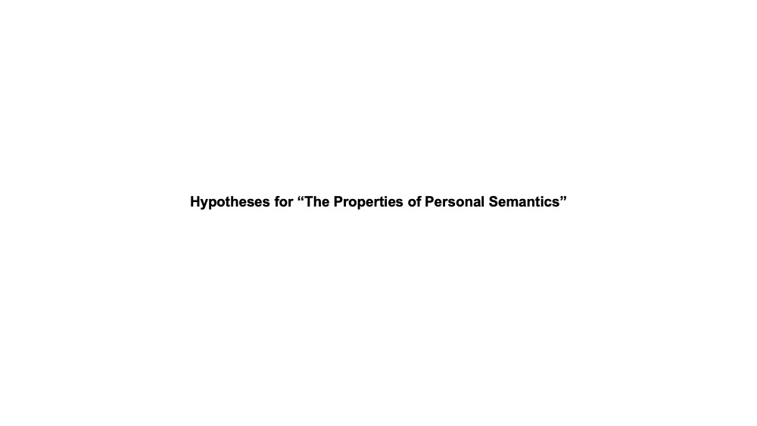
Note. This online video shows the main hypotheses of the study. The original PowerPoint file is available on https://osf.io/ypdt8.
The between-subject design of Study 1 minimized sensitization to the goal of the study and to the expected differences between conditions (as described above). Nevertheless, the examples could have introduced demand characteristics. Indeed, the Property Generation task is difficult to grasp without examples, and these are only helpful to the extent that they are relevant. Our hypotheses imply that the combination of features may be part and parcel of PS. If so, eliminating detailed examples entirely from PS may be complicated (and even undesirable), but a match could be achieved in other ways. In Study 2, we counterbalanced the conditions in a within-subject design and we modified the examples used for GS and PS so that they were matched on key variables of interests, that is, the number of features and the diversity of parts-of-speech. Study 2 preserved all other aspects, including the implementation in Qualtrics (Qualtrics, 2021; 2025) and the recruitment through Prolific (Prolific, 2021, 2025), to facilitate comparison across studies. Through Study 2, we further aimed to eliminate interindividual differences that may confound contrasts of interests in between-subject designs, and to conduct a replication. We expected to replicate all key findings of Study 1 despite the modification in study design and examples.

Methods

Participants
Study 1
We recruited 311 participants, including 136 women, 171 men, and three non-binary or other gender identities, with a mean age of 26.75 years (SD = 5.13) and a mean of 15.29 years of education (SD = 2.34). Some participants did not report demographic information: 1 for gender, 5 for age, and 8 for education. We recruited from Prolific (Prolific, 2021), an online pool of participants that produces data quality equal to or better than a student pool and facilitates access to a more diverse sample (Palan & Schitter, 2018; Peer et al., 2017; Uittenhove et al., 2023). Participants received a $5 compensation for their participation, which was expected to take a maximum of 30 minutes. The Health Sciences and Sciences Research Ethics Boards of the University of Ottawa approved the ethical aspects of the study (H-07-20-5955; date of initial approval: 23/09/2020).
As preregistered, we excluded participants with: 1) incomplete data or an incorrect response to a simple attention check (described below; n = 31), 2) a low number of features (i.e., less than five feature lines on average; n = 21), 3) a low duration per trial (we considered more than three trials out of six with a duration less than 40 seconds to be suspicious, due to the minimum of 30 seconds per trial; n = 6), 4) a disclosed neurological/psychiatric disorder or related medication (n = 11), 5) residence outside of Canada (n = 1), and 6) nonsensical responses on more than one trial (n = 1). The research team agreed on the exclusion of one participant and one concept each for two participants in the GS condition due to nonsensical responses. We did not exclude participants who disclosed using cannabis (n = 9 in the GS condition, n = 4 in the PS condition).
Two hundred forty participants were included in the final sample, half of whom completed each condition (120 participants in GS, 120 in PS; see Table 1 for sample characteristics). The two groups were balanced on age, gender, education, and proportion with English as a first language (see Table 1 below). The sample size was based on norms of semantic features (McRae et al., 2005); that is, we aimed to have around 30 participants per subset of concepts (four subsets of six concepts) in the two conditions (range 27 to 32 participants per subset/condition). No equivalent study could serve as an adequate basis to estimate the effect size of the difference between GS and PS. However, we planned for a small to moderate effect size ($η_{p}^{2}$ = .05) based on event-related potentials (ERP) findings suggesting that differences between GS and PS can be small for semantic processing (Coronel & Federmeier, 2016; Renoult et al., 2015; Tanguay et al., 2018, 2020), although this may depend on the type of PS (Renoult et al., 2016). The actual sample size was larger than the required sample size (N = 202) to detect an effect if the effect size was small to moderate, with a power of $β$ = .90, numerator df [GS vs. PS] = 1, groups [cells of the design] = 8, $α$ = .05, tested in G*Power 3.1.9.7 (Faul et al., 2007).
Table 1
Demographic Characteristics in Study 1
 | General semantics (n = 120) | Personal semantics (n = 120) | Statistics
Age in years | M = 27.10 (SD = 5.20, 18-45) | M = 26.68 (SD = 5.01, 18-36) | t(237) = 0.63, p = .526
Gender | 54 women, 65 men, 1 Non-binary/Unlisted | 60 women, 60 men | $X^{2}$ (2, N = 240) = 1.52, p = .469
Highest level of education in years | M = 15.33 (SD = 2.34, 12-20) | M = 15.36 (SD = 2.29, 12-20) | t(235) = -0.10, p = .918
First language | 106 English, 14 other language | 110 English, 10 other language | $X^{2}$ (2, N = 240) = 0.42, p = .519
Note. Undisclosed information: Two for highest level of education in General semantics, one for highest level education and one for age in Personal semantics.

Study 2
We recruited 164 participants from Prolific (Prolific, 2025), including 77 women, 86 men (and one person who did not to report their gender), with a mean age of 30.32 years (SD = 5.03) and mean years of education of 15.74 years (SD = 2.02). As in Study 1, we excluded participants with: 1) incomplete data or an incorrect response to a simple attention check (n = 16), 2) a low number of features (n = 12), 4) a disclosed neurological/psychiatric disorder or related medication (n = 8). Four participants were excluded due to PS intrusions on all of GS cues as voted by three authors (AFNT, LR, PSRD). As a result, 124 participants were included in the final sample (see Table 2 for characteristics). The goal was to achieve a similar number of participants per condition (i.e., ~120) as Study 1 after exclusion. For an equivalent effect size, a within-subject design should increase statistical power.
Table 2
Demographic Characteristics in Study 2
 | Descriptives (n = 124)
Age in years | M = 30.30 (SD = 4.96, 19-39)
Gender | 58 women, 65 men, 1 undisclosed
Highest level of education in years | M = 15.81 (SD = 1.93, 12-21)
First language | 112 English, 12 other language
Note. Undisclosed information: One for gender.

Measures
Property Generation Task
Study 1. Participants generated features of concepts, thinking either about their meaning for people in general (GS condition) or for themselves (PS condition). The instructions from Klooster and Duff (2015), based on McRae et al. (2005), were slightly modified to accommodate this comparison of GS and PS, and also to reflect the written format of the task (as in Buchanan et al., 2019; McRae et al., 2005). In the GS condition, participants read: “Please write as many properties of the concept to which the word refers in terms of its meaning for people in general.” In the PS condition, participants read “Please write as many properties of the concept to which the word refers in terms of its meaning for you (e.g., your life or who are).” Pilot participants in the PS condition disclosed being unsure whether they should name features that would be unique to them. Hence, for that condition, we added: “This means properties may be unique to you.” As in the original instructions, the instructions then listed what could be properties of the concept, such as “physical properties”, “functional properties”, “things that the concept is related to”, and “any other facts”. The “any other facts” read as: “other facts, such as how it behaves, or where it comes from”, taken from McRae et al. (2005), which we expanded (in bold): “and any other facts, such as how it behaves and traits, any preferences or where it comes from or is located”. Participants received the same instructions in both conditions, except as indicated above in italics, and they read examples for the same concepts (i.e., wedding, bookstore, dog), but with features corresponding to the condition. Pilot data inspired the examples (ten from Prolific and two from the Laboratory’s network). See Supplementary Table 1 for the full list of example features. After processing with the bag-of-words approach used in this paper, the concepts had the following number of features: bookstore had 19 for GS and 33 for PS, dog had 19 for GS and 27 for PS, and wedding had 16 for GS and 25 for PS. The total parts-of-speech over all concepts were 34 (49.28%) in GS and 33 (29.46%) in PS for nouns, 10 in GS (14.49%) and 20 (17.86%) in PS for adjectives, 19 (27.54%) in GS and 26 (23.21%) in PS for verbs, and 1 (1.45%) in GS and 9 (8.04%) in PS for prepositions, with other parts-of-speech being infrequent.
As stimuli, we selected 24 nouns that were places, events, or people that could take a different meaning in the general versus personal sense (e.g., house, job, family, inspired from Dritschel et al., 1992; Greenberg et al., 2009; Ryan et al., 2008; Sheldon & Moscovitch 2012; see Supplementary Material for additional details on stimuli). Most personally relevant concepts should have a corresponding meaning in terms of world knowledge, but the opposite may not be true. For example, a person may know about black holes while black holes would have little to no meaning for their personal identity or life story. Hence, we selected concepts on the basis of their likely personal relevance in a broad population. Due to their broad relevance, these concepts should be commonly found in PS stimuli, instructions, or responses (e.g., Kopelman et al., 1989b; Melega et al., 2024; Wank et al., 2021). Participants completed the Features task for a subset of six concepts (two places, two events, two objects). The selection of the six concepts was not random, but rather predetermined such that approximately 30 participants in each group would see the same six concepts. As we attributed six out of the 24 concepts to each participant, there were four possible subsets of concepts. Although the two conditions included the same concepts, they were introduced with “my” in the PS condition (e.g., my family) to emphasize the personal perspective of that condition throughout the task (similar to Ryan et al., 2008, who added “you” or “your” for autobiographical memory). We pseudo-randomly attributed concepts to one of the four subsets. Each subset included two places, two events, and two people concepts. Participants completed the six trials of a subset in a random order (see Figure 1 for an illustration of a trial). The duration of each trial was restricted to a minimum of 30 seconds (to minimize speeding through the task) and a maximum of 2 minutes (the upper limit was inspired from Blumenthal et al., 2017; Klooster & Duff, 2015). The trial duration is also similar to the one of feature norms (Devereux et al., 2014; McRae et al., 2005; Vinson & Vigliocco, 2008), according to an estimate based on the number of trials and total study duration. A total of six concepts per participant and 24 overall limited the study duration to reduce effects of fatigue.
Figure 1
Trial of the Property Generation Task
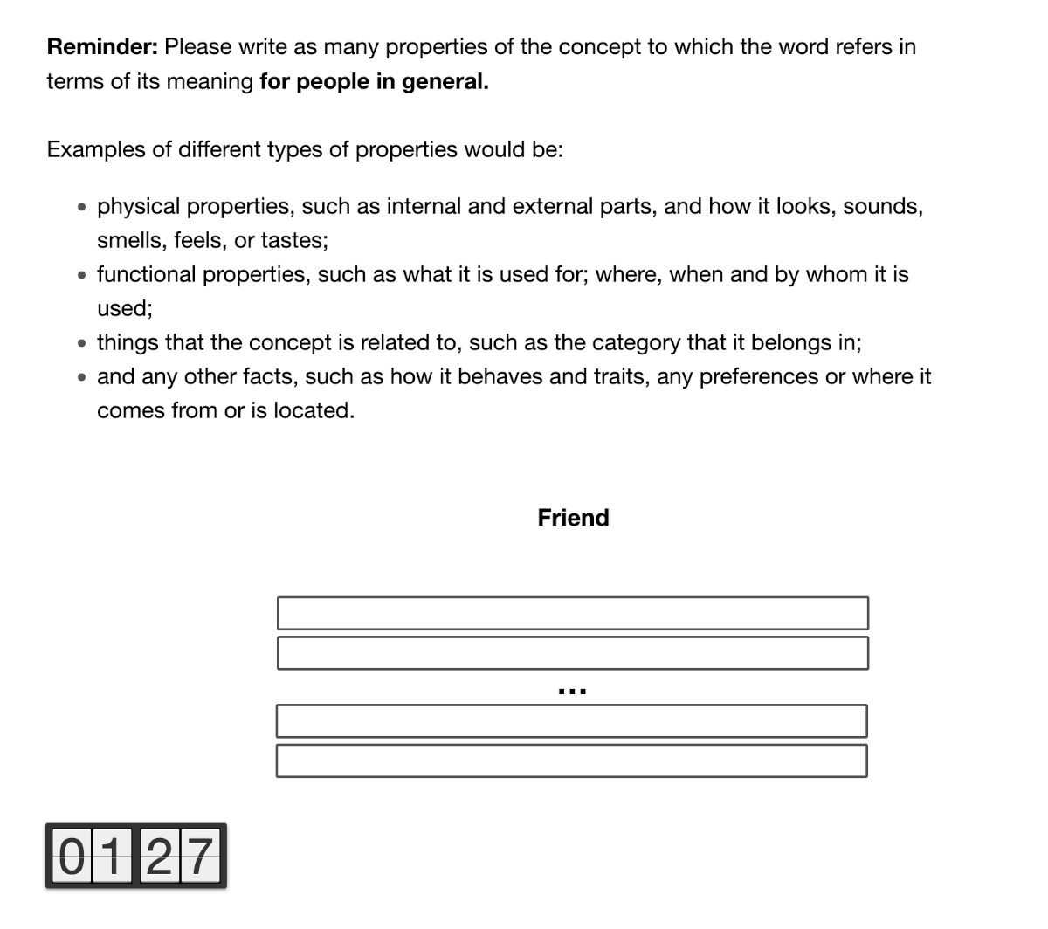
Note. An example of a trial for the GS condition with the concept “friend”. The maximal number of lines participants could fill was 25 (abbreviated above), and the timer was shown at the bottom of the screen. Participants reached the maximum number of lines only 17 times out of all responses for Study 1 and five times for Study 2, with six to eight being the most frequent number of lines used in both conditions. The timer was only visible after scrolling down the screen.
After each trial of feature generation for a concept, participants provided three separate ratings to indicate how frequently events came to mind when listing the features. Each rating referred to one of three categories of event memory: 1) single events that happen at a specific time and place, 2) events that last an extended period (more than 1 day), and 3) events that happen repeatedly, like a routine. Participants could select never, sometimes, half of the time, most of the time, and all the time. If any events came to mind, participants then rated the number of details of these event types by selecting an option from “faint with few details” (1) to “exceptionally clear with great detail recalled” (5). Next, all participants rated the intensity of their emotions when they listed the features from “devoid of emotional experience” (1) to “intense emotional experience” (5). The trial ended with a rating of personal significance of the concept from “not significant” (1) to “greatly significant” (5). The preregistration included the full instructions and pictures of the rating scales (see https://osf.io/ypdt8).
Study 2. In Study 1, the PS condition had slightly more information than the GS condition in its instructions, in bold: “Please write as many properties of the concept to which the word refers in terms of its meaning for you (e.g., your life or who are). This means properties may be unique to you.” Consequently, we modified the instructions of both conditions to improve the match (in bold): “Please write as many properties of the concept to which the word refers in terms of its culturally-shared meaning, for people in general. This means properties may be shared with other people” in the GS condition, and “its personal meaning, for you specifically. This means properties may be unique to you” in the PS condition. Both conditions further stated “any other facts” included those in “relation to events or identity”. In Study 1, the instructions included examples intended to be representative of each condition and accordingly, not matched. In Study 2, Participants received examples (set 1: wedding[s], bookstore[s], dog[s]; set 2: graduation[s], movie theatre[s], cat[s]) that were counterbalanced to appear in the GS or PS condition. The GS and PS versions of a cue had exactly the same number of words on each line and in total and referred to a similar content (see Supplementary Table 2). Additionally, the examples of all concepts, in both versions, comprised 56 features once processed using the bag-of-words approach used in this paper. The total parts-of-speech of the six concepts were similar between conditions (i.e., noun: 171 in GS and 158 in PS; adjective: 62 in GS, 60 in PS, verb: 81 in GS and 95 in PS, prepositions: 45 in GS and 37 in PS). The participants received randomly three distinct concepts in each condition out of the 24 concepts (from Study 1), one from each category: activity, person, place. The order of the conditions (GS first, PS first) was counterbalanced across participants. All the concepts for a condition were blocked together to reduce confusion within participants. The task was identical to Study 1, with the exception of those changes and an added function to prevent the copy/pasting responses from online sources. We screened data thoroughly for responses indicative of copying and pasting in Study 1. The explosion of artificial intelligence use between our running Study 1 and Study 2 heightened our concerns around plagiarism, prompting the implementation of this additional copy-paste blocking measure in Study 2. We further minimized the likelihood of participants relying on artificial intelligence in Study 2 through the separation of responses across lines, the 2-minute time limit per trial along with the stringent criteria for inclusion (e.g., minimum number of responses per trial) and a researcher screening all responses (as in Study 1).
Survey of Autobiographical Memory (SAM) – Episodic Memory Subscale (Palombo et al., 2013)
The eight items of the episodic memory subscale assess the perception of stable characteristics of one’s own episodic memory function, such as number of details and confidence in the recollection. A higher score reflects a perception of having better episodic memory function. We included this scale for secondary research questions, not included in this paper.

Procedure
Study 1
Participants filled a demographic and health questionnaire before being redirected to the Features task. This questionnaire ended with an attention check that asked about the topic of the survey with instructions to select “other” and type their favorite color (inspired by instructional manipulation checks, Oppenheimer et al., 2009). The Features task also included a more demanding attention check that we did not expect all participants to succeed in; however, it was included as supporting information regarding the overall quality of the data. The concept was “stop” and the instructions asked participants to stop and skip to the next trial. The appearance of the trial and the amount of text were similar to regular trials. Of the included participants, 40.83% did not pass this attention check, but provided high quality data otherwise (e.g., passing other attention checks, providing sensical responses, spending more than the minimum time on trials, and giving more than a few responses per trial). After the Features task, participants completed the episodic memory subscale of SAM. We inserted an attention check where participants had to select a specific response from one of the five response options (selected randomly from SAM’s response options). Participants had to correctly respond to this simple attention check to be included in the sample. The study ended with the participants rating the difficulty of the main task, whether they agreed they participated to the best of their ability, and their satisfaction with their study experience. All study components were self-administered on Prolific (Prolific, 2021) using a Qualtrics (Qualtrics, 2021) survey following an approach inspired by Buchanan et al. (2019) for collecting feature norms.
Study 2
The procedure was identical with the following exceptions. The order of the conditions (GS first, PS first) was counterbalanced across participants. Moreover, we kept the demanding attention check to preserve all aspects of Study 1, but changed the cue to “Instructions(s)” to shift the focus to the alteration in instructions. Of the included participants, 45.16% failed this attention check, yet produced quality responses. Further, we collected ratings of effort and difficulty after each condition.

Processing and Scoring of Features
Study 1
Responses from participants in the GS and PS conditions differed qualitatively and quantitatively, for instance, in the amount of text per line (as further explored in the results section). For example, a participant in the GS condition wrote “challenging” on one line for the concept of “school” (ID = 46), whereas a participant in the PS condition wrote “libraries not as nice as my undergraduate institution” on one line and “symbolic association with wisdom, knowledge, and innovation” on another line (ID = 48). To equate the conditions, we took a bag-of-words approach (based on recent norms; Buchanan et al., 2019, 2020), but we also scored the number of features manually. In the bag-of-words approach (described below), a feature would be each word (or token) retained after cleaning. The bag-of-words approach alleviates concerns about biased scoring due to the impossibility of blinding scorers to condition.
The steps for the bag-of word approach were inspired from the guidelines and scripts of Buchanan et al. (2020) on preprocessing data from Properties Generation tasks (see Figure 2 for an overview of the steps). We computed metrics on the lemmatized features, which approximates McRae et al. (2005)’s approach of amalgamating the responses that are phrased differently but contain the same information.

Figure 2
Text Processing Pipeline
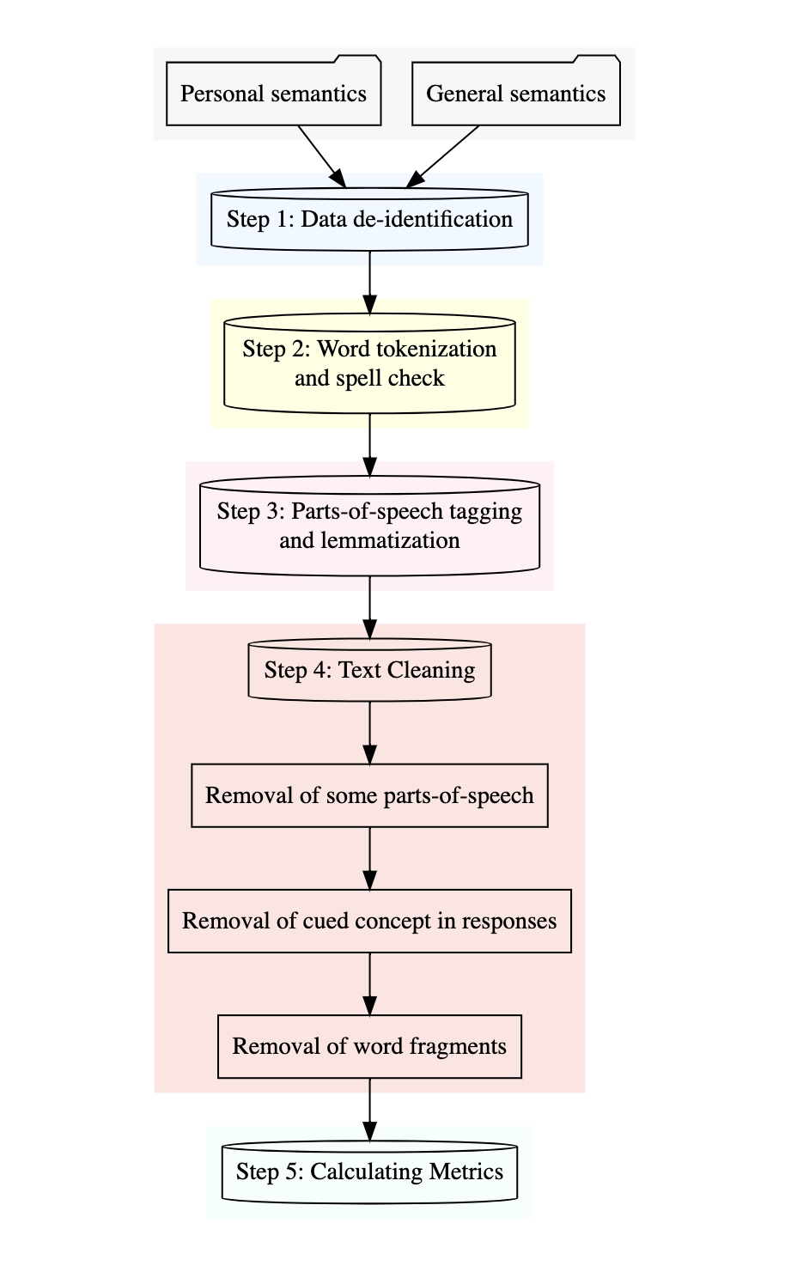
Note. In Step 1, we replaced identifying names with unique labels for each instance per participant (e.g., Name1, Store1, City1). In Step 2, tokenization separated text into word units, which were spell checked using Hunspell (Joroen Ooms and Authors of libhunspell, 2020). De-identified and corrected responses were used in all analyses of the paper. In Step 3, TreeTagger (Schmid, 1994) tagged parts-of-speech and put the features in their lemma form (e.g., beaches [noun] -> beach, relaxing [verb] -> relax). In Step 4, we removed the cued concept from the responses (e.g., “friends are helpful” for the concept “friend” would get “friends” removed; i.e., friend cannot be a feature of friend), word fragments on the last lines, and parts-of-speech that convey little meaning: determiner, possessive, existential, symbol, punctuation, predeterminer, conjunction, to, comma, listmarker, and full stop. In Step 4, we computed the following key metrics: number of features, idiosyncratic features, distinguishing features, cosine similarity, and number of parts-of-speech. The steps required the following packages: stringi (Gagolewski, 2021), tokenizers (Mullen et al., 2018), koRpus (Michalke, 2021), koRpus.lang.en (Michalke, 2020), and other versatile R packages cited in text. The figure was prepared using DiagrammeR (Iannone, 2023).
Additionally, the number of features was scored by two raters. One was a research assistant who was naïve to our research question, hypotheses, and methods, and the other was KT. We tested consistency on single measures using the irr package (Gamer et al., 2019) and a two-way model. A feature was an element of the concept, conveying unique meaning about the concept (see Table 3 for examples). Strict repetitions of previously mentioned features and the concept itself did not count, but scorers included semantic errors (e.g., an orange is a vegetable) and events as features. Semantics errors were included because accuracy could not be verified for the PS condition. Hence, features reflect a person’s knowledge about a concept regardless of accuracy. We assessed agreement using pilot data (n = 10 participants) and a random subset of the included data (n = 22 participants). Agreement for the average number of features per participant was excellent, ICC(C,1) = 0.98, CI 95% [0.95, 0.99]. The high ICC suggests that prior knowledge of the study minimally influenced the second rater. The scoring aimed to offer converging evidence to the bag-of-word approach, which had the advantage of being free from bias due to researcher expectations or awareness of distinct responses.
Scorers further indicated whether features were intrusions, such that participants generated personal features in the GS condition. We assumed that participants followed the instructions, unless the features clearly suggested otherwise. For example, “my job is the worst” for the concept “job” would unambiguously be personal and an intrusion for the GS condition, whereas “most people like a big bed” would be general and an intrusion for the PS condition. Single measure agreement on the number of intrusions per participant was acceptable, ICC(C,1) = 0.67, CI 95% [0.43, 0.83].

Table 3
Examples of Scored Features
ID | Group | Concept | Feature | Intrusion
36 | GS | birthday | Everyone has one (1 feature) | No
60 | PS | birthday | on my birthday, my family (1 feature) gathered (1 feature) to have a party (1 feature). | No
21 | GS | friend | can be human (1 feature) or animal (1 feature) | No
147 | PS | friend | gamers (1 feature) | No
112 | GS | boss | Man, is there anything positive to say about my boss? (1 feature) | Yes
179 | PS | boss | Has a big heart (1 feature) | No
Note. For a participant ID, Group (GS = General semantics, PS = Personal semantics), and concept, the number of scored features on a line, and whether it was scored as an intrusion.

Further, we calculated semantic distance with the Text package (Kjell et al., 2023), first obtaining word embeddings using the RoBERTa model (roberta-base), an improvement on BERT models (Liu et al., 2019). Next, we computed the semantic distance from one line of response to the next line using the textDistance function with the Euclidean method, after the embeddings were centered and scaled. Higher values indicate higher semantic distance. This analysis diverged from pre-registration because SemDis (Beaty & Johnson, 2021) requires that the cue is a single word. Further, we only calculated semantic distance from line-to-line because previous analyses of Study 1 data suggested semantic distance from concept-to-line produced equivalent results.
Study 2
This study used only the bag-of-words approach due to this measure obtaining a high correlation with manual scoring in Study 1 (see Total Number of Features in the main results section). The pipeline was identical. One researcher (AFNT) singled out all PS intrusions in the GS responses, which two other researchers (PSRD, LR) verified. There were no GS intrusions in the PS condition. This approach to verification of intrusion was intended to preserve a maximum of data.

Data Analysis
Study 1
We conducted analyses in R (R Core Team, 2021), using papaja (Aust & Barth, 2020), knitr (Xie, 2015), english (Fox et al., 2021), lme4 (Bates et al., 2015), dplyr (Wickham et al., 2021), tidyr (Wickham, 2021), tidyverse (Wickham et al., 2019), and effectsize (Ben-Shachar et al., 2020, and additional packages cited in text) to create a reproducible manuscript.
For main analyses, we used mixed effects regression models that predicted the dependent variable of interest (e.g., number of features generated) as a function of condition (effect coded; GS = -0.5, PS = 0.5) with a linking function appropriate to the data structure (log for count data and logit for binary data). The random effects structure was determined using the Buildmer package in R (Voeten, 2023) which identifies the largest possible regression model that will converge and uses stepwise elimination to find the most parsimonious model based on information criteria. The maximal model included random intercepts for participant, concept, and subset of concepts and random slopes for condition by concept and subset of concepts. To interpret significant coefficients, we used incidence rate ratio for log-linked regressions and odds ratios for logit-linked binomial regressions.
We calculated cosine similarity using the lsa package (Wild, 2022) to obtain a metric of the conditions’ similarity in terms of the frequency of features generated for a given concept. The calculation compared GS and PS in terms of the frequency with which a feature was named across all participants of that sample, and this was done for all of the features generated in either condition, while accounting for the total number of features in each condition. In text-based applications, cosine similarity can range from 0 (no similarity) to 1 (perfect similarity).
Additional analyses on participant experience and task performance compared the GS and PS with t-tests for data meeting assumptions of parametric tests and the Wilcoxon rank sum test with continuity correction in other cases. For parametric tests, we brought univariate outliers closer to the mean at z = 3.00 (using winsorZ, Pagliaccio, 2021) and excluded bivariate outliers for Pearson correlations determined with the Mahalanobis distance (p < .01; see preregistration).
Study 2
The modifications to the design led to a few adaptations to the analyses. First, we omitted the subset of concepts as a random effect because of the random selection of concepts in Study 2. Second, we were able to add random slopes of condition by participant due to the within-subject design. The maximal models included random intercepts for participant, concept, task order (GS first, PS first), and random slopes for condition by participant, condition by concept, and condition by task order.

Results

Confirmatory Analyses
Total Number of Features
Study 1. We examined the number of features produced by participants in the GS and PS conditions, first using a bag-of-words approach and then using the manually scored data. The models included random intercepts for participant and concept. Using the bag of words approach, we found a significant effect of condition $\hat{β}=0.26$, 95% CI $\left[0.15,0.37\right]$, $z=4.67$, $p<.001$ (see Figure 3a); participants produced approximately 1.30 times as many features in the PS (M number of features = 20.26; SE = 0.84) as in the GS condition (M = 15.24; SE = 0.55). Similarly, there was a significant effect of condition using the manually scored data $\hat{β}=0.10$, 95% CI $\left[0.01,0.19\right]$, $z=2.14$, $p=.032$; participants produced approximately 1.11 times as many features in the PS (M number of features = 14.05; SE = 0.49) as in the GS (M = 12.61; SE = 0.42) condition when data were scored manually.
A Pearson correlation showed a strong positive relation between the mean number of features (averaged across concepts for each participant) that were obtained using the bag-of-words approach and manual scoring, $r=.89$, 95% CI $\left[.87,.92\right]$, $t\left(231\right)=30.37$, $p<.001$. However, the rules of manual scoring signify that pronouns, prepositions, and modal verbs were unlikely to be manually scored as a single feature. Their removal from the bag-of-words data yielded a stronger correlation with manually scored data, $r=.95$, 95% CI $\left[.93,.96\right]$, $t\left(230\right)=44.49$, $p<.001$, suggesting that the bag-of-words could be optimized to maximize the fit with manual scoring. Nevertheless, we retained all the processed data from the bag-of-words approach because of their potential semantic value. All subsequent analyses on features exploited the bag-of-words data.
Study 2. The model tested the effect of condition on the number of features estimated using the bag-of-word approach. The model included random intercepts for participant and concept, and random slopes of condition by participant. We found a significant effect of condition $\hat{β}=0.16$, 95% CI $\left[0.11,0.21\right]$, $z=5.93$, $p<.001$ (see Figure 3b); participants produced 1.17 times as many features in the PS (M number of features = 23.27; SE = 0.92) as in the GS condition (M = 20.19; SE = 0.85).

Figure 3
Total Number of Features Per Concept
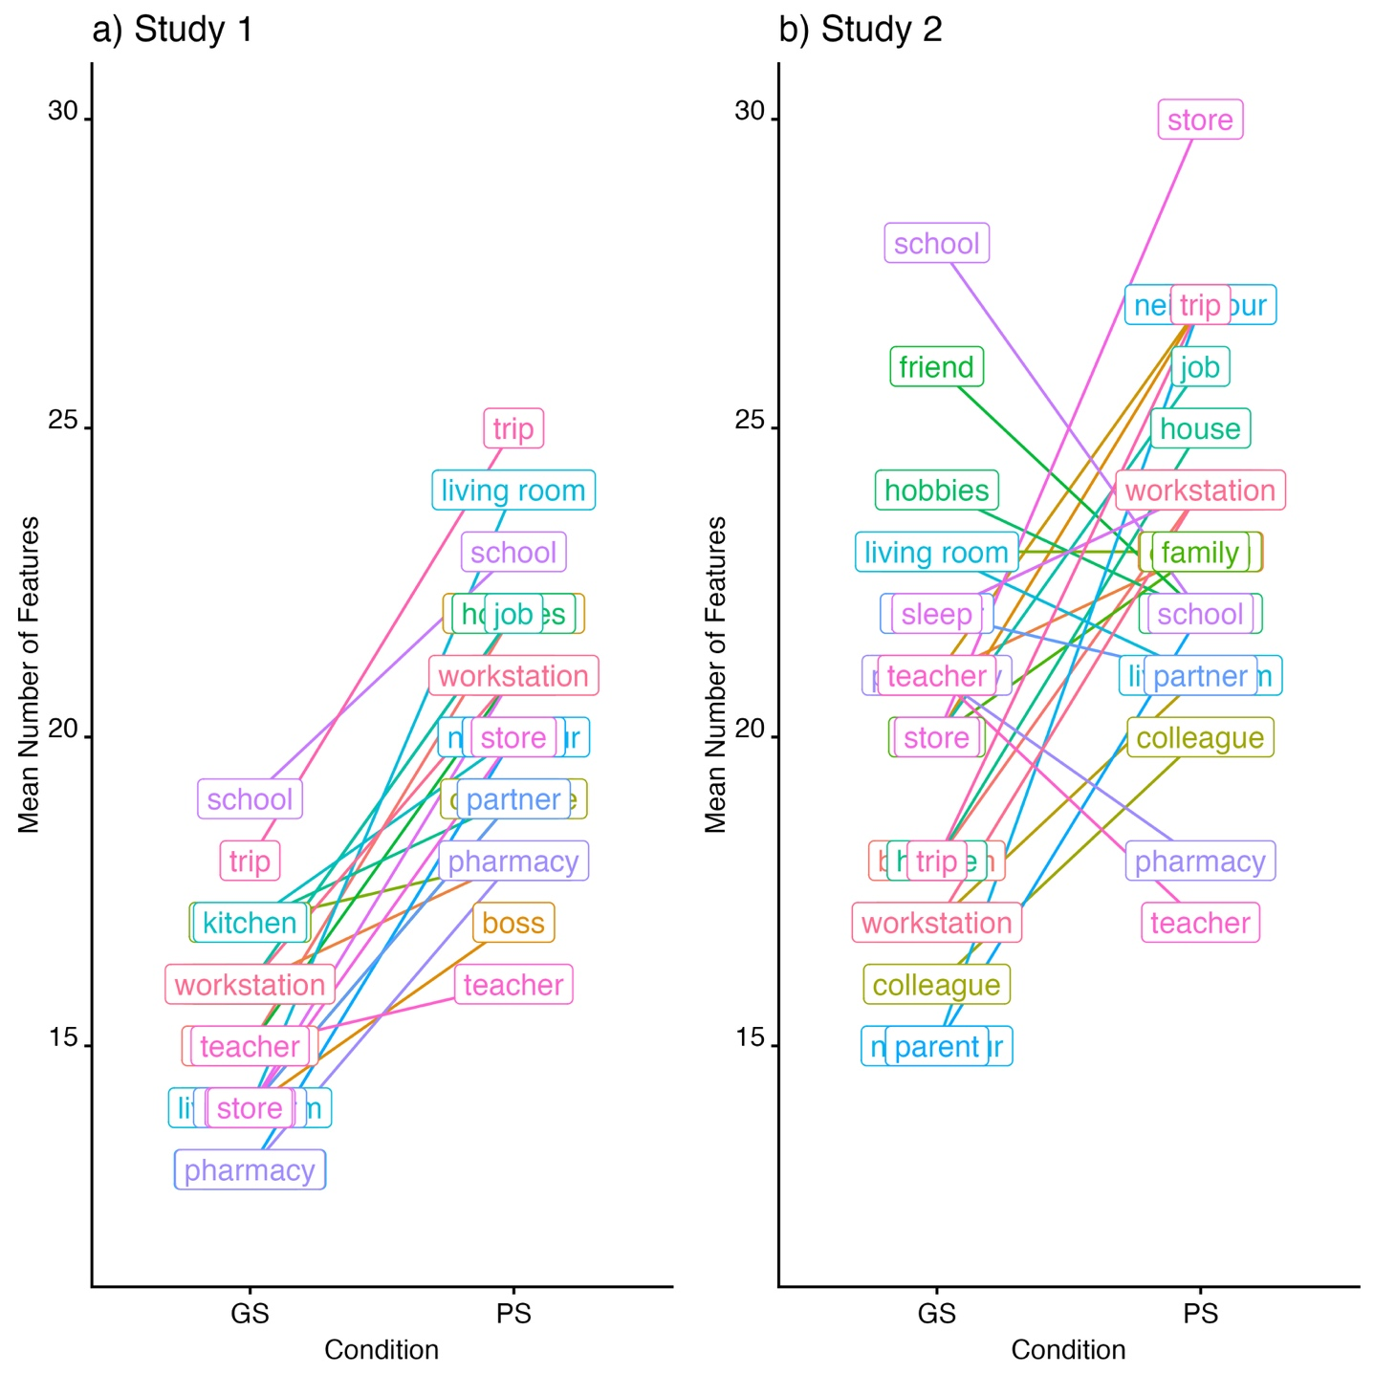
Note. This figure shows the mean number of features counted using the bag-of-words approach for a) Study 1 (GS: M = 15.24; SE = 0.55; PS: M = 20.26; SE = 0.84) and b) Study 2 (GS: M = 20.19; SE = 0.85; M = 23.27; SE = 0.92). A line links each concept between the two conditions (GS left, PS right). The figure was prepared using the ggplot2 (Wickham, 2016) and Scales (Wickham & Seidel, 2022) packages.
Number of Shared and Idiosyncratic Features (Across Participants)
Study 1. When only a small subset of the sample (i.e., 16% or less, based on Buchanan et al., 2020; McRae et al., 2005) generate a feature for a concept, these are labelled “idiosyncratic features”, whereas more frequent features are labelled “shared features” (based on Buchanan et al., 2020; McRae et al., 2005). As an example that applies to both conditions in this study, “sleep” was a shared feature of bedroom because it was named by more than 16% of participants (in that condition), and “book” was an idiosyncratic feature of bedroom because it was named by 16% or less of the participants (in that condition; see Figure 4). We examined the probability that participants produced an idiosyncratic feature (idiosyncratic = 1, shared = 0) as a function of condition, with a random intercept for concept. Contrary to expectation, there was no significant effect of condition, $\hat{β}=0.07$, 95% CI $\left[-0.06,0.21\right]$, $z=1.06$, $p=.290$, indicating that the probability of participants producing an idiosyncratic feature did not significantly differ between the PS (M proportion of idiosyncratic features = 0.94; SE = 0.00) and GS (M = 0.93; SE = 0.01) conditions.
Study 2. The equivalent model on idiosyncratic features included a random intercept for concept, and random slopes for condition by concept. The effect of condition was not significant (as in Study 1) but approached significance, $\hat{β}=0.18$, 95% CI $\left[-0.01,0.37\right]$, $z=1.89$, $p=.059$, in the originally predicted direction of higher idiosyncratic features for PS (M proportion of idiosyncratic features = 0.87; SE = 0.01) than GS (M = 0.85; SE = 0.01).
Figure 4
Top Features Per Condition
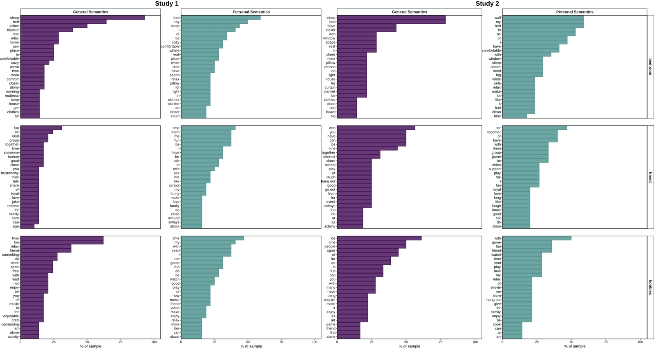
Note. The 25 most frequent features per condition (Study 1 left and Study 2 right) for three concepts: bedroom, friend, and hobbies. The x axis shows the percentage of the sample who listed the feature. Features with 16% or less would be considered “idiosyncratic” features. The figure was prepared using the ggplot2 (Wickham, 2016), tidytext (Silge & Robinson, 2016), forcats (Wickham, 2021), and ggpubr (Kassambara, 2020) packages.
Number of Distinguishing Features (Across Concepts).
Study 1. Idiosyncratic features are assessed relative to their overall frequency in a sample. Distinguishing features are instead categorized based on their occurrence across concepts (McRae et al., 2005). For example, the feature “sanctuary” was only named for the concept “bedroom”, making it a distinguishing feature of bedroom in this dataset (this was true in both conditions coincidentally). In comparison, many concepts shared the feature “love” (e.g., family, cooking, bedroom) and so the feature “love” was less useful to distinguish concepts (again in both conditions, though correspondence between conditions did not need to happen necessarily). Due to the small number of concepts, we considered features named for a single concept as distinguishing features (as opposed to one or two concepts in McRae et al., 2005). We examined the probability that participants produced a distinguishing feature (distinguishing = 1, non-distinguishing = 0) as a function of condition, with a random intercept for concept. There was a significant effect of condition, $\hat{β}=-0.26$, 95% CI $\left[-0.34,-0.17\right]$, $z=-6.19$, $p<.001$; participants were only 77.43% as likely to produce a distinguishing feature in the PS (M proportion of distinguishing features = 0.20; SE = 0.01) compared to the GS (M = 0.25; SE = 0.01) condition.
Study 2. The model examined the probability that participants produced a distinguishing feature as a function of condition, with a random intercept for concept. There was a significant effect of condition, $\hat{β}=-0.10$, 95% CI $\left[-0.19,0.00\right]$, $z=-2.07$, $p=.039$; participants were only 90.82% as likely to produce a distinguishing feature in the PS (M proportion of distinguishing features = 0.24; SE = 0.01) compared to the GS (M = 0.26; SE = 0.01) condition. As in Study 1, concepts had greater overlap in their features in the PS than GS condition.

Semantic Distance.
Study 1. In this analysis, we tested whether conditions differed on their semantic distance line-to-line, with random intercepts for participant and concept, and random slopes of condition by concept. Higher values indicate higher semantic distance. There was a significant effect of condition on semantic distance, $\hat{β}=0.63$, 95% CI $\left[0.47,0.79\right]$, $t\left(165.33\right)=7.77$, $p<.001$. Compared to the GS (M semantic distance = 7.09, SE = 0.06) condition, features generated in the PS (M semantic distance = 7.74, SE = 0.05) condition had a line-to-line semantic distance that was greater by a magnitude of 0.63 on average (see Figure 5a).
Study 2. This model had random intercepts for participant and concept, and random slopes of condition by participant. There was a significant effect of condition on semantic distance, $\hat{β}=0.22$, 95% CI $\left[0.10,0.34\right]$, $t\left(96.94\right)=3.54$, $p<.001$. Compared to the GS (M semantic distance = 7.72, SE = 0.07) condition, features generated in the PS (M semantic distance = 7.94, SE = 0.06) condition had a line-to-line semantic distance that was greater by a magnitude of 0.22 on average (see Figure 5b).

Figure 5
Semantic Distance
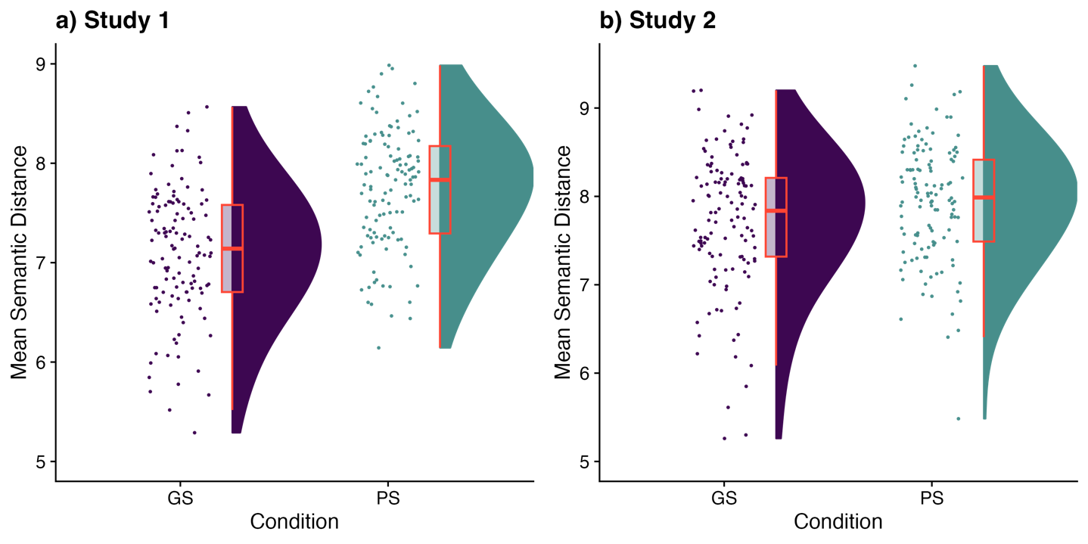
Note. The mean semantic distance grouped by condition (GS and PS) for a) Study 1 (GS: M = 7.09, SE = 0.06; PS: M = 7.74, SE = 0.05) and b) Study 2 (GS: M = 7.72, SE = 0.07; PS: M = 7.94, SE = 0.06). The rain represents individual data points (jittered), whereas the cloud displays the distribution and has the boxplot overlaid in orange. The plot was prepared using the raincloudplots package (Allen et al., 2021) with a theme from the cowplot (Wilke, 2020)
Self-reported Recollection During Property Generation.
Study 1. The self-reported frequency of recollection of events was similar between conditions regardless of event type: unique events (GS: M = 2.37, SE = 0.08, PS: M = 2.23, SE = 0.07), $ΔMdn=0.17$, 95% CI $\left[0.00,0.33\right]$, $W=7,878.00$, $p=.207$; repeated events (GS: M = 2.99, SE = 0.07, PS: M = 3.10, SE = 0.07), $ΔMdn=-0.17$, 95% CI $\left[\text{-0.33,0.17}\right]$, $W=6,634.00$, $p=.292$, and extended events (GS: M = 2.30, SE = 0.07, PS: M = 2.42, SE = 0.07), $ΔMdn=-0.17$, 95% CI $\left[-0.33,0.17\right]$, $W=6,602.50$, $p=.266$ (see Table 4). The means ranged approximately from 2 to 3, signifying participants were aware of having recalled personal events “sometimes” to “half the time” in both conditions.
When participants thought of repeated events during the features task, these were less detailed in the GS (M = 3.25, SE = 0.08) than in the PS condition (M = 3.50, SE = 0.07), $ΔMdn=-0.20$, 95% CI $\left[-0.47,0.00\right]$, $W=6,013.50$, $p=.035$. The two conditions did not differ in the amount of details for unique events (GS: M = 3.16, SE = 0.08; PS: 3.32, SE = 0.07), $ΔMdn=-0.17$, 95% CI $\left[-0.33,0.03\right]$, $W=5,932.50$, $p=.180$, nor extended events (GS: M = 3.13, SE = 0.08; PS: 3.27, SE = 0.07), $ΔMdn=-0.17$, 95% CI $\left[-0.33,0.03\right]$, $W=6,093.00$, $p=.215$.
Study 2. Participants reported they thought more frequently about extended events in the PS (M = 2.52, SE = 0.10) than the GS (M = 2.27, SE = 0.09) condition, ${Mdn}^{*}=-0.33$, 95% CI $\left[-0.50,-0.17\right]$, $V=1,809.00$, $p=.004$. Participants also thought more frequently about unique events in the PS (M = 2.70, SE = 0.09) than GS condition (M = 2.51, SE = 0.09), ${Mdn}^{*}=-0.17$, 95% CI $\left[-0.50,0.00\right]$, $V=2,107.50$, $p=.015$. The difference between PS and GS in the frequency of repeated events was in the same direction and approached statistical significance (PS: M = 3.30, SE = 0.09; GS: M = 3.11, SE = 0.09), ${Mdn}^{*}=-0.17$, 95% CI $\left[-0.50,0.00\right]$, $V=2,057.00$, $p=.057$. The means were approximately in the 2 to 3 range as in Study 1.
The next set of analyses only included participants who reported having thoughts about events of a particular category (i.e., unique, extended, repeated) in both conditions. One hundred eleven participants thought of unique events on at least one trial in both conditions. For those, we averaged across all trials within a condition that had a rating. The unique events had greater details in the PS (M = 3.74, SE = 0.08) than GS condition (M = 3.39, SE = 0.08), ${Mdn}^{*}=-0.42$, 95% CI $\left[-0.67,-0.25\right]$, $V=1,130.50$, $p<.001$. Similarly, the 100 participants who reported thinking of extended events in both conditions indicated those events were more detailed in the PS (M = 3.50, SE = 0.09) than GS (M = 3.30, SE = 0.07) condition, ${Mdn}^{*}=-0.33$, 95% CI $\left[-0.50,0.00\right]$, $V=995.50$, $p=.015$. Lastly, the 120 participants who thought of repeated events in both conditions had events that were more detailed for the PS (M = 3.65, SE = 0.09) than GS condition (M = 3.48, SE = 0.08), ${\text{Mdn}}^{\text{*}}\text{=-0.17}$, 95% CI $\left[-0.42,0.00\right]$, $V=2,054.50$, $p=.040$. Together, the two studies suggest memory representations were more detailed for the PS than GS condition, but effects were not perfectly consistent per event category.
Table 4
Mean (SE) for Participants’ Self-report
 | Study 1 |  |  | Study 2
Variable | GS | PS |  | GS | PS
Unique events frequency | 2.37 (0.08) | 2.23 (0.07) |  | 2.51 (0.09) | 2.70 (0.09)
Repeated events frequency | 2.99 (0.07) | 3.10 (0.07) |  | 3.11 (0.09) | 3.30 (0.09)
Extended events frequency | 2.30 (0.07) | 2.42 (0.07) |  | 2.27 (0.09) | 2.52 (0.10)
Unique events details | 3.16 (0.08) | 3.32 (0.07) |  | 3.39 (0.08) | 3.74 (0.08)
Repeated events details | 3.25 (0.08) | 3.50 (0.07) |  | 3.48 (0.08) | 3.65 (0.09)
Extended events details | 3.13 (0.08) | 3.27 (0.07) |  | 3.30 (0.07) | 3.50 (0.09)
Personal significance | 3.19 (0.07) | 3.35 (0.07) |  | 3.20 (0.08) | 3.40 (0.08)
Emotion Intensity | 3.06 (0.06) | 3.22 (0.06) |  | 2.98 (0.07) | 3.31 (0.07)
Task difficulty | 2.99 (0.09) | 3.02 (0.09) |  | 2.55 (0.10) | 2.45 (0.09)
Effort | 4.47 (0.11) | 4.67 (0.09) |  | 4.62 (0.08) | 4.62 (0.08)
Note. M (SE). Significant tests at p < .05 in bold.

Descriptive and Exploratory Analyses
Similarity of Features Between Conditions
Study 1. We calculated cosine similarity using the lsa package (Wild, 2022) to obtain an estimate of features’ similarity between GS and PS for each concept. Calculations were performed on vectors representing the frequency of each feature per condition across all participants. For example, the vectors included the number of times participants named “love” as a feature of “family” in GS and PS, and so on for each feature of either condition (see Table 5). We subsampled participants randomly to obtain an equal number of participants in each subgroup (condition/subset of concepts, 8 subgroups, n = 27), and lowered the n to 26 to obtain a number divisible by two. A random selection of half (n = 13) of each subgroup were then attributed to either a “Group 1” or “Group 2” for each condition. This approach ensured the comparison of each concept would be based on the same number of participants, and allowed within-group comparisons that offer a benchmark for the comparison of two groups (but in this case completing the same task). The same subgroups were also used in the between-group comparisons to offer better comparability (e.g., the same sample size).
Table 5
Lemma Frequency per Condition for the Concept ‘Family’
lemma | GS | PS
brother | 14 | 4
care | 8 | 7
child | 6 | 0
holiday | 2 | 5
home | 10 | 4
love | 10 | 15
parent | 15 | 5
sister | 12 | 5
small | 2 | 6
time | 2 | 6
together | 9 | 5
business | 0 | 1
Note. This table includes 12 out of 453 lemmas generated in either condition for the concept ‘family’ in Study 1. The table illustrates the creation of vectors with the frequencies of lemmas, which is the basis for calculating cosine similarity.

The mean cosine similarity of all concepts was 0.47 (SD = 0.08; ranging from 0.25 for cleaning to 0.61 for birthday) for subgroup 1 (GS vs. PS) and 0.44 (SD = 0.09; ranging from 0.26 for partner to 0.61 for birthday) for subgroup 2 (GS. vs. PS), whereas it was 0.61 (SD = 0.11; ranging from 0.42 for cleaning to 0.85 for birthday) when comparing subgroups of GS, and 0.62 (SD = 0.09; ranging from 0.40 for boss to 0.75 for living room) for PS subgroups. Therefore, feature similarity was lower between conditions than within conditions (see Figure 6a for values per concept).
Study 2. The concept with the smaller number of participants for a given condition had 11 participants. Consequently, we subsampled participants randomly to obtain 11 participants per concept and per condition. The comparison between conditions necessarily included distinct participants due to the completion of a concept within a single condition, yielding an analogous comparison of conditions as Study 1. Study 2 produced similar indices of overlap in features across conditions as in Study 1. That is, the mean cosine similarity of all concepts was 0.48 (SD = 0.08; ranging from 0.27 for living room to 0.63 for birthday; see Figure 6b). We take findings of Study 1 as a benchmark for a comparison of concepts within a condition (~0.60) due to the low number of participants per concept within a condition.

Figure 6
Cosine Similarity Per Concept
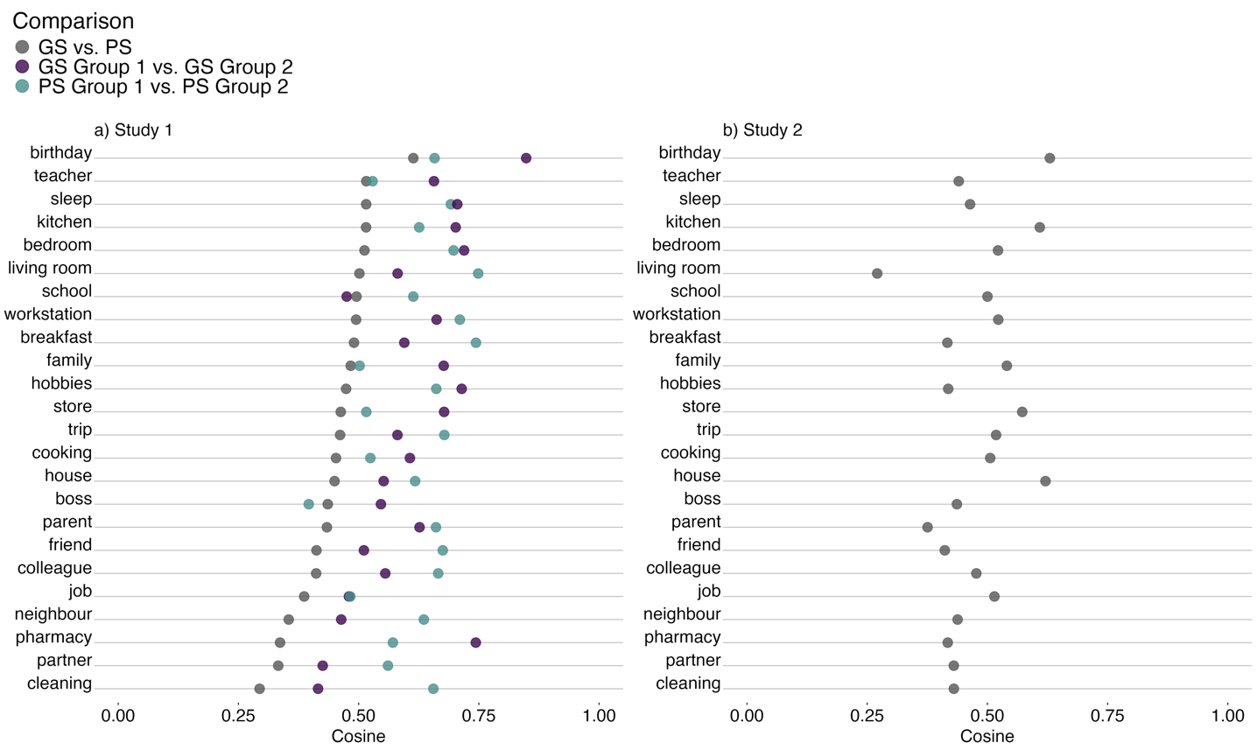
Note. Cosine similarity comparing the features of GS and PS in grey for a) Study 1 (subgroup 1 and subgroup 2 averaged), and b) Study 2, and for Study 1 on panel a within the GS group is shown in purple, and within the PS group is shown in blue. GS within and PS within overlap almost fully for “job” (in panel a). The higher cosine similarity score for the concept of birthday (0.61) vs. cleaning (0.29) in panel a indicates that the features participants generated in the GS and PS conditions were more similar to one another in their frequencies of occurrence for birthday than they were for cleaning. The figure was prepared using the ggplot2 (Wickham, 2016) package.
Parts-of-Speech.
Study 1. We examined the probability that participants produced features that were nouns, verbs, adjectives, prepositions, and infrequent parts of speech (i.e., mean frequency < 5%, which included interjections, foreign words, names, numbers, modals, pronouns, and adverbs) as a function of condition. Each of these dependent variables was converted to a binary format (e.g., noun = 1, all other parts of speech = 0). All models included a random intercept for participant. Additionally, the verb and preposition models had a random intercept for concept, and the verb model also had a random intercept for the subset of concepts. The noun, adjective, and infrequent parts-of-speech models added a random slope of condition by concept, with the infrequent parts-of-speech model further adding a random slope of condition by subset of concepts. There was a significant effect of condition on the probability of producing a feature that was a noun, $\hat{β}=-0.91$, 95% CI $\left[-1.07,-0.75\right]$, $z=-11.17$, $p<.001$; participants were only 40.40% as likely to produce a noun in the PS (M percentage of features = 37.38%; SE = 1.21) compared to the GS (M = 58.88%; SE = 1.26) condition (see Figure 7a, see Table 6). There was a significant effect of condition on the probability of producing a feature that was a verb, $\hat{β}=0.34$, 95% CI $\left[0.20,0.47\right]$, $z=4.94$, $p<.001$; participants were 1.40 times more likely to produce a verb in the PS (M percentage of features = 19.12%; SE = 0.68) compared to the GS (M = 14.45%; SE = 0.67) condition. There was also a significant effect of condition on the probability of producing a feature that was an adjective, $\hat{β}=0.31$, 95% CI $\left[0.12,0.49\right]$, $z=3.20$, $p=.001$; participants were 1.36 times more likely to produce an adjective in the PS (M percentage of features = 23.56%; SE = 1.14) compared to the GS (M = 17.59%; SE = 0.81) condition. Further, there was a significant effect of condition on the probability of producing a feature that was a preposition, $\hat{β}=0.64$, 95% CI $\left[0.44,0.84\right]$, $z=6.26$, $p<.001$; participants were 1.90 times more likely to produce a preposition in the PS (M percentage of features = 6.63%; SE = 0.38) compared to the GS (M = 3.94%; SE = 0.33) condition. Lastly, there was a significant effect of condition on the probability of producing a feature that was another infrequent part of speech, $\hat{β}=1.17$, 95% CI $\left[0.89,1.44\right]$, $z=8.23$, $p<.001$; participants were 3.21 times more likely to produce an other infrequent part of speech in the PS (M percentage of features = 13.31%; SE = 0.76) compared to the GS (M = 5.15%; SE = 0.48) condition.
Study 2. We examined the probability that participants produced features that were nouns, verbs, adjectives, prepositions, and infrequent parts of speech as a function of condition. All models included a random intercept for participant. Additionally, the noun, adjective, verb, and infrequent parts-of-speech models included a random slope of condition by participant, and a random intercept for concepts. The infrequent parts-of-speech model further added a random slope of condition by concepts. As in Study 1, there was an effect of condition on the probability of producing a feature that was a noun, $\hat{β}=-0.45$, 95% CI $\left[-0.56,-0.34\right]$, $z=-7.85$, $p<.001$; participants were only 63.68% as likely to produce a noun in the PS (M percentage of features = 36.38%; SE = 1.20) compared to the GS (M = 46.97%; SE = 1.61) condition. Condition also had an effect on the probability of producing a feature that was an adjective, $\hat{β}=0.18$, 95% CI $\left[0.05,0.30\right]$, $z=2.77$, $p=.006$; participants were 1.20 times more likely to produce an adjective in the PS (M percentage of features = 17.48%; SE = 0.85) compared to the GS (M = 14.65%; SE = 0.76) condition. Moreover, there was a significant effect of condition on the probability of producing a feature that was an infrequent part of speech, $\hat{β}=0.66$, 95% CI $\left[0.46,0.87\right]$, $z=6.44$, $p<.001$; participants were 1.94 times more likely to produce an infrequent part of speech in the PS (M percentage of features = 17.65%; SE = 0.91) compared to the GS (M = 10.58%; SE = 0.76) condition. Unlike in Study 1, there was no significant effect of condition on the probability of producing a feature that was a verb, $\hat{β}=-0.02$, 95% CI $\left[-0.12,0.07\right]$, $z=-0.49$, $p=.624$, or a preposition, $\hat{β}=0.06$, 95% CI $\left[-0.03,0.16\right]$, $z=1.29$, $p=.197$ (see Figure 7b, see Table 6).
Figure 7
Proportion of Parts-of-speech
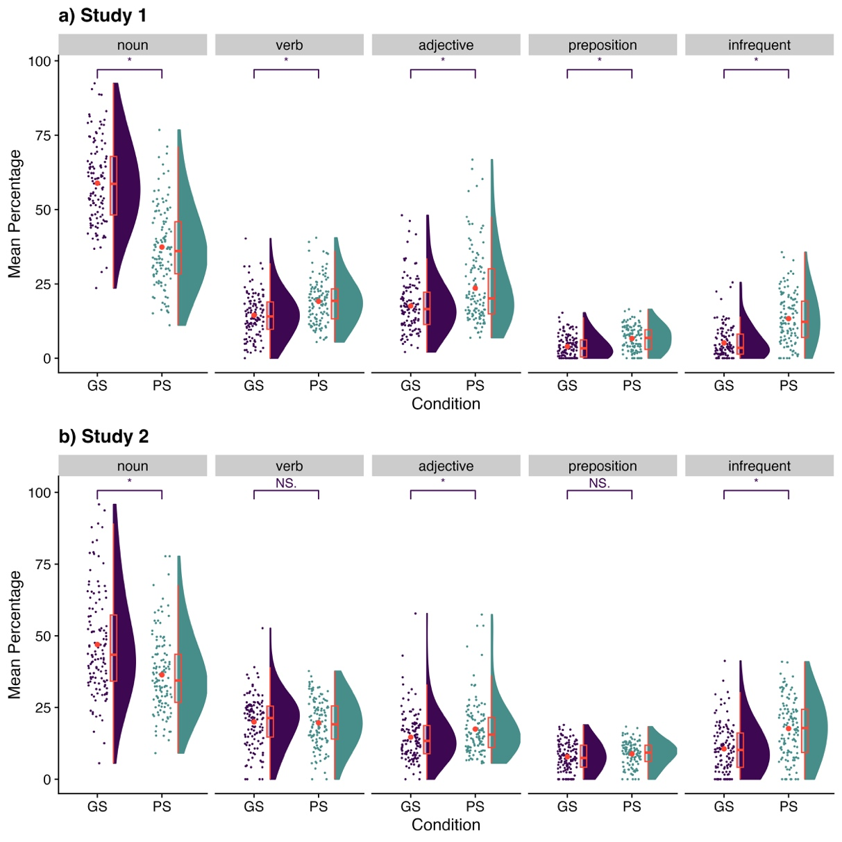
Note. Raincloud plot showing the percentage of parts-of-speech (number of features classified as a parts-of-speech relative to the total number of features for that concept) averaged across all concepts (y axis), per condition (x axis, GS in blue, PS in pink), and broken into the parts-of-speech categories (panels), for a) Study 1 and b) Study 2. Infrequent parts of speech included: interjection, foreign, name, number, modal, pronoun, and adverb. The rain represents individual data points (jittered), whereas the clouds display the distribution of data, and have boxplots and a dot representing the mean overlaid in orange. The plot was prepared using the raincloudplots package (Allen et al., 2021) with a theme from the cowplot (Wilke, 2020) package. * p < .01.
Table 6
Mean (SE) for the Percentage of Parts-of-speech
 | Study 1 |  |  | Study 2
Variable | GS | PS |  | GS | PS
Nouns | 58.88 (1.26) | 37.38 (1.21) |  | 46.97 (1.61) | 36.38 (1.20)
Verbs | 14.45 (0.67) | 19.12 (0.68) |  | 19.98 (0.80) | 19.65 (0.74)
Adjectives | 17.59 (0.81) | 23.56 (1.14) |  | 14.65 (0.76) | 17.48 (0.85)
Prepositions | 3.94 (0.33) | 6.63 (0.38) |  | 7.82 (0.44) | 8.84 (0.37)
Infrequent | 5.15 (0.48) | 13.31 (0.76) |  | 10.58 (0.76) | 17.65 (0.91)
Note. M (SE). Significant tests at p < .05 in bold.

Personal Significance.
Study 1. The concepts did not differ in perceived personal significance between conditions (GS: M = 3.19, SE = 0.07, PS: M = 3.35, SE = 0.07), $ΔM=-0.15$, 95% CI $\left[-0.34,0.03\right]$, $t\left(238\right)=-1.62$, $p=.106$, Hedges’ g = -0.21, 95% [-0.46, 0.04] (see Table 4).
Study 2. Participants perceived the concepts had higher personal significance in the PS (M = 3.40, SE = 0.08) than GS condition (M = 3.20, SE = 0.08), ${Mdn}^{*}=-0.17$, 95% CI $\left[-0.50,0.00\right]$, $V=2,146.50$, $p=.015$, in the expected direction.
Emotion Intensity
Study 1. Participants experienced a moderate intensity of emotion during the task in a comparable manner between conditions (GS: M = 3.06, SE = 0.06; PS: M = 3.22, SE = 0.06), $ΔM=-0.16$, 95% CI $\left[-0.34,0.02\right]$, $t\left(238\right)=-1.77$, $p=.078$, Hedges’ g = -0.23 95% [-0.48, 0.03] (see Table 4).
Study 2. Participants experienced emotions with a higher intensity in the PS (M = 3.31, SE = 0.07) than GS condition (M = 2.98, SE = 0.07), ${Mdn}^{*}=-0.33$, 95% CI $\left[-0.50,-0.17\right]$, $V=1,395.50$, $p<.001$.
Intrusions
Study 1. This analysis considered the presence of intrusions on a feature line rather than per feature for simplicity. For example, “parks in front of my house” counted as one intrusion for the concept “neighbour” (ID = 16) in the GS condition. The mean number of total intrusions per participant was low in the GS condition (M = 0.62, SE = 0.13) and there were none in the PS condition.
Study 2. The mean number of intrusions per participant did not differ between Study 1 and Study 2 (M = 0.71, SE = 0.17) for the GS condition as tested using a Wilcoxon text, $ΔMdn=0.00$, 95% CI $\left[0.00, 0.00\right]$, $W=7,199.00$, $p=.561$, and there were also no intrusions for the PS condition.
Trial Duration
Study 1. Participants spent a longer time on trials in the PS (M = 98.26 sec, SE = 1.96) than GS condition (M = 90.87 sec, SE = 2.34), $ΔMdn=-3.98$, 95% CI $\left[-11.79,-0.01\right]$, $W=6,052.00$, $p=.033$.
Study 2. Participants spent a similar time on trials when comparing conditions (GS: M = 98.98 sec, SE = 2.38; PS: M = 102.65 sec, SE = 2.04), ${Mdn}^{*}=-0.72$, 95% CI $\left[-4.51,0.05\right]$, $V=3,493.50$, $p=.342$.
Task Difficulty
Study 1. Participants could choose from 5 options to report how difficult they found the task (1 = extremely easy, 2 = somewhat easy, 3 = neither easy nor difficult, 4 = somewhat difficult, 5 = extremely difficult). Task difficulty was “neither easy nor difficult” on average and did not differ between GS (M = 2.99, SE = 0.09) and PS (M = 3.02, SE = 0.09), $ΔMdn=0.00$, 95% CI $\left[0.00,0.00\right]$, $W=6,185.50$, $p=.762$(see Table 4).
Study 2. Participants did not experience a different level of difficulty between conditions (GS: M = 2.55, SE = 0.10; PS: M = 2.45, SE = 0.09), ${Mdn}^{*}=0.00$, 95% CI $\left[0.00,1.00\right]$, $V=746.50$, $p=.275$, with means in the “somewhat easy” to “neither easy nor difficult” range.
Effort
Study 1. Participants rated their agreement with the statement “I completed the tasks to the best of my ability” from 1 (strongly disagree) to 5 (strongly agree). Participants in the GS (M = 4.47, SE = 0.11) and PS (M = 4.67, SE = 0.09) exerted a similar level of effort, with numbers suggesting they had done their best overall, $ΔMdn=0.00$, 95% CI $\left[0.00,0.00\right]$, $W=5,822.00$, $p=.148$ (see Table 4).
Study 2. Participants reported a similar level of effort between conditions (GS: M = 4.62, SE = 0.08; PS: M = 4.62, SE = 0.08, ${Mdn}^{*}=0.00$, 95% CI $\left[-1.00,1.00\right]$, $V=59.50$, $p>.999$.

Discussion
We adapted a tool that has been instrumental in advancing GS research, the Property Generation task, to explore the composition of concepts within GS and PS memory. The instructions, task format, and subjective experience of participants (i.e., level of effort, difficulty) were closely aligned between GS and PS. We ran two studies that included a total of 364 participants, one with a between-subject design where participants did either the GS or PS version, and one with a within-subject design where all participants did both versions. Study 2 also matched the GS and PS examples in the number of words, features and parts-of-speech. Across both studies, concepts in the PS condition were associated with more features and greater semantic distance feature-to-feature than GS, in accordance with our prediction that PS would recruit a larger and more diverse semantic network than GS at the concept level. Moreover, the features of GS had a higher proportion of nouns than PS, whereas PS had more adjectives and other parts-of-speech (i.e., pronouns, names, and numbers) than GS. Our data suggest that PS features are more descriptive, sensory, and attributed to people and objects, whereas GS features are more focused on entities (cf. De Deyne et al., 2015). PS appear more specific than their GS counterparts due to their greater number of details (for example “They never message me, but I never message them” in PS [ID 41]) vs. “Talk” in GS [ID 269] for the concept “friend”). Thus, some of the previously documented differences between GS and PS (e.g., Tanguay et al., 2023) may stem from enhanced relational processing for PS compared to GS, as much in terms of forming a quantitatively richer semantic representation as in terms of drawing from a diverse set of information (e.g., action-based, perceptual, social, event-related).
Despite the significant differences between GS and PS in both studies, GS and PS shared remarkable similarities overall. First, the comparison of features between conditions yielded a mean cosine similarity of approximately 0.46, a midway between total divergence (i.e., 0) and perfect overlap (i.e., 1) in the frequency of features. This could be interpreted as the dissimilarity between conditions being 0.54; however, even a comparison of features within two subsets of the same group did not produce perfect overlap. In fact, the between-groups cosine similarity was only lower than within-group comparisons by 0.15 on average. Hence, 0.46 likely reflects some of the intra- and inter-subject variability in feature generation (as discussed in Barsalou, 1993), as well as differences in the frequency of features between GS and PS that appear altogether smaller than expected.
The top features of PS shown in Figure 4 further illustrate some of the resemblance captured by the cosine similarity value. For example, the two conditions frequently had the following features for the concept “friend” for Study 1: fun, be, time, close, talk, share, of, love, and family; and for Study 2: with, have, be, time, together, play, of, laugh, good, for, group, game, fun, and do. A possible explanation for the overlap may be PS’s reliance on GS’s semantic features. For instance, “my dog” has four paws, sharp teeth, and hair like almost any other dog. PS features could build on these GS features to state “my dog has four big paws, he likes to bite my hands with his sharp teeth, he has soft and curly hair because he is a poodle, and so on.” Of course, PS may also inform GS feature generation, a position predicated on a grounded cognition view of semantic memory (Barsalou, 2020). This perspective highlights the role of personal experiences in shaping concepts, including experiences originating from perception, and the physical and social environment (Barsalou, 2020). Although GS could be perceived as more basic and generalized (and thus a prerequisite for PS), a mutual exchange is possible (and even likely). Nevertheless, flagrant intrusions of PS-type answers into the GS task, and vice versa, were quite rare in the present study. Informal enquiries to Dr Ken McRae and Dr. Melissa C. Duff about the responses obtained in their Property Generation tasks and inspection of raw responses online (https://osf.io/cjyzw/ from Buchanan et al., 2019) point to their participants’ usually good compliance with instructions and little-to-no PS contamination of GS responses (see also Klooster & Duff, 2015 about specific events). A within-subject design comparison of the same concepts and a think aloud procedure may be helpful to further delineate how GS and PS are related to, and potentially influence, one another, because an absence of clear intrusions does not rule out a mutual influence.
Unexpectedly, the two conditions were also similar in their frequency of idiosyncratic features (when accounting for their overall difference in number of features), though it approached significance in Study 2. PS, by definition, should be idiosyncratic, or unique to each person. However, idiosyncrasy may arise from the combination or conjunction of features rather than from the occurrence of individual features. In other words, when thinking about “my bedroom”, what is idiosyncratic (and personal) is not that it contains something “large”, something “blue”, and a “bed”, but that it contains a “large blue bed”. The importance of the combination or conjunction of features could help to explain the increased reliance on relational processing for PS versus GS. Indeed, the conjunction of features engages structures of the medial temporal lobes (Martin et al., 2018; Martin et al., 2023). In the future, a personalized selection of concepts would make for a solid test of the idiosyncrasy of PS features because in the present study we purposefully selected concepts that would be familiar and self-relevant to the population broadly (e.g., family, friends, bedroom), omitting concepts like cars, computers, and books. Nonetheless, there remains the possibility that the PS network may not be quite as idiosyncratic as would be initially expected, at least at the level of individual features. The role of personal experiences, as outlined in the grounded cognition perspective (Barsalou, 2020), may underlie some of the variability in feature generation, making both GS and PS fairly idiosyncratic. As another possibility, if shared features (e.g., the four paws, sharp teeth, and hair, in the example above) must be generated as groundwork before describing a concept in a personal way, the overall idiosyncrasy of PS features may be reduced. Altogether, these results are equally compatible with a role of the conjunction of features, a grounded cognitive perspective of semantics, and the dependence of PS on GS.
In this study, we considered an alternative explanation for an increase in features for PS and GS. Semantic richness could be inspired from the recollection of personal past events (e.g., “I went to a show last weekend” sparked the thought of “going to shows” as a feature for the concept of “hobby”) rather than depend on a component process like a domain-general relational binding. For example, Sheldon and Moscovitch (2012) found increased hippocampal activity for autobiographical categories and at later stages of a verbal fluency trial, when the responses became more open-ended and could benefit from episodic memory (see also Ryan et al., 2008; Hoscheidt et al., 2010; Viskontas et al., 2009). Further, some behavioral and neural findings on PS can be interpreted as reflecting a privileged interaction with episodic memory (Coronel & Federmeier, 2016; Renoult et al., 2016; Sheldon et al., 2020; Tanguay et al., 2022, 2023). Accordingly, PS could have increased the likelihood of evoking personal events in our participants, which would in turn have facilitated the generation of features. This proximity of PS to episodic memory was equivocal in Study 1, but emerged in Study 2, possibly due to the higher statistical power of within-subject designs. In Study 2, participants reported a higher frequency of extended events and unique events for PS than for GS, and effects were marginally significant in the expected direction for repeated events. Further, participants reported that their event representations were more detailed in the PS than GS condition when thinking of repeated events (Study 1 and Study 2), unique events (Study 2), and extended events (Study 2). Consequently, the activation of related events and their greater level of detail in the PS as compared to the GS condition may have enhanced feature generation, at least partly, in addition to the common reliance on relational processing. However, both PS and GS conditions did provoke thoughts about events in the “sometimes” to “half the time” range, suggesting that a role for recall of events may not be specific to PS. PS and GS appear to draw from the same pool of autobiographical knowledge and experiences, perhaps because autobiographical memory is integral to comprehension (Mace, 2023; Sui & Humpreys, 2015).
The GS condition was associated with more distinguishing features than the PS condition, which indicates that concepts shared more features in the PS than GS condition. In other words, we observed greater semantic richness for PS than GS at the concept level (i.e., number of overall features, semantic distance), but not across concepts (i.e., number of distinguishing features). On the one hand, the redundancy across concepts follows reason if the self (including one’s life) permeates all PS knowledge. Concretely, this would mean that a person could say: I have a family with my partner; one of my hobbies is to watch movies with my partner; my partner often leaves their socks on the floor in our bedroom, etc. We bolded the concept and italicized the common feature, but note also the commonality in pronouns. Because partner was named in each of the concepts in this example, it would be a distinguishing feature of none. On the other hand, the result regarding distinguishing features challenges the notion that PS could be a more comprehensive version of the traditional semantic memory network (inspired by the importance of the self as argued in Conway et al., 2019; Sui & Humphreys, 2015), and thus richer. Nevertheless, all concepts tested in the present studies were concrete (e.g., breakfast, living, family; see Supplementary Material), and the extent of the network could plausibly vary with a greater range of concepts, including some that are more abstract such as “love” or “self”. Thus, a next step may be to vary the level of abstraction of concepts to establish the depth and breadth of the GS and PS network(s).
Notably, the taxonomy of PS distinguishes abstract forms of knowledge like personality traits from autobiographical facts (Renoult et al., 2012). For example, self-knowledge of traits can be impaired when other types of personal knowledge appear preserved (Grilli et al., 2018; Grilli & Verfaellie, 2014, 2016; Marquine et al., 2016; Stendardi et al., 2023; Wank et al., 2021). However, greater abstraction would imply a greater departure from the traditional Property Generation task. For example, how would one list features for being kind or respond to an “I am” prompt in a way that would truly capture all possible features? What would be acceptable features in that context? In the end, language abilities may impose the upper limit on determining the full breadth of the PS and GS network(s; Reilly et al., 2023).

Limitations and Future Directions
The present findings suggest several future directions for research. A future version of the instructions could add that features can include thoughts and feelings about a concept, due to their importance in grounding conceptual representations (Barsalou, 2020; Connell et al., 2018; Dove, 2009; Mazzuca et al., 2021). Another critical next step will be to compare the same concepts in a within-subject design rather than using distinct concepts across both conditions. It is possible that the cosine similarity would be even higher in such a context, although study design would deserve special considerations to avoid an artificial inflation of similarity due to cross-tasks contamination (e.g., priming). This could perhaps be overcome by including a long delay (e.g., weeks, or months) between GS and PS conditions. Future research should also examine the robustness of the GS vs. PS differences across a larger set of concepts, perhaps individually selected for each participant based on self-relevance. Indeed, Figure 3 indicates that some concepts may be less susceptible to a benefit of thinking of them from the PS compared to the GS perspective in terms of the number of features. The pre-registration of this study predicted that the effects would be contingent on characteristics of the concepts, particularly their self-relevance: “For instance, basic concepts like ‘key’ may have more features in the general than personal sense (‘my key’), unlike concepts like ‘family’ and ‘job’” (see the Deviation table on https://osf.io/ypdt8 for more details). However, we omitted concepts with low self-relevance like “key” or “black hole” because their association with PS would be debatable. What does a “key” mean for a person’s identity or their life? Examining the similarities and differences between GS and PS across a larger set of concepts is an important next step to clarify the overall structure of the semantic network.
Our main instructions, concepts, and task format were carefully matched between GS and PS. However, the online format of our study limits comprehension of control processes (how participants selected general or personal features based on current task demands) and of a possible influence of context. Future studies could examine whether differences between conditions are modulated across specific contexts (e.g., home versus laboratory) and when increasing demands on control processes (e.g., varying the specificity of the cue words used). Further, we imposed a trial duration of 30 to 120 seconds to minimize discrepancies between conditions that could have accrued throughout the session. Nevertheless, these time limits may have led to an underestimation of the differences between conditions, and the time limit could be removed.
Due to the novelty of the task, many more analyses would be possible, some described in the preregistration of this study (https://osf.io/ypdt8), and we hope that such approaches will be facilitated through the availability of this dataset in a repository. Valuable approaches to feature analyses abound in the semantic memory literature (e.g., Baroni et al., 2010; Borovsky et al., 2023; Montefinese et al., 2014). In particular, some computational approaches explicitly bridge the gap between semantic and episodic memory (Jamieson et al., 2022; Johns et al., 2020), and could provide inspiration for next steps.
Another important direction will be to investigate the type and number of features generated by cognitively healthy older adults. On the one hand, when compared to young adults, several studies show that older adults are biased to retrieve PS regardless of the solicited information (Melega et al., 2024; Renoult et al., 2020; Strikwerda-Brown, Williams, et al., 2021), and demonstrate a preservation of PS or smaller age differences for PS compared to episodic memory (Abram et al., .2014; Martinelli et al., 2013; Piolino et al., 2002). Similarly, GS is generally thought to be well-preserved in aging with some aspects of GS showing exceptions (e.g., names; Drag & Bieliauskas, 2010). Relative to properties of concepts, older adults generated a higher number of unique features and a higher number of idiosynscratic features than young adults (Vivas et al., 2021). On the other hand, the relational processing hypothesis along with hippocampal atrophy in aging (Raz et al., 2005) would predict some alterations. Some age differences in the GS network have been documented. For example, older adults had a higher vocabulary than young adults, an indicator of accumulated knowledge, but their GS network had a lower efficiency and higher modularity (e.g., a higher number of groupings; Cosgrove et al., 2023); and these age-differences may be specific to concrete concepts (Cosgrove et al., 2026). It is unclear how these observations from previous studies would translate to a Property generation task that considers personal and general knowledge. It would be important to consider the overlap in features across participants, across concepts and between memory perspectives, and whether the features contribute to the resilience or to impoverishment of episodic representations in aging.
We note that the present study was conducted in English, and specific language characteristics may drive differences in the results. For example, responses in agglutinative languages such as Turkish may differ from those in English due to cueing across the personal and general domains. However, we postulate that the distinction between PS and GS should be universal across languages. Future cross-linguistic studies should test this hypothesis.

Conclusion
In two studies, we found that PS was associated with a greater number of features and that these features were more diverse than those associated with GS. Interestingly, we observed greater richness for PS than GS at the level of concepts, but not when considering features across all the concepts of a memory condition. Specifically, the analyses of distinguishing features showed that there was greater overlap in features for the PS compared to the GS condition. However, overall, there were many similarities between GS and PS. The similarities include the frequency of features (per cosine similarity value) and the number of idiosyncratic features. The similarities suggests that there is a common set of component processes subserving both GS and PS.
The Property Generation task likely recruits control processes to produce a flexible composition of a concept’s features in accordance with the goal of the task (Badre & Wagner, 2007; Novick et al., 2009; Vatansever et al., 2021). Our adaptation of the Property generation task demonstrates the possibility of flexibly switching between more personally relevant features and generalizable features. PS could involve a conjunction of diverse features (e.g., episodic, social, emotional) because these are the features that make it personal. Subsequent research will be necessary to establish how these characteristics influence the resilience of the semantic network (e.g., better preserved PS than GS in aging and major neurocognitive disorders; Renoult et al., 2020; Strikwerda-Brown et al., 2019; Strikwerda-Brown, Shaw, et al., 2021; Westmacott et al., 2004) and its interaction with episodic memory.
The differences between PS and GS coexist with the similarities, possibly explaining why the pendulum appears to swing from perfect amalgamation to marked division in different studies in the literature. Historically, the contribution of personal knowledge to general knowledge (and vice-versa) has been often treated tangentially, if at all, with the closest scrutiny up to now speaking to embodied cognition (e.g., Barsalou, 2020). The PS framework (Renoult et al., 2012) offers a fresh perspective on these issues, which may help us understand what bridges GS and episodic memory as it is one aspect where PS shines: as an intermediate memory type that brings together elements of both. Moreover, PS is one of the most frequently generated types of knowledge (e.g., Barsalou, 1988; Curot et al., 2017). Because PS is clearly interwoven with GS, a full understanding of one may not be possible without the other.

Acknowledgements
We are grateful to pilot participants for helpful feedback, all study participants, and Steven Carton for help with scoring.

Declarations

Funding
This research was supported through an Academic and Professional Development Fund from APTPUO (University of Ottawa) to AFNT. We acknowledge the support of the Natural Sciences and Engineering Research Council of Canada to PSRD (Nous remercions le Conseil de recherches en sciences naturelles et en génie du Canada (CRSNG) de son soutien à PSRD).

Conflicts of interest
The authors have no competing interests.

Ethics approval
The Health Sciences and Sciences Research Ethics Boards of the University of Ottawa approved the ethical aspects of the study (H-07-20-5955; date of initial approval: 23/09/2020).

Consent to participate
All participants gave an informed consent in accordance with the approved procedure.

Consent for publication
All participants gave consent for the publication of findings and the sharing of anonymized data through a repository such as osf.io.

Availability of data and materials
A preregistration and a deviation from preregistration form for Study 1, and anonymized data Study 1 and 2 are available at https://osf.io/ypdt8. The preregistration includes instructions, ratings, and stimuli.

Code availability
Scripts are available at https://osf.io/ypdt8 .

Authors’ contributions
The authors made the following contributions. Annick F. N. Tanguay: Conceptualization (lead), Formal analysis, Investigation (lead), Data curation (lead), Writing - Original draft (lead), Writing - Review & Editing, Visualization (lead), Project administration, Funding acquisition; Kim Thériault: Conceptualization, Investigation, Data curation, Writing - Original draft, Writing - Review & Editing; Sharice Clough: Formal analysis, Visualization, Writing - Original draft, Writing - Review & Editing; Vanessa Taler: Writing - Review & Editing; Louis Renoult: Conceptualization (lead), Writing - Original draft, Writing - Review & Editing (lead); Patrick S. R. Davidson: Conceptualization (lead), Writing - Original draft, Writing - Review & Editing (lead), Resources, Supervision, Data curation, Project administration, Funding acquisition.

References
Abram, M., Picard, L., Navarro, B., & Piolino, P. (2014). Mechanisms of remembering the past and imagining the future – New data from autobiographical memory tasks in a lifespan approach. Consciousness and Cognition, 29, 76–89. https://doi.org/10.1016/j.concog.2014.07.011
Acevedo-Molina, M. C., Matijevic, S., & Grilli, M. D. (2020). Beyond episodic remembering: Elaborative retrieval of lifetime periods in young and older adults. Memory, 28(1), 83–93. https://doi.org/10.1080/09658211.2019.1686152
Allen, M., Poggiali, D., Whitaker, K., Marshall, T. R., van Langen, J., & Kievit, R. A. (2021). Raincloud plots: A multi-platform tool for robust data visualization. Wellcome Open Research, 4, 63. https://doi.org/10.12688/wellcomeopenres.15191.2
Aust, F., & Barth, M. (2020). papaja: Create APA manuscripts with R Markdown. https://github.com/crsh/papaja
Badre, D., & Wagner, A. D. (2007). Left ventrolateral prefrontal cortex and the cognitive control of memory. Neuropsychologia, 45(13), 2883–2901. https://doi.org/10.1016/j.neuropsychologia.2007.06.015
Baroni, M., Murphy, B., Barbu, E., & Poesio, M. (2010). Strudel: A corpus-based semantic model based on properties and types. Cognitive Science, 34(2), 222–254. https://doi.org/10.1111/j.1551-6709.2009.01068.x
Barsalou, L. W. (1988). The content and organization of autobiographical memory. In U. Neisser & E. Winograd (Eds.), Remembering reconsidered (pp. 193–243). Cambridge University Press.
Barsalou, L. W. (1993). Flexibility, structure, and linguistic vagary in concepts: Manifestations of a compositional system of perceptual symbols. In A. Collins, S. Gathercole, M. A. Conway, & P. E. Morris (Eds.), Theories of memory (p. 1). Lawrence Erlbaum.
Barsalou, L. W. (2020). Challenges and opportunities for grounding cognition. Journal of Cognition, 3(1), 31. https://doi.org/10.5334/joc.116
Bates, D., Mächler, M., Bolker, B., & Walker, S. (2015). Fitting linear mixed-effects models using lme4. Journal of Statistical Software, 67(1), 1–48. https://doi.org/10.18637/jss.v067.i01
Beaty, R. E., & Johnson, D. R. (2021). Automating creativity assessment with SemDis: An open platform for computing semantic distance. Behavior Research Methods, 53(2), 757–780. https://doi.org/10.3758/s13428-020-01453-w
Ben-Shachar, M. S., Lüdecke, D., & Makowski, D. (2020). effectsize: Estimation of effect size indices and standardized parameters. Journal of Open Source Software, 5(56), 2815. https://doi.org/10.21105/joss.02815
Blumenthal, A., Duke, D., Bowles, B., Gilboa, A., Rosenbaum, R. S., Köhler, S., & McRae, K. (2017). Abnormal semantic knowledge in a case of developmental amnesia. Neuropsychologia, 102, 237–247. https://doi.org/10.1016/j.neuropsychologia.2017.06.018
Borovsky, A., Peters, R. E., Cox, J. I., & McRae, K. (2023). Feats: A database of semantic features for early produced noun concepts. Behavior Research Methods. https://doi.org/10.3758/s13428-023-02242-x
Buchanan, E. M., De Deyne, S., & Montefinese, M. (2020). A practical primer on processing semantic property norm data. Cognitive Processing, 21(4), 587–599. https://doi.org/10.1007/s10339-019-00939-6
Buchanan, E. M., Valentine, K. D., & Maxwell, N. P. (2019). English semantic feature production norms: An extended database of 4436 concepts. Behavior Research Methods, 51(4), 1849–1863. https://doi.org/10.3758/s13428-019-01243-z
Cabeza, R., & Moscovitch, M. (2013). Memory systems, processing modes, and components: Functional neuroimaging evidence. Perspectives on Psychological Science, 8(1), 49–55. https://doi.org/10.1177/1745691612469033
Cermak, L. S., & O’Connor, M. (1983). The anterograde and retrograde retrieval ability of a patient with amnesia due to encephalities. Neuropsychologia, 21(3), 213–234.
Chen, L., & Rogers, T. T. (2014). Revisiting domain-general accounts of category specificity in mind and brain: Revisiting domain-general accounts of category specificity. Wiley Interdisciplinary Reviews: Cognitive Science, 5(3), 327–344. https://doi.org/10.1002/wcs.1283
Collins, A. M., & Loftus, E. F. (1975). A spreading-activation theory of semantic processing. Psychological Review, 82(6), 407–428. https://doi.org/10.1037/0033-295X.82.6.407
Connell, L., Lynott, D., & Banks, B. (2018). Interoception: The forgotten modality in perceptual grounding of abstract and concrete concepts. Philosophical Transactions of the Royal Society B: Biological Sciences, 373(1752), 20170143. https://doi.org/10.1098/rstb.2017.0143
Conway, M. A. (1996). Autobiographical Memory. In E. Ligon Bjork & R. A. Bjork (Eds.), Memory (pp. 165–194). Elsevier. https://doi.org/10.1016/B978-012102570-0/50008-2
Conway, M. A. (2005). Memory and the self. Journal of Memory and Language, 53(4), 594–628. https://doi.org/10.1016/j.jml.2005.08.005
Conway, M. A., Justice, L. V., & D’Argembeau, A. (2019). The self-memory system revisited: Past, present, and future. In J. H. Mace (Ed.), The organization and structure of autobiographical memory (pp. 28–51). Oxford University Press. https://doi.org/10.1093/oso/9780198784845.003.0003
Conway, M. A., & Pleydell-Pearce, C. W. (2000). The construction of autobiographical memories in the self-memory system. Psychological Review, 107(2), 261–288. https://doi.org/10.1037/0033-295X.107.2.261
Coronel, J. C., & Federmeier, K. D. (2016). The N400 reveals how personal semantics is processed: Insights into the nature and organization of self-knowledge. Neuropsychologia, 84, 36–43. https://doi.org/10.1016/j.neuropsychologia.2016.01.029
Coste, C., Navarro, B., Vallat-Azouvi, C., Brami, M., Azouvi, P., & Piolino, P. (2015). Disruption of temporally extended self-memory system following traumatic brain injury. Neuropsychologia, 71, 133–145. https://doi.org/10.1016/j.neuropsychologia.2015.03.014
Cowell, R. A., Barense, M. D., & Sadil, P. S. (2019). A roadmap for understanding memory: Decomposing cognitive processes into operations and representations. Eneuro, 6(4), ENEURO.0122–19.2019. https://doi.org/10.1523/ENEURO.0122-19.2019
Curot, J., Busigny, T., Valton, L., Denuelle, M., Vignal, J.-P., Maillard, L., Chauvel, P., Pariente, J., Trebuchon, A., Bartolomei, F., & Barbeau, E. J. (2017). Memory scrutinized through electrical brain stimulation: A review of 80 years of experiential phenomena. Neuroscience & Biobehavioral Reviews, 78, 161–177. https://doi.org/10.1016/j.neubiorev.2017.04.018
Cutler, R. A., Duff, M. C., & Polyn, S. M. (2019). Searching for semantic knowledge: A vector space semantic analysis of the feature generation task. Frontiers in Human Neuroscience, 13, 341. https://doi.org/10.3389/fnhum.2019.00341
Damasio, A. R., Eslinger, P. J., Damasio, H., Van Hoesen, G. W., & Cornell, S. (1985). Multimodal amnesic syndrome following bilateral temporal and basal forebrain damage. Archives of Neurology, 42(3), 252–259. https://doi.org/doi:10.1001/archneur.1985.04060030070012
Devereux, B. J., Tyler, L. K., Geertzen, J., & Randall, B. (2014). The Centre for Speech, Language and the Brain (CSLB) concept property norms. Behavior Research Methods, 46(4), 1119–1127. https://doi.org/10.3758/s13428-013-0420-4
Devlin, J. T., Gonnerman, L. M., Andersen, E. S., & Seidenberg, M. S. (1998). Category-specific semantic deficits in focal and widespread brain damage: A computational account. Journal of Cognitive Neuroscience, 10(1), 77–94. https://doi.org/10.1162/089892998563798
Dove, G. (2009). Beyond perceptual symbols: A call for representational pluralism. Cognition, 110(3), 412–431. https://doi.org/10.1016/j.cognition.2008.11.016
Drag, L. L., & Bieliauskas, L. A. (2010). Contemporary review 2009: Cognitive aging. Journal of Geriatric Psychiatry and Neurology, 23(2), Article 2. https://doi.org/10.1177/0891988709358590
Dritschel, B. H., Williams, J. M. G., Baddeley, A. D., & Nimmo-Smith, I. (1992). Autobiographical fluency: A method for the study of personal memory. Memory & Cognition, 20(2), 133–140. https://doi.org/10.3758/BF03197162
Duff, M. C., Covington, N. V., Hilverman, C., & Cohen, N. J. (2020). Semantic memory and the hippocampus: Revisiting, reaffirming, and extending the reach of their critical relationship. Frontiers in Human Neuroscience, 13, 471. https://doi.org/10.3389/fnhum.2019.00471
Duval, C., Desgranges, B., de La Sayette, V., Belliard, S., Eustache, F., & Piolino, P. (2012). What happens to personal identity when semantic knowledge degrades? A study of the self and autobiographical memory in semantic dementia. Neuropsychologia, 50(2), 254–265. https://doi.org/10.1016/j.neuropsychologia.2011.11.019
Faul, F., Erdfelder, E., Lang, A.-G., & Buchner, A. (2007). G*Power 3: A flexible statistical power analysis program for the social, behavioral, and biomedical sciences. Behavior Research Methods, 39(2), 175–191. https://doi.org/10.3758/BF03193146
Fox, J., Venables, B., Damico, A., & Salverda, A. P. (2021). English: Translate integers into english. https://CRAN.R-project.org/package=english
Gagolewski, M. (2021). Stringi: Fast and portable character string processing in r. Journal of Statistical Software.
Gamer, M., Lemon, J., Fellows, I., & Singh, P. (2019). Irr: Various coefficients of interrater reliability and agreement. https://CRAN.R-project.org/package=irr
Garrard, P., Lambon Ralph, M. A., Hodges, J. R., & Patterson, K. (2001). Prototypicality, distinctiveness, and intercorrelation: Analyses of the semantic attributes of living and nonliving concepts. Cognitive Neuropsychology, 18(2), 125–174. https://doi.org/10.1080/02643290125857
Greenberg, D. L., Keane, M. M., Ryan, L., & Verfaellie, M. (2009). Impaired category fluency in medial temporal lobe amnesia: The role of episodic memory. Journal of Neuroscience, 29(35), 10900–10908. https://doi.org/10.1523/JNEUROSCI.1202-09.2009
Grilli, M. D., Bercel, J. J., Wank, A. A., & Rapcsak, S. Z. (2018). The contribution of the left anterior ventrolateral temporal lobe to the retrieval of personal semantics. Neuropsychologia, 117, 178–187. https://doi.org/10.1016/j.neuropsychologia.2018.06.002
Grilli, M. D., & Verfaellie, M. (2014). Personal semantic memory: Insights from neuropsychological research on amnesia. Neuropsychologia, 61, 56–64. https://doi.org/10.1016/j.neuropsychologia.2014.06.012
Grilli, M. D., & Verfaellie, M. (2016). Experience-near but not experience-far autobiographical facts depend on the medial temporal lobe for retrieval: Evidence from amnesia. Neuropsychologia, 81, 180–185. https://doi.org/10.1016/j.neuropsychologia.2015.12.023
Grilli, M. D., Wank, A. A., Huentelman, M. J., & Ryan, L. (2021). Autobiographical memory fluency reductions in cognitively unimpaired middle-aged and older adults at increased risk for alzheimer’s disease dementia. Journal of the International Neuropsychological Society, 1–11. https://doi.org/10.1017/S1355617720001319
Hoscheidt, S. M., Nadel, L., Payne, J., & Ryan, L. (2010). Hippocampal activation during retrieval of spatial context from episodic and semantic memory. Behavioural Brain Research, 212(2), 121–132. https://doi.org/10.1016/j.bbr.2010.04.010
Iannone, R. (2023). DiagrammeR: Graph/network visualization. https://CRAN.R-project.org/package=DiagrammeR
Jamieson, R. K., Johns, B. T., Vokey, J. R., & Jones, M. N. (2022). Instance theory as a domain-general framework for cognitive psychology. Nature Reviews Psychology, 1(3), 174–183. https://doi.org/10.1038/s44159-022-00025-3
Johns, B. T., Jamieson, R. K., Crump, M. J. C., Jones, M. N., & Mewhort, D. J. K. (2020). Production without rules: Using an instance memory model to exploit structure in natural language. Journal of Memory and Language, 115, 104165. https://doi.org/10.1016/j.jml.2020.104165
Jones, M. N., Willits, J., & Dennis, S. (2015). Models of semantic memory (J. R. Busemeyer, Z. Wang, J. T. Townsend, & A. Eidels, Eds.; Vol. 1). Oxford University Press. https://doi.org/10.1093/oxfordhb/9780199957996.013.11
Joroen Ooms and Authors of libhunspell. (2020). High-performance stemmer, tokenizer, and spell checker. https://cran.r-project.org/package=hunspell
Kassambara, A. (2020). Ggpubr: ’ggplot2’ based publication ready plots. https://CRAN.R-project.org/package=ggpubr
Kjell, O., Giorgi, S., & Schwartz, H. A. (2023). The text-package: An r-package for analyzing and visualizing human language using natural language processing and deep learning. Psychological Methods. https://doi.org/10.1037/met0000542
Kivisaari, S. L., Hultén, A., Van Vliet, M., Lindh-Knuutila, T., & Salmelin, R. (2023). Semantic feature norms: A cross-method and cross-language comparison. Behavior Research Methods. https://doi.org/10.3758/s13428-023-02311-1
Klooster, N. B., & Duff, M. C. (2015). Remote semantic memory is impoverished in hippocampal amnesia. Neuropsychologia, 79, 42–52. https://doi.org/10.1016/j.neuropsychologia.2015.10.017
Klooster, N. B., Tranel, D., & Duff, M. C. (2020). The hippocampus and semantic memory over time. Brain and Language, 201, 104711. https://doi.org/10.1016/j.bandl.2019.104711
Kopelman, M. D., Wilson, B. A., & Baddeley, A. D. (1989a). The autobiographical memory interview: A new assessment of autobiographical and personal semantic memory in amnesic patients. Journal of Clinical and Experimental Neuropsychology, 11(5), 724–744. https://doi.org/10.1080/01688638908400928
Kopelman, M. D., Wilson, B. A., & Baddeley, A. D. (1989b). The autobiographical memory interview: A new assessment of autobiographical and personal semantic memory in amnesic patients. Journal of Clinical and Experimental Neuropsychology, 11(5), 724–744. https://doi.org/10.1080/01688638908400928
Kumar, A. A. (2021). Semantic memory: A review of methods, models, and current challenges. Psychonomic Bulletin & Review, 28(1), 40–80. https://doi.org/10.3758/s13423-020-01792-x
Kumar, A. A., Steyvers, M., & Balota, D. A. (2022). A critical review of network-based and distributional approaches to semantic memory structure and processes. Topics in Cognitive Science, 14(1), 54–77. https://doi.org/10.1111/tops.12548
Lambon Ralph, M. A., Jefferies, E., Patterson, K., & Rogers, T. T. (2017). The neural and computational bases of semantic cognition. Nature Reviews Neuroscience, 18(1), 42–55. https://doi.org/10.1038/nrn.2016.150
Liu, Y., Ott, M., Goyal, N., Du, J., Joshi, M., Chen, D., Levy, O., Lewis, M., Zettlemoyer, L., & Stoyanov, V. (2019). RoBERTa: A Robustly Optimized BERT Pretraining Approach (Version 1). arXiv. https://doi.org/10.48550/ARXIV.1907.11692
Mace, J. H. (2023). Priming in the autobiographical memory system: Implications and future directions. Memory, 1–15. https://doi.org/10.1080/09658211.2023.2277134
Maguire, E. A., & Frith, C. D. (2003). Aging affects the engagement of the hippocampus during autobiographical memory retrieval. Brain, 126(7), 1511–1523. https://doi.org/10.1093/brain/awg157
Maguire, E. A., & Mummery, C. J. (1999). Differential modulation of a common memory retrieval network revealed by positron emission tomography. Hippocampus, 9(1), 54–61.
Marquine, M. J., Grilli, M. D., Rapcsak, S. Z., Kaszniak, A. W., Ryan, L., Walther, K., & Glisky, E. L. (2016). Impaired personal trait knowledge, but spared other-person trait knowledge, in an individual with bilateral damage to the medial prefrontal cortex. Neuropsychologia, 89, 245–253. https://doi.org/10.1016/j.neuropsychologia.2016.06.021
Martin, A. (2001). Functional neuroimaging of semantic memory. In R. Cabeza & A. Kingstone (Eds.), Handbook of Functional NeuroImaging of Cognition (pp. 153–186). MIT Press.
Martin, C. B., Douglas, D. M., Man, L. L. Y., Newsome, R. N., Kretschmar, R. A., Park, H., Aslam, H. M., & Barense, M. D. (2023). Resolving cross-modal semantic interference among object concepts requires medial temporal lobe cortex. Journal of Cognitive Neuroscience, 35(5), 869–884. https://doi.org/10.1162/jocn_a_01980
Martin, C. B., Douglas, D., Newsome, R. N., Man, L. L., & Barense, M. D. (2018). Integrative and distinctive coding of visual and conceptual object features in the ventral visual stream. eLife, 7. https://doi.org/10.7554/eLife.31873
Martinelli, P., Anssens, A., Sperduti, M., & Piolino, P. (2013). The influence of normal aging and Alzheimer’s disease in autobiographical memory highly related to the self. Neuropsychology, 27(1), 69–78. https://doi.org/10.1037/a0030453
Mazzuca, C., Fini, C., Michalland, A. H., Falcinelli, I., Da Rold, F., Tummolini, L., & Borghi, A. M. (2021). From affordances to abstract words: The flexibility of sensorimotor grounding. Brain Sciences, 11(10), 1304. https://doi.org/10.3390/brainsci11101304
McRae, K., Cree, G. S., Seidenberg, M. S., & Mcnorgan, C. (2005). Semantic feature production norms for a large set of living and nonliving things. Behavior Research Methods, 37(4), 547–559. https://doi.org/10.3758/BF03192726
Melega, G., Lancelotte, F., Johnen, A.-K., Hornberger, M., Levine, B., & Renoult, L. (2024). Evoking episodic and semantic details with instructional manipulation during autobiographical recall. Psychology and Aging, 39(4), 378–390. https://doi.org/10.1037/pag0000821
Michalke, M. (2020). koRpus.lang.en: Language support for ’koRpus’ package: english. https://reaktanz.de/?c=hacking&s=koRpus
Michalke, M. (2021). koRpus: Text analysis with emphasis on POS tagging, readability, and lexical diversity. https://reaktanz.de/?c=hacking&s=koRpus
Montefinese, M., Ambrosini, E., Fairfield, B., & Mammarella, N. (2013). Semantic memory: A feature-based analysis and new norms for Italian. Behavior Research Methods, 45(2), 440–461. https://doi.org/10.3758/s13428-012-0263-4
Montefinese, M., Ambrosini, E., Fairfield, B., & Mammarella, N. (2014). Semantic significance: A new measure of feature salience. Memory & Cognition, 42, 355–369. https://doi.org/10.3758/s13421-013-0365-y
Moscovitch, M. (1992). Memory and working-with-memory: A component process model based on modules and central systems. Journal of Cognitive Neuroscience, 4(3), 257–267. https://doi.org/10.1162/jocn.1992.4.3.257
Mullen, L. A., Benoit, K., Keyes, O., Selivanov, D., & Arnold, J. (2018). Fast, consistent tokenization of natural language text. Journal of Open Source Software, 3, 655. https://doi.org/10.21105/joss.00655
Novick, J. M., Kan, I. P., Trueswell, J. C., & Thompson-Schill, S. L. (2009). A case for conflict across multiple domains: Memory and language impairments following damage to ventrolateral prefrontal cortex. Cognitive Neuropsychology, 26(6), 527–567. https://doi.org/10.1080/02643290903519367
Oppenheimer, D. M., Meyvis, T., & Davidenko, N. (2009). Instructional manipulation checks: Detecting satisficing to increase statistical power. Journal of Experimental Social Psychology, 45(4), 867–872. https://doi.org/10.1016/j.jesp.2009.03.009
Pagliaccio, D. (2021). Scipub: Summarize data for scientific publication. https://CRAN.R-project.org/package=scipub
Palan, S., & Schitter, C. (2018). Prolific.ac—A subject pool for online experiments. Journal of Behavioral and Experimental Finance, 17, 22–27. https://doi.org/10.1016/j.jbef.2017.12.004
Palombo, D. J., Williams, L. J., Abdi, H., & Levine, B. (2013). The survey of autobiographical memory (SAM): A novel measure of trait mnemonics in everyday life. Cortex, 49(6), 1526–1540. https://doi.org/10.1016/j.cortex.2012.08.023
Peer, E., Brandimarte, L., Samat, S., & Acquisti, A. (2017). Beyond the Turk: Alternative platforms for crowdsourcing behavioral research. Journal of Experimental Social Psychology, 70, 153–163. https://doi.org/10.1016/j.jesp.2017.01.006
Piolino, P., Coste, C., Martinelli, P., Macé, A.-L., Quinette, P., Guillery-Girard, B., & Belleville, S. (2010). Reduced specificity of autobiographical memory and aging: Do the executive and feature binding functions of working memory have a role? Neuropsychologia, 48(2), 429–440. https://doi.org/10.1016/j.neuropsychologia.2009.09.035
Piolino, P., Desgranges, B., Benali, K., & Eustache, F. (2002). Episodic and semantic remote autobiographical memory in ageing. Memory, 10(4), 239–257. https://doi.org/10.1080/09658210143000353
Prolific. (2021). Prolific. https://www.prolific.co/
Prolific. (2025). Prolific. https://www.prolific.co/
Qualtrics. (2021). Qualtrics. https://www.qualtrics.com
Qualtrics. (2025). Qualtrics. https://www.qualtrics.com
Quillian, M. R. (1966). Semantic Memory [Unpublished {{Ph}}.{{D}}. Dissertation]. Carnegie Institute of Technology.
R Core Team. (2021). R: A language and environment for statistical computing. R Foundation for Statistical Computing. https://www.R-project.org/
Raz, N., Lindenberger, U., Rodrigue, K. M., Kennedy, K. M., Head, D., Williamson, A., Dahle, C., Gerstorf, D., & Acker, J. D. (2005). Regional brain changes in aging healthy adults: General trends, individual differences and modifiers. Cerebral Cortex, 15(11), 1676–1689. https://doi.org/10.1093/cercor/bhi044
Reilly, J., Peelle, J. E., Garcia, A., & Crutch, S. J. (2016). Linking somatic and symbolic representation in semantic memory: The dynamic multilevel reactivation framework. Psychonomic Bulletin & Review, 23(4), 1002–1014. https://doi.org/10.3758/s13423-015-0824-5
Reilly, J., Shain, C., Borghesani, V., Kuhnke, P., Vigliocco, G., Peelle, J. E., Mahon, B., Buxbaum, L., Majid, A., Brysbaert, M., Borghi, A. M., De Deyne, S., Dove, G., Papeo, L., Pexman, P. M., Poeppel, D., Lupyan, G., Boggio, P., Hickock, G., … Vinson, D. (2023). What we mean when we say semantic: A Consensus statement on the nomenclature of semantic memory [Preprint]. PsyArXiv. https://doi.org/10.31234/osf.io/xrnb2
Renoult, L. (2016). Semantic memory: Behavioral, electrophysiological and neuroimaging approaches. In D. F. Marques & J. A. Toscano (Eds.), From Neurosciences to Neuropsychology - the Study of the Human Brain. Corporacion Universitaria Reformada.
Renoult, L., Armson, M. J., Diamond, N. B., Fan, C. L., Jeyakumar, N., Levesque, L., Oliva, L., McKinnon, M., Papadopoulos, A., Selarka, D., St Jacques, P. L., & Levine, B. (2020). Classification of general and personal semantic details in the Autobiographical Interview. Neuropsychologia, 144, 107501. https://doi.org/10.1016/j.neuropsychologia.2020.107501
Renoult, L., Davidson, P. S. R., Palombo, D. J., Moscovitch, M., & Levine, B. (2012). Personal semantics: At the crossroads of semantic and episodic memory. Trends in Cognitive Sciences, 16(11), 550–558. https://doi.org/10.1016/j.tics.2012.09.003
Renoult, L., Davidson, P. S. R., Schmitz, E., Park, L., Campbell, K., Moscovitch, M., & Levine, B. (2015). Autobiographically significant concepts: More episodic than semantic in nature? An electrophysiological investigation of overlapping types of memory. Journal of Cognitive Neuroscience, 27(1), 57–72. https://doi.org/10.1162/jocn_a_00689
Renoult, L., & Rugg, M. D. (2020). An historical perspective on Endel Tulving’s episodic-semantic distinction. Neuropsychologia, 139, 11. https://doi.org/10.1016/j.neuropsychologia.2020.107366
Renoult, L., Tanguay, A. F. N., Beaudry, M., Tavakoli, P., Rabipour, S., Campbell, K., Moscovitch, M., Levine, B., & Davidson, P. S. R. (2016). Personal semantics: Is it distinct from episodic and semantic memory? An electrophysiological study of memory for autobiographical facts and repeated events in honor of Shlomo Bentin. Neuropsychologia, 83, 242–256. https://doi.org/10.1016/j.neuropsychologia.2015.08.013
Riordan, B., & Jones, M. N. (2011). Redundancy in perceptual and linguistic experience: Comparing feature-based and distributional models of semantic representation. Topics in Cognitive Science, 3(2), 303–345. https://doi.org/10.1111/j.1756-8765.2010.01111.x
Rubin, R. D., Watson, P. D., Duff, M. C., & Cohen, N. J. (2014). The role of the hippocampus in flexible cognition and social behavior. Frontiers in Human Neuroscience, 8. https://doi.org/10.3389/fnhum.2014.00742
Ryan, L., Cox, C., Hayes, S. M., & Nadel, L. (2008). Hippocampal activation during episodic and semantic memory retrieval: Comparing category production and category cued recall. Neuropsychologia, 46(8), 2109–2121. https://doi.org/10.1016/j.neuropsychologia.2008.02.030
Schacter, D. L., & Addis, D. R. (2007). The cognitive neuroscience of constructive memory: Remembering the past and imagining the future. Philosophical Transactions of the Royal Society B: Biological Sciences, 362(1481), 773–786. https://doi.org/10.1098/rstb.2007.2087
Schmid, H. (1994). Probabilistic part-of-speech tagging using decision trees. Proceedings of the International Conference on New Methods in Language Rocessing.
Sheldon, S., & Moscovitch, M. (2012). The nature and time-course of medial temporal lobe contributions to semantic retrieval: An fMRI study on verbal fluency. Hippocampus, 22(6), 1451–1466. https://doi.org/10.1002/hipo.20985
Sheldon, S., Peters, S., & Renoult, L. (2020). Altering access to autobiographical episodes with prior semantic knowledge. Consciousness and Cognition, 86, 103039. https://doi.org/10.1016/j.concog.2020.103039
Silge, J., & Robinson, D. (2016). Tidytext: Text mining and analysis using tidy data principles in r. JOSS, 1(3). https://doi.org/10.21105/joss.00037
Solomon, S. H., & Schapiro, A. C. (2020). Semantic search as pattern completion across a concept. Trends in Cognitive Sciences, 24(2), 95–98. https://doi.org/10.1016/j.tics.2019.12.003
Stendardi, D., Giordani, L. G., Gambino, S., Kaplan, R., & Ciaramelli, E. (2023). Who am I really? The ephemerality of the self-schema following vmPFC damage. Neuropsychologia, 188, 108651. https://doi.org/10.1016/j.neuropsychologia.2023.108651
Strikwerda-Brown, C., Grilli, M. D., Andrews-Hanna, J., & Irish, M. (2019). “All Is Not Lost”—Rethinking the nature of memory and the self in dementia. Ageing Research Reviews, 54, 100932. https://doi.org/10.1016/j.arr.2019.100932
Strikwerda-Brown, C., Mothakunnel, A., Hodges, J. R., Piguet, O., & Irish, M. (2018). External details revisited - A new taxonomy for coding “non-episodic” content during autobiographical memory retrieval. Journal of Neuropsychology. https://doi.org/10.1111/jnp.12160
Strikwerda-Brown, C., Shaw, S. R., Hodges, J. R., Piguet, O., & Irish, M. (2021). Examining the episodic-semantic interaction during future thinking – A reanalysis of external details. Memory & Cognition. https://doi.org/10.3758/s13421-021-01222-w
Sui, J., & Humphreys, G. W. (2015). The integrative self: How self-reference integrates perception and memory. Trends in Cognitive Sciences, 19(12), 719–728. https://doi.org/10.1016/j.tics.2015.08.015
Tanguay, A. F. N., Benton, L., Romio, L., Sievers, C., Davidson, P. S. R., & Renoult, L. (2018). The ERP correlates of self-knowledge: Are assessments of one’s past, present, and future traits closer to semantic or episodic memory? Neuropsychologia, 110, 65–83. https://doi.org/10.1016/j.neuropsychologia.2017.10.024
Tanguay, A. F. N., Johnen, A.-K., Markostamou, I., Lambert, R., Rudrum, M., Davidson, P. S. R., & Renoult, L. (2022). The ERP correlates of self-knowledge in ageing. Memory & Cognition, 50(3), 564–585. https://doi.org/10.3758/s13421-021-01225-7
Tanguay, A. F. N., Palombo, D. J., Atance, C. M., Renoult, L., & Davidson, P. S. R. (2020). Scrutinizing the grey areas of declarative memory: Do the self-reference and temporal orientation of a trait knowledge task modulate the Late Positive Component (LPC)? Neuropsychologia, 142, 107444. https://doi.org/10.1016/j.neuropsychologia.2020.107444
Tanguay, A. F. N., Palombo, D. J., Love, B., Glikstein, R., Davidson, P. S., & Renoult, L. (2023). The shared and unique neural correlates of personal semantic, general semantic, and episodic memory. eLife, 12, e83645. https://doi.org/10.7554/eLife.83645
Taylor, K. I., Devereux, B. J., Acres, K., Randall, B., & Tyler, L. K. (2012). Contrasting effects of feature-based statistics on the categorisation and basic-level identification of visual objects. Cognition, 122(3), 363–374. https://doi.org/10.1016/j.cognition.2011.11.001
Taylor, K. I., Devereux, B. J., & Tyler, L. K. (2011). Conceptual structure: Towards an integrated neurocognitive account. Language and Cognitive Processes, 26(9), 1368–1401. https://doi.org/10.1080/01690965.2011.568227
Thomsen, D. K. (2015). Autobiographical periods: A review and central components of a theory. Review of General Psychology, 19(3), 294–310. https://doi.org/10.1037/gpr0000043
Tomadesso, C., Gonneaud, J., Egret, S., Perrotin, A., Pélerin, A., Flores, R. de, Sayette, V. de la, Desgranges, B., Chételat, G., & La Joie, R. (2019). Is there a specific memory signature associated with A$β$-PET positivity in patients with amnestic mild cognitive impairment? Neurobiology of Aging, 77, 94–103. https://doi.org/10.1016/j.neurobiolaging.2019.01.017
Tulving, E. (1972). Episodic and semantic memory. In E. Tulving & W. Donaldson (Eds.), Organization of memory (pp. 382–402). Academic Press.
Tulving, E. (1983). Elements of episodic memory. Oxford University Press.
Uittenhove, K., Jeanneret, S., & Vergauwe, E. (2023). From lab-testing to web-testing in cognitive research: Who you test is more important than how you test. Journal of Cognition, 6(1), 13. https://doi.org/10.5334/joc.259
Unsworth, N., Brewer, G. A., & Spillers, G. J. (2014). Strategic search from long-term memory: An examination of semantic and autobiographical recall. Memory, 22(6), 687–699. https://doi.org/10.1080/09658211.2013.812736
Vallee-Tourangeau, F. (1998). Strategies for generating multiple instances of common and ad hoc categories. Memory, 6(5), 555–592. https://doi.org/10.1080/741943085
Vatansever, D., Smallwood, J., & Jefferies, E. (2021). Varying demands for cognitive control reveals shared neural processes supporting semantic and episodic memory retrieval. Nature Communications, 12(1), 2134. https://doi.org/10.1038/s41467-021-22443-2
Vinson, D. P., & Vigliocco, G. (2008). Semantic feature production norms for a large set of objects and events. Behavior Research Methods, 40(1), 183–190. https://doi.org/10.3758/BRM.40.1.183
Viskontas, I. V., Quiroga, R. Q., & Fried, I. (2009). Human medial temporal lobe neurons respond preferentially to personally relevant images. Proceedings of the National Academy of Sciences, 106(50), 21329–21334. https://doi.org/10.1073/pnas.0902319106
Vivas, L., Yerro, M., Romanelli, S., García Coni, A., Comesaña, A., Lizarralde, F., Passoni, I., & Vivas, J. (2021). New Spanish semantic feature production norms for older adults. Behavior Research Methods, 54(2), 970–986. https://doi.org/10.3758/s13428-021-01660-z
Voeten, C. C. (2023). Buildmer: Stepwise elimination and term reordering for mixed-effects regression. https://CRAN.R-project.org/package=buildmer
Wank, A. A., Robertson, A., Thayer, S. C., Verfaellie, M., Rapcsak, S. Z., & Grilli, M. D. (2021). Autobiographical memory unknown: Pervasive autobiographical memory loss encompassing personality trait knowledge in an individual with medial temporal lobe amnesia. Cortex, S0010945221003725. https://doi.org/10.1016/j.cortex.2021.11.013
Westmacott, R., Black, S. E., Freedman, M., & Moscovitch, M. (2004). The Contribution of Autobiographical Significance to Semantic Memory: Evidence from Alzheimer’s Disease, Semantic Dementia, and Amnesia. Neuropsychologia, 42(1), 25–48. https://doi.org/10.1016/S0028-3932(03)00147-7
Westmacott, R., & Moscovitch, M. (2003). The contribution of autobiographical significance to semantic memory. Memory & Cognition, 31(5), 761–774. https://doi.org/10.3758/BF03196114à
Wickham, H. (2016). ggplot2: Elegant graphics for data analysis. Springer-Verlag New York. https://ggplot2.tidyverse.org
Wickham, H. (2021a). Forcats: Tools for working with categorical variables (factors). https://CRAN.R-project.org/package=forcats
Wickham, H. (2021). Tidyr: Tidy messy data. https://CRAN.R-project.org/package=tidyr
Wickham, H., Averick, M., Bryan, J., Chang, W., McGowan, L. D., François, R., Grolemund, G., Hayes, A., Henry, L., Hester, J., Kuhn, M., Pedersen, T. L., Miller, E., Bache, S. M., Müller, K., Ooms, J., Robinson, D., Seidel, D. P., Spinu, V., … Yutani, H. (2019). Welcome to the tidyverse. Journal of Open Source Software, 4(43), 1686. https://doi.org/10.21105/joss.01686
Wickham, H., François, R., Henry, L., & Müller, K. (2021). Dplyr: A grammar of data manipulation. https://CRAN.R-project.org/package=dplyr
Wickham, H., & Seidel, D. (2022). Scales: Scale functions for visualization. https://CRAN.R-project.org/package=scales
Wild, F. (2022). Lsa: Latent semantic analysis. https://CRAN.R-project.org/package=lsa
Wilke, C. O. (2020). Cowplot: Streamlined plot theme and plot annotations for ’ggplot2’. https://CRAN.R-project.org/package=cowplot
Xie, Y. (2015). Dynamic documents with R and knitr (2nd ed.). Chapman; Hall/CRC. https://yihui.org/knitr/
Yee, E., Jones, M. N., & McRae, K. (2018). Semantic memory. In J. T. Wixted (Ed.), Stevens’ Handbook of Experimental Psychology and Cognitive Neuroscience (1st ed., pp. 1–38). Wiley. https://doi.org/10.1002/9781119170174.epcn309
Yee, E., & Thompson-Schill, S. L. (2016). Putting concepts into context. Psychonomic Bulletin & Review, 23(4), 1015–1027. https://doi.org/10.3758/s13423-015-0948-7

Our preregistration included subsets of concepts as covariate. We made a modification to use mixed effects models to account for the random variability introduced by differences in participants and stimuli (concepts and subsets of concepts), because there are multiple observations clustered within each of these factors. This approach accounts for this non-independence and variability in the dependent variables that might be attributed to it. See https://osf.io/ypdt8 for a description of all deviations.
We thank an anonymous reviewer for this suggestion.

