1 Long-term adaptation pathways for Venice and its

2 lagoon under sea-level rise
3 Piero Lionello1,*, Valeria Di Fant2,3, Ulysse Pasquier4, Luigi Tosi5, Gone´ri Le Cozannet10,
4,15 6 7 8,16

4 Robert J. Nicholls , Wolfgang Cramer , Roger Cremades , Carlo Giupponi , Jochen
9 11 12 13 14,17

5 Hinkel , Adriano Sfriso
, Pietro Teatini
2,3
, Athanasios T. Vafeidis
, Georg Umgiesser ,

6 and Marjolijn Haasnoot

7 1Department of Biological and Environmental Sciences and Technologies - DiSTeBA, University of Salento, Lecce
8 73100, Italy
9 2Department of Climate Adaptation and Disaster Risk Management, Deltares, Delft 2629 HV, The Netherlands
10 3Department of Physical Geography, Faculty of Geosciences, Utrecht University, Utrecht 3584 CB, The Netherlands
11 4Tyndall Centre for Climate Change Research, University of East Anglia, Norwich NR4 7TJ, UK
12 5Institute of Geosciences and Earth Resources - CNR-IGG, National Research Council, Padova 35127, Italy
13 6The Mediterranean Institute of Biodiversity and Marine and 21 22 Continental Ecology IMBE – UMR CNRS 7263 /
14 IRD 237 / Aix Marseille Universite´ / Avignon Universite´, Marseille 13397, France
15 7Sustainability Research Institute, University of Leeds, Leeds LS2 9JT, UK
16 8Department of Economics, Ca’ Foscari University of Venice, Venezia 30121, Italy
17 9Department of Adaptation and Social Learning Global Climate Forum e.V. (GCF), Berlin 10178, Germany
18 10Coastal Risks and Climate Change Unit, Risks Department, BRGM – French Geological Survey, Orle´ans 45000,
19 France
20 11Department of Environmental Sciences, Informatics and Statistics, Ca’ Foscari University of Venice, Mestre
21 (Venice) 30172, Italy
22 12Department of Civil, Environmental and Architectural Engineering - DICEA, University of Padova, Padova 35131,
23 Italy
24 13Institute of Geography, Christian-Albrechts University Kiel, Kiel 24106, Germany
25 14Institute of Marine Sciences - ISMAR, National Research Council - CNR, Venezia 30122, Italy
26 15School of Engineering, University of Southampton, Southampton SO17 1BJ, United Kingdom
27 16Adapt@Ve Programme, Fondazione Eni Enrico Mattei - FEEM, Venezia 30124, Italy
28 17Klaipeda University - KU, Institute of Marine Research - JTU, Klaipeda 92294, Lithuania
29 *piero.lionello@unisalento.it

30 ABSTRACT

The substantial risks posed to Venice and its lagoon by ongoing and projected sea-level rise (SLR) require unprecedented long-term adaptation strategies. We map the evolution of development pathways and the progressive shrinking of the solution space as SLR advances, identifying adaptation tipping points and analysing the relative pros and cons of alternative measures. The analysis highlights trade-offs among environmental quality, heritage preservation, social well-being and relevant Sustainable Development Goals, and costs increasing with SLR. With present insufficient greenhouse gas mitigation policies, the current
31 open lagoon strategy, with mobile barriers and multiple accommodation measures, is likely to encounter hard limits within the current century. Follow-up strategies include ring-dikes isolating the city from the rest of the lagoon, or a closed lagoon with permanent coastal dams, each preserving different combinations of values while entailing major ecological and socio-cultural transitions. Under extreme SLR, relocation of monuments to suitable inland areas and abandonment would be the only remaining strategy, which might become unavoidable in the 22nd century under current climate policies and an Antarctic ice-sheet collapse. Rapid mitigation could still avoid the most disruptive long-term outcomes.

32 Introduction

33 Venice and its lagoon are an iconic environment, with outstanding and multiple cultural, monumental and environmental values,
34 which in 1987 led to their inclusion among the UNESCO world heritage sites as “an inseparable whole”^{1,2}. This lagoon,
35 covering about 550km², is the largest in the Mediterranean. It hosts important biodiversity, aquaculture activities and provides
36 substantial ecosystem services. These outstanding values, the huge flow of tourists (above 22M visitors per year³ with a
37 turnover worth about 2-3Ge per year), the presence of a major port, and population decline from 170,000 in the early 1950’s to
38 less than 50,000 in 2024⁴ make Venice a sustainability hotspot.
39 The preservation of Venice has been a growing concern, as it has been increasingly flooded during the last 150 years, with
40 18 out of 28 extreme events (flooding of more than 60% of the city) in the last 23 years⁵. This is due to relative sea-level
41 rise (SLR)⁶, which has until now been caused in approximately equal parts by global SLR and local land subsidence due
42 to natural processes and anthropogenic activities^{7,8}. Since 2022, a system of mobile barriers (MoSE, Modulo Sperimentale
43 Elettromeccanico^{9,10}) has prevented extensive floods. MoSE closes the three lagoon inlets during storm surges and lies on the
44 bottom under normal conditions, thus allowing navigation and water exchange with the open sea. The process leading to MoSE
45 was triggered by the dramatic 1966 flood¹¹ and initiated in 1973, when the Italian government established a legal framework
46 for safeguarding Venice. MoSE has demonstrated its capability to protect the city, but the increasing number of closures due to
47 future SLR will jeopardize its viability and have serious impacts on the lagoon ecosystem^{7,12–14}.
48 SLR in the North Adriatic Sea is expected to closely follow the global SLR, posing unprecedented adaptation challenges, as
49 in 2020 more than 50% of Venice lies 0.80-1.20 m above the mean sea level (MSL), with a tidal range of about 1 m. By 2100,
50 compared to beginning of the century, the SLR in Venice is expected to reach 0.42m under a low (RCP2.6) and 0.81m (up to
51 1.80m cannot be excluded) under a very high (RCP8.5) emissions scenario⁸. This would lead to 15%, 70% and 98% of the city
52 centre being flooded daily at the astronomical tide maxima without defence structures. In 2300, global SLR will be in the range
53 0.3-3.1m and 1.7-6.8m in a low and very high emissions scenario, respectively, while a 16m rise cannot be ruled out¹⁵.
54 Since the establishment of Venice, centuries of multiple and diversified large scale human interventions have shaped an
55 original natural lagoon in the current strongly anthropic environment (Fig.1), such as in the 15th and 16th centuries river
56 diversions to prevent sediments from filling the lagoon¹⁶ and since the late 19th century the construction of embankments
57 to prevent the lagoon from expanding inland¹⁷. Consequently, the lagoon is surrounded by polders resulting from the large
58 subsidence that affected these former wetlands¹⁸), which are kept dry by a large network of pumping stations and drainage canals
59 (Fig.2). Ongoing and future SLR poses unprecedented risks to this unique environment. Given grossly insufficient international
60 efforts to reduce greenhouse gas emissions¹⁹ and the inertia of SLR, it is essential to contemplate radical transformations for
61 the city of Venice and its lagoon, considering the preservation of its monuments, lagoon ecosystem, traditions and cultures,
62 economic prosperity, well-being and safety of citizens, which in the absence of adaptation would ultimately be lost.
63 The objective of this study is to map the evolution of the adaptation solution space under rising sea levels and to identify how
64 physical, ecological, social and economic constraints progressively limit the viability of alternative strategies. This study does
65 not aim to perform a cost–benefit analysis, which is neither feasible nor appropriate given the irreplaceable nature of Venice’s
66 monumental and cultural heritage and the multidimensional values that cannot be (or would highly debatable) expressed in
67 monetary terms. Indicative cost estimates are used comparatively, to illustrate feasibility thresholds rather than to determine
68 optimal choices.
69 To provide the necessary counterfactual context, we qualitatively describe, for each strategy, the main values that would be
70 preserved relative to a no-action baseline. This framing clarifies that the analysis considers not only what adaptation costs, but
71 also what each pathway effectively saves, thereby situating the results within a decision-relevant perspective.

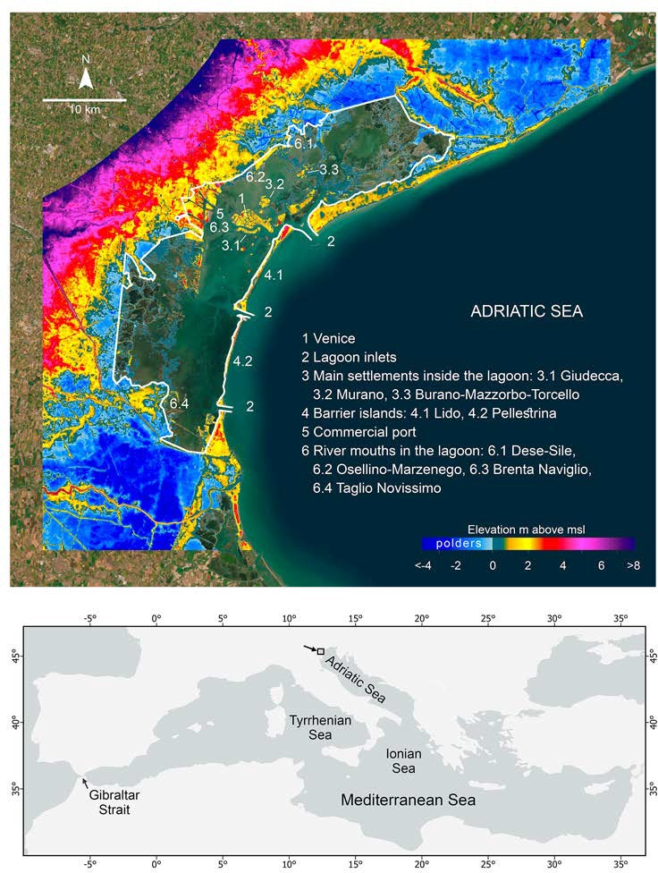
a
Source: Esri, Maxar, Earthstar Geographics, and the GIS User Community
Venice
Esri, TomTom, Garmin, FAO, NOAA, USG

b

72

Figure 1. a) Color bar shows the elevation of land areas around the Venice lagoon and of the lagoon islands superimposed to the background satellite picture. Values are with respect to the MSL at the end of the 20th century. The white line represents the jurisdictional boundary of the lagoon, which approximates its physical boundary except at the port. b) the Venice lagoon in the Mediterranean region. Maps produced using ArcGIS Pro 3.6.0 (Esri; https://www.esri.com/) with the Esri World Imagery basemap (credits: Esri, Maxar, Earthstar Geographics, and the GIS User Community).

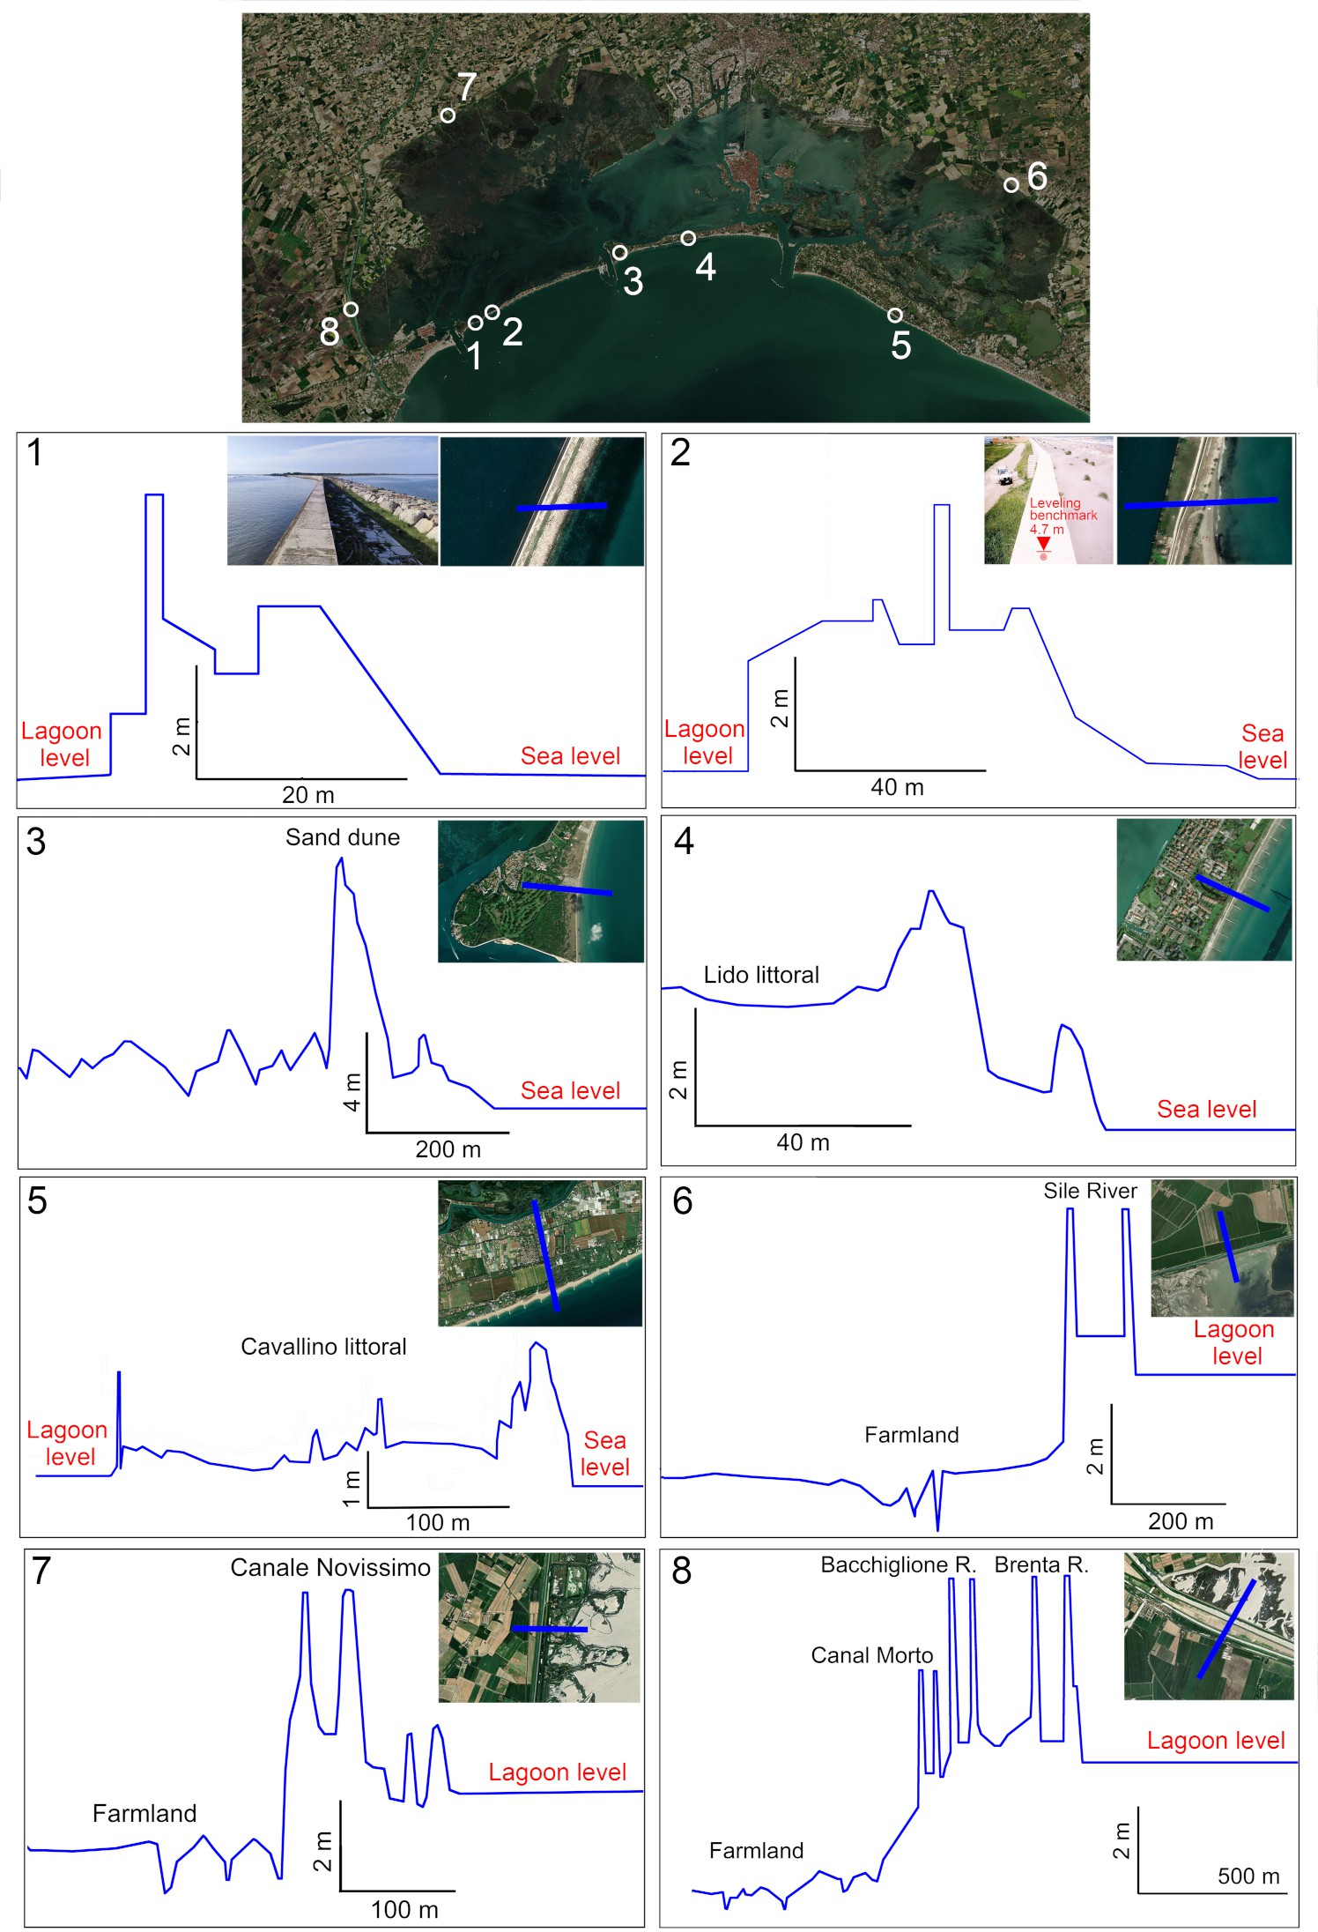
73

Figure 2. Elevation profiles of the Venice lagoon boundaries outlining the elevation of primary defenses with respect to the present lagoon and sea level: dike (1) and seawall (2) on Pellestrina barrier island; dunes (3) and embankment (4) on Lido barrier island; dunes and embankments along the northern littoral (5); and embankments protecting the polders along the lagoon border (6, 7, 8). The locations of the transects are displayed on the map at the top of this panel. The panels report also the name of rivers and canals that are crossed by the transects. Data were downloaded from the MASE geoportal (https://gn.mase.gov.it/portale/en/home). Transect locations are shown on the overview map (top) and by the blue lines in the inset images; each panel also lists the names of the rivers and canals crossed by the transects. The overview map is based on a Sentinel-2 image (acquired 12 April 2024) accessed via Copernicus Browser (https://browser.dataspace.copernicus.eu/) on 8 January 2026 and processed by the European Space Agency (ESA). Insets use the Esri World Imagery basemap (credits: Esri, Maxar, Earthstar Geographics, and the GIS User Community). The figure was produced using ArcGIS Pro 3.6.0 (Esri; https://www.esri.com/) and Office 365 software (Microsoft; https://www.microsoft.com/).

74 Results

75 Adaptation strategies: suitabilities, limits and costs
76 Based on the available knowledge and technologies, we consider four strategies to address the risks posed by SLR to Venice
77 and its lagoon: open lagoon, ring-diking, closed lagoon and retreat, each of them combining multiple measures with different
78 SLR adaptation capabilities and costs (Figs.3, 4). For each strategy, we also indicate which social, economic, environmental
79 and cultural values would be preserved relative to a no-action baseline. This qualitative counterfactual provides the necessary
80 context for interpreting the indicative cost thresholds and clarifies that the comparison concerns not only what each option
81 costs, but also what it allows Venice to retain as sea level rises.

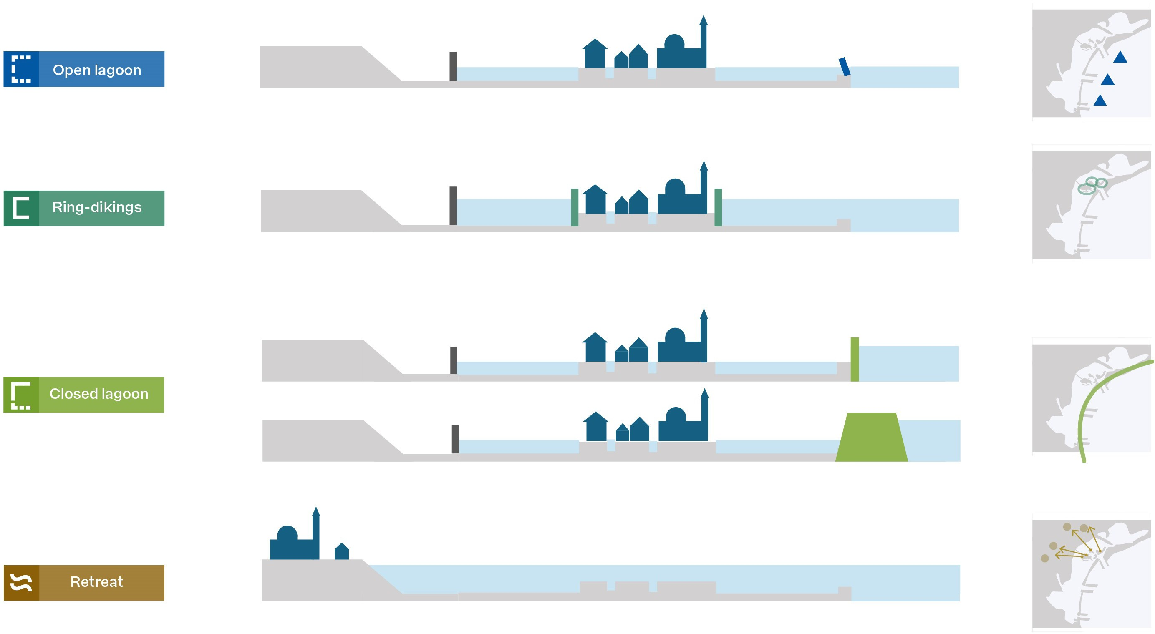

82

Figure 3. a) Illustrations of the strategies described in this article, with an additional line showing superlevees (part of the closed lagoon strategy).

83 Open Lagoon
84 The open lagoon strategy involves the present system of mobile barriers (MoSE), which closes the lagoon inlets during high
85 waters to reduce flood risk, while remaining otherwise open. Relative to a no-action baseline, the open-lagoon strategy initially
86 preserves the lagoon ecosystem, the monumental and cultural heritage, economic activities and residents’ well-being, though
87 its effectiveness rapidly diminishes as future relative SLR sets a limit to MoSE’s functional lifetime by increasing frequency
88 and duration of closures⁷. As closure frequency increases, the probability of malfunction or delayed operation rises, reducing
89 the level of protection afforded to monuments and the safety of residents¹⁴. addtitionally, this would limit port operations¹³,
90 degrade the lagoon ecosystems, and, in the case of multi-day long closures, require an appropriate sewage treatment system for
91 water quality and a large-scale pumping system to maintain lagoon levels below sea level. Altogether, an increased frequency
92 and length of closures will result in higher failure risk and additional costs (see section Methods for all cost estimates), which
93 are in the range of 0.25-1.1Ge for the large-scale pump system, 0.3Ge for the sewage treatment system, between 1.5 and
94 3.5Ge assuming a 0.75 m SLR (with respect to the beginning of the 21stcentury, here and the rest of the text) until 2100 for
95 MoSE operations and disrupted port activities during closures, growing to more than 0.1Ge per year in case of relative SLR
96 above 1m. Alternatively, the relocation of the port could be considered (with costs of about 4.1-4.5Ge). Adopting 2 or 6

97 months as an upper limit for annual closure duration would imply a relative SLR of about 0.50 or 0.75 m as the suitability
98 threshold for this strategy⁷.
99 Complementary accommodation measures can increase the effectiveness and extend the functional lifetime of the open
100 lagoon strategy.
101 Measures for large-scale accommodation include injecting seawater into the saline aquifers in the depth range 600 to 1000
102 m beneath the lagoon, to gradually raise its central portion by up to 0.30 m over a 10-year period, with even a 0.50 m uplift
103 possible if depths below 1000 m are considered^{20–22}. Total costs of this measure are estimated in the range 0.3-0.4Ge and it
104 could extend the effectiveness of the open lagoon strategy to a SLR of 1.25 m.
105 Since the 1960s, accommodation has been extensively implemented in Venice by raising street pavements, adapting the
106 ground floor of individual buildings and placing removable door gates. This latter measure can be scaled up across the city by
107 installing structures protecting monumental areas (with costs higher than 1Ge), such as that implemented for the St. Mark’s
108 Basilica, but space availability and negative visual impacts limit it. De-composing and re-constructing in-situ individual
109 buildings on new higher foundations would have costs from 2 to 6 Ge depending on the fraction of the city centre and height
110 raised. These measures could extend the effectiveness of the open lagoon strategy to protect the main monuments, but not the
111 rest of the city, for a SLR of about 1.75 m. These accommodation measures do not, however, safeguard lagoon ecosystems,
112 traditions and cultural practices tied to lagoon use, safety and well-being of residents.

113 Ring dikings
114 Ring-dikes consist of dikes isolating the city centre and other settlements from the rest of the lagoon, which remains connected
115 to the open sea. Compared to no action, ring-diking preserves monuments, residential areas and most economic functions,
116 while altering the traditional landscape and weakening the physical and cultural connection between the city and its lagoon.
117 Ring-diking does not require the operation of the MoSE barriers and the lagoon remains continuously open to marine exchange.
118 Consequently, lagoon ecosystems would evolve under sea-level rise, climate change and other anthropogenic pressures,
119 but without the impacts of the engineering interventions of the open- or closedlagoon strategies. Ring-diking has to be
120 complemented with an efficient city sewage system and systems of pumps maintaining the internal water level below the
121 surrounding lagoon, with additional costs up to 0.65Ge. Construction costs are estimated from 0.5 to 4.5Ge depending on the
122 dike length and height²³. Cost estimates are shown for ring dikes designed to withstand 2 m and 6 m of SLR, reflecting the fact
123 that this strategy can technically be upgraded to protection levels in this range, depending on available space and structure
124 heights. Impacts of ring-diking would be non-negligible on tourism, because of substantial landscape changes, but minimal
125 on the ecosystems of most of the lagoon. Emergency preparedness would be required in the case of failure of the defence
126 system. Propensity to live in Venice could be affected by lacking attitude to risk and loss of connection to the lagoon. Public
127 and commercial transportation, the port location and its organisation would need to be completely redesigned.

128 Closed lagoon
129 The closed lagoon strategy consists of transforming the lagoon into a coastal lake (similar to Marina Bay, Singapore and the
130 IJssel Lake, The Netherlands). This strategy preserves the city’s monumental fabric, residential areas, and tourism activities,
131 but sacrifices the natural lagoon ecosystem, thereby maintaining the urban cultural heritage while losing the environmental
132 context that historically shaped it. At difference with ring-diking it would not affect the city landscape and safety issues will be
133 similar to that of polders. It would require permanent dams across the lagoon inlets, raising of the barrier islands and of the
134 landward embankments separating the lagoon from the surrounding polders, with costs that could be as high as 0.54Ge, 4.8Ge
135 and 20Ge, respectively²³. The technical limit of this strategy is determined by the maximum potential heights of dams and
136 barriers and it would probably occur later than in the ring-diking strategy because the defence structures will be located far
137 from the city without directly impacting it. The cost ranges corresponding to protection levels of 2 m and 10 m of SLR are
138 reported, indicating that this strategy can in principle be extended to very high SLR values. Ecosystem and biota losses would
139 be unavoidable. Actions would be needed to control water quality in the lagoon. The required system of permanently active
140 pumps would be much larger than for the ring-diking strategy. The closed lagoon strategy could be scaled up to protect against
141 even higher SLR by using a super levee approach, a structure with a width about 30 times its height, such as proposed for
142 some low-lying areas of Tokyo^{24,25} with costs likely exceeding 30Ge. The closed lagoon strategy would force port relocation
143 or provision of large-scale locks that would likely strongly affect its operation and profitability. Touristic activities and the
144 residential environment would be affected only partially. A complementary function of both the ring-dike and closed-lagoon
145 strategies is the possibility of managing pluvial and river inputs through dedicated pumping systems, which allow excess water

146 to be discharged outside of the protected areas (see section Pluvial and river flood risks).

147 Retreat
148 Planned relocation and abandonment by residents are two components of the retreat strategy. Compared to a no-action
149 counterfactual, this strategy preserves only selected monuments (if relocated), while the historical urban fabric, lagoon-based
150 culture, traditional lifestyles, and most economic activities would be irreversibly lost. Without active management, substantial
151 SLR would transform the present lagoon into a deeper marine environment, where non-indigenous species, warming and
152 more saline waters would establish a new ecological regime, fundamentally different from the historical lagoon that shaped
153 Venice’s cultural and natural heritage. Planned relocation consists in dismounting buildings and reassembling them in new
154 higher locations. This unprecedented and complex operation (applied at a small scale, e.g. for the Abu Simbel temple in
155 Egypt²⁶) would not prevent the loss of the cultural, historical and monumental assets of the original settlement. Up-scaling
156 former projects produces costs estimates in the range 1-10Ge, but this could be increased ten times in the Venice context. The
157 relocated monuments could be visited by tourists and new residential areas built around them. The flooded remains would
158 progressively deteriorate and could be visited for a limited period by boat (and submarine). It would imply the loss of private
159 properties with eventual compensation costs of order from 5 to 6.5Ge²⁷. Abandonment by residents could happen either
160 gradually, as residents and activities move away as the flooded areas increase in time, or abruptly, after catastrophic events
161 caused by the failure of the implemented defence system.

25 0.1 0 0.10 0.25 0.50 0.75 125 1.75 4.0 6.0 10.0 ^{SLR}


Movable barriers
Protection of individual buildiniliJ.S• De/recomposing individual buildings Soil up-lift
Sewage system Pumps

- Lenght of measure, from implementation to tipping point
- Uncertainty in timing of implementation, or of tipping point Measure remains, but becomes part of another strategy

Relocation of port
Ring-diking
◄

- ♦NH++

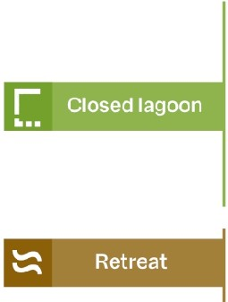

�

�

�

�

Pumps Dams
Raising of barrier islands protections Raising of embankments
Pumps

Super levees
Relocation of monument Abandonment

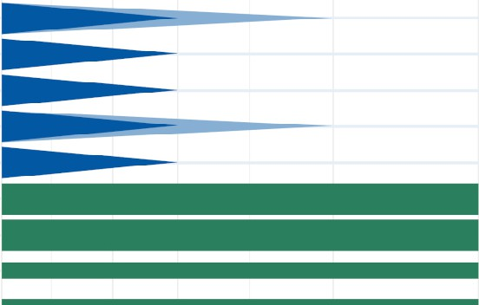
Monuments Ecosystems Traditions & culture Economic prosperity Safety and wellbeing Monuments Ecosystems Traditions & culture Economic prosperity Safety and wellbeing
Monuments Ecosystems Traditions & culture Economic prosperity Safety and wellbeing Monuments Ecosystems Traditions & culture Economic prosperity
Safety and wellbeing

--------- -----

30.0
20.0
10.0
8.0
Q 6.0
s
4.0

Closed lagoon


=J Open lagoon
Super levees

Retreat

t,
0 2.0
()
1.0
0.75
0.50 Ring-dikings
0.25
-.25 -0.1 0 0.10 0.25 0.50 0.75 125 1.75 4.0 6.0 10.0 ^{SLR}
1900 1960 2000

162

Low (SSP1 RCP2.6)

Very high (SSP5-RCP8.5)
2100 I----, 2300
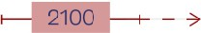

Figure 4. a) Measures involved in the four adaptation strategies and the SLR range for their functional lifetime (solid lines), with associated uncertainties (dashed lines) and continuation as components of other strategies (light solid line). Uncertainties are caused by decision processes, technical limits, dependencies on complementary measures. b) Suitability level of the four strategies for safeguarding monuments, lagoon ecosystem, traditions and cultures, economic prosperity, safety and well-being of residents. The thickness of the horizontal bars conveys qualitatively three relative levels (full, partial, nil) of suitability. For the open-lagoon strategy, bar thickness decreases with increasing SLR to represent its progressively diminishing effectiveness, while the light blue bars indicate the potential of accommodation measures. In case of retreat, absence of residents prevents the analysis of suitability for safety and well-being, while suitability for safeguarding ecosystems decreases with progressing SLR.
c) Broad range of indicative costs (y-axis) versus SLR (x-axis) combining lifetime information from panel with cost data from sections "Land uplift by seawater injection ..." and "Indicative cost estimates..". The limits of the boxes are obtained considering the minimum and maximum values of measures in panels a) and b), capturing both costs and lifetime uncertainties. The bottom annotation indicates the approximate relative SLR values (with respect to the end of the 20th century, blue arrow) and SLR likely (boxes) and very likely (whiskers) ranges under low (green) and very high (red) emission scenarios for 2100 and 2300. Dashed arrows refer to the case of a large Antarctic contribution to SLR. Lead times are not considered. they might be multidecadal as in the case of MoSE and other flood barriers²⁸.

163 Adaptation Pathways
164 Adaptation pathways²⁹ result from combinations of the strategies over time, with adaptation tipping points (ATP) marking the
165 switch from one strategy to another, when risk becomes too large (fig.5).
166 Nowadays, the system is in an incremental adaptation phase, during which the implemented mobile barriers defence
167 system (MoSE) in combination with accommodation can efficiently maintain an open lagoon. Our estimate is that, when
168 the relative SLR will be in the range 0.75-1.75m, an adaptation tipping point (ATP, where a strategy can no longer meet its
169 intended goals) to a transformational phase will necessarily occur, and Venice and its lagoon will necessarily shift to a condition
170 unprecedented in their long history with fundamental implications for the economy, ecosystems, residents and the universal
171 value of the UNESCO property. This transformation is unlikely earlier than the 2070’s, even in a very high emissions scenario,
172 and remains unlikely until the 22nd century in a low emissions scenario. However, the increased risk of pluvial and river
173 flooding during extreme sea-level events may reduce the operational lifetime of the open-lagoon strategy compared to the limits
174 imposed by SLR alone. The SLR upper limit of the open lagoon strategy, corresponding to the successful implementation of
175 all accommodation measures, depends on whether the socio-economic scenario will support them and on not fully explored
176 technologies (e.g. uplifting the ground with pumping). The ATP could be anticipated if the MoSE would show signs of stress
177 or malfunctioning or in the case of major failure leading to a catastrophic event during a high storm surge, which could even
178 trigger the abandonment of the lagoon. Extending the open lagoon strategy to its upper limit by implementing accommodation
179 options appears more expensive than the ring-diking or closed lagoon strategies.
180 When the ring-diking or the closed lagoon strategy would be adopted the system would enter into transformational
181 adaptation, whose first part is a resilient development opportunity phase, where the present city structure and functioning are
182 maintained, though the connection to the lagoon (ring-diking) or to the open sea (closed lagoon) would be disrupted. As the
183 upper limit of the ring-diking is lower than that of the closed lagoon strategy, the former could be adopted first and the latter
184 postponed to a higher SLR. Transitioning towards the transformational adaptation phase before reaching the upper limit of the
185 open lagoon strategy would be cheaper overall and it could be maintained up to a 6 to 10-meter SLR.
186 Retreat may be a plausible path before reaching the technical limits of other strategies, if the economic profits and socio-
187 cultural reasons supporting the maintenance of the city structure critically diminish. Otherwise, the first ATP towards the retreat
188 strategy is in the 4-10m SLR range. It would be determined by the capability of the dams to sustain the sea-level difference
189 (depending on technology and geomorphology) and by the social acceptance of living in an area where a dam failure might
190 not allow sufficient time to escape/evacuate. The decision to abandon by the population and the relocation of Venice would
191 have costs higher than any former strategy except the construction of a super levee. In this strategy, the costs of raising the
192 embankments separating the lagoon from the polders around Venice is not considered, as it needs to be analyzed in the context
193 of the adaptation strategy of the wider North Adriatic coast to SLR, which is beyond the scope of this study. Retreat before the
194 end of the 24th century is likely in a very high emissions scenario, but it is unlikely in a low emission scenario^{30,31}.

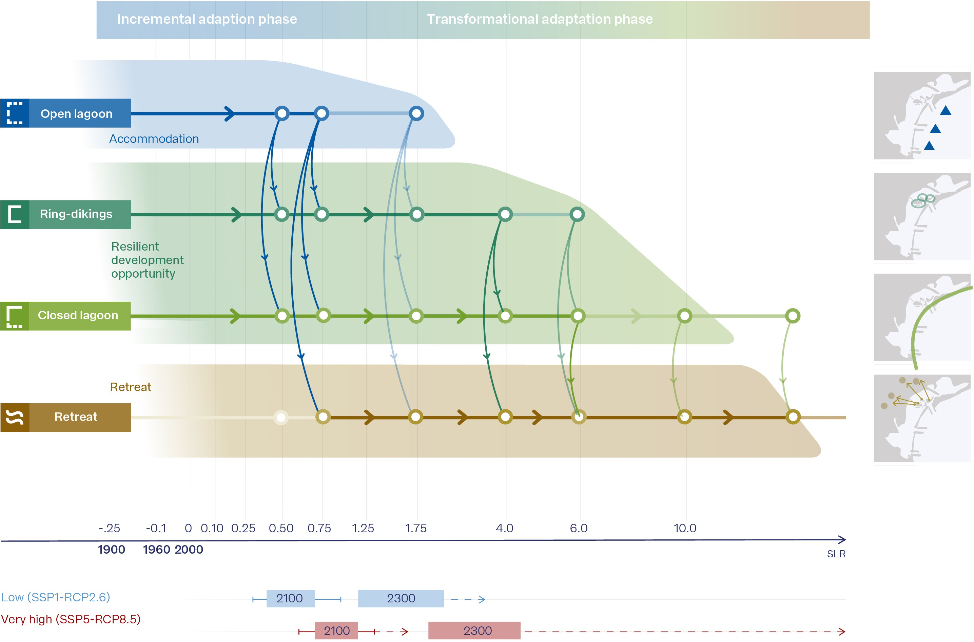

Figure 5. Adaptation pathways and tipping points marking the switch from one strategy to another. This figures highlightes the decreasing and shifting solution space with SLR as the system evolves from incremental to transformational adaptation, consisting in climate resilient development or retreat. Annotation at the bottom indicates the approximate relative SLR values (with respect to the end of the 20th century, blue arrow) and SLR likely range (boxes) and very likely (whiskers) in a low (green) and very high (red) emission scenario in 2100 and 2300. The dashed arrows refer to the case of a large Antarctic contribution to SLR.

195 Discussion

196 This discussion is structured around five key themes. First, we outline the multiple goals at stake and the limits of monetary
197 valuation for cultural heritage. Second, we examine how strategy-dependent risks emerge from interactions with tourism, port
198 activities and ecological drivers. Third, we discuss how rising sea levels introduce adaptation tipping points that progressively
199 narrow the solution space. We then consider the long lead times required for major interventions, which make timely decisions
200 essential. Finally, we situate the Venice case within the broader context of global coastal challenges.
201 Multiple goals must be considered when evaluating SLR adaptation strategies for Venice (Fig.6): preservation of monuments,
202 lagoon ecosystems, living traditions and culture (goals linked to its UNESCO world heritage status and Sustainable Development
203 Goals (SDGs) 11, 14, 15), and safeguarding economic prosperity, safety and well-being of residents (linked to SDGs 3, 8 and
204 9).

205 The four proposed strategies differ in the values that they can safeguard as SLR progresses. The open-lagoon strategy
206 preserves all major values in the near term, but its capacity declines as closure frequency increases. Adding accommodation
207 measures extends the protection of monuments and urban functions, but does not prevent the progressive ecological degradation
208 associated with more frequent MoSE operations. Ring-diking preserves monuments, residential areas and most economic
209 activities for substantially higher SLR, while leaving the lagoon ecosystem largely free to evolve, but at the cost of weakening
210 the cultural and physical connection between the city and its lagoon and introducing residual safety risks linked to dike
211 failure. The closed-lagoon strategy maximizes protection of the monumental fabric and urban life at the expense of the lagoon
212 ecosystem, which would be irreversibly transformed. Finally, retreat safeguards only selected monuments, with irreversible

213 loss of the urban fabric, lagoon-based culture and present-day economic functions. Ultimately, the choice among adaptation
214 strategies depends on the priority assigned to different values and on the resources available, notwithstanding that losses will be
215 unavoidable under high SLR.
216 Protecting Venice’s economic system (its real estate, infrastructure, port activity and tourism) would provide an economic
217 rationale for even the most costly strategies, as the potential losses of a no-action future substantially exceed their indicative
218 costs. In contrast, preserving the lagoon ecosystem, while environmentally beneficial, contributes only marginally to economic
219 comparison. Citizens’ well-being has measurable economic value, but it remains lower than the cost of a full-scale defence
220 once SLR exceeds roughly 2 meters.
221 Methods for monetary valuation of non-market goods, including cultural heritage, can be applied, but they capture only a
222 single component of value³². Monetary valuation can inform decisions when the expected changes in assets are marginal. But
223 the potential loss of Venice is, by no measure, a marginal loss. While society must still assign a finite, though possibly very
224 large "willingness-to-pay" to protect heritage, cultural values transcend monetary representation, making the integration of
225 cultural and economic assessments indispensable for policy decisions. A unique historical asset such as the city of Venice is
226 ultimately priceless: no monetary estimate can replace the cultural meaning and collective memory embedded in the city. This
227 universal and irreplaceable value provides the fundamental motivation for maintaining protection for as long as technically
228 feasible.
229 Risks depend on the adopted strategy and its interactions with other environmental drivers including tourism, port activities,
230 and non-indigenous species. These drivers can amplify the impacts of SLR, making strategy-dependent risks a central element
231 of long-term planning.

232

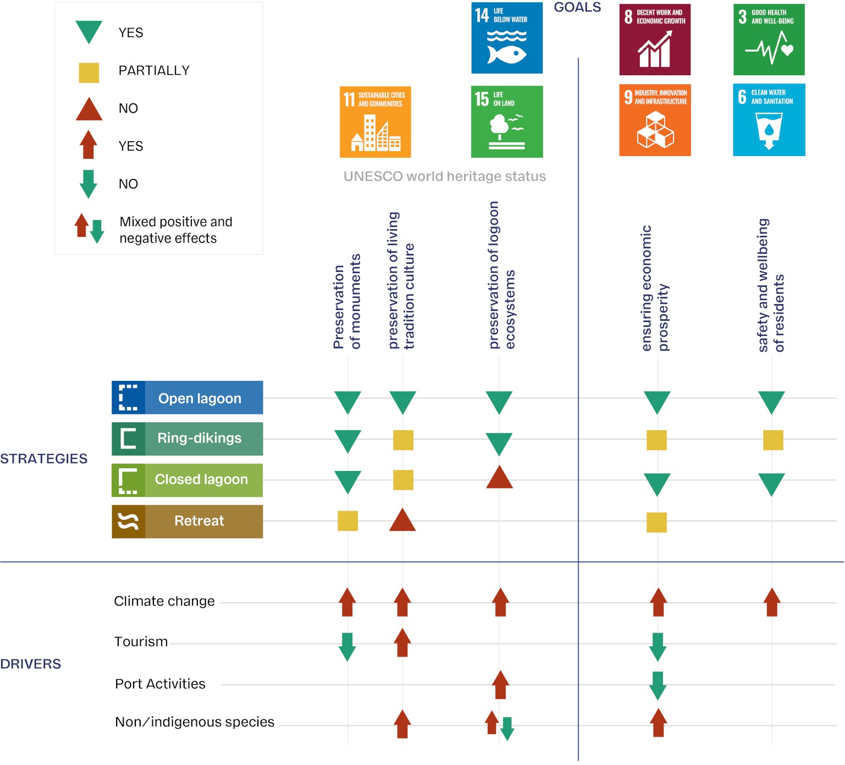

233

Figure 6. Goals, adaptation strategies and drivers. Symbols show whether strategies achieve (YES/NO/Partially) each goal and drivers increase (YES/NO/Mixed) the risk of missing them. Open-lagoon effectiveness declines with SLR.

234 Frequent closures of the mobile barriers would affect water temperature and salinity³³, potentially reverse the ongo-
235 ing decrease of pollution and eutrophication^{34–36} and impact the lagoon morphology by decreasing the import of marine
236 sediments^{37,38}. Ecosystem risks would increase enormously under the closed lagoon strategy. Further risks are caused by
237 ongoing and future warming^{33,39,40}, combined with mixed positive-negative effects of non-indigenous species on ecosystem
238 services^{40–42}.
239 Living tradition and culture are threatened by accommodation measures that disrupt the city’s internal connectivity and by
240 strategies that alter the link between Venice and its lagoon, which would be completely lost under retreat. Further risks are
241 posed by non-indigenous species increasingly impacting artisanal fisheries^{43,44}.
242 The safety of residents and visitors depends critically on the reliability of the current mobile barriers and of other defense
243 systems and it will be threatened by insufficient funding, maintenance gaps or technical malfunctions. The health of residents
244 would be at risk if measures to guarantee good water quality in and around the city are not thoroughly implemented.
245 All long-term protection strategies also carry the possibility of major structural failures. This aspect is particularly critical
246 for the ring-diking strategy because of the immediate proximity between the dikes and the historic city. A failure of even a single
247 segment during high sea levels would result in rapid inundation of the city centre, potentially with several metres of water depth
248 and very limited time for emergency response. Although such failure modes lie beyond the scope of the present analysis, their

249 existence underscores the need to complement long-term planning with robust risk-management and emergency-preparedness
250 considerations.
251 Tourism and port activities are major contributors to local economic prosperity. While tourism helps sustain the city’s current
252 service infrastructure and contributes indirectly to the preservation of its monumental heritage, it can also reduce residents’
253 quality of life, affect local traditions and culture⁴⁵ and increase pollution⁴⁶. Tourism is broadly compatible with the open
254 lagoon, closed lagoon, ring-diking strategies, which would maintain the existing visitor services. However, accommodation
255 measures could affect tourism if the usable urban areas or the internal connectivity of the city decrease. Retreat strategies would
256 imply a complete reorganisation of tourism and presumably major reduction of flows.
257 The future of the port of Venice will be strongly impacted by changing global commercial patterns (with eventually less coal
258 and oil, more multimodal container shipping, and a decrease of large cruise ships) associated with climate change mitigation
259 policies^{47–50} and competition with other large ports in the North Adriatic¹³. Local adaptive actions include changes in port
260 operation or quite possibly relocation of the port outside the lagoon.
261 Under a high-emission scenario and assuming no additional accommodation measures, the present open-lagoon strategy
262 is likely to become inadequate before the end of the century as the frequency and duration of closures continue to increase.
263 Because large-scale interventions, such as permanent barriers, ring dikes or major structural reinforcements, require lead times
264 of 30–50 years, the effective window for initiating a transition to alternative strategies is already approaching. If procedures and
265 institutional processes similar to those that led to the MoSE are followed, timely planning will be essential to ensure that any
266 new strategy becomes operational before the current one reaches its functional limits.
267 Pathways include ATPs, which are associated with large societal and environmental consequences, the commitment of
268 huge budgets (whose source/availability is not obvious) and long (multidecadal) preparation and implementation timescales.
269 Decisions around ATPs are shaped by society’s capacity to absorb the required changes, including institutional readiness,
270 long-term financial commitments and the acceptability of trade-offs among competing goals. In extreme cases abandonment
271 might result from limited budget, declining cultural identity, shrinking population and catastrophic events.
272 High SLR would threaten permanent flooding of large densely populated and highly productive areas along the entire North
273 Adriatic coast (with 4,800 km² of land below 2 m elevation) and all adaptation strategies for Venice and its lagoon need to be
274 embedded within a large-scale regional adaptation strategy rather than considered in isolation.
275 The adaptation solution space will progressively shrink with SLR as in many low-lying regions⁵¹. For Venice this contraction
276 implies a transition from the present open lagoon strategy (incremental adaptation) to the ring-diking or closed lagoon (the
277 opportunity window for resilient, transformational adaptation) and ultimately to relocation-abandonment during the irreversible
278 retreat phase under very high SLR. The timing of these transitions will depend on the rate of SLR. Abandonment of the open
279 lagoon strategy appears unavoidable on multi-centennial time scales. While it could be postponed to the 22nd century under a
280 low emission scenario, it might be required within the end of the 21st century under a very high emission scenario. Mapping the
281 progressive contraction of the solution space therefore informs decision-makers not about which option is optimal in economic
282 terms, but about which values can still be preserved and for how long as sea level continues to rise.
283 Venice exemplifies the challenges that many low-lying coastal areas will face due to SLR over the coming centuries⁵², as
284 illustrated by the Maldives⁵³, the Netherlands^{54–56}, and coastal cities⁵⁷. Most populated low-lying areas are already engaging
285 in adaptation to manage inundation and flooding , yet current approaches will probably be able to work for limited time as sea
286 level continues to rise. Ultimately difficult and costly decisions are inevitable. The adaptation pathways approach illustrated for
287 Venice has global relevance and thinking through potential pathways is an important step towards practical and realistic coastal
288 adaptation given the long-term commitment to SLR and the uncertainty in its rate.
289 Venice has faced transformation and adaptation to a changing environment throughout a millennial history, but future
290 challenges are unprecedented in terms of pace of change and structural dimension. While the historical evolution of Venice
291 and its lagoon was largely dependent on local cultural and economic capacity, it now requires solutions relying on large-scale
292 cooperation and depending substantially on drivers acting beyond local control.
293 Taken together, our results show that adaptation pathways provide a decision-relevant framework to clarify which long-term
294 choices Venice will face as sea level continues to rise. Each feasible strategy preserves a distinct configuration of economic,
295 environmental, social and cultural values, and the narrowing of the solution space with rising SLR highlights the need for early
296 judgement on which of these values future communities aim to retain. For decision makers, the pathways approach does not
297 prescribe an optimal option; rather, it makes explicit the trade-offs and the adaptation tipping points at which transitions become

298 unavoidable. This enables choices to be made with full awareness of the gains and losses across competing interests, and of the
299 lead times required for large-scale interventions. More broadly, Venice illustrates how pathways can guide robust long-term
300 coastal planning under deep uncertainty, helping societies align present decisions with the values they wish to preserve in the
301 centuries ahead.

302 Methods

303 Estimates of sea-level rise and land elevation
304 The SLR values in figure 3 and in the text are based on state of the art projections assessed in the 6th Assessment Report of the
305 IPCC¹⁵. Values specific for Venice can be extracted from public repositories providing consistent values with minor differences
306 that are not relevant for this study^{8,58–61}.
307 While these data approximately consider land subsidence in the historical city centre, where values in the last 50 years,
308 after the regulation of groundwater use, are between 1 and 2 mm year⁻¹⁶², subsidence increases across the lagoon up to 4 to
309 6 mm/year in poorly consolidated salt marshes^{38,63}. This analysis assumes that the effective regulation of groundwater use
310 continues. Hence, land subsidence is due to long term natural components largely due to the consolidation of the shallow
311 subsurface sediments, i.e. the Holocene depositional units, and its variability reflects the geological setting of the lagoon⁶⁴.
312 Extrapolating to the next centuries the current rates of about 1-2 mm/year for the historic centre and 3-4 mm/year for the lagoon
313 is plausible, but anthropogenic activities (e.g. construction of dikes or dams) could locally affect it. Therefore, for low emission
314 scenarios, as long as the SLR velocity is in the same order of magnitude as the land subsidence, the relative SLR footprint in
315 Venice and its lagoon will be heterogeneous³⁸ with substantial implications for the preservation of the lagoon ecosystems and
316 of monuments.
317 Timing of global SLR milestones up to 5 m until 2300 are accessible through the same website⁵⁸ and are considered
318 adequate in this study for the long term estimates based on evidence that past (neglecting land subsidence interannual variability)
319 and future long term trends in Venice are very similar to global values^{7,65,66}. Among other data used for this study, the IPCC
320 AR6 WG1 chapter 9¹⁵ reports that global mean sea level will rise between 0.3 and 3.1 m and between 1.7 and 6.8 under
321 SSP1-2.6 and SSP5-8.5 by 2300, respectively, and in the latter case up to 16 m considering possible contributions from marine
322 ice cliff instability. Further studies, based on different methods and published after the 6th IPCC Assessment Report have
323 revisited low-likelyhood-high impact scenarios to 2300 without changing significantly these values^{30,31}.
324 The map shown in Fig.1 is a digital terrain model (DTM) provided by the Veneto Region (https://idt2.regione.veneto.it/idt/downloader/down
325 which is intended to illustrate the general morphological setting of the area around Venice. The DTM is based on surveys
326 carried out in the 1990s and the data refer to the Italian national geodetic network, which in turn refers to the MSL determined
327 in the 1940s. Actually, land subsidence and SLR have led to a further reduction in ground elevation. Land subsidence, acting
328 with a large spatial variability ranges from negligible values up to 1 cm/year^{64,67}, has contributed up to 20 cm in some areas,
329 while the SLR implies a uniform negative decrease of 1.2 mm/year⁸, i.e. about 10 cm compared to the 1940s. Practically these
330 two sources imply a negative systematic error with a magnitude of about 25-30 cm, which is too small to be relevant in this
331 analysis.
332 The fraction of historical centre flooded as a function of the sea level are computed using the data provided by Insula spa
333 (http://smu.insula.it/index.html).

334 Land uplift by seawater injection: values, technical details and costs
335 Fluid injection into the subsurface is used worldwide for multiple purposes (managed aquifer recharge, enhanced oil recovery,
336 geologic sequestration of CO₂ and wastewaters, and underground gas such as CH₄, H₂ storage) and it is always accompanied
337 by an uplift of the land surface above the injection facilities. State-of-the-art 3D hydro-geomechanical modelling shows that
338 using 12 wells located on a 10-km diameter circle around the Venice city centre to inject seawater into the deep aquifer system
339 below the lagoon between 600 and 1000 m depth can produce an uplift of approximately 25-30 cm²¹. With the planned well
340 locations, the area benefiting by the uplift encompasses the Venice historic centre, Murano, and other islands around Venice.
341 A proper management of the injection rates, combined with the large depth of the targeted aquifers, would ensure a uniform
342 uplift, with displacement gradients that are substantially smaller than those caused by land subsidence over the past century,
343 precluding risks for building instability²⁰. The maximum overpressure would occur well below the fracturing threshold. A
344 thick clay unit revealed by seismic surveys and borehole lithostratigraphy, will preclude any propagation of the saline water

345 toward the freshwater aquifers located above 350 m depth. Costs, initially estimated to be 0.08Ge for construction of the wells
346 and 0.1Ge for operating them for 10 years⁶⁸, have now risen to a total in the range 0.3-0.4Ge considering the increased costs
347 of the drilling, equipment, and energy costs over the last 10 to 15 years. With the present market prices, annual maintenance
348 and operating costs, including electricity, seawater treatment, and personnel is estimated in 0.02Ge/year.

349 Extreme sea-level events and height of coastal defenses
350 In Fig.2 elevation profiles have been utilized to outline the primary coastal defenses located at the boundaries of the Venice
351 lagoon. Elevation datasets refer to the DTM with 1 and 2 m ground resolution resulting from LiDAR scanning on an
352 aerial platform acquired by the Ministry of the Environment and the Protection of Land and Sea under the Extraordinary
353 Environmental Detection Plan (PST-A). The datasets are available from the Ministry of the Environment and Energy Security
354 (https://gn.mase.gov.it/portale/en/home and https://sim.mase.gov.it/portalediaccesso/mappe/#/viewer/new).
355 Dunes in the areas without artificial protection have a level of about 9 m above MSL, although a detailed inspection reveals
356 the presence of small isolated gaps where the maximum elevation is between 2 and 3 m. The height of the current defenses
357 along the barrier islands is approximately 5 m. Currently, dykes and riverbanks approximately 4-meters high separate the lagoon
358 from the adjacent polders. Therefore, a head height of 5 m above mean sea level is sufficient to prevent wave overtopping
359 during major storms and damage to inhabited areas.
360 These values of the height of the coastal defenses are consistent with other estimates. The 100-year return level has
361 been estimated to be approximately 1.50 m⁶⁹, but excluding the contribution of astronomical tides and of interannual to
362 seasonal sea-level variability. During major past events, the contribution of the interannual to seasonal sea-level variability
363 never exceeded 20cm. Considering a further addition of astronomical tide (maximum of about 50cm) confirms that 3 m are a
364 reasonable upper limit for sea-level maxima, which with a 60% addition to prevent wave overtopping would lead to a height of
365 5m.

366 The future increase of extremes during storms will be mostly produced by SLR⁷⁰, with changes of storminess playing a
367 minor role⁷¹. The effect of SLR on astronomical tides will depend on the future large scale adaptation strategy⁷². Preserving the
368 present coastline of the Adriatic will lead to a decrease of the amplitude of astronomical tides, while allowing a free expansion
369 of the sea inland will increase the amplitude of the diurnal components. As a consequence, it has been estimated that a 2-meters
370 SLR might lead to a 5% increase or decrease of the amplitude extreme events⁷².
371 In conclusion, 3-meters high ring dikes inside the lagoon, where wave propagation from the sea is prevented by barrier
372 islands, and 5-meters high dams across the inlets and embankments along the barrier islands, both with respect to the mean sea
373 level, are expected to provide sufficient protection.
374 The height of embankments separating the lagoon from the surrounding polders would be different depending on whether
375 the closed lagoon or the ring-diking strategy is adopted. In the former case, the water level inside the lagoon will remain at its
376 present level and the increase of the embankments will not be required. In case of ring-diking the water level inside the lagoon
377 will follow the SLR and the height of the embankments should match that of the dikes. However, the protection of the polders
378 will require an overall revision of the coastal protection and hydraulic drainage system at regional level, beyond the adaptation
379 of the Venice lagoon to SLR, whose discussion is beyond the scope of this article.

Table 1. Total costs associated with the operation of the MoSE system. total duration of closures is based on literature⁷. Total costs include operation of the barriers and disruption of port activities.

SLR (cm) yearly duration of closures (months) Total cost (Ge/year)

50 | 2 | 0.015 - 0.031
75 | 6 | 0.044 - 0.093
120 | 10.5 | 0.077 - 0.162

380 Pluvial and river flood risks
381 Although this study focuses on long-term sea-level rise, pluvial and riverine inputs represent an additional source of flooding
382 that becomes relevant whenever the lagoon—or parts of it—is temporarily (during MoSE closures) or permanently (under

Table 2. Total Costs of raising existing buildings. Unit costs (column 2) in UST/ft at 2010 prices are extracted from literature⁷³ and converted to Ge 2024 prices in columns 3 (35% of buildings) and 4 (all buildings in the historical centre)

raise buildings by (m) Unit cost (USD/ft²) Total cost for 35% of buildings (Ge) costs for all buildings (Ge)

0.6 | 88 | 1.01 | 2.83
1.2 | 91 | 1.05 | 2.93
1.8 | 96 | 1.10 | 3.09
bottomrule

Table 3. Ring dikes with indicative construction (top) and pumping costs (bottom). Each dike has a head of 3 m, for a total height obtained by adding head, SLR and a depth of 4 m around Venice’s historical centre, and 2 m in the other dikes. The large perimeter ring dike corresponds to a separate configuration that would enclose Venice’s historical centre as well as other developed areas. Different SLR conditions are considered only for construction costs, as they have a negligible effect on pumping (including energy and maintenance) costs. Pumping costs are computed to cover a 50 years duration.
CONSTRUCTION COSTS
ring diking area | length (km) | area (km²) | present SL (Ge) | 2 m SLR (Ge) | 4 m SLR (Ge) | 6m SLR (Ge)
Venice | 15.8 | 10.3 | 0.45-1.24 | 0.58-1.60 | 0.71-1.96 | 0.84-2.31
Murano | 5.3 | 1.7 | 0.11-0.30 | 0.15-0.42 | 0.20-0.54 | 0.24-0.66
Murano-Mazzorbo-Torcello | 8.9 | 3.1 | 0.18-0.50 | 0.25-0.70 | 0.33-0.90 | 0.40-1.10
large | 36.2 | 99.3 | 0.74-2.04 | 1.04-2.85 | 1.33-3.66 | 1.63-4.48
bottomrule
PUMPING (energy and maintenance) COSTS
ring diking area | area | from present SL up to 6m SLR
 | (km²) | (Ge)
Venice | 10.3 | 0.02-0.07
Murano | 1.7 | 0.003-0.01
Murano-Mazzorbo-Torcello | 3.1 | 0.005-0.02
large | 99.3 | 0.16-0.65
bottomrule

383 ring-dike or closed-lagoon strategies) isolated from the sea.
384 Recent observational analyses for Italy show suggestive evidence of increasing heavy rainfall intensity, despite spatial
385 heterogeneity in the trends^{74,75}. Future projections indicate a widespread intensification of precipitation extremes across
386 northern and northeastern Italy under high-emission scenarios⁷⁶.
387 Intense precipitation and river inflows can raise water levels inside a closed lagoon independently of the sea level.
388 Hydrodynamic simulations and observations indicate that rainfall over the lagoon surface and river discharge may increase
389 lagoon water levels by several centimetres during MoSE closures^{12,33,77}. Comparable risks would arise under the closed-lagoon
390 strategy and, to a lesser extent, under ring-diking. In the latter case, river flooding would be irrelevant, and only precipitation
391 falling on the protected areas would need to be managed.
392 Installing pumping systems is an effective way to reduce pluvial and river-flood risks. For a fully closed lagoon, a first-order
393 engineering estimate indicates that managing precipitation and river inflows during extreme events requires a peak pumping
394 capacity of approximately 1,000 m³s⁻¹ under present climate conditions. This estimate is obtained by summing the current
395 estimated river peak discharge⁷⁸ and the contribution of the maximum daily precipitation from observational gridded data
396 in the area around the lagoon⁷⁵. Assuming a 20% increase in precipitation extremes by the end of the century under a very
397 high-emissions scenario, the required peak pumping capacity would rise to roughly 1200 m³s⁻¹.
398 Pumping requirements would be substantially lower for the ring-dike strategy because the contributing surface is much
399 smaller and river inputs are excluded. Incorporating these operational needs into future assessments would imply increasing
400 long-term pumping-system costs by a factor of 2 to 3 for both strategies.

Table 4. Indicative construction costs for dams at lagoon inlets, embankments along the barrier islands and the borders of the lagoon assuming a head of 5 m and SLR of 2, 6, 10 m. The costs are based on the total height, which is estimated adding depth, SLR and head
CONSTRUCTION COSTS
inlet | depth (m) | length (m) | present SL | 2 m SLR (Ge) 6 m SLR (Ge) |  | 10 m SLR (Ge)
Lido 1 | 8 | 420 | 0.02-0.06 | 0.03-0.07 | 0.03-0.09 | 0.04-0.11
Lido 2 | 8 | 440 | 0.02-0.06 | 0.03-0.07 | 0.03-0.09 | 0.04-0.11
Malamocco | 14 | 540 | 0.04-0.11 | 0.05-0.13 | 0.06-0.15 | 0.06-0.18
Chioggia | 8 | 550 | 0.03-0.08 | 0.03-0.09 | 0.04-0.12 | 0.05-0.14
Total  bottomrule embankments |  |  | 0.12-0.32 | 0.13-0.37 | 0.16-0.45 | 0.20-0.54
barrier islands |  |  | 0.58-1.60 | 0.83-2.22 | 1.3-3.53 | 1.75-4.81
lagoon borders  bottomrule |  |  | 2.45-6.75 | 3.44-9.45 | 5.40-14.9 | 7.36-20.02
PUMPING (energy and maintenance) COSTS
 | area (km²) |  | from present SL up to 6m SLR (Ge)
whole lagoon bottomrule | 550 |  | 0.44-1.78

401 Indicative cost estimates of the strategies and of the corresponding measures
402 Indicative capital costs for the proposed measures and adaptation pathways are estimated using unit costs from previous
403 literature, international analogs and expert judgement (fig.7). This analysis is a first approximation, which has the high relevance
404 of being the first to attempt a systematic assessment of the order of magnitude of the broadest conceivable set of long term
405 adaptation strategies. Unless specified, all amounts presented here are adjusted for inflation to 2024 prices. Due to the city’s
406 historical and cultural importance, as well as its unique geography, costs in Venice tend to be much higher than comparable
407 experiences elsewhere. Our estimate is subjected to this systematic uncertainty and might be a systematic underestimate of
408 order up to 50%. While cost will be a determinant factor in the realization of individual strategies, it is important to note
409 that our analysis aims at providing indicative estimates rather than precise values mainly in order to compare the costs of the
410 different options. As a reference, all the estimated costs could be compared to the 6Ge total cost for the construction of the
411 MoSE system¹³.

412 Open lagoon
413 Maintaining the open lagoon includes the costs of operating MoSE and of the implementation of the pumping and sewage
414 systems required by frequent closures of the lagoon. The increase of MoSE costs with SLR are summarised in Table 1. They
415 are obtained adding operating costs (between 30 and 300 Ke per closure) to costs caused by disruption of ship traffic (average
416 215Ke per closure⁷⁹, assuming daily durations and that prolonged multi-day closures are equivalent to the sum of individual
417 closures¹³. Total estimates would depend on the rate of SLR. As an order of magnitude estimate, one could assume costs
418 linearly increasing over 75 years until there is a 6 month annual duration of closures, with total costs in the range 1.5 to 3.5 Ge.
419 Costs (not considering maintenance) of pumping systems vary between 0.47 and 2 Me/m3/s and depend on factors such as
420 length of pipes, distance to source area, motor type and drainage area⁸⁰. Assuming that the pumping system is designed to
421 respond to the maximum peak flow of the Venice lagoon tributaries and sub-basins (a reference value of 344 m³/s⁷⁸ and to the
422 precipitation inside the lagoon (about 200 m³/s in case of a 50mm daily precipitation), the construction of the pumping system
423 for a lagoon-scale system would cost from 0.25 to 1.1Ge.
424 A wastewater treatment plant currently under construction for an area of 150,000 people in Trento in Northern Italy, is
425 estimated at a cost of 0.113Ge, with an expected operational cost of 1.3Me/year considering current costs in the region⁸¹.
426 These costs are roughly consistent with the upper limit of the estimated costs for conventional sewage systems (USD 770 per
427 inhabitant at 2010 prices⁸². Considering the complexity of creating a collection system in the historical centre, the unit costs
428 can be multiplied by at least a factor of two with respect to the cost sustained in Trento, reaching a cost in the order of 0.3Ge,

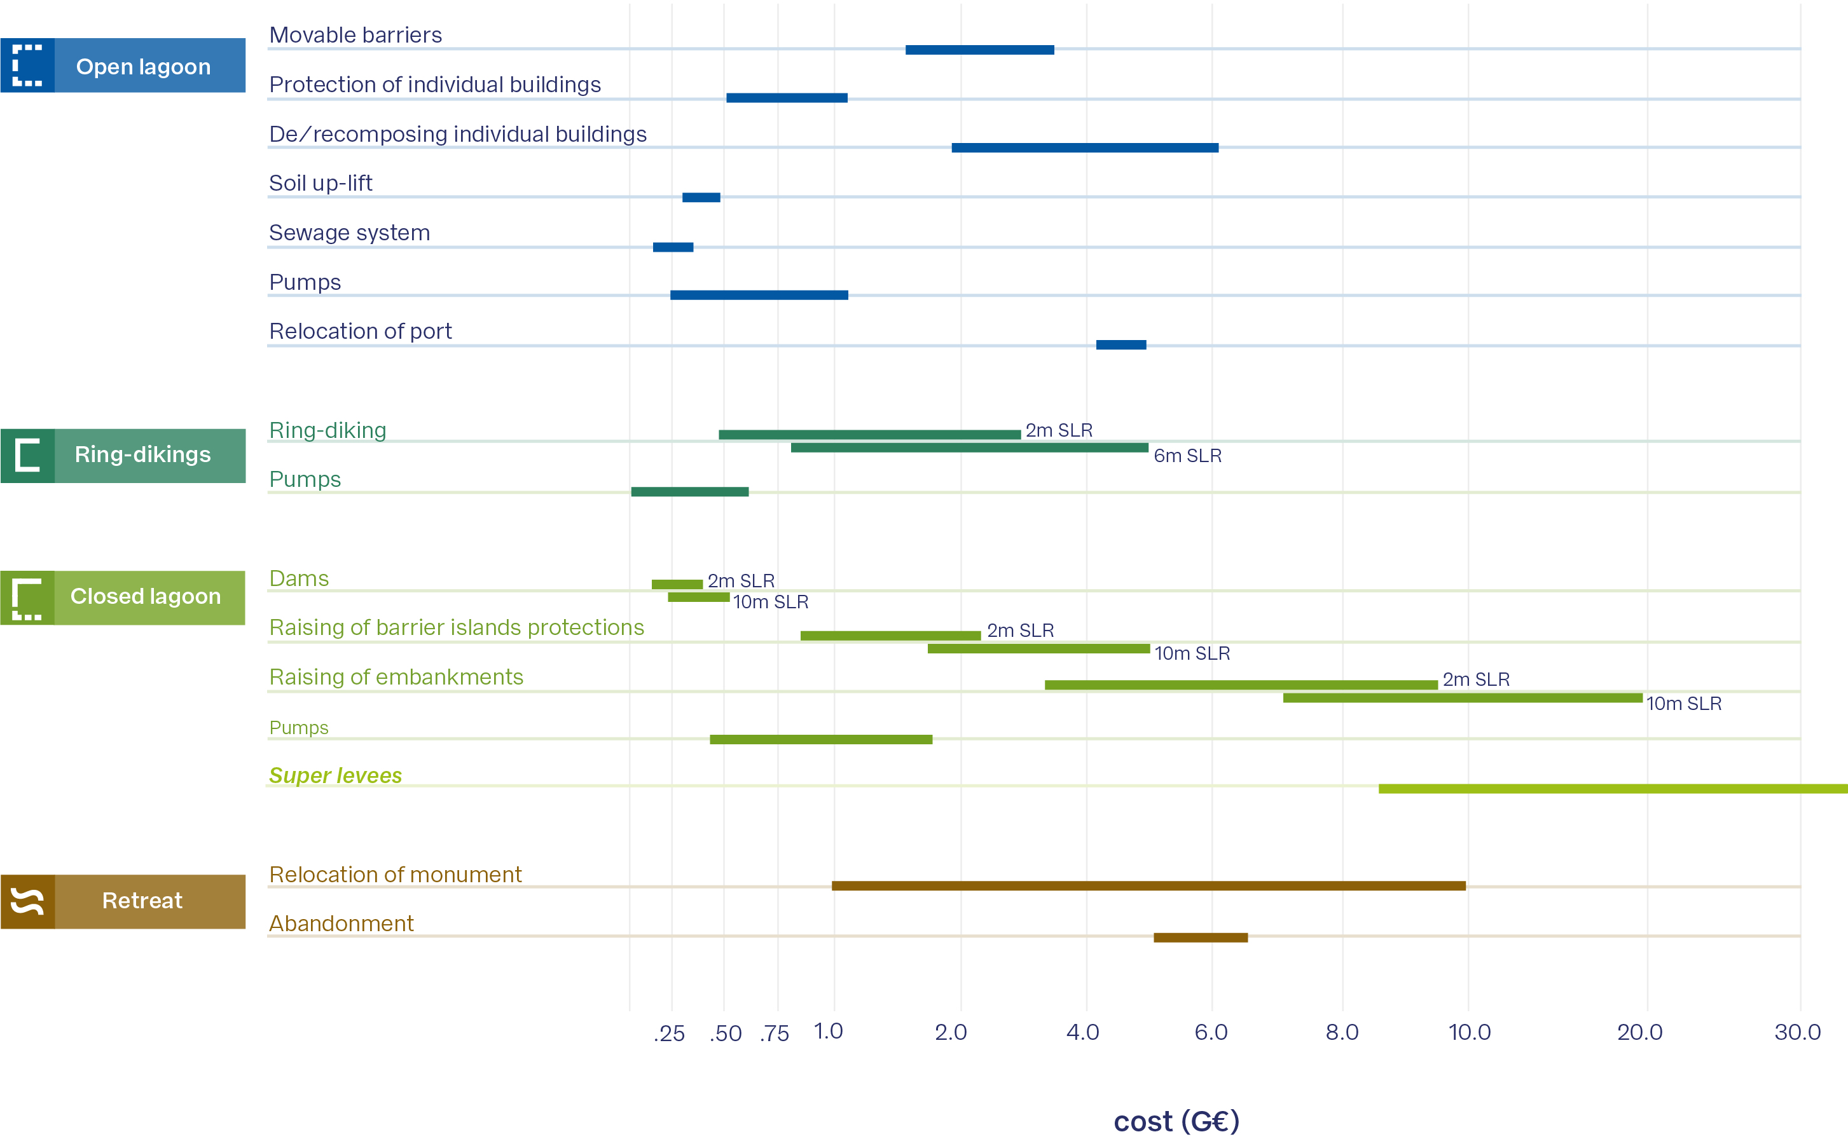

Figure 7. Indicative costs of the measures (in Ge). Each bar extends from the minimum to the maximum estimated cost. For the ring-diking and closed lagoon strategy, the costs corresponding to 2 and 6 m and to 2 and 10 m, respectively, are shown.

429 including operating it for 75 years. Dry-proofing individual buildings (e.g. protective shields, external impervious coating, etc.)
430 is already ongoing in Venice. Costs vary between USD9,000 and USD23,000/building (2016 prices) in developed countries⁸⁰.
431 Applying this strategy to the 2740 buildings below an elevation of 1 m in Venice’s historical centre would thereby cost from
432 0.03Ge to 0.08Ge. Maintenance costs per year are estimated at 1-3% of the investment cost⁸⁰. This is a low cost option
433 compared to other accommodation measures that would be needed to extend the lifetime of the open lagoon strategy.
434 In 2022, a glass barrier was installed to protect St. Mark’s Basilica. The 150m-long and 1.3m-high barrier is reported to
435 have cost 5.3Me⁸³ and is equipped with a pumping system. Taking the same unit cost and height as the barrier protecting the
436 Basilica, deploying this measure to protect exposed (below 1m elevation) buildings of cultural significance would cost 1.1Ge
437 (excluding maintenance costs). In this calculation, 245 buildings are considered and it is assumed the glass barriers align with
438 respective building perimeters.
439 The reconstruction and raising of existing buildings is a much more expensive process. An estimate for building types
440 in Los Angeles⁷³, provides unit costs per building footprint that highly dependent on the type of structure, with “masonry
441 structure with slab-on-grade" being the most fitting category to buildings found in Venice. Costs in Table 2 consider an average
442 building footprint of about 1363 m² (calculated using OpenStreetMap features). An important caveat of these estimates is the
443 extremely soft subsurface layers, the complexity of structures and foundations in Venice, which would lead to much greater
444 costs than in other cities. It is therefore plausible to apply a factor 2 or larger to the costs in Table 2.

445

446

447

448

449

450

451

452
Ring-diking
Two different ring diking configurations are considered. The first comprises three ring dikes around (1) Venice’s historical centre and Giudecca, (2) Murano and (3) Burano-Mazzorbo-Torcello. The second configuration covers a much larger perimeter to enclose Venice as well as developed surrounding islands, connecting the dike to the Lido barrier island. The depth near Venice’s historical centre is assumed to be deeper than in the rest of the lagoon at 4 m compared to 2 m for the other dikes. A hydraulic head of 3 m is targeted for each dike.
Energy costs of pumping C_{PE} would increase with SLR because of increasing difference of water level between the two sides of the dikes:
C_{PE} = c ρgVH , (1)
φ 6
3.6 · 10

453 where ρ is water density (about 1030 Kg/m³), g is gravity (9.8 m/s² ), V is the total annual precipitation (800mm), H (is
454 the level difference, m), φ the pump efficiency (0.7). Assuming a cost of 0.2e/kWh and a maintenance cost of 3% of the
455 capital cost (ignoring SLR related compounding factors such as salinity, corrosion and more frequent operations) shows that
456 the former ones are a minor fraction of the latter ones (in the range from 5% to 20%). Table 3 shows the dike and drainage
457 area characteristics and associated construction and pumping (including energy and maintenance) costs based on available
458 estimates²³.

459 Closed lagoon
460 The permanent closure of the lagoon requires the construction of stationary barriers across the present lagoon inlets, the raising
461 of barrier islands to prevent encroachment and possibly of the whole system of canal banks around the lagoon separating it
462 from the surrounding polders.
463 The unit cost of sea dikes for Italy is estimated at 4.09-11.25 Me/km/m²³ , adjusted to 2024 prices. Yearly maintenance
464 costs are assumed to be 3% of construction costs. Table 4 presents estimated costs of the permanent barriers with a 5-meter
465 hydraulic head for different SLR values.
466 A closed lagoon strategy might require elevating the banks separating the lagoon from surrounding polders either to avoid
467 “backdoor” flooding of the lagoon or flooding of the polders, depending on regional adaptation strategy. A 5m-high dike over
468 the 120 km length of the lagoon perimeter would cost up to 20Ge²³ in case of a 10-meter SLR. This cost would be about 90%
469 lower if a 3-meter head and the present water level inside the lagoon are assumed. The cost for a stone embankment of the
470 same height stretching 28.5 km on the Lido, Pellestrina barrier islands and the Sottomarina peninsula to the South of the lagoon
471 can be estimated in a similar way in the range 0.83 – 4.81 Ge depending on SLR. Pumping costs of the closed lagoon strategy
472 (estimate in the range 0.44-1.78Ge) would be much higher than for the ring-diking strategy as the water level of the whole
473 should be kept fixed. The coastal offshore front of the lagoon could also be considered for a “super-levee”. An example has
474 been conceptualised in Tokyo, Japan²⁵. This structure would be much wider (a width equal to 30 times its height) and therefore
475 significantly more expensive than a simple dike and reliant on available space. The cost of a super-levee of roughly the same
476 length (44 km) in Edogawa was estimated at 16.91Ge²⁵.
477 The cost associated with the relocation of Venice’s port is derived from the unit cost of USD millions 16.6/km2/m⁵⁰. This
478 value is based on costs reported for the Maasvlakte2 development in Rotterdam and includes land reclamation and construction
479 of infrastructure. The current Port of Venice covers an area of 20.45 km2. For a maximum depth of 13.5 m the cost of relocation
480 is estimated at 4.1Ge. For an additional 1.2 m depth, the cost increases to 4.47Ge. Costs for sewage treatment are to be
481 considered as part of the closed-lagoon strategy, as it was described for the open-lagoon strategy.

482 Relocation
483 The relocation of historical monuments is a costly and complex operation. The example of Abu Simbel in 1968 cost between
484 M$ 40 and M$ 70, which corresponds to 0.34Ge - 0.56Ge in 2024²⁶. This was a relatively small-scale operation compared to
485 the extent of relocation that would be required in Venice. Adopting the cost of Abu Simbel to the relocation of 3 to 30 buildings
486 would therefore result in a range from 1 to 10Ge. However, this is a very uncertain estimate, because of unknown technical
487 issues and dependence on the number of considered buildings.

488 Abandonment
489 Low direct costs can be assumed for the abandonment strategy, though the removal of environmentally damaging material (e.g.
490 oil) would need to be considered. However the relocation of residents would have relevant costs. An example is the scheme
491 offered by the Austria government (Relocation as adaptation to flooding in the Eferdinger Becken, Austria), which offered 80%
492 of their house value to people as compensation if they agreed to relocate from areas prone to floods. Considering market price a
493 100m² apartment in Venice would have a cost of about 0.33Me, which would bring a compensation costs of 0.26Me per each
494 household. Considering 25,000 households in total would imply a total compensation cost of about 6.5Ge. If, alternatively, a
495 cost of 3 x GDP/capita (approximately 35Ke) per person moved is assumed²⁷, the cost would be about 5.25Ge considering
496 50,000 inhabitants. Furthermore, abandonment would imply the cancellation of the tourism sector, which has presently an
497 annual turnover of approximately 1Ge⁸⁴.

498 References
ICOMOS, I. C. o. M. & Sites. Insular Venice and its lagoon (1987). Available at https://whc.unesco.org/document/153362. UNESCO, S., UNITED NATIONS EDUCATIONAL & ORGANIZATION, C. Report sc-87/conf.oos/9 (1988). Available
499 | 1.
500 | 2.
501
502 | 3.
503
504 | 4.
505
506 | 5.
507
508 | 6.
509
510 | 7.
511
512
513 | 8.
514
515 | 9.
516
517
518 | 10.
519
520 | 11.
521
522 | 12.
523
524 | 13.
525
526 | 14.
527
528 | 15.
529
530
531
532 | 16.
533
534

at https://whc.unesco.org/document/904.
Bertocchi, D., Camatti, N., Giove, S. & van Der Borg, J. Venice and overtourism: Simulating sustainable development scenarios through a tourism carrying capacity model. Sustainability 12, 512 (2020).
di Venezia, C. popolazione residente (last updated 11/3/2025). Available at https://www.comune.venezia.it/it/content/ grafici-e-statistiche.
CPSM, C. d. V., Centro Previsioni e Segnalazioni Maree. Grafici e statistiche (last updated 14 february 2024). Available at https://www.comune.venezia.it/it/content/grafici-e-statistiche.
Lionello, P. et al. Severe marine storms in the northern adriatic: Characteristics and trends. Phys. Chem. Earth, Parts A/B/C 40-41, 93–105, DOI: https://doi.org/10.1016/j.pce.2010.10.002 (2012).
Lionello, P., Nicholls, R. J., Umgiesser, G. & Zanchettin, D. Venice flooding and sea level: past evolution, present issues, and future projections (introduction to the special issue). Nat. Hazards Earth Syst. Sci. 21, 2633–2641, DOI: 10.5194/nhess-21-2633-2021 (2021).
Zanchettin, D. et al. Sea-level rise in Venice: historic and future trends (review article). Nat. Hazards Earth Syst. Sci. 21, 2643–2678, DOI: 10.5194/nhess-21-2643-2021 (2021).
Colamussi, A. Venice high water barriers: Problems analysis and design approach. Tech. Rep., ICCE 1992 local organising committee (1992). Accessed on 21 june 2025 at https://repository.tudelft.nl/file/File_ 0b02df37-be8d-42f7-a36c-78e2f04319ac?preview=1.
Bourdeau, P. et al. Report on the Mobile Gates Project for the Tidal Flow Regulation at the Venice Lagoon Inlets (Collegio di Esperti di Livello Internazionale, Brussels, Belgium, 1998).
De Zolt, S., Lionello, P., Nuhu, A. & Tomasin, A. The disastrous storm of 4 november 1966 on italy. Nat. Hazards Earth Syst. Sci. 6, 861–879, DOI: 10.5194/nhess-6-861-2006 (2006).
Umgiesser, G. The impact of operating the mobile barriers in Venice (mose) under climate change. J. for Nat. Conserv. 54, 125783, DOI: https://doi.org/10.1016/j.jnc.2019.125783 (2020).
Giupponi, C. et al. Boon and burden: economic performance and future perspectives of the Venice flood protection system.
Reg. environmental change 24, 44, DOI: doi.org/10.1007/s10113-024-02193-9 (2024).
Haigh, I. D. et al. Rapid acceleration in the number of closures of storm surge barriers in the future: A new tool for estimating barrier closures. Preprints DOI: 10.20944/preprints202410.2298.v1 (2024).
Fox-Kemper, B. et al. 2021: Ocean, cryosphere and sea level change. In Masson-Delmotte, V. et al. (eds.) Climate Change 2021: The Physical Science Basis. Contribution of Working Group I to the Sixth Assessment Report of the Intergovernmental Panel on Climate Change, 1211–1362 (Cambridge University Press, Cambridge, United Kingdom and New York, NY, USA, 2021).
Bondesan, A. & Furlanetto, P. Artificial fluvial diversions in the mainland of the lagoon of Venice during the 16th and 17th centuries inferred by historical cartography analysis. Géomorphologie: relief, processus, environnement 18, 175–200, DOI: doi.org/10.4000/geomorphologie.9815 (2012).

535 17. Tosi, L., Carbognin, L., Teatini, P., Rosselli, R. & Gasparetto-Stori, G. The ISES project subsidence monitoring of the
536 catchment basin south of the Venice lagoon (Italy). Land subsidence 2, 113–126 (2000).
537 18. Gambolati, G. et al. Peat land oxidation enhances subsidence in the Venice watershed. Eos, Transactions Am. Geophys.
538 Union 86, 217–220 (2005).
539 19. Programme, U. N. E. Emissions gap report 2024: No more hot air . . . please! with a massive gap between rhetoric and
540 reality, countries draft new climate commitments (2024-10).
541 20. Gambolati, G. et al. On the uniformity of anthropogenic Venice uplift. Terra Nova 21, 467–473 (2009).
542 21. Teatini, P., Castelletto, N., Ferronato, M., Gambolati, G. & Tosi, L. A new hydrogeologic model to predict anthropogenic
543 uplift of Venice. Water Resour. Res. 47 (2011).
544 22. Gambolati, G. & Teatini, P. Venice shall rise again: Engineered uplift of Venice through seawater injection (Elsevier,
545 London, 2013).
546 23. Nicholls, R., Hinkel, J., Lincke, D. & van der Pol, T. Global investment costs for coastal defense through the 21st century.
547 Project Report, World Bank (2019).
548 24. Esteban, M. et al. Adaptation to sea level rise: Learning from present examples of land subsidence. Ocean. & Coast.
549 Manag. 189, 104852 (2020).
550 25. Cao, A., Esteban, M. & Onuki, M. Public support for flood adaptation policy in tokyo lowland areas. Clim. Policy 24,
551 1275–1292 (2024).
552 26. Hill, A. C. ‘the battle for abu simbel’: Archaeology and postcolonial diplomacy in the UNESCO campaign for Nubia. J.
553 Contemp. Hist. 56, 502–521, DOI: doi.org/10.1177/0022009421997884 (2021).
554 27. Lincke, D. & Hinkel, J. Coastal migration due to 21st century sea-level rise. Earth’s Futur. 9, e2020EF001965, DOI:
555 https://doi.org/10.1029/2020EF001965 (2021).
556 28. Haasnoot, M. et al. Adaptation to uncertain sea-level rise; how uncertainty in antarctic mass-loss impacts the coastal
557 adaptation strategy of the netherlands. Environ. Res. Lett. 15, 034007, DOI: 10.1088/1748-9326/ab666c (2020).
558 29. Haasnoot, M., Di Fant, V., Kwakkel, J. & Lawrence, J. Lessons from a decade of adaptive pathways studies for climate
559 adaptation. Glob. Environ. Chang. 88, 102907 (2024).
560 30. van de Wal, R. S. W. et al. A high-end estimate of sea level rise for practitioners. Earth’s Futur. 10, e2022EF002751
561 (2022).
562 31. Bamber, J., Oppenheimer, M., Kopp, R., Aspinall, W. & Cooke, R. M. Ice sheet and climate processes driving the
563 uncertainty in projections of future sea level rise: Findings from a structured expert judgement approach. Earth’s Futur.
564 10, e2022EF002772 (2022).
565 32. Licciardi, G. & Amirtahmasebi, R. The economics of uniqueness: investing in historic city cores and cultural heritage
566 assets for sustainable development (World Bank Publications, 2012).
567 33. Ferrarin, C., Bonaldo, D., Bergamasco, A. & Ghezzo, M. Sea level and temperature extremes in a regulated lagoon of
568 Venice. Front. Clim. 5, 1330388 (2024).
569 34. Sfriso, A. et al. Long-term changes of the trophic status in transitional ecosystems of the northern adriatic sea, key
570 parameters and future expectations: The lagoon of Venice as a study case. Nat. Conserv. 34, 193–215 (2019).
571 35. Zonta, R., Cassin, D., Pini, R. & Dominik, J. Substantial decrease in contaminant concentrations in the sediments of the
572 Venice (italy) canal network in the last two decades—implications for sediment management. Water 12, 1965 (2020).
573 36. Bernardi Aubry, F., Acri, F., Finotto, S. & Pugnetti, A. Phytoplankton dynamics and water quality in the Venice lagoon.
574 Water 13, 2780 (2021).
575 37. Tognin, D. et al. Loss of geomorphic diversity in shallow tidal embayments promoted by storm-surge barriers. Sci. Adv. 8,
576 eabm8446, DOI: 10.1126/sciadv.abm8446 (2022).
577 38. Tosi, L., Da Lio, C., Cosma, M. & Donnici, S. Vulnerability of tidal morphologies to relative sea-level rise in the Venice
578 Lagoon. Sci. Total. Environ. 931, 173006 (2024).
579 39. Amos, C. L., Umgiesser, G., Ghezzo, M., Kassem, H. & Ferrarin, C. Sea surface temperature trends in Venice lagoon and
580 the adjacent waters. J. Coast. Res. 33, 385–395 (2017).
581 40. Sfriso, A., Wolf, M. A., Buosi, A., Sciuto, K. & Sfriso, A. A. Alien macroalgal rearrangement in the soft substrata of the
582 Venice lagoon (italy): impacts, threats, time and future trends. Sustainability 15, 8256 (2023).

583 41. Marchini, A., Ferrario, J., Sfriso, A. & Occhipinti-Ambrogi, A. Current status and trends of biological invasions in the
584 lagoon of Venice, a hotspot of marine nis introductions in the mediterranean sea. Biol. invasions 17, 2943–2962 (2015).
585 42. Sfriso, A., Buosi, A., Wolf, M. & Sfriso, A. Invasion of alien macroalgae in the Venice lagoon, a pest or a resource?
586 Aquatic Invasions 15, 245–270 (2020).
587 43. Piccardi, F. et al. Assessing the impact of the invasive ctenophore mnemiopsis leidyi on artisanal fisheries in the Venice
588 lagoon: an interdisciplinary approach. Hydrobiologia 1–19 (2024).
589 44. Stasolla, G., Tricarico, E. & Vilizzi, L. Risk screening of the potential invasiveness of non-native marine crustacean
590 decapods and barnacles in the mediterranean sea. Hydrobiologia 848, 1997–2009 (2021).
591 45. Bertocchi, D. & Visentin, F. “the overwhelmed city”: Physical and social over-capacities of global tourism in Venice.
592 Sustainability 11, 6937 (2019).
593 46. Cecchi, T. Analysis of volatiles organic compounds in Venice lagoon water reveals covid 19 lockdown impact on
594 microplastics and mass tourism related pollutants. Sci. Total. Environ. 783, 146951 (2021).
595 47. Walsh, C. et al. Trade and trade-offs: Shipping in changing climates. Mar. Policy 106, 103537 (2019).
596 48. Müller-Casseres, E., Edelenbosch, O. Y., Szklo, A., Schaeffer, R. & van Vuuren, D. P. Global futures of trade impacting
597 the challenge to decarbonize the international shipping sector. Energy 237, 121547 (2021).
598 49. Jaramillo, P. et al. Transport. In Shukla, P. R. et al. (eds.) Climate Change 2022: Mitigation of Climate Change.
599 Contribution of Working Group III to the Sixth Assessment Report of the Intergovernmental Panel on Climate Change,
600 1049–1160 (Cambridge University Press, Cambridge, United Kingdom and New York, NY, USA, 2022).
601 50. Hanson, S. E. & Nicholls, R. J. Demand for ports to 2050: Climate policy, growing trade and the impacts of sea-level rise.
602 Earth’s Futur. 8, e2020EF001543 (2020).
603 51. Haasnoot, M., Lawrence, J. & Magnan, A. K. Pathways to coastal retreat. Science 372, 1287–1290 (2021).
604 52. Nicholls, R. J. et al. Stabilization of global temperature at 1.5 c and 2.0 c: implications for coastal areas. Philos.
605 Transactions Royal Soc. A: Math. Phys. Eng. Sci. 376, 20160448 (2018).
606 53. Magnan, A. K. & Duvat, V. K. Towards adaptation pathways for atoll islands. insights from the maldives. Reg. Environ.
607 Chang. 20, 1–17 (2020).
608 54. Van Alphen, J., Haasnoot, M. & Diermanse, F. Uncertain accelerated sea-level rise, potential consequences, and adaptive
609 strategies in the netherlands. Water 14, 1527 (2022).
610 55. Kool, R., Lawrence, J., Larsen, M. A. D., Osborne, A. & Drews, M. Spatiotemporal aspects in coastal multi-risk climate
611 change decision-making: Wait, protect, or retreat? Ocean. & Coast. Manag. 258, 107385 (2024).
612 56. Lawrence, J. et al. Dynamic adaptive pathways planning for adaptation: lessons learned from a decade of practice in
613 aotearoa new zealand. J. Integr. Environ. Sci. 22, 2451424 (2025).
614 57. Cao, A. et al. Future of asian deltaic megacities under sea level rise and land subsidence: current adaptation pathways for
615 tokyo, jakarta, manila, and ho chi minh city. Curr. opinion environmental sustainability 50, 87–97 (2021).
616 58. Garner, G. G. et al. Ipcc ar6 sea level projections, DOI: 10.5281/zenodo.6382554 (2021).
617 59. Zanchettin, D., Bruni, S., Thiéblemont, R. & Rubinetti, S. Data from article "sea-level rise in Venice: historic and future
618 trends (review article)", DOI: 10.5281/zenodo.5139890 (2021).
619 60. Garner, G. et al. Ipcc ar6 wgi relative sea level projection distributions without background component, DOI: 10.26050/
620 WDCC/AR6.IPCC-DDC_AR6_Sup_DistBC (2023).
621 61. Kopp, R. E. et al. The framework for assessing changes to sea-level (facts) v1.0: a platform for characterizing parametric
622 and structural uncertainty in future global, relative, and extreme sea-level change. Geosci. Model. Dev. 16, 7461–7489,
623 DOI: 10.5194/gmd-16-7461-2023 (2023).
624 62. Tosi, L., Teatini, P. & Strozzi, T. Natural versus anthropogenic subsidence of Venice. Sci. reports 3, 2710 (2013).
625 63. Da Lio, C., Teatini, P., Strozzi, T. & Tosi, L. Understanding land subsidence in salt marshes of the Venice lagoon from sar
626 interferometry and ground-based investigations. Remote. sensing environment 205, 56–70 (2018).
627 64. Tosi, L., Teatini, P., Carbognin, L. & Brancolini, G. Using high resolution data to reveal depth-dependent mechanisms that
628 drive land subsidence: The Venice coast, italy. Tectonophysics 474, 271–284 (2009).
629 65. Calafat, F. M., Chambers, D. P. & Tsimplis, M. N. Mechanisms of decadal sea level variability in the eastern north atlantic
630 and the mediterranean sea. J. Geophys. Res. Ocean. 117 (2012).

631 66. Scarascia, L. & Lionello, P. Global and regional factors contributing to the past and future sea level rise in the northern
632 adriatic sea. Glob. planetary change 106, 51–63 (2013).
633 67. Tosi, L., Strozzi, T., Da Lio, C. & Teatini, P. Regional and local land subsidence at the Venice coastland by terrasar-x psi.
634 Proc. Int. Assoc. Hydrol. Sci. 372, 199–205 (2015).
635 68. Gambolati, G. & Teatini, P. Venice shall rise again: Engineered uplift of Venice through seawater injection (Elsevier,
636 London, 2013).
637 69. Lionello, P. et al. Extreme storm surges in the gulf of Venice: Present and future climate. In Flooding and Environmental
638 Challenges for Venice and Its Lagoon: State of Knowledge, 59–65 (Cambridge University Press, 2005).
639 70. Lionello, P. et al. Extremes floods of Venice: characteristics, dynamics, past and future evolution. Nat. Hazards Earth Syst.
640 Sci. Discuss. 2020, 1–34 (2020).
641 71. Conte, D. & Lionello, P. Characteristics of large positive and negative surges in the mediterranean sea and their attenuation
642 in future climate scenarios. Glob. Planet. Chang. 111, 159–173 (2013).
643 72. Lionello, P., Mufato, R. & Tomasin, A. Sensitivity of free and forced oscillations of the adriatic sea to sea level rise. Clim.
644 Res. 29, 23–39 (2005).
645 73. Aerts, J. C. et al. Pathways to resilience: adapting to sea level rise in los angeles. Annals New York Acad. Sci. 1427, 1–90,
646 DOI: https://doi.org/10.1111/nyas.13917 (2022). https://nyaspubs.onlinelibrary.wiley.com/doi/pdf/10.1111/nyas.13917.
647 74. Libertino, A., Ganora, D. & Claps, P. Evidence for increasing rainfall extremes remains elusive at large spatial scales: The
648 case of italy. Geophys. Res. Lett. 46, 7437–7446 (2019).
649 75. Parisi, S. G., Alimonti, G. & Mariani, L. Mean and extreme precipitation regime in north and central italy – between
650 stability and change. Italian J. Agrometeorology DOI: 10.36253/ijam-3315 (2025).
651 76. Faggian, P. & Trevisiol, A. Climate extreme scenarios affecting the italian energy system with a multi-hazard approach.
652 Bull. Atmospheric Sci. Technol. 5, 4 (2024).
653 77. Rinaldo, A. et al. Sea level rise, hydrologic runoff, and the flooding of venice. Water Resour. Res. 44 (2008).
654 78. Zuliani, A., Zaggia, L., Collavini, F. & Zonta, R. Freshwater discharge from the drainage basin to the Venice lagoon (italy).
655 Environ. Int. 31, 929–938 (2005).
656 79. Caporin, M. & Fontini, F. Damages evaluation, periodic floods, and local sea level rise: the case of Venice, italy. In
657 Handbook of environmental and sustainable finance, 93–110 (Elsevier, 2016).
658 80. Aerts, J. C. J. H. A review of cost estimates for flood adaptation. Water 10, DOI: 10.3390/w10111646 (2018).
659 81. Scrinzi, D., Ferrentino, R., Baù, E., Fiori, L. & Andreottola, G. Sewage sludge management at district level: reduction and
660 nutrients recovery via hydrothermal carbonization. Waste Biomass Valorization 14, 2505–2517 (2023).
661 82. von Sperling, M. & Salazar, B. L. Determination of capital costs for conventional sewerage systems (collection, transporta-
662 tion and treatment) in a developing country. J. water, sanitation hygiene for development 3, 365–374 (2013).
663 83. Somers Cocks, A. Venice erects glass barriers around st mark’s basilica to fight flooding (2022-10).
664 84. Manente, M. & Montaguti, F. L’impatto economico del turismo veneziano. Quaderni Insula 6, 29–37 (2004).

665 keywords

666 Venice, sea-level rise, climate change, adaptation pathways, sustainable development

667 Acknowledgements

668 The authors acknowledge Fondazione Eni Enrico Mattei (FEEM) for the organization of a workshop in February 2023
669 instrumental for this study.

670 Funding

671 CG acknowledges financial support from the Fondazione Eni Enrico Mattei (Adapt@Ve Programme). VDF was supported
672 by the European Union’s Horizon 2020 research and innovation programme through the Pathways2Resilience project (Grant
673 Agreement No. 101093942). UP, RJN, and ATV acknowledge financial support from the Horizon Europe project CoCliCo
674 (Coastal Climate Core Services).

675 Author contributions statement

676 PL: coordination, conceptualization, discussion, writing of the whole text, graphics of figures 3, 4, 5 and 6
677 VDF: conceptualization, discussion and description of measures and strategies and writing of the corresponding text
678 UP: computation of costs estimates and writing of the corresponding text
679 LT: assessment of the elevation of ground and defence systems, production of figures 1 and 2
680 GLC: conceptualization, discussion, analysis of sea-level rise
681 RJN: conceptualization, discussion, methodology for cost estimates, contribution to overall writing
682 PT conceptualization, discussion and detailed cost estimate of the measure for ground elevation
683 WC, RC, CG, JH, AS, ATV, GU : conceptualization and discussion
684 MH: conceptualization, discussion, graphics of figures 4,5,6
685

686 Additional information
687 Data Availability

688 Sea-level projection data used in this study are publicly available from the following repositories:
689 Zenodo: https://doi.org/10.5281/zenodo.6382554
690 Zenodo: https://doi.org/10.5281/zenodo.5139890
691 IPCC AR6 Data Distribution Centre (Distilled and Bias-Corrected Sea Level Projections):
692 https://doi.org/10.26050/WDCC/AR6.IPCC-DDC_AR6_Sup_DistBC
693 Code and associated data described in:
694 https://doi.org/10.5194/gmd-16-7461-2023 (see section “Code and Data Availability”).
695
696 Land elevation datasets of the areas surrounding the Venice Lagoon and of the lagoon islands used in this study are publicly
697 available from the Italian Ministry of the Environment and Energy Security via the National Geoportal
698 (https://gn.mase.gov.it/portale/en/home)
699 and the Spatial Data Access Portal
700 (https://sim.mase.gov.it/portalediaccesso/mappe/#/viewer/new).
701
702 For Figure 1 and related analyses, land elevation data were extracted from a Digital Terrain Model (DTM) provided by
703 the Veneto Region, available at
704 https://idt2.regione.veneto.it/idt/downloader/download.
705
706 High-resolution elevation datasets of the Venice lagoon boundaries with 1 m and 2 m ground resolution (Figure 2 and
707 associated text), derived from airborne LiDAR surveys, were acquired by the Italian Ministry of the Environment and the
708 Protection of Land and Sea under the Extraordinary Environmental Detection Plan (PST-A). These datasets are publicly
709 accessible via the portals of the Italian Ministry of the Environment and Energy Security listed above.
710
711 Ground elevation data of the Venice historical centre used in this study to compute the fraction of flooded area are pub-
712 licly available from the RAMSES project promoted by the Municipality of Venice and implemented by Insula S.p.A., via the
713 Insula S.p.A. portal (http://smu.insula.it/index.html).
714
715 Information used for cost estimates was obtained from the peer-reviewed scientific literature cited in the manuscript.

716 Competing interests

717 The authors declares no competing interest and no conflict of interest in relation to the work described in this manuscript

