Meta analysis of Manning’s coefficient for saltmarsh and mangroves to support broad scale assessment
Syed Shamsil Arefin¹, Robert J Nicholls¹, Stefanie Nolte^{1,2}, Jack Heslop¹
¹ University of East Anglia, Tyndall Centre for Climate Change Research, School of Environmental Sciences, Norwich, NR4 7TJ, UK.
² Lower Saxon Wadden Sea National Park Authority, Virchowstr. 1, 26382 Wilhelmshaven, Germany.

Abstract: The natural protection offered by saltmarsh and mangrove wetlands is increasingly recognised and there is widespread interest in understanding this phenomenon to assist nature-based coastal interventions. Roughness plays a fundamental role in shallow-water hydrodynamic process and hence is a critical parameter for simulating flow over coastal vegetation and the resulting dynamics of surge and wave attenuation. This study provides a comprehensive review of our understanding of the Manning’s coefficient (T/L^{1/3}) in saltmarsh and mangroves. The literature was screened using a rigorous selection procedure to identify studies relevant to saltmarsh and mangrove hydrodynamics and bed roughness. Considering all the numerical, laboratory and ﬁeld studies that used Manning’s coefficient in saltmarsh and mangrove ecosystems, 36 papers were identified and assessed. The results indicate an interquartile range of Manning’s coefficient (s/m^{1/3}) from 0.04 to 0.08 for saltmarshes and 0.10 to 0.14 for mangroves, providing indicative ‘global’ estimates for these two coastal wetland types. Geographic location, tidal range and temperature showed no statistical relationship, supporting the use of global indicative values. However, statistical testing reveals that the Manning’s coefficient for saltmarshes and mangroves do show significant cross-shore variability with increasing values from the seaward to landward direction. This should be considered and further assessed, especially in more detailed studies. Hence, this analysis provides an indicative ‘global’ constant estimate of Manning’s coefficient for saltmarshes and mangroves, as well as suggestions for more systematic future research on wetland roughness.
Keywords: Manning’s coefficient, Hydrodynamics, Numerical Modelling, Coastal Wetlands, global assessment

INTRODUCTION
Coastal wetlands such as saltmarshes and mangroves, provide a wide range of vital ecosystem services. These wetlands are necessary for biodiversity, offering critical habitats for a diverse array of species that support both commercial and recreational fishing (Carr et al., 2012). Additionally, they play an essential role in carbon sequestration helping to mitigate climate change by storing carbon (Ouyang et al., 2000; Gu et al., 2022) and contribute to climate regulation by reducing the impacts of sea-level rise (Fourqurean et al., 2012). Saltmarshes and mangroves also serve as natural barriers against various natural hazards including extreme tides and storm surges (Krauss et al., 2009), tsunamis (Olwig et al., 2007) and coastal erosion. By acting as a natural buffer zone they enhance the resilience of coastal areas supplementing existing protective measures and reducing the damage caused by such events (Temmerman et al., 2022).

Despite their importance, saltmarshes and mangroves are experiencing significant losses globally: saltmarshes were declining at a rate of 0.28% per year between 2000 and 2019 (Campbell et al., 2022) while mangroves were being lost at a faster rate of 0.67% per year (Keys et al., 2019). This threatens the continued delivery of all their ecosystem services, including coastal protection. Morphological attributes of saltmarshes and mangroves play a critical role in their ability to dissipate wave energy and tidal forces (Best et al., 2018) with key factors including bed roughness of the wetland floor and vegetation drag exerted by plant structures in the water column (Zhang et al., 2022). Representing these dissipative attributes in numerical simulation studies is complex. The dynamics of waves, tides, and currents coupled with data limitations pose significant challenges within wetland environments (Möller et al., 2014).

This research considers roughness estimates for nature-based coastal protection services based on wave and still water attenuation across coastal wetlands. It is a key component of an exploratory analyses of the global costs and benefits of coastal restoration (cf. Sanchez-Arcilla et al., 2022). This analysis uses an integrated assessment model combining the Global Coastal Wetland Model (Schuerch et al., 2018) and the Dynamic Interactive Vulnerability Assessment (DIVA) flood module (Hinkel et al., 2014; Lincke and Hinkel, 2021). Hence the approach has to be applicable globally.

In depth-integrated two-dimensional models, Manning’s coefficient (T/L^{1/3}) (Units s/m^{1/3}) offers a simple and well-known approach to represent bed roughness due to vegetation (Bouma et al., 2009). Drag based approaches offer a more physically realistic representation of wetland flow resistance (Etminan et al., 2017; Holzenthal et al., 2022; Zhang et al., 2020). However, they require detailed information on stem diameter, density, and species composition, which vary substantially. This complexity increases vegetation data demands particularly for broad-scale assessments (Temmerman et al., 2015). Increasing data on typical stem densities, diameter, vegetation height, and other relevant information for mangroves (e.g., Horstman et al., (2014; 2021) and Lopez-Arias et al., 2024) and saltmarshes (e.g., Silinski et al., 2018, Schoutens et al., 2022 and Temple et al., 2024), as well as new global assessments of dominant genera (e.g., Twomey & Lovelock 2024; Twomey et al., 2024) provides a basis to develop drag-based roughness estimates. However, they do not yet yield the spatially explicit inputs needed for global implementation. In addition, the available global wetland datasets are generalised, typically distinguishing only broad classes such as saltmarsh, mangroves or tidal flat rather than the detailed species information (e.g., Schuerch et al., 2018). Within these constraints, Manning’s coefficient offers a pragmatic and computationally efficient means of representing enhanced roughness due to vegetation at global scales for the purposes of this assessment. While this approach does not explicitly account for vegetation drag, porosity, or seasonal variability, it has been shown to be appropriate in coastal settings dominated by high storm surges (Chen et al., 2021) and has been applied successfully in regional wetland hydrodynamic studies (Horstman et al., 2014; Barinas et al., 2024). Manning’s coefficient is therefore adopted here as a scale-appropriate parameterisation, consistent with current data availability and the exploratory objectives of the overall global assessment of coastal restoration.

Tidal range and temperature are environmental drivers that influence the hydrodynamic behaviour and physical characteristics of coastal wetlands and hence may influence roughness representation. Tidal range governs the frequency and depth of inundation which in turn controls sediment deposition, vegetation structure and wetland stability (Schuerch et al., 2018; Xie et al., 2022). Larger tidal ranges enhance sediment accretion and vertical resilience to sea-level rise, while smaller tidal amplitudes limit sediment supply. This may alter vegetation density that influence bed roughness and the effective Manning’s coefficient. Global variation in temperature also plays an important role in defining the distribution and physiological thresholds of saltmarshes and mangroves, potentially influencing roughness.

There is a large literature available regarding saltmarsh and mangrove hydrodynamics (Wamsley et al., 2010; Zhang et al., 2010). While Manning’s coefficient has been widely used in regional studies to represent vegetation and wetland roughness in coastal wetlands (Barinas et al., 2024; Soliman et al., 2022) there has been no comprehensive literature assessment of its use at broad scales. This limits our understanding of Manning’s coefficient and how it varies between saltmarshes and mangroves, by geographic location, tidal range and temperature, and cross-shire zonation effects. Addressing this gap will determine how Manning’s coefficient might be best used to represent saltmarsh and mangrove roughness in broadscale assessments. This analysis also synthesises a body of knowledge which increases understanding of coastal wetland roughness.

METHODOLOGY

Literature Search
This research uses the ‘Web of Science’ database to search the literature. The focus of this search is to select all the studies which contain relevant information on ‘coastal wetlands’. This was then further narrowed using filters to consider literature that only contains (1) either ‘saltmarsh’ or ‘mangroves’, (2) ‘hydrodynamics’., and (3) ‘Manning’s coefficient’. The workflow for the literature search is illustrated in Figure 1 and this identified a total of 267 research papers.
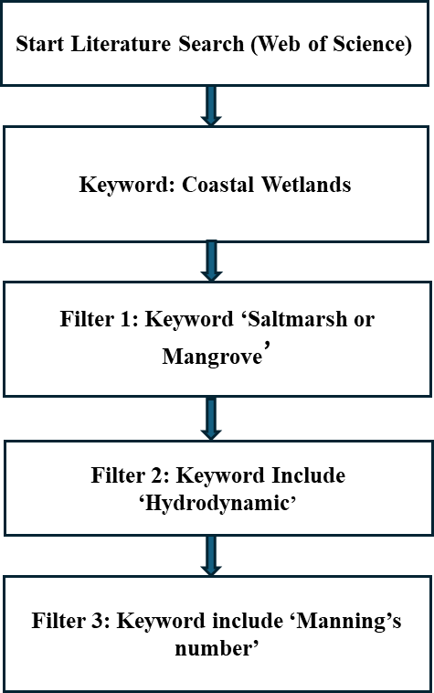
Figure 1. Workflow for the search criteria in Web of Science

Literature Selection
From these 267 papers, we select only those studies which meet specific criteria related to numerical models, Manning’s coefficient, model calibration and spatial variability (Figure 2).
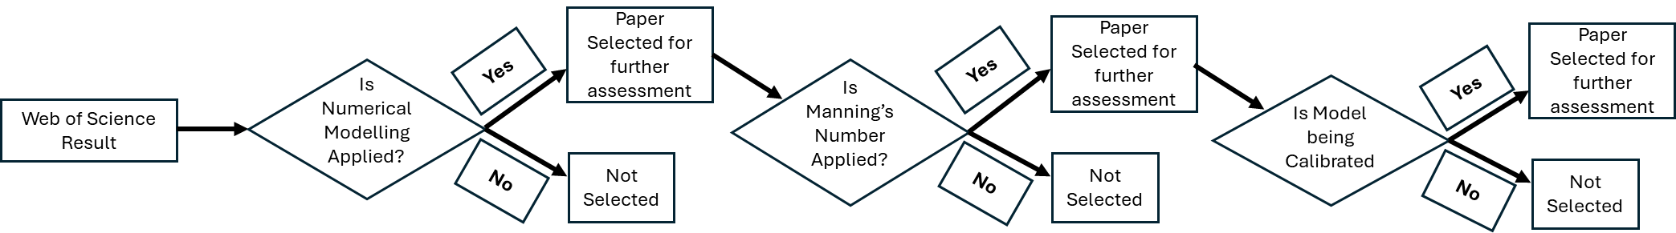
Figure 2. Workflow for the selection of papers for detailed analysis
Firstly, eligible studies must employ numerical models specifically designed to simulate hydrodynamic processes in saltmarshes or mangroves addressing water flow, wave attenuation or other hydrodynamic functions influenced by vegetation and bed roughness. Moreover, each selected study had to use Manning’s coefficient as a key modelling parameter, either as a constant or variable reflecting different environmental conditions. In addition, the rationale behind the choice of the value of Manning’s coefficient whether based on empirical data, previous literature, or calibration procedures had to be documented. To maintain methodological rigour only studies detailing the calibration procedures employed were included, as calibration is essential for accurately representing Manning’s coefficient in varied environmental settings. Calibration data whether derived from field measurements, observational data, or empirical calibration enhances the robustness of Manning’s coefficient as a parameter. Hence, studies lacking calibration or relying solely on uncalibrated models were excluded as this could lead to misleading results particularly in assessing spatial variability. In addition, studies needed to specify the geographic location of the study to enable spatial analysis of Manning’s coefficient. To ensure consistency only studies published in English were included, prioritising peer-reviewed journal articles, conference papers and technical reports with sufficient citations (>10). The focus is on studies from the last 20 years, except for a few earlier foundational works that were heavily cited and influential in the field
Using this selection criteria manually we identified a total 36 research papers out of the 267 potential papers of which 18 focussed on saltmarshes and 18 focused on mangroves. The global distribution of the selected study sites are presented in the Figure 3.
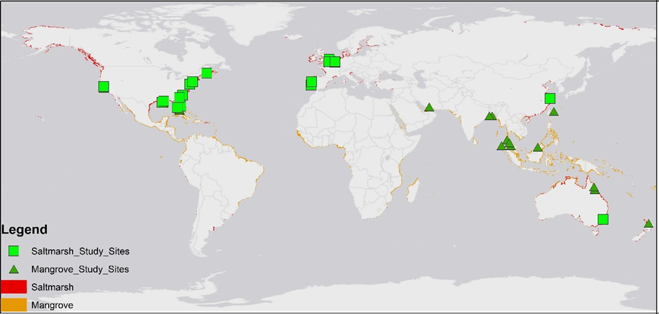
Figure 3. The global distribution of saltmarsh (McOwen et al., 2017) and mangroves (Worthington et al., 2020) and the research locations considered in this study. Saltmarsh sites are green rectangles and mangroves sites are green triangles.

Data extraction
Both qualitative and quantitative data are extracted from the 36 studies, including (1) year of study, (2) location, (3) annual mean temperature, (4) Mean tidal range and (5) Manning’s coefficient, including any spatial variability, as appropriate. All studies used standard SI units (Units (s/m^{1/3}) and hence the data has been directly used. Any gaps in annual mean temperature data were filled with data from Mourshed 2016. We also extracted categorical variables for (a) the spatial variability of roughness (zonation [along cross-section]), (b) location [i.e. continent]) and (c) vegetation type (saltmarsh and mangroves). The resulting data set is given in Appendix-A.

Analysis
Initially the papers for both mangroves and saltmarshes have been analysed in terms of their citations of earlier papers considered in this analysis to understand their connection. To understand the roughness variability, simple ANOVA (Analysis of variance), ANCOVA (Analysis of covariance), and t-test analysis has been performed on spatial distribution, tidal range, temperature, and influence of cross-shore zonation of both saltmarsh and mangroves. For the analysis of cross-shore zonation, seaward and landward zonation has been used (in accordance with Schwarz et al.,2022). The Manning’s coefficient has been used as the response variable and spatial distribution, tidal range, temperature, zonation are used as the explanatory variable in the ANOVA, ANCOVA and t-test.
To determine the broad scale range of Manning’s coefficient for saltmarshes and mangroves, cumulative distribution functions has been constructed using data compiled from all selected studies. From these distributions key statistical indicators including the mean, median and interquartile range (IQR) is being calculated to effectively summarize the central tendency and variability of the roughness values. All statistical analysis were performed using the software MATLAB 2015 (The MathWorks, 2015) and, except for ANCOVAs, were analysed separately for salt marshes and mangroves due to the different roughness characteristics of these two vegetation types.

RESULTS
The selected literature for saltmarsh comprised 52% from North America, 34% from Europe and 14% from the rest of the world. For mangroves it comprised 50% from Asia, 25% from North America, 20% from Australia and 5% from the rest of the world. Figure 3 shows the sites and demonstrates a bias to US sites for saltmarshes, with Asia dominating the mangroves sites. There is notably no data from Africa and little data from Central and South America.

Research interdependency and bias
Understanding how Manning's coefficient is adopted and referenced across studies allows us to assess potential study bias in hydrodynamic modelling. Study bias can arise when earlier roughness values are uncritically reused in subsequent research, potentially propagating outdated or context-specific values without recalibration. Figure 4 visualizes the relationships between studies by linking those that reference or directly use Manning's coefficient from earlier work. Solid lines indicate that the previous values was used directly in the new study, while dashed lines denote citation to the earlier study with a new value being developed. By mapping these connections, we aim to identify to what degree the field is evolving through critical evaluation and refinement of roughness coefficients versus reliance on established values.
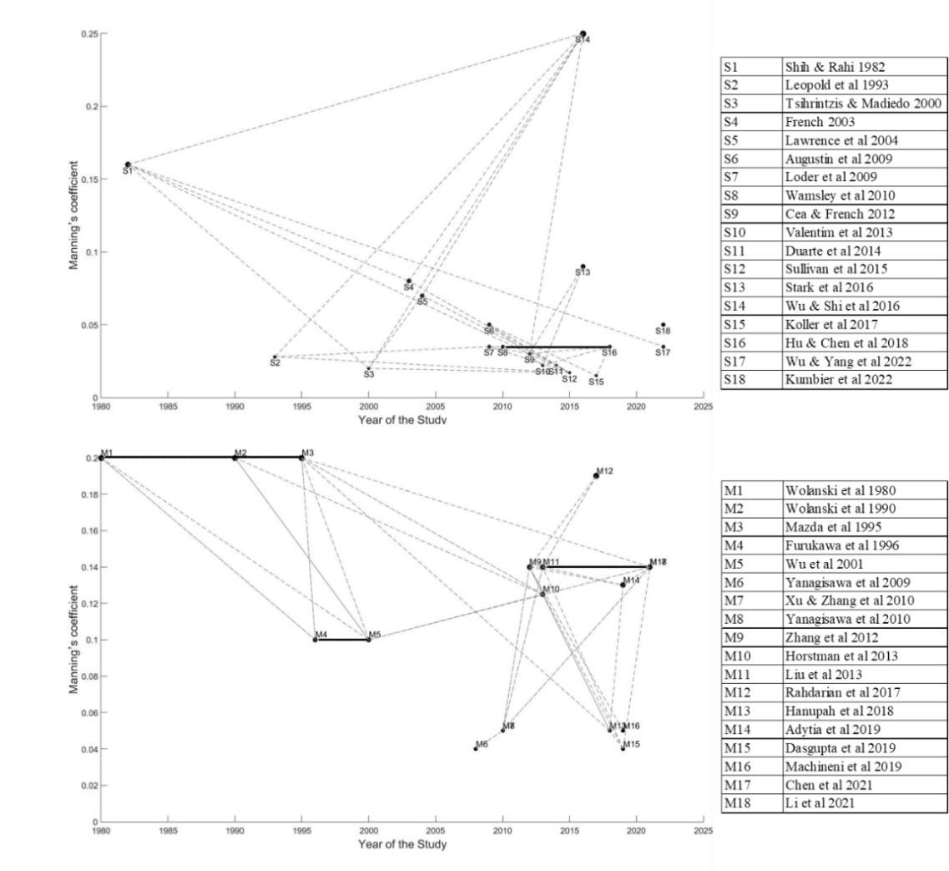
Figure 4. Estimates of Manning’s coefficient from the different studies for (a) saltmarsh and (b) mangroves versus time. The lines indicate pairs of papers where the later paper cited the former paper (dashed line) and used the earlier value (solid line).
Comparing the papers, the mangroves research space shows more interconnectedness than the saltmarsh research space (more dashed and solid lines linking the papers). The mangroves research space also shows a high proportion of dashed linkages, denoting where previous studies have been referenced, but the Manning’s coefficient has not been uncritically adopted. Most saltmarsh studies reference previous studies but rarely used the Manning’s coefficient from those previous studies. In several cases, the saltmarsh studies use previous Manning’s coefficient but calibrated to their local indicators (S1 & S17, S3 & S14, S4 & S13). In contrast, mangrove studies often directly use earlier Manning’s coefficients. The first three mangrove studies (M1, M2 & M3) used the same Manning’s coefficient. M4 references the previous studies but calibrate their own Manning’s coefficient which is again used by M5. M9 is referenced and used in later studies (M11 & M18). Figure 4 also indicates that before the year 2000 the Manning’s coefficient used in both saltmarshes and mangroves was generally higher (S1, M1, M2 & M3) than for studies after 2000 with some exceptions for saltmarsh (S14) and for mangroves (M12). For the saltmarsh study (S17), Manning’s coefficient has been used from a previous study (S1) with a similar coastal barrier configuration but has also been calibrated with local observed datasets for flow and velocity. For mangroves, the study (M12) has also been calibrated with local datasets. Figure 4 also indicates for mangroves that there has been one key paper (M9) which has been extensively cited and used in later studies after 2012 (cited by 9 of the other papers in our analysis). In contrast for saltmarsh studies no such key paper is apparent.

Spatial variability of wetland roughness
To understand whether the Manning’s coefficient significantly varies in space a simple ANOVA test has been performed with the study sites from North America, Asia, Europe and Australia (Figure 5). The Manning’s coefficient value in salt marshes is not significantly affected by location (F= 0.51, P= 0.61; Fig 5a). For mangroves likewise no significant effect of location was found (F = 1.31, P = 0.29; Fig 5b).
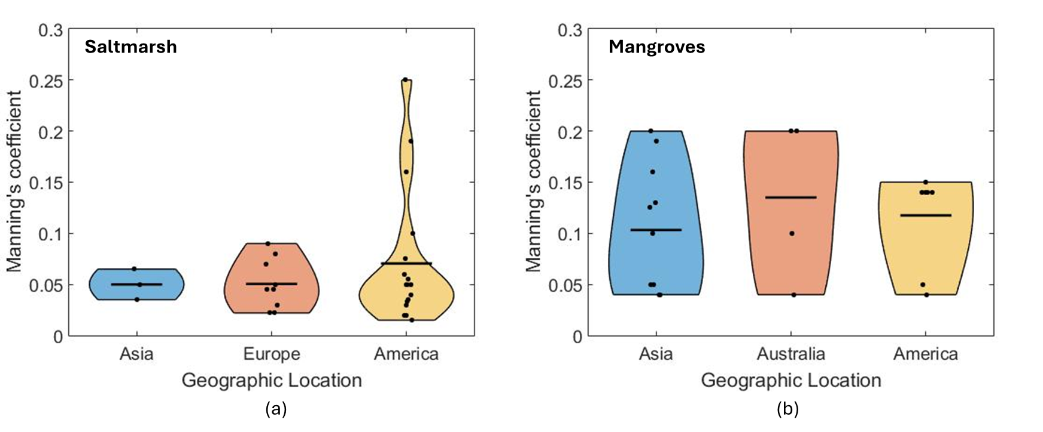
Figure 5. Manning’s coefficient (range and median) based on geographic location. (a) Saltmarsh studies (sample size: 18) and (b) Mangroves studies (sample size: 18). Each violin plot the horizontal line indicating the median and whiskers representing the data range excluding outliers.
To understand the statistical significance of the cross-sectional roughness zonation, a t-test is performed for both saltmarsh and mangroves wetland types. The result of the t-tests indicate that Manning’s coefficient is significantly affected by zonation for both saltmarsh and mangroves. Saltmarshes have higher Manning’s coefficient in the landward zone compared to the seaward zone (P= 0.0042, t-stat= -3.59; Fig 7a). For Mangroves, a t-test was performed for both landward and seaward zones and the results indicate a statistically significant impact, with a higher Manning’s coefficient in the landward zone (P=0.0029, t-stat= -7.57; Fig 7b).
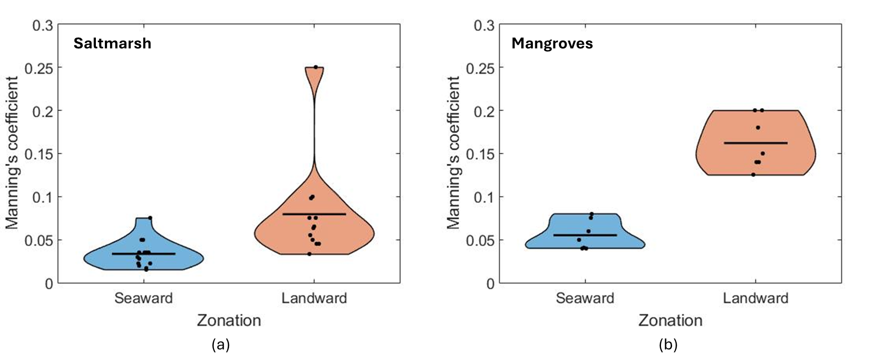
Figure 6. Statistical distribution of Manning’s coefficient (range and median) based on cross-shore zonation; Saltmarsh studies (sample size: 18) (a) and Mangroves studies (sample size: 18) (b). The black horizontal line in each violin indicates the median of the scatter data

Impact of tidal range on wetland roughness
It is also useful to categorise the sites by tidal range. Here we adopt the approach of (Short 1991), categorising sites by tidal range into micro (Tidal Range<2m), meso (2m<Tidal Range<4m) and macro (Tidal Range>4m) tidal range to understand the distribution and statistical significance on roughness value. An ANOVA test is performed for the tidal range and shows that Manning’s coefficient in salt marshes is not significantly affected by tidal range (F= 2.35, P= 0.12; Fig 6a). For mangroves likewise no significant effect of tidal range was found (F = 1.48, P = 0.62; Fig 6b).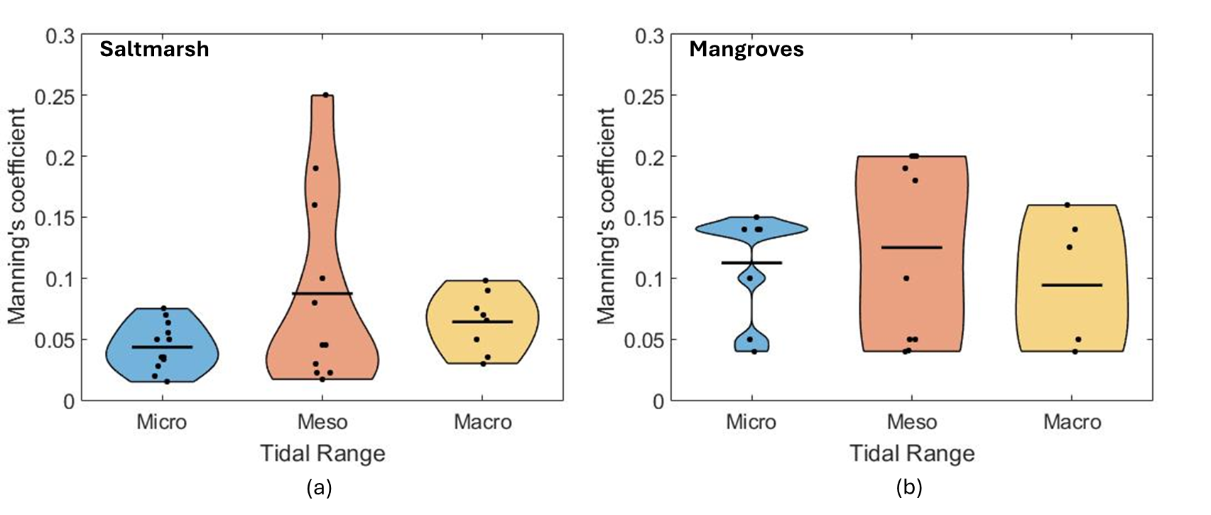 Figure 7. Statistical distribution of Manning’s coefficient (violin plot and median) based on Tidal Range. (a) Saltmarsh studies (sample size: 18) and (b) Mangroves studies (sample size: 18).
A simple ANCOVA test has been done to analyse the effect of wetland type and tidal range on Manning’s coefficient including all studies. Manning’s coefficient is not significantly affected by tidal range (P= 0.27, F-statistics= 1.27). The wetland and tidal range interaction effect indicates that there is no significant interaction effect between wetland type and tidal range on the dependent variable (P= 0.92, F-statistics= 0.01; Fig 8).
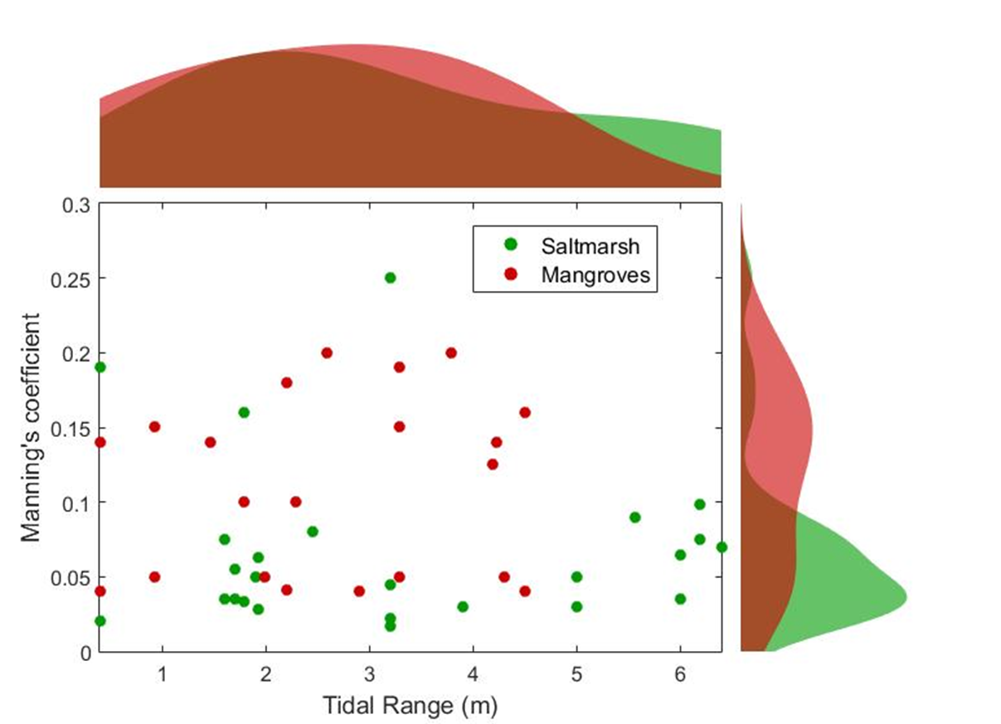
Figure 8. Scatter plot and distributions of Manning’s coefficient against tidal range for saltmarsh and mangroves

Impact of temperature on wetland roughness
Manning’s coefficient is not significantly affected by temperature (P= 0.33, F-statistics= 0.96).
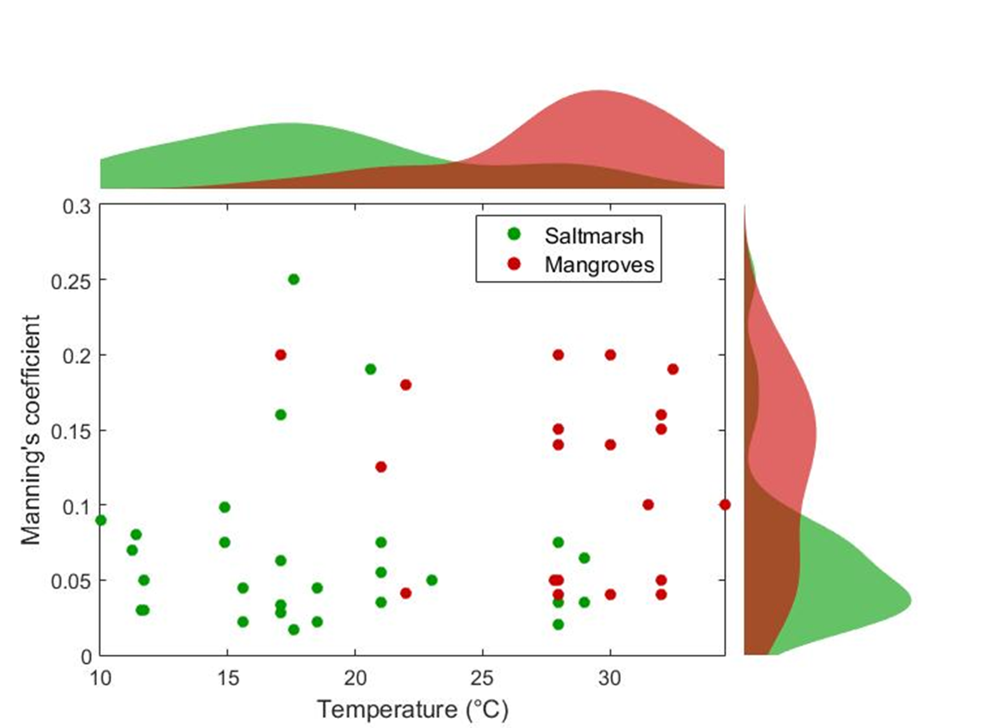
Figure 9. Scatter plot and distributions of Manning’s coefficient against temperature for saltmarsh and mangroves

Distribution and Variability of wetland roughness
The distribution of Manning’s coefficient is shown for all the saltmarsh and mangrove data in Figure 10. For saltmarsh, Manning’s coefficient ranges from 0.03 to 0.25 with mean 0.07 and median 0.06. This indicates that most values were clustered toward lower roughness levels For mangroves, Manning’s coefficient falls between 0.05 to 0.28 with mean 0.12 and median 0.11. The standard deviation for saltmarsh is 0.05 and the IQR (Interquartile range – the difference between the 25th and 75th percentile value) is 0.04 suggesting a moderate but compact spread. For mangroves, the standard deviation is 0.06 and IQR is 0.04.
Using statistical methods alone, one might define outliers in a distribution by setting specific high and low percentile thresholds, beyond which data points are considered anomalous. However, examining the Manning’s coefficient values for saltmarshes and mangroves separately reveals breakpoints that can be used to define outliers. For saltmarshes, 15 of the 18 studies report a coefficient ≤0.1, while the remaining three studies all report coefficients ≥0.15. This distinct gap suggests that the three values above 0.15 are outliers from the main data cluster. For mangroves, there are no clear outliers, as several studies report coefficients close to the highest value of 0.2. Nevertheless, the data do form two distinct clusters, separated by a gap from 0.05 to 0.1. The seven studies with coefficients ≤0.05 all correspond to pioneer sites with less-established mangrove vegetation, which results in lower roughness. In contrast, mangrove sites with values above 0.1 represent more established mangrove vegetation and exhibit proportionally greater roughness. This clustering is useful for assigning Manning’s coefficients to mangrove sites when site-specific vegetation data (e.g., stem diameters and densities) is unavailable. If a site can be classified as either well-established or less-established, an appropriate coefficient can be inferred from the relevant cluster of values.
Table 1 Statistics for Manning's coefficient for saltmarsh and mangroves
Vegetation Type | Mean | Median | Standard Deviation | 25th percentile | 75th percentile | IQR
Saltmarsh | 0.07 | 0.06 | 0.05 | 0.04 | 0.08 | 0.04
Mangrove | 0.12 | 0.11 | 0.06 | 0.10 | 0.14 | 0.04

For both wetlands the mean exceeded the median indicating a right-skewed distribution influenced by higher roughness outliers. These patterns are clearly reflected in the cumulative distribution functions (CDF) where the saltmarsh CDF rises steeply at lower Manning’s coefficients whereas the mangrove CDF shows the mean and median data shifts toward higher Manning’s coefficient.
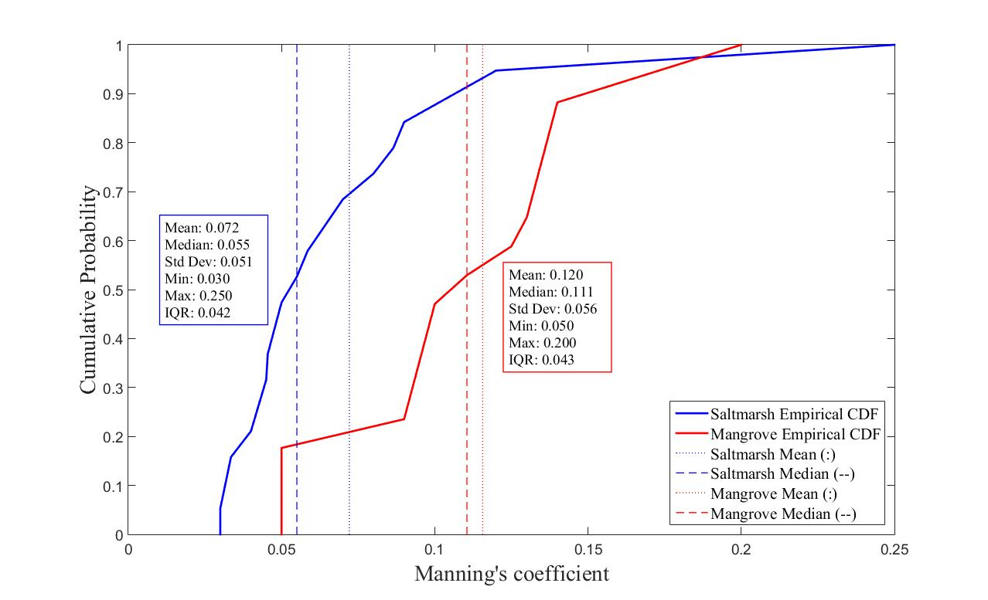
Figure 10. Cumulative distribution of Manning’s coefficient for all the saltmarsh and mangrove sites considered in this paper

DISCUSSION
Our focus in this paper is to analyse and synthesise the data on Manning’s coefficient from past studies on saltmarsh and mangroves. The cumulative distribution function (CDF) of Manning’s coefficient establishes reasonable broad scale operational ranges (Figure 10): the IQR for saltmarsh is 0.04 - 0.08 and for mangroves is 0.10 – 0.14. This provides a robust basis for assigning roughness parameters in hydrodynamic models of vegetated wetlands ensuring both realistic and conservative estimates of flow resistance under a range of vegetation conditions.
This study also finds the data from the literature indicate a few of the early (pre-2000) estimates of Manning’s coefficient for saltmarshes (two cases exceeding 0.15) and mangroves (three cases around 0.20) are much higher than more recent estimates (Figure 4). These cases are discounted as extreme cases’ and do not influence the IQR range in Figure 10. From 2000 to 2024, the reported value for Manning’s coefficient for saltmarsh ranges from 0.04-0.08 except for one paper (Wu & Shi, 2016) where it was taken as 0.25. This is higher than any previous study and this value was not cited or used by any subsequent paper. This study was calibrated with observed data indicating the local impact of vegetation roughness. For mangroves, the studies below the 25th percentile only considered pioneer (i.e. small) mangroves explaining these lower values, while the values higher than the 75th percentile are considered extreme cases’. Another important aspect for mangrove studies is that one key paper (Zhang et al., 2012) and its estimate of Manning’s coefficient (0.14) has been cited widely and used by subsequent papers.
This paper also asked the question, can the Manning’s coefficient be a useful parameter for broad scale assessment of saltmarsh and mangroves? The statistics aimed to explore trends and dependencies of the roughness value using the ANOVA, ANCOVA and t-test statistical methods. Based on these results, this study provides insights into the factors influencing Manning’s coefficient in saltmarshes and mangroves. Certain factors (location, tidal range and temperature) do not have a statistically significant impact on bed roughness variability, while wetland type and cross-shore zonation do influence Manning’s coefficient. Our study synthesizes data from 36 studies with 18 focused on saltmarsh and 18 focused on mangroves sites. While this sample size seems limited for a global assessment, we prioritized robust datasets which enhances the validity of our findings despite the small sample size. It is also noteworthy that there are geographic gaps in the literature. This identifies future research potential for further assessment of representative roughness parameters including Manning’s coefficient for coastal wetlands in underrepresented regions, such as Africa, to enhance broad scale assessments. Despite these limitations our study captures significant broad scale patterns and identifies the key factors influencing Manning’s coefficient across diverse geographic and environmental contexts. These findings provide a crucial foundation for advancing broad scale assessment of roughness in coastal wetlands. We hope this stimulates further analysis of vegetation roughness, including more detailed and mechanistic approaches as much as the observations and scale of analysis allow.
Geographic location, tidal range and temperature
The results of ANOVA and ANCOVA show no statistically significant effect of geographic location, tidal range or temperature on Manning’s coefficient. This suggests that natural variability in environmental conditions across regions do not lead to significant differences in Manning’s coefficient. However, the lack of statistical significance for tidal range or temperature does not necessarily imply that these variables are unimportant rather it may reflect limitations in the dataset or sample size. While these findings tentatively support the use of Manning’s coefficient as a generalized parameter across diverse geographic and climatic settings, further studies with broader datasets are needed to confirm this conclusion.
Wetland type (saltmarsh vs. mangroves)
The ANCOVA results show significant differences in Manning’s coefficient between saltmarshes and mangroves demonstrating that the physical structure and vegetation characteristics inherent to each wetland type play a significant role in influencing bed roughness. This finding emphasizes the necessity to distinguish between saltmarsh and mangroves when assessing the flow resistance provided by each ecosystem type. Mangroves have higher Manning’s coefficient than saltmarshes. While these wetland types do not commonly occur together, they may be treated as two roughness elements in specific cases where this happens (e.g., southern USA and southern China). This highlights the necessity of refining simulation approaches to account for their distinct hydrodynamic properties when saltmarsh and mangroves coexist in the same coastal system, or where mangroves replace saltmarsh over time due to warming.
Cross-shore zonation within wetlands
The analysis also reveals a significant impact of cross-shore zonation on Manning’s coefficient as confirmed by a t-test. Roughness generally increases in a landward direction. This zonation corresponds to variations in vegetation density, root structure and exposure to tidal forces. This finding is particularly relevant for hydrodynamic models that aim to capture the full range of protective services that wetlands offer. This is in line with previous studies for saltmarsh (Augustin et al., 2009, Wamsley et al., 2010, Leopold et al., 1993) and for mangroves (Dasgupta et al., 2019, Horstman et al., 2021) where spatially variable Manning’s coefficients have been used to simulate wetland hydrodynamics. Incorporating cross-shore roughness zonation is likely to provide an improved representation of water flow and wave attenuation, especially in cases where cross-shore differences in vegetation density and structure influence resistance to tidal and wave forces. However, this would be more appropriate with our present understanding for local simulations, and the implications and feasibility of using these zonation values at broader ‘global’ assessment needs further consideration. Using single values for mangroves and saltmarshes is a reasonable first assumption based on this review. The cumulative distribution curve and statistics from previous studies suggests that although there are outliers (saltmarshes assigned a Manning’s coefficient above 0.15), the global average Manning’s coefficient for saltmarsh and mangroves is stable with a consistent central tendency.

CONCLUSION
This study provides a systematic synthesis of Manning’s coefficient for saltmarsh and mangroves ecosystems offering new understanding into its variability and the controlling environmental factors. By analysing 36 studies we have laid the groundwork for a more ‘global’ understanding of the roughness values relevant to saltmarsh and mangroves hydrodynamics. Our findings suggest that despite regional and temporal variations, Manning’s coefficient is relatively stable across geographic locations and tidal ranges for each vegetation type, with an interquartile range of 0.04–0.08 for saltmarshes, and 0.10–0.14 for mangroves, respectively. This supports its robustness as a global parameter and its suitability for use in exploratory global analysis of wetland protective functions and coastal restoration. The analysis also shows that mangroves tend to have a higher Manning’s coefficient than saltmarsh. Statistical analysis using ANOVA, ANCOVA and t-tests demonstrated that there is no significant dependency of Manning’s coefficient on geographic location, tidal range or temperature. However, the significant differences between saltmarsh and mangroves and across saltmarsh and mangroves profiles underscore the importance of appropriate consideration of wetland type and zonation in model applications.
While our analysis provides a foundation for using Manning’s coefficient in global and broad scale assessments we recognize several limitations in our approach. Firstly, the dataset has a modest sample size and there is geographic bias (e.g., no African studies). This reflects both the stringent selection criteria used to ensure data quality and relevance, as well as bias in earlier studies. Our approach strengthens the reliability of our findings but underscores the need for more geographically diverse field research in the future. Given the small sample size, more data could change the results. We would also stress the need to collect data at the level of saltmarsh and mangroves species, allowing more detailed analysis. Moreover, transitions between saltmarsh and mangrove ecosystems driven by climate change, sea-level rise and human intervention may alter surface roughness and thereby influence associated hydrodynamics, morphodynamics and ecological functioning (Wei et al., 2024).
Our study focused towards a simple broadscale overview of Manning’s coefficient as an appropriate parameter for an exploratory assessment of coastal restoration benefits at global scale. We were unable to consider frontal area and drag-based coefficients due to lack of data and published studies. Future research should focus on quantifying wetland roughness more precisely and in more detail across saltmarsh and mangroves species including consideration of species type and zonation, as well as transitions where these occur. With the inclusion of new datasets for dominant species with vegetation parameters future research should build towards a species level understanding focusing on more accurate wetland roughness parameters (e.g. vegetation drag and frontal area). The poor data coverage in some regions, particularly Africa, should also be addressed. Expanding the geographic scope and datasets will refine our understanding of wetland roughness and its role in detailed to broadscale saltmarsh and mangroves assessment and simulation.
Acknowledgements:
This work was supported by the Rest-Coast Project under the European Union’s Horizon 2020 research and innovation program under grant agreement number 101037097.
Bibliography
Adytia D., Husrin D. and Latifah A.L., (2019), Dissipation of solitary wave due to mangroves forest: a numerical study by using non-dispersive wave model, Ilmu kelautan: Indonesian Journal of Marine Sciences March 2019 Vol 24(1):41-50, ISSN 0853-7291
Augustin, L.N., Irish, J.L. and Lynett, P. (2009) Laboratory and Numerical Studies of Wave Damping by Emergent and Near-Emergent Wetland Vegetation. Coastal Engineering, 56, 332-340.
Barinas G, Good Stephen P, Tullos D. Continental Scale Assessment of Variation in Floodplain Roughness With Vegetation and Flow Characteristics. Geophysical research letters 2024, https://doi-org.uea.idm.oclc.org/10.1029/2023GL105588
Ballut-Dajud, G.A.; Sandoval Herazo, L.C.; Fernández-Lambert, G.; Marín-Muñiz, J.L.; López Méndez, M.C.; Betanzo-Torres, E.A. Factors Affecting Wetland Loss: A Review. Land 2022, 11, 434. https://doi.org/10.3390/land11030434
Bendoni M, Georgiou I.Y., Roelvink D., Oumeraci H., (2019) Numerical modelling of the erosion of marsh boundaries due to wave impact, Coastal Engineering, Volume 152, 2019, 103514, ISSN 0378-3839, https://doi.org/10.1016/j.coastaleng.2019.103514.
Best U.S.N, Wegen M. Van der, Dijkstra J, Willemsen P.W.J.M., Borsje B.W., Roelvink Dano J.A., Do salt marshes survive sea level rise? Modelling wave action, morphodynamics and vegetation dynamics, Environmental Modelling & Software, Volume 109, 2018, Pages 152-166, ISSN 1364-8152, https://doi.org/10.1016/j.envsoft.2018.08.004.
Bouma, T. J., Friedrichs, M., Klaassen, P., et al. (2009). Effects of shoot stiffness, shoot size and current velocity on scouring sediment from around seedlings and propagules. Marine Ecology Progress Series, 388, 293-297.
Campbell, A.D., Fatoyinbo, L., Goldberg, L. et al. Global hotspots of salt marsh change and carbon emissions. Nature 612, 701–706 (2022). https://doi-org.uea.idm.oclc.org/10.1038/s41586-022-05355-z.
Carr MH, Neigel JE, Estes JA, Andelman S, Warner RR, Largier JL (2012). Comparing marine and terrestrial ecosystems: implications for the design of coastal marine reserves. Ecol Appl. 2012;12(4):961-972.
Cavanaugh, K.C., Dangremond, E.M., Doughty, C.L., Williams, A.P., Parker, J.D., Hayes, M.A., Rodriguez, W. and Feller, I.C. (2019) ‘Climate-driven regime shifts in a mangrove–salt marsh ecotone over the past 250 years’, Proceedings of the National Academy of Sciences of the United States of America (PNAS), 116(43), pp. 21602–21608. doi:10.1073/pnas.1902181116.
Cea L, French J.R., Bathymetric error estimation for the calibration and validation of estuarine hydrodynamic models, Estuarine, Coastal and Shelf Science, Volume 100, 2012, Pages 124-132, ISSN 0272-7714, https://doi.org/10.1016/j.ecss.2012.01.004.
Chen, Q., Li, Y., Kelly, D. M., Zhang, K., Zachry, B., and Rhome, J.: Improved modeling of the role of mangroves in storm surge attenuation, Estuar. Coast Shelf Sci., 260, 107515, https://doi.org/10.1016/j.ecss.2021.107515, 2021.
Chow, V.T. (1959) Open Channel Hydraulics. McGraw-Hill, New York.
Dasgupta S, I. M. (2019). Quantifying the protective capacity of mangroves from storm surges in coastal Bangladesh. PLoS ONE 14(3): e0214079, https://doi.org/10.1371/journal.pone. 0214079.
Duarte B. , Valentim J.M. , Dias J.M., Silva H. , Marques J.C., Cac I.¸ ador (2014), Modelling sea level rise (SLR) impacts on salt marsh detrital outwelling C and N exports from an estuarine coastal lagoon to the ocean (Ria de Aveiro, Portugal), Ecological Modelling, 289 (2014) 36-44. doi:10.1016/j.ecolmodel.2014.06.020
Etminan, V., Nikora, V. I., & Nikora, N. (2017), A new model for predicting the drag exerted by vegetation in open channel flow. Water Resources Research, 53(6), 4561–4580.
Fourqurean JW, Duarte CM, Kennedy H, Marbà N, Holmer M, Mateo MA, et al. Seagrass ecosystems as a globally significant carbon stock. Nat Geosci. 2012;5(7):505-509.
French J.R, Airborne LiDAR in support of geomorphological and hydraulic modelling [2003], https://doi.org/10.1002/esp.484
Furukawa K., E. Wolanski, H. Mueller (1996), Currents and Sediment Transport in Mangroves Forests, Estuarine, Coastal and Shelf Science (1997) 44, 301-310
Gu Jiali, Wu Jiaping, Blue carbon effects of mangroves restoration in subtropics where Spartina alterniflora invaded, Ecological Engineering, Volume 186, 2023, 106822, ISSN 0925-8574, https://doi.org/10.1016/j.ecoleng.2022.106822.
Hanipah A. H. A. , Z. R. Guo and E. -. M. M. Zahran, "Hydrodynamics modelling of a river with mangroves forests," 7th Brunei International Conference on Engineering and Technology 2018 (BICET 2018), Bandar Seri Begawan, Brunei, 2018, pp. 1-4, doi: 10.1049/cp.2018.1511
Hinkel, J., Lincke, D., Vafeidis, A. T., Perrette, M., Nicholls, R. J., Tol, R. S. J., Marzeion, B., Fettweis, X., Ionescu, C., & Levermann, A. (2014). Coastal flood damage and adaptation costs under 21st century sea-level rise. Proceedings of the National Academy of Sciences, 111(9), 3292–3297. https://doi.org/10.1073/pnas.1222469111
Horritt, M. S. (2000), Calibration of a two-dimensional finite element flood flow model using satellite radar imagery, Water Resour. Res., 36(11), 3279– 3291
Horstman EM, Bryan KR (2021) Mullarney JC (2021) Drag variations, tidal asymmetry and tidal range changes in a mangroves creek system. Earth Surf Process Landforms 46:1828–1846. https:// doi.org/ 10. 1002/ esp. 5124
Horstman, E. M., Dohmen-Janssen, C. M., Narra, P. M. F., et al. (2014). Wave attenuation in mangroves: A quantitative approach to field observations. Coastal Engineering, 94, 47-62.
Horstman, E., Dohmen-Janssen, C. M., & Hulscher, S. J. M. H. (2013). Modeling tidal dynamics in a mangroves creek catchment in Delft3D. In P. Bonneton, & T. Garlan (Eds.), Coastal Dynamics 2013: 24-28 June 2013, Arcachon, France (pp. 833-844). Bordeaux University - SHOM. https://dx.doi.org/10.1016/j.coastaleng.2008.09.004"
Holzenthal, E. R., et al. (2022), Multi-Scale Influence of Flexible Submerged Aquatic Vegetation on Tidal-Flat Hydrodynamics. Journal of Marine Science and Engineering, 10(4), 554.
Huiqing Liu, Keqi Zhang, Yuepeng Li, Lian Xie, Numerical study of the sensitivity of mangroves in reducing storm surge and flooding to hurricane characteristics in southern Florida, Continental Shelf Research, Volume 64, 2013, Pages 51-65, ISSN 0278-4343, https://doi.org/10.1016/j.csr.2013.05.015.
Kelin Hu, Qin Chen, Hongqing Wang, Ellen K. Hartig, Philip M. Orton (2018), Numerical modelling of salt marsh morphological change induced by Hurricane Sandy, Coastal Engineering 132 (2018) 63-81
Keyes, A., Perry, J., & Johnson, D. H. (2019). Effects of mangroves deforestation on near-shore coral reefs. Bios, 90(1), 8–13. https://www.jstor.org/stable/26849509
Kjerfvec B, Miranda L.B., Wolanski E. (1991), Modelling water circulation in an estuary and intertidal salt marsh system, Netherlands Journal of Sea Research, Volume 28, Issue 3, Pages 141-147, ISSN 0077-7579, https://doi.org/10.1016/0077-7579(91)90013-Q.
Krauss K., Doyle T., Doyle T., Swarzenski C., From A., Day R., Conner W., 2009, Water level observations in mangroves swamps during two hurricanes in Florida. Wetlands 29, 142e149.
Kumbier K, Rogers K, Hughes MG, Lal KK, Mogensen LA and Woodroffe CD (2022) An Eco-Morphodynamic Modelling Approach to Estuarine Hydrodynamics & Wetlands in Response to Sea-Level Rise. Front. Mar. Sci. 9:860910. doi: 10.3389/fmars.2022.860910
Lawrence D. S. L, Allen J. R. L, and Havelock G. M. "Salt Marsh Morphodynamics: an Investigation of Tidal Flows and Marsh Channel Equilibrium," Journal of Coastal Research 20(1), 301-316, (1 January 2004). https://doi.org/10.2112/1551-5036(2004)20 [301: SMMAIO]2.0.CO;2
Leopold, L. B., J. N. Collins, and L. M. Collins (1993), Hydrology of some tidal channels in estuarine marshland near San Francisco, Catena, 20(5), 469–493.
Lincke, D., & Hinkel, J. (2021). Coastal Migration due to 21st Century Sea-Level Rise. Earth’s Future, 9(5), e2020EF001965. https://doi.org/10.1029/2020EF001965
Li Y, Chen Q, Kelly DM and Zhang K (2021) Hurricane Irma Simulation at South Florida Using the Parallel CEST Model. Front. Clim. 3:609688. doi: 10.3389/fclim.2021.609688
Loder N.M, Irish J.L.,Cialone M.A.,Wamsley T.V. , Sensitivity of hurricane surge to morphological parameters of coastal wetlands, Estuarine, Coastal and Shelf Science, Volume 84, Issue 4, 2009, Pages 625-636, ISSN0272-7714, https://doi.org/10.1016/j.ecss.2009.07.036. (https://www.sciencedirect.com/science/article/pii/S0272771409003692)
Logan M. Ashall, Ryan P. Mulligan, Danika van Proosdij, Emma Poirier, Application and validation of a three-dimensional hydrodynamic model of a macrotidal salt marsh, Coastal Engineering, Volume 114, 2016, Pages 35-46, ISSN 0378-3839, https://doi.org/10.1016/j.coastaleng.2016.04.005. (https://www.sciencedirect.com/science/article/pii/S0378383916300503)
Martyr-Koller RC, Kernkamp H.W.J., Dam A.V., Wegen M.V.D, Lucas L.V., Knowles N., Jaffe B., Fregoso T.A. (2017), Application of an unstructured 3D ﬁnite volume numerical model to ﬂows and salinity dynamics in the San Francisco Bay-Delta, Estuarine, Coastal and Shelf Science 192 (2017) 86-107.
Mazda, Y., Kanazawa, N. & Wolanski, E. Tidal asymmetry in mangroves creeks. Hydrobiologia 295, 51–58 (1995). https://doi-org.uea.idm.oclc.org/10.1007/BF00029110
Mcowen C, Weatherdon LV, Bochove J, Sullivan E, Blyth S, Zockler C, Stanwell-Smith D, Kingston N, Martin CS, Spalding M, Fletcher S (2017). A global map of saltmarshes (v6.1). Biodiversity Data Journal 5: e11764. Paper DOI: https://doi.org/10.3897/BDJ.5.e11764. Data DOI: https://doi.org/10.34892/07vk-ws51
Mitsch, W.J. and Gosselink, J.G. (2015) Wetlands. 5th Edition, John Wiley & Sons, Inc., Hoboken.
Möller, I., Kudella, M., Rupprecht, F., et al. (2014). Wave attenuation over coastal salt marshes under storm surge conditions. Nature Geoscience, 7(10), 727-731.
Mourshed, M 2016, Climatic parameters for building energy applications: A temporal-geospatial assessment of temperature indicators, Renewable Energy, Volume 94, 2016, Pages 55-71, ISSN 0960-1481, https://doi.org/10.1016/j.renene.2016.03.021.
Nehru Machineni, Vinay S.P. Sinha, Prasoon Singh, N.T. Reddy, The impact of distributed landuse information in hydrodynamic model application in storm surge inundation, Estuarine, Coastal and Shelf Science, Volume 231, 2019, 106466, ISSN 0272-7714, https://doi.org/10.1016/j.ecss.2019.106466.
Olwig M., Sørensen M., Rasmussen M., Danielsen F., Selvam V., Hansen L., Nyborg L., Vestergaard K., Parish F., Karunagaran V., 2007. Using remote sensing to assess the protective role of coastal woody vegetation against tsunami waves. International Journal of Remote Sensing 28, 3153e3169.
Ouyang, X., Lee, S.Y. Improved estimates on global carbon stock and carbon pools in tidal wetlands. Nature Communication 11, 317 (2020). https://doi-org.uea.idm.oclc.org/10.1038/s41467-019-14120-2.
Ouyang, Y., Luo, S.M., Cui, L.H. et al. Estimation of water dynamics in a vertical-flow constructed wetland with a growing plant species. J Soils Sediments 10, 1219–1228 (2010). https://doi-org.uea.idm.oclc.org/10.1007/s11368-010-0240-4
Pelckmans I, Gourgue O, Belliard JP, Dominguez-Granda LE, Slobbe C, Temmerman S, (2023), Mangroves ecosystem properties regulate high water levels in a river delta, Natural Hazards and Earth System Sciences 23 (9), 3169-3183
Rahdarian A , Niksokhan M H (2017), Numerical modeling of storm surge attenuation by mangroves in protected area of mangroves of Qheshm Island, Ocean Engineering 145 (2017) 304315, http://dx.doi.org/10.1016/j.oceaneng.2017.09.026
Schwarz, C., van Rees, F., Xie, D. et al. Salt marshes create more extensive channel networks than mangroves. Nat Commun 13, 2017 (2022). https://doi.org/10.1038/s41467-022-29654-1
Schuerch, M., Spencer, T., Temmerman, S., Kirwan, M.L., Wolff, C., Lincke, D., McOwen, C.J., Pickering, M.D., Reef, R., Vafeidis, A.T., Hinkel, J., Nicholls, R.J. and Brown, S. (2018) ‘Future response of global coastal wetlands to sea-level rise’, Nature, 561(7722), pp. 231–234. doi:10.1038/s41586-018-0476-5.
Shepard, C. C., Crain, C. M., & Beck, M. W. (2011). The Protective Role of Coastal Marshes: A Systematic Review and Meta-analysis. PLOS ONE, 6(11), e27374.
Shih, S. F., and G. S. Rahi (1982), Seasonal variations of Manning’s roughness coefﬁcient in a subtropical marsh, Trans. Am. Soc. Agric. Eng., 25(1), 116–119.
Short A.D, Macro-Meso Tidal Beach Morphodynamics: An Overview (1991), Journal of Coastal Research, Vol. 7, No. 2 (Spring, 1991), pp. 417-436, Coastal Education & Research Foundation
Soliman, M.; Morsy, M.M.; Radwan, H.G. Assessment of Implementing Land Use/Land Cover LULC 2020-ESRI Global Maps in 2D Flood Modeling Application. Water 2022, 14, 3963. https://doi.org/10.3390/w14233963
Stark J, Plancke Y, Ides S, Meire P, Temmerman S (2016), Coastal flood protection by a combined nature-based and engineering approach: modeling the effects of marsh geometry and surrounding dikes. estuarine coastal and shelf science, 175, 34-45. https://doi.org/10.1016/j.ecss.2016.03.027
Sullivan, J. C., R. Torres, A. Garrett, J. Blanton, C. Alexander, M. Robinson, T. Moore, J. Amft, and D. Hayes (2015), Complexity in salt marsh circulation for a semienclosed basin, J. Geophys. Res. Earth Surf., 120, 1973–1989, doi:10.1002/2014JF003365.
Temmerman, S., & Kirwan, M. L. (2015). Building land with a rising sea. Science, 349(6248), 588-589.
Temmerman S., Krauss K. W., Pelckmans I., Horstman E. M. , Mullarney J. C., Schoutens K., 2022, Marshes and Mangroves as Nature-Based Coastal Storm Buffers, Annu. Rev. Mar. Sci. 2023. 15:95–118, https://doi.org/10.1146/annurev-marine-040422092951.
The MathWorks, Inc. (2015). MATLAB version: 9.13.0 (R2022b). Accessed: January 01, 2023. Available: https://www.mathworks.com.Twomey, A., Lovelock, C., 2024, Global spatial dataset of mangrove genus distribution in seaward and riverine margins. Sci. Data 11, 306. https://doi.org/10.1038/s41597-024-03134-1.
Twomey, A.J., Lovelock, C.E., 2024. Variation in Mangrove Geometric Traits Among Genera and Climate Zones. Estuaries Coasts 48, 55. https://doi.org/10.1007/s12237-025-01487-3.
Tsihrintzis, V., and E. E. Madiedo (2000), Hydraulic resistance determination in marsh wetlands, Water Resour. Manag., 14(4), 285–309,doi:10.1023/A:1008130827797.
Ü.S.N. Best, M. Van der Wegen, J. Dijkstra, P.W.J.M. Willemsen, B.W. Borsje, Dano J.A. Roelvink, Do salt marshes survive sea level rise? Modelling wave action, morphodynamics and vegetation dynamics, Environmental Modelling & Software, Volume 109,2018, Pages 152-166, ISSN 1364-8152, https://doi.org/10.1016/j.envsoft.2018.08.004.(https://www.sciencedirect.com/science/article/pii/S1364815217309428)
Valentim J.M., Vaz N., Silva H., Duarte B., Caçador I., Dias J.M. (2013), Tagus estuary and Ria de Aveiro salt marsh dynamics and the impact of sea level rise, Estuarine, Coastal and Shelf Science, 130 (2013) 138-151.
Wamsley TV, Cialone MA, Smith JM, Atkinson JH, Rosati JD. 2010. The potential of wetlands in reducing storm surge. Ocean Engineering 37(1):59–68.
Wenting Wu, Zhaoqing Yang, Chunpeng Chen, Bo Tian, Tracking the environmental impacts of ecological engineering on coastal wetlands with numerical modeling and remote sensing, Journal of Environmental Management, Volume 302, Part A, 2022, 113957, ISSN 0301-4797, https://doi.org/10.1016/j.jenvman.2021.113957.
Wolanski E, Mazda Y, King B & Gay S (1990), Dynamics, Flushing and Trapping in Hinchinbrook Channel, a Giant Mangroves Swamp, Australia, Estuarine, Coastal and Shelf Science (1990) 31,555-579
Wolanski E., Jones M and Bunt J.S (1980), Hydrodynamics of a Tidal Creek-Mangroves Swamp System, Australian Journal of Marine and Freshwater Research 31(4) 431 - 450
Worthington, T.A., zu Ermgassen, P.S.E., Friess, D.A., Krauss, K.W., Lovelock, C.E., Thorley, J., Tingey, R., Woodroffe, C.D., Bunting, P., Cormier, N., Lagomasino, D., Lucas, R., Murray, N.J., Sutherland, W.J., Spalding, M., 2020. A global biophysical typology of mangroves and its relevance for ecosystem structure and deforestation. Sci. Rep. 10, 14652. https://doi.org/10.1038/s41598-020-71194-5
Wei, Y., van Maanen, B., Xie, D., Jiang, Q., Zhou, Z. and Schwarz, C. (2024) ‘Mangrove–saltmarsh ecotones: Are species shifts determining eco-morphodynamic landform configurations?’, Earth’s Future, 12(10), e2024EF004990. doi:10.1029/2024EF004990.
Wu Chenhui , Wu Shiqiang , Wu Xiufeng , Zhang Yu , Feng Kedong , Zhang Weile , Zhao Yuhang (2023), Hydrodynamics affected by submerged vegetation with different flexibility under unidirectional flow, Frontiers in Marine Science, Volume 9, DOI:10.3389/fmars.2022.1041351, ISSN=2296-7745
Wu G, Shi F, Kirby J T, Mieras R, Liang B, Li H, Shi J (2016), Pre-storage, subgrid model for simulating ﬂooding and draining processes in salt marshes (2016), Coastal Engineering 108 (2016) 65-78
Wu Y. , Falconer R.A., J. Struve (2000), Mathematical modelling of tidal currents in mangroves forests, Environmental Modelling & Software 16 (2001) 19–29
Xie, D., van Maanen, B., Schwarz, C., Zhang, K. and Friedrichs, C.T. (2022) ‘Implications of coastal conditions and sea-level rise on mangrove vulnerability: A bio-morphodynamic modeling study’, Journal of Geophysical Research: Earth Surface, 127(8), e2021JF006301. doi:10.1029/2021JF006301.
Xu, H., Zhang, K., Shen, J., Li, Y., 2010. Storm surge simulation along the U.S. East and Gulf Coasts using a multi-scale numerical model approach. Ocean Dynamics 60 (6), 1597e1619.
Yanagisawa H, Koshimura S, Goto K, Miyagi T, Imamura F, Ruangrassamee A, Tanavud C (2009), The reduction effects of mangroves forest on a tsunami based on field surveys at Pakarang Cape, Thailand and numerical analysis, Estuarine, Coastal and Shelf Science, Volume 81, Issue 1, 2009, Pages 27-37, ISSN 0272-7714, https://doi.org/10.1016/j.ecss.2008.10.001.
Yanagisawa, H.; Koshimura, S.; Miyagi, T.; Imamura, F. Tsunami damage reduction performance of a mangroves forest in Banda Aceh, Indonesia inferred from field data and a numerical model. J. Geophys. Res. 2010, 115, C06032
Zhang, K., Liu, H., Li, Y., Xu, H., Shen, J., Rhome, J., Smith, T.J., 2012. The role of mangroves in attenuating storm surges. Estuarine, Coastal and Shelf Science 102, 11e23.
Zhang, Y., Wu, C., & Wu, J. (2020). Drag Coefficient of Emergent Flexible Vegetation in Steady Non-uniform Flow. Water Resources Research, 56(8), https://doi.org/10.1029/2020WR027613.

