Copper is an intestinal habitat filter affecting the gut microbiota interactions with Salmonella Typhimurium
Rafał Kolenda^{1,2,*}, Marwa M. Hassan³, Ainhoa Arrieta-Gisasola⁴, Abioseh Kamara⁵, Rebecca Ansorge¹, Katarzyna Sidorczuk¹, Luke Acton¹, Gaëtan Thilliez^{1,6}, Dave J. Baker¹, Michał Burdukiewicz⁷, Mark D. Stares⁸, Hilary P. Browne⁸, Gwenaelle Le Gall⁵, Ricardo C. Torres⁹, Alfredo Chavez-Arroyo¹⁰, John Garrett¹¹, Mark P. Stevens⁹, Trevor D. Lawley⁸, Andreas J. Bäumler¹⁰, Roberto La Ragione^{3,12}, Falk Hildebrand^{1,5,13}, Robert A. Kingsley^{1,5,*}

Quadram Institute, Norwich, United Kingdom¹
Department of Biochemistry and Molecular Biology, Faculty of Veterinary Medicine, Wrocław University of Environmental and Life Sciences, Poland²
School of Veterinary Medicine, University of Surrey, Guildford, Surrey, United Kingdom³
University of the Basque Country, Vitoria-Gasteiz, Spain⁴
University of East Anglia, Norwich, United Kingdom⁵
School of Biotechnology, Dublin City University, Dublin, Ireland⁶
Clinical Research Centre, Medical University of Białystok, Poland⁷
Host-Microbiota Interactions Laboratory, Wellcome Sanger Institute, Hinxton, United Kingdom⁸
Roslin Institute, United Kingdom⁹
UC Davis, Davis, California, USA¹⁰
Sparsholt College, Sparsholt, Hampshire, SO21 2NF, United Kingdom¹¹
School of Biosciences, University of Surrey, Guildford, Surrey, United Kingdom¹²
Earlham Institute, Norwich, United Kingdom¹³

*Correspondence: rob.kingsley@quadram.ac.uk (RAK) and rafal.kolenda@upwr.edu.pl (RK)

Abstract

Background: Foodborne pathogens, including Salmonella enterica serovar Typhimurium (S. Typhimurium), pose a significant threat to both human health and livestock productivity. The pandemic S. Typhimurium ST34 clone acquired a genomic island (SGI-4) conferring high copper resistance, an adaptation relevant in the context of the widespread use of copper sulphate at therapeutic levels in pig farming. We investigated how high dietary copper influences the piglet gut microbiota and Salmonella-microbiota interactions, that may explain the global spread of S. Typhimurium ST34.
Results: An on-farm study combined with faecal shotgun metagenomics revealed that several potential Salmonella competitor species, including Bifidobacterium, Escherichia, and Lactobacillus, were less abundant in piglets on high-copper diets. Anaerobic and aerobic culturing alongside whole-genome sequencing of 131 species and copper sulphate susceptibility testing identified copper resistance gene acquisition in selected microbes, particularly within Escherichia. Niche competition assays demonstrated that copper resistance is critical for inter-species competition under high-copper conditions, with Salmonella's Type VI Secretion System providing a distinct advantage over Escherichia in copper-modified niche.
Conclusions: Our findings suggest that copper supplementation alters the piglet gut environment, impacting competitive dynamics between pathogenic and commensal bacteria, likely to influence the zoonotic transmission of pathogens.

- Introduction
Salmonella enterica is a leading zoonotic cause of foodborne illness worldwide, with livestock a primary source of infection. Consequently, an understanding of the impact of livestock husbandry practices on the colonisation of livestock by this pathogen is crucial to devise strategies to reduce the burden of salmonellosis. Salmonella enterica serovar Typhimurium (S. Typhimurium) is one of the most common causes of human salmonellosis. In 2023, S. Typhimurium accounted for 14% of reported human cases in the EU and UK (5.1% monophasic) (European Food Safety, European Centre for Disease, and Control 2024). Similar trends have been observed in the USA, where S. Typhimurium caused 15% of domestic outbreaks and 7% of all Salmonella infections (Shah et al. 2024). S. Typhimurium prevalence is also a concern for livestock farming due to its impact on animal welfare and productivity (Boyen et al. 2008). Over the past 70 years, five different S. Typhimurium pandemic clones have dominated human infections, each for approximately 10-15 years (Rabsch et al. 2011). Epidemiological data from the last 15 years indicate that the previously dominant DT104 clone has been replaced by a new pandemic clone, S. Typhimurium ST34 (Petrovska et al. 2016). This clone first appeared in the epidemiological record in Europe around 2005 and became dominant in the UK by 2010 (Petrovska et al. 2016). S. Typhimurium ST34 is characterized by resistance to ampicillin, streptomycin, sulfamethoxazole, and tetracycline (Bawn et al. 2020) and acquisition of Salmonella Genomic Island 4 (SGI-4), conferring resistance to copper salts (Branchu et al. 2019). Furthermore, the acquisition of prophages encoding a virulence factor SopE contributed to the clonal expansion of S. Typhimurium ST34 (Tassinari et al. 2020).
Between 2015 and 2019, pork was the primary source of S. Typhimurium outbreaks in the EU (Chaname Pinedo et al. 2022). A meta-analysis of Salmonella serovars in animal-based foods identified Typhimurium, and less frequently Derby, as the most prevalent serovars in pork across Europe, Oceania, Asia, and North America (Ferrari et al. 2019). Pork constitutes over 30% of consumed meat in the world (source:UN-FAO) and demand has been steadily increasing over the past century (World Agriculture: Towards 2015/2030, An FAO Study 2003). This increased demand has led to intensified livestock production (Murray et al. 2023). Growth promoters, including antibiotics, administered with feed became common practice in the latter half of the 20th century to improve animal growth and fattening (Dibner and Richards 2005). However, the increasing resistance to antibiotics used as growth promoters in zoonotic pathogens, including Salmonella, and the associated risk to human health was recognized in the 1960s (Anderson 1968). This led to bans on the use of antibiotics as growth promoters in the EU (2006), the USA (2017), and China (2020). Following these restrictions, livestock producers increasingly relied on copper salts as growth promoters (Brinck et al. 2023), which coincided with the emergence of copper-resistant S. Typhimurium ST34 as a pandemic clone. Copper is an essential micronutrient required in feed (~10 ppm), but at elevated concentrations routinely used in pig production for 4 weeks after weaning (>150 ppm) it is also a potent antimicrobial ((FEEDAP) 2016). The use of copper has the advantage that it is not used in human medicine, but the emergence of copper-resistant S. Typhimurium ST34 raises the question of whether its use is still effective for controlling Salmonella in pigs. Furthermore, the observation that pigs on a copper-supplemented diet cleared ST34 infections more slowly (Bearson et al. 2020) and had a greater burden of ST34 2 days post-infection (Arai et al. 2024) than pigs on a conventional diet, suggests that there may also be an increased risk to food safety.
S. Typhimurium pathogenicity in livestock and humans is characterised by inflammatory gastroenteritis (Rivera-Chavez and Baumler 2015). The host inflammatory response to Salmonella infection disrupts the microbiota and creates a nutrient-rich niche favourable for Salmonella growth. One of the beneficial effects of growth promoters in piglets is the inhibition of potential pathogens like S. enterica and enterotoxigenic E. coli, along with improved intestinal health, characterized by reduced crypt depth and increased villus height (Zhao et al. 2007; Sun and Kim 2017). Disrupting the microbiota through antibiotic pretreatment increases host susceptibility to Salmonella infection, highlighting the importance of a healthy microbiota in conferring colonisation resistance (Barthel et al. 2003; Rogers, Tsolis, and Baumler 2021). Therapeutic levels of copper have been shown to affect the piglet microbiota, altering the abundance of Escherichia/coliforms, Bifidobacterium, Lactobacillus, and other microbial groups (Espinosa and Stein 2021; Brinck et al. 2023).
We previously reported that sil/pco clusters encoded on SGI-4 provide advantage for survival of the Salmonella ST34 pandemic clone in vitro during anaerobiosis in the presence of CuSO₄ (Branchu et al. 2019). This indicated that copper resistance might be important factor for Salmonella survival in the anaerobic environment of the gut of weaned piglets and as a result its maintenance in the food chain and transmissions to humans. It has been previously demonstrated that Salmonella competes with the intestinal microbiota during host colonisation and that the microbial community composition might be altered by copper supplementation of feed. We therefore tested the hypothesis that copper supplementation at therapeutic levels (150 ppm) routinely used in pigs alters the gut microbiota composition in piglets and changes Salmonella-microbiota competition dynamics.
- Results
  - High copper diet affects the relative abundance of a minor subset of the microbiota in the gut of weaned piglets
Previous studies using culture-dependent methods or lower-resolution amplicon sequencing provided valuable insight into the effect of therapeutic copper supplementation (150 ppm) in feed on microbiota composition (Jensen 2016; Zhang et al. 2019). We used a metagenomic approach to provide a species-level resolution of changes to the bacterial community. A farm study was designed to replicate the common practice of copper supplementation of feed in the first week of weaning to characterise its effect on the gut microbiota of piglets. During this period the gut microbiome is at its most turbulent as it adapts to the change in diet from milk to a commercial solid feed. We identified a total of 748 metagenomic species among all samples. Supplementation of feed with 150 ppm copper for 2 weeks did not lead to significant changes in species richness reflected in similar Shannon Index of Diversity and Simpson’s 1-D Index of Diversity for piglets on high (150 ppm) and low (10 ppm) copper diet (Fig. 1A, 1B). Assessment of species composition dissimilarity revealed minor differences between therapeutic and nutritional levels of copper at study day 19 (ANOSIM statistic R = 0.13, p < 0.001). Comparison of dissimilarity of samples prior to changes in copper supplementation on day 5 (high and low) and day 19 (high and low) after two weeks on the altered diet revealed moderate differences (ANOSIM statistic R = 0.6, p < 0.001) indicating the dynamic nature of the microbial communities during post-weaning period regardless of copper supplementation (Fig. 1C).

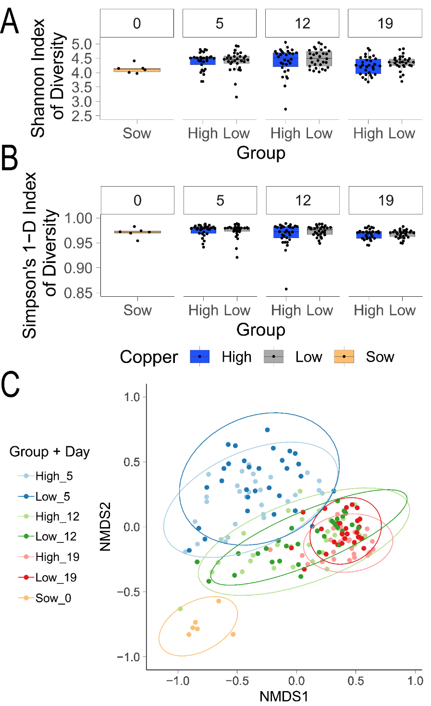
Figure 1. Effect of copper supplementation on pig microbiota communities using shotgun metagenomics
A) Shannon Index of Diversity and B) Simpson’s 1-D Index of Diversity. Animal groups are shown on the bottom x-axis and animal study day on the top x-axis. Values for each animal in the group in timepoint are shown as single point. C) Non-metric multidimensional scaling (NMDS) using Bray-Curtis dissimilarity showing dissimilarity of species composition between groups during pig farm study. Ellipses for each group display a 95% confidence level for a multivariate t-distribution of each group.

The relative abundances of phyla, genera and species were compared to investigate which microbiota are responsible for minor differences in microbial composition between high and low copper supplementation. At the phylum level, Desulfobacteriota I at study day 12 exhibited decreased abundance on high copper diet (Wilcoxon test, p < 0.05, Fig. S1, S2). This phylum included the genus Desulfovibrio (Fig. S3), but this genus alone did not reach statistical significance (Wilcoxon test, p = 0.084). Increased abundance of the phylum Cyanobacteria was observed in piglets on high copper diet at study day 19 (Wilcoxon test, p < 0.05) (Fig. S1, S2), reflected in an increased abundance of Stercorousia sp001765415, UBA2883 sp900768915, Zag111 sp002103105 species at day 19 (Wilcoxon test, p < 0.05) (Fig. 2, Fig. S4). The relative abundance of phylum Pseudomonadota increased with therapeutic levels of copper in the feed of piglets (Wilcoxon test, p < 0.05) (Fig. S1, S2), but investigation of changes within this phylum on the genus and species level revealed that genus Succinivibrio increased in relative abundance in piglets on high copper diet (Wilcoxon test, p < 0.05), while genus Escherichia and species Escherichia coli decreased in abundance (Fig. 2, Fig. S4, Fig. S5) (Wilcoxon test, p < 0.05). Overall, the high copper diet affected the relative abundance of 14 species on day 19 (Fig. 2, Fig. S4). Four species belonging to the genus Agathobacter, Stercorousia, UBA2883 and Zag111 had an increased relative abundance on high copper diet. Among ten species with decreased abundance on high copper diet were bacterial species belonging to genus Bifidobacterium, Lactobacillus, Gemmiger, Holdemanella, Faecalibacterium and Prevotella. Together our data suggests that copper has only a minor effect on the microbiota composition, but these effects may be biologically significant based on the effect on bacterial taxa with established roles in the healthy microbiome and exclusion of pathogens.
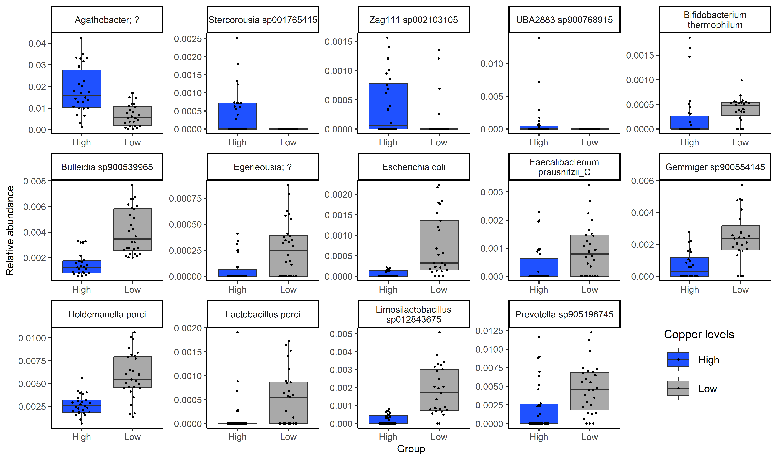
Fig. 2. Relative abundance of species with significant differences between high and low copper supplementation at study day 19
Relative abundance of species in all faecal samples for piglets from the farm study. Animal groups are shown on the bottom x-axis and coloured as shown on the legend and bacterial species on the top x-axis. Relative abundance is shown on the y-axis. Each dot represents relative abundance for one piglet from one group at day 19. Outliers were removed. The plot with all datapoints is shown in Fig. S4.

  - Cultured pig gut microbiota exhibit variation in copper susceptibility
To directly assess the copper sensitivity of pig gut microbiota and enable identification of copper resistance or homeostasis genes, we cultured bacterial isolates from faecal samples from piglets and sows. Overall, 641 isolates encompassing 131 species belonging to five phyla were cultured to purity and their whole genome sequence was determined (Fig. 3A, Fig S6, Table S1). 39 species were not previously described, and their taxonomy was performed with Type (Strain) Genome Server (TYGS) (Dataset S1). Of the 131 cultured species, 107 were detected in pig metagenomic reads in this or previous studies (Xiao et al. 2016; Gurbich et al. 2023) (Fig. S7, S8). Ten of 24 species not detected in metagenomic reads were previously found in the animal gastrointestinal tract or faeces (five in pigs) (Table S2). Another ten represent new species or genera not previously isolated. Three species were associated with pigs through Microbeatlas (Matias Rodrigues et al. 2017) and one remaining species - Bacillus_A bombysepticus - belongs to B. cereus group.
Representative strains for each species were selected, totalling 383 strains, and copper sulphate MIC screen was performed on 369 (Dataset S2). Overall, Pseudomonadota represented mainly by E. coli, accounted for the highest proportion of strains with high MIC compared to other phyla (Fig. 3B, 3C). Additionally, isolates of Bacillota differed in MIC when compared with Actinomycetota, Bacillota_A and Bacteroidota. Increased resistance to copper sulphate was associated with higher count of genes associated with copper homeostasis and/or resistance in Pseudomonadota and Bacteroidota (Fig. 3D). By combining high-throughput culturing and whole genome sequencing we characterized the post-weaning piglet gut microbiota and its resistance to copper sulphate.
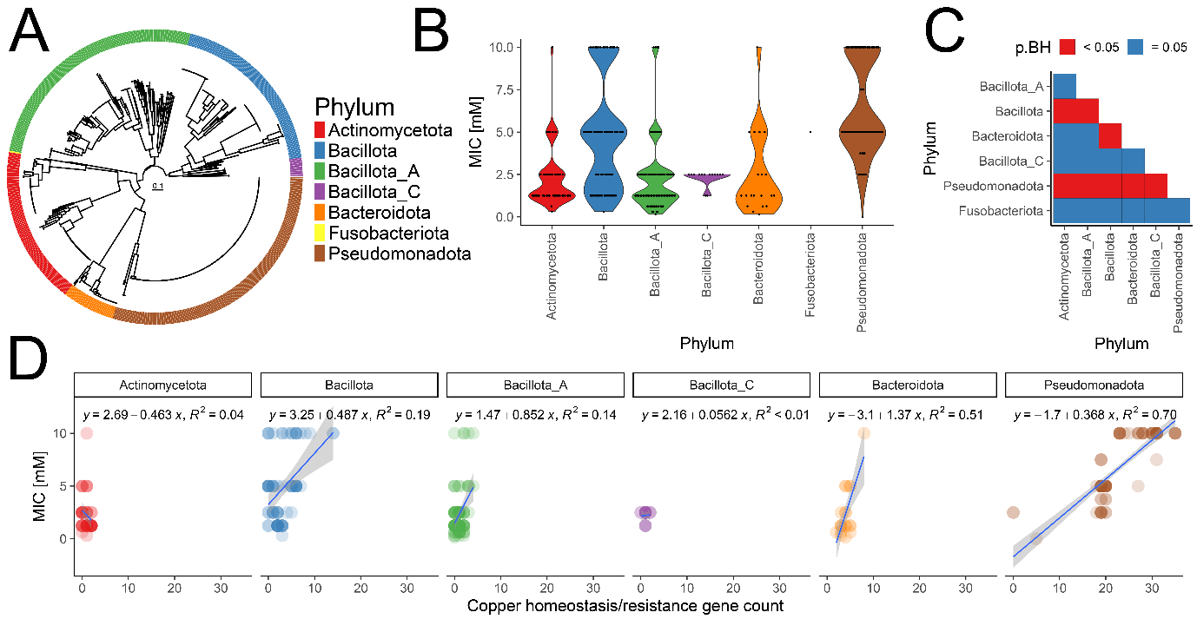
Figure 3. Copper sulphate susceptibility testing of cultured pig microbiota
A) Phylogenetic tree based on alignment of 120 phylogenetically informative markers concatenated of all cultured bacterial isolates in this study annotated with phylum. B) Violin-dotplot with copper sulphate MIC in cultured pig bacteria. Microbial phyla are shown on the x-axis and copper sulphate MIC on the y-axis. Violin colours correspond to phyla and are shown on the legend. Each dot represents MIC value for one bacterial isolate. C) Heatmap with statistical comparisons of copper sulphate MIC differences between phyla. Microbial phyla are shown on the x-axis and y-axis. Statistically significant comparisons are marked with red coloured tile (Wilcoxon test, p < 0.05). D) Correlation of copper homeostasis/resistance gene count with copper sulphate MIC. Dotplot with fitted linear model for correlation of copper homeostasis/resistance gene count with copper sulphate MIC. Gene count is shown on the x-axis and copper sulphate MIC on the y-axis. Linear model was used to fit a line (blue) based on available datapoints and 0.95 confidence interval was plotted (grey). Model fit equation and R² values were annotated for each phylum.

  - Escherichia coli copper resistance clusters are on mobile genetic elements distinct from copper-encoding SGI-4 in S. Typhimurium ST34
Having observed that a subset of Pseudomonadota exhibited higher copper sulphate MICs and was associated with an increased number of copper homeostasis/resistance genes, we investigated the genetic determinants underlying this phenotype. Nearly all of 174 Escherichia isolated during this study encoded well-characterised copper homeostasis genes including copA, cueOR, cusABCFRS, ndh-2 and rclA. The copper resistance gene clusters sil/pco or sil alone, were identified in 45 and 11 isolates, respectively (Fig. 4A). The frequency of copper resistance genes sil/pco or sil alone was greater in isolates from piglets on high copper diet when compared to piglets on low copper diet (Fig. 4B, Chi-squared test, p = 0.05563) or sows (Chi-squared test, p < 0.005). When the sequence diversity of sil and pco clusters was investigated, 11 sil variants and 9 pco variants were identified, resulting in a total of 12 sil/pco sequence variants. Copper sulphate MIC determined by broth microdilution method on E. coli isolate subset revealed that all sil/pco variants provided similar levels of resistance to SGI-4-encoded sil/pco of S. Typhimurium ST34 (Fig. 4C). All Escherichia isolates without sil/pco clusters had MIC that was at least 6 mM lower than Escherichia with sil/pco. Long read sequencing revealed that only two of the sil/pco sequence variants were plasmid-encoded. All ten chromosome-encoded sil/pco variants were integrated into one locus and associated with Tn7-like transposon (Fig. 4D). The sil cluster on a plasmid in strain LCP22S3_I2 was surrounded by IS1-like transposable element genes and the sil/pco cluster on a plasmid in strain LCP17S3_I1 was found in proximity of IS3-like genes.
The siderophore yersiniabactin has also been implicated in conferring additional tolerance to copper, albeit in low micromolar concentrations (Chaturvedi et al. 2012). We therefore investigated the presence of this and the related siderophore system aerobactin, within the whole genome sequence of E. coli isolates. A total of 23 isolates encoded genes encoding the yersiniabactin system and 17 isolates encoded the aerobactin system (Fig. S9). None of the strains encoding the sil and pco genes encoded either siderophore system. One strain encoding yersiniabactin but lacking sil and pco genes had an MIC similar to other strains lacking all these systems, consistent with previous reports of yersiniabactin having a modest impact on copper resistance relative to that imparted by sil and pco (Chaturvedi et al. 2012).
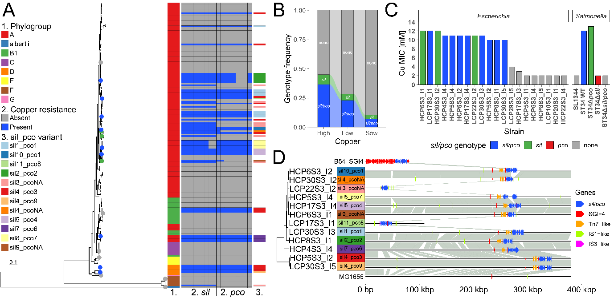
Figure 4. Escherichia isolated from pigs and copper resistance
A) Phylogenetic tree based on core genome SNPs of 174 Escherichia isolates in this study annotated with phylogroup, sil/pco genes and sil/pco gene cluster variants. Strains selected for copper sulphate broth microdilution assays are marked with blue (sil/pco-positive, n=9), green (sil-positive, n=3) or grey dot (sil/pco-negative, n=8) B) Alluvial plot with frequency of copper resistance clusters in Escherichia from sows, piglets on high and low copper diet. Groups are shown on the x-axis and genotype frequency on the y-axis. Colours correspond to genotype and are labelled with text on the corresponding bars. C) Barplot with copper sulphate MIC in selected strains of Escherichia in anaerobic conditions. Isolate names are shown on the bottom x-axis and genera on the top x-axis. Copper sulphate MIC are shown on the y-axis. Colours correspond to genotype and are shown on the legend. D) Comparison of sil/pco clusters with SGI-4 and plasmid/chromosomal localisation of sil/pco clusters in Escherichia. Base position in the sequences is shown on the x-axis (to 380 kbp) and isolate name on the y-axis. Regions homologues between sequences are connected with grey lines. Localisation of SGI-4 genes (including sil/pco) is shown with blue squares. Localisation of Tn7-like genes is shown with orange squares. Phylogenetic tree based on core genome SNPs of 12 Escherichia isolates annotated with sil/pco sequence variants.

  - Presence of copper sulphate alters the outcome of interaction between S. Typhimurium and E. coli
Our farm study demonstrated a decrease in the relative abundance of several commonly recognized probiotic/beneficial microbes in piglets fed a high-copper diet. Given that previous research has shown S. Typhimurium strains compete with E. coli both in vivo and in vitro (Schierack et al. 2011; Deriu et al. 2013; Litvak et al. 2019), we investigated the interactions between selected porcine Escherichia isolates and Salmonella, specifically examining the influence of copper supplementation on these interspecies dynamics. We determined the impact of co-culture of 20 diverse Escherichia isolates, selected as described in Material and Methods, on bioluminescent S. Typhimurium ST34 growth during anaerobiosis, to model the conditions of the host colon. Niche-competition and niche-invasion assays were used to model direct competition or the establishment of Salmonella colonisation when E. coli is already present in the colon. Initially we investigated the interaction in the absence of copper supplementation to identify strains that competed better than others (Fig. 5A). Both assays showed that addition of E. coli decreased the luminescence signal from Salmonella by at least 50% for 18 of the 20 E. coli strains tested (Fig. 5B), consistent with competition. Few pig E. coli isolates achieved similar levels of inhibition as addition of E. coli Nissle 1917, a probiotic strain, previously proven to compete with various pathogenic bacteria. Further, some strains differed in their relative effectiveness at inhibiting Salmonella in niche-competition or niche-invasion. Four E. coli strains were selected for niche-competition and niche-invasion assays with presence of copper sulphate based on the highest inhibitory activity, two with and two lacking the sil/pco gene cluster. All E. coli strains tested could significantly reduce Salmonella CFU in competition and invasion assays in medium without copper supplementation (Wilcoxon test, p < 0.05, Fig. S10). Addition of copper sulphate resulted in significant changes of the interaction trajectories between Salmonella and E. coli in niche competition assays, which was reflected by altered competitive indices (CIs) in media containing from 1 to 14 mM CuSO₄ (Wilcoxon test, p < 0.05) (Fig. 5C) and the observation that E. coli was no longer able to reduce Salmonella CFUs in most of the tested concentrations (Fig. S10). Similar tendencies were observed for niche invasion assays, with the exception of copper-resistant strain HCP6S3_I2, which inhibited Salmonella growth at five different (1, 5, 7, 8 and 9 mM) copper concentrations (Wilcoxon test, p < 0.05) (Fig. S10). Surprisingly, in the case of strains HCP4S3_I4, LCP10S3_I1 and LCP29S3_I5, increase of Salmonella CFU was observed at two different copper concentrations (Fig. S10). The presence of copper resistance genes was key for E. coli survival during competition and invasion assays, but Salmonella dominated the copper-altered niche irrespectively of sil/pco presence in E. coli (Wilcoxon test, p < 0.05) (Fig. 5C). Comparison of CFUs for copper-resistant E. coli strains (HCP4S3_I4, HCP6S3_I2) during niche competition assay and monoculture revealed two-four log10(CFU) reduction when Salmonella was present in the medium with copper (Fig. 5D). Taken together, our observations were consistent with the idea that copper sulphate substantially changes the interactions between Salmonella and E. coli in niche competition and invasion assay in vitro.
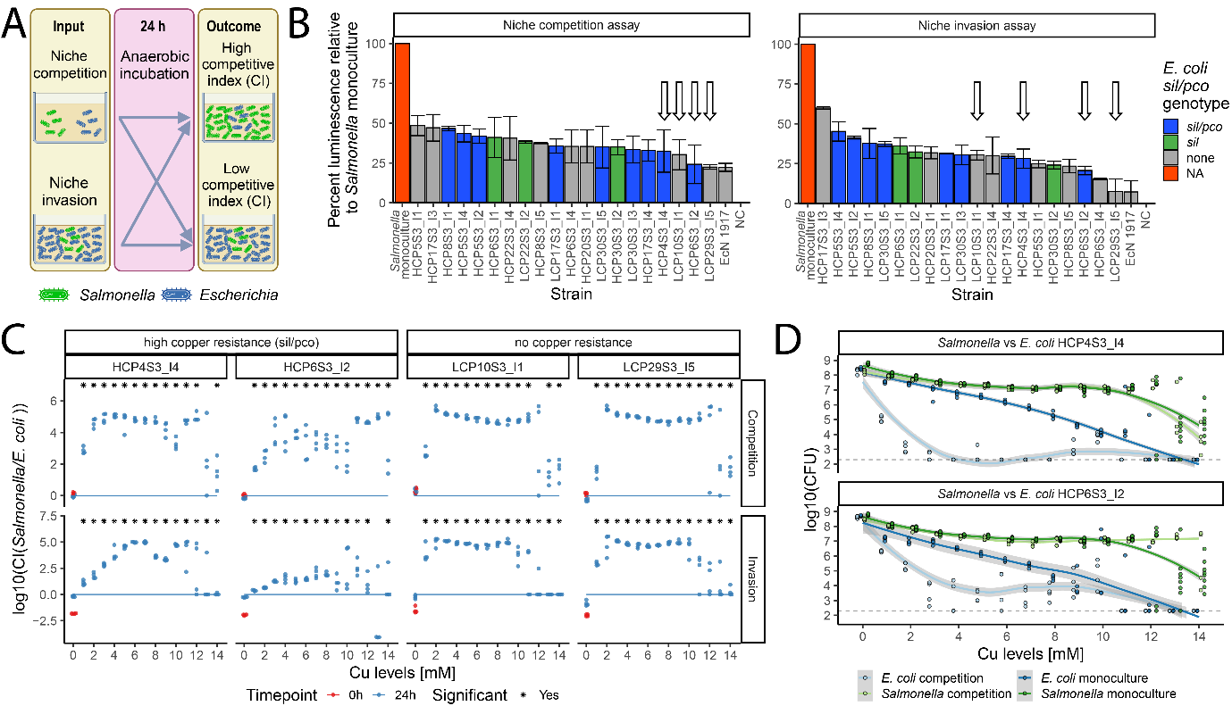
Figure 5. Competition between Salmonella and E. coli in copper sulphate-altered niche
A) Schematic representation of niche competition and invasion assays in anaerobic conditions. 1x10⁶ CFU of luminescent Salmonella and 20 µl or 180 µl of E. coli was used for luminescence competition and invasion assay, respectively. 1x10⁶ CFU of luminescent Salmonella and 1x10⁶ CFU or 50 µl of E. coli was used for competition and invasion assay with copper supplementation, respectively. B) Barplot with effect of Escherichia on Salmonella luminescence. Isolate names are shown on the bottom x-axis and assay type on the top x-axis. Luminescence relative to Salmonella only cultures (percent) are shown on the y-axis. Colours correspond to genotype and are shown on the legend. Strains selected for further testing are marked with the arrows. C) Competitive index between Salmonella and E. coli in competition and invasion assay with copper supplementation. Copper sulphate concentrations [in mM] are shown on the bottom x-axis and E. coli strain name on the top x-axis. Log10 competitive index (CI) between Salmonella and E. coli CFUs are shown on the left y-axis and the assay type on the right y-axis. Line marks values where CI equals 1. D) CFUs of Salmonella and E. coli strain HCP4S3_I4 or HCP6S3_I2 during competition assays or monoculture. Dotplots showing CFU of bacterial strains. Copper sulphate concentrations [in mM] are shown on the x-axis and Log10 CFU for Salmonella and E. coli are shown on the y-axis. Geom_smooth function from ggplot was used to draw a line between available datapoints and 0.95 confidence interval was plotted (grey). Different colours correspond to CFU of strains in monoculture and co-culture (”competition”) and are shown on the legend attached below the figure. Limit of detection is shown as a grey dotted line.

  - Contact-dependent factors provide Salmonella significant advantage over Escherichia in the presence of therapeutic levels of copper
Bacteria have evolved a wide range of mechanisms to compete with each other (Granato, Meiller-Legrand, and Foster 2019). To determine how Salmonella outcompetes porcine E. coli isolates in the presence of copper, we first investigated if S. Typhimurium encode bacteriocins that inhibit E. coli growth. No bacteriocins/antimicrobial peptides were found in Salmonella genome using in silico approaches. Furthermore, overlay disc diffusion assay of S. Typhimurium ST34 strain B54_C9 with E. coli strain HCP4S3_I4 revealed no growth inhibition of HCP4S3_I4 (data not shown). Next, the possibility of contact-dependent killing of E. coli by S. Typhimurium was tested using a Transwell system, which separates two bacterial populations with semi-permeable membranes with 0.45 µM pores. When interaction of Salmonella and E. coli was compared in medium without copper supplementation, competition between both species was diminished in the Transwell system, which was reflected by increase of ratio Salmonella : E. coli (t test, p < 0.001) and increase of Salmonella CFU counts (t test, p < 0.001) (Fig. 6A, 6B). Assays in medium with 3 mM copper supplementation revealed a major decrease of ratio Salmonella : E. coli (t test, p < 0.00005) and increase in E. coli CFU counts in Transwell system (t test, p < 0.05), which indicated that contact-dependent interaction contributes in great extent to the copper-induced E. coli killing by Salmonella.
As the Type 6 Secretion System (T6SS) was previously shown to be an important factor in competition between Salmonella and Klebsiella (Sana et al. 2016), the whole T6SS was disrupted in S. Typhimurium ST34 to investigate contribution of this apparatus to observed phenomena between Salmonella and two E. coli strains. Competition assays with newly constructed strain revealed that advantage of Salmonella over both tested E. coli strains in copper-supplemented media decreased significantly, which was reflected by lower CI values for ΔT6SS / E. coli when compared wild-type Salmonella / E. coli (Wilcoxon test, p < 0.05) (Fig. 6C). Assays performed without copper supplementation showed no difference between CIs including wild-type Salmonella or ΔT6SS. Significant differences were found when CFUs of both E. coli strains were compared between co-incubations with wild-type Salmonella and ΔT6SS in 3 or 6 mM copper (Wilcoxon test, p < 0.05) (Fig. 7D). Small changes in CFUs were also observed after the competition of HCP4S3_I4 strain with wild-type Salmonella and ΔT6SS in medium without copper supplementation (Wilcoxon test, p < 0.05) (Fig. 7D). Salmonella ΔT6SS CFUs increased while co-incubated with E. coli in comparison to WT Salmonella co-incubated with the same E. coli strain at 6 mM (Wilcoxon test, p < 0.05) (Fig. 6D). Furthermore, Salmonella ΔT6SS CFUs increased in monoculture in comparison to WT Salmonella in monoculture at 3 and 6 mM (Wilcoxon test, p < 0.05) (Fig. 6D).
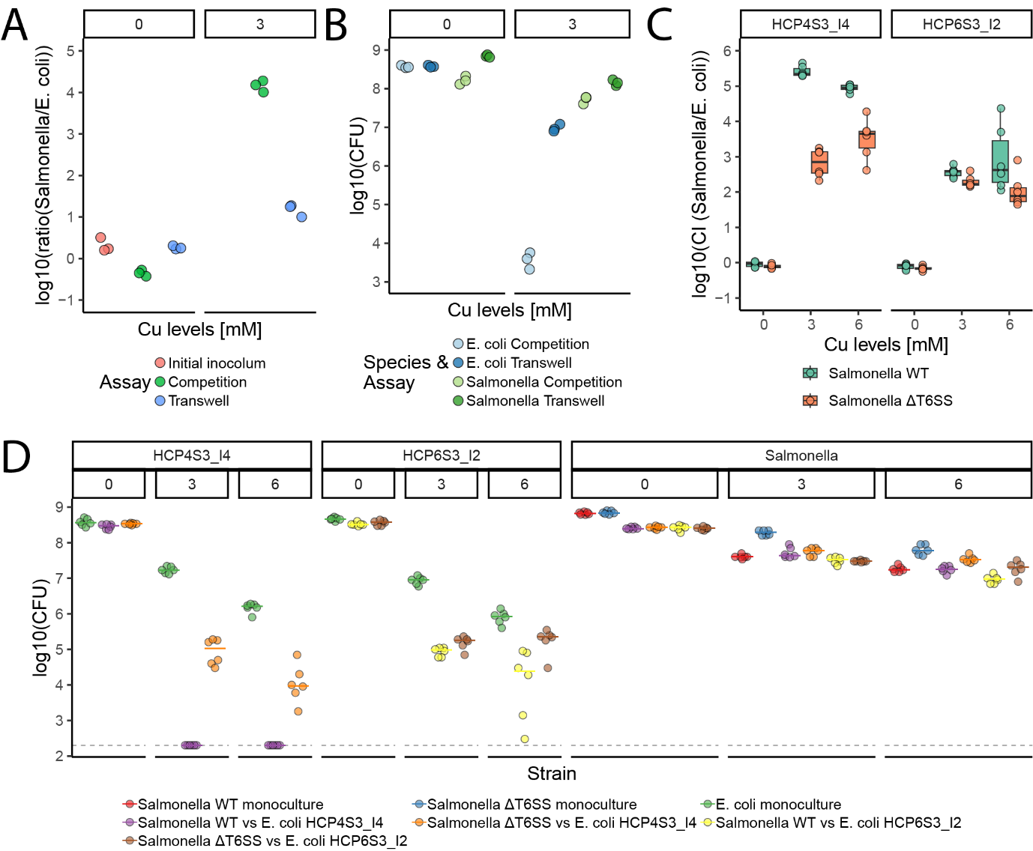
Figure 6. Contact-dependent competition between Salmonella and E. coli in copper sulphate-altered niche
A) Ratios between Salmonella and E. coli HCP4S3_I4 in competition and Transwell assay with copper supplementation. Copper sulphate concentrations [in mM] are shown on the top x-axis. Log10 ratios between Salmonella and E. coli CFUs are shown on the y-axis and the assay type and timepoint is marked with colours showed on the legend below the plot. B) CFU counts for Salmonella and E. coli HCP4S3_I4 in competition and Transwell assay with copper supplementation. Copper sulphate concentrations [in mM] are shown on the top x-axis. Log10 CFUs for Salmonella and E. coli are shown on the y-axis and the species and assay type is marked with colours showed on the legend below the plot. C) Competitive index between Salmonella WT or ΔT6SS and E. coli strains in competition assay with copper supplementation. Copper sulphate concentrations [in mM] are shown on the bottom x-axis and E. coli strain name on the top x-axis. Log10 competitive index (CI) between Salmonella and E. coli CFUs are shown on the y-axis and the Salmonella strain used for competition is marked with colours showed on the legend below the plot. D) CFUs counts for Salmonella and E. coli strains in monoculture or competition assay with copper supplementation. Genus or E. coli strain name and copper sulphate concentrations [in mM] are shown on the upper top x-axis and on copper sulphate concentrations (0, 3, 6 [mM]) in the media on the lower top x-axis. CFU of E. coli and Salmonella in competition or monocultures are shown on the y-axis and the bacterial strain(-s) is(are) marked with colours showed on the legend below the plot. Limit of detection is shown with a grey dashed line.

- Discussion
Foodborne pathogens remain one of the major causes of human infections worldwide (Havelaar et al. 2015). Some of them, including S. Typhimurium, are also a significant cause of disease and reduced productivity in livestock. In such cases, disease prevention and management in affected animals can help reduce pathogen transmission to humans as well as boosting livestock productivity. Several husbandry methods have been applied to increase health and productivity of livestock, including feed additives to improve productivity through growth promotion, and have been shown to improve gut health and exclude pathogens. Since the turn of century, changes in regulations necessitated a reduced reliance on antibiotics as growth promotors in animal production, leading to the common use of copper compounds in animal feed due to lack of other alternatives (Pettigrew 2006).
Since the first report about beneficial effects of copper sulphate on pig health and growth more than 60 years ago (Barber et al. 1955), many studies have reported this effect in farm studies. The most recent study was performed prior to or shortly following the emergence and global spread of copper resistant S. Typhimurium ST34 (Perez et al. 2011), raising the question as to whether copper supplementation remains beneficial.
It has been known for some time that the beneficial effects of copper sulphate supplementation for pigs coincides with changes in intestinal microbiota (Fuller et al. 1960; Bunch et al. 1961). To further explore the changes in the microbial communities with greater resolution we employed shotgun metagenomics to assess the effect of copper sulphate on weaned piglet microbiota. Consistent with previous studies (Zhang et al. 2019; Brinck et al. 2023), no major changes in alpha and beta diversity indices were observed between piglet supplemented with therapeutic (150 ppm) and nutritional (10 ppm) levels of copper. The relative abundance of bacterial species belonging to Bifidobacterium and Lactobacillus decreased in piglets on high copper sulphate diet in agreement with a previous report (Brinck et al. 2023). Increased abundance of bacteria belonging to the family Lachnospiraceae have been observed previously (Forouzandeh et al. 2022), we made concordant observations for a previously unreported species of genus Agathobacter, of the family Lachnospiraceae. The same study reported that bacteria from genus Holdemanella increased in relative abundance, which was not observed in our study. No differences in relative abundance of Enterobacteriaceae or Escherichia were reported in the study of Forouzandeh et al. (2022) and Brinck et al (2023) do not report any information about this family or genus (Forouzandeh et al. 2022; Brinck et al. 2023). Several culture-based studies focused on changes in coliforms upon high copper sulphate supplementation in piglets, but the results were inconsistent, suggesting that there may be other factors affecting changes in coliforms/Enterobacteriaceae in these studies (Jensen 2016), leaving inconclusive results from community-sequencing based approaches.
Extensive culturing of gut bacteria has emerged in recent years as an approach to better characterise the functional attributes of the intestinal microbiota (Browne et al. 2016; Forster et al. 2019). We aimed to culture weaned piglet microbiota to investigate the resistance of microbes to copper sulphate. Previous studies focused on microbiota isolations from pigs using various culturing media and resulted in isolation of 110 species across nine phyla, including 22 novel species (Wylensek et al. 2020), 46 species from four phyla (Fenske et al. 2020), 23 species from four phyla (Mun et al. 2021), 148 species from 12 phyla with potentially four novel species (Wang et al. 2021). In our approach we isolated of 131 species from five phyla, including 39 species taxa that could not be assigned to known species using current databases and are therefore candidate new species. This indicated that despite recent advances in pig gut microbiota culturomics, a large portion of uncultured microbiota remains to be explored in the future studies.
Cultured strains of species from the genera Bulleidia, Bifidobacterium, Limosilactobacillus, Lactobacillus and Prevotella had a relatively high susceptibility to copper sulphate MIC in vitro, even compared to E. coli and S. Typhimurium ST34 that lack copper resistance genes sil/pco. This was consistent with an observed decrease in relative abundance of species belonging to these genera observed using metagenomics. Surprisingly, despite the reduction in relative abundance of E. coli in piglets on a high copper diet in our metagenomics data we observed commonly occurring strains that exhibited a high level of resistance to copper sulphate. These results indicate that reduction of E. coli abundance might not be a direct effect of copper toxicity. Instead, this may be due to indirect effects of copper toxicity on microbiota community that affect the niche or inter-bacterial interactions. In vitro niche competition assays (Fig. 5D) indicated that copper-resistant E. coli in monoculture with copper sulphate supplementation grew to lower CFUs than Salmonella, indicative of different adaptation mechanisms to stress imposed on sil/pco-positive E. coli by copper. Furthermore, presence of copper sulphate as a stressor induced competition mechanisms between Salmonella and E. coli decreasing the survival of E. coli. It has been shown previously that several bacterial species induce toxin production or activate T6SS upon exposure to various stresses. It is therefore possible that species of the gut microbiota also elaborate killing mechanisms in the gut of piglets with high copper supplementation (Cornforth and Foster 2013; Guan et al. 2015). Alternatively, copper sulphate may alter the host gut environment, impacting oxygen levels and thereby reducing E. coli relative abundance. Limited oxygen is known to decrease abundance of facultative anaerobes like E. coli (Mueller et al. 2015) and oxygen availability has been linked to host epithelial metabolism and inflammation (Byndloss et al. 2017). Considering that high copper supplementation has been associated with increased epithelial villus height, reduced crypt depth, reduced intestinal permeability and inflammation (Zhao et al. 2007; Espinosa and Stein 2021), the direct effect of copper sulphate on host cells should be considered in the future as a possible factor affecting microbiota assembly and E. coli relative abundance (Chavez-Arroyo, Radlinski, and Baumler 2025).
Since the phylum Pseudomonadota (dominated by Escherichia in our study) has been identified as a group with the highest number of copper resistance genes associated with increased copper sulphate MIC, we investigated the genetic background of this phenotype. We were able to detect sil together with pco genes as well as sil genes alone encoded on the chromosome or on a plasmid of E. coli strains isolated from piglets, which corroborates previous reports where copper resistance cluster sil/pco have been identified in various Enterobacteriaceae on plasmids or chromosomes (Chalmers et al. 2018; Branchu et al. 2019).
The sil operon has been initially identified as a key genetic determinant providing resistance to silver, but Salmonella genomic island-4 (SGI-4) encoding sil has been confirmed as a major contributor to copper resistance in S. Typhimurium ST34 (Branchu et al. 2019). However, there are still aspects that remain unclear in other serovars or Enterobacterales species. While several studies, including ours, have established sil as the primary driver of copper resistance in S. Typhimurium in anaerobic conditions (Mourao et al. 2016; Branchu et al. 2019), a recent investigation in S. Senftenberg suggests that pco can confer resistance as well (Hikal et al. 2024). Contribution of sil/pco to copper resistance in E. coli have been questioned in study of Chalmers et al. (2018), even though three out of four strains carrying these clusters had higher copper sulphate broth MIC than three sil/pco-negative strains (Chalmers et al. 2018). The role of pco in providing copper resistance has been questioned, yet a possible contribution of sil to copper resistance was not considered (Yang et al. 2020). Copper sulphate MIC determined by a broth dilution on E. coli isolated during our study (Fig. 5C) in anaerobic conditions revealed that different sil/pco variants provide similar levels of copper resistance, but all Escherichia isolates lacking sil/pco or sil clusters had an MIC at least 6 mM lower than sil/pco- or sil-positive Escherichia. Removal of sil or sil/pco from S. Typhimurium ST34 yielded a copper MIC like that of S. Typhimurium SL1344 (which has no copper resistance genes) and disruption of pco in ST34 resulted in an increase of MIC by 1 mM (Fig. 5C), defining sil and pco involvement in copper resistance. Our analysis revealed that the sil/pco gene clusters were often associated with mobile genetic elements (MGE) such as transposons or plasmids in the phylogenetically diverse E. coli strains being investigated, concordant with the proposed role of MGE in copper resistance spread (Fang et al. 2016; Chalmers et al. 2018). Plasmid-encoded sil/pco clusters in our collection co-localised with IS1- and IS3-like genetic elements, which, to our knowledge was not previously reported, indicating that copper resistance-associated mobilome can be more diverse than previously expected.
As our metagenomic and culturing investigations indicated the impact of copper sulphate on microbiota composition, we aimed to investigate if therapeutic levels of copper sulphate can affect interactions between common pig pathogen S. Typhimurium ST34 and porcine E. coli isolates. Several studies have identified bacteriocins as important factors in competitive interactions between these two species. For example, colicin Ib mediates competitive advantage for S. Typhimurium SL1344 in the inflamed gut (Nedialkova et al. 2014), but we did not find any bacteriocin sequences in genome of S. Typhimurium ST34 or any indications that copper sulphate induces bacteriocin production. Furthermore, it has been previously shown that S. Typhimurium ST34 isolates lack plasmids that typically encode bacteriocins, such as that present in SL1344 encoding for colicin Ib (Bawn et al. 2020). As Transwell assays revealed that the competitive advantage of S. Typhimurium ST34 over porcine E. coli isolates in copper supplemented media is contact-dependent, we investigated the contribution of T6SS to these interactions, which revealed that indeed this system confers ST34 advantage over porcine E. coli. Previous research indicated that T6SS of S. Typhimurium LT2 can mediate killing of laboratory E. coli strain K-12 W3110 (Brunet et al. 2015). Another report with use of SL1344 and E. coli mouse commensal strain JB2 showed that the T6SS does not contribute to competition between these two strains (Sana et al. 2016). Indeed, we observed considerable differences in the degree of T6SS-dependent killing of two strains of E. coli by a S. Typhimurium ST34 strain. The reason for this is not known and the two strains were highly divergent and therefore containing many insertions and deletions and single nucleotide polymorphisms that could account for this observation. Our results together with previously published research indicate that contribution of T6SS to E. coli killing might be strain-dependent, but more work is needed to explain mechanism of E. coli resistance against Salmonella T6SS.
The increase in T6SS-mediated killing of E. coli by copper sulphate poses the question as to how this compound activates expression of this secretion system or how copper sulphate increases susceptibility of E. coli to Salmonella’s T6SS. Ferric uptake regulator Fur is a pivotal global transcriptional regulator in bacteria, primarily recognized for its central role in maintaining iron homeostasis, but this protein has been shown to repress T6SS in S. Typhimurium in iron-rich media (Wang et al. 2019). Although the link between iron and copper homeostasis have not been studied previously in Salmonella, several reports show cross-talk between iron and copper homeostasis in E. coli (Hyre, Casanova-Hampton, and Subashchandrabose 2021). Study of Kershaw et al. (2005) reported increased expression of fur and enterobactin operon in E. coli upon high (2 mM) copper exposure in aerobic conditions (Kershaw et al. 2005). Deletion of periplasmic multicopper oxidase (CueO) increased intracellular levels of iron in uropathogenic E. coli, which indicated that this protein is critical not only for copper homeostasis, but iron as well (Tree et al. 2008). As multiple other factors have been implicated in T6SS regulation in various microbes (Hespanhol, Nobrega-Silva, and Bayer-Santos 2023), the role of copper sulphate as T6SS activator requires further research.
Our study is consistent with the view that high copper supplementation in weaned piglets selectively impacts the relative abundance of gut microbiota, affecting key members associated with microbiome function. The increased presence of copper resistance genes in Pseudomonadota, particularly the acquisition of sil/pco clusters, directly enhances copper resistance in E. coli. This resistance is a necessary, but not sufficient, factor for competitive interactions between Salmonella and E. coli under high copper conditions in vitro. Salmonella possesses additional mechanisms like T6SS that provide a competitive advantage in this copper-rich environment. The prevalence of copper resistant Salmonella Typhimurium ST34 in pigs (Petrovska et al. 2016) and diverse E. coli found in these studies raises important questions. First, is the use of therapeutic levels of copper in pig feed still beneficial in boosting gut health and productivity in pigs. Second, whether Salmonella can exploit the altered gut niche resulting from copper supplementation, and if this has a negative impact on the risk to food safety.
- Material and methods
  - Farm study
Farm study was performed on a commercial farm and utilised 60 commercial piglets derived from six sows (Fig. 7). Sows were kept on a commercial low copper diet. Piglets were separated into four pens with similar numbers, sex and weight of piglets in each of the pens. All piglets were kept on a commercial pre-starter low copper diet. After 5 days, 30 piglets were put on the high copper (150 ppm Cu) commercial starter diet and rest were kept on the low copper (10 ppm Cu) starter diet. Freshly voided faecal samples were collected from piglets at day 5, 12 and 19 and immediately placed into 50-mL falcon tubes and kept on ice for 2-6 h. Faecal samples were aliquoted in anaerobic conditions (Whitley A35 Workstation) for storage frozen at -80ºC. The pig study received a favourable ethical opinion from the University of Surrey’s Non-Animals Scientific Procedures Act (NASPA) ethics committee (NASPA-2122-07).
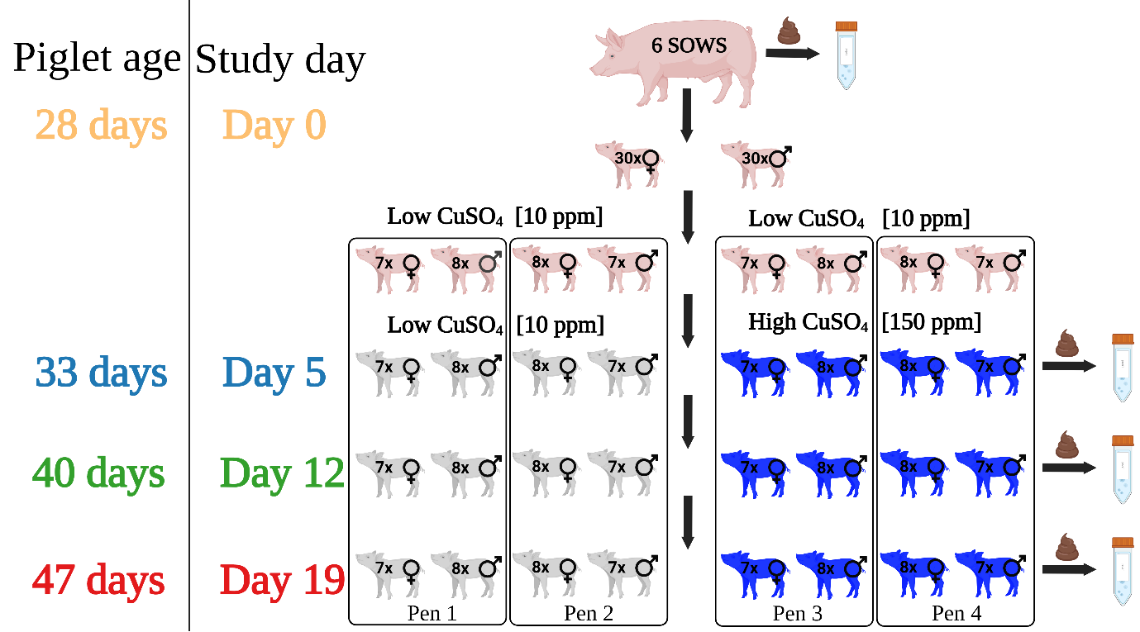
Fig. 7. Farm study design and sample collection
Sixty commercial piglets from six sows were divided into four pens. Half received a high copper (150 ppm Cu) starter diet, and the other half received a low copper (10 ppm Cu) starter diet. Fresh faecal samples were collected on days 5, 12, and 19 and stored at -80ºC.

  - Shotgun metagenomic sequencing and analysis
DNA from faecal samples was isolated using a Maxwell RSC 48 Instrument and Maxwell RSC PureFood GMO and Authentication kit with minor modifications. Briefly, 1 mL of CTAB buffer and around 100 mg of faeces was added to a lysing matrix E tube (MP Biomedicals). Samples were heated at 95ºC for 5 minutes, vortexed and homogenized in the FastPrep24 Instrument for 45 seconds at a frequency of 6.0 m/s. Next, 40 µl of Proteinase K and 20 µl of RNase A were added, samples were vortexed and incubated at 70ºC for 10 minutes. 300 µl of the lysates was used for purification with Maxwell RSC 48 Instrument. DNA concentration was measured with Qubit Fluorometer and Qubit™ dsDNA BR Quantification Assay Kit. DNA was diluted to 5 ng/µl and library was prepared using tagmentation protocol (Illumina). The libraries were quantified using the Promega QuantiFluor® dsDNA System (Catalogue No. E2670) and run on a GloMax® Discover Microplate Reader. Libraries were pooled following quantification in equal quantities. The final pool was double-SPRI size selected between 0.5 and 0.7X bead volumes using sample purification beads (Illumina® DNA Prep, (M) Tagmentation (96 Samples, IPB), 20060059). The final pool was quantified on a Qubit 3.0 instrument and run on a D5000 ScreenTape (Agilent Catalogue No. 5067-5579) using the Agilent Tapestation 4200 to calculate the final library pool molarity. The pool was sent to Source Bioscience and run on two NovaSeq S4 lanes. 295 pig metagenomic samples from BioProject PRJEB11755 were downloaded for additional analyses (Xiao et al. 2016).
MG-TK pipeline was used for read quality assessment, metagenome-assembled genomes assembly, read mapping and species abundance determination (Frioux et al. 2023). Host reads were filtered out by using Kraken v2.1.0 with parameter “--confidence 0.01” and database generated with Sus scrofa genomes assembly (GCF_000003025.6) (Wood, Lu, and Langmead 2019; Warr et al. 2020). Raw shotgun metagenomes were quality filtered using sdm v1.63 with default parameters (Ozkurt et al. 2022), assembled using MEGAHIT v 1.2.9 with parameters “--k-list 25,43,67,87,101,127“ (Li et al. 2016) and reads mapped onto assemblies using Bowtie2 v2.3.4.1 with parameters “--end-to-end“ (Langmead and Salzberg 2012), genes predicted with Prodigal v2.6.1 with parameters “-p meta” (Hyatt et al. 2010) and a gene catalogue clustered at 95% nt identity using MMseqs2.80 (Mirdita, Steinegger, and Soding 2019). Metagenomic assembled genomes (MAGs) were binned using SeminBin2 (Pan, Zhao, and Coelho 2023) and combined with canopy clusters (Nielsen et al. 2014) in MG-TK to species-level dereplicated MGS (metagenomic species). RTK was used to calculate abundance matrices from MGS representative genes in the gene catalogue (Saary et al. 2017). Vegan package was used for analysis of alpha (Shannon and Simpson’s indices) and beta (Brey-Curtis dissimilarity) diversity in microbiota (Oksanen 2010). Anosim function with 1000 permutations from vegan package was used to test for difference in beta diversity between groups (Shade, Jones, and McMahon 2008). Wilcoxon rank-sum test with Benjamini-Hochberg correction for multiple comparisons was used to compare differences in relative abundance between microbiota (Li et al. 2023).
  - Culturing of bacterial isolates
Faecal samples from 6 piglets (3 from high and low copper supplementation) and 1 sow were used for isolation of anaerobic bacteria in anaerobic cabinet using pre-reduced reagents following protocol of Browne et al., (2016), with minor changes (Browne et al. 2016). Frozen faecal samples were diluted in PBS to concentration of 0.1 g/ml of PBS and serially diluted on YCFA agar plates (2x90mm for each dilution) supplemented with 0.002 g/ml each of glucose, maltose and cellobiose or starch. For a subset of samples, 0.1 g of faeces was treated with 70% ethanol for 4 h at room temperature, washed three time with PBS and serial dilutions plated on YCFA agar supplemented with 0.1% sodium taurocholate to isolate ethanol-resistant endospores (spores). 95 colonies were picked for each sample after 72 h from plating in anaerobic cabinet. Each colony was purified by re-streaking and culturing on YCFA agar 3 times. A single colony was then selected from last plate and used for YCFA broth culture and cryo-stocks. If bacteria did not grow in YCFA broth for 1 week, 2-3 YCFA plates were used to spread a single colony and bacteria were harvested from the plates after 3 days with the aid of of 2-mL of YCFA and L-shaped inoculating loop and used for cryo-stocks and genomic DNA isolation. Bacterial cryo-stocks were generated by mixing an equal amount of bacterial culture with 40% glycerol in ddH₂O. 750 µl of bacterial culture was used for DNA isolation. Cultures were centrifuged 15,000xg for 5 minutes, washed in PBS and pellets were frozen for at least 24h at -80ºC.
Faecal samples from 28 piglets (14 from high and low copper supplementation) and 6 sows were used for isolation of Enterobacteriaceae in aerobic conditions. Frozen faecal samples were diluted in PBS to concentration of 0.1 g/ml of PBS and serially diluted on Eosin-Methylene Blue (EMB) agar plates (90 mm, 1 plate per dilution) and incubated at 37℃ for 24 h. Five single colonies were re-streaked onto MacConkey agar and subsequently onto LB agar (10 g Tryptone, 5 g Yeast Extract, 10 g NaCl, 15 g agar per litre). Subsequently, each isolate was cultured aerobically O/N in 5-ml LB broth (10 g Tryptone, 5 g Yeast Extract, 10 g NaCl per litre) and O/N cultures were used for DNA isolation and cryostock preparation.
DNA from bacteria was isolated with use of Maxwell RSC 48 Instrument and Maxwell RSC PureFood GMO and Authentication kit with slight modifications. Frozen bacterial pellets were resuspended in 500 µl of CTAB buffer with chicken lysozyme (30 mg/ml) and incubated at 37ºC for 1h. Next, 30 µl of Proteinase K and 20 µl of RNase A were added, samples were vortexed and incubated at 60ºC for at least 1h, aerobically. 300 µl of the lysates was used for purification with Maxwell RSC 48 Instrument. DNA concentration was measured with Qubit Fluorometer and Qubit™ dsDNA BR Quantification Assay Kit. Library preparation protocol was the same as the one used for metagenomic samples. Sequencing was performed using Novaseq500 or NextSeq2000. Genome assembly and annotation was performed with shovill pipeline v1.1.0 and Bakta v1.5.0, respectively (Kolenda, Sidorczuk, et al. 2021; Schwengers et al. 2021). Proteins annotated with Bakta as copper homeostasis genes were pooled together and redundant genes were dereplicated with CD-HIT v4.8.1 with parameters “-c 0.8 -s 0.8” and annotated with InterPro database (Paysan-Lafosse et al. 2023; Fu et al. 2012). Proteins with no domains associated with copper/heavy metal homeostasis/resistance were removed and used for blastp query of all bacterial genomes (coverage and identity of 80% and above were considered a positive hit). CheckM v1.2.1 was used for contamination control and GTDB-Tk v2.1.1 with database version 214 was used for species determination (Chaumeil et al. 2019; Parks et al. 2015). Quast v4.6.3 was used for assembly statistics (Gurevich et al. 2013). Genomes of bacterial isolates with no species name assigned by GTDB-tk were analysed with TYGS platform (Meier-Kolthoff and Goker 2019). Comparison of cultured microbiota with species present in metagenomic samples was done with dataset generated during this study, dataset of 295 pig metagenomic samples from France, Denmark and China and all pig dataset analysed with Pig Gut v1.0 MGnify Genome database accessed on 21.02.2024 (Xiao et al. 2016; Gurbich et al. 2023). All shotgun metagenomic data was additionally analysed with metaphlan v.4.1.1 and database mpa_vJun23_CHOCOPhlAnSGB_202403 (Manghi et al. 2023).
  - Escherichia genomics
ClermonTyping was utilized for strain phylotyping (Beghain et al. 2018). Abricate with custom database containing: 1) SGI-4 coding sequences (CDSs); 2) E. coli copper homeostasis genes or 3) genes encoding aerobactin and yersiniabactin was used to determine presence of these genes in E. coli assemblies isolated from pigs (Sidorczuk et al. 2023). Snippy v4.6.0 was used for reference-based phylogeny and E. coli MG1655 (NC_000913.3) was used as reference for mapping and SNP-calling (Seeman 2020). RAxML-NG v1.1 with GTR+G model and 1000 bootstrap replicates was used for phylogenetic tree calculation (Kozlov et al. 2019). R packages ggtree and ggtreeExtra have been utilized for phylogenetic tree annotation (Yu et al. 2017; Xu et al. 2021). BLAST version 2.12 was used for sil or pco cluster extraction from E. coli genomes (Altschul et al. 1990). Sil or pco gene clusters were aligned with Clustal Omega and tree was generated with RAxML-NG (Sievers and Higgins 2014). Distance matrix based on SNP-distance was generated with snp-dist included in Snippy software. Sil and pco gene cluster was considered a new variant if distance to the closest variant was more than 10 and 3 SNPs, respectively.
  - Bacterial strains and mutants
Salmonella mutants were generated by exchange of region of interest (gene, gene cluster) with kanamycin (aph) or chloramphenicol (cat) cassette tagged with 50 bp extensions homologous to regions overlapping DNA fragment being replaced (Datsenko and Wanner 2000). To minimise the potential for polar effects on surrounding genes, primers were designed to precisely remove the entire sil and pco loci that are known to form a commonly mobilised region that together function in resistance to copper. For deletion of the T6SS SPI-6 gene cluster, to minimise potential off-target polar effects we deleted the same genomic region that was previously used for which functional loss was complemented by the T6SS SPI-6 gene cluster encoded on a plasmid (Pezoa et al. 2013; Sana et al. 2016) indicating that the deletion did not have polar effects on neighbouring genes. Phage Lambda homologous recombination machinery genes encoded on pSIM18 plasmid were used to induce homologous recombination and antibiotic cassette insertion allowed selection of strains devoid of region of interest (Chan et al. 2007). Correct gene/gene cluster removal was confirmed with colony PCR. Whole genome sequencing was used to confirm lack of off-target mutations of new strains (Khan et al. 2024).
Nalidixic acid spontaneous mutants of E. coli were selected by plating O/N broth cultures on increasing concentrations of antibiotic (0, 10, 25, 50, 100, 200 µg/ml). Strains that grew on highest nalidixic acid concentrations were selected and submitted to whole genome sequencing. The presence of mutations in nalidixic acid resistant strains was investigated by mapping raw reads of wild type and mutants to the assembly of wild-type strain and determining SNPs and indels using snippy pipeline (Seeman 2020). All SNPs detected only in mutants were confirmed by visualisation of BAM files in ARTEMIS software (Carver et al. 2012). Growth curve experiments were performed to investigate the influence of nalidixic acid mutation on strain growth abilities (Kolenda, Burdukiewicz, et al. 2021). Briefly, overnight cultures were diluted to 5x10⁶ bacteria/ml in LB and 150 µl bacterial solution was pipetted into each well of a 96-well plate. Bacterial growth was measured with Logphase600 (BioTek) at 37ºC for 24 h with constant shaking (700 rpm) and OD₆₀₀ measurements every 10 minutes. Wild type and mutants were included in each experiment. At least three biological replicates with at least four technical replicates were performed for each strain (Fig. S11). One strain with a single mutation in the gyrA gene, no off-target mutations and no growth defect in LB was selected for experimental procedures.
Luminescent Salmonella B54 WT strain was constructed by integrating lux operon into 16S site (Riedel et al. 2007). Briefly, p16Slux plasmid was transformed into Salmonella and heat stress (42ºC, 24 h) was used to induce integration of luxABCDE operon into ssu locus, which was confirmed by colony PCR. Growth curves and WGS were utilized to select strain with similar growth rate to WT and no off-target mutations, respectively.
All strains are listed in Table 1. All primers are listed in Table 2.
  - Copper minimal inhibitory concentrations assays
Minimal inhibitory concentration screen for pig microbiota (anaerobic bacteria and 100 E. coli isolates) was performed by spotting bacterial suspensions onto YCFA agar plates supplemented with increasing concentrations of CuSO₄ (concentrations tested: 0, 0.156, 0.313, 0.625, 1.25, 2.5, 5, 10, 20 [mM]). Isolate selection criteria were as follows: 1) for bacteria cultured on YCFA: at least one isolate for each species isolated and in case when more isolates were cultured, phylogeny, snp-distance and pangenome were taken into account during strain selection, 2) for bacteria cultured on EMB and MacConkey: 100 isolates. Anaerobic bacteria were grown on YCFA agar plates (1 strain per plate) for 3 days, re-streaked on YCFA agar for another 3 days at 37°C and scraped into PBS. E. coli isolates were grown O/N in 96-well plate in LB broth. 5 µl of bacterial suspension was spotted onto YCFA agar and incubated for 3 days in anaerobic conditions. MIC was defined as the lowest concentration where bacterial growth was not observed on plates for two technical replicates. Salmonella WT and Δsil-pco::kan-1 were included in all experiments as reference.
Minimal inhibitory concentrations (MIC) for Salmonella strains and selected E. coli strains was performed using broth microdilution method (Branchu et al. 2019). E. coli strains were selected based on phylogroup, sil/sil-pco cluster presence, and sil/sil-pco cluster variation (Table S3). Bacteria were grown in anaerobic conditions in 5-ml LB broth, diluted in LB in 25 mM HEPES buffer (pH=7.4, later referred as “LB HEPES”) to 1x10⁶ CFU/ml and 100 µl was inoculated into 100 µl of serial dilution of CuSO₄ (2 to 40 in 2 mM intervals) in LB HEPES allowing for MIC testing in the range from 0 to 20 mM in 1 mM intervals in 96-well plate. Optical density of bacteria incubated in anaerobic conditions for 24 h were measured at 600 nm with BMG OMEGA plate reader. The MIC was defined as the lowest concentration where bacterial growth was not observed for at least three biological replicates.
  - Ecological niche competition and invasion assays
A screen of the interactions between Salmonella and Escherichia coli pig isolates was performed with use of lux-tagged Salmonella and 20 pre-selected E. coli isolates detailed in paragraph 2.6 (Table S3). Bacteria were grown in 5-ml LB broth in anaerobic conditions overnight. Salmonella was diluted in LB to 5x10⁷CFU/ml and 20 µl was used for niche competition and invasion assays. In the case of E. coli, 20 µl or 180 µl of O/N culture was used for niche competition and invasion assay, respectively (Spragge et al. 2023). Only Salmonella control consisted of 20 µl of diluted bacteria and 180 µl of LB. Bacterial isolates were incubated in 96-well plates for 24h in anaerobic conditions and then transferred in aerobic conditions to a white polypropylene 96-well plate. Luminescence was measured using BMG OMEGA plate reader. The experiment was performed in at least three technical and biological replicates.
S. Typhimurium B54-C9 and E. coli strains with nalidixic acid resistance were grown in 5-ml of LB HEPES O/N in anaerobic conditions for niche competition and invasion assays in CuSO₄-containing media. LB HEPES with increasing concentrations of CuSO₄ was used in the assays. 1x10⁵ CFU of Salmonella and E. coli used for competition assay in 200 µl of LB HEPES. Controls included only 1x10⁵ CFU of single strain incubated in the same conditions. 1x10⁵ CFU of Salmonella and 50 µl of E. coli O/N cultures was used for invasion assay in total volume of 200 µl of LB HEPES. To confirm initial inoculum for each strain, bacterial dilutions were plated on selective media and CFU counted next day. Assay lasted for 24h and CFU counts were determined by serial dilution plating on selective media. The experiments were performed in at least four biological replicates.
Bacteriocin production was tested by using overlay disc diffusion assay (Kleta et al. 2006). O/N cultures of S. Typhimurium B54_C9 and E. coli HCP4S3_I4 were grown in anaerobic conditions in LB HEPES supplemented with 0 or 3 mM CuSO₄ at 37°C. 100 µl of O/N E. coli culture was added to melted soft LB agar (0.5 % agar) supplemented with 0 or 3 mM CuSO₄, mixed and overlaid over an LB agar plate. Whatman paper 5 mm discs were placed on solidified agar and 10 µl spots of S. Typhimurium B54_C9 O/N cultures. Plates were incubated O/N at 37°C and checked for zones of inhibition on the following day. Macrel software was used to search S. Typhimurium B54_C9 genome for presence of antimicrobial peptides (Santos-Junior et al. 2020). Bactibase2 bacteriocin protein sequences and blastx were used on S. Typhimurium B54_C9 genome to search for bacteriocins (Hammami et al. 2010).
Transwell competition assays were performed with use of Corning™ Transwell™ 6 Well Plate with Permeable Polyester Membrane Inserts (0.4 µm pores) and LB HEPES without or with 3 mM CuSO₄ (Koskiniemi et al. 2013). S. Typhimurium B54-C9 and E. coli HCP4S3_I4_NalR1 were grown O/N in 5-ml of LB HEPES in anaerobic conditions. Bacteria were diluted in LB HEPES to 1x10⁶CFU/ml. Next, 1.3 mL of LB HEPES or LB HEPES with 6 mM CuSO₄ was added to corning plates and universal tubes followed by 1.3 mL of E. coli. Transwell insert were placed in the Corning plate and 0.75 ml of LB HEPES or LB HEPES with 6 mM CuSO₄ were added to inserts and universal tubes. Next, 0.75 ml of Salmonella was added to Transwell inserts and universal tubes. CFU counts were determined by serial dilution plating on selective media for initial inocula and bacteria incubated for 24 h.
  - Data availability
Pig faecal shotgun metagenomics data for this study are freely available from the NCBI BioProject database under accession number PRJNA1219188. Data associated with pig microbiota culturing are available from the NCBI BioProject database under accession numbers: PRJNA1273087, PRJNA1273977 and PRJNA1276128.

- Acknowledgements
The authors would like to thank the participating farm and farm staff for assisting with the pig study. Bacterial isolates cultured in this study are available upon reasonable request to corresponding author. We acknowledge the use of a large language model (LLM), Gemini, developed by Google, for assistance with grammar checking and stylistic improvements during the preparation of this manuscript.

- Funding
This work was supported by research grant BB/W003155/1 and by the BBSRC Institute Strategic Programme Microbes and Food Safety BB/X011011/1 and its constituent projects, BBS/E/F/000PR13635 and BBS/E/F/000PR13636. The funders had no role in study design, data collection and analysis, decision to publish, or preparation of the manuscript.
- Declaration
  - Ethics approval and consent to participate
The pig study received a favourable ethical opinion from the University of Surrey’s Non-Animals Scientific Procedures Act (NASPA) ethics committee (NASPA-2122-07).
  - Consent for publication
not applicable
- Competing interests
The authors declare that they have no competing interests.
- References

(FEEDAP), EFSA Panel on Additives and Products or Substances used in Animal Feed. 2016. 'Revision of the currently authorised maximum copper content in complete feed', EFSA J, 14: e04563.
Altschul, S. F., W. Gish, W. Miller, E. W. Myers, and D. J. Lipman. 1990. 'Basic local alignment search tool', J Mol Biol, 215: 403–10.
Anderson, E. S. 1968. 'Drug resistance in Salmonella typhimurium and its implications', Br Med J, 3: 333–9.
Arai, N., T. Shibahara, R. Nishiura, Y. Tamamura-Andoh, H. Nishiura, Y. Muneta, H. Sawada, A. Watanabe-Yanai, T. Iwata, M. Akiba, and M. Kusumoto. 2024. 'ICEmST contributes to colonization of Salmonella in the intestine of piglets', Sci Rep, 14: 31407.
Barber, R.S., R. Braude, K. G. Mitchell, and J. Cassidy. 1955. 'High copper mineral mixture for fattening pigs', Chemistry and Industry, 21.
Barthel, M., S. Hapfelmeier, L. Quintanilla-Martinez, M. Kremer, M. Rohde, M. Hogardt, K. Pfeffer, H. Russmann, and W. D. Hardt. 2003. 'Pretreatment of mice with streptomycin provides a Salmonella enterica serovar Typhimurium colitis model that allows analysis of both pathogen and host', Infect Immun, 71: 2839–58.
Bawn, M., N. F. Alikhan, G. Thilliez, M. Kirkwood, N. E. Wheeler, L. Petrovska, T. J. Dallman, E. M. Adriaenssens, N. Hall, and R. A. Kingsley. 2020. 'Evolution of Salmonella enterica serotype Typhimurium driven by anthropogenic selection and niche adaptation', PLoS Genet, 16: e1008850.
Bearson, B. L., J. M. Trachsel, D. C. Shippy, S. K. Sivasankaran, B. J. Kerr, C. L. Loving, B. W. Brunelle, S. M. Curry, N. K. Gabler, and S. M. D. Bearson. 2020. 'The Role of Salmonella Genomic Island 4 in Metal Tolerance of Salmonella enterica Serovar I 4,[5],12:i:- Pork Outbreak Isolate USDA15WA-1', Genes (Basel), 11.
Beghain, J., A. Bridier-Nahmias, H. Le Nagard, E. Denamur, and O. Clermont. 2018. 'ClermonTyping: an easy-to-use and accurate in silico method for Escherichia genus strain phylotyping', Microb Genom, 4.
Boyen, F., F. Haesebrouck, D. Maes, F. Van Immerseel, R. Ducatelle, and F. Pasmans. 2008. 'Non-typhoidal Salmonella infections in pigs: a closer look at epidemiology, pathogenesis and control', Vet Microbiol, 130: 1–19.
Branchu, P., O. J. Charity, M. Bawn, G. Thilliez, T. J. Dallman, L. Petrovska, and R. A. Kingsley. 2019. 'SGI-4 in Monophasic Salmonella Typhimurium ST34 Is a Novel ICE That Enhances Resistance to Copper', Front Microbiol, 10: 1118.
Brinck, J. E., S. B. Lassen, A. Forouzandeh, T. Pan, Y. Z. Wang, A. Monteiro, L. Blavi, D. Sola-Oriol, H. H. Stein, J. Q. Su, and K. K. Brandt. 2023. 'Impacts of dietary copper on the swine gut microbiome and antibiotic resistome', Sci Total Environ, 857: 159609.
Browne, H. P., S. C. Forster, B. O. Anonye, N. Kumar, B. A. Neville, M. D. Stares, D. Goulding, and T. D. Lawley. 2016. 'Culturing of 'unculturable' human microbiota reveals novel taxa and extensive sporulation', Nature, 533: 543–+.
Brunet, Y. R., A. Khodr, L. Logger, L. Aussel, T. Mignot, S. Rimsky, and E. Cascales. 2015. 'H-NS Silencing of the Salmonella Pathogenicity Island 6-Encoded Type VI Secretion System Limits Salmonella enterica Serovar Typhimurium Interbacterial Killing', Infect Immun, 83: 2738–50.
Bunch, R. J., V. C. Speer, V. W. Hays, J. H. Hawbaker, and D. V. Catron. 1961. 'Effects of Copper Sulfate, Copper Oxide and Chlortetracycline on Baby Pig Performance', Journal of Animal Science, 20: 723–26.
Byndloss, M. X., E. E. Olsan, F. Rivera-Chavez, C. R. Tiffany, S. A. Cevallos, K. L. Lokken, T. P. Torres, A. J. Byndloss, F. Faber, Y. Gao, Y. Litvak, C. A. Lopez, G. Xu, E. Napoli, C. Giulivi, R. M. Tsolis, A. Revzin, C. B. Lebrilla, and A. J. Baumler. 2017. 'Microbiota-activated PPAR-gamma signaling inhibits dysbiotic Enterobacteriaceae expansion', Science, 357: 570–75.
Carver, T., S. R. Harris, M. Berriman, J. Parkhill, and J. A. McQuillan. 2012. 'Artemis: an integrated platform for visualization and analysis of high-throughput sequence-based experimental data', Bioinformatics, 28: 464–9.
Chalmers, G., K. M. Rozas, R. G. Amachawadi, H. M. Scott, K. N. Norman, T. G. Nagaraja, M. D. Tokach, and P. Boerlin. 2018. 'Distribution of the pco Gene Cluster and Associated Genetic Determinants among Swine Escherichia coli from a Controlled Feeding Trial', Genes (Basel), 9.
Chan, W., N. Costantino, R. Li, S. C. Lee, Q. Su, D. Melvin, D. L. Court, and P. Liu. 2007. 'A recombineering based approach for high-throughput conditional knockout targeting vector construction', Nucleic Acids Res, 35: e64.
Chaname Pinedo, L., L. Mughini-Gras, E. Franz, T. Hald, and S. M. Pires. 2022. 'Sources and trends of human salmonellosis in Europe, 2015-2019: An analysis of outbreak data', Int J Food Microbiol, 379: 109850.
Chaturvedi, K. S., C. S. Hung, J. R. Crowley, A. E. Stapleton, and J. P. Henderson. 2012. 'The siderophore yersiniabactin binds copper to protect pathogens during infection', Nat Chem Biol, 8: 731–6.
Chaumeil, P. A., A. J. Mussig, P. Hugenholtz, and D. H. Parks. 2019. 'GTDB-Tk: a toolkit to classify genomes with the Genome Taxonomy Database', Bioinformatics, 36: 1925–7.
Chavez-Arroyo, A., L. C. Radlinski, and A. J. Baumler. 2025. 'Principles of gut microbiota assembly', Trends Microbiol.
Cornforth, D. M., and K. R. Foster. 2013. 'Competition sensing: the social side of bacterial stress responses', Nat Rev Microbiol, 11: 285–93.
Datsenko, K. A., and B. L. Wanner. 2000. 'One-step inactivation of chromosomal genes in Escherichia coli K-12 using PCR products', Proc Natl Acad Sci U S A, 97: 6640–5.
Deriu, E., J. Z. Liu, M. Pezeshki, R. A. Edwards, R. J. Ochoa, H. Contreras, S. J. Libby, F. C. Fang, and M. Raffatellu. 2013. 'Probiotic bacteria reduce salmonella typhimurium intestinal colonization by competing for iron', Cell Host Microbe, 14: 26–37.
Dibner, J. J., and J. D. Richards. 2005. 'Antibiotic growth promoters in agriculture: history and mode of action', Poult Sci, 84: 634–43.
Espinosa, C. D., and H. H. Stein. 2021. 'Digestibility and metabolism of copper in diets for pigs and influence of dietary copper on growth performance, intestinal health, and overall immune status: a review', J Anim Sci Biotechnol, 12: 13.
European Food Safety, Authority, Prevention European Centre for Disease, and Control. 2024. 'The European Union One Health 2023 Zoonoses report', EFSA J, 22: e9106.
Fang, L., X. Li, L. Li, S. Li, X. Liao, J. Sun, and Y. Liu. 2016. 'Co-spread of metal and antibiotic resistance within ST3-IncHI2 plasmids from E. coli isolates of food-producing animals', Sci Rep, 6: 25312.
Fenske, G. J., S. Ghimire, L. Antony, J. Christopher-Hennings, and J. Scaria. 2020. 'Integration of culture-dependent and independent methods provides a more coherent picture of the pig gut microbiome', FEMS Microbiol Ecol, 96.
Ferrari, R. G., D. K. A. Rosario, A. Cunha-Neto, S. B. Mano, E. E. S. Figueiredo, and C. A. Conte-Junior. 2019. 'Worldwide Epidemiology of Salmonella Serovars in Animal-Based Foods: a Meta-analysis', Appl Environ Microbiol, 85.
Forouzandeh, A., L. Blavi, J. F. Perez, M. D'Angelo, F. Gonzalez-Sole, A. Monteiro, H. H. Stein, and D. Sola-Oriol. 2022. 'How copper can impact pig growth: comparing the effect of copper sulfate and monovalent copper oxide on oxidative status, inflammation, gene abundance, and microbial modulation as potential mechanisms of action', J Anim Sci, 100.
Forster, S. C., N. Kumar, B. O. Anonye, A. Almeida, E. Viciani, M. D. Stares, M. Dunn, T. T. Mkandawire, A. Zhu, Y. Shao, L. J. Pike, T. Louie, H. P. Browne, A. L. Mitchell, B. A. Neville, R. D. Finn, and T. D. Lawley. 2019. 'A human gut bacterial genome and culture collection for improved metagenomic analyses', Nat Biotechnol, 37: 186–92.
Frioux, C., R. Ansorge, E. Ozkurt, C. Ghassemi Nedjad, J. Fritscher, C. Quince, S. M. Waszak, and F. Hildebrand. 2023. 'Enterosignatures define common bacterial guilds in the human gut microbiome', Cell Host Microbe, 31: 1111–25 e6.
Fu, L., B. Niu, Z. Zhu, S. Wu, and W. Li. 2012. 'CD-HIT: accelerated for clustering the next-generation sequencing data', Bioinformatics, 28: 3150–2.
Fuller, R., L. G. M. Newland, C. A. E. Briggs, R. Braude, and K. G. Mitchell. 1960. 'THE NORMAL INTESTINAL FLORA OF THE PIG. IV. THE EFFECT OF DIETARY SUPPLEMENTS OF PENICILLIN, CHLORTETRACYCLINE OR COPPER SULPHATE ON THE FAECAL FLORA', Journal of Applied Bacteriology, 23: 195–205.
Granato, E. T., T. A. Meiller-Legrand, and K. R. Foster. 2019. 'The Evolution and Ecology of Bacterial Warfare', Curr Biol, 29: R521–R37.
Guan, J., X. Xiao, S. Xu, F. Gao, J. Wang, T. Wang, Y. Song, J. Pan, X. Shen, and Y. Wang. 2015. 'Roles of RpoS in Yersinia pseudotuberculosis stress survival, motility, biofilm formation and type VI secretion system expression', J Microbiol, 53: 633–42.
Gurbich, T. A., A. Almeida, M. Beracochea, T. Burdett, J. Burgin, G. Cochrane, S. Raj, L. Richardson, A. B. Rogers, E. Sakharova, G. A. Salazar, and R. D. Finn. 2023. 'MGnify Genomes: A Resource for Biome-specific Microbial Genome Catalogues', J Mol Biol, 435: 168016.
Gurevich, A., V. Saveliev, N. Vyahhi, and G. Tesler. 2013. 'QUAST: quality assessment tool for genome assemblies', Bioinformatics, 29: 1072–5.
Hammami, R., A. Zouhir, C. Le Lay, J. Ben Hamida, and I. Fliss. 2010. 'BACTIBASE second release: a database and tool platform for bacteriocin characterization', BMC Microbiol, 10: 22.
Havelaar, A. H., M. D. Kirk, P. R. Torgerson, H. J. Gibb, T. Hald, R. J. Lake, N. Praet, D. C. Bellinger, N. R. de Silva, N. Gargouri, N. Speybroeck, A. Cawthorne, C. Mathers, C. Stein, F. J. Angulo, B. Devleesschauwer, and Group World Health Organization Foodborne Disease Burden Epidemiology Reference. 2015. 'World Health Organization Global Estimates and Regional Comparisons of the Burden of Foodborne Disease in 2010', PLoS Med, 12: e1001923.
Hespanhol, J. T., L. Nobrega-Silva, and E. Bayer-Santos. 2023. 'Regulation of type VI secretion systems at the transcriptional, posttranscriptional and posttranslational level', Microbiology (Reading), 169.
Hikal, A. F., S. Hasan, D. Gudeta, S. Zhao, S. Foley, and A. A. Khan. 2024. 'The acquired pco gene cluster in Salmonella enterica mediates resistance to copper', Front Microbiol, 15: 1454763.
Hyatt, D., G. L. Chen, P. F. Locascio, M. L. Land, F. W. Larimer, and L. J. Hauser. 2010. 'Prodigal: prokaryotic gene recognition and translation initiation site identification', BMC Bioinformatics, 11: 119.
Hyre, A., K. Casanova-Hampton, and S. Subashchandrabose. 2021. 'Copper Homeostatic Mechanisms and Their Role in the Virulence of Escherichia coli and Salmonella enterica', EcoSal Plus, 9: eESP00142020.
Jensen, Bent Borg. 2016. 'Extensive Literature Search on the ‘Effects of Copper intake levels in the gut microbiota profile of target animals, in particular piglets’', EFSA Supporting Publications.
Kershaw, C. J., N. L. Brown, C. Constantinidou, M. D. Patel, and J. L. Hobman. 2005. 'The expression profile of Escherichia coli K-12 in response to minimal, optimal and excess copper concentrations', Microbiology (Reading), 151: 1187–98.
Khan, M. M., K. Sidorczuk, J. Becker, A. Aleksandrowicz, K. Baraniewicz, C. Ludwig, A. Ali, R. A. Kingsley, P. Schierack, and R. Kolenda. 2024. 'Characterization of clumpy adhesion of Escherichia coli to human cells and associated factors influencing antibiotic sensitivity', Microbiol Spectr, 12: e0260623.
Kleta, S., H. Steinruck, G. Breves, S. Duncker, C. Laturnus, L. H. Wieler, and P. Schierack. 2006. 'Detection and distribution of probiotic Escherichia coli Nissle 1917 clones in swine herds in Germany', J Appl Microbiol, 101: 1357–66.
Kolenda, R., M. Burdukiewicz, M. Wimonc, A. Aleksandrowicz, A. Ali, I. Szabo, K. Tedin, J. Bartholdson Scott, D. Pickard, and P. Schierack. 2021. 'Identification of Natural Mutations Responsible for Altered Infection Phenotypes of Salmonella enterica Clinical Isolates by Using Cell Line Infection Screens', Appl Environ Microbiol, 87.
Kolenda, R., K. Sidorczuk, M. Noszka, A. Aleksandrowicz, M. M. Khan, M. Burdukiewicz, D. Pickard, and P. Schierack. 2021. 'Genome placement of alpha-haemolysin cluster is associated with alpha-haemolysin sequence variation, adhesin and iron acquisition factor profile of Escherichia coli', Microb Genom, 7.
Koskiniemi, S., J. G. Lamoureux, K. C. Nikolakakis, C. t'Kint de Roodenbeke, M. D. Kaplan, D. A. Low, and C. S. Hayes. 2013. 'Rhs proteins from diverse bacteria mediate intercellular competition', Proc Natl Acad Sci U S A, 110: 7032–7.
Kozlov, A. M., D. Darriba, T. Flouri, B. Morel, and A. Stamatakis. 2019. 'RAxML-NG: a fast, scalable and user-friendly tool for maximum likelihood phylogenetic inference', Bioinformatics, 35: 4453–55.
Langmead, B., and S. L. Salzberg. 2012. 'Fast gapped-read alignment with Bowtie 2', Nat Methods, 9: 357–9.
Li, D., R. Luo, C. M. Liu, C. M. Leung, H. F. Ting, K. Sadakane, H. Yamashita, and T. W. Lam. 2016. 'MEGAHIT v1.0: A fast and scalable metagenome assembler driven by advanced methodologies and community practices', Methods, 102: 3–11.
Li, X., A. Brejnrod, J. Thorsen, T. Zachariasen, U. Trivedi, J. Russel, G. A. Vestergaard, J. Stokholm, M. A. Rasmussen, and S. J. Sorensen. 2023. 'Differential responses of the gut microbiome and resistome to antibiotic exposures in infants and adults', Nat Commun, 14: 8526.
Litvak, Y., K. K. Z. Mon, H. Nguyen, G. Chanthavixay, M. Liou, E. M. Velazquez, L. Kutter, M. A. Alcantara, M. X. Byndloss, C. R. Tiffany, G. T. Walker, F. Faber, Y. Zhu, D. N. Bronner, A. J. Byndloss, R. M. Tsolis, H. Zhou, and A. J. Baumler. 2019. 'Commensal Enterobacteriaceae Protect against Salmonella Colonization through Oxygen Competition', Cell Host Microbe, 25: 128–39 e5.
Manghi, P., A. Blanco-Miguez, S. Manara, A. NabiNejad, F. Cumbo, F. Beghini, F. Armanini, D. Golzato, K. D. Huang, A. M. Thomas, G. Piccinno, M. Puncochar, M. Zolfo, T. R. Lesker, M. Bredon, J. Planchais, J. Glodt, M. Valles-Colomer, O. Koren, E. Pasolli, F. Asnicar, T. Strowig, H. Sokol, and N. Segata. 2023. 'MetaPhlAn 4 profiling of unknown species-level genome bins improves the characterization of diet-associated microbiome changes in mice', Cell Rep, 42: 112464.
Matias Rodrigues, J. F., T. S. B. Schmidt, J. Tackmann, and C. von Mering. 2017. 'MAPseq: highly efficient k-mer search with confidence estimates, for rRNA sequence analysis', Bioinformatics, 33: 3808–10.
Meier-Kolthoff, J. P., and M. Goker. 2019. 'TYGS is an automated high-throughput platform for state-of-the-art genome-based taxonomy', Nat Commun, 10: 2182.
Mirdita, M., M. Steinegger, and J. Soding. 2019. 'MMseqs2 desktop and local web server app for fast, interactive sequence searches', Bioinformatics, 35: 2856–58.
Mourao, J., S. Marcal, P. Ramos, J. Campos, J. Machado, L. Peixe, C. Novais, and P. Antunes. 2016. 'Tolerance to multiple metal stressors in emerging non-typhoidal MDR Salmonella serotypes: a relevant role for copper in anaerobic conditions', J Antimicrob Chemother, 71: 2147–57.
Mueller, N. T., E. Bakacs, J. Combellick, Z. Grigoryan, and M. G. Dominguez-Bello. 2015. 'The infant microbiome development: mom matters', Trends Mol Med, 21: 109–17.
Mun, D., H. Kim, M. Shin, S. Ryu, M. Song, S. Oh, and Y. Kim. 2021. 'Decoding the intestinal microbiota repertoire of sow and weaned pigs using culturomic and metagenomic approaches', J Anim Sci Technol, 63: 1423–32.
Murray, G. G. R., Asmm Hossain, E. L. Miller, S. Bruchmann, A. J. Balmer, M. Matuszewska, J. Herbert, N. F. Hadjirin, R. Mugabi, G. Li, M. L. Ferrando, I. M. Fernandes de Oliveira, T. Nguyen, P. L. K. Yen, H. D. Phuc, A. Zaw Moe, T. Su Wai, M. Gottschalk, V. Aragon, P. Valentin-Weigand, P. M. H. Heegaard, M. Vrieling, M. Thein Maw, H. Thidar Myint, Y. Tun Win, N. Thi Hoa, S. D. Bentley, M. J. Clavijo, J. M. Wells, A. W. Tucker, and L. A. Weinert. 2023. 'The emergence and diversification of a zoonotic pathogen from within the microbiota of intensively farmed pigs', Proc Natl Acad Sci U S A, 120: e2307773120.
Nedialkova, L. P., R. Denzler, M. B. Koeppel, M. Diehl, D. Ring, T. Wille, R. G. Gerlach, and B. Stecher. 2014. 'Inflammation fuels colicin Ib-dependent competition of Salmonella serovar Typhimurium and E. coli in enterobacterial blooms', PLoS Pathog, 10: e1003844.
Nielsen, H. B., M. Almeida, A. S. Juncker, S. Rasmussen, J. Li, S. Sunagawa, D. R. Plichta, L. Gautier, A. G. Pedersen, E. Le Chatelier, E. Pelletier, I. Bonde, T. Nielsen, C. Manichanh, M. Arumugam, J. M. Batto, M. B. Quintanilha Dos Santos, N. Blom, N. Borruel, K. S. Burgdorf, F. Boumezbeur, F. Casellas, J. Dore, P. Dworzynski, F. Guarner, T. Hansen, F. Hildebrand, R. S. Kaas, S. Kennedy, K. Kristiansen, J. R. Kultima, P. Leonard, F. Levenez, O. Lund, B. Moumen, D. Le Paslier, N. Pons, O. Pedersen, E. Prifti, J. Qin, J. Raes, S. Sorensen, J. Tap, S. Tims, D. W. Ussery, T. Yamada, H. I. T. Consortium Meta, P. Renault, T. Sicheritz-Ponten, P. Bork, J. Wang, S. Brunak, S. D. Ehrlich, and H. I. T. Consortium Meta. 2014. 'Identification and assembly of genomes and genetic elements in complex metagenomic samples without using reference genomes', Nat Biotechnol, 32: 822–8.
Oksanen, Jari. 2010. "Vegan: community ecology package." In.
Ozkurt, E., J. Fritscher, N. Soranzo, D. Y. K. Ng, R. P. Davey, M. Bahram, and F. Hildebrand. 2022. 'LotuS2: an ultrafast and highly accurate tool for amplicon sequencing analysis', Microbiome, 10: 176.
Pan, S., X. M. Zhao, and L. P. Coelho. 2023. 'SemiBin2: self-supervised contrastive learning leads to better MAGs for short- and long-read sequencing', Bioinformatics, 39: i21–i29.
Parks, D. H., M. Imelfort, C. T. Skennerton, P. Hugenholtz, and G. W. Tyson. 2015. 'CheckM: assessing the quality of microbial genomes recovered from isolates, single cells, and metagenomes', Genome Res, 25: 1043–55.
Paysan-Lafosse, T., M. Blum, S. Chuguransky, T. Grego, B. L. Pinto, G. A. Salazar, M. L. Bileschi, P. Bork, A. Bridge, L. Colwell, J. Gough, D. H. Haft, I. Letunic, A. Marchler-Bauer, H. Mi, D. A. Natale, C. A. Orengo, A. P. Pandurangan, C. Rivoire, C. J. A. Sigrist, I. Sillitoe, N. Thanki, P. D. Thomas, S. C. E. Tosatto, C. H. Wu, and A. Bateman. 2023. 'InterPro in 2022', Nucleic Acids Res, 51: D418–D27.
Perez, V. G., A. M. Waguespack, T. D. Bidner, L. L. Southern, T. M. Fakler, T. L. Ward, M. Steidinger, and J. E. Pettigrew. 2011. 'Additivity of effects from dietary copper and zinc on growth performance and fecal microbiota of pigs after weaning', J Anim Sci, 89: 414–25.
Petrovska, L., A. E. Mather, M. AbuOun, P. Branchu, S. R. Harris, T. Connor, K. L. Hopkins, A. Underwood, A. A. Lettini, A. Page, M. Bagnall, J. Wain, J. Parkhill, G. Dougan, R. Davies, and R. A. Kingsley. 2016. 'Microevolution of Monophasic Salmonella Typhimurium during Epidemic, United Kingdom, 2005-2010', Emerg Infect Dis, 22: 617–24.
Pettigrew, J. E. 2006. 'Reduced use of antibiotic growth promoters in diets fed to weanling pigs: dietary tools, part 1', Anim Biotechnol, 17: 207–15.
Pezoa, D., H. J. Yang, C. J. Blondel, C. A. Santiviago, H. L. Andrews-Polymenis, and I. Contreras. 2013. 'The type VI secretion system encoded in SPI-6 plays a role in gastrointestinal colonization and systemic spread of Salmonella enterica serovar Typhimurium in the chicken', PLoS One, 8: e63917.
Rabsch, W., S. Truepschuch, D. Windhorst, and R.G. Gerlach. 2011. Typing phages and prophages of Salmonella (Caister Academic Press: Norfolk, UK).
Riedel, C. U., P. G. Casey, H. Mulcahy, F. O'Gara, C. G. Gahan, and C. Hill. 2007. 'Construction of p16Slux, a novel vector for improved bioluminescent labeling of gram-negative bacteria', Appl Environ Microbiol, 73: 7092–5.
Rivera-Chavez, F., and A. J. Baumler. 2015. 'The Pyromaniac Inside You: Salmonella Metabolism in the Host Gut', Annu Rev Microbiol, 69: 31–48.
Rogers, A. W. L., R. M. Tsolis, and A. J. Baumler. 2021. 'Salmonella versus the Microbiome', Microbiol Mol Biol Rev, 85.
Saary, P., K. Forslund, P. Bork, and F. Hildebrand. 2017. 'RTK: efficient rarefaction analysis of large datasets', Bioinformatics, 33: 2594–95.
Sana, T. G., N. Flaugnatti, K. A. Lugo, L. H. Lam, A. Jacobson, V. Baylot, E. Durand, L. Journet, E. Cascales, and D. M. Monack. 2016. 'Salmonella Typhimurium utilizes a T6SS-mediated antibacterial weapon to establish in the host gut', Proc Natl Acad Sci U S A, 113: E5044–51.
Santos-Junior, C. D., S. Pan, X. M. Zhao, and L. P. Coelho. 2020. 'Macrel: antimicrobial peptide screening in genomes and metagenomes', PeerJ, 8: e10555.
Schierack, P., S. Kleta, K. Tedin, J. T. Babila, S. Oswald, T. A. Oelschlaeger, R. Hiemann, S. Paetzold, and L. H. Wieler. 2011. 'E. coli Nissle 1917 Affects Salmonella adhesion to porcine intestinal epithelial cells', PLoS One, 6: e14712.
Schwengers, O., L. Jelonek, M. A. Dieckmann, S. Beyvers, J. Blom, and A. Goesmann. 2021. 'Bakta: rapid and standardized annotation of bacterial genomes via alignment-free sequence identification', Microb Genom, 7.
Seeman, T. 2020. "snippy." In.
Shade, A., S. E. Jones, and K. D. McMahon. 2008. 'The influence of habitat heterogeneity on freshwater bacterial community composition and dynamics', Environ Microbiol, 10: 1057–67.
Shah, H. J., R. H. Jervis, K. Wymore, T. Rissman, B. LaClair, M. M. Boyle, K. Smith, S. Lathrop, S. McGuire, R. Trevejo, M. McMillian, S. Harris, J. Zablotsky Kufel, K. Houck, C. E. Lau, C. J. Devine, D. Boxrud, and D. L. Weller. 2024. 'Reported Incidence of Infections Caused by Pathogens Transmitted Commonly Through Food: Impact of Increased Use of Culture-Independent Diagnostic Tests - Foodborne Diseases Active Surveillance Network, 1996-2023', MMWR Morb Mortal Wkly Rep, 73: 584–93.
Sidorczuk, K., A. Aleksandrowicz, M. Burdukiewicz, R. A. Kingsley, and R. Kolenda. 2023. 'Genomic characterization of enterohaemolysin-encoding haemolytic Escherichia coli of animal and human origin', Microb Genom, 9.
Sievers, F., and D. G. Higgins. 2014. 'Clustal Omega, accurate alignment of very large numbers of sequences', Methods Mol Biol, 1079: 105–16.
Spragge, F., E. Bakkeren, M. T. Jahn, B. N. Araujo E, C. F. Pearson, X. Wang, L. Pankhurst, O. Cunrath, and K. R. Foster. 2023. 'Microbiome diversity protects against pathogens by nutrient blocking', Science, 382: eadj3502.
Sun, Y., and S. W. Kim. 2017. 'Intestinal challenge with enterotoxigenic Escherichia coli in pigs, and nutritional intervention to prevent postweaning diarrhea', Anim Nutr, 3: 322–30.
Tassinari, E., M. Bawn, G. Thilliez, O. Charity, L. Acton, M. Kirkwood, L. Petrovska, T. Dallman, C. M. Burgess, N. Hall, G. Duffy, and R. A. Kingsley. 2020. 'Whole-genome epidemiology links phage-mediated acquisition of a virulence gene to the clonal expansion of a pandemic Salmonella enterica serovar Typhimurium clone', Microb Genom, 6.
Tree, J. J., G. C. Ulett, C. L. Ong, D. J. Trott, A. G. McEwan, and M. A. Schembri. 2008. 'Trade-off between iron uptake and protection against oxidative stress: deletion of cueO promotes uropathogenic Escherichia coli virulence in a mouse model of urinary tract infection', J Bacteriol, 190: 6909–12.
Wang, S., D. Yang, X. Wu, Z. Yi, Y. Wang, S. Xin, D. Wang, M. Tian, T. Li, J. Qi, C. Ding, and S. Yu. 2019. 'The Ferric Uptake Regulator Represses Type VI Secretion System Function by Binding Directly to the clpV Promoter in Salmonella enterica Serovar Typhimurium', Infect Immun, 87.
Wang, X., S. Howe, X. Wei, F. Deng, T. Tsai, J. Chai, Y. Xiao, H. Yang, C. V. Maxwell, Y. Li, and J. Zhao. 2021. 'Comprehensive Cultivation of the Swine Gut Microbiome Reveals High Bacterial Diversity and Guides Bacterial Isolation in Pigs', mSystems, 6: e0047721.
Warr, A., N. Affara, B. Aken, H. Beiki, D. M. Bickhart, K. Billis, W. Chow, L. Eory, H. A. Finlayson, P. Flicek, C. G. Giron, D. K. Griffin, R. Hall, G. Hannum, T. Hourlier, K. Howe, D. A. Hume, O. Izuogu, K. Kim, S. Koren, H. Liu, N. Manchanda, F. J. Martin, D. J. Nonneman, R. E. O'Connor, A. M. Phillippy, G. A. Rohrer, B. D. Rosen, L. A. Rund, C. A. Sargent, L. B. Schook, S. G. Schroeder, A. S. Schwartz, B. M. Skinner, R. Talbot, E. Tseng, C. K. Tuggle, M. Watson, T. P. L. Smith, and A. L. Archibald. 2020. 'An improved pig reference genome sequence to enable pig genetics and genomics research', Gigascience, 9.
Wood, D. E., J. Lu, and B. Langmead. 2019. 'Improved metagenomic analysis with Kraken 2', Genome Biol, 20: 257.
World Agriculture: Towards 2015/2030, An FAO Study. 2003. (Routledge).
Wylensek, D., T. C. A. Hitch, T. Riedel, A. Afrizal, N. Kumar, E. Wortmann, T. Liu, S. Devendran, T. R. Lesker, S. B. Hernandez, V. Heine, E. M. Buhl, M. D' Agostino P, F. Cumbo, T. Fischoder, M. Wyschkon, T. Looft, V. R. Parreira, B. Abt, H. L. Doden, L. Ly, J. M. P. Alves, M. Reichlin, K. Flisikowski, L. N. Suarez, A. P. Neumann, G. Suen, T. de Wouters, S. Rohn, I. Lagkouvardos, E. Allen-Vercoe, C. Sproer, B. Bunk, A. J. Taverne-Thiele, M. Giesbers, J. M. Wells, K. Neuhaus, A. Schnieke, F. Cava, N. Segata, L. Elling, T. Strowig, J. M. Ridlon, T. A. M. Gulder, J. Overmann, and T. Clavel. 2020. 'A collection of bacterial isolates from the pig intestine reveals functional and taxonomic diversity', Nat Commun, 11: 6389.
Xiao, L., J. Estelle, P. Kiilerich, Y. Ramayo-Caldas, Z. Xia, Q. Feng, S. Liang, A. O. Pedersen, N. J. Kjeldsen, C. Liu, E. Maguin, J. Dore, N. Pons, E. Le Chatelier, E. Prifti, J. Li, H. Jia, X. Liu, X. Xu, S. D. Ehrlich, L. Madsen, K. Kristiansen, C. Rogel-Gaillard, and J. Wang. 2016. 'A reference gene catalogue of the pig gut microbiome', Nat Microbiol, 1: 16161.
Xu, S. B., Z. H. Dai, P. F. Guo, X. C. Fu, S. S. Liu, L. Zhou, W. L. Tang, T. Z. Feng, M. J. Chen, L. Zhan, T. Z. Wu, E. Q. Hu, Y. Jiang, X. C. Bo, and G. C. Yu. 2021. 'ggtreeExtra: Compact Visualization of Richly Annotated Phylogenetic Data', Molecular Biology and Evolution, 38: 4039–42.
Yang, H., S. H. Wei, J. L. Hobman, and C. E. R. Dodd. 2020. 'Antibiotic and Metal Resistance in Escherichia coli Isolated from Pig Slaughterhouses in the United Kingdom', Antibiotics (Basel), 9.
Yu, G. C., D. K. Smith, H. C. Zhu, Y. Guan, and T. T. Y. Lam. 2017. 'GGTREE: an R package for visualization and annotation of phylogenetic trees with their covariates and other associated data', Methods in Ecology and Evolution, 8: 28–36.
Zhang, Y., J. Zhou, Z. Dong, G. Li, J. Wang, Y. Li, D. Wan, H. Yang, and Y. Yin. 2019. 'Effect of Dietary Copper on Intestinal Microbiota and Antimicrobial Resistance Profiles of Escherichia coli in Weaned Piglets', Front Microbiol, 10: 2808.
Zhao, J., A. F. Harper, M. J. Estienne, K. E. Webb, Jr., A. P. McElroy, and D. M. Denbow. 2007. 'Growth performance and intestinal morphology responses in early weaned pigs to supplementation of antibiotic-free diets with an organic copper complex and spray-dried plasma protein in sanitary and nonsanitary environments', J Anim Sci, 85: 1302–10.

Tables

Table 1. Bacterial strains used in this study

Strain | Relevant feature(s) | Reference
S. Typhimurium ST34 B54-C9 | wild type | This study
S.Typhimurium B54_C9Δsil-pco::kan-1 | sil/pco cluster deletion mutant | This study
S.Typhimurium B54_C9Δsil::kan-1 | sil cluster deletion mutant | This study
S.Typhimurium B54_C9Δpco::kan-1 | pco cluster deletion mutant | This study
S.Typhimurium B54_C9_SGI4mark1::kan-1 | insertion of kanamycin resistance into SGI-4 | This study
S.Typhimurium B54_C9::p16Slux-1 | integration of lux cassette into 16S region | This study
LCP10S3_I1_NalR1 | nalidixic acid resistant | This study
LCP29S3_I5_NalR4 | nalidixic acid resistant | This study
HCP4S3_I4_NalR1 | nalidixic acid resistant | This study
HCP6S3_I2_NalR2 | nalidixic acid resistant | This study
S.Typhimurium B54_C9ΔT6SS::kan-1 | T6SS cluster deletion mutant | This study

Table 2. Primers used in this study

ID | Name | Sequence (5-3) | Ref
QRK006 | k1 | CAGTCATAGCCGAATAGCCT | (Datsenko and Wanner 2000)
QRK007 | k2 | CGGTGCCCTGAATGAACTGC | (Datsenko and Wanner 2000)
QRK008 | c1 | TTATACGCAAGGCGACAAGG | (Datsenko and Wanner 2000)
QRK009 | c2 | GATCTTCCGTCACAGGTAGG | (Datsenko and Wanner 2000)
QRK010 | silEdelfor | AGGAATAATCTATCAAGGAAAGGGTAAAAGCACGGATACTACAGTCGCATGTGTAGGCTGGAGCTGCTTC | This study
QRK011 | pcoEdelrev | AAACCAGTGATGCCAGCGTCAAAAGAGGGTCTAACAAATGGGGCTGCGGGCATATGAATATCCTCCTTAG | This study
QRK012 | silE100UpFor | TACCGGTTAATTGTAGCTGAGTC | This study
QRK013 | silEinternalRev | ATGAAACCATGACGAACGGA | This study
QRK014 | pcoE100DownRev | GAACACTCACACTGTCACCC | This study
QRK015 | silPdelrev | TACTTTTCATACTGGACTCCTTCTGTTCGTAACAGACCCTTCACTCAGAGCATATGAATATCCTCCTTAG | This study
QRK016 | silP100DownRev | GGGCAGACCAGCAATAACA | This study
QRK017 | pcoGdelfor | ACGATAAAAAAAATTAATTCGGCAAACGGGGCCGCGTCGCGGTCCCGTTAGTGTAGGCTGGAGCTGCTTC | This study
QRK018 | pcoG100UpFor | TGTTATTGCTGGTCTGCCC | This study
QRK019 | pcoGinternalRev | CCCGGACCGAATACAACAG | This study
QRK073 | SGI4mark1delfor | AGTACACAATAAAAAAACCCGAAGTAAATCGGGTTTTAATTATTTAACGTGTGTAGGCTGGAGCTGCTTC | This study
QRK074 | SGI4mark1delrev | AACGCCATGATAAGCGTACTTTTAAATCACTCCCGGGCACGGGAGCCTGTCATATGAATATCCTCCTTAG | This study
QRK075 | SGI4mark1.100UpFor | CAACCTAACATGAAGGAACACAGG | This study
QRK076 | SGI4mark1.100DownRev | GCAATGGCTGAAACCGAGC | This study
QRK107 | 16S_rev_XhoI | CTGATCTCGAGGGCGGTGTGTACAAGG | (Riedel et al. 2007)
QRK108 | 16S_fwd_int | ATTAGCTAGTAGGTGGGGTAACGGCTCACCTAGG | (Riedel et al. 2007)
QRK123 | T6SSdelFor | TTTTTATACATCCTGTGAAGTAAAAAAAACCGTATCACTGTAAAAGGGATGTGTAGGCTGGAGCTGCTTC | This study
QRK124 | T6SSdelRev | ATGGCACATTAATTTGAAGCAGCTCTCATCCGGTATCGCTTTTCAGTGCACATATGAATATCCTCCTTAG | This study
QRK125 | T6SS100UpFor | GCAGCAACTGATTCAAAAGGTGAG | This study
QRK126 | T6SS100DownRev | GTCTCAACACTAAGAGCTGACTGA | This study
QRK127 | T6SSinternalRev | GGGATCAAAATAGCCATGACAGTG | This study

