Supplementary Material 1
The use-wear results of the experiments in detail
Results

Pre-experiment use-wear
The manufacture traces on each replica were analysed microscopically before the experiments so that they could be taken into consideration when interpreting the use traces. Manufacture traces covered all edges and surfaces of the replicas. Every replica was made in the same way and had the same traces. They include close, V-shaped striations which covered the implements (Fig 1a-d). They were long and intermittent and in parallel arrangements, occasional overlapping when grinding direction changed. Very small superficial pits with a close density existed next to the striations. The striations were also associated with closely connected patches of levelled and polished stone grains which covered the stone surfaces, with exception of the tip.
Analysis under high magnifications revealed that the manufacture polish was flat with dense, wide, and long striations in a parallel arrangement (Fig1e-f). The areas of polish covered by the striations had a rough appearance.
Fig 1. Wear caused by the manufacture process
Splitting wood with battle-axe Replica 1
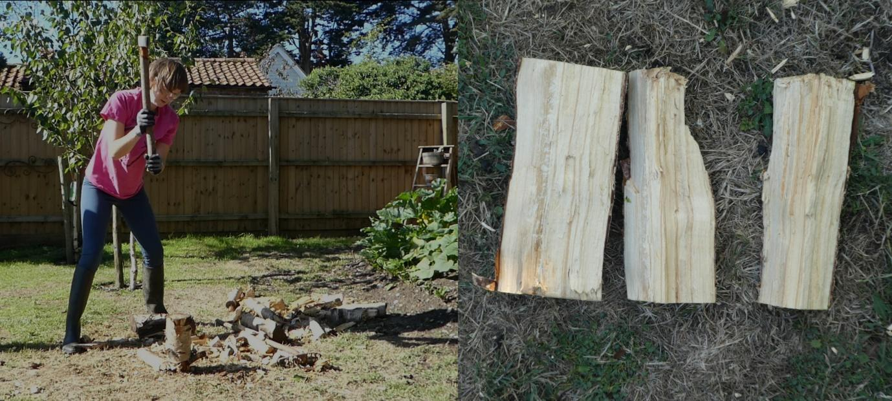
Fig 2. The splitting wood experiment

Fifty strikes
During the first 50 strikes, the experiment successfully split logs. When the initial strike did not split the log, the log often fell over.
The first 50 strikes created limited use-wear. However, rounding of the blade tip was beginning to develop on the highest topography surrounding the grain removal pits. The grain removal pits were few and sparse. They were located on the blade tip in three groups, central (Fig 2a) and towards the blade corners. Very small striations were associated with these pits, running from them. The three groups of striations were present on just one side of the blade and existed in groups of two to three parallel striations running perpendicular to the blade edge. Both the pits and the striations were superficial and narrow. Striations from the manufacturing process remained clearly visible. A flake removal occurred on the top corner of the blade when it was dropped onto a stone, leaving a small flake negative.
Analysis of the casts taken during the 50-strike pause revealed no change in the production polish and no additional use-polish development (Fig 2b).
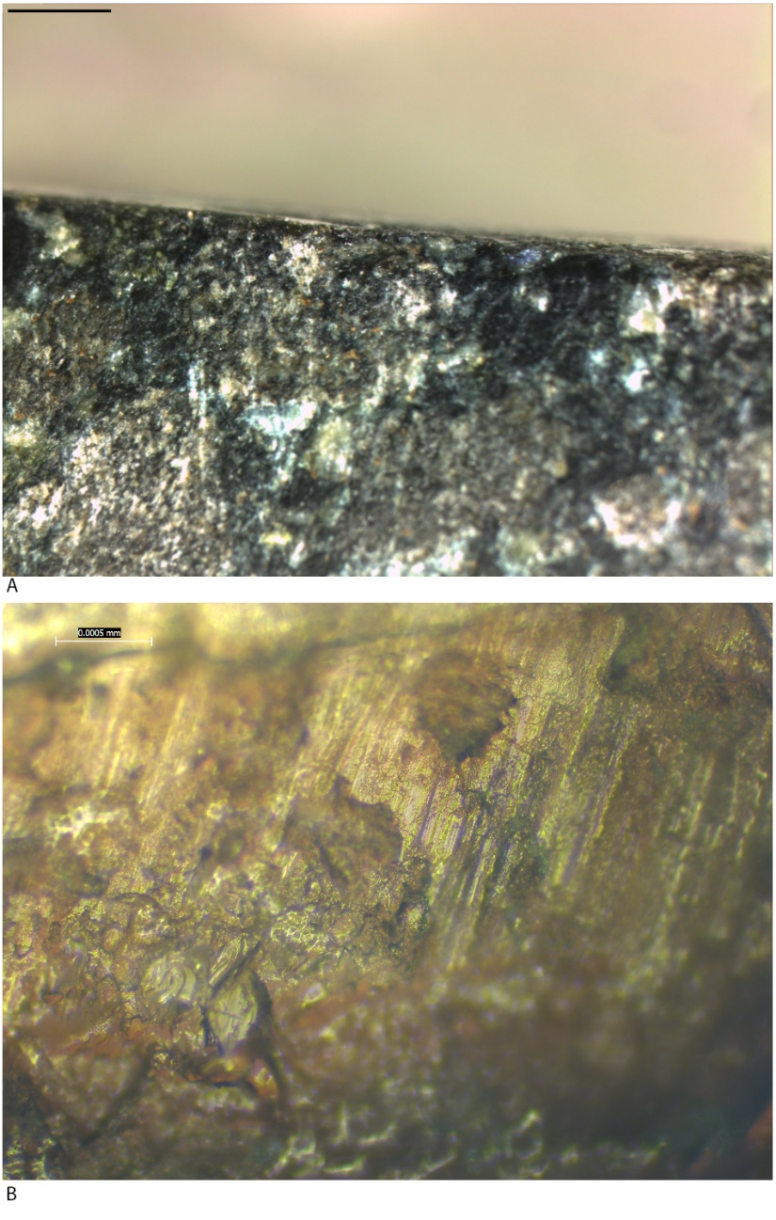
Fig 3. Use-wear after fifty strikes during splitting wood

One-hundred strikes
At 100 strikes the experiment continued to split the logs. The initial strike created a split down the log but often did not split the log into two until the later strikes. Some strikes also caused the crushing of the wood grains.
One hundred strikes caused little development in wear. Rounding continued to be present with the flake negative becoming slightly rounding on its higher topography (Fig 4a). A small number of bifacial striations were added to the three small groups of striations in the centre and towards the corners of the blade (Fig 4b), therefore increasing the size of these groups of wear attributes (for a discussion of use-wear development in three group see Roy 2020b).
Analysis of casts taken at this stage revealed sparse, small patches of polished stone grains with a slightly rough granular appearance in between large patches of production polish. In some areas, the large patches of production polish (Fig 4d) were reducing in size due to the removal of stone grains (Fig 4c).
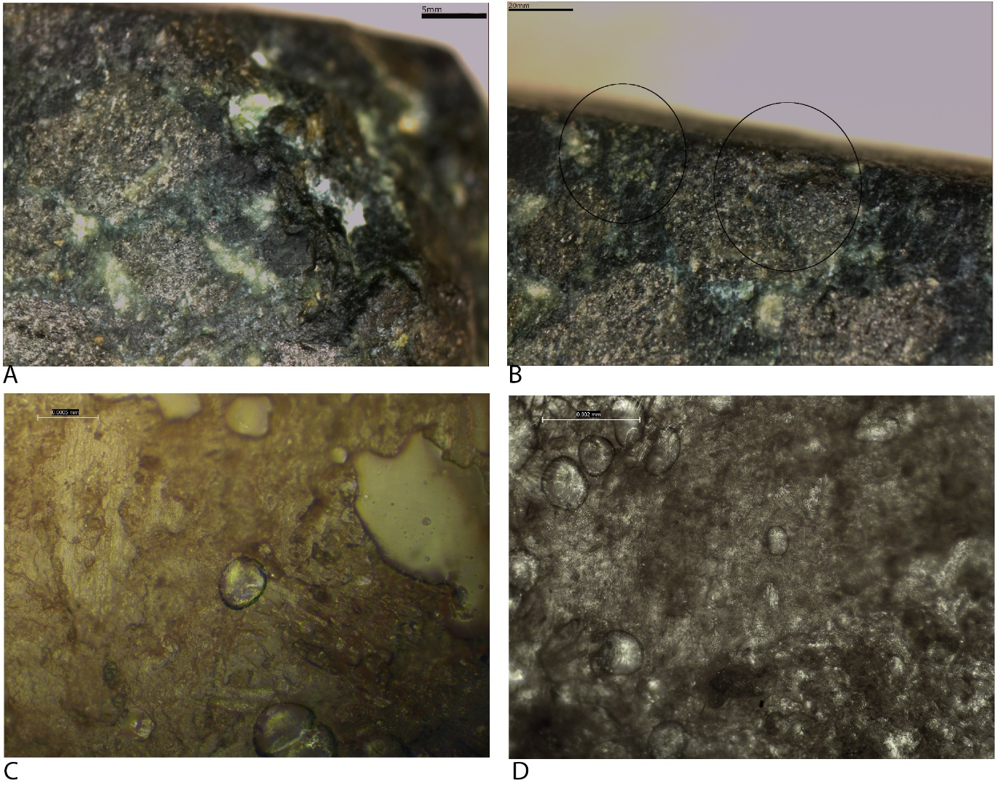
Fig 4. Use-wear after one-hundred strikes during splitting wood

Two-hundred strikes
After 200 strikes the experiment continued with the same results as previously. During the next phase of strikes, the groups of narrow, superficial grain removal pits increased in size, although remained small. Bifacial short striations continue to run from the three groups of pits increasing in number by 1-2 (Fig 4a). They were shallow and u-shaped in profile. The corners of the blade tip had been rounded further. The pits also increased on the blade tip within these groups so that they formed small, superficial clusters of edge damage (Fig 5b).
Analysis of the casts after 200 strikes revealed patches of partially connected domed polish with an uneven morphology relief and an infrequent development as well as polished singular grains on the blade edge, directly next to the tip and along the blade tip (Fig 5d). This wear signifies the early stages of the formation of wood polish known from the reference collection I analysed at Leiden University. Manufacture polish was also visible in places (Fig 5c).
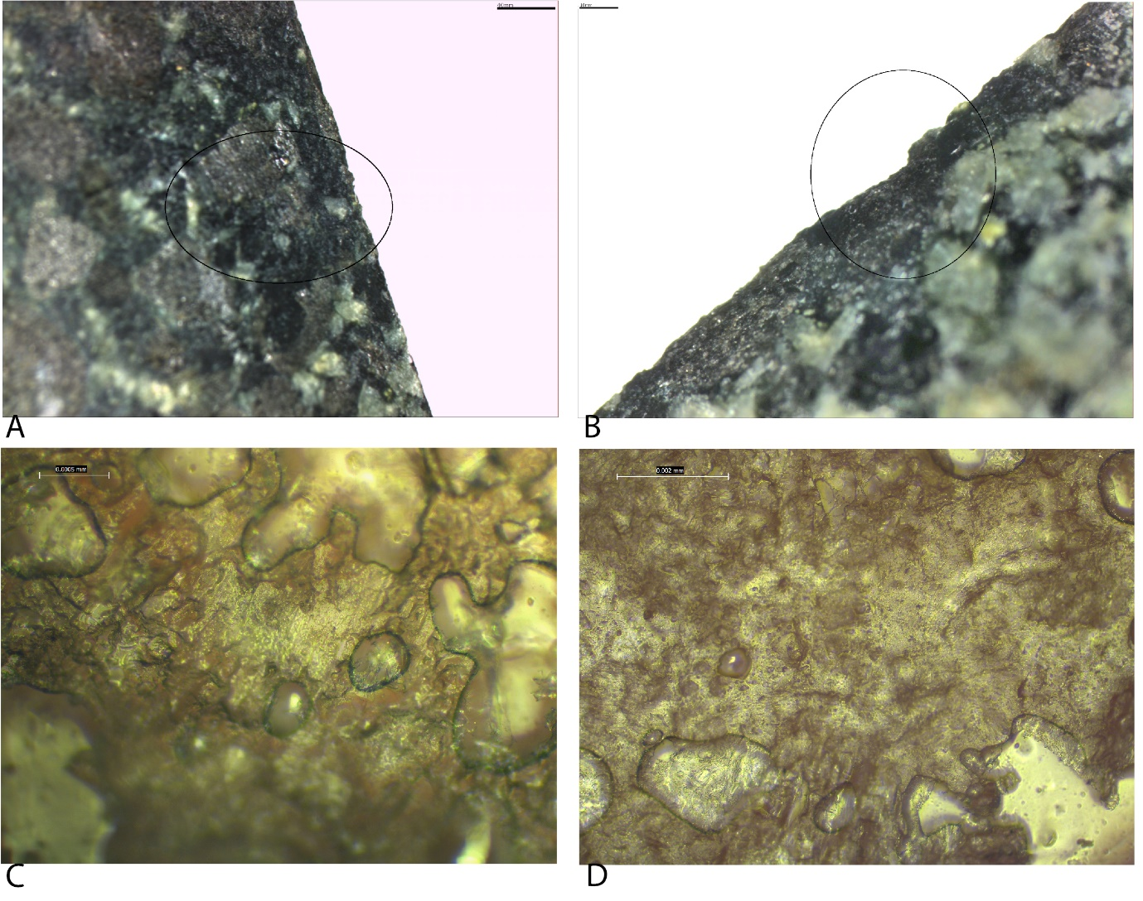
Fig 5. Use-wear after two-hundred strikes during splitting wood

Five-hundred strikes
After 500 strikes the experiment continued with the same results as previously. The log was split with fewer strikes when the aim was more precise.
The next pause was taken at 500-strikes. During the previous 300 strikes, it was the aim for the axe-head to contact the wood at a 90-degree angle, however, miss-hits often resulted in the axe-head hitting the log at an angle, often slanted to one side.
During this phase, the groups of grain removal pits and associated striations developed slightly, becoming greater in number. A total of six groups now existed. The striations were more numerous and continued to be u-shaped in profile, parallel in arrangement and perpendicular in orientation. The grain removal pits remained narrow and superficial, although they were more frequent, remaining directly on the tip in close density within the groups; the groups had a sparse density and contained clusters of 2-3 pits combined. The largest quantity of pits and associated striations was in the centre of the blade tip where the edge damage occurred most. The high topography of the blade corners remained rounded, particularly evident is the high topography of the flake negative on the top corner (Fig 6a). The high topography surrounding the grain removal pits on the blade tip were rounded and polished in the centre and at the corners of the blade (Fig 6c).
Analysis of the casts at high magnifications revealed small patches of partially connected domed polish on the high topography of blade edges (Fig 6b) and tip (Fig 6d) with a patchy development and a levelled morphology, which is a development from the singular polished grains analysed at 200 strikes. The domed patches had small groups of 2-3 striations in a parallel arrangement embedded within the polish, oriented similarly to the directionality of the polish. The polish was less to moderately developed wood polish.
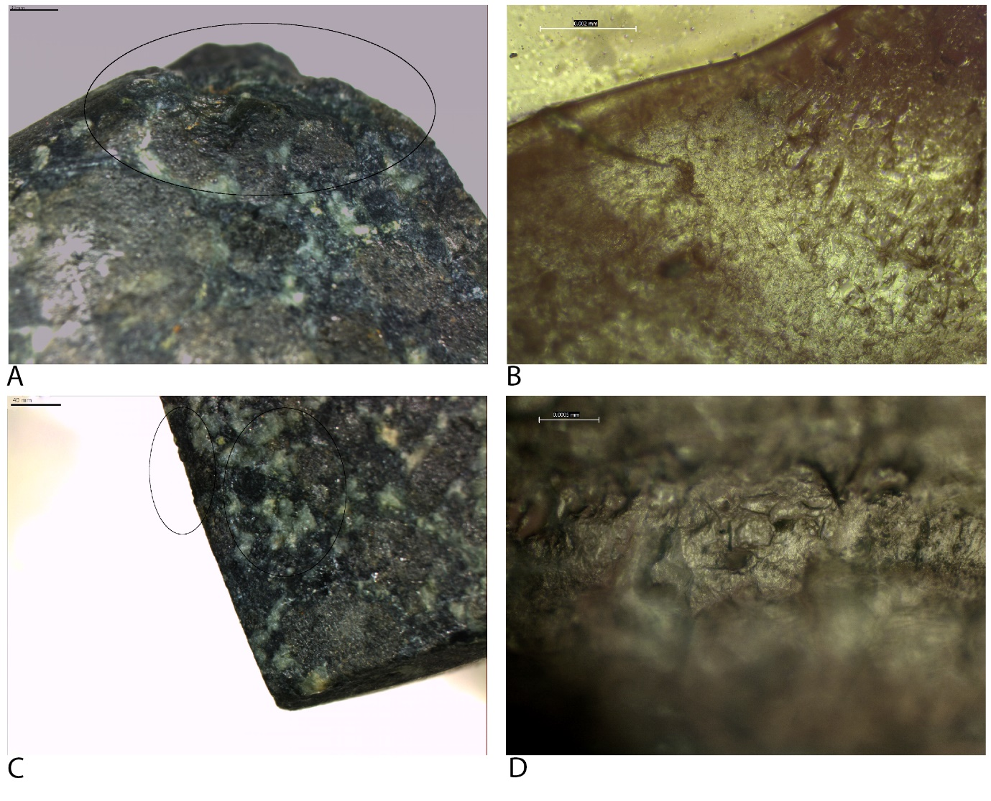
Fig 6. Use-wear after five-hundred strikes during splitting wood

One-thousand strikes
After 1000 strikes the experiment continued with the same results as previously. Contact with the wood left wood residue on the blade tip and edge, as well as within the pits on the tip.
At 1000 strikes the bifacial striations had developed enough to be visible macroscopically, as was a small, shallow dip in the centre of the blade tip, caused by the increased size of a cluster of grain remove pits and edge damage which removed enough stone to create a visible difference in the blade shape. The wear at 1000 strikes was significantly developed in comparison to 500 strikes. The groups of pits became denser and appeared on the blade edge as well as the tip and were associated with roiunded high topography (Fig 7a). The pits remained narrow and superficial but were dense within the groups of pits; each group was now close in density. The densest pit groups existed in the centre of the blade, causing the shallow dip visible macroscopically (Fig 7b). This density extended a small way towards the top corner of the blade which appeared to come into contact with the wood first, with the most force. The striations in association with the pits were now spread more evenly along the blade edge, although the initial group of wear that developed previously were still vaguely visible since the striations were closer in density in these areas. The striations remained short, parallel, and run perpendicular to the blade edge with a u-shaped profile. The rounding of the corners extended to cover more of the corners.
The polish analysed on the casts was a more developed wood polish. The patches of domed polish were larger and connected in more locations along the blade edge and tip with more pronounced rounded of grain edges and high topography. It had partial linkage and a patchy development on the blade edges (Fig 7c) and tip (Fig 7d). Directionality was clear, travelling perpendicular to the blade edge, and the small striations embedded within the polish continued to cover the patches in parallel arrangements in a close density.
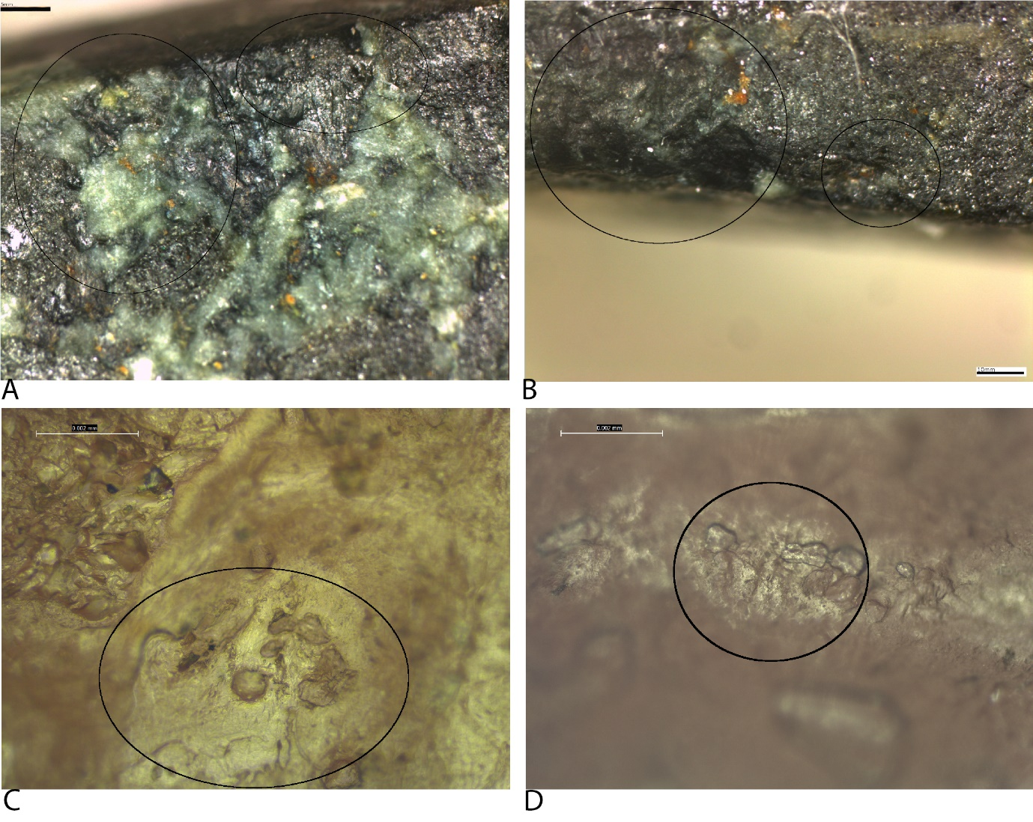
Fig 7. Use-wear on the blade edges and tip after one-thousand strikes during splitting wood

One-thousand-five-hundred strikes
At 1500 strikes, the experiment continued with the same results as previously.
The final pause before the end of the experiment, at 1500 strikes, saw the development of some abrasion and edge damage on the blade edges up to 5mm from the tip. This was previously restricted to the blade tip. At this stage, the clusters of grain removal pits on the blade tip and edges and associated edge damage were visible macroscopically despite their superficial and narrow shape. Microscopically it was clear the density of these pits has increased. The denser areas of pits remained in the areas where the three groups of pits and associated striations developed during the first stages of the experiment (the centre (Fig 8c) and towards the blade corners). Less dense pits and striations existed between these three areas. At this stage of the experiment, the axe-head manufacture traces were barely visible on the blade. Rounding had developed further and extended from the tip onto the blade edge, with the largest groups surrounding the use-wear towards the corners and the centre of the tip. A greater number of pits extended onto the blade edges bifacially, and they were accompanied by close-dense striations which were more numerous than at previous stages (Fig 8e). A small number of sparse striations, with a medium length and straight-diagonal orientation, existed on the blade edges starting at 5mm from the blade edge (Fig 8a). These were associated with the abraded areas and were most likely caused when the axe-head moved between the log when it was split in two. Finally, the polish was not evident on the blade corners, associated with the rounding of the higher topography.
At 1500 strikes the polish revealed during cast analysis covered all the casts in small to medium-sized patches across the high topography which were larger than the patches of polish create after 1000 strikes. The patches were close in density with a moderate linkage (Fig 8b, d), and their directionality (Fig 8b) signified the direction of use. Some more polished singular domed grains had developed in between these patches (Fig 8f); this was less/limited developed wood polish which will turn into larger patches like those which surrounded it with prolonged use.
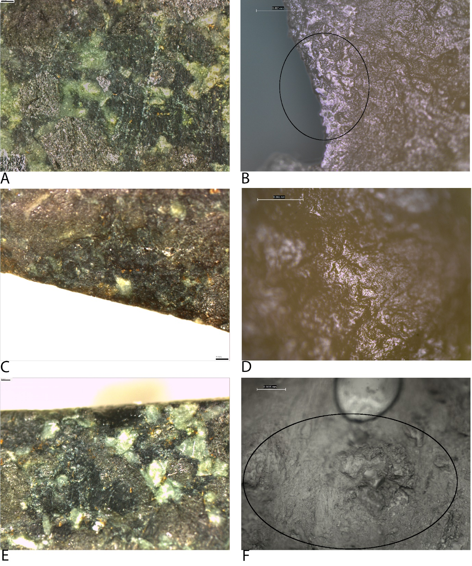
Fig 8. Use-wear after one-thousand-five-hundred strikes during splitting wood

Two-thousand strikes
Through the experiment, the results remained constant. Wood residue covered the tip and accurate strikes split the logs with fewer strikes.
The experiment ended at 2000 strikes. The blade remained sharp despite the developed wear created throughout the experiment. This points to the possibility that the axe-head could continue to be used for at least another 2000 strikes, if not more before it would need to be re-sharpened. Grain removal pits extend across the blade tip and edges, bifacially. Those on the tip are dense while those on the blade edge were dense close to the tip and close in density further away from the tip. They extended 10mm back from the tip (Fig 9c). The densest pits remained in the three groups described previously where wide clusters of overlapping pits (Fig 9d) spread onto both blade edges and contained microfractures. These groups had expanded in size due to the number of pits on the blade and therefore were very close to each other. The pits remained superficial and narrow, although those in the denser areas of pits had increased in size and their edges had become increasingly rounded (Fig 9b). Rounding of the high topography and the edges of pits is present along the blade tip and at the corners. The corners were still polished. The striations were dense and evenly spread along the blade edges, bifacially (Fig 9a). They were slightly longer and in places appear intermittent. Pits surrounded them. Overall, the wear became dense and well developed.
Analysis of the casts revealed polish comparable to the casts taken at 1500 strikes. The patches of domed polish remained the same size although they were slightly more connected. Also, the parallel striations, embedded within the polish, appeared to be slightly more numerous, facing in the same direction as the directionality of the polish. On ending the experiment, the wood polish was clear and recognisable with a moderate to developed development with a continuous development and levelled morphology.

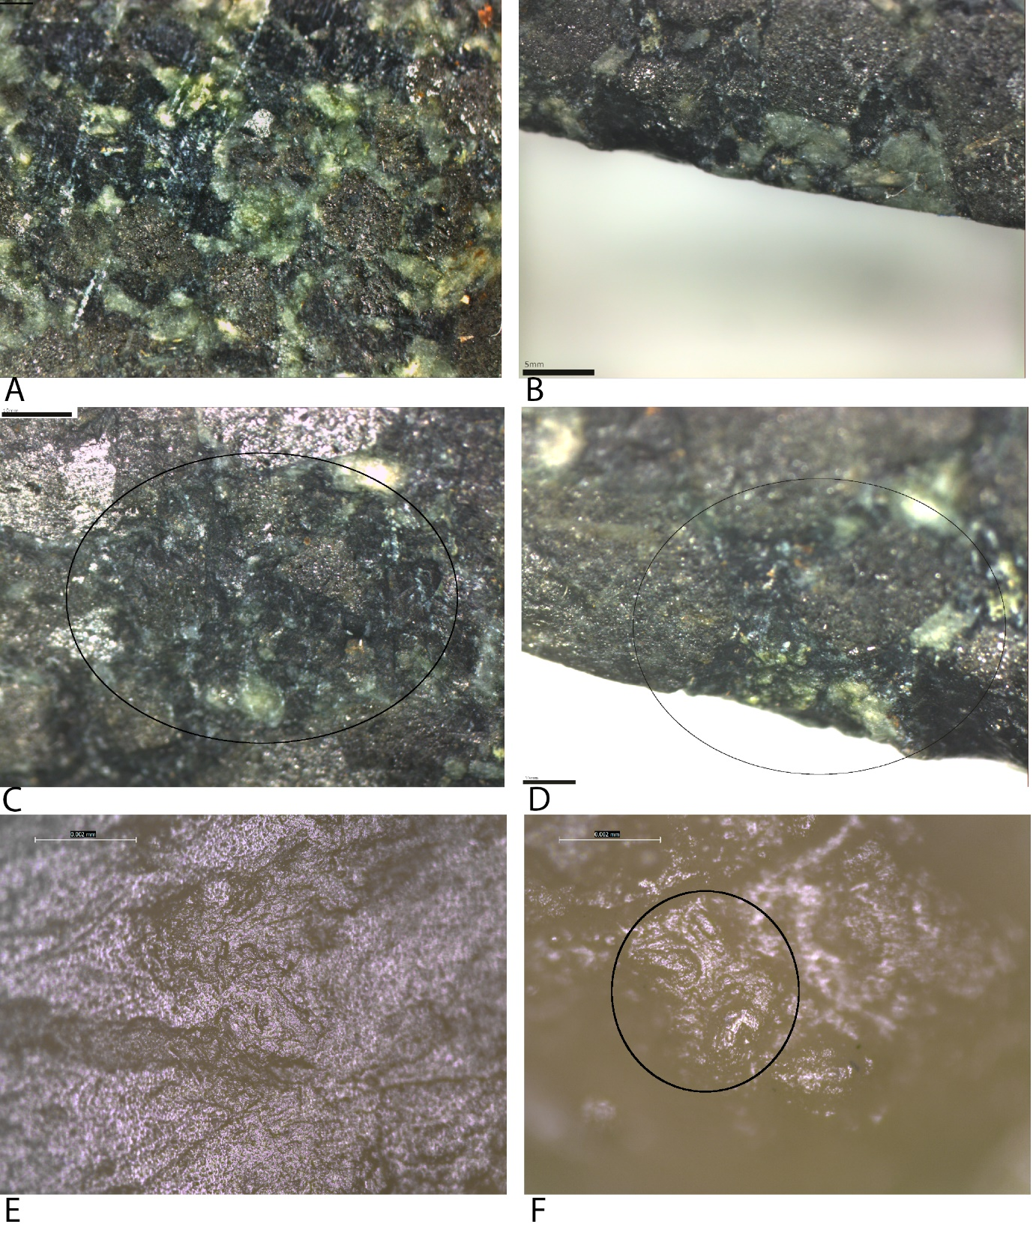
Fig 9. Use-wear after two-thousand strikes during splitting wood

Wear development related to manufacture
Low Magnification: Use smoothed the edge of the manufacture striations and pits, reducing its influence on the development of subsequent wear. The three groups of pits that developed at the start of the experiment developed independently of the manufacture pit (those groups towards to corners of the blade) while the central group did develop around a manufacture pit which may have influenced its development. Yet the other pits in this group are slightly separated from one another with rounded high topography in between, which means they likely developed irrespective of the manufacture pit in the centre. By 100 strikes the angular pits and deep striations on the tip and blade edges were smoothed and reduced to limited to no visibility. The fracture that occurred at one corner of R1 after the axe was dropped in the early stages of use demonstrates that wear developed in a similar manner there as the rest of the blade. By 100 strikes the high topography of this fracture was rounded and by 200 strikes parallel striations ran into the fracture, associated with small clusters of pits; just like the rest of the blade.
High Magnification: No change to the manufacture polish on the blade until one hundred strikes when they reduced in size. Polish from use also began to develop in areas the production polish was not located allowing visibility of the early formation of use polish. The manufacture continued to reduce in size and quantity as grains were being removed and altered through use. By 200 strikes in some areas the manufacture polish remained with smoothed edges and doming but with greater connection, while patches of smooth domed polish with directionality are more prevalent, appearing to have smoothed and domed the manufacture polish to such a degree with the surrounding domed stone grains that wider patches of dome, smooth polish with a new clear directionality appeared. Once patches of smooth domed polish developed, the development of this polish type continued, showing no influence from the previous and altered manufacture polish. By 500 strikes the manufacture polish was no longer visible.

Chopping wood with battle-axe Replica 2
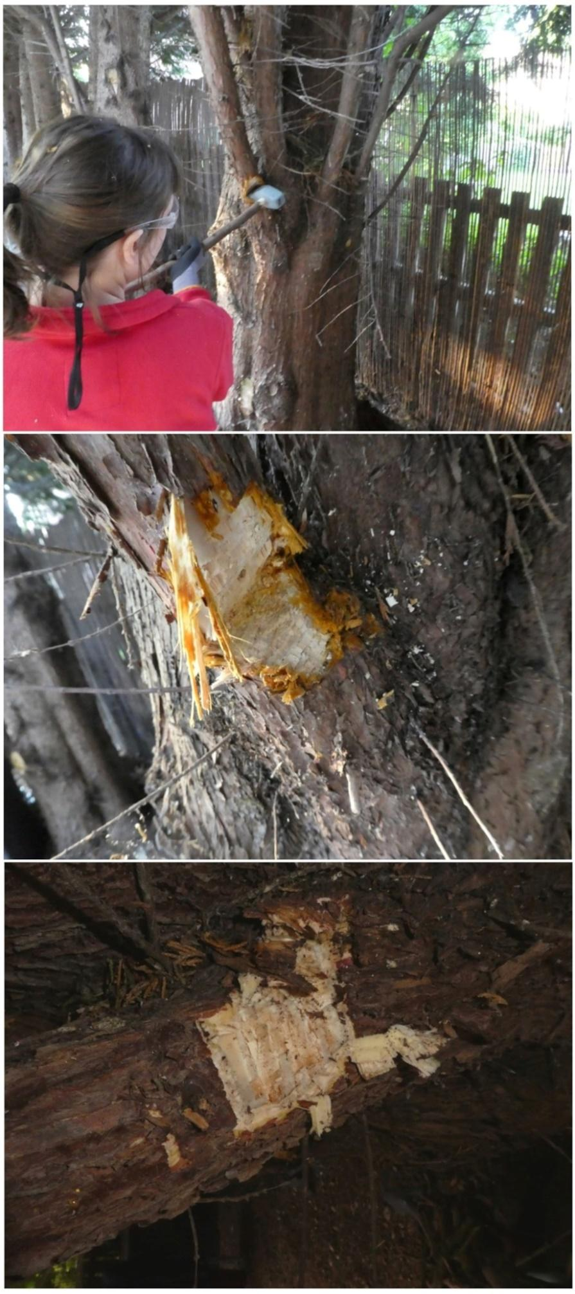
Fig 10. Images from the chopping wood experiment

Fifty strikes
In the first phase of the experiment, the chopping action removed the bark on the tree easily and quickly and created a small groove in the branch. Wood residue appeared in the centre of the blade tip and edges.
The first pause during the experiment, at 50 strikes, presented very limited wear. Sparse, superficial, and narrow grain removal pits were present in small groups on the blade tip (Fig 11a). Equally sparse, short striations with a u-shaped profile were associated, running parallel to one another and perpendicular to the blade edge. All wear from use is faint and superficial. It congregated into three groups, one central and one towards either corner. Striations from the production process were still visible.
Analysis of the casts taken at this early stage in the experiment revealed minimally altered polish from their manufacture (Fig 11b). In few areas, this polish appeared slightly rounded at the edges and areas of the high topography (Fig11c).
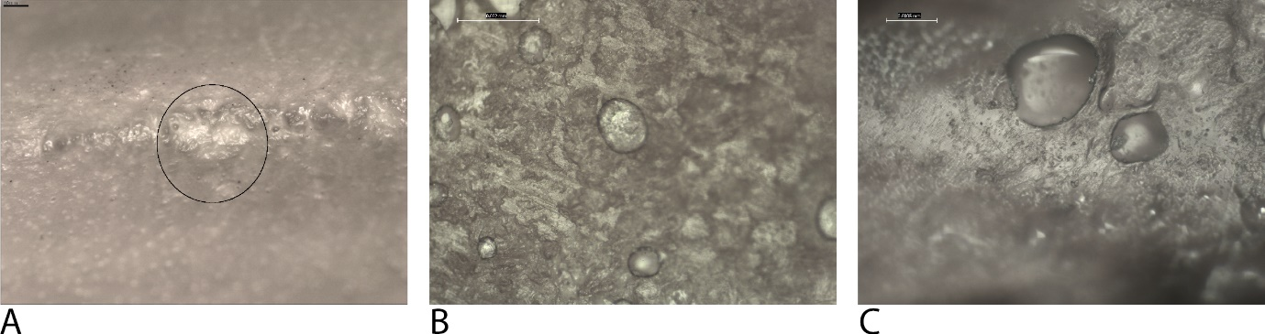
Fig 11. Use-wear after fifty strikes during chopping wood

One-hundred strikes
By 100 strikes, the axehead created a wider and deeper V-shaped groove in the branch. The residue continued to occur on the blade tip and edges.
One-hundred strikes caused limited edge damage. The three groups of pits and associated striations become more apparent with a slightly greater density and quantity. The pits within the groups had a close density (fig 12a), while the groups were sparse and separated. These pits developed over the production traces, differentiating them. The associated bifacial, short striations were slightly greater in number, appearing in groups of 3-4, and have an equally close density (Fig 12b). At this stage, rounding of the high topography of the corners of the blade had begun to develop. The wear was still limited and less developed.
Analysis of the casts revealed the development of domed polish on the high topography of singular stone grains, separated, in small, sparse patches on the blade tip (Fig 12d). The production polish on the blade edges remained with no signs of change (Fig 12c).
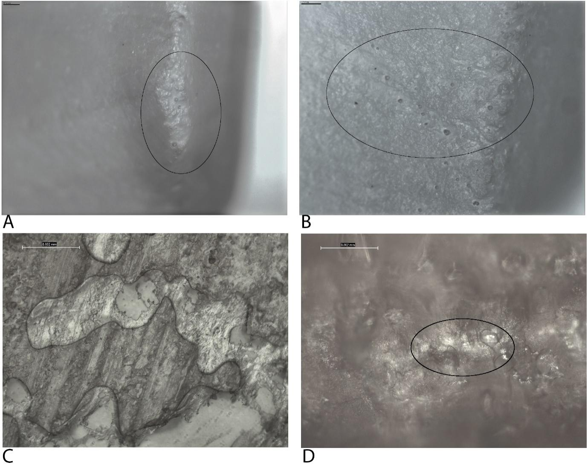
Fig 12. Use-wear after one-hundred strikes during chopping wood

Two-hundred strikes
By 200 strikes, the axehead had chopped through half of the branch. 10-20mm chips were also being removed from this area. Wood residue spread across the blade tip and into the pits.
After 200 strikes the wear had sufficiently developed so that it spread onto the blade edge very slightly, approximately 2mm. The grain removal pits had increased in size and presented signs of microdamage on the grain edges, and several in the centre were large enough to cover the blade tip and edge/s (Fig 13a). The increase in size was accompanied by additional pits around the larger pits (Fig 13b); these were superficial and narrow like those found at 50 strikes. Pits and associated striations were also found on the corners of the blade, the associated striations were smaller than those on the blade edges and were diagonal, facing towards the blade edges. Rounding of the higher topography of the pits, i.e., the tops of the pits, were present along the blade tip.
Analysis of the casts revealed polish comparable to that of 100 strikes. The tip continued to have sparse patches of domed polish on the high topography of singular stone grains (Fig 13e-f). This polish was beginning to show a slight directionality, indicating the direction of use (Fig 13d). At this stage, the production polish was still visible (Fig 13c).
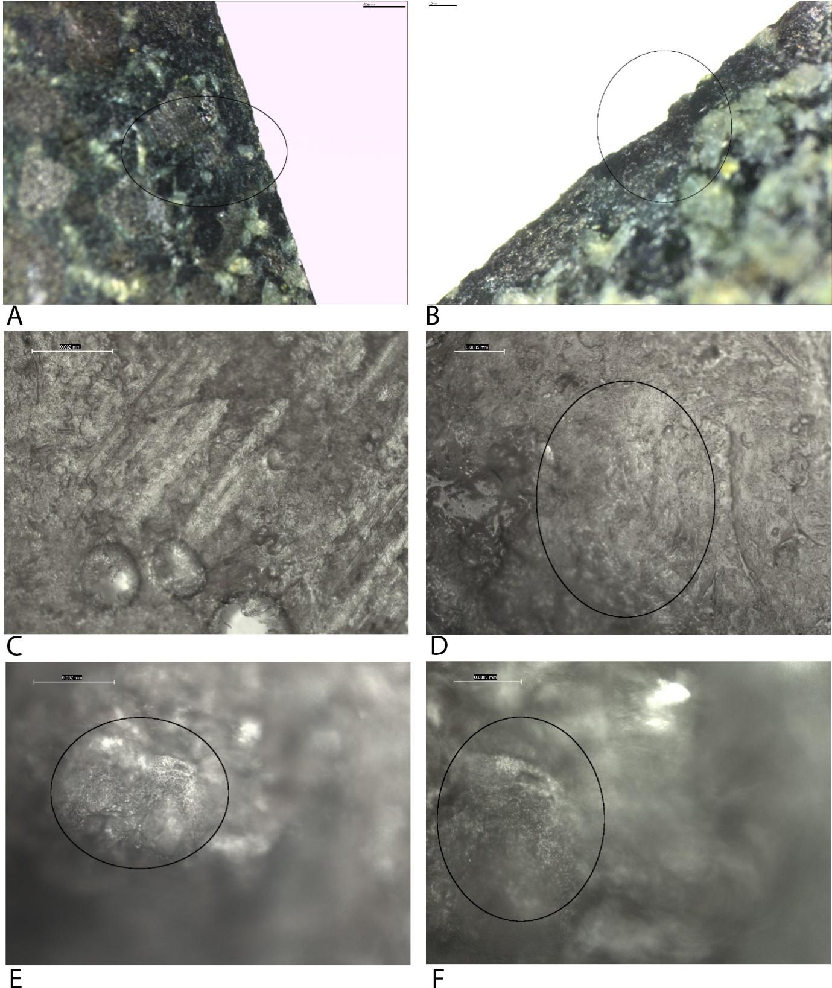
Fig 13. Use-wear after two-hundred strikes during chopping wood

Five-hundred strikes
By 500 strikes, the V-shaped wedge, caused by using chopping motions with the axehead, has almost cut through the entire branch. The residue continued to cover the blade tip and edges as before.
A pause at 500 strikes showed that all three groups of wear attributes had increased in size. As a result, the wear covered larger areas of the blade tip and corners, although there were still small gaps between the groups of edge damage. At this stage, the pits were larger and occurred on both the blade tip and edges. Smaller pits, much like those at 50 strikes, surrounded the larger pits on the blade edges. The number of striations had increased so that the differentiation between the groups was less clear. They remained with a close density and u-shaped profile (Fig 14a). Rounding continued to be present on the high topography of the pits (Fig 14b).
Analysis of the casts revealed small patches of domed polish, mostly located on the tip of the axe-head. The polished stone grains were partially connected within the patches with partial linkage and close density within the patches. Patches were sparse. A few loose parallel striations were embedded in the polish and oriented in the same direction as the directionality of the polish, perpendicular to the blade edge (Fig 14c, e). Production polish remained visible (Fig 14d).
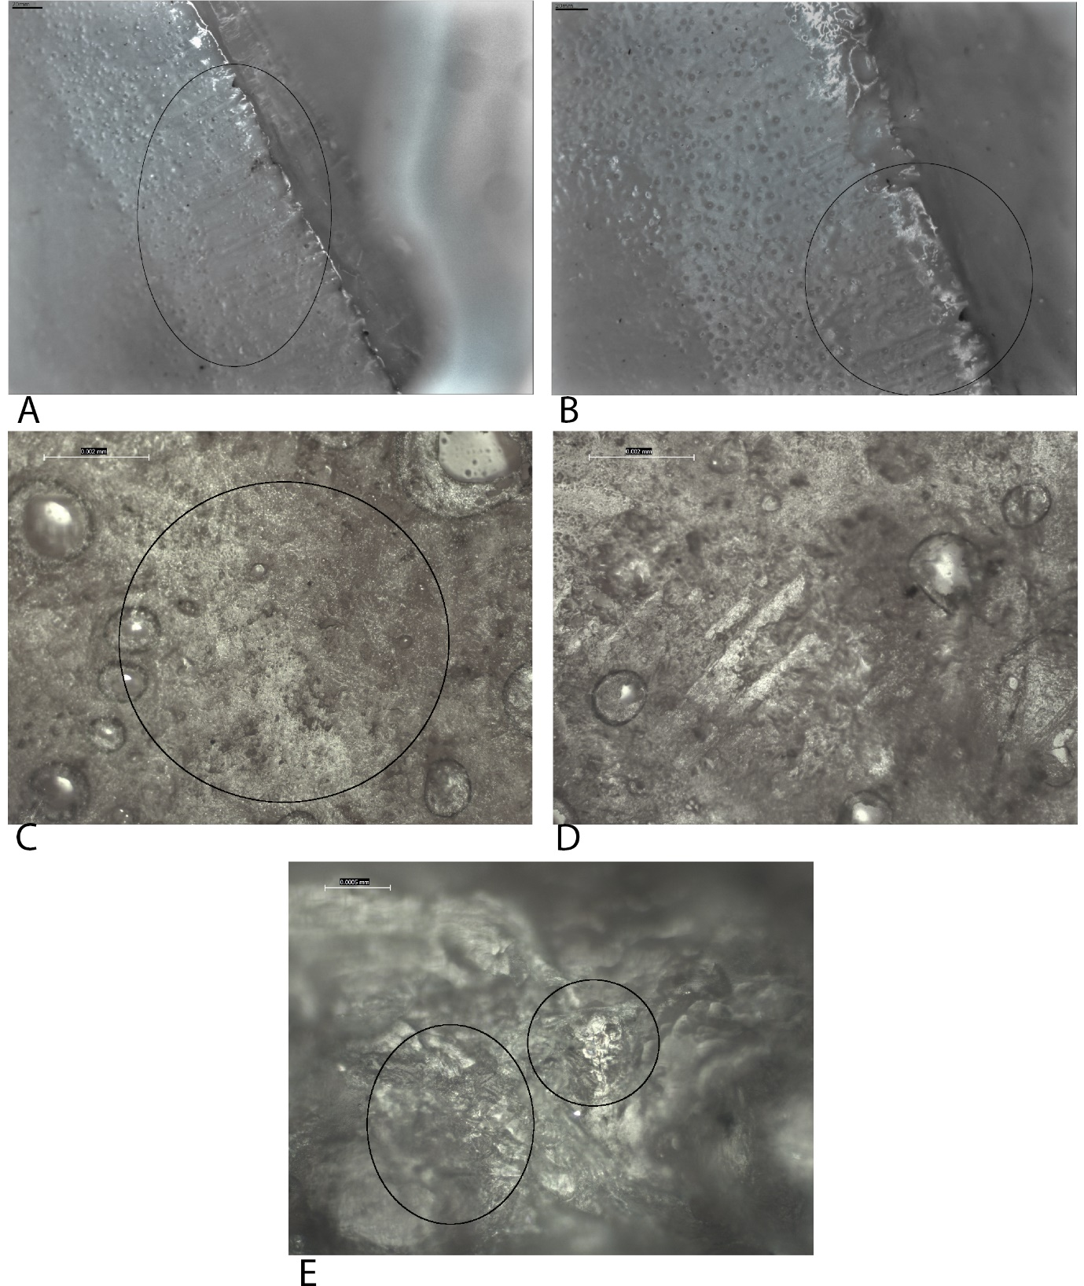
Fig 14. Use-wear after five-hundred strikes during chopping wood. All figures are taken from casts.

One-thousand strikes
At 1000 strikes, the first branch with a 400mm diameter was chopped through and a second branch, 300mm in diameter, begun to be chopped with the same results efficiency as before.
Analysis of the wear after 1000 strikes revealed clusters of edge damage which contained a larger quantity of grain removal pits, up to six, and spread further onto the blade edges, approximately 5mm. The groups of pits remained superficial, although they had become wider. The groups of pits and associated striations were no longer in separate patches as the gaps between them had been filled with pits (Fig 15b) and striations with similar characteristics. The increase in pits had caused some to join to form larger pits, or clusters, although this remained relevant for only those directly on the tip (Fig 15a). The largest pits were on and closest to the tip, while those further away were smaller since they occurred more recently. At this stage, the striations were also greater in number, seeming almost seamlessly to spread along the blade edges with a close density. Edge scarring was visible within the larger pits. They were short, u-shaped in profile and are arranged parallel to one another and perpendicular to the blade edge. Rounding remained the same as the previous pause.
The casts taken at the 1000-strike stage revealed moderately developed wood polish in small patches, with a partial linkage and patchy development. They had parallel embedded striations running perpendicular to the blade edge, the same as the directionality, and were surrounded by singular polished stone grains with a domed appearance (15c, d, f). This polish is the less developed polish appearing in locations and did not exist at 500 strikes. The patches were sparse to close in density and production polish was still visible in large areas of the blade edges but altered due a smoother appearance (Fig 15e).
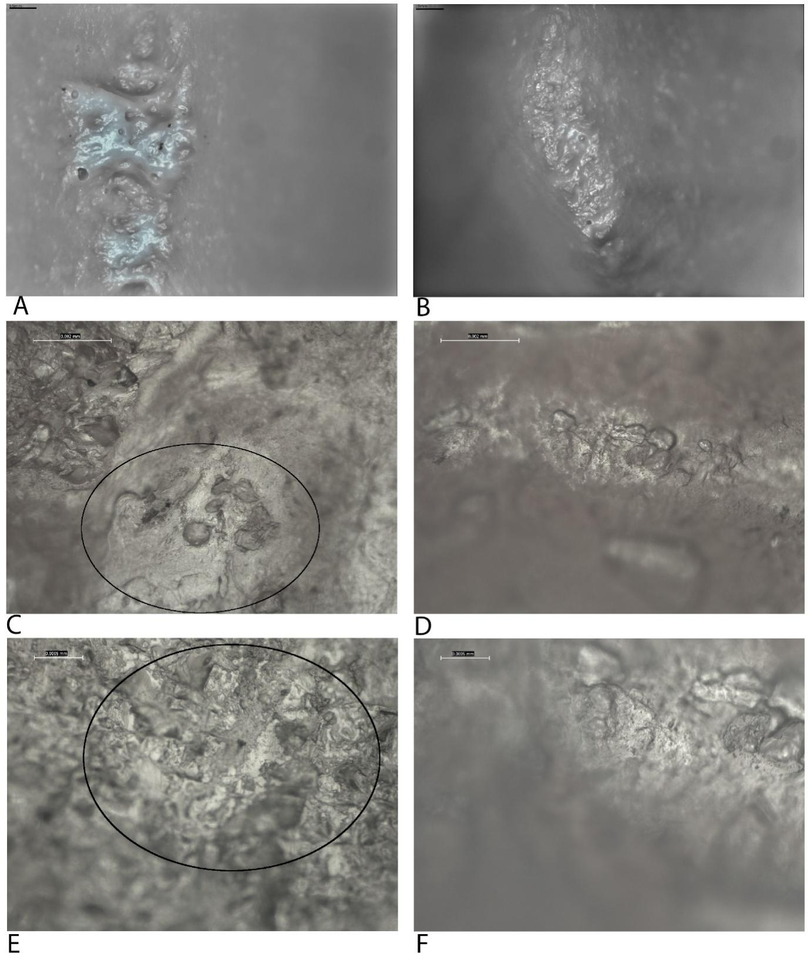
Fig 15. Use-wear after one-thousand strikes during chopping wood. All figures are taken from casts.

One-thousand-five-hundred strikes
In the next phase of strikes the second branch was chopped through and a third, 300mm in diameter began. The efficiency and rate of ‘chopping through’ was maintained throughout each branch.
At 1500 strikes, the use-wear appeared continuous across the blade tip and edges. Many more grain removal pits joined together to form larger pit clusters, several of which expanded onto both blade edges and contained edge scarring within them. The high topography surrounding the pit clusters also had scarring and some crushed stone grains (Fig 16a). The pits on the blade edges also became larger but did not extend further onto the blade edge than they did at 100 strikes. At this stage, the striations associated with the pits were closer in density, with a close to dense density (Fig 16b). Those in the centre of the blade became longer, up to 8mm, and those at the corners of the blade began to overlap one another. All wear was bifacial and rounding continued to exist on the high topography of the tip. A flake negative occurred during this phase of strikes when the axe-head became loose and fell off the haft, hitting a hard stone. A flake from the top corner of the axe-head was removed. Continued use rounded the edges of this flake negative.
Analysis of the casts taken after 1500 strikes showed larger patches of polish from use. The domed polished grains (Fig 16d-e) were now partially connected linkage, and the density of the patches increased, being close on the blade edge and denser on the tip where it had a continuous development in places. The centre of the blade tip had the densest and largest patches of domed polish (Fig 16c). On all patches, short parallel striations and directionality indicated the direction of use, perpendicular to the blade edge. The polish was wood polish. In a few places, the production polish was still visible, although it was significantly reduced in size and linkage.
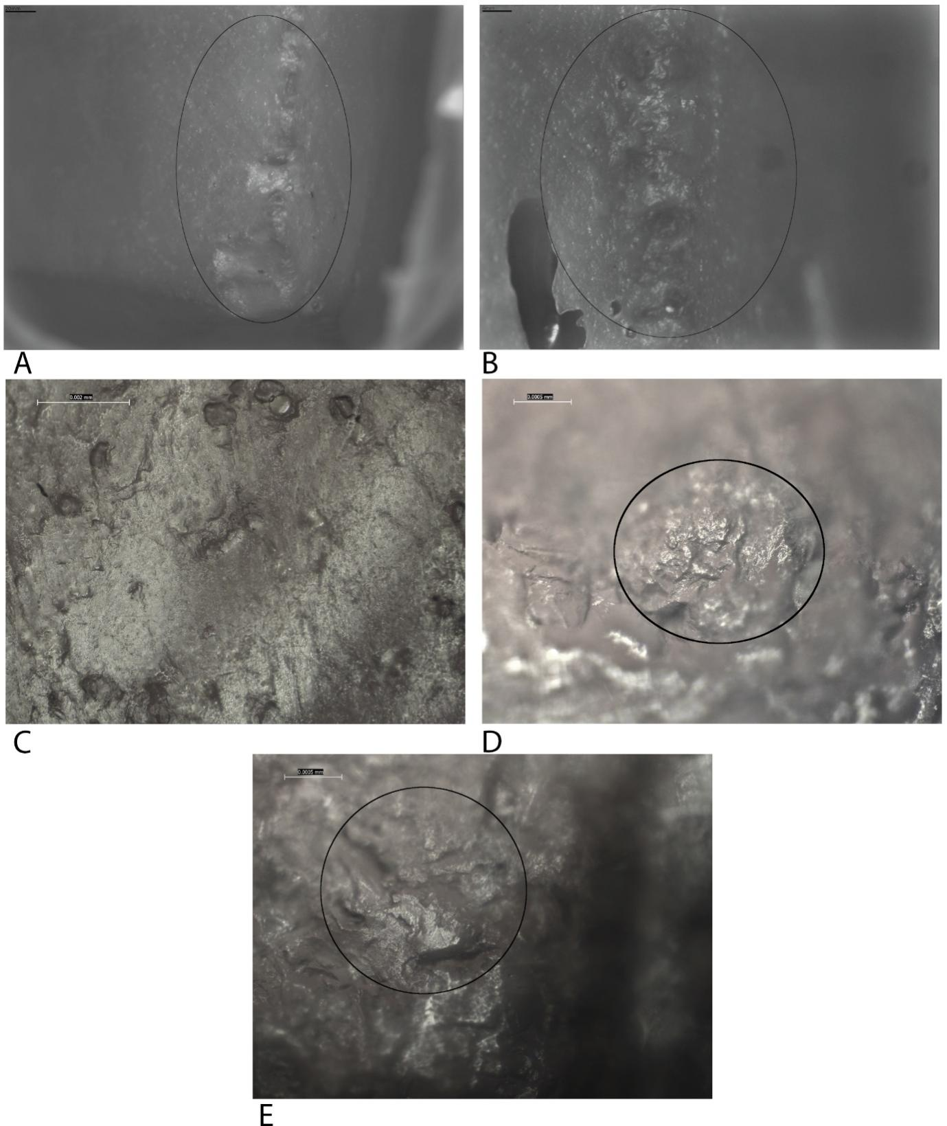
Fig 16. Use-wear after one-thousand-five-hundred strikes during chopping wood. All figures are taken from casts.

Two-thousand strikes
In the final stage of the experiment, the third branch was easily and effectively chopped through. As with all the branches, chopping created a V-shaped notch which increased in width and depth with greater strikes, eventually chopping through the branch.
The final analysis of the axe-head taken after 2000 strikes revealed the dense formation of wear bifacially on both blade edges. Grain removal pits spread continuously along the tip and blade edge, remaining close to the tip and extending 5-10mm onto the blade edge. The pits on the blade edge remained narrow and slightly superficial, while those on the tip were much wider and deeper and occurred in wide clusters. Edge scarring occurred within the clusters and crushed stone grains were present on the high topography of the tip, occurring mostly in the centre (Fig 17b). The dense formation, edge damage and clusters along the tip caused the surface to become rough. A small flake negative was also present on the top corner of the blade (Fig 17c), from continued contact. It was rounded, as was the high topography of the large flake negative described at 1500 strikes (Fig 17a). Striations running from the pits on the tip and blade edges were dense, running parallel to one another and perpendicular to the blade edge. They were u-shape in profile and were often interrupted by pits (Fig 17d). Diagonal striations, pointing towards the centre of the axe-head, cut across these perpendicular striations in the centre and top corner of the blade edges (Fig 17c). This wear indicates the movement of the axe-head when meeting the wood at 90 degrees and moving into the wood and leaning in with the bottom corner leaving first, thus leaving the top corner in contact with the wood more often. The wear at 2000 strikes was well developed and dense, but despite this, the blade remained functional and did not need to be re-sharped to maintain this.
Analysis of the casts and stereoscopic analysis of the blade under a metallographic microscope revealed the domed patches of polish had increased across the high topography in size and were partially connected with a close density covering the casts with a continuous development (Fig 17 e-h). The directionality, perpendicular to the blade edge, was clear with the embedded parallel striations in the same direction. The polish was smooth.
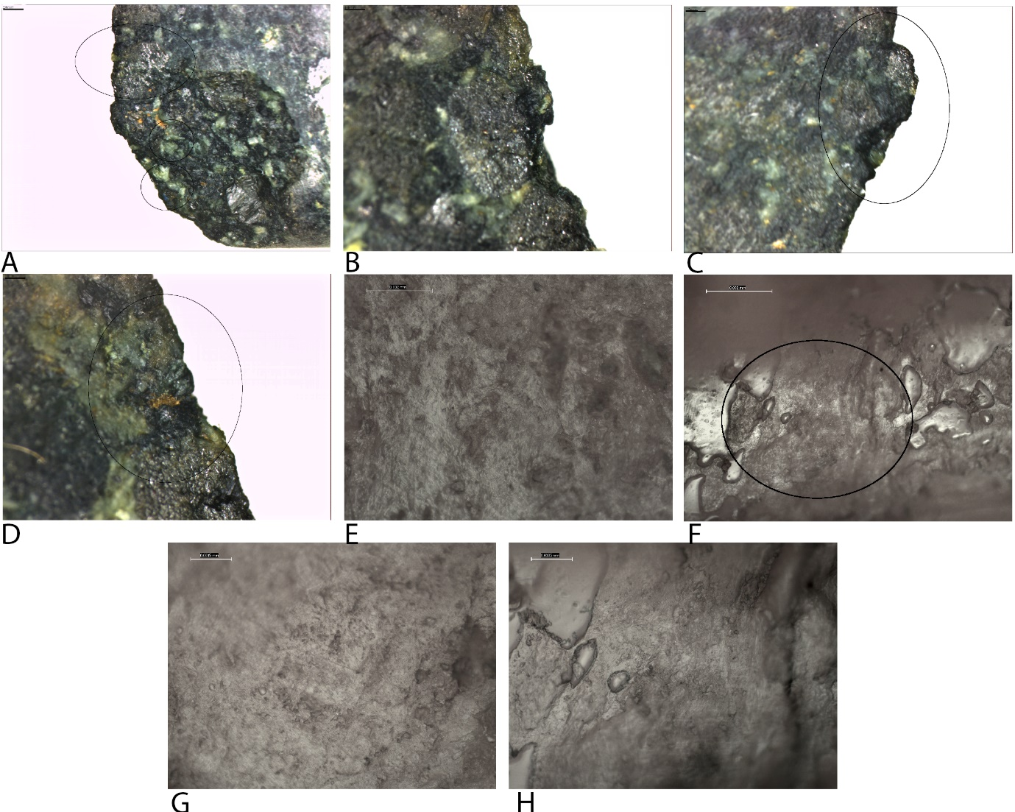
Fig 17. Use-wear after two-thousand strikes during chopping wood

Wear development related to manufacture
Low Magnification: Manufacture created two superficial fractures in the centre of the tip, the edges of these were smoothed during use with small pits visible within the fractures and pits developing in between them, creating a central group of wear. By 2000 strikes in the centre of the tip the edge scarring was likely influenced by the development of removals within an around the central manufacture traces. The rest of the wear interacted and altered the manufacture traces in the same way as replica 1.
High Magnification: The manufacture polish was initially altered when its edges were rounded (50 strikes). From 100-strikes onwards the use-polish began to develop in gaps between the manufacture polish and the manufacture polish was altered through smoothing and doming of the higher topography. The form of the manufacture polish had completely disappeared on the tip by 1000 strikes, being replaced by domed polish with a plan unlike the manufacture polish. That on the blade edges had areas of wide domed and smoothed polish as well as altered manufacture polish in areas where polish development had not connected newly formed domed polish with altered domed manufacture polish. All developed a directionality.

Digging soil containing stones with battle-axe Replica 3
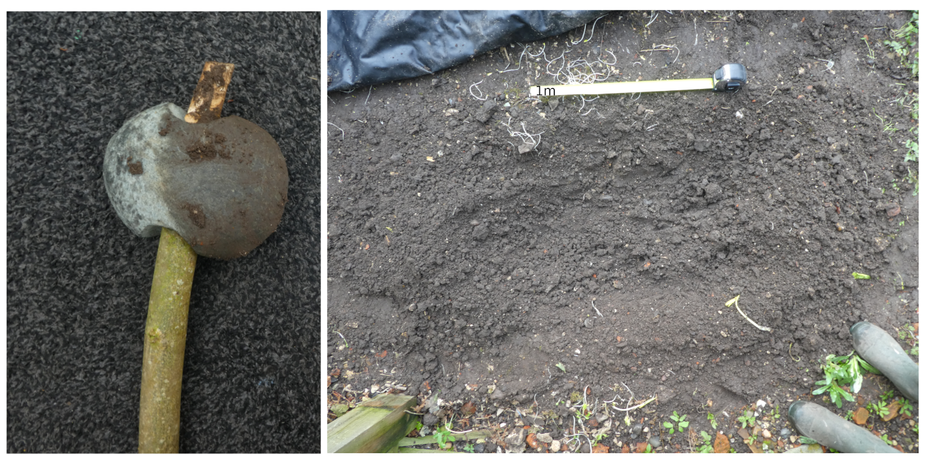
Fig 18. Images from the digging soil containing stones experiment

Fifty strikes
During the first phase of the experiment, the axehead was very effective at breaking apart the soil, although it did not remove it from the dug area well. Soil residue covered most of the front half of the axehead.
At the 50-strike stage, limited damage occurred. A few, sparse striations were dotted across the blade edges, bifacially. They were long and were the result of contact with stones in the soil. These stones also created small clusters of grain removal pits in the centre of the blade tip and edges and smaller clusters towards its corner, the groups numbered five in total. The use-wear extended onto the blade edge 5mm. Contact with stones in the areas caused sparse crushed stone grains and edge scarring within the grain removal pits on both the tip and the blade edge (Fig 18a-b). Production traces were still clearly visible.
Analysis of the casts revealed production polish from the manufacturing process was still visible, but the edges of these traces appeared very slightly rounded in places (Fig 18c-d).
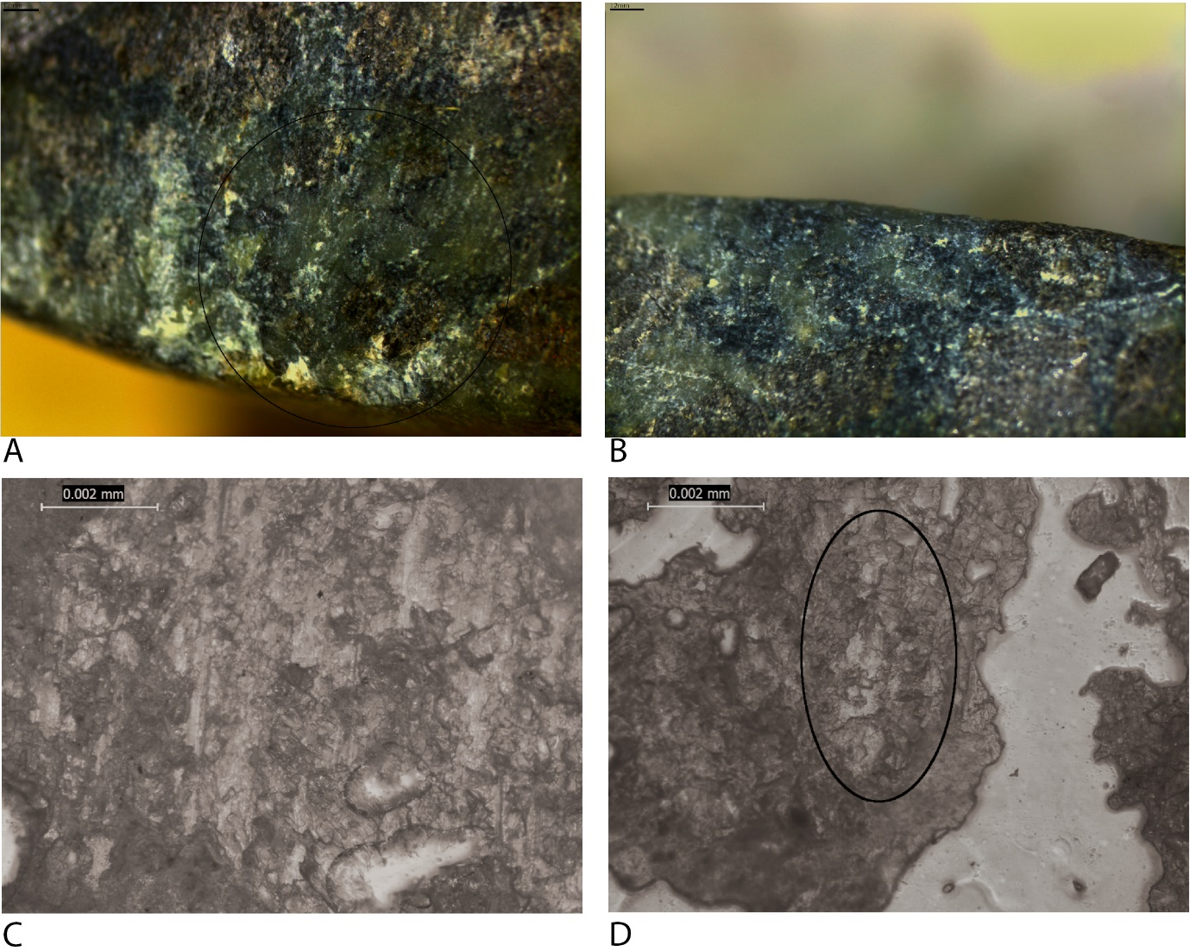
Fig 19. Use-wear after fifty strikes during digging soil containing stones.

One-hundred strikes
In the next phase of strikes, the results remained the same. The axe-head created a v-shape in the soil, similar to an ard furrow.
At the 100-strike stage, more bifacial striations developed across the blade edges, with a greater number on one side than the other caused by the location of stones in the soil. The clusters of grain removal pits seen at the previous phase were deeper and wider, the clusters were more numerous, spread sparsely and evenly along the blade tip. The clusters had a greater amount of microfractures within them which caused a frosted appearance (Fig 20b), including within striations (Fig 20a). The pits extended slightly onto the blade edge up to 5mm and were associated with clumps of parallel striations with a similar density, running perpendicular to the blade edge (Fig 20c). Rounding from contact with the soil were also becoming slightly apparent on the higher topography of the pits (Fig 20d).
Analysis of the casts revealed that the production polish was still very clear and that a granular polish on singular grains was also beginning to develop in separated patches, lessening the extent of the production polish. Production polish was altered by removals on the blade edge (Fig 20e) and tip (Fig 20f).
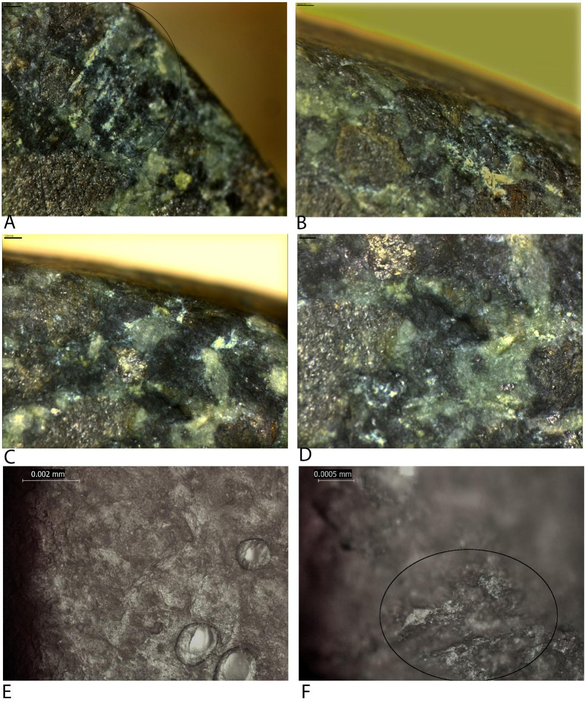
Fig 20. Use-wear after one-hundred strikes during digging soil containing stones.

Two-hundred strikes
During the next phase of strikes, the experiment continued the same as previously.
Another pause was taken at 200 strikes. During the strikes leading up to this pause, the hole being dug increased in depth and, as a result, the axe-head became more efficient at breaking apart the soil. This was most effective when the blade was able to hit the wall of the earth head-on. The use-wear at this stage included a greater number of striations in singular and parallel arrangements, running perpendicular to the blade and slightly diagonal and overlapping (Fig 21a). They were spread across the blade edges and associated with the grain removal pits. Sparse long scratches also appeared on the blade edges from the sharper, broken flint in the soil (Fig 21a). At this stage, the groups of grain removal pits had increased in size on the blade edges. The pits appeared angular and had joined together to create clusters at the centre and towards the edges of the blade (Fig 21b). These clusters were slightly larger than at 100 strikes but were still small. Crushing of grains and microfractures were more apparent at this phase and existed mostly in the centre of the blade and blade edge in association with the grain removal pits and striations in this location created linear patches of wear with a frosted appearance. Rounding from contact with the soil continues to be present on the higher topography (Fig 21c).
Analysis of the casts again revealed the continued presence of production polish, but this appeared to have become slightly smoother through use and a partial linkage being reduced through grain removal (Fig 21f). Small, sparse patches of use polish included granular polish on singular grains and sinuous patches with infrequent development and partial linkage, with overlapping striations from contact with the soil grains and a lack of directionality (Fig 21d-e).
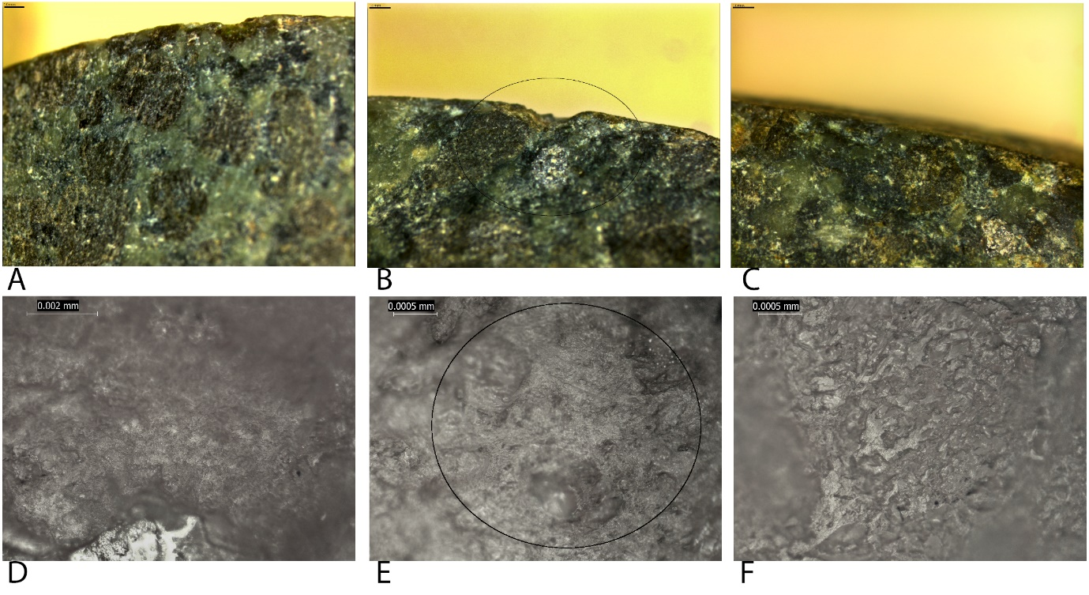
Fig 21. Use-wear after two-hundred strikes during digging soil containing stones

Five-hundred strikes
At 500 strikes, the experiment remained effective at breaking up the soil. The length of the haft meant that digging deeper required the digger to bend lower.
During this phase, the axe-head began to spin on its haft, so small wooden wedges, approximately 40mm long, were hammered into the gaps between the haft and the perforation to secure it. At 500 strikes, abrasion became apparent towards the top corner of the blade, the area initially in contact with the soil and earth. In this area, more numerous grain removal pits extended 20mm onto the blade edges bifacially and were related to crushed grains and microfractures creating a frosted appearance. Pits on the remainder of the blade extended onto the blade edge approximately 10mm. The clusters along the blade tip were more pronounced due to their larger size. Clear, short striations ran from the pits. They were dense at the centre of the blade and their density decreases to close on the remaining areas of the blade edges. The striations were parallel with singular striations overlapping. The 500-strike pause saw the first flake negatives occur; overlapping. multiple flake negatives were present centrally on the tip caused by increased contact with stones. Rounding was present on the higher topography and occurred mostly on the bottom corner of the blade.
Analysis of the casts revealed the production polish was noticeably altered, becoming smoother. The polish from use remained as granular singular polished grains as well as patches of smoothed polish with a close density, although the grains were sparsely connected and they had an infrequent distribution (Fig 22e-h). Some small striations, overlapping, existed in patches on the blade tip amongst the granular polish.
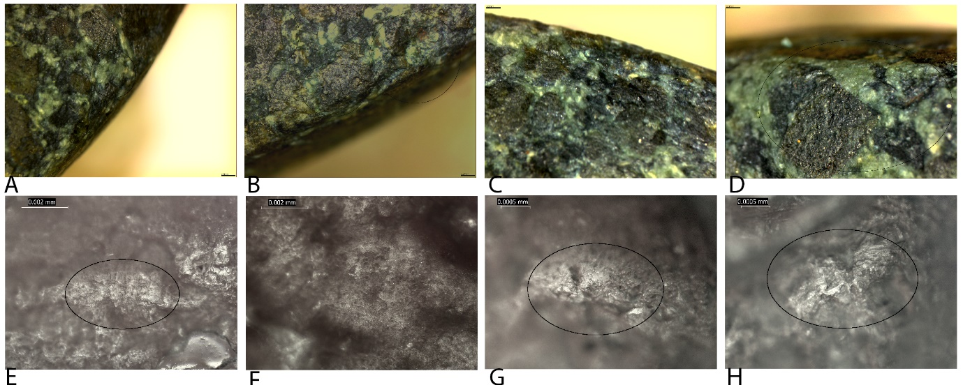
Fig 22. Use-wear after five-hundred strikes during digging soil containing stones.

One-thousand strikes
The next phase saw the experiment continue that same as previously.
A pause was taken at 1000 strikes. The wear at this phase could be described as developed. Multiple, overlapping flake negatives were present at the centre and towards the top corner of the blade. These bifacial removals overlapped and had crushed grains and microfractures on their edges where the topography was higher. Grain removal pits were dense across the blade tip and extended onto the blade edge. They existed in large clusters of overlapping angular pits with crushed grains closely distributed. Short to long parallel striations in a close density ran from the pits on the blade tip, associated with them. Striations on the blade edges were also close to dense pits extending up to 20mm. Rounding was limited to the bottom corner of the blade tip. Increased contact with stones, a hard contact material, aggressively removed the stone grains, which grains were also slightly rounded by the soil.
Analysis of the casts taken after 1000 strikes revealed much more developed polish. The granular polish of singular grains developed to become partially connected and large smooth patches of polish formed with partial linkage, patchy development, and a levelled morphology (Fig 23c-d). The patches were composed of connected triangular patches and were mostly on the high topography, but in places extend slightly down the sides of grains. The striations on these patches had a close to dense density. They were thin and overlapped. Although production polish was still visible, it was limited in size being infrequent in development and often lacking linkage.
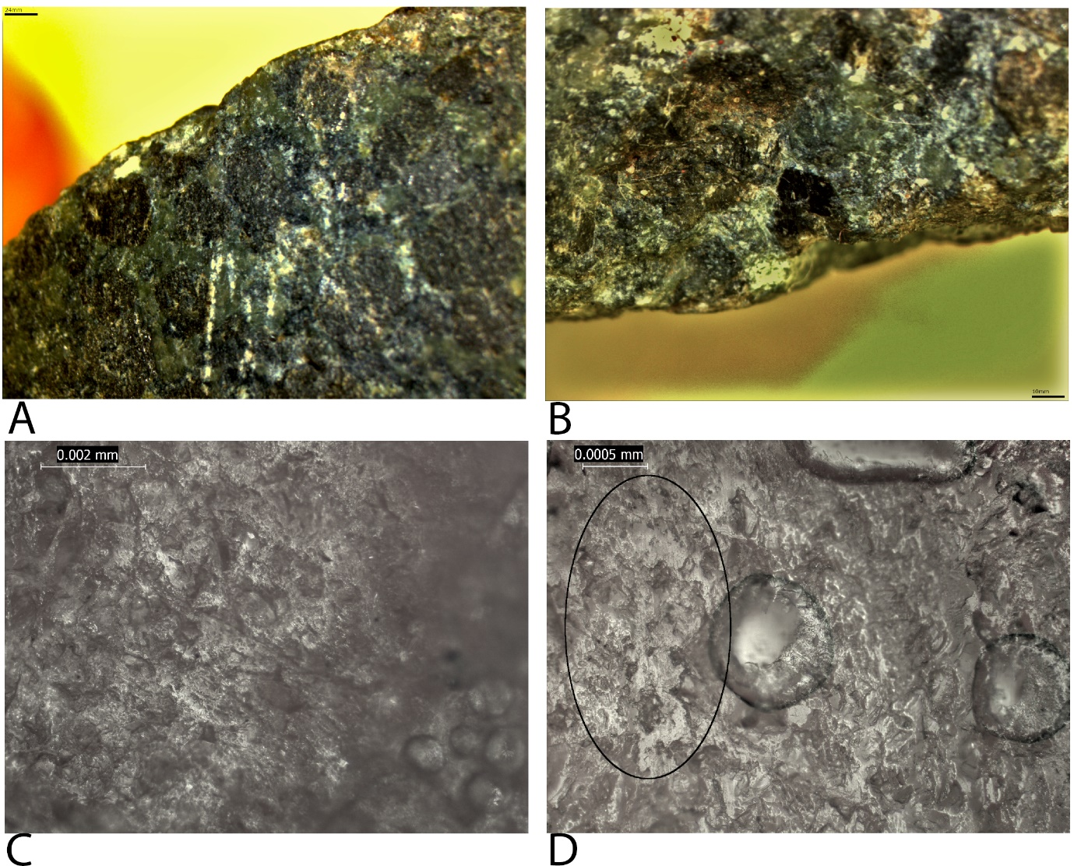
Fig 23. Use-wear after one-thousand strikes during digging soil containing stones.

Two-thousand strikes
The final phase saw the experiment continue that same as previously. Throughout the entire experiment, the position of the blade meant that the soil was difficult to remove, however it was very effective at breaking it apart.
Due to an error, a pause was taken after 1500 strikes to analyse the use-wear development. The experiment ended after 2000 strikes when the wear was developed. The blade was truncated in several areas, taking the appearance of a wave. This truncation was caused by the increased quantity and density of grain removal pits and fractures, the highest density of which was present in the centre and towards the top of the axe-head which initially met the soil and stones with each strike, thus increasing the development of wear. Flake negatives were amongst the densest pits and were wide and made up of multiple fractures. Crushed grains and microfractures with a close density were present along the blade and concentrated around the flake negatives. Long striations ran from the pits on the blade tip, they were intermittent and often broken up by pits on the blade edge. Thin striations from contact with soil extend intermittently to the back side of the perforation, approximately 50mm from the blade tip. Rounding and polish were most clear at 2000 strikes. They existed at the corners of the blade and extended back towards the perforation. Areas of the butt close to the perforation were also rounded from contact with soil.
Analysis of the casts revealed large smooth and connected patches of polish extending slightly down the sides of grains and with a patchy development across the blade and tip due to removals, relating to the types of soil the axe-head came into contact with. Less developed polish from contact with clay/soil was noticeable as granular polish on singular grains which are seen to be partially connected in areas where this polish is more developed. Dense microfractures and parallel and singular striations covered the large patches of connected polish, overlapping.
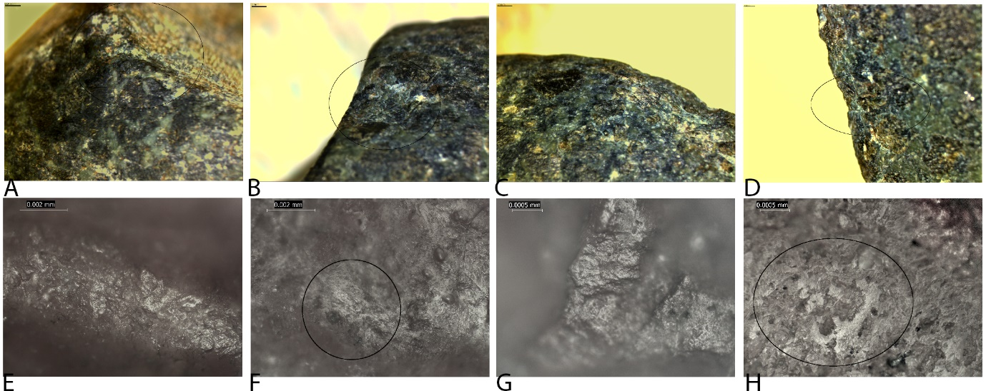
Fig 24. Use-wear after two-thousand strikes during digging soil containing stones.

Wear development related to manufacture
Low Magnification: Minimal superficial pits, sparse along the tip contained some crushed grains after manufacture. These were still visible at 50 strikes, but by 100 strikes the stone grains had been smoothed, extending slightly into the lower topography and removing all traces of crushed grains, and previous, superficial pits on the tip. The wear that developed at 50 strikes included edge scaring and crushing which developed in locations on the tip and blade edge where crushing had not previously occurred and were thus, not associated with the similar wear formed during manufacture. The development of pit clusters extend superficial manufacture clusters as well as developing in areas with no previous removals in the same manner indicating limited influence of the manufacture traces on wear development.
High Magnification: At 50 strikes the edges of the manufacture polish traces appeared very slightly rounded in places. At 100 stikes alterations from blade edge and tip removals affected the production polish by removing stone grains and allowing polish to develop on unaltered stone. The granular polish was also beginning to develop in separated patches between the manufacture traces as well as lessening the extent of the production polish by smoothing the edges, turning the once flat polish to one that was more sinuous looking. From 200 strikes onward the production polish was separated and reduced from grain and flake removals as well as being smoothed from contact with soil, on top of which the polish associated with contact with soil developed further.

Digging soil containing roots with battle-axe Replica 4
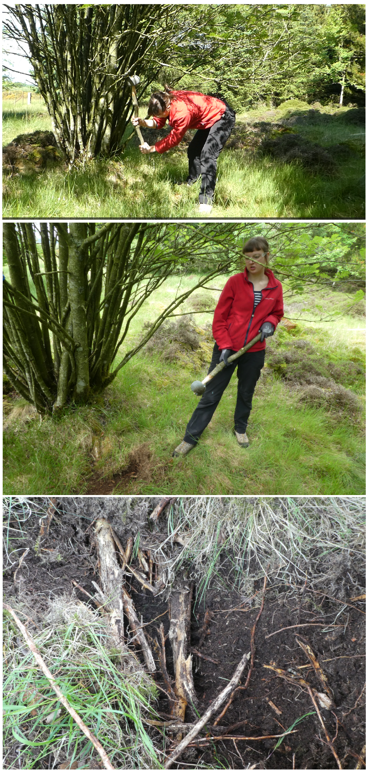
Fig 25. Images from the digging soil containing roots experiment.

Fifty strikes
The start of the experiment begun with oblique vertical chopping motions digging through soil containing roots. Initially, the axehead broke the ground surface quickly and easily in a couple of strikes. In this initial phase, small roots (5mm diameter) were cut through with one strike. A larger root, 30mm diameter, was splintered. Soil residue covered much of the blade edges.
During the first pause, it was evident the use-wear was minimal. Small, superficial, and narrow grain removal pits, which appeared quite faint, were present on the tip in a sparse distribution. They were focused mostly on the corners. Even fewer striations existed on the blade edges, associated with the pits. They were very short and occurred in clumps of 1-2 in a parallel arrangement perpendicular to the blade edge. Production traces were still visible, although they were discernible from the use-wear. The wear was limited and less developed.
Analysis of the casts taken at this stage show production polish remained the most frequent polish. However, it was slightly altered by small, thin embedded striations in multiple directions which were caused by contact with the soil grains.
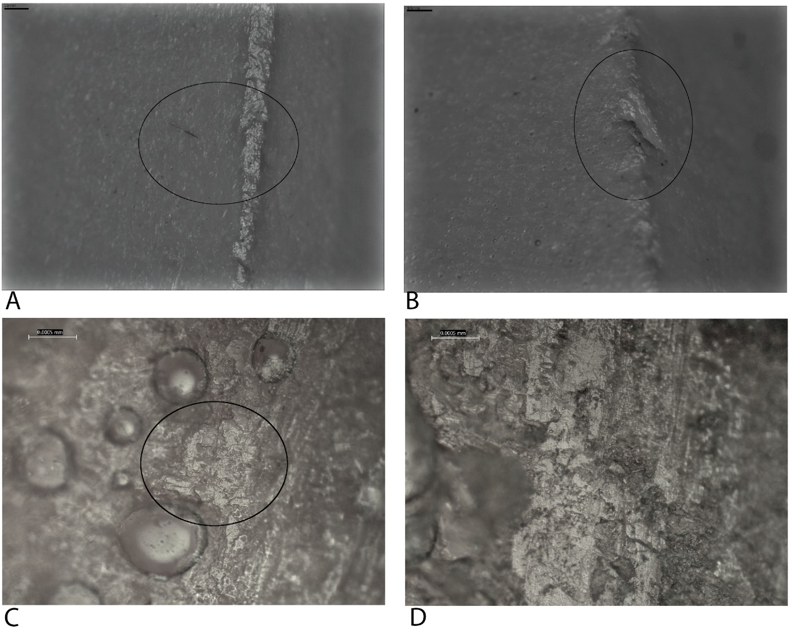
Fig 26. Use-wear after fifty strikes during digging soil containing roots. All figures are taken from casts.

One-hundred strikes
The next phase of strikes saw the same results as the previous phase, with the soil being cut through and broken apart very efficiently. Soil residue covered much of the blade edges and wood residue developed in the centre of the blade tip.
At 100 strikes the number of pits had increased considerably, covering areas of the tip and blade edges. More pits were on the blade edges compared to the tip. They remained very small and superficial and surrounded the striations on the blade edges. The short striations occurred bifacially in six groups along the blade edges. They were in a parallel arrangement and ran perpendicular to the blade edge with a sparse to close density. A few, very sparse longer striations occurred in the centre of the blade, and towards the corners, these were intermittent and overlapped the other striations.
Analysis of the casts revealed the reduced quantity, distribution and linkage of production traces and the development of a granular polish on the blade tip and edges. There was a slight rounding of the edges and high topography of these grains. Singular, short, striations were found embedded within and surrounding the granular polish on singular grains with an orientation perpendicular to the blade edges.
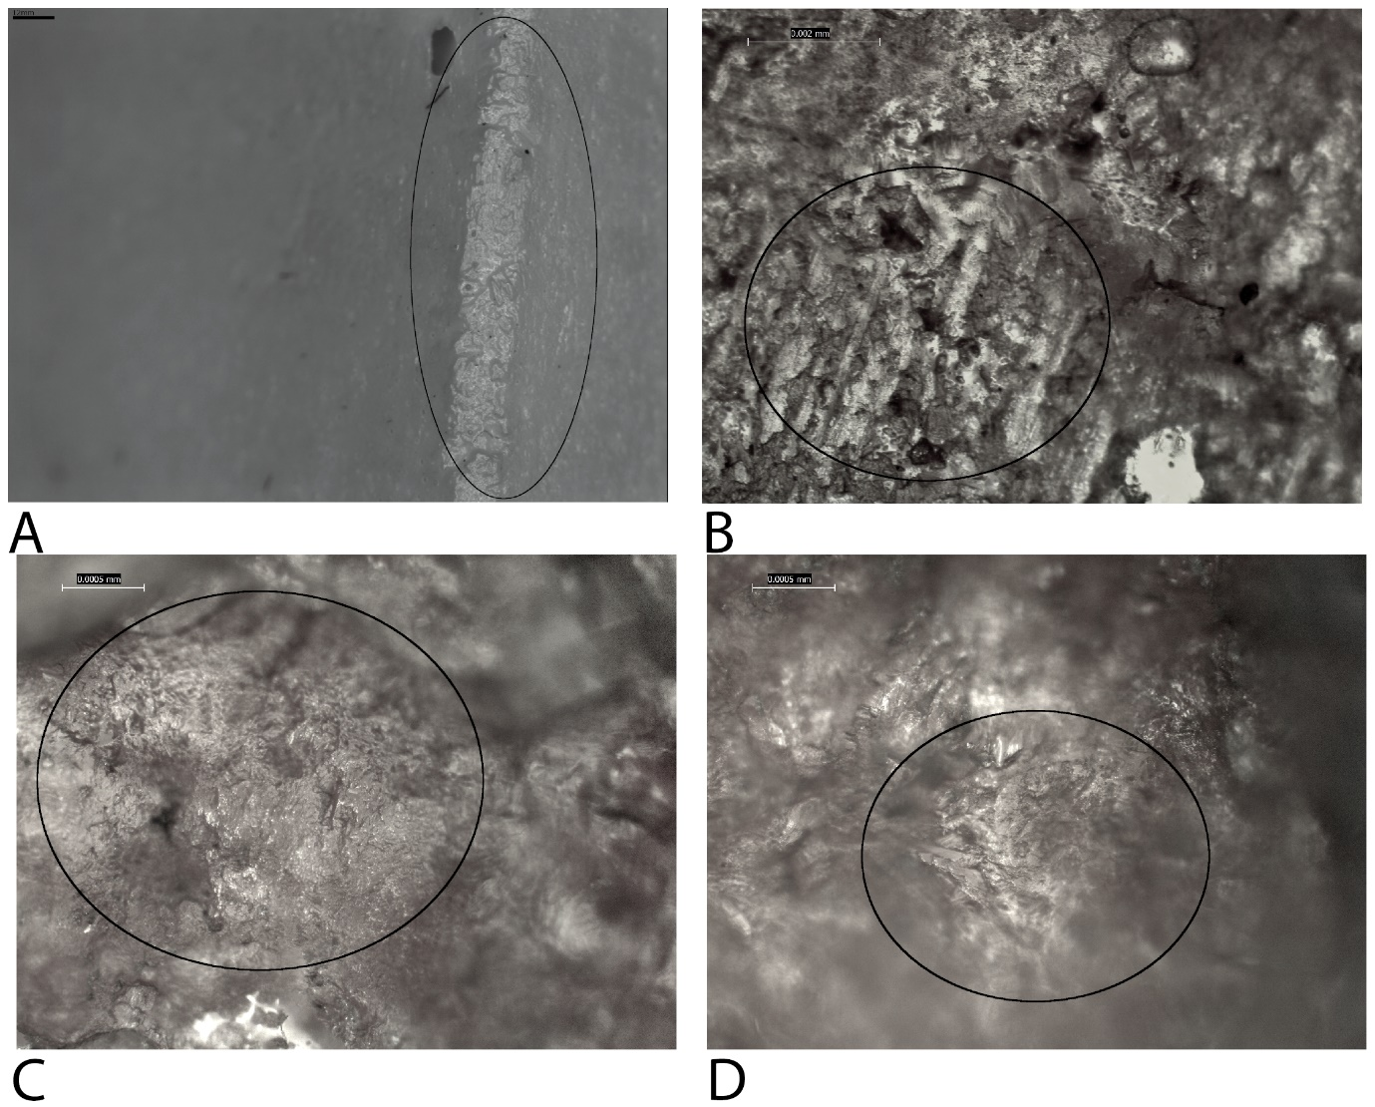
Fig 27. Use-wear after one-hundred strikes during digging soil containing roots. All figures are taken from casts.

Two-hundred strikes
By 200 strikes, the area being dug had double in size and was deeper. The effectiveness of digging through the soil continued, the smaller roots were chopped through with one strike and the larger roots were splintered but not broken through yet. The residue developed in the same way as previously.
Analysis of the axe-head after 200 strikes saw more grain removal pits on the blade edges with intermittent, thin striations with a u-shaped profile amongst them. The pits were small, narrow and superficial but were now close in density. Those pits closest to the blade tip were wider where edge damage was developing fastest. Smaller, newly developed pits existed between the six groups of wear seen at 100 strikes. At 200 strikes, rounding of the higher topography in the centre of the blade appeared.
The casts taken after 200 strikes revealed polish with a slight degree of directionality beginning to develop. These small patches of sparse granular singular polished continued to be present, with a few striations oriented in the same direction as the directionality, perpendicular to the blade edge. Small, sparse to close domed patches on the high topography were also present. These patches had a partial linkage and an infrequent development apart from in the centre of the blade tip where they had a patchy development, the patches were bigger and closer, and the striations also appeared longer. Slight rounding was present, the same as at 100 strikes.
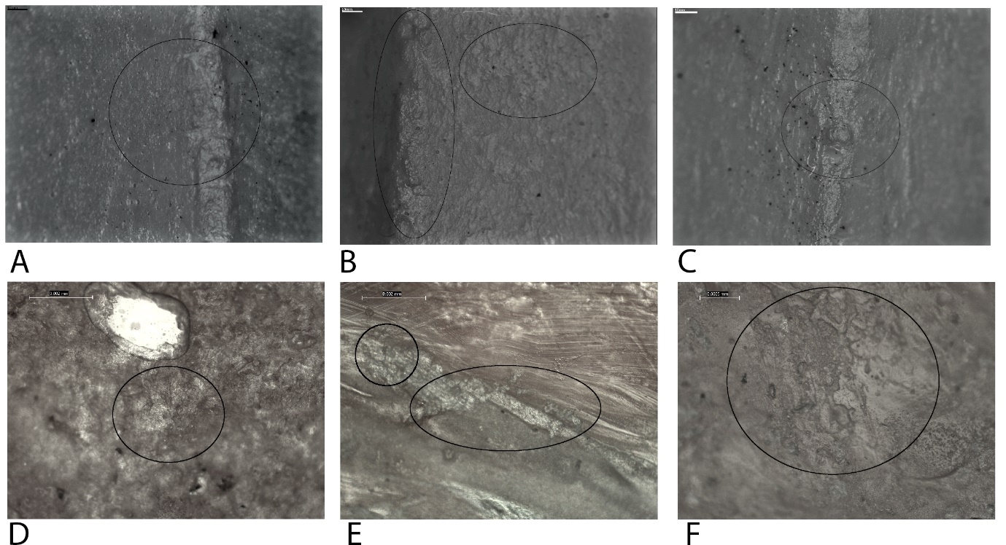
Fig 28. Use-wear after two-hundred strikes during digging soil containing roots. All figures are taken from casts.

Five-hundred strikes
The next phase of strikes cut through the larger roots further, one of which 90% chopping through. The soil and smaller roots continued to be broken apart with a single strike, although the axehead was not good at removing this material.
By 500 strikes the wear was considerably more developed. At this stage edge damage had spread onto the blade edges with many more intermittent striations spread across the blade edges, extending 10-12mm from the blade edge with a close density, surrounded by the small, superficial pits described in the previous pauses, although these too were more numerous. The striations in the centre overlapped, due to their diagonal orientations, while the wear towards the bottom corner of the axe-head was limited, with much few pits and striations. The pits extended 1-2mm from the blade edge, and the striations were equally short. This wear indicates that the area of the axe-head in contact with the contact material most often was the centre and top corner.
Analysis of the casts taken at this stage revealed semi-connected patches of granular polish. The edges of the grains appear slightly rounded, with an almost domed high topography, and associated striations were more numerous, often overlapping and with multiple directions of orientation. The patches remained small but were close in density and with a patchy linkage and development. Contact with soil caused the granular polish. However, contact with wood roots resulted in the slight rounded, domed appearance of some grains.
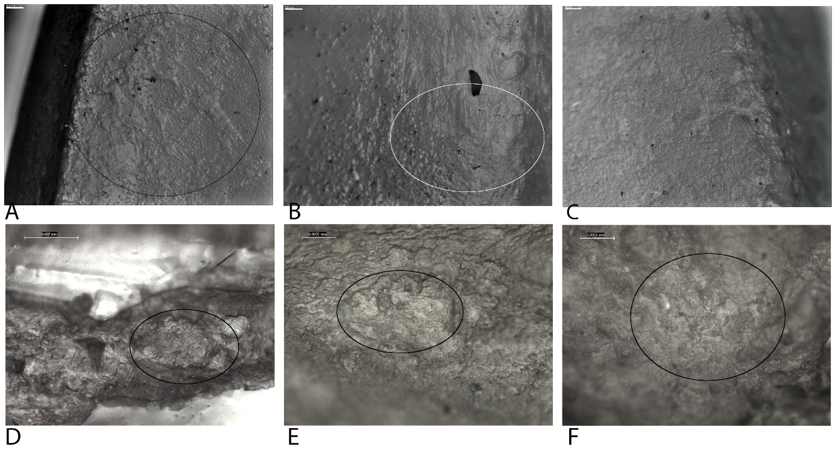
Fig 29. Use-wear after five-hundred strikes during digging soil containing roots. All figures are taken from casts.

One-thousand strikes
In the next phase of strikes, the effectiveness continued and one of the larger roots was broken through. The blade edge and tip was covered with soil and wood residue, with a concentration of wood residue in the centre of the blade and towards the bottom corner.
After 1000 strikes the extent of the wear extended slightly more evenly across the entire blade. The bottom corner of the blade, which, at 500 strikes, had limited wear, now had pits with rounded high topography and related intermittent striations that extended 15mm onto the blade edges. The remaining centre and top corner of the axe-head had denser wear, and the grain removal pits were larger. Clusters of two to four grain removal pits and micro fractured stone grains were present along the blade tip, extending on the blade edges, sparse in distribution.
Analysis of the casts taken after 1000 strikes revealed close, partially connected wide patches of domed polish on the high topography with a patchy to continuous development and loose micropitting. The embedded striations on the polish were long and often singular in multiple directions. The areas surrounding the patches had less developed granular polish. The domed polish was indicative of contact with wood roots while the striations indicate a more granular contact material, the soil.
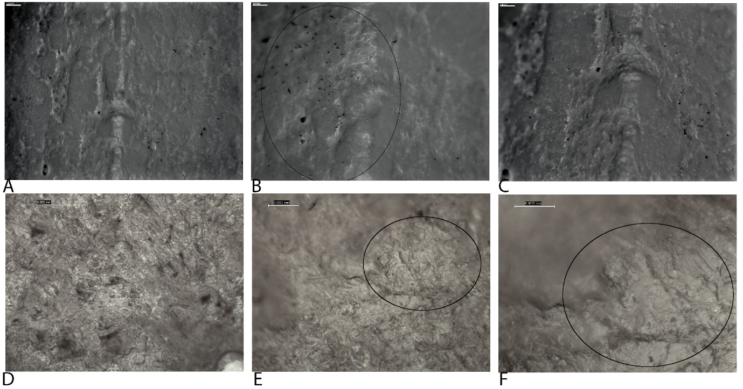
Fig 30. Use-wear after one-thousand strikes during digging soil containing roots. All figures are taken from casts.

One-thousand-five-hundred strikes
At this stage, the second large tree root was broken through. Splinters from breaking apart the larger roots were amongst the removed material which the axehead was coming into contact with. The blade edge and tip was covered with soil and wood residue, with a concentration of wood residue in the centre of the blade and towards the bottom corner.
At 1500 strikes the grain removal pits were greater in quantity and extended further onto the blade edge, 15-20mm. The high topography surrounding the pits on the blade tip and edge were rounded. There were equally more striations associated with the grain removal pits and extended intermittently just as far onto the blade edge, overlapping, and facing multiple directions. This wear was caused by this increased contact with granular soil. The pits closest to the tip were larger due to smaller pits combining. The pits along the blade tip were in large, superficial clusters of 10-20mm in width and extending onto the blade edges by 20-25mm. Edge scarring and microfractures were present in the centre of the clusters on the blade tip, and amongst the pits in the centre of the blade edges. By 1500 strikes the wear was more evenly spread across the blade, however, the pits and clusters of use-wear were larger in the centre and towards the top side of the axehead; these areas came into contact with the soil and roots more frequently.
The casts taken after 1500 strikes revealed larger patches of partially connected polish. They were slightly domed, but parts surround this polish also appeared as granular polished singular grains. The polish was accompanied by both abrasive and embedded overlapping, multi-directional striations and dense micropitting. A directionality perpendicular to the blade edge was apparent for all patches. This wear was very similar to that at 1000 strikes, but its development resulted in it being more connected and closer in density. At this stage, the polish took had a continuous development across the blade edge with a partial to connected linkage. It form linear and triangular forms in plan similar to replica 3 and were mostly on the high topography, but in places extend slightly down the sides of grains.
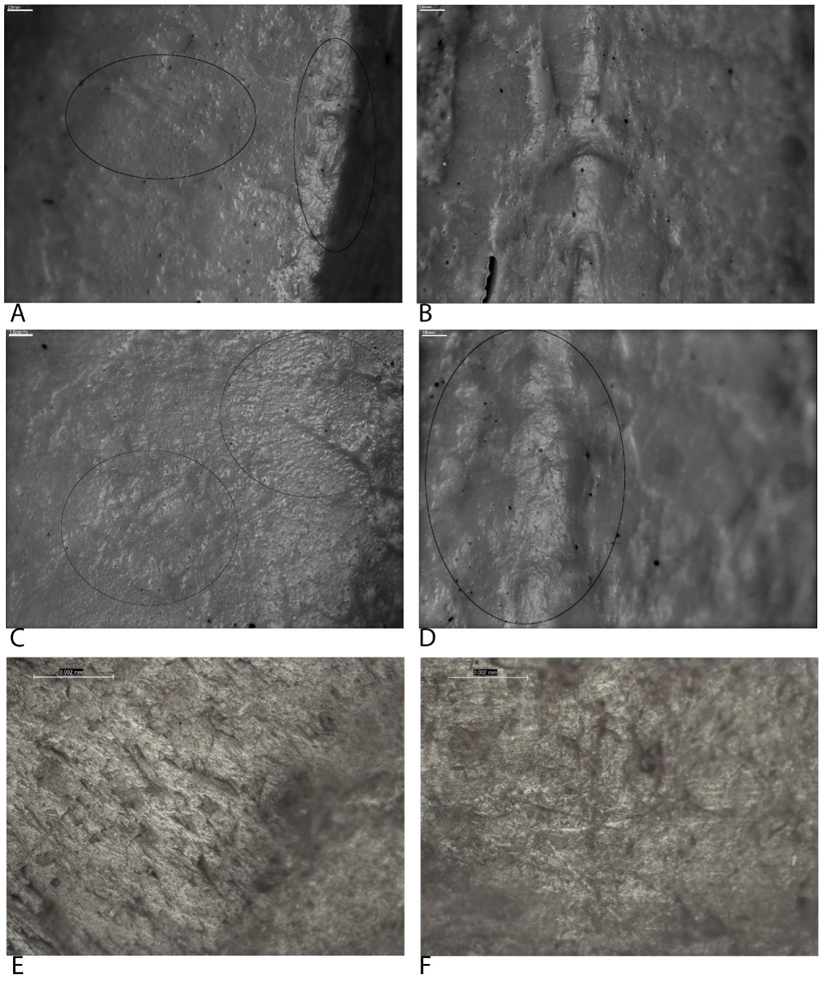
Fig 31. Use-wear after one-thousand-five-hundred strikes during digging soil containing roots. All figures are taken from casts.

Two-thousand strikes
In the final phase of the experiment, the axehead dug an area of 1m by 0.5m at an average depth of 30cm. The larger roots were gradually chopped through throughout the experiment, while the smaller roots were chopped through on impact. The soil was broken apart very easily, however, the material could not be removed effectively with the axehead. Soil residue covered the axe blade throughout use and wood residue was restricted to the centre and bottom edge of the blade.
Analysis of the axe-head at the end of the experiment, after 2000 strikes, revealed more developed wear with a close to dense concentration. The thin striations were more numerous and longer, extending up to 20mm, and spread along the entirety of the blade edges bifacially. Small, superficial, and narrow pits extended onto the blade edges, running close to the striations. They were dense near to the tip where they were also more numerous. Few pits exist on the tip which was very rounded and smooth. The pits that have developed on the tip were wide and shallow with smaller pits extending from them on the blade edges bifacially. Microfractures of the stone grains amongst the groups of dense grain removal pits on the blade tip and 20mm onto the blade edges, create a frosted appearance. Although, grain edge rounding of this area has lessened the appearance. The blade edges were also rounded, reducing the depth of the grain removal pits. The striations were parallel and run perpendicular to the blade edge, however, those more central had diagonal striations overlapping them. In these areas, the grain removal pits were slightly more numerous and denser, showing that this area of the blade was in contact initially and more often with the spoil and roots.
Analysis of the casts taken after 2000 strikes revealed that the patches of domed polish with granular areas had increased in size, the latter were partially linked. Long abrasive striations covered the patches and existed in multiple directions, often overlapping. Fewer embedded parallel striations formed on the domed high topography, close in density. The patches had a mostly connected linkage and a continuous development across the blade edges, and small, dense micro-removals indicate removals of grains during use. The domed areas of high topography were caused by the contact with the wood roots while the more granular areas and long, multiple-directional striations were created from contact with soil.
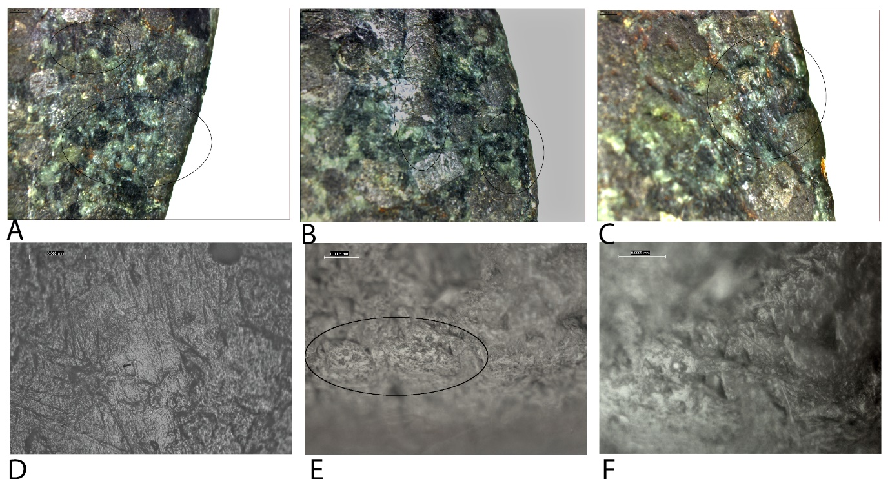
Fig 32. Use-wear after two-thousand strikes during digging soil containing roots

Wear development related to manufacture
Low Magnification: Initially, contact with soil smoothed the surface of the stone along the blade edge and tip, quickly smoothing the angular edges of the manufacture striations and reducing the high topography of the very superficial pits on the tip to almost level with the surrounding area. Continued use, with primarily contact with soil, caused continental smoothing of the higher and slightly lower topography, thus creating a flatter, more level surface for wear from use to further develop, not influenced by any manufacture traces. The minimal pits on the tip likely played a minor or no role in future grain removal since they were originally superficial and were smoothed relatively quickly.
High Magnification: At 50 strikes the manufacture polish was altered by the addition of multi-directional striations, thinner and shallower that the manufacture striations and cutting across them. Rounding of the linear manufacture polish and formation of granular and domed polish in between. By 200 strikes that shape of the manufacture polish had disappeared during to smoothing and creation of new polish on grains around and including the manufacture polish, particularly from contact with soil. The subsequent polish did not reflect the shape or orientation of the manufacture polish.

Breaking bone with axe-hammer Replica 5
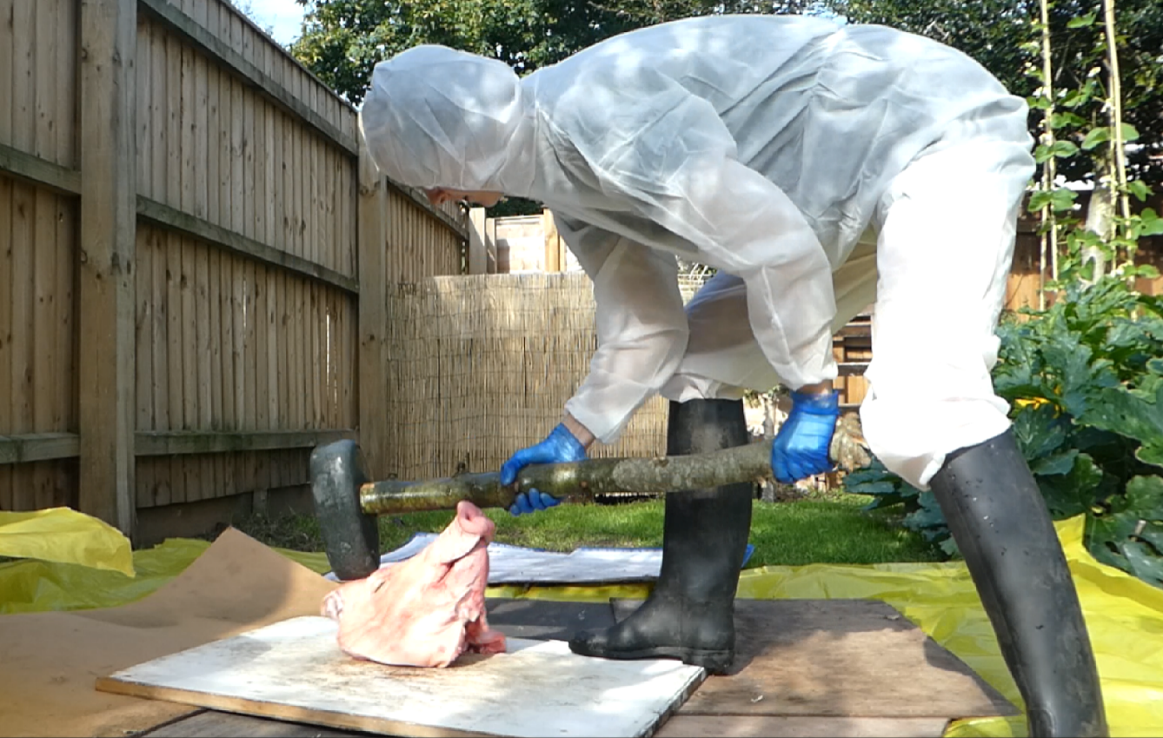
Fig 33. Images from the experiment breaking bone

Fifty strikes
The initial phase of the experiment saw the effective used of an axe-hammer to damage a pig skull. On initial impact, the skull cracked. A tissue residue covered the blade tip. The axe-hammer was heavy, but despite this, it remained easy to use.
The first pause during this experiment was at 50 strikes. Residue covered the majority of the axe from contact with animal tissues. These were wet and greasy and would have contributed to the development of the sheen like polish and rounded stone grains which appeared in small patches along the blade edges and tip with a close density. This extending 10mm onto the blade edges. Limited, faint striations in two parallel patches, perpendicular to the blade edge, bifacially, were located towards the top corner of the blade. These are the areas of the blade that came into contact with the head initially with each strike. The bone underneath the flesh is hard and therefore will cause striations and removals. Superficial, narrow grain removal pits developed in separated, sparse clumps along the blade tip. Towards the corners of the axe-head, they extend slightly onto the blade edges, and occasional pits had crushed grains and microfractures caused by the hard material. They were associated with and surrounding the striations.
Analysis of the casts under high magnifications revealed no change to the production polish and nor was any use-polish visible at this early stage in the experiment.
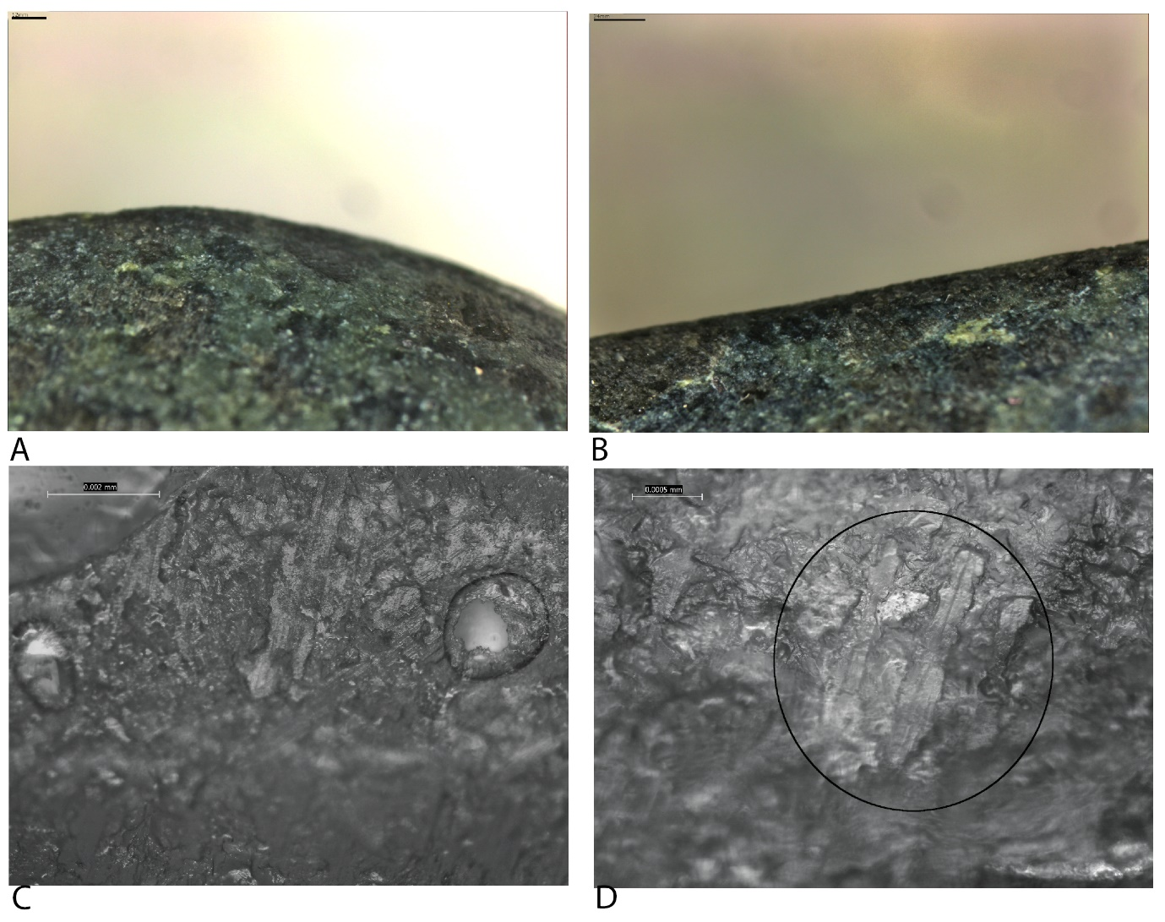
Fig 34. Use-wear after fifty strikes during breaking bone.

One-hundred strikes
During the next phase, the experiment developed in the same way as the initial phase. While the skull was broken on initial impact, the skin did not always break with impact.
After 100 strikes the wear was not visible macroscopically. Rounding and the sheen like polish continued to be present on the high topography along the blade tip and edges. However, it was not as extensive due to the slightly abraded surface and grain removal pits. The pits were small, superficial and narrow, and clustered in groups amongst abrasive wear on the blade edge, in particular in the centre of the blade and extending 5mm onto the blade edges. The separated small pits on the blade tip contained microfractures. By 100 strikes the striations had increased in quantity and now extended across the blade edges, mostly bifacially. They were not uniform, and their size and orientation were variable, occasionally being intermittent. Some of the larger striations, closer to the blade corners, were diagonal and slightly overlapping, while the remaining linear features ran perpendicular to the blade edge. The striations were associated with the grain removal pits on the tip and blade edges. The use-wear remained limited and faint.
Analysis of the casts revealed partially altered production polish, which appeared smoother across the high topography. In other areas lacking manufacture polish, the grains within the higher topography also had a smooth polish on unconnected stone grains with an infrequent development.
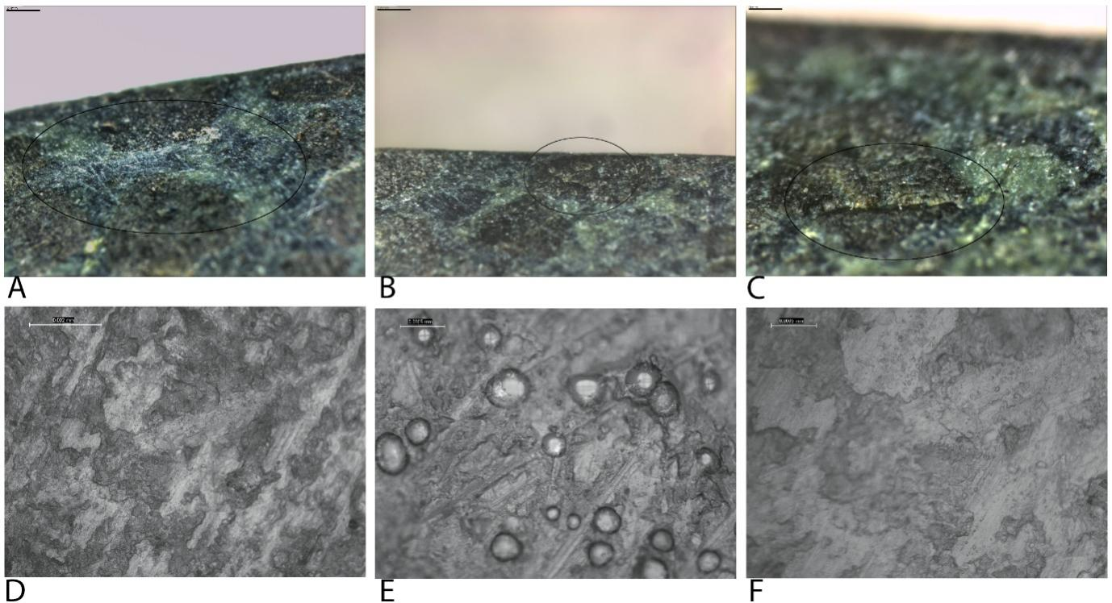
Fig 35. Use-wear after one-hundred strikes during breaking bone.

Two-hundred strikes
Over the next strikes, two pig heads were used. The second was a thicker and larger skull which took four strikes to fracture the skull.
A pause at 200 strikes revealed the development of scratches on the blade edges, approximately 50mm in length. They were caused by direct contact with the skull surface. By this stage there was an increased quantity of grain removal pits on the blade edges, however, they were limited to the tip which was also rounded along its entirety. Groups of superficial, narrow pits were present on the tip, they were very small, and the edges were rounded. The pits on the blade edge were equally small but were less rounded and contained microfractures. They extended onto the blade edge 10mm with a close density and were associated with the striations which ran intermittently for the same distance and were greater in quantity in comparison to 100 strikes. Sparse diagonal striations overlapped the other striation across the blade edges, but with a focus at the corners of the blade edges.
The casts taken after 200 strikes were analysed to reveal larger patches of smooth polish on the high topography with a higher quantity and density of short embedded parallel striations and dense micropitting. These patches had a partial linkage and were patchy to continuous in development closer to the tip. At this stage, the striations were often overlapping. Some rounding of the edges of these patches was visible and also of the still visible production polish. This was most likely from the contact with flesh.
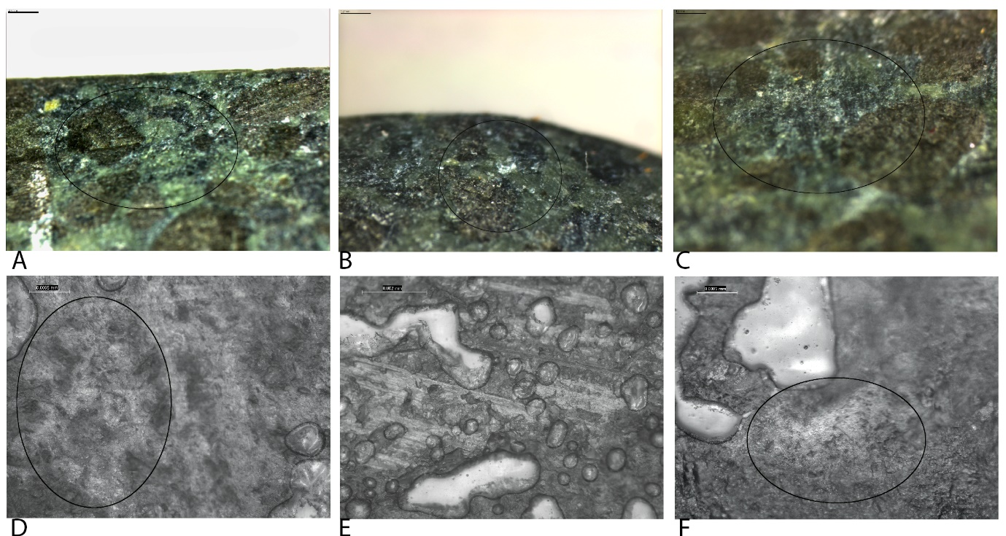
Fig 36. Use-wear after two-hundred strikes during breaking bone.

Five-hundred strikes
By 500 strikes, the experiment proceeded like the preceding phases with the axe-hammer fracturing the skull on initial impact. Tissue residue from this impact was present on the blade tip and slightly on the blade edges.
The wear at 500 strikes was much the same as 200 strikes but in higher quantities. The striations were also longer, and the grain removal pits extended further away from the blade edge, 10-20mm, comparable to the striation length. Clusters of small and superficial crushed and micro fractured stone grains associated with the pits were present on the tip and amongst the striations on the blade edges with a separated distribution. The striations remained thin and faint; they were mostly intermittent and were a mixture of straight and diagonal striations, overlapping. Rounding was limited to the blade tip, mainly the corners, and some areas on the centre blade edges. Scratches remained on the body of the axe-head not far from the blade tip.
Analysis of the casts revealed larger patches of smooth polish which were closer in density and partially connected with a similar development to the previous pause, patchy to continuous. The polish appeared slightly rounded with the highest topography domed. The embedded striations at this stage were clearer and occurred in larger numbers, 5-6, in a parallel arrangement. They were a mix of diagonal and straight striations, occasionally overlapping and associated with loose micropitting.
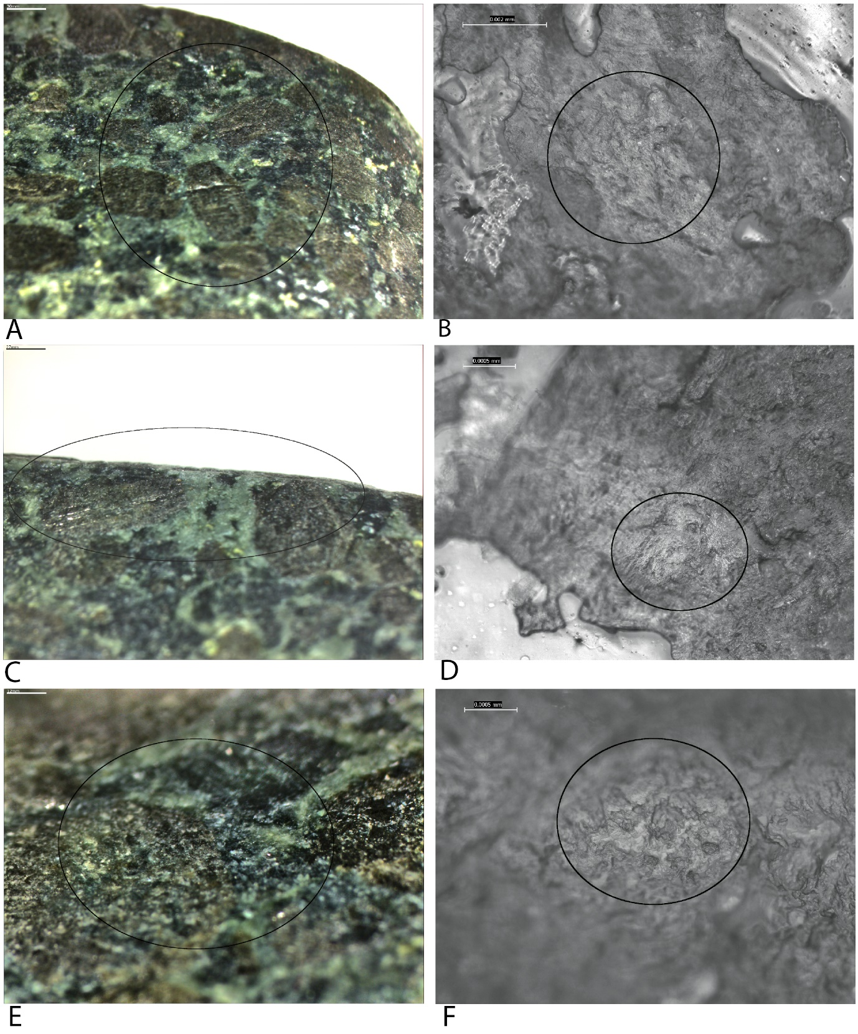
Fig 37. Use-wear after five-hundred strikes during breaking bone.

One-thousand strikes
In the next phase, the pig skull used was thicker and so initial contact created dents in the skill rather than fractures. Fractures occurred after 15 strikes.
At 1000 strikes the development of wear was in line with the previous two pauses. The wear was very similar to 500 strikes but was greater in quantity and size. Rounding was more extensive and spread further onto the blade edge, by approximately 5mm. Overlapping, thin, long striations starting 10mm from the blade edge were more numerous and were accompanied by superficial, narrow grain removal pits and small clusters of micro fractured stone grains. Both wear types were close in density. The pits on the tip and blade edge close to the tip were larger in diameter but remained superficial; their edges were rounded, and the centres were fractured.
The metallographic microscopic analysis revealed that the patches of polish with rounded edges and domed high topography had increased in size, with a close density and partial linkage and covered by patches of an increasing number of embedded parallel striations, 5-10 and dense micropits. They remained in straight and diagonal positions, often overlapping. Grian removal interrupted the polish giving it a patchy development.
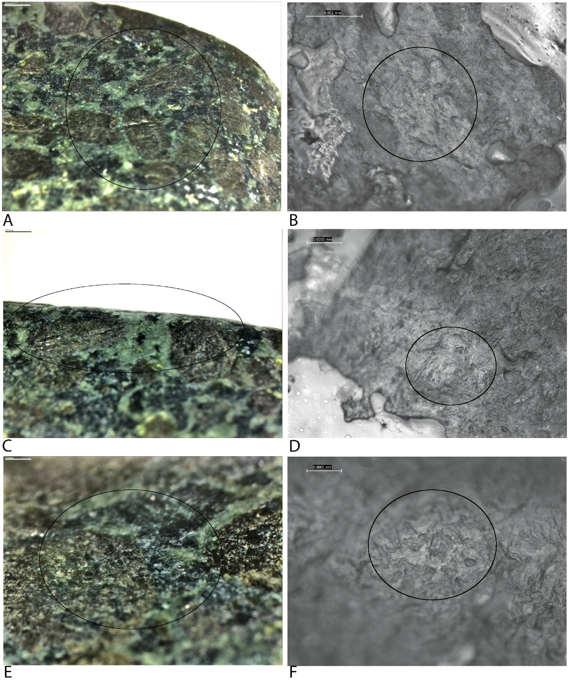
Fig 38. Use-wear after one-thousand strikes during breaking bone.

One-thousand-five-hundred strikes
The next phase of the experiment had the same effectiveness as the previous, with skulls fractures occurring with every strike and the formation of tissue residue on the blade tip and edge.
At this stage, there was still no wear visible macroscopically. The use-wear was not too different to the use-wear analysed at 1000 strikes. Striations, microfractures and grain removal pits were comparable while the rounding extended 15mm from the blade edge. A few wider striations were present on the blade edge, diagonal and facing towards the centre of the blade at an obtuse angle. They were wider than the thin striations covering the rest of the blade edge and were most likely from direct contact with bone. Contact with flesh and skin resulted in the smooth appearance of the surface of the blade edges and tip.
Analysis of the casts under a metallographic microscope showed larger patches of smooth polish with slightly rounded edges and domed high topography. Micro-removals from the removal of grains continued at a similar density through use. Close density striations covered the patches of polish, occasionally overlapping. Patches were close in density with a connected linkage and continuous development closest to the tip. At this stage, this density, connected linkage and continuous development extended further onto the blade edges than the previous pause at one thousand strikes.
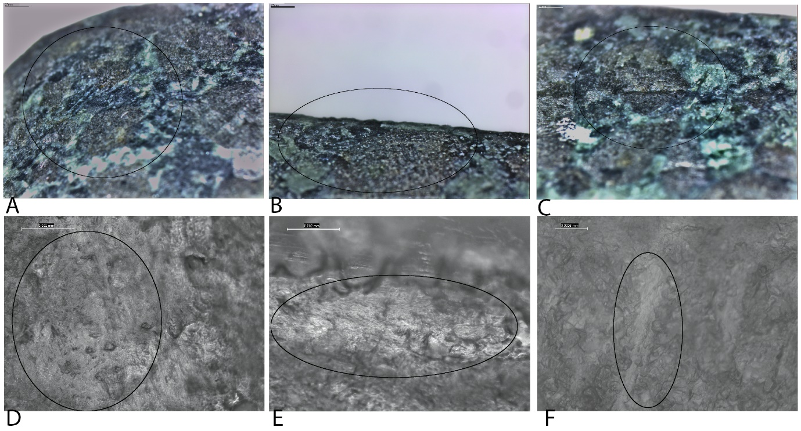
Fig 39. Use-wear after one-thousand-five-hundred strikes during breaking bone.

Two-thousand strikes
The final phase of the experiment maintained the same effectiveness and results as the rest of the experiment. The axe-hammer effectively fractured pig skills on initial impact, with thicker skulls taking between 5 and 15 strikes to fracture. The axe-hammer was heavy to use but its weight added to the effectiveness of each strike and did not hinder the user.
The experiment ended after 2000 strikes. At this stage, the use-wear was visible macroscopically as small pits running along the blade tip. Microscopic analysis revealed an increase in the number of pits and striations on the blade edges, running up to 25mm from the blade tip. The striations were a mixture of straight parallel, short striations close to the tip and longer, singular striations with diagonal orientations often overlapping each other as well as the shorter striations. The narrow, superficial pits surrounded the striations in a close density which became denser closer to the blade tip where they appeared in wide, superficial clusters. The pits were less clear on the tip due to the rounded grains from contact with flesh. However, they appeared larger and more spread out along the blade edge. Some large scratches exist on the blade edges, running almost parallel with the blade edge. Separated patches of microfractures, creating a frosted appearance, exist on the blade edge directly next to the tip. They were 10mm wide and travelled 2-4mm onto the blade edge. Small, close patches of micro-fractured grains, interrupted by grain removal pits, extend across the blade tip. The grain edges were rounded.
Analysis under a metallographic microscope showed the development of the smooth domed polish to a density that was dense. The patches of polish were large, creating plateaus of continuous development and connected linage. They were covered by dense embedded striations in parallel groups. Overlapping micropits were evident in the patches as well as wider removals of stone grains interrupting the polish, particularly on the tip.
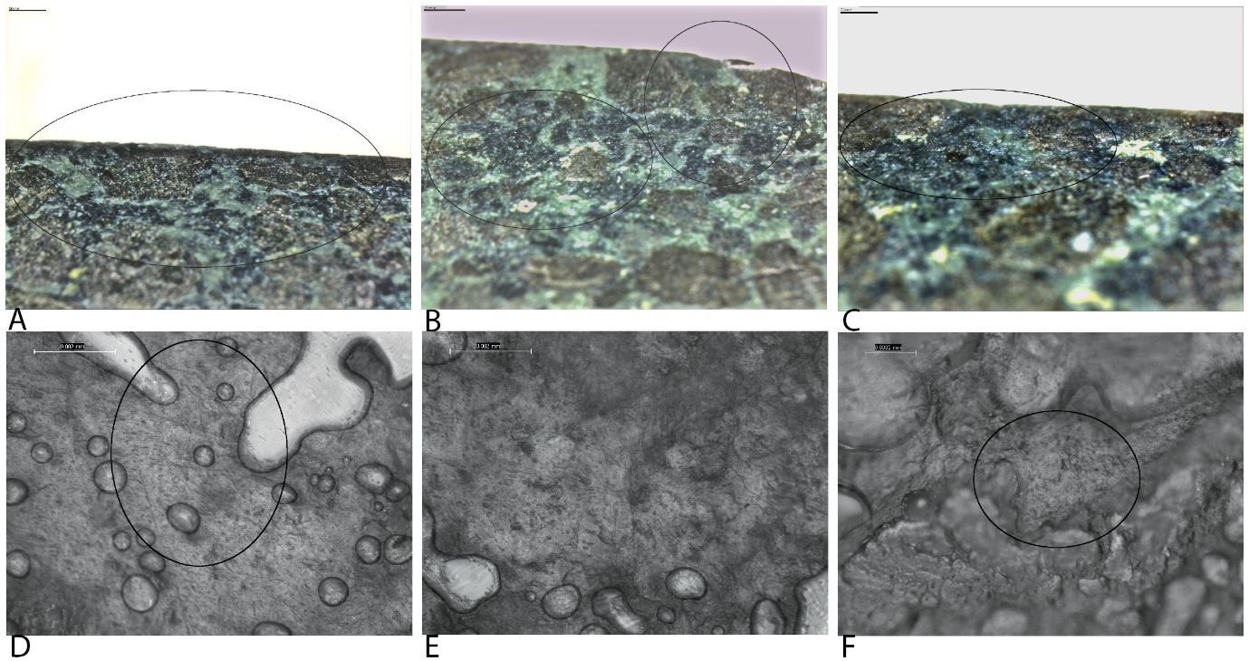
Fig 40. Use-wear after two-thousand strikes during breaking bone.

Wear development related to manufacture
Low Magnification: Smoothing of the high topography began with the initial 50 strikes so that by 200 strikes the angular edges of sparse singular grain removals and striations were reduced and smoothed almost level. The sparse and few manufacture pits on the tip were not added to with other removals until 200 strikes when removals spread across the entire blade. Intilial removal focussed on the centre of the blade and spread towards the corners as use continued, thus they did not occur because of previous manufacture traces. Equally, when the manufacture pits were incorporated with use pits, their edges were smoothed and rounded from contact with bone and flesh, thus reduced the chance of further removals from them. Manufacturer traces were no longer visible on the tip and blade edges close to the tip from 500 strikes onwards.
High Magnification: From 100 strikes the manufacture polish was increasingly smoothed and smooth polish on singular grains between the manufacture polish developed. Overlapping shallow striations also altered the manufacture polish. By 500 strikes on the blade edges the original flat manufacture polish with deep striations had disappeared, with wider, smoothed and domed polish replacing it through smoothing the previous polish and developing and connecting newly formed polish in between the manufacture polish. Increased use furthered this, removing all traces of manufacture polish and creating wide patches of use polish with not characteristic of the initial manufacture polish.

Splitting wood with a wedge with Replica 6
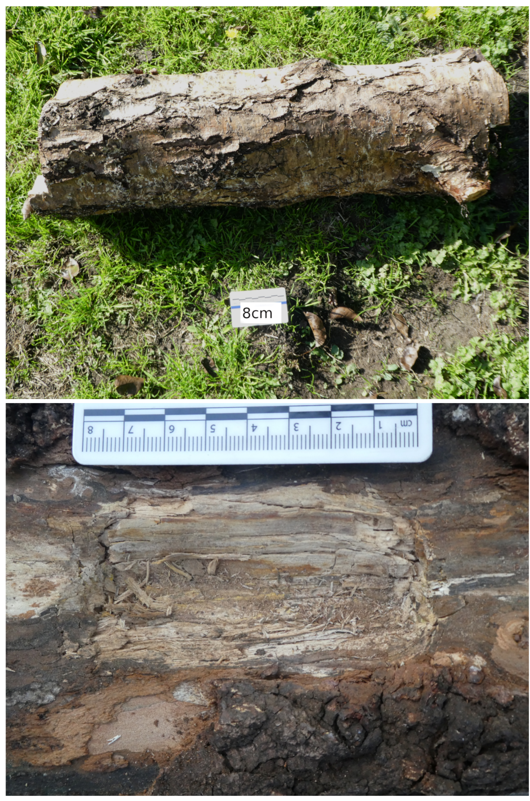
Fig 41. Images from an experiment splitting wood with a wedge.

Fifty strikes
The first pause during the experiment occurred after 50 strikes. During this stage, the wood beneath the blade was crushed, but no cracks or splits formed. Macroscopically the blade and butt appeared unchanged. Analysis of the blade and butt under a stereomicroscope revealed minimal patches of small striations on the blade edges associated with superficial and narrow pits in small groups towards the corners of the blade. More wear was present on one side. Very few traces of use-wear were present on the butt, just a small patch of close, superficial grain removal pits located off centre.
Analysis of the casts under a metallographic microscope revealed polish produced during the production process was visible and unchanged.
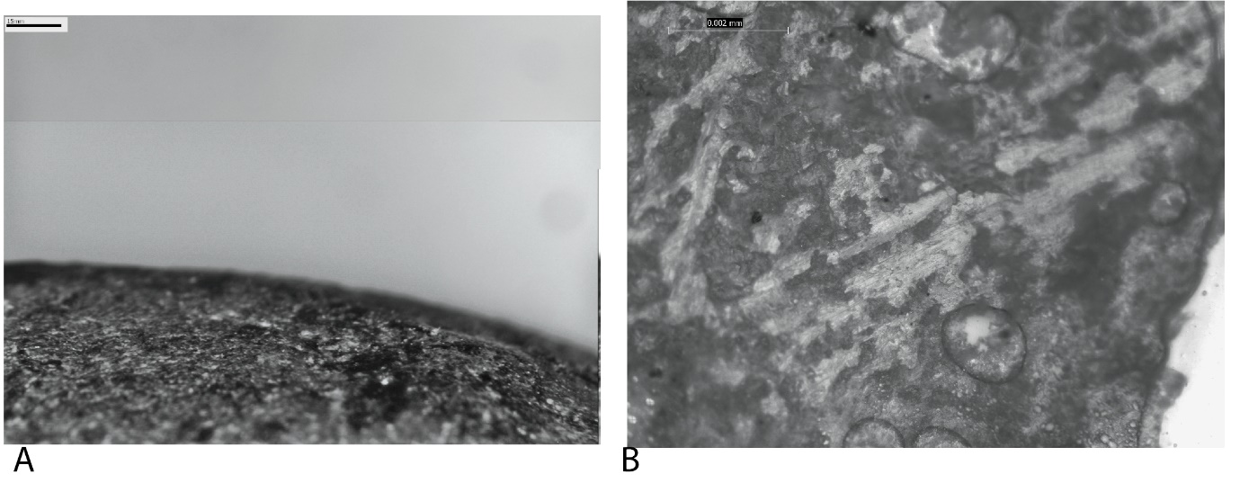
Fig 42. Use-wear after fifty strikes during splitting wood with a wedge.

One-hundred strikes
A pause was taken after 100 strikes during which a small linear hole was created in the log with a V-shaped profile. Grains of wood were crushed and removed during this process. The wood did not split during this stage. When analysing the blade and butt under a stereomicroscope, the wear had visibly increased in quantity, although it remained less developed. The striations on the blade edges were both long and short and a mix of diagonal and perpendicular to the blade edge. They were in four groups along the blade edges, bifacially and were associated with four larger clusters of grain removal pits extending 10-15mm onto the blade edge. The pit clusters on the blade edges and those which ran with a close density along the blade tip contained micro-fractured stone grains. The largest quantity of pits and fractures existed in the centre of the blade tip and edges, and smaller groups of use-wear existed towards the blade corners. Rounding was first seen in the centre of the blade. Few sparse pits were present on the butt.
Metallographic analysis of the casts showed altered production polish from removal of grains interrupting it as well as slight smoothing of the highest topography. In sparse places closest to the tip, the high topography and edges of the production polish were domed and areas surrounding these traces were filled with singular and partially connected granular polished grains, creating small, slightly connected patches of polish interrupting the manufacture polish on the blade edges and butt.
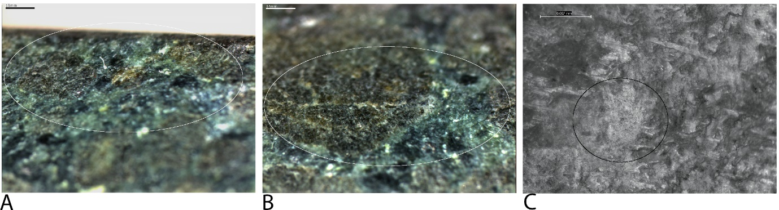
Fig 43. Use-wear after one-hundred strikes during splitting wood with a wedge.

Two-hundred strikes
After 200 strikes, the use-wear was first visible macroscopically, albeit superficial and sparse. The stereoscopic analysis revealed the use-wear had developed enough to cover the length of blade edges, bifacially, with a sparse to close density. Grain removal pits extended along the blade tip and edge, extending 10mm onto the blade edge. They were close in density but remained superficial and narrow. Separated micro-fractured stone grains were also spread across this area. Associated striations remained the same formation and length as at 100 strikes, although were greater in number and therefore occasionally overlapped each other. Rounding remained minimal at this stage. This is the first time a cluster of crushed stone grains were visible, found at a corner of the blade edge, and related to the clump of grain removal pits present in that area. The corners of the blade had slightly denser wear, and more grains were rounded. The wear analysed on the butt of the axe-hammer after 200 strikes were similarly developed. Greater quantities of grain removal pits and microfractures stone grains, superficial but wider than the previous stage, occurred in several clusters around the centre of the butt.
Metallographic analysis of the casts taken of the blade edges, tip, and butt after 200 strikes revealed the development of a use polish visibly different to the production traces that were still present. More areas of the production polish on the blade edges were rounded from use while wider patches of the domed and slightly granular polished grains were larger and present in a close density, with a patchy development, replacing the production polish. Parallel embedded striations accompanied by loose micropits follow the directionality of the polish, perpendicular to the tip. The patches were sparse and were larger at the corners of the blade where the use-wear analysed under the stereomicroscope revealed larger patches of denser grain removal pits and rounding.
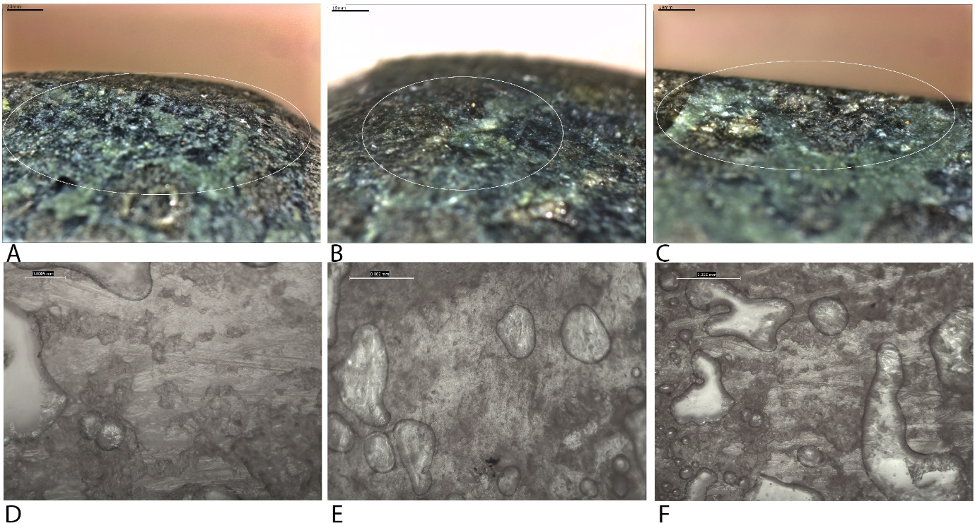
Fig 44. Use-wear after two-hundred strikes during splitting wood with a wedge.

Five-hundred strikes
After 500 strikes, a larger hole in the log was created, 100mm in length with crushed wood grains at the bottom of its V-shaped profile. However, a split did not occur. Analysis of the axe-hammer under a stereomicroscope showed the patches of grain removal pits extended further onto the blade edges, by approximately 15mm, although remained superficial. Associated striations in a parallel arrangement extended this far also, being intermittent, multi-directional and overlapping. The use-wear further away from the blade tip had a sparser density, while that closer to the blade tip was close and more numerous and had associated clusters of microfractures extending from the tip onto the bade edge. Sparse rounding was present on grains on the tip. The corners of the blade edges continued to have a greater quantity of pits and striations compared to the remainder of the blade.
The clusters of pits on the butt increase in quantity to five and spread from the centre towards the edges of the butt. The pits remained superficial and small, with a close density. The clusters were separated from one another, and all were associated with short singular and sparse striations orientated in multiple directions. Microfractures existed within the pit clusters.
The development of polish from use was apparent during the analysis of the casts taken after 500 strikes under a metallographic microscope. Unconnected domed polish was present on the tip of the blade while small patches of slightly connected domed polished patches, with a patchy development and partial linkage were found on the blade edges, smaller than the patches seen at 200 strikes due to removals of stone grains during use interrupting the polish. They showed clear directionality and had embedded close density parallel striations in the same direction, perpendicular to the blade edge. The butt also had patches of slightly connected domed polish with a clear directionality across its width, embedded parallel striations occurred in groups of 2-3 and ran in the same direction. These patches were limited to the centre of the butt and had a patchy development and partial linkage.
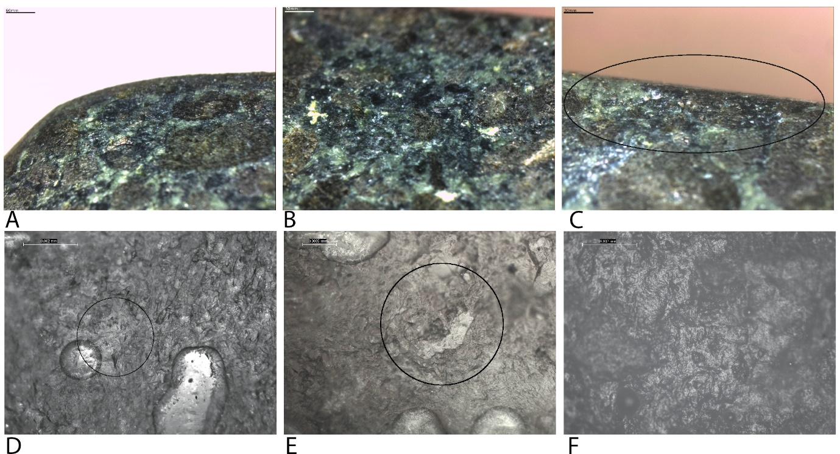
Fig 45. Use-wear after five-hundred strikes during splitting wood with a wedge.

One-thousand strikes
A pause was taken after 1000 strikes. Again, the experiment failed to cause a split in the log; it did, however, increase the width and depth of the hole. At this stage, the wear was considerably more developed, being more numerous and closer in density. It could be described as moderate use. The striations and pits extended 20mm onto the blade edges, bifacially and were accompanied by microfractures. The superficial pits spread across the tip and blade edge in large linear patches which were most dense at the tip where the microfractures were also most frequent. Associated striations covered much more of the blade edge than previously. They were in a parallel arrangement, perpendicular to the blade and diagonal, overlapping in the centre of the blade edges. At this stage, short parallel striations, slightly diagonal, also started on the blade after 10mm. The wear at the corners of the blade edges was close to dense in density and thus remained more developed than on the remaining blade. Rounding of grains was present across the blade tip and corners at this stage. Grain removal pits on the butt were also greater in number and density with some rounding developing on the higher topography. The pit clusters were deeper and wider and has dense microfractures within them. Associated striations were also apparent, occurring in parallel patches in multiple directions, occasionally overlapping. The use-wear on the butt at 1000 strikes extended across most of the butt.
Metallographic analysis of the casts taken at this pause revealed close patches of domed polish with a clear directionality, some patches were perpendicular, and others were parallel with the blade edge, present on the blade edges and tip. The patches of polish closer to the tip had increased in size again, to that seen at 200 strikes, and with a patchy development and partial linkage. Similar patches of domed polish were also present on the butt, although the striations slightly overlapped which correlated with the striations analysed under the stereomicroscope.
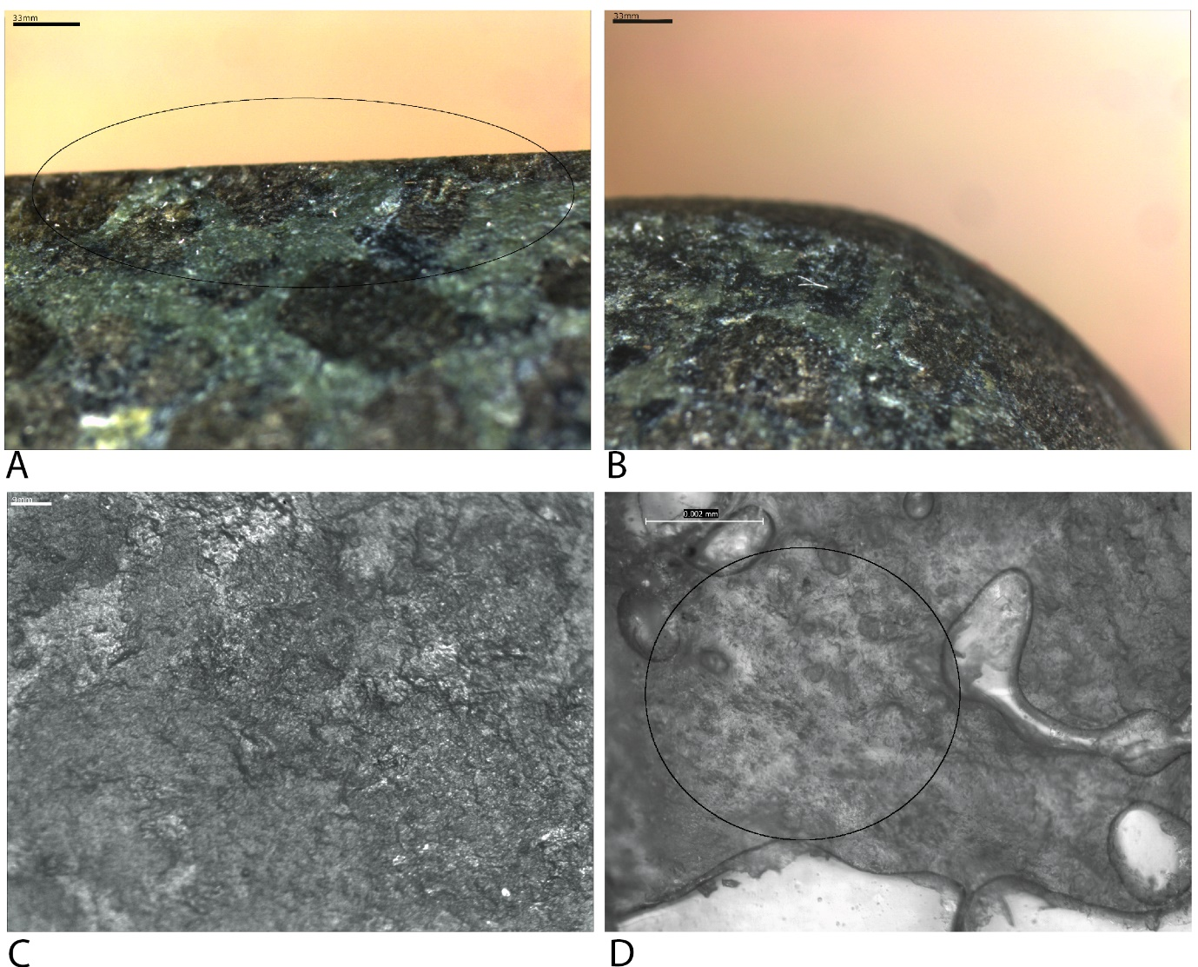
Fig 46. Use-wear after one-thousand strikes during splitting wood with a wedge.

One-thousand-five-hundred strikes
The penultimate pause during the experiment occurred at 1500 strikes. The log was not split, and the hole increased in width and depth slightly. Small pits were visible macroscopically up to 20mm from the tip, and larger pits were visibly spread evenly along the tip. Analysis under a stereomicroscope revealed pits on the blade edge were close in density and extended 20-25mm from the blade tip. The further away from the tip, the pits were less developed, being more superficial, narrow and less dense. The more developed pits on the tip were larger and in wide clusters that have associated microfractures within them. The high topography surrounding the pits and clusters on the tip were more heavily rounded. The striations at this stage overlapped to a greater extent, with many crossing diagonally over one another, particularly in the centre of the blade edges. Grain removal pits on the butt were denser and were associated with overlapping parallel striations of equal density. Clusters of pits became much wider and combined to make much larger clusters. Larger areas of crushed stone grains were also present centrally while smaller microfractures were still visible within the clusters of pits. Rounding of the higher topography was present on the blade tip and butt.
Metallographic microscopic analysis of the casts revealed larger patches of domed polish covering the casts from the blade tip and edges and the butt, with a close density, partial linkage and a patchy development. Clear directionality and associated embedded close density parallel striations and loose micropits remained the same as the previous pause.
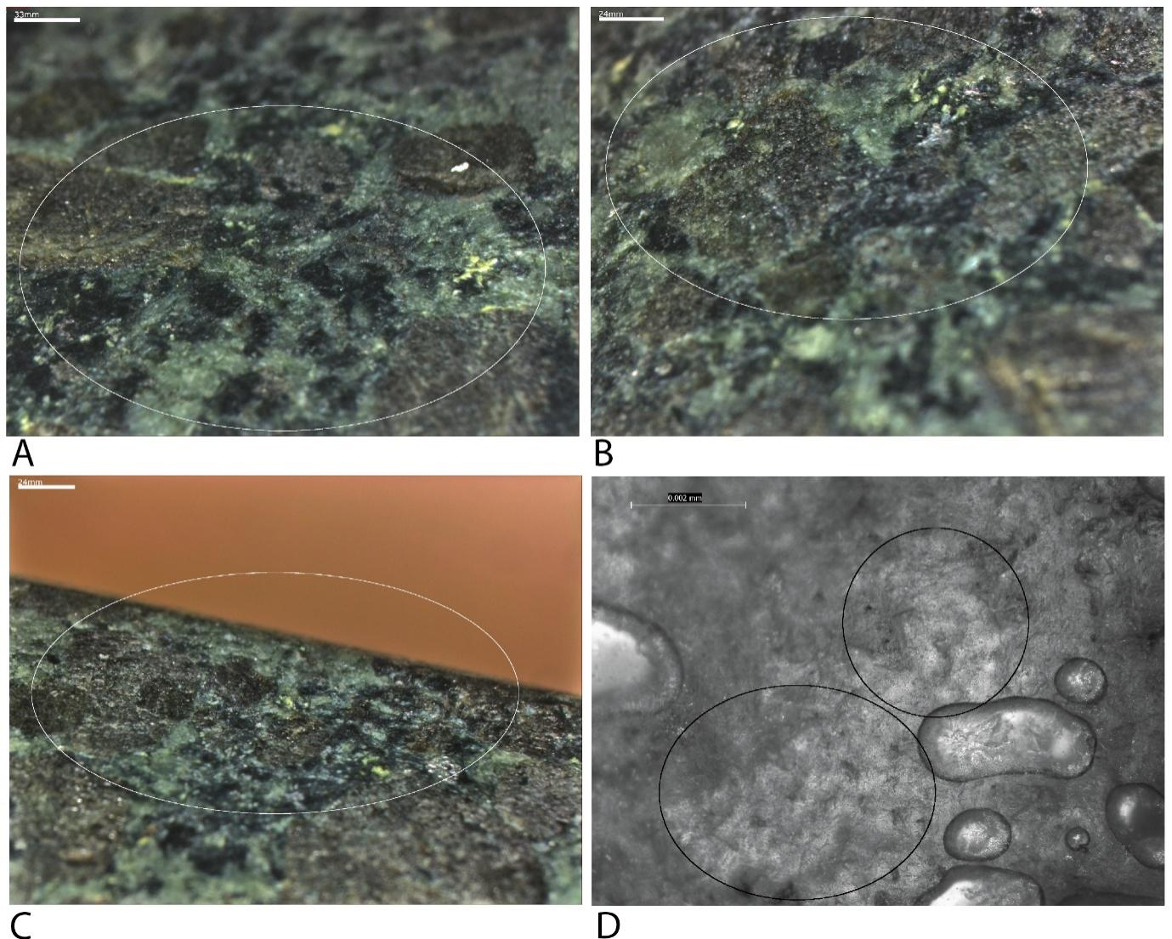
Fig 47. Use-wear after one-thousand-five-hundred strikes during splitting wood with a wedge.

Two-thousand strikes
The final pause occurred at the end of the experiment at 2000 strikes. A split did not occur at any point during the experiment. By 2000 strikes the hole created in the log was again wider and longer, remaining with a V-shaped profile. It had a depth of 30mm and a length of 100mm. Macroscopically the pits on the blade tip and edge were evident. Analysis of the axe-hammer under a stereomicroscope revealed that the pits extended 30mm from the blade edge and remained small. Larger pits were present on the tip and the blade edge directly next to the tip where pit clusters also increased in size where the pits were most dense. In these areas, the pits are close to dense in density. The remaining pits had a close density with those furthest away from the tip (between 25-30mm) being sparse to close in density. The associated overlapping striations also extend up to 30mm from the tip. They are intermediate and range in length from small to medium and were deeper in the centre of the blade edges. The pits and striations were most dense at the cornered of the blade edges where rounding is also most prevalent. Irregular patches of fractured stone grains, 5x5mm, create a frosted appearance. They are located centrally on the blade edges and were associated with deep striations.
The use-wear on the butt was also denser and greater in quantity. The clusters of pits combined to create two large clusters covering most of the butt. Pits combined to make much larger pits and microfractures covered the clusters with a close density. Larger areas of crushed stones grains existed centrally.
Analysis of the casts under a metallographic microscope revealed patches of domed polish covering the casts with clear directionality. On the blade, the patches were close to one another with a patchy development; the domed grains within the patches were partially connected/linked. The patches were smaller than at 1500 strikes due to the increased grain removal interrupting the development of polish. Mixtures of smaller and larger patches of domed polish were present across the centre of the butt with a patchy development and partial linkage. Dense micro-removals and embedded parallel striations on both the blade and butt follow the directionality of the polish, overlapping occasionally. By 2000 strikes the higher topography of the domed polish in all locations was smooth and more reflective than the surrounding areas from increased contact with the contact material.
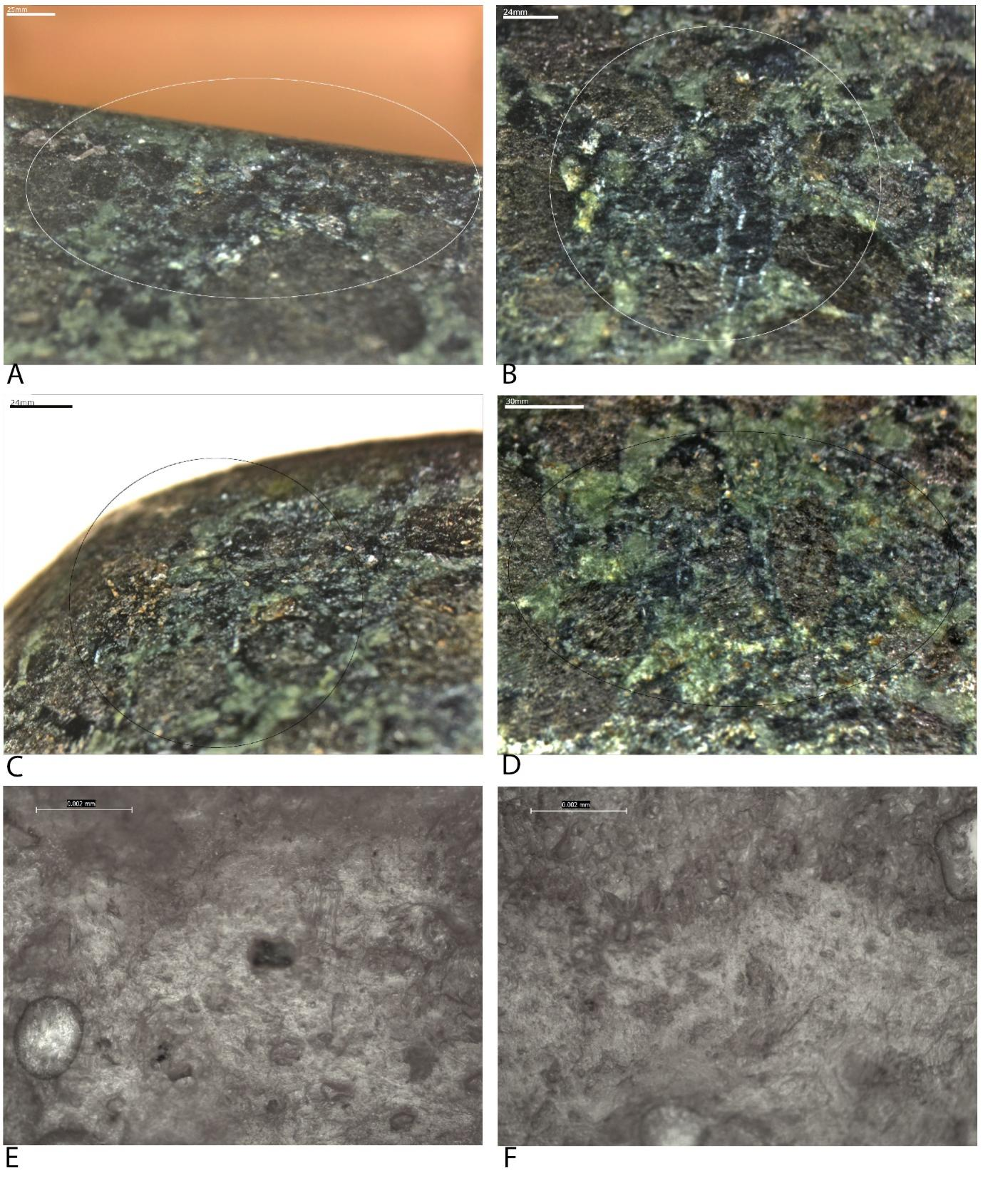
Fig 48. Use-wear after two-thousand strikes during splitting wood with a wedge.

Wear development related to manufacture
Low Magnification: As with the other replicas, within the first 50 strikes the high topography of the blade began to be smoothed and rounded, thus reducing the angular edges of the manufacture striations and making the highly superficial manufacture pits almost invisible. The development of a pit group on the butt at 50 strikes cut through the manufacture traces, they occur at the point of the butt where the wooden hammer made contact, but we cannot rule out the amount or size of the pits being influenced by the angular striations and superficial pits present from manufacture. Continued use rounded and smoothed the both the manufacture and use wear on the blade and butt, created more levelled areas for wear development and reduced angular edges which increase the likelihood of future removals. The development of pits on the tip and blade edges began in areas away from the manufacture pits, by 100 strikes pits had joined the already highly rounded manufacture pits close to the centre of the blade tip and edge. By 1000 strikes the manufacture wear was highly smoothed and rounded, to the extent that it was barely discernible.
High Magnification: From 100 strikes the manufacture polish on the blade and butt is interrupted by granular polish on top of and around the manufacture polish which is also smoothed and rounded in areas. Throughout use the production polish was separated and reduced from grain and flake removals as well as being smoothed and rounded and connected to newly formed polish in areas around the initial manufacture polish. The subsequent polish did not reflect the shape or orientation of the manufacture polish.

