
nature climate change

Article
https://doi.org/10.1038/s41558-026-02557-5

Biodiversity implications of land-intensive carbon dioxide removal

Received: 14 April 2025
Accepted: 8 January 2026
Published online: 30 January 2026


Check for updates
Ruben Prütz ^{1,2,3} , Joeri Rogelj ^{3,4,5}, Gaurav Ganti ^{1,2,4,6}, Jeff Price ⁷,
Rachel Warren ⁷, Nicole Forstenhäusler ⁷, Yazhen Wu ⁴,
Andrey Lessa Derci Augustynczik ⁴, Michael Wögerer ⁴, Tamás Krisztin ⁴, Petr Havlík ⁴, Florian Kraxner ⁴, Stefan Frank ^{4,8}, Tomoko Hasegawa ^{9,10,11}, Jonathan C. Doelman ^{12,13}, Vassilis Daioglou ^{12,13}, Florian Humpenöder ², Alexander Popp ^{2,14} & Sabine Fuss ^{1,2}

Pathways consistent with global climate objectives typically deploy billions of tonnes of carbon dioxide removal (CDR) from land-intensive methods such as forestation and bioenergy with carbon capture and storage. Such large-scale deployment of land-intensive CDR may have negative consequences for biodiversity. Here we assess scenarios across five integrated assessment models and show that scenarios consistent with limiting warming to 1.5 °C allocate up to 13% of global areas of high biodiversity importance for land-intensive CDR. These overlaps are distributed unevenly, with higher shares in low- and middle-income countries. Understanding the potential conflicts between climate action and biodiversity conservation is crucial. An illustrative analysis shows that
if current biodiversity hotspots were protected from land-use change, over half the land allocated for forestation and bioenergy with carbon capture and storage in the assessed scenarios would be unavailable unless synergies between climate and conservation goals are leveraged. Our analysis also indicates CDR-related biodiversity benefits due to avoided warming.

As global climate action remains insufficient^{1,2}, and in light of the soon-exhausted remaining carbon budget for at least a 50% chance of staying below 1.5 °C of global warming³, carbon dioxide removal (CDR) is gaining political attention. Modelled pathways that outline how global warming could be limited to less than 2 °C or 1.5 °C largely depend on CO₂ removals from afforestation and reforestation as well as from bioenergy with carbon capture and storage (BECCS)^{4,5}. These CDR options are land intensive, and their gigatonne-scale deployment
may come with severe sustainability risks^{6–8}, including risks to biodiver-sity, if implemented poorly⁹. Understanding the potential biodiversity implications is crucial to enable just climate action that fosters syner-gies between climate change mitigation and biodiversity conservation, rather than falling into the trap of environmental problem shifting¹⁰. Climate change mitigation pathways generated by integrated assessment models (IAMs) play a key role in informing policymakers about the effectiveness and implications of climate policy choices¹¹.

¹Geography Department, Humboldt-Universität zu Berlin, Berlin, Germany. ²Potsdam Institute for Climate Impact Research, Member of the Leibniz Association, Potsdam, Germany. ³Grantham Institute for Climate Change and the Environment, Imperial College London, London, UK. ⁴International Institute for Applied Systems Analysis, Laxenburg, Austria. ⁵Centre for Environmental Policy, Imperial College London, London, UK. ⁶IRI THESys, Humboldt-Universität zu Berlin, Berlin, Germany. ⁷Tyndall Centre for Climate Change Research, University of East Anglia, Norwich, UK. ⁸Institute of Sustainable Economic Development, BOKU University, Vienna, Austria. ⁹Department of Environmental Engineering, Kyoto University, Kyoto, Japan. ¹⁰Social Systems Division, National Institute for Environmental Studies, Tsukuba, Japan. ¹¹Research Organization of Science and Technology, Ritsumeikan University, Kusatsu, Japan. ¹²PBL Netherlands Environmental Assessment Agency, The Hague, the Netherlands. ¹³Copernicus Institute of Sustainable Development, Utrecht University, Utrecht, the Netherlands. ¹⁴Faculty of Organic Agricultural Sciences, University of Kassel, Witzenhausen, Germany. e-mail: ruben.pruetz@pik-potsdam.de

However, implications for biodiversity have not been accounted for in the previous generations of pathways¹². Previous studies have already started to assess mitigation-related biodiversity implications—some with an explicit focus on implications of afforestation, bioenergy or BECCS^{8,13–19}. Existing studies, assessing changes to species richness due to afforestation, bioenergy or BECCS, mostly rely on a single model framework (for example, refs. 13–16), and consider between 5,500 and 25,000 terrestrial vertebrate and plant species. Multimodel stud-ies assessing land use-related implications for biodiversity exist^{20–23}; however, they are largely without an explicit focus on CDR, which is a key driver of future land-use change.
Three central entry points arise to explore biodiversity implica-tions more comprehensively: (1) assessing consensus across multiple IAM frameworks concerning interregional differences in CDR-related biodiversity implications, (2) increasing the number and diversity of considered species (beyond vertebrates and plants) and (3) illustrating implications of biodiversity conservation for CDR deployment^{13,20}.
Here, we perform a multimodel assessment of existing, cost-effective mitigation scenarios to explore land allocation for forestation (afforestation, reforestation or forest restoration) and bioenergy crops (for BECCS) within areas of high biodiversity impor-tance, considering around 135,000 terrestrial species (fungi, plants, invertebrates and vertebrates) and more than 170 hotspots. Specifi-cally, we focus on CDR land allocation within climate refugia (defined as areas where at least 75% of the baseline species richness will remain for a given global warming level)^{24,25} and within terrestrial biodiversity hotspots (characterized by exceptionally high species richness, includ-ing endemic and rare species)²⁶ to unveil location-specific overlap. We focus on CDR-related biodiversity implications owing to the key role of CDR in driving land-use change in the assessed scenarios (as shown in the Supplementary Information). We complement this main analy-sis with an assessment of land use-related biodiversity implications beyond CDR (Supplementary Information).
We show the magnitude of CDR land allocation within climate refu-gia throughout the twenty-first century for three warming scenarios: current policies, a 2 °C scenario and a 1.5 °C scenario (Table 1). We then explore the geographic distribution of CDR land allocation within climate refugia and evaluate agreement across five considered model frameworks to identify deployment areas within climate refugia and bio-
Table 1 | Overview of scenarios and biodiversity metrics used in the main analysis
Scenarios Description
1.5 °C scenarios The 1.5 °C scenarios (Fig. 1) are based on RCP1.9.
This representative concentration pathway was combined with two shared socioeconomic pathways: a world shifting towards sustainability (SSP1) and a world following historical patterns (SSP2)^{79,80}. RCP1.9 was considered to show CDR-related biodiversity implications of a highly ambitious mitigation scenario.

2 °C scenarios
The 2 °C scenarios (Fig. 1) are based on RCP2.6 and two socioeconomic pathways (SSP1-2)^{80,81}. The analysis underlying Figs. 2–4 is based on SSP2-26, a 2 °C scenario in which socioeconomic development follows historical patterns, while global warming is limited to less than
2 °C, with median peak warming of 1.8 °C across the five considered model frameworks⁴. SSP2-26 was used as a focus scenario as it fulfils this analysis’ data availability requirements for the three main model frameworks.
Current policies Current policies are roughly in line with RCP4.5,
based on the socioeconomic pathways SSP1-3.
SSP3 represents a world characterized by resurgent nationalism and regional rivalry. RCP4.5 exceeds 2 °C but stays below 3 °C throughout the twenty-first century^{1,4,81}. This scenario is shown in Fig. 1 to highlight CDR-related biodiversity implications of a mitigation scenario based on the current level of political ambition.

Biodiversity Description
Climate refugia This metric describes, for various global warming levels, areas within which climatic conditions would still be suitable for at least 75% of the species initially present, considering around 135,000 terrestrial species (fungi, plants, invertebrates and vertebrates)^{24,25,82,83}. In Fig. 1, this metric is always matched to the scenario warming for a given time step. In Figs. 2–4, this metric is used to depict climate refugia resilient to 1.8 °C (median peak warming of the focus scenario SSP2-26 across the five considered models).
Biodiversity
This metric is based on the IPCC AR6 WGII definition of
hotspots (current) biodiversity hotspots, combining WWF G200 data on ecoregions for conservation⁸⁴, inhabiting exceptional levels of biodiversity richness and endemism, and data on biodiversity hotspots for conservation priorities^{85–88}. This metric is used in Fig. 4.

diversity hotspots that require particular policy attention. Ultimately, we highlight how much of the allocated land would not be available for land-intensive CDR deployment if the goal of halting the loss of areas of high biodiversity importance were to be strictly enforced^{27,28}. Build-ing on our analysis findings, we discuss circumstances under which land-intensive forestation and BECCS will be ineffective and detrimental to biodiversity conservation and how focusing on the restoration of natural ecosystems could jointly achieve carbon sequestration and biodiversity conservation. Our discussion is informed by an illustrative
Biodiversity hotspots (resilient)
This metric combines current biodiversity hotspots and climate refugia areas resilient to 1.8 °C by looking at
the spatial intersection of these two metrics. Resilient biodiversity hotspots are hotspot areas resilient to global warming of 1.8 °C (median peak warming of the focus scenario SSP2-26 across the five considered models).
This metric is used in Figs. 3 and 4.

evaluation of potentially beneficial or likely harmful spatial overlaps between scenario-based CDR and areas of high biodiversity importance. We base our analysis on existing mitigation scenario data from the original Shared Socioeconomic Pathways (SSP) quantifications from the Asia–Pacific Integrated Model (AIM)^{29,30}, the Global Biosphere Man-agement Model (GLOBIOM)³¹ and the Integrated Model to Assess the Global Environment (IMAGE)^{32,33}. In addition, we consider data from the Global Change Analysis Model (GCAM)³⁴ (2020 SSP quantification) and the REMIND-MAgPIE integrated assessment modelling framework^{35,36} (original SSP quantification), insofar as these two models meet the data requirements for specific components of our analysis. The scenarios and biodiversity metrics used in this analysis are detailed in the Meth-
ods (for an overview, see Table 1).

Global implications of CDR deployment
We observe that the share of land-intensive CDR located within remain-ing climate refugia (while tracking warming-related refugia loss)
increases over time (Fig. 1a,b). The degree of overlap scales with the stringency of mitigation action: under current policies, the share of land-intensive CDR (forestation and BECCS combined) within climate refugia is consistently below 6%. This share increases to up to 9% in scenarios consistent with 2 °C of warming and 13% in those consistent with the 1.5 °C warming limit of the Paris Agreement. While ambitious mitigation scenarios result in a marked decrease in the warming-related climate refugia loss compared with the current policies scenario^{24,25}, their higher dependence on land-intensive CDR results in a relative increase in spatial overlap with climate refugia.
In the evaluated scenarios, markedly more land within climate refugia areas is allocated for forestation than for the conversion to bioenergy cropland (for BECCS). While global CDR land allocation within remaining climate refugia is negligible in 2020, it increases towards the end of the century to up to around 11% for forestation and up to around 4% for the conversion to bioenergy cropland (for BECCS) in the 1.5 °C scenarios, albeit with distinct model fingerprints (Fig. 1a).

a 1.5 °C 2 °C Current policies b c

Global (forestation)
12

9

6
Share of remaining refugia allocated for CDR (%)
AIM

3

0

12

9
GLOBIOM

6

3

0

12

9
IMAGE

6

3

0
Global (BECCS)
12

9

6

3

0

12

9

6

3

0

12

9

6

3

0
Annex I (forestation)
16

12

8

4

0

16

12

8

4

0

16

12

8

4

0
Non-Annex I (forestation)
16

12

8

4

0

16

12

8

4

0

16

12

8

4

0

15
10
Share of remaining refugia conserved and allocated due to CDR (%) ('net' effect = avoided warming – land allocation)
5
AIM
0
−5
−10

15
10
GLOBIOM
5
0
−5
−10

15
10
5
IMAGE
0
−5
−10
Global (both)

2020 2100
2020 2100 2020 2100
2020 2100
2020 2100

Fig. 1 | Global climate refugia implications of CDR deployment (2020–2100). a, The global share of remaining (remaining per warming level per time step) climate refugia allocated for forestation (afforestation, reforestation and forest restoration) and BECCS. b, The share of remaining climate refugia allocated
for forestation across Annex I and non-Annex I countries. c, The ‘net’ effect of forestation and crop-based BECCS on climate refugia by showing the share of remaining climate refugia that would be conserved owing to CDR-related avoided warming, minus climate refugia land allocated for CDR deployment (assuming fully negative effects). Scenarios correspond to RCP1.9 (1.5 °C scenario), RCP2.6 (2 °C scenario) and RCP4.5 (current policies). The line plots show the median and the full range across the considered shared socioeconomic pathways (SSP1-3).
Uncertainty ranges also span the potential outcomes from no climate refugia recovery to full recovery after peak warming in the context of overshoot. For each
time step, climate refugia data are matched to the warming level of the respective scenario and model framework to dynamically track how much climate refugia
is remaining. The underlying global warming information is based on median estimates of the GSAT from the reduced-complexity earth system model MAGICC v7.5.3 and the AR6 best estimate for the TCRE (for details, see Methods). In c, the
1.5 °C scenario for AIM is not shown owing to lacking data on CO₂ removal from forestation. GCAM and REMIND-MAgPIE were not considered for this analysis component as these two models do not report the required AR6 CO₂ removal data or partly lack SSP–RCP combinations. The results for the share of remaining climate refugia allocated for crop-based BECCS across Annex I and non-Annex
I countries as well as the warming-related CDR implications are shown in the Supplementary Information.

The AIM model allocates considerably more remaining climate refugia for forestation than GLOBIOM and IMAGE. The scale of land allocation for bioenergy crops (for BECCS) within globally remaining climate refugia is relatively consistent across the three models.
To illustrate the potential ‘net’ biodiversity effect, we subtract the share of remaining climate refugia allocated for CDR deployment from the CDR-related avoided warming loss of climate refugia (tak-ing a conservative approach by assuming fully negative biodiversity effects of CDR-related land allocation). The estimated ‘net’ biodiver-sity effect is highly uncertain with a tendency towards ‘net’ benefits (Fig. 1c). However, the degree to which CDR deployment may reduce warming-related climate refugia loss (up to around 25% avoided warm-ing loss) strongly depends on underlying assumptions about climate refugia recovery after peak warming in the context of temperature overshoot (Methods and Supplementary Information). Assuming no climate refugia recovery after peak warming strongly reduces the potential of CDR to avoid long-term climate refugia loss, thereby reduc-ing the potential ‘net’ benefit of CDR deployment or even leading to ‘net’ harm (Fig. 1c).

Regional patterns and hotspots
The global results mask important regional differences in the overlap between CDR on land and climate refugia. We assess these differences through the lens of the annex-based classification in the United Nations Framework Convention on Climate Change (UNFCCC) (Methods). Up to 15% of the remaining climate refugia in non-Annex I countries is
allocated for forestation compared with around 7% in Annex I coun-tries, highlighting a dual inequity. These regions, which are often least responsible for causing climate change, face a dual challenge of pre-serving biodiversity and contributing CO₂ removals via forestation to help reduce the impacts of climate change (Fig. 1). No such pattern was observed for the BECCS (Supplementary Information).
To diagnose regional model fingerprints more granularly, we select a focus scenario (SSP2-26) that has the necessary information across three of the five models (Methods), identify a common CO₂ removal level (6 GtCO₂) and set the climate refugia extent to 1.8 °C of global warming, which roughly corresponds to the median peak warm-ing of the focus scenario across the five considered models. Holding these elements consistent across the models allows us to consistently tease out country-level and regional differences.
Generally, we observe notable regional and country-level differ-ences across the considered models (Fig. 2). At the country level, sub-stantial shares of national refugia are allocated for CDR deployment, even at moderate CO₂ removal levels of 6 GtCO₂. High relative allocation shares are especially observed in countries with very little remaining climate refugia areas, even when CDR land allocation is low in absolute terms. Countries with largely intact climate refugia areas at 1.8 °C, such as the USA, see comparatively low relative CDR land allocation within national refugia areas, despite large absolute CDR deployment.
For all five models, we identify several regions where at least two models deploy CDR within 1.8 °C-resilient climate refugia for SSP2-26 in 2100 (variations are presented in the Supplementary Information).

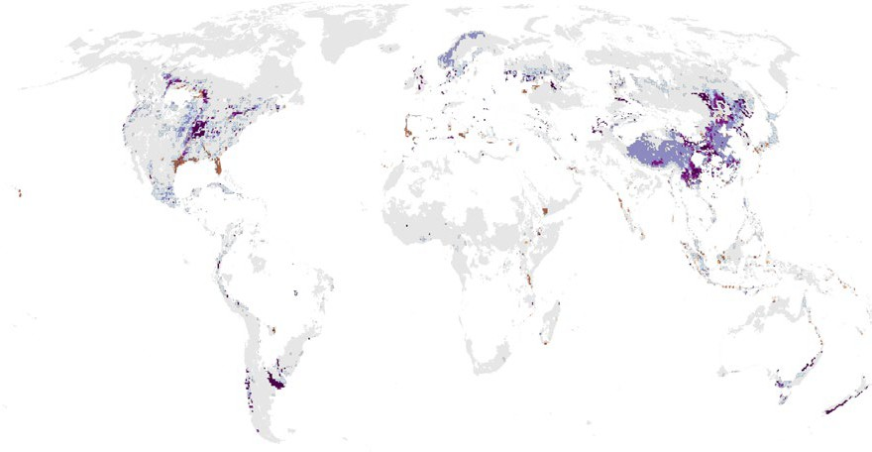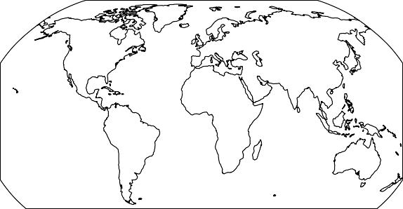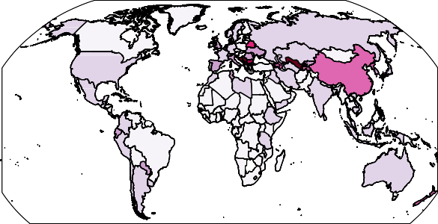
a
AIM SSP2-26
AIM SSP2-26
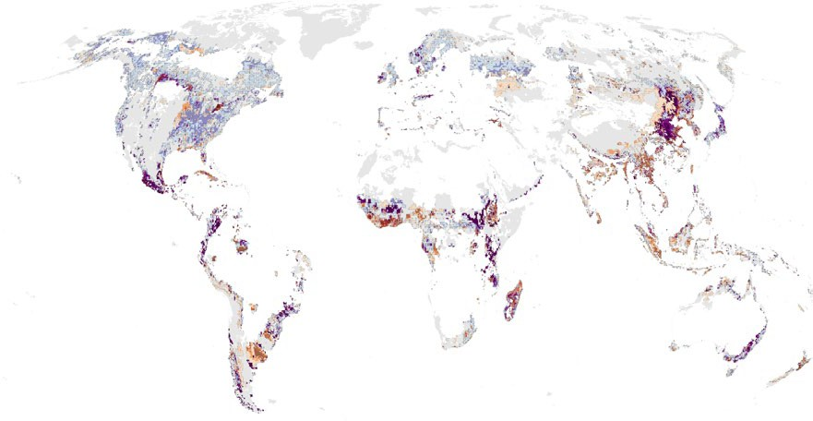
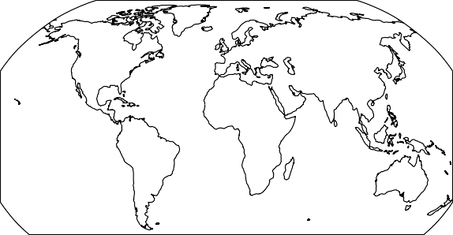
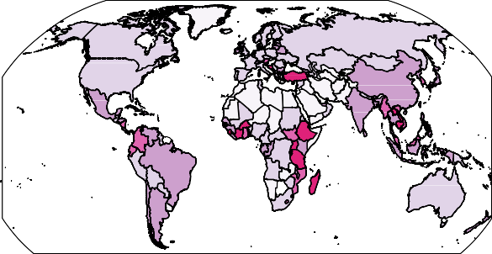
b
GLOBIOM SSP2-26
GLOBIOM SSP2-26

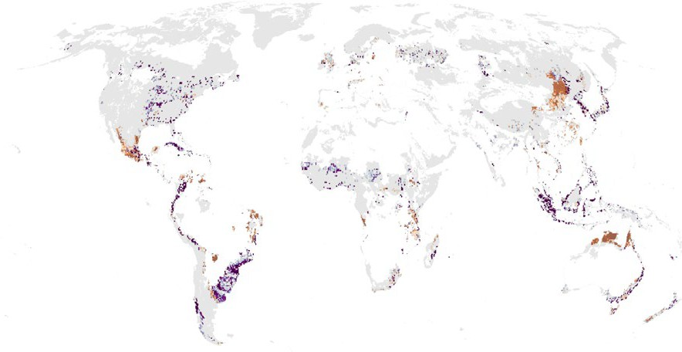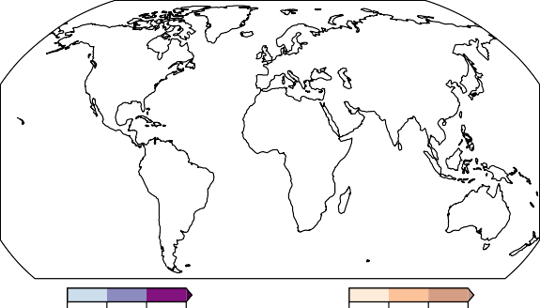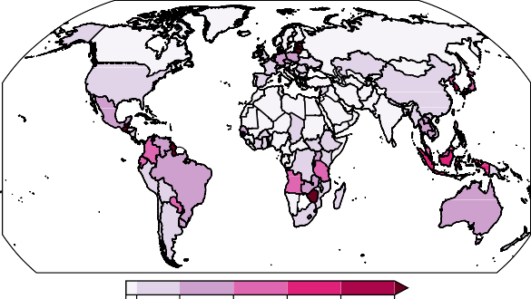
c
IMAGE SSP2-26
IMAGE SSP2-26

1 5 10 20
Forestation per grid cell for removals
of 3 GtCO₂ (%)
1 5 10 20
BECCS per grid cell for removals of 3 GtCO₂ (%)
0 1 5 10 15 20 25
Share of national refugia covered by forestation and BECCS for removals of 6 GtCO₂ (%)

Fig. 2 | Spatial land allocation for CDR deployment within climate refugia resilient to 1.8 °C. The figures are based on the focus scenario SSP2-26 and show the results for an annual CO₂ removal of 6 GtCO₂. The remaining climate refugia at 1.8 °C are shown in grey in the left column. a–c, The spatially explicit (left column) and country-level (right column) allocation of climate refugia for CDR deployment is shown for the three model frameworks AIM (a), GLOBIOM
(b) and IMAGE (c). Global warming of 1.8 °C roughly corresponds to the median peak warming of the focus scenario SSP2-26 across the five model frameworks and is therefore chosen as the warming level for climate refugia. The CDR land allocation in all maps in this figure corresponds to the CO₂ removal of 3 GtCO₂ via
forestation (afforestation, reforestation and forest restoration) and 3 GtCO₂ via crop-based BECCS as this is the highest CO₂ removal level reached by both CDR options across all three model frameworks in SSP2-26, allowing for a consistent comparison across CDR options and models. GCAM and REMIND-MAgPIE were not considered for this analysis component as these two models do not report the required AR6 CO₂ removal data. The robustness of the results presented here is evaluated in the Supplementary Information. Information on CO₂
removal scaling and related land requirements is provided in the Supplementary Information. Basemaps were generated in Cartopy using Natural Earth data⁸⁹.

This model consensus exercise highlights areas of particular impor-tance where potential CDR–biodiversity conflicts or synergies may arise (Fig. 3). The areas of model consensus primarily lie within Eastern China (for forestation), parts of the USA, West Africa (for BECCS) and Indo-Pacific Island states.
A majority of model consensus areas lie in regions that may not be suitable for land-intensive CDR deployment. For forestation, this is the case in climate refugia areas without reforestation potential³⁷, while for BECCS, this is the case in areas of bioenergy cropland inter-ference with biosphere integrity^{8,38}. In a few cases, we also identify model consensus areas, where CDR deployment may be beneficial to biodiversity (Fig. 3). However, CDR deployment in such potentially suit-able areas can still result in negative outcomes if mode and intensity of implementation are not sensitive to the local context or if deployment
negatively affects aspects such as species composition, phenology or habitat connectivity^{39,40}. We stress that our evaluation of potentially beneficial or likely harmful implications is for illustrative purposes to provide a first-order indication of the effect direction and that our approach is conservative as it considers exclusion criteria beyond biodiversity (Methods). Generally, more granular analyses are required to adequately assess the location-specific suitability of CDR deploy-ment⁴¹. Particular attention also needs to be paid to 1.8 °C-resilient biodiversity hotspots, in which at least two of the five models deploy CDR (Fig. 3)—many of these consensus regions are today composed of croplands, forests and shrublands^{42,43}. While land-intensive CDR is a key driver of land-use change in the assessed scenarios (Supplementary Information), non-CDR drivers of land-use change, such as urban⁴⁴ or cropland expansion⁴⁵, may also affect biodiversity. Information

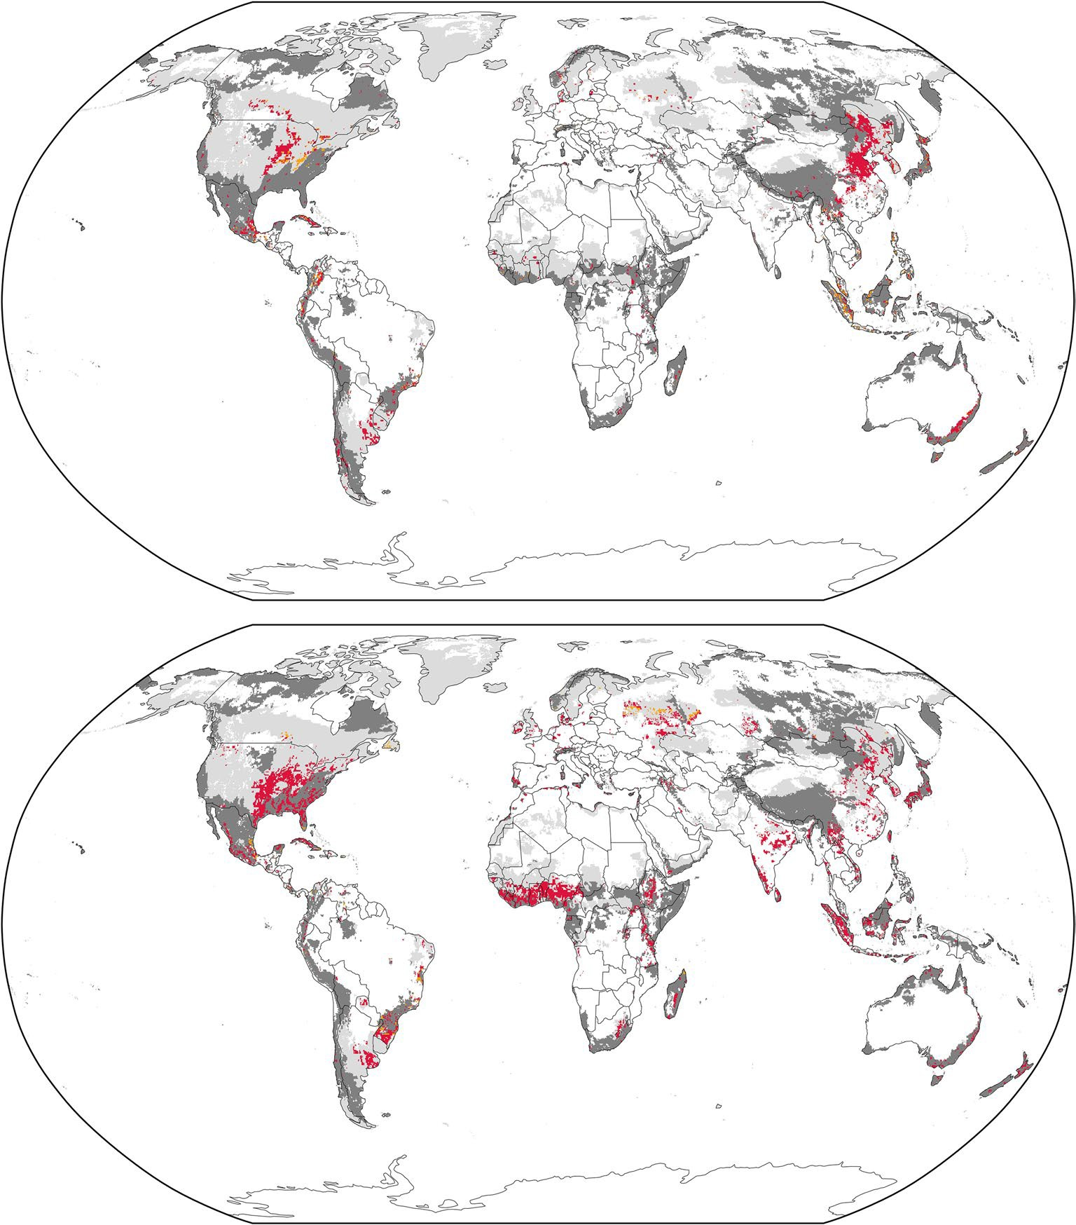
a
Forestation
Potentially beneficial Likely harmful Refugia at 1.8 °C
Hotspot resilient to 1.8 °C
SSP2-26 2100
Minimum cell share: 10% Model agreement: two of five
b
BECCS
Potentially beneficial Likely harmful Refugia at 1.8 °C
Hotspot resilient to 1.8 °C
SSP2-26 2100
Minimum cell share: 10% Model agreement: two of five

Fig. 3 | Model agreement on land allocation for CDR deployment within biodiversity areas. The figures are based on the focus scenario SSP2-26 in 2100 and the five considered model frameworks AIM, GCAM, GLOBIOM, IMAGE
and REMIND-MAgPIE. The remaining refugia at 1.8 °C are shown in light grey, whereas refugia areas that are also resilient biodiversity hotspots are shown in dark grey. CDR land allocation within refugia areas that could potentially benefit from such land interventions is shown in yellow, while refugia areas that such land interventions would likely harm are shown in red. The CDR land allocation
outside of refugia areas is not shown. At least two out of the five considered models need to allocate at least 10% of a grid cell surface for CDR deployment within a climate refugia area to be mapped in this figure. a, The results for forestation (afforestation, reforestation and forest restoration). b, The results for BECCS. Supplementary results, based on alternative minimum thresholds for model agreement and relative cell allocation are presented in the Supplementary Information. Basemaps were generated in Cartopy using Natural Earth data⁸⁹.

on the scenario-based biodiversity impacts of land-use types beyond forestation and BECCS is provided in the Supplementary Information.

Implications of conservation
While land-intensive CDR is not per-definition detrimental to biodi-versity, large-scale allocation of areas of high biodiversity importance may conflict with internationally agreed targets for biodiversity con-servation, which imply halting land-use change-related biodiversity loss. The 2030 Agenda for Sustainable Development has set the goal of halting “(…) the loss of biodiversity and, by 2020, protect and prevent the extinction of threatened species” (SDG 15.5)²⁷. The more recent Kunming-Montreal Global Biodiversity Framework reiterates this target by aiming to “(…) bring the loss of areas of high biodiversity importance, including ecosystems of high ecological integrity, close to zero by 2030” (target 1)²⁸.
To illustrate the potential implications of these targets for CDR deployment, we omit areas of high biodiversity importance from CDR land allocation. As areas of high biodiversity importance are not clearly defined, we use three biodiversity metrics (defined in Table 1) to esti-mate how much less land for CDR deployment would be available if areas of high biodiversity importance were strictly excluded from allocation in the 2 °C focus scenario (SSP2-26). If current biodiversity hotspot areas were excluded from CDR deployment, more than 50% (median estimate) of the scenario-based land allocated for foresta-tion and BECCS would not be available by 2050 (Fig. 4). The share of CDR land not available for allocation is largely stable across the three evaluated time steps, underlining that potential CDR deployment constraints owing to interference with biodiversity conservation may arise as early as 2030. However, models could still allocate land in other less cost-effective places, resort to alternative, less land-intensive

Forestation BECCS Both AIM GCAM GLOBIOM IMAGE REMIND-MAgPIE

70
Reduction in CDR land available for allocation in SSP2-26 (%) (median and individual model estimate)

60

50

40

30

20

10

0
2030 2050 2100
Criteria A: no CDR within current biodiversity hotspots

2030 2050 2100
Criteria B: no CDR within
1.8 °C-resilient climate refugia

2030 2050 2100
Criteria AB: no CDR within
1.8 °C-resilient biodiversity hotspots

Fig. 4 | Share of allocated land not available for CDR deployment under strictly enforced biodiversity conservation. The results are shown for forestation (afforestation, reforestation and forest restoration), bioenergy cropland (for BECCS) and for both CDR options together for the years 2030, 2050 and 2100, based on three different exclusion criteria. The first criterion (A) excludes land from CDR allocation that is a biodiversity hotspot, regardless of the hotspot’s
resilience to 1.8 °C. The second criterion (B) excludes land from CDR allocation that is a climate refugia resilient to 1.8 °C, irrespective of whether these refugia areas are biodiversity hotspots. The third criterion (AB) excludes land from CDR allocation that is a climate refugia resilient to 1.8 °C while also being a
biodiversity hotspot. The robustness of the results presented here is evaluated in the Supplementary Information.

mitigation options or pursue more biodiversity-sensitive deployment approaches, as more recent IAM-based analyses partly already do^{12,46,47}. Also, more granular differentiations between afforestation, reforesta-tion and forest restoration within areas of high biodiversity importance could further ease the illustrated land constraint, for example, by allow-ing CDR in areas with reforestation potential where biodiversity may benefit from deployment (Supplementary Information).

Discussion
In this study, we explore potential biodiversity implications of future land conversion for forestation and bioenergy crops (for BECCS) in deep mitigation pathways from the original SSP quantification. CO₂ removals from forestation and BECCS could reduce long-term warming-related climate refugia loss by up to around 25% in the evaluated scenar-ios. However, the effectiveness of such CO₂ removals for reducing warming-related refugia loss is highly uncertain and contingent on the ability of climate refugia to recover from temperature overshoot. Higher deployment of land-intensive CDR in the evaluated scenarios results in increased allocation of remaining climate refugia. We show that up to 11% of global remaining climate refugia areas may overlap with areas selected for forestation (around 4% overlap with bioenergy cropland for BECCS), in scenarios consistent with limiting warming to
1.5 °C in 2100. While this overlap does not automatically imply a loss of climate refugia, the assessed magnitude of refugia allocation is concern-ing given the sensitivity of species response to human disturbances. Even a species loss of 5% could be catastrophic for global ecosystems⁴⁸. Already at a moderate annual CO₂ removal rate of 6 GtCO₂, substan-
tial shares of peak warming resilient climate refugia would be allocated for forestation and BECCS in some countries, while the exact alloca-tion shares are highly uncertain. Importantly, the share of remaining climate refugia allocated for CDR deployment differs largely between regions, with disproportionate allocation in UNFCCC non-Annex I countries, which are largely non-high-income countries^{49–53}. Given the uneven distribution of responsibilities and capabilities to address both the climate crisis and the biodiversity crisis, and in the light of the
biodiversity finance gap of US$700 billion per year²⁸, Annex I countries are obliged to substantially increase biodiversity-related financial flows to non-Annex I countries.
Strictly enforcing area-based biodiversity conservation, as agreed in international policy frameworks, could increase the challenge to allocate land for CDR deployment, as more than 50% (median estimate) of the land for scenario-based forestation and BECCS would not be available for allocation when excluding current biodiversity hotspots. While IAMs can design new scenarios that achieve similar CO₂ removal levels without interfering with biodiversity, the overall competition for land may increase, especially in light of other non-biodiversity-related CDR constraints such as fire risk⁵⁴, food security^{55,56} and planetary boundaries other than biosphere integrity⁸, which are not the focus of this study.
However, CDR is not per-definition detrimental to biodiversity and prioritizing biodiversity conservation helps to protect existing carbon pools and can promote additional carbon sequestration^{57–59}. While mis-informed tree planting harms biodiversity in many regions⁶⁰, carefully increasing forest cover can support habitat conservation⁶¹. In degraded ecosystems, which have historically been forest land, forest restoration and reforestation with highly diverse and locally adapted plant species can increase the extent and connectivity of habitats and therefore sup-port biodiversity conservation while sequestering carbon^{26,62}. Such approaches to carbon sequestration are not only favourable from a biodiversity but also from a mitigation standpoint as more carbon is sequestered⁶² and carbon stored in natural ecosystems is more resilient to climate change than plantation forests based on fast-growing mono-cultures⁶³. We have indicated where such reforestation and restoration potential may be realized within the identified scenario-based model consensus regions of CDR deployment, providing an entry point for location-specific climate policy planning. Still, nuanced assessments of reforestation potential in such areas are needed to protect intact grassy biomes, which have partly been misinterpreted as degraded forests in the past⁶⁰. Natural areas that have historically not been for-est land, such as savannas or grassland, are unsuitable for forest-based

CDR, as deployment would likely yield negative biodiversity effects^{26,62} and increase vulnerability to disturbances such as fire⁶³. Many of the consensus regions of scenario-based forestation (and more so the land allocation fingerprints of the individual models) fall into such likely unsuitable areas^{8,37,38,64}.
Mostly negative implications for biodiversity are expected from the use of bioenergy crops for BECCS, and irrigation-related sustainability concerns may further increase land demand for bioenergy crops, inten-sifying pressure on biodiversity^{65,66}. Allocating abandoned cropland for BECCS may be favourable^{26,67} but does not guarantee sustainable outcomes⁴¹. Moreover, perennial bioenergy crops on intensively farmed cropland may be more sustainable than annual bioenergy crops^{68,69}. Using biogenic waste and residues as feedstock for BECCS could reduce its additional land footprint. Also, BECCS may constrain warming-related biodiversity loss^{13,14}. However, the larger the dependence on forestation and BECCS, the less likely it would be that the potential land-related co-benefits can be realized, while preventing negative implications⁷.
Our illustrative analysis flags areas of high biodiversity importance that may be harmed by scenario-implied land-intensive CDR deploy-ment, calling for a careful assessment and prioritization of areas for which policy goals for climate action and biodiversity conservation can be aligned. Such an alignment is not only required to conserve biodiversity but also to protect carbon pools as biodiversity loss can trigger the release of carbon, leading to a lose–lose situation for the climate and biodiversity⁵⁷. Our illustrative indication of potentially beneficial and likely harmful model consensus areas for CDR land allo-cation pose an entry point for future IAM-based analyses to produce more biodiversity-sensitive mitigation scenarios.
While forestation and BECCS feature prominently in mitigation pathways^{4,5}, direct air carbon capture and storage has become another dominant option, and more IAMs model larger CDR portfolios, includ-ing enhanced weathering⁷⁰ or biochar⁷¹. Diverse CDR portfolios help reduce negative externalities^{70,72–74} by reducing the dependence on land-intensive CDR. Nevertheless, some of these newer CDR options are still nascent, costly or may also be associated with a considerable land footprint^{75,76}. Ensuring that CDR use is restricted to suit critical needs^{77,78} and drastically raising the ambition for near-term gross emis-sion reductions are key steps to avoid overreliance on land-intensive CDR and to avert negative implications for biodiversity. Ultimately, prioritizing the restoration of degraded ecosystems can partly alleviate negative implications by simultaneously supporting biodiversity con-servation and carbon sequestration while strengthening the climate resilience of ecosystems.

Online content
Any methods, additional references, Nature Portfolio reporting sum-maries, source data, extended data, supplementary information, acknowledgements, peer review information; details of author con-tributions and competing interests; and statements of data and code availability are available at https://doi.org/10.1038/s41558-026-02557-5.

References
- Rogelj, J. et al. Credibility gap in net-zero climate targets leaves world at high risk. Science 380, 1014–1016 (2023).
- Boehm, S. et al. State of Climate Action 2023 (World Resources Institute, 2023); https://doi.org/10.46830/wrirpt.23.00010
- Forster, P. M. et al. Indicators of global climate change 2023: annual update of key indicators of the state of the climate system and human influence. Earth Syst. Sci. Data 16, 2625–2658 (2024).
- Byers, E. et al. AR6 Scenarios Database. Zenodo https://doi.org/ 10.5281/zenodo.5886912 (2022).
- Riahi, K. et al. IPCC Climate Change 2022: Mitigation of Climate Change (eds Shukla, P. R. et al.) (Cambridge Univ. Press, 2022).
- Fuss, S. et al. Negative emissions—part 2: costs, potentials and side effects. Environ. Res. Lett. 13, 63002 (2018).

- Deprez, B. A. et al. Sustainability limits needed for CO₂ removal.
Science 383, 484–486 (2024).
- Braun, J. et al. Multiple planetary boundaries preclude biomass crops for carbon capture and storage outside of agricultural areas. Commun. Earth Environ. 6, 1–14 (2025).
- Pörtner, H. O. et al. IPCC Climate Change 2022: Impacts, Adaptation and Vulnerability (Cambridge Univ. Press, 2023); https://doi.org/10.1017/9781009325844.001
- Wood Hansen, O. & van den Bergh, J. Environmental problem shifting from climate change mitigation: a mapping review. Proc. Natl Acad. Sci. USA Nexus 3, pgad448 (2024).
- Vaidyanathan, G. Integrated assessment climate policy models have proven useful, with caveats. Proc. Natl Acad. Sci. USA 118, e2101899118 (2021).
- Soergel, B. et al. A sustainable development pathway for climate action within the UN 2030 agenda. Nat. Clim. Change 11, 656–664 (2021).
- Hirata, A. et al. The choice of land-based climate change mitigation measures influences future global biodiversity loss. Commun. Earth Environ. 5, 259 (2024).
- Hanssen, S. V. et al. Biomass residues as twenty-first century bioenergy feedstock—a comparison of eight integrated assessment models. Clim. Change 163, 1569–1586 (2020).
- Hof, C. et al. Bioenergy cropland expansion may offset positive effects of climate change mitigation for global vertebrate diversity. Proc. Natl Acad. Sci. USA 115, 13294–13299 (2018).
- Ohashi, H. et al. Biodiversity can benefit from climate stabilization despite adverse side effects of land-based mitigation. Nat. Commun. 10, 5240 (2019).
- Heck, V., Gerten, D., Lucht, W. & Popp, A. Biomass-based negative emissions difficult to reconcile with planetary boundaries. Nat. Clim. Change 8, 151–155 (2018).
- Azuero-Pedraza, C. G., Lauri, P., Lessa Derci Augustynczik, A. & Thomas, V. M. Managing forests for biodiversity conservation and climate change mitigation. Environ. Sci. Technol. 58, 9175–9186 (2024).
- Powell, T. W. R. & Lenton, T. M. Scenarios for future biodiversity loss due to multiple drivers reveal conflict between mitigating climate change and preserving biodiversity. Environ. Res. Lett. 8, 025024 (2013).
- Leclère, D. et al. Bending the curve of terrestrial biodiversity needs an integrated strategy. Nature 585, 551–556 (2020).
- Newbold, T. et al. Global effects of land use on local terrestrial biodiversity. Nature 520, 45–50 (2015).
- Powers, R. P. & Jetz, W. Global habitat loss and extinction risk of terrestrial vertebrates under future land-use-change scenarios. Nat. Clim. Change 9, 323–329 (2019).
- Jantz, S. M. et al. Future habitat loss and extinctions driven by land-use change in biodiversity hotspots under four scenarios of climate-change mitigation. Conserv. Biol. 29, 1122–1131 (2015).
- Warren, R., Price, J., Graham, E., Forstenhaeusler, N. & VanDerWal,
J. The projected effect on insects, vertebrates, and plants of limiting global warming to 1.5 °C rather than 2 °C. Science 360, 791–795 (2018).
- Price, J., Warren, R. & Forstenhäusler, N. Biodiversity losses associated with global warming of 1.5 to 4 °C above pre-industrial levels in six countries. Clim. Change 177, 47 (2024).
- IPCC Climate Change 2022: Impacts, Adaptation and Vulnerability (Cambridge Univ. Press, 2023); https://doi.org/ 10.1017/9781009325844
- Global Indicator Framework for the Sustainable Development Goals and Targets of the 2030 Agenda for Sustainable Development. A/RES/71/313 (United Nations, 2017).
- Kunming–Montreal Global Biodiversity Framework. CBD/COP/ DEC/15/4 (CBD, 2022).

- Fujimori, S. et al. Downscaling Global Emissions and Its Implications Derived from Climate Model Experiments. PLoS One 12, e0169733–e0169733 (2017).
- Hasegawa, T., Fujimori, S., Ito, A., Takahashi, K. & Masui, T. Global land-use allocation model linked to an integrated assessment model. Sci. Total Environ. 580, 787–796 (2017).
- Havlík, P. et al. Climate change mitigation through livestock system transitions. Proc. Natl Acad. Sci. USA 111, 3709–3714 (2014).
- IMAGE Framework Version Overview (PBL, 2025).
- van Vuuren, D. P. et al. Energy, land-use and greenhouse gas emissions trajectories under a green growth paradigm. Glob. Environ. Change 42, 237–250 (2017).
- Chen, M. et al. Global land use for 2015–2100 at 0.05° resolution under diverse socioeconomic and climate scenarios. Sci. Data 7, 320 (2020).
- Kriegler, E. et al. Fossil-fueled development (SSP5): an energy and resource intensive scenario for the 21st century. Glob. Environ. Change 42, 297–315 (2017).
- Popp, A. et al. Land-use futures in the shared socio-economic pathways. Glob. Environ. Change 42, 331–345 (2017).
- Fesenmyer, K. A. et al. Addressing critiques refines global estimates of reforestation potential for climate change mitigation. Nat. Commun. 16, 4572 (2025).
- Stenzel, F. et al. biospheremetrics v1.0.2: an R package to calculate two complementary terrestrial biosphere integrity indicators—human colonization of the biosphere (BioCol) and risk of ecosystem destabilization (EcoRisk). Geosci. Model Dev. 17, 3235–3258 (2024).
- Smith, J. R., Beaury, E. M., Cook-Patton, S. C. & Levine, J. M. Variable impacts of land-based climate mitigation on habitat area for vertebrate diversity. Science 387, 420–425 (2025).
- Hu, X., Huang, B., Verones, F., Cavalett, O. & Cherubini, F. Overview of recent land-cover changes in biodiversity hotspots. Front. Ecol. Environ. 19, 91–97 (2021).
- Winberg, J., Smith, H. G. & Ekroos, J. Bioenergy crops, biodiversity and ecosystem services in temperate agricultural landscapes—a review of synergies and trade-offs. GCB Bioenergy 15, 1204–1220 (2023).
- ESA CCI/C3S Global Land Cover product 2022 v2.1.1 (ESA, 2022); https://maps.elie.ucl.ac.be/CCI/viewer/download.php
- Klein Goldewijk, K., Beusen, A., Doelman, J. & Stehfest, E. Anthropogenic land use estimates for the Holocene—HYDE 3.2. Earth Syst. Sci. Data 9, 927–953 (2017).
- Simkin, R. D., Seto, K. C., McDonald, R. I. & Jetz, W. Biodiversity impacts and conservation implications of urban land expansion projected to 2050. Proc. Natl Acad. Sci. USA 119, e2117297119 (2022).
- Molotoks, A. et al. Global projections of future cropland expansion to 2050 and direct impacts on biodiversity and carbon storage. Glob. Change Biol. 24, 5895–5908 (2018).
- Soergel, B. et al. Multiple pathways towards sustainable development goals and climate targets. Environ. Res. Lett. 19, 124009 (2024).
- Doelman, J. C. et al. Quantifying synergies and trade-offs in the global water-land–food–climate nexus using a multi-model scenario approach. Environ. Res. Lett. 17, 045004 (2022).
- Urban, M. C. Climate change extinctions. Science 386, 1123–1128
(2024).
- World Bank Country and Lending Groups (World Bank, 2025); https://datahelpdesk.worldbank.org/knowledgebase/ articles/906519-world-bank-country-and-lending-groups
- Fyson, C. L., Baur, S., Gidden, M. & Schleussner, C. F. Fair-share carbon dioxide removal increases major emitter responsibility. Nat. Clim. Change 10, 836–841 (2020).

- Rajamani, L. et al. National ‘fair shares’ in reducing greenhouse gas emissions within the principled framework of international environmental law. Clim. Policy 21, 983–1004 (2021).
- United Nations Framework Convention On Climate Change (United Nations, 1992).
- Carton, W., Lund, J. F. & Dooley, K. Undoing equivalence: rethinking carbon accounting for just carbon removal. Front. Clim. https://doi.org/10.3389/fclim.2021.664130 (2021).
- Jäger, F. et al. Fire weather compromises forestation-reliant climate mitigation pathways. Earth Syst. Dyn. 15, 1055–1071 (2024).
- Fujimori, S. et al. Land-based climate change mitigation measures can affect agricultural markets and food security. Nat. Food 3, 110–121 (2022).
- Stevanović, M. et al. Mitigation strategies for greenhouse gas emissions from agriculture and land-use change: consequences for food prices. Environ. Sci. Technol. 51, 365–374 (2017).
- Weiskopf, S. R. et al. Biodiversity loss reduces global terrestrial carbon storage. Nat. Commun. 15, 4354 (2024).
- Mori, A. S. et al. Biodiversity–productivity relationships are key to nature-based climate solutions. Nat. Clim. Change 11, 543–550 (2021).
- Yang, Y., Tilman, D., Furey, G. & Lehman, C. Soil carbon sequestration accelerated by restoration of grassland biodiversity. Nat. Commun. 10, 718 (2019).
- Veldman, J. W. et al. Where tree planting and forest expansion are bad for biodiversity and ecosystem services. BioScience 65, 1011–1018 (2015).
- Prütz, R., Fuss, S., Lück, S., Stephan, L. & Rogelj, J. A taxonomy to map evidence on the co-benefits, challenges, and limits of carbon dioxide removal. Commun. Earth Environ. 5, 1–11 (2024).
- Di Sacco, A. et al. Ten golden rules for reforestation to optimize carbon sequestration, biodiversity recovery and livelihood benefits. Glob. Change Biol. 27, 1328–1348 (2021).
- Seddon, N., Turner, B., Berry, P., Chausson, A. & Girardin, C. A. J. Grounding nature-based climate solutions in sound biodiversity science. Nat. Clim. Change 9, 84–87 (2019).
- Griscom, B. W. et al. Natural climate solutions. Proc. Natl Acad. Sci. USA 114, 11645–11650 (2017).
- Stenzel, F., Gerten, D. & Hanasaki, N. Global scenarios of irrigation water abstractions for bioenergy production: a systematic review. Hydrol. Earth Syst. Sci. 25, 1711–1726 (2021).
- Humpenöder, F. et al. Large-scale bioenergy production: how to resolve sustainability trade-offs?. Environ. Res. Lett. 13, 024011 (2018).
- Næss, J. S., Cavalett, O. & Cherubini, F. The land–energy–water nexus of global bioenergy potentials from abandoned cropland. Nat. Sustain. 4, 525–536 (2021).
- Werling, B. P. et al. Perennial grasslands enhance biodiversity and multiple ecosystem services in bioenergy landscapes. Proc. Natl Acad. Sci. USA 111, 1652–1657 (2014).
- Immerzeel, D. J., Verweij, P. A., van der Hilst, F. & Faaij, A.
P. C. Biodiversity impacts of bioenergy crop production: a state-of-the-art review. GCB Bioenergy 6, 183–209 (2014).
- Strefler, J. et al. Carbon dioxide removal technologies are not born equal. Environ. Res. Lett. 16, 074021 (2021).
- Bergero, C., Wise, M., Lamers, P., Wang, Y. & Weber, M. Biochar as a carbon dioxide removal strategy in integrated long-run mitigation scenarios. Environ. Res. Lett. 19, 074076 (2024).
- Rueda, O., Mogollón, J. M., Tukker, A. & Scherer, L.
Negative-emissions technology portfolios to meet the 1.5 °C target. Glob. Environ. Change 67, 102238 (2021).
- Fuhrman, J. et al. Diverse carbon dioxide removal approaches could reduce impacts on the energy–water–land system. Nat. Clim. Change https://doi.org/10.1038/s41558-023-01604-9 (2023).

- Rodriguez Mendez, Q., Creutzig, F. & Fuss, S. Deep uncertainty in carbon dioxide removal portfolios. Environ. Res. Lett. https://doi.org/ 10.1088/1748-9326/adc613 (2025).
- Terlouw, T., Treyer, K., Bauer, C. & Mazzotti, M. Life cycle assessment of direct air carbon capture and storage with
low-carbon energy sources. Environ. Sci. Technol. 55, 11397–11411
(2021).
- Adam, M., Kleinen, T., May, M. M. & Rehfeld, K. Land conversions not climate effects are the dominant indirect consequence of sun-driven CO₂ capture, conversion, and sequestration. Environ. Res. Lett. 20, 034011 (2025).
- Shindell, D. & Rogelj, J. Preserving carbon dioxide removal to
serve critical needs. Nat. Clim. Change https://doi.org/10.1038/ s41558-025-02251-y (2025).
- Buck, H. J., Carton, W., Lund, J. F. & Markusson, N. Why residual emissions matter right now. Nat. Clim. Change 13, 351–358 (2022).
- Rogelj, J. et al. Scenarios towards limiting global mean temperature increase below 1.5 °C. Nat. Clim. Change 8, 325–332 (2018).
- Riahi, K. et al. The Shared Socioeconomic Pathways and their energy, land use, and greenhouse gas emissions implications: an overview. Glob. Environ. Change 42, 153–168 (2017).
- van Vuuren, D. P. et al. The representative concentration pathways: an overview. Clim. Change 109, 5 (2011).
- Warren, R., Price, J., VanDerWal, J., Cornelius, S. & Sohl, H. The implications of the United Nations Paris Agreement on climate change for globally significant biodiversity areas. Clim. Change 147, 395–409 (2018).
- Warren, R. et al. Quantifying the benefit of early climate change
mitigation in avoiding biodiversity loss. Nat. Clim. Change 3, 678–682 (2013).
- Olson, D. M. & Dinerstein, E. The Global 200: priority ecoregions for global conservation. Ann. Missouri Bot. Gard. 89, 199 (2002).

- Myers, N., Mittermeier, R. A., Mittermeier, C. G., da Fonseca, G.
A. B. & Kent, J. Biodiversity hotspots for conservation priorities.
Nature 403, 853–858 (2000).
- Hoffman, M., Koenig, K., Bunting, G., Costanza, J. & Williams, K. J. Biodiversity hotspots (version 2016.1). Zenodo https://doi.org/ 10.5281/ZENODO.3261807 (2016).
- Noss, R. F. et al. How global biodiversity hotspots may go unrecognized: lessons from the North American coastal plain. Divers. Distrib. 21, 236–244 (2015).
- Williams, K. J. et al. in Biodiversity Hotspots: Distribution and Protection of Conservation Priority Areas (eds Zachos, F. E. & Habel, J. C.) (Springer, 2011); https://doi.org/10.1007/978-3-642-20992-5_16
- Elson, P. et al. SciTools/cartopy: REL: v0.24.1. Zenodo https://doi.org/ 10.5281/ZENODO.1182735 (2024).
Publisher’s note Springer Nature remains neutral with regard to jurisdictional claims in published maps and institutional affiliations.

Open Access This article is licensed under a Creative Commons Attribution 4.0 International License, which permits use, sharing, adaptation, distribution and reproduction in any medium or format, as long as you give appropriate credit to the original author(s) and the source, provide a link to the Creative Commons licence, and indicate if changes were made. The images or other third party material in this article are included in the article’s Creative Commons licence, unless indicated otherwise in a credit line to the material. If material is not included in the article’s Creative Commons licence and your intended use is not permitted by statutory regulation or exceeds the permitted use, you will need to obtain permission directly from the copyright holder. To view a copy of this licence, visit http://creativecommons. org/licenses/by/4.0/.

© The Author(s) 2026

Methods

Analysis overview
We combined 12 existing datasets in the main analysis of this study: (1) spatial data on climate refugia areas, (2–3) spatial data on biodiversity hotspots, (4–8) spatial land-use data on forestation and bioenergy cropland (for BECCS) for various scenarios and from five different model frameworks; (9–10) two maps indicating the constrained land allocation potential for reforestation and bioenergy cropland, (11) non-spatial data on CO₂ removals from forestation and BECCS for the same scenarios and model frameworks as for the land-use data and (12) spatial data on the world administrative boundaries at the country level.
First, we estimated the scenario-based CDR land allocation within remaining climate refugia throughout the twenty-first century by overlaying climate refugia data and land-use data from the three model frameworks that satisfy the data requirements for this analysis compo-nent (AIM, GLOBIOM and IMAGE). We also estimated the avoided warm-ing effect of CDR deployment and its implications for warming-related climate refugia loss. Second, we combined the CO₂ removal data with the land-use data to estimate spatially explicit land allocation for a given CO₂ removal via forestation and BECCS for each of these three model frameworks. Then, we spatially overlaid the CO₂ removal-based land allocation data from the three model frameworks with the data on climate refugia. Third, we evaluated the scenario-based CDR land allocation agreement in biodiversity areas across all five considered model frameworks. Ultimately, we estimated how much of the total CDR land allocation is outside of climate refugia areas and biodiversity hotspots. Data preprocessing of the world administrative boundaries and the biodiversity hotspots was done in QGIS 3.28 while all other analysis steps were implemented in Python 3.11. Details on our analysis approach are provided below. The analysis code is made available at https://doi.org/10.5281/zenodo.15210722 (ref. 90).

Climate refugia
Data on climate refugia were retrieved from previous analyses^{24,25,82,83} based on the Wallace Initiative database and are available at 10 arcmin spatial resolution. This existing dataset describes the climatically suitable range of around 135,000 terrestrial species (fungi, plants, invertebrates and vertebrates) and the potential change in species’ climatically suitable ranges for various levels of global warming rela-tive to pre-industrial warming levels (1850–1900) based on the species distribution model MaxENT^{24,91}. The dataset builds on the assumption that the current statistical relationship between climatic conditions and species distribution will hold in the future. Future projections of species’ distribution are based on 21 regional climate change projec-tions (CMIP5). The individual species’ models were aggregated to depict remaining species richness per grid cell for various levels of global warming. Refugia areas are defined as places (grid cells) where at least 75% of the initially present species will remain for a given warming level, requiring at least 11 of the 21 regional climate model projections to agree on a refugia’s future existence. The dataset and its underlying methodology are further detailed in refs. 24,25,82,83. Where necessary, we linearly interpolated between available warming steps to retrieve climate refugia maps per hundredth of a degree of warming.

Biodiversity hotspots
Data on biodiversity hotspots are based on the WWF Global 200 ecore-gions (G200)⁸⁴, in combination with ref. 85 and subsequent updates⁸⁶, following the hotspots definition in IPCC AR6 WGII²⁶. The G200 ecore-gions are characterized by “(…) exceptional levels of species richness or endemism, or those with unusual ecological or evolutionary phe-nomena.”⁸⁴ The complementary hotspot dataset contains 36 recog-nized biodiversity hotspots for conservation priorities, which implies that these areas inhabit at least 1,500 endemic vascular plant species and have already lost 70% or more of their primary native vegetation.
The datasets and their underlying methodology are further detailed in refs. 84–88.

Forestation and BECCS
Data on the location and extent of forestation and bioenergy cropland (for BECCS) areas for several SSP–RCP scenario combinations (original SSP quantification)^{79,80} were retrieved from AIM-SSP/RCP v2018⁹² at 30 arcmin spatial resolution, from GCAM-Demeter-LU³⁴ at 3 arcmin spatial resolution, from GLOBIOM³¹ at 5 arcmin spatial resolution, from IMAGE
3.0.132 at 30 arcmin resolution and from REMIND-MAgPIE 1.6-3.0^{35,36} at
30 arcmin resolution. A variable for bioenergy cropland is available in the datasets from the five model frameworks, whereas forestation is approximated as the net increase in managed and unmanaged forest cover per grid cell between 2010 and a given future time step. The AIM dataset is further detailed in refs. 29,30 and the GCAM dataset is further detailed in ref. 34. Further detail on GLOBIOM is provided in ref. 93 and IMAGE 3.0.1 is described further in ref. 32. REMIND-MAgPIE 1.6-3.0 is described further in refs. 35,36.
Our estimation of the fraction of bioenergy cropland used for BECCS relies on global AR6 data on primary bioenergy with or without carbon capture and storage for each considered model and scenario. AR6 R10 level data, which would allow for higher granularity across regions, is not available. AR6 R5 level data is available⁴; however, we refrained from using R5 data instead of the global data as this would require additional assumptions about cross-regional biomass trade since the biomass is not necessarily used in the region where it is pro-duced. Such assumptions are not straightforwards given the available data, and trade flows differ across models.
Data on CO₂ removals via forestation and BECCS were retrieved from the AR6 Scenarios Database⁴ for several SSP–RCP scenario combinations^{79,80} (Supplementary Information), based on the three models AIM/CGE 2.0, MESSAGE-GLOBIOM 1.0 and IMAGE 3.0.1. Infor-
mation on primary bioenergy from bioenergy crops and residues from the three main model frameworks was used per considered scenario to estimate the fraction of BECCS-related CO₂ removal coming from bio-energy crops (Supplementary Table 5). CO₂ removal and CDR-related land use per scenario and year is shown in the Supplementary Informa-tion. GCAM and REMIND-MAgPIE were not considered here as these two models do not report the required AR6 CO₂ removal data. Global land cover for six land-use types across all five considered models and related scenarios is shown and discussed in the Supplementary Infor-mation. The selection of models and model assumptions are further discussed in the Supplementary Information.
We used 10-year time steps for all spatial and non-spatial scenario data related to forestation and BECCS. In this analysis, it was not pos-sible to distinguish afforestation, reforestation and natural forest res-toration owing to the limited differentiation in the evaluated land-use data. Thus, we collectively refer to these CDR options as forestation, which captures both forest expansion and natural regrowth. Consistent with the standard practice of this generation of models, the gridded scenario data on forestation and BECCS relies on net land-use transi-tions per grid cell. Land-use expansion and contraction are further discussed in the Supplementary Information.

Biodiversity-sensitive CDR deployment areas
To indicate where land-intensive CDR deployment could be potentially beneficial or likely harmful, we made use of a constrained reforestation potential map³⁷ and a constrained bioenergy cropland map⁸.
The constrained reforestation potential map is based on a con-servative, biodiversity-sensitive definition of forests (more than 60% tree cover) and indicates areas where forests are currently absent but naturally occur. Further, the constrained reforestation potential map excludes areas with unfavourable albedo⁹⁴, areas in peatlands or wet-lands with vulnerable carbon stocks⁶², croplands⁹⁵ and areas that fall within fire-adapted and fire-maintained ecosystems. If scenario-based

forestation occurs in such reforestation potential areas³⁷, we indicated ‘potentially beneficial’ biodiversity implications. While forestation in such areas may in principle be beneficial to biodiversity, the implica-tions for biodiversity still depend on the mode of implementation, for example, in terms of forestation intensity and selected forest spe-cies. If scenario-based forestation occurs in places that are not within reforestation potential areas, we indicated ‘likely harmful’ outcomes, as this would imply forest in places where forests do not naturally occur. The constrained bioenergy cropland potential map⁸ is based on a map showing maximum biomass plantation potential while reserving current agricultural areas and excluding areas that are not compatible with the planetary boundary constraint for biosphere integrity^{8,38}. If scenario-based bioenergy cropland occurs in places that are not within the constrained BECCS potential areas, we indicated ‘likely harmful’ outcomes as this would interfere with biosphere integrity or agri-cultural production. Likewise, if scenario-based bioenergy cropland occurs in places that are within the constrained BECCS potential areas, we indicated ‘potentially beneficial’ implications owing to avoided interference with the planetary boundary constraint for biosphere integrity and current agricultural areas. Nevertheless, depending on the mode of implementation, for example, regarding the land-use intensity, bioenergy cropland in such areas could still be harmful
for biodiversity.
The indication of potentially beneficial and likely harmful bio-diversity implications of forestation and BECCS are for illustrative purposes and suit as a first-order estimate, but more granular analy-ses are required to better capture CDR land use-related biodiversity impacts, especially since the maps used to indicate constrained CDR deployment potential consider additional aspects beyond biodiver-sity. To complement the results presented in the main analysis and to indicate biodiversity implications of all scenario-based land use beyond forestation and BECCS, we used characterization factors by ref. 96 to estimate the potentially disappeared fraction of global species for 2020 and 2050 across all considered models and scenarios. The results and discussion of this supplementary analysis are provided in the Supplementary Information.

World administrative boundaries
Spatial data on global administrative boundaries are retrieved from ref. 97 and joined with non-spatial data on the UNFCCC annex country classification⁹⁸ to spatially distinguish between Annex I countries and non-Annex I countries. Annex I is composed of highly industrialized countries and countries transitioning to a market economy. The group of non-Annex I comprises all other countries, mostly not classified as high-income countries^{49,52,99}. We only considered UNFCCC parties but not territories and dependencies. Areas of unsettled sovereignty status, as classified in the world administrative boundaries data, are shown as blank.

Data resampling and matching
For the analysis of CDR land allocation within climate refugia, we resam-pled the CDR-related data to 10 arcmin to match the spatial resolution of the climate refugia. GCAM and GLOBIOM data were downsampled, whereas AIM, IMAGE and REMIND-MAgPIE were upsampled using near-est neighbour resampling. These resampling steps allowed us to align the spatial resolutions of the datasets while preserving their numerical properties. Spatial vector data for the world administrative bounda-ries, the G200 ecoregions and biodiversity hotspots for conservation priorities were also rasterized to match 10 arcmin spatial resolution.
We combined the SSP–RCP CO₂ removal data from the AR6 Sce-narios Database for AIM/CGE 2.0, MESSAGE-GLOBIOM 1.0 and IMAGE
3.0.1 with the SSP–RCP land-use data from AIM-SSP/RCP Ver2018, the corresponding version of GLOBIOM and IMAGE 3.0.1 to estimate land-per-removal throughout the twenty-first century. GCAM and REMIND-MAgPIE were not considered for this analysis component as
these two models do not report the required AR6 CO₂ removal data or partly lack SSP–RCP combinations. For the link between CO₂ removal data and land-use data on forestation and bioenergy croplands for BECCS, we had to rely on available datasets from different model ver-sions of AIM. While this is not a perfect match between datasets, we believe that matching CO₂ removal and land demand for the two con-sidered CDR options based on the SSP–RCP scenarios from similar versions of the same model framework is reasonably accurate for the purpose of this analysis. The same applies to GCAM concerning the estimated share of bioenergy cropland for BECCS.

Analysis underlying Fig. 1
To estimate the magnitude of land allocation for forestation and bio-energy cropland (for BECCS) within remaining climate refugia, we overlaid the spatial CDR land allocation data with the spatial climate refugia data. We did this for the three model frameworks AIM, GLO-BIOM and IMAGE for RCP1.9, RCP2.6 and RCP4.5 across SSP1-3, while matching the climate refugia data to the global warming levels of the SSP–RCP combinations for the considered time steps until 2100. GCAM and REMIND-MAgPIE were not considered for this analysis component as these two models do not report the required AR6 CO₂ removal data or partly lack SSP–RCP combinations. For each scenario and for each time step, we calculated the share of climate refugia (remaining for a given warming level) allocated for forestation or bioenergy cropland (for BECCS) at the global level, across Annex I countries, and across non-Annex I countries. Here, we only considered direct UNFCCC par-ties but not territories, dependencies or areas of unsettled sovereignty status (see note above).
Global warming levels per scenario are based on median esti-mates for the global mean surface air temperature (GSAT) based on the reduced-complexity earth system model MAGICC v7.5.3. To esti-mate the share of remaining climate refugia lost when excluding CO₂ removals from forestation and crop-based BECCS, we first linearly interpolated annual CO₂ removal between available time steps for 2020–2100 and estimated cumulative total CO₂ removal between 2020 and each subsequent time step. Next, we used the AR6 best estimate for the transient climate response to cumulative CO₂ emissions (TCRE) to estimate avoided warming due to CDR per time step (similar to the approach in ref. 100). Ultimately, we added the estimates for avoided warming per time step to the original scenario warming curves to estimate counterfactual warming-related climate refugia loss. Since the ability of climate refugia to recover from warming-related loss after peak warming in the context of temporary temperature overshoot is uncertain, the results (in Fig. 1) span the range of outcomes for two extreme recovery assumptions, namely no climate refugia recovery to full climate refugia recovery. To illustrate the potential ‘net’ biodiver-sity effect (Fig. 1c) we subtract the share of remaining climate refugia allocated for CDR deployment (Fig. 1a) from the avoided warming loss of remaining climate refugia (Supplementary Fig. 3a). In addition to median estimates, we also illustrate the warming-related climate refugia loss for the 83.3rd percentile range of GSAT and TCRE, which corresponds to the upper bound of the likely range (Supplementary Information). We denote ‘net’ biodiversity effect in quotations as this estimation is based on the conservative and illustrative assumption that CDR-related land allocation would lead to climate refugia loss. However, CDR deployment may be in part beneficial to biodiversity, as described and discussed in the main analysis.

Analysis underlying Fig. 2
To estimate the extent and location of forestation and bioenergy crop-land (for BECCS) areas for a targeted CO₂ removal level (3 GtCO₂ per option) we determined the first year (target year) in the scenario time-series (2020–2100), in which the targeted CO₂ removal level is achieved, based on the CO₂ removal data in the AR6 Scenarios Database. We then linearly interpolated between available years in the spatially explicit

land-use data for forestation and bioenergy cropland (for BECCS) to determine the CDR land allocation in the target year. The focus scenario for this analysis is SSP2-26. The ‘middle of the road’ narrative for socio-economic assumptions (SSP2) was chosen as a progression of historical patterns. RCP2.6 was chosen as this is the most ambitious scenario for which all required variables are available across the three model frame-works AIM, GLOBIOM and IMAGE. GCAM and REMIND-MAgPIE were not considered for this analysis component as these two models do not report the required AR6 CO₂ removal data or partly lack SSP–RCP com-binations. The target CO₂ removal level of 3 GtCO₂ per CDR option was chosen as this is the highest CO₂ removal level that is reached by both forestation and BECCS across all three model frameworks in SSP2-26, allowing for a consistent comparison across CDR options and models.
Next, we spatially overlaid the estimated CDR land allocation for the targeted CO₂ removal level for forestation and BECCS with the cli-mate refugia areas resilient to 1.8 °C of global warming and calculated the share of total remaining climate refugia allocated for the deploy-ment of forestation and BECCS. Ultimately, we intersected the spatially explicit overlays with the world administrative boundaries to compare CDR land allocation within remaining climate refugia at the country level. Climate refugia areas resilient to 1.8 °C of global warming were chosen for this analysis as this roughly corresponds to the median peak warming in SSP2-26 across the five considered model frameworks, implying that these climate refugia areas are warming resilient for the entire period for which the scenarios were initially computed. To test the robustness of our results, we also compared CDR land allocation within remaining climate refugia for the scenarios SSP1-26 and SSP2-26 for the scenario year in which the combined CO₂ removal from both CDR options equals the target annual CO₂ removal (6 or 10 GtCO₂) for the first time, regardless of the relative contribution of the two CDR options (Supplementary Information).

Analysis underlying Fig. 3
To evaluate model agreement, we identified areas (1) within climate refugia resilient to 1.8 °C of global warming that could potentially benefit from CDR deployment or (2) within climate refugia resilient to
1.8 °C of global warming that would likely be harmed by CDR deploy-ment, in which at least two of the five considered model frameworks deploy forestation or BECCS. We did this for the focus scenario SSP2-26 in 2100 and imposed a minimum threshold for CDR deployment of 10% of the surface area per grid cell to be considered as notable agreement. The distinction between climate refugia that could potentially benefit or likely be harmed by forestation or BECCS is based on refs. 8,37,38, as described above. To test the robustness of our results, we also assessed model agreement based on SSP1-26 and varied the minimum thresh-olds for grid cell surface allocation and number of agreeing models, as described in the Supplementary Information.

Analysis underlying Fig. 4
To estimate the impact of enforcing biodiversity conservation on land allocation for CDR deployment, we used the following criteria toexclude areas for CDR deployment that are currently biodiversity hotspots (A), climate refugia resilient to 1.8 °C of global warming (B) or biodiversity hotspots that are also climate refugia resilient to 1.8 °C of global warm-ing (AB). Next, we calculated how much less land for CDR deployment would be available when imposing the different exclusion criteria. We did this based on the focus scenario SSP2-26 for forestation, BECCS or both across the five considered model frameworks and focused on 2030, 2050 and 2100. Further results for SSP1-26 and for the reduction in CDR land if allowing land allocation in areas that could potentially benefit from CDR deployment are shown in the Supplementary Information.

Reporting summary
Further information on research design is available in the Nature Portfolio Reporting Summary linked to this article.

Data availability
Underlying data on climate refugia can be made available upon reasona-ble request. Underlying data on the WWF G200 ecoregions are available at https://databasin.org/datasets/a5b34649cc69417ba52ac8e2d-ce34c3b/. Underlying data on biodiversity hotspots for conserva-tion priorities are available via Zenodo at https://doi.org/10.5281/ zenodo.3261807 (ref. 86). Underlying data on CO₂ removals and biomass-based primary energy from the AR6 Scenarios Database are available via Zenodo at https://doi.org/10.5281/zenodo.7197970 (ref. 4). Underlying data on land use from AIM-SSP/RCP Ver2018 are avail-able at https://doi.org/10.18959/20180403.001 (ref. 92). Underlying data on land use from GCAM-Demeter are available at https://doi.org/ 10.25584/data.2020-07.1357/1644253 (ref. 101). Underlying data on land use from GLOBIOM are available via Zenodo at https://doi. org/10.5281/zenodo.15964077 (ref. 102). Underlying data on land use from IMAGE 3.0.1 are available via Zenodo at https://doi.org/10.5281/ zenodo.17046335 (ref. 103). Underlying data on land use from REMIND-MAgPIE 1.6-3.0 are available via Zenodo at https://doi.org/ 10.5281/zenodo.17047534 (ref. 104). Underlying data on the UNFCCC annex country classification are available via GitHub at https://github. com/setupelz/regioniso3c. Underlying data on the constrained refor-estation potential map are available at https://www.naturebase.org. Underlying data on the constrained biomass plantation map are avail-able via Zenodo at https://doi.org/10.5281/zenodo.14514051 (ref. 105). Underlying data on world administrative boundaries are available at https://geonode.wfp.org/layers/geonode%3Awld_bnd_adm0_wfp.

Code availability
The analysis code is available via Zenodo at https://doi.org/10.5281/ zenodo.15210722 (ref. 90).

References
- Prütz, R. et al. Biodiversity implications of land-intensive carbon dioxide removal. Zenodo https://doi.org/10.5281/ ZENODO.15210722 (2025).
- Phillips, S. J., Anderson, R. P. & Schapire, R. E. Maximum entropy modeling of species geographic distributions. Ecol. Model. 190, 231–259 (2006).
- Fujimori, S. & Hasegawa, T. AIM-SSP/RCP gridded emissions and land-use data. National Institute for Environmental Studies, Japan https://doi.org/10.18959/20180403.001 (2018).
- Frank, S. et al. Land-based climate change mitigation potentials within the agenda for sustainable development. Environ. Res. Lett. 16, 24006 (2021).
- Hasler, N. et al. Accounting for albedo change to identify climate-positive tree cover restoration. Nat. Commun. 15, 2275 (2024).
- Doelman, J. C. & Stehfest, E. The risks of overstating the climate benefits of ecosystem restoration. Nature 609, E1–E3 (2022).
- Scherer, L. et al. Biodiversity impact assessment considering land use intensities and fragmentation. Environ. Sci. Technol. 57, 19612–19623 (2023).
- World Administrative Boundaries—Countries and Territories (World Food Programme, 2019).
- Pelz, S. Unofficial regional—iso3c mapping. GitHub https://github. com/setupelz/regioniso3c (2024).
- Country classification (UNCTAD, 2025); https://unctadstat.unctad. org/EN/Classifications.html
- Stuart-Smith, R. F. et al. Implications of states’ dependence on carbon dioxide removal for achieving the Paris temperature goal. Clim. Policy https://doi.org/10.1080/14693062.2025.2528775 (2025).
- Chen, M. et al. Global Land Use for 2015–2100 at 0.05° Resolution Under Diverse Socioeconomic and Climate Scenarios (Pacific Northwest National Laboratory 2, 2020); https://doi.org/10.25584/ DATA.2020-07.1357/1644253

- Krisztin, T., Havlik, P. & Leclère, D. Downscaled land cover for SSP IAM ‘marker’ scenarios, 2010–2100. Zenodo https://doi.org/ 10.5281/ZENODO.15964077 (2025).
- Doelman, J. & Daioglou, V. Gridded SSP-RCP land cover data from IMAGE 3.0.1. Zenodo https://doi.org/10.5281/ZENODO.17046335 (2025).
- Popp, A. & Humpenöder, F. Gridded SSP-RCP land cover data from REMIND-MAgPIE 1.6-3.0. Zenodo https://doi.org/10.5281/ ZENODO.17047534 (2025).
- Braun, J. et al. Code and data for ‘Multiple planetary boundaries preclude BECCS outside of agricultural areas’. Zenodo https://doi.org/10.5281/ZENODO.14514051 (2024).

Acknowledgements
R.P., S. Fuss, J.R., J.P., N.F. and R.W. acknowledge funding from the European Union’s Horizon 2020 research and innovation programme under grant agreement no. 101003687 (PROVIDE). R.P., G.G. and S. Fuss received funding from the European Union’s Horizon Europe research and innovation programme under grant agreement no.
101081521 (UPTAKE). G.G. received funding from the European Union’s Horizon Europe research and innovation programme under grant agreement no. 101081369 (SPARCCLE). We acknowledge funding from the ERC-2020-SyG ‘GENIE’ (grant ID 951542) and the German Ministry for Education and Research under grant agreement no. 01LS2101F (CDRSynTra). This work was partly conducted as part of the Young Scientists Summer Program, for which R.P. received funding by the German member organization of the International Institute for Applied Systems Analysis.

Author contributions
R.P., S. Fuss and J.R. conceptualized the study. R.P., P.H., Y.W., A.L.D.A.,
F.K., S. Frank, T.H., J.C.D., V.D., F.H., A.P., S. Fuss, G.G. and J.R. worked
on the integration of the land-use data. R.P., J.P., N.F. and R.W. worked on the integration of the climate refugia data. R.P. implemented the data analysis and wrote the original draft, and all authors reviewed and edited the paper.

Funding
Open access funding provided by Humboldt-Universität zu Berlin.

Competing interests
The authors declare no competing interests.

Additional information
Supplementary information The online version contains supplementary material available at https://doi.org/10.1038/s41558-026-02557-5.

Correspondence and requests for materials should be addressed to Ruben Prütz.

Peer review information Nature Climate Change thanks Jan Sandstad Næss, Josefin Winberg and Brinda Yarlagadda for their contribution to the peer review of this work.

Reprints and permissions information is available at www.nature.com/reprints.

:::}
ClJ
,---+
C
n3
u
0�
,---+
o'
0
n3
u
0�
ct".
:::}
lO
V)
C
3
3
ClJ
'<


Corresponding author(s): Ruben Prutz Last updated by author(s): Nov 25, 2025

Reporting Summary
Nature Portfolio wishes to improve the reproducibility of the work that we publish. This form provides structure for consistency and transparency in reporting. For further information on Nature Portfolio policies, see our Editorial Policies and the Editorial Policy Checklist.

Statistics
For all statistical analyses, confirm that the following items are present in the figure legend, table legend, main text, or Methods section.

n/a Confirmed
- The exact sample size (n) for each experimental group/condition, given as a discrete number and unit of measurement
- A statement on whether measurements were taken from distinct samples or whether the same sample was measured repeatedly
□
The statistical test(s) used AND whether they are one- or two-sided
Only common tests should be described solely by name; describe more complex techniques in the Methods section.
- A description of all covariates tested
- A description of any assumptions or corrections, such as tests of normality and adjustment for multiple comparisons
D A full description of the statistical parameters including central tendency (e.g. means) or other basic estimates (e.g. regression coefficient)
AND variation (e.g. standard deviation) or associated estimates of uncertainty (e.g. confidence intervals)
- For null hypothesis testing, the test statistic (e.g. F, t, r) with confidence intervals, effect sizes, degrees of freedom and P value noted
Give P values as exact values whenever suitable.
D For Bayesian analysis, information on the choice of priors and Markov chain Monte Carlo settings
D For hierarchical and complex designs, identification of the appropriate level for tests and full reporting of outcomes
D Estimates of effect sizes (e.g. Cohen's d, Pearson's r), indicating how they were calculated
Our web collection on statistics for biologists contains articles on many of the points above.

Software and code
o data was collected as part of this study.
Policy information about availability of computer code Data collection
Data analysis
ata was analyzed in QGIS 3.28 and Python 3.11. The analysis code is made available at: https://doi.org/10.5281/zenodo.15210722
For manuscripts utilizing custom algorithms or software that are central to the research but not yet described in published literature, software must be made available to editors and reviewers. We strongly encourage code deposition in a community repository (e.g. GitHub). See the Nature Portfolio guidelines for submitting code & software for further information.

Data
Policy information about availability of data
All manuscripts must include a data availability stateme This statement should provide the following information, where applicable:
- Accession codes, unique identifiers, or web links for publicly available datasets
- A description of any restrictions on data availability
- For clinical datasets or third party data, please ensure that the statement adheres to our QQlkY_
Underlying data on climate refugia can be made available upon reasonable request.
Underlying data on the WWF G200 ecoregions is available at: https://databasin.org/datasets/a5b34649cc69417ba52ac8e2dce34c3b/ Underlying data on biodiversity hotspots for conservation priorities is available at: https://doi.org/10.5281/zenodo.3261807
nderlying data on CO2 removals and biomass-based primary energy from the AR6 Scenarios Database is available at: https://doi.org/10.5281/zenodo.7197970

:::}
ClJ
,-+
C
n3
u
0�
,-+
o'
0

n3
u
0�
ct".
:::}
lO
V)
C
3
3
ClJ
'<
2
nderlying data on land use from AIM-SSP/RCP Ver2018 is available at: http://doi.org/10.18959/20180403.001 Underlying data on land use from GCAM-Demeter is available at: https://doi.org/10.25584/data.2020-07.1357/1644253 Underlying data on land use from GLOBIOM is available at: https://doi.org/10.5281/zenodo.15964077
Underlying data on land use from IMAGE3.0.1 is available at: https://doi.org/10.5281/zenodo.17046335
Underlying data on land use from REMIND-MAgPIE 1.6-3.0 is available at: https://doi.org/10.5281/zenodo.17047534 Underlying data on the UNFCCC annex country classification is available at: https://github.com/setupelz/regioniso3c Underlying data on the constrained reforestation potential map is available at: https://www.naturebase.org Underlying data on the constrained biomass plantation map is available at: https://doi.org/10.5281/zenodo.14514051
Underlying data on world administrative boundaries isavailable at: https://geonode.wfp.org/layers/geonode%3Awld_bnd_adm0_wfp

Research involving human participants, their data, or biological material
Policy information about studies with human participants or human data. See also policy information about sex, gender (identity/presentation), and sexual orientation and race, ethnicity and racism.
Reporting on sex and gender
ot applicable

Reporting on race, ethnicity, or other socially relevant groupings
ot applicable

Population characteristics Recruitment
ot applicable
ot applicable
Ethics oversight
ot applicable
Note that full information on the approval of the study protocol must also be provided in the manuscript.

Field-specific reporting
Please select the one below that is the best fit for your research. If you are not sure, read the appropriate sections before making your selection.
D Life sciences D Behavioural & social sciences Ecological, evolutionary & environmental sciences
For a reference copy of the document with all sections, see nature.com/documents/nr-reporting-summary-flat.pdf

Ecological, evolutionary & environmental sciences study design
All studies must disclose on these points even when the disclosure is negative.

Study description |   spatially overlay existing datasets, combining data on biodiversity (refugia and hotspots) with scenario data on land-intensive rbon dioxide removal (forestation and bioenergy with carbon capture and storage).
Research sample | ot applicable
Sampling strategy | ot applicable | I
Data collection | ot applicable | )
Timing and spatial scale 1
ot applicable
Data exclusions )
ot applicable
Reproducibility i
ot applicable
ot applicable
Randomization J
Blinding i
ot applicable
Did the study involve field work? Oves No

Reporting for specific materials, systems and methods

We require information from authors about some types of materials, experimental systems and methods used in many studies. Here, indicate whether each material, system or method listed is relevant to your study. If you are not sure if a list item applies to your research, read the appropriate section before selecting a response.

Materials & experimental systems
n/a Involved in the study
D Antibodies
D Eukaryotic cell lines
D Palaeontology and archaeology D Animals and other organisms D Clinical data
D Dual use research of concern
D Plants

Methods

n/a Involved in the study
ChlP-seq
□
D Flow cytometry
D MRI-based neuroimaging

:::}
ClJ
,--+
C
n3
u
0�
,--+
o'
0
n3
u
0�
ct".
:::}
lO
V)
C
3
3
ClJ
'<
3
Plants
Seed stocks

Novel plant genotypes j
ot applicable
ot applicable

Authentication
ot applicable

