Public participation in tropical conservation and environmental management research: Towards a locally grounded and reflexive practice
Natalia C. Piland, Department of Earth & Environment, Florida International University, Miami, USA npiland@fiu.edu https://orcid.org/0000-0002-4176-0773
Thiago B. A. Couto, School of Environmental Sciences, University of East Anglia, Norwich, UK t.couto@uea.ac.uk https://orcid.org/0000-0002-2485-4970
Maria Pulido-Velosa, The Milano School of Public Engagement, The New School https://orcid.org/0000-0001-9119-9411
Juan Cruz, Department of Earth & Environment, Florida International University, Miami, USA jcruz285@fiu.edu
Mariana Varese, Amazon Waters Alliance, Wildlife Conservation Society, Lima, Perú mvarese@wcs.org https://orcid.org/0000-0002-2761-4796
Gina Leite, Amazon Waters Alliance, Wildlife Conservation Society, Lima, Perú gleite@wcs.org
Sebastian Heilpern, Department of Natural Resources and the Environment, Cornell University, Ithaca, USA s.heilpern@cornell.edu https://orcid.org/0000-0001-8673-3149
Aaron A. Koning, Global Water Center, University of Nevada, Reno, USA akoning@unr.edu https://orcid.org/0000-0002-1222-8972
Jynessa Dutka-Gianelli, Department of Environmental Conservation, University of Massachusetts-Amherst, Amherst, USA jgianelli@umass.edu https://orcid.org/0000-0001-5982-1506
Sue Jackson, Australian Rivers Institute, Griffith University, Brisbane, QLD, Australia sue.jackson@griffith.edu.au https://orcid.org/0000-0001-6498-5783
Pendo Hyera, Shahidi Wa Maji, Morogoro, Tanzania pendo11za@gmail.com
Faisal Hossain, Department of Civil & Environmental Engineering, University of Washington, Seattle, USA fhossain@uw.edu https://orcid.org/0000-0001-6192-3157
Tamlin Pavelsky, Department of Earth, Marine and Environmental Sciences, University of North Carolina, Chapel Hill, USA pavelsky@unc.edu https://orcid.org/0000-0002-0613-3838
Angélica M. Gómez, Department of Earth, Marine and Environmental Sciences, University of North Carolina, Chapel Hill, USA. Departamento de Geografía. Universidad Nacional de Colombia – Sede Bogotá. angegomez@unal.edu.co https://orcid.org/0000-0001-7073-4841
Tun Myint, Department of Political Science, Carleton College, Northfield, USA tmyint@carleton.edu
Wisa Wisesjindawat-Fink, Mekong Culture WELL Project and Department of Geography, Environment, and Spatial Sciences, Michigan State University, East Lansing, USA finkwisa@msu.edu
Brenna Kays, Department of Earth & Environment, Florida International University, Miami, USA bkays@fiu.edu
Elizabeth P. Anderson*, Department of Earth & Environment and Institute of Environment, Florida International University, Miami, USA epanders@fiu.edu https://orcid.org/0000-0003-4641-5810
* corresponding author
Submission and Acceptance Dates: At the bottom of the title page every article must include: Received: ; Revised: (optional); Accepted: . (Biotropica will fill in the dates.)
Abstract
Public participation in scientific research (PPSR) is the intentional engagement of the public in scientific inquiry and is increasingly popular in conservation and related fields. It advances knowledge, participant learning opportunities, local innovation and empowerment, and more equitable natural resource management. While the published literature recognizes various PPSR types, many reviews — especially those labelled “citizen science” — have overlooked comparable experiences in tropical countries and territories. Consequently, our current knowledge of PPSR in the tropics is limited to a few regions and case studies, hindering broader connections and lessons. This review aims to clarify PPSR and the interactions between institutions, the environment, and local and non-local actors by drawing from a bibliometric review and authorial experiences to illustrate the role of PPSR across the global tropics. Results show that public participation has significantly contributed to tropical conservation and environmental management for at least 50 years. However, international authorities and scholarly sources only began recognizing their value and potential in the early 1990s. Most publications reviewed (383/453 papers published through to 2020) describe one place-based research activity, with high representation from terrestrial-oriented research in the field of resource management located in developed countries (e.g., Australia and British, French, and US territories). We follow with vignettes to illustrate participation and make recommendations from our synthesis of the lessons. These recommendations present public participation as an opportunity for tropical conservation and environmental management to better value the local context and contributions from diverse communities. This approach encourages embedding participation in more reflexive practices to enhance the overall effectiveness and inclusivity of conservation efforts.
Keywords: bibliometric review, citizen science, participatory management, public engagement, research practice
- INTRODUCTION

Public participation in scientific research (PPSR) describes projects that intentionally engage members of the public in scientific inquiry (Bonney et al., 2009; Shirk et al., 2012). PPSR is increasingly popular in conservation and adjacent fields, contributing to the advancement of knowledge, learning opportunities for participants, local innovation and empowerment, and, ideally, more equitable natural resource management (Conrad & Hilchey, 2011; Miller-Rushing et al., 2012; Stepenuck & Green, 2015; Irwin, 2018; McKinley et al., 2017). The characteristics and impact of these projects vary based on factors such as who designs, leads, and participates in projects (and how), the natural and social history of where the project takes place, and the duration, structure, and intended outcomes of the projects (Cornwall, 2008; Pandya, 2012; Shirk et al., 2012; Kimura & Kinchy, 2016). Researchers and practitioners can design and implement projects informed by prior efforts by understanding the diversity of public participation in scientific, conservation, and environmental management research (which we broadly refer to as PPSR). For researchers and practitioners working in the tropics, like Biotropica’s readers, a synthesis of PPSR in this region contributes to this goal.
Many of the most well-known PPSR projects in ‘developed’ countries are led by professional scientists, where the participation of volunteers is conceived as an educational leisure activity, one that is typically undertaken by a middle-class environmentally aware citizen (Wiggins, 2011; for a discussion on country categorization, see Supplementary Information). These projects are often run through internet portals or applications, such as eBird or iNaturalist (Sullivan et al., 2009; Newman et al., 2012; Requier et al., 2020). Although growing in popularity, this model does not apply to every context, and alternative models of PPSR exist to fit the needs of different publics and the diversity of project types (Requier et al., 2020). These alternative models, for example, can be centered on natural resource management and involve various levels of engagement from participants who have a direct interest in monitoring the resources on which they depend for food and income (Hackel, 1999; Danielsen et al., 2009; Franco et al., 2021). The published literature has begun recognizing and celebrating this PPSR-type gamut. Yet, many reviews on PPSR — especially those under the “citizen science” umbrella — have tended to overlook comparable or divergent experiences in developing, often tropical, countries and territories (e.g., Silvertown, 2009; Conrad & Hilchey, 2011; Miller-Rushing et al., 2012; Weingart et al., 2021). As a result, our current knowledge of PPSR in the tropics is generally limited to a few regions and case studies, hindering our ability to make connections, analyze trends, and adapt conservation practices to enhance positive outcomes.
This review aims to clarify PPSR and the interactions between institutions, environment, and agency of local and non-local actors that constitute tropical conservation action (e.g., the dynamic negotiations involved in implementing payment for ecosystem services described in Shapiro-Garza et al. 2020). While we use the acronym PPSR across the review, we use it to encompass participation in scientific research and involvement in conservation and environmental management. The review was initially conceived to assess citizen science in the tropics for Biotropica. As the review changed leadership, a broad suite of researchers and practitioners with varied disciplinary and geographic backgrounds and decades of experience were incorporated, shifting the focus and selection of methods. In this paper, we first present a bibliometric analysis of PPSR in peer-reviewed literature, followed by reflections from authors’ experiences in the field and the practice of PPSR in the tropics. We then offer recommendations that strive to facilitate participation from the tropics in a just way.

- MAIN TRENDS IN PUBLISHED LITERATURE

2.1. Search and data collection
We conducted a bibliometric review on Web of Science to assess trends in published work on PPSR in tropical conservation and environmental literature. For complete search terms and methods, see Supplementary Information. Briefly, we ran two literature searches. The first literature search, from 1995 to August 2020 was based on 19 key terms describing PPSR and resulted in 1,986 papers, of which 414 were deemed relevant to our review (21% of the total). Selection criteria first constrained papers to those based on tropical and subtropical ecoregions (661 papers, 33% of search results) and then to those reporting primary data from research activities relevant to conservation and environmental management. The second literature search in early December 2024 used the same methods as the first but limited the time frame from the date of the first search to the date of the second search. This search resulted in 39 additional papers from 2020, and 958 articles from 2021-2024. We collected information on the research activities described in included papers, which we define as the independent research investigations reported in each paper. Papers published through the end of 2020 (n = 453 papers) were considered in the full review set presented here, while a discussion of the papers found from 2021 onwards is presented in Supplementary Information. We justify splitting the dataset to avoid the confounding factor of the COVID-19 epidemic on public participation in environmental science globally (e.g., Crimmins et al. 2021; Sánchez-Clavijo et al. 2021; see Supplementary Information for full discussion).
2.2. General patterns
The papers in our review set represented 484 research activities across 56 countries from 1995 to 2020 (Figure 1a). They described either one place-based research activity (where the research happened in one locality; 370 papers), multiple independent research activities (where the paper describes disparate activities as case studies, 29 papers), or research designed to take place in multiple countries ( 54 papers) (Figure 1b). The countries with the most published PPSR activities in our set are Australia (80 activities), South Africa (30), the tropical and subtropical United States (29), and Brazil (23). Publication rapidly increased starting in 2005, with peaks in years associated with special issues in journals such as Biodiversity and Conservation (2005), Conservation Biology (2016), Ecology and Society (2017), and Environmental Conservation (2010, 2018). We found only one Biotropica publication that described PPSR, in which public surveys were used to estimate invasive species distribution (Mohanty, Sachin, Selvaraj, & Vasudevan, 2018).
Most research activities investigated terrestrial habitats (274 activities, 57%), followed by marine habitats (158, 33%) and freshwater habitats (37, 8%) (Figure 2a). The remaining 15 activities took place in a combination of habitat types. In most of Oceania, Southeast Asia, and the tropical island holdings of the United Kingdom, most activities occurred in marine habitats. Only 9% of research activities occurred in urban areas. The three most frequent topics researched were resource management (i.e., management of natural resources like fisheries and timber; 24%), species diversity and distributions (i.e., the understanding of biogeographic patterns; 20%), and the citizen science process (i.e., methods, data validation, and participant’s involvement; 13%) (Figure 2b). Out of research activities with a taxonomic focus (432), birds were the most frequent (84), followed by fish (83), and then mammals (69) (Figure 2c).
We assessed the use of technology by noting if the data collection methods were analog or electronic, if social media was used, and if natural history platforms (mobile applications and large-scale databases relating to natural history) were used. Most research activities in our set (304, 63%) did not use electronics (tablets, cellular phones, GPS, cameras, or other tools) to collect data. Forty-four activities (9%) mentioned using social media in data collection and/or participation recruitment. Of these, Facebook was the most popular (28), followed by Twitter (6), Instagram (5), YouTube (4) and Flickr (4). Other large corporate social media platforms include LINE, WhatsApp, and Vimeo. Two research activities used specific social media platforms for niche interest groups (i.e., scuba divers and beekeepers). At least 48 different natural history platforms were used in 95 research activities. While the most popular platforms were eBird (30) and iNaturalist (13), many research activities developed their own applications through tools like Open Data Kit (e.g., Oviedo & Bursztyn, 2017).
We used categories outlined by Shirk et al. (2012) to characterize the participation types reported for each research activity (Example of other typologies are proposed in Haklay, 2013, and Cooper et al 2007). These categories range from high community input across all research stages in “co-created” and “collegial” activities to “contributory” activities, in which the public is least involved in activity oversight, with “collaborative” activities in between. “Contractual” research constitutes activities where local communities contract researchers to answer local questions. The difference between collegial and co-created is that collegial activities do not involve professional researchers. Contributory refers to activities where scientists ask participants to collect and contribute data, and collaborative refers to activities where participants assist scientists in developing a study and collecting and analyzing data for shared research goals.
In our review, the most common participation category was contributory, with 380 research activities (79%), followed by collaborative (12%, 58 activities), co-created (8%, 40 activities), and collegial (1%, 6 activities). We found no contractual research activities. These categories of papers highlighted lessons learned and challenges (Table 1). Much of the contributory research focused on the validity and reliability of the collected data and conclusions and how it compares with and complements standard research methodologies and training. The other participation categories focused on empowerment of participants, diversity of success, and knowledge of participants.
The distribution of authorial leadership and funding sources revealed the involvement of institutions outside the tropics. A large proportion of research papers (374 of 453, 84%) have at least one author affiliated with a local institution (where local means the institution is headquartered in the same country as where the activity was carried out), and 63% (285) of the papers had a first author affiliated with a local institution (Figure 3a). Further, out of the reported funding sources (data for 337 papers, 225 funders), the United States had the highest number of headquarters (64 funders), with their resources being invested in every political region. Other non-tropical countries in Europe and Northern America made the list of most prevalent funders, funding research in multiple political regions and, in some instances, in former colonies and tropical territories (e.g., France and the United Kingdom). The tropical countries with the most funding sources map onto the tropical countries with the most publications (Figure 3c and Figure 1a). Australia, South Africa, and Brazil funders primarily funded research within their borders.

2.3. Key features and remarks
Although PPSR was not widely documented in the peer-reviewed conservation and environmental management literature until 2005, the trends in the literature reveal patterns highlighting the opportunity to make visible the contributions that non-professionals have made to the tropical conservation and environmental management fields. For example, our analysis shows that most of the reviewed literature had at least one author affiliated with a local institution, with 63% of papers with a first author with a local institution affiliation (Figure 3a). This is higher than in adjacent literature, like bird taxonomy, where only 41.2% of new species descriptions since 1995 had a first author with a local institution affiliation (Dubay, Palmer, & Piland, 2020). We also show that much of the documented participation is connected to topics that directly affect livelihoods, such as natural resource management and fish, which is a significant protein source in the tropics (McIntyre, Liermann, & Revenga 2016; Heilpern et al. 2021). The fact that most research activities reported were undertaken in “the field” also allows readers to search for experiences that give context to future initiatives in those places or nearby and showcase the importance of the locality to the research. Similarly, the frequency of apps designed for specific research and analog data collection tools shows the importance of context-dependent tools rather than universal digital platforms.
Our results provide a snapshot of the major trends and diversity of PPSR projects in the tropics. Still, we highlight that the papers reviewed in this study represent only a fraction of the gamut of PPSR being undertaken across the world’s tropics. The scientific publications that supported our analyses are all from peer-reviewed and internationally indexed journals in English. This selection ignores a potentially rich source of information available, such as gray literature, organizations’ internal reports, and publications in other languages. This could explain the lack of contractual research activities since these could have different publication media depending on who is contracting. In a preliminary attempt to characterize gray literature on public participation in research overall, trends in production from specific countries were quite different from peer-reviewed literature databases using the same search terms (Piland et al., 2020). In addition, our findings are based on what is communicated in the published papers themselves, which may not reflect the complexity of the experience on the ground. Peer-reviewed journals, with an audience of scientists and researchers, may favor the validation of methods and techniques, which can explain why most contributory research focuses on the participation’s validity and reliability. A future step would be to intentionally seek out experiences communicated via other means, including journals not indexed by the Web of Science, gray literature, and literature written in different languages (see similar calls to actions, e.g., Amano et al., 2021).
Another limitation of the dataset is the time range included (up through 2020). We made this decision due to an increased attention to public participation in research during the COVID-19 pandemic, declared in March 2020, and its potential effect on how these approaches play out, which we hypothesized would begin to be published as empirical articles in 2021 (e.g., Crimmins et al. 2021; Sánchez-Clavijo et al. 2021). We have provided preliminary analyses and the dataset from our 2021-2024 literature as Supplementary Information to facilitate further research.

- REFLECTIONS FROM THE TROPICS

The tropics have their own histories of public participation in research, which occur in parallel and in conversation with those of the temperate zones—both happening within a wide range of social, political, and economic contexts. We have drawn from our own experiences to supplement what we learned from peer-reviewed literature. Our author list includes ecologists, conservation practitioners, geographers, hydrologists, environmental managers, political scientists, sustainability scientists, and fisheries scientists. Our work in the tropics has focused on Australia, Bangladesh, Bolivia, Brazil, Cambodia, Colombia, Costa Rica, Ecuador, Florida (United States), India, Pakistan, Peru, Tanzania, and Thailand. Most of us work in freshwater systems. This section offers brief vignettes illustrating key reflections on participation in the tropics.
3.1. Participation bridges theory and action across the tropics
While public participation has been of increasing interest to conservation and environmental management in temperate zones, participation in the tropics has linked regional scholarly theory to action for at least sixty years. For example, conceptual offerings from South America, such as “popular education” and “participatory action research,” led to the community-based research common in the region’s conservation initiatives. The “popular education” approach centers people, particularly those marginalized, on the foundation that everyone has important knowledge gained through experience. Education occurs in the dialogue between the educator’s and the student’s knowledge (Freire, 2000[1970]; Kane, 2010; Jara, 2010). To achieve dialogue, students actively participate in creating their education (Freire, 2000[1970], p. 65). “Participatory Action Research” (PAR) takes the centering and active participation of marginalized people one step further, demanding participation from “the grass-roots and their cadres … from the very beginning … remain[ing] involved at every step of the [research] process” (Fals-Borda, 1987, p. 337). While popular education asks poor people to share their experiences, PAR begins with the question, “Why is there poverty?” seeing knowledge production as a way that the powerful reproduce themselves and thus subverting this tradition by promoting research by non-professional researchers (Fals-Borda, 1987). These approaches are influential across Latin American environmental management, where issues of “social” and “environmental” justice are often not considered separately (Santos, 2018). Indeed, Fals Borda’s PAR projects engaged Andean peasants and Atlantic coast Colombian Afro-Indigenous peasants whose livelihoods depended directly on natural resources (Rojas Guerra, 2009). While Fals Borda of Colombia is known as a key proponent of PAR, by the time he organized the first World Conference of Participatory Action Research in 1977, similar concepts, theories, and practices had arisen worldwide. Scholars from Africa, Asia, and other places participated in the conference, resulting in the International Participatory Research Network (Hall & Tandon, 2018). Despite this history, the valuation of Indigenous, local, and non-professional scientist knowledge and international participation in natural resources management is relatively recent (with Ostrom, 1990 encouraging much of this work). For example, the first international agreement to acknowledge the role and importance of local communities’ knowledge and participation in environmental management and sustainable development was passed in 1992 (Secretariat of the Convention on Biological Diversity, 2011; Markkula, Turunen, & Kantola, 2019). These international organizations seek to affirm the norm of public participation for national governments to include citizens in environmental conservation and management, particularly in the face of climate change (see, for example, the Sustainable Development Goals and the Paris Agreement). Proponents of PPSR continue to make the case for their inclusion for advancing global sustainability goals (Fritz et al., 2019; McElwee et al., 2020; de Sherbinin et al., 2021) and, in the meantime, documenting lessons learned, successes, and activities in peer-reviewed literature is one strategy to build momentum towards a codified norm and value.
3.2. The importance of understanding local trust in institutions for participation
Lake Observations by Citizens Scientists and Satellites (LOCSS, www.locss.org) is an effort to better understand how the volume of water in lakes changes over time. The project uses satellites and a network of citizen scientists to monitor lake elevation. Citizen scientists observe water level changes on LOCSS-installed gauges and report them via text message, through the LOCSS website, or using spreadsheets sent via email. While the project has sites worldwide, participation in LOCSS occurs across regions and organizations that collaborate with the project. In the tropics, lakes monitored by LOCSS are located in South Asia, Kenya, and Colombia. LOCSS’s experience establishing relationships in the tropics emphasized the need to understand country-specific governance realities. Each place’s history called for a different way of moving forward with the project. Despite challenges in some cases, this work has led to research publications that have advanced understanding of water resources in the region (e.g., Ahmad et al., 2020; Khan et al., 2023, Khan et al., 2024, Gómez et al. (In Press)).
In Colombia, the project relied on existing relationships between communities and LOCSS collaborators nurtured through other initiatives. Working with the local communities directly depends on the strength of the relationship between the initial collaborators in the project (governmental or academic institutions). . Part of the approach has been to ask the local communities whether to participate in the project. Communities participate if they trust the institution that initiated the collaboration on the ground. In the Northern state of Uttar Pradesh in India, relationships proved to be important too, but this time, those of the project with the government rather than with the community, as the bottom-up approach of engaging with the public via local academic institutions failed. Leveraging personal connections with some city officials allowed the establishment of a public lake monitoring program on a limited scale. In Bangladesh, the government was able to help recruit participants through formal means. The Bangladesh Water Development Board saw the long-term potential of using citizens to improve data collection for water security planning and actively supported the citizen-observed network for gauges to monitor lakes. This support led to the Bangladesh government prioritizing the expansion of the activity, building an active stake in the LOCSS program (Figure 4a). The involvement of citizens was then orchestrated and fast-tracked via Government staff and their field offices. Finally, there was a strong need for a similar involvement of the government water agency for both participation and logistical support in Nepal, given the rugged and remote terrain and the need for institutional support to maintain networks. The government agency there was motivated by the big-picture value of public participation and has been lending its institutional support to initiate a participatory lake monitoring program. In Kenya, collaboration started thanks to an individual citizen who connected the project to academia. Approaching to local organizations was possible thanks to the work and trust the Technical University of Kenya has in the ground. Through this work, LOCCS has learned that an accurate understanding of the top-down governance history and a strong local community-academia relationship are needed to understand appropriate public participatory frameworks. One the connections with the local communities are established keeping constant communication and delivering updates are key in maintaining trust and connections with the collaborators.

3.3. Participation in environmental conservation and management for Indigenous sovereignty
Tropical Northern Australia is a region of high conservation significance and home to over 300,000 Indigenous peoples. Indigenous peoples’ engagement in environmental management activities and scientific research differs significantly from the general characteristics of “public” or citizen engagement due to distinctive socio-political features embedded in a settler-colonial context (Hill et al., 2006; Tengö et al., 2021). Over the last 50 years, Indigenous peoples in Tropical Northern Australia have asserted their sovereign rights and interests to collective self-determination and control over their customary estates. Reflecting ethics and norms of care (Jackson & Palmer, 2015), Indigenous land and water management practices are referred to locally as ‘caring for country’ (Altman & Kerins, 2012) and include work on all the region’s major cultural, environmental and biodiversity issues, including fire management, feral animal and weed control, biodiversity monitoring, and threatened species protection. Management practices enable Indigenous communities to fulfill cultural and religious responsibilities, produce knowledge, collaborate with government agencies and other stakeholders, and develop innovative partnerships with researchers to exchange knowledge and solve existing and emerging environmental problems. This stewardship has worked with land restitution schemes and the recognition of native title, which has returned substantial territory to Indigenous control. The extensive network of community groups has grown into a “social movement, attempting to reverse destructive social and cultural change that had come about from people separated from and thus losing management control of their ancestral country” (Altman & Kerins, 2012, p. 36). This transformative movement emerged outside the formal state-based conservation system over four decades as a response to demands for Indigenous land justice and reconciliation and the pressing need to craft regional development pathways to address Indigenous disadvantage in ways that accord with local aspirations.
3.4. Expanded capacity for resource management through formal public participation
Participation in environmental management and conservation has also increased partly because of new policy and institutional frameworks adopted in response to repeated failures of projects that excluded impacted communities. For example, at Tanzanian independence in the 1960s, water and environmental policies did not consider the role of communities or private sector involvement in water development projects; most water projects failed due to poor operation and maintenance and limited public participation, especially in rural areas. A major shortfall identified in the National Water Policy of 1991 and earlier policies was the government’s assumption of responsibility for the planning, design, and construction of water supply projects and the management of water resources; these policies excluded the role of stakeholders in these functions. Water was considered a free common good, and rural people did not pay for water services. In this context, communities referred to all projects as government-owned with no commitment to ensure long-term sustainability. Tanzania’s current water policy, enacted in 2002, brought a significant change in the institutional framework (United Republic of Tanzania, 2002). It emphasizes community participation from the national to village level and involves the public in planning, constructing, operating, and maintaining water projects to ensure sustainable service provision. Water Users Associations (WUA) were established to oversee water resource management, while community-owned water suppliers are responsible for the day-to-day operation and maintenance of community water supply. WUAs must have representation from every water group in a basin (small farmers, domestic users, industrial users, and commercial agriculture), and the process of setting one up includes participatory research, awareness-building campaigns, participatory planning, and operational training (Kabogo, Anderson, Hyera, & Kajanja, 2017). WUAs’ leadership is elected by water users, and they are organized by hydrological boundaries rather than political/administrative ones (Kabogo, Anderson, Hyera, & Kajanja, 2017). Among the functions of WUA are the protection and conservation of water sources, conflict management, and monitoring of water use and environmental conditions at the village or sub-basin level. The institutional changes in Tanzania have brought forth a sequential, formal, and incremental increase in public participation in water resource management and research (Dungumaro & Madulu, 2003; Kabogo, Anderson, Hyera, & Kajanja, 2017).
3.5. Using technical applications flexibly allows for adaptive project management
Citizen Science for the Amazon began as a project to generate knowledge about freshwater ecosystems at the Amazon basin extent to inform decision-making towards human and environmental well-being. By using a citizen science approach, it sought to act as a bridge between local people, science, and governance. Over time, the project (2016-2019) became the Citizen Science for the Amazon Network (2019-2023) and then the Amazon Waters Alliance (2023 to date; https://en.aguasamazonicas.org/). It continues to promote and connect citizen science initiatives in subject matters such as fisheries monitoring, environmental DNA, water quality monitoring, and environmental education to inform policies and decisions, ultimately contributing to the integrity and connectivity of the Amazon Basin’s freshwater systems. Here, we highlight how participation in developing Ictio.org (a mobile app platform to collect and share data on fisheries across Amazon) changed the nature of collaboration and work from project to network to alliance.
The Ictio.org platform and app were developed, tested, and deployed through participatory processes (Amazon Waters Alliance, 2024) and eventually showed that the app was only sometimes the right tool for local interests and capacities and that a diversified approach was necessary. In 2017, the Cornell Lab of Ornithology partnered with the Wildlife Conservation Society to lead the process in collaboration with over 15 organizations as part of Citizen Science for the Amazon. More than 60 small group meetings, workshop sessions with partners, and focus groups with fishers in Bolivia, Brazil, and Peru were held before the app was ready to be deployed in July 2018. The main challenges in the platform and app development process entailed balancing or managing tensions between ease of use and scientific requirements, catalyzing a community of citizen scientists while addressing privacy and intellectual property concerns, and lacking digital access and/or literacy by fishers. Since the test launch in 2017 and the 2.5 version launch in 2019, a rigorous privacy policy was developed and agreed upon through a series of partner meetings. This policy allows users to access their data and opt out of summative data. Protocols to collect? data with pen and paper or WhatsApp/Facebook groups as appropriate were developed to address digital access concerns. Finally, direct lines of communication to participating local partners and the team that maintains the Ictio.org database and mobile app are made available to all users.
As new priorities and interests emerged among partners over time, there was momentum for the project to morph into something different that could more directly represent their interests. Project partners agreed to convene a small representative committee to design this new collaboration mode. Through a systematic, participatory, and transparent process, the committee presented different options for working together, identified a way to move forward, and co-created a governance structure for the resulting Citizen Science for the Amazon Network governance model (Figure 4b). Organizations and individuals participated in research projects and information exchanges: from annual members’ meetings to frequent collaboration group meetings, from working in schools with students to attending webinars, from helping organize the Network to registering data on Ictio.org during a fishing trip. In 2023, as the group articulated its desire for shared knowledge to influence policies, it evolved into the Amazon Waters Alliance.
3.6. Participatory research as a tool for contestation and negotiation
In some cases, participation opposes the national government’s aims. In Thailand, the participatory methodology Thai Baan Research (Ngan Wijai Thai Baan, Tai Baan, Thaibaan, or TBR) was first implemented in 2001 to legitimize the claims of local communities affected by the construction of the Pak Mun Dam in 1994. Local communities’ protests had been dismissed by the government for lacking an ‘empirical’ basis, so they forged relationships with Thai academics and non-governmental organizations to respond, creating TBR and the Living River Siam Association, or Chiang Chong Conservation Group (formerly Southeast Asia River Network; Myint, 2016). By emphasizing the roles of local communities as villager-researchers, TBR mobilizes communities’ ecological knowledge to implement frameworks for conservation agendas and pursue political resistance to dam development (Heis & Chayan, 2020). This PPSR revealed the negative effects of the Pak Mun Dam. More specifically, Thai Baan community researchers documented a decline from 265 to 45 fish species (Southeast Asia Rivers Network [SEARIN], 2004) and a significant loss of livelihoods following the construction of the dam (about 1.4 million USD, Amornsakhai et al., 2000, p. 43; Ubon Ratchathani University, 2002). By leveraging this information, the communities convinced the government to open the dam’s sluice gates for a year and evaluate the impact on fish and livelihoods. 129 fish species returned to the river (SEARIN, 2004), and livelihoods improved but did not reach pre-dam levels (Ubon Ratchathani University, 2002). These results were critical for negotiations with the government (Sretthachau, 2002; Myint, 2016), leading to agreements that assured the dam’s gates would open during the wet season. Today, Pak Mun communities continue to demand that the dam be permanently decommission to fully restore their livelihoods (Sretthachau, 2002; Baird, Manorom, Phenow, & Gaja-Svasti, 2020). TBR methodologies have expanded to other community groups, including The Chiang Khong Conservation Group along the Mekong River and Indigenous upland communities along the Salween River (Committee of Researchers of the Salween Sgaw Karen, 2005; Hengsuwan, 2019; Heis & Chayan, 2020; Sanjaroenkijthaworn, 2021). PPSR, in the form of TBR, has forged a route for local communities to have a say in.

- RECOMMENDATIONS

In developing this paper, we agreed on five recommendations for Biotropica readers to support public participation in tropical conservation and environmental management and better value the local context and contributions from diverse communities (for how we arrived at these recommendations, see Supplementary Information).
4.1. Improve publishing structures
A first step towards a broad recognition of PPSR across the tropics, particularly in academic circles, would be to make publishing more accessible to researchers and practitioners in the tropics. Organizations, either publishers or universities, could hire translators and copy editors to support researchers’ writing (Ramírez-Castañeda, 2020; Nuñez, Chiuffo, Pauchard, & Zenni, 2021). Perhaps this work could also be supported by new artificial intelligence tools that have improved translation services to streamline efforts (Steigerwald et al., 2022). Editors can also instruct reviewers to focus their comments and judgments on the content of research articles rather than wordsmithing or style (Pettorelli et al., 2021). Increasing the diversity of editors and reviewers to better represent people with lived experience in the tropics may also provide a more supportive publishing environment and may increase the dissemination of research innovative or relevant to the region in international research publications (Espin et al., 2017; Nuñez et al., 2019). These changes could also make way for the publication of multilingual pieces, where researchers can write in the language of their choice, and translators supply an English version to accompany it (Nuñez et al., 2019; UNESCO & Canadian Commission for UNESCO, 2022). Finally, we recommend that article processing charges take account of the effect of pricing in research dissemination (van Noorden, 2013; Smith et al., 2021).
4.2. Transparent articulation and negotiation of research benefits
Research projects that engage the public require clear communication and transparency about the costs and benefits of research (Southwest Network for Environmental and Economic Justice, 1996; Eleta, Clavell, Righi, & Balestrini, 2019; Cooper, Martin, Wilson, & Rasmussen, 2023). In many projects, researchers conceptualize and articulate the participants’ costs and benefits before public engagement commences. While this constitutes a necessary step towards establishing a protocol or formal agreement to guide research activities, there must be multiple opportunities for consent or refusal to take part in the research and for the research direction to adapt to how these opportunities play out (Tuck & Yang, 2014; Rodenbiker, 2022). Benefits for participation can include payment, authorship, data, and others, but they should be negotiated with the participants (Cooper, Martin, Wilson, & Rasmussen, 2023; Ocampo-Ariza et al., 2023). As the previous discussion indicates, some benefits may not be economic but political or cultural or a combination of these kinds (Ocampo-Ariza et al., 2023; de Lange et al., 2023). This practice can also create the possibility of community peer review, where participants and communities impacted by the research can comment to improve it (Liboiron, 2021). Moving towards a dynamic where participants are supported to articulate how they benefit, what costs they might incur and how to avoid or mitigate them, and the temporality or extent of their participation under transparent conditions promotes trust, a fundamental aspect of partnerships and collaborations (Jackson, 2019; Saif, Keane, & Staddon, 2022).
4.3. Researchers actively engage with local voices
In addition to negotiating research benefits, researchers must be open to local engagements and contributions of their knowledge (Miller et al., 2008). Lack of engagement with different ways of knowing (Indigenous and otherwise) can lead to a poor understanding of the potential outcomes of environmental research (Ferguson, 1994; Collard, Dempsey, & Sundberg, 2015). Critically engaging with local non-academic knowledge media in the local language, such as gray literature, news items, social media, podcasts, and stories, can help move researchers beyond the “official story” toward plural understandings of a situation (Haddaway & Bayliss, 2015; Amano et al., 2021; Nuñez & Amano, 2021). Further, acknowledging these knowledge sources through citation and improving the publishing structures can help change the research culture and lead to more ethical engagement with knowledge sources (Ahmed, 2017; Liboiron, 2021). The changes seen in researchers by these engagements should translate to flexibility and changes in the research projects themselves or reflexive environmental ethics (Cordner, Ciplet, Brown, & Morello-Frosch, 2012; Pienkowski et al., 2023). This body of work acknowledges that ethical research depends on each situation's context, power dynamics, and objectives.
4.4. Expand what the standard representation of research is
Taking non-dominant knowledges seriously also requires expanding how research is defined (Checker, 2007). Contributions by non-professional scientists are well documented but only sometimes acknowledged (Varese et al., 2021). As we showed in the literature review, PPSR is an opportunity to better value the contributions of non-professional scientists. As we expand authorship and improve publishing structures, the next step is to re-think standards in standard research practice. Authorship standards can be changed to include Indigenous knowledge-holders who communicate foundational local context for Western naturalists, among others frequently excluded (Cooke et al., 2021). Additionally, standard measurements can help communicate data to academics, but they do not always make data and research legible to non-academic audiences. One example of how to do this can be learned from Thai Baan Research, where fish were measured by spoons, making the research not only more accessible but more actionable for villagers (Myint, pers. comm.). The push for standardization in established science is one of the strategies historically employed since the Enlightenment to prioritize specific ways of knowing over others, leading to epistemic injustices (Grosfoguel, 2013; Saif, Keane, & Staddon, 2022). As such, changes to these standards must also allow for them to be influenced by the people involved in and the objectives of the research: Transdisciplinary good science, research, and conservation must be reflexive to the context in which it occurs (Schneider et al., 2022).
4.5. Long-term relationship building
These recommendations align with other calls for more equitable conservation partnerships (e.g., Ramirez-Castañeda et al., 2022; The ICBOs and Allies Workgroup, 2022). These partnerships require trust to be built (Jackson, 2019; Saif, Keane, & Staddon, 2022), and, because of the history of much conservation and sustainable development work, this means a commitment to long-term relationships (as opposed to “parachute science,” where outsider researchers complete a study and never go back; Asase, Mzumara-Gawa, Owino, Peterson, & Saupe, 2022). While some individuals can prioritize long-term relationships, many run into institutional barriers, such as professional incentives that prioritize quantity over quality, time and funding limitations, insecure infrastructure and jobs, and others (Kainer et al., 2009; Tropical Rivers Lab, 2021). Long-term, meaningful relationships are not just attitudes and interpersonal practices that researchers and the public take on but a set of enabling structural conditions that are needed for these practices to be possible (e.g., Tadaki, Brierley, Dickson, Le Heron, & Salmond, 2015). This point is supported by our authorial experience and funding bibliometric analysis: the continuing over-representation of institutions outside of the tropics, particularly in funders, suggests that many institutions in the tropics do not have the capacity and resources (including staffing and time) to invest in participatory conservation and environmental management. What institutional and organizational changes need to be made to facilitate equitable collaborations is likely context-specific. This need is illustrated in our case studies: Citizen Science for the Amazon moved from project to network to share decision-making across participants and partners, and LOCSS prioritized relationship-building where regulatory structures and partners were most powerful for implementation success. In these two cases, the organizations will likely change again to advance public participation as time passes.

- CONCLUSION

In this paper, we bring together authors’ experience, literature review, and bibliometric analysis to contribute to an understanding of what public participation in tropical research, conservation, and environmental management is occurring and why. We show that public participation has been important to our scientific understanding and management of tropical ecosystems and resources for over 50 years and has also been an avenue for expressing Indigenous sovereignty, local self-determination, and institutionalizing multiscale collaborations for even longer. At the same time, indexed journals and international policies only really started to reflect these experiences in the early 1990s, with a burst in the early 2000s. As interest in PPSR continues to increase, we propose a set of recommendations and experiences that show the importance of flexibility in research projects to adjust to local realities, knowledge, relations, and desires. Public participation presents an opportunity for context-driven and reflexive conservation, environmental management, and research practice.
Table 1. Illustrative examples per category of public participation in the research activities assessed in the 414 papers processed. Participation categories followed the classification proposed by Shirk et al., 2012.
Participation Category | Title, year, country, ecosystem | Description | Authorship & funding | Topic, participant, and data type | Opportunities, Challenges, and/or Lessons Learned
Contributory  (n = 349 activities) | Modeling avian full annual cycle distribution and population trends with citizen science data  2020  Countries in the Americas, Terrestrial | Observation data from the global bird monitoring project, eBird, was obtained to estimate the occurrence and abundance of the Wood Thrush (a long-distance Neotropical migrant and species of conservation concern) across various spatial scales throughout the annual cycle. | First Author: Fink, D.,  Cornell Univ. USA  # Authors: 6  Funding:  Foundation (USA) | Topic: Species diversity/ distribution of birds  Participants: eBird users.  Data Type: pictures, eBird App lists | - Citizen science data demonstrated to be reliable enough to estimate relative abundance trends  - Citizen science data should not supplant data collected using more formal sampling data-- they are complementary and give information outside of the scope of any one individual sampling design, providing a basis for inference in additional habitat types, regions, and seasons that do not currently have enough research representation.
Contributory  (n = 349 activities) | Tracing coral reefs: A citizen science approach in mapping coral reefs to enhance marine park management strategies  2019  Malaysia, Marine | Coral reef health surveys were conducted over 32 days by a team of surveyors comprising marine biologists and volunteers who recorded information on fish species, invertebrates, and substrate. This citizen science approach proved successful and generated a baseline map revealing a difference in the health of coral reefs between the west and east sides of Tioman Island, where the West had <25% live coral cover as compared to >50% on the East. | First Author: Lau, C., ReefCheck, Malaysia  # Authors: 14  Funding: Government (Malaysia) | Topic: Coral bleaching/ climate change  Participants: Volunteers from Pulau Tioman  Data Type: biological samples, field notes | - Authors highlight that the citizen science approach allows producing a baseline map with minimal resources and is still sufficiently reliable.  - Intentional training is important: All volunteers were trained to ensure a minimum 80% correct identification of indicator species and substrate categories.
Collaborative  (n = 57 activities) | Population recovery, seasonal site fidelity, and daily activity of pirarucu (Arapaima spp.) in an Amazonian floodplain mosaic  2019  Brazil, Freshwater | Community leaders and local fishermen tagged and monitored pirarucu movements and migration patterns. Scientists worked with local people to choose the sampled lakes. They interviewed experienced pirarucu fishermen about their perception of the types of habitats used by pirarucu, the level of habitat fidelity, and any differences in movement ecology between adults and juveniles. | First Author: Campos-Silva, J.,  Fed. Univ. Alagoas,  Brazil  # Authors: 3  Funding: International Cooperation (UK) | Topic: Migration/  movement of fish  Participants: Juruá River Fishing Community  Data Type: field notes and interview responses | - Fishing agreements empower local communities to encourage sustainable management of aquatic resources in tropical floodplains.  - Questions regarding daily and seasonal movement patterns interest fishers and can be answered by them.
Collaborative  (n = 57 activities) | Participatory resource mapping for adaptive collaborative management at Mt. Kasigau, Kenya  2007  Kenya, Terrestrial | Researchers in Makwasinyi and Jora villages facilitated resource-mapping sessions, compiled historical timelines, and recorded photos and narratives on transect walks. Participants mapped different natural and human-constructed features related to their gendered work activities. | First Author: Kalibo, H.,  Miami Univ.  USA  #Authors: 2  Funding:  Academic (USA) | Topic: Ethnobiology  Participants:  Community of Makwasinyi and Jora villages  Data Type: field notes and interview responses | - Participatory exercises and local collaboration create a legible study by community members.  - “How the plan is developed becomes just as important as the plan.” (pg. 156)  - Participatory studies can open up opportunities for other capacity-building experiences and participation in decision-making.
Co-Created  (n = 37 activities) | Towards local governance of marine resources and ecosystems on Easter Island  2017  Easter Island - Chile,  Marine | The local community on Easter Island started a bottom-up process to improve marine resources conservation and management. Local stakeholders formed a working group that has regular meetings and goals, such as creating a sea council and action plans, thus initiating a local governance transformation process. A participatory process was conducted together with a local organization that led the marine conservation issues on the island to define the factors that could favor and/or undermine the formation of the sea council. | First Author: Aburto, J., Univ. Catolica Norte, Chile  # Authors: 1  Funding: Government (Chile) | Topic: Resource management – fisheries  Participants: Rapanui community, Fishers  Data Type: field notes and interview responses | - Participatory process can identify the key issues in hindering or favoring a desired governance transformation  - An important obstacle in governance transformations is low attendance at meetings. The lack of funding is the second most influential factor in the system, which has an impact on attendance.
Co-Created  (n = 37 activities) | Participatory Monitoring and Evaluation of Management Strategies to Control Xanthomonas Wilt of Banana in East and Central Africa  2009  Rwanda, Burundi and Democratic Republic of Congo, Uganda, Kenya, and Tanzania,  Terrestrial | A regional participatory strategy was implemented to control the disease - Xanthomonas wilt - affecting banana trees in East and Central African countries. The tools for monitoring and evaluating the effects of capacity-building efforts were developed with farmers in workshops. Results indicate that the regional strategy has been variably implemented, with differing success across the region. | First Author: Karamura, E., Biodiversity International, Uganda  # Authors: 6  Funding: International Cooperation (USA) | Topic: Resource management - agriculture  Participants: Banana Farmers, NGO representatives,  Stakeholders  Data Type: field notes, biological samples | - Despite targeted strengthening of capacity building, management is differentially implemented to different levels of success.  - Mobilization of stakeholders through communications efforts such as posters, brochures and pamphlets, radio/television, documentaries, and monitoring and evaluating were seen as the first lines of defense against Xanthomonas wilt.  - Overall participation in participatory management changes over time, with communications efforts helping broaden participation and raise funds.
Collegial  (n = 6 activities) | Community-based conservation of leatherback turtles in Solomon Islands: Local responses to global pressures  2018  Solomon Islands, Marine | The Zaira community self-initiated the construction of a leatherback hatchery that could replicate the ideal nesting temperature for balanced sex ratios. The community developed a nest monitoring and satellite telemetry program to provide a regional context to their conservation efforts. The scientific and traditional knowledge of the Zaira community underpinned the community-based management regime of Leatherback Sea Turtles. | First Author: Jino, N.,  Zaira Community. Solomon Islands  # Authors: 7  Funding: Not listed. | Topic: Resource management  Participants: Zaira community  Data Type: field notes and pictures | - The success of this effort resulted from centuries-old knowledge of leatherback turtle nesting behavior and seasonality held by the Zaira people.  - “Motivations for management of leatherbacks in Zaira appear to be driven by local identity, maintenance of land tenure, and genuine local concern about declines in leatherback populations in recent decades. In contrast with many other community-based sea turtle conservation programs, community participation in this project is not motivated by direct economic incentives or benefits, making it less vulnerable to changing market forces.” (pg. 465)
Collegial  (n = 6 activities) | Involving recreational snorkelers in inventory improvement or  creation: a case study in the Indian Ocean  2018  Reunion Island, Marine | Four amateur naturalists and underwater photographers registered sixty first-time entries for a species, with three species probably new to science at Reunion Island (Indian Ocean). | First Author: Boujon, P., Volunteer Observer Network of Reunion Marine Park, France  # Authors: 4  Funding: Not listed. | Topic: Taxonomy/ Inventories  Participants: amateur naturalists and underwater photographers,  practicing snorkeling  Data Type: pictures | - Three key factors of success: “(1) freedom of initiative of each participant, (2) regular practice of random path snorkeling sessions by resident observers, and (3) the existence of correspondent observers with sufficient naturalist skills to select relevant data for transmission to experts and authorities in charge of the management and conservation of coastal areas.” (pg. 457)  - Authors suggest that future programs should create web resources with identification tools and training programs in naturalist photography, identification, and best practices in the field.

Figure 1. (a) Number of tropical research activities found by country and ecosystem where the research took place. Intensity of yellow indicates number of research activities conducted in inland habitats (terrestrial and freshwater) and intensity of blue indicates number of research activities carried out in marine habitats. Countries or parts of them outside of tropical biogeographic regions (such as the United States and France) are colored in, but the research took place in their holdings within the tropics (such as Hawai’i and southern Florida for the United States, and French Polynesia and Reunion Island for France). No color means no research activities were identified for that country, although it is worth noting that activities that reported research in multiple countries are not included (61 activities total). See Supplementary Materials for more information on methods. (b) Cumulative number of research activities reported in each political region identified in 453 papers from 1995-2020 by publication year. The category “multiple” here refers to research activities conducted in multiple political regions. For research conducted in multiple countries within a single political region, activities were classified according to the political region.

Figure 2. Bar plots with the number of research activities by ecosystem type (a), research topic (b), and taxonomic group (c). The colors of the bars in panel (c) differentiate animals (shades of purple), plants (shades of green), and other organisms (white).

Figure 3. Plots show authorial leadership and funding patterns across the multiple research papers and activities. Donut plots show that (a) 84% of reviewed papers (n = 374 papers) included an author with a local institution affiliation, and (b) 63% of reviewed papers (n = 285 papers) had a first author with a local institution affiliation. (c) Sankey diagram shows the flow of funds from the country where the primary funding source is located to where the research funds are carried out. Five countries with the most funding institutions are shown individually (United States, Australia, United Kingdom, South Africa, France, and Brazil), and the rest are summarized by political region.

Figure 4. (a) Visual aid to guide the conversation around organizational governance structures at the Citizen Science for the Amazon Workshop in Leticia, Colombia, 2019. Drawing by Karen Soacha. Image credit: Natalia C. Piland. (b) Participants holding informational signs as part of the LOCSS project in Bangladesh. Image credit: Bangladesh Water Development Board.

Figure 1.
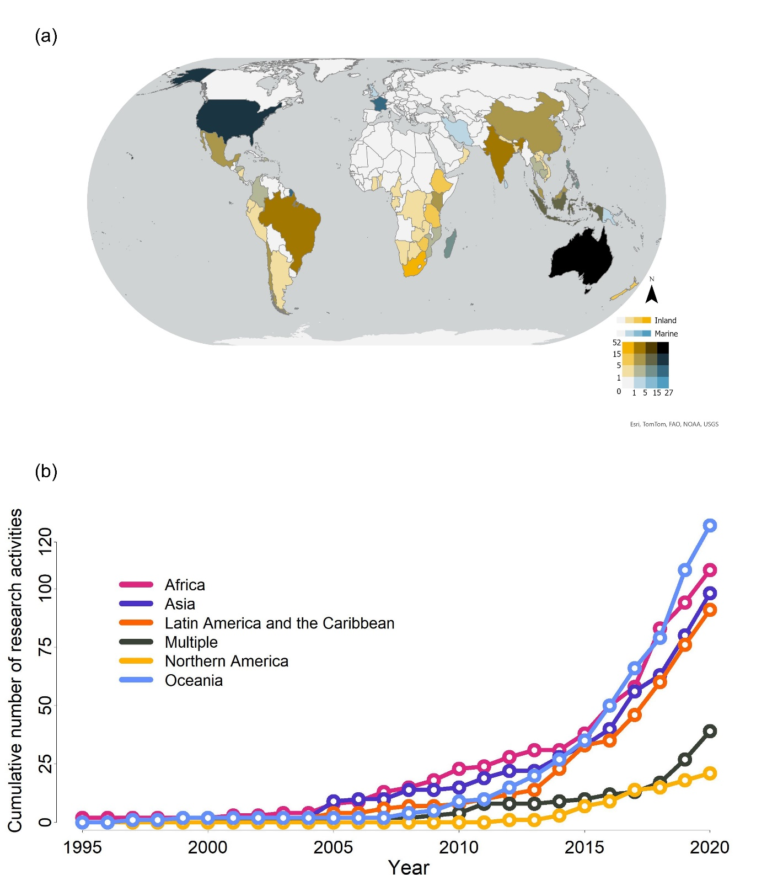

Figure 2.
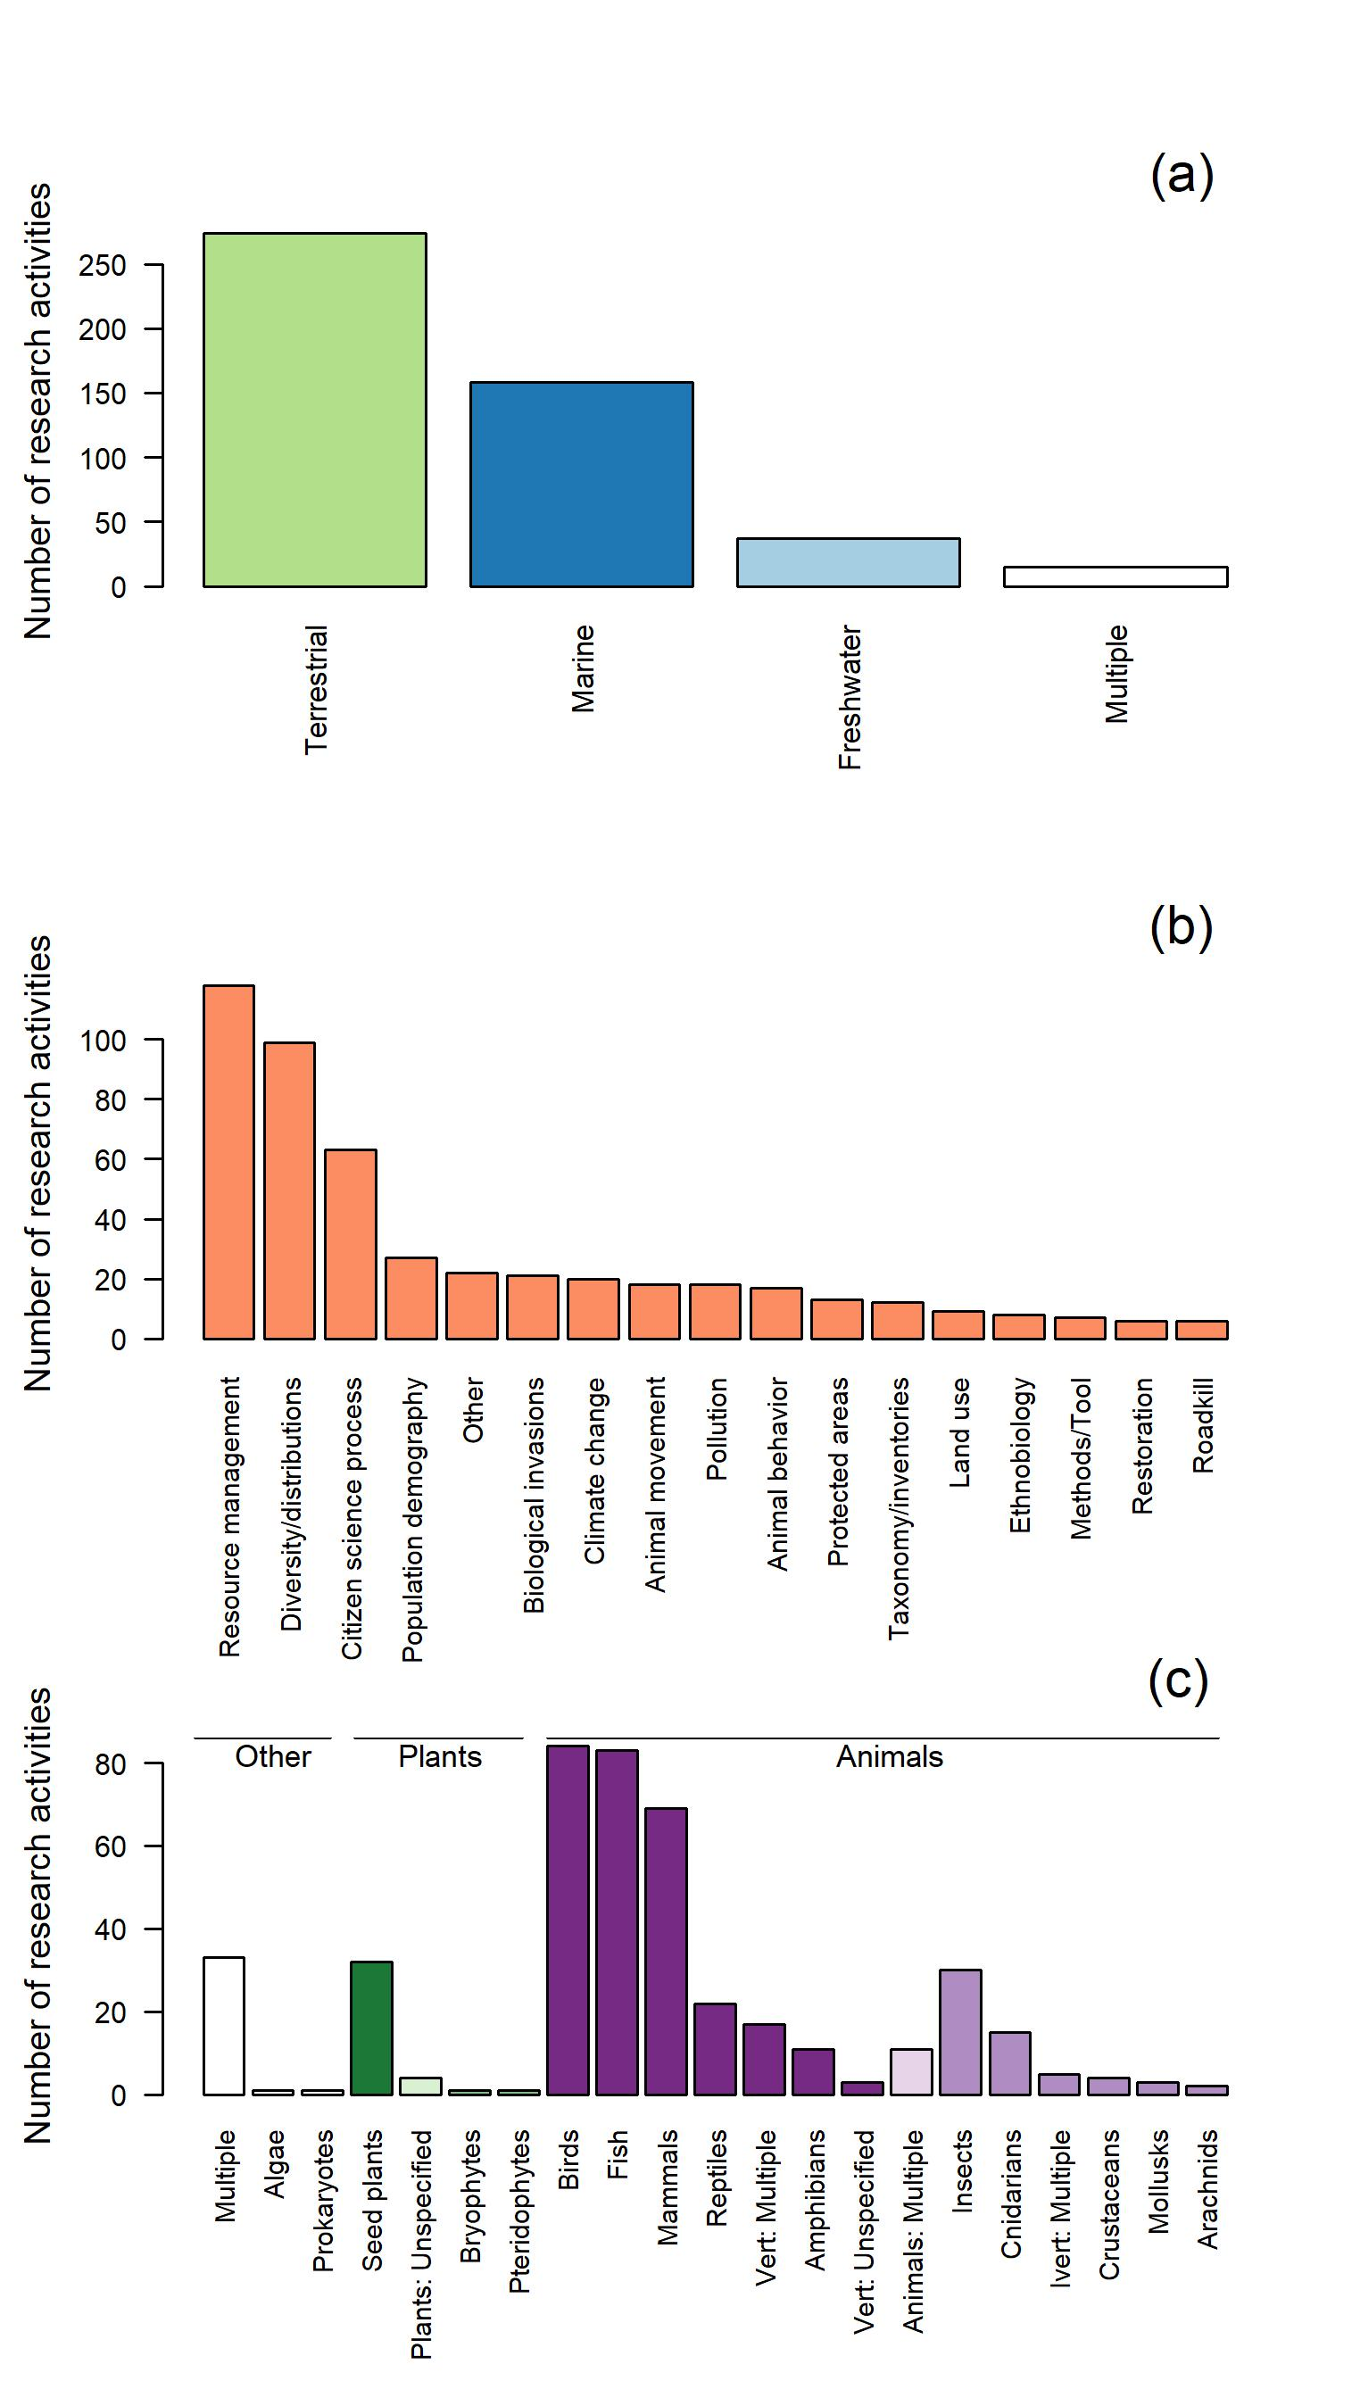
Figure 3.
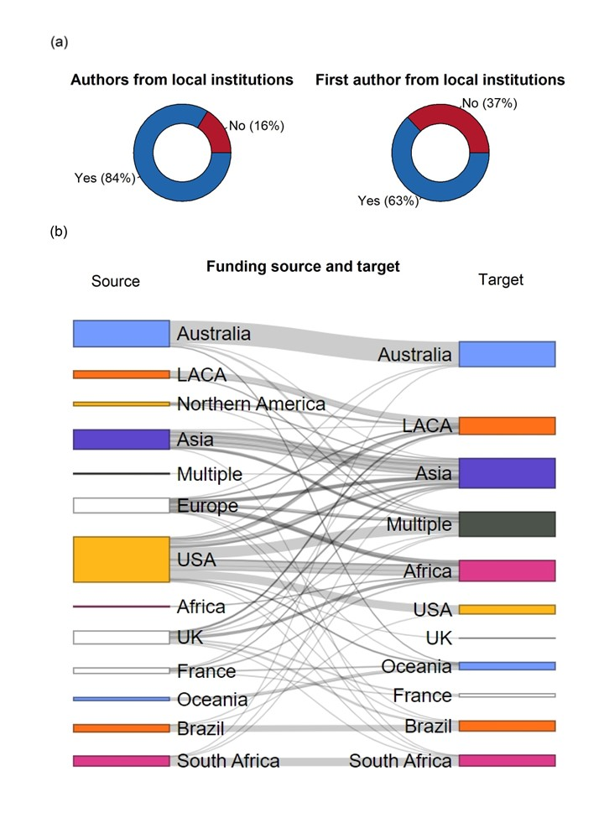
Figure 4.
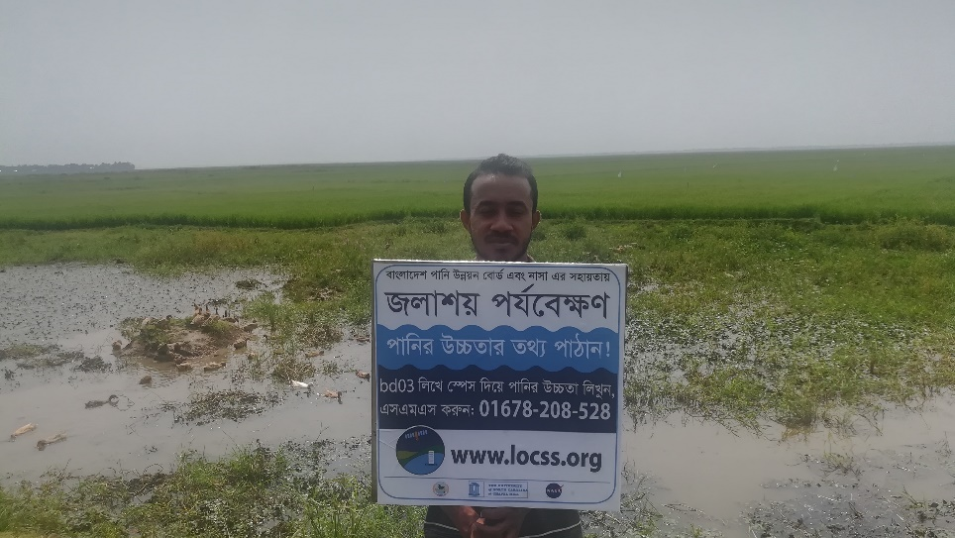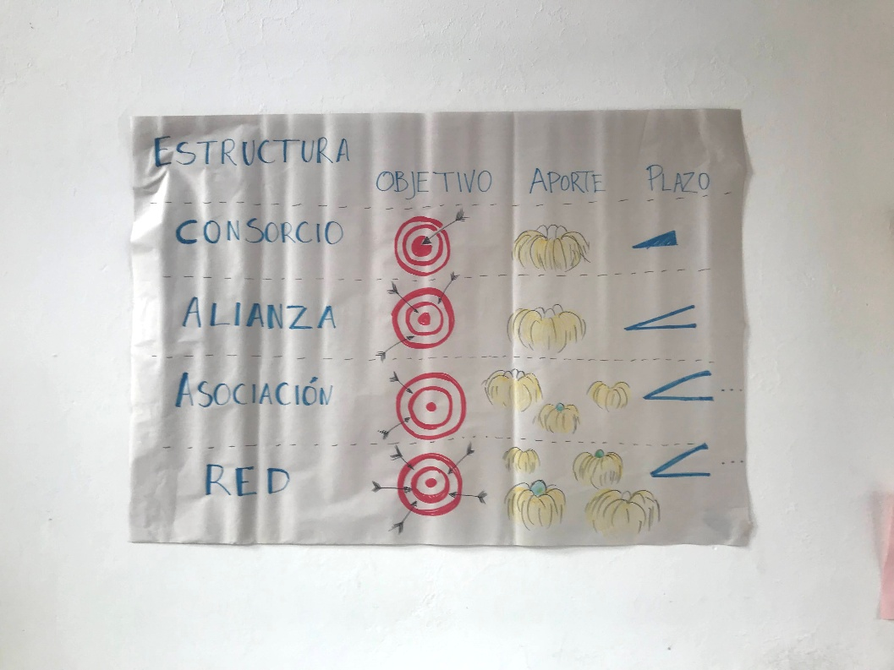

ACKNOWLEDGMENTS
We thank Emilio Bruna for the initial invitation to write this review. We also thank Foster Brown for participating in the panel that led to the initial invitation to the review and Karen Purcell's advice in this paper's early stages. We also thank our funding sources, including the MacArthur Foundation’s Living Andean Rivers initiative (Grant # 16-1607-151053-CSD), for supporting Natalia Piland, Thiago Couto, and Elizabeth Anderson. Work by Tamlin Pavelsky, Faisal Hossain, and Angélica M. Gómez was funded by NASA Citizen Science for Earth Systems Program grant # 80NSSC21K0854, managed by Dr. Stinger Guala. Finally, we thank Wendy Martin, Jennifer Powers, Eleanor Slade, and Mário Tagliari for their peer and editorial review, as well as their patience.

AUTHOR CONTRIBUTION STATEMENT
Conceptualization—N. C. Piland, T. B. A. Couto, M. Pulido-Velosa, B. Kays, & E. P. Anderson. Data Curation and Validation—N. C. Piland, T. B. A. Couto, M. Pulido-Velosa, & J. Cruz. Methodology, Formal Analysis, & Visualization—N. C. Piland, T. B. A. Couto, M. Pulido-Velosa, & J. Cruz. Investigation—N. C. Piland, T. B. A. Couto, M. Pulido-Velosa, M. Varese, G. Leite, S. Heilpern, A. Koning, J. Dutka-Gianelli, S. Jackson, P. Hyera, F. Hossain, T. Pavelsky, T. Myint, A. M. Gómez, W. Wisesjindawat-Fink, B. Kays, & E. P. Anderson. Project Administration—N. C. Piland, & T. B. A. Couto. Writing—N. C. Piland (lead), T. B. A. Couto, M. Pulido-Velosa, M. Varese, G. Leite, A. Koning, S. Jackson, P. Hyera, F. Hossain, T. Pavelsky, T. Myint, A. M. Gómez, & W. Wisesjindawat-Fink. Review & Editing—all authors.

DISCLOSURE STATEMENTS
The corresponding author confirms on behalf of all authors that there has been no involvement that might raise the question of bias in the work reported or in the conclusions, implications, or opinions stated.
REFERENCES
Ahmad, S. K., Hossain, F., Pavelsky, T., Parkins, G. M., Yelton, S., Rodgers, M., … Biswas, R. K. (2020). Understanding Volumetric Water Storage in Monsoonal Wetlands of Northeastern Bangladesh. Water Resources Research, 56(12), e2020WR027989. https://doi.org/10.1029/2020WR027989
Ahmed, S. (2017). Living a Feminist Life. Durham, NC: Duke University Press.
Altman, J. C., & Kerins, S. (Eds.). (2012). People on country: Vital landscapes indigenous futures. Annandale, N.S.W: The Federation Press.
Amano, T., Berdejo-Espinola, V., Christie, A. P., Willott, K., Akasaka, M., Báldi, A., … Sutherland, W. J. (2021). Tapping into non-English-language science for the conservation of global biodiversity. PLOS Biology, 19(10), e3001296. https://doi.org/10.1371/journal.pbio.3001296
Amazon Waters Alliance. (2024). “ICTIO: Aguas Amazonicas.” https://aguasamazonicas.org/programas/ciencia-ciudadana/soluciones/ictio Accessed: July 27th, 2024.
Amazon Waters Initiative. (2016). Declaración Conjunta: Iniciativa Aguas Amazónicas. https://aguasamazonicas.org/wp-content/uploads/2016/06/DECLARACIO%CC%81N-CONJUNTA.pdf
Amornsakchai, S., Annez, P., Vongvisessomjai, S., Choowaew, S., Thailand Development Research Institutes, Kunurat, P., … Watana, E. (2000). Pak Mun Dam, Mekong River Basin, Thailand [WCD Case Study]. Cape Town, South Africa: World Commission on Dams.
Asase, A., Mzumara-Gawa, T. I., Owino, J. O., Peterson, A. T., & Saupe, E. (2022). Replacing “parachute science” with “global science” in ecology and conservation biology. Conservation Science and Practice, 4, e517. https://doi.org/10.1111/csp2.517
Baird, I. G., Manorom, K., Phenow, A., & Gaja-Svasti, S. (2020). Opening the Gates of the Pak Mun Dam: Fish Migrations, Domestic Water Supply, Irrigation Projects and Politics. Water Alternatives, 13(1), 141–159.
Bonney, R., Cooper, C. B., Dickinson, J., Kelling, S., Phillips, T., Rosenberg, K. V., & Shirk, J. (2009). Citizen Science: A Developing Tool for Expanding Science Knowledge and Scientific Literacy. BioScience, 59(11), 977–984. https://doi.org/10.1525/bio.2009.59.11.9
Checker, M. (2007). “But I Know It’s True”: Environmental Risk Assessment, Justice, and Anthropology. Human Organization, 66(2), 112–124. https://doi.org/10.17730/humo.66.2.1582262175731728
Collard, R.-C., Dempsey, J., & Sundberg, J. (2015). A Manifesto for Abundant Futures. Annals of the Association of American Geographers, 105(2), 322–330. https://doi.org/10.1080/00045608.2014.973007
Committee of Researchers of the Salween Sgaw Karen (Director). (2005). Thai Baan Research in the Salween River: Villager’s research by the Thai-Karen Communities (in Thai with English summary) [Documentary, Short Film]. Southeast Asia Rivers Network. Retrieved from http://www.livingriversiam.org/4river-tran/4sw/swd_vdo2-tb-research.html
Conrad, C. C., & Hilchey, K. G. (2011). A review of citizen science and community-based environmental monitoring: Issues and opportunities. Environmental Monitoring and Assessment, 176(1–4), 273–291. https://doi.org/10.1007/s10661-010-1582-5
Cooke, S. J., Nguyen, V. M., Young, N., Reid, A. J., Roche, D. G., Bennett, N. J., … Bennett, J. R. (2021). Contemporary authorship guidelines fail to recognize diverse contributions in conservation science research. Ecological Solutions and Evidence, 2(2), e12060. https://doi.org/10.1002/2688-8319.12060
Cooper, C., Martin, V., Wilson, O., & Rasmussen, L. (2023). Equitable Data Governance Models for the Participatory Sciences. Community Science, 2(2), e2022CSJ000025. https://doi.org/10.1029/2022CSJ000025
Cordner, A., Ciplet, D., Brown, P., & Morello-Frosch, R. (2012). Reflexive Research Ethics for Environmental Health and Justice: Academics and Movement Building. Social Movement Studies, 11(2), 161–176. https://doi.org/10.1080/14742837.2012.664898
Cornwall, A. (2008). Unpacking ‘Participation’: Models, meanings and practices. Community Development Journal, 43(3), 269–283. https://doi.org/10.1093/cdj/bsn010
Crimmins, TM, Posthumus, E, Schaffer, S and Prudic, KL. 2021. COVID-19 impacts on participation in large scale biodiversity-themed community science projects in the United States. Biological Conservation, 256: 109017. https://doi.org/10.1016/j.biocon.2021.109017
Danielsen, F., Burgess, N. D., Balmford, A., Donald, P. F., Funder, M., Jones, J. P. G., … Yonten, D. (2009). Local Participation in Natural Resource Monitoring: A Characterization of Approaches. Conservation Biology, 23(1), 31–42. https://doi.org/10.1111/j.1523-1739.2008.01063.x
de Lange, E., Sze, J. S., Allan, J., Atkinson, S., Booth, H., Fletcher, R., … Saif, O. (2023). A global conservation basic income to safeguard biodiversity. Nature Sustainability, 6(8), 1016–1023. https://doi.org/10.1038/s41893-023-01115-7
de Sherbinin, A., Bowser, A., Chuang, T.-R., Cooper, C., Danielsen, F., Edmunds, R., … Sivakumar, K. (2021). The Critical Importance of Citizen Science Data. Frontiers in Climate, 3, 650760. https://doi.org/10.3389/fclim.2021.650760
DuBay, S., Palmer, D. H., & Piland, N. (2020). Global inequity in scientific names and who they honor [Preprint]. Zoology. https://doi.org/10.1101/2020.08.09.243238
Dungumaro, E. W., & Madulu, N. F. (2003). Public participation in integrated water resources management: The case of Tanzania. Physics and Chemistry of the Earth, Parts A/B/C, 28(20), 1009–1014. https://doi.org/10.1016/j.pce.2003.08.042
Eleta, I., Clavell, G. G., Righi, V., & Balestrini, M. (2019). The Promise of Participation and Decision-Making Power in Citizen Science. Citizen Science: Theory and Practice, 4(1), 8. https://doi.org/10.5334/cstp.171
Espin, J., Palmas, S., Carrasco-Rueda, F., Riemer, K., Allen, P. E., Berkebile, N., … Bruna, E. M. (2017). A persistent lack of international representation on editorial boards in environmental biology. PLOS Biology, 15(12), e2002760. https://doi.org/10.1371/journal.pbio.2002760
Fals-Borda, O. (1987). The Application of Participatory Action-Research in Latin America. International Sociology, 2(4), 329–347. https://doi.org/10.1177/026858098700200401
Ferguson, J. (1994). Anti-Politics Machine: Development, Depoliticization, and Bureaucratic Power in Lesotho. U of Minnesota Press.
Franco, C. L. B., El Bizri, H. R., Souza, P. R. E., Fa, J. E., Valsecchi, J., Sousa, I. S. D., & Queiroz, H. L. D. (2021). Community-based environmental protection in the Brazilian Amazon: Recent history, legal landmarks and expansion across protected areas. Journal of Environmental Management, 287, 112314. https://doi.org/10.1016/j.jenvman.2021.112314
Freire, P. (2000). Pedagogy of the oppressed (30th anniversary ed). New York: Continuum.
Fritz, S., See, L., Carlson, T., Haklay, M. (Muki), Oliver, J. L., Fraisl, D., … West, S. (2019). Citizen science and the United Nations Sustainable Development Goals. Nature Sustainability, 2(10), 922–930. https://doi.org/10.1038/s41893-019-0390-3
Grosfoguel, R. (2013). The Structure of Knowledge in Westernized Universities: Epistemic Racism/Sexism and the Four Genocides/Epistemicides of the Long 16th Century. Human Architecture: Journal of the Sociology of Self-Knowledge, XI(1), 73–90.
Hackel, J. D. (1999). Community Conservation and the Future of Africa’s Wildlife. Conservation Biology, 13(4), 726–734. https://doi.org/10.1046/j.1523-1739.1999.98210.x
Haddaway, N. R., & Bayliss, H. R. (2015). Shades of grey: Two forms of grey literature important for reviews in conservation. Biological Conservation, 191, 827–829. https://doi.org/10.1016/j.biocon.2015.08.018
Haklay, M. (2013). Citizen Science and Volunteered Geographic Information: Overview and Typology of Participation. In D. Sui, S. Elwood, & M. Goodchild (Eds.), Crowdsourcing Geographic Knowledge: Volunteered Geographic Information (VGI) in Theory and Practice (pp. 105–122). Dordrecht: Springer Netherlands. https://doi.org/10.1007/978-94-007-4587-2_7
Hall, B. L., & Tandon, R. (2018). From action research to knowledge democracy. Cartagena 1977-2017*. Revista Colombiana de Sociología, 41(1), 227–236.
Heilpern, S. A., Fiorella, K., Cañas, C., Flecker, A. S., Moya, L., Naeem, S., … DeFries, R. (2021). Substitution of inland fisheries with aquaculture and chicken undermines human nutrition in the Peruvian Amazon. Nature Food, 2(3), 192–197. https://doi.org/10.1038/s43016-021-00242-8
Heis, A., & Chayan, V. (2020). Thai Baan Methodology and Transdisciplinarity as Collaborative Research Practices: Common Ground and Divergent Directions. Advances in Southeast Asian Studies, 13(2), 211–228. https://doi.org/10.14764/10.ASEAS-0040
Hengsuwan, P. (2019). Not only Anti-dam: Simplistic Rendering of Complex Salween Communities in Their Negotiation for Development in Thailand. In C. Middleton & V. Lamb (Eds.), Knowing the Salween River: Resource Politics of a Contested Transboundary River. Springer, Cham. Retrieved from https://www.researchgate.net/publication/335133488_Not_only_Anti-dam_Simplistic_Rendering_of_Complex_Salween_Communities_in_Their_Negotiation_for_Development_in_Thailand
Hill, R., Grant, C., George, M., Robinson, C. J., Jackson, S., & Abel, N. (2012). A Typology of Indigenous Engagement in Australian Environmental Management: Implications for Knowledge Integration and Social-ecological System Sustainability. Ecology and Society, 17(1). Retrieved from https://www.jstor.org/stable/26269005
Irwin, A. (2018). No PhDs needed: How citizen science is transforming research. Nature, 562(7728), 480–482. https://doi.org/10.1038/d41586-018-07106-5
Jackson, S., & Palmer, L. R. (2015). Reconceptualizing ecosystem services: Possibilities for cultivating and valuing the ethics and practices of care. Progress in Human Geography, 39(2), 122–145. https://doi.org/10.1177/0309132514540016
Jackson, S. (2019). Building trust and establishing legitimacy across scientific, water management and Indigenous cultures. Australasian Journal of Water Resources, 23(1), 14–23. https://doi.org/10.1080/13241583.2018.1505994
Jara H., O. (2010). Popular education and social change in Latin America. Community Development Journal, 45(3), 287–296.
Kabogo, J., Anderson, E., Hyera, P., & Kajanja, G. (2017). Facilitating public participation in water resources management: Reflections from Tanzania. Ecology and Society, 22(4). https://doi.org/10.5751/ES-09739-220426
Kainer, K. A., DiGiano, M. L., Duchelle, A. E., Wadt, L. H. O., Bruna, E., & Dain, J. L. (2009). Partnering for Greater Success: Local Stakeholders and Research in Tropical Biology and Conservation: Partnering for Greater Success. Biotropica, 41(5), 555–562. https://doi.org/10.1111/j.1744-7429.2009.00560.x
Kane, L. (2010). Community development: Learning from popular education in Latin America. Community Development Journal, 45(3), 276–286.
Khan, S., Hossain, F., Pavelsky, T., Gomez, A., Ghafoor, S., Lane, M., ... & Borua, P. P. (2024). A network design approach for citizen science-satellite monitoring of surface water volume changes in Bangladesh. Environmental Modelling & Software, 172, 105919.
Kimura, A. H., & Kinchy, A. (2016). Citizen Science: Probing the Virtues and Contexts of Participatory Research. Engaging Science, Technology, and Society, 2, 331–361. https://doi.org/10.17351/ests2016.99
Liboiron, M. (2021). Pollution Is Colonialism. Durham, NC: Duke University Press.
Lohmann, L., & Ferguson, J. (1994). The Anti-Politics Machine: Development, Depoliticization, and Bureaucratic Power in Lesotho. The Ecologist, 24(5), 176–181.
Markkula, I., Turunen, M., & Kantola, S. (2019). Traditional and local knowledge in land use planning: Insights into the use of the Akwé: Kon Guidelines in Eanodat, Finnish Sápmi. Ecology and Society, 24(1). https://doi.org/10.5751/ES-10735-240120
McElwee, P., Fernández‐Llamazares, Á., Aumeeruddy‐Thomas, Y., Babai, D., Bates, P., Galvin, K., … Brondízio, E. S. (2020). Working with Indigenous and local knowledge (ILK) in large‐scale ecological assessments: Reviewing the experience of the IPBES Global Assessment. Journal of Applied Ecology, 57(9), 1666–1676. https://doi.org/10.1111/1365-2664.13705
McIntyre, P. B., Liermann, C. A. R., & Revenga, C. (2016). Linking freshwater fishery management to global food security and biodiversity conservation. Proceedings of the National Academy of Sciences, 113(45), 12880–12885. https://doi.org/10.1073/pnas.1521540113
McKinley, D. C., Miller-Rushing, A. J., Ballard, H. L., Bonney, R., Brown, H., Cook-Patton, S. C., … Soukup, M. A. (2017). Citizen science can improve conservation science, natural resource management, and environmental protection. Biological Conservation, 208, 15–28. https://doi.org/10.1016/j.biocon.2016.05.015
Miller, T., Baird, T., Littlefield, C., Kofinas, G., Chapin III, F. S., & Redman, C. (2008). Epistemological Pluralism: Reorganizing Interdisciplinary Research. Ecology and Society, 13(2). https://doi.org/10.5751/ES-02671-130246
Miller-Rushing, A., Primack, R., & Bonney, R. (2012). The history of public participation in ecological research. Frontiers in Ecology and the Environment, 10(6), 285–290. https://doi.org/10.1890/110278
Mohanty, N. P., Sachin, A., Selvaraj, G., & Vasudevan, K. (2018). Using public surveys to reliably and rapidly estimate the distributions of multiple invasive species on the Andaman archipelago. Biotropica, 50(2), 197–201. https://doi.org/10.1111/btp.12534
Myint, T. (2016). Citizen Science in a Democracy: The Case of Thai Baan Research. Tocqueville Lecture Series, 58.
Newman, G., Wiggins, A., Crall, A., Graham, E., Newman, S., & Crowston, K. (2012). The future of citizen science: Emerging technologies and shifting paradigms. Frontiers in Ecology and the Environment, 10(6), 298–304. https://doi.org/10.1890/110294
Nuñez, M. A., & Amano, T. (2021). Monolingual searches can limit and bias results in global literature reviews. Nature Ecology & Evolution, 5(3), 264–264. https://doi.org/10.1038/s41559-020-01369-w
Nuñez, M. A., Barlow, J., Cadotte, M., Lucas, K., Newton, E., Pettorelli, N., & Stephens, P. A. (2019). Assessing the uneven global distribution of readership, submissions and publications in applied ecology: Obvious problems without obvious solutions. Journal of Applied Ecology, 56(1), 4–9. https://doi.org/10.1111/1365-2664.13319
Nuñez, M. A., Chiuffo, M. C., Pauchard, A., & Zenni, R. D. (2021). Making ecology really global. Trends in Ecology & Evolution, 36(9), 766–769. https://doi.org/10.1016/j.tree.2021.06.004
Ocampo-Ariza, C., Toledo-Hernández, M., Librán-Embid, F., Armenteras, D., Vansynghel, J., Raveloaritiana, E., … Maas, B. (2023). Global South leadership towards inclusive tropical ecology and conservation. Perspectives in Ecology and Conservation, 21(1), 17–24. https://doi.org/10.1016/j.pecon.2023.01.002
Ostrom, E. (1990). Governing the commons: The evolution of institutions for collective action. Cambridge: Cambridge Univ. Press.
Oviedo, A. F. P., & Bursztyn, M. (2017). Community-based monitoring of small-scale fisheries with digital devices in Brazilian Amazon. Fisheries Management and Ecology, 24(4), 320–329. https://doi.org/10.1111/fme.12231
Pandya, R. E. (2012). A framework for engaging diverse communities in citizen science in the US. Frontiers in Ecology and the Environment, 10(6), 314–317. https://doi.org/10.1890/120007
Pettorelli, N., Barlow, J., Nuñez, M. A., Rader, R., Stephens, P. A., Pinfield, T., & Newton, E. (2021). How international journals can support ecology from the Global South. Journal of Applied Ecology, 58(1), 4–8. https://doi.org/10.1111/1365-2664.13815
Pienkowski, T., Kiik, L., Catalano, A., Hazenbosch, M., Izquierdo-Tort, S., Khanyari, M., … Sandbrook, C. (2023). Recognizing reflexivity among conservation practitioners. Conservation Biology, 37(2), e14022. https://doi.org/10.1111/cobi.14022
Piland, N. C., Varese, M., Soacha, K., Ponciano, L., Castañeda, A., Álvarez, H., … Wallace, R. (2020). Citizen Science from the Iberoamerican Perspective: An overview and insights by the RICAP network. Poster presented at the European Citizen Science Association. Virtual. https://drive.google.com/file/d/17Hz4TeehK4UZtL2w1mF3oV3F1uipIvSf/view?usp=sharing
Ramírez-Castañeda, V. (2020). Disadvantages in preparing and publishing scientific papers caused by the dominance of the English language in science: The case of Colombian researchers in biological sciences. PLOS ONE, 15(9), e0238372. https://doi.org/10.1371/journal.pone.0238372
Ramírez-Castañeda, V., Westeen, E. P., Frederick, J., Amini, S., Wait, D. R., Achmadi, A. S., … Tarvin, R. D. (2022). A set of principles and practical suggestions for equitable fieldwork in biology. Proceedings of the National Academy of Sciences, 119(34), e2122667119. https://doi.org/10.1073/pnas.2122667119
Requier, F., Andersson, G. K., Oddi, F. J., & Garibaldi, L. A. (2020). Citizen science in developing countries: How to improve volunteer participation. Frontiers in Ecology and the Environment, 18(2), 101–108. https://doi.org/10.1002/fee.2150
Rodenbiker, J. (2022). Adapting participatory research methods for reflexive environmental management. Qualitative Research, 22(4), 559–577. https://doi.org/10.1177/1468794121990966
Rojas Guerra, J. M. (2009). LA CONSTRUCCIÓN DE LA IAP: UNA EXPLORACIÓN EN LA OBRA DEL AUTOR. análisis político, 67, 224–234.
Saif, O., Keane, A., & Staddon, S. (2022). Making a case for the consideration of trust, justice, and power in conservation relationships. Conservation Biology, 36(4), e13903. https://doi.org/10.1111/cobi.13903
Sánchez-Clavijo, LM, Martínez-Callejas, SJ, Acevedo-Charry, O, Diaz-Pulido, A, Gómez-Valencia, B, Ocampo-Peñuela, N, Ocampo, D, Olaya-Rodríguez, MH, Rey-Velasco, JC, Soto-Vargas, C and Ochoa-Quintero, JM. 2021. Differential reporting of biodiversity in two citizen science platforms during COVID-19 lockdown in Colombia. Biological Conservation, 256: 109077. https://doi.org/10.1016/j.biocon.2021.109077
Sanjaroenkijthaworn, T. (2021, January 12). Thai Mekong People’s Forum: Cooperation among Various Riparian People as Groundbreaking Step towards Mekong People’s Forum of ASEAN. Retrieved November 19, 2023, from The Mekong Butterfly website: https://themekongbutterfly.wordpress.com/2021/01/12/thai-mekong-peoples-forum-cooperation-among-various-riparian-people-as-groundbreaking-step-towards-mekong-peoples-forum-of-asean/
Santos, B. de S. (2018). The End of the Cognitive Empire: The Coming of Age of Epistemologies of the South. Durham, NC: Duke University Press.
Schneider, F., Llanque-Zonta, A., Andriamihaja, O. R., Andriatsitohaina, R. N. N., Tun, A. M., Boniface, K., … Zaehringer, J. G. (2022). How context affects transdisciplinary research: Insights from Asia, Africa and Latin America. Sustainability Science, 17(6), 2331–2345. https://doi.org/10.1007/s11625-022-01201-3
Secretariat of the Convention on Biological Diversity. Convention on Biological Diversity. , (2011).
Shapiro‐Garza, E., McElwee, P., Van Hecken, G., & Corbera, E. (2020). Beyond Market Logics: Payments for Ecosystem Services as Alternative Development Practices in the Global South. Development and Change, 51(1), 3–25. https://doi.org/10.1111/dech.12546
Shirk, J., Ballard, H., Wilderman, C., Phillips, T., Wiggins, A., Jordan, R., … Bonney, R. (2012). Public Participation in Scientific Research: A Framework for Deliberate Design. Ecology and Society, 17(2). https://doi.org/10.5751/ES-04705-170229
Silvertown, J. (2009). A new dawn for citizen science. Trends in Ecology & Evolution, 24(9), 467–471. https://doi.org/10.1016/j.tree.2009.03.017
Smith, A. C., Merz, L., Borden, J. B., Gulick, C. K., Kshirsagar, A. R., & Bruna, E. M. (2021). Assessing the effect of article processing charges on the geographic diversity of authors using Elsevier’s “Mirror Journal” system. Quantitative Science Studies, 2(4), 1123–1143. https://doi.org/10.1162/qss_a_00157
Southeast Asia Rivers Network. (2004). The Return of Fish, River Ecology and Local Livelihoods of the Mun River: A Thai Baan (Villagers’) Research. Chiang Mai, Thailand: Southeast Asia Rivers Network. Retrieved from http://www.livingriversiam.org/3river-thai/pm/tb_research/pm-fish-book-eng.pdf
Southwest Network for Environmental and Economic Justice. (1996). Jemez Principles for Democratic Organizing. Jemez, New Mexico. Retrieved from http://lvejo.org/wp-content/uploads/2015/04/ej-jemez-principles.pdf
Sretthachau, C. (2002). Mae Mun Kan Klup Keun Ma Khong Kon Ha Pla. Bot Sarup Lae Khwam Ru Rueang Pla Khong Kon Pak Mun [in Thai][Mun River–Return of the Fishers: Summary and Fisheries Knowledge of Pak Mun People]. Chiang Mai, Thailand: Thai Ban Research Project, Southeast Asian Rivers ….
Steigerwald, E., Ramírez-Castañeda, V., Brandt, D. Y. C., Báldi, A., Shapiro, J. T., Bowker, L., & Tarvin, R. D. (2022). Overcoming Language Barriers in Academia: Machine Translation Tools and a Vision for a Multilingual Future. BioScience, 72(10), 988–998. https://doi.org/10.1093/biosci/biac062
Stepenuck, K. F., & Green, L. T. (2015). Individual- and community-level impacts of volunteer environmental monitoring: A synthesis of peer-reviewed literature. Ecology and Society, 20(3). Retrieved from https://www.jstor.org/stable/26270236
Sullivan, B. L., Phillips, T., Dayer, A. A., Wood, C. L., Farnsworth, A., Iliff, M. J., … Kelling, S. (2017). Using open access observational data for conservation action: A case study for birds. Biological Conservation, 208, 5–14. https://doi.org/10.1016/j.biocon.2016.04.031
Tadaki, M., Brierley, G., Dickson, M., Le Heron, R., & Salmond, J. (2015). Cultivating critical practices in physical geography. The Geographical Journal, 181(2), 160–171.
Tengö, M., Austin, B. J., Danielsen, F., & Fernández-Llamazares, Á. (2021). Creating Synergies between Citizen Science and Indigenous and Local Knowledge. BioScience, 71(5), 503–518. https://doi.org/10.1093/biosci/biab023
The ICBOs and Allies Workgroup. (2022). Understanding the Impact of Equitable Collaborations between Science Institutions and Community-Based Organizations: Improving Science through Community-Led Research. BioScience, 72(6), 585–600. https://doi.org/10.1093/biosci/biac001
The Tropical Rivers Lab. (2021). Reflections on Negotiating the Science-Society Relationship Together. Open Rivers: Rethinking Water, Place & Community. https://doi.org/10.24926/2471190X.8273
Tuck, E., & Yang, K. W. (2014). Unbecoming Claims: Pedagogies of Refusal in Qualitative Research. Qualitative Inquiry, 20(6), 811–818. https://doi.org/10.1177/1077800414530265
Ubon Ratchatani University. (2002). Project to Study Approaches to Restoration of the Ecology, Livelihood, and Communities Receiving Impacts from Construction of Pak Mun Dam. Ubon Ratchatani Unviersity. Retrieved from Ubon Ratchatani Unviersity website: https://www.irn.org/files/programs_2Fpakmun_2F/021022.ubonexecsum.pdf
UNESCO & Canadian National Commission for UNESCO. (2022). An introduction to the UNESCO Recommendation on Open Science (No. SC-PBS-STIP/2022/OSB/1). Paris, France: UNESCO. https://doi.org/10.54677/XOIR1696
United Republic of Tanzania. National Water Policy. (2002).
Van Noorden, R. (2013). Open access: The true cost of science publishing. Nature, 495(7442), 426–429. https://doi.org/10.1038/495426a
Varese, M., Rodríguez, C., Piland, N., Athayde, S., Alvira Reyes, D., Rodrigues da Costa Doria, C., … Trujillo, L. A. (2021). Chapter 33: Connecting and sharing diverse knowledges to support sustainable pathways in the Amazon. In C. Nobre, A. Encalada, E. Anderson, F. H. Roca Alcazar, M. Bustamante, C. Mena, … G. Zapata-Ríos (Eds.), Amazon Assessment Report 2021 (1st ed.; By Science Panel for the Amazon). UN Sustainable Development Solutions Network (SDSN). https://doi.org/10.55161/DYAK8997
Weingart, P., Joubert, M., & Connoway, K. (2021). Public engagement with science—Origins, motives and impact in academic literature and science policy. PLOS ONE, 16(7), e0254201. https://doi.org/10.1371/journal.pone.0254201
Wiggins, A. (2011). eBirding: Technology adoption and the transformation of leisure into science. Proceedings of the 2011 iConference, 798–799. Seattle Washington USA: ACM. https://doi.org/10.1145/1940761.1940910

