Genome engineering in biodiversity conservation and restoration

Cock van Oosterhout¹, Megan A. Supple², Hernán E. Morales³, Thomas Birley¹, Vikash Tatayah⁴, Carl G. Jones^{4,5}, Harriet L. Whitford⁵, Simon Tollington⁵, Kevin Ruhomaun⁶, Jim Groombridge⁷, Leandra Brickson², Anna L. Keyte⁸, Beth Shapiro^{8,9}, Matt James^{2,8}, Stephen D. Turner^{2,8}
- School of Environmental Sciences, University of East Anglia, Norwich Research Park, Norwich, United Kingdom
- Colossal Foundation, Dallas TX, United States
- Globe Institute, University of Copenhagen, Copenhagen, Denmark
- Mauritian Wildlife Foundation, Vacoas, Mauritius
- Durrell Wildlife Conservation Trust
- National Parks and Conservation Service, Ministry of Agro-Industry, Food Security, Blue Economy and Fisheries, Government of Mauritius
- Durrell Institute of Conservation and Ecology, School of Natural Sciences, University of Kent, Canterbury, UK
- Colossal Biosciences, Dallas TX, United States
- Department of Ecology and Evolutionary Biology, University of California Santa Cruz

Abstract
Biodiversity loss due to habitat destruction, climate change, and other anthropogenic pressures threatens the resilience of ecosystems globally. Traditional conservation methods are critically important for immediate species survival, but they cannot restore genetic diversity that has been lost from the species’ gene pool. Advances in genome engineering offer a transformative solution by enabling the targeted restoration of genetic diversity from historical samples, biobanks, and related species. In this Perspective we explore the integration of genome editing technologies into biodiversity conservation, and discuss the benefits and risks associated with such genetic rescue. We highlight case studies demonstrating the potential to reduce genetic load, recover lost adaptive traits, and fortify populations against emerging challenges such as disease and climate change. We also discuss ethical, societal, and economic considerations, emphasizing the importance of equitable access and stakeholder engagement. When combined with habitat restoration and other conservation actions, genome engineering can make species more resilient against future environmental change in the Anthropocene.
Abstract 1
Introduction 3
Saving species from extinction past and present 3
Genomic erosion 4
Genetic rescue 5
Genome engineering for genetic rescue 6
Genome engineering primer 6
Targets for genome engineering 7
Introducing immunogenetic variation 7
Introducing climate adaptive genetic variation 8
Reducing genetic load 8
Consequences of genome engineering 8
Societal, economic, and bioethical dimensions 9
Public perception and societal attitudes 9
Funding and equitable access considerations 9
Principles for gene editing in conservation 10
Outlook 11
References 12
Glossary 19
Display items 20
Boxes 20
Box 1: Genomic erosion case studies 20
Box 2: Genetic rescue case studies 21
Successful genetic rescue 21
Genetic rescue candidates 22
Box 3: Genome engineering technologies for conservation 22
Editing Modalities 23
Applications in Conservation 23
Implementation considerations 23
Figures 25
Figure 1 25
Figure 2 26
Figure 3 27
Figure 4 28

Introduction
We are in the UN's Decade on Ecosystem Restoration, yet over 46,000 (28%) of the 166,061 species in the IUCN Red List of Threatened Species are at risk of extinction¹. Recent global analyses highlight that genetic diversity is being lost at alarming rates, with direct consequences for population resilience and biodiversity conservation². Humans are currently changing ecosystems at a pace that exceeds the rate of natural habitat transitions during glaciation cycles³. The pace of change is more comparable to that observed during tectonic and volcanic activities, which have sudden environmental impacts that have led to mass extinctions⁴. Present-day species are facing this extreme challenge hampered by an ecological and evolutionary disadvantage. Habitats have been destroyed and fragmented, obstructing migration of threatened species to more habitable environments. Furthermore, genetic diversity of species has been in decline for decades if not centuries. Direct and indirect effects of human activities have decimated the population size of many species, leading to a loss of genetic diversity that compromises their long-term viability and evolutionary potential^{5–7}.
In recent decades, conservation biologists have saved numerous species from extinction, often against remarkable odds^{8–10}. Traditional conservation approaches focus on demographic recovery through habitat protection and restoration, predator and alien species control, supplementary feeding, and captive breeding programs^{11,12}. While such “first aid” conservation efforts have successfully prevented many immediate extinctions⁸, it cannot restore genetic diversity that has been lost from the species’ living gene pool. Long-term sustainability of biodiversity depends on a combination of traditional conservation strategies, as well as biobanks and technological advances. Genome engineering can be considered “second aid”, and it involves the restoration of damage incurred by genomic erosion, including the recovery of lost genetic diversity, reduction of the genetic load, and increase of the evolutionary potential of threatened populations.
In this Perspective, we discuss the benefits, challenges and ethical considerations of genome engineering in biodiversity conservation, and we propose an approach for its implementation into conservation practice (Figure 1). By combining traditional conservation with advances in genomics-informed conservation, assisted reproductive technology, and genome engineering, we can now consider reintroducing lost genetic variation from preserved specimens into threatened populations (Figure 2). To ensure the long-term survival of threatened species in our rapidly changing environment, we must embrace new technological advances alongside traditional conservation approaches¹³.

Saving species from extinction past and present
Throughout evolution, species have avoided extinction by hybridizing with closely related species and subspecies¹⁴. Deep time reticulation in phylogenetic trees suggests that such interspecific gene flow might be more common in nature than previously thought, and that it is an important contributor to evolutionary rescue^{15,16}. Our own genome bears the sign of 1–4% of DNA inherited from Neanderthal ancestors, which have enabled adaptation to new environments, including cold climates, increased UV exposure, increased hypoxia, and novel pathogens^{17,18}. Genetic exchanges between species are fundamental to adaptive evolution^{19,20}.
Some species possess viable zoo populations that serve as “insurance populations,” indeed around 90 species considered extinct in the wild persist in ex-situ facilities²¹. Zoos that are members of the European Association for Zoos and Aquaria (EAZA) and the Association of Zoos and Aquaria (AZA) collectively manage over 1000 species through their breeding programs. However, this represents only a small portion of species at risk of extinction. Moreover, captive bred populations face various challenges, such as inbreeding, genetic drift, adaptation to captivity, accumulation of harmful mutations in the benign environment, emerging infectious diseases, and logistical challenges²².
Conservation biologists have long recognized these challenges, establishing biobanks and cryopreservation facilities to preserve genetic diversity^{23,24}. Natural history museums worldwide house over 2 billion specimens collected over centuries that too contain valuable genetic diversity^{25,26}. This preserved DNA could improve the viability of threatened species, but until recently, we lacked the tools to study and utilize this genetic diversity.
Conservation genetics has developed rapidly in the past 50 years. It has its roots in a theoretical population genetics framework dating back a century, and it is now starting to employ cutting-edge genomic tools for species preservation and restoration^{27–30}. This development mirrors broader advances in genetic technologies, from early molecular markers to whole-genome sequencing, and genome engineering. Understanding evolutionary genetic processes – from the erosion of diversity in small populations, to new strategies for increasing the speed and effectiveness of genetic rescue – has become essential for effective biodiversity conservation^{31–35}.
Following a “first aid” approach, species that have faced severe population size decline may require “second aid” conservation to counter genomic erosion and improve their evolutionary potential³⁶. The remaining genetic variation may be insufficient to prevent local extinctions of subpopulations. The loss of evolutionary significant units (ESUs) and habitat fragmentation limits effective gene flow and the adaptive evolutionary response of metapopulations.
The genetic health of the population is, however, rarely assessed during the first phase in conservation. Yet, we know that genetic diversity is necessary for the long-term survival and adaptability of species^{31–35} with some arguing that genetic data should be included in the IUCN Red List assessments³⁷. Additionally, the IUCN Red List assesses extinction risk over a comparatively short timeframe (3 generations or 10 years, whichever is longer), and it therefore ignores the long-term risk of extinction due to genomic erosion.

Genomic erosion
Timing is critical. Many species face an ongoing "drift debt" – a slow but steady erosion of genetic diversity that continues to threaten declining species, even after population sizes stabilize or partially recover^{38,39}. Genomic erosion compromises the evolutionary potential of populations^{35,40,41}. Due to the drift debt, loss of genetic diversity will continue for many decades even after habitats are protected and populations increase⁴².

Genomic erosion also affects genetic load. During population recovery, purifying selection removes the most deleterious alleles, but less harmful variants may increase in frequency due to drift⁴³. Loci become more homozygous not only due to inbreeding, but also because the frequency of some deleterious alleles increases. Inbreeding and drift lead to a conversion of masked load into realized load, resulting in inbreeding depression⁴⁴. Fixation of harmful genetic variants can lead to a gradual loss of fitness and population viability. This so-called drift load is not rapidly redressed via new compensatory mutations in small populations, which have a limited capacity of evolutionary rescue through natural means⁴⁵. Genomic erosion puts additional pressure on the population on top of any external threats that led to its initial population decline⁴³.

Assessing extinction risks without evaluating the genetic health of populations may create a misleading sense that all conservation efforts have been completed. Traditional conservation management has helped many species to recover demographically after a severe bottleneck, and in recognition of such conservation success, these species are often down-listed on the IUCN Red List and in the Species Directory of the Endangered Species Act (ESA). Some conservation geneticists are concerned by such down-listings, arguing they are premature, and that the species are still at considerable risk of extinction^{5,38,46}. Their concern is that without the intense conservation support, the down-listed species are at risk of a decline due to a drift debt caused by ongoing genomic erosion and conversion of genetic load. See Box 1 for case studies in genomic erosion.

Genetic rescue
The goal of genetic rescue is to increase individual fitness and population viability by introducing new alleles into the population, thereby increasing genetic diversity and reducing realized load^{47,48}. Gene flow has large and consistent benefits⁴⁹, and nearly half of reintroductions of captive-bred animals into the wild were considered to be successful⁵⁰. Nevertheless, implementation of genetic rescue has historically been limited by concerns about outbreeding depression, loss of local adaptation, and various cultural and legislative barriers⁵¹. Evaluation of these risks and formulation of guidelines for genetic rescue^{51,52} have somewhat alleviated these fears. With recent improvements in bioinformatics and analysis tools, genomics data can be used to select optimal individuals and populations for genetic rescue, increasing genetic diversity while limiting the number of potentially harmful variants^{47,53}. See Box 2 for case studies in genetic rescue.
Museum collections, biobanks and cryopreservation facilities ^{23,24} contain potentially important sources of genetic variation for genetic rescue, enabling the reintroduction of recently lost genetic variants. Museum collections also provide a catalog of historical genetic variants that provides a baseline on past genetic diversity^{25,26}. With the advances in the extraction and analysis of DNA from museum specimens, it is now possible to evaluate historical genetic diversity to inform conservation strategies⁵⁴. Furthermore, biobanks are able to preserve high-quality specimens. Facilities such as the biobanks of the European Association of Zoos and Aquaria (EAZA), the San Diego Zoo's Frozen Zoo⁵⁵, Nature's SAFE, and the Smithsonian's National Zoo and Conservation Biology Institute⁵⁶, provide critical resources, including living cell lines, reproductive materials, and cryopreserved tissues that could be used to augment genetic rescue with genome engineering. While this perspective primarily focuses on animals, similar challenges and opportunities exist for plants, where genome editing is increasingly recognized as a valuable tool for conservation⁵⁷.

Genome engineering for genetic rescue
Genome engineering offers a complementary solution to recover lost genetic diversity and replace harmful variants in a targeted way, providing much-needed “second aid” conservation to make species more resilient against future environmental change (Figure 3). However, this technology is not a silver bullet, and it may benefit only a subset of species. In particular, it could help recover the viability of species that lack immunogenetic variation critical for defence against emerging infectious diseases. In addition, the vital rates of threatened species that have fixed harmful genetic variants after a bottleneck could be improved by this technology. Moreover, it could improve the adaptive potential of species threatened by rapid climate change in the future⁵⁸.
As with any novel approach, these technologies must be implemented with caution. Risks such as unintended off-target genetic modifications, ecological repercussions of engineered organisms (e.g., gene flow to non-target populations), and ethical dilemmas surrounding intervention in natural systems (e.g., altering species traits and ecological roles) must be carefully evaluated. To mitigate these risks, genome engineering efforts must align with clearly defined conservation goals that are evaluated and agreed upon by all stakeholders. Transparency, robust risk assessments, and inclusive engagement with conservation practitioners, ecologists, ethicists, and local communities will be essential to ensure these technologies are applied responsibly and effectively (Figure 1). Genome engineering should be viewed as a complementary tool that can be applied not only when traditional conservation genetics and other approaches prove insufficient, but also when it offers enhanced efficiency, cost-effectiveness, or the opportunity to avoid removing wild individuals for captive breeding. In this way, it serves as a strategic option to optimize conservation outcomes while minimizing potential ecological disruptions. For many species, cost-effective and well-established methods are adequate for addressing conservation challenges. We acknowledge that genome engineering is not a standalone solution but rather an emerging complementary tool to traditional conservation strategies.

Genome engineering primer
Recent advances in genome engineering technologies, particularly CRISPR-Cas9 and related complexes, have opened new possibilities for genetic rescue and biodiversity conservation. These foundational technologies have been thoroughly reviewed elsewhere^{59–64}. These tools offer unprecedented precision in genetic modification (see Box 3). The continuing evolution of these technologies, from simple gene knockouts to precise base changes and large sequence insertions, provides conservation biologists with an expanding toolkit for addressing genetic challenges in threatened species⁶⁵. When combined with advances in genomic sequencing, bioinformatics, computer modelling, and our understanding of evolutionary genetics, these tools offer promising new approaches for species conservation, particularly in cases where traditional methods alone are insufficient to ensure long-term survival⁶⁶.
We can learn from evolution to engineer genomes of endangered species, helping them to cope better with future threats of genetic drift, inbreeding, and environmental change. Some species are able to rapidly recover from a population crash, whereas others are much more vulnerable to drift and inbreeding^{5,31}. With modern genome engineering it is possible to change the genomic architecture to make vulnerable species more tolerant to genetic drift, inbreeding, and imminent threats such as disease and environmental change.

Targets for genome engineering

Introducing immunogenetic variation
Genome engineering can introduce beneficial variants that help populations cope with specific threats, particularly emerging infectious diseases. The American chestnut (Castanea dentata) demonstrates how engineering disease resistance can restore a species: researchers successfully introduced an oxalate oxidase gene from wheat to create blight-resistant trees that can coexist with the fungal pathogen that nearly drove the species to extinction^{67,68}. Genome modifications that introduce heterospecific DNA to gain disease resistance are common practice in crops⁶⁹.
Genome modifications could help other species threatened by (re)emerging infectious diseases, in particular species that lack (or have lost) immunogenetic variants that offer tolerance or resistance to disease. Examples are amphibians affected by chytrid fungus, where research has identified potential target genes involved in skin integrity and immune response⁷⁰. Similarly, Tasmanian devils (Sarcophilus harrisii) that are impacted by facial tumor disease could potentially benefit from genome engineering, given that a genome-wide association study identified rare candidate regions associated with disease resistance⁷¹.
The critically endangered orange-bellied parrot (Neophema chrysogaster) has lost immunogenetic diversity at Toll-like receptor (TLR) genes critical for pathogen defense⁷². Contemporary populations show reduced TLR allelic diversity compared to their ancestors, with particularly concerning losses in genes linked to bacterial infection resistance. Identifying and restoring immunogenetic diversity that has been lost from the historical gene pool could improve the long-term viability of vulnerable species like the orange-bellied parrot, which is predicted to become extinct by 2038⁷².

Introducing climate adaptive genetic variation
Climate change presents another critical challenge where genetic rescue augmented with genome engineering could help threatened species adapt to rapidly changing conditions. The IPCC report warns about increased intensity and frequency of temperature extremes which threaten biodiversity loss in most ecosystems⁷³. Genome editing techniques could help increase the adaptive potential of species by introducing heterospecific DNA from species already adapted to these conditions, in a more intentional process than cross-breeding. By widening the environmental envelope of keystone species, genome engineering could potentially improve the resilience of the most vulnerable ecosystems. One of the many challenges is whether we can scale-up these techniques to provide sufficient genetic diversity to enable an adaptive evolutionary response to rapidly changing selection pressures. Corals exemplify this potential: by introducing heat tolerance genes identified in resilient coral species, we might enhance the survival prospects of vulnerable reef ecosystems facing warming oceans^{74–77}. Additionally, large-scale comparative genomics projects like Zoonomia⁷⁸ and the Bird 10K Genomes Project⁷⁹ can help identify target variants for both disease resistance and climate adaptation. These targets can be further validated through genome-wide association studies and analysis of model organisms⁸⁰.

Reducing genetic load
Deleterious mutations that have become fixed through genetic drift can no longer be purged from the population by natural selection⁴³. Such drift load is particularly high in species with large ancestral population size that underwent a small bottleneck or founder event⁸¹. Genome engineering can reduce this drift load by replacing fixed mutations with ancestral wild-type alleles. Using genome engineering to replace harmful alleles has been successfully achieved in model systems^{82,83} and recently the FDA approved the first CRISPR therapy to treat an inherited disease⁸⁴. Modern computational methods and bioinformatics techniques can identify high-impact deleterious mutations that are prime candidates for editing, allowing researchers to prioritize variants likely to have the largest impact on fitness^{44,47}. An example of using genome engineering for genetic rescue to incorporate historical variation from museum, biobank, or other ESU samples is shown in Figure 2.

Consequences of genome engineering
The introduction and spread of edited variants through the population could lead to genetic erosion through hard selective sweeps, i.e., the localised reduction of genetic diversity around the targeted locus due to genetic hitchhiking⁸⁵ (Figure 4). Moreover, providing additional targets for strong positive selection risks reducing the effective population size (Ne) by increasing the variance in lifetime reproductive success, which erodes diversity at a genome-wide scale⁸⁶. Furthermore, Hill–Robertson interference can reduce the efficacy of purifying selection against other (slightly less) harmful variants⁸⁷, which may reduce the efficiency of purging of genetic load. The cost of selection is less in larger populations and during population size expansion because it takes longer for the beneficial edited variant to become fixed in the population (Figure 4). This allows for more recombination, which helps to preserve genetic diversity. The inadvertent negative consequences of genome engineering can be minimized when it is combined with conventional conservation actions. The restoration of habitat and increase of carrying capacity can lead to population growth, which reduces genomic erosion caused by the additional selection pressures associated with the introduction of novel beneficial variants. Computer simulation models can help assess the benefits and risks of targeting specific variants, allowing for informed decision-making before implementing genomic engineering and genetic rescue programs.

Societal, economic, and bioethical dimensions
Genome engineering is accompanied by ethical, technical, and regulatory challenges that must be considered to ensure that such genetic rescue efforts are socially and ethically acceptable and scientifically sound. Public perception, ecological risks, and policy considerations all play roles in determining how these technologies can be deployed in conservation efforts.

Public perception and societal attitudes
Public support is necessary for the success of conservation initiatives involving genetic engineering because this new technology risks altering practices, concepts, and values in conservation⁸⁸. Studies have shown that public attitudes towards such interventions vary across stakeholder groups and are strongly influenced by perceptions of environmental benefits and risks^{75,89}. While conservation professionals and scientists generally perceive lower risks and greater benefits, public acceptance often depends on trust in regulatory institutions and clear communication about potential outcomes⁸⁸. Research on genetic rescue projects like that aimed at restoring the American chestnut has demonstrated that early engagement with stakeholders and transparent discussion of both benefits and limitations is essential for building public support⁸⁹.

Funding and equitable access considerations
We argue that knowledge and techniques developed for genome modification can now be applied to save threatened species from extinction. A common concern is that funding for genetic engineering in species restoration projects may divert resources away from actual conservation efforts^{90,91}. No genetic rescue intervention (engineering or otherwise) makes sense without ecosystem restoration and species protection. Critics argue that investing in high-tech solutions could undermine support for conventional strategies, which remain critical for biodiversity conservation^{65,88,90,92,93}. However, funding for genome engineering and species restoration often originates from distinct sources specifically targeting technological innovation, such as private donors, biotechnology firms, or grants focused on scientific advancements. These funds are typically non-fungible and would not otherwise be redirected to conventional conservation efforts⁹⁴. Genome engineering complements rather than replaces traditional conservation measures. By restoring genetic diversity, it can enhance population fitness and adaptive capacity (Figure 3), amplify the success of habitat restoration and captive breeding, and create a more optimistic outlook on species recovery, serving as a beacon that encourages broader conservation initiatives like habitat restoration. We argue that rapid developments in genome engineering technologies are transferable, and that they should be applied to avoid extinction. As such, genome engineering can become a transformative and inclusive tool for biodiversity conservation and restoration, enhancing the resilience and viability of species by providing much-needed "second aid". It is important to acknowledge the disparities in access to these new technologies. Many conservation laboratories rely on microsatellite and other lower-cost tools and may perceive the promotion of genome editing as a dismissal of these foundational methods. Transparent communication and equitable collaboration are necessary to avoid marginalizing practitioners without access to expensive technologies.

Principles for gene editing in conservation
In response to the rapid advances in synthetic biology the IUCN provided a set of recommendations and guidance regarding the positive potential and potentially negative impacts of synthetic biology in biodiversity conservation⁹⁵. Six suggested principles for the responsible governance of gene editing in agriculture and the environment⁹⁶ can be adapted to support species conservation initiatives.
Principle 1 emphasizes the delivery of tangible societal benefits, ensuring that gene-editing applications prioritize ecosystem health and biodiversity preservation. This principle applies to appropriate species selection, prioritizing those that have the lowest risk/benefit ratio and those that can provide cascading ecosystem function improvements and/or economic societal benefits. Genome engineering for conservation should be accompanied by long-term efforts to restore habitat (or other factors that are responsible for decline).
Principle 2 advocates for inclusive societal engagement, involving diverse stakeholders – particularly indigenous and local communities – in the decision-making process. Genome engineering technologies can challenge indigenous perspectives on humans’ spiritual responsibilities and kinship relationships with other species⁹⁷. The ethics framework in ref. ⁸⁸ provides a structured approach to address this issue. Locally relevant actors need to be consulted at the very start and be included throughout the process.
Principle 3 calls for effective, science-based regulation to ensure gene-editing practices are safe, ethical, and evidence-driven. For example, genetic interventions aimed at climate adaptation must carefully consider evolutionary dynamics and potential unintended consequences⁶⁶, as well as disease risk analysis prior to reintroductions⁹⁸.
Principle 4 highlights the role of voluntary best practices to promote accountability and ethical stewardship in conservation projects.
Principle 5 stresses the importance of transparency regarding gene-edited organisms in natural ecosystems, enabling informed public dialogue and trust. Emphasis should be placed on appropriate, accessible communication to non-specialist stakeholders to avoid “black-box” unknowns, as many practitioners and managers are not familiar with modern genome engineering technologies.
Principle 6 emphasizes inclusive access to technology and resources while respecting sovereign rights; genetically modified individuals must remain the property or natural resource of their native country, as exemplified by the case of Mauritius and its stewardship of the pink pigeon. Efforts in genome engineering for genetic rescue must recognize international agreements such as the Nagoya Protocol⁹⁹, and must aim to share technologies in-country implementing exchange programs wherever possible with detailed and independently verified material transfer agreements.
Ethical analysis of genome engineering in conservation will need to consider cultural values, philosophical principles about human-nature relationships, and complex questions about species’ evolutionary futures, ecological roles, and well-being. This calls for inclusive governance frameworks that can integrate diverse perspectives and values into decision-making about if and how to deploy these potentially powerful technologies and factors to consider during reintroduction of gene-edited species^{95,100}. Together, these principles provide a robust framework for integrating gene editing into conservation with integrity and equity.

Outlook
Future extinctions will be driven by a combination of factors which cannot be parried by traditional approaches alone (Figure 3). The integration of genome engineering into conservation biology represents a transformative approach to genetic rescue, offering possibilities for addressing species decline and extinction. However, before genome engineering can contribute to applied conservation and ecosystem restoration, several critical challenges must be addressed. First, we need improved understanding of the relationship between genetic variation and fitness in non-model organisms. This requires significant investment in basic research into the genetic load and adaptive genetic diversity. Such fundamental research is critical to help identify which species might benefit from this technology, and target the most advantageous genetic modifications that can increase fitness and population viability. Second, delivery methods for genetic modifications must be optimized for diverse taxa, particularly for species with complex reproduction like birds^{91,101,102}. Third, we need to be able to assess the potentially negative impact of introducing engineered variants into a population, particularly the risks associated with selective sweeps and the loss of standing genetic variation.
Public acceptance of genetic technologies in conservation will require transparent communication about both benefits and risks. We must develop clear ethical frameworks and regulatory guidelines that consider not just technical feasibility but also ecological consequences and cultural values. Indigenous peoples and local communities must be engaged as key stakeholders in decisions about genetic interventions in their territories.
Looking ahead, we envision genome engineering will become one component of an expanded conservation toolkit, complementing rather than replacing traditional genetic rescue approaches (Figure 3). Initially, its utility is likely to be limited to a small number of “flagship” conservation species, but as these technologies develop, we hope that they become applicable to threatened species more widely. We emphasize that genome engineering should not overshadow traditional conservation methods, which remain effective for many threatened species. Expanding access to genomic technologies and supporting diverse approaches will be essential to ensuring that the conservation community benefits from these advancements without exacerbating existing inequities. In the future, gene editing may be used to introduce variants that reduce genomic erosion, provide resistance to diseases, and facilitate adaptations to future environmental change. Successful implementation will require collaboration between ecologists, geneticists, evolutionary biologists, bioinformaticians, climate scientists, conservation practitioners, local communities, and policymakers. Working together, we could make genome engineering the next chapter in conservation biology – one in which we not only prevent extinctions but also restore the genetic health of endangered species for long-term survival in our rapidly changing world.

References
1. IUCN. The IUCN Red List of Threatened Species. IUCN Red List of Threatened Species https://www.iucnredlist.org/en (2024).
2. Shaw, R. E. et al. Global meta-analysis shows action is needed to halt genetic diversity loss. Nature 1–7 (2025) doi:10.1038/s41586-024-08458-x.
3. Condamine, F. L., Rolland, J. & Morlon, H. Macroevolutionary perspectives to environmental change. Ecol. Lett. 16, 72–85 (2013).
4. Barnosky, A. D. et al. Approaching a state shift in Earth’s biosphere. Nature 486, 52–58 (2012).
5. Femerling, G. et al. Genetic Load and Adaptive Potential of a Recovered Avian Species that Narrowly Avoided Extinction. Mol. Biol. Evol. 40, msad256 (2023).
6. Kardos, M. et al. The crucial role of genome-wide genetic variation in conservation. Proc. Natl. Acad. Sci. 118, e2104642118 (2021).
7. Matthews, T. J. et al. The global loss of avian functional and phylogenetic diversity from anthropogenic extinctions. Science 386, 55–60 (2024).
8. Bolam, F. C. et al. How many bird and mammal extinctions has recent conservation action prevented? Conserv. Lett. 14, e12762 (2021).
9. Butchart, S. H. M., Stattersfield, A. J. & Collar, N. J. How many bird extinctions have we prevented? Oryx 40, 266–278 (2006).
10. Hoffmann, M. et al. The Impact of Conservation on the Status of the World’s Vertebrates. Science 330, 1503–1509 (2010).
11. Prior, K. M., Adams, D. C., Klepzig, K. D. & Hulcr, J. When does invasive species removal lead to ecological recovery? Implications for management success. Biol. Invasions 20, 267–283 (2018).
12. Sutherland, W. J., Newton, I. & Green, R. Bird Ecology and Conservation: A Handbook of Techniques. (OUP Oxford, 2004).
13. Marx, V. Can stem cells save the animals? Nat. Methods 22, 8–12 (2025).
14. Stelkens, R. B., Brockhurst, M. A., Hurst, G. D. D. & Greig, D. Hybridization facilitates evolutionary rescue. Evol. Appl. 7, 1209–1217 (2014).
15. Burbrink, F. T. & Gehara, M. The Biogeography of Deep Time Phylogenetic Reticulation. Syst. Biol. 67, 743–755 (2018).
16. Vedder, D. et al. Hybridization may aid evolutionary rescue of an endangered East African passerine. Evol. Appl. 15, 1177–1188 (2022).
17. Ongaro, L. & Huerta-Sanchez, E. A history of multiple Denisovan introgression events in modern humans. Nat. Genet. 56, 2612–2622 (2024).
18. Reilly, P. F., Tjahjadi, A., Miller, S. L., Akey, J. M. & Tucci, S. The contribution of Neanderthal introgression to modern human traits. Curr. Biol. 32, R970–R983 (2022).
19. Brown, R. M. et al. Range expansion and hybridization in Round Island petrels (Pterodroma spp.): evidence from microsatellite genotypes. Mol. Ecol. 19, 3157–3170 (2010).
20. Brown, R. M. et al. Phylogenetic Relationships in Pterodroma Petrels Are Obscured by Recent Secondary Contact and Hybridization. PLOS ONE 6, e20350 (2011).
21. Smith, D. et al. Extinct in the wild: The precarious state of Earth’s most threatened group of species. Science 379, eadd2889 (2023).
22. Lacy, R. C. Achieving True Sustainability of Zoo Populations. Zoo Biol. 32, 19–26 (2013).
23. Bolton, R. L. et al. Resurrecting biodiversity: advanced assisted reproductive technologies and biobanking. (2022) doi:10.1530/RAF-22-0005.
24. Soulé, M., Gilpin, M., Conway, W. & Foose, T. The millenium ark: How long a voyage, how many staterooms, how many passengers? Zoo Biol. 5, 101–113 (1986).
25. Rogers, N. Museum drawers go digital. Science 352, 762–765 (2016).
26. Rohwer, V. G., Rohwer, Y. & Dillman, C. B. Declining growth of natural history collections fails future generations. PLOS Biol. 20, e3001613 (2022).
27. Hohenlohe, P. A., Funk, W. C. & Rajora, O. P. Population genomics for wildlife conservation and management. Mol. Ecol. 30, 62–82 (2021).
28. Segelbacher, G. et al. New developments in the field of genomic technologies and their relevance to conservation management. Conserv. Genet. 23, 217–242 (2022).
29. Supple, M. A. & Shapiro, B. Conservation of biodiversity in the genomics era. Genome Biol. 19, 131 (2018).
30. Theissinger, K. et al. How genomics can help biodiversity conservation. Trends Genet. 39, 545–559 (2023).
31. Cavill, E. L. et al. When birds of a feather flock together: Severe genomic erosion and the implications for genetic rescue in an endangered island passerine. Evol. Appl. 17, e13739 (2024).
32. Hoffmann, A. A., Miller, A. D. & Weeks, A. R. Genetic mixing for population management: From genetic rescue to provenancing. Evol. Appl. 14, 634–652 (2021).
33. Leroy, G. et al. Next-generation metrics for monitoring genetic erosion within populations of conservation concern. Evol. Appl. 11, 1066–1083 (2018).
34. Ralls, K., Sunnucks, P., Lacy, R. C. & Frankham, R. Genetic rescue: A critique of the evidence supports maximizing genetic diversity rather than minimizing the introduction of putatively harmful genetic variation. Biol. Conserv. 251, 108784 (2020).
35. Willi, Y., Buskirk, J. V. & Hoffmann, A. A. Limits to the Adaptive Potential of Small Populations. Annu. Rev. Ecol. Evol. Syst. 37, 433–458 (2006).
36. van Oosterhout, C. Conservation genetics: 50 Years and counting. Conserv. Lett. 14, e12789 (2021).
37. McLaughlin, C. M., Hinshaw, C., Sandoval-Arango, S., Zavala-Paez, M. & Hamilton, J. A. Redlisting genetics: towards inclusion of genetic data in IUCN Red List assessments. Conserv. Genet. (2025) doi:10.1007/s10592-024-01671-1.
38. Jackson, H. A. et al. Genomic erosion in a demographically recovered bird species during conservation rescue. Conserv. Biol. 36, e13918 (2022).
39. Pinto, A. V., Hansson, B., Patramanis, I., Morales, H. E. & van Oosterhout, C. The impact of habitat loss and population fragmentation on genomic erosion. Conserv. Genet. 25, 49–57 (2024).
40. Charlesworth, D. & Willis, J. H. The genetics of inbreeding depression. Nat. Rev. Genet. 10, 783–796 (2009).
41. Grossen, C. & Ramakrishnan, U. Genetic load. Curr. Biol. 34, R1216–R1220 (2024).
42. Mualim, K. S. et al. Genetic diversity loss in the Anthropocene will continue long after habitat destruction ends. 2024.10.21.619096 Preprint at https://doi.org/10.1101/2024.10.21.619096 (2024).
43. Dussex, N., Morales, H. E., Grossen, C., Dalén, L. & Oosterhout, C. van. Purging and accumulation of genetic load in conservation. Trends Ecol. Evol. 38, 961–969 (2023).
44. Bertorelle, G. et al. Genetic load: genomic estimates and applications in non-model animals. Nat. Rev. Genet. 23, 492–503 (2022).
45. Adams, P. E. et al. Slow Recovery from Inbreeding Depression Generated by the Complex Genetic Architecture of Segregating Deleterious Mutations. Mol. Biol. Evol. 39, msab330 (2022).
46. Fontsere, C. et al. Persistent genomic erosion in whooping cranes despite demographic recovery. 2024.12.12.628160 Preprint at https://doi.org/10.1101/2024.12.12.628160 (2024).
47. Speak, S. A. et al. Genomics-informed captive breeding can reduce inbreeding depression and the genetic load in zoo populations. Mol. Ecol. Resour. e13967 (2024) doi:10.1111/1755-0998.13967.
48. Whiteley, A. R., Fitzpatrick, S. W., Funk, W. C. & Tallmon, D. A. Genetic rescue to the rescue. Trends Ecol. Evol. 30, 42–49 (2015).
49. Frankham, R. et al. Genetic Management of Fragmented Animal and Plant Populations. (Oxford University Press, 2017).
50. Resende, P. S., Viana–Junior, A. B., Young, R. J. & de Azevedo, C. S. A global review of animal translocation programs. Anim. Biodivers. Conserv. 43, (2020).
51. Ralls, K. et al. Call for a Paradigm Shift in the Genetic Management of Fragmented Populations. Conserv. Lett. 11, e12412 (2018).
52. Frankham, R. et al. Predicting the Probability of Outbreeding Depression. Conserv. Biol. 25, 465–475 (2011).
53. Willi, Y. et al. Conservation genetics as a management tool: The five best-supported paradigms to assist the management of threatened species. Proc. Natl. Acad. Sci. 119, e2105076119 (2022).
54. Raxworthy, C. J. & Smith, B. T. Mining museums for historical DNA: advances and challenges in museomics. Trends Ecol. Evol. 36, 1049–1060 (2021).
55. Chemnick, L. G., Houck, M. L. & Ryder, O. A. 10. Banking of Genetic Resources: The Frozen Zoo at the San Diego Zoo. in Conservation Genetics in the Age of Genomics (eds. Amato, G., DeSalle, R., Ryder, O. A. & Rosenbaum, H. C.) 124–130 (Columbia University Press, 2009). doi:10.7312/amat12832-015.
56. Comizzoli, P. C-29: The Pan-Smithsonian cryo-initiative-freezing for the future. Cryobiology 69, 509 (2014).
57. Yin, K., Chung, M. Y., Lan, B., Du, F. K. & Chung, M. G. Plant conservation in the age of genome editing: opportunities and challenges. Genome Biol. 25, 279 (2024).
58. Chaplin-Kramer, R. et al. Wildlife’s contributions to people. Nat. Rev. Biodivers. 1, 68–81 (2025).
59. Wang, J. Y. & Doudna, J. A. CRISPR technology: A decade of genome editing is only the beginning. Science 379, eadd8643 (2023).
60. Khalil, A. M. The genome editing revolution: review. J. Genet. Eng. Biotechnol. 18, 68 (2020).
61. Anzalone, A. V., Koblan, L. W. & Liu, D. R. Genome editing with CRISPR–Cas nucleases, base editors, transposases and prime editors. Nat. Biotechnol. 38, 824–844 (2020).
62. Pickar-Oliver, A. & Gersbach, C. A. The next generation of CRISPR–Cas technologies and applications. Nat. Rev. Mol. Cell Biol. 20, 490–507 (2019).
63. Bak, R. O., Gomez-Ospina, N. & Porteus, M. H. Gene Editing on Center Stage. Trends Genet. 34, 600–611 (2018).
64. Adli, M. The CRISPR tool kit for genome editing and beyond. Nat. Commun. 9, 1911 (2018).
65. Phelps, M. P., Seeb, L. W. & Seeb, J. E. Transforming ecology and conservation biology through genome editing. Conserv. Biol. 34, 54–65 (2020).
66. Iverson, E. N. K. Conservation Mitonuclear Replacement: Facilitated mitochondrial adaptation for a changing world. Evol. Appl. 17, e13642 (2024).
67. Popkin, G. Can Genetic Engineering Bring Back the American Chestnut? The New York Times (2020).
68. Powell, W. A., Newhouse, A. E. & Coffey, V. Developing Blight-Tolerant American Chestnut Trees. Cold Spring Harb. Perspect. Biol. 11, a034587 (2019).
69. Witek, K. et al. A complex resistance locus in Solanum americanum recognizes a conserved Phytophthora effector. Nat. Plants 7, 198–208 (2021).
70. Zamudio, K. R., McDonald, C. A. & Belasen, A. M. High Variability in Infection Mechanisms and Host Responses: A Review of Functional Genomic Studies of Amphibian Chytridiomycosis. Herpetologica 76, 189–200 (2020).
71. Wright, B. et al. Variants in the host genome may inhibit tumour growth in devil facial tumours: evidence from genome-wide association. Sci. Rep. 7, 423 (2017).
72. Silver, L. W. et al. Temporal loss of genome-wide and immunogenetic diversity in a near-extinct parrot. 2024.11.10.622863 Preprint at https://doi.org/10.1101/2024.11.10.622863 (2024).
73. Calvin, K. et al. IPCC, 2023: Climate Change 2023: Synthesis Report. Contribution of Working Groups I, II and III to the Sixth Assessment Report of the Intergovernmental Panel on Climate Change [Core Writing Team, H. Lee and J. Romero (eds.)]. IPCC, Geneva, Switzerland. https://www.ipcc.ch/report/ar6/syr/ (2023) doi:10.59327/IPCC/AR6-9789291691647.
74. Cornwall, W. Researchers embrace a radical idea: engineering coral to cope with climate change. https://www.science.org/content/article/researchers-embrace-radical-idea-engineering-coral-cope-climate-change (2019).
75. Hobman, E. V., Mankad, A., Carter, L. & Ruttley, C. Genetically engineered heat-resistant coral: An initial analysis of public opinion. PLOS ONE 17, e0252739 (2022).
76. van Oppen, M. J. H., Oliver, J. K., Putnam, H. M. & Gates, R. D. Building coral reef resilience through assisted evolution. Proc. Natl. Acad. Sci. 112, 2307–2313 (2015).
77. van Oppen, M. J. H. et al. Shifting paradigms in restoration of the world’s coral reefs. Glob. Change Biol. 23, 3437–3448 (2017).
78. Christmas, M. J. et al. Evolutionary constraint and innovation across hundreds of placental mammals. http://biorxiv.org/lookup/doi/10.1101/2023.03.09.531574 (2023) doi:10.1101/2023.03.09.531574.
79. Stiller, J. et al. Complexity of avian evolution revealed by family-level genomes. Nature 629, 851–860 (2024).
80. Uffelmann, E. et al. Genome-wide association studies. Nat. Rev. Methods Primer 1, 1–21 (2021).
81. Smeds, L. & Ellegren, H. From high masked to high realized genetic load in inbred Scandinavian wolves. Mol. Ecol. 32, 1567–1580 (2023).
82. Anzalone, A. V. et al. Search-and-replace genome editing without double-strand breaks or donor DNA. Nature 576, 149–157 (2019).
83. Doudna, J. A. The promise and challenge of therapeutic genome editing. Nature 578, 229–236 (2020).
84. Leonard, A. & Tisdale, J. F. A new frontier: FDA approvals for gene therapy in sickle cell disease. Mol. Ther. 32, 264–267 (2024).
85. Maynard Smith, J. & Haigh, J. The hitch-hiking effect of a favourable gene. Genet. Res. 23, 23–35 (1974).
86. Santiago, E. & Caballero, A. Effective Size and Polymorphism of Linked Neutral Loci in Populations Under Directional Selection. Genetics 149, 2105–2117 (1998).
87. Charlesworth, B. The Effects of Deleterious Mutations on Evolution at Linked Sites. Genetics 190, 5–22 (2012).
88. Sandler, R. L., Moses, L. & Wisely, S. M. An ethical analysis of cloning for genetic rescue: Case study of the black-footed ferret. Biol. Conserv. 257, 109118 (2021).
89. Petit, J. D., Needham, M. D. & Howe, G. T. Cognitive and demographic drivers of attitudes toward using genetic engineering to restore American chestnut trees. For. Policy Econ. 125, 102385 (2021).
90. Bennett, J. R. et al. Spending limited resources on de-extinction could lead to net biodiversity loss. Nat. Ecol. Evol. 1, 53 (2017).
91. Novak, B. J. De-Extinction. Genes 9, 548 (2018).
92. Mark, J. Back from the dead. Earth Isl. J. 28, 30–37 (2013).
93. Scientific American. Why Efforts to Bring Extinct Species Back from the Dead Miss the Point. Why Efforts to Bring Extinct Species Back from the Dead Miss the Point https://www.scientificamerican.com/article/why-efforts-bring-extinct-species-back-from-dead-miss-point/ (2013).
94. Donlan, J. De-extinction in a crisis discipline. Front. Biogeogr. 6, (2014).
95. IUCN. Genetic frontiers for conservation. https://portals.iucn.org/library/node/48408 (2019) doi:10.2305/IUCN.CH.2019.05.en.
96. Gordon, D. R. et al. Responsible governance of gene editing in agriculture and the environment. Nat. Biotechnol. 39, 1055–1057 (2021).
97. Barnhill-Dilling, S. K. & Delborne, J. A. The genetically engineered American chestnut tree as opportunity for reciprocal restoration in Haudenosaunee communities. Biol. Conserv. 232, 1–7 (2019).
98. Sainsbury, A. W. & Vaughan-Higgins, R. J. Analyzing Disease Risks Associated with Translocations. Conserv. Biol. 26, 442–452 (2012).
99. Convention on Biological Diversity. Nagoya Protocol on access to genetic resources and the fair and equitable sharing of benefits arising from their utilization to the convention on biological diversity: text and annex. (2011).
100. IUCN. Guidelines for reintroductions and other conservation translocations. https://portals.iucn.org/library/node/10386 (2013).
101. van de Lavoir, M.-C. et al. Germline transmission of genetically modified primordial germ cells. Nature 441, 766–769 (2006).
102. van de Lavoir, M.-C. et al. Interspecific germline transmission of cultured primordial germ cells. PloS One 7, e35664 (2012).
103. Jones, C. G. The larger land-birds of Mauritius. in Studies of Mascarene Island Birds (ed. Diamond, A. W.) 208–300 (Cambridge University Press, 1987). doi:10.1017/CBO9780511735769.007.
104. Dehasque, M. et al. Temporal dynamics of woolly mammoth genome erosion prior to extinction. Cell 0, (2024).
105. Adams, N. E. & Edmands, S. Genomic recovery lags behind demographic recovery in bottlenecked populations of the Channel Island fox, Urocyon littoralis. Mol. Ecol. 32, 4151–4164 (2023).
106. Feng, Y. et al. Genome sequences and population genomics provide insights into the demographic history, inbreeding, and mutation load of two ‘living fossil’ tree species of Dipteronia. Plant J. 117, 177–192 (2024).
107. McBride, R. T., McBride, R. T., McBride, R. M. & McBride, C. E. Counting Pumas by Categorizing Physical Evidence. Southeast. Nat. 7, 381–400 (2008).
108. Hedrick, P. W. & Fredrickson, R. Genetic rescue guidelines with examples from Mexican wolves and Florida panthers. Conserv. Genet. 11, 615–626 (2010).
109. Hedrick, P. W. Gene Flow and Genetic Restoration: The Florida Panther as a Case Study. Conserv. Biol. 9, 996–1007 (1995).
110. Onorato, D. P. et al. Multi-generational benefits of genetic rescue. Sci. Rep. 14, 17519 (2024).
111. Westemeier, R. L., Buhnerkempe, J. E., Edwards, W. R., Brawn, J. D. & Simpson, S. A. Parasitism of Greater Prairie-Chicken Nests by Ring-Necked Pheasants. J. Wildl. Manag. 62, 854–863 (1998).
112. Bouzat, J. L. et al. Beyond the beneficial effects of translocations as an effective tool for the genetic restoration of isolated populations. Conserv. Genet. 10, 191–201 (2009).
113. Liberg, O. et al. Severe inbreeding depression in a wild wolf Canis lupus population. Biol. Lett. 1, 17–20 (2005).
114. Vilà, C. et al. Rescue of a severely bottlenecked wolf (Canis lupus) population by a single immigrant. Proc. R. Soc. B Biol. Sci. 270, 91–97 (2003).
115. Weeks, A. R. et al. Genetic rescue increases fitness and aids rapid recovery of an endangered marsupial population. Nat. Commun. 8, 1071 (2017).
116. Wisely, S. M., Ryder, O. A., Santymire, R. M., Engelhardt, J. F. & Novak, B. J. A Road Map for 21st Century Genetic Restoration: Gene Pool Enrichment of the Black-Footed Ferret. J. Hered. 106, 581–592 (2015).
117. Jones, C. G. & Swinnerton, K. J. A summary of the conservation status and research for the Mauritius Kestrel Falco punctatus, Pink Pigeon Columba mayeri and Echo Parakeet Psittacula eques. Dodo J. Jersey Wildl. Preserv. Trust 33, 72–75 (1997).
118. Jones, C. G. The Birds of Africa: Volume VIII: The Malagasy Region: Madagascar, Seychelles, Comoros, Mascarenes. (A&C Black, 2013).
119. Korody, M. L. et al. Rewinding Extinction in the Northern White Rhinoceros: Genetically Diverse Induced Pluripotent Stem Cell Bank for Genetic Rescue. Stem Cells Dev. 30, 177–189 (2021).
120. Friedrich Ben-Nun, I. et al. Induced pluripotent stem cells from highly endangered species. Nat. Methods 8, 829–831 (2011).
121. Hildebrandt, T. B. et al. Embryos and embryonic stem cells from the white rhinoceros. Nat. Commun. 9, 2589 (2018).
122. Hildebrandt, T. B. et al. The ART of bringing extinction to a freeze - History and future of species conservation, exemplified by rhinos. Theriogenology 169, 76–88 (2021).
123. Tunstall, T. et al. Evaluating recovery potential of the northern white rhinoceros from cryopreserved somatic cells. Genome Res. 28, 780–788 (2018).
124. Wilder, A. P. et al. Genetic load and viability of a future restored northern white rhino population. Evol. Appl. 17, e13683 (2024).
125. Joung, J. K. & Sander, J. D. TALENs: a widely applicable technology for targeted genome editing. Nat. Rev. Mol. Cell Biol. 14, 49–55 (2013).
126. Urnov, F. D., Rebar, E. J., Holmes, M. C., Zhang, H. S. & Gregory, P. D. Genome editing with engineered zinc finger nucleases. Nat. Rev. Genet. 11, 636–646 (2010).
127. Ishino, Y., Shinagawa, H., Makino, K., Amemura, M. & Nakata, A. Nucleotide sequence of the iap gene, responsible for alkaline phosphatase isozyme conversion in Escherichia coli, and identification of the gene product. J. Bacteriol. 169, 5429–5433 (1987).
128. Cong, L. et al. Multiplex Genome Engineering Using CRISPR/Cas Systems. Science 339, 819–823 (2013).
129. Mali, P. et al. RNA-Guided Human Genome Engineering via Cas9. Science 339, 823–826 (2013).
130. Moody, E. R. R. et al. The nature of the last universal common ancestor and its impact on the early Earth system. Nat. Ecol. Evol. 1–13 (2024) doi:10.1038/s41559-024-02461-1.
131. Porto, E. M., Komor, A. C., Slaymaker, I. M. & Yeo, G. W. Base editing: advances and therapeutic opportunities. Nat. Rev. Drug Discov. 19, 839–859 (2020).
132. Chen, P. J. & Liu, D. R. Prime editing for precise and highly versatile genome manipulation. Nat. Rev. Genet. 24, 161–177 (2023).
133. Yarnall, M. T. N. et al. Drag-and-drop genome insertion of large sequences without double-strand DNA cleavage using CRISPR-directed integrases. Nat. Biotechnol. 41, 500–512 (2023).

Glossary

- Base Editing/Prime Editing: Precise genome engineering techniques that enable specific DNA modifications without double-strand breaks.
- Conservation Genomics: The use of genome-wide data and analysis to inform conservation management decisions and strategies.
- Drift Debt: The continued loss of genetic diversity that occurs even after population size stabilizes, due to the delayed effects of past population bottlenecks.
- Drift Load: The genetic load arising from deleterious alleles fixed by genetic drift in small populations.
- Effective Population Size (Ne): The number of breeding individuals in an idealized population that would experience the same rate of genetic drift as the actual population.
- Evolutionarily significant unit (ESU) is a population of organisms representing an evolutionary lineage that has been reproductively isolated from other such lineages. Each ESU has a unique evolutionary trajectory within the gene pool of species, and for conservation of biodiversity, the distinct genetic diversity needs to be protected. Preservation of this unique genetic variation in biobanks and cryobanks would also help future genome engineering restore variation that has been lost from the surviving gene pool.
- Genetic Load: The reduction in population fitness caused by the presence of deleterious mutations.
- Genetic Rescue: The introduction of new genetic variation into a population to increase diversity and reduce inbreeding depression, traditionally through managed gene flow.
- Genome Engineering: The deliberate modification of an organism’s genetic material using molecular tools like CRISPR-Cas9 to achieve specific genetic changes.
- Genomic Erosion: The gradual loss of genetic diversity over time, particularly in small populations, leading to reduced fitness and adaptive potential.
- Hill-Robertson Interference: A population genetic phenomenon where linkage between selected loci reduces the efficiency of natural selection. In regions of low recombination, beneficial mutations can be hindered by linked deleterious variants, slowing adaptation and increasing genetic drift effects. Hill-Robertson Interference explains the advantage of recombination in maintaining genetic diversity and influences genome evolution.
- Masked Load: Deleterious alleles present in the population but hidden in heterozygous individuals.
- Outbreeding Depression: Reduced fitness in offspring resulting from crosses between distantly related populations due to the disruption of locally adapted gene complexes.
- Realized Load: The component of genetic load resulting from the homozygosity of deleterious alleles.
- Runs of Homozygosity (ROH): Long stretches of identical DNA sequences inherited from both parents, indicating recent inbreeding.
- Selective Sweeps: The process through which a beneficial mutation increases in frequency within a population, potentially reducing genetic diversity.

Display items

Boxes

Box 1: Genomic erosion case studies
The Seychelles paradise flycatcher (Terpsiphone corvina) population declined to 28 individuals in the 1960s but recovered to over 250 individuals by the 1990s. However, despite its recovery and down-listing in the Red List from Critically Endangered to Vulnerable, the species experienced a 10-fold loss in genetic diversity, accumulating mildly deleterious mutations that compromise long-term viability⁵.
The whooping crane (Grus americana) population made a remarkable recovery from 16 individuals in 1941 to circa 840 individuals at present. Temporal genomic analyses detected a loss of 70% of genetic diversity. Furthermore, inbreeding has increased the realized load, which is higher than the masked load in the present-day population. Its severe genomic erosion argues against the planned downlisting of the species on the IUCN Red List and the Endangered Species Act. The study also detected private genetic variation in both the wild and captive populations, which suggests that the release of captive-bred birds into the wild could enhance genetic diversity and reduce the realized load⁴⁶.

The pink pigeon (Nesoenas mayeri) has also recovered after a severe population bottleneck of around 10 individuals in 1990 to over 600 individuals today ^{38,103}. However, during its rapid recovery, the population continued to lose genetic diversity. Population viability analyses suggest that without genetic rescue, the species is likely to go extinct in the next 50 to 100 years³⁸.
The woolly mammoth (Mammuthus primigenius) population on Wrangel Island presents a unique case study of genomic erosion over an extended timeframe¹⁰⁴. The population became isolated around 10,000 years ago when rising sea levels cut off the island, creating a severe bottleneck with simulations suggesting an effective population size of just eight individuals. Although simulations indicate that the population recovered within about 20 generations to an effective size of 200-300 individuals, genomic analyses reveal persistent genetic consequences. Despite population stability for 6,000 years before extinction, the island mammoths experienced a sharp decrease in heterozygosity and four-fold increase in inbreeding compared to mainland populations. While highly deleterious mutations were purged through natural selection, moderately harmful mutations continued to accumulate. The population also showed reduced diversity in immune-related (MHC complex) genes, potentially compromising their ability to respond to pathogens. This case demonstrates how genomic erosion can persist for hundreds of generations after demographic recovery, potentially contributing to extinction vulnerability even in seemingly stable populations¹⁰⁴.
The Channel Island fox (Urocyon littoralis) population declined by 90%–99% in the 1990s, but it recovered and was delisted under the Endangered Species Act. However, genetic diversity remains low, particularly on San Miguel and Santa Rosa Islands. Genomic recovery lags behind demographic recovery, which may limit their ability to adapt to changing environmental conditions¹⁰⁵.
Plants in the Dipteronia genus illustrate that demographic history impacts whether or not a species is likely to recover after a bottleneck¹⁰⁶. Dipteronia sinensis is a wider-ranging species that repeatedly recovered from population bottlenecks, whereas the population size of the narrow-ranged D. dyeriana steadily decreased after the Last Glacial Maximum. Population size fluctuations are thought to have led to efficient purging of severely deleterious mutations in D. sinensis. In contrast, some of these mutations have become fixed during the continuous population decline in D. dyeriana, undermining its adaptive potential and future viability¹⁰⁶.

Box 2: Genetic rescue case studies

Successful genetic rescue
The Florida panther (Puma concolor coryi) represents one of the most successful genetic rescue efforts. By the 1990s, the census population estimatewas between 30 and 50 individuals, but monitoring suggests the numbers were lower¹⁰⁷. Due to the low population size, a collection of rare and deleterious traits were observed in the population suggesting that genetic drift had fixed deleterious variants¹⁰⁸. In 1995 a program was initiated to release eight females from a close natural population in Texas to restore fitness in the Florida panther population¹⁰⁹. After the introduction, traits associated with inbreeding decreased, genetic diversity increased, and population size increased, demonstrating that supplementation of additional genetic diversity increased fitness of the Florida panther population¹¹⁰.
The prairie chicken (Tympanuchus cupido) demonstrates how genetic rescue can help recover severely bottlenecked avian populations. By the 1990s, the Illinois population had declined to fewer than 50 birds despite protection efforts. In 1992, managers began translocating over 271 birds from larger populations in Kansas, Nebraska, and Minnesota¹¹¹. Following these translocations, the population showed clear signs of genetic rescue – egg viability increased and fertility rates improved significantly. After the genetic rescue effort, population numbers increased substantially demonstrating that supplementation of genetic diversity from larger populations could restore population viability even after severe declines¹¹².
The Scandinavian wolf (Canis lupus) is another compelling example of genetic rescue success. A severely bottlenecked and geographically isolated population of wolves founded by only two individuals led to severe inbreeding depression^{113,114}. In the early 1990s, the immigration of a single wolf from the Finnish-Russian population introduced new genetic material, which significantly improved genetic diversity and fitness, and led to a rapid population size increase to around 100 individuals^{108,114}.
The mountain pygmy possum (Burramys parvus) is one of Australia's most threatened marsupials, restricted to alpine regions with populations genetically isolated for over 20,000 years. The highly threatened southern population, confined to the Mount Buller Alpine Resort, experienced a severe decline in genetic diversity alongside a demographic collapse, leading to predictions of imminent extinction. In response, a recovery program was implemented, combining habitat restoration, predator control, and environmental protection with genetic rescue. Males from genetically diverse populations were introduced in 2011 and 2014, resulting in increased genetic diversity. Hybrid individuals exhibited enhanced fitness, larger body sizes, and greater reproductive success, driving rapid population recovery. This case highlights the potential of integrating genetic rescue with traditional conservation techniques to safeguard small, isolated populations¹¹⁵.

Genetic rescue candidates
The black-footed ferret (Mustela nigripes) demonstrates how modern biotechnology can enhance genetic rescue. The black-footed ferret has severely reduced genetic variation, but biobanks contain genetic variation from individuals not represented in the extant population²⁸. Previous research has suggested that restoring genetic variation via cloning could establish a new model for implementing conservation breeding programs that would be applicable not only to the black-footed ferret but for genetic restoration in other vulnerable species having suffered recent population bottlenecks¹¹⁶.
The pink pigeon of Mauritius has faced significant population declines due to habitat destruction and invasive species¹¹⁷. Between 1976 and 1981, 12 individuals were taken from the free-living population and used to establish a captive breeding population at UK and US zoos. By 1990, the free-living population was reduced to ~10 individuals¹¹⁸, but it recovered to ~400 birds by 2000. This intensive conservation management (ex situ breeding programs, traditional genetic rescue, disease management, supplementary feeding sites, careful reintroduction with close monitoring and tracking) resulted in the recovery that culminated in the down-listing of the pink pigeon from Critically Endangered to Vulnerable¹. However, the population has experienced severe genomic erosion³⁸. Without additional genetic rescue, the species is likely to go extinct within the next 100 years due to its high genetic load and continued inbreeding³⁸. Genetic rescue with captive-bred birds from zoos could help recover lost variation, alleviate the realized load of homozygous mutations, reduce inbreeding depression, and prevent extinction^{38,47}.
The northern white rhinoceros illustrates how biobanking efforts, such as the creation of frozen zoos, can play an important role in genetic rescue and the restoration of genetic diversity for species facing imminent extinction¹¹⁹. Cryopreserved semen samples from the northern white rhinoceros could be used to create induced pluripotent stem cells, and could aid in the genetic rescue and prevention of the northern white rhino’s extinction in combination with advanced assistive reproductive technologies including artificial insemination, in vitro embryo generation, cloning, inner cell mass transfer, and stem cell associated techniques for generating gametes^{119–124}.

Box 3: Genome engineering technologies for conservation
Genome engineering encompasses several technologies that enable precise genetic modifications. The field has evolved from early methods like zinc finger nucleases (ZFNs) and transcription activator-like effector nucleases (TALENs) to the current CRISPR-Cas9 system and its derivatives (reviewed in ^{59,64}). These early technologies laid crucial groundwork by demonstrating the possibility of targeted genetic modifications, though they required significant expertise and time to implement^{125,126}.
The discovery and development of CRISPR spans decades, beginning with an unexpected observation of repetitive DNA sequences in bacteria¹²⁷ and culminating in one of the most revolutionary advances in biotechnology in decades. The CRISPR-Cas9 system uses an RNA-guided nuclease to make targeted DNA modifications, offering unprecedented simplicity and versatility^{128,129}. Recent research has even uncovered that CRISPR-Cas effector proteins were present in the last universal common ancestor of all cellular life over 4 billion years ago¹³⁰.

Editing Modalities
Base editing: Enables direct conversion of one DNA base to another without double-strand breaks, reducing unintended effects. This precision is crucial for conservation applications where maintaining genomic integrity is paramount. Reviewed in ref ¹³¹.
Prime editing: Allows precise insertions, deletions, and substitutions with improved accuracy. The versatility of prime editing makes it particularly valuable for restoring lost genetic variation or correcting deleterious mutations. Reviewed in ref ¹³².
Large-scale modifications: New tools like PASTE enable insertion of larger DNA sequences¹³³, while twin prime editing facilitates programmable replacement of large DNA fragments⁶¹. These advances open possibilities for introducing complex adaptive traits or restoring substantial lost genetic variation.

Applications in Conservation
- Replace deleterious mutations with ancestral variants. This is critical for reducing genetic load in small populations where harmful mutations have become fixed through drift.
- Introduce beneficial alleles for disease resistance: This is important for species threatened by emerging diseases, allowing introduction of resistance variants found in related species or historical populations.
- Restore lost genetic diversity from historical samples: This enables recovery of adaptive potential by reintroducing variation preserved in museum specimens or biobanks.
- Enhance adaptive potential for climate resilience: This is important for species facing rapid environmental change, potentially enabling introduction of, for instance, heat tolerance or drought resistance alleles.

Implementation considerations
Successful implementation requires (1) precise identification of target sequences through comprehensive genomic analysis and historical DNA studies, (2) efficient delivery and embryology methods appropriate for the target species (e.g., PGC editing and xenotransplantation in birds), (3) careful screening for off-target effects to maintain genomic integrity, (4) a risk analysis involving computer simulations (e.g., in SLiM) to predict the long-term consequences of introducing novel variants and assess the impact of selective sweep, and (5) integration with traditional conservation approaches to maximize population recovery potential. The application of gene editing tools in conservation requires careful consideration of both technical and ethical aspects, particularly when working with endangered species (cloning for conservation is reviewed in⁸⁸). Recent advances in sequencing technologies and bioinformatics have improved our ability to identify appropriate targets and assess potential impacts. When combined with careful risk assessment and appropriate regulatory oversight, genome engineering represents a powerful new addition to the conservation toolkit.

Figures

Figure 1
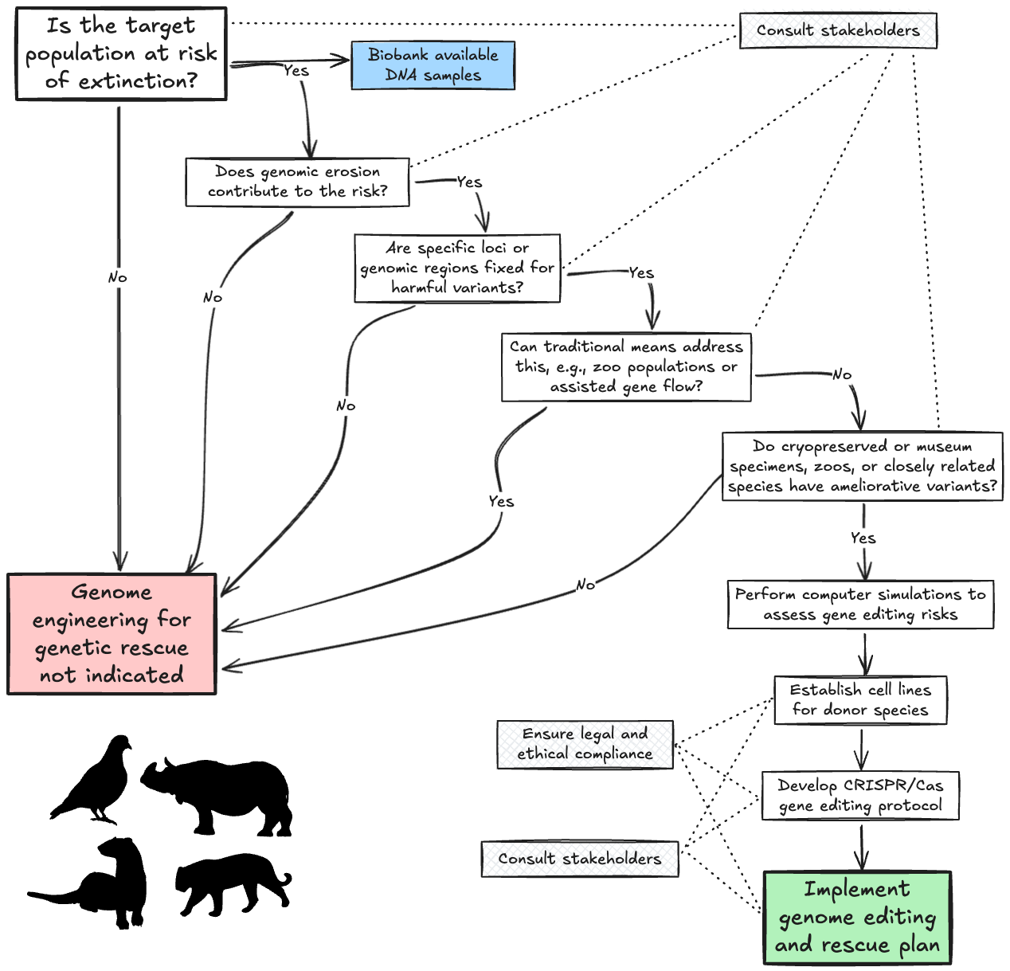
Figure 1: Roadmap for genome engineering in genetic rescue. Genome engineering is unlikely to be a useful tool under a wide range of conditions. Its value depends on the availability of cryopreserved specimens, museum specimens, individuals in zoos, or closely related species, and whether these possess genetic variants that can replace harmful variants fixed in genetic loci. Computer simulations can help assess the consequences of gene editing, taking into account the risks of selective sweeps and loss of diversity, which are dependent on the recombination rate, strength of selection, and the population growth rate of the rescued population. Stakeholders will need to be consulted, and ethical and legal compliance will need to be assured when formulating a genetic rescue plan that involves genome editing.

Figure 2
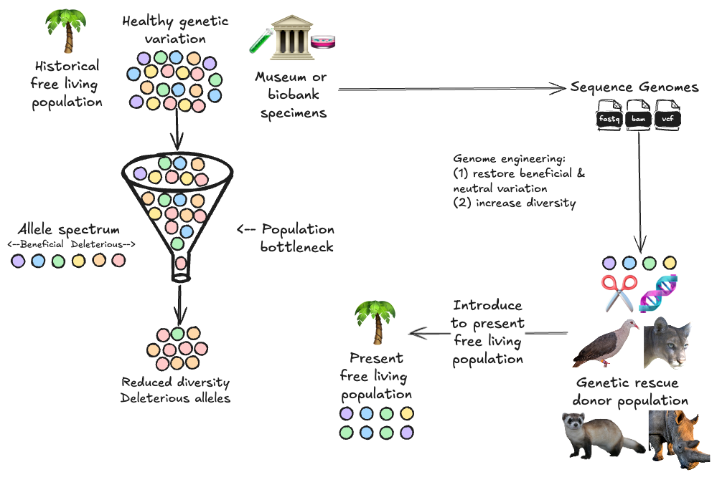
Figure 2: Genome engineering for genetic rescue. The declining population is split into wild and captive populations. Samples collected before the population bottleneck held in museums, biobanks, or other ESUs are used to restore lost DNA variation into wild populations with genome engineering, thus reducing the genetic load of harmful mutations that have been fixed in the population.

Figure 3
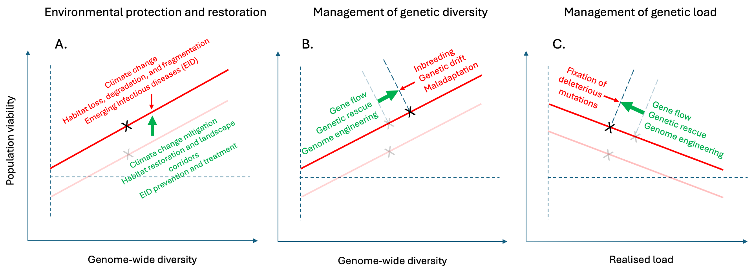
Figure 3: Conservation and restoration of biodiversity requires an integrated approach involving environmental protection and genetic management. (A) Environmental pressures reduce the viability of populations, particularly of populations with little genome-wide diversity. Environmental restoration can increase the viability of populations without necessarily increasing genetic diversity, resulting in only a partial recovery (black and grey crosses). The transparent line shows the viability of the population before environmental restoration. (B) Conservation actions aimed at restoring genetic diversity can counter genomic erosion caused by inbreeding, genetic drift, and maladaptation, thereby potentially increasing population viability. (C) Genetic management can also reduce the realised load of populations and alleviate the fitness-loss caused by variants that have become fixed in the population. Genome engineering has the potential to form part of genetic management of threatened populations, alongside environmental protection and actions that aim to reduce inbreeding, increase gene flow, and genetic rescue.

Figure 4

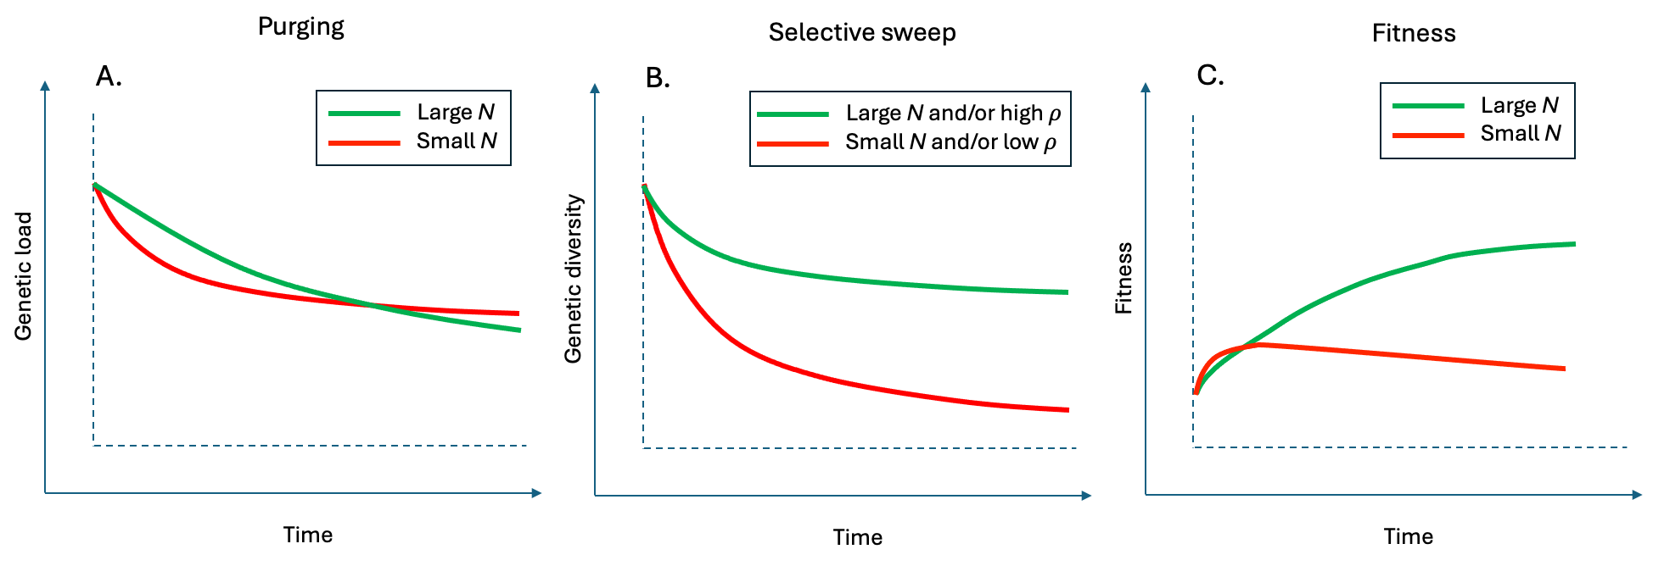
Figure 4: Conceptual figure showing the impact of genome engineering on genetic load, diversity, and fitness. (A) Introduction of a beneficial genetic variant by gene editing can reduce genetic load. Although purging proceeds faster in small populations, Hill–Robertson interference may reduce the efficacy of purifying selection against other harmful variants in the longer term. (B) Genome editing may lead to selective sweeps and loss of genetic diversity, which is worst in populations with small census size (N), and when a variant is introduced into a genomic region with low recombination rate (𝜌). (C) Small populations are likely to show a rapid increase in fitness after the introduction of a beneficial genetic variant, but large populations will have a more sustained, long-term benefit because they are less affected by selective sweeps and Hill–Robertson interference.

