Fijian Urban Youth Futures: Arts | Transmission | Resilience
Karen Jacobs
Sainsbury Research Unit, University of East Anglia

Abstract:
The online exhibition iSausauvou: Arts | Transmission | Resilience (2022-ongoing) was organized in the framework of Urban Pathways: Fiji. Youth. Arts. Culture., a collaborative research project funded by the British Academy’s Youth Futures program. After an overview of the project and its core activities, this article focuses on the online exhibition, which showcases art works created by young people who live in Fiji and its diaspora communities and were asked to reflect on urban youth culture. These young artists contemplate the social and cultural expectations that come with being youth in a multi-faith and multi-lingual urban environment during the Covid-19 pandemic. By putting these youth artistic expressions within the framework of scholarship of “the future”, this paper aims to move away from the trend to associate youth with youth problems, such as unemployment and lack of education, and instead focus on how youth imagine the future through art.
Keywords
Urban identity, Fiji, exhibition, youth art, future

Hope for the future
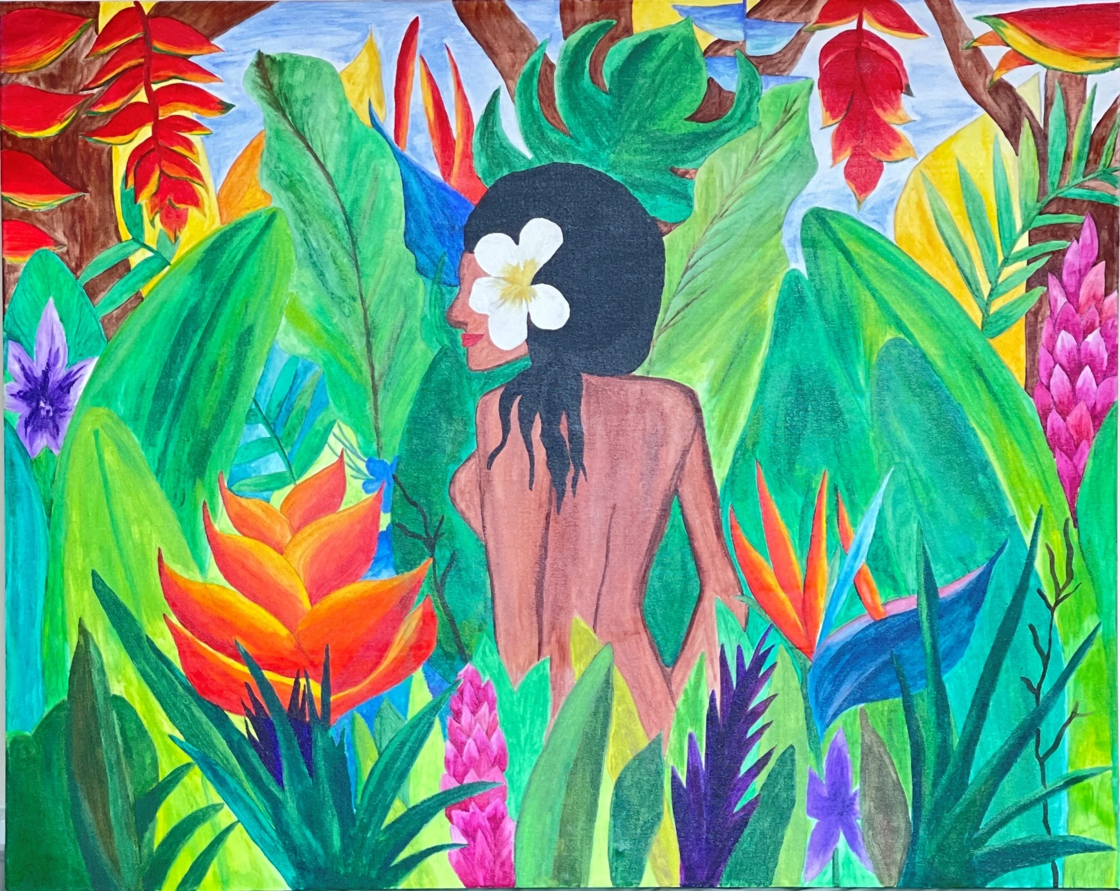
[Figure 1: Salaima Raluvenitoga Kanasalusalu Tuisovivi, Yalewa Kaukauwa, 2022. Acrylic paint. Photograph by Salaima Raluvenitoga Kanasalusalu Tuisovivi. Courtesy of the artist.]
The connection we have to our countries of heritage is a part of our very souls. It enables us to see our identity as one of our greatest strengths. It grants us fearlessness, authenticity, self-acceptance, power and a voice. It is the very best part of who and what we are, rooted in culture, language, history, tradition, custom but most importantly, ancestry. For our ancestors gave us more than trauma, they gave us a future.
Salaima Raluvenitoga Kanasalusalu Tuisovivi wrote these words in the artist statement that accompanied her acrylic painting Yalewa Kaukauwa (strong woman), a work that she submitted to an online exhibition showcasing artworks created by young people that reflected urban youth culture. By refusing to reduce the past to trauma and by focusing on the future, Salaima re-centers the historical narrative away from colonial interventions. She highlights continuity and resilience with her identity as her greatest power.
The online exhibition iSausauvou: Arts | Transmission | Resilience (2022-ongoing) was organized in the framework of the collaborative research project “Urban Pathways: Fiji. Youth. Arts. Culture.,” which was funded by the British Academy’s Youth Futures program.
After an overview of the larger project and the work placement program, this article analyzes the online exhibition by drawing on anthropological scholarship on the concept of “the future” because not only are young adults considered to be the future, the youth phase in one’s life is a transitional one directed towards the future. Critical future studies emerged in anthropological scholarship mainly since the 2000s, when academic reflection on uncertain futures resulted from the repercussions of a global financial crisis, a “war on terror,” and climate change. Faced with a difficulty and even inability to anticipate the future, anthropologists became interested in the subject and moved away from the tradition/modernity dichotomy that characterized anthropological thinking. Closely linked with this study of the future was a scholarly interest in temporality and nonlinear chronology. As Salaima reminds us in the quote above, time is cyclical rather than linear. She refers to her ancestors in relation to her future, echoing Ailton Krenak’s work, which, in reference to the ever-shifting form of rivers reflecting nonlinear temporality, proposes that the future is ancestral; it is rooted in ancestral knowledge.
Temporality is also important in Indigenous futurism scholarship that is inspired by the tropes of science fiction and shifts in focus to local and marginalized voices and presence when re-imagining the future. Fijian author Gina Cole coined the concept “Pasifikafuturism” when she wanted to write science fiction but was confronted with the lack of Pasifika writers, characters, or stories. Cole put forward Pacific knowledge as the “science” in science fiction, as such demonstrating that ancestral knowledge informs the future. What makes Pasifikafuturism unique is the centrality of the Pacific Ocean. Cole is inspired by ancestral practices of wayfinding. Drawing on the work of master navigator Hoturoa Barclay Kerr, she argues that wayfinding is an ancestral practice that demonstrates that “Pacific peoples and teachers have always been and continue to evolve as futurist thinkers.” Cole’s concept is valuable in this paper on youth seeking guidance when considering the future.

Youth Futures

Between October 2020 and October 2022, the British Academy’s Youth Futures program funded the collaborative research project “Urban Pathways: Fiji. Youth. Arts. Culture.” Supported under the UK Government’s Global Challenges Research Fund, the Youth Futures program was set up in response to the high unemployment or underemployment rates for youth who live in developing countries. The program sought projects that offered a youth-led perspective on the UN’s 2030 Sustainable Development Agenda. Projects needed to be genuinely interdisciplinary and be based on collaborative work with young people that extended beyond the standard research model. Through collaborations with urban Fijian youth, the Urban Pathways project aimed to bring youth communities into Fiji’s cultural heritage institutions and help them consider these environments as potential employment opportunities. The project brought together scholars in visual and intangible arts, anthropology, education, museum studies, and marine science. The project partners were the Sainsbury Research Unit at the University of East Anglia (Norwich, United Kingdom), Fiji Museum (Suva, Fiji), The Pacific Community (SPC, Suva, Fiji), the School of Agriculture, Geography, Environment, Ocean and Natural Sciences at the University of South Pacific (Suva, Fiji) and VOU Dance Fiji (Nadi, Fiji).
The Urban Pathways project team worked with Fijian urban youth. The term “Fijian” was used to encompass all ethnicities in Fiji and what unified the group was not the tenacious binary of Indigenous/non-Indigenous but their status as young people who live in a hierarchical society. While urbanization only developed in Fiji in the 1950s after the colonial government had lifted limitations on the mobility of Indigenous Fijians from villages, currently half of the population lives in urban areas. The urban environment in Fiji is also a multi-faith and multilingual environment where, as the Fijian sociologist specialized in youth studies Patrick Vakaoti observed, youth might be “less bound by cultural expectations” and have easier access to higher education. However, urban centers also attract rural youth who might lack the qualifications to find employment, resulting in a high level of youth unemployment.
Indeed, statistics indicate that urban youth is an important demographic in Fiji. Fiji’s 2017 census logged the nation’s population as 884,887 and the average population growth at 0.6%. More than half of the population (55.9%) lived in urban regions and half the population was below 27.5 years old, which was recorded as the median age; 69% was under the age of 40. Since the last official census, statistics appear to remain similar with the median age recorded as 27 years amongst a population number of 935,974. Fiji’s statistics correspond to other nations in the Pacific region. In fact, there are growing concerns about the ‘youth bulge’ in Pacific populations, a phenomenon that is believed to occur when the youth population, people aged between 15-24, exceeds 20% of the total population. This can be positive when strong supporting frameworks are in place and employment rates are high, but often this theory has been used to highlight that the youth population is considered a problem to be managed and some of the underlying causes of youth problems quoted are “poverty, education systems focused on white-collar employment skills, stagnating economies that do not provide enough employment opportunities, and rural/urban inequalities.”
While the United Nations’ definition of youth is people aged 15-24, in Fiji the non-governmental definition of youth falls between the ages of 18-35, while governmentally the age range shifts to 15-35 years. These additional ten years demonstrate Fijian cultural and community values and speak to stages of important life-cycles experienced in Fiji, as well as iTaukei (Indigenous Fijian) hierarchical structures. A person can still be considered a youth if unmarried, living with parents, married but without children, financially dependent or not yet in a position of authority. Consequently, as Aidan Craney writes in relation to urban youth in Fiji and the Solomon Islands: “Although youth are numerically significant, the power they exercise and the extent to which their civic engagement is encouraged are extremely limited.”
Following an opportunity, rather than a problem-oriented approach, the Urban Pathways project aimed to reach youth who do not consider the arts and cultural heritage sector to be a viable employment sector by offering a paid youth work placement program. In Fiji, youth generally do not visit museums and cultural heritage institutions, apart from during school trips. This has long been a global trend as youth felt that museums did not cater to their interests. However, museum-based youth programs that target skill development, professional learning, and cultural and social inclusion support youth engagement with the museum and have been proven to have a positive impact on youth. The Urban Pathways project enabled paid placements for fifteen youth at three partner institutions— Fiji Museum, University of South Pacific, and VOU Dance Fiji—over a set number of days in a twelve-month timeframe between March 2021 and June 2022.
The participants were an even mix of male-identifying and female-identifying people who represented diverse ethnic identities from urban areas in Viti Levu (Suva, Nadi, and Lautoka). At Fiji Museum, six youth were completely integrated into the museum’s work force and took up positions as technical interns in conservation, collections management and exhibitions, education, policy and legislation, library and archives, and digital media. They actively contributed to everyday work in their departments as well as the refurbishment of the museum. VOU Dance Fiji created five positions in arts and events management, focusing on areas of the sector that were undervalued and without representation in Fiji’s cultural industry. The four youth, based at the University of South Pacific, worked with the Marine Collections and conducted individual and group research projects that explored the cultural significance of natural heritage. Fully immersed in the organizations and treated as fully-fledged staff members, the work placement program allowed youth to learn about career opportunities in this sector. The program also taught the organizations how to value and champion youth engagement and participation. The youth produced wide-reaching outputs; through their work placements, they hosted online open days, conducted research projects linked to their cultural heritage, undertook ‘fieldwork’ trips, and created an exhibition.
Overall, the youth work placement program went beyond work experience as youth realized the potential of heritage as a profession and as a tool to own their unique multicultural identity. Interns at Fiji Museum, for instance, brought the collections out of the museum, both metaphorically and literally. Each of the Fiji Museum youth interns completed a fieldwork trip in which they focused on community outreach. Intern Inise Kuruwale accompanied Fiji Museum staff on a fieldwork trip to Nairukuruku to accompany a civa vonovono (composite whale tooth and pearl shell breastplate) for use by its traditional owners. In a blog post of her experience, she wrote: “Going up to Nairukuruku made me appreciate the uniqueness of our itaukei culture and tradition even more.”
The youth at USP conducted individual research projects on animal or plant species. Abraham Waqairoba selected the vermiculated rabbitfish (Siganus vernmiculatus), locally known as nuqa-ni-vei-dogo. This fish is not only an important food source, it has cultural significance in the Fijian lunar calendar (vula vakaviti). In his blog entry about the experience, Abraham writes how he mostly enjoyed the different ways of gathering information. Not only did he retrieve information from scientific journals and social media posts, he had discussions with family members, elders, friends, and people from his community. In his words, “It made me understand the value of traditional education to me as a person and as a Fijian.” Zelda Rafai has always had an interest and passion in learning more about her Rotuman culture, which is why she chose to base her research project around three local birds of cultural significance based on discussions with elders, mentors, brothers, and sisters. These examples demonstrate how youth emphasized the significance of intergenerational knowledge exchange, and temporal and geographical crossings by drawing on cultural heritage.

iSausauvou: Arts | Transmission | Resilience

The project team had always intended to reach wider youth groups beyond those involved in the work placement program, but this was complicated by the Covid-19 pandemic. The team managed to organize three short online placements for Fijian UK-based youth at the UK-based Cambridge Museum of Archaeology and Anthropology (MAA), which holds the largest Fijian collections outside of Fiji Museum, but most of the originally planned events to attract broader groups of urban youth in Fiji had to be canceled or moved online. Therefore, an online exhibition competition was organized to showcase more youth voices. A way to celebrate arts, culture, and creativity in the time of Covid-19, the competition call invited young Fijian artists, aged 15-25, based in Fiji and its diaspora communities, to send in submissions that illustrated the theme of “urban youth culture.” Artists were allowed to submit a maximum of two works and were asked to include an artist statement of a maximum of 500 words with their submission. Participation was open to everyone who met the criteria and participants therefore self-selected by entering their work. However, it should be acknowledged that pandemic-related restrictions implied that the project team could only accept entries online and therefore limited entry to youth who had access to the required technology. While this kind of access is less an issue in the urban areas that this competition targeted, the circumstances affected youth from disadvantaged backgrounds that prevent access to technology. Thirteen artworks were submitted by nine artists. They used different types of media—artworks ranged from paintings to digital work, film, and performance (see Table 1).

Artist/Artist collective name | Artwork title | Form of output
Anthea Reddy | Rewrite the Stars | Poem
Blackwater Triad | Na noqu vosa | Performance (filmed)
Blackwater Triad | Eyes | Photograph (black and white)
Epi Vuruna | My Ball | Film (2’19’’)
Epi Vuruna | Cula | Film (17’46’’)
James Rabuatoka | Expressionist | Photograph (animated)
Jonathan Tudreu | Passing Time* | Digital illustration
Keresi Vosa | Everything will be owl right | Painting
Salaima Raluvenitoga Kanasalusalu Tuisovivi | Yalewa Kaukauwa | Painting
Takenivula Rakei | Rogoci Viti | Video Performance
Takenivula Rakei | Raici Au | Photograph (colour)
Teresa Regina Vaka‘uta | Dis Connection* | Digital illustration
Teresa Regina Vaka‘uta | Promises | Digital illustration
Table 1: Overview of contributions to exhibition competition. Artists listed in alphabetical order based on first name. Starred works were chosen by the jury as winning entries. There were two prizes of FJD $500 available for winning entries, which were chosen by an independent international jury.

The exhibition’s title, iSausauvou, is a polite Fijian honorific expression that refers to young people of high status, with the implication of them having future leadership roles. Usually the terms cauravou (young men) and goneyalewa (young women) are used to refer to youth, but the term iSausauvou was chosen by Fijian speakers on the project team to empower youth. The exhibition’s subtitle consists of the words “art,” “transmission,” and “resilience,” not only to demonstrate the youth’s resilience but also their desire to be surrounded by strong holistic education and governance systems. The artworks, with the artist’s statements, are viewable online, with the choice to view the artworks as standalone images or to experience the virtual exhibition. The latter was an effort to provide a gallery space for the artworks. Within the limitations of the system, curatorial choices involved featured objects that draw the visitor’s attention and displaying the film work in a dark room. However, curatorial interventions were kept to a minimum as the focus was on the artworks and the accompanying artist statements as expressions of youth identity. The aim was to amplify young voices that often remain unheard in a society that emphasizes age hierarchy. The exhibition aimed to show that youth have valid ideas that are worth listening to and to engage youth through the arts.

The artworks

The short film Cula (needle, injection) by Epi Vuruna tells the story of an anti-vax preacher and his shock when he discovers that his son agreed to have the Covid vaccine. It was the artist’s first drama, shot over five nights and in post-production for three months. The film expressed a pressing problem in Fiji, which Vuruna summarized as: “To jab or not to jab, that is the question.” In his accompanying artist statement, Vuruna explained that in Fiji, as elsewhere in the world, people were torn by their decision to have the Covid vaccine: “As hundreds move in droves to vaccine stations to take their jab, hundreds more remain skeptical about the drug for their own reasons and choose to sit on the side-lines still wondering.” The film conveys how the son felt confident in his decision, but that confidence disappeared quickly when he was reprimanded and punished by his father. The short film painfully shows the reality many Fijian youth were living at the time when decisions were influenced by generational gaps or religious beliefs.
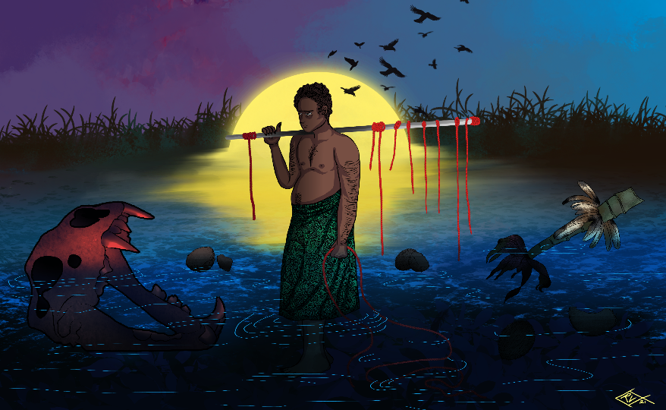
[Figure 2: Teresa Regina Vaka‘uta, Promises, 2022. Digital illustration. Courtesy of the artist.]

Other artists reflected on general issues that youth face, which were only exacerbated by the pandemic. Teresa Regina Vaka‘uta’s Promises (Fig. 2) is a digital artwork that shows a young male standing in a flooded landscape with unfulfilled promises floating by while the sun is setting. In her words:
Urban youth now more than ever are struggling with lack of employment and job security. From a young age we are fed an idea and promises of what a good future looks like, what a successful adult looks like, etc… we are told if we go to school, study and work hard, if we stay healthy and do X, Y, Z, we’re promised a better future. This piece is based on the Fiji flag, and these ideals being challenged by climate change, an economic crash, Covid, illness, etc.
The flooded landscape is a clear allusion to the threat of climate change. Vaka‘uta also refers to the country’s coat of arms depicted on the Fijian flag. However, the lion, which tops the coat of arms, is now reduced to a skeleton, the banana bunch damaged, the coconut palm uprooted, and the doves of peace are flying away. The young male in the center of the artwork holds pieces of red thread referencing the use of red in the British flag shown in the corner of the Fiji flag and in the coat of arms—now reduced to remnants of red thread—high hopes of opportunity turned into empty promises.
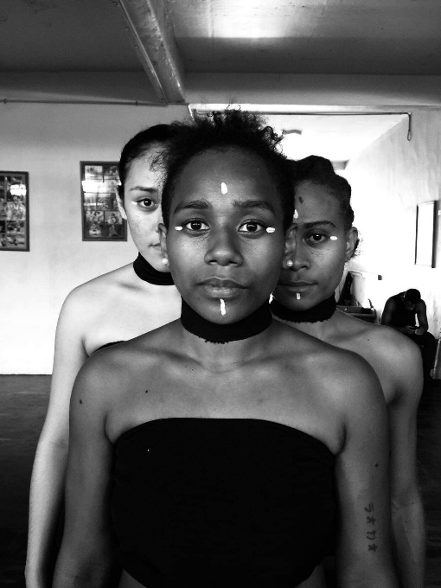
[Figure 3: Blackwater Triad, Eyes, 2022. Photograph. Courtesy of the artists.]
The work Eyes by Blackwater Triad, a black and white photographic portrait of three women with white face paint that highlights their eyes (Fig. 3), emphasizes that youth want to be seen. In their artist statement, the makers explained that this photograph was made once work resumed after the pandemic had hit. They wanted to call attention to the eyes of the women in the photograph: “The eyes are like books that are being written continuously yet aren’t told. You wish someone could listen to you through your eyes at times because they are the very windows to your souls.” While eyes might reveal a lot about someone, this does not necessarily mean that people are seen. The artists refer to the fact that youth voices are not necessarily heard or valued. Consequently, many youth do not feel seen.
In the poem Rewrite the stars, “a story narrated by the moon personified,” Anthea Reddy reflects in free verse on “the predicament of two people from different religions yet the same gender being denied the one universal language which is love.” This is expressed in various of the poem’s verses, such as “Soul mates anticipating for their pathways to align, to be reborn in another time, in a foreign land.” Reddy reflects on social and cultural expectations that come with being youth in a multi-faith and multilingual urban environment. The issues and stigmas surrounding same-sex relationships in Fiji are obviously not limited to youth or the urban environment, but in Fiji the urban environment brings more opportunities for multi-faith and multi-ethnic social interaction.
Some youth problems stem from the playground, as the film My Ball by Epi Vuruna shows. The short film focuses on young boys who try to take another boy’s ball, an act that results in martial arts fighting accompanied by cartoon noises. While the artist statement explains that this was just a fun film made because Vuruna’s cousins requested it, the playground is a social setting that can have a lasting impact on people, particularly if it was a negative experience. However, this work expresses a longing for innocence, which is also shown in the work Expressionist by James Rabuatoka, a short video compilation of portraits of a young child.

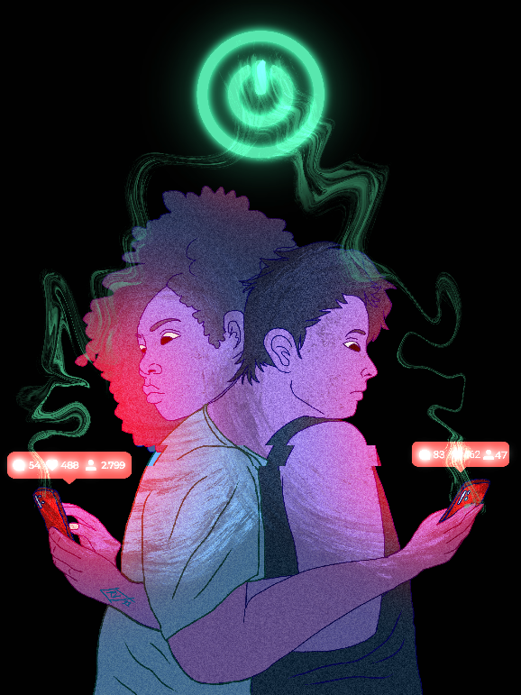
[Figure 4: Teresa Regina Vaka‘uta, Dis Connection, 2022. Digital illustration. Courtesy of the artist.]

Teresa Regina Vaka‘uta’s second entry, a digital illustration entitled Dis Connection, explores (dis)connection that comes with technology (Fig. 4). The digital drawing shows two young people embracing, resting their heads on each other’s shoulder while looking at their phones. In a video uploaded as a blog entry, Vaka‘uta explains that the competition theme reminded her of social media, screen dependency, and economic/stability fears that developed during the Covid pandemic. Her artwork title was intentionally spelled “dis connection” to refer to 1) the act of detaching one thing from another, 2) the feeling of isolation, and 3) “this” connection between us. She states that more and more youth are hungry for genuine connection and not just talking to a screen.
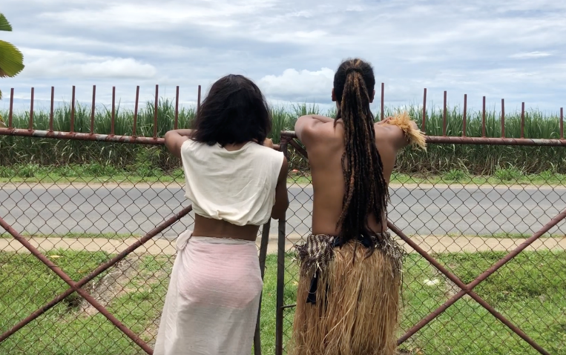
[Figure 5: Blackwater Triad, Na noqu Vosa, 2022. Video. Screenshot taken by author. Courtesy of the artist.]
Communication was also at the center of the performance piece Na noqu Vosa (my language) by the collective Blackwater Triad (Fig. 5), which, as the artists state, aimed “to highlight a challenge we believe some of the youths in Fiji face which is having knowledge of your mother tongue, the language spoken by our forefathers” The artist collective addresses the fact that English is the most common language spoken in Fiji, particularly in educational and professional contexts. This can lead to a loss of one’s mother tongue. The collective demonstrates that, for some youth, dance can be a form of expression that supports a reconnection with their mother language that they might have forgotten. The two artists’ dance space is juxtaposed by a road on one side and a field on the other, which could be interpreted as the contrast between urban and rural environments. Cars pass while the dancers move to the spoken words: Na yacaqu—my name (this is the only phrase that is also uttered in English); Vakamacalataki iko—explain yourself, or explain about yourself (to one person—iko); Na noqu vosa—my language. Dance is used as a language to express the potential loss of spoken word.
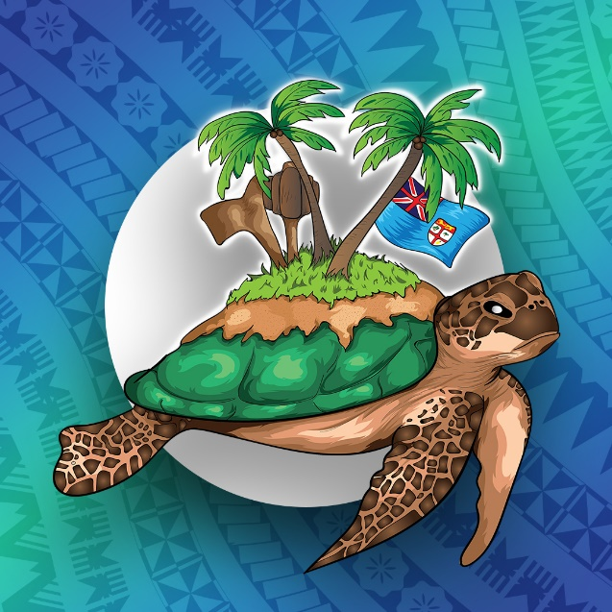
[Figure 6: Jonathan Tudreu, Passing Time, 2022. Digital illustration. Courtesy of the artist.]
Jonathan Tudreu’s digital illustration, Passing Time, shows a turtle at the center with coconut trees growing on its shell, Indigenous Fijian wooden clubs, and the Fijian flag (Fig. 6). The turtle is depicted on a blue background with rows of patterns usually found on Fijian barkcloth. The turtle, as a long-living creature, Tudreu states, “represents time/strength/knowledge of culture and preservation while the things on its shell represent our traditional practices.” Tudreu’s message is an appeal to preserve culture and traditions and transfer this knowledge to subsequent generations.
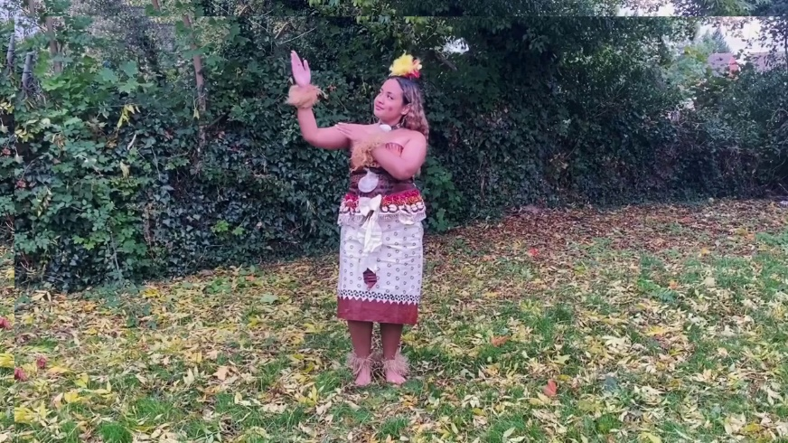
[Figure 7: Takenivula Rakei, Rogoci Viti, 2022. Still of video. Courtesy of the artist.]
The main theme of the performance piece by Takenivula Rakei, Rogoci Viti (listen to Fiji), is rebirth (Fig. 7). In her artist statement, Rakei describes that the inspiration for her artwork came to her during her UK-based internship at the Museum of Archaeology and Anthropology, University of Cambridge, for the Urban Pathways project when youth were given access to the collections. Rakei uses historical photographs of meke (movement including song/dance) performances from the museum’s Fiji photograph collection at the start of her video. The main part of the video is taken up by Rakei’s choreography of a meke that she performs herself in a British garden dressed in masi (barkcloth), hibiscus flower salusalu (garland), a magimagi (coir) belt with pearl shell wrapped around her waist, a white cowrie shell neck ornament, as well as vau (hibiscus fibre) armbands and leglets. In her words:
I felt that my understanding of my own culture was lacking in some areas and the internship represented that promise of a fresh start. To reconnect with my roots, building upon all that I knew so far, in a safe space, free from judgement. I chose the song Rogoci Viti because to me the internship was about listening to Fiji, to my history and culture and reconnecting with it.

The acrylic painting entitled Yalewa Kaukauwa (strong woman) by Salaima Raluvenitoga Kanasalusalu Tuisovivi, who also was based in the UK, was “inspired by the homeland that I continue to long for each and every day” (Fig. 1). While the work, which shows the back of a woman with a flower in her hair amidst vividly colored tropical foliage, might remind viewers of popular representations of Pacific women, the title refers to a yalewa kaukawa, a powerful woman, and reflects, according to the artist, “what it means to be an indigenous young woman who chooses to turn her back on colonialism, as she slowly navigates her way through life and strives to preserve the authenticity of her identity.”
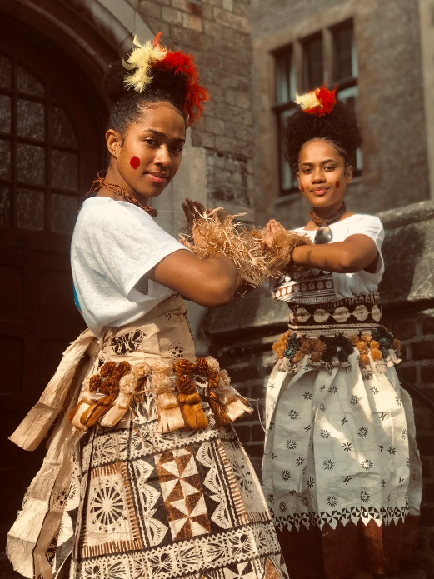
[Figure 8: Takenivula Rakei, Raici Au, 2019. Photograph. Courtesy of the artist.]
Culture, tradition, and their transmission are also themes of Raici Au (Look at me), another work by Takenivula Rakei. The photograph depicting Emele Robanakadavu and Mary Patricia was taken after they, together with Ana Lavekau and Rakei, performed a meke at Westminster Abbey, London, on February 22, 2019. The two women are in their performance attire, wearing feathered headpieces, shell necklaces, barkcloth skirts wrapped with salusalu (garlands), and hibiscus fibre armlets. The event reminded Rakei of the fact that two Fijians had been chosen to attend the coronation of George VI at Westminster Abbey in May 1937, but that no meke had been performed in situ since. Performing her meke more than eighty years later at the same location was a momentous occasion that Rakei wanted to capture. She states that the photograph represents resilience. On the one hand, she wants to refer to the resilience of meke as an art form that has changed over time and has crossed boundaries as it was taken by Fijians to diaspora regions. On the other hand, Rakei suggests that the photograph expresses the resilience of the two young women depicted:
The title of this photograph is “Raici Au” which means look at me. Look at these two young Fijian women who even when surrounded by a culture that is not their own, they still had the courage to make that first step and say “yes” to performing a meke in Westminster Abbey to a large audience.
Overall, the online exhibition features artistic expressions by young people from Fiji who raise awareness of issues that they are facing or they feel will chart their future. However, in her painting of a white owl on a black patterned background, entitled Everything will be Owl right, Keresi Vosa expresses hope for Fiji’s urban youth’s future.

Urban Displacement: longing for belonging

In times of uncertainty, hope is a way to face the future. Hope has been defined as “a desire, longing or aspiration for something and the confidence that its fulfilment is possible.” Hope is about possibility, and even though not all possibilities are necessarily actualized, these in turn create new hope. Referring to Ernst Bloch’s philosophical writings on hope, anthropologist Hirokazu Miyazaki observes that a philosophy of hope is “open to the future” and “entails a commitment to changing the world.” Writing about Suvavou people in Fiji, Miyazaki demonstrates that hope was a method of self-knowledge, “that is, knowledge about who they were.” Youth is a transitory stage in life, a phase that is betwixt and between. It is this liminality that makes it an uncertain stage and one during which hope is important. Equally it is that liminal status that implies that youth are not always heard. Indeed, while hope is commonly seen as an aspiration linked to possibility, it can also lead to an overwhelming feeling of being stuck when not linked to action. The youth creations at the center of this paper need to be considered in this context.
As anthropologist Michaela Haug writes, “studying the aspirations that people have for the future and how they inform their actions in the present reveals a great heterogeneity,” which “allows us to explore their entanglement within existing power relations and inequalities.” By organizing the exhibition competition, the project team hoped that it would provide a space for dialogue around issues facing urban Fijian youth. As much as “youth” is not a homogenous category, these artworks resist any singular conclusion about what it means to be an urban Fijian youth today. Yet within this diversity, there is a unified strength connected by a love for cultural origins and how these origins are in dialogue with present-day challenges and desires.
What the youth generally highlighted in their artworks and artist statements was a need for transmission and connection in times of displacement. For some, displacement was caused by the pandemic (i.e., Vaka‘uta’s Dis Connection, Blackwater Triad’s Eyes, Vuruna’s Cula). Indeed, the pandemic was the closest we all came to a futuristic dystopia or the apocalypse in science fiction. When Covid-19 spread across the world, quarantines, curfews, and lockdowns were put in place. People died, people lost their jobs or were told to stay home, social distancing became the norm, and mask-wearing was introduced. While much of the world lost all sense of normality, the list of rules that were put in place aimed to generate a “new normal.” No wonder that sociologist Daniel Briggs writes that reporting on the virus and the pandemic followed similar scenarios to dystopian future films.
However, science fiction shows that an apocalypse not only leaves devastation, but as Briggs writes, it leaves survivors who endure and persist, who are guided by hope, and who eventually orchestrate a new future. Rakei uses similar phrasing in her artist statement of Rogoci Viti. As mentioned, her video begins with photographs from MAA’s Fiji photograph collection, which Rakei had accompanied by an audio track of lali (drum) beats:
The lali beat describes a village which has burnt down. For me, that burnt village represented the understanding and confidence I had in my culture and identity before the internship. When you picture a burnt village, it conjures feelings of hopelessness. But on the other hand, however devastating a burnt village may be, there’s also a sliver of hope in the promise of a fresh start over the horizon. A new beginning doesn't necessarily mean going back to square one and losing all the progress that you’ve made, but rather an opportunity to start again with the knowledge and lessons you have gained from the first try.
Rakei imagines her future by drawing on her ancestral past and cultural identity as drivers for the future. This is a common feature in the artworks submitted to the iSausauvou exhibition, although the reasons for that feeling of displacement differed.
Other artists expressed a sense of displacement by focusing on the fact that being a youth is to be in a transitional status. It is a stage in one’s life when one feels old enough to make one’s own decisions yet is not necessarily free to do so, and this ranges from decisions about vaccines (Vuruna’s Cula) to choosing one’s partner (Reddy) to expressing disappointment in previous generations’ choices and their impact on youth today (Blackwater Triad’s Na noqu vosa and Vaka‘uta’s Promises).
Youth also reflected on the urban environment (Rakei’s Raici Au, Tuisovivi’s Yalewa Kaukauwa). The collective Blackwater Triad shows in their performance piece Na noqu Vosa that the urban experience influences the knowledge of language. Accompanied by Fijian spoken language, the dancers emphasize the power of dance as a visual language. They state that: “In dance our forefathers were able to use chants to pass on the stories or legends of our people. It is through these mediums that most Fijian youths who are dancers feel a slight bit . . . closer towards their cultural roots.” The artworks in the iSausauvou exhibition expressed youth resilience by drawing on the transmission of culture as ways of dealing with these issues.
In his digital illustration Passing Time, Tudreu’s message is an appeal to urban youth to preserve knowledge of culture and traditions in an urban environment: “We won’t be on this earth for long, but the knowledge of our traditions and culture can be preserved and passed down from generation to generation.” In other words, while the urban environment can result in feelings of loss of language and cultural roots—which is reflected in the submitted artworks—the creations are equally, “unapologetically urban,” to use Pacific Studies scholar Lana Lopesi’s phrasing. In her description of the development of the Pacific arts scene in Aotearoa New Zealand, Lopesi describes how Pacific people were making their place in Aotearoa as expressed in urban-flavoured art works: “The lingering question of Pacific identity could have been the cause of inner turmoil and self-implosion. But for the musicians, designers and partiers, it led to an explosion of infinite possibilities.”
When Adi Lewa Boginisoko completed a work placement at the Museum of Archaeology and Anthropology in Cambridge, United Kingdom, she came across a music recording in the museum collections that was taken in her ancestral village. Her mother had learned to perform a Tongan-style lakalaka dance to this song, which she then taught her daughter Adi Lewa during the placement. This was a deeply personal experience that bolstered confidence, as conveyed in her blog post about the experience: “It has enabled me to connect with my culture on a deeper level.”
Part of the placement program for UK-based Fijian youth was a talanoa (open, inclusive, participatory dialogue) session with the Fiji-based youth participants in Fiji. Together they discussed the impact of growing up in their respective social settings. About this experience, Adi Lewa wrote: “The fact that these Fiji interns were based in Fiji I had assumed that they had a stronger connection with their culture, whereas in reality we were a lot more similar than I had thought, in terms of trying to preserve our culture and traditions for the future generations in our continuous fast-moving world.” Because people in diaspora can no longer practice their traditions in their homeland, Pacific Studies scholar Albert L. Refiti writes that they “‘coil’ them into concepts, carry them in a ‘tool box’ of theory, then unpack, operate and perform with them when required,” using them as tools to create a new home. And this is exactly what the young artists who feature in this paper are doing. Their stories are not merely stories of displacement but stories of mobility, of resilience, creativity, family, and urban identities.

Conclusion: youth is the future?

This paper aimed to move away from regarding youth as a problem to be managed by arguing that youth should be viewed as having great potential to make valuable contributions to their communities and their futures. In other words, while youth should certainly be considered as the future, they should not be limited to the future but be heard in the present too.
While the artworks discussed in this paper reference youth problems and issues, they mostly center re-connection. Created at times when the youth were feeling disconnected either because of Covid, geographical distances, or other forms of detachment, the youth’s future-oriented creations were neither a fantasy nor speculative fiction. Rather, these creations were aspirational; they expressed a prevailing sense of hope. In trying or difficult times, hope can be a tool of empowerment. Scholarly writing on hope reminds us that uncertainty or disappointment can be engines of hope. The status of youth, which is transitional and therefore uncertain and trying, is important in this regard, and the Fijian youth who participated in this project reflected on this status and showed their resilience.
The artworks in the exhibition and the discussions in the broader project at the basis of this exhibition demonstrate that youth connected to different temporalities in order to build a future. The youth were forward-looking yet they sought guidance and direction in these artistic imaginaries of the future. Their future was an ancestral future, to use Krenak’s words. Youth drew on their past, on their ancestors, while dynamically moving forward, transforming along the way. However, while imagining the future involves contemplation of temporality, what the youth in this exhibition and project have shown is that it equally implies reflection about place. Diasporic youth outside of Fiji and urban youth in Fiji perceived the urban and diaspora environment in similar ways. Both felt that they are living away from their cultural homelands and are trying to make efforts to maintain their cultural affiliations. Their reflections on displacement are expressions of possibility, hope, and resilience, which should be transmitted as much as being influenced by transmission of cultural knowledge.

Acknowledgments
I am grateful to the British Academy and to the Urban Pathways project team, the youth interns, artists and judges who were involved in the project: vinaka vakalevu. Thank you also to Clementine Debrosse, Garance Nyssen, and the two anonymous peer reviewers for their helpful comments.

Salaima Raluvenitoga Kanasalusalu Tuisovivi, “Yalewa Kaukauwa”, artist statement: https://fijiyouthculture.wordpress.com/yalewa-kaukauwa/
The official project title was (Re)Defining Culture: Engaging urban Fijian youth in sustainable employment opportunities in the cultural heritage sector, but the project team changed it to Urban Pathways: Fiji. Youth. Arts. Culture to make it more accessible. The project was supported by the British Academy’s Youth Futures Program, supported under the UK Government’s Global Challenges Research Fund under Grant YF\190078. Ethical approval was granted by the University of East Anglia‘s Faculty of Arts and Humanities Research Ethics Sub-Committee (reference: SREC 20-015).
The focus on “the future” was also inspired by the Pacific Arts journal call for papers on futurism.
Rebecca Bryant and Daniel M, Knight, The anthropology of the future (Cambridge University Press, 2019), 6-9. See also, Arjun Appadurai, The future as a cultural fact: Essays on the global condition (Verso Book, 2013), amongst others.
Bryant and Knight, “The anthropology of the future,” 14.
Ailton Krenak, Ancestral Future (Polity Pres, 2024).
Gina Cole, “Wayfinding Pasifikafuturism: An Indigenous Science Fiction Vision of the Ocean in Space,” In The Routledge Handbook of CoFuturisms, ed. T.J. Taylor et al. (Routledge, 2023), 55.
Gina Cole, “‘Pasifikafuturism’: the new genre of science fiction invented by author Gina Cole,” Stuff October 29 (2022). https://www.stuff.co.nz/life-style/130306614/pasifikafuturism-the-new-genre-of-science-fiction-invented-by-author-gina-cole
Cole, “Wayfinding Pasifikafuturism,” 55.
For more information, see https://www.thebritishacademy.ac.uk/programmes/youth-futures/.
In the UK, the project team consisted of Karen Jacobs, Principal Investigator (PI), and Katrina Igglesden, Postdoctoral Research Associate (PDRA), at the Sainsbury Research Unit, University of East Anglia. In Fiji, the project’s Co-Investigator (Co-I) Frances C. Koya Vaka’uta is Team Leader - Culture for Development in the Human Rights and Social Development (HRSD) Division at the Pacific Community (SPC). The team further comprised Sipiriano Nemani, Director Fiji Museum, Sachiko Soro, Director of VOU Dance Fiji Company, and Kelly Brown, Curator of the Marine Collection at the University of South Pacific.
Fiji Demographics, see https://www.countryreports.org/country/Fiji/population.htm
Patrick Vakaoti, “Young people’s participation in Fiji: Understanding conceptualizations and experiences,” Journal of Youth Studies 20 no. 6 (2017): 700. https://doi.org/10.1080/13676261.2016.1260695.
Patrick Vakaoti, Street-Frequenting Young People in Fiji: Theory and Practice, (Palgrave Macmillan, 2018), 27.
Fiji Bureau of Statistics, “Population Census 2017,” https://www.statsfiji.gov.fj/census-surveys/census-of-population-and-housing/#2017
See https://www.countryreports.org/country/Fiji/population.htm
Richard Curtain and Patrick Vakaoti, The State of Pacific Youth 2011: Opportunities and obstacles, (UNICEF Pacific, Secretariat of the Pacific Community. 2011), 5. See also: SPC, Pacific youth development framework 2014–2023: A coordinated approach to youth-centred development in the Pacific (Social Development Division of the Secretariat of the Pacific Community, 2015); Patrick Kaiku, “A critique of the youth bulge theory in Papua New Guinea and Melanesia,” Pacific Studies 41, no. 3 (2018): 188–198; Aidan Craney, Youth in Fiji and Solomon Islands: Livelihoods, Leadership and Civic Engagement, (ANU Press, 2022).
Government of Fiji, Situational analysis of youths in Fiji 2011, (Ministry of Youth and Sports, 2012), 3.
Craney, “Youth in Fiji and Solomon Islands,” 13. The edited volume on Pacific youth by Helen Lee demonstrates that understanding the impact of ignoring youth is essential when considering the future of Pacific countries: Helen Lee (ed.), Pacific Youth: Local and Global Futures (ANU Press, 2019).
Kathleen McLean, “Museum exhibitions and the dynamics of dialogue,” Daedalus 128, no. 3 (1999): 83-108; David M. Mason and Conal McCarthy, “The feeling of exclusion’: Young peoples’ perceptions of art galleries.” Museum Management and Curatorship, 21, no. 1 (2006): 20-31; Emily Dawson, ““Not designed for us”: How science museums and science centers socially exclude low-income, minority ethnic groups,” Science Education, 98 no. 6 (2014): 981–1008.
Alison L Mroczkowski, Aaron C. Price, Natalie C. Harris and Angela D. Skeeles-Worley, “Youths’ Perceptions of Features of a Museum-Based Youth Development Program That Create a Supportive Community Context: A Qualitative Case Study,” Journal of Adolescent Research (2021): 1–36.
For examples, see the blog posts written by youth: https://fijiyouthculture.wordpress.com/.
See Karen Jacobs, “Youth as a Community at the Ethnography Museum: Urban Pathways: Fiji. Youth. Arts. Culture.,” Journal of Museum Ethnography 35 (2022): 63-74.
Inise Kuruwale, “Nairukuruku Fieldwork – the story of a civa vonovono,” blog post: https://fijiyouthculture.wordpress.com/2022/02/09/nairukuruku-fieldwork-the-story-of-a-civa-vonovono/.
Abraham Waqairoba, “My research experience on the nuqa-ni-vei-dogo, the vermiculate rabbitfish,” blog post: https://fijiyouthculture.wordpress.com/2021/10/05/my-research-experience-on-the-nuqa-ni-vei-dogo-the-vermiculate-rabbitfish/.
Zelda Rafai, “A youth’s experience as a Marine Studies intern working on a research project,” blog post: https://fijiyouthculture.wordpress.com/2021/09/29/a-youths-experience-as-a-marine-studies-intern-working-on-a-research-project/.
Committee Members were Lambert Ho, Jerry Wong, Tarisi Vunidilo, Arunesh Kumar and Josaia Tokoni, who judged each artwork on four main criteria: interpretation/relevance of theme; originality/creativity; quality of artistic composition—skill and technique; overall impression (including artist statement) (report on project files). Because pandemic-related restrictions had relaxed by the time the exhibition was launched online, the project team managed to organize an exhibition opening at Fiji Museum for the participating artists, project members, youth ambassadors, and representatives of the arts and culture sector in Fiji. During the opening, the two winning artists, Jonathan Tudreu and Teresa Regina Vaka‘uta, were awarded their prize by the Director of Fiji Arts Council (29 March 2022). Members of the jury also decided to add personal accolades and Vuruna, Rabuatoka, Vosa, and Tuisovivi were recommended for further mentoring in the arts.
Vakaoti, “Street-Frequenting Young People in Fiji,” 13.
To view the standalone artworks see https://fijiyouthculture.wordpress.com/isausauvou/, to see the virtual exhibition, see: https://www.artsteps.com/view/621dfe61884c75c4b6219442
Epi Vuruna, “Cula,” artist statement: https://fijiyouthculture.wordpress.com/cula/
Vuruna, “Cula”.
Teresa Regina Vaka‘uta, “Promises,” artist statement: https://fijiyouthculture.wordpress.com/promises/.
Karen Jacobs, “Ocean as Pathway: From Museum Collections to Contemporary Creations,” In Transnational Island Museologies: Materials for a Discussion, ed. K. Brown, J.A. Brown, J. A. and A.S.G. Rueda (International Committee for Museology (ICOFOM), 2024), 91.
Blackwater Triad, “Eyes,” artist statement: https://fijiyouthculture.wordpress.com/eyes/.
Anthea Reddy, “Rewrite the stars,” artist statement: https://fijiyouthculture.wordpress.com/rewrite-the-stars/.
Epi Vuruna, “My ball,” artist statement: https://fijiyouthculture.wordpress.com/my-ball/.
Teresa Regina Vaka‘uta, “Dis Connection,” artist statement https://fijiyouthculture.wordpress.com/dis-connection/.
Blackwater Triad, “Na noqu vosa,” artist statement: https://fijiyouthculture.wordpress.com/na-noqu-vosa/.
Jonathan Tudreu, “Passing Time,” artist statement: https://fijiyouthculture.wordpress.com/passing-time/.
Takenivula Rakei, “Rogoci Viti”, artist statement: https://fijiyouthculture.wordpress.com/rogoci-viti/.
Salaima Raluvenitoga Kanasalusalu Tuisovivi, “Yalewa kaukawa,” artist statement: https://fijiyouthculture.wordpress.com/yalewa-kaukauwa/.
Salaima Raluvenitoga Kanasalusalu Tuisovivi, “Yalewa kaukawa”.
Takenivula Rakei, “Raici au”, artist statement: https://fijiyouthculture.wordpress.com/raici-au/.
Keresi Vosa, “Everything will be Owl Right,” artist statement https://fijiyouthculture.wordpress.com/everything-will-be-owl-right/.
Michaela Haug, “Framing the future through the lens of hope,” Zeitschrift für Ethnologie (ZfE)/Journal of Social and Cultural Anthropology (JSCA), no. 1 (2020): 75.
Bryant and Knight, “The anthropology of the future,” 134.
Hirokzu Miyazaki, The method of hope: Anthropology, philosophy, and Fijian knowledge (Stanford University Press, 2006), 14.
Miyazaki, “The method of hope,” 26.
Haug, “Framing the future through the lens of hope,” 75.
Michaela Haug, “Framing the future through the lens of hope,” Zeitschrift für Ethnologie (ZfE)/Journal of Social and Cultural Anthropology (JSCA), no. 1 (2020): 73.
Daniel Briggs, "Hope, dystopian futures and Covid-19 as the ‘event ’that changed the world (forever?)," Journal of Contemporary Crime, Harm, and Ethics 2, no. 1 (2022): 78. https://doi.org/10.19164/jcche.v2i1.1220
Briggs, “Hope, Dystopian Futures,” 62.
Rakei, “Rogoci Viti”.
Blackwater Triad, “Na noqu vosa”.
Tudreu, “Passing Time”.
Lana Lopesi, “Urban Pacific,” In Pacific Arts Aotearoa: the powerful and dynamic legacy of Pacific Arts in Aoteroa, as told by the artists themselves, ed. L. Lopesi (Penguin Random House New Zealand in association with Pacific Arts, Creative New Zealand, 2023), 230.
Lopesi, “Urban Pacific,” 230.
Adi Lewa Boginisoko, “Connecting with Culture – thoughts from a UK-based youth,” blog: https://fijiyouthculture.wordpress.com/2021/11/15/connecting-with-culture-thoughts-from-a-uk-based-youth/.
Boginisoko, “Connecting with Culture”.
Albert Refiti, “Building the House of Noa No and Lave Lave: a possible theory of Pacific art,” In Home AKL: Artists of Pacific Heritage in Auckland, ed. R. Brownson et al. (Auckland Art Gallery Toi o Tamaki, 2012), 12.
Ernst Bloch, The principle of hope (Blackwell, 1986); Solnit, “Hope in the dark”; Rebecca Bryant and Daniel M. Knight, The anthropology of the future (Cambridge University Press, 2019).
Krenak, “Ancestral Future”.

