Public Opinions of a Net Outcome Policy: The Case of Biodiversity Net Gain in England

Abstract
Increasingly, there is social pressure for organisations and governments to recognize and address their biodiversity impact or risk reputational (and potentially financial) damage. Biodiversity Net Gain (BNG) is being introduced globally as a means of addressing biodiversity loss and has recently been mandated in England. Understanding public opinions of BNG is crucial for assessing the likelihood of BNG-related project rejection, which has significant implications for operational risk. Using a questionnaire with a nationally representative by age and gender (for England) sample of 500 people, we found that most respondents had limited knowledge of BNG, with 21% reporting experience with a project aiming to achieve BNG, but generally accepted its core assumptions: that habitat creation, restoration, or enhancement can achieve net biodiversity gains after development losses (58.2%), and that biodiversity can be measured using a standardised metric (42.8%). While distrust was high among most actors involved in BNG, particularly developers (48.2% somewhat or strongly distrust), wildlife charities and ecological consultants were trusted by most respondents (75.6% and 66.0% somewhat or strongly trust respectively). Over half (55.6%) of the respondents felt that a project's environmental impact is acceptable if it achieves BNG. As a result, BNG may act to reassure the majority of the public about a project’s biodiversity impacts thereby reducing operational risk. Our findings suggest four strategies to further boost BNG's acceptability: providing understandable information for stakeholders, involving trusted actors like wildlife charities, avoiding the use of pre-existing biodiversity credits; and ensuring developers are seen as responsible for compensatory sites.

Keywords: Biodiversity Net Gain; net outcome policy; acceptability; operational risk; trust

1 Introduction
In 2018, biodiversity net gain (BNG) was consulted on as a potential policy in England in the hope that a “transparent and consistent requirement could provide certainty, allowing developers to factor in [biodiversity] obligations up front” (Defra, 2018, p. 10). Having become mandatory in February 2024 (Stuart et al., 2024), BNG requires most terrestrial developments to demonstrate at least a 10% increase in the value of biodiversity assessed using the statutory metric, hereafter referred to as ‘the metric’, through on- or off-site compensation measures (Natural England, 2022). As a policy, BNG reflects the previous Conservative Government’s desire to increase the use of private investment and market-based instruments in nature conservation and follows on from a failed attempt to introduce Biodiversity Offsetting (BDO) in the 2010s (Stuart et al., 2024), which proved decidedly unpopular and gained the moniker of being a “Licence to Trash” (Carrington, 2013; Howarth, 2013).
Much of the disdain towards offsetting revolved around its framing of biodiversity as isolated and ‘placeless’ (Apostolopoulou & Adams, 2015), which underpins two of the central assumptions of BNG: that biodiversity can be measured and compared with a standardised numeric metric; and that the production of one ‘bit’ of biodiversity can be used to replace the loss of another to achieve a neutral or positive net outcome. Further adding to this was a sense that actors involved in BDO, namely developers and Local Planning Authorities, were using it to depoliticise and push through development that should not be given planning permission due to significant environmental and social impacts (Apostolopoulou, 2020). If this perception remains true for BNG it is likely to reduce trust in both the developer and Local Planning Authority. As trust is a key element in individuals’ decisions on whether to accept a project (Stuart et al., 2023), it is likely to have substantial implications for the acceptance of BNG as a whole.
The approach taken to BNG also has the potential to impact individuals’ decisions to accept BNG. Where the approach to compensation is seen as lower risk, individuals may feel less vulnerable and thus be more likely to accept the project even with relatively low levels of trust (Stuart et al., 2023). Within other environmental policies and areas, such as tackling climate change, there is a push for the ‘polluter pays principle’, in which developers are required to pay for the remediation of any environmental impacts they cause (Damiens et al., 2021). However, the ability to simply buy pre-made ‘units’ of biodiversity is seen by some as a way for organisations to shirk their environmental responsibilities, allowing environmentally harmful business-as-usual to continue (Biodiversity Net Positive, 2023; Dasgupta, 2024). As such, it is important for developers to know whether buying biodiversity units is seen as an acceptable way of achieving BNG, as this is currently a widely used strategy for small developments (Rampling et al., 2024).
It is of note that, when the UK Government Department for Environment and Rural Affairs (Defra) ran a consultation on whether net gain should be mandated in 2018, BNG proved popular, with 78% of respondents supporting BNG being made a mandatory requirement and broad acceptance across all stakeholder groups that responded, including a majority of those responding as individuals (Defra, 2019). This represented a substantial change from BDO when the equivalent consultation in 2013 found only 53% supported the introduction of a biodiversity offsetting system in England, with very little support from individual respondents (Defra, 2016). This is despite BNG not addressing the fundamental objections to BDO, sharing the same assumptions, as discussed above, and broadly using the same tools and methods (Stuart et al., 2024). Further, the ten percent ‘gain’ within the English BNG policy was chosen as “the lowest level of net gain that the department could confidently expect to deliver genuine net gain, or at least no net loss, of biodiversity” (Regulatory Policy Committee, 2018, p. 20). This means that the main difference between the two policies, and thus subsequent differences in opinion, is one of framing, moving from talking about ‘offsets’ to ‘gains’.
The acceptance, or legitimacy, of BNG is important for two reasons. The first is as an end in and of itself: the perceived legitimacy of a policy, particularly by those within its jurisdiction, is a significant dimension by which policy success is judged (Marsh & McConnell, 2010; Wallner, 2008). The second is that the acceptance of BNG has the potential to impact a project or organisation’s Social Licence to Operate (SLO), a conceptualisation that links acceptance of projects and organisations with organisations’ ability to function (Stuart et al., 2024). Part of the uncertainty faced by developers during the planning process is community acceptance as, without it, the developer faces significant operational risk, without which planning applications may be rejected (Roddis et al., 2018); thereby increasing the potential of protests, which can cause significant costs and delays (Franks et al., 2014). Further, going ahead without SLO can be seen as a violation of the rights of the local people (Syn, 2014) and result in negative justice outcomes (Bidaud et al., 2017). This means it is important for developers to understand the likely acceptance of a project before going ahead.
During the introduction of BNG, policy makers hoped that “reassured by a robust biodiversity net gain policy, local communities could be more confident in accepting development” (Defra, 2018, p. 2). If true, the extent to which the public (and other stakeholders) understand and accept BNG has the potential to significantly impact the reputational and financial risks associated with development, particularly where developers are relying on BNG to achieve acceptance of their development’s biodiversity impacts. However, despite the expectation that BNG would reassure stakeholders, cases have been seen where the environmental impacts of projects using BNG as part of their environmental strategy have been rejected by local communities, meaning this role is not guaranteed, with arguments reflecting those levelled against BDO (Apostolopoulou, 2020; Environmental Law Foundation, 2023).
Our knowledge of opinions of BNG comes from consultations and protests, which tend to consist of highly engaged and/or motivated stakeholders, often with significant knowledge of and experience with BNG. It is thus hard to know whether our existing understanding is representative of the more general public’s views on BNG. This reduces our understanding of how likely it is that the BNG aspects of projects will be rejected and thus has significant implications for operational risk. This paper forms part of a wider project on understanding the acceptance of BNG and what this means for the SLO of developments. The wider project has the aim of informing good practice under mandatory BNG that meets the expectations of social stakeholders and allowing developers to understand and manage the impacts of BNG on operational risk. The specific objective of this research was to gain a broad understanding of the public’s knowledge of and opinions about BNG as a policy, as opposed to its impact on specific developments. We used a questionnaire, distributed through a research panel to sample the opinions of 500 people, nationally representative by age and gender. These data were used to address the following broad research question: do the English public accept BNG as an approach to the environment? To answer this, we will look at the following sub-research questions:
- What is the public’s knowledge of and experience with BNG?
- Do the public believe the assumptions behind BNG?
- To what extent do the public trust the organisations involved in BNG?
- What is the public’s opinion of BNG as an approach? What predicts this?
- What is the public’s desired approach to BNG?

2 Methods
We undertook an online survey of 500 adults living in England between the 18th and 23rd July 2024 inclusive. Participants were recruited through Respondi, a commercial research panel who provide participants a small incentive for completing the survey. The questionnaire survey was designed to take around ten minutes to complete and was accessed in a web browser. A pdf version of the questionnaire has been included as Appendix A. Participant requirements were based on the respondent self-reporting that they were over 16 (answering yes to “Are you over 16?”) and that they lived in England (answering yes to “do you live in England?”). These questions were the first thing asked to the potential respondents, as part of the consent form, and any potential respondents who answered no to this were screened out.
Interlocking age and gender quotas (detailed in Table B1) were used to ensure a broadly representative sample. Information on age and gender was gathered at the start of the questionnaire at which point any respondents who were part of a full quota were screened out. Gender was assessed by asking potential respondents “Which of the following best describes your gender identity?” with the options “Female”, “Male”, “Non-binary / third gender”, “Prefer not to say”. Where potential respondents did not answer “Female” or “Male”, only the age quota was applied. We also gathered a self-reported measure of education for use in the analysis; however, this was not used in the quotas and there were no requirements on education for responding.
A total of 937 people were sent the questionnaire, of which 113 did not start; 109 were screened out due to not consenting or not meeting the participant requirements (over 16 years old and living in England); 136 were rejected due to their respective quota being full; 79 were suspended due to over 30 minutes of inactivity; leaving 500 completed surveys. Details of the sample are available in Appendix B.
The authors recognise that incentivising respondents can increase rates of careless responding, this is thought to be at least in part due to recruiting less interested respondents (Jaeger & Cardello, 2022). The accurate identification of careless responses is challenging, with no single agreed upon metric (e.g., Conrad et al., 2017; Greszki et al., 2015; Jaeger & Cardello, 2022). As this analysis is aiming to assess the opinions of the general population, some extent of disinterest is both expected and important. This, combined with previous findings that low-quality “speeder” responses (those where the survey has been completed faster than expected) added random noise to data but made little difference to the results drawn (Greszki et al., 2015), led us to choose not to remove these responses.
To account for the impact “speeder” responses may have had on our results, we tested the sensitivity of our results to two minimum time thresholds. The first was a more extreme version of the psychological threshold based on reading speed used by Conrad et al. (2017) amongst others, removing respondents who answered in less than 2.67 minutes (“extreme speeders”: 18 respondents), the estimated time taken to read only the questions assuming the disputed "skimming" speed of 450 words per minute (wpm)(Carver, 1992 per Brysbaert, 2019). The second threshold removed respondents who answered at least 30% faster than the median completion time of 7.45 minutes (“up to 70% median speeders”: 111 respondents), used as an “inclusive” threshold for speeding by Greszki et al. (2017). The treatment used for “speeder” responses did not impact direction or significance for most analyses; where there was a difference, this is discussed in the text.
After agreeing consent and giving basic demographic information (age, gender identity, education), the questionnaire was split into five sections relevant to this paper: an introduction to BNG; knowledge and opinions of the metric; preferences for compensatory habitat; extent of trust in actors involved in BNG; and overall opinions of BNG as an approach. A short introductory text was given at the beginning of each section introducing a new concept (i.e., all but demographic information and overall opinions) to ensure the respondents had enough knowledge to answer the questions. This work was approved by the University of East Anglia Faculty of Science Research Ethics Subcommittee (Application ID ETH2324-2530). All data were analysed and visualised using the programming language R. The study utilized R packages including MASS, Tidyverse, ggpubr, etc, and the authors provided the code used for analysis in Appendix C. Where correlations are reported, Pearson correlation coefficients are used and their strengths are given using the conventions set out in Dancey & Reidy (2007) i.e., no correlation if |r| < 0.1; weak correlation if 0.1 ≤ |r| ≤ 0.35; moderate correlation if 0.35 < |r| ≤ 0.65; strong correlation if 0.65 < |r| < 1; or perfect correlation, if |r| = 1.

3 Results and discussion

3.1 What is the public’s knowledge and experience of Biodiversity Net Gain?
When asked whether they had experience of projects aiming to achieve BNG, 21% (105 of 500) responded that they had experience with BNG. Of these 105, 48.6% said they had experience of a local project aiming to achieve BNG, 26.7% said they had experience of a non-local project, 25.7% said they had experience of BNG at work (industry), 25.7% said they had academic experience of BNG, and 5.7% said they had some other experience. Both knowledge of BNG as a whole (Figure 1a) and knowledge of the metric (Figure 1b) were significantly associated with whether the respondent reported having experience with a project aiming to achieve BNG, with respondents who reported having experience of BNG tending to report greater existing knowledge of both. Knowledge of BNG and knowledge of the metric were also significantly associated (X-squared = 231, df = 12, p-value < 0.0001) meaning that respondent who knew more about one than average, also knew more about the other than average.
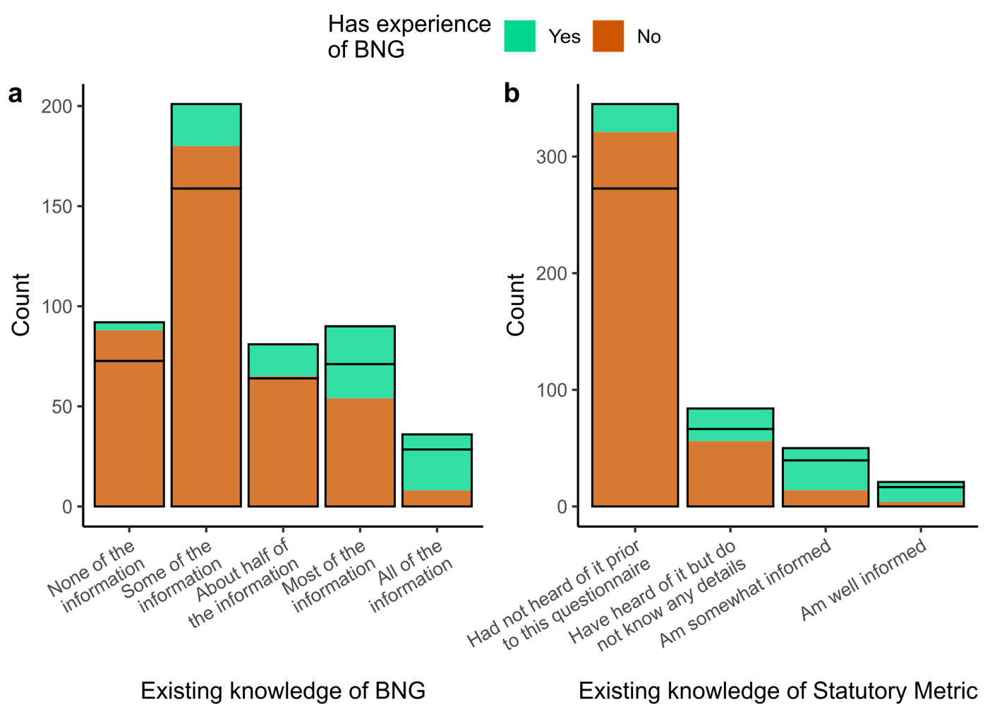
Figure 1: Respondents who reported having experience of a project aiming to achieve Biodiversity Net Gain (BNG) was associated with higher reported existing knowledge of both: (a) BNG as a whole, measured as the proportion of a short paragraph on BNG respondents reported that they already knew (X-squared = 118, df = 4, adjusted p-value < 0.0001), and (b) the metric, measured by asking how much the respondent knew about the metric (X-squared = 173, df = 3, adjusted p-value < 0.0001). Both plots are coloured according to whether the respondent reported having experience with a project aiming to achieve BNG. The expected distribution if experience were distributed evenly across levels of knowledge is shown with black lines.

The information given on BNG that formed the basis of our measure of existing knowledge was very basic, with some of it just introducing biodiversity as a concept, meaning that these results suggest the public have a very low level of existing knowledge of BNG. It is surprising, then, that multiple respondents claimed to be ‘somewhat informed’ or ‘well informed’ about the metric, a complex and specialist topic, without having known all of the basic and more general information on biodiversity net gain, suggesting some respondents may have misinterpreted the question or over-stated their own knowledge, a known phenomenon within measures of self-reported expertise (e.g., Snibsøer et al., 2018). The number of respondents reporting experience of BNG was also surprisingly high given its recent mandate. This could be for one of three reasons: the proportion of the English public with experience of BNG is higher than expected; respondents said they had experience of BNG thinking it may be required for them to continue the questionnaire (Krosnick, 1991); or, there are respondents who falsely believe they have experience of projects aiming to achieve BNG, meaning their opinions may be based on experiences that do not actually represent BNG itself. More research is required to understand which of these (or combination of these) is true and, if it is the third option, how this might impact acceptance of BNG.

3.2 Do the public believe the assumptions behind Biodiversity Net Gain?
The questionnaire asked about two beliefs related to BNG (Figure 2): whether respondents believed it was possible to create a net gain in biodiversity by creating, restoring and enhancing habitat after a development causes biodiversity loss (BNG belief) and whether respondents believed it is possible to measure and compare the value of biodiversity in an area using a standardised numeric metric (measurement belief). Most respondents believed it was possible to create a net gain after a loss due to biodiversity (58.2% yes, 30.8% don’t know, 9.8% no). Less than half of respondents believed it was possible to measure biodiversity with a standardised numeric metric, with many responding that they did not know (42.8% yes, 41.2% don’t know, 14.8% no). Five respondents responded “Other” for the BNG belief and six responded “Other” for the measurement belief. Across both questions “Other” answers either gave more nuanced understanding or expressed uncertainty; due to the very small number we removed the “Other” responses from the subsequent analysis. The two beliefs were significantly associated with one-another, with respondents tending to give the same answer for both questions (Figure 2).
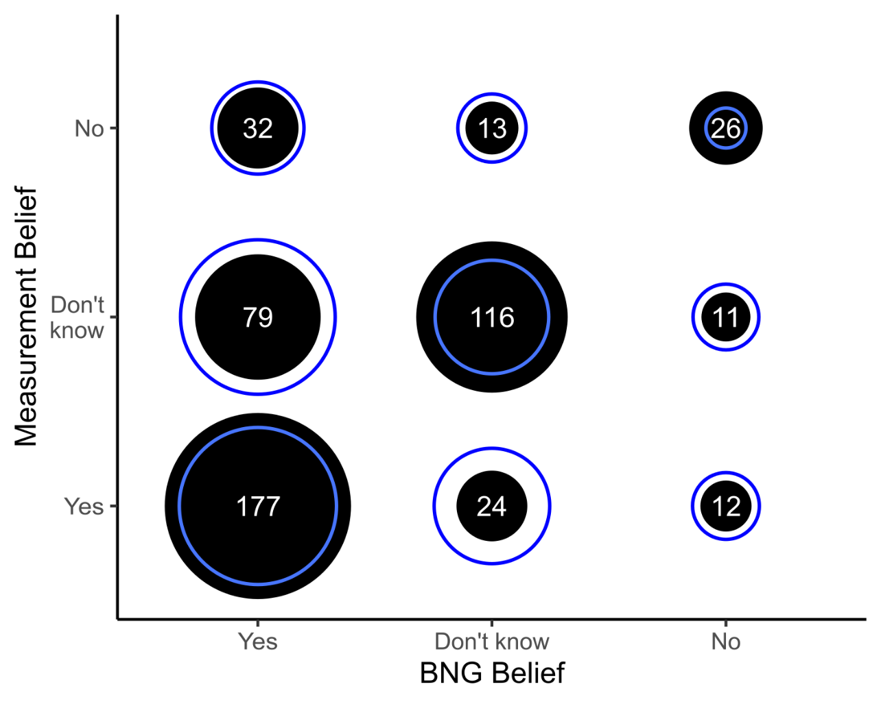
Figure 2: Respondents’ beliefs in whether it is possible to achieve a net gain in biodiversity through habitat creation, restoration, and enhancement after a loss due to development (BNG belief) and whether it is possible to measure biodiversity with a standardised numeric metric (measurement belief) were significantly associated with one-another, with respondents tending to give the same answer for both questions (X-squared = 170, df = 4, p-value < 0.0001). Filled black circles and white text labels show the number of respondents who gave each pair of answers, with expected values if the two beliefs were independent shown using a blue ring.
Due to the high proportion of “Don’t know” responses to the measurement belief (believing it is possible to measure and compare biodiversity value with a standardised numeric), we hypothesised that respondents’ answers may have been influenced by a lack of information on the topic. People who do not have an internal model for how something, such as the ‘netting’ of biodiversity, may be done are unlikely to believe it is possible (Suchman, 1995). To assess this, we modelled respondents’ answers to the metric belief question (whether it is possible to measure and compare biodiversity using a standardised numeric metric) predicted by their existing knowledge of the metric; whether the respondent had chosen to see the additional metric information (optional) before answering the metric belief question; and their BNG belief.
We ran two nested models, the first assessed, across all respondents, what affected whether a respondent answered “Don’t know” to the metric belief question. The second assessed, for respondents that answered “Yes” or “No”, what factors affected their metric belief. The results of both models supported our hypothesis. Respondents that did not choose to see the metric information were five times more likely to answer “Don’t know” to the measurement belief question. Within the respondents that answered either “Yes” or “No” to the measurement belief question, those that had chosen to see the metric text were 2.6 times more likely to answer “Yes”. Figure 3 shows respondents’ measurement beliefs, split by: whether they chose to see the metric text, their existing metric knowledge, and BNG belief. This result was significant within the full sample and with “extreme speeders” removed, and near-significant (p = 0.07) after removing “up to 70% median speeders”. Full summaries of the analysis for the whole sample are presented in Appendix D2.
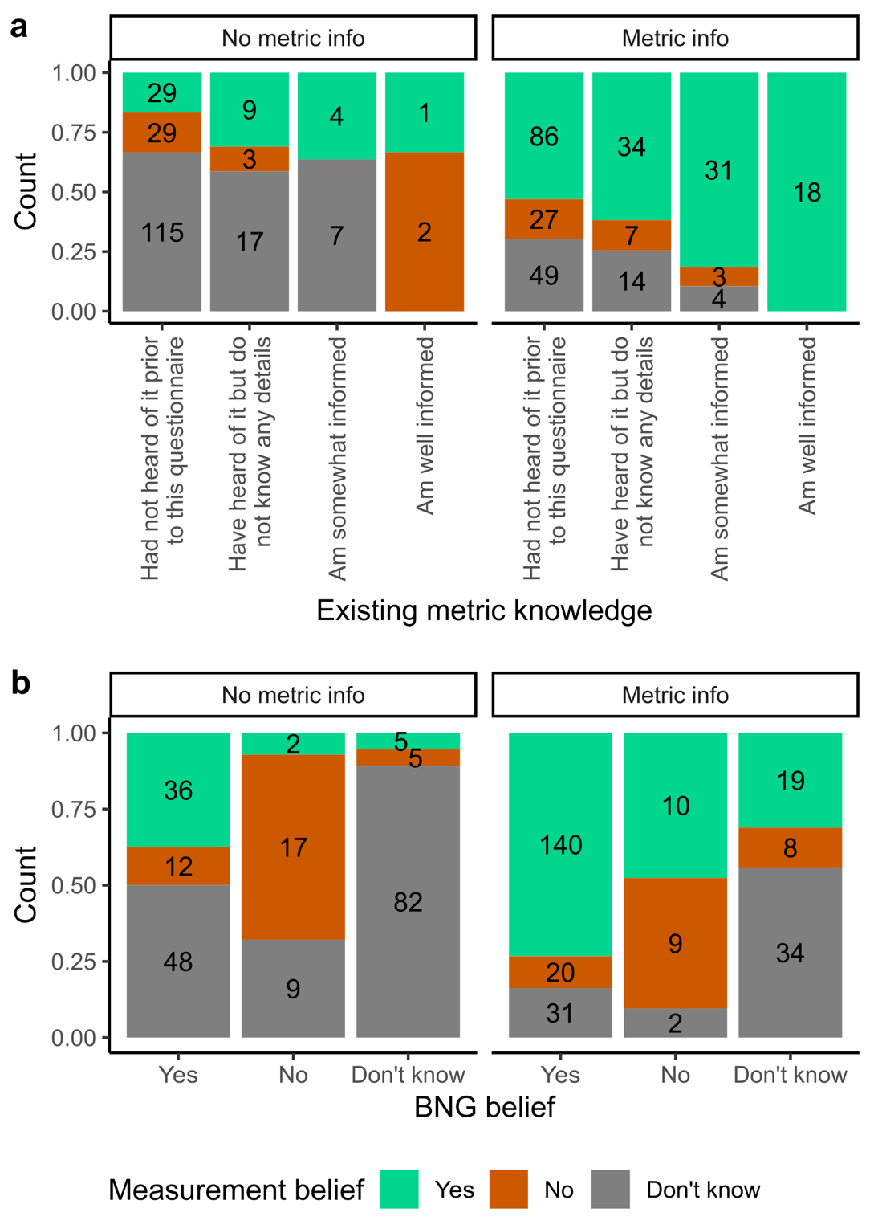
Figure 3: Differences in proportions of respondents’ measurement belief (whether they believed it is possible to measure and compare biodiversity value with a standardised numeric) between respondents who did not (No metric info) and did (Metric info) choose to see additional information on the statutory numeric used to measure biodiversity within Biodiversity Net Gain (BNG), split by (a) existing knowledge of the statutory metric and (b) their BNG belief (whether they believed it is possible to create a net gain in biodiversity through habitat creation or enhancement after a loss due to development).
Where stakeholders are undecided or weakly against BNG as an approach, providing simple, logical, and easy to understand information about BNG and how it fits in with society may increase acceptance of these beliefs (Leeuwerik et al., 2021; Saenz, 2019; Suchman, 1995). However, this will only increase acceptance where the additional information provided fits with the stakeholders’ existing belief systems and their experience of reality (Powell & DiMaggio, 1991 per Suchman, 1995). For example, informed, political arguments are often made against BNG, the metric, and the framing of biodiversity as “placeless” (see e.g., Apostolopoulou & Adams, 2015 as an example) which are highly unlikely to be resolved through providing more information. It is also important to note that we asked respondents whether it is possible to create a net gain after a loss of biodiversity and measure biodiversity with a standardised numeric metric, not whether it is possible in all cases. It is likely that there are certain places or habitats individuals particularly value and do not see as “offsettable”; more research is required to understand the extent to which this is predictable and how large an impact it has on acceptance.

3.3 To what extent do the public trust the organisations involved in Biodiversity Net Gain?
Figure 4a shows the level of trust assigned to the main actors in BNG. There was a lack of trust in most actors regarding their roles in BNG, with more respondents stating they somewhat or strongly distrusted than somewhat or strongly trusted developers (48.2% distrust, 21.8% trust), central government (44.2% distrust, 19.4% trust), private landowners (42.0% distrust, 18.6% trust), government agencies (39.0% distrust, 24.0% trust), and local planning authorities (34.0% distrust, 29.2% trust). In contrast, most respondents stated they somewhat or strongly trusted wildlife charities (4.8% distrust, 75.6% trust) and ecological consultants (6.6% distrust, 66.0% trust). There was a positive correlation between trust in all pairs of actors, with the exception of wildlife charities and developers, and wildlife charities and private landowners (Figure 4b, significance and scatter plots shown in Appendix D1, Figure D1.1). For easier analysis, actors were averaged into three groups: external expertise (wildlife charities and ecological consultants); financial beneficiaries (developers and private landowners); and governing bodies (Local Planning Authorities, government agencies, and central Government). There was a strong positive correlation between trust in governing bodies and financial beneficiaries, whereas trust in external expertise was weakly positively correlated with both other actor groups (Appendix D1, Figure D1.2).
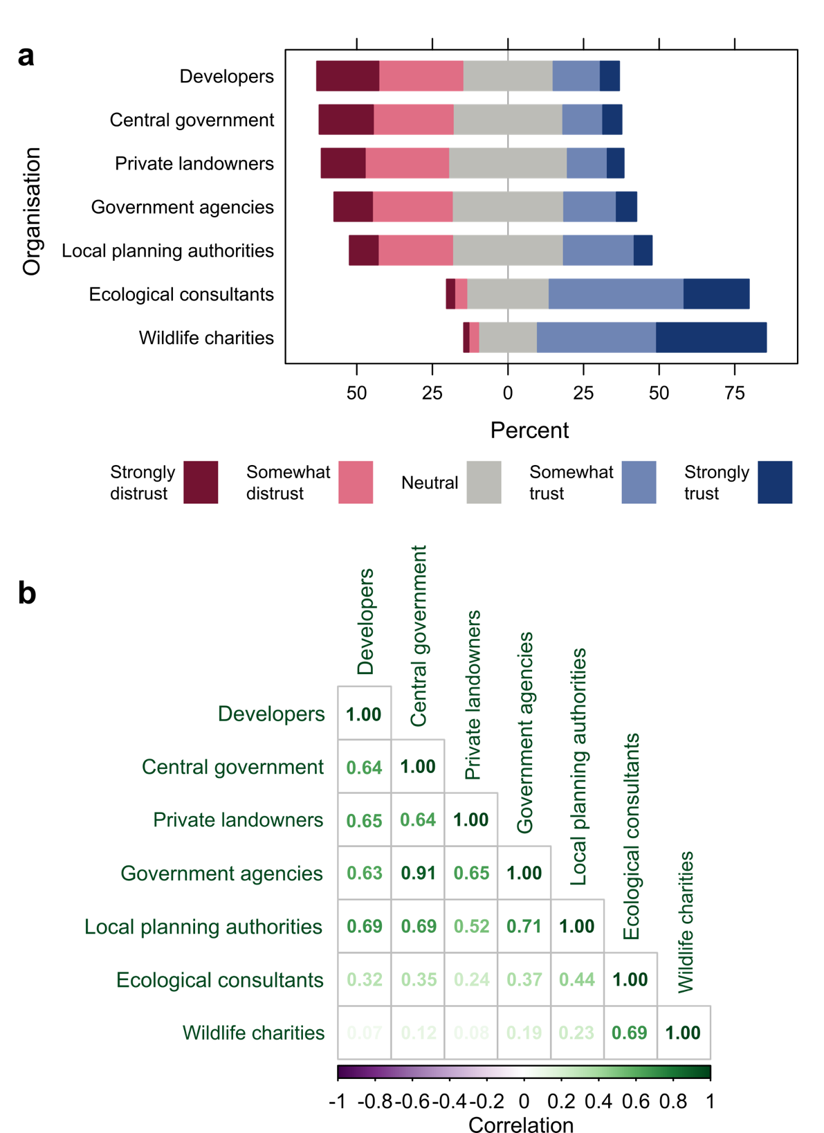
Figure 4: (a) Respondents’ level of trust in organisations involved in Biodiversity Net Gain, ordered from least trusted at the top (developers), to most trusted at the bottom (wildlife charities). Panel (b) polychoric correlation coefficients between trust in all pairs of actors, where present all correlations were positive; stronger correlations are shown in darker green.
The substantial level of distrust in financial beneficiaries is not a new finding, in fact, a survey by the developer Grosvenor found that only 2% of the UK public trusted developers, with most citing that their distrust was because developers “only care about making money” (Champ, 2019, para. 3). The distrust of governing bodies, again, reflects a wider lack of trust in local and national governing bodies in the UK (ONS, 2022). We hypothesise that this distrust in the context of BNG is a product of two things. Firstly, since its conception as a policy in England one of the primary focuses of BNG has been to benefit, or at least not harm, development (Defra, 2018). Although respondents may not know this about BNG, especially given the relatively low existing knowledge, the approach is consistent with the wider neoliberal stance of the UK government (Knight-Lenihan, 2020). Where regulators are seen as overly pro-development, stakeholders are less likely to be confident that their interests, in this case the protection of the environment, are being adequately prioritised (Lesser et al., 2021; Prno & Slocombe, 2014). Secondly, both within BNG and more widely, there is a lack of capacity within Local Planning Authorities to assess and enforce BNG (Robertson, 2021), meaning that even where governing bodies are seen as having good intentions, they may not be seen as likely to carry through on them (Stuart et al., 2023). Thus, the lack of trust in governance structures is likely to reduce the acceptance of BNG as an approach to the environment in practice.

3.4 What is the public’s opinion of Biodiversity Net Gain as an approach?
Most respondents had a positive overall opinion of BNG as an approach (Figure 5a; 63.8% somewhat or extremely positive, 6.4% somewhat or extremely negative); felt the metric was an effective tool for measuring biodiversity (Figure 5b; 68.5% somewhat or very effective, 17.3% somewhat or very ineffective); and agreed that BNG would both improve nature in England (70% somewhat or strongly agree, 6.4% somewhat or strongly disagree) and make a project’s environmental impacts acceptable (Figure 5c). This positivity aligns with the support for a BNG mandate seen within the 2018 Defra consultation on BNG (Defra, 2019) and suggests that the positive framing of BNG has been effective at creating more positive perceptions of BNG than were seen for BDO.

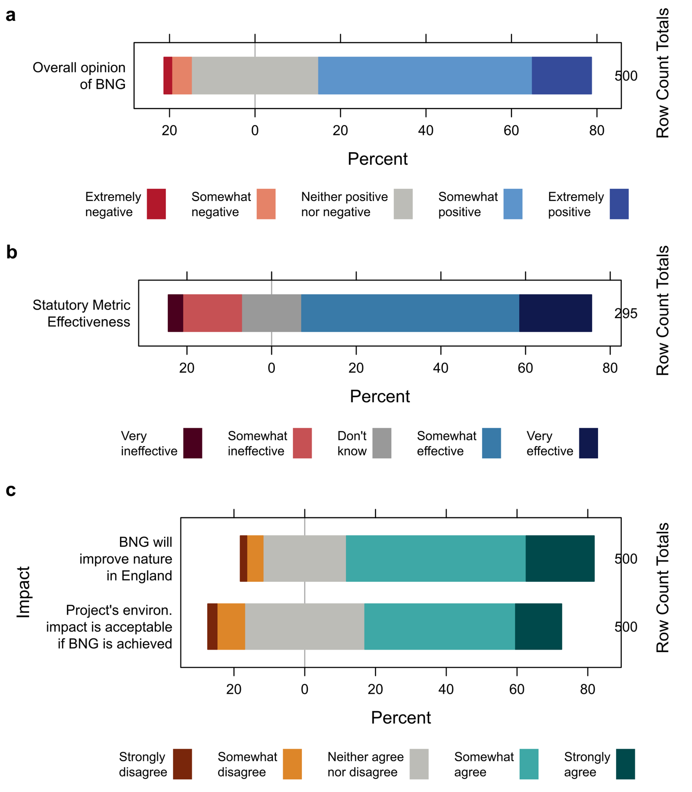
Figure 5: Respondents’ stated opinions of (a) Biodiversity Net Gain as an approach to the environment; (b) the effectiveness of the statutory metric at measuring the value of biodiversity; and (c) the impacts of following Biodiversity Net Gain as a policy.
It is important to note that, for most respondents, these opinions were based on very limited understanding of BNG and the metric (see section 3.1) and the metric text in the survey providing only basic and un-nuanced information about its components for those who chose to read it. It is increasingly accepted that the valuations and equivalence provided by the metric do not necessarily correlate with the biological reality of habitats (e.g., Duffus et al., 2024; Hawkins et al., 2022; Marshall et al., 2024) meaning that, even where compatible within stakeholders’ belief systems, with increasing knowledge there is the potential that the results in Figure 5 will drift towards more negative opinions, leading to potential rejection of BNG for not reflecting stakeholders’ experiences of reality. More detailed research is required to understand if, and at what point of knowledge, this occurs.
We modelled respondents’ overall opinion of BNG predicted by their BNG belief, measurement belief, whether they had experience with BNG, existing knowledge of BNG, existing knowledge of the metric, trust in external expertise, trust in governing bodies, trust in financial beneficiaries, age, gender identity, and education. The modelling process is described in Appendix D3 and all significant variables are shown in Figure 6. Across all models, believing it is possible to measure biodiversity with a standardised numeric metric (measurement belief), trust in external expertise, trust in governing bodies, higher educational attainment, existing knowledge of the metric, and believing it is possible to create a net gain in biodiversity after a loss had a significant positive effect on overall opinion of BNG as an approach. Existing metric knowledge had a significant positive quadratic term, meaning the difference between levels of knowledge increased at higher knowledge levels. Education had a significant negative quadratic term, meaning the difference between educational categories decreased at higher education levels. Neither education nor existing knowledge of the metric were significant when the “up to 70% median speeders” were removed.

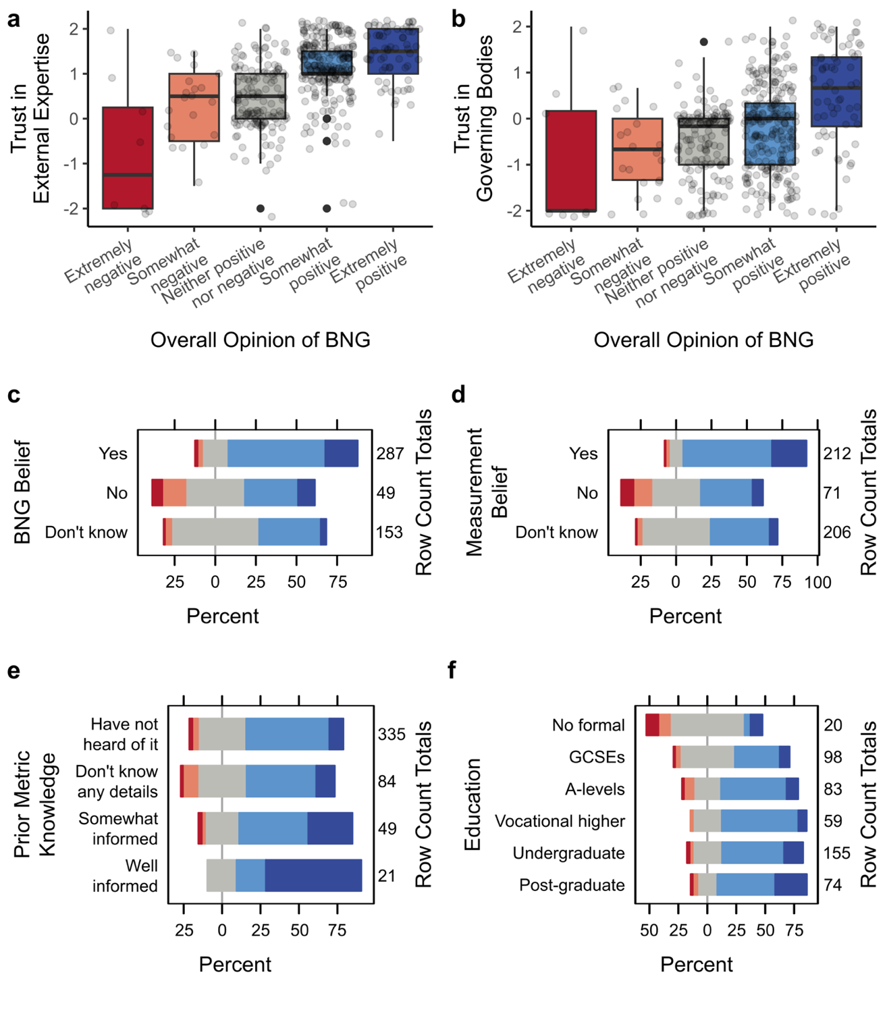
Figure 6: All factors that significantly predict overall opinion: (a) trust in external expertise; (b) trust in governing bodies; (c) whether the respondent believed it is possible to create a net gain in biodiversity after a loss due to development; (d) whether the respondent believed it is possible to measure biodiversity using a standardised numeric metric; (e) the respondent’s existing knowledge of the metric; and (f) the respondent’s level of education. Across all panels, overall opinion is shown using colour and position, from very negative in dark red on the left to very positive in dark blue on the right. For panels (a) and (b), numeric values for trust are the mean of Likert-type responses for level of trust in actors within that group (-2 ≈ strongly distrust; -1 ≈ somewhat distrust; 0 ≈ neither trust nor distrust; 1 ≈ somewhat trust; 2 ≈ strongly trust).
The importance of the assumptions underpinning BNG in determining respondents’ overall opinions of BNG was not unexpected, as one would expect respondents that do not believe it is possible to create a net gain after a loss due to development, nor that it can be quantified with a standardised numeric metric, to be much less likely to be confident it will have a positive outcome. There were, however, a small minority of respondents who did not believe in the assumptions underpinning BNG yet had positive opinions of it as an approach to the environment. Although it is only a small sample, this may reflect the cognitive dissonance within neoliberal nature conservation, with the steps needed to ‘net’ nature seen as both impossible and inevitable (Anantharajah & Evans, 2024), resulting in some stakeholders accepting BNG even where they do not agree with the underlying principles.
Trust and accountability in BNG are particularly important for acceptance as the loss of biodiversity is, in most cases, certain but the gain relies on proper implementation (Rampling et al., 2024). It is, therefore, also not surprising that trust in actors involved in BNG was important in predicting overall opinion. Where stakeholders do not trust actors to do the right thing, as we have found is the case for financial beneficiaries within BNG, trust in the surrounding governance structures becomes more important as you don’t need to trust someone if you trust the person holding them accountable (Stuart et al., 2023). This likely explains the presence of trust in governing bodies as an important factor in determining overall opinion of BNG and the relative unimportance of trust in the financial beneficiaries themselves, although it is of note that trust in financial beneficiaries and trust in governing bodies were highly correlated.
The lack of trust in both developers and private landowners and the governing bodies meant to hold them accountable potentially explains the importance of trust in external expertise in determining overall opinion of BNG, as external organisations such as NGOs are likely being seen as the last accountability structure protecting the interests of nature. To ensure the effect that trust in external expertise had on overall opinion was not due to it measuring some aspect of intrinsic trust, we re-ran the model including average trust across all actors and residual trust for each actor group; residual trust in external expertise remained significant and thus we determined it was a genuine effect (Appendix D3). More detailed research is required to truly unpick this relationship but it is clear that trust is an important element in the acceptance of BNG. Building trust is difficult and requires repeatedly making and keeping promises, as well as showing that you are acting in the interest of people and nature (Stuart et al., 2023). This takes time and, in the short term, it is likely that developers will need to publicly involve and listen to the trusted actors and sources of independent expertise. However, care must be taken not to delegitimise currently trusted actors by involving them in problematic projects.

3.5 What is the public’s desired approach to Biodiversity Net Gain?
Respondents showed a preference for compensation to be provided through a mixture of habitat creation, enhancement and restoration (62.2%), followed by providing compensation through restoration and enhancement of existing habitats (29.4%), providing compensation solely by creating new habitats was the least popular option (7.2%) (Figure 7a). Six respondents gave “Other” responses to their preferred compensation approach, primarily expressing uncertainty. This may reflect a feeling that we need to look after what we already have, or a distrust in the ecological success of habitat creation, however, more research is required to gain a deeper understanding of desired approaches to compensation and biodiversity losses that may trigger rejection.
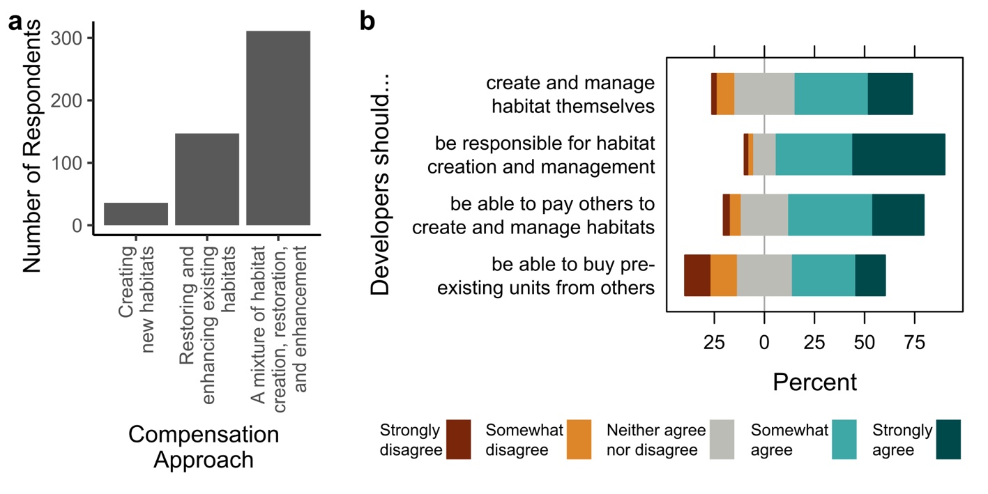
Figure 7: Respondents’ preferences for (a) the approach to compensatory habitat within Biodiversity Net Gain (BNG); and (b) extent of agreement with different approaches for developers to fulfil their responsibilities under BNG.
Respondents agreed that developers should be responsible for the creation and management of habitat (Figure 7b: 84% somewhat or strongly agree, 4% somewhat or strongly disagree), indicating a desire for BNG to follow the “polluter-restores”, as opposed to the “polluter-pays”, principle (see e.g., Damiens et al., 2021). Following this, respondents were much less positive about developers being able to buy pre-existing units from others (Figure 7b: 46.2% somewhat or strongly agree, 25.6% somewhat or strongly disagree), reflecting the recent controversy around the use of carbon credits (e.g., Greenfield, 2023). Whether developers should create and manage habitats themselves (Figure 7b: 58.4% somewhat or strongly agree, 10.8% somewhat or strongly disagree) or be able to pay others to create and manage habitat for them (Figure 7b: 67.4% somewhat or strongly agree, 8.2% somewhat or strongly disagree) was less clearcut, with respondents tending to agree with both statements. There was no significant correlation in respondents’ levels of agreement with whether “developers should be responsible for habitat creation and management” and whether “developers should be able to buy pre-existing units”, indicating these views are not mutually exclusive. There was, however, a moderate positive correlation between agreement with whether “developers should create and manage habitats themselves” and whether “developers should be responsible for habitat creation” and management, indicating a desire for developers to take responsibility may drive the judgement that developers should create and manage habitats themselves. All correlations between pairs of statements are shown in Appendix D1, Figure D1.3.

3.6 What are the wider implications of acceptance of Biodiversity Net Gain?
When done well BNG, like BDO, can provide a positive contribution to local people’s wellbeing, both through ensuring local ecosystem services are retained and enhanced (Jones et al., 2019) and through facilitating development that is wanted by the local and wider community, for example social housebuilding (Places for People, 2024). Carrying out BNG in a way that is socially acceptable, would likely also benefit developers, unless it proves prohibitively expensive to achieve, through reducing operational risk and ‘unlocking’ development sites that were previously marginal on environmental grounds. It is, however, in this capacity that ‘socially acceptable’ BNG has the potential to cause social harm. Research on BDO shows that the approaches needed to provide simplicity and certainty for developers, an aim of both BDO and BNG, often directly conflict the more comprehensive and context-dependent approaches that are preferred by many social and environmental stakeholders, representing a value conflict that is not easily solved (Lockhart, 2015; Sullivan & Hannis, 2015).
BNG, like BDO before it, has the potential to provide false objectivity (Carver & Sullivan, 2017) and depoliticise discussions around continuing development and urban expansion (Apostolopoulou et al., 2014). In doing so, it may exclude local communities from both nature and discussions around its fate (Apostolopoulou, 2020; Apostolopoulou et al., 2014; Jones et al., 2019). Such exclusion, where present, is likely to have a disproportionate impact on already marginalised communities, who often lack the power and resources to prevent undesired projects (e.g., Roddis et al., 2018) aggravated by the lack of agreement on the extent of consensus required to deem something as being socially acceptable (see e.g., Boutilier, 2014; Jijelava & Vanclay, 2014; Wilburn & Wilburn, 2011).
Together, the presence of values conflicts, potential for misuse, and lack of trust in developers and governing bodies mean that, although we have found that BNG is widely accepted as a policy, this does not guarantee its acceptance in practice. In addition, the low levels of trust in developers and governing bodies means that even those who accept BNG as an approach may not believe a developer will carry through on their promises in practice, potentially reducing the impact acceptance of BNG has on overall project acceptance. Real-world project acceptance involves navigating these complex and contextual justice and power dynamics and will be highly dependent on the desirability of the project itself and the specific context within which it is proposed to be built, which extend far beyond this analysis of the general public’s opinions ‘in theory’.

4 Conclusions
The public's knowledge of Biodiversity Net Gain (BNG) is generally limited, with only 21% of respondents reporting some form of experience with BNG projects. Even among those who had experience, understanding of key components such as the BNG metric was minimal. Further, due to the tendency for respondents to over-estimate their own knowledge, all measures of knowledge and experience are likely to be an overestimate. This suggests that the public has a low baseline of knowledge about BNG, which could influence their ability to critically evaluate BNG initiatives and policies.
Most respondents (58.2%) believed the assumption that it is possible to create a net gain in biodiversity by creating, restoring and enhancing habitat after a development causes biodiversity loss. Fewer respondents (42.8%) believed the assumption that it is possible to measure and compare the value of biodiversity in an area using a standardised numeric metric, with a significant number of respondents being unsure (41.2%). However, respondents who had read extra text describing the metric used to measure biodiversity within BNG were 2.6x more likely to believe that it is possible to measure and compare the value of biodiversity in an area using a standardised numeric metric, suggesting the lower acceptance may be due to not having a concept of how the measurement of biodiversity might be made.
Trust in organizations involved in BNG was generally low, particularly for developers and government bodies, with the exception of wildlife charities and ecological consultants, who were viewed as more trustworthy. This trust disparity is critical, as the public’s confidence in the entities responsible for implementing and overseeing BNG efforts directly impacts their acceptance of such initiatives.
Overall, the public holds a generally positive view of BNG as an approach, with only 6.4% of respondents having a negative view of BNG as an approach to the environment and over half responding that a project’s environmental impact is acceptable if it achieves BNG. Key predictors of this positive opinion include trust in external expertise (wildlife charities and ecological consultants), belief in the assumptions underlying BNG, and existing knowledge of the BNG metric. This suggests that increasing trust in the organizations involved and improving public knowledge could enhance public support for BNG.
The public expressed a clear preference for a mixed approach to compensatory habitat creation, favouring a combination of habitat creation, restoration, and enhancement (62.2%) over purely creating new habitats. There was also strong agreement that developers should be responsible for the creation and management of compensatory habitats (84% somewhat or strongly agree), with a quarter of respondents somewhat or strongly disagreeing that developers should be able to purchase pre-existing biodiversity units. This indicates a desire for accountability and direct involvement from developers in managing biodiversity impacts.
While the English public supports the general concept of BNG, limited knowledge, low trust in developers and governing bodies, and use of pre-existing biodiversity units may reduce acceptance of projects following mandatory BNG in practice. Our results suggest that key strategies to increase support include providing understandable information about how BNG works, involving trusted organizations, and ensuring developers are seen as taking responsibility for the creation and maintenance of compensatory habitats. These strategies, however, do not address fundamental criticisms of the metric and treating biodiversity as ‘placeless,’ nor the potential of BNG to facilitate developments that may not be in the communities’ interests, meaning more research is required to understand how BNG may impact opinions on specific projects.

Declaration of generative AI and AI-assisted technologies in the writing process
During the preparation of this work the author(s) used ChatGPT 4.0 in order to improve the readability of the abstract and conclusions. After using this tool/service, the author(s) reviewed and edited the content as needed and take(s) full responsibility for the content of the publication.

5 References
Anantharajah, K., & Evans, M. C. (2024, March). Biodiversity finance as a technology of power: Discourses of innovation and regulation in an Australian case study. OSF. https://doi.org/10.31235/osf.io/ep8zr
Apostolopoulou, E. (2020). Beyond post-politics: Offsetting, depoliticisation, and contestation in a community struggle against executive housing. Transactions of the Institute of British Geographers, 45(2), 345–361. https://doi.org/10.1111/tran.12354
Apostolopoulou, E., & Adams, W. M. (2015). Biodiversity offsetting and conservation: Reframing nature to save it. Oryx, 51(1), 23–31. https://doi.org/10.1017/S0030605315000782
Apostolopoulou, E., Bormpoudakis, D., Paloniemi, R., Cent, J., Grodzińska-Jurczak, M., Pietrzyk-Kaszyńska, A., & Pantis, J. D. (2014). Governance rescaling and the neoliberalization of nature: The case of biodiversity conservation in four EU countries. International Journal of Sustainable Development & World Ecology, 21(6), 481–494. https://doi.org/10.1080/13504509.2014.979904
Bidaud, C., Schreckenberg, K., Rabeharison, M., Ranjatson, P., Gibbons, J., & Jones, JuliaP. G. (2017). The Sweet and the Bitter: Intertwined Positive and Negative Social Impacts of a Biodiversity Offset. Conservation and Society, 15(1), 1. https://doi.org/10.4103/0972-4923.196315
Biodiversity Net Positive. (2023). Exploring The Controversial Market for Biodiversity Credits. https://www.biodiversitynetpositive.com/the-controversial-market-for-biodiversity-credits/
Boutilier, R. G. (2014). Frequently asked questions about the social licence to operate. Impact Assessment and Project Appraisal, 32(4), 263–272. https://doi.org/10.1080/14615517.2014.941141
Brysbaert, M. (2019). How many words do we read per minute? A review and meta-analysis of reading rate. Journal of Memory and Language, 109, 104047. https://doi.org/10.1016/j.jml.2019.104047
Carrington, D. (2013, September 5). Biodiversity offsetting proposals ‘a licence to trash nature’. The Guardian. https://www.theguardian.com/environment/2013/sep/05/biodiversity-offsetting-proposals-licence-to-trash
Carver, L., & Sullivan, S. (2017). How economic contexts shape calculations of yield in biodiversity offsetting. Conservation Biology, 31(5), 1053–1065. https://doi.org/10.1111/cobi.12917
Champ, H. (2019, July 12). 98% of public don’t trust developers, research shows. Building Design. https://www.bdonline.co.uk/news/98-of-public-dont-trust-developers-research-shows/5100575.article
Conrad, F. G., Couper, M. P., Tourangeau, R., & Zhang, C. (2017). Reducing speeding in web surveys by providing immediate feedback. Survey Research Methods, 11(1), 45. https://doi.org/10.18148/srm/2017.v11i1.6304
Damiens, F. L. P., Backstrom, A., & Gordon, A. (2021). Governing for “no net loss” of biodiversity over the long term: Challenges and pathways forward. One Earth, 4(1), 60–74. https://doi.org/10.1016/j.oneear.2020.12.012
Dancey, C. P., & Reidy, J. (2007). Statistics Without Maths for Psychology. Pearson Education.
Dasgupta, S. (2024, March 19). Are biodiversity credits just another business-as-usual finance scheme? Mongabay Environmental News. https://news.mongabay.com/2024/03/are-biodiversity-credits-just-another-business-as-usual-finance-scheme/
Defra. (2016). Consultation on biodiversity offsetting in England Summary of responses. https://assets.publishing.service.gov.uk/media/5a809e6aed915d74e622f7f8/biodiversity-offsetting-consult-sum-resp.pdf
Defra. (2018). Net gain Consultation proposals. https://consult.defra.gov.uk/land-use/net-gain/supporting_documents/netgainconsultationdocument.pdf
Defra. (2019). Net gain: Summary of responses and government response. https://assets.publishing.service.gov.uk/government/uploads/system/uploads/attachment_data/file/819823/net-gain-consult-sum-resp.pdf
Duffus, N. E., Lewis, O. T., Grenyer, R., Comont, R. F., Goddard, D., Goulson, D., Ollerton, J., Townsend, M. C., Webb, J. A., Wilson, R. I., & Ermgassen, S. O. S. E. zu. (2024). Leveraging Biodiversity Net Gain to address invertebrate declines in England. https://ecoevorxiv.org/repository/view/6667/
Environmental Law Foundation. (2023, July 19). Questioning Biodiversity Net Gain: The Wenny Road Meadow Scenario. Environmental Law Foundation. https://elflaw.org/past-cases/biodiversity-net-gain-policy-implementation-challenges/
Franks, D. M., Davis, R., Bebbington, A. J., Ali, S. H., Kemp, D., & Scurrah, M. (2014). Conflict translates environmental and social risk into business costs. Proceedings of the National Academy of Sciences, 111(21), 7576–7581. https://doi.org/10.1073/pnas.1405135111
Greenfield, P. (2023, January 18). Revealed: More than 90% of rainforest carbon offsets by biggest certifier are worthless, analysis shows. The Guardian. https://www.theguardian.com/environment/2023/jan/18/revealed-forest-carbon-offsets-biggest-provider-worthless-verra-aoe
Greszki, R., Meyer, M., & Schoen, H. (2015). Exploring the Effects of Removing “Too Fast” Responses and Respondents from Web Surveys. Public Opinion Quarterly, 79(2), 471–503. https://doi.org/10.1093/poq/nfu058
Hawkins, I., Zu Ermgassen, S., Grub, H. M. J., Treweek, J., & Milner-Gulland, E. J. (2022). No consistent relationship found between habitat scores determined using the Biodiversity Metric and presence of species of conservation priority. In Practice, 118. https://ora.ox.ac.uk/objects/uuid:d0f359e9-f9f5-4a61-ba1d-f6ba5a8943fb
Howarth, L. (2013, September 9). A license to trash? Why Biodiversity Offsetting (BO) will be a disaster for the environment. https://theecologist.org/2013/sep/09/license-trash-why-biodiversity-offsetting-bo-will-be-disaster-environment
Jaeger, S. R., & Cardello, A. V. (2022). Factors affecting data quality of online questionnaires: Issues and metrics for sensory and consumer research. Food Quality and Preference, 102, 104676. https://doi.org/10.1016/j.foodqual.2022.104676
Jijelava, D., & Vanclay, F. (2014). Assessing the Social Licence to Operate of Development Cooperation Organizations: A Case Study of Mercy Corps in Samtskhe-Javakheti, Georgia. Social Epistemology, 28(3–4), 297–317. https://doi.org/10.1080/02691728.2014.922638
Jones, J. P. G., Bull, J. W., Roe, D., Baker, J., Griffiths, V. F., Starkey, M., Sonter, L. J., & Milner-Gulland, E. J. (2019). Net Gain: Seeking Better Outcomes for Local People when Mitigating Biodiversity Loss from Development. One Earth, 1(2), 195–201. https://doi.org/10.1016/j.oneear.2019.09.007
Knight-Lenihan, S. (2020). Achieving biodiversity net gain in a neoliberal economy: The case of England. Ambio, 49(12), 2052–2060. https://doi.org/10.1007/s13280-020-01337-5
Krosnick, J. A. (1991). Response strategies for coping with the cognitive demands of attitude measures in surveys. Applied Cognitive Psychology, 5(3), 213–236. https://doi.org/10.1002/acp.2350050305
Leeuwerik, R. N. C., Rozemeijer, M. J. C., & van Leeuwen, J. (2021). Conceptualizing the interaction of context, process and status in the Social License to operate: The case of marine diamond mining in Namibia. Resources Policy, 73, 102153. https://doi.org/10.1016/j.resourpol.2021.102153
Lesser, P., Gugerell, K., Poelzer, G., Hitch, M., & Tost, M. (2021). European mining and the social license to operate. The Extractive Industries and Society, 8(2), 100787. https://doi.org/10.1016/j.exis.2020.07.021
Lockhart, A. (2015). Developing an offsetting programme: Tensions, dilemmas and difficulties in biodiversity market-making in England. Environmental Conservation, 42(4), 335–344. https://doi.org/10.1017/S0376892915000193
Marsh, D., & McConnell, A. (2010). Towards a Framework for Establishing Policy Success. Public Administration, 88(2), 564–583. https://doi.org/10.1111/j.1467-9299.2009.01803.x
Marshall, C. A. M., Wade, K., Kendall, I. S., Porcher, H., Poffley, J., Bladon, A. J., Dicks, L. V., & Treweek, J. (2024). England’s statutory biodiversity metric enhances plant, but not bird nor butterfly, biodiversity. Journal of Applied Ecology, 61(8), 1918–1931. https://doi.org/10.1111/1365-2664.14697
Nahhas, R. W. (2024). 5.20 Collinearity. In Introduction to Regression Methods for Public Health Using R. https://www.bookdown.org/rwnahhas/RMPH/mlr-collinearity.html
Natural England. (2022). Biodiversity Net Gain: An introduction to the benefits. https://naturalengland.blog.gov.uk/wp-content/uploads/sites/183/2022/04/BNG-Brochure_Final_Compressed-002.pdf
ONS. (2022, July 13). Trust in government, UK. Office for National Statistics. https://www.ons.gov.uk/peoplepopulationandcommunity/wellbeing/bulletins/trustingovernmentuk/2022#:~:text=The%20survey%20looks%20at%20people%27s,took%20place%20in%20March%202022.
Places for People. (2024, June 19). UK public want more social housebuilding. https://www.placesforpeople.co.uk/news/all-news/uk-public-want-more-social-housebuilding/
Powell, W. W., & DiMaggio, P. J. (Eds.). (1991). The New Institutionalism in Organizational Analysis. University of Chicago Press. https://press.uchicago.edu/ucp/books/book/chicago/N/bo3684488.html
Prno, J., & Slocombe, D. S. (2014). A systems-based conceptual framework for assessing the determinants of a social license to operate in the mining industry. Environmental Management, 53(3), 672–689. https://doi.org/10.1007/s00267-013-0221-7
Rampling, E. E., zu Ermgassen, S. O. S. E., Hawkins, I., & Bull, J. W. (2024). Achieving biodiversity net gain by addressing governance gaps underpinning ecological compensation policies. Conservation Biology, 38(2), e14198. https://doi.org/10.1111/cobi.14198
Robertson, M. (2021). The State of No Net Loss/Net Gain and Biodiversity Offsetting Policy in English Local Planning Authorities: Full Report. https://cieem.net/wp-content/uploads/2021/09/LPA-Survey-Full-Report-Aug-23-2021-FINAL.pdf
Roddis, P., Carver, S., Dallimer, M., Norman, P., & Ziv, G. (2018). The role of community acceptance in planning outcomes for onshore wind and solar farms: An energy justice analysis. Applied Energy, 226, 353–364. https://doi.org/10.1016/j.apenergy.2018.05.087
Saenz, C. (2019). Building legitimacy and trust between a mining company and a community to earn social license to operate: A Peruvian case study. Corporate Social Responsibility and Environmental Management, 26(2), 296–306. https://doi.org/10.1002/csr.1679
Snibsøer, A. K., Ciliska, D., Yost, J., Graverholt, B., Nortvedt, M. W., Riise, T., & Espehaug, B. (2018). Self-reported and objectively assessed knowledge of evidence-based practice terminology among healthcare students: A cross-sectional study. PLOS ONE, 13(7), e0200313. https://doi.org/10.1371/journal.pone.0200313
Stuart, A., Bond, A., Franco, A., Gerrard, C., Baker, J., ten Kate, K., Butterworth, T., Bull, J., & Treweek, J. (2024). How England got to Mandatory Biodiversity Net Gain: A Timeline (SSRN Scholarly Paper 4883170). https://doi.org/10.2139/ssrn.4883170
Stuart, A., Bond, A., Franco, A. M. A., Baker, J., Gerrard, C., Danino, V., & Jones, K. (2023). Conceptualising social licence to operate. Resources Policy, 85, 103962. https://doi.org/10.1016/j.resourpol.2023.103962
Suchman, M. C. (1995). Managing Legitimacy: Strategic and Institutional Approaches. The Academy of Management Review, 20(3), 571. https://doi.org/10.2307/258788
Sullivan, S., & Hannis, M. (2015). Nets and frames, losses and gains: Value struggles in engagements with biodiversity offsetting policy in England. Ecosystem Services, 15, 162–173. https://doi.org/10.1016/j.ecoser.2015.01.009
Syn, J. (2014). The Social License: Empowering Communities and a Better Way Forward. Social Epistemology, 28(3–4), 318–339. https://doi.org/10.1080/02691728.2014.922640
Wallner, J. (2008). Legitimacy and Public Policy: Seeing Beyond Effectiveness, Efficiency, and Performance. Policy Studies Journal, 36(3), 421–443. https://doi.org/10.1111/j.1541-0072.2008.00275.x
Wilburn, K. M., & Wilburn, R. (2011). ACHIEVING SOCIAL LICENSE TO OPERATE USING STAKEHOLDER THEORY. Journal of International Business Ethics, 4(2), 3-16. https://americanscholarspress.us/journals/JIBE/pdf/JIBE-2-2011/v4n211-art1.pdf

Data Availability Statement
The data used in this analysis, as well as a PDF copy of the questionnaire used to gather it are available of FigShare (doi.org/10.6084/m9.figshare.27545187)

Appendix A – Full Questionnaire (attached as .pdf)

Appendix B – Description of Sample
Table B1: Quotas for age and gender used within data collection. Quotas were calculated using Office for National Statistics data (https://www.ons.gov.uk/peoplepopulationandcommunity/populationandmigration/populationestimates/articles/ukpopulationpyramidinteractive/2020-01-08) implemented as maxima to account for non-binary participants and those who do not want to provide demographic information.
Age | Gender Identity | Proportion | Number
16-24 | male | 0.07 | 33
16-24 | female | 0.06 | 31
25-34 | male | 0.08 | 42
25-34 | female | 0.08 | 41
35-44 | male | 0.08 | 40
35-44 | female | 0.08 | 40
45-54 | male | 0.08 | 41
45-54 | female | 0.08 | 41
55-64 | male | 0.08 | 38
55-64 | female | 0.08 | 39
65 or older | male | 0.10 | 51
65 or older | female | 0.12 | 61

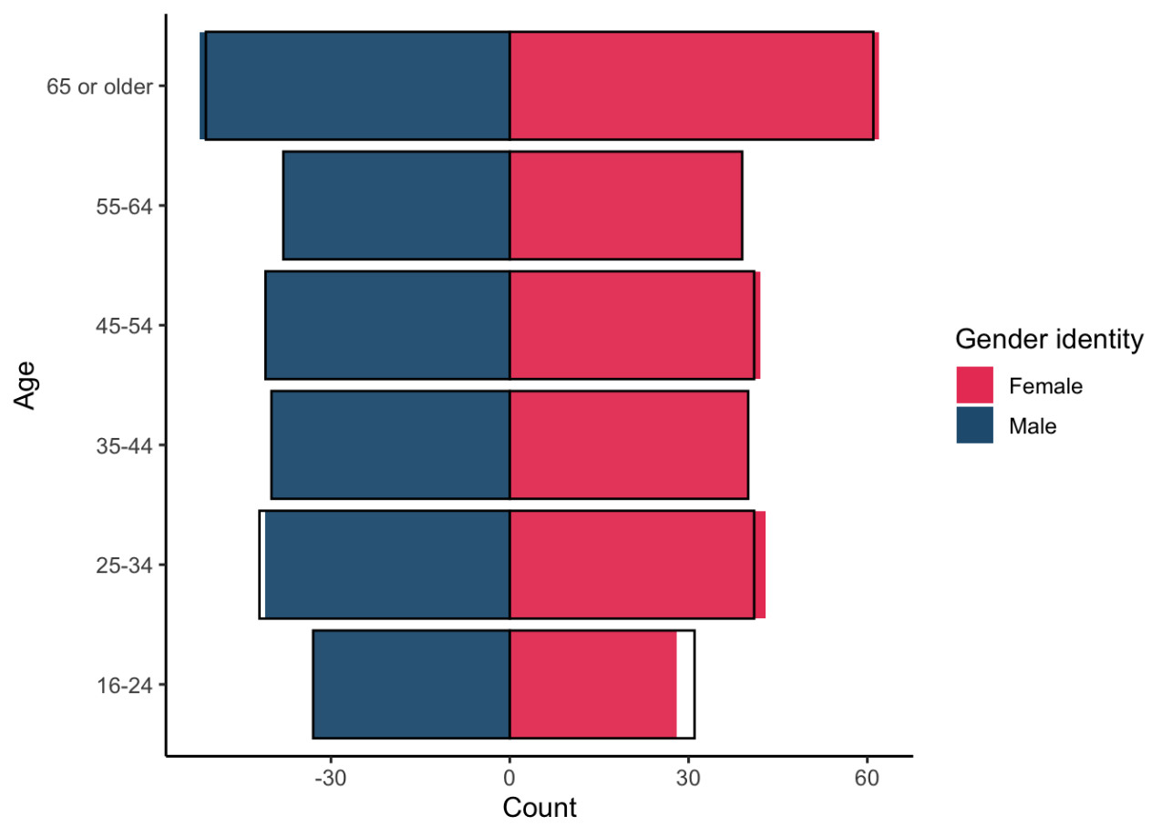
Figure B2: Distribution of sample between age and gender categories (shown in solid blue and pink bars) compared with intended quota (shown as hollow black bar outline).

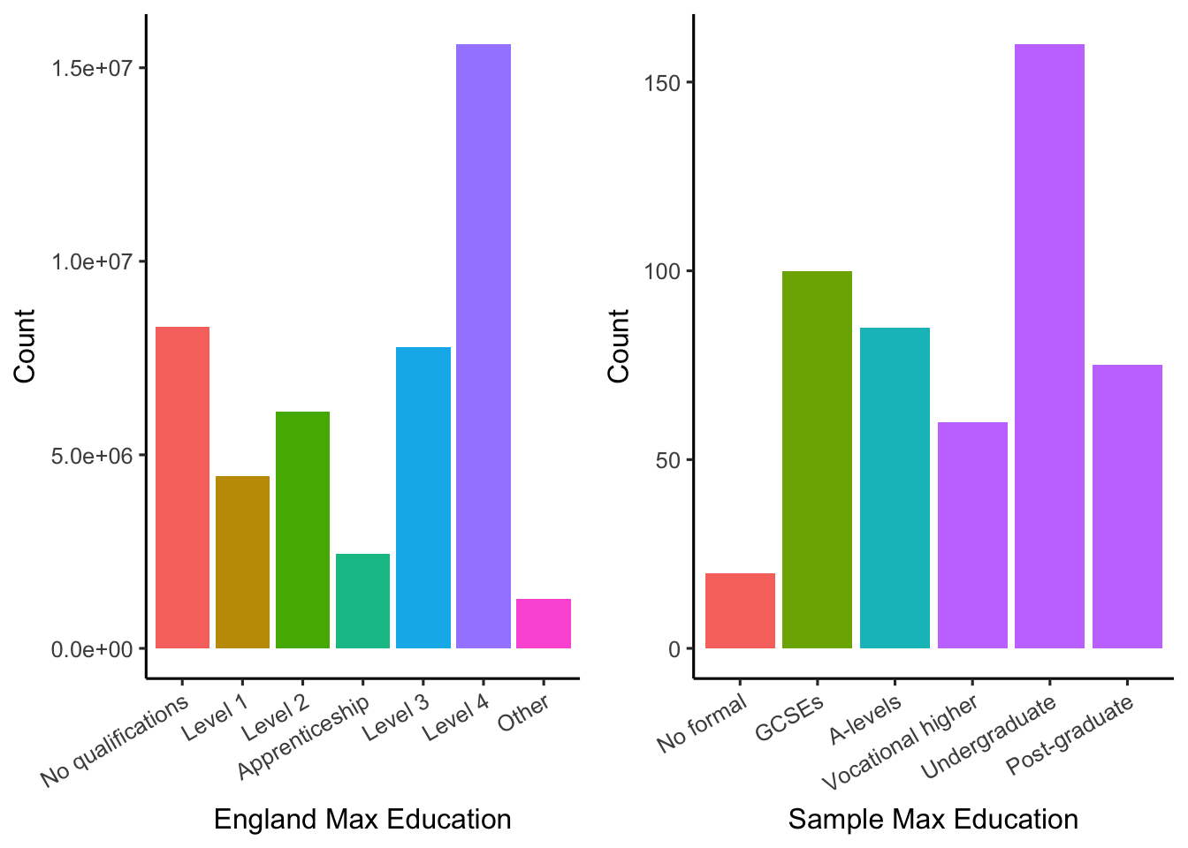
Figure B2: Comparison of highest level of education within the English population as a whole, according to the 2021 Census data (a), and our sample (b). Note that direct comparison is not possible due to different levels. Education levels within the census data are Level 1 and entry level qualifications: 1 to 4 GCSEs grade A* to C or grade 4 and above, any GCSEs at other grades, O levels or CSEs (any grades), 1 AS level, NVQ level 1, Foundation GNVQ, Basic or Essential Skills; Level 2 qualifications: 5 or more GCSEs (A* to C or 9 to 4), O levels (passes), CSEs (grade 1), School Certification, 1 A level, 2 to 3 AS levels, VCEs, Intermediate or Higher Diploma, Welsh Baccalaureate Intermediate Diploma, NVQ level 2, Intermediate GNVQ, City and Guilds Craft, BTEC First or General Diploma, RSA Diploma; Level 3 qualifications: 2 or more A levels or VCEs, 4 or more AS levels, Higher School Certificate, Progression or Advanced Diploma, Welsh Baccalaureate Advance Diploma, NVQ level 3, Advanced GNVQ, City and Guilds Advanced Craft, ONC, OND, BTEC National, RSA Advanced Diploma; Level 4 qualifications and above: degree (BA, BSc), higher degree (MA, PhD, PGCE), NVQ level 4 to 5, HNC, HND, RSA Higher Diploma, BTEC Higher level, professional qualifications (for example, teaching, nursing, accountancy); Other: vocational or work-related qualifications, other qualifications achieved in England or Wales, qualifications achieved outside England or Wales (equivalent not stated or unknown).
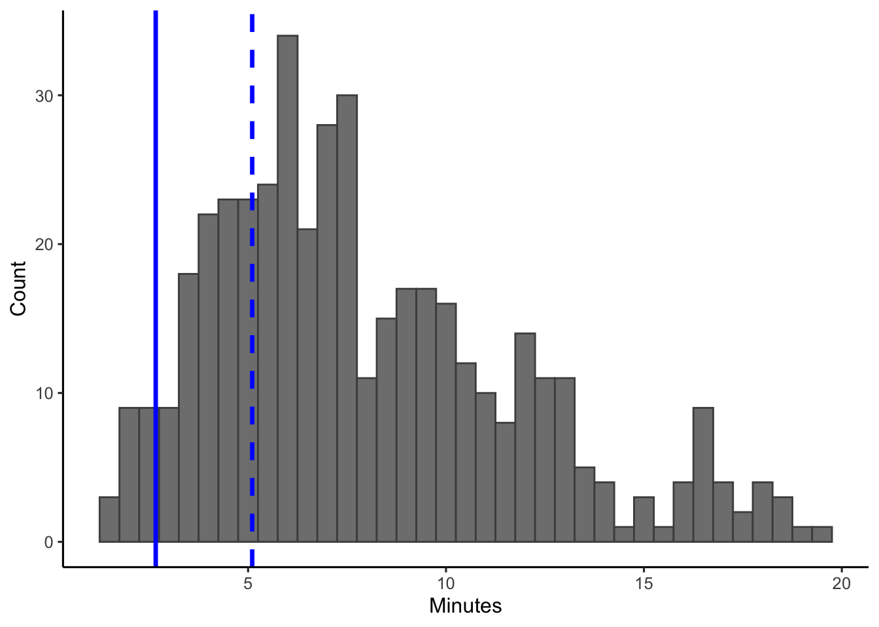
Figure B3: Time taken to complete the survey (for respondents who completed it in one go), dashed blue line shows the cutoff for ‘up to 70% median speeders’ (5.1 minutes) and solid blue line shows the cutoff for ‘extreme speeders’ (2.67 minutes). Respondents who took longer than 20 minutes (37) have not been shown. The questionnaire has approximately 2800 total words, approx. 400 of which are the participant information, 250 the optional metric text, 950 the non-optional introductory text for each topic, and the final 1200 the questions themselves. We were expecting the questionnaire to take around 10 minutes. Assuming a reading speed of 238wpm (Brysbaert), it should take 11.8 minutes to read all text or 5.0 minutes to read just the questions. Assuming the disputed "skimming" speed of 450wpm from Carver (per Brysbaert), it should take 6.2 minutes to skim the whole text or 2.7 minutes to skim just the questions.

Appendix C – R Code (attached as .html)

Appendix D – Supplementary Plots and Tables

Appendix D1 - Correlation Plots
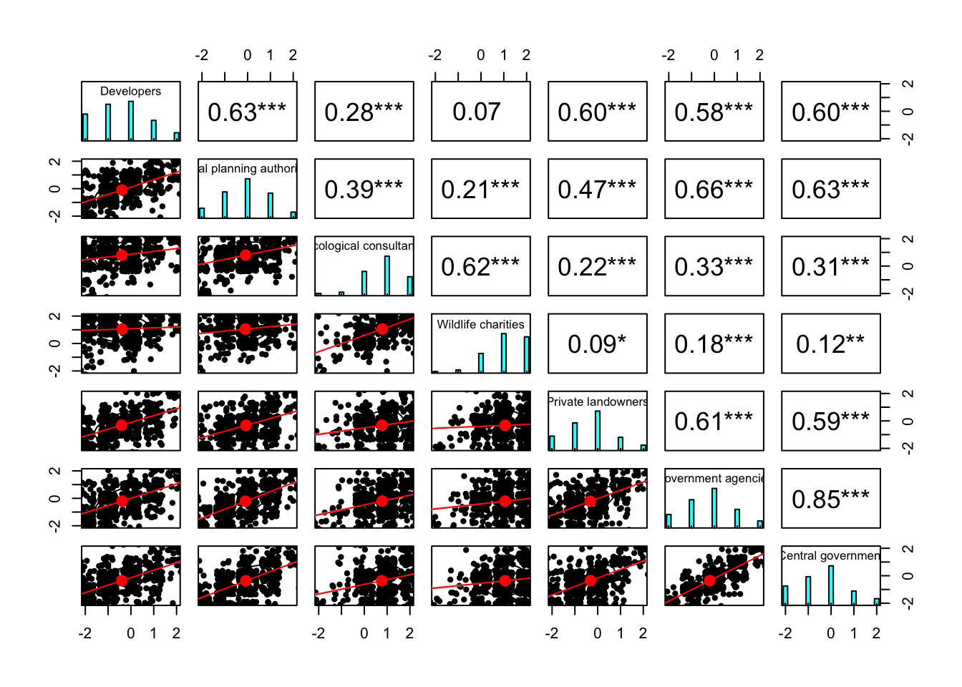
Figure D1.1: Panel (b) correlations between trust in all pairs of actors, showing jittered scatterplots with linear model (bottom left); histogram of values (diagonal top left to bottom right); and correlation coefficients with significance shown using asterisks (top right, * 0.05 > p > 0.01, ** 0.01 > p > 0.001, *** 0.001 > p).
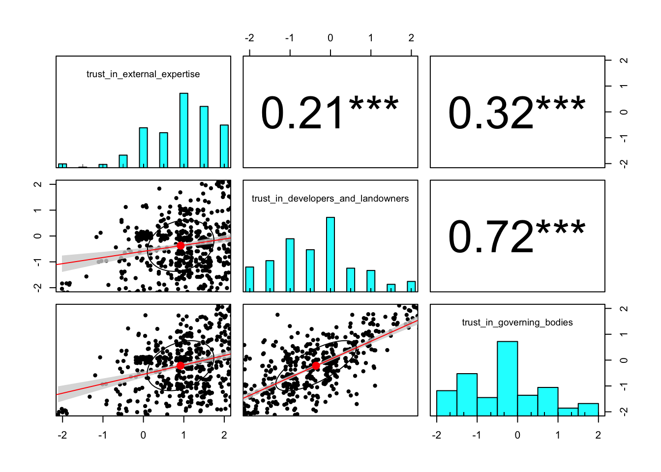
Figure D1.2: Correlations between trust in the three simplified actor groups (external expertise, financial beneficiaries, and governing bodies), shown as jittered scatterplots with linear model (bottom left); histogram of values (diagonal top left to bottom right); and correlation coefficients with significance shown using asterisks (top right, * 0.05 > p > 0.01, ** 0.01 > p > 0.001, *** 0.001 > p).
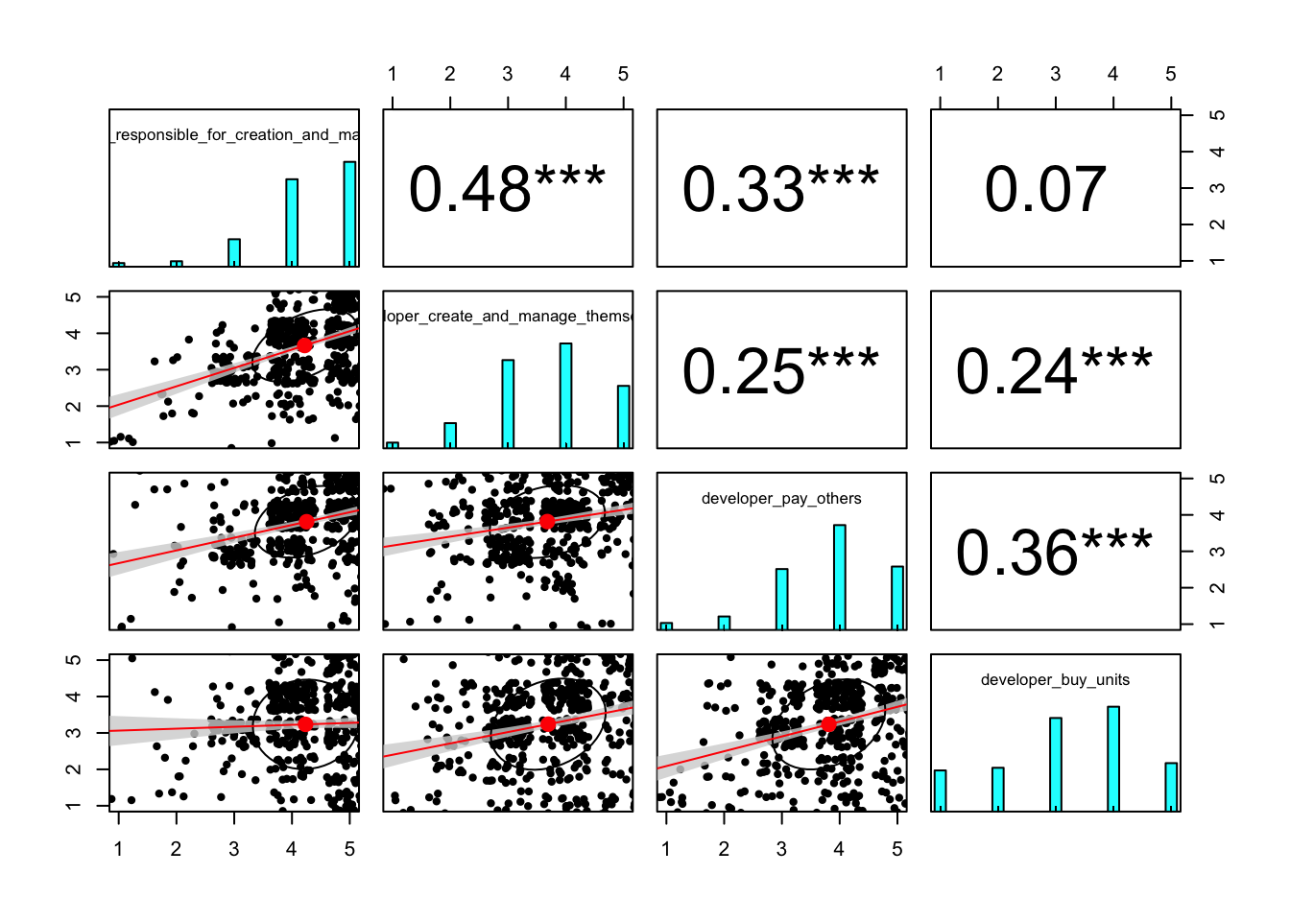
Figure D1.3: Correlations between each of the developer responsibilities, showing jittered scatterplots with linear model (bottom left); histogram of values (diagonal top left to bottom right); and correlation coefficients with significance shown using asterisks (top right, * 0.05 > p > 0.01, ** 0.01 > p > 0.001, *** 0.001 > p).

Appendix D2 - Modelling Measurement Belief
To understand whether and how measurement belief (whether a respondent believes it is possible to measure and compare the biodiversity value of habitats using a standardised numeric metric) is impacted by existing knowledge of the metric, we first created a binomial general linear model assessing the factors that affect whether a respondent does not know with the following formula:

glm(formula = measurement_belief_dont_know ~ existing_metric_knowledge +
metric_info + BNG_belief, family = "binomial", data = modelling_data %>%
mutate(measurement_belief_dont_know = measurement_belief ==
"Don't know"))

The variables were:
- measurement_belief_dont_know: logical, whether the respondent did not know if it is possible to measure and compare the biodiversity value of habitats using a standardised numeric metric (TRUE) or gave a yes/no answer (FALSE)
- existing_metric_knowledge: ordered factor, how familiar the respondent stated they were with the statutory metric (levels: “Had not heard of it prior to this questionnaire”, “Have heard of it but do not know any details”, “Am somewhat informed”, “Am well informed”)
- metric_info: logical, whether the respondent chose to see additional text on the statutory metric
- BNG_belief: factor, whether the respondent believed it is possible to create a net gain in biodiversity through habitat creation, restoration, or enhancement after a loss due to development (levels: “Yes”, “No”, “Don’t know”)
The below shows the model coefficients for the measurement belief know/don’t know model and yes/no models.
##
## Call:
##
##
## Coefficients:
## Estimate Std. Error z value Pr(>|z|)
## (Intercept) -4.3415 200.3157 -0.022 0.9827
## existing_metric_knowledge.L -11.4889 537.5033 -0.021 0.9829
## existing_metric_knowledge.Q -7.9449 400.6314 -0.020 0.9842
## existing_metric_knowledge.C -3.5719 179.1681 -0.020 0.9841
## metric_infoTRUE -1.6019 0.2310 -6.933 4.11e-12 ***
## BNG_beliefNo -0.7973 0.3986 -2.000 0.0455 *
## BNG_beliefDon't know 1.9023 0.2509 7.581 3.43e-14 ***
## ---
## Signif. codes: 0 '***' 0.001 '**' 0.01 '*' 0.05 '.' 0.1 ' ' 1
##
## (Dispersion parameter for binomial family taken to be 1)
##
## Null deviance: 665.72 on 488 degrees of freedom
## Residual deviance: 481.41 on 482 degrees of freedom
## AIC: 495.41
##
## Number of Fisher Scoring iterations: 16
Subsequently, we ran a second model for respondents that answered yes or no for their metric belief, assessing the factors that affected whether they did or did not have the metric belif with the following formula:
glm(formula = measurement_belief_yes ~ existing_metric_knowledge +
metric_info + BNG_belief, family = "binomial", data = modelling_data %>%
mutate(measurement_belief_dont_know = measurement_belief ==
"Don't know", measurement_belief_yes = measurement_belief ==
"Yes") %>% filter(!measurement_belief_dont_know))
In addition to the above variables, this model included:
- measurement_belief_yes: logical, whether the respondent believed it is possible to measure and compare the biodiversity value of habitats using a standardised numeric metric (TRUE) or did not believe (FALSE)

##
## Coefficients:
## Estimate Std. Error z value Pr(>|z|)
## (Intercept) 1.52442 0.37716 4.042 5.30e-05 ***
## existing_metric_knowledge.L 1.21225 0.59024 2.054 0.03999 *
## existing_metric_knowledge.Q -0.03706 0.56004 -0.066 0.94724
## existing_metric_knowledge.C -0.24927 0.52230 -0.477 0.63318
## metric_infoTRUE 0.95914 0.32889 2.916 0.00354 **
## BNG_beliefNo -2.29663 0.42727 -5.375 7.65e-08 ***
## BNG_beliefDon't know -0.97841 0.40800 -2.398 0.01648 *
## ---
## Signif. codes: 0 '***' 0.001 '**' 0.01 '*' 0.05 '.' 0.1 ' ' 1
##
## (Dispersion parameter for binomial family taken to be 1)
##
## Null deviance: 318.83 on 282 degrees of freedom
## Residual deviance: 254.92 on 276 degrees of freedom
## AIC: 268.92
##
## Number of Fisher Scoring iterations: 5
There was some difference in the estimates depending on the speeding threshold used (full sample: estimate = 1.0 ± 0.3, p = 0.004; “extreme speeders” removed: estimate = 0.9 ± 0.3, p = 0.01; “up to 70% median speeders” removed: estimate = 0.7 ± 0.4, p = 0.07).

Appendix D3 - Modelling Overall Opinion
To investigate which factors predict a respondent’s overall opinion of BNG we conducted an ordinal logistic regression. The variables were as follows:
- BNG_belief: factor, whether the respondent believed it is possible to create a net gain in biodiversity through habitat creation, restoration, or enhancement after a loss due to development (levels: “Yes”, “No”, “Don’t know”)
- measurement_belief: factor, whether the respondent believed it is possible to measure and compare the biodiversity value of habitats using a standardised numeric metric (levels: “Yes”, “No”, “Don’t know”)
- BNG_experience: logical, whether the respondent reported having had experience with a project aiming to achieve BNG (TRUE) or not (FALSE)
- BNG.existing.knowledge: ordered factor, amount of paragraph providing information on BNG the respondent reported knowing (levels: “None of the information”, “Some of the information”, “About hald of the information”, “Most of the information”, “All of the information”)
- existing_metric_knowledge: ordered factor, how familiar the respondent stated they were with the statutory metric (levels: “Had not heard of it prior to this questionnaire”, “Have heard of it but do not know any details”, “Am somewhat informed”, “Am well informed”)
- trust.in.external.expertise: numeric, the mean of Likert-type responses for level of trust in wildlife charities and ecological consultants (-2 ≈ strongly distrust; -1 ≈ somewhat distrust; 0 ≈ neither trust nor distrust; 1 ≈ somewhat trust; 2 ≈ strongly trust)
- trust.in.developers.and.landowners: numeric, the mean of Likert-type responses for level of trust in developers and private landowners (-2 ≈ strongly distrust; -1 ≈ somewhat distrust; 0 ≈ neither trust nor distrust; 1 ≈ somewhat trust; 2 ≈ strongly trust)
- trust.in.governing.bodies: numeric, the mean of Likert-type responses for level of trust in central government, local planning authorities, and government agencies (-2 ≈ strongly distrust; -1 ≈ somewhat distrust; 0 ≈ neither trust nor distrust; 1 ≈ somewhat trust; 2 ≈ strongly trust)
- age: ordered factor, which age group the respondent is in (levels: “16-24”, “25-34”, “35-44”, “45-54”, “55-64”, “65+”)
- gender.identity: factor, respondent’s gender identity (levels: “Female”, “Male”)
- education: ordered factor, the highest educational level the respondent has attained (levels: “No formal”, “GCSEs or equivalent, “A-levels or equivalent”, “Vocational higher”, “Undergraduate”, “Post-graduate”)
The predictor variables were tested a priori to assess multicollinearity (see Table D3.1), all adjusted generalised standard error inflation factor (aGSIF) values were below 1.6 meaning that, although some covariance was present, it was acceptably low (Nahhas, 2024).
Table D3.1: Generalised VIF (GVIF), degrees of freedom (Df), and adjusted generalised standard error inflation factor (aGSIF) values for all variables included in the global opinion model.
Variable | GVIF | Df | aGSIF
BNG_belief | 1.750673 | 2 | 1.150274
measurement_belief | 1.915029 | 2 | 1.176370
BNG_experience | 1.848182 | 1 | 1.359479
BNG_existing_knowledge | 2.544760 | 4 | 1.123843
existing_metric_knowledge | 2.904596 | 3 | 1.194486
trust_in_external_expertise | 1.313497 | 1 | 1.146079
trust_in_developers_and_landowners | 2.473692 | 1 | 1.572798
trust_in_governing_bodies | 2.389342 | 1 | 1.545750
age | 1.648388 | 5 | 1.051250
gender_identity | 1.083729 | 1 | 1.041023
education | 1.668799 | 5 | 1.052544

The the best models predict overall opinion of BNG were extracted from the global ordinal regression (i.e. model containing all possible predictor variables) by dredging, a process which assesses the goodness of fit of all possible combinations of factors to select the best models based on their Aichi Information Criterion (AIC), the predictor variables and their significance for all models with delta less than or equal to two are shown in Table D3.2.
Table D3.2: Table of variables included in selected models of overall opinion of BNG, their log-odds ratio, and their significance (* p <= 0.05.; ** p <= 0.01; *** p <= 0.001). All models have a deltaAIC of <2.
Variable | Model 1 | Model 2 | Model 3
measurement_beliefNo | -1.28*** | -1.28*** | -1.27***
measurement_beliefDon’t know | -0.85*** | -0.84*** | -0.82***
trust_in_external_expertise | 1.22*** | 1.23*** | 1.23***
trust_in_governing_bodies | 0.37*** | 0.36** | 0.36**
education.L | 1.04** | 1.04** | 1.03**
education.Q | -0.71* | -0.7* | -0.71*
existing_metric_knowledge.L | 0.98* | 0.95* | 0.87*
existing_metric_knowledge.Q | 0.87** | 0.88** | 0.89**
BNG_beliefNo | -0.65 | -0.64 | -0.65
BNG_beliefDon’t know | -0.7** | -0.68** | -0.68**
gender_identityMale |  | 0.21
BNG_experienceYes |  |  | 0.22

Also of interest was direction of opinion, that is whether the respondent answered negatively, neutrally, or positively. Direction of opinion shared the same predictors, other than existing metric knowledge, which was not significant (Table D3.3).
Table D3.3: Table of variables included in selected models of direction of overall opinion of BNG, their log-odds ratio, and their significance (* p <= 0.05.; ** p <= 0.01; *** p <= 0.001). All models have a deltaAIC of <2.
Variable | Model 1 | Model 2 | Model 3 | Model 4 | Model 5 | Model 6
BNG_beliefNo | -0.78* | -0.85* | -0.78* | -0.85* | -0.85* | -0.77*
BNG_beliefDon’t know | -0.75** | -0.71** | -0.71** | -0.73** | -0.74** | -0.74**
BNG_experience Yes | -0.58 |  |  | -0.34 |  | -0.58
education.L | 1** | 1.06** | 0.94** | 1.09** | 1.09** | 1**
education.Q | -1.1** | -1.11** | -1.11** | -1.12** | -1.08** | -1.1**
measurement_ beliefNo | -1.59*** | -1.61*** | -1.49*** | -1.65*** | -1.65*** | -1.59***
measurement_ beliefDon’t know | -1.24*** | -1.21*** | -1.08*** | -1.27*** | -1.24*** | -1.23***
trust_in_external_expertise | 1.21*** | 1.2*** | 1.23*** | 1.19*** | 1.23*** | 1.21***
trust_in_governing_bodies | 0.32* | 0.32* | 0.28* | 0.33* |  | 0.32*
existing_metric_ knowledge.L |  | -0.17 |  | -0.04 | -0.16
existing_metric_ knowledge.Q |  | 0.49 |  | 0.45 | 0.52
trust_in_financial_beneficiaries |  |  |  |  | 0.28*
gender_identity Male |  |  |  |  |  | 0.09

To understand whether the importance of trust in external expertise was genuine, or whether it was measuring the respondent’s overall propensity to trust, we re-ran the model including trust as average_trust, the mean trust assigned across all seven actors, and “residual” trust for each actor group, calculated as the average trust within that group minus average_trust. The predictor variables were tested a priori to assess multicolinearity, a high level of correlation was found between residual trust in governing bodies and residual trust in private organisations, so two models were run to separate these two variables. The two global ordinal regression was dredged to select the best models based on AIC, the predictor variables and their significance for all models with delta less than or equal to two are shown in Table D3.4. Both average trust and residual trust in external expertise had a significant positive effect on overall opinion of BNG, leading to the conclusion that respondent’s level of trust in external expertise had an impact beyond being a proxy for the respondent’s general propensity to trust. Visual comparisons of trust in external expertise with average trust and trust in the other actors are shown in Figure D3.1.
Table D3.4: Table of variables included in selected models of overall opinion of BNG (where trust is included as average and residual), their log-odds ratio, and their significance (* p <= 0.05.; ** p <= 0.01; *** p <= 0.001). All models have a deltaAIC of <2.
Variable | Model 1 | Model 2 | Model 3 | Model 4 | Model 5 | Model 6 | Model 7
average_trust | 1.6 *** | 1.61 *** | 1.58 *** | 1.58 *** | 1.6 *** | 1.59 *** | 1.59 ***
residual_trust_in_ external_expertise | 1.08 *** | 1.09 *** | 0.97 *** | 1.23 *** | 1.09 *** | 1.23 *** | 0.99 ***
residual_trust_in_ developers_and_ landowners |  |  | -0.26 |  |  |  | -0.24
residual_trust_in_ governing_bodies |  |  |  | 0.39 |  | 0.36
BNG_beliefNo | -0.64 | -0.63 | -0.65 | -0.65 | -0.64 | -0.64 | -0.64
BNG_beliefDon’t know | -0.71 ** | -0.69 ** | -0.7 ** | -0.7 ** | -0.7 ** | -0.68 ** | -0.68 **
education.L | 1.06 ** | 1.06 ** | 1.04 ** | 1.04 ** | 1.04 ** | 1.04 ** | 1.04 **
education.Q | -0.7 * | -0.69 * | -0.71 * | -0.71 * | -0.7 * | -0.7 * | -0.7 *
existing_metric_ knowledge.L | 0.92 * | 0.89 * | 0.98 * | 0.98 * | 0.83 * | 0.95 * | 0.95 *
existing_metric_ knowledge.Q | 0.87 ** | 0.88 ** | 0.87 ** | 0.87 ** | 0.89 ** | 0.88 ** | 0.88 **
measurement_ beliefNo | -1.3 *** | -1.31 *** | -1.28 *** | -1.28 *** | -1.3 *** | -1.28 *** | -1.28 ***
measurement_ beliefDon’t know | -0.87 *** | -0.86 *** | -0.85 *** | -0.85 *** | -0.85 *** | -0.84 *** | -0.84 ***
gender_identity Male |  | 0.23 |  |  |  | 0.21 | 0.21
BNG_experience Yes |  |  |  |  | 0.2

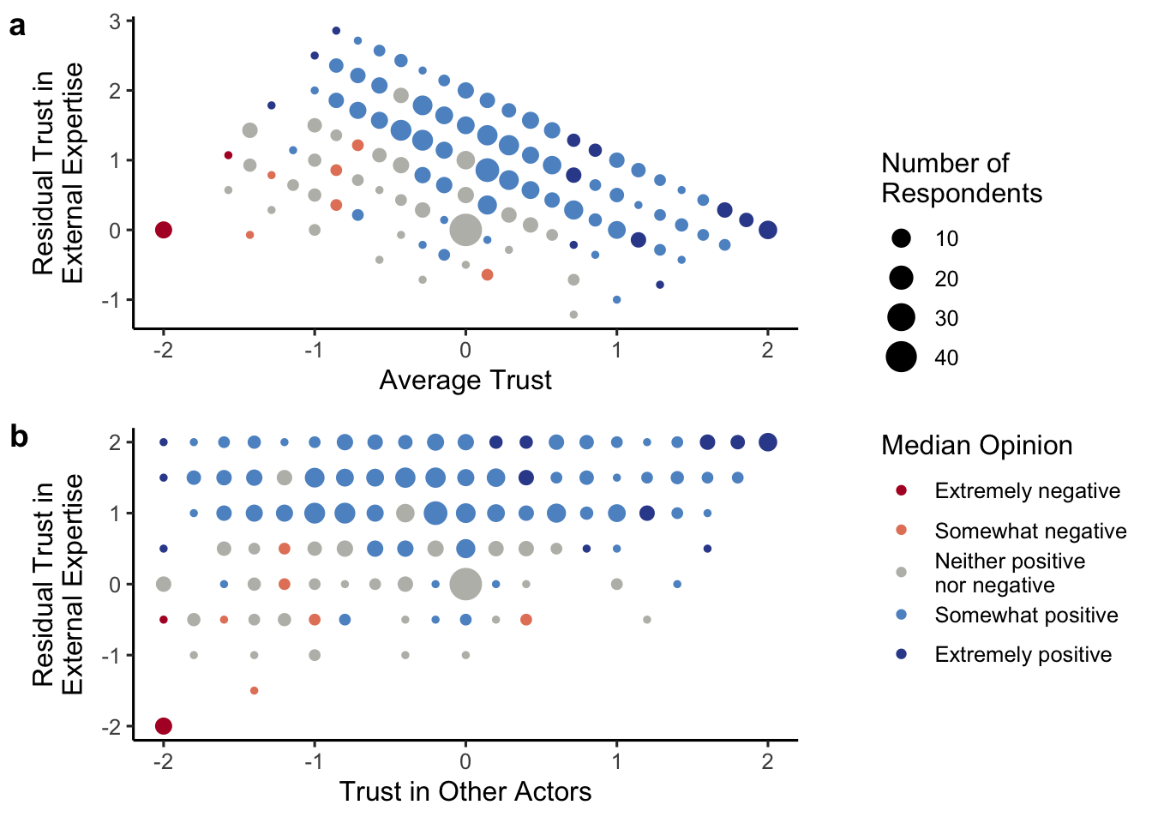
Figure D3.1: Two alternative plots for trust: (a) plotting residual trust in external expertise (i.e. the difference between average trust assigned to external expertise and average trust assigned across all organisations); and (b) plotting average trust in external expertise against average trust in all other actors. In both plots, colour is used to show median overall opinion and size is used to show the number of respondents with those values for trust.

